Virtual Try-On Technology
A helping tool for online apparel shopping?
Insight into attitudes that predict the use of Virtual Try-On Technology and
the influence on consumers’ buying intention.

ERASMUS UNIVERSITY ROTTERDAM
Erasmus School of Economics (ESE)
Master Thesis
Supervisor: Bas Donkers

Hamide Tokucin (320153)
16-8-2013

Table of Contents
Executive Summary 3
1. Introduction 4
1.1 Virtual Try-On; Taking the online shopping experience to a higher level 4
1.2 Problem statement 5
1.3 Purpose of the research 6
2. Theoretical Framework 7
2.1 Attitude… 7
2.2 Perceived Usefulness 8
2.3 Perceived Ease of Use 10
2.4 Entertainment 11
2.5 Fashion involvement 12
2.6 Lack of Physical Examination 14
2.7 Past Behavioural Experience 15
2.8 Online Buying Intention 15
2.6 Conceptual Model 17
3. Data Description 18
3.1 Questionnaire design 18
3.1.1 Frequency 19
3.1.2 Fashion Involvement 19
3.1.3 Attitude towards Virtual Try- On 19
3.1.4 Usefulness 20
3.1.5 Ease of Use 20
3.1.6 Entertainment 20
3.1.7 Lack of Physical Examination 21
3.1.8 Shop & Buying Intention 21
4. Methodology 22
4.1 Factor Analysis & Reliability 22
4.2 Regression & Correlation analysis 22
5. Results 24
5.1 Factor analysis 23
5.2 Reliability analysis 27
5.2.1 Fashion Involvement 27
5.2.2 Past behavioural experience 27
5.2.3 Attitude 27
5.2.4 Usefulness 27
5.2.5 Ease of use 28
5.2.6 Entertainment 28
5.2.7 Lack of physical examination 28
5.2.8 Buying intention 28
5.3 Conceptual Model & Hypotheses 30
5.3.1 Correlations 31
5.3.2 Regression Model 1 (dependent: attitude) 32
5.3.2 Regression Model 2 (dependent: buying intention) 34
5.3.2 Regression Model 3 (Mediation Analysis) 37
6. Conclusion 40
7. Limitations and future reaearch 43
8. References 44
Appendix 48
A. Questionnaire used for this research. 48

Executive Summary
The internet together with the fast growing power of computer technology has proven to be a forceful channel for sale of apparel products. The online shopping environment has seen a wide range of innovation that will continue to attract consumers to the market. However, the challenge for retailers is to make online shopping for clothes a more enjoyable, effective and profitable way of buying clothes than traditional home shopping has been until now. Thanks to the growing online shopping environment and the speed of internet technology, we have seen the creation of 3D body scanners, automatic body measurement, the customization of existing styles and Virtual-Try-On visualization techniques. The idea of such technologies is to minimize the negative feelings of consumers towards buying clothing online.

There are several factors that could influence consumers to use a Virtual Try-On tool in order to buy apparel on the internet. Therefore the research question of this study is: “Which factors influence the use of Virtual Try-On and how does this affect the consumer’s buying intention?” This research studied different indicators of attitude towards the use of Virtual Try-On. The conclusion is that perceived easefulness, perceived ease of use and perceived entertainment are all strong indicators of attitudes towards the use of Virtual Try-On, which in turn influence the buying intention. Fashion involvement, lack of physical examination and past behavioral experience were not significant in predicting the attitude towards the use of Virtual Try-On.

In order to attract consumers, online retailers should keep updating the tools they are providing to aid consumers during their visit. These tools should be easy to understand, clear, helpful, fun to use and it should not take a lot of time. But most of all it should match with how consumers would like to evaluate clothing. This research confirms that people who shop on the internet for clothing are willing to use the tool, regardless if they are highly fashion involved or a heavy online shopper. In addition, online retailers should not worry that people would like to physically evaluate the clothing before they make a purchase. This item is not relevant and does not affect the buying intention.

Future research could test this study on different types of technologies. There are several types of Virtual Try-On tools, some technologies are very complicated to understand while other technologies are very straightforward, but boring and the selection of clothing that is available is minimal.

1. Introduction

1.1 Virtual Try-On; Taking the online shopping experience to a higher level
An online shopping experience is quite different from traditional shopping, because it is a virtual environment, where you cannot feel any fabric or see the garment in real life. Most consumers are hesitant to purchase garments online or are unsatisfied with their online shopping experience, which results into high return rates. The most important reason for this is because many online retail stores lack product information.

According to Cho (2003), people who have positive attitudes towards internet purchasing are less likely to abort an intended online transaction. The most important factor for aborting an online transaction is the lack of physical examination; online retailers have so little control over this aspect. But to minimize the lack of physical examination, online retailers offer secure deliveries, generous return policies and various types of image interactivity technology also known as Virtual Try-On. This includes close-up pictures or zoom-in functions, mix-and-match functions and 3D models to enhance consumers’ online shopping experience.
The main purpose of Virtual Try On is to serve the consumer with more and better information that is similar to physical examination. This should lead to consumers being more confident in their final purchasing decision and should decrease the probability of consumers returning clothing. This consideration is crucial for retailers since return rates for apparel are dramatic, with an industry average of 35% for both catalogue and online sales (Nantel, 2004).

Other research sketches that many consumers who are visiting internet shops intend to buy something online, but often leave the websites without completing their intended purchase (Cho, 2003).
With Virtual Try-On technology, consumers can create their own virtual model based on their measurements, facial characteristics, hair and eye color and their body shape. Furthermore, it gives users the ability to zoom in on product features, rotate the garment or view it from different angles. Users are also able to select different colors of a product (Kim & Forsythe, 2008).
Virtual Try-On can provide product information that is comparable to the information gained from observing the product directly.

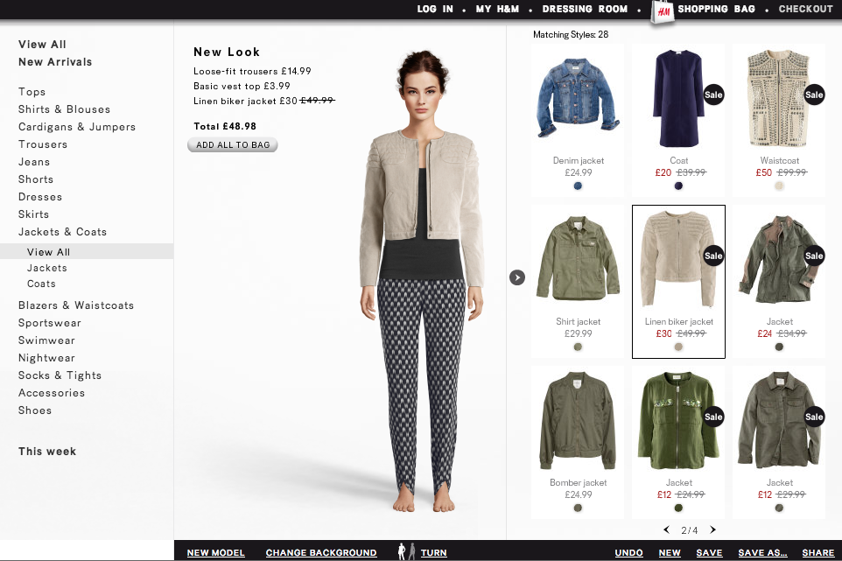
Figure 1: Example of a Virtual Try-On/Virtual Dressing Room Tool on H&M

1.2 Problem Statement
Previous studies examined important findings for online retailers and marketers. Online apparel retailers may implement Virtual Models to improve virtual product examination and improve the consumer’s view of the online store environment, which may result in interactivity and enjoyment with the online shopping process leading to favorable responses towards the online retailer.

However, the same studies do not focus on fashion involvement, which could be an important indicator of using Virtual Try-On Tools. There is also no discussion of the influence of previous experiences with these tools. The studies also lack barriers for consumers when they are using these tools. A good example is the physical examination. Virtual Try-On Technology is designed to minimize the lack of physical examination. Is there a link between Virtual Try-On Technology and the lack of physical examination? Is the information that is provided in a Virtual Try-On Tool enough for the consumer to buy?

How does Virtual Try-On Technology help consumers to buy in an online shopping environment? The purpose of this thesis is to research if consumers have the intention to buy apparel on a website that supports Virtual Try-On Technology.
“Which factors influence the use of Virtual Try-On and how does this affect the consumer’s buying intention?”
In order to answer the main question the following sub-questions will be answered:
• Which functional and hedonic attitudes affect the usage of Virtual Try-On Tools and how does this influence the consumer’s buying intention?
• Which social factors affect the usage of Virtual Try-On Tools and how does this influence the consumer’s buying intention?
• Which risks lead to using the Virtual Try-On Tool and how does this influence the consumer’s buying intention?

1.3 Purpose of the research
Nowadays consumers are very demanding when it comes to buying on the internet. Consumer’s mention their inability to examine (try on) clothes as their main reason for hesitating to buy clothing online (Thompson, 2002). Other reasons are the consumer’s concern with fit and correct sizing (Beck, 2001). Online retailers have come up with some innovative ways to get around the fear of buying something that will not fit. Thanks to the growing online shopping environment and the speed of internet technology, we have seen the creation of 3D body scanners, automatic body measurement, the customization of existing styles and Virtual-Try-On Technology.
The idea of such technologies is to minimize the negative feelings of consumers towards buying clothing online and to improve their online shopping behavior by providing more information and present the apparel as detailed as possible.

The main purpose of this research is to determine whether the use of Virtual Try-On tools helps the consumer and if so, whether this leads to an actual buying intention. Other purposes are to identify whether fashion involvement has an influence on the attitudes towards the use of Virtual Try-On Technology and whether he lack of physical product examination influences the decision of a consumer to buy or to abort the transaction.
2. Theoretical Framework

For the purpose of researching the effectiveness of Virtual Try-On as a marketing tool, the intention and attitude of consumers in general will be discussed. Next, the conceptual model will be analyzed, which will explain the acceptance of new technologies and the consumer’s true intention after using the new technology. The final topics that will be discussed in this chapter are the social factor and the perceived risk.
This chapter will be completed with a conceptual framework summarizing the expected effects of the social factors, functional and hedonic motives and the risks on the intention to buy apparel on the website after the use of Virtual Try-On.

2.1 Attitude
Attitude has been characterized as a person’s preference to show a certain response towards a concept or object (Doob, 1947). It has been implied that attitude can be split into cognitive (our thoughts and beliefs about something) and affective (feelings and emotions) components (Fishbein, 1967). The Theory of Reasoned Action (TRA) supports this illustration (figure 2). The TRA model implicates that a person's intention of performing a certain act is deeply inﬂuenced by an overall affective evaluation of performing that act (attitude) and that such an evaluation is made based on one’s cognitive evaluation of consequences of that act (Sheppard, Hartwick & Warshaw, 1988). This theory distinguishes functional and psychological consequences. Functional consequences relate to the evaluations that are immediate, direct and tangible and the psychological consequences relate to the evaluations that are internal, personal and abstract. These evaluations concern the potential advantages and risks that usage of a certain product might have. Rogers (1995) stated that most consumers adopt a new technology once they gain benefits when using it.

Attitude has been defined in this thesis as ‘the degree to which a consumer likes Virtual Try-On Technology and thinks it to be a good technology’.
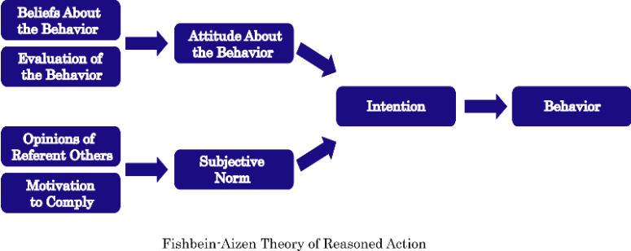
Figure 2: Fishbein-Aizen (1967): Theory of Reasoned Action (TRA)

2.2 Perceived Usefulness
Decisions to shop in an online shopping environment are influenced by functional motives (making a good choice) and hedonic motives (enjoyment of the shopping experience) (Childers et al, 2001; Babin, Darden & Griffin, 1994).

To link these motives to product visualization technologies, the Technology Acceptance Model (TAM) introduced by Davis (1989) is used (figure 3). This will help build the important constructs for consumers to use such technologies. The model suggests that when users are presented with a new technology, a number of factors affect their decision about how and when they will use it.

Perceived Usefulness (PU) is another major determinant of attitude toward use in the TAM model (Davis, et al., 1989). PU is defined as the degree to which the user believes that the technology will enhance his or her job performance (Davis et al., 1989). This means that using a product visualization technology as a shopping medium enhances the outcome of a consumer’s shopping experience (Dellaert et al., 2008).

According to McCloskey (2006), the ability to improve shopping performance, shopping productivity, and most importantly, achieving shopping goals, were concluded as valid determinants as to what makes consumers’ shopping activity a success. This is in sync with the findings of Barkhi et al. (2008) as their study suggests that consumers will develop favorable attitudes toward products and/or services that they believe to provide sufficient benefits or attributes toward a solution and negative attitudes toward those that are inadequate.
Given this scenario, Kim et al. (2003) argued that online shopping sites that provide functions that aid consumers in making better shopping decisions would be perceived as useful. Another research confirms that the PU has been proven to be a strong predictor of consumers’ attitudes towards using Virtual Tools for online apparel shopping (Kim & Forsythe, 2008).

The same logic was observed in the work of Bisdee (2007) who concluded that online shopping sites, which are able to offer useful services to consumers, that are not available in traditional shopping (e.g. a comparison between products), will be perceived as useful by consumers, thus leading to the development of favorable attitudes toward online shopping. This perception is supported by Childers et al. (2001), who observed that consumers who have favorable attitudes toward online shopping, were found to perceive online retailers as being useful, so that online retailers were able to enhance their shopping productivity and effectiveness.

The PU indicates whether the chosen clothes match with what the person likes and it should also indicate to which extent the consumer believes that the use of Virtual Try-On gives them a better view of the apparel product. The shopping effectiveness is linked to the consumer’s ability to accomplish their shopping goals more quickly by using a Virtual Try-On Tool. The shopping productivity is linked to the consumer’s ability to shop more efficiently. A good example is combining clothes on a model to see if it matches.

It basically comes down to that when a consumer has favorable attitudes towards the use of Virtual Try-On is satisfied with the result in the application he or she is more willing to buy that item.

H1. The perceived usefulness is positively related to the attitudes towards the use of Virtual Try-On (a) and an indirect positive effect on the actual buying intention after the use of Virtual Try On (b).

  - Perceived ease of use
A lot of studies confirm that it is really important for consumers that the website they visit is easy to use. If the website is not easy to use, this can lead to the abortion of a transaction.
Quelch and Takeuchi (1981) propose that consumers would be more likely to shop in non-store channels only if the experience is comparable to shopping in a real store.

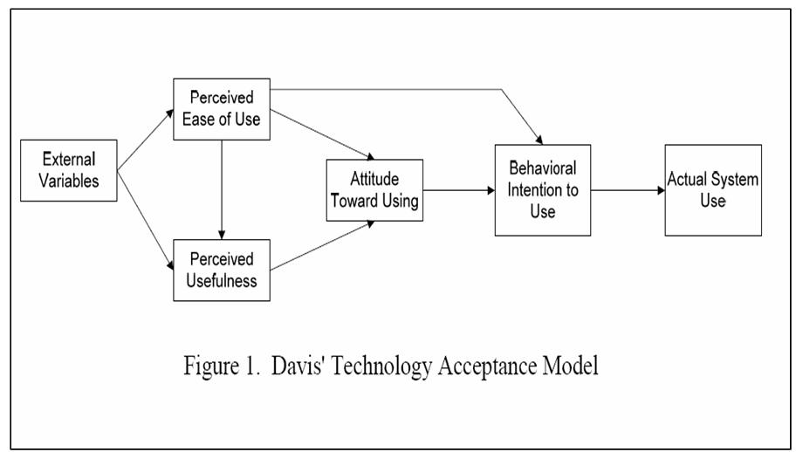Figure 3 Technology Acceptance Model (TAM Model), Davis, 1989

Davis (1989) defines the perceived ease of use as "the degree to which a person believes, that using a particular system would be free from effort". It can be stated that the ease of use refers to how easy product visualization technology is as a medium to buy apparel in an online shopping environment (Dellaert et al., 2008). The perceived ease of use can be linked to the complexity of using such tools.

It can be assumed that consumers who have a positive attitude towards online shopping are more likely to use Virtual Try-On when it is free from effort. This will have an indirect positive effect on the actual buying intention. The easier and more uncomplicated a technology is, the more likely it is that the consumer will use this technology. It is predicted that the perceived ease of use is not only positively related to the attitudes towards the use of Virtual Try-On, but to the perceived usefulness and perceived entertainment as well.

H2. The perceived ease of use is positively related to the attitudes towards the use of Virtual Try-On (a) and an indirect positive effect on the actual buying intention after the use of Virtual Try On (b).

  - Entertainment
A more recent addition to the TAM model is the “entertainment” concept, or “the extent to which the activity of using the new technology is perceived to provide reinforcement in its own right, apart from any performance consequences that may be anticipated” (Davis et al., 1992). Within the TAM framework, both functional and hedonic aspects are considered to act as determinants of consumers’ attitude toward using a new technology. Understanding the determinants of consumers’ attitude, it is claimed that this attitude has a strong, direct, and positive effect on consumers’ intentions to actually use the new technology or system (Bobbitt and Dabholkar, 2001)

Previous research shows that the hedonic motivation has a stronger positive relationship than functional motivations with the attitude toward using product virtualization technologies. This means that the entertainment value is a stronger determinant of attitude toward using product virtualization technologies than the perceived usefulness (Kim & Forsythe, 2007).

Deci & Ryan (1985) proved that when people are intrinsically motivated, they experience interest and amusement. It can be concluded that amusement/enjoyment can also be seen as intrinsic motivator. This is related to the need for self-determination, the need for competence, interest-excitement and flow (Shang et al, 2005).

The perceived entertainment value is another strong factor of consumers’ attitudes towards using Virtual Try-On for online apparel shopping. This is the degree to which a person believes he or she enjoys using Virtual Try-On. We can assume that people who are more enjoying the use of Virtual Try-On are more likely to buy apparel on that website.

H3. The perceived enjoyment is positively related to the attitudes towards the use of Virtual Try-On (a) and an indirect positive effect on the actual buying intention after the use of Virtual Try On (b).

  - Fashion involvement
Fashion leaders (people who are very fashion involved) represent a unique and important segment of the fashion market, because they are the first to buy apparel when the newest trends are introduced to he market. Their criticism may be essential to the final success or failure of the apparel product. (Goldsmith et al., 1999).

Fashion leaders influence fashion followers by exposing the new fashion trends. Fashion leaders have a control and a powerful effect on later adopters. Fashion leaders can be profiled as people who tend to spend more money on apparel, read more fashion magazines, shop more often and are younger than fashion followers (Beaudoin et al.,1998). It can be concluded that fashion leaders are more interested in fashion and enjoy shopping more than fashion followers. Tigert et al. (1976) demonstrated that the highly fashion involved consumer is also a heavy fashion clothing buyer.

In a study examining the personal characteristics of frequent fashion buyers, four psychological concepts were also related to the frequent use of clothing purchases (Goldsmith, 2002); a) Innovativeness, b) Knowledge, c) Involvement, d) Opinion Leadership.
In this thesis the focus will be on fashion involvement.

Fashion involvement is a consumer’s perceived value of fashion clothing (O’Cass, 2001). Another study confirms that users whose consumption is more easily affected by fashion trends may be more likely to shop online (Shang et al, 2005).

Jones and Kim (2006) verified that clothing involvement was shown to have a significant impact on online apparel shopping intention. This basically means that shoppers who are more involved with fashion clothing are more likely to shop online for apparel. This result is in line with the findings of Goldsmith & Flynn (2005), who conclude that shoppers who are more involved with fashion clothing are more likely to purchase through remote channels, like the internet. Jones and Kim also suggest that retailers targeting consumers who are highly involved with fashion can turn a visitor into an active shopper.

Tigert et al. (1976) state that fashion involvement is composed of five dimensions of fashion adoption-related behavior; a) Fashion innovativeness and time of purchase, b) Fashion, interpersonal connection, c) Fashion interest, d) Fashion knowledge ability, e) Fashion awareness and reaction to changing fashion trends.
The five dimensions of fashion involvement presented by Tigert et al. (1976) were used to confirm Zaichkowsky’s (1985) involvement instrument. Results supported the PII as being a reliable and valid measure of the involvement construct (Fairhust et al., 1989).

From the information above it can be concluded that there is empirical evidence that fashion involvement is a strong predictor of online apparel shopping.
A positive relationship is expected between fashion involvement and the use of Virtual Try-On and buying intention. The more a person is involved in fashion, the more he or she is likely to have a positive attitude towards the use of Virtual Try-On which may lead to the intention to buy.
It is expected that fashion involvement should also moderate the impact of attitudes towards using Virtual Try-On on its actual usage. This means that it is expected that the effect of attitudes on use is likely to be stronger for those with high levels of fashion involvement.

4a. Consumers’ fashion involvement is positively related to the attitudes towards the use of Virtual Try-On.
4b. Consumers’ fashion involvement will have a positive impact on the buying intention of Virtual Try-On Technology.
4c. Consumers’ fashion involvement will moderate the impact of attitudes towards using Virtual Try-On on the buying intention.

  - Lack of Physical Examination
There are several barriers for consumers to shop online. Forsythe & Shi (2003) distinguish four types of barriers for consumers to shop online and how they affect online shopping.

- Perceived financial risk (not feeling secure about payment method).
- Psychological risk (the risk that personal information will not be kept private).
- Perceived product performance risk (difficult to evaluate product).
- Perceived time/convenience loss risk (faster and easier to purchase in a traditional shop).

In this thesis the focus will only be on the perceived performance risk. Forsythe & Shi (2003) conclude that product performance risk was the most common reason for consumers not to shop online. We can assume that this risk can make a consumer abort their transaction in the last step, because he or she is afraid that the product will not fit and this results in that they might have to worry about returning the product. Consumers who have higher levels of concern over lack of physical examination are more likely to abort the intended online transaction (Cho, 2004).

It is important to understand if such a tool is helping the consumer to minimize the lack of physical examination. Virtual Try-On Tools were invented to minimize these concerns. So we can conclude that consumers who feel the need to physically examine the apparel product after the use of Virtual Try-On will have a negative impact on the actual buying intention. A moderating effect is expected, because a consumer who has favorable attitudes towards the use of Virtual Try-On can have concerns about the fit of the product, which may lead to the abortion of a transaction.

H5a. Lack of physical examination will have a negative influence on the intended use and buying intention.
H5b. Lack of physical examination will moderate the impact (negative) of attitudes towards using Virtual Try-On on the buying intention.
  - Past behavioral experience
Shim et al. (2000) states that the most significant predictor of intention to search for information via the internet was previous internet purchase experience, and that this is a factor related to consumers’ perceived risk.

Consumers are more likely to abort a transaction when they are uncertain about their choice or evaluation. Studies have indicated that a behavioral history influences the likelihood that the same behavior will be performed again (Eastlick, 1996). Lohse et al. (2000) stated that the number of years of experience someone has in using the internet as well as the frequency and the amount of time using the internet per visit were positively related to intention of online purchasing. Another research supports: “Consumers who had at least one prior purchasing from the internet are indeed less likely to abort intended online transactions than those without such an experience” (Cho, 2004).

Using the internet for a long time, a higher frequency of using the internet and the time spent per visit can be indirect signs that a consumer has had more possibilities to discover the website and gain knowledge about internet shopping and in this case, the use of a Virtual Try-On Tool. It can be concluded that past behavioral experience of internet shopping has a positive effect on the attitude towards using Virtual Try-On and has an indirect as well as direct effect on the actual buying intention.

H6a. Past behavioral experience of internet shopping is positively related to the attitudes toward using Virtual Try-On.
H6b. Past behavioral experience is positively related to the buying intention.

  - Online buying intention
2.8.1 Behavioral Intention:
Shopping on the internet is behavior. Behavioral intention (BI) is defined as a person's perceived likelihood or "subjective probability that he or she will engage in a given behaviour". In this research this is defined as a person’s perceived likelihood or subjective probability that he or she will engage in buying apparel on a website that supports Virtual Try-On Technology. In this research behavioral intention will be replaced by the online buying intention.

2.8.2 Online buying intention:
Buying intention is an important determinant of online shopping behavior and represents the best estimates of future behavior available to market researchers (Fishbein & Ajzen, 1975).

Buying intention can predict the possibility of a consumer to buy a product, and the higher the purchase intention is, the higher a consumer’s willingness to buy a product (Schiffman et al, 2000). Purchase intention implies that consumers will follow their experience, preference and external environment to gather information, assess alternatives and make a buying decision (Yang, 2009).

Furthermore, consumer-buying intention comes from consumers’ perception on benefits and values of the product in question, and it is an important to predict consumer-buying behavior. Monroe and Krishnan (1985) stated that perceived value and perceived quality will influence the buying intention, therefore the more perceived value and perceived quality, the higher the buying intention is.
Fournier (1998) exposed that if a retailer provides product functions that meet consumer needs, consumers will make psychological associations and an irreplaceable relation with the retailer, which will lead to interaction with the retailer and raise their purchase intention accordingly.

Online buying intention reflects the desire of consumers to buy a product on a certain website. We define this as the desire of consumers to buy apparel on a website that supports Virtual Try-On. Previous research confirms that website design affects the online purchase intention (Chen Y.H. et al., 2010).
Therefore, the study proposes the following hypothesis:

H7. Attitudes toward using Virtual Try-On tools are positively related to the buying intention.

2.9 Conceptual Model
This section summarizes the hypothesis described in the theoretical framework.

Fashion Involvement

Lack of Physical Examination

H4c
H4a
H1
H5b

Ease of Use

Usefulness

H4b

Buying Intention:
Use website to shop & buy clothes

Attitude toward using Virtual Try-On tool

H2
H7

H6b
H6a
H3

Entertainment

Past behavioural experience

Figure 5: Conceptual Model

3. Data Description

In this chapter, the emphasis will be on the questionnaire and data collection. At first, the questionnaire will be reviewed. This chapter will be about the questionnaire, the question development and the sample size of the questionnaire.

3.1 Questionnaire design
An online survey was used to collect quantitative data to test hypotheses. Participants were asked to follow the link and read the instructions on that link. Participants were asked to visit an online dressing room on H&M and to try on three items of apparel products. In order to receive a large number of respondents to the questionnaire friends were asked to spread and share the questionnaire with their friends. The target group is homogeneous (young adults between 16- 40 with interest in online shopping), so this group was not difficult to approach by social media. However, it was difficult to make them fill in the questionnaire, because the participants were asked to do an experiment first before they could start and fill in the survey.

The questionnaire was sent out at the beginning of May 2013. A total of 196 respondents filled in the questionnaire, which is a large enough sample to use for answering the research question. Unfortunately, after checking the answered questionnaires, a number of 14 versions appeared to be unusable because of an incorrect way of responding or not completing. This led to a total number of 182 useful answered questionnaires.

In table 1, the different items are stated and divided under the nine different dimensions. Furthermore, the complete questionnaire is presented in Appendix 1.

Table 1: Variables
Explanatory variable | Description
Demographics | Categories in which respondents indicate their age, gender, income and education
Frequency (past behavioral experience) | Construct measuring the degree to which the respondent is an online shopper
Fashion Involvement | Construct measuring the degree to which the respondent is fashion involved
Attitude towards Virtual Try-On | Construct measuring the degree to which the respondent has a favorable attitude towards the Virtual Dressing Room Tool
Usefulness | Construct measuring the degree to which the respondent finds the VDT useful
Ease of Use | Construct measuring the degree to which the respondent finds the VDT easy in use
Entertainment | Construct measuring the degree to which the respondent finds the VDT entertaining
Lack of Physical Examination | Construct measuring the degree to which the respondent wants to physically examine the clothing
Shop & Buying Intention | Construct measuring the degree to which the respondent would buy or use clothing when using the VDT

3.1.1 Frequency
Lohse et al. (2000) stated that the number of years of experience someone has in using the internet as well as the frequency and the amount of time using the internet per visit were positively related to intention of online purchasing. Therefore, questions like the amount of time using the internet per visit, number of years’ experience of an internet user and the frequency as well as questions like experience in using Virtual Try-On Tools in the past were part of the questionnaire. These questions will define the past behavioral experience of the participant.

3.1.2 Fashion Involvement
The validated fashion involvement index, developed by Tigert, Ring and King (1976) has been used to predict consumers’ attitude toward fashion products. Five dimensions were integrated in the construct: fashion innovativeness and time of purchase, fashion interpersonal communication, fashion interest, fashion knowledge ability, fashion awareness and reaction to changing fashion trends. The optional answers for two of the items measuring fashion involvement were reversed in the coding procedure: the items that measure the fashion innovativeness and time of purchase; and fashion awareness and reaction to changing fashion trends. Each of the first four items were measured by a single item on a three-point scale, with one being least fashion involved and three being highest fashion involved. A five-point scale for a single item was used to measure the fifth item, with one being least fashion involved and five being highest fashion involved.

3.1.3 Attitude towards Virtual Try- On
Attitude towards Virtual Try-On is defined as ‘the degree to which a consumer likes Virtual Try-On Technology and thinks it to be a good technology’. This construct is important, because it is the dependent variable of this study. It has been implied that attitude can be split into cognitive (our thoughts and beliefs about something) and affective (feelings and emotions) components (1967, Fishbein). The questions are based on the TRA (theory of reasoned action). Consumers were asked if they thought whether it is a good technology (thoughts and beliefs) and if they liked or enjoyed (feelings and emotions) to use the tool etc. Respondents had the option to answer the question based on the seven-point Likert scale, with one being strongly disagree and seven being strongly agree.

3.1.4 Usefulness
In order to measure the usefulness of the tool, questions included were if the participant agreed on whether the Virtual Try-On tool is useful in aiding their purchase decision and whether it increased consumer’s productivity and efficiency. McCloskey (2006) defined the ability to improve shopping performance, shopping productivity, and most importantly to achieve shopping goals, determines what makes consumers’ shopping activity a success. Consumers where asked if the tool was helpful to achieve their shopping goals, if they liked to combine clothes to see whether they match (shopping productivity) and whether it fits well with the way the consumer likes to evaluate the clothing (shopping performance).
Respondents had the option to answer the question based on the seven-point Likert scale, with one being strongly disagree and seven being strongly agree.

3.1.5 Ease of Use
The ease of use is "the degree to which a person believes, that using a particular system would be free from effort" (Davis, 1989). It can be stated that the ease of use refers to how easy product visualization technology is as a medium to buy apparel in an online shopping environment (Dellaert et al., 2008). The perceived ease of use can be linked to the complexity of using such tools. In order to measure the ease of use of the tool, questions included were if the participant agreed on whether the Virtual Try-On tool is easy to use, such as its navigation and how easy it is to learn to use the tool.
Respondents had the option to answer the question based on the seven-point Likert scale, with one being strongly disagree and seven being strongly agree.

3.1.6 Entertainment
In order to measure the entertainment construct of the tool, questions included were if the participant agreed on whether the shopping experience was fun and enjoyable. Deci & Ryan (1985) verified that when people are intrinsically motivated, they experience interest and amusement. Igbaria et al. (1999) showed that if users are more playful with their computer systems, they would be more willing to use them. Respondents had questions like whether they experienced fun and interest when using the tool.
Respondents had the option to answer the question based on the seven-point Likert scale, with one being strongly disagree and seven being strongly agree.

3.1.7 Lack of Physical Examination
Consumers who have higher levels of concern over lack of physical examination are more likely to abort intended online transaction (Cho, 2003).
In order to measure the lack of physical examination, questions included were if the participant would want to feel the fabric in real life before purchasing.
Respondents had the option to answer the question based on the seven-point Likert scale, with one being strongly disagree and seven being strongly agree.

3.1.8 Intended use & Buying Intention
Shopping on the internet is behavior and this is defined as a person's perceived likelihood or probability that he or she will engage in a certain behavior,
Buying intention can predict the possibility of a consumer to buy a product, and the higher the purchase intention is; the higher a consumer’s willingness to buy a product (Schiffman & Kanuk, 2000).
In order to measure the intended use & buying intention, questions included were if the participant would shop and/or buy clothing in an online environment that supports Virtual Try-On. Respondents had the option to answer the question based on the seven-point Likert scale, with one being strongly disagree and seven being strongly agree.
4. Methodology

Now that the data is collected and summarized in chapter three, it is time to analyze the data.
This chapter will summarize the methods that were used in analyzing the data, so that the main research question of this thesis can be answered. Factor analysis is important in this research and will be explained concisely. Since the results are presented in the next chapter, this chapter will only summarize the methods and where they are used.

4.1 Factor Analysis & Reliability
A method for finding structure in datasets and decreasing these datasets to a smaller size is factor analysis. This type of method is often used in the analysis of surveys; because answers to questions might be correlated with each other and can measure the same. Factor analysis identifies these correlated questions in order to find underlying factors in the dataset.
Executing the factor analysis over the data, results in a table containing the values for all components in all factors. According to these values, it is possible to determine which items belong to which component. At this moment it is possible to identify whether different items are correlated and, if yes if this can be combined into different factors to reduce the size of the dataset.
After the factor analysis, it is important to check whether the factors are reliable. In order to test the reliabilit, it is essential to measure the reliability with Cronbach’s α.
Based on the reliability of the factor, a conclusion can be made whether the factor is reliable to be used in finding structure in the dataset.

4.2 Regression and correlation analysis:
Regression analysis involves recognizing the relationship between a dependent variable and one or more independent variables. A model of the hypothesized relationship is developed, and estimates of the parameter values are used to develop an estimated regression equation. Various tests are then performed to determine if the model is acceptable. If the model is considered acceptable, the estimated regression computation can be used to forecast the value of the dependent variable given values for the independent variables.
5. Results

Since a description has been given on which methods were used in the research and the data is already reviewed, it is time to examine the results that were gained from performing the methods. In order to examine the hypotheses and, more importantly, find an answer to the main research question, the results of this research will be summarized.

5.1 Factor Analysis
An exploratory factor analysis has been used to find out whether the a priori constructed scales would be identified by the factor analysis. A Promax rotation (Kappa 4) was used, because the expectation is that the factors will correlate (see theoretical model). Therefore it was decided to not use an orthogonal rotation like Varimax.

As can be read from table 2, the KMO test is .910, which is above the threshold of .500. The Bartlett’s test of sphericity is significant (p=<.001). This indicates that there are sufficient correlations between the items to execute a factor analysis.

Table 2: KMO and Bartlett’s Test
Kaiser-Meyer-Olkin Measure of Sampling Adequacy. |  | .910
Bartlett's Test of Sphericity | Approx. Chi-Square | 3654,509
 | df | 630
 | Sig. | .000

There are several options to define the number of components to extract in a factor analysis, for example the Kaiser criterion (all factors with an eigenvalue>1) or an a priori defined number. The purpose is to identify the eight scales that are combined the theoretical model, so extraction of eight factors has been chosen. Table 3 shows that these eight factors are the same number as would be identified with the Kaiser criterion: eight factors have an eigenvalue >1. Together they explain 65.6% of the variance.

Table 3: Extraction Method: Principal Component Analysis.(Total variance explained)
Component | Initial Eigenvalues |  |  | Extraction Sums of Squared Loadings |  |  | Rotation Sums of Squared Loadingsª
 | Total | % of Variance | Cumulative % | Total | % of Variance | Cumulative % | Total
1 | 12.859 | 35.719 | 35.719 | 12.859 | 35.719 | 35.719 | 11.943
2 | 2.719 | 7.553 | 43.272 | 2.719 | 7.553 | 43.272 | 9.870
3 | 1.816 | 5.046 | 48.318 | 1.816 | 5.046 | 48.318 | 3.706
4 | 1.525 | 4.235 | 52.552 | 1.525 | 4.235 | 52.552 | 1.851
5 | 1.256 | 3.489 | 56.042 | 1.256 | 3.489 | 56.042 | 2.689
6 | 1.201 | 3.335 | 59.377 | 1.201 | 3.335 | 59.377 | 1.767
7 | 1.145 | 3.179 | 62.556 | 1.145 | 3.179 | 62.556 | 2.177
8 | 1.098 | 3.051 | 65.607 | 1.098 | 3.051 | 65.607 | 1.612
9 | .973 | 2.702 | 68.309
10 | .875 | 2.431 | 70.740
11 | .845 | 2.348 | 73.089
12 | .789 | 2.192 | 75.281
13 | .682 | 1.893 | 77.174
14 | .651 | 1.808 | 78.982
15 | .621 | 1.726 | 80.708
16 | .593 | 1.648 | 82.356
17 | .549 | 1.524 | 83.880
18 | .506 | 1.406 | 85.285
19 | .483 | 1.341 | 86.626
20 | .454 | 1.260 | 87.886
21 | .420 | 1.167 | 89.053
22 | .406 | 1.128 | 90.181
23 | .378 | 1.049 | 91.230
24 | .352 | .979 | 92.209
25 | .338 | .939 | 93.148
26 | .326 | .905 | 94.054
27 | .305 | .846 | 94.900
28 | .270 | .749 | 95.649
29 | .260 | .722 | 96.370
30 | .245 | .682 | 97.052
31 | .222 | .617 | 97.670
32 | .204 | .566 | 98.236
33 | .198 | .549 | 98.785
34 | .176 | .488 | 99.273
35 | .138 | .383 | 99.656
36 | .124 | .344 | 100.000
- When components are correlated, sums of squared loadings cannot be added to obtain a total variance.

The structure matrix in table 4 demonstrates the rotated factor loadings. This table indicates that:

- The fashion involvement items load on the third factor, except for “info friends”. This question is related to how much information the participant is giving to their friends. It has very low influence on the other factors, therefore it seems that this is a factor on its own.
- The first three items of “past behavioral experience” load on the fourth factor, but the last two items of this scale load on the fifth factor (specific experience with VDT) and the fourth item loads on the eighth factor.
- On the first factor high loadings have been identified for the items “attitude” and “usefulness”; the analysis does not identify these as two separate scales. It was expected that “attitude” and “usefulness” were correlated; the conceptual model specifies an influence of “usefulness” on “attitude”.

- On the second factor high loadings have been measured for the items “ease of use” and “entertainment”; the analysis does not identify these as two separate scales either. Also note that these items load fairly high on the first factor as well. Apparently, “attitude”, “usefulness”, “ease of use” and “entertainment” are closely related aspects of virtual shopping.

- The items of “lack of physical examination” load highly on the sixth factor.

- The items of “ buying intention” load highly on the first two factors, indicating that buying intention correlates with “attitude”, “usefulness”, “ease of use” and “entertainment”, which is also specified in the conceptual model.

Table 4: Extraction Method: Principal Component Analysis.
Structure Matrix
 | Component
 | 1 | 2 | 3 | 4 | 5 | 6 | 7 | 8
season | -.187 | -.118 | .624 | -.265 | -.143 | -.007 | -.140 | -.057
info friends | .207 | .181 | .252 | .121 | .087 | .044 | .804 | .170
interest | .171 | .138 | .817 | .191 | .109 | .042 | .170 | .151
advice | .256 | .238 | .669 | -.103 | .125 | -.142 | .471 | -.001
reaction | -.360 | -.091 | .684 | .049 | -.428 | .151 | -.047 | -.192
Duration online shopping | .198 | .175 | .093 | .838 | .058 | .066 | .002 | .095
Frequency online shopping | .223 | .068 | .401 | .617 | .023 | -.005 | .515 | .104
Time per visit | .075 | .137 | .436 | .591 | -.071 | .243 | .245 | .466
Purchase history | -.157 | -.133 | -.190 | -.127 | -.059 | .044 | -.167 | -.753
Experience VDT on H&M | -.338 | -.244 | -.321 | -.008 | -.593 | .077 | -.433 | .043
Experience VDT other websites | -.173 | -.127 | -.218 | -.082 | -.748 | -.028 | -.056 | -.059
Like | .822 | .546 | .368 | .039 | .269 | -.126 | .180 | -.015
Comfortable | .743 | .596 | .210 | .077 | .241 | -.135 | .318 | -.067
Good idea | .817 | .646 | .164 | .035 | .284 | -.227 | .102 | .027
Helpful | .787 | .667 | .175 | .016 | .294 | -.192 | .134 | .061
Positive evaluation | .799 | .557 | .293 | .028 | .183 | -.068 | .169 | .138
Purchase intention | .774 | .578 | .254 | -.048 | .204 | .011 | .330 | .087
Quickly | .731 | .596 | .251 | .017 | .042 | -.057 | .186 | -.036
Shopping effectiveness | .653 | .462 | .113 | .203 | -.030 | .002 | .076 | .226
Fit | .800 | .525 | .255 | .102 | .176 | .037 | .110 | .089
Evaluation | .747 | .516 | .168 | .152 | .292 | .034 | -.011 | .139
FitOnMe | .772 | .479 | .194 | .094 | .311 | .033 | .126 | -.068
Purchase decision | .775 | .604 | .229 | .278 | .260 | -.095 | .020 | .184
Ease of use | .653 | .613 | .156 | .043 | -.049 | .161 | .297 | .292
Makes shopping easier | .598 | .739 | .181 | .080 | -.002 | .066 | .201 | .033
Navigation | .574 | .770 | .262 | .030 | -.085 | .180 | .233 | .295
Learn to use | .549 | .760 | .195 | .039 | .013 | .130 | .116 | .277
Skillful | .614 | .664 | .321 | .020 | .085 | .052 | -.004 | .401
Fun | .618 | .765 | .061 | .106 | .360 | -.205 | .194 | -.124
Interesting | .616 | .731 | .178 | .023 | .439 | -.124 | -.108 | .120
Enjoy the interaction | .573 | .712 | .090 | .200 | .268 | -.120 | .091 | -.005
Enjoy using tool | .647 | .675 | .215 | -.051 | .490 | -.180 | -.104 | -.018
Info Texture | .033 | .074 | .093 | .015 | -.045 | .833 | .032 | .121
Examine clothing | -.006 | -.012 | -.122 | .144 | .013 | .723 | .023 | -.086
Shop intention | .698 | .710 | .209 | .018 | .376 | -.259 | .187 | -.224
Buying intention | .693 | .776 | .232 | .044 | .274 | -.186 | .209 | -.209
Rotation Method: Promax with Kaiser Normalization.

5.2 Reliability Analysis
This paragraph describes the reliability of all scales and what the reliability is when certain items are removed, see table 5.

5.2.1 Fashion Involvement
The items of the fashion involvement scale are: season, info friends, interest, advice and reaction. The items are measured on different scales; the first four items are measured on a three-point scale and the last item is measured on a five-point scale. Therefore, the items have been standardized; all are on the same scale now. Also, the first and the last item have been reversed as higher scores on these items indicate lower fashion involvement.

Initially Cronbach’s alpha is .59, just below the .60 threshold. The factor analysis demonstrated the 2nd item not to load on the same factor as the other items; it has a low item-total correlation also (.20). The reliability has been run again without this item.

When removing the 2nd item, this results in a satisfying alpha of .61.

5.2.2 Past Behavioral Experience
The items of past behavioral experience are measured on different scales: 2-point, 3-point, 4-point and 7-point. Therefore, the items have been standardized; also the last three items have been reversed.
Cronbach’s alpha is sufficient: .61. Even though the factor analysis indicated the third item to be another factor as well as the last two items, the last column of the item-total statistics table indicates that removing these items would make alpha unacceptably low. Therefore it was decided to keep all six items to measure past behavioral experience.

5.2.3 Attitude
The “attitude” scale is highly internally consistent. Cronbach’s alpha is .91. This scale is highly reliable; none of the items need to be removed.

5.2.4 Usefulness
The “usefulness” scale is also very reliable. Cronbach’s alpha is .87; none of the items need to be removed.

5.2.5 Ease of use
Like the two previous scales, “ease of use” is very reliable as well; Cronbach’s alpha is .86. All five items remain part of the scale.

5.2.6 Entertainment
Entertainment’s Cornbach’s alpha is .84, this is also a very reliable scale with high item-total correlations.

5.2.7 Lack of physical examination
The “lack of physical examination” scale has sufficient internal consistency; Cronbach’s alpha is .66.

5.2.8 Buying intention
Buying intention is a very reliable scale; Cronbach’s alpha is .87.

Table 5: Values of Cronbach’s α for all eight factors

Factor 1: Fashion Involvement | Alpha if item deleted
Season | .546
Info to friends | .608
Interest | .466
Advice | .510
Reaction to changes fashion | .520
Total α for factor 1 | .588
Factor 2: Frequency | Alpha if item deleted
Duration online shopping | .575
Frequency online shopping | .509
Time per visit | .513
Previous purchase | .598
Previous use of Tool on H&M | .577
Previous use of Tool on other websites | .583
Total α for factor 2 | 0.605
Factor 3: Attitude | Alpha if item deleted
Like | .888
Comfortable | .891
Good idea | .887
Helpful | .887
Positive Evaluation | .889
Purchase intention | .897
Total α for factor 3 | .907
Factor 4: Usefulness | Alpha if item deleted
Quikly | .861
Shopping Effectiveness | .867
Fit | .838
Evaluation | .839
FitOnMe | .852
Purchase decision | .843
Total α for factor 4 | .872
Factor 5: Ease of Use | Alpha if item deleted
Ease of use | .833
Makes shopping easier | .832
Navigation | .817
Learn to use | .812
Skilful | .842
Total α for factor 5 | .857
Factor 6: Entertainment | Alpha if item deleted
Fun | .798
Interesting | .799
Enjoy the interaction | .814
Enjoy using tool | .802
Total α for factor 6 | .845
Factor 7: Lack of Physical Examination | Alpha if item deleted
Info Texture | .
Examine clothing | .
Total α for factor 7 | .658
Factor 8: Buying Intention | Alpha if item deleted
Shop online | .
Buy online | .
Total α for factor 8 | .871

5.3 Conceptual Model & Hypotheses
The conceptual model is demonstrated in figure 5. To examine the hypothesized relationships between the model variables, the correlations need to be inspected first.

5.3. 1 Correlations
In the correlation matrix below in table 6, all hypotheses (except for H1b, H2b, H3b, H4b and H5 which cannot be tested by looking at the correlations), are initially confirmed.

H1. The preference fit (perceived usefulness) is positively related to the attitudes towards the use of Virtual Try-On. Confirmed, r=.85.

H2. The perceived entertainment is positively related to the attitudes towards the use of Virtual Try-On. Confirmed, r=.70

H3a. The perceived ease of use is positively related to the attitudes towards the use of Virtual Try-On. Confirmed, r=.73

H4a. Consumers’ fashion involvement will have a positive impact on the intended use and buying intention of Virtual Try-On Technology. Confirmed, r=.26

H6a. Past behavioral experience of Internet shopping is positively related to the attitudes toward using Virtual Try-On. Confirmed, r=.32

H6b. Past behavioral experience is positively related to the intended use and buying intention of Virtual Try-On. Confirmed, r=.22

H7. Attitudes toward using Virtual Try-On tool are positively related to the intended use and buying intention of Virtual Try-On. Confirmed, r=.72

Table 6: Correlations Matrix
 |  | past behavioral experience | attitude | usefulness | ease of use | enter-tainment | lack of physical examination | buying intention
fashion involvement | r | .439** | .300** | .267** | .237** | .211** | -.012 | .257**
 | p | .000 | .000 | .000 | .001 | .004 | .870 | .000
 | N | 182 | 182 | 182 | 182 | 182 | 182 | 182
past behavioral experience | r | 1 | .317** | .334** | .309** | .284** | .061 | .223**
 | p |  | .000 | .000 | .000 | .000 | .416 | .003
 | N | 182 | 182 | 182 | 182 | 182 | 182 | 182
attitude | r | .317** | 1 | .846** | .731** | .733** | -.019 | .723**
 | p | .000 |  | .000 | .000 | .000 | .799 | .000
 | N | 182 | 182 | 182 | 182 | 182 | 182 | 182
usefulness | r | .334** | .846** | 1 | .729** | .700** | .053 | .670**
 | p | .000 | .000 |  | .000 | .000 | .479 | .000
 | N | 182 | 182 | 182 | 182 | 182 | 182 | 182
ease of use | r | .309** | .731** | .729** | 1 | .662** | .088 | .631**
 | p | .000 | .000 | .000 |  | .000 | .239 | .000
 | N | 182 | 182 | 182 | 182 | 182 | 182 | 182
entertainment | r | .284** | .733** | .700** | .662** | 1 | .005 | .714**
 | p | .000 | .000 | .000 | .000 |  | .952 | .000
 | N | 182 | 182 | 182 | 182 | 182 | 182 | 182
lack of physical examination | r | .061 | -.019 | .053 | .088 | .005 | 1 | -.026
 | p | .416 | .799 | .479 | .239 | .952 |  | .726
 | N | 182 | 182 | 182 | 182 | 182 | 182 | 182
*: p= <.01
**: p=<.05

5.3.2 Regression model 1 (dependent: attitude)
In this section, hypotheses 1, 2 and 3a are tested simultaneously (the left side of the model, see Figure 6), to identify the unique contributions of Usefulness, Ease of use and Entertainment in predicting Attitude. Gender has been used as a control variable; it is entered in the first step of the analysis followed by the three independent variables Usefulness, Ease of use and Entertainment in the second step.

Fashion Involvement

Lack of Physical Examintion

H5a
H4c
H4a
H1
H5b

Ease of Use

Usefulness

H4b

Buying Intention:
Use website to shop & buy clothes

Attitude toward using Virtual Try-On tool

H2
H7

H6b
H6a
H3

Entertainment

Past behavioural experience

Figure 6: Left side of the Conceptual Model

The results of the analysis show that gender explains a significant amount of variance, r²=2%, F(1,180)=4.2, p<.05. The three independent variables Usefulness, Ease of use and Entertainment explain a significant amount of extra variance, r²_{ch}=74% F_{ch}(3.180)=190.1, p<.001.

Table 7: Model Summary^{e} with attitude as dependent variable

Model | R | R Square | Adjusted R Square | Std. Error of the Estimate | Change Statistics
 |  |  |  |  | R Square Change | F Change | df1 | df2 | Sig. F Change
1 | .15ª | .02 | .02 | .95 | .02 | 4.17 | 1 | 180 | .043
2 | .88^{b} | .77 | .76 | .47 | .75 | 190.14 | 3 | 177 | .000
a. Predictors: (Constant), Gender
b. Predictors: (Constant), Gender, ease of use, entertainment, usefulness
c. Dependent Variable: attitude

Inspecting the coefficients, we see a significant positive effect of gender, B=.32, p<.05. The positive B-coefficients indicate that women (code 2) have a more positive attitude than men (code 1).

However, when Usefulness, Ease of use and Entertainment are added to the analysis, the gender effect becomes insignificant. Usefulness (B=.56, p<.001), Ease of use (B=.19, p<.01) and Entertainment (B=.23, p=<.001) each have a positive influence on attitude. The Beta-coefficients show that the relative influence of Usefulness is the strongest (Beta=0.56), followed by Entertainment (Beta=0.22) and Ease of use (Beta=0.17).

Table 8: Coefficients with attitude as dependent variable
Model |  | Unstandardized Coefficients |  | Standardized Coefficients | t | Sig.
 |  | B | Std. Error | Beta
1 | (Constant) | 4.76 | .28 |  | 17.25 | .000
 | Gender | .32 | .16 | .15 | 2.04 | .043
2 | (Constant) | .13 | .25 |  | .54 | .591
 | Gender | .07 | .08 | .03 | .89 | .374
 | usefulness | .56 | .06 | .56 | 9.54 | .000
 | ease of use | .19 | .06 | .17 | 3.11 | .002
 | entertainment | .23 | .05 | .22 | 4.18 | .000
a. Dependent Variable: attitude

This analysis confirms hypotheses 1a, 2a and 3a.

5.3.3. Regression model 2 (dependent: buying intention)
In this section, hypotheses 4a, 4b, 5, 6b and 7 are tested simultaneously (the right side of the model, see Figure 7).

Fashion Involvement

Lack of Physical Examintion

H5a
H4c
H4a
H1
H5b

Ease of Use

Usefulness

H4b

Buying Intention:
Use website to shop & buy clothes

Attitude toward using Virtual Try-On tool

H2
H7

H6b
H6a
H3

Entertainment

Past behavioural experience

Figure 7: Right side of the Conceptual Model

Gender is entered in the first step of the analysis followed by Usefulness, Ease of use, Entertainment and Attitude in the second step. In the third step, Fashion Involvement, Past behavioral experience and Lack of Physical Examination are added and finally, in the fourth step, the interactions between Fashion Involvement and Lack of Physical Examination on the one hand, and Attitude on the other hand. These variables are standardized before calculating the interaction variables.

The results of the analysis show that gender does not explain a significant amount of variance of buying intention, r²=.3%, F(1.180)=1.6, ns. Usefulness, Ease of use, Entertainment and Attitude do explain a significant amount of variance, r²_{ch}=60% F_{ch}(4.176)=66.0, p<.001. The role of attitude as a mediating role, with buying intention as dependent variable and Usefulness, Ease of use and Entertainment as independent variables, will be discussed in the next paragraph. There are no significant main or moderating effects of Fashion Involvement and Lack of Physical Examination, r²_{ch}=.7% F_{ch}(3.173)=1.0, ns and r²_{ch}=.2% F_{ch}(2.171)=.5, ns.
Table 9: Model Summary ^{e} with buying intention as dependent variable
Model | R | R Square | Adjusted R Square | Std. Error of the Estimate | Change Statistics
 |  |  |  |  | R Square Change | F Change | df1 | df2 | Sig. F Change
1 | .09ª | .01 | .00 | .99 | .01 | 1.6 | 1 | 180 | .207
2 | .78^{b} | .60 | .59 | .63 | .60 | 66.00 | 4 | 176 | .000
3 | .78^{c} | .61 | .59 | .63 | .01 | 1.00 | 3 | 173 | .394
4 | .78^{d} | .61 | .59 | .63 | .00 | .45 | 2 | 171 | .636
a. Predictors: (Constant), Gender
b. Predictors: (Constant), Gender, ease_of_use, entertainment, usefulness, attitude
c. Predictors: (Constant), Gender, ease_of_use, entertainment, usefulness, attitude, lack_of_physical_examination, fashion_involvement, past_behavioural_experience
d. Predictors: (Constant), Gender, ease_of_use, entertainment, usefulness, attitude, lack_of_physical_examination, fashion_involvement, past_behavioural_experience, H4a, H5
e. Dependent Variable: buying_intention

The coefficients demonstrate only significant positive effects of Entertainment (B=.39, p<.001) and Attitude (B=.31, p<.01) on Buying intention. This confirms hypothesis 7.
Hypotheses 4a, 4b, 5, 6b are not confirmed.

Table 10: Coefficientsª with buying intention as dependent variable
Model |  | Unstandardized Coefficients |  | Standardized Coefficients | t | Sig.
 |  | B | Std. Error | Beta
4 | (Constant) | .64 | .44 |  | 1.45 | .149
 | Gender | -.04 | .11 | -.02 | -.36 | .718
 | usefulness | .09 | .10 | .09 | .94 | .351
 | ease of use | .13 | .09 | .11 | 1.41 | .159
 | entertainment | .39 | .08 | .37 | 4.95 | .000
 | attitude | .31 | .11 | .30 | 2.97 | .003
 | fashion involvement | .10 | .08 | .08 | 1.38 | .170
 | past behavioral experience | -.11 | .10 | -.07 | -1.17 | .245
 | lack of physical examination | -.02 | .04 | -.02 | -.47 | .643
 | fashion involvement1 (4b) | .04 | .04 | .05 | .95 | .345
 | past behavioral experience2 (5b) | .00 | .03 | .00 | .04 | .966
a. Dependent Variable: buying intention

We tested the last model again, without Usefulness, Ease of use and Entertainment, see table 10 & 11. The results are similar to the previous analysis; hypothesis 7 is confirmed but hypotheses 4a, 5, 6b are not.

Table 10: Model Summary^{e} with buying intention as dependent variable
Model | R | R Square | Adjusted R Square | Std. Error of the Estimate | Change Statistics
 |  |  |  |  | R Square Change | F Change | df1 | df2 | Sig. F Change
1 | .094ª | .009 | .003 | .99062 | .009 | 1.603 | 1 | 180 | .207
2 | .723^{b} | .522 | .517 | .68963 | .513 | 192.411 | 1 | 179 | .000
3 | .725^{c} | .525 | .512 | .69337 | .003 | .358 | 3 | 176 | .783
4 | .725^{d} | .526 | .507 | .69691 | .001 | .107 | 2 | 174 | .898
a. Predictors: (Constant). Gender
b. Predictors: (Constant), Gender, attitude
c. Predictors: (Constant), Gender, attitude, lack of physical examination, past behavioral experience, fashion involvement
d. Predictors: (Constant), Gender, attitude, lack of physical examination, past behavioral experience, fashion involvement, H4b, H5
e. Dependent Variable: buying intention

Table 11: Coefficientsª with buying intention as dependent variable
Model |  | Unstandardized Coefficients |  | Standardized Coefficients | t | Sig.
 |  | B | Std. Error | Beta
4 | (Constant) | 1.456 | .441 |  | 3.301 | .001
 | Gender | -.050 | .121 | -.023 | -.415 | .679
 | attitude | .746 | .061 | .719 | 12.230 | .000
 | fashion involvement | .083 | .082 | .061 | 1.006 | .316
 | past behavioral experience | -.041 | .103 | -.024 | -.395 | .693
 | lack of physical examination | -.004 | .043 | -.005 | -.094 | .925
 | fashion involvement1 (4b) | .018 | .040 | .025 | .455 | .649
 | past behavioral experience2 (5b) | .002 | .035 | .004 | .068 | .946
a. Dependent Variable: buying intention

5.3.4. Regression model 3: Mediation Analysis
In this paragraph a mediation analysis is performed to identify the unique contributions of Usefulness, Ease of use and Entertainment in predicting the buying intention.

The conceptual model showed that the different constructs are mediating one another.
Expected is that ease of use, entertainment and usefulness is leading to buying intention with attitude as mediator.
In order to research this effect mediation analyse is performed on the data.
To establish mediation, Baron and Kenny (1986) introduced four conditions that need to be met. The first condition is that the independent variable has to have a significant effect on the dependent variable. Second condition is that the dependent variable needs to have a significant effect on the mediator. This mediator needs to have a significant effect on the independent variable (condition number three); so that the independent variable must be controlled in defining the effect of the mediator on the outcome. The last condition, number four, is to check whether the remaining effect of the independent variable is zero or close to zero when the mediator is used in the analyse. For this a Sobel test will be performed.

H1

Ease of Use

Usefulness

Buying Intention:
Use website to shop & buy clothes

Attitude toward using Virtual Try-On tool

H7
H2

Entertainment

H3

Figure 8: Middle of the Conceptual Model

In paragraph 5.3.2 hypothesis 1a, 2a and 3a were confirmed and concluded was that of Usefulness, Ease of use and Entertainment have significant positive effects on Attitude.

This confirms hypothesis 1a, 2a and 3a. All three variables are significant; Step one is met, so step two can be performed.

The results of the analysis show that Usefulness, Ease of use, Entertainment and Attitude do explain a significant amount of variance, r²_{ch}=60%, F_{ch}(1.177) =10.10, p<.01.

Table 12: Model Summary^{e} with buying intention as dependent variable
Model | R | R Square | Adjusted R Square | Std. Error of the Estimate | Change Statistics
 |  |  |  |  | R Square Change | F Change | df1 | df2 | Sig. F Change
1 | ,761ª | ,579 | ,571 | ,64954 | ,579 | 81,467 | 3 | 178 | ,000
2 | ,777^{b} | ,603 | ,594 | ,63204 | ,025 | 10,995 | 1 | 177 | ,001
a. Predictors: (Constant), entertainment, ease_of_use, usefulness
b. Predictors: (Constant), entertainment, ease_of_use, usefulness, attitude
c. Dependent Variable: buying_intention

The coefficients demonstrate only significant positive effects of Entertainment (B=.46, p<.001) and Attitude (B=.31, p<.01) on Buying intention. This confirms hypothesis 7 and 3b.
Hypotheses 3a and 3b are not confirmed.

Table 13: Coefficientsª with buying intention as dependent variable
Model |  | Unstandardized Coefficients |  | Standardized Coefficients | t | Sig.
 |  | B | Std. Error | Beta
1 | (Constant) | ,643 | ,315 |  | 2,040 | ,043
 | usefulness | ,258 | ,081 | ,249 | 3,173 | ,002
 | ease_of_use | ,185 | ,085 | ,163 | 2,179 | ,031
 | entertainment | ,456 | ,076 | ,432 | 6,035 | ,000
2 | (Constant) | ,564 | ,307 |  | 1,835 | ,068
 | usefulness | ,067 | ,098 | ,065 | ,690 | ,491
 | ease_of_use | ,123 | ,085 | ,108 | 1,443 | ,151
 | entertainment | ,378 | ,077 | ,359 | 4,905 | ,000
 | attitude | ,338 | ,102 | ,326 | 3,316 | ,001
a. Dependent Variable: buying_intention
The total effect c of Usefulness (0.258) almost disappears (c=0.067) when Attitude is used as a predictor of the buying intention. For Ease of Use the total effect c is 0.185, which almost disappears (c=0.123) when Attitude is used as a predictor the buying intention. For Entertainment the total effect c is 0.456, which partially disappears (c=0.378) when Attitude is used as a predictor the buying intention.

It looks like a complete mediation effect for Usefulness and Ease of Use an Entertainment a partially mediation effect.

The Sobel test has been performed, see table 14. From the information below we can conclude that there is mediation for Usefulness and Entertainment, which confirm hypthese 1b and 3b.

Table 14: Result of Sobel test
 | S (sobel test) | p* | p**
Usefulness | 3.14 | 0.00 | 0.02
Ease of Use | 0.59 | 0.28 | 0.57
Entertainment | 3.17 | 0.00 | 0.02

5. Conclusion
The final model is demonstrated in Figure 8: Usefulness, Ease of use and Entertainment each contribute to a positive attitude towards using the Virtual Try-On Tool, which in turn positively influences the Buying intention.

H1

Ease of Use

Usefulness

Buying Intention:
Use website to shop & buy clothes

Attitude toward using Virtual Try-On tool

H7
H2
H3

Entertainment

Figure 8: Final Conceptual Model

The purpose of this research was to provide an answer to the main research question that was given in the introduction chapter:
“Which factors influence the use of Virtual Try-On and how does this affect the consumer’s buying intention?”
In order to answer this question, the variables that predict the use of Virtual Try-On and the buying intention were examined.
Specifically, the fashion involvement, ease of use, perceived usefulness, enjoyment and the past behavioral experience of online internet shoppers were examined to identify any significant relationships.

Conclusion is that there is a significant relationship between the Perceived usefulness, Perceived ease of use and Entertainment and the attitude towards the use of Virtual Try-On. These three constructs are important indicators of attitude towards the use of such tools. This is in line with the research of Kim J & Forsythe (2008).
Adoption of Virtual Try-on technology for online apparel shopping concluded that perceived ease of use, perceived usefulness and entertainment are strong predictors of attitudes towards the use of Virtual Try-On.
More important is that consumers value the usefulness, ease of use and entertainment of the online shopping experience. These aspects generate favorable attitudes towards the use of Virtual Try-On and in turn positively influence the buying intention. The focus of online retailers should be to make it more convenient, helpful and useful for online shoppers. Entertainment is also a strong predictor of the actual buying intention. Next to that, online retailers should make the tools easier in use to increase consumers’ shopping productivity and efficiency, which will increase the consumers’ buying intention.

It was expected that fashion involvement would positively influence the attitude towards the use of Virtual Try-On and moderate the impact between the attitude towards the use of Virtual Try-On and the buying intention, however there was no significant relationship, H4a, H4b and H4c were not supported. Similarly the lack of physical examination does not have a moderating impact between the attitude and the buying intention; therefore “H5a & H5b” were not supported. This might be because the consumer does not perceive high risk, since H&M has reasonable and affordable prices, therefore the risk for the consumer is low. Future research can include this on websites where the prices are higher than on the H&M website and by research that supports different types of Virtual Try-On. The tool on the H&M website is not advanced enough.
Past behavioral experience “H6a and H6b” were expected to influence the attitude towards the use of Virtual Try-On; however there was no significant relationship.

Reasons that the above three constructs had no significant relationship in this research could be due to the fact that these factors might be good indicators for shopping online, but not for Virtual Try-On tools. This means that consumers who shop online either do not care about the presence of such a tool or that they have adopted the tool already, because it is part of their online shopping experience. Although fashion involvement, past behavioral experience and lack of physical examination are not considered as indicators of attitudes towards Virtual Try-On, this study is still useful for online retailers. This research confirms that people who shop on the internet for clothing are willing to adopt the Virtual Try-On tool and make a purchase decision, regardless of whether they are highly fashion involved or an experienced internet user.
This also means that people who are uncertain whether the product will fit them are not afraid to make a transaction. As described earlier, this might be due to the fact that the website where the tool was tested on has affordable prices for consumers to take the risk.

Another important finding, which was not part of the research, is that men are less interested in using Virtual Try-On than women. Women find it important to combine clothing on a model to see if it matches together, which increases the efficiency of online shopping and in turn creates favorable attitudes towards Virtual Try-On and influences buying intention.

7. Limitations and future research

The conditions under which this experiment was performed are subject to a number of limitations, which may have had an influence on the results.

The results are clearly limited by the use of only a single short experiment and the use of a student sample. The single short experiment refers to the Virtual Try-On tool that has been used on the website of H&M. Limitation here is that only one type of Virtual Try-On was used and only one website. The sample included randomly selected undergraduate and graduate students aged between eighteen and forty. This may be meaningful in the sense they use the website.

It is believed that the extended network of constructs examined in this study has contributed to a better understanding of not only attitudes, but also its impact on important variables that are essential in understanding consumer behavior. Such superior information should aid marketers to develop better marketing mix strategies.

An indicated task for future research is to use different types of Virtual Try-On technology in combination with different types of websites.
Future research can also include what men and women value in Virtual Try-On tools to better serve these two groups.

8. References

Babin, B.J., Darden, W.R. & Griffin, M. (1994). Work and/or Fun: Measuring Hedonic and Utilitarian Shopping Value, Journal of Consumer Research, Vol. 20, No. 4, 644-656.

Baron, R.M. & Kenny, D.A. (1986). The moderator-mediator variable distinction in social
psychological research: conceptual, strategic, and statistical considerations. Journal of
Personality and Social Psychology, 51(6), 1173-1182.

Barkhi, R., Belanger, F., Hicks, J. (2008). A model of the determinants of purchasing from virtual stores. Journal of Organizational Computing and Electronic Commerce, Vol.18 No.3 177.

Beaudoin P., Moore, M. & and Goldsmith, R. (1998).Young fashion leaders’ and followers’ attitudes toward American and imported apparel. Journal of Product and Brand Management, 7 (3), 193-207.

Belleau, B., Nowlin, K., Summers, T. and Xu, Y. (2001). “Fashion leaders’ and followers’ attitudes towards exotic leather apparel products”, Journal of Fashion Marketing and Management, 5 (2), 133-144.

Beck, B.(2001), “Key Strategic Issues in Online Apparel Retailing -The Need for an Online Fitting Solution”, http://www.techexchange.com/thelibrary/online_fit.html

Bisdee, D. (2007). Consumer Attitudes Review. Office of Fair Trading. June, 1-147.

Bobbitt, L. M., & Dabholkar, P. A. (2001). Integrating attitudinal theories to understand and predict use of technology-based self-service: the Internet as an illustration. International Journal of Service Industry Management, 12(5), 423-450.

Chen, Y.H., Hsu, I.C. & Lin, C.C. (2010), “Website attributes that increase consumer purchase intention: A conjoint analysis. Journal of Business Research, Volume 63, Issues 9–10, September–October 2010, 1007–1014.

Cho, J. (2004), “Likelihood to abort an online transaction: influences from cognitive evaluations, attitudes, and behavioral variables. Information & Management” Volume 41, Issue 7, 827–838.

Childers, T. L., Carr, C. L., Peck, J., & Carson, S. (2001). Hedonic and utilitarian motivations for online retail shopping behavior. Journal of Retailing, 77, 511 – 535.

Davis, F. D. (1989). Perceived usefulness, perceived ease of use and user acceptance. MIS Quarterly, 13 (3), 319-340.

Davis, F. D., Bagozzi, R. P., & Warshaw, P. R. (1989). User acceptance of computer technology: A comparison of two theoretical models. Management Science, 35 (8), 982-1003.

Deci, E. L., & Ryan, R. M. (1985). Intrinsic motivation and self-determination in human behavior. New York: Plenum.

Doob, L.W. (1947), “The behaviour of attitudes. Psychological review, 54, 135-156.

Douglas J. Tigert, Lawrence J. Ring, and Charles W. King (1976). Fashion Involvement and Buying Behavior: a Methodological Study, in NA - Advances in Consumer Research Volume 03, eds. Beverlee B. Anderson, Cincinnati, OH : Association for Consumer Research, 46-52.

Eastlick, M.A.(1996). Consumer intention to adopt interactive teleshopping. Report-Marketing Science Institute Cambridge Massachusetts.

Fairhurst, A. E., Good, L. K., & Gentry, J. W. (1989). Fashion involvement: An instrument validation procedure. Clothing and textiles research journal, 7(3), 10-14.
Field, A., (2005), “Discovering Statistics using SPSS”, SAGE Publications Ltd., 2nd edition, pp. 286-301.
Fishbein, M. ( 1967). A behavior theory approach to the relations between beliefs about an object and attitude toward the object. Readings in Attitude Theory and Measurement, Wiley, New York, 389–400.

Fishbein, M., & Ajzen, I. (1975). Belief, attitude, intention and behavior: An introduction to theory and research.

Forsythe, S.M. & Shi, B. (2003). Consumer patronage and risk perceptions in Internet shopping. Journal of Business Research, Volume 56, Issue 11, 867–875.

Fournier, S. (1998). Consumers and their brands: developing relationship theory in consumer research. Journal of consumer research, 24(4), 343-353.

Goldsmith, R., Moore M. & Beaudoin, P. (1999). Fashion innovativeness and self-concept: A replication. Journal of Product and Brand Management, 8 (1), 7-18.

Goldsmith, R. (2002). Some personality traits of frequent clothing buyers. Journal of Fashion
Marketing and Management, 6 (3), 303-316.

Igbaria, M. (1999). The driving forces in the virtual society. Communications of the ACM, 42(12), 64-70.

Jones, C. & Kim, S. (2010). Influences of retail brand trust, off-line patronage, clothing involvement and website quality on online apparel shopping intention. International Journal of Consumer Studies, Volume 34, Issue 6, 627–637.

Kim, Y.K., Kim, E.Y., Kumar, S. (2003). Testing the behavioral intentions model of online shopping for clothing. Clothing and Textiles Research Journal, Vol. 21 No.1, 32-40.

Kim, J., Forsythe S., (2008). Adoption of Virtual Try-on technology for online apparel shopping. Journal of Interactive Marketing, Volume 22, Issue 2, 45–59.

McCloskey, D. W. (2006). The importance of ease of use, usefulness, and trust to online consumers: an examination of the technology acceptance model with older customers. Journal of Organizational and End User Computing (JOEUC), 18(3), 47-65.

Miller, C.M., McIntyre, S.H. & Mantrala, M.K. (1993). Toward formalizing fashion theory. Journal of Marketing Research 30, 142–157.

Lohse, G., Bellman, S., & Johnson, E. (2000). Consumer buying behavior on the Internet: Findings from panel data. Journal of interactive Marketing, 14(1), 15-29.

Monsuwé, T.P., Dellaert, B.G.C., Ruyter, K., (2004). What drives consumers to shop online? A literature review. International Journal of Service Industry Management, Vol. 15 Iss: 1, 102 – 121

Monroe, K. B., & Krishnan, R. (1985). The effect of price on subjective product evaluation. Perspective in in Consumer Behavior, Glenview, 43-55.

Nantel, J. (2004) My virtual model: virtual reality comes into apparel. Journal of Interactive Marketing, 18, 73–86.

O’Cass, A., Fenech, T. (2003). Web retailing adoption: exploring the nature of internet users Web retailing behavior. Journal of Retailing and Consumer Services, Volume 10, Issue 2, 81–94.

Ramayah, T., Ignatius, J. (2005). Impact of perceived usefulness. Journal of Management, CFAI Journal of Systems Management (IJSM), Vol. III, No. 3, 36-51.

Rogers, E. M. 1995. Diffusion of innovations, 4th edition, New York: Free Press.
Ronald, E. Goldsmith, Leisa, R. Flynn, (2005). Bricks, clicks, and pix: apparel buyers' use of stores, internet, and catalogs compared. International Journal of Retail & Distribution Management, Vol. 33 Iss: 4, 271 – 283.

Schiffman, L. G., & Kanuk, L. L. (2000). Consumer Behavior, 7th.

Shang, R.A., Chen, Y.C., Shen, L. (2005). Extrinsic versus intrinsic motivations for consumers to shop on-line. Information and Management, 42 (3), 401–413.

Sheppard, B.H., Hartwick, J. & Warshaw, P.R (1988). The theory of reasoned action: a meta-analysis of past research with recommendations for modiﬁcations and future research. Journal of Consumer Research 15 (3), 325–343.

Shim, S., Eastlick, M.A., Lotz, S.L., Warrington, P. (2000). Journal of Retailing, Volume 77, Issue 3, 397–416.

Thompson, S.H. T. (2002). Attitudes toward online shopping and the Internet. Behaviour & Information Technology. Volume 21, Issue 4, 259-271.
Venkatesh, V. (2000). Determinants of Perceived Ease of Use: Integrating Control, Intrinsic Motivation, and Emotion into the Technology Acceptance Model”, Information Systems Research 11: 342-365.

Quelch, J. A. & Takeuchi, H. (1981). Nonstore Marketing: Fast Track or Slow? Harvard Business Review, 59 (4): 75–84.

Yang, S., & Wang, K. (2009). The influence of information sensitivity compensation on privacy concern and behavioral intention. ACM SIGMIS Database, 40(1), 38-51.

Zaichkowsky, J.L. (1985). Measuring the Involvement Construct. Journal of Consumer Research, 12 (December), 341-352.

Appendix A: Questionnaire
Dear Participant,
I am currently studying Master in Marketing, and for my thesis I am researching the Virtual Dressing Room tool on the internet.
I would really appreciate it if you could complete my questionnaire. This will only take 10 minutes of your time.
Before you complete the questionnaire, I would like you to first take part in a little experiment.
Please visit the Virtual Dressing Room of H&M.
Ladies: please go to www.hm.com/dressingroom/LADIES
Gentlemen: please go to www.hm.com/dressingroom/MEN
Select your favourite model and then proceed by selecting 3 items of clothing.
Below the model, you will find a thick, black toolbar with various options. They give you the choice to change the model, to change the background, to turn the model or to save and share your result via social media. Please amuse yourself with these options for a minute.
Thanks in advance!
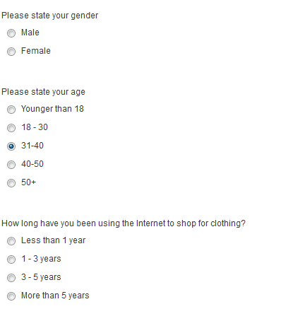

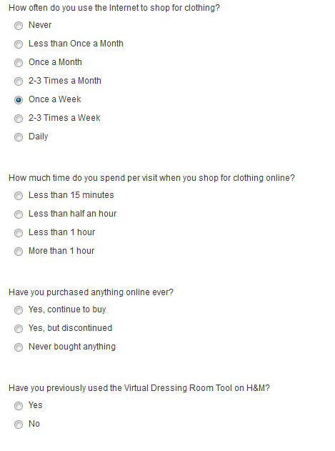
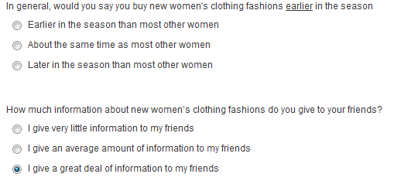

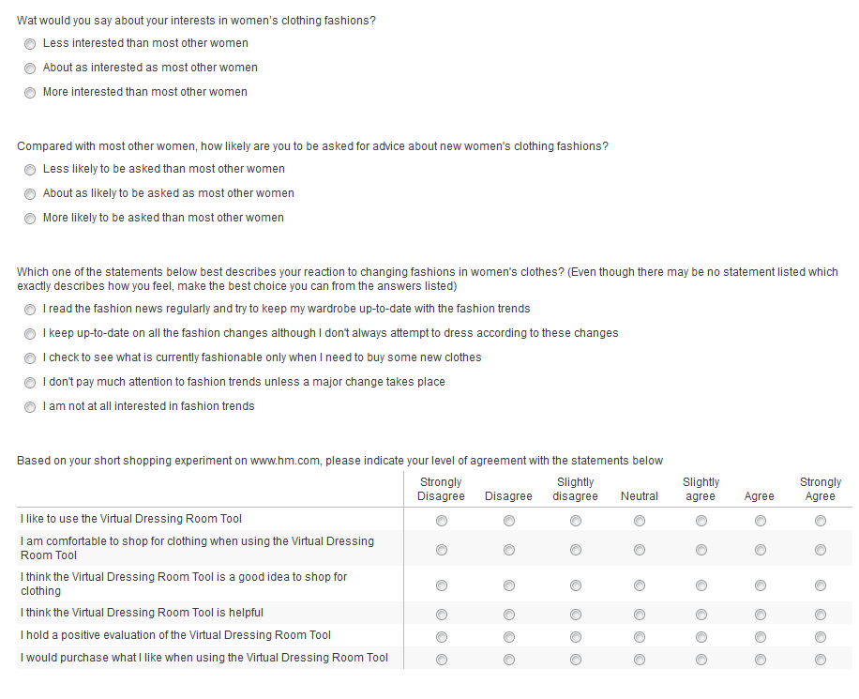
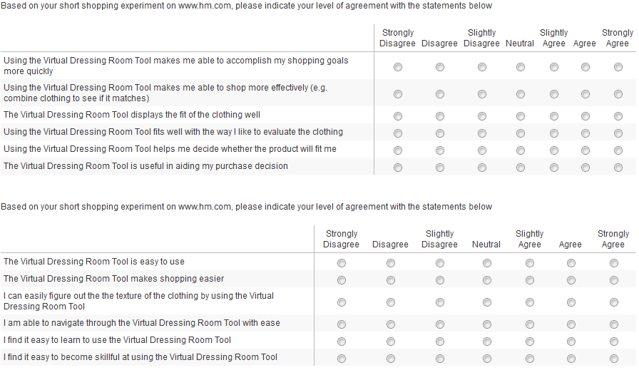

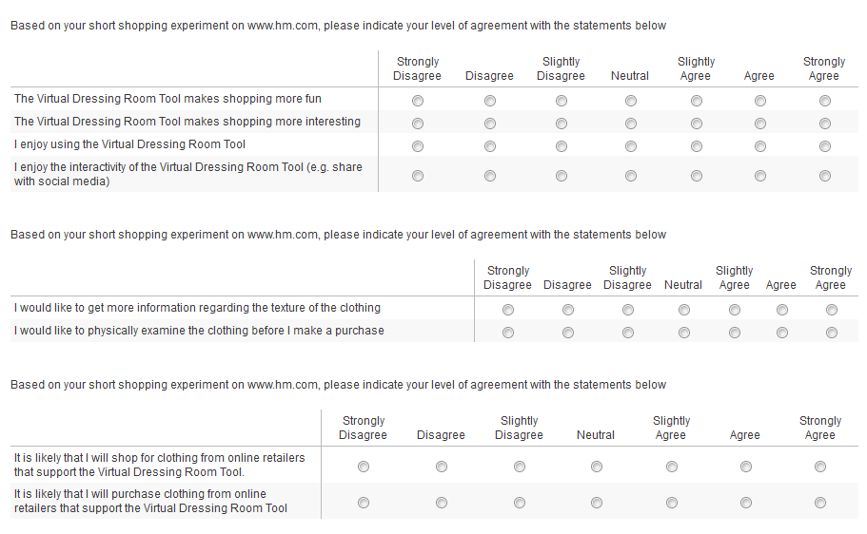

Committee on Communication for Behaviour Change in the 21st Century, 2002

