Does the logo make a difference?
The influence of Ik Kies Bewust logos on consumer purchase intention

Master Thesis
Marieke van der Wal
Student number 376947
Supervised by Dr. J.M. Liberali

MSc. Economics and Business
Specialization Marketing
Erasmus School of Economics
Erasmus University Rotterdam
September 2013

Abstract
Where obesity has become a major global problem, the Dutch Ik Kies Bewust foundation answered the call of the World Health Organization to stimulate consumers in making healthy choices by providing the Ik Kies Bewust logos. The ‘healthy’ green and ‘conscious’ blue logo should make it easier for consumers to recognize food that fits a healthy lifestyle. To make sure that the logos are contributing in the right way to a change in consumers’ choice for healthy products, the research question in this study is as following:
“Do Ik Kies Bewust logos have a positive influence on consumer purchase intention?
In order to answer this research question, and make a proper distinction between green, blue and no-logo situations, this study has an experimental design. 177 Respondents filled in a questionnaire, which resulted in the variables purchase intention, knowledge about the logos, nutritional context, impulse buying tendency and normative evaluation.
After analyzing via one-way ANOVA and linear regression, the following conclusions are:
- Ik Kies Bewust logos do not have a direct positive effect on purchase intention;
- The majority of the respondents knows the logos, but it does not strengthen the relation between logos and purchase intention;
- A healthy nutritional context has a positive moderating effect for green logos;
- The moderation of impulse buying tendency on the relationship of Ik Kies Bewust logos and purchase intention does not have any influence;
- Green Ik Kies Bewust logos do have a positive influence on normative evaluation.
This study provides the Ik Kies Bewust foundation with clear insights about the functioning of the Ik Kies Bewust logos and extents the past literature with new conclusions.

Foreword
Now I am almost ready with my Master Marketing, it is time to think about my plans for the future. Finding a job, getting promoted, taking the maximum out of life both for my career and personal life. When studying, I tried to give it a full 100 percent. This Master Thesis is my last educational achievement (for now), where I tried to bundle all my experience and knowledge from the past years. This project challenged me to address myself to be self-disciplined and motivated and it made me raise the bar even higher. What lies in front of you, is the result of hard work, overcoming obstacles and late hours. I am proud to show it to you, and hope that you enjoy reading it as much as I enjoyed writing it.
I would like to express my gratitude to mrs. Jordana Liberali for her insights in the past six months. With her clear feedback she directed me to what my thesis is today and, with her positive energy, she always made me find renewed motivation.
Second, I would like to thank and wish all the best to my fellow students who helped me out or shared the burden of writing a thesis at many moments. Special thanks to Denise Heijstek, who happened to be great company during the night, my roommate Lisa Boddé, who always made me laugh during hard moments, Daphne Noijons, who always believes in me and special thanks to my family that cannot be more supportive.
22nd August 2013, Rotterdam
Marieke van der Wal

Table of contents
Figures 9
Tables 9
1. Introduction 10
1.1 Background 10
1.2 Ik Kies Bewust 11
1.3 Problem statement and research question 12
1.4 Academic relevance 12
1.5 Managerial relevance 13
1.6 Thesis structure 13
2. Theoretical framework 11
2.1 Nutrition labels, health- and nutritional claims 11
2.1.1 Endorsement 11
2.1.2 Knowledge, search and evaluation of labels 14
2.1.3 Nutritional context and nature of the product 15
2.2 Impulse buying tendency and normative evaluation 16
2.2.1 Impulse buying tendency 16
2.2.2 Normative evaluation 18
2.3 Hypotheses 18
3. Methodology 23
3.1 Research design 23
3.2 Population and sample size 24
3.3 Structure of questionnaire 24
3.3.1 Purchase intention 25
3.3.2 Demographics 26
3.3.3 Normative evaluation 26
3.3.4 Impulse buying tendency 26
3.3.5 Knowledge 27
3.4 Pre-testing 27
3.5 Translation 27
3.6 Analysis 28
3.7 Validity and reliability 28
4. Data 29
4.1 Sample 29
4.2 Normal distribution 30
4.3 Validity and reliability of Impulse Buying Tendency scale 30
4.3.1 Factor analysis 31
4.3.2 Reliability test 32
5. Results 33
5.1 Descriptive analysis 33
5.2 Type of logo versus purchase intention 34
5.3 Moderation of knowledge 35
5.4 Moderation of context 37
5.4.1 Linear regression 37
5.4.2 ANOVA 38
5.5 Impulse buying tendency versus purchase intention 39
5.5.1 Pearson’s correlation 39
5.5.2 Linear regression 40
5.6 Moderator Impulse Buying Tendency 41
5.7 Ik Kies Bewust logos versus normative evaluation 41
5.8 Normative evaluation versus purchase intention 43
5.9 Mediator normative evaluation 44
6. Discussion 46
6.1 Ik Kies Bewust logos versus purchase intention 46
6.2 Moderation of knowledge 46
6.3 Moderation of context 47
6.4 Impulse buying tendency versus purchase intention 47
6.5 Moderator impulse buying tendency 47
6.6 Ik Kies Bewust logos versus normative evaluation 47
6.7 Normative evaluation versus purchase intention 48
6.8 Mediator normative evaluation 48
7. Conclusions 49
7.1 Academic implications 49
7.2 Managerial implications 49
7.3 Limitations and further research recommendations 50
7.4 Conclusions 51
References 52
Appendix I - Questionnaire English 56
Appendix II - Questionnaire Dutch 61
Appendix III – Data 66
Normal distributions 66
Factor analysis 67
Reliability test 67
Appendix IV – Analysis output 68
Hypothesis 1 68
Hypothesis 2 70
Hypothesis 3 72
Linear regression 72
ANOVA 72
Hypothesis 4 73
Hypothesis 5 74
Hypothesis 6 75
Hypothesis 7 75
Hypothesis 8 76

Figures
Figure 1. Ik Kies Bewust logos 12
Figure 2. Conceptual framework 1/7 19
Figure 3. Conceptual framework 2/7 19
Figure 4. Conceptual framework 3/7 20
Figure 5. Conceptual framework 4/7 20
Figure 6. Conceptual framework 5/7 21
Figure 7. Conceptual framework 6/7 21
Figure 8. Conceptual framework 7/7 22
Figure 9. Sample profile 29
Figure 10. Kruskal-Wallis test 42

Tables
Table 1. Experiment matrix 23
Table 2. Questionnaire structure 25
Table 3. Analysis overview 28
Table 4. Factor analysis 31
Table 5. Reliability test 32
Table 6. ANOVA and t-test for age and gender 33
Table 7. ANOVA type logo versus purchase intention 34
Table 8. Tukey’s test type logo versus purchase intention 35
Table 9. Coefficients moderation of context on relation logos and intention 38
Table 10. Pearson’s correlation IBT versus purchase intention 39
Table 11. ANOVA linear regression IBT versus purchase intention 40
Table 12. Correlations Spearman’s Rho normative evaluation versus intention 43
Table 13. Coefficients regression mediator normative evaluation 44

Introduction
This introduction chapter will present the background of this study in paragraph 1.1. After that, the Ik Kies Bewust foundation and their initiative is described in paragraph 1.2, followed by the problem statement and research question of this study in paragraph 1.3. At last, academic and managerial relevance and the structure of this thesis is presented in respectively paragraph 1.4, 1.5 and 1.6.

Background
The world population tends to grow with 1.2 per cent annually and makes the world face the biggest population growth in years (United Nations, 2005). The Population Challenges and Development Goals report shows that the last addition of the sixth billion of people in the world took place in only twelve years. Where in 2005 the world population ‘only’ consisted of 6.5 billion people, it is now expected to reach 9 billion at the year of 2050. Over the past years, not only the size but also the nature of our society has changed. We have become ‘consuming people’ in a consumer society (Dagevos & De Bakker, 2008). As consumers, our way and the extent in which we buy has changed and increased. While the world population keeps getting bigger, food supply systems and world populations’ health has entered the danger zone, making global health one of the issues that concerns many organizations worldwide.
The contrast in the world between rich and poor, developed and undeveloped countries and highly-consuming and low-consuming people is big. According to the World Health Organization (2012): “at the same time that there are 170 million children in poor countries who are underweight, and over three million of them die each year as a result, there are more than one billion adults worldwide who are overweight and at least 300 million who are clinically obese”. It is even predicted that this number of consumers with obesity will be increased by 1.5 times in 2015 (James, 2008).
What might be interesting is the fact that obesity nowadays is more centred in low- and middle- income countries. Also cardiovascular diseases and other diseases linked to overweight people occur more extensively in these countries, especially in South Asia (Vaidya, Shakya, & Krettek, 2010).
But between countries there are great differences in obesity rates. The United States faces the highest rates with 33 percent of its population with a Body Mass Index (BMI) above 30, where a country as Austria only has 12 per cent of its population in this condition (Bhattacharya & Sood, 2011). But Bhattacharya and Sood (2011) take the discussion of obesity a step further. They state that in the perspective of personal health the alarm bells should be ringing loudly at this moment, while obesity is linked to many diseases like diabetes and heart diseases. But although this is also mentioned in many other articles, they also point out the economic and public policy effects. It is studied that people who are obese have higher health costs, which pressures the rest of the population. They conclude that obesity is a complex social problem instead of only a physical problem and that it is interlinked with many other issues like healthcare R&D, prices for food and exercise and for example peer effects.
In contrary, Bhattacharya and Sood (2011) also state that obesity can also have “positive” effects on society. People with obesity will probably die in an earlier stage of life than “thin” people, thereby claiming less in Social Security benefits.
Although this last part also shows a rather obscure positive side of obese, all prior studies agree that overconsumption and obese have a very negative effect on society and wellbeing. Therefore, different organizations in the world came up with solutions in order to prevent the worldwide population of consuming excessive fat, salt and sugar. This started for example in the United States with the Nutritional Labeling and Education Act (1990). This act of the Food and Drug Administration required nutritional labelling and specification of the approved use of the nutrient content and health claims on all packages (Andrews, Netemeyer, & Burton, 1998).
On a more global scale the World Health Organization (WHO) tried to influence not only consumers but also the food industry in the fight against obesity. In 2003, the World Health Organization and Food Agriculture Organization (FAO) approached the food industry for making it easier for consumers to make a healthier food choice.

Ik Kies Bewust
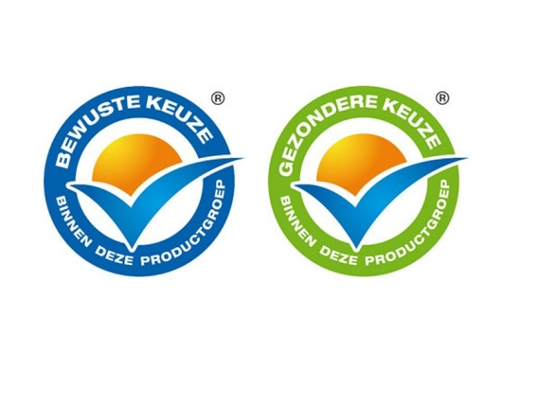
As an answer to the call of the World Health Organization, Dutch companies Campina, Friesland Foods and Unilever joined forces in 2006 (Ik Kies Bewust Foundation, 2013). In cooperation with Dutch supermarket chains and the Association of Dutch Catering Organizations they decided to set up a foundation that provides Dutch consumers and companies with a quality mark: the Ik Kies Bewust logo (ENG: I chose consciously). It is an open initiative for the food industry, retail and food service industry that stimulates a healthy food choice by providing a simple logo that is easy to recognize. By setting up special criteria, the goal is to encourage food producers to use less fat, less added sugar and less salt in their products. When the product is then identified as a healthier product, the producer is allowed to place the logo on the packaging. Making it easier for the consumer to recognize food that provides a healthier choice. By also starting a cooperation in 2011 with supermarket chain Albert Heijn, which already had a quality mark to indicate healthy choices, the Ik Kies Bewust Foundation made a distinction between a healthy choice and a conscious choice.

Figure 1. Ik Kies Bewust logos
The blue logo, presenting the conscious choice, is meant for products that are in nature not truly healthy, but provide a ‘healthier’ choice. In an example this could be diet coke, as it contains less added sugar than regular coke. The green logo presents the healthy choice, meaning that the product contributes to a healthy lifestyle and health condition.

Problem statement and research question
The initiative of the Ik Kies Bewust Foundation tends to bring Dutch consumers one step closer to a healthy lifestyle. But whether these logos are in any regard changing attitudes, intentions or behaviour of consumers has not yet been studied. To make sure that these logos are contributing in the right way to a change in consumer’s choice for healthy products, the research question derived from this is as following:
“Do Ik Kies Bewust logos have a positive influence on consumer purchase intention?”

Academic relevance
Various researches have been done in the area of product labelling and its effect on different consumer factors (Balasubramanian & Cole, 2002; Bhaskaran & Hardley, 2002; Roe, Levy, & Derby, 1999). Where most studies focus on the different factors influencing the consumer decision making process and consumer purchase process in the context of product labelling, this study provides a practical example of the relation between health logo and purchase intention. Impulse buying tendency has not yet been studied in the context of product labelling and/or health claims, this study also investigates whether impulse buying tendency makes a difference in this context.

Managerial relevance
This research provides useful information for the Ik Kies Bewust Foundation, the food industry and other organizations that may use Ik Kies Bewust logos in the future. It describes the effect of the Ik Kies Bewust logos on consumer’ purchase intentions and how this interacts with other factors that are common in the consumer choice process. By putting the Ik Kies Bewust logos in a broader context and measuring its effects, companies and the Ik Kies Bewust Foundation are better able to understand the effectiveness of the logos and are more able to adapt the logos to make them more useful.

Thesis structure
This thesis is build up in different chapters, all referring to a different part of the study process. First of all, the theoretical framework in chapter 2 contains a literature review of all prior research that is done in the context of endorsement, health claims, impulse buying tendency and normative evaluation. This forms the base for this study, wherefore the hypotheses are described in a later stadium of chapter 2. Continuously, chapter 3 will provide the entire methodology that is used in this research. This will contain a description of the research design, sample size and how the analysis of different hypotheses looks like. Chapter 4 will present an overview of the data, focussing on demographics, normal distributions etc. Chapter 5 describes, in order of the hypothesis, the results of the analysis. The results will then be discussed in chapter 6, interpreting the numbers and meaning of these numbers. The last chapter presents the final conclusion of this study and describes limitations and managerial implications.

Theoretical framework
As already presented in the introduction of this thesis, global actions have been taken to make consumers more aware of healthy diets and nutrition. The NLEA (Nutrition Labeling and Education Act, 1990) was the start of a new manner in which consumers were made more aware of and educated in nutritional information. Nowadays, the nutritional labels, health claims and nutritional claims are on almost 100% of products available on the worldwide market. The Ik Kies Bewust logos are the Dutch variant of these health claims. This research investigates the influence of the Ik Kies Bewust logos on purchase intention. Other factors that might play an influencing role in this relationship, like the search and evaluation process of consumers, nutritional context of the product, impulse buying tendency and normative evaluation, are presented as well in the theoretical framework and taken into account in the analysis.

Nutrition labels, health- and nutritional claims
Many consumer research studies from the past years point out that there is an enlarging group of consumers that form a preference for certified and labelled products in general, and who are willing to pay more for these products (Teisl, Peavey, Newman, Buono, & Hermann, 2002). With many market-based research studies, the food market is quite advanced in measuring the effectiveness of claims and labels.
To process the information brought by previous research, it is best to first explain what the difference between health claims and nutrition information is. Following the NLEA (1990), nutrition information is seen as the Nutrition Facts Panel on (most of the time) the back of the product. “It contains a broad explanation of the major nutrients and it provides nutrient reference expressed as “% of Daily Values”, according to Kozup, Creyer and Burton (2003). Nutritional claims are specific claims based on a products’ nutrient content like “low in fat”. Health claims identify the link between the specific nutrient the product holds and a disease or health condition. The Ik Kies Bewust logos are an example of the last claim.

Endorsement
Purchase intention is one variable that has been used in many studies to identify whether consumers are affected by something. In theory, intention is defined as “a person’s commitment, plan or decision to carry out an action or achieve a goal” (Eagly & Chaiken, 1993). In context of labelling and claims, also purchase intention has been measured in many studies.
By adding the Ik kies Bewust logos to the packaging of the product, a “meaning transfer” takes place, making the logo a form of endorsement. The properties and values of the endorser, in this case the Ik Kies Bewust Foundation, move from the endorser to the consumer good and from the consumer good to the consumer (McCracken, 1989). The transfer from endorser to consumer good is facilitated by the logo and advertisement, where the endorser identifies the meanings intended for the product and brings this in a concrete form. The transfer form consumer good to the consumer itself is situated in the search of the consumer to products that not only satisfy their needs, but also the search to the meaning they would like to identify with (Belk, 1988).
The ability of endorsements to affect consumer intention has been suggested in both academic literature and the popular trade/press (Dean, 1999). Most studies lay focus on the endorsement of celebrities, where these endorsements are more identifiable for the public. But of course there are more forms of endorsement. Dean (1999) refers to an example from a study of Peterson, Wilson and Brown (1992), where sales of Buick LeSabre grew with 62% after the company used the “most trouble-free American car” title from the J.D. Power Company in its advertisement. This form of endorsement is called a third-party endorsement. The intent of this type of endorsement is to mark the quality and uniqueness of the product and to enhance the credibility of the product with the information of the independent third party (Dean & Biswas, 2001).
Another form of endorsement, named association endorsement, is also proven to have a positive influence on purchase intention (Daneshvary & Schwer, 2000). In an example Danseshvary and Schwer (2000) refer to a study by Longman (1997) about the American Dental Association endorsement for Procter & Gambles’ Crest toothpaste. Within two years, this they made it into the bestselling toothpaste. But also in their own article they have identified the positive influence of endorsement on purchase intention, where 59% of their respondents had higher purchase intention when the product was endorsed by the Professional Rodeo Cowboys Association (PRCA).
In this study, not only the relation between endorsement and purchase intention in the context of Ik Kies Bewust logos is based on the endorsement literature, but it is also based on the findings of studies within the nutrition information environment. Roe, Levy and Derby (1999) started with researching the impact of the presence of health claims. They found that consumers would have more favourable ratings of the healthiness of a product and higher purchase intentions after they were exposed to a general statement claiming that the product was “healthy”. Kozup, Creyer and Burton (2003) confirm this in their research when talking about the influence of health claims and nutrition information on packaged food, and extent this by finding the same effect for restaurant menu items. Especially favourable nutrition information, like positive claims and focus on health, had a positive impact.
Bhaskaran and Hardley (2002) found in their qualitative research that the effect of health claims on purchase intention is also depending on the age of the consumer. For younger consumers the health claims had less effect, where they are more searching for factors as taste, quality and price. Only about 20% of the younger participants stated that health attributes influenced their purchase decision. This resulted mostly in searching for products with health or nutritional claims. Older consumers (in this research older than 55) were more aware of healthy food and above all of claims and nutritional information.
A final (and often recurring in studies) influence on purchase intention in context of endorsement is source credibility. This defines the way in which the consumer evaluates the endorser of being right in the context. In other words: does the endorser fit with the product and values/meaning of the product. The variable “source credibility” has been discussed in many researches over the past years; McCracken (1989) states, based on prior research, that the effectiveness of an endorsement message depends on the expertness and trustworthiness of the endorser. This is also in line with the research by Ohanian (1991). A couple years later, also Dean (1999) states that source credibility consists of three types of attribution biases: expertise, trustworthiness and perceived social value. For third-party endorsements like the “Best Buy” of Consumer Reports, the endorser is likely to rank high on expertise (testing products in own environment) and trustworthy (for not being in the market itself, being non-profit and not advertising). In an example, Dean (1999) states that the Best Buy logo is seen has highly informative and as a mark for quality, making consumers searching process shorter. Firms are trying to differentiate nowadays with such logos because it appears to be that consumers look for signals that are unprofitable for low-quality sellers, but profitable for high-quality sellers.

Getting into the context of health claims, it is studied that consumers think that nutritional and health claims should be verified by independent sources to believe them (Bhaskaran & Hardley, 2002). Bhaskaran and Hardley (2002) also suggest that the relationship between government/health organisations and food manufacturers should encourage wider preventative health behaviour.

Knowledge, search and evaluation of labels
In order to understand how consumers react to health claims and nutritional information, it is first wise to understand how consumers examine and evaluate the health claim. Keller et al. (1997) came up with a framework that described how the process of food purchase is built up. They state that a health claim is only evaluated when the consumer is in a state of awareness, when the consumer understands the claim, when it draws inferences from it, when it considers it to be credible and then the customer translates it into action. Information can be processed via different ways. Either this can be in depth, which indicates a state of systematic processing, or more superficial, which indicates a state of heuristic processing. Consumers who process via the systematic way are using more information available, where consumers who process heuristic use quick available information using simple rules of thumb or cognitive heuristics (Leathwood, Richardson, Sträter, Todd, & van Trijp, 2007).
Based on research of Ford et al. (1996), consumers are first looking at the health claim presented on the front of the package. This is the moment where they create expectations about the product and its nutritional values. The Nutritional Fact Panel is more or less meant for the confirmation or rejection of their expectations.
Roe et al. (1999) builds up this idea and states: “the presence of a health claim, and to a lesser extent a nutrient-content claim, are associated significantly with a greater probability of a search limited to the front panel (hereafter, truncated search) relative to a search that involves looking at the Nutrition facts panel”. In other words, in presence of a health claim consumers are less likely to turn to the back side of the product to view the nutrition information. They stop their search after getting the information of the front panel.
Balasubramanian and Cole (2002) also state that, even when consumers have the ability to read both the health claim and the nutrition information to integrate the two, consumers may rely only on easily visible nutrition claims and ignore the backside of the product. Because of the NLEA regulations, consumers may trust the claims more than in the pre-NLEA time and therefore do not search as extensively as in the past.
And at last, also Kozup et al. (2003) claims that “with only ambiguous information (e.g., a product picture) available to address expectations formed by the exposure to the claim, the effect of the claim on product evaluations and disease risk perceptions should be favourable compared with no-claim condition”.
All above confirms that the health claims (or Ik Kies Bewust logos) are mainly processed via the heuristic way. Most of the time, when motivation, knowledge or time is lacking, this is the case (Leathwood et al., 2007).
Consumer’ knowledge about the meaning of the health claim/logo and the credibility of the endorser influences confidence, which in turn influences purchase intention (Lafferty & Goldsmith, 1999; Laroche, Kim, & Zhou, 1996). Also Teisl et al. (2002) state that information about the endorsing entity and the evaluation procedure would be essential in order to boost consumer confidence and that it would likely influence how heavily consumers weight the label information.

Nutritional context and nature of the product
Not every product has the same content. Products differ in shape, purpose, nutritional value and so on. Kozup et al. (2003) acknowledges that there are differences between products and the interaction with the health claim and nutritional information. In a situation where there is “favorable nutritional information” available, a healthy claim further helps to create positive attitude towards the product. But in a situation where “unfavorable nutritional information” is given, the claim has no influence on either the evaluations of the product or disease risk perceptions. This means that when the product is seen as “unhealthy”, a health claim has no or less effect on evaluation and intentions than when it is on a “healthy” product.
In the same article, Kozup et al. (2003) state that consumers are also influenced by the context in which nutritional information/claims are given. In their research they find that the nutritional context in which a food is evaluated moderates the main effects of nutrition information. In other words, when the alternatives in the same product group/consideration set are in a healthy context (i.e., the products have a healthy content), favourable claims and nutrition information have less effect for the ‘target product’. When the context is unhealthy (other products have an unhealthy content), unfavourable nutrition claims and information has less effect. But when the context is unhealthy, consumer’s evaluations of the target product will be more favourable compared with the healthy context.

Impulse buying tendency and normative evaluation

Impulse buying tendency
Impulse buying is a topic that is keeping researchers busy for quite a long time. Not only economists and philosophers are wondering about what impulse buying is and how it occurs, even theologians name the word impulse where it is a central theme in the legend of Adam and Eve. The discussion about what is the exact definition of impulse buying is going on for years, expanding, narrowing and rewriting it every new study. Where it first was mentioned as “unplanned” purchases, it changed quickly in many different definitions (Rook, 1987). Rook (1987) stated: “Impulse buying occurs when a consumer experiences a sudden, often powerful and persistent urge to buy something immediately. The impulse to buy is hedonically complex and may stimulate emotional conflict. Also, impulse buying is prone to occur with diminished regard for its consequences.” Impulse buying is more emotional than rational and is more likely to be perceived as bad than good, as Rook (1987) says. Hoch and Loewenstein (1991) add the note that impulse buying is a struggle between the psychological forces of desires and willpower.
With this mostly used definition, many new studies changed focus from the product to the consumer behavioural elements of impulse buying. Where first impulse buying was part of the distinguishing between planned and unplanned purchases, based on time-consuming information searches and the speed with making a decision (Piron, 1991; Stern, 1962), researchers now agree that impulse buying involves a hedonic or affective component (Hausman, 2000).
Although some methodological considerations made the research not completely able to generalize, Gardner and Rook (1993) found that consumers’ pre-shopping mood had a big influence on impulse buying. Besides the affective side of impulse buying, there is also a cognitive side (Burroughs, 1996). He states: “it is suggested that much impulsive buying behaviour can be characterized as a type of holistic information processing whereby a match is recognized between the symbolic meanings of a particular product and a consumer's self-concept”. Rook and Fisher (1995) point at the normative influences on impulse buying, which will be further explained in a later part of this theoretical background. Also in later researches it is tried to further explain what constructs impulse buying. Personality factors as lack of control, stress reaction and absorption are found related to impulse buying tendencies (Youn & Faber, 2000). At last, individual consumer differences have an effect on impulse buying and purchase intention, expressed in impulse buying tendency (Beatty & Ferrell, 1998).
The trait of impulse tendency is studied and described in many different scientific areas. Psychology and criminology are two out of many. In terms of marketing, impulsiveness has been linked to buying impulsiveness. Studies nowadays state that impulse buying tendency is a consumer personality trait, which indicates that it is possible to differentiate consumers based on this trait (Jones, Reynolds, Seungoog, & Beatty, 2003).
Rook and Fisher (1995), accompanied by psychologists’ enduring treatment of impulsiveness as a basic human trait, state that individuals’ buying tendencies can be seen as a consumer trait that is labelled ‘buying impulsiveness’. They define: “buying impulsiveness is a consumer’s tendency to buy spontaneously, unreflectively, immediately and kinetically”. Consumers who have high impulsive buying tendency are more likely to react stronger on buying stimuli. As stated in the article, their shopping lists are more “open” and receptive to sudden, unexpected buying ideas. They are less reflecting and are more led by emotional reactions towards the stimuli. This leads to more purchases that are based on immediate response, instead of thinking over the purchase once more. People with high impulsive buying tendency are likely to experience more often and more strong buying impulses than people with lower buying tendency. Beatty & Ferrell (1998) also examined the impulsive buying tendency trait and found that this also affects in-store browsing and the number of urges experienced to buy impulsively while browsing.
In order to measure consumers’ impulse buying tendency, many researches came up with a scale (Beatty & Ferrell, 1998; Puri, 1996; Rook & Fisher, 1995; Rook & Gardner, 1993). But in all these researches, the impulse buying tendency is seen as a generalized trait that is consistent across product categories. Consumers who have the trait of being highly impulsive buyers should also show a general tendency to make an impulsive purchase in all product categories. Jones et al. (2003) tried to put impulse buying in a more detailed way by also taking into account different product categories. By differentiating impulse buying tendency for clothing and for music, they discovered that general impulse buying tendency was a precursor for product-specific impulse buying tendency. By having involvement as a positive influence on product-specific impulse buying tendency, buying tendency in general was positively associated with product-specific impulse purchases for both music and clothing.

Normative evaluation
When we speak about impulse buying tendency, we also have to discuss the normative evaluation of impulse purchases. Impulse behaviour knows a long history where it has been evaluated very negatively. It is associated with being immature, foolish, “defect of the will”, lower intelligence and even criminality (Rook & Fisher, 1995). It used to be seen as a bad habit and linked to negative consequences in the areas of personal finance, negative purchase satisfaction, social reactions and self-esteem (Rook, 1987). But as research continues, it happened to be found that impulse buying is not in every situation seen as a negative issue. Rook and Fisher (1995) state: “when impulse buying is more virtuously motivated, it is likely to elicit more positive normative evaluations”. Examples are spontaneously buying a gift for a sick friend or taking advantage of a two-for-one action in the grocery store that is characterized as kind, generous and practical activities. So, it is clear that actually moving on to an impulse purchase depends on impulse buying tendency, but also on the normative evaluation of the purchase situation. When a consumer that has high general impulse buying tendency experiences a stimulus and on the other hand evaluates this stimulus as appropriate (making trait and normative influence harmonious), this consumer is more likely to take action. On the opposite, when a consumer with high impulse buying tendency evaluates a situation as negative, this normative evaluation might cause that the consumer will act less impulsive.

Hypotheses
All prior mentioned literature forms the base for this research in context of the Ik Kies Bewust logos. The Ik Kies Bewust logos transfer “healthy” values to the products that carry them, which makes this a form of endorsement. The articles of McCracken (1989), Dean (1999) and Daneshvary and Schwer (2000) identify that endorsement affects consumer purchase intention in a positive way. But also more specific, Roe et al. (1999) and Kozup et al. (2003) make clear that consumers who were exposed to a general statement claiming that the product was healthy had higher purchase intentions than before being exposed to the claims. Where the Ik Kies Bewust logos are just not only a simple third-party endorsement, but also a health claim that states that the product is a “healthy choice”, the following hypothesis is proposed:
H1: The Ik Kies Bewust logos have a positive influence on consumers’ purchase intention
But because of the difference between the green and blue logo, making a distinguishing between “healthy choice” and “conscious choice” we assume that consumers will react more strongly on the logo that gives them the most benefit, resulting in the following hypotheses:
H1a: Green Ik Kies Bewust logos have a strong positive influence on consumers’ purchase intention
H1b: Blue Ik Kies Bewust logo have a less strong positive influence on consumers’ purchase intention than the green Ik Kies Bewust logo
Figure 2. Conceptual framework 1/7
The literature states that there are many variables influencing the relationship between endorsement and purchase intention. One of these variables is the knowledge searching process and knowledge about the logo/endorsement itself. The consumer’ knowledge about the meaning of the health claim/logo and the endorser of it influences confidence, which in turn influences purchase intention (Laroche, Kim, & Zhou, 1996). It gives the consumer the feeling that the endorser is credible and increases the purchase intention (Lafferty & Goldsmith, 1999). This is also described by Teisl et al. (2002). It is clear that a high level of knowledge has a positive influence, but whether consumers possess knowledge about the Ik Kies Bewust logos and whether this also has a moderating effect on the relationship between the logos and purchase intention is not studied. Therefore the following hypothesis is proposed:
H2: A high level of knowledge about the Ik Kies Bewust logos has a positive moderating effect on the relation between Ik Kies Bewust logos and purchase intention

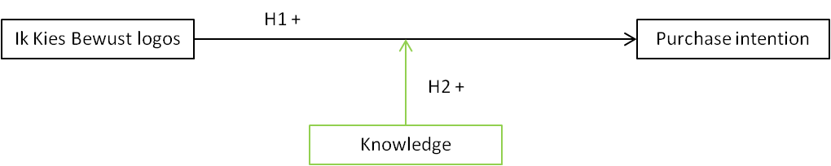
Figure 3. Conceptual framework 2/7

Also the nutritional context is been proven to be a variable. Kozup et al. (2003) acknowledges that there are there is a different interaction between product and health claim/nutritional information for different products. When the product is seen as “healthy”, while there is favourable nutritional information presented on the product, a health claim strengthens positive attitudes and purchase intention. When a product is seen as “unhealthier”, while there is less favourable nutritional information presented on the product, a health claim has less or no effect on positive attitudes and purchase intention. This brings us to the following hypotheses:
H3a: A healthy nutritional context has a positive influence on the relation between Ik Kies Bewust logos and purchase intention
H3b: An unhealthy nutritional context has a less than the green label or no influence on the relation between Ik Kies Bewust logos and purchase intention
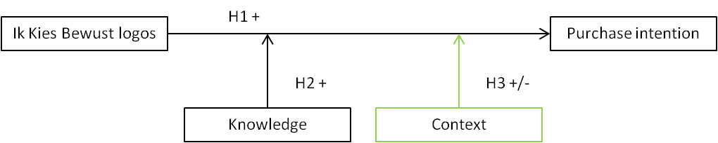
Figure 4. Conceptual framework 3/7
Theory states that the trait of impulse buying tendency is different for every consumer (Youn & Faber, 2000). Rook and Gardner (1993) state that consumers with high impulse buying tendency are more likely to have high purchase intention. Impulse buying tendency is seen as a generalized trait that has a consistent effect across product categories (Rook & Fisher, 1995). In order to check that this is also the case in the context of Ik Kies Bewust logos and in order to form a base for other hypotheses, the next hypothesis will be tested.
H4: Impulse buying tendency has a positive influence on purchase intention
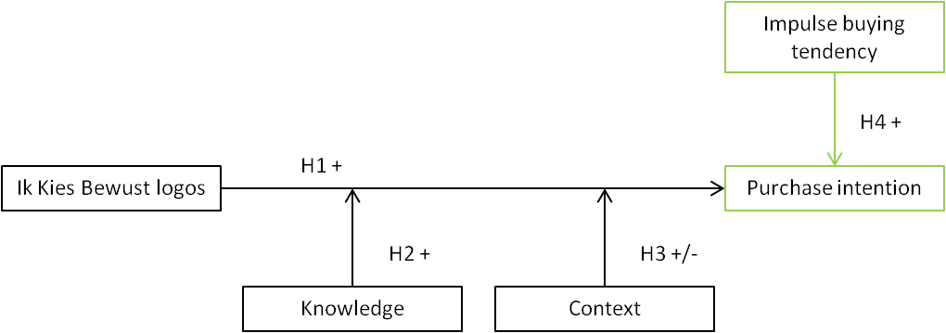
Figure 5. Conceptual framework 4/7
Prior research suggests that impulse buying tendency and health claims have a positive influence on purchase intention. In this research it would be interesting to see whether there is an interaction between impulse buying tendency and the influence of Ik Kies Bewust logos on purchase intention.
H5: Impulse buying tendency has a positive moderating effect on the relationship between Ik Kies Bewust logos and purchase intention
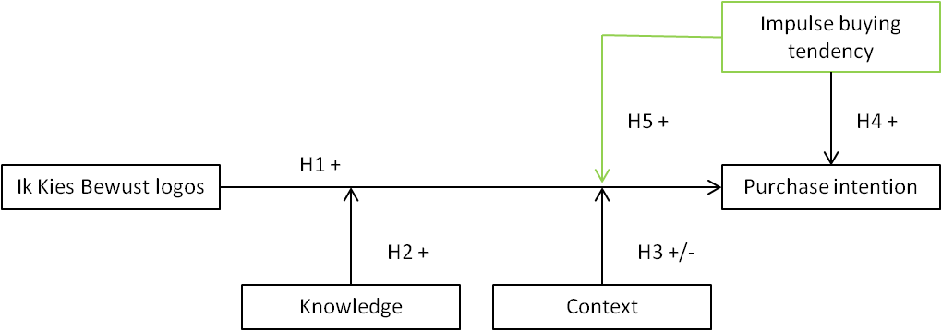
Figure 6. Conceptual framework 5/7
Normative evaluation is presented as an important factor in the relation of impulse buying tendency and purchase intention (Rook & Fisher, 1995). Normally, buying something in an impulse is seen as a bad habit, which is linked to negative consequences (Rook, 1987). But this does not count when the buying context is virtuous of nature, according to Rook and Fisher (1995). Buying something because it has a positive influence on your health is more of a practical matter, where the consumer takes own health into consideration. Therefore the following hypothesis will be tested.
H6: Ik Kies Bewust logos have a positive influence on normative evaluation
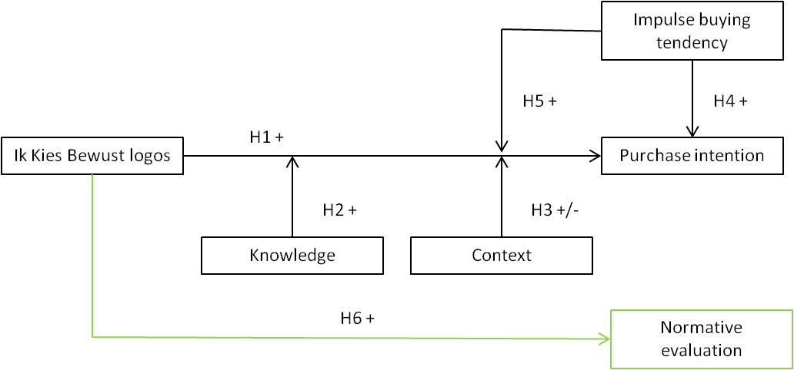
Figure 7. Conceptual framework 6/7

Rook and Fisher (1995) state: “when impulse buying is more virtuously motivated, it is likely to elicit more positive normal evaluations”. As tested in hypotheses 6, this study expects that Ik Kies Bewust logos have a positive influence on normative evaluation. Rook and Fisher (1995) confirm that when a stimulus like health claims is evaluated as appropriate, the consumer is likely to take action. In this study it is then expected that normative evaluation will be positively correlated with purchase intention. With the objective of getting a complete interaction model, not only the direct effects and correlations of Ik Kies Bewust logos and normative evaluation on purchase intention will be measured. Also it will be tested whether the interaction between Ik Kies Bewust logos and normative evaluation as a mediator has a positive effect on purchase intention.
H7: Normative evaluation is correlated with purchase intention
H8: Normative evaluation has a positive mediating effect on the relationship between Ik Kies Bewust logos and purchase intention
The final conceptual framework of this study is shown below.

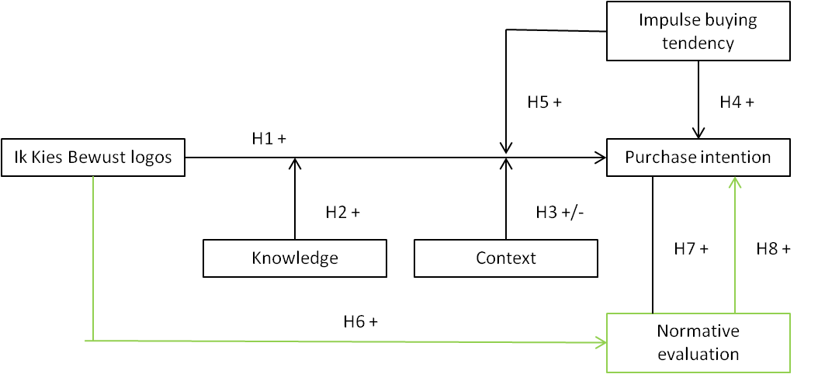
Figure 8. Conceptual framework 7/7

Methodology
This chapter will present the research method and design. The first section will start with explaining what kind of research design this study has followed, which will be followed by a paragraph describing the sample for this study. The structure of the experiment and questionnaire is presented in 3.3. After that, section 3.4 will give insight in the pre-testing fase and translation procedure.

Research design
To measure the effect of the Ik Kies Bewust logos on purchase intention, this research has to consider two different labels, the ‘healthy green’ and the ‘conscious blue’ one. By making a difference between these two types of Ik Kies Bewust logos, not only the main effect of logo on purchase intention is measured, but also the possible difference between green and blue can be studied. Therefore, an experiment is the best design for this study. As Kozup et al. (2003) mentioned, consumers may also react differently to logos when they are either in a “positive” or “negative” nutritional context. In order to make it possible to measure whether this is true in the context of Ik Kies Bewust logos, the design of this research is:
 | Green label | Blue label | No label
Healthy context | Scenario 1 | Scenario 2 | Scenario 3
Unhealthy context | Scenario 4 | Scenario 5 | Scenario 6
Table 1. Experiment matrix
With a quantitative marketing research approach, the experiment is part of a survey. Respondents are divided into six different groups, according to the matrix, and every group is confronted with one of the scenarios of the matrix. The questions are prearranged and the same for every questionnaire in the study. Fixed response questions ensure that there is less variability in the data, which makes it easier to analyse.
Before distributing the questionnaire, a pre-test has been conducted to make sure that misinterpretation of questions and prearranged answers was not possible. After that, the questionnaire was made and distributed via online tool Qualtrics and questionnaires were collected offline in Barendrecht during the break of a dance show. Having the survey partly online, the survey is easy to distribute via e-mail and social media, it keeps down the costs, prevents this study from interviewer bias and results in high speed, high quality results.

Population and sample size
The Ik Kies Bewust logos are a Dutch phenomenon. Therefore it makes sense to start with providing the population of this research with a frame by having the criteria of ‘living in the Netherlands’. This makes sure that the population has the ability to come in contact with Ik Kies Bewust logos. According to CBS, the Dutch Bureau of Statistics, the Dutch population nowadays exists of 16,778,025 people, and 7,513,000 households (Centraal Bureau voor de Statistiek, 2013). Divided by gender, there are approximately 8,306,326 men and 8,471,699 women.
But of course there are other factors that have to be taken into account in this research. The entire Dutch population is quite broad and consists also of children that will never do groceries. This part of the population might not have the ability to come in contact with the logos, therefore the next criteria for the population is ‘age above 18’. It is assumed that Dutch people with an age of 18 or higher do groceries for themselves and/or their households and that they have the ability to come in contact with the Ik Kies Bewust logos. The Dutch population above 18 years consists of 12,907,602 people.
Because of the experimental design, software of G*power is used to determine the sample size (Faul, Erdfelder, Buchner, & Lang, 2009). The research question indicates a main effect between Ik Kies Bewust logos and purchase intention, which is analysed with a one-way ANOVA. Effect size in this calculation is based on Cohen’s (1988) convention for correlations and is set at 0.3 (between medium of 0.25 and large of 0.4 effect size, because a medium to large effect is expected. ‘α Err prob’ and ‘Power’ are set at respectively 0.05 and 0.95. This calculation suggests a total sample size of 177 respondents, meaning that there were at least 30 respondents per cell needed.

Structure of questionnaire
The conceptual framework as shown in chapter 2 and the experiment design are forming the base for the questionnaire (Appendix I & II). Some questions are based on prior literature, this helps to improve the validation of this study. The questionnaire is divided into five different parts that each represents a variable of the conceptual framework.
The questionnaire starts with an introduction. Here respondents are thanked for their participation in the first place and are given an estimation of the time needed to fill in the survey. The purpose of the study is given as ‘a study to consumer purchase intention’. Respondents are not given any clue about the meaning of Ik Kies Bewust logos in order to make sure that the experiment is not biased. The introduction also tells respondents that the answers of the survey will be processed completely confidential.
At the end of the questionnaire respondents are thanked for participating and an e-mail address is presented to give respondents the ability to ask questions or ask for results of the study.
 | Variable | Question | Method | Measurement level
1 | Purchase intention | On a scale of 1 to 5, how big is the chance that you would buy this product, if set for the choice right now? | 5-point Likert scale | Ordinal
2 | Demographics | How old are you? | Validated regular questions | Scale
 |  | What is your gender? |  | Nominal
 |  | What is your current town of living? |  | Nominal
3 | Normative evaluation | What would Marie chose? | Semantic differential scale | Nominal
 |  | Make a choice between every contradiction |  | Nominal
4 | Impulse buying tendency | Indicate on a scale of 1 to 5 how much you are able to identify yourself with the following statements | 5-point Likert scale | Ordinal
5 | Knowledge | How familiar are you with the Ik Kies Bewust logos? | Validated regular question | Ordinal
Table 2. Questionnaire structure

Purchase intention
After the introduction, the questionnaire continues with a stimulus. Respondents are confronted with a picture of one of the six matrix-options: Optimel diet curd with green label, blue label or no label and Diamant frying oil with green label, blue label or no label. These products are chosen according to the pre-test, which will be explained later on in this paragraph. Only the front of the package is shown, which is for both Optimel and Diamant the same in every questionnaire besides the difference of the logo. The following question lets the respondent indicate on a 5-point Likert scale how big the chance is that they would buy it, if set for the choice right now. Objective of this question is to indicate the purchase intention of the respondent in relation with the logo. The variable purchase intention is ordinal.
After the first question, a second question identifies on what arguments the respondent based his/her answer. This allows the researcher to indicate whether the respondent conscientiously based his choice on the logo or on other product features. This variable is nominal.

Demographics
The objective of the demographic questions is to make sure that the respondents fit the sample and its criteria and to be able to analyse the data in more detail. When making differences between gender, age and region, it is possible to categorise the respondents. These questions are validated by pre-testing. ‘Age’ will be treated as a scale variable, the other two as nominal variables.

Normative evaluation
Normative evaluation is measured by using two questions formulated by Rook and Fisher (1995). The first question presents a dilemma between buying dinner only with the given amount of money Marie has or also buying an additional product, which she actually cannot afford. Respondents are asked what they think Marie will do, measuring their impulse buying behaviour. After that, 10 contradictions measure whether the respondents’ normative evaluation is positive or negative in the case of Marie buying both dinner and the product on credit. These contradictions are eventually transformed into one variable, giving the mean of positive evaluation.
The questions concerning normative evaluation result in two variables, impulse buying behaviour and normative evaluation, respectively ordinal and scale variables.

Impulse buying tendency
Impulse buying tendency was measured with nine statements and a 5-point Likert scale based on the research of Rook and Fisher (1995). Eight of these statements reflect a positive impulse buying tendency like “I often buy things spontaneously”, one statement confirms the opposite of impulse buying tendency with “I always plan my purchases”. After the nine items are answered, a profile of the impulse buying tendency is presented. This profile, which is the mean of all nine statements, is a scale variable.

Knowledge
In order to test to what extent the respondents knows the Ik Kies Bewust logos, a question about familiarity with the logos is included. On a 5-point scale respondents are asked if the logos are completely unknown to “I know where the logos stand for and use them while doing groceries”. This variable is ordinal.

Pre-testing
In order to make sure that there is no chance of misinterpretation of the questionnaire or lack of identification with the products used in the experiment, the questionnaire was pre-tested. In addition to the questionnaire building, to make sure a true healthy and unhealthy product is given in the questionnaire, five people that fit the sample are handed over a list with a mix of twenty products on it. This test-group is asked to make a distinguishing between the healthy and unhealthy products. The lists of all five pre-testers are checked on similarities and two products were chosen to present the healthy and unhealthy context. The other way around, a second test-group was shown the two chosen products and was asked if this would be a healthy or unhealthy product in their opinion. Both products were identified in the same presumed context. This way, the choice for the products is validated.
After the products were validated, the entire questionnaire was handed over to 30 other test-respondents that fit the sample. These respondents were asked to fill in the questionnaire first. Afterwards, the questionnaire was discussed for questions that were not clear and other comments or recommendations. Based on this pre-testing phase, the questionnaire got its final form.

Translation
Because of the fact that the questionnaire is originally written in English, but the sample is taken from a Dutch population, it is translated into Dutch. This is done on the base of Su and Parham (2002). The English questionnaire is translated by five people into Dutch. These five different translations were discussed and brought down to one overall questionnaire. In addition, three people who have extensive knowledge about the English language because of work or background retranslated the Dutch version into English, making sure that the questionnaire is interpreted the same in both the English and Dutch version.

Analysis
The questions from the questionnaire, as described in paragraph 3.3, result in a set of variables, which are the base of the analysis. The table below describes which tests were performed, taken into account the different measuring levels of the dependent, independent and moderator/mediator variables.
Hypothesis | Dependent variable | Independent variable | Moderator/mediator | Test
1 | Purchase intention | Type of logo | - | ANOVA
2 | Purchase intention | Type of logo | Knowledge | Linear regression
3 | Purchase intention | Type of logo | Context | Linear regression
4 | Purchase intention | Impulse buying tendency |  | Linear regression
5 | Normative evaluation | Type of logo |  | Kruskal-Wallis
6 | Purchase intention | Normative evaluation |  | Kendall’s Tau
7 | Purchase intention | Type of logo | Impulse buying tendency | Linear regression
8 | Purchase intention | Type of logo | Normative evaluation | ANOVA
Table 3. Analysis overview

Validity and reliability
Validity indicates whether this study measures what it should measure. It can be subdivided into two different kinds of validity: internal and external validity. The internal validity, which in this case will be construct validity, is met because of the use of factor analysis and prior validated measurements. By meeting the criteria of a sample size bigger than 177 respondents, the sample is big enough to have the power to identify an effect (if present), making the study even more valid. Respondents were able to fill in the questionnaire on their own, filtering out any interviewer or experimenter bias.
Reliability indicates whether this study provides significant results that are more than just a one-off finding and that this study will be repeatable, delivering the same results. Where the different scales are all tested with Cronbachs Alpha, the reliability will be guaranteed.

Data
This fourth chapter gives an overview of the sample profile, normal distribution of the data and findings from the factor analysis and reliability tests that were conducted. This in order to make sure that further analysis will be based on correct data. The analysis is performed in IBM SPSS Statistics, version 20.0.

Sample
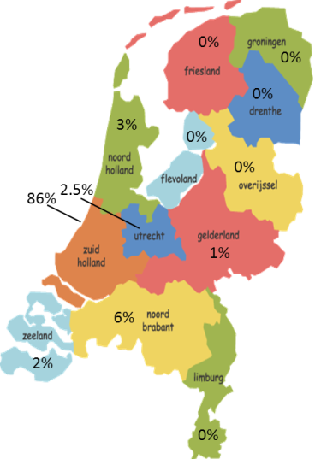
As described in chapter 3, methodology, the sample in this study is based on the 2x3 matrix of the experiment. Each cell of the matrix consisted at least 30 respondents. These respondents had to meet the criteria of living in the Netherlands and being above the age of 18. After analysing the profile of the sample, it is found that 201 respondents fulfilled the questionnaire entirely and correctly. These subjects are divided into 58.7% female and 41.3% male. Based on the article of Bhaskaran and Hardley (2002), respondents of different age could be influenced differently by health claims and logos. They divide the sample at the age of 55, describing that people of 55 or older have, most of the time, more health issues and are for this reason more focused on health. In the sample of this study, 11.5% of the respondents were in an age of 55 or older. Most respondents though were between 45 and 54 (25.9%), close followed by 25.4% of the respondents between 18 and 24. All respondents lived in the Netherlands, where the biggest parts of respondents are settled in the province Zuid-Holland (85.6%). This makes sense, considering that the research mainly has been conducted in this part of the Netherlands.

Figure 9. Sample profile

Normal distribution
To make sure that the right parametric tests are used, it is important to check assumptions. One of these assumptions is that there is normally distributed data. When the sample data are approximately normal, then the sampling distribution will also be. Especially with a rather small sample (only 180 respondents) it is important to check normality.
For this study the normality of all ordinal and scale variables is checked by producing histograms with a normal curve. When the normality distribution tend to show possible skewness or kurtosis, a further look is been given to both skewness and kurtosis and their standard errors. Based on these numbers, the variables are either named normally distributed or non-parametric. This gives the following information about normality:
- Purchase intention: normally distributed
- Knowledge: normally distributed
- Normative evaluation: the histogram shows a tendency for normative evaluation to be positively skewed. Meaning that there is a pile-up of scores on the left side of the distribution. Statistics identify a skewness of 0.733 and a kurtosis of -0.751. This leads to the conclusion that indeed normative evaluation has to be analysed with non-parametric tests, where the scores are piled-up on the left side of the distribution and where the distribution is rather flat and light-tailed.
- Impulse buying tendency: normally distributed
All outcomes and histograms are displayed in Appendix III.

Validity and reliability of Impulse Buying Tendency scale
It is not possible to measure Impulse Buying Tendency directly, as it is measured with many different facets. Rook and Gardner (1993) came up with a scale that measures Impulse Buying Tendency by having different statements that all focus on this tendency and how inclined a person is to buy something in an impulse. In this study we need to be sure that this scale is, also in the context of Ik Kies Bewust logos, measuring what it should be measuring. Therefore, a factor analysis is run.

Factor analysis
Factor analysis observes whether there are linear combinations of the factors that are in the scale. It is used to discover underlying dimensions in the scale and it helps making sure that the scale that is used is valid (Field, 2009).
Previous on conducting a factor analysis, it is useful to indicate whether the sample size and data are adequate for running factor analysis. This can be done by the Kaiser-Meyer-Olkin Measure of Sampling Adequacy and Bartlett’s Test of Sphericity. Kaiser (1974) recommends a minimum of the KMO measure of 0.5. From 0.5 to 0.7 the measure will be mediocre, values between 0.7 and 0.8 are good, between 0.8 and 0.9 are great and above 0.9 are superb. The scale of Impulse Buying Tendency scores a 0.880 (Appendix III), which makes it great for factor analysis. When looking at the anti-image correlation matrix, it makes clear that every statement of the scale scores at least between 0.8 and 0.9, and sometimes even above 0.9. Concluding, this means that no item of the scale has to be removed before running any further analysis. At last, the Bartlett’s measure gives a last confirmation while the measure is significant with Sig. 0.000.
By conducting the actual factor analysis, the eigenvalues above 1 result in the amount of factors that explain most of the variance. In the case of the impulse buying tendency scale, this is only one factor that explains 50% of the variance. Also the scree plot confirms this. The distribution of the items of the scale on this one factor is given below. This makes clear that all items of the scale are actually measuring impulse buying tendency.
Item | Factor 1 | Communalities
I often buy things spontaneously | ,811 | ,577
"Just buy it" describes the way I purchase | ,774 | ,389
I often buy something without thinking | ,771 | ,594
"Seeing is buying" | ,760 | ,447
"Buy now, think about it later" describes me | ,740 | ,599
Sometimes I tend to buy things on the spur of the moment | ,703 | ,659
I often buy things based on how feel at that moment | ,669 | ,494
I always plan my purchases carefully | ,624 | ,159
Sometimes I am a bit reckless when buying things | - | ,548
Table 4. Factor analysis

Reliability test
Besides validity also reliability is tested of the impulse buying tendency scale, where it is deducted from prior research. The reliability test shows the Cronbach’s Alpha. George and Mallery (2003) created a rule of thumb to determine the internal consistency of a variable. When Cronbach’s Alpha lies between 0.8 and 0.9, the internal consistency is perceived as good. This concludes that the impulse buying tendency scale, in this research, is also reliable.
 | Cronbach’s Alpha | N of items
Impulse buying tendency scale | 0.815 | 9
Table 5. Reliability test

Results
The following chapter presents the results that originate from the hypotheses and analysis in SPSS. Each section describes a hypotheses and the analysis that has been performed in order to reject or accept the hypothesis. First, descriptive analysis will present possible differences between age, gender and the other variables in this research model. All SPSS output is presented in Appendix IV.

Descriptive analysis
A descriptive analysis identifies differences between respondents’ demographics in relation to other variables. While comparing means, all variables in the conceptual framework are put against the different age categories and gender. Using ANOVA and the independent sample t-test, this forms a broader context for the analysis in further paragraphs.
As can be read from the table below, there is not a significant difference while comparing age categories and purchase intention. This is the same for gender, where p > 0.05. On the other hand, the different age categories do have a significant difference while compared to the other variables in the table. Only normative evaluation is not significant in the case of gender. The overall means in the first column show that respondents have quite low purchase intention (2.74 on scale of 1 to 5), that they actually do know the logos and where they stand for (3.60 on scale of 1 to 5), that they evaluate an impulse purchase with Ik Kies Bewust logo not rather positive (0.319 on scale of 0 to 1) and that respondents do not have a very impulsive nature (2.919 on a scale of 1 to 5). Also it is remarkable that people of an older age know less about the logos, and that respondents between 18 and 24 years old buy more in an impulse (3.2 on scale of 1 to 5). Next paragraphs will give the results for every hypothesis of the conceptual framework for overall respondents.
 |  |  | Age (M) |  |  |  |  |  |  | P | Gender (M) |  | P
 | M | SD | 18-24 | 25-34 | 35-44 | 45-54 | 55-64 | 65-74 | 74-85 |  | M | F
Purchase intention | 2,74 | 1,172 | 3,06 | 2,61 | 2,68 | 2,54 | 3,00 | 2,33 | 4,00 | 0,830 | 2,57 | 2,86 | 0,076
Knowledge | 3,60 | 1,342 | 3,94 | 3,77 | 3,36 | 3,71 | 3,75 | 2,33 | 2,33 | 0,003 | 2,90 | 4,09 | 0,000
Normative evaluation | 0,319 | 0,311 | 0,327 | 0,423 | 0,375 | 0,212 | 0,238 | 0,275 | 0,533 | 0,035 | 0,329 | 0,312 | 0,703
Impulse buying tendency | 2,919 | 0,717 | 3,218 | 3,122 | 2,944 | 2,735 | 2,417 | 2,222 | 2,919 | 0,000 | 0,764 | 0,673 | 0,047
Table 6. ANOVA and t-test for age and gender

Type of logo versus purchase intention
H1: Ik Kies Bewust logos have a positive influence on consumers’ purchase intention
Of the total of 201 respondents, 45.8% indicated that the chance of buying the presented product with or without the Ik Kies Bewust logos was very small or small. 28.9% Of the respondents indicated this chance of big or very big. 25.4% Stated to be neutral in this decision. These numbers point out that the majority of the sample is more negative than positive while making this buying decision. When taking a deeper look at the differences between logos, there are not many big differences between percentages. For the green logo, the highest percentages are for neutral (11.9%) and very small (8.5%). The blue logo received 10.4% on small and 7.5% for both neutral and big. The no logo variant had the highest percentage for small (10.0%), followed by big with 7.5%. Means for green, blue and no logo in relation to purchase intention are respectively 2.69, 2.87 and 2.68.
To identify whether there is an overall experimental effect of Ik Kies Bewust logos on purchase intention, an ANOVA is conducted. While there is only one categorical independent variable and only one, normally distributed, continuous dependent variable, the ANOVA is univariate.
First checking the result of Levene’s test, which is designed to test whether the variances of the groups are the same. The Levene’s test results in a significance level of 0.506, which means that the variances are not significantly different (p > 0.05). Hereby no assumptions for ANOVA are violated, and the output can be analysed further. When looking at the between subjects-effects, type of logo has no effect on purchase behaviour because p > 0.05. Degrees of freedom are equal to two and the F-ratio is 0.488. This means that there is a 61.5% chance (Sig.) that the F-ratio would occur in reality when there is no effect.
 | Sum of squares | df | Mean square | F | Sig.
Between groups  Within groups  Total | 1,347  273,201  274,547 | 2  198  200 | ,673  1,380 | ,488 | ,615
Table 7. ANOVA type logo versus purchase intention

H1a: Green Ik Kies Bewust logos have a strong positive influence on consumers’ purchase intention
H1b: Blue Ik Kies Bewust logos have a less strong positive influence on consumers’ purchase intention
When comparing the means of the different type of logos versus purchase intention, the blue logo has the highest mean with 2.87. After that, green logo and no logo are very close in their mean of purchase intention with respectively 2.69 and 2.68. Already is ascertained that the logos do not show a significant difference, the significance level is lower than 0.05, but a post-hoc test gives more insight. A Tukey’s test gives more information about how means differ between the different categories.
(I) Type of logo | (J) Type of logo | Mean difference  (I-J) | Sig. | 95% Confidence interval
 |  |  |  | Lower bound | Upper bound
Green | Blue  No logo | -,18  ,01  ,18  ,18  -,01  -,18 | ,200  ,200  ,200  ,214  ,200  ,214 | -,65  -,46 | ,30  ,48
Blue | Green  No logo |  |  | -,30  -,32 | ,65  ,69
No logo | Green  Blue |  |  | -,48  -,69 | ,46  ,32
Table 8. Tukey’s test type logo versus purchase intention
The mean difference is calculated for every combination of categories. When looking at the mean differences, every comparison shows that the means are very similar. Highest differences between means are those between green versus blue logo and blue versus no logo with 0.18 positive or negative. Significance levels for all comparisons show that none of the groups differ significantly, where there is no one that meets p < 0.05.

Above mentioned results indicate that hypothesis 1 is rejected, as both are hypothesis 1a and 1b.

Moderation of knowledge
H2: A high level of knowledge about the Ik Kies Bewust logos has a positive moderating effect on the relationship between Ik Kies Bewust logos and purchase intention
The relationship between Ik Kies Bewust logos and purchase intention is presented in section 5.2. Prior literature states that high knowledge about health claims/logos have a positive influence on the relationship between these logos and purchase intention (Keller, et al., 1997). Therefore, this research aims to identify whether knowledge about the Ik Kies Bewust logos has a positive moderating effect. A moderator is able to change size and/or direction of the relationship (Field, 2009).
In this research, 45.3% of the respondents stated that they know where the Ik Kies Bewust logos stand for, but that they do not use them while doing groceries. This percentage forms the biggest group of respondents, followed by 21.4% of the respondents that know where the Ik Kies Bewust logos stand for and actually use them while doing groceries. Rest of the respondents are divided over the last 3 answer possibilities, which are of a lower knowledge level. The mean of knowledge level in the context of Ik Kies Bewust logos is at 3.60 on a scale of 1 to 5.
Within this model, the type of logo is a categorical variable. In order to measure the moderating effect of the knowledge variable on the relationship with purchase intention, two dummy variables have been formed. The green Ik Kies Bewust logo is taken as the constant. To measure the interaction effect, every dummy variable has been multiplied with knowledge. Every variable in this analysis is normally distributed, therefore a multiple regression is performed with the objective to measure the influence of knowledge on the relation between Ik Kies Bewust logos and purchase intention. The following formula describes this regression more precise:
Purchase intentionᵢ = b0 + b1 Type of logo + b2 Knowledge + b3 Interaction + εᵢ
Chapter 4 already described that all variables in this regression model are normally distributed. But to make sure that no assumptions about regression are violated, also collinearity is checked. Almost all tolerance values are < 0.20 and almost all VIF values are >10. This means that it seems that there is a case of multicollinearity in this study. But because there are dummy variables included, this multicollinearity is ‘logic’. Where no respondent was presented more than one logo-situation, each ‘respondent-row’ in the data set will have a positive value in only one of the type of logo columns. This means that the constant term is a perfect linear combination of the dummy variables (University of Kentucky, 2004). Therefore it makes sense that the model presents low tolerance values and high VIF values and multicollinearity can be ignored.
R² presents a value of 0.016 in the no-interaction model and 0.023 in the interaction model. This means that 0.7 % more of the variance would be explained by the interaction model. ANOVA gives a Sig. of 0.357 and 0.470, which makes p > 0.05 and the model not significant. This means that the moderation of knowledge has no effect on the relation between Ik Kies Bewust logos and purchase intention. Taking a closer look at the interactions in the coefficient matrix, none of the interactions result in a significant result. This means that there is also no difference between the logos or level of knowledge in the interaction with the main effect.
Above mentioned results indicate that hypothesis 2 is rejected.

Moderation of context
H3a: A healthy nutritional context has a positive influence on the relation between Ik Kies Bewust logos and purchase intention
H3b: An unhealthy nutritional context has a negative influence on the relation between Ik Kies Bewust logos and purchase intention
This moderation model exists of two categorical independent variables. Type of logo is a categorical variable with more than two categories. Therefore the same dummy variables have been used as in the regression model with knowledge. The context variable only has two categories, coded with 0 and 1, and can therefore be used in this way. Purchase intention forms the dependent variable and is continuous and normally distributed.

Linear regression
A multiple regression is performed with the objective to measure the influence of the nutritional context on the relation between Ik Kies Bewust logos and purchase intention. The following formula summarizes the model.
Purchase intention ᵢ = b0 + b1 Type of logo + b2 Context + b3 Interaction + ε ᵢ
In the case of this model, some variables have a VIF value <10 and all variables have a tolerance value >0.20. This means that there is multicollinearity. This again can be explained by the use of dummy variables.

Model |  | Unstandardized  coefficients |  | t | Sig. | Collinearity  statistics
 |  | B | Std. error |  |  | Tolerance | VIF
1 | (Constant)  Green x blue dummy  Green x no label dummy  Healthy vs. non-healthy | 3,309  ,288  ,044  -,446 | ,262  ,198  ,198  ,165 | 12,638  1,150  ,224  -2,706 | ,000  ,251  ,823  ,007 | ,811  ,811  ,987 | 1,233  1,233  1,014
2 | (Constant)  Green x blue dummy  Green x no label dummy  Healthy vs. non-healthy  Dummy 1 x context  Dummy 2 x context | 3,228  ,438  ,105  -,388  -,145  -,045 | ,389  ,614  ,614  ,266  ,401  ,401 | 8,293  ,714  ,171  -1,462  -,362  -,112 | ,000  ,476  ,864  ,145  ,718  ,911 | ,085  ,085  ,384  ,077  ,077 | 11,740  11,740  2,603  13,046  13,046
Table 9. Coefficients moderation of context on relation logos and purchase intention
The above coefficients matrix shows two different situations. The green logo is taken as the constant with the dummy variables. Model 1 only shows the direct effect of the green, blue and no logo on purchase intention. Model 2 shows the moderation effect, where dummy1 is the same as “Green x blue dummy” in situation 1 and dummy2 the same as “ Green x no label”. So, model 2 shows the interaction effect between the dummy and the nutritional context.
Model summary states that R² has a value of 0.041 in both normal and interaction model. This means that 4.1% of the variance is explained by this model. A significant result is not found for the interaction effects, with Sig. 0.142, meaning p > 0.05. But the regression model without interaction variables shows a p-value of 0.042. This indicates significance without a moderating effect. This means that the context of the product/logo has a direct effect on purchase intention.

ANOVA
The linear regression indicates that there is a direct relationship between context and purchase intention. By running an ANOVA test, this relation will be made clearer. It shows that Levene’s statistic is not significant, which indicates that there is no homogeneity of variances. Sig. is 0.009, making p < 0.01.
Above mentioned results indicate that hypothesis 3a and 3b are rejected, but point out that there is a direct positive effect of context on purchase intention.

Impulse buying tendency versus purchase intention
H4: Impulse buying tendency has a positive influence on purchase intention
Factor analysis and the reliability test showed that the impulse buying tendency scale was both valid and reliable in the context of this study. In order to be able to get clear insights on what the effect is of impulse buying tendency on purchase intention, all nine statements have been brought down to a mean variable. This results in an analysis with two continuous variables. Both variables are normally distributed.
Means of impulse buying tendency scale lay between 0 and 5, originated from the 5-point Likert scale. Overall mean for impulse buying tendency is 2.74, the most counted mean for impulse buying tendency is 3.11 with 9% of total respondents. Purchase intention has most been rated on a small buying chance with almost 30% of the counts and has an overall mean of 2.92.

Pearson’s correlation
In order to make sure that there is a correlation between impulse buying tendency and purchase intention, a Pearson’s correlation test is run. The one-tailed significance is 0.003, which implies p < 0.01. When looking further at the Pearson correlation coefficient, this indicates that there is a perfectly positive correlation between the two variables. If impulse buying tendency increases, purchase intention will also increase with a proportionate amount.
 |  | Purchase intention | Impulse buying tendency
Purchase intention | Pearson correlation  Sig. (1-tailed)  N | 1  201 | 0,194  0,003  201
Impulse buying tendency | Pearson correlation  Sig. (1-tailed)  N | 0,194  0,003  201 | 1  201
Table 10. Pearson’s correlation IBT versus purchase intention
Now that it is clear that impulse buying tendency is positively correlated with purchase intention, a linear regression analysis will provide more insights on how impulse buying tendency actually predicts purchase intention.

Linear regression
To measure whether impulse buying tendency predicts purchase intention, a linear regression is the perfect test for two continuous variables. Means and standard deviations are the same as earlier described and also the correlation output gives the same values. But although the correlation is significant, the coefficient is small, indicating that impulse buying tendency may not predict purchase intention that well.
Purchase intention ᵢ = b0 + b1 Impulse buying tendency + e ᵢ
The R in the table finds the same 0.194 as in the Pearson’s correlation test, confirming that this is the right correlation. R² indicates how much impulse buying tendency accounts for the variation in purchase intention. This is 0.038, meaning that only 3.8% of the variance in purchase intention is accounted by impulse buying tendency. This means that 96.2% of the variance is explained by other variables that have an influence on purchase intention.
The ANOVA tells whether the model results in a significantly good degree of prediction of the outcome variable (Field, 2009). From the table below we see that F-ratio is 7.760, which is significant at p < 0.01. This tells that there is less than 1% chance that, when the null hypothesis was true, an F-ratio of this size would occur again. The regression model results in significantly better predictions of purchase intention than the mean value of purchase intention.
Model |  | Sum of squares | df | Mean square | F | Sig.
1 | Regression  Residual  Total | 10,305  264,243  274,547 | 1  199  200 | 10,305  1,328 | 7,760 | ,006
Table 11. ANOVA linear regression IBT versus purchase intention
A last look at the coefficients table from the output shows that, when there is absence of any impulse buying tendency, the model predicts that the chance of buying the product would be 1.817 (B-value constant). This indicates a small chance. B1 can interpreted as, when impulse buying tendency would increase with one unit, the purchase intention would raise with 0,317. Significance of p < 0.01 results in the conclusion that the B-values are different from 0 and that impulse buying tendency makes a significant contribution in predicting purchase intention.
Above mentioned results indicate that hypothesis 4 is accepted.

Moderator Impulse Buying Tendency
H5: Impulse buying tendency has a positive moderating effect on the relationship between Ik Kies Bewust logos and purchase intention
Earlier analysis showed that impulse buying tendency has a positive influence on purchase intention. This hypothesis tests whether it also strengthens the influence of Ik Kies Bewust logos on purchase intention. All variables in this model are normally distributed.
Because of the categorical character of the type of logo variable, the three earlier used dummy variables are also implemented in this regression model. To get the interaction effect with impulse buying tendency, all dummy variables (created in the way described in section 5.3) are multiplied with impulse buying tendency. The following formula is leading.
Purchase intention ᵢ = b0 + b1 Type of logo + b2 Impulse buying tendency + b3 Interaction + e ᵢ
Again, because of the use of dummy variables, VIF values are mostly >10 and tolerance values are <0.20. R² is 0.040 and 0,051 for respectively non-interaction and interaction model, meaning that only 1.1% of the variance is extra explained by this model. Sig. is 0.065 for the interaction model, which is bigger than 0.05, and thus there is no significant moderating effect.
Above mentioned results indicate that hypothesis 5 is rejected.

Ik Kies Bewust logos versus normative evaluation
H6: Ik Kies Bewust logos have a positive influence on normative evaluation
From the data chapter it is concluded that normative evaluation is a continuous variable, which is not normally distributed. Therefore, to test hypothesis 5, a non-parametric test is used. The Kruskal-Wallis test is the non-parametric variant of the ANOVA when having a categorical predictor with more than two categories. The semantic differential scale that is used in measuring normative evaluations is brought to a new variable, presenting the mean evaluation of every respondent between 0 and 1.
The Kruskal-Wallis test shows that there is a significant difference between categories (logos) in relation with normative evaluation, with p < 0.01. Pairwise comparison, as presented in the table below, also indicates that there are significant differences between categories (p < 0.01). The green logo, compared to the blue and no logo condition, has significant influence on normative evaluation. So, the green logo has a significant influence on normative evaluation, where the blue and no logo condition have pretty much no effect.
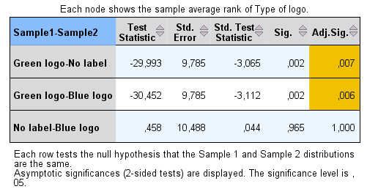
Figure 10. Kruskal-Wallis test
Also a Jonkheere-Terpstra test has been driven to indicate whether there is a trend within the analysis of type of logo and normative evaluation. Where the Sig. Is 0.001, this means that there is a trend. And again the green label has a significant trend effect, where blue and no logo have none.
Above mentioned results indicate that hypothesis 6 is partially accepted for green logos.

Normative evaluation versus purchase intention
H7: Normative evaluation is positively correlated with purchase intention
As already mentioned in the analysis of hypotheses 5, the variable of normative evaluation is not normally distributed. Mean of the normative evaluation is 0.319, which indicates that respondents overall do not evaluate an impulse buying with logo-product as very positive (scale of 0 to 5). Purchase intention frequencies and mean are already described in paragraph 5.1.
For this analysis also a non-parametric test is used. Because of the fact that there is both an independent and dependent continuous variable, a Spearman Correlation test and Kendall’s Tau are performed. Spearman Correlation test is the most common test to use in this kind of cases, but Kendall’s Tau should be used rather there is a small data set with a large number of tied ranks (Field, 2009). For a complete picture and comparison both tests are used.
 |  |  | Normative evaluation | Purchase intention
Kendall’s Tau | Normative evaluation | Correlation coefficient  Sig. (1-tailed)  N | 1,000  201 | ,150**  ,003  201
 | Purchase intention | Correlation coefficient  Sig. (1-tailed)  N | ,150**  ,003  201 | 1,000  201
Spearman’s Rho | Normative evaluation | Correlation coefficient  Sig. (1-tailed)  N | 1,000  201 | ,186**  ,004  201
 | Purchase intention | Correlation coefficient  Sig. (1-tailed)  N | ,186**  ,004  201 | 1,000  201
Table 12. Correlations Spearman’s rho normative evaluation versus purchase intention
Both tests show that there is a significant relationship between normative evaluation and purchase intention with both p < 0.01. Kendall’s Tau performs a somewhat smaller significance level, but this is the result of the fit of the test with the smaller sample. Going further with this test, the correlation coefficient shows a positive correlation of 0.150, which means that, when normative evaluation gets more positive, the purchase intention increases.
Above mentioned results indicate that hypothesis 7 is accepted.

Mediator normative evaluation
H8: Normative evaluation has a positive mediating effect on the relationship between Ik Kies Bewust logos and purchase intention
Previous sections indicated that green logos have a positive influence on normative evaluation and that normative evaluation is positively correlated with purchase intention. To check whether normative evaluation has a mediating effect on the relationship between Ik Kies Bewust logos and purchase intention, a multiplte regression test has been performed.
Because of the fact that normative evaluation is not normally distributed, the results of this test should be interpreted with consideration.
The dummies as described in section 5.4.1 are also used in this multiple regression. The first model describes the relation between Ik Kies Bewust logos and purchase intention, the second model describes this with the effect of normative evaluation.
The ANOVA table shows that the interaction model is not significant with a p-value of 0.093. This would indicate that there is no significant mediating effect of normative evaluation on the relationship between the logos and purchase intention. But the coefficient matrix gives more details.
Model |  | Unstandardized coefficients |  | t | Sig.
 |  | B | Std. error
1 | (Constant)  Green x blue dummy  Green x no logo dummy  Normative evaluation | 2,522  ,055  -,125  ,752 | ,142  ,202  ,201  ,272 | 17,746  ,272  -,620  2,770 | ,000  ,786  ,536  ,006
2 | (Constant)  Green x blue dummy  Green x no logo dummy  Normative evaluation  Dummy 1 x NE  Dummy 2 x NE | 2,606  -,084  -,295  ,382  ,515  ,599 | ,167  ,289  ,287  ,470  ,667  ,666 | 15,648  -,292  -1,029  ,812  ,773  ,900 | ,000  ,770  ,305  ,418  ,441  ,369
Table 13. Coefficients regression mediator normative evaluation
The positive relation between normative evaluation and purchase intention is shown with a significance level of 0.006. But when looking at model 2, it is clear that there is no mediating effect of normative evaluation on the relationship between Ik Kies Bewust logos and purchase intention, while the interaction effects are both non-significant.
Above mentioned results indicate that hypothesis 8 is rejected.

Discussion
This chapter discusses the results as found in chapter 5. It takes this study a step further in the process of explaining relationships that were or were not found and gives a solid base for conclusions in the next chapter. Each section represents the outcome of one variable.

Ik Kies Bewust logos versus purchase intention
The analysis of hypotheses 1, measuring the relationship between Ik Kies Bewust logos and purchase intention, indicates that there is no significant effect. This means that there is, in the purchase intention of the sample, no difference in intensity between a product with an Ik Kies Bewust logo and one without. Where the theory indicated that endorsement should actually increase purchase intention (Daneshvary & Schwer, 2000; Kozup, Creyer & Burton, 2003), even in specific cases with health claims/logos, these findings do not match with prior literature.
In order to explain this different outcome than presumed, this study gets back to prior literature. Although the literature pointed at a positive influence of Ik Kies Bewust logos on purchase intention, there are some factors that might have led to this outcome. First of all, other studies point at the effect of the weight of the logo, given by the consumer (Teisl, Peavey, Newman, Buono, & Hermann, 2002). When consumers do or do not value the label as assumed, the logo has less effect. Second, there might be an influencing factor in the design of the questionnaire. Ford et al. (1996) view in their theoretical framework “the health claim as information that creates an expectation about the product’s nutritional contribution and that consumers regard the Nutrition Facts Panel as information that either confirms or contradicts this expectation”. In the experiment of this study only the front of the product has been shown. Respondents were not able to view the Nutritional Facts Panel.

Moderation of knowledge
Paragraph 5.3 describes that the level of knowledge a respondent has about the Ik Kies Bewust logos does not have a positive moderate effect on the relationship between Ik Kies Bewust logos and purchase intention. Although the majority of the respondents know where the logos stand for, and even 21.4% uses them, this does not strengthen the relationship with purchase intention.
Probably this has also to do with the main relationship, between logos and intention that is not significant. Respondents might have known the labels and values of it, but did not gain much confidence from it, which resulted in a non-significant interaction.

Moderation of context
After running a linear regression, hypothesis 3a and 3b were rejected, making clear that there was no moderating effect of nutritional context on the relation Ik Kies Bewust logos versus purchase intention. But, despite this outcome, it became clear that the nutritional context has a direct positive effect on purchase intention. The more healthy the context, the higher the purchase intention will be. So, consumers do actually care about a product being healthy but they do not care as much about the Ik Kies Bewust logos.

Impulse buying tendency versus purchase intention
While doing a Pearson’s correlation test it became clear that there is a relation between impulse buying tendency and purchase intention. Linear regression made this even clearer, focusing on the size of the relationship. Where the relation was strongly significant, it indicates that the higher the impulse buying tendency is, the higher the purchase intention will be. This is consistent with prior research.

Moderator impulse buying tendency
Although impulse buying tendency has a direct relation to purchase intention, it does not work as a moderator on the relation between Ik Kies Bewust logos and purchase intention. This might be a result of the main relation being non-significant. Because Ik Kies Bewust logos, in this study, do not have an effect on purchase intention, it would be very hard to turn this no-effect into a positive effect with the impulse buying tendency moderator.

Ik Kies Bewust logos versus normative evaluation
Where hypothesis 6 indicated that Ik Kies Bewust logos have a positive influence on normative evaluation, this seems to be only partially true. With a Krusal-Wallis test, because of the non-parametrical nature of normative evaluation, it became clear that only the green logo has a significant influence on normative evaluation. This would also make sense, because the more virtuous (or in this case ‘good for your health’) the product seems, the more positive the consumer will evaluate the purchase. The no influence of the blue label suggests that this label does not overrule the less nutrient benefits of the ‘conscious choice’.

Normative evaluation versus purchase intention
Hypothesis 7, defining the positive relationship between normative evaluation and purchase intention, is accepted. Kendall’s Tau indicates that, although there is strong significance, the correlation is quite small. Meaning that a real high normative evaluation has a mediocre or small effect on purchase intention. But, although it is small, the effect is still there.

Mediator normative evaluation
Hypothesis 8 was rejected because the interaction of normative evaluation and Ik Kies Bewust logos do not make the relationship between logos and purchase intention more positive. From the acceptance of hypothesis 6 it is identified that green Ik Kies Bewust logos do have a positive impact on normative evaluation and the acceptance of hypothesis 7 made clear that there is a positive correlation between normative evaluation and purchase intention. The rejection of hypothesis 8 indicates that the Ik Kies Bewust logos do have a positive influence on normative evaluation, but that this is not translated into a higher purchase intention.

Conclusions
This last chapter describes what kind of implications this study provides in a managerial way and academic way. This first one is covered in sections 7.1 and 7.2, where academic managerial implications are made. Paragraph 7.2 will point out the limitations of this research. Last but not least, the overall conclusions of this study will be given in the last section.

Academic implications
In an academic sense, this study enriched the present literature with the inclusion of new variables in the labeling context. Before, both impulse buying tendency and normative evaluation have not been linked to the relationship of labels and purchase intention. Although this study presents that the effect is low or not existing, it forms a base for further research. Section 7.3 brings up some recommendations for future research.

Managerial implications
Besides that on an academic ground this research enriches the literature and findings that already have been done over the past years, also on a managerial ground this study is useful. First of all, it provides the Ik Kies Bewust Foundation with useful information about how effective the logo is at this moment. With many different influencing factors a figure has been created, presenting what does and what does not influence the consumer in purchasing healthier food. Second, not only the Ik Kies Bewust Foundation, but also cooperating food retailers and manufacturers can use the findings of this study in a policy-writing way. The logo itself, the values of the logo and different other factors can be taken into account now that there is more information about what the effect is of the logo on which other factors. Managers and the foundation itself can use this information to adjust the logos so that it will be used in the most effective way, and meeting the foundations objectives in the most quick and efficient manner. According to the results of this study, the next recommendations are made:
- Now that it is clear that a healthy context has a positive influence on purchase intention, it is advised that the Ik Kies Bewust foundation especially focuses on healthy products to place their logo on, with the logo being more visible to make consumers more aware.
- Only green Ik Kies Bewust logos have a positive influence on normative evaluation of the product. Normative evaluation is positively correlated with purchase intention. It is advised to make consumers more aware of the fact that the blue logo also indicates that a product fits better in a healthy lifestyle, in order to also change the normative evaluation towards the product with blue logo and eventually try to influence purchase intention.

Limitations and further research recommendations
Several limitations influenced the research process. A first limitation lays in the execution of the experiment. As already mentioned in chapter 6, only the front of the product is shown with the logo being in realistic size and shape. This makes the experiment come close to real-life but prevents this study from being able to completely emphasize and actually measure attitudes towards it. The researcher recommends another study, where the respondent will be more directed to the logo, in order to measure whether this would influence the relationship between Ik Kies Bewust logos and purchase intention and with the option to view the backside of the product.
A second limitation lays in an environmental bias. Half of the questionnaires was filled in online, half offline. This means that respondents might differ in surroundings and environment, and might be influenced by external stimuli in a different way. Although there are not major differences in data, the researcher recommends further analysis in the same environment for every respondent to filter out any differences in noise.
A third limitation is situated in the design of question 9 in the questionnaire. This question measures both knowledge about the Ik Kies Bewust logos as the usage of the logos by combining both in one answer possibility. In order to get better insights in the loose parts, further research is recommended with using two separate questions.
Furthermore, the researcher recommends doing this research again, focusing on other variables that were mentioned in chapter 6, discussion. By making the choice of defining the research in the way it has been done in this study, there is still room to extent this study with including variables as, for example, the value of the logo in consumers’ mind. Where the results of this study were not always as presumed, this would be a great way to study whether these other factors made a difference.

Conclusions
This research tested the impact of Ik Kies Bewust logos on purchase intention and measured the influence of knowledge, nutritional context, normative evaluation and impulse buying tendency in relation with that. The conceptual framework and results that formed the outcome of this study provide a better understanding about the effect of the logos. The research question “what is the influence of Ik Kies Bewust logos on purchase intention” stood central in this study. Based on the outcomes of this research, the answer is that there is no significant relationship. Only the nutritional context had a direct positive effect on purchase intention, together with impulse buying tendency. The green Ik Kies Bewust logo is significantly related to normative evaluation, which is in his turn positively correlated with purchase intention. This research will mainly be most useful to the Ik Kies Bewust Foundation, who is trying to bring consumers a better sense of healthy nutrition and tries to stimulate Dutch consumers to buy products that fit a healthy lifestyle.

References
Nutrition Labeling and Education Act. (1990 йил 8-November). Pub. L. 101-535. 104 Stat. 2355.
Andrews, J. C., Netemeyer, R. G., & Burton, S. (1998). Consumer generalization of nutrient content claims in advertising. Journal of Marketing, 62-75.
Balasubramanian, S. K., & Cole, C. (2002). Consumers' search and use of nutrition information: the challenge and promise of the nutrition labeling and education act. Journal of Marketing, 112-127.
Beatty, S. E., & Ferrell, E. M. (1998). Impulse buying: modelng its precursors. Journal of Retailing, 169-191.
Belk, R. W. (1988). Posessions and the extended self. Journal of Consumer Research, 139-168.
Bhaskaran, S., & Hardley, F. (2002). Buyer beliefs, attitudes and behaviour: foods with therapeutic claims. Journal of Consumer Marketing, 591-606.
Bhattacharya, J., & Sood, N. (2011). Who pays for obesity? Journal of Economic Perspectives, 139-157.
Burroughs, J. E. (1996). Product symbolism, self meaning, and holisitic matching: the role of information processing in impulsive buying. Advances in Consumer Research, 463-469.
Centraal Bureau voor de Statistiek. (2013 йил 27-July). Bevolking; kerncijfers. From CBS: http://statline.cbs.nl/StatWeb/publication/?VW=T&DM=SLNL&PA=37296ned&D1=a&D2=0,10,20,30,40,50,60,%28l-1%29,l&HD=130605-0924&HDR=G1&STB=T
Dagevos, H., & De Bakker, E. (2008). Consumptie verplicht: een kleine sociologie van consumeren tussen vreten en geweten. The Hague: LEI.
Daneshvary, R., & Schwer, R. K. (2000). The association endorsement and consumers' intention to purchase. Journal of Consumer Marketing, 203-213.
Dean, D. H. (1999). Brand endorsement, popularity and event sponsorship as advertising cues affecting consumer pre-purchase attitudes. Journal of Advertising, 1-12.
Dean, D. H., & Biswas, A. (2001). Third-party organization endorsement of products: an advertising cue affecting consumer prepurchase evaluation of goods and services. Journal of Advertising, 41-57.
Eagly, A., & Chaiken, S. (1993). The psychology of attitudes. Fort Worth, TX: Harcourt Brace Jovanovich.
Faul, F., Erdfelder, E., Buchner, A., & Lang, A. G. (2009). Statistical power analyses using G*Power 3.1: tests for correlation and regression analyses. Behavior Research Methods(41), 1149-1160.
Field, A. (2009). Discovering statistics using SPSS. London: SAGE Publications Ltd.
Global Energy Assessment (GEA) Council. (2012). Global energy assessment: towards a sustainable future. Cambridge: Cambridge University Press.
Hausman, A. (2000). A multi-method investigation of consumer motivations in impulse buying behavior. Journal of Consumer Marketing, 403-419.
Ik Kies Bewust Foundation. (2013 йил 19-July). Organisatie Stichting Ik Kies Bewust. From Het vinkje: http://www.hetvinkje.nl/oranisatie
James, W. P. (2008). The epidemiology of obesity: the size of the problem. Journal of Internal Medicine, 336-352.
Jones, M. A., Reynolds, K. E., Seungoog, W., & Beatty, S. E. (2003). The product-specific nature of impulse buying tendency. Journal of Business Research, 505-511.
Keller, S. B., Landry, M., Olson, J., Velliquette, A. M., Burton, S., & Andrews, J. C. (1997). The effects of nutrition package claims, nutrition facts panels, and motivation to process nutrition information on consumer product evaluations. Journal of Public Policy and Marketing, 256-269.
Kozup, J. C., Creyer, E. H., & Burton, S. (2003). Making healthful food choices: the influence of health claims and nutrition information on consumers' evaluations of packaged food and restaurant menu items. Journal of Marketing, 19-34.
Lafferty, B. A., & Goldsmith, R. E. (1999). Corporate credibility's role in consumers' attitudes and purchase intentions when a high versus a low credibility endorser is used in the ad . Journal of Business Research, 109-116.
Laroche, M., Kim, C., & Zhou, L. (1996). Brand familiarity and and confidence as determinants of purchase intention: an empirical test in a multiple brand context. Journal of Business Research, 115-120.
Leathwood, P. D., Richardson, D. P., Sträter, P., Todd, P. M., & van Trijp, H. C. (2007). Consumer understanding of nutrition and health claims: sources of evidence. British Journal of Nutrition, 474-484.
McCall, L., & Percheski, C. (2010). Income Inequality: New Trends and Research Directions. Annual Review of Sociology, 329-347.
McCracken, G. (1989). Who is the celebrity endorser? Cultural foundations of the endorsement process. Journal of Consumer Research, 310-321.
Piron, F. (1991). Defining impulse purchasing. Advances in Consumer Research, 509-513.
Puri, R. (1996). Measuring and modifying consumer impulsiveness: a cost-benefit accessibility framework. Journal of Consumer Psychology, 87-113.
Roe, B., Levy, A. S., & Derby, B. M. (1999). The impact of health claims on consumer search and product evaluation outcomes: results from FDA experimental data. Journal of Public Policy & Marketing, 89-105.
Rook, D. W. (1987). The buying impulse. Journal of Consumer Research, 189-199.
Rook, D. W., & Fisher, R. J. (1995). Normative influences on impulsive buying behavior. Journal of Consumer Research, 305-313.
Rook, D. W., & Gardner, M. P. (1993). In the mood: impulse buying's affective antecedents. Research in Consumer Behavior, 1-28.
Shaiderov, I. (2012). Quantitative marketing research . Brno.
Stern, H. (1962). The significance of impulse buying today. Journal of Marketing, 59-63.
Teisl, M. F., Peavey, S., Newman, F., Buono, J., & Hermann, M. (2002). Consumer reactions to environmental labels for forest products: a preliminary look. Forest Products Journal, 52.
UN Water. (2012). World water development report. New York: United Nations Educational, Scientific and Cultural Organization.
United Nations. (2005). Population challenges and development goals. New York: United Nations Publication.
University of Kentucky. (2004). Multicollinearity. Entry for Encyclopedia of Social Measurement, 1-36.
Vaidya, A., Shakya, S., & Krettek, A. (2010). Obesity prevalence in Nepal: public health challenges in a low-income nation during an alarming worldwide trend. Journal of Environmental Research and Public Health, 2726-2744.
Youn, S., & Faber, R. J. (2000). Impulse buying: its relation to personality traits and cues. Advances in Consumer Research, 179-185.

Appendix I - Questionnaire English
On forehand, thank you for filling in this survey. This research is about consumer purchase intention and will only take a maximum of 5 minutes to be filled in. Afterwards, it will be analyzed completely anonymous. Thank you very much for your cooperation.
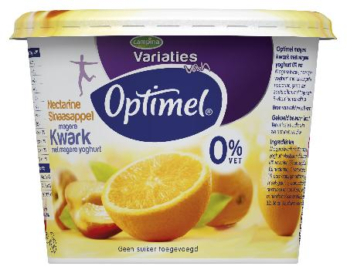
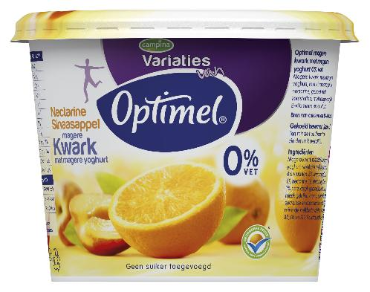
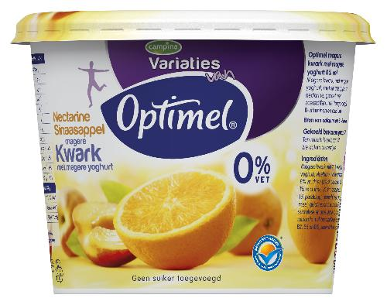
Scenario I Scenario II Scenario III

Scenario IV Scenario V Scenario VI
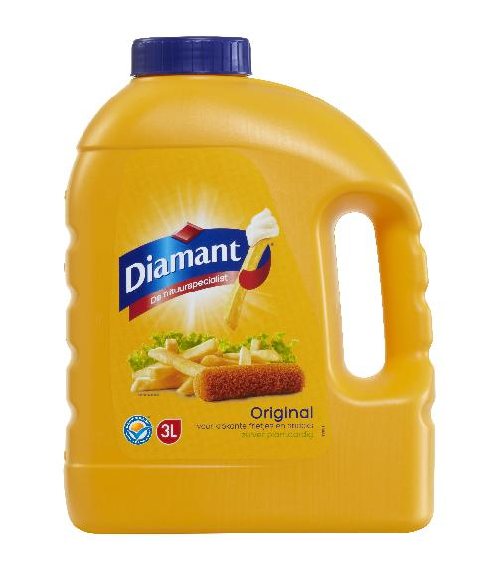
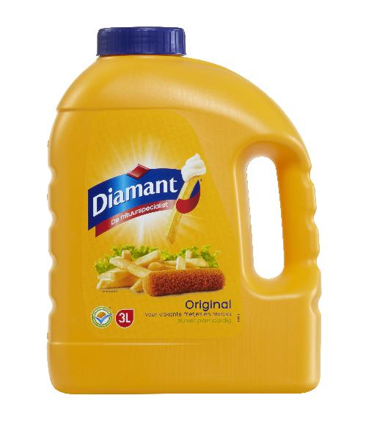

Question 1. On a scale of 1 to 5, when looking at the product above, how big is the chance that you would buy this product when set for the choice right now?
 | Very small | Small | Neutral | Big | Very big
Chance:

Question 2. On which product attributes did you base your previous answer?
.......................................................................................................................................................
Question 3. What is your gender?
- Male
- Female

Question 4. What is your age?
............... years

Question 5. What is your current hometown?
...............................................................................

Read the situation below and please indicate which of the five purchase alternatives Marie will choose.
Scenario I Scenario II Scenario III

Scenario IV Scenario V Scenario VI

Mary is a 21 year old college student with a part-time job. It is two days before Mary gets her new paycheck and she has only $ 5 left for necessities. Besides a few dollars she has to pay back to a friend, Mary needs to buy dinner for tonight. After work, she goes with her friend Susan to the grocery store. As they are walking through the Albert Heijn, Mary sees the product as shown above and in question 1. This product costs $ 3.
Question 6. What will Marie do?
- Marie decides to only buy dinner
- Marie would like to buy the product, but chose not to
- Marie decides not to buy dinner for this evening
- Marie decides to buy both dinner and the product on credit
- Marie does not only buy dinner and the product, but also lovely cereals with it on credit

Question 7. Now imagine that Marie would have bought both the unplanned product of $ 3 and dinner for tonight. How would you evaluate this purchase? Please make a decision between every comparison.
- Bad
- Emotional
- Productive
- Stupid
- Unattractive
- Acceptable
- Selfish
- Silly
- Childish
- Wrong
- Good
- Rational
- Wasteful
- Smart
- Attractive
- Unacceptable
- Generous
- Sober
- Mature
- Right

Question 8. Please indicate on the scale below how much you are able to identify yourself with the following statements.
 | Totally disagree | Disagree | Neutral | Agree | Totally agree
I often buy things spontaneously
"Just buy it” describes the way I purchase
I often buy things without thinking
"Seeing is buying"
"Buy now, think about it later” describes me
Sometimes I tend to buy things without thinking
I buy things based on how I feel at that moment
I always plan my purchases carefully
Sometimes I am a bit reckless in what I buy

Question 9. How familiar are you with the Ik Kies Bewust logos?
- I do not know the Ik Kies Bewust logos
- I have heard about the Ik Kies Bewust logos, but I do not know where they stand for
- I have seen the Ik Kies Bewust logos, but I do not know where they stand for
- I knwo where the Ik Kies Bewust logos stand for, but do not use them while doing groceries
- I know where the Ik Kies Bewust logos stand for, and use them while doing groceries
- Other; ____________________

Thank you very much for participating. If you have any questions about this questionnaire or when you are interested in the outcomes of this study, you can always contact marieke.van.der.wal@hotmail.com.

Appendix II - Questionnaire Dutch
Graag wil ik u bij voorbaat hartelijk danken voor het invullen van deze enquête. Dit onderzoek gaat over koopintentie en het zal u maximaal 5 minuten kosten om deze vragenlijst in te vullen. De gegevens zullen volledig anoniem verwerkt worden. Hartelijk dank voor uw medewerking.
Scenario I Scenario II Scenario III

Scenario IV Scenario V Scenario VI

Vraag 1. Op een schaal van 1 tot 5, hoe groot is de kans dat u het bovenstaande product aan zou schaffen, wanneer nu voor de keus gesteld?
 | Zeer klein | Klein | Neutraal | Groot | Zeer groot
Kans:

Vraag 2. Welke producteigenschappen waren bepalend voor uw antwoord op vraag 1?
…………………………………………………………………………………………………...
Vraag 3. Wat is uw geslacht?
- Man
- Vrouw
Vraag 4. Wat is uw leeftijd?
………
Vraag 5. Wat is uw huidige woonplaats?
………………………………………………
Lees onderstaande situatie en geef aan welk van de vijf aankoop alternatieven Marie volgens u zal kiezen.
Scenario I Scenario II Scenario III

Scenario IV Scenario V Scenario VI

Marie is een 21-jarige student met een bijbaan. Het is twee dagen voor de uitbetaling van haar salaris en zij heeft slechts €5 over voor haar eerste levensbehoeften. Buiten een paar Euro die zij nog terug moet betalen aan een vriend, moet zij ook nog het avondeten voor vanavond kopen. Na werktijd gaat zij met haar vriendin Susan naar de supermarkt. Terwijl ze door de winkel loopt, ziet Marie het product zoals in vraag 1 en hierboven getoond. Dit product kost €3.
Vraag 6. Wat zal Marie doen?
- Marie koopt alleen avondeten
- Marie wil graag de magere kwark kopen maar doet dat niet
- Marie besluit geen avondeten te kopen voor deze dag
- Marie koopt zowel avondeten als de magere kwark op krediet
- Marie koopt niet alleen avondeten en de magere kwark, maar nog een heerlijk bijgaande muesli op krediet
Vraag 7. Stelt u zich voor dat Marie uiteindelijk zowel het geplande avondeten als de ongeplande magere kwark van €3 koopt, hoe zou u deze aankoop beoordelen? Maak bij iedere tegenstelling een keuze.
- Goed
- Slecht
- Emotioneel
- Nuttig
- Dom
- Onaantrekkelijk
- Acceptabel
- Egoïstisch
- Uitbundig
- Kinderachtig
- Fout
- Rationeel
- Spilziek
- Slim
- Aantrekkelijk
- Onacceptabel
- Genereus
- Sober
- Volwassen
- Correct

Vraag 8. Geef aan op onderstaande schaal in hoeverre u zich kunt identificeren met de volgende stellingen.
 | Totaal oneens | Oneens | Neutraal | Eens | Totaal eens
Ik koop vaak iets spontaan
"Koop het gewoon" beschrijft de manier waarop ik iets aanschaf
Ik koop vaak iets zonder er bij na te denken
"Zien is kopen"
"Koop nu, denk er later over na" omschrijft mij
Soms ben ik erg geneigd dingen te kopen in een opwelling
Ik koop dingen gebaseerd op hoe ik mij voel op dat moment
Ik plan mijn aankopen zorgvuldig
Soms ben ik roekeloos in wat ik koop

Vraag 9. Hoe bekend bent u met Ik Kies Bewust logo's?
- Ik ken de Ik Kies Bewust logo's niet
- Ik heb er wel eens van gehoord, maar weet niet waar de Ik Kies Bewust logo's voor staan
- Ik heb ze wel eens gezien, maar weet niet waar de Ik Kies Bewust logo's voor staan
- Ik weet waar de Ik Kies Bewust logo's voor staan, maar let er nooit op tijdens het boodschappen doen
- Ik weet waar de Ik Kies Bewust logo's voor staan en let er op tijdens het boodschappen doen
- Anders; ____________________

Hartelijk dank voor uw deelname. Mocht u naar aanleiding van deze enquête nog vragen hebben of bent u geïnteresseerd in de uitkomsten van dit onderzoek, dan kunt u altijd contact opnemen via marieke.van.der.wal@hotmail.com.

Appendix III – Data

Normal distributions
Statistics
 |  | Purchase intention | Knowledge | Normative evaluation | Impulse buying tendency
N | Valid | 201 | 201 | 201 | 201
 | Missing | 0 | 0 | 0 | 0
Mean |  | 2,74 | 3,60 | ,319 | 2,9187
Median |  | 3,00 | 4,00 | ,200 | 2,8889
Mode |  | 2 | 4 | ,0 | 3,11
Std. Deviation |  | 1,172 | 1,342 | ,3107 | ,71705
Variance |  | 1,373 | 1,801 | ,097 | ,514
Skewness |  | ,178 | -,621 | ,733 | ,325
Std. Error of Skewness |  | ,172 | ,172 | ,172 | ,172
Kurtosis |  | -,893 | -,600 | -,751 | -,063
Std. Error of Kurtosis |  | ,341 | ,341 | ,341 | ,341
Minimum |  | 1 | 1 | ,0 | 1,33
Maximum |  | 5 | 6 | 1,0 | 5,00
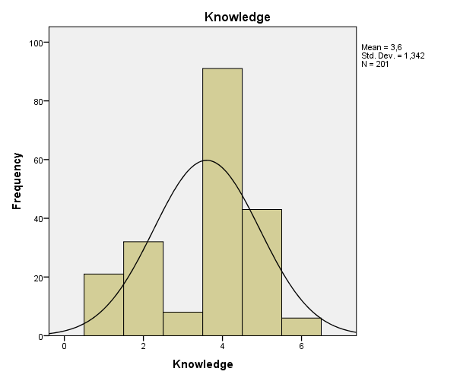
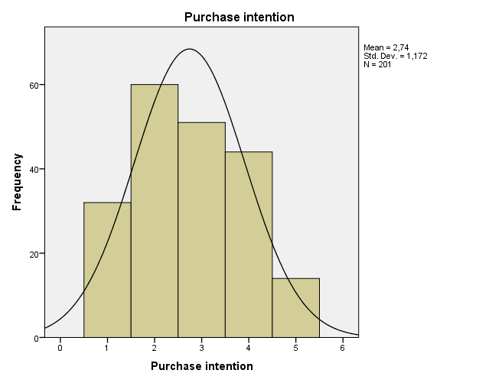

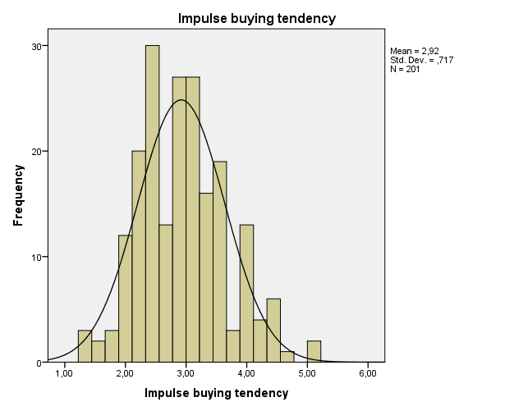
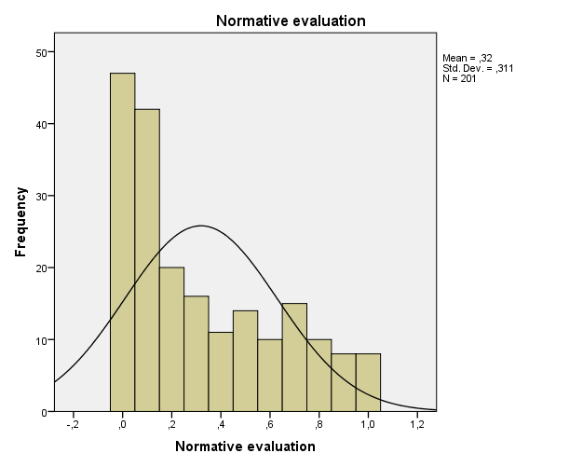

Factor analysis
KMO and Bartlett's Test
Kaiser-Meyer-Olkin Measure of Sampling Adequacy. |  | ,880
Bartlett's Test of Sphericity | Approx. Chi-Square | 750,146
 | df | 36
 | Sig. | ,000

Anti-image Correlation

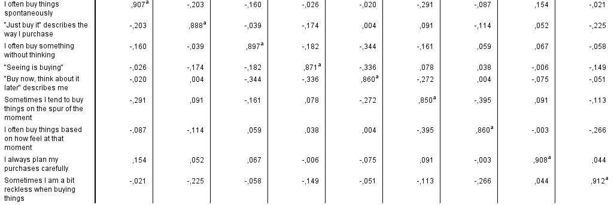

Total Variance Explained
Component | Initial Eigenvalues |  |  | Extraction Sums of Squared Loadings
 | Total | % of Variance | Cumulative % | Total | % of Variance | Cumulative %
1 | 4,466 | 49,618 | 49,618 | 4,466 | 49,618 | 49,618
2 | ,988 | 10,973 | 60,591
3 | ,820 | 9,116 | 69,707
4 | ,774 | 8,604 | 78,311
5 | ,549 | 6,101 | 84,412
6 | ,414 | 4,600 | 89,013
7 | ,400 | 4,442 | 93,455
8 | ,326 | 3,622 | 97,077
9 | ,263 | 2,923 | 100,000
Extraction Method: Principal Component Analysis.

Reliability test
Reliability Statistics
Cronbach's Alpha | N of Items
,815 | 9

Appendix IV – Analysis output

Hypothesis 1
Purchase intention
 |  | Frequency | Percent | Valid Percent | Cumulative Percent
Valid | Very small | 32 | 15,9 | 15,9 | 15,9
 | Small | 60 | 29,9 | 29,9 | 45,8
 | Neutral | 51 | 25,4 | 25,4 | 71,1
 | Big | 44 | 21,9 | 21,9 | 93,0
 | Very big | 14 | 7,0 | 7,0 | 100,0
 | Total | 201 | 100,0 | 100,0

Purchase intention * Type of logo Crosstabulation
 |  |  | Type of logo |  |  | Total
 |  |  | Green logo | Blue logo | No label
Purchase intention | Very small | Count | 17 | 5 | 10 | 32
 |  | % of Total | 8,5% | 2,5% | 5,0% | 15,9%
 | Small | Count | 19 | 21 | 20 | 60
 |  | % of Total | 9,5% | 10,4% | 10,0% | 29,9%
 | Neutral | Count | 24 | 15 | 12 | 51
 |  | % of Total | 11,9% | 7,5% | 6,0% | 25,4%
 | Big | Count | 14 | 15 | 15 | 44
 |  | % of Total | 7,0% | 7,5% | 7,5% | 21,9%
 | Very big | Count | 7 | 4 | 3 | 14
 |  | % of Total | 3,5% | 2,0% | 1,5% | 7,0%
Total |  | Count | 81 | 60 | 60 | 201
 |  | % of Total | 40,3% | 29,9% | 29,9% | 100,0%

Levene's Test of Equality of Error Variancesª
Dependent Variable: Purchase intention
F | df1 | df2 | Sig.
,684 | 2 | 198 | ,506
Tests the null hypothesis that the error variance of the dependent variable is equal across groups.
a. Design: Intercept + Type_logo

Tests of Between-Subjects Effects
Dependent Variable: Purchase intention
Source | Type III Sum of Squares | df | Mean Square | F | Sig.
Corrected Model | 1,347ª | 2 | ,673 | ,488 | ,615
Intercept | 1486,897 | 1 | 1486,897 | 1077,617 | ,000
Type_logo | 1,347 | 2 | ,673 | ,488 | ,615
Error | 273,201 | 198 | 1,380
Total | 1785,000 | 201
Corrected Total | 274,547 | 200
a. R Squared = ,005 (Adjusted R Squared = -,005)

Hypothesis 2
Knowledge
 |  |  | Frequency | Percent | Valid Percent | Cumulative Percent
Valid | I do not know the Ik Kies Bewust logos |  | 21 | 10,4 | 10,4 | 10,4
 | I heard of the Ik Kies Bewust logos, but do not know where they stand for |  | 32 | 15,9 | 15,9 | 26,4
 | I have seen the Ik Kies Bewust logos, but do not know where they stand for |  | 8 | 4,0 | 4,0 | 30,3
 | I know where the Ik Kies Bewust logos stand for, but do not use them while doing groceries |  | 91 | 45,3 | 45,3 | 75,6
 | I know where the Ik Kies Bewust logos stand for, and use them while doing groceries |  | 43 | 21,4 | 21,4 | 97,0
 | Other |  | 6 | 3,0 | 3,0 | 100,0
 | Total |  | 201 | 100,0 | 100,0
Model Summary
Model | R | R Square | Adjusted R Square | Std. Error of the Estimate
1 | ,127ª | ,016 | ,001 | 1,171
2 | ,152^{b} | ,023 | -,002 | 1,173
a. Predictors: (Constant), Green x no label dummy, Knowledge, Green x blue dummy
b. Predictors: (Constant), Green x no label dummy, Knowledge, Green x blue dummy, dummy1xknowledge, dummy2xknowledge
ANOVAª
Model |  | Sum of Squares | df | Mean Square | F | Sig.
1 | Regression | 4,463 | 3 | 1,488 | 1,085 | ,357^{b}
 | Residual | 270,085 | 197 | 1,371
 | Total | 274,547 | 200
2 | Regression | 6,317 | 5 | 1,263 | ,918 | ,470^{c}
 | Residual | 268,231 | 195 | 1,376
 | Total | 274,547 | 200
Coefficientsª
Model |  | Unstandardized Coefficients |  | Standardized Coefficients | t | Sig. | Collinearity Statistics
 |  | B | Std. Error | Beta |  |  | Tolerance | VIF
1 | (Constant) | 2,333 | ,271 |  | 8,617 | ,000
 | Knowledge | ,094 | ,062 | ,107 | 1,508 | ,133 | ,982 | 1,018
 | Green x blue dummy | ,213 | ,201 | ,083 | 1,058 | ,291 | ,806 | 1,240
 | Green x no label dummy | ,022 | ,200 | ,008 | ,107 | ,915 | ,811 | 1,233
2 | (Constant) | 2,654 | ,402 |  | 6,597 | ,000
 | Knowledge | ,010 | ,100 | ,011 | ,099 | ,921 | ,384 | 2,606
 | Green x blue dummy | -,404 | ,572 | -,158 | -,706 | ,481 | ,100 | 10,017
 | Green x no label dummy | -,361 | ,590 | -,141 | -,612 | ,541 | ,094 | 10,658
 | dummy1xknowledge | ,171 | ,149 | ,253 | 1,146 | ,253 | ,103 | 9,733
 | dummy2xknowledge | ,102 | ,153 | ,153 | ,666 | ,506 | ,095 | 10,481
a. Dependent Variable: Purchase intention

Hypothesis 3

Linear regression
Model Summary
Model | R | R Square | Adjusted R Square | Std. Error of the Estimate
1 | ,201ª | ,041 | ,026 | 1,156
2 | ,203^{b} | ,041 | ,017 | 1,162
a. Predictors: (Constant), Healthy vs. unhealthy, Green x no label dummy, Green x blue dummy
b. Predictors: (Constant), Healthy vs. unhealthy, Green x no label dummy, Green x blue dummy, dummy1xcontext, dummy2xcontext

ANOVAª
Model |  | Sum of Squares | df | Mean Square | F | Sig.
1 | Regression | 11,136 | 3 | 3,712 | 2,776 | ,042^{b}
 | Residual | 263,411 | 197 | 1,337
 | Total | 274,547 | 200
2 | Regression | 11,317 | 5 | 2,263 | 1,677 | ,142^{c}
 | Residual | 263,231 | 195 | 1,350
 | Total | 274,547 | 200
a. Dependent Variable: Purchase intention
b. Predictors: (Constant), Healthy vs. unhealthy, Green x no label dummy, Green x blue dummy
c. Predictors: (Constant), Healthy vs. unhealthy, Green x no label dummy, Green x blue dummy, dummy1xcontext, dummy2xcontext

ANOVA
Test of Homogeneity of Variances
Purchase intention
Levene Statistic | df1 | df2 | Sig.
3,175 | 1 | 199 | ,076

ANOVA
Purchase intention
 | Sum of Squares | df | Mean Square | F | Sig.
Between Groups | 9,245 | 1 | 9,245 | 6,935 | ,009
Within Groups | 265,302 | 199 | 1,333
Total | 274,547 | 200

Hypothesis 4
Impulse buying tendency
 |  |  | Frequency |  | Percent |  | Valid Percent |  | Cumulative Percent
Valid | 1,33 |  | 3 |  | 1,5 |  | 1,5 |  | 1,5
 | 1,44 |  | 2 |  | 1,0 |  | 1,0 |  | 2,5
 | 1,67 |  | 1 |  | ,5 |  | ,5 |  | 3,0
 | 1,78 |  | 2 |  | 1,0 |  | 1,0 |  | 4,0
 | 1,89 |  | 6 |  | 3,0 |  | 3,0 |  | 7,0
 | 2,00 |  | 6 |  | 3,0 |  | 3,0 |  | 10,0
 | 2,11 |  | 7 |  | 3,5 |  | 3,5 |  | 13,4
 | 2,22 |  | 13 |  | 6,5 |  | 6,5 |  | 19,9
 | 2,33 |  | 9 |  | 4,5 |  | 4,5 |  | 24,4
 | 2,44 |  | 11 |  | 5,5 |  | 5,5 |  | 29,9
 | 2,56 |  | 10 |  | 5,0 |  | 5,0 |  | 34,8
 | 2,67 |  | 13 |  | 6,5 |  | 6,5 |  | 41,3
 | 2,78 |  | 13 |  | 6,5 |  | 6,5 |  | 47,8
 | 2,89 |  | 14 |  | 7,0 |  | 7,0 |  | 54,7
 | 3,00 |  | 9 |  | 4,5 |  | 4,5 |  | 59,2
 | 3,11 |  | 18 |  | 9,0 |  | 9,0 |  | 68,2
 | 3,22 |  | 10 |  | 5,0 |  | 5,0 |  | 73,1
 | 3,33 |  | 6 |  | 3,0 |  | 3,0 |  | 76,1
 | 3,44 |  | 6 |  | 3,0 |  | 3,0 |  | 79,1
 | 3,56 |  | 4 |  | 2,0 |  | 2,0 |  | 81,1
 | 3,67 |  | 9 |  | 4,5 |  | 4,5 |  | 85,6
 | 3,78 |  | 3 |  | 1,5 |  | 1,5 |  | 87,1
 | 3,89 |  | 7 |  | 3,5 |  | 3,5 |  | 90,5
 | 4,00 |  | 6 |  | 3,0 |  | 3,0 |  | 93,5
 | 4,11 |  | 4 |  | 2,0 |  | 2,0 |  | 95,5
 | 4,33 |  | 4 |  | 2,0 |  | 2,0 |  | 97,5
 | 4,44 |  | 2 |  | 1,0 |  | 1,0 |  | 98,5
 | 4,56 |  | 1 |  | ,5 |  | ,5 |  | 99,0
 | 5,00 |  | 2 |  | 1,0 |  | 1,0 |  | 100,0
 | Total |  | 201 |  | 100,0 |  | 100,0
Model Summary
Model |  | R |  | R Square |  | Adjusted R Square |  | Std. Error of the Estimate
1 |  | ,194ª |  | ,038 |  | ,033 |  | 1,152
a. Predictors: (Constant), Impulse buying tendency

Hypothesis 5
Model Summary
Model |  | R | R Square |  | Adjusted R Square |  | Std. Error of the Estimate
1 |  | ,199ª | ,040 |  | ,025 |  | 1,157
2 |  | ,227^{b} | ,051 |  | ,027 |  | 1,156
a. Predictors: (Constant), Green x no label dummy, Impulse buying tendency, Green x blue dummy
b. Predictors: (Constant), Green x no label dummy, Impulse buying tendency, Green x blue dummy, dummy2xIBTmean, dummy1xIBTmean
ANOVAª
Model |  |  |  | Sum of Squares |  | df |  | Mean Square |  | F | Sig.
1 | Regression |  |  | 10,879 |  | 3 |  | 3,626 |  | 2,710 | ,046^{b}
 | Residual |  |  | 263,668 |  | 197 |  | 1,338
 | Total |  |  | 274,547 |  | 200
2 | Regression |  |  | 14,139 |  | 5 |  | 2,828 |  | 2,118 | ,065^{c}
 | Residual |  |  | 260,408 |  | 195 |  | 1,335
 | Total |  |  | 274,547 |  | 200
a. Dependent Variable: Purchase intention
b. Predictors: (Constant), Green x no label dummy, Impulse buying tendency, Green x blue dummy
c. Predictors: (Constant), Green x no label dummy, Impulse buying tendency, Green x blue dummy, dummy2xIBTmean, dummy1xIBTmean

Coefficientsª
Model |  | Unstandardized Coefficients |  | Standardized Coefficients | t | Sig. | Collinearity Statistics
 |  | B | Std. Error | Beta |  |  | Tolerance | VIF
1 | (Constant) | 1,827 | ,349 |  | 5,240 | ,000
 | Impulse buying tendency | ,308 | ,115 | ,189 | 2,669 | ,008 | ,976 | 1,024
 | Green x blue dummy | ,093 | ,199 | ,037 | ,469 | ,640 | ,800 | 1,251
 | Green x no label dummy | -,042 | ,197 | -,016 | -,212 | ,832 | ,816 | 1,226
2 | (Constant) | 2,133 | ,663 |  | 3,217 | ,002
 | Impulse buying tendency | ,199 | ,232 | ,122 | ,858 | ,392 | ,242 | 4,137
 | Green x blue dummy | ,288 | ,896 | ,113 | ,321 | ,748 | ,040 | 25,314
 | Green x no label dummy | -1,009 | ,870 | -,395 | -1,161 | ,247 | ,042 | 23,832
 | dummy1xIBTmean | -,054 | ,300 | -,068 | -,180 | ,858 | ,034 | 29,223
 | dummy2xIBTmean | ,336 | ,297 | ,404 | 1,130 | ,260 | ,038 | 26,231

Hypothesis 6
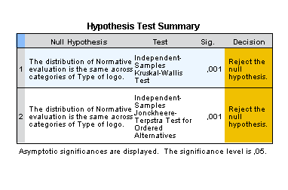

Hypothesis 7
Statistics
Normative evaluation
N | Valid | 201
 | Missing | 0
Mean |  | ,319

Hypothesis 8
Model Summary
Model | R | R Square | Adjusted R Square | Std. Error of the Estimate
1 | ,205ª | ,042 | ,028 | 1,155
2 | ,216^{b} | ,047 | ,022 | 1,158
a. Predictors: (Constant), Normative evaluation, Green x no label dummy, Green x blue dummy
b. Predictors: (Constant), Normative evaluation, Green x no label dummy, Green x blue dummy, dummy2xNE, dummy1xNE

ANOVAª
Model |  | Sum of Squares | df | Mean Square | F | Sig.
1 | Regression | 11,590 | 3 | 3,863 | 2,894 | ,036^{b}
 | Residual | 262,958 | 197 | 1,335
 | Total | 274,547 | 200
2 | Regression | 12,864 | 5 | 2,573 | 1,917 | ,093^{c}
 | Residual | 261,683 | 195 | 1,342
 | Total | 274,547 | 200
a. Dependent Variable: Purchase intention
b. Predictors: (Constant), Normative evaluation, Green x no label dummy, Green x blue dummy
c. Predictors: (Constant), Normative evaluation, Green x no label dummy, Green x blue dummy, dummy2xNE, dummy1xNE

