# 

“The influence of the ongoing financial crisis on the usefulness of IFRS based financial statements in the Netherlands”

**ABSTRACT**

**Prior research regarding the value relevance of accounting information indicates that the value relevance of reported earnings decline and the value relevance of reported book values increase during financially unstable times. In this research the effects of the ongoing financial crisis in the European Union on the value relevance of accounting numbers are empirical tested. The purpose is to provide empirical evidence regarding the capability of IFRS to provide value relevant information during a crisis. The research consists of two sample periods, a pre-crisis period and an in-crisis period and is conducted in the Netherlands. The empirical results show that the value relevance of reported earnings decline during a crisis and the value relevance of reported book values increase during a crisis. The incremental value relevance of book values almost tripled during the financial crisis but did not fully replace the decline in value relevance of the reported earnings. In both periods reported losses seems more value relevant than reported profits.**

**July 2013**

**Erasmus University Rotterdam**

**Master Business Economics**

**Author : Sebastiaan van Dijk (280251)**

**Supervisor : E.A. de Knecht RA**

**Co-reader : Drs R. van der Wal**

# Preface

*The final part of the Master Program at the Erasmus University in Rotterdam involves writing a master thesis. The master thesis is an empirical research in the field of accountancy and is the final test for graduation. One of the criteria for the master thesis is that the research topic is relevant. The research topic in this thesis is the value relevance of accounting numbers during financially unstable times. The current ongoing financial crisis is the first financially unstable period after the endorsement of IFRS. I am very excited that I had this unique opportunity to conduct empirical research on this topic.*

*The road to completion of this thesis was long and had some difficult obstacles. There are several people who I personally want to thank for their support during the process of writing this thesis. First of all I want to show my deepest respect and gratitude to my supervisor Mr. de Knecht. Under the supervision of Mr. de Knecht my thesis reached an academic level.*

*Furthermore I want to thank my friends and colleagues for their support and confidence. I am especially thankful to my girlfriend Ashley Engelen, who I wish all the luck and health she deserves.*

*I dedicate this thesis to my father Frans van Dijk and my mother Hettie van Gaal for their endless confidence and support during the course of my study.*

*Sebastiaan van Dijk*

*Rotterdam, July 2013*

Table of Contents

1

Preface 2

1. Introduction 5

1.1 Introduction to the problem 5

1.2 Relevance 6

1.3 Objective of the study 7

1.4 Methodology 8

1.5 Demarcation and limitations 9

1.6 Structure 9

2. Theories behind financial accounting research 10

2.1 Introduction 10

2.2 Normative and positive accounting theory 10

2.3 The agency theory 11

2.4 The development of the positive accounting theory 11

2.5 The efficient market hypothesis 12

2.6 The Positive Accounting Theory 13

2.7 The stakeholder theory 14

2.8 Capital market accounting research 15

2.9 Summary 16

3. Literature study on the value relevance of financial statement information 17

3.1 Introduction 17

3.2 Lev (1989): On the Usefulness of Earnings and Earnings Research: Lessons and Directions from Two Decades of Empirical Research 17

3.3 Lundholm (1995): A Tutorial on the Ohlson (1995) and Feltham-Ohlson (1995) papers 18

3.4 Nichols and Wahlen (2004): The relation between the earning numbers and the stock returns 19

3.5 Prior results from value relevance researches 22

3.5.1 Hayn (1995): The information content of losses 22

3.5.2 Amir and Lev (1996): Value relevance of non-financial information 23

3.5.3 Implications from the Collins, Maydew and Weiss (1997) research paper 24

3.5.4 Francis and Schipper (1999): Another approach to value relevance research 26

3.7 The information content of published financial statements during financially unstable times 27

3.7.1 Graham, King and Bailes: The Value Relevance of Accounting Information during a Financial Crisis: Thailand and the 1997 Decline in the Value of the Baht 27

3.7.2 Ho, Liu & Sik (2012): The value relevance of accounting information around the 1997 Asian financial crisis – the case of South Korea 29

3.8 Summary 31

4. Research Design 32

4.1 Introduction 32

4.1 Types of research 32

4.1.1 Empirical research 32

4.1.2 Types of quantitative empirical research 32

4.2 Research methodology 33

4.3 Hypotheses 34

4.3.1 The explanatory power of reported earnings and book values per share 34

4.3.2 The incremental explanatory power of reported earnings and book values per share 35

4.3.3 Possible biases from differences in sample composition 35

4.4 Models for measuring value relevance 36

4.5 Control and dummy variables 37

4.6 Multicollinearity and homoscedasticity 38

4.7 Data collection and sample periods 38

4.7.1 Sample selection 38

4.7.2 Sample periods 39

4.8 Conclusion 40

5 Empirical results 41

5.1 Introduction 41

5.2 Data collection 41

5.3 Sample selection 42

5.4 Descriptive statistics and statistical inferences 43

5.4.1 Tests for normal distribution, linearity and homoscedastic 43

5.4.2 Descriptive statistics 44

5.5 Regression results 47

5.5.1 Regression results of the pre-crisis period 47

5.5.2 Regression results of the in-crisis period 49

5.5.3 Summary of results and the incremental value relevance calculations 53

5.5.4 The effect of loss-cases and one-time items 55

5.6 Summary 60

6. Conclusion 61

6.1 Introduction 61

6.2 Summary of results 61

6.3 Final conclusion 62

6.4 Limitations and Recommendations 63

Literature list 65

Appendix A: Literature Table 67

Appendix B: Sample firms 70

Appendix C: Boxplots (before and after exclusion of extreme values) 71

Appendix D: The Assumption of Linearity, Homoscedastic and Normality 75

# 1. Introduction

## 1.1 Introduction to the problem

The European Union enforced publicly held companies, starting in the year 2005, to prepare their consolidated financial statements in accordance with the International Financial Reporting Standards (hereafter IFRS). IFRS was a revolution in the accounting world and was a base for numerous studies in the field of financial accounting. The main reason for the implementation of the new financial reporting standards was the enhancement of the quality of the financial reporting, one of the objectives of the IFRS foundation (International organization consisting of the IASB (International Accounting Standards Board) and the IFRIC (the IFRS Interpretations Committee). Other objectives of the IFRS foundation are (<http://www.ifrs.org/The+organisation/IASCF+and+IASB.htm>, June 14, 2013 ):

* “to develop a single set of high quality, understandable, enforceable and globally accepted International Financial Reporting Standards (IFRSs) through its standard-setting body, the International Accounting Standards Board (IASB);
* to promote the use and rigorous application of those standards;
* to take account of the financial reporting needs of emerging economies and small and medium-sized entities (SMEs); and
* to promote and facilitate adoption of IFRSs, being the standards and interpretations issues by the IASB, through the convergence of national accounting standards and IFRSs.”

The question that should be answered is in which way the quality of the financial reporting standards can be defined. Following the IFRS framework for financial reporting the objective of the general purpose of the financial reporting is (<http://www.ifrs.org/IFRSs/Documents/English%20Web%20summaries/Conceptual%20Framework.pdf>, June 14, 2013): *“To provide financial information about the reporting entity that is useful to existing and potential investors, lenders and other creditors in making decisions about providing resources to the entity”*. In addition, the IFRS Foundation states that financial information is useful when the next qualitative characteristics of financial information are met (<http://www.iasplus.com/en/standards/framework>, June 14, 2013):

* *relevance and faithful representation – the fundamental qualitative characteristics;*
* *comparability, timeliness, verifiability and understandability – the enhancing qualitative characteristics that differs useful information from less useful information.*

Considering the definition of the financial reporting quality the new IFRS standards, which became effective in 2005, should enhance the usefulness of the financial statement information by primary increasing the relevance and the faithful representation of the financial statement information. One of the major changes of the mandatory adoption of IFRS compared to the existent general accounting principles (GAAP) in the European Union (for instance Dutch GAAP) is the extensive use of fair value accounting (FVA hereafter). Because fair value information is considered to provide more timely and relevant information than the conventional cost-based models, investors for a long period lobbied for a more extensive use of FVA. FVA is defined as: the amount for which an asset could be exchanged, or a liability could be settled, between knowledgeable, willing parties in an arm’s length transaction. The more extensive use of fair value accounting is not the only major change in the accounting policy. After the mandatory adoption of IFRS much research has been performed regarding the usefulness of the financial statement information. The most important question which should be answered is: Did the EU-endorsement of the new reporting standards have a positive effect on the usefulness of the financial statement information? In the value relevance literature the results are quite diverse. For instance, Clarkson, Douglas Hanna, Richardson, and Thompson (2011) [hereafter CDRT] researched the impact on the value relevance of the book value and the published earnings after the adoption of IFRS in Europe and in Australia and did not find significant changes in the value relevance. Similar results were found by Gjerde, Knivsfla, and Saettem (2008) [hereafter GKS]. GKS compared the value relevance of 145 Norwegian GAAP restatements to IFRS with the value relevance of the original statements measured as a correlation with stock values. No significant differences in value relevance were found. The main focus of the researches signaled was to find evidence for an increase of the value relevance after the implementation of IFRS. Considering their results it seems to be that no major differences in the usefulness of the reporting standards exists measured as an association between the stock prices and the published accounting numbers. However, these researches did not cover a period of instability on the financial markets. It is essential to know if IFRS is capable of capturing accurate and useful information in the accounting numbers even when the financial markets are instable. It is evidenced that the IFRS differ significantly from the conventional cost-based models and consequently it is not possible to conclude on the effects of a financial crisis on the value relevance of IFRS based financial statements based on prior research, which is mostly performed in the pre-IFRS period.

To further elaborate on the problem which is addressed in this thesis, a clear distinction is presented regarding the different research questions answered in the before signaled researches. Researches exist that address the change in the value relevance due to the transition from the conventional historical cost-based models to the use of IFRS. These researches are performed in almost all areas of Europe, in upcoming Asian industries, and in upcoming industries in the Middle-East and intent to answer the question whether IFRS or the historical cost-based models provides more value relevant information. Since the results have implications for the development of the hypotheses, for this thesis it is relevant to gain knowledge of the results.

Other research tries to identify the effects of the macro-economic circumstances on the reported accounting numbers, more specific whether the financially unstable times affect the value relevance of the published financial statement information. The research questions answered in this thesis relate to this problem setting. In fact, it is not known if the value relevance of IFRS-based financial statements is effected by the ongoing financial crisis in Europe and more specifically in the Netherlands. The relevance of the research topic and more specifically of this thesis is further explained in the next paragraph.

## 1.2 Relevance

As signaled earlier, the main focus of the accounting standard setting bodies is to develop a set of accounting standards which provide reliable and relevant information for the users of the financial statements. One aspect of relevancy regarding financial statements is the value relevance. Barth, Beaver and Landsman (2001) [hereafter BBL] performed an extensive research on the value relevance literature for financial accounting standard setting and explain ‘value relevance research’ as follows (BBL, page 77) : “value relevance research assesses how well accounting amounts reflect information used by equity investors, and provides insights into questions of interest to standard setters”. BBL explains that the most common way to address value relevance is to develop valuation models that correlate with the stock market prices. In addition, BBL explains in which way the correlation between the published accounting numbers and the stock prices relates to the definition of ‘relevant information’ as used by the Financial Accounting Standard Body (FASB). The results of BBL show that value relevance research provides useful information for financial standard setting. The exact conclusion of BBL (2001) is presented for the reader’s understanding: “

1. value relevance research provides insights into questions of interest to standard setters and other non-academic constituents.
2. A primary focus of the FASB and other standard setters is equity investments. The possible contracting and other uses of financial statements in no way diminish the importance of value relevance research.
3. Empirical implementations of extant valuation models can be used to address questions of value relevance despite their simplifying assumptions.
4. Value relevance research can accommodate conservatism, and can be used to study its implications for the relation between accounting amounts and equity values.
5. Value relevance studies are designed to assess whether particular accounting amounts reflect information that is used by investors in valuing firms’ equity, not to estimate firm value.
6. Value relevance research employs well-established techniques for mitigating the effects of various econometric issues that arise in value relevance studies.”

The importance of value relevance research is signaled in the above-mentioned. Next, the relevancy of new value relevance research will be explained. Prior value relevance research regarding the implementation of IFRS after the endorsement tried to evidence an increase in the value relevance. In prior research no clear increase in value relevance was found. However, the incremental value relevance of the book values after the endorsement of IFRS seems to increase. Since compared to the conventional historical cost-based models, fair value accounting gains importance in the IFRS-standards this is in conformance with the general expectation. Fair value implies earlier recognition of gains and losses and consequently contributes to more fluctuating published earnings. Since the valuation theory of firms states that the firm value is the present value of the future dividends, it is obvious that after the endorsement balance sheet numbers gain importance. Because losses are unlikely to perpetuate (abandonment option on assets), Hayne (1995) shows that loss-reporting firms are likely to have a lower value relevance. Considering the before facts it is interesting and relevant to observe the effects of a financial crisis on the value relevance of the published accounting numbers. A strong decrease in the value relevance of published earnings is expected while the value relevance of the book values is expected to increase.

In the next paragraph the objective of the study and the related research questions will be presented.

## 1.3 Objective of the study

The objective of this thesis is to investigate the effects of economic unstable times on the value relevance of IFRS accounting numbers in the Netherlands. Such research in the Netherlands has not been performed concerning IFRS in particular; consequently, the results of this thesis can help standard setters to understand the effects of unstable markets on the financial reporting. The research will be performed in the Netherlands concerning the period starting from the endorsement of IFRS in 2005 up to and including 2012, the last reporting year of the ongoing financial crisis. The research question that will be answered is:

***What are the effects of the ongoing financial crisis on the value relevance of financial statement information for Dutch stock exchange quoted companies reporting based on IFRS?***

To structure the thesis and to answer the research question, the next sub questions need to be answered:

1. What is the theory behind financial accounting research?
2. What does prior research communicate about the value relevance of accounting information?
3. What does prior research communicate about the value relevance of IFRS?
4. Which research approach fits the research question the most?
5. Which model is useful for the empirical analysis?
6. What are the results of the empirical analysis?
7. In which way the empirical results can be interpreted?

In the next paragraph the methodology used to answer the research will be explained.

## 1.4 Methodology

Concerning the usefulness of financial statement information two main perspectives exist. Before elaborating on these perspectives, reference is made to the definition of the usefulness of financial statement information as presented in the first paragraph. In general, financial statement information is considered useful when investors or other users of the published financial statements can perform decisions based on the published information. Both perspectives can be addressed by capital market accounting research.

The information perspective states that the financial statement information should have useful information content. Capital market research focusing on the information content of specific financial statement information tries to identify capital market reactions after the information became public. In general the information content is considered relevant for decision purposes when fluctuation in share prices can be observed.

The measurement perspective states that financial statement information should be useful for valuation purposes. Capital market accounting research regarding this topic tries to define relationships between the published accounting numbers and the share prices. The association between the share prices and the published accounting numbers is known as the ‘value relevance’ of the published accounting numbers. In this thesis the usefulness of the financial statement information will be examined based on the measurement perspective. To determine the value relevance of the financial statement information the Ohlson (1995) valuation model will be applied. The Ohlson (1995) valuation model defines the market value of equity as the book value of the equity plus the present value of the (abnormal) earnings.

The sample used for the empirical research is extracted from Thomson One Banker and includes all stock exchange quoted companies in the Netherlands from the year 2005 (year of the mandatory adoption of IFRS) until and including 2012 (the last reporting year of the financial crisis). Financials and commodities will be excluded from the sample since additional laws and regulations apply to those companies. The relevant information consists of share prices, published earnings and published equity and is directly available in Thomson One Banker. Descriptive statistics of the sample will be provided and corrective actions will be taken for potential outliers or missing items. The variables in the sample will be tested for a normal distribution, multicollinearity and homoscedastic. Hereafter the relevant regression analytics (based on the Ohlson 1995 model) will be performed in SPSS (statistical package for social sciences). Based on the empirical evidence the research question will be answered.

## 1.5 Demarcation and limitations

As signaled before regarding the usefulness of financial statement information two perspectives exist. In this thesis only the measurement perspective will be addressed and consequently the information perspective is not part of the research.

Much research has been performed regarding the value relevance of IFRS compared to other GAAP’s. The scope of this thesis is limited to IFRS and will not investigate such differences. The research period covers the period after the endorsement of IFRS up to and including the financial reporting year 2012 for Dutch stock exchanges quoted companies. It is not the purpose of this thesis to identify possible differences between the Netherlands and other European Union countries. Consequently, it is not possible to communicate conclusions regarding the value relevance of the financial statement information in other European Union countries after the endorsement of IFRS based on the results of this research. Additional research should be performed regarding the effects of the corporate governance structures (or other country-specific factors) on the value relevance of the financial statement information before the results can be projected on other European Union countries.

In addition, the Ohlson (1995) valuation model cannot be used to identify particular IFRS standards which increase or decrease the value relevance of financial statement information in financial unstable times. Since the main objective of this thesis is to identify the effects of the financial crises on the value relevance of IFRS-based published financial statements it is not relevant to identify those particular standards.

Additional research needs to be performed to identify and to quantify possible biases due to changes in the macro-economic or political environment.

## 1.6 Structure

In the second chapter the theories behind financial accounting research will be presented. In the third chapter an extensive review and discussion of prior research regarding value relevance and the use of IFRS will be presented. Based on the knowledge gained with the broad and extensive review of prior research a suitable research approach will be developed in chapter four. The literature study on the value relevance in addition includes some researches performed during the financial instable times from which results are valuable for the development of the expectations and the hypotheses. The hypotheses which are part of the research design are presented in chapter four. Chapter five includes the empirical results including their interpretation. In chapter six the conclusion, the limitations and the recommendations for further research will be presented.

# 2. Theories behind financial accounting research

## 2.1 Introduction

In this chapter the theoretical background regarding accounting research will be presented. As a starting point the differences between positive and normative accounting theory will be explained. In addition a discussion of the relevant positive accounting theories like Watts and Zimmerman’s Positive Accounting Theory, the agency theory, the stakeholder theory and Fama’s efficient market hypothesis will be presented. These positive accounting theories and the EMH relate to the specific field of accounting research ‘value relevance research’, which is the topic of this study. These theories are the basis for value relevance research and knowledge about these theories are considered necessary for the understanding of the value relevance research approaches which are presented in chapter three. At the end of the chapter the reader should have a sufficient understanding of the relevant theories and their relationship with value relevance research. The chapter ends with a summary.

## 2.2 Normative and positive accounting theory

In the field of accounting research various types of theories exist. Concerning this thesis two major classes are relevant for discussion. Firstly the normative accounting theories and secondly the positive accounting theories. Before further explaining the differences between the two, a small background of the content of the term ‘theory’ will be provided. With respect to this thesis the definition of the term ‘theory’ by Hendriksen (1970) relates the best. Hendriksen (1970, page 1) describes a theory as: “A coherent set of hypothetical, conceptual and pragmatic principles forming the general framework of reference for a field of inquiry”. Based on the literature review as presented in this chapter and in the following chapters in this thesis, in the field of financial accounting a standalone theory is unlikely to withhold. At least a theory needs to exist that provides with measurable characteristics of value relevance AND a theory providing with a useable framework for measuring these characteristics.

Deegan and Unerman (2006) [hereafter DU] explain the difference between a normative and positive theory. As stated by DU, a positive accounting theory seeks to predict and to explain particular phenomena in which a normative accounting theory tries to prescribe particular actions based on the norms, values or beliefs of the researchers proposing the theory. It is evident that value relevance research and the related theories constitute positive accounting research. Nonetheless, the endorsement of IFRS is based on normative accounting theories in which the application of fair value accounting is the most important change compared to historical cost based accounting theories. Since the normative accounting theory is of less relevance for the objective of this thesis, only the positive accounting theory will be further explained.

In the next paragraph a discussion of the agency theory will be presented. The agency theory plays an important part in the development of the Positive Accounting theory, which will be presented in paragraph 2.4.

## 2.3 The agency theory

The agency theory focuses on the relationships between the principals and agents, for instance between shareholders and managers. Consistent with the PAT which will be presented in the next paragraph, the agency theory does not assume that individuals act in the interest of the firm in case their own interests are at stake.

Moreover, according to the agency theory, a firm is a nexus of contracts where the contracts are of such order that all individuals (which tend to act in their own self-interest) are motivated to maximize firm value. In addition, the agency theory states that it is a necessity for firms to implement mechanisms to ensure that managers act in the interest of the firm. According to DU, most of the mechanisms addressed in the agency theory research relate to accounting numbers.

Examples of mechanisms are bonus schemes based on accounting income, internal monitoring institutions like the board of directors or audit committee, the internal labor market, the external labor market, external monitoring, or audits by an independent auditor.

An important implication of the agency theory is that a firm always should try to minimize its agency costs.

The agency costs are considered to be inherent to the agency theory and find their basis in the so-called ‘incentive problem’. The incentive problem is further described by Lambert (2001), and includes some typical reasons for conflicts of interest. The typical conflicts of interest as mentioned by Lambert are:

1. Effort aversion by the agent (the agent prefers to work less hard);
2. The possibility to extract company’s resources for personal use ;
3. Differential time horizons (the agent is likely to look at the current period and is less concerned about the effects of the current decisions on future periods);
4. Differential risk assertions (the agent may take high risks to ensure his bonus while those high risks are not preferable in the view of the agent).

According to the agency theory these typical conflicts of interests should be challenged by the implemented mechanisms to ensure a firm’s success. As signaled before, the agency theory predicts managers’ choices for accounting methods based on the principal-agency relationship and the implemented mechanisms. For example, a manager of a firm which has a bonus scheme tied to the current year reported earnings is likely to choose accounting methods which increase current year’s reported earnings.

In the next paragraph the development and implications of the positive accounting theory will be presented.

## 2.4 The development of the positive accounting theory

DU further describes the development of the positive accounting theory. The positive accounting theory became prominent in the mid-1960s and became the dominant type of accounting research in the 1970s and in 1980s. According to DU, the shift in paradigm from the normative to the positive accounting research can be related to the changes in the United Stated educational institutions in the 1950s / 1960s. In addition, Watts and Zimmerman (1986) relate the rise of positive accounting research to the development of faster computers and the creation of large databases (for example: Compustat). Due to these developments, the costs associated with the positive accounting theory became much lower. A more crucial change was the development of the efficient market hypothesis. Before further elaborating on the positive accounting theory and other relating theories, the efficient market hypothesis as proposed by Fama (1970) will be presented.

## 2.5 The efficient market hypothesis

The changes in the educational standard in the US and the available infrastructure (computers and databases) were not the only changes crucial to the development of positive accounting theories. Watts and Zimmerman (1986) signaled the efficient market hypothesis (Fama, 1970) as the most crucial development supporting the rise of positive accounting theories. The efficient market hypothesis (hereafter EMH) is based on one important assumption: capital markets react in an efficient and unbiased manner to publicly available information. It is not the purpose of this thesis to provide evidence for the assumptions of the EMH; consequently only the conclusions from the Fama (1970) paper are presented. Fama (1970) noticed that all available empirical literature at the time is based on the assumption that the conditions of market equilibrium are to be found in terms of expected returns. Furthermore, Fama (1970) concludes that the available literature can be divided into three major classes, each based on the available information subset of interest.

The first class considers investors / individuals who have monopolistic access to all available information relevant for price setting. This particular class of tests is known as the strong-form tests and is not considered as a correct reflection of the world but is useful to determine the effects of departures from the EMH.

The second class of tests considers only publicly available information and is known as the semi-strong form of the EMH. The third class considers only historical price information and return sequences. This form is known as the weak-form of the EMH and constitutes most of the capital market researches. As presented by Fama (1970) the results of these researches show significant evidence of the positive dependence in day-to-day price changes and returns on common stocks. In addition, Fame (1970) concludes that the weak-form of the EMH can be used as the basis of marginally profitable trading rules.

Fama (1970) also provides evidence for support of the semi-strong form of the EMH based on researches by Fama, Fisher, Jensen and Roll (1969), Ball and Brown (1968), and Scholes (1969). The before signaled researches mainly provide evidence for the EMH related to the earnings announcements and the stock splits. As signaled earlier, the strong-form of the EMH needs to be qualified as a benchmark for which deviations from market efficiency can be interpreted.

The most important lesson that can be learned from the Fama (1970) research is that capital markets tend to operate efficiently and consequently share prices reflect all the available information. More particular, the weak-form of the EMH states that available historical cost based information is reflected in the share prices. It is evident that annual reports of stock exchange quoted companies qualify as historical cost-based information but also include information about the future. Predictive information can be found due to the extensive use of fair value accounting in the IFRS based financial statements.

In the next paragraph the definition and background of positive accounting research will be further explained.

## 2.6 The Positive Accounting Theory

There are several theories which can be classified as a positive accounting theory. However, the theory developed by Watts and Zimmerman (1986) [hereafter WZ] is the most important in its class and is known as the ‘Positive Accounting Theory’ [hereafter PAT]. In this paragraph the PAT from WZ will be presented and in the next paragraphs other important positive accounting theories are presented.

According to DU (page 207) the PAT focuses on: “the relationships between the various individuals involved in providing resources to an organization and how accounting is used to assist in the functioning of these relationships”. In general, there are conflicts of interest between the different types of individuals, for instance between the owners and the managers or between the owners and debt providers. These relationships are about delegating decision making from one individual or party to another individual or party and are known as agency relationships. DU further explains that the PAT is based on the central-economics based assumption that all individuals act in their self-interest and moreover will act in an opportunistic manner when those actions will increase their own wealth. The assumption that all individuals act in their own interest is the most important assumption in the Watts and Zimmermann (1978) paper, which is, according to DU, the key paper in the development of the PAT. The central question in most of the positive accounting theories relates to the choice-making process of firms and more specifically of managers. After the Watts and Zimmerman (1978) paper a lot of research has been done which relates to the further development of the PAT.

Watts and Zimmerman (1990) summarized all relevant research regarding the PAT and concluded that there are three central hypotheses in the PAT. All three hypotheses relate to the prediction of choices made by management for a particular accounting method.

DU further elaborates on the three key hypotheses as signaled by Watts and Zimmerman (1990). According to DU the three hypotheses are:

1. The management compensation hypothesis (also known as the bonus plan hypothesis);
2. The debt hypothesis; and
3. The political cost hypothesis.

The management compensation hypothesis predicts that managers (which have bonus plans depending on reported income) are more likely to choose accounting methods that increase reported income and consequently their bonuses. According to Watts and Zimmerman (1990) existing research, in general, supports the management compensation hypothesis.

The debt hypothesis predicts that managers are more likely to choose accounting methods that increase income in case the debt/equity ratio of a particular company is relatively high. Moreover, DU explains that firms with a high debt/equity ratio are more likely to default of debt covenants and consequently are more likely to incur costs from technical default. By choosing accounting methods which increase income, the change on technical default becomes lower.

The political cost hypothesis is the last hypothesis of the Watts and Zimmerman (1990) study. The hypothesis relates to political scrutiny which could affect a firm’s future profitability. According to DU the political cost hypothesis predicts that managers choose accounting methods which lower the firms’ reporting income to prevent the firm from political scrutiny. In general political scrutiny comes with higher associated costs like legal costs, union costs, lobbying costs or monitoring costs. Moreover Watts and Zimmerman (1978) state that firm size is the most important proxy for political scrutiny based on their research regarding voting behavior on General Price Level Accounting.

In the next paragraph the development and implications of the stakeholder theory will be presented.

## 2.7 The stakeholder theory

According to DU the stakeholder theory is derived from the political economy theory. The political economy theory assumes that the social, political and economic frameworks are inseparable from each other and consequently economic issues can only be investigated if all three frameworks are taken into consideration. DU also states that by considering this broader perspective, a researcher has the opportunity to consider societal issues on manager’s choices for certain accounting methods.

The political economy theory can be divided into two major classes, known as the ‘classical political economy’ and ‘the bourgeois political economy’. Deegan and Unerman (2006, page 270) state that the classical political economy tends to “perceive accounting reports and disclosures as a means of maintaining the favored position (for example the wealth and power) of those who control scarce resources (capital), and as a means of undermining the position of those without scarce capital. It focuses on the structural conflicts within society”. Contrary to the classical political economy, Deegan and Unerman (2006, page 270) state that the bourgeois political economy “does not explicitly consider structural conflicts and class struggles but rather ‘tends to be concerned with interactions between groups in an essentially pluralistic world”. The stakeholder theory is derived from the bourgeois political economy.

The stakeholder theory has both a normative and positive branch. In the perspective of the normative branch all stakeholders should be treated fairly by an organization. Moreover DU (page 286) states that “the impact of the organization on the life experiences of a stakeholder should be what determines the organization’s responsibilities to that stakeholder, rather than the extent of that stakeholder’s (economic) power over the organization”. Another term which is frequently used within the stakeholder theory is the ‘intrinsic rights’ of stakeholders. Examples of these intrinsic rights are a reasonable salary, a safe working environment, or sufficient post-employment benefits.

Clarkson (1995) divided stakeholders into two groups, known as the primary stakeholders and secondary stakeholders. The primary stakeholders are those stakeholders which should be considered by management for a firm to succeed. The secondary stakeholders are those that are affected by the firm’s actions but are not of primary consideration of management. In the normative branch of the stakeholder theory all stakeholders should be considered by management. DU further state that corporate reporting should be responsibility driven and the role of corporate reporting should be to inform the society (principal) on the firm’s actions and the way those actions fulfill the firm’s responsibility.

The positive branch of the stakeholder theory (also known as the managerial branch) tries to explain how managers fulfill the expectations of stakeholders. Contrary to the normative branch the managerial branch provides theories which can be empirically tested. The managerial branch considers each stakeholder separately and tries to explain manager’s choices (for example accounting choices) considering the objectives of the firm. In general, the more powerful stakeholders are considered to be of greater importance for the firm and consequently are considered by management in more detail. In other words, the expectations of the more important stakeholders are likely to be incorporated in the firm’s strategy by management. Furthermore, management is likely to provide additional information to the respective stakeholders to proof that their interests are considered and conformed.

## 2.8 Capital market accounting research

In this paragraph the revolutionary paper by Ball and Brown (1968) will be presented introducing capital market accounting research. The research by Ball and Brown (1968) heavily depends on the efficient market hypothesis as signaled before. Based on the paper of Fama (1970) enough evidence exists to support the efficient market hypothesis and henceforth the Ball and Brown (1968) research, that was published earlier, justifiably classifies the capital market as efficient.

Ball and Brown, in their 1968 paper, introduce a new approach to capital market research In fact; Ball and Brown were pioneers in using an empirical approach in studying the relationship between the accounting numbers (especially earnings) and the stock prices. Ball and Brown supported their approach with the fact that some important researches [for instance: Samuel (1965), Fama (1965), Fama and Blume (1966), Fama et al. (1967), and Jensen (1968)] provided evidence for the claim that capital markets are efficient.

Ball and Brown further stated that IF capital markets are efficient AND accounting information is useful for firm valuation, than capital markets should adjust asset prices relatively quick. The possibility to perform this parallel observation between asset prices and stock prices creates for researchers the opportunity to measure the usefulness of accounting information to develop empirically models relating accounting numbers to stock prices. Ball and Brown examined the supposed relationship based on the following condition: in the absence of useful information on the firm level, the particular firm rate of return should only reflect market-wide information. Ball and Brown extracted market effects from their model and could identify the effects of specific firm information (in this case: reported income numbers). Unexpected income changes by Ball and Brown are defined as the difference between the earnings forecasts and the actual reported income numbers. With the use of a regression model and a naive model Ball and Brown investigated the relationship between the unexpected income changes and the stock prices. Based on the results of the empirical tests the conclusion is that the market typically reacted in the same direction as the difference between the expected and the actual reported income, which implies that the income number is useful for firm valuation. Nonetheless, due to the fact that earnings numbers cannot be determined substantively it is not possible to apply a fully analytical approach. According to Ball and Brown this shortcoming does not imply that an empirical approach is useless, which is supported by the fact that the Ball and Brown (1968) research resulted in a shift in accounting research from a theoretical to an empirical approach. For the purpose of this research it is not relevant to comment the extensive number of researches performed since the most important conclusion can be found in a research performed by Lev in 1989.

The research of Lev will be presented in the next chapter which consists of prior research regarding the value relevance of the reported accounting numbers and the value relevance of accounting numbers during a financial crisis.

## 2.9 Summary

In this chapter some important positive accounting theories are signaled and capital market accounting research is introduced. Capital market accounting research is applied within the positive accounting theory and is based on the efficient market hypothesis of Fama. The main objective of the different types of market based accounting research is to predict particular phenomena by performing a parallel observation between stock market prices and other types of information. An example of market based accounting research is value relevance research, which tries to predict relationships between accounting numbers and stock prices. In the next chapter a further elaboration on the capital market research and more specifically value relevance research will be presented.

# 3. Literature study on the value relevance of financial statement information

## 3.1 Introduction

A large number of studies are performed in the field of value relevance research. In this chapter the most important researches for this thesis are examined for the purpose of defining an effective research approach. Most of the researchers applied the Ohlson-models to calculate the value relevance of the accounting numbers and their results raised new topics of discussion in the field of value relevance research. For instance, Hayn (1995) concluded that the inclusion of loss-reporting firms in the used populations contributed to a decline in the relationship between accounting numbers and stock returns. A result that is in line with the significant relationship between abnormal stock returns and earnings persistence as concluded from Nichols and Wahlen (2004) research. Other researches which are presented in this chapter are Lev (1989), Amir and Lev (1996), Collins, Maydew & Weiss (1997), Francis & Schipper (1999), Graham, King & Bailes (2000) and Ho, Liu & Suk (2012). All signaled researches have as common subject the value relevance of accounting numbers with as main purpose finding new or better methods to use accounting numbers for valuation purposes. More generally, the purpose of those researches is to identify possible shortcomings in earlier research. Obviously the results of these researches are of high importance to determine the most effective method to investigate the value relevance of accounting numbers before and during the financial crisis.

Since most of the researches build further on earlier research, the signaled researches will be presented in order of time.

## 3.2 Lev (1989): On the Usefulness of Earnings and Earnings Research: Lessons and Directions from Two Decades of Empirical Research

Lev finds the earnings numbers the most relevant source of information for investors. Many valuation models use the earnings number as explanatory variable, stock market analysts communicate their expectations in earnings forecasts, and management rewards are based on the earnings objectives. In his paper Lev tries to assess the usefulness of earnings for investors and examines existing accounting research on this topic.

Lev found a weak relationship between earnings and stock returns, and a low ability of earnings to predict stock prices and returns. Lev signaled several reasons for this weak relationship:

* methodological shortcomings of the research paradigm;
* investors irrationality;
* and a low information quality of the reported earnings.

The last reason by Lev is further explored by Lev and creates the next conclusion (Lev 1989 page 185): ‘capital market research should, consequently, shift its focus to the examination of the role of accounting measurement rules in asset valuation’. Especially this conclusion is interesting in comparison with the Ohlson (1995) valuation models that were in fact a response to Lev’s claims about the low usefulness of earnings for investors. Because the papers are highly related to each other the Ohlson (1995) and the Feltham-Ohlson (1995) papers will be presented in the next paragraph.

In addition reference is made to paragraph 3.6 in which the Nichols and Wahlen (2004) research paper which includes updated evidence and understanding of the relationship between accounting numbers and stock returns is presented.

## 3.3 Lundholm (1995): A Tutorial on the Ohlson (1995) and Feltham-Ohlson (1995) papers

The research of Ohlson (1995) is one of the most important in its category. Consequently it is no surprise that the largest share of researches presented in chapter three and four is based on the Ohlson and the Feltham-Ohlson (1995) valuation models. The model Feltham and Ohlson developed relates not only to published earnings (and earning components) and stock prices, but also includes book values and dividends. The model is based on the clean surplus relation, which implies that all changes in the book values (except dividends and capital contributions) are recognized in the earnings. Ohlson tried to find a way to connect this relation to a user perspective by separating the variables earnings, the book values and the dividends. Based on his research Ohlson developed a valuation model which relates all the before signaled components to the stock prices.

Concerning the further commenting of the Ohlson and the Feltham-Ohlson models, a tutorial published by Lundholm (1995) is used. Lundholm explains the three crucial assumptions used for the development of the valuation models and explained how the assumptions create the eventual valuation model used in numerous value relevance researches. Lundholm starts with the first two assumptions, the equilibrium condition and the clean-surplus relation.

Equilibrium condition:  (1)

Clean-surplus relation*:* , where (2)

Pt= ex-dividend equity price at date t

dt= the dividend

xt= earnings

yt= the book value

Rf=the risk free return

The equilibrium condition is described by Lundholm (1995, page 750) as “the no-intertemporal arbitrage price that results when interest rates are no stochastic, beliefs are homogeneous, and individuals are risk-neutral.” Lundholm (1995, page 750) further defines the clean-surplus relation as: “book value this year equals last year’s book value plus income minus dividends”. Based on the equilibrium and clean-surplus assumption Ohlson derived the next relationship between the share prices and the accounting information:

, refer to equation (1) and (2) for the terms (3)

Ohlson further defined abnormal earnings as the earnings which are in excess of the risk-free rate of interest on the book value, in formula form as:

, refer to equation (1) and (2) for the terms (4)

Considering the before presented definition the model can be rewritten as:

, refer to equation (1) and (2) for the terms (5)

The last assumption in the Ohlson model refers to the “linear information dynamic”, which implies that the published earnings and no accounting information are autoregressive. Earnings and no accounting information being autoregressive imply that no accounting information needs to be recognized in the abnormal earnings in period t+1 and further. In formula form the linear information dynamic can be presented as:

, and (6)

, where (7)

vt= no accounting information.

Lundholm further provides the reader with a number of examples in which the three assumptions are tested and proved that the assumptions are reliable enough for the purpose of the model. Finally Lundholm concludes that (Lundholm 1995, page 761): “Ohlson and Feltham present us with a very crisp yet descriptive representation of the accounting and valuation process”.

The Ohlson model as used in value relevance researches performed by for instance Collins, Maydew and Weiss (1997) is of a less complex form and can be written as:

**, where (8)

*Pit=*the price of a share of firm *i* three months after fiscal year end,

*Eit=* the earnings per share for firm *i* during the year *t*,

*BVit=*  the book value per share of firm *i* at the end of the year *t*, and

*εit=* represents all other value relevant information.

Based on the model, the predictive value of the published earnings is an essential factor for the explanatory power of the model. In other words, the higher the earnings persistence is, the stronger the relationship between the stock prices and the accounting numbers is. Consequently, the use of accounting conservatism for the Ohlson (1995) model can be a weakness.

In the next paragraph a further elaboration on the relationship between the reported earnings numbers and the stock returns is presented. It is relevant for the objective of this study to understand this relationship since the relationship is crucial for the explanatory power of the Ohlson (1995) and Feltham-Ohlson (1995) models.

## 3.4 Nichols and Wahlen (2004): The relation between the earning numbers and the stock returns

The relationship between the earning numbers and the stock returns as signaled in the Ball and Brown (1968) paper is updated with new evidence by Nichols and Wahlen (2004) [hereafter NW]. NW summarizes the theory and the available evidence on the relationship between the accounting numbers and stock returns and extent three studies using data from 1988 and 2002. First, they extended the research by Ball and Brown (1968), particularly to demonstrate the relationship between the earning changes and the stock returns. Secondly, they demonstrate the impact of earnings persistence on stock returns and the effects of differences in earnings increases and decreases. Finally, they assess the efficiency of capital markets regarding the reflection of quarterly earnings information.

Nichols and Wahlen (2004, page 263) define the earnings number of a firm as: “an accrual accounting measure of the firm’s profit or loss from business activities and events during a quarter or annual period”. In addition, they state that the earnings number can be qualified as an accounting measure of the change in the value of the firm. The actual change in the firm value can be measured as a firm’s stock return over a period of time and is in fact the bottom line performance of the firm as measured in the capital market (refers to the EMH). The question which NW seeks to answer is in which way two measures of bottom line earnings relate to each other. It is evident that the answer to this question is essential for understanding the relevance of accounting information.

To answer the question NW uses the three-link-theoretical framework developed by Beaver (1998). The three links as presented by Nichols and Wahlen (2004, page 264) and developed by Beaver (1998) are:

1. “current period earnings provides information to predict future periods’ earnings, which
2. provide information to develop expectations about dividends in future periods, which
3. provide information to determine share value, which represents the present value of expected future dividends.”

The before three-link-framework depends on several important assumptions for which NW provide evidence with their empirical research. To provide the reader with a better understanding of these assumptions NW further elaborate on the theory behind the three-link framework. The first link is based on the assumption that a current period earnings number provides two types of information relevant for developing the dividend expectation. The first type of information consists of information about the firm’s wealth creation and the second type of information consists of information about future earnings. NW state that firms use accrual accounting principles which in fact quantify the effects from events and transactions on firm’s equity and consequently contain information about the wealth created by the firm from operating activities. In addition, the current earnings number and financial statement information provide information about the ability of the company to create value in the future, mainly due to the fact that operating income is presented separately from other types on income (which are less likely to recur).

The second link in the three-link framework assumes that current and future earnings (for instance as published in the firm’s financial statements) represent the firms wealth creation which eventually will be paid to the firms shareholders through dividends. The third link is the common approach to equity valuation and assumes that the share value equals the present value of all future dividend payments to the shareholders.

The three-link framework and the underlying assumptions are presented in figure 1 which is derived from Nichols and Wahlen (2004, page 266).

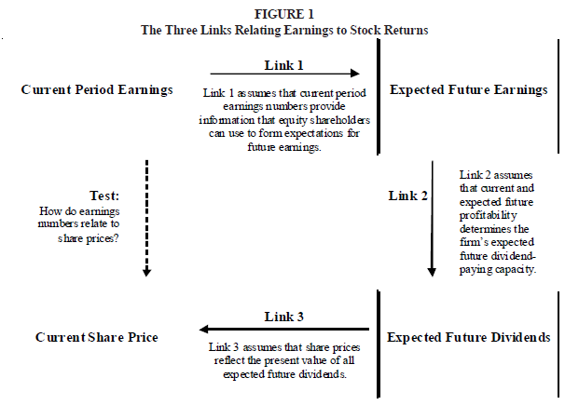

Figure 1: figure is obtained from Nichols and Wahlen (2004), page 6

NW extended the research of Ball and Brown (1968) using data from NYSE, AMEX and NASDAQ listed companies from the period 1988 up to and including 2002. They found a significant relation between the sign of annual earnings changes and the annual stock returns and consequently evidence for the existence of the three-links. Furthermore, they extended their analysis to cash flows from operations and found that the value relevance of earnings is substantially higher than the value relevance of cash flows from operations.

Kormendi and Lipe (1968) developed a model linking earnings persistence to abnormal stock returns and found a significant relationship. NW extended the Kormendi and Lipe (1969) research with a triple-sort approach. Sample firms are sorted into two portfolios. The first portfolio consist of firms with earnings increases and the second portfolio of firms with earnings decreases. Both portfolios are then sorted into ten deciles based on the magnitude of the earnings changes. Finally NW sorted each earning change into ten new deciles based on firm-specific earnings persistence parameters. By applying this triple-sort method NW were able to perform a clean assessment of the implications of earnings persistence for stock returns. NW reperformed the Kormendi and Lipe (1987) research for the same sample as used for the update of the Ball and Brown (1968) research. Their results show that the applied triple-sort method successfully controls for the magnitude of the earnings changes and the actual differences in the stock returns are attributable to the differences in the earnings persistence. With these results strong empirical evidence has been obtained supporting link 1 in the three-link framework.

NW further provided empirical evidence relating to earnings announcements. Since the research question of this thesis relates to the measurement perspective and not to the information perspective, the empirical results will not further be presented.

As we learned from the Nichols and Wahlen (2004) research, earnings significantly relate to stock returns and earnings persistence is significantly related to abnormal returns.

## 3.5 Prior results from value relevance researches

The results of prior value relevance research will be commented in this paragraph. Those results are relevant for defining the research approach and developing the hypotheses in chapter four. There are two specific value relevance researches signaled which relate to the value relevance of accounting numbers during a financial crisis. These researches will be presented separately in paragraph 3.6. and the other researches will be presented in a chronological order.

### 3.5.1 Hayn (1995): The information content of losses

The first research to be presented is a research by Hayn (1995) [hereafter Hayn] regarding the information content of losses. Hayn referred to the article of Lev (1989) in which the low quality of reported earnings is mentioned as one of the reasons for the weak link between the stock numbers and the reported earnings numbers. According to Hayn, the low quality of reported earnings can be explained by the shareholders liquidation option of assets. Due to this option it is unlikely for losses to perpetuate and therefore the relationship between the reported losses and stock numbers is likely to be more weakly. Hayn (1995, page 126) states: “Losses are considered to be temporary since shareholders can always liquidate the firm rather than suffer from indefinite losses”.

Hayn states that it is very likely that the inclusion of loss cases in samples used to determine the return-earnings correlation results in much lower outcomes. For the empirical evidence of this statement Hayn used a sample of 85.919 firm years over the period 1962-1990 which represents 9.752 distinct firms. The sample consists of all available firms in the 1991 Compustat research database. Hayn uses a regression model whose general form is:

 (9)

Rt= the return over the 12-month period commencing with the 4th month after the end of the firms’ fiscal year *t-1*

Xt= the earnings variable or the primary earnings-per-share of year *t* of the change in EPS in that year

*εit=*  the error term

Hayn divided the sample into profitable and loss firm-years and furthermore into groups according to the frequency of reported losses. Hayn further states that if loss cases in the sample have a negative effect on the regression parameters than the next equation should hold:

ERC (R2) losses < ERC (R2) full sample < ERC (R2) profits (10)

The results of the regression analysis show that both the ERC and R2 are considerably depressed due to the inclusion of loss cases. The Beta (which is the ERC) is only 0,95 in the overall sample and 2,62 in the sample with only profit cases. With these results it is evident that the inclusion of loss cases in a sample could considerably contribute to changes in the earnings/price ratio. Hayn further found evidence that only the liquidation option explains the low information content of losses. Other explanations are mean reversal, firm risk, transitory components in reported losses, or conservatism in accounting. No evidence was found for these explanations and consequently the results will not be presented further.

In conclusion, Hayn found significant evidence that the inclusion of loss cases results in a lower relationship between reported earnings numbers and stock returns. Consequently it is of great importance to consider the distribution of loss cases between the different firm years for the statistical analysis.

The next article to be presented is the article of Amir and Lev (1996) considering the effects of non-accounting information on the value relevance of financial statement information.

### 3.5.2 Amir and Lev (1996): Value relevance of non-financial information

The second paper which is relevant to discuss is the research by Amir and Lev (1996) [hereafter: AL]. AL found that financial statement information of independent cellular companies (on a stand-alone basis) is largely irrelevant for security valuation. There are several explanations for these findings. First of all, telecom companies create significant market values by production and investment activities which in their turn are not fully recognized in financial statement information. For instance, brand development and customer-base creation are unlikely to be recognized in the balance sheet but instead are likely to be fully expensed at the moment they occur. Since the market tends to recognize these investments as triggers for large positive cash flows in the future and the accounting numbers don’t, there seems to be a lower relationship between the financial statement information of cellular companies and market values compared to regular companies.

AL based their evidence on conventional methods of regressing stock prices and return to relevant financial statement variables as earnings or book values. These methods are consistent with the methods described by Nichols and Wahlen (2004) and Ohlson (1995) and are relevant considering the measurement perspective of this thesis. For their analysis the quarterly financial information of a sample of 14 independent and listed cellular companies was used over the period 1984-1993. With the empirical results AL seeks to answer the following questions (AL, page 4):

1. “What is the value-relevance of reported financial information of fast-changing, science-based companies? While earnings and book values of such companies are typically depressed due to excessive investments expensing, do they still provide relevant (predictive) information for asset valuation?
2. What is the incremental value-relevance of *nonfinancial* information (e.g., customer penetration rate of cellular companies) over that of financial information?”

AL uses a standard regression to determine the value relevance of the reported financial statement information and developed separate models for both the earnings and book values:

--> Earnings model (11)

--> Book value model, where (12)

Rjt= cumulative, market-adjusted return of firm *j* over three alternative periods (a two-day window around quarter *t* earnings announcement, a seven-day window centered on the quarterly earnings announcement, and a three-month window starting with the beginning of the third month of quarter *t* and ending two months following it)

Pjt= stock price of firm *j* at the end of the second month following quarter *t*

Ejt­, ΔEjt=quarter *t* earnings per share and the change in EPS respectively

BVjt= book value per share of firm *j* at end of quarter *t*

The results show that the financial statement information is largely irrelevant for equity valuation for the selected companies on a stand-alone-basis. AL further investigates the relevance of the financial statement information after correcting the accounting variables for excessive expensing of intangibles and found that some of these variables do contribute to the explanation of stock prices. In addition, AL argues that the results are likely to have implications for other science-based, high-growth sectors as well. As a result, the AL research has implications for this thesis as well. It might be necessary to correct for, or exclude technology firms in the research samples as the value relevance might be affected by differences in the populations’ composition rather than the differences in the sample periods.

In the next paragraph one of the largest value relevance researches performed is presented. The research of Collins, Maydew and Weiss (1997) not only provides relevant insights in the value relevance of financial statement information over a long period of time but also provides methods to correct for the inclusion of technology firms and loss reporting firms.

### 3.5.3 Implications from the Collins, Maydew and Weiss (1997) research paper

As signaled before, the inclusion of high-technology firms and/or loss reporting firms is likely to result in a dampened earnings/price ratio and consequently lower value relevance of the published financial statements. The results of Hayn (1995) and Amir and Lev (1996) are considered by Collins, Maydew and Weiss (1997) [hereafter CM&W] in their research on the changes in the value-relevance of earnings and book values. In addition, CM&W considered the increasing frequency of one-time items and changes in average firm size. Moreover, CM&W (page 40) state: “many claim that the shift from an industrialized economy to a high-tech, service-oriented economy has rendered traditional financial statements less relevant for assessing shareholder value”. These claims are consistent with the results of Amir and Lev (1996). CM&W also state that the same factors contributing to a decline in the value-relevance of earnings are likely to contribute to an increase in the value-relevance of book values. According to CM&W prior research on the value-relevance of book values and earnings signaled a shift from value relevance of earnings to book values, mainly due to negative earnings and non-recurring items (which are in conformity with the findings of Hayn). CM&W (page 40) state that there are two common explanations for these findings:

1. “Book values serve as a better proxy for future earnings when current earnings contain large transitory components, and
2. Book value serves as a proxy for the firm’s abandonment option.”

In response to previous findings CM&W investigated the value-relevance of book values and earnings by using the Ohlson (1995) framework. In addition, CM&W decomposed the combined value relevance of earnings and book values into three separate components:

1. The incremental explanatory power of earnings
2. The incremental explanatory power of book values
3. The explanatory power common to both earnings and book values

Decomposing the incremental value relevance of book values and earnings provided CM&W the opportunity to investigate which factors contribute to the shift in value relevance.

The basic model which is used by CM&W is:

****, where (13)

Pit= the price of a share of firm *i* three months after fiscal year-end *t*

Eit= the earnings per share of firm *i* during the year *t*

BVit= the book value pershare of firm *i* at the end of year *t*

εit= all other value relevant information of firm *i* of year *t* orthogonal to earnings and book values

The further decomposition of the model to determine the incremental value relevance of book values and earnings results in the next models:

****, and

****, where the variables are the same as for equation (13)

The three models provide three coefficients of determination from which the incremental explanatory power of book values, the incremental explanatory power of earnings and the incremental explanatory power of the common factors could be determined.

CM&W denote the coefficients of determination as:, , and respectively. Considering these coefficients the incremental explanatory powers can be written as:

Incremental explanatory power of earnings: - =  (14)

Incremental explanatory power of book values: -=  (15)

Explanatory power common to both earnings and book values: - - =  (16)

The results of the regression analysis show that the combined value-relevance of earnings and book values did not decline over the sample period. In addition, the results show that the incremental value-relevance of reported earnings declined over the sample period while the incremental value-relevance of the reported book values increased over the sample period. CM&W did not only examine whether the value relevance of book values and earnings declined but also examined why the relationship may have changed. To examine the changes in the value-relevance over time, a regression on a time-trend variable has been performed.

The coefficients from the three equations are regressed on a time-trend variable:

, where (17)

TIMEt= corresponding to the years 1953-1999

To identify possible explanations for the changes in value relevance CM&W divided the population into separate portfolios relating to the signaled explanations for changes in the value relevance of accounting numbers (non-recurring items, loss cases, firm size, technology-based firms). For these factors independent variables are added to the time-trend regression. Including these proxies result in the next model:

, where (18)

INT= the percentage of firms in intangible-intensive industries

ONEt= the mean absolute value of one-time items as a percent of net income of all firms in year *t*

LOSS= the percentage of firms in year *t* that have negative net income

SIZE= the natural log of the average inflation-adjusted market value of equity of sample firms in year *t*

The results of the time regression show that the factor TIME becomes insignificant in explaining the changes in the value-relevance of accounting numbers over the sample period when the additional proxies are included in the model. In addition, the results show that the different proxies are all significant in explaining variation in at least one of the models. The regressions of the different proxies show the following results:

|  |  |  |  |
| --- | --- | --- | --- |
| Dependent variable | Combined explanatory power | Incremental explanatory power of book values | Incremental explanatory power of earnings |
| TIME | Insignificant, t=0.116 | Marginally significant, t=-1.839 | Insignificant, t=-0.697 |
| INT | Insignificant, t=-0.190 | Significant, t=2.505 | Insignificant, t=-0.903 |
| ONE | Significant, t=-3.541 | Significant, t=2.378 | Significant, t=-3.033 |
| LOSS | Significant, t=2.846 | Insignificant, t=1.403 | Insignificant, t=0.271 |
| SIZE | Significant, t=-3.653 | Insignificant, t=1.480 | Significant, t=2.779 |

CM&W (page 65) conclude that “much of the shift in value-relevance from earnings to book values can be explained by the increasing significance of one-time items, the increased frequency of negative earnings, and changes in firm size and intangible intensity across time”. This conclusion is relevant for the research design since the sample period during the crisis is likely to consist of a higher proportion of loss-reporting firms. In addition, it could be relevant to observe the distribution of one-time items in the sample periods.

### 3.5.4 Francis and Schipper (1999): Another approach to value relevance research

The fourth paper signaled for the literature review on value relevance researches is the research of Francis and Schipper (1999) [hereafter: FS]. At the time that the research is performed there was a common concern regarding a possible decline in the value relevance of published accounting numbers. FS main goal is to contribute to the discussion about whether financial statements lost their value relevance and address the empirical implications of a possible decline.

FS define two measures for the relevancy of financial statement information. The first measure defines relevance as the total return that could be earned from foreknowledge of published financial statements. The second measure defines relevance as the ability of earnings to explain annual market-adjusted returns and the ability of earnings and book values of assets and liabilities to explain equity value.

The first measure is considered less important for this thesis since the main perspective of this thesis is the measurement perspective of useful information. However, for the reader’s interest both the results will be provided. FS found evidence for a decline in both measures for broad samples of exchange-listed and NASDAQ firms. The research period covered in their research is the period 1952-1994.

FS explains that there were two common approaches to measuring value relevance, portfolio returns test and explained variation tests. The test applied by FS is the portfolio returns test which is very similar to the Ball and Brown (1968) approach to value relevance. With the portfolio return test FS seek to collect empirical evidence to answer the question (FS: page 320): “Would investments based on financial statement information earn progressively less over time?”

FS expect a decline in the ability of published financial statements to explain cross-sectional variation in security returns and expect a decline in the ability of balance sheet information to predict equity valuation IF the actual value relevance of financial statement information has declined. The results of both the portfolio returns test and the explained variation test show a decline in the value relevance of earnings and an increase in the value relevance of balance sheet information. These findings are consistent with the other signaled researches in this chapter and therefore the methods used by FS do not provide better results considering the measurement perspective.

## 

## 3.7 The information content of published financial statements during financially unstable times

Two researches regarding the value relevance of reported book values, reported earnings and reported cash flows are presented in this paragraph. The papers from Graham, King & Bailes (2000), and Ho, Liu & Sohn (2012) are relevant for the development of the hypotheses and to determine the usefulness of the Ohlson model for the objective of the study. The value relevance of book values, earnings, and cash flows were investigated during the Asian financial crisis in 1997 in Thailand and South-Korea. The results support the usefulness of the Ohlson model and the expectations as presented in the introduction in chapter one.

### 3.7.1 Graham, King and Bailes: The Value Relevance of Accounting Information during a Financial Crisis: Thailand and the 1997 Decline in the Value of the Baht

Graham, King and Bailes (2000) [hereafter: GKB] investigated the value relevance of accounting information during the crisis in Thailand over the period 1992-1998. After a period of fast growth the Thai market collapsed in 1997 after the decision of the Bank of Thailand to allow the Baht to float free on the international currency markets. GKB did not have the intend to investigate possible other reasons for a change in value relevance than the crisis, however, GKB noticed that the fluctuation of the Thai Baht and the recognition of foreign exchange losses may have affected the value relevance of Thai financial statement information. GKB defines value relevance as the explanatory power of accounting information with respect to security prices and uses both the residual earnings model from Beaver (1968) and a similar method as CM&W to determine the (incremental) value relevance of book values and earnings.

The residual earnings model used by GKB is:

, where (19)

Vt= value of the firm at time t

bt= sum of net book value at time t

xa= discounted expected future abnormal earnings

GKB define the abnormal earnings as earnings exceeding the required return on equity capital.

To determine the relative and incremental value relevance of book values and earnings GKB used the next models:

, and (20)

, where (21)

MVPSit+2 = price per share in baht for firm i at balance sheet date t plus two months,

BVPSit = book value per share in baht for firm i at balance sheet date t,

EPSit = quarterly earnings per share in baht for firm i for period t, and

ŋ1 … ŋ28 = represent indicator variables for the industries in the sample.

For the combined value relevance of book values and earnings GKB uses:

, where (22)

the parameters are the same as in equation (20) and in equation (21).

To calculate the incremental value relevance of book values over earnings or vice versa GKB applied the same method as CM&W. The R2 from regression (1), regression (2), and regression (3) are used as measures of relative value relevance.

The total sample consists of 8.166 firm-quarter observations from the first quarter of 1992 through the first quarter of 1998. The firm observations are presented per quarter and divided in relative value relevance of book values and earnings, incremental value relevance of book values, incremental value relevance of earnings and combined value relevance. The next results were found by GKB:

|  |  |  |
| --- | --- | --- |
| Coefficient |  | Result |
| BVPS (relative) |  | Positive overall and for each quarter and greater than one in 21 of the 25 quarters |
| EPS (relative) |  | Positive and significant overall and in 23 of the 25 quarters |
| BVPS and EPS (relative) |  | Quarterly coefficients declined over time, implicating a decline in value relevance |
| BVPS (incremental) |  | Greater than the incremental value relevance of earnings and increasing around the crisis |
| EPS (incremental) |  | Lower than the incremental value relevance of earnings and further decreasing around the financial crisis |
| BVPS and EPS (common) |  | Greater than the incremental value relevance of earnings or book values and decreasing around the financial crisis |

GKB further examined the significance of the decline in incremental value relevance of earnings, the incremental value relevance of book values and the common explanatory power of both book values and earnings. GKB uses the Chow (1960) tests to test for differences in the explanatory powers. The results of the Chow tests shows significant declines in the value relevance of book values, the value relevance of earnings and the value relevance of both earnings and book values. In addition, GKB reperformed the Chow tests excluding negative (core) earnings in the sample. The results are less significant as the first test but support the conclusion that the value relevance indeed declined around the crisis.

The results of GKB are quite interesting considering the fact that IFRS based financial statements tend to recognize losses directly since fair value is the common ground for valuation purposes. Since the recognition of losses influences the earnings volatility it is expected that the incremental value relevance of earnings will also decline during a financial crisis when reporting under IFRS. Refer also to the theoretical background on value relevance and the predictive nature of earnings for future e dividends and hence firm value.

### 3.7.2 Ho, Liu & Sik (2012): The value relevance of accounting information around the 1997 Asian financial crisis – the case of South Korea

Ho, Liu & Sik (2012) [hereafter HLS] performed a research regarding the value relevance of book values, earnings, and cash flows of Korean firms during the 1997 financial crisis in Asia. The study of HLS is motivated by claims in the value relevance literature that the price-earnings relationship varies across observations. This claim is supported by several studies (including CM&W, Hayn (1995)). Furthermore, the HLS research is motivated by the 1997 Asian crisis, which is the same research period as in GKB.

HLS performed separate regressions on the stock prices three months after the fiscal year-end against earnings, book values and cash flows from operations.

, and (23)

, and (24)

, where (25)

Pjt = the price per share of firm j three months after fiscal year-end t

EARNjt = the earnings before extraordinary items per share of firm j during the year t

BOOKjt = the book value of equity per share of firm j at the end of year t

CASHit = the cash flows per share of firm j during the year t

In addition, HLS applied the Ohlson model to determine the incremental value relevance of book values over earnings and vice versa. This method is applied in a large share of value relevance researches (including CM&W, GKB) and consequently only the model is presented.

The model is stated as follows:

, where (26)

the symbols are similar as for equation (23) and (24)

Contrary to the models applied by CM&W and GKB, HLS included cash flows from operations in their models as well. This is interesting since none of the before signaled researches provided evidence for the possibility that cash flows can be applied as substitute of earnings for valuation purposes. According to HLS most of the earlier performed studies regarding the value relevance of cash flows from operations did not find significant results for the incremental value relevance of cash flows from operations over earnings. HLS developed the next model to determine the incremental value relevance of cash flows from operations over earnings:

, where (27)

the symbols are similar as for equation (23) and (24)

The final model of HLS includes all signaled independent variables and is written as:

, where (28)

the symbols are similar as for equation (23) and (24)

The incremental explanatory power of the different variables is determined in the same manner as by CM&W and consequently not further explained. In addition, HLS introduce a new and extended model which is used to examine the changes on each accounting variable during the financial crisis. The approach from HLS differs from the approach of CM&W and GKB and will be further explained.

HLS combined the coefficient of earnings, book values and cash flows from the pre-crisis period and the in-crisis period into one regression model. HLS created multiple combinations of the valuation coefficient tests. These combinations are similar to equations (26), (27), and (28) and consequently only the model with all coefficients is presented. The model states: (29)

where Dt = 0 for the pre-crisis period and Dt = 1 for the in-crisis period

The accounting data for the statistical analysis has been obtained from Korea Investors Service Inc. (credit rating company) and the security data is obtained from the Korea Stock Exchange. The total sample consists of 429 firms over the period 1995-1998.

HLS found that the coefficient on book values were positive and significant in al years. The coefficient of earnings was positive and significant in all years except 1997 (negative and significant at the o.06 level). Finally, the coefficient of cash flows was positive and significant in all years. In addition, HLS found that the explanatory power of earnings was considerably lower in the in-crisis period, which is in line with their expectations. The explanatory power of book values decreased during the in-crisis period but is higher than the explanatory power of earnings in each sample year. The explanatory power of cash flows increased in the in-crisis period which, according to HLS, assumes that cash flows become more value relevant during a crisis. The test results for the incremental explanatory power of earnings over book values and/or cash flows were all in line with the expectations. The incremental explanatory power of earnings decreased in the in-crisis period and the incremental explanatory power of book values and cash flows increased.

The results on the coefficient tests show that the valuation coefficients of earnings decreased during the in-crisis period. The decrease in the earnings coefficient is, contrary to the expectation, not substituted by an increase in the valuation coefficients of book values. In addition, HLS found that the coefficient of cash flows is positive but not significant at any conventional level in the earnings and cash flow model. In the combined model (earnings, cash flows and book values) the cash flows coefficient is positive and significant at the 0.06 level.

HLS tested the robustness of their results by developing multiple portfolio combinations in their tests. The first portfolio test excludes all loss reporting firms from the sample to control for the effect of negative earnings. HLS found that the results of the coefficient test hold for the sample with only positive reported earnings. The second portfolio distinguishes firms with high financial leverage from those with low financial leverage. Also in these both portfolios are the results on the earnings and book values coefficients hold. For the high leverage firms the coefficient on cash flows increased to 0.521 and is highly significant at the 0.01 level. Finally, HLS introduced a new model to adjust for the foreign exchange losses which were highly volatile during the Korean financial crisis. The model will not be presented since the volatility of exchange losses are of less importance during the financial crisis in Europe and more specifically the Netherlands. After controlling for foreign exchange losses the earlier results still hold.

As signaled by HLS the (incremental) explanatory power of earnings and book values decreased during the financial crisis while the explanatory power of cash flows from operations increased during the financial crisis for most portfolios. The decrease in value relevance of earnings is in line with the results of GKB. The decrease in value relevance of reported book values however is not supported by the results of GKB.

## 3.8 Summary

As we learned from the Nichols and Wahlen (2004) research, earnings significantly relate to stock returns and earnings persistence is significantly related to abnormal returns. In addition, we learned that Lev (1989) considered the link between earnings and stock returns as weak and therefore less important for firm valuation purposes. As a reaction on the Lev (1989) research Ohlson (1995) and Feltham-Ohlson (1996) developed valuation models considering not only published earnings but also the book value of assets. The Ohlson and Feltham-Ohlson models are accepted as landmark studies and used by a large share of authors. Furthermore, empirical evidence is presented considering the effects of loss cases, the inclusion of high-intangible oriented firms, firm sizes and non-recurring items. These effects are all addressed by CMW and were significant in at least one of the valuation models. The intangible-intensity was not significant in the combined model and consequently is considered of less importance. Two researches were signaled which described the effects of a financial crisis on the value relevance of accounting numbers. The results of these researches both show a decrease in value relevance of earnings and combined explanatory power of book values and earnings. A third variable (cash flows from operations) was introduced and seems to gain importance during a financial crisis. The results of these studies will be used in the next chapter where the hypotheses are developed.

# 4. Research Design

## 4.1 Introduction

As basis for the research design the knowledge obtained from the theoretical background presented in chapter two and the signaled prior research in chapter three will be applied. Before the research approach is further constructed a brief overview of the available research methods will be presented in paragraph two. The research methodology is presented in paragraph three followed by the developed hypotheses in paragraph four. The selected models to measure the value relevance are presented in paragraph five and the relevant control variables as signaled in the presentation of prior research in chapter three paragraph six. In the final paragraph the method for data collection will be presented including a further definition of the sample periods.

## 4.1 Types of research

Multiple types of research and research approaches exist. The aim of this paragraph is to signal the most appropriate research approach for this thesis. First of all, the research question in this thesis should be answered based on empirical evidence. The types of empirical research are presented in the next section.

### 4.1.1 Empirical research

Empirical evidence refers to observations which contain either relevant quantitative or relevant qualitative characteristics. The empirical evidence can be collected on multiple ways and is stored in datasets for further analysis. Based on the educational book of Creswell (1994) two types of empirical research exist. The type of empirical research relates to the type of observations used in the research. The first type of empirical research is called quantitative research which focuses on the relationship between for instance share prices and reported earnings or the length of a person and his nationality. The data for quantitative research can be collected with queries on existent data, direct observations, and or experiments. In the field of accounting research the data for quantitative research is usually available in large research databases as Thomson One Banker and Compustat.

The second type of empirical research is called qualitative research and is considered to be a more soft type of research. Qualitative research focuses on the behavior of people and is mostly applied in the field of social cultural research. The data for qualitative research can be collected with questionnaires, interviews, or direct observations. In the field of accounting research qualitative research can be applied to gain an understanding of the behavior of for instance the principal and the agent. Since the research topic of this thesis is to provide empirical evidence regarding the relationship between the share prices and accounting information this research is classified as a quantitative empirical research. In the next section the different types of quantitative empirical research are presented.

### 4.1.2 Types of quantitative empirical research

Based on the educational book of Creswell (1994) three types of quantitative empirical research exist. The first type is called ‘the survey methodology’ and is described by Creswell (1994, page 17) as: “A survey design provides a quantitative or numeric description of trends, attitudes, or opinions of a population by studying a sample of that population. From sample results, the researcher generalizes or makes claims about the population.” Since it is not the purpose of this thesis to obtain an understanding of a certain population, a survey study is not considered a suitable methodology.

The second type of quantitative research is labeled as experiments. The difference between an experiment and a survey is described by Creswell (1994, page 17) as: “In an experiment, investigators may also identify a sample and generalize to a population; however, the basic intent of an experiment is to test the impact of a treatment (or an intervention) on an outcome, controlling for all other factors that might influence that outcome.”

The third type of quantitative research is called ‘desk research’. In a desk research a researcher uses data which is collected or produced by other researchers. The name ‘desk research’ refers to the fact that no direct contact with the research object will occur. To obtain relevant information in a desk research three common methods exist. The first method is to perform a literature review on educational books and prior research (preferably published in a high-standard journal). The second method is to collect data from secondary data sources. The most common secondary data in the field of accounting research are the earlier signaled research databases containing historical financial statement information. The last type of data consists of official statistical databases. An example of such a database is ‘StatLine’ from the Central Agency of Statistics (abbreviated as CBS).

In this thesis the method of ‘desk research’ will be applied. A literature review has been executed in chapter two (conceptual background) and chapter three (prior research) and an empirical research is developed in the remainder of this chapter. Since the purpose of this thesis is to describe the possible effects of the financial crisis on the value relevance of accounting information it is relevant to include as many cases as possible in the research sample. Concerning the statistical analysis it is the most efficient and effective feasibility to collect secondary data from available resources. In the next paragraph the research methodology is further described.

## 4.2 Research methodology

The research question in this thesis relates to the value relevance of accounting numbers during a financial crisis. As signaled in chapter two, the value relevance of accounting numbers is defined as the relationship of the share prices (or stock returns) and the reported accounting numbers (or abnormal earnings). This type of research is positive accounting research and more specifically classifies as capital market accounting research. To answer the research question a relevant set of hypotheses are developed and presented in paragraph 4.3. The hypotheses are tested with a quantitative empirical approach which is based on the signaled prior literature in chapter three. The Ohlson models are the most appropriate approach to determine whether changes in value relevance occurred during the financial crisis (CM&W, HLS and GKB presented suitable approaches involving the Ohlson models). The selection of the appropriate models is further described in paragraph 4.4.

To determine whether the value relevance declined during the financial crisis two sample periods will be compared with each other. Since not only the financial crisis could result in a decline or increase of the value relevance but also other factors can change over time relevant, control variables are introduced in paragraph 4.5.

## 4.3 Hypotheses

To obtain empirical evidence to answer the research question it is necessary to develop a set of hypotheses. The hypotheses are based on prior research and on the developed expectations. Since it is not only the purpose of this thesis to provide evidence whether the value relevance of financial statement information declined during the financial crisis but also to try to identify other effects (for instance a change in the incremental explanatory power of book values over earnings or vice versa) multiple hypotheses are formulated.

### 4.3.1 The explanatory power of reported earnings and book values per share

The first set of hypotheses is based on the results of GKB and HLS. Both GKB and HLS found significant empirical evidence that the value relevance of financial statement information declined during the crisis. In addition, GKB found that the decrease in the explanatory power of earnings was partially replaced by an increase in the explanatory power of book values, this result however is not supported by the result of HLS. Since the book values of equity are considered to be a reliable proxy for the abandonment option an increase of the explanatory power of the book values is expected. The explanatory power of earnings is expected to decrease due to the fact that the earnings persistence in financially unstable times is likely to decrease. Following Nichols and Wahlen a decrease in earnings persistence will result in a lower explanatory power. The next hypotheses will be tested:

|  |  |
| --- | --- |
| Null hypothesis | Description |
| 1 | Before the financial crisis no positive relationship exists between the reported earnings per share and the share price |
| 2 | During the financial crisis no positive relationship exists between the reported earnings per share and the share price |
| 3 | Before the financial crisis no positive relationship exists between the reported book value per share and the share price |
| 4 | During the financial crisis no positive relationship exists between the reported book value per share and the share price |
| 5 | Before the financial crisis in the combined model no positive relationship exists between the reported book values and the earnings per share |
| 6 | During the financial crisis in the combined model no positive relationship exists between the reported book values and the earnings per share |
| 7 | During the financial crisis the explanatory power of the reported earnings per share model did not decline |
| 8 | During the financial crisis the explanatory power of the reported book value per share model did not increase |
| 9 | During the financial crisis the explanatory power of the combined model did not decline |

### 4.3.2 The incremental explanatory power of reported earnings and book values per share

The hypotheses presented in paragraph 4.3.1 describe the effects of the ongoing financial crisis on the value relevance of the published accounting numbers. Since it is not the only objective of this thesis to present empirical evidence on the value relevance of accounting numbers but also to provide evidence for other effects of the financial crisis, an additional set of hypotheses regarding the incremental value relevance of the reported earnings per share over the value relevance of the reported book value per share and vice versa will be tested. The second set of hypotheses is:

|  |  |
| --- | --- |
| Null hypothesis | Description |
| 10 | During the financial crisis the incremental value relevance of the earnings per share did not decline |
| 11 | During the financial crisis the incremental value relevance of the book values per share did not increase |
| 12 | During the financial crisis the incremental value relevance of the common factor of book values per share and earnings per share did not decline |

### 4.3.3 Possible biases from differences in sample composition

As signaled in the value relevance literature in chapter three multiple explanations exist for a possible decline in the value relevance of published accounting information. To be able to provide a reliable answer on the research question it is necessary to correct for the identified effects of other factors in the empirical models. For instance, the magnitude of loss cases (Hayn & CM&W) is likely to increase during the crisis and consequently the explanatory power of the published earnings is expected to decrease. In addition, the size of the firms included in the sample could have an impact on the value relevance as well since large firms tend to report greater earnings and are generally less sensitive to the abandonment option (CM&W). Other factors which have a negative effect on the earnings persistence and consequently the explanatory power of earnings are reported one-time items. Examples of one-time items are impairment losses, losses on the sales of assets, restructuring costs, and charges for discontinued operations. Since it is likely that these types of one-time items increased during the financial crisis, the results should be controlled for these effects. The fourth and the final signaled possible bias is the intangible intensity of the selected samples (AL and CM&W). Since the sample consists of two consecutive periods in a relatively small time span (8 years), and in addition no changes exists in the reporting requirement between the periods it is not necessary to control for this last factor. The last set of hypotheses is developed to correct for the relevant signaled biases and state:

|  |  |
| --- | --- |
| Null hypothesis | Description |
| 13 | During the financial crisis and after the exclusion of loss cases the combined value relevance of book values and earnings did not increase |
| 13 | During the financial crisis and after the exclusion of one-time items the combined value relevance of book values and earnings did not decline |

In the next paragraph a selection of reliable models from prior research will be presented. The models are selected in such manner that empirical evidence can be collected to support or reject the developed null hypotheses.

## 4.4 Models for measuring value relevance

As signaled in chapter three two major classes in the value relevance literature exist. The first class focuses on the earnings – returns relationship and uses the (abnormal) earnings number as the explanatory variable for stock prices. The second class uses valuation models which uses published accounting information as book value per share and the earnings per share as the explanatory variables for the market value per share of a firm. These valuation models are primarily based on the work of Ohlson (1995) and Feltham-Ohlson (1996). As signaled in chapter three the Ohlson (1995) framework was a response to the Lev (1989) research in which the usefulness of the published earnings for valuation purposes was challenged. The Ohlson (1995) valuation framework is further used by AL, CMW, GKB, and HLS, who all found a significant relationship between the market value of a firm and the published earnings and book value of the equity in their developed valuation models. For the purpose of this thesis the Ohlson (1995) valuation framework is the most effective approach for measuring the value relevance of the published financial statement information. As stated by CM&W the book values of equity are a reliable proxy for the abandonment or the liquidation value of a company and consequently the inclusion of book values of equity in the valuation models are likely to result in a higher explanatory power of the valuation model. Since the abandonment option becomes more important when firms face financial distress, it is obvious that in times of economic uncertainty the valuation framework of Ohlson is likely to result in a higher explanatory power than earnings –returns models. In addition, the signaled researches regarding the value relevance of financial statement information during a financial crisis all use models derived from the Ohlson (1995) framework and proved to provide a reliable basis for comparison between periods. This last observation in addition was proved by CM&W who use the R2 of the regression models in a time regression analysis. The most applied models in the signaled prior research are the Ohlson (1995) valuation models, from which the results showed strong and significant explanatory powers. As results of this observation in this thesis the value relevance of financial statement information will be measured using the basic valuation model which states:

, where (30)

P­it = the price of a share of firm i three months after fiscal year-end t

Eit = the earnings per share of firm i during the year t

BVit = the book value per share of firm i at the end of year t

εit = all other value relevant information of firm i of year t

To measure the value relevance of reported earnings and the reported book values on a stand-alone-basis the next models are selected:

, and (31)

, where the symbols are the same as under (30) (32)

These models should be able to provide evidence to support hypotheses 1-10. For hypotheses 11-13 the same method as applied by CM&W and GKB will be applied. CM&W and GKB measured the incremental value relevance using a decomposition technique which is described by Theil (1971) and results in the next three equations:

Incremental explanatory power of earnings: - =  (33)

Incremental explanatory power of book values: -=  (34)

Explanatory power common to both earnings and book values: - - = , where (35)

Rt  = the R2 of equation (1)

R­2 = the R2 of equation (2)

R3 = the R2 of equation (3)

In the next paragraph a further description on the research method will be presented. In addition, a description of the relevant control variables will be presented. Also a dummy variable will be introduced which makes it possible to measure the effect of the financial crisis on the explanatory power of the different models.

## 4.5 Control and dummy variables

To determine the effects of the financial crisis on the value relevance of accounting numbers in the Netherlands it is important to create an opportunity to statistically test the differences in explanatory power of the models as presented in paragraph 4.4. It is possible to compare two samples (pre-crisis and during the crisis) and manually calculate the differences in the total explanatory power and the relative explanatory powers of book values and earnings. This method will provide insights in the development of the explanatory powers but will not provide empirical evidence for the significance of the signaled differences. GKB applied another statistical technique to determine the significance of the signaled changes. GKB used the Chow (1960) test which measures the differences in explanatory power as an F-statistic. The higher the value of the F-statistic, the higher the more significant the changes are. For the purpose of this thesis it is necessary to conduct empirical research regarding the differences in explanatory power of the model before and during the crisis. In SPSS (software package for statistical research) it is possible to include a dummy variable in the regression analysis from which the effects are measured in an F-statistic. Consequently, the most effective and efficient method is to develop a dummy variable for the two research periods (pre-crisis and during the crisis). In this research all sample years before the crisis are given the value ‘1’ and all sample years in the crisis period are given the value ‘2’. As presented in paragraph 4.3 the expectation exist that the dummy variable, and thus the crisis, has a significant impact on the value relevance of the accounting numbers.

The inclusion of the dummy variable does not provide enough comfort regarding the actual change in the value relevance of accounting numbers if the factors presented by Hayn (1995) and CM&W are not taken into account. As signaled by CM&W the size of a company has a significant influence on the value relevance of the accounting numbers. To control for the size-effects between the two research periods a control variable is introduced in the model. CM&W used the deflated natural logarithm of the market value of company *i* at year *t* as proxy for firm size. This measure provided significant results and is considered to be a reliable measure for firm size. The natural logarithm to the variable results in a lognormal distribution. A lognormal distribution is preferred since it is very unlikely that additional cases should be excluded from the sample to create a bell-shaped curve in the distribution of the variable (normal distribution). A normal distribution is required for the application of linear regression models.

Two other factors of interest (as presented in paragraph 4.3.3.) are the loss cased and one-time-items. Both these factors tend to influence the earnings persistence and consequently predicting value of current earnings for future earnings. Several methods to correct for these factors were signaled in prior research. CM&W calculated the number of loss reporting firms in year *t* as a percentage of the total number of firms in year *t* and applied this measure in a time-trend-regression. Since no time-trend-regression is applied it is not considered effective to use the measure of CM&W as proxy for the control variable in the model. The method applied by HLS and GKB is more useful for the purpose of this research. By excluding loss reporting firms and firms which reported one-time items from the sample the effects of these cases can be observed. Since it is not the objective of this study to determine the effects of loss cases and/or one-time-items this method will provide reliable evidence. The regression models as presented in paragraph 4.4 will be applied to both samples with loss cased and one-time-items and without loss cases and one-time items.

## 4.6 Multicollinearity and homoscedasticity

If linear regression models are applied the assumption of homoscedasticity in the random variables is of great importance. As part of the statistical analysis the assumption of homoscedasticity of each relevant variable will be tested. Assuming a homoscedastic distribution while in fact it is a heteroscedastic distribution can result in an overestimated Pearsons coefficient.

In addition, the phenomena of multicollinearity between the different variables in the model can result in biased outcomes of the regression analysis. Multicollinearity occurs when two or more variables influence each other. If the method of regression analysis is applied it is a necessity to exclude all variables which interact at unacceptable levels with each other. The existence of multicollinearity between one or more variables in the model will not result in a biased R2 of the regression models but in wrongly calculated coefficients of the separate variables. The different applied models will be tested for Multicollinearity between the variables to assure a reliable outcome of the regression analysis.

## 4.7 Data collection and sample periods

The method and criteria for data collection will be presented in this paragraph. In addition, the sample periods will be defined based on the general accepted and known definition of the European

### 4.7.1 Sample selection

The relevant data to measure the variables in the models will be obtained from the Thomson Financial database. All firms which had a quotation in the first sample year (2005) at the Euronext (Amsterdam) stock exchange will be included in the search query. The data will be extracted from the Thomson Financial using the Thomson ONE Banker-excel add-in. The Thomson One Banker excel add-in provides the opportunity to download all necessary information at once using the option to upload a list of the relevant SEDOL-codes (Stock Exchange Daily Official List which consists of unique security identifiers). The relevant SEDOL-codes for the sample will be derived from the online tool ‘Datastream Navigator’ (tool developed by Thomson Reuters to search for company and stock information). In Datastream Navigator it is possible to include dates (for instance January 2005) in the search query and consequently to obtain a list of SEDOL-codes which contain only companies which had a quotation in 2005 at the Euronext (Amsterdam) stock exchange.

After the data has been collected from Thomson One Banker a first selection of firm’s will be performed. Since the time span of the research period is eight years and it is very likely that events (besides the financial crisis) occurred which influenced the value relevance of accounting numbers. It is relevant to control for these events. By deselecting all firms which do not have a quotation at the Euronext in all sample years, possible effects of other available information for investors are partially mitigated. For instance, a possible delisting, merger or takeover of a firm is likely to influence the market value of the firm and thus result in biases in the model.

The next step for the data selection is to exclude all firms which operate in industries with additional or different laws and regulations which could influence the results of the model. It is considered common knowledge that firms operating in industries which classify as financial should be excluded to control for the biases created by the additional applicable laws and regulations. Not all firms classified as financial are relevant for exclusion, for the sector code (40: Financials) only the industry subsectors (4010: Banks), (4020: Diversified Financials), and (4030: Insurance) have to be excluded. The industry subsector (4040: Real Estate) is not subject to additional laws and regulations. In addition, relatively large firms operating in the commodity sector will be excluded. In the case of the Netherlands only Shell classifies as such firm. In the next paragraph the relevant sample periods will be determined.

### 4.7.2 Sample periods

Since the objective of the study is to observe the effects of the financial crisis on the value relevance of accounting information it is of great importance to define the pre-crisis and crisis period in a reliable manner. The ongoing financial crisis found its origin in the subprime mortgage crisis in the United States of America. In the summer of 2007 some of the largest financial companies recognized the need to devaluate a significant part of their outstanding loans (mostly subprime mortgages which were not fully insured with underlying assets such as real estate). Due to these significant losses on outstanding loans the financial health of banks decreased rapidly and they stopped financing each other loans. As a result the lending capacity of American banks decreased which eventually affected the ‘real’ economy. The crisis grew in September 2008, after one of the largest banks in the United States (Lehman Brothers) filed for bankruptcy. The crisis emerged rapidly around the world affecting most of the western countries. In the European Union the crisis changed from a credit crunch crisis to the so called European Debt Crisis. The starting point of the European Debt Crisis is considered to be the potential bankruptcy of Greece (membership country of the European Union). The European Debt Crisis is still ongoing and an increasing number of countries are facing financial distress.

To determine the sample period the starting period of the financial crisis is determined at the moment the Dutch economic development turned into a recession. The definition of a recession as stated by the CBS (Dutch Statistics Agency) is a decrease in the BNP (Bruto National Product) in two consecutive quarters (source: http://www.cbs.nl/nl-NL/menu/methoden/begrippen/default.htm?conceptid=586, July 10, 2013). According to the numbers in the CBS Statline database there were two consecutive periods of a decrease in the BNP at the beginning of the second quarter of 2008. In the years following there were several periods of economic growth and two more periods of recession. The Dutch economy is still in a recession in the second quarter of 2013 and consequently the period 2008-2012 will be defined as the in-crisis period for the purpose of statistical analysis between the two periods.

## 4.8 Conclusion

In this chapter a reliable research approach is presented together with a set of hypotheses which are relevant to answer the research question. The most applied models in prior research are based on the Ohlson framework and considered to be the most appropriate for this research. In addition, the sample selection method is described and a definition of the research periods is provided. In the next chapter the results of the empirical analysis will be presented.

# 5 Empirical results

## 5.1 Introduction

In this chapter the results of the empirical analysis will be presented. The process for data collection will be described in the second paragraph. In the third paragraph a further selection based on the criteria as presented in the research design in chapter four will be provided, resulting in the final sample for the empirical analysis. The integrity and usefulness of the data for further statistical analysis (regression) will be assessed in paragraph four. In addition paragraph four will include the descriptive statistics of the two different research periods. The results of the regression analysis will be presented in paragraph five. The regression tests are performed again in paragraph six to identify the possible bias created by the inclusion of loss cases. The control variable for firm-size and one-time items will only be included if large differences are identified in the descriptive statistics between the two sample periods. The chapter will end with a summary of results which are the basis for the conclusion in chapter six.

## 5.2 Data collection

The process for data collection consists of several steps and includes the use of multiple sources. The process is described per step to assure the process can be re-performed by other researchers. First of all the criteria for the initial sample selection will be presented. As defined in chapter four all companies which had a stock quotation at the Euronext in 2005 should be included in the sample. Consequently the first step in the data collection process if to obtain a list of all listed companies at the Euronext stock exchange in 2005. The online tool ‘Datastream Navigator’ is used to obtain the relevant list with SEDOL-codes. A search query was used to obtain the relevant list of companies. The search resulted in a list of 99 SEDOL-codes, each code representing a unique company listed at the Euronext stock exchange. Contrary to the expectation the list consists of all companies which had a quotation in at least one of the years in the period 2005-2012. As a result it is necessary to manually correct for firms without a quotation in all years.

The second step in the data collection process is to obtain the relevant data from the Thomson One Financial database. The list as obtained from Datastream Navigator is uploaded on the central server of Thomson One Financial. The excel add-in has the option to select all relevant companies with the use of stock specific identifiers (in this case the SEDOL-codes). After the relevant companies were selected the necessary variables were selected using the search option in the excel add-in. To identify the company and the sector it is operating in, the relevant GICS identifiers were selected. The relevant identifiers are TF.GICS, TF.GICSGROUP, TF.GICSIND, TF.GICSSECTOR, and TF.GCISSUBIND. With these identifiers the sample can be filtered for financials (banks and insurance companies) and relatively large firms operating in the commodities sector. The models used for empirical analysis as developed and presented in chapter four includes four separate variables. The first (and dependent) variable is the stock price of a firm three months after year end. In Thomson Financial the relevant code is TF.PriceClose. This code will return the stock price at the end of the selected period (in this case three months after year-end) and hence can be directly included in SPSS for statistical analysis. The second variable (independent variable) is the company’s earnings per share measured as the reported earnings over the period divided by the average weighted number of outstanding shares to common shareholders. In Thomson Financial this number can be obtained with the code TF.EPSAsReported. Also the earnings per share data as obtained from Thomson Financial can be directly included in SPSS for statistical analysis. The third variable (independent variable) is the book value per share at the end of the year. Also these figures can be directly obtained from Thomson Financial for inclusion in SPSS. The relevant code for the book value per share is TF.BookValuePerShare. In addition two possible biases other than loss reporting firms (which can be identified by the earnings per share variable) were identified. The first is the effect of one-time items on the explanatory power of earnings. The one-time items are available in the Thomson Financial database as well and can be obtained with the code TF.ExtraItemsAndGnLsSaleofAsset. The last necessary variable is the year-end market value of the selected companies. The year-end market value can be obtained with the code TF.YrEndMarketCap. In Thomson Financial it is possible to automatically correct for stock splits and other capital changes, which makes it unnecessary to obtain the adjustment factor for stock splits. The variable for market value will be used to control for possible biases created by the size effect as explained by CM&W. Since the TF.YrEndMarketCap returns the market value in euro’s at the end of year *t* it is necessary to manually correct for the inflation in the research period covered. The deflated year-end market values are manually calculated in the excel spreadsheet. As deflation rate the Consumer Price Index Numbers as calculated by the Dutch Central Agency for Statistics and presented on their website. The next rates are applied:

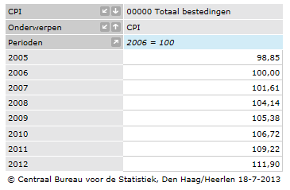

Source: http://statline.cbs.nl, July 18, 2013

Due to the large differences in the deflated market value between the AEX and AScX a lognormal distribution is created using the LN function in Excel. The LN of the deflated market value will be used in SPSS for statistical analysis since the assumption of normality is a requisite for using regression analysis.

## 5.3 Sample selection

The results from the queries in the Thomson One Banker excel add-in are downloaded in the excel spreadsheet. Companies with missing values in at least one of the selected years are manually excluded from the sample. In addition all banks and insurance companies are manually filtered from the sample based on the relevant GICS identifiers as presented in chapter four. Finally relatively large companies (which are likely to bias the results) are excluded. Besides the large financials listed on the AEX only Shell is excluded from the sample.

The initial data set consisted of 97 companies (one SEDOL-code was not recognized) and are presented in Appendix B. After the exclusion of before described cases the sample consists of 53 companies. The excluded companies are double-crossed in Appendix B and consequently can be easily identified. For the remaining 54 companies all necessary data is obtained and included in the SPSS datasheet for further descriptive statistics and analysis. The total number of firm-years observations in SPSS is 432 from which 162 belongs to research period 1 and 270 belongs to research period 2.

For the statistical analysis the SPSS statistical software package version 20 will be used. In SPSS is it possible to identify the outliers from the different variables and exclude those cases from the sample. The further process of identifying and excluding the outliers will be described in the next chapter. In addition the assumption of a normal distribution will be tested for the dependent variable.

## 5.4 Descriptive statistics and statistical inferences

Before the further descriptive statistics are presented the dependent and independent variables are tested for outliers with the use of the boxplot-graph from SPSS. In addition the dependent variable should have a normal distribution if a linear regression model is applied. The normality of the distribution of the dependent variable will be tested for each independent variable separately, using a normal P-P plot in SPSS.

### 5.4.1 Tests for normal distribution, linearity and homoscedastic

To obtain evidence for the assumptions of normality, linearity and homoscedastic the linear regression models were prepared in SPSS together with the PP-plots of the standardized residuals of the regression, the frequency histogram showing the normal distribution and the scatterplot of the standardized residual and standardized predicted value. The first results were not satisfying, the assumptions of normality, linearity and homoscedastic did not hold. The main reason is to be found in a relatively large number of extreme values and outliers. The extreme values should be excluded from the sample to obtain a normal distribution and homoscedastics between the variables. The exclusion of the extreme values is not considered as a weakness for the statistical analysis since the sample size is relatively large compared to the number of variables. The risk of selection biases consequently is considered to be very low.

To identify the outliers and extreme values the option Graphs-Boxplot is selected to create boxplots in which the outliers are visibly marked with an asterisk. Extreme values are defined as values which are five times the standard deviation away from the variable’s mean. All extreme values have to be excluded from the sample since they most likely will affect the reliability of the results of the linear regression analysis. The outliers are defined as values which are three times the standard deviation away from the variable’s mean. These outliers most likely have an informative value and deleting them will results in a selection bias in the sample. Since all variables approaches a normal distribution curve it is not considered necessary to investigate the outliers separately. Since the normal distribution assumption will be tested for the separate regression models the possible negative effects of the outliers will be noticed anyway. After the extreme values are excluded from the sample the total sample consists of 381 cases, consequently 51 cases are excluded from the sample. The results are presented in Appendix C for the dependent and independent variables. The histograms of the different variables all approaches a normal distribution and consequently the assumption of normality for the separate variables hold. In addition the sample sizes for the pre-crisis and in-crisis period are large enough to apply regression analysis. The numbers of pre-crisis and in-crisis cases are 141 and 240 respectively.

In addition the histograms and plots as presented in Appendix D provide enough comfort to accept the assumption of linearity and homoscedastic. The scatterplot shows a steady line with no extreme values (possible outliers). In conclusion the statistical method of regression analysis can be applied to the different variables. In the next section the descriptive statistics of the full sample and the descriptive statistics for the two time periods are presented.

### 5.4.2 Descriptive statistics

The total sample for the empirical analysis consists of 381 firm-year observations. The number of firm-year observations per financial reporting year varies from 46 to 50 over the years and is relatively steady distributed. Since the pre-crisis period consists of only three years compared to five years for the in-crisis period there are considerably more observations for the in-crisis period. Both sample periods consists of enough firm-year observations to apply regression models. Table 1 presents the distribution per financial reporting year and table 2 presents the distribution of firm-year observations between the pre-crisis and in-crisis period.

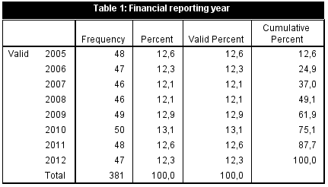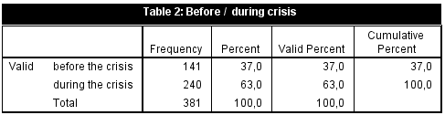

The descriptive statistics as derived from SPSS will be analyzed for the whole research period, the before-crisis period, and the in-crisis period. Since the regression analysis only is applied on these three periods and not per year no further descriptive analytics for the different sample years are presented. The outputs of the descriptive statistics for the three sample periods are presented in table 3, table 4 and table 5 for comparison purposes. In addition the descriptive statistics provide further insight in the relationship between the dependent variable and independent variable. Nonetheless, the regression models should provide the empirical evidence to support the developed hypotheses and expectations.

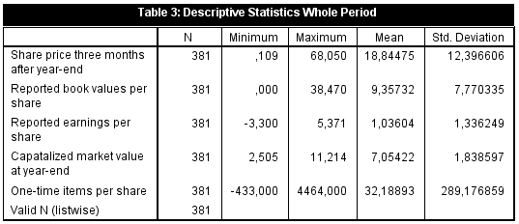

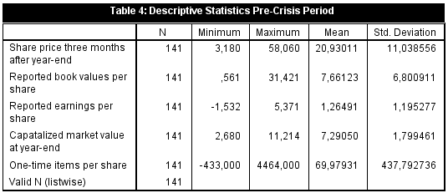

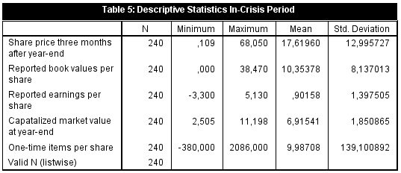

In the total sample the share price varies between 11 eurocent and 68,05 euro with a mean of 18,85 euro and a standard deviation of 12,40. In the pre-crisis period the share price varies between 3,18 euro and 58,06 euro and with a mean of 20,93 euro and a standard deviation of 11,04 . In the in-crisis period the share prices varies between 11 eurocent and 68,05 euro with a mean of 17,62 euro and a standard deviation of 12,99. As expected the share prices were on average lower during the in-crisis period with a higher standard deviation.

The reported book values per share vary between 0 euro and 38,47 euro with a mean of 7,66 euro in the pre-crisis period and 10,35 euro in the in-crisis period. This observation is remarkable since the share prices were on average higher during the financial crisis. It seems that the earnings are stronger related to the share prices than the book values are. The earnings show indeed a similar pattern. The earnings per share vary between minus 3,30 euro and 5,37 euro with a mean of 1,26 euro in the pre-crisis period and a mean of 90 eurocent in the in-crisis period. In the pre-crisis period the earnings per share are higher, the book value per share is lower resulting in an on average higher share price. For the regression analysis the expectation exist that the earnings are much more relevant for valuation in the pre-crisis period than during the in-crisis period.

The control variable capitalized market value (measured as the LN of the actual deflated market value) varies between 2,505 and 11,214 with an average value of 7,29 in the pre-crisis period and 6,92 for the in-crisis period. This pattern is similar to the pattern of the share prices and in line with the expectation since the market value is determined as the share prices times the number of common outstanding shares. Since the differences are relatively low between the two sample periods an independent T-test is performed to determine whether the control variable is relevant for the regression models. The Levene’s test for equality of variances shows an F-score of 0,365 and a p-value of 0,546 and consequently equal variances is assumed. Furthermore the t-test for equality of means shows a t-score of 1,930 and is significant at the 0,10 level (p-value is 0,054). It seems irrelevant for the purpose of this thesis to control for firm size between the two sample periods and consequently the control variable will not be included in the model.

The amount of one-time items per share varies between minus 43 eurocent and 4,46 euro with a mean of 7 eurocent in the pre-crisis period and a mean of 0,1 eurocent in the in-crisis period. As signaled by CM&W the number and amount of one-time items are likely to influence the value relevance of accounting numbers. As we can see the average amount of one-time items is higher in the pre-crisis period and consequently the results of the regression analysis in the in-crisis period could be biased by the higher number of reported one-time items. It seems that it is indeed necessary to perform the regression analysis with and without firms publishing one-time items.

For the number of loss reporting firms in the two time-periods a separate selection is made in SPSS. Cases are selected with the criterion that the reported earnings per share are lower than zero. The results are presented in table 6 and table 7 hereunder. The results show that there are 10 loss-reporting firms in the pre-crisis period compared to 44 loss-reporting firms in the in-crisis period. Since the sample for the in-crisis period is larger than the sample of the pre-crisis period the relative number of loss cases is calculated. The percentage of loss cases in the pre-crisis period is 7% compared to 18,3% in the in-crisis period. In addition the mean of the loss-reporting firms in the pre-crisis period is only minus 57 cent compared to 1,09 euro in the in-crisis period. It seems that also the number and magnitude of reported losses could have a negative impact on the outcomes of the regression analysis.



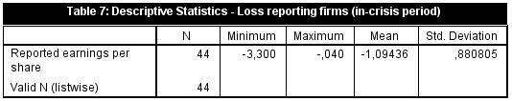

As signaled before, the variables show the expected patterns and the independent variables seem to have linear relationships with the dependent variable. The number of one-time-items and number of loss cases varies heavily between the two research periods and consequently it is necessary to test the robustness of the regression analysis by creating separate samples (with and without loss cases and one-time items).

## 5.5 Regression results

As signaled in paragraph 5.4.1 the statistical method of regression analysis can be applied. In the remainder of this paragraph the results of the regression will be presented and discussed. Eventually the results should provide empirical evidence to accept or reject the hypotheses as developed in chapter three. The results will be presented separately for each period and for groups with or without loss cases and groups with or without reported one-time items.

### 5.5.1 Regression results of the pre-crisis period

The results of the regression models as developed in chapter four are presented hereunder. An overview of all the results will be presented in paragraph 5.5.3 together with the calculated incremental value relevance of earnings over that of book values and vice versa. Based on the summary of the results the hypotheses

**Table 8: Regression results model 30 -->** 

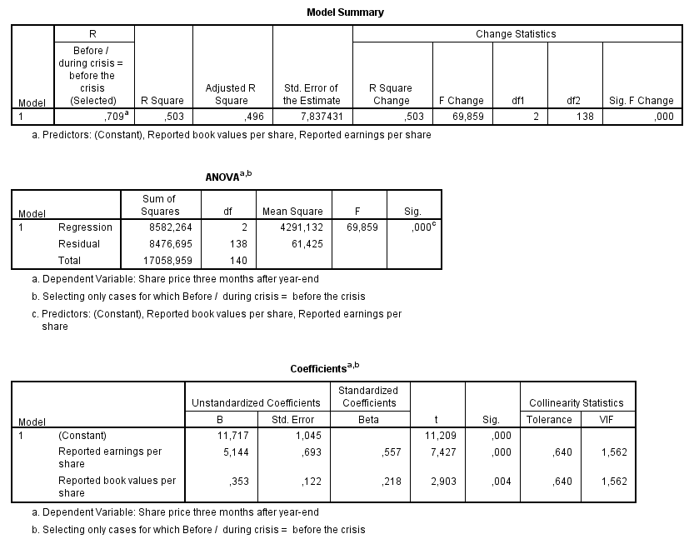

The results of the regression of the combined model show an adjusted R-square of 0,503 that implies that 50,3% of the variation in the share prices can be predicted by the model. The F-value of 69,859 and the corresponding p-value of 0,000 imply that the results are significant at any convenient level. In addition the model is tested for multicollinearity using the collinearity diagnostics in SPSS. The results shows a VIF score of 1,562 which indicate that the predictors may be moderately correlated. The results are not of such order that the estimates on the coefficients might be poor. Consequently the coefficient of 0,557 for the reported earnings per share and 0,218 for the reported book value are considered reliable estimates. Both the coefficient of reported earnings per share and the coefficient on the reported book value per share are positive and highly significant at the 0,01 level. The before presented results are in line with the results of HLS, GKB and CM&W and in line with the developed expectation.

The results on the earnings per share model (31) will be presented next.

**Table 9: Regression results model 31 --> **

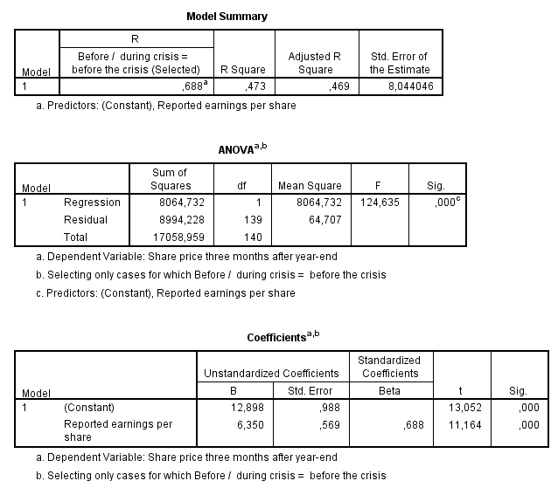

The results show an R-square of 0,473 implying that 47,3% of the variances in share prices can be predicted by the model. The F-value of 124,635 and the corresponding p-value of 0,000 imply that the results are significant at any convenient level. In addition the coefficient of the reported earnings per share is 0,688 and significant at the 0,01 level. The results are in line with the results of HLS, GKB and CM&W and in line with the developed expectation. In addition the results imply that the book value per share has explanatory power since the R-square of model 28 is higher than the R-square of model 29. The results on the book value per share model (32) are presented next.

**Table 10: Regression results model 32 -->**

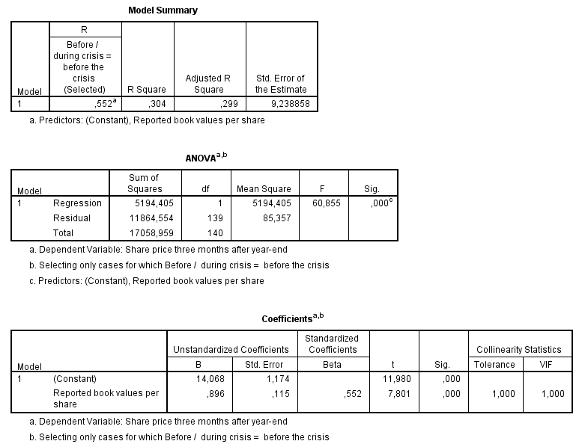

The results show an R-square of 0,304 implying that 30,4% of the variances in share prices can be predicted by the book value per share model. The F-value of 60,855 and the corresponding p-value of 0,000 imply that the results are significant at any convenient level. In addition the coefficient of the reported book value per share is 0,552 and significant at the 0,01 level. The results are in line with the results of HLS, GKB and CM&W and in line with the developed expectation. In addition the results imply that the book value per share model has less explanatory power than the earnings per share model. Since the combined model has the highest explanatory power the book values per share seems to have incremental value relevance over the reported earnings per share and vice versa. The incremental value relevance of the different variables is calculated manually and will be presented in paragraph 5.5.4.

### 5.5.2 Regression results of the in-crisis period

The results of the regression models as developed in chapter four for the in-crisis period are presented hereunder. A summary of all the results will be presented in paragraph 5.5.3. Based on the summary of the results the relevant hypotheses will be accepted or rejected. As signaled in chapter three the book values per share are expected to become more value relevant and the earnings per share are expected to become less value relevant. These expectations are in line with the findings of GKB and HLS and supported by the underlying theory of the abandonment option and earnings persistence as signaled in chapter two.

**Table 11: Regression results model 30 -->** 

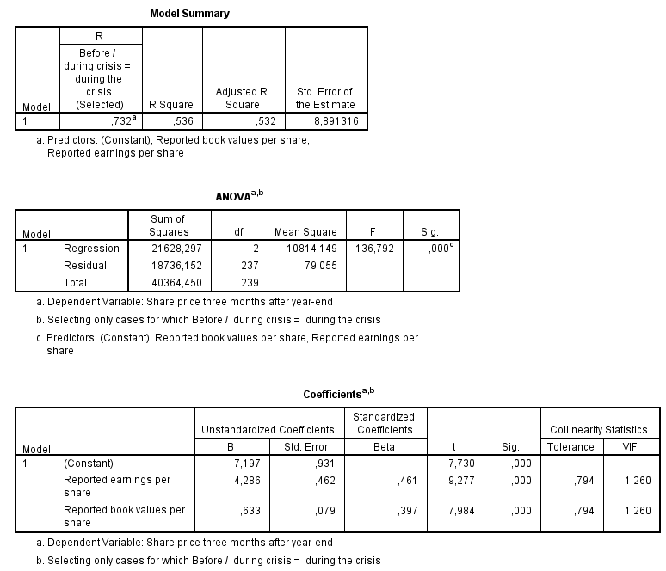

The results of the regression of the combined model in the in-crisis period show an R-square of 0,536 that implies that 53,6% of the variation in the share prices can be predicted by the model. The F-value of 136,792 and the corresponding p-value of 0,000 imply that the results are significant at any convenient level. In addition the model is tested for multicollinearity using the collinearity diagnostics in SPSS. The results shows a VIF score of 1,260 which indicate that the predictors may be moderately correlated. The results are not of such order that the estimates on the coefficients might be poor. Consequently the coefficient of 0,461 for the reported earnings per share and 0,397 for the reported book value are considered reliable estimates. Both the coefficient of reported earnings per share and the coefficient on the reported book value per share are positive and highly significant at the 0,01 level. The before presented results are not in line with prior research and the developed expectation and are relevant for further discussion. It seems that the variables in the in-crisis period are capable of providing more value relevant information than during the pre-crisis period. Since the variables are the results of the application of the IFRS reporting standards it could be that certain characteristics of IFRS (like the broad application of fair value accounting) are indeed better capable of capturing the ‘real’ value of a firm during financially unstable times. These results however are premature since the descriptive statistics already showed that the pre-crisis period included a high degree of one-time items which could have had a negative impact on the value relevant of the reported accounting numbers. For the further discussion of this result reference is made to paragraph 5.5.4.

The results on the earnings per share model (31) will be presented next.

**Table 12: Regression results model 31 --> **

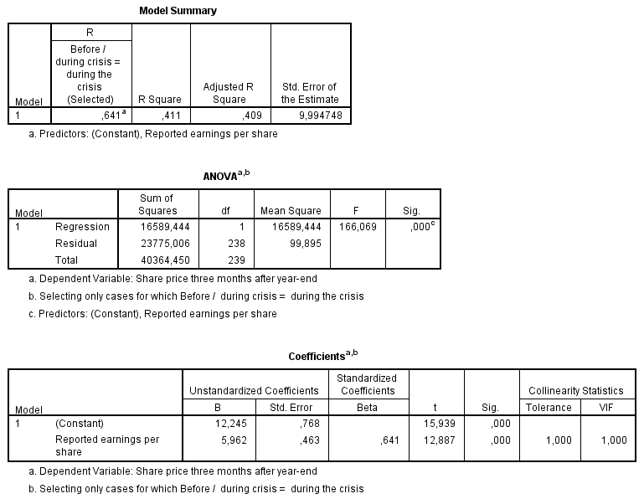

The results show an R-square of 0,411 implying that 41,1% of the variances in share prices can be predicted by the model. The F-value of 166,069 and the corresponding p-value of 0,000 imply that the results are significant at any convenient level. In addition the coefficient of the reported earnings per share is 0,641 and significant at the 0,01 level. The results are in line with the results of HLS, GKB and CM&W and in line with the developed expectation. In addition the results imply that the value relevance of the earnings declined during the financial crisis. The explanatory power of the earnings model decreased from 0,473 to 0,411 which is a relative decrease of 13,11%. These results are in line with the results of HLS and GKB and in line with the theory of earnings persistence as described by Nichols and Wahlen (2004). The results on the book value per share model (32) are presented next. The value relevance of the book value per share model is expected to increase during the financial crisis since the abandonment option is likely to gain importance in financially unstable times. This expectation is in line with the results of HLS and GKB.

**Table 13: Regression results model 32 -->**

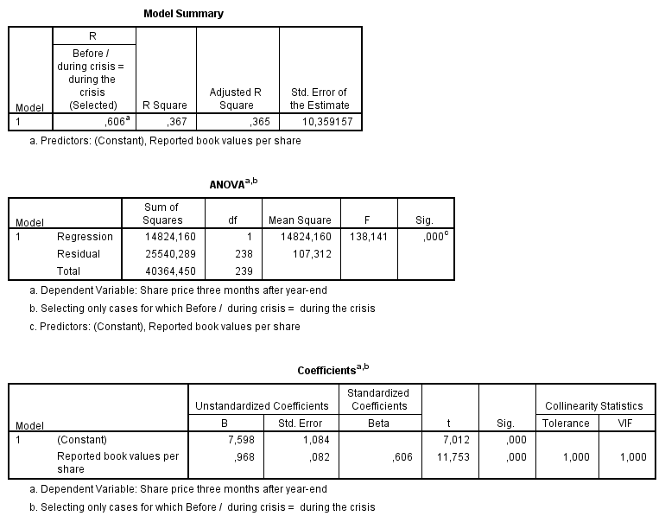

The results show an R-square of 0,367 implying that 36,7% of the variances in share prices can be predicted by the book value per share model. The F-value of 138,141 and the corresponding p-value of 0,000 imply that the results are significant at any convenient level. In addition the coefficient of the reported book values per share is 0,606 and significant at any convenient level. The results are in line with the results of HLS, GKB and CM&W and in line with the developed expectation. In addition the results imply that in the in-crisis period the book value per share model has almost the same explanatory power as the earnings per share model. This shift in the value relevance of the reporting earnings per share to the reported book value per share can be explained by the earlier mentioned abandonment option and the lower earnings persistence in financial unstable times. The results however has to be values with the greatest caution since the descriptive statistics showed a strong increase in the number of loss reporting firms during the financial crisis. Additional empirical evidence on this subject will be presented in paragraph 5.5.7.

In the next paragraph the summary of results will be presented and applied to the hypotheses developed in chapter four.

### 5.5.3 Summary of results and the incremental value relevance calculations

The results of paragraph 5.5.1 and 5.5.2 are combined into one table to enhance the visibility of the changes. In addition the results of the calculations of the incremental value relevance are included in the table. The hypotheses as developed in chapter four are rejected of accepted based on the empirical results as included in the table. The first nine hypotheses are tested with the results of the regression analysis and the hypotheses with reference number ten, eleven, and twelve are tested using the results of the incremental value relevance calculations.

**Table 14: Overview of results**

|  |  |  |  |  |
| --- | --- | --- | --- | --- |
| Model | Before the crisis | During the crisis | Difference before/during | % Difference before/during |
| 30: | R2 = 0,503 | R2 = 0,536 | ΔR2 = 0,033 | +6,56% |
| 31: | R2 = 0,473 | R2 = 0,411 | ΔR2 = -0,062 | -13,11% |
| 32: | R2 = 0,304 | R2 = 0,367 | ΔR2 = 0,063 | +20,72% |
| 33: - = | 0,503 – 0,304 = 0,199 | 0,536 – 0,367 = 0,169 | ΔINCR = -0,03 | -15,08% |
| 34: -= | 0,503 – 0,473 = 0,03 | 0,536 – 0,411 = 0,125 | ΔINCR = 0,095 | +316,67% |
| 35: - - = | 0,503 – 0,199 – 0,03 = 0,274 | 0,536 – 0,169 – 0,125 = 0,242 | ΔINCR = -0,032 | -11,68% |
| INCR stands for incremental value relevance as calculated | | | | |

Notice that all results as included in the table were significant. Furthermore the coefficients on the different variables were positive and significant in both periods and in all of the three models. For the precise results and t-statistics reference is made to paragraph 5.5.1 and 5.5.2. The results on the first and second set of hypotheses are presented in table 15.

**Table 15: Results on the hypotheses**

|  |  |
| --- | --- |
| Null hypothesis | Accept / Reject |
| 1 | Before the financial crisis no positive relationship exists between the reported earnings per share and the share price  **REJECT: the null hypothesis is rejected at the 0,01 level. Consequently the alternative hypothesis that a positive relationship exist is accepted.** |
| 2 | During the financial crisis no positive relationship exists between the reported earnings per share and the share price  **REJECT: the null hypothesis is rejected at the 0,01 level. Consequently the alternative hypothesis that a positive relationship exist is accepted.** |
| 3 | Before the financial crisis no positive relationship exists between the reported book value per share and the share price  **REJECT: the null hypothesis is rejected at the 0,01 level. Consequently the alternative hypothesis that a positive relationship exist is accepted.** |
| 4 | During the financial crisis no positive relationship exists between the reported book value per share and the share price  **REJECT: the null hypothesis is rejected at the 0,01 level. Consequently the alternative hypothesis that a positive relationship exist is accepted.** |
| 5 | Before the financial crisis in the combined model no positive relationship exists between the reported book values and the earnings per share  **REJECT: the null hypothesis is rejected at the 0,01 level. Consequently the alternative hypothesis that a positive relationship exist is accepted.** |
| 6 | During the financial crisis in the combined model no positive relationship exists between the reported book values and the earnings per share  **REJECT: the null hypothesis is rejected at the 0,01 level. Consequently the alternative hypothesis that a positive relationship exist is accepted.** |
| 7 | During the financial crisis the explanatory power of the reported earnings per share model did not decline  **REJECT: the decrease in explanatory power of the reported earnings is minus 13,11% and consequently the hypothesis should be rejected.** |
| 8 | During the financial crisis the explanatory power of the reported book value per share model did not increase  **REJECT: the increase in explanatory power of the reported book value per share model is 20,72% and consequently the hypothesis should be rejected.** |
| 9 | During the financial crisis the explanatory power of the combined model did not decline  **ACCEPT: the increase in explanatory power of the combined model increased with 6,56% during the financial crisis** |
| 10 | During the financial crisis the incremental value relevance of the earnings per share did not decline  **REJECT: the incremental value relevance of the earnings per share declined with 15,08%** |
| 11 | During the financial crisis the incremental value relevance of the book values per share did not increase  **REJECT: the incremental value relevance of the book values per share increased with 316,67% during the financial crisis** |
| 12 | During the financial crisis the incremental value relevance of the common factor of book values per share and earnings per share did not decline  **REJECT: the incremental value relevance of the common factor declined with 11,68% during the financial crisis** |

The results of the empirical analysis support most of the developed expectations. There is only one null-hypothesis which should be accepted. The expectation that the combined explanatory power of reported earnings and reported book values will decrease during a crisis are not supported by the empirical evidence. This result is very interesting since the HLS and GKB both provided empirical evidence for a decrease in explanatory power in the in-crisis period. Possible explanations for the different outcome are:

* IFRS provides more timely and value relevant information than the local GAAPs of South-Korea and Thailand;
* In the pre-crisis period the number of reported one-time items has a relatively large effect on the value relevance of earnings;
* Differences in the corporate governance structure between the Netherlands and South-Korea or Thailand respectively;

The difference in the number of loss reporting firms between the two sample periods is unlikely to explain the increase in the explanatory power of the combined model. In fact the exclusion of loss reporting firms will most likely result in a further increase of the explanatory power of the combined model. In addition the number of reported one-time-items in the pre-crisis period will most likely result in a higher explanatory power of earnings but will not explain the relatively large increase in the explanatory power of book values during the financial crisis. Considering these explanations further research should be performed regarding the differences in the corporate governance structure or differences in the applied financial reporting standards. In the next paragraph the robustness of the empirical results will be tested on different sample compositions. Based on the results as presented in paragraph 5.5.1 and 5.5.2 and the analysis as presented in this paragraph the expectation exists that the explanatory power of the combined model remains higher in the in-crisis period after loss-cases and cases with one-time items are excluded from the sample. This expectation is not in line with the initial expectation as developed in chapter four.

### 5.5.4 The effect of loss-cases and one-time items

To obtain empirical evidence for the effects of reported one-time items and the effects of loss reporting firms the regression models as developed in chapter four will be applied to different sample compositions. The first test will be performed on a sample which contains only profitable firms. The loss reporting firms are excluded from the sample by applying a conditional filter on the variable ‘Reported earnings per share’. The presentation of the results is different compared to paragraph 5.5.1 and paragraph 5.5.2. Both the results of the before-crisis period and the in-crisis period are presented in the same regression analysis by applying the ‘split file’ option in SPSS with the dummy variable ‘CRISIS’ as criterion for the split. After the application of the conditional filter the total number of valid cases is 327 that is 54 cases less than the total number of 381 cases. The number of cases in the pre-crisis period is 131 and the number of cases in the in-crisis period is 196. The results on the combined earnings per share and book value per share model are presented as first.

**Table 16: Regression results model 30 without loss cases -->** 

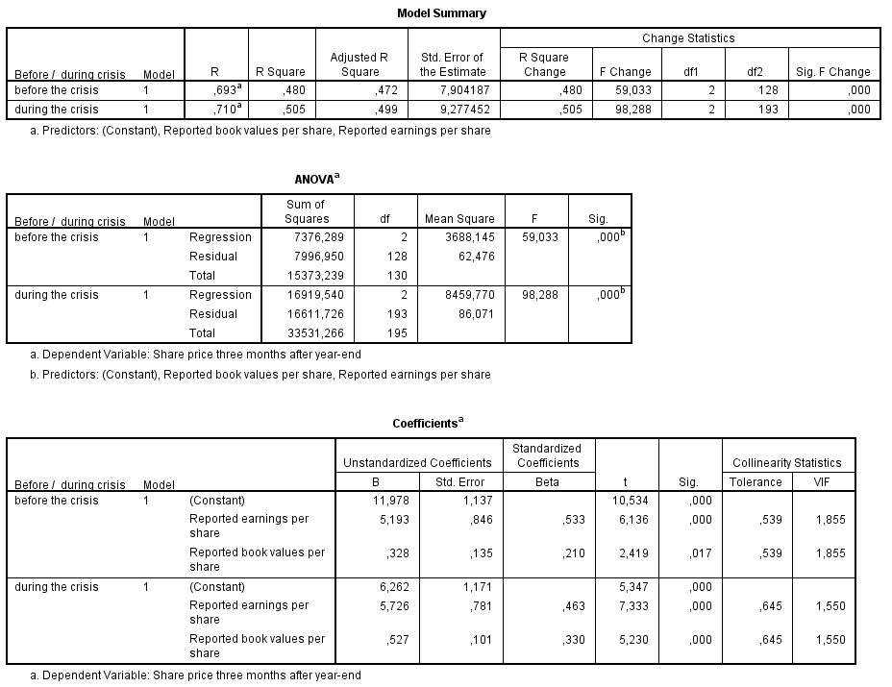

The results of the regression of the combined model show an R-square of 0,480 for the pre-crisis period that implies that 48,0% of the variation in the share prices can be predicted by the model. The F-value of 59,033 and the corresponding p-value of 0,000 imply that the results are significant at any convenient level. In addition the model is tested for multicollinearity using the collinearity diagnostics in SPSS. The results shows a VIF score of 1,855 which indicate that the predictors may be moderately correlated. The results are not of such order that the estimates on the coefficients might be poor. Consequently the coefficient of 0,533 for the reported earnings per share and 0,210 for the reported book value are considered reliable estimates. Both the coefficient of reported earnings per share and the coefficient on the reported book value per share are positive and highly significant at the 0,01 level. In the pre-crisis period the combined explanatory power of reported earnings and reported book values is lower than in the sample with loss cases. In fact the R-square declined with 4,57%. The results indicate that the reported losses are value-relevant under IFRS and in fact have a higher explanatory power than the reported earnings in the pre-crisis period. In addition the R-square of the in-crisis period is significant at the 0,01 level and declined from 53,6% to 50,5%, which is a relative decline of 6,14%. The results of the in-crisis period are in line with the results for the pre-crisis period and consequently are considered to be reliable. Moreover the results explain the increase in the explanatory power of the combined model during the financial crisis since there were more loss-reporting firms in the in-crisis period than there were in the pre-crisis period. Based on the results hypothesis 13 should be accepted.

**Table 17: Result on hypothesis 13**

|  |  |
| --- | --- |
| Null hypothesis | Accept/Reject |
| 13 | During the financial crisis and after the exclusion of loss cases the combined value relevance of book values and earnings did not increase  **ACCEPT: the combined value relevance of reported earnings and reported book values declined with 4,57% and 6,14% for the pre-crisis and in-crisis period respectively. In addition the combined value relevance remains higher in the in-crisis period.** |

The results of the initial regression analysis (including all cases) are more reliable than the results of the regression analysis without loss cases. However the preliminary conclusions as stated in paragraph 5.5.1 and 5.5.2 can also be influences by the number of reported one-time items. As signaled by the descriptive statistics in paragraph 5.4.2 the number of one-time items was much higher in the pre-crisis period than in the in-crisis period. Following Hayn and CM&W the reported one-time items are likely to result in a lower explanatory power of reported earnings.

The one-time items are filtered from the sample using a conditional filter on the variable ‘One-time items per share’. If the value of the variable is greater or smaller than zero then the item will be excluded from the sample.

After the exclusion of one-time items from the sample the total sample consists of 321 firm-year observations. The number of firm-year observations in the pre-crisis period is 112 and the number of firm-year observations in the in-crisis period is 209. Both periods consists of enough firm-year observations to apply a regression analysis. The results of the regression are presented in table 18.

**Table 18: Regression results model 30 without one-time items -->** 

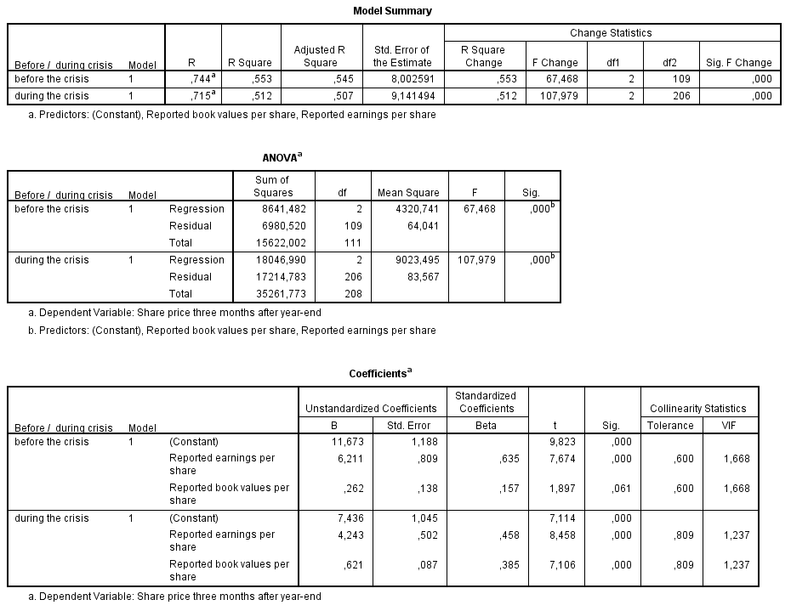

For the pre-crisis period the results of the regression of the combined model for the sample without one-time items shows an R-square of 0,553% which implies that 55,3% of the variation in the share prices can be predicted by the model. The F-value of 67,468 and the corresponding p-value of 0,000 imply that the results are significant at any convenient level. In addition the model is tested for multicollinearity using the collinearity diagnostics in SPSS. The results show a VIF score of 1,668 which indicates that the predictors may be moderately correlated. The results are not of such order that the estimates on the coefficients might be poor. Consequently the coefficient of 0,635 for the reported earnings per share and 0,138 for the reported book value are considered reliable estimates. Both the coefficient of reported earnings per share and the coefficient on the reported book value per share are positive and significant at the 0,01 and 0,05 level respectively. In the pre-crisis period the combined explanatory power of reported earnings and reported book values is higher than in the sample with one-time items. The R-square increased from 50,3% to 55,3% this is a relative increase of 9,94%. The R-square of the in-crisis period is 51,2% and is significant at the 0,01 level. In the in-crisis period the VIF score is 1,237 which imply almost no collinearity. Consequently the correlation coefficients are considered to be good estimates. The correlation coefficients are 0,458 for the reported earnings per share and 0,385 for the reported book values per share and are both significant at the o,01 level. The R-square in the in-crisis period with one-time items was 53,6%. The exclusion of one-time items from the sample shows opposite results for the pre-crisis and in-crisis period. As signaled by the descriptive statistics the mean of one-time items in the pre-crisis period was 7 eurocent and the mean in the in-crisis period was only 0,1 eurocent, which is a difference of minus 98,6%. Considering the fact that there were almost the same number of cases with one-time items in the pre-crisis and in-crisis period (29 and 31 respectively) the explanation for the opposite results should be found in the mean of the reported one-time items. The results of the regression analysis presented in paragraph 5.5.1 and 5.5.2 seems to be biased by the magnitude of the reported one-time items in the in-crisis period.

**Table 17: Regression results model 31 without one-time items--> **

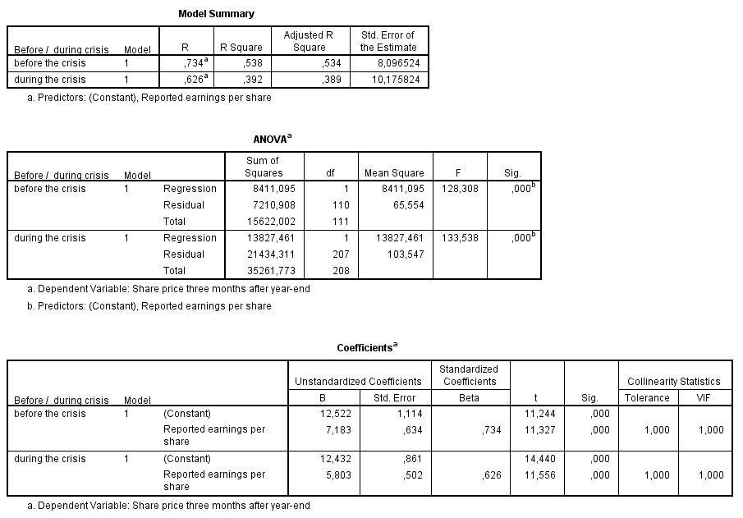

For the pre-crisis period the results show an R-square of 0,538 implying that 53,8% of the variances in share prices can be predicted by the earnings per share model. The F-value of 128,308 and the corresponding p-value of 0,000 imply that the results are significant at any convenient level. In addition the coefficient of the reported earnings per share is 0,734 and significant at any convenient level. The results are in line with the results of HLS, GKB and CM&W and in line with the developed expectation. For the in-crisis period the results show an R-square of 0,392 which is relatively 27,14% lower than in the pre-crisis period. The coefficient on the reported earnings is 0,626 and significant at any convenient level. Compared to the pre-crisis sample with reported one-time items the results show an increase in the R-square from 0,473 to 0,538 which is a relative increase of 13,74%. For the in-crisis period there is a decrease in the R-square from 0,411 to 0,392 which is a relative decrease of minus 4,62%. The differences between the pre-crisis and the in-crisis period are similar as the results presented in paragraph 5.5.1 and 5.5.2. However the decrease in the value relevance of the earnings per share model in the in-crisis period was not expected. Reported one-time items are expected to have a negative impact on the earnings persistence and hence the explanatory power of earnings in valuation models. A possible explanation is the difference in the mean of the one-time items between the two research periods. The results on the book value per share model are presented next.

**Table 18: Regression results model 32 -->**

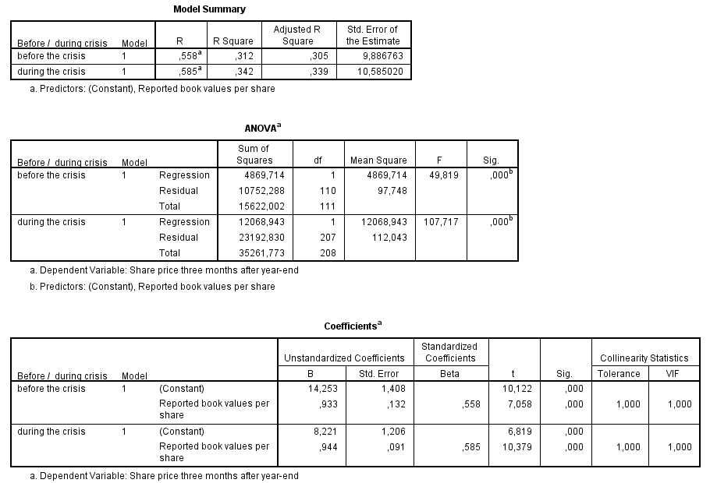

For the pre-crisis period the results show an R-square of 0,312 implying that 31,2% of the variances in share prices can be predicted by the book value per share model. The F-value of 49,819 and the corresponding p-value of 0,000 imply that the results are significant at any convenient level. In addition the coefficient of the reported book values per share is 0,558 and significant at any convenient level. The results are in line with the results of HLS, GKB and CM&W and in line with the developed expectation. Compared to the pre-crisis period with reported one-time items the R-square increased from 0,304 to 0,312 which is a relative increase of 2,63%.

For the in-crisis period the results show an R-square of 0,342 implying that 34,2% of the variances in share prices can be predicted by the book value per share model. The results are significant at any convenient level. The coefficient on the reported book values per share is 0,585 and significant at any convenient level. Compared to the in-crisis period with one-time items the R-square decreased from 0,367 to 0,342 which is a relative decrease of minus 6,81%.

The R-square of the reported book values per share is higher in the in-crisis period than during the pre-crisis period which is a similar result as presented in paragraph 5.5.1 and 5.5.2 and in line with the expectations and prior research.

The results of the regression analysis of the sample without reported one-time items suggest that the increase in value relevance between the pre-crisis and in-crisis period are significantly influenced by the firm-year observations with reported one-time items. In fact the R-square of the combined model decreased from 0,553 to 0,512 which is a relative decrease of 7,41%. In the sample with one-time items the R-square increased from 0,503 to 0,536 which is a relative increase of 6,56%. As a result the last hypothesis should be rejected.

|  |  |
| --- | --- |
| Null hypothesis | Description |
| 14 | During the financial crisis and after the exclusion of one-time items the combined value relevance of book values and earnings did not decline  **Reject: In the in-crisis period and after the exclusion of one-time items the value relevance of the combined model declined with 7,41%** |

## 5.6 Summary

The results of the empirical analysis supported most of the hypotheses as developed in chapter four. The results of the initial sample (with loss cases and with reported one-time items) show an increase in explanatory power of the combined model, a decrease of explanatory power in the earnings per share model and finally an increase in explanatory power of the book value per share model. As expected the reported book values are more value relevant during the in-crisis period than in the pre-crisis period. The increase in value-relevance of the combined model however did not hold after the reported one-time items are excluded from the sample. The most remarkable result of the empirical analysis is the relatively high value relevance of reported losses. Contrary to the results in prior literature (Hayn, CM&W, GKB and HLS) the exclusion of loss cases from the sample resulted in a lower value relevance of the combined model.

# 6. Conclusion

## 6.1 Introduction

In the final chapter of this thesis the final conclusion and answer to the research question are presented. Before the research question is answered a brief summary of the thesis is presented in paragraph 6.2. The summary includes the most important aspects of this thesis. Firstly the underlying theories of value relevance are summarized, secondly the conclusions from prior research are presented and finally the conclusions from the empirical research. After the answer to the research question is provided the limitations of this research and recommendations for other researchers are presented.

## 6.2 Summary of results

The research topic of this thesis was introduced in chapter one and found its origin in the ongoing financial crisis. Prior research mainly focuses on the change in value relevance over time or changes in value relevance due to changes in the reporting regime of geographical area. No prior results are signaled which address the effects of the ongoing financial crisis on the value relevance of accounting numbers. The objective of this study is to examine the change in value relevance in the Netherlands during the financial crisis.

In chapter two the positive and normative accounting theories were introduced. Positive accounting theories try to explain choices made by principals and agents and have a descriptive characteristic. The positive accounting theory highly relies upon the agency theory which assumes that individuals act in an opportunistic manner. Furthermore, the work of Ball and Brown is presented which led to a shift to capital market accounting research.

In chapter three the landmark studies of Ohlson and Feltham-Ohlson were introduced and some definitions of value relevance were introduced. In this thesis value relevance is defined as the correlation between share prices and accounting numbers. Furthermore, the chapter included the extensive study of CM&W. The research approach of CM&W is also applied in the studies of GKB and HLS and forms the basis for the research approach in this study.

The research approach is defined in chapter four together with the relevant hypotheses, selected models, and a definition of the research periods. The models from CM&W (which are in fact derived from the Ohlson- and Feltham-Ohlson framework) are chosen for the purpose of this thesis. The regression models include the share price three months after year-end as the dependent variable and earnings per share and book values per share as dependent variable. Finally some possible negative effects of certain items in de sample were presented.

The empirical results which are the basis for the rejection or acceptance of the developed null-hypotheses are presented in chapter five. Single and multiple regression models are applied which have the common objective to observe changes in at least one of the next relationships:

* Share price – Reported earnings per share
* Share price – Reported book values per share
* Share price – Reported earnings per share and reported book values per share

Most of the developed hypotheses and expectations are supported by the empirical evidence. In addition the empirical evidence was in line with the empirical evidence from prior research.

## 6.3 Final conclusion

The objective of the study is to determine whether the financial statements of Dutch listed companies are useful for valuation purposes in financially unstable times. More specifically the objective is to determine whether the financial statements become more or less value relevant during the ongoing financial crisis. It is evident that financial statements should be useful for investors irrespective of the financial situation at the time of publication. The financial statements in the Netherlands are based on IFRS for which the application is mandatory in the European Union for listed companies. The main difference between IFRS and the conventional historical cost based accounting standards is the broad application of fair value accounting. Fair value accounting provides more timely and relevant information and might be more useful during financially unstable times than the conventional models. The descriptive statistics in chapter four seemed to support the claim that fair value accounting provides more timely and relevant information. The magnitude and mean of reported one-time items was significantly higher in the pre-crisis period. The research question which was developed in the introduction of this thesis was:

***What are the effects of the ongoing financial crisis on the value relevance of financial statement information for Dutch stock exchange quoted companies reporting based on IFRS?***

Prior research (HLS and GKB) indicated that the reported financial statement information of listed companies becomes less relevant in financially unstable times. Moreover prior research indicated that the value relevance of reported earnings decreases during a financial crisis and the value relevance of reported book values increases during a financial crisis. To answer the research question the value relevance of the published financial statements of Dutch stock exchange quoted companies were compared between two consecutive periods. The first period included the years 2005-2007 and the second period included the years 2008-2012. As signaled in prior researches there were four possible biases which could influence the outcome of the empirical analysis. Larger firms tend to publish more value relevant information than small firms and firms operating in an intangible intensive industry tend to publish less value relevant information. Furthermore, reported losses are likely to be less value relevant than reported earnings due to the abandonment option of assets. Finally, reported one-time items are likely to have a negative impact on the value relevance of earnings due to the fact that one-time items are not persistent. Since the research period consists of two consecutive periods the intangible intensity is not further examined as possible bias in the outcome of the empirical research. Firm size was initially signaled as a relevant control variable. However, the differences between the samples were of such small order that including the control variable seemed irrelevant. The empirical results were tested for robustness by performing separate regressions for samples with and without loss cases or one-time items.

The Ohlson model was used as the basis for collecting empirical evidence about the value relevance of financial statement information. Value relevance is defined as the correlation between the share prices and the reported earnings per share and reported book values per share. As expected positive relationships between the share prices and the reported earnings and book values were found in both research periods and in all sample combinations. These results where significant at conventional levels except for the reported book values per share in the pre-crisis sample without reported one-time items. Furthermore, the results on the full sample indicated an increase in the value relevance of the financial statement information in the in-crisis period. The value relevance of the reported earnings per share decreased but was more than replaced by an increase in the value relevance of reported book values per share. These results are in line with the results of the incremental value relevance models which indicated an increase in the incremental value relevance of the book value per share model of more than 300%. After the exclusion of loss-cases from the sample the value relevance of the reported earnings per share decreased in both time periods. The value relevance of the combined model remained higher in the in-crisis period and consequently the results hold. The exclusion of one-time items from the sample resulted in a major increase in the value relevance of reported earnings in the pre-crisis period. The increase was of such order that the value relevance of the combined model was higher in the pre-crisis period and the in-crisis period and in line with the results of prior research. The signaled shift in value-relevance between the reported earnings per share and the reported book values per share is still supported by the empirical results of the sample without one-time items.

After controlling for one-time items the results are in line with prior research. The value relevance of reported earnings decline during financially unstable times and are only partially replaced by an increase of the value relevance of reported book values. In addition the incremental value relevance of reported book values per share over the value relevance of reported earnings per share is higher during financially unstable times. The final conclusion is that IFRS-based financial statements of Dutch stock exchange quoted companies were less value relevant during the economic crisis.

## 6.4 Limitations and Recommendations

In this paragraph the limitations of the empirical research and the recommendations for further research are presented. The first limitation which could have an impact on the empirical results of this research is the fact that the share prices can also be influences by macro-economic events surrounding the three-month-period. There were many important decisions taken by the European Union involving solutions to resolve the European debt crisis. These decisions and the period surrounding them could have significant influences on the stock markets and consequently the share prices. A second limitation of the research is the research area. Since only Dutch stock exchange listed companies are included in the sample the results should be interpreted with great caution for other European countries or the European as a whole. The corporate governance structures in the different European Countries might have an influence on the reliability of the published financial statements. In addition local laws and regulations might prescribe to provide additional information to investors resulting in an informational bias between countries. A third limitation of this study is the used valuation model. Since only the reported book values and reported earnings per share are included as independent variables it is not possible to identify whether there are specific IFRS-standards which cause the decline in value relevance. The final limitation relate to the chosen sample periods. Since the available information in Thomson One Banker results in 54 firm-year observations per year it is difficult to provide reliable empirical evidence for the value relevance in a certain financial reporting year. Consequently the possibility that one specific financial reporting year causes the decline in the value relevance cannot be excluded.

The most remarkable empirical results relate to the value relevance of reported losses in the pre-crisis and in-crisis period. These results were not in line with prior research and no clear explanation for the results could be provided. A possible explanation could be the sentiment of investors when losses are reported. A more likely explanation could be that IFRS is capable of providing more timely and reliable information. The first recommendation for further research is to investigate why the value relevance of reported losses is higher than the value relevance of reported earnings since this could be a valuable aspect of IFRS. The second recommendation for further research relate to the sample area. Since IFRS is mandatory for all stock exchange listed companies in the European Union it is valuable to provide additional empirical evidence considering the value relevance in other European countries. The last recommendation relate to the macro-economic environment in which the study has been performed. The macro-economic environment was very turbulent in both research periods and could have a significant impact on the empirical results. Further research could focus on the effects of these specific macro-economic factors on the value relevance of reported accounting numbers. Possible relevant control variables can be included in the model to control for the identified macro-economic factors.

# Literature list

Amir, E. & Lev, B. (1996). “Value-relevance of nonfinancial information: The wireless communications industry”. *Journal of Accounting and Economics*, 22, 3-30.

Barth, M.E. & Beaver, M.H. & Landsman, W.R. (2001). “The relevance of the value relevance literature for financial accounting standard setting: another view”. *Journal of Accounting and Economics,* 31 (1-3), 77-104.

Ball, R. & Brown, P. (1968). “An Empirical Evaluation of Accounting Income Numbers”. *Journal of Accounting Research*, 6 (2), 159-178.

Beaver, W. (1968). “The information content of annual earnings announcements”. *Journal of Financial Economics*, 6, 103-126.

Clarkson, M. (1995). “A stakeholder framework for analyzing and evaluating corporate social performance”. *Academy of Management review*. 20 (1), 92-118.

Clarkson, P. & Hanna, J.D. & Richardson, G.D. & Thompson, R. (2011). “The impact of IFRS Adoption on the Value Relevance of Book Value and Earnings”. *Journal of Contemporary Accounting & Economics,* 7 (1),1-17.

Deegan, C. & Unerman, J. (2006), *Financial Accounting Theory,* McGraw-Hill Education.

Fama, E.F. (1965). “The Behavior of Stock-Market Prices”. *The Journal of Business*, 38 (1), 34-105.

Fama, E.F. (1966). “Filter Rules and Stock Market Trading”. *The Journal of Business,* 39 (1), 226-241.

Feltham, G. & Ohlson, J.A. (1995), “Valuation and Clean Surplus Accounting for Operating and Financial Activities”. *Contemporary Accounting Research*, 11 (2), 689-731.

Francis, J. & Schipper, K. (1999), “Have Financial Statements Lost Their Relevance?”. *Journal of Accounting Research*, 37 (2), 319-352.

Gjered,O.& Knivsfla, K. & Saettem, F. (2008), “The value-relevance of adopting IFRS: Evidence from 145 NGAAP restatements”. *Journal of International Accounting, Auditing and Taxation*, 17 (2), 92-112.

Graham, R. & King, R. & Bailes, J. (2000), “The Value Relevance of Accounting Information during a Financial Crisis: Thailand and the 1997 Decline in the Value of the Baht”. *Journal of International Financial Management and Accounting*, 11 (2), 84-107.

Hayne, C. (1995), “The information content of losses”. *Journal of Accounting and Economics,* 20 (2), 125-153.

Hendriksen, E. (1970). *Accounting Theory*, Illinois: Richard D. Irwin, 1.

Ho, L.C.J & Liu, C.S. & Sohn, P.S. (2001). “The value relevance of accounting information around the 1997 Asian financial crisis – the case of South Korea”. *Asia-Pacific Journal of Accounting & Economics*, 8 (2), 83-107.

Jensen, M.C. (1967). “The Performance Of Mutual Funds In The Period 1945-1964”. *Journal of Finance*, 23 (2), 389-416.

Kormendi, R. & Lipe, R. (1987). “Earnings Innovations, Earnings Persistence, and Stock Returns”. *The Journal of Business*, 60 (3), 323-345.

Lev, B. (1989). “On the Usefulness of Earnings and Earnings Research: Lessons and Directions from Two Decades of Empirical Research”. *Journal of Accounting Research*, 27, 153-192.

Lambert, R. (2001). “Contracting theory and accounting”. *Journal of Accounting and Economics*, 32, 3-87.

Lundholm, R.J. (1995). “A Tutorial on the Ohlson and Feltham-Ohlson Models: Answers to Some Frequently Asked Questions”. *Contemporary Accounting Research*, 11 (2), 749-761.

Nichols, D.C. & Wahlen, J.M. (2004). “How do earnings numbers relate to stock returns? A review of classic accounting research with updated evidence”. *Accounting Horizons,* 18 (4), 263-286.

Ohlson, J.A. (1995). “Earnings, Book Values, and Dividends in Equity Valuation”. *Contemporary Accounting Research*, 11 (2), 661-687.

Watts, R.L. & Zimmerman, J.L. (1978). “Towards a positive theory of the determination of accounting standards”. *Accounting Review,* 53 (1), 112-134.

Watts, R.L. & Zimmerman, J.L. (1986). *Positive Accounting Theory,* Englewood Cliffs, New Jersey: Prentice-Hall Inc., 339.

Watts, R.L. & Zimmerman, J.L. (1990). “Positive accounting theory: A ten year perspective”. *The Accounting Review”*, 65 (1), 259-285.

# Appendix A: Literature Table

|  |  |  |  |  |
| --- | --- | --- | --- | --- |
| Author(s) | Object of study | Sample | Methodology | Outcome |
| Lev (1989) | The usefulness of earnings and earnings research | 150 firms from the United States from which information is available on the Compustat Database for the period 1980-1984 | Regression analysis relating stock returns to reported earnings | There is a weak relationship between reported earnings numbers and stock returns. |
| Lundholm (1995) | Tutorial on the Ohlson and Feltham-Ohlson framework | Not applicable, Lundholm uses examples to explain how the assumptions of the Ohlson and Feltham-Ohlson models withhold | Lundholm uses the MM algorithm to determine the strength of the structural equations for the assumptions in the models | The Ohlson and Feltham-Ohlson models are proven to present a descriptive representation of the accounting and valuation process and consequently are useful for value relevance researchers. |
| Hayn (1995) | The information content of reported losses | 85.919 firm- years over the period 1962-1990 as available on the 1991 release of the Compustat’s primary, secondary and tertiary active and research files | Regression analysis relating stock returns to reported earnings numbers considering samples with and without loss cases | The inclusion of loss cases dampens the information content of earnings due to the shareholders liquidation option on assets. |
| Amir and Lev (1996) | The relevance of financial statement information in the telecom sector | 560 firm-quarter observations in the United States (NYSE, AMEX and OTC) over the period 1984-1993 | Regression analysis relating stock returns to earning numbers and book values to equity value | On a stand-alone basis accounting numbers from telecom companies are largely irrelevant for valuation purposes. These results are argued to be relevant for other science-based, high-growth markets. |
| Collins, Maydew and Weiss (1997) | The value relevance of book values and earnings | The sample consists of 115.514 firm-year observations in the United States (NYSE, AMEX and NASDAQ) over the period 1953-1993. | Regression analysis relating earnings per share and book values per share to market value per share. Time-regression considering four proxies (losses, intangibles, non-recurring items and size) | The combined explanatory power of earnings and book values increased over the sample period while the incremental explanatory power of earnings declined and the incremental explanatory power of book values increased over the sample period. After controlling for the four proxies no highly significant evidence remains for the argued decline in value relevance. |
| Francis and Schipper (1999) | The relevance of financial statement information | The sample consists of firm-year observations in the United States (NYSE and NASDAQ) over the period 1952-1994. The firm-year observations increased from 393 in 1952 to 4.811 in 1994. | Portfolio returns tests and explained variation tests | Both tests show a decline in the value relevance of earnings and an increase in the value relevance of balance sheet information. |
| Graham, King & Bailes (2000) | The value relevance of accounting information during the 1997 financial crisis in Thailand | The sample consist of 8.166 firm-quarter observations from SET-listed (Thailand’s stock exchange) firms from the first quarter of 1992 through the first quarter of 1998. | Regression analysis relating earnings and book values per share to the share prices and tests on incremental value relevance by decomposing the R2 from the regression analysis | Book values show a positive relationship with share prices and are significant in all firm-quarter observations. Earnings show a positive relationship and are significant in 23 of 25 firm-quarter observations. The combined explanatory power is positive and significant in all firm-quarter observations but declines during the financial crisis. Finally, the incremental value relevance of earnings decreased during the financial crisis and is only partially replaces by an increase in value relevance of book values. In conclusion: the value relevance of accounting information declined during the financial crisis. |
| Ho, Liu and Sik (2001) | The value relevance of book values, earnings and cash flows from operations before and during the Korean crisis | The sample consists of 429 firms from 1995-1998 from Korean listed companies for which information is available in the Korea Investors Service Inc. database. | Regression analysis and a valuation coefficient test based on the Ohlson models | The value relevance of earnings decreased during the crisis and is not replaced by an increase in value relevance of book values. The value relevance of cash flows from operations increased during the financial crisis but the total explanatory power of the combined models were lower. The results hold after adjustments for negative earnings, financial leverage and foreign exchange losses. |
| Nichols and Wahlen (2004) | The relationship between reported earnings and stock returns | 31.923 firm-year observations and 90.470 firm-quarter observations over the period 1988-2002 in the United States (NYSE, AMEX and NASDAQ) | Regression analysis and sign-tests | There is a significant relationship between annual stock returns and the sign of annual earnings. Differences in the relation between stock returns and earning numbers can be partially explained by earnings persistence. Finally, earnings announcements are rapidly incorporated in share prices. |

# Appendix B: Sample firms



# Appendix C: Boxplots (before and after exclusion of extreme values)

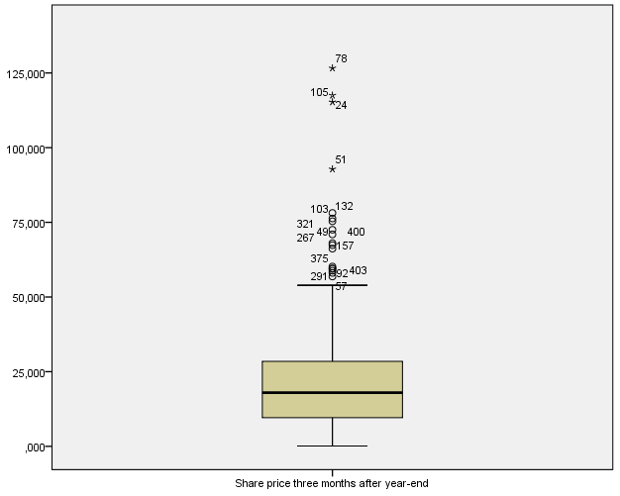

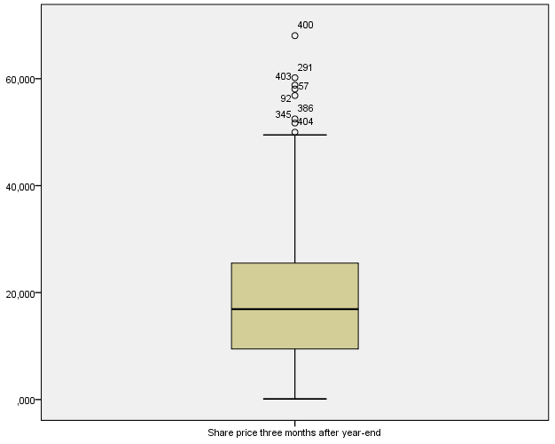

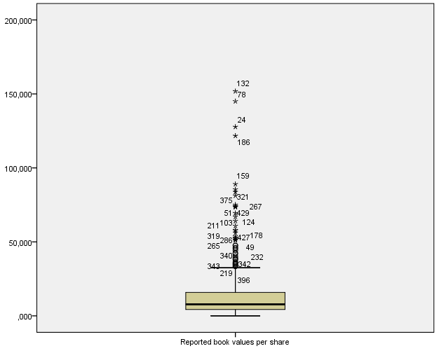

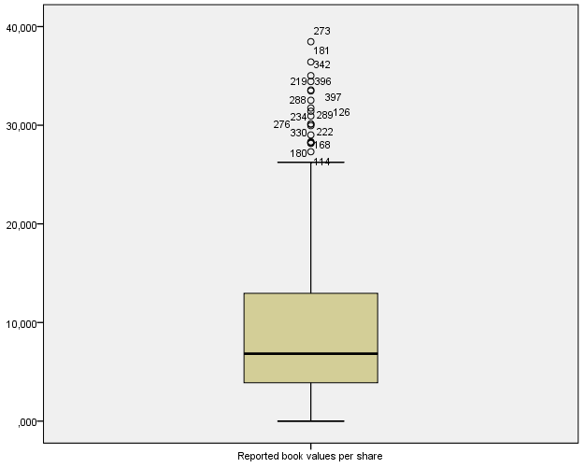

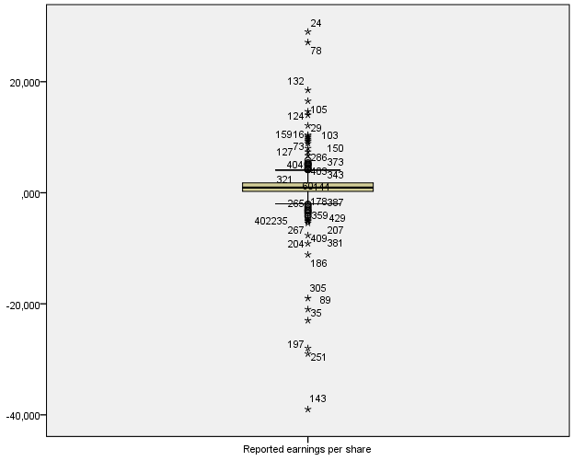

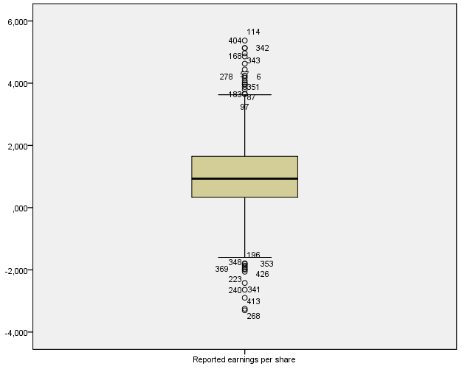

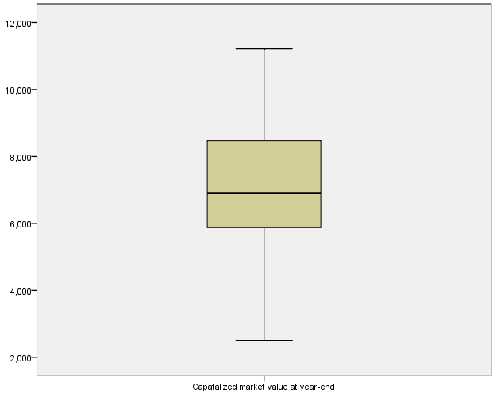



# Appendix D: The Assumption of Linearity, Homoscedastic and Normality

In this appendix the SPSS outputs for the total population are presented. The dependent variable is tested for each independent variable on the assumptions of linearity, homoscedastic and normality. The P-P plot of the regression standardized residual should show a straight line if there is in fact a normal distribution and linearity between the variables. In addition the histogram showing the frequency of the standardized residuals per category should be bell-shaped without any large outliers at the sides of the histogram. The results show that all the assumptions hold and consequently the statistical method regression analysis can be applied. The combined model contains multiple variables and consequently the risk of multicollinearity exists. In SPSS it is possible to test for multicollinearity using the VIF-scores which results out of the regression analysis. The tests for multicollinearity will be presented as part of the discussion of the regression results.

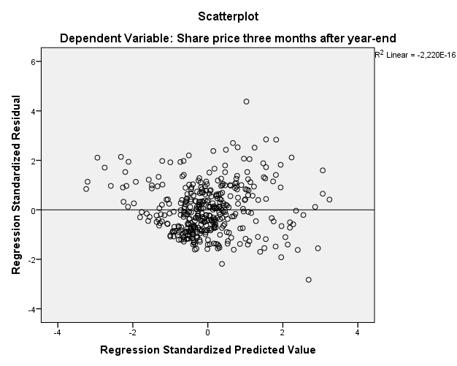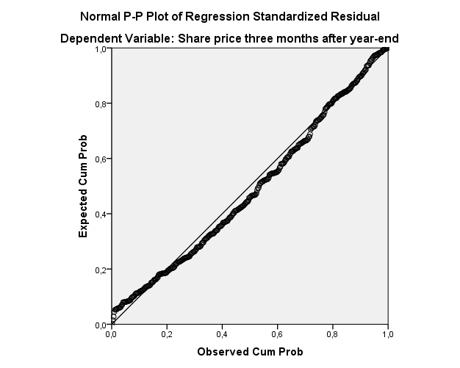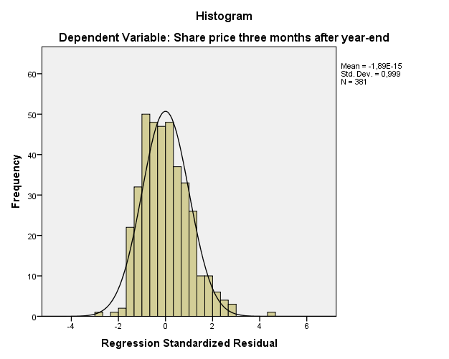**Independent variable: earnings per share**

**Independent variable: book value per share**

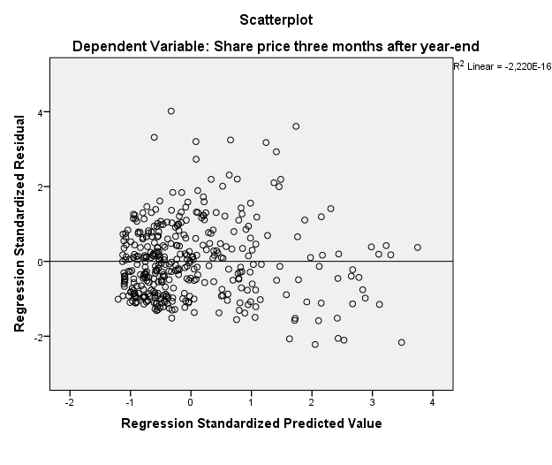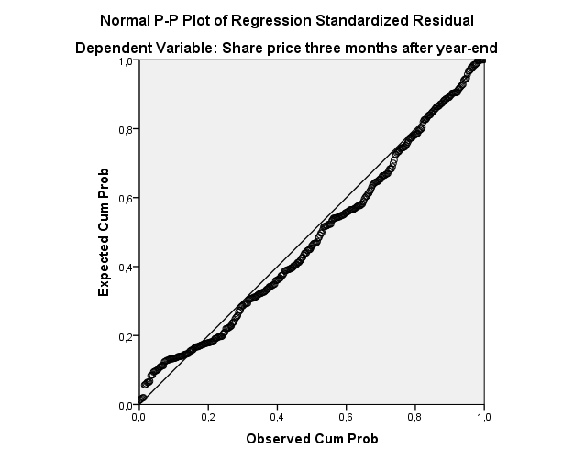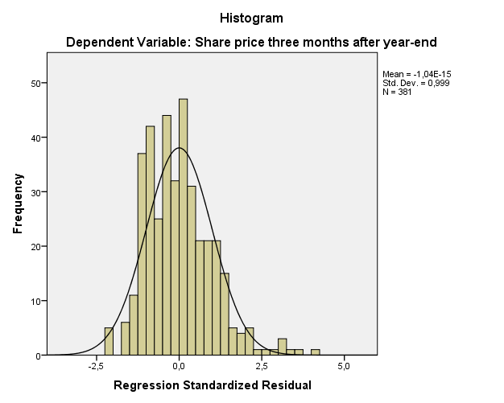

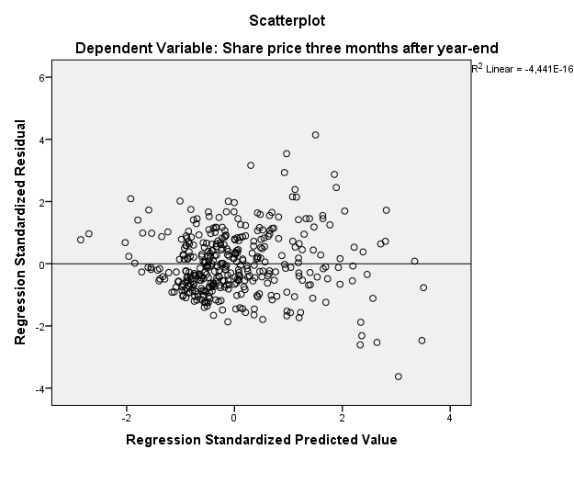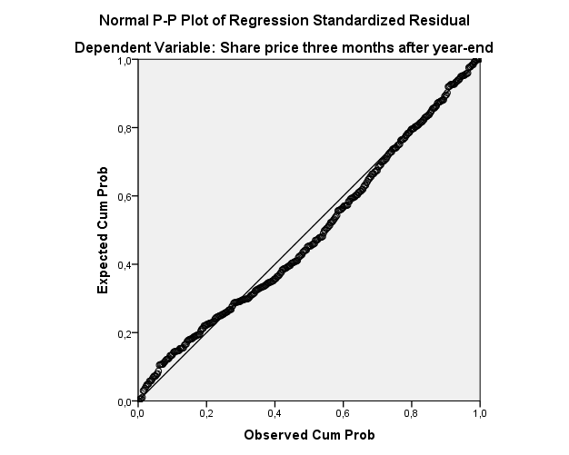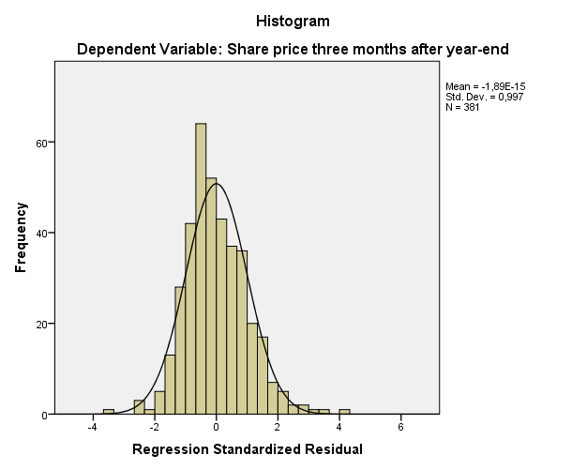**Independent variables: earnings per share and book value per share**