**Unconditional conservatism in code law European high- and low-technology industries in times with and without economic turmoil**

Master Thesis Accounting, Auditing, and Control

FEB11032-12

June 2013

Author:

S.A. van Iperen 332493

Erasmus University Rotterdam

Thesis supervisor:

Dr. Sc. Ind. A.H. van der Boom

Second reader:

-----------------------------------

KPMG de Meern

Thesis supervisor:

Mr. Y. Davidsson

**Abstract:** Within this study the difference in the level of unconditional conservatism in code law European listed firms in low-technology industries and high-technology industries is studied. It is expected that the level of unconditional conservatism is higher in high-technology industries due to regulations around research and development expenses. Furthermore it is studied whether the level of unconditional conservatism is different in times with economic turmoil compared with times without economic turmoil. To study this a normal and an adapted earnings-return regression of Basu (1997) are used including a dummy variable to define the times with economic turmoil and the times without economic turmoil. The results of this study show that there is a significant higher level of unconditional conservatism in high-technology industries compared with low-technology industries. For low-technology industries as well as for high-technology industries a significant lower level of unconditional conservatism is found within times with economic turmoil compared with times without economic turmoil. The results of this study could be useful for standard setters, managers, investors and other stakeholders.

**Keywords:** unconditional conservatism; low-technology industries; high-technology industries; economic turmoil; code law European listed firms

**Data availability:** All data is available at CompuStat Global and Datastream.

# Preface

First of all, I would like to express my gratitude for everyone who helped me. Especially I would like to thank Dr. Sc. Ind. A.H. van der Boom for supervising my master thesis and applying a good structure within it. I really appreciated the time Mr. van der Boom invested in me. Besides I would like to thank KPMG de Meern for giving me the opportunity to write my thesis at their office. It really helped me to work productively. I would like to thank Mr. Y. Davidsson for giving advice. Furthermore, I would like to thank all my colleagues at KPMG de Meern. I really enjoyed working there.

I would also like to thank the data team from the Erasmus University, especially Judith, for helping me collecting the data needed for my master thesis. Finding the data in co-operation with the data team was a big eye-opener and it helped me a lot. Furthermore, I would like to thank the second reader for giving me some extra advice and giving me the opportunity to improve my master thesis.

Finally, I would like to thank all my family and friends for listening to my ideas and supporting me during my study at the Erasmus University. I would really like to thank my parents for giving me the opportunity to study and Stijn for the support he gave me to succeed my study.

**Table of contents**

Preface 2

1. Introduction 6

§1.1 Introduction to main theme and sub theme 6

§1.2 Relevance 7

§1.3 Main research question and sub questions 8

§1.4 Structure of the paper 9

§1.5 Summary 10

2. Background 11

§2.1 Background information 11

Conservatism 11

High- and low-technology industries 13

Economic turmoil 13

§2.2 Research approaches relevant for this study 13

Market based accounting research 13

Agency theory 13

Positive accounting theory 14

§2.3 Chosen research approach 15

§2.4 Summary 16

3. Literature study 17

§3.1 Conservatism 17

§3.2 Conservatism in association with technology industries in times of non economic turmoil 21

§3.3 Conservatism in times of economic turmoil 24

§3.4 Elements of prior literature that will be used for this study 26

§3.5 Summary 27

4. Hypotheses 28

§4.1 Hypotheses 28

§4.2 Summary 29

5. Research design 30

§5.1 Research method and model 30

Basu model (1997) 30

First hypothesis 31

Second hypothesis 33

§5.2 Sample 37

§5.3 Data collection 37

§5.4 Statistical analysis 38

§5.5 Attainability 40

§5.6 Summary 40

6. Results 41

§6.1 Research and development expenses 41

§6.2 Hypothesis 1 42

Normal earnings-return regression of Basu (1997) – low-technology 42

Normal earnings-return regression of Basu (1997) – high-technology 44

Two sample one-tailed t-test normal earnings-return regression of Basu (1997) 45

First adapted earnings-return regression of Basu (1997) – low-technology 46

First adapted earnings-return regression of Basu (1997) – high-technology 47

Two sample one-tailed t-test first adapted earnings-return regression of Basu (1997) 49

§6.3 Hypothesis 2 50

Second adapted earnings-return regression of Basu (1997) – low-technology 50

Second adapted earnings-return regression of Basu (1997) – high-technology 52

Third adapted earnings-return regression of Basu (1997) – low-technology 54

Third adapted earnings-return regression of Basu (1997) – high-technology 56

§6.4 Summary 58

7. Analysis 60

§7.1 Hypothesis 1 60

§7.2 Hypothesis 2 61

§7.3 Summary 63

8. Summary and conclusion 64

§8.1 Summary 64

§8.2 Main conclusion and contribution 65

Main conclusion 65

Contribution 66

§8.3 Limitations 66

§8.4 Suggestions for further research 67

§8.5 Summary 68

References 69

Appendix A: Literature review 73

Appendix B: Industries included in high- and low-technology samples (three-digit *SIC* codes) 76

Appendix C: Industries included in high- and low-technology samples (four-digit *SIC* codes) 77

Appendix D: Normal earnings-return regression of Basu (1997) - LT 81

Appendix E: Normal earnings-return regression of Basu (1997) - HT 83

Appendix F: First adapted earnings-return regression of Basu (1997) - LT 85

Appendix G: First adapted earnings-return regression of Basu (1997) - HT 87

Appendix H: Second adapted earnings-return regression of Basu (1997) - LT 89

Appendix I: Second adapted earnings-return regression of Basu (1997) - HT 91

Appendix J: Third adapted earnings-return regression of Basu (1997) - LT 93

Appendix K: Third adapted earnings-return regression of Basu (1997) - HT 95

Appendix L: Two sample one-tailed t-test 97

# 1. Introduction

## §1.1 Introduction to main theme and sub theme

Technology is becoming increasingly important for our world. Naisbitt (ASCD 1983) mentioned high-tech as megatrend and transforming the direction of our lives already in 1982. Associated with high-technology industries is the high amount of research and development in these industries compared with other low-technology industries (Chandra et al. 2004). Due to the current accounting guidelines, International Accounting Standards (IAS) 38: Intangible Assets and Financial Accounting Standards (FAS) 142: Goodwill and Other Intangible Assets, intangible assets are typically not recognized or the fair value of intangible assets is not mentioned within the financial statements (Barth et al. 2002). It should be noted that there are some differences between IAS 38 and FAS 142. Following IAS 38 the research costs should immediately be expensed and development costs should be capitalized when certain technical and commercial feasibility criteria are met, initially at cost and subsequently against cost or using the revaluation model. Furthermore, IAS 38 requires a company to recognize an intangible asset when it is purchased and sometimes when it is self-generated. (Deloitte 2013) On the other hand, FAS 142 requires entities nearly always to expense all costs related to the internal development of intangibles. Within FAS 142 it is sometimes possible to recognize self-generated intangibles, however significantly less compared with IAS 38. (Deloitte 2013; FASB 2001)

Another trend is the increasing use of conservatism in financial accounting. Conservatism is better known as *“anticipate no profit, but anticipate all losses”* (Watts 2003a, 208). Other evidence of prior research associates the understatement of net assets, the behavior of earnings and accruals, and the earnings/stock return relation with conservatism in US financial reporting. (Watts 2003a and 2003b)

Finally, a subsection of interest is the association studied by several authors between high-technology industries and conservatism. A study of Chandra et al. (2004) combined the increasing trend of conservatism in US firms during a sample period of 1982 up to 2002 and the influence of Statement of Financial Accounting Standards (SFAS) 2 on this trend. SFAS 2 is an accounting standard around research and development costs. Out of this study can be concluded that SFAS 2 is especially related with news independent conservatism, also known as unconditional conservatism, in high-technology industries (see §2.1). Another type of conservatism is news dependent conservatism, also known as conditional conservatism (see §2.1). The use of unconditional conservatism in high-technology industries is related to the high amount of research and development in these industries. This results, partly due to the current regulation, in an understatement of net assets. This is why the results of the study of Chandra et al. (2004) suggests that the Financial Accounting Standards Board (FASB) should make some revision in their regulations with the intention to provide more unbiased financial statements to stakeholders. The association found within this study is emphasized in the later study of Chandra (2011).

Based on the studies of Chandra et al. (2004) and Chandra (2011) only unconditional conservatism and European code law countries will be taken into account in this study. This because in the studies of Chandra et al. (2004) and Chandra (2011) is found that unconditional conservatism can especially be related to high-technology industries in Europe instead of conditional conservatism, since conditional conservatism (as measured with shareholder litigations) is mainly present in common law countries. A higher level of conditional conservatism in common law countries is due to a higher shareholder protection within these countries through civil litigation (Ball et al. 2000). Using a conservative way of accounting could reduce several costs including litigation costs (see §2.1). Most European countries are based upon code law excluding the United Kingdom, Ireland and Scotland (Hertel 2009). Furthermore, based on a limitation of a study of Kwon et al. (2006) also the association between unconditional conservatism and economic turmoil will be investigated. Mixed results related to this association are found in prior literature. One study concluded that more conservatism will be used since there will be an increased focus on downside risk by managers as well as by auditors (Jenkins et al. 2009). Another study found a significant decrease in the use of conservatism in times of economic turmoil (Gul et al. 2002).

## §1.2 Relevance

The association of interest within this study is the association between unconditional conservatism and high- and low-technology industries in code law European countries. Kwon et al. (2006) for example tested significant differences in the level of conservatism between high-technology and low-technology firms. However, a limitation mentioned in the study of Kwon et al. (2006) is that the results could be different when testing it in times of economic turmoil. The level of conservatism in times of economic turmoil is tested before (Gul et al. 2002; Francis et al. 2011), however these studies are based upon an Asian sample and an US sample.

So especially, testing these relations for European code law countries could be highly interesting. Other accounting principles are applied in European code law countries compared with the US or Asia, so the relations found within this study could have other implications for standard setters, managers and stakeholders in European code law countries than in the US what especially has been widely studied in prior literature. An example of other accounting regulations related to research and development is the expensing of research as well as development under SFAS 2, and the expensing of research and the capitalizing of development when certain criteria are met under IAS 38 (Deloitte 2013; FASB 1974). Differences in accounting regulations could be partly explained by the legal system applied in different countries (see §2.1).

Overall this thesis could be interesting for standard setters, because an adjustment of their regulations towards the more increasing trend of conservatism in combination with high-technology industries, could ensure that the value relevance of information is ensured as Chandra et al. (2004) also suggested in their research. Besides that, this study could also be interesting for managers. Based on this managers could adjust their structure of the financial statement attributing to an increase in the value relevance of information for their stakeholders. Furthermore, this study can be interesting for stakeholders because it could improve their future earnings analysis. Finally, this study could be important as when investors, managers and regulators can better understand the bias included in accounting numbers, they could enhance the usefulness of their decision making processes (Chandra 2011, 288).

## §1.3 Main research question and sub questions

Based on and inspired by prior literature, this thesis contains the following main research question: ***Is the level of unconditional conservatism significantly different in high-technology industries compared with low-technology industries and in times of economic turmoil compared with economic times without economic turmoil in European code law countries?***

This main research question will be studied on basis of the following sub questions:

* 1. Which definition of conservatism, high- and low-technology industries and economic turmoil will be used within this study?
  2. Which research approaches will be used for this study?
  3. What has been studied in prior literature related to conservatism, high- and low-technology industries and economic turmoil related to the subject of this study?
  4. Which hypotheses based on the main research question and prior literature will be used for this study?
  5. What research design could be used to study the associations of interest within this study?
  6. What are the results derived from the empirical research?
  7. What are the differences between the expectations and outcomes of the study?
  8. What are the conclusions and limitations of this study, and possible suggestions for further research?

To study the main research question and sub questions, a sample period from 2005 up to

2011 will be used. 2005 up to 2007 will be included in the economic time sample without economic turmoil and 2008 up to 2011 in the times of economic turmoil sample (see §2.1). The chosen European code law countries are Finland, Germany, France, Spain, Portugal and Greece. These countries are chosen to have countries from each part of Europe (north, east, west and south) and to have an equal amount of countries with really severe problems during the economic turmoil and less severe problems during the economic turmoil (EuropaNU 2013) (see §2.1). The total sample consists of 3756 firm year observations (see §5.3). The level of unconditional conservatism will be tested based on the earnings-return regression of Basu (1997) as often used in prior literature (Chandra et a. 2004; Chandra 2011; Gul et al. 2002) (see §5.1).

## §1.4 Structure of the paper

Within this study only unconditional conservatism will be used in European code law countries based on the studies of Chandra et al. (2004) and Chandra (2011) as mentioned above (see §1.1) and further elucidated in §2.1. High- and low-technology industries will be based on *SIC* codes identified in the study of Francis and Schipper (1999) since this is used often in prior literature (Chandra et al. 2004; Chandra 2011; and Kwon et al; 2006). Furthermore, this study will use the market based approach in combination with the agency theory and positive accounting theory as a theoretical foundation. All relevant aspects of this foundation will be explained more in §2.1.

The remainder of the thesis is organized as follows. Chapter 2 contains some background information about the main concepts, main definitions and main research approaches used that could be relevant for this thesis. Chapter 3 describes a literature review that has been done on different subtopics, as partly outlined in the introduction of this study. Furthermore, this chapter describes which parts of prior literature will be used for this thesis. Chapter 4 contains the development of hypotheses based on the main research question and prior literature that will be used within this thesis. Chapter 5 embraces the following topics to study the associations of interest within this study: the research method and model, the sample/data selection and descriptive statistics of this thesis. Chapter 6 describes the empirical research used and results of the study done within this thesis. Chapter 7 will contain an analysis of the results found in chapter 6. Finally, chapter 8 summarizes and concludes the findings of the research done within this thesis and will contain some limitations of this thesis and suggestions for further research.

## §1.5 Summary

In this chapter the introduction to the main theme and sub themes (unconditional conservatism, high- and low-technology industries, times of economic turmoil and European code law countries) are described. This study could be relevant since most of prior literature studied conservatism in the US. Especially since different rules are applied in the US than in Europe according to research and development costs, this study could lead to different results than prior literature. Also studying the association in times of economic turmoil could lead to different results. The main research question and sub questions are described within this chapter and will be used to study the main theme and sub themes. A sample period from 2005 up to 2011 is chosen and the sample includes Finland, Germany, France, Spain, Portugal and Greece. Lastly, the structure of the paper is described.

# 2. Background

Within this subsection, first of all different aspects that will be investigated within this thesis are described. Thereafter, the agency theory will be discussed in relation with the use of conservatism. Lastly, research approaches used in prior literature and this thesis will be described.

## §2.1 Background information

### Conservatism

Conservatism is mostly described as *“anticipate no profit, but anticipate all losses”* (Watts 2003a, 208). An important consequence of using conservatism in financial statements is the understatement of net assets and therewith the understatement of earnings. The understatement of net assets is associated with expensing the costs for research and development of internally generated intangibles, a different approach has been taken within different accounting regulations (see §1.1), leading to an incomplete capitalization of all costs related to research and development. Expensing a major part or all costs belonging to research and development leads to overspending resulting in an understatement of earnings.

Four main explanations for conservatism according to Watts (2003a) are contracting, shareholder litigation, taxation and accounting regulation. Contracting shall bring conservatism due to information asymmetry and therewith the associated agency costs (see §2.2). Contracts are often made to overcome these agency costs and to fulfill the contracts’ arrangements timely information is needed. This often leads towards a conservative way of accounting since all information should be verifiable, while earnings and net assets measures could not be verified in a facile way. The risk of shareholder litigation, as a second explanation for conservatism, will be higher when assets and earnings are overstated. The expected litigation costs related to this are also higher when assets and earnings are overstated than in the situation assets and earnings are understated. These reasons lead to a more frequent use of conservatism. Thirdly, earnings will be deferred to defer tax payments. Lastly, accounting regulation could lead to conservatism since losses from overstated assets and earnings are more observable than gains from understated assets and earnings leading to higher political costs. To minimize these political costs a more conservative way of accounting is often encouraged within accounting regulations.

Conservatism can be divided into conditional conservatism (also known as news dependent conservatism) and unconditional conservatism (also known as news independent conservatism). The understatement of net assets is better known as unconditional conservatism since it is a continuous way of financial accounting (e.g. valuation at historical cost) chosen by managers of the company and it does not depend on an economic news event. Conditional conservatism is in contrast with unconditional conservatism related to events and it entails a faster recognition of bad news than good news. (Chandra et al. 2004; Chandra 2011; Beaver and Ryan 2005) *“It is likely that the two types of conservatism have different costs and benefits to different parties, and that these cost-benefit tradeoffs influence the choice between the two types of conservatism in different environments.”* (Basu 2005, 313). This means that companies use both types of conservatism determined on basis of the height of for example agency costs, litigation costs and political costs. These costs are inter alia dependent upon the environment of a company. Moreover, in the studies of Chandra et al. (2004) and Chandra (2011) is found that unconditional conservatism can especially be related to high-technology industries in Europe instead of conditional conservatism, since conditional conservatism (as measured with shareholder litigations) is mainly present in common law countries. A higher level of conditional conservatism in common law countries is due to a higher shareholder protection within these countries through civil litigation (Ball et al. 2000). Using a conservative way of accounting could reduce several costs including litigation costs (see above). Most European countries are based upon code law excluding the United Kingdom, Ireland and Scotland (Hertel 2009). The difference between common law countries and code law countries is the legal system applied. Common law countries for example face a higher shareholder litigation due to a higher shareholder protection in these countries. Furthermore, accounting rules and practices are more determined in the private sector within common law countries than in code law countries. In code law countries there is a higher political influence on the accounting practices applied. Moreover, code law countries give more opportunities to managers to decide at which time some expenses or revenues are included, for example when managers are deferring expenses related to research and development. (Ball et al. 2000)

### High- and low-technology industries

Most prior literature defined high-technology industries as firms included in the computer, electronics, pharmaceutical, and telecommunications industries (Chandra et al. 2004; Chandra 2011; and Kwon et al. 2006). Moreover, Francis and Schipper (1999) define in their study a division of industries in high-technology and low-technology samples (see Appendix B). Associated with high-technology industries is the high amount of research and development in these industries compared with low-technology industries (Chandra et al. 2004).

### Economic turmoil

In Europe the first signs of economic turmoil expressed themselves in November 2008. Especially south-European countries have large financial problems and some of these south-European countries have requested European support. (EuropaNU 2013) To have an equal amount of countries with really severe problems during the economic turmoil and less severe problems during the economic turmoil, three countries that requested European support (Spain, Portugal and Greece) and three countries that did not requested European support are chosen (Finland, Germany and France).

## §2.2 Research approaches relevant for this study

Within prior research related to unconditional conservatism, high-technology industries and economic turmoil, mostly market based accounting research is used in combination with positive accounting theory. Almost all prior literature used archival data for their empirical research.

### Market based accounting research

The market based accounting research is a research approach that studies the relationship between publicly disclosed accounting information and the reflection of this in stock prices and stock trade volume on major stock exchanges. (Lev and Ohlson 1982)

### Agency theory

Especially one theory is useful in explaining the fundamental basis of financial statements and the use of conservative accounting within these financial statements, the agency theory (Palepu et al. 2010; Watts 2003a). The agency theory can be explained as the principal-agent problem. The agent (the company) and the principal (for example shareholders or lenders) will be exposed to an asymmetry of information and personal utility maximization of both parties. So, the interest of the agent (the company) and the principal (for example shareholders or lenders) are not aligned and often it is difficult for the principal to verify if the intentions and actions of management are justified. Often some divergence between the agent and the principal is established. To overcome part of this divergence between the agent and the principal some alignment is needed resulting in agency costs. These agency costs can be divided into: monitoring costs and costs of risk and rewards for the principal, bonding costs for the agent and a residual loss for both parties. To make sure the agent acts in a favorable way for the principal, the principal could monitor the agent leading to monitoring costs. Bonding costs could arise when the agent has to convince the principal about the validity of his actions. However, the interest of both parties could not always be fully aligned leading towards a residual loss. (Jensen and Mackling 1976) The agency theory could be used to understand the reasons of applying conservative accounting in financial statements. To decrease the exposure to litigation by shareholders or lenders, managers and auditors will use a more conservative way of accounting in the financial statements leading towards a decrease in the agency costs and other related costs mentioned above (Watts 2003a and 2003b).

### Positive accounting theory

Positive accounting theory describes, explains and predicts the accounting choices of managers. Some factors like taxes, regulation, management compensation plans, bookkeeping costs and political costs are likely to have an effect on this behavior. Within positive accounting theory it is assumed that individuals act in a way to maximize their personal utility. Therefore, the interests of individuals will not always coincide as previously explained within the agency theory. (Watts and Zimmerman 1978) Three hypotheses were developed by Watts and Zimmermann (1990) to explain and predict whether a manager would support or would not support a particular accounting method:

1. Bonus plan hypothesis;

Management compensation sometimes is partly dependent upon managers performance. To measure managers performance some accounting measures are used like earnings and earnings per share. Managers have the incentive to influence these accounting measures using the most favorable accounting methods in their opinion, so often to increase current bonus compensation. (Watts and Zimmerman 1990)

2. Debt covenant hypothesis;

To align the interests of management as debt holder and another party as lender a contract will be signed with some explicit arrangements. Within these explicit arrangements the lender wants to make sure the creditworthiness of the company. The debt covenant hypothesis state that managers have an incentive to influence some accounting measures like the debt to equity ratio to influence the creditworthiness of a company. Different accounting methods will be used to achieve this. Especially when the debt to equity ratio is very high, managers are very likely to use accounting methods to increase earnings. (Watts and Zimmerman 1990)

3. Political cost hypothesis.

Especially large companies, measured with the amount of earnings, will attract attention from outside parties. Often it is seen as undesirable by a company and therefore managers of the company will influence different accounting measures stated in the financial reports, thereby manipulating possible consequences. It is seen undesirable by companies due to the cost of information and monitoring. (Watts and Zimmerman 1990)

These hypotheses are somewhat nuanced in a study of Graham et al. (2005). Within this study is found that managers most often use real transactions to manipulate earnings instead of using different accounting methods. Managers are more likely to take actions that will have negative long-term consequences for the company than using different accounting methods to manipulate earnings. So to conclude, managers do use accounting methods to manipulate earnings but it is not the only way to influence earnings.

## §2.3 Chosen research approach

Within this thesis market based accounting research will be used in combination with positive accounting theory. Especially one theory is useful in explaining the fundamental basis of financial statements and the use of conservative accounting within these financial statements, the agency theory (Palepu et al. 2010; Watts 2003a). Furthermore, the use of unconditional conservatism will be tested based on the earnings-return regression of Basu (1997) (see §5.1).

## §2.4 Summary

An answer to the first two sub questions can be given based upon this chapter. The first sub question: **Which definition of conservatism, high- and low-technology industries and economic turmoil will be used within this study?**

Conservatism is mostly described as *“anticipate no profit, but anticipate all losses”* (Watts 2003a, 208) and can be divided into conditional conservatism (also known as news dependent conservatism) and unconditional conservatism (also known as news independent conservatism) (Chandra et al. 2004; Chandra 2011; Beaver and Ryan 2005). However, in the studies of Chandra et al. (2004) and Chandra (2011) is found that unconditional conservatism can especially be related to high-technology industries in Europe instead off conditional conservatism. So, within this study especially unconditional conservatism will be tested. High-technology industries are defined in most prior studies as firms included in the computer, electronics, pharmaceutical, and telecommunications industries (Chandra et al. 2004; Chandra 2011; and Kwon et al. 2006). Lastly, times with economic turmoil will fall within the period 2008 up to 2011 and times without economic turmoil will fall within the period 2005 up to 2007.

The second sub question: **Which research approach will be used for this study?**

As research approaches mostly market based accounting research and positive accounting theory are used in prior literature. The relation between the use of conservative accounting in financial accounting can be explained using the agency theory. These research approaches and theories will be used for this study.

# 3. Literature study

This chapter will describe the literature study of this thesis. The literature will be divided into subtopics to clarify associations and topics used within prior literature.

## §3.1 Conservatism

Following Basu (1997), conservatism will be reflected in a more complete and quick

respond to bad news in comparison with good news. This prediction is made due to the timeliness of responding so bad news will be less persistent than good news. Furthermore, Basu takes the assumption that conservatism is an inclination to ask a higher verification for good news rather than for bad news. Moreover he assumes, as later on discussed by Watts (2003a), that the origin of conservatism is driven by contracting issues. Especially in the last part of the 20th century, conservatism is also driven by tax, litigation, political processes and regulatory forces. The unexpected annual stock returns are used as a proxy in. Furthermore, the prediction is made that the earnings-return association is relatively stronger than the cash flow-return association.

A ‘reverse’ regression has been used to test the hypotheses over a sample period from 1963 up to 1990 for public listed US business enterprises. Within the ‘reverse’ regression annual earnings per share scaled by the beginning stock price is taken as the dependent variable and current annual returns as independent variable leading towards the following regression:



When the R2 of the regression is higher, this is a sign for earnings reflecting bad news in a more timely way than good news. Furthermore, β will be higher for bad news because earnings will react more sensitive to bad news. More specific, β1 measures the difference in the sensitivity of earnings towards positive and negative returns. A dummy variable, D, is included in the ‘reverse’ regression to indicate whether the annual return is negative (D will be one) or positive (D will be zero). The chosen research methodology to test this is a market based approach in combination with the positive accounting theory.

The results of the tests of the first prediction show that earnings are between four and a half and six and a half times more sensitive to bad news and the explanatory power is significantly higher for bad news. To test the second prediction of a relatively stronger earnings-return association than cash flow-return association, Basu (1997) examines whether the exclusion of extraordinary items and other items from earnings will reduce the measured conservatism. The results show conservatism especially being reflected in accruals. The prediction that bad news is less persistent than good news is tested with the price-deflated change in earnings related to different periods. The results are consistent with the prediction. Overall, the results show that good news explain more in this particular sample than bad news does. Lastly, in an additional test Basu (1997) tests whether the timing of changes in auditor liability exposure is associated with the timing of changes in conservatism. There is an association found, however this association should be interpreted cautiously. Another interesting issue mentioned in the subsection of additional tests of this study, is the possibility of an association between the more rapid technological change and the degree of conservatism.

The study of Givoly and Hayn (2000) extends the research of Basu (1997) by studying the variations in the level of conservatism over time. Especially the authors have tested whether there is a change in the patterns of earnings, cash flows and accruals over the last four decades and the association with the level of conservatism in financial reporting. To study this association different measures of conservatism are used. As a first measure the sign of accumulated accruals over times is used, where negative accumulated accruals are a sign of conservatism. As a second measure the ‘reverse’ regression of Basu (1997) is used (see §3.1), however in contrast to Basu (1997) stock price movements aren’t used. This in order to include also non-listed companies within the sample. The ‘reverse’ regression of Basu (1997) will be applied using the skewness and variability of the earnings distribution. As a last measure of conservatism a method developed by Feltham and Ohlson (1995) is used. Within the study of Feltham and Ohslon (1995) the market-to-book ratio is used as a proxy for the level of conservatism.

A sample period from 1950 up to 1998 for US enterprises is used to complete the above measures of conservatism. To make the results more comparable over time a ‘constant sample’ is used for the period 1968 up to 1998. The chosen research methodology to test this is a market based approach in combination with the positive accounting theory. The results of all four measures show an increasing level of conservatism in financial reporting over time. But, always keep in mind other factors could also have contributed to the results as described within the study of Givoly and Hayn (2000).

Balachandran and Mohanram (2011) have also tested the level of conservatism within their study. Moreover, they have studied the association between the trends in accounting

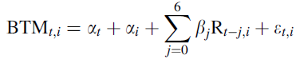conservatism and the value relevance of accounting earnings and book values over time. To test this association on a more comprehensive basis, two measures for conservatism are used: 1) the BR-CONS used in Beaver and Ryan (2000), and 2) C-SCORE developed by Penman and Zhang (2002, see §3.1). Especially to measure unconditional conservatism the measure of Beaver and Ryan (2000) is used: However, to yield a measure positively associated with conservatism the market-to-book ratio is used instead of the book-to-market ratio. The sum of α1 and αi will be used as measure of conservatism (BR-CONS). The Penman and Zhang (2002) measure of unconditional conservatism uses the sum of capitalized R&D, capitalized R&D expense, and the LIFO reserve scale by net operating assets. To measure value relevance, three measures are used: 1) adjusted R2 from regressions of price on contemporaneous earnings and book value, 2) adjusted R2 from regressions of returns on contemporaneous earnings and change in earnings, 3) market-adjusted measure of returns that could be earned from perfect foresight of earnings and book value.

The regressions will be tested using a sample period from 1975 up to 2004 including US business enterprises. The chosen research methodology to test this is a market based approach in combination with the positive accounting theory. Overall, no evidence is found that a decline in price value relevance of financial information is related with an increasing use of conservatism. Only evidence is found that firms with steady conservatism is related with declines in price value relevance.

The first review paper of Watts (2003a) describes some different explanations for conservatism in financial statements and the implications of conservatism for accounting regulators. Conservatism is mostly described as *“anticipate no profit, but anticipate all losses”* (Watts 2003a, 208). An important consequence of using conservatism in financial statements is the understatement of net assets and therewith the understatement of earnings. The explanations mentioned within this study for conservatism are the same as earlier mentioned by Basu (1997): contracting, shareholder litigation, taxation, and accounting regulation.

Conservatism is used within contracting to overcome the asymmetric information problem. Due to accounting contracts, more timely information about earnings is needed and a contract is not legally enforceable when cash flows are not verifiable. Underlying to the concept of conservatism and debt contracts is the orderly liquidation concept. This concepts describes that a liquidator will anticipate all losses but no unverifiable gains. Furthermore, conservatism and executive compensation contracts are characterized with a defer of rewards to managers. Lastly, conservatism and firm governance is also related to asymmetric verifiability.

Furthermore, when using conservatism the likelihood for possible shareholder litigation will be lower since understating of net assets is associated with a lower litigation than the overvaluation of net assets. Moreover, due to conservatism tax payments are deferred since net assets and therefore earnings are understated. Lastly, conservatism reduces the possibility of political costs for standard setters and regulators. Accounting regulation as last explanation for conservatism seems to be decreasingly important since the FASB wants to take a more “neutral” position. Watts (2003a) believes that this isn’t a good case since in his opinion earnings and the value of net assets should be verifiable.

The second review paper of Watts (2003b) discuss empirical evidence of conservatism, the increasing trend of conservatism over time, and alternative explanations of conservatism as discussed in the first review paper of Watts (2003a). Briefly mentioned in the paper is that conservatism is found to be increasing over time. More thoroughly discussed are models used to measure conservatism.

Especially relevant for this study, is how the understatement of net assets is measured as explanation for conservatism. According to Watts (2003b) most models used in prior literature are models who compare *“the valuation of the firm’s shares and/or the ratio of the firm’s book value of net assets to its equity value (book-to-market ratio)”* (Watts 2003b, 288). To measure these relations, mostly Feltham-Ohlson valuation models are used. However, since contrary evidence is found between the regressions and the time-series regressions, this is the weakest test following Watts (2003b). Another model that is often used is the model of Beaver and Ryan (2000) that measures conservatism on a book-to-market ratio basis. More explicitly, the model of Beaver and Ryan (2000) discuss whether the bias in the book-to-market ratio (BTM) has different implications to predict future book return on equity (ROE) than the lag in the BTM. Bias is meant as the situation whereby the book value is persistently higher (lower) than the market value, this will be measured with the firm effect. Lags can be described as whether the unexpected gains (losses) are recognized in book value over time instead of immediately, resulting in a temporarily different BTM, and current and lagged returns will serve as a proxy. Especially interesting for this study is the case that a more conservative bias is reflected in a persistently lower BTM, and one example of an aspect that yields bias is the immediate expensing of advertising and most research and development expenditures.

The study of Watts (2003b) conclude that of the four explanations mentioned in Part I (Watts 2003a), especially contracting and shareholder litigation are found as a main cause. Taxation and accounting regulation are especially emphasized during the time-series evidence, but these relations are not directly addressed in other studies.

Lastly, a study related to conservatism is the study of Penman and Zhang (2002). Within this study it is studied in which way accounting methods influence the quality of earnings. Conservative accounting within this study refers to LIFO accounting, expensing R&D costs, a depreciation method that consistently use short asset lives, and overestimated allowances for doubtful accounts, sales returns, and warranty liabilities. Especially the expensing of R&D costs is interesting for this thesis. A change in R&D expensing over time will be related with lower quality of earnings. To measure conservatism in relation with the expensing of R&D costs on the balance sheet, the C-Score is used. This is measured as: Cit = RDresit. The RDresit is calculated trough capitalizing R&D expenditures and thereafter amortize them following the industry coefficient estimated by Lev and Sougiannis (1996). Furthermore, a subscore is calculated by dividing RDresit by NOA (NOA is total assets – total liabilities). The hypotheses are tested over a sample period from 1975-1997 for public listed US business enterprises. The chosen research methodology is a market based approach in combination with the positive accounting theory.

The results of this research show that a temporarily change in investment leads to a lower quality of earnings. Furthermore, the market cannot go through the real issues of conservatism in accounting.

## §3.2 Conservatism in association with technology industries in times of non economic turmoil

This subsection describes some studies that have studied the relation between conservatism and technology industries in economic circumstances without economic turmoil. Two studies related to this, Chandra et al. (2004) and Chandra (2011), examine primarily the same association. These studies examine whether a higher level of conditional conservatism in high-technology industries is driven by a high shareholder litigation risk and whether a high level of unconditional conservatism in high-technology industries is driven by conservative accounting rules like SFAS 2 (immediately expensing of R&D costs). The above mentioned assumptions will be tested with a chosen sample period of 1982-2002 in the US for the study of Chandra et al. (2004), and a sample period of 1975-2006 in the US for the study of Chandra (2011). The research methodology used within this study is a market based accounting research combined with positive accounting theory.

To accomplish the results, both studies used some profitability measures (PM, ROA and ROE) and the incidence of losses to test the differences of conservatism between high-technology industries and low-technology industries. Furthermore, in both studies the unconditional conservatism is measured using the level of operating cash flows and using the earnings-return regression of Basu (1997): Eit = α0 + α1 Dit + β0 Rit + β1 Rit Dit + uit. Lower operating cash flows will be related with more unconditional conservatism, since the CFO will decrease when R&D investments are directly expensed. The interception term in the Basu model will be lower when unconditional conservatism is present since this also has a decreasing affect on overall income of the firm due to a high amount of expense related with investments in R&D. An interesting comment included in the conclusion is the recommendation of the author to consider potential controls for R&D intensity and industry membership in future research (Chandra 2011, 310).

Within the study of Chandra et al. (2004) and the study of Chandra (2011) is first of all a significant higher use of overall conservatism found for technology industries in comparison with non-technology industries. Besides that, they found that technology industries rely on higher levels of conservative accounting primarily due to conservative accounting rules (SFAS 2, immediately expensing of R&D costs) and a higher shareholder litigation risk. Managers will rely on higher level of conservatism to diminish political costs and to reduce the likelihood of being sued by shareholders. Cross-sectional differences in conservatism within the technology sample are also investigated within both studies. Within this part of the study is found that a high R&D intensity is associated with higher news independent conservatism. However, a higher growth in R&D intensity is associated with lower news independent conservatism. Furthermore, younger technology firms are associated with higher news independent conservatism. Overall, SFAS 2 has an influence on news independent conservatism. Another examination with time-series evidence done within the study of Chandra (2011) concludes there is an increasing trend of conservatism from 1975 up to 2006 for US business enterprises and this is significantly more existent in high-technology industries.

In contradiction with the study of Chandra (2011), for this thesis only accounting regulation will be studied in an association with conservatism in high-technology industries. As mentioned in the study of Chandra (2011) shareholder litigation is especially a concern in common law countries. For this research European firms will be used, most countries within Europe are based upon code law with the exception of the United Kingdom, Ireland and Scotland (Hertel 2009).

Another study related to this subsection is the study of Kwon et al. (2006). This study investigates whether there are significant differences in the level of conditional conservatism between high- and low-technology industries. Reasons for this examination are regulations in the US which resulted in an increasing use of conservatism in high-technology industries. Besides that, more uncertainty within high-technology industries and possible higher-growth opportunities leading to a higher shareholder litigation and scrutiny of analysts will encourage the use of conservatism within these industries. The use of conservatism in high-technology industries could also decrease political costs, this is related to litigation because investors losses could lead to higher political costs following to a litigation. Lastly, high-technology industries are more likely to attract external financial sources. Within this study the main drivers behind conservatism are unknown and only conditional conservatism is tested. The author does not know, as in the study of Chandra et al. (2004) and the study of Chandra (2011), whether the conditional conservatism is caused by accounting regulations or a higher shareholder litigation in relation with high-technology industries.

The empirical tests used within the study of Kwon et al. (2006) focus on tests used within prior research: *“(1) cumulative negative nonoperating accruals, (2) the slope coefficients from the income timeliness models in Basu, (1997), (3) the skewness of earnings, and (4) the variability of earnings”* (Kwon et al. 2006, 145). The sample used to perform these empirical tests includes firms in computer, electronics, pharmaceutical, and telecommunications industries and cover US firms in a period from 1990-1998. The chosen research methodology are the market based approach in combination with positive accounting theory. The tests used within this study won’t be further described, since these tests seems to measure conditional conservatism while within this thesis only unconditional conservatism will be measured since shareholder litigation risk within European countries will be much lower, and this is especially related to conditional conservatism according to Chandra et al. (2004) and Chandra (2011).

The results of all empirical tests in the study of Kwon et al. (2006) conclude that high-technology industries use conservative accounting methods, and are significant more conservative in accounting than low-technology industries. Restructuring, mergers and acquisitions and cost of pension and post-retirement benefits are mentioned as possible influencing variables of negative nonoperating accruals, however they do not influence the conclusions of this study. Another robustness check is performed for testing if higher response of stock returns to bad news in high-technology industries isn’t driven by aggressive accounting, the results confirm the conclusion of a higher use of conservatism in high-technology industries. In an additional analysis the reason for conservatism in high-technology industries is studied, however in the study of Kwon et al. (2006) it is not clear whether a higher use of conservatism in high-technology industries is due to stricter accounting rules or deliberate management decisions. Another additional analysis concludes when controlling for conservatism, low-tech earnings are more value relevant than high-tech earnings, so high-tech stocks would be overpriced. Consequently, conservatism cannot close the market valuation gap between low-technology and high-technology industries. A limitation of this study is that the results could be different when testing it in a market crash period.

Another study related to this subsection is the review paper of Ryan (2006) which studies the measurements for conditional conservatism, especially related to asymmetric timeliness. According to this study can be concluded that unconditional conservatism is often been associated with the immediate expensing of costs made for intangible assets and is better known as ex ante conservatism. Assets will be valued below the market values of their lives. Unconditional conservatism isn’t really news dependent.

## §3.3 Conservatism in times of economic turmoil

A first study within this subsection is related to conservatism during the Asian Financial

Crisis by Gul et al. (2002). The authors investigate whether the level of conservatism is lower in times of economic turmoil and whether this is related to an increase in audit fees. Gul et al. (2002) categorize conservatism into: 1) conservatism of GAAP, and 2) discretionary conservatism. To measure the level of conservatism, the Basu (1997) model is used because of the importance this model gives towards the timing and recognition in GAAP. A dummy variable is included in the Basu (1997) model to measure the effects of economic turmoil. The relation between conservatism and audit fees is tested using OLS-regressions. To test the assumption a sample period from 1990-1998 is used of Thai firms and the market based approach and positive accounting theory are the underlying research methodologies of the research. The results of this study show that in times of economic turmoil managers use less conservative accounting methods, and the audit fees at that time seem to increase.

Another study of Jenkins et al. (2009) studies whether the level of conservatism differs across business cycles. To test this a sample period from 1980-2003 is used from US business enterprises and the market based approach and positive accounting theory are the underlying methodologies of the research. The results and analysis of the results show that the increased focus on downside risk during periods of economic turmoil stimulates a more conservative method of accounting by management as well as by auditors. The tendency towards a higher use of conditional conservatism in times of economic turmoil is related to a higher shareholder litigation in these times, heightened uncertainty about future outcomes and firms will look more towards external financing in times of economic turmoil. In short, the results of this study show that the level of conditional conservatism is higher during times of economic turmoil over the sample from 1980 up to 2003 for US business enterprises.

In the study of Francis et al. (2011) is studied to what extent conservatism affect shareholder value in times of economic turmoil. To measure conservatism, the C-Score and earnings regression of Basu (1997) are used. Firm specific characteristics are included to control for size, market to book, and leverage. Size (logarithm of market value of equity) is included to control for a possible influence of large firms since large firms are assumed to rely less on debt financing and will have less information asymmetries. Market to book is included to control for large firms during times of economic turmoil since large firms are expected to perform bettering during these times of economic turmoil. As a last control variable leverage (ratio of total liabilities divided by the market value of equity) is included. Leverage is included since firms with a high level of debt financing are expected to have larger problems during times of economic turmoil to attract extra financing. All included control variables had a significant impact on the dependent variable. The interesting variable of unconditional conservatism in the measure of Basu (1997), α0, will then be converted towards α0 + µ2 x SIZE + µ3 x M/B + µ4 x LEVERAGE. Size will be measured as the logarithm of market value of equity. Leverage is the ratio of total liabilities to the market value of equity. To test this association a sample period from October 2007-March 2009 is used for US business enterprises and the market based approach and positive accounting theory are the underlying methodologies of the research. Within the results and analysis of these results it is argued that firms in financial distress face more agency problems and information risks because managers are more likely to use aggressive accounting methods, this increase in agency problems and information risk leads to less reliable and less transparent information to shareholders. Firms that use more conservative methods during times of economic turmoil will be seen as more reliable and transparent. Overall, more conservative firms in times of economic turmoil are expected to have less decline in their stock prices.

## §3.4 Elements of prior literature that will be used for this study

Only the unconditional conservatism will be measured for this study. This because the expensing of R&D costs is highly relevant for high-technology industries as mentioned in the studies of Chandra et al. (2004) and Chandra (2011). The level of unconditional conservatism in different industries (high-technology industries and low-technology industries) will be measured using the earnings-return regression of Basu (1997): Eit = α0 + α1 Dit + β0 Rit + β1 Rit Dit + uit (see §5.1). The earnings-return regression of Basu (1997) is also used within the study of Chandra et al. (2004) and Chandra (2011) concerning the relation between conservatism in different technology industries, and furthermore in the study of Gul et al. (2002) and Francis et al. (2009) in relation with the Asian Financial Crisis. When using the earnings-return regression of Basu (1997) also within this study, the results of prior literature can be well compared with the results of this empirical research. Especially α0 is of interest within this study since this is a measure for unconditional conservatism. The included measure for conditional conservatism within the earnings-return regression of Basu (1997) will be disregarded within this study.

In the study of Francis et al. (2009) firm specific characteristics are included to control for size, market to book, and leverage. The interesting variable of unconditional conservatism in the measure of Basu (1997), α0, will then be converted towards α0 + µ2 x SIZE + µ3 x M/B + µ4 x LEVERAGE (see §5.1). Size will be measured as the logarithm of market value of equity. Leverage is the ratio of total liabilities to the market value of equity. All control variables had a significant impact on the dependent variable within the study of Francis et al. (2009).

The studies of Gul et al. (2002), Jenkins et al. (2009) and Francis et al. (2011) are especially interesting in developing the hypotheses concerning conservatism in times of economic turmoil (see §4.1). Following Jenkins et al. (2009) a more conservative method of accounting will be used by both managers and auditors. Contrary, Francis et al. (2011) and Gul et al. (2002) argue that managers are more tended to use aggressive accounting during times of economic turmoil, so less conservatism.

All mentioned elements of prior research will be applied in chapter 5 research design and chapter 7 to analyze the results found in this study and compare these results with expectations and results found within prior literature.

## §3.5 Summary

An answer to the third sub question can be given based upon this chapter. The third sub question: **What has been studied in prior literature related to conservatism, high- and low-technology industries and economic turmoil related to the subject of this study?**

Conservatism is mostly described as *“anticipate no profit, but anticipate all losses”* (Watts 2003a, 208). An important consequence of using conservatism in financial statements is the understatement of net assets and therewith the understatement of earnings. The explanations mentioned within this study for conservatism are contracting, shareholder litigation, taxation, and accounting regulation (Watts 2003a). In the study of Chandra et al. (2004) and Chandra (2011) is found that especially unconditional conservatism is related with high-technology industries due to the expensing of research and development costs. Unconditional conservatism is mostly measured with the Basu model (1997) and in prior literature is found that unconditional conservatism is higher in high-technology industries compared with low-technology industries. Related to economic turmoil, prior literature found mixed evidence that the increased focus on downside risk during periods of economic turmoil stimulates a more conservative method of accounting by management as well as by auditors (Gul et al. 2002; Jenkins et al. 2009; Francis et al. 2011).

# 4. Hypotheses

Within this subchapter hypotheses will be described based on prior research mentioned in the literature study above.

## §4.1 Hypotheses

Within prior literature (Chandra et al. 2004; Chandra 2011; Kwon et al. 2006) a significant higher level of overall conservatism is found for technology industries in comparison with non-technology industries in the United States. Especially conservative accounting rules (SFAS 2, immediately expensing of R&D costs) have led to a higher level of news independent conservatism, also known as unconditional conservatism (Chandra et al. 2004; Chandra 2011). However, the level of (unconditional) conservatism in the literature study described above is only related to US business enterprises. So, first of all the it will be tested whether this is the same for code law European listed firms in Finland, Germany, France, Spain, Portugal and Greece. Based on prior literature the following hypothesis is formulated:

**H1: Code law European listed firms in high-technology industries are positively associated with a higher level of unconditional conservatism than European listed firms in low-technology industries.**

Following the study of Jenkins et al. (2009) economic turmoil will lead to a more conservative way of accounting in financial statements since there will be an increased focus on downside risk by managers as well as by auditors. Contrary, a study of Gul et al. (2002) found a significant decrease in accounting conservatism during times of economic turmoil. Furthermore, an example of a non-listed firm, operating in a low-technology industry, audited by KPMG supports the results found in the study of Gul et al. (2002). This specific firm in a low-technology industry changed their accounting method in relation with research and development. Before the time of economic turmoil, this specific firm expensed all research and development costs. Right now, this changed during the time of economic turmoil, this firm is capitalizing the research and development costs to fulfill the conditions of their debt contracts. So, this specific non-listed firm in a low-technology industry in the Netherlands has become less conservative in times of economic turmoil. (Van Dijk 2013) This mixed evidence based on prior literature and a recent interview leads to the following hypothesis:

**H2: A change from non economic turmoil to economic turmoil is associated with a change in the use of unconditional conservatism for code law European listed firms in high-technology industries as well as for code law European listed firms in low-technology industries.**

## §4.2 Summary

An answer to the fourth sub question can be given based upon this chapter. The fourth sub question: **Which hypotheses based on the main research question and prior literature will be used for this study?**

First of all, the study will test whether the level of unconditional conservatism will be higher in European listed firms in high-technology industries than in European listed firms in low-technology industries as expected. After that it will be tested if the level of unconditional conservatism will change in times of economic turmoil.

# 5. Research design

Within this chapter first the research model and model proxies will be described that will be used to test the hypotheses mentioned in chapter 4. Further the sample selection will be described and will be more clear shown using descriptive statistics. After that the statistical analysis used within this study will be described and lastly the attainability of this study will be discussed.

## §5.1 Research method and model

### Basu model (1997)

For testing hypotheses H1 and H2 the earnings-return regression of Basu (1997) will be used. The earnings-return regression of Basu (1997) is also used within the study of Chandra et al. (2004) and Chandra (2011) concerning the relation between conservatism in different technology industries, and furthermore in the study of Gul et al. (2002) and Francis et al. (2009) in relation with the Asian Financial Crisis. When using the earnings-return regression of Basu (1997) also within this study, the results of prior literature can be well compared with the results of this empirical research. Especially α0 is of interest within this study since this is a measure for unconditional conservatism. The included measure for conditional conservatism within the earnings-return regression of Basu (1997) will be disregarded within this study.

The interception term (α0) in the Basu model will be lower when unconditional conservatism is present since this will also has a decreasing effect on overall income of the firm due to the high amount of expense related with investments in R&D (Basu 1997; Chandra et al. 2004; Chandra 2011).

Eit = α0 + α1 Dit + β0 Rit + β1 Rit Dit + uit

Eit = annual earnings per share in year *t* for firm *i* scaled by beginning stock price;

Rit = the firm’s annual stock return in year *t*;

Dit = 1 if Rit is negative, and 0 otherwise;

uit = error term.

*Dependent and independent variables*

The data for the dependent variable will be obtained by CompuStat Global (annual earnings per share in year *t* for firm *i*) and Datastream (beginning stock price of firm *i*). The data for the independent variable Rit will be obtained from Datastream (beginning stock price of firm *i* and ending stock price of firm *i*). Rit will be measured as follows: (Pt – Pt-1)/Pt (Jenkins et al. 2009).

### First hypothesis

**H1: Code law European listed firms in high-technology industries are positively associated with a higher level of unconditional conservatism than European listed firms in low-technology industries.**

Since in the first hypothesis the difference of unconditional conservatism in code law European listed firms in high-technology industries and code law European listed firm in low-technology industries will be measured, the regression will be executed twice following Chandra et al. (2004) and Chandra (2011). Once for a sample with only code law European listed firms in low-technology industries and once for a sample for only code law European listed firms in high-technology industries. The results will thereafter be compared using a two samples one-tailed t-test (see §5.4).

Normal earnings-return regression of Basu (1997)

**(1) Eit = α0 + α1 Dit + β0 Rit + β1 Rit Dit + uit**

Eit = annual earnings per share in year *t* for firm *i* scaled by beginning stock price;

Rit = the firm’s annual stock return in year *t*;

Dit = 1 if Rit is negative, and 0 otherwise;

uit = error term.

To define which company should be included in which sample, four-digit *SIC* codes will be used (see §2.1, Appendix D). As mentioned before, α0 will be lower if a higher level of unconditional conservatism is present. See §5.4 for the statistical analysis.

*Dependent and independent variables*

The data for the dependent variable will be obtained by CompuStat Global (annual earnings per share in year *t* for firm *i*) and Datastream (beginning stock price of firm *i*). The data for the independent variable Rit will be obtained from Datastream (beginning stock price of firm *i* and ending stock price of firm *i*). Rit will be measured as follows: (Pt – Pt-1)/Pt (Jenkins et al. 2009).

First adapted earnings-return regression of Basu (1997) – introduction of SIZEit

An interesting comment included is the recommendation of the author to consider potential controls for R&D intensity and industry membership in future research (Chandra 2011, 310). Francis et al. (2011) included three control variables to overcome part of the factors mentioned in Chandra (2011) and thereby to overcome the possible influence of these factors.

The three control variables included are SIZEit, Mit/Bit and LEVERAGEit (see §3.3). Only one of the three control variables will be included in second adapted earnings-return regression of Basu (1997) since the other two control variables are especially related towards times of economic turmoil. SIZEit is included since large firms are less likely to rely on debt financing and will have less information asymmetries than smaller firms. Mit/Bit and LEVERAGEit will be included later on since, as explained above, these control variables could especially have an effect in times of economic turmoil. The inclusion of one of these control variables leads to the following adapted earnings-return regression of Basu (1997):

**(2) Eit = α0 + α1 SIZEit + α4 Dit + β0 Rit + β1 Rit Dit + uit**

Eit = annual earnings per share in year *t* for firm *i* scaled by beginning stock price;

Rit = the firm’s annual stock return in year *t*;

Dit = 1 if Rit is negative, and 0 otherwise;

SECTOR = 1 if the firm is in a high-technology industry, and 0 otherwise;

SIZEit = natural log of market value of equity of firm *i* at fiscal year-end;

uit = error term.

As mentioned before, α0 will be lower if a higher level of unconditional conservatism is present. See §5.4 for the statistical analysis.

*Dependent and independent variables*

The data for the dependent variable will be obtained by CompuStat Global (annual earnings per share in year *t* for firm *i*) and Datastream (beginning stock price of firm *i*). The data for the independent variable Rit will be obtained from Datastream (beginning stock price of firm *i* and ending stock price of firm *i*). Rit will be measured as follows: (Pt – Pt-1)/Pt (Jenkins et al. 2009).

*Control variable*

SIZEit as measured by the logarithm of market value of equity will be included since firms in high-technology industries are less likely to rely on debt financing (Francis et al. 2011; Hogan and Hutson 2005). The market value of equity will be measured using the stock price of firm’s *i* shares at fiscal year-end (DataStream) multiplied by the number of shares outstanding of firm *i* at fiscal year-end (CompuStat Global) (Wang 2007).

### Second hypothesis

**H2: A change from non economic turmoil to economic turmoil is associated with a change in the use of unconditional conservatism for code law European listed firms in high-technology industries as well as for code law European listed firms in low-technology industries.**

Second adapted earnings-return regression of Basu (1997) – introduction of CRISIS

Since in the second hypothesis the difference of unconditional conservatism in code law European listed firms in high-technology industries and code law European listed firm in low-technology industries will be measured, the regression will be executed twice following Chandra et al. (2004) and Chandra (2011). Once for a sample with only code law European listed firms in low-technology industries and once for a sample for only code law European listed firms in high-technology firms. The results will thereafter be compared using a two samples two-tailed t-test (see §5.4). Furthermore, a dummy variable is needed for the second hypothesis to test whether the level of unconditional conservatism changes in times with economic turmoil (Gul et al. 2002):

**(3) Eit = α0 + α1 CRISIS + α2 Dit + β0 Rit + β1 Rit Dit + uit**

Eit = annual earnings per share in year *t* for firm *i* scaled by beginning stock price;

Rit = the firm’s annual stock return in year *t*;

Dit = 1 if Rit is negative, and 0 otherwise;

CRISIS = 1 if it is during a period of economic turmoil (2008, 2009, 2010, 2011); 0

otherwise (2005, 2006, 2007)

uit = error term.

CRISIS is included to test whether the level of unconditional conservatism is different in times of economic turmoil compared with times without economic turmoil. Which years belong to the times with and without economic turmoil is based upon the first signs of economic turmoil in November 2008 in Europe (see §2.1).

As mentioned before, α0 will be lower if a higher level of unconditional conservatism is present. The level of unconditional conservatism will be α0 + α1 for both code law European listed firms in high-technology industries and code law European listed firms in low-technology industries after including the dummy variable CRISIS. So, α0 + α1 will be lower if a higher level of unconditional conservatism is present. See §5.4 for the statistical analysis.

Third adapted earnings-return regression of Basu (1997) – introduction of CRISIS, SIZEit, Mit/Bit and LEVERAGE

To test for the second hypothesis whether some control variables will have an influence on the results of this study all three control variables (SIZEit, Mit/Bit and LEVERAGEit) mentioned in the study of Francis et al. (2011) will be included (see §3.3). SIZEit as measured by the logarithm of market value of equity will be included since firms in high-technology industries are less likely to rely on debt financing (Francis et al. 2011; Hogan and Hutson 2005). Since hypothesis two is related to times with and without economic turmoil also market to book ratio and leverage are included as control variables. Mit/Bit as measured by the market-to-book ratio of firm *i* at fiscal year-end will be included since firms with a higher market-book-ratio are expected to perform better during times of economic turmoil since these firms are likely to have more growth options which will help these firms to preserve their equity value during times of economic turmoil (Francis et al. 2011). LEVERAGEit as measured by the debt-to-equity ratio of firm *i* at fiscal year-end will be included since highly leveraged firms are more likely to have difficulties obtaining external financing during times of economic turmoil and as result of this these firms are expected to have a higher decline in their market value during times of economic turmoil. The inclusion of all three control variables leads to the following adapted earnings-return regression of Basu (1997) to test hypothesis two:

**(4) Eit = α0 + α2 CRISIS + α3 SIZEit + α4 Mit/Bit + α5 LEVERAGEit + α7 Dit + β0 Rit + β1 Rit Dit + uit**

Eit = annual earnings per share in year *t* for firm *i* scaled by beginning stock price;

Rit = the firm’s annual stock return in year *t*;

Dit = 1 if Rit is negative, and 0 otherwise;

CRISIS = 1 if it is during a period of economic turmoil (2008, 2009, 2010, 2011); 0

otherwise (2005, 2006, 2007)

SIZEit = natural log of market value of firm *i* at fiscal year-end;

Mit/Bit = market-to-book ratio of firm *i* at fiscal year-end;

LEVERAGEit = debt-to-equity ratio of firm *i* at fiscal-year end;

uit = error term.

As mentioned before, α0 will be lower if a higher level of unconditional conservatism is present. The level of unconditional conservatism will be α0 + α1 for both code law European listed firms in high-technology industries and code law European listed firms in low-technology industries after including the dummy variable CRISIS. So, α0 + α1 will be lower if a higher level of unconditional conservatism is present. See §5.4 for the statistical analysis.

*Dependent and independent variables*

The data for the dependent variable will be obtained by CompuStat Global (annual earnings per share in year *t* for firm *i*) and Datastream (beginning stock price of firm *i*). The data for the independent variable Rit will be obtained from Datastream (beginning stock price of firm *i* and ending stock price of firm *i*). Rit will be measured as follows: (Pt – Pt-1)/Pt (Jenkins et al. 2009).

*Control variables*

SIZEit as measured by the logarithm of market value of equity will be included since firms in high-technology industries are less likely to rely on debt financing (Francis et al. 2011; Hogan and Hutson 2005). The market value of equity will be measured using the stock price of firm’s *i* shares at fiscal year-end (DataStream) multiplied by the number of shares outstanding of firm *i* at fiscal year-end (CompuStat Global) (Wang 2007). Mit/Bit as measured by the market-to-book ratio of firm *i* at fiscal year-end will be included since firms with a higher market-book-ratio are expected to perform better during times of economic turmoil since these firms are likely to have more growth options which will help these firms to preserve their equity value during times of economic turmoil (Francis et al. 2011). The market-to-book ratio will be measured using the market value of equity at fiscal year-end (Datastream and CompuStat Global) as used in control variable SIZEit explained above, and the book ratio of the firm will be measured using the book value of common equity at fiscal year-end (CompuStat Global) (Chandra 2011; Francis et al. 2011). As a last control variable, LEVERAGEit as measured by the debt-to-equity ratio of firm *i* at fiscal year-end will be included since highly leveraged firms are more likely to have difficulties obtaining external financing during times of economic turmoil and as result of this these firms are expected to have a higher decline in their market value during times of economic turmoil. The debt-to-equity ratio is measured using total liabilities (long-term plus short-term debt) of firm *i* at fiscal year-end (CompuStat Global) divided by the market value of equity at fiscal year-end (CompuStat Global and Datastream). (Francis et al. 2011) The market value of equity at fiscal year-end will be measured on the same basis as used in control variable SIZEit as explained above.

## §5.2 Sample

Within this study only publicly listed code law European companies are included. Only companies out of Finland, Germany, France, Spain, Portugal and Greece are included (see §2.1) within a period from 2005 up to 2011 (see §2.1). The starting year of 2005 is chosen since all publicly listed firms in Europe are from then required to report following the International Financial Reporting Standards (IFRS) (PwC 2013) It is possible that firms included within this sample are not active any longer due to bankruptcy or mergers and acquisitions. However, when excluding these data the study will have a problem with a survivorship bias (Chandra 2011).

## §5.3 Data collection

*Classification benchmarks*

In most prior literature the high-technology industries are defined based on the qualification of Francis and Schipper (1999) related to *SIC* codes (see appendix B). These three-digit *SIC* codes are converted into four-digit *SIC* codes (see appendix C) since these four-digit *SIC* codes are needed to classify the obtained data from CompuStat Global.

*Data collection*

All data used within this study is obtained from CompuStat Global (total common equity, total liabilities, research and development expense, common shares outstanding, earnings per share) or Datastream (beginning and ending stock prices) (see §5.1). CompuStat Global provided 12077 firm year observations. Following Chandra (2011) all financial services are excluded since these companies must comply with other legislations.

The firm year observations retrieved from Compustat Global are combined with firm year observations from Datastream. After combining both datasets into one dataset it became clear a lot of data was missing. Furthermore when Compustat Global provided a point (.) as outcome this means that no data was available within the annual report related to this specific item. When there was a point included into total common equity, total liabilities, common shares outstanding or earnings per share the specific year observation is removed. This is not the case for research and development expenses since a lot of companies do not spend any money on research and development or not every year. So excluding all dese data points would not be reliable.

After excluding all the firm years and firms with missing data a number of 3756 firm year observations was left. A total number of 1058 firm year observations is included in the low-technology sample and a total number of 2698 firm year observations in the high-technology industry. Further, a total number of 2245 firm year observations is included in the period with economic turmoil sample and a total number of 1511 firm year observations is included in the period without economic turmoil sample. A logarithm will be used for some variables (see §5.4) in order to prevent outliers.

Figure 5.3.1 Sample

|  |  |  |  |  |
| --- | --- | --- | --- | --- |
| Country | Number of firms | Number of firm year observations | Period without economic turmoil | Period with economic turmoil |
| 1. Finland high-technology | 33 | 221 | 93 | 128 |
| 1. Finland low-technology | 11 | 64 | 30 | 34 |
| 2. Germany high-technology | 209 | 1180 | 487 | 693 |
| 2. Germany low-technology | 52 | 307 | 121 | 186 |
| 3. France high-technology | 205 | 1094 | 419 | 675 |
| 3. France low-technology | 42 | 276 | 118 | 158 |
| 4. Spain high-technology | 14 | 79 | 28 | 51 |
| 4. Spain low-technology | 17 | 99 | 39 | 60 |
| 5. Portugal high-technology | 5 | 35 | 15 | 20 |
| 5. Portugal low-technology | 14 | 87 | 35 | 52 |
| 6. Greece high-technology | 16 | 89 | 39 | 50 |
| 6. Greece low-technology | 39 | 225 | 87 | 138 |
| Total high-technology | **482** | **2698** | **1081** | **1617** |
| Total low-technology | **175** | **1058** | **430** | **627** |
| Total | **657** | **3756** | **1511** | **2245** |

## §5.4 Statistical analysis

The use of unconditional conservatism in high-technology industries is related to the high amount of research and development expenses in these industries (Chandra et al. 2004). Following the study of Chandra et al. (2004), first of all the sample will be tested whether the research and development expenses are higher in high-technology industries compared with low-technology industries as expected. An independent t-test will be used to test this expectation since this test can be used in situations with two different groups (in this study: companies in high-technology industries and companies in low-technology industries). To overcome the problem with large differences in data points the logarithm is used. (Benoit 2011; Field 2009) Assumptions for the independent t-test are: (1) homogeneity of variance, and (2) scores are independent. To test the homogeneity of variance Levene’s test can be used. When this test is significant (p < 0,05) homogeneity of variance is violated and when this test is not significant (p > 0,05) homogeneity of variance is not violated. Whether the scores are independent cannot be tested within an independent-t test and it comes to rationality. Since the research and development expenses of companies are extracted from a database, it cannot be the case these companies have influenced each other resulting in dependent scores.

To test the two hypotheses (see §4.1) first a multiple regression will be used. For some variables used within this multiple regression (Eit, Rit, DitRit) a logarithm is used to eliminate large differences between the lowest and highest data points observed. (Benoit 2011; Field 2009) Before running a multiple regression it should be tested whether the model fits the data. This could be done by checking the outliers and residuals of the regression (Studentized residual) or looking at influential cases (Studentized residual or Cook’s Distance). Studentized residuals should have a mean of zero. Cook’s Distance will be a concern for the model if it takes a value greater than one. (Field 2009)

After controlling whether the model fits the data, some assumptions should be tested to ensure the validity of your multiple regression (Field 2009):

1. No multicollinearity (VIF);

- If the average VIF is greater than one, the model may be biased

1. No heteroskedasticity (*ZRESID and *ZPRED plot);

- When there is a line in the variances, homogeneity of variance is violated (so heteroskedasticity)

1. There should be independent errors (Durbin-Watson test);

- A value less than one or greater than three is a concern

1. There should be a normal distribution of errors with a mean of zero (regression plots).

Furthermore, the predictive power of the model should be checked using the adjusted R2. More variance is explained by the independent variables of the dependent variable with a higher adjusted R2.

Finally, to test whether hypothesis 1 (see §4.1) is true a two sample one-tailed t-test (hypothesis 1) will be used following Chandra (2011). A two sample one-tailed t-test (for the formula and calculations, see Appendix L) can be used for the first hypothesis since the first hypothesis state that the level of unconditional conservatism for code law European listed firms in high-technology industries will be higher than the level of unconditional conservatism for code law European listed firms in low-technology industries (see §4.1). More specific, a Welch’s t-test will be used since there are unequal samples with unequal variances. (Moore et al. 2009)

## §5.5 Attainability

Since all data needed for the adapted earnings-return regression of Basu (1997) (see §5.1) can be obtained from CompuStat Global and Datastream this study is highly attainable. Within the full adapted earnings-return regression of Basu (1997) (see §5.1) seven variables are included. Following Field (2009), for each variable included in the regression a minimal of fifty observations should be included. This would be 350 firm year observations within this study. With a total of 3756 firm year observations included within this study this number is easily exceeded.

## §5.6 Summary

An answer to the fifth sub question can be given based upon this chapter. The fifth sub question: **What research design could be used to study the associations of interest within this study?**

Within this chapter first of all one normal earnings-return regression of Basu (1997) and three adapted earnings-return regressions of Basu (1997) has been formulated that will be used to test the two hypotheses of this study. Thereafter the sample and data collection is described. The sample consists of a total of 3756 firm year observations obtained from Compustat Global and Datastream. The four adapted earnings-return regression of Basu (1997) will be tested using an independent t-test, multiple regressions and two sample one-tailed t-test. This study is highly attainable since enough data is available and all statistical methods are used in prior literature (Chandra et al. 2004, Chandra 2011 and Gul et al. 2002).

# 6. Results

Within this chapter empirical research using different statistical methods will be shown. First of all, the high-technology industry sample and the low-technology industry sample will be compared based on research and development expenses. Furthermore, hypothesis 1 and hypothesis 2 will be tested.

## §6.1 Research and development expenses

First of all, the high-technology industry sample and the low-technology industry sample will be compared based on research and development expenses following the study of Chandra et al. (2004) and Chandra (2011) since this a key criterion to classify both samples. To compare both samples an independent t-test will be used (Field 2009).

Figure 6.1.1 Independent sample t-test R&D expenses

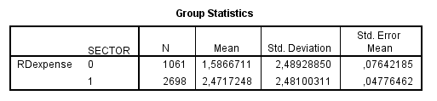

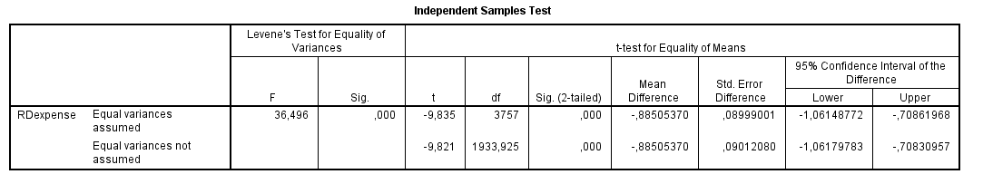

Within the independent t-test showed above the mean research and development expenses between the high-technology sector (1) and low-technology sector (2) are compared. The test is based upon a significant level of 5% (α = 0,05). Levene’s test is significant (p = 0,000, which is lower than 0,05) so *Equal variances not assumed* should be used to conclude. When Levene’s test is not significant the variances within the two samples are not different and the homogeneity of variances is not violated. (Field 2009) Out of the results can be concluded that the mean research and development expenses within the high-technology industry sample are significantly higher than the mean research and development expenses within the low-technology sample (p = 0,000, which is lower than 0,05).

## §6.2 Hypothesis 1

**H1: Code law European listed firms in high-technology industries are positively associated with a higher level of unconditional conservatism than European listed firms in low-technology industries.**

For hypothesis 1 the first two adapted earning-return regressions of Basu (1997) (see §5.1) will be tested using a multiple regression for firms included in the sample for code law European listed firms in low-technology industries and for firms included in the sample for code law European listed firms in high-technology industries. Thereafter, the significance of the difference of the α0’s of these multiple regressions will be compared using a two sample one-tailed t-test (see §5.4).

### Normal earnings-return regression of Basu (1997) – low-technology

*Outliers and influential cases (see §5.4)*

The studentized residuals do have a mean of -0,001 (see figure D.1 Appendix D). The mean of Cook’s Distance is 0,003 (see figure D.1 Appendix D) and this is far below 1, so no outliers are present. To conclude: the model fits the data.

*Assumptions (see §5.4)*

1. There is no multicollinearity between the independent variables and the dependent variable Eit, since the VIF’s of these variables are much lower than 10, see figure 6.2.2 below. This assumption is met;
2. There is no heteroskedasticity looking at the histogram (see D.2 Appendix D). This assumption is met;
3. There is some concern of correlated residual terms since the Durbin-Watson of 0,426 is not located between one and three (see figure 6.2.2). This assumption is not met;
4. There are normally distributed errors with a mean of zero (see figure D.3 Appendix D). This assumption is met.

The adjusted R2 is 0,087. To conclude: 8,7% of the variance of the dependent variable is explained by the included independent variables.

*Multiple regression*

The descriptive statistics give an overview of the variables included and the properties of the variables included:

Figure 6.2.1 Descriptive statistics normal earnings-return regression of Basu (1997) – low-technology

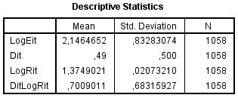

The normal earnings-return regression of Basu (1997) for low-technology is as follows (see figure 6.2.2): Log(Eit) = 10,356 - 0,067 Dit – 6,071 Log(Rit) + 0,243 DitLog(Rit) + uit. It can be concluded that α0 does have a significant impact on Eit (p = 0,000).

Figure 6.2.2 First earnings-return regression of Basu (1997) – low-technology

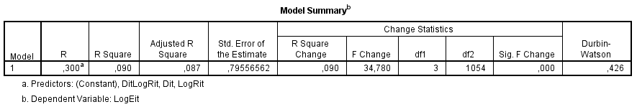

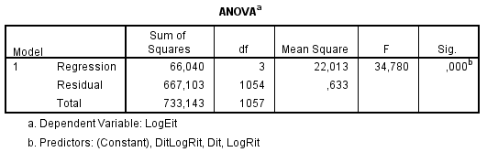

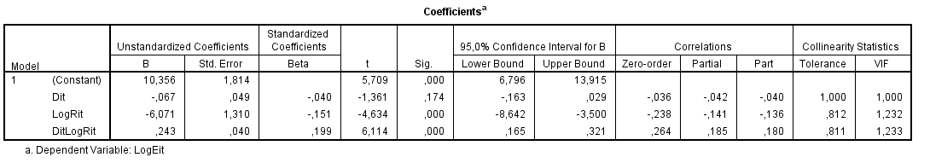

### Normal earnings-return regression of Basu (1997) – high-technology

*Outliers and influential cases (see §5.4)*

The studentized residuals do have a mean of -0,003 (see figure E.1 Appendix E). The mean of Cook’s Distance is 0,213 (see figure E.1 Appendix E) and this is far below 1, so no outliers are present. To conclude: the model fits the data.

*Assumptions (see §5.4)*

1. There is no multicollinearity between the independent variables and the dependent variable Eit, since the VIF’s of these variables are much lower than 10, see figure 6.2.4 below. This assumption is met;
2. There is no heteroskedasticity looking at the histogram (see E.2 Appendix E). This assumption is met;
3. There is some concern of correlated residual terms since the Durbin-Watson of 0,435 is not located between one and three (see figure 6.2.4). This assumption is not met;
4. There are normally distributed errors with a mean of zero (see figure E.3 Appendix E). This assumption is met.

The adjusted R2 is 0,072. To conclude: 7,2% of the variance of the dependent variable is explained by the included independent variables.

*Multiple regression*

The descriptive statistics give an overview of the variables included and the properties of the variables included:

Figure 6.2.3 Descriptive statistics normal earnings-return regression of Basu (1997) – high-technology

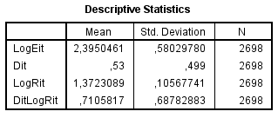

The normal earnings-return regression of Basu (1997) for high-technology is as follows (see figure 6.2.4): Log(Eit) = 2,914 - 0,023 Dit – 0,483 Log(Rit) + 0,219 DitLog(Rit) + uit. It can be concluded that α0 does have a significant impact on Eit (p = 0,000).

Figure 6.2.4 Normal earnings-return regression of Basu (1997) – high-technology

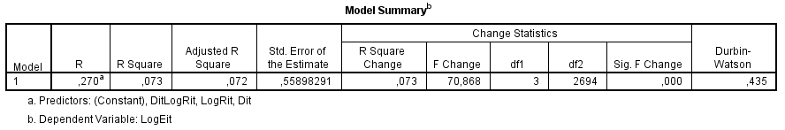

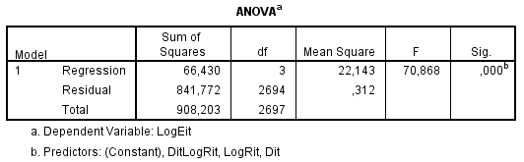

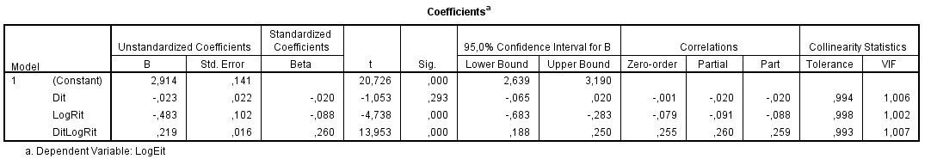

### Two sample one-tailed t-test normal earnings-return regression of Basu (1997)

Comparing the two means of α0 of both multiple regressions results in t-statistic of 250,67 (see Appendix L). Since this t-statistic is much larger than the t-critical of 1,64 hypothesis 1 is accepted.

**Hypothesis 1 is accepted.**

### First adapted earnings-return regression of Basu (1997) – low-technology

*Outliers and influential cases (see §5.4)*

The studentized residuals do have a mean of -0,001 (see figure F.1 Appendix F). The mean of Cook’s Distance is 0,002 (see figure F.1 Appendix F) and this is far below 1, so no outliers are present. To conclude: the model fits the data.

*Assumptions (see §5.4)*

1. There is no multicollinearity between the independent variables and the dependent variable Eit, since the VIF’s of these variables are much lower than 10, see figure 6.2.6 below. This assumption is met;
2. There is no heteroskedasticity looking at the histogram (see F.2 Appendix F). This assumption is met;
3. There is some concern of correlated residual terms since the Durbin-Watson of 0,445 is not located between one and three (see figure 6.2.6). This assumption is not met;
4. There are normally distributed errors with a mean of zero (see figure F.3 Appendix F). This assumption is met.

The adjusted R2 is 0,328. To conclude: 32,8% of the variance of the dependent variable is explained by the included independent variables. The model is improved compared with the normal earnings-return regression of Basu (1997) – low-technology due to the addition of the control variable SIZEit.

*Multiple regression*

The descriptive statistics give an overview of the variables included and the properties of the variables included:

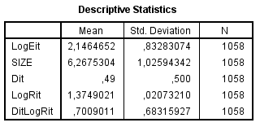  
Figure 6.2.5 Descriptive statistics first adapted earnings-return regression of Basu (1997) – low-technology

The first adapted earnings-return regression of Basu (1997) for low-technology is as follows (see figure 6.2.6): Log(Eit) = 9,859 - 0,410 SIZEit – 0,048 Dit – 3,800 Log(Rit) + 0,146 DitLog(Rit) + uit. It can be concluded that α0 does have a significant impact on Eit (p = 0,000). Besides it can be concluded that SIZEit has a significant impact (p = 0,000; see figure 6.2.6) on the dependent variable Eit but it also has an influence on the level of unconditional conservatism. The level of unconditional conservatism will be lower when the size, measured as the logarithm of market value of equity (see §5.1), is greater.

Figure 6.2.6 First adapted earnings-return regression of Basu (1997) – low-technology

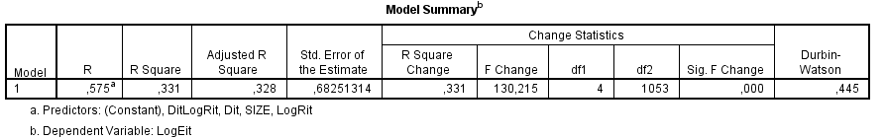

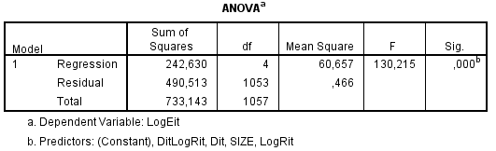

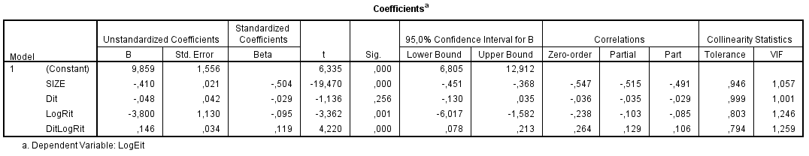

### First adapted earnings-return regression of Basu (1997) – high-technology

*Outliers and influential cases (see §5.4)*

The studentized residuals do have a mean of -0,002 (see figure G.1 Appendix G). The mean of Cook’s Distance is 0,111 (see figure G.1 Appendix G) and this is far below 1, so no outliers are present. To conclude: the model fits the data.

*Assumptions (see §5.4)*

1. There is no multicollinearity between the independent variables and the dependent variable Eit, since the VIF’s of these variables are much lower than 10, see figure 6.2.8 below. This assumption is met;
2. There is no heteroskedasticity looking at the histogram (see G.2 Appendix G). This assumption is met;
3. There is some concern of correlated residual terms since the Durbin-Watson of 0,399 is not located between one and three (see figure 6.2.6). This assumption is not met;
4. There are normally distributed errors with a mean of zero (see figure G.3 Appendix G). This assumption is met.

The adjusted R2 is 0,409. To conclude: 40,9% of the variance of the dependent variable is explained by the included independent variables. The model is improved compared with the first adapted earnings-return regression of Basu (1997) – high-technology due to the addition of the control variable SIZEit.

*Multiple regression*

The descriptive statistics give an overview of the variables included and the properties of the variables included:

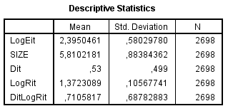Figure 6.2.7 Descriptive statistics first adapted earnings-return regression of Basu (1997) – high-technology

The first adapted earnings-return regression of Basu (1997) for high-technology is as follows (see figure 6.2.8): Log(Eit) = 4,910 - 0,385 SIZE – 0,027 Dit – 0,275 Log(Rit) + 0,158 DitLog(Rit) + uit. It can be concluded that α0 does have a significant impact on Eit (p = 0,000). Besides it can be concluded that SIZEit has a significant impact (p = 0,000; see figure 6.2.8) on the dependent variable Eit but it also has an influence on the level of unconditional conservatism. The level of unconditional conservatism will be lower when the size, measured as the logarithm of market value of equity (see §5.1), is greater.

Figure 6.2.8 First adapted earnings-return regression of Basu (1997) – high-technology

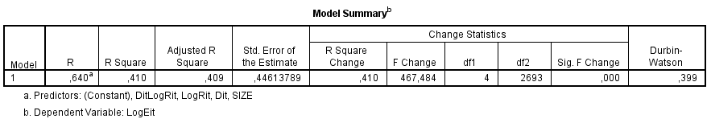

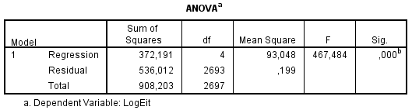

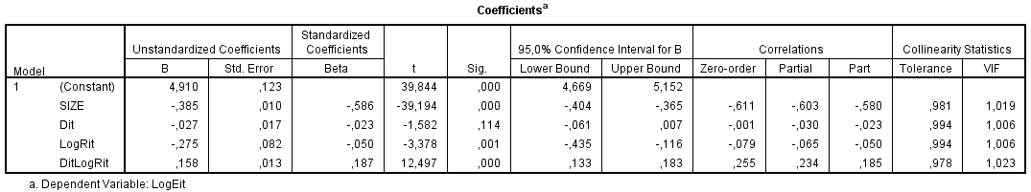

### Two sample one-tailed t-test first adapted earnings-return regression of Basu (1997)

Comparing the two means of α0 of both multiple regressions results in t-statistic of 194,32 (see Appendix L). Since this t-statistic is much larger than the t-critical of 1,64 hypothesis 1 is accepted.

**Hypothesis 1 is accepted.**

## §6.3 Hypothesis 2

**H2: A change from non economic turmoil to economic turmoil is associated with a change in the use of unconditional conservatism for code law European listed firms in high-technology industries as well as for code law European listed firms in low-technology industries.**

For hypothesis 2 the first two adapted earnings-return regressions of Basu (1997) (see §5.1) will be tested using a multiple regression for firms included in the sample for code law European listed firms in low-technology industries and for firms included in the sample for code law European listed firms in high-technology industries.

### Second adapted earnings-return regression of Basu (1997) – low-technology

*Outliers and influential cases (see §5.4)*

The studentized residuals do have a mean of -0,001 (see figure H.1 Appendix H). The mean of Cook’s Distance is 0,002 (see figure H.1 Appendix H) and this is far below 1, so no outliers are present. To conclude: the model fits the data.

*Assumptions (see §5.4)*

1. There is no multicollinearity between the independent variables and the dependent variable Eit, since the VIF’s of these variables are much lower than 10, see figure 6.3.2 below. This assumption is met;
2. There is no heteroskedasticity looking at the histogram (see H.2 Appendix H). This assumption is met;
3. There is some concern of correlated residual terms since the Durbin-Watson of 0,414 is not located between one and three (see figure 6.3.2). This assumption is not met;
4. There are normally distributed errors with a mean of zero (see figure H.3 Appendix H). This assumption is met.

The adjusted R2 is 0,091. To conclude: 9,1% of the variance of the dependent variable is explained by the included independent variables.

*Multiple regression*

The descriptive statistics give an overview of the variables included and the properties of the variables included:

Figure 6.3.1 Descriptive statistics second adapted earnings-return regression of Basu (1997) – low-technology

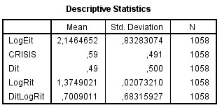

The second adapted earnings-return regression of Basu (1997) for low-technology is as follows (see figure 6.3.2): Log(Eit) = 9,692 + 0,120 CRISIS – 0,061 Dit – 5,631 Log(Rit) + 0,221 DitLog(Rit) + uit. It can be concluded that α0 does have a significant impact on Eit (p = 0,000). Besides it can be concluded that α1 (CRISIS) has a significant impact (p = 0,023; see figure 6.3.2) on the dependent variable Eit but it also has an influence on the level of unconditional conservatism. The level of unconditional conservatism is higher when α0 (period without economic turmoil) or α0+α1 (period with economic turmoil) is lower. So, out of this regression it can be concluded that the level of unconditional conservatism is higher in periods without economic turmoil (9,692) than in periods with economic turmoil (9,692 + 0,120).

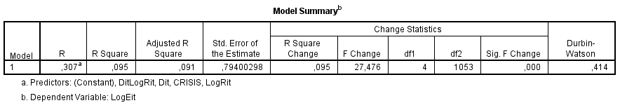Figure 6.3.2 Second adapted earnings-return regression of Basu (1997) – low-technology

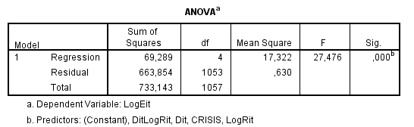

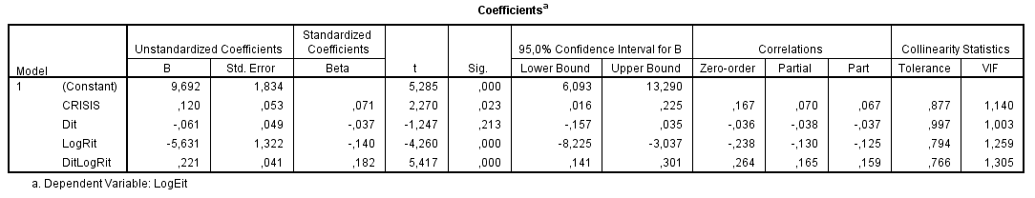

### 

**Hypothesis 2 is accepted.**

### Second adapted earnings-return regression of Basu (1997) – high-technology

*Outliers and influential cases (see §5.4)*

The studentized residuals do have a mean of -0,002 (see figure I.1 Appendix I). The mean of Cook’s Distance is 0,147 (see figure I.1 Appendix I) and this is far below 1, so no outliers are present. To conclude: the model fits the data.

*Assumptions (see §5.4)*

1. There is no multicollinearity between the independent variables and the dependent variable Eit, since the VIF’s of these variables are much lower than 10, see figure 6.3.4 below. This assumption is met;
2. There is no heteroskedasticity looking at the histogram (see I.2 Appendix I). This assumption is met;
3. There is some concern of correlated residual terms since the Durbin-Watson of 0,407 is not located between one and three (see figure 6.3.4). This assumption is not met;
4. There are normally distributed errors with a mean of zero (see figure I.3 Appendix I). This assumption is met.

The adjusted R2 is 0,093. To conclude: 9,3% of the variance of the dependent variable is explained by the included independent variables.

*Multiple regression*

The descriptive statistics give an overview of the variables included and the properties of the variables included:

Figure 6.3.3 Descriptive statistics second adapted earnings-return regression of Basu (1997) – high-technology

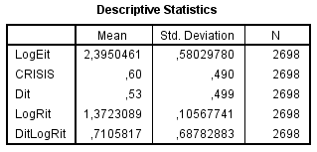

The second adapted earnings-return regression of Basu (1997) for high-technology is as follows (see figure 6.3.4): Log(Eit) = 2,760 + 0,176 CRISIS – 0,023 Dit – 0,438 Log(Rit) + 0,200 DitLog(Rit) + uit. It can be concluded that α0 does have a significant impact on Eit (p = 0,000). Besides it can be concluded that α1 (CRISIS) has a significant impact (p = 0,000; see figure 6.3.4) on the dependent variable Eit but it also has an influence on the level of unconditional conservatism. The level of unconditional conservatism is higher when α0 (period without economic turmoil) or α0+α1 (period with economic turmoil) is lower. So, out of this regression it can be concluded that the level of unconditional conservatism is higher in periods without economic turmoil (2,760) than in periods with economic turmoil (2,760 + 0,176).

Figure 6.3.4 Second adapted earnings-return regression of Basu (1997) – high-technology

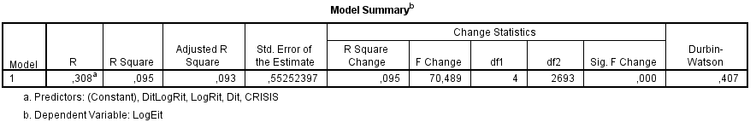

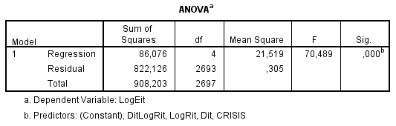

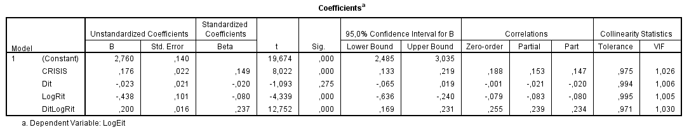

### 

**Hypothesis 2 is accepted.**

### Third adapted earnings-return regression of Basu (1997) – low-technology

*Outliers and influential cases (see §5.4)*

The studentized residuals do have a mean of -0,001 (see figure J.1 Appendix J). The mean of Cook’s Distance is 0,020 (see figure J.1 Appendix J) and this is far below 1, so no outliers are present. To conclude: the model fits the data.

*Assumptions (see §5.4)*

1. There is no multicollinearity between the independent variables and the dependent variable Eit, since the VIF’s of these variables are lower than 10, see figure 6.3.6 below. This assumption is met;
2. There is no heteroskedasticity looking at the histogram (see J.2 Appendix J). This assumption is met;
3. There is some concern of correlated residual terms since the Durbin-Watson of 0,387 is not located between one and three (see figure 6.3.6). This assumption is not met;
4. There are normally distributed errors with a mean of zero (see figure J.3 Appendix J). This assumption is met.

The adjusted R2 is 0,349. To conclude: 34,9% of the variance of the dependent variable is explained by the included independent variables. The model is improved compared with the second adapted earnings-return regression of Basu (1997) – low-technology due to the addition of the control variables SIZEit and LEVERAGEit. Mit/Bit is not significant (p = 0,118; see 6.3.6).

*Multiple regression*

The descriptive statistics give an overview of the variables included and the properties of the variables included:

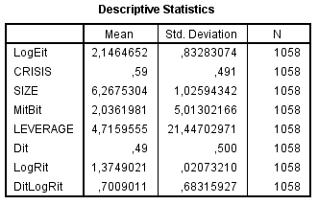Figure 6.3.5 Descriptive statistics third adapted earnings-return regression of Basu (1997) – low-technology

The third adapted earnings-return regression of Basu (1997) for low-technology is as follows (see figure 6.3.6): Log(Eit) = 11,593 + 0,098 CRISIS -0,427 SIZEit + 0,007 Mit/Bit -0,006 LEVERAGEit – 0,035 Dit – 5,008 Log(Rit) + 0,121 DitLog(Rit) + uit. Besides it can be concluded that α1 (CRISIS) has a significant impact (p = 0,030; see figure 6.3.6) on the dependent variable Eit but it also has an influence on the level of unconditional conservatism. The level of unconditional conservatism is higher when α0 (period without economic turmoil) or α0+α1 (period with economic turmoil) is lower. So, out of this regression it can be concluded that the level of unconditional conservatism is higher in periods without economic turmoil (11,593) than in periods with economic turmoil (11,593 + 0,098).Furthermore, two of the three included control variables are significant (p = 0,000). First of all, the level of unconditional conservatism will be higher when the SIZEit, measured as the logarithm of market value of equity (see §5.1), is greater. Lastly, the level of unconditional conservatism will be higher when the LEVERAGEit, measured as long-term debt plus short-term debt divided by the market value of equity (see §5.1), is greater.

Figure 6.3.6 Third adapted earnings-return regression of Basu (1997) – low-technology

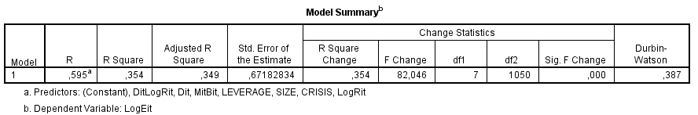

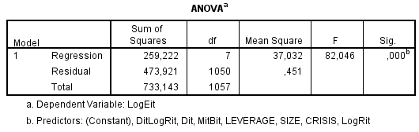

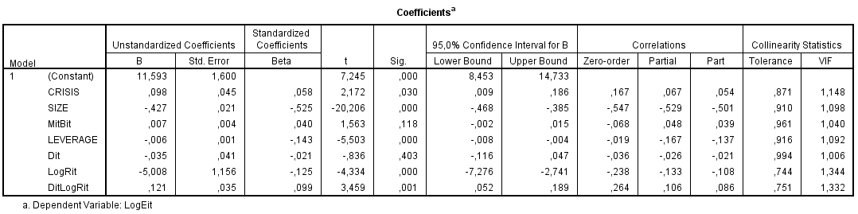

### 

**Hypothesis 2 is accepted.**

### Third adapted earnings-return regression of Basu (1997) – high-technology

*Outliers and influential cases (see §5.4)*

The studentized residuals do have a mean of -0,002 (see figure K.1 Appendix K). The mean of Cook’s Distance is 0,070 (see figure K.1 Appendix K) and this is far below 1, so no outliers are present. To conclude: the model fits the data.

*Assumptions (see §5.4)*

1. There is no multicollinearity between the independent variables and the dependent variable Eit, since the VIF’s of these variables are lower than 10, see figure 6.3.8 below. This assumption is met;
2. There is no heteroskedasticity looking at the histogram (see K.2 Appendix K). This assumption is met;
3. There is some concern of correlated residual terms since the Durbin-Watson of 0,377 is not located between one and three (see figure 6.3.8). This assumption is not met;
4. There are normally distributed errors with a mean of zero (see figure K.3 Appendix K). This assumption is met.

The adjusted R2 is 0,418. To conclude: 41,8% of the variance of the dependent variable is explained by the included independent variables. The model is improved compared with the second adapted earnings-return regression of Basu (1997) – high-technology due to the addition of the control variables SIZEit. Mit/Bit and LEVERAGEit are not significant (p = 0,112 and p = 0130; see 6.3.8).

*Multiple regression*

The descriptive statistics give an overview of the variables included and the properties of the variables included:

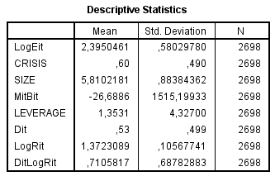Figure 6.3.7 Descriptive statistics third adapted earnings-return regression of Basu (1997) – high-technology

The third adapted earnings-return regression of Basu (1997) for high-technology is as follows (see figure 6.3.8): Log(Eit) = 4,547 + 0,112 CRISIS -0,376 SIZEit - 0,000 Mit/Bit + 0,005 LEVERAGEit – 0,028 Dit – 0,096 Log(Rit) + 0,148 DitLog(Rit) + uit. It can be concluded that α0 does have a significant impact on Eit (p = 0,000). Besides it can be concluded that α1 (CRISIS) has a significant impact (p = 0,000; see figure 6.3.8) on the dependent variable Eit but it also has an influence on the level of unconditional conservatism. The level of unconditional conservatism is higher when α0 (period without economic turmoil) or α0+α1 (period with economic turmoil) is lower. So, out of this regression it can be concluded that the level of unconditional conservatism is higher in periods without economic turmoil (4,547) than in periods with economic turmoil (4,024 + 0,112). Furthermore, one the three included control variables is significant (p = 0,000). The level of unconditional conservatism will be higher when the SIZEit, measured as the logarithm of market value of equity (see §5.1), is greater.

Figure 6.3.8 Third adapted earnings-return regression of Basu (1997) – high-technology

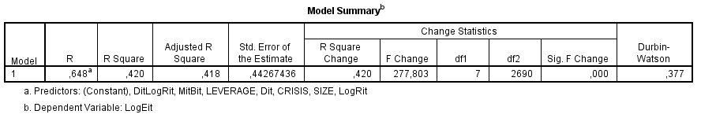

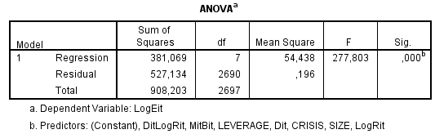

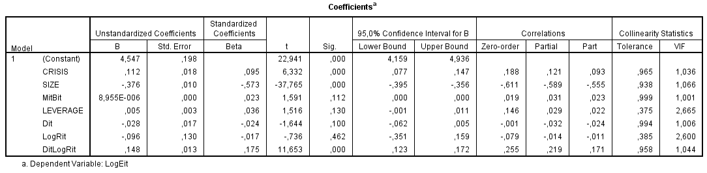

## 

**Hypothesis 2 is accepted.**

## §6.4 Summary

An answer to the sixth sub question can be given based upon this chapter. The sixth sub

question: **What are the results derived from the empirical research?**

There is a significant higher level of unconditional conservatism for code law European listed firms in high-technology industries than code law European listed firms in low-technology industries. There is also a change from times without economic turmoil to times with economic turmoil in the level of unconditional conservatism for code law European listed firms in low-technology industries as well as for code law European listed firms in high-technology industries.

|  |  |  |
| --- | --- | --- |
| Regression | Hypothesis accepted/rejected |  |
| Normal earnings-return regression of Basu (1997) – low-technology | Hypothesis 1 is accepted. | A significant higher level of unconditional conservatism within high-technology industries compared with low-technology industries. |
| Normal earnings-return regression of Basu (1997) – high-technology | Hypothesis 1 is accepted. | A significant higher level of unconditional conservatism within high-technology industries compared with low-technology industries. |
| First adapted earnings-return regression of Basu (1997) – low-technology | Hypothesis 1 is accepted. | A significant higher level of unconditional conservatism within high-technology industries compared with low-technology industries. SIZEit is significant. |
| First adapted earnings-return regression of Basu (1997) – high-technology | Hypothesis 1 is accepted. | A significant higher level of unconditional conservatism within high-technology industries compared with low-technology industries. SIZEit is significant. |
| Second adapted earnings-return regression of Basu (1997) – low-technology | Hypothesis 2 is accepted. | A significant lower level of unconditional conservatism in times with economic turmoil compared with times without economic turmoil in low-technology industries. |
| Second adapted earnings-return regression of Basu (1997) – high-technology | Hypothesis 2 is accepted. | A significant lower level of unconditional conservatism in times with economic turmoil compared with times without economic turmoil in high-technology industries. |
| Third adapted earnings-return regression of Basu (1997) – low-technology | Hypothesis 2 is accepted. | A significant lower level of unconditional conservatism in times with economic turmoil compared with times without economic turmoil in low-technology industries. SIZEit and LEVERAGEit are significant. |
| Third adapted earnings-return regression of Basu (1997) – high-technology | Hypothesis 2 is accepted. | A significant lower level of unconditional conservatism in times with economic turmoil compared with times without economic turmoil in high-technology industries. SIZEit is significant. |

# 

# 7. Analysis

Within this chapter an analysis will be described based upon the results presented in chapter 6, the hypotheses described in chapter 4 and prior literature described in chapter 3.

## §7.1 Hypothesis 1

The first hypothesis stated in chapter 4 (see §4.1):

**H1: Code law European listed firms in high-technology industries are positively associated with a higher level of conditional conservatism than European listed firms in low-technology industries.**

The results in chapter 6 (see §6.2) show that the level of unconditional conservatism used in code law European listed firms in high-technology industries is significantly higher than the level of unconditional conservatism used in code law European listed firms in low-technology industries. Prior literature (see chapter 3) mainly executed in the United States also found a significant higher level of overall conservatism for high-technology industries compared with low-technology industries (Chandra et al. 2004; Chandra 2011; Kwon et al. 2006). Especially conservative accounting rules (SFAS 2, immediately expensing of R&D costs) is mentioned as a reason behind the higher level of unconditional in high-technology industries (Chandra et al. 2004; Chandra 2011). This because firms in high-technology industries do have a significantly higher level of research and development expenses compared with firms in low-technology industries (Chandra et al. 2004). Within Europe the rules concerning research and development costs are partly different. An example of other accounting rules related to research and development is the expensing of research as well as development under SFAS 2, and the expensing of research and the capitalizing of development when certain criteria are met under IAS 38 (Deloitte 2013; FASB 1974). Nevertheless it seems that the regulations also under IAS 38 related towards research and development are leading towards a higher level of unconditional conservatism for firms in high-technology industries.

## §7.2 Hypothesis 2

The second hypothesis stated in Chapter 4 (see §4.1):

**H2: A change from non economic turmoil to economic turmoil is associated with a change in the use of unconditional conservatism for code law European listed firms in high-technology industries as well as for code law European listed firms in low-technology industries.**

*Low-technology industry*

The results in chapter 6 (see §6.2) show that the level of unconditional conservatism used in code law European listed firms in low-technology industries differs significantly in the second and third adapted earnings-return regression of Basu (1997) (see §5.1) in times with economic turmoil compared with times without economic turmoil. Within the second and third adapted earnings-return regression of Basu (1997) is found that the level of unconditional conservatism used in code law European listed firms within low-technology industries is lower during times with economic turmoil. In prior literature (see §3.3) mixed evidence was found related to this (Jenkins et al. 2009; Gul et al. 2002). The results of this study correspond to the results found in the study of Gul et al. (2009). A possible reason for this could be found in the interview described within §4.1. Firms could become less conservative in times with economic turmoil to fulfill the conditions of their debt contracts (Van Dijk 2013). This corresponds with the debt covenant hypothesis (see §2.2). Another possible reason for a significant lower level of unconditional conservatism during times with economic turmoil could be that firms want to present good results for their shareholders and other interested parties to fulfill their expectations.

The results in chapter 6 (see §6.2) show that the level of unconditional conservatism used in code law European listed firms in low-technology industries will be somewhat lower when SIZEit and LEVERAGEit as significant control variables are included within the third earnings-return regression of Basu (1997). This could possibly be explained by a lower level of leverage during times with economic turmoil. In this situation LEVERAGEit would already incorporate the effect of CRISIS. Firms with a high leverage ratio are expected to have more difficulties in attracting external financial supplies in times with economic turmoil. For that reason, these firms are expected to have a larger decline in market value of equity than firms with a lower leverage ratio. Also the size of these companies is related to this since it is measured as the logarithm of market value of equity. (Francis et al. 2011) So, a lower SIZEit and lower LEVERAGEit could have incorporated the effect of CRISIS within the third regression for code law European listed firms in low-technology industries.

*High-technology industry*

The results in chapter 6 (see §6.3) show that the level of unconditional conservatism used in code law European listed firms in high-technology industries differs significantly in the second and third adapted earnings-return regression of Basu (1997) (see §5.1) in times of economic turmoil compared with times without economic turmoil. Within the second and third regression is found that the level of unconditional conservatism used in code law European listed firms within high-technology industries is lower during times with economic turmoil. In prior literature (see §3.3) mixed evidence was found related to this (Jenkins et al. 2009; Gul et al. 2002). The results of this study correspond to the results found in the study of Gul et al. (2009). A possible reason for this could be found in the interview described within §4.1. Firms could become less conservative in times with economic turmoil to fulfill the conditions of their debt contracts (Van Dijk 2013). This corresponds with the debt covenant hypothesis (see §2.2). Another possible reason for a significant lower level of unconditional conservatism during times with economic turmoil could be that firms want to present good results for their shareholders and other interested parties to fulfill their expectations.

The results in chapter 6 (see §6.3) show that the level of unconditional conservatism used in code law European listed firms in high-technology industries will be somewhat lower when SIZEit as a significant control variable is included within the third earnings-return regression of Basu (1997). This could possibly be explained by a lower market value of equity during times with economic turmoil. (Francis et al. 2011) A lower SIZEit could have incorporated the effect of CRISIS within the third regression for code law European listed firms in high-technology industries.

In the second and third earnings-return regression of Basu (1997) a lower level of unconditional conservatism is shown for code law European listed firms in high-technology industries compared with code law European listed firms in low-technology industries. This could possibly be explained by a higher latitude in assets for firms in high-technology industries compared with firms in low-technology industries.

## §7.3 Summary

An answer to the seventh sub question can be given based upon this chapter. The seventh

sub question: **What are the differences between the expectations and outcomes of the study?**

Overall the expectations are confirmed with the outcomes of this study. Related to the first hypothesis it can be concluded that it seems that the regulations also under IAS 38 related towards research and development are leading towards a higher level of unconditional conservatism for firms in high-technology industries. Related to the second hypothesis it can be concluded that overall a lower level of unconditional conservatism is associated with a period with economic turmoil compared with a period without economic turmoil for both code law European listed firms in low-technology industries as well as for code law European listed firms in high-technology industries. A possible reason for this would be that firms have to fulfill the conditions of their debt contracts. Another possible reason for a significant lower level of unconditional conservatism during times with economic turmoil could be that firms want to present good results for their shareholders and other interested parties to fulfill their expectations.

# 8. Summary and conclusion

Within this chapter a summary, the main conclusion and contribution of this study will be given. Besides some limitations of this study and suggestions for further research will be given.

## §8.1 Summary

Within this study the difference in the level of unconditional conservatism in code law European listed firms in low-technology industries and high-technology industries is studied. It is expected that the level of unconditional conservatism is higher in high-technology industries. Especially conservative accounting rules (SFAS 2, immediately expensing of R&D costs) is mentioned as a reason behind the higher level of unconditional in high-technology industries (Chandra et al. 2004; Chandra 2011). This because firms in high-technology industries do have a significantly higher level of research and development expenses compared with firms in low-technology industries (Chandra et al. 2004). To study this a normal and adapted earnings-return regression of Basu (1997) are used. Furthermore it is studied whether the level of unconditional conservatism is different in times with economic turmoil compared with times without economic turmoil. To study this an adapted earnings-return regression of Basu (1997) is used including a dummy variable to define the times with economic turmoil and the times without economic turmoil.

The sample used to perform these empirical tests includes code law European listed firms in low-technology industries as well as in high-technology industries based on four-digit *SIC* codes. Finland, Germany, France, Spain, Portugal and Greece are included within a period from 2005 up to 2011. The sample consists of a number 3756 firm year observations. The chosen research methodology to test this is a market based approach in combination with the positive accounting theory.

The results of this study show that there is a higher level of unconditional conservatism in high-technology industries compared with low-technology industries. For low-technology as well as for high-technology industries a lower level of unconditional conservatism is found within times with economic turmoil compared with times without economic turmoil. A possible reason for this would be that firms have to fulfill the conditions of their debt contracts. Another possible reason for a significant lower level of unconditional conservatism during times with economic turmoil could be that firms want to present good results for their shareholders and other interested parties to fulfill their expectations.

In the second and third earnings-return regression of Basu (1997) a lower level of unconditional conservatism is shown for code law European listed firms in high-technology industries compared with code law European listed firms in low-technology industries. This could possibly be explained by a higher latitude in assets for firms in high-technology industries compared with firms in low-technology industries.

The results of this study could be useful for standard setters, managers, investors and other stakeholders.

## §8.2 Main conclusion and contribution

### Main conclusion

Within this study building blocks are provided to find a possible answer to the main research question (see §1.3):

***Is the level of unconditional conservatism significantly different in high-technology industries compared with low-technology industries and in times of economic turmoil compared with economic times without economic turmoil in European code law countries?***

The main findings within this study indicated that there is a significantly different level of unconditional conservatism within code law European listed firms in high-technology industries compared with code law European listed firms in low-technology industries (see §6.2). More specific, the level of unconditional conservatism for code law European listed firm in high-technology industries is significantly higher than the level of unconditional conservatism for code law European listed firms in low-technology industries. These results where as expected (see §4.1 and §7.1).

For code law European listed firms in low-technology industries as well as for code law European listed firms in high-technology industries a significant different level of unconditional conservatism is found in times with economic turmoil compared with times without economic turmoil. Within the second and third adapted earnings-return regression of Basu (1997) is found that the level of unconditional conservatism used in code law European listed firms is lower during times with economic turmoil (see §5.1 and §6.3).

A possible reason for a lower level of unconditional conservatism in times with economic turmoil can be found in the interview described within §4.1. Firms could become less conservative in times with economic turmoil to fulfill the conditions of their debt contracts (Van Dijk 2013). Another possible reason for a significant lower level of unconditional conservatism during times with economic turmoil could be that firms want to present good results for their shareholders and other interested parties to fulfill their expectations.

In the second and third earnings-return regression of Basu (1997) a lower level of unconditional conservatism is shown for code law European listed firms in high-technology industries compared with code law European listed firms in low-technology industries. This could possibly be explained by a higher latitude in assets for firms in high-technology industries compared with firms in low-technology industries.

### Contribution

The results of this study can be used to extend the knowledge of standard setters as they can use it to change their regulations to ensure the value relevance of information (Chandra et al. 2004). Besides, managers can use this information to adjust their financial statements to increase the value relevance of information for their stakeholders. Furthermore, the results could be interesting for stakeholders because it could improve their future earnings analysis. Lastly, the results could be important for investors, managers as well as for regulators since they could better understand the bias included in accounting numbers.

The elements mentioned above could result in different adjustments, earnings analysis and other analysis due to the results found for code law European listed firms in low-technology industries and code law European listed firm in high-technology industries. Besides it could result in different adjustments, earnings analysis and other analysis for times with economic turmoil and times without economic turmoil.

## §8.3 Limitations

A first limitation of this study concerns the sample used. The main conclusion of this study (see §8.1) is generalized for all code law European listed firms, however only six countries of all code law European listed firms are included within this study. The limitation is partly mitigated by including countries out of each part of Europe (see §1.3 and §2.1). Furthermore, it could be arguable which countries belong to the countries with severe problems during this economic turmoil since many definitions exist to define which country belongs to the countries in Europe with less severe problems during this economic turmoil and countries in Europe with more severe problems during this economic turmoil.

Another limitation of this study also concerns the sample used. Within this study only code law European listed firms were used since stock prices were needed for the regressions (see §5.1) used within this study. It would be more interesting when all code law European listed firms were included. Possibly different results were found when all code law European listed firms were included leading towards a more general contribution of knowledge for standard setters, managers, investors and all other stakeholders.

A third limitation of this study is that the errors of the multiple regressions are not independent. An assumption for multiple regressions is that there should be independent errors (see §5.4). Since all Durbin-Watson tests resulted in a value below one (see §6.2 and §6.3), it indicates a positive correlation between the errors within the multiple regression. This could possibly be adjusted by a change within the number of variables included or the number of observations included within the sample since the value of Durbin-Watson depends on it. (Field 2009) As a possible reason for the positive correlation of errors found within this study the log adjustment needed (see §5.4) to make the observed data points comparable could be mentioned.

A fourth limitation of this study is that the level of conditional conservatism also measured within the earnings-return regression of Basu (1997) (see §5.1) could possibly have affected the level of unconditional conservatism as interesting variable within this study.

As a last limitation it should be mentioned that the results found within this study could not be generalized for all code law European listed firms. The level of unconditional conservatism would be different for each firm. Furthermore, also the level of unconditional conservatism during times with economic turmoil and times without economic turmoil would be different for all firms since the reaction of firms to different times is not generalizable. This study could only be seen as a descriptive study, not as a predictive study.

## §8.4 Suggestions for further research

For further research it would be interesting to include all years with economic turmoil of this specific economic crisis for Europe. When including all years the results could be different since the severity could differ between years. Furthermore, it would be interesting to include also the subsequent years of the time with economic turmoil years to compare the before, during and subsequent level of unconditional conservatism.

Furthermore it would be interesting to include all code law European listed countries within the sample to make the results of this study more generalizable. This would enhance the knowledge of standard setters, managers, investors and other stakeholders. Besides, it would be interesting to have results for all code law European countries separate to improve our overall knowledge.

Studying all code law European countries separately would especially be interesting to get knowledge whether different standards and values of different European countries could possibly have an influence on the level of unconditional conservatism. This would be interesting since standard setters, managers, investors and other stakeholders could adjust regulations, earnings analysis and other analysis more towards a specific country within Europe.

## §8.5 Summary

An answer to the eighth sub question can be given based upon this chapter. The eighth

sub question: **What are the conclusions and limitations of this study, and possible suggestions for further research?**

The main conclusion of this study is that the level of unconditional conservatism is significantly different between code law European listed firms in low-technology industries and code law European listed firms in high-technology industries. Furthermore a significant difference in the level of unconditional conservatism in times with economic turmoil compared with times without economic turmoil is found. The results of this study could extend the knowledge of standard setters, managers, investors and other stakeholders resulting in adjustments of regulations, different earnings analysis and a change in other analysis. Limitations of this study concern the sample, no independent errors, incorporation of the effect of conditional conservatism and no possibilities for generalization. For further research it would be interesting to include all years with economic turmoil and to include all code law European countries.

# References

Ball, R., Kothari, S., and Robin, A. (2000). The effect of international institutional factors on properties of accounting earnings. *Journal of Accounting and Economics*, 1-51.

Basu, S. (1997). The conservatism principle and the asymmetric timeliness of earnings. *Journal of Accounting and Economics*, 3-37.

Basu, S. (2005). Discussion of "Conditional and Unconditional Conservatism: Concepts and Modeling". *Review of Accounting Studies*, 311-321.

Beaver, W., and Ryan, S. (2000). Biases and Lags in Book Value and Their Effects on the Ability of the Book-to-Market Ratio to Predict Book Return on Equity. *Journal of Accounting Research*, 127-148.

Beaver, W., and Ryan, S. (2005). Conditional and Unconditional Conservatism: Concepts and Modeling. *Review of Accounting Studies*, 269-309.

Benoit, K. (2011, March 17). *KenBenoit.* Retrieved June 3, 2013, from KenBenoit: http://www.kenbenoit.net/courses/ME104/logmodels2.pdf

Chandra, U. (2011). Income Conservatism in the U.S. Technology Sector. *Accounting Horizons*, 285-314.

Chandra, U., Wasley, C., and Waymire, G. (2004, January 5). *Social Science Research Network.* Retrieved January 27, 2013, from SSRN: http://papers.ssrn.com/sol3/papers.cfm?abstract_id=485064

Deloitte. (2013). *Deloitte IASPlus*. Retrieved May 6, 2013, from Deloitte IASPlus: http://www.iasplus.com/en/standards/ias38

Dijk, R. v. (2013, March 20). Conservatism in times of economic turmoil. (S. v. Iperen, Interviewer)

EuropaNU Onafhankelijk & actueel. (n.d.). *EuropaNU Onafhankelijk & actueel*. Retrieved April 26, 2013, from EuropaNU Onafhankelijk & actueel: http://www.europa-nu.nl/id/vifhdvtmvdxg/eurocrisis_door_begrotingstekort_en

FASB. (1974, October). *FASB .* Retrieved May 6, 2013, from FASB: http://www.fasb.org/cs/BlobServer?blobkey=id&blobnocache=true&blobwhere=1175820911202&blobheader=application%2Fpdf&blobcol=urldata&blobtable=MungoBlobs

FASB. (2001, June). *FASB.* Retrieved May 6, 2013, from FASB: http://www.fasb.org/cs/BlobServer?blobkey=id&blobnocache=true&blobwhere=1175820927971&blobheader=application%2Fpdf&blobcol=urldata&blobtable=MungoBlobs

Feltham, G. A., and Ohlson, J. (1995). Valuation and Clean Surplus Accounting for Operating and Financial Activities. *Contemporary Accounting Research*, 689-731.

Field, A. (2009). *Discovering statistics using SPSS.* London: SAGE Publications Ltd.

Francis, B., Hasan, I., and Wu, Q. (2011, October). *Social Science Research Network.* Retrieved March 17, 2013, from Social Science Research Network: http://papers.ssrn.com/sol3/papers.cfm?abstract_id=1970102

Francis, J., and Schipper, K. (1999). Have Financial Statements Lost Their Relevance? *Journal of Accounting Research*, 319-352.

Givoly, D., and Hayn, C. (2000). The changing time-series properties of earnings, cash flows and accruals: Has financial reporting become more conservative? *Journal of Accounting and Economics*, 287-320.

Graham, J., Harvey, C., & Rajgopal, S. (2005). The economic implications of corporate financial reporting. *Journal of Accounting and Economics*, 3-73.

Gul, F., Srinidhi, B., and Shieh, T. (2002). *Social Science Research Network.* Retrieved March 20, 2013, from Social Science Research Network: http://papers.ssrn.com/sol3/papers.cfm?abstract_id=315062

Hertel, C. (2009, February 1). *Notarius International.* Retrieved May 6, 2013, from Notarius International: http://www.notarius-international.uinl.org/DataBase/2009/Notarius_2009_01_02_hertel_en.pdf

Hogan, T., and Hutson, E. (2005). Capital structure in new-technology based firms: Evidence from the Irish software sector. *Global Finance Journal*, 369-387.

Jenkins, D., Kane, G., and Velury, U. (2009). Earnings Conservatism and Value Relevance Across the Business Cycle. *Journal of Business Finance & Accounting*, 1041-1058.

Jensen, M., and Meckling, W. (1976). Theory of the firm: managerial behavior, agency costs and ownership structure. *Journal of Financial Economics*, 305-360.

Kwon, S., Yin, Q., and Han, J. (2006). The effect of differential accounting conservatism on the “over-valuation” of high-tech firms relative to low-tech firms. *Review of Quantitative Finance and Accounting*, 143-173.

Lev, B., and Ohlson, J. (1982). Market-Based Empirical Research in Accounting: A Review Interpretation, and Extension. *Journal of Accounting Research*, 249-322.

Lev, B., and Sougiannis, T. (1996). The capitalization, amortization, and value-relevance of R&D. *Journal of Accounting and Economics*, 107-138.

Moore, D., McCabe, G., Duckworth, W., and Alwan, L. (2009). *The Practice of Business Statistics: Using Data For Decisions.* New York: W.H. Freeman & Company.

Naisbitt, J. (1983, May). *ASCD.* Retrieved February 1, 2013, from ASCD: http://www.ascd.org/ASCD/pdf/journals/ed_lead/el_198305_reviews.pdf

Palepu, K., Healy, P., and Peek, E. (2010). *Business Analysis and Valuation IFRS Edition.* Stamford: Cengage Learning Services.

Penman, S., and Zhang, X. (2002). Accounting Conservatism, the Quality of Earnings, and Stock Returns. *The Accounting Review*, 237-264.

PwC. (2013). *Pricewaterhouse Coopers*. Retrieved May 27, 2013, from Pricewaterhouse Coopers: http://www.pwc.nl/nl/corporate-governance/ifrs.jhtml

Ryan, S. (2006). Identifying Conditional Conservatism. *European Accounting Review*, 511-526.

U.S. Department of Labor. (1987). *United States Department of Labor*. Retrieved May 15, 2013, from United States Department of Labor: http://www.osha.gov/pls/imis/sicsearch.html

Wang, F. (2007). *Three Essays on Corporate Liquidity, Financial Distress and Equity Returns.* Morgantown: West Virginia University.

Watts, R. (2003). Conservatism in Accounting Part I: Explanations and Implications. *Accounting Horizons*, 207-221.

Watts, R. (2003). Conservatism in Accounting Part II: Evidence and Research Opportunities. *Accounting Horizons*, 287-301.

Watts, R., and Zimmerman, J. (1978). Towards a Positive Theory of the Determination of Accounting Standards. *The Accounting Review*, 112-134.

Watts, R., and Zimmerman, J. (1990). Positive Accounting Theory: A Ten Year Perspective. *The Accounting Review*, 131-156.

# Appendix A: Literature review

|  |  |  |  |  |  |
| --- | --- | --- | --- | --- | --- |
| **#** | **Author(s) and publication date** | **Object study** | **Sample** | **Research methodology** | **Outcome** |
| 1 | S. Basu (1997). | To determine whether earnings react in a more sensitive way to bad news than good news, implying conservatism. Furthermore, to test whether bad earnings news is less persistent than good earnings news. | Sample period 1963-1990, US business enterprises. Retrieved from CRSP NYSE/AMEX  and Compustat. | Market based accounting research and positive accounting theory;  archival data. | The simultaneous sensitivity of earnings towards negative returns is two to six times higher than towards positive returns. Furthermore, negative earnings changes are less persistent than positive earnings changes. |
| 2 | S. Balachandran and P. Mohanram (2011). | Studying the association between the trends in accounting conservatism and the value relevance of accounting earnings and book values over time. | Sample period from 1975 up to 2004, US business enterprises. | Market based accounting research and positive accounting theory;  archival data. | Overall, no evidence is found that a decline in value relevance of financial information is related with an increasing use of conservatism. |
| 3 | U. Chandra (2011). | The study investigates the role of shareholder litigation and accounting standards on income conservatism for U.S. technology firms since 1975. | Sample period from 1975 up to 2006 in 13 U.S. “high-  technology” industries. Retrieved by following the rules of Francis and Schipper (1999). A total of 204.749 firm-years are included. The data is retrieved from Compustat and CRSP. | Market based accounting research and positive accounting theory; archival data. | The results of this study suggests that there is increasing  conditional and increasing unconditional conservatism for high-technology firms in the mid-1990s. Furthermore, SFAS 2 and shareholder litigation are found to be the primary drivers of the increasing conservatism found within this industry. |
| 4 | U. Chandra, C. Wasley, and G. Waymire (2004). | Investigating the scale and the nature of conservatism in  high-technology firms in the U.S., especially the impact of shareholder litigation and conservative accounting standards. | Sample period 1982-2001. 31 U.S. technology-based  industries retrieved conform Francis and Schipper (1999) and from the technology-related market indices compiled by the investment community; the Annual Compustat Industrial, Full Coverage and Research files. Total sample contains 33,527 firm-year observations. A sample for comparison is included, also retrieved from the annual Compustat Industrial, Full Coverage and Research files, and contains 101,601 firm-year observations. | Market based accounting research and positive accounting theory; archival data. | Technology firms rely on higher levels of conservatism compared to other U.S. firms. Especially, lower operating cash  flows drive this higher level of conservatism, so it would be primarily due to news independent conservatism. A significant trend in conservatism is found for technology firms in the mid-1990s, and the increasing conservatism is related to R&D expensing. |
| 5 | B. Francis, I. Hasan and Q. Wu (2011). | To what extent conservatism affect shareholder value in times of economic turmoil. | From October 2007 up to March 2009, US business enterprises.  Retrieved from CRSP and Compustat. | Market based accounting research and positive accounting theory; archival data. | Firms that use more conservative methods during times of economic turmoil will be seen as more reliable and transparent. Overall, more conservative firms in times of economic turmoil are expected to have less decline in their stock prices. |
| 6 | D. Givoly and C. Hayn (2000). | To test whether there is a change in the patterns of earnings,  cash flows and accruals over the last four decades and the association with the level of conservatism in financial reporting. | Sample period from 1950 up to 1998 for US enterprises. To  compare the results over time a ‘constant sample’ is used for the period 1968 up to 1998. | Market based accounting research and positive accounting theory; archival data. | Increasing trend in the level of conservatism in financial  reporting is found. |
| 7 | F.A. Gul, B. Srinidhi, and T. Shieh (2002). | Investigating whether the use of accounting conservatism is less during times of economic turmoil and whether this has an influence on increasing audit fees. | Sample period 1990 up to 1997, Hong Kong firms. Retrieved  from the Company Registry of Hong Kong SAR, the Official Receiver’s Office of Hong Kong SAR, PACAP Database and financial statements. | Market based accounting research and positive accounting theory; archival data. | In times of economic downturn managers use less conservative accounting methods, and the audit fees at that time seem to increase. |
| 8 | D.S. Jenkins, G.D. Kane, and U. Velury (2009). | The investigation of conditional conservatism across business  cycles and the impact on value relevance. | Sample period from 1980 up to 2003, US business enterprises. Retrieved from Compustat. | Market based accounting research and positive accounting theory; archival data. | Conditional conservatism and value relevance are higher during  times of economic contraction. Furthermore, the value relevance of  future earnings expiations is greater in times of economic expansion. |
| 9 | S.S. Kwon, Q.J. Yin, and J. Han (2006). | Significant differences in the level of conservatism  between high-tech and low-tech firms. | Sample period: 1990s (1990-1998). Retrieved from 1999 Compustat, CNNFN.com and according to Francis and Schipper (1999). 2728 U.S. high-tech firms and 984 U.S. low-tech firms. | Market based accounting research and positive accounting theory; archival data. | High-tech firms using a significant higher level of  conservatism than low-tech firms, high-tech firms especially use more income-decreasing discretionary accruals. After controlling for the effect of conservatism, low-tech firms seems to have more value relevant financial information. |
| 10 | S.H. Penman and X. Zhang (2002). | Investigating in which way accounting methods influence the quality of earnings. Especially the joint effect of investing and conservatism. | Sample period 1975 up to 1997; NYSE and AMEX (US business enterprises). Retrieved from Compustat Annual Industrial and Research files and CRSP. | Market based accounting research and positive accounting theory; archival data. | A temporarily change in investments leads to a less quality of earnings. Furthermore, the market cannot go through the real issues of conservatism in accounting. |
| 11 | S.G. Ryan (2007). | Measurements for conditional conservatism, especially  asymmetric timeliness. | - | Review paper, no empirical research. | Asymmetric timeliness could be used for identifying  conditional conservatism with some adjustments: including factors of the firm’s industry and business cycle, and filtering return by removing returns around earnings announcements. Always keep in mind the influence of unconditional conservatism. |
| 12 | R.L. Watts (2003a). | Alternative explanations for conservatism in accounting and their implications for accounting regulators. | - | Review paper, no empirical research. | Main explanations for conservatism are contracting, shareholder  litigation, taxation, and accounting regulation. Main reason of  conservatism in relation with contracting is to overcome asymmetric information. |
| 13 | R.L. Watts (2003b). | Discuss empirical evidence on the existence of conservatism, the  increasing trend of conservatism over time, and alternative explanations of conservatism. | - | Review paper, no empirical research. | The results show that all alternative explanations are important in  explaining conservatism. |

# Appendix B: Industries included in high- and low-technology samples (three-digit *SIC* codes)

The table below is out of the empirical research conducted by Francis and Schipper (1999, 343). The categorizing of industries as mentioned in the table below is used in prior literature that has been studied and used for this study (Chandra et al. 2004; Chandra 2011; Kwon 2006).



# Appendix C: Industries included in high- and low-technology samples (four-digit *SIC* codes)

The table below contains the three-digit *SIC* codes out of the empirical research conducted by Francis and Schipper (1999, 343) and the related four-digit *SIC* codes retrieved from the U.S. Department of Labor (1987). The four-digit *SIC* codes are obtained from the data from CompuStat Global.









# Appendix D: Normal earnings-return regression of Basu (1997) - LT

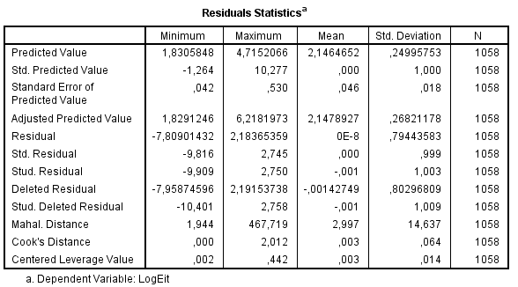Figure D.1 Outliers and influential cases

Figure D.2 *ZRESID and *ZPRED plot

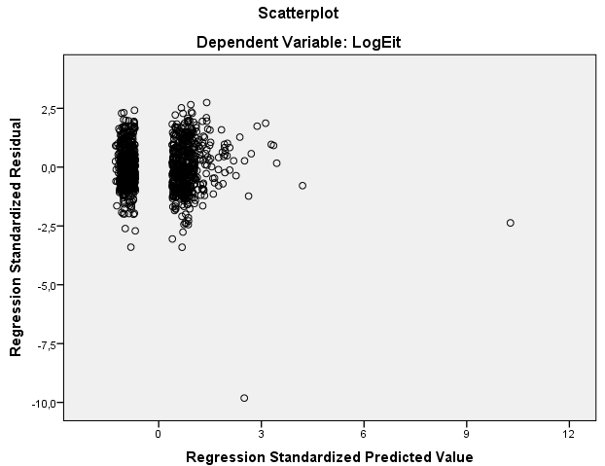

Figure D.3 Normally distributed errors

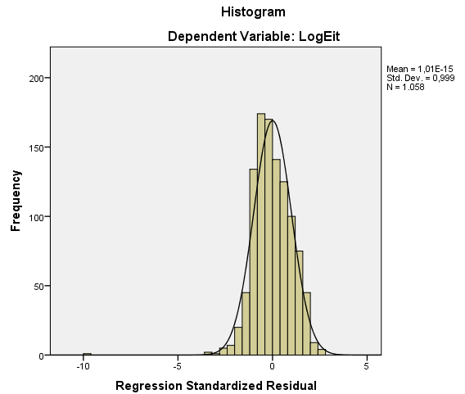

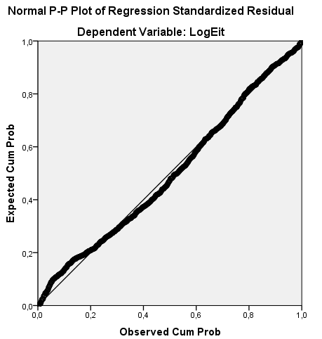

# Appendix E: Normal earnings-return regression of Basu (1997) - HT

Figure E.1 Outliers and influential cases

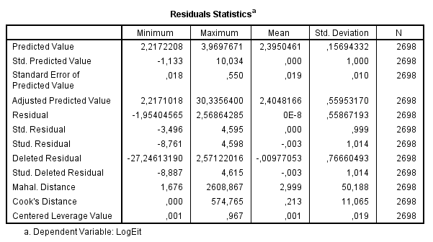

Figure E.2 *ZRESID and *ZPRED plot

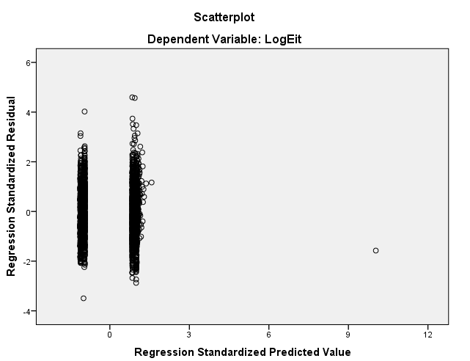

Figure E.3 Normally distributed errors

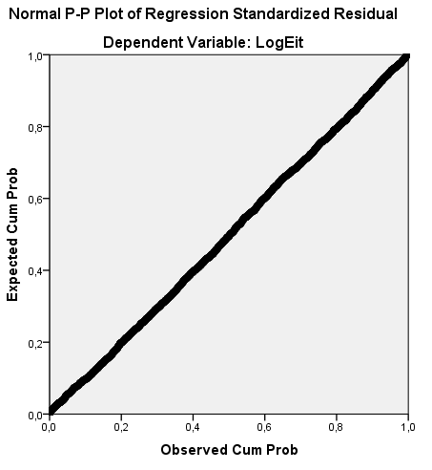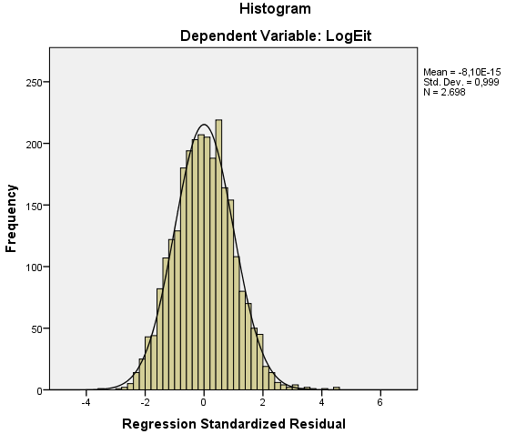

# Appendix F: First adapted earnings-return regression of Basu (1997) - LT

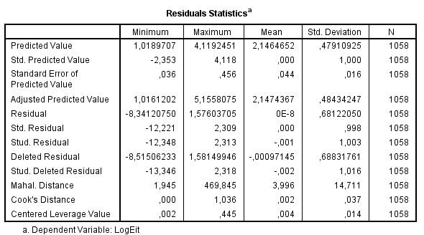Figure F.1 Outliers and influential cases

Figure F.2 *ZRESID and *ZPRED plot

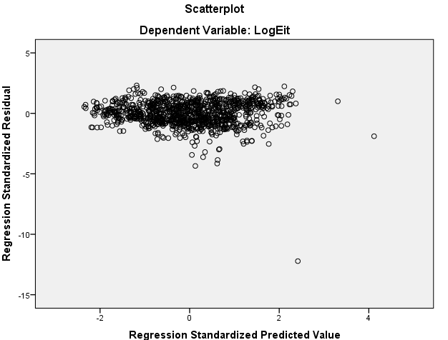

Figure F.3 Normally distributed errors

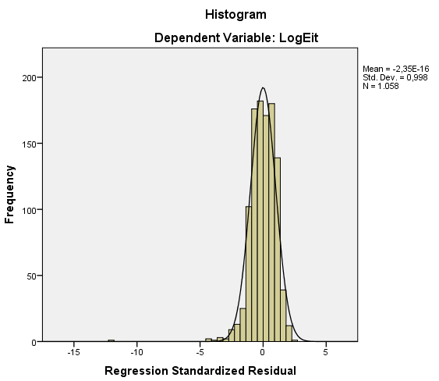

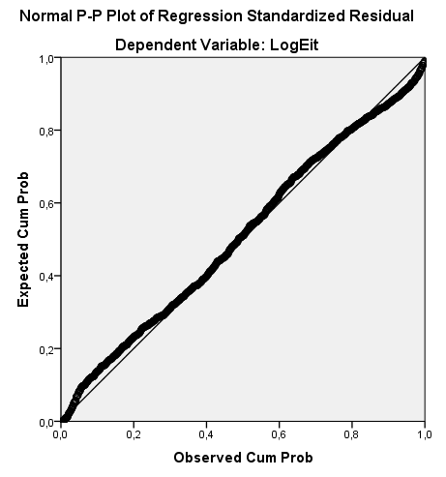

# Appendix G: First adapted earnings-return regression of Basu (1997) - HT

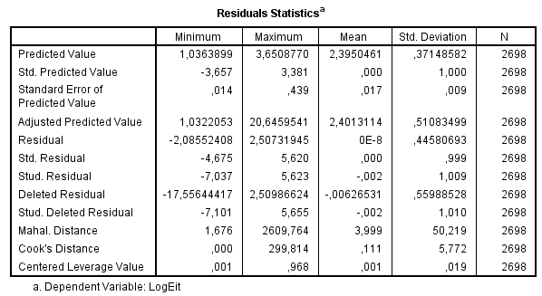Figure G.1 Outliers and influential cases

Figure G.2 *ZRESID and *ZPRED plot

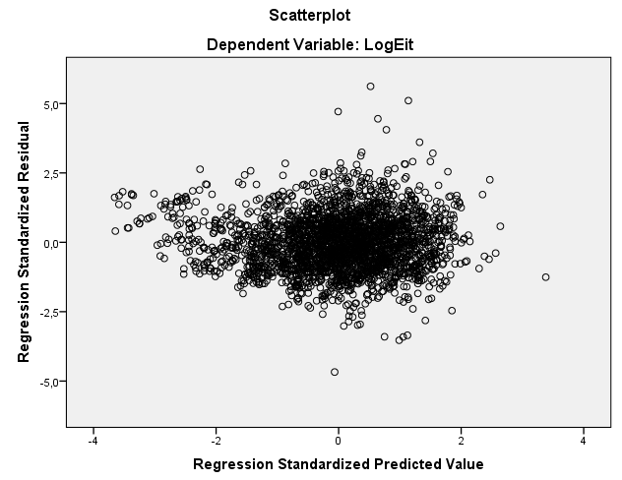

Figure G.3 Normally distributed errors

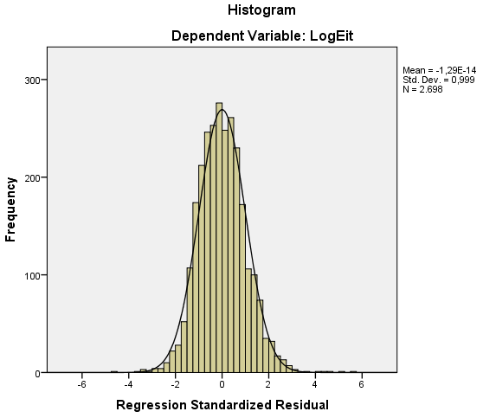

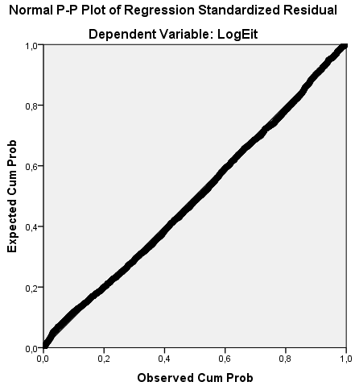

# Appendix H: Second adapted earnings-return regression of Basu (1997) - LT

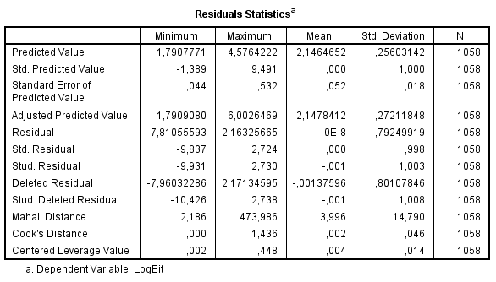Figure H.1 Outliers and influential cases

Figure H.2 *ZRESID and *ZPRED plot

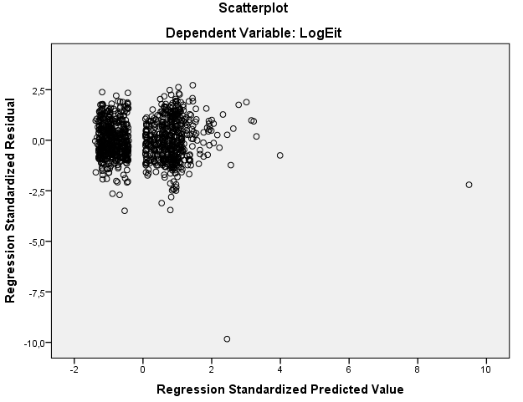

Figure H.3 Normally distributed errors

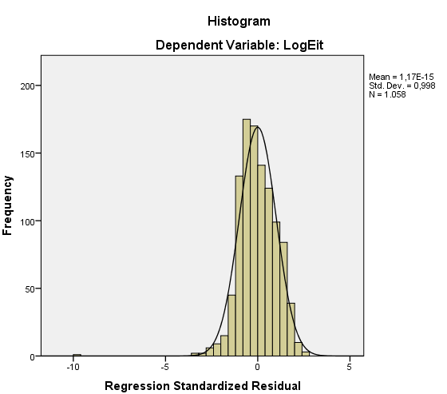

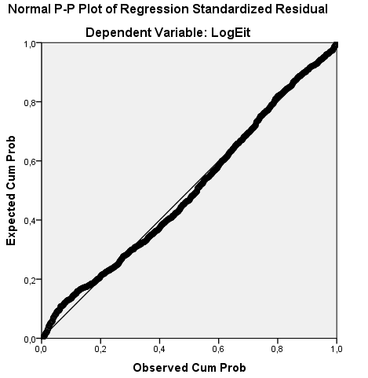

# Appendix I: Second adapted earnings-return regression of Basu (1997) - HT

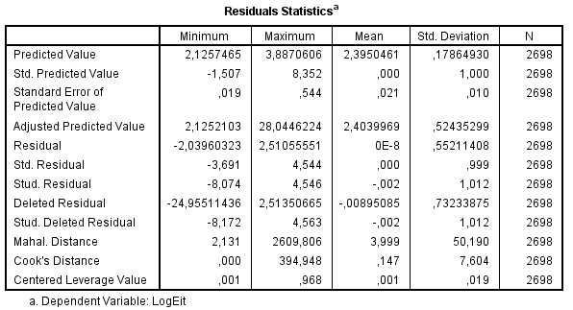Figure I.1 Outliers and influential cases

Figure I.2 *ZRESID and *ZPRED plot

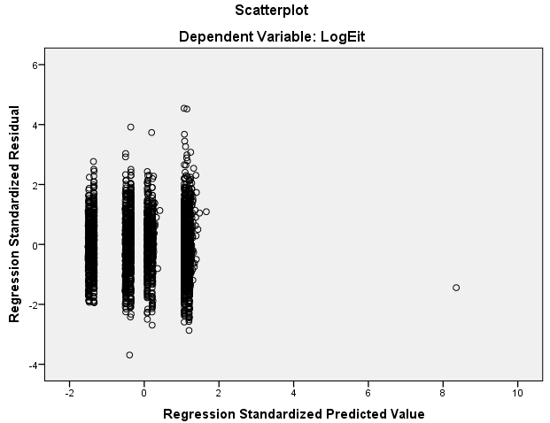

Figure I.3 Normally distributed errors

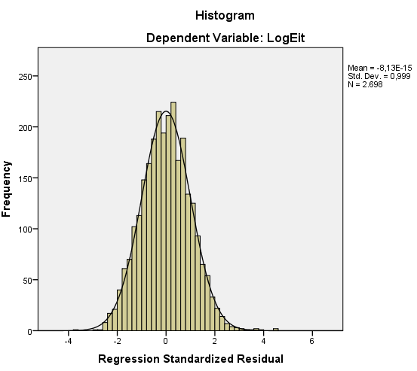

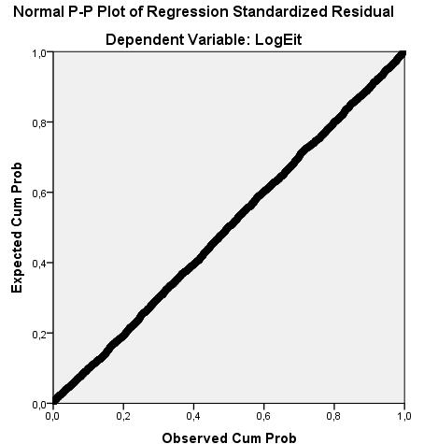

# Appendix J: Third adapted earnings-return regression of Basu (1997) - LT

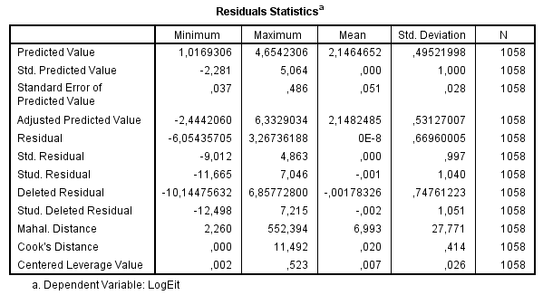Figure J.1 Outliers and influential cases

Figure J.2 *ZRESID and *ZPRED plot

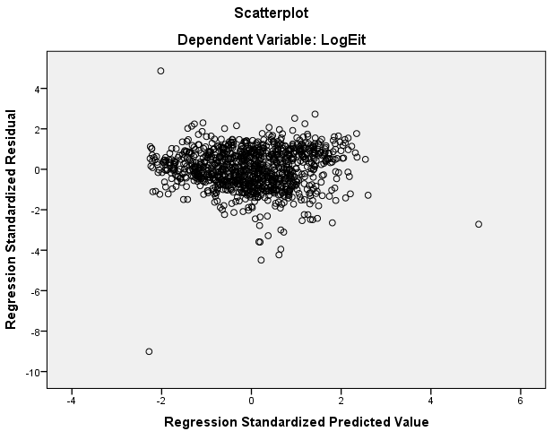

Figure J.3 Normally distributed errors

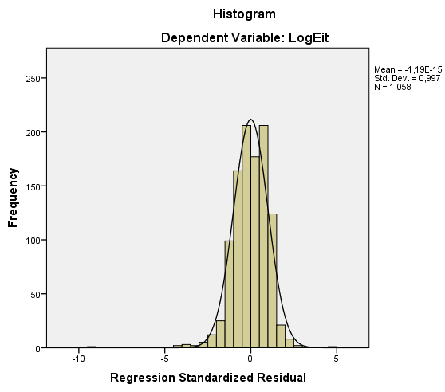

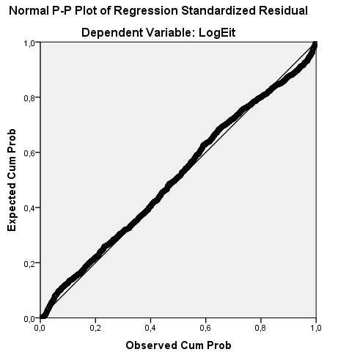

# Appendix K: Third adapted earnings-return regression of Basu (1997) - HT

Figure K.1 Outliers and influential cases

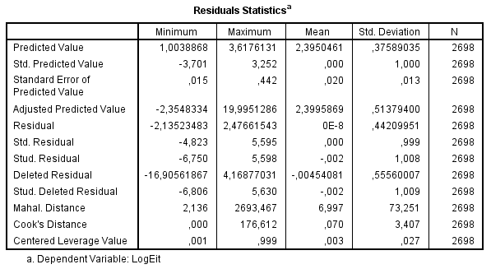

Figure K.2 *ZRESID and *ZPRED plot

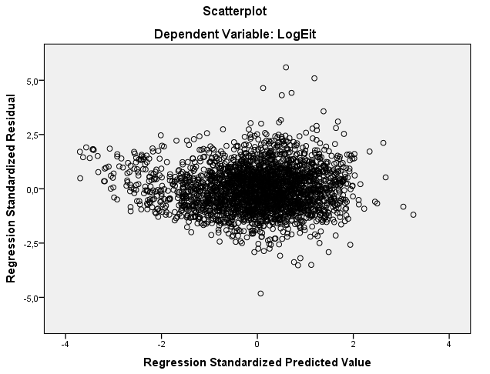

Figure K.3 Normally distributed errors

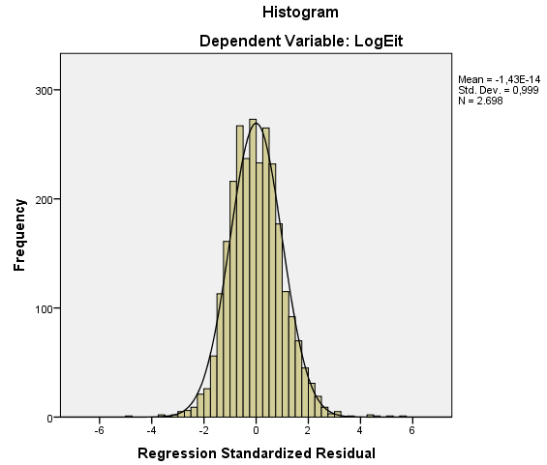

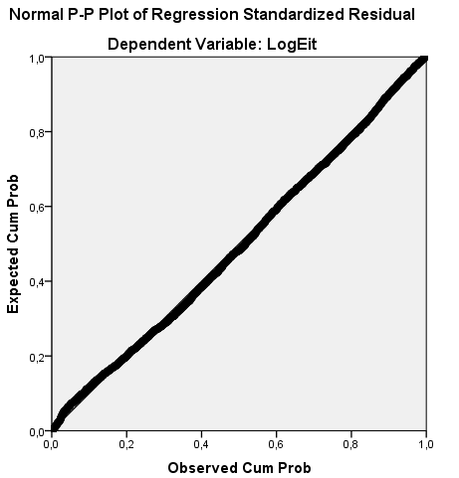

# Appendix L: Two sample one-tailed t-test

Within this appendix the formula of the two sample one-tailed t-test is given. Furthermore, the calculations done for the first hypothesis will be given. The formulas are obtained from Moore et al. (2009).

Figure L.1 Welch’s t-test

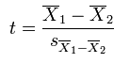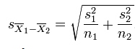



*Calculation normal earnings-return regression of Basu (1997)*

|  |  |  |  |
| --- | --- | --- | --- |
|  | S | N | X |
| LT | 1,814 | 1058 | 10,356 |
| HT | 0,141 | 2698 | 2,914 |



Sx1-x2 = (1,8142 + 0,1412) / (1058 + 2698) = 0,029688106

t = (10,356 – 2,914) / 0,029688106 = 250,67

d.f. = (1,8142/1058 + 0,1412/2698)2 / [(1,8142/1058)2/(1058-1)+(0,1412/2698)2/(2698-1)]

d.f. = 1092,82

t* = 1,64 (α = 0,05)

*Calculation first adapted earnings-return regression of Basu (1997)*

|  |  |  |  |
| --- | --- | --- | --- |
|  | S | N | X |
| LT | 1,556 | 1058 | 9,859 |
| HT | 0,123 | 2698 | 4,910 |



Sx1-x2 = (1,5562 + 0,1232) / (1058 + 2698) = 0,025468271

t = (9,859 – 4,910) / 0,025468271 = 194,32

d.f. = (1,5562/1058 + 0,1232/2698)2 / [(1,5562/1058)2/(1058-1)+(0,1232/2698)2/(2698-1)]

d.f. = 1062,18

t* = 1,64 (α = 0,05)