Master Thesis Accounting, Auditing, and Control 2013
Erasmus University Rotterdam
Erasmus School of Economics
Accounting, Auditing & Control

“Is Research and Development intensity of firms related to Corporate Social Responsibility Disclosures?”

An Empirical Research on the London Stock Exchange.

Author: Jeansy R. Martina Jr.
Student number: #342692
Email: 342692jm@student.eur.nl
Supervisor: Dr. K.E.H. (Karen) Maas
Co-reader: E.A. (Evert) de Knecht RA
Word count: 20.614
Date: 4 July 2013

Preface
First of all, I would like to thank my thesis supervisor Dr. Karen Maas of the Erasmus University of Rotterdam for all her assistance during this whole process. With her guidance and suggestions I was able to finalize this research within my estimated planning. Additionally, I would also like to thank Evert de Knecht RA for his participation as the co-reader for this master thesis. With his valuable suggestions this thesis could be presented in a more professional manner. Finally, I would like to thank my family and friends for their love and support throughout this whole process. They and I know that it has not been an easy road to walk. But we are here now by God’s good graces!

Abstract
This study examines the influence of Research and Development (R&D) intensity on Corporate Social Responsibility Disclosures (CSRD). This research is based mainly on the Stakeholder Theory, which makes the argument that managers will tend to disclose more CSR related information to satisfy the information need of their stakeholders. This research extends and adds value to the field of study of Corporate Social Responsibility (CSR) – Financial Performance (FP). This research focused on the London Stock Exchange to obtain empirical evidence that R&D intensity positively affects CSRD. Through content analysis and a regression model this relationship will be tested. As expressions of R&D and CSRD, R&D intensity (R&D expenditure/ Total Sales) and content analysis scores will be used respectively. Results show that there is a significant relation between R&D intensity and CSRD, but this is a negative one. Concluding that the lower the intensity of a company’s R&D the more CSR information they disclose.

Keywords:
Research and Development, Corporate Social Responsibility, Content Analysis, Stakeholder Theory, CSR performance-disclosure gap.

Table of Contents

Preface 2
Abstract 2
Table of Contents 3
Chapter 1 Introduction 5
1.1 Introduction into the Research Topic 5
1.2 Introduction to the Research Question 5
1.3 Research and Development 6
1.3 Why the United Kingdom 7
1.4 Relevance and Added value of the research 7
1.6 Outline paper 8
Chapter 2. Research and Development 9
2.1 Why invest in R&D 9
2.2 Definitions and classifications of Research and Development 10
2.3 UK GAAP and IFRS IAS R&D regulations 12
Chapter 3. Corporate Social Responsibility and CSR reporting 15
3.1 Introduction and definition to Corporate Social Responsibility 15
3.2 Defining CSR reporting 17
3.3 Incentives for CSR reporting 18
3.4 Chosen standard for content measurement 19
Chapter 4. Corporate Social Responsibility theories 21
4.1 Approach for this research 21
4.2 Legitimacy theory 22
4.3 Stakeholder theory 23
Chapter 5. Literature Review and Hypotheses development 25
5.1. Introduction Literature review 25
5.2 Corporate Social Responsibility and Financial Performance 25
5.3 Corporate Social Performance and Corporate Social Responsibility Disclosures 29
5.4 Research and Development and Financial Performance 31
5. 5 Research and Development and Corporate Social Performance 32
5.6 Research and Development and Corporate Social Performance Disclosures 33
5.7 Hypothesis development 34
Chapter 6. Research Methodology 36
6.1 Research framework 36
6.2 Research type 37
6.3 Data sample collection 37
6.4 CSR content scoring framework 39
6.5 Statistical test variables and regression analysis model 42
6.6 Statistical tests and regression analysis 43
Chapter 7. Empirical analysis results and discussions 45
7.1 Descriptive Statistics and data discussions 45
7.2 Results and discussion hypothesis 1 48
7.3 Results and discussion hypothesis 2 49
7.4 Results and discussion hypothesis 3 50
Conclusions 52
References 54
Appendices 59
Appendix A: Relationship between Legitimacy theory and Stakeholder theory 59
Appendix B: Content Scoring Framework scorecard: 60
Appendix C: Company list and relevant data 65

Chapter 1 Introduction

1.1 Introduction into the Research Topic
Corporate Social Responsibility (CSR) reporting has become increasingly famous and widely used in the recent years that have just passed (Gamerschlag et al., 2011; Font et al., 2012; and KPMG, 2008). Companies in today’s business world spend a great deal of funds and effort on disclosing information of their social and environmental performance (Gamerschlag et al., 2011). According to a survey conducted by KPMG (KPMG, 2011, p. 19) reputation and ethical considerations are the two most important drivers for CSR reporting. Despite the global financial crisis, researchers demonstrate that companies continue to show interest and thus invest in sustainable initiatives globally. Whiteman et al. (2013) signals that the initiatives to invest in sustainable activities are continuously significant which shows that sustainability is not a simple ‘icing on the cake’ when things are looking good.
These companies are aiming to give their stakeholders and society as a whole a good or at least positive image that their organizations are striving at the very least to conduct their business in a way that meats the expectations of society. According to McWilliams and Siegel (2000, p. 605) and Padgett and Galán (2010, p. 15) stakeholders are putting additional pressure on firms to improve their business processes and products to thus improve their negative impact on the social and environmental arena. The assumption is that firms might in turn increase their Research and Development (R&D) intensity to meet up with the standards and expectations of their stakeholders. Additionally, they might also try to report their progress and Corporate Social Performance (CSP) through their Corporate Social Responsibility Disclosures (CSRD). This following section continues with an elaboration of the research question.

1.2 Introduction to the Research Question
This research is an extension of the study conducted by Padgett and Galán (2010). The objective of their study was to measure the effect that R&D intensity has on CSP of manufacturing and non-manufacturing industries. They gave evidence that R&D intensity in manufacturing industry firms are positively associated with CSP and that this relationship is significant. Additionally, this research also builds on a research conducted by McWilliams and Siegel (2000) where they investigated the relation of R&D on CSP. This was a ground breaking finding which sparked numerous other researches (Padgett and Galán, 2010; Rothenberg and Zyglidopoulos, 2007; Hull and Rothenberg, 2008; and Anderson and Dejoy, 2011).
The main objective of this research is to investigate and give empirical evidence of the relation between CSR reporting and R&D intensity in the UK stock market. Since the UK has been named numerous times in published reports as being one of the top CSR reporting countries across the globe (Kolk, 2003; KPMG, 2008 and 2011). The period that will be analyzed will be 2006 till 2010. These years were selected due to the fact that according to a Statistical Bulletin published by the Office for National Statistics in the UK in October 2012, firms active in the UK have more on R&D during this time period. This provided an opportunity for this research to investigate this period. It also helped this research when the data availability for this period was actually available. Years before 2006 were limited with data availability, specifically CSR reports and related disclosures.

I have formulated the following main research question:

Is R&D intensity related to CSRD in firms listed on the London Stock Exchange?

To help answer the main research question a number of sub questions were formulated.
- What is the definition of R&D?
- What are the incentives of R&D?
- What are the international and UK accounting standards on R&D?
- How can R&D be measured?
- What is CSR and CSR reporting (CSRD)?
- What are the theories that support CSR?
- What are the incentives of CSR and CSRD?
- How can CSR be measured?
- How is R&D related to CSR and CSRD?

1.3 Research and Development
The intention of this research is to illustrate the quantifiable evidence that the more intensive R&D firms report more on CSR than the ones that are less intensive. I am making this assumption based on the stakeholder theory, which is stated in Deegan (2011) that managers are concerned to meet and beat the expectations of their influential stakeholders. For instance the media, government (safety) and consumer groups. By investing in R&D activities the multinational firms tries to show their commitment in the CSR reports that they are focusing on improving their products and thus their impact on the stakeholder’s social and environmental ecology. To be more precise, due to the fact that R&D expenditures are usually not the primary business practice of an organization, managers will tend to justify this in their CSR disclosures by mentioning the company’s intention and efforts to researching and developing ‘greener’ products and processes so that it will most likely improve the company’s social and environmental performance. As reported by McWilliams and Siegel (2000), recent years has shown an increase in R&D expenditure by firms to invest in the production and development of sustainable products and/or services to show their commitment to CSR because this demonstrates to their stakeholders that the organization in question is willing to improve its social and environmental impact that is leaves to conducts its operations. Additionally, McWilliams and Siegel (2000) argues that companies that strive to maintain and/or work towards a ‘CSR’ image will be viewed by society and stakeholders as more reliable and having superior stocks of products.

1.3 Why the United Kingdom
I have chosen to research the UK markets because multinational companies that are operating in the UK market are known to be frequent reporters of CSR information (KMPG, 2008). Additionally, KPMG (2011) also reported that the top 100 firms in the UK have increased their CSR disclosures since 2005 dramatically. KPMG (2011 p.8) stated, “that UK is one of the leaders in CSR reporting”. Kolk (2003) investigated the increasing trend in sustainability reporting worldwide. The research observed that a number of countries have a high level of sustainability reports. One of these countries is UK. Others were Japan, France and Germany. Gray et al. (2001) conducted another research using data available of firms active in UK.

1.4 Relevance and Added value of the research
This research will be relevant to future researchers who want to continue their empirical investigation of the relation between a firm’s performance (FP) and Corporate Social Responsibility (CSR). By providing insight on whether companies in the UK disclose more CSR information based on their intensity in Research and Development (R&D) activities. Users of this information will be able to assess whether these firms are striving to improve their productivity and products. I believe that this study can also be interesting to standard setters of Corporate Social Responsibility Disclosures (CSRD) in the way that it can show how firms in the London Stock Exchange discloses CSR information based on their R&D intensity. One important note; as far as the author is concerned no other literatures could be found that investigated the direct link of R&D intensity and CSRD. Lastly, this research will add value to the academic literatures that investigates the notion that the relationship between CSR and FP is not straightforward, but instead is complex and R&D plays an important role in this relationship. Secondly, based on the results it might be possible to add value in the topic of the performance gap between CSP and CSR where R&D might explain to a certain extent the reason why R&D has a negative affect on CSRD.

1.6 Outline paper
This thesis will cover the following subjects of the research in the following manner. Firstly, the theoretical backgrounds will be elaborated on in chapter 2, 3, and 4. Secondly, the various literatures that were used and reviewed will be discussed. Thirdly, the various research methods that were used will be elaborated on and explained. Fourthly, the empirical analysis and results will be elaborated on. Lastly, the conclusion, limitations and future research aims are discussed.

Chapter 2. Research and Development
This chapter covers the general theory behind the company’s participation in Research and Development activities. Also, the reader will find a general outline of two accounting frameworks and the respective accounting regulations with regards to R&D costs. Also, the possible reasons why companies invest their time, effort and finances in these activities will be discussed.

2.1 Why invest in R&D
The general intention of R&D activities for firms is to create additional assets and also improve product and process innovation (McWilliams and Siegel, 2000). Additionally, according to a concept paper written by Deloitte researchers on Research and Development expenses (Deloitte, 2011), R&D related activities usually involves constant revitalization of knowledge and expertise, and could result in developments. These developments are usually related to new and improved products, improved operational processes, meeting the changing requirements of customers, cost reduction, and meeting the changing social and environmental standards. These activities are intended to provide these results and thus, according to theory, the firm is expected to benefit from these results (McWilliams and Siegel, 2000; Hull and Rothenberg, 2008; Deloitte, 2011; and Rothenberg and Zyglidopoulos, 2007). If an R&D activity is fruitful in its intended purpose to give the firm in possession of this newly innovated asset a competitive edge over its competitors it is also the assumption, according to theory, that said firm will gain the a competitive advantage financially. Therefore, it is also proven that firms that are more intense in R&D activities are positively related to improved financial performance of firms (Hull and Rothenberg, 2008). As Hull and Rothenberg (2008) signaled in their paper, companies that introduce new and innovative ideas to the market and thus to the world may benefit from increased brand recognition and financial benefits, but also the all-important ability to stay relevant and intensely active in the market in which they operate (O’Reilly and Tushman, 2004). Additionally, studies also show that innovation can have a positive impact on financial performance of a firm when environmental factors are added to the equation (Chander et al., 2000).
A recent study conducted by the Office for National Statistics in the UK showed that the amount spent on R&D activities in the UK have steadily increased since 1985. In 2011 (Figure 1) the amount spent in cash terms on R&D expenditures increased with 8% compared to 2010. In 2011 businesses in UK spent £17.4 billion on R&D compared to 2010 where they spent £16.1 in cash terms. Additionally, businesses in UK spent in 2006 and 2008 respectively £14.1 and £15.8 billion. This shows an increase in expenditure on R&D of 12% for 2006 to 2008 and 2% from 2008 to 2010.

Figure 2.1: R&D expenditure by businesses in the UK
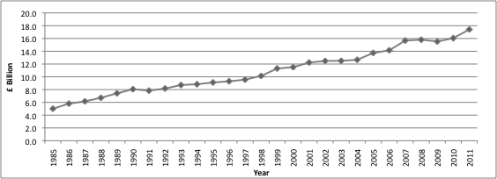

2.2 Definitions and classifications of Research and Development
There are many interpretations of activities that are related to Research and Development in organizations. For instance, the Department of Business Innovation and Skills (2011, p. 5) defines innovation (R&D) as “Innovation is the development of new products, services and processes, which may be based on cutting edge research”.
Another definition for R&D that is also interesting is the definition provided in the concept paper for Research and Development expenses written by Deloitte (2011). Deloitte (2011, p. 3) described R&D as “the process of discovering new knowledge about products and services and application of such knowledge to create new and improved products/ processes to meet market requirements”.
Although there are various definitions and interpretations, efforts are still being undertaken to streamline and standardize the way R&D related data are collected, constructed, and used for various kinds of research. One of these endeavors is the one proposed in the ‘Frascatie’ Manual issued by the Organization for Economic Cooperation and Development (OECD, 2002). OECD (2002, p. 30) defines R&D as “ creative work undertaken on a systematic basis in order to increase the stock of knowledge, including knowledge of man, culture and society, and the use of this stock of knowledge to devise new application”.
All in all, every company and especially each industry will classify these activities differently. All of them will have different end goals in mind and all of them will contain varied approaches. However, all of these activities that are categorized as R&D have all the general intention to benefit the certain parties in a social, environmental, pragmatic, or financial aspect. I.e. new and improved products, improved operational processes, meeting the changing requirements of customers, cost reduction, and meeting the changing social and environmental standards (OECD, 2012, p. 86). Seeing that this research focuses on R&D activities in the business market, this research will use the following definition of R&D. While reviewing various literatures, this definition was created for this research by altering and summarizing the definitions provided by the following literatures (1) Department of Business Innovation and Skills (2011, p. 5), (2) Deloitte (2011, p. 3), and (3) OECD (2002, p.30): “Systematic processes with the intention of researching and further developing new and improved products and/or improved operational processes that can meet the changing requirements of customers and/or meet the changing social and environmental standards that may or may not improve the financial position of the entity conducting these systematic R&D processes”
According to a Statistical Bulletin published by the Office for National Statistics in the UK in October 2012 there are two simple models of determining R&D activities. First model is when these activities’ primary function is to develop new products. Second model can be split in two functions. First function is to discover and create new ideas with regards to science and technological advancements with the intention of applying these advancements in the uncovering and enabling developments of new products, processes, and services.
These models are similar to the methods signaled in the ‘Frascatie’ Manual. This manual was issued by and for experts in the OECD countries that gathers and provides relevant data on R&D. The methods and definitions in this manual are internationally accepted and serve as the standard for the collection, construction, and applying R&D data for research.
In the ‘Frascatie’ Manual R&D is classified using either Institutional classification methods or the Functional distribution method. The Institutional classification method focuses on key characteristics and classifications of these institutions. The standard institutions classifications are (1) business enterprise, (2) government, (3) private non-profit (PNP), (4) higher education, and (5) abroad. The main advantage of this method is that data obtained of R&D in this manner are more easily compared to other economic data (Size, Leverage, Equity, etc) because it is collected using the same framework. The second method, Functional distribution method, is centered on the nature of the activity itself and thus categorizes it by its type, product field, objective, field of science, and other detailed categories.
For the purpose of this paper, the Institutional method will be used to examine the R&D data. Furthermore, since this research aims at analyzing listed firms in the UK stock market, it should be noted that only the business enterprise classification would be taken into consideration. Using this choice of method and classification will assist this research in identifying and selecting R&D data.

2.3 UK GAAP and IFRS IAS R&D regulations
As previously signaled, R&D is used as a term to cover a wide range of activities within companies that provide various sorts of services. This means that they might have multiple characteristics that are indistinctive of one another. The UK GAAP SSAP 13 provides guidelines for the accounting policies that can be followed with regards to R&D expenditure. These policies must adhere to fundamental accounting concepts, including the accruals methodology and the prudence concept. However, the UK GAAP SSAP 13 Accounting for R&D recognizes and distinguishes these activities in three activities that can fall under their recognition as R&D activities i.e. R&D expenses. These categories are (1) pure research, (2) applied research and (3) development. In SSAP 13 they distinguish R&D activity from non R&D activity by issuing the following statement:“Research and Development activity is distinguishable from non- research based activity by the presence or absence of an appreciable element of innovation. If the activity departs from routine and break new ground it should normally be included; if it follows an established pattern it should normally be excluded”.
However, the IFRS has another way of recognizing the R&D expenditures in their financial statements. IAS 38 Intangible Assets covers the accounting policy guideline that covers a broad range of items that can be found in financial reports. Namely, (1) financial assets, (2) exploration of assets (for extractive industries), (3) expenditure on the development and extraction of minerals, oil, natural gas and similar resources, (4) intangible assets arising from insurance contracts issued by insurance companies, and (5) other intangible assets covered by another IFRS, for example intangible held for sale, deferred tax assets, lease assets, assets arising from employee benefits, and goodwill.
Although, the two accounting standards’ approach to the subject of R&D are different they provide specific guidelines in their standards with regards to this subject. SSAP 13 states that expenditures on pure and applied research should be written off in the profit and loss (P&L) account; unless it is part on fixed assets then it should be capitalized and amortized based on their useful lives. With regards to expenditure on developments, the UK GAAP assumes that companies invest in these activities with reasonable expectation of specific commercial success and future economic benefits arising from the work. If these criteria’s are met then it is permissible to defer these expenses to the extent that they can be reasonably assured and should be matched against future revenue. Thus, firms that adhere to SSAP 13 either have a choice to capitalize these developments costs when the criteria’s are met or allocate them as expenditures. When it comes to the recognition of the development expenditure SSAP 13 and IAS 38 are almost similar in its methods, as you will soon find out.
IAS 38 uses the following criteria in general for all of its recognized items. It can be purchased of self-created; it must be probable that the future economic benefits of the assets will flow to the entity; and the cost of the asset can be measured reliably. When it comes to development expenditures, the sale of usage of the asset must first be established in order for the expenses to be capitalized. Thus the company must intend to use or sell the intangible asset (in this case the developed product) and also must demonstrate how this product will generate future economic benefits to the company. With regards to research related expenses it is simple, all research activities expenses must be charged as such. In other words IFRS does not allow the capitalization of research related expenses. See Table 1 for a summary of the two accounting treatments for R&D.
For the purpose of this research, it was relevant to gain knowledge on how both the UK GAAP and the international accounting standards account for R&D costs because the expensed R&D portions will be used to measure the R&D intensity. This will thus represent the amount of effort a company puts on its R&D activities. Additionally, to account for the capitalization of the possibly developed assets the ROA will be used as control variable. This is in line with previous researches (McWilliams and Siegel, 2000 and Hull and Rothenberg, 2008).

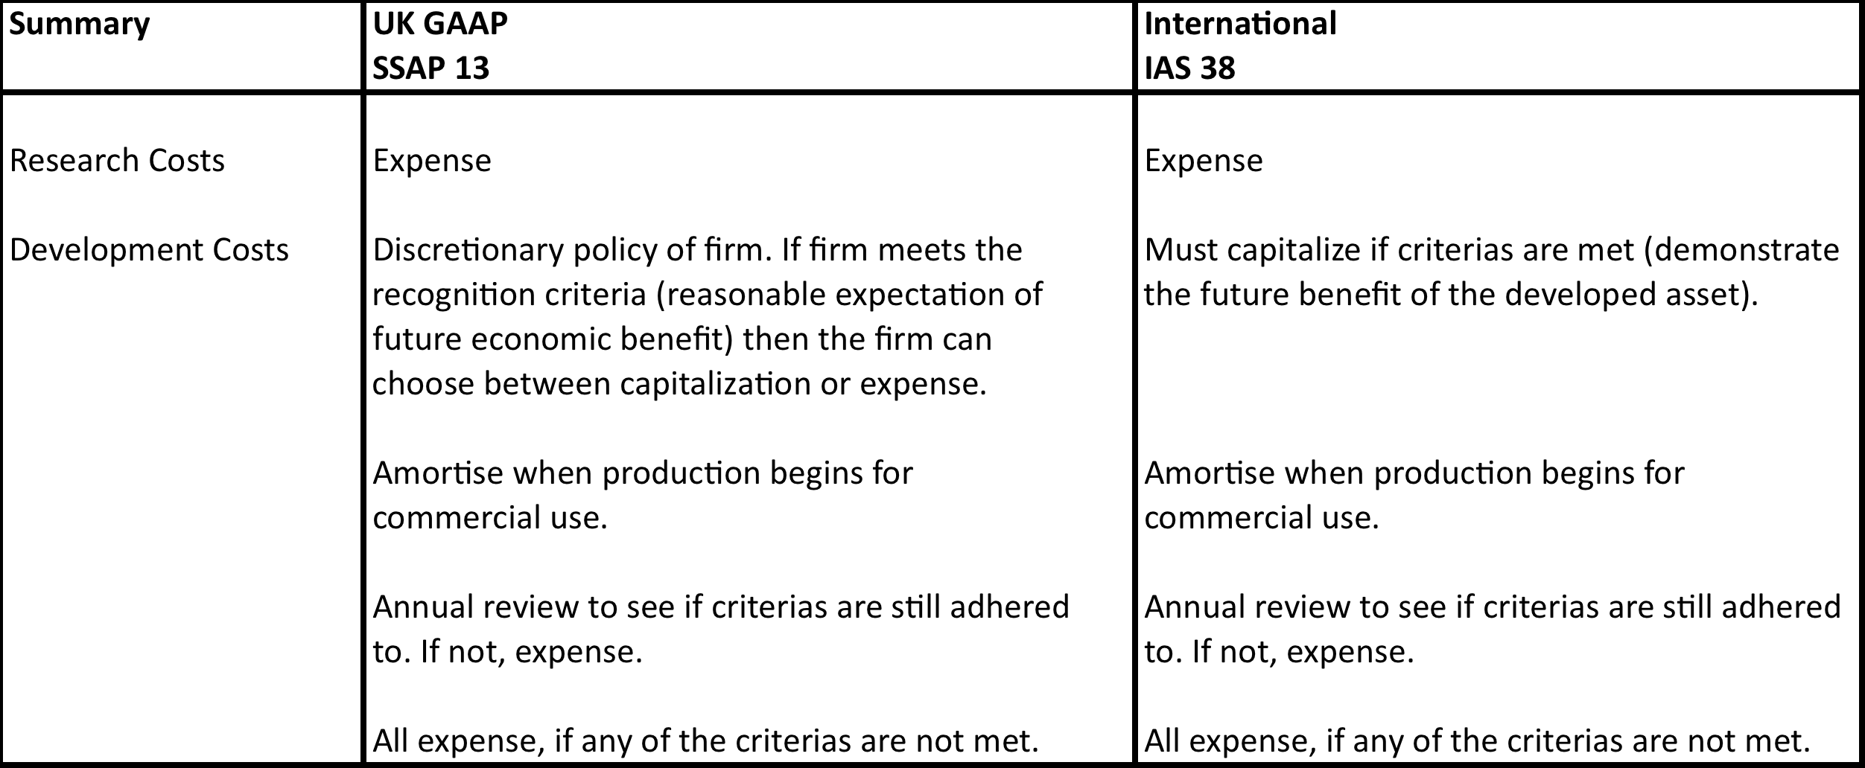
Table 2.1: Summary UK GAAP (SSAP13) and International standards (IAS 38)

As could be read in this chapter, the UK GAAP and the international accounting standards (IAS) have quite similar methods in recognizing and valuating R&D activities. Since this research will investigate the relation between R&D expenditures (intensity) and CSR (disclosures) the following chapter provides some general information on CSR.

Chapter 3. Corporate Social Responsibility and CSR reporting
This chapter will provide some general knowledge and concepts of Corporate Social Responsibility (CSR) and the reporting on CSR of firms. Additionally, this section will also elaborate on the value and relevance of CSR and CSR reporting for firms and also other groups surrounding the reporting entity. Lastly, this section will cover relevant topics regarding CSR reporting.

3.1 Introduction and definition to Corporate Social Responsibility
In the past years there has been a dramatic increase in the media regarding the social responsibility of multinational firms there are still confusions as to how CSR should be defined. Before this section dives in to CSR reporting, let’s take a moment to understand in depth what Corporate Social Responsibility is.
Carroll et al. (1979, p. 499) first argued in their paper that social responsibility consists of four aspects. These are economic, legal, ethical, and discretionary responsibilities. In the past the most important category was the economic responsibility of companies. Companies mainly focused on the revenue and profit generating activities, which were mainly the production and sale of their goods and/or services. Additionally, these companies just had to make sure they operated within the civil legal requirements. These were considered as the legal responsibility of the organizations. These two categories go hand in hand in the operational process. There is also the ethical aspect that is also embedded within these categories that was introduced by Carroll (1979, p. 499). Due to the occurrence of certain business scandals, where companies participated in questionable business accounting and corporate governance’s practices, governments, shareholders, workers, and general stakeholders wanted a more effective manner of monitoring the health and stability of a company. The demand was high for a way to monitor not only the non- financial results but also risk management practices and the added value of said firm on the environment and social arena (KPMG, 2008, p. 8). Although there are legal structures in place for organizations to follow and comply with, there are also social and general ethical norms that are not mandatory for organizations to meet but are expected from them from society. These responsibilities are categorized under the ethical category.
Apart from the before listed categories of Carroll’s (1979, p. 499) model for understanding, defining, and measuring CSR, there is the last category, namely the ‘discretionary responsibility’ for organizations. This is by far the most vague responsibility of them all because society has no clear-cut answer and expectations of what they aspect and sometimes demand from companies to comply with. Carroll (1979, p. 500) signals that in this last category each individual is left to make his or her own decision as to what they expect high a company or organization must meet their standards i.e. individual judgment. Other authors agree with the approach of Carroll (1979) but finds that this last category, discretionary responsibility, needs to be redefined so that it can be more objectionably measured. One major research that researched this was that of Donna J. Wood (2010). Wood (2010) studied the model of Carroll (1979), adapted it and made improvement to this model and thus created a new model for understanding, defining CSR. Additionally, as signaled by Wood (2010, p. 51-53) the actual intention for creating this model was to make improvement as to how CSR can be measured more reliably. Wood (2010) predominantly focused on improving how the discretionary responsibility proposed by Carroll (1979) could be interpreted and thus measured and also adding the aspect of predicting outcomes of certain business activities that are linked to the categories in the model.
To summarize, because Carroll (1979) argues that CSR is related to these four categories a clear definition must also cover these four aspects. Carroll (1997, p. 500) defines CSR as “The social responsibility of businesses encompasses the economic, legal, ethical, and discretionary expectations that society has of organizations at a given point in time”.
Wood (1991) understood the perspective of Carroll (1979) but abstained from providing a clear cut defining term for CSR. Instead, Wood (1991) argues that CSR must adhere to three principles that are related to society as a whole. So it is stated in Wood (1991, pp. 695-696) that the principles are (1) the principle of legitimacy, (2) the principle for public responsibility, and (3) the principle for managerial discretion.
Seeing that CSR is such a broad term it is understandable that there will be numerous interpretations and definitions. Additionally, it is also understandable that there will be other approaches to understanding, defining, and measuring CSR (CSP or CSR disclosures). One of these approaches is the one argued by Gamerschlag et al. (2011, p. 3-4). Gamerschlag et al. (2011, p. 3-4) defines CSR as “Corporate Social Responsibility (CSR) refers to a company’s voluntary contribution to sustainable development which goes beyond legal requirements”.
Basing their arguments on the stakeholder theory, they intended to show that, companies issue CSR reports and disclosures to reduce political and societal costs they are likely to experience from their stakeholders (Gamerschlag et al., 2011, p. 2).
One famous and widely used definition is the one issued by the European commission. The green paper published the European commission (EU commission, 2001, p. 6) define CSR as “CSR is a concept whereby companies integrate social and environmental concerns in their business operations and in their interactions with stakeholders on a voluntary basis”.
This definition is also supported by Dahlsrud (2008, p. 4) where this researcher measured to what extent certain dimensions are used in CSR definitions. Dahlsrud (2008, p. 4) identified 5 dimensions most used in the definitions of CSR which were (1) environmental, (2) social, (3) economic, (4) stakeholder, and (5) voluntariness.
For this research, the definitions of EU commission (2001, p. 6) will be used. Firstly, because this research is measuring CSR reports issued by companies in the UK and seeing that the European commission set this definition it would count for the reporting organizations operating in the UK. Secondly, because two (environmental and social) of the five dimensions reported by Dahlsrud (2008) are also the two main topics of the content analysis that this research will use to score the collected CSR disclosures. Lastly, because this research is based on the argument that companies are more likely to report on their CSR activities and performance to meet or beat the expectations of their stakeholders. This will thus demonstrate to the stakeholders the commitment of the companies in question for improving their products and processes, by investing in R&D projects, and thus improving their impact on the stakeholder’s social and environmental arena to the stakeholders (Deegan, 2011). Despite the numerous terminology of CSR that exist in the literature, to some extend all of them takes the same issues at the end into account.

3.2 Defining CSR reporting
Because there are various ways of defining CSR there are also various ways of defining how to report on CSR. Many researchers have tried to explain why companies voluntarily participate in CSR disclosure (Hibbitt, 2004; Gray et al., 1995, and Gamerschlag et al., 2011). At the same time many of these researchers provide different definitions for CSR reporting. One example is that of Gamerschlag et al. (2011, p.4), where it is stated in the research papers that CSR can be defined as “CSR disclosures are the information that a company discloses about its environmental impact and its relationship with its stakeholders by means of relevant communication channels”.
Another definition is that of Hibbitt (2004, p. 18) where it is stated that CSR can be defined as “The external communication of environmental, health and safety and energy issues relating to the policies, activities, undertakings and beliefs of an organization through company- wide reports which are placed in the public domain on a regular basis”.

In the literature can be seen that there are numerous definitions and terminology to describe the social and environmental responsibility of organizations. By taking into account the basis for this research and that of Gamerschlag et al. (2011, p. 4), Dahlsrud (2008, p. 4), and EU Commission (2001, p. 6) a definition was created by altering and summarizing the definitions of Gamerschlag et al. (2011, p. 4), Dahlsrud (2008, p. 4), and EU Commission (2001, p. 6), which is “CSR disclosures are the information that a company discloses about its social and environmental impact and its relationship with its stakeholders by means of relevant voluntary communication methods and channels”.
The reasoning for this definition is similar to the argument given in the previous paragraph for choosing a definition for CSR for this research.

3.3 Incentives for CSR reporting
Companies tend to report their social and environmental performance for different reasons. According to a survey conducted by KPMG (KPMG, 2011, p. 19) reputation and ethical considerations are the two most important drivers for CSR reporting. These companies are aiming to give their stakeholders and society as a whole a good or at least positive image that their organizations are striving at the very least to conduct their business in a way that meats the expectations of society. The study conducted by KPMG was done on the Global Fortune 250 (G250) and the largest 100 companies (N100) in each 34 countries that were included in KPMG’s survey. It falls in line with the argument made by Deegan (2002, p. 290) where it is signaled that companies are driven to comply with community expectations so that they can comply with the “social contract” i.e. legitimizing their social right to operate.
What was interesting to see in the report by KPMG (2011, p. 19) is that innovation and learning was a second tier CSR reporting driver alongside with the employee motivation driver. Innovation and learning falls in the scope of this research where R&D intensity will be measured and its affects on CSR disclosures.
Continuing with other incentives for companies to report on their social and environmental performances, Deegan (2002) argues that the desire to comply with legal requirements will act as a strong incentive for firms to issue CSR related reports. Additionally, it will improve the relation between the organization in question and governmental authorities. The survey of KPMG (2011) also identified something similar, which is to improve the relationships with governmental authorities.
Keeping in line with the stakeholder approach another incentive argued by Deegen (2002) was that of the economic considerations. When it comes to economic considerations that argument is that companies might be economic advantages when firms “appear” to do the right thing. KPMG (2011) also found similar drivers, which were (1) economic considerations, (2) market position (market share) improvement, and (3) cost saving.
Another motivation for organizations to report on their CSR performances is to attract investment funds (Deegan, 2002, p. 290). In this scenario organizations are intending to demonstrate that by reporting on their social and environmental performances they are “doing good”. This might attract investors to the organizations and thus increase the organization’s access to capital. A good example is that of the FTSE4GOOD index, where companies are measured based on their CSR performances. Investors can use this to objectively see which company is meeting international CSR standards. KPMG (2011) also found a similar motivation in their survey, which was access to capital or increased shareholder value.
Some motivations that were found by KPMG (2011) that is in line with the stakeholder approach were that of the previously signaled employee motivation and also the motivation to strengthen supplier relation, these are some of the most powerful stakeholder any organization has. Stakeholders have different but powerful influences in the operation and general standing of an organization (Deegan 2002, p. 290). Additionally, firms are highly likely to incorporate multiple drivers for CSR reporting at any given time.

3.4 Chosen standard for content measurement
For this research, the GRI issued framework for reporting on CSR performances will be used because their proposed framework is the largest and most influential standard setting policy in the field of CSR reporting at an international level (Gamerschlag et al., 2011; KPMG, 2011; and Morhardt et al., 2002). Additionally, the GRI also uses the perspective that is based on the stakeholder theory where organizations are reporting on the CSR activities and CSP to satisfy certain requirements and expectations of stakeholders.
KPMG (2011, p. 6) reported that 95% of the G250 and 64% of the N100 report on their CSR performances. In their study they found that 100% of UK companies report on their CSR activities either in stand-alone CSR reports or in their annual reports. Of the 34 countries they studied, UK was the country that came on top with the highest score of CSR reporting companies. Of the companies that were studied in these countries, 80% of the G250 and 69% of the N100 issue their reports based on the GRI framework.
The perspective of issuing a CSR report should be based on the intent to measure, disclosing, and being accountable to internal and external stakeholders for organizational performance towards the goal of sustainable development (GRI, 2006, p. 3). Additionally, the GRI framework proposed is intended to serve as a universal framework for organizations issuing reports on its economic, environmental, and social performance. The framework is intended to be applicable from organizations that are active in divers industries and divers geographical locations to firms that are active in a more limited fashion (industries, countries, etc) (GRI, 2006, p. 3).
The GRI has issued several versions of their CSR reporting framework. The first sustainability reporting guidelines “G1” was released in 2000 and in August 2002 the second version of their reporting guidelines “G2” was released. (Brown et al., 2009, p. 4-5). A few months later the GRI issued sector specific guidelines to account for key aspects that differ between industries but were significantly important to each industry. In October 2006 they introduced the third installment of their reporting framework “G3” and in March 2011 they unveiled the updated version of their sustainability reporting guidelines “G3.1”. Finally, the most recent version of the GRI’s CSR reporting framework “G4” has been introduced May 2013.
For this research the “G3” will be used as a benchmark because the years that will be measured will be 2006, 2008, and 2010. Seeing that “G3” was introduced between these years this framework is relevant for this research in the content analysis section.
To summarize, this chapter covered the general understanding of what this research considered to be CSR and CSRD. Additionally, this chapter also proposed a new definition for CSR and CSRD where these were created through analyzing, altering and summarizing various literatures that are relevant to CSR and CSRD. The following chapter will cover the theories that will be used to interpret the results for this research.

Chapter 4. Corporate Social Responsibility theories
This chapter dives into the line of reasoning for this research based on various theories. Two theories will be discussed in this section that provide a clear explanation why this approach is taken for this research. Firstly, the approach of this research will be discussed. Afterwards, the two relevant theories to explain CSR disclosures and why managers would disclose this kind of information will be discussed. Lastly, this section will elaborate on why the stakeholder theory is chosen as the primary theory for explaining the approach and interpretation of the empirical results.

4.1 Approach for this research
The purpose of this research is to measure the relation that R&D intensity has on CSR disclosures in a 4 year time span period for firms that are listed in the London Stock Exchange. This section will dive into the discussion as to why ‘in theory’ companies or managers are likely to disclose CSR related information. According to Deegan (2011), the Political Economy Theory is an essential theory to try to explain the possible reasons why organizations tend to report on their CSR activities and performances. Also known as the ‘system oriented theories’, these two theories that are also parts of Political Economy Theory will be discussed in this section. These are (1) the legitimacy theory and (2) the stakeholder theory. Firstly, these theories have been chosen because they consider the systems- oriented view. This is where the focus lays on the role of information between the organization and society (state, individuals, and groups). See figure 4.1. Additionally, Deegan (2011) states that the organization has influence and in turn is also influenced by the society in which it operates. Secondly, these theories have been used various times by researchers when conducting research in the field of CSR (Perego and Kolk, 2012; Oberseder et al., 2011; Anderson and Dejoy, 2011; Gray et al., 1995a; and Guthrie et al., 2008).

Figure 4.1: The organization as part of a wider social system (Deegan, 2011)
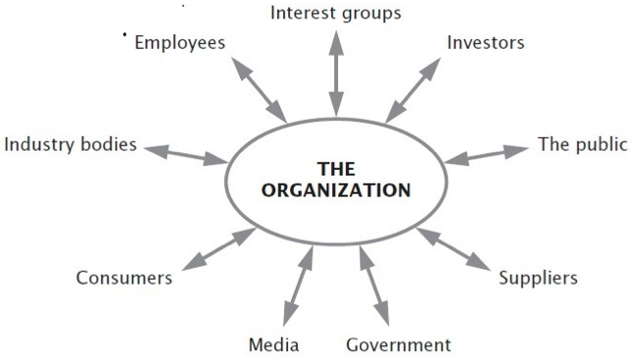

4.2 Legitimacy theory
As the name of this particular theory signals, here the reporting entity or organization continually seek to ensure that they are perceived as conducting business within the bounds and norms of their respective societies i.e. their activities are perceived as ‘legitimate’ by society (Brown, 1998, p. 22-24). These bounds and norms are not considered to be fixed or constant, but vary as times goes on. This requires organizations to be responsive to the ethical and/or moral environment where they are active in (Deegan, 2011). Deegan (2011, p. 40) provides the following definition for legitimacy theory as “A condition or status, which exists when an entity’s value system is congruent with the value system of the larger social system of which the entity is a part.”
Legitimacy theory follows the notion that there exists a ‘social contract’ between the entity and the society where the entity is active in (Dai, 2010). The social contract entails that society has implicit and explicit expectations about how the entity should be operating. Furthermore, Dai (2010) signaled that based on the legitimacy theory, an entity is considered legitimate if the activities of the entity fall in line with the social norm of the larger social system’s beliefs and values. Additionally, this theory emphasizes that the organizations must appear to consider the rights of society as a whole and not solely that of its investors. Failure to live up to the expectations of society i.e. ‘social contract’ may result in sanctions being imposed on the entity by society (Brown, 1998, p. 23).
As signaled before, the expectations of society are not constant or fixed. This also means that organizations must also adapt to the ever-changing norms and values of society. O’Dwyer et al. (2011) argued that if managers react swiftly to these changing expectations and priorities they are considered to be effective. Deegan (2011) also backs this assertion.

According to Deegan (2011) and Brown (1998), organizations have various ways of ensuring their legitimacy and the legitimacy of their activities:
- Adapt and adjust their outputs, goals, and methods of operations to confirm with the dominant standard of legitimacy.
- Attempt to alter the society’s definition of legitimacy through communication so that the term legitimacy meets the level of acceptance of the organization’s current activities, output, and values. If successful then the company’s legitimacy is most likely secured.
- Attempt to align the organization with symbols, values, or other organizations, which contain a strong and positive link to the value and norms of legitimacy.

4.3 Stakeholder theory
As Deegan (2011) signals, there are various similarities between legitimacy theory and the stakeholder theory. Additionally, Deegan (2011) argues that these two theories should not be treated as separate but two overlapping perspectives that cover the concerns and influences that society has on the organization i.e. ‘political economy’. See appendix A for an illustration of the relation between both theories. Both of these theories conceptualizes the organization as part of a broader social system wherein the organization impacts, and in turn is impacted by, other ‘powerful’ groups within society (Deegan, 2011).
An important difference between perspectives is that, while legitimacy theory argues for the expectation of the society as a whole i.e. ‘social contract’, stakeholder theory provides a more detailed and refined distinction of groups by identifying (powerful) stakeholders within society. This is an important distinction because since it is already known that society as a whole has a certain level of influence and power over the resources of an organization it would be wise for the organization identify which groups in society has more ‘power’ than the other.
According to Garvare and Johansson (2010, p. 741), a stakeholder can be categorized as “Actors that provide essential means of support required by an organization; and could withdraw their support if their wants or expectations are not met, thus causing the organization to fail, or inflicting unacceptable levels of damage”.
Additionally, according to Deegan (2011), stakeholders can be divided into two groups:
- Primary stakeholder: the organization in question cannot survive without the continuing participation of said stakeholder
- Secondary stakeholder: has a certain influence on or is influenced by the organization in question, but is not engaged in a transaction with the organization and is not essential for its survival.

Deegan (2011) argues that an improved relationship with stakeholders will improve the organizations ability to benefit from the resources that these stakeholders provide. By keeping a good relationship with stakeholders, the organization might disclose information that it knows that the stakeholders will find relevant and thus with the intention to satisfy or meet the expectations of the stakeholders they in intend to complete this task.
The stakeholder theory has a (1) positive (managerial) branch and an (2) ethical (moral) or normative branch. The ethical branch of the stakeholder theory argues that all stakeholders have the right to be treated equally without preference before another and not taking into account the power differences that each of them have on the organization. Here, the intrinsic rights of the stakeholders are prioritized and these should not be violated. Within the managerial branch, the organization distinguishes between certain powerful stakeholders. Garvare and Johansson (2010) argue that this perspective tends to be more organization centered. In this theory, stakeholders are identified by the level of concern they posses for the organization and thus are given the appropriate attention. This results in different groups receiving different levels of attention from the organization. More important stakeholders will receive a higher level of attention as to manage the relationship between it and the organization.

This research will incorporate the stakeholder theory approach when conducting and measuring the empirical analysis and interpreting the empirical results. The perspective that this research is taking is that manager are most likely to identify stakeholders that have a higher degree of influence on the company’s ability to produce beneficial results. So following the stakeholder theory, managers are likely to disclose more information to satisfy and thus to meet the expectations of its ‘powerful’ stakeholders. To be more precise, due to the fact that R&D expenditures are usually not the primary business practice of an organization, managers will tend to justify this in their CSR disclosures by mentioning the company’s intention and efforts to researching and developing ‘greener’ products and processes so that it will most likely improve the company’s social and environmental performance.

Chapter 5. Literature Review and Hypotheses development
This chapter will dive into various literature that were reviewed and used to strengthen and assist this research. Firstly this section will give an overview of the initial researches conducted in the field of CSR and its relation to the FP of an organization. Secondly, the various literatures linking R&D and FP of organizations will be elaborated on. Thirdly, this section will focus its attention more specifically on various studies conducted researching the empirical relation between R&D and CSP of companies. Fourthly, a detour will be taken in the literature review to address various issues regarding CSP and CSR. Finally, the section will discuss various possibilities and expectations for the existence of a link between R&D and CSRD and will propose the corresponding hypotheses for this research.

5.1. Introduction Literature review
Since the goal of this research is to identify and give empirical evidence that there is a relation between R&D and CSRD this chapter will elaborate based on passed researches for the reason of this argument and explain why the prediction exists for this relationship.
Chapter 3 and 4 gives a broad explanation of CSR in its general form, reasons why managers participate in CSR activities, and also provides a theoretical background for the participation and disclosure of CSR activities and performances (CSRD). The next section will begin directly describing past research on the affect that CSR has on FP and vice versa.

5.2 Corporate Social Responsibility and Financial Performance
The quest to find indisputable empirical evidence that CSR (CSP or CSRD) is indeed positively (or negatively) related to FP has been going on for decades. The quest to find this relationship and a valid ‘economic case’ for CSR activities are both based on “a normative, schismatic view of CSP as something a firm ‘should’ do in addition to striving to meet its economic goals”(Wood, 2010, p. 59). Additionally, Wood (2010, p. 59) states “For unbelievers, the assumption is that CSP is something a firm ‘should not’ do because it takes valuable resources from the firm’s principal function”. So there is are clearly two points of view regarding the participation in CSR activities for companies. Both of these arguments (pro- and against CSR) based their arguments on an ‘economic case’. In other words, they are arguing the issue whether or not CSR is needed for firms and basing their argument on the economic benefit of the firm. As Waddock and Graves (1997) signaled in the paper (p. 306), firms with a healthier financial performance have additional recourses to invest and participate in a broader range of CSR activities and thus improve its CSP. This will strengthen the relationship with the company’s stakeholders in a way which shows that because companies are performing good or better in the social and environmental aspect their ‘powerful’ stakeholders will take notice and thus are less likely to inflict damage to an organization (Garvare and Johansson, 2010). This drive for knowledge in CSR and FP has generated many studies, essays, literature reviews, and empirical researches (Wood, 2010; Wagner, 2005; Margolis et al., 2007; and Correa and Lopez, 2007).
While reviewing one of the most important empirical analysis conducted in R&D and CSP, McWilliams and Siegel (2000, p. 604) signals in their paper that there are generally two types of studies carried out when empirically measuring the relationship between CSR and FP. Firstly, there are studies conducted using event study methodology to ascertain and analyze the short-term financial impact when firms participate in CSR related activities. See for example Posnikoff (1997) and Teoh et al. (1999). Where Posnikoff (1997) investigated how the abnormal returns (short term) of US firms were affected when the companies announced their withdrawal or disinvestment from South Africa in the 1980s. An event-study methodology was used to analyze the effects. A positive relationship was found between the announcements and the abnormal returns. Teoh et al. (1999) studied a certain event during the ‘Apartheid’ regime in South Africa namely, corporate involvement in the period when the ‘Apartheid’ regime was being heavily boycotted. No relationships were found between the CSR and FP measures they used. Other studies that are usually done to analyze the relationship between CSR and FP are those that study the nature of the relationships between certain measures of CSP and long term firm FP. Financial and accounting measures representing profitability are usually used (McWilliams and Siegel, 2000 and Waddock and Graves, 1997). As this research intends to find the possible relationship between a certain financial measurement and a specific CSR aspect (CSRD) it will use R&D intensity as the independent variable and content scores of CSRD as the variable representing CSR. Additionally, it should be noted that this study can be categorized as the second type of studies signaled by McWilliams and Siegel (2000) when empirically analyzing the relationship between CSR and FP.
From the two examples signaled earlier in this section (Teoh et al., 1999 and Posnikoff, 1997) it can be seen that there are differing results when researching this topic (CSR and FP). Wood (2010, p. 59) went as far as saying that “the end results are wishy-washy at best – ‘doing good’ does not seem to hurt companies most of the time, and ‘causing harm’ sometimes does hurt” i.e. with all the documented results it only helps place a bigger question mark of the whole relation between CSR and FP. Throughout the review of various literature it could be seen and understood that researchers that conducted their studies in this research topic categorized three kinds of results produced by other researchers, which is also logical. This section will now shift its attention to these three kinds of results.
Certain studies conducted in this research topic have produced positive results. Orlitzky et al. (2003) conducted a meta-analysis on 52 previous studies that provided them with a sample size of 33,878 observations to work with. Their initial intent was to provide “a more methodologically more rigorous review than previous efforts” (Orlitzky et al., 2003, p. 403). They used a meta-analysis technique used by Hunter and Schmidt’s (1990) where all the correlations are accumulated and they are corrected for various study characteristics in order to reliably produce a true score of the correlation between CSP and FP. Orlitzky et al. (2003) corrected for sampling error, measurement error, and lag CFP findings in previous researches. For their research they found a positive relationship between CSP and FP. Specifically stating, “CSP appears to be more highly correlated with accounting-based measures of CFP than with market-based indicators”. Another study that conducted a similar empirical analysis was that of Margolis et al. (2007). Margolis et al. (2007) conducted a meta-analysis of 167 studies over a period from 1972 through 2007 that researched the same relationship between CSP and FP. By categorizing and measuring nine categories of CSP they were able to obtain 192 observations. One note for this research is that it did not account for sampling errors, measurement errors, or CFP lag failures, instead they considered all results to be of equal value (Wood, 2010, p. 62). Margolis et al. (2007) found a mildly positive result between CSP and FP in their research. Despite Wood (2010) acknowledging the findings of Margolis et al. (2007), a side note was still added stating due to the fact that the statistical analysis of Margolis et al. (2007) did not take into account the types of contaminations and methodological issues covered by Orlitzky et al. (2003) “this approach may account for their finding of a smaller overall positive relationship between CSP and FP than that obtained by Orlitzky et al. (2003)”.
Continuing on the different kinds of results, negative results have also been produced. As signaled before, parties on the side of a negative association i.e. ‘unbelievers’ (Wood, 2010, p. 59) argues that there is a negative relationship between CSR and FP because they believe that companies that participate in CSR related activities i.e. ‘perform responsibly’ obtain a competitive disadvantage (Waddock and Graves, 1997) because they are adding additional costs that could be easily avoided or should be incurred by others (e.g. institutions, government, and individuals). One of the studies that obtained a negative result was that of Wagner (2005). Wagner (2005) investigated the relationship between environmental and economic performance (FP) and the influence of corporate strategies that are linked to the development of sustainability and the environment. Wagner (2005) conducted his investigation in the pulp and paper industry in four European companies (Germany, Italy, the Netherlands, and UK). In this research a distinction has been made between an emissions-based index that largely reflects end-of-pipe strategies and inputs-based index that represents integrated pollution prevention. For the emission-based index of Wagner (2005) a mostly negative relationship was found between environmental and economic performance. However, their research did produce a certain degree of mixed results. One of these results was that for the inputs-based index that Wagner (2005) used, no significant relation could be found. Additionally, firms with pollution prevention-oriented corporate environmental strategies have a more positive relationship. This implies that corporations are more likely to make improvements in CSR. So Wagner (2005) provided all three of the different results identified, namely positive, negative, and no relationship. Other researches that provided a ‘no relationship’ result i.e. ‘mixed’ finding was that of Correa and Lopez (2007). Correa and Lopez (2007) conducted a study on the food industry focusing on 140 factories of multinational companies in France and the UK. They mainly used secondary data of famous (mostly American) multinational companies. Correa and Lopez (2007) proposed a strategic framework that identified six categories of ‘myths’ i.e. “commonly accepted misunderstandings in the analysis, selection/ implementation and control of proactive environmental strategies.” (p. 357). They incorporated a correlation statistical analysis to measure the relation between CSP and FP. For CSP they used emissions of organic carbon as a variable and for FP return on investment (ROI) and return on equity (ROE) were used as variables for the analysis. They concluded that there is no relationship between environmental performance and progression and financial performance. One reason provided by Wood (2010) for the different results in various literatures was due to methodological differences in definitions or CSR and financial performances (p. 61-62). It could be possible that the initial approach may hamper the analysis that may cause these different results in the end.
As already signaled in Chapter 4 and other sections, this research will base its approach on the stakeholder theory. Specifically stating, if organizations participate in CSR related activities and disclose their activities and performances in CSRD, this will thus strengthen the relationship with its stakeholders. The relationship will improve because stakeholders are being fed with information that regards issues that they hold to a certain high degree. This will thus satisfy their need for information on certain organizations. Some stakeholders might be bankers, investors, and government officials. As signaled in Deegan (2011), it falls in line of logic to think that an improved relationship between firms and their stakeholders can improve the organization’s access certain (economical) benefits that these stakeholders have in their possession. Additionally, Gray (2006) states, “socially and environmentally responsible acts are those which benefit stakeholders and the company simultaneously.” (p. 81). Such acts must be linked with FP by definition. The following section of the literature review will take a small and short detour into studies conducted in the search of finding a link between CSP and CSRD.

5.3 Corporate Social Performance and Corporate Social Responsibility Disclosures
Before this chapter dives deeper into the actual focus of this research, it will take a slight detour to address various studies that investigated the link between CSP and CSRD i.e. the ‘CSR performance-disclosure gap’.
Wood (2010) signals that there are two types of measures for CSR when conducting an empirical analysis (p. 60). First, there is the ‘social disclosure’ where the CSR reports and pollutions reports are used and secondly there is the ‘social performance’ for example the KLD database. Wood (2010) derived these categories from Ullmann’s (1985). So in other words, according to Wood (2010) and Ullmann (1985) the two ways of measuring a company’s CSR aspect or performance is by using (1) external i.e. third party sources that assess a company’s CSP based on their own criteria. For example the KLD database or FTSE4GOOD index. Measuring CSP is a social concept and not some physical construct that measures the true state of the organization’s CSR (Font et al., 2012, p. 1545). In this case the performance evaluation is not determined by the organization itself but by ‘society’. It is logical to think that there are bound to be arguments and discussions regarding true state of an organization’s CSP (Wood, 2010), namely between the organization in question and the independent party conducting the CSP measurement. The other method is (2) using methods of content analysis to analyze the CSRD that organizations publish to the public i.e. made available to any party outside of the organization. So it would be interesting and possibly beneficial for this research to review what kinds of researches there are that investigated the link between CSP and CSRD.
Gray (2006, p. 77-78) argues that the main reasons for the interest in investigating the possible relationship between CSP and CSRD is to give empirical evidence if in fact CSRD reflects CSP in any way of the organization in question. The most studies done in this specific section of study have produced mostly negative results. One example is that of Cho et al. (2012) where they found a negative correlation between CSP and CSRD. They investigated whether environmental performance is mirrored in perceptions of their environmental reputation and if CSRD’s are used as a mediator to lessen the negative affects when an organizations has a poorer CSP. They conducted this investigation using a cross-sectional sample of 92 companies in the USA that are ‘environmentally sensitive’. They used a path analysis so they could consider all direct and indirect relations among all of the analysis. They ultimately conclude that CSRD is negatively related to environmental performance (CSP) stating, “worse performers have more extensive disclosures”(Cho et al., 2012, p. 15). Another study that concluded similar results was that of Cho and Patten (2007), where they used sized-matched groups of companies distinguished by industry memberships to empirically analyze the relationship between CSP (using KLD) and CSRD (content analysis). They provided results that are similar with most of other studies conducted in this field of research (Patten, 2002; Font et al., 2012; and Hughes et al., 2001). Most of these researchers based their conclusions on a similar argument, which is, firms use CSRD’s to offset the likely negative effects of poor environmental performance (Cho et al., 2012, p. 15). They based their theoretical framework on the Legitimacy theory, saying that because of a poor(er) CSP would reflect negatively on the firm, they issue more CSRD in an attempt to negate this negative effect. The argument stated by researchers is that by issuing more CSRD they can address the (increased) threat to its legitimacy (Cho and Patten, 2007, p. 640). Font et al. (2012) argued that through a literature review it could be understood that “companies publish environmental information in reaction to an actual or potential crisis or threat.”(p. 1545).
This section was relevant to discuss due to the fact that it is also an important topic that has relevance in the whole field of empirical study with regards to CSR-FP. Additionally, it is also relevant to this research due to the fact that it might assist this research in explaining and interpreting certain results. See Figure 5.1 for an illustration of the CSR-FP relationship proposed by Ullmann (1985) and used by Wood (2010). Although the legitimacy theory has been discussed in this section of the literature review, this research will use stakeholder theory as signaled in section 5.3.
The following section will elaborate of literatures covering the link between R&D and FP.

Figure 5.1: CSR-FP measurement (Ullmann, 1985)

5.4 Research and Development and Financial Performance
The general intention of R&D activities for firms is to create additional assets and also improve product and process innovation (McWilliams and Siegel, 2000). Additionally, according to a concept paper written by Deloitte researchers on Research and Development expenses (Deloitte, 2011), R&D related activities usually involves constant revitalization of knowledge and expertise, and could result in developments. These developments are usually related to new and improved products, improved operational processes, meeting the changing requirements of customers, cost reduction, and meeting the changing social and environmental standards (McWilliams and Siegel, 2000 and Padgett and Galán, 2010). Additionally, Padgett and Galán (2010, p. 4) argues that because the innovative strategies employed by companies have a significant impact on processes and tend to create new products and services, it will eventually lead the company in gaining a competitive advantage. According, to McWilliams and Siegel, (2000, p. 605) there is robust empirical evidence that supports the notion that with the increased competitive advantage and increased productivity it will thus lead to an increased economic advantage. One empirical example is that of Panditt et al. (2011) where they investigated whether investments in R&D are fruitful in the future when it comes to the financial performance of firms. They ultimately concluded that, by using the level and variability of both future earnings and future cash flows as dependant variables, the mean level of realized future-operating performance is positively associated with the patent quality of companies. The patent quality is measured as the citation index of a firm’s patent portfolio. Another study that found a positive relationship was that of Lichtenberg and Siegel (1991). Using a data obtained for 2000 firms Lichtenberg and Siegel (1991) concludes that there is a strong positive relationship between R&D investments and growth in total factor productivity. Additionally, Lin et al. (2006) shed light on the positive relation between firm’s financial performance (FP) and R&D strategies and technology commercialization. They investigated the main effects that R&D intensity, knowledge stocks, and commercialization orientation has on FP. Lastly, Hull and Rothenberg (2008) investigated various aspects of influence that innovation (R&D) has in firm performance (FP) and CSP. One of their conclusions was that R&D positively influences firm performance.
As reported by McWilliams and Siegel (2000), recent years has shown an increase in R&D expenditure by firms to invest in the production and development of sustainable products and/or services to show their commitment to CSR because this demonstrates to their stakeholders that the organization in question is willing to improve its social and environmental impact that is leaves to conducts its operations. Additionally, McWilliams and Siegel (2000, p. 605) argues that companies that strive to maintain and/or work towards an improved ‘CSR’ image will be viewed by society and stakeholders as more reliable and having superior stocks of products.
This opens up the section where the link between R&D and CSR (CSP) is elaborated on.

5. 5 Research and Development and Corporate Social Performance
The previous section covered the review of literature on the link between R&D activities and strategies FP and lastly the focus of R&D projects on the research and development of more ‘sustainable’ products and/or services has been elaborated on. This strengthens the argument why R&D can be associated to CSR. Additionally, McWilliams and Siegel (2000) provided an argument that strengthens this case. McWilliams and Siegel (2000) argued that by excluding R&D from the models when empirically analyzing the relationship between CSP and FP would result in the model showing an upwardly biased link (p. 605). If R&D does positively impact on FP, then the coefficient on any variable that is heavily correlated with R&D will be overestimated when R&D is omitted from the model (McWilliams and Siegel, 2000, p. 605). They concluded that R&D intensity is strongly related to CSP when using KLD as a proxy for CSP. Another paper that corroborated their findings was that of Hull and Rothenberg (2008), where they also concluded that R&D is positively related to CSP after testing their multi-variants regression analysis. Rothenberg and Zyglidopoulos (2007) found that the more an organization adopts innovative strategies, the more likely it is to adopt a greater amount of environmental innovation.
As signaled in the first chapter, this research builds on i.e. received its inspiration from a study conducted by Padgett and Galán (2010). They wanted to ascertain if in fact the findings of McWilliams and Siegel (2000) could hold. Their study measured R&D intensity specifically and its affects on CSP through a multi-variants regression analysis. Their results show that there is a significantly positive relation between R&D intensity on the CSP of firms. They explained this by stating, firms are very likely to intend to surpass the expectations of stakeholders by participating is CSR related activities that minimize waste and reduce energy consumption and by initiating human resource management programmers (Padgett and Galán, 2010, p. 15).
These studies gave empirical evidences with regards to the various empirical studies conducted in field of CSR-FP studies. (See figure 5.1 for the relationship interpretation proposed by Ullemann (1985) for CSR-FP) Specifically, in section 5.4 and 5.5 the various literatures researching R&D-FP and R&D-CSP were reviewed. The following section will elaborate on the focus of this research, namely R&D-CSRD.

5.6 Research and Development and Corporate Social Performance Disclosures
As could be read in the first chapter the main research question is as follows:

Is R&D intensity of firms listed on the London Stock Exchange related to CSR disclosure?

This section will now provide an in-depth explanation as to how and why this research question was developed using various literatures reviewed.
From the previous sections it could be seen that there is an increased interest from past researches to examine the empirical relation between R&D intensity and CSR using CSP as a measure for CSR. The interest in R&D was because companies are facing increased pressure from stakeholders (e.g. customers, investors, and government) to improve their business processes (McWilliams and Siegel, 2000, p. 605 and Padgett and Galán, 2010, p. 15). For example, start initiatives and participate in innovative actions that will reduce CO2 emissions (KPMG, 2011, p. 19). This will result in the organization reducing their negative impacts on the social and environmental arena and thus improving their CSP. These firms are also receiving pressure from their stakeholders to initiate and develop sustainable products i.e. ‘green-products’ (KPMG, 2011, p. 19). This might lead to brand recognition and an increase in reputation. Additionally, this might also help the company create brand and product differentiations. Since stakeholders assign an increased pressure on firms to ‘perform’ better with regards to sustainability (CSP), it is also logical to think that these stakeholders would like to obtain information of these activities and the initiatives that these organizations are embracing to meet their expectations. Firms acknowledge this ‘need’ of stakeholders for information and thus report their initiatives, activities, and performances through various CSR related disclosures (CSRD). According to a 2012 Statistical Bulletin published by the Office for National Statistics of the UK, it showed that R&D expenditure has steadily increased throughout the last 10 years in for businesses operating in the UK market. Additionally, KMPG (2008 and 2011) reported that the top 100 firms (N100) in the UK also steadily increased their participation in CSRD throughout the last 8 years. Of the N100 in UK 71% participated in CSRD in 2005. This increased to 91% in 2008 and in 2011 a 100% participation of N100 in the UK discloses information that is related to CSR either in stand-alone CSR reports or in their integrated reporting. Due, also, to the argument of McWilliams and Siegel (2000, p. 605) and Padgett and Galán (2010, p. 15) that stakeholders are putting increased pressure on firms to produce more sustainable services and products, companies are, therefore, increasing their R&D intensity to develop their business processes and products to meet the unofficial requirements and expectations of their stakeholders. To inform stakeholders and report on the progression and performance of these initiatives and other CSR related information, these companies thusly report their activities, participation and performance in their CSRD, to thus meet the expectations of their stakeholders. Which leads this research to the before signaled main research question.

5.7 Hypothesis development
The following section elaborates on the hypothesis for this research that were set up based on the before chapters and most recently the literature review.
As signaled in the previous section (section 5.6), R&D expenses has steadily increased throughout the last 10 years in the UK. The first hypothesis of this research is to test whether in fact the increase is significant between the measured time periods for this research. This will be conducted through the data that were collected for this research for the UK firms listed in the London Stock Exchange. The first hypothesis is:

H1: Does R&D intensity increase significantly over the years 2006-2010?

Additionally, KMPG (2008 and 2011) reported that the top 100 firms (N100) in the UK also steadily increased their participation in CSRD throughout the last 8 years. Of the N100 in UK 71% participated in CSRD in 2005. This increased to 91% in 2008 and in 2011 a 100% participation of N100 in the UK discloses information that is related to CSR either in stand-alone CSR reports of in their integrated reporting. To test whether the topics reported in these CSR have also increased throughout the years 2006-2010 the following hypothesis will be proposed:

H2: Does CSR content scores increase significantly throughout the years 2006-2010?

Based on the argument of McWilliams and Siegel (2000) and Padgett and Galán (2010) that stakeholders are putting increased pressure on firms to produce more sustainable services and products, companies are increasing their R&D intensity. As a result, the assumption is that companies report their activities, participation and performance in their CSRD to thus meet the expectations of their (powerful) stakeholders. This thus brings this research to the final and main hypothesis:

H3: Is R&D intensity positively associated to CSR content scores of firms listed on the London Stock Exchange?
To summarize, this chapter has provided a review of the various literature covering the relationship of between CSR and FP. A detour was also taken to elaborate on a related issue namely the CSP-CSRD (performance/disclosure) gap. Furthermore, this section covers the literature review with various elaboration on the studies conducted between R&D-FP and R&D-CSP. Finally, an in-depth explanation was provided that elaborates the assumptions for this research i.e. the (positive) link between R&D-CSRD.
The following chapter will elaborate on the various methods that will be incorporated in this study to examine and give empirically evidence for these before-signaled hypotheses. The empirical results for these hypotheses will be discussed in Chapter 7.

Chapter 6. Research Methodology
This chapter covers the research type and framework and discusses how this research was carried out. Additionally, this section will provide the reader with a full description of the data sample collected and used. This section will then dive into the content analysis and the CSR scoring framework developed for this research. Afterwards, the regression analysis model and the accompanying variables will be discussed. Lastly, this section will cover how the three hypotheses will be tested.

6.1 Research framework
The intention of this research is to explain the possible effect of R&D intensity of firms on their disclosures that are meant to report on their CSR related activities and performances. Firstly, this research will analyze the progression of the R&D intensity of firms listed in London Stock Exchange between the years 2006 and 2010. These years were selected due to the fact that according to a Statistical Bulletin published by the Office for National Statistics in the UK in October 2012, firms active in the UK have more on R&D during this time period. This provided an opportunity for this research to investigate this period. It also helped this research when the data availability for this period was actually available. Years before 2006 were limited with data availability, specifically CSR reports and related disclosures. Secondly, the CSR related disclosures issued by the firms collected in the data sample will be analyzed using content analysis with the intention to score the individual disclosures in the CSR reports or Annual reports and to measure how the levels of disclosures have progressed over the years of 2006, 2008, and 2010. Lastly, this research analyzes whether a positive relationship can be identified between R&D intensity of firms and their CSR related disclosures and reports. Figure 6.1 illustrates the research framework.
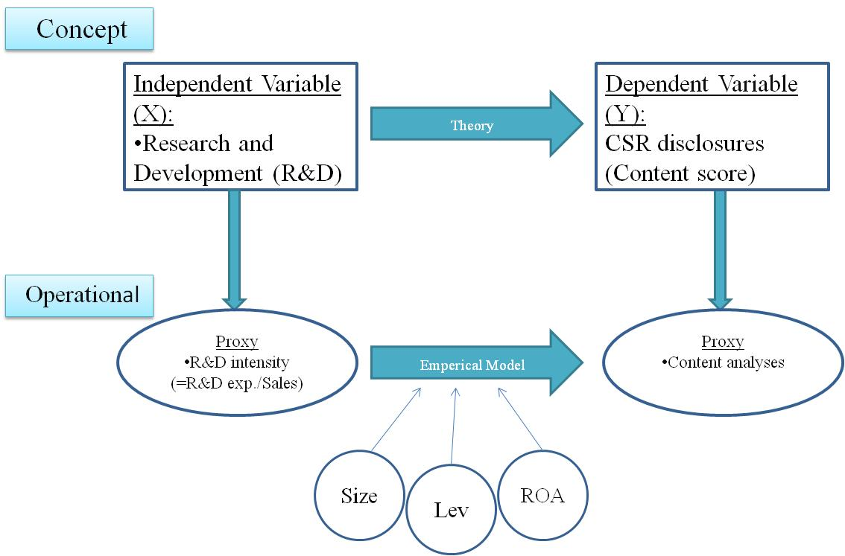
Figure 6.1: Research framework

McWilliams and Siegel (2000, p 605) and Padgett and Galán (2010, p. 15) argued that stakeholders are putting increased pressure on firms to produce more sustainable services and products. Therefore, companies are increasing their R&D intensity to develop their business processes and products to meet the unofficial requirements and expectations of their stakeholders. To inform stakeholders and report on the progression and performance of these initiatives and other CSR related information, these companies thusly report their activities, participation and performance in their CSRD, to thus meet the expectations of their stakeholders. That is why the main research objective of this study is to find empirical evidence that R&D intensity positively affects CSRD.
In order to examine the possible relationship between R&D intensity and CSR disclosers, the CSR disclosure will be scored based on the G3 reporting framework issued by the Global Reporting Initiative in October 2006. For a more detailed explanation of all variables and scoring framework see section 6.4 and 6.5.

6.2 Research type
This research consists of two crucial analyses. Firstly, a content analysis will be conducted on the publicized CSR related disclosures. Secondly, an empirical analysis will be done to measure the possible relation between R&D intensity and CSR related content (=CSR content scores).

6.3 Data sample collection
The data sample was selected from firms that are listed in the London Stock Exchange in London, United Kingdom. As signaled in the first Chapter, the UK is known to be among the top ranked firms that are active in CSR reporting (Kolk, 2003, p. 283). The selection of the data sample is comprised of two phases.
Firstly, the financial data of potential firms were obtained from Datastream. The first criterion for selections was that of firm size. As signaled before, Gamerschlag et al. (2010, p. 23-24) argues that one main determinant factor of firms reporting on CSR are their size. One reliable method of measuring the size of a firms’ is by taking its market capitalization into consideration. This is an indication of the size of a company taking the share price multiplied by amount of shares outstanding.
Thus, the companies were selected initially based on their market capitalization reported in the Datastream results in the selected years. Afterwards, the companies that are not active in R&D activities i.e. no R&D expenses recorded are eliminated from the selection seeing that R&D intensity will be used as an important variable. Then the top firms in R&D intensity were arranged from top to bottom. After the first phase of the sample selection, which included size (market capitalization) and R&D intensity (R&D expenses/Sales) 300 firms were selected from the initial 677. Other financial variables were used as control variables in the regression model (ROA and Leverage). These will be discussed in more detail in section 6.5.

Secondly, to collect all the CSR related disclosures a web based search was conducted to gather all the CSR and sustainability related reports and also all the annual reports of the respective years were gathered to compensate for some organizations that did not issue a CSR report in certain years but well in other years. The sources used were:
- Company websites: These are the official firm websites where they publish their annual reports and CSR/ sustainability related reports.
- Global Reporting Initiative (GRI): The foremost international sustainability reporting framework standard setter for international companies. GRI is a multi-stakeholder, network based organization that proposes and establishes reporting guidelines for companies to increase the organizational transparency of the economic, environmental, social, and governance performance (Global Reporting Initiative (GRI), 2006).
- Corporateregister.com: Is known to be the largest online database for CSR related reports issued by international companies. The database was used to search reports of companies operating on their official name with the Public Limited Company (PLC) title.
- Company.info: This is another database that provides users with relevant information of more than 100.000 international firms. For this research this database was mostly used to gather the annual reports of firms when needed.

When collecting the reports it could be seen that firms use different titles for their CSR related disclosures. For example, Diegeo PLC uses the title “Corporate Citizens Report” and BHP Billition PLC names its report “Sustainability Report”. Both of these reports cover exclusively their environmental and social performances within a certain period. Other firms in the sample use other titles for their CSR related reports. While other firm report their environmental and social performances in their annual integrated reports. This research categorized 2 types of reports. Firstly, all reports that cover exclusive CSR related performances are categorized as CSR reports. Secondly, reports that include environmental, social, and an extensive coverage of financial performance are categorized as annual reports. In the final sample there are 28 Annual reports (33%) and 56 (67%) collected.
Initially there were 1367 observations (677 firms) for the years 2006, 2008, and 2010. After the selection process based on market capitalization, top R&D intensive firms, and the web based search for CSR related disclosures the decision was taken to take the top 28 firms that were left after this selection process. The decision to take 28 firms for each year (84 observations) was taken based on reviewing other researches conducted using content analysis and also using the GRI framework as a scoring benchmark. See Appendix C for a list of all firms and relevant data. Skouloudis et al. (2010) used 55 reports when analyzing firms CSR disclosures in the Greek market. Another research was that of Morhardt et al. (2002) where 40 CSR reports of the Global Fortune 500 were analyzed. With 28 firms for the years 2006, 2008, and 2010 it provided this research with a sample size of 84 observations. When conducting the regression analysis the top and bottom 1% of firms were eliminated based on their R&D intensity. This action was conducted to account for homoscedasticity. This action removed 2 observations from the sample size and left 82 observations as the final sample size.

6.4 CSR content scoring framework
The chosen scoring framework for the content analysis is a numerical scoring system that was created based on the GRI standards that were established by the Global Reporting Initiative. GRI is a multi-stakeholder, network based organization that proposes and establishes reporting guidelines for companies to increase the organizational transparency of the economic, environmental, social, and governance performance (Global Reporting Initiative (GRI), 2006). Participation of organizations in the reporting framework is completely voluntary.
To measure specific topics in CSRDs of a reporting entity a scorecard was created using the G3 the GRI. Additionally, the scoring framework that was created and used is intended to address and measure various aspects of the CSRD of a reporting entity. Firstly, using the core indicators of the G3 the intention was to reflect core aspects of CSR activities within an organization that is argued to be similar across industries (Global Reporting Initiative (GRI), 2006). Secondly, many of these core indicators also reflect a reporting entity’s efforts and initiatives to improve, innovate, and develop their business processes and products. This falls in line with the general intention of R&D as signaled in chapter 2. Thirdly, the additional topics we also chosen to measure various aspects and efforts of an organization to further improve its business processes and products. See Appendix (B) for the scorecard and explanations for the topic selection.
Previous researches have also used the GRI framework as a benchmark to score the CSRDs. Skouloudis et al. (2010) devised their scoring framework using the GRI guidelines as a benchmark and thus measured the quality and the progress of triple bottom line reporting of firms operating in the Greek market. Morhardt et al. (2002) also created a numerical scoring framework based on the GRI 2000 established guidelines to evaluate as to the extent that then current environmental report met the requirements of the Global reporting Initiative GRI 2000 standards.
A numerical scoring framework was developed following the principles of previous researches conducted by Morhardt et al. (2002) and Skouloudis et al. (2010). By issuing scores for the selected reporting topics of the GRI reporting guidelines this method will issue measurable scores for each report that a company issues in a certain year based on the completeness and comprehensiveness of its contents. After a critical review of the recent GRI reporting guidelines (G3) a set of topics were selected of the 49 core indicators and the 30 additional that reporting companies may choose to disclose that are possibly related to R&D activities and results. See appendix (B) for the scoring framework’ score card list and an explanation for each topic.
A total of 31 topics were selected. Each topic criteria can get a score between 0 and 3 points. This gives each report a maximum score of 93. The following part will dive into the distinctions between the scores that a reporting topic can receive.

- 0 points: when a specific topic was not reported on it gets no points i.e. 0.

- 1 point: when a company briefly covers or provides generic statements on a certain topic, it gets 1 point. For example, a company provides some information of future intentions and strives to improve their performances with regards to sustainability performances.

- 2 points: when a more detailed and extensive coverage is provided but lacks the comparable data/ hard data i.e. provides a broad range of information that paints a more detailed image of their activities but falls short of measurable data. For example, their participation in community involvement to lower the amount of high school dropouts in closely related communities or provides employee training to increase their level of skills and knowledge in their respective fields of work. However, the reporting firm falls short of providing the monetary amount spent on these activities and/ or hours of firm representatives participating in these activities. Respectively, they fall short of providing the amount of employee training hours in a certain period.

- 3 points: when a topic is as extensively reported on as the previous point (2 points) or more and provides data that are comparable and measurable it will receive 3 points. The information provided should be systematically covered and the reporting data is measurable and comparable to previous reports and/ or reports of other companies. For example, a firm provides graphs and tables to illustrate the performance of its employees per department and/or service sector. Another example could be when these companies provide data to report on the amount of registered sick leaves and/or injuries occurred during employment. These types of information will receive the highest score for this scoring framework i.e. a 3 point score.

After the disclosures of the company are scored it is then categorized in one of three groups that distinguish the level of reported CSR information.

Figure 6.2: Level of CSR reporting categories
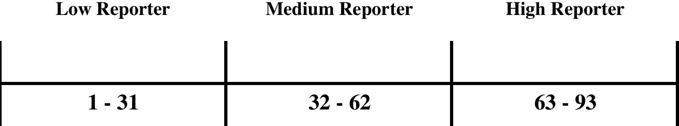

Now this section will discuss the interpretation of the scores. For scores of a company’s CSR related disclosures in a certain year that falls between 1 and 31 will be categorized as a “Low Reporter”. For instance, Shell’s CSR related disclosures in 2008 receives a score of 22, then it falls under the category of “Low Reporter”. Scores between 32 and 62 will fall under the category “Medium Reporter”. Scores between 62 and 93 will then fall under the “High Reporter” category. These terms will be used to categorize the scores in more convenient groups.
It is noteworthy to mention that for this research actions were taken to remove a certain amount of subjectivity when conducting the content analysis. The assistance of a couple of acquaintances in other higher education studies was asked to score these reports. These persons that have been selected have sufficient knowledge to understand and interpret these reports and the information that are provided. It might also be important to note that these persons are currently enrolled in various masters programs across the Netherlands and sufficiently proficient in the general English language. In total 3 people were asked to score the CSR reports of all firms (28) obtained for one year. So for example, person 1 scored all 28 reports for the year 2006, person 2 scored all 28 for 2008 and the same counts for person 3. Additionally, they were not informed of the research objective. They were only instructed to score the reports that each person received (28) based on the scoring framework and the before signaled distinctions between scores.
The scorers were instructed to hand in 4 batches of content scores in a scheduled timeframe. The ‘batch’ system was used to control in a structured manner if in fact the content analysis were being conducted based on the established content analysis’ framework and guidelines. Each person was instructed to hand in 7 reports in each batch. In each batch of each person a number of the content score cards were controlled to see whether the scoring was done properly. Firstly, a number of content score cards were taken at random out of each batch of 7. Secondly, the respective CSR disclosures of the randomly selected CSR content score cards were taken and reviewed in conjunction with the scores given on each topic on the scorecards. The control was aimed to see whether the guidelines when distinguishing between 1, 2, or 3 score were adhered to. Thirdly, if any noticeable deviations were noticed then these were discussed with the scorer to see why certain scores were given. In the first round of batches 2 content score cards were randomly selected, in the second round of batches only 1 content score card was selected, in the third round it was 2 and in the forth it was 1. In total 18 scorecards were controlled out of the total 84. See section 6.4 for guidelines and appendix (B.) for the scoring framework.

6.5 Statistical test variables and regression analysis model
In this section the variables used in the statistical and regression analysis will be covered. To analyze whether R&D intensity is related to CSR disclosures a regression analysis will be performed. This is represented as equation 1.

CSRit = β0 + β1R&Dit- + β2SIZEit + β3LEVit + β4ROAit + εit
Equation 1
This regression will demonstrate the extent of the relation between CSR disclosures and R&D intensity. Below the variables will be discussed.

Dependant variable
- CSR: This is the content score of the CSR related disclosures of company i during reporting year t. This variable is measured by taking the numerical score and then divides it by the total score that the report could receive (93). Previous reports showed that this method of calculation is a proper way to measure the correlation between CSR disclosures and other financial and non- financial variables (Skouloudis et al., 2010 Gamerschlag et al., 2011; and Lui and Anbumozhi, 2009). These scores were established through an index-based content analysis. See appendix B for the list of topics and section 6.4 for the content analysis.

Independent variables
- R&D: This is the ratio between the amount that a company spend annually in R&D with their annual revenue i.e. R&D intensity. This method of estimation is a reliable way to estimate the level of commitment a firm puts in its R&D activities. Other researchers also incorporate this measurement method in their studies when investigating the relation between R&D intensity and other variables (Hull and Rothenberg, 2008; and McWilliams and Siegel, 2000).

Control variables
- ROA: In this research ROA (Return on Assets) will be used a control variable because it shows the results that a firms is benefitting from possible fruitful R&D activities that was intended to give the company a competitive edge (Hull and Rothenberg, 2008). This is calculated by taking the net profit divided by the total assets.

- SIZE: This is to account for the amount of information the firm is able to disclose. This has been previously signaled, as it is an important determinant for CSR disclosures (Hull and Rothenberg, 2008; and Lui and Anbumozhi, 2009). The size is represented by the market capitalization of the firm. The ‘size’ variable will be calculated by, taking the share price and multiplying it with the amount of outstanding shares.

- LEV: Leverage is the relative size of the total debt in relation to the total assets of firm i. This has also been used in previous researches that conducted a similar kind of study in the field of CSR (Hull and Rothenberg, 2008; and McWilliams and Siegel, 2000).

6.6 Statistical tests and regression analysis
This section will elaborate how the proposed hypothesis will be tested using the before signaled statistical and regression models.
H1: To test the first hypothesis, which was to measure if in fact R&D intensity has increased over the years between 2006 and 2010, the T-test was used. This was conducted to see if the mean between the two years would contain significant differences.
H2: To conduct the second hypothesis a T-test was also used to measure if in fact CSR disclosures have improved based on their completeness and comprehensiveness. This was done between the years 2006 and 2010. The method of test is similar to the test conducted in H1.
H3: To test if there is a link between R&D intensity and CSRD a regression model was created. The regression model will be a longitudinal measurement model intended to measure the effects of R&D intensity for firm (i) at moment (t) on CSR at moment (t).

Chapter 7. Empirical analysis results and discussions
This chapter elaborates on the empirical analyses and results that were conducted to test the previously signaled hypotheses in Chapter 6. Additionally, this chapter dives into the discussions regarding these empirical results and will provide an analysis of the respective results. As a last note, this chapter discusses developments of certain data that were used in the empirical analysis.

7.1 Descriptive Statistics and data discussions
Before this section dives into the descriptive statistics used in the empirical analysis it will discuss some general data developments that were seen in the dataset. Seeing that R&D intensity is the independent variable and one of the main variables in this research it will discuss certain developments of R&D intensity. As can be seen in figure 7.1 BHP Billition PLC, Smith Group PLC and Vodafone PLC were the most intensive firms in R&D. As can be seen in figure 7.1 no ‘one’ industry dominates before others in R&D intensity. For example, Invensys PLC is part of tech industry but is far less intensive then Smith Group PLC, which is also in the technological industry.
As can be seen in figure 7.1 each company has its own level of R&D intensity, which can be interpreted as R&D intensity and its related activities is up to the management discretion on how to invest in these activities. Although, it was stated in the final section in chapter 5 that managers are likely to invest more in R&D to meet the expectation of their stakeholders with regards to ‘greener’ solutions, this figure 7.1 demonstrates that each company invest in R&D at its own discretion.

Figure 7.1: UK firms R&D intensity development
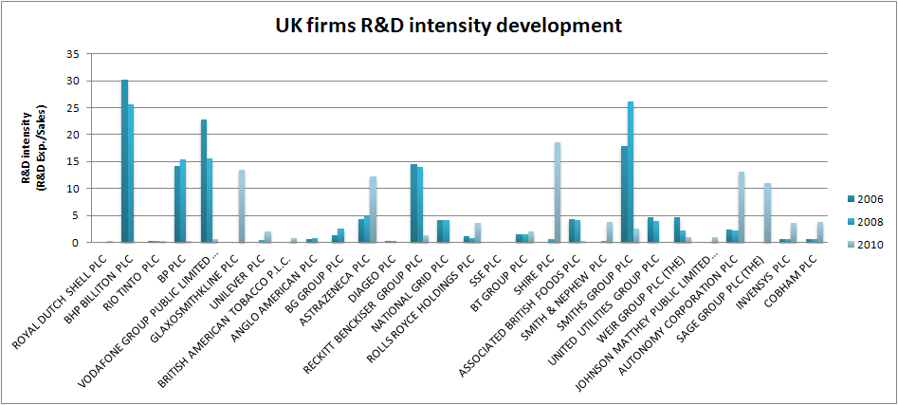

Now this section will discuss certain developments with regards to CSRD scores. Firstly, this section will discuss the three different reporting groups i.e. reporting levels throughout the data sample and years that will be measured. As can be seen in figure 7.2 most of the CSRDs are considered to be low reporters while a small percentage of them are consider to be high. It can be seen that throughout the years that the level of high reporters have slightly increased while the level of medium has lowered. For lower reporters it has stayed relatively the same.

Figure 7.2: UK firms CSR reporting level
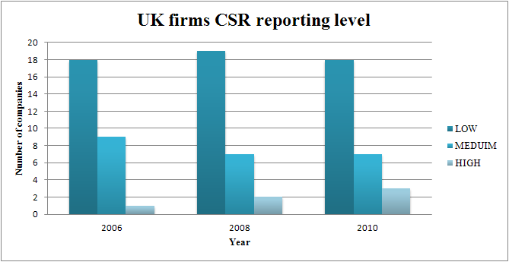

In figure 7.3 it can be seen that most of the companies are less than 30 points for their CSRD scores, which corroborates what was illustrated in figure 7.2. Throughout the three measured years (2006, 2008 and 2010) it can be seen that most of the companies have fairly similar scores when each of their three CSR scores are compared to their corresponding year counterparts. Two reports that attracted some attention were the one of Astrazeca PLC (2010) and that of Vodafone PLC (2008), where in those years they presented significantly ‘better’ reports compared to other years.

Figure 7.3: UK firms CSRD scores
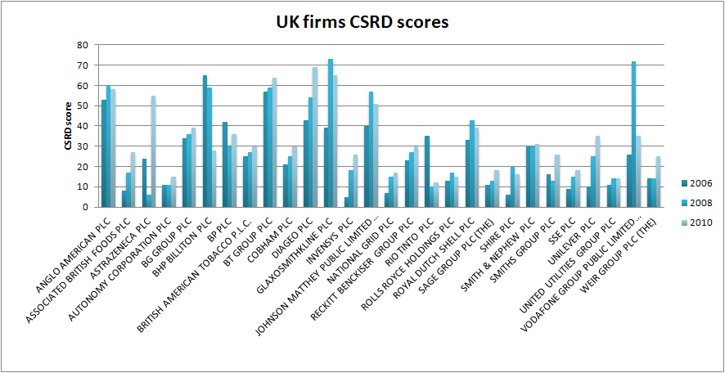

Now this section will elaborate on the descriptive statistics for this research. Table 7.1 provides details about the descriptive statistics of the regression model used in this research to measure CSR disclosure. The dependant variable, which is the CSRD scores, is signaled in this table seeing that the intention of this research is to measure if and to what extent the CSRD are affected by the independent variables. The independent variables are ROA, Market Capitalization, Leverage, and R&D intensity. Table 2 shows that the average score of the UK firms are 31 based on the total scores (93) that can be scored according to the scoring framework used in this research. According to various reports by KPGM (2008 and 2011) UK firms have increased their CSRD dramatically since 2005. This might have saturated the CSRD market to a point where every company reports on the bare minimum. Since there are many companies in the UK reporting on CSR firms might just try to report the same information that others are trying to report to demonstrate to their stakeholder that they are also taking the same step or measures as their other counterparts or other members i.e. companies in the business markets. The Market capitalization shows that on average firms in this sample are worth 29% more than their reported total assets in a given year. Herein, some of the largest (28) firms in the London Stock Exchange were used in this sample size. Table 7.1 provides evidence that these 28 companies in the London Stock Exchange spend on average 3% of their sales on R&D. As signaled by Mc Williams and Siegel, (2000) and Morhardt et al. (2002) R&D intensity differs highly from each other based on their respective industries. Additionally, this research takes an holistic approach when collecting and analyzing the data. So it is likely that some industries have significantly higher or lower R&D intensity compared to others.

Table 7.1: Descriptive statistics
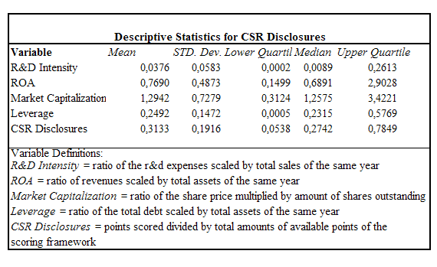

7.2 Results and discussion hypothesis 1
This section provides the emperical analysis and result of the firsthypothesis which is to measure if in fact the difference in R&D intensity between 2006 and 2010. The results provided in this test would indicate if the average R&D intensity value of firms between 2006 and 2010 is different. This analysis was conducted through the use of a T-test.
Recall that figure 2.1. provided an illusration that the general R&D expenditures in the UK has increased trhoughout the years and this also counts for the years that will be measure that is 2006 and 2010. Table 7.2 provides the result of hypothesis 1.

Table 7.2: T-test R&D intensity
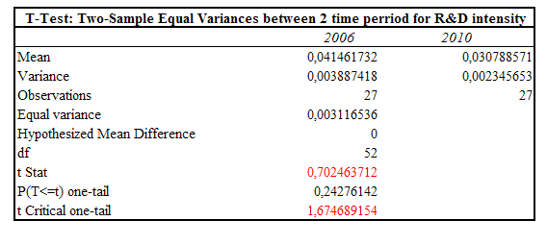
As seen in table 7.2 the differences between the two periods measured are not significant. Additionally, it can be seen that the mean in 2010 (0.031) is lower than the mean of 2006 (0.041). With all these results it can be concluded that our first hypothesis should be rejected because the assumption was that R&D intensity would significantly increase during the years measured. But this was not the case. In fact, the mean of 2010 is lower than that of 2006, which can be interpreted in various ways. Firstly, certain companies may have decided to lower their R&D expenditure for example Anglo American PLC. This result in a lowered R&D intensity compared to the sales. Secondly, certain companies might have benefitted from an increase in sales while taking the decision to continue spending the same amount on R&D. This also resulted in a lowered R&D intensity. However, during a certain period of the economic crisis (2008 and 2009) it can be seen in figure 2.1 that general R&D expenditure has lowered compare to 2006. This can be interpreted that companies are forced to reduce their R&D expenditure because they were suffering from an economic pressure that was generated from the worldwide economic crisis.

7.3 Results and discussion hypothesis 2
As the previous section elaborated on hypothesis 1, this section will elaborate on the analysis and results of the second hypothesis, which was to see if in fact CSRD scores for UK firms have increased over the years of 2006-2010. This hypothesis will also be tested using the T-test as signaled in section 7.2.
As was signaled in various reports issued by KPMG (2008 and 2011), UK has increased its amount of disclosures dramatically since 2005 so the intention of this hypothesis is to test whether if in the CSRD scores of these disclosures have also increased from 2006 till 2010. Table 7.3 presents the results of this test.

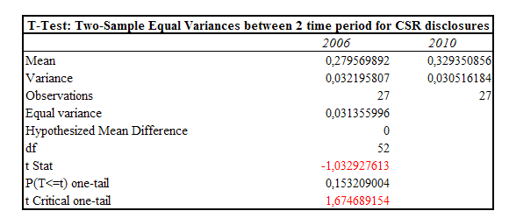
Table 7.3: T- test CSRD score

Table 7.3 presents that, although the mean scores have increased from 2006 till 2010, the difference between these two are not significant. Herby, this concludes that the second hypothesis is rejected, because the original hypothesis was that CSRD scores would increase significantly from 2006 till 2010 but this is not the case. As signaled in the previous section the result of this hypothesis can be interpreted in various ways. One way is that due to the slight (not significant) in CSRD scores was caused to the saturation of CSR disclosures. Recall that KPMG (2008 and 2011) reported that UK had increased its amount of disclosures drastically since 2005. It is a possibility due to this abundance of this CSRD issued by the firm of UK creating an acceptable level of reporting quality where most of the reports are disclosing the same amount of qualitative amount of CSR information. Additionally, if these companies see that stakeholders accept a certain degree of qualitative CSRD they might all strive to meet the minimum standards i.e. low reporter. An example of this might be that of Vodafone PLC 2008 where this report scored 72 points of the 93 total points that can be scored in the scoring framework. The following measured year (2010) Vodafone PLC score 35. It might be possible that Vodafone PLC saw that stakeholders are satisfied with a certain degree of CSRD quality and thus report accordingly.

7.4 Results and discussion hypothesis 3
Finally this section elaborates on the result of the final and most important hypothesis, which was to investigate whether in fact R&D intensity is positively related to CSRD. To test this hypothesis a regression model was used for the years between 2006, 2008 and 2010. Other studies incorporated a similar model was Padgett and Galán (2010), Hull and Rothenberg (2008) and McWilliams and Siegel (2000). Table 7.4 provided the results of the regression.

Table 7.4: Regression model and results
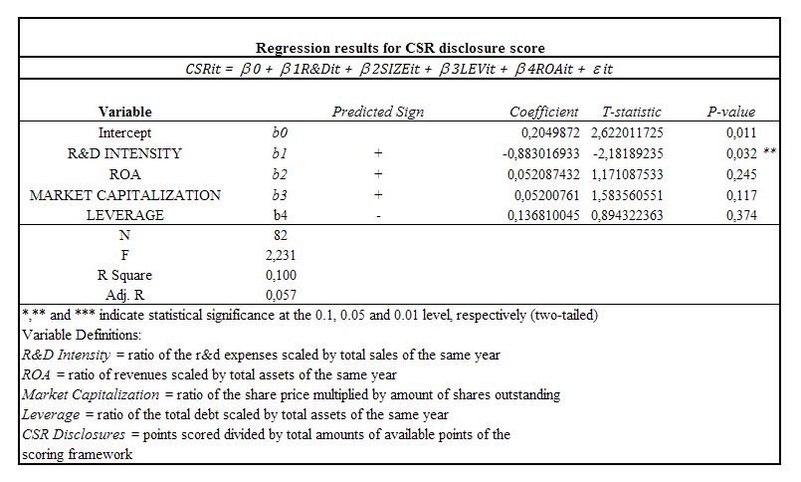

Based on table 7.4 it can be seen that R&D intensity is negatively related to CSRD on an significant level of 5% thus the third hypothesis is rejected. Since this result is significant it will be focused on for the most part in the rest of this section. This result can be interpreted as; the higher R&D intensity is the less a firm is likely to disclose with regard to CSR. One argument could be that based on the study by Padgett and Galán (2010), CSR and R&D possess similar characteristic for the firm. Additionally, they stated that R&D and CSR both allow a firm to achieve a competitive advantage and at the same time benefit the society. Seeing that CSR (CSRD) and R&D are usually not primarily business practices it falls under the discretion of managers to incorporate these strategies and activities. It is however a fact that both of these strategies are highly costly to a firm so managers must decide to do one of the other. Additionally, as was signaled in the previous section (7.3), companies in the UK firms might have realized that stakeholders are possibly satisfied with a certain qualitative degree of CSRD and thus decide to spend less on R&D activities since they do not need to disclose more qualified CSR related information.
Another argument could be that because firms are intensive in R&D activities, which has been proven by various authors that R&D intensity is positively related to CSP at various significance levels (Padgett and Galán, 2010; Hull and Rothenberg, 2008; McWilliams and Siegel, 2000 and Anderson and Dejoy, 2011) they do not need to participate as much in CSRD since they are already performing ‘well’. Based on studies by Cho et al. (2012) and Patten (2002), where the CSP-CSRD performance gap was measured, companies tend to disclose more when certain issues arise that threaten the reputation i.e. ‘legitimacy’ of the organization. Cho et al., (2012), Patten (2002) and Font et al. (2012) argued that this reaction was considered to be a strategy to offset the likely negative effects of poor environmental performance (Cho et al., 2012, p. 15). They based their theoretical framework on the Legitimacy theory, saying that because of a poor(er) CSP would reflect negatively on the firm, they issue more CSRD in an attempt to negate this negative effect. Font et al. (2012) argued that through a literature review it could be understood that “companies publish environmental information in reaction to an actual or potential crisis or threat.”(p. 1545).
It can be also concluded that the coefficient of ROA is positively related with CSRD. But, since the relation is insignificant it shows that there is not enough evidence to proof that the higher the ROA of an organization, the higher the CSRD of said organizations. One argument is that it lies at the manager’s discretion to invest more in R&D activities if they realize a higher ROA.
The results for Market Capitalization show that the relationship is positive but insignificant. Thus there is insignificant evidence to prove that bigger companies disclose more.

Conclusions
Corporate Social Responsibility (CSR) reporting has become more and more popular in the recent years that have just passed (Gamerschlag et al., 2011; Font et al., 2012; and KPMG, 2008). Companies in today’s business world spend a great deal of funds and effort on disclosing information of their social and environmental performance (Gamerschlag et al., 2011). McWilliams and Siegel (2000) and Padgett and Galán (2010) also reported that stakeholders are increasing pressure on companies to improve their business processes and products to thus lessen their negative effect on the social and environmental arena companies thus turn to R&D activities in search of innovation to thus reach the expectations of stakeholders. The main hypothesis was to test whether in fact the R&D intensity of firms has a positive effect on CSRD. To test this hypothesis a regression model was used. The test was conducted on firms listed in the London stock exchange. The years that were selected were 2006, 2008 and 2010 because data of these firms were scarce and the only years that a whole dataset could be created were in these years. The result of this regression model shows that R&D intensity is negatively related to CSRD on a significant level. Therefore it can be concluded that the lower a company is in its intensity in R&D activities the higher the CSR related information they disclosed in their CSRDs. These results cannot be compared to prior literatures because as far as the author (J.R. Martina Jr.) knows there is no other similar research conducted in this specific field of research when studying CSR FP relationships. Additionally, it should be noted that the stakeholder theory was used as the primary theoretical approach. However, based on the results, the assumption that was grounded on the stakeholder theory could not hold. This thus however opens up a new assumption that is based on the CSP-CSRD performance gap studies (Cho et al., 2012; Cho and Patten, 2007; Patten 2002; and Font et al., 2012).
With regards to limitations of this research, it should be signaled that due to the fact that this research took a holistic approach it was not in the intention to measure industry specific aspects and their effects. The intention was to measure the link that R&D intensity has on CSRD of the collected sample that would provide a representation of the UK market. This in itself caused this research to be limited up to a certain point because as signaled by Padgett and Galán (2010), Hull and Rothenberg (2008) and McWilliams and Siegel (2000) industries does influence the effect that R&D has on CSR. Do to industry specific circumstances this in itself dictates how intensive a company can be in R&D and their CSR strategies (Morhardt et al., 2002, p. 228 and Kolk, 2003, p. 280-284).
This research can be helpful to standard setters in a way that it shows based on the content scoring framework how well firms in the UK market are disclosing CSR information. Additionally, it also shows up to a certain extent how intensely UK firms are active in R&D activities. Standard setters of CSRD could use this research and the results to assess up to a certain point how firms will disclose CSR information based on their R&D intensity.
As this is the first research that gave empirically evidence that R&D intensity is (however negatively) related to CSRD it is relevant for future researches that are intended to investigate the relation between a firm’s FP and CSR. By providing insight on whether companies in the UK disclose less CSR information, based on their intensity in Research and Development (R&D) activities, researchers that use CSRD as a representation of CSR will have to take into account the effect that R&D has on CSRD as it does on CSP (McWilliams and Siegel, 2000). Additionally, this research will add value to the academic literatures that investigates the notion that the relationship between CSR and FP is not straightforward, but instead is complex and R&D plays an important role in this relationship (McWilliams and Siegel, 2000). Based on the results it might be possible to add value in the topic of the performance gap between CSP and CSRD where the results might explain up to a certain extent the reasons why R&D has a negative effect on CSRD.
For future research it would be interesting to investigate which industry has a higher or lower association between R&D intensity and CSRD. Future researchers could used the model incorporated by this research and adjust certain variables if it meets the wishes of said researchers. An example might be to use the total amount of employees of a firm as a representation of firm size instead of market capitalization (McWilliams and Siegel, 2000). Another example might be to incorporate risk that a company encounters when conducting innovative activities and other high-risk activities (Hull an Rothenberg, 2008). Lastly, it might also be interesting to conduct the same research in other countries that are also highly active in CSRD and R&D activities. For example, the United States of America (U.S.A.) or Germany would fall under this category.

References
Andersen, M. L., & Dejoy, J. S. (2011). Corporate social and financial performance: The role of size, industry, risk, R&D and advertising expenses as control variables. Business and Society Review, 116(2), 237-256. doi:10.1111/j.1467-8594.2011.00384.
Aragón-Correa, J. A., & A. Rubio-López, E. (2007). Proactive corporate environmental strategies: Myths and misunderstandings. Long Range Planning, 40(3), 357-381. doi:http://dx.doi.org/10.1016/j.lrp.2007.02.008
Baker, E., & Solak, S. (2011). Climate change and optimal energy technology R&D policy. European Journal of Operational Research, 213(2), 442-454. doi:10.1016/j.ejor.2011.03.046
Brendan O'Dwyer. (2003). Conceptions of corporate social responsibility: The nature of managerial capture. Accounting, Auditing & Accountability Journal, 16(4), 523.
Brown, H., de Jong, M., & Lessidrenska, T. (2009). The rise of the global reporting initiative: A case of institutional entrepreneurship. Environmental Politics, 18(2), 182-200. doi:10.1080/09644010802682551
Brown, N. N. (1998). The public disclosure of environmental performance information—a dual test of media agenda setting theory and legitimacy theory. Accounting and Business Research, 29(1), 21; 21-41; 41.
Carroll, A. B. (1979). A three-dimensional conceptual model of corporate performance. The Academy of Management Review, 4(4), 497-505.
Chander, G. N., Keller, C., & Lyon, D. W. (2000). Unraveling the determinants and consequences of an innovation-supportive organizational culture. Entrepreneurship: Theory & Practice, 25(1), 59.
Cho, C. H., & Patten, D. M. (2007). The role of environmental disclosures as tools of legitimacy: A research note. Accounting, Organizations and Society, 32(7), 639-647. doi:10.1016/j.aos.2006.09.009
Cho, C. H., Guidry, R. P., Hageman, A. M., & Patten, D. M. (2012). Do actions speak louder than words? an empirical investigation of corporate environmental reputation. Accounting, Organizations and Society, 37(1), 14-25. doi:10.1016/j.aos.2011.12.001
Dahlsrud, A. (2008). How corporate social responsibility is defined: An analysis of 37 definitions. Corporate Social Responsibility and Environmental Management, 15(1), 1-13. doi:10.1002/csr.132
Dai, X. (2010). The comparative study of political legitimacy theory and organizational legitimacy theory. Journal of Beijing Institute of Technology (Social Sciences Edition), 12(6), 96-101.
Dedman, E., Lin, S. W. -., Prakash, A. J., & Chang, C. (2008). Voluntary disclosure and its impact on share prices: Evidence from the UK biotechnology sector. Journal of Accounting and Public Policy, 27(3), 195-216. doi:10.1016/j.jaccpubpol.2008.02.001
Deegan, C. C. (2002). Introduction: The legitimising effect of social and environmental disclosures – a theoretical foundation. Accounting, Auditing, & Accountability, 15(3), 282; 282-311; 311.
Deegan, C. M. (2011). Financial accounting theory. Maidenhead: McGraw-Hill Higher Education.
Deloitte. (2011). Research & development expenditure. A concept paper. Deloitte,
Department for Business Innovation and Skills (B.I.S.) (2011), Innovation and research strategy for growth. B.I.S., Cmd Paper issued December 2011, Cm8239
European Commission. (2001). Promoting a european framework for corporate social responsibility: Green paper. Luxembourg: Office for Official Publications of the European Communities.
Font, X., Walmsley, A., Cogotti, S., McCombes, L., & Häusler, N. (2012). Corporate social responsibility: The disclosure–performance gap. Tourism Management, 33(6), 1544-1553. doi:http://dx.doi.org/10.1016/j.tourman.2012.02.012
Gamerschlag, R., Möller, K., & Verbeeten, F. H. M. (2011). Determinants of voluntary CSR disclosure: Empirical evidence from germany
Garvare, R., Johansson, P., Quality Technology and Management, Department of Business Administration,Technology and Social Sciences, & Business Administration and Industrial Engineering. (2010). Management for sustainability - A stakeholder theory. Total Quality Management & Business Excellence, 21(7), 737-744. doi:10.1080/14783363.2010.483095
Gelb, D. S. (2002). Intangible assets and firms' disclosures: An empirical investigation. Journal of Business Finance & Accounting, 29(3-4), 457-476. doi:10.1111/1468-5957.00438
Global Reporting Initiative (GRI). (2006). Sustainability reporting guidelines (G3). (). doi:2006
Gray, R. (2006). Does sustainability reporting improve corporate behaviour? wrong question? right time? Accounting and Business Research, Supp., 65-88.
Gray, R. R. (1995). Constructing a research database of social and environmentalreporting by UK companies. Accounting, Auditing, & Accountability, 8(2), 78; 78-101; 101.
Gray, R., Javad, M., Power, D. M., & Sinclair, C. D. (2001). Social and environmental disclosure and corporate characteristics: A research note and extension. Journal of Business Finance & Accounting, 28(3-4), 327-356. doi:10.1111/1468-5957.00376
Gray, R., Kouhy, R., & Lavers, S. (1995). Corporate social and environmental reporting: A review of the literature and a longitudinal study of UK disclosure. Accounting, Auditing & Accountability Journal, 8(2), 47.
Griliches, Z. (1979). Issues in assessing the contribution of research and development to productivity growth. The Bell Journal of Economics, 10(1), 92-116.
Guthrie, J., Cuganesan, S., & Ward, L. (2008). Industry specific social and environmental reporting: The australian food and beverage industry. Accounting Forum, 32(1), 1-15. doi:10.1016/j.accfor.2007.10.001
Hibbitt, C. J. (2004). External environmental disclosure and reporting by large european companies: An economic, social, and political analysis of managerial behaviour Rozenberg Publishers.
Ho, Y. K., Tjahjapranata, M., & Yap, C. M. (2006). Size, leverage, concentration, and R&D investment in generating growth opportunities. The Journal of Business, 79(2), 851-876. doi:10.1086/499140
Hughes, S. B., Anderson, A., & Golden, S. (2001). Corporate environmental disclosures: Are they useful in determining environmental performance? Journal of Accounting and Public Policy, 20(3), 217-240. doi:10.1016/S0278-4254(01)00031-X
Hunter, J. E., & Schmidt, F. L. (1990). Methods of meta-analysis: Correcting error and bias in research findings
IAS 38: Intangible assets. (2004). International Accounting Standards.IAS, , 1587.
Kafouros, M. I. (2005). R&D and productivity growth: Evidence from the UK. Economics of Innovation and New Technology, 14(6), 479-497.
Kolk, A. (2003). Trends in sustainability reporting by the fortune global 250. Business Strategy and the Environment, 12(5), 279-291. doi:10.1002/bse.370
KPMG (2008). KPMG international survey of corporate responsibility reporting 2008. KPMG Global SustainabilityServices, KPMG International: Amsterdam.
KPMG (2011). KPMG international survey of corporate responsibility reporting 2011. KPMG Global SustainabilityServices, KPMG International: Amsterdam.
Lichtenberg, F. R., & Siegel, D. (1991). The impact of r&d investment on productivity?new evidence using linked r&d?lrd data. Economic Inquiry, 29(2), 203-229. doi:10.1111/j.1465-7295.1991.tb01267.x
Lin, B., Lee, Y., & Hung, S. (2006). R&D intensity and commercialization orientation effects on financial performance. Journal of Business Research, 59(6), 679-685. doi:10.1016/j.jbusres.2006.01.002
Liu, X., & Anbumozhi, V. (2009). Determinant factors of corporate environmental information disclosure: An empirical study of chinese listed companies. Journal of Cleaner Production, 17(6), 593-600. doi:10.1016/j.jclepro.2008.10.001
Lozano, R.Sustainability inter-linkages in reporting vindicated: A study of european companies. Journal of Cleaner Production, (0) doi:10.1016/j.jclepro.2013.01.039
Margolis, J. D., Elfenbein, H. A., & Walsh, J. P. (2007). Does it pay to be good? A meta-analysis and redirection of research on the relationship between corporate social and financial performance. Ann Arbor, 1001, 48109-41234.
McWilliams, A., & Siegel, D. (2000). Corporate social responsibility and financial performance: correlation or misspecification?. Strategic management journal, 21(5), 603-609.
McWilliams, A., & Siegel, D. (2001). Corporate social responsibility: A theory of the firm perspective. The Academy of Management Review, 26(1), 117-127.
Morhardt, J. E., Baird, S., & Freeman, K. (2002). Scoring corporate environmental and sustainability reports using GRI 2000, ISO 14031 and other criteria. Corporate Social Responsibility and Environmental Management, 9(4), 215-233. doi:10.1002/csr.26
O’Dwyer, B., Owen, D., & Unerman, J. (2011). Seeking legitimacy for new assurance forms: The case of assurance on sustainability reporting. Accounting, Organizations and Society, 36(1), 31-52. doi:http://dx.doi.org/10.1016/j.aos.2011.01.002
Öberseder, M., Schlegelmilch, B. B., & Gruber, V. (2011). “Why Don’t consumers care about CSR?”: A qualitative study exploring the role of CSR in consumption decisions. Journal of Business Ethics, 104(4), 449-460. doi:10.1007/s10551-011-0925-7
OECD. (2002). Frascati manual 2002 Organisation for Economic Co-operation and Development. doi:10.1787/9789264199040-en
Office for National Statistics. (20 November 2012). Business enterprise research and development, 2011. doi:2011
O'Reilly III, C. A., & Tushman, M. L. (2004). The ambidextrous organization. Harvard Business Review, 82(4), 74-81.
Orlitzky, M. M. (2003). Corporate social and financial performance: A meta-analysis. Organization Studies, 24(3), 403; 403-441; 441.
Padgett, R. C., & Galan, J. I. (2010). The effect of R&D intensity on corporate social responsibility. Journal of Business Ethics, 93(3), 407-418.
Pandit,S., Wasley, C. E., & Zach, T. (2011). The effect of research and development (R&D) inputs and outputs on the relation between the uncertainty of future operating performance and R&D expenditures. Journal of Accounting, Auditing & Finance, 26(1), 121.
Patten, D. M. (2002). The relation between environmental performance and environmental disclosure: A research note. Accounting, Organizations and Society, 27(8), 763-773. doi:http://dx.doi.org/10.1016/S0361-3682(02)00028-4
Perego, P., & Kolk, A. (2012). Multinationals’ accountability on sustainability: The evolution of third-party assurance of sustainability reports. Journal of Business Ethics, 110(2), 173-190. doi:10.1007/s10551-012-1420-5
Posnikoff, J. F. (1997). Disinvestment from south africa: They did well by doing good. Contemporary Economic Policy, 15(1), 76-86. doi:10.1111/j.1465-7287.1997.tb00456.x
R&D and productivity: The econometric evidence: By zvi griliches. the university of chicago press, chicago, IL. (1998). 382 pages. $56.00, GBP 44.75. (1998). Computers & Mathematics with Applications, 36(3), 126. doi:http://dx.doi.org/10.1016/S0898-1221(98)90207-3
Rothenberg, S., & Zyglidopoulos, S. C. (2007). Determinants of environmental innovation adoption in the printing industry: The importance of task environment. Business Strategy and the Environment, 16(1), 39-49. doi:10.1002/bse.441
Skouloudis, A., Evangelinos, K., & Kourmousis, F. (2010). Assessing non-financial reports according to the global reporting initiative guidelines: Evidence from greece. Journal of Cleaner Production, 18(5), 426-438. doi:10.1016/j.jclepro.2009.11.015
Teoh, S. H., Welch, I., & Wazzan, C. P. (1999). The effect of socially activist investment policies on the financial markets: Evidence from the south african boycott. The Journal of Business, 72(1), 35-89.
Ullmann, A. A. (1985). Data in search of a theory: A critical examination of the relationships among social performance, social disclosure, and economic performance of U. S. firms. The Academy of Management Review, 10(3), 540-557.
Waddock, S. A., & Graves, S. B. (1997). The corporate social performance-financial performance link. Strategic Management Journal, 18(4), 303-319. doi:10.1002/(SICI)1097-
Wagner, M. (2005). How to reconcile environmental and economic performance to improve corporate sustainability: Corporate environmental strategies in the european paper industry. Journal of Environmental Management, 76(2), 105-118. doi:http://dx.doi.org/10.1016/j.jenvman.2004.11.021
Whiteman, G., Walker, B., & Perego, P. (2013). Planetary boundaries: Ecological foundations for corporate sustainability. Journal of Management Studies, 50(2), 307-336. doi:10.1111/j.1467-6486.2012.01073.x
Wood, D. J. (1991). Corporate social performance revisited. The Academy of Management Review, 16(4), 691-718.
Wood, D. J. (2010). Measuring corporate social performance: A review. International Journal of Management Reviews, 12(1), 50-84. doi:10.1111/j.1468-2370.2009.00274.

Appendices

Appendix A: Relationship between Legitimacy theory and Stakeholder theory
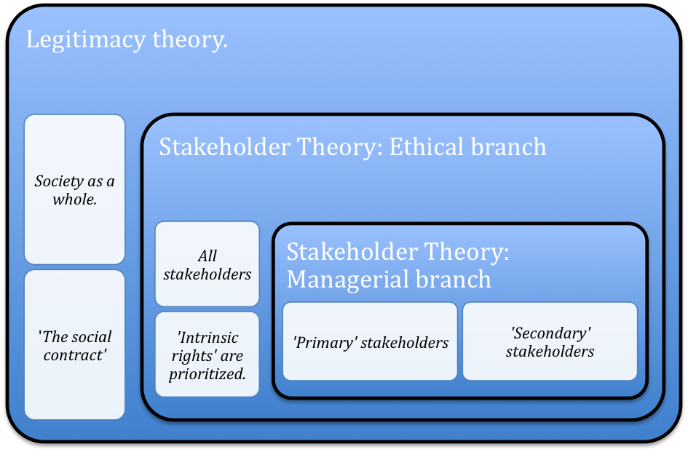

Appendix B: Content Scoring Framework scorecard:
Company
Year
Topic No. | Code | C/A | Performance Indicator | 2006 | 2008 | 2010
Environmental Performance Indicator
1 | EN1/2 | C | Materials used by weight and volume and percentage used that are recycled input materials.
2 | EN3/4 | C | Direct and indirect energy consumption.
3 | EN5 | C | Energy saved due to conservation and efficiency improvements.
4 | EN6 | A | Initiatives to provide energy-efficient  or renewable energy based products  and services, and reductions in energy requirements as a result of these initiatives.
5 | EN7 | A | Initiatives to reduce indirect energy consumption and reductions achieved.
6 | EN8/10 | C/A | Total water volume withdrawal, recycled, and reused by source.
7 | EN14 | A | Strategies, current actions, and future plans for managing impacts on biodiversity
8 | EN12 | C | Description of impacts of activities, products, and services on biodiversity in protected areas and areas of high biodiversity value outside protected areas.
9 | EN16/17 | C | Greenhouse gas emissions, ozone-depleting substances or NO, SO emissions, and other significant emissions by type and weight.
10 | EN18 | A | Initiatives to reduce greenhouse gas emissions and reductions achieved.
11 | EN21 | C | Total water discharge by quality and destination.
12 | EN22/23 | C | Total weight of waste by type and disposal method and/or total number and volume of significant spills.
13 | EN26 | C | Initiatives to mitigate environmental impacts of products and services, and extent of impact mitigation.
14 | EN27 | C | Percentage of products sold and their packaging materials that are reclaimed by category.
15 | EN28 | C | Monetary value of significant fines and total number of non-monetary sanctions for non-compliance with environmental laws and regulations.
16 | EN30 | A | Total environmental protection expenditures and investments by type.
Subtotal
Social: Labor Practices and Decent Work Performance Indicators
17 | LA2 | C | Total number and rate of employee turnover by age group, gender, and region
18 | LA7 | C | Rates of injury, occupational diseases, lost days, and absenteeism, and number of work related fatalities by region.
19 | LA8 | C | Education, training, counseling, prevention, and risk-control programs in place to assist work-performance members, their families, or community members regarding serious diseases.
20 | LA10 | C | Average hours of training per year per employee category.
Subtotal
Social: Society Performance Indicators
21 | S01 | C | Nature, scope, and effectiveness of any programs and practices that assess and manage the impacts of operations of communities, including entering, operating, and exiting.
22 | S04 | C | Actions taken in response to incidents of corruption.
23 | S05 | C | Public policy positions and participation in public policy development and lobbying.
24 | S08 | C | Monetary value of significant fines and total number of non-monetary sanctions for non- compliance with laws and regulations.
Subtotal
Social: Product Responsibility Performance Indicators
25 | PR1 | C | Life cycle stages in which health and safety impacts of products and services are assessed for improvement, and percentage of significant products and services categories subject to such procedures.
26 | PR2 | A | Total number of incidents of non-compliance with regulations and voluntary codes concerning health and safety impacts of products and services during their life cycle, by type of outcomes.
27 | PR3 | C | Type of product and service information required by procedures, and percentage of significant products and services subject to such information requirements.
28 | PR4 | A | Total number of incidents of non-compliance with regulations and voluntary codes concerning product and service information and labeling, by type of outcomes.
29 | PR5 | A | Practices related to customer satisfaction, including results of surveys measuring customer satisfaction.
30 | PR8 | A | Total number of substantiated complaints regarding breaches of customer privacy and losses of customer data.
31 | PR9 | C | Monetary value of significant fines for non- compliance with laws and regulations concerning the provision and use of products and services.
Subtotal
Total Scores
Reporting level

Appendix C: Company list and relevant data
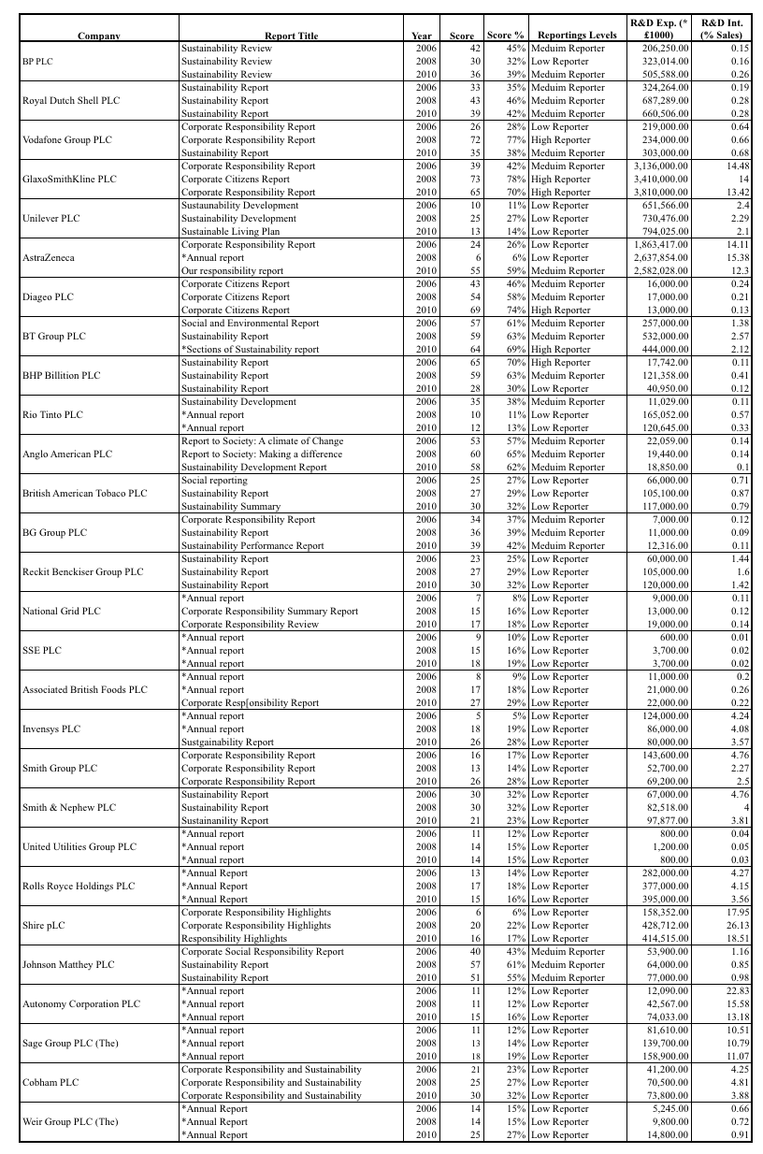

This manual was issued by and for experts in the OECD countries that gathers and provides relevant data on R&D. The methods and definitions in this manual are internationally accepted and serve as the standard for the collection, construction, and applying R&D data for research.
This report aims at the business enterprise classification of R&D in UK in 2011. It provides information on various R&D related expenditures within the UK market.
http://frc.org.uk/Our-Work/Codes-Standards/Accounting-and-Reporting-Policy/Standards-in-Issue/SSAP-13-Accounting-for-research-and-development.aspx
http://frc.org.uk/Our-Work/Codes-Standards/Accounting-and-Reporting-Policy/Standardsin- Issue/SSAP-13-Accounting-for-research-and-development.aspx
http://www.big4.com/kpmg/kpmg-nearly-every-g250-company-undertakes-cr-reporting/
Datastream is a well-known database sponsored by Thomson Reuters that offers researchers a wide range of economic information of a wide range firms that are active across the globe.
This indicator represents the organizations impact on global resources and its initiatives to reduce its effects and increase its efficiency of resource usage. These initiatives might fall under R&D activities where companies are striving to improve business processes. (Source: https://www.globalreporting.org/reporting/G3andG3-1/g3-guidelines/Pages/default.aspx)
Shows the usage of (primary and secondary) energy by the reporting entity. Changes in the usage amounts might reflect the organization’s efforts to improve its energy usage. (Source: see note 6)
This represents the initiatives that the reporting entity has taken to improve its energy usage. These improvements might have come to pass through R&D activities. (Source: see note 6)
The use of energy is one of the main causes for climate change and the increase of greenhouse gasses. These initiatives may indicate an organization’s efforts to improve their energy efficiency. This might fall under an R&D activity. (Source: see note 6)
Secondary energy usage occurs through the use of traveling services, commuting, and subcontracted production. These initiatives may reflect a company’s commitment to reducing their indirect energy consumptions. This in turn improves their business processes. (Source: see note 6)
This indicates the concerns, acknowledgements, and efforts to reduce the company’s impact and need for water. Additionally, these initiatives will reduce the overall water costs of the organization, which is also one of the general intentions of R&D activities. (Source: see note 6)
Managing the organization’s impact on biodiversity is an important indicator on how concern the managers are on the current and future state of the affected bio-environments. It also demonstrates potential initiatives (R&D) that the organization is undertaking to realize their plans. This indicator will allow stakeholders to analyze the organization’s strategies, current actions, and future policies to address any potential impacts on biodiversity. (Source: see note 6)
This core indicator reflects the company’s awareness and acknowledgement of the impact of its products and business processes on biodiversity. This can be seen as an incentive to initiate certain activities or introduce certain policies that will result in a reduction of this effect on biodiversity. (Source: see note 6)
As it is generally argued, greenhouse gasses and other climate harming substances are mainly the cause of climate change. This indicator illustrates the company’s awareness and efforts to reduce its emissions of these harmful substances into the atmosphere. Demonstrating reductions may demonstrate their efforts in improving their CSP. (Source: see note 6)
As stated in note 14, these disclosures might indicate the organization’s efforts and initiatives to improve their emissions i.e. reduce them. (Source: see note 6)
This represents the quality of water the reporting organization discharges into the environment. Through improvements of business processes these companies can improve the quality of the water they discharge and thus reduce the negative impact that they have on the ecological environment. These improvements in business processes can be regarded as R&D activities. (Source: see note 6)
As stated in note 16, waste is also something that the organization discharges and has an affect on the social and ecological environment. Companies might initiate R&D activities to improve its waste reduction efforts. These efforts might thus improve the direct relation of the company that is has with its stakeholders. (Source: see note 6)
These disclosures indicate the organizations initiative of mitigating the impacts of their products and services on the environment. These initiatives demonstrate the concern, efforts, and progress of the strategies and actions that the organization is taking to achieve this. These can spark manager’s interest in innovation and thus decide to invest in R&D. (Source: see note 6)
These activities that are disclosed demonstrate the organization’s efforts of reducing the amount of their packaging roaming around as waste and garbage. Additionally, these reclaimed packaging materials can be recycled in some shape way or form. (Source: see note 6)
This kind of disclosure could demonstrate the acknowledgement and responsibility of the organization’s lack of confirmation with certain environmental laws, regulation, and standards. By disclosing these information the reporting organization will show their commitment of improving their environmental performance and thus meet up to these standards. This in turn might be an incentive for organization to invest in some sort of R&D activities. (Source: see note 6)
Companies that spend certain amounts of monetary resources show that they are willing to invest in activities that improve its effect on the environment. (Source: see note 6)
Labor indicators may indicate certain dissatisfactions by employees in the organization or change in the structure of the core operations of the company. On the other hand, improvements might indicate certain positive occurrences or policies that the organization is undertaking to improve the production of its employees. (Source: see note 6)
This indicates whether the policies that management is currently undertaking are effective in minimizing these unfortunate occurrences from happening. Additionally, low absenteeism and injury rates are positive links that employees have a positive and fairly high morale and thus produce more. (Source: see note 6)
These disclosures are an indicator of what the organization considers to be of importance with regard to their employees. This is of importance to very powerful stakeholders of the organization, not to mention the most important one, namely workforce. (Source: see note 6)
Improving the knowledge base within the organization and developing human capital is of great importance with regards to an organization’s development. Additionally, the scale of these activities and efforts indicate how motivated the managers are to develop human capital asset. (Source: see note 6)
Reporting organizations might assess and evaluate how their activities affect their surrounding societies. By acknowledging their impact on these social environments they demonstrate their awareness. These activities will maintain the stakeholders aware of the controlling activities of the organization. (Source: see note 6)
This represents the organization’s action in response to fraudulent activities. These activities might shed a negative light to the stakeholders. By disclosing their actions in response to corruption they demonstrate to their stakeholders that they are actively fighting to improve certain aspects of their organization to mitigate occurrence of these activities. (Source: see note 6)
These disclosures represent the policies that the organization supports and thus defends and strives to improve for their benefit and also for the stakeholders and society as a whole. This counts for sustainable policies as lowering emissions and waste but also social policies such as the fight against sex trafficking and child labor. (Source: see note 6)
This kind of disclosure could demonstrate the acknowledgement and responsibility of the organization’s lack of confirmation with certain society laws, regulation, and standards. Organization would likely disclose more information if they have developed other means (R&D) of mitigating certain negative occurrences. (Source: see note 6)
This demonstrates the organization’s efforts and actions to improve and develop their products and services to meet up with the standards of their stakeholders. For example their customers expect that these products and services be assessed based on their effects that they have on the health and safety of their customers. (Source: see note 6)
This kind of disclosure could demonstrate the acknowledgement and responsibility of the organization’s lack of confirmation with certain product health and safety laws, regulation, and standards. By disclosing these information the reporting organization will show their commitment of improving product health and safety performance and thus meet up to these standards. This in turn might be an incentive for organization to invest in some sort of R&D activities. (Source: see note 6)
This signifies the kind of information the organization discloses to the public about its positive and negative impacts on society and the environment. By disclosing these kinds of information for the public (customers, review institutions, etc.) it will demonstrate their motivation and efforts to reduce as much as possible the negative impacts their product and/or services have on customers and the rest of the environment. Organization would likely disclose more information if they have developed other means (R&D) of mitigating certain negative occurrences. (Source: see note 6)
This kind of disclosure could demonstrate the acknowledgement and responsibility of the organization’s lack of confirmation with certain labeling laws, regulation, and standards. Organization would likely disclose more information if they have developed other means (R&D) of mitigating certain negative occurrences. (Source: see note 6)
This can represent the organization’s effort of gaining an understanding of their current standing with their customers. Using these kinds of methods they can identify what kind of developments their customers would like to see. Thus this can spark the interest of an organization in R&D activities. (Source: see note 6)
Protection of customer privacy is usually considered as a top priority of organization but mostly the national regulations setter. Organization’s disclosure of this topic signifies certain significant weaknesses in the organization’s structure and it needs to be addressed. (Source: see note 6)
This kind of disclosure could demonstrate the acknowledgement and responsibility of the organization’s lack of confirmation with certain product laws, regulation, and standards. Organization would likely disclose more information if they have developed other means (R&D) of mitigating certain negative occurrences. (Source: see note 6)

