**The effect of a financial crisis on the use of Earnings Management**

*‘A continental comparison of: America, Asia, and Europe’*

19 July 2013



*Erasmus School of Economics*

Master Accounting, Auditing & Control - Research 2012-2013

***Abstract***

Several researches have been performed to test the influence of financial and economic downturns on the use of earnings management. No recent researches have been performed related to the financial and economic crises that started in late 2008; consequently this study investigates the effect of an economic recession on the use of earnings management. In prior research individual Asian countries were selected especially related to the economic recession that occurred in Asia in 1997 refer to Charoenwong et al. (2008) and Agarwal et al. (2005). In contrary, this study compares the use of earnings management while determining and continental comparison of the trend of the top sixteen stock exchanges quoted companies per continent: Asia, America and Europe. To determine the probability of the existence of the use of earnings management pre- and during the economic recession that started in late 2008, the discretionary accruals-based on the Modified Jones model developed by Dechow et al. (1995) is used.

*Keywords: earnings management, economic recession, financial crisis, modified jones model, discretionary accruals and regression analysis.*

Name : Riaaz William

Student number : 314881

Coach : Mr. E. A. de Knecht RA

Co-reader : Mr. Drs. R.D. Achaibersing RA

Date : 19 July 2013

Master : Accounting, Auditing and Control

Preface

All master studies are completed with a final scientific research. The purpose of this research is to apply the knowledge gained during the master phase and conduct a new research with the assessment of empirical research. This research is performed to complete my master Accounting, Auditing and Control at the Erasmus University Rotterdam. Due to the fact that no research results are available (yet) which compares the effect on the changes in the use of earnings management in times of a financial crisis between different continents, such as Asia, America and Europe, .the purpose of this study is to assess if the financial crisis that started in late 2008 affect the extent in which earnings management is used through Asia, America and Europe. The consequences are important for all users (internal and external) of the financial statements. Prior researches (mainly related to the Asian financial crisis in 1997) concluded that a significant effect existed on the use of earnings management. Consequently, it is interesting to investigate the eventual consequences occurring in the current financial crisis and the comparison between Asia, America and Europe.

During the first semester of the masters’ programme related to Accounting, Auditing and Control I attended and completed the Seminar Advanced Financial Accounting. In this seminar in particular the use of earnings management has been discussed, and it caught my immediate attention. In this seminar me and my fellow student / companion performed a literature review and filed a thesis proposal, which was approved by the lecturer. I adapted this proposal partly, as this was a combined paper, in order to conduct my own independent research I added the comparison between continents to my research.

This research is conducted under the supervision of Mr. E.A. de Knecht – RA from the Erasmus University Rotterdam. I would like to take the opportunity to thank Mr. de Knecht for his supervision, positive attitude and availability which I experienced as very much motivational and much appreciated. Keep on the good work!

Finally, I would like to pay my respect to all individuals that have supported me during my master study and thesis, in particular my parents which have always supported me in any way possible.

Riaaz William

The Hague, July 2013

The Netherlands

Chapter 1: Introduction 6

1.1: Background 6

1.2: Objectives 7

1.3: Problem definition 8

1.4: Methodology 8

1.5: Limitations 9

1.6: Structure 9

Chapter 2: Financial Accounting Theories 10

2.1: Introduction 10

2.2: Normative accounting approach 10

2.3: Market based accounting approach 10

2.4: Agency Theory and Positive Accounting Theory 11

2.4.1: Agency theory 11

2.4.2: Positive Accounting Theory (PAT) 11

2.4.2.1 Key hypothesis of Positive Accounting Theory 13

2.5: Summary 14

Chapter 3: Earnings Management 15

3.1: Introduction 15

3.2: Definition of earnings management 15

3.3: Earnings Management and purpose 16

3.4: Earnings Management and financial fraud 17

3.5: Earnings Management and accruals 18

3.6: Summary 19

Chapter 4: Measuring Earnings Management 20

4.1: Introduction 20

4.2: The Healy model (1985) 21

4.3: The De Angelo Model (1986) 21

4.4: The Jones model (1991) 22

4.5: Cross Sectional Jones Model (1994) 23

4.6: Modified Jones Model (1995) 23

4.7: Performance matching model (2005) 24

4.8: Alternative Models (Ronen and Yaari, 2008) 24

4.9: Summary 25

Chapter 5: Prior research 26

5.1: Introduction 26

5.2: Dechow et al., 1995 26

5.3: Guay et al., 1996 27

5.4: Lin & Shih, 2002 28

5.5: Johl et al., 2003 30

5.6: Agarwal et al., 2005 33

5.7: Lara et al., 2005 35

5.8: Charoenwong & Jiraporn, 2008 38

5.9: Vichitsarawong et al., 2009 40

5.10: Summary 42

Chapter 6: Research Design 43

6.1: Introduction 43

6.2: Research approach 43

6.3: The Modified Jones Model (Dechow et al., 1995) 45

6.4: Control variables 49

6.5: Data selection 50

6.6: Data collection 52

6.7: Data processing 52

6.8: Statistic approach 53

6.9: Summary 53

Chapter 7: Empirical results 54

7.1: Introduction 54

7.2: Data analysis – Normal distribution of Total accruals 54

7.2.1: Normal distribution of the variable Total Accruals 54

7.2.3: Outlier analysis of the variable Total Accruals (residuals) for the purpose of estimating the firm-specific parameters per continent 55

7.2.4: Descriptive statistics of the Total accruals 56

7.2.5: Applying the regression model TA for predicting firm-specific parameter estimation 57

7.3: Analysing the Discretionary Accruals 58

7.3.1 Descriptive statistics of Discretionary Accruals 58

7.3.2.1 Descriptive analysis of the Discretionary Accruals in Europe 60

7.3.2.2 Descriptive analysis of the Discretionary Accruals in Asia 60

7.3.2.3 Descriptive analysis of the Discretionary Accruals in America 61

7.4: Control variables and outlier analysis over the control variables 62

7.5: Descriptive statistics of square rooted discretionary accruals 64

7.6: Analysing the absolute value of discretionary accruals - hypothesis 1: Change in earnings management 67

7.7: Analysing the effect of Crisis on the magnitude of discretionary accruals related to hypothesis 2 69

Checking the assumptions of the regression model 70

7.8: Empirical analysis 71

7.8.1. Analysis related to hypothesis 1: 71

7.8.2 Analysis related to hypothesis 2: 73

Chapter 8: Conclusion 75

8.1: Introduction 75

8.2: Summary of the findings 75

8.3: Main conclusion 77

8.4: Limitations and Recommendations 80

References 83

**Appendix 1: Summary of prior research 89**

**Appendix 2: Sample population 94**

**Appendix 3: Test of normal distribution of the variable Total Accruals 95**

**Appendix 4: Multiple regression analysis for parameter-estimation 105**

**Appendix 5: Descriptive analysis of the Discretionary Accruals 112**

**Appendix 6: Exploring Control variables 121**

**Appendix 7: Descriptive statistics of square rooted discretionary accruals 125**

**Appendix 8: Analysing the absolute value of discretionary accruals (hypothesis 1) 126**

**Appendix 9: Analysing the effect of Crisis on the discretionary accruals (hypothesis 2) 128**

# Chapter 1: Introduction

# 1.1: Background

Earnings are determined to be the most valuable information in the financial statement. Earnings represent the value of the company. An increase of earnings indicates an increase of the company value and a decrease of earnings a decrease in the company value. Company value and earnings shows if and in which extent the company has participated in value-added activities. It is a signal that helps direct resource allocation in the capital markets. It is in the company’s best interest to have high involvement in achieving a high (actual) company value and related earnings. Earnings management can be used to present the current position of company value and the earnings.

Earnings Management may be defined as “reasonable and legal management decision making and reporting intended to achieve stable and predictable financial results”, McKee, T. (2005, page 1). While performing research on the use of earnings management and prior studies it is determined that different definitions of earnings management exist; these definitions will be commented in chapter two of this paper. The basic concept of this study relies on the use of earnings management and, in particular, the extent of earnings management used in times of a financial crisis / recession. Many prior researches are available that prove that in times of a financial crisis / recession the extent of earnings management used has increased.

The definition of an economic recession is: “*a business cycle contraction, a general slowdown in economic activity and GDP (Gross Domestic Product) over a period of two quarters*” (Hebbink & Van Velthoven, 2003, page 153). The generally-accepted assumption of the cause of a recession is a drop in spending due to changes in the macro-economic indicators. Indicators such as production as measured by Gross Domestic Profit (GDP), investment expenses, employment rate, capacity use, home incomes, business profits and inflation, all decline in periods of recession. In contrast to this indicators such as bankruptcies and unemployment rates will increase in periods of recession. All macro-economic indicators have a high influence on the earnings (and value) of companies. In times of recession earnings will decrease and debts will rise.

Since late 2008 the worldwide economy experienced harsh times. The first signs of the current economic recession were noted in December 2007, when the housing market in the US collapsed. As a result of this several Americans were not able to pay their monthly mortgage repayments. Large mortgage lenders such as Fannie Mae and Freddie Mac were at the edge of bankruptcy.

Because due to the strong economic connection between the US market and other international financial markets, banks in Europe and Asia were confronted with bankruptcies or financial difficulties. In addition, the exchange market rates dropped down with huge intensity around the world.

Due to the before stated in addition the trade industry experience difficulties due to the fact that the banking industry did not provide credits and investment and resulted in a decline in trust in the economy. The economic crisis was born and is elevated to a larger scale in the current economic environment throughout the entire world.

As stated before, the published earnings are influenced by many different factors such as the macro-economic indicators and the use of earnings management. In this case the figures in the financial statements are influenced by the financial crisis / economic recession. Due to the fact that these different factors influence the figures of the financial statements it is hard to determine explicit the use of earnings management. Although the International Accounting Standard Boards (IASB) and the Financial Accounting Standards Board (FASB) do not allow the practise of the use of earnings management, no strict rules exist to prevent the use of earnings management. However, different models exist in which the different factors which can influence the published earnings are accounted for and used to indicate the use of earnings management. Due to the fact that in time of a financial crisis earnings will decline and debts will rise, it is expected that the use of earnings management will be enhanced and this can result in impropriate and false figures in the financial statements. Consequently, in this thesis the effect of the financial crises on the financial statements with the use of earnings management will be tested by comparing three continents with each other.

# 1.2: Objectives

This research will focus on the use of earnings management during the financial crisis which started as from 2008. The different perspectives in using earnings management in addition will be commented and analysed. Due to the fact that no research results are available (yet) which compares the effect on the changes in the use of earnings management in times of a financial crisis between different continents, such as Asia, America and Europe, it is interesting to investigate the eventual consequences occurring in and between these continents. The consequences are important for all users (internal as well as external) of the financial statements as based on the financial statements future expectations, planning and forecasts (internal) and investments (external) are perform. The main objective of this approach is to examine whether the same effects on earnings management during times of financial crisis occur than without a financial crisis. In this research a comparison is perform which shows the effect within each separate continent and the relation between Asia, Europe and America.

# 1.3: Problem definition

The research question is:

‘Does the financial crisis affect the extent in which earnings management is used in Asia, America and Europe?’

In order to provide the answer on the research question, the next sub questions need to be answered:

* Which accounting approach is suitable for this research?
* What is the definition of the term and discussion related to earnings management?
* In which way the use of earnings management can be measured?
* What did prior researches focussing on this topic concluded?
* In order to measure the use of earnings management in times of a financial crisis which research design and methodology is best suitable?
* Which selection criterion is needed to obtain sufficient data?
* Which statistical techniques are most suitable to conduct this research?

# 1.4: Methodology

This study is a desk research. A desk research is a research strategy where, the researcher uses existing material and data produced by others. In other words, the researcher uses this material and / or data through reflection of the personal study and consulting prior literature in order to obtain new insights.

In this study, selections are based on stock exchange data available from the online database company.info which contains ‘in depth’ information related to companies that are active of the worldwide stock markets and data is retrieved from financial statements.

This research investigates the effects of the use of earnings management (by assessing total, discretionary and non-discretionary accruals) in times of a financial crisis. By assessing the period from 2002 up to and included 2011, this research concentrates on six years (2002-2007) without the effect of a financial crisis and four years (2008 up to and included 2011) with the effect of a financial crisis. The financial crisis started from the third quarter of 2008 till the current date (while conducting this research).

In order to attain sufficient data information for this study all top sixteen listed companies are used, which results in a dataset of sixteen companies per continent (Europe, Asia and America) and compared figures of the financial figures of 2002 up to and included 2011 (ten years), with a total of 48 companies and 480 financial statements. In order to provide for determination of research models, prior research is conducted. And SPSS 20.0 is used to perform statistical analysis.

# 1.5: Limitations

This study contains multiple limitations, which are presented in chapter seven after conducting this research. The pre-research limitations are discussed in this section. This first limitation of this study is that the data used (sample) is limited to only the top sixteen stock exchange market listed companies. The second limitation of this study is that only three continents are selected (Asia, America and Europe). Consequently, based on the above stated limitations, the findings of this study cannot be generalized for all companies active on the stock market and continents not included in this study. The third limitation of this study is that not for all companies (including related variables derived from the financial statements used in this study) the variations can be explained, which can be of influence on the main conclusion. In addition, only companies are included of which sufficient variables are available. As in every research the possibility of unavailability of insufficient datasets exists, the conclusions of this study can change when obtaining (in the future) the entire data set and take this into account in the same research.

# 1.6: Structure

The different financial accounting theories, with relation to earnings management, are commented and explained in chapter two. In chapter three the different definitions of earnings management are described. The different models to detect the use of earnings management are explained in chapter four. Chapter five contains an extensive literature review about prior researches performed on the use of earnings management in times of recession / financial crises, and the main findings of these investigations. Chapter six elaborates the research methodology, the main research question, the hypotheses and the data selection. The empirical research and the analysis will be explained in chapter seven. Finally this thesis ends with the concluding remarks in chapter eight. At the end of this thesis an appendix is submitted that includes all the used SPSS outputs (SPSS is a computer program used for statistical analysis) and a summary of the main findings of prior researches.

# Chapter 2: Financial Accounting Theories

# 2.1: Introduction

Different accounting theories exist that can be used as approaches in different scientific researches, in particular to assess the use of earnings management. Related to earnings management three main accounting theories exist; the Normative accounting approach, the Market-based accounting approach and the Positive accounting approach that will briefly be described in this chapter. In this chapter the answer on the following sub-question is provided: “Which accounting approach is suitable for this research?” This chapter ends with a summary.

# 2.2: Normative accounting approach

The *normative accounting approach* is an approach that is based on values and on beliefs. It is based on the particular judgments of the information needed by various users of the information and in which way the financial accounting process should be perform. This theory is based on historical cost accounting. Deegan and Unerman (2006, p. 124) stated that ‘methods of accounting that do not take into account the changing of prices, such as historical cost accounting, can tend to overstate profits in times of rising prices’. Due to this statement and the fact that in this study the change of prices is essential this approach has no further contribution to this thesis. Consequently, this approach is not used and will not be elaborated any further.

# 2.3: Market based accounting approach

The *market based accounting approach* consists of two parts (i) capital market research and (ii) behavioural research. The capital market research analyses share price reactions that affect all the investors. The behavioural research concentrates on individual reactions, on new information of the users of the financial statements (amongst others investors, management, auditors, analysts). This approach defines statistical relations between the financial information, the returns and the share prices and is due to the nature of this research not relevant and not further elaborated.

# 2.4: Agency Theory and Positive Accounting Theory

The primary relation is the agency relation on which the positive accounting theory is based. Consequently the agency theory is elaborated in section 2.4.1 and in section 2.4.2 the Positive Accounting Theory is elaborated

# 2.4.1: Agency theory

Due to the different interests of the many individuals (agents) a delegation of decision-making authority (by the principals) can create inefficient and loss increasing situations. The costs of these inefficient situations can be defined as the agency costs (Deegan and Unerman, 2006, p. 207). Watts and Zimmerman (1986) stated that the Positive Accounting Theory is based on the central economics-based assumption that all individuals’ actions are driven by self-interest and that individuals to the extent that the actions will increase their wealth will always act in an opportunistic manner (Deegan and Unerman, 2006, p. 207).

In this research the agency relation with the positive accounting theory will be used that is in accordance with Watts and Zimmerman, 1986. Watts and Zimmerman, 1986 stated that the ‘positive accounting theory is designed to explain and to predict which firms will and which firms will not use a particular accounting method’. ‘This not explains which method a firm should use’ (Deegan and Unerman, 2006, page 206). The Positive Accounting Theory concentrates on the relation between different individuals (amongst others management, employers, stakeholders) that have influence on a company and in which way accounting practices support the functioning of these relations.

# 2.4.2: Positive Accounting Theory (PAT)

A positive theory is a theory that seeks to explain and to predict particular phenomena (Deegan and Unerman, 2006, p. 206). Due to the fact that the effect of an economic recession / financial crisis on the use of earnings management is assessed, this theory is suitable for this research. The particular phenomenon is the use of earnings management in times of recessions. By comparing the results of this study and the results of prior researches in different continents, the goal is to explain the eventual differences and predict these events for the future.

The Positive Accounting Theory assumes that in order to prevent the agency costs for occurring, by companies actions will be taken to align the different interests of the individuals. An example of such alignment of interests between stakeholders and managers of the company is to provide bonuses for managers if the company generate profits. In order to retrieve their bonuses, the company will generate more profit and this will satisfy the stakeholders, shortly everyone will be satisfied, managers will ‘work harder’. Some of these methods are based on the output of the accounting system. In order to prevent that mangers will manipulate the accounting system in their advantage, the presence of strict auditing and monitoring will increase (monitoring cost). As signalled before, in order to reduce the agency problem/costs to align the interests of the individuals, control mechanisms should be implemented. These control mechanisms can be internal (managerial incentive plans, director monitoring, and the internal labour market) and external (outside shareholder or debt holder) monitoring, the market for corporate control, competition in the product market, the external managerial labour market, and securities laws that protect outside investors against expropriation by corporate insiders (Bushman and Smith, 2001, p. 238). The Positive Accounting theory emphasized that efficiently written contracts, with many being tied to the output of the accounting system, were a crucial component of an efficient corporate governance structure.

While relying only on prior researches performed, with the assumption that the Efficient Market Hypothesis (which concludes that no transaction and information costs exist and that all public and private information is directly and effectively adapted in the stock prices) holds and that the different accounting methods have no influence on firm value, it is difficult to predict and explain why in different situations particular accounting methods are used. Through the agency theory, managers’ choice of accounting methods can be predicted and explained (Jensen and Meckling, 1976). Due to the fact that the interests of the agents and principal face much pressure in times of an economic recession, the assumption is that the use of earnings management is implemented to conceal such interests. Consequently, the assumption is that, in times when earnings decline and debts will increase, the interests of agents and principals cannot be aligned.

Jensen and Meckling (1976, p. 308) defined the agency relationship as ‘a contract under which one or more (principals) engage another person (the agent) to perform some service on their behalf which involves delegating some decision-making authority to the agent’. They stated a well-functioning firm was considered to be one that minimizes its agency costs (Deegan and Unerman, 2006, p.213).

The main issue of the existence of the agency problem are the incentive problems, Lambert (2001, p.2) states: ‘Agency theory models are constructed based on the philosophy that it is important to examine incentive problems and their ‘resolution’ in an economic setting in which the potential incentive actually exists.

Typical reasons for conflicts of interest include:

1. effort aversion by the agent;
2. the agent can divert resources for his private consumption or use;
3. differential time horizons, e.g., the agent is less concerned about the future period effects of his current period actions because he does not expect to be with the firm or the agent is concerned about in which way his actions will affect others’ assessments of his skill, which will affect the compensation in the future;
4. differential risk aversion on the part of the agent.

These reasons for conflict of interests can provide incentives for managers to manipulate the published earnings. In relation to the use of earnings management, the managers can manipulate the published earnings in order to, for example, hold their bonuses constant, keep the stakeholders satisfied or conceal major changes in the financial statements. While conducting this research it is expected that in times of a severe recession / financial crisis compared to a stagnant economy or an economic growth managers will use earnings management in a more excessive and aggressive way.

# 2.4.2.1 Key hypothesis of Positive Accounting Theory

Watts and Zimmerman in their paper titled: ‘Positive Accounting Theory: A Ten Year Perspective’ (1990), identified three key hypothesis that were used to explain and to predict particular phenomena.

These hypothesis and their definitions by Watts and Zimmerman are;

* **Management compensation hypothesis (bonus plan hypothesis);**

‘The bonus plan hypothesis is that managers of firms with bonus plans (tied to reported income) are more likely to use accounting methods that increase the current period reported income. Such selection will presumably increase the present value of the bonuses if the compensation committee of the board of directors does not adjust for the method chosen. The choice studies to date find results generally consistent with the bonus plan hypotheses’. Watts and Zimmerman (1990, p. 138)

The fact that the theory relies on simplifications, prior tests of the bonus hypothesis were not significant. As signalled in the introduction, managers with a bonus plan have not always incentives to manage the earnings upwards. For example, when the threshold of achieving bonuses in a particular year cannot be realized, managers will try to transfer earnings to the year in which they expect to achieve the bonus threshold. Due to the nature of this research and the use of accruals based models, this assumption will used.

* **Debt hypothesis (debt/equity hypothesis);**

‘The debt/equity hypothesis predicts that the higher the firms’ debt/equity ratio, the more likely managers will use accounting methods that increase the income. The higher the debt/equity ratio, the closer (i.e. tighter) the firm is to the constraints in the debt covenants. The tighter the covenant constraint, the greater the probability of a covenant violation and of incurring costs from technical default. Managers exercising discretion by choosing income increasing methods relax debt constraints and reduce the costs of technical default’. Watts and Zimmerman (1990, p. 139)

Managers try to recline debt constraints and reduce the costs of technical default while using accounting methods to increase the published earnings. Due to the nature of this research and the use of accruals based models, this assumption will used.

* **Political cost hypothesis.**

‘The political cost hypothesis predicts that large firms rather than small firms are more likely to use accounting choices that reduce the reported profits. Size is a proxy variable for political attention. Underlying this is the assumption that for individuals it is too costly to become informed about whether accounting profits really represent monopoly profits and to ‘contract’ with others in the political process to enact laws and regulation that enhance their welfare. Consequently, rational individuals are less than fully informed. In that respect the political process is not different from the market process. Based on the cost of information and monitoring, managers have incentive to exercise discretion over accounting profits and the parties in the political process settle for a rational amount of ex post opportunism’. Watts and Zimmerman (1990, p. 139)

As the cost of information and monitoring are high, the management has incentives to manipulate accounting earnings. The participants of the political process, due to the high costs, accept a rational amount of ex post opportunism. Due to the nature of this research, this hypothesis is not used.

# 2.5: Summary

In order to conduct scientific research chapter two presents the different financial accounting approaches that are assessed. In this study the agency theory and the positive accounting theory of Watts and Zimmerman is used (1986). They stated that based on the central economics-assumption all individuals’ actions are driven by self-interest, that individuals will always act in an opportunistic manner to increase their wealth. In addition, the related hypotheses of the positive accounting theory are further elaborated. The bonus-plan and the debt hypothesis in this research are used. In the next chapter the term earnings management is elaborated and commented.

# Chapter 3: Earnings Management

# 3.1: Introduction

In order to provide a full overview of the content and the discussion related to earnings management, in this chapter the answer on the following sub-question(s) are provided: ‘What is the definition of the term and what is the discussion related to earnings management?’ In section 3.2 the definition(s) of earnings management is explained and in the following sections the main purpose of the use of earnings management and the relation with financial fraud is elaborated. This chapter end with the summary.

# 3.2: Definition of earnings management

In addition, to the definition of earnings management of McKee (2005, p. 2) as stated in chapter 1, there are several ‘other’ definitions of earnings management which are used is research approaches.

The additional different definitions and perspectives related to the use of earnings management are:

* Healy and Wahlen (1999, p. 361)

‘Earnings management occurs when management use judgment in financial reporting and in structuring transactions to alter financial reports to either mislead some stakeholders about the underlying economic performance of the company or to influence contractual outcomes that depend on reported accounting numbers.’

* Schipper (1989, p. 92):

‘…… a purposeful intervention in the external financial reporting process, with the intent of obtaining some private gain (as opposed to, say, merely facilitating the neutral operation of the process)……’

* Ronen and Yaari (2008, p. 27):

Earnings management is a collection of managerial decisions that result in not reporting the true short-term, value-maximizing earnings as known to management.

* + Earnings management can be;
    - Beneficial: it signals long-term value;
    - Pernicious: it conceals short- or long-term value;
    - Neutral: it reveals the short-term true performance.

The managed earnings result from taking production/investment actions before earnings are realized, or using accounting choices that affect the earnings numbers and their interpretation after the true earnings are realized.

Based on the content of their definitions of the use of earnings management such as to ‘mislead and conduct certain outcomes’ (Healy and Whalen, 1999 and Schipper, 1989) by manipulating the financial statements to obtain private gain some researchers relate the use of earnings management as a negative form. Ronen and, Yaari (2008) are not consistent with this negative definition of the use of earnings management and consequently relate the use of earnings management in a positive way. In their opinion earnings management signals a more reliable long-term value. As in this research it is expected that the influence of a financial crisis on the use of earnings management created incentives for management to mislead users by manipulating the financial statements and reports results that do not reflect the economic reality the negative definition / form of the use of earnings management in conformity with the definition of Healy and Wahlen (1999) will be adapted. In the opinion of Healy and Whalen (1999) abusive earnings management is condemned illegal. This is considered as ‘Cooking the books’ that includes the misrepresentation of the final results and create decisions that are based on false / incomplete figures.

# 3.3: Earnings Management and purpose

Earnings are determined to be the most value information in the financial statement. Consequently, the company’s management has great interest in in which way earnings are reported. In addition, high level management (directors) are obliged to understand the accounting principles and standards used in order to perform profitable decisions that are in the best interest of the company.

Central in this thesis is the definition of earnings management formulated by Healy and Wahlen (1999, p. 361) that implies that external users are misled by managements decisions or that management attempt to influence contractual outcomes that be depend on the reported accounting numbers by (re)structuring transactions to alter financial statements. As the use of earnings management in addition can be formulated in a positive manner, with the main conclusion that the use of earnings management signals a more reliable long-term value, it is a term that can be used for multiple purposes.

The use of earnings management is primarily achieved by management actions that make it easier to achieve the desired earnings levels through:

• Accounting choices;

• Operating decisions (economic earnings management);

• Communicate private information to financial statement users.

Consequently, it is useful for all users of the financial statements to understand which type is being practiced and to understand its significance.

Criticisms of the use of earnings management conclude that by manipulating the actual earnings of the company the transparency is reducing. However proper use (positive) of earnings management can be determined as beneficial to the shareholders on a long term even though the financial statements conceals the truth related to the actual earnings.

# 3.4: Earnings Management and financial fraud

In addition, a fine link exists between the use of earnings management and another phenomenon as ‘cooking the books’ and ‘income smoothing’. ‘Cooking the books’ is determined an illegal activity as financial statements are deliberately manipulated and do not reflect the actual economic reality. ‘Cooking the books’ is determined as financial fraud. The National Association of Certified Fraud Examiners (NACFE) defines financial fraud as follows. “The intentional, deliberate misstatement or omission of material facts, or accounting data, which is misleading and, when considered with all the information made available, would cause the reader to change or alter his or her judgment or decision” (National Association of Certified Fraud Examiners, Cooking the Books: *What Every Accountant Should Know About Fraud* Self-Study Workbook, No. 92-5401. Austin, TX: NACFE, 1993, p. 12). ‘Income smoothing’ is the process of manipulating the time profile of earnings or earnings reports to make the reported income stream less variable (Fudenberg & Tirole, 1995, p. 1).

Between the use of earnings management and ‘Cooking the books’ / financial fraud the main difference is the next. The main goal of the use of earnings management is to enhance earnings in the best interest of the company within the limits of the accounting standards and applicable laws (legal) while the main purpose of financial fraud is to deceive the users of the financial statements, which is strictly forbidden by law, and accounting standards (illegal).

Many executives face much pressure not to cross the line from the use of earnings management to cooking the books while staying within the limits of the accounting standards. They are expected to decide (accounting / operating) which reflects the company’s economic situation accurately. However, in addition it is expected that they do so while keeping in mind that they serve the ‘best’ interest for the company. What is ‘best’ is a key element that reduces the line between the use of earnings management and fraud. This can only be determined by assessing management decisions and accounting decisions are in most cases unobservable. Management determines what the ‘best’ is for a company is determined by and that can differ per company and per management. The incentive to commit fraud is personal gain. The gain itself is separated into two elements: direct and indirect. Direct personal gain is for example the bonus for the year and an example of indirect gain is job security.

The management have different incentives to manage earnings downwards (income-decreasing). These incentives could include the following; reducing the value of the stocks to enhance a management buyout (Perry and Williams, 1994), lower the risks of adverse political consequences (Jones, 1991), and create opportunities to increase the reported income in future periods (Levitt, 1998).

In order to satisfy the many different users, many companies want their financial statements in the ‘best’ condition. Because this is mainly determined by the law and the accounting standards used, and the managements’ intentions are nearly unobservable, it is difficult to determine the use of earnings management in a particular situation. Consequently, it is difficult to prove that the use of earnings management is implemented. In addition, the current models to detect the use of earnings management are limited to the assumption (they can only assume and not explicitly determined) that, in a particular situation, the use of earnings management exists.

# 3.5: Earnings Management and accruals

Key in measuring the use of earnings management is accruals. The definition of accruals is explained through the explanation of the ‘accrual accounting’ method. ‘Accrual accounting’ is an accounting principle that is used to recognize revenues and costs in the correct / applicable accounting period. This method is to ensure that when revenues are earned and expenses when they incurred are immediately recognized, regardless of when they are received or paid.

Accruals are split up into two components: discretionary accruals and non-discretionary accruals. Discretionary accruals are accruals that can be influenced by management, which can result in manipulating the financial figures. Non-discretional accruals are accruals that cannot be influenced by the management; consequently no risk of the use of earnings management exists. Consequently the focus in this paper will be mainly on the discretionary accruals. Accruals can generally be measured by using several accrual models; every model measures the accruals from a different dimension.

Many models exist to ‘detect’ (indicate) the use of earnings management. Examples of these models are the models invented by Healy (1985), and by Jones (1991). A summary of the different models to detect earnings management will be further elaborated in chapter four.

# 3.6: Summary

In this chapter the different definitions of the use of earnings management are presented and commented. The relation between the use of earnings management and financial fraud in this chapter in addition is elaborated. In this study the definition of Healy and Wahlen (1999) is used. They stated: ‘Earnings management occurs when management use judgment in financial reporting and in structuring transactions to alter financial reports to either mislead some stakeholders about the underlying economic performance of the company or to influence contractual outcomes that depend on reported accounting numbers’. This definition is within the expectation of this study that in times of a financial crisis the published earnings will decline and debts will increase and consequently more incentives exists for managers to use earnings management in which they qualified as most suitable (self-interest) instead of representing the actual value of the company. In addition, as earnings management is performed through accruals, this chapter elaborates further on the relation between the use of earnings management and accruals. In the next chapter the different accrual-based models to detect earnings management are further elaborated.

# Chapter 4: Measuring Earnings Management

# 4.1: Introduction

In this chapter the different models to detect earnings management are presented. Commonly used models in scientific economic literatures are accrual based models. In this chapter, the answer on the following sub-question is provided: ‘In which way(s) can the use of earnings management be measured?’

As signalled before, accruals can be used as a measure for the use of earnings management. The definition of accruals is *the difference between the cash flow from operation and the net income / net earnings*. In this chapter different accrual models will be commented.

In his study to detect the use of earnings management McNichols (2000) categorizes three different approaches:

* Single accrual models (e.g. McNichols and Wilson 1988);
* Total accruals models (e.g. Healy 1985; Jones 1991);
* Investigate discontinuities in the distribution of earnings (Burgstahler and Dichev 1997).

However, Jones (1991) distinguishes two forms of accruals:

1. Discretionary accruals and;
2. Non-discretionary accruals.

Discretionary accruals are transactions which are not mandatory (such as bonuses and salary of the management) and that are not realized but are recorded in the accounting system. Non-discretionary accruals are transactions which are mandatory (such as invoices, payments to suppliers, and salary of employers) and that are recorded in the accounting system but are not realized (Jones, 1991).

Discretionary accruals measure the intensity of earnings management applied. They represent the accounting decisions made by managers to manage earnings in a subjective manner. The magnitude of discretionary accruals is indicated as a percentage of the total assets of a firm (R. Chung *et al*., 2002). Earnings management can be applied in two ways: income-increasing and income-decreasing. If the discretionary accruals are negative this indicates income-decreasing decisions and if the discretionary accruals are positive this indicates income-increasing decisions performed by the management to manipulate the reported earnings. With a higher the value of the discretionary accruals, the probability is greater that the earnings are manipulated.

Due to the developments over recent year with respect to detect earnings management the models within the context of this study are described in the following sections. As the models used to detect earnings management are accrual based models, this chapter is limited to explain only the commonly accrual based models used to detect the use of earnings management.

# 4.2: The Healy model (1985)

As the measure of discretionary accruals in the Healy (1985) model, the use of earnings management is tested by comparing the mean total accruals (TA) scaled by the lagged total assets (At-1) in the estimation period.

The Healy model in the event year is:

**NDA i ,t = 1/n ∑ τ (TA i , τ / A i , τ-1 )**

NDA i,t = non-discretionary accruals of firm i in year t scaled by lagged total assets

TA i,t = total accruals of firm i in year t

N = number of years in the estimation period

T = a year subscript indicating a year in the event period

t = is a year subscript for years included in the estimation period

A i,t-1 = total assets of firm i at the end of year t-1

The difference between the total accruals in the event year t scaled by Ai,t-1 and NDAi,t is the discretionary component of the accruals.

# 4.3: The De Angelo Model (1986)

De Angelo (1986) starts tested the use of earnings management by first calculating the differences in the total accruals and after this she assumed that the first differences in the total accruals have an expected value of zero under the null hypothesis of no earnings management. To measure the non-discretionary accruals, the De Angelo model uses the total accruals of the last period (scaled by the lagged total assets).

The De Angelo model is as follow:

**NDAi,t = TAi,t-1 / Ai,t-2**

NDAi,t = non-discretionary accruals of firm i in year t scaled by lagged total assets

TAi,t-1 = total accruals of firm i in year t-1

Ai,t-2 = total assets of firm i at the end of year t-2

A difference between the Healy model and the De Angelo model is that for the assumption of the NDA the Healy model uses a mean reverting process while the De Angelo model uses a random walk process. The discretionary accruals is the difference between the total accruals in the event year t scaled by Ai,t-1 and NDAi,t .

# 4.4: The Jones model (1991)

The Jones (1991) model is one of the most used accruals based model to split the total accruals into the non-discretionary accrual and the discretionary accrual. The Jones model utilizes two stages to split the total accruals into non-discretionary accruals and in the discretionary accruals. In the first stage the total accruals are regressed to the change in sales and the level of gross property, plant and equipment for each sample firm using the longest available time series of data prior to the ‘event’ year (Peasnell et al 2000).

To determine the discretionary component of the total accruals in the second stage the estimated parameters of the first stage are combined with TA, ∆REV and PPE data from the event year. To control for the portion of the total accruals related to the non-discretionary depreciation expenses, gross property plant and equipment is included (Peasnell et al., 2000). An assumption only in the Jones model is that revenues are non-discretionary.

The Jones model for non-discretionary accruals in event year:

**NDAi,t = α1 (1/Ai,t-1 ) + α2 (∆REVi,t / Ai,t-1 ) + α3 (PPEi,t /Ai,t-1 )**

NDAi,t = the non-discretionary accruals of firm i in year t scaled by lagged total assets

Ai,t-1 = total assets of firm i at the end of year t-1

∆REVi,t = is revenues of firm i in year t less revenues in year t-1

PPEi,t = is gross property plant and equipment of firm i at the end of year t

α1, α2, α3 **=** firm specific parameters.

Model for estimating firm specific parameters in the estimation period:

**TAi,t =a1(1/Ai,t-1 ) + a2 (∆REVi,t/At-1 ) + a3 (PPEi,t / Ai,t-1 ) + ε t**

TAi,t = total accruals of firm i in year t scaled by lagged total assets

∆REVi,t = revenues of firm i in year t less revenues in year t-1

a1,a2,a3 = represent the estimates of α1,α2,α3

Ai,t-1 = total assets of firm i at the end of year t-1

ε t = firm specific discretionary portion of total accruals

# 4.5: Cross Sectional Jones Model (1994)

The cross sectional Jones Model and the cross sectional modified Jones Model are both almost identical to the Jones Model and the Modified Jones Model with the exception that the cross sectional models use cross sectional data instead of time-series data. The estimated parameters are industry and year specific rather than firm specific parameters consequently the data used in this model contains all firms in the concerning industry matched on year. Since the formula of the cross-sectional model is similar to the time-series model of Jones, a formula is not presented.

# 4.6: Modified Jones Model (1995)

The Modified Jones model by Dechow et al (1995) is almost identical to the Jones Model. The first stage of the Jones model and the Modified Jones model are identical. The difference between these two models is that in the second stage of the modified Jones model the change in revenues (∆REV) is adjusted for the change in the receivables (∆REC). The Modified Jones model is the only model that assumes that all changes in the credit sales in the event period are the results from the use of earnings management.

The modified Jones model for non-discretionary accruals during the event period:

**NDAi,t = α1 (1/Ai,t-1) + α2 [(ΔREVi,t- ΔRECi,t)/ Ai,t-1] + α3 (PPEi,t/At-1)**

NDAi,t  = the non-discretionary accruals of firm i in year t scaled by lagged total assets

RREVi,t  = revenues of firm i in year t less revenues in year t-1

ΔRECi,t  = receivables of firm i in year t less receivables in year t-1

PPEi,t  = is gross property plant and equipment of firm i at the end of year t

α1, α2, α3 = firm specific parameters

Ai,t-1  = total assets of firm i at the end of year t-1

# 4.7: Performance matching model (2005)

The performance matching by Kothari et al (2005**)** has two different approaches. In the first approach identical firms are matched with each other this relieve the need to use ordinary least squares (OLS) estimate of the discretionary accruals. OLS is a method to estimate the unavailable parameters in a linear regression model. OLS is useful when the parameters are unknown and the relationship between the dependent variable and the explanatory variable is a hypothesis that needs to be tested (Chumney E.C.G., Simpson, K.N., 2006). In the second approach of the linear performance matching model, two modifications of the Jones model and the Modified Jones model are incorporated. The first modification of the model is the addition of an intercept and the second modification of the model is an additional control for the lagged rate of return on assets (ROA t-1)

The linear-performance-matched Jones model:

**NDAi,t = α0 + α1 (1/Ai,t-1) + α2 [(∆REVi,t - ∆RECi,t) / Ai,t-1)] + α3 (PPEi,t /Ai,t-1)**

**+ α4 (ROAi,t-1)**

NDAi,t = the non-discretionary accruals of firm i in year t scaled by lagged total assets

∆REVi,t = revenues of firm i in year t less revenues in year t-1

∆RECi,t = receivables of firm i in year t less receivables in year t-1

PPEi,t = is gross property plant and equipment of firm i at the end of year t

ROAi,t-1 = lagged rate of return on assets of firm i in year t-1

Ai,t-1 = total assets of firm i at the end of year t-1

α1,α 2, α3,α4 = firm specific parameters

α0, = a constant

# 4.8: Alternative Models (Ronen and Yaari, 2008)

In the book *‘EARNINGS MANAGEMENT - Emerging Insights in Theory, Practice, and Research’* of Rooney and Yaari (2008), the following improvements are signalled to the Jones model (1991):

1. The modified Jones model of Dechow, Sloan, and Sweeney (1995).
2. The forward-looking model of Dechow, Richardson, and Tuna (2003).
3. Three performance-adjusted models:
   1. The components model of Kang and Sivaramakrishnan (1995);
   2. The cash-flows model of Dechow and Dichev (2002);
   3. The linear performance-matching Jones model of Kothari, Leone, and Wasley (2005);
4. The synthesis model of Ye (2006).

After evaluating these models can conclude that in this research the forward looking model (Dechow et al 2003) might be more suitable for detecting the use of earnings management. The forward looking model of Dechow et al (2003) includes three innovations to the original Jones (1991) Model.

These innovations are:

* Separation of NDA from the DA in credit sales
* A control for lagged accruals
* A control for growth

# 4.9: Summary

This chapter presents the different accrual models to detect the use of earnings management.

The models presented are; the Healy model (1985), the De Angelo Model (1986), the Jones model (1991), the Cross Sectional Jones Model (1994), the Modified Jones Model (1995), the Performance matching model (2005) and finally, the alternative Models developed by Ronen and Yaari (2008).

In this chapter in addition the difference between the non-discretionary and the discretionary accruals of the main and most popular accrual models are briefly explained. Discretionary accruals are transactions which are not mandatory (such as bonuses and salary of the management) and that are not realized but are recorded in the accounting system. Non-discretionary accruals are transactions which are mandatory (such as invoices, payments to suppliers, and salary of employers) and that are recorded in the accounting system but are not realized (Jones, 1991). In the next chapter the results of prior researches related to the object of this study and the hypotheses development is presented.

# Chapter 5: Prior research

# 5.1: Introduction

In this chapter different method of research performed in the past on the use of earnings management in times of recession is presented. In this chapter and sections, the answer on the following sub-question is provided: ‘What did prior researches focusing on this topic concluded?’ In addition, an extensive literature review is conducted and the main findings of prior empirical are presented. In addition, a summary of the main findings is presented in Appendix 1.

# 5.2: Detecting Earnings Management (Dechow et al., 1995)

Dechow et al. (1995) assessed alternative accrual-based models for detecting earnings management. The evaluation compares the specification and power of commonly used test statistics across the measures of discretionary accruals generated by the models and provides the following major insights (Dechow et al., 1995, page 1).

In this research the following models were tested: the Healy model (1985), the DeAngelo model (1986), the Jones model (1991), the modified Jones model (designed by Dechow et al., 1995) and the Industry model (Dechow and Sloan, 1991). All formulas related to the aforementioned models are already elaborated in chapter 4; consequently reference is made to this chapter.

Dechow et al., (1995) tested which of the models had the best estimates in order determine earnings management by conducting the following samples of firm-years as event-years to the above stated models:

1. a randomly selected sample of 1000 firm-years;
2. samples of 1000 firm-years that are randomly selected from pools of firm-years experiencing extreme financial performance;
3. samples of 1000 randomly selected firm-years in which a fixed and known amount of accrual manipulation has been artificially introduced;
4. a sample of 32 firms subject to SEC enforcement actions for allegedly overstating annual earnings in 56 firm-years.

The conclusion of their study is that when conducting tests on the randomly selected sample of event-years (i) and (iii) produced reasonable well-specified test results. However, in relation with plausible economic magnitudes, the power decreased significantly of all tests.

When applying the models to the sample (ii) experiencing extreme financial performance, all models led to less and incorrect test results. Overall, the authors concluded that the modified version of the Jones model (1991) generated the most powerful tests related to the determination of earnings management.

# 5.3: A Market-Based Evaluation of Discretionary Accrual Models (Guay et al., 1996)

In this study Guay et al. (1996) evaluates the results of five discretionary-accrual models to detect earnings management by; specifying a simple earnings model, present managerial discretion hypotheses from existing literature, and assume efficient markets.

The authors specified three managerial discretion hypotheses (Guay et al., 1996, p. 86 / 87):

1. Performance measure hypothesis: discretionary accruals help managers produce a reliable and timelier measure of firm performance (i.e., earnings) than using nondiscretionary accruals alone;
2. Opportunistic accrual management hypothesis: discretionary accruals are employed to hide poor performance or postpone a portion of un-usually good current earnings to future years;
3. Noise hypothesis: discretionary accruals are noise in earnings.

The contribution of the authors is to make the joint hypotheses explicit and generate explicit predictions about the relative variability of earnings components, earnings, and the relation between stock returns and earnings components (Guay et al., 1996, p. 83).

In this study, the same five models as in the study by Dechow et al., (1995) are used:

* The Healy model [1985];
* The DeAngelo model [1986];
* The Jones model [1991];
* The modified Jones model [1995]; and
* The Industry model [1991].

The earnings component variability and correlation predictions with evidence, enables the authors to empirically assess the relative validity of the extant managerial discretion hypotheses conditional on the earnings model (Guay et al., 1996, p. 83).

Random and non-random samples were selected. Motivated by alternate hypothesis, the authors enhanced the evaluation of the discretionary accruals by benchmarking the discretionary accrual models against a model that randomly decompose accruals into discretionary and nondiscretionary components. To conduct this research the following sample size is used 31.372 firm-year observations from companies active on the New York and American Stock Exchange market.

The authors concluded that the Healy, DeAngelo, and industry models are not effective in isolating discretionary accruals that are consistent with opportunism, firm performance, or noise. The conclusion holds for both large samples and smaller non-random samples. In addition, the Jones (1991) and the modified Jones (1995) models yield discretionary accruals that are consistent with both performance-improving and opportunistic smoothing of earnings (Guay et al., 1996, p.86). Results showed evidence that the two models identify discretionary accruals. Multiple regression results are consistent with the Jones and modified Jones models estimating discretionary accruals with considerable imprecision and / or misspecification of the assumed earnings process, market efficiency, and/or managerial discretion.

# 5.4: Earnings Management in Economic Downturns and Adjacent Periods Evidence from the 1990-1991 Recession (Lin & Shih, 2002)

The object of this study is to investigate if discretionary accruals, taken in an economic period of severe recession, differ from other periods. In this research the authors stated that they extended former researches by adding macro-economic setting in relation to the application of the use of earnings management. In particular the economic recession of 1990 to 1991 is investigated. Former researches concentrated on the abnormal accruals taken and the extent of the earnings management used by the firms.

The data used for this research are the discretionary accruals taken by the firms from 1989 up to and included 1993. The recession started in the third quarter of 1990 up to and included the first quarter of 1991. They reported the annual real Gross Domestic Product (GDP) growth rates for these three quarters.

They submitted all the companies that meet the following criteria:

1. a non-financial institution,
2. only companies with a 31 December fiscal year end
3. companies that have all data required available to estimate the discretionary accruals by the Jones model (1991).

The final sample the authors used consisted of 513 firms from a wide variety of industries. To avoid high industry concentration they selected no more than 7% from the same industry. For these companies they acquired data about quarterly earnings and cash flow data for the 20 quarters in 1989-1993 from Compustat industrial files. The test results are based on data for 10,260 company quarter combinations.

The authors used the following variation of the Jones model (1991) to measure the discretionary accruals:



*Source: Lin & Shih (2002, p. 9)*

For the descriptive of the variables used, reference is made to Lin & Shih (2002, p. 9).

Results showed that in the fourth quarter of 1990 the discretionary accruals were the lowest of all the quarters examined. In addition, the discretional accruals of the nearby quarters present a good impression of the real economic activity. When the real GDP growth was very high or very low, the discretional accruals were negative and positive in an equal growth. This encourages the assumption that the use of earnings management is affiliated with the administration of bonus plans. When the threshold of receiving a bonus in a specific period (period of weak economic growth) could not be reached, managers will manipulate the earnings downwards. If the possibility exists this threshold will reached, or already have reached, (periods of moderate or high growth), managers manipulate the published earnings upwards (Healy 1985). This is consistent with the results of this research.

Due to the less strict reaction of the investors, managers have the incentives to transfer income to future periods. This is concluded by analysing the fourth quarter of 1990 in which the discretional accruals were the lowest and the negative discretionary accruals in periods with a high real GDP growth. However, the negative discretionary accruals in periods with a negative or weaker GDP growth are not consistent with the assumption of transferring income by the managers.

Based on the conclusion that managers have in order to achieve their bonus plans (earnings management) incentives to transfer income to future periods the following hypotheses are developed (note that these hypotheses are expanded within the limits of this research, namely: the comparison of three continents):

H2.0 : The used level of discretionary accruals by firms during a financial crisis is not different from those taken in other periods.

H2.1a : The used level of discretionary accruals by firms in Asia during a financial crisis is different from those taken in other periods.

H2.1b : The used level of discretionary accruals by firms in America during a financial crisis is different from those taken in other periods.

H2.1c : The used level of discretionary accruals by firms in Europe during a financial crisis is different from those taken in other periods.

For all the signalled hypotheses the pre- and during the financial crisis figures will be commented and analysed. This hypothesis examines the sign (positive or negative) of the discretionary accruals.

The performances of firms individually influenced the direction and extent of the application of earnings management during the recession. Companies with the highest decrease and the highest increase in earnings during the recession corrected the published earnings downward. For that reason these companies applied earnings management in a much intensive way.

In order to maximize bonuses in the long run, earnings reserves of the companies where announced and included later in the accounting records. In addition, the results showed that managers have great control over the immensity and the timing of the reporting negative special items, such as asset write-offs and write-downs and restructuring charges.

# 5.5: Audit Quality: Earnings Management in the context of the 1997 Asian Crisis (Johl et al., 2003)

This paper investigates the audit quality by examining earnings management behaviour of auditees during periods of discernibly different macroeconomic condition during the pre and the post 1997 Asian crisis in Malaysia. Since many East Asian corporations received clean audit reports that afterwards may not have been appropriate, during the Asian Crisis by the World Bank the quality of audits by the Big 5 auditors operating in Asia was questioned.

The authors of this research presented different motivations to perform this research:

* To date that no study has published which investigates the effects of macroeconomic condition on the behaviour of the auditor.
* In this study they will investigate the issue that in a period of economic decline some firms are implementing income decreasing accruals methods
* This study extends prior research and examines the relationship between the industry specialist auditors, a finer measure of the audit quality than auditor size alone (as conducted by Creswell et al (1995)), and the use of earnings management.
* In this study they investigate if factors exist that are important to the level of the use of earnings management in the West and can be translated to the East.

Since data is heavily influenced by common-law resources based on the historical influence of the International Accounting Standards (IAS) and the International Standards on Auditing (ISA) the authors choose to use data from Malaysia. Consequently, as it was easier to compare the data with the western world and the accounting and the auditing standards of Malaysia are considered to be among the highest quality in East Asia. A difference between Malaysia and the Western countries is that reputational damage from negative publicity is not the same.

In this research it is argued that companies with the probability of failing and companies seeking debt restructuring are more likely to use income-decreasing methods instead of income-increasing methods. This is because during economic crisis, regulators and lenders are alerted to the prospect of financial difficulties and consequently a greater chance exists that they would “see through” income – increasing earnings management. Additionally, if managers would try to evade their covenants or hide their companies’ difficulties, they could lose their credibility with investors and lenders, and risk their position when renegotiating debts or when trying to obtain financing (Johl et al, 2003).

The data for this research have primarily been collected by hand from annual reports of companies listed on the Kuala Lumpur Stock Exchange (KLSE). The data are collected from 1994 to 1999 and are divided into three sub periods. The companies used in this research had to be listed, report in Malaysian currency and need to audit by a Malaysian based auditor, with all financial data available, not newly listed and without change in fiscal year-end. This study investigated the impact of the economic condition pre-crisis (1994-1996), crisis (1997-1998) and post-crisis (1999) on the behaviour of auditors with respect constraining earnings management. Since a small number of non-big 5 auditors in the data are present an amount of 1512 observations that meet the data requirements were reduced to 596 observations.

To divide the total accruals into the non-discretionary and the discretionary accruals in this study the modified Jones model (1991) is used.



*Source: Johl et al., (2003, p. 13)*

For the descriptive of the variables used, reference is made to section 4.5.

To enforce the results of the Jones model, since some critic exists that the Modified Jones model does not perform well in circumstances of extreme financial performance, besides the Modified Jones model they have used the frequency distribution approach. In this study they use the cross sectional modified Jones model. The advantage of using a cross-sectional approach is that specific year changes in the economic conditions affecting accruals are filtered out.

As expected, the result of this study was that an average of the selected companies was affected by the Asian financial crisis. Compared to the pre-crisis period in this financial crisis the companies registered negative profits, negative returns on assets and higher levels of leverage.

In general the study shows that the big 5 auditors tend to constrain income-increasing abnormal accruals but it is only the segment of the big 5 auditors that specialize along industry lines that constrain income-decreasing abnormal accruals.

According to the results in this paper, mixed evidence exist of the difference of the product when auditors are faced with income-decreasing abnormal accruals. Industry specialist seemed to constrain income-decreasing earnings management. On the other hand, big 5 non-industry specialist auditors seem to tolerate income-decreasing accounting choices.

The testing of the hypothesis in this study, whether quality auditors limit the use of earnings management, revealed two findings when excluding macroeconomic conditions:

* The results were consistent with prior studies confirming again that big 5 auditees report lower abnormal accruals than non-Big 5 auditees.
* Industry specialist audit clients report lower abnormal accruals than other clients. This shows the difference in quality among the top auditors.

When including the macroeconomic conditions in the analyses the researchers concluded that the results are consistent with the results of the World Bank and the International Monetary Fund (IMF) that prior to the crisis no significant difference exists in quality between the Big 5 and Non-Big 5 in contrast to US and Australia.

As expected the results of this research were not across all macroeconomics periods. With respect to constraining earnings management, prior to the crisis not much difference exists between the Big 5 auditors and the non-Big 5 auditors. These findings were according to the concerns of various international bodies regarding the quality of the Big 5 auditors in Asia.

Based on the conclusion that no difference exists between the big 5 auditors and the non-big 5 auditors it is not recommended to take this for the purposes of this research into account. However, to prevent that the results are biased with this information, only the big four auditors are implemented as control variable.

# 5.6: Earnings Management Behaviours under Different Economic Environments: Evidence from Japanese Banks (Agarwal et al., 2005)

In this research the authors investigate if the practise of the use of earnings management is similar during different times and economic environments.

They commented three economic environments:

(1) high-growth with asset price bubble economy (1985-1990);

(2) stagnant growth with financial distress economy (1991-1996); and

(3) severe recession with credit crunch economy (1997-1999).

Their motivation for this research is that since the mid 1980’s, the Japanese Banks experienced many fluctuations in the economy and structural transformation in the function of its financial intermediaries, and they wanted to investigate the effect of these fluctuations on the use of earnings management.

In this research they empirically assess the effect of the use of earnings management on loan loss provisions and the gains from security portfolios under three distinct economic environments. In other words, in which way loan loss provisions and the gains from security portfolios are manipulated by the use of earnings management. They sampled the data of 78 Japanese banks over a period of 15 years (1985-1999). Due to economic and financial factors they divided this period in the three environments as signalled earlier.

The authors used the Shrieves and Dahl (2003) model to conduct their research. The only deviation from this model relates to the measure of capital ratios. While the surplus regulatory capital ratios (BIS) is used in the Shrieves and Dahl’s study, the authors used the overall equity capital ratios (CAP)because of the difficulty in measuring risk-weighted capital during the transition period, during which the banking regulator did not fully enforce the reported BIS ratios in Japan (Agarwal et al., 2005, p. 15).





*Source: Shrieves and Dahl (2003, p. 1228-1231)*

For the definitions of all variables used in this research, reference is made to the article of Shrieves and Dahl, ‘Discretionary accounting and the behavior of Japanese banks under financial duress’, [*Journal of Banking & Finance*](http://www.sciencedirect.com/science/journal/03784266), [Volume 27, Issue 7](http://www.sciencedirect.com/science/journal/03784266/27/7), July 2003, P. 1232.

First, the authors concluded that they could not yield stable results while estimating a model through the three different economic environments. In other words, they could not generalize the observed use of earnings management through the economic time periods, specifically at the end of the severe recession and the credit crunch economy (Agarwal et al., 2005, p. 22).

The results showed that the Japanese banks managed the earnings from sale of securities across all three periods. This suggests that the Japanese banks wanted to conceal the impact of loan loss provisions on income with the earnings from the sale of securities. However they concluded that this was significant harder for banks with negative non-discretionary income during periods of economic downturns. In addition, the results showed that in the high and in the stagnant growth period Japanese banks used loan loss provisions to manage the earnings. In times of severe recessions income smoothing was not used. Due to the intensive capital constraints this would have a negative impact on the return on investment. The reason for this can be that the Japanese banks needed to increase their shares. However, this limited their ability to use loan loss provisions for the use of earnings management. In addition to this, banks with negative non-discretionary income continued to use provisions for the purpose of income smoothing.

The lending activities differed significantly throughout the three economic periods. In the high growth period the lending activities were significantly lower due to the higher realized net dividend earnings and lower average loan loss provisions. In the stagnant growth period the lending activities of the larger Japanese banks aggravated due to the macro-economic contraction and in the severe recession the provisions rose significantly. The Japanese banks decreased their lending position due to the increase of gains on sale of securities and loan loss provisions during the stagnant growth and the severe recession period. Hall (1993) stated that, in order to maintain adequate levels of capital, the banks reduced the lending activities with the purpose to decrease the risk full assets in their portfolios. The final conclusion about the lending activities of the Japanese banks in the stagnant growth period and in the severe recession period where significantly lower due to the bursting of the asset price bubble (Hall, 1993 and Horiuchi & Shimizu, 1995).

In order to accomplish higher dividend pay-out ratios, in the severe recession period the Japanese banks reduced the earnings from the sale of securities. In all the three economic periods the current pay-out ratio is determined by the former period’s pay-out ratio. This indicates that Japanese banks have a high value on stable growth dividend earnings for the investors. Dividend pay-outs were significantly at risk while the lending’s activities increased during the period of high growth. In order to maintain a stable dividend pay-out ratio the banks understated the losses of loan provisions in the high growth period and in the stagnant growth period. While increasing their loan loss provisions, in the severe recession period, for the investors the banks could maintain a stable dividend growth.

# 5.7: The Effect of Earnings Management on the Asymmetric Timeliness of Earnings(Lara et al., 2005)

In this study Lara et al. (2005) analyse the existence of earnings conservatism (= whether bad news is captured faster than good news in financial statements) in France, in Germany and in the UK. In this research the use of conservatism is defined as a "prudent reaction to uncertainty", (FASB 1980, SFAC2) which implies that assets or income are not overstated and liabilities or expenses are not understated. The use of conservatism does not allow the deliberate and the consistent understatement of income or the overstatement of expenses. Since their objectives deviate from the protection of investors and they only serve the managers' own incentives if this nevertheless have perform, and then this should be considered as earnings management practices.

Prior research by Jensen & Meckling (1976) points out that the lack of alignment between managers and shareholders' interests creates incentives for managers to use the firm's resources in a self-beneficial way by altering the financial reports on purpose; studies show how widespread and pervasive these practices are, affecting most publicly traded companies all over the world. Different institutional environments create differences in managers' incentives to manipulate the published earnings. In code-law based countries (France, Germany) accounting income is strongly linked to current pay-outs to employees, managers, shareholders and the government. The incentives to manage earnings downwards are more pronounced in good news periods, with the apparent bad news effect being greater.

By using the following elements, Lara et al. (2005) explain why continental European managers engage in persistent income decreasing strategies:

* the link between the dividends and the published earnings
* the pecking order theory
* the link between the published earnings and the taxation
* the reduced incentives to manage the published earnings upwards
* the existence of strong labour unions

They use all observations available in the DataStream "Live" and "Dead" files for UK, France and Germany. They exclude financial firms and firms with accounting periods of more than 380 or less than 350 days. They exclude firms with missing industry information and industry-year combinations with fewer than 6 observations at each of the DataStream level-3 industrial classification groups. The sample size used to estimate the earnings conservatism consist of 10,131 observations in the UK, 1,367 observations for France and 3,245 observations for Germany.

Since they suspect that continental European managers have incentives to consistently manage the published earnings downwards, in addition they examine the existence of the use of earnings management in these three countries.

Lara et al. (2005) compared the results of analysing the existence of the use of earnings conservatism in European countries (UK, France and Germany) before taking into account the effect of the use of earnings management. For the test the Basu (1997) model was used as described in section 5.5. To calculate the discretionary accruals they used the cross-sectional standard Jones model (1991) as described in section 5.6.

The result of this research is that the use of earnings conservatism exists in all the investigated countries. Consistent with prior studies, between these three countries no significant differences in the level on the use of conservatism were found. They present (graphical) evidence confirming their expectation that the strong link between accounting income to current pay-outs to employees, managers, shareholders and the government in code-law based countries creates additional managerial incentives to manage the published earnings downwards.

In their study, Lara et al. (2005) replicate all their analyses using earnings after extraordinary items (news, in particular bad news, being classified as extraordinary items). They in addition find that the use of earnings conservatism for European countries is more pronounced for small firms when using observed earnings and large firms are more conservative. Finally, when using earnings minus discretionary accruals their overall results indicate a decrease in the differential earnings response to bad news with respect to good news.

Lara et al. (2005) showed that when dealing with weaker investor protection and less dispersed ownership structure, the use of earnings management drives significantly the measures of earnings conservatism. Their findings explain why in previous studies the measures of the use of earnings conservatism in European continental countries were too large and too similar to those in the UK. They find that managers in European continental countries have incentives to manage the published earnings downwards and that this behaviour will seriously affect the results of accounting research in Europe.

They recommend that further investigation should be effectuated in, amongst other things, the area of the use of earnings conservatism in Europe, in particular because the European Commission has set up comparability in the accounting information as one of its main objectives. Lara et al. (2005) raised the question as to whether standardisation is enough to achieve comparability if no harmonisation of incentives exists.

# 5.8: Earnings Management to Exceed Thresholds: Evidence from Singapore and Thailand (Charoenwong & Jiraporn, 2008)

As signalled in chapter 1, the published earnings of companies are essential for the user of the financial statements. By management these earnings are used “for senior executive’s employment and compensations benefits” Charoenwong & Jiraporn (2008). Consequently, the executives have strong incentives to use earnings management within the limits of the Generally Accepted Accounting Principles (GAAP). This study is an extension of an earlier study performed by DeGeorge et al. (1999) and Burgstahler & Dichev (1997). In these studies the authors investigated the degree in which earnings management is applied to accomplish two psychological thresholds: (1) positive earnings and (2) positive earnings growth relative to the last period’s earnings.

The authors of this paper extended the research of DeGeorge et al. (1999) and Burgstahler & Dichev (1997) by adding data of international companies to the dataset instead of only U.S. companies.

For the following reasons the authors selected Singapore and Thailand;

1. these two countries encountered a severe financial crisis in the period of 1997;
2. they stated that in an economic crisis the management will apply earnings management to avoid different kinds of thresholds. Consequently, the authors expect that the extent of earnings management used in an economic crisis differs from the extent used in economic growth. In economic crises the level of earnings management used is expected to be higher than in periods of economic growth;
3. the structure of corporate governance is different from the structure used in the U.S. In the U.S. the corporate governance is stricter than in Asia. Because of these arguments they find it interesting to investigate the effect of an economic crisis on the use of earnings management. The central question in this paper is the impact of an economic crisis on the use of earnings management and the role of corporate governance.

For their research they used and compared data of the period from 1975 up to and included 2003 for Singaporean companies and 1975 up to and included 1999 (due to incomplete data) for Thai companies. The data used were extracted from different databases such as Pacific-Basin Capital Markets (PACAP), I/B/E/S International Inc., Bureau Van Dijk’s Osiris database, Yahoo Finance and other Osiris databases. The final sample consists of companies for which all data required are available. After these selection criteria they used data of 49 financial and 386 non-financial companies of Singapore and 96 financial and 380 non-financial Thai companies.

The authors used the behavioural framework developed by DeGeorge et al. (1999) by applying the following formula:



*Source: Charoenwong & Jiraporn (2008, p. 11)*

For the descriptive of the variables used, reference is made to Charoenwong & Jiraporn (2008, p. 11).

In Singapore, results showed that the non-financial companies applied earnings management to avoid and minimize thresholds. Thresholds, such as reporting losses and reporting negative earnings growth, where avoided through the use of earnings management. In Singapore evidence showed that in the pre- and in the post-crisis the same level of earnings management was used. Consequently, they concluded that the economic crisis of 1997 did not influence the use of earnings management in Singapore.

For companies in Singapore they used the assumption that the companies are partly managed by the government. In Singapore they call these companies Government Linked Corporations (GLCs). These GLCs are known by their level of good governance. Their study found that a relation exists between the existence of corporate governance and the extent in which earnings management is used. The results showed that the GLCs (which are obliged to use corporate governance) in Singapore did not avoid the threshold to avoid reporting losses but the non-GLCs did. However, the GLCs did not approve to report negative earnings losses.

In Thailand to avoid reporting losses and negative earnings growth, both the financial and the non-financial companies used earnings management. However, after analysing the pre-data and the post-data of the financial crisis in 1997, the non-financial companies did not continue their use of earnings management after the economic recession, while the financial companies used earnings management throughout the whole period. For the non-financial companies in Thailand monitored by financial analysts they concluded that no change in the application of earnings management exists.

Based on the conclusion that in Thailand the use of earnings management has increased in time of the financial crisis the following hypothesis are developed (note that these hypothesis are expanded within the limits of this research, namely: the comparison of three continents):

H1.0 : The use of discretionary accruals has not changed in times of a financial crisis.

H1.1a : The use of discretionary accruals has changed in times of a financial crisis in Asia.

H1.1b : The use of discretionary accruals has changed in times of a financial crisis in America.

H1.1c : The use of discretionary accruals has changed in times of a financial crisis in Europe.

For all the signalled hypotheses the pre- and during the financial crisis figures will be commented and analysed.

# 5.9: The impact of Asian financial crisis on conservatism and timeliness of earnings: Evidence from Hong Kong, Malaysia, Singapore and Thailand. (Vichitsarawong et al., 2009)

In this article the authors investigated the impact of the 1997 financial crisis on the use of conservatism and the timeliness of the published earnings in the four East Asian countries as signalled in the title. The first step conducted is examining the effect of the financial crisis on the use of accounting conservatism and the impact of corporate governance reforms after the crisis period. After this the authors focussed on the use of conservatism and the timeliness of earnings in the pre-crisis and in the post-crisis periods. These four Asian countries implemented several measures to improve the regulations and the supervision and to comply with the internationally accepted accounting standards.

The data for the research is acquired from the global Vantage database over the period 1995-2004. Since they were under great pressure during the financial crisis, financial, insurance and real estate institutions were excluded from the research.

The sample is pooled into three sub periods:

* Pre crisis (1995-1996)
* Crisis (1997-1998)
* Post crisis (1999-2004)

The sample selection in this study is identical to the prior research by Ball et al (2003). The sample observations are grouped by countries and by sub-periods. The sample size ranged from 92 observations in Hong Kong (pre-crisis) to 2760 observations in Malaysia (post crisis).

In this paper the authors examine whether the use of conservatism and the timeliness of the published earnings improve following the implementation of good corporate governance in the post crisis period. They measure this by using the Basu (1997) model:



*Source: Vichitsarawong et al., (2009, p. 44)*

For the descriptive of the variables used, reference is made to Vichitsarawong et al., (2009, p. 44).

The results of the research of the periods indicate that the use of accounting conservatism is low before the crisis period, consistent with the previous study of Ball et al (2003). The results suggest that firms are less conservative during the crisis period, which can be related to the fact that firms convey, being under pressure, more positive information to the investors and consequently reduce the negative impact of the crisis.

The results of this paper showed that compared to normal economic periods accounting earnings in these countries were less timely and conservative during the crisis period. According to the results after the crisis period the use of conservatism improved and is better than in the pre-crisis period. An explanation for this improvement could be the improvement of the corporate governance in these countries. The findings strongly support an increase in the use of conservatism and timeliness and timeliness for Malaysia and Singapore but partially support an improvement in the use of conservatism for Hong Kong and Thailand. An explanation for this result could be that in Singapore and Malaysia a higher level of corporate governance (reforms and improvement) exists than in Hong Kong and in Thailand.

The result of the measured timeliness for these four countries was that Hong Kong and Singapore had higher timeliness in the crisis and in the post crisis period than in Malaysia and in Thailand. This implies that Malaysia and Thailand were more affected by the crisis than Hong Kong and Singapore.

Since the results of Basu (1997) have some limitations when measuring the use of conservatism to confirm the results the researchers included a model by Givoly and Hayn (2000). Givoly and Hayn (2000) use the accumulation of negative non-operating accruals over time as measure of the use of conservatism. The results of this model show that accounting conservatism is applied in these four countries. In addition, the results showed that business operations in these four countries are better during the post-crisis period than in the crisis period and that an increase in the use of conservatism exists after the financial crisis in these four East Asian countries. The results of the model of Givoly and Hayn (2000) are consistent with the Basu (1997) model pointing out that an increase in the use of conservatism exists in the post-crisis period.

# 5.10: Summary

This chapter includes an extensive literature review that comments on models to detect the use of earnings management and the use of earnings management in times of a financial crisis and economic recession. As many researches are available related to the use of earnings management, in this chapter the model used, prior findings on the use of earnings management and the hypothesis development is further elaborated. The model in this research use is the modified Jones model of Dechow et al., (1995). Based on prior researches is concluded that this accrual-based model is the most suitable model to detect the use of earnings management. In addition, based on prior research can be determined that during a financial crisis and / or economic recession the extent in which earnings management is used showed significant results. Lin & Shih (2002) and Agarwal et al., (2005) commented further on this subject as they conducted research on the effects on the use of earnings management in respectively the economic crisis of 1991 and the Asian financial crisis of 1997. The hypothesis developed by analysing prior researches are: 1) The use of discretionary accruals has not changed in times of a financial crisis and 2) The used level (positive or negative sign) of discretionary accruals by firms during a financial crisis is not different from those taken in other periods. In the next chapter the research design and methodology are presented.

# Chapter 6: Research Design

# 6.1: Introduction

In this chapter the research design is presented. In this chapter the answer on the following sub-question is provided: ‘In order to measure the use of earnings management in times of a financial crisis which research design and methodology is best suitable?’ In section 6.2 the research approach is elaborated and in section 6.3 the model that will be used to detect the use of earnings management is presented. This chapter includes a brief explanation why this model is chosen and which control variables (section 6.4) to determine the use of earnings management are used.

In addition, the following sub-questions in this chapter are answered: ‘Which selection criterion is needed to obtain sufficient data?’ and ‘Which statistical techniques are most suitable to conduct this research?’ In order to provide a full and accurate understanding of the results, the sample size / data selection (section 6.5), data collection (section 6.6), data processing (section 6.7), and statistical techniques (section 6.7) are explained. This is useful for gaining basic knowledge for users of the study without any research experience and replicating this study for correctional purposes. This chapter end with the summary.

# 6.2: Research approach

In different studies many types of researches have been used. Creswell (1994, p. 153-208) in his book *‘Research design: Qualitative, Quantitative, and mixed methods approaches’* formulated two generally accepted types of research approaches:

1) the qualitative research approach and

2) the quantitative research approach.

In this section the approaches are further elaborated and commented which approach is most suitable for this thesis.

*Qualitative research* has the ability (individuals’ interpretation) to provide a complete and detailed description. The qualitative research tends to be subjective, in other words ‘individuals’ interpretation of events is important e.g., uses participant observation, in-depth interviews etc.’ Due to the variety of the data (individuals opinion), qualitative research is difficult to generalize and more time consuming. In identifying the research problem the researchers have an exploratory and understanding orientation. Reviewing the literature and describing the research problem in qualitative research is essential. In selecting a sample/data the researcher has to take the emerging protocols into account. Data are collected through text or images and consists of small groups (of individuals) or sites. Qualitative research uses text analysis. By the use of textual analysis this research approach provides description, analysis and thematic development to provide a complete and detailed description. Reporting their findings is flexible and emerging and in evaluating their research the researches are subjective/reflexive and biased.

*Quantitative research* has the ability, through statistical analysis, to measure the relation and the intensity of this relation. Consequently the use of numbers is crucial. In identifying the research problem the researchers have a descriptive and explanation orientation. Reviewing the literature, describing and specification for the importance of the research problem in quantitative research are essential. In selecting a sample/data the researcher can select specific numbers (through predetermined instruments) needed for the research. These numbers are measurable and observable. By the use of statistical analysis the researchers can determine descriptions of trends, comparison of groups, or relationships among variables. In addition, the results can compare with predictions and past studies. Reporting the findings is standard and fixed and in evaluating the research the researches are objective and unbiased.

Due to the fact that the purpose of this thesis is to determine the relation between variables (an independent and a dependent variable) in a sample and the relation between the variables can only be assessed through statistical analysis, the quantitative approach is determined to be the most suitable approach. Consequently, the quantitative research approach will be used.

Within the quantitative research approach three types of sub researches exist:

* Surveys

Require questionnaires and/or interviews for data collection. Cross-sectional and longitudinal studies are included in this sub-research. Surveys are used to estimate interest elements for large populations;

* Experiments

They are used to define causality (cause and effect relation). Experiments are implemented by random assignments of subjects to one or two groups;

* Desk research

This is a research strategy in which the researcher uses existing material and data produced by others. In other words, in order to obtain new insights the researcher uses this material and / or data through reflection of the personal study and consulting prior literature.

Of the before stated quantitative research approaches the desk research seems to be the most suitable research for this study. Consequently, the desk research is further elaborated.

A desk research is characterised as follows:

* Use of existing material, in combination with reflection;
* No direct contact with the research case and object;
* Use of material that is produced for other purposes than the problem statement and research subject.

The use of financial statements (which is produced primary for informational purposes for all external users) and prior research, meets the characteristics of a desk research. No direct relation exists of the existing material and the reflection with this study and with the research question. In addition, in order to create through individual study new insights related to a particular subject, in this case the use of earnings management, because as prior scientific literature and existing data produced by others in this study will be used, this is a quantitative desk research.

# 6.3: The Modified Jones Model (Dechow et al., 1995)

As stated in chapter four and five, many studies exist that comment the different models to detect the use of earnings management. According to the research, included in chapter five, of Dechow et al., (1995) the modified Jones model is the most powerful model used to measure the use of earnings management.

To measure the use of earnings management, of the Jones model and the modified Jones model a cross sectional approach and a time series approach can be used. The time series approach of the modified Jones model uses the estimate of the firm specific parameters for every firm in the sample. To measure the use of earnings management in current period this approach uses data from a prior period. While the cross sectional approach is more year specific and industry related. The choice which approach is more suitable for measuring the use of earnings management depends on what is investigated by the researchers.

In addition, as commented in chapter five, research performed by Guay et al., (1996) by evaluating the results of five discretionary-accrual models to detect earnings management by; specifying a simple earnings model, present managerial discretion hypotheses from existing literature, and assume efficient markets, showed that the modified Jones (1995) model yields discretionary accruals that are consistent with both performance improving and opportunistic smoothing of earnings (Guay et al., 1996, p. 86).

After evaluating the different models in chapter four, the different existing literature used to detect earnings management and the before stated findings in prior research, the model used is this study to measure the use of earnings management is the modified Jones model (Dechow et al 1995).

Since this research investigates the use of earnings management over a period and not at one point in time, for this research the time series version of the modified Jones model will be used. A disadvantage of using the time series approach is that a long time series is needed when estimating the parameters in the first stage. When firms do not have enough time series data available they are excluded from the research, which could limit the sample size. Since the period after the mandatory adoption of the IFRS by public companies in 2005 is investigated and consequently it is assumed that these companies will provide the financial information in an accurate way for the users of the financial statements, in this thesis it is not expected to encounter the issue of not having sufficient time –series data. In addition, when the use of earnings management is expected via bad debt accounts or revenue, the time series approach of the Jones and modified Jones Model are expected to be more proper to detect the use of earnings management.

In the next section the Modified Jones Model will be elaborated as described in Dechow et al., (1995).

The first step is to estimate the total accruals. In order to calculate the total accruals the following formula of total accruals (TA) will be used, such as in previous studies (e.g. Healy 1985; Jones 1991):

**TAi,t = (Δ CAi,t – Δ CLi,t- Δ Cashi,t + Δ STDi,t – Depi,t ) / (Ai,t-1) (1)**

Where:

TAi,t  = total accruals of firm i at year t scaled by lagged total assets

ΔCAi,t  = current assets of firm i in year t less current assets in year t-1

ΔCLi,t  = current liabilities of firm i in year t less current liabilities year t-1

ΔCashi,t  = cash and cash equivalent of firm i in year t less cash and cash equivalent t-1

ΔSTDi,t  = debt included in current liabilities of firm i in year t less debt included in current liabilities t-1

Depi,t  = depreciation and amortization of expense of firm i in year t

Ai,t-1  = total assets of firm i in year t-1

t = a year subscription indicating a year in the event period

The second step is to use the formula derived from the original Jones model (1991) to obtain the firm-specific parameters is:

**TAi,t = α1 (1/ Ai,t-1) + α2 (ΔREVi,t /Ai,t- 1) + α3 (PPEi,t / Ai,t-1 ) + εi,t (2)**

Where:

TAi,t  = total accruals of firm i at year t scaled by lagged total assets

ΔREVi,t  = revenues of firm i in year t less revenues in year t-1

ΔRECi,t  = receivables of firm i in year t less receivables in year t-1

PPEi,t  = gross property, plant and equipment of firm i in year t

Ai,t-1  = total assets of firm i in year t-1

α1, α2, α3 = firm specific parameters

t = a year subscription indicating a year in the estimation period

As stated in chapter four, the first step of the Jones (1991) model and the Modified Jones model (Dechow et al., 1995) are identical. Related to the second step, Ronen and Yaari (2008, p. 440) concluded that including change in receivable (ΔREC) when estimating the total accruals and non-discretionary accruals will eliminate the concern that managed credit sales bias the normal accruals in the event period when estimating the total accruals and the non-discretionary accruals in this research the change in receivable (∆REC) will be included. When estimating the non-discretionary accruals in the second stage, the modified Jones model includes the change in the receivables (∆REC).

After estimating the total accruals (TAi,t) and the firm-specific parameters (α1, α2 and α3) by combining the estimated firm-specific parameters and the gross property, plant and equipment and the changes in revenue, receivables data of the event period the non-discretionary accruals are calculated by using the following formula :

**NDAi,t = α1 (1/ Ai,t-1) + α2 ( ΔREV i,t - Δ RECi,t / Ai,t-1) + α3 (PPEi,t / Ai,t-1) + εi,t (3)**

Where:

NDAi,t  = non-discretionary accruals of firm i in year t scaled by lagged total assets

ΔREVi,t  = revenues of firm i in year t less revenues in year t-1

ΔRECi,t  = receivables of firm i in year t less receivables in year t-1

PPEi,t  = gross property, plant and equipment of firm i in year t

Ai,t-1  = total assets of firm i in year t-1

α1, α2, α3 = firm specific parameters

t = a year subscription indicating a year in the event period

After the non-discretionary accruals are calculated the discretionary accruals are calculated by using the following formula:

**(DAi,t / Ai,t-1) = (TAi,t / Ai,t-1) – (NDAi,t / Ai,t-1) (4)**

Where:

DAi,t = discretionary accruals of firm i in year t

TAi,t  = total accruals of firm i at year t scaled by lagged total assets, see (1)

NDAi,t  = non-discretionary accruals of firm i in year t scaled by lagged total assets, see (3)

Ai,t-1  = total assets of firm i in year t-1

Since the parameters are already specified in the previous formulas these are not specified here.

Note that in order to assess hypothesis 1, the absolute values of the discretionary accruals are taken into account as hypothesis 1 validates the use of earnings management through the research period. The absolute difference from 0 provides information in which extent earnings management is used (0 = no earnings management used). It is not evident which sign (positive or negative) the movement of earnings management has. The explicit signs of the discretionary accruals are tested through hypothesis 2.

To derive the absolute values of the discretionary accruals, for hypothesis 1, the following formula will be used:

$${absolute estimated DA}_{t,i}={|estimated DA}_{t,i}|$$

To study the relationship between the use of earnings management and the economic recession / financial crisis concerning the correlation, a regression analysis is used. The relation between two variables is measured using correlation. The correlation coefficient offers information regarding the degree of the relationship. The variables are perfectly correlated if the coefficient is equal to 1. If the coefficient is equal to 1 it implies that if variable X increases, variable Y in addition will increase with an even amount.

A Hierarchic Regression Model will be performed with the discretionary accruals as the dependent variable.

**The population regression model is as follows:**

$${DA}_{i,t}= β0 + β1 \left({dCrisis}_{i,t}\right)+ β2 \left({Continent}_{i,t}\right)+ β3 \left({Continent}_{i,t}×{dCrisis}_{i,t}\right)+ ε_{i,t}$$

CONTINENT = Asia, America or Europe

FINANCIAL CRISIS = Dummy variable that equals 0 if the period if before onset (2002-2007)

and equals 1 if period is after onset (2008-2011) of the financial crisis.

# 6.4: Control variables

***Size***

Since size often is used as an indicator for the companies’ sensitivity for political measures, the size of the selected firm is added to the regression. The size of the companies will be calculated by the natural log of the total assets of the firm.

***Growth***

To control for the level of growth of the company since the use of earnings management is related to the growth of a company the book-to-market ratio in the regression is included. The book–to-market ratio will be measured by the market capitalization divided by the shareholders equity value.

***Leverage***

High amount of debt creates high cost of capital which may encourage companies to use earnings management to increase the reported income. Companies with high level of leverage might reach the point that they cannot pay of their debt. For the possible effects of leverage on the use of earnings management a measure of leverage LEV is added to the regression. The leverage will be measured by dividing end of year long term debt by end of year total assets.

After adding the previous variables in the regression the following formula will be used:

$${DA}_{i.t}= β0+ β1 \left({dCrisis}_{i,t}\right)+ β2 \left({Continent}_{i,t}\right)+ β3 \left({Continent}_{i,t}×{dCrisis}_{i,t}\right)+ β4 \left({Size}_{i,t}\right)+ β5 \left({Growth}_{i,t}\right)+ β6 \left({Leverage}_{i,t}\right)+ε_{i,t}$$

# 6.5: Data selection

This study investigates movement of the discretionary accruals during the economic recession / financial crisis. A comparison is performed between Asia, America, and Europe. In order to test the movement of the discretionary accruals accurately, in order to conduct proper statements, data and movement before the economic crisis should be analysed. As the economic crisis started in late 2008, this study includes all the data available from 6 years prior to the crisis. Consequently, on the stock markets only will select companies of which the financial statements were available from 2001 up to and included 2011. In which 2001 up to and included 2007 is the estimation period and 2008 up to and included 2011 the event period. The estimation period is the period without the economic crisis and in which no systematic earnings management is hypothesized and the event period is the period during the economic crisis and in which systematic earnings management is hypothesized.

In order to obtain the required data for this research, the first step that needs to be performed, is classifying the stock exchanges per continent based on the data available on <https://company.info> as per 31-12-2011. As in this research Europe, Asia and America are investigated; all different stock-exchanges were divided per continent based on their location. This resulted in 30 stock exchanges in Europe, 15 stock exchanges in Asia and 11 stock exchanges in America (North and South America combined).

After selecting these stock exchanges the companies were searched based on the two following criteria; the amount of total assets and only companies with >1000 employees were selected. These criteria are added to ensure that only the largest companies in the dataset are included. In this research it is expected that the use of earnings management during the financial crisis will increase. Selecting these large companies enhances the probability to test for the use of earnings management. The total preliminary output contained; 1.206 European, 34 Asian, and 1.080 American companies.

In addition, the total output is subjected to the following specific criteria:

• Financial institutions and utilities are excluded;

• Only public companies will be included;

• Only companies that are audited by the BIG-4 are submitted.

• Selected the top sixteen listed companies based on total assets per continent

• Data period from 2001 up and included 2011;

Financial institutions and Utilities are excluded:

* Financial institutions: due to the financial crises, the bankruptcies of many financial institutions, aggressive takeovers, rise of debts, it is not expected to retrieve accurate and reliable information for this study.
* Utilities: are companies that operate in sectors that provide important services and products for the purpose of public utility (Such as electricity, gas and water supply). These companies are often (partly) regulated by the government. To eliminate the influence of the government on the formation of financial statements (for example public pressure) these companies are excluded from the sample.

Public companies:

By including only private companies it is difficult to attain the data required for this study due to the lack of availability of financial information of private companies. Private companies have no obligation to provide much/if any financial disclosure/information. Competitors can take advantage of these figures.

Private companies have only few shareholders that participate in the funding of the companies. The effect of earnings management will consequently only affect these participants. And private companies have less pressure to publish monthly or quarterly figures that contain sales and profits. This study assesses if the extend of earnings management used increased in times of recession. Consequently, due to the disadvantages of private companies, these are excluded from the data sample.

Auditing by the BIG-Four

The selected public companies are only included if they are audited by the Big Four audit companies. These are PricewaterhouseCoopers, Deloitte, Ernst & Young and KPMG. Because the all of the top ten listed companies in Asia, America and Europe are audited by these four audit companies Note that in this research is chosen not to use the auditing by the Big Four audit companies as a control variable. For this study it is important to measure (and the degree of) earnings management while these companies are audited by the Big Four. In order to compare the results of our study with prior studies only the public companies that are audited by the Big Four are included.

Top sixteen listed companies on the stock-exchange in Asia, America and Europe:

To conduct this research based on one specific exchange market (such as the Euronext) will be insufficient merely due to the fact that only few companies are listed in this index. To attain sufficient data information and a large sample size in order to provide significant and valid results. consequently this research includes data of all stock-exchanges divided per continent and the top sixteen listed companies in Asia, in America and in Europe are selected .

Data period 2001-2011:

In this chapter is determined that the Modified Jones Model is the best way to measure the use earnings management. The equation belonging to this model requires in addition data from the years previous from the experimental period (2002 up and included 2011); such as Total Assets of year t-1. Consequently this research conducts data not from 2002, but starting with the year 2001.

While taking these selection criteria into consideration the top sixteen companies per continent that meets these criteria are selected, which resulted in a final sample with a total of 48 companies (top sixteen companies per continent). Per company the annual reports were analysed over a period of 10 years (2002 up and included 2011). The data is obtained by analysing 480 financial statements (10 annual reports per company and 16 companies per continent) manually and by using the following financial databases; Compustat Global, Compustat North America, Orbis, Thomson One Banker, and Worldscope.

In this research the year-end figures (annual financial statements) of the selected companies listed on the stock-exchange in Asia, in America and in Europe are used to measure the effect of a financial crisis on the use of earnings management. From these annual financial statements the variables as stated in the Modified Jones Model are derived for further research purposes. A description of these variables is presented in chapter four and paragraph 6.2 of this research.

# 6.6: Data collection

In section 6.2 and respectively section 6.3, is determined that the quantitative desk research approach and the Modified Jones Model are the most suitable for this research. While using the Modified Jones Model the following variables from the annual financial statements needs to be retrieved: Current assets, Current liabilities, Cash and Cash Equivalents, Debt included in current liabilities, Depreciation and amortization expenses, Total assets, Revenue, Gross PPE (Property, Plant and Equipment) and the Net receivables.

# 6.7: Data processing

After obtaining and retrieving the required data, these are uploaded into Microsoft Excel for additional calculations. These additional calculations are based on the formulas of the Jones model and on the Modified Jones Model. The main calculated variables are the discretionary accruals of each company.

The variables obtained from the annual statements are used to calculate the discretionary accruals, by following the formulas of the modified Jones model (Dechow et al., 1995):

TAt = total accruals in year t scaled by lagged total assets

NDAt = nondiscretionary accruals in year t scaled by lagged total assets

DAt = TAt - NDAt = discretionary accruals in year t scaled by lagged total assets

As signalled earlier the discretionary accruals are the basic variables used to determine the probability of the of earnings management. The discretionary accruals are uploaded in the statistical program SPSS 19.0 in which the statistical analyses and reports are generated to assess the central question of this study.

# 6.8: Statistic approach

The sample data is analysed with use of the statistical program SPSS version 19.0. The statistical method used is the inferential statistics. This method is used to test the hypotheses, estimate the sample statistics, and their reliability. The hypothesis tested in this research is the so-called null hypothesis. The null hypotheses state always the denial of the problem statement. For example, no effect exists between the use of earnings management and the financial crisis or no relation exists between the use of earnings management and the discretionary accruals between the continents Asia, America, and Europe. In all cases, the tests concluded whether the null hypotheses can be accepted or rejected, which implies the outcome of the contra hypothesis (which states that a relation or effect exists). In order to accept or reject the null hypotheses the p-value need to be calculated, this is calculated by performing a statistic test in SPSS. The p-value indicates the theoretical probability of accepting the null hypotheses is true. The p-value is always measured with the chosen probability before accepting or rejected the null hypotheses. In other words, if the p-value < probability the null hypotheses is rejected and if the p-value > probability the null hypotheses is accepted. As stated before, in case of rejection of the null hypotheses the contra hypothesis is accepted and confirms the problem statement.

# 6.9: Summary

In this chapter the research design and the methodology are presented in which the different research approaches are elaborated. This study used the quantitative approach; desk research as this is a research strategy in which the researcher uses existing material and data produced by others. In other words, in order to obtain new insights the researcher uses this material and / or data through reflection of the personal study and the consulting of prior scientific economic literature. In addition, the modified Jones model of Dechow et al., (1995) and the control variables (size, growth and leverage) used in this research are extensively elaborated.

In addition, in this chapter the data selection criterion is presented. The main selection criteria used in this research are; 1) companies active on the stock market, 2) > 1000 employees and 3) top sixteen companies are selected based on the total assets as per 31-12-2011. After applying the criteria the final data sample resulted in: 48 companies per continent. Per company the annual reports were analysed over a period of 10 years (2002 up and included 2011). The data is obtained by analysing 480 financial statements (10 annual reports per company and 16 companies per continent) manually and by using the following financial databases; Compustat Global, Compustat North America, Orbis, Thomson One Banker, and Worldscope. In order to conduct reliable results, this research used the multiple regression analysis. In the next chapter the empirical results and the analysis are presented.

# Chapter 7: Empirical results

# 7.1: Introduction

In this chapter the empirical results of the research are presented. After determining the research design as presented in chapter 6, the first step conducted in this research is the determination of the normal distribution of the total accruals, for which is referred to section 7.1. After this, the analysis of the discretionary accruals is performed in section 73. The statistical results related to the control variables are presented in 7.4. The descriptive statistics of the absolute discretionary accruals is presented in 7.5. The empirical results of this study are presented in section 7.6 and 7.7. Note that the empirical results only provide information related to the statistical part of this study. Further explanations and interpretation of the results will be elaborated in section 7.8.

Note that in this study, the regression analysis is used to test for any significant effect on the use of earnings management between Asia, America, and Europe in times of a financial crisis. The null hypothesis is consequently: no significant effect, relationship, or coherence exists between earnings management, the three continents, and the financial crisis. The null hypothesis is only rejected when concluding from statistical tests on the magnitude or significance that states the contrary (p-value > probability). In this study and statistical analysis, a probability of 95% or in other words a significance level of 5% is used.

# 7.2: Data analysis – Normal distribution of Total accruals

As stated in chapter six the total accruals, as calculated in the first step of the modified Jones model (Dechow et al., 2005) of the estimation period (2002 up to and included 2007), are used to determine the firm specific parameters.

# 7.2.1: Normal distribution of the variable Total Accruals

In order to generate reliable output of the firm specific parameters, the first step of the statistical analysis is to determine if the total accruals are normally distributed. To determine the normal distribution of the variable Total Accruals the Kolmogorov-Smirnov test per continent and on a total level is performed. The Kolmogorov-Smirnov test, tests the null-hypothesis (assumption) that the variable is normally distributed. If the p-value > 0.05 (significance level α) the null-hypothesis is accepted.

The Kolmogorov-Smirnov results showed that the variable Total Accruals for all the three continents holds the assumption for a normal distribution. For Europe (*K-S* = 0.07, *p* > 0.2), Asia (*K-S* = 0.07, *p* > 0.2) and America (*K-S* = 0.09, *p* > 0.05). In addition the assumption of a normal distribution holds for the variable Total Accruals on a total level (*K-S* = 0.06, *p* > 0.05). For the Kolmogorov-Smirnov tests performed, reference is made to respectively Appendix 3.1 and 3.2. In addition, after assessing the normality of the variable Total Accruals, the Q-Q plot and histogram approaches in addition showed a normal distribution for the variable Total Accruals used to estimate the firm specific parameter. For the Q-Q plot and the histogram reference is made to appendix 3.3. For informational purposes the Q-Q plots and histograms per individual continent are included in appendix 3.4.

# 7.2.3: Outlier analysis of the variable Total Accruals (residuals) for the purpose of estimating the firm-specific parameters per continent

After determining that the variable Total Accrual is normally distributed the next step is to conduct an outlier analysis over the residuals. The variables of the 16, in chapter six, selected companies over the estimation period (2002 up to and included 2007) per continent will be used to conduct the outlier analysis. For each of the selected sample (company) with outlying Total Accruals in the years are carefully analysed for possible deletion. After this outlier analysis and the removal of the outliers, the remaining companies and related variables will be used to generate the firm specific parameters for each continent. Three outlier analyses are conducted to identify and to remove the outliers. All companies with a standardised residual Z-value over |3| (extremes) are deleted from the sample selection. The companies removed from the sample selection per analysis are presented in Table 7.A.

*Table 7.A: Outlier analysis of the Total Accruals in order to estimate the firm-specific parameters*

|  |  |  |  |
| --- | --- | --- | --- |
| **Continent** | **1st analysis\*** | **2nd analysis\*** | **3rd analysis\*** |
| **Europe** | BMW 2005 (-3.59)  Arcelormittal 2006 (3.56) | Volkswagen 2004 (-3.31) |  |
| **Asia** | Satyam 2003 (4.96)  Satyam 2007 (3.84) | Hyundai Merchant 2006 (3.09) | Sekisui Ltd 2007 (3.36)  Orchid Chem. 2002 (-3.32) |
| **America** | General Elec 2005 (-3.42)  Pfizer Inc. 2002 (3.12) |  |  |

**\* Numbers in between brackets represent the standardised residual Z-values over |3|.**

After conducting the before stated outlier analysis, the following 5 ‘outliers’ were not excluded from the data sample: Europe: 2005 - E.ON Aktiengesellschaft , Düsseldorf (Z-value: 2.98), 2006 - Telefonica SA (Z-value: -2.44); Asia: 2006 - Nomura Co Ltd. (Z-value: -3.00) and America: 2002 - Ford Motor Co (Z-value (1.49), 2005- Qwest Communications International Inc. (Z-value: -0.55).

These companies were not considered as outliers in this study as only the outliers with extreme standardised z-values (absolute standardised Z-value > |3|) are excluded. These outliers can consequently not be determined as extremes and as for Europe and America these are located on both sides of the boxplot, this reduces the significant influence on the regression analysis. For the boxplot reference is made to appendix 3.4.4.

After conducting the outlier analysis and removal of the outliers with a standardised Z-value over the absolute value |3| (extremes) the total number of companies included to estimate the firm-specific parameters per continent is 39 (Europe: 13, Asia: 12 and America 14).

# 7.2.4: Descriptive statistics of the Total accruals

The descriptive statistics of the total accruals per continent and on a total level are presented in table 7.B (for detailed descriptive statistics reference is made to appendix 4).

*Table 7.B: Descriptive statistics total accruals per continent and total (after deletion of outliers)*

|  |  |  |  |  |  |  |  |  |
| --- | --- | --- | --- | --- | --- | --- | --- | --- |
| **Continent** | **N** | **Mean** | **SD** | **Median** | **Minimum** | **Maximum** | **Z(skewness)** | **Z(kurtosis)** |
| **Europe** | 78 | -0.063 | 0.044 | -0.057 | -0.190 | 0.074 | -0.044 | 0.580 |
| **Asia** | 72 | -0.045 | 0.045 | -0.043 | -0.154 | 0.103 | 1.654 | 2.288 |
| **America** | 84 | -0.064 | 0.033 | -0.060 | -0.158 | 0.035 | -0.692 | 1.388 |
| **Total** | 234 | -0.058 | 0.043 | -0.055 | -0.193 | 0.103 | 0.943 | 3.432 |

The means for all continents are negative (Europe M = -0.06, Asia M = -0.05 and America M = -0.06). The standardised values related to the skewness and kurtosis are within the interval of (-3;3), which implicates a normal distribution of the total accruals after the in section 7.2.3 deleted outliers.

Note that the sum of the kurtosis related to the total accruals exceeds the interval of (-3; 3). However, as the total of all continents is not used in the regression models and is of no influence to estimate the firm-specific parameters per continent, this is not further investigated.

# 7.2.5: Applying the regression model TA for predicting firm-specific parameter estimation

The next phase is to calculate the firm-specific parameters per continent by performing a regressing analysis by applying the following regression formula:

TAi,t = α1 (1/ Ai,t-1) + α2 (ΔREV i,t /Ai,t- 1) + α3 (PPE i,t / Ai,t-1 ) + εi,t

After conducting the regression analysis the firm-specific parameters per continent are generated and presented in table 7.C.

*Table 7.C: Parameter estimates of independent variables per continent predicting TA*

|  |  |  |  |
| --- | --- | --- | --- |
| **Independent Variable** | **Model 1 (Europe)** | **Model 2 (Asia)** | **Model 3 (America)** |
| **(1/ Ai,t-1)** | -31.074 | 2401.093** | -1484.737*** |
| **(ΔREV i,t /Ai,t- 1)** | .094* | .008 | .000 |
| **(PPE i,t / Ai,t-1 )** | -.074*** | -.065*** | -.047*** |

**\*p < 0.05; **p < 0.01; ***p < 0.001**

In the table before the coefficients are summarised per continent, for a detailed description of the regression analysis performed, reference is made to Appendix 4 (Europe – Appendix 4.1, Asia – Appendix 4.2 and America – Appendix 4.3). In order to calculate the discretionary accruals per continent that will be elaborated further is this chapter, these coefficients are used.

# Checking assumptions of the regression model

The first assumption to be assessed is that the regression results show no severe form of multi-collinearity. The criteria that is used to determine no severe multi-collinearity is that all tolerance values exceeds 0.2 (or VIF <5). In all of the three models, the tolerances meet the criteria of no severe multi-collineairity; all tolerance levels are above 0.35. For a detail description of the tolerance levels per continent, reference is made to Appendix 4.1 till 4.3 (column *Collinearity Statistics*).

Again, the Kolmogorov-Smirnov test is performed to determine normal distribution of residual deviation per continent. The Kolmogorov-Smirnov test, tests the null-hypothesis (assumption) that the variable is normally distributed. If the p-value > 0.05 (significance level α) the null-hypothesis is accepted.

The Kolmogorov-Smirnov results showed that the residual deviation for all three continents holds the assumption for a normal distribution. The distribution of the residuals is normal for Europe (*K-S* = 0.05, *p* > 0.2), Asia (*K-S* = 0.06, *p* > 0.2) and America (*K-S* = 0.06, *p* > 0.2). For the exact statistics reference is made to Appendix 4.4.

In addition, after assessing the normality of the residual deviation for all three continents, the residuals show no severe forms of hetroscedasticity. In America a cluster of 6 years/companies with a low standardised predictive value (below -1 SD) exists. The range of their standardised residual values is smaller and more likely to be positive. However, due to the small number of observations of this cluster, heteroscedasticity is not evident. For the scatterplots which shows no form of hetroscedasticity and the histograms which show a normal distribution of the residual deviations, is refer to Appendix 4.1 till 4.4.

# 7.3: Analysing the Discretionary Accruals

With the firm-specific parameters per continent presented in table 7.C, the total (2) and the non-discretionary (3) accruals by applying the following formulas of the modified Jones model (Dechow et al., 1995) are calculated for the period 2002 up to and included 2011:

**TAi,t = α1 (1/ Ai,t-1) + α2 (ΔREV i,t /Ai,t- 1) + α3 (PPEi,t / Ai,t-1 ) + εi,t (2)**

**NDAi,t = α1 (1/ Ai,t-1) + α2 ( ΔREV i,t - Δ RECi,t / Ai,t-1) + α3 (PPEi,t / Ai,t-1) + εi,t (3)**

After the determination of the total and the non-discretionary accruals the discretionary accruals for the research period 2002 up to and included 2007 are calculated by applying the following formula of the modified Jones model (Dechow et al., 1995):

**(DAi,t / Ai,t-1) = (TAi,t / Ai,t-1) – (NDAi,t / Ai,t-1) (4)**

# 7.3.1 Descriptive statistics of Discretionary Accruals

The means and the standard deviation of the estimation of the discretionary accruals over the period 2002 up to and included 2011 over the three continents, that are derived from the calculations as stated in section 7.3, are shown in table 7. D. Next to the means of all companies, the standard deviation per continent / year is presented. To visualise the difference between the selected continents in graph 7.1, the means are plotted per year. In addition, in table 7.E the means and the standard deviations of the estimated discretionary accruals before and after onset of the crisis per continent are presented. For the graph of the mean discretionary accruals on a total level, reference is made to Appendix 5.1.

For each continent an outlier analysis is performed (reference is made to appendix 5.2). If there can be determined from the regression analysis that extreme values are included in the data set, these will be deleted from the sample size. Each outlier will be assessed if these are outliers of the residual deviation in the test for normal distribution of the regression analysis.

*Table 7.D: Means and standard deviation of discretionary accruals per continent over 2002-2011*

|  |  |  |  |  |  |  |  |  |  |
| --- | --- | --- | --- | --- | --- | --- | --- | --- | --- |
| **Year** | | **Discretionary Accruals** | | | | | | | |
| **Europe (n = 130)** | | **Asia (n = 120)** | | **America (n = 140)** | | **Total (n = 390)** | |
| ***Mean*** | ***SD*** | ***Mean*** | ***SD*** | ***Mean*** | ***SD*** | ***Mean*** | ***SD*** |
|  | 2002 | -,0095 | ,0423 | -,0246 | ,0393 | -,0080 | ,0375 | -,0141 | ,0390 |
| 2003 | -,0039 | ,0407 | -,0037 | ,0244 | -,0146 | ,0215 | -,0081 | ,0281 |
| 2004 | ,0045 | ,0478 | ,0120 | ,0314 | -,0023 | ,0273 | ,0044 | ,0344 |
| 2005 | -,0035 | ,0754 | -,0125 | ,0380 | -,0084 | ,0242 | -,0085 | ,0452 |
| 2006 | -,0035 | ,0499 | ,0147 | ,0495 | -,0054 | ,0304 | ,0020 | ,0427 |
| 2007 | -,0066 | ,0407 | -,0092 | ,0287 | -,0085 | ,0421 | -,0083 | ,0366 |
| 2008 | -,0009 | ,0482 | -,0023 | ,0573 | -,0016 | ,0460 | -,0017 | ,0492 |
| 2009 | ,0232 | ,0419 | -,0264 | ,0372 | ,0020 | ,0299 | -,0023 | ,0398 |
| 2010 | -,0099 | ,0239 | -,0118 | ,0363 | -,0085 | ,0360 | -,0100 | ,0325 |
| 2011 | ,0133 | ,0440 | ,0193 | ,0382 | -,0105 | ,0193 | ,0058 | ,0355 |

The below presented graph (7.1) shows the estimation of the discretionary accruals over the period 2002 up to and included 2011 in the three selected continents.

*Graph 7.1: Plotted means of discretionary accruals per continent over the period 2002-2011.*

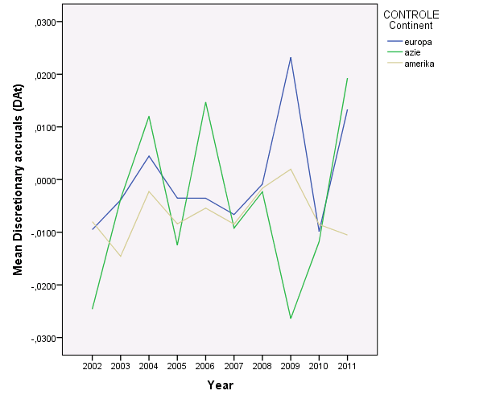

*Table 7.E: Means and standard deviations of estimated discretionary accruals before and after onset of the crisis per continent*

|  |  |  |  |  |
| --- | --- | --- | --- | --- |
| **Continent** | **CRISIS** | | | |
| **Before onset** | | **After onset** | |
| **Mean** | **SD** | **Mean** | **SD** |
| **Europe**  **Asia**  **America** | -,0069 | ,0531 | ,0041 | ,0411 |
| -,0039 | ,0375 | -,0053 | ,0450 |
| -,0079 | ,0306 | -,0047 | ,0336 |

# 7.3.2.1 Descriptive analysis of the Discretionary Accruals in Europe

In Europe the change of discretionary accruals is presented in graph 7.1 (blue line). Only in the year 2010-2011 a significant increase exists in the estimated discretionary accruals, t (12) = -2.56, p < 0.05 (reference is made to appendix 5.2.2).

The mean of the discretionary accruals (as presented in table 7.E) in Europe before (M = -0.0069, SD = 0.05) and during the crisis (M = 0.0041, SD = 0.04), shows the largest deviation in discretionary accruals when compared to the other continents. On average, Europe is the only continent that shows positive discretionary accruals during the crisis. This is mainly caused by the year 2009, when is estimated that the discretionary accruals are on average 0.023 (table 7.D).

Correlations are only significant in the change from 2002 to 2003, r = 0.617, p < 0.05. An interesting figure is shown in appendix 5.3, that is, a negative correlation is found between the years 2008 and 2009, (*r* = -0.148, *p* > 0.6).

For every year a boxplot is presented to have insight in the distribution and the outliers (see appendix 5.4.2). The discretionary accruals for 2009 are expected to be highest (*M* = 0.023, *SD* = .042), in 2005 the lowest (M = -.0095, SD = .0423). The boxplot shows that EDF has a higher estimated discretionary accrual in the years 2003 and 2011. When referring to the boxplot that shows the distribution of all the research years combined (reference is made to appendix 5.4.1) however, EDF is not defined as an outlier. This implies that the outcomes in 2003 and in 2011 can be predicted by the regression model. This assumption in addition is valid for Telefonica SA and consequently is not deleted from the analysis.

# 7.3.2.2 Descriptive analysis of the Discretionary Accruals in Asia

The course of the discretionary accruals over the research period 2002 up to and included 011 (graph 7.1), shows a high volatility for Asia (green line). Still, two significant differences are found for Asia, between 2002 and 2003 t (11) = -0.24, p < 0.05, and between 2010-2011, t (11) = -2.24, p < 0.05. For an overview of all correlations, reference is made to appendix 5.2.3.

In Asia, according to table 7.E the discretionary accruals before (M = -0.0039, SD = 0.04) is less negative than during the crisis (M = -.0053, SD = 0.04). The most negative discretionary accruals can be found in 2002 and 2009 (reference is made to table 7.D).

No correlations between discretionary accruals over two subsequent years are significant, however, this could be cause by a lack of statistical power (n=12). As equally to Europe, the strongest negative relationship is found in between 2008 and 2009, during the onset of the crisis, r = -0.21, p > 0.5 (reference is made to appendix 5.3).

According to the boxplot which shows distribution of the discretionary accruals per research year, the figures of the 12 companies from Asia don not show any outliers. Only a big range in discretionary accruals in the years 2006 and 2008 is noted (reference is made to 5.4.4). When analysing the boxplot which shows the distribution of all research years combined (reference is made to appendix 5.4.3) 6 outliers are noted. These outliers cannot be determined as extremes and as these are located on both sides of the boxplot, this reduces the significant influence on the regression analysis.

# 7.3.2.3 Descriptive analysis of the Discretionary Accruals in America

The course of the discretionary accruals over the period 2002-2011 (graph 7.1) shows the smallest fluctuations for America (grey line). Without controlling for any other variable, the discretionary accruals in America is more negative before (M = -0.0079, SD = 0.03) than during the event period (M = -0.0047, SD = 0.03), reference is made to table 7.E. The means are presented in table 7.D.

However, for America one significant difference is found between 2003 and 2004, t (13) = -2.24, p < 0.05 (see appendix 5.2.4). Correlations between the discretionary accruals over two subsequent years are all positive and 4 time periods are significant, between 2003 and 2004 (r = 0.67, p > 0.5); between 2007 and 2008 (r = 0.90, p > 0.001); between 2008 and 2009 (r = 0.77, p > 0.01); between 2010 and 2011 (r = 0.63, p < 0.5). All correlations are presented in appendix 5.3.

In the boxplots, which shows distribution of the discretionary accruals per research year (appendix 5.4.6) and the distribution of all research years combined (appendix 5.4.5), 6 outliers are found related to America on the total discretionary accruals. By performing a residual outlier analysis there will be determined whether these cases have to be deleted.

# 7.4: Control variables and outlier analysis over the control variables

The course of the standardized values (compared to the other years) of the control variables are presented in graph 7.2.

*Graph 7.2: Standardised total means of the control variables over the period 2002-2011.*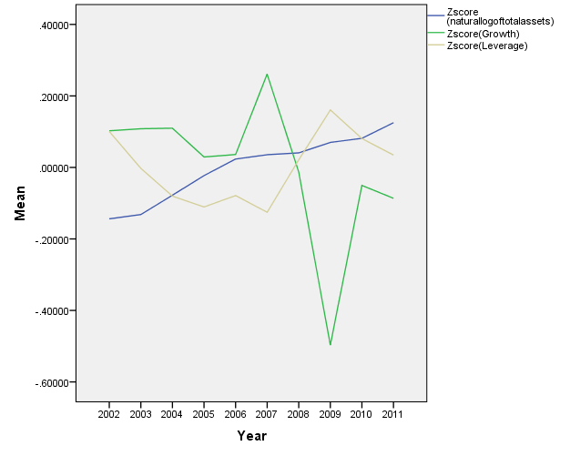

It shows especially reduced growth in the year 2009 and smaller growth after the onset of the crisis than before. Size, as measure as the natural log of total assets, shows almost a linear increase over the years, leverage is more fluctuating than size over the years with the highest levels in 2002 and 2009. Unstandardized means and standard deviations of the continents per continent are presented in table 7.F and the means and standard deviations of the control variables before and after onset of the crisis are presented in table 7.G.

*Table 7.F: Means and standard deviations of the control variables per continent*

|  |  |  |  |  |  |  |
| --- | --- | --- | --- | --- | --- | --- |
| **Control variables** | **Continent** | | | | | |
| **Europe** | | **Asia** | | **America** | |
| ***Mean*** | ***SD*** | ***Mean*** | ***SD*** | ***Mean*** | ***SD*** |
| **SIZE FIRM** | 11.64 | 0.51 | 14.51 | 1.76 | 11.63 | 0.66 |
| **GROWTH** | 2.13 | 1.31 | 1.38 | 0.83 | 2.75 | 1.52 |
| **LEVERAGE** | 0.19 | 0.11 | 0.13 | 0.09 | 0.20 | 0.15 |

*Table 7.G: Means and standard deviations of the control variables before and after onset of the crisis*

|  |  |  |  |  |  |  |  |
| --- | --- | --- | --- | --- | --- | --- | --- |
|  | | **CONTROLE SIZE FIRM (Natural log of total assets)** | | **CONTROLE Growth (Book to market ratio)** | | **CONTROLE Leverage (YE long term debt / YE total assets)** | |
| **Mean** | **Standard Deviation** | **Mean** | **Standard Deviation** | **Mean** | **Standard Deviation** |
| **dCrisis** | **Before onset** | 12.43 | 1.75 | 2.38 | 1.48 | 0.17 | .13 |
| **After onset** | 12.66 | 1.67 | 1.68 | 1.00 | 0.19 | .12 |

***Size***

In order to create a normal distribution for the size of the firm, a natural log was taken. The firms in Asia on average are bigger (*M* = 14.51, *SD* = 1.76) than the firms in Europe and in America with the largest deviation, reference is made to table 7.F. The size of the firms in the estimation (*M* = 12.43, *SD* = 1.75) and events period (*M* = 12.66, *SD* = 1.67) are almost the same (reference is made to table 7.G).

The numbers of the outliers of the control variable size are, due to the logarithmic transformation, reduced. Values over an absolute standardised value of |3| relative to the continent are deleted and exclude Sanofi in years 2002 and 2003 (GDF SUEZ and QWEST COMMUNICATIONS have standardised values relative to their continent under an absolute standardised value of |3|, reference is made to appendix 6.1.1.

***Growth***

Firms in America have the largest growth (book to market ratio) (*M*= 1.38, *SD* = 7.15). The smallest growth is found in Asia (*M* = 1.38, *SD* = 0.83). The growth in Asia in addition has the smallest deviation (see table 7.F). The Crisis seems to have influence on the growth of the companies. Before the crisis the growth (*M* = 2.38, *SD* = 1.48) on average is higher than after the crisis (*M* = 1.68, *SD* = 1.00), reference is made to table 7.G.

Especially growth as a control variable has many outliers. In the boxplot (reference is made to appendix 6.1.2), the outliers are shown for this control variable. All outliers with an absolute Z-value over |3| were deleted. This resulted in the deletion of the following samples: Qwest Communications, International Business Machines Corp, Sanyo Electric, Proctor and France Telecom. Not the whole companies are deleted, due to loss of useable data, just the year in which the extreme value has been realized is deleted.

***Leverage***

The companies from America (*M* = 0.20, *SD* = 0.15) and Europe *M* = 0.19, *SD* = 0.11) have comparable leverage. Asia has the smallest leverage (*M* = 0.13, *SD* = 0.09), reference is made to table 7.F. Before and during the crisis, on average, the leverage has increased from 0.17 (*SD* = 0.13) before the crisis to 0.19 (*SD* = 0.12) during the crisis (reference is made to table 7.G).

Leverage has one company with many outliers, Qwest Communications, from 2002-2010 (see appendix 6.1). These years in addition are outliers in growth. Consequently Qwest Communication is deleted form the sample and not included in the analysis of this study.

***Final Sample***

In total, as a consequence of the outlier analysis from estimating the total accruals and extreme cases on the control variables, the discretionary accruals of in total N = 360 (36 companies with 10 years data available from the financial statements), ordered by company and continent, are analysed. For a full overview of the companies and the number of occurrences in the analysis, reference is made to appendix 6.2.

# 7.5: Descriptive statistics of square rooted discretionary accruals

As stated in the research methodology in chapter six, in order to address hypothesis 1 that relates to the determination if earnings management through discretionary accruals is used, the absolute value of the discretionary accruals is analysed.

At first when plotted and analysis of the histogram of the discretionary accruals, the histogram shows that the shape of the distribution of the discretionary accruals are not normally distributed, reference for the histogram is made to appendix 7.1. The distribution of absolute value of discretionary accruals resembles two times the right tail of a normal distribution. For this reason, the variable is root transformed. The absolute values of discretionary accruals are square rooted.

This results in the following histogram, Q-Q plot and box plot which show normal distribution:

*Graph 7.3: Histogram, Q-Q plot and box plot of the square rooted discretionary accruals*

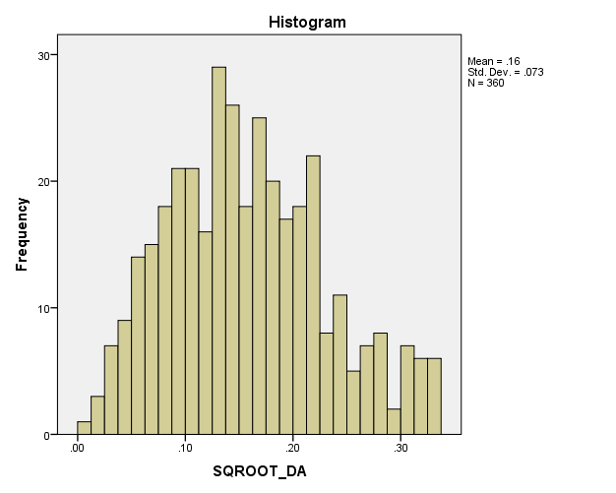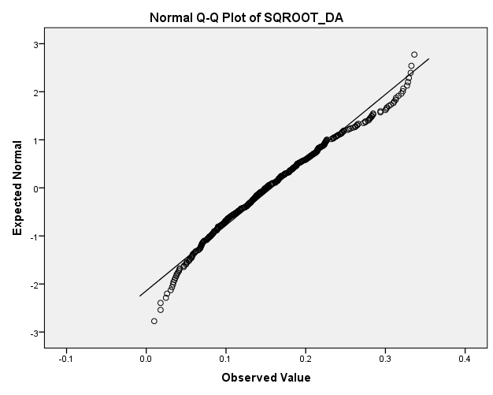

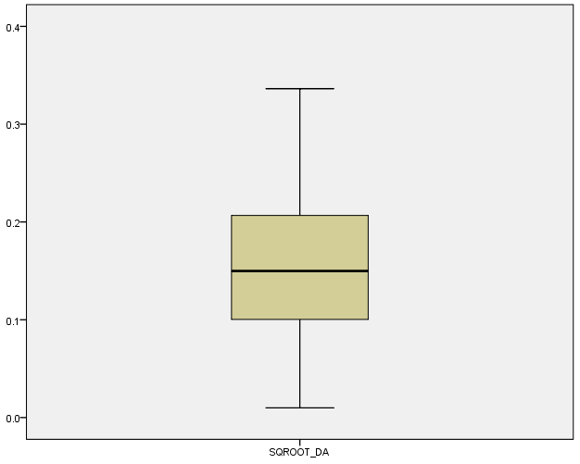

By rooting the discretionary accruals, excerpt the normal distribution in addition no outliers are noted (due to the higher values of discretionary accrual), as is visible in the before stated boxplot.

To determine normal distribution of the variable Total Accruals the Kolmogorov-Smirnov test per continent and on a total level is performed. The Kolmogorov-Smirnov test, tests the null-hypothesis (assumption) that the variable is normally distributed. If the p-value > 0.05 (significance level α) the null-hypothesis is accepted.

The transformed variable (square root) meets the criterion of a normal distribution (*K-S* = 0.04, *p* > 0.18) for all used data. If explored per continent, the distribution is normal for Europe (*K-S* = 0.06, *p* > 0.2), Asia (*K-S* = 0.08, *p* > 0.05) and America (*K-S* = 0.07, *p* > 0.2), reference is made to table 7.H. For the histograms which show normal distribution per continent, reference is made to appendix 7.2.

*Table 7.H: Kolmogorov-Smirnov test of normality square rooted discretionary accruals per continent*

|  |  |  |  |  |  |  |  |
| --- | --- | --- | --- | --- | --- | --- | --- |
| **Tests of Normality** | | | | | | | |
| CONTROLE Continent | | Kolmogorov-Smirnova | | | Shapiro-Wilk | | |
| Statistic | Df | Sig. | Statistic | df | Sig. |
| SQROOT_DA | Europe | .049 | 124 | .200* | .982 | 124 | .094 |
| Asia | .082 | 118 | .051 | .967 | 118 | .006 |
| America | .071 | 118 | .200* | .977 | 118 | .043 |
| *. This is a lower bound of the true significance. | | | | | | | |
| a. Lilliefors Significance Correction | | | | | | | |

Related to hypothesis 1, the means and the standard deviations of the use of earnings management measured through the square root of the estimated discretionary accruals are presented in table 7.I.

*Table 7.I: Earnings management measured as the square root of the estimated discretionary accruals*

|  |  |  |  |
| --- | --- | --- | --- |
| **Continent** | **Mean** | **N** | **Std. Deviation** |
| **Europe** | 0.173 | 124 | 0.077 |
| **Asia** | 0.159 | 118 | 0.074 |
| **America** | 0.139 | 118 | 0.066 |
| **Total** | 0.159 | 360 | 0.073 |

As visible in table 7.I , the means of the square root transformed discretionary accruals shows the highest estimation of the use of earnings management in firms from Europe (*M* = 0.17, *SD* = 0.08), followed by Asia (*M* = 0.16, *SD* = 0.07) and America (*M* = 0.14, *SD* = 0.07).

Related to hypothesis 2, the means and the standard deviations of the use of earnings management measured through the estimated discretionary accruals per continent are presented in table 7.J.

*Table 7.J: Means and standard deviations discretionary accruals per continent*

|  |  |  |  |
| --- | --- | --- | --- |
| **Continent** | **Mean** | **N** | **Std. Deviation** |
| **Europe** | -.0030 | 124 | .0453 |
| **Asia** | -.0039 | 118 | .0406 |
| **America** | -.0090 | 118 | .0305 |
| **Total** | -.0056 | 360 | .0390 |

As visible in table 7.I, the means and standard deviations of the 3 continents show relatively small differences between the continents. The largest difference is found between Europe (*M* = -0.003, *SD* = 0.05) and America (*M* = -0.01, *SD* = 0.03).

# 7.6: Analysing the absolute value of discretionary accruals - hypothesis 1: Change in earnings management

All 39 companies (final sample of N = 390 as stated in section 7.4) over 2002 up to and included 2011 are included in the analysis. If the residual value exceeds an absolute level of |3|, and the related cases are deleted from the analysis. After conducting a final outlier analysis, in total the following six outliers are deleted from the sample; Siemens (2008), EDF (2011) and Hankook Tire Co Ltd. (2006 and 2008), Ford Motors (2007) and Merck & Co Inc. (2008). The results below are calculated over the remaining cases (N = 354). To examine hypothesis 1, table 7.K shows the effect of continent and crisis, with and without controlling for growth, leverage and size.

*The following regression models are used to test hypothesis 1 and 2:*

**Model 1: $${DA}_{i,t}= β0 + β1 \left({dCrisis}_{i,t}\right)+ β2 \left({Continent}_{i,t}\right)+ β3 \left({Continent}_{i,t}×{dCrisis}_{i,t}\right)+ ε_{i,t}$$**

And

**Model 2: $${DA}_{i.t}= β0+ β1 \left({dCrisis}_{i,t}\right)+ β2 \left({Continent}_{i,t}\right)+ β3 \left({Continent}_{i,t}×{dCrisis}_{i,t}\right)+ β4 \left({Size}_{i,t}\right)+ β5 \left({Growth}_{i,t}\right)+ β6 \left({Leverage}_{i,t}\right)+ε_{i,t}$$**

*Table 7.K: Hierarchic regression analysis with as dependent variable the root square of the absolute estimated discretionary accruals*

|  |  |  |  |
| --- | --- | --- | --- |
|  | **Model 1** | **Model 2** | **Tolerance** |
|  | **Standardised Betas** | |  |
| **dAmerica** | -.11 | -.19 | .22 |
| **dEurope** | .23*** | .12 | .22 |
| **dCrisis** | .10 | .09 | .32 |
| **AmericaXdCrisis** | -.06 | -.06 | .34 |
| **EuropeXdCrisis** | -.23** | -.23** | .33 |
| **SIZE FIRM** |  | -.15 | .36 |
| **Growth** |  | -.06 | .71 |
| **Leverage** |  | .01 | .83 |
| **R-square** | 0.07 | 0.08 |  |
| **Adj. R-square** | 0.05 | 0.06 |  |
| **N** | 354 | 354 |  |

**\**p* < 0.05; ** *p* < 0.01; *** *p* < 0.001**

***In model 1***, the predictor variables continent and crisis, without the control variables are analysed. Model 1 explains 7% of the total variance of the *square rooted absolute value of discretionary accruals* (dependent variable). For a full overview of the regression model, reference is made to appendix 8.1.

The effects of America and Europe are analysed in comparison with the reference category Asia. Europe has a significant higher absolute discretionary accruals than the reference category Asia (*Beta* = 0.23, *p* < 0.05), controlling for the crisis. America has on average less discretionary accruals than Asia (*Beta* = -0.11, *p* > 0.1), but this difference is not significant. Deriving from these two findings, Europe and America in addition have significant difference in the use of earnings management (*p* < 0.05).

When analysing the effect of the predictor variable Crisis in model 1, both Europe and America shows less intensive use of discretionary accruals in the event period. However, for Europe this difference is significant (B*eta* = -0.23, *p* < 0.05). The crisis has not a significance effect on the use of earnings management in Asia (*Beta* = 0.10, *p* > 0.3) and in America (*Beta* = -0.11, *p* > 0.3).

***In model 2***, the control variables growth, leverage and size are taken into account. Model 2 explains 8% of the total variance that is 1% more than model 1. However, in predicting the *root square of the absolute values of discretionary accruals*, the regression fails to find any significant effect of these firm characteristics (control variables).

The control variables do influence the outcome in answering hypothesis 1. Significant direct effects of the root squared discretionary accruals between Europe and Asia disappears (*Beta* = 0.12, p > 0.05). The difference in discretionary accruals between America and Europe is still significant (p < 0.05).

The interaction term between Europe and dCrisis is significant in model 2 (*Beta* = -0.23, p < 0.05). Controlling for the characteristics of firms, Europe has less extensive use of earnings management than Asia after the onset of the crisis. No significant differences in the use of earnings management have be found between America and Asia after the onset of the crisis (*Beta* = -0.06, p > 0.6).

# Checking the assumptions of the model

All the tolerances are above the criterion of 0.2 tolerance, consequently no clear indication of a multi-collinearity problem have been found (reference is made to appendix 8.1 at the coefficients table, column Collenearity statistics).

The scatterplot of the predicted value against the residual values, show no clear signs of heteroskedasticity. The distribution of the residuals seems to be slightly larger with higher predicted values, however this does not to be alarming or violating the assumption of homoskedasticity (for the scatterplot reference is made to appendix 8.2).

In addition, the main goal to use the square root of the discretionary accruals is to get a normal distributed dependent variable (appendix 8.2). The analysis of the residuals shows more or less normal distribution. Standardized residuals in the range of -1 and 0 are more cases than is expected based a normal distribution. This might be the result of the transformation of the discretionary accruals in absolute values.

# 7.7: Analysing the effect of Crisis on the magnitude of discretionary accruals related to hypothesis 2

In order to analyse the magnitude of the discretionary accruals, the estimation of the values of the discretionary accruals (with information included if the discretionary accruals shows positive or negative movement) is analysed. The model is generated with all the cases (N = 360) as specified under outlier analysis in section 7.4. If the residual value exceeds an absolute level of |3|, and the related cases are deleted from the analysis. The results below are calculated over the remaining cases (N = 359).

To test the differences, a hierarchical regression analysis was conducted. After conducting a final outlier analysis by extreme residual value, the following outlier from the sample is deleted, Siemens (2008).

To examine hypothesis 2, model 1 is performed without the control variables and model 2 is the model with control variables (model 1 and model 2 as described in section 7.6). Table 7.L shows the effect of continent and crisis, with and without controlling for growth, leverage and size.

*Table 7.L: Hierarchic regression analysis with as dependent variable the root square of the absolute estimated discretionary accruals*

|  |  |  |  |
| --- | --- | --- | --- |
|  | **Model 1** | **Model 2** | **Tolerance** |
|  | **Standardised Beta’s** | |  |
| **dAmerica** | -.07 | 0.01 | .22 |
| **dEuropa** | -.05 | 0.13 | .22 |
| **dCrisis** | -.00 | .06 | .32 |
| **AmericaXcrisis** | .01 | .03 | .34 |
| **EuropaXcrisis** | .13 | .14 | .33 |
| **SIZE** |  | .21* | .35 |
| **Growth** |  | .22** | .71 |
| **Leverage** |  | -.30*** | .83 |
| **R-square** | 0.02 | 0.13 |  |
| **Adj R-square** | 0.00 | 0.11 |  |
| **N** | 359 | 359 |  |

**\**p* < 0.05; ** *p* < 0.01; *** *p* < 0.001**

In the models before not a significant effect exists of continent on the value of the estimated discretionary accruals. In model 1 the predictor variables without the control variables is visible. The R-square is low and little of the variance in discretionary accruals is explained by continent, crisis or the interaction between the crisis and the continent (*R2* = 0.02; 2%). As is estimated, the coefficient for Europe (*Beta* = -.05, *p* > 0.7) and America (*Beta* = -0.7, *p* > 0.7) is negative, implying that the discretionary accruals on average are lower than the reference category Asia, without controlling for leverage, growth and size of firm. These findings are not significant. For a full overview of the hierarchic regression model, reference is made to appendix 9.1.

Before and during the crisis, not a substantial difference exists in the magnitude of the discretionary accruals for Asia (*Beta* = .01, *p* > 0.9). No significant difference could be found for America (*Beta* = 0.01, *p* > 0.5) and for Europe (*Beta* = 0.13, *p* > 0.15).

In model 2 the control variables are taken into account. The total explained variance of discretionary accruals is 13%. The control variables have significant coefficients in predicting discretionary accruals. Size (*Beta* = 0.21, *p* < 0.05) and growth (*Beta* = 0.22, *p* < 0.001) have significant positive effects on estimating discretionary accruals. Leverage has a significant negative effect (*Beta* = -0.30, *p* <0.001).

No significant effects have been found for continent, for crisis or for the interaction between crisis and continent.

# Checking the assumptions of the regression model

All the tolerances are above the criteria of 0.2 tolerance, consequently no multi-collinearity problem is likely to occur (reference is made to appendix 9.1 at the coefficients table, column Collinearity Statistics).

The distribution of the residuals is normally distributed, as is visible in the graph (histogram) of the standardized residuals (appendix 9.2). The distribution takes the form of a bell curve, like expected.

The distribution over the standardized predicted values in addition meets the assumption of homoscedasticity. The variation of the residual values is alike for the predicted values, as is visible in the scatterplot included in appendix 9.2.

# 7.8: Empirical analysis

This section elaborates on the statistical test results as presented in section 7.6 and 7.7 related to respectively hypothesis 1 and 2.

# 7.8.1. Analysis related to hypothesis 1:

The results related to hypothesis 1 (excluding the control variables) showed that Europe has a significant (at a 5% significance level) change in the use of earnings management (absolute discretionary accruals) than the reference category Asia, when controlling for the financial crisis. In addition, America showed no significant (at a 5% significance level) difference when taking the financial crisis into account. Due to the fact that Europe and America are compared with the reverence category Asia, this results automatically in a significant (at a 5% significance level) difference in the use of earnings management when comparing Europe and America.

When analysing the effect of the financial crisis, both Europe and America shows less intensive use of earnings management (discretionary accruals) in the financial crisis. However, for Europe this difference is significant (at a 5% significance level). The financial crisis has not a significance (at a 5% significance level) effect on the use of earnings management in Asia and in America.

When taking the control variables; growth, leverage and size into account, the results showed no significant (at a 5% significance level) effect on the use of earnings management in times of a financial crisis of these firm characteristics (control variables). By including the control variables, the outcome is influenced as the significant (at a 5% significance level) direct effects between Europe and Asia is no longer valid. However, the difference in the use of earnings management (discretionary accruals) between America and Europe is still applicable.

The before stated findings related to Asia (no significant effect of the financial crisis) is in accordance with the research results of Charoenwong & Jiraporn (2008). They stated that in Singapore evidence showed that in the pre- and in the post-crisis the same level of earnings management was used, due to avoidance and to minimize thresholds. Thresholds, such as reporting losses and reporting negative earnings growth, where avoided through the use of earnings management. Consequently, they concluded that the economic crisis of 1997 did not influence the use of earnings management in Singapore and for Thailand they concluded that the non-financial companies in Thailand, monitored by financial analysts, no change in the application of earnings management existed, which enhances the results of this study.

In contrary, they concluded that in Thailand, to avoid reporting losses and negative earnings growth, both the financial and the non-financial companies used earnings management. However, the non-financial companies did not continue their use of earnings management after the economic recession, while the financial companies used earnings management throughout the whole period.

Related to the significant effect of Europe, Lin & Shih (2002) examined the 1990-1991 recession whether the pervasiveness and the aggregate direction of the use of earnings management vary across macro-economic settings. They concluded that the mean discretionary accruals were negative during the recession of 1990-1991, indicating that many firms at that time manipulated the published earnings downward. The result is consistent with the bonus maximization hypothesis of Healy (1985) as stated in chapter 2. He suggested that firms with the largest revenues declines or the largest revenues increases during the recession of 1990-1991 manipulated the published earnings downward.

In addition, the research performed by Lara et al., (2005) showed that in certain institutional contexts (weaker investor protection and less dispersed ownership structure); the use of earnings management significantly drives the measures of the use of earnings conservatism.

They stated that after removing the effect of the discretionary accruals the use of earnings conservatism in the UK did not change significantly. However, in France and in Germany the typical measure of the use of earnings conservatism (the incremental bad news effect, in a regression of earnings on returns) suffered a significant reduction.

They in addition argue that managers in European continental countries have incentives to manage the published earnings downwards, and that this behaviour is likely to affect seriously the results of accounting research in Europe.

Generally, based on the results of this study related to hypothesis 1 (model 2) is determined that after the onset of the crisis when controlling for the characteristics of firms, Europe has less extensive use of earnings management than Asia. After the onset of the crisis no significant (at a 5% significance level) differences in earnings management have been found between America and Asia. This implies that for America and for Asia the null-hypothesis (The use of earnings management has not changed in times of a financial crisis) is accepted and that for Europe the null-hypothesis is rejected.

# 7.8.2 Analysis related to hypothesis 2:

The results related to hypothesis 2 showed no significant (at a 5% significance level) effect of continent, crisis or the interaction between crisis and continent on the value of the used earnings management (estimated discretionary accruals). The discretionary accruals used in Europe and in America on average are lower (however not significant at a 5% significance level) than the reference category Asia, without controlling for leverage, growth and size of firm. Before and during the crisis, no substantial difference in the magnitude of discretionary accruals exists for Europe, Asia and America.

When taking the control variables; growth, leverage and size into account, the results in addition showed no significant (at a 5% significance level) effect in continent, crisis or the interaction between crisis and continent. However, the control variables (size, growth and leverage) do have significant (at a 5% significance level) effects in predicting earnings management applied (estimated discretionary accruals).

Size and growth have a significant positive effects and leverage has a significant negative effect (at a 5% significance level) on estimating the use of earnings management (estimated discretionary accruals).

This is in accordance with the conclusion of Charoenwong & Jiraporn (2008) as stated in section 7.8.1 that no change in the application of earnings management during the financial crisis existed.

Related to the same financial crisis of 1997, Agarwal et al., (2005) concluded that due to the intensive capital constraints, this would have a negative impact on the return on investment, in times of severe recession income smoothing was not used.

However, they in addition stated that the lending activities in the severe recession the provisions rose significantly. The Japanese banks decreased their lending position (decrease / negative sign of discretionary accruals) due to the increase of gains on sale of securities and loan loss provisions (increase / positive sign of discretionary accruals) during the stagnant growth and the severe recession period.

Hall (1993) stated that, in order to maintain the adequate levels of capital, the banks reduced the lending activities with the purpose to decrease the risk full assets in their portfolios.

In contrary to this (to accomplish higher dividend pay-out ratios), in the severe recession period the Japanese banks reduced the earnings from the sale of securities (decrease / negative sign of discretionary accruals). In order to maintain a stable dividend pay-out ratio the banks understated the losses of loan provisions in the high growth period and in the stagnant growth period. While increasing their loan loss provisions (increase / positive sign of discretionary accruals), in the severe recession period, the banks could maintain a stable dividend growth.

Generally, based on the results of this study related to hypothesis 2 (model 2) is determined is that with and without controlling for the characteristics of firms no significant (at a 5% significance level) effects are found by continent, by crisis or by the interaction between the crisis and the continent. However, the control variables have significant (at a 5% significance level) effects in estimating the used earnings management. This implies that for Europe, America and Asia the null-hypothesis is not rejected and consequently can be concluded that ‘Discretionary accruals taken by firms during a financial crisis are not different from those taken in other periods’.

The next chapter contains the conclusion.

# Chapter 8: Conclusion

# 8.1: Introduction

In this chapter the conclusion of this thesis is presented. In order to provide a full overview this chapter starts with the overall summary of the findings and the analysis. After this, the main conclusion of this study will be presented. In this section in addition the answer will be provided on the central problem statement. This chapter will be concluded with the limitations of this study and the recommendations for future researches.

# 8.2: Overall summary

In this study the following research question is investigated: ‘Does the financial crisis affect the extent in which earnings management is used in Asia, America and Europe’?

Financial statements are used for internal and external purposes (internal, such as concerning management decisions, forecasting and planning purposes and external, as investors and stakeholders to examine the healthiness of the company). Overall, the financial statements are of great importance for all users. As earnings represent the actual value of the company, earnings are determined to be the most valuable information stated in the financial statements. Managers face great incentives to report earnings that are most suitable by applying the use of earnings management as it is in the company’s best interest to have high involvement in achieving a high (actual) company value and related earnings. This research focuses on the effect of the financial crises on the financial statements with the use of earnings management by comparing Europe, America and Asia. In order to provide an answer on the research question, an extensive literature review is conducted with comments and findings of prior research on models to detect the use of earnings management and the use of earnings management in times of a financial crisis and economic recession. As related to the use of earnings management many researches are available, based on prior findings related to the use of earnings management the following hypothesis are developed

1. The use of discretionary accruals has not changed in times of a financial crisis and
2. The used level (positive or negative sign) of discretionary accruals by firms during a financial crisis is not different from those taken in other periods.

The model used in this research is the modified Jones model of Dechow et al., (1995). Based on prior researches is concluded that this accrual-based model is the most suitable model to detect the use of earnings management. In addition, based on prior research can be concluded that in times of a financial crisis and / or economic recession the extent in which earnings management is used showed significant results. In this study the agency theory and the positive accounting theory of Watts and Zimmerman is used (1986). They stated that based on the central economics-assumption all individuals’ actions are driven by self-interest, to increase their wealth that individuals will always act in an opportunistic manner. In addition, the related hypotheses of the positive accounting theory are further elaborated. In this research the bonus-plan and the debt hypothesis are used.

The definition of earnings management developed by Healy and Wahlen (1999) is the central starting point of this study. They stated that: ‘Earnings management occurs when management use judgment in financial reporting and in structuring transactions to alter financial reports to either mislead some stakeholders about the underlying economic performance of the company or to influence contractual outcomes that depend on reported accounting numbers’. This definition is the expectation of this study that in times of a financial crisis earnings will decline and debts will increase and consequently for managers more incentives exists to use earnings management in which they qualified as most suitable (self-interest) instead of representing the actual value of the company. In addition, as earnings management is performed through accruals, is further elaborates on the relation between the use of earnings management and accruals.

In this thesis the quantitative approach; desk research is used as the research strategy in which the researcher uses existing material and data produced by others. In other words, in order to obtain new insights the researcher uses this material and / or data through reflection of the personal study and the consulting of prior scientific economic literature. The main selection criteria used in this research are; 1) companies active on the stock market, 2) > 1000 employees and 3) top sixteen companies are selected based on the total assets as per 31-12-2011. After applying the criteria the final data sample resulted in: 48 companies per continent. Per company the annual reports were analysed over a period of 10 years (2002 up and included 2011). The data is obtained by analysing 480 financial statements (10 annual reports per company and 16 companies per continent) manually and by using the following financial databases; Compustat Global, Compustat North America, Orbis, Thomson One Banker, and Worldscope. In order to conduct reliable results, this research used the multiple regression analysis.

This research ends with the main conclusion in which the answer is provided to the research question in this thesis.

# 8.3: Conclusion

Earnings are determined to be the most valuable information in the financial statement as earnings represent the value of the company. An increase of earnings indicates an increase of the company value and a decrease of earnings implies a decrease in the company value. After all, the company value and published earnings show if and in which extent the company has participated in the value-added activities. It is in the company’s best interest to have high involvement in achieving a high (actual) company value and in the related earnings. Due to this, management have more incentives to manage the published earnings in a way they qualified as the most suitable for their financial position. The result of applying earnings management can tend to under- or overstate the earnings in the financial statements, which is not a reliable presentation of the company’s performance.

In addition, this implies that internal and external users of the financial statements are misled by managements decisions or that management attempt to influence the contractual outcomes that be depend on the reported accounting numbers by (re)structuring transactions to alter the financial statements. As the extent of use of earnings management is expected to be different in times of a recession and or financial crisis, indicators such as bankruptcies and unemployment rates in periods of recession will increase. All macro-economic indicators have a high influence on the published earnings (and value) of companies. In addition, in times of recession earnings will decrease and debts will increase.

Consequently, the basic concept of this study relies on the use of earnings management and, in particular, the extent of the use of earnings management in times of a financial crisis / recession. The next research question is developed:

*‘Does the financial crisis affect the extent in which earnings management is used in Asia, America and Europe?’*

Based on prior research only results are available for the economic recession occurred in Asia. In order to provide the internal and the external users of the financial statements understandings of which type of theory is being practiced and to understand its significance, this study concentrates on the development in the current recession while comparing Asia, America and Europe.

Prior research assessed the effect of different economic period and environments on the use of earnings management, in particular the economic recession of 1991 and the Asian financial crisis in 1997. Related to the recession of 1991, Lin & Shih (2002) stated that the use of earnings management is affiliated with the administration of bonus plans. When the threshold of receiving a bonus in a specific period (period of weak economic growth) could not be reached, managers will manipulate the earnings downwards. If the possibility exists this threshold will reached (periods of moderate or high growth), managers manipulate the published earnings upwards (Healy 1985). The performances of firms individually influenced the direction and the extent of the application of earnings management during the recession. Companies with the highest decrease and the highest increase in earnings during the recession corrected the published earnings downward. For that reason these companies applied earnings management in a much intensive way.

Related to the Asian financial crisis in 1997, Agarwal et al., (2005) concluded that in times of severe recession income smoothing was not used. During the recession period the Japanese banks reduced the earnings from the sale of securities. In all the three economic periods the current pay-out ratio is determined by the former period’s pay-out ratio. This indicates that Japanese banks have a high value on stable growth dividend earnings for the investors. Dividend pay-outs were significantly at risk while the lending’s activities increased during the period of high growth. In order to maintain a stable dividend pay-out ratio the banks understated the losses of loan provisions in the high growth period and in the stagnant growth period. While increasing their loan loss provisions, in the severe recession period, for the investors the banks could maintain a stable dividend growth.

In addition Lara et al., (2005) concluded that use of earnings conservatism exists in all of the investigated countries. They presented (graphical) evidence confirming their expectation that the strong link between accounting income to current pay-outs to employees, managers, shareholders and the government in code-law based countries creates additional managerial incentives to manage the published earnings downwards. In addition, they found that the use of earnings conservatism for European countries is more pronounced for small firms when using observed earnings and large firms are more conservative.

In addition, Charoenwong & Jiraporn, (2008) showed evidence that the non-financial companies applied earnings management to avoid and minimize the thresholds. Thresholds, such as reporting losses and reporting negative earnings growth, where avoided through the use of earnings management. However, in Singapore they noted that in the pre- and in the post-crisis the same level of earnings management was used. Consequently, they concluded that the economic crisis of 1997 did not influence the use of earnings management in Singapore. Related to Thailand in order to avoid reporting losses and negative earnings growth, both the financial and the non-financial companies used earnings management. For the non-financial companies in Thailand monitored by financial analysts they concluded that no change in the application of earnings management exists.

Based on the findings in prior research in which economic downturns are assessed, this study evaluates the effect of a financial crisis on the extent of the use of earnings management. In particular, as only studies are available for the economic recession in 1991 and the Asian financial crisis in 1997, the effect of the current financial crisis is assessed. In order to expand the research the comparison of three continents: Asia, America and Europe are taken into account. In order to assess the research question, the accrual based modified Jones model of Dechow et al., 1995 is used.

Finally, the following remark exists related to the influence on the outcome of this study. The discretionary accruals explained by the continent, the crisis, the interaction the between crisis and the continent and the controls variables (*R2)*throughout this study are low. For hypothesis 1 this was 8% (*R2* = 0.08) and for hypothesis 2 this was 13% (*R2* = 0.13). This is mainly the result of the choice of the control variables. As the use of earnings management (discretionary accruals) are influenced by many internal and external factors it is difficult to determine beforehand which control variables has more explanation power of the variance in the discretionary accruals.

Generally, this study found evidence that the extent of earnings management used in times of a financial crisis did not show any variances pre- and after the crisis. However, without taking size of firms, growth and leverage into account Europe showed a change in the use of earnings management during the crisis. In addition, while taking the control variables into account, no signs of change were determined in the use of earnings management. Evident in this study is that conclusions are based on data that is controlled for normal distribution, outlier analysis, homoscedasticity, multi-collinearity and with a significance level of 5%. In order to provide a reliable conclusion, these control mechanisms are essential. Finally, this study indicated no significant forms of earnings management applied during the financial crisis and the earnings stated on the financial statements presents the actual current value.

# 8.4: Limitations and recommendations

This section summarizes the limitations of this study and based on the limitations any recommendations for future research will be provided.

The first limitation of this research is the general assumption that the use of earnings management in certain continents during a financial crisis is applied more often than without a financial crisis. The limitation is that the applied accounting standards and principles (IFRS, GAAP) are not accounted for in this study. As this would result in to general research, the related recommendation is to conduct a research, which includes the specific differences between the accounting standards, and principles which can enhances or even makes it more difficult to determine the use of earnings management properly.

The second limitation of this study is that the sample population (of sixteen companies per continent) is selected mainly based on three criteria: active on the stock market, more than >1.000 employees and total assets as per 31-12-2011. The limitation is that the industry specific parameters are not controlled for in the regression model (no selection based on industry is performed). As this thesis is based on a total level (total of all industries), it could be interesting to test the use of earnings management within specific industries in which companies operates. Consequently, it is highly recommended to conduct a research to test the use of earnings management based on industry level.

As in the thesis the estimation period (period without the economic crisis and in which no systematic earnings management is hypothesized) is determined to be from 2002 up to and included 2007 this thesis did not controlled for the implementation of the IFRS standards in 2005, which is the third limitation of this study. The introduction of the IFRS standards in 2005 could have had a huge impact on the financial statements in that period. The main purpose of IFRS is to enhance the comparability and the disclosure of the relevant information in the financial statements. However, any new introduction has advantages and in addition disadvantages. As the introduction of the IFRS standards in 2005 in addition had an effect on the value relevance of book value and earnings, this in addition for management can creates new incentives to adapt the use of earnings management. Multiple researches are available that commented this topic, this not elaborated any further. However, it is recommended to investigate what impact the introduction of the IFRS standards had one the use of earnings management.

As stated in chapter 7 (section 7.8) the variance in discretionary accruals explained by continent, crisis, the interaction between crisis and continent and the controls variables (*R2)*throughout this study low. This is mainly the result of the choice of the control variables. As earnings management (discretionary accruals) are influenced by many internal and external factors it is difficult to determine beforehand which control variables has more explanation power of the variance in discretionary accruals, which is the fourth limitation of this study. Consequently, in order to enhance the variance explanation for future research it is recommended to include a different set of control variables.

The fifth limitation of this study is that only prior economic scientific literature is available for the economic recessions occurred in Asia, and the available literature is limited to the current economic recession related to Europe and America. The recommendation is to conduct more researchers related to the current economic crisis in Europe and in America.

As a final recommendation (sixth limitation), it is interesting to test within specific countries (Asian) what the impact of country / company / management culture and local laws have on the use of earnings management. In the thesis one of the selection criteria is that the selected companies are audited by the big four audit companies. In addition, it is interesting to investigate companies that are not audit by the big four audit companies.

# References

Agarwal, S., Chomsisengphet, S., Liu, C & Rhee, S.G. (2005). Earnings Management Behaviours under Different Economic Environments: Evidence from Japanese Banks. I*nternational Review of Economics & Finance, Volume 16, Issue 3, 2007*, pages 429-443.

Bartov, E., A. Gul, F.A., Judy S. & Tsui, L. ( 2001). Discretionary-accruals models and audit qualifications. *Journal of Accounting and Economics, Volume 30, Issue 3, December 2001*, Pages 421-452.

Basu, S. (1997). The conservatism Principle and the Asymmetric Timeliness of Earnings. 1997. *Journal of Accounting and Economics, Volume 24, 1997*, pages 3-37.

Burgstahler, D. & Dichev, I. (1997). Earnings Management to Avoid Earnings Decreases and Losses. *Journal of Accounting and Economics, Vol. 24*, pages 99-126.

Charoenwong, C. & Pornsit Jiraporn, P. (2008). Earnings Management to Exceed Thresholds: Evidence from Singapore and Thailand. *Journal of Multinational Financial Management Volume 19, Issue 3, July 2009*, pages 221-236.

Chumney E.C.G., Simpson, K.N. 2006. Methods and Designs for Outcomes Research. *ASHP, 2006*, pages 94-104.

Creswell J.W. (1994). RESEARCH DESIGN: Qualitative, Quantitative, and mixed methods approaches, SECOND EDITION, pages 153-20.

De Angelo, L.(1986). Accounting numbers as market valuation substitutes: a study of management buyouts of public shareholders. *The Accounting Review 61, 1986*, pages 400-420.

Dechow, P.M., Sloan, R.G. & Sweeney, A.P. (1994). Detecting Earnings Management. *The Accounting Review, Vol. 70, No. 2 (Apr., 1995)*, pages 193-225.

Dechow, P.M., Sloan, R.G. & Sweeney, A.P. (1996). Causes and consequences of earnings manipulations: An analysis of firms subject to enforcement actions by the SEC. *Contemporary Accounting Research 13 (1)*, pages. 1-3.

Dechow, P.M. & Dichev ,I.D. (2002). The quality of accruals and earnings: The role of accrual estimation errors. *The Accounting Review, 77 (Supplement)*, pages 35–59.

Deegan, C. & Unerman, J. (2006). Financial Accounting Theory. European Edition. Berkshire, Great Britain: McGraw-Hill Education.

DeFond, M.L. & Jiambalvo, J. (1994). Debt covenant violation and manipulation of accruals. *Journal of Accounting and Economics 17*, pages 145-176.

DeGeorge, F., Patel, J. & Zeckhauser, R. (1999). Earnings Management to Exceed Threshold. *The Journal of Business, Vol. 72,* pages 1-33.

Fudenberg, D. & Tirole, J. (1995). A Theory of Income and Dividend Smoothing Based on Incumbency Rents. *Journal of Political Economy, Vol. 103, No. 1 (Feb., 1995)*, pages 75-93.

García Lara, J.M., Mora, A., & García Osma, B. (2005). The Effect of Earnings Management on the Asymmetric Timeliness of Earnings. *Journal of Business Finance & Accounting, 32(3) & (4), April/May 2005*, pages 691-726.

Givoly, D. and Hayn, C. (2000). The Changing Time-Series Properties of Earnings, Cash Flow and Accruals: Has Financial Reporting Become More Conservative? *Journal of Accounting and Economics 29 (2000)*, pages 287-320.

Gul, F., Srinidhi B. & Shieh T. (2004). The Asian Financial Crisis, Accounting Conservatism and Audit Fees : Evidence from Hong Kong. *Working paper, City University of Hong Kong*.

Hall, B. J. (1993). How has the Basle Accord affected bank portfolios? *Journal of the Japanese and International Economies, 7*, pages 408−440.

Guay, W.R., Kothari S.P. & Watts R.L. (1996). A Market-Based Evaluation of Discretionary Accrual Models. *Journal of Accounting Research, Vol. 34, Studies on Recognition, Measurement, and Disclosure Issues in Accounting (1996)*, pages. 83-105

Hebbink, G.E. & Van Velthoven, B.C.J. (2003). Macro-economie en stabilisatiepolitiek. Groningen, Nederland: Stenfert-Kroese.

Healy, P. (1985). The effect of bonus schemes on accounting decisions. *Journal of Accounting and Economics 7*, pages 85-107.

Healy, P. & Wahlen, J. (1999). A review of the earnings management literature and its implications for standard setting. *Accounting Horizon 13*, pages 365-383.

Holthausen, R.W., Larcker, D.F. & Sloan, R.G.(1995). Annual bonus schemes and the manipulation of earnings. *Journal of Accounting and Economics Volume 19, Issue 1, February 1995*, pages 29-74.

Horiuchi, A. & Shimizu, K. (1995). The deterioration of banks' balance sheets in Japan: Risk-taking and recapitalization. Working paper, University of Tokyo.

Jensen, M. & W. Meckling (1976). Theory of the Firm: Managerial Behaviour, Agency Costs and Ownership Structure. *Journal of Financial Economics, Vol. 3 (October)*, pages 305–60.

Johl, S., Jubb, C.A. & Houghton, K.A. (2003). Audit Quality: Earnings Management in the Context of the 1997 Asian Crisis. Business University Illinois. Derived from <http://www.business.illinois.edu>

Jones, J.J. (1991). Earnings Management During Import Relief Investigations. *Journal of Accounting Research, Vol. 29 (autumn)*, pages 193–228.

Kothari, S.P., Leone, A.J. & Wasley, C.E. (2004). Performance matched discretionary accrual measures. *Journal of Accounting and Economics, Volume 39, Issue 1, February 2005*, pages 163-197.

Kothari, S.P., Lewellen, J.W. & Warner, J.B. (2005). Stock returns, aggregate earnings surprises, and behavioural finance. *Journal of Financial Economics 79*, pages 537–568.

Lambert, R.A. (2001). Contracting theory and accounting. Journal of Accounting and Economics, volume 32, pages 3–87.

Lev, B. (1989). On the usefulness of Earnings and Earnings Research: Lessons and Directions From two Decades of Empirical Research. *Journal of Accounting Research, 27 supplement (1989)*, pages 153-201.

Marquardt, C.A. & Wiedman, C.I. (2004). How Are Earnings Managed? An Examination of Specific Accruals. *Contemporary Accounting Research, Volume 21, Number 2 / Summer 2004*, pages 461-491.

McKee, T.E. 2005. Earnings Management: An executive perspective. (1st edition). Southwestern Educational Publishing: New York, (page 1)

McNichols, M.F. (2000). Research design issues in earnings management studies, *Journal of Accounting and Public Policy 19(4-5)*, pages 313-345.

Peasnell, K.V., Pope, P.F. & Young, S.E. (2000). Detecting earnings management using cross-sectional abnormal accruals models. *Accounting and Business Research, 30 (4), pages* 313-326. ISSN 0001-4788

Ronen, J. & Yaari, V. (2008). Earnings Management Emerging Insights in Theory, Practice, and Research. *Springer Series in Accounting Scholarship Vol 3*, page 27.

Schipper, K. (1989). Commentary on Earnings Management. *Accounting Horizons 3 (December),* pages 91-102.

Shih, M.S.H. & Lin, Z.X. (2002). Earnings Management in Economic Downturns and Adjacent Periods: Evidence from the 1990-1991 Recession. Social Science Research Network

Shrieves and Dahl (2003). Discretionary accounting and the behavior of Japanese banks under financial duress. [*Journal of Banking & Finance*](http://www.sciencedirect.com/science/journal/03784266)*,* [*Volume 27, Issue 7*](http://www.sciencedirect.com/science/journal/03784266/27/7)*, July 2003*, pages 1219–1243.

Vichitsarawong, T., Eng, L.L. & Meek, G.K. (2009). The Impact of the Asian Financial Crisis on Conservatism and Timeliness of Earnings: Evidence from Hong Kong, Malaysia, Singapore, and Thailand. *Journal of International Financial Management & Accounting, Volume 21 Issue 1*, pages 32 – 61.

Xiong, Y. (2006). Earnings management and its measurement: a theoretical perspective. *The journal of American Academy of Business, Cambridge, Volume 9, Issue 1, March 2006*, pages 214-219.

**APPENDIX 1: Summary of prior research**

|  |  |  |  |  |  |
| --- | --- | --- | --- | --- | --- |
| **Year** | **Author(s)** | **Object of study** | **Sample** | **Methodology** | **Outcome** |
| **1995** | **Dechow et al.** | Assessment of alternative accrual-based models for detecting earnings management | 1. a randomly selected sample of 1000 firm-years; 2. samples of 1000 firm-years that are randomly selected from pools of firm-years experiencing extreme financial performance; 3. samples of 1000 randomly selected firm-years in which a fixed and known amount of accrual manipulation has been artificially introduced; 4. sample of 32 firms that are subject to SEC enforcement actions for allegedly overstating annual earnings in 56 firm-years. | The Healy model (1985)  The DeAngelo model (1986)  The Jones model (1991)  The modified Jones model (1995)  The Industry model (1991). | The modified version of the Jones model (1991) generated the most powerful tests related to the determination of earnings management |
| **1996** | **Guay et al.** | Evaluating the results of five discretionary-accrual models to detect earnings management by; specifying a simple earnings model, present managerial discretion hypotheses from existing literature, and assume efficient markets. | i. 31.372 firm-year observations from companies active on the New York and American Stock Exchange market. | The Healy model (1985)  The DeAngelo model (1986)  The Jones model (1991)  The modified Jones model (1995)  The Industry model (1991). | - The Healy, DeAngelo, and industry models are not effective in isolating discretionary accruals that are consistent with opportunism, firm performance, or noise.  - The Jones (1991) and the modified Jones (1995) models yield discretionary accruals that are consistent with both performance-improving and opportunistic smoothing of earnings  - Multiple regression results are consistent with the Jones and modified Jones models estimating discretionary accruals with considerable imprecision and / or misspecification of the assumed earnings process, market efficiency, and/or managerial discretion |
| **Year** | **Author(s)** | **Object of study** | **Sample** | **Methodology** | **Outcome** |

|  |  |  |  |  |  |
| --- | --- | --- | --- | --- | --- |
| **2002** | **Lin & Shih** | Investigate if discretionary accruals, taken in the economic period of severe recession of 1990 to 1991, differ from other periods | 1. 513 firms from a wide variety of industries with quarterly earnings 2. cash flow data for the 20 quarters in 1989-1993 from the Compustat industrial files | The Jones model (1991) | * Discretionary accruals were negative during the 1990-1991 recession, indicating that many firms manipulated earnings downward at that time. * Mean discretionary accruals tend to be negative in quarters of very strong or very weak real GDP growth, and positive in quarters of moderate real GDP growth. * Firms with the largest revenues declines or the largest revenues increase manipulated earnings downward during the 1990-1991 recession. * Earnings reserves accumulated during the recession by firms were later released in quarters of moderate economic growth * The proportion of firms reporting negative special items (including asset write-offs and write-downs, and restructuring charges) is higher in quarters of very weak or very strong real GDP growth. |
| **2003** | **Johl et al.** | Investigates changes in audit quality by examining earnings management behaviour of auditees during periods of discernibly different macro-economic conditions. | 1. All companies listed on the Kuala Lumpur Stock Exchange (KLSE) covering financial periods between 1994-1999. The data was mostly hand-collected from annual reports. Other sources were: KLSE on disk, KLSE handbook, KLSE-RIAM online database, Worldscope database, Che Ahmad’s (2001) dataset and *Investor Digest*. | The modified Jones model (1995) | * Clients of Big 5 auditors reflect higher quality levels by reporting lower absolute discretionary accruals and lower incidence of loss avoidance and sustenance of prior year’s profit (also valid when recognising industry specialisation). * Prior to the crisis Big 5 auditors in Malaysia appear to be no different from the non-Big 5 auditors with respect to constraining earnings management. * Industry Specialist auditees report lower abnormal accruals during the post-crisis period than non-Industry |
|
|

|  |  |  |  |  |  |
| --- | --- | --- | --- | --- | --- |
| **Year** | **Author(s)** | **Object of study** | **Sample** | **Methodology** | **Outcome** |

|  |  |  |  |  |  |
| --- | --- | --- | --- | --- | --- |
| **2005** | **Lara et al.** | Analyse the existence of earnings conservatism in France, Germany and the UK and re-examine earnings conservatism while controlled for earnings management. | 1. 10.131 firm-year observations ii. for the UK 2. 1.367 for France 3. 3.245 for Germany,   For the period 1990–2001 available in the DataStream ‘Live’ and ‘Dead’ files for the UK, France and Germany. | The Basu model (1997)  The modified Jones model (1995) | * Earnings conservatism exists in all three countries. * While earnings conservatism does not change significantly in the UK after removing the effect of discretionary accruals, in the cases of France and Germany the typical measure of earnings conservatism suffers a significant reduction. |
| **2005** | **Agarwal et al.** | Analyse changes in Japanese banks’ earnings management behaviour (use of loan loss provisions and realized gains from securities portfolios) under three distinct economic environments. | 1. 78 Japanese banks over a 15-year study period, 1985-1999.   Annual income statements and balance sheet data available in the Pacific-Basin Capital Market Research Centre (PACAP). The sample in addition includes city and regional banks that are listed on the Tokyo Stock Exchange (TSE). | The Shrieves and Dahl model | Japanese banks used gains from sale of securities used as a means to manage their earnings throughout all three periods. In the high and in the stagnant growth period Japanese banks used loan loss provisions to manage the earnings. In times of severe recessions income smoothing was not used. The lending activities differed significantly throughout the three economic periods. In order to accomplish higher dividend pay-out ratios, in the severe recession period the Japanese banks reduced the earnings from the sale of securities. |

|  |  |  |  |  |  |
| --- | --- | --- | --- | --- | --- |
| **Year** | **Author(s)** | **Object of study** | **Sample** | **Methodology** | **Outcome** |

|  |  |  |  |  |  |
| --- | --- | --- | --- | --- | --- |
| **2008** | **Charoenwong et al.** | Investigates the extent to which earnings are managed to accomplish two psychological thresholds; (1) positive earnings and (2) positive earnings growth relative to the last period’s earnings. | 1. 49 financial firms and 386 non-financial firms for Singapore listed companies on the Singapore Stock Exchange (SGX) for the period of 1975 to 2003 2. 96 financial institutions and 380 non-financial institutions for Thailand listed companies on the Stock Exchange of Thailand (SET) for the period of 1975 to 1999   Data was extracted from: Pacific-Basin Capital Markets (PACAP), I/B/E/S International Inc. database, the Bureau Van Dijk’s Osiris database, SGX library and Yahoo Finance. | The behavioural framework developed by DeGeorge et al. (1999) | For Singapore: The non-financial companies applied earnings management to avoid and minimize thresholds. However, in the pre- and in the post-crisis the same level of earnings management was used. Conclusion is that the economic crisis of 1997 did not influence the use of earnings management in Singapore. |

|  |  |  |  |  |  |
| --- | --- | --- | --- | --- | --- |
|  |  |  |  |  | For Thailand: To avoid reporting losses and negative earnings growth, both the financial and the non-financial companies used earnings management. However, after analyzing the pre-data and the post-data of the financial crisis in 1997, the non-financial companies did not continue their use of earnings management after the economic recession, while the financial companies used earnings management throughout the whole period. For the non-financial companies in Thailand monitored by financial analysts they concluded that no change in the application of earnings management exists. |

|  |  |  |  |  |  |
| --- | --- | --- | --- | --- | --- |
| **Year** | **Author(s)** | **Object of study** | **Sample** | **Methodology** | **Outcome** |

|  |  |  |  |  |  |
| --- | --- | --- | --- | --- | --- |
| **2009** | **Vichitsarawong et al.** | Examines the impact of the 1997 financial crisis on the use of conservatism and the timeliness of the published earnings in conservatism and timeliness of earnings in Hong Kong, Malaysia, Singapore, and Thailand. | 1. Range of 92 observations in Hong Kong (pre-crisis) to 2760 observations in Malaysia (post-crisis).   Data for listed companies in Hong Kong, Malaysia, Singapore, and Thailand are obtained from the Global Vantage database (Research Insight) over the period 1995–2004. | The Basu model (1997)  Givoly and Hayn model (2000) | * Timeliness and conservatism during the crisis period are low. * Conservatism and timeliness in the post-crisis period is greater than in the pre-crisis period. * Accounting conservatism in the post-crisis period improved and is even higher than in the pre-crisis period. * Trends in accruals as an alternative measure of conservatism showed an improvement in conservatism in the post-crisis period. * Corporate governance reforms in these four countries had a positive impact on conservatism and timeliness of earnings. |

**APPENDIX 2: Sample population**

In this study, we selected in total 48 companies to conduct this research. In the table below all companies included are summarized by continent.

|  |  |  |  |
| --- | --- | --- | --- |
| **#** | **Asia** | **America** | **Europe** |
| **1** | Dai Nippon Printing Co Ltd | AT&T Inc | Arcelormittal SA |
| **2** | Hankook Tire Co Ltd | Chevron Corp | Bayerische Motoren Werke AG |
| **3** | Hyundai Merchant Marine Co Ltd | Comcast Corp | BP PLC |
| **4** | Hyundai Motor Co Ltd | ConocoPhillips | Daimler AG |
| **5** | Kaneka Corp | Exxon Mobil Corp | Deutsche Telekom AG |
| **6** | Mitsui & Co Ltd | Ford Motor Co | E.ON Aktiengesellschaft, Duesseldorf |
| **7** | Nec Corp | General Electric Co | EDF |
| **8** | Nomura Co Ltd | Hewlett-Packard Co | France Telecom SA |
| **9** | Orchid Chemicals& Pharmaceuticals Ltd | International Business Machines Corp | GDF Suez |
| **10** | Panasonic Corp | Johnson & Johnson | Rwe AG |
| **11** | Petrochina Co Ltd | Merck & Co Inc. | Sanofi |
| **12** | Pioneer Corp | Pfizer Inc | Siemens AG |
| **13** | Ricoh Co Ltd | Procter & Gamble Co (The) | Telefonica SA |
| **14** | Sanyo Electric Co Ltd | Qwest Communications International Inc. | Total |
| **15** | Satyam Computer Services Ltd | Verizon Communications Inc | Vodafone Group PLC |
| **16** | Sekisui House Ltd | Wal-Mart Stores Inc | Volkswagen AG, Wolfsburg |

**APPENDIX 3: Test of normal distribution of the variable Total Accruals in order to estimate the firm-specific parameters in the estimation period.**

*3.1: Test of normality total accruals per continent*

|  |  |  |  |  |  |  |  |
| --- | --- | --- | --- | --- | --- | --- | --- |
| **Tests of Normality of the variable Total Accruals per continent** | | | | | | | |
| Continent | | Kolmogorov-Smirnova | | | Shapiro-Wilk | | |
| Statistic | df | Sig. | Statistic | df | Sig. |
| TAt | Europe | .067 | 78 | .200* | .992 | 78 | .899 |
| Asia | .074 | 72 | .200* | .977 | 72 | .219 |
| America | .094 | 84 | .063 | .983 | 84 | .316 |
| *. This is a lower bound of the true significance. | | | | | | | |
| a. Lilliefors Significance Correction | | | | | | | |

*3.2: Descriptive statistics and Test of normality total accruals all continents*

|  |  |  |  |  |  |  |  |  |  |
| --- | --- | --- | --- | --- | --- | --- | --- | --- | --- |
| **Descriptive Statistics** | | | | | | | | | |
|  | | | | | | Statistic | | Std. Error | |
| TAt | Mean | | | | | -.0578 | | .0029 | |
| 95% Confidence Interval for Mean | | | Lower Bound | | -.0634 | |  | |
| Upper Bound | | -.0521 | |  | |
| 5% Trimmed Mean | | | | | -.0582 | |  | |
| Median | | | | | -.0548 | |  | |
| Variance | | | | | .0019 | |  | |
| Std. Deviation | | | | | .0438 | |  | |
| Minimum | | | | | -.1931 | |  | |
| Maximum | | | | | .1028 | |  | |
| Range | | | | | .2959 | |  | |
| Interquartile Range | | | | | .0519 | |  | |
| Skewness | | | | | .1500 | | .1591 | |
| Kurtosis | | | | | 1.0882 | | .3169 | |
| **Tests of Normality of the variable Total Accruals per continent** | | | | | | | | | | |
|  | Kolmogorov-Smirnova | | | | Shapiro-Wilk | | | | | |
| Statistic | df | Sig. | | Statistic | | df | | Sig. | |
| TAt | .057 | 234 | .060 | | .985 | | 234 | | .015 | |
| a. Lilliefors Significance Correction | | | | | | | | | | |

*3.3: Test of normality total accruals total (Q-Q plot and Histogram)*

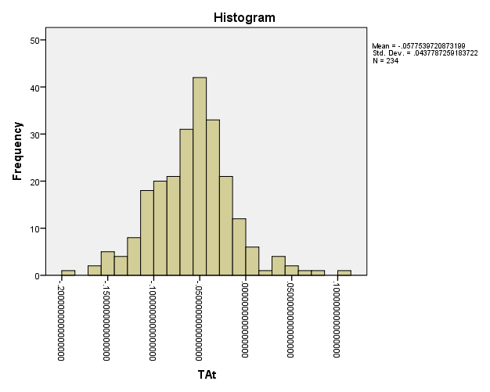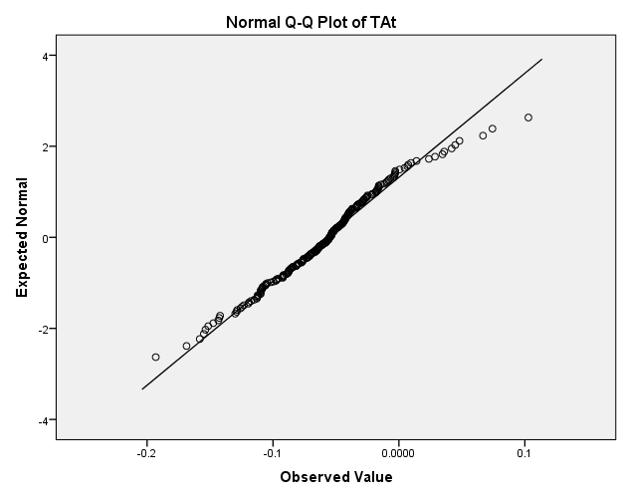

*3.4: Descriptive statistics, histogram, Q-Q plot and Boxplot per continent to test for normality of total accruals*

*3.4.1: Descriptive statistics, histogram and Q-Q plot to test for normality of total accruals related to Europe*

|  |  |  |  |  |  |
| --- | --- | --- | --- | --- | --- |
| **Descriptive** | | | | | |
| Continent | | | | Statistic | Std. Error |
| TAt | Europe | Mean | | -.0630 | .0057 |
| 95% Confidence Interval for Mean | Lower Bound | -.0744 |  |
| Upper Bound | -.0516 |  |
| 5% Trimmed Mean | | -.0634 |  |
| Median | | -.0573 |  |
| Variance | | .0026 |  |
| Std. Deviation | | .0505 |  |
| Minimum | | -.1931 |  |
| Maximum | | .0742 |  |
| Range | | .2674 |  |
| Interquartile Range | | .0640 |  |
| Skewness | | -.0121 | .2722 |
| Kurtosis | | .3123 | .5382 |

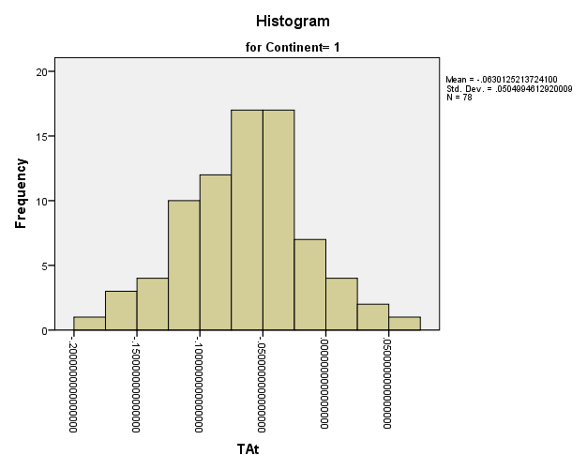 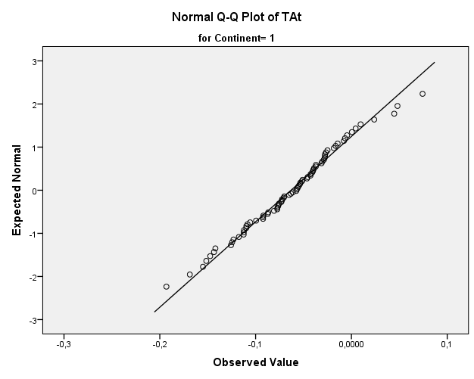

*3.4.2: Descriptive statistics, histogram and Q-Q plot to test for normality of total accruals related to Asia*

|  |  |  |  |  |  |
| --- | --- | --- | --- | --- | --- |
| **Descriptive** | | | | | |
| Continent | | | | Statistic | Std. Error |
| TAt | Asia | Mean | | -.0451 | .0053 |
| 95% Confidence Interval for Mean | Lower Bound | -.0556 |  |
| Upper Bound | -.0346 |  |
| 5% Trimmed Mean | | -.0464 |  |
| Median | | -.0430 |  |
| Variance | | .0020 |  |
| Std. Deviation | | .0446 |  |
| Minimum | | -.1536 |  |
| Maximum | | .1028 |  |
| Range | | .2564 |  |
| Interquartile Range | | .0597 |  |
| Skewness | | .4683 | .2829 |
| Kurtosis | | 12789 | .5588 |

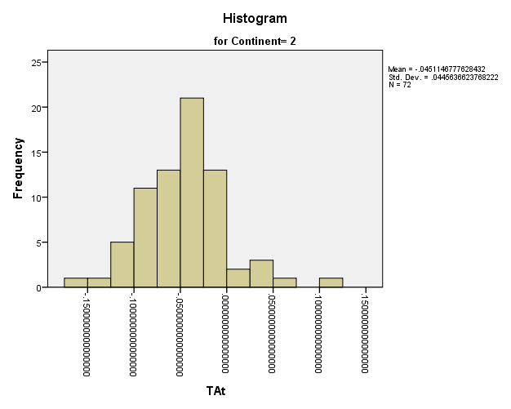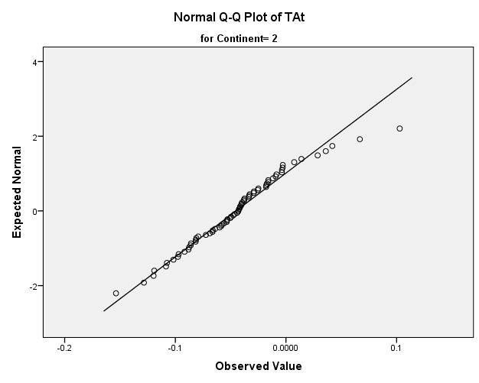

*3.4.3: Descriptive statistics, histogram and Q-Q plot to test for normality of total accruals related to America*

|  |  |  |  |  |  |
| --- | --- | --- | --- | --- | --- |
| **Descriptive** | | | | | |
| Continent | | | | Statistic | Std. Error |
| TAt | America | Mean | | -.0637 | .0036 |
| 95% Confidence Interval for Mean | Lower Bound | -.0710 |  |
| Upper Bound | -.0565 |  |
| 5% Trimmed Mean | | -.0634 |  |
| Median | | -.0604 |  |
| Variance | | .0011 |  |
| Std. Deviation | | .0334 |  |
| Minimum | | -.1582 |  |
| Maximum | | .0346 |  |
| Range | | .1927 |  |
| Interquartile Range | | .0405 |  |
| Skewness | | -.1821 | .2627 |
| Kurtosis | | .7217 | .5197 |

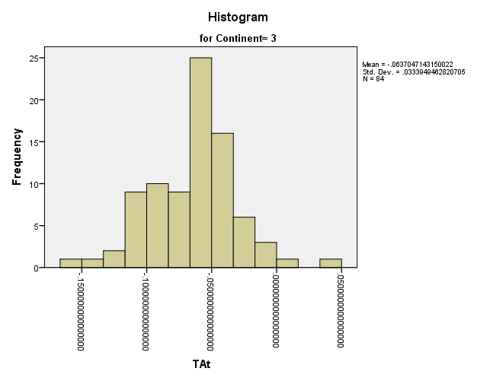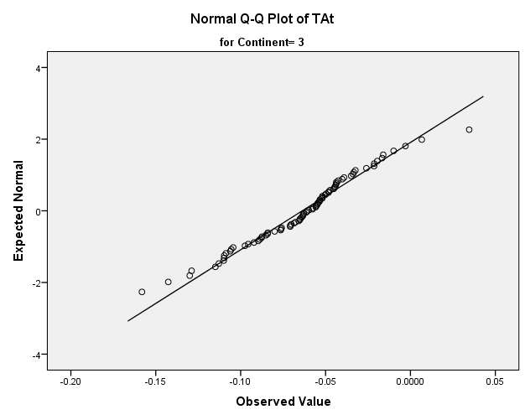

*3.4.4: Boxplot of total accruals per continent to test outliers in the dataset*

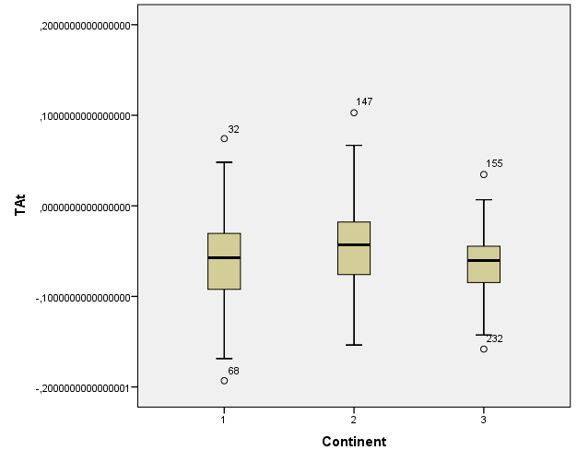

**APPENDIX 4: Multiple regression analysis for parameter-estimation predicting Total Accruals per continent**

*4.1: Multiple regression analysis for parameter-estimation predicting Total Accruals: EUROPE*

|  |  |  |  |  |  |  |  |  |
| --- | --- | --- | --- | --- | --- | --- | --- | --- |
| **Coefficientsa,b,c** | | | | | | | | |
| Model | | Unstandardized Coefficients | | Standardized Coefficients | t | Sig. | Collinearity Statistics | |
| B | Std. Error | Beta | Tolerance | VIF |
| 1 | (1/At-1) | **-31,074** | 316,757 | -,009 | -,098 | ,922 | ,640 | 1,563 |
| ((REVt - REVt-1)/At-1) | **,094** | ,045 | ,176 | 2,068 | ,042 | ,760 | 1,316 |
| (PPEt/At-1) | **-,074** | ,008 | -,804 | -9,218 | ,000 | ,728 | 1,374 |
| a. Continent = 1 | | | | | | | | |
| b. Dependent Variable: TAt | | | | | | | | |
| c. Linear Regression through the Origin | | | | | | | | |

|  |  |  |  |  |
| --- | --- | --- | --- | --- |
| **Model Summarya,d,e** | | | | |
| Model | R | R Squarec | Adjusted R Square | Std. Error of the Estimate |
| 1 | ,765b | ,585 | ,569 | ,052910822521860 |
| a. Continent = 1 | | | | |
| b. Predictors: (PPEt/At-1), ((REVt - REVt-1)/At-1), (1/At-1) | | | | |
| c. For regression through the origin (the no-intercept model), R Square measures the proportion of the variability in the dependent variable about the origin explained by regression. This CANNOT be compared to R Square for models which include an intercept. | | | | |
| d. Dependent Variable: TAt | | | | |
| e. Linear Regression through the Origin | | | | |



*4.2: Multiple regression analysis for parameter-estimation predicting Total Accruals: ASIA*

|  |  |  |  |  |  |  |  |  |
| --- | --- | --- | --- | --- | --- | --- | --- | --- |
| **Coefficientsa,b,c** | | | | | | | | |
| Model | | Unstandardized Coefficients | | Standardized Coefficients | t | Sig. | Collinearity Statistics | |
| B | Std. Error | Beta | Tolerance | VIF |
| 1 | (1/At-1) | 2401,093 | 787,702 | ,231 | 3,048 | ,003 | ,880 | 1,136 |
| ((REVt - REVt-1)/At-1) | ,008 | ,054 | ,013 | ,149 | ,882 | ,633 | 1,579 |
| (PPEt/At-1) | -,065 | ,007 | -,843 | -9,652 | ,000 | ,664 | 1,507 |
| a. Continent = 2 | | | | | | | | |
| b. Dependent Variable: TAt | | | | | | | | |
| c. Linear Regression through the Origin | | | | | | | | |

|  |  |  |  |  |
| --- | --- | --- | --- | --- |
| **Model Summarya,d,e** | | | | |
| Model | R | R Squarec | Adjusted R Square | Std. Error of the Estimate |
| 1 | ,807b | ,651 | ,635 | ,038157612872593 |
| a. Continent = 2 | | | | |
| b. Predictors: (PPEt/At-1), (1/At-1), ((REVt - REVt-1)/At-1) | | | | |
| c. For regression through the origin (the no-intercept model), R Square measures the proportion of the variability in the dependent variable about the origin explained by regression. This CANNOT be compared to R Square for models which include an intercept. | | | | |
| d. Dependent Variable: TAt | | | | |
| e. Linear Regression through the Origin | | | | |



*4.3: Multiple regression analysis for parameter-estimation predicting Total Accruals: AMERICA*

|  |  |  |  |  |  |  |  |  |
| --- | --- | --- | --- | --- | --- | --- | --- | --- |
| **Coefficientsa,b,c** | | | | | | | | |
| Model | | Unstandardized Coefficients | | Standardized Coefficients | t | Sig. | Collinearity Statistics | |
| B | Std. Error | Beta | Tolerance | VIF |
| 1 | (1/At-1) | -1484,737 | 304,777 | -,351 | -4,872 | ,000 | ,394 | 2,538 |
| ((REVt - REVt-1)/At-1) | ,000 | ,019 | ,001 | ,010 | ,992 | ,767 | 1,304 |
| (PPEt/At-1) | -,047 | ,006 | -,614 | -8,092 | ,000 | ,355 | 2,816 |
| a. Continent = 3 | | | | | | | | |
| b. Dependent Variable: TAt | | | | | | | | |
| c. Linear Regression through the Origin | | | | | | | | |

|  |  |  |  |  |
| --- | --- | --- | --- | --- |
| **Model Summarya,d,e** | | | | |
| Model | R | R Squarec | Adjusted R Square | Std. Error of the Estimate |
| 1 | ,914b | ,835 | ,828 | ,029759809509546 |
| a. Continent = 3 | | | | |
| b. Predictors: (PPEt/At-1), ((REVt - REVt-1)/At-1), (1/At-1) | | | | |
| c. For regression through the origin (the no-intercept model), R Square measures the proportion of the variability in the dependent variable about the origin explained by regression. This CANNOT be compared to R Square for models which include an intercept. | | | | |
| d. Dependent Variable: TAt | | | | |
| e. Linear Regression through the Origin | | | | |



*4.4: Normality test residuals for predicting total accruals per continent*

|  |  |  |  |  |  |  |  |
| --- | --- | --- | --- | --- | --- | --- | --- |
| **Tests of Normality** | | | | | | | |
|  | Continent | Kolmogorov-Smirnova | | | Shapiro-Wilk | | |
|  | Statistic | df | Sig. | Statistic | df | Sig. |
| Unstandardized Residual | europe | .052 | 78 | .200* | .991 | 78 | .878 |
| asia | .063 | 72 | .200* | .988 | 72 | .731 |
| america | .062 | 84 | .200* | .987 | 84 | .572 |
| *. This is a lower bound of the true significance. | | | | | | | |
| a. Lilliefors Significance Correction | | | | | | | |

*4.5: Boxplot of the unstandardized residuals per continent to test for normality of total accruals*

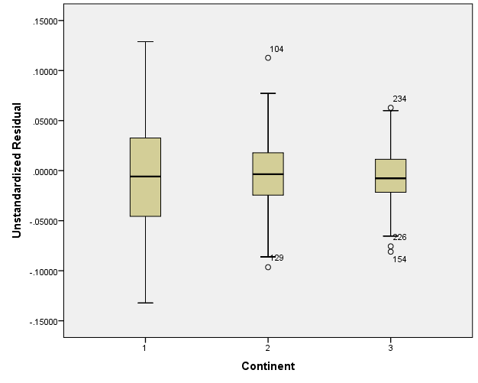

**APPENDIX 5: Descriptive analysis of the Discretionary Accruals**

*5.1: Graph of the mean discretionary accruals over the period of 2002-2011 of the companies of all three continents combined (39 companies) and outcomes (N = 390).*

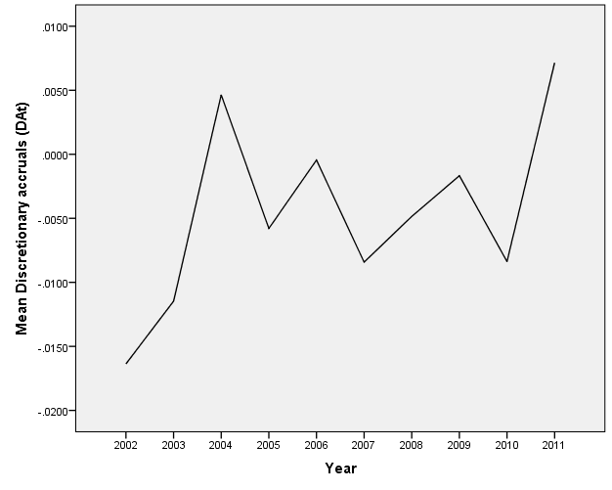

*5.2: Dependent t-tests over companies of all continents*

In order to analyse the change over two following years, 9 dependent t-test are performed. Two changes give significant results, the change from 2003 to 2004 (t (38) = -2.31, p < 0.05), and the change from 2010 to 2011 (t (38) = -2.68, p < 0.05). Both changes are negative. The results of the performed t-tests can be found in the following tables.

*5.2.1: Dependent t-test total of all continents*

|  |  |  |  |  |  |  |  |  |  |
| --- | --- | --- | --- | --- | --- | --- | --- | --- | --- |
| **Paired Samples Test** | | | | | | | | | |
|  | | **Paired Differences** | | | | | **t** | **df** | **Sig. (2-tailed)** |
| **Mean** | **Std. Deviation** | **Std. Error Mean** | **95% Confidence Interval of the Difference** | |
| **Lower** | **Upper** |
| Pair 1 | DA2002 - DA2003 | -.00490 | .03899 | .00624 | -.01754 | .00774 | -.785 | 38 | .437 |
| Pair 2 | DA2003 - DA2004 | -.01611 | .04365 | .00699 | -.03026 | -.00196 | -2.305 | 38 | .027 |
| Pair 3 | DA2004 - DA2005 | .01043 | .06335 | .01014 | -.01011 | .03096 | 1.028 | 38 | .310 |
| Pair 4 | DA2005 - DA2006 | -.00533 | .06239 | .00999 | -.02556 | .01489 | -.534 | 38 | .597 |
| Pair 5 | DA2006 - DA2007 | .00797 | .05066 | .00811 | -.00845 | .02439 | .983 | 38 | .332 |
| Pair 6 | DA2007 - DA2008 | -.00357 | .04504 | .00721 | -.01817 | .01103 | -.495 | 38 | .623 |
| Pair 7 | DA2008 - DA2009 | -.00318 | .06264 | .01003 | -.02348 | .01713 | -.317 | 38 | .753 |
| Pair 8 | DA2009 - DA2010 | .00670 | .04490 | .00719 | -.00785 | .02126 | .932 | 38 | .357 |
| Pair 9 | DA2010 - DA2011 | -.01552 | .03616 | .00579 | -.02724 | -.00380 | -2.680 | 38 | .011 |

*5.2.2: Dependent t-test Europe*

|  |  |  |  |  |  |  |  |  |  |
| --- | --- | --- | --- | --- | --- | --- | --- | --- | --- |
| **Paired Samples Testa** | | | | | | | | | |
|  | | **Paired Differences** | | | | | **t** | **df** | **Sig. (2-tailed)** |
| **Mean** | **Std. Deviation** | **Std. Error Mean** | **95% Confidence Interval of the Difference** | |
| **Lower** | **Upper** |
| Pair 1 | DA2002 - DA2003 | -.02092 | .03264 | .00942 | -.04166 | -.00018 | -2.220 | 11 | .048 |
| Pair 2 | DA2003 - DA2004 | -.01571 | .03619 | .01045 | -.03871 | .00728 | -1.504 | 11 | .161 |
| Pair 3 | DA2004 - DA2005 | .02447 | .05171 | .01493 | -.00839 | .05733 | 1.639 | 11 | .129 |
| Pair 4 | DA2005 - DA2006 | -.02717 | .05673 | .01638 | -.06321 | .00887 | -1.659 | 11 | .125 |
| Pair 5 | DA2006 - DA2007 | .02393 | .05884 | .01698 | -.01346 | .06131 | 1.409 | 11 | .187 |
| Pair 6 | DA2007 - DA2008 | -.00689 | .05484 | .01583 | -.04173 | .02796 | -.435 | 11 | .672 |
| Pair 7 | DA2008 - DA2009 | .02406 | .07471 | .02157 | -.02341 | .07153 | 1.116 | 11 | .288 |
| Pair 8 | DA2009 - DA2010 | -.01461 | .05143 | .01485 | -.04729 | .01807 | -.984 | 11 | .346 |
| Pair 9 | DA2010 - DA2011 | -.03106 | .04208 | .01215 | -.05780 | -.00433 | -2.557 | 11 | .027 |
| a. CONTROLE Continent = Europe | | | | | | | | | |

*5.2.3: Dependent t-test Asia*

|  |  |  |  |  |  |  |  |  |  |
| --- | --- | --- | --- | --- | --- | --- | --- | --- | --- |
| **Paired Samples Testa** | | | | | | | | | |
|  | | **Paired Differences** | | | | | **t** | **df** | **Sig. (2-tailed)** |
| **Mean** | **Std. Deviation** | **Std. Error Mean** | **95% Confidence Interval of the Difference** | |
| **Lower** | **Upper** |
| Pair 1 | DA2002 - DA2003 | -.00249 | .03801 | .01054 | -.02546 | .02048 | -.237 | 12 | .817 |
| Pair 2 | DA2003 - DA2004 | -.02057 | .06584 | .01826 | -.06035 | .01922 | -1.126 | 12 | .282 |
| Pair 3 | DA2004 - DA2005 | .00206 | .09260 | .02568 | -.05389 | .05802 | .080 | 12 | .937 |
| Pair 4 | DA2005 - DA2006 | .01232 | .08423 | .02336 | -.03858 | .06322 | .527 | 12 | .608 |
| Pair 5 | DA2006 - DA2007 | -.00146 | .05243 | .01454 | -.03315 | .03022 | -.101 | 12 | .921 |
| Pair 6 | DA2007 - DA2008 | .00300 | .05629 | .01561 | -.03102 | .03701 | .192 | 12 | .851 |
| Pair 7 | DA2008 - DA2009 | -.02786 | .07064 | .01959 | -.07055 | .01483 | -1.422 | 12 | .181 |
| Pair 8 | DA2009 - DA2010 | .02229 | .04226 | .01172 | -.00325 | .04782 | 1.902 | 12 | .081 |
| Pair 9 | DA2010 - DA2011 | -.02003 | .03221 | .00893 | -.03950 | -.00057 | -2.243 | 12 | .045 |
| a. CONTROLE Continent = Asia | | | | | | | | | |

*5.2.4: Dependent t-test America*

|  |  |  |  |  |  |  |  |  |  |
| --- | --- | --- | --- | --- | --- | --- | --- | --- | --- |
| **Paired Samples Testa** | | | | | | | | | |
|  | | **Paired Differences** | | | | | **t** | **df** | **Sig. (2-tailed)** |
| **Mean** | **Std. Deviation** | **Std. Error Mean** | **95% Confidence Interval of the Difference** | |
| **Lower** | **Upper** |
| Pair 1 | DA2002 - DA2003 | .00659 | .04270 | .01141 | -.01806 | .03125 | .578 | 13 | .573 |
| Pair 2 | DA2003 - DA2004 | -.01231 | .02058 | .00550 | -.02420 | -.00043 | -2.238 | 13 | .043 |
| Pair 3 | DA2004 - DA2005 | .00616 | .03577 | .00956 | -.01449 | .02681 | .644 | 13 | .531 |
| Pair 4 | DA2005 - DA2006 | -.00301 | .03673 | .00982 | -.02421 | .01820 | -.306 | 13 | .764 |
| Pair 5 | DA2006 - DA2007 | .00305 | .04106 | .01097 | -.02065 | .02676 | .278 | 13 | .785 |
| Pair 6 | DA2007 - DA2008 | -.00683 | .01990 | .00532 | -.01832 | .00466 | -1.285 | 13 | .221 |
| Pair 7 | DA2008 - DA2009 | -.00360 | .02911 | .00778 | -.02041 | .01320 | -.463 | 13 | .651 |
| Pair 8 | DA2009 - DA2010 | .01050 | .03647 | .00975 | -.01056 | .03156 | 1.077 | 13 | .301 |
| Pair 9 | DA2010 - DA2011 | .00199 | .02816 | .00753 | -.01427 | .01825 | .264 | 13 | .796 |
| a. CONTROLE Continent = America | | | | | | | | | |

*5.3: Correlations between 2 following years per continent*

| **Period** | **Total (N = 39)** | **Europe (N = 13)** | **Asia (N = 12)** | **America (N= 14)** |
| --- | --- | --- | --- | --- |
| **2002-2003** | .411** | .617* | .560 | .028 |
| **2003-2004** | .351* | .309 | .177 | .668*** |
| **2004-2005** | .060 | .107 | -.102 | .040 |
| **2005-2006** | .123 | .158 | .181 | .110 |
| **2006-2007** | .237 | .387 | -.064 | .396 |
| **2007-2008** | .514** | .294 | .335 | .902*** |
| **2008-2009** | .046 | -.148 | -.214 | .786*** |
| **2009-2010** | .209 | .184 | .020 | .399 |
| **2010-2011** | .416** | .530 | .362 | .629* |

Correlation is significant at * p < 0.05; ** p < 0.01; *** p < 0.001.

The correlations over the years on a total level are all positive (r > 0). The table shows only positive correlations, which means, that companies with a discretionary accruals below average (so relative to the other companies) in the first year of the period, will also have a discretionary accruals below average (relative to the other companies) in the year after. Companies with discretionary accruals above average, keep discretionary accruals above average. This assumption holds in comparing 2002-2003, 2003-2004, in 2007-2008 and 2010-2011.

*5.4: Boxplots of discretionary accruals per continent*

*5.4.1:* Boxplot of discretionary accruals Europe *of all research years combined*

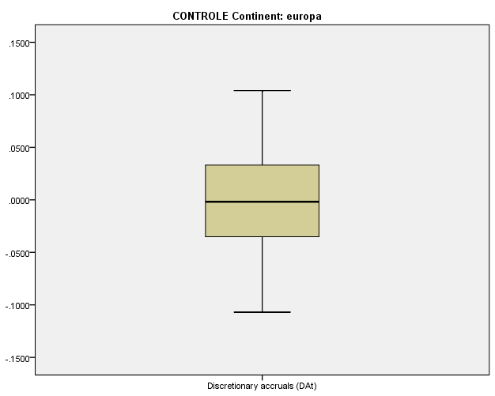

*5.4.2: The discretionary accruals over the period of 2002-2011 in Europe*

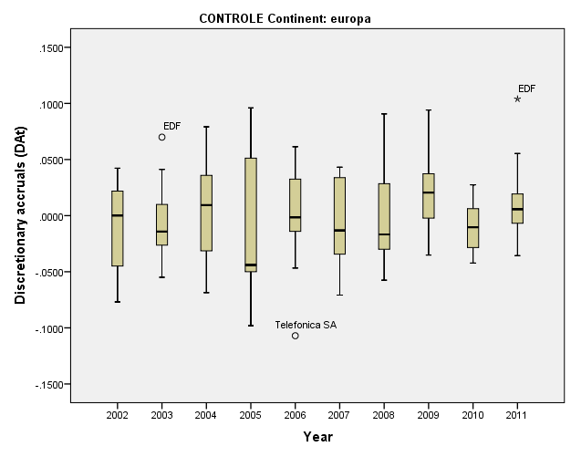

*5.4.3: Boxplot of discretionary accruals Asia of all research years combined*

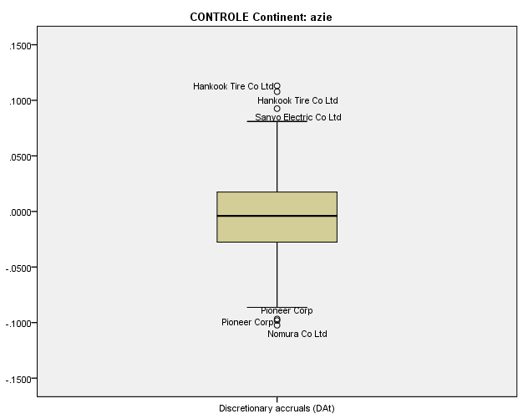

*5.4.4: The discretionary accruals over the period of 2002-2011 in Asia*

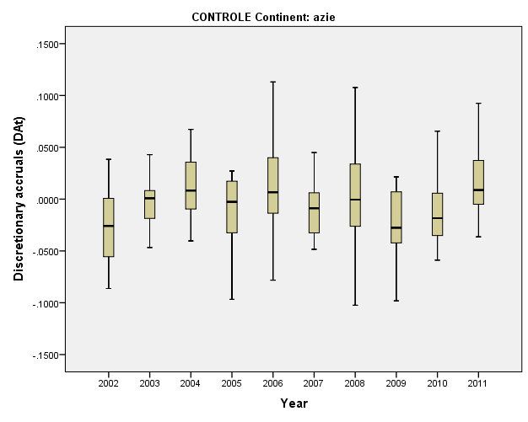

*5.4.5: Boxplot of discretionary accruals America of all research years combined*

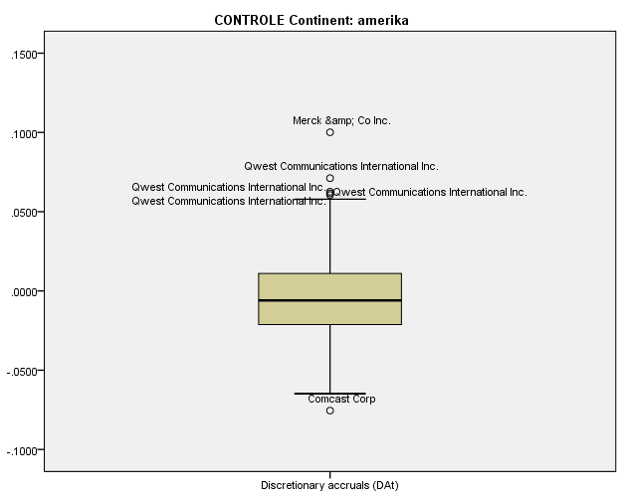

*5.4.6: The discretionary accruals over the period of 2002-2011 in America*

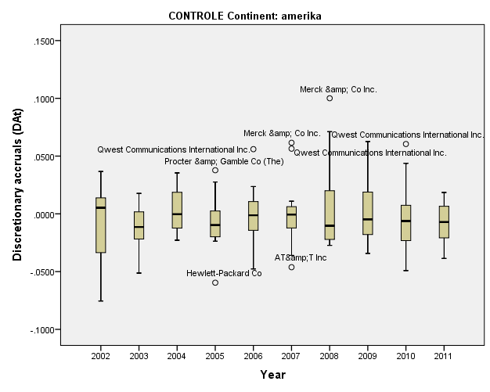

**APPENDIX 6: Exploring Control variables**

*6.1: Boxplots for the 3 control variables: Size Firm, Growth and Leverage*

*6.1.1: Boxplot for the control variable: Size Firm 6.1.2: Boxplot for the control variable: Growth*

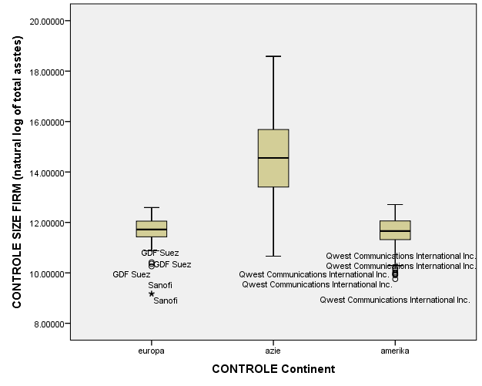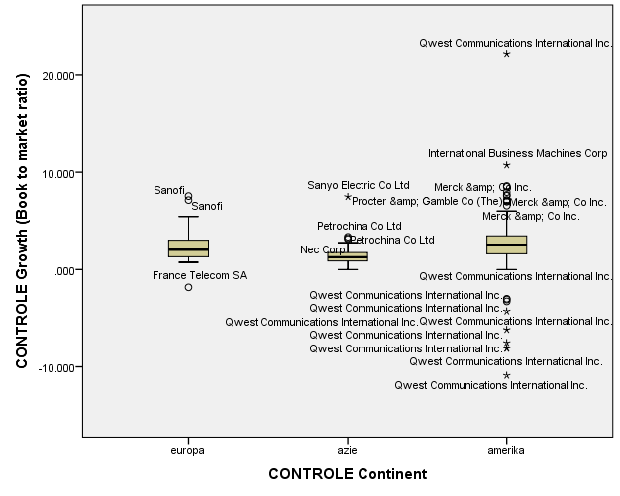

*6.1.3: Boxplot for the control variable: Leverage*

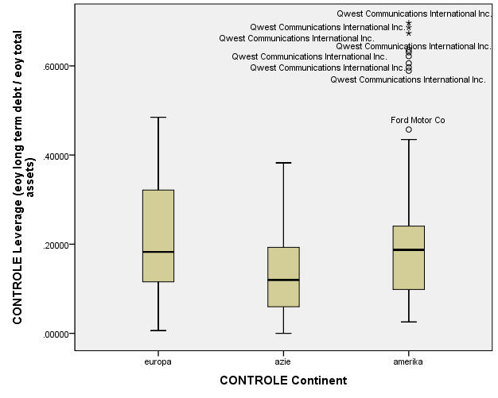

*6.2: Final sample: full overview of the companies and number of occurrences in the analysis*

|  |  |  |
| --- | --- | --- |
| **Europe** | | **Number of occurrences in the analyses 2002-2011** |
|  | BP PLC | 10 |
| Daimler AG | 10 |
| Deutsche Telekom AG | 10 |
| E.ON Aktiengesellschaft, Düsseldorf | 9 |
| EDF | 10 |
| France Telecom SA | 9 |
| GDF Suez | 10 |
| Rwe AG | 9 |
| Sanofi | 8 |
| Siemens AG | 10 |
| Telefonica SA | 10 |
| Total | 10 |
| Vodafone Group PLC | 9 |
| **Total** | **124** |

|  |  |  |
| --- | --- | --- |
| **Asia** | | **Number of occurrences in the analyses 2002-2011** |
|  | Dai Nippon Printing Co Ltd | 10 |
| Hankook Tire Co Ltd | 10 |
| Hyundai Motor Co Ltd | 10 |
| Kaneka Corp | 10 |
| Mitsui &amp; Co Ltd | 10 |
| NEC Corp | 10 |
| Nomura Co Ltd | 10 |
| Panasonic Corp | 10 |
| Petrochina Co Ltd | 10 |
| Pioneer Corp | 10 |
| Ricoh Co Ltd | 10 |
| Sanyo Electric Co Ltd | 8 |
| **Total** | **118** |

|  |  |  |
| --- | --- | --- |
| **America** | | **Number of occurrences in the analyses 2002-2011** |
|  | AT&T Inc. | 10 |
| Chevron Corp | 10 |
| Comcast Corp | 10 |
| ConocoPhillips | 10 |
| Exxon Mobil Corp | 10 |
| Ford Motor Co | 10 |
| Hewlett-Packard Co | 10 |
| Johnson &amp; Johnson | 10 |
| Merck &amp; Co Inc. | 10 |
| Procter &amp; Gamble Co (The) | 8 |
| Verizon Communications Inc. | 10 |
| Wal-Mart Stores Inc. | 10 |
| **Total** | **118** |

**APPENDIX 7: Descriptive statistics of square rooted discretionary accruals**

*7.1: Histogram of the absolute discretionary accruals which shows no normal distribution*

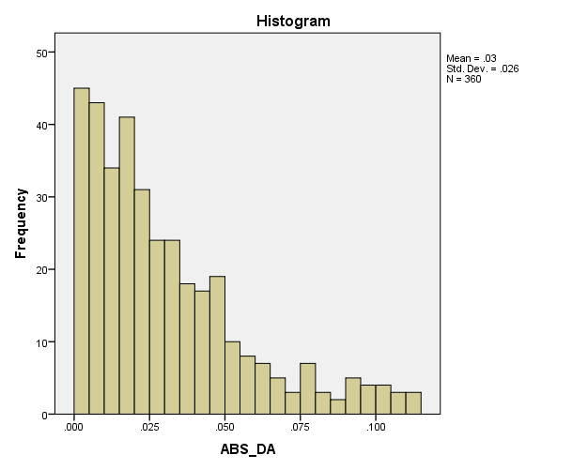

*7.2: Histograms of square rooted discretionary accruals per continent which shows normal distribution*

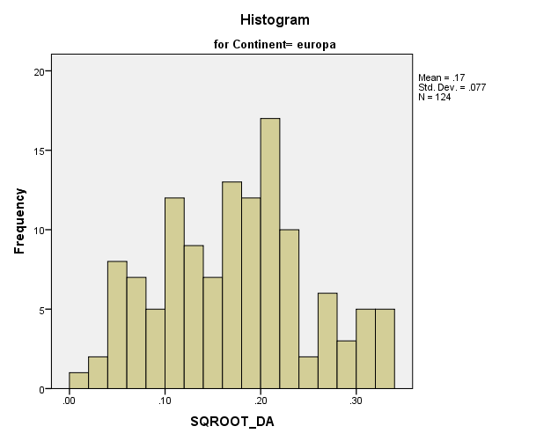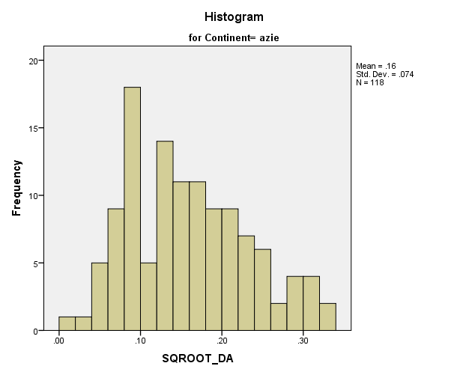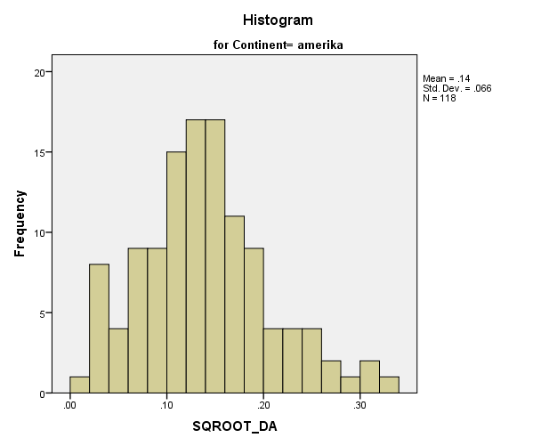

**APPENDIX 8: Analysing the absolute value of discretionary accruals - hypothesis 1: Change in earnings management**

*8.1: Full overview of the Hierarchic regression model 1 and 2 in relation to hypothesis 1*

|  |  |  |  |  |  |  |  |  |
| --- | --- | --- | --- | --- | --- | --- | --- | --- |
| **Model Summaryc** | | | | | | | | |
| Model | | R | R Square | | Adjusted R Square | | Std. Error of the Estimate | |
| 1 | | .256a | .066 | | .052 | | .02339 | |
| 2 | | .277b | .077 | | .055 | | .02335 | |
| a. Predictors: (Constant), EuropaXcrisis, AmericaXcrisis, dEuropa, dAmerica, dCrisis | | | | | | | | | | | |
| b. Predictors: (Constant), EuropaXcrisis, AmericaXcrisis, dEuropa, dAmerica, dCrisis, Control Variables: Leverage, Growth, SIZE FIRM | | | | | | | | | | | |
| c. Dependent Variable: ABS_DA | | | | | | | | | | | |
| **ANOVAa** | | | | | | | | | | | |
| Model | | | | Sum of Squares | | df | | Mean Square | | F | Sig. |
| 1 | Regression | | | .013 | | 5 | | .003 | | 4.881 | .000b |
| Residual | | | .190 | | 348 | | .001 | |  |  |
| Total | | | .204 | | 353 | |  | |  |  |
| 2 | Regression | | | .016 | | 8 | | .002 | | 3.585 | .001c |
| Residual | | | .188 | | 345 | | .001 | |  |  |
| Total | | | .204 | | 353 | |  | |  |  |
| a. Dependent Variable: ABS_DA | | | | | | | | | | | |
| b. Predictors: (Constant), EuropaXcrisis, AmericaXcrisis, dEuropa, dAmerica, dCrisis | | | | | | | | | | | |
| c. Predictors: (Constant), EuropaXcrisis, AmericaXcrisis, dEuropa, dAmerica, dCrisis, Control Variables: Leverage, Growth, SIZE FIRM | | | | | | | | | | | |

|  |  |  |  |  |  |  |  |  |
| --- | --- | --- | --- | --- | --- | --- | --- | --- |
| **Coefficientsa** | | | | | | | | |
| Model | | Unstandardized Coefficients | | Standardized Coefficients | t | Sig. | Collinearity Statistics | |
| B | Std. Error | Beta | Tolerance | VIF |
| 1 | (Constant) | .027 | .003 |  | 9.885 | .000 |  |  |
| dAmerica | -.005 | .004 | -.106 | -1.371 | .171 | .449 | 2.229 |
| dEurope | .012 | .004 | .229 | 2.961 | .003 | .447 | 2.237 |
| dCrisis | .005 | .004 | .100 | 1.100 | .272 | .324 | 3.088 |
| AmericaXcrisis | -.005 | .006 | -.064 | -.720 | .472 | .340 | 2.938 |
| EuropeXcrisis | -.016 | .006 | -.232 | -2.575 | .010 | .332 | 3.014 |
| 2 | (Constant) | .061 | .018 |  | 3.459 | .001 |  |  |
| dAmerica | -.010 | .006 | -.195 | -1.774 | .077 | .223 | 4.494 |
| dEurope | .006 | .006 | .121 | 1.098 | .273 | .220 | 4.552 |
| dCrisis | .005 | .004 | .092 | 1.004 | .316 | .319 | 3.138 |
| AmericaXcrisis | -.004 | .006 | -.063 | -.703 | .482 | .337 | 2.971 |
| EuropeXcrisis | -.016 | .006 | -.232 | -2.576 | .010 | .330 | 3.027 |
| CONTROLE SIZE FIRM | -.002 | .001 | -.156 | -1.818 | .070 | .361 | 2.769 |
| CONTROLE Growth | -.001 | .001 | -.061 | -.985 | .325 | .707 | 1.415 |
| CONTROLE Leverage | .002 | .013 | .008 | .138 | .890 | .833 | 1.200 |
| a. Dependent Variable: ABS_DA | | | | | | | | |

*8.2: Scatterplot and histogram of the dependent variable absolute discretionary accruals which shows normal distribution*

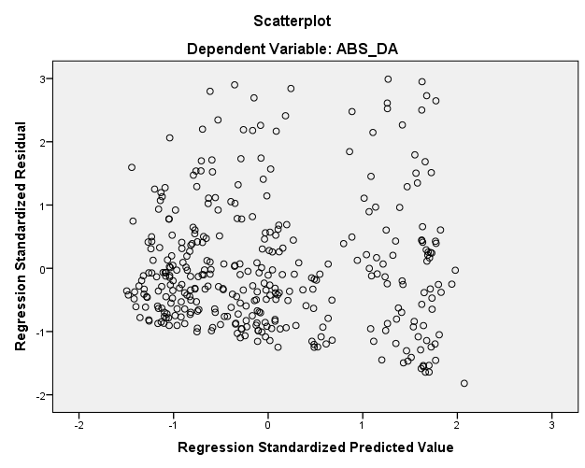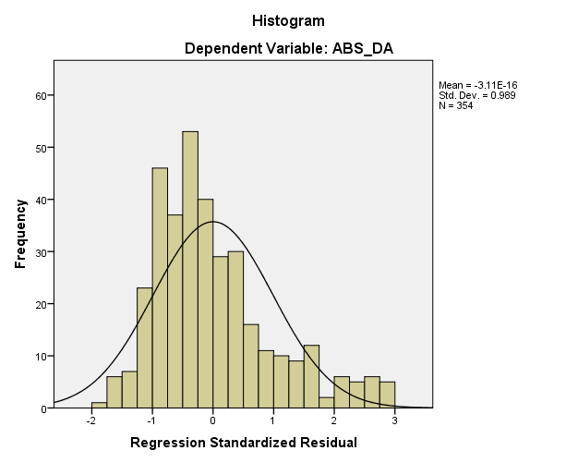

**APPENDIX 9: Analysing the effect of Crisis on the magnitude of discretionary accruals - hypothesis 2: magnitude of earnings management**

*9.1: Full overview of the Hierarchic regression model 1 and 2 in relation to hypothesis 2*

|  |  |  |  |  |
| --- | --- | --- | --- | --- |
| **Model Summaryc** | | | | |
| Model | R | R Square | Adjusted R Square | Std. Error of the Estimate |
| 1 | .131a | .017 | .003 | .0389565 |
| 2 | .363b | .132 | .112 | .0367760 |

1. Predictors: (Constant), EuropaXcrisis, AmericaXcrisis, dEuropa, dAmerica, dCrisis
2. Predictors: (Constant), EuropaXcrisis, AmericaXcrisis, dEuropa, dAmerica, dCrisis,

Control Variables: Leverage, Growth, SIZE FIRM

1. Dependent Variable: Discretionary accruals (DAt)

|  |  |  |  |  |  |  |
| --- | --- | --- | --- | --- | --- | --- |
| **ANOVAa** | | | | | | |
| Model | | Sum of Squares | df | Mean Square | F | Sig. |
| 1 | Regression | .009 | 5 | .002 | 1.239 | .290b |
| Residual | .536 | 353 | .002 |  |  |
| Total | .545 | 358 |  |  |  |
| 2 | Regression | .072 | 8 | .009 | 6.632 | .000c |
| Residual | .473 | 350 | .001 |  |  |
| Total | .545 | 358 |  |  |  |
| 1. Dependent Variable: Discretionary accruals (DAt) | | | | | | |
| 1. Predictors: (Constant), EuropaXcrisis, AmericaXcrisis, dEuropa, dAmerica, dCrisis | | | | | | |
| 1. Predictors: (Constant), EuropaXcrisis, AmericaXcrisis, dEuropa, dAmerica, dCrisis, Control Variables: Leverage, Growth, SIZE FIRM | | | | | | |

|  |  |  |  |  |  |  |  |  |
| --- | --- | --- | --- | --- | --- | --- | --- | --- |
| **Coefficientsa** | | | | | | | | |
| Model | | Unstandardized Coefficients | | Standardized Coefficients | t | Sig. | Collinearity Statistics | |
| B | Std. Error | Beta | Tolerance | VIF |
| 1 | (Constant) | -.004 | .005 |  | -.844 | .399 |  |  |
| dAmerica | -.006 | .007 | -.068 | -.868 | .386 | .448 | 2.232 |
| dEuropa | -.004 | .006 | -.053 | -.669 | .504 | .445 | 2.246 |
| dCrisis | -6.971E-005 | .007 | -.001 | -.009 | .992 | .325 | 3.079 |
| AmericaXcrisis | .001 | .010 | .013 | .141 | .888 | .340 | 2.942 |
| EuropaXcrisis | .015 | .010 | .131 | 1.431 | .153 | .331 | 3.025 |
| 2 | (Constant) | -.068 | .028 |  | -2.469 | .014 |  |  |
| dAmerica | .001 | .009 | .014 | .128 | .899 | .221 | 4.526 |
| dEuropa | .011 | .009 | .131 | 1.226 | .221 | .218 | 4.583 |
| dCrisis | .005 | .007 | .060 | .678 | .498 | .320 | 3.129 |
| AmericaXcrisis | .003 | .010 | .028 | .322 | .747 | .337 | 2.971 |
| EuropaXcrisis | .016 | .010 | .142 | 1.630 | .104 | .329 | 3.039 |
| SIZE FIRM (natural log of total assets) | .005 | .002 | .205 | 2.459 | .014 | .358 | 2.797 |
| CONTROLE Growth (Book to market ratio) | .007 | .002 | .219 | 3.692 | .000 | .705 | 1.418 |
| CONTROLE Leverage (eoy long term debt / eoy total assets) | -.113 | .020 | -.303 | -5.552 | .000 | .832 | 1.202 |
| a. Dependent Variable: Discretionary accruals (DAt) | | | | | | | | |

*9.2: Histogram and Scatterplot of the dependent variable discretionary accruals which shows normal distribution*

