Influence of political ideology on health expenditures per capita
An empirical research and a literature review of the effect of political ideology on health expenditures in the OECD countries during 1960-1990.

Bachelor thesis
My supervisor: Teresa Bago d'Uva
Erasmus School of Economics
Rotterdam
Abstract
In this thesis I propose to analyze the influence of political ideology on the health expenditures per capita across 19 OECD countries in the period 1960-1990. So far, Potrafke is the only person who has analyzed the influence of political ideology on health expenditures. He finds that political ideology has no influence on health expenditures (Potrafke, 2010). I use panel data of the OECD health data set, a data set of the World Bank and a data set of Woldendorp. I draw my main conclusions from a log linear model with time and country fixed effects. Governments with a share of seats of rightwing parties between 1/3 – 2/3 and a share of seats of centre parties between 1/3 – 2/3 spend on average more on health expenditures than governments with another political ideology.

Student Number | Surname | First Name
344524 | Klein | Max

1.Introduction

‘’Then there's the problem of rising cost. We spend one and a half times more per person on health care than any other country, but we aren't any healthier for it.’’
Barack Obama on September 2009 (CBS, 2009).
Why does the United States have a higher health expenditure per person than other countries and are the people in the United States not healthier for this reason? Following Potrafke, the health sector plays a main role in modern policy and the policy responsibilities among health care are extensive (Potrafke, 2010). This raises the question what the influence of a government’s political ideology in the United States on their health expenditures is? Does the same holds in a homogenous sample such as the OECD countries (Gerdtham, Bengt, MacFarlan, & Oxley, 1998)? Do governments with a rightist ideology spend different amounts of money on health care than governments with a leftish ideology? Rightist ideologists are individualists and think that success is a consequence of effort. Leftish ideologists are egalitarians (Domhoff, 2009). So far, Potrafke is the only person who has analyzed the influence of political ideology on health expenditures. He finds that political ideology has no influence on health expenditures (Potrafke, 2010).
The aim of this thesis is to examine the relationship between political ideology and health expenditures. I use data sets of OECD health data set (OECD, 2013), the World Bank (Worldbank, 2013) and the data set of Woldendorp (Woldendorp, Keman, & Budge, 1998) with data from 1960-1990 of the OECD countries. I have formulated a research question for this thesis:

The research question: What is the influence of the political ideology of a government on total health expenditures per capita in the OECD countries?
Hypothesis: Political ideology has no influence on total health expenditures (Potrafke, 2010).

The outline of this thesis is as follows. First, the literature will be discussed in the section Background. In this section the impact of political ideology and control variables on health expenditures will be explained. Second, I discuss the Methodology. In this section the statistical decisions are explained. Third, I describe the data in section Data. Fourth, I discuss the results of my study. Fifth, I answer my research question and draw my conclusions in section Conclusion. Any suggestion for further research will be added in this section.

2.Background
In this thesis I will address the question whether political ideology explains a difference in health expenditure. There is only one study that examines the influence of political ideology on health expenditure (Potrafke, 2010). However, there are other studies that examine the relationship between political ideologies on the population’s health (Navarro, et al., 2006) and the relationship between political ideologies on social expenditure (Potrafke, 2009). The literature on the sources of health expenditure is extensive with the number of potential determinants. From the analysis of the literature, the three major determinants of explaining health expenditure are GDP, population aging content and medical technology (Roberts, 1999) & (Gerdtham, Søgaard, Andersson, & Jönsson, 1992) & (Zweifel, Felder, & Meiers, 1999) & (Getzen, 1992) & (Okunade & Murthy, 2002).

2.1 Politics
Potrafke does not find a significant coefficient of government ideology on the growth of public health expenditure in the period 1971-2004 in 18 OECD countries. Further he indicates that the fall of the Iron Curtain may have had a big impact on the health expenditures in the 1990s (Potrafke, 2010). Most of the European countries went into a recession after this fall, especially the countries whose currencies were pegged to the Deutsche Mark (Potrafke, 2010). This may have resulted in lower health expenditure in these countries. Finally, the influence of political ideology is weaker than in other fields of policy, because health is a different good. Therefore government ideology may not matter in providing public health care. Potrafke found no evidence for the influence of government ideology on health expenditures (Potrafke, 2010).
Navarro researches the effect of political ideologies on population health instead of health expenditures. He concludes that political parties with egalitarian ideologies are related with redistributive policies (Navarro, et al., 2006). Policies which tend to reduce social inequalities have on average a negative effect on infant mortality. Further these policies have a less significant positive effect on life expectancy at birth. So the variable politics have an influence on population health (Navarro, et al., 2006).
Potrafke also researches the impact of political ideologies during the period 1980 until 2003 in OECD countries on social expenditures, so not only health expenditure. Political variables explain a small part of social spending (Potrafke, 2009). Leftist governments spent more on social programs than right wing parties until 1990’s. This relationship completely disappeared in the 1990s. Sometimes it is claimed that globalization restricts governments to implement their favoured policies. Globalization may decrease the power of countries. However, research shows that this is not the case; constraints of government budgets instead of globalization did restrict policies to implement their favoured policies in the 1990s (Potrafke, 2009).
2.2 GDP
Following the literature, GDP is the most important factor in explaining the difference in health expenditure between countries. When GDP increases, the health expenditures may also increase, because a country has more money to spend. In the studies of the impact of GDP on health expenditure, two data structures are used. The first type is cross section data and the second type is panel data.
2.2.1 Cross section, panel data
Cross section data refers to data collected by observing entities at one point in time (Brooks, 2008). Panel data refers to data collected by observing entities through time (Brooks, 2008). A disadvantage of cross section is the smallness of the dataset, because only information between countries is available at the same point in time (Hansen & King, 1996). An advantage of panel data is the use of both cross-section and time series information. So panel data uses a larger sample size (Brooks, 2008).

2.2.2 Cross section
The first researcher who investigates this is Newhouse (Newhouse, 1977). He uses cross section data and concludes that the income elasticity exceeds one (Newhouse, 1977). The income elasticity of health care spending is a measure of how a rise in GDP relates to a rise in health expenditure. When the income elasticity is equal to four, a rise in GDP of ten percent results in a rise in health expenditure of forty percent, ceteris paribus (Investopedia, 2013). This means that income elasticity is an indicator of the influence of income (or GDP) on health expenditures. Newhouse’s conclusion is in line with the research of other researchers, who also use cross section and also conclude that health care expenditure has an income elasticity which exceeds one (Gerdtham, Søgaard, Andersson, & Jönsson, 1992). Parkin uses cross section data, but also uses purchasing power parity conversions and finds an income elasticity of 0.9 (Parkin, McGuire, & Yule, 1987). The purchasing power parity conversion factor is the amount of money people need in the country’s own currency to buy a bundle of goods in the domestic market. The bundle of goods is worth a US dollar in the United States. Using the PPP conversion, people can buy the same amount of goods with an amount of money (WorldBank, 2013).
2.2.3 Panel data
Hitiris and Posnett have investigated the impact of GDP on health expenditure with panel data. They find an income elasticity of 1.16. Hitiris and Posnett use PPP conversions for GDP and health expenditures and in a log linear form (Hitiris & Posnett, 1992), because the slope of GDP and health expenditures is not linear, but exponential (see graph 1 and graph 2 on page 12). The slope of the logarithm of health expenditure and GDP is linear (Brooks, 2008). This is an assumption of OLS (Brooks, 2008). OLS will be discussed in the methodology. Roberts uses also a log linear form and he finds an income elasticity approximately equal to one (Roberts, 1999).

Table 1. Income elasticity of health care spending

 | Cross section | Panel data
Newhouse & Gerdtham | >1
Parkin | 0.9
Hitiris & Posnett |  | 1.16
Roberts |  | ±1

2.3 Aging
Over the last 30 years, the OECD countries experienced a change in the age structure. The relative number of old people has increased. This trend will continue in the future (Zweifel, Felder, & Meiers, 1999). The demand of older people for health care is on average higher than the demand of younger people. Hitiris and Posnett find a significant influence of the proportion of population above 65 years on health expenditures. (Hitiris & Posnett, 1992). Getzen concludes that the health care consumption of older people has been rising faster than that can be accounting for by demographic changes between countries (Getzen, 1992). Still Getzen finds an insignificant influence of population age structure on the health expenditures (Getzen, 1992). There is no influence of the age structure on the health costs, because aging does not affect the total health expenditures but only the allocation of spending. Getzen explains this with the current budgetary limitations. Aging will increase the demand for health care, but governments have limitations to reach these demand curves with extra health expenditures (Getzen, 1992). So therefore the effect of aging is too small to be significant. Without these budget limitations, there would be a higher positive relationship between aging and health expenditures per capita (Getzen, 1992). Furthermore health care expenditures depend more on remaining time to death than age. So the high health expenditures shift to higher age due to a rise in life expectancy (Zweifel, Felder, & Meiers, 1999).
Aging will be a greater problem in the future. Public health systems in the OECD countries have to be reformed in the future to maintain the regular care. Left wing parties may have different solutions for this problem than right wing policies (Potrafke, 2010).

2.4 Medical technology
Medical technology can result in more health expenditures by new technologies or by intensity of use of current technology or by an extended application through an improvement of quality over the predecessor (Gelijns & Rosenberg, 1994). The benefit of a technology change may result in a change of an untreatable in a treatable condition. So in that way a patient may get medical care which helps the patient to get better. This shift will bring extra health care costs (Weisbrod, 1991). The effect of medical technology is however ambiguous. Medical technology could increase, but also decrease the total health expenditures (Ligthart, 2007). First, medical technology decreases the total health expenditures when the new technology results in a higher productivity (Ligthart, 2007). Second, medical technology increases the total health expenditures when the new technology has higher benefits and costs than the current technology (Evans, 1985). Okunade and Murthy did research the influence of medical technology on the health expenditure. They found a positive relationship in the United States in the period 1960–1997 (Okunade & Murthy, 2002).

3.Methodology
In this section I will introduce the model. I will start with the representation and interpretation of the model. Second, I will explain a panel data model. A panel has multiple variables for different entities and over several periods in time. Third, I will describe the use of fixed effects with panel data models. Then I will introduce the adjusted R squared. I will use the adjusted R squared to select the favourite model.
3.1 The linear regression model
In an economic study we start with data. These data are described by two types of variables. The first type is het dependent variable, denoted as y. The second type is the independent variable, which is denoted as x. The independent variable explains the rise in the dependent variable (Brooks, 2008). This linear relation between x and y is given by the correlation. A correlation near 1 means that there is a high linear relation between the dependent and independent variable. A correlation of zero means that there is no relation between the dependent and independent variable (Brooks, 2008).
Normally, the dependent variable depends on more independent variables. It is possible to summarise this in a model. In case of a linear relationship between the dependent and independent variables, it is a regression model (see figure 1), where $α$ is the intercept, $x$ the independent variable and $β$ the slope of the independent variable.
Eq 1:
$$y= α+ βx+u$$
$α$ and $βx$cannot fit the data perfectly. Therefore a disturbance term ($u$) is added. $α$ and $β$ are chosen so that the distances from the data points to the fitted lines are minimised. The line fits the data as closely as possible. The most common method used to fit a line to the data points is known as ordinary least squares (OLS). OLS takes each vertical distance from the data point to the line, squaring it and minimising the total distance. The estimators $α$ and $β$ determined by OLS have a number of desired properties, which are known as Best linear unbiased estimators. First, the estimators $α$ and $β$ are linear combinations of $y$. Second, the estimators $α$and $β$ have to be on average equal to their true values, which is called unbiased. It requires the assumption of exogeneity. This means that the independent variables are not correlated with the error terms. Third, the OLS estimator for $β$is efficient, which means that $β$has the lowest variance.
3.2 Panel data model
A panel has multiple variables for different entities and over several periods in time. Panel data models are models in which there is a correlation both across time and between cross sectional entities (see equation 2) (Brooks, 2008).
Eq 2:
$y$_{it} = $α$ + $βx$_{i,t} + $u$_{i,t}
$u$_{i,t} contains an individual specific error term m_{i} and a time specific error term t_{t.}
3.3 Log-log model
In order to use a linear panel data model, the relationship between the dependent and independent variables has to be linear (Brooks, 2008). The slope of health expenditure and GDP is exponential. This means that there is no linear relationship between the dependent and independent variables. The equation of the model may be then written in a log-log form (Gerdtham, Bengt, MacFarlan, & Oxley, 1998). This means that the dependent variable and at least one independent variable are logarithms. This results in a linear relationship between the dependent and independent variables. Then the assumption of linearity is fulfilled (Brooks, 2008).
3.4 Fixed effect models
It could be useful to use fixed effects for panel data models (Brooks, 2008). Fixed effects are required, when unobservable (and omitted) independent variables are correlated with variables that are included in the regression. This causes omitted variable bias. This means that the effect of the omitted variables are incorporated in the error terms. When the omitted variables are correlated with the independent variables, the independent variables are also correlated with the error term (Kim, 2012). The OLS estimates are not unbiased anymore, because the exogeneity assumption has not been satisfied (Kim, 2012). Fixed effects eliminate the omitted variable bias (Blumenstock, 2013). With cross section fixed effects there is controlled for the unobserved country’s specific effect (Brooks, 2008). With time fixed effects there is controlled for the unobserved time specific effect (Brooks, 2008). It is also possible to use both time and cross section fixed effects (Brooks, 2008).

3.5 Adjusted R squared
The adjusted R squared is a measure for how much of the variation of the dependent variable is explained by the model (Brooks, 2008). The values of R squared are between 0 and 1. A high R square means that a high part of the variation of the dependent variable is explained by the model. So a model with a high R squared is recommendable. R squared never decreases if more explanatory variables are added to the model (Brooks, 2008). When there are more variables added to a model, the adjusted R squared can decrease. The adjusted R squared change depends on whether the including of an extra variable adds explanatory power to the model. I will use the adjusted R squared to select the favourite model (Brooks, 2008).
Data

First, I will extract two data sets with time periods 1960-1990 from the OECD health data set (OECD, 2013). Second, I will extract data with a time period 1960-1990 from the data set of the World Bank (Worldbank, 2013). Third, I will extract data with a time period 1960-1990 from the data set of Woldendorp (Woldendorp, Keman, & Budge, 1998). The time range I use is the period from January 1960 till 1995. This is because most writers of the scientific papers concerning the impact of variables on health expenditures use a data set from 1960 up to the latest year possible. Year 1995 is the latest year possible in Woldendorp’s data set. However there are too many missing observations in the period 1991-1995 for the variable political ideology (Woldendorp, Keman, & Budge, 1998). Therefore the time period is from 1960-1990.
The total data set covers 19 OECD countries. This set contains the countries: Australia, Austria, Belgium, Canada, Denmark, Finland, France, Germany, Iceland, Ireland, Israel, Italy, Japan, The Netherlands, New Zealand, Norway, Sweden, Switzerland and the United Kingdom. (Woldendorp, Keman, & Budge, 1998).
The dataset consists of the variables health expenditures, political ideology, GDP and aging. The health expenditure values are extracted from the OECD data set (OECD, 2013). The average value is 1429 dollar per capita (see table 2). Education and training of health personnel, research and development in health, food, hygiene and drinking water control, environmental health and administration costs are excluded from the total health expenditures in the OECD health data set (OECD, 2013).
Also GDP values are extracted from the OECD data set (OECD, 2013). The average value is 810404 dollar per capita. The correlation between GDP and health expenditures is 0.154.
The variables health expenditures and GDP are measured per capita to observe the relative differences between countries (Getzen, 1992) (Roberts, 1999). In this way it is possible to compare for instance the United Kingdom (a country with relatively many residents) with the Netherlands (a country with relatively few residents). Otherwise not the relative difference in health expenditures is measured, but the absolute difference. Further the health expenditures and GDP have to be converted into US dollars by purchasing power parities (PPPs). In addition, the health expenditures and GDP have to be measured in constant prices, because of inflation effects. Inflation results in higher health expenditures, ceteris paribus (when circumstances remain the same). Current PPPs use the latest benchmark information, so therefore current PPPs have to be used for comparisons between countries at a particular time moment (esds, 2013). However constant PPPs have to be used when countries will be compared over time, because the base does not change over time (esds, 2013). In this paper time series will be used, so therefore health expenditures and GDP are measured in constant prices. In the OECD health data set the base year has to be chosen. The writers of the scientific papers use the latest base year (Getzen, 1992) (Roberts, 1999) (Okunade, Karakus, & Okeke, 2004). So therefore 2005 is the base year in this thesis, because 2005 is the latest base year of the OECD health data set.
The proportion of people with an age of 65 and above as a percentage of the total population is a measure for aging in a country (Getzen, 1992) (Roberts, 1999). The observations which regards to aging are extracted from The World Bank website (Worldbank, 2013). The average value is 11.96. There is not an obvious slope. One remarkable thing is that it seems that the increasing slope stopped after 1980 and it increasing slope continues in 1985 (see graph 3). The correlation between aging and health expenditures is 0.7941.
In this research, the main purpose is to reach a conclusion regarding the impact of political ideology on the height of the health expenditure. Woldendorp and his cowriters have given a number between 1 and 5 of each government of nearly all the OECD countries in the period from 1945 until 1990. Political complexion of parliament and government is the name of the measure in Woldendorp’s paper (Woldendorp, Keman, & Budge, 1998). Table 4 presents the structure of political complexion in to values 1 -5. If a government has value 1, the share of seats of rightwing parties in Government and their supporting parties in Parliament is larger than 2/3 of the total seats. If a government has value 2, the share of seats of rightwing parties is between 1/3 and 2/3 and the share of centre parties is also between 1/3 and 2/3 (Woldendorp, Keman, & Budge, 1998). The average value is 2.30. The correlation between political ideology and health expenditures is 0.0208 (see table 2). Table 3 presents the time period of the observations of political ideology across the countries. Every country has a time range of observations from 1960 till at least 1991.
If the government changed in one year, there will be a weighted average of the numerical values, calculated by days. For example, there is one government with value 1 which runs the country for 300 days in a year and there is one government with value 3 which runs the country for the other 65 days in the same year. Then the value for that year is 300/365*1+65/365*3=1,356. However, in this thesis the values between numerical values will be rounded off on 1,2,3,4 and 5. Therefore 1,356 will be rounded off on 1. (Woldendorp, Keman, & Budge, 1998). The dataset of this paper is used by many other scientific papers. It has been quoted 148 times on Google Scholar (Belke & Potrafke, 2012) & (Bejar, Mukherja, & Moore, 2011).
Table 2. Descriptive statistics

 | Mean with dataset of all countries | Correlation with health care expenditures in dataset with all countries | Number of all observations
Health care expenditures | 1429,346 | 1 | 424
Political ideology | 2,29771 | 0,020846 | 424
GDP | 810404,3 | 0,153689 | 424
Aging | 11,96118 | 0,794091 | 424

*If a variable has no missing observations, the number of observations is 717.

Table 3. Time period of observations of the variables
Countries | Time period of observations  Political ideology | Time period of observations Health expenditures | Time period of observations of GDP | Time period of observations of aging
Australia | 1960-1990 | 1960-1990 | 1960-1990 | 1960-1990
Austria | 1960-1990 | 1960-1990 | 1970-1990 | 1960-1990
Belgium | 1960-1990 | 1970-1990 | 1970-1990 | 1960-1990
Canada | 1960-1990 | 1960-1990 | 1970-1990 | 1960-1990
Denmark | 1960-1990 | 1971-1990 | 1966-1990 | 1960-1990
Finland | 1960-1990 | 1960-1990 | 1970-1990 | 1960-1990
France | 1960-1990 | 1960-1990 | 1960-1990 | 1960-1990
Germany | 1960-1990 | 1970-1990 | 1970-1990 | 1960-1990
Iceland | 1960-1990 | 1960-1990 | 1970-1990 | 1960-1990
Ireland | 1960-1990 | 1960-1990 | 1970-1990 | 1960-1990
Israel | 1960-1990 | 1977-1990 | 1970-1990 | 1960-1990
Italy | 1960-1990 | 1988-1990 | 1970-1990 | 1960-1990
Japan | 1960-1990 | 1960-1990 | 1970-1990 | 1960-1990
Netherlands | 1960-1990 | 1972-1990 | 1969-1990 | 1960-1990
New Zealand | 1960-1990 | 1970-1990 | 1970-1990 | 1960-1990
Norway | 1960-1990 | 1960-1990 | 1970-1990 | 1960-1990
Sweden | 1960-1990 | 1970-1990 | 1960-1990 | 1960-1990
Switzerland | 1960-1990 | 1960-1990 | 1970-1990 | 1960-1990
United Kingdom | 1960-1990 | 1960-1990 | 1970-1990 | 1960-1990

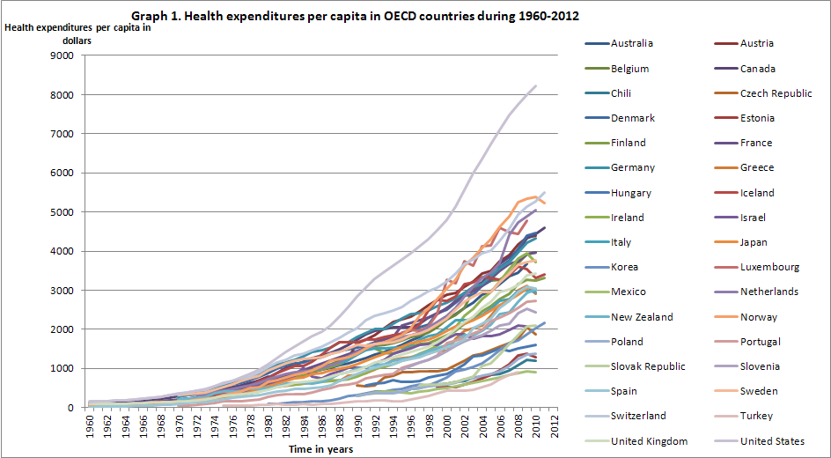
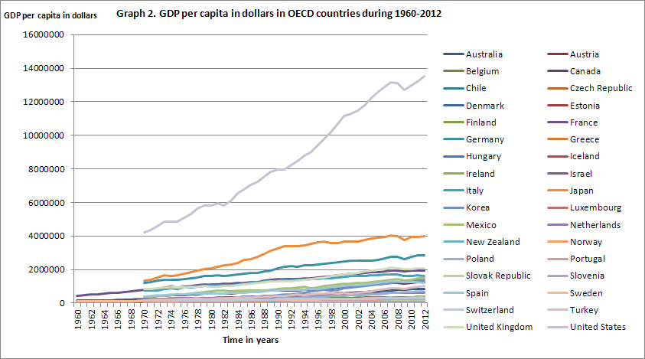
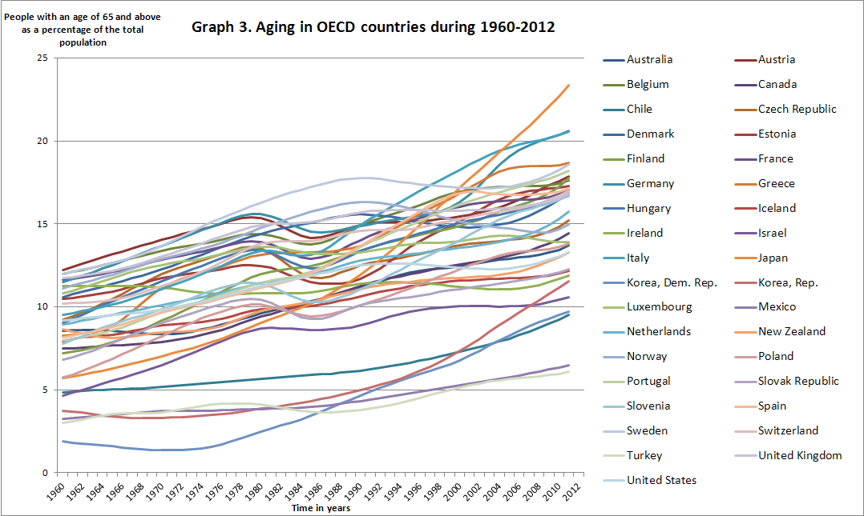

Table 4. Structure of political complexion of parliament and government (Woldendorp, Keman, & Budge, 1998).

 | Share of seats of rightwing parties in Government and their supporting parties in Parliament | Share of seats of leftwing parties in Government and their supporting parties in Parliament | Share of seats of centre parties in Government and their supporting parties in Parliament | Share of seats of centre parties in Government and their supporting parties in Parliament or share of seats of right and left parties together not dominated by one side or the other
1 right-wing dominance | Larger than 2/3 | Less than 1/3 | Less than 1/3 | Less than 1/3
2 right-centre complexion | Between 1/3 and 2/3 | Less than 1/3 | Between 1/3 and 2/3 | Less than 1/3
3 balanced situation | Less than 1/2 | Less than 1/2 | Less than 1/2 | Larger than 1/2
4 left-centre complexion | Less than 1/3 | Between 1/3 and 2/3 | Between 1/3 and 2/3 | Less than 1/3
5 left-wing dominance | Less than 1/3 | Larger than 2/3 | Less than 1/3 | Less than 1/3

5.Results
In this section I will discuss the results of my empirical research. First, I will discuss the different models I use. Second, I will present the outcome of the regressions. I will discuss what my favourite model is. Third, I will discuss the outcome of my favourite model.
In this empirical research I use four different regression models. First, I use a linear regression model. In this model the logarithm of health expenditures is the dependent variable. The model consists of an intercept ($α)$, four dummy variables of the variable political ideology, the logarithm of the variable GDP, the variable aging and an error term ($u$_{it}) (see eq3). The $βs$ are the coefficients of the independent variables and the $δs$ are the coefficients of the dummy variables of the variable political ideology (Gerdtham, Bengt, MacFarlan, & Oxley, 1998). Second, I use a time fixed effect model (see eq 4). The time fixed effect ($\sum^{30}{t}$_{t}*D_{t} ) is added to the model. D_{t} is the dummy for the time fixed effects. The dummy D_{t} takes the value one for all observations on the first year, the value two for all observations on the second year, etc. t_{t} is the coefficient of the time fixed effect dummy (Gerdtham, Bengt, MacFarlan, & Oxley, 1998). Third, I use a country fixed effect model (see eq 5). The country fixed effect ($\sum^{19}{m}$_{i}*D_{i} ) is added to the model. The dummy D_{i} takes the value one for all observations on the first country, value two for all observations on the second country, etc. m_{i} is the coefficient of the country fixed effect dummy (Gerdtham, Bengt, MacFarlan, & Oxley, 1998). Fourth, I use a model with both time and country fixed effects (see eq 6). The time fixed effect and the country fixed effect are added to the model (Gerdtham, Bengt, MacFarlan, & Oxley, 1998).

Eq 3:
$Log(Healthexp$_{i,t}) = $α$ + $δ$₁$DPol$2_{it} + $δ$₂$DPol$3_{it} + $δ$₃$DPol$4_{it} + $δ$₄$DPol$5_{it} +$β$₁$Log(GDP)$_{it} + $β$₂$Aging$_{it} + $u$_{it}
Eq 4:
$Log(Healthexp$_{i,t}) = $α$ + $\sum^{30}{t}$_{t}*D_{t +}$δ$₁$DPol$2_{it} + $δ$₂$DPol$3_{it} + $δ$₃$DPol$4_{it} + $δ$₄$DPol$5_{it} +$β$₁$Log(GDP)$_{it} + $β$₂$Aging$_{it} + $u$_{it}
Eq 5:
$Log(Healthexp$_{i,t}) = $α$ + $\sum^{19}{m}$_{i}*D_{i +}$δ$₁$DPol$2_{it} + $δ$₂$DPol$3_{it} + $δ$₃$DPol$4_{it} + $δ$₄$DPol$5_{it} +$β$₁$Log(GDP)$_{it} + $β$₂$Aging$_{it} + $u$_{it}
Eq 6:
$Log(Healthexp$_{i,t}) = $α$ + $\sum^{19}{m}$_{i}*D_{i} + $\sum^{30}{t}$_{t}*D_{t +}$δ$₁$DPol$2_{it} + $δ$₂$DPol$3_{it} + $δ$₃$DPol$4_{it} + $δ$₄$DPol$5_{it} +$β$₁$Log(GDP)$_{it} + $β$₂$Aging$_{it} + $u$_{it}
Table 6 presents the outcome of four regressions. The first regression is a linear regression. The fourth and fifth dummy of political ideology have a significant coefficient in the linear regression. These coefficients have a negative sign. The coefficient of the fourth dummy is more negative than the fifth dummy. Furthermore the variable aging is significant. Aging has a positive sign. The value of the adjusted R squared is 0,2054. This means that 20,54 percent of the variation of the dependent variable is explained by the model.
The second regression includes the time fixed effect. Now the second and fourth dummies of the variable are significant and positive. The coefficient of the variable aging is again positive and significant. The adjusted R squared is 0,8856.
The third regression includes the country fixed effect. The third, fourth and fifth dummy of the variable political ideology are significant and negative. The fourth dummy is more negative than the third dummy but less negative than the fifth dummy. Furthermore aging and the logarithm of GDP are significant and positive. The adjusted R squared is 0,9332.
The fourth regression includes both time and country fixed effects. Only the second dummy of the variable political ideology is significant. The sign of the dummy is positive. Furthermore the coefficient of variable GDP is significant. However the coefficient of GDP is less positive than in the third regression. Besides the coefficient of aging is not significant. The adjusted R squared is 0,9865.
When I compare the linear regression model with the time fixed effect model, I can see a change. The time fixed effect changes the effect of the political dummies from highly significant dummies in to less significant dummies. So it seems that there are unobserved time effects that are correlated with political ideology and with health expenditures. This can bias the results. Therefore it is recommendable to include time fixed effects in the model. The time fixed effects eliminate the unobserved time’s specific effect.
When I include country fixed effects, the coefficient of GDP increases. Furthermore the coefficient of GDP becomes significant. It seems that there are unobserved country effects that are correlated with GDP and health expenditures. There is a high variation between countries in the average political ideology over the years (see table 7). This can bias the results. A solution for this problem of bias is to include country fixed effects in the model. The country fixed effect eliminates the unobserved country’s specific effect.
The R squared of the fixed effects models are higher than the linear regression. Therefore models with fixed effects seem to fit the data better. The coefficient of GDP is significant in the third (country fixed effect) and the fourth regression (both time and country fixed effects). Earlier writers concludes a significant influence of GDP on health expenditures with a magnitude around unity. With respect to the effect of GDP, the outcome of the fourth model is therefore more in line with what I could expect from previous literature. The model with both time and country fixed effects is for these reasons my favourite model. Therefore I draw my main conclusion from the last model.
The coefficients of the third, fourth and fifth dummies of the variable political ideology are not significant. This means that there is not enough evidence that the health expenditures of a government with a value 3,4 or 5 has different health expenditures than a government with a value 1 for political ideology. Only the second dummy of the variable political ideology is significant. The magnitude of the coefficient is 0,05936. This means that if the second dummy has value 1, and the other variables remain the same, the health expenditures increase with 5,936% compared to the health expenditures of a government with a value of 1,3,4,5. The coefficient of the logarithm of GDP is 0,76787 and is significant. This means that if GDP per capita increases with 1%, and the other variables remain constant, then the health expenditures per capita increase with 0,7679% increase in health expenditures.

Table 6. Regression outputs
Variables | Linear regression | Time fixed effect | Country fixed effect | Both time and country fixed effects
Log(GDP) | 0,010876 | 0,000551 | 2,551534*** | 0,76787***
Aging | 0,1298*** | 0,03149*** | 0,10877*** | -0,01293
Dummypolitics2 | 0,09677 | 0,16469*** | -0,007911 | 0,05936***
Dummypolitics3 | -0,0149 | -0,008298 | -0,076030** | 0,015956
Dummypolitics4 | -0,3817*** | 0,11015** | -0,13359*** | 0,003812
Dummypolitics5 | -0,2942*** | 0,01349 | -0,1478*** | -0,002154
Constant | 4,8640*** | 6,1329*** | -25,888*** | -2,6663***
Adjusted R^2 | 0,2054 | 0,8856 | 0,9332 | 0,9865
The dependent variable is the logarithm of health expenditures
* p-value <0,1; ** p-value <0,05; ***p-value<0,01

Table 7. Average political ideology in time of all countries
country | Average political ideology
Australia | 2,594
Austria | 3,551
Belgium | 2,320
Canada | 1
Denmark | 2,955
Finland | 2,701
France | 1,998
Germany | 2,314
Iceland | 2,384
Ireland | 1,319
Israel | 3,082
Italy | 1,714
Japan | 1,084
Netherlands | 1,662
New Zealand | 2,131
Norway | 3,493
Sweden | 4,030
Switzerland | 2
United Kingdom | 2,355

6. Conclusion
The health sector plays a main role in modern policy and the policy responsibilities among health care are extensive (Potrafke, 2010). This raises the question what the influence is of a government’s political ideology on their health expenditures. Rightist ideologists are individualists and leftish ideologists are egalitarians (Domhoff, 2009). Do governments with a rightist ideology spend different amounts of money on health care than governments with a leftish ideology? So far, Potrafke is the only person who has analyzed the influence of political ideology on health expenditures. He has researched 18 OECD countries in the time period from 1971-2004. He finds that political ideology has no influence on health expenditures (Potrafke, 2010). Following the literature, GDP is the most important factor in explaining the difference in health expenditures between countries. The influence of GDP on health expenditures is positive and around unity. The influence of aging on health expenditures is not clear. Hitiris and Posnett find a significant influence of the proportion of population above 65 years on health expenditures. (Hitiris & Posnett, 1992). However Getzen finds an insignificant influence of population age structure on the health expenditures (Getzen, 1992). Okunade and Murthy find a positive influence of medical technology on the health expenditure in the United States in the period 1960-1997 (Okunade & Murthy, 2002).
In this thesis I have proposed to analyze the influence of political ideology on the health expenditures per capita across 19 OECD countries in the period 1960-1990. Aging and GDP were my control variables. I made regressions with different models, including the linear regression model, a model with cross section fixed effects, a model with time fixed effects and a model with both cross section fixed and time fixed effects. Earlier writers concludes a significant influence of GDP on health expenditures with a magnitude around unity. With respect to the effect of GDP, the outcome of the model with both fixed cross section and fixed time effects is therefore most in line with what I could expect from previous literature. Besides the adjusted R squared was the highest for this model. Excluding fixed effects could results in biased outcomes. First, with cross section fixed effects there is controlled for the unobserved country’s specific effect. Second, with time fixed effects there is controlled for the unobserved time specific effect (Brooks, 2008). The model with both time fixed and cross section fixed effects is therefore the model from which I draw my conclusions. Political ideology has influence on the total health expenditures per capita. Governments with a value of two for political ideology spend on average 5,936% more on health expenditures than governments with a different political ideology. A government with a value two for political ideology means a government with a share of seats of rightwing parties between 1/3 - 2/3 and also a share of seats of centre parties between 1/3-2/3. Also GDP has an influence on the health expenditures. GDP has a positive effect on health expenditure. Furthermore there is not enough proof that aging has an influence on health expenditure.
In this thesis I researched the effect of political ideology on health expenditures in the time period 1960-1990. It is interesting to research the effect of political ideology on health expenditures for the same countries in a time period from 1990-2012. Perhaps the influence of political ideology has changed the last decade. The financial crisis may influence decisions politicians make among health care expenditures.

Bibliography
Bejar, S., Mukherja, B., & Moore, W. H. (2011). Time horizons matter: the hazard rate of coalition governments and the size of government. Economics of Governance, pp. 201-235.
Belke, A., & Potrafke, N. (2012). Does government ideology matter in monetary policy? A panel data analysis for OECD countries. Journal of International Money and Finance, pp. 1126-1139.
Blumenstock, J. (2013). Mgmt 469 fixed effect models. Retrieved from jblumenstock.com: http://www.jblumenstock.com/files/courses/econ174/FEModels.pdf
Brooks, C. (2008). Introductory econometrics for finance. Cambridge University Press .
CBS. (2009, september 10). Transcript: Obama's health care speach. Retrieved from Cbsnews : www.cbsnews.com
Domhoff, G. (2009, june). The Left and the Right in Thinking, Personality, and Politics. Retrieved from who rules america?: http://www2.ucsc.edu/whorulesamerica/change/left_and_right.html
esds. (2013). 2.5.6 Purchasing Power Parity Exchange Rates . Retrieved from esds: http://www.esds.ac.uk/international/elearning/limmd/materials/LIMMD-unit2/page3-5-6.html
Evans, R. G. (1985). Illusions of necessity: evading responsibility for choice in health care. Journal of health politics, policy and law, pp. 439-467.
Gelijns, A., & Rosenberg, N. (1994). The dynamics of technological change in medicine. Health Affairs, pp. 28-46.
Gerdtham, U.-G., Bengt, J., MacFarlan, M., & Oxley, H. (1998). The determinants of health expenditure in the OECD countries: a pooled data analysis. Developments in health economics and public policy, pp. 113-134.
Gerdtham, U.-G., Søgaard, J., Andersson, F., & Jönsson, B. (1992). An econometric analysis of health care expenditure: A cross-section study of the OECD countries. Journal of health economics, pp. 63-84.
Getzen, T. E. (1992). Population aging and the growth of health expenditures. Journal of gerontology: social sciences, pp. 98-104.
Hansen, P., & King, A. (1996). The determinants of health care expenditure: a cointegration approach. Journal of health economics, pp. 127-137.
Hitiris, T., & Posnett, J. (1992). The determinants and effects of health expenditure in developed countries. Journal of health economics, pp. 173-181.
Investopedia. (2013). Income Elasticity Of Demand. Retrieved from investopedia: http://www.investopedia.com/terms/i/incomeelasticityofdemand.asp
Kim, H. (2012). Lecture note 8 Panel Data. Retrieved from econ.umn.edu: http://www.econ.umn.edu/~kimx1395/econ4211_fall2012/note4211_8.pdf
Kittel, B., & Obinger, H. (2003). Political parties, institutions, and the dynamics of social expenditure in times of austerity. Journal of European public policy, pp. 20-45.
Ligthart, M. (2007). Determinanten van de gezondheidszorguitgaven. Een analyse op basis van paneldata. CPB, 1-27.
Navarro, V., Muntaner, C., Benach, J., Quiroga, Á., Rodríguez-Sanz, M., Vergés, N., & Pasarin, M. I. (2006). Politics and health outcomes. Lancet, pp. 1033-1037.
Newhouse, J. P. (1977). Medical-care expenditure: a cross-national survey. The journal of human resources, 115-125.
OECD. (2013). Retrieved from OECD statistics: http://stats.oecd.org/Index.aspx?DataSetCode=SHA#
OECD. (2013). About the OECD. Retrieved from OECD website: http://www.oecd.org/
Okunade, A. A., & Murthy, V. N. (2002). Technology as a 'major driver' of health care costs: a cointegration analysis of the Newhouse conjecture. Journal of health economics, pp. 147-159.
Okunade, A. A., Karakus, M. C., & Okeke, C. (2004). Determinants of health expenditure growth of the OECD countries. Jackknife resampling plan estimates. Health care management science, pp. 173-183.
Parkin, D., McGuire, A., & Yule, B. (1987). Aggregate health care expenditures and national income. Is health care a luxury good? Journal of health economics, pp. 109-127.
Potrafke, N. (2009). Did globalization restrict partisan politics? An empirical evaluation of social expenditures in a panel of OECD countries. Public choice, pp. 105-124.
Potrafke, N. (2010). The growth of public health expenditures in OECD countries: do government ideology and electoral motives matter? Journal of health economics, pp. 797-810.
Roberts, J. (1999). Sensitivity of elasticity estimates for OECD health care spending: analysis of a dynamic heterogenous data field. Health economics, pp. 459-472.
Weisbrod, B. A. (1991, jun). The health care quadrilemma: an essay on technological change, insurance, quality of care and cost containment. Journal of economic literature, pp. 523-552.
Woldendorp, J., Keman, H., & Budge, I. (1998). Party government in 20 democracies: an update (1990-1995). European journal of political research, pp. 125-164.
Worldbank. (2013). Population ages 65 and above (% of total). Retrieved from World Bank: http://data.worldbank.org/indicator/SP.POP.65UP.TO.ZS/countries
WorldBank. (2013). PPP conversion factor, GDP (LCU per international $). Retrieved from World Bank: http://data.worldbank.org/indicator/PA.NUS.PPP
Zweifel, P., Felder, S., & Meiers, M. (1999). Ageing of population and health care expenditure: a red herring? Health economics, pp. 485-496.

The OECD is an organisation with the goal to stimulate economic and social well-being of people around the world (OECD, 2013).
I was also considered using a selection of countries. I made this selection based on the selection of countries used by previous writers concerning the impact of variables on health expenditure. However these writers do not give a justification for their selection. Furthermore, the selection of countries does not make a difference for the results of this thesis.
I was also considered using the variable medical technology. Previous writers often use this variable for explaining health expenditure. However there are too many missing observations for the variable medical technology. Besides, for the results it does not make a difference if medical technology is included in the model.
HC.1 – HC.9 and HC.R.1 is the code for the total health expenditures in the OECD health data set (OECD, 2013).
These references are examples of articles where the data set of Woldendorp has been used.

