“Under 18 and a Sexual Being?”

Knowledge and Attitudes on Sexuality and Relationships: Adolescents in Boarding Schools in Ghana
A Research Paper presented by:
Genevieve Partington
(Ghana)
in partial fulfilment of the requirements for obtaining the degree of
MASTER OF ARTS IN DEVELOPMENT STUDIES

Major:
Human Rights, Gender & Conflict Studies: Social Justice Perspectives
(SJP)
Specialization:
Women and Gender Studies

Members of the Examining Committee:
Dr. Loes Keysers
Dr. Silke Heumann

The Hague, The Netherlands
December 2013
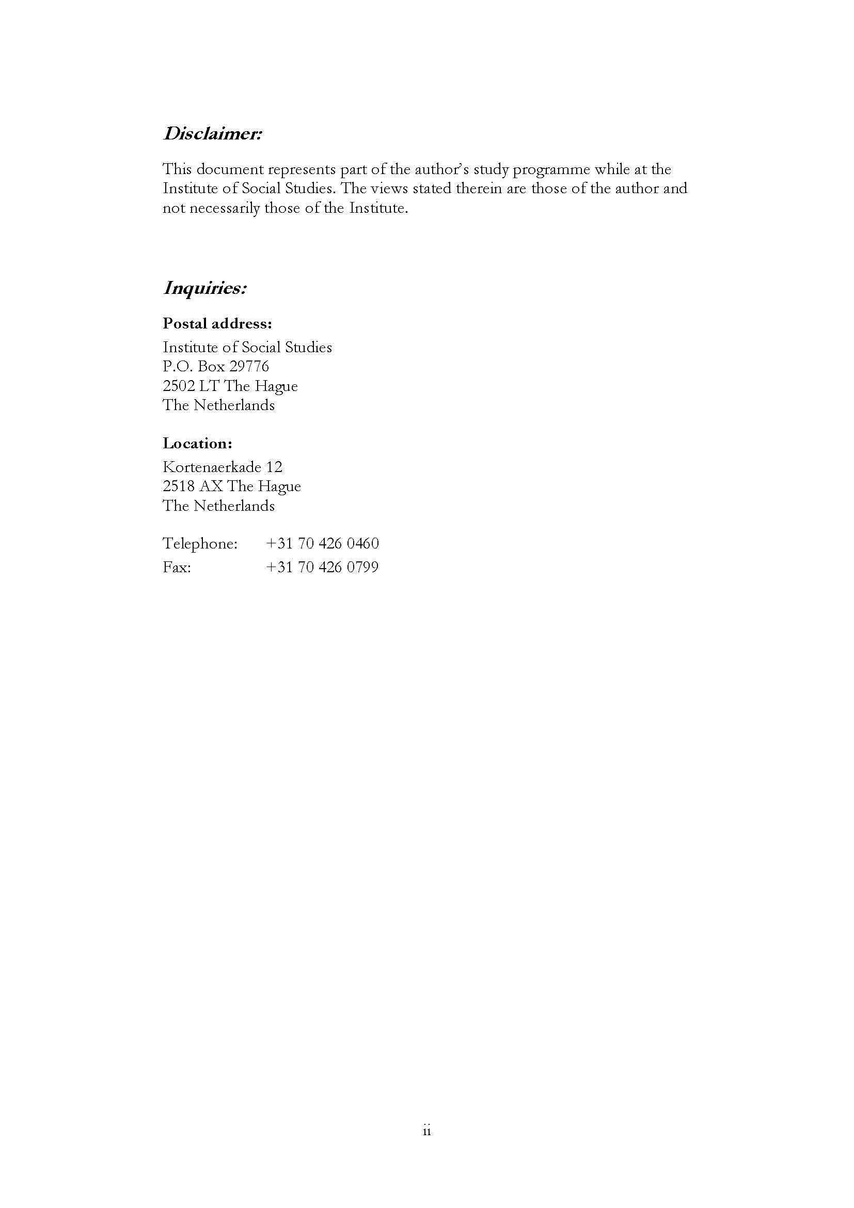
December 2013
Contents
List of Tables v
List of Figures v
List of Maps v
List of Appendices v
List of Acronyms vii
Acknowledgements viii
Abstract ix
Chapter 1 Introduction 1
1.1 Statement of the Research Problem 1
1.2 Contextual Background 2
1.3 Research Objectives 4
1.4 Research Questions 4
1.5 Methodological Strategies, Methods of Data Collection and Analysis 5
Primary Data Collection 7
Secondary Data / Literature Review 11
1.6 Ethical Considerations 13
1.7 Scope and Limitations of the Research 13
1.8 Organization of the Paper 15
Chapter 2 Conceptual Framework 16
2.1 Introduction 16
2.2 Conceptualising Sexuality, Locating Gender and Locating the Body 16
2.3 Hegemonic Norms: Seeing Through the Cracks 18
The Double Standards in Sexuality 18
Hetero-normativity 20
2.4 The Ecological Model in Gendered Sexual Behaviour in Adolescents 23
Chapter 3 Background on Research :Adolescents and Sexuality 25
3.1 Introduction 25
3.2 Context of Adolescents in Ghana/ The Ghanaian Setting 25
3.3 The Research Journey 26
Chapter 4 Findings 29
4.1 Introduction 29
4.2 Prioritisation of Abstinence Message in Ghana’s Sex Education Programme 29
4.3 Comparison Between What is Taught in Sex Education and the Reality on the Ground 31
4.4 The Bedroom Politics of Phone Sex 32
4.5 The Irony of Counselling Practices in High Schools 33
4.6 Can I Be in a Relationship at This Age? 33
4.7 The Colloquialism of Straight Talk 35
Chapter 5 Conclusion 39
5.1 Introduction 39
5.2 Synthesis of Research and Reflections 39
5.3 Policy Recommendations 40
5.4 Suggestions for Further Research 41
References 42
Appendices 46

List of Tables
Table 1.1 Fertility Indicators in Ghana in 1998 and 2003 2
Table 1.3 Codes for focus group discussions in three boarding schools in Ghana 7
Table 1.4 Codes for one-on-one interviews in three boarding schools in Ghana 7
List of Figures
Figure 2.1Household-based Survey- Project on Protecting the Next Generation: Understanding HIV Risk among Youth: Understanding Parent communication 17
Figure 2.2 The Sex Hierarchy: the charmed circle vs. the outer limits Rubin Gayle 1984 22
Figure 2.3 What influences an adolescent’s knowledge and attitudes towards sexuality and relationships in Ghana? 23
Figure 4.1 Game on 'What is sex?' some responses from an all-boys school 36
List of Maps
Map 1.1 Ghana, Central Region, Cape Coast 5
Map 1.2 Central Region of Ghana 6
List of Appendices
Appendix 1 Definitions used in the study 46
Appendix 2 Thirty one-on-one interviews conducted, number of interviews in each school 47
Appendix 3 Form of consent for those taking part in the Focus Group Discussions 47
Appendix 4 Guideline for Focus Group Discussions and one-on-one interviews 48
Appendix 5 Questionnaire for general information on sexuality and relationships 48
Appendix 6: Data on Four Focus Group Discussions conducted in three senior high boarding schools. 49
Appendix 7 Brochure on Abstinence (Ghana AIDS Commission) 55
Appendix 8 Continuation of Brochure on Abstinence (Ghana AIDS Commission) 56
Appendix 9 Game of 'What is sex?' Responses from an all-boys school during a FGD 57
Appendix 10 Game 'What is sex?' Responses from an all-boys school during a FGD (continuation) 58
Appendix 11 Game of 'What is sex?' responses from an all-girls school FGD 59
Appendix 12 Game of 'What is sex?' responses from a mixed school in FGD (girls session) 60
Appendix 13 Game on 'What is sex?' Responses from a mixed school in FGD(boys session) 61

List of Acronyms
ADHD Adolescent Health and Development Programme
AIDS Acquired Immune Deficiency Virus
CRC Convention on the Rights of a Child
FGD(s) Focus Group Discussion(s)
GES Ghana Education Service
GHS Ghana Health Service
HIV Human Immunodeficiency Virus
IPPF International Planned Parenthood Federation
ISS International Institute of Social Studies
MOE Ministry of Education, Ghana
MOH Ministry of Health, Ghana
NGO Non-governmental Organisation
NPC National Population Council of Ghana
OHCHR Office of the High Commissioner for Human Rights
STDs Sexually Transmitted Diseases
STIs Sexually Transmitted Infections
UNDP United Nations Development Programme
UNESCO United Nations Educational, Scientific and Cultural Organization
UNICEF United Nations Children’s Fund
WHO World Health Organisation

Acknowledgements
My gratitude goes to the schools and the students that participated in this research. Your enlightening and honest contributions have made this study worthwhile.
My appreciation also goes to my Supervisor (Dr. Loes Keysers) and 2nd Reader (Dr. Silke Heumann) for all your comments, contributions; and understanding me even in the rough times.
To my mum and dad for constantly encouraging me, to my sisters (Giselle, Georgette and Geraldine) for keeping me company during the late nights.
Ms. Vicky Okine for all the words of encouragement and for your indispensable advice throughout my stay at ISS.
Thanks to my discussants Unaiti Jaime and Ha Tran Phuong for the late night hours giving critical comments and feedback on my paper and all my friends who encouraged me during the whole process. In my rough times, you guys helped me pull through.
Last but not the least, a special thanks to my scholarship provider Ghana Education Trust Fund (GETFund) for giving me the opportunity to study at ISS.

All of my help cometh from the Lord!
Abstract
In many developing countries, adolescents under 18 are denied their sexual rights through social policies and negative societal perceptions on sexuality and relationships of adolescents. Adolescents are usually denied of their sexual rights because they are seen as children and not grown-ups therefore the less they know the better. Furthermore, adolescents in Ghana who are usually put in boarding schools tend to develop their sexual identities and thinking from societal norms and attitudes. All these have an effect on the attitudes and knowledge of adolescents towards sexuality and relationships.
Hence, this research will explore the knowledge and attitudes of adolescents (16-19 years) in senior high boarding schools on taboo issues such as sexual intercourse, sexual pleasure, homosexuality, masturbation, love-play and relationships. With the use of qualitative interviews (focus group discussions, one-on-one interviews and/or in-depth interviews) to discover their reactions and their feelings when talking about such issues considering the conservative environment they find themselves in and how these attitudes are interpreted and understood interlinking this with concepts of hetero-normativity and the ecological model. Also, the research will bring to the table the importance of comprehensive sexuality education for teenagers that does not only talk about abstinence but also makes room for sexual minorities (adolescents who are already sexually active).
Relevance to Development Studies
This study contributes to research on the knowledge and attitudes of adolescents on sexuality and relationships in relation to formal sex education programmes. Furthermore, the study will show the significance of sexual rights within the principles of social justice which view bodily health and integrity (i.e. sexual rights) as a human right. The research seeks to create an entry point to gradually break barriers on taboo issues of sexuality and how education on sexual pleasure and relationships is important and needs to be integrated into the sexuality education programmes for high schools as it is vital in the development of one’s sexuality and sexual identity..
Keywords
Adolescents, sexuality, sex education, knowledge, attitudes, relationships, hetero-normativity, ecological model.

Introduction

1.1 Statement of the Research Problem
This research will explore the knowledge and attitudes of adolescents concerning adolescent sexuality and relationships. Current statistics and studies that focus on rural areas and the less privileged show that, it is the less educated that end up having unwanted pregnancies, HIV/AIDS, STDs and so on. This research will focus on adolescents in-school who have access to sex education, nevertheless still fall into this category of uninformed or not informed enough population due to the limited content and prioritisation of the message, abstinence.
Sex education is a formal process of learning in the classroom about sex, teenage pregnancy, condom use, HIV/AIDS, STDs, biological construction of the male and female genitalia and so on. This definition of sex education varies from one country context to another and many other issues have been added to the scope of sex education. Sexuality education is found within sex education and covers topics such as sexual orientation, sexual pleasure and gender identity (IPPF). However, looking at the content of a standard sex education programme, one may say that the current sex education programme in Ghana is not up to standard with what actually happens in practice in the world today; there is no current policy framework on homosexuality and very limited scope on relationships. Recognising the fact that formal education is not the only place where adolescents acquire their knowledge on sexuality and relationships, it would be interesting to know the other sources of knowledge, what their attitudes are and how their attitudes have been formed. This research will not evaluate the current sex education programme in Ghana but would rather use it as a point of reference to understand how adolescents acquire their knowledge and attitudes.
With a population of 24,966,000 in 2011, 22% of Ghana’s population is below 19 years (UNICEF 2011). According to a study, adolescents in Ghana begin to be sexually active in their middle to late teens (Glover, Evam et al. 2003). 44% of women and 26% of men in Ghana are sexually active by 18 years, this is especially so in the rural areas; young people who have a higher level of education are more prone to wait a little longer (Ibid.).

Table 1.1 Fertility Indicators in Ghana in 1998 and 2003
 | 1998 | 2003
Age at first sex | 17.5 years | 18.3 years
Age at first marriage | 19.1 years | 19.6 years
Early births (< 20 years) | 32% | 23%
Adolescent contraceptive use | 5% | 6.9%
Source: Ghana DHS Report

This belief is contradictory to the significant percentage of adolescents that are sexually active; this statement covers by and large, sexual acts such as intercourse, kissing, masturbation, oral sex and so on. This research focuses on adolescents in-school mainly because previous research focuses more on adolescents out of school in rural areas due to statistics that show that young people in rural areas are more sexually active than those in urban areas because they receive less sex education. Prior to this, non-governmental organisations in their capacity give more attention to rural areas in providing birth control, sex education and information on reproductive health services. This, in a way excludes adolescents in-school in urban areas that also practice pre-marital sex but less attention is paid to them. In addition to that, the average age of marriage in Ghana is 19.8 years for women and much later for men. Although this age is increasing these days due to the better access to education for women (Glover 2003). The average age of marriage may imply that a significant number of women in Ghana begin sexual relations before reaching the age of nineteen, contrary to traditional beliefs that view pre-marital sex as a taboo. This goes a long way to indicate that a significant number of adolescents in Ghana have an active sexual life before they graduate from high school. To understand the research, it is necessary to define what I mean by knowledge, attitudes, adolescents and then also situate concepts such as sexuality, femininity, masculinity, hetero-normativity and the ecological model by relating them to the findings. Sex education is given in both formal and informal circumstances by institutions, NGOs, community projects, parents, teachers or friends. In addition to that, sex education extends to more than just penile-vaginal penetration; it also has to do with sexual reproductive health and well-being, relationship education, condom use, HIV/AIDS prevention, birth control to mention but a few (Ghana Adolescent Reproductive Health Policy 2000). Ghana sex education focuses more on, but is not limited to HIV/AIDS prevention strategies and the message of abstinence. Given this information, I would define sexuality contextually as the sexual well-being of an adolescent which includes sexual orientation, sexual pleasure, eroticism which links to sexual practices, condom use and other issues in sex education.
This study would be on a small scale so any generalizations will be avoided, but tentative suggestions would be made to explain why adolescents have certain knowledge and attitudes towards sexuality and relationships.

1.2 Contextual Background
The paper will present a study on the knowledge and attitudes of adolescents aged 16-19 years toward sexuality and relationships. It is important however to distinguish between knowledge and attitudes, and define adolescence, sexuality and relationships.
In this context, I would define knowledge as the facts or information acquired (formally or informally) by an adolescent on topics in the sex education programme. The knowledge that is acquired by these adolescents does not necessarily relate to their attitudes; one may know something but still have a different attitude towards it. An attitude can change and influence an individual’s behaviour towards an issue. Attitude does not deal with experience or application. For example an adolescent may know a lot about sexual intercourse, and their attitude towards it is that sexual intercourse is not the best at a young age, therefore he/she would prefer not to practice it yet. In this research, I would define attitudes as the views an adolescent has toward the issues brought up in sex education; that is, what they think about the issue or how they personally feel towards it. The WHO working definition of sexuality would be the most appropriate to use for this study: “Sexuality is a central aspect of being human throughout life and encompasses sex, gender identities and roles, sexual orientation, eroticism, pleasure, intimacy and reproduction. Sexuality is experienced and expressed in thoughts, fantasies, desires, beliefs, attitudes, values, behaviours, practices, roles and relationships…” (2002).
According to the Ghana Strategic Plan for the Health and Development of Adolescents and Young People, adolescence is a challenging time where young people find themselves more vulnerable and subtle to pressure from other peers to engage in risky health behaviours and also developing one’s identity. To understand where they get their knowledge from, this research will briefly review the content of the sex education programme in Ghana in carrying out specific messages and also seek to understand views of adolescents on sexuality and relationships through interviews.
Sexuality has always been a sensitive issue all over the world, and Ghana is no exception, consequently, ‘in many societies, attitudes and laws stifle public discussion of sexuality and sexual behaviour – for example in relation to contraception, abortion, and sexual diversity’ (UNESCO 2009). Talk of sex is not only sensitive but a taboo (especially among adolescents) due to the type of setting we find ourselves in in Ghana with significant religious and traditional influences. The traditional beliefs reinforce the position of a child (adolescent) in the Ghanaian context. This leads to the denial of seeing adolescents (children in the eyes of Ghanaian culture) as sexual beings. Indeed ‘many adults are in denial that young people are sexual beings’ that bare feelings of physical attraction, emotions and sexual pleasure (Esiet 2008: 191), this is what makes it even more difficult to talk about, hence address the issue of sexuality and relationships whether at home or in school. Many adolescents in Ghana start relationships early (probably from 10 years old) without the knowledge of their parents out of fear of being scolded. The refusal of adults to recognise this hinders proper sex education, especially when relationships and sexuality go hand in hand.
In 1996, the MOH and MOE developed a Comprehensive sex education programme which has been integrated into the school curriculum from primary up to senior high school for adolescents between the ages of 15 to 24 years called ADHD programme and focuses on ‘promoting the health of young people, preventing and responding to health problems from early, unprotected, unwanted sex, use and misuse of drugs including cigarettes and alcohol, poor nutrition, endemic diseases, violence and injuries’ (GHS Annual Report 2010). It is clear that the programme covers many issues dealing with the well-being of adolescents and the youth, however, I am interested in how the content of the programme tackles issues on sexuality such as condom use, masturbation, sexual orientation and relationships and how adolescents are able to relate to these topics in question in their everyday life.
ADHD has been integrated into biology, social studies, religious and moral studies, management in living and integrated science. Most of these subjects address a limited part of sex education; for example, biology focuses more on visuals of the genital organs and reproduction, whereas social studies focuses on the institution of marriage and pre-marital sex. These wholly or partly exclude eroticism, sexual pleasure, sexual orientation and relationships which are a core to sexuality education. Meanwhile, these are the very issues that many young people face today. Looking at the documents provided on the ADHD website targeted at adolescents to broaden their knowledge on sex and also for teachers to use as material for class, common discourse used in these documents are from religious and societal cultural norms, for example: ‘No culture or religion approves of premarital sex!!’ and other posters on abstinence that show a strong discourse on their position on pre-marital sex.. These type of strong messages may be perceived as judgmental towards those who engage in pre-marital sex and also shows the institutional stance on this matter.

1.3 Research Objectives
The purpose of this study is to understand how adolescents in Ghana acquire their knowledge and attitudes in sexuality and relationships looking at the sex education programme in Ghana and how they feel about these topics. It may also give further insight to research on adolescent knowledge and attitudes on sexuality and relationships.

1.4 Research Questions
Based on the above universal objective, the following research questions were developed:
- What kind of views/attitudes do adolescents in Ghana have toward sexuality and relationships at this age (16-19 years)?
- How do adolescents acquire knowledge and attitudes on sexuality and relationships of adolescents in Ghana?
- How are these views and attitudes related to/different from the messages they receive in the sex education programme?
- How do they react/ feel towards these spoken norms on sexuality and relationships?

1.5 Methodological Strategies, Methods of Data Collection and Analysis
Data were gathered from three public senior high schools in Cape Coast. Both male and female students in the second year of senior high school participated in the study.
Most high schools in Ghana of an average standard are boarding schools mostly located outside the capital Accra. It is therefore very normal for Ghanaian teenagers to attend a government/public boarding schools. These schools were established in the late nineteenth and early twentieth century during the colonial period. At the time, they carried a strong religious affiliation (Anglican, Catholic or Methodist) and those that headed the school were usually religious ministers (reverends and nuns), now some of these schools have a relatively less religious aspect.
I selected students in the second year of high school mainly because they had been in the school system for at least one year/ Also, the research period (July/August) was a time where final year students had already taken their final exams and returned home and then first years were just settling in into the school system, hence they might have been too shy or afraid to open up to me, as a researcher.
Map 1.1 Ghana, Central Region, Cape Coast
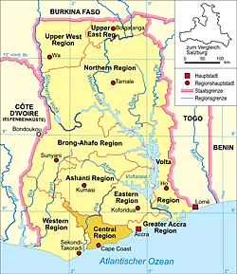 Source: Wikipedia
The Central Region of Ghana was chosen as the study area: with its regional capital as Cape Coast.

Map 1.2 Central Region of Ghana
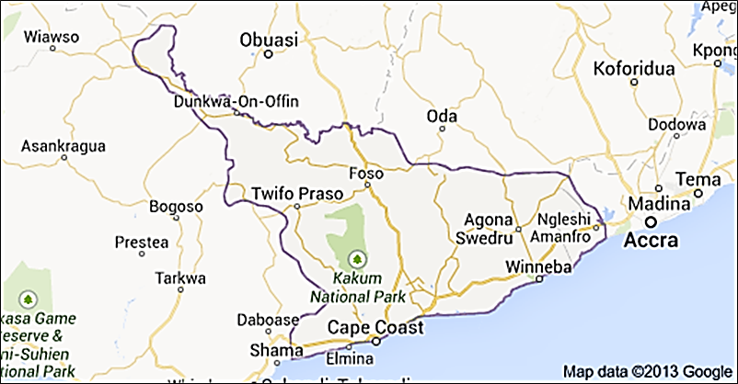
This region and also the schools were chosen out of convenience. There are several senior high boarding schools within and around Cape Coast and most of them are high-ranking, thus clustering the interviews and FGDs was most preferable and would enable management of time, energy and financial resources. Overall, seven schools were contacted before reaching the field, and then three of them were selected based on the level of enthusiasm to participate in the research. As a result, two single sexed schools (1 all-boys school and 1 all-girls school) and one mixed school were selected for the research. I decided to use high-ranking schools that have a significant student population from middle class homes because significant research has been done on rural schools or adolescents out of school because they are perceived to be more sexually active. It is my intention to also explore their attitudes towards sexuality and relationships and whether these attitudes had anything to do with the environment they have been placed in.
Atlas ti7, a qualitative analysis tool, used to analyse textual, graphical and audio data was used to process and analyse the data. Open and selective coding facilitated the categorizing of various themes and re-occurrences in the data. FGDs were recorded and one-on-one interviews were written on paper (note-taking). The FGDs were then transcribed and the transcription was put in the Atlas Ti7 application for analysis. All FGDs and one-on-one interviews were coded with Atlas Ti7 application. For reasons of sensitivity, the transcription of the data and names of respondents cannot be published with this paper.
From this point onwards the FGDs and one-one interviews will be referred to, based on the following codes:

Table 1.3 Codes for focus group discussions in three boarding schools in Ghana
P1 | FGD at All-boys school
P2 | FGD at Mixed School, Boys Session
P3 | FGD at Mixed School, Girls Session
P4 | FGD at All-girls School

Table 1.4 Codes for one-on-one interviews in three boarding schools in Ghana
All Boys School | Interview 1 | AB1
 | Interview 2 | AB2
 | Interview 3 | AB3
 | Interview 4 | AB4
 | Interview 5 | AB5
 | Interview 6 | AB6
 | Interview 7 | AB7
 | Interview 8 | AB8
 | Interview 9 | AB9
All-Girls School | Interview 1 | AG1
 | Interview 2 | AG2
 | Interview 3 | AG3
 | Interview 4 | AG4
 | Interview 5 | AG5
 | Interview 6 | AG6
 | Interview 7 | AG7
 | Interview 8 | AG8
Mixed School Boys | Interview 1 | MSB1
 | Interview 2 | MSB2
 | Interview 3 | MSB3
 | Interview 4 | MSB4
 | Interview 5 | MSB5
 | Interview 6 | MSB6
Mixed School Girls | Interview 1 | MSG1
 | Interview 2 | MSG2
 | Interview 3 | MSG3
 | Interview 4 | MSG4
 | Interview 5 | MSG5
 | Interview 6 | MSG6
 | Interview 7 | MSG7

Primary Data Collection
Three methods of data collection were carried out: FGDs, a short questionnaire to collect basic information of the respondent and one-on-one interviews to go further into detail from the FGDs. 30 one-on-one semi-structured interviews, 4 FGDs consisting of approximately 10 students each, interviews with three counsellors and also the programme manager of ADHD programme were conducted; making a total of 34 qualitative interviews and 4 FGDs.
Qualitative interviews would be the best way to address a sensitive issue such as knowledge and attitudes among adolescents towards sexuality and relationships as it creates an open and trustworthy environment between the interviewer and interviewee. It also allows reflexivity to some extent, so that the interviewer can ‘explicitly examine how his/her research agenda and assumptions, subject location(s), personal beliefs, and emotions enter into their research’ (Hsiung, 2008:212); in other words, how do my personal beliefs and own experiences reflect on my research work (during the design, before field work, during field work, the analysis stage then the final write up). This is very important in sexuality studies, as my role as a researcher may determine the type of information that can be gotten from interviewees. Taking personal notes (reflective journal) after interviews and reflecting on the interview process is a way of reflexivity and sharing a few personal experiences with interviewees when I was their age might help them feel relaxed talking to me. Furthermore reflexivity would deal with the power dynamics between the interviewer and interviewee; how I position myself as a researcher is this context, how the interviewees view me and how this is related to the type of responses they may provide. The interviewees might view me as an older person (adult) while they see themselves as children. This power relation can influence the interviewees to be less open during interviews out of respect or fear of what I might think if they express a personal opinion. As a young female researcher, female students would see me more as a sister or experienced peer for advice and to share secrets with, and the male students would open up to the opposite sex to show that they are knowledgeable in the field of sex and relationships, reinforcing their masculine tendencies to please the opposite sex and to be well informed about sexuality. Reflexivity will be seen throughout the paper, as I give both academic and my own personal reflections about the study.
The selection process of the male and female students was based on convenience and quota sampling methods. First of all, I went to schools who were willing to cooperate (convenience sample), then as a researcher I made sure I had representative FGDs and one-on-one interviews by selecting male and female students with different educational backgrounds from different majors such as visual arts, general arts, music, business, vocational skills, technical skills and science (quota sampling). In the all-boys school the Assistant Head Prefect helped in selecting participants for the research; he went in to different classrooms and handpicked students. In the mixed school, I went round to each class and selected by pointing out at any of the students and in the all-girls school, the form leaders were selected. There was a possibility of bias due to the fact that in two cases a school authority selected the students, however after interviewing the students and having brief conversations with them, they were from different back grounds, affiliated to different social and religious clubs in the school and also came from different dormitories. The assistant head prefect in the all-boys school was in the second year just like the other informants, so they saw him more as a classmate than an authority. Also, the assistant head master seemed to have a very good relationship with the students judging from observation of the interactions witnessed among them during the research work. After the selection process the assistant head master excused himself and gave room for the researcher to work. This helped especially FGDs to be diverse in nature and enable rich responses. In the case of the all-girls school, exams was approaching so it was very difficult to get girls that were interested in the research, one of the form leaders (class prefect) called on other form leaders and girls who were on campus at that moment to come and take part in the research. Out of the 8 girls, 4 were form leaders. Form leaders are usually nominated by their classmates: she can be the most popular girl in the class, or the quietest girl in the class, she can also be who they think is the most intelligent, there is no specific criteria. Just like the other FGDs, the all-girls school also had a variety of personalities.
Another important interview was with the Programme Manager of the ADHD Programme to have insight on the programme and how it is going in general. It was important for the programme manager to explain the content of the programme and also know whether the content was objective relating to her personal views on sexuality and relationships among adolescents. Finally separate interview sessions with three counsellors to know whether they are confronted with any issues of sexuality or relationships from the students.

Qualitative Interviews
Concerning sensitive topics such as sexuality, qualitative interviews are proven to acquire more data and less bias from individual’s responses (Lee 1993). The research involved a composition of qualitative research tools such as field notes, recording, note-taking, , participant observation, reflexive journal, FGDs, and one-on-one interviews. A total of thirty one-on-one interviews with male and female students between the ages of 16-19 were conducted, the shortest interview lasted fifteen minutes and the longest was one hour ten minutes, averagely interviews lasted thirty minutes. How in-depth an interview was depended on how open and free the student was to talk to me. Ideally, I was going to conduct 40 one-on-one interviews but after 30, I had reached a point of saturation where interviewees started repeating views I had already heard. As a researcher on a sensitive issue, semi-structured interviews allowed me to explore and gain a deeper understanding of the knowledge and attitudes of adolescents in Ghana towards sexuality and relationships. Since the questions were only used as a guideline, there was no specific sequence depending on how the conversation went it was the interviewee that determined the sequence of topics in most cases.
To understand their views, sensitive topics that are considered taboo to talk about in the Ghanaian culture or that generally made people feel uncomfortable such as relationships, sexual intercourse, masturbation, homosexuality, condom use, to mention but a few were brought up by the researcher to observe participants reactions when talking about such topics. Topics such as HIV/AIDS, STDs and teenage pregnancy were not raised by the researcher but somehow cropped up as comments from the informants during interviews; may be because these topics form a core part of the sex education programme and also get a lot of media attention through campaigns. These topics were not part of the research for the simple fact that talking about them had created some type of banality among the youth hence they feel comfortable talking about these issues.
The interviews were conducted in empty classrooms, assembly hall and one FGD was conducted under a tree in an area where the students called the ‘Lover’s Bench’. So far as the place was airy, comfortable and out of reach of other students that might pass by and listen, the location of the interviews had very little to do with the type of responses gotten. Students were used to being in classrooms, but this did not significantly influence them to give classroom based definitions of sex. In the first game played to discover what students thought was sex, some gave structural definitions they had learnt from home or class, but some also used their creativity to define it in their own words.
Qualitative interviews did not only create a relaxed environment to help me get more information from respondents but also allowed some form of reflexivity in the research process, this enabled many interviewees to open up.

Focus Group Discussions
Each FGD lasted approximately one hour. 2 FGDs were done in classrooms 1 in an assembly hall and 1 at what the students called ‘The Lovers’ Bench’ which was a well-known area were students presumably in relationships would sit and chat at break time or in the evenings. At the beginning of the FGDs, the research work was briefly described to give discussants space to address the topic in their own way (Lee 1993: 103). FGDs can work both ways; to the advantage of the interviewer or can collect only normative responses from participants. As an interviewer, I critically observed the type of reactions within the group when different topics were raised and how adolescent boys reacted similarly/differently to adolescent girls in the overall FGDs.
To begin the FGDs, since the participants of the research were meeting the interviewer for the first time, it was necessary to create an open, comfortable and relaxed environment to enable them to give frank opinions and express themselves freely. To create this atmosphere, a game was introduced where students had to write on pieces of paper their own definition of sex. No names were put on these papers and then responses were folded and put into a bag to ensure anonymousness. After this, I read out responses to the group and asked what they thought about the various definitions given. This game was used as an ice-breaker to create a more relaxed environment for students to feel free talking about the topic of sexuality as they giggled, laughed and expressed whether they agreed or disagreed with each definition. Hence, a platform was established regarding their basic knowledge on what they thought was sex which led to further questions on attitudes. After the game, questions were asked on topics such as homosexuality, masturbation, condom use, and relationships to explore their level of knowledge in these topics and also to find out and understand their attitude towards talking about them and practicing them. I selected these particular topics because they are very sensitive issues to talk about openly not only in the Ghanaian context but also all over the world, therefore using them in FGDs and one-on-one interviews helped understand the knowledge and attitudes they had towards the sexuality and relationships. These questions served as an entry point to unfold other issues adolescents viewed, hence they were open-ended which allowed room for other issues to crop up and also not restrict the responses of the interviewees to see how they viewed sexuality and relationships in their own words.

Questionnaire
The questionnaire was distributed right after the FGDs. It contained ten questions: six close-ended questions and four open-ended questions. Questions such as age, main messages they receive from the sex education programme, and also their main sources of information were asked. Asking the age of participants during one-on-one interviews may make them uncomfortable and might have established an invisible barrier between the interviewer and interviewee.

Secondary Data / Literature Review
Documents reviewed included: Article 4 of the Convention on the Rights of a Child which deals with government’s responsibility to protect the rights of children (under 18years) including the right to sexuality education. The Ghana Strategic Plan for the Health and Development of Adolescents and Young People from the MOH, the Adolescent Reproductive Health Policy of Ghana (National Population Council 2000), brochures and posters from the ADHD website and ‘Youth for Youth’ a magazine written by the youth in senior high schools were reviewed, more specifically content and the type of discourse used. The above mentioned documents were very useful as they form the main policy framework for sex education for senior high schools and the youth in Ghana. Other documents reviewed were namely texts from books, scholarly articles focusing on abstinence-only programmes, adolescent sexuality, knowledge and attitudes of adolescents toward sexuality, relationships and so on.
The secondary data would provide the research with a good grounding to formulate arguments which address how adolescents themselves judge or perceive the impact of messages from the sex education programme as well as adolescents’ knowledge and attitudes towards these issues in Ghana. In addition to that, reviewing brochures and national policy frameworks will give the researcher a concrete understanding of Ghana’s approach to adolescent sex education and then move to specifics such as sexuality and relationships.
Recently on BBC news Ghana showed the likelihood of increasing the age of marriage from 18 to 23 years (17/07/2013). Increasing the legal age of marriage might rather have an adverse effect on the youth’s sexual behaviour; needless to say, pre-marital sex will still be present. Focus needs to be given rather to sex education which may reduce the number of unwanted pregnancies, decrease in new infections and decrease in unsafe abortions, to mention but a few.
A study was conducted over a period of 20 years divided into 3 projects in England on adolescent sexuality, the third project focused on adolescents aged 12- 21years. The study showed that there was a difference between boys and girls responses to sex education lessons; the boys would disturb and interrupt sex education lessons while the girls were more interested (Measor 2004). Their preferred source of information was from friends, maybe this could be an explanation why they showed un-interest in the subject in formal classroom situations where they felt they only got basic information from. This attitude shown by the adolescent boys toward sex education in classroom situations may vary in the Ghanaian context. Peers play a critical role in sharing information about sex. Many studies in adolescent sexuality show the importance of social networks as a source of information on sexuality. This research will focus more on the attitudes and knowledge of adolescents in understanding adolescent sexuality and relationships while shedding some light on the sex education programme as one of the many sources of information.
In Nigeria, there is a lot of pressure on girls by their boyfriends to have sex in exchange for gifts or favours OR just as a form of assurance that the boy would not leave them, these adolescents also face similar pressure from their parents, teachers and abstinence programmes in schools to keep their virginity (Correa and Jolly 2008: 35). Nigeria has a similar cultural background to Ghana, and so it can be assumed that this may also be the case in Ghana. Female adolescents face a lot of pressure to please boys they are in relationship with by giving in to sex, with the hope that the boy would not leave them. Furthermore, with the hetero-normative masculine role, adolescent boys are pressured to play in society, they tend to have numerous sexual encounters which are not necessarily done in a safe way and also show dominance in sexual relations with adolescent girls. There is a reluctance from States in many parts of world to integrate sexuality into their agendas due to a number of misconceptions and myths (Ilkkaracan and Ronge 2008: 225).
Sexual satisfaction, sexual identity and sexual pleasure are the most neglected and stigmatised issues in sexuality (Ikkaracan and Ronge 2008: 227) they are usually spoken about only when associated with deviance (Jolly 2007:13 as cited in Harcourt 2009:131). Maybe because of the sensitivity attached to these issues and the fact that sexuality and sex in general are seen as a private matter. Due to the issues surrounding sexuality and the number of people receiving prejudice and stigma because of their sexual practices that do not fit into social constructions, sexuality has become more of a public than private matter. Although this take has it’s disadvantages, it has definitely enriched and expanded discussions in sex talk other than heterosexual sex talk.

1.6 Ethical Considerations
The Ghanaian culture discourages pre-marital sex hence question the use of sexuality education since you are unmarried and should not be practicing it in the first place. This does not change present circumstances in Ghana which indicate that adolescents ARE sexually active from an early age. Society does not recognise adolescents as sexual beings. The more we deny this, the more we leave ourselves vulnerable to HIV/AIDS, abuse and unwanted pregnancies and unsafe abortions. Being a strong believer of sex education, my future wish do more research into sexuality in Ghana and also develop a sex education programme which will include issues such as sexual orientation, sexual pleasure and relationship education to help teenagers make informed decisions in their sex lives to live happy, safe, and healthy life styles. Hopefully this research will gradually break the barriers that society has created on these sensitive issues due to traditional beliefs, perceptions and attitudes toward sex being solely for married grown-up folks.
I faced problems mentioning the subject being researched to people in Ghana, because they may question the essence of the study and misinterpret the message I want to get across. The research paper might be subject to a certain amount of criticism due to the religious nature of the Ghanaian community at large. One school already showed their disinterest in the research and felt the findings would not benefit the school in any way and so they refused to participate due to their religious underpinnings. Nevertheless, it will also serve as a stepping stone to gradually break the existing barriers in sexuality and relationships in sex education.
As a young female researcher coming from a religious background with fairly liberal views; I faced challenges reading certain documents that were very explicit about sexual pleasure and eroticism: for example the Pleasure Project which is an advocacy project to help promote safer sex by eroticising it. Maybe because I am not used to reading about sex so explicitly in publications or being used to how sex is usually presented in very subtle language in many writings apart from fictional fantasy books.

1.7 Scope and Limitations of the Research
The research will not make universal generalizations about knowledge and attitudes of adolescents in sexuality and relationships but will rather make tentative suggestions based on how adolescents view sexuality and relationships from in their own words.
Interviewing students in boarding schools was interesting since they are restricted one way or the other; that is, living under rules and regulations within the school whereas they have different attitudes or personalities when at home on holidays. This ‘double personality’ is established when they have to fit into the school’s rules and regulations, however they equally have their own lives outside the school. Sex and relationships are not allowed while in school, this does not stop the students from having these when at home. Exploring their knowledge and attitudes toward sexuality and relationships is important to understand their mind set. It will also help in developing more practical programmes in sex education for their age group.
Working with government institutions can always be a challenge due to red-tapeism, however contact was established first through a phone call then a direct meeting with the Programme Manager of the ADHD Programme. Several documents, brochures and manuals concerning the ADHD Programme were provided. School entry was also considered as a challenge, as some schools turned away the research work due to ethical concerns or no official letter of permission from the GES. Others were slightly apprehensive about how the findings were going to be used. One all girls Catholic school in particular turned down the research proposal because they simply did not see the relevance. Sometimes direct contact with schools helps them to be reassured that the research will not be used against them but rather they are contributing to something that will benefit the nation as a whole one day. A level of trust had to be established between school authorities before the research was conducted, once that was done, data collection went on smoothly.
The position or stance of the interviewer/researcher and also the social characteristics of the interviewee are very important as both influence to some extent and thus determine the type of information that will be received from interviewees(Lee 1993: 99). From Bleek’s experience, informants become less and less interested in the research as the questions go deeper and get more embarrassing or sensitive, this forces the informants to lie (1987) nevertheless it is part and parcel of the research process and can be registered as a contribution rather than seen as a negative aspect of the research. Teenagers usually feel free talking to outsiders because they have no fear of the outsider sharing information with others. In addition to that, they would most likely feel more comfortable talking to an interviewer they can relate to. For example, in my case, I am a young female researcher, students were intrigued and curious about my Masters and experience with sexuality living in Holland since it is viewed as relatively liberal on issues of sexual identity and orientation.
Considering the sensitivity of the study, it was normal to observe the discomfort of some interviewees especially during FGDs. I dealt with this by opening up to the interviewees on my part as a researcher which helped them feel ok to open up too, especially in the one-on-one interviews. Interviewees would feel some kind of bond with me as a researcher if I share personal information with them so they do not feel bad about whatever they say, at the same time not giving my personal view on any of the issues that were addressed. This type of gesture established a level of trust between the interviewer and interviewee hence more valid information was received from the interviewee during and outside the interview context.
As a researcher, I may face interviewees that will give me bias responses; they may even try to be politically correct by telling me what they are supposed to do and not what they actually do. A review done by Sudman and Bradburn (1974) concludes that effects from the interviewer are minimal compared to other effects, Bradburn affirms that ‘interviewer effects are neither substantial nor pervasive’ (Lee 1993: 100). In this case, interviewees (male and female students) may see me as a peer they can talk to and air their views freely with or as a big sister they can ask for advice.
There is also a risk in bias in the responses, if there happens to be a teacher present during these interviews; the students will be either shy or timid to express themselves freely. Fortunately, after explaining into detail what the research was about, the teachers allowed the me (the researcher) to be alone with the students, due to the level of trust established at the entry level of the research. There was no supervision whatsoever and this enabled a free and smooth interaction with the students.

1.8 Organization of the Paper
This paper is organised into five chapters: chapter one is an introduction to the study that focuses on the contextual background, methodology, methods of data collection and why those specific methods were chosen; chapter two addresses the conceptual framework starting with general concepts of gender, sexuality and the body that are fundamental to the study, then going a step further to the double standards in sexuality and hetero-normativity, which will all be engulfed into the ecological model and how it can be adapted to the Ghanaian context of adolescents and most importantly how these concepts are related to the knowledge and attitudes of adolescents in sexuality and relationships; Chapter three will contextualise knowledge and attitudes of adolescents in sexuality and relationships in the Ghanaian context and then give insight on the research journey as a process; chapter four presents the findings and at the same time relates them to the above mentioned concepts; finally, chapter five, draws a conclusion by synthesizing the findings, then further exploring possible policy recommendations to promote adolescent friendly services in sexuality and relationship education, finally wrapping up with suggestions for further research.

Conceptual Framework

2.1 Introduction
Concepts surrounding the topic of sexuality can be problematic, controversial and vary on a contextual level. This chapter will underpin the fundamental concepts of the study which are gender, sexuality and the body by contextualising and exploring how they are located in the Ghanaian context; the next part will talk about the dominant sexual norms in society and how these have reinforced the double standards of sexuality and hetero-normativity; finally a look at Bronfenbrenner’s Ecological model and how it can be adapted to sexuality research in adolescents but also what is missing from this concept.

2.2 Conceptualising Sexuality, Locating Gender and Locating the Body
Defining sexuality can be problematic and looking back at the history of sexuality makes it even more difficult to define. Some scholars define it based on its modus operandi (mode of operation) which are in ‘gender, reproduction, the family, and socialization; love and intercourse’ (Padgug 1979). Debates on sexuality as public/private, or biological/ideological/societal point of view; at the end of the day there cannot be a universal definition of sexuality. One can however try to define sexuality in the Ghanaian context since sexuality is context specific hence based on a cultural construct (Padgug 1979). IPPF gives a concise definition of sexuality as ‘the experience and expression of eroticism, sexual pleasure, and intimacy, sexual orientation and gender identity’ of young people who are also sexual beings; it is not just about having sex.
The concept of sexuality in Ghana is defined by certain cultural norms which is based on the assumption that only adults have sex and not adolescents. This definition of adults may or may not include those who get married at an early age. Sexuality is not only a sensitive research topic but also a sensitive subject to talk about in many parts of the world today yet it is an everyday activity for human beings. Arnfred affirms this as he views ‘extra-marital relations as one thing but to talk about it is another…extra-marital affairs do not exist as long as they are not spoken about’( 2004: 74). This statement shows how idealist society is about sexuality and how we live in denial that sexuality is part and parcel of our everyday lives. Adolescents having sex before marriage is termed as pre-marital sex. Pre-marital sex is believed to be rare in cultures with a strong religious affiliation, this is untrue. Adults co-habituating with other adults (which is a very common situation in the slums and rural areas in Ghana) are not seen as having pre-marital sex in the Ghanaian context yet they are not officially married. Adolescents are viewed immoral/bad when engaging in pre-marital sex. With these existing attitudes in society it is difficult to talk about sexuality anywhere. To put it another way, Ghanaian culture, like many other cultures, denies the fact that adolescents have sex; this is an even deeper denial masked by cultural beliefs and attitudes.
The chart below is from a household based survey about sex of 4,430 youth aged 12-19 years conducted in 2004 in Ghana. The study shows that most adolescents (66% females, and 80% males) said that neither parent had ever talked to them about sex-related matters (Guttmacher Institute 2006); this means that parents do not talk to their children about anything having to do with sex (condom-use, relationships, sexual intercourse and so on). Parents especially, live in denial as their kids experience sexual encounters; the notion that adolescents cannot and do not have sex is greatly embedded in negative societal attitudes and perceptions toward pre-marital sex. This in a way is worrying as the societal perception on a whole influences policies on adolescent reproductive health, what is taught in schools about sexuality and how it is taught.

Figure 2.1Household-based Survey- Project on Protecting the Next Generation: Understanding HIV Risk among Youth: Understanding Parent communication
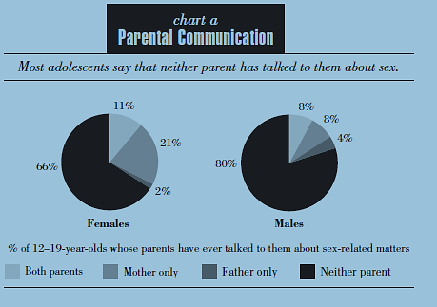
Source: Guttmacher Institute (2004)

‘Researching human sexuality without looking at gender is like cooking pepper soup without pepper- it might look like pepper soups but one sip will make it clear that an essential ingredient in this Nigerian speciality is missing!’
Sylvia Tamale
In this intriguing statement, Tamale shows that sexuality cannot be understood without looking through a gender lens. Many researchers view sexuality as just the sexual act, however sexuality covers but is not limited to pleasure, gender identity, power, human body, self-esteem, way of dressing and also violence. Studies concerning sexuality should therefore be nuanced and also show its multi-levelled nature (2011:11). Again she adds that, ‘There is no uniform or monolithic way of experiencing within one culture or even among individuals, it is wise to start off with the premise of multiple sexualities’.
In locating gender, the question of ‘How does one become a man or a woman?’ is frequently asked and interpreted in sex education programmes; one of the brochures on gender describe this and states that ‘it is important to remain a male or female in all aspects of life as one is growing up’. Also, in public discourse, men and women have an erotic gaze as men being arousers and women being the seducers in adult sexuality. In adolescent sexuality in Ghana, girls are seen as timid and ‘good girls’; showing very little knowledge on sexual matters indicates their innocence (Ampofo and Boateng 2011).
Sexuality and sexual pleasure are culturally and socially constructed. What is conceived as sexual pleasure is dependent on what is defined as such within one culture… in each society this changes with time as sexual behaviour and practice, morality, and ideology are constantly in a state of flux’(Caplan 1987 as cited in Arnfred 2004: 88). What adolescents define as sex and sexual pleasure may be based on cultural norms and social construction; these cultural norms are very much linked to the religious continuum of no pre-marital sex and sex being only for reproduction and not pleasure. And these social constructions of sexuality are formed based on the different gender roles in society hence the importance of exploring gendered roles or identities. As Abraham said, ‘just like the division of labour, male and female gender roles have been culturally constructed regarding sexuality’(2002: 359).
Furthermore, the concepts of gender and sexuality have an interrelation with the body. Locating the body is very important in this study as an adolescent is in a transition period from childhood to adulthood. Adolescence is a time of growth and discovery where young people face confusion and insecurities in what is right/wrong or safe/dangerous and sexuality is a greater phase of this transition period. Bodily maturing is not always on the same level as social maturing. With the bodily (physical) maturing the young person is given a new social status (Youth Incentives 2006: II) from child, to adolescent to adult. However the same process does not apply to sexuality in the Ghanaian context, adolescents are still viewed as children in sexual matters and therefore not recognised as sexual beings.

2.3 Hegemonic Norms: Seeing Through the Cracks

The Double Standards in Sexuality
Freud argues that male control in hetero-sexual relations is important to ensure male pleasure (as cited in Taylor 1995: 687) however many feminist writers view this notion of hetero-sexuality as a ‘patriarchal institution that involves a system of social structures and practices in which men dominate, oppress and exploit women (Walby 1990 as cited in Taylor 1995: 688) which explicitly shows the double standards in sexuality where men dominate women socially, economically and sexually. The double standards of sexuality start at a very young age due to how an individual is brought up in society, and everything around us in the media, television, radio, social circles and at home reiterate the role of a woman, this includes her sexual role. Sexuality and gender are inextricably linked with power-relations and dominance. And these in turn play with ideologies of masculinity and femininity. Explaining masculinity will automatically give an understanding of the concept of femininity in sexuality which ‘prescribe sexual modesty for girls and sexual prowess for boys’ hence the double standards in sexuality (Vanwesenbeeck 2010: 4).
Concerning masculinity, there are different kinds expressed by different scholarship. Essentialists define masculinity as the masculine nature of men being ‘risk-takers, irresponsible, aggressive and having Zeus energy…’ (Connell 1999). This may be too simple and general in terms of a definition and excluding the cultural context. Out of these types of masculinities, hegemonic masculinity is the dominant form, and this type of masculinity does not only supress women but men also: it deals with class relations among men. The adolescent boys in boarding schools for example may feel the pressure of proving their masculine nature, they may also feel challenged when faced with other male adolescents with feminine tendencies. It presents a socially constructed version of how men should behave; this gives all sorts of pressure, especially to adolescent boys who have to fulfil their role as the ‘Alpha male’ but not all men can be alpha males. ‘Men and boys who fail to live up to this form of masculinity are ridiculed’ (Adomako Ampofo and Boateng 2011). Adolescent boys may say they are in a relationship with the opposite sex to justify their masculinity, or they may also use sports, for example being part of the football team would prove that one is not homosexual or does not have homosexual tendencies.
Men get all sorts of pressure to use sex as a way of proving their masculinity, reason why they have several sexual partners, exhibit risky behaviour and shows desires of control in sexual relations with women and this is linked to the socialization process of men whom at a young age (adolescent-hood) are taught to be ‘self-reliant, not show emotions, and not seek assistance in times of need and stress’ (Greig et al. 2008: 90). This hetero-normative masculinity produces constraints on adolescent males who feel pressured to fit into these gendered roles in society, hence their anxiety sometimes to perform well sexually (sexual potency) to show dominant level in gender power relations (Greig et al. 2008: 91). Although this construct of masculinity is very essentialist, we must not forget the fact that these men make their own decisions at the end of the day and can be held accountable. Adolescent boys face a lot of pressure not only from society but from peers to fulfil their role as men. So they get involved in relationships and sexual escapades at an early age and this is where their gender role in sexual relations starts to form. This type of male dominance is widely accepted in Ghana where the men are seen to be stronger, wiser, more responsible and are taught to control the women.
Women are depicted in the media as objects of love: sensitive, gentle and nurturing (Christopher 1987 as cited in Taylor 2008: 688). The image of women in the media has always been that of a sexualised body. Underwear gurus like Victoria Secret, Hunkemoller, alcoholic drinks and even food product advertisements are centred on using the bodies of women as a sexual image to arouse the public into buying and then again, used in pornography to arouse men’s sexual desire (Coveney et al as cited in Taylor 2008: 688). This image reinforces the vulnerability of women and our subordinate nature in the bedroom. ‘The New Right’s messages to women have been, precisely that we are emotional and sexual property of men, and that autonomy, and equality of women threaten family, religion and state (Rich 1982: 209). This may also be the case with adolescents when negotiating on sex; an adolescent boy may be able to convince an adolescent girl into sex or a relationship. ‘Incidents of sexual harassment indicate that male sexual desire itself may be aroused by female vulnerability’; since this enables men to feel in control and more dominant over women, a way of validating their masculinity. Female vulnerability even with adolescent girls is seen as sexually desirable and is perceived to satisfy the sexual pleasure of men. ‘Women are viewed and view themselves as ‘slags, ‘sluts’, or ‘loose’ if they are sexually active and take multiple partners, while men are congratulated for such behaviour’; in this regard sexuality gets framed as a male domain of control (Arnfred 2004: 75) and if women even take on the sexual behaviour of men, they are seen as bad and dangerous, this clearly shows the double standards of sexuality between men and women and also how this plays a role in gender power relations. In the Ghanaian context for example, an adolescent girl that knows too much about sex or is sexually active is considered bad or immoral. It is possible that during the FGDs the adolescent girls may show signs of shyness and naivety, reinforcing the notion of vulnerability. The more one knows, the more one is associated with immorality.
The stratification of gender roles are often handed down from one generation to the next, moreover oral literature and proverbs emphasize this essentialist stereotype of masculinity and femininity (Adomako Ampofo and Boateng 2011: 423). ‘Biologically, men have only one innate orientation- a sexual one which draws them to women, while women have two innate orientations, sexual toward men and reproductive toward their young’ (Rossi 1976 as cited in Rich 1982: 210). This also shows the varying nature of the roles ascribed to each gender in society, as if to say women have less of a sexual desire than men. As one writer put it, ‘the suppression and subordination of feminine sexuality is universal’ (Weiss 1993 as cited in Abraham 2002:359). Although pre-marital sex is a taboo, cultural construct has made it in a way that gender socialization process allows male sexuality while suppressing that of females through ideological practices (Dube and Das as cited in Abraham 2002:259) then again, denying that females also like to indulge in sexual pleasure. This concept will build on the gender power relations existing in adolescents sexuality and relationships through the narratives of participants of the research based on their own sexual experiences of that of peers.

Hetero-normativity
According to Rich, heterosexuality is a ‘man-made institution’ where male power is manifested and maintained in several ways; one in particular way is by denying women of (their own) sexuality (1982). In her book, ‘Compulsory Heterosexuality and Lesbian Existence’, Rich explains how heterosexuality is another means of oppressing women sexually and also gay men. I would define Hetero-normativity in this context as enforcing heterosexuality and marriage normativity in addressing sexual relations between two people. Government institutions and policy frameworks are framed under the assumption that most people will live out their sexuality through heterosexual and marriage relations, leaving out those who are unmarried and engaging in pre-marital sex.
‘Progressive legal frameworks are a step towards breaking with gender and sex orders that hinder the realization of human rights and development. But where progressive laws depart from every days beliefs and practices, challenges arise’ (Cornwall et al. 2008). Governments institutions can come out with legal frameworks that encourage openness when talking about sex but can however clash with social norms that consider certain topics and sexual practices as taboo… culture. Many development initiatives are formed not only formed with a hetero-normative basis, but also on marriage normativity. This reinforces dominant social norms that restrict non-married men and women who also eventually suffer the consequences of stigma in getting sexual and reproductive health services. In this research, adolescents between the ages of 16 and 19 may fall under this category of unmarried men and women and may therefore lack ease of access to these services due to the stigma associated with pre-marital sex (Shamar, Correa and Jolly as cited in Cornwall et al. 2008). While some suffer and are socially excluded because their sexuality does not fit in with societies agenda, those who also conform to the norms also ‘suffer consequences of the limits to freedom and well-being that crop up in the regulation of sexuality’ (Cornwall et al. 2008). The sexual hierarchy depicts this societal limits to sexuality and where it draws the line between good and bad.

Figure 2.2 The Sex Hierarchy: the charmed circle vs. the outer limits Rubin Gayle 1984
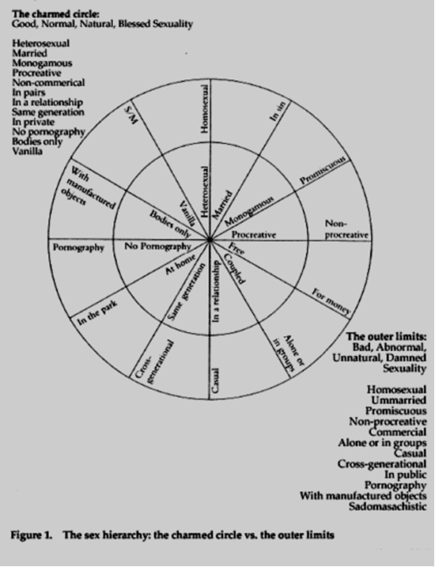
Source: Dr Sarah Jansen Blog Spot http://drsarahjensen.blogspot.nl/2012/05/hierarchies-of-sexual-value.html#!/2012/05/hierarchies-of-sexual-value.html
The ‘sex hierarchy’ chart of Rubin Gayle shows society’s construction of what is called ‘good, normal, natural, blessed sexuality’ (the charmed circle) which marriage and heterosexual relationships fall under and then ‘bad, abnormal, unnatural, dammed sex’ (the outer limits) which includes homosexuality, masturbation, and pornography. In the Ghanaian context, adolescent sexuality and pre-marital sex may fall under these outer limits along with masturbation and homosexuality because it is also seen as bad and unacceptable (1984).

2.4 The Ecological Model in Gendered Sexual Behaviour in Adolescents
“Human beings make their own history, but not in circumstances of their own choosing” Karl Marx, The 18th Brumaire of Louis Bonaparte (Berner 1998).
Figure 2.3 What influences an adolescent’s knowledge and attitudes towards sexuality and relationships in Ghana?

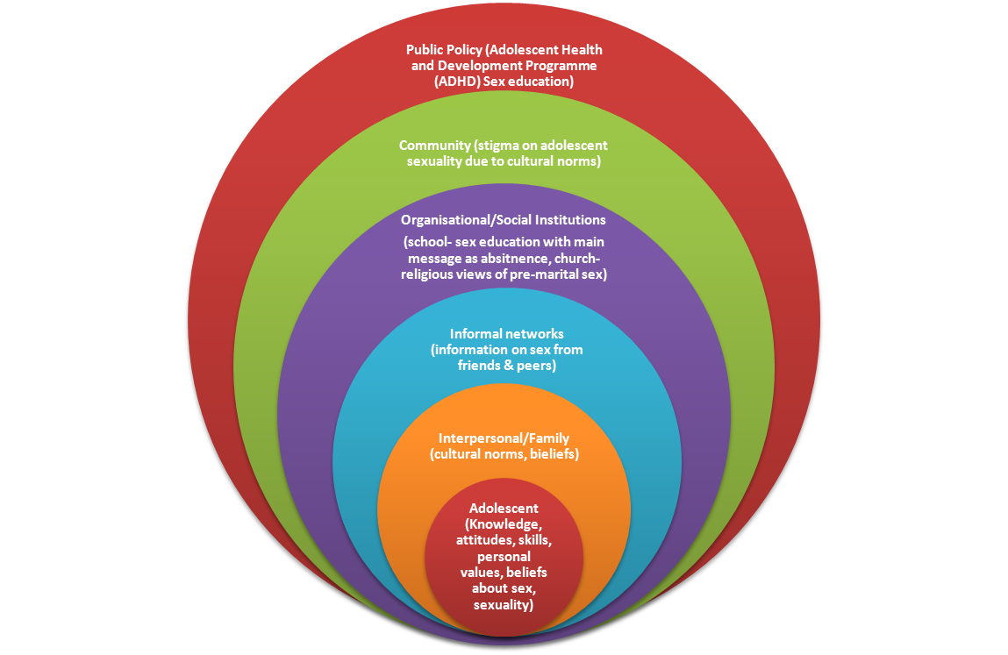
Adapted for sexuality and relationships of adolescents in Ghana from the Ecological Model: Bronfenbrenner 1979

As an individual, the environment around you may affect your behaviour mentally, emotionally and socially one way or the other. Although individuals have the liberty to make their own decisions, many other factors in society have an influence in their decision-making process.
Everywhere in the world, there is no universal definition of sexual immorality however, sexual practices are given particular meanings based on culture and whether the conditions of having sex is seen as ok or immoral vary on a contextual and geographical level; for example it can be to wear a thong on a beach in Brazil but not ok to wear on a beach in Ghana (N. Fischer 2011: 38). The same applies to pre-marital sex; in the Ghanaian context, pre-marital sex and any other form of sexual activity is considered as immoral in the religious sphere. Religion has quite an influence on national policy frameworks; hence, institutions and society also have this significant influence on the youth of today. Bronfenbrenner talks about the ecological model which outlines that the community, social institutions and social networks correlate to an individual’s way of thinking and behaviour (1998, it can also be viewed as intersectionality.
The ecological model can be used to explain certain answers the informants gave, based on society, their parents or teachers and their peers, resulting in them making decisions which are partly influenced by cultural norms. For instance, in FGDs and some interviews, the informants would give normative answers initially then after being asked questions about sex, they would give normative answers about what is sex and whether having sex at this age was ok. Most informants would start their answer by stating, ‘In the Ghanaian context…’, then the researcher what rephrase and ask the question again and then they would give a personal view. This goes a long way to show how the culture of a society may influence the how one’s views on sexuality however still have an agency in decision-making. In this sense, self- determination comes into play, when the adolescent makes his/her own decision whether or not to have sex regardless of what society may think or believe or regardless of what religion perceives as moral and immoral. Based on Bronfenbrenner’s ecological model, the diagram shows the adolescent with his or her attitudes, knowledge, and personal beliefs, surrounded by other circles such as people in the household (parents and siblings), informal networks (friends and neighbours), social institutions such as school authorities that have their established rules and regulations, the community with its cultural beliefs and lastly the state with its policies on sex education.
An individual’s behaviour is partly influenced by society and partly self-motivated to make one’s own decisions (Deci and Ryan 2002), the ecological model however does not inculcate agency in its definition. The ecological model involves the process of socialisation where adolescents have to relate to the dominant ideologies that are offered to them, where they have a choice to either comply or resist (Vanwesenbeeck 2010: 3), however compliance is always the easier option as this fits the normative standards. For example, compliance to hetero-sexuality because that is the culture one grew up with and one is used to. This may be seen as the deterministic approach where an adolescent’s environment determines how they will behave, but this is not always the case (Berner 1998: 2). Despite the significance of the ecological model in this research, it tends to exclude the use of the agency of an individual (self-determination). Although Karl Marx is right in saying that usually the environments we grow up in or cultural norms we are used to are not of our own choosing, in the long run human beings do make their own history in the type of decisions they make (Berner 1998). Your decisions is your agency. Although a number of studies have shown that sexual knowledge is not related to sexual behaviour (Somers and Paulson 2000), the ecological model proves that there is some level of influence from the individual’s environment.

Background on Research :Adolescents and Sexuality

3.1 Introduction
This chapter will focus on the Ghanaian setting by putting adolescents in Ghana into context regarding cultural norms and societal perceptions. In addition to that, I will give personal and academic reflections during and after the field work and also on the whole research process through participant observation and also events that occurred during and outside interviews to add onto ways of conducting research with adolescents in sexuality and relationships.

3.2 Context of Adolescents in Ghana/ The Ghanaian Setting
The research will focus on students in the senior high school level. Senior high schools in Ghana comprise a 3 year programme where the average age range of students is between 16- 19 years. The percentage of students that complete junior high school and gain admission to senior high schools is around 40%, this means most adolescents stop going to school after junior high and seek employment, consequently the students who are more likely to end up in secondary schools come from families with a better socio-economic standing (middle class families)(Glover 2003). There is an assumption that these students are often those who wait longer before having sex. Studies show that adolescents who stay in school for a longer period are less likely to fall pregnant early due to their level of education; this assumption does not factor in the number of abortions that occur among senior high school students for the simple fact that these abortions are mostly self-induced and discrete. Maybe because of the risk they face in jeopardizing their image in social circles and because of this fear; it is assumed that there are possibly higher rates of abortion among the middle and upper class because of easier access to these abortion services. Hence in my opinion it does not necessarily mean that they do not fall pregnant, rather they have higher rates of abortions because they can afford to abort and rather undergo abortion instead of public shame in carrying a baby at such a young age or because they are unmarried. Adolescents are always under social pressures to conform.
Both the family and school play an important role in the socialisation of an adolescent. Adolescents are under rules and regulations both at school and at home, however their behaviour differs in both circumstances. At school they are more restricted from the outside world: no mobile phones, no means of using social media, and in the same-sexed school very limited access to the opposite sex. This situation restricts the sexual life of high school students in boarding schools for a period of time as they are put in a type of bubble, when they go home they have some amount of freedom as they are more access to these things. Parents are part of the socialisation process of their children, little gestures they make to show they agree or disagree with something develop the behaviour of a child which usually ‘fit’ the child’s gender and into society (Vanwesenbeeck 2010 :3). According to the interviewees, although their parents can be strict while at home, they have unrestricted internet access and have ways and means of meeting up with friends. Besides, most of the interviewees were dating outside their respective schools and the only chance of seeing their partners was when they were on holidays at home,
‘My boyfriend works in Takoradi, where I live…it’s the only time I get to see him…can I ask you something? What if you’re having sex and you want to stop, what do you do?’ (MSG1 Personal interview).
In Ghana, people can always determine the senior high school you attended simply by your mannerisms. Schools (especially boarding schools where you live and learn from each other for three years) are a special environment for adolescents to build their personality and sexual identity (Epstein and Johnson 1998 as cited in Mirembe and Davies 2001), just like home it is also a socialisation process adolescents go through . It is an environment of control and authority not only by school authorities but also by the students of gender power relations: hegemonic masculinity and compulsory heterosexuality.

3.3 The Research Journey
According to statistics 92% of adolescents between ages 12-14 have never had sex before, reason why this research focuses on adolescents between ages 16- 19 years who are most likely to have had at least one sexual experience (Awusabo-Asare et al. 2004). Hearing the experiences and observations of adolescents on sexuality and relationships based on not only what they are taught in class but also on what they see and hear on television, radio, and social media opened a Pandora’s box on issues they are facing today in their lives concerning sexuality and relationships. Most of the interviewees had myths of sexuality that they learnt through religious publications, older relatives or parents that would keep them away from sex. They also thought that homosexuality and masturbation came about through evil spirits. A strong religious influence on the students, not just from school but also from home. Throughout the fieldwork, I met four counsellors and interviewed three; out of the four, two were religiously affiliated.
How I positioned myself as a researcher and presented myself to the interviewees was very important. From dress code, to vocabulary I used to mannerisms. I dressed semi-casual (usually a pair of jeans and a shirt), to enable the interviewees connect with me and see me more as a peer or young lady yet treating me with respect during interviews to get insightful and enriching responses. I also tried to use very simple vocabulary so they understood what I was saying and expected from. The aim was to help them see me on a peer-to-peer level and not on a teacher-student level. This same technique was used with both sexes so they could see me as a peer they could confide in, however I had to make more of an effort with the girls to get closer to them.
Adolescent boys were ready and willing to give information about their sexual experiences more than the adolescent girls who were shy and reflective about the questions being asked. For example, the FGD at the all-boys school (P1) gave a good amount of information compared to the one in all-girls school (P4). This may be because male adolescents feel the need to express themselves more in a group to show their masculine nature (Connell 1999). Most of the adolescent boys made it clear they were in relationships; whether this was true or not, it relates to their situation of being in an all-boys school where homosexuality is prevalent, a reason for them to create a space where they can prove/justify to the other boys that they are not homosexual.
In the all-girls school, the researcher played the role of a sister and a peer so that some level of trust was developed between the researcher and the girls. Telling them a personal experience I had at that age helped the girls open up. Unlike the boys, the girls wanted more to prove of their innocence by showing they knew very little about sex due to the reason that, in Ghanaian society the more you know the more you are associated with being a bad girl. There were scenarios where I (researcher) would ask what they thought about masturbation and then one of the girls asked ‘what is masturbation?’. Third person reporting was also very common among the girls. They would either give a scenario of a friend in a relationship or ask ‘what if’ questions. This behaviour can be explained by perhaps fear established by the interviewee of being branded as ‘bad/naughty/immoral’ due to negative societal perceptions of girls being classified as bad and dirty when they know too much about sex (Fischer 2011).
Interviewees started to confide in me and ask for personal advice about their own relationships or speak sometimes in the third person and whether I thought it was normal for them to be experiencing these types of things. For example, one girl called my phone after an FGD and told me about a friend who had missed her period twice and she asked me what the friend should do and if I could be of any assistance. Also, some of the interviewees asked for the researcher’s opinion on topics concerning homosexuality, masturbation and pre-marital sex. As a young researcher refraining from giving answers to these questions was challenging. Nevertheless, instead of leaving the respondents hanging after being interviewed, I left them with a brief piece of advice about life, academics or relationships so they did not feel empty. Interviewees were pushed to talk by making sensitive issues like masturbation and homosexuality sound lighter through indirect questions and creating a discussion around the topic. For example, not using so often direct words like ‘masturbation’ or ‘blow jobs’ but rather asked in an explanatory mode; ‘Sometimes people touch themselves, how do you feel about this?’. Also having an indifferent facial expression to avoid looking judgemental when talking about sex, made interviewees open up more about their own sexual experiences they have had. Slight teasing helped the girls feel at ease to talk. In addition to that, sometimes the interviewee may divert the topic during an interview due to his personal interest in the interviewer. Acting normal and indifferent was the best way to handle this situation and relating the interviewees personal interest in the interviewer back to the questionnaire led to in-depth responses.
As a researcher, it was useful to pick on words the respondents used to continue discussions in the FGDs. The girls were fond of teasing each other while the boys were more confident and had independent opinions regardless of what the others thought. This is typical of gendered behaviour in society where girls are portrayed as shy and reserved and boys are seen as aggressive and more out-spoken, hence the term ‘boisterous’.
I felt nostalgic when the practical field work had come to an end as I felt a connection with the interviewees. I felt the need to play the role of a big sister to advise them, however that was not my aim and it would have jeopardised the type of responses I would have gotten.

Findings

4.1 Introduction
This chapter will present the findings based on what I found most interesting during the interviews as well as responding to the research questions on a whole. A lot of data was collected, however not all of it could be factored into this paper. I will start by presenting the main message adolescents receive in the sex education programme, how they relate to this message and how this message of abstinence is related to established societal norms of sexuality that is sex being strictly for married heterosexual couples. Secondly, I will compare what is taught to the reality that adolescents actually face based on their responses. Thirdly, I will explore the idea of phone sex as a form of bedroom politics since it equally involves gender power relations hence reinforces the role of women as being subordinate in sexual activities and the dominant role of men in sexual pleasure. Fourthly, I will unpack the counselling practices in high schools and whether adolescents find counselling useful. Then, explore how adolescents view relationships at this period of their lives and whether it is ok to be in a relationship at this age. I will end by looking again at a contextual analysis of hetero-normativity as against homosexuality.

4.2 Prioritisation of Abstinence Message in Ghana’s Sex Education Programme
‘The notion that sex per se is harmful to the young has been chiselled into extensive social and legal structures designed to insulate minors from sexual knowledge and experience’- Gayle Rubin (1984).

The message of abstinence goes all the way back to the late nineteenth century where there were morality crusaders campaigned for chastity and attacked all forms of obscene material (literature, music, contraceptive campaigns and the likes) and these campaigns have affected societal attitudes today towards sex (Rubin 1984), Ghana is no exception. Although the sex education programme touches on issues of condom use and birth control, it explicitly focuses on abstinence education for adolescents under 18.
The Committee on the Rights of the Child encourages States to put in place policies for children that will reduce teenage pregnancies, improve the knowledge and access to family planning services and also develop education programmes on adolescent reproductive health (CRC Paragraph 57). This statement however has its limits in areas or settings attached to traditional beliefs or cultural values where comprehensive sexuality education is seen as inappropriate for children, as the notion indicates that children are ‘young, naïve, and innocent’. The Ghanaian context views children as such naïve and innocent beings just as the state views comprehensive sex education programmes to perhaps increase the disposition of adolescents to engage in sexual activity, despite this view, there is no evidence (Beh 2006: 14). These types of environments which are more traditionally and culturally inclined usually adopt or focus mainly on the abstinence-only approach so as to not pollute the minds of the adolescents at an early age and also to discourage pre-marital sex which is not openly accepted in Ghanaian culture. Hence interviewees, used negative language such as ‘consequences, dangers, effects’ to describe sex. These are terms that are not only resonated in classrooms but also at home and in the Ghanaian media.
Abstinence-only education teaches that ‘a monogamous, marital, heterosexual relationship’ is the only accepted societal norm and that anything outside this thinking is harmful to the individual physically and psychologically (Beh 2006: 12). Consequently, abstinence-only sex education is directly linked to hetero-normativity as its campaign is centred on heterosexual relationships and waiting until marriage hence the incorporation of religious views which frown upon pre-marital sex. Mixed messages on waiting or complete abstinence from pre-marital sex can be found throughout the sex education programme. From messages such as ‘No culture or religion accepts pre-marital sex!’ to messages like ‘Decide how far you will go before you get into pressured situations’ can be found on the ADHD programme brochures, which in way give you the choice to decide when to have sex even so, bring a religious perspective of pre-marital sex as wrong. Through participant observation, I sat in a social studies class and coincidentally the topic was on ‘Marriage’. The adolescents had to repeat after the teacher that ‘sex is for only married people’; a typical class situation regarding abstinence approach in sex education.
The adolescent boys were of the view that more practical topics such as how to use a condom should be added to the programme especially for those who were already sexually active. The girls on the other hand were satisfied with the programme’s focus so far and although aware of the reality that adolescents were sexually active at an early age, said it would be better to keep the programme focused on abstinence only to discourage them from having sex and to help them concentrate on their studies. Both boys and girls appreciated that teachers would sometimes deviate from the syllabus and tell students about their personal views or experiences on sex.
According to the ADHD Programme, sexual abstinence refers to refraining from vaginal, anal or oral sex either for a long period of time or until marriage (NPC 2000). Many of the interviewees clarified that abstinence was the main message they got from school. With catch phrases like ‘It Pays to Wait!’ on billboards and brochures. The informants expressed content about having a programme focused on abstinence but were however concerned about the lack of information on condom use and birth control pills, etcetera if one was sexually active. Out of the 30 informants, more than half were in intimate relationships: intimate meaning kissing, fondling and/or sex, a handful were absolute virgins and 10 did not want to reveal their intimacy level but were however ok with some intimacy in a relationship. The reason for the abstinence-only programme is maybe out of fear that the more adolescents know about sex, the most likely they are to experiment out of curiosity. Yet many studies show that sex education does not have an effect on the likelihood of an adolescent to have intercourse (Dawson 1986: 162). Formal instruction of contraceptive use for example may help in a behavioural change to being safe when having intercourse but not necessarily influence the adolescent to start having intercourse. Further studies show that sexual knowledge is not directly related to sexual behaviour (Somers and Paulson 2000); adolescents may be knowledgeable about sex, may know how to use a condom but when the time comes they might decide not to use a condom.
The problem also with this abstinence message in the programme is that it is not contextual. Reading through the documents and brochures available to adolescents and teachers, one brochure proposes possible activities that can keep one’s mind off sex and help to abstain such as hiking, gardening, water sports and so on. All these activities cannot be applied to the Ghanaian context moreover, to a typical life of a Ghanaian adolescent. Such documents need to be reviewed and be more context specific.

4.3 Comparison Between What is Taught in Sex Education and the Reality on the Ground
‘The best sex education for kids is when daddy pats mommy on the fanny when he comes home from work’ – William Masters
Media: film industry, internet, radio and erotic literature influence the articulation of youth sexuality (Abraham 2002: 359).Adolescents find it difficult to relate what they are taught in class to what they experience in reality. After having interviews during the day, I received a phone call later in the evening from one of the girls I interviewed. She told me she suspected her friend (who was also in the same-school) was pregnant because she had missed her period twice.
This is the conversation that transpired:
Girl: She hasn’t told anyone because she is scared and we haven’t gone to the hospital.
Researcher (me): You need to do a test to be sure first before you tell anyone. You can use a pregnancy test kit then you need to confide in someone older, a relative or your mother and tell them if you are pregnant.
Girl: What is that?
Researcher (me): What is what?
Girl: You said a pregnancy test what?
This is a clear example of ignorance due to lack of information on birth control and contraceptive use and what to do if suspecting a pregnancy. Furthermore, this conversation and several one-on-one interviews pointed out how sexually active adolescents of that age were yet the sex education programme was centred more on abstinence. This is a challenge since a number of adolescents are automatically excluded from the programme because they do not get the appropriate information they need about sex and how they can live healthy, safe, happy lifestyles, so they would turn to peers, media and the internet instead and these sources do not always give the most reliable information. ‘Not for me, because there is no practical…they always tell you do this, don’t do this but never WHY’ (P2: FGD at Mixed School, Boys Session).
That aside, there was an overall preference that sex education be taught in schools other than parents getting the word out. Concerns were raised by interviewees about the need for practical demonstration of condom use, many other issues were not clear to them since they could only define them as given in class or text books but could not apply what they were taught to real life situations.

4.4 The Bedroom Politics of Phone Sex
More than ever, technology has an ever increasing role to play in the development of adolescent views and attitudes in sexuality and relationships. Internet connectivity is not at its best in Ghana yet, so video chat is not very common in Ghana. As a result, almost everybody owns a mobile phone in Ghana, and children acquire mobile phones from their parents at an early age. Packages such as free night calls and free SMS on competing mobile networks attract adolescents. Even if they are restricted from going out and meeting up with friends, they can still spend long hours via phone, chatting away OR having phone sex. The adolescents girls spoke a lot about phone sex and how a number of boys had proposed phone sex to them. Many of them resort to this to either preserve their virginity or reduce the risk of getting into trouble (teenage pregnancy). Phone sex is a trend amongst many teenagers these days which entails getting intimate through phone calls, it can involve one adolescent (usually the male) giving directions to the female to take off her clothes or touch herself, involves more of the sexual imagination. This also shows the gendered roles in sexual behaviour where the male is in control of sexual matters not only in the bedroom but also via phone. The female adolescents told me that the adolescent boys would usually instruct them on what to do during phone sex.
‘Feminists have argued that in modern capitalist societies sexuality norms are gendered and vary only in cultural form and ideological content.; sexual power relations between men and women start at a very early age such as the period of adolescence, this is the time where girl and boy adolescents explore their sexuality’ (Weiss et al. 2000: 233 as cited in Abraham 2002: 359).
Even with phone sex among adolescents, the gender power imbalance is marked; the adolescent girls are given instructions from the boys and do as they are told in these conversations. In addition to that, to see whether there was any difference between phone sex and masturbation was a challenge for the informants, as they made the argument that masturbation involved one person whereas phone sex involved two people. The view that masturbation and phone sex were two different entities and the denial that phone sex was a form of masturbation showed the negative view some of the interviewees had about the latter.

4.5 The Irony of Counselling Practices in High Schools
School counsellors are usually present for students to consult when they have emotional and social needs. Interviewing the school counsellors was necessary in this research to analyse their level of importance and whether students were using these facilities in seeking advice or information concerning their sexual lifestyles or relationships. In the three schools that took part in the research, most of the counsellors played three roles; teacher, reverend and counsellor at the same time. The all-boys school however had one of the counsellors as independent; this counsellor was consulted often by a number of students even during the research period. The independent counsellor confirmed that students with sexual concerns approached him regularly especially those confused about their sexuality. The other counsellors played this melange of teacher/reverend/counsellor roles and did not share much experience about being consulted on sex related topics but more on family and religious matters. Interviewees confirmed that they did not use this counselling facility at all due to the stigma related to consulting a counsellor. Most students viewed counselling as an aftermath of getting into trouble with school authorities, meaning if you ever went for counselling it meant you had done something terribly wrong or had broken some school rules.
Counselling is stigmatised in the Ghanaian culture, if a student goes for counselling, you are seen as a problem child. This is contradictory to the type of adolescent friendly environment the ADHD Programme is trying to create. Another form of counselling the students have access to is ‘Peer Educators’; a network of students that talk to other students about issues teenagers face such as drug abuse, HIV/AIDS, reproductive health rights to mention but a few. Peer educators is a useful student network addressing issues that the youth go through at this stage in their lives. The challenge they face however is patronage and supervisory. Most of these peer educator meetings have a teacher present this restricts the students from talking freely about certain sensitive topics on sexuality and relationships: while issues such as drug abuse and personal hygiene are addressed freely, sensitive topics like sex are limited to the message of abstinence. The actual goal of the counsellors is counterfactual given the stigma around counselling and the multi-faceted role of a counsellor, make them even more difficult to approach.

4.6 Can I Be in a Relationship at This Age?
One topic in particular they address is the ‘Continuum of touch’, where lessons are given on what is a good touch and what is a bad touch and from whom: this is a good start nonetheless, it does not develop further to relationships. During the research, informants asked several questions about relationships and whether it was ok at this age to be in one. Many of them, during the FGDs thought that 18 years was a fair enough age to start a relationship, however during one-one-one interviews it was discovered that several of them were either already in relationships and/or had been in one already from as old as 14 years. Culture tends to ignore that adolescents feelings and emotions develop at an early age and these emotions need to be guided and understood.
The discussion on relationships in the girls’ FGDs was a challenge: either informants were shy to talk or they did not know much about relationships or out of fear of being judged by their fellow peers, they preferred to give scanty information about their views. Nevertheless, a significant number of the informants were of the view that being in a relationship at this age was detrimental to their education. It was impossible to have a limited form of intimacy in a relationship as they stated that ‘kissing is not ok at this age, because it will lead to sex’. The belief of an all or nothing approach to sex and relationships is very much among adolescents and again leads to the continuum of gender power relations in sex negotiation. The view that one level of intimacy can progress to the ultimate (sexual intercourse) was a reason why a number of the adolescents opted out of or stayed away from relationships.
I was able to acquire more information out of the female informants from the one-on-one interviews and it revealed that many of the female interviewees especially in the mixed school were actually dating people outside of the school who were working and much older than they were whom they could only see during the holidays when they were at home. This meant that they were most likely sexually active. Thus, it reflects back to gender power relations, where the men being older and not adolescents use their age as a power tool in negotiating for sex and adolescents girls out of fear that they would lose in the relationship would eventually give in. As a result, adolescent girls depend on these older men for gifts, favours and transport back home, the girls might feel obliged to comply with whatever the male wants and usually males tend to look for sexual partners that are younger and much smaller than them to reinforce their role of control and dominance. This was clearly illustrated when I asked one of the girls who buys the condoms and she replied sharply, ‘he does of course, he’s the man, that’s not my problem’. The use of the missionary position is also a way a man tries to manifest his dominance over woman sexually (Coveney et al 1984 as cited in Taylor 1995:689).
The belief that men are more knowledgeable and experienced in sexual matters also makes women less sure of themselves (Wight 1992 as cited in Taylor 1995: 689). Adolescent girls who are shy will not be confident in sexual matters, they therefore perceive their sexual identity and sexual desire within male sexuality (Ibid.), because of this, their sexuality only develops based on a sexual encounter with the opposite sex.
The adolescent boys however were very keen on letting everyone know that they were in a relationship, dating the opposite sex or in a period of courtship with the opposite sex; all this maybe to make an outward declaration that they were not gay. Further details of the relationship were given during the one-on-one interviews. One of the boys had been nicknamed ‘Single’ just because he was not in a relationship. For the male interviewees, 18 years seemed to be the appropriate age to do anything (drink alcohol, have sexual intercourse and get into a relationship). Most of them affirmed that after leaving senior high school, they would turn 18 years and be entering the university so it was ok and legal to be in a relationship because society would accept it better. In the FGDs for the girls, they echoed out that they would wait until marriage before having sex, but reactions differed in one-on-one interviews were some admitted to pressure from their boyfriends for sex or being already sexually active.
In a nutshell, most of the adolescents interviewed based their normative answers on the social construction of relationships which is only between a man and a woman. They simply reproduced what they were used to and what they have been taught over the years through cultural and societal norms. It was interesting to explore this social construction of heterosexuality of relationships as opposed to the realities adolescents encountered in boarding schools where relationships were not just heterosexual but also homosexual.

4.7 The Colloquialism of Straight Talk
As previously stated in the conceptual framework, adolescents based their initial definitions of sex on the social construction of sexuality and what is accepted in Ghanaian society which is sexual relations are between male and female only. This kind of straight talk has become colloquial in the sense that it is part and parcel of these adolescents because that is the environment they grew up in, thus the normative nature of heterosexuality with a cocktail of religious views towards the issue.
‘I just don’t know how to describe it, it’s out of your world. It’s not done…originally…between a man and woman. In the bible, the moral aspect, it’s wrong, God created man and woman, he did not say let there be Eve and Eva...It’s Adam and Eve’. (P4)
The game ‘What is sex?’ played at the four FGDs during the research work reflected the normative responses adolescents had about sex being between a heterosexual married couple based on social construction. Digging further as to whether they thought this was the ONLY type of sex sprung up in the one-on-one interviews. There was a high frequency of responses showing that adolescents viewed this as a norm, however when further probed about their views on homosexuality in the one-on-one interviews, some expressed their indifference to it although they thought it was morally wrong. Many of their definitions of homosexuality were in fact based on myths, some said it was spiritual others thought it was through influence. Others were in denial that homosexuality existed within the school especially in the same-sexed schools; they viewed it as a phase where since they did not have access to the opposite sex, girls would make out with girls just for comfort: ‘they are not lesbians but just make out with girls…substitute girls for the meantime’ (P4). Interviewees rejected that homosexuality was sex and viewed these same-sex relationships (especially lesbianism within the all-girls school) as experimental and temporal situations that would change once they had finished boarding school.
Figure 4.1 Game on 'What is sex?' some responses from an all-boys school
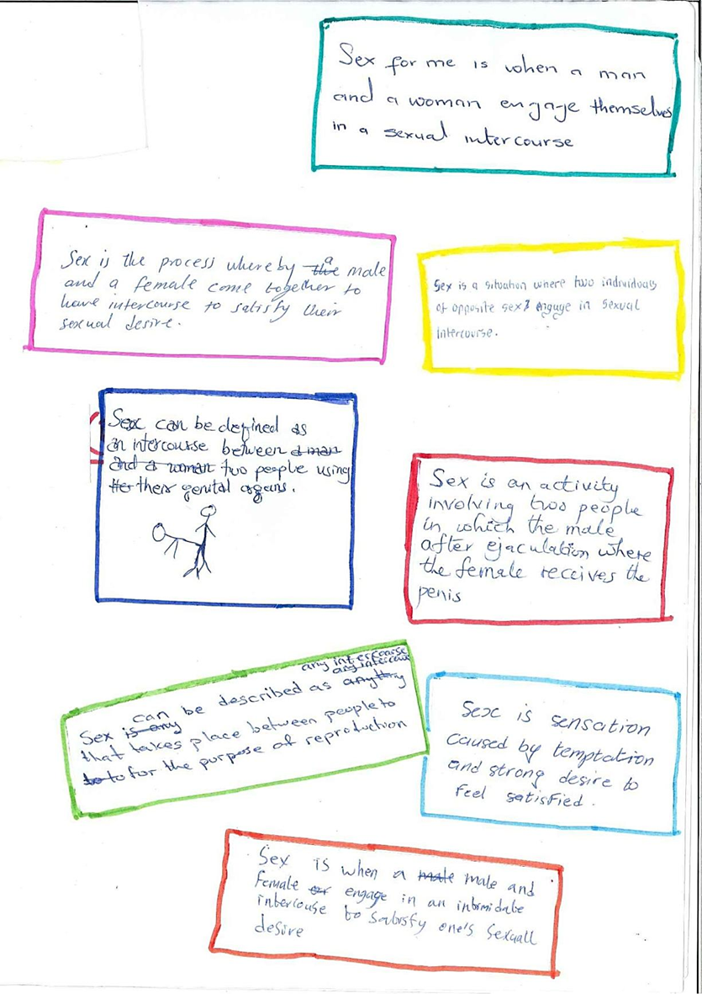
Many adolescents start discovering their sexual identity in high schools. In same-sexed boarding schools homosexuality is common. Male adolescents start to question their masculinity when they see boys involved with boys. Many of the informants were convinced they could change the sexual orientation of their homosexual classmates if they pushed them to play football and engage in other masculine activities. They explained to me (the researcher) that for the all-boys school, becoming homosexual was a recruitment process where boys were brain-washed or mislead to perform homosexual acts. They seemed to be applying the ‘brain-wash theory’ which believes that individuals are forced or fooled into certain sexual acts that are seen as unacceptable and disgusting in society (Rubin 1984: 168) for example homosexuality and masturbation.. This denial of homosexuality existing but only there for experiment sake also led the students to believe that homosexuality comes through influence. The informants explained to me that the first years (freshmen) were the main targets of the seniors; and they would gradually lure them into the practice, therefore it does not happen out of your own free will, but out of peer pressure this is referred to as a process of sexualisation that Biddulph describes as imposed sexual behaviour (2013). The juniors therefore keep a distance from the recruiters so they do not fall into the trap.
‘Homosexuals? I can’t judge them but we should not live by just the law, God will judge us one day, we should live by God not by legal terms’ (MSB5 Personal interview).
One informant spoke of being on a committee which had a handful of homosexuals who were not shy to express themselves in front of him, it made him and some other members of the committee uncomfortable. Seniors who were homosexuals rarely hid that they were because they dominated the school realm in a way and had the authority to boss around the juniors, this in a contrasting way depicts homosexuality as the hegemonic type of masculinity in boarding schools where heterosexual males feel intimidated.
Heterosexuality was a banal response in FGDs and was defined as the accepted relationship; anything else outside this thinking was excluded. Many of the respondents were also confused between how they felt towards homosexuals opposed to society’s general view of homosexuals. The adolescent reproductive health policy does not cover homosexuality directly but addresses it by defining gender roles in society; for example ‘Sex refers to being male or female. It is important to remain a male or female in all aspects of life as one is growing up’. This further reinforces the social construction of gender roles and gender power relations in sexuality where the male is dominant and the female submissive (Arnfred 2004). How a man should behave and how a woman should behave are explained in this brochure according to the social and cultural constructs in Ghana. No provision is made for people who do not fit into these two categories, you are either one or the other. The brochure dwells on essentialist notions of gender which are also interlinked to gendered behaviour when talking about sex. Females are supposed to be shy, naïve when talking about sex and showing how much they know about it hence female interviewees portrayed the same characteristics out of fear of being called a bad/ naughty girl and if they did not understand a term such as masturbation, even if I would offer to explain, they would prefer not to know so that their minds would not be polluted.
The female interviewees were either obliged to agree with what other female participants were saying or just keep silent; so that gossip, shunning, nasty looks among them could be avoided, we call this informal social control’ (Fischer 2011: 39).

Conclusion

5.1 Introduction
This chapter will synthesise the study while tailoring answers to the four research questions and then giving my own reflections, finally it will end with policy recommendations and suggestions for further research.

5.2 Synthesis of Research and Reflections
Adolescents acquire their knowledge on sexuality and relationships not just through the formal sex education programme but also through the internet and peers. These sources are however not as reliable as the classrooms, hence participants expressed their appreciation for learning about topics on sexuality in school but requested the sex education programme be more detailed and practical to suit their real life situations.
Exploring the attitudes and knowledge of adolescents in sexuality and relationships brought about an understanding on what adolescents learn and think about sexuality and relationships. Doing this research has helped realise that there is a gap in what is taught and what they do. In addition to that, environments which value and live by cultural and traditional norms seem to partly have an influence on the perceptions of adolescents on sexuality and relationships. The inevitable normative answers that were given by interviewees at the beginning of the research compared to the types of responses as I dug deeper, showed that cultural norms and values are the first thing the adolescents reciprocate, then express their own personal view thereafter which in a few cases were different from the norms. The debate still remains on how comprehensive a sex education programme should be taking into consideration the cultural context of a country. In a nutshell, the participants revealed that abstinence-only education reinforces hegemonic norms of heterosexual relationships which significantly excludes the sexual minority youth. Given the fact that, sexuality and relationships are sensitive topics to talk about openly in the Ghanaian society, the was a sense of discomfort talking about topics of intercourse, masturbation, homosexuality and relationships during FGDs and one-on-one interviews. Although the adolescent boys were not shy or timid during FGDs, some were embarrassed or felt awkward talking about sex to me during the one-on-one interviews. Many of them showed hostile views toward homosexuality, but the few that were indifferent or did not see anything wrong with it gave an essence of hope that negative attitudes towards homosexuality are gradually changing.
Fischer talks about America being a dualistic culture where there only exists one side or the other (black/white, good/bad, right/wrong etc.) there is no in between (2011: 40). The same goes with Ghanaian culture toward issues of sexuality; it is either seen as moral/immoral or right/wrong. Many of the respondents bared this characteristic, only a handful were indifferent about masturbation, pre-marital sex and homosexuality while the rest used words like disgusting, bad or immoral to describe masturbation and homosexuality. It shows the dualistic nature of Ghanaian culture and how this influences the views of adolescents in Ghana on sexuality and relationships which reiterates the concept of the ecological model where culture and policies partly have a role to play in an adolescent’s reactions and attitudes towards issues in sexuality and relationships. Even if individual and particularly adolescents have a libertarian (live and let live attitude ) view towards sexuality and relationships for fear of receiving nasty looks and of being accused as non-conformist they would rather not express this view openly (Fischer 2011: 44).
The Ghanaian context does not recognise adolescents under 18 as sexual beings; to make progress in developing more-friendly adolescent services in sexual health, society needs to accept them as such, to create a safe space to allow them to talk about sexuality and relationships as they make informed decisions about their sexual lives.

5.3 Policy Recommendations
‘Without Knowledge, you cannot make use of your rights…’
Boa Nnipa Foundation

Interviewees expressed that formal sex education was beneficial to them, in the sense that they could ask several questions in a classroom scenario without being pointed out individually by teachers or peers as being rotten for asking such questions. There is still the need to improve on specific areas of interest, I hereby make the following recommendations:
1.Broadening of content of sex education programme in Ghana.
- As one of the interviewees put it, ‘Abstinence is good at this age however you can also have sex at this age if you are prepared for the consequences’. Given this statement, adolescents appreciate the prioritisation of abstinence education however government needs to acknowledge that there are many adolescents who are sexually active thus, they need to give adolescents under 18 more practical information on birth control and condom use. Knowledge is power, therefore giving these adolescents this information would not increase the probability of them having sex but would rather help them to make informed decisions about their sexual life.
- Students indicated that there were limits to the programme and this was also the same view the Programme Manager expressed: very little is said about sexual orientation. There is a strong need for the programme to be expanded to help adolescents understand their sexual identity and rights and also create a more tolerant society. The problematic is also how homosexuality will be addressed or interpreted in the programme content regarding the negative societal perception towards it.
- In addition to that, very little information is available on relationships for adolescents yet, very significant when growing up to know how to manage one’s feelings. A good example the government can dwell on is the current programme by Path Organisation in Thailand called Teen Path (Thaweesit & Boonmongkon 2009:1). Teen Path covers a lot of literature on relationships so that adolescents are able to deal better with their emotions. Commendable literature and manuals have been published in Ghana such as the ABC of Counselling Adolescents Towards Behavioural Change (2nd Edition) which does not focus entirely on abstinence-only education but also looks at counselling for adolescents who are sexually active, condom use and protection from STIs. The saying ‘practice what you preach’ is easier said than done; in circumstances where there are comprehensive documents on sex education yet societal attitudes towards adolescents talking about sex, or engaging in sex is contrary to what is written, poses a challenge to how the message is carried out by teachers, parents, counsellors who have this behaviour embedded within them.
2. Improving on other sources of information/innovative ways of getting the word out.
- Interviewees stated that most of the information they get about sex and relationships were from friends, the media and internet. Therefore introducing or improving on programmes such as peer to peer education, interactive websites for teenagers where adolescents can ask questions privately about sexuality (interactive learning).
- Also, more teacher and counsellor training in sexuality education. Government needs to employ independent counsellors so that students feel free and are able to trust them with sensitive information. If government could use these tools more effectively, information on sensitive topics such as condom use (which some teachers have difficulty teaching due to their religious affiliation) can be ready available to adolescents.
- Other than the sex education programme led by government, there are many other initiatives out there by NGOs to help adolescents in-school be more knowledgeable about sex and make informed decisions. A collaboration with these organisations to learn further innovative ways for sexuality education and what they are doing differently is equally recommended.
Even when good policy guidelines are in place, financial conditions and social mind sets are major obstacles for sexuality education. Change of mind sets may take a period of time, but when done can help in improving the environment for talking about sex and also if policy frameworks are more contextualised than generalised.

5.4 Suggestions for Further Research
It would be interesting to do further research on the gendered power dynamics in boarding schools and how this plays a role in the development of the sexual identity of adolescents.
Also, if the sexual knowledge of adolescents is related to their sexual behaviour, since the ecological model shows that the environment has a way of influencing an adolescent’s decisions when it comes to sexual matters.
Finally, it is necessary for further studies to be done on relationships among adolescents in various developing countries. Since there is very little literature covering relationships and not many national sex education programmes in developing countries have developed content on this aspect of adolescent development.
References
Abraham, L. (2002) ‘Bhai-Behen, True Love, Time Pass: Friendships and Sexual Partnerships Among Youth in an Indian Metropolis’, Culture, Health & Sexuality, 4(3): 337-353.
‘Adolescents in Ghana Fact Sheet’ (2006) Accessed 22 May 2013. <http://www.guttmacher.org/pubs/2006/06/01/fb_ghana_adolescents.pdf>.
Agarwal, B. (1997) '''Bargaining'' and Gender Relations: Within and Beyond the Household', Feminist economics 3(1): 1-51.
Amekudi, O., A. Sefa-Dedeh, F. Oware-Gyekye, E. Tetteh, R. Mensah and R. Nutakor (eds)(2008) ABC of Counselling Adolescents Towards Behaviour Change.(2nd Edition) Accra: Ghana Health Service, Ministry of Health: 85-129.
Ampofo, A. A., & Boateng, J. (2007) Multiple meanings of manhood among boys in Ghana. From boys to men: Social Constructions of Masculinity in Contemporary Society: 50-74.
Arnfred, S. (2004) African Sexuality'/sexuality in Africa: Tales and silences. Re-thinking sexualities in Africa: 59-76.
Awusabo-Asare K, Abane A.M. and Kumi-Kyereme K (2004) Adolescent Sexual and Reproductive Health in Ghana: A Synthesis of Research Evidence, Occasional Report, New York: The Alan Guttmacher Institute, No. 13. Accessed 21 May 2013.
Awusabo-Asare K et al. (2006) Adolescent Sexual and Reproductive Health in Ghana: Results from the 2004 National Survey of Adolescents, Occasional Report, New York: Guttmacher Institute, No.22.
Beh, H. and M. Diamond (2006) 'The Failure of Abstinence-Only Education: Minors have the Right to Honest Talk about Sex', Columbia Journal of Gender and Law 15(1).
Berner, E. (1998) Social Structure and Human Agency: An Introduction. Basic text for INT, 101: 1-7.
Biddulph, S. (2013) ‘Sexualisation of the Young is Becoming Society’s Cancer’. Accessed 12 November 2013 <http://www.theage.com.au/federal-politics/contributors/sexualisation-of-the-young-is-becoming-societys-cancer-20130225-2f1y4.html.>.
Boa Nnipa Foundation. Accessed 23 January 2013 <http://www.boannipa.com/en/projekte/eban-im-detail/>.
Bronfenbrenner, U. and P.A. Morris (1998) 'The Ecology of Developmental Processes':
Brooks-Gunn, J. and F.F. Furstenberg Jr. (1989) 'Adolescent Sexual Behaviour.', American Psychologist 44(2): 249.
Connell, R.W. (1999) The Social Organization of Masculinity (Chapter 3) Masculinities. London, Polity Press: 68-77 .
Connell, R. W., & Connell, R. (2000) The men and the boys. University of California Pr.
Cornwall, A., Corrêa, S. and S. Jolly (2008) 'Development’s Encounter with Sexuality: Essentialism and Beyond’', Development With a Body: Sexuality, Human Rights And Development, Zed Books London : 22-42.
Davenport-Hines, R.P.T. (1990) Sex, Death and Punishment: Attitudes to Sex and Sexuality in Britain since the Renaissance, Collins London.
Dawson, D. A. (1986) The Effects of Sex Education on Adolescent Behaviour. Family Planning Perspectives : 162-170.
Deci, E. L., & Ryan, R. M. (Eds.)(2002) Handbook of Self-Determination Research, University Rochester Press.
Dickson-Swift, V., E.L. James, S. Kippen and P. Liamputtong (2007) 'Doing Sensitive Research: What Challenges do Qualitative Researchers Face?', Qualitative Research 7(3): 327-353.
EBAN Project in Ghana, Boa Nnipa Foundation http://www.youtube.com/watch?v=bjMRwLdgrlk (accessed 20 January 2013).
Faust-Sterling, A. (2000) Sexing the Body: Gender Politics and the Construction of Sexuality. Basic Books.
Fischer, N. (2011) 'Purity and Pollution; Sex as a Moral Discourse', Introducing the new Sexuality Studies : 38-43.
Ghana Health Service Annual Report (2010) Accessed 28 May 2013. < http://www.ghanahealthservice.org/includes/upload/publications/GHS_2010_Annual%20Report_Final.pdf >.
Ghana Health Service. Brochure on Healthy Young People Better Future: Gender Accessed 8 November 2013 <http://adhdghana.org/download/iec_materials/for_adolescents/Gender.pdf>.
Ghana National Adolescent Health and Development Programme. Accessed 20 February 2013 < http://adhdghana.org/ >.
Ghana Strategic Plan for the Health and Development of Adolescents and Young People 2009-2015; 1-95.
Glover, E.K., A. Bannerman, B.W. Pence, H. Jones, R. Miller, E. Weiss et al. (2003) 'Sexual Health Experiences of Adolescents in Three Ghanaian Towns', International Family Planning Perspectives : 32-40.
Greig, A., Peacock, D., Jewkes, R., & Msimang, S. (2008) Gender and AIDS: time to act. AIDS (London, England), 22(Suppl 2), S35.
Guttmacher Advisory, Review of Report on ‘Emerging Answers 2007: Research Findings on Programs to Reduce Teen Pregnancy and Sexually Transmitted Diseases’, Guttmacher Institute.
Harcourt, W. (2009) Body Politics in Development: Critical Debates in Gender and Development. Zed Books London and New York: 130-135.
Hawkes, G. (1996) A Sociology of Sex and Sexuality. Open University Press Buckingham.
Hayes, C.D. (1987) Risking the Future: Adolescent Sexuality, Pregnancy, and Childbearing. Vol. 2. National Academy Pr.
Herdt, G. (ed.)(2008) Moral Panics, Sex Panics: Fear and the Fight over Sexual Rights. New York: New York University Press.
Human Rights Watch/Africa (2005) ‘The Less They Know, the Better: Abstinence-Only HIV/AIDS Programs in Uganda.’
Janus, S.S. (1993) The Janus Report on Sexual Behaviour. Wiley New York.
Kalipeni, E. (2009) Strong Women, Dangerous Times: Gender and HIV/AIDS in Africa. Nova Science Pub Inc.
Kantor, L.M., J.S. Santelli, J. Teitler and R. Balmer (2008) ‘Abstinence-only policies and programs: an overview’, Sexuality Research and Social Policy 5(3): 6-17.
Khan, S. and V.K. Mishra (2008) Youth Reproductive and Sexual Health. Macro International.
Kirby, D., A. Obasi and B. Laris (2006) 'The Effectiveness of Sex Education and HIV Education Interventions in Schools in Developing Countries', Technical Report Series-World Health Organization 938: 103.
Lee, R.M. (1993) Doing Research on Sensitive Topics. Sage: 20-24, 107-120, 164-170.
Lindberg, L.D. and I. Maddow-Zimet (2012) 'Consequences of Sex Education on Teen and Young Adult Sexual Behaviours and Outcomes', Journal of Adolescent Health 51(4): 332-338.
Lloyd C.B. (ed.) (2005) Growing Up Global: The Changing Transitions to Adulthood in Developing Countries, Washington, DC: National Academies Press.
Masters, W.H., V.E. Johnson, R.C. Kolodny and M.B. Bergen (1995) Human Sexuality. HarperCollins College Publishers New York, NY.
Measor*, L. (2004) 'Young People's Views of Sex Education: Gender, Information and Knowledge', Sex Education 4(2): 153-166.
Mirembe, R. and L. Davies (2001) 'Is Schooling a Risk? Gender, Power Relations, and School Culture in Uganda', Gender and Education 13(4): 401-416.
MOH (2008) ABC of Counselling Adolescents Towards Behavioural Change (2nd ed.). Accra, Ghana. Ministry of Health.
National Population Council (2000) Adolescent Reproductive Health Policy. Ghana National Population Council.
Nussbaum, M. (2004) ‘Beyond the Social Contract: Capabilities and Global Justice’ in Oxford Development Studies, Carfax PublishingVol.32, No.1, March 2004: 3-18.
Oakley, A., D. Fullerton, J. Holland, S. Arnold, M. France-Dawson, P. Kelley et al. (1995) 'Sexual Health Education Interventions for Young People: A Methodological Review.', BMJ: British Medical Journal 310(6973): 158.
Oxford Dictionaries, Oxford University Press. Accessed 9 November 2013 < http://www.oxforddictionaries.com/ >
Padgug, R. A. (1999). Sexual matters: On conceptualizing sexuality in history. Section I: Culture, Society and Sexuality 11 Part 1: Conceptual Frameworks 13, 15.
Parker, R.G. (2000) Framing the Sexual Subject: The Politics of Gender, Sexuality, and Power. University of California Press.
Parker, R. and P. Aggleton (2007) 2nd ed. Culture, Society and Sexuality: A Reader. Routledge: 263-272,
Peacock, D., Redpath, J., Weston, M., Evans, K., Daub, A., & Greig, A. (2008). Literature review on men, gender, health and HIV and AIDS in South Africa. Sonke Gender Justice Network. Accessed 9 November 2013 <http://www.xyonline.net/sites/default/files/Sonke,%20Literature%20Review%20on%20Men,%20Gender,%20Health%20and%20HIV%20and%20AIDS%20in%20South%20Africa%2008[1].pdf >.
Rich, A. (1980) 'Compulsory Heterosexuality and Lesbian Existence', Signs 5(4): 631-660.
Rubin, G. (1984) 'Thinking Sex: Notes for a Radical Theory Of the Politics of Sexuality', Pleasure and Danger: 143- 161.
Seidman, S., N. Fischer and C. Meeks (2011) Introducing the New Sexuality Studies. Routledge.
Simon, W. and J.H. Gagnon (1984) 'Sexual Scripts: Permanence and Change', Archives of Sexual Behaviour 15(2): 31-40.
Somers, C.L. and S.E. Paulson (2000) 'Students' Perceptions of parent–adolescent Closeness and Communication about Sexuality: Relations with Sexual Knowledge, Attitudes, and Behaviours', Journal of adolescence 23(5): 629-644.
Speizer, I.S., R.J. Magnani and C.E. Colvin (2003) 'The Effectiveness of Adolescent Reproductive Health Interventions in Developing Countries: A Review of the Evidence', Journal of Adolescent Health 33(5): 324-348.
Tamale, S. (2011) African Sexualities: A Reader. Fahamu/Pambazuka: 11-25.
Taylor, B.M. (1995) 'Gender‐power Relations and Safer Sex Negotiation*', Journal of advanced nursing 22(4): 687-693.
‘Teaching Kids about Sex: What to Say When?’ (2012) Polina Boiko (Host) Voice of Russia UK. <http://www.youtube.com/watch?v=d-afAWjAuNY> (Accessed 20 January 2013).
Thaweesit, S., & Boonmongkon, P. (2009) ‘Sexuality Education and Sexual Harassment: Two Critical Issues on Sexual Reproductive Health and Rights in Thailand’. Accessed 11 November 2013. http://www.teenpath.net/data/r-research/00010/tpfile/00001.pdf .
OHCHR (2013) The Right of the Child to the Enjoyment of the Highest Attainable Standard of Health. Geneva: United Nations Office of the High Commissioner for Human Rights.
UNESCO (2009) The International Technical Guidance on Sexuality Education. An evidence-informed Approach for Schools, Teachers and Health Educators. United Nations Educational, Scientific and Cultural Organization. Accessed 10 May 2013.
Vanwesenbeeck, Ina (2010) Sexual Socialisation, Background paper to Sexuality under 18, International Conference Rutgers WPF, Amersfoort 11-12 Oct. 2010:1- 9.
Walsh, David, 1998, ‘Structure/Agency’ in Jenks, Chris (ed.) Core Sociological Dichotomies, London: Sage: 8-29.
Youth Incentives (2004, 2nd edn. 2006) ‘Young and Sexual, An Exploration of Young People’s Sexuality and Their Sexual Development’ Rutgers Nisso Groep: 1-24.

Appendices
Appendix 1 Definitions used in the study
Throughout this research paper, I use terms such as homosexuality, boyfriend, girlfriend sexuality and others.
I use homosexuality to refer to both men and women. I define girlfriend or boyfriend as a partner or the person you are in an intimate (emotionally and physically) relationship with. Definitions of sexuality, sexual rights and sexual health, I use WHO working definitions.
“Sexuality is a central aspect of being human throughout life and encompasses sex, gender identities and roles, sexual orientation, eroticism, pleasure, intimacy and reproduction. Sexuality is experienced and expressed in thoughts, fantasies, desires, beliefs, attitudes, values, behaviours, practices, roles and relationships. While sexuality can include all of these dimensions, not all of them are always experienced or expressed. Sexuality is influenced by the interaction of biological, psychological, social, economic, political, cultural, ethical, legal, historical and religious and spiritual factors.” (WHO working definition, 2002)
Sexual Health is “A state of physical, emotional, and mental wellbeing related to sexuality: not merely the absence of disease, dysfunction, or infirmity. Sexual health requires a positive and respectful approach to sexuality and sexual relationships, as well as the possibility of having pleasurable and safe sexual experiences, free of coercion, discrimination and violence. For sexual health to be attained and maintained, the sexual rights of all persons must be respected, protected and fulfilled.” (WHO, working definition, 2002)
“Sexual rights embrace human rights that are already recognised in national laws, international human rights documents and other international agreements. These include the right of all persons, free of coercion, discrimination and violence, to: the highest attainable standard of health in relation to sexuality, including access to sexual and reproductive health care services, to seek and impart information in relation to sexuality, sexuality education, respect of bodily integrity, choice of partner, decide to be sexually active or not, consensual sexual relations, consensual marriage, decide whether or not and when to have children, pursue a satisfying, safe and pleasurable sexual life. The responsible exercise of human rights requires that all persons respect the rights of others.” (WHO, working definition 2002)
As sexual trends evolve, scholars have had extreme difficulty in defining masturbation/ autoerotism, I will use the simplest of definitions which is the ‘stimulation of one’s genitals with one’s hand for sexual pleasure’. Oxford Dictionaries. Accessed 9th November 2013. < http://www.oxforddictionaries.com/definition/english/masturbate#masturbate__9 > .
Sexual minority include adolescents in Ghana who are sexually active and also homosexuals; anything outside of hetero-normativity.
Sexualisation refers to ‘sexual behaviour imposed on someone as opposed to arising from their own yearnings or desire’. (Biddulph 2013)
The Ghana National ADHD Programme was designed in 1996 by the Ministry of Health in Ghana ‘to make available appropriate information and counselling services on young people’s health and provide comprehensive health services and other complementary programmes such as self-care, life and livelihood skills to adolescents and young peoples’ health’ (ADHD Ghana). The ADHD is a holistic programme for adolescents that cover some parts of sexuality, reproductive health and well-being, drug abuse, to mention but a few, to promote healthy lifestyles among the youth while growing up.

Appendix 2 Thirty one-on-one interviews conducted, number of interviews in each school
All-boys school | 9
Mixed School (Boys) | 7
Mixed School (Girls) | 6
All-girls School | 8
Total | 30

Appendix 3 Form of consent for those taking part in the Focus Group Discussions
INFORMED CONSENT

Knowledge and Attitudes on Sexuality and Relationships: Adolescents in Boarding Schools in Ghana
Principal Investigator:
Genevieve Partington (MA in Development Studies)
International Institute of Social Studies
2518 AX The Hague
The Netherlands
Email: gene_kp@yahoo.com

Background:
You are being invited to take part in a research study. Before you decide to participate in this study, it is important that you understand why the research is being done and what it will involve. Please take the time to read the following information carefully. Please ask the researcher if there is anything that is not clear or if you need more information.

The purpose of this study is to find out how adolescents derive meanings of sexuality and relationships from sex education in the school programme. Your expected time commitment for this study is: 45 minutes to 1 hour.

Confidentiality:
Your responses will be anonymous. Every effort will be made by the researcher to preserve your confidentiality.

Person To Contact:
Should you have any questions about the research or any related matters, please contact the researcher at gene_kp@yahoo.com or +233508921472.

Consent:
By signing this consent form, I confirm that I have read and understood the information and have had the opportunity to ask questions. I understand that my participation is voluntary and that I am free to withdraw at any time, without giving a reason and without cost. I understand that I will be given a copy of this consent form. I voluntarily agree to take part in this study.

Signature …. ……….. Date……..

Appendix 4 Guideline for Focus Group Discussions and one-on-one interviews
- What do you learn in class about sex?
- Can you relate the topics you cover in class to reality?
- What is sex to you/ what do you consider as sex? (GAME: Pieces of paper, write and put in bowl to remain anonymous).
- How do you feel talking about sex to your peers/teachers?
- Have you ever bought a condom?
- How do you feel about buying condoms?
- What is a relationship to you (Boyfriend/girlfriend)?
- Is it normal at this age to be in a relationship?
- Are your parents aware you are in a relationship with someone?
- How do they feel about you being in a relationship?
- Does the programme cover anything about relationships?
- What is the main message you receive from what is taught in class?
- What do you think about homosexuality?
- How about masturbation?

Appendix 5 Questionnaire for general information on sexuality and relationships
This questionnaire is to find out what kind of sex education is being provided in senior high schools in Ghana and what students think about sexuality. It would be of great help if you could respond to the following questions.
- How old are you?
- Male/ Female
- Does your school provide sexuality education?
  - Yes
  - No
- How do you learn about sex education?
  - In class
  - Through a parent or relative
  - Through friends
  - Through the internet
- What does the sex education programme in school teach you? (please tick)
  - How to use condoms
  - How to use contraceptives
  - Teenage pregnancy
  - HIV/STIs *Sexually Transmitted Infections
  - Sexual intercourse
- Does your program address issues of gender and sexual identity?
  - Yes
  - No
  - I don’t know what that means
- What subjects in class incorporate sex education?
- What message does the program provide students about sex?
- What other topic would you like to know about concerning sexuality?
- As a student, do you feel that the information you are receiving is appropriate for your age?

Appendix 6: Data on Four Focus Group Discussions conducted in three senior high boarding schools.
Frequency of responses according to research themes in each focus group discussion. Codes were created after data transcription based on the responses during the discussion.
Data generated by Atlas Ti7
  - What is the appropriate time for sex and relationship?
Codes | P 1: All-boys School | P 2: Mixed school- boys session | P 3: Mixed school- girls session | P 4: All-girls school | TOTALS:
15 years is ok for a relationship | 1 | 0 | 0 | 0 | 1
18 years is the appropriate age for a relationship | 0 | 2 | 2 | 0 | 4
18 years is appropriate age for sex | 0 | 1 | 2 | 0 | 3
25 years is the appropriate age for sex | 0 | 0 | 1 | 0 | 1
  - Condom Use
Codes | P 1: All-boys school | P 2: Mixed school- boys session | P 3: Mixed school- girls session | P 4: All-girls school | TOTALS:
acquire free condoms through street campaigns | 0 | 2 | 0 | 0 | 2
buying a condom, by writing it on a piece of paper and handing it over to the pharmacist | 0 | 1 | 0 | 0 | 1
feels normal buying a condom | 1 | 0 | 0 | 0 | 1
Gets condoms from someone older: relative | 1 | 0 | 0 | 0 | 1
guilt when buying a condom due to religious background | 2 | 0 | 0 | 0 | 2
lack of discretion from pharmacists when buying a condom | 0 | 1 | 0 | 0 | 1
pharmacists asking adolescents their age when coming to buy a condom | 0 | 1 | 0 | 0 | 1
pharmacists need to be educated on how to sell condoms | 0 | 1 | 0 | 0 | 1
practice of unprotected sex if I can't get a condom | 0 | 1 | 0 | 0 | 1
risky not having a condom | 1 | 0 | 0 | 0 | 1
shy to buy condom | 1 | 0 | 0 | 0 | 1
use of withdrawal method if I can't find a condom | 0 | 1 | 0 | 0 | 1
will never go buy a condom | 0 | 0 | 1 | 0 | 1
TOTALS: | 6 | 8 | 1 | 0 | 15
  - Views on Homosexuality
Codes | P 1: All-boys school | P 2: Mixed school- boys session | P 3: Mixed school- girls session | P 4: All-girls school | TOTALS:
belief that you can be influenced and become homosexual therefore keeping a distance | 3 | 4 | 2 | 5 | 14
belief that you can change a homosexual by doing masculine activities | 2 | 0 | 0 | 0 | 2
denial of having a homosexual friend | 0 | 1 | 2 | 1 | 4
disgust towards homosexuality | 3 | 3 | 1 | 1 | 8
homosexuality as an addiction | 0 | 1 | 0 | 0 | 1
homosexuality as bad, but no discrimination | 3 | 0 | 0 | 0 | 3
homosexuality being associated with medical complications if practiced | 0 | 1 | 0 | 1 | 2
Homosexuality can cause death due to anal expansion | 1 | 0 | 0 | 0 | 1
homosexuality is bad based on religious views | 3 | 2 | 3 | 0 | 8
homosexuality is unlawful | 0 | 1 | 0 | 0 | 1
homosexuality is wrong based on cultural norms | 0 | 1 | 2 | 4 | 7
homosexuality related to genetic problem | 1 | 0 | 1 | 0 | 2
homosexuality related to mental illness | 0 | 1 | 0 | 0 | 1
indifferent attitude towards homosexuals | 1 | 0 | 1 | 0 | 2
Lesbians: use emotional acts | 0 | 0 | 1 | 0 | 1
moral view on lesbianism to justify it being wrong | 0 | 0 | 0 | 1 | 1
more discrimination leads to increase in number of homosexuals | 1 | 0 | 0 | 0 | 1
relating homosexuality to evil spirits | 1 | 1 | 0 | 0 | 2
Sissies being seen as homosexual | 4 | 0 | 0 | 0 | 4
suspicion of people being homosexual | 1 | 0 | 1 | 0 | 2
use of animals to validate that homosexuality is wrong | 0 | 1 | 1 | 0 | 2
TOTALS: | 35 | 41 | 29 | 40 | 145
  - Definition of sex
Codes | P 1: All-boys school | P 2: Mixed school- boys session | P 3: Mixed school- girls session | P 4: All-girls school | TOTALS:
bestiality as sex | 0 | 1 | 0 | 0 | 1
heterosexuality as the only norm in sexual relations | 5 | 10 | 7 | 10 | 32
masturbation as a form of sex | 0 | 1 | 0 | 0 | 1
moral view of sex | 2 | 0 | 0 | 0 | 2
oral sex as bad | 0 | 0 | 0 | 1 | 1
oral sex as sex | 0 | 1 | 1 | 1 | 3
penetration not the only form of sex | 0 | 0 | 1 | 0 | 1
phone sex as sex | 0 | 1 | 0 | 2 | 3
possibility of same-sex couples | 0 | 2 | 0 | 1 | 3
sex as a game | 0 | 0 | 0 | 1 | 1
sex as gender: male/female | 0 | 0 | 2 | 0 | 2
sex as intercourse | 1 | 2 | 1 | 5 | 9
sex as pleasure | 1 | 1 | 1 | 2 | 5
sex as reproduction | 1 | 0 | 1 | 3 | 5
sex as satisfaction | 1 | 6 | 0 | 0 | 7
sex as something spiritual | 0 | 0 | 0 | 1 | 1
sex can be with several people | 0 | 1 | 0 | 0 | 1
TOTALS: | 11 | 26 | 14 | 27 | 78
  - Level of intimacy at this age
Codes | P 1: All-boys school | P 2: Mixed school- boys session | P 3: Mixed school- girls session | P 4: All-girls school | TOTALS:
holding hands is ok at this age | 0 | 0 | 0 | 3 | 3
hugging is ok at this age | 0 | 0 | 0 | 3 | 3
kissing and fondling is ok at this age | 0 | 0 | 1 | 2 | 3
kissing is not ok at this age because it leads to sex | 0 | 0 | 0 | 5 | 5
no physical intimacy in a relationship at this age | 0 | 1 | 1 | 3 | 5
physical intimacy is required in a relationship | 0 | 2 | 0 | 0 | 2
TOTALS: | 0 | 3 | 2 | 16 | 21
  - Views on masturbation
Codes | P 1: All-boys school | P 2: Mixed school- boys session | P 3: Mixed school- girls session | P 4: All-girls school | TOTALS:
doctor says there is nothing wrong with masturbation | 1 | 0 | 0 | 0 | 1
masturbation is bad | 0 | 3 | 2 | 1 | 6
masturbation can lead to infection | 0 | 0 | 1 | 1 | 2
masturbation is not covered in school curriculum | 0 | 0 | 1 | 0 | 1
masturbation is not good, because you are wasting semen that can be used for reproduction | 1 | 0 | 0 | 0 | 1
masturbation is ok if you do not ejaculate | 1 | 0 | 0 | 0 | 1
masturbation so you don't have to have sex | 0 | 0 | 0 | 2 | 2
masturbation to preserve virginity | 0 | 1 | 0 | 0 | 1
masturbation to prevent 'blue balls' | 0 | 1 | 0 | 0 | 1
masturbation to prevent pregnancy | 0 | 0 | 1 | 0 | 1
no infection when you masturbate so it's safe | 0 | 0 | 0 | 1 | 1
phone sex leads to masturbation | 0 | 0 | 2 | 1 | 3
religious view of masturbation being bad | 0 | 1 | 0 | 0 | 1
too much masturbation = less sexual satisfaction during intercourse | 0 | 0 | 1 | 0 | 1
use of objects for masturbation | 0 | 0 | 0 | 3 | 3
TOTALS: | 3 | 9 | 10 | 21 | 43
  - Sex education programme
Codes | P 1: All-boys school | P 2: Mixed school- boys session | P 3: Mixed school- girls session | P 4: All-girls school | TOTALS:
abstinence message a good thing at this age | 0 | 2 | 2 | 0 | 4
Attitude of student in class: Excitement | 1 | 0 | 0 | 0 | 1
course content: contraceptives | 1 | 0 | 0 | 0 | 1
course content: relationships and dating | 0 | 0 | 0 | 1 | 1
course content: teenage pregnancy | 0 | 0 | 1 | 0 | 1
course content: HIV/AIDS and STDs | 1 | 0 | 1 | 2 | 4
course content: reproduction | 2 | 0 | 0 | 1 | 3
main message as consequences of sex to make students abstain until marriage | 0 | 1 | 0 | 1 | 2
main message being abstinence | 1 | 5 | 1 | 2 | 9
more education on condom use if we can't abstain | 1 | 0 | 0 | 0 | 1
practical condom use not taught in class | 1 | 1 | 0 | 0 | 2
sex education in integrated science | 1 | 1 | 1 | 1 | 4
sex education in Management in Living | 0 | 0 | 1 | 1 | 2
sex education in social studies | 1 | 1 | 1 | 1 | 4
sex education is practical enough | 0 | 0 | 0 | 1 | 1
sex education not practical for reality | 2 | 1 | 0 | 2 | 5
sex education should cover condom use and not just abstinence | 1 | 1 | 0 | 0 | 2
teachers deviate from syllabus: good thing | 2 | 0 | 4 | 1 | 7
teachers not ok with students getting into relationships | 0 | 0 | 1 | 2 | 3
teachers say masturbation is wrong | 1 | 0 | 0 | 0 | 1
teachers say there is nothing wrong with masturbation | 1 | 0 | 0 | 0 | 1
teachers take a moral view therefore are limited | 1 | 0 | 0 | 0 | 1
TOTALS: | 18 | 16 | 15 | 28 | 77
  - Sources of information on sex
Codes | P 1: All-boys school | P 2: Mixed school- boys session | P 3: Mixed school- girls session | P 4: All-girls school | TOTALS:
Counselors seen as advisors when in trouble but not for sex | 1 | 0 | 2 | 0 | 3
friends are not a reliable source of information on sex | 0 | 0 | 1 | 0 | 1
Friends as main source of info on sex | 1 | 1 | 3 | 0 | 5
Internet as source of information for sex | 1 | 2 | 1 | 0 | 4
ok talking to siblings about sex | 0 | 0 | 0 | 1 | 1
ok talking to someone older about sex | 0 | 0 | 2 | 4 | 6
ok talking with parent about sex | 0 | 0 | 1 | 2 | 3
TOTALS: | 3 | 6 | 12 | 19 | 40
  - Views on relationships
Codes | P 1: All-boys school | P 2: Mixed school- boys session | P 3: Mixed school- girls session | P 4: All-girls school | TOTALS:
denial about being in a relationship | 0 | 0 | 1 | 0 | 1
feeling of regret after being in a relationship | 0 | 0 | 0 | 1 | 1
necessary to lay down rules in a relationship to create mutual understanding | 0 | 0 | 0 | 2 | 2
Social club in school that talks about relationships | 1 | 0 | 0 | 0 | 1
TOTALS: | 1 | 0 | 1 | 3 | 5
  - Attitudes towards phone sex
Codes | P 1: All-boys school | P 2: Mixed school- boys session | P 3: Mixed school- girls session | P 4: All-girls school | TOTALS:
phone sex as disgusting | 0 | 0 | 1 | 0 | 1
phone sex as sex | 0 | 1 | 0 | 2 | 3
phone sex leads to masturbation | 0 | 0 | 2 | 1 | 3
Phone sex: trend for adolescents | 0 | 1 | 3 | 2 | 6
TOTALS: | 0 | 2 | 6 | 5 | 13

Appendix 7 Brochure on Abstinence (Ghana AIDS Commission)
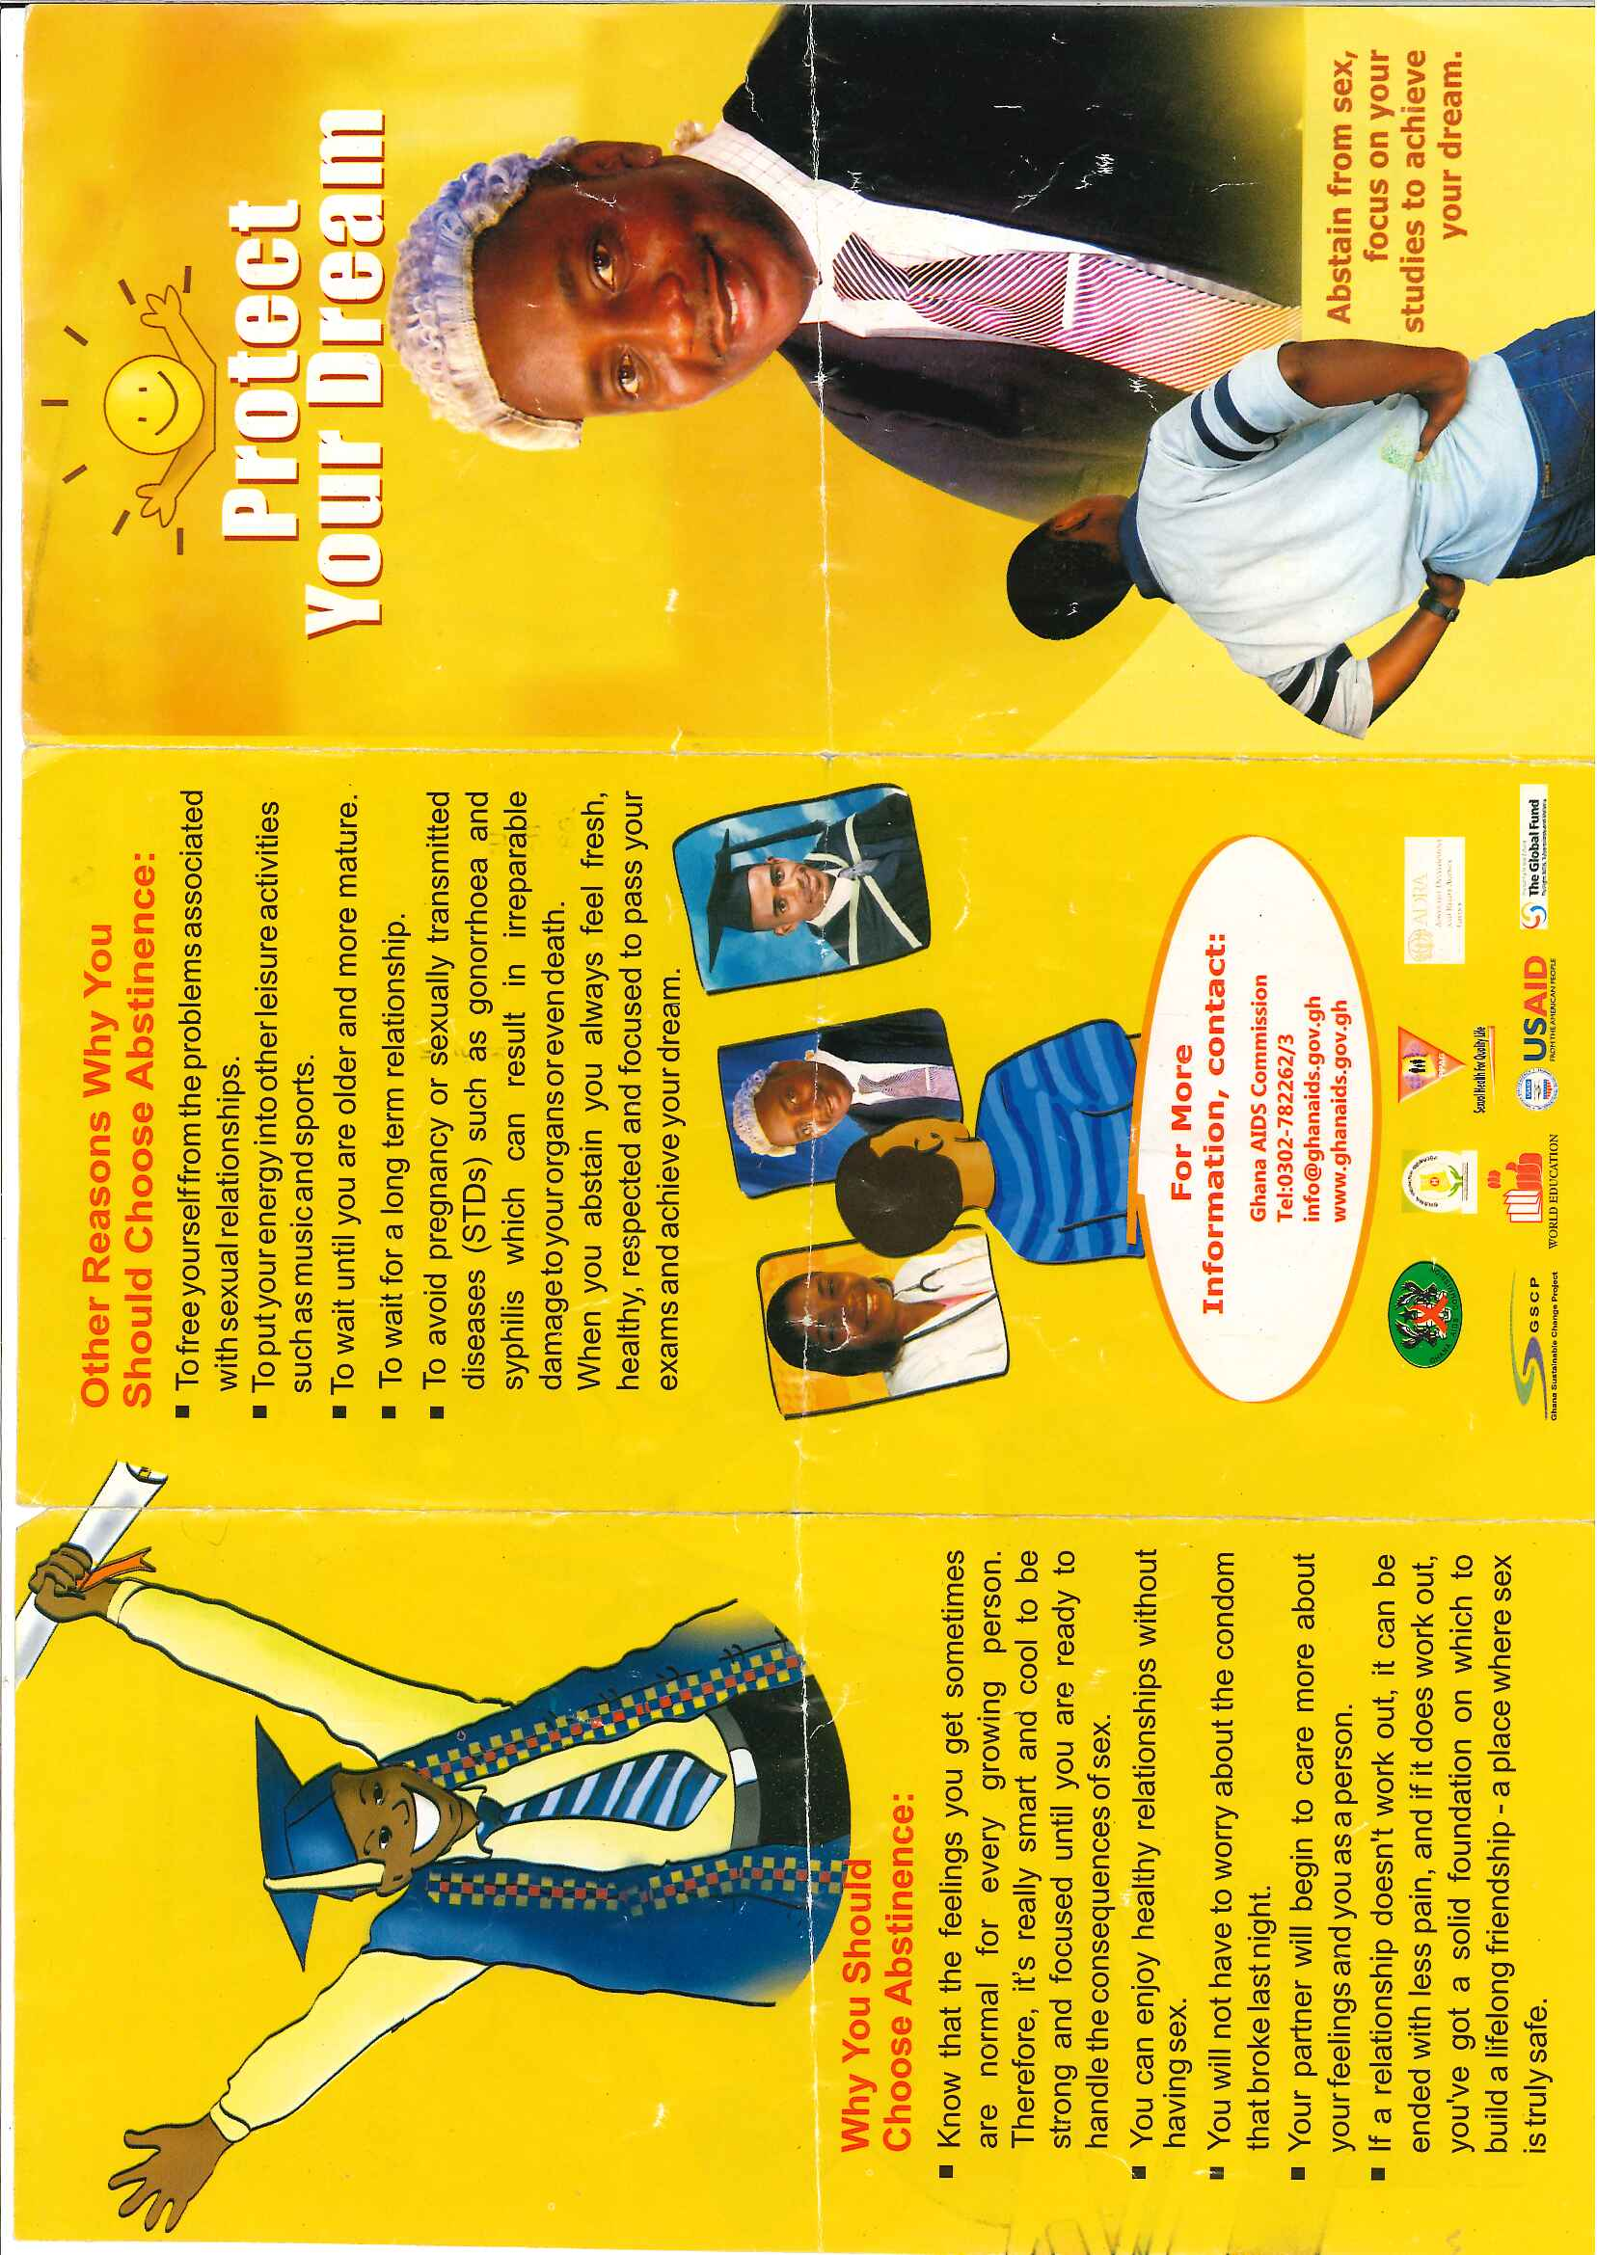

Appendix 8 Continuation of Brochure on Abstinence (Ghana AIDS Commission)
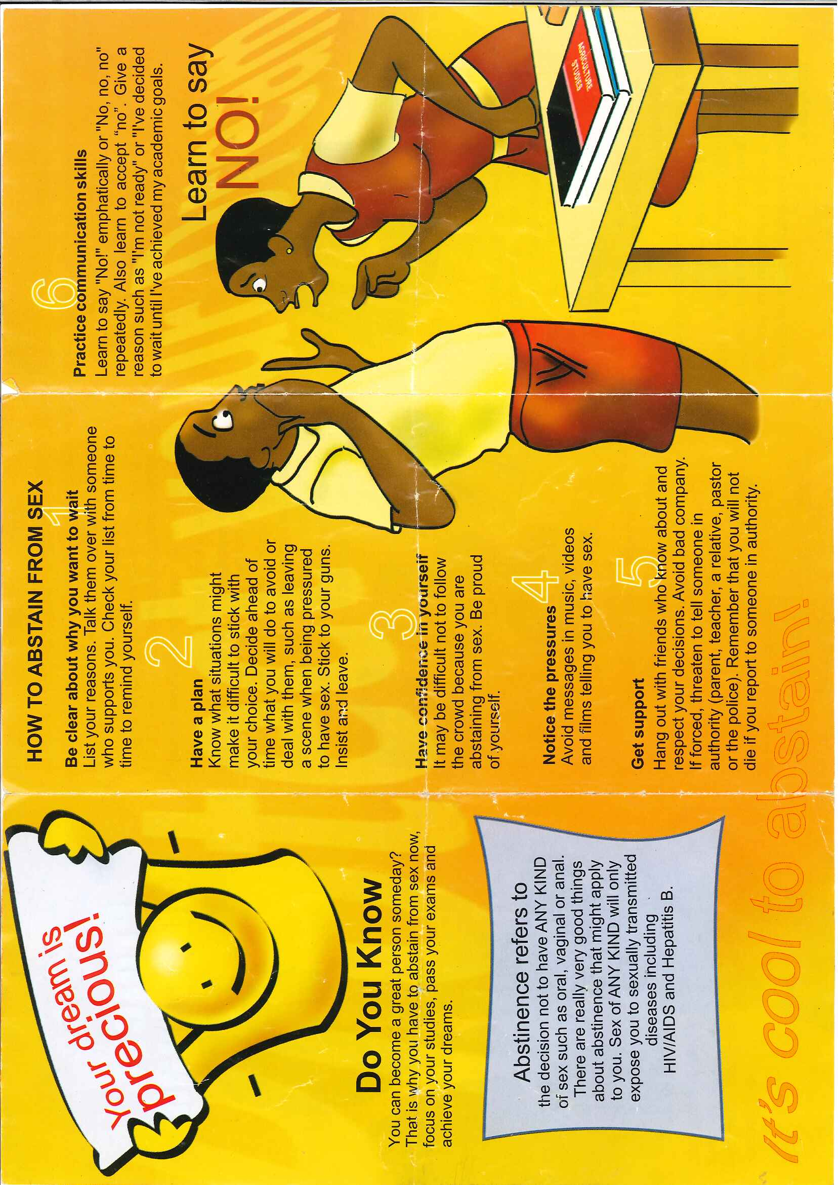

Appendix 9 Game of 'What is sex?' Responses from an all-boys school during a FGD
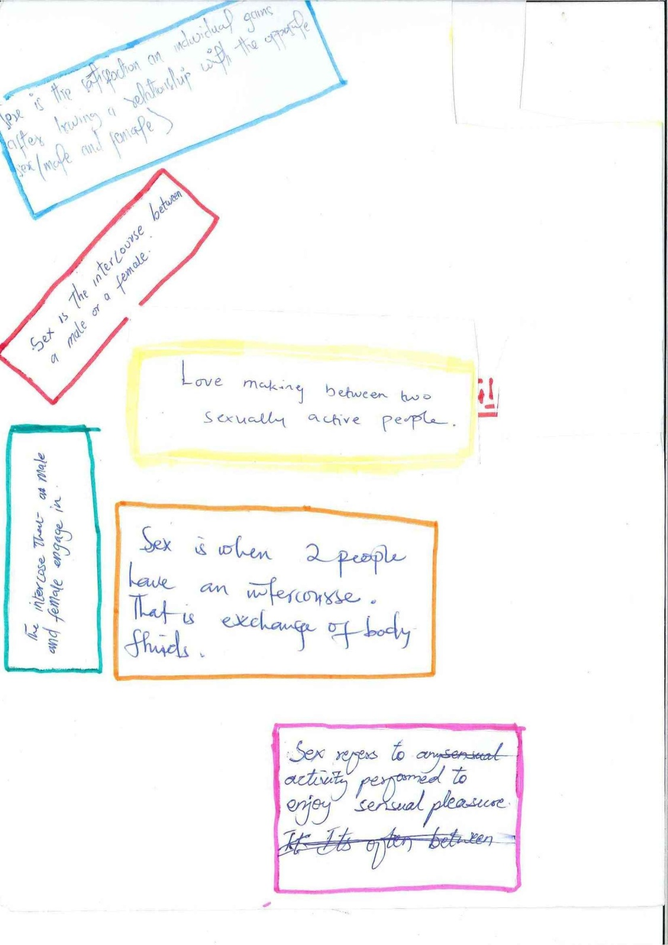
Appendix 10 Game 'What is sex?' Responses from an all-boys school during a FGD (continuation)
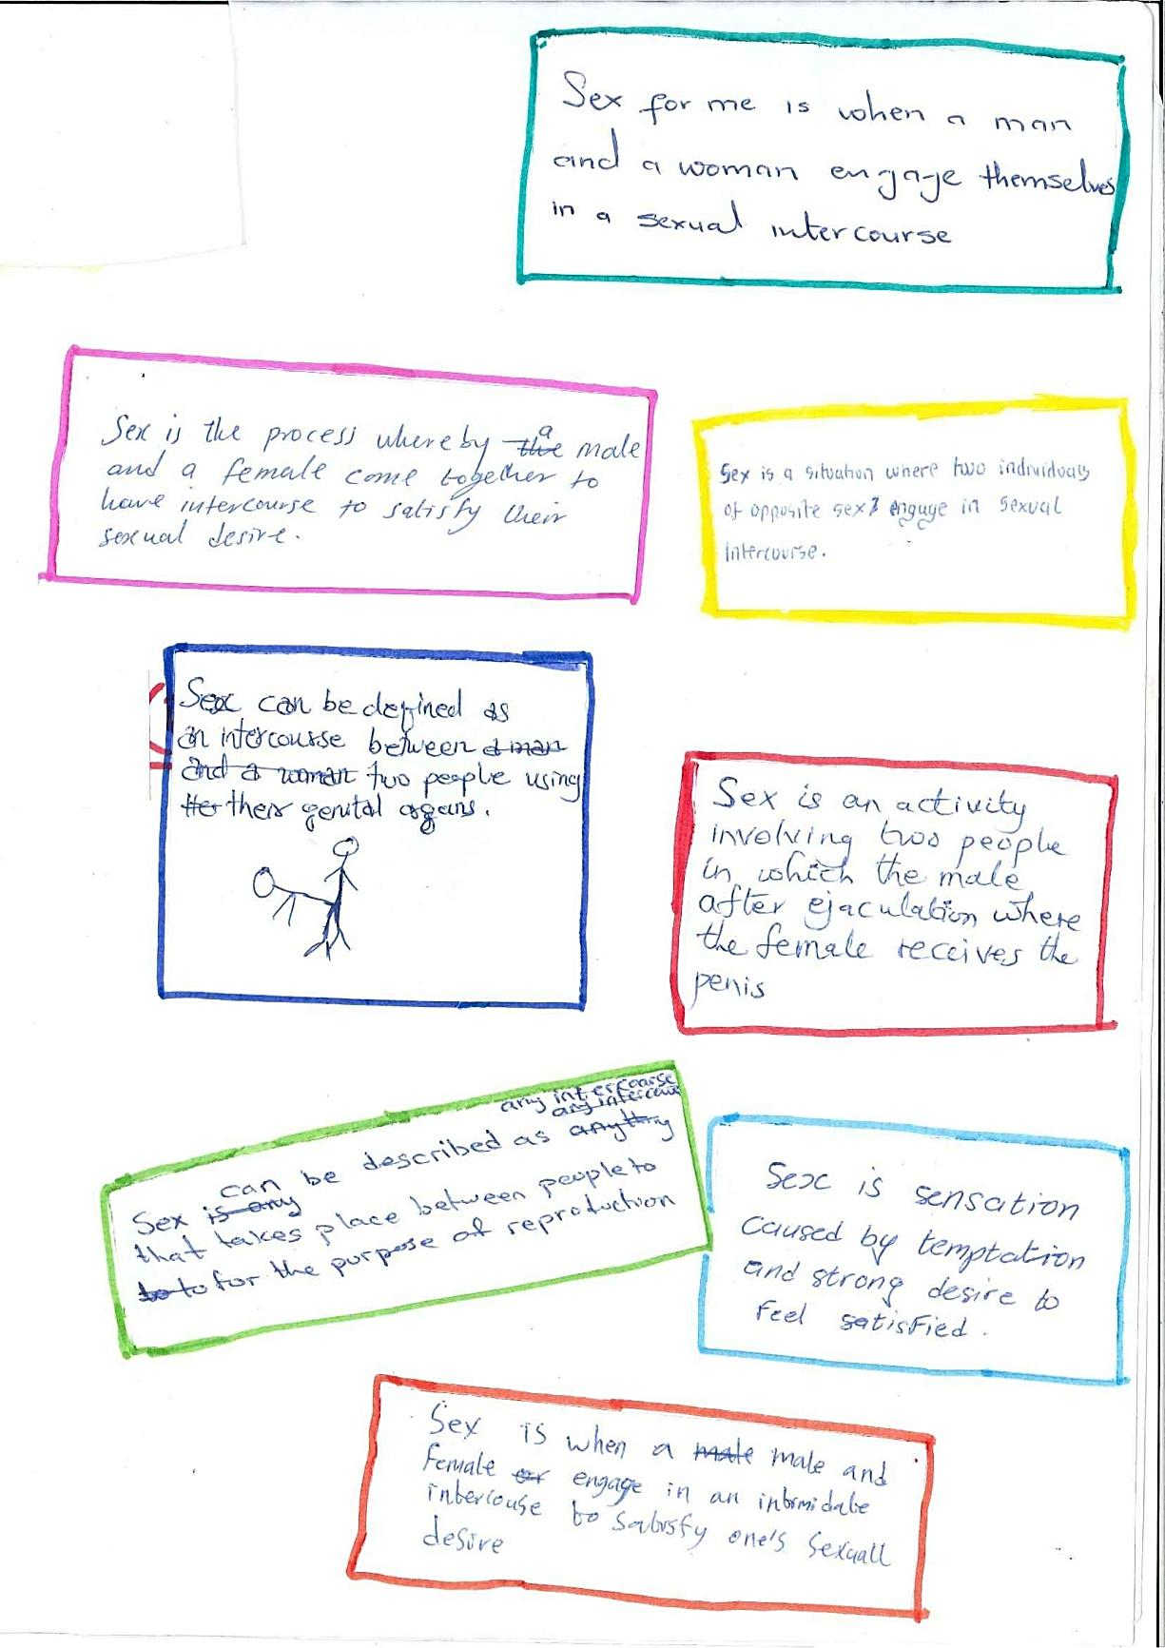

Appendix 11 Game of 'What is sex?' responses from an all-girls school FGD
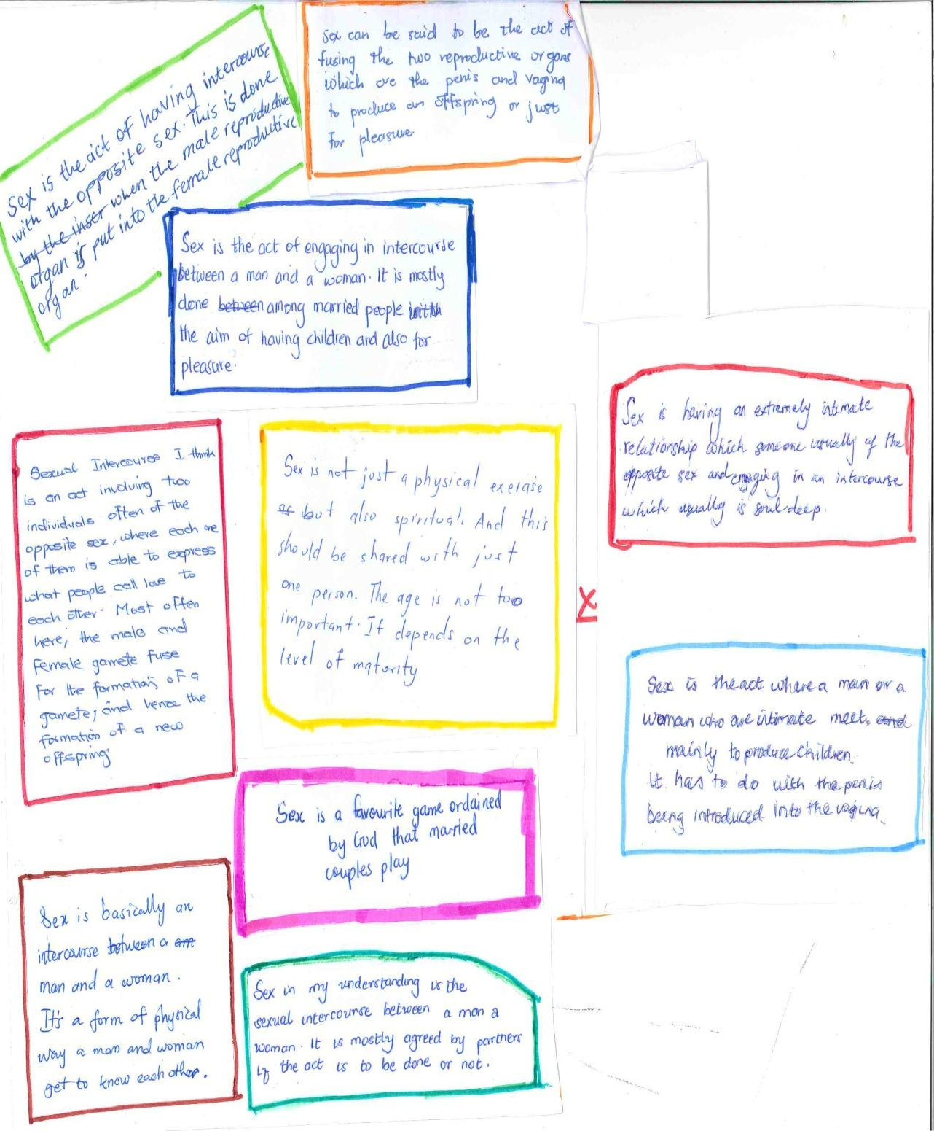

Appendix 12 Game of 'What is sex?' responses from a mixed school in FGD (girls session)
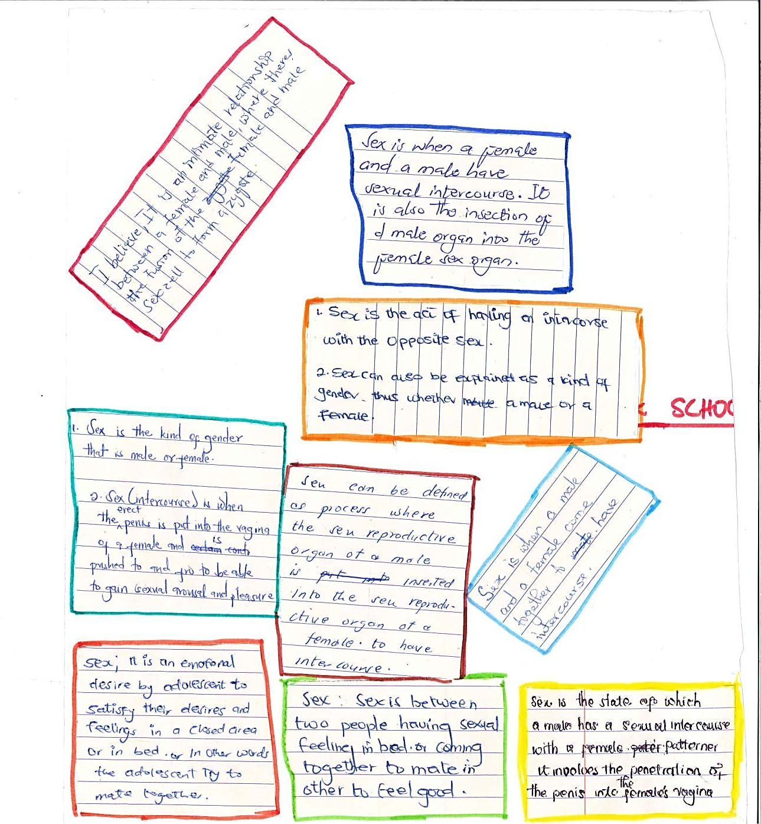

Appendix 13 Game on 'What is sex?' Responses from a mixed school in FGD(boys session)
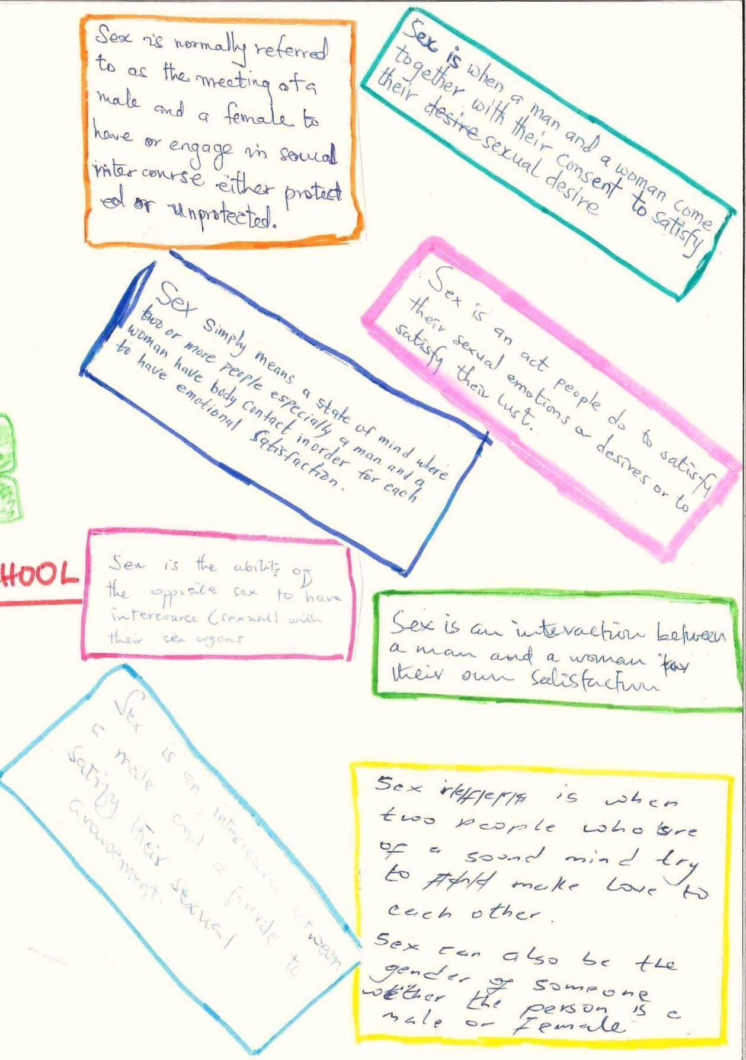

Table 1.1 Fertility Indicators in Ghana in 1998 and 2003
Ghana Strategic Plan for the Health and Development of Adolescents and Young People 2009-2015; 1.
UNESCO International Technical Guidance on Sexuality Education 2009
See also Map 5.1 Ghana and its Regions
Quota sampling: targeting specific people with different educational backgrounds in the sample group (school) to create less bias.
See Appendix 9-13 on responses to game ‘what is sex? From FGDs
See Appendix 4 Guideline for FGDs and one-on-one interviews
See Appendix 5 Questionnaire for General Information
ADHD brochure on Healthy Young People Better Future: Gender, GHS.
One-on-one interview in All-girls school.
‘Studies across societies have shown that sexuality norms are gender asymmetric and that ‘power imbalance characteristic of sexual relations between men and women has many of its roots in adolescence’’ (Weiss et al. 2000; 233 as cited in Abraham 2002; 359), indicated that gendered power relations in sex start at a young age.
P4: FGD in all-girls school
One-on-one interview mixed school-girl
P4: FGD in all-girls school
See Appendix 8-12 responses from game in FGDs.
P4: FGD in All-girls School.
Appendix 1 Definitions used in the study
One-on-one Interview with a boy at mixed school.
AB6: one-on-one interview at an All-boys school
Brochure on Gender from ADHD Programme

