The Influence of Sleeping Behaviour on Consumers’ Likelihood of Purchase: a Case of Consumer Electronic Products

Author: Bas Vendrig
Email address: 376378bv@eur.nl
Supervisor: Dr. V. Avagyan
Study Program: Business Economics
Specialization: Marketing
Date: 08-10-2013

Abstract
The author of this study examines the effect of early birds and night owls on the likelihood of purchase after reading or receiving a product recommendation. A survey experiment was conducted amongst 240 respondents to test their likelihood of purchase on two electronic consumer products (Google glass, smartwatch). Previous studies state that product recommendations by acquaintances, experts or other unknown consumers influence the likelihood of purchase. After these results were replicated, this study includes the moderating variable chronotype into the linear multiple regression model. The results show that being a morning type has a positive significant effect on the likelihood of purchase after receiving a product recommendation, being an evening type results in a relatively lower likelihood of purchase. Previous studies show that morning types attach more value to known data, experiences and tangible facts. Evening types were proven to have a more impulsive character.

Acknowledgments
I would like to express my gratitude to my supervisor Vardan Avagyan for his useful and beneficial suggestions, remarks and insights throughout the writing and learning process of this Master’s thesis. Also, I would like to thank of all the participants of my survey, who have invested their time and effort enabling me to complete this research. I would like to thank my family and friends, who have supported me throughout the entire process, both for their support and encouragement.

Table of Contents
1. Introduction 4
1.1 Problem Statement and Research Questions 5
1.2 Relevance 5
1.3 Structure of thesis 6
2. Literature Review 6
2.1 Circadian rhythm 6
2.2 Online product recommendations 10
2.3 Hypotheses development 14
2.4 Conceptual Framework 16
3. Research Methodology 17
3.1 Data collection 17
3.1.1 Pretest 17
3.1.2 Distribution 18
3.2 Design and Measurement 18
3.2.1 Design and Manipulation 18
3.2.2 Measurement 19
3.3 Analysis 20
3.3.1 Participants 20
3.3.2 Testing assumptions 21
4. Results 24
4.1 Hypotheses H1a, b and c 25
4.2 Hypotheses H2a, b and c 27
5. Conclusion and Discussion 30
5.1 Conclusions 30
5.2 Managerial Implications 31
5.3 Limitations and Future research 31
6. References 33
7. Appendix 39
7.1 Appendix A: Questionnaire 39

1. Introduction
Today the internet is not only a way to gain and share information but it has also become an ordinary way to sell and buy products and services. It is very common to do your shopping right out of your lazy chair in the living room. The introduction of tablets, smartphones and safe paying methods increased the easiness and safety of doing online purchases. However, there will always be a certain risk factor that comes with doing shopping via the internet: you can’t feel, use, experience or look at the product before you buy it. The worldwide adaptation of the internet has facilitated the way consumers acquire information about certain products. A way to acquire information on products is to search and read product recommendations. Product recommendations help us minimize this risk and help to determine whether a product would be a worthy purchase. Expert, friends or even consumers that we don’t know in person can help judge if we should buy the particular product or not. But, how do people react on the different types of product recommendations that they receive and read? This thesis will expand our knowledge as regards to human product recommendations (acquaintance, consumers and expert recommendations) and the effect it has on the likelihood to make an online purchase.
However, the core of this thesis focusses at the moderation effect of circadian rhythm on the relationship between product recommendations and the likelihood of purchase a particular product online. The circadian rhythm is the 24-hour rhythmic cycle of an individual, regularly explained as the sleeping behaviour and preference. As far as sleeping preferences concerns, you can derive two extreme types of people namely: early birds and night owls. This thesis will take a closer look at early birds and night owls, respectively called morning and evening types. This study was derived due to the lack of prior studies in this specific topic. To understand this study, a proper introduction to morning types and evening types is desirable. Early birds or larks are people who choose to go to bed early and get up early in the morning, larks also tend to plan their activities early on the day since they are active in the morning. Horne and Östberg (1976) label someone a morning type when you go to bed between 20:00 and 22:15 and when you get up between 5:00 and 7:45. These are just two of the nineteen qualifications that Horne and Östberg developed in their article and included questionnaire. Night owls prefer to go to bed late and to get up late in the morning, they are active in the evening. In this case you are a night owl when you go to bed between 00:30 and 3:00 and when you get up between 09:45 and noon.
Obviously not all individuals can be classified in either the morning type segment or the evening type segment. Biss and Hasher (2012) give some insight in the results of their study. 49,7% of younger adults is neutral (neither morning nor evening types) and 36,0% of the older adults, a big part of the respondents, according to the results in their article, can be considered neither a morning nor evening type. Younger adults in this study are 17-38 years and older adults 59-79 years.

1.1 Problem Statement and Research Questions
The purpose of this study is to gain a better understanding on possible relationships between morning and evening types and shopping via the internet. To do so, a research question has been formulated. This research question will offer insight in what to expect when reading this study:

‘Is the use of human product recommendations, to decide before buying a product online, significantly different for early birds and night owls?’

1.2 Relevance
Online shopping has become a major part of today’s civilization. Numerous studies have been conducted that focussed on online shopping and the role and effect of (online) product recommendations. However a study in likelihood of purchase online when it comes to human product recommendations and the differences between early birds and night owls has, to the best of my knowledge, not been done yet. The results for this thesis are unique and contribute to two different streams of literature, these two different topics would be: early birds and night owls and also product recommendations in online buying behaviour.
The results of this study can be very interesting and insightful for companies and organisations across a wide variety of different markets. Customer databases and information can be personalized depending on what kind of type (morning or evening type) a certain person is, there are several applications that can be thought of with that acquired information. Depending on which human recommendation suits which chronotype best, newsletters and e-mails can be personalized with the appropriate human recommendation. For instance, if early birds respond well on product recommendations by human experts they should be contacted with product recommendations of expert reviewers in their e-mail or in personalized newsletters.

What information or offer to send to a customer is crucial but the time at which you decide to contact a customer is evenly important. Morning types can be contacted best early on the day. The optimal time to contact evening types is later on the day and preferably in the evening. Contact in this case could be: phone calls but also e-mails and newsletters. An e-mail with a special offer will be better remembered by a customer when he or she reads it at the time that he or she is most active, at his/her optimal time.
The findings of the study will also be interesting and stimulating to researchers of future studies in the same field of interest.

1.3 Structure of thesis
This chapter explains the way this thesis is structured. After this chapter the literature review can be found, the most important theories and findings from prior studies will be discussed here. Chapter 2 also contains the hypotheses. Chapter 3 consists of the research methodology. This chapter discusses the setup of the research and the way the research is conducted. Chapter 4 explains data analysis and present the results. Chapter 5 concludes the research with: general discussion, academic contribution, managerial implications as well as limitations and directions for future research.

2. Literature Review
Two streams of literature can be found in this literature review. The first segment contains findings and outcomes of articles on circadian rhythm, the second segment focusses on online shopping and in particular online product recommendations.

2.1 Circadian rhythm
There are multiple studies available that are focussed on the concepts early birds and night owls. A big influence on the knowledge on chronotypes was the article and the questionnaire of Horne and Östberg (1976), the authors describe the early bird, also called morning type or lark, as someone who wakes up early, plans activities early in the day and go to bed early. Evening types or night owls awake late, are active later on the day and go to bed later. The questionnaire was developed as a tool to determine whether someone is a morning type or an evening type. The questionnaire contains 19 items that question on time you get up, go to bed, your sleeping preferences and how you feel at different times in a day. The authors state in the article that the majority of the people fall between these extreme types and thus can be considered neither a morning nor evening type.
Kim et al. (2002) found age differences when it comes to morningness and eveningness. Eveningness is significantly more related to younger adults, this move towards eveningness starts at the age of 13. Preferences of people at and above the age of 50 are more related towards Morningness. Being a morning type or an evening type is also influenced by gender. Randler (2007) reports the following results in his study: ‘There is a relative small significant effect of gender on being a morning or evening type’. The results show that women score significantly higher on morningness than men. An additional note, the shift towards eveningness that, on average, takes place at the age of 13 obscures gender differences and thus might be different for men and women.
Biss and Hasher (2012) found proof that larks/morning types are significantly more satisfied with their lives than evening types. This results can be transferred to younger (17-38 age) and older adults (59-79). Morningness is also significantly associated with a better subjective health than eveningness.
Hornik and Miniero (2009) show that early birds and night owls are active on different times off the day. Morning types are active in the morning and evening types are active in the evening. The study also reveals the optimal times for the two different chronotypes. The optimal time represents the time at which the particular chronotypes can perform optimal, the reverse can be said of the non-optimal time. The optimal time for morning type is 9:00 am (non-optimal, time evening types) and the non-optimal time is 6:30 pm (optimal time, evening types).
Hornik et al. (2010) studied the effect of consumers' diurnal preferences on temporal behaviour, they concluded: ‘On both empirical and theoretical grounds, we have established that, in the morning, morning types perform better, tend to underestimate time duration, and show greater satisfaction from a service than they do later in the day (when they tend to overestimate). Evening types perform better and evaluate higher but tend to underestimate in the evening relative to earlier in the day (when they tend to overestimate). Also, both groups performed better when tested at their respective optimal times’.
Multiple studies have contributed to the knowledge on personality differences between early birds and night owls. Cavallera and Giudici (2008) studied the differences in personality between the two types. The authors present various results in the outcome of their article. Evening types were found to be more intelligent, have a better memory and process things faster. However, evening types suffer significantly more from depression, conflicts and stress. Giampietro and Cavallera (2007) presented differences in creativity between morning/evening types in their article. Their study, consisted of a sample of 120 subjects, presented that evening types are significantly more creative than morning types. Creativity was measured with the variable creative thinking consisting of: ﬂexibility, ﬂuidity, originality and elaboration. Komarraju et al. (2011) describe the five personalities in their articles. Agreeableness consists of behavioural characteristics such as: kindness, sympathetic and considerate. Conscientiousness is the state of being thorough and careful. Extraversion and openness showed no relationship with diurnal preference. Neuroticism was related to Eveningness, characteristics that belong to this personality trait are: worry, envy, moodiness and anxiety. Randler (2008) also found some remarkable results in the personality differences between early birds and night owls. This study looked if differences could be found in five big personality factors. These factors are: extraversion, agreeableness, conscientiousness, neuroticism and openness. There were significant positive associations between morningness and agreeableness, and morningness and conscientiousness.

Table 1: Literature review of articles on circadian rhythm
Author | Study description | Results
Horne and Östberg (1976) | Study to develop a questionnaire to determine whether someone is considered a morning, intermediate or evening type. | A self-assessment questionnaire. Characteristics of morning types and evening types.
Kim et al. (2002) | Comprehensive study on the time of day preference of children. | Eveningness is more related towards young adults. This shift starts at the age of 13.
Díaz-Morales (2007) | The aim of the present study was to explore the personality styles of morning and evening-types. | Morning people gather their information from the tangible and concrete, trusting direct experience and observable phenomena, prefer using analysis and logic and transform new knowledge according to what is known. Evening types behaviour is more based on symbolical and unknown data, they tend to be more creative.
Giampietro and Cavallera (2007) | This exploratory study investigates the relationship between morning and evening types and creative  Thinking. | Proved that eveningness is significantly more correlated with creative thinking than for morningness.
Randler (2007) | Analysis of differences in gender in self-report questionnaires on morningness and Eveningness. | An effect of gender on being a morning or evening type occurred. Women score significantly higher on morningness.
Cavallera and Giudici (2008) | The article investigates central aspects of Morningness–Eveningness personality, focusing on recent literature in this ﬁeld from 1995. | Evening types were found to be more intelligent, have a better memory and process things faster. Evening types suffer significantly more from depression, conflicts and stress. Evening types are more impulsive than morning types.
Randler (2008) | The aim of this study was to explore associations between chronotype and sleep–wake variables on the one hand and personality on the other. | There were significant positive associations between morningness and agreeableness, and morningness and conscientiousness.
Hornik and Miniero (2009) | The authors investigate the effect of consumers' “morningness”–“eveningness” orientation and time of day on their performance. | Early birds and night owls are active on different times off a day. Both types perform significantly better at their peak time than at their off-peak time.
Hornik et al. (2010) | The purpose of this study is to determine whether customers' diurnal preferences, tested at different times of the day, affect their responses and behaviour. | Morning types perform better in the early hours and evening types perform better later on the day. Both groups performed better when tested at their respective optimal times.
Biss and Hasher (2012) | A literature that studies the differences between larks and night owls and how satisfied they are with life. | Morning types are significantly more satisfied with their lives than evening types. Morningness is also significantly associated with a better subjective health than Eveningness.
Volmer and Randler (2012) | This articles studies the differences in personality values between early birds and night owls. | Evening types prefer individual values, morning types on the other hand prefer individual values.

2.2 Online product recommendations
The next section consists of two parts. The first few articles are about online shopping and the behaviour of various segments when it comes to online shopping. The second and core part discusses multiple articles on different types of product recommendations.
Monsuwé et al. (2004) constructed a conceptual framework, by writing a literature review, to illustrate what drives consumers to shop online. The framework contains multiple independent variables that influence the dependent variable: intention to shop online. The independent variables are: usefulness (service excellence and consumer return on investment), ease of use (experience, control, computer playfulness, computer anxiety), enjoyment (escapism, pleasure, arousal), consumer traits, situational factors, trust in online shopping, product characteristics, previous online shopping experiences.
Sorce et al. (2005) studied the differences in online purchase behaviour amongst different ages. In their sample of 308 students, 91,5% had ever used the internet to shop online, this proves that online shopping is a big part of today’s shopping experience. Key finding is that there was no significant difference between age levels in online purchase behaviour. However, younger people (under 30 years) had a more positive attitude towards online shopping. Despite this finding, the results show that older adults purchase the same amount of products via internet as younger adults.
Hasan (2010) surveyed a sample of 80 students and showed that males score significantly higher than females on three components when it comes to their attitude towards online shopping. These three attitudinal components are cognitive, affective and behavioural. The article illustrate the three components as follows: ‘The cognitive component refers to what a person knows about an object, e.g. knowing that online shopping is a convenient way for shopping. The affective component concerns the extent to which an individual likes or dislikes the object. Lastly, the behavioural component pertains to the behavioural intention, covert, or overt actions toward the object; what type of action a person will take regarding the given object (e.g. online shopping). A person’s knowledge (cognition) and liking (affect) of the object influence his/her behavioural attitude toward the object’. The conclusion of the study as stated in the article is: ‘Male’s means are noticeably higher than those of females in all three attitudinal components. Females’ cognitive attitude toward online shopping is the lowest and behavioural intention to shop online is high among males and females’. Yang and Lester (2005) did an extensive study on differences in e-commerce between females and males. The conclusion explains the predictor for online purchases. ‘For the men, the only predictor of purchasing products online was the number of hours they spent online. For women, the predictors of making purchases online included anxiety about using computers and attitudes towards money, in addition to the number of hours spent online’. Brown et al. (2003) also found that there are differences between gender and the intention to shop online. Men are significantly sooner inclined to do a purchase online than women. In addition to this they also found that prior purchase of products online will have a direct effect on an individual’s future online purchase intentions. Other differences between genders, when it comes to online shopping, were found by Bae and Lee (2011). In their study they found that the effect of online consumer reviews on purchase intention is stronger for women than for men. The effect that negative reviews have more impact than positive reviews applies more to women than men.
Moe (2003) explains the 4 different shopping strategies, also accountable for online shopping. Directed buying, the shopper intends to make a purchase and does not lack any substantial information. Search/deliberation is also carefully planned but is motivated by a future purchase. With hedonic browsing the shopper also intends to make a purchase but is dominated by exploratory search behaviour. With knowledge building the shopper doesn’t necessary planned a purchase, above all he or she wants to increase his/her expertise of the product. Ling et al. (2010) developed a regression equation to calculate the customer online purchase intention. The results show that impulse purchase intention, quality orientation, brand orientation, online trust and prior online purchase experience were positively related to customer online purchase intention. Harmon and Coney (1982) reveal the effects of source credibility in lease and buy situations. The results imply that highly credible sources are naturally better appreciated than moderately credible sources. ’The high credibility source elicited more favourable attitudes and behavioural intentions in the buy condition which operationalized unfavourable own thoughts’. If persons own thoughts unfavourable are, a credible and trustworthy source can alter the thoughts on a product or service.
Senecal et al. (2005) showed that the consumers who use an online product recommendation put more effort into buying a product online, since they significantly visit more pages. The overall conclusion is that consumers who use online recommendations have a more complex browsing behaviour than consumers who decide not to use an online recommendation. The type of product does not have a significant influence on the consumers’ online shopping behaviour. Chen (2008) takes a closer look at what people moves to purchase a book online, mainly what references they use to determine if a certain book would be a good purchase. The results show that book recommendations of other consumers have more influence than the recommendations of experts. Zhu and Zhang (2010) conclude in their article that an increase in online reviews results in higher sales for products that currently have relatively low sales. An increase in online reviews also results in higher sales for products that target consumers with greater internet experience. Online reviews are especially crucial for the less popular products. Reinstein and Snyder (2005) found proof that expert reviews have an effect on the revenues of movies. An early positive review increases the number of consumers who visit the movie. Expert reviews in this case have effect on the success of the product. Positive reviews of expert reviewers have a large influence on the success of the product, particularly for products (in this study, movies) that are recently released. Chatterjee (2001) found in his study that word of mouth has a stronger effect on products and firms/sites that are unfamiliar for the customers. When a customer is familiar with a firm he or she is less likely to search and act on negative word of mouth information, since the consumer already has his or her own experience with the site/firm and hence knows what to expect. Chang et al. (2010) wrote about the influence of the e-word of mouth and had some interesting conclusions. Trustworthiness of messages positively affects the e-word of mouth effect. The message sender’s of e-word of mouth personal experience positively affects the trustworthiness of the message. The sender’s expertise positively affects the information’s trustworthiness. Lim et al. (2012) did research on the e-word of mouth on the sport market. The sender of the message moderates the effect of the message quality on the purchase intention. Another interesting conclusion is: ‘The sport consumer will have a higher purchase intention when exposed to the consumer - generated message as compared to the marketer – generated message’. The message provided by other consumers is a very important medium for companies. Fan and Miao (2012) state that e-WOM credibility has a significant effect on e-WOM acceptance and intent to purchase. In their article they look for gender differences and found that gender differences affect the perceived e-word-of-mouth credibility. Gender differences also affect the use and acceptance of e-WOM and purchasing decisions. Female customers find credibility of e-WOM more important than male customers. Wang and Chang (2008) studied the phenomenon online word of mouth in adolescents’ purchase decision making. The results of their study shows that purchase decisions are in fact influenced by online word of mouth. The higher the level of involvement, the higher the motivation to consult online before making the purchase. Less purchase experienced adolescents are also more likely to consult online.

Table 2: Literature review of articles on product recommendations
Author | Study description | Results
Harmon and Coney (1982) | This article studies the effect of source credibility in buy and lease situations. | Highly credible sources are naturally better appreciated than moderately credible sources.
Chatterjee (2001) | Examines the effect of negative reviews on retailer evaluation and patronage intention given that the consumer has already made a product/brand decision. | Word of mouth has a stronger effect on products and firms/sites that are unfamiliar for the customers. When a customer is familiar with a firm he/she is less likely to search and act on negative word of mouth information.
Senecal and Nantel (2004) | This study investigates consumers’ usage of online recommendation sources and their inﬂuence on online product choices. | Product recommendation helps influence the consumers’ decision. Human experts were considered more expert than recommender systems and other consumers. Other consumers/human experts were considered to be more trustworthy than recommender systems’.
Reinstein and Snyder (2005) | Looks at the influence of expert reviews on the success of movies. | Expert reviews have an effect on the revenues of movies. An early positive review increases the number of consumers who visit the movie.
Senecal et al. (2005) | The objective of this study is to investigate how different online decision-making processes used by consumers, influence the complexity  of their online shopping behaviour. | Showed that the consumers who use an online product recommendation put more effort in buying a product online. Since they significantly visit more pages.
Chevalier and Mayzlin (2006) | The authors examine the effect of consumer reviews on relative sales. | Found that online amateur book rating affect the consuming purchasing behaviour. Reviews of other consumers also show a significantly effect. 1 star reviews have a greater impact than 5 star reviews.
Murphy et al. (2007) | The purpose is to find the effect of relatives/fiends and other consumers on making travel decisions. | Friends and relatives have been identiﬁed as organic image-formation agents, and it has been emphasized that this WOM information is one of the most relied-upon sources of information for destination selection’.
Wang and Chang (2008) | Purpose of this study is to discuss the effect of product expertise and purchase involvement on the influence on purchase decision of word-of-mouth from different people. | Purchase decisions are in fact influenced by online word of mouth. The higher the level of involvement, the higher the motivation to consult online before making the purchase. Less purchase experienced adolescents are also more likely to consult online.
Chen (2008) | This work presents four studies examining herd behaviour of online book purchasing. | The results show that the recommendations of other consumers have more influence than the recommendations of experts.
Chang et al. (2010) | This study aims to explore the causal relationship between e-word-of-mouth and its influence on  purchase decisions. | Trustworthiness positively affects the e-word of mouth effect. The message sender’s of e-word of mouth personal experience affects the trustworthiness of the message.
Zhu and Zhang (2010) | This article examines how product and consumer characteristics moderate the influence of online consumer reviews on product sales using data from the video game industry. | An increase in online reviews results in higher sales for product that currently have relatively low sales. An increase in online reviews also results in higher sales for products that target consumers with greater internet experience.
Lim et al. (2012) | This study examined how the combination of the quality of the eWOM message and the provider affects purchase intentions. | The sender of the message moderates the effect of the message quality on the purchase intention.
Fan and Miao (2012) | Looks at the effect of electronic WOM on consumer purchase intention. | Gender differences affect the perceived e-word-of-mouth credibility. Gender differences also affect the use and acceptance of e-WOM and purchasing decisions.

2.3 Hypotheses development
Senecal and Nantel (2004) conducted a study on online product recommendations and presented some interesting results: ‘Consumers who consult a product recommendation were more likely to select the recommended product than consumers who do not consult a recommendation source’. Consumers are influenced more by recommendations for experience products than for search products. On human experts they found the following: ‘Human expert were considered as more expert than recommender systems. Other consumers were considered as less expert than human expert and recommender systems. Other consumers and human expert were considered to be more trustworthy than recommender systems’. Chevalier and Mayzlin (2006) found that online amateur book rating (reviews and ratings of consumers on books) significantly affect the consuming purchasing behaviour. The results also show that 1 star reviews have a greater impact than 5 star reviews. Murphy et al. (2007) contribute the following conclusion in their article on word of mouth influences in the travel market: ‘Friends and relatives have been identiﬁed as organic image-formation agents, and it has been emphasized that this WOM information is one of the most relied-upon sources of information for destination selection’. Given this information you see that recommendations by acquaintances, other consumers and expert all have a significant influence on the likelihood of purchase. With that conclusion, the following hypotheses were developed. Note that the following hypotheses are already confirmed in previous studies, the aim of including these hypotheses is to replicate the findings of the earlier mentioned previous studies.

H1a: Product recommendations by acquaintances have a positive significant effect on the likelihood of making an online purchase on the specific product.
H1b: Product recommendations by other consumers have a positive significant effect on the likelihood of making an online purchase on the specific product.
H1c: Product recommendations by experts have a positive significant effect on the likelihood of making an online purchase on the specific product.
Volmer and Randler (2012) concluded that evening types preferred individual values, morning types on the other hand prefer social values. For this study individual values were divided into two categories: openness to change (e.g. be free, new things, be creative) and self-enhancement (e.g. be successful, get respect, expensive things). Social values were also divided into two categories: conservation (e.g. be modest, follow rules, live secure) and self-transcendence (e.g. people are equal, care for nature, understand people). This research showed that morning types identify themselves more with the social values and evening types identify themselves more with individual values. Cavallera and Giudici (2008) found that evening types have a more impulsive personality while impulsivity is negatively correlated with morningness. Díaz-Morales (2007) looks in his study at an array of personality traits and how they might differ between morning and evening types. The determinants of online shopping, that were mentioned earlier, also show that cognition might influence the intention to shop online. The article looks at the manner in which early birds and night owls gather their information. Morning people gather their information from the tangible and concrete, trusting direct experiences and observable phenomena, prefer using analysis and logic and transform new knowledge according to what is known. Evening types behaviour is more based on symbolical and unknown data, they tend to be more creative. As mentioned earlier, evening types behave more impulsive. Morning types rely more on known data and previous experiences, so one could expect that they inform themselves and depend on more sources before they purchase anything online. The different studies helped creating the assumption that chronotype has a moderating influence on the effect of different product recommendations on the likelihood of purchasing the product online. This study focusses itself mainly on the relationship between chronotype and the influence they have on human recommendations and making online purchases. Therefore, the three hypotheses below are the main focus and core part of the research.
H2a: Chronotype positively moderates the influence of product recommendations by acquaintances on the likelihood of making an online purchase.
H2b: Chronotype positively moderates the influence of product recommendations by other consumers on the likelihood of making an online purchase.
H2c: Chronotype positively moderates the influence of product recommendations by experts on the likelihood of making an online purchase.
The moderating variable, the main contribution and focus of this study, is chronotype. It is expected that chronotype has an acceleration effect on the relationship between product recommendations and the likelihood of making purchase. Morning types rely more on known data, reviews by people who already experienced the product should be essential for morning types. Early birds furthermore prefer the social value above the individual value, while evening types tend to make more impulsive purchases. Taken this into account, it is expected that morning types are positively influenced by human product recommendations. The impact of human product recommendations on evening types is expected to be positive but in a relatively smaller matter.
To test the relative effect of the independent variables and the moderating variable on the dependent variable, multiple control variables are included into the model. The five control variables that are included are: age, gender, education, income and familiarity with the products. These control variables are introduced to see if the effect of the independent variable on the dependent variable remains similar after the control variables are introduced into the model. Age and gender are added to see if people of a certain age might buy more often via the internet, the effect can also be different for women and men. People with a higher level of education could be more familiar with computers and internet and would therefore be sooner inclined to buy directly via the internet. Income could be a stimulus on whether to buy the products presented in the survey or not, people with a higher disposable income might be easier inclined to buy the products presented in the survey than people with a lower disposable income. Familiarity with products could be a reason for people to buy or not buy the product. When a respondent is very unfamiliar with a product it could be a reason not to purchase that particular product, including it as controlling variable can help determine if the effect on likelihood of purchase comes from the type of recommendation or the familiarity with the product.

2.4 Conceptual Framework
Figure 1 illustrates the conceptual framework with all variables and hypotheses that are used in this study. The illustration also shows the control variables used in the model.
Figure 1: Conceptual framework
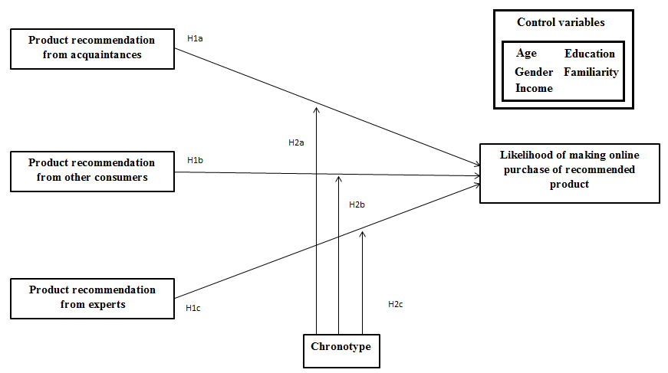

3. Research Methodology

3.1 Data collection

3.1.1 Pretest
A survey experiment was decided as the most proper method to acquire data for this study. To obtain the necessary information, a survey experiment was held through a questionnaire. The questionnaire consists of three different parts. First part of the survey contains the demographic questions, outcome of these questions are used to function as control variables. The second part focusses on the sleeping preferences and behaviour of the respondents. Questions on the circadian rhythm are developed with aid of the Morningness Eveningness Questionnaire (MEQ) designed by Horne and Östberg (1976) as well as the reduced MEQ by Adan and Almirall (1991). Final part of the questionnaire recreates an online environment where the participant is exposed to two products in an online shop and the corresponding product recommendations. The online environment was simulated by manipulating screenshots of familiar sites and social networks, namely: Facebook, Amazon, CNET reviews.com and were selected for their familiarity and recognisability. The complete questionnaire consists of a total of 25 questions (for the complete survey, see the Appendix) and takes approximately 10 minutes to complete. Due to the between-subject design of this study each individual has to complete 13 questions. The questionnaire was pretested by a small sample of family and acquaintances to the survey on completeness and accuracy of the questions. Qualtrics was used to create and design the survey.

3.1.2 Distribution
A total of 240 respondents participated in this study by completing the questionnaire. A wide variety of age, gender, education and income is present in this sample of respondents, this ensures valid and reliable results. Renée and Hasher (2012) have shown that younger adults are more likely to be evening types and older adults are more likely to be morning types. To guarantee a similar amount of both types, the sample consists of both morning types as well as evening types. Taillard et al. (2004) find in their study in a sample of middle-aged workers that 62.1% were morning types, 36.6% neither types, and 2.2% evening types. However, their study didn’t contain young adults, explaining the low number of evening types. This research is not bound to study young adults, therefore the sample of participants exists of people across all ages.
The participants were addressed via crowdsourcing marketplace Amazon Mechanical Turk. Amazon M Turk enables individuals or organisations to place tasks online that are open for people to complete them, generally in exchange for a small compensation. On 31 of August the survey was put on Amazon M Turk and would expire on the 7th of September. The desired amount of participants was collected in 4 days, so the assignment was completed on the 4th of September. Every participant received a compensation of $0.15, the average time that respondents took to answer the 13 questions was 7 minutes and 21 seconds.

3.2 Design and Measurement

3.2.1 Design and Manipulation
This study uses a between-subject design for the different recommendations types (acquaintance, expert, other consumer and no recommendation). This means that the respondents are divided into four groups to answer the questions that belong to the particular recommendation. Therefore, every respondent completes 13 questions instead of the total of 25 questions. Gneezy and Charness (2012) discussed a number of advantages and disadvantages for the within-subjects design as well as the between-subject design. Between-subject design came out on top for this particular study. Between-subject design makes sure that there is no chance on carryover effects in the form of practice or fatigue. The questions in this particular survey are very likely to cause these carryover effects in the case of using a within-subjects design. Within-design may lead to spurious effects, participants might answer to match the experimenter’s expectations. This ‘demand effect’ is more likely to occur when within-subjects design is used.

3.2.2 Measurement
A variety of different variables are included into this analysis. Table 3 shows the different types of variables and how they are measured.
Table 3: Explanation of variables
Variable | Type of variable | How to measure | Reference
Likelihood of making online purchase of recommended product | Dependent variable: Continuous variable | The likelihood will be measured with a seven point Likert scale | Likert (1932)
Type of recommendation | Independent variable: Categorical/nominal variable | Type of product recommendation that is assigned to participants: expert, acquaintance, unknown consumer or no recommendation | N/A
Chronotype | Moderating variable: Categorical/nominal variable | 5 option button questions | Adan and Almirall (1991)
Age | Controlling variable: Continuous variable | Open question on age of respondent | N/A
Gender | Controlling variable: Categorical/nominal variable | Option button question on gender of respondent | N/A
Education | Controlling variable: Categorical/nominal variable | Option button question on highest completed education of respondent | Boehm and Schlottmann (1999).
Income | Controlling variable: Categorical/nominal variable | Option button on yearly salary | Easterlin (2001)
Familiarity | Controlling variable:  Ordinal variable | Familiarity of the two products questions (five point scale). | N/A

The dependent variable in this study is the likelihood of purchase measured with a seven point Likert scale, thus will be treated as continuous variable. Two products are presented to each participant, including two products instead of only one is done to acquire more valid results (e.g. a respondent can be very distrustful towards a certain brand).
The independent variable is the type of recommendation that was submitted to the respondent, and can be considered a nominal variable, the different types of product recommendation that are submitted to the participants are: expert, acquaintance, other consumer and no recommendation. These recommendations represent the most well-known human product recommendations, ‘no recommendation’ is included to capture the differences between receiving additional information in the form of a recommendation or basing your purchase decision without any type of recommendation. Each recommendation in the survey was manipulated to become as close to real life as possible. The acquaintance recommendation was designed as a Facebook conversation/post to recreate a social environment that a lot of respondents will recognize. An expert review for both products was recreated and written to function as a genuine expert recommendation, the design and layout comes from CNET reviews (large website for consumer product reviews). The unknown consumer recommendation looks just as the reviews you often come across on web shops, in this case the layout is copied from Amazon.com. All the recommendations have their own style and therefore unique and able to bring out their message.
The controlling variables in the analysis are: age, gender, education, income and familiarity. These controlling variables are added into the model to see the impact that they have on the dependent variable, and if they manipulate the outcome of the model in a certain way.

3.3 Analysis

3.3.1 Participants
Before reviewing the outcome of the regression models, the sample of respondents will be introduced to get some insight into the participants that cooperated with this study. 240 respondents completed the survey, 59,6% of the respondents are male and 40,4% female. Figure 2 shows the frequencies of the participants’ age. The graph shows positive skewness where the biggest part belongs in the age category of 20-35, average age is 32,17. Level of education of the respondents is on average high, most of the respondents are college graduates (52,5%) or postgraduate (23,3%). However, the income of the respondents is relatively low, the biggest group of people (30%) earns $10,000-$29,000 a year. The second biggest group (28,3%) earns less than $10,000 a year.
Figure 2: Age distribution of respondents
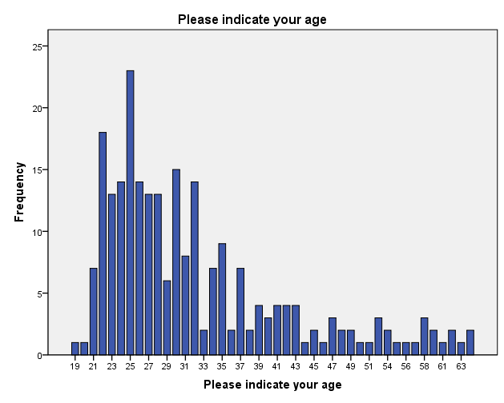
Looking at the distribution of chronotype we see that the biggest part (44,2%) of the respondents can be considered neither a morning nor evening type. 33,8% of the respondents can be considered a morning type and 22,1% an evening type.
Comparing the means of the likelihood of purchase and the type of recommendation that respondents got assigned to, give us for the Google glass: Acquaintance (4,22), expert (4,00), other consumer (4,02) and no recommendation (3,34). Participants who got assigned to the acquaintance recommendation have, on average, the highest likelihood for purchasing the Google glass, no recommendation shows the lowest likelihood of purchase. The following applies to the likelihood for the smartwatch: Acquaintance (4,42), expert (4,32), other consumer (4,56) and no recommendation (3,67). ‘Other consumers’ has the highest average and no recommendation the lowest. Receiving no recommendation results in a low likelihood compared to the any of the three recommendations. Overall, the smartwatch scores considerably higher than the Google glass, presumably because of the higher price, accessibility and target group of the Google glass.

3.3.2 Testing assumptions
The model that will be used to explain the results is a linear regression with multiple independent variables. A linear regression is used to explore the relationship between the dependent variable and independent variable(s), where the dependent variable has to be continuous. Assumptions are tested to see if linear regression is the appropriate model. The linear regression is performed with cross-section data, since the data comes from several subjects at a single point in time.
The analysis consists of three parts: (1) testing the assumptions, (2) replicating the results of recommendations on likelihood of purchase, (3) analysis moderation effect recommendations on likelihood of purchase. The three stages of the analysis are done with statistical analysis program SPSS.
To ensure the regression model fits with the data, (Berry, 1993) published the assumptions to look for when performing a regression analysis. The assumptions that are tested are:
- Predictor variables must be quantitative/categorical, outcome variable must be quantitative, categorical and unbounded.
- Non-zero variance.
- No perfect multicollinearity.
- Predictors are uncorrelated with ‘external variables’.
- Homoscedasticity.
- Independent errors.
- Normally distributed errors.
- Independence of outcome variable.
- Linearity.
Besides looking at the respondents, we need to test the assumptions that come with linear regression models before proceeding to the actual analysis. All assumptions are tested and clarified in this paragraph (a list of all assumptions that are tested can be found in chapter 3). The predictor variables are categorical and the outcome variable is continuous, the independent and dependent variables contain the right measure to continue with the regression analysis. The predictor variables should have some variation in value, the first predictor variable can be divided into the four types of recommendation that were assigned to the respondents. Acquaintance (24,6%), expert (25,8%), other consumer (25,4%), no recommendation (24,2%) the percentages refer to the part of the total participants that was assigned to that particular type of recommendation. Thus, there is variation in the value of the predictor variable. There is no perfect multicollinearity between the predictor variables, since there is only one predictor. The predictor variables don’t correlate with external variables, since the predictor value is just a value of which type of recommendation is assigned to each participant. To test the homoscedasticity, also referred to as homogeneity of variance, we use Levene’s Test (table 4). p > 0,05 in both Levene’s Test, this means that variances are equal and the assumption is not violated. Levene’s Test is done for both the likelihood of purchase for the Google glass as well as the smartwatch.
Table 4: Test of Homogeneity of Variances
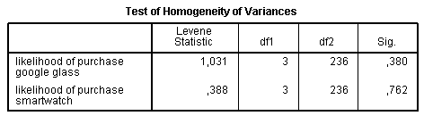
The Durbin Watson test (table 5) is done for every single regression model that is performed in SPSS. The outcome of the Durbin Watson test should be around 2 and not greater than 3 or smaller than 1. That assumption was never violated, example of the outcome of one of the regression models can be found in table 5. This model shows the regression model from a type of recommendation against no recommendation. With dependent variable likelihood of purchase Google glass Durbin Watson is 1,845 and likelihood of purchase smartwatch Durbin Watson is 1,721.
Table 5: Durbin-Watson Test
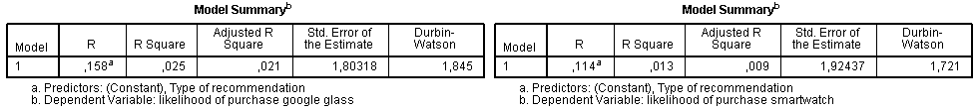
The Shapiro-Wilk statistic tells us whether the data is normally distributed. Table 6 shows the output of the test of normality. The likelihood for both products for all types of recommendations is significant, this means that this assumption is violated.
Table 6: Test of Normality
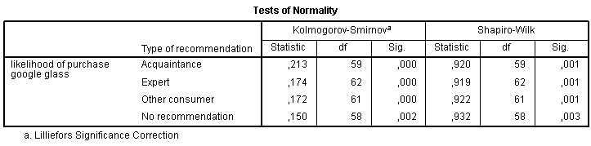
Figure 3 shows the distribution of likelihood of purchase for the smartwatch of other consumers. A normal distribution would show a lot of values 3, 4, 5 and less 1, 2 and 6, 7. However, this question asks about the likelihood that you would purchase a particular product, answering with 4 would mean you don’t whether you are going to buy that product. The respondents have a positive or negative attitude towards the product and know whether they will buy the product or not.
Figure 3: Other consumers Likelihood of Purchase Smartwatch
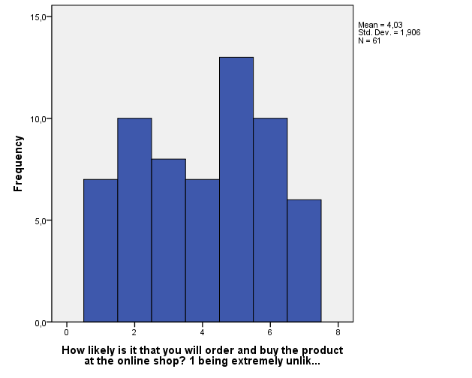

The results were checked on double participants, thus every entity in this survey is independent (no respondent has participated in more than one questionnaire).
Table 7 shows the linearity between the independent and dependent variable. If p > 0,05 the relationship is linear and non-problematic. 0,475 > 0,05 and 0,122 > 0,05 therefore we can safely say that the relationship between the independent and dependent variable is linear.
Table 7: Linearity of variables
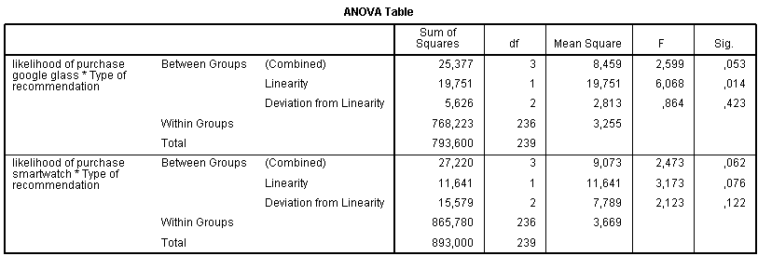
The second stage of the analysis is capturing the outcomes of previous literature on the effect of recommendations on the likelihood of purchase. The formula that is used to replicate the outcome is:
$$Y=β_{0}+β_{1}x_{1}+ ε$$

The effect of β₁ depends on the x₁, which is the type of product recommendation. Outcome of the model will reject or prove hypothesis H1a, H1b and H1c.
Third stage of the analysis is the main focus of this study and the stage where the eventual moderation effect of sleeping behaviour will be tested. The formula introduced in the second stage is extended with a second variable, this is type of recommendation x chronotype of the respondent to test the moderation effect. The final formula in the third stage looks as follows:

$$Y=β_{0}+β_{1 }x_{1}+β_{2}\left(x_{1}×chronotype\right)+ε$$

The variable chronotype should take into account that there will be respondents that are neither evening nor morning types. The MEQ that was mentioned earlier counts 5 types: Definite morning, moderate morning, neither, moderate evening and definite evening. This study will base the results on 3 types: morning, neither and evening. Moderate and definite morning are combined as well as moderate and definite evening, this ensures that the analysis is clear and easy to interpret.

4. Results

4.1 Hypotheses H1a, b and c
Interpreting the results is done in two phases. First, we start testing if we can prove or reject the outcome of the hypotheses 1a, b and c. Second, we do the same for the main hypotheses, namely: 2a, b and c.
Hypotheses 1a, b and c try to replicate results found in earlier literature, these results tell us that product recommendations by acquaintances, experts and by other unknown consumers all have a significant influence on the likelihood of purchase. Thus, the first regression model will test if these results can also be found with the data and respondents used in this study. To replicate the results the effect of recommendation, using dummy-variables, is tested on the likelihood of purchase for both Google glass as well as the smartwatch.
Testing the effect of being exposed to a product recommendation versus no recommendation, for Google glass, show the following results, p-value is 0,007 < 0,05 α (significance level). Constant is 3,345 and β is 0,876 (0 is no recommendation and 1 is recommendation by acquaintance). The outcome when looking at the smartwatch is a p-value of 0,039 < 0,05. Constant is 3,672 and β is 0,751 (0 is no recommendation and 1 is recommendation by acquaintance). Both results support hypothesis 1a.
Hypothesis 1b looks at the effect of product recommendations by experts. Choosing the likelihood of purchase for the Google glass give us the following results, p-value is 0,045 < 0,05. Constant is 3,345 and β is 0,655 (0 is no recommendation and 1 is recommendation by expert). For the smartwatch the results are: p-value is 0,061 > 0,05, so is insignificant. Constant is 3,672 and β is 0,650 (0 is no recommendation and 1 is recommendation by expert). This relationship is insignificant. Only the results for the likelihood of purchase for the Google glass support 1b.
Hypothesis 1c tries to replicate the results that product recommendations by other, unknown consumers have a significant effect on the likelihood of purchase. The results of the likelihood for Google glass show, p-value 0,044 < 0,05. The constant value is 3,345 and the β value is 0,672 (0 is no recommendation and 1 is recommendation by other consumer). For the smartwatch, the following results are found. The p-value here is 0,016 < 0,05. The constant in this model is 3,672 and the value of β is 0,885. Both models show a significant outcome for the product recommendation by unknown consumers. Hypothesis 1c is supported.
Control variables age, gender, education and income are all insignificant, only education is significant with H1b (smartwatch). Familiarity is significant and very easy to explain. Participants who are familiar with a product are more likely to purchase that product, if you are not familiar with a product (specifically a technical, electronic product) you will probably not buy the product until you know more about it. To give an idea of the effect of familiarity, the likelihood of purchase of the Google glass for acquaintance recommendations is tested. Value of the constant is 1,971 + 0,904 (multiple with 1 for people that were assigned to an acquaintance recommendation) + 0,474 (times the value of the 5-point Likert scale familiarity). Familiarity has a very large effect on the likelihood of purchase. However this effect really depends on the product, presumably the effect will be significantly smaller with a simple, straightforward product. The significant models with familiarity included are:
H1a (Google glass): 1,684 + 0,913 (acquaintance) + 0,570 (familiarity)
H1a (Smartwatch): 1,594 + 0,634 (acquaintance) + 0,693 (familiarity)
H1b (Google glass): 1,662 + 0,587 (expert) + 0,578 (familiarity)
H1c (Google glass): 2,086 + 0,719 (other consumer) + 0,432 (familiarity)
H1c (Smartwatch): 1,513 + 0,861 (other consumer) + 0,720 (familiarity)
The only model (H1b Smartwatch) where the type of recommendation is insignificant is the model for ‘expert’ and ‘smartwatch’.

4.2 Hypotheses H2a, b and c
Core part of this study are the results of the next regression models. After replicating the results found in previous studies, the stage is adding the moderating variable chronotype. H2a, b and c suggest that chronotype moderates the effect that product recommendations have on the likelihood of purchase. Since, familiarity is proven to be a significant influence on the likelihood of purchase it will be added into the regression models.
First regression model will test the overall effect of the moderator variable on the relationship between ‘some sort of recommendation’ versus ‘no recommendation’ and the likelihood of purchase for both products. Both regression models (for both products a regression model) add chronotype, since the focus lays on the difference between morning and evening types the ‘neither types’ are left out. Table 8 shows the multiple regression output with the likelihood of purchase for the Google glass as the dependent variable. All the independent variables are significant. ‘Some_Chrono’ functions as the moderator variable which is computed by multiplying ‘some sort of recommendation’ with ‘chronotype’. This moderator variable is significant, therefor we can say that chronotype influences the likelihood of purchase for all the three recommendations versus ‘no recommendation’. Table 8 and 9 included the significant control variables. The equation of the model will clarify the meaning of the moderating variable, 1,247 (constant) + 1,763 (0 no recommendation, 1 any of three recommendations) + 0,592 (5-point Likert scale) – 0,566 (0-1 no recommendation vs. any of three recommendations × 1 morning type, 2 neither type, 3 evening type). When comparing morning types and evening types, the outcome/likelihood of the equation will be higher when the respondent is a morning type instead of an evening type. Interesting is that in this model education and gender are significant. That means, that for this model a small effect of 0,258 (education) and – 0,437 (gender) should be added. Exploitation for the significant control variables could be: female are less avid towards Google glass, such a technologic device is generally more focussed on male consumers. The effect of education is harder to explain, perhaps higher educated people are more used to work with technology and therefore more interested in particular products. This could be an interesting question for future research.
Table 8: Linear regression Likelihood of Purchase Google
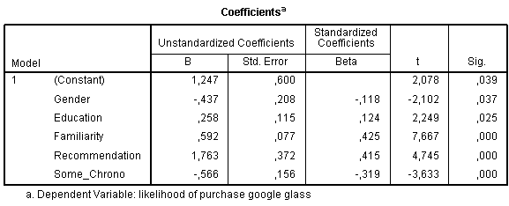
The output of the regression model in table 9 does the same thing, but instead the dependent variable is the likelihood of purchasing the smartwatch. Just as the previous model all the variables added into the model in table 9 are significant, the control variables excluded. The equation of this model would look like: 1,278 (constant) + 1,469 (0 no recommendation, 1 any of three recommendations) + 0,664 (5-point Likert scale) – 0,431 (0-1 no recommendation vs. any of three recommendations × 1 morning type, 2 neither type, 3 evening type). Both equations suggest that the likelihood of purchase will be higher for morning types than in case of evening types. The different types of recommendations will be individually tested to prove or reject hypotheses H2a, b and c, the control variables will also be added. The model from table 9 showed no significant control variables.
Table 9: Linear regression Likelihood of Purchase Smartwatch
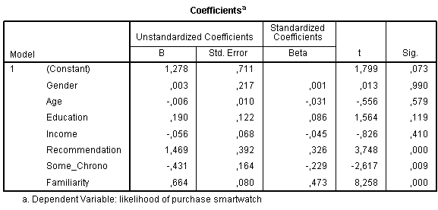
H2a will test if there is a moderation effect on the proven significant relationship between the product recommendations by acquaintances and likelihood of purchase. Just like H2b and H2c, this will be tested for the Google glass as well as the smartwatch. The models contain the significant control variables, including variable familiarity. For the Google glass the model looks like: 1,754 (constant) + 1,868 (acquaintance) + 0,558 (familiarity) – 0,580 (0-1 for acquaintance × 1 morning type, 2 neither type, 3 evening type). The model shows that being an evening type reduces the likelihood of purchase. The model with the smart watch for acquaintances shows an insignificant outcome.
H2b tests the effect for expert recommendations. The equation that comes out of the multiple regression model for the Google glass looks like this: 1,704 (constant) + 1,601 (expert) + 0,563 (familiarity) – 0,523 (0-1 for expert × 1 morning type, 2 neither type, 3 evening type). Again, the outcome for the smartwatch is insignificant.
The regression model for ‘other consumer’ recommendations and the Google glass results in this equation: 3,893 (constant) + 2,087 (other consumer) + 0,332 (familiarity) – 0,716 (0-1 for other consumer × 1 morning type, 2 neither type, 3 evening type) – 0,049 (age). Age is a significant control variable in this model. The regression model for the smartwatch shows insignificance. Striking in testing the models is that chronotype is insignificant in the three regression analyses for the smartwatch and not for the Google glass. This phenomenon can partly be explained due to the relatively heavy weight of the variable familiarity. Discovering familiarity is significant is no surprise, especially with technical products, but the big impact of this variable hurts the study on differences in chronotype. Hypotheses H2a, b and c will be tested one more time without the variable familiarity, purely to check the effect, importance and weight of chronotype on likelihood of purchase. H2a also contains ‘acquaintance’ vs. ‘no recommendation’, H2b contains ‘expert’ vs. ‘no recommendation’, H2c contains ‘other consumer’ vs. ‘no recommendation’.
H2a moderator chronotype is 0,028 < 0,05, thus significance for Google glass. R square is 0,091, moderator ‘chronotype’ and ‘acquaintance vs. no recommendation’ explain 9,1% of variation of likelihood of purchase Google glass for the acquaintance recommendations. β value of chronotype is -0,680. The smartwatch model is significant for the moderator variable 0,013 < 0,05. R square is 8,4%. β value of chronotype is -0,861.
H2b chronotype shows a significance outcome of 0,037 < 0,05, for the Google glass. R square is 0,089. Chronotype in the smartwatch model is insignificant 0,066 > 0,05, we also saw this with H1b (smartwatch).
H2c’s moderator for the Google glass is significant 0,013 < 0,05. This model does however contain a control variable (age). This explains the slightly higher R square of 0,168. For the smartwatch the p-value is 0,017. Control variable age is also significant in this model, R square is 0,177.
In this last case we can approve all hypotheses, with the slight exception of H2b (smartwatch). The multiple regression models show that the moderator of type of recommendation and chronotype is significant and has influence on the outcome of the likelihood of purchase. Morning types score significantly higher, on likelihood of purchase, than evening types. This agrees with the previous studies on character and personalities between early birds and night owls. Early birds rely more on known data and experiences of owners/experts of the product. Night owls however are known to be more impulsive.

5. Conclusion and Discussion

5.1 Conclusions
After the conceptual framework was developed 6 hypotheses surfaced, these 6 hypotheses cover two stages in this study. The first three hypotheses aimed at replicating the proof that recommendations by acquaintances, experts and other unknown consumer have a significant influence on the likelihood of purchase when compared to ‘no product recommendation’. H1a, b and c (for both the Google glass and the smartwatch) were all found to be significant except for H1b (smartwatch). We can say with 95% confidence that when someone gets a product recommendation from an acquaintance, expert or other consumer his/her likelihood of purchase is higher than when he/she wouldn’t have got a recommendation. These findings can be called rational and not quite surprising, getting info/data from people that already used the product makes a reliable source when considering purchasing that product.
Hypotheses H2a, b and c can be considered the core part of this study and added unique value to the knowledge we have on chronotypes and their behaviour. After removing the very present variable familiarity, there was proof that chronotype as a moderator influences the relationship between type of recommendation and the likelihood of purchase for the Google glass and the smartwatch. Morning types show a higher likelihood of purchase after getting a product recommendation than evening types. The explanation for this phenomenon is the character of morning types who rely on tangible and known facts or data, evening types however are more impulsive. Early birds also attach more value to the social aspect of shopping and might therefore be more inclined to listen to acquaintances, experts and other consumers.

5.2 Managerial Implications
The knowledge that has been acquired in this research will help managers make future decisions with regard to consumers and their circadian rhythm. Testing the hypotheses H1a, b and c gave the first implications. Web shops would do well by providing easy access to product recommendations on their sites, since people who read a product recommendation are more likely to purchase that product than people who don’t have access to a product recommendation. Notable is that product recommendations of acquaintances and other unknown consumers are better appreciated than expert recommendations.
Major contribution of this study is about the moderator variable chronotype. Companies that know if a customer is a morning type or evening type (or neither type) is an advantage. The optimal time and non-optimal time for both types are known, companies should contact types only on and around their optimal time.
Most critical is that the effect of recommendations by acquaintances and other consumers has a greater effect on early birds and night owls. Both types are less affected by expert recommendations.
Finally, results show that morning types are more likely to purchase a product after reading a product recommendation than evening types. Managers should realize that evening types need more attention to pursue them to purchase the product, attention could be in the form of: special offers, more recommendations, discount, and loyalty points.

5.3 Limitations and Future research
Limitations to this study should be considered. Frequencies in age distribution of the participants show that biggest group is between 20-35 years, these results can’t be translated to an entire population when the age distribution in the survey experiment is not comparable with the age distribution in real life. Future research should include all age levels or look for differences between age groups.
For future research it would be desirable to increase the sample size, 240 respondents cooperated with this study. Due to the between-subject design it means that every type of recommendation used in this study gets approximately 60 participants assigned. The fact that the biggest part of the study consists of neither morning nor evening types can be considered room for improvement in future research.
Another limitation is the explaining factor of familiarity. The variable familiarity has a significant higher explaining value than the moderating variable chronotype, there is a significant effect for chronotype but it is relatively small.
Future research could focus itself on different products in the electronic branch or perhaps a totally different branch. A limitation of the products that were chosen for this study is the target group of them. A smartwatch is for the smartphone user and therefore eliminates people who don’t own a smartphone, not to mention that older people could be less interested in such electronic devices. The Google glass is even more a product with a specific target group. The Google glass is more for hard-core electronic products users, it has a geeky image and attracts more males than females. Replicating the results with different products can also investigate the nature of the effect of control variables education and gender.
The findings suggest that the product recommendations by experts are less convincing to result in a higher likelihood versus no recommendation than the other two product recommendation. An interesting study could focus itself on one type of product recommendations individually to find more deep, profound results of one of the recommendations.

6. References
Adan, Ana and Helena Almirall (1991), “Horne & Östberg morningness-eveningness questionnaire: A reduced scale”, Personality and Individual Differences, 12 (3), 241-253.

Bae, Soonyong and Taesik Lee (2011), “Gender differences in consumers’ perception of online consumer reviews”, Electronic Commerce Research, 11 (2), 201-214.

Baron, Reuben M. and David A. Kenny (1986), “The Moderator-Mediator Variable Distinction in Social Psychological Research: Conceptual, Strategic and Statistical Considerations”, Journal of Personality and Social Psychology, 51 (6), 1173-1182.

Berry, William D. (1993), Understanding regression assumptions, Newbury Park, CA: Sage.

Biss, Renée K. and Lynn Hasher (2012), “Happy as a Lark: Morning-Type Younger and Older Adults Are Higher in Positive Affect”. American Psychological Association, 12 (3), 437–441.

Boehm, Thomas P. and Alan M. Schlottmann (1999), “Does home ownership by parents have an economic impact on their children”, Journal of Housing Economics, 8 (3), 217-232.

Brown, Mark, Nigel Pope and Kevin Voges (2003), “Buying or browsing? An exploration of shopping orientations and online purchase intention”, European Journal of Marketing, 37 (11/12), 1666-1684.

Bucklin, Randolph E. and Catarina Sismeiro (2003), “A Model of Web Site Browsing Behavior Estimated on Clickstream Data”, Journal of Marketing Research, 40, 249-267.

Cavallera, G.M and S. Giudici (2008), “Morningness and Eveningness personality: A survey in literature from 1995 up till 2006”, Journal of the International Society for the Study of Individual Differences, 44, 3-21.

Chatterjee, Patrali (2001), “Online Reviews: Do Consumers Use Them?”, Association for Consumer Research, 129-134.

Chang, Lung-Yu, Yu-Je Lee and Ching-Lin Huang (2010), “The Influence of E-Word-Of-Mouth on the Consumer’s Purchase Decision: a Case of Body Care Products”, Journal of Global Business Management, 6 (2), 1-7.

Chelminski, I., F.R. Ferraro, T. Petros and J. J. Plaud (1997), “Horne and Östberg Questionnaire: A score distribution in a large sample of young adults”, Personality and Individual Differences, 4, 647–652.

Chen, Yi-Fen (2008), “Herd behaviour in purchasing books online”, Computers in Human Behavior, 24, 1977-1992.

Chevalier, Judith A. and Dina Mayzlin (2006), “The effect of Word of Mouth on Sales: Online Book Reviews”, Journal of Marketing Research, 43, 345-354.

Childers, Terry L., Christopher L. Carr, Joann Peck and Stephen Carson (2001), “Hedonic and utilitarian motivations for online retail shopping behaviour”, Journal of Retailing, 77, 511-535.

Demangeot, Catherine and Amanda J. Broderick (2007), “Conceptualising consumer behaviour in online shopping environments”, International Journal of Retail & Distribution Management, 35 (11), 878-894.

Díaz-Morales, Juan Francisco (2007), “Morning and evening-types: Exploring their personality styles”, Personality and Individual Differences, 43 (4), 769-778.

Easterlin, Richard A. (2001), “Income and Hapiness: Towards a Unified Theory”, The Economic Journal, 111 (473), 465-484.

Fan, Yi-Wen and Yi-Feng Miao (2012), “Effect of electronic word-of-mouth on consumer purchase intention: the perspective of gender differences”, International Journal of Electronic Business Management, 10 (3), 175-181.

Giampietro, M. and G.M. Cavallera (2007), “Morning and Evening types and creative thinking”, Personality and Individual Differences, 42, 453-463.

Gneezy, Uri and Gary Charness (2012), “Experimental methods: Between-subject and within-subject design”, Journal of Economic Behavior & Organization, 81, 1-8.

Harmon, Robert R. and Kenneth A. Coney (1982), “The Persuasive Effects of Source Credibility in Buy and Lease Situations”, Journal of Marketing Research, 19, 255-260.

Hasan, Bassam (2010), “Exploring gender differences in online shopping attitude”, Computers in Human Behavior, 26, 597-601.

Hauser, John R., Glen L. Urban, Guilherme Liberali and Michael Braun (2008), “Website Morphing”, Marketing Science, 28 (2), 202-223.

Horne, J. A. and O. Östberg (1976), “A self-assessment questionnaire to determine Morningness-Eveningness in human circadian rhythms”, International Journal of Chronobiology, 4, 97–110.

Horne, J. A. and O. Östberg (1977), “Individual differences in human circadian rhythms”, Biological Psychology, 5, 179–190.

Hornik, Jacob and Giulia Miniero (2009), “Synchrony effects on customers' responses and behaviors”, International Journal of Research in Marketing, 26, 34-40.

Hornik, Jacob, Chezy Ofir and Rinat Shaanan-satchi (2010), “The effect of consumers' diurnal preferences on temporal behaviour”, Journal of Consumer Psychology, 20, 53-65.

Juster, F.T. (1966), “Consumer buying intentions and purchase probability: An experiment in survey design”, Journal of the American Statistical Association, 61 (315), 658-696.

Kim, S., G.L. Dueker, L. Hasher and D. Goldstein (2002), “Children’s time of day preference: Age, gender, and ethnic differences”, Personality and Individual Differences, 33, 1083–1090.

Komarraju, Meera, Steven J. Karau, Ronald R. Schmeck and Alen Avdic (2011), “The Big Five personality traits, learning styles, and academic achievement”, Personality and Individual Differences, 51, 472-477.

Likert, Rensis (1932), “A Technique for the Measurement of Attitudes”, Archives of Psychology, 140, 1-55.

Lim, Choong Hoon, Jinwook Jason Chung and Paul M. Pedersen (2012), “Effect of electronic wom messages”, Sport Management International Journal, 8 (1), 1-21.

Ling, Kwek Choon, Lau Teck Chai and Tan Hoi Piew (2010), “The Effect of Shopping Orientations, Online Trust and Prior Online Experience toward Customers’ Online Purchase Intention”, International Business Research, 3 (3), 63-76.

Moe, Wendy W. (2003), Buying, Searching, or Browsing: “Differentiating Between Online Shoppers Using In-Store Navigational Clickstream”, Journal of Consumer Psychology, 13 (1&2), 29-39.

Monsuwé, Toñita Perea y, Benedict G.C. Dellaert and Ko de Ruyter (2004), “What drives consumers to shop online? A literature review”, International Journal of Service Industry Management, 15 (1), 102-121.

Murphy, Laurie, Gianna Mascardo and Pierre Benckendorff (2007), “Exploring word-of-mouth influences on travel decisions: friends and relatives vs. other travellers”, International Journal of Consumer Studies, 31 (5), 517-527.

Randler, Christoph (2007), ”Gender differences in morningness–eveningness assessed by
self-report questionnaires: A meta-analysis”, Personality and Individual Differences, 43, 1667-1675.

Randler, Christoph (2008), “Morningness–Eveningness, sleep–wake variables and big five personality factors”, Personality and Individual Differences, 45, 191-196.

Reinstein, David A. and Christopher M. Snyder (2005), “The Influence of Expert Reviews on Consumer Demand for Experience Goods: A case study of movie critics”, The journal of Industrial Economics, 53, 27-51.

Senecal, Sylvain and Jacques Nantel (2004), “The influence of online product recommendations on consumers’ online choices”, Journal of Retailing, 80, 159-169.

Senecal, Sylvain, Pawel J. Kalczynski and Jacques Nantel (2005), “Consumers’ decision-making process and their online shopping behavior: a clickstream analysis”, Journal of Business Research, 58, 1599-1608.

Sorce, Patricia, Victor Perotti and Stanley Widrick (2005), “Attitude and age differences in online buying”, International Journal of Retail & Distribution Management, 33 (2), 122-132.

Taillard, J., P. Philip, J.F. Chastang and B. Bioulac (2004), “Validation of Horne and Östberg Morningness–eveningness questionnaire in a middle-aged population of French workers”. Journal of Biological Rhythms, 19, 76–86.

Urbán, Róbert, Tímea Magyaródi, and Adrien Rigó (2011), “Morningness-Eveningness, Chronotypes and Health-Impairing Behaviors in Adolescents”, Chronobiology International, 28 (3), 238–247.

Volmer, Christian and Christoph Randler (2012), “Circadian preferences and personality values: Morning types prefer social values, evening types prefer individual values”, Personality and Individual Differences, 52, 738-743.

Wang, Chih-Chien and Shu-Chen Chang (2008), “Online Word of Mouth as a Determination in Adolescents’ Purchase Decision Making: the Influence of Expertise and Involvement”, Communications of the IBIMA, 4, 1-7.

Yang, Bijou and David Lester (2005), “Gender Differences in E-Commerce”, Applied Economics, 37 (18), 2077-2089.

Zhu, Feng and Xiaoquan (Michael) Zhang (2010), “Impact of Online Consumer Reviews on Sales: The moderating Role of Product and Consumer Characteristics”, Journal of Marketing, 74, 133-148.

7. Appendix

7.1 Appendix A: Questionnaire

Dear participants,

This survey is part of completing my Master’s thesis at the Erasmus University. Aim of this questionnaire is looking at your likelihood of purchase. Completing this survey will take approximately 10 minutes and will be entirely anonymous. Please take a good look at the pictures and read the questions carefully.

Thanks

- Please indicate your gender

o Male
o Female

- Please indicate your age

___ years

- Please indicate your highest completed education

o Less than High school (< 12 years)
o High-school graduate (12 years)
o Some secondary institution (13-15 years)
o College graduate (16 years)
o Postgraduate (> 16 years)

- Please indicate your annual income

o Less than $10,000
o $10,000-$29,999
o $30,000-$39,999
o $40,000-$49,999
o $50,000-74,999
o $75,000 and over

The following questions are about your sleeping behaviour. There are no wrong answers, just try to complete every question as accurate as possible.

- Considering only your own ‘feeling beat’ rhythm, at what time would you get up if you were entirely free to plan your day?

o 5:00 AM – 6:30 AM
o 6:30 AM – 7:45 AM
o 7:45 AM – 9:45 AM
o 9:45 AM – 11:00 AM
o 11:00 AM – Later

- During the first half hour after having woken up in the morning, how tired do you feel?

o Very tired
o Fairly tired
o Fairly refreshed
o Very refreshed

- At what time in the evening do you feel tired and as a result the need for sleep?

o 8:00 PM – 9:00 PM
o 9:00 PM – 10:30 PM
o 10:30 PM – 12:30 AM
o 12:30 AM – 2:00 AM
o 2:00 AM – Later

- At what time of the day do you think that you reach your ‘feeling best’ peak?

o 12:00 AM – 4:30 AM
o 4:30 AM – 7:30 AM
o 7:30 AM – 9:30 AM
o 9:30 AM – 4:30 PM
o 4:30 PM – 9:30 PM
o 9:30 PM – 12:00 AM

- One hears about ‘morning’ and ‘evening’ types of people. Which one of these types do you consider yourself to be?

o Definitely a morning type
o Rather more a morning type than an evening type
o Rather more an evening type than a morning type
o Definitely an evening type

Product recommendations

For this part, I am interested in measuring how likely you are to buy a particular product. Please carefully read all the provided information and indicate your familiarity with the product and the likelihood that you would buy the particular product.

Acquaintance: Google Glass

In a Facebook conversation, a good friend of you says the following:

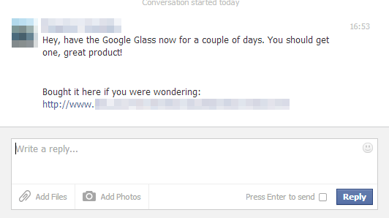

After reading the conversation, you decide to check it out.

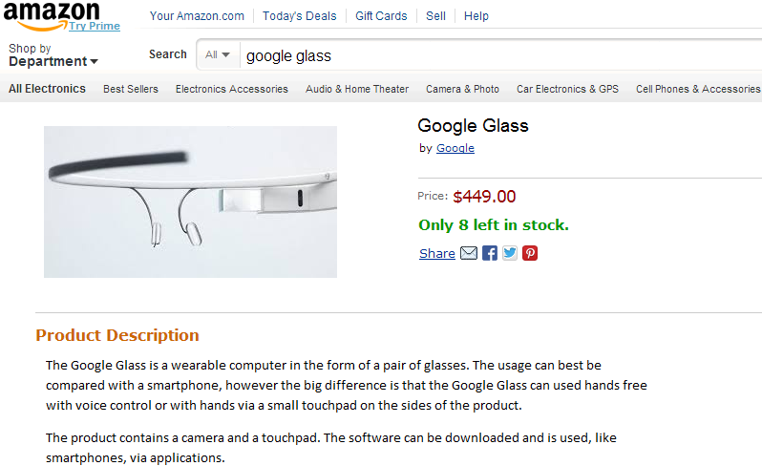

- How familiar are you with the described product? On a scale form 1-5, 1 being not familiar at all and 5 being very familiar.

o 1
o 2
o 3
o 4
o 5

- How likely is it that you will order and buy the product at the online shop ? On a scale from 1-7, 1 being extremely unlikely and 7 being extremely likely.

o 1
o 2
o 3
o 4
o 5
o 6
o 7

Acquaintance: Smartwatch

Scrolling through your Facebook newsfeed you come across the following status of a good friend of yours:

After reading your friend’s status update you start surfing and you run into the same smartwatch you know your friend has.

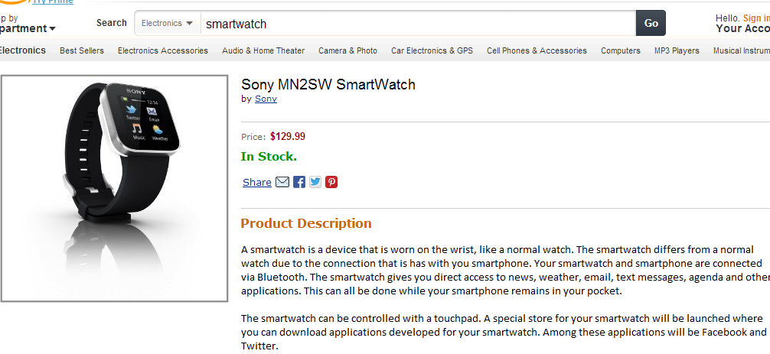

- How familiar are you with the described product? On a scale form 1-5, 1 being not familiar at all and 5 being very familiar.

o 1
o 2
o 3
o 4
o 5

- How likely is it that you will order and buy the product at the online shop ? On a scale from 1-7, 1 being extremely unlikely and 7 being extremely likely.

o 1
o 2
o 3
o 4
o 5
o 6
o 7

Expert: Google Glass
Browsing the internet, you stumble on a review of the Google Glass. The author of the piece can be considered an expert on the product. The bottom line is the conclusion of the review.
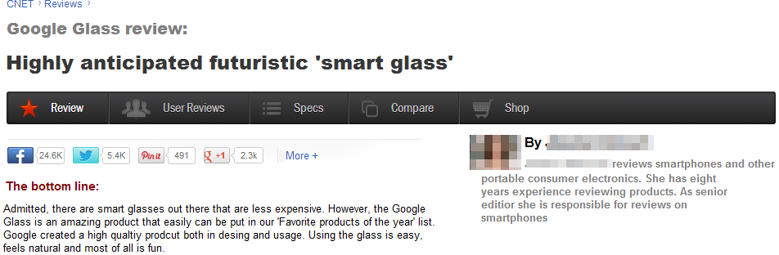
After reading the article, you find the particular product in an online shop.
- How familiar are you with the described product? On a scale form 1-5, 1 being not familiar at all and 5 being very familiar.

o 1
o 2
o 3
o 4
o 5

- How likely is it that you will order and buy the product at the online shop ? On a scale from 1-7, 1 being extremely unlikely and 7 being extremely likely.

o 1
o 2
o 3
o 4
o 5
o 6
o 7

Expert: Smartwatch

On a product review site you find the following article on a smartwatch. The author of the piece can be considered an expert on the product. The bottom line is the conclusion of the review.

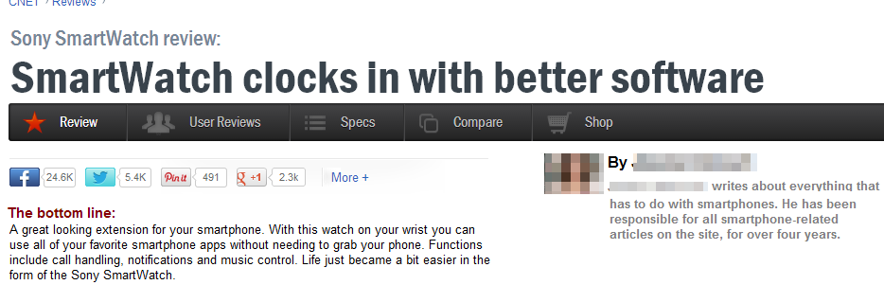

After reading the article, you find the particular product in an online shop.

- How familiar are you with the described product? On a scale form 1-5, 1 being not familiar at all and 5 being very familiar.

o 1
o 2
o 3
o 4
o 5

- How likely is it that you will order and buy the product at the online shop ? On a scale from 1-7, 1 being extremely unlikely and 7 being extremely likely.

o 1
o 2
o 3
o 4
o 5
o 6
o 7

Unknown consumer: Google Glass
Browsing the internet you find a customer review on the Google Glass.
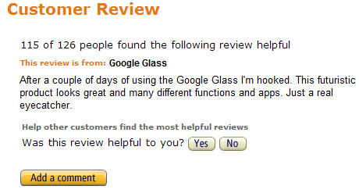
After this you come across the particular product in an online shop.

- How familiar are you with the described product? On a scale form 1-5, 1 being not familiar at all and 5 being very familiar.

o 1
o 2
o 3
o 4
o 5

- How likely is it that you will order and buy the product at the online shop ? On a scale from 1-7, 1 being extremely unlikely and 7 being extremely likely.

o 1
o 2
o 3
o 4
o 5
o 6
o 7

Unknown consumer: Smartwatch

When surfing the internet you find a review of a customer on a smartwatch.
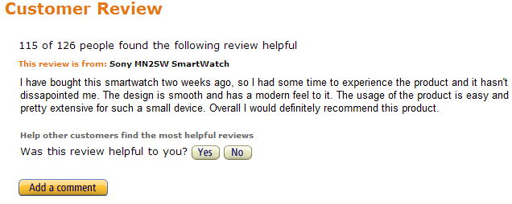
After reading the review you find the product in an online shop.
- How familiar are you with the described product? On a scale form 1-5, 1 being not familiar at all and 5 being very familiar.

o 1
o 2
o 3
o 4
o 5

- How likely is it that you will order and buy the product at the online shop ? On a scale from 1-7, 1 being extremely unlikely and 7 being extremely likely.

o 1
o 2
o 3
o 4
o 5
o 6
o 7

No recommendation: Google Glass
Browsing the internet, you come across the following product in an online shop.
- How familiar are you with the described product? On a scale form 1-5, 1 being not familiar at all and 5 being very familiar.

o 1
o 2
o 3
o 4
o 5

- How likely is it that you will order and buy the product at the online shop ? On a scale from 1-7, 1 being extremely unlikely and 7 being extremely likely.

o 1
o 2
o 3
o 4
o 5
o 6
o 7

No recommendation: Smartwatch
Scrolling through an online store, you find the following product.
- How familiar are you with the described product? On a scale form 1-5, 1 being not familiar at all and 5 being very familiar.

o 1
o 2
o 3
o 4
o 5

- How likely is it that you will order and buy the product at the online shop ? On a scale from 1-7, 1 being extremely unlikely and 7 being extremely likely.

o 1
o 2
o 3
o 4
o 5
o 6
o 7

