MASTER THESIS

Share, Like and Win?
Virality of brand messages on social media

Author: Rick van der Vliet
Supervisor: Dr. H.R. Nam

Master of Economics and Business
Major Marketing
Erasmus School of Economics
Erasmus University Rotterdam
November 14, 2013
_____________________________________________________________________________________________

Share, Like and Win?
Virality of brand messages on social media

Rick van der Vliet, 325192
Supervisor: Dr. H.R. Nam

Abstract

Social media is an important medium for brands to reach and interact with their customers. One way for brands to communicate on social media with consumers is to create brand messages. To maximize the effect of brand messages on social media this present study examines the possible factors behind the virality of brand messages on social media. Furthermore this study indicates which predictors increase the virality of brand messages. In order to clarify these factors an experiment in the form of a questionnaire is conducted. The observed predictors in the questionnaire are subsequently brand attachment, product category involvement, intrinsic- and extrinsic motivations and hard-sell versus soft-sell messages appeals. The findings suggest that brand attachment and intrinsic motivation determines the virality of brand messages on social media. Moreover product category involvement positively influences the relationship between brand attachment and brand message virality on social media. Unfortunately the other drivers seem not to significantly influence the virality of brand messages on social media.

_____________________________________________________________________________________________
Preface
This master thesis means the end of my years of study. In the end I am satisfied with the study path I followed. I have met friends for life, created a network of professional relationships and gained a lot of knowledge. Nonetheless this master thesis is also the begin of a new moving era: a business career.

First I would like to thank Dr. H.R. Nam for her contribution. Her comment and insights have helped me in the process. I am especially grateful for her fast and honest reviews. Also I want to thank the co-reader. Not to forget, otherwise I will have problems at home: I want to thank my parents, brother, roommates and girlfriend. They have always encouraged and supported during the writing process. In particular I want to thank Pravesh Kalloe, my best friend, for his reviews and critical remarks, which helped me a lot.

TABLE OF CONTENTS
1. INTRODUCTION 7
1.1 Background 7
1.2 Social media messages by brands 8
1.3 Research question 9
1.4 Academic relevance 10
1.5 Managerial relevance 11
1.6 Thesis structure 12
2. THEORETICAL FRAMEWORK 13
2.1 Literature review 13
2.1.1 Viral marketing 13
2.1.2 Online advertising by viral brand messages 14
2.1.3 The path of a brand message on social media 15
2.1.4 Hard-sell versus soft-sell appeals 16
2.1.5 Motivations to spread viral brand messages 17
2.1.6 Brand attachment 18
2.1.7 Category product involvement 19
2.2 Hypotheses 20
2.3 Conceptual model 25
3. methodology 26
3.1 Research design 26
3.2 Population and sample size 26
3.3 Questionnaire structure 27
3.3.1 Virality of a brand message 30
3.3.2 Brand attachment strength 30
3.3.3 Intrinsic vs. extrinsic motivations 30
3.3.4 Product category involvement 31
3.3.5 Hard sell vs. soft sell appeal 31
3.3.6 Demographics 32
3.4 Pre-test 32
4. DATA ANALYSIS 33
4.1 Sample 33
4.2 Data preparation 33
4.2.2 Factor analysis 34
5. RESULTS 37
5.1 Descriptive Analysis 37
5.2 Hypotheses Testing: Virality of brand message 38
5.2.1 Brand attachment 38
5.2.2 Intrinsic- and extrinsic motivations 39
5.2.3 Product category involvement 39
5.2.4 Brand message appeals 39
5.2.6 Dummy variables 40
5.3 Summary of hypotheses results 41
5.4 Additional Analysis 41
6. GENERAL DISCUSSION 43
6.1 Conclusion 43
6.2 Contributions 44
6.3 Limitations 45
6.4 Managerial implications 46
REFERENCES 48
Appendix A. Questionnaire 55
Appendix B. Hard–Sell vs. Soft-Sell Nikon 61
Appendix C. Hard–Sell vs. Soft-Sell Ray - Ban 62
Appendix D. Hard–Sell vs. Soft-Sell Vespa 63
Appendix E – Factor Analysis Intrinsic- and Extrinsic Motivations 64
Appendix F – Correlations Matrix 65

FIGURES
Figure 1: Elements in the communication process 4
Figure 2: Elements in the communication process 14
Figure 3: The path of a brand message on social media 15
Figure 4: Left: Soft – sell appeal Right: Hard - sell appeal 16
Figure 5: Conceptual model 24

TABLES
Table 1: Questionnaire structure 24
Table 2: Results reliability test 33
Table 3: Results factor analysis 35
Table 4: Results descriptive analysis 36
Table 5: Regression analysis brand message virality 39
Table 6: Hypotheses summary 40
Table 7: Regression analysis offline WOM intention 40

1. INTRODUCTION
For many people social media is a part of daily life. Because of this daily routine social media platforms are becoming more and more important for brands to reach their customers. This chapter will give a background of social media messages by brands. This is followed by the main research question and sub questions. Thereafter the academic- and managerial relevance will be pointed out. Finally an overview of the thesis structure is given.

1.1 Background
Nowadays more than 1 billion people are using social media (Van Belleghem, Eenhuizen & Verias, 2011). Facebook has almost 100% brand awareness and is by far the most popular social network. In January 2013 Facebook claimed to have 1.11 billion active users every month. Van Belleghem et al. (2011) state that 50% of the 1.11 billion users are following a brand on social media. These figures give a lot of opportunities for brands to reach their customers. Companies are investing immensely in social media. Williamson (2011) reports a worldwide marketing spending of $4.3 billion on social network sites. Brands invest in social media to interact with their consumers.

Consumers can interact with brands on social networks by liking, commenting and sharing on brand posts (McAlexander, Schouten & Koenig, 2002). These brand followers show more loyalty and commitments towards the brand and show more willingness to receive news about the brand (Bagozzi & Dholakia 2006). The unique feature of social network is that consumers can interact with consumers about brands (Mangold & Faulds, 2009). This unique feature is an online form of word-of-mouth (WOM) communication. Compared to traditional WOM communication online WOM communication has the ability to reach thousands of other people with one message.

Moreover, brand fans tend to visit the store more often, generate more positive WOM, and are more emotionally attached to the brand than non-brand fans (Dholakia & Durham 2010). Previous literature has examined the success of marketing activities on social media. Still little is known about the drivers that influence brand message popularity. Brand popularity is measured by the number of shares, likes and comments on brand messages at brand fan pages (Ryan & Zabin, 2010). Management-oriented studies about brand post popularity are mainly descriptive; they provide no theoretical foundation and do not thoroughly test which activities actually improve brand post popularity. These studies propose that companies should experiment with different brand message characteristics, like images, text and videos (Brookes, 2010). The current literature about the virality of brand messages is therefore limited. This has increased the demand for studies on brand message virality in the context of social media, as indicated by the subject of this study.

1.2 Social media messages by brands
Social media is an excellent tool to maintain the relationship between brands and consumers. De Vries, Gensler and Leeflang (2012) mention one technique to do this in their study: creating brand fan pages. “Companies can place brand posts (containing videos, messages, quizzes, information, and other material) on these brand fan pages’’ (De Vries et al., 2012). Consumers can share, like and comment these messages by brands.

Messages by brands are free and often include contests if consumers share, like or comment on the message. In figure 1 two brand messages are illustrated. This brand message is the first step in the path of a potentially viral message on social media. The complete path is further explained in sector 2.3.

Brands benefit more from viral messages when it reaches more consumers. To accomplish this, these consumers should spread the message to extend the reach.
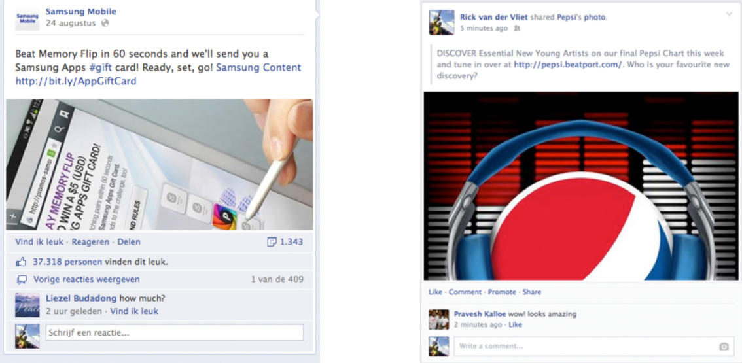

Figure 1: Brand messages on social media

1.3 Research question
As concluded from the studies in the previous sector it is still hard to explain the successful factors of viral messages. This study is an attempt to close the gap of previous academic literature.

Phelps, Lewis, Mobilio, Perry and Raman (2004) stated that strong emotions need to be considered when composing an e-mail to increase the forwarding behaviour. Humour, sadness, fear and inspiration are more likely to be forwarded. An essential part of successful viral content is the development of an engaging advertisement campaign that stimulates the forwarding behaviour of consumers (Dobele, Toleman & Beverland, 2005).

To examine the factors that leads to an engaging viral advertisement campaign several studies are conducted about the success of marketing activities on social media. Still little is known about the factors that influence message virality on social media (Ryan & Zabin, 2010). The studies about brands messages on social media are mainly descriptive, are not theoretical founded and do not test which factors increases the popularity of a brand post. These studies suggest that brands need to use different types of media (e.g. photos, text and videos) to improve brand popularity (Brookes, 2010). However they do not point out which factors or characteristics are important or less important. De Vries et al. (2012) focused on the brand post itself, like position and the influence of positive or negative comments. This study will focus on the relationship between the brand and the consumer plus the brand message and the consumer. The main research question is as followed:

- “What determines the virality of brand messages on social media and how can this be increased?”

The main research question is separated in four sub-questions:

- “Is the virality of brand messages on social media (partly) determined by brand attachment?”

- “Is the virality of brand messages on social media (partly) determined by product category involvement?”

- “Is the virality of brand messages on social media (partly) determined by intrinsic and extrinsic motivations?

- “Is the virality of brand messages on social media (partly) determined by hard-sell or soft-sell appeals?”

1.4 Academic relevance
Various studies have been carried out considering the sharing behaviour of viral content. Previous studies examined content as marketing campaigns (Dobele et al., 2005), news articles (Berger & Milkman, 2009) and video advertisements (Southgate, Westoby & Graham Page, 2010). Less research is done on the virality of brand messages on social media. Ho and Demspey (2009) stated that despite the increased acceptance of viral marketing it is still not entirely clear which factors contribute to the success of this type of marketing communication. The authors suggest exploring the characteristics of viral content in future research is essential to identify which factors increases the virality of online content. Therefore this study will use old and new practice to examine the virality of brand messages on social media. In addition this study will explore the offline WOM intention of consumers. A number of studies in the viral marketing literature determine emotional factors as the driver for viral content (Phelps et al, 2004; Berger & Milkman, 2009). This present study tries to identify the factors behind the virality of viral content from another point of view. These factors; brand attachment, product category involvement, intrinsic- and extrinsic motivations and hard-sell versus soft-sell message appeals, are not yet widely examined in the context of viral marketing.

1.5 Managerial relevance
Since social media is part of a lot of consumers’ daily routine, it has an essential part in the marketing activities of brands to communicate services and products. In the last decades social media has been transformed into an efficient tool to attract consumers. As a result the marketing activities of brands on social media have increased massively. This present study has important managerial relevance, as it will identify determinants that engage consumers to contribute to the virality of brand messages on social media.

This study offers valuable information for brands active on social networks. Brands can use socials media to maintain a relationship with their consumers (De Vries et al, 2012). By examining the virality of brand messages on social media and measuring several effects, brands will better comprehend the virality of brand messages on social media. In addition, brands could maximize the benefits from the use of social media. Marketing managers can use the results of this study to create effective viral marketing campaigns on social media. Furthermore marketing managers can use the social media to support the traditional media. The marketeers can improve the effectiveness of the marketing strategies by using the outcomes of this study in combination with previous literature about the virality of online content.

1.6 Thesis structure
The goal of this master thesis is to determine the virality of messages of social media and how this can be increased. To answer the research question and the sub-questions the study has multiple chapters. This thesis is structured as followed:

In the second chapter a theoretical framework is presented where the current literature about virality is reviewed. Based on this literature review hypotheses are formulated. In the third chapter the methodological approach is presented and in the fourth chapter an overview of the data analysis is given. Finally the results with an overview of the executed SPSS tests are given in the fifth chapter. Conclusions, limitations and future research are drafted in the sixth chapter.

2. THEORETICAL FRAMEWORK
As mentioned in chapter one of this master thesis social media becomes more important for brands. This study examines the virality of brand messages on social media and factors that might influence the virality. In sector 2.1 the wide relevant literature will be reviewed. In sector 2.2 the hypotheses of this study are presented and in sector 2.3 all hypotheses are shown in a thorough conceptual model.

2.1 Literature review

2.1.1 Viral marketing
Jurvetson and Draper (1997) mentioned the term viral marketing for the first time. They described the marketing strategy of the e-mail service Hotmail. If members of Hotmail sent an e-mail there was always a promotional message included with an open invitation to use the free e-mail services of Hotmail (Phelps et al., 2004).

Nowadays more and more research is done to clarify the viral marketing phenomenon. Dobele et al. (2005) explains viral marketing as crafting online messages into a online WOM system from one consumer to another consumer, whereby the consumers are encouraged to diffuse the message to their own network. They claim that viral marketing has two primary goals: consumption and forwarding behaviour. On the other hand Helm (2000) explains the goal of viral marketing as maximizing reach. Helm (2000) explains maximizing reach as trying to reach as many as possible consumers by spreading a viral message. The previous literature written about viral marketing always includes the companies’ perspective. Companies attempt to use consumer networks to promote and sell products (Helm, 2000). Companies can achieve multiple benefits with viral marketing; create awareness, develop interest and finally adopt the product or services (De Bruyn & Lillien, 2008).

2.1.2 Online advertising by viral brand messages
Viral advertising is described as “unpaid peer-to-peer communication of provocative content originating from an identified sponsor using the Internet to persuade or influence an audience to pass along the content to others” (Porter and Golan, 2006).

Van der Lans, Van Bruggen, Eliashnberg and Wierenga (2010) developed a prediction model to examine the reach of a viral marketing campaign. Three categories are mentioned: by emails, by online advertisement and by offline advertising. Viral messages are in general sent by the brand itself or by a marketing agency to consumers that subscribed for newsletters and other promotional emails (Bonfrer & Dreze, 2009). Online advertising is indicated as an important factor to influence viral diffusion (Van der Lans et al., 2010). The effectiveness of online advertising depends on the consumers and on the medium, which the brand messages are placed. An advantage of online advertising is the possibility to accurately observe the reach accurately. Based on these observations brands can easily adjust their strategies. At last brands can use offline advertisements like magazines or TV advertisements. This type of viral spreading seems to be less popular and less effective because consumers cannot directly visit the viral message. But this traditional type of media can be used for promotion of the online brand messages (Clow & Baack, 2007). An example is a billboard or poster where consumers are asked to like the brands’ Facebook page.

Brands can use viral advertising seeding websites for the seeding of viral messages (Cruz and Fill, 2008). On seeding websites potentially viral content can be posted by brands. There are two types of seeding websites: independent third parties (Porter and Golan, 2006) and paid-for placement (Cruz & Fill, 2008). When consumers receive unannounced messages from brands, they are more likely to evoke irritation towards the brand and delete the message without reading (Phelps et al., 2004) However when the same messages are received from a familiar person the content is seen as more valuable and trustworthy.

2.1.3 The path of a brand message on social media
To understand which path a viral text message takes in a social network all elements of the communication process, as seen below in the model of Kotler & Keller (2009), will be clarified. The communication model contains nine elements. Sender and receiver are the main components in this communication model. Another two elements are the communication tools; the message and the medium. The medium explored in this thesis is the online social network. The literature on the communication models describes communication effectiveness when the senders’ encoding process matches the receivers’ process (Kotler & Keller, 2009). The basic model of communication is shown in figure 2.
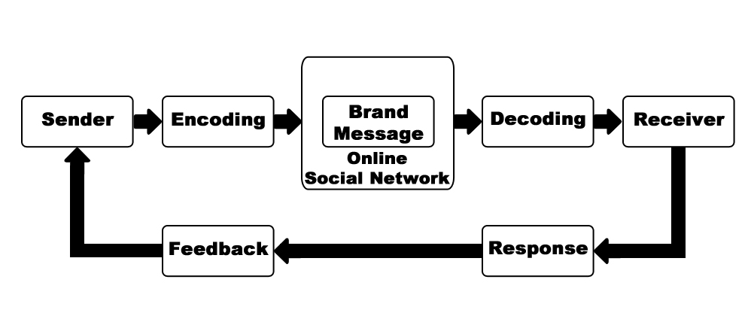
Figure 2: Elements in the communication process

This model does not correlate with literature on viral marketing and online WOM. The path of a brand message on social media must be taken into account and implanted in the model. The goals of viral marketing as described earlier are reach maximum range (Helm, 2000) and encourage forwarding behaviour (Dobele, 2007). If you simplify these theories you can say the desired response is to share a brand message. Because the medium used in this master thesis is Facebook the brand message will reach not one receiver but multiple. In the literature on marketing communication feedback can be amount of consumptions, visits to websites, reviews or inquiries (Kotler & Keller, 2009). On a social media platform feedback can be comments, likes or establishing a network connection between consumers or between the brand and the consumer. In figure 3 the basic path of a viral text message is illustrated.
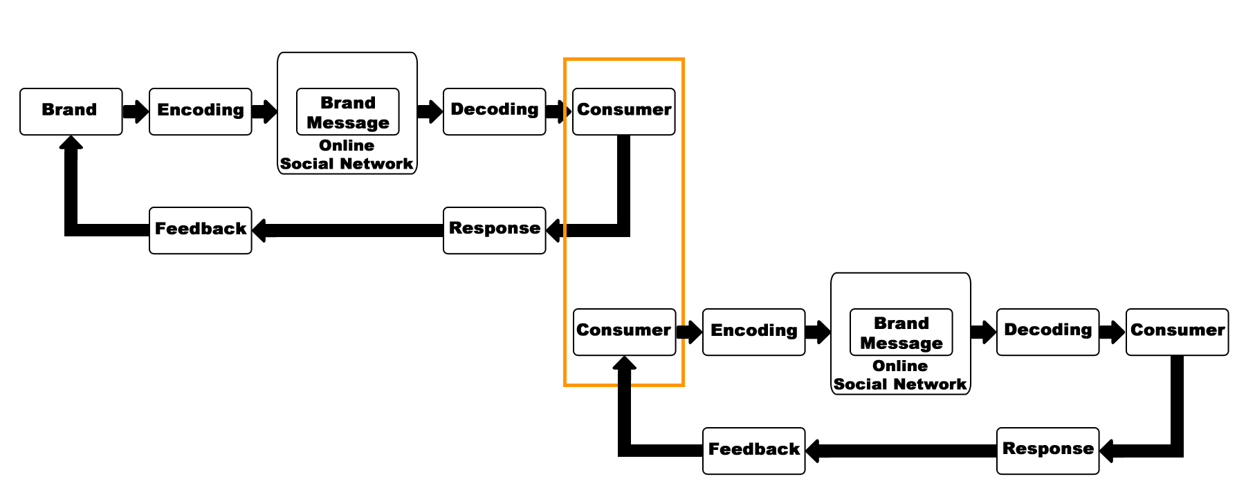

Figure 3: The path of a brand message on social media

2.1.4 Hard-sell versus soft-sell appeals
Social media messages by brands can use different kind of message appeals. A previous study on appeals in advertisements calls the differences rational versus emotional (Albers-Miller & Stafford, 1999). Ozaki, Mueller and Taylor (2010) use the terms hard-sell and soft-sell appeals. Ozaki et al., (2010) adopted the terms soft-sell and hard-sell from Mueller’s (1987) study. Mueller examined the different appeals used in Japanese and American advertisements. This study similarly uses the definitions from Mueller: ‘A soft-sell appeal is one in which human emotions are emphasized to induce an affective (feeling) reaction from the viewer.’ According to Mueller soft-sell appeals are often indirect and subtle. An example is an image of a beautiful scene, a breath-taking atmosphere or an emotional story. ‘A hard-sell appeal is one in which the objective is to induce rational thinking on the part of the receiver’. Hard-sell appeals are often direct, sales orientated. Also in many cases factual information, such as product comparisons, product specifications and product advantages are displayed. In figure 4 soft-sell and hard–sell appeals used in advertisements are illustrated.

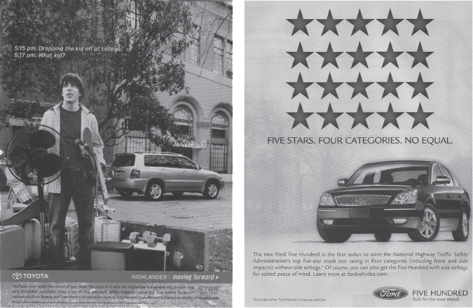
Figure 4: Left: Soft – sell appeal Right: Hard - sell appeal (Ozaki et al., 2010)

2.1.5 Motivations to spread viral brand messages
An important aspect of a successful viral marketing campaign is to create engagement and encouragement for consumers to forward the message (Dobele et al., 2005). Intrinsic and extrinsic motivations can increase the reach and success of a viral marketing campaign. The terms intrinsic and extrinsic is not yet widely examined in the context of viral marketing. In psychological literature intrinsic is described as engaging in an activity only for the satisfaction and pleasure (Deci, 1975). When a person acts because of intrinsic reasons the behaviour is completely voluntarily with no perspectives on material rewards (Deci & Ryan, 1985). In contrast, extrinsic is described as engaging in an activity that comes outside a person.

Phelps et al. (2004) studied the motivations and rewards experienced to pass along emails. In their quality research they found that a lot of consumers are forwarding an email because of intrinsic reasons. The most mentioned motives are: ‘’because it is fun’’ and ‘’because I enjoy it’’. On the other hand 46,7% of the consumers indicated to forward email to be eligible for free stuff. Because it is fun and because I enjoy it are described with the term intrinsic motivations in marketing literature. Offering free stuff can be assigned to the term extrinsic motivations. Intrinsic motivation is described as the internal gratification that comes along (Dobele et al., 2007). Also Phelps et al. (2004) indicated that forwarding an e-mail could evoke feelings as happy and satisfied by the sender. Consumers are often engaged in the virality of brand messages on social media by extrinsic motivations. Brands are responding on this behaviour by offering gift vouchers, event tickets, discounts and other cost advantages (Dobele et al. 2007). On social network sites as Facebook consumers are often triggered to share, like or comment on a Facebook post to win a specific free product or free service. Dobele et al. (2005) mention the introduction of Procter and Gamble new shampoo called Physique. Consumers could refer the website advertisement to ten friends, when they did they entered a contest to win one year free shampoo. At least two million referrals were made what makes Physique the most successful launch of a shampoo in the United States.

2.1.6 Brand attachment
Previous studies in marketing have explored the consumers’ attachment to brands. The first study on attachment is conducted by Bowlby (1979). Bowlby (1979) defines attachment as an emotionally bond between a person and an object. The strength of attachments does vary and strong attachments are often related to strong feelings of passion, love, affection and connection. (Aron &Westbay, 1996). The strength of attachment to an object can eventually lead to promoting the relationship between a person and the object (Van Lange et al., 1997).

Brand attachments vary in strength from weak to strong (C.W. Park, 2010). Brand attachment can be defined as the strength of the connection between the consumer and the brand. Brand attachment can lead to several consumer behaviors, such as purchase, repeat purchase and motivation to recommend a brand. The last criteria “recommend a brand” is an important one for the context of this thesis. When a consumer contributes to the virality of a brand messages (e.g. sharing, liking or commenting a brand message) he or she indirectly recommend a brand. A small attempt to examine the importance of brand attachment in the context of viral marketing is made by Southgate (2010). His study determines the creative attributes of online viral TV advertising. Southgate (2010) expected that more appealing brands for consumers, or in other words brand with strong brand attachments have a greater chance to go viral. However Southgate did not found any significant relevance between brand attachment and virality. But Southgate recommended further research because of the small size of the data collection. Ketelaar, van Voskuijlen and Lathouwers (2010) researched the motivations to forward a viral marketing campaign in an online social network. The study indicates that brands, which are appreciated by consumers, had a higher likelihood to being forward.

2.1.7 Category product involvement
Product category involvement is seen as an important variable to an advertising strategy (Ray, 1973). Product category involvement is defined as the extent to which the product category is important for the consumer based on the interests, values and needs (Zaichkowsky, 1994).

Depending on the level of product category involvement of the consumers the behavior and decision differs. When consumers receive an advertisement they can react passive or active depending on their level of involvement. In addition consumers can limit or extend the process of their communication (Rothschild, 1979). Ad effectiveness is positively influenced by product involvement (Te’eni-Harar, Lampert & Lehman-Wilzig, 2009). In other words, when a high level of product involvement occurs the consumer attitudes are positively influenced. On the other hand, when a low level of product involvement occurs the consumers attitudes towards the advertisement are significantly lower.

The term involvement is widely examined in the context of marketing. Before the term viral marketing existed Dichter (1966) researched WOM recommendations for products and services. Motivations to talk about product or services were the result of multiple types of involvement. Dichter describes product involvement as the experience with the product or service that produces a tension which is not eased by the use of the product alone. Besides product involvement is influenced by the way of talking, recommending and the degree of enthusiasm.

Zaichkowsky (1994) stated that it is important to use ad-to-consumer and brand-to-consumer involvement to understand the intention to forward the advertisement. This is mainly because consumers do not have to be an expert of a product category to be involved with an advertisement. Chung and Darke (2006) examined the relation between the product and word-of-mouth. They suggest that consumers are more likely to engage in WOM when the product is relevant to them. These products that engage in WOM are closely aligned to the consumers self-image, in other words products that tell others who the consumers are. Numerous studies claimed that involvement of the consumer effects forward behavior positively. Phelps et al. (2004) suggest when the forwarded emails meet the standards for quality or relevance of the consumer the likelihood to forward will increase.

2.2 Hypotheses
In this sector the hypotheses of this study will be formed. At last a conceptual model will be illustrated.

On social network sites like Facebook you can see posts of all your Facebook friends and it is possible to see posts of non-friends. Consumers receive posts on social network through multiple sources: consumers and brands. Previous studies focuses on the tie strength between consumers. However this hypothesis will examine the strength of the connection between the consumer and the brand, generally defined as brand attachment strength.

De Bruyn & Lillien (2008) stated that tie strength is a significantly factor when deciding to open and forward an e-mail. When receiving an e-mail from a strong tie consumers are more likely to open it compared to e-mails received from a weak tie. De Bruyn & Lillien (2008) found that e-mails from strong ties are classified as trustworthy and safe and e-mails from weak ties as possible danger. Southgate (2010) did not found any significant relation between brand attachment and online viral viewing. However Southgate recommend further research because of the lack of a reasonable data set.

Therefore this thesis predicts that a strong brand attachment can enhance the forwarding behaviour of the consumer. All in all, this hypothesis expects that a strong brand attachment, compared to a weak brand attachment lead to a higher virality of the brand message. Consequently the following hypothesis propose:

Hypothesis 1: The virality of brand messages on social media is expected to be higher when the brand messages are delivered to a consumer with a relatively strong brand attachment.

Millward Brown (2007) unveiled that consumers are reacting positively on online advertisements when they are extrinsically motivated by a reward. The rewards need to be valuable, relevant and engaging in exchange for their efforts. Consumers will click twice as much when the brands offer them gift cards, coupons and tickets. On social network sites as Facebook brands often offer the consumers coupons, free products and other valuable stuff when they share, like or comment on the potentially viral brand message.

In known literature it has been proven that intrinsic- and extrinsic motivations are major predictors of human behaviour. Potential intrinsic- and extrinsic rewards are a sign of appreciation of someone’s behaviour, in this study the consumer, by the reward giver, in this study the brand (Pousttchi, & Wiedemann, 2007). Phelps et al. (2004) stated that offering free stuff increased the likelihood to forward e-mails twice. However Kirschner (2010) studied extrinsic and intrinsic motivations to persuade consumers. The study stated that people are more likely to spread the viral brand message by intrinsic motivations compared to extrinsic motivations. On the contrary Teo, Vivien and Lai (1999) concluded in their study to examine the differences between intrinsic and extrinsic motivation in Internet usage that people are more engaged when they are extrinsically motivated Therefore it is not clear which type of motivation increases the likelihood to increase the virality of a brand message. Hypothesis 2a and 2b will examine which type of motivations works better.

Hypothesis 2a: The virality of brand messages on social media is expected to be higher when the consumer is acting out of extrinsic motivations compared to intrinsic motivations.

Hypothesis 2b: The virality of brand messages on social media is expected to be higher when the consumer is acting out of intrinsic motivations compared to extrinsic motivations.

Chung and Darke (2006) state when the message is more self-relevant, in other words when the consumers is more involved, consumers are more likely to be engaged in WOM. Phelps et al. (2004) confirmed this theory and claimed that consumers are more likely to forward an e-mail when the message is relevant.

The research findings will contribute to the current viral marketing literature since previous studies only focused on brand involvement and message involvement. According to the known literature on involvement in the context of viral marketing, involvement has a positively influence on the likelihood to forward viral content. Therefore this study predicts that a high product involvement positively affects the virality of a brand message on social media. This results in the following hypothesis:

Hypothesis 3: The virality of brand messages on social media is expected to be higher when consumers are more involved in the product category.

One of the techniques to influence and persuade consumers is using hard sell or soft sell mechanisms in advertisements. Porter and Golan (2006) state that viral advertising also has the characteristic to persuade and influence consumers. Kaikati & Kaikati (2004) mention viral marketing as a stealth marketing principle. The theory of stealth marketing unveils that consumers responds negatively when they become aware of a commercial brands advertisement to persuade the consumers to action. Like the term proposes, stealth marketing uses a more subtle or softer technique to persuade consumers.

Previous studies did not yet examined the role of hard/soft sell techniques in a viral marketing context. Dichter (1966) claimed nevertheless a positive relation between word-of-mouth and a soft selling technique. According to Dichter the advertisement should be naturally, non-commercially, in other words the advertisement should use a soft sell technique. Besides a soft sell technique will increase the sales Cruz and Fill (2008) agreed to Dichter theory and state that consumers prefer a viral message that is intended to be commercial-free (soft sell) and did not include “call-to-action” features (hard sell). Therefore this thesis predicts that soft sell techniques are performing better than hard sell techniques in a viral marketing context. This leads to the following hypothesis:

Hypothesis 4: The virality of brand messages on social media is expected to be higher when the brand message is received as more soft-sell than hard-sell
In addition the main effects mentioned above this study examines several moderation effects between variables.

Traylor (1983) stated the general agreement in literature is that consumers’ product category involvement is directly related to the consumers’ commitment to a particular brand within that product category. However Traylor (1983) stated the more important a product category is to the consumer, the stronger the brand attachment. Conversely, the lower the importance is of a product category for a consumer, the lower the brand attachment (Traylor, 1981). Traylor suggests when a consumer shows a low product category involvement, the consumer would have a large consideration set and therefore will be more likely to switch between brands. Contrariwise, Traylor (1981) suggests that consumers with a small consideration set shows more brand commitment.

Others suggest when product category involvement is low; consumers are less likely to process information deeply (Malar, Krohmer, Hoyer & Nyffenegger, 2011). The product category is not important enough for consumers and therefore the consumers are less likely to establish a connection between the brand and themselves, which leads to a lower brand attachment. Conversely, when product category involvement is high, consumers are more likely to process the information and invest in the connection between the brand and themselves.

Combining the literature of Traylor (1981; 1983) and Malar et al. (2011) this research expects when involvement is high, consumers are more willing to process the brand message deeply and therefore a brand messages tend to have a higher virality. As a result, these consumers are more likely to make the connection between the brand and their actual self and therefore the brand message is more interesting to spread.

Hypothesis 5: Product category involvement affects the relationship between the virality of a brand message on social media and brand attachment.

According to Sherif & Hovland (1980) high involvement results in more resistance to persuasion. Furthermore Sternhal, Philips & Dholakia (1978) stated that high ad involvement leads to more counter argumentation. Kapferer & Laurent (1985) stated that consumers who are highly involved process information more active compared with consumers who are slightly involved. When are consumers are slightly involved they are more likely to follow the heuristic road of persuasion (Chaiken, 1980). In the context of this study this implicates they might avoid processing persuasive argumentation such as product specifications and other facts mentioned in the brand message. These consumers are more likely to focus on elements of the brand message that require minimal efforts to interpret (Chaiken, 1989). As explained in sector 2.1.4 hard-sell appeals tend to have more persuasive argumentation and soft-sell appeals often have an emotional setting that require minimal efforts to interpret.

Therefore this study examine if product category involvement has a positive effect on the relationship between the virality of brand messages and brand message appeals. This research expects that product category involvement moderates the relationship between brand message appeals and the virality of the brand message. This leads to the following hypotheses:

Hypothesis 6a: Product category involvement affects the relationship between the virality of the brand message on social media and soft-sell brand message appeals.

Hypothesis 6b: Product category involvement affects the relationship between the virality of the brand message on social media and hard-sell brand message appeals.

2.3 Conceptual model
The complete conceptual model of this study is illustrated below. In the conceptual model brand attachment (H1), intrinsic- and extrinsic motivations (H2), product category involvement (H3), hard-sell versus soft-sell appeals (H4) are withdrawn from existing literature and explained in sector 2.2. Additionally, category product involvement is indicated as a moderator for respectively brand attachment (H5) and hard-sell versus soft-sell appeals (H6). In the next chapter the study explains the research design of this study will be explained.
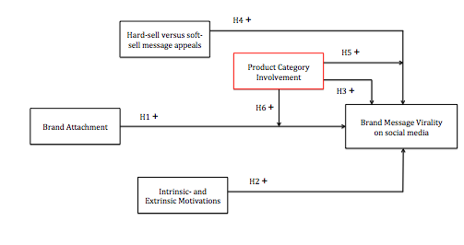

Figure 5: Conceptual model
3. METHODOLOGY
This chapter will present the methodological approaches. The first sector defines the research design. The next section consists the sample method and sample clarification.

3.1 Research design
To measure the virality of a brand message on social media this study has two types of brand messages. Consequently there are two scenarios. The first scenario is a brand message with a hard-sell appeal. The second brand message uses a soft sell appeal. The differences between both message appeals is clarified in sector 2.1.4 Because this study makes a difference between these two types of brand messages not only the main effect of the virality of brand messages on social media is measured but also the possible difference between hard-sell and soft-sell.

Respondents are equally assigned to one of the two scenarios. Subsequently each group of respondents get one of the two scenarios assigned. The scenarios for measuring hard- and soft sell contains prearranged questions and are the same for every questionnaire in this research. By applying fixed response questions there is less variability in the research date. Therefore the data is easier to analyse. Before the questionnaire is completed, a pre-test (N=10) is conducted to ensure there is no misinterpretation of the questionnaire. The questionnaire is created with an online tool called Qualtrics. Since this it was an online questionnaire, it was easy to distributed through Facebook and e-mail.

3.2 Population and sample size
Social media is used worldwide. Half of the social media users are following a brand. The entire social media community in the Netherlands is quite broad and consists also of children and old people that are incapable of buying the products used in this study or are inactive users. PEW research centre indicated that the most active social media users ranged in the age of 18 – 29. Besides there are just slightly more women that uses social media compared with men. And there is no difference in social media activity between well-educated people and less educated people. Therefore respondents had to meet just two criteria. The first one is that they used social media and the second one is that they were aged between 18 – 29.

To measure the required respondents in an experimental design the software of G*Power is practiced (Faul, F., Erdfelder, E., Buchner, A., & Lang, A.-G, 2009). The study examined a main effect between the brand message on social media and the virality of the brand message. This main effect is analysed with a one-way ANOVA. According to G*Power a total sample size of 84 respondents is required for the total data collection. This means at least 42 respondents each cell. The effect size used in the G*POWER statistics is based on Cohen’s (1988) proposed rules for effect sized and is set on .4 because a medium effect is expected. α Err prob and Power 1- β err prob are not adjusted and set on the standard figures respectively .05 and .95.

3.3 Questionnaire structure
The structure of the questionnaire is based on the conceptual model illustrated in chapter three and the research design described in sector 4.1. All questionnaire questions are grounded on previous literature to ensure the validation of this study. Each variable of the conceptual framework is a part of the survey. On top of that a few demographic questions are asked. The first part of the questionnaire contains an introduction. Respondents receives a thank note and an estimated timeframe to complete the survey. Also the respondents are ensured that their answers will be treated confidentially. After the introduction consumers will be confronted with three brand messages that are posted on the social network Facebook. Respondents are asked several questions about each brand message to test the independent variables. See table 1 below. The last part of the questionnaire contains a closing. Respondents are thanked for participation and respondents can indicate if they want to receive results of the study (see Appendix A for the entire questionnaire; Appendix B, D and D contains the different scenarios used in the questionnaire).

 | Variable | Question | Method | Academic references
1 | Virality of brand messages | How likely is it that you would share this Facebook post? | 7-point Likert scale
 |  | How likely is it that you would like this Facebook post?
 |  | How likely is it that you would comment on this Facebook post?
2 | Offline WOM intention | If my friends were looking for a (productcategory), I would tell them to try (brand). | 7-point Likert scale | Maxham III, J.G. and R.G. Netemeyer, Modeling customer perceptions of complaint handling over time: the effects of perceived justice on satisfaction and intent. Journal of Retailing, 2002. 78(4): p. 239-252.
 |  | How likely are you to spread positive word-of-mouth about (brand)?
 |  | I would recommend (brand) (productcategory) to my friends.
3 | Brand attachment | To what extent do you have many thoughts about (brand)? | 5-point Likert scale | Park, C.W., MacInnis, D.J., JPriester, J., Eisingerich, A.B., Iacobucci, D (2010) Brand Attachment and Brand Attitude Strength: Conceptual and Empirical Differentiation of Two Critical Brand Equity Drivers. Journal of Marketing: November 2010, Vol. 74, No. 6, pp. 1-17.
 |  | To what extent is (brand) part of you and who you are?
 |  | To what extent does the word (brand) automatically evoke many good thoughts about the past, present and future?
 |  | To what extent do you feel emotionally bonded to (brand)?
4 | Product category involvement | I put in quite a great deal of effort when I made a decision about which (productcategory) to buy. | 5-point Likert scale | Kapferer, J. and Laurent, G., (1985) ,"Consumers' Involvement Profile: New Empirical Results", in NA - Advances in Consumer Research Volume 12, eds. Elizabeth C. Hirschman and Moris B. Holbrook, Provo, UT : Association for Consumer Research, Pages: 290-295.
 |  | I always bought the same brand of (productcategory) because I really like my particular brand.
 |  | I would be upset when I have to by another (productcategory) because my brand was not available.
 |  | Although another (productcategory)is on sale I still bought this particular brand of toothpastes.
5 | Hard sell versus soft sell appeal  (PRETEST) | Image vs. factual | 7-point semantic differential scale | Okazaki , S., Mueller, B., Taylor, C.R. (2010) Measuring Soft-Sell Versus Hard-Sell Advertising Appeals, Journal of Advertising, 39:2, 5-20
 |  | Indirect vs. direct
 |  | Pshylogical vs. informative
 |  | Creative vs. Logical
 |  | Subtle vs. aggresive
 |  | Interpretive vs. descriptive
6 | Extrinsic motivation | I would share this Facebook post because I am strongly motivated by the money/benefits/rewards I can earn | 5-point likert scale | Amabile, T. M., Hill, K. G., Hennessey, B. A., & Tighe, E. M. (1994). The work preference inventory: Assessing intrinsic and extrinsic motivational orientations. Journal of Personality and Social Psychology, 66: 950-967.
 |  | I would share this Facebook post because I have to feel that I am earning something for what I do
 |  | I would share this Facebook post because I share them in order to attain what I desire
7 | Intrinsic motivation | Because sharing this Facebook post is interesting | 5-point likert scale | Guay, F., Vallerand, R.J., & Blanchard, C.M. (2000). On the assessment of state intrinsic and extrinsic motivation: The situational motivation scale (SIMS). Motivation and Emotion, 24,  175–213.
 |  | Because sharing this Facebook post is pleasant
 |  | Because sharing this Facebook post is fun
8 | Facebook Intensity (FBI) | Facebook is part of my everyday activity. | 5-point likert scale | Ellison, N. B., Steinfield, C., & Lampe, C. (2007). The benefits of Facebook "friends:" Social capital and college students use of online social network sites. Journal of Computer-Mediated Communication, 12, 1143-1168.
 |  | I am proud to tell people I'm on Facebook.
 |  | Facebook has become part of my daily routine.
 |  | I feel out of touch when I haven't logged onto Facebook for a while.
 |  | Approximately how many TOTAL Facebook friends do you have?
 |  | In the past week, on average, approximately how much time PER DAY have you spent actively using Facebook?
9 | Opinion Leadership | My opinion about products seems not to count with other people | 5-point likert scale | Flynn Leisa Reinecke, Goldsmith Ronald E, Eastman Jacqueline K.  Opinion leaders and opinion seekers: two new measurement scales.  Journal of Academy of Marketing Science 1996;24(2);137 –47.
 |  | When I consider buying a product, I ask other people for advice
 |  | Other people rarely come to me for advice about choosing products
 |  | I rarely ask other people what products to buy
 |  | I often persuade other to buy the products I like
 |  | I feel more comfortable buying a product when I gotten other people's opinion on it
10 | Need to belong | My feelings are easily hurt when I feel that others do not accept me. | 5-point likert scale | Leary, M. R., Kelly, K. M., Cottrell, C. A., & Schreindorfer, L. S. (2013). Individual differences in the need to belong: Mapping the nomological network. Journal of Personality Assessment.
 |  | I try hard not to do things that will make other people avoid or reject me.
 |  | I want other people to accept me.
 |  | I have a strong need to belong.
11 | Demographics | What is your age? | Validated regular questions
 |  | What is your gender?
Table 1: Questionnaire structure

3.3.1 Virality of a brand message
The virality of a brand message is the first subject in the survey. Every questionnaire presents a small scenario. After the introduction respondents are confronted with a brand message with a hard-sell or soft-sell appeal. The brands used in the questionnaire are chosen according to the pre-test. The pre-test will be further described in this sector 3.4. Respondents will be asked three questions: how likely is it to share this Facebook post, how likely is it to like this Facebook post and how likely is it to comment on this Facebook post. Respondents can indicates the degree of likelihood on a 5-point Likert scale. The object of this question is to indicate the virality of the brand message. The variable virality of brand message is ordinal.

3.3.2 Brand attachment strength
Brand attachment is measured by using questions all presented in the study by C.W Park, MacInnis, Priester, Eisingerich and Iacobucci (2010). The participant is confronted with one brand message of the two possible scenarios. Respondents are firstly asked is if they are familiar with the brand. After that, five questions measure whether the consumers have a strong or weak strong brand attachment like “to what extent do you have many thoughts about (brand)?” These five questions are eventually transformed into one ordinal variable, explaining the degree of brand attachment. This research uses three brands: respectively Nikon, Ray - Ban and Vespa. A pre-test has indicated Nikon as a high utilitarian brand, Vespa as a high hedonic brand and Ray – Ban as a combination of both. Therefore this study covers all possible products.

3.3.3 Intrinsic vs. extrinsic motivations
The impact of intrinsic- and extrinsic rewards on the virality of a brand message is measured according to the Situational Motivation Scale the (SIMS) and the Work Preferences Inventory (WPI).

The SIMS item is applied in experimental studies to measure intrinsic motivation (Guay, Vallerand & Blanchard, 2000). The four item scales mentioned are adopted and modified to fit to the subject of the experiment, but are further left identical. Participants are confronted with a few statements, which they can measure with a 5-point Likert scale. The 5-point Likert scale ranging from “strongly agree” to “strongly disagree”.

Because there is no extrinsic reward measurement scales available in current marketing literature this study adapt the WPI. The WPI is a measurement scale to examine respondents’ extrinsic motivation (Amabile, Hill, Hennessey & Tighe, 1994). WPI is mainly performed in research related to work environment. In this study the WPI items are modified to fit to the subject of potential viral brand messages. After the modification a pre-test measured if the item scale were clear and measured the proposed objectives. Respondents are shown several statements and a 7-point Likert scale. The scales range from “strongly agree” to “strongly disagree”.

3.3.4 Product category involvement
To test the relationship the virality of a brand message on social media and product category involvement this research use the Consumer Involvement Profile scale (CIP) (Kapfer & Laurent, 1985). Respondents are confronted with several 5-point Likert-type statements ranging from “strongly agree to “strongly disagree”.

3.3.5 Hard sell vs. soft sell appeal
The pre-test measured two types of brand message appeals. One uses a hard-sell appeal and the other uses a soft-sell appeal. The pre-test questions are based on research of Ozaki et al. (2010). The authors developed a scale to measure hard-sell and soft-sell appeals in advertising. To measure the soft-sell appeal of the brand message three proposed dimensions are used: feeling, implicitness and image. These three dimensions are divided into 12 proposed items. To measure the soft-sell appeal of the brand message three proposed dimensions are used: thinking, explicitness and facts. The dimensions are further divided into 15 proposed items.

Depending on the scenario respondents viewed a hard-sell or soft-sell brand message appeal without receiving any information about the appeals to avoid an experiment bias.

3.3.6 Demographics
The last questions of the questionnaire are not designed to measure any hypothesized effects. To ensure validation of the research several demographical questions are included to verify that outcomes were not caused by differences between the different groups.

3.4 Pre-test
To preclude a misinterpretation of the survey a pre-test is performed. First the questionnaire was handed over to five respondents if they completely understood the questions. Second the brands used in the questionnaire were tested on identification strength and brand awareness. Subsequently a test group (N =10) completed a small survey to measure hard-sell and soft-sell appeals according to Ozaki et al., (2010). Respondents were confronted with several hard-sell and soft-sell brand messages. A 7-point semantic differential scale examined if the respondents identified the brand message as hard-sell or soft-sell. Based on these outcomes three brands are selected for the final questionnaire.

After the brand messages were validated, another test group filled in the final survey. After they completed the survey they were asked if there was something was not entirely clear or if they had any other remarks. Based on this remarks the final questionnaire was finished.

4. DATA ANALYSIS
In this chapter an overview is given of the data analysis. In 4.1 the sample of the questionnaire is described. In 4.2 the data is prepared for further analysis by a reliability analysis and factor analysis. The analyses were executed in IBM SPSS 20.

4.1 Sample
The data is collected in four days. Every scenario needs to have at least 42 respondents, consequently 84 respondents in total. Eventually 152 participants filled in the survey, but 45 respondents did not complete the survey. An explanation of the uncompleted surveys could be the length of the survey in combination with the estimated time that was needed to complete the survey. Of the 107 respondents that completed the survey two respondents were not included in to the research due to the phenomenon ‘outliers’. Participants are equally distributed across the two different scenarios. An equal distribution between scenarios is vital because this is a requirement for proposed ANOVA analysis (Shaw & Mitchell-Olds, 1993). 98% of the respondents meet the criteria of being a member of Facebook between the ages of 18 – 29. The participated respondents are almost equally divided in male and females respectively 49,5% and 50,5%. The distribution of age was normally distributed. Of all participated respondents 59,9% is aged between 22 – 25, 30,9% is aged between 18 – 21 and 9,3% is aged between 26-29.

4.2 Data preparation
Before testing the hypotheses a reliability analysis and a factor analysis is performed. By applying the Cronbach’s alpha in 4.2.1 the reliability analysis is performed. In 4.2.2 all item scales that measures one variable are taken together in a factor analysis to prepare the date for further analysis.

4.2.1 Reliability analysis
All variable tested in the questionnaire are verified on their reliability. The results are reliable when they are greater than or equal to minimal Cronbach’s alpha score of .7 (Cortina, 1993). To underline the reliability of the study even more the reliability test is performed on the separated brands. The table below illustrates the number of item scale for the variable used in this study and the Cronbach’s alpha.

Construct | Item Scales | Cronbach’s alpha
Virality of brand message | 3 | α = .726
Offline WOM intention | 3 | α = .937
Brand attachment | 4 | α = .918
Product involvement | 4 | α = .820
Intrinsic motivation | 4 | α = .878
Extrinsic motivation | 3 | α = .741
Facebook post attractiveness | 4 | α = .837
Need to belong | 5 | α = .733
Opinion leadership | 2 | α = .716
Facebook intensity | 6 | α = .820
Table 2: Results reliability test

According to the outcomes all variables meets the Cronbach’s alpha criteria, > .7. In the table above opinion leadership’s Cronbach’s alpha is .716. This exceeds the minimum criteria of .7. However the Cronbach’s alpha of opinion leadership is based on two-item scales, where the originally survey used six-item scales to measure opinion leadership. Four-item scales are deleted due reliability issues; the originally six-item scale scored a Cronbach’s alpha of .324.

4.2.2 Factor analysis
A factor analysis is fulfilled to look if the scales used in the survey are valid and to observe underlying dimensions (Field, 2009). In other words the proposed item scales measure the variable they belong to. Factors analyses can indicate if multiple item scales can be take together to represent one single variable. Factor analysis has several important values.

The first test is the Kaiser-Meyer-Olkin (KMO) measure of sampling. The KMO value is between 0 and 1. The closer the KMO value to 1 the more reliable and distinct the factors are. Kaiser (1974) mentioned several categories. A value above .5 is weakly accepted, a value between .5 - .7 is indicated as mediocre, values between .7 - .8 are good, values between .8 - .9 are great and values above .9 are superb.

The opinion leadership variable consists of six-item scales. But because of low reliability four items are deleted and are not used for further research. Although opinion leadership scores the lowest values after deleting several item-scales it is still allowed to compute the remaining item scales into one variable. Furthermore the factor analysis shows that need to belong and opinion leadership has the lowest KMO (KMO = .52). Despite the relative low KMO value of .52 it still meets the criteria of Kaiser (1974) and the values can be labelled as mediocre. Brand attachment has the highest KMO (KMO = .84). All constructs meets the criteria of KMO > .5 therefore the multiple items to measure a variable can be combined and transformed into one variable (Kaiser, 1974).

An additional factor analysis is performed to ensure the differences between intrinsic and extrinsic motivation measurements. See Appendix E for the factor analysis results. Two components have Eigenvalues over Kaiser’s (1974) criterion of 1. The scree plot also verifies two clear components. The rotated component matrix indicates that component one represents ‘intrinsic motivations’ and component two represents ‘extrinsic motivations’. This factor analysis confirms that the items scale of component one can be combined. The same applies for component two.

The second test is the Bartlett’s test of sphericity. The factor analysis indicates that the Barlett’s test of sphericity is highly significant (p < .001) for every construct. This indicates that correlations between items were sufficiently large for PCA.

Construct | KMO | Bartlett’s test  of sphericity | Total Eigenvalue | % of  Variance
Virality of brand message | .66 | 68.22*** | 1.95 | 64.94
Offline WOM intention | .69 | 62.76*** | 1.90 | 63.50
Brand attachment | .84 | 945.02*** | 3.22 | 80.47
Product involvement | .79 | 468.63*** | 2.61 | 65.21
Intrinsic motivation | .83 | 672.19*** | 2.94 | 1.99
Extrinsic motivation | .81 | 230.89*** | 73.44 | 66.40
Facebook post attractiveness | .76 | 552.37*** | 2.72 | 67.90
Need to belong | .52 | 41.00*** | 1.61 | 80.68
Opinion leadership | .52 | 41.00*** | 1.61 | 80.68
Facebook intensity | .80 | 235.78*** | 3.25 | 54.18
* p < .05 ; ** p < .01; *** p < .001
Table 3: Results factor analysis

5. RESULTS

5.1 Descriptive analysis
A Spearman’s rho analysis is performed to examine correlations between the variables of this study. In this study is chosen for a Spearman’s rho analysis because the relevant variables are ordinal. See Appendix E for the complete correlation matrix. The outcomes of the correlation matrix support the regression analysis outcomes. Correlations do not imply causality and therefore the correlation matrix is not part of further research.

 |  | Overall |  | Age (M) |  |  |  | Gender (M)
 |  | M | SD | 18-21 | 22-25 | 26-29 | P | M | F | P
All Brands | Virality of brand message | 2.58 | 1.50 | 2.72 | 2.45 | 2.91 | .14 | 2.41 | 2.75 | .33
 | Offline WOM intention | 3.97 | 1.69 | 4.08 | 3.85 | 4.31 | .27 | 3.80 | 4.13 | .01
 | Brand attachment | 2.20 | 1.09 | 2.28 | 2.15 | 2.22 | .61 | 2.25 | 2.15 | .36
 | Product Category Involvement | 2.90 | .95 | 3.11 | 2.81 | 2.79 | .03 | 2.87 | 2.94 | .41
 | Extrinsic Reward | 2.90 | .98 | 2.97 | 2.75 | 3.57 | .00 | 2.87 | 2.92 | .15
 | Intrinsic Reward | 2.35 | .91 | 2.48 | 2.26 | 2.51 | .10 | 2.15 | 2.56 | .48
 | Facebook Intensity | 3.30 | 1.50 | 3.33 | 3.26 | 3.48 | .35 | 3.12 | 3.49 | .30
 | Facebook post attractiveness | 4.36 | .82 | 4.53 | 4.24 | 4.65 | .17 | 4.27 | 4.46 | .10
 | Need to belong | 3.04 | .76 | 3.14 | 2.98 | 3.10 | .21 | 2.92 | 3.16 | .40
 | Opinion leadership | 3.45 | .89 | 3.5 | 3.37 | 3.80 | .04 | 3.37 | 3.54 | .17
Table 4: Results descriptive analysis
A descriptive analysis is conducted to identify differences between respondents’ demographics in relation to all variables. The variables are tested against the differences in age and gender. The differences in age are tested using an independent sample T –test and the differences in gender are tested using an ANOVA. The table below indicates that there is a significant difference between product category involvement and age categories. (p < .05). Also the results show a significant effect between extrinsic reward and age categories. The results of the independent T-test reveal only a significant difference between the offline WOM intention and gender.

There is a clear difference in overall means between virality of the brand message (M = 2.58 SD = 1.69) and offline WOM intention (M = 3.97 SD = 1.50) Apparently in this research consumers have more intent to engage in offline WOM than contribute to the virality of a brand message on social media by spreading it. Besides the large differences the overall mean of the virality of the brand message and the offline WOM intention are relatively low (M = 2.58 and 3.99 but on a 7-point likert scale) compared to brand attachment, product category involvement, extrinsic- and intrinsic motivations (M = 2.20, 2.90, 290 and 2.35 but on a 5 –point likert scale).

5.2 Hypotheses testing: virality of brand message
To test the relationships between the virality of the brand message and the independent variables a multiple regression is performed. The results are given in Table 5. In the first model the virality of a brand message on social media was predicted by using all control variables. Facebook intensity, brand message attractiveness and opinion leadership have all three a significant effect on the virality if the brand message (Facebook intensity p < .001, brand message attractiveness p < .001 and opinion leadership p < .01). In the second model the independents variables are added to the model and in the third model the moderation effects are added. These effects are described in all subsectors hereafter. Noteworthy to mention is that Facebook intensity and brand message attractiveness retains the significant effect (both p < .001) and the significant effect of opinion leadership increases in model 2 and 3 (p < .001). The Durban Watson is near 2 (1.79) and for every independent variables the tolerance is > .4. The VIF is below three for all independents variables (VIF < 2.63). This indicates low multicollinearity and autocorrelation.

5.2.1 Brand attachment
A multiple regression analysis is performed to test if brand attachment influences the virality of a brand message. The results in Table 5 indicate a direct positive relationship between brand attachment and the virality of a brand message on social media. In model 2 regression analysis shows: B = .36 and p < .001 and in model 3: B = .33 and p < .001. Consequently H1 is accepted. The virality of a brand message on social media is higher when a consumer has a stronger brand attachment compared to a weak brand attachment.

5.2.2 Intrinsic- and extrinsic motivations
A multiple regression analysis is performed to test if intrinsic- and extrinsic motivations influence the virality of a brand message on social media. Results in Table 5 indicate a non – significant effect between the virality of brand messages on social media and extrinsic motivation in both models (model 2: B = .08; p > .05 and model 3: B = .08; p > .05). Therefore H2a is rejected. The results in Table 5 indicate a significant effect between the virality of brand messages on social media and intrinsic motivation in both models (model 2: B = .43; p < .001 and model 3: B = .43; p < .001). Therefore H2b is accepted. Consumers are more likely to be engaged in virality when they have intrinsic motivations.

5.2.3 Product category involvement
Results in Table 5 show no significant effect between the virality of brand messages on social media and product category involvement. The results show in model 2 (B = .1; p > .05) and model 3 (B = -.01; p > .05) no significance. Consequently H3 is rejected.

5.2.4 Brand message appeals
Results in Table 5 shows no significant effect between the virality of a brand message on social media and the brand message appeals (model 2: B = -.18; p > .05, model 3: B = -.17; p > .05). Consequently H4 is rejected.

5.2.4 Product category involvement on brand attachment
The results in Table 5 show a significant effect in model 3 (p < .01) (B = .18). Therefore, product category involvement is a significant moderator of the relationship between brand attachment and the virality of brand messages on social media. Consequently H5 is accepted. When the product category involvement of a consumer is high it will positively effect the relationship between brand attachment and the virality of brand messages on social media.

5.2.5 Product category involvement on brand message appeals
Results in Table 6 shows that product category involvement is no significant moderator of the relationship between hard-sell versus soft-sell appeals and the virality of brand messages on social media (B = -.06; p > .05). Therefore H6a and H6b are rejected.

5.2.6 Dummy variables
In this study the brand Nikon is our baseline category. Both dummies show significant effects (dummy Ray – Ban model 1: B = .12, p < .001, model 2: B = .1 p < .01; dummy Vespa model 1: B = .51 p < .001, model 2: B = .48 p < .001). This implicates that the virality of the brand message increases when the brand is changed from Nikon to Ray – Ban and from Nikon to Vespa. The dummy variables gender and hard-sell versus soft-sell are both not significant (p > .05). Therefore the increase of brand message virality is not predicted whether someone is a male or female or whether the brand message uses hard-sell or soft-sell appeal.

 | Model 1 (control)  b | Model 2 (independents)  b |  | Model 3 (moderation)  b
(Constant) | -.22 | -.55 |  | -.87
Facebook intensity | .57** | .37 |  | .38***
Brand message attractiveness | .51*** | .32*** |  | .33***
Gender **** | 01 | .09 |  | .12
Age | .00 | .00 |  | .01
Need to belong | -.09 | -.16 |  | -.15
Opinion leadership | -.31** | -.29*** |  | -.30***
Hard-sell versus soft-sell**** |  | -.18 |  | -.17
Brand attachment |  | .37*** |  | .31***
Product category nvolvement |  | -.12 |  | -.06
Intrinsic motivation |  | .43*** |  | .43***
Extrinsic motivation |  | .08 |  | .08
Dummy Ray – Ban****** |  | .12** |  | .10*
Dummy Vespa****** |  | .51** |  | .48**
Product category involvement *  brand attachment |  |  |  | .18**
Product category involvement *  Hard-sell versus soft-sell appeals |  |  |  | -.06
R² | .36 | .51 |  | .53
R²_{adjusted} | .34 | .49 |  | .50
* p < .05 ; ** p < .01; *** p < .001
**** Male is the baseline ***** Hard-sell appeal is the baseline ****** Dummy baseline is Nikon
Table 5: Regression analysis virality of brand messages

5.3 Summary of hypotheses results

Hypotheses summary |  | Result
H1 | The virality of brand messages on social media is expected to be higher when the brand messages are delivered to a consumer with a relatively strong brand attachment. | Accepted
H2a | The virality of brand messages on social media is expected to be higher when the consumer is acting out of extrinsic motivations compared to intrinsic motivations. | Rejected
H2b | The virality of brand messages on social media is expected to be higher when the consumer is acting out of intrinsic motivations compared to extrinsic motivations. | Accepted
H3 | The virality of brand messages on social media is expected to be higher when consumers are more involved in the product category. | Rejected
H4 | The virality of brand messages on social media is expected to be higher when the brand message is received as more soft sell than hard sell | Rejected
H5 | Product category involvement affects the relationship between the virality of a brand message on social media and brand attachment. | Accepted
H6a | Product category involvement affects the relationship between the virality of the brand message on social media and soft-sell brand message appeals. | Rejected
H6b | Product category involvement affects the relationship between the virality of the brand message on social media and hard-sell brand message appeals. | Rejected
Table 6: Hypotheses summary

5.4 Additional analysis
An additional regression is conducted to identify possible differences between the virality of brand messages on social media and offline WOM intention. Results are presented in Table 7.

Compared to the multiple regression model of explaining virality of brand messages this regression model shows several similarities. Intrinsic motivation and brand attachment shows a significant effect on the offline WOM intention in model 2 and 3. The largest differences are the insignificant effects of the control variables Facebook intensity and opinion leadership (p > .05). Additionally the moderation effect product involvement * brand attachment indicates an insignificant effect in model 2 and 3 compared to the significant effect in the multiple regression model of predicting the virality of brand messages on social media.

 | Model 1 (control)  b | Model 2 (independents)  b |  |  | Model 3 (moderators)  b
(Constant) | -.35 | -1.34 |  |  | -1.58
Facebook intensity | .34** | .10 |  |  | .10
Brand message attractiveness | .56*** | .40*** |  |  | .41***
Gender**** | .14 | .12 |  |  | .13
Age | .03 | .05 |  |  | .06
Need to belong | .04 | -.07 |  |  | -.07
Opinion leadership | -.65 | -.09 |  |  | -.09
Hard-sell versus soft-sell appeals***** |  | .13 |  |  | .13
Brand attachment |  | .36*** |  |  | .33***
Product category nvolvement |  | .09 |  |  | .14
Intrinsic motivation |  | .53*** |  |  | .52***
Extrinsic motivation |  | .00 |  |  | .00
Dummy Ray – Ban****** |  | .44** |  |  | .44*
Dummy Vespa****** |  | -.13** |  |  | -.14
Product category involvement *  Brand attachment |  |  |  |  | .08
Product category involvement *  Hard-sell versus soft-sell appeals |  |  |  |  | -.08
R² | .31 | .51 |  |  | .51
R²_{adjusted} | .29 | .49 |  |  | .49
* p < .05 ; ** p < .01; *** p < .001
**** Male is baseline ***** Hard-sell appeal is baseline ****** Dummy baseline is Nikon
Table 7: Regression analysis offline WOM intention

6. GENERAL DISCUSSION
In this chapter the conclusion of this research is given, the results of the data analyses are discussed and eventually the limitations of this study are pointed out together with directions for further research.

6.1 Conclusion
In this master thesis different influences are examined that could explain the virality of brand messages on social media. By explaining these influences there is a tendency to find a clarification for the determinations of viral brand messages, furthermore the present study examined how the virality of brand messages on social media can be increased. Therefore, the present study answers the following research question: “What determines the virality of brand messages on social media and how can this be increased?”

The observed factors that influences the virality of brand messages on social media in this study are the following: brand attachment, product category involvement, intrinsic- and extrinsic motivations and hard-sell versus soft-sell appeals. The study is controlled by various control variables: Facebook intensity, opinion leadership, need to belong and demographics characteristics. To determine if these factors can actually influences the virality of brand messages and to examine if these factors can eventually increase the virality of brand messages a multiple linear regression is conducted. To observe if there were any differences between the demographics gender and age an independent T-test and ANOVA were performed.

It can be concluded that present study partly determines the virality of brand messages on social media. Previous literature suggests that brand attachment, product category involvement, intrinsic- and extrinsic motivations and hard- and soft-sell appeals might positively influence viral content. Nevertheless in this study only brand attachment and intrinsic motivation seem to influence the virality of brand message. All other variables seem not to influence the virality of brand messages on social media. This present study indicates that there are undoubtedly other unobserved factors that influence the virality of brand messages.

6.2 Contributions
The present research is performed as an extension of the literature about online viral content. It is satisfying that the present study shows similarities with previous literature. However this present study also gives new insights on the subject of viral content.

The literature about the influence of brand attachment in a viral marketing context had different insights. Some authors did not find any significant relevance (Southgate, 2010) and other authors indicated that brand attachment certainly influences the virality of the content. This study confirms that brand attachment has a positive influence on the virality of brand messages on social media. Remarkably, no significant influences were found between product category involvement and the virality of brand messages, despite the fact that previous literature indicated involvement as an important predictor of viral content (Ray, 1982). A possible explanation is that there is a difference between traditional advertising and the new interactive advertising such as social media advertising. In new interactive advertising other factors might have a larger influences, such as the degree of interactivity (Bezjian-Avery, Calder & Iacobucci, 1998). Consistently with previous literature a high product category involvement influences the relationship between brand attachment and the virality of brand messages on social media. A positive effect is found, which means that a high product category involvement has a positive effect on the relationship between brand attachment and the virality of brand messages.

Although in known viral marketing literature it is proven that offering free stuff increases the likelihood to forward content, this research indicates otherwise (Phelps et al. 2004). Surprisingly the present study shows that extrinsic motivation, in this case a chance to win a scooter, a pair of sunglasses or a camera, has no significant influence on the virality of brand messages. Intrinsic motivation on the other hand affects the virality of brand messages on social media positively. A possible explanation is that the promised extrinsic rewards are not guaranteed and therefore not interesting enough for consumers. Another possible explanation is that sharing a brand message on social media is visible for the entire social network of the consumer. Eventually the brand messages that tend to have extrinsic motivation aspects (e.g. share, like and win action on the social network Facebook) could lead to irritation from other consumers in the social network and therefore consumers decide not to engage in the virality of the brand message.

Following Cruz and Fill (2008), authors who claimed that consumers preferred a soft-sell appeal above hard-sell brand message appeals, this study observed if soft-sell appeals increases the virality of a brand message. Unfortunately, in this present study there was no positive relation between the use of soft-sell brand message appeal and the virality of brand messages on social media. Besides, no relation was found between the use of appeals and offline WOM intention. Previous studies concluded that there was a positive relation between the use of soft-sell appeals and WOM communication (Dichter, 1966). Inconsequently with known literature a soft-sell appeal has no positive effect on the relationship between product category involvement and the virality of a brand message on social media.

6.3 Limitations
In this current study several variables are observed to determine the virality of brand messages and to indicate if there are possibilities to increase the virality of brand message. Although the factors partly determined the virality of brand messages on social media the study did not achieved the preferred results.

The first limitation is the sample sizes of both scenarios. The used sample size of eventually 100 useable respondents is not representative for the total social media community. Besides social media is used worldwide. To achieve reliable results respondents should have more nationalities than only Dutch. Although all the respondents fitted the proposed population criteria, this research did not include any geographically differences. Therefore future research should measure if cultural factors influences the virality of brand messages on social media.

The second limitation is a lack of randomization. Every respondent filled in the questionnaire in the same order. As some subjects in the questionnaire had a lot of questions, the respondents could have been influenced by the previous question or the relatively long questionnaire. To avoid this, future researchers should include randomization and ask questions negative and positive.

An additional limitation is the scale used to measure opinion leadership towards the virality of brand messages. The questionnaire contained six-item scales to measure opinion leadership. However due to misinterpretation of the researcher some items were measuring opinion seeking. Eventually two items correctly measured opinion leadership. For proper measurement more items should be used.

This research is limited to brand messages containing images and text. However previous research has claimed that viral videos are also very suitable for viral marketing. Future research should examine if there are any differences between brand messages containing only images and brand messages containing only videos.

6.4 Managerial implications
Unfortunately this study does not explain the virality of brand messages on social media entirely. The results suggest that maybe other factors are also important to determine the virality of brand messages and to discover which factors leads to a higher virality. Nevertheless this study still presents valuable implications for marketing managers.

Results suggest that brand attachment is an important factor for determining the virality of brand messages. This results implicates that it is valuable for brands to have followers who are feeling connected with the brand. By increasing the number of followers with consumers that are feeling a strong connection with the brand the virality of a brand message on social media could increase significantly. Therefore it would be worthwhile to start campaigns to increase the number of followers. Besides online campaigns, offline campaign can be very effective to promote the online brand messages (Clow & Baack, 2007). Examples are billboards or posters where consumers are asked to like the brands’ Facebook page. To increase the possibility to reach only consumers with a strong brand attachment the online brand message promotion can be communicated in for example retail shops.

Despite of the fact that a lot of brands are offering extrinsic rewards to increase the virality of a brand message, this study indicates that consumers are more likely to engage in the virality of a brand message because of intrinsic motivations instead of extrinsic motivations. Consequently marketeers should focus on a more enjoyable, interesting and pleasant brand messages than brand messages containing contests and potentially rewards such as free product or services.

REFERENCES
Albers-Miller, N.D., Stafford, M.R. (1999) "International services advertising: an examination of variation in appeal use for experiential and utilitarian services", Journal of Services Marketing, Vol. 13 Iss: 4/5, pp.390 – 406

Amabile, T. M., Hill, K. G., Hennessey, B. A., & Tighe, E. M. (1994). The work preference inventory: Assessing intrinsic and extrinsic motivational orientations. Journal of Personality and Social Psychology, 66: 950-967.

Aron, A., Westbay, L.,(1996). “Dimensions of the Prototype of Love” Journal of Personality and Social Psychology 1996, Vol. 70, No. 3,535-551

Bagozzi, R.P. and Dholakia, U.M., 2006. Antecedents and purchase consequences of customer participation in small group brand communities. International Journal of Research in Marketing, 23, 45-61

Berger, J. A., & Milkman, K. L. (2009). What makes online content viral?. Available at SSRN 1528077.

Bezjian-Avery, A., Calder, B., & Iacobucci, D. (1998). New media interactive advertising vs. traditional advertising. Journal of advertising research, 38, 23-32.

Bonfrer, A & Dreze, X 2009, 'Real-Time Evaluation of E-mail Campaign Performance', Marketing Science: the marketing journal of INFORMS, vol. 28, no. 2, pp.

Bowlby, J. (1979). The making and breaking of affectional bonds. London: Tavistock.

Brookes, Erika J. (2010), The Anatomy of a Facebook Post: Study on Post Performance by Type, Day of the Week, and Time of Day. [http://marketingavata r.files.wordpress.com/2010/11/the-anatomy-of-a-facebook-post.pdf]

Chaiken, S. (1980). Heuristic versus systematic information processing and the use of source versus message cues in persuasion. Journal of Personality and Social Psychology, 39(5), 752-766.
Chung, Cindy M.Y. and Peter R. Darke (2006), “The consumer as advocate: Self-relevance, culture and word-of-mouth,”Marketing Letters, 17, 269-279.
Clow, K. E., Baack, D. E. (2007). Integrated advertising, promotion, and marketing communications. 3th edition, Prentice Hall.

Cortina, J. M. (1993). What is coefficient alpha? An examination of theory and applications. Journal of Applied Psychology, 78, 98-104.

Cruz, D., Fill, C. (2008). Evaluating viral marketing: isolating the key criteria. Marketing Intelligence and Planning, 26(7), 743-758.

De Bruyn, A., Lilien, G. L. (2008). A multi-stage model of word-of-mouth influence through viral marketing. International Journal of Research in Marketing, 25(3), 151-163.

Deci, E. L. (1975). Intrinsic motivation. New York: Plenum.

Deci, E. L., & Ryan, R. M. (1985). Intrinsic motivation and self-determination in human behavior. New York: Plenum.

De Vries L, Gensler S, Leeflang PSH (2012) Popularity of brand posts on brand fan pages: an investigation of the effects of social media marketing. J Interact Mark 26(2): 83-91

Dholakia, Utpal M. and Emily Durham (2010), "How Effective is Facebook Marketing?" Harvard Business Review, 88(3), 26. Reprint F1003E.

Dichter, E. (1966). How word-of-mouth advertising works. Harvard Business Review, 44(6), 147-166.

Dobele, A., Toleman, D., Beverland, M. (2005). Controlled infection! Spreading the brand message through viral marketing. Business Horizons, 48(2), 143-149.

Dobele, A., Lindgreen, A., Beverland, M., Vanhamme, J., Van Wijk, R. (2007). Why pass on viral messages? Because they connect emotionally. Business Horizons, 50(4), 291-304.

Faul, F., Erdfelder, E., Buchner, A., & Lang, A.-G. (2009). Statistical power analyses using G*Power 3.1: Tests for correlation and regression analyses. Behavior Research Methods, 41, 1149-1160

Field, A. (2009). Discovering statistics using SPSS. Sage publications.

Flynn Leisa Reinecke, Goldsmith Ronald E, Eastman Jacqueline K.Opinion leaders and opinion seekers: two new measurement scales. Journal of Academy of Marketing Science 1996;24(2);137 –47.

Guay, F., Vallerand, R.J., & Blanchard, C.M. (2000). On the assessment of state intrinsic and extrinsic motivation: The situational motivation scale (SIMS). Motivation and Emotion, 24, 175–213.

Helm, S. (2000), “Viral Marketing: Establishing Customer Relationship by ‘Word-of-Mouse’”, Electronic Markets, Vol. 10, No. 3, pp. 158-61

Jurvetson, S. and Draper, T. (1997): “Viral Marketing”, January 1, 1997. Accessed
August 1, 2009. Available at: http://www.dfj.com/news/article_26.shtml

Kaikati, A., Kaikati, J., 2004. Stealth marketing: how to reach consumers surreptitiously. California Management Review 46(4), 6–22.

Kaiser, H.F. (1974). An index of factorial simplicity. Psychometrika, 39, 31 -36

Kapferer, J. and Laurent, G., (1985) ,"Consumers' Involvement Profile: New Empirical Results", in NA - Advances in Consumer Research Volume 12, 290-295.

Ketelaar, P., van Voskuijlen, E., Lathouwers, K. (2010). Doorsturen van virale campagne: Vriendschap is toverformule. Tijdschrift voor marketing, 1, 45-46.

Kotler, P. & Keller, K. L. 2009. Marketing Management. Pearson International Edition. 13th edition. Pearson Education Inc. Upper Saddle River.

Malär, L., Krohmer, H., Hoyer, W. D., & Nyffenegger, B. (2011). Emotional brand attachment and brand personality: the relative importance of the actual and the ideal self. Journal of Marketing, 75(4), 35-52.

Mangold, W., Faulds, D., 2009. Social media: The new hybrid element of the promotion mix. Business Horizons 52(4), 357-365.

McAlexander, J. H., Schouten, J. W. and Koenig, H. F. (2002), "Building brand community", Journal of Marketing, Vol. 66, No. 1, pp. 38-54.

Millward Brown Knowledge Point (2007b) Advertising in a low interest category.http://www.millwardbrown.com/Sites/MillwardBrown/Media/Pdfs/en/KnowledgePoints/6E23CC28.pdf . Accessed on 9 July 2010.

Mueller, B. (1987). Reflections of culture: An analysis of Japanese and American advertising appeals.

Leary, M. R., Kelly, K. M., Cottrell, C. A., & Schreindorfer, L. S. (2013). Individual differences in the need to belong: Mapping the nomological network. Journal of Personality Assessment.

Okazaki , S., Mueller, B., Taylor, C.R. (2010) Measuring Soft-Sell Versus Hard-Sell Advertising Appeals, Journal of Advertising, 39:2, 5-20

Park, C.W., MacInnis, D.J., JPriester, J., Eisingerich, A.B., Iacobucci, D (2010) Brand Attachment and Brand Attitude Strength: Conceptual and Empirical Differentiation of Two Critical Brand Equity Drivers. Journal of Marketing: November 2010, Vol. 74, No. 6, pp. 1-17.

Phelps, J., Lewis, R., Mobilio, L., Perry, D., Raman, N. (2004). Viral marketing or electronic word-of-mouth advertising: Examining consumer responses and motivations to pass along email. Journal of Advertising Research, 44(4), 333-348.

Pousttchi, K. and Wiedemann, D.G. (2007). Success Factors in Mobile Viral Marketing: A multi-case study approach, in Proceedings of the 6th International Conference on Mobile Business (Toronto, Canada, 2007). IEE Computer Society.

Porter, L., Golan, G. J. (2006). From subservient chickens to brawny men: A comparison of viral advertising to television advertising. Journal of Interactive Advertising, 6(2), 26-33.

Ray, M. L. (1973), "Marketing Communication and the Hierarchy of Effects," in Sage Annual Reviews in Communication Research, F. Gerald Kline and P. Clark, eds. Beverly Hills, CA: Sage Publications.

Ryan, Kevin S. and Jeff Zabin (2010), “Gleansight: Social Media Marketing," Gleanster LCC, 1– 21.

Rothschild, M . L. (1979), "Advertising Strategies for High and Low Involvement Situations, "in Attitude Research P lays for High Stakes, J. C. Maloney and B. Silverman, eds. Chicago: American Marketing Association,7 4-93.

Hovland, Carl I.; Sherif, Muzafer (1980). Social judgment (Reprint from 1961 ed.). Westport: Greenwood.

Southgate, Westoby, and Graham Page (2010). Creative determinants of viral video viewing. International Journal of Advertising. 29: 349-368.

Sternthal, B., Philips, L. W., Dholakia, R. (1978). The persuasive Effect of Source Credibility: A Situational Analysis. The Public Opinion Quarterly, 42(3), 285-314.

Te'eni-Harari, T., Lampert, S., Lehman-Wilzig, S. (2009), "The importance of product involvement for predicting advertising effectiveness among young people", International Journal of Advertising, Vol. 28 No.2, pp.203-29.

Teo, Thompson S. H., Lim, Vivien K. G. and Lai, Raye Y. C., (1999), Intrinsic and extrinsic motivation in Internet usage, Omega, 27, issue 1, p. 25-37

Traylor M.B. (1981) “Product Involvement and Brand Commitment: Not Necessarily the Same”, Journal of Advertising Research, 21, 51-56.

Traylor M.D. (1983), “Ego Involvement and Brand Commitment: Not Necessarily the Same”, Journal of Consumer Marketing, 1, 75-79.

Van Belleghem, Steven, Marloes Eenhuizen, and Elias Veris (2011), Social Media Around the World 2011. InSites Consulting. Retrieved 18-11-2011 from [http://www.slideshare.net/stevenvanbelleghem/social-media-aroundtheworld 2011/download?lead=394fd930572c9b62fb082021af5a6d0922046ec4].

Van der Lans, R., Van Bruggen, G., Eliashberg, J., Wierenga, B. (2010). A viral branching model for predicting the spread of electronic word of mouth. Marketing Science, 29(2), 348-365.

Van Lange, P. A. M., Rusbult, C. E., Drigotas, S. M., Arriaga, X. B., Witcher, B. S., & Cox, C. L. (1997). Willingness to sacrifice in close relationships. Journal of Personality and Social Psychology, 72, 1373-1395.

Zaichkowsky, J. L. (1985). Measuring the involvement construct. The Journal of Consumer Research, 12(3), 341-352.

Zaichkowsky, J. L. (1994). Research notes: The personal involvement inventory: Reduction, revision, and application to advertising. Journal of Advertising, 23(4), 59-70.
Appendix A. Questionnaire
Welcome to this questionnaire. In this questionnaire you will see several Facebook Posts by brands. Please look closely at the Facebook Posts before answering the questions. The questionnaire will take approximately 10-15 minutes. Thank you for participating.

Are you a member of the social network Facebook?
☐ Yes | ☐ No

The following Facebook post appears on your Facebook Timeline. It is posted by the brand (brandname) that you are following.

How likely is it that you would share this Facebook post?
☐  Very Unlikely | ☐ Unlikely | ☐Somewhat Unlikely | ☐Undecided | ☐Somewhat Unlikely | ☐  Likely | ☐  Very Likely

How likely is it that you would like this Facebook post?
☐  Very Unlikely | ☐ Unlikely | ☐Somewhat Unlikely | ☐Undecided | ☐Somewhat Unlikely | ☐  Likely | ☐  Very Likely

How likely is it that you would comment on this Facebook post?
☐  Very Unlikely | ☐ Unlikely | ☐Somewhat Unlikely | ☐Undecided | ☐Somewhat Unlikely | ☐  Likely | ☐  Very Likely

If my friends were looking for a (productcategory), I would tell them to try (brandname).
☐  Very Unlikely | ☐ Unlikely | ☐Somewhat Unlikely | ☐Undecided | ☐Somewhat Unlikely | ☐  Likely | ☐  Very Likely

How likely are you to spread positive word-of-mouth about (brandname)?
☐  Very Unlikely | ☐ Unlikely | ☐Somewhat Unlikely | ☐Undecided | ☐Somewhat Unlikely | ☐  Likely | ☐  Very Likely

I would recommend (brandname)'s (productcategory) to my friends.
☐  Very Unlikely | ☐ Unlikely | ☐Somewhat Unlikely | ☐Undecided | ☐Somewhat Unlikely | ☐  Likely | ☐  Very Likely

How attractive do you think this Facebook post is?
☐  Very Unattractive | ☐ | ☐ | ☐ | ☐ | ☐ | ☐  Very Attractive

How attractive do you think the possible reward mentioned in the Facebook post is?
☐  Very Unattractive | ☐ | ☐ | ☐ | ☐ | ☐ | ☐  Very Attractive

How attractive do you think the image used in this Facebook post is?
☐  Very Unattractive | ☐ | ☐ | ☐ | ☐ | ☐ | ☐  Very Attractive

How attractive is the possible winning of an (brandname) D7000 (productcategory)?
☐  Very Unattractive | ☐ | ☐ | ☐ | ☐ | ☐ | ☐  Very Attractive

Imagine you would share this Facebook post. Please indicate your level of agreement with the following statements

I would share this Facebook post because it is interesting
☐  Strongly Disagree | ☐  Disagree | ☐  Neither Agree nor Disagree | ☐  Agree | ☐  Strongly Agree

I would share this Facebook post because I am strongly motivated by the money/benefits/rewards I can earn
☐  Strongly Disagree | ☐  Disagree | ☐  Neither Agree nor Disagree | ☐  Agree | ☐  Strongly Agree

I would share this Facebook post because it is pleasant
☐  Strongly Disagree | ☐  Disagree | ☐  Neither Agree nor Disagree | ☐  Agree | ☐  Strongly Agree

I would share this Facebook post because I have to feel that I am earning something for what I do
☐  Strongly Disagree | ☐  Disagree | ☐  Neither Agree nor Disagree | ☐  Agree | ☐  Strongly Agree

I would share this Facebook post because it is fun
☐  Strongly Disagree | ☐  Disagree | ☐  Neither Agree nor Disagree | ☐  Agree | ☐  Strongly Agree

I would share this Facebook post because I share them in order to attain what I desire
☐  Strongly Disagree | ☐  Disagree | ☐  Neither Agree nor Disagree | ☐  Agree | ☐  Strongly Agree

I would share this Facebook post because I feel good when sharing it
☐  Strongly Disagree | ☐  Disagree | ☐  Neither Agree nor Disagree | ☐  Agree | ☐  Strongly Agree

I would share this Facebook post because I feel good when sharing it
☐  Strongly Disagree | ☐  Disagree | ☐  Neither Agree nor Disagree | ☐  Agree | ☐  Strongly Agree

Please indicate your level of agreement with the following statements

To what extent do you have many thoughts about (brandname)?
☐  Not At All | ☐  Slightly | ☐  Somewhat | ☐  Moderately | ☐  Completely

To what extent is (brandname) part of you and who you are?
☐  Not At All | ☐  Slightly | ☐  Somewhat | ☐  Moderately | ☐  Completely

To what extent does the word (brandname) automatically evoke many good thoughts about the past, present and future?
☐  Not At All | ☐  Slightly | ☐  Somewhat | ☐  Moderately | ☐  Completely

To what extent do you feel emotionally bonded to (brandname)?
☐  Not At All | ☐  Slightly | ☐  Somewhat | ☐  Moderately | ☐  Completely

Imagine that you are buying a (productcategory) or think about the last time you bought a (productcategory). Click on the selection that suits best.

I put in quite a great deal of effort when I made a decision about which (productcategory) to buy.
☐  Strongly Disagree | ☐  Disagree | ☐  Neither Agree nor Disagree | ☐  Agree | ☐  Strongly Agree

I always bought the same brand of (productcategory)'s because I really like my particular brand.
☐  Strongly Disagree | ☐  Disagree | ☐  Neither Agree nor Disagree | ☐  Agree | ☐  Strongly Agree

I would be upset when I have to buy another (productcategory) brand because my brand was not available.
☐  Strongly Disagree | ☐  Disagree | ☐  Neither Agree nor Disagree | ☐  Agree | ☐  Strongly Agree

Although another (productcategory) brand is cheaper I still buy this particular brand of (productcategory)'s.
☐  Strongly Disagree | ☐  Disagree | ☐  Neither Agree nor Disagree | ☐  Agree | ☐  Strongly Agree

Please indicate your level of agreement with the following statements

My feelings are easily hurt when I feel that others do not accept me.
☐  Strongly Disagree | ☐  Disagree | ☐  Neither Agree nor Disagree | ☐  Agree | ☐  Strongly Agree

I try hard not to do things that will make other people avoid or reject me.
☐  Strongly Disagree | ☐  Disagree | ☐  Neither Agree nor Disagree | ☐  Agree | ☐  Strongly Agree

I want other people to accept me.
☐  Strongly Disagree | ☐  Disagree | ☐  Neither Agree nor Disagree | ☐  Agree | ☐  Strongly Agree

I have a strong need to belong.
☐  Strongly Disagree | ☐  Disagree | ☐  Neither Agree nor Disagree | ☐  Agree | ☐  Strongly Agree

Please indicate your level of agreement with the following statements

My opinion about products seems not to count with other people
☐  Strongly Disagree | ☐  Disagree | ☐  Neither Agree nor Disagree | ☐  Agree | ☐  Strongly Agree

When I consider buying a product, I ask other people for advice
☐  Strongly Disagree | ☐  Disagree | ☐  Neither Agree nor Disagree | ☐  Agree | ☐  Strongly Agree

Other people (rarely) come to me for advice about choosing products
☐  Strongly Disagree | ☐  Disagree | ☐  Neither Agree nor Disagree | ☐  Agree | ☐  Strongly Agree

I rarely ask other people what products to buy
☐  Strongly Disagree | ☐  Disagree | ☐  Neither Agree nor Disagree | ☐  Agree | ☐  Strongly Agree

I often persuade other to buy the products I like
☐  Strongly Disagree | ☐  Disagree | ☐  Neither Agree nor Disagree | ☐  Agree | ☐  Strongly Agree

Q105 I feel more comfortable buying a product when I gotten other people's opinion on it
☐  Strongly Disagree | ☐  Disagree | ☐  Neither Agree nor Disagree | ☐  Agree | ☐  Strongly Agree

Please indicate your level of agreement with the following statements

Facebook is part of my everyday activity.
☐  Strongly Disagree | ☐  Disagree | ☐  Neither Agree nor Disagree | ☐  Agree | ☐  Strongly Agree

I am proud to tell people I'm on Facebook.
☐  Strongly Disagree | ☐  Disagree | ☐  Neither Agree nor Disagree | ☐  Agree | ☐  Strongly Agree

Facebook has become part of my daily routine.
☐  Strongly Disagree | ☐  Disagree | ☐  Neither Agree nor Disagree | ☐  Agree | ☐  Strongly Agree

I feel out of touch when I haven't logged onto Facebook for a while.
☐  Strongly Disagree | ☐  Disagree | ☐  Neither Agree nor Disagree | ☐  Agree | ☐  Strongly Agree

Approximately how many TOTAL Facebook friends do you have?
☐  50 or less | ☐  50 - 100 | ☐  100 - 200 | ☐  200 - 500 | ☐  500 or more

In the past week, on average, approximately how much time PER DAY have you spent actively using Facebook?
☐  14 min or less | ☐  14 min – 29 min | ☐  29 min – 60 min | ☐  60 min – 120 min | ☐  120 min or more

What is your gender? What is your age?
☐  Male | ☐  Female

Appendix B. Hard–Sell vs. Soft-Sell Nikon
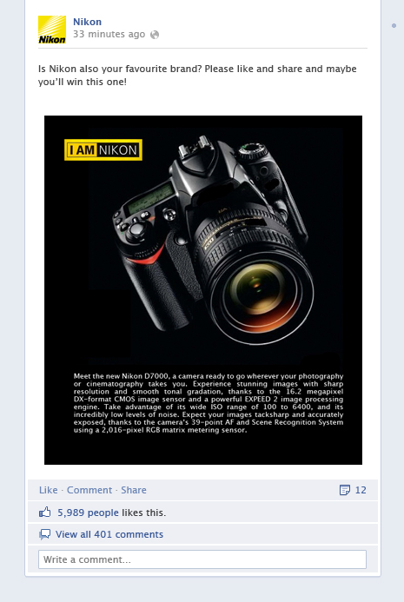 | 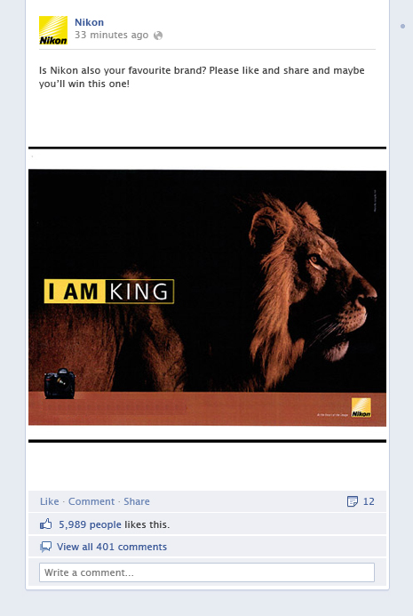
Hard-sell Nikon | Soft-sell Nikon

Appendix C. Hard–Sell vs. Soft-Sell Ray - Ban
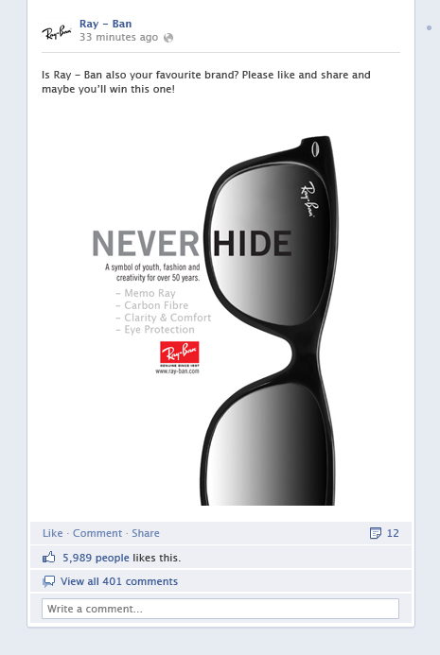 | 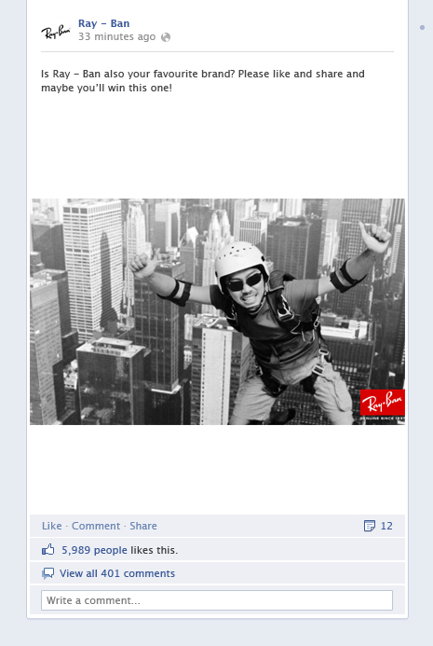
Hard-sell Ray - Ban | Soft-sell Ray - Ban

Appendix D. Hard–Sell vs. Soft-Sell Vespa
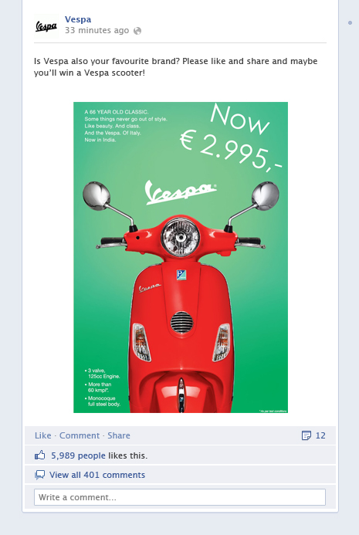 | 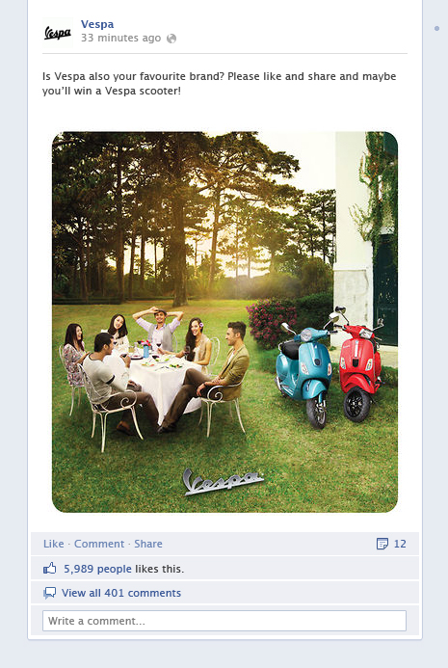
Hard-sell Vespa | Soft-sell Vespa

Appendix E – Factor Analysis Intrinsic- and Extrinsic Motivations
Rotated Component Matrix
 | Component 1 | Component 2
Intrinisic motivation Nikon | .86 | .21
Intrinisic motivation Ray - Ban | .89 | .19
Intrinisic motivation Vespa | .84 | .22
Extrinsic motivation Nikon | .16 | .88
Extrinsic motivation Ray - Ban | .20 | .87
Extrinsic motivation Vespa | .27 | .85
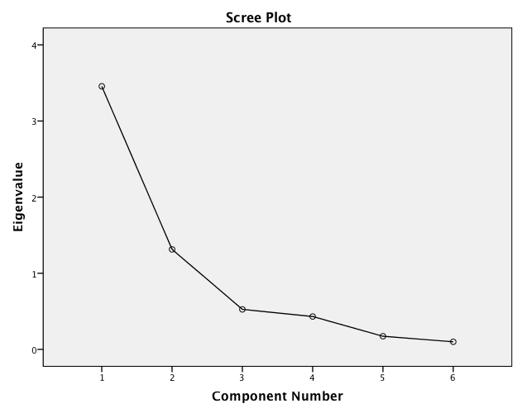

Appendix F – Correlations Matrix
