The effect of patent infringements on consumer perceptions of a brand, and the moderating effect of expectations
In the laptop industry

Everybody does it, don’t they?

Author: Tsewang Klein
Student number: 280273
Supervisor : Dr. V.G. Hariharan
Erasmus University Rotterdam
Erasmus School of Economics
Dec 2013
Acknowledgements

I would like to dedicate this paper to my parents. Who deserve my infinite gratitude for the patience and support that they have shown me, in life and in the completion of my studies. Without them, this would never have been possible

Secondly, I give my thanks Dr. Vijay Hariharan, whose guidance during the writing of this thesis was invaluable. His conception of the idea of studying the effects of patent infringements as well as the supervision he provided in its completion were key factors in my motivation and interest in the topic and this thesis.

Abstract
Corporate crisis are an established field of study within marketing literature, with a precedence of being a significance and relevant topic for both managers and academics alike. Until now the majority of work conducted in this field has been in regards to product harm crisis and product recall. However, another type of crisis has grown in recent years in levels of both frequency and scale which calls for attention. The number of patent infringements has been growing steadily over the years, with a recent spike in cases incurring “mega-damages” (Ansell, et al. for PWC, 2013). Recent cases such as the ongoing Apple v. Samsung feud highlight the attention that such events attract from the public, while the costs and damages in question gain notice from researchers and corporations. However, while the attention is fixed on the monetary aspect of such events, the scale of the publicity garnered by such an event raises questions as to the ramifications on image.
This thesis connects the dots between brand image theory, corporate crisis theory, and expectations theory (schema) to ask the question of whether these factors come together in a way that has implications for firms. More specifically this thesis poses the question, “To what extent do patent infringements affect the brand perceptions that a consumer has of a company, and are these perceptions mediated by their expectations of either the firm or its respective industry?”
To answer this question, empirical analysis was conducted through an experiment with 130 respondents via online social media. In the experiment, subjects were faced with an unraveling case study concerning a major laptop company facing a patent infringement accusation and subsequent trial. Throughout the case study, respondents were asked to update their evaluations of the brand, mapping out the changes in perceptions incurred.
The results were analyzed using mixed design ANOVA, among other forms of statistical analyses, and showed that news of both a patent infringement accusation as well as its conclusion adversely affects a consumer’s perceptions of a brand. Not only this, but a firm can expect negative effects on its image regardless of whether it wins or loses the case, albeit these effects were more pronounced in the event of a loss. Furthermore is the counter-intuitive result that consumers with strong brand expectations of a firm exude a higher sensitivity to the adverse effects of a patent infringement compared to those with weak expectations. And lastly, while preconceived notions about a firms industry mediate the effects of a patent infringement accusation, they hold no influence over the effects of a trial verdict on consumer perceptions.
These findings indicate the fact that brand image effects are a factor to consider when analyzing the costs of a patent infringement case. Not only this, but the intricacies and dynamics of effects at play are often counter intuitive, and show that ramifications may vary due to a number of factors. These results may be used to compliment crisis response strategies and allow firms to make better informed decisions in the face of a similar crisis.

Table of Contents
1 Introduction 6
§ 1.1 Topic 6
§ 1.2 Significance 7
§ 1.3 Objective and Research Questions 10
§ 1.4 Definitions 10
2 Literature Review 12
§ 2.1 Brand Perceptions 12
§ 2.1.1 Brand Image 12
§ 2.1.2 Brand Personality 14
§ 2.1.3 Brand attitude 15
§ 2.1.4 Perceived Quality 16
§ 2.1.5 Concluding Remarks 17
§ 2.3 How to measure brand perceptions 18
§ 2.3.1 Brand Image 18
§ 2.3.1.1 Brand Personality 20
§ 2.3.2 Brand Attitude 20
§ 2.3.3 Perceived Quality 21
§ 2.4 Brand Expectations: 22
§ 2.4.1 Schema theory 22
§ 2.4.2 Confirmation Bias 23
§ 2.4.3 Base-rate 24
§ 2.5 Negative Cues and the Corporate Crisis 26
§ 2.5.1 Corporate crisis 26
§ 2.6 Concluding Remarks 28
3 Hypothesis: 29
4 The study Design 32
§ 4.1 Sampling 32
§ 4.2 Structure 32
§ 4.3 Case Study Design 33
§ 4.3.1 Brand introduction and expectations manipulation 33
§ 4.3.2 Patent Infringement Accusation News Article 34
§ 4.3.3 Patent Infringement case conclusion 35
§ 4.3.4 Evaluation 35
§ 4.3.5 Base-rate 36
§ 4.3.6 Habits and Demographics 37
§ 4.4 Pretest: 37
§ 4.4.1 Pretest Construct: 37
§ 4.4.2 Pretest results for Laptop PCs 38
§ 4.4.3 Pretest results for Patent Infringements 39
5 The Study Results 41
§ 5.1 Response 41
§ 5.2 Measurement Scales 42
§ 5.3 Reliability and validity 43
§ 5.4 Methodology of Data Analysis: Mixed Design ANOVA 45
6 Results of Mixed Design ANOVA 48
7 Recap and summary of the Test Results: 58
8 Answers to the Hypothesis 60
§ 8.1 Summary of the answers to the hypothesis: 76
9 Implications: 78
10 Limitations 81
11 Areas for further research 83
12 References 85
Appendix I: Questionnaire 95
Appendix II: Factor Analysis and Outliers 108
Appendix III: Mixed Design ANOVA 111

1 Introduction

§ 1.1 Topic
Patent protection and infringements have always been an issue for firms wanting to protect their trademarks and technology. In an increasingly digital world, boundaries and definitions can blur and be subject to interpretation, with guilt or innocence being more apparent in shades of grey than being a case of black and white. Recent times have shown a new phenomenon of highly publicized and closely followed patent infringement lawsuits. The most famous case in point, and inspiration for this paper, would be the (currently) ongoing feud between mobile technology giants Apple inc. and Samsung Electronics. Starting in spring of 2011 (Chellel, 2012), the dispute has exploded to a high point of more than 50 lawsuits between them by July 2012 (Mueller, 2012). With both brands launching multiple lawsuits on either side of the ocean, the ongoing discord could be argued to have escaped the walls of both office and court, and have become very much a personal dispute between the two firms. With Steve Jobs declaring “thermonuclear war” on Samsung’s Android operating system (Parr, 2012), and Apple lawyers claiming Samsung’s strategy was to deliberately copycat Apple (Levine & Gupta, 2012) the unfolding back-and-forth between the two giants has captivated industry watchers, business analysts, and loyal consumers on both sides. As of November 2013, the current state of affairs has Apple being owed a total of $930 million in damages from Samsung (Wakabayashi, 2013), with the latter still heavily in the process of counter-litigating. Along with the direct costs of damages awarded come the legal fees, which will be substantial for a case this magnitude. Although little has been revealed about the specificities, industry speculation puts an estimate of roughly $60 million for Apple and a comparable amount for Samsung for the two year long spanning dispute. (Mosca, 2013)
However, amidst all the attention and speculation of concerning the monetary costs and damages incurred by such a long dispute, little thought has been spared to how the consumer perceives and interprets the events. In this modern day and age of consumer electronics which can be highly integrated into people lives, brand affinity and loyalty can be a highly personal subject. Furthermore, rising consumer sophistication is an increasingly apparent development fueled by easy access to information and news sourced from the internet. The combination of the two aforementioned facts, make for a marketplace which is increasingly savvy and informed by the day, and indicative of the potential influence that a highly publicized case such as the previously mentioned Apple v. Samsung case could have on a firm’s brand image. With so much new information, as well as often accusatory language and messages being launched, the question remains as to whether or not, and to what level and extent such perceptions and concepts can enter into a consumer’s psyche. At this point in time, little research has been conducted on the effects of a patent infringement case on the image a firm holds for consumers, and to what extent it may do so.

The topic therefore investigated in this thesis is the subject of patent infringement cases, and how a company’s involvement in such a case can affect their image in the eyes of consumers. Aspects of this relationship that are investigated are the changes in a consumer’s evaluation of a firm over the length of a patent infringement case, and how their expectations and preconceived notions can influence these changes. These preconceived notions are identified as those beliefs regarding the firm, dubbed “brand expectations”, and those beliefs regarding the frequency of such events within the industry, dubbed “base-rate.”

§ 1.2 Significance
Patent infringements cases are phenomena that are increasing in both frequency, as well as scale. A recent Price, Waterhouse, and Cooper ( Ansell, et al. 2013) report which looked at cases from 1995 to 2012 found that the quantity of cases has risen steadily over the years, with an annual growth rate of 7% since 1991, and a significant proportion being attributable to the 29% spike going from 2011 to 2012. Not only this, but an increasingly commonly occurring phenomenon is the case of payments reaching huge figures, aptly dubbed, "mega damages." Prior to the year 2012, the number of patent infringement cases which topped the $1 billion or greater mark for damages awarded numbered only three. However, since then this number has doubled as three more cases topped that mark in 2012 alone [Monsanto v. Duponte, Apple v. Samsung, and Carnegie v Mellon University v. Marvell].
Along with the steady increase in frequency of patent infringement litigation, an increasing academic and managerial interest has likewise grown concerning the costs that a patent infringement case occurs on a firm. Essen and Meurer (2008) looked at large stock of patent litigation cases from 1984-1999 and looked at the legal fees and loss of value a firm may face. They found that in the period of their study, alleged patent infringer's faced a drop in cumulative average return (CAR) of 2%. This figure was in line with a number of other researchers who also found significant drops in CAR such as Bhagat et al. (1998) who reported a 1.5% loss in their study on the effect of corporate litigation on firm value. Jang & Chen (2009) also looked at the effects of patent litigation. Specifically they were interested in the negative effects on share value, and the mediating effects of firm response.
Essen and Meurer (2008) also touched upon the fact that legal fees also made up a substantial amount of the costs incurred during a patent infringement case. By looking at records of fee-shifting (where the loser is made to pay the legal fees of the winner) they estimated a mean of $1.04 million for patent litigants and $2.46 million for infringer's in legal fees. These amounts however had the potential to reach significantly higher amounts, with an extreme high of $26 million. Furthermore, in a study by the American Intellectual Property Law Association (2001), patent litigators were asked to estimate the legal fees involved with a patent lawsuit. The results showed that estimated expenses were $499,000 for cases where the stakes were $1 million or less, $1.499 million for when stakes were between $1 million and $25 million, and $2.992 million for cases where the stakes are $25 million or higher. These substantial figures go to show that large fees beyond the awarded damages can be consequent for firms involved in a patent litigation case. As the scale and frequency of these cases increase, so do their financial repercussions increase likewise.
Beyond the obvious costs the Essen and Meuren (2008) also found and identified a number of indirect costs that results from a patent litigation such as costs of lost business, having employees distracted from primary business activities, possible lowered credit ratings, and strained business relationships, and loss in stock value. An interesting item they touched upon was the extra costs born upon alleged infringer's, who face the possibility of (temporary or otherwise) production shutdowns, as well as the reluctance of customers to purchase their products if they sense an impending withdrawal from the market (especially when there are complementary products). A cited example of this was the case of the microprocessor producer Cyrix, who found themselves the target of a patent infringement accusation from rival Intel. Because customers were wary of purchasing components which may be found to infringe, Cyrix ended up losing its window of opportunity as the 1.5 year long case took a heavy toll despite the company eventually being found not guilty. Although a business-to-business setting, the principles involved still stand to show that patent infringement cases can have an effect on sales.
The above mentioned studies serve to drive home the substantial effects patent infringement cases have on firms. This fact coupled with their increasingly occurring frequency underline the need for understanding their repercussions and implications for a firm. However, they also highlight the fact that the research conducted up till this point revolves solely around the monetary repercussions of a patent infringement case, with little attention being paid to the image effects. By increasing understanding of the extent and manner in which consumers view such patent infringement crisis, a better understanding of how it effect’s a firms brand image can be attained.
Brand image can be described as the "perceptions about a brand as reflected by the brand associations held in memory' (Keller 1993). These associations can come from a plethora of sources, and the vastness and dynamic nature in their creation has led firms to regard image management as an essential part of marketing. Companies spend millions of dollars to transmit and cultivate carefully designed images and associations in order to fit predetermined and favorable images. They do this through means such as sponsorships, advertisements, and affiliations. And while the many sources of brand image influence are topics that are highly researched, current studies center largely around the effects of internal decision making policies can make on brand image, such as image transfer in sponsorship (see Gwinner & Eaton,1999; Dean 1999; Richards & Wilson 2004; Carrillat, Harris, and Lafferty 2010) or the effects of brand extensions (Romeo 1991; Martinez & de Chernatony 2004). However, this is not to say that the effects of negative external effects have gone ignored. Firms have long been aware of the need for damage control after being involved in a negative publicity event. Because of this, response theory and image restoration strategy are topics that have highly researched in the past. Benoit’s (1995) theory of image restoration remains one of the most prominent in field. He maintained that damage could be reduced, and brand image repaired through proper choice and implementation of response strategy. Numerous papers have been published by himself and others regarding how firms can best respond to negative publicity, of which a brief list of examples can be seen in the following table:
Author | Title | Year | Subject
Benoit | Image Repair Discourse and Crisis Communication | 1997 | Argued that theory of image restoration as method of response to corporate image crisis
Blaney, Benoit, and Brazeal [5] | Blowout!: Firestone’s image restoration campaign | 2002 | An analysis of the managerial response, in the wake of Firestone’s failing tire crisis.
Deshpande and Hitchon | Cause related marketing ads in the light of negative news | 2002 | Investigated the effects of image restoration strategies in the wake of negative publicity
Reierson, Sellnow, and Ulmer | Complexities of Crisis Renewal Over Time: Learning from the Tainted Odwalla Apple Juice Case | 2009 | Investigated the image renewal of Odwalla after their apple juice was tainted with E.coli

While it is apparent that firms and researchers alike recognize the importance and attention that must be paid in formulating an appropriate and effective response in order to try and restore as much of a firms image as possible, the vast majority of research has been from a reactionary or retrospective perspective. In 1989, Botan commented that research in public relations had failed to move beyond tentative answers and work and test more on predictive methods. This was as sentiment echoed by Coombs (1995, 2000), who stressed the fact that managers required a better understanding of the dynamics involved in crisis and crisis response in order to act in a prescriptive manner as opposed to reactive. This serves to show that although there is a solid foundation of theory as to how to react to negative image crisis, there remains an acknowledged requirement in the existing literature to expand and deepen understanding of the exact nature of these effects. In the context of a patent infringement crisis, research conducted into the nature of brand image effects such an event has on consumers would serve to deepen understanding of the event, and would serve to compliment a firm’s response strategy.
The above mentioned subjects show that there exist gaps in existing knowledge and research from a managerial perspective as well as academic. Together, they form the motivation and significance of this research thesis. The frequency and magnitude of patent infringement have shown that their repercussions are of considerable relevance and interest from a managerial perspective. While the monetary consequences that a firm faces in their wake are something that has been touched upon, there exists no research as to the image effects that they may or may not have. Furthermore, the large interest and research in image management and restoration in the face of negative publicity shows that there is a recognition and need from both industry and academia in how to combat and reverse negative publicity image effects. But as mentioned earlier, the reactionary stance taken by most research remains lacking in its predictive qualities, and has made a call for better understanding of the dynamics of the negative effects at play. By executing research and procuring answers for this thesis, a small contribution will be made towards filling the gaps in understand outlined above.

§ 1.3 Objective and Research Questions
Until this point; little research has been conducted regarding the adverse effects of patent infringement cases on the perceptions consumers’ hold of firms. It is not only unclear how and if these events can affect the different dynamics of a brands image, but also how the expectations and preconceived notions a consumer holds may alter or change those influences. This study aims to investigate the answers to such questions, through means of literature review, and the use of empirical study. Therefore, the main objective of this thesis is to:
Investigate the effects of patent infringement accusations and litigation on the perceptions and image that consumers hold of a brand.
While doing so, the dynamics and relationships involved concerning the expectations a consumer may hold of a firm and its industry will also be investigated, leading to the second objective, which is to:
Investigate the effects of a consumer’s brand expectations and conceptions of the industry on how information concerning a firm’s involvement in a patent infringement case is received and evaluated.
In this thesis, answers to these objectives will be formulated through means of a review of previous literature, which will lead to an empirical study.

§ 1.4 Definitions
For the sake of clarity, a brief list of terms and definitions used throughout the thesis are provided
Brand
Can be defined as, "a name, term, sign, symbol, or design, or combination of them which is intended to identify the goods and services of one seller or group of sellers and to differentiate them from those of competitors" (Kotler 1991; p. 442)
“A name, term, sign, symbol, shape or a combination thereof that aims to define the sellers' products and services and differentiate it from its competitors” (American Marketing Association, 2006).

Brand Perceptions
A blanket term, used in the context of this thesis to refer to the three constructs for measuring the way consumers perceive brands, being brand image, brand attitude, and perceptions of quality.

Brand Image
"Perceptions about a brand as reflected by the brand associations held in memory' (Keller 1993)

Brand Attitude
A value judgment element that refers to a consumer’s general evaluation of whether a brand was, "good," or, "bad." (see Keller, 1998)

Perceptions of Quality
“Consumer's judgment about a product's overall excellence or superiority" (Zeithaml, 1988; Aaker and Jacobson, 1994).

Brand Personality
‘The set of human characteristics associated with a brand’ (Aaker, 1997)

Patent Infringement:
When an entity, “makes, uses, offers to sell, or sells any patented invention, within the United States or imports into the United States any patented invention during the term of the patent therefore, infringes the patent.” (35 U.S.C. 271 - Infringement of patent)

2 Literature Review

In order to gain an understanding of the basic concepts and relationships explored in this thesis, it is paramount that a solid foundation is laid. The following sections are designed to provide the reader with an overview of the previous literature and related research conducted. This will facilitate the understanding of the constructs made and justifications for the theory and logic employed by this thesis.

§ 2.1 Brand Perceptions
Throughout this paper we use the term, “brand perceptions” as a blanket term to describe the way consumers view and judge a firm's brand image. In order to understand the way that a patent infringement case influences these brand perceptions, it is important that we first identify the different ways in that this can occur. This seems to be a rather straightforward concept at first, however it became apparent during the research and review of prior literature that there lacked a concrete academic consensus on certain aspects. While the majority of papers seemed to have a degree of consensus regarding the general meaning behind brand image and consumer perceptions, it is when investigating further that the inconsistencies become apparent. Although many authors use the same terms in their papers, the differences in connotations range from slight changes in nuance, to completely different definitions. And while some authors use the same terms interchangeably when describing certain phenomena or aspects of consumer perceptions, other authors maintained stricter differences between terms with more rigorous definitions attached to them. Because of this, the following section will not only be an overview of the previous research and literature on brand perceptions, but will also be used to set forth the definitions that will set the theoretical foundation for this study.
Of the concepts and elements of brand image most mentioned and noted in the literature, there are four distinct concepts identified in this thesis which are most touched upon by previous authors. These concepts were chosen because they are distinctly defined ideas that together form a reasonably complete picture of the current concept of brand perceptions as well as being concepts and terms which consistently appear throughout previous literature. Where these concepts often differ however throughout previous studies is in the names ascribed by the different authors, their position or role in the brand perceptions construct, and the method of their measurement. In the following sections we will identify and discuss these main concepts and solidify their meanings for the purpose of this study.

§ 2.1.1 Brand Image

Arguably the most important element of the brand perceptions identified in this thesis is the concept of brand image. "Brand image" is a phrase often heard within marketing terms, and is used as an all encompassing term which refers to all of the associations, expectations, and feelings that a person or consumer has with a brand. As a concept, brand image is something that was long known in practice within industries before its academic conception was solidified. Shopkeepers and businessmen were aware that some firms could charge a premium, or conversely would suffer, even though their wares and goods were identical to the rest of the market, due to preconceived notions or perceptions by their consumers. While the very notion of advertising takes it roots from the idea that favorable consumer perceptions can add value to a brand. One of the earliest mentions of this concept in the academic world was by James Duesenberry, who observed in 1949 that the symbolic behavior of consumption of a product could possibly be more important to individuals than the functional benefits. However it was not till a few years later in 1955, in the Harvard business review article from Gardner and Levy, that this concept was solidified. In their paper, "the product and the brand," purchase motivations were explored with the resulting findings that besides the physical benefits of a product, there also exists a social and sociological side for consumers. This set of attitudes, feelings, and ideas that constituted the "image" held by consumers of a brand, was a crucial element of their purchase decision. This finding would be the first time that a consumer brand image perception was identified academically.
In the 1990's, we saw the introduction of brand image and associations as an integral part of the brand equity construct by David Aaker and Kevin Keller which forms the most notable current day interpretation of brand image. In their works, the terms "brand image," and "brand associations," were often used interchangeably with regards to the same general concepts.
Aaker (1991) referred to brand associations as the category of a brand's assets and liabilities that included all things in a consumer's memory that were "linked" to a brand. Aaker recognized the value of brand image in creating value in a number of different ways which included helping customer’s process product information, providing a means of differentiation, adding positive feelings, and helping to generate reasons to purchase. This concept would later play a part in the now classic Aaker's Model (1996) in which he stressed the importance of developing a brand identity with which to offer consumers an aspiring model for their own brand image.
In Keller's (1993) work on brand equity he used the term, "brand knowledge" to describe perceptions of brands held by consumers. This concept consisted of both brand awareness, which referred to recall and recognition, and brand image which he defined as "perceptions about a brand as reflected by the brand associations held in consumer memory structure," and can be thought of as the depth and breadth of brand knowledge, respectively. His definition took an associative memory network view, and saw brand associations as informational nodes that were linked in memory to the brand node and consisted of what consumers felt the brand meant to them. These links are created from a number of sources, including product and brand category experiences, pricing, product attributes, promotional communication and positions, packaging, typical user imagery, and usage occasion. (Keller 1998).
The promotion of these associations to try and place firms in a positive light is something that has long been studied and pursued. Brand names are used to group together information and act as a summary of expectations consumers will have of future interactions with a brand (Bettman and Jacoby 1976, Jacoby et al 1977), and building positive brand equity has been linked with having influence on a firm’s financial performance (i.e Walfried, Mittal, and Sharma 1995; Kim, Gon, and Kim, 2002). Drumwright (1996) found in a survey of corporate managers, that advertising campaigns were often conducted which did not directly serve to increase sales, but were instead highly effective in promoting company image and mission. This shows that in practice, managers understand the importance of promoting brand image and will even do so in lieu of direct monetary gains. However, it is also possible for firms to become connected with unfavorable associations through negative publicity events. Smith, Thomas, and Quelch (1996) spoke of the importance of limiting damaging effects to brand associations and protecting brand equity. They noted that negative publicity could generate a substantial amount of brand awareness, and negatively impact a brand’s image. Even after the specific features or events which gave rise to an impression are forgotten, the retained evaluation and attitude conceived can continue to endure (Burnstein and Schul, 1983). Especially these last two points serve to indicate the lasting effects brand image can have; where the subsequent adverse effects of negative publicity events such as a patent infringement accusation may remain long after the specificities of the case are forgotten.
The preceding literature has shown that the definition of brand image is has some differences in terms, constructs, and nuance. However, the underlying principles which all authors have in common are that it encompasses all the associations, (primary and secondary), expectations, and information that have to do with the firm. Because this definition is consistent with the stance taken by the majority of modern academics, and best captures the general understanding of the concept as used by other researchers, it will be the definition adopted for this thesis. Furthermore this definition, as well as the reasons stated earlier, also lay credit to the idea that a negative publicity event can become embroidered in a consumer’s image of a firm, with the possibility of dire consequences. In the context of this thesis, this negative publicity event is an accusation of patent infringement.

§ 2.1.2 Brand Personality

Brand personality is one of the most common methods of describing brand image in practical applications, and the two terms are often even used interchangeably. Its usefulness and popularity stem from the fact that it presents a stable and defined construct for describing brand image, which contains a sea of possibilities due to its open and general definition. Because it is so often used in the marketing field, and provides a convenient method of ascribing brand image traits, it is allotted its own sub-section for discussion.
The predominant work on brand personality stems from Jennifer Aaker, whose 1997 paper is regarded as the staple of brand personality theory. In it, she defined brand personality simply and succinctly as, "the set of human characteristics associated with a brand." Because her definition of brand personality is the one most often used in marketing research, it is the one that shall be applied in this thesis.
A large reason for the popularity of the brand personality concept is because of its unique measurement constructs compared to other brand associations, which make it one of the more commonly applied methods of measuring consumer perceptions in practice. Brand personality represents a fundamentally unique way of thinking of brands by serving as a self-expressive or symbolic function (Keller 1993). By thinking of a brand as an individual or personality, it allows consumers to relate to the brand more easily (Fournier 1994).
Many practitioners also regard it as an important way to differentiate a brand within a product category (Halliday 1996), as a key driver for consumer preference and appliance (Biel 1993), and as a bridging tool that helps a brand to span across cultures (Plummer 1985). Furthermore, choosing the "right" brand can enable a consumer to develop a unique and visible representation of themselves (ligas 2000, Fournier 1991). These facts serve to show the importance that the right personality traits are associated with a brand in order to benefit a firm and drive sales. However, possessing certain brand personality traits can also help to dampen the effects of a negative publicity event. Aaker, Fournier, and Brasel (2004) showed in their study on product failure scenarios that firms could vary in the amount of reputational damage they incurred depending on their varying degrees of specific brand personality traits. Not only does this highlight the fact that brand personality can have a role to play in negative publicity events, but also indicates the role that consumer’s expectations may play in consumer evaluations. This is something that will be further investigated in a later section of this thesis.

§ 2.1.3 Brand attitude

Brand attitude is a generalized value judgment component of consumer perceptions of a brand, and has been mentioned in many previous brand image constructs, including Keller’s (1993) brand equity construct discussed earlier. Martineau (1957) referred to a psychological perspective of brand image that included, "the total set of attitudes, the halo of psychological meanings, the association of feeling, and the indelibly written aesthetic messages over and above the bare physical qualities." While Mitchel and Olson (1981) defined it succinctly as the, “individual’s internal evaluation of the brand,” whether good or bad. According to Giner-Sorolla (1999), this definition is one of the most used in marketing research, and incorporates two of the characteristics of attitude that have been consistently found across definitions in contemporary research. Namely that;
- Attitude is directed at or centered on an object, being a brand in this case (Bird, Channon and Ebrenberg, 1970).
- The nature of attitude is evaluative, meaning that there is an insinuation of some element of being "good" or "bad" in the object of concern (Eagly and Chaiken, 1993).
While other notable elements of brand attitude taken from previous literature include:
- Attitude "endures for at least a short period of time and presumably energizes and directs behavior.” (Eagly and Chaiken, 1993, p.7)
- Brand attitude and attribute information may be stored and retrieved separately from each other in an individual’s memory (Anderson and Hubert 1963; Carlston 1980; Lingle and Ostrom 1979; Riskey 1979).
It is especially the last point which illustrates the idea that brand attitude is a compliment to brand image in the brand perceptions construct. While brand image indicates all the associations and ideas that a consumer may have about a brand, brand attitude is the value judgment of how the consumer subsequently feels about the brand, and overall evaluation. This image is subjective, and can vary from consumer to consumer. Bullmore (1984) wrote, "those thoughts and feelings will not - cannot - be universally identical ...The image lies in the mind of the beholder - and is conditioned at least as much by the nature of the beholder as by the nature of the object itself."

Much like brand image, several studies have also been conducted investigating the relationship between brand attitude and negative brand publicity. Ahluwalia et al. (2000) studied the effects negative publicity on brand attitude and consumer commitment as a moderator. They found that commitment levels played a role in resisting counter attitudinal information. Similarly Pullig, Netemeyer, and Biswas (2006) studied the effect that previous brand attitude had on the impact of negative publicity. They found that brands held in high regard had a tendency to be better insulated to the adverse effects on brand attitude when compared to brands held in lower regard. They further noted that investigating the dynamics of such events is an under researched topic, and could serve to better inform firms how to position themselves to optimally react and go through such a negative publicity event. These previous works of research show that not only is the brand attitudes of consumers susceptible to negative publicity, but also highlights the fact that its effects are subject to moderation by preconceived evaluations and notions. This is a premise that is held later in the thesis, when investigating the relationship of consumer’s expectations and consumers perceptions of patent infringement cases.
Lastly, it is important also to note that although intrinsically linked, purchase intention does not necessarily flow from positive brand attitude. Attitude merely indicates the amount that a consumer is for or against an object, product, or brand (Fishbein and Ajzen, 1975; Thurstone, 1931), while purchase is a measure of behavior intentions and is defined as a person's intention to purchase. Simply put; attitude is thought of in terms of evaluative dimensions, while purchase intent is a construct of probability.

§ 2.1.4 Perceived Quality

The last element of brand perceptions identified in this thesis is what is called the consumer’s perceived quality of a brand (also referred throughout as perceptions of quality). Perceived quality has received a considerable amount of attention in marketing literature, with a consistent definition of, “consumer's judgment about a product's overall excellence or superiority" (Zeithaml, 1988; Aaker and Jacobson, 1994).
The word "superiority" is indicative of the fact that perceived quality may be a relative concept. Aaker (1991) defined perceived quality as, “the customer’s perception of overall quality or superiority of a product or service with respect to the intended purpose, relative to alternatives.” This indicates that consumers may refer to alternatives for a basis for comparison when making such an evaluation. Consumers are rational thinkers who value their time, and may rely on perceived quality and feelings about product characteristics to reduce time and effort spent when choosing a brand. This notion lends weight to the generally accepted understanding that high perceived quality can add value to a brand and be a driving measure in the consumers purchase process. The findings of Sethuraman and Cole (1997) supported this notion with the findings that a considerable amount of the variation in price premium that consumers were willing to pay for national brands could be explained by perceived quality differences. Perceived quality has been further linked to firm performance such as in the 1987 paper by Aaker and Jacobson. They found that lagged perceived quality was positively linked to return on investment for a wide variety of product types. And again in 1994 they estimated a model that showed the ability of perceived quality to significantly influence the return of stock as compared to a firms return on assets. These papers highlight the importance perceived quality have for both the consumers as well as for firms.
Perceived quality is a concept that is often paired, and sometimes used interchangeably with brand attitude. Garvin (1984) ascribed attributes such as performance, serviceability, incidence of defects, durability, and 'fit and finish' to the term, "brand attitude." Aaker & Keller (1990) used the term to refer to overall perception of quality of a brand by consumers. The two constructs often move in the same direction, which makes intuitive sense as brand attitude is the subjective evaluation of brand image, while perceived quality is a driving force of positive brand image (Aaker and Jacobson, 2001). However it must be noted that they are two distinct concepts and this may not always be the case. It is completely possible that a consumer may find that a brand produces products that are of a high functional quality, even though there are other non-quality related associations and attributes of the brand’s image which makes it disagreeable to a consumer. In this paper, we make the distinction that while brand attitude involves a decision on the amount of how much a consumer is "for" or "against" a brand and measures their overall attitude, perceived quality is more to do with an appraisal of to what degree it fulfills its functional obligations.

§ 2.1.5 Concluding Remarks

The above mentioned concepts should not be viewed as a definitive construct, nor is any such claim made, as that was not the goal of this paper. They are merely a summary of the elements involved in this thesis’ construct of brand perceptions, and are meant as a guideline for the purpose of this study, and to provide a foundational base on which to conduct the relevant research. They were chosen because;
- They are the most often cited terms concerning brand perceptions in marketing research.
- They have different measures that are all published, reliable, and commonly found in prior literature.
- They have clear and distinguishing conceptual definitions.
It is furthermore important to recognize that the above components do not encapsulate all aspects of brand perceptions, and that consumer perceptions are highly complex by nature. The concepts mentioned are not meant to be thought of as independent elements, nor are we suggesting that they are separate in consumers’ minds. Indeed it is likely they contain a good amount of correlation and overlap in consumers psyche in practice. However, together they encompass the relevant elements and facets of brand perception explored in previous literature as well as the aspects that we wish to research and are interested in. The following chart depicts a visual representation of the relevant elements.

Brand image and personality can be seen as encompassing the image and association aspects of consumer perspective, while attitude and perceived quality correspond with functional and value judgment elements.

§ 2.3 How to measure brand perceptions
In the previous section an identification and overview of the different elements of a consumer's brand perception were identified, as they would be used in this thesis. However, a crucial aspect of the study of brand perceptions is the ability to measure and contrast the differences in brand perceptions between consumers. The following section contains the relevant literature which discusses the techniques and methods which have been employed in previous literature. The same division and construct of brand perception elements will be maintained as in the previous section, and therefore the discussion of their measurement will likewise partitioned.

§ 2.3.1 Brand Image

When looking at the field of marketing research, a number of perspectives can be found in the way that brand image has been defined. This is a characteristic that is maintained in its measurement constructs as well, with many authors using brand evaluation, perceptions of quality, and willingness to purchase measurements under the name of brand image effect measurement. While these measurement constructs all have somewhat standardized scale constructs, they do not ascribe to the definition of brand image as adopted by this thesis. When looking at the concept of brand image concept as defined by Keller (1993), which concerns associations instead of evaluations, previous research shows a lack of existing scale measures that can be generalized across different scenarios.

However, although there is a lack of a general construct that may be used to measure brand image, there does exist some consensus in the manner that which the question of measurement is approached. Many authors are in agreement that brand image associations are largely category specific, and have advocated the use of custom measurement constructs to capture their unique industry characteristics (i.e. Dolich, 1969; Fry and Claxton, 1971: Bearden and Etzel, 1982; Park and Srinivasan, 1994). The challenge therefore when dealing with brand image measurement is to select scale measures that accurately access consumers associations for the particular product category in question. In order to do so, a number of suggested protocols for brand image construct development have also been put forth, of which the general design remains similar, and revolve around a combination of both qualitative and quantitative research techniques (i.e. Boivin, 1987; Low & Lamb, 2000; Keller 1993; 2012), a summary of which can be found below in Table 1.

Table 1: Overview of suggested protocols for brand image measurement
Author(s) | Date | Title | Research Method
low and lamb | 2000 | The measurement and dimensionality of brand associations | Advocated qualitative techniques (free response) to discover associations and quantitative techniques (semantic differential scales) to measure them
Boivin | 1986 | A free response approach to the measurement of brand perceptions | Proposed a 3 stage approach to brand image studies which included the collection, coding and scoring of free response results.
Keller | 1993 | Conceptualizing, Measuring, and Managing Customer-Based Brand Equity | Suggests the use of qualitative techniques to assess types of brand associations, and rating scales to measure strength and favorability of associations
Keller | 2012 (3rd ed.) | Strategic brand management | Advocates free association as best technique for exploring brand image associations, and subsequent use of semantic differentiation scales to rate them.

Perhaps the most accepted and well known of which is that put forward by Kevin Keller (1993; 2012). As mentioned earlier in the thesis, the concept of brand image as adopted by this paper follows that definition as set by Keller (1993). This fact combined with the academic acceptance of Keller's methods, as well as its successful use in previous brand image studies that also used hypothetical brands (low and lamb, 2000); make it the reason why we follow his protocol in this study. Keller recognized the difficulties in generalizing brand image measurement constructs across industries and suggested a combination of both qualitative and quantitative techniques. Because of the exploratory nature of qualitative research, they have been merited by Keller as appropriate and useful techniques for suggesting possible brand associations. Although Keller outlines a variety of possible qualitative methods for discovering brand image associations, he notes that free association tests are the simplest and most powerful of techniques. Once these associations are established, quantitative techniques such as semantic differential scaled surveys are used to measure the strength and favorability of the respective associations.

§ 2.3.1.1 Brand Personality

Due to the all encompassing and open nature of the way that brand image is defined, brand personality is an oft used method of ascribing image traits to a brand in the field of marketing. Brand personality gives researchers a general construct made up of a finite number of descriptive traits, which translates to a more practical and easier to execute measurement method.
As mentioned earlier, the most prominent theories of brand personality is the construct as set for by Jennifer Aaker (1997), who based her method of measurement in human personality scales. Aaker's brand personality scale was developed by use of reducing 114 personality traits down to five main dimensions which paralleled the 'big five' traits used in human personality constructs. These five personality dimensions further included a total of fifteen facets, the overview of which can be seen in the table below:

Table 2: The Dimensions and facets of Aaker's brand personality scale
Dimension: | Sincerity | Excitement | Competence | Sophistication | Ruggedness
Facets: | Down-to-earth | Daring | Reliable | Upper Class | Outdoorsy
 | Honest | Spirited | Intelligent | Charming | Tough
 | Wholesome | Imaginative | Successful

Since then, this measurement scale has formed the de facto standard in brand personality measurement, as well as having been validated in a number of different contexts and cultures (see; J. L. Aaker et al. 2001; Swaminathan et al. 2009). However it is not without its criticism as many researchers have noted that while Aaker's construct proved capable of comparing brand personality constructs across categories, there is some debate on its reliability when measuring the brand personality of individual brands or making comparisons within categories (Austin, Siguaw & Mattila, 2003; Low and Lamb 2000). Never-the-less it has been included in this thesis as part of the literature research for its relevancy as well as its practicality in ascribing a general structure to brand image. Furthermore, previous papers have been conducted successfully using Aaker's framework within a single product category (e.g. Kim, Han and Park, 2001) although a high degree of caution is advised when doing so (Austin, Siguaw & Mattila (2003).

§ 2.3.2 Brand Attitude

Although approaches to modeling brand attitude have been proposed throughout previous literature, the most widely accepted measurement technique is to use multi attribute formulation where brand attitude is modeled as a dependent variable on a brand’s salient benefits and attributes. The most influential example of this multi-attribute model being that of Fishbein and Ajzen (1975; 1980), who in their expectancy-value model, wrote that attitudes are viewed as a multiplicative function of;
- The extent to which a brand has certain benefits or attributes in consumers mind (Saliency)
- An evaluation of how good or bad it is that the brand has those benefits and/or attributes (Judgment)
However, it has been found by other researchers that including all relevant attributes or benefits is difficult, and may not give a complete picture of brand attitude. For this reason it has been advised to also include a scale for general attitude towards the brand in order to capture any residual traits that may not be included within the attributes and benefit components of a brand (Park 1991; Srinivasan 1979). This seems to make implicit sense and alludes to previous papers which theorized that brand attributes and brand attitude may be stored separately in the mind (Anderson and Hubert 1963; Carlston 1980; Lingle and Ostrom 1979; Riskey 1979). This distinction lends further credit to the treatment of brand attitude and perceived quality as separate constructs.
A reoccurring method that has frequently appeared when measuring brand attitude in marketing literature is the use of semantic differential scales to gauge affect measures. Below follows a table with a few samples out of previous literature:

Table 3: Examples of attitude measurement approaches used in previous literature:
Author | Year | Study | Measurement
Aaker | 2001 | Effect of brand equity on firm value (laptop industry) | Three point scale (positive/neutral/negative) based on attitudinal measures from political science (Robinson, Shaver, Wrightman, 1999)
Batra and Ray | 1986 | Affective response mediating acceptance of advertising | Four item scale (useful/useless, important/ unimportant, pleasant /unpleasant, and nice / awful)
MacKenzie, Lutz, and Belch | 1986 | Attitude effects on ad effectiveness | Three item, seven-point scale (favorable/unfavorable, good /bad, and wise /foolish)
Spears and Singh | 2004 | Developing brand attitude scales | five item scale (appealing/unappealing, good/bad, pleasant/unpleasant, favorable/unfavorable, likable/unlikable)

§ 2.3.3 Perceived Quality

Similar to brand attitude, perceived quality has a history of prior research with a common approach based in semantic differential scales. Although case specific scales can be developed, the measures used for general perceptions of perceived quality have a reasonable amount of commonality, which is affect measure scaling, often with multiple items. With the three most common measurements used being the dimensions of “superiority vs. inferiority”, “excellent vs. poor”, and “good quality vs. bad quality” (low and lamb, 2000). As with brand attitude, below follows a table with a sample of measures used in previous literature.

Table 4: Examples of perceived quality measurement approaches used in previous literature
Author | Year | Study | Measurement
Keller and Aaker | 1992 | Sequential extensions and image transfer | Two sets of three 7-point scales (low quality/high quality, not at all likely to try/very likely to try,  Inferior product/superior product). And, (overall low quality products/overall high quality products, not at all good at manufacturing/very good at manufacturing, overall inferior products/overall superior products)
Keller and Aaker | 1990 | Brand extensions and image transfer | Two seven point likert scales for parent and extension brand (inferior/superior)
Low and Lamb | 2000 | Study on dimensions of brand associations | Three seven point likert scale measures (superior/inferior, excellent/poor, good quality/bad quality)
Aaker and Jacobson | 1994 | Financial information content of perceived quality | Eleven point likert scale corresponding to (11=Outstanding / 0=poor)

§ 2.4 Brand Expectations:
Expectations are beliefs that a person may have, that effects or moderates their perceptions of a future occurrence or outcome. In the context of this study, brand expectations will refer to consumer’s existing beliefs and perceptions held about a brand, that moderate the way they interpret and evaluate new information regarding that brand. In the following section, literature will be explored which will give a basis to support the reasoning for why it would be possible that expectations could influence the way consumers’ process new information, specifically news of a patent infringement accusation. Topics discussed include the way individuals organize their thoughts, expectations, and new information. From there, literature regarding negative cues and their effects in a marketing context will be discussed.

§ 2.4.1 Schema theory

To begin, it is important to understand how consumers and people in general organize their thoughts, and information. One of the most prominent theories of how this is done concerns schema theory. Schema theory is a concept from psychology that is often discussed and of great interest to marketing researchers. Proposed originally by Bartlett (1932), a schema is, “a cognitive structure that represents organized knowledge about a given concept or type of stimulus” (Fiske & Taylor 1984, p. 140; Lord and Foti, 1986). Schemata are used by individuals to organize their thoughts and perceptions and allow them to recall general information instead of having to recall specific information when dealing with situations or experiences. The theory focuses on how we assimilate existing knowledge and new information and is based on research which found that an individual's memory was not a verbatim account of their past experiences, but was instead a combination of specific memories and general abstractions regarding types of activities, objects, and people (Bartlett, 1932; Rumelhart & Ortony, 1977). These experiences are developed into a schema, as the individual components are collected and integrated into an organizational unit with strong associations between them (Fiske and Dyer 1985). These organizational units are then activated in order to provide an individual with a perspective when interpreting and attending to new events, and help to provide a guideline for evaluations.

Expectations themselves can be regarded as associations of a brand, as previous literature has defined corporate associations as all the information a person holds about a company (Brown and Dacin, 1997). These associations differ however from brand equity, as instead of relating to a company's product or services, they are in regards to the brand itself. This is a distinction made several times in previous literature, such as Keller (1993) who differentiated between brand knowledge and secondary associations, and Aaker (1996) who distinguished between brand and organizational associations. It is therefore not overly presumptive to regard expectations as making up part of the overall consumer brand perception as secondary associations, and being part of a consumer’s schema for a brand. This reasoning forms the premise for why we can expect consumer expectations to mediate new information, such as publicity concerning a patent infringement.

§ 2.4.2 Confirmation Bias

As mentioned above, schema acts as an organizational function for assimilation of new information. However, the mental shortcuts and guiding components of schemata can cast biasing association effects in consumer’s evaluations. When new information is found to be matching with previous expectations, it has been found that individuals have a tendency to store and recall that information with greater ease (Oswald and Grosjean, 2004).

This phenomenon is a common concept in psychology literature, known as “confirmation bias.” Variously labeled throughout previous studies as motivated reasoning (Jain & Maheswaran , 2000) or expectations-evidence framework (Dean, 2004 ), the core concept remains that people are prone to the interpretation or seeking of information or evidence which supports existing beliefs or expectations (Nickerson, 1998; Darley and Gross 1983 ). An example of this phenomenon is best illustrated by the classic study of Darley and Gross (1983), who found that experimental subject's judgment of children's academic ability changed depending on the children's social-economic environments. This effect of biased information processing can even extend to other elements, not directly related. It was found in previous research that the possession of certain attributes, such as attractiveness, can cause what was dubbed a "halo effect" on the perceptions of other attributes, namely intelligence. (E.g. Dion, Berscheid, and Walster 1972, Landy and Sigall 1974).

Confirmation bias is not only limited to the seeking of confirmatory information, but can also play a factor when processing new information that is discrepant. This term, dubbed the “disconfirmation bias”, refers to individual’s tendency to hold information which contradicts expectations to a higher standard of evidence (Taber and Lodge, 2006). Past research has shown that individuals tend to pay special attention to information that is inconsistent with existing schemata, often taking longer to process and interpret them. While Fiske and Taylor (1984) noted that behavior that was considered inconsistent with a certain schema could also be regarded as being due to temporary situational factors and even be dismissed, and possibly not remembered. Lord et al. (1979) proposed that individuals had a tendency towards scrutinizing arguments when they are disconfirming of prior beliefs, but readily accepting any evidence at face value if it was in support of those beliefs. When new information challenges a prior evaluation, individuals may initially look for grounds to defend their prior judgmental convictions, indicating an active search in their memory and prior schema (Kunda, 1990). A powerful example of this effect was put forth by Sherif and Hovland (1961), who found that if this new information was discrepant enough, it could even cause attitude changes in the opposite direction of what was advocated by the new information. In these cases, individuals who already had positive attitudes towards the product tended to overcompensate and regarded the new information as biased. This finding that consumers defended their strong pro-brand attitudes by initiating counter arguments in response to the negative publicity, or elaborating on pro-brand sentiments in order to mitigate any negative impact was corroborated by many researchers since then. (e.g. Ahluwalia, Burnkrant, & Unnava, 2000; Dawar & Pillutla, 2000; Herr, Kardes, & Kim, 1991; Pullig, Netemeyer, & Biswas, 2006).
Confirmation bias has also been previously studied in the context of consumers interpreting new information about firms, however the work conducted in previous literature revolves for the large part mainly around product harm crisis. Dawar and Pillutla (2000) examined the mediating effects of firm expectations in product harms crisis. Employing confirmation bias theory under the name expectation-evidence, they argued that identical firms would experience different effects from negative publicity. They concluded that high expectations served to filter negative effects on consumer’s evaluation of a firm. Similar results were found in the context of product recalls (Mowen, 1980; Mowen and Ellis, 1981). While Ha and Hoch (1989) found evidence of interactions between expectations cultivated through advertisements and consumer’s product trial evaluations. Aaker, Fournier, and Brasel (2004) showed in their study on product failure scenarios that firms could vary in the amount of reputational damage they incurred due to service failure depending on their varying degrees of specific brand personality traits. Pullig, Netemeyer, and Biswas (2006) studied the effect that previous brand attitude had on the impact of negative publicity generated by product failure. They found that brands held in high regard had a tendency to be better insulated to the adverse effects on brand attitude when compared to brands held in lower regard. The aforementioned studies show that there is a long precedence set establishing the interest and relevance that the mediating effects consumer expectations have on negative publicity. What is evident though from researching previous literature is that very little work is conducted regarding the effects of a crisis outside of product harm scenarios.

It should be noted that the level that new information challenges the current associations and evaluations can be also partially dependent on the level of commensurability between the prior information and the new information. When new information is not seen to be measurable by a common standard as with previous evaluations or less commensurable, the more the greater the diagnostic power in updating evaluations (Pham and Muthukrishnan, 2002). While Slovic and MacPhillamy (1974) found that a lacking of commensurability between sets of information obscured the effects of challenging information in updating evaluations. This is something that has also been previously seen in the context of negative publicity. Niraj and Lei (2009) found that the degree of impact that a crisis has is related to how relevant it is with a firm’s brand associations. This will be addressed in the empirical study section of the thesis.

§ 2.4.3 Base-rate

Consumer expectations of a brand may also be influenced by conceptions of the brands environmental factors. The degree of how common consumers perceive a focal behavior or incident among the population of interest is what is known as the base-rate. In the context of this thesis, base-rate information would correspond to how common or frequent consumers perceived patent infringements to be within the laptop industry.

The reason why base-rate information consensus (base-rate) information is appealing as a foundation for attribution can be explained intuitively (Kassin 1979; Pilkonis 1977). People will often ponder if others would act similarly when considering an event or behavior. If this behavior is deemed to fall within the norm for an actor's group of peers or population, it is possible that any image effects will be neither unique nor significant. This type of behavior was also found to translate to a consumer-firm relationship scenario, where consumers were found to engage in reasoning about negative cues without any prompting (Wong and Weiner 1981; Folkes 1988). While Lei, Niraj, and Zeynep (2012) found in their study on the effects of base-rate perceptions on product harm crisis that a higher base rate leads to less blame attributed to the brand through a discounting effect, where as a lower base rate leads to less blame through a sub typing effect.
This process is typified as working in a two stage process, where the locus of cause is identified, followed by an attribution of blame for the event (McGill 1990; Weiner 1980). While locus refers to the manner in which cause is divided amongst parties involved, blame is an evaluative judgment made by consumers concerning the liability of each party (Bradbury and Fincham 1990). Generally, a higher degree of cause attribution also leads to a subsequently higher degree of blame (Folkes 1988; Weiner 1980), however this need not always be the case. Previous research has shown that although being perceived as the cause by observers, an actor can avoid being blamed if the behavior or outcome is considered to be excusable or acceptable (Bradbury and Fincham 1990; Fincham, Beach, and Nelson 1987; Folkes and Kotsos 1986; McGill 1990). In the context of this thesis, it is therefore possible that even though a company is found to be guilty of patent infringement, the amount of blame assigned to them may be contingent on base-rate conceptions consumers hold for the occurrence.

However, although consensus information and base-rate are highly researched topics in the subject of attribution theory, findings on the exact nature of this effect brings mixed results. Previous research generally shows that higher base-rate perceptions tend to go hand in lower actor attribution, due to higher frequency suggesting blame be attributed to external factors. Alternatively, many previous papers have also found evidence that base-rate effects on attribution may indeed be negligible or even nonexistent (Nisbett &Borgida 1975; Kassin 1979; Kardes 1988). These differences in research findings may be partially explained by contextual factors (Higgins and Bryant 1982; Kardes 1988). For example, it is logical that base-rates for patent infringements would be more common in technology heavy industries, as compared to other industries (i.e. primary industries).

Lastly, there is also a theoretical interaction relationship between base-rate expectations, and the expectations that consumers may have of the actors involved in an event. Prior beliefs and expectations consumers have concerning a brand can create an informational crisis if the new information is inconsistent with existing knowledge and may subsequently bias their interpretations (Johar 1996). In order to resolve these inconsistencies, consumers may elaborate and reason on new information, in order to maintain prior positive beliefs held about an actor. In this sort of "mental defense," people may be more receptive to, or even actively seek out information to defend their prior beliefs and may use base-rates as means of refuting negative information such as product harm crisis (Kunda 1990; Edwards and Smith 1996). We may therefore theoretically even see higher base rates pairing alongside stronger brand expectations to work in tandem when consumers evaluate the news of a patent infringement.

§ 2.5 Negative Cues and the Corporate Crisis
In the following section, literature will be discussed with the goal of underlining the significance of negative cues for both the consumer and the firm, as well as creating the basis of reasoning why a patent infringement case constitutes an event of negative publicity, that will elicit a consumer reaction.
As mentioned in the preceding section, research has shown that individuals think about, and remember information that is inconsistent with their schema, or are exceptional. In particular, negative informational adjectives have been found to be more powerful than positive ones (Anderson 1965; Mizerski, 1982) and have consistently received greater weights than positive adjectives when compared in an overall evaluation (Feldman 1966, Richey, McClelland, and Shimkunas 1967). In a marketing context, Weinberger and Dillon (1996) found that the impact of unfavorable product reviews had a greater effect on the purchase intentions and attitudes of consumers, when compared to ratings that were favorable. One possible explanation for this phenomenon is that there are more positive cues in the environment, making negative cues stand out in relative terms. Because these cues deviate from the moderate positive norm, they are considered to be more informative and are thus delegated more attention (Fiske, 1980), as their rareness acts as a signal of their informational value.
These findings have ramifications for firms and corporations. In today's world, consumers have a wide variety of sources for product information made accessible to them. While these outlets and sources provide firms with many opportunities to market and promote their products, the other side of the coin is that it is more challenging for companies to manage or restrict negative publicity they may potentially receive. Another trend, increasing the susceptibility of firms to negative publicity, is the propensity of the media to report bad news over good Dennis and Merril (1996), which could possibly result in firms having a higher likelihood of receiving bad press than good.

§ 2.5.1 Corporate crisis

The topic of the effect of negative cues on brands is a highly researched topic in marketing, especially in the context of the phenomena dubbed, the "corporate crisis" which can be seen as a severe form of a negative cue. A corporate crisis is defined as, "an unexpected, non-routine event that creates uncertainty and threatens an organization's priority goals" (Seeger, Sellnow, & Ulmer,1998) . Brand crisis often arise due to negative information or rumors regarding a brand, and can harm the confidence that consumers put in it. Especially when this information is in conflict with key brand messages can these types of rumors cause serious damage to a brands associations and the trust placed in it by consumers. (Dawar and Lei, 2009). Some examples of corporate brand image crisis include the case of:
- Proctor and Gamble's wash and go shampoo in Denmark. Reports of the shampoo causing hair loss damaged the core brand association of P&G's which was "hair protection: and resulted in a subsequent market share drop of 75% (Jensen, 1993). And,
- Japan's Snow brand beef, whose mislabeling of beef as being of domestic origin when it in fact was foreign imported, breached their consumers trust and damaged their core association of being authentic Japanese. This led to a subsequent halt of all production and a severe drop in stock price (Nakamoto, 2002).
Such examples underpin the damaging and dramatic ramifications an image crisis can have on a firm, with even direct denial by firms doing little to impede their effects (Griffin, Babin, & Attaway, 1991; Menon, Jewell, & Unnava, 1999; Tybout, Calder, & Sternthal, 1981).

In the study of corporate crisis, three important issues have been identified by (Ulmer and Sellnow 2000):
- Corporate crisis shine doubts on a company’s social legitimacy. Acts which exhibit a lack of concern for the community such as dishonesty, irresponsibility, or breaking the law will lower a firm’s congruency with local values and societal norms.
- A resulting step of a corporate crisis is the examination of evidence, to determine and process the turn of events. Often this may involve a drawn out civil or legal process. These procedures are often complicated and result in the general public requiring interpretation and information mediation by the media before their meaning is comprehended.
- Finally, during a corporate crisis is always the question of blame. The identification and designation of a guilty party is often required by the public so that blame can be assigned. This need is generally in direct proportion with the severity of the crisis and the degree of responsibility of the event that can be assigned to the firm (Benoit, 1995).
Although little previous literature has been done on the subject of patent infringement, we consider it as being similar in nature to the corporate crisis. It should be noted that all three criteria mentioned above are met for the case of a patent infringement case. First of all, patent infringement is by nature an act that goes against societal views of what is considered ethical or a norm, with clearly defined roles of perpetrator and victim. Second, the accusation and evidence is examined in a court of law, often with publicized results and speculation. And lastly, the outcome of such cases usually results in a verdict of either guilt or innocence, so that blame is clearly assigned to a party. Therefore based on the previous sections overview of corporate crisis and the definite outlined, patent infringements fit the criteria to be considered as a form of corporate crisis and therefore justifies the inclusion of the theory. A noteworthy and interesting possible conclusion that can be taken from point 2 is that the interpretation of evidence can be subject to influence. The phenomena of the impact of information being manipulated due to differences ingrained in the subjects was also found to be present in corporate crisis theory, where it was found that firm expectations influenced the perceived favor-ability of firm responses to negative publicity ( Dean, 2004).

§ 2.6 Concluding Remarks
In this chapter, a foundation for the understanding consumer brand perception and measurement has been set. By reviewing previous related literature, the three distinct constructs of brand image (including brand personality), brand attitude, and perceived quality were identified. Furthermore, previous research has been discussed which creates a basis of understanding for the premise of this thesis. In summary, a patent infringement is closely related and fulfills many requirements to be considered a corporate crisis and adversely affect the perceptions and image a consumer holds of a brand. Expectations theory show that there is a strong history of empirical evidence indicating that consumer expectations can moderate the way that new information, such a negative publicity, is processed. While the section concerning schema theory has provided reasoning to suggest that expectations can be considered part of a brand’s associations and schema. These ideas together form the construct that supports one of the main premises of this thesis, which is that preconceived evaluations and notions can affect the way new information is processed and that this selective information processing can be expected to occur in a patent infringement setting. In the second half of this thesis, empirical study will be discussed and executed which will put these theories to the test.

3 Hypothesis:

In the previous sections, a foundation of background knowledge was set through summarization of relevant existing literature. Concepts regarding expectations, brand perceptions, and negative cues were discussed, and it is at this point that this study draws upon the findings of their work to formulate the hypothesis that will be discussed in this thesis.
We have seen in corporate crisis theory that negative cues can have a significant effect on consumer’s perceptions of brands. Although existing literature on consumer perceptions of patent infringements do not currently exist, patent infringements are considered a breach of societal norms and law, with 'punishment' dispensed in the form of fines and financial damage payments. It therefore intuitively follows that they would be taken as a negative cue in consumer psyche, and would warrant a similar response in respondents. This line of thinking leads to the first two hypotheses:

H1: News of a patent infringement accusation will have an adverse effect on respondent's brand perceptions. And,
H2: News of a verdict to the patent infringement case will have an adverse effect on respondent's brand perceptions

Specifically, it has been shown that negative cues stand out above positive cues and have a larger impact on individuals, which is a phenomenon proven to exist in marketing settings as well. This leads to the following sub-hypothesis:

H2a: A guilty verdict of patent infringement will have negative effect on respondent brand perceptions. While,
H2b: An innocent verdict of patent infringement will not restore brand perceptions to their original level.

Furthermore, in the literature section concerning expectations it was shown that incongruent information and prior evaluations could affect the strength of negative cue effects on brand image. This relationship was also found in marketing theory, where previous studies had found that positive consumer expectations could buffer the effects of negative messages and cues. This would lead us to believe that the same effects will take place in the context of patent infringement accusation and litigation. It is therefore proposed that objectively identical outcomes of a patent infringement case can yield different consequences for brand perceptions due to difference in consumer brand expectations. The second hypothesis, formulated formally is therefore:

H3: Brand expectations will have a moderating effect on the adverse changes in brand perception due to a patent infringement case.

Specifically, Confirmation and disconfirmation bias has shown that individuals have a tendency to more easily accept information that is congruent with existing schema and be more scrutinizing of information that is not. This would lead us to believe that individuals who have stronger expectations would react less negatively to a guilty verdict, due to its incongruence with brand schema, while individuals with weak expectations will not benefit from this effect. Formulated formally, this leads to the following sub-hypothesis:

H3a: Respondents exposed to strong brand expectations will experience weaker adverse effects on brand perception due to a patent infringement accusation, when compared to respondents exposed to weaker brand expectations.

H3b: Respondents exposed to strong brand expectations will experience weaker adverse effects on brand perception due to a guilty verdict of patent infringement, when compared to respondents exposed to weaker brand expectations.

Finally, expectations about the respective industry have also been found to have an effect on consumer evaluations as was shown in the preceding sections of this study. Literature was discussed which found that consumer expectations of the commonality and frequency of occurrence of a transgression could have a moderating effect on its brand perception influence. It was further found that this effect could in some scenarios be stronger for consumers, if they had positive prior evaluations of the brand in question. This translates formally into the final hypothesis:

H4: Respondent base-rate perceptions will have a moderating effect on the adverse changes in brand perception due to a patent infringement case.

Specifically, previous research has shown that in general, higher base-rates result in lower blame attribution towards actors. Formulated formally, this leads to the following sub-hypothesis:

H4a: Respondents with higher base-rates will experience weaker adverse effects on brand perception due to a patent infringement accusation, when compared to respondents exposed to weaker brand expectations.

H4b: Respondents with lower base-rates will experience weaker adverse effects on brand perception due to a guilty verdict of patent infringement, when compared to respondents exposed to weaker brand expectations.

Furthermore:

H4c: There will be an interaction effect of respondent brand expectations and base-rate perceptions on the brand perception effects due to the patent infringement case.

The following conceptual model gives a visual representation of how a patent infringement case is expected to affect brand perception in its two stages, with well as the relationship with consumer’s brand and base-rate expectations. In the model are the variables which will be taken into account in the empirical section of this study, when testing the hypothesis.

H4c
H4 (a & b)
H3 (a & b)
H1 & H2 (a & b)
Patent Infringement Case

Brand Expectations
Base-Rate Expectations
Brand Perceptions
- Brand Image
- Brand Attitude
- Perceptions of quality
Figure 1: conceptual model of the thesis hypotheses

4 The study Design

The previous chapters covered the relevant literature and previous research concerning the subject matter. It is at this junction that we test the formulated hypothesis in this thesis using our own study design. In order to test the effects of patent infringements on consumers, and the possible effects that may occur due to their expectations, an empirical study was conducted trough quantitative techniques. A case study, which detailed the ongoing of a patent infringement case, was used paired with an online experiment to collect data on respondent brand perceptions, and their changes. As mentioned in the literature review, brand image associations can be industry specific. For this reason it was decided to make the case study pertaining to Laptop PC’s. Further details of the case study and experiment will be discussed in the following sections.

§ 4.1 Sampling
In order to investigate the extent of effects of patent infringement litigation on brand perceptions, a qualitative empirical study was conducted through means of an online experiment. We are interested in users who have a basic working knowledge of the laptop and technology industry, who are above the age of eighteen. By conducting the experiment online digitally, we ensure that the respondents that we are dealing with have a basic level of familiarity and working knowledge of laptops and pc computers.

§ 4.2 Structure
The online experiment was presented as a case study which was unraveled over three clearly segmented sections. The first section of the case study is where the fictional brand was introduced. This brand introduction section contains the first experimental manipulation, leading to the respondent being either exposed to either strong expectations for the brand, or weak expectations. Respondents were then presented with a series of likert scale questions designed to gauge their perceptions of the brand. Thereafter respondents were shown a fake newspaper article in which news of the patent infringement accusation is detailed, before subsequently presented with the same set likert scale questions in order to check for any updates or modifications to their brand perceptions. The concluding case study element is then presented in the form of a fictional newspaper article announcing the conclusion of the patent infringement court case. This case conclusion is the setting for the second experimental manipulation, where respondents are told that the firm has either won, or lost, the case. Thereafter, respondents are presented with the final set of likert scale questions in order to check perceptions after the conclusion of the case. After that follows a section to measure base-rate perceptions in respondents concerning the laptop industry. And finally the experiment is concluded with some short questions regarding laptop purchase history and demographics.

Between the two experimental manipulations, there results a possibility of four different experiment versions, with combinations of respondents being exposed to either strong vs weak brand expectations, and the firm either winning or losing the patent infringement case. The following table details these four combinations:

Table 5: combinations of experiment versions
 | Strong Brand Expectations | Weak Brand Expectations
Win the case | Strong x Win | Weak x Win
Lose the case | Strong x Lose | Weak x Lose

§ 4.3 Case Study Design
In this section we discuss the construct and design of the questionnaire used for this empirical study. The exact experiment, as displayed to respondents can be found in appendix I.

§ 4.3.1 Brand introduction and expectations manipulation

The first section of the experiment is comprised of the brand introduction. For the purpose of this study, it was decided to use hypothetical brands in order to avoid any bias from prior judgments or attitudes that respondents would have had for existing brands. It has been shown, that previous brand knowledge can effect a respondents preferences, perceptions, and product choice (e.g., Allison and Uhl 1964; Jacoby, Olson, and Haddock 1971), and that brand familiarity can influence the effect of crises (Mowen, 1980; Mowen and Ellis, 1981). Sunadaram and Webster (1999) also found that brands that less harm was caused by negative word-of-mouth for brands that were familiar to respondents due to their stable brand images. This highlights the importance of hypothetical brands, of which respondents have no previous knowledge in order to mitigate bias. Especially in the case of this study, using fake brands is not only empirically sound but also a necessity in order to sufficiently manipulate consumer brand expectations in this experimental environment. The name “FreshNote” was chosen as the firm’s name, and was maintained for all versions of the experiment.
Prior literature specifically in the field of brand equity perceptions also contains a record of researchers who either advocated, or employed the use of hypothetical brands, of which a short overview of some relevant studies can be found in the table below:

Table 6: overview of related papers which used hypothetical brand
Author | Title | Study
Keller | Conceptualizing, Measuring, and Managing Customer-Based Brand equity (1993) | Keller advocated the usage of what he called "blind" testing, where he found success in experimental realism, and advocated the use of sufficiently detailed concept statements.
Romeo | The Effect of Negative Information on the Evaluations of Brand Extensions and the Family Brand (1991) | Experimental case studies using hypothetical brands were used in order to manipulate negative information about brand extensions.
Dawar and Pillutla | Impact of Product-Harm Crises on Brand Equity: The Moderating Role of Consumer Expectations (2000) | Used hypothetical brands to be able to manipulate consumer expectations in product harm effects.

In the brand description, several elements were developed to manipulate respondent’s expectations. Among them were included a short introduction stating some simple facts about the brand, a Consumer Report style article regarding the brand's latest laptop, and a sample online customer review. The first two elements are designed to provide the respondent with some background and basic technical information from a perceived credible source, while the customer review is given to provide information that conceptually comes from "someone like them." Peer communication has been found to have strong influence on the brand evaluations of consumers. This effect was found to be especially prevalent when dealing with unknown brands (Herr, Kardes, and Kim 1991), as is the case in this study.
When manipulating brand expectations, it is important that the brand is described using concepts that are positive, as well as commensurable and relevant with a patent infringement scenario. Because of this, originality and innovativeness are the brand features that are emphasized when manipulating consumer expectations.
Specifically, the brand introduction introduces FreshNote as a leading brand in the laptop industry. In the case of introducing the brand with strong brand expectations, included throughout the description elements are multiple mentions of the brand's reputation for innovativeness and originality. In order to give the respondents a more tangible subject for the patent infringement, we mention a newly developed and anticipated technology called the Innovo processor, which will remain a focus point throughout the experiment.
Conversely, for the weak brand expectations, FreshNote is introduced as a mid-range laptop with modest prices and a decent reputation. Described as a good choice for those who do not need to be on the edge of innovation, care was taken to present the brand in a neutral light.

§ 4.3.2 Patent Infringement Accusation News Article

In this section the respondent is presented with a fictional, but realistic, newspaper article. In the article it is revealed that the brand previously introduced has been accused of infringing on a number patents belonging to a rival brand. The information was presented in the form of a newspaper article to instill an element of both realism and credibility. Elements of the newspaper article include:
  - Reference to the brands new laptop model, and processor to give the respondent a key tangible subject for the patent infringement.
  - Within-industry reaction, to provide credibility for the accusation in the eyes of the reader.
  - The possibility of high financial damages payment, to impress upon the reader the seriousness of the situation and possibility of repercussions.

§ 4.3.3 Patent Infringement case conclusion

The final part of the fictional scenario regarding the patent infringement litigation case is the court's verdict. This information is also presented to the readers through a realistic, but fictional newspaper article snippet. As part of the experiment, two versions of the conclusion were presented to readers, with FreshNote winning the court case in one, and alternatively losing the case in the other. In both cases, in order to instill a sense of both decisiveness as well as finality, it is mentioned that the verdict was unanimous and that FreshNote had no intention of appealing the verdict.

§ 4.3.4 Evaluation

The following brand perception measurement construct was repeated three times, first after the brand introduction, as well as each subsequent update in the following patent infringement case. By monitoring the changes in brand perceptions, updates to respondent’s evaluations can be measured after each subsequent development in the experiment case study.

The evaluation that was presented to respondents follows a similar construct as the brand perception measurement concepts presented earlier in this thesis. The evaluation was made of three individual sections, pertaining to brand image, attitude, and perceptions of quality, respectively. These three sections were presented in random order each of the three times that they are presented to the respondents. Based on the recommendations of and protocols outlined in the section on brand image measurement, the evaluation construct is a mix of custom design, and established evaluation methods taken from previous research literature. The three elements of the brand perception evaluation were randomly rotated every time it was presented to the respondents to avoid order effects.

As mentioned in the section regarding the measurement of brand image, constructs in this area are best made through custom design. A custom brand image construct is suitable for this study, as it follows that not all aspect of brand image will be affected by a patent infringement case. Furthermore, because we are using hypothetical brands in this experiment, respondents will not have a large pool of information on which to base their evaluations. It therefore follows that in order to keep the experiment concise and relevant; a custom construct should be used. The first order of designing the construct was to conduct a pretest, which was administered to ten respondents, in order to determine the aspects of brand image most relevant to a patent infringement scenario. In the original pretest design, respondents were shown a short case study regarding a firm involved in a patent infringement situation. Subsequently a list of 15 brand personality facets drawn from Jennifer Aaker's (1997) brand personality was shown. Respondents were then asked to indicate any of the brand personality facets they found to be of relevance in any way to a patent infringement scenario. Brand personality is one of the leading methods of evaluating brand image, and one of the easiest ways for respondents to picture and conceptualize brand image, which is why it was initially chosen as the foundation for the brand image construct. However, an overwhelming number of respondents found it difficult to ascribe brand personality traits to hypothetical firms. From the feedback provided, it was determined that the actions of hypothetical brands did not provide respondents with enough brand knowledge and familiarly to confidently form an image to which ascribe personality traits. It was therefore decided to redesign and execute the pretest with a different set of 10 new subjects. Respondents were tested using free responses techniques in order to ascertain the most common and salient associations. After analysis of the pretest results, it was deemed that trustworthiness was the most relevant association that both the laptop industry and a patent infringement situation held in common. Scale items were chosen from previous literature, as well as using brand personality theory as a guideline. These questions were three 7-point likert scale items (trustworthy vs. not at all trust worthy, dependable vs. not at all dependable and reliable vs. not at all reliable) which would then be averaged to give a single score for brand trustworthiness. An exact explanation of the pre-test method and results can be found in the section preceding the study results.

The second part of the evaluation was in regards to measuring the effects on respondent brand attitude. The evaluation consisted of multiple scale items to discern perceptions of the brands general image that had all been used in previous literature (Aaker 1991; Keller 1993; Agarwal and Rao 1996). The questions were three 7-point likert scale questions (“bad vs. good”, “favorable vs. unfavorable”, “positive vs. negative”) which were averaged to give a single score for respondent brand attitude

The third element of brand perception measurement was in regards to respondent perceptions of quality. Multi-scale items were chosen after consideration of measures taken in previous literature, which can be seen in table 4 in the section 2.3.3 regarding the measurement of perceptions of quality. The chosen appropriate measurement items were two 7-point likert scales which asked if the respondent perceived the quality of the brand's products to be excellent vs poor, or superior vs inferior. The resulting scores were averaged to give a single value for perceptions of quality.

§ 4.3.5 Base-rate

In this section of the experiment, respondent base-rate expectations are explored. The reason why base rates are not manipulated the same way as brand expectations is for a number of reasons. The first is because of the obvious ease with which a fictional brand's back-story can be manipulated credibly, in contrast to the laptop industry which is of course non-fictional. Second is because of the fact that consumers may already have implicit base-rate perceptions. Information that is drawn from personal experience is more salient and vivid than information that is learned otherwise (see Borgida & Nisbett 1977; Nisbett & Borgida 1975; Nisbett et al. 1982; Nisbett & Ross 1980). This could lead to a tangible possibility of respondents possibly overriding experimentally provided base-rates with their own self generated base-rates, should the two be conflicting. Furthermore, it has been found in previous research that base rates can be subject to bias if respondents find the observed actors to be similar with their own self image (Higgins and Bryant, 1982). In those cases, observers generate base-rate information on behalf of the actors in question based on their own behavior instead. For those reasons, experimentally manipulating base-rates was deemed too prone to bias, and it was therefore decided to measure it after the case study instead.

This is performed through multi-scale items which prompt responses regarding consumer's perceptions of how unique patent infringements are within the laptop industry. The question asked involve the respondents first reading a statement about the laptop industry before ranking their agreement with the statement on a 7-point likert scale ("not at all frequent" vs "very frequent", "not at all common" vs "very common", and "not at all widespread" vs "very widespread") similar to that used in previous base-rate studies (Lei, Dawar, Gurhan-Canli, 2012). The results were averaged to produce a single score representing respondent base-rate perceptions for the laptop industry.

§ 4.3.6 Habits and Demographics

The final section of the experiment is designed to generate data with which to facilitate the segmentation of respondents into groups based on laptop experience, and demographics. This will allow some basic segmentations of the respondent pool into smaller groups. The first question is in regards to frequency of laptop or desktop PC purchases, while the second question is in regards to approximate budget in the event of a laptop purchase in the near future. Together these two questions provide information regarding both the extent of use, as well as financial information that are more relevant than income. Income alone would only reveal spending power, and not how much importance was placed by respondents on laptops in financial terms. Furthermore, frequency of purchases coupled with budget expense gives a representation of the respondent in terms of customer value, which will facilitate higher informational usefulness. Thereafter follow two short questions regarding age and gender. Age was split into five segments of 10 year gaps starting from legal adulthood and ending at the traditional retirement age of 65.

§ 4.4 Pretest:
Before continuing with the results of the study, the implementation and interpretation of the pretest will be discussed. As mentioned in the review of brand image measurement, the lack of general and standardized measurement constructs has led to an advocating of custom constructs. As mentioned in the experiment description, a pretest was conducted in order to identify the most relevant associations for the context of this thesis, following the protocols outlined earlier in the thesis in table 1. The results were then used in the forming of the brand image measurement construct.

§ 4.4.1 Pretest Construct:

Because this thesis is interested in the brand image effects of a patent infringement case, the amount of associations we are interested in pertain only to a specific scenario, and need not be neither comprehensive, nor exhaustive. For this reason, only the strongest brand image associations involving both the laptop industry and patent infringements are of interest. Furthermore, the dimensions and depth of consumer knowledge structures are also suggested to be connected with the brand experience (Alba and Hutchinson, 1987; Walker et al., 1987), which would suggest that for a study that involves hypothetical brands such as this thesis, only the strongest and most general and direct of associations be used for the measurement construct.

The protocols for brand association discovery followed by this thesis, advocate the use of qualitative research techniques to discover category specific brand image associations. Although a number of techniques are possible, Keller (1993; 2012), advocated the use of free response techniques as the simplest and most powerful technique for discovering brand associations. Furthermore, free associations technique is also the most commonly used amongst other suggested brand image measurement, as can be seen in Table 1.

For the pretest, a group of ten respondents were asked to take part in a two-part free response test. Respondents were chosen based on the same selection criteria as the experiment in order to maintain representativeness and generalization of the results. For the first part of the pretest, subjects were asked to write down all feelings, attitudes, association, or ideas that they associate with a laptop PC. In accordance with Keller's suggestions on the execution of a free response test, guiding questions were included to stimulate respondents, including questions which addressed what associations were found to be important, favorable and unique. While for the second part of the pretest, respondents were asked to do the same for patent infringements. The open ended free verbalizations were compared and tabulated in order to reduce the associations down to more general concepts through content analysis.

§ 4.4.2 Pretest results for Laptop PCs

Table 7: result of pretest associations for laptop PC’s
Association | Count | Association | Count
Trustworthiness | 1 | Expenses | 5
Image/statement | 2 | Quality | 6
School | 3 | Internet | 6
Specific brands | 3 | Performace | 6
Innovation | 4 | Physical attributes | 6
Work | 4 | Portability | 6
Components | 4 | Communication | 7
Entertainment | 5 | Defects | 7
Competence | 5
*Colors correspond to different association theme groups

After tabulating and tallying the results from the free associations pre-test, we can compare the most common associations that respondents offered. Looking at the first pretest, the most common associations that were found amongst respondent’s results can be grouped into three larger themes. The first group seemed to center around the concept of quality, performance, defects, expense, and competence, while the second associations group regarded specific uses for laptops such as Internet and work, and the third seemed focused on physical attributes of the laptop, which include listing simple attribute associations such as a screen or hard drive. Because types of usage scenarios are unlikely to change between laptop brands, as well as physical attributes such as screens and hard drives being laptop requisites which will not be deemed to change as a result of brand image effects we can disregard them for the purpose of this thesis, and will therefore focus on the group of associations regarding performance, quality, defects, and expense.

§ 4.4.3 Pretest results for Patent Infringements

Table 8: result of pretest associations for laptop PC’s
Association | Count | Association | Count
China | 1 | Robbery | 4
Specific Brands | 1 | Anti competitive | 5
Uncreative | 1 | Lazy | 5
Clever smart | 2 | Unfair | 6
Anti innovation | 3 | Cheating | 7
Profits / greedy | 3 | Can vary in degree of severity | 7
Lack of guilt / remorse | 4

For the second part of the pretest, regarding patent infringements, results were also analyzed through tabulation and content analysis. Here, the majority of themes centered on distrust, with “unfair" and "cheating" being the two most common terms. Other popular associations were in a similar negative vein, such as, "anti-competition", “lazy," and “robbery.” The fact that the majority of associations that respondents delivered in the free associations test are negative confirms that consumers do indeed regard patent infringements as a negative activity, and indicates that it may indeed have a possible negative effect on brand perceptions. However, another interesting result that was common amongst respondents is that a clear majority made some mention of varying degrees of severity of patent infringement, with the possibility of some incidents being worse than others, without any provocation or prompting from the instructions or instructor. This could indicate a possibility that respondents may be highly receptive to mediating or explanatory factors when considering a patent infringement situation.

The results of both pretests were then compared with associations found in previous literature In order to derive relevant measurement scales. Because brand image effects of patent infringements is a previously little researched area, papers regarding corporate crisis and product harm crisis were used. In these previous studies, we see that trustworthiness is a brand image association that is both relevant to the most common themes found in both pre-test results, as well as being a common measurement scale when measuring the brand image effects of related incidents (Lei & Dawar & Gürhan-Canli 2012 ; Dawar & Pillutla 2000). The most commonly used measurement items for trustworthiness include scale questions regarding brands being viewed as trustworthy vs. not at all trust worthy, dependable vs. not at all dependable and reliable vs. not at all reliable. These three scale items tap into the most common and relevant elements of both pre-tests without overlapping and creating redundancies with other elements of the brand perceptions constructs such as perceived quality and brand attitude. Furthermore, all three elements are included as brand personality facets of Aaker's brand personality theory (1997), indicating their academic acceptance as elements of the brand image construct.

Because of their similarity and relevance to the associations found in the pretest results, as well as proven track record as measurement constructs in similar studies and consistency with brand image theory, they afore mentioned multi-item measures are included in the experiment as a component of consumer brand perceptions. The resulting scores of the three scale items will be averaged to give a single score for brand trustworthiness, which taps into the most relevant associations of brand image, as determined in the pretest.

5 The Study Results

As mentioned in the study design, respondents were approached through social media channels such as Facebook.com and reddit.com to complete the online experiment. The only requirements being possession of basic knowledge and understanding on the operation of computers, and being of legal adult age (eighteen). By using online methods and social media it was ensured that the first criterion was met, due the very nature of the medium. Furthermore, respondents were informed of the age requirement for the experiment in the invitation. Due to these two reasons, screen outs were negligible, and virtually every respondent qualified for the online experiment. In the following chapter, the results of the experiment will be discussed and reviewed.

§ 5.1 Response
Once the requests for experiment respondents went live on social media, it took approximately three weeks for the required number of completed respondents to be collected. Following generally recognized requirements for statistical accuracy, a quota of thirty respondents per experiment variation was set. By the time the experiment had run its course and was closed, a total of 341 experiments had been initiated, of which 130 were filled until completion for a 38.12% completion rate. The exact spread between the four experiment variations can be found in the following table:

Table 9: overview if experiment response
 | Strong Expectations | Weak Expectations
Win case | 109 initiated of which 30 completed and 1 deleted | 77 initiated of which 36 completed
Lose case | 85 initiated of which 32 completed | 70 initiated of which 33 completed

The demographic makeup and other descriptive variables of the respondents of the 130 completed experiments can be found in the charts below. We see that respondents were roughly evenly distributed between the two genders, with only a negligible amount either abstaining or choosing an alternative answer. Age categories on the other hand are somewhat less evenly spread, with the vast majority falling into the aged 18 to 34 category. This is possibly a byproduct of the fact that respondents were mined from social media sources.

Figure 2: Summary of respondent make-up
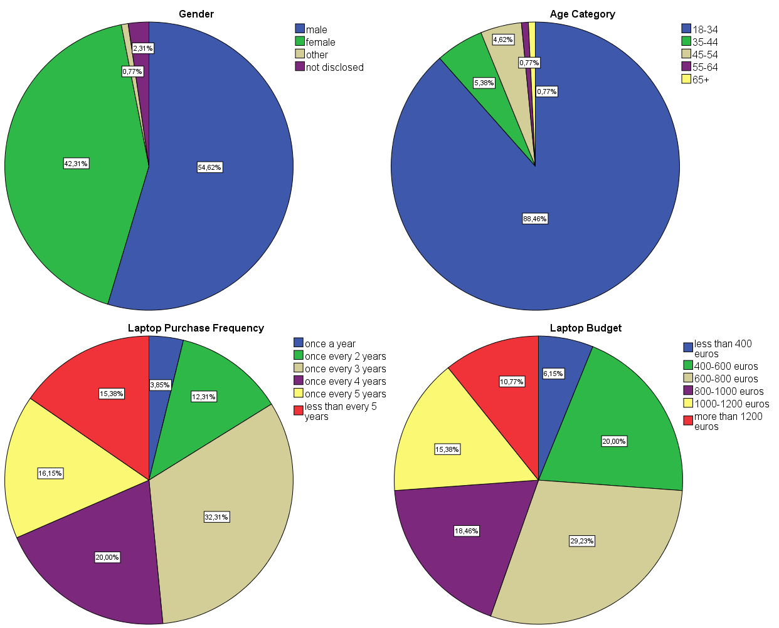

Looking at the descriptive data concerning laptop purchasing habits, we see a more wide spread in respondent categories. Aside from group with the highest frequency in new laptop purchases of a new laptop less than every year, the other groups seem to reasonably be represented. Likewise is the case for approximated typical laptop budgets, where each group is also reasonably represented, barring perhaps the smallest budget bracket.

§ 5.2 Measurement Scales
For clarity, we first summarise the measurement scales used, and the respective papers that they were sourced from, which can be found in the following table:

Table 10: summary of measurement scales
Brand Construct | Measurement Scales (7-point Likert) | Source
Brand Attitude | My general opinion of FreshNote is:  1- “bad vs. good”  2- “favorable vs. unfavorable”  3- “positive vs. negative | (Aaker 1991; Keller 1993; Agarwal and Rao 1996)
Perception of Quality | I would expect products from FreshNote to be:  1- “good vs. bad”  2- “excellent vs poor”,  3- “superior vs inferior” | (Aaker and Keller, 1990, 1992; Low and Lamb, 2000)
Brand Trustworthiness | My general impression of FreshNote is that it is:  1- “trustworthy vs. not at all trust worthy”  2- “dependable vs. not at all dependable”  3- “reliable vs. not at all reliable” | (Aaker, J. 1997; Lei et al. 2012 ; Dawar & Pillutla 2000).
Base-Rate | In my opinion, patent infringement in the laptop industry is:  1- “not at all frequent" vs "very frequent"  2- "not at all common" vs "very common"  3- "not at all widespread" vs "very widespread") | (Lei,Dawar, Gurhan-Canli, 2012).

Before continuing with deeper investigation of the experiment response data, all reverse coded scales were rescaled to maintain uniformity between measurement constructs, as well as for ease of interpretation and analysis. The multi-scale items outlined above were averaged to give scores for their respective brand perspective measurement components, as is shown in the following figure.

Figure 3: Overview of how the experiment questions were averaged to form single brand perception scores

Brand Trustworthiness
Perception of Quality
Good vs Bad
Favorable vs Unfavorable

Positive vs Negative

Good vs Bad (Quality)
Superior vs Inferior

Excellent vs Poor

Trustworthy vs Untrustworthy
Dependable vs Undependable

Reliable vs Unreliable

Brand Attitude
Scale Items
Construct
Base Rate
Frequent vs Infrequent
Common vs Uncommon

Widespread vs Not Widespread

§ 5.3 Reliability and validity
Before conducting any statistical analysis, it is important that the reliability of the multi-scale constructs is checked. This is important to make sure that the scale items used are in fact measuring the same concepts. In order to do so, Cronbach alpha coefficients were calculated for each of the constructs measured at each time interval, which can be found in the table below:

Table 11: Cronbahc alpa scores
Measurement Construct | Cronbach Alpha Coefficient at Time 1 | Cronbach Alpha Coefficient at Time 2 | Cronbach Alpha Coefficient at Time 3
Attitude | 0,922 | 0,956 | 0,963
Trustworthiness | 0,905 | 0,867 | 0,910
Quality perception | 0,913 | 0,922 | 0,946
Base Rate | 0,936 | 0,936 | 0,936

As can be seen, the initial results look very promising. All four of the multi-scale items used in the experiment result in high coefficients, easily making it over the minimum threshold amount of 0,700 and indicating a high degree of internal consistency and therefore reliability of each of the dimensions.
Because the multi-item scales were drawn from previous literature and have a precedence of validity and successful implementation, tests of validity were not deemed necessary. However, exploratory factor analysis was performed in order to determine if any there are any underlying dimensions that may better fit the multi scale items. This analysis is conducted using a principal component extraction method, which gives the following results:
- The Keiser-Meyer-Olkin measure is 0,871, which is adequate as its over 0,6.
- Bartlet’s test of sphericity is significant.

The scree plot showed two factors with eigenvalues of 1 or higher, and one which was almost 1. Because we expect the variables to move closely together, we relax our requirements and set the number of factors for the confirmatory factor analysis at three. Choosing varimax rotation gives a rotated factor matrix for the brand perception measurement from the initial measurement as follows:
Table 12: results of factor analysis
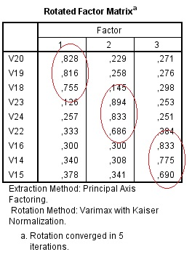
The three factors circled correspond to the scale items of the three respective brand perception measurement constructs. This helps to indicate that there are no latent variables, and the scale items for the constructs are correctly designated. Similar factor analysis performed on the second and third round of measurements revealed similar results, with the factor loads corresponding to the three constructs devised for the study.

§ 5.4 Methodology of Data Analysis: Mixed Design ANOVA
The nature of the experiment called for the repeated measurement of the same scale questions, using the same respondents, under varying circumstances. Essentially, we are interested in changes in the dependent variables from one measure to another as well as differences due to between-participant variables. Because of this, a mixed design ANOVA was selected as the most appropriate analysis to test for effects. Mixed design ANOVA is a method of testing the difference in means, when the same people are contributing to the different means, while including a mixture of effects from both the within-subject as well as between-subject variables. Stated formally, the null hypothesis (H₀) states that the means are equal, while the alternate hypothesis states that they are not equal:

H₀: µ₁ = µ₂ = µ₃ = … = µ_{k}
H_{A}: at least two means are significantly different
Where, µ = population mean and k = number of related measurement levels

Within-subject factor: During independent ANOVA, within-participant variance normally gives the residual variance, or variance created by differences in individual performance. However, when carrying out experimental manipulation on the same respondents using repeated measures, the within-participant factor represents the variance in scores across multiple measurements and can now include the effect of the manipulation. In the case of this thesis, the scales resulting from the brand perception evaluation are the repeated measure, which was performed three times per respondents and are designated by the newly created variable time, with the corresponding terms: TIME 1, TIME 2, and TIME 3.

Between-subject factor: While the within-subject variable is manipulated by testing the same respondent at different levels of the variable, the between-subjects variable is when different groups of subjects are used for each level. Subjects who are a member of one level can also not be a member of another level. In the case of this thesis, the two between-subject variables which were manipulated were whether the respondent belonged to the strong or weak brand expectations group [STRONG], and whether the firm won or lost the patent infringement group [WIN].

Covariates: Lastly, covariates are the independent variables which cannot be manipulated, but are included in the analysis for control reasons. In this thesis, the covariates include the demographic [GENDER & AGECATEGORY] and laptop purchase tendency variables [PURCHASEFREQ & BUDGET], as well as the base-rate [BASERATE].

Because different aspects are being manipulated between measurements, the three levels of repeated measures were tested in paired stages instead of all three simultaneously. This was done to avoid including the effects of the court verdict (which is a between-subject variable) throughout all three measurement levels, when it is in fact only applicable in the last level as it is only then that it is revealed to respondents. On the next page follows a chart illustrating the testing process:

Figure 4: overview of mixed design ANOVA testing process

Time 1: Initial Measurement
Time 2: Post Accusation Measurement

Time 3: Post Verdict Measurement

Brand Trustworthiness
Brand Attitude
Perception of Quality
Brand Trustworthiness
Brand Attitude
Perception of Quality
Brand Trustworthiness
Brand Attitude
Perception of Quality
Accusation
Verdict
Test 1: Time 1 to Time 2
Test 2: Time 2 to Time 3
Test 3: Time 1 to Time 3
In the chart, the three measurement phases are represented by the three blue boxes, and correspond with the three levels of the repeated measure. Time 1 corresponds to the initial brand perception measurement, and Time 2 and Time 3 to the post accusation and post verdict measurements respectively. The two main patent infringement events, the accusation and court case verdict are likewise represented by the two green boxes, and represent the experiment manipulations on the within participant measures. As mentioned earlier, the repeated measures will performed with measurement periods being paired as follows:
Test 1: This test will compare the mean scores awarded at Time 1 and Time 2, giving us an idea of what occurs between initial measurement and after the patent infringement accusation. The main effect of the patent infringement accusation is contained in the within-factor variable, while the respondents brand expectations are given by the between-subject factor STRONG.
Test 2: Here the mean scores are compared between Time 2 and Time 3m and corresponds with the changes occurring between after the accusation, and after the final verdict. In this case, things are slightly more complicated, as while there is a within-subject factor of TIME, the manipulation occurs in the between-subject factor of WIN. This is because winning and losing are two mutually exclusive scenarios, and no respondent can be subject to both. As in Test 1, brand expectations are given by the between-factors variable of STRONG.
Test 3: Finally, the overall effect of the patent infringement case is tested by comparing the initial brand evaluation (Time 1) to the evaluation conducted at the conclusion (Time 3). Similarly to Test 2, the effect of the manipulated variable of winning or losing the court case is contained within the between-subject factor of WIN. Furthermore, as in the previous two tests, brand expectations are represented by the between-subject factor of STRONG.
It should be further noted that the covariate variables were included within all three tests.

6 Results of Mixed Design ANOVA

It is now in this section that we look at the results of the mixed design ANOVA tests conducted following the design outlined in the methodology section.
Test 1: Time 1 to Time 2
Below follows a table summarizing the results found in the mixed design ANOVA analysis Test 1, which corresponding with the change in mean brand perception scores going from time 1 to time 2. The table outlines the significant factors for each construct, as well as the corresponding parameter values. Mean scores were divided whenever significant between-subject factors made grouping applicable.
Table 13: Analysis of Significant factors for Test 1
Construct | Significant Factors  (time 1 – time 2) | F | Mean Score at Time 1 | Mean Score at Time 2
Brand Attitude | time (p=0.00)  time*base-rate (p=0.023)  time*strong (p=0.022) | 15,226  5,297  5,354 | Strong: 5,087  Weak: 4,763  Total: 4,915 | Strong: 3,667  Weak: 3,696  Total: 3,682
Brand Trustworthiness | time (p=0.004)  time*base-rate (p=0.048) | 8,701  3,992 | Total: 4,997 | Total: 3,872
Perception of quality | time*strong (p=0.00) | 12,817 | Strong: 5,273  Weak: 4,271  Total: 4,915 | Strong: 4,585  Weak: 4,271  Total: 3,682

Brand Attitude:
We can see from the results above that there is a significant difference between the mean scores of brand attitude in time 1 and 2, shown by the factor, time (P=0.00). Because this factor encapsulates the within-subjects factor of the patent infringement accusation, we can subsequently conclude it as the cause. Furthermore there is also a significant interaction effect with both the variable for brand expectations, time*strong (P=0.022) as well as the variable for respondent base-rate, time*base-rate (P=0.023) on the change of mean scores. Brand attitude scores initially were 5,087 for respondents exposed to strong brand expectations and 4,763 for respondents exposed to weak brand expectations. After the patent infringement accusation, these scored dropped to 3,667 and 3,696 for firms with strong expectations and firms with weak expectations, respectively. These shifts in mean brand attitude are visually displayed in the following graph:

Graph 1: Changes in mean Brand Attitude scores from Time 1 to Time 2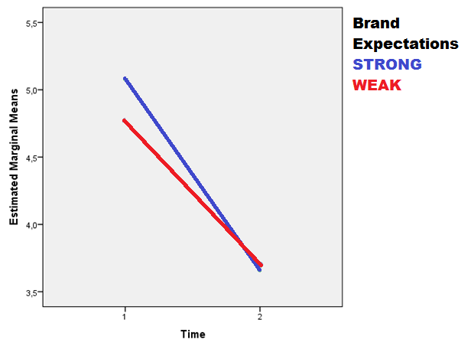
Surprisingly, we see that after the patent infringement accusation respondents who were exposed to strong expectations showed a greater drop in mean brand attitude score when compared with respondents exposed to weak expectations. At Time 2, we see that brand attitude scores are even slightly lower for the group of respondents with high expectations than the group with lower expectations, indicating a greater degree of sensitivity to the adverse effects of a patent infringement accusation. However, another possibility is that the scores of both groups simply were moved towards a universal mean low score reserved for "cheaters" or "bad firms."
In order to interpret the effect of different base rates, mean scores were were rounded, and their respective change in brand attitude scores were plotted in the following table and chart:
Table and Chart: Mean brand attitude change by respondent base-rate
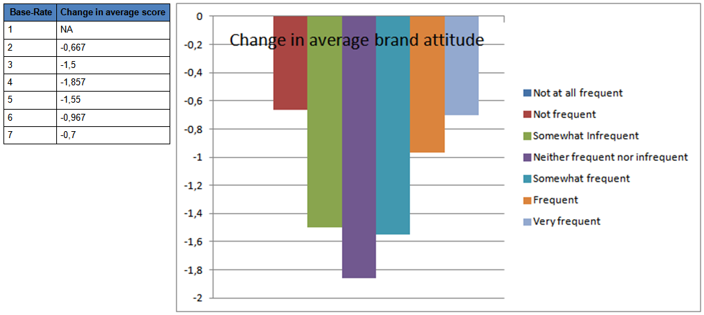

Looking at the above table and chart we can see that there is a very clear pattern emerging. Those respondents with the most neutral base-rates showed the most significant drop in mean brand attitude scores due to the patent infringement accusation. While those respondents with base-rates that fit into the more extreme brackets of low and high base-rates had increasingly smaller drops in attitude change as they moved away from the neutral middle in either direction. Research conducted in the literature review had showed that respondents with higher base-rates tend to exhibit an insulating effect of dismissing negative publicity occurrences as ‘common-place’ and ‘typical.’ Furthermore, a possible explanation for the lower adverse effects exhibited by respondents with lower base-rates may be explained due to respondents scrutinizing or dismissing information which falls out of their expectations, as was discussed in the section on (dis)confirmation bias.

Brand Trustworthiness:
Looking at the table, we can see that there is once again a significant difference between the mean scores of brand attitude in Time 1 and Time 2, given by the variable time (P=0.066). This difference can be attributed to the patent infringement accusation, which is contained in the within-subject factor. Respondent’s mean brand trustworthiness score goes from 4,997 measured before the accusation, to 3,872 after the accusation. Furthermore there is also a significant effect of respondent base-rate, given by time*base-rate (P=0.031), on the change of mean scores. The change in mean trustworthiness scores were graphed in the following table:
Graph 2: Changes in mean Brand Trustworthiness scores from Time 1 to Time 2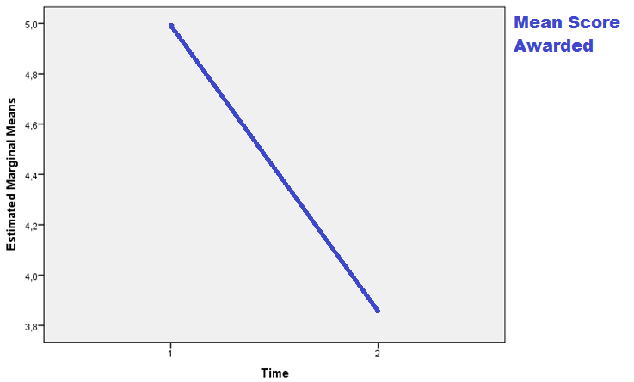
As in the previous section on brand attitude, respondent mean scores were divided according to their base-rates and their respective changes between Time 1 and Time 2 were tabulated in the following table and chart:

Table and Chart: Mean brand trustworthiness change by respondent base-rate
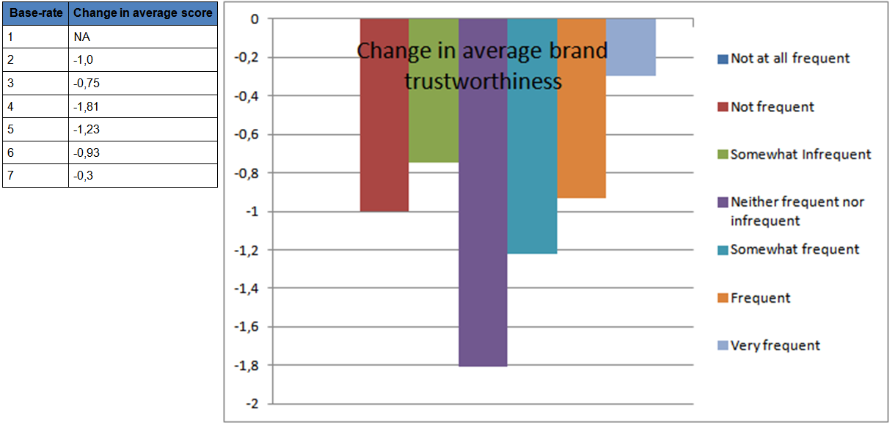

As was seen earlier in the section about brand attitude, we see from the above table and chart that there is a very similar pattern apparent. Those respondents with the most neutral base-rates had the most significant average drop in brand attitude due to the patent infringement accusation. While moving into either direction up or down the spectrum of respondents whose base-rates fit into the higher and lower brackets of base-rate perceptions had increasingly lower drops in brand trustworthiness due to the patent infringement accusation. Similarly to brand attitude, this reaction from respondents with high base-rates follows in line with previous base-rate theory, while a possible explanation for respondents with low base-rates may lie in dis-confirmation theory.

Perceptions of quality:
Finally for perceptions of quality, we see that the main within factor effect of the patent infringement by itself does not produce any significant changes in perceptions of quality. However, we do see that there is a significant interaction between time and STRONG (p=0,00). This indicates that there is a significant difference in the change in mean scores awarded before and after the patent infringement accusation depending on respondent expectations, but not by the patent infringement accusation by itself alone. Respondents who were exposed to Strong expectations started in Time 1 with an average perception of quality score of 5.273 at initial measurement, which dropped to 4.585 after the accusation. Respondents with weak expectations started with an average perception of quality score of 4.271 which subsequently dropped to 4.063 after the accusation.

Graph 3: Changes in mean Perception of Quality scores from Time 1 to Time 2
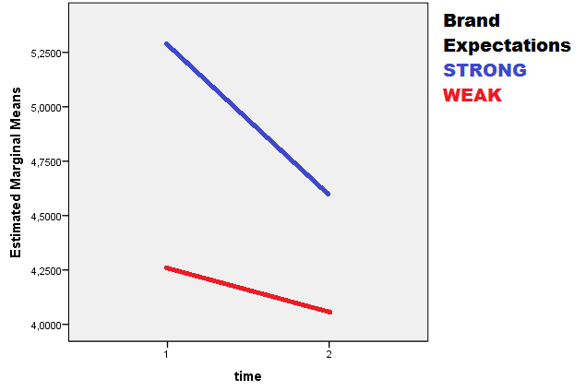
As was the case for brand attitude, we see again that although respondents exposed to higher expectations started off with higher brand trustworthiness scores, an accusation of patent infringement caused mean scores to drop more than those of respondents with weak expectations.
Test 2: of significant factors for Time 2 to Time 3.
In this section the results of the mixed design ANOVA Test 2 are presented. Once again, we start with a summary of the results which have been tabulated in the table below.
Table 14: Analysis of Significant factors for Test 2
Construct | Significant Factors  (time 2 – time 3) | F | Mean Score at Time 2 | Mean Score at Time 3
Brand Attitude | time*win (p=.000) | 73,587 | 3,682 | Win: 4,600  Lose: 3,292
Brand Trustworthiness | time (p=.028)  time*WIN (p=.000) | 4,937  53,737 | 3,872 | Win: 4,677  Lose: 3,621
Perception of quality | time*WIN (p=.000)  time*WIN*STRONG (p=.045) | 32,639  4,115 | Strong: 4,585  Weak: 4,063  Total: 4.308 | Win*Strong: 5,000  Win*Weak: 4,102  Win Total: 4,502  Lose*Strong: 4,123  Lose*Weak: 4,081 Lose Total: 4,108

Brand Attitude:
As can be seen in the table, the variable corresponding with the verdict of the patent infringement case, win, has a significant interaction effect with the main within-subject factor of time. What this means, is that there is a significant difference in mean brand attitude scores awarded between Time 2 and Time 3, depending on the outcome of patent infringement case verdict. Brand attitude goes from a mean score of 3,682 post accusation (period 2) to 3,292 if the firm loses the court case (period 3) or 4,600 if they win the court case

Graph 4: Changes in Mean Brand Attitude scores from Time 2 to Time 3
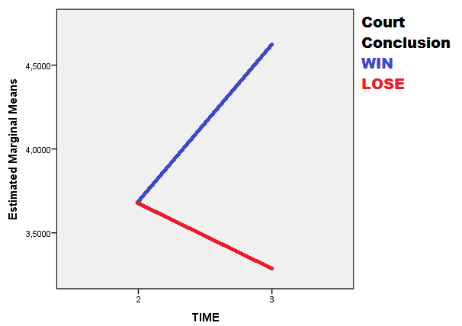

Brand Trustworthiness:
For brand trustworthiness, we see that there is also a significant interaction effect for the variables time and win (p=0,0o0). Again this shows that the mean brand trustworthiness scores differ between Time 2 and Time 3 depending on court case verdict. Brand Trustworthiness goes from a mean score of 3,872 post accusation (period 2) to 3,621 if the firm loses the court case (period 3) or 4,677 if they win the court case. In contrast to brand attitude, we see that the between-subjects factor of time also is significant by itself. What this means is that as opposed to brand attitude, the significant difference in mean scores is not completely captured by the time*win interaction effect alone.
Graph 5: Changes in Mean Brand Trustworthiness scores from Time 2 to Time 3
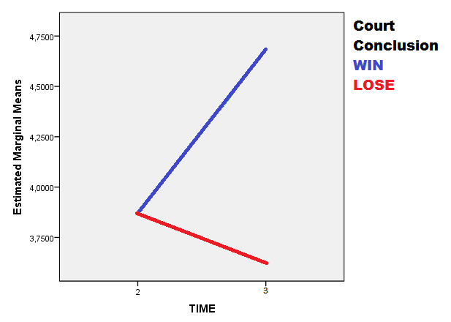

Perceptions of Quality:
Finally looking at the results of Test 2 for perceived quality we see a number of interesting effects. The significant interaction of time*win (p=0,000) tells us that there is a significant difference in mean scores of perceived quality between Time 1 and Time 3 depending on whether the firm won or lost the case. On top of that, the three-way interaction effect of time*win*strong (p=0,045) tell us that not only does winning or losing have an effects, but that there is furthermore also a significant effect depending also on which brand expectations the respondents were exposed to. Brand perceived quality starts from a mean score of 4,308 in Time 1, with Strong expectation respondents having a mean of 4,585 and weak respondents having an average mean score of 4,063. This transforms in time 3 to an average score 4.502 if they win, with the average score given further being 5.000 if they have strong expectations and 4.102 if weak. If they lose, the average score awarded is 4.108 on average, with the average score awarded furthermore being 4.123 if expectations are strong, and 4.081 if weak. These figures are visually represented in the following two graphs which chronicle the change in mean scores awarded for brand trustworthiness for respondents exposed to strong and weak expectations in first the scenario where the firm wins the patent case and second in the scenario where it loses the case.
Graph 6 and 7: Changes in mean perceived quality scores from Time 2 to Time 3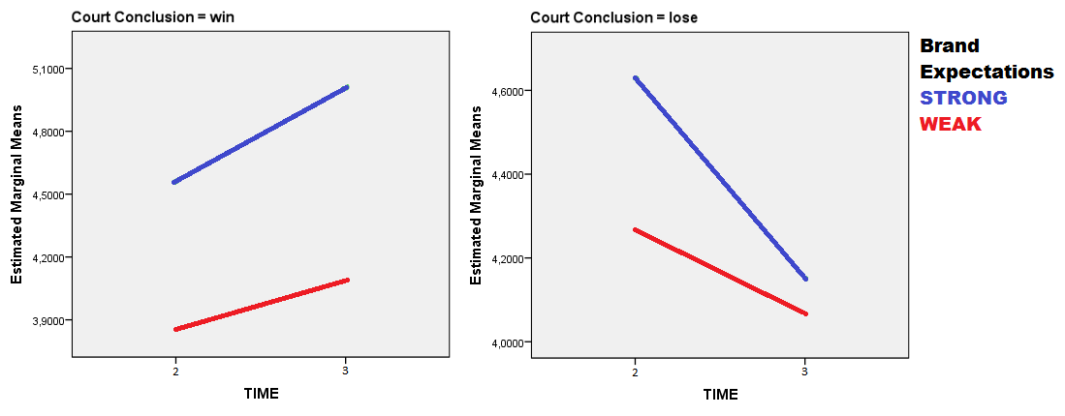
As can be seen above, the line for respondents exposed to strong expectations exhibits a steeper plots for both the win and lose scenario. This would indicate that these respondents are more sensitive the outcome of the case and subsequently "punish" firms harsher for losing, as well a "redeem" them more for winning when compared to respondents exposed to weak expectations. Also apparent from the above graphs, is that this contrast between firm expectations groups is considerably more apparent in the case that the firm loses the patent infringement case. Here, the mean brand trustworthiness score for respondents with strong firm expectations drops so low that it almost converges with those of respondents who were exposed to weak expectations. Presumably, this is a manifestation of the three-way interaction, time*win*strong.
However, as was mentioned before, it should not be ruled out that it is possible that in the win scenario, respondents are simply restoring both firms scores back to some X fraction of their former position, while for the lose scenario both scores are simply conjugating at some universal negative point where "losers" are mentally positioned.

Test 3: Time 1 to Time 3

Finally we examine the results of the change in brand perceptions spanning the entire patent infringement case study, starting at the initial measurement and ending with the post court case verdict measurement. This time span corresponds with the two measurement periods of Time 1 and Time 3. To begin, we look at the results of Test 3, which were summarized into the table below:

Table 15: Analysis of Significant factors for Test 3 (Time 1 to Time 3)

Construct | Significant Factors  (time 1 – time 3) | F | Mean Score at Time 1 | Mean Score at Time 3
Brand Attitude | time (p=.018)  time*strong (p=.044)  time*win (p=.000) | 5,757  4,125  45,619 | Strong: 5,087  Weak: 4,763  Total: 4,915 | Strong*Win: 4,793  Strong*Lose: 3,115  Strong Total: 3,913  Weak*Win: 4,444  Weak*Lose: 3,464  Weak Total: 3,976
Brand Trustworthiness | time*win (p=.000) | 23,939 | 4,997 | Win: 4,677  Lose: 3,621
Perception of quality | time*strong (p=.000)  time*win (p=.001)  time*strong*win (p=.008) | 13,489  11,535  7,231 | Strong: 5,273  Weak: 4,271  Total:4,741 | Strong*Win: 5,000  Strong*Lose: 4,135  Strong Total: 4,546  Weak*Win: 4,102  Weak*Lose: 4,081  Weak Total: 4,092

Brand Attitude:
In the above table, we can see that the within- subject measure of time is significantly different between time 1 and 3 (p=0.018). This indicates that the mean scores awarded by respondents differed significantly between the first measurement taken just before the patent infringement, and the last which was taken after the case was concluded. Furthermore, the change in brand attitude going from time 1 to time 3 is significantly affected by the court case verdict shown by the variable time*win (p=0.00) as well as the brand expectations, which is shown by the variable time*strong (p=0.044). For those respondents exposed to strong brand expectations, Initial mean score of 5.087 was awarded for brand attitude, which subsequently became 3,115 when the firm lost the patent infringement case and 4.793 in the event that the firm won the case. For respondents exposed to weak brand expectations, mean scores awarded for brand attitude were initially 4,763 which became 3,464 when the firm lost the case or 4,444 if it won. These changes in mean brand attitude scores are visually represented in the following graphs.

Graph 8 and 9: Changes in Mean Brand Attitude scores from Time 1 to Time 3
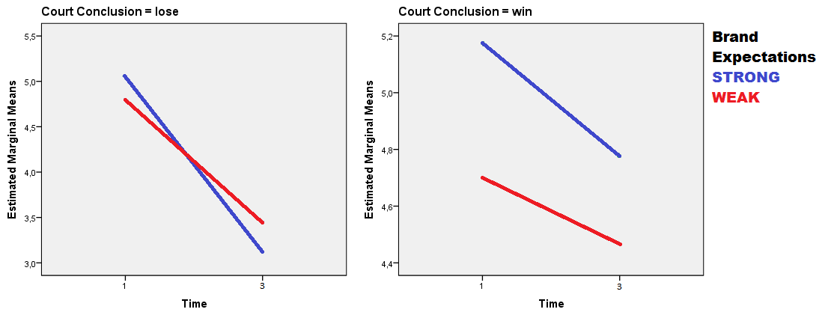

Interestingly, we see that both regardless of whether the firm wins or loses the case, brand attitude scores are reduced in Time 3. A surprising result is that in the case of respondents who were exposed to strong brand expectations, this drop in brand attitude exceeded the drop for respondents who were exposed to weak brand expectations. While in the event that the firm lost the patent case, brand attitude for respondents exposed to strong brand expectations even ended up being lower than that of those with weak expectations.
Brand Trustworthiness:
For brand trustworthiness, we see that the within subject measure of brand trustworthiness is not significantly different between time 1 and 3. However, The change in brand trustworthiness going from time 1 to time 3 is significantly affected depending on the court case verdict, which is given by time*win (p=0.00). This indicates that the significant difference between the two times is largely captured by the difference in court verdicts alone. Starting with a mean score of 4.997 in the initial measurement conducted before the patent infringement case began, the mean score becomes 3,621in the event of a loss and 4,677 in the event that the firm wins the case.

Graph 10: Change in Brand Trustworthiness from Time 1 to Time 3

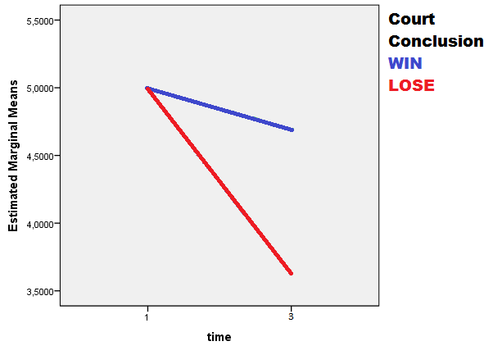

Perception of Quality:
Finally, for perceived quality we again see some interesting results. First of all, there are significant interaction effect of both time*win (p=0.001) and time*strong (p=0.000), indicating that perceived quality change from time 1 to time 3 depending on both the court case verdict, and respondent brand expectations. Furthermore there is also a significant three-way interaction effect of time*strong*win (p=0,008) which tells us that the different combinations of court case and verdict also have a significant effect on the change of brand quality perception. This can be seen in the mean scores, which were initially measured at 5,273 for respondents exposed to strong brand expectations and 4,102 for respondents exposed to weak brand expectations. When the case concluded in loss for the firm, the scores dropped to 4,135 and 4,081 for respondents with strong brand expectations and respondents with weak expectations, respectively. While in the case of a win, the mean perception of quality scores ended at 5,000 and 4,102 for respondents with strong brand expectations and respondents with weak expectations, respectively. These shifts in mean brand perceptions scores are visually represented in the following graphs:

Graph 11 and 12: Change in perceived quality from Time 1 to Time 3

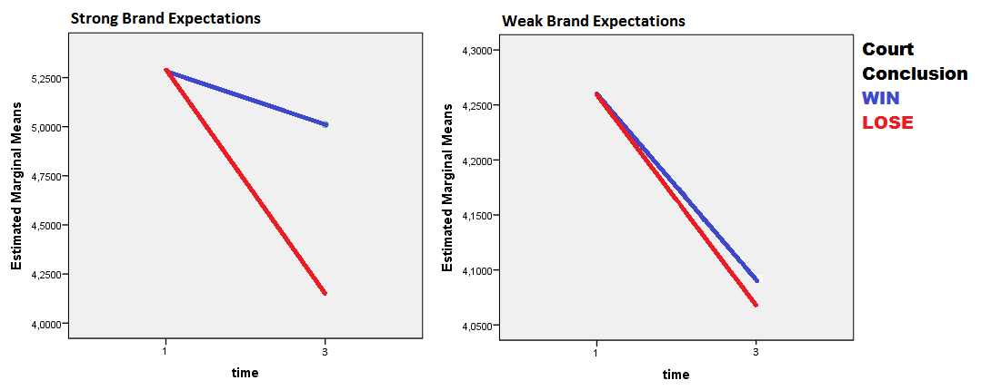
We can see in the above graphs that perceived quality dropped in Time 3 regardless of the case outcome, although this result was significantly stronger in the case that the firm lost. Interestingly, we see that while both firms with strong brand expectations and those with weak expectations experienced a reduction in perceived quality when they won the case, firms with strong brand expectations experienced this adverse effect to a considerably lower degree.

7 Recap and summary of the Test Results:

It is at this point, that the results of the mixed design ANOVA test are summarized in order to give a total, comprehensive view of the factors at play before continuing with the answers to the hypotheses. To begin, a summary of the mean scores awarded by respondents for each brand perception construct, as well as the significant variables at play for each construct across time are visually represented in the chart below:

Figure 5: Summary of mean scores and significant effects across the patent infringement case study
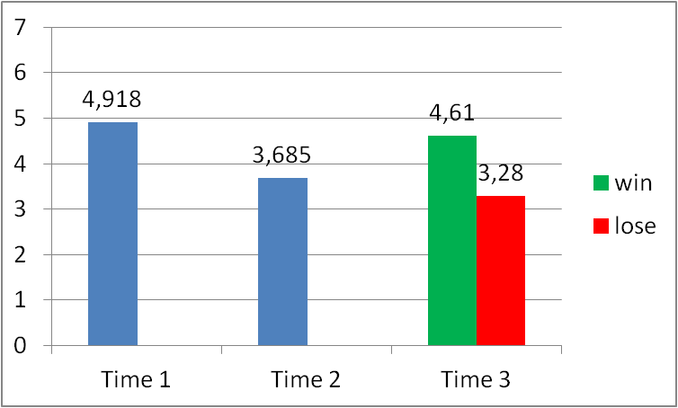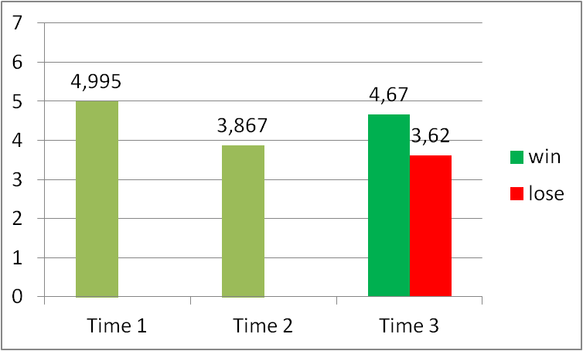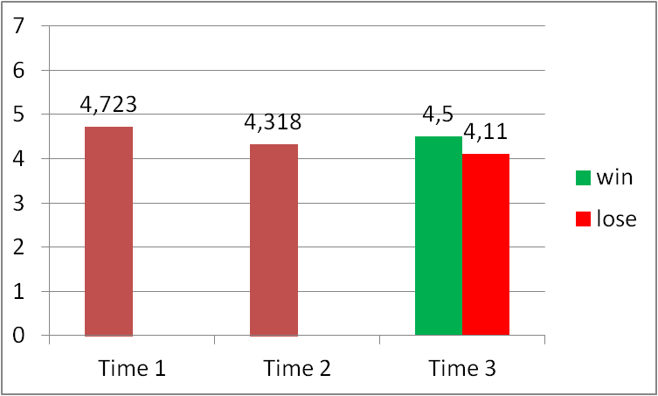
Significant Effects Across Time
Mean Scores Across Time
Time (p=0,018)
Time x STRONG (p=0,044)
Time x WIN (p=0,000)
Time (p=0,000)
Time x STRONG (p=0,022)
Time x Base-Rate (p=0,025)
Time x WIN (p=0,000)
Time x WIN (p=0,000)
Time (p=0,004)
Time x Base-Rate (p=0,048)
Time x WIN (p=0,000)
Time (p=0,028)
Time x STRONG (p=0,000)

Time x WIN (p=0,001)

Time x STRONG x WIN (p=0,008)
Time x STRONG (p=0,000)

Time x WIN (p=0,000)

Time x STRONG x WIN (p=0,045)

Brand Attitude
Brand Trustworthiness
Perception of Quality

The top half of the above diagram shows the brand perception construct levels during the case, with the mean scores given on the y-axis and the time period given on the x-axis. What is immediately apparent is that the two constructs which showed the most sensitivity to the patent infringement case were brand attitude and brand trustworthiness. This is most visible after the accusation occurs between Time 1 and Time 2, where mean scores can be seen to drop to a greater extent than was the case with perceptions of quality. Furthermore, we see that for these two constructs, the effect of an accusation created the created adverse effect, while subsequent guilty verdicts only seemed to incrementally damage mean scores. Because the two afore-mentioned constructs showed the greatest sensitivity during the case, we see that they subsequently also have the greatest difference in final mean score depending on whether the case was won or lost.
As was mentioned earlier in the answers to the hypothesis, another interesting aspect is at the conclusion of the patent infringement case. Here we see that the incremental ‘damage’ that occurs after a guilty verdict seems to be only a small amount when compared to the adverse effects caused by the accusation. The fact that the majority of the adverse effects occurs after the accusation, seems to indicate that respondents conduct the majority of their evaluation when they are made aware of the accusation, with the guilty verdict serving as a confirmation. In contrast to losing the case, an innocent verdict results in a much larger effect of reversing the brand perception score back up. However, as mentioned earlier an interesting result is that none of the brand perception constructs returned all the way to their initial pre-case levels. Perceived quality ended with a mean score that was closest back to their original level, but this may also simply be due to its lower level of sensitivity to the patent case in general.
In the bottom half of the chart, the significant variables that effect mean scores across the length of the patent infringement case are displayed. The top bars in red signify the variables which correspond to Test 3, and have a significant effect when looking at the changes of brand perception scores from the start of the patent infringement case going to the very end. Here we can see that the only experimental manipulation that was a significant effect for all three brand perceptions was the result of either winning or losing the patent infringement case. Furthermore, while brand expectations showed no significant effect on brand trustworthiness, there were significant effects for brand attitude and perceived quality as well as an interaction of both brand expectations and court verdict for perceived quality.
The second set of variables shown in the green bars corresponds with the results of Test 1 and shows the variables which had a significant effect on the changes in brand perception scores going from the initial measurement to just after the patent infringement accusation. This period is noteworthy as being the only time in the entire patent infringement case where respondent base-rates had a significant effect on mean scores. Here we also see once again that brand expectations had a significant effect on only brand attitude and perceptions of quality.
Finally, the last set of variables represented by the purple bars correspond to Test 2, and give the variables which show significant effects on the change in mean scores going from just after the patent infringement accusation to after the verdict is delivered. We see here that the court case verdict had a significant effect for all three brand perception constructs, and even an interaction effect with brand expectations for perceptions of quality.

8 Answers to the Hypothesis

It is in this section that results of the mixed design ANOVA tests, as well as other methods of analysis are employed to provide answers to the hypothesis posed earlier in the study. Because the results of the mixed design ANOVA is already discussed in the previous section, only the relevant excerpts will be displayed as required.

H1: News of a patent infringement accusation will have an adverse effect on respondent's brand perceptions.

To start off, t-tests and simple repeated measures ANOVA (only within measures factor) can be used to compare the mean scores awarded in Time 1 with Time 2. These two periods correspond to the initial brand evaluation and the evaluation just after the patent infringement accusation respectively. The results are shown in the tables below:

Table 16: T-test results of comparing group means of measurements taken at Time 1 and Time 2:

Construct | T-value | Sig | Change in mean score
Brand Attitude | 9,096 | 0,000 | Decreases from 4.915 to 3.682
Brand Trustworthiness | 8,157 | 0,000 | Decreases from 4.997 to 3.872
Perception of quality | 3,202 | 0,001 | Decreases from 4.741 to 4.308

Table 17: Repeated measures ANOVA results of comparing group means of measurements taken at Time 1 and Time 2:

Construct | F | Sig | Change in mean score
Brand Attitude | 146,669 | 0,000 | Decreases from 4.915 to 3.682
Brand Trustworthiness | 124,786 | 0,000 | Decreases from 4.997 to 3.872
Perception of quality | 38,649 | 0,000 | Decreases from 4.741 to 4.308

Independent t-tests treat the two scores as if they were two separate groups, while repeated measures ANOVA accounts for the fact that we are measuring the same respondents twice. The results for both tests show that for all three brand perception measurement constructs, the scores given were significantly different (p<0.05) when comparing the evaluations prior to and after the patent infringement accusation.

Because the only experimental manipulation between the two time periods is the exposure to the newspaper article concerning the patent infringement accusation, we can therefore conclude that this was also the cause for the significant change in scores given. Therefore, hypothesis H1a is confirmed, news of patent infringement accusation has an adverse effect on respondent's brand perceptions.

H2: News of a verdict to the patent infringement case will have an effect on respondent's brand perceptions. And,

H2a: A guilty verdict of patent infringement will have an adverse effect on respondent brand perceptions.

In order to provide an answer for this hypothesis, we first look back at the tests on the period going from after the patent infringement accusation to the court verdict (Time 2 to Time 3). This corresponds with the results of the mixed design ANOVA Test 2, the results of which can be found in the table below.
Table 18: Analysis of Significant factors for Test 2 (Time 2 to Time 3)
Construct | Significant Factors  (time 2 – time 3) | F | Mean Score at Time 2 | Mean Score at Time 3
Brand Attitude | time*win (p=.000) | 73,587 | 3,682 | Win: 4,600  Lose: 3,292
Brand Trustworthiness | time (p=.028)  time*win (p=.000) | 4,937  53,737 | 3,872 | Win: 4,677  Lose: 3,621
Perception of quality | time*win (p=.000)  time*win*strong (p=.045) | 32,639  4,115 | Strong: 4,585  Weak: 4,063  Total: 4.308 | Win*Strong: 5,000  Win*Weak: 4,102  Win Total: 4,502  Lose*Strong: 4,123  Lose*Weak: 4,081 Lose  Total: 4,108

As can be seen in the table, the variable corresponding with the verdict of the patent infringement case (win) was a significant interaction effect with the main within-subject factor of time for all three brand perception constructs (p<0,05). What this means, is that there is a significant difference in mean scores awarded between Time 2 and Time 3, depending on the outcome of patent infringement case verdict.
However Test 2 only corresponds with the change in brand perception scores from after the accusation to the post verdict period. It is still necessary to examine the results of the change in brand perceptions spanning the entire patent infringement case study, starting at the initial measurement. In order to do so, we look at the results of Test 3, which were summarized into the following table.

Table 19: Analysis of Significant factors for Test 3 (Time 1 to Time 3)

Construct | Significant Factors  (time 1 – time 3) | F | Mean Score at Time 1 | Mean Score at Time 3
Brand Attitude | time (p=.018)  time*strong (p=.044)  time*win (p=.000) | 5,757  4,125  45,619 | Strong: 5,087  Weak: 4,763  Total: 4,912 | Strong*Win: 4,793  Strong*Lose: 3,115  Strong Total: 3,913  Weak*Win: 4,444  Weak*Lose: 3,464  Weak Total: 3,976
Brand Trustworthiness | time*win (p=.000) | 23,939 | 4,997 | Win: 4,677  Lose: 3,621
Perception of quality | time*strong (p=.000)  time*win (p=.001)  time*strong*win (p=.008) | 13,489  11,535  7,231 | Strong: 5,273  Weak: 4,271  Total: | Strong*Win: 5,000  Strong*Lose: 4,135  Strong Total: 4,546  Weak*Win: 4,102  Weak*Lose: 4,081  Weak Total: 4,092

We see that when the patent infringement case is taken into account in its entirety, the verdict of the court case has a significant interaction effect for all three brand perception constructs. As was the case earlier, this signifies a significant difference in brand perception scores awarded, depending on the court case outcome. Therefore, we can confidently report that both hypothesis H2 and H2a are confirmed, and that the court case verdict has a significant adverse effect on brand perceptions. This is the case for both respondents who are aware of the case and are awaiting a conclusion, as well as the total effect of the entire case study.

H2b: An innocent verdict of patent infringement will not restore brand perceptions to their original level.

The above hypothesis is relatively easy to test. It has already been established that winning or losing has a significant impact on brand perception measurement scales; therefore it is only necessary to examine mean results of the evaluation scores awarded during the case study which are summarized in the tables below:
Table 20: Total mean scores

Scale | Initial Measurement | Post Accusation | Post Verdict Win (Lose)
Attitude | 4.92 | 3.68 | 4.60 (3.29)
Trustworthiness | 4.10 | 3.87 | 4.68 (3.62)
Perceptions of quality | 4.74 | 4.31 | 4.50 (4.11)

Table 21: Mean scores for strong expectation group:

Scale | Initial Measurement | Post Accusation | Post Verdict Win (Lose)
Attitude | 5.13 | 3.67 | 4.79 (3.12)
Trustworthiness | 5.05 | 3.72 | 4.82 (3.45)
Perceptions of quality | 5.25 | 4.59 | 5.00 (4.14)

Table 22: Mean scores for weak expectation group:

Scale | Initial Measurement | Post Accusation | Post Verdict Win (Lose)
Attitude | 4.76 | 3.70 | 4.44 (3.47)
Trustworthiness | 5.04 | 4.01 | 4.57 (3.79)
Perceptions of quality | 4.27 | 4.06 | 4.10 (4.08)

As can be seen above, brand perception scores for all three constructs are at their highest point during the initial measurement, and that winning the court case does not restore scores back to their original levels. This is also the case when respondents are divided and analyzed separately by brand expectations, which shows that there was no difference between those respondents who were exposed to either strong or weak brand expectations. These mean scores were graphed in the following charts to give a visual representation of the measurements across the case study:

Graphs 13, 14 and 15: Overview of mean scores across the patent case

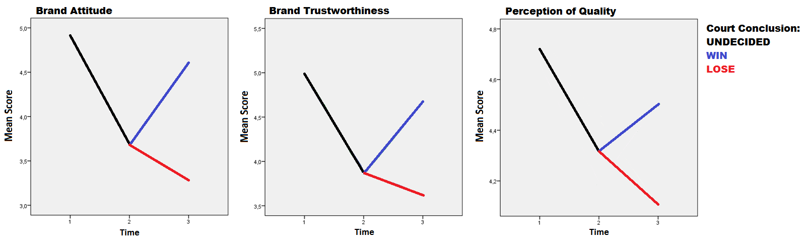
Looking at all three measurement constructs we can see in both the tables as well as the graphs, that not one of them returned to the initial measurement levels from the pre-accusation period, even after winning the patent infringement case and being cleared of all charges. It should be remembered once again that in the case-study, care was made to make sure that in the winning scenario was presented in a fashion that was unequivocal and without doubt, so as to make sure that the outcome in the eyes of the respondents was final.
However, although the mean scores are not restored to their original position in this case, we must still test to see if this difference is statistically significant. Repeated measures ANOVA tests were conducted comparing the mean scores awarded at the beginning of the case study, as well as after a verdict of not guilty were awarded. The results for all three of the brand perception constructs can be found in the following tables, as well as the separate results for the respondents of each brand expectation group.

Table 23: Repeated measures ANOVA results for total mean scores:

Scale | Initial Measurement | Post Verdict (Innocent) | F- value | df | Sig
Attitude | 4.90 | 4,61 | 8,317 | (1,64) | 0,005
Trustworthiness | 5,05 | 4,67 | 14,349 | (1,64) | 0,000
Perceptions of quality | 4,67 | 4,50 | 6,609 | (1,64) | 0,012

Table 24: Repeated measures ANOVA results strong brand expectations mean scores:

Scale | Initial Measurement | Post Verdict (Innocent) | F- value | df | Sig
Attitude* | 5,13 | 4,79 | 3,942 | (1,28) | 0,057
Trustworthiness | 5,05 | 4,82 | 2,571 | (1,28) | 0,120
Perceptions of quality* | 5,25 | 5,00 | 4,613 | (1,64) | 0,041*

Table 25: Repeated measures ANOVA results weak brand expectations mean scores:

Scale | Initial Measurement | Post Verdict (Innocent) | F- value | df | Sig
Attitude* | 4,72 | 4,45 | 4,267 | (1,35) | 0,046*
Trustworthiness | 5,06 | 4,56 | 13,186 | (1,35) | 0,001
Perceptions of quality* | 4,20 | 4,10 | 2,041 | (1,35) | 0,162
*Brand perception construct which showed significant difference in mean score based on expectation group

The results tabulated in the tables above show that for all three brand perception constructs, the resulting scores awarded in light of the firm winning the patent infringement case, and being absolved of any wrongdoings, differs significantly (p<0,05) from the scores initially awarded at the beginning of the case study when respondents were not yet aware of any alleged infringement. We can therefore conclude that hypothesis H2b is confirmed. An innocent verdict of patent infringement does not restore brand perceptions back to their original levels (initial measurements, before any mention of patent infringement was made).
Interestingly, we see that dividing respondents based on brand expectation group gives somewhat different results. Because we saw during the mixed design ANOVA Test 3 that brand attitude and perceived quality were the only brand perception constructs which exhibited significant effects from differing brand expectations, they are therefore the only two constructs we can meaningfully derive any conclusions from regarding differences between brand expectation groups. For respondents with strong brand expectations, we can see that perceived quality were significantly different (p=0,041) when comparing the measurement at Time 1 with the measurement post court case victory. While for respondents with weak brand expectations, brand attitude (p=0,046) was the only construct which exhibited significant differences between the mean scores awarded at Time 1 and after winning the court case.

H3: Brand expectations will have a moderating effect on the changes in brand perceptions due to a patent infringement case.

In order to provide an answer for the above hypothesis, the results of all three mixed design ANOVA tests (Test 1, Test 2, and Test 3) are employed. As stated in the section on study methodology, brand expectations effects appear as the between-subject factor, strong. A significant interaction effect with time indicates that there is a difference in means, depending on whether respondents are exposed to strong or weak brand expectations. We start first by looking at the overall effects of the patent infringement, shown in the results of Test 3.

Table 26: Significant effects found in Test 3 (Time 1 – 3)

Construct | Significant Factors  (time 1 – time 3) | F | Mean Score at Time 1 | Mean Score at Time 3
Brand Attitude | time (p=.018)  time*strong (p=.044)  time*win (p=.000) | 5,757  4,125  45,619 | Strong: 5,087  Weak: 4,763  Total: 4,912 | Strong*Win: 4,793  Strong*Lose: 3,115  Strong Total: 3,913  Weak*Win: 4,444  Weak*Lose: 3,464  Weak Total: 3,976
Brand Trustworthiness | time*win (p=.000) | 23,939 | 4,997 | Win: 4,677  Lose: 3,621
Perception of quality | time*strong (p=.000)  time*win (p=.001)  time*strong*win (p=.008) | 13,489  11,535  7,231 | Strong: 5,273  Weak: 4,271  Total: | Strong*Win: 5,000  Strong*Lose: 4,135  Strong Total: 4,546  Weak*Win: 4,102  Weak*Lose: 4,081  Weak Total: 4,092

In Test 3, significant interaction effects for time*strong were found for both brand attitude and perceptions of quality. This indicates that means scores awarded for brand attitude and perceived quality between the initial evaluation (Time 1) and after the court verdict (Time 3) are significantly different when divided into respondents with strong and weak brand expectations. Furthermore, for perceptions of quality, there was also a three-way interaction effect between time, strong, and win, indicating that there was a difference in mean scores across the entire patent infringement case, depending not only on brand expectations, but also together with the court case verdict.
In order to interpret the parameters, the means scores awarded for brand attitude were plotted in the graphs below:
Graph 16 and 17: Changes in Mean Brand Attitude scores from Time 1 to Time 3

Interestingly, we see that regardless of whether the firm wins or loses the case, brand attitude scores are reduced in Time 3. A surprising result is that in the case of respondents who were exposed to strong brand expectations, this drop in brand attitude exceeded the drop for respondents who were exposed to weak brand expectations. While in the event that the firm lost the patent case, brand attitude for respondents exposed to strong brand expectations even ended up being lower than that of those with weak expectations.
In order to interpret the parameters for perceptions of quality, the mean scores going from Time 1 to Time 3 were also graphed.
Graph 18 and 19: Change in Perceived Quality from Time 1 to Time 3
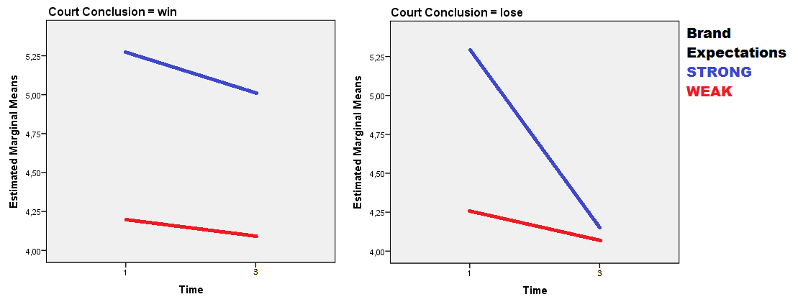
We can see in the above graphs that perceived quality dropped in Time 3 regardless of the case outcome, although this result was stronger in the case that the firm lost the patent case. Interestingly, we see that while both firms with strong brand expectations and those with weak expectations experienced a reduction in perceived quality when they won the case, firms with strong brand expectations experienced this adverse effect to a considerably lower degree. This can be seen in the second graph, where the firm with strong brand expectations shows the steepest dive in perception of quality scores after a guilty verdict. Presumably, this effect of the combination of brand expectations and court verdict is a manifestation of the three-way interaction, time*strong*win.
Next we examine results of Test 1 to investigate the effects brand expectations occurring from Time 1 to Time 2, which can be seen summarized in the table below.
Table 27: Significant effects found in Test 1 (Time 1 – 2)
Construct | Significant Factors  (time 1 – time 2) | F | Mean Score at Time 1 | Mean Score at Time 2
Brand Attitude | time (p=0.00)  time*base-rate (p=0.023)  time*strong (p=0.022) | 15,226  5,297  5,354 | Strong: 5,087  Weak: 4,763  Total: 4,915 | Strong: 3,667  Weak: 3,696  Total: 3,682
Brand Trustworthiness | time (p=0.004)  time*base-rate (p=0.048) | 8,701  3,992 | Total: 4,997 | Total: 3,872
Perception of quality | time*strong (p=0.00) | 12,817 | Strong: 5,273  Weak: 4,271  Total: 4,915 | Strong: 4,585  Weak: 4,271  Total: 3,682

In Test 1, significant interaction effects for time*strong were again found for both brand attitude and perceived quality. This indicates that means scores awarded for brand attitude and perceived quality between the initial evaluation (Time 1) and just after the patent infringement accusation (Time 2) showed significant differences when divided into respondents with strong and weak brand expectations. Because the patent infringement accusation was the only experimental manipulation between these two time periods, it is safe to conclude that brand expectations have a significant effect on the change in brand attitude and perceived quality due to a patent infringement accusation.
In order to interpret the parameters, the change in mean scores across Time 1 and Time 2 were graphed, starting with brand attitude:
Graph 20: Changes in mean Brand Attitude scores from Time 1 to Time 2
Surprisingly, we see that after the patent infringement accusation respondents who were exposed to strong expectations showed a greater drop in mean brand attitude score when compared with respondents exposed to weak expectations. At Time 2, we see that brand attitude scores are even slightly lower for the group of respondents with high expectations than the group with lower expectations, indicating a greater degree of sensitivity to the adverse effects of a patent infringement accusation. However, another possibility is that the scores of both groups simply were moved towards a universal mean low score reserved for "cheaters" or "bad firms."
Next we plot the change in mean scores for perceived quality for easier interpretation of the parameters, which can be seen in the following graph.

Graph 21: Changes in mean Perception of Quality scores from Time 1 to Time 2
As was the case for brand attitude, we see again that although respondents exposed to higher expectations started off with higher brand trustworthiness scores, an accusation of patent infringement caused mean scores to drop more than those of respondents with weak expectations.
Finally, we look at the results of Test 2, to examine significant effects of brand expectations at play when going from Time 2 to Time 3
Table 28: Significant effects found in Test 2 (Time 2 – 3)
Construct | Significant Factors  (time 2 – time 3) | F | Mean Score at Time 2 | Mean Score at Time 3
Brand Attitude | time*win (p=.000) | 73,587 | 3,682 | Win: 4,600  Lose: 3,292
Brand Trustworthiness | time (p=.028)  time*WIN (p=.000) | 4,937  53,737 | 3,872 | Win: 4,677  Lose: 3,621
Perception of quality | time*WIN (p=.000)  time*WIN*STRONG (p=.045) | 32,639  4,115 | Strong: 4,585  Weak: 4,063  Total: 4.308 | Win*Strong: 5,000  Win*Weak: 4,102  Win Total: 4,502  Lose*Strong: 4,123  Lose*Weak: 4,081 Lose Total: 4,108

From the table above, we see in Test 2 that significant interaction effects for time*strong were only found for perceptions of quality. This indicates that means scores awarded for perceived quality between just after the accusation (Time 2) and after the court verdict was announced (Time 3) showed significant differences when divided into respondents with strong and weak brand expectations. In order to interpret the parameters, the change in mean scores was graphed, as seen below:

Graph 22: Changes in mean Perception of Quality scores from Time 2 to Time 3
As can be seen above, the plot for respondents exposed to strong expectations exhibits a steeper plots for both the win and lose scenario. This would indicate that these respondents are more sensitive the outcome of the case and subsequently "punish" firms harsher for losing, as well as "redeem" them more for winning when compared to respondents exposed to weak expectations. Also apparent from the above graphs, is that this contrast between firm expectations groups is considerably more apparent in the case that the firm loses the patent infringement case. Here, the mean brand trustworthiness score for respondents with strong firm expectations drops so low that it almost converges with those of respondents who were exposed to weak expectations. Presumably, this is a manifestation of the three-way interaction, time*win*strong.
However, as was mentioned before, it should not be ruled out that it is possible that in the win scenario, respondents are simply restoring both firms scores back to some X fraction of their former position, while for the lose scenario both scores are simply conjugating at some universal negative point where "losers" are mentally positioned.

After reviewing the results of the mixed design ANOVA tests, we found significant effects of brand expectations for some, but not all, of the brand perception constructs. Furthermore, it was shown that presence of these effects differed, depending on the stage of the patent infringement case. An interesting insight found was that for almost every scenario, respondents who were exposed to strong brand expectations showed a greater sensitivity to the events of a patent infringement, for both the case that the firm wins, and the case that the firm loses. We can therefore conclude, that hypothesis H3 has been partially confirmed.

H3a: Respondents exposed to strong brand expectations will experience weaker adverse effects on brand perception due to a patent infringement accusation, when compared to respondents exposed to weaker brand expectations.

In order to answer hypothesis H3a, we expand on the analysis of hypothesis H3. In the analysis of Test 1, which corresponded to the relevant time phase in question, it was found that brand attitude and perception of quality were the only two construct which had a significant relationship with brand expectations (p<0,00). Plotting the mean scores awarded over Time 1 to Time 2 for both respondents exposed to strong and weak brand expectations resulted in the following graphs:

Graph 23 and 24: Change in mean score going from Time 1 to Time 2
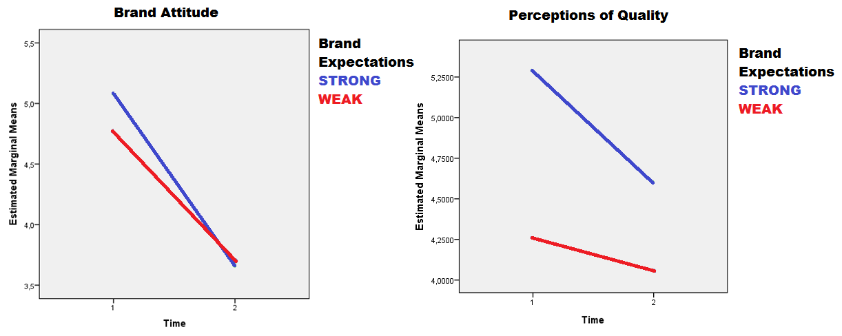

In both the case of brand attitude as well as perceptions of quality, there is a considerably sharper drop in average brand perception scores for respondents who were presented with strong expectations, when compared to those presented with weak brand expectations. This indicates a stronger adverse reaction on the part of respondents with strong brand expectations to the patent infringement accusation, which is the exact opposite of what previous literature had led us to expect. For brand attitude, the mean score for respondents with strong brand expectations even went below those of respondents with weak brand expectations. This is an interesting result, and is open to a number of possible interpretations. We can therefore conclude, that hypothesis H3a is refuted.

H3b: Respondents exposed to strong brand expectations will experience weaker adverse effects on brand perception due to a guilty verdict of patent infringement, when compared to respondents exposed to weaker brand expectations.

An answer to hypothesis H3b can also be obtained by expanding on the tables created for hypothesis H3. The mixed design ANOVA Test 3 corresponds with the change in brand perception scores cross the entire patent infringement case. It was found there that the brand perception constructs which showed significant effects due to brand expectations going from Time 1 to Time 3 included brand attitude and perceptions of quality. We start by interpreting the parameters for brand attitude. The mean scores awarded were graphed for both the situation that the firm wins the court case, as well as losing the case, to provide the following visual representation of the changes:

Graph 25 and 26: Changes in Mean Brand Attitude scores from Time 1 to Time 3
Note: As was shown earlier, in the analysis of hypothesis H2b, mean brand perception scores are not restored after a court case victory, which is why both verdict scenarios show a drop in brand perception scores.
As can be seen above, in both the scenario that the firm won and when the firm lost the patent infringement case we can see that respondents presented with strong brand expectations had sharper drops in average brand attitude scores when compared to respondents who were presented with weak brand expectations. As was seen in hypothesis H3a, once again in the case that the firm loses the case, the score awarded by respondents exposed to strong brand expectations even dropped below those with weak expectations. This indicates that respondents with strong brand expectations experienced a stronger adverse effect on mean brand attitude scores due to a guilty verdict. Next we plotted the parameters for perceptions of quality:
Graph 27 and 28: perceived quality for Time 1 to Time 3:

Again, we see that for the mean scores awarded for perceptions of quality, sharper drops are found for those respondents who were exposed to strong brand expectations when compared to those respondents who were exposed to weak brand expectations. This effect was apparent for both possible outcomes of the case, but was much more pronounced when the firm lost the case. This considerably sharper "punishment" of brands with strong expectations losing the case can be interpreted as a manifestation of the three-way time*strong*win interaction effect.
In conclusion, we can see from the previous graphs and analysis that those respondents exposed to strong brand expectations experienced stronger adverse effects on their mean brand perception scores awarded due to a guilty verdict in the patent infringement case. This adverse effect was the strongest in the case of perceived quality for respondents with strong brand expectations, where there was a significant three-way interaction effect of time*win*strong (p=0,008). Effectively, these results provide evidence that refutes hypothesis H3b
The previous analysis concerns the effects of expectations on the court verdict when looking at the patent infringement case in its entirety. But we are also curious if these expectations play a part when looking at the change in scores awarded going from post accusation to the verdict. As was found in hypothesis H3, when looking at Time 2 and Time 3, brand expectations only appeared as a three-way interaction effect with the court verdict and changes of perceptions of quality, time*strong*win (p=0,045). The resulting respective change in mean scores was graphed in the following charts:
Graph 29 and 20: Changes in mean Perception of Quality scores from Time 2 to Time 3

We see in the graphs above that winning or losing the court case changed the respective direction in which perceived quality moved after a verdict was made. In the case of the firm winning the court case, we see that the mean scores of strong brands rose more sharply than weak brands. While in the case of losing the court case, strong brands experienced a sharper drop mean brand scores. Again, as was seen previously, this effect appears to be considerably more pronounce in the case that the firm faces a losing verdict. This would lead us to believe that a winning verdict “restores” the perception of quality of firms with strong expectations more than those with weak expectations. While when the firms lose the court case, firms with strong expectations are "punished" much more severely with a more dramatic drop in perceptions of quality. This “punishing” effect of losing the case appears to be significantly stronger than the “restoring” effect of winning, as is apparent from the three-way interaction of time*strong*win. This finding also seems to be in line with the conclusion from hypothesis H2b.
Curiously, again results appear to show that not only is H3b refuted, but that the opposite appears to be true. In all situations where brands expectations played a significant effect, brand with strong expectations experience stronger adverse effects due to a guilty verdict of patent infringement than brands with weak expectations. This included both when looking at the patent infringement case study as a whole, as well as when looking specifically when going from an accusation to a verdict.

H4: Respondent base-rate perceptions will have a moderating effect on the adverse changes in brand perception due to a patent infringement case.

H4a: Respondents with higher base-rates will experience weaker adverse effects on brand perception due to a patent infringement accusation, when compared to respondents exposed to weaker brand expectations.

During the entire patent infringement case study, base-rates only showed a significant effect on changes in brand perceptions mean scores that occurred after the patent infringement accusation. This was apparent upon analysis of the results of mixed design ANOVA Test 1, which can be seen in the table below:
Table 29: Analysis of Significant factors for Test 1 (Time 1 to Time 2)
Construct | Significant Factors  (time 1 – time 2) | F | Mean Score at Time 1 | Mean Score at Time 2
Brand Attitude | time (p=0.00)  time*base-rate (p=0.023)  time*strong (p=0.022) | 15,226  5,297  5,354 | Strong: 5,087  Weak: 4,763  Total: 4,915 | Strong: 3,667  Weak: 3,696  Total: 3,682
Brand Trustworthiness | time (p=0.004)  time*base-rate (p=0.048) | 8,701  3,992 | Total: 4,997 | Total: 3,872
Perception of quality | time*strong (p=0.00) | 12,817 | Strong: 5,273  Weak: 4,271  Total: 4,915 | Strong: 4,585  Weak: 4,271  Total: 3,682

As can be seen above, during that transition from Time 1 to Time 2, significant effects of respondent base-rates were found on brand attitude (p=0,023) and brand trustworthiness (p=0,048). The mean change in brand attitude and trustworthiness scores were divided depending on respondent base-rate perceptions and tabulated, as well as graphed in the following charts:

Graph and Table: Change in brand attitude from Time 1 to Time 2 according to base-rate group

Graph and Table: Change in brand trustworthiness from Time 1 to Time 2 according to base-rate group

The graphs both show a relatively clear trend, which is for respondents with neutral level base-rates to reduce their score for brand attitude and trustworthiness to the most severly due to a patent infringement accusation. As base-rate perceptions move in either direction of the spectrum (either more frequent or less frequent) the degree in which they downgraded brand perception scores becomes less harsh. This is an interesting result, as although we expected higher base-rates to coincide with weaker adverse effects on brand perceptions, we did not expect that low base-rates would also do the same. This is perhaps because while respondents with high base-rates excuse infringement behavior as "part of the norm,” respondents with low base-rate expectations may likewise give firms the benefit of the doubt (speculation). Therefore hypothesis H4 is confirmed, while hypothesis H4a is partially confirmed.

H4b: Respondents with lower base-rates will experience weaker adverse effects on brand perception due to a guilty verdict of patent infringement, when compared to respondents exposed to weaker brand expectations.

Looking at the results of the mixed design ANOVA Test 2 and Test 3, which coincide with the relevant time periods for hypothesis H4b, we see that no significant effects for base-rate were present. We therefore can consider hypothesis H4b refuted.

H4c: There will be an interaction effect of respondent brand expectations and base-rate perceptions on the brand perception effects due to the patent infringement case.

Once again we can find no significant interaction effects for base-rate and brand expectations when looking at the results of the mixed design ANOVA Test 1, Test 2, or Test 3, which coincide with the relevant time periods for hypothesis H4c. We therefore can consider hypothesis H4c refuted.

§ 8.1 Summary of the answers to the hypothesis:
In order to provide an oversight of the findings of this thesis, as well as for the sake of convenience, a summary of the answers to the hypotheses can be found in the table below:
Hypothesis | Conclusion | Method | Test | Sig. Levels
H1: News of a patent infringement accusation will have an adverse effect on respondent's brand perceptions. | Supported | Compared mean scores of brand perceptions from Time 1 to Time 2 | T-test and  Repeated Measures | Refer to table
H2: News of a verdict to the patent infringement case will have an effect on respondent's brand perceptions | Supported | Compared the mean scores of brand perceptions for Time 2 to Time 3, as well as Time 1 to Time 3 | Mixed design ANOVA
H2a: A guilty verdict of patent infringement will have an adverse effect on respondent brand perceptions. | Supported | Compared the mean scores of brand perceptions for Time 2 to Time 3, as well as Time 1 to Time 3 | Mixed design ANOVA
H2b: An innocent verdict of patent infringement will not restore brand perceptions to their original level | Supported | Compared mean scores of brand perceptions for Time 1 with scores of Time 3 in the event of a patent case win | Repeated measures ANOVA
H3: Brand expectations will have a moderating effect on the changes in brand perception due to a patent infringement case. | Partially Supported:  Effects only found for brand attitude and perceptions of quality. | Compared means scores using combinations of all three time periods [Time 1 to Time 2, Time 2 to Time 3, and Time 1 to Time 3]. | Mixed Design ANOVA
H3a: Respondents exposed to strong brand expectations will experience weaker adverse effects on brand perception due to a patent infringement accusation, when compared to respondents exposed to weaker brand expectations. | Refuted:  The opposite was found | Compared mean scores of brand perceptions for Time 1 to Time 2 | Mixed Design ANOVA
H3b: Respondents exposed to strong brand expectations will experience weaker adverse effects on brand perception due to a guilty verdict of patent infringement, when compared to respondents exposed to weaker brand expectations. | Refuted | Compared mean scores of brand perceptions for Time 1 and Time 3 | Mixed Design ANOVA
H4: Respondent base-rate perceptions will have a moderating effect on the adverse changes in brand perception due to a patent infringement case. | Supported | Compared means scores using combinations of all three time periods [Time 1 to Time 2, Time 2 to Time 3, and Time 1 to Time 3]. | Mixed Design ANOVA
H4a: Respondents with higher base-rates will experience weaker adverse effects on brand perception due to a patent infringement accusation, when compared to respondents exposed to weaker brand expectations. | Partially Supported:  Both higher and lower base-rates groups showed reduced adverse effects. Neutral base-rates showed the greatest sensitivity. | Compared mean scores of brand perceptions from Time 1 to Time 2 | Mixed Design ANOVA
H4b: Respondents with lower base-rates will experience weaker adverse effects on brand perception due to a guilty verdict of patent infringement, when compared to respondents exposed to weaker brand expectations. | Refuted | Compared the mean scores of brand perceptions for Time 2 to Time 3, as well as Time 1 to Time 3 | Mixed Design ANOVA
H4c: There will be an interaction effect of respondent brand expectations and base-rate perceptions on the brand perception effects due to the patent infringement case. | Refuted | Compared means scores using combinations of all three time periods [Time 1 to Time 2, Time 2 to Time 3, and Time 1 to Time 3]. | Mixed Design ANOVA

9 Implications:

The objective of this thesis was to understand the dynamics and effects of a patent infringement case, and how its impact differed due to consumer expectations. The purpose of which is to not only gain an academic understanding of how such a case effects consumers, but to also result in implementable recommendations or tangible guidelines that could also be of practical use. In this section we draw upon the conclusions and test results to expand on how these findings are of relevance to firms. Because of the specific nature of the experiment performed in this thesis, as well as the industry specific nature of relevant brand image facets, any interferences or recommendations made will be limited to the context of the laptop industry.

To start with the main finding of this thesis, it has been determined that patent infringements do result in damage to a consumer’s brand perceptions of a firm. In this way, the premise made earlier in this thesis that a patent infringement can be similarly regarded as a form of corporate crisis, seems to have been validated. The implication of this finding is that the brand image effects caused by a patent infringement case may be a real and tangible cost faced by firms, and should subsequently be taken into account when calculating the consequences of such a situation.

While being subject to a patent infringement accusation remains largely out of a firm’s control, the results of this thesis will help a firm to understand the consequences of the different possible outcomes to such a scenario, as well as forming a strategy to best mitigate those effects. As mentioned earlier in this thesis, previous researchers in the field of image restoration have called for a deeper understanding of negative publicity events, so which to better adopt more prescriptive strategies for which to manage them (Botan, 1989, Coombs, 1995, 2000). The work and conclusions found in this thesis help to provide information that will allow managers to make better informed decisions following a patent infringement accusation and compliment their response strategy formulation.
Specifically, while it was found that the effects of the court verdict were in line with what was expected, in that a guilty verdict resulted in adverse reactions, some interesting caveats were found. For one, it was shown that simply being the subject of a patent infringement case will result in adverse effects on a firm, regardless of whether they win or lose the case. As was shown in hypothesis H2b, scores for firms found innocent at the end of the case were lower, and significantly different, from those at the beginning of the case for all three brand perception constructs. What we can take away from this is that firms can expect the possibility of negative effects on their brand image, regardless of if they win the case, and that an accusation of patent infringement can leave a lasting stigma with residual negative effects.
However, some types of brand perceptions seem to be more resilient to these lasting residual effects than others. Specifically, it was found that the perceived quality construct showed a considerable amount of stability throughout the case, when compared to brand attitude or brand trustworthiness. This would lead us to believe firms with different brand messages may experience the effects of a patent infringement to varying degrees. For example a that firm which has a grounded reputation for producing high quality products as a core competency may weather a patent infringement case better than those who do not. While firms who strive to emulate an image of trustworthiness for example, may find their brand message to be sorely compromised were they to find themselves on the receiving end of a patent infringement allegation, due to its greater sensitivity to the adverse effects involved. Results such as these will allow firms to not only have a stronger sense of what effects to expect, but will possibly allow them to make better informed response strategies.

Another interesting lesson to take away from this thesis is the result that shows that strong brand expectations can penalize a firm instead of shielding it from the adverse effects of a patent infringement, as was seen in hypothesis H3a and H3b. In some instances, such as for brand attitude, firms with strong brand expectations even experienced greater adverse effects from the patent infringement case than firms with weak expectations. Previous research on consumer expectations and corporate crisis had found that strong brand expectations usually tended to shield firms from these effects (Aaker et al, 2004; Ha and Hoch, 1989; Pullig et al, 2006). However, a fundamental difference is that while those previous papers were largely in the context of product harm cases, this thesis investigated the effects in the context of a legal crisis. This finding shows that the mediating effects of consumer’s expectations may yield different results depending on contextual differences such as crisis or industry type. Firms who find themselves in a patent infringement case expecting to be shielded by their strong reputation may find themselves unpleasantly surprised that it turns out to be a handicap instead of an asset.
Another finding which went counter to the expectations garnered in the literature review was concerning the effects of consumer base-rate. Previous works had led us to believe that higher base-rate perceptions worked to mitigate or lower blame attribution for wrongdoings (Lei, Niraj, and Zeynep, 2012). While that was also the case in the findings of this thesis, it was also discovered that respondents with base-rate perceptions on lower end of the spectrum also displayed these effects. Presumably this is because they either excused the behavior as being normal for the industry, or an anomaly which deserved the benefit of the doubt, similar to the dis-confirmation effects discussed earlier (Taber and Lodge, 2006). Firms therefore operating in industries which are known to have either low or high base-rates could possibly also expect to experience the same leniency in adverse image effects should they find themselves accused of a patent infringement.

In general, firms could look at similarities in the results of this thesis to get clear picture of where and how their brand image may be affected by a patent infringement case. By comparing their brand associations with the results of this thesis, sensitive aspects and vulnerabilities can be identified, and a plan of action made. This could result in a firm moving to reduce the impact of negative effects through damage control, or perhaps by deciding to forgo litigation altogether by settling out of court to try and reduce publicity as much as possible. By reducing uncertainty concerning the ramifications of the different outcomes, firms are given a more clear picture of what their set of options are, and each of their possible outcome.

In conclusion, what has been shown in this thesis is that patent infringement cases affect the brand perceptions consumers’ hold of firms adversely, and should be taken into account when evaluating the cost of a patent infringement case. These effects are also subject to expectations that consumers may hold about the individual firms, as well as to its respective industry. While these adverse effects are strongest due to a case loss, even those firms found innocent are not spared from the ramifications. However, what has also been discovered is that there are considerable number of intricacies and dynamics which occur under the surface. Different aspects within the consumers perceptions construct react differently, and to different degrees. By analyzing a firms core associations and the context of its situation, it should be possible to get a sense of how well or un-well a firm will weather a patent infringement case, as well as which specific aspects will be most affected by the outcome. These insights will allow a firm to prepare and strategize how best to meet these challenges, as well as to plan a course of action to mitigate any damage done through response strategies.

10 Limitations

Although this paper has successfully concluded with answers to all of the hypotheses, it is at this point we allow for self-criticism and reflection on the limitations of the thesis.

One of the limitations of this research was the nature of the data collection. Although the requirements for experimental subjects were fairly low, the resulting response was fairly homogenous in a few aspects. Especially the age category of experiment subjects was heavily biased, with the 18-34 years old group being dominantly represented. This under-representation of the other age groups was likely a result of the data-collection method, which relied solely on online social media. Furthermore, the data collection method of online social media, while helping to fulfill the respondent requirement of basic computer knowledge, also resulted in a possible bias. Social media may possibly attract a certain kind of respondent who has a higher predisposition towards communal thinking or seeks social validation. These respondents may be more sensitive to group think, or perceived societal views. In the context of this paper, they may be adversely awarding brand perception scores; because that is how they think society would view the actions of those firms.

The data itself also had several characteristics which resulted in compromises to the analysis results. For one, many of the variables resulted in non-normal distribution, which is a violation of the assumptions for mixed design ANOVA. Furthermore, the mean scores awarded for perceived quality displayed a considerable amount of outliers. And lastly, for the factor analysis conducted on the multi-scale questions in the study results analysis (Appendix II) the normal eigen-values threshold of 1 for factor identification was lowered. These assumptions were relaxed in order to facilitate the completion of the thesis. While not being violations of the requirement of a master’s thesis, they do however represent a compromise in the statistical accuracy of the results which bears mentioning.

Another limitation of the study results from the specificity of its execution and relevancy. Patent infringements can hold a wide range of contexts and scenarios. The study is in regards to laptop computers, and may not necessarily provide conclusions that are applicable outside of its specific industry. As was mentioned in the literature review, brand associations are often industry specific, with certain facets being more or less relevant depending on the situation at hand. A pretest as was conducted in this thesis may yield different results for other industries. Because of this, specific conclusions found in this thesis may not be generally applicable to other industries.

The case study involved in the experiment was also regarding a patent infringement case which may normally be an ongoing process of months if not years. In the experiment however, this time frame was compressed into a matter of minutes, as respondents were exposed to developments in relatively quick succession. The time to process and digest information was therefore substantially shorter than what it would have been in real life. Furthermore, it is also highly likely that each new development or bit of information would not receive the same amount of exposure. In the experiment, each development in the case was exposed to respondents with an equal amount of attention, while in reality this may be considerably more asymmetrical.

Lastly, while using hypothetical brands for the study was a necessity explained in the study design description. It is always a possibility that the results may not translate completely to a real life case. Furthermore, it is also possible that while reading the experiment consumers may draw parallels between the firms of the case study and actual firms in real life. This may also be a possible source of bias, as respondent’s answers become influence by preconceived evaluations and notions.

11 Areas for further research

Some interesting findings of this thesis included the effects of brand expectations and base-rate which went counter to the expectations fostered through literature review. This indicates that the mediating effects of consumer’s expectations on a negative publicity event such as a patent infringement may be subject to contextual factors. The largest difference between this paper and the ones studied in the literature review was that this study considered a patent infringement scenario as opposed to a product harm crisis. However, whether or not this was the cause of the discrepancy in conclusions cannot be said with certainty. For that reason, analysis of the variance of the effects of consumer expectations on negative publicity evaluation due to contextual factors such as crisis type is a recommended field of interest.

Secondly, one of the motivations noted for this thesis was the need for more information to allow for more prescriptive attitude towards corporate crisis (Botan, 1989; Coombs, 2000). This thesis provides insight into the dynamics of a patent infringement’s effects on consumer’s brand perceptions which may help to better equip firms to face their effects. Drawing parallels between the findings of this thesis and the work done in crisis response theory may yield interesting insights. Therefore, a recommendation for further study would be to investigate the effects of patent infringements on consumers from a reactionary perspective by testing the effectiveness of different response strategies based on the insights afforded by this thesis.

Another limitation of this thesis stems from an anomaly that was detected amongst the scores for perceptions of quality. Those respondents displayed the effect of actually increased their scores awarded after news of a patent infringement accusation, counter to the results of the rest of the experiment subjects. The phenomenon was not detected in the other brand perceptions construct scores to the same degree, which would indicate that it was not due to a experiment response error. This could have occurred for a number of reasons, the naming of which would be based purely on speculation. What is indicated however is that a group of respondents exist, whose response deviated from that of the others, and whose motivation remains unclear. Investigation of this group of respondents would most likely require qualitative analysis in order to discern the motivations behind such behavior.

Furthermore, in previous brand image research much attention has been given to the relationships between brand image and respondent image congruity (i.e. Hogg et al, 2000; Jamal and Goode, 2001). The degree to which respondents related and see themselves in the brands in question and how this affects their response to a patent infringement would be an interesting topic of research. The above mentioned group of respondents who reverse scored for perceived quality for example may be indicative of possible findings.

The thesis was also conducted with the use of hypothetical firms for the experiment. While it was deemed the prudent choice for this study, the contrasting use of existing firms would open up a number of possibilities for further research. First of all it would help to confirm that the findings were or were not also applicable in a real life setting. Furthermore it could also facilitate the use of brand personality construct for affect measurement. As was stated in the study design and initial pre-test, brand personality was deemed to complex of a measurement construct better suited for general appraisal of brands with a higher degree of respondent familiarity, and not for the measurement of specific effects. However, it may be possible to do so when using existing brands with a higher degree of consumer brand familiarity and saliency. The use of a more general construct like brand personality could possibly yield interesting and more generally applicable results if pursued in future research.

Lastly, the patent infringement case used in this thesis experiment is compressed into a very short time-frame. A possible future study would be to see if the same results would be produced if the case and experiment were to be drawn over a longer timeframe. One of the findings of this thesis was that patent infringements seem to leave residual negative effects or stigma, with lasting damage, even in the case that the firm wins the case. It is a possibility that this may be related to the short term and compact nature of the experiment case study which could mean that respondents were still processing earlier segments of the case study while being presented with new information. Furthermore, it was also shown that while respondent base-rates had an interaction effect on the reaction to the initial accusation for some brand perception constructs, that there was no significant effect on the outcome for the overall impact of the patent infringement case. While this may initially seem as if base-rate is not relevant for the laptop industry, conventional wisdom and information from the literature review may suggest otherwise. As was noted, consumers have a tendency to pay higher attention to bad news over good news. Dennis and Merril (1996) also wrote about the propensity of the media to report more bad news than good. Therefore it is entirely possible that outside an experimental situation, large groups of consumers are subject to asymmetric exposure concerning the case, with greater visibility of certain stages over others. Some consumers may only hear of the case verdict, while another group may only hear of the accusation and subsequently base their entire evaluation there upon.

12 References

- Aaker DA. Building Strong Brands. New York: Free Press; 1996.

- Aaker J.L., Benet-Martinez V., & Garolera J. (2001), Consumption Symbols as carriers of Culture: A Study of Japanese, Spanish and North American Brand Personality Dimensions, Marketing Science Institute working paper No. 01-113

- Aaker, D.A. (1991), “Managing Brand Equity: Capitalizing on the Value of a Brand Name.” The Free Press, New York, NY.

- Aaker, D.A. and Jacobson, R. (1994), “The financial information content of perceived quality'', Journal of Marketing Research, Vol. 31, May, pp. 191-201.

- Aaker, David A., and Robert Jacobson. "The value relevance of brand attitude in high-technology markets." Journal of marketing research (2001): 485-493.
- Aaker, David and Keller, K.L. Consumer Evaluations of Brand Extensions Journal of Marketing, Vol. 54, No. 1 (Jan., 1990), pp. 27-41

- Aaker, J.L., 1997. Dimensions of Brand Personality. Journal of Marketing Research, Vol. 34 No. 3 pp. 347-356
- Agarwal, Manoj K. and Vithala R. Rao (1996), "An Empirical Comparison of Consumer-Based Measures of Brand Equity," Marketing Letters, 7 (3), 237-47.

- Ahluwalia, Rohini, Robert E. Burnkrant, and H. Rao Unnava. "Consumer response to negative publicity: The moderating role of commitment." Journal of marketing research (2000): 203-214.

- Ajzen, Icek, and Martin Fishbein. "Understanding attitudes and predicting social behaviour." (1980).

- Alba, Joseph W., and J. Wesley Hutchinson. "Dimensions of consumer expertise." Journal of consumer research (1987): 411-454.

- Allison, Ralph I., and Kenneth P. Uhl. "Influence of beer brand identification on taste perception." Journal of Marketing Research (1964): 36-39.

- Anderson NH. “Averaging versus adding as a stimulus combination role in impression formation.” J Pers Social Psychology 1965; 2:1–9.

- Anderson NH. Foundations of Information Integration Theory. New York: Academic Press; 1981.

- Anderson, Norman H. and Stephen Hubert (1963), "Effects of Concomitant Verbal Recall on Order Effects in Personality Impression Formation," Journal of Verbal Learning and Verbal Behavior, 2 (5-6), 379-91.

- Anderson, Norman H., and Stephen Hubert. "Effects of concomitant verbal recall on order effects in personality impression formation." Journal of Verbal Learning and Verbal Behavior 2.5 (1963): 379-391.

- Ansell, L. Arad, R. Barry, C. and Clark, Evan (2013). “Big cases make headlines, while patent cases proliferate.” Report for Price, Waterhouse, Cooper LLP. http://www.pwc.com/us/en/forensic-services/publications/2013-patent-litigation-study.jhtml

- Austin, Jon R., Judy A. Siguaw, and Anna S. Mattila. "A re-examination of the generalizability of the Aaker brand personality measurement framework."Journal of Strategic Marketing 11.2 (2003): 77-92.

- Azoulay, Audrey, and Jean-Noel Kapferer. "Do brand personality scales really measure brand personality?" The Journal of Brand Management 11.2 (2003): 143-155.

- Bartlett, Frederic Frederic Charles, and Frederic C. Bartlett. Remembering: A study in experimental and social psychology. Vol. 14. Cambridge University Press, 1995.

- Batra, Rajeev, and Michael L. Ray. "Affective responses mediating acceptance of advertising." Journal of consumer research (1986): 234-249.

- Bearden, W.O. and Etzel, M.J. (1982), ``Reference group influence on product and brand purchase decisions'', Journal of Consumer Research, Vol. 9, September, pp. 183-94.

- Belk, R.W. (1988) Possessions and the extended self. Journal of Consumer Research 15, 139–68.

- Benoit, W. L. (1995). Accounts, excuses, and apologies. Albany: State University of New York Press.
- Benoit, William L. "Image repair discourse and crisis communication." Public relations review 23.2 (1997): 177-186.

- Biel, Alexander (1993) "Converting Image into Equity," in Brand Equity and Advertising, David A. Aaker and Alexander Biel, eds. Hillsdale, NJ: Lawrence Erlbaum Associates.

- Bird, M., Channon, C, and Ehrenberg, A.S.C. (1970), "Brand Image and Brand Usage." Journal of Marketing Research, Xn(August), 307-14.
- Blaney, Joseph R., William L. Benoit, and LeAnn M. Brazeal. "Blowout!: Firestone’s image restoration campaign." Public Relations Review 28.4 (2002): 379-392.

- Boivin, Yvan. "A free response approach to the measurement of brand perceptions." International Journal of Research in Marketing 3.1 (1986): 11-17.

- Borgida, Eugene, and Richard E. Nisbett. "The Differential Impact of Abstract vs. Concrete Information on Decisions1." Journal of Applied Social Psychology7.3 (1977): 258-271.

- Botan, Carl H. and Hazleton, Vincent. "The role of theory in public relations."Public relations theory (1989): 3-15.

- Bradbury, Thomas N. and Frank D. Fincham (1990), “Attributions in Marriage: Review and Critique,” Psychological Bulletin, 107 (1), 3–33.

- Brown, Tom J., and Peter A. Dacin. "The company and the product: corporate associations and consumer product responses." The Journal of Marketing(1997): 68-84.

- Bullmore, J. (1984), "The Brand and its Image Revisited." International Journal of Advertising, 3,235-238.

- Carlston, Donald E. (1980), "The Recall and Use of Traits and Events in Social Inference Processes," Journal of Experimental Social Psychology, 16 (July), 303-28.

- Chellel, Kit (July 9, 2012). "Samsung Wins U.K. Apple Ruling Over ‘Not As Cool’ Galaxy Tab". Bloomberg. Retrieved July 27, 2012. http://www.bloomberg.com/news/2012-07-09/samsung-wins-u-k-apple-ruling-over-not-as-cool-galaxy-tablet.html

- Coombs, W.T. (1995), ‘Choosing the Right Words: The Development of Guidelines for the Selection of the ‘‘Appropriate’’ Crisis-Response Strategies’, Management Communication Quarterly, Volume 8, Number 4, pp. 447–476.

- Coombs, W.T. (2000), ‘Designing Post-Crisis Messages: Lessons from Crisis Response Strategies’, Review of Business, Volume 21, Number 3/4, pp. 37–41.

- Darley, John M., and Paget H. Gross. "A hypothesis-confirming bias in labeling effects." Journal of Personality and Social Psychology 44.1 (1983): 20.

- Das, G., Datta, B., Guin, K.K., 2012. From brands in general to retail brands: A review and future agenda for brand personality measurements. Marketing review, Vol.12 No.1 pp.91-106
- Dawar, Niraj, and Jing Lei. "Brand crises: The roles of brand familiarity and crisis relevance in determining the impact on brand evaluations." Journal of Business Research 62.4 (2009): 509-516.

- Dawar, Niraj, and Madan M. Pillutla. "Impact of product-harm crises on brand equity: The moderating role of consumer expectations." Journal of Marketing Research (2000): 215-226.

- Dawn Dobni and George M. Zinkhan (1990) ,"In Search of Brand Image: a Foundation Analysis", in NA - Advances in Consumer Research Volume 17, eds. Marvin E. Goldberg, Gerald Gorn, and Richard W. Pollay, Provo, UT : Association for Consumer Research, Pages: 110-119.

- Dean, Dwane Hal. "Consumer reaction to negative publicity effects of corporate reputation, response, and responsibility for a crisis event." Journal of Business Communication 41.2 (2004): 192-211.

- Dennis, Everette E., and John Calhoun Merrill. Media debates: Issues in mass communication. Longman, 1991.

- Deshpande, Sameer, and Jacqueline C. Hitchon. "Cause-related marketing ads in the light of negative news." Journalism & Mass Communication Quarterly79.4 (2002): 905-926.

- Dion, Karen, Ellen Berscheid, and Elaine Walster. "What is beautiful is good."Journal of personality and social psychology 24.3 (1972): 285.

- Dobni, Dawn, and George M. Zinkhan. "In search of brand image: a foundation analysis." Advances in consumer research 17.1 (1990): 110-119.

- Dolich, I.J. (1969), "Congruence Relationships between Self Images and Product Brands." Journal of Marketing Research, VI (February), 80-84.

- Duesenbeny, James S. (1949), Income, Savings and the Theory of Consumer Behavior. Cambridge: Harvard University Press.

- Dwane, Hal Dean Journal of Advertising, Brand Endorsement, Popularity, and Event Sponsorship as Advertising Cues Affecting Consumer Pre-Purchase Attitudes. Vol. 28, No. 3 (Autumn, 1999), pp. 112

- Eagly, Alice H. and Chaiken, Shelly (1993), The Psychology of Attitudes, New York Harcourt Brace College Publishers.

- Edgar E. Gunther, "Evaluating Corporate Image Measurements: A Review of Techniques," Proceedings: Advertising Research Foundation, 5th Annual Conference, (New York, 1959).

- Edwards, Kari and Edward E. Smith (1996), “A Disconfirmation Bias in the Evaluation of arguments,” Journal of Personality and Social Psychology, 71 (1), 5–24.

- Extensions and the Family Brand", in NA Advances in Consumer Research Volume 18, (1991): 399-406.

- Feldman, Sheldon (1966), "Motivational Aspects of Attitudinal Elements and Their Place in Cognitive Interaction," Cognitive Consistency, S. Feldman, Ed., New York: Academic Press.

- Fincham, Frank D., Steven Beach, and George Nelson (1987), “Attribution Processes in Distressed and Non-distressed Couples: 3. Causal and Responsibility Attributions for Spouse Behavior,” Cognitive Therapy and Research, 11 (1), 71–86.

- Finkel, Steven E., Lee Sigelman, and Stan Humphries. "Democratic Values and Political Tolerance. Chapter 5 in Robinson, John P., Philip R. Shaver, and Lawrence S. Wrightman." Measures of Political Attitudes (1999).

- Fishbein, Martin and Icek Ajzen (1975), Beliefs, Attitude, Intention and Behavior: An Introduction to Theory and Re-search. Reading, MA: Addison-Wesley

- Fiske, Susan T. (1980), "Attention and Weight in Person Perception: The Impact of Negative and Extreme Behavior," Journal of Personality and Social Psychology, 38 (6), 889-906.

- Fiske, Susan T. and Shelley Taylor (1984), Social Cognition, Reading, MA: Addison-Wesley Publishing Company.

- Fiske, Susan T., and Linda M. Dyer. "Structure and development of social schemata: Evidence from positive and negative transfer effects." Journal of Personality and Social Psychology 48.4 (1985): 839.

- Folkes, Valerie S. (1988), “Recent Attribution Research in Consumer Behavior: A Review and New Directions,” Journal of Consumer Research, 14 (4), 548–65.

- Folkes, Valerie S., and Barbara Kotsos. "Buyers' and sellers' explanations for product failure: who done it?" The Journal of Marketing (1986): 74-80.

- Fortuitous brand image transfer: investigating the side effect of concurrent sponsorships. Journal of Advertising| June 22, 2010 | Carrillat, Francois A.; Harris, Eric G.; Lafferty, Barbara

- Fournier, S. (1991) A meaning-based framework for the study of consumer – object relations. In R. Holman and M. Soloman (Eds.) Advances in Consumer Research 18, 736–42, Provo, UT: Association for Consumer Research.

- Fournier, Susan (1994), "A Consumer-Brands Relationship Framework for Strategic Brand Management," Unpublished doctoral dissertation, University of Florida.

- Fry, J.N. and Claxton, J.D. (1971), ``Semantic differential and non-metric multi-dimensional scaling descriptions of brand images'', Journal of Marketing Research, Vol. 8, May, pp. 238-40.

- Fry, J.N., and Claxton, J.D. (1971), "Semantic Differential and Non-metric Multidimensional Scaling Descriptions of Brand Images." Journal of Marketing Research, Vm(May), 238-40.

- Gardner, B.G., and Levy, S.J. (1955), "The Product and the Brand." Harvard Business Review, March-April, 33-39.

- Garvin, David A. (1984), "Product Quality: An Important Strategic Weapon," BusinessHorizons, 27 (May-June), 40-3.

- George S. Low, Charles W. Lamb Jr, (2000) "The measurement and dimensionality of brand associations", Journal of Product & Brand Management, Vol. 9 Iss: 6, pp.350 – 370

- Giner-Sorolla, Roger (1999), "Affect in Attitude: Immediate and Deliberative Perspectives," in Dual-Process Theories in Social Psychology, S. Chaiken and Y. Trope, the Guilford Press: New York, 441-61.

- Griffin, Mitch, Barry J. Babin, and Jill S. Attaway. "An empirical investigation of the impact of negative public publicity on consumer attitudes and intentions."Advances in consumer research 18.1 (1991): 334-341.

- Gwinner, Kevin P. and Eaton, John. Journal of Advertising Vol. 28, No. 4 (Winter, 1999), pp. 4757

- Ha, Young-Won and Stephen J. Hoch (1989), "Ambiguity, Processing Strategy, and Advertising-Evidence

- Halliday, Jean (1996), "Chrysler Brings Out Brand Personalities with '97 Ads," Advertising Age (September 30), 3.

- Helgeson J G, Supphellen M, 2004 International Journal of Market Research, Volume: 46 Issue: 2 pp.205-233

- Hendon, D.W., and Williams, E.L. (1985), "Winning the Battle for Your Customer." Journal of Consumer Marketing, 2, 4(Fall), 65-75.

- Herr, Paul M., Frank R. Kardes, and John Kim. "Effects of word-of-mouth and product-attribute information on persuasion: An accessibility-diagnosticity perspective." Journal of Consumer Research (1991): 454-462.

- Higgins, E. Tory and Susan L. Bryant (1982), “Consensus Information and the Fundamental Attribution Error: The Role of Development and In-Group versus Out-Group Knowledge,” Journal of Personality & Social Psychology, 43 (5), 889–900.

- Hilton, Denis J., Richard H. Smith, and Sung Hee Kin. "Processes of causal explanation and dispositional attribution." Journal of Personality and Social Psychology 68.3 (1995): 377.
International Journal of Research in Marketing, 3, 11-17.

- Hogg, Margaret K., Alastair J. Cox, and Kathy Keeling. "The impact of self-monitoring on image congruence and product/brand evaluation." European Journal of Marketing 34.5/6 (2000): 641-667.

- Jacoby, Jacob, Jerry C. Olson, and Rafael A. Haddock. "Price, brand name, and product composition characteristics as determinants of perceived quality."Journal of Applied Psychology 55.6 (1971): 570.

- Jain, Shailendra Pratap, and Durairaj Maheswaran. "Motivated reasoning: A depth-of-processing perspective." Journal of Consumer Research 26.4 (2000): 358-371.

- Jamal, Ahmad, and Mark MH Goode. "Consumers and brands: a study of the impact of self-image congruence on brand preference and satisfaction."Marketing Intelligence & Planning 19.7 (2001): 482-492.

- Romeo, Jean B. "The effect of negative information on the evaluations of brand extensions and the family brand." Advances in consumer research 18.1 (1991): 399-406.

- Jensen JM. A strategic framework for analyzing negative rumors in the marketplace: the case of wash & go in Denmark. In: Sirgy J, Bahn KD, Erem T, editors. Proceedings of the Sixth B-Annual Conference of the Academy of Marketing Science; 1993. p. 559–63.

- Johar, Gita Venkataramani (1996), “Intended and Unintended Effects of Corrective Advertising on Beliefs and Evaluations: An Exploratory Analysis,” Journal of Consumer Psychology, 5 (3), 209–230

- Kardes, Frank (1988), “Base Rate Information, Causal Inference, and Preference,” in Advances in Consumer Research, Vol. 15, Michael J. Houston, ed. Provo, UT: Association for Consumer Research, 96–100.

- Kassin, Saul M. (1979), “Consensus Information, Prediction, and Causal Attribution: A Review of the Literature and Issues,” Journal of Personality and Social Psychology, 37 (11), 1966–81.

- Keller, K.L. (1998), Strategic Brand Management: Building, Measuring, and Managing Brand
Equity, Prentice-Hall, Upper Saddle River, NJ.

- Keller, Kevin Lane (1993), "Conceptualizing, Measuring, and Managing Customer-Based Brand Equity," Journal of Marketing, 57 (1), 1-22.

- Keller, Kevin Lane, and David A. Aaker. "The effects of sequential introduction of brand extensions." Journal of marketing research (1992): 35-50.

- Keller, Kevin Lane, M. G. Parameswaran, and Isaac Jacob. Strategic brand management: Building, measuring, and managing brand equity. Pearson Education India, 2011.

- Kelley, Harold H., and John L. Michela. "Attribution theory and research."Annual review of psychology 31.1 (1980): 457-501.

- Kim, Chung K., Dongchul Han, and Seung‐Bae Park. "The effect of brand personality and brand identification on brand loyalty: Applying the theory of social identification." Japanese Psychological Research 43.4 (2001): 195-206.
- Kleine, Robert E., Susan Schultz Kleine, and Jerome B. Kernan (1993), "Mundane Consumption and the Self: A Social-Identity Perspective, "J ournal of Consumer Psychology, 2 (3), 209-35.

- Kotler, Philip H. (1991), Marketing Management: Analysis, Planning, and Control, 8th ed. Englewood Cliffs, NJ: Prentice-Hall, Inc.

- Kunda, Ziva. "The case for motivated reasoning." Psychological bulletin 108.3 (1990): 480.

- Landy, David, and Harold Sigall. "Beauty is talent: Task evaluation as a function of the performer's physical attractiveness." Journal of Personality and Social Psychology 29.3 (1974): 299.

- Lei, Jing, Niraj Dawar, and Zeynep Gürhan-Canli. "Base-Rate Information in Consumer Attributions of Product-Harm Crises." Journal of Marketing Research49.3 (2012): 336-348.

- Levine, Dan and Gupta, Poornima. “Apple lawyer says Samsung deliberately chose to copy iPhone” Reuters Online. http://www.reuters.com/article/2012/07/31/apple-samsung-trial-idUSL2E8IV7W720120731

- Ligas, M. (2000) People, products and pursuits: exploring the relationship between consumer goals and product meanings, Psychology and Marketing 17, 983–1003.

- Lingle, John H. and Thomas M. Ostrom (1979), "Retrieval Selectivity in Memory-Based Impression Judgments," Journal of Experimental Social Psychology, 23 (March), 93-118.
Longman.

- Lord, C. G., Ross, L., & Lepper, M. R. (1979). Biased assimilation and attitude polarization: The effects of prior theories on subsequently considered evidence. Journal of Personality and Social Psychology, 37, 2098–2109.

- Lord, Robert G., and Roseanne J. Foti. "Schema theories, information processing, and organizational behavior." The thinking organization (1986): 20-48.
MA.

- MacKenzie, Scott B., Richard J. Lutz, and George E. Belch. "The role of attitude toward the ad as a mediator of advertising effectiveness: A test of competing explanations." Journal of marketing research (1986): 130-143.

- Malhotra, N.K. (1988), “Self-concept and product choice: an integrated perspective”, Journal of Economic Psychology, Vol. 9 No. 1, pp. 1-28.

- Martineau P. (1958), The personality of a retail store, Harvard Business Review, vol. 36,

- McGill, Ann L. (1990), “Predicting Consumers’ Reactions to Product Failure: Do Responsibility Judgments Follow from Consumers’ Causal Explanations,” Marketing Letters, 2 (1), 59–70.

- McGill, Ann L. (1990), “Predicting Consumers’ Reactions to Product Failure: Do Responsibility Judgments Follow from Consumers’ Causal Explanations,” Marketing Letters, 2 (1), 59–70.

- Menon, Geeta, R. D. Jewel, and H. Rao Unnava. "When a company does not respond to negative publicity: cognitive elaboration vs. negative affect perspective." Advances in Consumer Research 26 (1999): 325-329.

- Mitchell, A.A. and Olson, J.C. (1981), “Are product attribute beliefs the only mediator of advertising effects on brand attitude?'', Journal of Marketing Research, Vol. 18, August.

- Mizerski, Richard W. "An attribution explanation of the disproportionate influence of unfavorable information." Journal of Consumer Research (1982): 301-310.

Mosca, Stefane. “Apple, Samsung patent cases offer big payout for IP lawyers“. December 11, 2013. Inside Counsel Online. http://www.insidecounsel.com/2013/12/11/apple-samsung-patent-cases-offer-big-payout-for-ip

- Mowen, John C. "Further information on consumer perceptions of product recalls." Advances in Consumer Research 7.1 (1980): 519-523.

- Mowen, John C., and Hal W. Ellis. "The product defect: managerial considerations and consumer implications." Review of Marketing (1981): 158-172.

- Mueller, Florian. “Apple seeks $2.5 billion in damages from Samsung, offers half a cent per standard-essential patent”, July 24 2012. http://www.fosspatents.com/2012/07/apple-seeks-25-billion-in-damages-from.html

- Nakamoto M. Snow brand shares tumble on beef scandal. Financial Times; 2002. January 23.

- Nickerson, Raymond S. "Confirmation bias: a ubiquitous phenomenon in many guises." Review of General Psychology 2.2 (1998): 175.

- Nisbett, Richard E. and Eugene Borgida (1975), “Attribution and the Psychology of Prediction,” Journal of Personality & Social Psychology, 32 (5), 932–43.

- Nisbett, Richard E. and Lee Ross (1980), Human Inference: Strategies and Shortcomings of Social Judgment, Englewood Cliffs, NJ: Prentice-Hall

- Nisbett, Richard E., David H. Krantz, Christopher Jepson, and Geoffrey T. Fong. "Improving inductive inference." Judgment under uncertainty: Heuristics and biases (1982): 445-459. Nov- Dec.

- Osgood, Charles, E. Suci, George J. and Tannenbaum, Percy H. The Measurement of Meaning (Urbana: University of Illinois Press, 1957).

- Oswald, Margit E., and Stefan Grosjean. "4 Confirmation bias." Cognitive illusions: A handbook on fallacies and biases in thinking, judgement and memory (2004): 79.

- Park, C.S. and Srinivasan, V. (1994) A survey-based method for measuring and understanding brand equity and its extendibility. Journal of Marketing Research 31, 271–88.

- Park, Chan Su (1991), "Estimation and Prediction of Brand Equities through Survey Measurement of Consumer Preference Structures," doctoral dissertation. Graduate school of business, University of Standford.

- Parr, Ben. “Jobs gets wish in 'thermonuclear war,' at least for now.” August 24, 2012. http://news.cnet.com/8301-33617_3-57500246-276/jobs-gets-wish-in-thermonuclear-war-at-least-for-now/

- Pham, Michel Tuan, and Annamalai V. Muthukrishnan. "Search and alignment in judgment revision: Implications for brand positioning." Journal of Marketing Research (2002): 18-30.

- Pilkonis, Paul A. (1977), “The Influence of Consensus Information and Prior Expectations on Dispositional and Situational Attributions,” Journal of Social Psychology, 101 (2), 267–80.

- Plummer, Joseph T. (1985), "Brand Personality: A Strategic Concept For Multinational Advertising," in Marketing Educators' Conference. New York: Young & Rubicam, 1-31.
pp. 318-32.

- Public relations theory (pp. 99–110). Hillsdale, NJ: Lawrence Erlbaum Associates, Inc.

- Pullig, Chris, Richard G. Netemeyer, and Abhijit Biswas. "Attitude basis, certainty, and challenge alignment: A case of negative brand publicity." Journal of the Academy of Marketing Science 34.4 (2006): 528-542.

- Reierson, Jennifer L., Timothy L. Sellnow, and Robert R. Ulmer. "Complexities of crisis renewal over time: Learning from the tainted Odwalla apple juice case." Communication Studies 60.2 (2009): 114-129.

- Richards, Greg and Wilson, Julie, 200. The Impact of Cultural Events on City Image: Rotterdam, Cultural Capital of Europe. Urban Stud 2004 41: 1931

- Richey, Marjorie H., Lucille McClelland, and Algimantas M. Shimkunas. "Relative influence of positive and negative information in impression formation and persistence." Journal of Personality and Social Psychology 6.3 (1967): 322.

- Riskey, Dwight R. (1979), "Verbal Memory Processes in Impression Formation," Journal of Experimental Psychology: Human Learning and Memory, 5 (3), 271-81.

- Roloff (Ed.), Communication yearbook (Vol. 21, pp. 231-275). Thousand Oaks, CA: Sage.

- Romeo, Jean B. "The effect of negative information on the evaluations of brand extensions and the family brand." Advances in consumer research 18.1 (1991): 399-406.

- Rook, Dennis W. (1985), "The Ritual Dimension of Consumer Behavior, "Journal of Consumer Research, 12 (December), 251-64.

- Rumelhart, David E. and Andrew Ortony (1977), The Representation of Knowledge in Memory," in Schooling and the Acquisition of Knowledge, Richard C. Anderson, Rand J. Spiro, and William E. Montague, eds., Hillsdale, NJ: Lawrence Erlbaum Associates.

- Seeger, M.W., Sellnow, T. L.,&Ulmer, R. R. (1998). Communication, organization, and crisis. In M. E.

- Sethuraman, R. and Cole, C. (1997), “Why Do Consumers Pay More for National Brands Than for Store Brands”, Marketing Science Institute, Report No. 979-126, Cambridge,

- Sherif, Muzafer, and Carl I. Hovland. "Social judgment: Assimilation and contrast effects in communication and attitude change." (1961).

- Slovic, Paul, and Douglas MacPhillamy. "Dimensional commensurability and cue utilization in comparative judgment." Organizational Behavior and Human Performance 11.2 (1974): 172-194.

- Spears, Nancy, and Surendra N. Singh. "Measuring attitude toward the brand and purchase intentions." Journal of Current Issues & Research in Advertising26.2 (2004): 53-66.

- Srinivasan, Seenu V. (1979), "Network Models for Estimating Brand-Specific Effects in Multi-Attribute Marketing Models," Management Science, 25, 1, 11-21.

- Sundaram DS, Webster C. The role of brand familiarity on the impact of word-of-mouth communication on brand evaluations. Adv Consum Res 1999;26 (1):664–70.
- Swaminathan, Vanitha, Karen M. Stilley, and Rohini Ahluwalia. "When brand personality matters: The moderating role of attachment styles." Journal of Consumer Research 35.6 (2009): 985-1002.

- Taber, Charles S., and Milton Lodge. "Motivated skepticism in the evaluation of political beliefs." American Journal of Political Science 50.3 (2006): 755-769.

- The effect of brand extension strategies upon brand image Martinez, Eva, de Chernatony, Leslie the Journal of Consumer Marketing 21. 1 (2004): 3950. The Free Press, New York, NY.

- Thurstone, Louis Leon. "The measurement of social attitudes." The Journal of Abnormal and Social Psychology 26.3 (1931): 249.

- Tybout AM, Calder BJ, Sternthal B. Using information processing theory to design marketing strategies. J Mark Res 1981;18:73–9 (February).

- Tybout, Alice M., Bobby J. Calder, and Brian Sternthal. "Using information processing theory to design marketing strategies." Journal of Marketing Research (1981): 73-79.

- Ulmer, R. R., & Sellnow, T. L. (2000). Consistent questions of ambiguity in organizational crisis communication: Jack in the Box as a case study. Journal of Business Ethics, 25, 143-155.

- Wakabayashi, Daisuke. “Apple awarded $290 million from Samsung in patent case.” Nov 1, 2013. Wall Street Journal Online. http://online.wsj.com/news/articles/SB10001424052702304607104579212293317935038

- Walker, Beth, Richard Celsi, and Jerry Olson (1987), "Exploring the Structural Characteristics of Consumers' Knowledge," in Advances in Consumer Research, Vol. 14, eds. Melanie Wallendorf and Paul Anderson, Provo, UT: Association for Consumer Research, 17-21.

- Weinberger, Marc G. and William R. Dillon (1980), "The Effects of Unfavorable Product Information," in Advances in Consumer Research, J. Olson, Ed., 7, 528-532.

- Weiner, Bernard (1980), Human Motivation. New York: Holt, Rinehart and Winston

- Wong, Paul T., and Bernard Weiner. "When people ask" why" questions, and the heuristics of attribution search." Journal of personality and social psychology 40.4 (1981): 650.

- Zeithaml, V. (1988), “Consumer perceptions of price, quality, and value: a means-end and synthesis of evidence'', Journal of Marketing, Vol. 52 No. 3, pp. 2-22.

Appendix I: Questionnaire

Introduction:
Thank you for taking the time to complete this experiment for my master's thesis, regarding laptop computers. This experiment should only take about 5 minutes of your time. Your answers will be completely anonymous. Respondents must be at least 18 years of age.
If you have any questions about the experiment, please contact me at 280273tk@student.eur.nl
In order to navigate through the experiment, first complete any questions (where applicable) and use the arrow button to move forward.
Text 1- The Brand Introduction
Version 1: Strong brand expectations
FreshNote Laptops is a leading laptop manufacturer with a highly reputable and successful track history. The company has had a long tradition of breaking new technologies into the market and is known to be one of the most original and innovative companies in the industry. Below are samples of reviews concerning their new flagship offering on the laptop market, called the FreshModel, please read and consider them before continuing the survey.
Sample Review 1 - An excerpt from LapTechReview.com, an online news and product review website specializing in laptops:
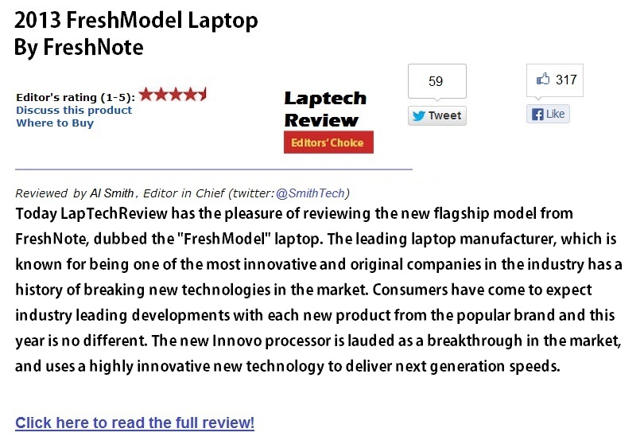

Sample Review #2 - A randomly chosen consumer review from CTechReviews.com, a website concerning user reviews for consumer technology:
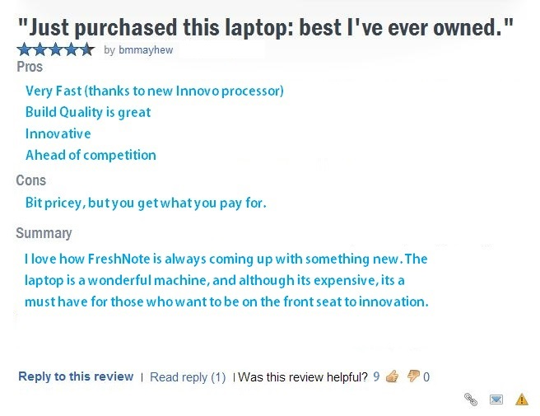
Version 2: Weak brand expectations
FreshNote Laptops is a leading laptop manufacturer in the laptop industry for the last 30 years. The company is positioned as a mid-range offering, with moderate prices. Below are samples of reviews concerning their new flagship offering on the laptop market, called the FreshModel, please read and consider them before continuing the survey.
Sample Review 1 - An excerpt from LapTechReview.com, an online news and product review website specializing in laptops:
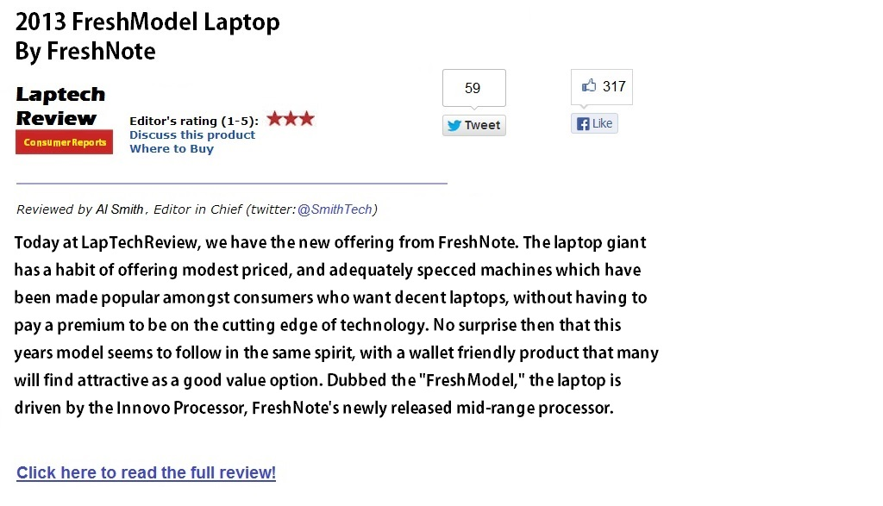
Sample Review #2 - A randomly chosen consumer review from CTechReviews.com, a website concerning user reviews for consumer technology:
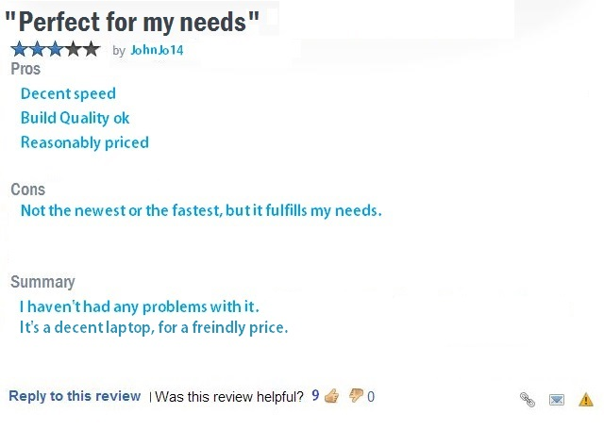
Based on the information presented in the previous page, please answer the following questions regarding your overall ATTITUDE of the brand FreshNote

Q1- My general opinion of FreshNote is:
- Very unfavorable (1)
- Unfavorable (2)
- Somewhat unfavorable (3)
- Neither favorable or unfavorable (4)
- Somewhat favorable (5)
- Favorable (6)
- Very favorable (7)

Q2- I feel that overall, FreshNote is:
- Very bad (1)
- Bad (2)
- Somewhat bad (3)
- Neither good or bad (4)
- Somewhat good (5)
- Good (6)
- Very good (7)

Q3- My overall view of FreshNote is:
- Very Negative (1)
- Negative (2)
- Somewhat Negative (3)
- Neither positive or Negative (4)
- Somewhat positive (5)
- Positive (6)
- Very positive (7)

Based on the information presented in the previous page, please answer the following questions regarding your overall TRUSTWORTHINESS of the FreshNote brand.

Q4- My general impression of FreshNote is that it is:
- Very Trustworthy (1)
- Trustworthy (2)
- Somewhat Trustworthy (3)
- Neither Trustworthy or Untrustworthy (4)
- Somewhat Untrustworthy (5)
- Untrustworthy (6)
- Very Untrustworthy (7)

Q5- My general impression of FreshNote is that it is:
- Very Dependable (1)
- Dependable (2)
- Somewhat Dependable (3)
- Neither Dependable nor Undependable (4)
- Somewhat Undependable (5)
- Undependable (6)
- Very Undependable (7)

Q6- My general impression of FreshNote is that it is:
- Very Reliable (1)
- Reliable (2)
- Somewhat Reliable (3)
- Neither Reliable nor Unreliable (4)
- Somewhat Unreliable (5)
- Unreliable (6)
- Very Unreliable (7)

Based on the information presented in the previous page, please answer the following questions about FreshNote regarding QUALITY

Q7- I would expect products from FreshNote to be:
- Very bad quality (1)
- Bad quality (2)
- Somewhat bad quality (3)
- Neither good or bad quality (4)
- Somewhat good quality (5)
- Good quality (6)
- Very good quality (7)

Q8- I would expect products from FreshNote to be:
- Very inferior (1)
- Inferior (2)
- Somewhat inferior (3)
- Neither superior or inferior (4)
- Somewhat superior (5)
- superior (6)
- Very superior (7)

Q9- I would expect products from FreshNote to be:
- Very poor (1)
- Poor (2)
- Somewhat poor (3)
- Neither excellent or poor (4)
- Somewhat excellent (5)
- excellent (6)
- Very excellent (7)

Presentation of news article concerning patent infringement accusation:
Please carefully read and consider the following newspaper article, before continuing with the survey:

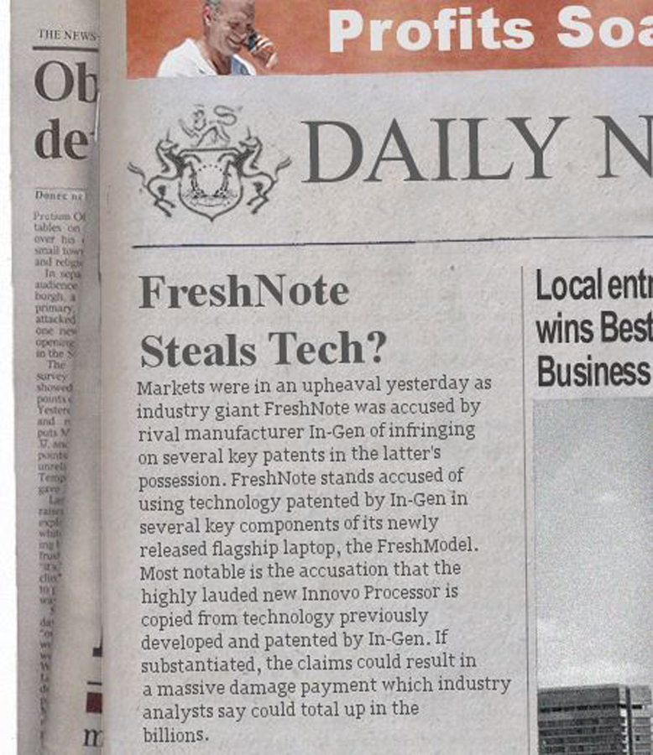

Given the new information presented in the previous article, please answer the following questions regarding your overall ATTITUDE of the brand FreshNote.

Q10- My general opinion of FreshNote is:
- Very unfavorable (1)
- Unfavorable (2)
- Somewhat unfavorable (3)
- Neither favorable or unfavorable (4)
- Somewhat favorable (5)
- Favorable (6)
- Very favorable (7)

Q11- I feel that overall, FreshNote is:
- Very bad (1)
- Bad (2)
- Somewhat bad (3)
- Neither good or bad (4)
- Somewhat good (5)
- Good (6)
- Very good (7)

Q12- My overall view of FreshNote is:
- Very Negative (1)
- Negative (2)
- Somewhat Negative (3)
- Neither positive or Negative (4)
- Somewhat positive (5)
- Positive (6)
- Very positive (7)

Given the new information presented in the previous article, please answer the following questions about FreshNote regarding QUALITY

Q13- I would expect products from FreshNote to be:
- Very bad quality (1)
- Bad quality (2)
- Somewhat bad quality (3)
- Neither good or bad quality (4)
- Somewhat good quality (5)
- Good quality (6)
- Very good quality (7)

Q14- I would expect products from FreshNote to be:
- Very inferior (1)
- Inferior (2)
- Somewhat inferior (3)
- Neither superior or inferior (4)
- Somewhat superior (5)
- superior (6)
- Very superior (7)

Q15- I would expect products from FreshNote to be:
- Very poor (1)
- Poor (2)
- Somewhat poor (3)
- Neither excellent or poor (4)
- Somewhat excellent (5)
- excellent (6)
- Very excellent (7)

Given the new information presented in the previous article, please answer the following questions regarding your overall TRUSTWORTHINESS of the FreshNote brand.

Q16- My general impression of FreshNote is that it is:
- Very Trustworthy (1)
- Trustworthy (2)
- Somewhat Trustworthy (3)
- Neither Trustworthy or Untrustworthy (4)
- Somewhat Untrustworthy (5)
- Untrustworthy (6)
- Very Untrustworthy (7)

Q17- My general impression of FreshNote is that it is:
- Very Dependable (1)
- Dependable (2)
- Somewhat Dependable (3)
- Neither Dependable nor Undependable (4)
- Somewhat Undependable (5)
- Undependable (6)
- Very Undependable (7)

Q18- My general impression of FreshNote is that it is:
- Very Reliable (1)
- Reliable (2)
- Somewhat Reliable (3)
- Neither Reliable nor Unreliable (4)
- Somewhat Unreliable (5)
- Unreliable (6)
- Very Unreliable (7)

Presentation of news article concerning patent infringement case verdict:

Please carefully read and consider the following newspaper article, before continuing with the survey:
Version 1: FreshNote wins the case
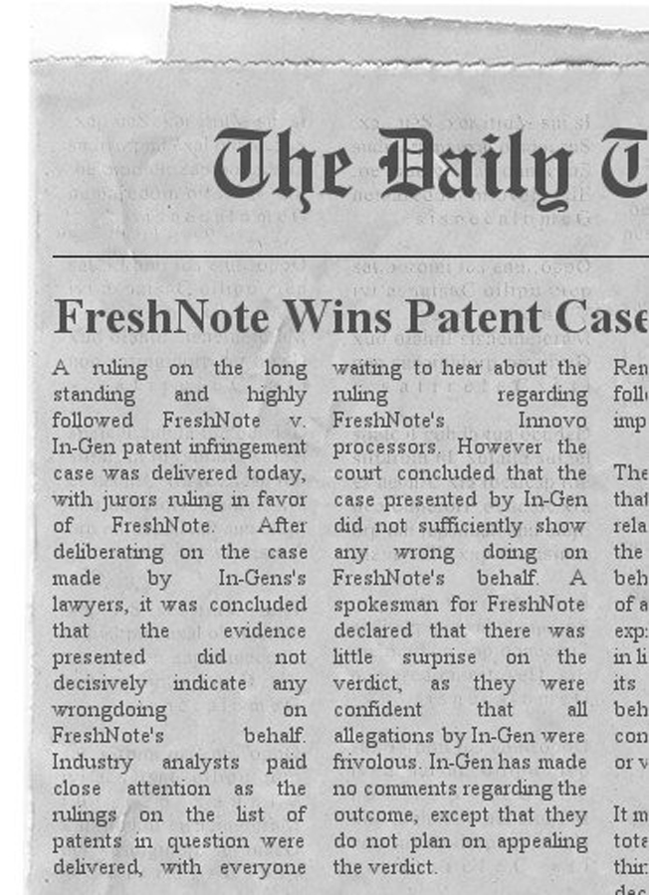

Version 2: FreshNote loses the case
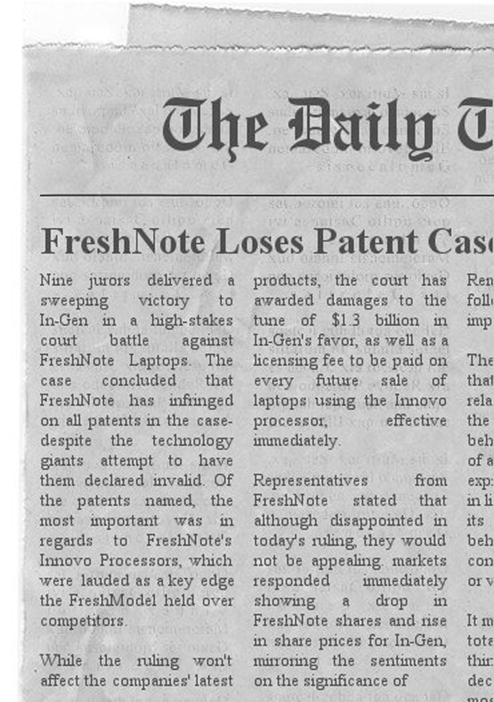

Given the new information presented in the previous article, please answer the following questions regarding your overall ATTITUDE of the brand FreshNote

Q19- My general opinion of FreshNote is:
- Very unfavorable (1)
- Unfavorable (2)
- Somewhat unfavorable (3)
- Neither favorable or unfavorable (4)
- Somewhat favorable (5)
- Favorable (6)
- Very favorable (7)

Q20- I feel that overall, FreshNote is:
- Very bad (1)
- Bad (2)
- Somewhat bad (3)
- Neither good or bad (4)
- Somewhat good (5)
- Good (6)
- Very good (7)

Q21- My overall view of FreshNote is:
- Very Negative (1)
- Negative (2)
- Somewhat Negative (3)
- Neither positive or Negative (4)
- Somewhat positive (5)
- Positive (6)
- Very positive (7)

Based on the information presented in the previous page, please answer the following questions regarding your overall TRUSTWORTHINESS of the FreshNote brand.

Q22- My general impression of FreshNote is that it is:
- Very Trustworthy (1)
- Trustworthy (2)
- Somewhat Trustworthy (3)
- Neither Trustworthy or Untrustworthy (4)
- Somewhat Untrustworthy (5)
- Untrustworthy (6)
- Very Untrustworthy (7)

Q23- My general impression of FreshNote is that it is:
- Very Dependable (1)
- Dependable (2)
- Somewhat Dependable (3)
- Neither Dependable nor Undependable (4)
- Somewhat Undependable (5)
- Undependable (6)
- Very Undependable (7)

Q24- My general impression of FreshNote is that it is:
- Very Reliable (1)
- Reliable (2)
- Somewhat Reliable (3)
- Neither Reliable nor Unreliable (4)
- Somewhat Unreliable (5)
- Unreliable (6)
- Very Unreliable (7)

Given the new information presented in the previous article, please answer the following questions about FreshNote regarding QUALITY

Q25- I would expect products from FreshNote to be:
- Very bad quality (1)
- Bad quality (2)
- Somewhat bad quality (3)
- Neither good or bad quality (4)
- Somewhat good quality (5)
- Good quality (6)
- Very good quality (7)

Q26- I would expect products from FreshNote to be:
- Very inferior (1)
- Inferior (2)
- Somewhat inferior (3)
- Neither superior or inferior (4)
- Somewhat superior (5)
- superior (6)
- Very superior (7)

Q27- I would expect products from FreshNote to be:
- Very poor (1)
- Poor (2)
- Somewhat poor (3)
- Neither excellent or poor (4)
- Somewhat excellent (5)
- excellent (6)
- Very excellent (7)

Below are some questions regarding patent infringement within the laptop industry, please read each statement before choosing an answer that you feel best completes each statement.

Q28- In the laptop industry, infringing on a competitors patents is an occurrence that is probably:
- Not at all frequent (1)
- Not frequent (2)
- Somewhat infrequent (3)
- Neither frequent nor infrequent (4)
- Somewhat frequent (5)
- Frequent (6)
- Very frequent (7)

Q29- Patent infringements within the laptop industry are:
- Not at all common (1)
- Uncommon (2)
- Somewhat uncommon (3)
- Neither common or uncommon (4)
- Somewhat common (5)
- Common (6)
- Very common (7)

Q30- Within the laptop industry, patent infringements are:
- Not at all widespread (1)
- Not widespread (2)
- Somewhat not widespread (3)
- Neither widespread, or not widespread (4)
- Somewhat widespread (5)
- Widespread (6)
- Very widespread (7)

Finally, please answer some short questions about yourself and your experience with laptops

Q31- Approximately how often do you purchase a new laptop or desktop pc?
- More than once a year (1)
- Once a year (2)
- Once every 2 years (3)
- Once every 3 years (4)
- Once every 4 years (5)
- Once every 5 years (6)
- Less than every 5 years (7)

Q32- If you were to purchase a laptop in the near future, what would plan on spending approximately?
- Less than 400 Euros (1)
- 400-600 Euros (2)
- 600-800 Euros (3)
- 800-1000 Euros (4)
- 1000-1200 Euros (5)
- more than 1200 Euros (6)

Q33- In to which age category do you fall?
- 18-34 (1)
- 35-44 (2)
- 45-54 (3)
- 55-64 (4)
- 65+ (5)
- prefer not to disclose (6)

Q34- What is your gender?
- Male (1)
- Female (2)
- Other (3)
- Prefer not to disclose (4)

This is the end of the survey, thank you so much for participating.

Appendix II: Factor Analysis and Outliers

Factor Analysis:

Step 1:

A factor analysis is conducted in order to explore if there are any underlying dimensions that may better fit the multi scale items. This analysis is conducted using a principal component extraction method, which gives the following results:

the Keiser-Meyer-Olkin measure is 0,871, which is adequate as its over 0,6.
Bartlets test of sphericity is significant.

scree plot:

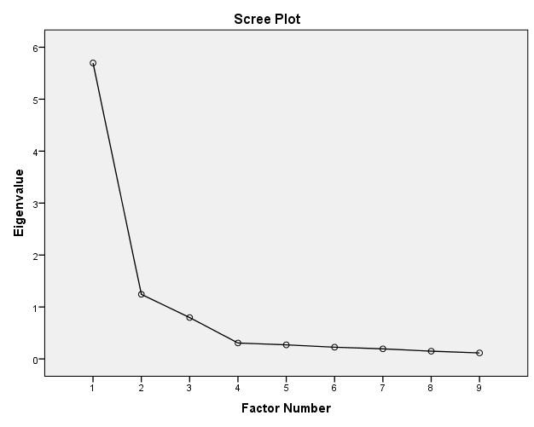

The scree plot shows one strong point, and 2 weaker points before the beginning of the scree.

Step 2:

The next step is to perform a confirmatory factor analysis. Choosing 3 factors, and choosing varimax rotation gives a rotated factor matrix as follows:

Rotated Factor Matrixª
 | Factor
 | 1 | 2 | 3
V20 | ,828 | ,229 | ,271
V19 | ,816 | ,258 | ,276
V18 | ,755 | ,145 | ,298
V23 | ,126 | ,894 | ,253
V24 | ,257 | ,833 | ,251
V22 | ,333 | ,686 | ,384
V16 | ,300 | ,300 | ,833
V14 | ,340 | ,308 | ,775
V15 | ,378 | ,341 | ,690
Extraction Method: Principal Axis Factoring.
Rotation Method: Varimax with Kaiser Normalization.
a. Rotation converged in 5 iterations.
The three factors correspond to the scale items of the three respective brand perception measurement constructs. This helps to indicate that there are no latent variables, and the scale items for the constructs are correctly designated.
Factor analysis of the second and third round of measurements revealed similar results, with the factor loads corresponding to the three constructs devised for the study.

Tests of Normality

Tests of Normality
 | Kolmogorov-Smirnovª |  |  | Shapiro-Wilk
 | Statistic | df | Sig. | Statistic | df | Sig.
1 AVG ATT | ,170 | 130 | ,000 | ,943 | 130 | ,000
1 AVG TRUST | ,151 | 130 | ,000 | ,936 | 130 | ,000
1 AVG QUAL | ,099 | 130 | ,003 | ,983 | 130 | ,110
2 AVG ATT | ,098 | 130 | ,004 | ,975 | 130 | ,018
2 AVG QUAL | ,109 | 130 | ,001 | ,967 | 130 | ,003
2 AVG TRUST | ,074 | 130 | ,076 | ,982 | 130 | ,086
3 AVG ATT | ,101 | 130 | ,002 | ,970 | 130 | ,005
3 AVG TRUST | ,096 | 130 | ,005 | ,962 | 130 | ,001
3 AVG QUAL | ,152 | 130 | ,000 | ,960 | 130 | ,001
BASE RATE | ,164 | 130 | ,000 | ,957 | 130 | ,000
a. Lilliefors Significance Correction

When all the measurements are looked at individually divided by time of collection (initial / after accusation / after verdict) almost all items are differ significantly from normally distribution based on Shapiro-wilk test. Only Quality perception measured at the beginning of the survey and Brand trust measured after the infringement accusation are significant for the null hypothesis of normality. This violation of the normal distribution assumption is acceptable for the purpose of this thesis, however it should be noted as a limitation.

This is supported by the fact that when all the measurements are aggregated (irrespective of when they were measured) we find that all three constructs provide significantly normal distributions:

Tests of Normality
 | Kolmogorov-Smirnovª |  |  | Shapiro-Wilk
 | Statistic | df | Sig. | Statistic | df | Sig.
1 AVG ATT | ,124 | 390 | ,000 | ,972 | 390 | ,000
1 AVG TRUST | ,098 | 390 | ,000 | ,969 | 390 | ,000
1 AVG QUAL | ,108 | 390 | ,000 | ,979 | 390 | ,000
a. Lilliefors Significance Correction
Furthermore, all the histograms of both aggregated and non aggregated results show distributions which follow approximately normal curves. As well as having Q-Q plots which have observations close to the line, indicating normal distribution.

Checking for multicollinearity

Coefficientsª
Model |  | Collinearity Statistics
 |  | Tolerance | VIF
1 | Base Rate | ,953 | 1,049
 | Laptop Purchase Frequency | ,873 | 1,145
 | Laptop Budget | ,883 | 1,132
 | Age Category | ,998 | 1,002
 | Gender | ,998 | 1,002
a. Dependent Variable: 1 AVG ATT

Coefficientsª
Model |  | Collinearity Statistics
 |  | Tolerance | VIF
1 | Base Rate | ,930 | 1,076
 | Laptop Purchase Frequency | ,869 | 1,151
 | Laptop Budget | ,877 | 1,140
 | Age Category | ,997 | 1,003
 | Expectations | ,966 | 1,035
 | Court Conclusion | ,991 | 1,009
a. Dependent Variable: 1 AVG QUAL

Coefficientsª
Model |  | Collinearity Statistics
 |  | Tolerance | VIF
1 | Base Rate | ,930 | 1,076
 | Laptop Purchase Frequency | ,869 | 1,151
 | Laptop Budget | ,877 | 1,140
 | Age Category | ,997 | 1,003
 | Expectations | ,966 | 1,035
 | Court Conclusion | ,991 | 1,009
a. Dependent Variable: 1 AVG TRUST

VIF's are all well bellow the threshhold of 3. So no multicollinearity amongst predictor variables

Outliers

Box plots:

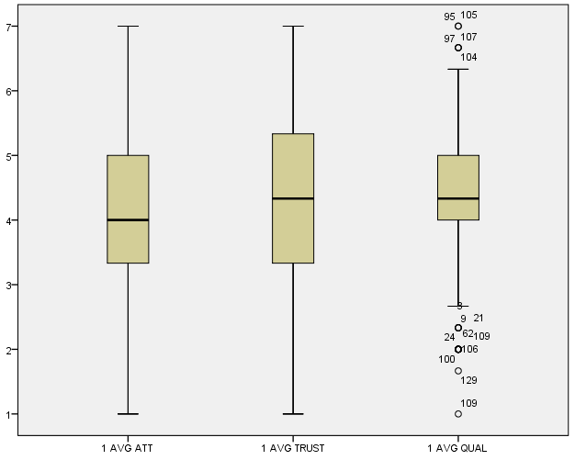

Appendix III: Mixed Design ANOVA

Test 1 (Time 1 to Time 2)

Attitude :

Tests of Within-Subjects Effects
Measure: attitude
Source |  | Type III Sum of Squares | df | Mean Square | F | Sig.
time | Sphericity Assumed | 9,564 | 1 | 9,564 | 15,226 | ,000
 | Greenhouse-Geisser | 9,564 | 1,000 | 9,564 | 15,226 | ,000
 | Huynh-Feldt | 9,564 | 1,000 | 9,564 | 15,226 | ,000
 | Lower-bound | 9,564 | 1,000 | 9,564 | 15,226 | ,000
time * @BASERATE | Sphericity Assumed | 3,327 | 1 | 3,327 | 5,297 | ,023
 | Greenhouse-Geisser | 3,327 | 1,000 | 3,327 | 5,297 | ,023
 | Huynh-Feldt | 3,327 | 1,000 | 3,327 | 5,297 | ,023
 | Lower-bound | 3,327 | 1,000 | 3,327 | 5,297 | ,023
time * PURCHASEFREQ | Sphericity Assumed | ,228 | 1 | ,228 | ,364 | ,548
 | Greenhouse-Geisser | ,228 | 1,000 | ,228 | ,364 | ,548
 | Huynh-Feldt | ,228 | 1,000 | ,228 | ,364 | ,548
 | Lower-bound | ,228 | 1,000 | ,228 | ,364 | ,548
time * LAPTOPBUDGET | Sphericity Assumed | 1,112 | 1 | 1,112 | 1,771 | ,186
 | Greenhouse-Geisser | 1,112 | 1,000 | 1,112 | 1,771 | ,186
 | Huynh-Feldt | 1,112 | 1,000 | 1,112 | 1,771 | ,186
 | Lower-bound | 1,112 | 1,000 | 1,112 | 1,771 | ,186
time * AGECAT | Sphericity Assumed | 2,182 | 1 | 2,182 | 3,473 | ,065
 | Greenhouse-Geisser | 2,182 | 1,000 | 2,182 | 3,473 | ,065
 | Huynh-Feldt | 2,182 | 1,000 | 2,182 | 3,473 | ,065
 | Lower-bound | 2,182 | 1,000 | 2,182 | 3,473 | ,065
time * GENDER | Sphericity Assumed | ,533 | 1 | ,533 | ,848 | ,359
 | Greenhouse-Geisser | ,533 | 1,000 | ,533 | ,848 | ,359
 | Huynh-Feldt | ,533 | 1,000 | ,533 | ,848 | ,359
 | Lower-bound | ,533 | 1,000 | ,533 | ,848 | ,359
time * STRONG | Sphericity Assumed | 3,363 | 1 | 3,363 | 5,354 | ,022
 | Greenhouse-Geisser | 3,363 | 1,000 | 3,363 | 5,354 | ,022
 | Huynh-Feldt | 3,363 | 1,000 | 3,363 | 5,354 | ,022
 | Lower-bound | 3,363 | 1,000 | 3,363 | 5,354 | ,022
Error(time) | Sphericity Assumed | 77,258 | 123 | ,628
 | Greenhouse-Geisser | 77,258 | 123,000 | ,628
 | Huynh-Feldt | 77,258 | 123,000 | ,628
 | Lower-bound | 77,258 | 123,000 | ,628

Descriptive Statistics
 | STRONG OR WEAK | Mean | Std. Deviation | N
1 AVG ATT | Weak | 4,763285 | 1,0832978 | 69
 | Strong | 5,087432 | 1,0127002 | 61
 | Total | 4,915385 | 1,0592373 | 130
2 AVG ATT | Weak | 3,695652 | 1,0583301 | 69
 | Strong | 3,666667 | 1,2125883 | 61
 | Total | 3,682051 | 1,1289485 | 130
We can see from the results above that there is a significant difference between the mean scores of brand attitude in time 1 and 2 (P=0.00) due to the patent infringement accusation. Furthermore there is also a significant effect of both brand expectations (P=0.022) as well as respondent base-rate (P=0.023) on the change of mean scores.
Initial mean scores awarded for brand attitude were 5,087 for firms with strong expectations which dropped to 3,667
Initial mean scores awarded for brand attitude for weak firms was 4,763 which dropped to 3,696 after the accusation

Base rates were rounded, and their respective average change in brand attitude scores calculated to give the following table:

Base-Rate | Change in average score
1 | NA
2 | -0,667
3 | -1,5
4 | -1,857
5 | -1,55
6 | -0,967
7 | -0,7

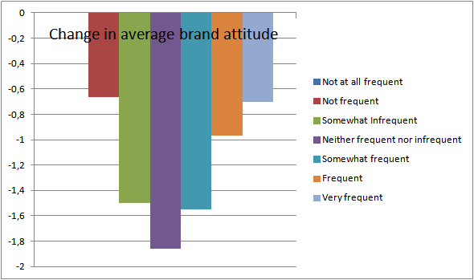

We see from the above table and chart, that there is a very clear pattern. Those respondents with the most neutral base-rates had the most significant average drop in brand attitude due to the patent infringement accusation. While those whose base-rates fit into the more extreme brackets of low and high base-rates had increasingly lower drops in attitude as they moved away from the neutral middle in either direction.

r (time*baserate)= sqrt [ F(1,dfR) / F(1,dfR) + dfR ]

r (time*baserate)= sqrt [ 5.297 / 5.297 + 121 ]

r (time*baserate)= 0.205

which is small (>.10)

r (time*strong)= sqrt [ F(1,dfR) / F(1,dfR) + dfR ]

r (time*strong)= sqrt [ 5.354 / 5.354 + 121 ]

r (time*strong)= 0.206

which is small (>.10)

Trustworthiness:

Tests of Within-Subjects Effects
Measure: trustworthiness
Source |  | Type III Sum of Squares | df | Mean Square | F | Sig.
time | Sphericity Assumed | 5,748 | 1 | 5,748 | 8,701 | ,004
 | Greenhouse-Geisser | 5,748 | 1,000 | 5,748 | 8,701 | ,004
 | Huynh-Feldt | 5,748 | 1,000 | 5,748 | 8,701 | ,004
 | Lower-bound | 5,748 | 1,000 | 5,748 | 8,701 | ,004
time * @BASERATE | Sphericity Assumed | 2,637 | 1 | 2,637 | 3,992 | ,048
 | Greenhouse-Geisser | 2,637 | 1,000 | 2,637 | 3,992 | ,048
 | Huynh-Feldt | 2,637 | 1,000 | 2,637 | 3,992 | ,048
 | Lower-bound | 2,637 | 1,000 | 2,637 | 3,992 | ,048
time * PURCHASEFREQ | Sphericity Assumed | ,412 | 1 | ,412 | ,624 | ,431
 | Greenhouse-Geisser | ,412 | 1,000 | ,412 | ,624 | ,431
 | Huynh-Feldt | ,412 | 1,000 | ,412 | ,624 | ,431
 | Lower-bound | ,412 | 1,000 | ,412 | ,624 | ,431
time * LAPTOPBUDGET | Sphericity Assumed | ,035 | 1 | ,035 | ,052 | ,819
 | Greenhouse-Geisser | ,035 | 1,000 | ,035 | ,052 | ,819
 | Huynh-Feldt | ,035 | 1,000 | ,035 | ,052 | ,819
 | Lower-bound | ,035 | 1,000 | ,035 | ,052 | ,819
time * AGECAT | Sphericity Assumed | ,237 | 1 | ,237 | ,359 | ,550
 | Greenhouse-Geisser | ,237 | 1,000 | ,237 | ,359 | ,550
 | Huynh-Feldt | ,237 | 1,000 | ,237 | ,359 | ,550
 | Lower-bound | ,237 | 1,000 | ,237 | ,359 | ,550
time * GENDER | Sphericity Assumed | ,116 | 1 | ,116 | ,175 | ,676
 | Greenhouse-Geisser | ,116 | 1,000 | ,116 | ,175 | ,676
 | Huynh-Feldt | ,116 | 1,000 | ,116 | ,175 | ,676
 | Lower-bound | ,116 | 1,000 | ,116 | ,175 | ,676
time * STRONG | Sphericity Assumed | 1,121 | 1 | 1,121 | 1,697 | ,195
 | Greenhouse-Geisser | 1,121 | 1,000 | 1,121 | 1,697 | ,195
 | Huynh-Feldt | 1,121 | 1,000 | 1,121 | 1,697 | ,195
 | Lower-bound | 1,121 | 1,000 | 1,121 | 1,697 | ,195
Error(time) | Sphericity Assumed | 81,257 | 123 | ,661
 | Greenhouse-Geisser | 81,257 | 123,000 | ,661
 | Huynh-Feldt | 81,257 | 123,000 | ,661
 | Lower-bound | 81,257 | 123,000 | ,661

Descriptive Statistics
 | STRONG OR WEAK | Mean | Std. Deviation | N
1 AVG TRUST | Weak | 5,038647 | 1,0518211 | 69
 | Strong | 4,950820 | 1,1052670 | 61
 | Total | 4,997436 | 1,0739225 | 130
2 AVG TRUST | Weak | 4,009662 | 1,1645233 | 69
 | Strong | 3,715847 | 1,1576414 | 61
 | Total | 3,871795 | 1,1661199 | 130

Levene's Test of Equality of Error Variancesª
 | F | df1 | df2 | Sig.
1 AVG TRUST | 1,280 | 1 | 128 | ,260
2 AVG TRUST | ,000 | 1 | 128 | ,990
Tests the null hypothesis that the error variance of the dependent variable is equal across groups.
a. Design: Intercept + @BASERATE + PURCHASEFREQ + LAPTOPBUDGET + AGECAT + GENDER + STRONG
Within Subjects Design: time

Tests of Between-Subjects Effects
Measure: trustworthiness
Transformed Variable: Average
Source | Type III Sum of Squares | df | Mean Square | F | Sig.
Intercept | 48,575 | 1 | 48,575 | 51,955 | ,000
@BASERATE | ,883 | 1 | ,883 | ,944 | ,333
PURCHASEFREQ | ,049 | 1 | ,049 | ,052 | ,820
LAPTOPBUDGET | ,556 | 1 | ,556 | ,594 | ,442
AGECAT | 1,020 | 1 | 1,020 | 1,091 | ,298
GENDER | ,373 | 1 | ,373 | ,398 | ,529
STRONG | ,874 | 1 | ,874 | ,935 | ,335
Error | 114,998 | 123 | ,935
We can see from the results above that there is a significant difference between the mean scores of brand attitude in time 1 and 2 (P=0.066) due to the patent infringement accusation. Furthermore there is also a significant effect of respondent base-rate (P=0.031) on the change of mean scores.
Respondent average brand trustworthiness scores go from 4,997 before the accusation to 3,872 after the accusation

levene's test shows that variances are homogenous for all levels of the repeated measures variables (because all significance values are greater than .05).

Base rates were rounded, and their respective average change in brand trustworthiness scores calculated to give the following table:

Base-rate | Change in average score
1 | NA
2 | -1,0
3 | -0,75
4 | -1,81
5 | -1,23
6 | -0,93
7 | -0,3

Plot of the change in mean scores per base-rate group

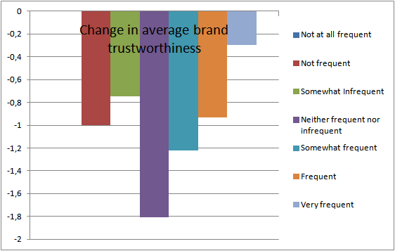

Similar to brand attitude, We see from the above table and chart, that there is a very clear pattern. Those respondents with the most neutral base-rates had the most significant average drop in brand attitude due to the patent infringement accusation. While those whose base-rates fit into the more extreme brackets of low and high base-rates had increasingly lower drops in attitude as they moved away from the neutral middle in either direction.

Perceived Quality:

Tests of Within-Subjects Effects
Measure: qual
Source |  | Type III Sum of Squares | df | Mean Square | F | Sig.
time | Sphericity Assumed | 5,610E-005 | 1 | 5,610E-005 | ,000 | ,989
 | Greenhouse-Geisser | 5,610E-005 | 1,000 | 5,610E-005 | ,000 | ,989
 | Huynh-Feldt | 5,610E-005 | 1,000 | 5,610E-005 | ,000 | ,989
 | Lower-bound | 5,610E-005 | 1,000 | 5,610E-005 | ,000 | ,989
time * @BASERATE | Sphericity Assumed | ,193 | 1 | ,193 | ,671 | ,414
 | Greenhouse-Geisser | ,193 | 1,000 | ,193 | ,671 | ,414
 | Huynh-Feldt | ,193 | 1,000 | ,193 | ,671 | ,414
 | Lower-bound | ,193 | 1,000 | ,193 | ,671 | ,414
time * PURCHASEFREQ | Sphericity Assumed | ,748 | 1 | ,748 | 2,595 | ,110
 | Greenhouse-Geisser | ,748 | 1,000 | ,748 | 2,595 | ,110
 | Huynh-Feldt | ,748 | 1,000 | ,748 | 2,595 | ,110
 | Lower-bound | ,748 | 1,000 | ,748 | 2,595 | ,110
time * LAPTOPBUDGET | Sphericity Assumed | ,395 | 1 | ,395 | 1,371 | ,244
 | Greenhouse-Geisser | ,395 | 1,000 | ,395 | 1,371 | ,244
 | Huynh-Feldt | ,395 | 1,000 | ,395 | 1,371 | ,244
 | Lower-bound | ,395 | 1,000 | ,395 | 1,371 | ,244
time * AGECAT | Sphericity Assumed | ,059 | 1 | ,059 | ,203 | ,653
 | Greenhouse-Geisser | ,059 | 1,000 | ,059 | ,203 | ,653
 | Huynh-Feldt | ,059 | 1,000 | ,059 | ,203 | ,653
 | Lower-bound | ,059 | 1,000 | ,059 | ,203 | ,653
time * GENDER | Sphericity Assumed | ,359 | 1 | ,359 | 1,245 | ,267
 | Greenhouse-Geisser | ,359 | 1,000 | ,359 | 1,245 | ,267
 | Huynh-Feldt | ,359 | 1,000 | ,359 | 1,245 | ,267
 | Lower-bound | ,359 | 1,000 | ,359 | 1,245 | ,267
time * STRONG | Sphericity Assumed | 3,692 | 1 | 3,692 | 12,817 | ,000
 | Greenhouse-Geisser | 3,692 | 1,000 | 3,692 | 12,817 | ,000
 | Huynh-Feldt | 3,692 | 1,000 | 3,692 | 12,817 | ,000
 | Lower-bound | 3,692 | 1,000 | 3,692 | 12,817 | ,000
Error(time) | Sphericity Assumed | 35,435 | 123 | ,288
 | Greenhouse-Geisser | 35,435 | 123,000 | ,288
 | Huynh-Feldt | 35,435 | 123,000 | ,288
 | Lower-bound | 35,435 | 123,000 | ,288

Descriptive Statistics
 | STRONG OR WEAK | Mean | Std. Deviation | N
1 AVG QUAL | Weak | 4,270531 | ,7415656 | 69
 | Strong | 5,273224 | 1,0027891 | 61
 | Total | 4,741026 | 1,0049536 | 130
2 AVG QUAL | Weak | 4,062802 | ,9467443 | 69
 | Strong | 4,584699 | 1,0482008 | 61
 | Total | 4,307692 | 1,0256112 | 130
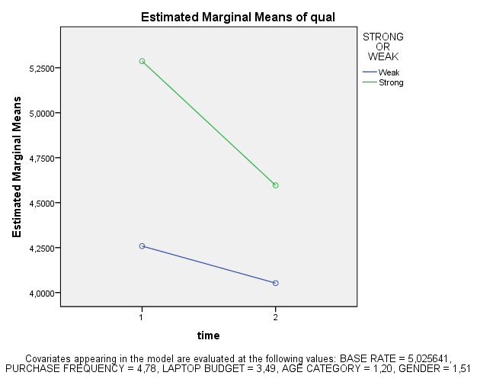

Levene's Test of Equality of Error Variancesª
 | F | df1 | df2 | Sig.
1 AVG QUAL | 6,919 | 1 | 128 | ,010
2 AVG QUAL | 1,966 | 1 | 128 | ,163
Tests the null hypothesis that the error variance of the dependent variable is equal across groups.
a. Design: Intercept + @BASERATE + PURCHASEFREQ + LAPTOPBUDGET + AGECAT + GENDER + STRONG
Within Subjects Design: time

Tests of Between-Subjects Effects
Measure: qual
Transformed Variable: Average
Source | Type III Sum of Squares | df | Mean Square | F | Sig.
Intercept | 50,572 | 1 | 50,572 | 67,042 | ,000
@BASERATE | ,567 | 1 | ,567 | ,752 | ,388
PURCHASEFREQ | ,248 | 1 | ,248 | ,329 | ,567
LAPTOPBUDGET | ,123 | 1 | ,123 | ,163 | ,687
AGECAT | ,136 | 1 | ,136 | ,180 | ,672
GENDER | ,091 | 1 | ,091 | ,121 | ,729
STRONG | 19,428 | 1 | 19,428 | 25,755 | ,000
Error | 92,783 | 123 | ,754
Conclusion: We see that the main within factor effect of the patent infringement by itself does not produce any significant changes in perceptions of quality. However, we do see that there is a significant interaction between time and STRONG (p=0,00). This indicates that there is a significant difference in the change in mean scores awarded before and after the patent infringement accusation depending on respondent expectations, but not by the patent infringement accusation by itself alone.
Strong expectations: respondents have a average perception of quality score of 5.273 at initial measurement, which drops to 4.585 after the accusation

Weak expectations: respondents have a average perception of quality score of 4.271 at initial measurement, which drops to 4.063 after the accusation

Test 2 (Time 2 to Time 3)

Attitude:

Tests of Within-Subjects Effects
Measure: Attitude
Source |  | Type III Sum of Squares | df | Mean Square | F | Sig.
TIME | Sphericity Assumed | 1,408 | 1 | 1,408 | 3,735 | ,056
 | Greenhouse-Geisser | 1,408 | 1,000 | 1,408 | 3,735 | ,056
 | Huynh-Feldt | 1,408 | 1,000 | 1,408 | 3,735 | ,056
 | Lower-bound | 1,408 | 1,000 | 1,408 | 3,735 | ,056
TIME * PURCHASEFREQ | Sphericity Assumed | ,377 | 1 | ,377 | 1,001 | ,319
 | Greenhouse-Geisser | ,377 | 1,000 | ,377 | 1,001 | ,319
 | Huynh-Feldt | ,377 | 1,000 | ,377 | 1,001 | ,319
 | Lower-bound | ,377 | 1,000 | ,377 | 1,001 | ,319
TIME * LAPTOPBUDGET | Sphericity Assumed | ,140 | 1 | ,140 | ,372 | ,543
 | Greenhouse-Geisser | ,140 | 1,000 | ,140 | ,372 | ,543
 | Huynh-Feldt | ,140 | 1,000 | ,140 | ,372 | ,543
 | Lower-bound | ,140 | 1,000 | ,140 | ,372 | ,543
TIME * AGECAT | Sphericity Assumed | 1,380 | 1 | 1,380 | 3,662 | ,058
 | Greenhouse-Geisser | 1,380 | 1,000 | 1,380 | 3,662 | ,058
 | Huynh-Feldt | 1,380 | 1,000 | 1,380 | 3,662 | ,058
 | Lower-bound | 1,380 | 1,000 | 1,380 | 3,662 | ,058
TIME * GENDER | Sphericity Assumed | ,005 | 1 | ,005 | ,013 | ,908
 | Greenhouse-Geisser | ,005 | 1,000 | ,005 | ,013 | ,908
 | Huynh-Feldt | ,005 | 1,000 | ,005 | ,013 | ,908
 | Lower-bound | ,005 | 1,000 | ,005 | ,013 | ,908
TIME * @BASERATE | Sphericity Assumed | ,162 | 1 | ,162 | ,430 | ,513
 | Greenhouse-Geisser | ,162 | 1,000 | ,162 | ,430 | ,513
 | Huynh-Feldt | ,162 | 1,000 | ,162 | ,430 | ,513
 | Lower-bound | ,162 | 1,000 | ,162 | ,430 | ,513
TIME * WIN | Sphericity Assumed | 27,738 | 1 | 27,738 | 73,587 | ,000
 | Greenhouse-Geisser | 27,738 | 1,000 | 27,738 | 73,587 | ,000
 | Huynh-Feldt | 27,738 | 1,000 | 27,738 | 73,587 | ,000
 | Lower-bound | 27,738 | 1,000 | 27,738 | 73,587 | ,000
TIME * STRONG | Sphericity Assumed | ,067 | 1 | ,067 | ,179 | ,673
 | Greenhouse-Geisser | ,067 | 1,000 | ,067 | ,179 | ,673
 | Huynh-Feldt | ,067 | 1,000 | ,067 | ,179 | ,673
 | Lower-bound | ,067 | 1,000 | ,067 | ,179 | ,673
TIME * WIN * STRONG | Sphericity Assumed | ,506 | 1 | ,506 | 1,342 | ,249
 | Greenhouse-Geisser | ,506 | 1,000 | ,506 | 1,342 | ,249
 | Huynh-Feldt | ,506 | 1,000 | ,506 | 1,342 | ,249
 | Lower-bound | ,506 | 1,000 | ,506 | 1,342 | ,249
Error(TIME) | Sphericity Assumed | 45,609 | 121 | ,377
 | Greenhouse-Geisser | 45,609 | 121,000 | ,377
 | Huynh-Feldt | 45,609 | 121,000 | ,377
 | Lower-bound | 45,609 | 121,000 | ,377

Main within measure of time is not significant (barely), but interaction term of time*win is (p=0.00). What it basically means, that if we ignore whether the company win or lost the patent case, then there was no (barely) significant change in brand attitude scores awarded from period two to three. However, The significant interaction between TIME and WIN tells us that (although there is no significant difference in attitude scores going from time 2 to 3) there is a significant difference depending on whether the firm won or lost the case.

Brand attitude goes from a mean score of 3.682 in period 2 to 3.292 if the firm loses in period 3 or 4.600 if they win

r (time*win)= sqrt [ F(1,dfR) / F(1,dfR) + dfR ]

r (time*win)= sqrt [ 73.587 / 73.587 + 121 ]

r (time*win)= 0.615

which is large (>0.5)

now we look at the main effect of WIN. levene's test shows that variances are homogenous for all levels of the repeated measures variables (because all significance values are greater than .05).

Levene's Test of Equality of Error Variancesª
 | F | df1 | df2 | Sig.
2 AVG ATT | 2,582 | 3 | 126 | ,056
3 AVG ATT | ,177 | 3 | 126 | ,912
Tests the null hypothesis that the error variance of the dependent variable is equal across groups.
a. Design: Intercept + PURCHASEFREQ + LAPTOPBUDGET + AGECAT + GENDER + @BASERATE + WIN + STRONG + WIN * STRONG
Within Subjects Design: TIME

Tests of Between-Subjects Effects
Measure: Attitude
Transformed Variable: Average
Source | Type III Sum of Squares | df | Mean Square | F | Sig.
Intercept | 21,457 | 1 | 21,457 | 19,810 | ,000
PURCHASEFREQ | ,076 | 1 | ,076 | ,070 | ,792
LAPTOPBUDGET | ,114 | 1 | ,114 | ,105 | ,746
AGECAT | 2,505 | 1 | 2,505 | 2,312 | ,131
GENDER | ,015 | 1 | ,015 | ,014 | ,908
@BASERATE | ,324 | 1 | ,324 | ,299 | ,586
WIN | 14,395 | 1 | 14,395 | 13,290 | ,000
STRONG | ,064 | 1 | ,064 | ,059 | ,809
WIN * STRONG | 1,821 | 1 | 1,821 | 1,682 | ,197
Error | 131,059 | 121 | 1,083

Win has a significant main effect. This tells us that if we ignored all other variables, the ratings of those firms which won were significantly different from those who lost.

Descriptive Statistics
 | WIN OR LOSE | STRONG OR WEAK | Mean | Std. Deviation | N
2 AVG ATT | Lose | Weak | 3,808081 | 1,0770017 | 33
 |  | Strong | 3,541667 | 1,3407054 | 32
 |  | Total | 3,676923 | 1,2118759 | 65
 | Win | Weak | 3,592593 | 1,0453559 | 36
 |  | Strong | 3,804598 | 1,0597890 | 29
 |  | Total | 3,687179 | 1,0489362 | 65
 | Total | Weak | 3,695652 | 1,0583301 | 69
 |  | Strong | 3,666667 | 1,2125883 | 61
 |  | Total | 3,682051 | 1,1289485 | 130
3 AVG ATT | Lose | Weak | 3,464646 | 1,1635058 | 33
 |  | Strong | 3,114583 | 1,1658503 | 32
 |  | Total | 3,292308 | 1,1689081 | 65
 | Win | Weak | 4,444444 | 1,0047506 | 36
 |  | Strong | 4,793103 | 1,0853051 | 29
 |  | Total | 4,600000 | 1,0478152 | 65
 | Total | Weak | 3,975845 | 1,1831039 | 69
 |  | Strong | 3,912568 | 1,4022490 | 61
 |  | Total | 3,946154 | 1,2858495 | 130

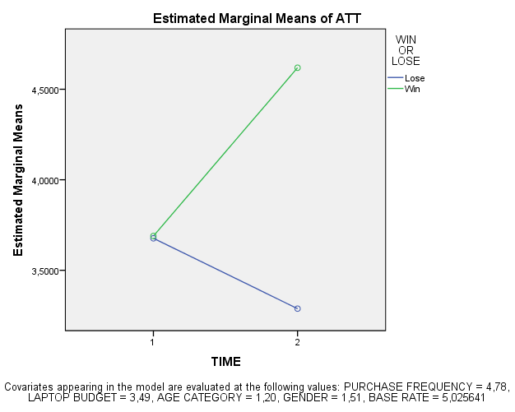

Trustworthiness:

Tests of Within-Subjects Effects
Measure: Trsutworthiness
Source |  | Type III Sum of Squares | df | Mean Square | F | Sig.
TIME | Sphericity Assumed | 2,052 | 1 | 2,052 | 4,937 | ,028
 | Greenhouse-Geisser | 2,052 | 1,000 | 2,052 | 4,937 | ,028
 | Huynh-Feldt | 2,052 | 1,000 | 2,052 | 4,937 | ,028
 | Lower-bound | 2,052 | 1,000 | 2,052 | 4,937 | ,028
TIME * PURCHASEFREQ | Sphericity Assumed | 1,482 | 1 | 1,482 | 3,565 | ,061
 | Greenhouse-Geisser | 1,482 | 1,000 | 1,482 | 3,565 | ,061
 | Huynh-Feldt | 1,482 | 1,000 | 1,482 | 3,565 | ,061
 | Lower-bound | 1,482 | 1,000 | 1,482 | 3,565 | ,061
TIME * LAPTOPBUDGET | Sphericity Assumed | ,352 | 1 | ,352 | ,847 | ,359
 | Greenhouse-Geisser | ,352 | 1,000 | ,352 | ,847 | ,359
 | Huynh-Feldt | ,352 | 1,000 | ,352 | ,847 | ,359
 | Lower-bound | ,352 | 1,000 | ,352 | ,847 | ,359
TIME * AGECAT | Sphericity Assumed | ,006 | 1 | ,006 | ,015 | ,903
 | Greenhouse-Geisser | ,006 | 1,000 | ,006 | ,015 | ,903
 | Huynh-Feldt | ,006 | 1,000 | ,006 | ,015 | ,903
 | Lower-bound | ,006 | 1,000 | ,006 | ,015 | ,903
TIME * GENDER | Sphericity Assumed | ,002 | 1 | ,002 | ,004 | ,947
 | Greenhouse-Geisser | ,002 | 1,000 | ,002 | ,004 | ,947
 | Huynh-Feldt | ,002 | 1,000 | ,002 | ,004 | ,947
 | Lower-bound | ,002 | 1,000 | ,002 | ,004 | ,947
TIME * @BASERATE | Sphericity Assumed | ,329 | 1 | ,329 | ,791 | ,375
 | Greenhouse-Geisser | ,329 | 1,000 | ,329 | ,791 | ,375
 | Huynh-Feldt | ,329 | 1,000 | ,329 | ,791 | ,375
 | Lower-bound | ,329 | 1,000 | ,329 | ,791 | ,375
TIME * WIN | Sphericity Assumed | 22,337 | 1 | 22,337 | 53,737 | ,000
 | Greenhouse-Geisser | 22,337 | 1,000 | 22,337 | 53,737 | ,000
 | Huynh-Feldt | 22,337 | 1,000 | 22,337 | 53,737 | ,000
 | Lower-bound | 22,337 | 1,000 | 22,337 | 53,737 | ,000
TIME * STRONG | Sphericity Assumed | 1,342 | 1 | 1,342 | 3,229 | ,075
 | Greenhouse-Geisser | 1,342 | 1,000 | 1,342 | 3,229 | ,075
 | Huynh-Feldt | 1,342 | 1,000 | 1,342 | 3,229 | ,075
 | Lower-bound | 1,342 | 1,000 | 1,342 | 3,229 | ,075
TIME * WIN * STRONG | Sphericity Assumed | ,619 | 1 | ,619 | 1,490 | ,225
 | Greenhouse-Geisser | ,619 | 1,000 | ,619 | 1,490 | ,225
 | Huynh-Feldt | ,619 | 1,000 | ,619 | 1,490 | ,225
 | Lower-bound | ,619 | 1,000 | ,619 | 1,490 | ,225
Error(TIME) | Sphericity Assumed | 50,297 | 121 | ,416
 | Greenhouse-Geisser | 50,297 | 121,000 | ,416
 | Huynh-Feldt | 50,297 | 121,000 | ,416
 | Lower-bound | 50,297 | 121,000 | ,416

Main within measures factor is significant (TIME has p=0.028), as well as TIME*WIN being significant (p=0.00). This means that the two measurements of brand attitude differ significantly. And depending on whether the firm wins or loses the case also differs significantly.

r (time*win)= sqrt [ F(1,dfR) / F(1,dfR) + dfR ]

r (time*win)= sqrt [ 53.737 / 53.737 + 121 ]

r (time*win)= 0.555

which is large (>0.5)

now we look at the main effect of WIN. levene's test shows that variances are homogenous for all levels of the repeated measures variables (because all significance values are greater than .05).

Levene's Test of Equality of Error Variancesª
 | F | df1 | df2 | Sig.
2 AVG TRUST | 1,365 | 3 | 126 | ,257
3 AVG TRUST | ,279 | 3 | 126 | ,841
Tests the null hypothesis that the error variance of the dependent variable is equal across groups.
a. Design: Intercept + PURCHASEFREQ + LAPTOPBUDGET + AGECAT + GENDER + @BASERATE + WIN + STRONG + WIN * STRONG
Within Subjects Design: TIME

Tests of Between-Subjects Effects
Measure: TRUST
Transformed Variable: Average
Source | Type III Sum of Squares | df | Mean Square | F | Sig.
Intercept | 39,575 | 1 | 39,575 | 36,287 | ,000
PURCHASEFREQ | ,048 | 1 | ,048 | ,044 | ,834
LAPTOPBUDGET | 1,820 | 1 | 1,820 | 1,669 | ,199
AGECAT | 1,438 | 1 | 1,438 | 1,318 | ,253
GENDER | ,830 | 1 | ,830 | ,761 | ,385
@BASERATE | ,034 | 1 | ,034 | ,031 | ,860
WIN | 7,023 | 1 | 7,023 | 6,440 | ,012
STRONG | ,783 | 1 | ,783 | ,718 | ,398
WIN * STRONG | 1,128 | 1 | 1,128 | 1,034 | ,311
Error | 131,965 | 121 | 1,091
Win has a significant main effect. This tells us that if we ignored all other variables, the ratings of those firms which won were significantly different from those who lost.

Descriptive Statistics
 | WIN OR LOSE | STRONG OR WEAK | Mean | Std. Deviation | N
2 AVG TRUST | Lose | Weak | 4,131313 | 1,1987824 | 33
 |  | Strong | 3,697917 | 1,2933782 | 32
 |  | Total | 3,917949 | 1,2555858 | 65
 | Win | Weak | 3,898148 | 1,1375815 | 36
 |  | Strong | 3,735632 | 1,0093976 | 29
 |  | Total | 3,825641 | 1,0770776 | 65
 | Total | Weak | 4,009662 | 1,1645233 | 69
 |  | Strong | 3,715847 | 1,1576414 | 61
 |  | Total | 3,871795 | 1,1661199 | 130
3 AVG TRUST | Lose | Weak | 3,787879 | 1,1359595 | 33
 |  | Strong | 3,447917 | 1,2021766 | 32
 |  | Total | 3,620513 | 1,1724217 | 65
 | Win | Weak | 4,564815 | 1,0625499 | 36
 |  | Strong | 4,816092 | ,9823288 | 29
 |  | Total | 4,676923 | 1,0273503 | 65
 | Total | Weak | 4,193237 | 1,1580999 | 69
 |  | Strong | 4,098361 | 1,2929213 | 61
 |  | Total | 4,148718 | 1,2193258 | 130

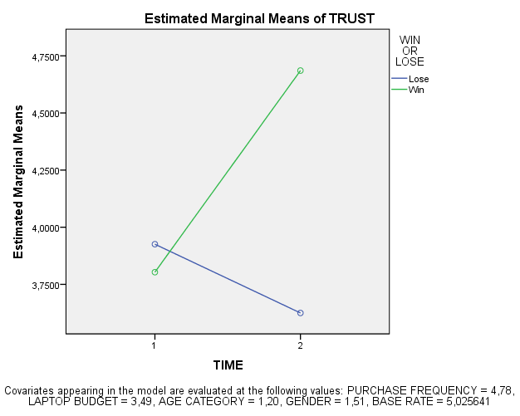

Brand Trustworthiness goes from a mean score of 3.872 in period 1 to 3.621 if the firm loses in period 3 or 4.677 if they win

Perceived Quality:

Tests of Within-Subjects Effects
Measure: QUAL
Source |  | Type III Sum of Squares | df | Mean Square | F | Sig.
TIME | Sphericity Assumed | ,136 | 1 | ,136 | ,597 | ,441
 | Greenhouse-Geisser | ,136 | 1,000 | ,136 | ,597 | ,441
 | Huynh-Feldt | ,136 | 1,000 | ,136 | ,597 | ,441
 | Lower-bound | ,136 | 1,000 | ,136 | ,597 | ,441
TIME * PURCHASEFREQ | Sphericity Assumed | ,397 | 1 | ,397 | 1,746 | ,189
 | Greenhouse-Geisser | ,397 | 1,000 | ,397 | 1,746 | ,189
 | Huynh-Feldt | ,397 | 1,000 | ,397 | 1,746 | ,189
 | Lower-bound | ,397 | 1,000 | ,397 | 1,746 | ,189
TIME * LAPTOPBUDGET | Sphericity Assumed | ,143 | 1 | ,143 | ,630 | ,429
 | Greenhouse-Geisser | ,143 | 1,000 | ,143 | ,630 | ,429
 | Huynh-Feldt | ,143 | 1,000 | ,143 | ,630 | ,429
 | Lower-bound | ,143 | 1,000 | ,143 | ,630 | ,429
TIME * AGECAT | Sphericity Assumed | ,096 | 1 | ,096 | ,421 | ,518
 | Greenhouse-Geisser | ,096 | 1,000 | ,096 | ,421 | ,518
 | Huynh-Feldt | ,096 | 1,000 | ,096 | ,421 | ,518
 | Lower-bound | ,096 | 1,000 | ,096 | ,421 | ,518
TIME * GENDER | Sphericity Assumed | ,069 | 1 | ,069 | ,304 | ,582
 | Greenhouse-Geisser | ,069 | 1,000 | ,069 | ,304 | ,582
 | Huynh-Feldt | ,069 | 1,000 | ,069 | ,304 | ,582
 | Lower-bound | ,069 | 1,000 | ,069 | ,304 | ,582
TIME * @BASERATE | Sphericity Assumed | ,007 | 1 | ,007 | ,031 | ,861
 | Greenhouse-Geisser | ,007 | 1,000 | ,007 | ,031 | ,861
 | Huynh-Feldt | ,007 | 1,000 | ,007 | ,031 | ,861
 | Lower-bound | ,007 | 1,000 | ,007 | ,031 | ,861
TIME * WIN | Sphericity Assumed | 7,424 | 1 | 7,424 | 32,639 | ,000
 | Greenhouse-Geisser | 7,424 | 1,000 | 7,424 | 32,639 | ,000
 | Huynh-Feldt | 7,424 | 1,000 | 7,424 | 32,639 | ,000
 | Lower-bound | 7,424 | 1,000 | 7,424 | 32,639 | ,000
TIME * STRONG | Sphericity Assumed | ,017 | 1 | ,017 | ,075 | ,784
 | Greenhouse-Geisser | ,017 | 1,000 | ,017 | ,075 | ,784
 | Huynh-Feldt | ,017 | 1,000 | ,017 | ,075 | ,784
 | Lower-bound | ,017 | 1,000 | ,017 | ,075 | ,784
TIME * WIN * STRONG | Sphericity Assumed | ,936 | 1 | ,936 | 4,115 | ,045
 | Greenhouse-Geisser | ,936 | 1,000 | ,936 | 4,115 | ,045
 | Huynh-Feldt | ,936 | 1,000 | ,936 | 4,115 | ,045
 | Lower-bound | ,936 | 1,000 | ,936 | 4,115 | ,045
Error(TIME) | Sphericity Assumed | 27,523 | 121 | ,227
 | Greenhouse-Geisser | 27,523 | 121,000 | ,227
 | Huynh-Feldt | 27,523 | 121,000 | ,227
 | Lower-bound | 27,523 | 121,000 | ,227

The main within factor measure is not significant. However the interaction effects of TIME*WIN and TIME*WIN*STRONG are significant.

What it basically means, that if we ignore all other factors, then there was no significant change in brand perceived quality scores awarded from period two to three. However, The significant interaction between TIME and WIN tells us that (although there is no significant difference in attitude scores going from time 2 to 3) there is a significant difference depending on whether the firm won or lost the case. On top of that, the interaction effect of TIME and WIN and STRONG tell us that not only does winning or losing have an effects, but that there is a significant effect depending on respondents brand expectations.

r (time*win)= sqrt [ F(1,dfR) / F(1,dfR) + dfR ]

r (time*win)= sqrt [ 32.639 / 32.639 + 121 ]

r (time*win)= 0.461

which is medium (>0.3), almost large (>0.5)

r (time*win*strong)= sqrt [ F(1,dfR) / F(1,dfR) + dfR ]

r (time*win*strong)= sqrt [ 4.115 / 4.115 + 121 ]

r (time*win*strong)= 0.181

which is between small (>0.10) and medium (>0.3)

now we look at the main effect of the between measure factors. levene's test shows indicates that variances are homogenous for only one level of the repeated measures variable (because all significance values are greater than .05).

-Due to the outliers maybe? is it a limitation or do i have to run a generalized test?

Levene's Test of Equality of Error Variancesª
 | F | df1 | df2 | Sig.
2 AVG QUAL | 1,583 | 3 | 126 | ,197
3 AVG QUAL | 5,307 | 3 | 126 | ,002
Tests the null hypothesis that the error variance of the dependent variable is equal across groups.
a. Design: Intercept + PURCHASEFREQ + LAPTOPBUDGET + AGECAT + GENDER + @BASERATE + WIN + STRONG + WIN * STRONG
Within Subjects Design: TIME

Tests of Between-Subjects Effects
Measure: QUAL
Transformed Variable: Average
Source | Type III Sum of Squares | df | Mean Square | F | Sig.
Intercept | 47,489 | 1 | 47,489 | 50,534 | ,000
PURCHASEFREQ | ,511 | 1 | ,511 | ,544 | ,462
LAPTOPBUDGET | 1,361 | 1 | 1,361 | 1,449 | ,231
AGECAT | ,355 | 1 | ,355 | ,378 | ,540
GENDER | 1,155E-006 | 1 | 1,155E-006 | ,000 | ,999
@BASERATE | ,125 | 1 | ,125 | ,133 | ,716
WIN | ,320 | 1 | ,320 | ,340 | ,561
STRONG | 8,426 | 1 | 8,426 | 8,966 | ,003
WIN * STRONG | 2,708 | 1 | 2,708 | 2,882 | ,092
Error | 113,709 | 121 | ,940

STRONG has a significant main effect (p=0.003). This tells us that if we ignored all other variables, the ratings of those firms with strong expectations were significantly different from those with weak.

Descriptive Statistics
 | WIN OR LOSE | STRONG OR WEAK | Mean | Std. Deviation | N
2 AVG QUAL | Lose | Weak | 4,272727 | ,9444816 | 33
 |  | Strong | 4,625000 | 1,1508140 | 32
 |  | Total | 4,446154 | 1,0578360 | 65
 | Win | Weak | 3,870370 | ,9198957 | 36
 |  | Strong | 4,540230 | ,9403385 | 29
 |  | Total | 4,169231 | ,9809347 | 65
 | Total | Weak | 4,062802 | ,9467443 | 69
 |  | Strong | 4,584699 | 1,0482008 | 61
 |  | Total | 4,307692 | 1,0256112 | 130
3 AVG QUAL | Lose | Weak | 4,080808 | ,8540358 | 33
 |  | Strong | 4,135417 | 1,3985640 | 32
 |  | Total | 4,107692 | 1,1458071 | 65
 | Win | Weak | 4,101852 | ,8973309 | 36
 |  | Strong | 5,000000 | ,9215239 | 29
 |  | Total | 4,502564 | 1,0071327 | 65
 | Total | Weak | 4,091787 | ,8705119 | 69
 |  | Strong | 4,546448 | 1,2634943 | 61
 |  | Total | 4,305128 | 1,0926381 | 130

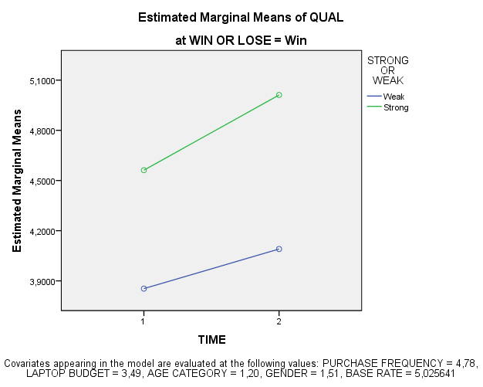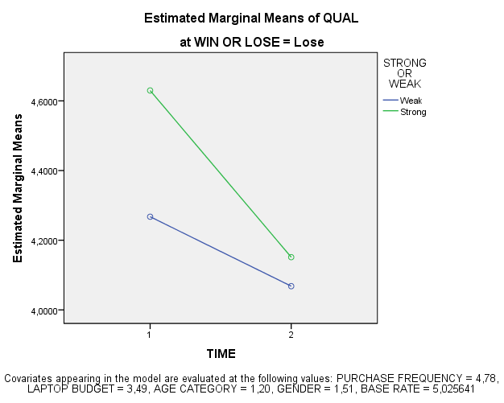

Brand perceived quality starts from a mean score of 4.308 in period 2, with Strong expectation respondents having a mean of 4.5847 and weak respondents having an average mean score of 4.0628
This transforms in time 3 to an average score 4.502 if they win, with the average score given further being 5.000 if they have strong expectations and 4.102 if weak.

If they lose, the average score awarded is 4.108 on average, with the average score awarded furthermore being 4.123 if expectations are strong, and 4.081 if weak.

The steeper plots foe strong expectations in both win and lose scenarios leads us to conclude that strong expectations are both "punished" harsher for losing, as well a "redeemed" more for winning.

it is possible that in the win scenario, respondents are simply restoring both firms scores back to some X fraction of their former position, while for the lose scenario both scores are simply conjugating at some universal negative point where "losers" are mentally positioned.

Test 3 (Time 1 to Time 3)

Attitude

Tests of Within-Subjects Effects
Measure: att
Source |  | Type III Sum of Squares | df | Mean Square | F | Sig.
time | Sphericity Assumed | 3,435 | 1 | 3,435 | 5,757 | ,018
 | Greenhouse-Geisser | 3,435 | 1,000 | 3,435 | 5,757 | ,018
 | Huynh-Feldt | 3,435 | 1,000 | 3,435 | 5,757 | ,018
 | Lower-bound | 3,435 | 1,000 | 3,435 | 5,757 | ,018
time * @BASERATE | Sphericity Assumed | 1,976 | 1 | 1,976 | 3,311 | ,071
 | Greenhouse-Geisser | 1,976 | 1,000 | 1,976 | 3,311 | ,071
 | Huynh-Feldt | 1,976 | 1,000 | 1,976 | 3,311 | ,071
 | Lower-bound | 1,976 | 1,000 | 1,976 | 3,311 | ,071
time * PURCHASEFREQ | Sphericity Assumed | ,023 | 1 | ,023 | ,039 | ,844
 | Greenhouse-Geisser | ,023 | 1,000 | ,023 | ,039 | ,844
 | Huynh-Feldt | ,023 | 1,000 | ,023 | ,039 | ,844
 | Lower-bound | ,023 | 1,000 | ,023 | ,039 | ,844
time * LAPTOPBUDGET | Sphericity Assumed | ,442 | 1 | ,442 | ,740 | ,391
 | Greenhouse-Geisser | ,442 | 1,000 | ,442 | ,740 | ,391
 | Huynh-Feldt | ,442 | 1,000 | ,442 | ,740 | ,391
 | Lower-bound | ,442 | 1,000 | ,442 | ,740 | ,391
time * AGECAT | Sphericity Assumed | ,065 | 1 | ,065 | ,109 | ,742
 | Greenhouse-Geisser | ,065 | 1,000 | ,065 | ,109 | ,742
 | Huynh-Feldt | ,065 | 1,000 | ,065 | ,109 | ,742
 | Lower-bound | ,065 | 1,000 | ,065 | ,109 | ,742
time * GENDER | Sphericity Assumed | ,426 | 1 | ,426 | ,714 | ,400
 | Greenhouse-Geisser | ,426 | 1,000 | ,426 | ,714 | ,400
 | Huynh-Feldt | ,426 | 1,000 | ,426 | ,714 | ,400
 | Lower-bound | ,426 | 1,000 | ,426 | ,714 | ,400
time * STRONG | Sphericity Assumed | 2,461 | 1 | 2,461 | 4,125 | ,044
 | Greenhouse-Geisser | 2,461 | 1,000 | 2,461 | 4,125 | ,044
 | Huynh-Feldt | 2,461 | 1,000 | 2,461 | 4,125 | ,044
 | Lower-bound | 2,461 | 1,000 | 2,461 | 4,125 | ,044
time * WIN | Sphericity Assumed | 27,220 | 1 | 27,220 | 45,619 | ,000
 | Greenhouse-Geisser | 27,220 | 1,000 | 27,220 | 45,619 | ,000
 | Huynh-Feldt | 27,220 | 1,000 | 27,220 | 45,619 | ,000
 | Lower-bound | 27,220 | 1,000 | 27,220 | 45,619 | ,000
time * STRONG * WIN | Sphericity Assumed | ,770 | 1 | ,770 | 1,291 | ,258
 | Greenhouse-Geisser | ,770 | 1,000 | ,770 | 1,291 | ,258
 | Huynh-Feldt | ,770 | 1,000 | ,770 | 1,291 | ,258
 | Lower-bound | ,770 | 1,000 | ,770 | 1,291 | ,258
Error(time) | Sphericity Assumed | 72,198 | 121 | ,597
 | Greenhouse-Geisser | 72,198 | 121,000 | ,597
 | Huynh-Feldt | 72,198 | 121,000 | ,597
 | Lower-bound | 72,198 | 121,000 | ,597

Descriptive Statistics
 | STRONG OR WEAK | WIN OR LOSE | Mean | Std. Deviation | N
1 AVG ATT | Weak | Lose | 4,808081 | 1,1274058 | 33
 |  | Win | 4,722222 | 1,0555973 | 36
 |  | Total | 4,763285 | 1,0832978 | 69
 | Strong | Lose | 5,052083 | 1,0338687 | 32
 |  | Win | 5,126437 | 1,0055946 | 29
 |  | Total | 5,087432 | 1,0127002 | 61
 | Total | Lose | 4,928205 | 1,0809145 | 65
 |  | Win | 4,902564 | 1,0453652 | 65
 |  | Total | 4,915385 | 1,0592373 | 130
3 AVG ATT | Weak | Lose | 3,464646 | 1,1635058 | 33
 |  | Win | 4,444444 | 1,0047506 | 36
 |  | Total | 3,975845 | 1,1831039 | 69
 | Strong | Lose | 3,114583 | 1,1658503 | 32
 |  | Win | 4,793103 | 1,0853051 | 29
 |  | Total | 3,912568 | 1,4022490 | 61
 | Total | Lose | 3,292308 | 1,1689081 | 65
 |  | Win | 4,600000 | 1,0478152 | 65
 |  | Total | 3,946154 | 1,2858495 | 130

Levene's Test of Equality of Error Variancesª
 | F | df1 | df2 | Sig.
1 AVG ATT | ,206 | 3 | 126 | ,892
3 AVG ATT | ,177 | 3 | 126 | ,912
Tests the null hypothesis that the error variance of the dependent variable is equal across groups.
a. Design: Intercept + @BASERATE + PURCHASEFREQ + LAPTOPBUDGET + AGECAT + GENDER + STRONG + WIN + STRONG * WIN
Within Subjects Design: time

Tests of Between-Subjects Effects
Measure: att
Transformed Variable: Average
Source | Type III Sum of Squares | df | Mean Square | F | Sig.
Intercept | 45,991 | 1 | 45,991 | 51,515 | ,000
@BASERATE | ,504 | 1 | ,504 | ,564 | ,454
PURCHASEFREQ | ,362 | 1 | ,362 | ,405 | ,526
LAPTOPBUDGET | ,158 | 1 | ,158 | ,177 | ,675
AGECAT | ,326 | 1 | ,326 | ,366 | ,547
GENDER | ,401 | 1 | ,401 | ,449 | ,504
STRONG | 1,082 | 1 | 1,082 | 1,212 | ,273
WIN | 14,661 | 1 | 14,661 | 16,422 | ,000
STRONG * WIN | 1,518 | 1 | 1,518 | 1,700 | ,195
Error | 108,026 | 121 | ,893

Conclusion: The within subject measure of brand attitude is significantly different between time 1 and 3 (p=0.00).

Furthermore, The change in brand attitude going from time 1 to time 3 is significantly effected by the court case verdict (p=0.00) as well as the brand expectations (p=0.044).

For strong expectations:
Starting with a mean score of 5.087 in the initial measurement, the mean score becomes 3.115 after a loss, and 4.793 after a win.

For weak expectation:
Starting with a mean score of 4.763 in the initial measurement, the mean score becomes 3.464 after a loss, and 4.444 after a win.

r (time*win)= sqrt [ F(1,dfR) / F(1,dfR) + dfR ]

r (time*win)= sqrt [ 45.619 / 45.619 + 121 ]

r (time*win)= 0.523

which is large (>0.5)

r (time*strong)= sqrt [ F(1,dfR) / F(1,dfR) + dfR ]

r (time*strong)= sqrt [ 4.125 / 4.125 + 121 ]

r (time*strong)= 0.182

which is between small (>0.1) and medium (>.3)

levene's test shows that variances are homogenous for all levels of the repeated measures variables (because all significance values are greater than .05).

and the between subjects effects tells us that the court verdict is a significant between subject effect (p=0.00) depending on which court case verdict they were presented with.

Trustworthiness:

Tests of Within-Subjects Effects
Measure: trustworthiness
Source |  | Type III Sum of Squares | df | Mean Square | F | Sig.
time | Sphericity Assumed | ,920 | 1 | ,920 | 1,576 | ,212
 | Greenhouse-Geisser | ,920 | 1,000 | ,920 | 1,576 | ,212
 | Huynh-Feldt | ,920 | 1,000 | ,920 | 1,576 | ,212
 | Lower-bound | ,920 | 1,000 | ,920 | 1,576 | ,212
time * @BASERATE | Sphericity Assumed | 1,226 | 1 | 1,226 | 2,100 | ,150
 | Greenhouse-Geisser | 1,226 | 1,000 | 1,226 | 2,100 | ,150
 | Huynh-Feldt | 1,226 | 1,000 | 1,226 | 2,100 | ,150
 | Lower-bound | 1,226 | 1,000 | 1,226 | 2,100 | ,150
time * PURCHASEFREQ | Sphericity Assumed | ,309 | 1 | ,309 | ,529 | ,468
 | Greenhouse-Geisser | ,309 | 1,000 | ,309 | ,529 | ,468
 | Huynh-Feldt | ,309 | 1,000 | ,309 | ,529 | ,468
 | Lower-bound | ,309 | 1,000 | ,309 | ,529 | ,468
time * LAPTOPBUDGET | Sphericity Assumed | ,655 | 1 | ,655 | 1,122 | ,292
 | Greenhouse-Geisser | ,655 | 1,000 | ,655 | 1,122 | ,292
 | Huynh-Feldt | ,655 | 1,000 | ,655 | 1,122 | ,292
 | Lower-bound | ,655 | 1,000 | ,655 | 1,122 | ,292
time * AGECAT | Sphericity Assumed | ,161 | 1 | ,161 | ,276 | ,600
 | Greenhouse-Geisser | ,161 | 1,000 | ,161 | ,276 | ,600
 | Huynh-Feldt | ,161 | 1,000 | ,161 | ,276 | ,600
 | Lower-bound | ,161 | 1,000 | ,161 | ,276 | ,600
time * GENDER | Sphericity Assumed | ,209 | 1 | ,209 | ,359 | ,550
 | Greenhouse-Geisser | ,209 | 1,000 | ,209 | ,359 | ,550
 | Huynh-Feldt | ,209 | 1,000 | ,209 | ,359 | ,550
 | Lower-bound | ,209 | 1,000 | ,209 | ,359 | ,550
time * STRONG | Sphericity Assumed | ,002 | 1 | ,002 | ,004 | ,949
 | Greenhouse-Geisser | ,002 | 1,000 | ,002 | ,004 | ,949
 | Huynh-Feldt | ,002 | 1,000 | ,002 | ,004 | ,949
 | Lower-bound | ,002 | 1,000 | ,002 | ,004 | ,949
time * WIN | Sphericity Assumed | 13,976 | 1 | 13,976 | 23,939 | ,000
 | Greenhouse-Geisser | 13,976 | 1,000 | 13,976 | 23,939 | ,000
 | Huynh-Feldt | 13,976 | 1,000 | 13,976 | 23,939 | ,000
 | Lower-bound | 13,976 | 1,000 | 13,976 | 23,939 | ,000
time * STRONG * WIN | Sphericity Assumed | ,635 | 1 | ,635 | 1,088 | ,299
 | Greenhouse-Geisser | ,635 | 1,000 | ,635 | 1,088 | ,299
 | Huynh-Feldt | ,635 | 1,000 | ,635 | 1,088 | ,299
 | Lower-bound | ,635 | 1,000 | ,635 | 1,088 | ,299
Error(time) | Sphericity Assumed | 70,641 | 121 | ,584
 | Greenhouse-Geisser | 70,641 | 121,000 | ,584
 | Huynh-Feldt | 70,641 | 121,000 | ,584
 | Lower-bound | 70,641 | 121,000 | ,584

Descriptive Statistics
 | STRONG OR WEAK | WIN OR LOSE | Mean | Std. Deviation | N
1 AVG TRUST | Weak | Lose | 5,020202 | 1,1871400 | 33
 |  | Win | 5,055556 | ,9275330 | 36
 |  | Total | 5,038647 | 1,0518211 | 69
 | Strong | Lose | 4,864583 | 1,1604577 | 32
 |  | Win | 5,045977 | 1,0530535 | 29
 |  | Total | 4,950820 | 1,1052670 | 61
 | Total | Lose | 4,943590 | 1,1675134 | 65
 |  | Win | 5,051282 | ,9775799 | 65
 |  | Total | 4,997436 | 1,0739225 | 130
3 AVG TRUST | Weak | Lose | 3,787879 | 1,1359595 | 33
 |  | Win | 4,564815 | 1,0625499 | 36
 |  | Total | 4,193237 | 1,1580999 | 69
 | Strong | Lose | 3,447917 | 1,2021766 | 32
 |  | Win | 4,816092 | ,9823288 | 29
 |  | Total | 4,098361 | 1,2929213 | 61
 | Total | Lose | 3,620513 | 1,1724217 | 65
 |  | Win | 4,676923 | 1,0273503 | 65
 |  | Total | 4,148718 | 1,2193258 | 130

Levene's Test of Equality of Error Variancesª
 | F | df1 | df2 | Sig.
1 AVG TRUST | ,899 | 3 | 126 | ,444
3 AVG TRUST | ,279 | 3 | 126 | ,841
Tests the null hypothesis that the error variance of the dependent variable is equal across groups.
a. Design: Intercept + @BASERATE + PURCHASEFREQ + LAPTOPBUDGET + AGECAT + GENDER + STRONG + WIN + STRONG * WIN
Within Subjects Design: time

Tests of Between-Subjects Effects
Measure: trust
Transformed Variable: Average
Source | Type III Sum of Squares | df | Mean Square | F | Sig.
Intercept | 63,713 | 1 | 63,713 | 70,674 | ,000
@BASERATE | 1,887 | 1 | 1,887 | 2,093 | ,151
PURCHASEFREQ | ,472 | 1 | ,472 | ,523 | ,471
LAPTOPBUDGET | 1,432 | 1 | 1,432 | 1,588 | ,210
AGECAT | ,738 | 1 | ,738 | ,819 | ,367
GENDER | ,382 | 1 | ,382 | ,424 | ,516
STRONG | ,010 | 1 | ,010 | ,011 | ,916
WIN | 11,213 | 1 | 11,213 | 12,438 | ,001
STRONG * WIN | 1,112 | 1 | 1,112 | 1,234 | ,269
Error | 109,083 | 121 | ,902

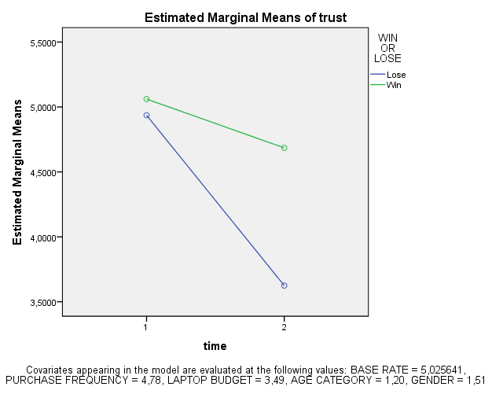

The within subject measure of brand trustworthiness is not significantly different between time 1 and 3.

However, The change in brand trustworthiness going from time 1 to time 3 is significantly effected by the court case verdict (p=0.00)

Starting with a mean score of 4.997 in the initial measurement, the mean score becomes 3.621 after a loss, and 4.677 after a win.

r (time*win)= sqrt [ F(1,dfR) / F(1,dfR) + dfR ]

r (time*win)= sqrt [ 23.939 / 23.939 + 121 ]

r (time*win)= 0.406

Which is between medium (>.3) and large (>0.5)

levene's test shows that variances are homogenous for all levels of the repeated measures variables (because all significance values are greater than .05).

and the between subjects effects tells us that the court verdict is a significant between subject effect (p=0.001) depending on which court case verdict they were presented with.

Perceived Quality:

Tests of Within-Subjects Effects
Measure: Perceptions of quality
Source |  | Type III Sum of Squares | df | Mean Square | F | Sig.
time | Sphericity Assumed | ,090 | 1 | ,090 | ,282 | ,596
 | Greenhouse-Geisser | ,090 | 1,000 | ,090 | ,282 | ,596
 | Huynh-Feldt | ,090 | 1,000 | ,090 | ,282 | ,596
 | Lower-bound | ,090 | 1,000 | ,090 | ,282 | ,596
time * @BASERATE | Sphericity Assumed | ,290 | 1 | ,290 | ,906 | ,343
 | Greenhouse-Geisser | ,290 | 1,000 | ,290 | ,906 | ,343
 | Huynh-Feldt | ,290 | 1,000 | ,290 | ,906 | ,343
 | Lower-bound | ,290 | 1,000 | ,290 | ,906 | ,343
time * PURCHASEFREQ | Sphericity Assumed | ,069 | 1 | ,069 | ,215 | ,644
 | Greenhouse-Geisser | ,069 | 1,000 | ,069 | ,215 | ,644
 | Huynh-Feldt | ,069 | 1,000 | ,069 | ,215 | ,644
 | Lower-bound | ,069 | 1,000 | ,069 | ,215 | ,644
time * LAPTOPBUDGET | Sphericity Assumed | 1,138 | 1 | 1,138 | 3,558 | ,062
 | Greenhouse-Geisser | 1,138 | 1,000 | 1,138 | 3,558 | ,062
 | Huynh-Feldt | 1,138 | 1,000 | 1,138 | 3,558 | ,062
 | Lower-bound | 1,138 | 1,000 | 1,138 | 3,558 | ,062
time * AGECAT | Sphericity Assumed | ,211 | 1 | ,211 | ,659 | ,419
 | Greenhouse-Geisser | ,211 | 1,000 | ,211 | ,659 | ,419
 | Huynh-Feldt | ,211 | 1,000 | ,211 | ,659 | ,419
 | Lower-bound | ,211 | 1,000 | ,211 | ,659 | ,419
time * GENDER | Sphericity Assumed | ,139 | 1 | ,139 | ,435 | ,511
 | Greenhouse-Geisser | ,139 | 1,000 | ,139 | ,435 | ,511
 | Huynh-Feldt | ,139 | 1,000 | ,139 | ,435 | ,511
 | Lower-bound | ,139 | 1,000 | ,139 | ,435 | ,511
time * STRONG | Sphericity Assumed | 4,315 | 1 | 4,315 | 13,489 | ,000
 | Greenhouse-Geisser | 4,315 | 1,000 | 4,315 | 13,489 | ,000
 | Huynh-Feldt | 4,315 | 1,000 | 4,315 | 13,489 | ,000
 | Lower-bound | 4,315 | 1,000 | 4,315 | 13,489 | ,000
time * WIN | Sphericity Assumed | 3,690 | 1 | 3,690 | 11,535 | ,001
 | Greenhouse-Geisser | 3,690 | 1,000 | 3,690 | 11,535 | ,001
 | Huynh-Feldt | 3,690 | 1,000 | 3,690 | 11,535 | ,001
 | Lower-bound | 3,690 | 1,000 | 3,690 | 11,535 | ,001
time * STRONG * WIN | Sphericity Assumed | 2,313 | 1 | 2,313 | 7,231 | ,008
 | Greenhouse-Geisser | 2,313 | 1,000 | 2,313 | 7,231 | ,008
 | Huynh-Feldt | 2,313 | 1,000 | 2,313 | 7,231 | ,008
 | Lower-bound | 2,313 | 1,000 | 2,313 | 7,231 | ,008
Error(time) | Sphericity Assumed | 38,708 | 121 | ,320
 | Greenhouse-Geisser | 38,708 | 121,000 | ,320
 | Huynh-Feldt | 38,708 | 121,000 | ,320
 | Lower-bound | 38,708 | 121,000 | ,320

Descriptive Statistics
 | STRONG OR WEAK | WIN OR LOSE | Mean | Std. Deviation | N
1 AVG QUAL | Weak | Lose | 4,313131 | ,7946846 | 33
 |  | Win | 4,231481 | ,6983856 | 36
 |  | Total | 4,270531 | ,7415656 | 69
 | Strong | Lose | 5,291667 | ,9900943 | 32
 |  | Win | 5,252874 | 1,0337755 | 29
 |  | Total | 5,273224 | 1,0027891 | 61
 | Total | Lose | 4,794872 | 1,0166877 | 65
 |  | Win | 4,687179 | ,9980483 | 65
 |  | Total | 4,741026 | 1,0049536 | 130
3 AVG QUAL | Weak | Lose | 4,080808 | ,8540358 | 33
 |  | Win | 4,101852 | ,8973309 | 36
 |  | Total | 4,091787 | ,8705119 | 69
 | Strong | Lose | 4,135417 | 1,3985640 | 32
 |  | Win | 5,000000 | ,9215239 | 29
 |  | Total | 4,546448 | 1,2634943 | 61
 | Total | Lose | 4,107692 | 1,1458071 | 65
 |  | Win | 4,502564 | 1,0071327 | 65
 |  | Total | 4,305128 | 1,0926381 | 130

Levene's Test of Equality of Error Variancesª
 | F | df1 | df2 | Sig.
1 AVG QUAL | 2,372 | 3 | 126 | ,074
3 AVG QUAL | 5,307 | 3 | 126 | ,002
Tests the null hypothesis that the error variance of the dependent variable is equal across groups.
a. Design: Intercept + @BASERATE + PURCHASEFREQ + LAPTOPBUDGET + AGECAT + GENDER + STRONG + WIN + STRONG * WIN
Within Subjects Design: time

Tests of Between-Subjects Effects
Measure: qual
Transformed Variable: Average
Source | Type III Sum of Squares | df | Mean Square | F | Sig.
Intercept | 46,829 | 1 | 46,829 | 59,611 | ,000
@BASERATE | ,456 | 1 | ,456 | ,581 | ,448
PURCHASEFREQ | ,007 | 1 | ,007 | ,009 | ,925
LAPTOPBUDGET | ,462 | 1 | ,462 | ,589 | ,444
AGECAT | ,240 | 1 | ,240 | ,306 | ,581
GENDER | ,201 | 1 | ,201 | ,256 | ,614
STRONG | 18,310 | 1 | 18,310 | 23,308 | ,000
WIN | 1,285 | 1 | 1,285 | 1,636 | ,203
STRONG * WIN | 1,573 | 1 | 1,573 | 2,003 | ,160
Error | 95,055 | 121 | ,786

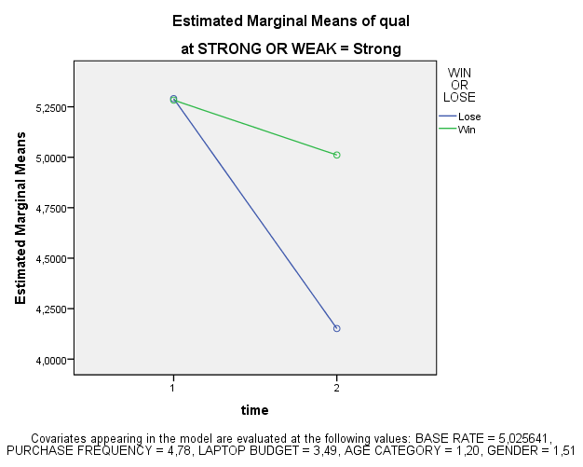

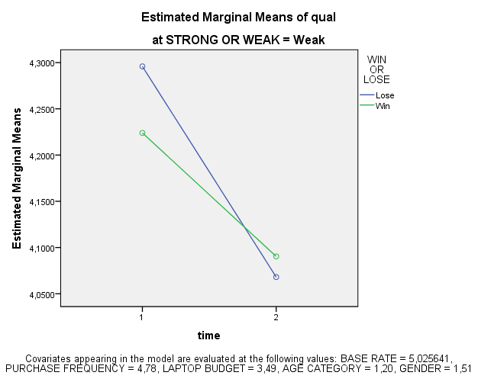

The within subject factor does not change significantly, if all other factors are ignored. However, there is a significant interaction of time*WIN (p=0.001) and time*STRONG (p=0.000), indicating that perceived quality change from time 1 to time 3 depending on the court case verdict, and respondent brand expectations. Furthermore there is also a significant interaction effect of time*STRONG*WIN indicating that the different combinations of court case and verdict also has a significant effect on the change of brand quality perception.

For strong expectations:
Starting with a mean score of 5.273 in the initial measurement, the mean score becomes 4.135 after a loss, and 5.000 after a win.

For weak expectation:
Starting with a mean score of 4.271 in the initial measurement, the mean score becomes 4.081 after a loss, and 4.102 after a win.

r (time*win)= sqrt [ F(1,dfR) / F(1,dfR) + dfR ]

r (time*win)= sqrt [ 11.535 / 11.535 + 121 ]

r (time*win)= 0.295

which is small (>.1) but almost qualifies as medium (>.3)

r (time*strong)= sqrt [ F(1,dfR) / F(1,dfR) + dfR ]

r (time*strong)= sqrt [ 13.489 / 13.489 + 121 ]

r (time*strong)= 0.317

Which is medium (>.3)

r (time*win*strong)= sqrt [ F(1,dfR) / F(1,dfR) + dfR ]

r (time*win*strong)= sqrt [ 7.231 / 7.231 + 121 ]

r (time*win*strong)= 0.237

which is between small (>0.1) and medium (>.3)

Looking at the main effect of the between measure factors:

levene's test shows indicates that variances are homogenous for only one level of the repeated measures variable (because all significance values are greater than .05).

Besides the intercept, only consumer brand expectations are a significant factor dividing mean scores between respondents (p=0.00)

