ERASMUS UNIVERSITEIT ROTTERDAM
ERASMUS SCHOOL OF ECONOMICS
Economics and Business, Marketing

Effect of degree of personalization and desirability of control on Ad effectiveness on social networks sites

Author: Wenwen Gu
Student number: 368921
Thesis Supervisor: Professor. Dr. Adiguzel
Date: 31/12/2013
Index
1. Introduction: 4
1.1 Background and context 4
1.2 Problem statement 6
1.3 Research Method 8
1.4 Scientific relevance 8
1.5 Relevance 11
1.5.1 Scientific contribution 11
1.5.2 Managerial contribution 13
1.6 Outline 14
2. Literature review and Conceptual framework 15
2.1 Online advertising 15
2.1.1 Introduction 15
2.1.2 How companies offer online ads 16
2.1.3 Online ads segmentation 17
2.2 Effectiveness of online ads 19
2.2.1 Introduction 19
2.2.2 Real life environmental indicators 19
2.2.3 Experiment environmental indicators 20
2.3 Personalization 21
2.3.1 Personalized social network advertising (SNA) 21
2.3.2 Degree of personalization on SNA 23
2.3.3 Degree of personalization on SNA and recall 23
2.4 Privacy concerns 24
2.4.1 Introduction 24
2.4.2 Privacy concerns and degree of personalization on SNA 25
2.4.3 Privacy concern and Attitude toward advertisers’ brand 26
2.4.4 The mediating role of privacy concern 27
2.4.5 The mediating role of attitude towards ad 27
2.5 Desirability of Control 28
2.6 Attitude towards brand and Purchase Intention 30
3. Research Methodology 30
3.1 Type of research 31
3.2 Scale 32
3.3 Pretest 37
3.4 Result of pretest 38
3.5 Stimulus of main study 40
3.5.1 Procedure: 41
3.5.2 Sample characteristics 42
3.6 Hypothesis testing 43
4. Results 46
4.1 Manipulation check 46
4.2 Validity and reliability of constructs 47
4.3 Descriptive analysis 50
4.4 Hypotheses results 51
5. Conclusion 66
6. Limitation 68
7. Future Research 69
Reference 70
Appendix 75

1. Introduction:

1.1 Background and context
With the rapid growth of World Wide Web (WWW) and the technology of data mining, personalized advertisements (PA) become more and more close to our online time. Internet users will not feel surprised anymore when they were searching information about vehicles through Google Search, and one hour later, they saw a Ford advertisement on Amazon. Search engine targeting is just one type of PA, which is the most frequently used by the online ads publishers and advertisers. Mentioning to the kinds of ads display platform, SNS by virtue of its users’ social purpose, enjoy the advantages of access to more precise and comprehensive individual-level profile data. Hence, Social Network Advertisements have stepped into a PA age.
Researchers found that customers actively avoid looking at online banner ads (Drèze and Hussherr 2003). For the sake of online banner ads’ profit, both advertisers and ads publishers rack their wits about attracting customers’ attention and booming ads effectiveness. Highly targeted advertising is believed to be far more effective in terms of response than less targeted advertising and it allows firms to eliminate "wasted" advertising to consumers whose preferences do not match products' attributes (Iyer et al., 2005). According to the research by Jun Yan et al in 2009, advertisements click through rate can be improved by as much as 670% on average through behavioral targeting. The most controversial part of PA is privacy intrusion, which may lead to consumer reactance. While this study shows that, in real life, Internet users complain a lot about privacy intrusion due to targeted ads, while the result of behavioral targeting (BT) still indicates to be lucrative, which make the related privacy provision futile. Therefore, BT, or other kind of PA do increase the utility to encourage Internet users to click banner ads.
In another article, Tucker (2011) did a research about personalized advertising on social network right during the period that Facebook announced to give their user more control over privacy settings. Her empirical analysis of both campaign-level and individual-level click-through data suggests that personalized advertising was over twice as effective at attracting users to the NPO's Facebook page after the shift in Facebook policy that gave users more control over their personal information.
Because most countries are still using self-discipline principles with equivocal words about BT ads, most companies or associations don’t take it seriously indeed. They try every possible and legitimate ways to dig up users’ behavioral data and manipulate in targeted ads display. After Twitter, following the steps of Facebook, announced that they would start cookies-based ads targeting in July 2013, almost all the worldwide leading social network service (SNS) sites has taken a step to PA.
In the same research of Yan et al. (2009), they only focus on two kinds of user data resource applying in BT ads, users’ search engine history and browsing history. As employees from Microsoft, they use large scale of search engine data and browsing history from cookies, then drawn the conclusion that user search behavioral can perform several times better than user browsing behavior. But SNS like Facebook, has much more user-generated data than solely search history and page-browsing history. The situation becomes even complicated in the SNS cases. As Hong & Zinkhan (1995) state, ads effectiveness varies, depending upon the degree of match (i.e. congruency) between the content of an advertisement and the way a consumer perceives him or herself (i.e. self-concept). But their conclusion didn’t get in an Internet environment. They showed 7 different ads about automobiles and shampoo the subjects to the subjects in the form of slides. That if the conclusion still valid in online environment is what we are interested in. SNS provides bunch of user generated data to reach higher congruency, meanwhile, users may feel their privacy were violated harder. The challenge is one of understanding the complexities of interactive communication to determine at which points online users exhibit a level of concern that will cause them to act not in accordance with the desires of online communicators (Sheehan, 2002). Therefore, we develop the following statement:

1.2 Problem statement
The golden age of SNS has gone. Some of them are still in the maturation period, like Facebook and Twitter, while some of them are already suffering a recession, for example, Myspace (See Appendix 1). As the biggest market share of visits SNS site, Facebook is representative enough to become our research object. To have a clear cognition of the current stage of Social Networks Ads (SNA), we made a horizontal comparison between Facebook and Google in several indicators. In the year 2012, Facebook has 0.984 billion users, while Google has more than twice its users, 2.01 billions. But mention to the advertising revenue, the global online ad revenue in 2012 of Facebook was $4.28 billion and was only less than one-tenth compared with Google Adwords’ $43.69 billion. Facebook got 3.10% of the global online ad market share, at the same time, Google enjoyed 44.10%. The global average click through rate (CTR) of Google Adwords reached 2.00%, but Facebook Ads’ global average CTR was only 0.05%.
It could be various possibilities which lead to such consequence. Social presence has the strongest impact on We-Intention to use Facebook, and therefore most people use Facebook so as to get instant communication and connection with their friends (Cheung et al., 2010). The essential difference in using purpose between Facebook users and Google users has to take partial responsibility. What’s more, less research was made on SNA due to its short existence.
Consumers might see personalized ad content on SNS as more appealing and more connected to their interests, but they also might conversely see it as ‘not only creepy, but off-putting’ if they feel that the firm has violated their privacy (Stone, 2010). Facebook can collect more user data with less effort than almost any other kinds of websites. According the ads publishing page on Facebook, advertisers could use location, gender, age & birthday, interests, education and connections to make more specific customer segmentation, thus enact more targeted ads. However when this targeting-technology is used negligent, marketers can over time be perceived as a serious threat to consumers’ privacy, leading consumers to behavior that protects the misuse of their personal information (i.e. concealing information, providing incorrect information) (Sheehan, 1999). If Facebook cross the line of users’ privacy concerns, not only their ads revenue will be damaged, but also may lead to user churn. Finding a balance point between personalization and privacy concerns is the critical point to win in the online ads battle.
In a marketing campaign, customers’ resonance is the crucial factor. People with different characters will give different responses to one same campaign. As indicated by Sundar and Marathe (2010), sense of control is of paramount importance for consumers with regard to their experiences with customized online environments. Given this finding, desirability of control will be considered in this study to gauge each consumer’s desire to control his or her own media environment. According to Burger (1985), desirability of control refers to ‘a stable personality trait reflecting the extent to which individuals generally are motivated to control the events in their lives’. In SNS environments, users may feel ‘loss of control’ when they are explored to personalized ads. Which kind of users (high/ low desirability of control) is more suitable to give personalized ads on SNS is also an important topic for advertisers.
In this thesis, we will study the different user generated data used in targeted ads and the endogenic difference among Facebook users to help advertisers to choose more profitable targeting ads plan on Facebook and help Facebook to improve its targeted ads plan.
The main research question this thesis tries to answer is:
What is the effect of different degree of personalization on Social Networks Ads (SNA) and users’ desirability of control (high/low) on ad effectiveness?
To answer the main question, the following sub-questions will also be answered:
- How do different degrees of personalization of SNA impact on users’ privacy concerns? And to what extent, users do not feel that their privacy is violated by personalized SNA?
- How do users’ desirability of control impact on their privacy concerns about personalized SNA at same degree of personalization?
- How do different levels of personalization of SNA influence the attitude towards ads and the advertiser’s brand?
- How do privacy concerns affect the attitude towards ads and the advertiser’s brand?
- How do users’ attitudes toward advertisers’ brand influence users’ click intention?

1.3 Research Method
An online environment experiment will be conducted to answer the research questions. Because of the limitation of capital and time, we are not able to running an experiment in real life SNS environment, but we tried to imitate a real-life one. The participants will be given a vignette. Then a simulative Facebook page will be shown to the participants. Each page will be equipped with three advertisements. After 30 seconds the participants were shown to the page, they will be lead to a survey page to explore their brand recall, attitude towards the ads, willingness to click and other related issues.

1.4 Scientific relevance
Table 1: Overview of most relevant literature and contribution
Author | Context | SNA or other online ad | Desirablity of control or not |  | Privacy concern measured or not | BT or SNT or not | Main findings
Pavlou & Stewart (2000) | Measuring the effectiveness of interactive advertising | Interactive ads |  | No | No | BT | They measure the impact of degree of personalization and other effects like, participation, comprehension on the effectiveness of interactive advertising.
White, Zahay & THobjornsen, Shavitt (2007) | Reactance to highly personalized email solicitations | Other online ads |  | No | Yes | BT | The responses of consumers who have not yet been convinced of a firm’s value proposition to highly targeted personalization efforts depend importantly on the extent to which these messages are perceived to be justified.
Yu & Brenda (2009) | Consumers’ perceptions about personalized advertising via email, letter and telephone call | Online and offline ads |  | No | Yes | BT | Consumers generally have a negative attitude towards personalized advertisements, both online and offline ones. They feel that their privacy was violated.
Yan, Wang & Chen (2009) | How much can behavioral targeting help online advertising | Other online ads |  | No | No | BT | (1) The users who clicked the same ad will be more similar than the users who clicked different ads; (2) ads CTR increase significantly by BT; and (3) tracking the short term user search behavior can perform better than tracking the long term user browsing behavior.
Taylor, Lewin & Strutton  (2011) | Do ads work on social networks? How gender and age shape receptivity | SNA |  | No | Yes | SNT | When SNA delivered content or impressions that provided entertainment or informational value or offered social value, consumers appeared more likely to respond favorably toward the ad stimuli themselves.
Tucker (2011) | Social networks, personalized advertising and privacy control | SNA |  | No | Yes | SNT | If social networks giving users more control over their private information can benefit advertising-supported media and advertisers on such sites.
Bright & Daugherty (2012) | Does customization impact advertising effectiveness | Other online ads |  | Yes | Yes | BT | Low control consumers in non-customized conditions exhibited the most positive attitude toward the ad; high control consumers in non-customized conditions had the most negative attitude toward the ad. Furthermore, Subjects with a low desire for control will in fact experience a decreased ability to recognize media content when exposed to a customized online environment.
This thesis (2013) | Relationship between level of personalization and privacy concerns and ad effectiveness | SNA |  | Yes | Yes | Both

1.5 Relevance

1.5.1 Scientific contribution
This thesis contributes to the current scientific knowledge in these following aspects:
First, this thesis extends the domain where privacy concerns are studied to the context of social networking sites (SNS). Advertising on SNS is little studied due to its short existence. A recent study by Taylor et al. (2011) is the only scientific paper that explicitly discusses attitude toward social network advertising (SNA), which examines privacy concerns as one of eight variables that influence attitude toward SNA.
Second, we define a new variable in the domain of personalized advertising. The existing PA researchers only consider the situation of personalized ads and non-personalized ads (Tucker, 2012; Taylor, 2011). Degree of personalization was not a new concept anymore. As far back as the article by Carpenter (1975), the term ‘degree of personalization’ was used. Since Internet hadn’t become popular in that age, Carpenter tested whether different degrees of personalization lead to various responses in regular mail marketing field. But in their research, no specific definition was given to ‘degree of personalization’. They applied three treatments to verify three different degrees (no/low/high). Still, we can summarize several aspects of degree of personalization according to their manipulation, which are amount of individual efforts to prepare the mailer (uniqueness), the complexity to recognize personalization (awareness). In the following literature, White et al. (2008) studied degree of personalization in online environment again. They argued two dimensions of personalization, which are distinctiveness and justification. Distinctiveness means the degree to which the personal information used in the message uniquely identifies or characterizes its recipient, namely, data uniqueness. Justification refers to the extent to which fit is justified to the consumer, namely, self-ad congruency. Combining both these two studies, we extend the definition of degree of personalization on SNA to three dimensions, data uniqueness, awareness of personalized and self-ad congruency.
Last, we bring psychological variable, namely desirability of control- into personalized SNA studies. No matter studies about BT or SNT only focus on how ad formats or contents impact on ads effectiveness, but not focus on how different user personalities impact on ads effectiveness. Bunch of existing literatures has put desirability of control into behavior studies. For instance, Burger (1985) conducted desire for control in the study of achievement-related behavior. Researches about behavior in examination (Wise et al., 1996) and behavior during dental treatment (Law et al., 1994) explored the relationship between behavior and desirability of control as well. However, desirability of control was still a fresh concept in the domain of personalized ads. Bright & Daugherty (2012) conducted a research to figure out how consumers’ attitude towards ad differs among people with different level of desirability of control (high/low) in diverse media environment (customized/non-customized). Because they didn’t take privacy concern into consideration, they failed to prove an explicit relationship between attitude towards ad and desirability of control. We study the relationship between users’ desirability of control and ads effectiveness, with consideration of privacy concern and fill the blank in this field.

1.5.2 Managerial contribution
For advertisers, they can choose more effective user data when they decide to put ads on SNSs according to their purpose. Advertisers on Facebook now apply personalized rules merely according to their subjective judgments. No existing researchers explicitly reveal which kind of user data gains the most attention of users, or pushes up sales mostly.
For SNSs, firstly, they can improve their ads pricing strategy. Given the result that different degree of personalization on SNA would lead to diverse ads effectiveness, SNSs, like Facebook, can make more revenue through give hierarchical pricing to different personalized rules. Secondly, SNSs are uniquely positioned to access end users. They can extract information whether this user is a high/low control subject based on his/her privacy control preferences. Then they can select right way of personalized ads for users without, or at least less, creating negative attitude towards ad, brand and Facebook itself. Then less intrusiveness will be brought in, but more utilities will be perceived by SNS users.

1.6 Outline
This thesis is divided in six chapters. In this first chapter, the purposes of the current paper and the concepts are presented. Furthermore, it also includes the main research question and sub-questions that need to be answered.
The second chapter includes the theoretical background of this research, the definitions of each of the variables based on the existing literature and arguments that lead to the connection of the independent with dependent variables. And also a conceptual framework including the hypothesis will be discussed in this chapter.
In addition, in chapter three, the methodology used for the research, the participants, the procedure followed and the survey instruments are discussed.
Chapter four provides the data analysis and the results. Chapter five will present a conclusion and discussion on the result from chapter four. Chapter six is about the limitations in this thesis and some suggestions for further researches.

2. Literature review and Conceptual framework

2.1 Online advertising

2.1.1 Introduction
Since the first banner ads appeared in 1994, the online advertising industry has experienced exceptional growth (Robinson, Wysocka and Hand, 2007). Online advertising, also called Internet advertising, uses Internet to deliver promotional marketing messages to consumers. An online ad can be presented in various formats, for example, banner ads, which is the most common type we can see in our daily life, interstitial ads, rich media ads, sponsorships ads or opt-in’s ads. Online advertising is a large business and is growing rapidly, especially in the recent decade. Dreze and Hussherr (2003) found that internet users avoided looking at ads while online, but internet users might perceive banner ads in their peripheral vision. This result means that even though users avoid seeing the ads, they will still get the ads content more or less. Attitude towards to online ads also differs in different user groups. Studies suggested that heavy Internet users, such as most of the SNSs users, are more likely to perceive online ads negatively (Yang, 2003).
In 2011, online advertising revenues in United States surpassed those of cable television and nearly exceeded those of television. In 2012, online advertising revenues in United States totaled $36.57 billion, a 15.2% increase over $31.74 billion in revenues in 2011 (IAB internet advertising report, 2012).To some extent, the recent swift growth should attribute to the improvement of the data mining techniques, which allows more and more online marketing tools be introduced to the mass. The new technologies and techniques made online marketing tools, such as Behavioral Targeting, Social Network Targeting, feasible.

2.1.2 How companies offer online ads
Like other advertising media, online advertising involves three necessary parts, an advertiser, a publisher, and audience (in this case, it is the traffic of the publisher’s website). But in reality, advertisers will not offer their ads only on one publisher’s website. It could be hundreds or even thousands of publishers. It’s a waste of both time and money for the advertisers to connect a mass of publishers, therefore online advertising agencies and publisher alliances or networks established. Almost all the agencies provide data mining service more or less, the most basic, tracking users’ IP address, getting the geographic information and delivering the ads more precise.
While, big multinational publishers, like Google, can be an agency and a publisher in the meantime. Except the most familiar Google product, Google Search, they have dozens of other products provide them with user behavioral data. Then they made their advertisers bank into a plug-in and everyone who owns a website or even a personal blog can provide a corner of their webpage and become a member of Google’s publisher network, which named Google Adsense program. Recently, Google announced that they started to use advertisers’ website cookies in their ads products, which means after that, no matter you are searching on Google, or using Google Chrome, or browsing a webpage of Google network affiliate, all these will determine which ads Google will show you.
There is other totally different kind of agency which is also a publisher, social media. They also gathering advertisers and provide them with personalization ads service. However, their targeting is profile-based instead of behavior-based. The whole process can be seen from Figure 1:

Figure 1:
The procedure of online ads publishing through different UGD integration agency:

Behavior-based targeting
- Google Adsense
- Amazon

Profile-based targeting
- Facebook
- Twitter

2.1.3 Online ads segmentation
There are dozens of principles to classify online ads into groups. Different scholars adopted different segmentations according to their own research purpose (Rubinfeld et al. 2010; Rodgers and Thorson, 2000). In this article, for the reason that our research question is about targeted ads, we will sort online ads by different targeting pattern. (See Figure 2)

Figure 2: Online ad segmentation

Non-targeted ads, as the name describes, don’t use any kind of data to target some certain users. Different targeted ads refer to a variety of data mining technologies behind them. Generic targeted ads describe the online ads which target certain groups by user data like IP address, online habits. This kind of targeting can be regarded as a tool of user resegmentation. Generic targeted ads are often used to match the region, language and gender between ads and audience. Personalized ad is a kind of even more targeted online ad. The publishers or the backstage of ads unit create a unique profile for each individual user. Then through some mechanism, they present the “right” ads to the “right” person according to some certain rules. We will consider both of PA on SNSs in this study.

2.2 Effectiveness of online ads

2.2.1 Introduction
Accountability in advertising is an important issue in marketing research and practice and has been extensively researched in terms of offline advertising (Clark, 1999; Vakratsas and Ambler, 1999; Gallagher et al., 2001; Chatterjee et al., 2003; Rust et al., 2004). A thriving number of studies measure effectiveness of online banner advertising and consumer acceptance of online advertisements. Online advertising is relatively easier to measure. Both the responses of users, such as clickthroughs, and the results of simulation experiments are more accessible and less costly compare with offline advertising (Goldfarb, 2013).
The analysis of advertising channel effectiveness and consumer behavior has emerged as a key concept in the marketing discipline for researchers and practitioners because it bridges consumer behavior and marketing strategy (Woodruff, 1997; Overby et al., 2004). The advertisers have different advertising purpose, like short term sales increase, traffic generation or just salience acquisition, so that diverse indicators of the effectiveness of online ads are needed. Pavlou and Stewart (2000) stated that the focus of advertising effectiveness evaluation will need to shift from a focus on outcomes to a focus on both process and outcomes. They summarized numerous dimensions which can be considered when measuring effectiveness of online interactive advertising, such as participation, comprehension, feedback, satisfaction, trust, persuasion and so on. In this paper, we just demonstrate several common indicators that focus on process and outcomes in both real-life environments and experiment environments.

2.2.2 Real life environmental indicators
Click-Through rate (CTR) is a way of measuring the success of an online advertising campaign for a particular website as well as the effectiveness of an email campaign by the number of users that clicked on a specific link. Briggs and Hollis (1997) argue that “the primary factor in generating click-throughs is the nature of the audience and what the inherent interest in the product category may hold for them”. It used to be a popular indicator of online ads effectiveness, but nowadays, noises querying its contribution become louder. CTR was criticized for not including the additional effects of online advertising such as branding (Briggs, 2001). In fact, CTRs continue to decline in the UK and Europe although interaction rates are continuing to perform well, according to the DoubleClick online advertising benchmark report for 2009.
Ad-to-Sales Ratio is a measurement of the effectiveness of an advertising campaign calculated by dividing total advertising expenses by sales revenue. The advertising-to-sales ratio is designed to show whether the resources a firm spends on an advertising campaign helped to generate new sales. It’s a good indicator for inner-association use when they want to notice the short-term effectiveness of online ads. It cannot reveal the long term impact and is easy to underestimate ads effectiveness. In addition, the sales data was so difficult to get for academic use.
Conversion rate is the proportion of visits to a website who take action to go beyond a casual content view or website visit, as a result of subtle or direct requests from marketers, advertisers, and content creators. The goal could be a sale of a product, a membership registration, newsletter subscription, software download, and so on.

2.2.3 Experiment environmental indicators
Recall rate refers to the proportion of participants shown an advertisement who can recall the contents after a certain time to the whole panel. Whether consumers can recall the ads contents reflects the degree of comprehension of the message intended by the advertiser in response to a product category and brand cue (Stewart and Furse, 1986, Stewart and Koslow, 1989). So it’s a good indicator if branding and awareness is the goal of the ad campaign.
Intention to click measures how much users want to click an ad after being exposed to it, even if they don’t click it eventually. It can be treated as a proxy of purchase intention, because if one want to click an ad, he/she is more possible to make a purchase. Intention to click is a psychological indicator, so it is always measured by a scale.

2.3 Personalization

2.3.1 Personalized social network advertising (SNA)
Social networking websites are virtual communities which allow people to connect and interact with each other on a particular subject or to just “hang out” together online (Murray & Waller, 2007). Users appear to be spending more time on SNSs as well, growing from an average of 3 hours per week in December 2008 to more than 5.5 hours in December 2010 (Nielsenwire, 2010). To tap this growing market, advertisers spent an estimated $1.2 billion on SNA in 2009, with totals for 2010 expected to grow by more than 7 percent (Williamson, 2009). Social network ads (SNA) describe a form of online ads that focus on SNSs. Social networking websites now account for 23 percent of online display advertising (Cormier, 2010). SNA covers advertising contents from a hyperlink of a certain product or company webpage to an individual or a corporate SNS fans page. Members of SNSs like Facebook not only reveal certain parts of their personal details and preferences (e.g. their favorite food type, opinion to a new released movie), but also reveal their friends and connections.
Providing personalized advertising is one of the hottest trends in online retailing (Turban et al., 2010). In this study, personalized advertising was defined as advertising that is created for an individual using information about the individual (Yuan and Tsao, 2003; Wolin and Korgaonkar, 2005). Several researchers have indicated that personalized advertising can increase user involvement and thus the advertisement’s effectiveness (Stewart and Ward, 1994; Roehm and Haugtvedt, 1999; Pavlou and Stewart, 2000; Yuan and Tsao, 2003; O’Leary et al., 2004). Rules of personalization we mentioned before are defined as different kinds of data they decided to use when offering ads. Referring to status quo, we classify rules of personalization into 2 broad headings, behavioral targeting and social network targeting. (See Figure 1)
Behavioral targeting is one of these burgeoning tools. According to the definition of BT from Wikipedia, “BT refers to a range of techniques and technologies used by online website advertisers and publishers which allow them to increase the effectiveness of their campaigns by capturing data generated by website and landing page visitors.” BT involves user behaviors like content displayed to users (contextual targeting), search engine history, webpage browsing history, etc. Being able to target users based on their recent behavior is a powerful and attractive proposition for advertisers. No matter which kind of data used in BT, it is basically a cookies-based mode. Initially, a certain cookie is only available to the relevant website, but recently advertisers and publishers form networks and share cookies with each other, not to mention browser providers who can assess to cookies with slight efforts.

The other notable tool is social network targeting (SNT), which allows the advertisers to personalize online ads according to SNSs members’ profiles (e.g. name, interests, connections). From the advertising page of Facebook, we can see that 7 kind of profile-based targeting options, including location, gender, age and birthday, interests, education and connections. Interests targeting helps advertisers target people based on information they’ve added to their timeline (e.g. pages they liked, apps they used, status they posted). Connections targeting helps advertisers control whether their ads show to people who already have a connection with the advertisers on Facebook and their friends (Advertising page of FB, 2013). Location targeting, gender targeting, age and birthday targeting and education targeting can be concluded as demographic profile targeting.

2.3.2 Degree of personalization on SNA
At first, SNA only use SNT when presenting ads to their members. Twitter announced that is going to start using cookies (which tracks the sites users have visited) in order to send out more targeted promoted tweets in July, 2013. This attempt brings both of the personalized ads to SNA. Therefore, personalized SNA contains six different rules. They are contextual targeting, search engine targeting, browsing history targeting, SNS demographic profile targeting, interests targeting and connection targeting. To give an unambiguous view of how all these six kinds of rules of personalized ads on social networking sites, we classify them into 3 levels. In the study of White et al. (2007), they first use the term degree of personalization on ads. In the SNS environment, we argue three dimensions for the degree of personalization. They are uniqueness, awareness of personalized and self-ads congruency. Uniqueness refers to how privacy the data used in PA is. The higher the uniqueness is, the higher is the degree of personalization. Awareness of personalized means how much are users aware of the use of their certain kind of data in PAs. Higher awareness of personalized reflects higher degree of personalization. Self-ads congruency refers to the degree of match between users’ personality and ads. The more the users perceived the match between themselves and the ads, the higher is the degree of personalization.
We ran a pretest to get which degree of personalization the six kinds of rules lie in according to users’ perception.

2.3.3 Degree of personalization on SNA and recall
Pavlou and Stewart (2000) hypothesized that the degree to which advertising is perceived to be personalized and individually focused would be an important measure of advertising’s effectiveness. Recall can be view as a proxy of comprehension of the message that advertisers try to present. In a lot of cases, advertiser use online advertising as a tool to raise brand awareness or attention to new products instead of short term sales. Therefore, recall is also a good indicator of online ads effectiveness. In Goldfarb and Tucker’s (2011) study, they found that online ads with higher visibility, such as interactive ads, enjoy a higher recall rate. The relevance accessibility framework (Lynch et al., 1988) also suggests that ad appeals are most likely be effective when they are both relevant and accessible (Baker and Lutz, 2000). Consumers’ feelings of relevance also trigger more motivated attention and comprehension processes (Celsi and Olson, 1988). Therefore, we expected that:
H1: The higher the degree of personalization on SNA is, the higher the brand recall rate will be.

2.4 Privacy concerns

2.4.1 Introduction
While a personalized advertising message may be more effective because the message is individualized (Pavlou and Stewart, 2000), it also may be rejected by consumers who are concerned about their privacy (Sheehan and Hoy, 1999; Miyazaki and Fernandez, 2000; Sacirbey, 2000; Phelps et al., 2001). Since companies start to use large scale of user data in customer relationship management (CRM), the topic of consumers’ privacy concerns and privacy protections was pushed to the forefront. A lot of scholars denoted themselves to find out the facts that influence consumers’ privacy concerns and the optimal point between data collecting and privacy violence.
Online privacy concerns are even more invasive since firms are able to monitor and record precise behaviors (i.e. time on spent on a website, click-streams) along with more generic descriptive data (Rapp et al., 2009). Not only are users concerned about what is done with their personal information, but this concern also relates negatively to their purchase behavior (Graeff & Harmon, 2002, Castaneda & Montoro, 2009). By means of various data mining technology, every single movement that users take online can be tracked by publishers or advertisers. Widely-used behavioral tracking, where marketers track consumers’ online use and collect information about consumers without their awareness or consent, is considered to be a breach of an implied social contract to protect consumers’ information privacy that may harm consumer trust and patronage by many researchers (Miyazaki, 2008; Poddar et al., 2009).
Several enactments about online privacy protections were released recent years (e.g. FTC principles for BA). Online ads publishers and advertisers are required to specify which kind of user data they used, provide an opt-out button for their users and get a prior permission from users. However, both the opt-out button and the announcement of permission work insufficiently because people tend not to read the privacy statements offered by websites due to the length and the legalistic nature (Beldad et al., 2010).
In the SNS environment, the costs of advertising for social networking sites are identified as the perceived invasiveness of advertisements and users’ loss of privacy concerns. “Privacy concerns” also are defined here as SNS users’ feeling of apprehension about their loss of privacy due to the collection of information by SNS providers and/or SNS advertisers (Taylor et al., 2012). Due to the SNSs users’ social purposes, SNSs can personalize ads not only according to their behavioral data (e.g. browsing history of other websites, purchase history), but also in accordance with the content they share on their profiles. Therefore, privacy concern can’t be ignored in researches of SNA.

2.4.2 Privacy concerns and degree of personalization on SNA
Milne and Rohm (2000) argued that consumer privacy exists only when consumers are aware of their information being collected and are able to remove their names from undesirable lists (exercise control) if they wish. The definition of degree of personalization on SNA contains the dimension that to what extent users realize their certain data was referred to personalize ads display. White et al. (2008) also documented that ‘reactance’ to personalized advertising is greatest when the information used is more unique. `Reactance' is a motivational state when consumers resist something they find coercive by behaving in the opposite way to the one intended (Brehm, 1966; Clee and Wicklund, 1980; Brehm, 1989). The strength of reactance is closely related with the intensity of users’ privacy concerns. Daughety and Reinganum (2010) demonstrate another possible source of privacy concerns: social preferences. People care about how others perceive them people, so they would be more sensitive about privacy violation on SNSs. So we get the following hypothesis:
H2: Higher the degree of personalization on SNA, higher the level of users’ privacy concerns.

2.4.3 Privacy concern and Attitude toward advertisers’ brand
Researchers have proved that privacy concerns not only related to behaviors (i.e. sharing or concealing of personal information, purchase intentions) but also to attitude (Phelps & Nowak, 2001; Sheehan & Koy, 1999; Sheehan, 2002). Consumers who are concerned about their privacy could possibly lead to negative attitudes as well as the marketer (Sheehan and Gleason, 2001). If consumers find the advertising intrusive and invasive of their privacy, and that ‘reactance’ will lead them to resist the ads’ appeal (White et al., 2008). Furthermore, when consumers’ privacy concerns increase, their intention to request their names be removed from audience lists will increase and they are more likely to send a highly negative message to advertisers (Sheehan and Hoy, 1999). All these kinds of ‘reactance’ reflects unamiable attitude towards advertisers. According to Tsang et al (2004) ’s study, people ’ s concern for their privacy and their ethical points of view toward personalized e-mails used as advertising may both be very influential on consumers ’ brand attitude or intention to purchase the product in the future.
In SNS environments, more user data will be involved compared with personalized e-mails. Therefore, we expect that SNS users’ privacy concern relate to their attitude towards advertisers’ brand. So we suggested that:
H3: As users’ privacy concern increase, their attitude towards advertisers’ brand will get more negative.

2.4.4 The mediating role of privacy concern
According to one industry-sponsored study, only 22 percent of consumers had a positive attitude toward social media advertising—and 8 percent of consumers studied had abandoned an SNS because of what they perceived as excessive advertising (AdReaction, 2010). Existing researches suggest that attitudes toward online advertising in general are composed of three dimensions—instrument, institution (Sandage and Leckenby, 1980) and function (Handel, Cowley, and Page, 2007). The “instrument” refers to the consumer’s evaluation of individual advertisers’ methods; “institution” refers to the social and economic impact of advertising as a whole; “function” encompass hedonic motives, social roles and image, and product information (Taylor et al., 2011). In our case, modifying the degree of personalization on SNA will drive the users’ perception of informativeness, invasiveness and privacy concerns. Perceived informativeness is positively related to attitude towards SNA, (Taylor et al., 2011), while this type of intrusiveness is well documented as a source of irritation and negative attitudes about advertising (Bauer and Greyser, 1968). As we mentioned before, users provide vast and unique data on SNSs so that their privacy concerns will be even higher than other online situations. Thus, we argue that:
H4: Privacy concerns mediate the relationship between degree of personalization on SNA and attitude towards advertisers’ brand, which lead to a negative relationship between these two variables.

2.4.5 The mediating role of attitude towards ad
Attitude towards the ad has often been postulated as a mediating variable in the process, through which advertising influences brand attitudes and purchase intentions (McKenzie et al., 1986; McKenzie & Belch, 1989, Mitchell and Olson, 1981). As we stated in H4, degree of personalization on SNA has a direct impact on attitude toward advertisers’ brand. According to Yu (2011)’s study, users generally have a negative perception about receiving personalized emails. So we argue that the higher the degree of personalization on SNA is, the more negative users view SNAs. In addition, attitude towards ads is a significant mediator of attitude towards brand (Lutz et al., 1983). So the mediating effect of attitude towards ad will be partially demonstrated in the relationship between degree of personalization on SNA and attitude towards brand. This leads to the following hypothesis:
H5: Attitude toward the ad partially mediates the relationship between degree of personalization on SNA and attitude towards advertisers’ brand.

2.5 Desirability of Control
Customized media environments, like SNSs made available to consumers through Web 2.0 services help personalize or tailor content as well as provide a sense of perceived control to the consumer (Bright & Daugherty, 2012). As indicated by Sundar and Marathe (2010), sense of control is of paramount importance for consumers with regard to their experiences with customized online environments. Burger (1985) defines desirability of control as ‘a stable personality trait reflecting the extent to which individuals generally are motivated to control the events in their lives’ as well as categorizing it as a motivational trait that measures how sought-after the personal control trait is for a person. People high in desire for control prefer to make their own decisions and take action to avoid potential loss of control. While those who are low in desire for control are motivated to avoid extra responsibilities and prefer to let others make decision for them.
Within the context of interactive media, Liu and Shrum (2002) have developed a theoretical model for interactivity and found that desirability of control is a key factor in obtaining satisfaction from the interactive process. They suggest that people who have a high desirability of control will be more satisfied with interactivity than people who have a low desirability of control. According to this research, Bright et al. (2012) argued that customized ads, or personalized ads, give more interactivity to users and present ads contents more close to their interests and choice. So they gave assumption that people with high desirability of control will have a more positive attitude towards advertising in a customized environment than advertising in a non-customized environment. However, they forgot to consider the impact of privacy concern in this procedure, so they didn’t get a significant result for this argument.
Phelps et al. (2000) demonstrated that there are four dominant parts to determine users’ degree of privacy concerns: type of personal information requested; amount of information control offered, potential consequences and benefits offered in the exchange; and consumer characteristics. Furthermore, bunch of empirical researches has consistently suggested that the amount of desirability of control is positively related to the amount of concern (Milne et al., 1999; Phelps et al., 2000). As we mentioned above, privacy concern has a negative impact on the attitude towards brand, we argue that privacy concern act as a mediator between the relationship of users’ desirability of control and their attitude towards advertisers’ brand. People with high desirability of control will experience more interactivity with personalized ads, meanwhile, they will undergo more loss of control due to privacy concerns. In the case of SNSs, privacy concerns will be even higher than other online environments. Thus, we give the hypothesis that:
H6: Privacy concerns mediate the relationship between users’ desirability of control and their attitude towards ad, and this lead to a negative correlation between desirability of control and attitude towards ad.

2.6 Attitude towards brand and Purchase Intention
For online advertising, people who are willing to click the ads has higher possibility to accomplish a purchase both online and offline compare with those who are not. Therefore, intention to click usually is used as a proxy of purchase intention. In Fishbein et al.’s (1975) formulation, attitudes influence behavior through behavioral intentions. Attitude towards brand has a direct impact on purchase intention (Edell and Burke, 1987) and they are positively related (Spears et al., 2004). We argue that:
H7: Attitude towards advertisers’ brand is positively related to users’ intention to click the ads.
Figure 3: Conceptual Model
H4

H3
H2
Degree of Personalization on SNA
Attitude towards brand
H7
Privacy concerns
H6
Desirability of control
Intention to click
H1

H5
Attitude towards ad
Brand recall rate

3. Research Methodology

In this section of the thesis, we will discuss the research methodology that is chosen to conduct our studies. Our study was consisted of two parts, a pretest ranking different personalization rules into degree of personalization according to users’ perception and a main study to get the results of our hypothesis. In the following paragraphs we will illustrate these two stages more precisely with their sample, research vignettes, and the scales we used for measuring the dependent variables (DVs) and independent variables (IVs).

3.1 Type of research
Our research explores the effect of a certain variable on another variable, to measure whether there is a cause and effect relationship (Cooper, 2003). All the results of our IVs and DVs were labeled quantitatively so that we can conduct statistical analyses later.
Our research could be divided into two stages. During the first stage, we ran a pretest to get users’ perception about the ranking of degree of personalization among six targeting rules we mentioned before (contextual targeting, search engine targeting, browsing history targeting, profile-based targeting, connection targeting and interest-based targeting). Since we merely wanted to get users’ perception about being personalized and we would told our subjects of our research purpose in the pretest stage, we decided to use a repeated measures design. We presented all the six scenarios correlated with different targeting rules to each subjects. The advantages of using a repeated measure design are obvious. It’s more economical and we can dramatically reduce the variation in scores among conditions which is due to non-experimental factors (i.e. participants’ differentiation). But a repeated measures design will also bring in ‘carry over’ effects from one condition to another.
In order to minimize the chance of error, a minimum of 30 participants are required to participate in this stage (Fraenkel and Wallen, 1993). All the subjects for the pretest were selected from the students of Erasmus University of Rotterdam (EUR). They were 30 students from various faculties from 18 to 35 years old. 10 of the subjects came from China, where mainstream SNSs (i.e. Facebook, Twitter) are not available. The others all came from regions that mainstream SNSs are accessible.
In the main study stage, we ran a quasi-experiment with the help of Qualtrics.com and Amazon Web Service (AWS). Quasi-experiments don’t allow unequivocally establish cause and effect in the same way that true experimental designs do. But in our situation, it was not possible to control the timing of the experiment manipulation outside a lab environment. Considering this reason, a quasi-experiment is a better choice for our study. We manipulated 5 groups according to the result of the pretest, two low degree of personalization, one medial degree, one high degree and a control group. Our subjects accessed our quasi-experiment through a link of Qualtrics Survey, and the vignettes along with the post-surveys were presented on Qualtrics.com. The corresponding simulative Facebook page to each vignettes were created by uploading html files to EC-2 of AWS. In the post-test survey, attitude toward brand/ad/SNS, recognition of media content (i.e. brand recall), behavioral intention for interacting with advertising (i.e. intention to click on the ad), and subjects’ desirability of control were collected. Since both users’ perception and reaction bring about our interests, this study requires the use of both traditional advertising measures (i.e. attitude and recall) and non-traditional measures (i.e. behavioral intention for clicking through on ads) to correspond with different degree of personalization situations (Bruner et al. 2000; Locander and Spivey 1978).
We recruited subjects for this quasi-experiment through two tunnels, students from EUR and workers from Amazon Mechanical Turk. The characteristic and subjects assignment procedure will go specifically in the ‘main study’ section.

3.2 Scale
In this section, we will introduce the scales we used in our main survey with the same order as the real survey. In addition, the whole questionnaire we used in our quasi-experiment post-test can be seen in Appendix 5. The questionnaire was collected by a multi-item with Likert-type scaling ranging from 1(Strongly Disagree) to 7 (Strongly Agree).
Brand Recall (BR)
We measured brand recall with one item that directly asked subjects whether they remember the brand of the ad they just saw on the “Facebook page”. If the answer “yes” was given, the subjects were asked to write down the brand name they remembered additionally, in case they answer the “yes/no” question random.
Attitude towards ad (Aad)
Attitude toward the ad was a three-item measure adopted from the paper by Spears et al. (2004), which is used by many academics. The original scale they used in their article was a 7 point scale with 5 item (unappealing/appealing, bad/good, unpleasant/pleasant, unfavorable/favorable, unlikable/likable). Since we want to keep the survey short, we decided to use a three-item scale out of these five. The items are still measured on a 7-point scale including unappealing/appealing, unlikable/likable and unpleasant/pleasant.
Attitude towards brand (Ab)
We measured attitude towards brand by a 7 point scale with three items. This scale was first used by McKenzie and Lutz (1989), which contains the items good/bad, pleasant/unpleasant, and favorable/unfavorable. These questions were measured on a 7-point scale ranging from “strongly disagree” to “strongly agree”.
Intention to click the ad (IC)
Grewal et al. (1998) created a two-item scale to measure purchase intentions. The items specifically are “The likelihood of purchasing this product is large”, “The probability that I would consider buying the product is large” and “If I am going to buy a …, the probability of buying this model is large”. We selected two items out of three and modify the items from buying intention to click intention. These questions were measured on a 7-point scale ranging from “strongly disagree” to “strongly agree”.
IC1: The likelihood of clicking the ad is large.
IC2: The probability that I would click the ad is large.
Attitude towards social network sites (ASNS)
Attitude towards SNS was also collected because we think it’s interesting to run an additional analysis to see if our IVs would also have an impact on attitude towards SNSs themselves. A 7 point scale with 4 items was adopted to measure attitude towards SNS. The original scale contains six items. We excluded three less relative items out of our study (“I like YouTube videos created by customs/fans of the product or brand”, “I like Twitter feeds for the product or brand” , “I like YouTube videos created by the sponsor company of the product or brand”) to keep the survey short. These questions were measured on a 7-point scale ranging from “strongly disagree” to “strongly agree”. The left items are:
I like banner product and brand advertising on SNS profiles
I like SNS profiles created by the sponsor or company of the product of brand.
I like SNS profiles created by customer/fans of the product or brand.
Furthermore, we add one more question to get deeper and more direct perception of subjects’ attitude toward SNS:
I think Facebook is a safety platform.
Privacy concerns (PC)
A three-item scale about privacy concern by Culnan (1993) is widely used by scholars. But this scale is more likely to measure general privacy concerns instead of privacy concerns of online environment, not mentioning SNS environment. We made a little change upon the questions. These questions were measured on a 7-point scale ranging from “strongly disagree” to “strongly agree”.
PC1: I am concerned about treats to my personal privacy after seeing this ad.
PC2: Facebook users have lost all control over how personal information is used.
PC3: Citizens begin surrendering their privacy the day they open their Facebook accounts or other SNS accounts.
Intrusiveness (I)
To measure the intrusiveness aroused by the ad on the “Facebook page”, we adopted the 7 point scale with 10 items which Doorn & Hoekstra (2013) used in their research. These questions were measured on a 7-point scale ranging from “strongly disagree” to “strongly agree”.
I1: I think this offer is disturbing.
I2: I think this offer is alarming.
I3: I think this offer is obtrusive.
I4: I think this offer is irritating.
I5: I think this offer is annoying.
I6: I think this offer is uncomfortable.
I7: I think it is uncomfortable that personal information is used in this offer.
I8: The supplier knows a lot about me.
I9: This offer gives me an uneasy feeling.
I10: This offer gives me an unsafe feeling.
Desirability of control (DC)
The most widely used scale for desirability of control is the one created by Burger (1979). It’s a 20-item scale and since we need to measure quite a lot variable in our study, we thought such a long scale might wearout our subjects’ patience. We adopted another scale for DC. It’s an 11-item scale created by Dahling et al. (2008). The length of this scale was still not satisfied, but we decided to use all the items and to see if we could exclude some items after we get the results. These questions were measured on a 7-point scale ranging from “strongly disagree” to “strongly agree”.
- I think that fear and threats are sometimes necessary to motivate people to do what I want.
- I like to give the orders in interpersonal situations.
- Telling people what they want to hear is a good way to control others.
- I enjoy having control over other people.
- If the situation calls for it, I don’t mind “playing a part” in order to get people to do what I want.
- Other people have a big influence over what happens to me.
- Success usually depends on pleasing other people.
- The actions of other people constantly influence my chances of success.
- I control the course of events in my life.
- I enjoy being able to control the situation.
- I determine what happens in my life.
Demographic and Control questions
- What is your gender? (Male/female)
- What’s your age? (Below 20/20-25/25-30/30-40/above 50)
- What’s your highest education level? (High school or below/bachelor/master/Doctor or above)
- Are Facebook, Twitter and other main stream SNSs available in your country? (Yes/no)
If not, please state your nationality
- How long have you been registered as a SNS user? (Within one year/1-3years/3-5years/above 5 years)
- How many hours do you spend on SNSs per week? (0-10/10-20/20-30/above30)
- Did you ever feel that the ads presented on your SNSs were personalized?(Yes/no)
- Did you participant in another survey about personalized ads we ran in the campus of EUR on 6th and 7th Nov.? (Yes/no)
The last question was added to exclude the subjects which have already participant our pretest and have noticed our purpose of experiment.
Manipulation check
We used the same five questions as we adopted in our pretest in our main study as well to make sure that our subjects perceive degree of personalization of each targeting rules (each scenarios) the same way as we manipulated. These questions were measured on a 7-point scale ranging from “strongly disagree” to “strongly agree”.
Table 2: Scale resources
Constructs | Source | Scale type
Brand Recall | New scale | 7 point scale
Attitude towards ad | Spears et al. (2004) | 7 point scale
Attitude towards brand | Madden et al.(1988) and Spears et al. (2004) | 7 point scale
Intention to click the ad | Grewal et al. (1998) | 7 point scale
Attitude towards Social network sites | Tyler et al. (2011) | 7 point scale
Privacy concern | Culnan (1993) | 7 point scale
Intrusiveness | Edwards et al. (2002) and Doorn&Hoekstra (2013) | 7 point scale
Desirability of control | Dahling et al. (2008) | 7 point scale
Demographic and control questions
Manipulation check | New scale

3.3 Pretest
Early in this article, we have mentioned that personalized SNA contains six different rules. They are contextual targeting, search engine targeting, browsing history targeting, SNS demographic profile targeting, interests targeting and connection targeting. 7 kind of profile-based targeting options: including location, gender, age and birthday, interests, education and connections. As we mentioned before, we gave a new definition of degree o personalization in this article, which includes three dimensions. They are uniqueness, awareness of personalized and self-ads congruency. 30 university students from Erasmus University of Rotterdam were selected to attend our pretest interview. They come from various nationalities and age from 18 to 32. In each interview, the participant was presented by six different vignettes (Appendix 2) one by one, and after a single vignette, degree of personalization was measured by a 5 point likert scale with 5 items. These five items are about uniqueness, awareness of personalized, self-ads congruency and one additional dimension, privacy concerns. The reason why we add privacy concern as an additional item here is that the other three dimensions of degree of personalization are closely related users’ privacy concerns. Besides, privacy concerns would be considered as a variable in our main stage. If we tested privacy concern during pretest stage, we can double check the relationship between privacy concern and degree of personalization then. All the five items were measured by a 7-point Likert scale ranging from 1 (strongly disagree) to 7 (strongly agree). As followed:
Table 3: Pretest interview questions to measure personalization perception (New Scale)
 | 1 | 2 | 3 | 4 | 5 | 6 | 7
Q1: The content of this kind of ads is congruent with me.
Q2: I would definitely realize that this kind of ads was personalized
Q3: I know which kind of data they used to personalize presented ads.
Q4: I think the data they use to personalize this kind of ads is private and unique.
Q5: I think my privacy was violated after seeing this ad.

Degree of personalization was quantified by the mean of the scores of the first four items. Highest score gives highest personalized ad perceptions. The purpose of this pretest is just to select three different personalized ads among possible options are really perceived as high, low, medium among respondents. Then we can compare ad effectiveness aroused by these three kinds of personalized ads in our main study stage.

3.4 Result of pretest
Table 4: SPSS output of descriptive analysis for pretest

Table 5: SPSS output of Post Hoc analysis for pretest
 | Contextual | Search engine | Browsing history | Profile-based | Interesting-based | Connection
Contextual |  | 0.854 | 0.6 | 0.031 | 0.987 | 0.998
Search engine | 0.854 |  | 0.998 | 0.412 | 0.996 | 0.6
Browsing history | 0.6 | 0.998 |  | 0.694 | 0.934 | 0.326
Profile-based | 0.031 | 0.412 | 0.694 |  | 0.162 | 0.008
Interesting-based | 0.987 | 0.996 | 0.934 | 0.162 |  | 0.885
Connection | 0.998 | 0.6 | 0.326 | 0.008 | 0.885

According to the means analysis of SPSS, interesting-based targeting has the highest congruency (M=5.43/7), while contextual targeting has the lowest congruency (M=4.67/7), lowest awareness of personalized (Mean of Q2+Q3 = 4.37/7), and lowest perceived data uniqueness (M=3.83/7). Profile-based targeting has the highest awareness of personalized (Mean of Q2+Q3 = 5.55/7), the highest perceived data uniqueness (M= 5.03/7), and also the highest privacy concern (M=5.33/7). The ranking of the sum up scores of the first four questions from high to low is: profile-based targeting, interests-based targeting, browser history targeting, search-engine targeting, connection-based targeting and contextual targeting. Profile-based targeting was also perceived with the highest privacy concerns, followed with browsing history targeting, search-engine targeting, browsing history targeting, interesting-based targeting, contextual targeting and connection targeting. By looking at Q5, people react negatively less for connection and contextual targeting compared to the others in terms of privacy.
A post hoc analysis was also conducted to test pairwise mean differences among these six targeting rules. We can tell that only profile-based versus contextual, connection versus profile-based are significantly different means in terms of personalization perception from the SPSS output (see Table 4 and 5).
In accordance with this result, we use profile-based targeting as the high degree of personalization, search-engine targeting as the medial degree of personalization and contextual targeting as the low degree one. Taking the factor that in the vignette contextual targeting, the ad was presented on a totally different Facebook page compare with other rules, we add connection-based targeting as another low degree of personalization vignette.

3.5 Stimulus of main study
In order to simulate the realistic experience of SNS sites browsing environment, while we can still maintain the greatest degree of control over other interference factors, three simulative Facebook page was designed to process our main study. All the “Facebook pages” are just a photo and can’t interactive with participants, which means our participants can just view the contents we gave in this photo but cannot access further or other contents. In the vignette of contextual targeting (low degree of personalization), the “Facebook page” was about an article about Japanese Culture from Facebook with an ad about travelling to Japan from a travel agency named “Best-trip” (Appendix 3). The “Facebook page” for connection-based targeting (low degree of personalization) and search engine targeting (medial degree of personalization) was about the virtual character, Chris Brown’s Facebook homepage with the same ad in Contextual targeting vignette (Appendix 4). The “Facebook page” for profile-based targeting (high degree of personalization) just made the ad mentioning Chris’s name in it comparing with the second “Facebook page” (Appendix 5). In the control group, the same “Facebook page” with connection-based targeting and search engine targeting was displayed.
For the budget reasons, lab experiments were ruled out. We decided to run an online quasi-experiment. To make our subjects can access the html file displaying the “Facebook pages” without accept them or download them, we assigned different domain name to these pages by uploading them to Amazon EC-2 instances. All the results of survey questions were collected by the platform, Qualtrics. Qualtrics is a private research software company. It enables users to do many kinds of online data collections and analysis (Wikipedia) which are sufficient for our experiment use.

3.5.1 Procedure:
Subjects were recruited from both student of Erasmus University of Rotterdam and workers of Amazon mechanicalTurk. MechanicalTurk is a fantastic platform to recruit subjects for both academic purpose and business purpose. Workers of MechanicalTurk refer to those who register on this website as a worker and earn money by finishing requester’s projects. A project can be a short survey which contains only one or two questions, or a complicated project like creating a sophisticated online community.
The subjects start our quasi-experiment by clicking through the link of our Qualtrics survey. We used the result of pretest and manipulate 5 groups (including a control group by presenting them an ad without personalization). All our subjects were randomly assigned to one group out of five (one control group/two low degree groups/one medial group/one high group), evenly. They were exposed to only one vignette in case that unnecessary bias (due to carryover effects) would be brought in. Upon arrival at the survey page, they will be informed to do a survey about their perception of UE (user experience) on social network sites.
At this point, subjects were exposed to a paragraph describing the scenario they need to image. In order to measure brand recall, they were not informed that an ad was on the Facebook page or it’s an ad related experiment. After they notice their situation, they would be asked to click a hyperlink to the corresponding simulated Facebook page with the scenario they just read. To control the time subjects stay on the pages, these “Facebook pages” were coded to close automatically after 20 seconds. Meanwhile, the subjects were also informed about that and were asked not to close it themselves. When the page closed, a popup hint would come out to inform our participants to go back to the Qualtrics page and continue to answer a survey. After they answered the questions about (1) brand recall, the ad would present to the subjects again and then we would queries subjects specifically about their (2) attitude toward the ad, (3) attitude toward the brand of the ad, (4) perceived privacy concerns, (5) perceived intrusiveness, (6) desirability of control, and (7) behavioral intention for clicking on the ad (Bruner, James, and Hensel 2000).

3.5.2 Sample characteristics
A total of 159 subjects (contextual/connection/search engine/profile-based=32 participants, control group=31 participants) were recruited for our main study. Part of them is university students from Erasmus University of Rotterdam and the rest are recruited from Amazon MechanicalTurk, which are all come from United States. After cleaning the data-set, a total of 139 cases were complete and valid which can be used for the following analysis (control group=28 subjects, contextual group=27 subjects, connection group=27 subjects, search engine group=30 subjects, profile-based group=27 subjects). Our sample composed with diversified across region, age, profession and other demographic indicators. This increases the external validity of our study. At the same time, the randomization of our subjects across quasi-experiment conditions increases the internal validity of our study (Bright et al., 2012).
Our sample consisted of 79 females (56.8%) and 60 males (43.2%). About half of our samples belong to the 20-25 age group (46.0%), and the followed by the 25-30 group (N-33, 23.7%), 30-40 age group (N-26, 18.7%), above 50 age group (N-7, 5%), 40-50 age group (N-6, 4.3%) and below 20 age group (N-3, 2.2%). We also asked out subjects whether the main stream SNS sites are available in their country. 91 (65.5%) of them said yes. And the rest 32.6% of them are all Chinese. But they have their regional SNS sites, like Weibo, Renren.com, which are extremely similar with user interfaces (UI) of Twitter and Facebook. The majority education level of the sample is bachelor (N-60, 43.2%). The remaining were master (N-43, 30.9%), high school or below (N-26, 18.7%) and doctor or above (N-10, 7.2%).

3.6 Hypothesis testing
Although in experimental research ANOVA analysis is commonly preferred, logistic analysis and multiple regression analysis will be used in this research. Logistic analysis will be conducted to test H1. Multiple regression analysis will be conducted in order to find out if the independent variables have any effect on the dependent variables for H2, H3 and H7. For the independent variable, degree of personalization, which was manipulated during our quasi-experiment, we create four dummies to test the difference among these treatments:
Ad1: dummy variable for contextual targeting: 1 – contextual, 0 – control
Ad2: dummy variable for connection targeting: 1 – connection, 0 – control
Ad3: dummy variable for search engine targeting: 1 – search engine, 0 – control
Ad4: dummy variable for profile-based targeting: 1 – profile, 0 – control
Furthermore, the independent variable, degree of personalization was coded by the result of the pretest, thus control group = 0, contextual group = 1, connection group = 2, search engine group = 3, profile-based group = 4.

Analysis1: Testing H1
A logistic regression was conducted to test this hypothesis, because the dependent variable, brand recall, is a categorical variable divided into two groups (0-no, 1-yes), meanwhile, the independent variable (DP) is also a categorical variable. Brand recall was collected by asking our subjects whether they remember the brand of the ad they just saw on the “Facebook page”. For the subjects who answered yes but cannot tell anything related with the brand, we also value them with “0”. The goal of logistic regression is to predict an ‘event’ which may or may not occur, so a logistic regression was suitable to be conducted.
Brand recall =β₀ + β₁DP+error term (1)
The significance and sign of the coefficient of β₁ will be checked for H1.

Analysis2: Testing H2 and H6
The dependent variable privacy concerns will be a measure of the 4 dummy variables and 2 independent variables (DP and DC) via the models below:
Privacy concerns=β₀+ β₁DP+β₂DC + error term
The significance and sign of the coefficient of β₁ will be checked for H2.
The significance and sign of the coefficient of β₂ will be checked for H6.

Analysis3: Testing H3
The dependent variable Attitude towards brand (Ab) will be a measure of the 4 dummy variables and 3 independent variables (DP, PC and Aad) via the models below:
Attitude towards brand=β₀ + β₁DP+β₂ PC+β₃Aad+ error term
The significance and sign of the coefficient of β₂ will be checked for H3.

Analysis 4: Testing H5 and H6
The dependent variable Attitude towards ad (Aad) will be a measure of the 4 dummy variables and 3 independent variables (DP, PC and DC) via the models below:
Attitude towards ad =β₀ + β₅DP+β₆ PC+β₇DC+ error term
The significance and sign of the coefficient of β₅ will be checked for H5.
The significance and sign of the coefficient of β₇ will be checked for H6.

Analysis 5: Testing H5
The dependent variable Attitude towards brand (Ab) will be a measure of the 4 dummy variables and one independent variable (Aad) via the models below:
Attitude towards brand =β₀+β₁ad1 (1= contextual targeting, 0= control) + β₂ad2 (1= Connection targeting: 2, 0= control) + β₃ad3 (1= Search engine targeting: 3
, 0= control) + β₄ad4 (1= Profile-based targeting: 4, 0= control) + β₅Aad + error term
The significance and sign of the coefficient of β₅ will be checked for H5.

Analysis6: Testing H7:
The dependent variable intention to click (IC) will be a measure of the 4 dummy variables and one independent variable (Ab) via the models below:
Intention to click =β₀+β₁ad1 (1= contextual targeting, 0= control) + β₂ad2 (1= Connection targeting: 2, 0= control) + β₃ad3 (1= Search engine targeting: 3
, 0= control) + β₄ad4 (1= Profile-based targeting: 4, 0= control) + β₅Ab+ error term
The significance and sign of the coefficient of β₅ will be checked for H7.

Testing mediating effects:
We use three steps Baron and Kenny mediating effect test. That is (the mediating role of privacy concern between degree of personalization and attitude towards brand):
- Personalization → privacy concerns (should be significant)
Privacy concern= β₀ + β₁DP+ error term
- privacy concerns → attitude towards ad(should be significant)
Attitude towards ad= β₀ + β₁PC+ error term
- personalization and privacy concerns → attitude towards ad；when you add privacy concerns if the coefficient of personalization becomes insignificant, privacy concerns is a full mediator; if significant but smaller, partial mediator
Attitude towards ad= β₀ +β₁DP + β₂PC+ error term
The other mediating effects were tested in the similar way.
The mediating role of Aad between DP and Ab:
Aad= β₀ + β₁DP+ error term
Ab= β₀ + β₁Aad+ error term
Ab= β₀ + β₁DP+ β₂Aad+ error term
The mediating role of Privacy concerns between DC and Aad:
PC= β₀ + β₁DC+ error term
Aad= β₀ + β₁PC+ error term
Aad= β₀ + β₁DC+ β₂PC+ error term

Control variable:
The dependent variable can be influenced by other variables. When investigating the effect of a variable on a response, we have to control for other variables that can influence results if omitted. In this research, intrusiveness would be considered as the most important control variable, since it’s always related with users’ attitude measures. Furthermore, gender, age, and education level will be included as control variables. They will be controlled in order to balance the effect across subjects and groups, and only study the relationship between the independent and the dependent variables.

In order to assure the multi-item scales used in experiment is consistent and measures what it is supposed to, a reliability and validity check will be conducted once all answers are computed.

4. Results

4.1 Manipulation check
According to the result of our pretest, the order of our scenarios according the ranking of degree of personalization from low to high should be control group, contextual targeting, connection targeting, search engine targeting and profile-based targeting. We get the same result in our manipulation check. Subjects in control group perceived the lowest degree of personalization (M=3.67/7, SD=1.35), followed by contextual targeting (M=4.35, SD=1.06), connection targeting (M=4.61, SD=1.21), search engine targeting (M=4.87, SD=1.10) and profile-based targeting (M=5.07, SD=1.12).
Before we start running our analysis, we give the value of degree of personalization to each targeting rules as followed according these results:
Control group: 0
Contextual targeting: 1
Connection targeting: 2
Search engine targeting: 3
Profile-based targeting: 4

4.2 Validity and reliability of constructs
Before we start to test our hypothesis, we ran factor analysis on each scale we used. To be more specific, this technique is applied to the data in order to assure the fact that every respondent comprehended the underlying constructs of each measurement as well as to avoid problems of multi-collinearity (Field, 2008).
Cronbach’s alpha was measured for seven different constructs: attitude towards the ad, attitude towards the brand, intention to click, privacy concern, intrusiveness, desirability of control and attitude towards SNSs. As Figures 30-33show, all constructs had coefficients higher than 0.70 (a coefficient higher than .70 is necessary for satisfactory internal consistency reliability). Cronbach’s alpha coefficient was 0.897 for the construct “attitude towards the ad”, 0.921 for “attitude towards the brand”, 0.924 for “intention to click”, 0.865 for “privacy concern”, 0.924 for “intrusiveness”, 0.713 for “desirability of control” , 0.877 for “attitude towards SNSs”, and 0.724 for degree of personalization (manipulation check), suggesting that all constructs have very high internal consistency.
Table 7: SPSS output of reliability analysis
Constructs | Cronbach's Alpha | Number of items
Attitude towards ad | 0.897 | 3
Attitude towards brand | 0.921 | 3
Intention to click | 0.924 | 2
Privacy concerns | 0.865 | 3
Intrusiveness | 0.924 | 10
Desirability of control | 0.713 | 3
Attitude towards SNSs | 0.877 | 4
Degree of personalization | 0.724 | 5

The communalities of each item were close to 1 and the factor loadings for this sample were above the value of 0.512 which is an accepted value according to Stevens (1992) for samples between the ranges of 100 to 200. Moreover, the Kaiser-Meyer-Olkin measure of sampling adequacy had a value of 0.749 which is great according to Hutchenson and Sofroniou (1999) meaning that factor analysis can yield distinct and reliable factors. Seven variables were tested with factor analysis: attitude towards brand, attitude towards ad, attitude towards SNS, intention to click, intrusiveness, privacy concern and desirability of control.
Refer to the results of factor analysis, only the scales of intrusiveness and desirability of control are multi-factor scales. We can tell from the rotated component matrix that there are two factors in the intrusiveness scale while three factors in the DC scale. The first factor of intrusiveness includes items from I1 to I6, while the other factor contains items from I7 to I10. We concluded the first factor of intrusiveness scale as “intrusiveness perception” and the second as “worry about intrusiveness of the company or concern about privacy concerns”. In the study of Doorn & Hoekstra (2013) which was in the same research field with ours, they included both of the two factors of this scale. Therefore, we decided to include all ten items. According to the factor analysis rotated components matrix for desirability of control scale, there were three factors within the DC scale. Factor one of the DC scale, these five items from the DC scale were more about controlling other people. Factor 2 was talking about controlling one’s life. And the last three items were about controlling one’s success. In our article, desirability of control in the situation when a person saw an ad in SNS environments was closely related with one’s desirability of control on his/her life. For the sake of this reason, we only choose factor 2 (DC6-DC8) out of the DC scale to conduct our analysis.

Table 8:Rotated Component Matrix of Intrusiveness
 | Component
 | 1 | 2
Obtrusive | .827 | .192
Alarming | .798 | .215
Irritating | .792 | .269
Annoying | .755 | .364
Disturbing | .738 | .316
Uncomfortable | .650 | .515
Unsafe feeling | .366 | .849
Uneasy feeling | .391 | .834
Uncomfortable with personal information usage | .348 | .770
Supplier knows a lot of me | .114 | .768
Extraction Method: Principal Component Analysis.
Rotation Method: Varimax with Kaiser Normalization.
a. Rotation converged in 3 iterations.

Table 9: Rotated Component Matrix of desirability of control
 | Component
 | 1 | 2 | 3
Enjoy control over others | .817 | .198 | .096
Telling others they want to hear is good way to control | .784 | .054 | .217
Give the orders in interpersonal situations | .778 | .169 | .041
Fear and threats are sometimes necessary to motivate people | .772 | -.146 | .037
If situation calls it I don’t mind play a role | .706 | .015 | .150
I control the course of events in my life | -.083 | .842 | -.150
I determine what happened in my life | .068 | .829 | -.176
I enjoy being able to control the situation | .223 | .663 | .034
Others’ action influence my chance to success | .112 | -.183 | .832
Success usually depend on pleasing others | .071 | .087 | .816
Other people have strong influence to what happen to me | .215 | -.263 | .587
Extraction Method: Principal Component Analysis.
Rotation Method: Varimax with Kaiser Normalization.
a. Rotation converged in 5 iterations.

4.3 Descriptive analysis
Since the results of reliability analysis and factor analysis of the scales we used were satisfied, we give the values to these variables (Aad, Ab, ASNS, IC, DC, Intrusivenss,PC) by calculating the means of the items in each scale. The following table demonstrates the means and standard deviation of our independent variables, dependent variables and mediators.

Table 10: One-way ANOVA and Descriptive analysis
 | Ad1(N=27) | Ad2(N=27) | Ad3(N=30) | Ad4(N=27) | Control(N=28) | Sig. between group
Brand recall | 0.19 | 0.30 | 0.37 | 0.37 | 0.11 | 0.103
Aad | 4.49 | 4.89 | 4.51 | 4.40 | 4.75 | 0.584
Ab | 4.27 | 4.51 | 4.19 | 4.63 | 4.21 | 0.641
ASNS | 3.90 | 4.10 | 3.33 | 3.90 | 3.65 | 0.189
IC | 3.50 | 4.06 | 3.52 | 3.19 | 2.96 | 0.091
PC | 4.11 | 4.46 | 5.00 | 5.25 | 2.94 | 0.00
Intrusiveness | 3.59 | 3.24 | 4.09 | 3.93 | 3.48 | 0.053
Notes: Ad1=contextual targeting, Ad2=connection targeting, Ad3=search engine targeting, Ad4=profile-based targeting, control=control group

First, an one-way ANOVA was conducted with degree of personalization as the factor, brand recall, Aad, Ab, ASNS, IC, DC, PC and intrusiveness as the dependent variables. The outputs from SPSS meant that brand recall was lowest for control group and highest for Ad3 and Ad4, namely, search engine targeting (medial level) and profile-based targeting (high level). The p-value of brand recall from the ANOVA analysis was 0.103>0.05, which meant that degree of personalization didn’t have a significant effect on brand recall. Similarly, PC was lowest for control group and highest for profile-based targeting (high level). This means degree of personalization has a significant effect on privacy concern (sig. =0.001<0.05). The effects of degree of personalization on other dependent variables were all insignificant.

4.4 Hypotheses results
Analysis 1: Testing H1
A binary logistic analysis was conducted based on the first model we mentioned in the methodology section, with the findings and analyzed and discussed below.
Figure 5: Binary logistic analysis SPSS output
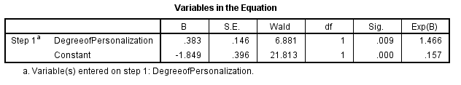

We ran the binary logistic analysis with the method “Enter”. Studenmund & Cassidy (1987) say this is the only appropriate method for theory testing, as stepwise techniques are influenced by random variation so seldom give replicable results if the model is retested within the same sample.
H1: The higher the degree of personalization on SNA is, the higher the brand recall rate will be.
The coefficient of DP was statistically significant (p-value=0.009<0.05), and therefore the null hypothesis can be rejected. B-value of DP was 0.383, which was a positive number. This means that degree of personalization has a positive impact on brand recall. Hypothesis 1 was proved.
To test whether these five types of ads are independent from brand recall or not (types of ads are categorical, brand recall is binary), a chi-square test was conducted.
Figure 6: Chi-square analysis SPSS output
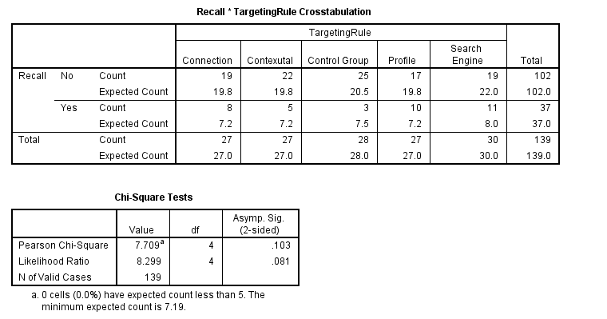
According to the results of the SPSS output of chi-square test, 0 cells have expected count less than 5. In addition, the value of Pearson Chi-Square was statistically insignificant (p=0.103>0.05). The null hypothesis cannot be rejected. This means brand recall was not significantly different among these five targeting rules (scenarios). Although profile and search engine targeted ads have higher brand recall than the others and no targeting has the lowest brand recall, brand recall is independent of targeting types.

Analysis 2: Testing H2 and H6
Figure 7: Regression analysis (DV: PC; IV: DP, DC) SPSS output
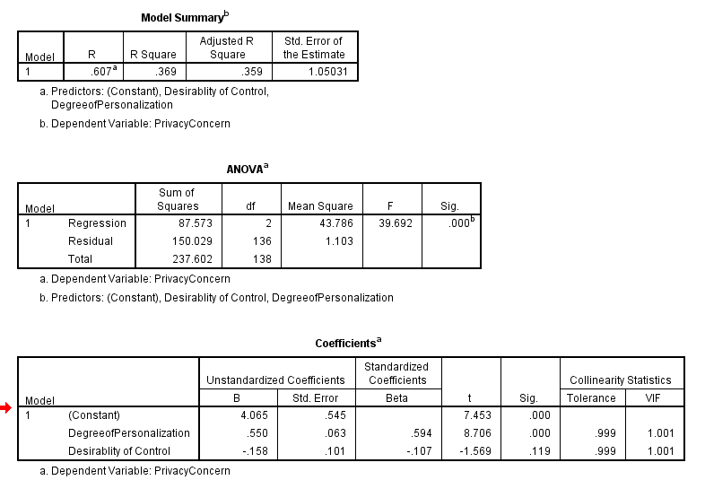
Multiple regression analysis was conducted to test H2. As we can see, the analysis is statistically significant (F=39.692, P =.000), and therefore the null hypothesis can be rejected. This means that independent variables have an effect on privacy concern. The R-squared has a value of 0.369, meaning that 36.9% of the variance in privacy concerns can be explained by the independent variables (degree of personalization and desirability of control). Moreover, this regression has accounted for multi-collinearity. All VIF values are smaller than 10, therefore there is no multi-collinearity existing.
H2: Higher the degree of personalization on SNA, higher the level of users’ privacy concerns. As can be seen in Figure 7, the β1 coefficient of degree of personalization is positive and statistically significant (P=0.000<0.05), so we reject H0. This means that, degree of personalization has a positive impact on privacy concern. The higher the degree of personalization is, the higher privacy concerns users will perceive. Thus, H2 was proved.

Analysis 3: Testing H3
Figure 8: Regression analysis (DV: Ab; IV: PC, Aad, DP) SPSS output
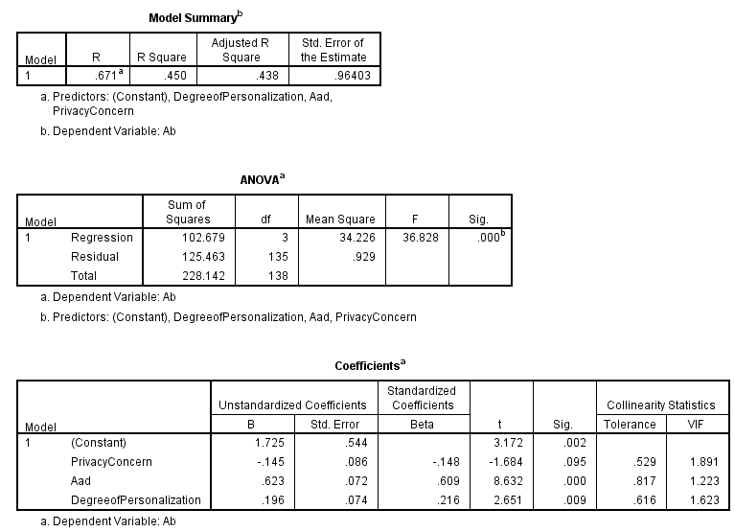

Multiple regression analysis was conducted by regressing privacy concerns, attitude towards ad (Aad) and degree of personalization on attitude towards brand (Ab). As we can see, the analysis is statistically significant (F=36.828, p =.000). Therefore the null hypothesis can be rejected, which means that independent variables have an effect on attitude toward brand. The R-squared has a value of 0.450, meaning that 45% of the variance in attitude towards brand can be explained by the independent variables (degree of personalization, privacy concerns and desirability of control). Multi-collinearity was also counted. All VIF values are smaller than 10, therefore there is no multi-collinearity existing.
H3：As users’ privacy concern increase, their attitude towards advertisers’ brand will get more negative. As can be seen in Figure 8, the β2 coefficient of privacy concern is negative but statistically insignificant at 95%confidence (P2=0.095>0.05), but marginally significant at 90% confidence (p=0.095<0.10), so we reject H0. Since our sample size is relatively small, β2 would be significant at the confidence level 90%. This means the null hypothesis can be rejected at the significance level of 0.1 and H3 was accepted. The relationship between privacy concern and Ab was marginally significant.
Additionally, β1 coefficient of DP and β3 coefficient of Aad are both positive and significant (P1=0.009<0.05, P2=0.000<0.05). To compare the magnitude of effects, standardized beta coefficients are used. As can be seen from figure 8, Aad is the most important factor to influence attitude towards brand (0.609), followed by DP (0.216) and privacy concern (-.0148).

Mediating role of PC between DP and Ab
Baron and Kenny (1986) proposed a four step approach in which several regression analyses are conducted and significance of the coefficients is examined at each step to test mediating effects.
Table 11. Mediating test of PC between Dp and Ab
 | Standardized Coefficients, Beta | Sig. | R-square
DP => PC | .603 | *(p=.000) | .369
PC => Ab | -.253 | *(p=.003) | .064
DP => Ab | .739 | *(p=.352) | .006
DP+ PC => Ab | .216; -.148 | *(p=.009); *(p=.095) | .45

Figure 9: Regression analysis (DV: Ab; IV: PC) SPSS output
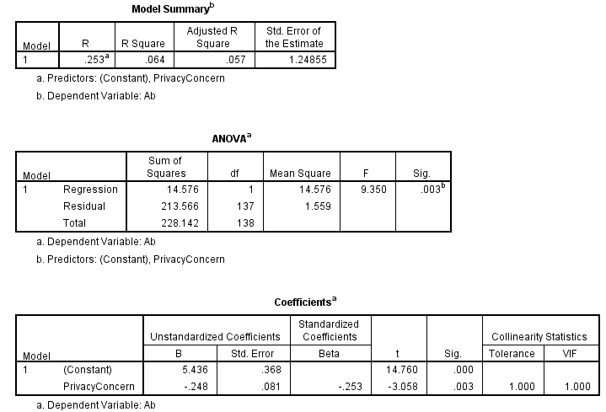

Figure 10: Regression analysis (DV: Ab; IV: DP) SPSS output
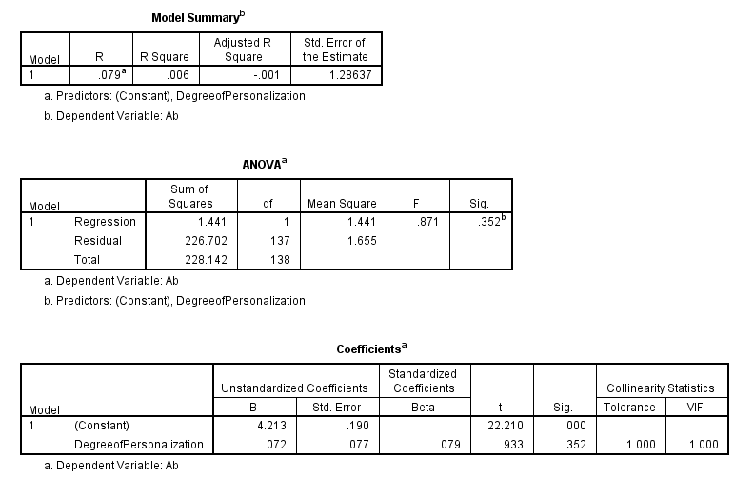
Before we add privacy concern into our model, the relationship between degree of personalization and Ab was insignificant (P=0.352>0.05). Then we included PC in this model, the standardized coefficient beta of DP changed (from 0.603 to 0.216), and the coefficient also become significant. This supported our hypothesis that privacy concern acted as a mediator between the relationship of DP and Ab. Furthermore, degree of personalization was statistically insignificant to attitude towards brand without the existence of PC, which means the relationship between DP and Ab was an indirect one. But the direction was opposite with we expected. The possible reason was that the negative impact that bring by PC was not strong enough to eliminate the positive impact bring by DP. The specific possible reason will be discussed in the next section.

Analysis 4: Testing H5 and H6
Figure 11: Regression analysis (DV: Aad; IV: PC, DP, DC) SPSS output
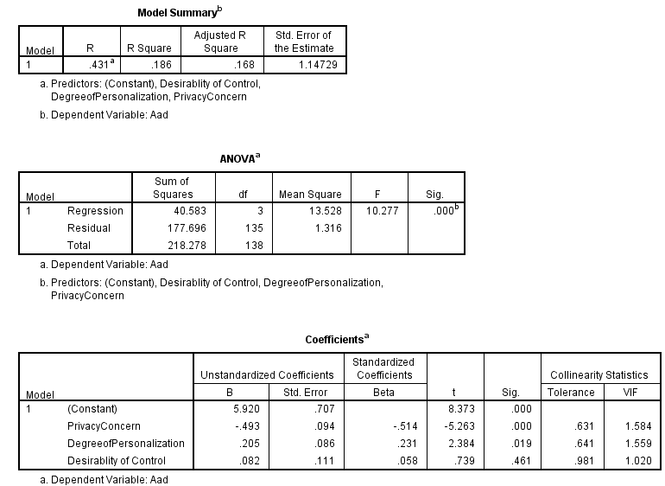

Multiple regression analysis was conducted to process analysis 4. As we can see, the analysis is statistically significant (F=10.277, p =.000). Therefore the null hypothesis can be rejected, which means that independent variables have an effect on attitude toward brand. R square was 0.186 which mean 18.6% of dependent variable Aad was explained by the independent variables (PC, DP and DC). Multi-collinearity was also counted. All VIF values are smaller than 10, therefore there is no multi-collinearity existing.
Standardized beta coefficients are considered to compare magnitude of effects. As can be seen from the Figure 7 below, the most important effect was privacy concern with the beta-value -0.514, and the second was DP (.231). PC had a negative impact on Aad with the coefficient -0.493, while DP had a positive impact on Aad, but this influence is diminutive (β1=0.082). DC was insignificant in this relationship (p=0.461>0.05), which is contrary to our previous assumption.

Analysis 5: Testing H5
Figure 12: Regression analysis (DV: Ab; IV: Aad, dummy 1, dummy 2, dummy 3, dummy 4) SPSS output
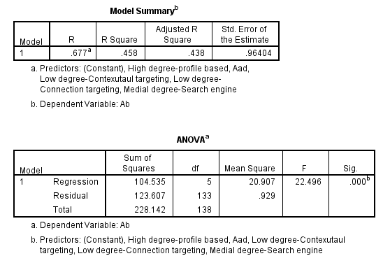

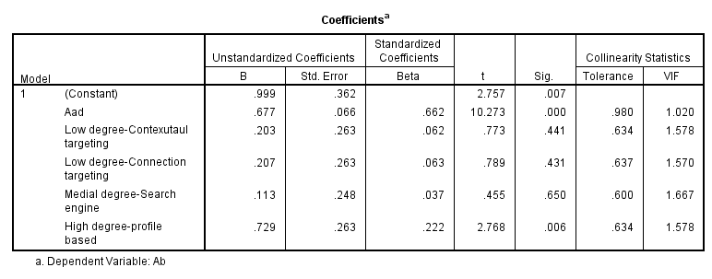
Analysis 5 was conducted to test the relationship between Aad and Ab, also, whether Ab had significant difference among 5 scenarios was considered. As we can see, the analysis is statistically significant (F=22.496, p =.000). Therefore the null hypothesis can be rejected, which means that independent variables have an effect on attitude toward brand. R square was 0.458 which mean 45.8% of dependent variable Ab was explained by the independent variables (4 dummies and Aad). Multi-collinearity was also counted. All VIF values are smaller than 10, therefore there is no multi-collinearity existing.
Standardized beta coefficients are considered to compare magnitude of effects. As can be seen from the Figure 7 below, the most important effect was Aad with the beta-value 0.662, and the second was dummy 4 (high degree-profile based targeting, beta-0.231). The other three dummies were insignificant. Since the constant could explain whether control variable has an impact on Ab and the coefficient of the constant was significant (P=0.007), we can get the conclusion that only the high degree of personalization (profile-based targeting) situation was significantly different from the control group on attitude towards brand. β5 (0.677) was significant and positive. This means Aad has a positive impact on Ab.

Mediating role of Aad between DP and Ab
Baron and Kenny’s three step mediating effect test was also conducted to test:
H5: Attitude toward the ad partially mediates the relationship between degree of personalization on SNA and attitude towards advertisers’ brand.
Table 12: Mediating test of Aad between DP and Ab
 | Standardized Coefficients, Beta | Sig. | R-square
DP => Aad | .231 | *(p=.019) | .186
Aad => Ab | .662 | *(p=.000) | .458
DP => Ab | .739 | *(p=.352) | .006
DP+ Aad => Ab | .216; .609 | *(p=.009); *(p=.000) | .45
Before we add privacy concern into our model, the relationship between degree of personalization and Ab was insignificant (P=0.352>0.05). Then we included Aad in this model, the standardized coefficient beta of DP changed (from 0.231 to 0.216), and the coefficient also become significant. This supported our hypothesis that Aad acted as a mediator between the relationship of DP and Ab. Furthermore, degree of personalization was statistically insignificant to attitude towards brand without the existence of Aad, which means the relationship between DP and Ab was an indirect one. But the direction was opposite with we expected. The possible reason was that the negative impact that bring by Aad was not strong enough to eliminate the positive impact bring by DP. The specific possible reason will be discussed in the next section.

Mediating role of PC between DC and Aad
H6: Privacy concerns mediate the relationship between users’ desirability of control and their attitude towards ad, and this lead to a negative correlation between desirability of control and attitude towards ad.

We can tell from the results of analysis 4 that the coefficient of DC in this model was insignificant (P=0.461>0.05). Thus, the null hypothesis cannot be rejected. We cannot prove significant relationship between desirability of control and attitude towards ad. Since one of the conditions to make Aad the mediator between DP and Ad was that DP should significantly predict Aad, hypothesis 6 was rejected.

Analysis 6:
Figure 13: Regression analysis (DV: IC; IV: Ab, dummy 1, dummy 2, dummy 3, dummy 4) SPSS output
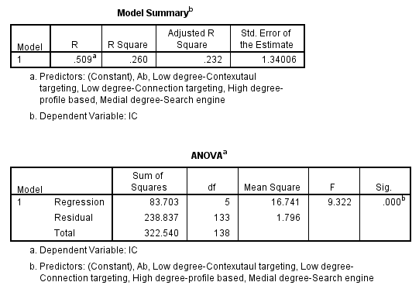
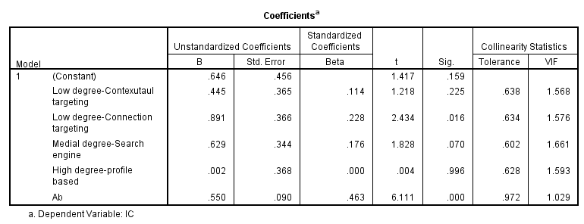
Analysis 6 was conducted to test the relationship between Ab and IC; also, whether IC had significant difference among 5 scenarios was considered. As we can see, the analysis is statistically significant (F=9.322, p =.000). Therefore the null hypothesis can be rejected, which means that independent variables have an effect on IC. R square was 0.260 which mean 26% of dependent variable IC was explained by the independent variables (4 dummies and Ab). Multi-collinearity was also counted. All VIF values are smaller than 10, therefore there is no multi-collinearity existing.
Standardized beta coefficients are considered to compare magnitude of effects. As can be seen from the Figure 13, the most important effect was Ab with the beta-value 0.463, and the second was dummy 2 (low degree-connection targeting, beta-.228). The other three dummies were insignificant. Since the constant could explain whether control variable has an impact on IC and the coefficient of the constant was insignificant (P=0.007), we can get the conclusion that among 5 scenarios, relative to control group, low degree of personalization (connection targeting) was statistically related to higher intention to click. Meanwhile, medium level of personalization (search-engine targeting) was marginally related to higher intention to click compare with control group. β5 (0.550) was significant and positive. This means Ab has a positive impact on IC. H7 was proved.
H7: Attitude towards advertisers’ brand is positively related to users’ intention to click the ads.

Control variables:
Figure 14: Regression analysis (Ab as DV) with control variables SPSS output
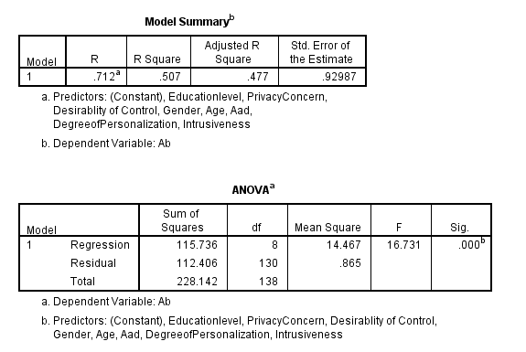
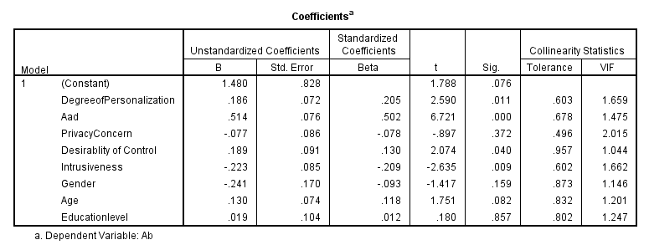
From the SPSS output, we can figure out that only the control variable intrusiveness significantly influenced Ab (P=0.009<0.05). Surprisingly, we found that even though desirability of control didn’t have an impact on Aad, it had a direct relationship with Ab (P=0.040). The coefficient of DC in this equation was 0.189, which means people have higher desirability of control would have a more positive attitude towards advertiser’s brand on SNSs. We assumed that the relationship between DC and Ab would be a negative relationship in H6, but the results showed a totally opposite one. We will discuss the possible reason in our conclusion session.

Additional finding:
Figure 15: Regression analysis (ASNS as DV) without control variables SPSS output
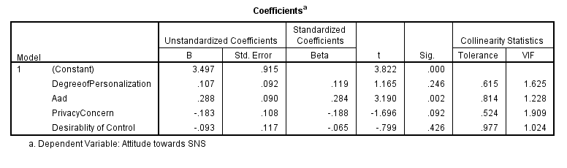
Figure 16: Regression analysis (ASNS as DV) with control variables SPSS output
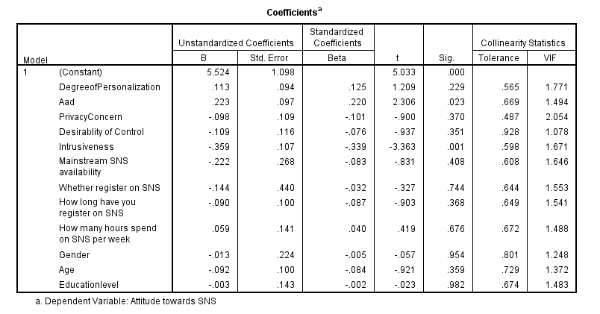
We ran two multiple regression to test the relationship between DV attitude towards SNS and all the IVs we used in Ab analysis (DP, PC, DC and Aad) with and without control variables (intrusiveness, mainstream SNS accessibility, SNS registration history, hours spend on SNS per week, gender, age and education level). As we can see, only the IV Aad and the control variable intrusiveness have an impact on ASNS (P1=0.023, P2=0.001). Additionally, we get the means of ASNS, intrusiveness and Pc for each personalized/control condition from the descriptive analysis. Subjects exposed to connection targeted ads showed the highest ASNS (4.10), followed by contextual targeting (3.90), profile-based targeting (3.90), control group (3.65) and search-engine targeting (3.33). We can get the conclusion that degree of personalization doesn’t have impact on ASNS.

Table 13: Mediating test of PC between DP and Aad
 | Standardized Coefficients, Beta | Sig. | R-square
DP => PC | .603 | *(p=.000) | .369
PC => Aad | -.368 | *(p=.000) | .147
DP => Aad | -.070 | *(p=.359) | .006
DP+ PC => Aad | .205; -.493 | *(p=.019); *(p=.000) | .186

Figure 17: Regression analysis Regression analysis (DV: Aad; IV: PC) SPSS output
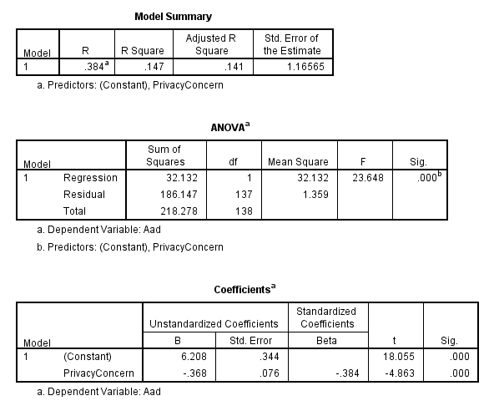

Figure 18: Regression analysis Regression analysis (DV: Aad; IV: DP) SPSS output
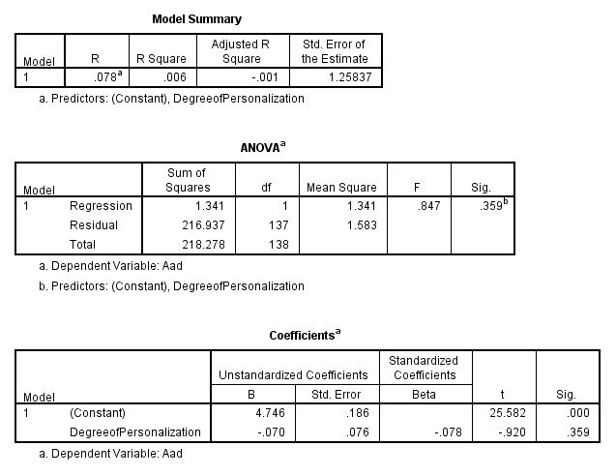
Before we add privacy concern into our model, the relationship between degree of personalization and Aad was insignificant (P=0.359>0.05). Then we included PC in this model, the standardized coefficient beta of DP changed (from -0.078 to 0.231), and the coefficient also become significant (P=0.019<0.05). This means that privacy concern acted as a mediator between the relationship of DP and Aad. Furthermore, degree of personalization was statistically insignificant to attitude towards brand without the existence of PC, which means the relationship between DP and Aad was an indirect one. But the direction was opposite with we expected. The possible reason was that the negative impact that bring by PC was not strong enough to eliminate the positive impact bring by DP. The specific possible reason will be discussed in the next section.

Table 14: Hypothesis summary
H1: The higher the degree of personalization on SNA is, the higher the brand recall rate will be. | Confirmed
H2: Higher the degree of personalization on SNA, higher the level of users’ privacy concerns. | Confirmed
H3: As users’ privacy concern increase, their attitude towards advertisers’ brand will get more negative. | Confirmed
H4: Privacy concerns mediate the relationship between degree of personalization on SNA and attitude towards advertisers’ brand, which lead to a negative relationship between these two variables. | Not confirmed (significant, but in opposite direction)
H5: Attitude toward the ad partially mediates the relationship between degree of personalization on SNA and attitude towards advertisers’ brand. | Confirmed
H6: Privacy concerns mediate the relationship between users’ desirability of control and their attitude towards ad, and this lead to a negative correlation between desirability of control and attitude towards ad. | Not confirmed
H7: Attitude towards advertisers’ brand is positively related to users’ intention to click the ads. | Confirmed

5. Conclusion
This research makes a number of theoretical and practical contributions.
Firstly, higher degree of personalization catches more attention from users and gets a higher recall rate. Normally, users are more easily to notice information which is related to them or is interested in. Second, privacy concern does act as a mediator between degree of personalization and attitude towards ad, but contrary to our expectation, there is no direct relationship between PC and Ab and the relationship between them is positive, namely, the higher the degree of personalization is, the more positive the attitude towards brand is. Our definition of degree of personalization has dimensions related to both positive (i.e., congruency, informative) and negative (privacy concern) utilities. The possible reason for this outcome is that the positive impacts brought by personalization are so strong which cannot totally be beat by privacy concern. Furthermore, the mediating role of Aad between DP and Ab was also confirmed. To get to the bottom of the reason why the relationship of DP and Ab is opposite to our expectation, we ran an additional analysis and found out that PC is also the mediator between DP and Aad. So the other possible explanation for the positive relationship between DP and Ab is that there are too many mediators between these two variables and we probably omitted some critical factors in this complicated relationship. Third, as the previous literature (Fishbein et al., 1975; Spears et al,. 2004) proved, attitude influences behavioral intention. Attitude towards brand is positively related to users’ intention to click the ad. Thus it’s reasonable to believe that the higher the degree of personalization is, the higher the users’ intention to click the ad will be.
The effect that desirability of control has on attitude towards ad was insignificant. Furthermore, we found that DC is actually directly related with attitude towards brand. Surprisingly, the relationship is contrary to our assumption. DC is positively related with Ab, namely, the higher a person´s desirability of control is, and the more positive his /her attitude towards the brand will be. Althaus and Tewksbury (2000) found that desirability of control is a strong predictor of news exposure. Specifically, the greater a person’s desirability of control, the more they will expose themselves to the media. In the following research, Liu and Shrum (2002) have developed a theoretical model for interactivity and found that desirability of control is a key factor in obtaining satisfaction from the interactive process. They suggest that people who have a high desirability of control will be more satisfied with interactivity than people who have a low desirability of control. We suggested that the previous research forgot to take privacy concerns into consideration, but it can been seen from our results that desirability of control is not significantly related with privacy concern, which means the previous researches were doing in a right way and their results were further supported.
After testing all of our hypothesis, in case we omitted some vital factors, we add some demographic dimensions (age/gender/education level), SNS usage-related dimensions (main SNS availability/whether and how long has been registered on SNSs/hours spend on SNS per week) and intrusiveness which was always be considered closely related with users´ attitude and purchase intention (Doorn & Hoekstra, 2013). According to our findings, only “intrusiveness” is statistically significant and has a negative impact on users´ attitude toward brand.
The relationship between degree of personalization and attitude towards SNS was studied as an additional analysis. Because we think it´s interesting to know if SNS websites themselves will benefit or impair from providing personalized ads. An interesting fact was observed. There is no direct relationship between DP and ASNS. One possible reason is there are some mediators between these two factors, such as Aad, privacy concern. We just ran a simple multiple regression with ASNS as the DV and DP, Aad, PC and DC as the Ivs. It´s possible that other more complicated relations were underlying between DP and ASNS. Another possible reason is that degree of personalization is a multidimensional definition and these dimensions lead to diverse direction of ASNS which made the relationship between DP and ASNS uncertain. Tyler et al. (2011) studied factors that could influence users´ attitude towards SNS after exposed to SNA. According to their findings, informative and self-brand congruity is positively related with ASNS, while invasiveness and privacy concern are negatively related with ASNS. These four dimensions are all correlated with DP. This could be an explanation of our result.

6. Management Summary
With the development of data mining technology, online advertisers are possible to give customized ads to each individual user. Since users provide plenty of data online (e.g. browsing history, demographic data, code of language…), a number of targeting rules can be used to decide ads display. Social network sites, due to its enormous user base and user-generated data, have become a force which cannot be ignored of online marketing. It’s interesting to know how personalization would influence the effectiveness of SNA. Personalized ads (PA) bring both pros and cons. Compared with non-personalized ads, PA carries more useful information and self-ad congruity, but meanwhile more privacy concern and intrusiveness. Considering these advantages and disadvantages, we used the concept degree of personalization to conduct our research. The three dimensions of DP were concluded from previous literatures (Carpenter, 1975; White et al., 2008). Additionally, we include a psychological factor, desirability of control in our research. Then we can see both endogenous and exogenous factors which influence the effectiveness of personalized SNA.
We tried to use secondary data to test our research questions, but it’s barely possible to get the internal data from Facebook or Facebook advertisers. Therefore, we switched to an experimental research. Considering our limitation of resource, on field experiment was also abandoned. Instead, we created three different web pages with independent IPs to mimic the real Facebook environment. In this way, we can control what would be presented to our subjects and make sure that subjects in the same group would see exactly the same contents easily. The subjects of our pretest were gathered from Erasmus University and they were excluded from our main experiment stage. The subjects of main experiment stage were hired from both EUR and Amazon Mechanical Turks. Each participants were paid by ＄0.6 after filling our post-test survey.

Managerial Suggestions:
For the advertisers of SNSs, our research can be use for reference to decide with kind of user data to use while choosing targeted users. Our suggestion is: First, for the new brands that need to arouse attention, it’s better to use higher degree of personalization rules, like profile-based targeting and search engine history targeting. Highly self-related information is easier to get users’ attention. Second, for the existing well-known brands, it’s better to use lower degree of personalization rules, like connection-based targeting and contextual targeting. In this way, users’ will not get a worse attitude towards brand but still keep a relatively close relationship with the certain brand.
For the SNSs providers, our research can be use for reference to give more precise personalization to different users. According to our results, people with higher desirability of control will have more positive attitude towards advertisers’ brand. SNS sites can extract information whether this user is a high/low control subject based on his/her privacy control preferences. SNSs, like Facebook, can make more revenue through give hierarchical pricing to targeting users with different level of desirability of control.

7. Limitation
One of the limitations of our study was the use of desirability of control and manipulation scale. For the purpose of keeping our questionnaire short, we abandon the most widely used scale by scholars created by Burger (1979). The scale we used (Dahling et al., 2008) is a multifactor scale and we just use one of three factors to present the users´ desirability of control. DC is a psychological factor; its result could change a lot if we use different scales. The manipulation scale was also conducted in our pretest stage, which was a new scale designed by ourselves. It could have some flaws.
Additionally, we conducted a quasi-experiment instead of a real-life on field experiment. Our subjects may have different reactions in a real Facebook environment. The Facebook page we presented to our subjects was just a screen print. It was not interactive with the subjects. But in real SNS environments, the pages are more informative and interactive. Users will maybe notice less intrusiveness from SNAs, and it´s more difficult to let them notice the ads contents.
Eventually, we test our thesis only in one product category. The results are not necessarily right in other category or industries. Users have different level of privacy sensitivity to different product categories. But due to lack of time and resource, we didn’t test our hypothesis in different categories.

8. Future Research
Limitations to this study suggest opportunities for further researches. Due to the limitation of our resource, we cannot run a Facebook on field experiment. Instead, only an imitative quasi-experiment was conducted to test our hypothesis. It would be interesting to conduct an experiment in real SNS environment for future research.
Another opportunity for future research arises from the definition of degree of personalization. Even thought DP is not a new word anymore, no authoritative definition was given to it. We use three dimensions concluded from two previous articles (Carpenter, 1975; White et al., 2008), but still there´s some chance that we omitted other influential dimensions. We recommend to testing every possible dimension separately as different independent variables with same dependent variables to see how much each dimension actually influences the DVs.
Furthermore, the desirability of control scale can be improved in future researches. It´s better to develop a new scale of desirability of control only for testing users´ desirability of control in online SNS environments.

Reference:
Agichtein, E., Brill, E., Dumais, S. (2006). “Improving Web Search Ranking by Incorporating User Behavior Information”. Proceedings of the 29th annual international ACM SIGIR conference on research and development in information retrieval, 08/2006, SIGIR '06, ISBN 1595933697, pp. 19 – 26
Ahn, J., Lee, JW. (2012). “Attention to Banner Ads and Their Effectiveness: An Eye-Tracking Approach”. International journal of electronic commerce, ISSN 1086-4415, 2012, Volume 17, Issue 1, pp. 119 – 137
Bright, L.F., Daugherty, T. (2012). “Does customization impact advertising effectiveness? An exploratory study of consumer perceptions of advertising in customized online environments”. Journal of marketing communications, ISSN 1352-7266, 2012, Volume 18, Issue 1, pp. 19 – 37
Burger, J.M. (1985). “Desire for Control and Achievement-Related Behaviors”. Journal of Personality and Social Psychology, ISSN 0022-3514, 06/1985, Volume 48, Issue 6, pp. 1520 – 1533
Burger, J.M. (1986). “Desire for Control and the illusion of Control: The Effects of Familiarity and Sequence of Outcomes”. Journal of Research in personality, 20, 66-76
Carpenter, E.H. (1974). “Personalizing Mail Surveys: A Replication and Reassessment”. The Public Opinion Quarterly, ISSN 0033-362X, 12/1974, Volume 38, Issue 4, pp. 614 – 620
Chen, Y., Pavlov, D., Canny, J. (2009). “Large-Scale Behavioral Targeting”. Proceedings of the 15th ACM SIGKDD international conference on knowledge discovery and data mining, 06/2009, KDD '09, ISBN 9781605584959, pp. 209 – 218
Cheung, C.M.K., Chiu, P.Y., Lee, M.K.O. (2011). “Online Social Networks: Why Do Students Use Facebook”. Computers in Human Behavior, Vol. 27, No. 4, pp. 1337-1343
Cho, C.H. (2004). “Why Do People Avoid Advertising on the Internet?”. Journal of Advertising, Vol. 33, No. 4, pp. 89-97
Culnan, M.J. (1993). “"How Did They Get My Name?": An Exploratory Investigation of Consumer Attitudes toward Secondary Information Use”. MIS Quarterly, ISSN 0276-7783, 09/1993, Volume 17, Issue 3, pp. 341 – 363
Doorn, J., Hoekstra, J.C. (2013). “Customization of online advertising: The role of intrusiveness”. Marketing Letters, ISSN 0923-0645
Dustin, D.B. (2011). “Balancing consumer privacy with behavioral targeting”. Santa Clara Computer and High - Technology Law Journal, ISSN 0882-3383, 02/2011, Volume 27, Issue 1, p. 3
Gardner, M.P. (1985). “Does Attitude toward the Ad Affect Brand Attitude under a Brand Evaluation Set”. Journal of Marketing Research, ISSN 0022-2437, 05/1985, Volume 22, Issue 2, pp. 192 – 198
Goldfarb, A., Tucker, C. (2011). “Online Advertising, Behavioral Targeting, and Privacy”. Communications of the ACM, ISSN 0001-0782, 05/2011, Volume 54, Issue 5, pp. 25 – 27
Goldfarb, A., Tucker, C. (2011). “Online Display Advertising: Targeting and Obtrusiveness”. Marketing Science, ISSN 0732-2399, 05/2011, Volume 30, Issue 3, pp. 389 – 404
Kim, C., Kwon, K., Chang, W. (2011). “How to measure the effectiveness of online advertising in online marketplaces”. Expert Systems with Applications, ISSN 0957-4174, 2011, Volume 38, Issue 4, pp. 4234 – 4243
Law, A., Logan, H., Baron, R.S. (1994). “Desire for Control, Felt Control, and Stress Inoculation Training During Dental Treatment”. Journal of Personality and Social Psychology, ISSN 0022-3514, 11/1994, Volume 67, Issue 5, pp. 926 - 936
Lewin, J.E., Taylor, D.G. (2011). “Friends, fans, and followers: do ads work on social networks? How gender and age shape receptivity”. Journal of advertising research, ISSN 0021-8499, 2011, Volume 51, Issue 1, pp. 258 – 275
Li, K., Idemudia, E.C., Lin, Z., Yu, Y. (2012). “A framework for intermediated online targeted advertising with banner ranking mechanism”. Information Systems and e-Business Management, ISSN 1617-9846, 06/2012, Volume 10, Issue 2, pp. 183 – 200
Mackenzie, S.B., Lutz, R.J. (1989). “An empirical examination of the structural antecedents of attitude toward the ad in an advertising pretesting context”. Journal of Marketing, Vol. 53, No. 2 (Apr., 1989), pp. 48-65
Malte, B., Andrea, S. (2010). “Online advertising effectiveness: a cross-cultural comparison”. Journal of Research in Interactive Marketing, ISSN 2040-7122, 2010, Volume 4, Issue 3, pp. 176 - 196
McKenzie, S.B., Lutz, R., Belch, G.E. (1986). “The Role of Attitude Toward the Ad as a Mediator of Advertising Effectiveness: A Test of Competing Explanations”. Journal of Marketing Research, Vol. 23, No. 2., pp. 130-143
Newsorn (2012). “Testing Mediation with Regression Analysis” . USP 654 Data analysis II
Pavlou, A.P., Stewart, W.D. (2000). “Measuring the effects and effectiveness of interactive advertising: A research agenda”. Journal of Interactive Advertising, ISSN 1525-2019, Fall 2000, Volume 1, No.1
Phelps, J.E., Nowak, G.J. (2001) “Antecedents and Consequences of Consumer Privacy Concerns: An Empirical Investigation”. Journal of Interactive Marketing, Vol. 15, No. 4, pp. 2-17
Robinson, H., Wysocka, A., Hand, C. (2007). “Internet advertising effectiveness-The effect of design on click-through rates for banner ads”. INTERNATIONAL JOURNAL OF ADVERTISING, ISSN 0265-0487, 2007, Volume 26, Issue 4, pp. 527 - 541
Rong, J., Vu, H.Q., Law, R., Li, G. (2012). “A behavioral analysis of web sharers and browsers in Hong Kong using targeted association rule mining”. Tourism Management, ISSN 0261-5177, 08/2012, Volume 33, Issue 4, pp. 731 - 740
Scott, B. (2009). “FTC principles for behavioral advertising”. Network World, ISSN 0887-7661, 02/2009, Volume 26, Issue 8, p. 20
Sheehan, K.B., Hoy, M.G. (1999). “Flaming, Complaining, Abstaining: How Online Users Respond to Privacy Concerns”. Journal of Advertising, Vol. 28, No. 3, pp. 37-51
Spears, N., Singh, N.S. (2004). “Measuring Attitude Toward the Brand and Purchase Intentions”. Journal of Current Issues and Research in Advertising, ISSN 1064-1734, 2004, Volume 26, Issue 2, pp. 53 – 66
Surprenant, C.F., Soloman, M.R. (1987). “Predictability and Personalization in the Service Encounter”. Journal of Marketing, Vol. 51, No. 2 (Apr., 1987), pp. 86-96
Taylor, D.G., Davis, D.F. (2009). “Privacy concern and online personalization: the moderating effects of information control and compensation”. Electronic commerce research, ISSN 1389-5753, 2009, Volume 9, Issue 3, pp. 203 - 223
Wise, S.L., Roos, L.L. (1996). “The Development and Validation of a Scale Measuring Desire for Control on Examinations”. Educational and Psychological Measurement, ISSN 0013-1644, 08/1996, Volume 56, Issue 4, pp. 710 – 718
Yan, J., Liu, N., Zhang, W., Jiang, Y., Chen, Z. (2009). “How much can Behavioral Targeting Help Online advertising”. Association for Computing Machinery, ISBN: 978-1-60558-487-4, 2009, pp. 261-270
Yu, J. (2011). “Is it worth it to be unethical? Consumers’ attitudes toward personalized commercial e-mails”. Journal of Database Marketing & Customer Strategy Management, ISSN 1741-2439, 12/2011,Volume 18, Issue 4, pp. 274 – 285
Yu, J.H., Cude, B. (2009). “Hello, Mrs. Sarah Jones! We recommend this product!’ Consumers’ perceptions about personalized advertising: comparisons across advertisements delivered via three different types of media” International journal of consumer studies, ISSN 1470-6423, 2009, Volume 33, Issue 4, pp. 503 – 514
Zubcsek, P.P., Sarvary, M. (2011). “Advertising to a Social Network”. Quantitative Marketing and Economics, Vol. 9 , No. 1, pp. 71-107
Amount of personal information shared on Facebook-profile
[high/low]
Ad-self Congruency
[high/medium/low]

Attitude towards receiving targeted ads on Facebook
Willingness to click on Facebook targeted ads
Privacy Concerns
[high/low]

Appendix
Appendix 1:
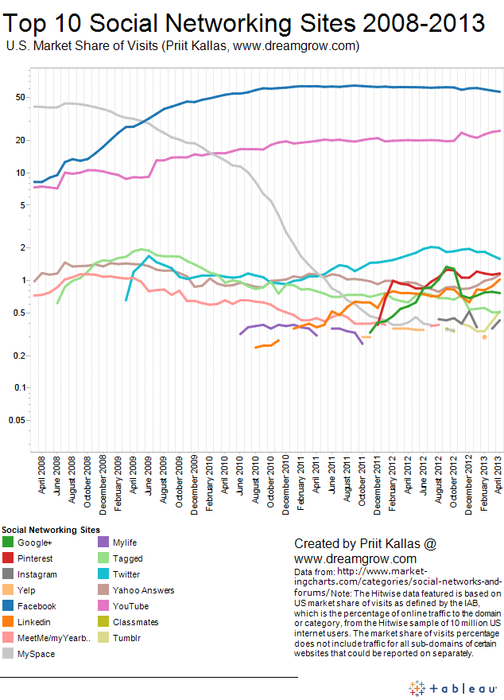

Appendix 2: Conteuxal targeting

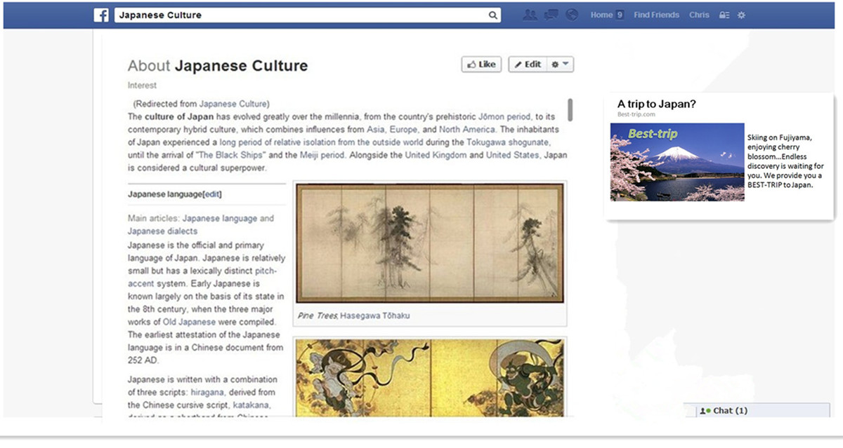

Appendix 3: Connection targeting/Search engine targeting/Control
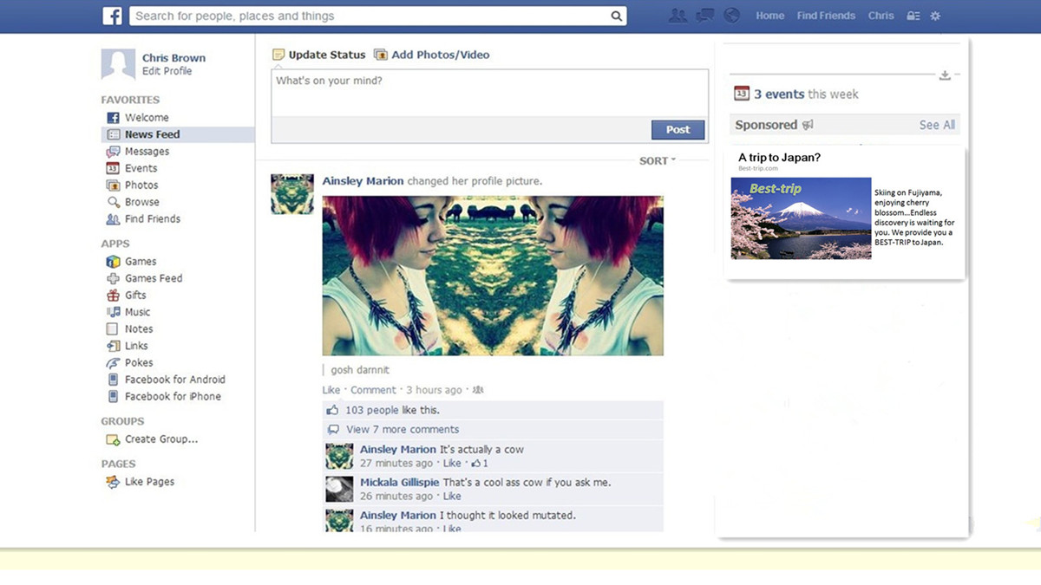

Appendix 4: Profile-based targeting
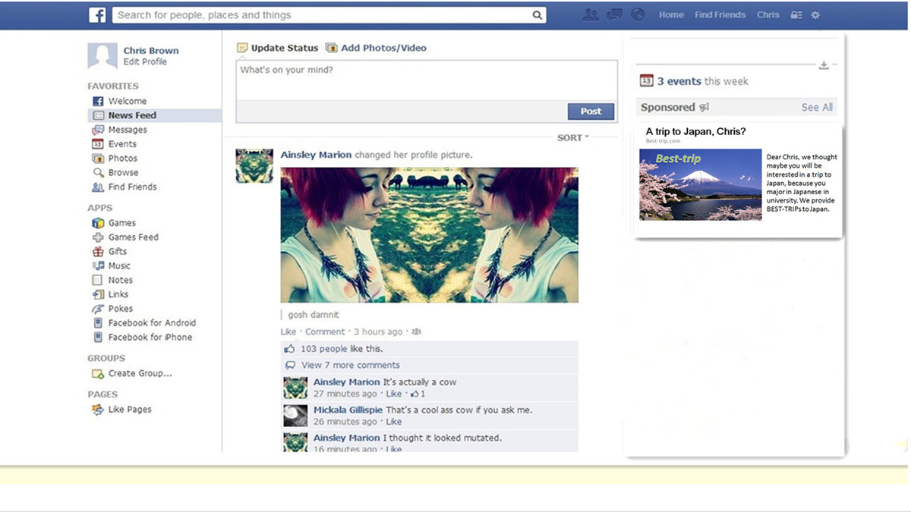

Appendix 5: Questionnaire
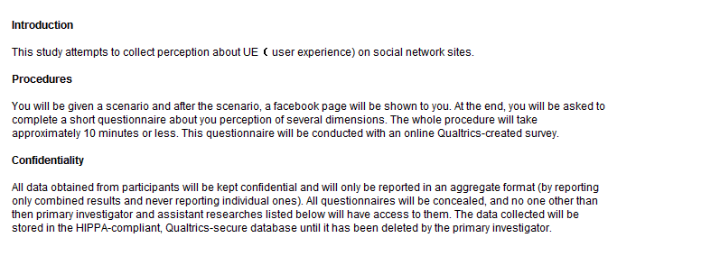
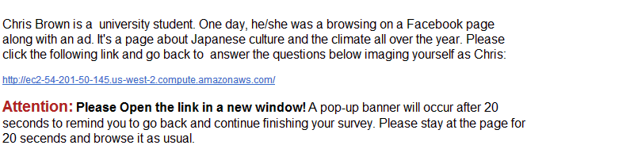
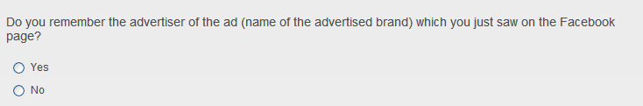

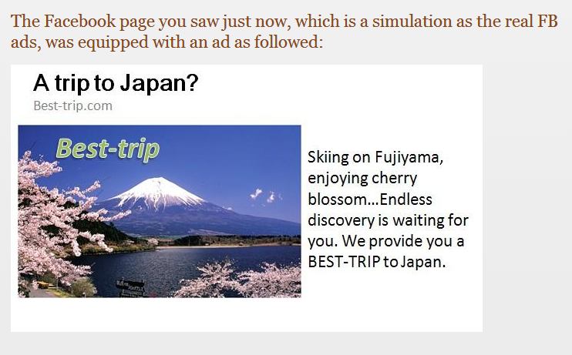
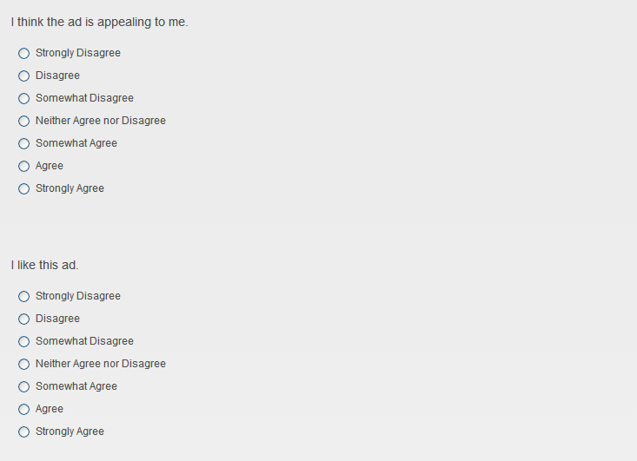
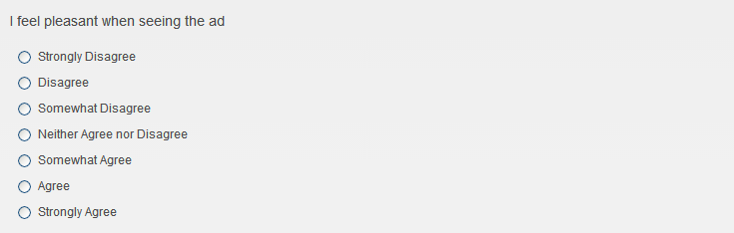
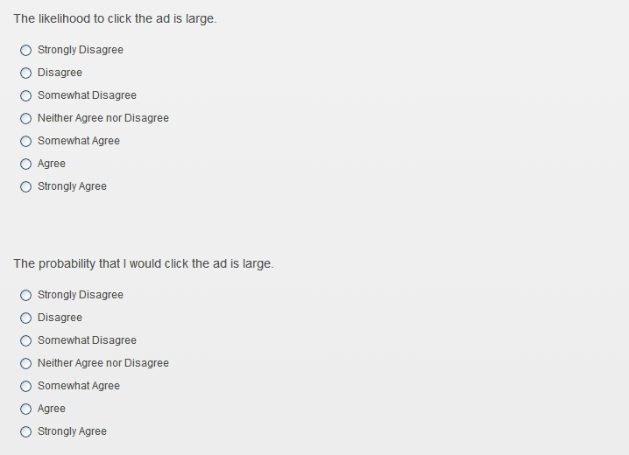
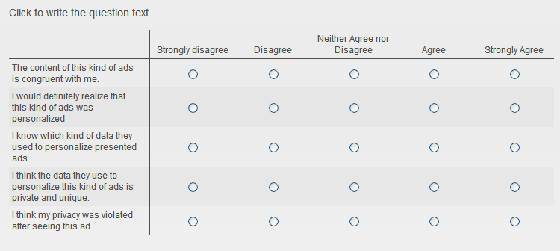
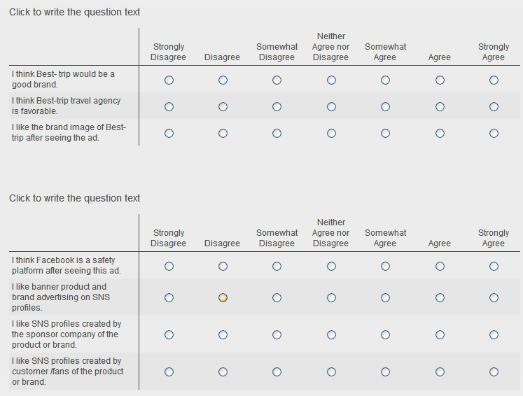
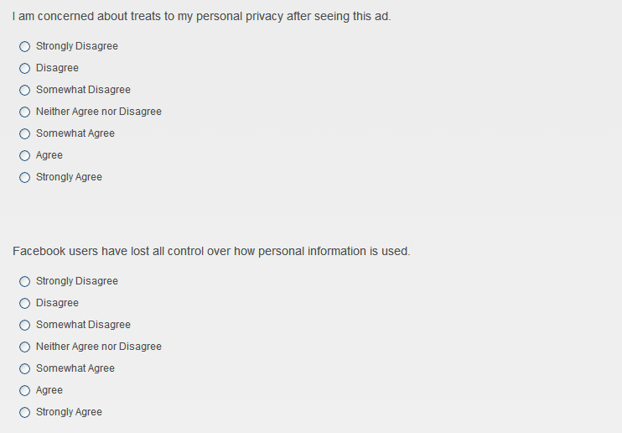
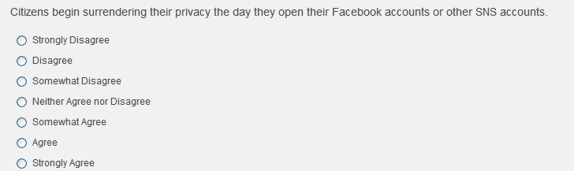
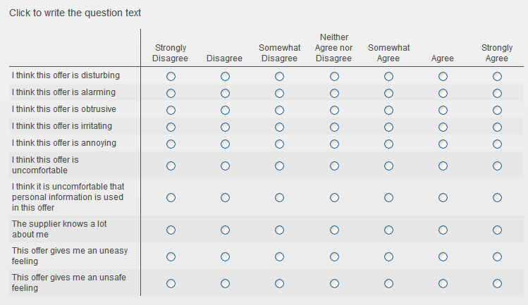
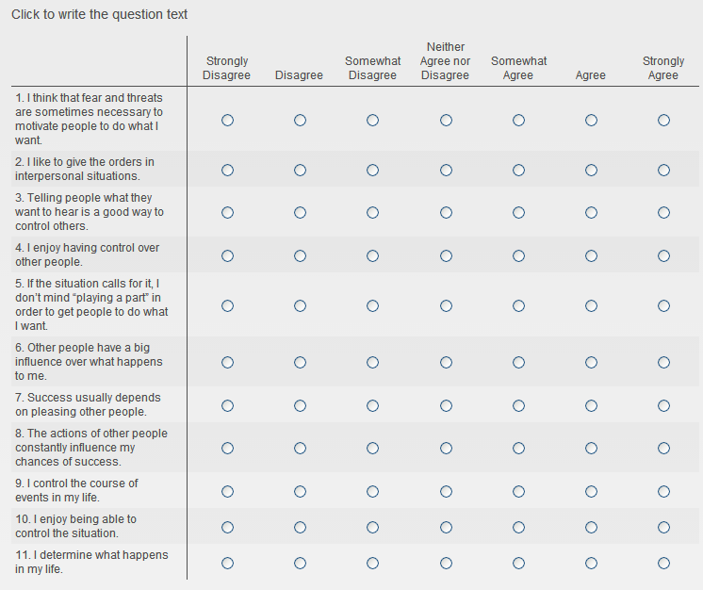
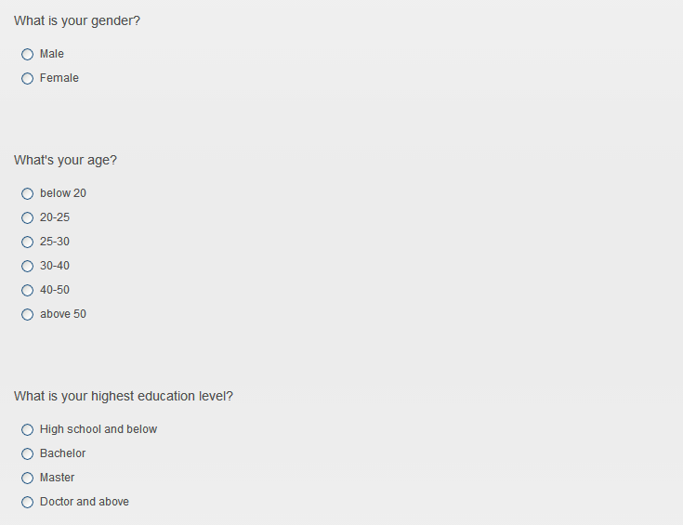


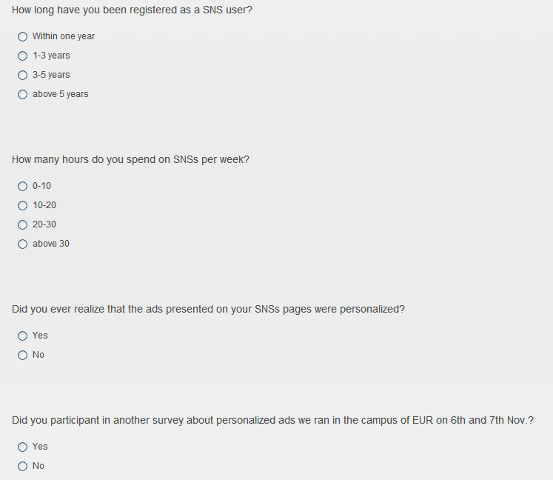

A vignette in psychological and sociological experiments presents a hypothetical situation, to which research participants respond thereby revealing their perceptions, values, social norms or impressions of events.
Behavioral targeting
Social network targeting
An interstitial ad is an advertisement that interrupts the users. Often pop-ups, e-mercials or intermercials.
Sponsoring a website can take many forms, most of which lead to placements that go beyond banner buys.
Opt-in email is an email containing information or advertising that users explicitly request to receive.
The possibility that effects gained from a previous treatment may still be present and, therefore, be carried over in the next treatment
N=number
Weibo and Renren.com are the most widely used SNSs in China. They are the substitutes of Twitter and Facebook. Weibo has the similar functions and UI with Twitter, while Renren.com is almost the same as Facebook. Both of these sites started providing personalized ad to their users in these two years. Renren.com presents ad to their users in the same way as Facebook does. Weibo doesn’t open their Advertising space which is at the bottom of users’ homepage to mass advertisers. They have several signed advertisers, and then users will be exposed to personalized ads from this ad bank.

