ERASMUS UNIVERSITY ROTTERDAM
ERASMUS SCHOOL OF ECONOMICS

Coordination problems and arrangements in hinterland transport chains: a literature review and a case study about the role of trust in the hinterland transport chain

Bachelor Thesis
July 2014

Student: Gülbahar Uysal
Student number: 354160
Supervisor Martijn van der Horst
Erasmus University
Rotterdam:
Contents
Chapter 1: Introduction 3
Chapter 2: Perspectives, definitions and elements of trust 6
2.1 Transaction cost economics 7
2.2 Agency theory 9
2.3 Social Exchange Theory 11
2.4 Three perspectives analyzed 13
2.5 Definitions 14
2.6 Driving factors of trust 15
Chapter 3: Hinterland transport chains and actors involved 18
3.1 Hinterland transport chains 18
3.2 Hinterland actors 19
3.2.2 hinterland chain actors 20
3.3 Coordination in the hinterland transport chains 22
3.4 Coordination problems hinterland transport chains 22
3.4.1 Coordination problems in container barging 22
3.4.2 Coordination problems in railway hinterland chain 23
3.4.3 Coordination problems in road transport chain 23
3.4.4 Coordination mechanisms 24
3.4.5 Coordination arrangements 25
Chapter 4: A case study: Portbase and INITI8 27
4.1 Portbase 27
4.1.1 Introduction 27
4.1.2 The system 28
4.2 INITI8: Synchronizing Barge Plans 28
4.2.1 Introduction 29
4.2.2 The system 29
4.2.3 Conclusion Case study 31
Chapter 6: Conclusion 33
Chapter 7: Limitations and suggestions 35
Appendix 36
References 40

Chapter 1: Introduction

In the area of supply chain management recent research have led to a debate about elements regarding to closer relationships between businesses. One of these elements is trust. Trust is often mentioned as one the most important success factor for cooperation among firms in a supply chain (Tejpal, Garg, & Sachdeva, 2013).
There is a widely-accepted hypothesis which claims that businesses will attain cost reduction on the long term when working closer with other companies (Kolluru & Meredith, 2001). Trust plays an important role when considering this closeness. In order to work closer, share information and gain experience, you need to trust each other. According to Becerra and Gupta (1999), empirical research has discovered the benefits of trust in different contexts, like reducing conflicts (Zaheer, McEvily, & Perrone, 1998), improving individual performances and promoting inter-organizational cooperation and growth (Ring & Van de Ven, 1994) (Becerra & Gupta, 1999).
In addition to the supply chain management view, trust is also been extensively researched in the social exchange literature (Zaheer, McEvily, & Perrone, 1998) in economics (Sako & Helper, 1998) in marketing (Doney & Cannon, 1997) and from many other perspectives. This growing relevance of trust is related to the growing importance of uncertainty. Uncertainty can be seen as a core aspect of trust. Trust is most significant in circumstances with high uncertainty. Trust and uncertainty are positively related. Low uncertainty requires low trust (Al-Mutairi, 2007). However, trust among the supply chain partners is a relatively new element. It has received a lot of interest from researchers and also shows an exponential growth (Tejpal, Garg, & Sachdeva, 2013). Many researchers from different perspectives have attempted to give a definition for trust (Figure 1). This has led to a range of different definitions according to their perspective. However, trust has still an unclear definition.
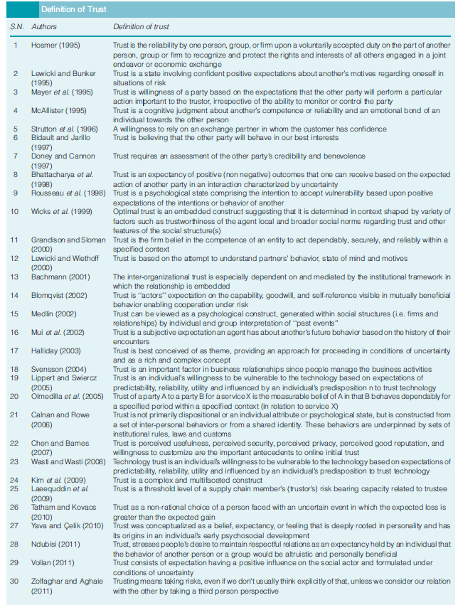
This thesis will attempt to understand trust as a condition for information sharing better in supply chains, especially in the context of hinterland transport chains. In addition it will also provide an answer for the question of what kind of role trust plays in port-related transport chains. Special attention will be given to information sharing as a result of trust between businesses. The reason for focusing on the hinterland transport is because it is an important lengthening of the total transport chain when considering the container market, involving a big part of the total transportation costs.
The approach for designing this paper will be based mainly on a literature review with empirical illustrations and a case study from the context of hinterland chains. With this literature review this thesis will try to give an insight to understand trust better, especially trust-related information sharing between businesses, by analyzing and perusing academic articles due to trust and hinterland chains.
The research question of this thesis is: To what degree is trust a condition for information sharing in order to have efficient coordinated hinterland chain? In order to give an answer to the main question of this thesis, there are three sub-questions conducted.
- What perspectives, definitions and driving factors of trust exist?
- How is the hinterland transport chain organized?
- What are the coordination problems in the hinterland?
Trust has been researched from many perspectives. In order to be able to answer the research question properly and due to the fact that information sharing occurs as a result of trust between two actors, it is important to gain insight in these perspectives and have a clear understanding about trust. Therefore, chapter 2 will research three perspectives (Transaction Cost Economics, Agency Theory and Social Exchange Theory), definitions and driving factors of trust, like uncertainty and duration of the relationship. The aim of this chapter is understand trust better.
In chapter 3, we will provide an overview of hinterland transport chains and the actors involved and we will show some coordination problems in the hinterland and explain what role trust plays in this context. This chapter will also look to the effects of information sharing as a result of coordination arrangements in hinterland transport chains.
Chapter 4 will analyze two cases with regard to information sharing coordination arrangements Portbase and INITI8.
As said before, the sub-questions and the main question will be answered by doing qualitative research based on academic literature.

Chapter 2: Perspectives, definitions and elements of trust

Building trust in the company is seen as a challenge due to the lack of conceptual clarity about it. Therefore supply chain members don’t know how to build trust. In this chapter we will attempt to give an answer on the following sub-question: What perspectives, definitions and elements of trust exist? In addition to this sub-question, we will also look to the relationship between trust and information sharing.
Trust has been analyzed from many different perspectives like psychology, sociology, management, behavioral, organizational, finance, marketing, decision making and competition. In this thesis will be looked at trust from a perspective of transaction cost economics (2.1), agency theory (2.2) and social exchange theory (2.3). The reason for concentrating on these specific perspectives is due to the fact that these disciplines provide a broader view associated with risks, opportunistic behavior and costs. These are also the main subjects and goals mentioned in a lot of trust literature. It is plausible that both economic (TCE & Agency Theory) and social (SET) factors will be applicable.
Table 1 is a summary of the different perspectives and their view on trust. This table provides us to compare easily the four different perspectives on different points like the assumptions, the problem orientation, the unit of analysis and their primary domain of interests. The perspectives will be analyzed on the basis of these items mentioned in table 1.
Tabel 1
 | Transaction Cost Economics | Agency theory | Social Exchange Theory
(Behavioral) assumptions | - Bounded rationality  - Opportunism  - Risk neutrality | - Bounded rationality  - Information asymmetry  - Conflicting goals | - Cognitive able to process information (rationality)
Problem Orientation | Exchanges, economizing and efficient governance structure | Designing a contract that minimizes the agency costs with incentives, monitoring and policy | Understand collaborative relationships
Time dimension | Static (considers past experiences very few) | Static | Dynamic
Unit of analysis | Transactions and its costs | The contractual relationship of the agent and principal | Relationships
Primary domain of interest | Economic exchanges and the transaction | Contract and incentives | Interdependencies, friendship, closeness and trust

2.1 Transaction cost economics
Williamson (1998) has done a lot of research about transaction cost economics. Despite his character of a mainstream economist, he also mentioned in his later works that also other insights provide an explanation for the economic organization. Transaction cost is described as an interdisciplinary carpenter of law, economics, and organization in which economics is the primus inter pares. It is a comparative institutional exercise in which economizing is the main case (Williamson O. E., 1998), and looks to the transaction cost as a central question to analyze.
Unit of analysis and problem orientation
Transaction cost economics takes the transaction as the basic unit of analysis. Transactional relationships can be characterized as economic exchanges, like exchanges of goods and/or services between parties, while collaborative relationships involve both economic and social exchanges. Transaction cost economics is more overcastted with the allocation of economic activity across alternative modes of organization, like markets and firms, and describes the firm as a governance structure (Menard & Shirley, 2005).
Williamson acknowledged that “trust is important and businessmen rely on it much more extensively than is commonly realized” (Williamson O. E., 1983). Unfortunately, trust is not included into the mainstream model of transaction cost economics. According to transaction cost economics is that exchanges occur without the experience of previous transactions. However, previous experiences, past relationships and personalities are also relevant (Nooteboom, 1996)
Behavioral assumptions
There are three behavioral assumptions in the transaction cost economics. These are bounded rationality, opportunism, and risk neutrality (Chiles & McMackin, 1996).
The first assumption of transaction cost economics is bounded rationality. Bounded rationality means that humans are cognitive limited. Thus, firms can not conduct comprehensive contract that take all possible contingencies into account. As a result, incomplete contracting occurs. Chiles and McMackin (1996) argue that there is a relationship between trust and bounded rationality. The presence of trust in a contractual relationship can lead to accurate, comprehensive and timely information exchange, broader susceptibility to influence by others and relaxation of control on others (Chiles & McMackin, 1996).
Transaction cost economics assume that opportunistic behavior will increase if investments in specific asset by the other party increase (Hill, 1990). This will result in higher transaction costs. It is possible that the transactions costs for making the market safe for your business can exceed the internal bureaucratic costs. This will lead to a change in the governance structure from market to hybrid or hierarchy (Figure 1 & 2, Appendix).
The third assumption of transaction cost economics was about risk. The relationship between trust and risk has a complex and interactive nature. This leads to a difficult establishment of the causality. Both trust and risk are subjective topics integrated in a web of social relationships.
There are also arguments that the introduction of trust into the transaction cost economics model can alter the efficient boundaries of the firm. In the presence of opportunism, contracts must include a lot of ‘safeguard’ which are meant to protect both parties from opportunistic behavior. Designing those safeguards is very costly and time consuming. When trust is infused into the relation, the risk of opportunism is less and thereby firms can reduce the wideness and costs associated with designing safeguards in the contracts (Chiles & McMackin, 1996). Although trust means loosening the contracts, but it does also mean more vulnerability.
The role of trust in transaction cost economics
Transaction cost economics describes the firm as a governance structure and is concentrated to the question how to make this structure efficient. It looks to the transaction as unit of analysis. The three behavioral assumptions are bounded rationality, opportunism and risk neutrality.
According to Williamson, trust can cause changes in the comparative efficacy among governance structure. When importing trust into the model of transaction costs economics, as we can see in figure 3 in the Appendix, the comparative costs of governance shifts rightward which means less costs by high asset specificity than before (Williamson O. E., 1985).
Information sharing
Information sharing is an important appearance which combines trust, risk and transaction cost. Trust can indirectly affect transaction costs through the need for information sharing. If firm A trusts firm B, A will let it make choices that take his perspective into account. This because there is less need for accreditation of the behavior of the other firm. Conversely, if firm A and B don’t trust each other, they will have to verify the behavior of the opposite firm accurately and timely. The firms will also conduct the safeguards and this all will increase the transaction costs. Besides that, the risk of information sharing can’t be only considered as a loss of information. It is losing and gaining information at the same time. When evaluating the risk of information sharing, we have compared the gained and lost information relatively. As a result, we can choose to trust, to investigate further, or not to trust.
The role of trust in this perspective with regard to the behavioral assumptions is as follows: there is a conviction that trust lessens the risk of opportunism. Secondly, the relation between trust and bounded rationality can be described as follows: the presence of trust in a contractual relationship can lead to an accurate, comprehensive and timely information exchange (Chiles & McMackin, 1996). Finally, the relationship between trust and risk is described as interactive. When we trust someone, we are taking risks at the same time and trust is most significant at high levels of risk.

2.2 Agency theory
The agency theory is accepted as one of the most important theories in many contexts like finance, accounting and management. Agency costs, incentives and profits show a relationship with forms of trust. Therefore, in this chapter, we will use this theory in the context of trust and decision making.
Unit of analysis and problem orientation
In the agency theory, two actors are taking an important role: the principal and the agent. The principal and the agent are connected with each other by a contractual relationship. The principal deputes certain tasks to another party, which is the agent. The aim of the agency theory is designing a contract that minimizes the costs to the principal of this agency relationship, in other words the agency costs. The solution of this principal-agency problem is at the point where the principal optimizes its utility function, given two constraints: the participation constraint (agent needs to agree to work for the principal) and the incentive constraint (the agent needs to work hard despite its disutility for work) (Becerra & Gupta, 1999). The unit of analysis of the agency theory is the contractual relationship of the agent and the principal. The main problem in this theory is the design of the contract which actually needs to minimize the agency costs with incentives, monitoring and policy.

Behavioral assumptions
The agency theory is based on three assumptions. The first assumption is bounded rationality. This corresponds with the assumption of the transaction cost economics. The second assumption is asymmetric information. In this case is the principal unable to identify the activities of the agent. The agent has always an information advantage due to the fact that the agent is closer to the subject compared to the principal (Economie Begrippen ).
The third assumption is conflicting goals. This means that the relationship between the principal (client) and the agent (contractor) has contradictory interests where the agent pursues other goals than the principal has in mind.
The role of trust in the agency theory
The relationship between the agency theory and trust is that the higher level of trust will result in a lower level of agency costs because of more information sharing and shared expectations. It crosses each other at the point of combining knowledge, resources and sharing information.
According to an agent based computational model of trust conducted by Gorobets and Nooteboom, profit tends to be higher under high than under low trust across all parameter settings. Another interesting result of this study is that both trust and opportunism can be profitable, but that each actor chooses for different strategies (Gorobets & Nooteboom, 2004).
Based on trust literature, the “agency theory perspective” is focusing exclusively on impersonal tools like incentives, monitoring and policy (Figure 4, Appendix). Figure 4 shows factors that affects the level of trust within an organization. The approach of the agency theory is near to the approach of the transaction cost economics. The agency theory and transaction cost economics actually predict the same, which is a high trust relationship resulting in lower agency and transaction costs. Meanwhile it also requires more external focus and easy transfer of knowledge and innovation (Becerra & Gupta, 1999).
Information sharing
Within any specific relationship, trust can go too far and it can result in a situation where a trusting person may be cheated. Therefore, trust means accepting risks and creating vulnerability towards others. This is illustrated by the empirical research conducted by Edelenbos and Klijn: strategies are disturbed by the unwillingness of actors to share information, because they fear opportunistic behavior from other actors, in other words: mistrust. This research also shows that shows that networks with a high level of trust proves more and better cooperation, more information exchange and therefore more innovative solutions for problems, and more satisfaction about complex decision-making processes (Edelenbos & Klijn, 2007).
2.3 Social Exchange Theory
In the past 30 years, business-to-business (B2B) relationships have been analyzed through a perspective of transactional relationships or short-term. Though, researchers have acknowledged that B2B relationships go beyond the short term relationships. Social exchange behavior such as trust and commitment is an influential factor for a successful long-term relationship (Lee, Mohamad, & Ramayah, 2010).
Unit of analysis and problem orientation
Relational exchange theories, in particular concepts from social exchange theory (SET), have been employed to understand collaborative relationships. (Lambe, Wittmann, & Speakman, 2001). Social exchange theory emphasizes the importance of long-term factors such as trust, communication behavior and interdependencies as a result of continued relationships between parties (Gainey, 2000). SET is a one of the most influent theories in organizational behavior. It is been analyzed and used from different disciplines like anthropology, social psychology and sociology (Cropanzano & Mitchell, 2005). Despite of the different disciplines, theorists agree that social exchange involves a range of interactions that create commitments (Emerson, 1976).
Behavioral assumptions
The social exchange theory is based on one assumption namely ability to process the information cognitively, also referred as rationality. The only assumption made is that actors select the best alternative after ranking their preferences between the potential alternatives (Blau, 1964). They are able to process the information given cognitively. However, rationality does not mean that the actors have all information. In this context, it signifies the process of information given for that particular case and finally chooses the best option.
The role of trust in the Social Exchange Theory
According to the social exchange theory, exchanges and cooperation often have a social dimension. In this theory, exchange relies more on unspecified, implicit obligations based on shared meanings and beliefs (Nooteboom, 1999). In the social exchange theory the interactions are assumed to be interdependent on the actions of another person (Blau, 1964). This theory also claims that these interdependent interactions can create high-quality relationships. Although, this will only occur under certain circumstances (when the rules are followed) (Cropanzano & Mitchell, 2005). The social exchanges involve factors such as interdependencies, friendships, closeness and trust (Bunduchi, 2008).
One dogma of the social exchange theory is that relationships develop over time into trusting, loyal and mutual commitments. But, for this, parties must cling to ‘rules of exchange’. These rules are reciprocity, negotiation, altruism and group gain. Reciprocity is probable the best known exchange rule and means repayment. Negotiation refers to the fact that the parties of exchange may negotiate rules in the hope to reach beneficial arrangements. Negotiated agreements have the tendency to be more explicit than reciprocal exchanges. When we want to be beneficial to another person, even if it is costly to us, we will call this rule altruism. Group gain is a rule which also occurs in the game theory. This prevent when all the benefits are put into one common pot (Cropanzano & Mitchell, 2005).
According to the study of Gainey about social exchanges, is trust greater for parties with a longer relationship and an effective communication behavior (Gainey, 2000). Social exchange covers the actions potentially on the rewarding reactions of others. This will over time provide for reciprocally and rewarding transactions and relationships (Cropanzano & Mitchell, 2005).
Information sharing
The social exchange theory does not mention information sharing explicitly. However, it emphasizes the importance of reciprocity obviously. We have seen that sharing information can encourage opportunistic behavior of other actors. In order to avoid this, it is a need to also gain information about the market and actors. When reciprocity is the way of doing, sharing information will mean gaining information and in that case, businesses will be more likely to join it appropriately. Although social exchange theory does not tell much about information sharing, it points to what is fundamental in order to create a qualitative and stable relationship.

2.4 Three perspectives analyzed

From table 1, as presented in chapter 2, we can observe that transaction costs economics, agency theory and social exchange theory are concentrated on exchanges and relationships. However, the perspectives of the transaction cost economics and agency theory are highly cost related and the perspective of the social exchange theory looks to relationships from a more sociological view. The transaction cost economics and the agency theory are also overlapping each other when considering the design of the contract. In order to protect parties form opportunistic behavior, costly and time consuming safeguards are designed. The most important factor which necessitates these safeguards is information asymmetry and mistrust. This assumption about asymmetric information is made only by the agency theory, but is a crucial part which also causes opportunistic behavior.
The approach of the agency theory is similar to the approach of the transaction cost economics. They have similar prediction, which is a high trust relationship resulting in lower agency and transaction costs. An important remark was that transaction costs economics provided a broader view including all kinds of transactions and not only the contract as the agency theory does. Therefore, the view of the agency theory seems to be too small in order to give a proper and complete understanding of the role of trust as a condition for information sharing in order to coordinate the hinterland chain better. Despite this, it provides a good insight in the contracting problem which appears frequently between actors.
In contrast to the agency theory, transaction cost economics provide insight in the behavior of agents during different types of exchanges and transactions, and are relevant for the analysis of coordination problems. It is also a proper perspective in order to understand the relation between trust, the behavioral assumptions and transaction costs. However the concept of the transaction cost economics does not offer a basis for empirical analysis and is also not used by other scholars (Van der Horst & de Langen, 2008).
Another considerable note to make is the time dimension of the perspectives. The transaction cost economics and the agency theory assumes the time dimension to be static. According to transaction cost economics and agency theory is that exchanges relationships occur without the experience of previous experiences. However, previous experiences, past relationships and personalities are also relevant (Nooteboom, Trust, opportunism and governance: A process and control model, 1996).
The final remark is that transaction cost economics and the agency theory are trying to give an explanation for the emergence of problems. In contrast to these two perspectives, the social exchange theory makes an attempt to understand collaborative relationships. In a case with a lack of clarity about trust and its effects, the most important first step is to understand these kinds of relationships. Therefore, the social exchange theory gives us a better insight for the understanding for the absence and presence of collaborative relationships.

2.5 Definitions
Figure 1 (Chapter 1, Introduction) shows a table containing different definitions of trust on chronological order. In order to give a further insight in different definitions among different perspectives, five references will be chosen. These definitions will be also shown in a chronological order.
The first definition belongs to Zand (1972): “trust is increasing one’s vulnerability to the risk of opportunistic behavior as one’s transaction partner, whose behavior is not under one’s control in a situation in which the costs of violating the trust are greater than the benefits of upholding the trust (Zand, 1972). This definition explains trust as a cost/benefit outcome. When the costs of infringe trust is greater than the benefits of upholding to trust, you will trust. Solely, this is only possible if every actor can measure the costs and benefits of trust. Often, this kind of cost-benefit equation cannot be made.
The second definition belongs to Nooteboom (1996). According to Nooteboom, trust may concern a partner’s ability to perform according to agreement (competence trust) or his intentions to do so (goodwill trust) (Nooteboom, 1996). Nooteboom distinguishes two types of trust: competence trust and goodwill trust. Goodwill trust cares about the intentions, which is nearly impossible to measure. Besides that, Nooteboom assumes that some agreements are prescribed. This may not always be the case, but it is a scenario which is often applicable.

The third definition, from Olmedilla et al (2005) is a more general definition referring to actions:” ‘‘trust of a party A to a party B for a service X is the measurable belief of A in that B behaves dependably for a specified period within a specified context (in relation to service X)” (Tejpal, Garg, & Sachdeva, 2013). This definition is a logical view of trust. However, a criticism could be of trust can be defined to a certain period or a particular context. According to the Social Exchange Theory, we have seen that trust and duration of a relationship is positively related to each other. The appropriate question to ask in this case is: Are there instances where you trust party A for context S but not for context T.

The fourth definition chosen refers to the past and can be seen as a reputation based trust: “Trust is a subjective expectation an agent has about another’s future behavior based on the history of their encounters (Mui, Mohtashemi, & Halberstadt, 2002).
The fifth definition is more from a psychological perspective and is stated by Yava en Çelik (2010): “Trust was conceptualized as a belief, expectancy, or feeling that is deeply rooted in personality and has its origins in an individual early psychosocial development”. Yava en Çelik equates trust with a belief, expectancy or feeling. These are very subjective and therefore hard to measure.
Observations leads to the conclusion that trust can be viewed very economically (cost/benefit equation) or very subjective (intentions, expectancy and belief). Trust is a broad concept which can be fulfilled to the context where it belongs. This figure shows that a definition depends strongly on the context or perspective where it is used. Although there is not a clear definition about trust, all these definitions are indicator for what trust can mean. In order to achieve shared expectations among this wide variety of definitions, it is important to explain to all the actors involved, what belongs to the definition of trust and what not. And this is again, a fact of open communication.
From these definitions, we observe that experiences from the past, expectancy, vulnerability and actions are one of the most important factors when defining trust. Vulnerability to the risk of opportunism shows us the link between trust and transaction economics as explained above. Nooteboom divides trust into two separate parts. Competence trust, which means that one party, believes that its partner has the competence to perform the job genuinely so they can both gain relationship benefits. On the other hand goodwill trust is explained as the expectancy of others in a social relationship about having moral obligations and responsibility to show a concern for the interest of others above their own (Liu, Li, Tao, & Wang, 2008).
Other factors influencing trust observed from the study of (Tejpal, Garg, & Sachdeva, 2013) is confidentially, honesty and integrity, work standards, politeness, shared values, experience and qualifications, reliability, customization, information sharing and reciprocity.

2.6 Driving factors of trust
Initially, we can analyze the driving factors of trust through a perspective of social norms. In that case, trust is generated as a result of social norms, such as norms of reciprocity (Gouldner, 1960) norms of obligation and cooperation (Bradach & Eccles, 1989), and norms of fairness (Kahneman, Knetsch, & Thaler, 1986). These social norms create shared expectations among peoples at different societal levels, including regional and local culture, industry sectors, standard business practices and trade associations (Husted, 1989). It is the honoring of moral commitments due to these social norms. This creates trust, which again constrains opportunistic behavior as explained in the transaction cost economics (Chiles & McMackin, 1996). From the definitions above, is observed that the meaning of trust highly depends on the context where it is mentioned. Besides that, habits and manners can differ according to the culture. These habits can be significant for whether trusting a person/partner or not. For these reasons, it is important to create shared expectations among these levels. However, the level of commitment to these social norms can also alter due to previous experiences. For instance, if the fairness of person A is abused, what is worked to his disadvantage, the step to be fair again could be hard.
Secondly, the elements of trust can be analyzed through a perspective of social embeddedness. In this case, trust is a result of personal relations which origin in the course of economic transactions. There is also a concern due to the fact that explicit attention to contracts may have detrimental implications of signaling a lack of trust and this may damage a friendship/partnership (Macaulay, 1963). The need for businesses that works extensively on making contracts is the risk for opportunistic behavior as mentioned in the transaction cost economics. But, the vitiation of a partnership as described through social embeddedness is only possible after the establishment of a trustworthy relationship. Relational contracting which constrains opportunistic behavior is illustrated a lot in the Japanese car industry, such as the Toyota Production Systems, also called lean production.
Third, the conditions for trust can be considered through a perspective of rational economics. In this case, the dilemma game as explained in the game theory is an important part for explaining “trust-like behavior”. This behavior is generated in a repeated prisoners’ dilemma game as a result of self-interest, maximizing utility and individuals calculating their net present value as the output of the game. For explaining such behavior, game theory has been widely analyzed. When the game is played repeatedly, both parties act with the expectation that they may be linked to each other again. This expectation about future economic relations constrains the actors’ opportunistic behavior in the present period (Chiles & McMackin, 1996). The conclusions about games that are repeated are crucial for economic cases. We can compare this with the goal to settle long-term relationships. When both parties decide to pursue the relationship on the long term, they will show less opportunistic behavior and will try to help each other more often in comparison with short-term relationships. This can also occur in the form of cooperation for information sharing. We have to note that this condition for trust is absolutely isolated from social perspectives. The rationality, egoistic behavior and the probability that they can encounter each other again have led to a “trust-like” behavior.
This trust-based relationship can also be driven by reputation. Reputation of a firm is very important. This explains a lot about the reliability, quality and honesty of the firm. Reputation is a crucial asset for firms in which they invest by engaging in trustworthy behavior. Firms, who own such reputational assets, could be willing to choose for the long-term benefits, such as decreased costs of finding and contracting with future partners, instead of short-term outcomes thanks to their opportunistic behavior. This means that trust may result in constraining opportunistic behavior (Chiles & McMackin, 1996). In other words, it can be stated that an aim to create a qualitative, long-term relationship is an important driving force of trust.
An empirical study about relationship stability, trust en relational risk shows that the time length of a relationship between a buyer and a supplier is positively related to the buyer’s goodwill and competence trust in the supplier. Besides that, it also demonstrates that the buyer’s goodwill trust in the supplier is negatively related to the relational risk perceived by the buyer and the competence trust is positively related. Finally, this study evidence that the positive relationship between a buyer’s competence trust in its supplier and its perceived relational risk will be weaker when the guanxi with the supplier is closer (Liu, Li, Tao, & Wang, 2008). This means that reciprocity, also in information sharing, will lead to a higher trust. But the relation between trust and information sharing can be symmetric. This means that not only reciprocity in information sharing will lead to a higher trust, but also that higher trust will lead to more information sharing. The outcome of the empirical study is shown in figure 5, Appendix.
According to a study of Gainey, the influential factors of trust were relationship tenure and frequent, accurate and open communication (Gainey, 2000). An accurate and open communication can create a clear picture about the expectations, problems and needs of the other actor. When this open communication is supplemented with information exchange, it can lead to an efficient supply chain with high-trust relationships.
In conclusion, can be said that information sharing, risks, uncertainty, reputation, reciprocity, cooperation, shared expectations, relational contracting, stability, length of a relationship and reliability are important elements which have an effect on trust.

Chapter 3: Hinterland transport chains and actors involved
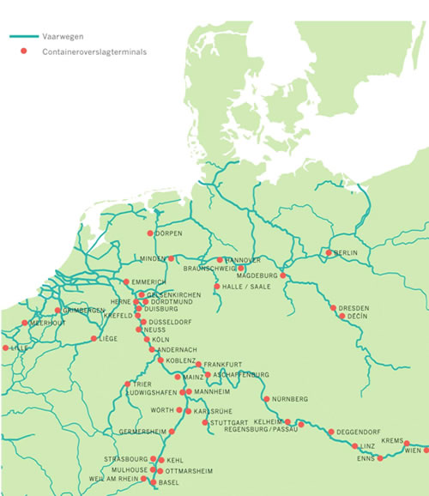
Freight transport, and particularly container transport, has grown very fast in the last decades. The increase of streams of goods between continents is been driven by globalization, economic growth and the upcoming economies in fast-growing countries like China. According to UNCTAD, global container transport is grown on average by 10% between the years 1985 and 2005. However, this growth is inhibited by the economic crisis, but in the long-term it is expected that global trade and freight transport will return to its own growth path (Zondag, Bucci, Gützkow, & de Jong, 2010).
Figure 2
In order to understand trust as a condition for information sharing in the coordination of the hinterland, it is important to know the basics of the transport chain. Therefore, this chapter will give an insight in the organization of port and its hinterland transport chain. In this chapter, it is attempted to give an answer on the following sub-question: How is the hinterland transport chain organized? In order to answer this question, we will look at the hinterland of Rotterdam. Attention will also be given to the actors playing a role in the port and hinterland transport chains.

3.1 Hinterland transport chains
According to Robinson (2002), port competition has moved toward a competition between transport chains, since container ports have become links in a global network of logistic chains (Robinson, 2002). In Europe, the port of Rotterdam counts for the biggest part in the context of container transshipment via inland gateway traffic.
The port has a role as a transfer point between different transport systems and actors. For many businesses, this is an important connection in their supply chain. Due to the weak coordination between the actors in the port and hinterland, problems appear like congestion, delays and other bottlenecks. Besides that the costs for hinterland transport are generally higher than the maritime transport costs. Therefore, it is important to create an effective and competitive hinterland transport chain in order to compete with other logistic chains. Hinterland access is becoming a key success factor for European ports (De Langen, 2004). Despite the importance of hinterland access, Panayides points to the fact of the lack of attention paid to integration and coordination in hinterland transport systems (Panayides, 2002).
The most common ways to reach the hinterland are inland barges, roads and rails. According to the Port Authority of Rotterdam, over 50% of the cargo that enters the port is forwarded to other hinterland destinations by barges. As shown in the figure 2 above, in the context of European hinterland, there is a good connection through the inland barges. Besides the inland barges, road transport is one of the most rapid options for short hauls. The biggest part of Europe can be reached within a maximum of 2 days. Finally, an ideal transport mode for large quantities of cargo over long distances at the hinterland is the rail transport (Port Authority of Rotterdam ). Port hinterland services mostly rely on road transport in Europe. However, the use of road for hinterland services can be challenged by rail and inland barges due to the costs, congestion and growing environmental awareness.
A final concept in the context of hinterland transport chains is combined transport. This is an intermodal transport where the biggest part of the journey is by rail, inland waterways or sea and the final steps are carried out by road (Frémont & Franc, 2010).

3.2 Hinterland actors
Freight transport system is a sequential transfer of goods between points of origin and destination (Roso, Woxenius, & Lumsden, 2009) There are many different actors playing a role when considering hinterland transport. Private companies, terminal operating companies, hinterland transport providers, intermediaries, inland terminal operators, but also public actors such as the port authority and infrastructure managers are examples of the involved actors playing a role in hinterland transport (Van der Horst & de Langen, 2008). In this section of the paper, we will take a closer look to the role of some actors.

3.2.2 Hinterland chain actors
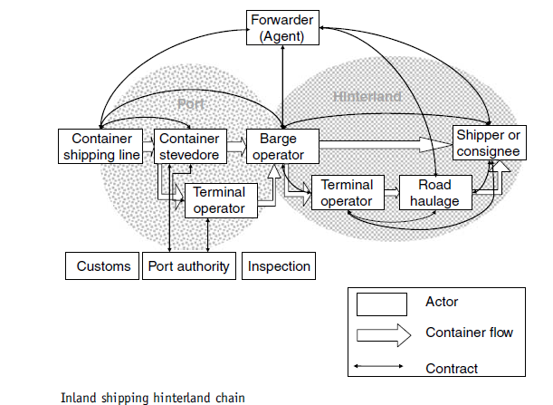
Barge transport has become a rival alternative to road and rail transport because its competence to offer cheap and reliable transport services. During the years from 1985 to 1995 the barge traffic in the hinterland of Rotterdam increased from 200.000 TEU to about 1 million TEU (Konings, 2007). The actors involved in the inland shipping chain are the barge operators, terminal operators, and the road haulage. Figure 3 shows the actors involved in the inland barges, their contractual relationships and the different activities in the hinterland chain. Table X gives a description for the responsibilities of these actors.
Figuur 3
In Europe, the rail cargo market has been liberalized. This is resulted in the separation of infrastructure provision from transport service provision (Van der Horst & de Langen, 2008). The actors involved in the railway hinterland chain are the rail operators, the railway company, the terminal operator and the road haulage.
The truck hinterland chain is the most simple hinterland chain. Despite of the large number of actors (the amount of truck companies in the Netherlands), the truck chain is sufficiently straightforward (van der Horst & de Langen, 2008). The actor involved in trucking hinterland chain is the trucking company.
The coordination in hinterland container transport is important because the costs for hinterland transport are generally higher than the maritime transport costs. Besides that, it is also clear that the most bottlenecks like congestion and insufficient infrastructure prevents the hinterland network. In order to realize an effective hinterland transport chain, all these actors must be aligned and need to be coordinated (van der Horst & de Langen, 2008).
This chapter has shown the actors who are involved in the transport of a good from A to B. There are many options to do this. The form of transport (by inland barges, railway or road), can be chosen on basis of a variety of reasons like speed, costs and quantity. The presence of the actors means the presence of interaction, relationships, exchanges and transactions. An alignment problem between these actors can cause important coordination problems among the hinterland transport chain. Chapter 2 made an effort to understand relationships and the role of trust herein. In this chapter were also exchanges and relationships discussed through different views and the conclusions can be significant for the alignment of the actors.
However, trying to create an alignment between the actors by sharing information is not so easy. It may involve a trust-problem. When we assume an information-sharing system with all actors involved, trust problem can occur in two ways, horizontally and vertically. Vertically, we can consider the actors with the same responsibilities, like all the barge operators. They can fear to share information due to the fact that it could be misused by other barge operators. The vertical competition among the barge operators can cause the trust-problem. The variety of actors involved in the whole chain that might have a contractual relationship. The actors might fear to share information due to the fact that it could be misused by other actors. They could have contractual relationships like a purchase relationship. The horizontal competition between the actors can cause the other trust-problem.

Table 2
Actor | Description
Shipping line | The service of transporting goods using high-capacity, ocean-going ships (World Shipping Council).
Terminal operator | A terminal operator is the business that contracts with shipping lines to provide services affiliated with the receipt (placing the cargo), intermediate storage (storing the cargo) and delivery (forwarding the cargo to railroad cars for instance) of the cargo. At the terminal, transport materials are being loaded and unloaded (Wisegeek.com)
Forwarder | A forwarder is an intermediary between the client and different transportation services. The forwarder is responsible for transporting the good to the proper destination, at the agreed date and in good condition. The forwarder contracts the shipping line, road haulage and the consignee (Wisegeek.com).
Barge operator | A barge operator is responsible for transporting the freight over inland barges.

3.3 Coordination in the hinterland transport chains
Ports are competing more with other ports serving the same hinterland. Especially in Northwest Europe, hinterland accessibility is a strategic matter because of the short distance of container ports (Konings, 2007). According to a study of de Langen (2004), coordination between the actors in the hinterland chain is a must in order to realize a smooth transportation of goods (De Langen, 2004) and gain a competitive advantage. The behavior of the actors in the hinterland transport chain, like terminal operators, freight forwarders and the port authority, determines the quality of the hinterland access of a port, so also the quality of the services provided (Van der Horst & de Langen, 2008). A good alignment between these actors is positively related to the competitive position of a port.
However, a smooth hinterland transport chain with a perfect alignment between the different companies in this chain is not always the case. Coordination does not develop itself spontaneously. In this section we will try to give an answer on the following sub-question: What are the coordination problems in the hinterland and what is the role of trust in order to realize information sharing in the context of hinterland transport chains? The coordination problems discussed in this chapter is related to the incoming and outgoing flows of transport in the port of Rotterdam.

3.4 Coordination problems hinterland transport chains
Since the hinterland of a port represents significant opportunities to rectify the efficiency of global freight distribution, the evolution and changes in port hinterlands with regard to wider logistics networks have received a lot of attention (Rodrigue & Notteboom, 2010). An example is the research about coordination in hinterland transport conducted by De Langen and Chouly (2004).This was a first initiative for analyzing the role of cooperation in hinterland transport chains (De Langen & Chouly, 2004). Another example is the research of Van der Horst and De Langen in which they have identified some coordination problems in the hinterland transport chains of the port of Rotterdam.
The coordination problems in the hinterland transport chain discussed in this chapter are identified on basis of relevant news items (reports, studies, journals etc.) and expert interviews with various managers in this chain (Van der Horst & de Langen, 2008). The coordination problems which will be discussed further, are problems mainly caused by lack of information sharing.

3.4.1 Coordination problems in container barging
The absence of contractual relationships between the barge operators and terminal operating companies has partially led to two important coordination problems in container barging. The first coordination problem the many calls and small call sizes per terminal which causes a long duration of loading and unloading cargo in the port. The second coordination problem is the insufficient quay and terminal planning for barge handling. The barges that leave the port of Rotterdam on time are counted on 62%.

3.4.2 Coordination problems in railway hinterland chain
As mentioned before, the European rail cargo market has been liberalized. In the Netherlands, infrastructure is provided by ProRail. ProRail is an independent rail infrastructure manager and allocates tracks to railway companies.
The coordination problem in the railway hinterland chain occurs on rail terminals in ports. There is an absence of an efficient terminal planning. This coordination problem again, is caused because of the lack of contractual relationships between the rail terminal operators and railway companies (Van der Horst & de Langen, 2008).

3.4.3 Coordination problems in road transport chain
As shown in chapter 3.2, the different actors involved in the road transport were at a minimum. Therefore, the coordination in the road chain is quite straightforward. However, coordination problems do also occur in this type of transport. The most common coordination problem is obviously the peak periods and the road capacity in other words, congestion. However, we will explain another coordination problem due to the lack of information exchange. The absence of this exchange causes an inefficient delivery and pick-up process at the deep-sea terminal. The actors involved in the appearance of these coordination problems are the container terminal operating company, the truck company and the forwarder (Van der Horst & de Langen, 2008).
Recurring coordination problems which occurs in all three types of transport is due to the limited information exchange between the different types of actors involved. Often is this absence of information about the destination of the container, the consignee and the customs status of the cargo. Besides that, we have seen coordination problems about the planning. This is also a result of transport companies lacking information about export containers. This container information can change at several time points, and in order to coordinate the planning of container stacking and transport, information need to be gained and integrated to the planning system. In order to do this, information sharing and collaborative planning between the actors is an important requirement.
Coordination problems also arise due to the lack of contractual relationships between different actors. This lack of contractual relationship causes restricted exchange of cargo and information between different barge operators, railway operators and/or forwarders, container terminal operating companies, truck companies and forwarders. This exchange could permit the companies many benefits and economies of scale like operating larger vessels, having higher service frequencies, higher equipment utilization rates and efficient delivery, pick-up processes, and planning. However, due to the fact that companies wish to stay independent, this kind of exchanges does not develop unprompted (Van der Horst & de Langen, 2008).

3.4.4 Coordination mechanisms
In a lot of cases, hinterland services counts for the largest part of the total transport bill (Konings, 2007). Ports have to integrate the port effectively into the networks of business relationships with efficient supply chains and ports have to utilize synergies with other players in the hinterland network (Notteboom, 2008). However, the number of parties involved and the amount of required communication shows that coordination can be challenging (Van Baalen, Zuidwijk, & Van Nunen, 2008).
Van der Horst and De Langen have proposed four different mechanisms in order to enhance coordination: introduction of incentives, creation of an interfirm alliance, changing scope and creating collective action. The framework with these four mechanisms is based on empirical evidence (the framework applied to the port and hinterland of Rotterdam). We will only concentrate on the coordination mechanisms of changing scopes and creating collective action (Van der Horst & de Langen, 2008).
The mechanism of creating collective action is appropriate when the investments have collective benefits. An important example is to establish and improve the information exchange between actors in order to bring the waiting times at terminals back. However, the barge handling innovations can only get through if all actors involved are convinced that it will be a win-win situation for all parties and if the free-riders are eliminated (Konings, 2007).
More trust and reliability on the other actor, is a major step in getting started for this kind of improvement. Trust is here a condition in order to realize an efficient information exchange between parties. But, trust is often not self-developing. Intermediaries and associations can play a significant role. The social exchange theory (Chapter 2.3) is a proper theory to explain coordination arrangements in order to realize information sharing, because it looks to the relationships as a whole and not only to the contract or transaction in a relationship. In the social exchange theory a relationship in a work setting can be seen as an association between to interacting partners (Cropanzano & Mitchell, 2005). According to the study of Lee et al. an important function of relationship marketing is to construct, maintain and support the firms’ relationships with external nodes like intermediaries and regulatory institutions (Lee, Mohamad, & Ramayah, 2010). In the context of international business, transactions are surrounded by networks of relationship across national boundaries (Fletcher & Fang, 2006). International business means different regional and/or ethnic business environments. All these networks, social technological, regional infrastructural, are influenced by the culture of the country (Lee, Mohamad, & Ramayah, 2010). It is a challenge to estimate the difference between the cultural aspects of the environment where the business partner is located. In such a case, intermediaries can realize a significant contribution to the creation of a stable, trustworthy relationship (Lee, Mohamad, & Ramayah, 2010).
Besides that, port authorities can also play a bigger role by enlarging their scope by contributing to the connection between the port and hinterland. Empirical evidences shows that transaction cost economics (Chapter 2.1) supports to appreciate that both shipping lines and terminal operator companies aim at enlarging their scopes in order to be able to cope with uncertainty (Franc & Van der Horst, 2010). In a case where port authorities enlarge their scopes, a port authority can act as a congregator of the different players or as a bringer of trust. As Notteboom and Rodrique argue: “Port authorities can create a platform in which various stakeholders are brought together to identify and address issues affecting logistics performance” (Notteboom & Rodrique, 2005). Van Klink and Van den Berg state that port authorities should orientate not only on the seaside, but also to the landside. They can do this by transforming from a landlord towards a network manager (van Klink & van den Berg, 1998).

3.4.5 Coordination arrangements
There exist already a substantial number of coordination arrangements (Figure 7, Appendix). As we have seen in the section before, these coordination arrangements can be based on four types of mechanisms which are the introduction of incentives, the creation of an interfirm alliance, changing scope and the creation of collective action. Due to the fact that this thesis attempts to give an answer on the question whether trust is a condition for information sharing, we will concentrate on the mechanisms of creating of collective action. In the port of Rotterdam, 34 collective actions coordination arrangements are identified. The associations of transport companies, the port cluster association and the port authority are involved in bringing about collective action. A port community system is an example of a coordination arrangement. A port community system is an electronic platform that connects the multiple systems operated by a variety of organizations that make up the port community (Van Baalen, Zuidwijk, & Van Nunen, 2008). Port community systems are used all over the world. Examples are Dakosy in Hamburg, Seagha in Antwerp, FIRST in the port of New York and Portned Tradenet in Singapore.
An example a port community system in the port of Rotterdam is Portbase. Portbase is a public-private partnership between the Port Authority Rotterdam and the industries association Deltalinqs (Van der Horst & de Langen, 2008). Figure 4 (Figure 6, Appendix) shows the communication between the actors with and without a port community system. Another example is INITI8. INITI8 is a consultancy which makes software in order to solve logistical problems (About INITI8).The cases Portbase and INITI8 will be discussed further in chapter 4.
Figuur 4
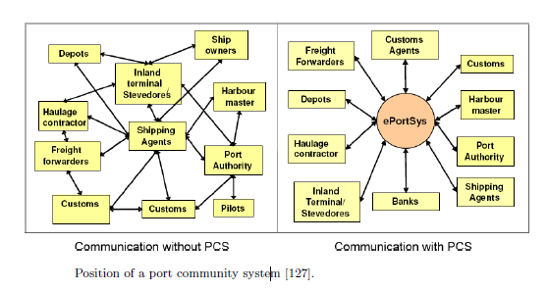

Chapter 4: A case study: Portbase and INITI8

Around 2500 companies are active in the port of Rotterdam related to containers which enter or exit the port. These companies are distributed over the variety of actors as discussed in chapter 3. An important characteristic of this network is that some companies strongly depend on each other in the logistic processes but have no relationships with each other. This causes the coordination problems like inadequate and inefficient planning (Chapter 3.3). Communication between these actors is required in order to create a smooth handling of cargo flow through the port of Rotterdam (Van Baalen, Zuidwijk, & Van Nunen, 2008). A port community system brings different actors together in order to share information. This information sharing can serve as an improvement of the flow of goods (Srour, Van Oosterhout, Van Baalen, & Zuidwijk, 2008). In this chapter, two cases of a port community system will be shortly discussed. These cases are Portbase and INITI8.

4.1 Portbase

4.1.1 Introduction
Portbase was founded in August 2002. It is a public-private partnership between the Port Authority Rotterdam and the Ports and industries’ association Deltalinqs (Van der Horst & de Langen, 2008). Portbase is a service provider that has a port-wide focus. In the year 2010, the Port of Amsterdam switched from PortNet to Portbase for his own information sharing. By forming a supervisory board with representatives of the Port Authority of Rotterdam, Dutch Customs, Deltalinqs and market players, Portbase has created a neutral position. This supervisory board decides the strategy and priorities. The mission of Portbase is the aim to optimize all international logistic processes through the Dutch ports by providing information and communication services (Portbase FAQ ). Making the port of Rotterdam the most efficient port in the world is an important goal in this mission. In order to reach this, a port community system was required. The port community system services were conducted together with the market. The services include communication between (governmental) organizations. Portbase served in 2006 approximately 1000 companies and made about 1 million information exchanges (Van Baalen, Zuidwijk, & Van Nunen, 2008).
The adoption to the new system proceeded smooth due to the fact that the companies already had planned to automate import procedures. The next step to implement the port community system in their businesses became easier. Besides that, Portbase provided also information applications for terminals, shippers and other actors in the port and hinterland chain (Figure 6, Appendix). The information application contains the information on cargo, which is sent to several parties. Furthermore, the information can be shared with other actors in this chain that do not receive information in time (Van Baalen, Zuidwijk, & Van Nunen, 2008). This all means that each actor could benefit from the port community system. And this in turn causes for more participation and loyalty towards the system.

4.1.2 The system
There are two main advantages of the system of Portbase. The first advantage is the relatively low development costs. Despite the high development costs in the first stage, are the development costs of the additional modules relatively low. The second advantage is the relatively stable maintenance costs relative to the increasing modules and volume. (Van Baalen, Zuidwijk, & Van Nunen, 2008). These two advantages can gain Portbase economies of scale.
The successful adoption of this new system by all actors involved is related to a few key success factors. The neutrality of the Portbase as a system is one of these success factors. Due to this neutrality, Portbase had the ability to set trustworthy relationships with and within the companies. This trust based relationships made the high participation and confidence in this system possible. Besides that, the success of Portbase also depends on the design of the development. Portbase had initially created pilots based on case studies. The port companies were set in project teams which worked on the case studies. They investigated the problems and opportunities in these cases. Important to note is that the selection of these port companies was carefully. Portbase had chosen large companies by creating the project teams, which also adopted the port community system first. This strategy was an important driving factor of further (successful) implementation of the port community system by other (smaller) actors (Van Baalen, Zuidwijk, & Van Nunen, 2008). Finally, Deltalinqs had an important role as a sector association. As mentioned before, according to the social exchange theory, an association or an intermediary can play a significant role in creating long-term trustworthy relationships. Deltalinqs in this case acted as a bringer of trust.
However, Portbase is still developing. One development is the provision of alert mechanisms. Incoming cargo is already reported electronically, but in time, departures and additional information needs to be also alerted (Port of Rotterdam).

4.2 INITI8: Synchronizing Barge Plans

4.2.1 Introduction
The inland waterway transport is an important link in the container transport to and from the hinterland. The container transport has grown enormously. There are daily approximately between 75 and 100 barges coming in to the port of Rotterdam. They call on average to eight different terminals for loading and/or unloading containers. These terminals are spread over three areas with a length of over 40 kilometers. The barge operators determine the route of the barges in alignment with the terminals. Unfortunately, this system is far from ideal. A lot of communication is required in order to align these logistic processes. There are a lot of double entries (appointments that are not canceled), long waiting times, unreliable plans, inefficient route along the terminals and a lot of irritation. INITI8, University of Twente, TU Delft and Erasmus University Rotterdam investigated how the planning and coordination between the inland shipping transport chain actors could be more efficient (Kuijpers, 2007).
INIT8 was used to make software aimed at solving logistical problems in critical situation for businesses through simulation models. Their mission was to realize a lot of cost savings in complex logistic processes, like planning of the loading or unloading of the hundreds of ships daily in the port of Rotterdam. INITI8 was used to focus on the global port industry, the care industry and also the construction industry (Smits, 2007). Nowadays INITI8 aims to helps, from a social engagement, the actors in the care industry (care suppliers, care networks and care customers) to keep the changing complexity controllable (About INITI8).

4.2.2 The system
The system developed by INITI8 aims to make an efficient and realistic barge rotation plans. Besides this, companies will not lose control over own operations and do not have to be transparent. The system used by INITI8 is called Agent Technology by which every actor in the inland shipping transport chain gets a personal assistant. An important note to make is that each actor has its own database which cannot be accessed by other participants. The system works as follows: the personal assistant of a barge operator attempts to make an appointment with the first terminal. They can answer only by ‘yes’ or ‘no’. If the answer is yes, the appointment becomes provisionally fixed. This process proceeds for all terminals. If the personal assistant of a barge operator gets a ‘no’, all provisionally fixed appointments will be deleted and the whole process starts from the beginning (Van Baalen, Zuidwijk, & Van Nunen, 2008).
By the adoption of INITI8 some barriers occurred. One barrier was the large amount of different actors with conflicting objectives. All of these actors decided for a strategy in their own interest without considering the interest of others. The goal is obviously not to act in your own detriment, but creating synergy effects together by sharing crucial information you need from them and information that they need from you. Deciding for a strategy in your own interest should be not hiding as much as information about your operations from other actors. Compared with Portbase, which focused on the port as a whole, the number of actors did not cause a problem. Actually, there was a lack of a trust which could appear in the form of a trusted party which should coordinate all the operations or trust-based relationships between the actors. In Portbase, the neutral supervisory board acted as the trust-bringing party. Once this trust is integrated into the relationship, the fair of sharing information about internal operations of companies would not be seen as losing independency but strengthening of your logistic operations.
Besides that, in contrast of Portbase, INITI8 was less convincing for actors in the inland shipping transport chain. One reason for this was the question whether they would get their fair share because coordination in barge rotation is seen as a cost saving rather than a profit (Van Baalen, Zuidwijk, & Van Nunen, 2008). The prospects about the cost savings were unclear. Portbase realized the persuasion by involving large companies to the pilot systems and they were the first who adopted Portbase. The fact that the system was adopted and implemented by many large companies in the port, made it possible to convince other actors for also implementing this system into their businesses.
The success of a port community system highly depends on actors contributing and using the data. In order to realize this, a significant level of both intentional and competence trust is needed. Intentional trust in this case, is that other actors will not misuse the exchanged information. Competence trust means the ability of the other actors to keep their promise for participation (Chapter 2.5, definitions). INITI8 made a system design that would mitigate these issues about trust. Due to the lack of time in order to garner this trust (and the fact that it could kill the project), INITI8 decided to make an agent system architecture (Srour, Van Oosterhout, Van Baalen, & Zuidwijk, 2008). However, time showed that a lot of barriers appeared and an optimal implementation never came.

4.2.3 Conclusion Case study
Table 3 shows a short summary of the cases. In this section we will analyze both cases according to the table.
Portbase has a port-wide function with more actors involved compared to INITI8. In contrast to Portbase, INITI8 focuses only on barges. The number and the variety of the actors involved in both systems could cause a problem because they are competing with each other and fear to share information. This fear can occur in two ways, horizontally and vertically. Horizontally, we consider different actors which could have a purchase relationship and therefore don’t want to share information with each other. Vertically, we consider the actors with the same duties and responsibilities. In the case INITI8, the fear of information sharing vertically was very high and no trustworthy relationships were set. Therefore, INITI8 implemented the system Agent Technology with the opportunity to remain intransparent.
However, it seems that this competition and the fear did not occur in the case of Portbase. This was due to several reasons. Initially, the neutral position and the power of the supervisory board and the involvement of Deltalinqs (sector associations) gave the potential users of the port community system confidence. The social exchange theory, which attempt to understand collaborative relationships, has shown that interdependent interactions (like Deltalinqs) can create high-quality relationships. On the other hand, INITI8 was founded by universities which have a research and testing character and not a researched, tested and valid character. This could have caused a confidence problem about the system.
Another advantage of Portbase above INITI8 was that Portbase created pilots which were tested and improved by large companies which were the potential users of the system. This gained Portbase the benefit of easy adoption and implementation of smaller companies. In the case of INITI8, the weak conviction about the system created a hard adoption of the system.
An important difference between Portbase and INITI8 is the presence and the use of trust. Portbase paid attention to trust and attempted to create a trustworthy relationship. The neutrality and power of the supervisory board, the sector associations and large market players made this possible. On the other hand, INITI8 did not even attempt to create a stable trustworthy relationship between the actors and/or system. Instead, they created a system where information remained invisible but still shared. The actors remain independent and did not lose control over own operations. However, the confidence in the system was so weak, finally it did not work.
These cases are examples of extremes: an information sharing system with and without trust. They show the importance of confidence, trust and stable relationships when considering information sharing in order to coordinate the hinterland efficiently.
Table 3
 | Portbase | INITI8
Focus | Port-wide | Inland shipping (barges)
Year | 2002 | 2005
Supervisory board | - Port Authority Rotterdam  - Dutch Customs  - Market players | - INITI8  - Erasmus University Rotterdam  - University of Twente  - TU Delft
Advantages | Relatively low development costs  Opportunities for economies of scale  Easy adoption of the system | No totally transparency of information  Not losing control over own operations  Small fee per container
Disadvantages | No alert system for departures and additional information (story of the cargo) | Hard adoption of the system  No convinced actors
Role of trust as a condition | Initially, a trustworthy relationships is created due to the neutrality of Portbase (the parties in the supervisory board worked as intermediaries) | No attempt to create initially a stable, trustworthy relationship between the actors of the inland shipping transport chain.

Chapter 6: Conclusion

In this thesis, trust is reviewed through three perspectives: transaction cost economics, agency theory and the social exchange theory. According to trust literature, trust could be able to provide good solutions for the main causes of the problems mentioned in the four perspectives, like information asymmetry, opportunistic behavior, minimal communication, contractual problems and bounded rationality. As we have seen in chapter 2, there exist a lot of different definitions according to their context. Despite the lack of an overall definition, the various definitions are important indicators of what trust could be. Moreover trust is driven by long-term relationship, previous experiences and reciprocity.
The hinterland chain involves different actors according to the type of transport. Terminal operators, barge/rail/road operators and forwarders are important actors. Among these actors, various coordination problems occur like inadequate planning and delays. According to Chiles and MacMackin, trust can create an accurate, timely information exchange (Chiles & McMackin, 1996). The allowance for information exchange might be the most influential effect of trust. Insufficient information exchange of container data as an important reason for coordination problems caused inadequate planning
The answer to the main question of the role of trust playing as a condition for information sharing in order to coordinate the hinterland chain can be given. Trust is a subjective topic which can differ significantly according to the context. However, trust is able to solve important issues as mentioned in the transaction cost economics, agency theory and the social exchange theory. An important appearance in response to trust is information sharing. A lot of coordination problems occur due to the lack of information about the cargo. In this thesis, two cases are considered. The first case, Portbase, was an initiative of the Port Authority of Rotterdam, Dutch Customs and various market players. In this case, as trustworthy relationship was created. This was possible due to the neutrality of the supervisory board and the involvement of large companies. Portbase acted as a successful port community system which is still used extensively. The second case, INITI8, was based on information sharing without trust, without forming relationships and without losing control over operations. Finally, INITI8 was not successful enough to continue with their services. We can conclude from all of this that trust is a crucial condition in order to realize efficient and timely information exchange.
However trust is in its early stages and varies depending on the context and the implementation of it. It is crucial to understand what trust is in the context of your business and how you can build trust in your strategies. Besides that, trust is also complex and subjective. But existing theories like the social exchange theory are valuable in order to understand trust in relationships and exchanges. From this review, we can conclude that conducting a definition in a designated context is the most important first step when implementing trust in the business.
It is important to note that building trust in the business and observing the results is a long-term issue. Besides that, the effects of trust is hard to measure due to the fact that trust is subjective and could not show its effects directly. Empirical research about the effects of trust is rare. Nevertheless, the lots of literature written about trust and the belief that trust can affect business practices positively cause a consideration about this topic.
In conclusion, hinterland accessibility is an important issue in ports. Therefore, ports needs to organize the hinterland transport network efficiently in order to compete with other ports. This thesis shows us the importance of trust across different disciplines and especially in the context of hinterland transport.

Chapter 7: Limitations and suggestions

Trust is a recent new phenomenon used in a lot of contexts, having a lot of definitions. Therefore, it is important to constrain the results gained in this thesis to the context where it is used in. Future work is needed to settle a relationship between trust characteristics and supply chain performance in other contexts. In this thesis is only looked at one type of industry namely port and hinterland transport. Another promising research would be to conduct the analysis in different hinterlands of ports.

Trust is a significantly cultural phenomenon. As we have seen in chapter 2, trust concepts can change between different cultures. Future studies can be composed with different managers of different cultures. In other words, samples from different geographies can be used in order to test for significant impact of culture and the extern validity.
Besides that, only two cases are used as an illustration for this thesis. In order to gain significant results, more cases should be analyzed
A final important note to make is to conduct an empirical research based on trust in hinterland transport chains. There is a lack of empirical data about trust in this context. In order to have valid results and conclusions, it is a must to substantiate it with empirical data.

Appendix
Figure 1
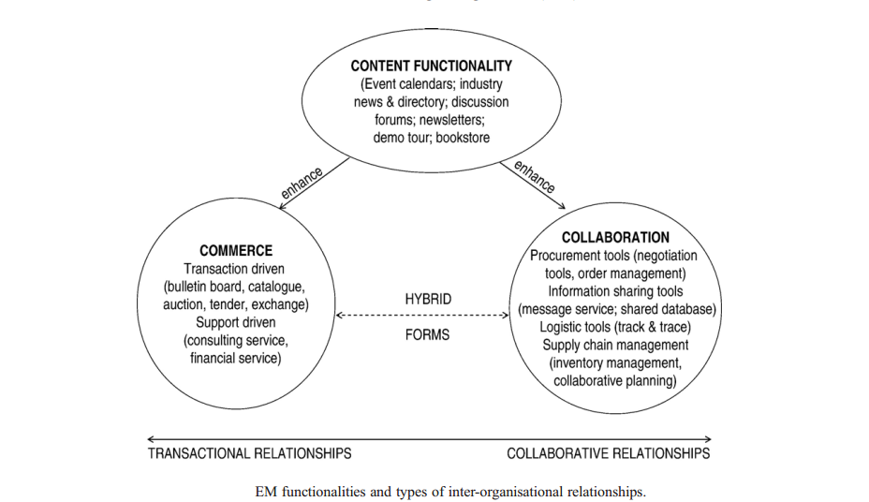
Figure 2
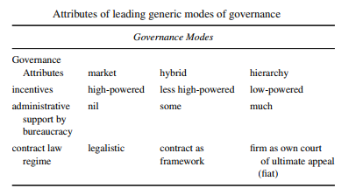
Figure 3
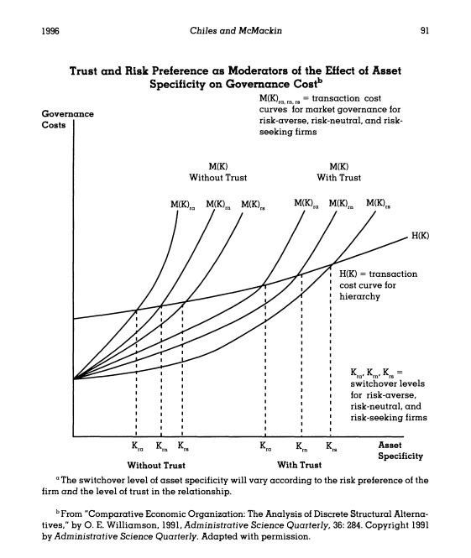
Figure 4
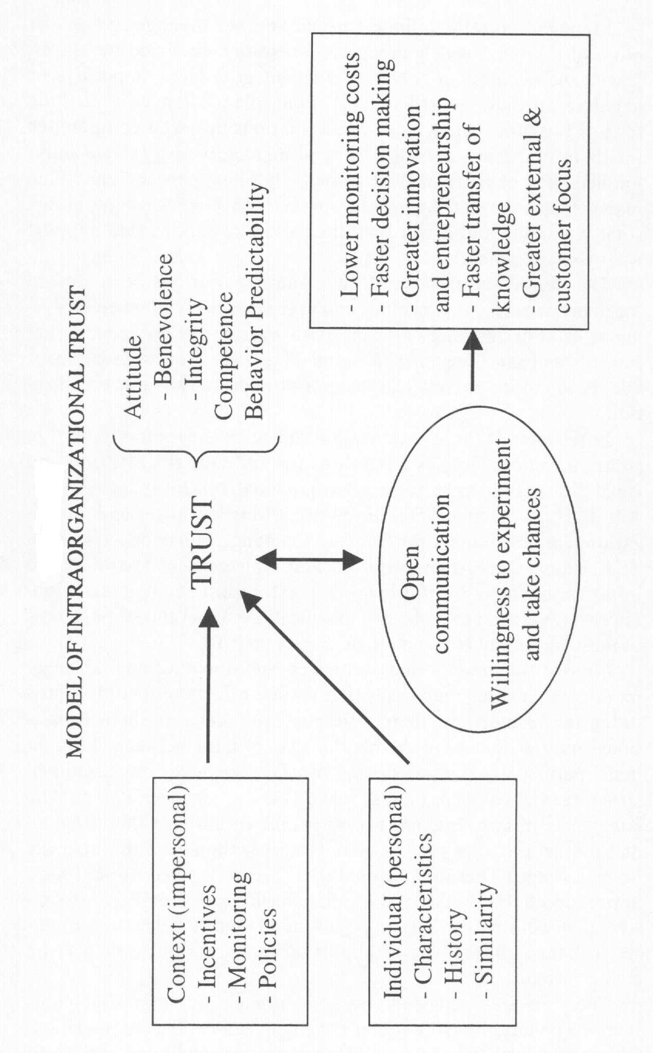
Figure 5
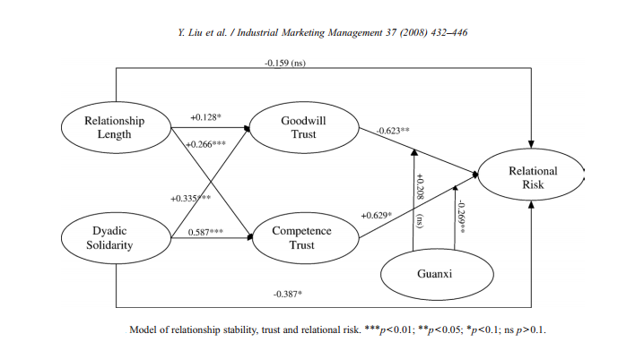

Figure 6
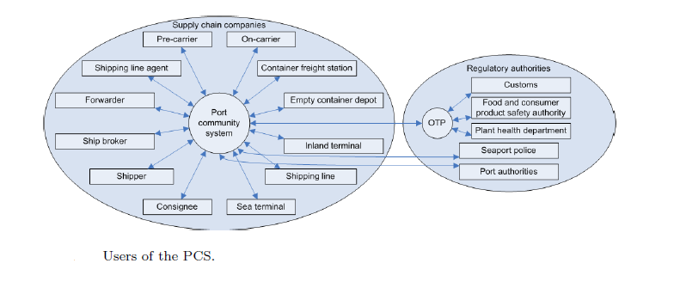

Figure 7
Collective action coordination arrangements | Hinterland chain
AMS- barge container service | Barge
River Information Services | Barge
Hinterlink protocol | Barge
Waterslag project | Barge
www.bargeplanning.nl | Barge
B-W@ve | Barge
Fixed window bonus (part Hinterlink protocol) | Barge
Cooperation 4 Dutch inland terminals | Barge
Quality Rail Rotterdam | Rail
Rail Cargo Information Netherlands | Rail
Platform rail capacity extension | Rail
Cooperation of several branch organisations in Rail Freight Transport | Rail
Trailes-on-trains project | Rail
Rail Shutte Wenen Linz-Rotterdam | Rail
User's platform Rail Freight Transport | Rail
Public transshipment point outside port regions | Truck
W@ve Road planning | Truck
Quality Road Rotterdam | Truck
Portbase (Port Community System) | Truck/barge/rail
Rotterdam Representatives in hinterland | Truck/barge/rail
Platform Modal Split - PCR RIL | Truck/barge/rail
FENEX (forwarders) regular conference with customs/inspection | Truck/barge/rail
Mobile Customs Scan | Truck/barge/rail
Custom check at inland terminals (export containers) | Truck/barge/rail
Central Electronic Gate ('secure lanes') | Truck/barge/rail

References
About INITI8. (sd). Opgeroepen op 06 30, 2014, van INITI8: http://www.initi8.nl/waarominiti8
Al-Mutairi, M. (2007). Preference Uncertainty and Trust in Decision Making. Waterloo, Canada .
Becerra, M., & Gupta, A. K. (1999). Trust within the organization: Integrating the trust literature with agency theory and transaction cost economics. Public Administration Quarterly, 23(2), 177-203.
Blau, P. M. (1964). Exchange and power in social life. New York: John Wiley .
Bradach, J. L., & Eccles, R. G. (1989). Price, authority, and trust: From ideal types to plural forms. Annual Review of Sociology , 15, 97-118.
Bunduchi, R. (2008). Trust, power and transaction costs in B2B exchanges — A socio-economics approach. Industrial Marketing Management, 37, 610-622.
Chiles, T. H., & McMackin, J. F. (1996, Januray). Integrating Variable Risk Preferences, Trust, and Transaction Cost Economics. The Academy of Management Review, 21(1), 73-99.
Cropanzano, R., & Mitchell, M. S. (2005). Social Exchange Theory: An interdisciplinary Review. Journal of Management, 31(6), 874-900.
De Langen, P. W. (2004). The performance of seaport clusters, a framework to analyze cluster performance and an application to the seaport clusters of Durban, Rotterdam, and the Lower Mississippi. Rotterdam: Erasmus Research Instititute of Management Ph.D. series.
De Langen, P. W., & Chouly, A. (2004). Hinterland access regimes in seaports. European Journal of Transport and Infrastructure Research, 4(4), 361-380.
Doney, P., & Cannon, J. (1997). An examination of the nature of trust in buyer-seller relationships. Journal of Marketing, 61(2), 35-51.
Economie Begrippen . (sd). Opgeroepen op 05 13, 2014, van Economische Begrippen: http://www.economische-begrippen.nl/index.php?sectie=begrippen&naam=Principaal-agent+theorie
Edelenbos, J., & Klijn, E.-H. (2007, March). Trust in Complex Decision-Making Networks: A Theoretical and Empirical Exploration. Administration & Society, 39(1), 25-50.
Emerson, R. M. (1976). Social Exchange Theory. Annual Review of Sociology, 2, 335-362.
Fletcher, R., & Fang, T. (2006). Assessing the impact of culture on relationship creation and network formation in emerging Asian markets. European Journal of Marketing , 40, 430-446.
Franc, P., & Van der Horst, M. (2010). Understanding hinterland service integration by shipping lines and terminal operators: a theoretical and empirical analysis. Journal of Transport Geography, 18, 557-566.
Frémont, A., & Franc, P. (2010). Hinterland transportation in Europe: Combined transport versus road transport. Journal of Transport Geography, 18, 548-556.
Gainey, T. W. (2000). Determinants of satisfaction with external training providers: an integration of transaction cost economics and social exchange theory . University of South Carolina , Business Administration. UMI .
Gorobets, A., & Nooteboom, B. (2004). Agent based computational model of trust. ERIM Report , Erasmus Universiteit Rotterdam, Erasmus Research Institute of Management (ERIM) , Rotterdam.
Gouldner, A. W. (1960). The norm of reciprocity: A preliminary statement . American Sociological Review, 25, 161-179.
Hill, C. L. (1990). Cooperation, opportunism, and the invisible hand: Implications for transaction cost theory. Academy of Management Review, 15, 500-514.
Husted, B. W. (1989). Trust in business relations: Directions for empirical research . Business and Professional Ethics Journal, 8(2), 23-40.
Kahneman, D., Knetsch, J. L., & Thaler, R. (1986). Fairness as a constraint on profit seeking: Entitlements in the market. American Economic Review, 76, 728-741.
Kolluru, R., & Meredith, P. H. (2001). Security and trust management in supply chains. Information Management & Computer Security, 9(5), 233-236.
Konings, R. (2007). Opportunities to improve container barge handling in the port of Rotterdam from a transport network perspective. Journal of Transport Geography, 15, 443-454.
Kuijpers, J. (2007, 03 18). Multi-agentsystemen: routeplanner voor rivierschepen. Supply Chain Magazine, 50-52. Opgeroepen op 06 30, 2014, van Supply Chain Magazine : http://www.supplychainmagazine.nl/wp-content/uploads/2009/12/SCM03-50-52-Multi-agents.pdf
Lambe, C. J., Wittmann, C. M., & Speakman, R. E. (2001). Social Exchange Theory and Research on Business-to-Business Relational Exchange. Journal of Business to Business Marketing, 8(3), 1-36.
Lee, J. W., Mohamad, O., & Ramayah, T. (2010). Outsourcing: is the social exchange theory still relevant in developing countries? Journal of Research in Interactive Marketing, 4(4), 316-345.
Liu, Y., Li, Y., Tao, L., & Wang, Y. (2008). Relationship stability, trust and relational risk in marketing channels: Evidence from China. Industrial Marketing Management, 37, 432-446.
Macaulay, S. (1963). Non-contractual relations in business: A preliminary study. American Sociological Review, 28, 55-70.
Menard, C., & Shirley, M. M. (2005). Handbook of New Institutional Economics. Dordrecht, The Netherlands: Springer.
Mui, L., Mohtashemi, M., & Halberstadt, A. (2002). A computational model of trust and reputation. Proceedings of the 35th International Conference on System Science (pp. 280-7). Los Alamitos, CA : IEEE Computer Society.
Nooteboom, B. (1996). Trust, opportunism and governance: A process and control model. Organization Studies, 11(6), 985-1010.
Nooteboom, B. (1999). The role and meaning of trust. In B. Nooteboom, Inter-Firm Alliances (pp. 24-34). London: Routledge.
Notteboom, T. (2008). The relationship between seaports and the intermodal hinterland in light of global supply chains. Joint Transport Research Centre. OECD/ITF.
Notteboom, T., & Rodrique, J. P. (2005). Port regionalization: towards a new phase in port development. Maritime Policy and Management, 32(3), 297-313.
Panayides, P. M. (2002). Economic organization of intermodal transport. Transport Reviews , 22, 401-404.
Port Authority of Rotterdam . (sd). Business of Port of Rotterdam. Opgeroepen op 05 27, 2014, van Port of Rotterdam: http://www.portofrotterdam.com/en/Business/connections/Pages/hinterland-connections.aspx
Port of Rotterdam. (sd). Port Authority. Opgeroepen op 05 29, 2014, van Port of Rotterdam: http://www.portofrotterdam.com/nl/havenbedrijf/Pages/default.aspx
Port Skills and Safety . (sd). Skills . Opgeroepen op 05 29, 2014, van Port Skills and Safety : http://www.portskillsandsafety.co.uk/skills/careers/industry_roles/stevedore
Portbase FAQ . (sd). Opgeroepen op June 29, 2014, van Portbase: http://www.portbase.com/nl/Portbase/FAQ.aspx
Ring, P. S., & Van de Ven, A. (1994). Dvelopment Processes of Cooperative Interorganization Relationships. Academy of Management Review, 90-118.
Robinson, R. (2002). Ports as elements in value-driven chain systems: The new paradigm. Maritime Policy & Management, 29, 241-255.
Rodrigue, J.-P., & Notteboom, T. (2010). Foreland-based regionalization: Integrating intermediate hubs with port hinterlands. Research in Transportation Economics, 27, 19-29.
Roso, V., Woxenius, J., & Lumsden, K. (2009). The dry port concept: connecting container seaports with the hinerland. Journal of Transport Geography, 17, 338-345.
Sako, M., & Helper, S. (1998). Determinants of trust in supplier relations: evidence from the automotive industry in Japan and the United States. Journal of Economic Behavior and Organization, 34(3), 387-417.
Smits, E. (2007, 07 11). INITI8 rijzende ster in regio delft. SYNC.nl.
Tejpal, G., Garg, R., & Sachdeva, A. (2013). Trust among supply chain partners: a review. Measuring Business Excellence, 17(1), 51-71.
Van Baalen, P., Zuidwijk, R., & Van Nunen, J. (2008). Port Inter-Organizational Information Systems: Capabilities to Service Global Supply Chains. Technology, Information and Operations Management, 2, 81-241.
van der Horst, M., & de Langen, P. W. (2008). Coordination in Hinterland Transport Chains: A Major Challenge for the Seaport Community. Maritime Economics & Logistics, 10, 108-129.
Van der Horst, M., & de Langen, P. W. (2008). Coordination in Hinterland Transport Chains: A Major Challenge for the Seaport Community. Maritime Economics & Logistics, 10, 108-129.
van Klink, H. A., & van den Berg, G. C. (1998). Gateways and intermodalism. Journal of Transportation Geography, 6(1), 1-9.
Williamson, O. E. (1983). Markets and Hierarchies: Analysis and Antitrust Implications : a Study in the Economics of Internal Organization (Illustrated ed.). (O. E. Williamson, Red.) New York: Free Press.
Williamson, O. E. (1985). The economic institutions of capitalism. New York: Free Press.
Williamson, O. E. (1998). Transaction cost economics: How it works: Where it is Headed. De Economist, 146, 23-58.
Wisegeek.com. (sd). Opgeroepen op 05 29, 2014, van Wisegeek.com: http://www.wisegeek.com/what-does-a-terminal-operator-do.htm
World Shipping Council. (sd). About the Industry. Opgeroepen op 05 29, 2014, van World Shipping Council: http://www.worldshipping.org/about-the-industry/how-liner-shipping-works
Zaheer, A., McEvily, B., & Perrone, V. (1998). Does trust matter? Exploring the effects of inter-organizational and interpersonal trust on performance. Organization Science, 9(2), 59-141.
Zand, D. E. (1972). Trust and managerial problem solving. Administrative Science Quarterly, 17(2), 229-239.
Zondag, B., Bucci, P., Gützkow, P., & de Jong, G. (2010, May ). Port competition modeling including maritime, port, and hinterland characteristics. Maritime Policy & Management: The flagship journal of international shipping and port research, 37(3), 179-194.

Guanxi between a buyer and a supplier implies a hidden norm of reciprocity that concerns equity and exchange of favors and long-term orientation (Ang & Leong, 2000).
United Nations Conference on Trade and Development
Standard unit for describing a ship's cargo carrying capacity, or a shipping terminal's cargo handling capacity. A standard forty-foot (40x8x8 feet) container equals two TEUs (each 20x8x8 feet) (Business Dictionary).

