

Table of contents

Preface 2
Abstract 3
1. Introduction 4
2. Literature review 7
2.1 Purpose 7
2.2 Employment and job opportunities in cities 7
2.3 Transit modes 10
2.4 Retail activities in the city center 13
2.5 Parking tarrifs 15
2.6 Car ownership 18
3. Methodology and dataset 20
3.1 Methodology 20
3.2 Dataset 21
4. Data analysis. 27
4.1 Dataset adjustments 27
4.2 Results 29
5. Conclusion 34
5.1 Recommendation 35
5.2 Limitations 35
Reference list 37
Appendix 41
Appendix A: 41
Appendix B: 42

Preface
This thesis is independent and unpublished work of Daniel Buijnink. References are mentioned of text that is directly taken from other research or published articles. I was responsible for all major areas like data collection and the analysis.
The research is performed in collaboration with Spark. Special thanks goes out to Dagmar Bisschops, the contact person of Spark who provided the student with data for the research. Giuliano Mingardo supervised the research and used his expertise to get the process right.

Abstract
In November of the year 2012, Spark published an official press release which raised a big problem regarding inner-city parking facilities. According to this Dutch consultancy firm, the use of inner-city parking facilities decreased with 10% between 2008 and 2012. This is a very shocking finding because the CBS consumption index decreased only 3.7% over the same time horizon. Based on these facts, Spark advised municipalities to be careful with parking facility expansions. These parking facility expansions are very costly affairs and when the usage decreases, these investments are a total waste.
This panel research of Spark is very interesting and useful for municipalities, but the press release doesn’t provide an explanation for this sudden decrease of the parking production over five years. This thesis will research possible indicators that could explain the change in the usage of inner-city parking facilities.
In cooperation with Spark, data is gathered to create a dataset. Spark provided the data about the parking production and the parking tariffs of 29 different municipalitites. Possible indicators which may influence the parking production are determined by a literature review. Data about these indicators are gathered from the central bureau of statistics database called Stateline. This database will serve as input for the quantitative research.
The quantitative research produced some very interesting results. The average WOZ value, which functions as an attractiveness indicator, is positively related to the parking production. When the average WOZ value increases, the parking production per parking spot will increase as well. There is also a significant positive relationship between the relative amount of retail stores and the parking production per parking spot. Last but not least, the research showed a negative relationship between the parking tariffs and the parking production. This negative relationship suffers from diminishing marginal effect. When the parking tariffs get higher, the negative effect of a price increase gets smaller.
These three significant relationships in the selected municipalities give a better insight in the problem that is raised by Spark. This research shows the importance of monitoring parking data in inner-city regions.

1. Introduction
‘’If I had asked people what they wanted, they would have said faster horses’’. This famous quote originate from Henry Ford, one of the most important persons in car building history. Since the day the car was introduced, the amount of motorized vehicles grew rapidly. For example, over 60 years the amount of cars in the UK had increased tenfold (figure 1).
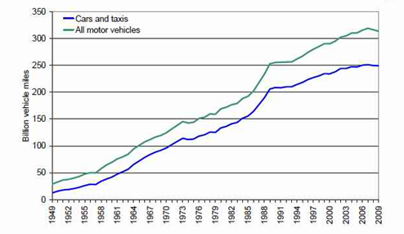

Figure 1: increase in motorized vehicles in the UK from 1949-2009. Source :National road traffic survey (Rethinking childhood, 2011)
From this moment on people got increasingly car dependent. More trips are done by car, even very short trips to school for example. Other factors like suburban sprawl makes car ownership essential. These societal changes led to car-centred town planning. Nowadays, Towns and cities are shaped by the assumption of universal car use and ownership (Rethinking childhood, 2011). The increase in car use and ownership also introduced car-related problems like pollution, congestion and parking shortages.
All over the internet, press releases about parking space shortages in cities are posted. A good example is the press release about a new parking garage that needs to solve the parking place shortage in Hoofddorp (Bosch, 2013). A shortage of 700 parking places will be refuted by the construction of a new parking garage. This example reflects the general view of Dutch municipalities about the parking facilities in the Netherlands. In their view there is a never ending parking shortage and it can be solved by building additional parking capacity.
On the 21st of November 2013, Spark published an official press release about the use of inner-city parking spaces (Spark, 2013). Spark is a Dutch consultancy firm specialised in the field of parking. This press release states that between 2008 and 2012, the use of inner-city parking spaces decreased with 10%. This finding is based on data about 19 inner-city parking areas. This press release fully contradicts the general view Dutch municipalities have about the modern day parking situation in Dutch cities.
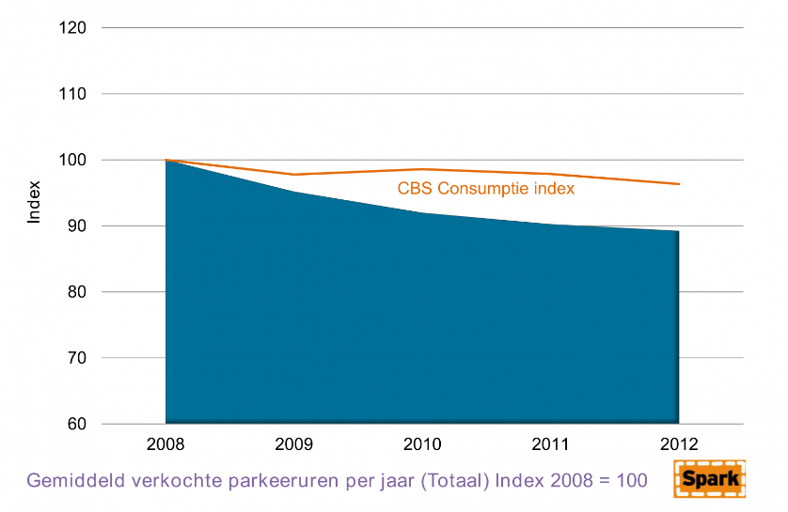

Figure 2: average sold parking hours index compared with the CBS consumption index. Source: Spark (2013)

Compared with the CBS consumption index, the average amount of sold parking hours decreased with 10% while the CBS consumption index decreased 3,7% over the same time horizon (figure 1). Spark (2013) claims that this shocking fact is a very important indication for municipalities to be careful with parking facility expansions. Expansion of parking facilities in cities is a very expensive affair and the invested money goes down the drain if the usage of these facilities decrease rapidly. In this case it is wise to focus on optimizing the usage of already existing capacity instead of increasing the parking capacity of inner city regions. With this research, Spark shows the importance of monitoring parking data in inner-city regions.
The finding of Spark about the usage of parking facilities in inner city regions is very important for designing municipal parking polices, but the most important insight is still missing. The website of ‘’Verkeersnet’’ published a similar message, but in this article a very important sentence is added. ‘’Verkeersnet’’ mentioned that: ‘’this research doesn’t give an explanation for the decrease in inner city parking facilities’’ (Verkeersnet, 2013). This insight, which is lacking in both press releases will be the main research question for this thesis. When municipalities are able to discover which factors cause this decrease in usage they can take appropriate measures.
To research the important question: ‘’ which factors cause the change in the usage of parking facilities in inner-city areas’’, Data of Parkeerbarometer will be used. Parkeerbarometer is an initiative of Spark in cooperation with the Erasmus University Rotterdam. Participating municipalities provide data about the usage of their parking amenities. Spark and the Erasmus University will process this data to provide insights in parking topic trends and developments (Parkeerbarometer, 2014). The Data of Parkeerbarometer will be used and replenished with data from CBS and other similar data sources. This dataset will serve as input for a quantitative research to discover factors that influence the parking usage in the inner city areas.
The remainder of the thesis will be organized as follows. The next section will discuss the literature review to get a better understanding of the problem and the way it is researched in the already existing literature. The third section describes the used methodology and the dataset. In this part all the used variables and their sources will be evaluated. Further, the results of the data analysis will be provided. The final part contains a conclusion as well as some limitations and a policy recommendation will be given.

2. Literature review

2.1 Purpose
The literature review has three important purposes (RMIT university,2013):
- Tell what existing research says about this topic (establish a theoretical framework).
- Evaluate the methodology that is already used in existing researches.
- Indicate the gap that this research tends to fill in.
After browsing through scientific articles and already existing researches, there was only a very small amount of information available about this problem. It is very hard to indicate valuable information and a methodology to research why the usage of inner city parking facilities dropped significantly.
Due to these findings, this thesis will be an important contribution to the already existing literature. The gap that this research tends to fill in is already explained. Spark in cooperation with the Erasmus University concluded that there is a significant drop in the yearly amount of parking hours sold, but there is no explanation for this phenomenon. This thesis tries to explain which factors cause this remarkable drop in parking facility usage. The purpose of this literature review is to determine possible indicators that influence parking demand. These indicators are based on scientific articles and other existing analysis.

2.2 Employment and job opportunities in cities
According to Voith (1998), the demand for parking is an example of a derived demand. Parking is not a need by itself but it allows people to get access to work, shopping, leisure and other needs. The demand of parking in the city center and the central business district for work thus depends on the amount of people that need to reach work-related destinations in that specific region. The attractiveness and the importance of the central business district and the city center as working area is also an important parameter for parking demand (Voith, 1998). Out of this information, the conclusion can be drawn that important and attractive business districts have a high demand for parking facilities.
During the financial crisis, a lot of people got fired and the amount of available jobs decreased significantly in the central business district. This phenomenon reduced the residential need to travel towards the central business district for working purposes (NOS, 2013). This could be a very important reason for the decreasing inner city parking demand that was described in the press release of Spark (Spark, 2013).
Another important observation that Voith (1998) points out is the increasing land prices in the city center and the central business district. In the last decades, the central business districts and the city center became very desirable locations and this reflected in increasing land prices. Also congestion in inner-city regions increased very fast during the last decade. These negative developments caused a rapid decentralization of both people and jobs. Technological changes also neutralized the need for companies to locate in centralized areas (Voith, 1998).
These findings are supported by Erickson and Wasylenko (1980). In this paper, the authors developed a model that tends to explain intra-metropolitan firm relocation. In this research both manufacturing and non-manufacturing industrial sectors are analyzed. The focus is to research the reallocation of firms which have left the central city region. From this paper can be concluded that firms in wholesale trade, construction, and to some extend retail, transport, finance and services relocate to places that are farther away from the central city district. Some firms that are active in the last four mentioned branches prefer to stay in the central business district, because of agglomeration economies and social contacts. Overall, a clear tendency of decentralization of firms can be detected (Erickson and Wasylenko, 1980). This research of Erickson and Wasylenko is performed more than 30 years ago. Because of this, the results should be nuanced a bit but they are still informative.
The papers of Erickson & Wasylenko (1980) and Voith (1998) introduce an important argument that reduce the need for parking spaces in inner-city regions. A lot of companies show a tendency to relocate towards out-of-town and inter-metropolitan locations. These events reduce employment in inner-city regions and this in turn can cause a decrease in the inner city parking demand. The papers are at least 20 years old so the results should be interpreted in a conservative way.
The employers also contribute to the decreasing parking demand. More and more employers in cooperation with municipalities introduce paid-parking schemes for employees to reduce car usage and parking demand. Willson (1991) shows the consequences of paid parking schemes for employees. In this paper, Willson introduces a model to examine the mode choice of employees before and after the paid-parking scheme is introduced.
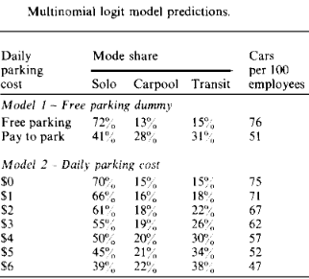
The main results are summarized in table 1. From the first and second row, it becomes clear that there is a consistent reduction in car use when employees have to pay for parking their car. When free parking is allowed, 72% of the employees travels solo by car, while if pay-to-park is introduced this amount shrinks to 41%. This is a significant decrease. The percentage of employees who carpool increases from 13% to 28% and the use of transit more than doubles from 15% to 31%. The total amount of cars that are used per 100 employees declines from 76 to 51. In the second part of the table, a differentiation between daily parking cost is made to distinguish the price elasticity. The price range varies from $0 to $6. When daily parking costs increase, employees are more inclined to use transit modes instead of their own car. In a later stage of the literature review, more attention will be paid to the effect of parking prices on parking demand.
table 1: mode choice before and after introducing pay-to-park. source: Willson (1991).
From these articles can be concluded that employment and firm locations definitely influence the parking demand in inner-city regions. This variable is one of the indicators that has to be included in the Quantitative analysis to see if it can explain the usage reduction of inner-city parking facilities.

2.3 Transit modes
Private cars are most of the time valued as fast, convenient and comfortable. Besides the functional aspect, the car also has affective and symbolic values for a lot of people. However, worldwide car use, especially in the city centers, caused a lot of environmental, sound, parking an congestion problems (Gärling & Schuitema, 2007). In the last decade, a lot of policies were focused on reducing the usage of private cars. In the paper of Gärling and Schuitema (2007), attention is paid to travel demand management measures (TDM). Travel demand management measures are introduced to increase the relative attractiveness of alternative modes of transport. Examples of these TDM measures are:
- Improving public transport (service related).
- Park and ride schemes.
- Improve infrastructure for walking and cycling.
- Prohibiting car traffic in city centers.
- Decreasing cost of public transport.
According to Gärling and Schuitema (2007), a balanced mix of travel demand management measures, under the right circumstances, will lead to a reduction of car use in the city center. This finding could be one of the reasons why Spark discovered a drop in the usage of inner-city parking facilities. The increased usage of public transport and other alternative modes of transport decreases the parking demand in inner-city regions.
Karamychev & van Reeven (2011) zoom in on one specific travel demand management measure, namely the park and ride schemes. These park and ride schemes are parking facilities located on the edge or outside cities with direct access to public transport. People use the car to travel to a park and ride location. Then they park their cars in the peripheral location and they use public transport for the remainder of their trip. According to Karamychev & van Reeven (2011), park and ride schemes are not forcing people to abandon their cars when using the private car is their preferred option. Instead, park and ride facilities integrate the preferred private car use into the public transport system. In their paper, the writers consider the most common type of park and ride which is the one located at the edge of cities (out-of-town & peripheral locations). By analyzing this type of park and ride, they try to determine the impact of this travel demand management measure on private car use.
Karamychev & van Reeven (2011) conclude that, based on their model, in all instances opening a park and ride facility reduces total car traffic. Their model identifies two reasons why individuals are willing to use the park and ride facilities. The first reason is that park and ride is cheaper compared to using the private car. The second reason is that park and ride provide access to more frequent public transport locations instead of the slow an low service in the place of origin. Park and ride schemes shifts traffic and parking demand away from the city center into peripheral locations and this reduces the parking demand for inner-city parking facilities.
The paper of Bos, Van der Heijden, Molin and Timmermans (2004) support the earlier described findings concerning park and ride facilities. In their paper, they introduce a case study about the park and ride scheme in Bristol. The park and ride facility in Bristol offers 1300 free parking spaces, high public transport services and access to busses and trains. The following numbers are the result of this case study. The table compares the situation before (1994) and after (1996) the introduction of the park and ride facility.
table 2: used modes of transport in % before (1994) and after (1996) the park and ride facility is introduced. Source: Bos et all. (2004).
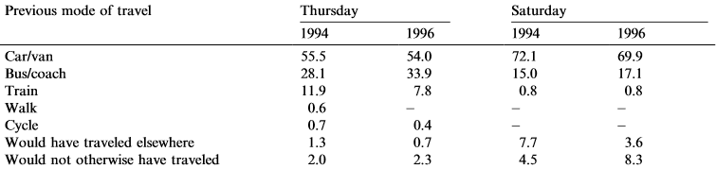
The conclusion drawn upon table 2 is that car use in Bristol has decreased during the week and throughout the weekends after the introduction of the park and ride facility. It is clear that a lot of former car users switched to the bus option in the new situation. We see that the bus gained a lot more travelers compared to the train because the Bristol park and ride facility focused on prioritizing busses by using special bus lanes. Another remarkable effect is that people that would not traveled in the old situation start traveling when the park and ride facility is introduced. People not only switch transport modes, but they also start using the park and ride facility while in the old situation they would have stayed at home.
The conclusion of this paper is that transport demand management measures that are intend to discourage car use are effective. People switch from car to other transport modes like public transport. People also start using park and ride facilities. They park their car in hugh and cheap parking lots in peripheral locations and they continue their journey toward the city center by using trains and busses. This increased use of public transport decreases the amount of cars in the city center and the parking demand of inner-city parking facilities. Based on these findings it is important to include an indicator too the quantitative model that reflects the usage of public transport. This indicator can contribute to the decreasing use of inner-city parking facilities.

2.4 Retail activities in the city center
Like earlier described, the crisis has a significant impact on employment in the central business district. Besides employment, retail activities also suffer from the negative consequences of the crisis. According to Commert (2013), 48% of the shopping street in the Netherlands are unable to make a profit. The crisis caused a lot of vacancies in these shopping streets. Retailnews (2014) even claims that the whole city suffers from the store vacancy in major shopping streets. Urban designer and architect Jeroen Bleijs advises that shopping streets should be transformed for housing and business purposes. On the website of Retailnews (2014) was stated that 25% of all customers are scared-off by the high amount of vacant stores. Vacant retail stores are for a quarter of all consumer the main reason to totally or partly avoid the shopping streets. These observations are very shocking and lead to a decrease in the amount of city center visitors.
An important cause for the vacancy rate are the high retail prices in the city center. For a long time, the opportunities for retail stores to move towards more peripheral regions were strictly regulated by municipalities and the government due to strict spatial planning. In the last decade, these regulated became more flexible and allowed large scale developments of retail stores outside the Dutch cities (Gorter, Nijkamp and Klamer 2003). A lot of retail activity moved to these out-of-town clusters at the expenses of the shopping streets. Many customers prefer the out-of-town retail clusters because they fit perfectly in the modern day shopping behavior. According to Gorter et al. (2003) modern customers prefer to buy large amounts in one trip and they try to minimize shopping time and costs to increase the efficiency of their shopping trip. In this way, customers exchange their inner-city shopping trip for a visit to one of the large out-of-town retail locations.
The paper of Thomas and Bromley (2002) confirm the earlier described change in the retail sector. Due to modern day shopping trends and the emphasis on accessibility, the out-of-town retail clusters gained a lot of popularity. Thomas and Bromley (2002) also mention the concerns of municipalities and other local governments. The popularity of the out-of-town retail villages has a deep impact and imposes problems upon the older town and city centers. It is widely recognized that these inner-city locations need regeneration and revitalization project to give them back their competitive edge. Central governments have exercised considerable caution about the retail decentralization, because it has a disruptive effect on the traditional shopping hierarchy that was focused on the city centers. In the paper of Thomas and Bromley (2002), there are a lot of case studies that show the rapid decline and the problems of physical and functional deterioration of inner-city shopping centers. The city center experience difficulties in offsetting the competitive forces of the large out-of-town retail centers and this causes a significant drop in the amount of visitors of the city centers.
Another major trend in the modern shopping branch is online shopping. Thuiswinkel (2013) shows that the revenue of online shopping increased with 8% in the first 6 months of 2013 compared with the same period in 2012. Weltevreden (2007) clearly explains the effect of internet purchases on the city center shopping streets and the potential of the internet to make the well-known retail business model redundant. E-shopping is defined as searching and/or buying of goods via the internet. Weltevreden claims that the internet definitely shows a substitution effect on the physical shopping experience. This claim is based on a lot of different researches that prove the substitution effect. The research of Cubukcu (2001) for example found a clear negative correlation between the amount of internet connections in a metropolitan area and the number of physical shopping trips. He also found that 78% of the people that own a computer made fewer shopping trips compared to people who did not use a computer. In the end, he emphasized that in the short run we already see the small effects of internet shopping on physical store trips and in the long run this substitution effect will become stronger.
Last decade, Out-of-town shopping centers and internet shopping gained popularity and caused a significant decrease in the amount of shoppers/visitors in the city centers. These papers show that an indicator for retail activity in the city center should be added to the model. This indicator could be able to explain the decrease in inner-city parking demand that was determined by spark (2013).

2.5 Parking tarrifs
In the paragraph 2.2 we have already discovered that parking prices have a big influence on the parking demand and the transport mode choice. In this case, the employers were able to determine the price but most of the time the prices are set by the municipality.
Brown and Lambe (1972) were able to capture the problem in two sentences. According to them, governments have problems with setting appropriate parking prices. Too low prices create excessive demand and too high prices result in underutilization of these value parking spaces in the city center. Another reason why setting the price is so difficult for governments is the bureaucracy. Private operators are able to change prices very frequently to discover the optimal rate. Municipalities cannot use this strategy because they have to get approval for every change in the parking rates (Brown and Lambe, 1972). These results are also more than 40 years. The political situation in the Netherlands positively changed throughout the years.
The structure of the parking prices throughout the city is very clear. Brown and Lambe (1972) explain that the mechanism that link prices with supply and demand is the walking distance. If we assume that the destination of every visitor is the city center, the prices closest to the center are the most expensive ones. People are willing to pay the highest prices, because they have to walk the smallest distance to reach their destination. These places have the highest occupancy rate. The most available spots are always on the edge of the city. People have to walk long distances to the city center so they are compensated for this by lower parking prices.
The paper of Litman (2013) is a very interesting paper that gives a clear understanding of the transport demands and elasticities. In this paper, the author describes how prices and other factors affect travel behavior. Litman first describes the factors that are influenced if parking fees are adjusted:
- Consumers change the amount of vehicles they own.
- Travelers shift travel routes.
- The change from peak travel to off-peak travel.
- Travelers shift to other modes of transport.
- Motorist shift trips to alternative destinations.
- People take fewer total trips.
- Change in location decisions (where to live and work).
From these findings, Litman concludes that parking prices are a very powerful policy tool. People tend to be very sensitive to parking prices because it is a direct charge and changes are directly noticed. Litman found that a 10% increase in parking prices reduces the share of automobiles by 0.7%, increase carpooling with 0.8%, increase use of transit modes with 3.71% and the use of slow modes increase with 0.9%.
The paper of Andrew Kelly and Peter Clinch (2006) researched the influence of varied parking tariffs on parking occupancy levels by trip purpose. The data for this research originate from an on-street survey. He asked people with different trip purposes how they would react on price changes varying from ₤2, ₤4 and ₤7. The most interesting observation of this research is the division of travelers for business and non-business purposes. Kelly and Clinch discovered that people traveling for business purposes are less sensitive for price changes compared with people who travel for non-business purposes. The results show that the business travelers are significantly less likely to stop parking in a certain area if the parking rate reaches ₤7 compared to non-business travelers. By raising parking tariffs in inner city regions, municipalities scare off non-business visitors and this can be very harmful for the local retail sector (Kelly and Clinch, 2006).
Pierce and Shoup (2013) also show a very interesting example of the influence of price adjustments on occupancy rates. This paper focusses on cruising problems and inequalities in occupancy rates of different parking blocks in San Francisco. In seven pilot zones, sensors are installed to report occupancy levels of different parking blocks. Based on these reports, the municipality changes parking prices in response to occupancy rates. In this way they try to open up some parking spaces to decrease cruising and to get a more equal occupancy rate between the different parking blocks. The prices are adjusted in the following way (table 3).

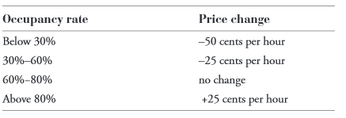

Table 3: Prices change according to occupancy rates. Source: Pierce and Shoup (2013)

From this table can be concluded that the ideal occupancy rate varies between 60%-80%. There will be no price changes in this range. When the occupancy rate drops the prices will decrease and if the occupancy rate rises above the 80% the parking price increases with 25 cents per hour. The results of this pricing strategy are very positive. The municipality managed to balance the occupancy rate in the seven different parking blocks. There is no severe overcrowding in some blocks while others are under occupied. Some places in overcrowded blocks opened up and reduced the amount of cruising kilometers in San Francisco. Pierce and Shoup (2013) show that price adjustments are a very important tool to influence the occupancy rate of parking facilities.
Based on these results, It can be very helpful to include a variable to the model that indicates price changes of inner-city parking rates. like earlier described, too high parking rates can lead to underutilization of valuable parking spaces. A significant increase of the parking rates over the last couple of years can be the cause of the decreased usage of the inner city parking facilities.

2.6 Car ownership
According to the Globe and Mail (2010), American car ownership shifts into reverse. Over de last couple of years, car ownership in America declined and this is the only large decline since the start of car related record keeping in 1960. This decline in car ownership can be related to the high gas prices, the expansion and better quality of the municipal transit networks and the popularity of social networks that replace car use (Globe and mail, 2010). IOL monitoring (2014) also reports a decline in the usage and ownership of cars among young adults. They have spotted this trends in a lot of different countries including the Netherlands. IOL monitoring also links changing lifestyles and economic conditions to the declining use and ownership of cars.
This phenomenon of declining car ownership and use can be an important factor in explaining the decreased parking demand in inner-cities. When people and especially young adults tend to own less cars and use them less often, it is very straightforward that the parking demand and usage of inner-city parking facilities will drop. These people replaced the car for other modes of transport like transit and slow modes to reach their shopping or working destination.
The paper of Goodwin, Dargay and Hanly (2004) describes the elasticities of road traffic with respect to prices and income. Goodwin, Dargay and Hanly link car ownership (vehicle stock) with fuel prices, income and car purchase costs.
Dependent variable | Independent variable | Short-term elasticity | Long term elasticity
Vehicle stock | Fuel price | -0.08 | -0.25
Vehicle stock | real income | 0.32 | 0.81
Vehicle stock | Car purchase costs | -0.24 | -0.49
Table 4: vehicle stock elasticities. Source: Goodwin et al (2004)
The first conclusion the authors draw from their research is about the elasticity of the vehicle stock with respect to fuel price (table 4). The elasticity is determined on -0.08 short term and -0.25 in the long term. This means that a 1% increase in the fuel price will lead to a short term decrease in the vehicle stock of -0.08% and a long term decrease of -0.25%. This is pretty interesting because in the last couple of years, the fuel prices increased very quick (Guardian, 2013). In table 4, the other elasticities are also stated. Table 4 shows a positive elasticity of the vehicle stock with respect to real income and a negative relationship regarding car purchasing costs. this paper shows that a fuel price increase, real income decrease or an increase in the car purchase costs can cause a decrease in the vehicle stock. This decrease in the vehicle stock maybe explains the dramatic decrease in the parking demand of inner-city regions.

3. Methodology and dataset

3.1 Methodology
The main research question is: “which factors cause the change in the usage of parking facilities in inner-city areas”. To answer this question, a dataset is constructed that contains variables which were determined in the literature review. These variables influence the usage of parking facilities in one way or another and they add explanatory power to answer the research question. This dataset will be discussed in paragraph 3.2.
The first step in the analysis is to show the national tendency of the variables in the dataset description. With the help of graphs, the national evolvement of the variables over time will be displayed. These graphs definitely add value to this research but it is not very informative for individual Dutch municipalities. The next step will be to analyze the problem on a regional scope. Multiple regressions (random or fixed effect models) will be used to show which factors over time influence the usage of parking facilities on a regional level. This methodology enables municipalities to see which factors cause the problem in their own region, so they can base their policy upon their unique regional situation. The significance level during the analysis is set on 10%. The three hypotheses that will be tested are:
- H0: An increase of the parking tariff causes a decrease in the parking production.
- H0: An increase in the average WOZ value (indicator for the attractiveness of a municipality) causes an increase in the parking production.
- H0: An increase in the relative amount of retail stores causes an increase in the parking production.
The methodology is summarized in figure 3.

Figure 3: methodology.

3.2 Dataset
In the literature review, all the variables that should be included in the dataset were determined. All these variables and their sources will be discussed extensively in this paragraph. The dataset consists of panel data, because it contains repeated observations on the same units over five years (2008-2012). This approach is chosen because the goal of this research is to identify changes over time at individual (municipal) level. The missing observations in the variables are dropped. Table 5 contains the summary statistics for the variables utilized in performing the analysis .
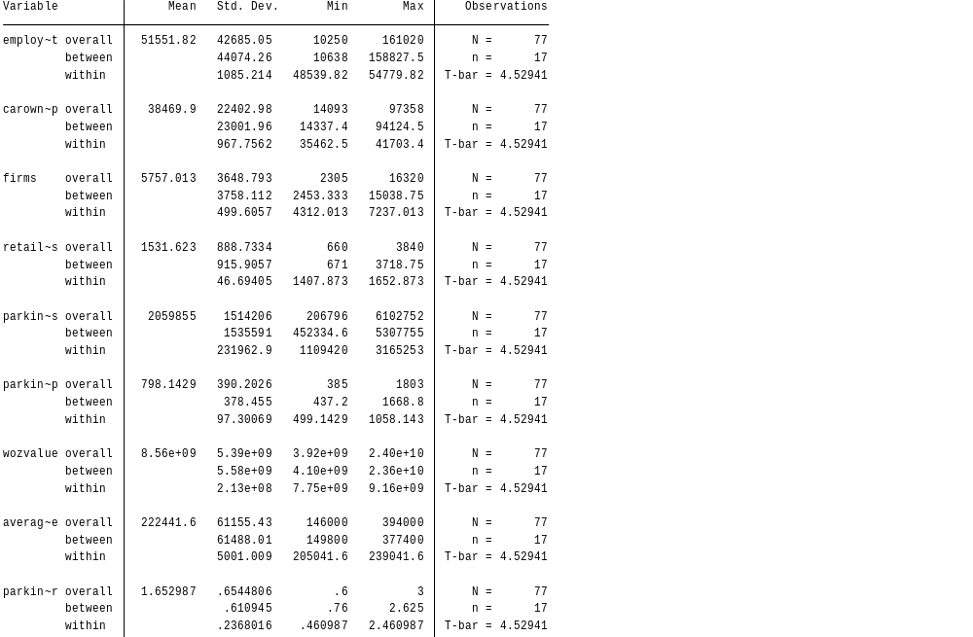

Table 5: dataset summary
1. Yearly parking production.
The dependent variable for this research is the amount of parking hours. This data originate from the databases of Spark (2014). The parking hours are gathered in 29 different municipalities over a period of 5 years (2008-2012). Besides the total parking hours per municipality, Spark also added the total parking hours per parking spot to the database. There are some missing values in these variables for two reasons. Firstly, Some municipalities showed a total non-response so there is no data available at all. Secondly, some municipalities only lack one or two years. The average amount of yearly parking hours is 2.059.855 with the highest amount in 's-Hertogenbosch (6.102.752 hours in 2008) and the lowest amount in Ridderkerk (206.796 hours in 2012). The description of the values must be further accompanied by the description of the values over time (figure 4). In sixteen random selected municipalities, there is a clear decreasing trend in the amount of total parking hours per parking spot. Appendix A contains graphs about the total amount of sold parking hours per municipality.

Figure 4: total parking hours per parking spot of 16 municipalities.
2. Car ownership.
This variable contains information about the total amount of personal cars. Data about the amount of personal cars is available on the national and regional scope. The data about car ownership originates from the central bureau of statistics (CBS, 2014). The average amount of personal cars per year on municipal level is 38.470. Eindhoven has the highest yearly amount (97.358 in 2012) and the lowest amount originate from Bussum (14.093 in 2009). In Figure 5, the total amount of personal cars in the Netherlands over time is plotted. From 2008-2012, a clear increasing trend is visible in the amount of personal cars owned by the population.

Figure 5: total amount of personal cars in the Netherlands.
3. Employment
The variable employment contains information about the amount of available jobs. Data about the amount the amount of jobs is available on the national and regional scope. Employment data is available on the website of CBS (2014). The average amount of jobs per year in the Dutch municipalities is 51.552 with the highest amount in Eindhoven (161.020 in 2011) and the lowest amount in Schouwen-Duiveland (10.250 in 2009). Figure 6 shows the total amount of jobs in the Netherlands over five years.

Figure 6: total amount of jobs in the Netherlands.
4. Firms
The variable firms reflects the amount of firms on national and regional level. This variable originates from the website of CBS (2014). The database contains two variables related to firms. The first one reflects the total amount of firms in the Netherlands and in the selected municipalities. The second variable indicates the amount of firms active in the retail and hotel/catering industry (SBI2008-G-I). The average amount of firms on municipal level per year is 5757. The highest amount of Firms are in Eindhoven (16.320 in 2012) and the smallest amount in Middelburg (2305 in 2008). The yearly average amount of firms per municipality, active in retail and hotel/catering, is 1532. The highest amount is again in Eindhoven (3840 in 2012) and the lowest amount in Bussum (660 in 2009). The total values of these variables in the Netherlands over time are visible in figure 7. Both variables show a clear increasing trend over time.
Figure 7: Firms in the Netherlands.
5. WOZ value.
The variable about WOZ value expresses the value of properties (CBS, 2014). The WOZ value is also an attractiveness indicator. When a lot of people move towards a certain municipality, because it gets more attractive in one way or another, the WOZ values of properties will rise. The WOZ value is stated in two ways. First, the total WOZ value on a national and regional scale. Second, The average WOZ property value is also stated. Both values are visible in figure 8. The WOZ values in the different municipalities are available on the website of CBS. The average value of the total housing stock per municipality is €8.560.000.000. The highest value originates from Eindhoven (€24.005.000.000 in 2010) and the lowest value was measured in Terneuzen (€3.918.000.000 in 2008). The Average WOZ value of housing in the selected municipalities is €222.442. The highest average WOZ value originate from Bussum (€394.000 in 2010) and the lowest one was measured in Leeuwarden (€146.000 in 2008). The total and average Dutch WOZ values over time are visible in figure 8. On the left-hand side, there is a clear decreasing trend in the total WOZ values in the Netherlands. Remarkable is the increase in average WOZ value in 2008 and 2009 and then we see a decreasing trend from 2010 which corresponds to the left-hand side of the figure.
Figure 8: WOZ values in the Netherlands.

6. Parking tariffs
The parking tariffs on the national and regional scale are very important parameters to explain the usage decrease of the inner-city parking facilities. The parking tariffs on a national scale stem from the national parking test (2008-2012) performed by Platform detailhandel Nederland. This parking test is a yearly test which compares multiple aspects of parking facilities in different cities. The regional values originate from Spark (2014). Spark keeps track of the parking tariffs in different regions and the changes over time. The average municipal parking tariff is €1.65. The highest value was measured in Groningen (€3 in 2011) and the lowest value stems from Schouwen-Duivenland (€0.6 in 2008). The national parking tariffs over time are plotted in figure 9. An increasing trend can be spotted in the average hourly parking tariff. In the analysis, the parking tariffs will undergo a log transformation. This logarithmic transformation is chosen based on existing literature and research which tried to determine the effect of parking tariffs on the parking production. The logarithmic transformation makes it possible to see the effect of a relative increase in the parking tariffs on the parking production. In a report of ecorys (platform verkeer en vervoer) is stated that price elasicities are very important to asses the effect of parking tariffs (ecorys, 2012).

Figure 9: average hourly parking tariff in the Netherlands

7. Amount of kilometers traveled by train
The amount of kilometers traveled by train is used as an indicator for public transport use in the Netherlands. Data about the use of public transport was unavailable on regional level so only national data is included. The data about the amount of kilometers traveled by train originate from the database of ‘het Kennis Insituut voor Mobiliteit’ (KIM, 2014). The increasing trend over time is visible in figure 10.

Figure 10: Total amount of kilometers traveled by train in the Netherlands.

4. Data analysis.

4.1 Dataset adjustments
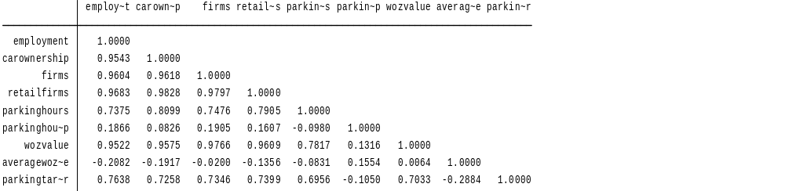
To see which variables could be included to the model, the correlation matrix is consulted to see which variables are interrelated (table 6).
Table 6: Correlation matrix of the initial dataset

This matrix clearly shows that some variables are highly correlated with each other. Firms are for example very high correlated with employment (0.96). This value is straightforward because in a municipality with a very important business district will house a lot of firms. These firms hire a lot of people so firms and employment are highly interlinked. These highly correlated variables cause problems for the data analysis, because they cannot be simultaneously included in the model. In this case the model will provide spurious and misleading results which can cause erroneous interpretations.
To solve this problem it is very important to correct the scale of the different municipalities. A very big municipality accommodates a lot of firms, employment in this region is very high and the attractiveness of this region causes high WOZ housing values etc. (variables are interlinked). The included variables should be reduced to relative units of measurements to create a fair comparison base. In the analysis, relative values should be compared between the different municipalities instead of the absolute values.
The variables that should be adjusted are car ownership, employment and the amount of firms (retail and total amount of firms). To fix the variable car ownership, data about the amount of inhabitants is added to the dataset. The total amount of cars in a municipality is devided by the amount of inhabitants. In this way, a ratio that indicates the amount of cars per inhabitant is created. This variable is comparable between the included municipalities. Then the total amount of firms is divided by the amount of retail firms to create a variable that indicates the relative share of retail firms in a city. This variable is also perfectly comparable between the different municipalities. To create a relative employment variable, the labour participation rate is added to the dataset. This variable is a ratio of the labour force devided by the working share of the labour force. A rise in this value means that more people got employed. This variable is stated in percentages and is comparable between the different municipalities. The parking production per spot will be used instead of the total parking production per municipality because the production per spot is better comparable. The same applies for the average and total WOZ value. The parking tariffs are stated per hour so this already forms a valid comparison base. A summary of the adjusted variables that will be utilized in the analysis is visible in table 7.
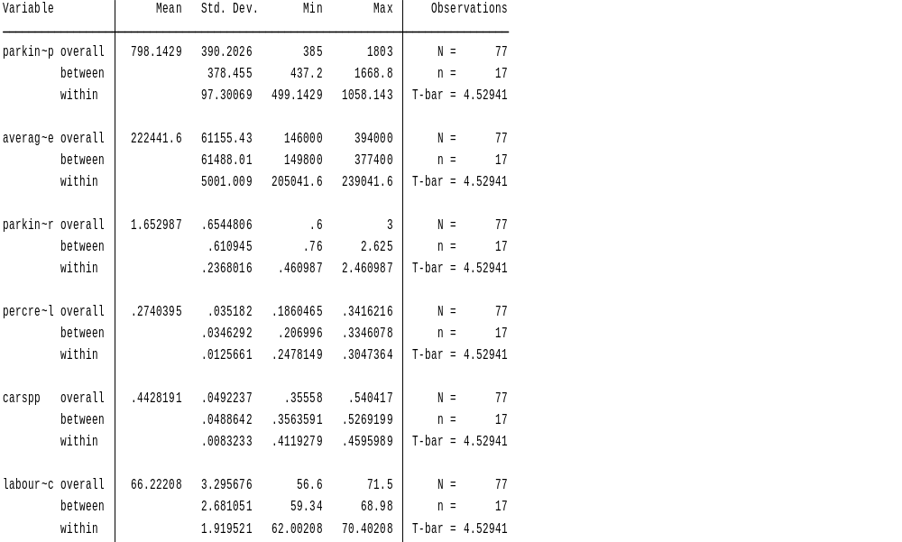

table 7: summary of the adjusted variables.

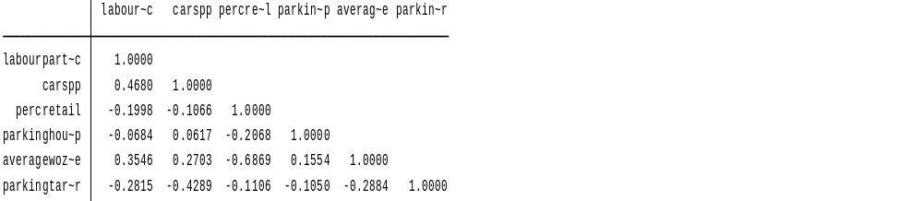
When the correlation between the adjusted variables is evaluated, the correlation values are reduced a lot (table 8). These variables can be combined in one model without the risk of spurious and misleading results.
table 8: correlation matrix of the adjusted variables.

4.2 Results
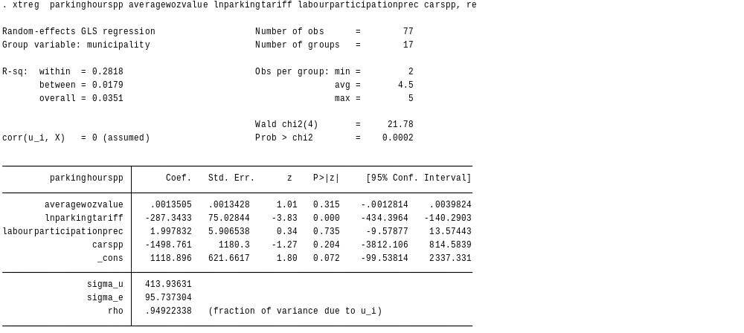
To discover the effects of the selected variables on the parking production, the first regression is plotted which includes four variables (table 9). The Hausman test was used to indicate the proper model (Appendix B1). The p-value of the Hausman test is 0.7250, which is bigger than 10%. This means that there is no significant difference between the coefficients of the random and the fixed effect model. In this case the random effect model is preferred because this one is unbiased and efficient.

Table 9: regression 1

From the first regression can be concluded that and increase in the parking tariffs per hour causes a decrease in the parking hours per parking spot. This effect is significant at a 10% level (p=0.000<0.10), ceteris paribus. The variable underwent a logarithmic transformation. If the parking tariff per hour increases with 1%, The amount of parking hours per parking place decreases with 2.87 hours per year. The other variables are not significant at a 10% level. The R^2 of this model is 0.2818. This means that 28.18% of the variance is explained by this model.
To see which effect the amount of retail stores has on the parking production, the variable ‘percentage retail’ is added to the initial model. The second regression is visible in table 10. The p-value of the Hausman test is 0.3993 (Appendix B2), which is bigger than 10%. In this case the random effect model is again preferred because it is unbiased and efficient.
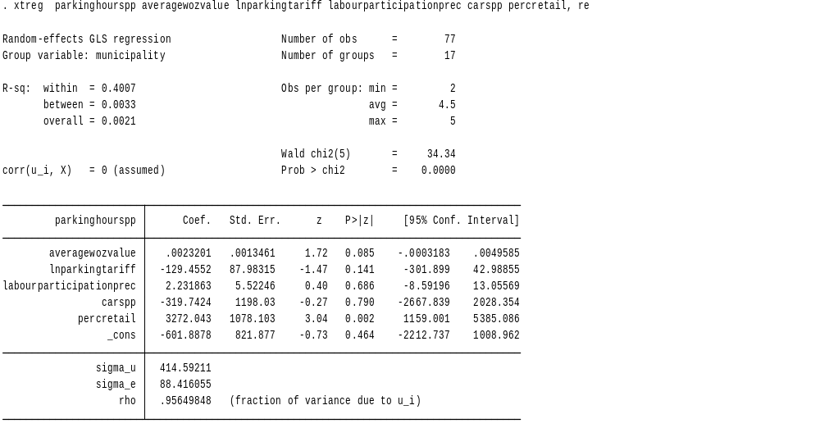

Table 10: regression 2.

When the variable ‘percentage retail’ is added, the parking tariff per hour turns out to be insignificant (p=0.141>0.10). further, the variable average WOZ value becomes significant (p=0.085<010), ceteris paribus. This means that an increase of the average WOZ value with €1 causes an increase in the yearly amount of hours parked per parking spot with 0.0023 hours. This effect is really small but reasonable because a €1 increase in the average WOZ value is almost neglectable. The relative amount of retail stores is also significant (p=0.002<0.10), ceteris paribus. This means that an increase in the ratio of retail stores against total amount of stores with 1%, the amount of yearly parking hours per parking spot increases with 3718 hours. The size of the coefiecent is unreasonably big and this is probably the case because there are a limited amount of observations included in the dataset. In this case, the sign and the significance should be interpreted. The other variables which are included in the second regression are insignificant at a 10% level. The R^2 of this model is 0.4007. This means that 40.07% of the variance is explained by this model. This number is higher compared with the first regression.
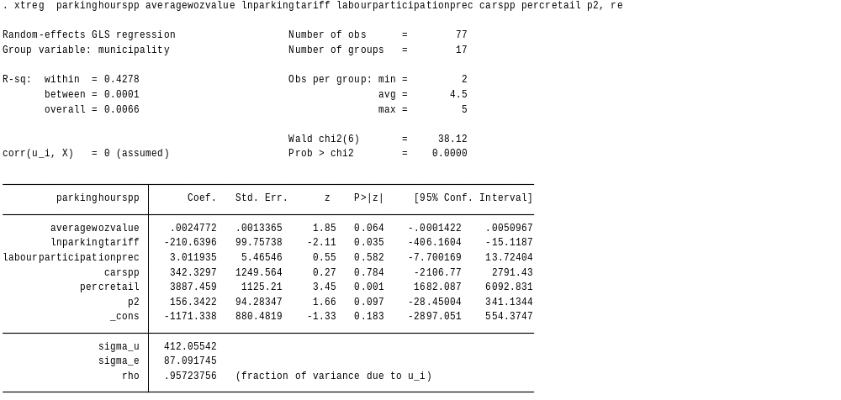
What can be concluded from the second regression is that when the relative amount of retail stores is added to the model, the parking tariffs per hour becomes irrelevant. A possible explanation for this phenomenon could be that parking tariffs don’t follow a linear distribution. To see if parking tariffs follow an other distribution, non-linearities could be added to the model. The new variable in this regression is called P2 and it is generated by multiplying the natural logarithm of parking tariffs per hour by itself. The third regression is visible in table 11. The p-value of the Hausman test is 0.4065 (Appendix B3), which is bigger than 10%. In this case the random effect model is preferred.

Table 11: regression 3.
From the third regression can be concluded that Both parking tariff per hour (p=0.035) and P2 (lnparkingtariff^2) (p=0.097) are significant at a 10% level. The marginal effect of the parking tariff on the parking production can be determined in the following way (Sydsaeter and Hammond, 2008). the graph of the marginal effect is visible in figure 11.
$$y=a-210.6(\ln\left(x1\right))+156.3{\left(\ln\left(x2\right)\right)}^{2}$$
$$\frac{d}{dx}F\left(x\right)=-210.6*\frac{d}{dx}\left(\ln\left(x\right)\right)+156.3\frac{d}{dx}\left({\left(\ln\left(x\right)\right)}^{2}\right)$$
$$= -210.6*\frac{1}{x}+156.3*2*\ln\left(x\right)*\frac{d}{dx}(ln⁡(x)$$
$$=-\frac{210.6}{x}+312.6*\ln\left(x\right) *\frac{1}{x}$$
$$=-\frac{210.6}{x}+\frac{312.6*ln\left(x\right)}{x}$$
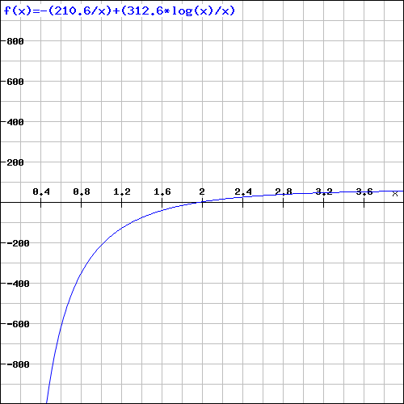
Figure 11: the marginal effect of the parking tariff (x-axis) on the parking production in hours per parking spot (y-axis).

This calculation shows that the hourly parking tariffs are non-linear and they suffer from diminishing marginal effects. The data for this research are gathered in relative small municipalities. The parking tariff in these municipalities are most of the time lower than the average prices in the Netherlands. When the prices are low in the selected municipalities, a price increase will have a big negative effect on the parking production. When the tariffs are higher, the same price raise will have a way smaller effect. This phenomenon is clearly visible in the figure 11. Close to the origine, the graph is very steep. A price increase in this region causes a big decrease in the parking production per parking spot. In the region where the prices are higher, the line and also the negative effect flattens. When municipalitites maintain a price between aproximatly €0 and €2, they have to be carefull with increasing the parking prices per hour. At around €2, a threshold can be noticed where the line crosses the x-axis. From this point on, a price increase only has a minor effect on the parking production. This can be explained by looking at attractiveness. When a municipality is very attractive, they maintain on average relative high parking tariffs. When these attractive municipalities increase their parking tariffs, people don’t change their parking behavior significantly because they are compensated by the attractiveness of this region.
Further, the average WOZ value (p=0.064) and the relative amount of retail stores (p=0.001) are still significant at a 10% level, ceteris paribus. The other variables stay insignificant. The R^2 of this model is 0.4278. This means that 42.78% of the variance is explained by this model. This number is higher compared with the previous regressions.

5. Conclusion
The consultancy firm Spark raised concerns about the usage of inner city parking facilities based on research performed in 19 different municipalities. Spark discovered that the usage of inner city parking facilities dropped 10% between 2008-2012, while the CBS consumption index decreased 3,7% over the same time horizon. The main goal of this thesis is to analyse which factors cause the change in the usage of parking facilities in inner-city areas.
The main research question is supported by three hypothesis. In this way, conclusions can be drawn in a structured way. The used hypothesis are:
- H0: An increase of the parking tariff causes a decrease in the parking production.
- H0: an increase in the average WOZ value (indicator for the attractiveness of a municipality) causes an increase in the parking production.
- H0: an increase in the relative amount of retail stores causes an increase in the parking production.
The hypothesis are accepted or rejected based on a quantitative research. The results show a negative relationship between the parking tariffs and the parking production. An increase in the parking tariffs lead to a decrease in the parking production per parking spot. Remarkable is the diminishing marginal effect of parking tariffs on the parking production. Based on these results, the first hypothesis is accepted. Further, the research showed a positive relationship between the average WOZ value and the parking production. The average WOZ value functions as an attractiveness indicator. When the attractiveness of a municipality increases (raise of the average WOZ value) the parking production per parking spot also increases. The second hypothesis is also accepted. The data displayed a positive relationship between the relative amount of retail stores and the parking production. When the share of retail stores in a municipality increases, the parking production per parking spot goes up. The third hypothesis is also accepted. All these results are in line with the economic theory and previously published results.
These results are only valid in the municipalities which were included in the research. These municipalities are all small and medium sized. The results cannot be generalized for other municipalities in the Netherlands. The external validity of this research is thus limited. A suggestion for further research is to indicate the effect of the different variables in the other Dutch municipalities, Especially the biggest four (Amsterdam, Rotterdam, Den Haag, Utrecht).
This thesis will be an important contribution to the already existing literature. The amount of researches in this field is very limited. The gap that this research fills in is providing indicators which influence the yearly amount of sold parking hours in 29 different municipalities. This research enables municipalities to see which factors cause the problem in their own region, so they can base their policy upon their unique regional situation.

5.1 Recommendation
Expension of the parking facilities in cities is very expensive. Spark already warned municipalities to be carefull with building additional parking capacity, because the parking production within municipalities decreased with 10% over the years 2008-2012. This research provided three relationships which affect the parking production significantly. When municipalities consider to build a new parkinig garage, it is wise to include these three variables in the decision making process. When decision makers observe increasing parking tariffs, decreasing WOZ values (region gets less attractive) or a reduction in the amount of retail stores, they should be carefull with making expensive investments. Another informative finding is about the parking prices. When municipalities maintain parking tariffs between approximately €0 and €2, they should be carefull with increasing the parking tariffs. In this price region, a price increase will cause a significant drop in the parking production. When municipalities still want to raise the parking tarrifs, they should compensate this raise with increasing the attractiveness of the region.

5.2 Limitations
There are some limitations in this research which cause a more conservative attitude towards the results. Firstly, there is a lack of prior research studies on this topic. Prior research forms the basis of the literature review and helps to get a good understanding of researched problem and the possible methodology to use.
Secondly, the dataset consist of 29 municipalities. Some of these municipalities suffer from missing variables in one or more years. The results are drawn upon five years which is also a limited time horizon. Because of this, we have to interpreted the results in a conservative way and it limits the scope of the research.
further, data about the usage of public transport in the different municipalities was unavailable. This is very unfortunate because the usage of public transport was potentially an important explanatory variable.

Reference list
Bos, I. D., Van der Heijden, R. E. C. M., Molin, E. J., & Timmermans, H. J. (2004). The choice of park and ride facilities: an analysis using a context-dependent hierarchical choice experiment. Environment and Planning A, 36(9), 1673.

Bosch, I. (2013). Nieuwe parkeergarage lost parkeerprobleem op. Acquired on 27-04-2014 from http://www.dichtbij.nl/haarlemmermeer/lifestyle/auto-en-motor/artikel/2864350/nieuwe-parkeergarage-lost-parkeertekort-op.aspx

Brown, S. A., & Lambe, T. A. (1972). Parking prices in the central business district. Socio-Economic Planning Sciences, 6(2), 133-144.

CBS, (2014). Data from the Statline database, acquired on 5 up to 18-05-2014 from http://statline.cbs.nl/StatWeb/dome/default.aspx

Commert, R. (2013). Crisis leidt tot leegstand in winkelstraten. Acquired on 01-05-2014 from http://www.telegraaf.nl/mijnbedrijf/21973799/__Leegstand_in_winkelstraten__.html

Cubukcu, K.M., 2001. Factors affecting shopping trip generation rates in metropolitan areas. Studies in Regional and Urban Planning 9, 51–67.

Ecorys, (2012). Economische onderbouwing parkeertarieven. Kennisplatform verkeer en vervoer. Acquired on 14-05-2014 from http://www.ecorys.nl/contents/uploads/publicaties/36_1.pdf

Erickson, R. A., & Wasylenko, M. (1980). Firm relocation and site selection in suburban municipalities. Journal of Urban Economics, 8(1), 69-85.

Gärling, T., & Schuitema, G. (2007). Travel demand management targeting reduced private car use: effectiveness, public acceptability and political feasibility. Journal of Social Issues, 63(1), 139-153.

Globe and mail, (2010). Car ownership shifts into reverse. Acquired on 05-05-2014 from http://www.theglobeandmail.com/news/world/us-car-ownership-shifts-into-reverse/article1418860/

Goodwin, P., Dargay, J., & Hanly, M. (2004). Elasticities of road traffic and fuel consumption with respect to price and income: a review. Transport Reviews, 24(3), 275-292.

Gorter, C., Nijkamp, P., & Klamer, P. (2003). The attraction force of out‐of‐town shopping malls: a case study on run‐fun shopping in the Netherlands. Tijdschrift voor economische en sociale geografie, 94(2), 219-229.

Guardian, (2013). Energy prices rise with 37% in three years. Acquired on 06-05-2014 from http://www.theguardian.com/money/2013/nov/16/energy-prices-rise

IOL, (2014). Car use declining amoung young adults. Acquired on 05-05-2014 from http://www.iol.co.za/motoring/industry-news/car-use-declining-among-young-adults-1.1634329#.U2d2lu9ZqP9

Karamychev, V., & van Reeven, P. (2011). Park-and-ride: Good for the city, good for the region?. Regional Science and Urban Economics, 41(5), 455-464.

Kelly, J.& Clinch, J. (2006). Influence of varied parking tariffs on parking occupancy levels by trip purpose. Transport Policy, 13(6), 487-495.

KIM (2014). Mobiliteit personen, reizigerskilometers trein. Acquired on 14-08-2014 from http://www.kimnet.nl/mobiliteit-personen

Litman, T. (2013). Understanding transport demands and elasticities. How prices and other factors affect travel behavior.(Victoria Transport Policy Institute: Litman) Available at http://www. vtpi. org/elasticities. pdf [Verified 22 November 2013].

Nationale parkeertest (2008-2012), Nationale parkeertest, platform detailhandel Nederland. Acquired on 13-05-2014 from http://www.detailhandel.nl/images/pdf/PDH_parkeertest08_web.pdf.

NOS, (2013). Hoogste aantal werkelozen ooit. Acquired on 28-04-2014 from http://nos.nl/artikel/496992-hoogste-aantal-werklozen-ooit.html

Parkeerbarometer, (2014). Parkeerbarometer spark-parkeren. Acquired on 27-04-2014 from http://www.spark-parkeren.nl/node/306

Pierce, G., & Shoup, D. (2013). Getting the prices right: an evaluation of pricing parking by demand in San Francisco. Journal of the American Planning Association, 79(1), 67-81.
Retailnews (2014), winkelleegstand probleem van de stad. Acquired on 01-05-2014 from http://www.retailnews.nl/rubrieken/meer/vastgoed/39676/--8216winkelleegstand-probleem-van-de-stad--8217.html

Retailnews (2014), leegstand schrikt kwart van de consumenten af. Acquired on 01-05-2014 from http://www.retailnews.nl/rubrieken/research/research/40367/leegstand-schrikt-kwart-van-consumenten-af.html

Rethinkingchildhood, (2011). World through a windscreen? Acquired on 27-04-2014 from http://rethinkingchildhood.com/2011/08/03/windscreen/

RMIT university, (2013). Purpose of a literature review. Aquired on 17-06-2014 from https://www.dlsweb.rmit.edu.au/lsu/content/2_AssessmentTasks/assess_tuts/lit_review_LL/purpose.html

Spark, (2013). Gebruik binnenstedelijke parkeerplaatsen daalt 10%. Acquired on 27-04-2014 from http://www.spark-parkeren.nl/node/361

Spark, (2014). Data about parking tariffs and parking production. Acquired on 12-05-2014 From the Spark database

Sydsaeter. K, Hammond. H, (2008). Essential mathematics for economic analysis. Harlow. Pearson education limited.

Thomas, C. J., & Bromley, R. D. (2002). The changing competitive relationship between small town centres and out-of-town retailing: town revival in South Wales. Urban Studies, 39(4), 791-817.

Thuiswinkel (2013). Omzet online shopping groeit met ruim 8% in 1e helft 2013. Acquired on 12-05-2014 from http://www.thuiswinkel.org/nieuws/omzet-online-shopping-groeit-met-ruim-8-in-1e-helft-2013

Verkeersnet, (2013). Gebruik binnenstedelijke parkeerplaatsen daalt. Acquired on 28-04-2014 from http://www.verkeersnet.nl/10501/gebruik-binnenstedelijke-parkeerplaatsen-daalt/

Voith, R. (1998). The downtown parking syndrome: Does curing the illness kill the patient?. Business Review, 1, 3-14.

Weltevreden, J. W. (2007). Substitution or complementarity? How the Internet changes city centre shopping. Journal of Retailing and Consumer Services, 14(3), 192-207.

Wilson, R. W. (1992). Estimating the travel and parking demand effects of employer-paid parking. Regional Science and Urban Economics, 22(1), 133-145.

Appendix

Appendix A:
The total amount of sold parking hours per year. The municipalities are dived in 3 categories based on the amount of inhabitants (>100.000)(50.000-100.000)(<50.000).

Appendix B:
Hausman test of the different models. This test is designed to indicate which model needs to be used (fixed effect or random effect).
B1.

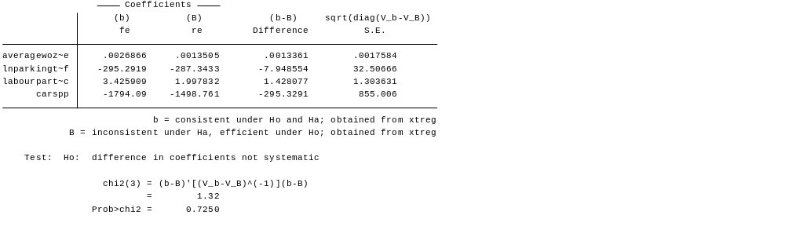

B2.

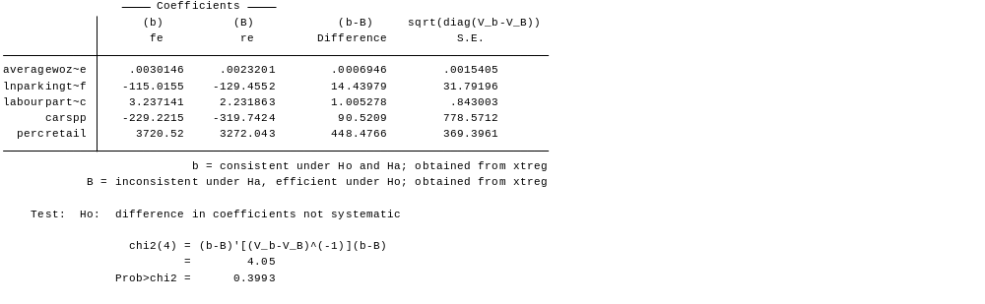
B3.

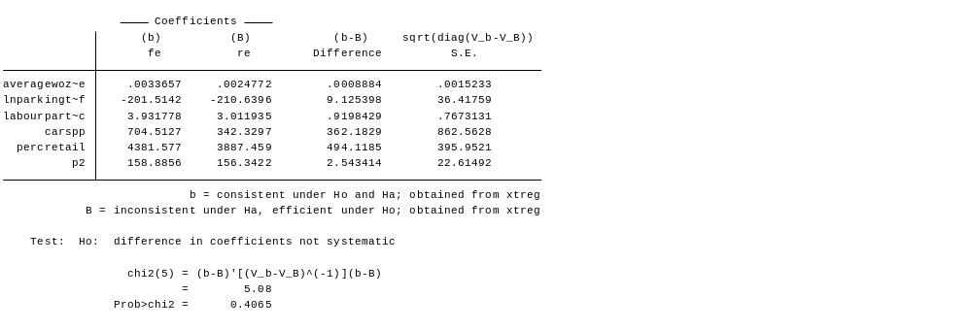

A standard to measure the development of the average consumer prices over time.
A standard to measure the development of the average consumer prices over time.
The price of park and ride should be set between the price of using a private car and using public transport. If the price of using park and ride is lower than the price of public transport in general, it will motivate people to shift from public transport to park and ride (and again use the private car for a part of their journey).
1. employment | 2. Car ownership | 3. Amount of firms | 4. Amount of retail firms | 5. Total yearly amount of parking hours sold. | 6. Yearly amount of parking hours sold per parking spot. | 7. Total WOZ value. | 8. Average WOZ value. | 9. Hourly parking tariff.
1. Parking production per parking spot | 2. Average WOZ value per house | 3. Hourly parking tariff | 4. Percentage retail firms | 5. Amount of cars per person. | 6. Labour participation rate
The first regression is a log level model. The dependent variable is stated in levels while the parking tariffs are log transformed. To interpretet the variable, the coefficient had to be divided by 100. So Δy=(β/100)%Δx

