

Erasmus School of Economics
MSc. Marketing

The effect of review valence and brand commitment on consumer’s purchase decision

Stefan Stefanov
369788
Master’s Thesis Marketing
Erasmus University
Erasmus School of Economics
July 2014

Abstract

An experiment was performed to determine whether review valence and brand commitment affected purchase probability. The type of product was a smartphone. Hundred and eighty-six people participated, each exposed to one of six experimental scenarios. Analysis of Variance and Analysis of Covariance were used to see the influence of consumer reviews with different valence and brand commitment on purchase probability. Negative reviews had a negative significant effect on consumers’ purchase likelihood. There was no significant effect for positive reviews. The negativity effect, or the greater weighing of negative as compared to equally extreme positive information in formation of evaluations, was found to be existent. Brand commitment acted as a moderator of review valence, leading to a change in perception of the positive and negative information.

Table of Contents
Abstract 1
1. Introduction 4
2. Literature review and conceptual foundation 6
2.1. Negativity effect 6
2.2. Review valence 7
2.3. Brand effect 9
2.4. Hypotheses 11
2.5. Conceptual framework 12
3. Methodology 13
3.1. Design 13
3.2. Participants 13
3.3. Procedure 14
4. Results 16
4.1. Review valence 16
4.2. Brand commitment 20
5. Discussion 24
5.1. Main discussion and conclusion 24
5.2. Managerial implications 26
5.3. Limitations and future research 27
List of references 29
Appendices 33
Appendix 1: Demographics and informative questions 34
Appendix 2: Brand commitment measure and selected critical values for Hartley’s variance ratio 41
Appendix 3: Experimental scenarios and questionnaire 42
Scenario 1 – No review/no brand 42
Scenario 2 – No review/brand 43
Scenario 3 – Positive review/no brand 44
Scenario 4 – Positive review/brand 46
Scenario 5 – Negative review/no brand 48
Scenario 6 – Negative review/brand 50
Questionnaire – brand mentioned 52
Questionnaire – brand not mentioned 58

Introduction

User generated content (UGC) is a broad term used to describe the body of information generated and uploaded to the internet, that includes podcasting, forums, review-sites, social networking, social media, etc. (Bishop, 2013). With the advent of the UGC platforms consumers can influence and reach large audiences easily and effortlessly, compared to traditional ways (Blakley, 2014). It enriches the user’s experience by letting the consumers voice their opinion online, whenever they choose. On the other hand, UGC presents a valuable source of information for companies, giving them feedback on their products and services, as well as ideas for improvement (Froggatt, 2014). Brands realize that following online conversations and monitoring consumer’s posts and opinions about them, is essential for the company. More and more firms incorporate social content in their marketing strategies and try to engage into customer-led conversations (Blakley, 2014). UGC could have a bigger impact than traditional commercial publications, stemming from the instant availability, low cost, wide access and reach (Digital Visitor, 2011). Its rapid growth in recent years and ability to be measured and monitored makes it attractive and valuable to firms. Traditional marketing tools are not as effective as they used to be, because consumers are more likely to believe reviews or online endorsements of their peers over brand-released marketing messages (Blakley, 2014). It is no surprise that Amazon has stopped its entire television and general-purpose print advertising because of beliefs that its clients trust other people’s opinions more than traditional media advertisements and that, electronic word of mouth (e-WOM) is more effective in influencing consumer behavior (Thompson, 2003).
A properly managed UGC campaign could bring many benefits to the company and reveal invaluable consumer insights. Knowing that customers have more control in creating the image of a brand, letting them express their feelings freely builds strong connections and increases loyalty (Bishop, 2013). Other benefits are better understanding of the target audience, increased customer satisfaction and establishment of a strong community (Raven Blog, 2013).
It has been found that UGC is related to the stock market performance of the firm (Tirunillai & Tellis, 2011). Tirunillai and Tellis (2011) show that user generated content is moderately correlated with abnormal returns, risk and trading volume. They point out that negative UGC has a strong effect on abnormal returns and trading volume, whereas positive UGC has no effect on them. The ability of UGC to predict returns makes it very important for managers and a necessary part of their marketing research.
Online consumer reviews are a form of e-WOM that allows people to express their opinions about a product/service and also help them make informed decisions about purchasing new products (Lee & Ma, 2012; Cui, Lui & Guo, 2012). With the penetration of the Internet to more and more households, the number of people searching for product information online is increasing. The expansion of the number of online communities, blogs and review sites, empowers the consumer to actively share his/her views with peers.
According to the fourth annual Global Consumer Shopping Habits Survey, conducted by ChannelAdvisor – a global e-commerce platform provider, peer-based product reviews are one of the factors that influence buying decisions of online shoppers the most. 90% of shoppers around the world who answered the survey said they read product reviews from other shoppers before buying, and 83% said the reviews affected their purchase decision (Csestrategies.com, 2011).
Most often, a review is written to give the reviewer’s support for a product and recommend it to others, or to discourage them from making a purchase. Accordingly, the tone of the message could be positive or negative (Sen & Lerman, 2007). This study focused on the effect of positive and negative consumer reviews on purchase likelihood. The product used in the study was a smartphone. The persuasive power of product reviews has been demonstrated by researchers (Chevalier & Mayzlin, 2006; Berger, Sorensen & Rasmussen, 2009; Sen & Lerman, 2007; Basuroy, Chatterjee & Ravid, 2003). The negativity effect is a phenomenon widely considered when analyzing the effect of positive and negative information (review in Kellermann, 1984; Herr, Kardes & Kim, 1991). The existence of this effect in consumer environments has been confirmed (Basuroy, Chatterjee & Ravid, 2003; Sen & Lerman, 2007) but also questioned (East, Hammond & Lomax, 2008; Zhang, Craciun & Shin, 2010) by research in the field.
Brand name and brand commitment, specifically, were also included in the study in order to see how they alter the perception and evaluation of information. Evidence was found that knowing and liking the brand could change the way consumers interpret brand-related information (Ahluwalia, 2002; Ahluwalia, Burnkrant & Unnava, 2000).

Literature review and conceptual foundation
This chapter focuses on prior research done in the field and links this theory to the hypotheses. The negativity effect, review valence and the effect of the brand on perception of product related information are discussed. Based on this theory, hypotheses are created. A conceptual framework of the research is provided in the final paragraph.

Negativity effect

To explain better how the review valence affects an individual’s decision-making process it is important to understand what the negativity effect (also called bias) is and its consequences on information processing. Kellermann (1984) defined the negativity effect as the disproportionate weight given to negative information in contrast to equidistantly valenced positive information when forming judgments. The tendency for negative information to be weighted more heavily than positive information in creating evaluations of social stimuli is a widely documented effect. Positive experiences or positive aspects of stimuli have been found to be less affecting in the formation of judgments than negative experiences or negative aspects of stimuli. The latter remains trues for a variety of events, settings and persons. Negative information is also more influential in initial formation of impressions and able to alter already existing impressions. Unfavorable first impressions are more resistant to change.
The negativity bias is also described as the tendency for a unit of activation to result in a greater change in output in the negative motivational system as compared with the positive motivational system (Cacioppo, Gardner & Berntson1997). The aftermath of the negativity effect is that attitudinal and behavioral expressions are to be more strongly influenced by negative than positive output (Cacioppo & Berntson, 1994). Rozin and Royzman (2001) claimed that the negativity bias made negative events more salient, potent, dominant in combinations, and generally efficacious than positive events.
A reason for the existence of the negativity effect is that extreme or negative behaviors are generally perceived as more diagnostic than moderate or positive behaviors (Skowronski & Carlston, 1989). Skowronski and Carlston (1989) alleged that people’s implicit hypotheses concerning the relationships between behavioral cues and trait categories made negative and extreme cues more influential. Herr, Kardes and Kim (1991) confirmed the statement that negative information tends to be more diagnostic or informative than positive or neutral information in consumer settings. According to them, negative attributes strongly implied membership in one category (e.g. low quality) to the exclusion of others. On the other hand, positive and neutral features were more ambiguous when it came to category membership. Positive and neutral features may refer to high-, medium- and low-quality products, whereas negative features had stronger implications for categorization. A single extremely negative feature could be highly informative; hence negative-attribute information is weighted heavily in judgment.
Ample evidence (Skowronski & Carlston, 1989; Herr, Kardes & Kim, 1991; Cacioppo & Berntson, 1994; Rozin & Royzman, 2001) demonstrates that there is greater responsiveness to negative stimuli than positive stimuli. Next in the literature review, it could be seen that the negativity effect is also present in consumer environments.

Review valence

A number of authors studied how the valence of product related information affects purchase behavior. Not all findings point in the same direction and it is yet to be agreed if favorable or unfavorable information weighs more on the attitudes and actions of consumers.
In their research, Chevalier and Mayzlin (2006) found evidence that an incremental negative review was more powerful in decreasing sales than an incremental positive review was in increasing sales. Studying online book retailers, they showed that an improvement in a book’s reviews led to an increase in relative sales – an increase in the average star rating on Amazon.com resulted in higher sales over time, and positive reviews improved sales, whereas negative hurt them. Moreover, the impact of one-star reviews was greater than the impact of five-star reviews in most cases. This suggests that negative information will have more power on an individual, compared to equally extreme positive information.
Berger, Sorensen and Rasmussen (2009) explored under which contexts negative publicity about a product can have positive versus negative effects. They argued that negative publicity could increase purchase likelihood and sales in situations where existing product awareness or accessibility was low. Analyzing book reviews on the New York Times and sales, they suggested that positive reviews always increased sales, while the effect of negative reviews depended on the familiarity with the author. Positive and negative publicity had different influence on the sales of established authors, but similar for new authors which showed that negative publicity may have a positive effect due to the dissociation of valence in memory and through affecting the consideration set. Also, for unknown products the effect of negative reviews became more positive with time because publicity valence faded but increased awareness remained.
Sen and Lerman (2007) investigated if people tend to weight negative information more than positive information when it comes to evaluating a product. They found out that product type moderated the effect of review valence and that people were more likely to read negative reviews and be more engaged with them rather than positive reviews. Their study supported the existence of negativity bias for utilitarian products, but not for hedonic products. Utilitarian products are described as instrumental and goal-orientated, that accomplish a functional or practical task (Strahilevitz & Myers, 1998). Hedonic products, on the other hand, bring affective and sensory experience of aesthetic or sensual pleasure (Hirschman & Holbrook, 1982). Also, people were more likely to consider using consumer reviews for utilitarian products in their decision-making, which demonstrates that overall consumer reviews would be more persuasive for utilitarian products.
The negativity bias was, also, confirmed by Basuroy, Chatterjee and Ravid (2003). They found evidence that positive and negative reviews were correlated with weekly box office revenue of films, and were able to predict and influence box office revenue. Comparing the impact of favorable and unfavorable reviews, it was shown that negative publications hurt performance more than positive improved it. They explained this with the perceived reviewer credibility – consumers were likely to consider the author of a positive review as having a studio bias, and the author of a negative as independent of studio influence. However, this effect diminished with time.
Not all research in the field is consistent with the belief that people give more weight to negative publications than to equally extreme positive ones. East, Hammond and Lomax (2008) concluded that positive word-of-mouth had more impact on brand purchase probability than negative word-of-mouth. They measured it as the shift in purchase probability and said that the impact of positive and negative advice was similar but positive word-of-mouth had slightly more effect. According to their research, statements that negative word-of-mouth is more influential than positive were mistaken. Furthermore, people resisted negative WOM on brands they were very likely to choose and positive WOM on brands they were very unlikely to choose.
Other research on the topic proposes that the persuasiveness of electronic word-of-mouth was moderated by the consumption goals of the reviewed product (Zhang, Craciun & Shin, 2010). Zhang et al. (2010) stated that for products associated with promotion consumption goals (e.g. photo-editing software), consumers displayed positivity bias i.e. positive reviews were rated as more persuasive than negative. For products associated with prevention consumption goals (e.g. anti-virus software), conversely, negativity bias was present. This showed that consumer regulatory focus matters.
These discrepancies about the existence of the negativity effect may be due to the setting in which the research was conducted. Samson (2006) stated that research conclusions about positive or negative WOM being more influential are not necessarily contradictory. Businesses in high-commitment/low-choice sectors may be more susceptible to negative WOM, while low-commitment/high-choice industries, to positive WOM (Samson, 2006). Zhu and Zhang (2010) wrote about the importance of product type and product category when analyzing online reviews and sales. This shows that generalizations about the effect of WOM should be careful and the product context should be clearly outlined.

Brand effect

The brand is seen as one of the most valuable assets that a company owns. It creates value that goes beyond the material aspect and addresses the psychological aspect by building brand associations that can be translated into feelings, attitudes, beliefs, images or other perceptions. People that are attached to certain brand and seek it have expectations derived from their experience with the brand. They perceive the brand in a special way and distinguish its products or services from competitors as having unique characteristics. The formation of such a relationship between the consumer and the brand creates brand equity (Keller 1993).
Brand commitment, similar to brand loyalty is more than just a repeat purchase. It could be defined as an emotional or psychological attachment to a brand within a product class (Lastovicka & Gardner 1977). This attachment forms strong attitudes toward the brand. People committed to a brand are likely to engage in different behaviors in regard to acquisition of information and are motivated to maintain cognitive consistency (Jacoby, Chestnut & Fisher, 1978; Crosby & Taylor, 1983). It could be expected that strong attitudes will lead to greater resistance to information that attacks them i.e. negatively valenced messages (Petty & Krosnick 1995).
In more recent research, brand commitment has been identified as a moderator of negative information effects (Ahluwalia, Burnkrant & Unnava, 2000). Ahluwalia et al. (2000) asserted that low-commitment consumers showed greater attitude change and their attitudes were more ambivalent when exposed to negative (versus positive) information. High-commitment consumers, however, did not exhibit such attitude change – the negativity effect was nearly reversed for them, making them resist negative information. They generated more counterarguments when negative (versus positive) information was presented, unlike low-commitment consumers, who acted similarly under both conditions. Furthermore, under low commitment negative information was perceived as more diagnostic compared to under high. Diagnosticity, as stated earlier in the literature review, is one rationale behind the existence of the negativity effect. However, people strongly attached to a brand dismissed negative information about its products, perceiving only positive messages as diagnostic. Hence the negativity effect was absent for committed consumers, when they were exposed to information about the brands they like. They displayed resistance to negative information about the brand and positive about the competition – refuting any information that could cause switching behavior (Ahluwalia, Burnkrant & Unnava, 2000).
Brand familiarity is another factor that could influence the circumstances when the negativity is present. Ahluwalia (2002) concluded that consumers who were familiar and like the brand support attitude-consistent positive information more than unfamiliar ones and consider it more diagnostic. When the brand was familiar, the negativity effect was attenuated, which led to enhanced diagnosticity of positive information. The same research, also found evidence that the presence of goals resulted in selective information processing. Goal-consistent information was accepted, whereas goal-inconsistent information was rejected. People who were familiar with a brand and had different type of involvement or processing goal were likely to assess the diagnosticity of new brand-related information very differently.
All of these findings suggest that the brand is something that should be taken into consideration when product information is perceived. Any level of attachment or favorable impressions about a brand can have consequences on customer interpretations and evaluations of product related inputs.
As it could be seen above, there is no clear and unambiguous statement about the effect of positive and negative information on individual’s decision making. The present study was a test of the existence of the negativity effect in consumer environments. The primary aims were to examine the effect on purchase probability of review valence and to see whether brand commitment would change the direction/strength of the effect. Since negative information is often perceived as more diagnostic negatively valenced reviews might be expected to be more influential than positive. Brand commitment could also be expected to interact with review valence and alter its effect on purchase intention.

Hypotheses

Based on the findings of Chevalier and Mayzlin (2006); and Berger, Sorensen and Rasmussen (2009) about the effect of the valence of product reviews on sales the following hypotheses were created:
H₁: Positive consumer reviews will have a positive effect on an individual’s purchase decision i.e. increase the probability of purchase.
H₂: Negative consumer reviews will have a negative effect on an individual’s purchase decision i.e. decrease the probability of purchase.
Regarding which reviews are more influential many authors consider the negativity effect – weighing negative information greatly, compared to equally positive information. However, the presence of the negativity effect in consumer environments is not proven in all research that has been done. Chevalier and Mayzlin (2006) alleged that negative reviews are more powerful than positive. Ahluwalia (2002) stated that the negativity effect was likely to emerge when there was high involvement for a product and the consumer was not attached to the brand. Berger, Sorensen and Rasmussen (2009) did not find the existence of such an effect in their study, showing that negative publicity could increase awareness and sales for unknown products – books. East, Hammond and Lomax (2008) concluded that this effect was not present for brand purchase probability. In this paper, it was assumed that the negativity effect was existent in consumer reviews, and the following hypotheses were created:
H₃: Negative consumer reviews will have more influence on an individual’s purchase decision than positive consumer reviews.
Based on the findings of Ahluwalia from 2000 about the interaction between negative publicity and brand commitment the following hypotheses were created:
H₄: Positive consumer reviews will have a positive effect on individual’s purchase decision, when his/her commitment to the brand is low.
H₅: Negative consumer reviews will have a negative effect on individual’s purchase decision, when his/her commitment to the brand is low.
H₆: Positive consumer reviews will have a positive effect on individual’s purchase decision, when his/her commitment to the brand is high.
H₇: However, negative reviews will be resisted by a consumer with high brand commitment, leading to no effect on decision making.

Conceptual framework

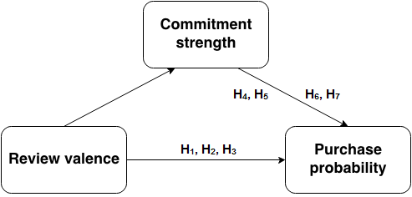
Figure 1 Conceptual framework

Methodology

Design

There were two independent variables: review valence (with three levels: no review available, positive review and negative review) and brand availability (with two levels: no brand available or brand available). This study used a 3x2 between-groups design, with each participant assigned to only one of the permutations of review and brand. The dependent variable was purchase probability.

Participants

Hundred and eighty-six participants took part in the experiment – 31 for each of the six conditions. Respondents were aged between 18 and 64 years, with a mean age of 30.76 (std. deviation 9.178). Hundred and fifty of them were males (80.6%) and 36 females (19.4%). The sample was random and respondents participated on a voluntary basis. The majority of the participants bought tech products every 2, 6 or 12 months and read online consumer reviews more than once or once a week. More information about demographics can be found in the appendix.
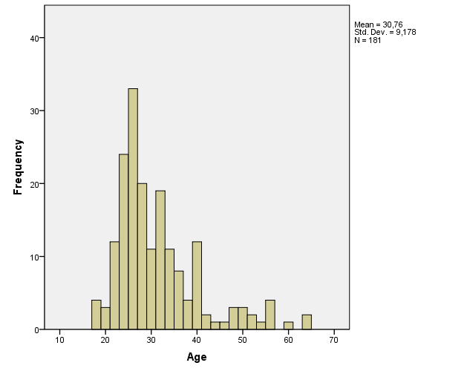
Figure 2 Age of respondents

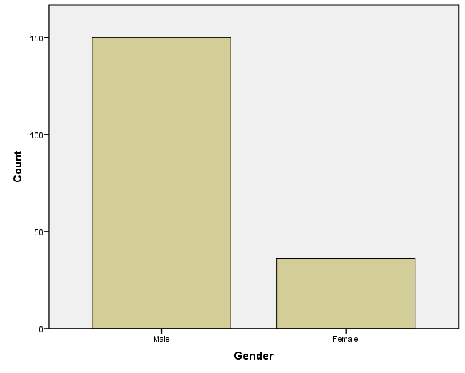
Figure 3 Gender of respondents

Procedure

Participants were required to read product information about a smartphone. The information available varied, according to the condition to which each respondent was assigned. Assignment was random. For the two control conditions, only product specifications were provided. In one of them the brand of the smartphone was mentioned, whereas in the other not. For the third and fourth conditions, product specs and review containing positive information about the product was available. Again, the presence of brand was manipulated. For the last two conditions, product specs and a review containing negative information about the product was available. Brand presence in the review was manipulated once again (all experimental conditions can be found in Table 1).
Experimental condition | Review | Brand availability
1 | No review | No brand
2 | No review | Brand
3 | Positive review | No brand
4 | Positive review | Brand
5 | Negative review | No brand
6 | Negative review | Brand
Table 1 Experimental conditions
After the respondents read the product information, a questionnaire was used to collect data about the influence of the material and its effect on the reader (all scenarios and questionnaire can be found in the appendix).
A real consumer review from Amazon.com was used, rated helpful by all people that have given it a score. The review was manipulated resulting in different reviews with equal extremity for the positive and negative scenario. Star ratings were removed so the emphasis could fall on the content of the review and not affect respondents’ judgment. The reviewed product – smartphone, was a high-involvement one. The reasoning behind choosing a high-involvement product, rather than low-involvement, is that people do more research when buying products that are considered a long-term investment. They visit review sites or manufacturer’s sites to find out more about what they plan to purchase and search for feedback. Also, people are more likely to consider using consumer reviews for utilitarian products (Sen & Lerman, 2007). This may have an impact when creating their consideration list or making the final decision.
Purchase probability was defined as a percentage from 0-100%, measuring the likelihood to buy the product. Every respondent was asked to give a number within these limits, immediately after reading the information presented to him/her.
Participant’s brand commitment was measured using a three item scale created and tested by Beatty, Kahle and Homer (1988). Respondents expressed their agreement with three statements on a nine-point scale anchored by disagree/agree (the three items could be found in the appendix). Subjects in the upper/lower third of the scale were considered high/low in commitment. A mean score of the three items was computed for each respondent and used as a commitment measure. The measure was tested for internal consistency reliability - Cronbach’s alpha for the three items was .85 (Table 1). This approach was used in Ahluwalia, Burnkrant and Unnava’s study (2000).
The smartphone brand used for the experiment was HTC, the model – HTC One M7. At the time when the data was collected, M7 was the newest phone from HTC available on the market. The reason behind choosing HTC is because it is one of the most popular brands of smartphones and with relatively high customer loyalty (Alan, 2014).
The survey was conducted through Qualtrics – a platform for online surveys.

Results

Review valence

A two-way Analysis of Variance (ANOVA) with independent measures on both variables was conducted on these data. Standard contrasts were used to break down the main effect of review valence and understand where the differences between groups lie. Simple contrast was selected to compare the categories – in this case positive and negative review conditions, to a reference category – no review condition. Bonferroni and Tukey post hoc tests were utilized to explore the data for any between-group differences in means. Tukey’s test results were used because of the smaller confidence intervals in this case, good control over the Type I error rate and more power when testing large number of means (Field, 2009).
Table 2 presents the mean purchase probability (%), standard deviations and number of participants for each of the experimental conditions.

Descriptive Statistics
Dependent Variable:purchase probability
review | brand | Mean | Std. Deviation | N
no review | no brand | 57,84 | 27,281 | 31
no review | brand | 47,77 | 36,778 | 31
no review | Total | 52,81 | 32,512 | 62
positive review | no brand | 54,39 | 29,739 | 31
positive review | brand | 58,16 | 34,598 | 31
positive review | Total | 56,27 | 32,051 | 62
negative review | no brand | 34,52 | 32,794 | 31
negative review | brand | 28,19 | 26,800 | 31
negative review | Total | 31,35 | 29,871 | 62
Total | no brand | 48,91 | 31,441 | 93
Total | brand | 44,71 | 34,952 | 93
Total | Total | 46,81 | 33,220 | 186
Table 2 Descriptive statistics

Table 3 shows the main ANOVA results summary table.

Tests of Between-Subjects Effects
Dependent Variable: Purchase probability
Source | Type III Sum of Squares | df | Mean Square | F | Sig. | Partial Eta Squared
Corrected Model | 25002,672ª | 5 | 5000,534 | 5,024 | ,000 | ,122
Intercept | 407590,586 | 1 | 407590,586 | 409,502 | ,000 | ,695
review | 22592,204 | 2 | 11296,102 | 11,349 | ,000 | ,112
brand | 821,941 | 1 | 821,941 | ,826 | ,365 | ,005
review * brand | 1588,527 | 2 | 794,263 | ,798 | ,452 | ,009
Error | 179159,742 | 180 | 995,332
Total | 611753,000 | 186
Corrected Total | 204162,414 | 185
a. R Squared = .122 (Adjusted R Squared = .098)

Table 3 Test of between-subjects effects

- There was a significant main effect of review valence on the purchase probability, F (2, 180) = 11.35, p < .001, r = .50. Tukey HSD post hoc test revealed that the negative review significantly decreased the purchase probability compared to the no review and positive review cases (both ps < .05). Purchase probability after being exposed to the positive review condition was not significantly different compared to the no review condition.
These findings suggest that H₁ was not supported – the positive review does not increase significantly the purchase probability. Looking at the means in Table 2, the mean purchase probability was higher only when brand name was mentioned (M _{positive review/brand group} = 58.16; M _{no review/brand group} = 47.77), which was not enough for the positive review to display a significant effect. H₂ and H₃, on the other hand, were supported. The negative consumer review had a negative effect on an individual’s purchase decision i.e. it decreased the probability of purchase. The mean purchase probability decreased with 21.45 (p < .05) when exposed to negative product information (Table 4). The negatively valenced review was more influential than the positive one when it comes to purchase decision making compared to when no review was available – change in mean purchase probability, respectively -21.45 (p < .05) and 3.47 (p = .814) (Table 4). These results were also confirmed from the simple contrasts – Table 5.
Multiple Comparisons
Dependent Variable: Purchase probability
 | (I) review | (J) review | Mean Difference (I-J) | Std. Error | Sig. | 95% Confidence Interval
 |  |  |  |  |  | Lower Bound | Upper Bound
Tukey HSD | no review | positive review | -3,47 | 5,666 | ,814 | -16,86 | 9,92
Tukey HSD | no review | negative review | 21,45* | 5,666 | ,001 | 8,06 | 34,84
Tukey HSD | positive review | no review | 3,47 | 5,666 | ,814 | -9,92 | 16,86
Tukey HSD | positive review | negative review | 24,92* | 5,666 | ,000 | 11,53 | 38,31
Tukey HSD | negative review | no review | -21,45* | 5,666 | ,001 | -34,84 | -8,06
Tukey HSD | negative review | positive review | -24,92* | 5,666 | ,000 | -38,31 | -11,53
Bonferroni | no review | positive review | -3,47 | 5,666 | 1,000 | -17,16 | 10,23
Bonferroni | no review | negative review | 21,45* | 5,666 | ,001 | 7,76 | 35,14
Bonferroni | positive review | no review | 3,47 | 5,666 | 1,000 | -10,23 | 17,16
Bonferroni | positive review | negative review | 24,92* | 5,666 | ,000 | 11,23 | 38,61
Bonferroni | negative review | no review | -21,45* | 5,666 | ,001 | -35,14 | -7,76
Bonferroni | negative review | positive review | -24,92* | 5,666 | ,000 | -38,61 | -11,23
*. The mean difference is significant at the .05 level.

Table 4 Post hoc tests
Contrast Results (K Matrix)
Review valence Simple Contrastª |  |  | Dependent Variable
 |  |  | Purchase probability
Positive vs. No review | Contrast Estimate |  | 3,468
Positive vs. No review | Hypothesized Value |  | 0
Positive vs. No review | Difference (Estimate - Hypothesized) |  | 3,468
Positive vs. No review | Std. Error |  | 5,666
Positive vs. No review | Sig. |  | ,541
Positive vs. No review | 95% Confidence Interval for Difference | Lower Bound | -7,713
Positive vs. No review | 95% Confidence Interval for Difference | Upper Bound | 14,649
Negative vs. No review | Contrast Estimate |  | -21,452
Negative vs. No review | Hypothesized Value |  | 0
Negative vs. No review | Difference (Estimate - Hypothesized) |  | -21,452
Negative vs. No review | Std. Error |  | 5,666
Negative vs. No review | Sig. |  | ,000
Negative vs. No review | 95% Confidence Interval for Difference | Lower Bound | -32,633
Negative vs. No review | 95% Confidence Interval for Difference | Upper Bound | -10,271
Table 5 Simple contrasts
- There was a non-significant main effect of the brand on the purchase probability F (1, 180) = .83, p = .365, r = .00. This means that whether the brand was mentioned or not, did not affect the chance of buying the product.

- There was a non-significant interaction effect between review valence and brand availability F (2, 180) = .80, p = .452, r = .00. As it could be seen on Figure 4, the purchase probability after reading a positive review and negative review changed by a similar amount. There was some difference in purchase probability for the no review case; however this was not enough to make the interaction significant.

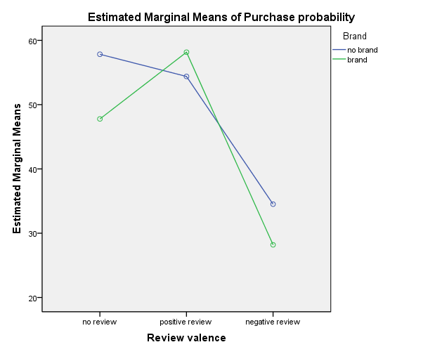
Figure 4 Interaction effect

Brand commitment

Analysis of Covariance (ANCOVA) was used to analyze how brand commitment affects purchase probability and alters the effect of review valence. Brand commitment was selected as a covariate. The covariate level in the model was changed in order to understand the consequences on the dependent variable when subjects are categorized as high/low in brand commitment. Parameter estimates and estimated marginal means were used to quantify the results.

Tests of Between-Subjects Effects
Dependent Variable:Purchase probability
Source | Type III Sum of Squares | df | Mean Square | F | Sig.
Corrected Model | 26311,209ª | 2 | 13155,605 | 17,223 | ,000
Intercept | 3355,382 | 1 | 3355,382 | 4,393 | ,040
br_com_mean | 12391,193 | 1 | 12391,193 | 16,222 | ,000
review | 4428,593 | 1 | 4428,593 | 5,798 | ,019
Error | 45065,839 | 59 | 763,828
Total | 186963,000 | 62
Corrected Total | 71377,048 | 61
a. R Squared = .369 (Adjusted R Squared = .347)

Table 6 Test of between-subjects effects

Levene's Test of Equality of Error Variancesª
Dependent Variable:Purchase probability
F | df1 | df2 | Sig.
4,629 | 1 | 60 | ,035
Tests the null hypothesis that the error variance of the dependent variable is equal across groups.
Table 7 Levene’s test
- Levene’s test was significant, F (1, 60) = 4.63, p < .05, indicating that the assumption of homogeneity of variance had been broken. To confirm this, the variance ratio proposed by Hartley was implemented (Pearson & Hartley, 1954). Compared to the critical values published in the former research the variance ratio was smaller which showed that there was no cause for concern regarding the differences in variances (Appendix 2). The main effect of review valence was significant, F (1, 59) = 5.80, p < .05, r = .37, indicating that purchase probability was lower after reading the negative review (M = 38.57, SE = 5.60) compared to after reading the positive review (M = 56.86, SE = 4.97) – Table 8.
Estimates
Dependent Variable:Purchase probability
Review valence | Mean | Std. Error | 95% Confidence Interval
Review valence | Mean | Std. Error | Lower Bound | Upper Bound
positive review | 56,864ª | 4,974 | 46,910 | 66,817
negative review | 38,575ª | 5,593 | 27,383 | 49,767
a. Covariates appearing in the model are evaluated at the following values: Brand commitment = 5.00.

Table 8 Estimates – neutral commitment

- The covariate was also significant, F (1, 59) = 16.22, p < .001, r = .57, indicating that level of brand commitment had a significant effect on purchase probability (there was a positive relationship between these two variables).

Table 9 shows the parameter estimates from the ANCOVA. The parameter estimate for brand commitment (b = 6.35, p < .001) reveals that, everything else being equal, if there is an increase in brand commitment by one unit, then purchase probability should increase by just over 6 units. The positive sign of the coefficient accounts for a positive relationship between brand commitment and purchase probability.

Parameter Estimates
Dependent Variable:Purchase probability
Parameter | B | Std. Error | t | Sig. | 95% Confidence Interval
 |  |  |  |  | Lower Bound | Upper Bound
Intercept | 6,816 | 7,267 | ,938 | ,352 | -7,726 | 21,357
Brand commitment | 6,352 | 1,577 | 4,028 | ,000 | 3,196 | 9,508
[review=2] | 18,288 | 7,595 | 2,408 | ,019 | 3,090 | 33,486
[review=3] | 0ª | . | . | . | . | .
a. This parameter is set to zero because it is redundant.

Table 9 Parameter estimates
To understand how high/low brand commitment affected purchase probability and how it altered the perception of the consumer review, the level of the covariate in the model was respectively increased or decreased. Table 10 and 11 display the estimated marginal means adjusted for the high/low level of the covariate. Since subjects with scores in the upper (7-9)/lower (1-3) third of the brand commitment measure were considered high/low in commitment, it should be noted that the highest and lowest values for commitment were used (1 for low, 9 for high).

Estimates
Dependent Variable:Purchase probability
Review valence | Mean | Std. Error | 95% Confidence Interval
Review valence | Mean | Std. Error | Lower Bound | Upper Bound
positive review | 82,271ª | 7,776 | 66,711 | 97,832
negative review | 63,983ª | 10,178 | 43,616 | 84,349
a. Covariates appearing in the model are evaluated at the following values: Brand commitment = 9.00.

Table 10 Estimates – high commitment
Table 10 shows the estimated marginal means adjusted for high brand commitment. Mean purchase probability after reading the positive review was 82.27 (SE = 7.78) and after reading the negative 63.98 (SE = 10.18). Compared to the means when brand commitment was 5 (Table 8), which could be considered neutral, there was an increase for both the positive and negative review condition.

Estimates
Dependent Variable:Purchase probability
Review valence | Mean | Std. Error | 95% Confidence Interval
Review valence | Mean | Std. Error | Lower Bound | Upper Bound
positive review | 31,456ª | 8,283 | 14,883 | 48,029
negative review | 13,168ª | 6,209 | ,742 | 25,593
a. Covariates appearing in the model are evaluated at the following values: Brand commitment = 1.00.

Table 11 Estimates – low commitment
Table 11 shows the estimated marginal means adjusted for low brand commitment. Mean purchase probability after being exposed to the positive and to the negative review was, respectively 31.46 (SE = 8.28) and 13.17 (SE = 6.21). Compared to the values when brand commitment was neutral (Table 8), there was a decrease for both experimental conditions.
Low/high brand commitment led to a decrease/increase of 25.41 units in purchase probability.
These findings suggest that H₄ and H₅ were supported i.e. positive/negative consumer reviews have a positive/negative effect on individual’s purchase decision when his/her commitment to the brand is low. H₆ and H₇ were also supported i.e. positive consumer reviews have a positive effect on purchase decision; however negative reviews are resisted when commitment to the brand is high. The results show that there was a decrease in purchase probability with 25.41 units after reading the positive/negative review when brand commitment was low compared to neutral. When commitment was high compared to neutral, an increase of 25.41 units was present for both conditions. This means that brand commitment moderated the effect of review valence on purchase probability. Low brand commitment led to a weaker effect of the positive review i.e. purchase probability decreased even though information strongly supporting the product was read. Contrary, when the review was with negative valence, the impact of the review became stronger i.e. it further decreased the chance of buying the smartphone. High commitment to the brand of the reviewed product, on the other hand, amplified the effect of the positive review – it increased purchase intention. This, however, was not true when the review was negative – high commitment led to subjects resisting the unfavorable information about the brand they like. The direction of the effect was reversed i.e. the chance of buying the smartphone increased.

Discussion

Main discussion and conclusion

The main result of this study was that reading a negative consumer review decreased the probability of a consumer purchasing the reviewed product – in this case the smartphone. This was true, regardless if the brand name was mentioned or not. There was no evidence that a positive consumer review increased participant’s chance of buying the product. Brand commitment altered the effect of review valence on purchase probability. Low commitment to the brand of the reviewed smartphone diminished the influence of the positive review and made the negative review more influential. High brand commitment increased the weight of the positive review on purchase intention and led to rejection of the negative review. The effect of the unfavorable information was reversed – it affected positively the buying decision.
The negativity effect or bias i.e. the disproportionate weight given to negative information compared to equally valenced positive information when forming judgments (Kellermann, 1984), was found to be existent. The negative consumer review had a bigger impact on purchase likelihood in contrast to the equally extreme positive review. The change in purchase probability was significantly higher for the negative scenario. This might be due to the higher perceived diagnosticity of unfavorable information (Skowronski & Carlston, 1989; Herr, Kardes & Kim, 1991).
The present study is consistent with the work of Chevalier and Mayzlin (2006) who examined the effect of consumer reviews on relative sales of books. They concluded that one-star reviews have a greater impact on sales than five-star reviews. Taken together, these studies suggest that negative reviews are more influential than positive when it comes to buying the reviewed product. The finding of Chevalier and Mayzlin that an improvement in reviews leads to an increase in sales is not confirmed. However, their study was based on numerous product reviews and in this case there was a single review. The proportion of favorable/unfavorable reviews is something that should be considered.
Sen and Lerman (2007) put the existence of the negativity effect in consumer reviews to a test. Their research classified product type as a moderator of the effect of review valence on product evaluation. According to their findings, the negativity bias was present only for utilitarian products and not for hedonic products. Arguably, smartphones could be categorized as utilitarian products, rather than hedonic. This result is consistent with the present study, excluding the case when brand commitment is high. The negativity bias was also found in critical reviews by Basuroy, Chatterjee and Ravid (2003). They concluded that negative reviews hurt performance of movies more than positive improve it. This was explained by the reluctance of people to believe critics because they might be paid by studios to promote their films. This makes sense for the aforementioned context since critics are opinion leaders and could influence large number of people. However, customer reviews are written by consumers for their peers to read, so this is highly unlikely to be the case.
The belief that people give more weight to negative publications than to positive ones is not supported by all work in the field. East, Hammond and Lomax (2008) reached the conclusion that positive WOM is more influential than negative WOM. They attributed similar impact to positive and negative WOM but emphasized that positive WOM is slightly more effective. This discrepancy with the current study may be due to the form of WOM that was researched. East et al. used offline WOM part of which were positive and negative advices given from friends. The relationship of the respondent with the source of the advice could have had an effect on the persuasive power of the information. Moreover, role play experiments and retrospective surveys were used to collect data and subjects were asked directly how WOM affected their purchase decision. The present research included a single type of product – smartphone and respondents were asked to state the probability of buying the product right after exposure to the consumer review. East et al. had several product categories in their surveys and substantial amount of time had passed before collecting information about purchase likelihood. Time is an important factor since the impact of WOM may fade or develop with time.
Taking into consideration consumption goals, Zhang et al. (2010) found out that, products with promotion consumption goals displayed positivity bias, whereas products with prevention consumption goals – negativity bias. The present research does not contradict the former since smartphones could be associated with both promotion and prevention goals.
Brand commitment turned out to be essential when interpreting the effect of review valence on purchase probability for brands to which the reader is attached, likes or cares about. Brand familiarity was found by Ahluwalia (2002) to impact the occurrence of the negativity effect. Moreover, consumers who were familiar with the brand supported attitude-consistent information more than unfamiliar consumers. The negativity bias was attenuated in the case of familiarity with the brand. This shows that being aware of the brand and having fairly favorable impression about it could influence perception of related information. The consequences of high involvement are far more beneficial for companies. The findings of this study are consistent with the work of Ahluwalia, Burnkrant and Unnava (2000) where brand commitment was identified as a moderator of negative information effects. Taken together, these studies suggest that the negativity effect is more likely to appear when commitment is low. The current paper finds evidence that not only is the negativity effect absent, but also purchase probability could increase under exposure to a negative review, at high levels of commitment.
Berger, Sorensen and Rasmussen (2009) provide evidence that negative publicity could increase purchase likelihood when product awareness is low. The results from this study showed that purchase probability can also increase after being exposed to a negative review when brand commitment is high. It should be noted that this may not be valid when the number of negative publications reaches a critical point. It could be expected that accumulating a certain amount of negative feedback could start decreasing purchase likelihood under high brand commitment. This is something that could be a subject for future research.
The negativity effect, a phenomenon which existence in consumer environments is questioned, was found to be existent. Negative consumer inputs were more influential than equally extreme positive. Brand commitment moderated the effect of review valence. These results suggested that consumer purchase behavior is influenced by online consumer publications.

Managerial implications

The internet allows consumers to gather and spread product related information effortlessly. The results of the present study revealed that a negative review hurt purchase likelihood more than a positive improved it. With that being said, overlooking consumer publications could have harmful effect on sales. This adds to what has already been found in past research (Tirunillai & Tellis, 2011; Sonnier, McAlister & Rutz, 2011). Negative e-WOM and consumer reviews in particular could be a signal for consumer discontent and should not be ignored by managers. Negative opinions on the web could reveal valuable insights about directions for improvement of the product. Taking them into account would make the customer feel appreciated, increase satisfaction and subsequently decrease negative e-WOM, which will positively influence sales. Moreover, companies could try to increase commitment to the brand in order to reduce the aftermath of negative publications and increase the consequences of positive.

Limitations and future research

Although it was demonstrated that review valence impacts purchase probability for smartphones, generalizations should be careful. Evidence has been found that product type moderates the effect of review valence (Sen & Lerman, 2007). These inconsistencies in findings of different studies (Chevalier & Mayzlin, 2006; East, Hammond & Lomax, 2008) may largely be due to the product category used. The importance of product type has been discussed by other authors (Zhu & Zhang, 2010).
Another limitation is the extremity of the consumer reviews used in the experiment. The content in both the positive and negative valence condition was rather extreme – highly praising the smartphone or expressing strong disapproval. Lower levels of satisfaction/dissatisfaction expressed would most likely influence readers differently.
The number of reviews available should also be considered. In this case there was a single piece of information to which the participants were exposed. There was also a single brand of smartphone being reviewed or no brand at all. Some authors analyze the effect of valence taking into account the proportion of reviews (Lee, Park & Han, 2007). Other important part is the level of detail. The consumer review consisted of detailed information about the smartphone features, the so called “in-depth” review. Generalizations about all type of reviews should be careful since reviews of two or three sentences would weigh differently on consumer’s judgment.
Finally, time should also be regarded. Subjects were asked to share their purchase likelihood directly after reading the review. The influence of the review may change as the impact of information fades or develops with time.
In further research, it would be useful to understand how purchase behavior is affected when factors such as the extremity of the content, the level of detail and the number of available reviews are manipulated. Moreover, the exact impact of the proportion of positive to negative consumer publications has not been quantified. Ambivalent reviews could also be a subject for research since most studies concentrate on positive and negative valence.
There was evidence that high brand commitment led to resisting unfavorable information about the brand’s product. Building on that, it would be interesting to see if there are a critical number of negative reviews, after which purchase probability will start declining under high commitment. As it was found that a very extreme negative review was not able to diminish purchase likelihood for highly-committed consumers, maybe accumulation of negative reviews will start weighing in on the attitudes and behavior at a certain point. Same for positive reviews under low commitment – could they increase the likelihood of buying the product with accumulation.
Future research could use time as a moderator of the influence of WOM. Berger et al. (2010) showed that negative publicity could be advantageous when there was time between receiving the information and purchase occasion.

List of references

Ahluwalia, R., Burnkrant, R., & Unnava, H. (2000). Consumer response to negative publicity: the moderating role of commitment. Journal Of Marketing Research, 37(2), 203-214.
Ahluwalia, R. (2002). How prevalent is the negativity effect in consumer environments?. Journal Of Consumer Research, 29(2), 270-279.
Alan, F. (2014). Survey of smartphone owners shows the power of brand loyalty. Phone Arena. Retrieved 30 June 2014, from http://www.phonearena.com/news/Survey-of-smartphone-owners-shows-the-power-of-brand-loyalty_id53939
Basuroy, S., Chatterjee, S., & Ravid, S. (2003). How critical are critical reviews? The box office effects of film critics, star power, and budgets. Journal Of Marketing, 67(4), 103-117.
Beatty, S., Homer, P., & Kahle, L. (1988). The involvement—commitment model: Theory and implications. Journal Of Business Research, 16(2), 149-167.
Berger, J., Sorensen, A., & Rasmussen, S. (2010). Positive Effects of Negative Publicity: When Negative Reviews Increase Sales. Marketing Science, 29(5), 815-827.
Bishop, J. (2013). The Opportunities With User-Generated Content. Jon Bishop. Retrieved 30 June 2014, from http://www.jonbishop.com/2013/08/the-opportunities-with-user-generated-content/
Blakley, J. (2014). Today's Publishers: A Look at How Branded + User-Generated Content is Changing Marketing. CMSWire.com. Retrieved 30 June 2014, from http://www.cmswire.com/cms/customer-experience/todays-publishers-a-look-at-how-branded-usergenerated-content-is-changing-marketing-022124.php
Cacioppo, J., & Berntson, G. (1994). Relationship between attitudes and evaluative space: A critical review, with emphasis on the separability of positive and negative substrates. Psychological Bulletin, 115(3), 401.
Cacioppo, J., Gardner, W., & Berntson, G. (1997). Beyond bipolar conceptualizations and measures: The case of attitudes and evaluative space. Personality And Social Psychology Review, 1(1), 3-25.
Chevalier, J., & Mayzlin, D. (2006). The effect of word of mouth on sales: Online book reviews. Journal Of Marketing Research, 43(3), 345-354.
Crosby, L., & Taylor, J. (1983). Psychological commitment and its effects on post-decision evaluation and preference stability among voters. Journal Of Consumer Research, 413-431.
Csestrategies.com,. (2011). 2011 Global Consumer Shopping Habits Survey - ChannelAdvisor Blog. Retrieved 30 June 2014, from http://www.csestrategies.com/channel_advisor_blog/2011/10/global-consumer-shopping-habits-survey.html
Cui, G., Lui, H., & Guo, X. (2012). The effect of online consumer reviews on new product sales. International Journal Of Electronic Commerce, 17(1), 39-58.
Digital Visitor,. (2011). The Benefits of User Generated Content - Digital Visitor. Retrieved 30 June 2014, from http://www.digitalvisitor.com/the-benefits-of-user-generated-content/
East, R., Hammond, K., & Lomax, W. (2008). Measuring the impact of positive and negative word of mouth on brand purchase probability. International Journal Of Research In Marketing, 25(3), 215-224.
Field, A., & Hole, G. (2003). How to design and report experiments (1st ed.). London: Sage Publications.
Field, A. (2009). Discovering Statistics Using SPSS (3rd ed.). London: Sage Publications.
Froggatt, L. (2014). The Significant Benefits of User Generated Content. Benchmark Email Marketing Blog. Retrieved 30 June 2014, from http://www.benchmarkemail.com/blogs/detail/the-significant-benefits-of-user-generated-content
Herr, P., Kardes, F., & Kim, J. (1991). Effects of Word-of-Mouth and Product-Attribute Information on Persuasion: An Accessibility-Diagnosticity Perspective. Journal Of Consumer Research, 17(4), 454-462.
Hirschman, E., & Holbrook, M. (1982). Hedonic consumption: emerging concepts, methods and propositions. The Journal Of Marketing, 92-101.
Jacoby, J., Chestnut, R., & Fisher, W. (1978). Simulating Non-Durable Purchase: Individual Differences and Information Acquisition Behavior. Journal Of Marketing Research, 15, 532-544.
Keller, K. (1993). Conceptualizing, measuring, and managing customer-based brand equity. The Journal Of Marketing, 1-22.
Kellermann, K. (1984). The negativity effect and its implications for initial interaction. Communication Monographs, 51(1), 37-55.
Lastovicka, J., & Gardner, D. (1978). Low Involvement Versus High Involvement Cognitive Structures. Advances In Consumer Research, 5, 87-92.
Lee, H., & Ma, Y. (2012). Consumer perceptions of online consumer product and service reviews: Focusing on information processing confidence and susceptibility to peer influence. Journal Of Research In Interactive Marketing, 6(2), 110-132.
Lee, J., Park, D., & Han, I. (2008). The effect of negative online consumer reviews on product attitude: An information processing view. Electronic Commerce Research And Applications, 7(3), 341-352.
Pearson, E., & Hartley, H. (1954). Biometrika tables for statisticians. [Based on "Tables for statisticians and biometricians" by Karl Pearson] (1st ed.). Cambridge.
Petty, R., & Krosnick, J. (1995). Attitude strength (1st ed.). Mahwah, N.J.: Lawrence Erlbaum Associates.
Raven Blog,. (2013). The Benefits of User-Generated Content. Retrieved 30 June 2014, from http://raventools.com/blog/benefits-user-generated-content/
Rozin, P., & Royzman, E. (2001). Negativity bias, negativity dominance, and contagion. Personality And Social Psychology Review, 5(4), 296-320.
Samson, A. (2006). Understanding the buzz that matters: negative vs positive word of mouth. International Journal Of Market Research, 48(6), 647-657.
Sen, S., & Lerman, D. (2007). Why are you telling me this? An examination into negative consumer reviews on the web. Journal Of Interactive Marketing, 21(4), 76-94.
Skowronski, J., & Carlston, D. (1989). Negativity and extremity biases in impression formation: A review of explanations. Psychological Bulletin, 105(1), 131.
Sonnier, G., McAlister, L., & Rutz, O. (2011). A dynamic model of the effect of online communications on firm sales. Marketing Science, 30(4), 702-716.
Strahilevitz, M., & Myers, J. (1998). Donations to charity as purchase incentives: How well they work may depend on what you are trying to sell. Journal Of Consumer Research, 24(4), 434-446.
Thompson, N. (2003). More companies pay heed to their'word of mouse'reputation. New York Times, 23.
Tirunillai, S., & Tellis, G. (2011). Does Chatter Really Matter? Dynamics of User-Generated Content and Stock Performance. ERIM Report Series Reference No. ERS-2011-021-MKT.
Tirunillai, S., & Tellis, G. (2011). Does Online Chatter Really Matter? Dynamics of User-Generated Content and Stock Performance.
Zhang, J., Craciun, G., & Shin, D. (2010). When does electronic word-of-mouth matter? A study of consumer product reviews. Journal Of Business Research, 63(12), 1336-1341.
Zhu, F., & Zhang, X. (2010). Impact of online consumer reviews on sales: The moderating role of product and consumer characteristics. Journal Of Marketing, 74(2), 133-148.

Appendices
Appendix 1: Demographics and informative questions
Appendix 2: Brand commitment measure and selected critical values for Hartley’s variance ratio
Appendix 3: Experimental scenarios and questionnaire

Appendix 1: Demographics and informative questions

Gender
 |  | Frequency | Percent | Valid Percent | Cumulative Percent
Valid | Male | 150 | 80,6 | 80,6 | 80,6
Valid | Female | 36 | 19,4 | 19,4 | 100,0
Valid | Total | 186 | 100,0 | 100,0
Table 12 Gender of respondents
Descriptive Statistics
 | N | Minimum | Maximum | Mean | Std. Deviation
Age | 181 | 18 | 64 | 30,76 | 9,178
Valid N (listwise) | 181
Table 13 Age of respondents
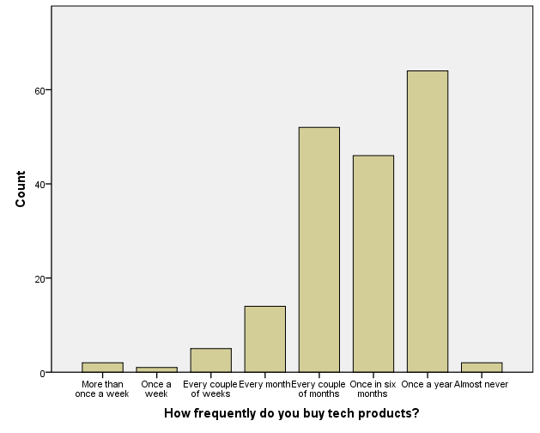
Figure 5
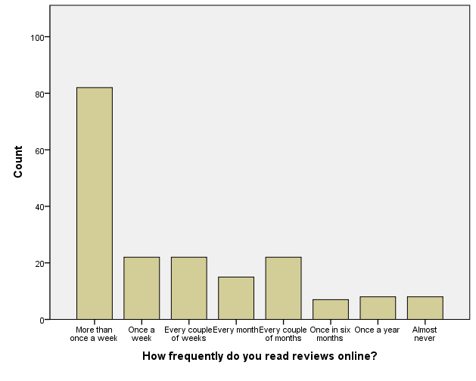
Figure 6
*If the brand name was mentioned, the questions in Figures 7-11 were regarding the smartphone - HTC and the review that was read by the respondent.
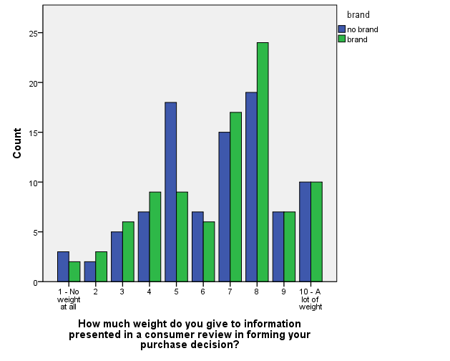
Figure 7*
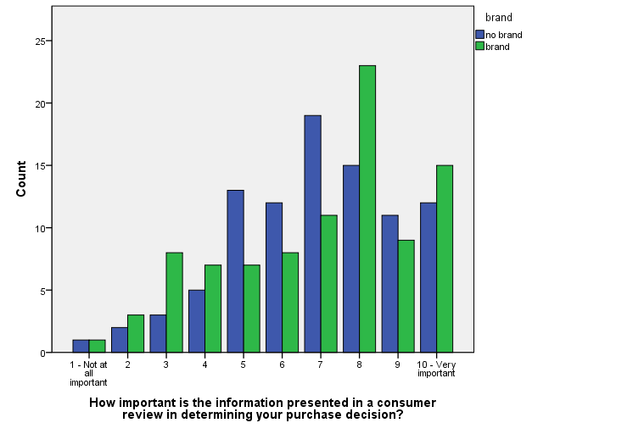
Figure 8*
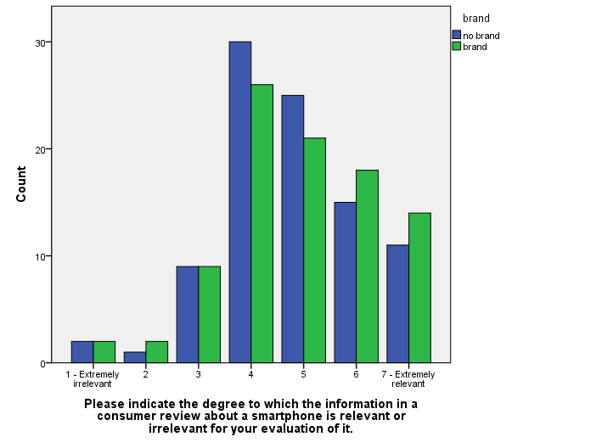
Figure 9*
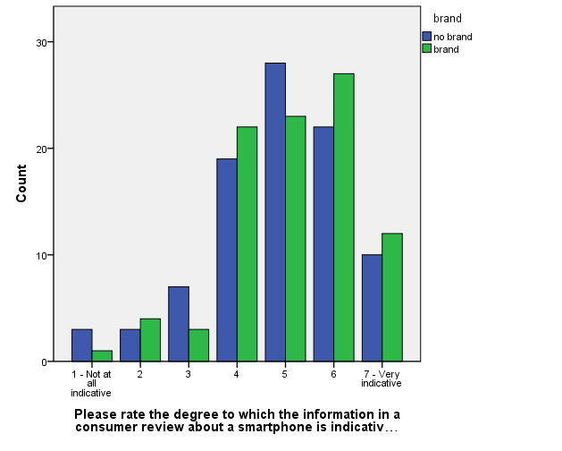
Figure 10*
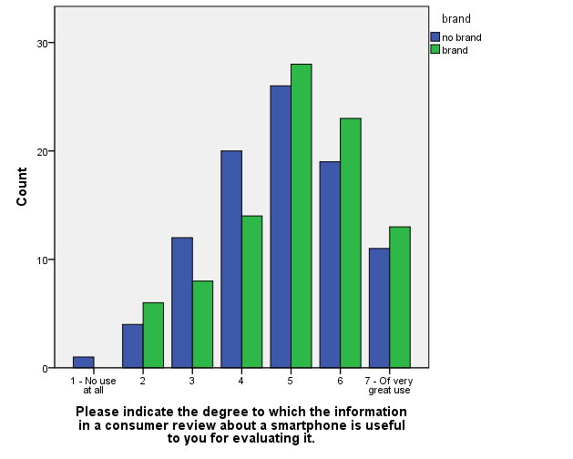
Figure 11*
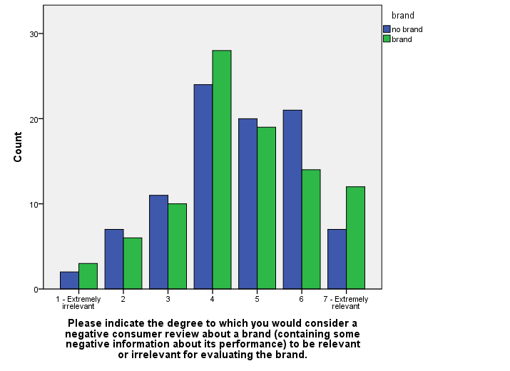
Figure 12
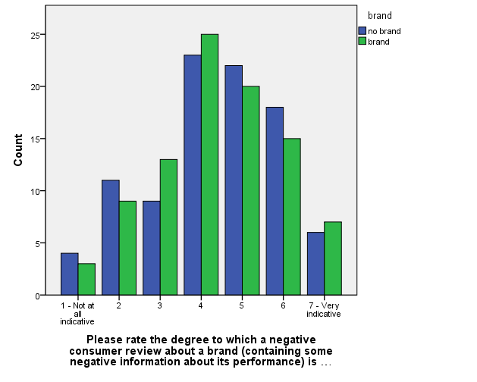
Figure 13
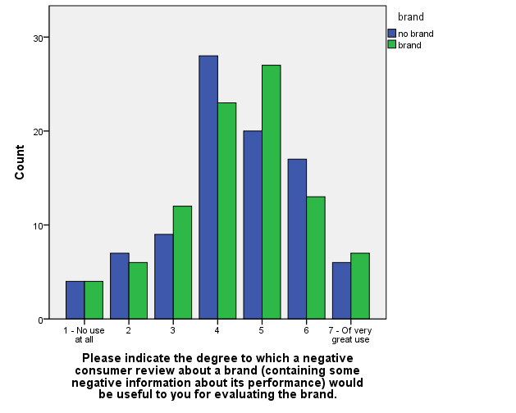
Figure 14
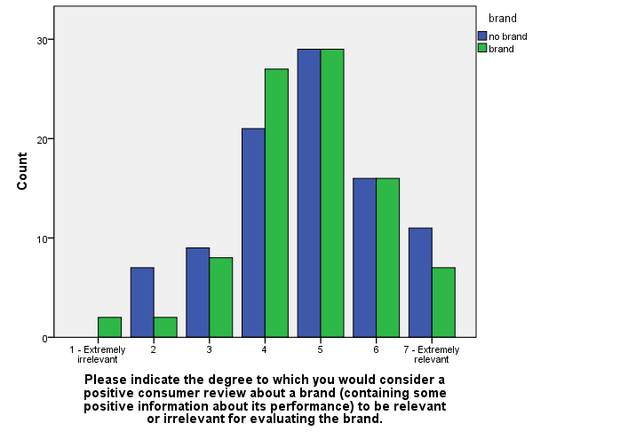
Figure 15
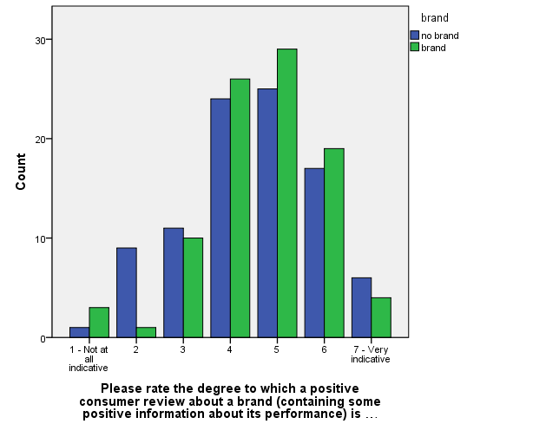
Figure 16
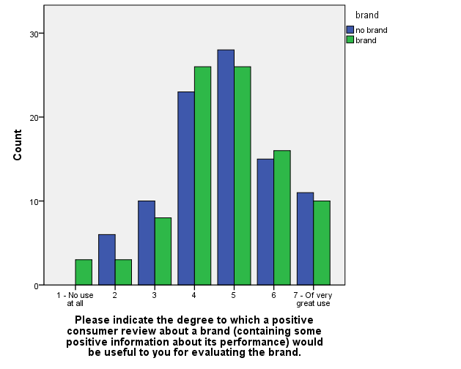
Figure 17

Appendix 2: Brand commitment measure and selected critical values for Hartley’s variance ratio

If HTC was not available at the store, it would make little difference to me if I had to choose another brand.
 | 1 | 2 | 3 | 4 | 5 | 6 | 7 | 8 | 9
Fully Disagree:Fully Agree

I consider myself to be highly loyal to HTC smartphones.
 | 1 | 2 | 3 | 4 | 5 | 6 | 7 | 8 | 9
Fully Disagree:Fully Agree

When another brand is on sale, I will generally purchase it rather than HTC.
 | 1 | 2 | 3 | 4 | 5 | 6 | 7 | 8 | 9
Fully Disagree:Fully Agree

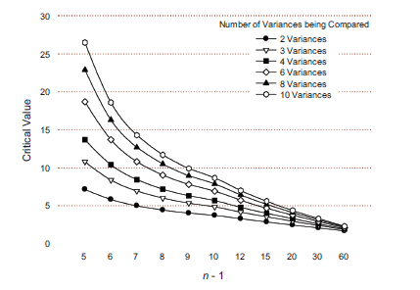
Figure 18 Selected critical values for Hartley’s variance ratio

Appendix 3: Experimental scenarios and questionnaire

Scenario 1 – No review/no brand

For the purpose of this research I will need you to read the given information and answer the questionnaire that follows. Imagine you are in a situation where you consider buying a smartphone and the following information is available to you. After reading it, please fill in the questionnaire. Please answer all the questions in the questionnaire. There are no right or wrong answers, so do not worry or puzzle over individual items.
Smartphone:
Product Features
- UltraPixel Camera - 4 MP, 2688 x 1520 pixels, autofocus, LED flash; 1080p Full HD video recording with HDR Video; microSIM
- 32GB/64GB Internal Memory, 2GB DDR2 RAM
- Super LCD3 capacitive touchscreen - 4.7 inch, Full HD 1080p, 468 PPI
- Audio sound enhancement
- OS v4.1.2, upgradable to v4.2.2
- 1.7 GHz Qualcomm Snapdragon 600 quad-core, Krait 300
- Battery Type: Lithium Ion, 2300 mAh
Dimensions
- Size (LWH): 13.7 cm, 0.9 cm, 6.8 cm
- Weight: 143 g (5.04 oz)
*Please read carefully all of the information presented above.

Scenario 2 – No review/brand

For the purpose of this research I will need you to read the given information and answer the questionnaire that follows. Imagine you are in a situation where you consider buying a smartphone and the following information is available to you. After reading it, please fill in the questionnaire. Please answer all the questions in the questionnaire. There are no right or wrong answers, so do not worry or puzzle over individual items.
HTC One M7 Silver:
Product Features
- HTC UltraPixel Camera - 4 MP, 2688 x 1520 pixels, autofocus, LED flash; 1080p Full HD video recording with HDR Video; microSIM
- 32GB/64GB Internal Memory, 2GB DDR2 RAM
- Super LCD3 capacitive touchscreen - 4.7 inch, Full HD 1080p, 468 PPI
- Beats Audio sound enhancement
- Android OS, v4.1.2 (Jelly Bean), upgradable to v4.2.2
- 1.7 GHz Qualcomm Snapdragon 600 quad-core, Krait 300
- Battery Type: Lithium Ion, 2300 mAh
Dimensions
- Size (LWH): 13.7 cm, 0.9 cm, 6.8 cm
- Weight: 143 g (5.04 oz)
*Please read carefully all of the information presented above.

Scenario 3 – Positive review/no brand

For the purpose of this research I will need you to read the given information and answer the questionnaire that follows. Imagine you are in a situation where you consider buying a smartphone and the following information is available to you. After reading it, please fill in the questionnaire. Please answer all the questions in the questionnaire. There are no right or wrong answers, so do not worry or puzzle over individual items.
Smartphone:
Product Features
- UltraPixel Camera - 4 MP, 2688 x 1520 pixels, autofocus, LED flash; 1080p Full HD video recording with HDR Video; microSIM
- 32GB/64GB Internal Memory, 2GB DDR2 RAM
- Super LCD3 capacitive touchscreen - 4.7 inch, Full HD 1080p, 468 PPI
- Audio sound enhancement
- OS v4.1.2, upgradable to v4.2.2
- 1.7 GHz Qualcomm Snapdragon 600 quad-core, Krait 300
- Battery Type: Lithium Ion, 2300 mAh
Dimensions
- Size (LWH): 13.7 cm, 0.9 cm, 6.8 cm
- Weight: 143 g (5.04 oz)
Customer review for the smartphone:
Simply the best, April 11, 2013
By
Tommy
As much as I liked the look of this smartphone, I was unnerved by some factors, although let me tell you: now that I have my hands on it, those fears were totally unfounded.
Firstly, battery life. It's fine, certainly no worse than any other phone I've used. As for the lack of a replacement battery, how often do you do that!? I actually had a spare battery for my previous phone, and I used it...once. So really, I just don't see this as an issue. It lasts through a day no problem (unless of course you are watching videos on it all day, but then what would you expect!)
Secondly, the camera. Now here I was a bit worried: 4MP!? But let me assure you that it is more than good enough for a camera on a phone. What's more, the low light camera is fantastic. And when I really think about it, I am usually taking pictures inside, in "low light" and this is perfect for that. In good lighting conditions I'd liken the camera quality to be slightly better than the camera on the latest tablets, so really quite good for a device you carry around in your pocket, and that does so much more than just take pictures.
Thirdly, the build quality. Is it really as good as the reviews make out? Answer: a resounding yes. When you hold if for the first time, it is a breathtaking moment (depending on how into phones you are!). Any one who has glanced at a smartphone with a pang of jealously as to the sleek, modern, sexy design, let me tell you, this is the phone for you. It feels brilliant in the hand, and feels truly luxury. And for those worrying about the extra weight over plastic? Let me tell you, it's just not an issue- it doesn't feel heavy, it feels well made. Very well made.
The content feed of this device is not my cup of tea, but it's certainly not annoying, and from time to time it is useful, and although maybe not being a brilliant thing for me (I don't really care what half my facebook "friends" are saying), it is certainly not a bad thing, and for the right, social media oriented person, this will surely be an excellent feature.
The rest of the phone is as advertised: The sound is amazing, the greatest benefit of this is the superior phone call quality, and in particular, the great speaker phone experience. It is finally not a trade off between call quality and convenience when I decide to use speaker phone. The screen is jaw droppingly beautiful, the colours are true to life and just look so much classier than my old phone.
All in all then, this phone is simply the best phone I have ever owned. It has it all. Yes, it would be nice if the camera was a tad better, but really, that is not a problem. I am truly relieved that I trusted my gut and opted for this phone over the other alternatives. If you get this, you will not be disappointed. You have to keep hold of a phone for a long time these days, and I for one will never get bored of seeing and holding this phone, as I very quickly did with my previous.
*Please read carefully all of the information presented above.

Scenario 4 – Positive review/brand

For the purpose of this research I will need you to read the given information and answer the questionnaire that follows. Imagine you are in a situation where you consider buying a smartphone and the following information is available to you. After reading it, please fill in the questionnaire. Please answer all the questions in the questionnaire. There are no right or wrong answers, so do not worry or puzzle over individual items.
HTC One M7 Silver:
Product Features
- HTC UltraPixel Camera - 4 MP, 2688 x 1520 pixels, autofocus, LED flash; 1080p Full HD video recording with HDR Video; microSIM
- 32GB/64GB Internal Memory, 2GB DDR2 RAM
- Super LCD3 capacitive touchscreen - 4.7 inch, Full HD 1080p, 468 PPI
- Beats Audio sound enhancement
- Android OS, v4.1.2 (Jelly Bean), upgradable to v4.2.2
- 1.7 GHz Qualcomm Snapdragon 600 quad-core, Krait 300
- Battery Type: Lithium Ion, 2300 mAh
Dimensions
- Size (LWH): 13.7 cm, 0.9 cm, 6.8 cm
- Weight: 143 g (5.04 oz)

Customer review for HTC One M7 Silver:
Simply the best, April 11, 2013
By
Tommy
As much as I liked the look of the HTC One, I was unnerved by some factors, although let me tell you: now that I have my hands on the HTC One, those fears were totally unfounded.
Firstly, battery life. It's fine, certainly no worse than any other phone I've used, namely my S3. As for the lack of a replacement battery, how often do you do that!? I actually had a spare battery for my S3, and I used it...once. So really, I just don't see this as an issue. It lasts through a day no problem (unless of course you are watching videos on it all day, but then what would you expect!)
Secondly, the camera. Now here I was a bit worried: 4MP!? But let me assure you that it is more than good enough for a camera on a phone. What's more, the low light camera is fantastic. And when I really think about it, I am usually taking pictures inside, in "low light" and this is perfect for that. In good lighting conditions I'd liken the camera quality to be slightly better than the camera on the latest iPad, so really quite good for a device you carry around in your pocket, and that does so much more than just take pictures.
Thirdly, the build quality. Is it really as good as the reviews make out? Answer: a resounding yes. When you hold if for the first time, it is a breathtaking moment (depending on how into phones you are!). Any one who has glanced at an iPhone 5 with a pang of jealously as to the sleek, modern, sexy design, let me tell you, this is the phone for you. It feels brilliant in the hand, and feels truly luxury. And for those worrying about the extra weight over plastic? Let me tell you, it's just not an issue- it doesn't feel heavy, it feels well made. Very well made.
Blinkfeed is not my cup of tea, but it's certainly not annoying, and from time to time it is useful, and although maybe not being a brilliant thing for me (I don't really care what half my facebook "friends" are saying), it is certainly not a bad thing, and for the right, social media oriented person, this will surely be an excellent feature.
The rest of the phone is as advertised: The sound is amazing, the greatest benefit of this is the superior phone call quality, and in particular, the great speaker phone experience. It is finally not a trade off between call quality and convenience when I decide to use speaker phone. The screen is jaw droppingly beautiful, the colours are true to life and just look so much classier than my Galaxy S3 ever did.
All in all then, this phone is simply the best phone I have ever owned. It has it all. Yes, it would be nice if the camera was a tad better, but really, that is not a problem. I am truly relieved that I trusted my gut and opted for this phone over the S4. If you get this, you will not be disappointed. You have to keep hold of a phone for a long time these days, and I for one will never get bored of seeing and holding this phone, as I very quickly did with my S3.
*Please read carefully all of the information presented above.

Scenario 5 – Negative review/no brand

For the purpose of this research I will need you to read the given information and answer the questionnaire that follows. Imagine you are in a situation where you consider buying a smartphone and the following information is available to you. After reading it, please fill in the questionnaire. Please answer all the questions in the questionnaire. There are no right or wrong answers, so do not worry or puzzle over individual items.
Smartphone:
Product Features
- UltraPixel Camera - 4 MP, 2688 x 1520 pixels, autofocus, LED flash; 1080p Full HD video recording with HDR Video; microSIM
- 32GB/64GB Internal Memory, 2GB DDR2 RAM
- Super LCD3 capacitive touchscreen - 4.7 inch, Full HD 1080p, 468 PPI
- Audio sound enhancement
- OS v4.1.2, upgradable to v4.2.2
- 1.7 GHz Qualcomm Snapdragon 600 quad-core, Krait 300
- Battery Type: Lithium Ion, 2300 mAh
Dimensions
- Size (LWH): 13.7 cm, 0.9 cm, 6.8 cm
- Weight: 143 g (5.04 oz)
Customer review for the smartphone:
Far below expectations, April 11, 2013
By
Tommy
As much as I liked the look of this smartphone, I was unnerved by some factors, and: now that I have my hands on it, those fears were totally justified.
Firstly, battery life. It's worse than any other phone I've used. As for the lack of a replacement battery, it could be problematic! I actually had a spare battery for my previous phone, and I used it a lot. So really, I see this as an issue. It hardly lasts a day (if you watch a videos on it all day, expect it to deplete in no time!)
Secondly, the camera. Now here I was worried: 4MP!? I can tell you that it is far from enough for a camera on a phone. What's more, the low light camera is awful. And when I really think about it, I am usually taking pictures inside, in "low light" and this makes it even worse. In good lighting conditions I'd liken the camera quality to be slightly worse than the camera on the latest tablets, so really quite bad for a device you carry around in your pocket, and that doesn’t do much more than just take pictures.
Thirdly, the build quality. Is it really as good as the reviews make out? Answer: a resounding no. When you hold it for the first time, you realize the sour truth (depending on how into phones you are!). Any one who has glanced at another smartphone with a pang of jealously as to the sleek, modern, sexy design, let me tell you, this is not the phone for you. It feels like nothing special in the hand, and made from cheap material. And for those worrying about the extra weight over plastic? Let me tell you, it could be an issue- it does feel heavy, it feels low-quality.
The content feed of this device is not my cup of tea, it's certainly annoying, and rarely useful, and although maybe not being a brilliant thing for me (I don't really care what half my facebook "friends" are saying), it is certainly a bad thing, even for the right, social media oriented person, this will surely be an unnecessary feature.
The rest of the phone is not even close to what is advertised: The sound is terrible, the greatest disadvantage of this is the poor phone call quality, and in particular, the poor speaker phone experience. It is a trade off between call quality and convenience when I decide to use speaker phone. The screen is quite the opposite of the beauty I expected, the colours don’t look true to life at all and just outclassed by my old phone.
All in all then, this phone is definitely not the best phone I have ever owned. It just doesn’t have it all. The quality of the camera is just one of the problems. I regret trusting my gut and opting for this phone over the other alternatives. If you get this, you will turn out to be disappointed just like me. You have to keep hold of a phone for a long time these days, and I quickly got bored of seeing and holding this phone, unlike I did with my previous.
*Please read carefully all of the information presented above.

Scenario 6 – Negative review/brand

For the purpose of this research I will need you to read the given information and answer the questionnaire that follows. Imagine you are in a situation where you consider buying a smartphone and the following information is available to you. After reading it, please fill in the questionnaire. Please answer all the questions in the questionnaire. There are no right or wrong answers, so do not worry or puzzle over individual items.
HTC One M7 Silver:
Product Features
- HTC UltraPixel Camera - 4 MP, 2688 x 1520 pixels, autofocus, LED flash; 1080p Full HD video recording with HDR Video; microSIM
- 32GB/64GB Internal Memory, 2GB DDR2 RAM
- Super LCD3 capacitive touchscreen - 4.7 inch, Full HD 1080p, 468 PPI
- Beats Audio sound enhancement
- Android OS, v4.1.2 (Jelly Bean), upgradable to v4.2.2
- 1.7 GHz Qualcomm Snapdragon 600 quad-core, Krait 300
- Battery Type: Lithium Ion, 2300 mAh
Dimensions
- Size (LWH): 13.7 cm, 0.9 cm, 6.8 cm
- Weight: 143 g (5.04 oz)
Customer review for HTC One M7 Silver:
Far below expectations, April 11, 2013
By
Tommy
As much as I liked the look of the HTC One, I was unnerved by some factors, and: now that I have my hands on the HTC One, those fears were totally justified.
Firstly, battery life. It's worse than any other phone I've used, namely my S3. As for the lack of a replacement battery, it could be problematic! I actually had a spare battery for my S3, and I used it a lot. So really, I see this as an issue. It hardly lasts a day (if you watch a videos on it all day, expect it to deplete in no time!)
Secondly, the camera. Now here I was worried: 4MP!? I can tell you that it is far from enough for a camera on a phone. What's more, the low light camera is awful. And when I really think about it, I am usually taking pictures inside, in "low light" and this makes it even worse. In good lighting conditions I'd liken the camera quality to be slightly worse than the camera on the latest iPad, so really quite bad for a device you carry around in your pocket, and that does not do much more than just take pictures.
Thirdly, the build quality. Is it really as good as the reviews make out? Answer: a resounding no. When you hold it for the first time, you realize the sour truth (depending on how into phones you are!). Any one who has glanced at an iPhone 5 with a pang of jealously as to the sleek, modern, sexy design, let me tell you, this is not the phone for you. It feels like nothing special in the hand, and made from cheap material. And for those worrying about the extra weight over plastic? Let me tell you, it could be an issue- it does feel heavy, it feels low-quality.
Blinkfeed is not my cup of tea, it's certainly annoying, and rarely useful, and although maybe not being a brilliant thing for me (I don't really care what half my facebook "friends" are saying), it is certainly a bad thing, even for the right, social media oriented person, this will surely be an unnecessary feature.
The rest of the phone is not even close to what is advertised: The sound is terrible, the greatest disadvantage of this is the poor phone call quality, and in particular, the poor speaker phone experience. It is a trade off between call quality and convenience when I decide to use speaker phone. The screen is quite the opposite of the beauty I expected, the colours don’t look true to life at all and just outclassed by Galaxy S3.
All in all then, this phone is definitely not the best phone I have ever owned. It just doesn’t have it all. The quality of the camera is just one of the problems. I regret trusting my gut and opting for this phone over the S4. If you get this, you will turn out to be disappointed just like me. You have to keep hold of a phone for a long time these days, and I quickly got bored of seeing and holding this phone, unlike I did with my S3.
*Please read carefully all of the information presented above.

Questionnaire – brand mentioned

*Please read carefully all of the information presented above.

What is the probability(%) that you buy this smartphone? (Enter a number from 0-100)

The following section contains statements about smartphones in general. Please read the statements carefully and indicate to what extent do you agree or disagree with them. Choosing 1 means you fully disagree, choosing 9 means you fully agree, choosing 5 means you neither agree nor disagree.

I can make many connections or associations between my use of a smartphone and experiences in my life.
 | 1 | 2 | 3 | 4 | 5 | 6 | 7 | 8 | 9
Fully Disagree:Fully Agree

The brand of smartphone I use says a lot about who I am.
 | 1 | 2 | 3 | 4 | 5 | 6 | 7 | 8 | 9
Fully Disagree:Fully Agree

My friends give me a hard time if I choose the wrong smartphone.
 | 1 | 2 | 3 | 4 | 5 | 6 | 7 | 8 | 9
Fully Disagree:Fully Agree

I am very concerned about what brand of smartphone I purchase.
 | 1 | 2 | 3 | 4 | 5 | 6 | 7 | 8 | 9
Fully Disagree:Fully Agree

I care a lot about what brand of smartphone I use.
 | 1 | 2 | 3 | 4 | 5 | 6 | 7 | 8 | 9
Fully Disagree:Fully Agree

Generally choosing the right brand of smartphone is important to me.
 | 1 | 2 | 3 | 4 | 5 | 6 | 7 | 8 | 9
Fully Disagree:Fully Agree

If HTC was not available at the store, it would make little difference to me if I had to choose another brand.
 | 1 | 2 | 3 | 4 | 5 | 6 | 7 | 8 | 9
Fully Disagree:Fully Agree

I consider myself to be highly loyal to HTC smartphones.
 | 1 | 2 | 3 | 4 | 5 | 6 | 7 | 8 | 9
Fully Disagree:Fully Agree

When another brand is on sale, I will generally purchase it rather than HTC.
 | 1 | 2 | 3 | 4 | 5 | 6 | 7 | 8 | 9
Fully Disagree:Fully Agree

Please answer the following questions. There are no right or wrong answers. Your opinion is what matters.

How much weight do you give to information presented in a consumer review in forming your purchase decision?
 | 1 | 2 | 3 | 4 | 5 | 6 | 7 | 8 | 9 | 10
No weight at all:A lot of weight

How important is the information presented in a consumer review in determining your purchase decision?
 | 1 | 2 | 3 | 4 | 5 | 6 | 7 | 8 | 9 | 10
Not at all important:Very important

Please indicate the degree to which the information in a consumer review about a smartphone is relevant or irrelevant for your evaluation of it.
 | 1 | 2 | 3 | 4 | 5 | 6 | 7
Extremely irrelevant:Extremely relevant

Please rate the degree to which the information in a consumer review about a smartphone is indicative of how good or bad it is.
 | 1 | 2 | 3 | 4 | 5 | 6 | 7
Not at all indicative:Very indicative

Please indicate the degree to which the information in a consumer review about a smartphone is useful to you for evaluating it.
 | 1 | 2 | 3 | 4 | 5 | 6 | 7
No use at all:Of very great use

Please indicate the degree to which you would consider a negative consumer review about a brand (containing some negative information about its performance) to be relevant or irrelevant for evaluating the brand.
 | 1 | 2 | 3 | 4 | 5 | 6 | 7
Extremely irrelevant:Extremely relevant

Please rate the degree to which a negative consumer review about a brand (containing some negative information about its performance) is indicative of how good or bad the brand is.
 | 1 | 2 | 3 | 4 | 5 | 6 | 7
Not at all indicative:Very indicative

Please indicate the degree to which a negative consumer review about a brand (containing some negative information about its performance) would be useful to you for evaluating the brand.
 | 1 | 2 | 3 | 4 | 5 | 6 | 7
No use at all:Of very great use

Please indicate the degree to which you would consider a positive consumer review about a brand (containing some positive information about its performance) to be relevant or irrelevant for evaluating the brand.
 | 1 | 2 | 3 | 4 | 5 | 6 | 7
Extremely irrelevant:Extremely relevant

Please rate the degree to which a positive consumer review about a brand (containing some positive information about its performance) is indicative of how good or bad the brand is.
 | 1 | 2 | 3 | 4 | 5 | 6 | 7
Not at all indicative:Very indicative

Please indicate the degree to which a positive consumer review about a brand (containing some positive information about its performance) would be useful to you for evaluating the brand.
 | 1 | 2 | 3 | 4 | 5 | 6 | 7
No use at all:Of very great use

What is your age?

What is your gender?
- Male
- Female

What is your level of education?
- PhD
- University / Master Degree
- University / Bachelor Degree
- College
- High School
- Elementary / Secondary School
- Other

How frequently do you buy tech products?
- More than once a week
- Once a week
- Every couple of weeks
- Every month
- Every couple of months
- Once in six months
- Once a year
- Almost never

How frequently do you read reviews online?
- More than once a week
- Once a week
- Every couple of weeks
- Every month
- Every couple of months
- Once in six months
- Once a year
- Almost never

Questionnaire – brand not mentioned

What is the probability(%) that you buy this smartphone? (Enter a number from 0-100)

The following section contains statements about smartphones in general. Please read the statements carefully and indicate to what extent do you agree or disagree with them. Choosing 1 means you fully disagree, choosing 9 means you fully agree, choosing 5 means you neither agree nor disagree.

I can make many connections or associations between my use of a smartphone and experiences in my life.
 | 1 | 2 | 3 | 4 | 5 | 6 | 7 | 8 | 9
Fully Disagree:Fully Agree

The brand of smartphone I use says a lot about who I am.
 | 1 | 2 | 3 | 4 | 5 | 6 | 7 | 8 | 9
Fully Disagree:Fully Agree

My friends give me a hard time if I choose the wrong smartphone.
 | 1 | 2 | 3 | 4 | 5 | 6 | 7 | 8 | 9
Fully Disagree:Fully Agree

I am very concerned about what brand of smartphone I purchase.
 | 1 | 2 | 3 | 4 | 5 | 6 | 7 | 8 | 9
Fully Disagree:Fully Agree

I care a lot about what brand of smartphone I use.
 | 1 | 2 | 3 | 4 | 5 | 6 | 7 | 8 | 9
Fully Disagree:Fully Agree

Generally choosing the right brand of smartphone is important to me.
 | 1 | 2 | 3 | 4 | 5 | 6 | 7 | 8 | 9
Fully Disagree:Fully Agree

If my preferred brand of smartphone was not available at the store, it would make little difference to me if I had to choose another brand.
 | 1 | 2 | 3 | 4 | 5 | 6 | 7 | 8 | 9
Fully Disagree:Fully Agree

I consider myself to be highly loyal to one brand of smartphones.
 | 1 | 2 | 3 | 4 | 5 | 6 | 7 | 8 | 9
Fully Disagree:Fully Agree

When another brand is on sale, I will generally purchase it rather than my usual brand.
 | 1 | 2 | 3 | 4 | 5 | 6 | 7 | 8 | 9
Fully Disagree:Fully Agree

Please answer the following questions. There are no right or wrong answers. Your opinion is what matters.

How much weight do you give to information presented in a consumer review in forming your purchase decision?
 | 1 | 2 | 3 | 4 | 5 | 6 | 7 | 8 | 9 | 10
No weight at all:A lot of weight

How important is the information presented in a consumer review in determining your purchase decision?
 | 1 | 2 | 3 | 4 | 5 | 6 | 7 | 8 | 9 | 10
Not at all important:Very important

Please indicate the degree to which the information in a consumer review about a smartphone is relevant or irrelevant for your evaluation of it.
 | 1 | 2 | 3 | 4 | 5 | 6 | 7
Extremely irrelevant:Extremely relevant

Please rate the degree to which the information in a consumer review about a smartphone is indicative of how good or bad it is.
 | 1 | 2 | 3 | 4 | 5 | 6 | 7
Not at all indicative:Very indicative

Please indicate the degree to which the information in a consumer review about a smartphone is useful to you for evaluating it.
 | 1 | 2 | 3 | 4 | 5 | 6 | 7
No use at all:Of very great use

Please indicate the degree to which you would consider a negative consumer review about a brand (containing some negative information about its performance) to be relevant or irrelevant for evaluating the brand.
 | 1 | 2 | 3 | 4 | 5 | 6 | 7
Extremely irrlelevant:Extremely relevant

Please rate the degree to which a negative consumer review about a brand (containing some negative information about its performance) is indicative of how good or bad the brand is.
 | 1 | 2 | 3 | 4 | 5 | 6 | 7
Not at all indicative:Very indicative

Please indicate the degree to which a negative consumer review about a brand (containing some negative information about its performance) would be useful to you for evaluating the brand.
 | 1 | 2 | 3 | 4 | 5 | 6 | 7
No use at all:Of very great use

Please indicate the degree to which you would consider a positive consumer review about a brand (containing some positive information about its performance) to be relevant or irrelevant for evaluating the brand.
 | 1 | 2 | 3 | 4 | 5 | 6 | 7
Extremely irrelevant:Extremely relevant

Please rate the degree to which a positive consumer review about a brand (containing some positive information about its performance) is indicative of how good or bad the brand is.
 | 1 | 2 | 3 | 4 | 5 | 6 | 7
Not at all indicative:Very indicative

Please indicate the degree to which a positive consumer review about a brand (containing some positive information about its performance) would be useful to you for evaluating the brand.
 | 1 | 2 | 3 | 4 | 5 | 6 | 7
No use at all:Of very great use

What is your age?

What is your gender?
- Male
- Female

What is your level of education?
- PhD
- University / Master Degree
- University / Bachelor Degree
- College
- High School
- Elementary / Secondary School
- Other

How frequently do you buy tech products?
- More than once a week
- Once a week
- Every couple of weeks
- Every month
- Every couple of months
- Once in six months
- Once a year
- Almost never

How frequently do you read reviews online?
- More than once a week
- Once a week
- Every couple of weeks
- Every month
- Every couple of months
- Once in six months
- Once a year
- Almost never

