Master Thesis, MSc Marketing
Erasmus University Rotterdam
Erasmus School of Economics
August, 2014
Author: Arjan Fiechter
Supervisor: Iris Versluis
Student number: 401009
E-mail: arjanfiechter@gmail.com
Tel: +31 (0) 6 55 59 70 57
BREAKING WITH COLOR CONVENTIONS AND ITS INFLUENCE ON CONSUMER BEHAVIOR
A study to the effect of changed product packaging on consumer buying intentions in the chocolate and chips category

Preface
This master thesis is the result of half a year of research at the School of Economics of the Erasmus University Rotterdam. The writing of this paper has gone through ups and downs, but the final result is presented in front of you. This thesis is the end of my university career which began in 2008 with a bachelor in Business Administration in Groningen and ends here in 2014 with a master in Marketing in Rotterdam.
My time as a student in Groningen, Seoul and Rotterdam was a wonderful experience in my life. My bachelor program in Groningen gave me the opportunity to gain a deeper understanding of a wide variety of specializations in business. After studying half a year in Seoul and following several specialization courses in marketing I knew that a further specialization in marketing would fit me the best. Therefore, in 2013 the choice for the Erasmus University Rotterdam was made to start with a master in marketing. It turned out to be the best choice I could have made. The materials, professors and fellow students made my time here in Rotterdam absolutely fantastic.
I would like to thank everyone who made my life as a student in Groningen, Seoul and Rotterdam so great. In particular I would like to thank my parents for always supporting and encouraging me throughout my entire study. For her help during this thesis, I would like to thank my supervisor, Iris Versluis, who gave me helpful feedback and insights during the process of writing this paper.

Table of Contents
Preface 1
Executive summary 4
1. Introduction 5
2. Theory 10
2.1 The importance of packaging in the communication of a product 10
2.2 Different functions of packaging 11
2.2.1 Logistics 12
2.2.2 Marketing 12
2.3 Consumer-decision making & involvement level 12
2.4 Different elements of packaging 15
2.4.1 Graphics and coloring 15
2.4.2 Packaging size and shape 16
2.4.3 Product information 16
2.4.4 The relative importance per element 16
2.4.5 The functions and elements of packaging summarized 17
2.5 The role of coloring in packaging 18
2.5.1 The history of color associations 18
2.5.2 Associative learning in the context of package coloring 18
2.5.3 Color conventions 19
2.5.4 The influence of involvement level on color associations 21
2.6 Breaking with color conventions 21
2.6.1 Consumer attitudes 23
2.6.2 The influence of involvement level on attention and attitudes 23
2.6.2 The influence of the strength of a color association on consumers 24
2.6.3 The influence of attention and attitudes on buying intention 25
2.7 Conceptual model 26
3. Method 28
3.1 Research methodology and design 28
3.2 Instrumentation 29
3.2.1 First part of the experiment 29
3.2.2 Second part of the questionnaire 31
3.2.1 Statistical tests per hypothesis 33
3.3 Selection of participants 34
4. Results 36
4.1 Participant in this study 36
4.2 Involvement & strength of color associations 37
4.2.1 Chips category 37
4.2.2 Chocolate category 38
4.2.3 Chips versus chocolate category 38
4.3 The effect of breaking with color conventions on attention 39
4.3.1 Chips category 40
4.3.2 Chocolate category 41
4.4 The effect of breaking with color conventions on attitudes 42
4.4.1 Chips category 43
4.4.2 Chocolate category 44
4.5 The effect of attention and attitudes on buying intention 45
4.5.1 Chips category 46
4.5.2 Chocolate category 48
4.6 Differences in responses between groups on buying intention I and II 49
4.7 Summary of the results 51
5. General discussion 52
5.1 Research questions 52
5.1.1 Involvement and color associations 54
5.1.2 Attention & attitudes 55
5.1.3 The influence of attitudes and attention on buying intention 56
5.2 Implications and limitations 56
5.3 Areas for future research 58
Reference List 59
Appendix I (questionnaire, scenario 1) 62
Appendix II (factors of involvement level and strength of color associations to chips) 66
Appendix III (factors of involvement level and strength of color associations to chocolate) 67
Appendix IV (attention) 68
Appendix V (Attitudes) 69
Appendix VI (buying intention) 70
Appendix VII (Anova analysis, differences between means) 71

Executive summary
This paper provides insights in the role of coloring in product packaging and its influence on consumer behavior. Because competition is increasing and consumers often tend to make purchase decisions in-store, the communication of a product via packaging becomes extremely important to attract consumers in trying to convince them of buying a product.
Product packaging include elements like size, shape, graphics and coloring. Several studies discussed the effect of packaging on consumer behavior, but a lack of literature exists of specific research on separate elements. Package coloring may help in reaching consumers and has the possibility to create brand associations among consumers. In some product categories there are color conventions which are colors that are used by multiple brands to distinguish a particular product or flavor. For example the color blue in chips is in The Netherlands often associated to paprika chips and the color red in chocolate is mostly associated to pure chocolate.
This study investigates the strength of color conventions in the chocolate and chips category in The Netherlands and test the possibility to break with these conventions to try to generate more attention and hence higher purchases. An experiment was conducted under 108 respondents with questions and images related to colors for the chips and chocolate category. The questionnaire consisted of three scenarios for which differences in responses were measured between a control group (confronted with normal coloring) and two other groups (confronted with packaging which break with color conventions).
Results show that attention increases when product packaging ‘breaks’ with color conventions in the chips and chocolate category. Consumer attitudes are negatively influenced by the use of different coloring. Both variables have an effect on consumer buying intentions in the chips category. The influence of involvement and strength of color associations on attention and attitudes could not be proven in this study. This paper provides evidence that breaking with color conventions could be an opportunity for brands to generate more attention towards their products. If brands can minimize the negative effect of breaking with color conventions on consumer attitudes it could be an opportunity to increase buying intentions, hence higher purchases.

1. Introduction
Did you ever wonder why different brands use the same coloring for the packaging of their products? For example, why is naturel chips in The Netherlands most often packed in red-colored packages and why does almost every brand in this category copies this behavior? Most likely you are one of many who never thought about it. This paper tries to give answers on these questions and provides ideas how brands can use coloring for their packaging as a cue to reach more consumers and convince them of buying a product.
Looking at different product categories in Dutch supermarkets, there are certain colors which are used more often in comparison to others. For example in the chocolate category, pure chocolate is most often packed in red packaging, while milk chocolate is most often packed in blue packaging. In the soft-drink category, a lot of brands copy Coca Cola in the use of the color red to distinguish it as cola. In the water category, non-sparkling water is most often packed in blue-colored bottles and sparkling water is packed in red-colored bottles. And last but not least, in the chips category distinctive coloring per flavor is used to differentiate all the different flavors. These are just a few of many examples which can be given about package coloring per product category. The interesting phenomenon in these examples is that multiple brands who are active in the same product categories, copy each other’s behavior in their product color choice.
A few reasonable explanations can be given for this phenomenon. One of the reasons for the use of the same colors in a product category can be the simplicity it offers to consumers. For example, if consumers are standing in front of a shelf with the intention to buy naturel chips, they unconsciously or consciously know that naturel chips will most likely be packed in a red-colored package. The only thing they have to consider is which naturel chips from which brand to take without taking much effort to process different colors from different brands. Another explanation, which contributes to the previous one, is that consumers already formulated color associations for certain products (Grossman & Wisenblit, 1999). They prefer certain colors for certain product categories and are used to this. So for brands, it makes sense to match the colors of their competitors in a product category to make sure consumers take their product into account when consumer make a purchasing decision in a certain product category.
The explanations for product color choices go into the direction of matching the packaging colors of competitors, instead of creating a product with different coloring. According to Grossman & Wisenblit (1999) a product color choice can create a potentially strong association, especially when it is unique to a particular brand. Brands can use coloring as a point of differentiation in comparison to competitors. Looking at it from this view, it makes sense for companies to analyze the possibilities to create their own color associations for their products instead of matching the coloring of competitors.
To analyze the possibilities for brands to create their own color associations, the first thing to take into account is the involvement level of consumers for different products or product categories. Several studies did research on the effect of involvement in consumer-decision making (Holmes & Buchanan, 1984. Zaichkowsky, 1986). Evidence suggest that attitudes are different in high-involvement versus low-involvement decision making. For example, when a consumer thinks a product category is important to him or her, consumers will prefer a specific brand and spend relatively more time in evaluating alternatives (Zaichkowsky, 1986). This is conversely to product categories which consumers see as relatively unimportant. In the absence of more important criteria, simple factors may influence a decision in consumer-decision making (Kardes, 1988). To put it in other words, consumers base their attitudes on very little information if their involvement is low. Therefore color, which may be seen as a relatively unimportant element of packaging, can play a major role in especially low-involvement decision making.
In the field of marketing literature, not much is written about the effects of package coloring on consumers. There are studies which give examples why brands choose to match coloring of competitors however, not much is written about the creation of own unique coloring for products or brands. It is interesting to study this phenomenon because it gives brands the possibility to differentiate themselves from competitors and create their own unique associations under consumers. For example, what would happen if a product ‘ breaks’ with color conventions in a certain category and come up with their own coloring? It may be interesting for brands to know if it is useful to create products which use their own unique coloring. Next to that, it seems useful to know what the potential influence is on consumer attitudes and attention towards a product. Therefore this paper investigates the impact of breaking with color conventions on consumer buying intent in the chips and chocolate category. The main question of this paper is:
- What happens to consumer buying intention when product packaging ‘breaks’ with color conventions in the chocolate and chips category?

‘Breaking’ with color conventions in this study means the use of different coloring in comparison to most of the competitors. Color conventions can be seen as the colors which are mostly used by different brands for the same product flavors. For this study, the chips and chocolate category are chosen, because in these categories most brands use the same package coloring per flavor. Therefore, it is possible consumers have created associations between flavors and colors in these categories. For example, paprika chips is most often packed in blue packaging, while cheese & onion is packed in yellow packaging. In the chocolate category, pure chocolate is often packed in red packaging, while milk chocolate is packed in blue packaging. If brands choose to create their own coloring for packaging and break with color conventions, it is interesting to study what is does with consumer buying intentions. Do they feel that a package communicates a conflicting message in comparison to the color used and does it influence their buying behavior?
Several sub questions have been made to provide enough evidence to answer the main question what influences the buying intentions of consumers. First of all, it is necessary to take the involvement level and the strength of color associations in the two product categories into account. This can provide a strong basis to support the main question of this thesis. Involvement level influences the information search of consumers. According to previous studies, when the involvement level increases, an element like coloring becomes less important. So the assessment of involvement level for both categories can give answers if this is also the case for the chocolate and chips category. Next to that, the strength of current color associations will be analyzed for both categories. The main idea is that consumers will have color associations for certain product flavors in both categories, but it may be the case, consumers do not have any associations between package coloring and flavors. If this would be the case there is no possibility to ‘break’ with color conventions, because consumers do not have existing associations. There is no existing literature about involvement level and the strength of the color associations in the two categories. Therefore, the following three sub questions will be answered in this paper.
- How involved are consumers in the chips and chocolate category?

- How strong are existing color associations in the chips and chocolate category?

- What is the effect of involvement and color associations on the actual breaking with color conventions?
Next to involvement level and the strength of color associations, there are other factors to consider when analyzing the possible change in buying intent towards a package which breaks with color conventions. If a product breaks with coloring, it could impact beliefs and attitudes about that product. For example, what does happen with the perception of taste if a naturel chips is packed in a purple package? To provide answers if there will be a change in attitudes, the following sub question is made.
- What is the impact of breaking with color conventions on consumer attitudes towards a product?
The ultimate goal of breaking with color conventions is to analyze if it affects consumers in a way that it will increase attention towards a product and thereby leads to increased sales for a product. Because higher sales is also dependent on consumer attitudes towards the product, the following questions were made and will be answered in this paper:
- Can breaking with color conventions lead to more attention towards a product?

- Does the effect of breaking with color conventions on consumer attitudes and attention leads to higher purchases?
Where other studies studied the consumer-decision making process, high versus low-involvement and the different elements of packaging, this study delineate itself by focusing solely on the influence of package coloring on consumer behavior. Because of this, specific conclusions can be drawn about the impact of package coloring on consumer buying intent towards a product. This paper hopes to provide conclusions if it would be useful for brands to break with color conventions in a product category to increase their sales. Several studies point out that package coloring is a way for brands to differentiate themselves from competitors and create unique associations under consumers. No study go as deep into product categories to discover the real strength of involvement and color associations on consumer attitudes and attention towards a product.
In the theory part, prior studies on involvement level, product packaging and the role of coloring in marketing will be discussed. Also the consumer decision-making process will be discussed in the context of high versus low involvement products to explain differences in the importance of communication elements of packaging. Next to that, other elements like product size and product information will be discussed in the theory part to give a better idea how important the role of package coloring in the total communication of a product can be. Based on previous studies on product coloring and general assumptions, hypotheses will be presented which will be analyzed in the fourth chapter.
In the actual analysis, the focus is solely on package coloring. The reason for this is that the majority of current literature has focused on all elements of packaging instead of only one element. Next to that, it would make it more complex to draw conclusions on the role of package coloring in communication if more elements are included in the analysis. Because of the focus on package coloring, this paper adds more detailed information if and how package coloring can influence consumer behavior.

2. Theory
This chapter provides a relevant literature overview to provide a strong basis for the further research. In the first part, the importance of packaging in communication and the different functions of packaging will be discussed. After this, the consumer decision making process and the differences between high- and low involvement products will be reviewed. The theory part ends with an overview of literature which is written about the role of coloring in marketing. Based on the theory, the hypotheses and conceptual model will be presented at the end of this chapter

2.1 The importance of packaging in the communication of a product
The increase of market segmentation and the shift from relatively small to larger supermarkets has led to an increase of products in supermarkets (Rettie & Brewer, 2000). Consumers can choose between many alternatives in almost every product category. Because of the increased competition, it becomes difficult to reach consumers with products in-store. One way of trying to reach consumers in-store is via communication on product packaging (Herrington & Capella, 1995). A large portion of purchase decisions are made at the point of sale (Gray & Guthrie, 1990). This means, consumers will make a decision what to buy at the moment they are standing in front of a shelf. Therefore, packaging becomes one of the biggest mediums of the communication of the product (Rettie & Brewer, 2000).
First of all, with product packaging nearly all consumers are reached in a certain product category. Consumers who want to buy a product from a certain product category will go to a store where, most probably, products are stored per category. Via this way, every product in a category gets the chance to be noticed by consumers. Therefore, the packaging gives a possibility for brands to communicate their message and thereby reach nearly all consumers in that specific product category.
Next to its reach, packaging is present at the crucial moment when the buying decision is made. If consumers are standing in front of a shelf with products from a certain category, they will base their decision mainly on the things they are confronted with at that particular moment. At that time, communication of a brand or product via commercials or other mediums is not possible anymore. Packaging is then one of the only ways of attracting consumers to convince them of buying a product.
A third reason why packaging is an important element of communication is that it is visible for high-involved and low-involved consumers (Rettie & Brewer, 2000). High-involved consumers will scan products differently in comparison to low-involved consumers, but for both type of consumers, packaging has the capability to reach consumers. In a later stage of this research more information will be given about the different levels of involvement and its influence on consumers.

2.2 Different functions of packaging
Different authors point out different functions of packaging for consumer goods. According to Robertson (1990), six primary functions of packaging exists. The functions identified are: Containment and protection, apportionment and unitization, convenience and communication (see table 1 with descriptions per function).
Function | Description
Containment and Protection | Control the content inside the package from interaction with the outside environment
Apportionment and Utilization | Distribution of products into manageable units for all stages in the supply chain.
Convenience and Communication | Easiness of opening, handling and disposing the product and the addition of branding and other informational features to the package
Table 1: The six primary functions of packaging (Robertson, 1990)
The above packaging functions can be directly linked to a firm’s competitive edges (Lockamy, 1995). This means for example, if a company creates a package in which a product can be contained longer relatively to their competitors it has the possibility to create a competitive advantage. The same can be said about the other functions of packaging. The six functions can be placed into two broader categories, which are either logistics- or marketing related functions (Prendergast, 1996). Containment, protection, apportionment and utilization belong to the logistics functions of packaging, while convenience and communication can be seen as the marketing functions of packaging.

2.2.1 Logistics
The protection of the actual product can be seen as one of the important logistics-related functions. A definition is given by Dyllick (1989): ‘Packaging protects the product in movements, it can reduce the risk of losing, spoil aging or damaging the product’. Protection of the actual product can create competitive advantages if companies can outperform competitors in creating effective protective packaging. Next to protection, packaging of products is also relevant in terms of the use of information technology and automation in warehousing (Prendergast, 1996). For example, using the same size packages for different products might contribute to warehouse productivity and may be important factors for efficient storage (Livingstone, 1994).

2.2.2 Marketing
The second major function of packaging is the marketing function. Packaging provides a method for companies to communicate different elements of a product. Consumers can instantly recognize products through the use of labeling and distinctive branding (Lockamy, 1995). For companies it is important to use efficient communication for their products. According to Gray & Guthrie (1990) packaging is the most important aspect to attract consumers in buying decisions made at the point of sale. In other words, if consumers do not know yet which product they want to buy before they go into a store, the communication of the product via packaging is the most important decision criteria in-store. A research in The United States in 1987 (Cook) concluded that impulse buying, amounts to 80 percent of all retail purchases. This means that the majority of decisions by consumers are made at the point of sale. Therefore, effective communication via packaging becomes extremely important in terms of differentiation and sales opportunities for companies. In this research the emphasis is on the communication function of packaging. The different elements of packaging and their relative importance will be discussed to assess their weights in purchase decisions made by consumers.

2.3 Consumer-decision making & involvement level
To assess the importance of the different elements of packaging which may affect consumer decision-making, it is useful to firstly review the way consumers make decisions. According to Sproles and Kendall (1986), consumer decision-making can be defined as a ‘mental orientation characterizing a consumer’s approach to making choices’. This mental orientation differs per individual and situation. One way of analyzing this mental orientation is by looking at the involvement level of consumers when they make purchase decisions.
The level of involvement influences the way consumers actively or passively scan products for information (Mitchell, 1981. Costeley, 1988). For high involvement products, in comparison to low involvement products, more information will be searched, processed and saved by consumers. Bauer et al. (2006) combined different levels of product involvement with mental characteristics to come up with a theoretical framework. According to Bauer et al., depending on the involvement level, consumers will behave differently in their orientation of making choices. With the highest cognitive effort (high involvement level) a product alternative is carefully studied and selected, while in decision-making with the lowest cognitive effort consumers will react more impulsively. Typically, the behavior of consumers with the lowest cognitive effort is exhibited in situations of purchasing low-priced, low-involvement products for temporally use and the decision to buy a product will be made at the point of sale.
Another research by Zaichkowsky (1985) on involvement level tried to develop a scale to capture the concept of involvement for products or product categories. As a definition, they state involvement can be described as ‘a person’s perceived relevance of the object based on inherent needs, values, and interests’. Based on other studies by several authors (e.g. Belk, 1981; Bowen and Chaffee, 1974) they came up with conditions for which products or product categories can be described as low involvement products. These conditions are:
- A relative lack of active information seeking about brands
- Little comparison among product attributes
- Perception of similarity among different brands
- No special preference for a particular brand
The above four conditions can be seen as low involvement conditions. Logically, the conditions which can be seen as high involvement criteria are the opposite of the low involvement conditions:
- A relative active attitude towards information seeking about brands
- Many comparison among product attributes
- Perception of differences among different brands
- Preferences for a particular brand
The statements above were tested for three products if these statements actually can be seen as determinants to measure the level of involvement. The three products for investigation were instant coffee, laundry detergent and color television. These three different products were chosen to represent different kind of products with different kind of involvement levels. Each of the propositions above where then tested for each of the products to see if the statements correspond with their expectations on high- versus low involvement. Results on each of the conditions formed prior to the analysis turned out to correspond with the hypotheses. High scorers on involvement tend to seek more information, more carefully evaluate available alternatives, perceive greater differences among brands and more often have a preference in a product category. The significance of the results show that the four conditions can be seen as an acceptable measure to study involvement level per category or product. This study however, also stresses out that the level of involvement varies greatly over individuals. Therefore, it is hard to assess beforehand if categories can be seen as high involvement or low involvement categories. Even if the above mentioned conditions are tested and state a certain category can been as a high- or low-involvement category, it can vary greatly over individuals.
What can be said about low- and high involvement categories is that the behavior of consumers with the lowest cognitive effort (Low involvement level) mostly corresponds with low-priced products for temporally use (Bauer et al., 2006). For this study, more research will be done on products in the chips and chocolate category. Chips and chocolate are both products which are relatively low-priced items and are both for temporally use. Specific academic research about the two categories cannot be found, however based on Bauer et al. (2006) we may assume at this stage that the products in these categories are low-involvement purchases for most consumers. Because it is not possible to draw final conclusions on this, in the actual analysis, the four conditions for involvement level will be taken into account to assess the level of involvement for each individual consumer for the two different categories.

2.4 Different elements of packaging
Like stated before, in this research the focus is on the marketing function of packaging. Several studies examined which packaging elements can influence consumers in their decision-making. Ampuero and Villa (2006) identified four key elements which can influence consumer perceptions which are in random order: color, typography, graphical forms and images. A distinction is made between two blocks of components which are graphical and structural components. Color and typography belong to the graphical component, while forms and shape belong to the structural component. Another research on elements of packaging (Silayoi and Speece, 2007) makes a distinction between visual and informational elements. As visual elements they identify the same elements (graphics, color, packaging size and shape) as Ampuero, while product information and packaging technology are added as informational elements. Especially when buying decisions are made where involvement is higher, consumers will require more information (Kupiec and Revell, 2001). Based on the above mentioned articles, for this research ‘graphics and coloring’, ‘packaging size and shape’ and ‘product information’ are taken into account as elements of packaging. Each of the elements will be discussed below.

2.4.1 Graphics and coloring
The graphics of packaging include multiple communication elements like image layout, color combinations and typography. Differences in marketing communication between companies, including coloring and image building, have a strong impact on consumer decision-making (Kupiec and Revell, 2001). Consumers can be targeted using distinctive coloring and graphics. Consumers respond in different ways to packages depending on their involvement (Mitchel, 1981; Costeley, 1988). Following the literature about high- and low-involvement decisions, graphics and coloring are especially important in low-involvement decision making (Grossman and Wisenblit, 1999). With low involvement, little cognitive effort is needed to process differences in visual elements between products in comparison to product information.
A study by Herrington and Capella (1995) on the effects of time pressure on consumer supermarket shopping behavior concluded that time-pressured shoppers spend less time in making purchase decisions and spend more money in the time available to them. So when consumers are scanning packages in-store, the graphical elements on a package can make the difference between identifying and missing a product. Another study (Silayoi and Speece, 2007) concluded that package coloring can raise a potentially strong association, especially when it is unique to a product or brand.

2.4.2 Packaging size and shape
Size and shape are two other important elements of packaging. Consumers make volume judgments about products based on the size and shape of a product. For example, they perceive more elongated packages to be larger even when the actual volume inside is similar to smaller packages (Raghubir and Krishna, 1999). Involvement level affects consumer perceptions about packaging sizes as well. In low involvement decisions for example, low pricing in larger packaging is seen as a good opportunity to get excellent value for money (Prendergast and Marr, 1997).

2.4.3 Product information
In contrast to the above mentioned packaging elements, product information becomes important when buying decisions are made when the involvement is high (Kupiec and Revell, 2001). More involved consumers will use packaging information to form an opinion about a product and base their decision to buy it on this information (Vakratsas and Ambler, 1999). If commitment is lower, consumers will most likely pay less attention to information on packaging and are more triggered by visual elements. A research in Norway (Wandel, 1997) studied the different elements of product information and their importance to consumers. According to this study, consumers are mostly interested in information about nutritional aspects. Consumers who require more information about a product are not necessarily more satisfied about a product. Product information on packaging can be too complex for which consumers are not satisfied in their needs for information.

2.4.4 The relative importance per element
It is hard to assess the relative values of each of the above mentioned packaging elements. Values depend on product category, involvement level and the perceptions and motivations of consumers to search for a certain product. A study by Silayoi and Speece (2005) tried to rank each of the different packaging elements. They made a distinction between convenience-orientated, image-seeking and information-seeking consumers. Results show convenience-orientated and information-seeking consumers were mostly interested in packaging technology, while image-seeking consumers where more interested in graphics, color and shapes of the products. These results corresponds with other studies which were discussed. In categories where involvement in decision-making is high, consumers will request more information and product information becomes an important element (convenience-orientated and information-seeking consumers). When looking at low involvement decisions, consumers will often take buying decisions in-store. This means consumers are more likely to respond to graphics and coloring, because low cognitive effort is needed to process this information in comparison to product information.

2.4.5 The functions and elements of packaging summarized
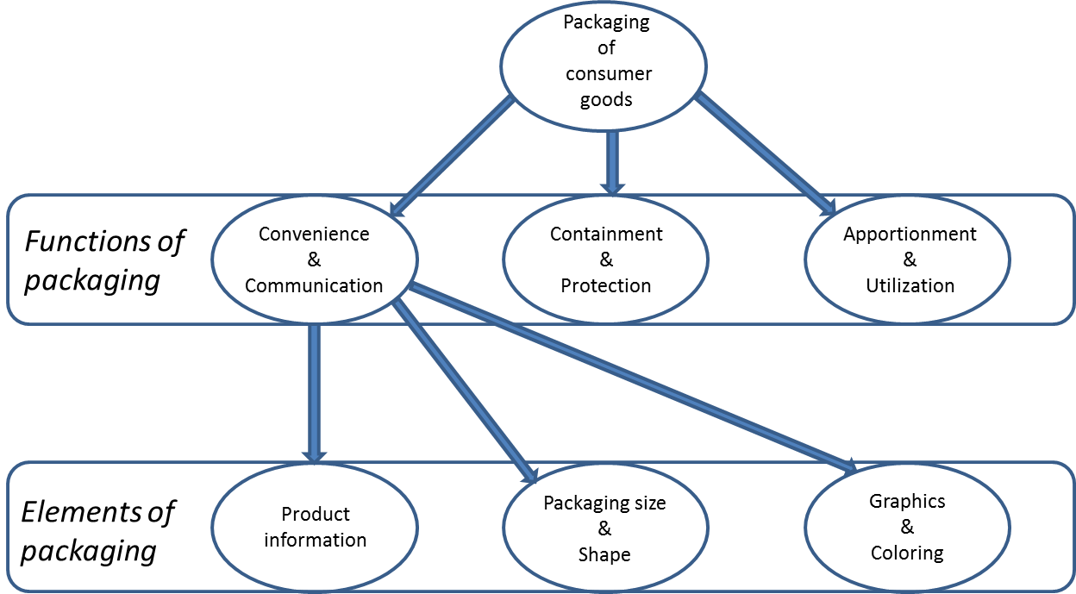
In the above sections, the functions and elements of packaging and the decision making of consumers were discussed. Following the theory, the figure below summarizes all functions and marketing elements which were discussed in the previous sections.
Figure 1: The different functions and elements of packaging
Following the literature on functions of packaging (Robertson, 1990), ‘Convenience & communication’ is the marketing function of packaging while ‘containment & protection’ and ‘apportionment & utilization’ represent the logistics functions of packaging. In this thesis the emphasis lies on the marketing function of packaging for which the different elements of packaging are shown in the above figure. ‘Packaging size & shape’ and ‘Graphics & Coloring’ can be seen as visual elements, while ‘Product information’ can be seen as the informational element of packaging (Ampuero & Villa, 2006. Silayoi and Speece, 2007).

2.5 The role of coloring in packaging
In this paragraph, an overview of literature about product coloring and their influence on consumers is reviewed. Package coloring can help consumers to distinguish a product or brand between other products in a category and is therefore an important element to consider in the consumer decision-making process. Like stated in the previous section, it has the capability to create a potentially strong association in consumers’ mind, especially when it is unique to a particular brand or product (Silayoi and Speece, 2007).

2.5.1 The history of color associations
According to Grossman and Wisenblit (1999) consumers learn color associations which lead them to prefer certain colors for certain product categories. In cultures, people develop their own associations based on the culture’s associations. This means that for example associations which consumers in The Netherlands might have, do not have to necessarily mean that the same color association exist for consumers in another country. A lot of people will have favorite colors however, this does not explain why consumers choose products with a certain coloring. It could be that associations were already created in the early years of mankind. Dark blue was associated with night and passivity and yellow and bright colors with activity (Luscher and Scott, 1969). Blue and black can be considered as calm colors, where red and orange colors can be considered arousing (Birren, 1973).

2.5.2 Associative learning in the context of package coloring
It is complex to fully explain the responses of consumers towards products and their package coloring. One way of reviewing the way consumers respond to coloring is to use the process of associative learning (Grosman and Wisenblit, 1999). A definition of associative learning is given by Shimp (1991): ‘Associative learning occurs when individuals make connections among events that take place in the environment’. There are differences per culture and country in the associations people have between colors and their meanings. Associations are learned by people based on connections they make between these two (Grossman and Wisenblit, 1999). Associative learning in this context can be explained as the connections individuals make between colors and products or product categories.
In a research by Holmes and Buchanan (1984) color preferences as a function of the object was studied. What they found is that favorite overall colors of respondents and the colors respondents picked for given objects significantly differed from each other. For example, no respondent gave brown as their favorite color, while brown was picked for several items as their color choice. This study stresses out that associations between colors and items are created by certain events and that color preferences per se does not give information on color preferences for products. Specific research per product or category is needed to gain information about existing associations in that specific category.
Only general questions about color preferences do not give much information about the reasoning why consumers prefer certain products. The underlying question why people prefer certain coloring for certain products is a far more interesting one. Via this way it is possible to study the underlying emotional aspects for preferred colors. Color preferences can change over time and are dependent on situations and associations’ people may have developed. Preferences are created via the process of associative learning where consumers make connections between products and coloring which are unconsciously put in their associative network.

2.5.3 Color conventions
If there are existing color conventions for a product category, marketers can use this information in a number of ways. First, they should identify the associations consumers have formulated about a product or category. According to Grossman and Wisenblit (1999) companies or marketers have the possibility to match coloring of products from competitors in the same category or create associations on their own.
Matching coloring of competitors may be more effective for high involvement products. There are several reasons for this. First, in high involvement categories there may be higher levels of social conformity (Grossman and Wisenblit, 1999). This means that for products in high involvement categories consumers tend to get used to coloring and the use of different coloring may have a bad impact on their beliefs and attitudes. Second, as explained in involvement levels towards products (Zaichkowsky, 1985), consumers seek more information when they are more involved. They create brand associations and perceive greater differences between brands. Graphics and coloring become less important if involvement of consumers for a certain product or category is high. This means the emphasis for consumers is on product information rather than on coloring.
Breaking or creating a new color association in a category with low involvement products could be a better opportunity (Grossman and Wisenblit, 1999). In low involvement categories, most consumers will have the perception of similarity between brands. Next to that, there are no strong brand associations in these categories (Zaichkowksky, 1985). An example of a company which tries to create new associations in a category is Pepsi. Soft drinks are generally associated through red in this category which is created by Coca Cola (Heath, 1997). Pepsi tries to break these associations by developing a strategy around the color blue. The differentiation of color helps Pepsi to build up their own associations which they do not have to share with competitors and it helps consumers to locate the product on the shelf.
A possible downside to this can be the complexity to create these new associations in consumers’ minds. Coco Cola is such a well-known brand in the soft-drink category that the creation of new associations cost time and require extra expenditures in marketing. Marketing campaigns have to build around the color blue to try to create new associations between cola and the brand Pepsi. More repetition is required to overcome past associations. Next to that, it could be difficult for consumers to articulate their color associations, mainly because they could be unaware of certain associations. Especially in low involvement categories graphics and coloring are important so if consumers would see a product with a ‘wrong color’, they may automatically think this is not the product they would like to buy.
It is easier to create associations for a new product or product category than for an existing product for which it is possible consumers already formed associations between the color and the product (Grossman and Wisenblit, 1999). It is still possible to create new associations between an existing product and new coloring, but more repetition is required to overcome past associations.

2.5.4 The influence of involvement level on color associations
Already a lot attention was drawn on the differences between high and low involvement products in the previous parts. The differences in involvement level per category or product also influences the role of package coloring. A study by Middlestadt (1990) measured the effect of background colors on product attitudes. Respondents were randomly assigned to one of two experimental conditions. One condition consisted of products which were shown with blue backlighting, the other condition consisted of the same products which were shown with red backlighting. The subjects were confronted with three products; a pen, perfume and mineral water. The products were then projected on a screen with either blue or red backlight. Results showed no significant effect of color manipulation on attitudes or beliefs to perfume and mineral water, but a significant effect on attitudes and beliefs towards the pen. Respondents which were shown the pen with blue backlight preferred the product more than respondents who were shown the product with red backlight. The results show that for the perfume, a potential high involvement product, different colors did not change the attitude towards the product, while for the low involvement product a significant change in beliefs between the different background colorings was found.
These results correspond with other studies on involvement level. If consumers are less involved in a product category, coloring becomes a relative important aspect in the communication of the product. For more involved product categories, a more complex set of associations is considered (Grossman and Wisenblit, 1999). Noticeable factors such as color could be more important in choosing a low involvement product, because they are easy processible and do not need much cognitive effort.

2.6 Breaking with color conventions
In current literature, the effect of the actual ‘breaking’ with color conventions cannot be found. The study of Middlestadt (1990) showed an attitude change towards a product when using different background coloring, but it did not study a potential change in attitudes when a product or packaging would change its color. The study of Heath (1997) showed an example of a company which tried to create their own color associations by ‘breaking’ with the color red in cola, but also in this study the real effects on attitudes on attention where not measured. In the previous parts, attention was drawn on the fact that companies or products can create their own unique associations by choosing a certain coloring. Next to that, certain coloring can make the difference in identifying and missing the product (Herrington and Capella, 1995). For this reason it is interesting to study what happens when a product chooses its own coloring for their packaging, instead of matching colors of competitors.
For this study, the chips and chocolate category will be studied. In these categories, most of the brands follow each other in the choice of their package coloring. For each flavor, a distinctive coloring is used by multiple brands. For this reason, these categories are interesting to analyze if there is a potential effect of breaking with color conventions. The first thing which is analyzed in this paper is the potential effect of breaking with color conventions on consumer attention. A distinction is made between striking and non-striking colored packages. This distinction is made to analyze if there is a difference in attention from consumers towards products with a striking color like pink and a non-striking color like grey.
It looks obvious that a product with a striking color attracts more attention from consumers, but it is interesting to analyze if this also the case when showing consumers a product with a non-striking color. Like explained in the previous section, dark colors are associated with night and passivity, while bright colors are associated with activity and are seen as arousing (Luscher & Scott, 1969). Therefore, in this analysis the colors ‘grey’ and ‘pink/purple’ are used as the colors for investigation. The hypotheses which will be analyzed are as follows:
Hypothesis 1a: A product that breaks with category color conventions with striking colored packages will gain more attention from consumers
Hypothesis 1b: A product that breaks with category color conventions with non-striking colored packages will gain more attention from consumers
Hypothesis 1c: A product that breaks with category color conventions with striking colored packages will gain more attention from consumers in comparison to non-striking colored packages
What can be seen in these hypotheses is that the potential effect is that a striking color, as well as a non-striking color, will attract more attention from consumers in comparison to normally used coloring for packaging. Next to that, hypothesis 1c is made to analyze if there is a significant difference in attention between a striking colored package and a non-striking colored package.

2.6.1 Consumer attitudes
Another important issue to consider when product packages are ’breaking’ with color conventions is to see if there is a change in beliefs in the product with different coloring. It is quite likely packages which break with color conventions will gain more attention, but if consumers have a negative change in beliefs, like what happened in the study of Middlestadt (1990), it seems complex to change or create a new color for a product. Consumer beliefs can be defined as follows: ‘If a man perceives some relationship between two things or between something and characteristic of it, he is said to have a belief’ (Duncan and Olshavsky, 1982). To put it in the context of this study we can explain it as the likelihood that a consumer beliefs a certain brand offers a product with a certain attribute. For this study the attributes ‘quality’ and ‘taste’ will be analyzed separately. To analyze consumer beliefs for the products in this study, the following hypotheses are made:
Hypothesis 2a: A product that breaks with color conventions will be expected to have lower quality than a product that does not break with color conventions
Hypothesis 2b: A product that breaks with color conventions will be expected to have a worse taste than a product that does not break with color conventions
It is interesting to analyze if consumer beliefs are negatively or positively changed towards chocolate and chips with new coloring compared to product ratings for a product which does not break with color conventions. If in the actual data analysis it turns out that taste and quality are closely correlated to each other, hypothesis 2a and 2b may be combined to make one hypothesis about consumer attitudes.

2.6.2 The influence of involvement level on attention and attitudes
Where hypothesis 1 and 2 analyze the effect of breaking with color conventions on attitudes and attention, the effect of involvement level must be taken into account as well. Following the literature on involvement level, the importance of package coloring decreases when involvement in a category increases. This means, when consumers are more involved, they may consider a more complex set of associations, instead of making their buying decision based on elements like graphics, colors and package size. In this paper, the effect of involvement will be reviewed as a moderating effect on consumer attention towards a product. In this scenario, the involvement level per category will be taken into account as a moderator because it best fits the current literature about high- and low involvement. For example, when consumers want to buy chips and they are highly involved in the category, the package coloring becomes less important, so the effect of breaking with color conventions on attention may be weakened. To measure this effect, the following hypothesis is made:
Hypothesis 3a: The positive effect of a package that breaks with color conventions on attention will be weakened when involvement is high
Next to the potential effect on consumer attention, involvement level may also influence consumer attitudes towards a product. If consumers are more involved in a category, they may find package coloring less important. So if a packaging breaks with color conventions, consumers may not experience a change in attitudes because they consider a more complex set of associations for which coloring is a relatively unimportant element. To capture this effect the following hypothesis is made:
Hypothesis 3b: The negative effect of a package that breaks with color conventions on attitudes will be weakened when involvement is high

2.6.2 The influence of the strength of a color association on consumers
Where the involvement level may have a moderating effect on attention and attitudes, color associations itself may also have a moderating effect on attention and attitudes towards packaging that breaks with color conventions. If consumers have strong color associations with a product or product category, a package which breaks with color conventions may attract more attention. For example, if consumers are used to red and blue packaging for chips packaging and they are suddenly confronted with a purple package it may grab their attention more in comparison to consumers without strong color associations. The consumers who do not have strong color associations may see a purple bag of chips as ‘just another colored chips in the supermarket’. To measure if there is a moderating effect of the strength of color associations on attention, the following hypothesis is made:

Hypothesis 4a: The positive effect of a package that breaks with color conventions on attention will be strengthened when color associations are strong

Where hypothesis 4a measures the effect on attention, a newly colored package may also affect attitudes towards a different colored product in a category. If consumers have strong color associations they may be used to certain coloring for certain products. If a newly colored package is introduced in a category where normally certain colors are used for certain flavors, it may raise question under consumers. For example, if a naturel chips, which color convention is red, is put in a pink bag, consumers may experience a change in attitudes towards that product. Especially when consumers have strong color associations, this effect may be strengthened. To measure, if there is a moderating effect of the strength of color associations on attitudes, the following hypothesis is made:

Hypothesis 4b: The negative effect of a package that breaks with color conventions on attitudes will be strengthened when color associations are strong

2.6.3 The influence of attention and attitudes on buying intention
The final thing to consider when creating a package which breaks with color conventions in a product category is to analyze if there is a change in buying intent towards the new colored package. If there is a negative change in buying intent, there is no need to ‘break’ with color conventions, because it would only hurt or damage the sales of a product. Buying intentions reflects consumers’ foreseeable behavior in short-term future purchase decisions (Fandos and Flavian, 2006).
To analyze the effect of different colored packages on buying intent, three elements will be analyzed. These three elements are attention, attitudes and habitual purchase. Habitual purchase is taken into account as a control variable and will be discussed in chapter 3 and 4. The first element which will be analyzed is the influence of attention on buying intention. Consumers often make buying decisions in-store and have limited amount of time to make their decisions (Herrington and Capella, 1995). A package can make the difference for consumers in identifying or missing the product. According to Schoormans (1997) stimulus that can lead to increased attention are color, size and motion. The use of these stimulus characteristics in a marketing environment, for example product packaging, increases the probability that consumers change or interrupt their choice behavior. Another study (Garber, 1995) argued that the form of packaged or in-store communications, like the stimuli explained above, succeed in distracting consumer shopping routines and interrupt existing patterns of behavior. The interesting phenomenon of these studies is that they show that an increase in attention may lead to a change in consumer behavior. This change in behavior could for example be an increase in buying intention towards a product. To measure the effect of attention on consumer behavior, which in this study will be regarded as buying intention, the following hypothesis is made:
Hypothesis 5: More attention towards a package leads to increased buying intent of a new package

The other element which is taken into account as a variable which may affect consumer buying behavior are consumer attitudes. According to Fandos and Flavian (2006) future buying intent can be seen as the configuration of attitudes. Attitudes develop due to a combination of beliefs and emotional responses to a product. For example, a negative attitude towards the new package may lead to decreased buying intent of the pack. The effect of attitudes is especially relevant for this analysis, because it can give outcomes on the beliefs and emotional responses of consumers when they are confronted with a packaging which ‘breaks’ with color conventions. To analyze this effect the following hypothesis is made:
Hypothesis 6: Negative consumer attitudes towards a package leads to decreased buying intent of a new package

2.7 Conceptual model
Together the six hypotheses will be analyzed to assess the impact of breaking with color conventions on consumer behavior. The variables and their relationships can be summarized in a conceptual model which is showed below. In the next chapter more information will be given on each of the variables and the statistical methods which will be used to test each of the relationships.
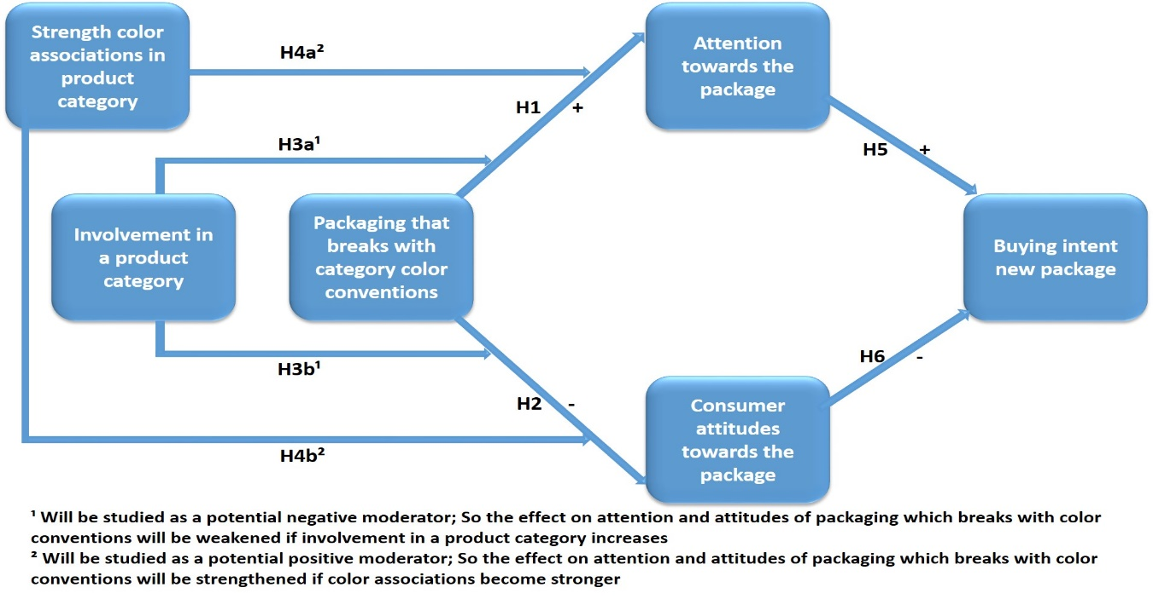
Figure 2: Conceptual model with the relationships between variables
H | Explanation
1 | A: A product that breaks with category color conventions with striking colored packages will gain more attention from consumers  B: A product that breaks with category color conventions with non-striking colored packages will gain more attention from consumers  C: A product that breaks with category color conventions with striking colored packages will gain more attention from consumers in comparison to non-striking colored packages
2 | A: A product that breaks with color conventions will be expected to have lower quality than a product that does not break with color conventions  B A product that breaks with color conventions will be expected to have a worse taste than a product that does not break with color conventions
3 | A: The positive effect of a package that breaks with color conventions on attention will be weakened when involvement is high  B: The negative effect of a package that breaks with color conventions on attitudes will be weakened when involvement is high
4 | A: The positive effect of a package that breaks with color conventions on attention will be strengthened when color associations are strong  B: The negative effect of a package that breaks with color conventions on attitudes will be strengthened when color associations are strong
5 | More attention towards a package leads to increased buying intent of a new package
6 | Negative consumer attitudes towards a package leads to decreased buying intent of a new package
Table 2: All hypotheses summarized

3. Method
This paper uses an experiment design to assess the influence of breaking with color conventions on consumer behavior. The data was gathered from random respondents who answered requests via e-mail, Facebook and twitter to participate in this study. Three conditions were designed for which one of each conditions was randomly assigned to each of the respondents. In a later stage of this chapter more information will be provided on the different conditions and the reasons why these conditions were chosen.

3.1 Research methodology and design
The goal of this study is to examine the influence of breaking with color conventions on consumer buying intentions via attention and attitudes towards a product. The most appropriate way to test the hypotheses in this study is via an experiment. An experiment offers the possibility to manipulate package coloring and test differences in responses between respondents in different scenarios. By manipulating the package coloring between the scenarios, differences in attention and attitudes and the potential moderating effect of the strength of color associations and product involvement can be measured. Therefore, for this study an experiment is chosen as the method for data collection.
In the previous chapters, the research questions and hypotheses with a conceptual model were discussed. Following the conceptual model, there are six variables which will be analyzed in this study. The dependent variable of this study is ‘buying intent of the new package’. The mediator variables are ‘consumer attitudes’ and ‘attention’. ‘Involvement in a product category’ and ‘strength of a color association in a product category’ can both be seen as moderator variables. The last variable of the conceptual model, ‘Packaging that breaks with category color conventions’, is the independent variable in the model.
The influence of breaking with color conventions (independent variable) on buying intention (dependent variable) will be tested via two mediator variables which are attention and attitudes. The first mediator, ‘attention towards the package’ will be tested on the hypothesis that more attention leads to increased buying intent of the new package (hypothesis 1). The other mediator variable, consumer attitudes, will also be analyzed to measure if there is a direct effect on buying intention. According to hypothesis 2, decreased consumer attitudes towards a product may lead to decreased buying intention.
The two moderating variables in the model are ‘involvement’ and ‘strength of a color association’. In the theory section, the importance of involvement in consumer decision-making has been addressed multiple times. In this study this variable is seen as a moderator, rather than a variable with a direct causal relationship to the other variables. The same applies for the other moderating variable, ‘strength of a color association’. These variables can both be seen as moderators which can influence the way consumers are attracted and value products, rather than having a direct causal effect on consumer attention and attitudes towards the products. The last variable in the model, ‘packaging that breaks with color conventions’, can be seen as the independent variable in the model. This variable is changed in this experiment for the three different scenario, but it does not get affected by the other variables and serves therefore as the independent variable in the model.

3.2 Instrumentation
On each of the variables a subset of questions was asked to each of the respondents. The experiment can be divided in roughly two parts. The first part consists of questions which were asked to each respondent, the second part consists of three scenarios, for which one scenario is randomly assigned to each of the respondents. All questions of the first scenario can be found in Appendix 1 (written in Dutch).

3.2.1 First part of the experiment
In the first part, questions for the chocolate as well as the chips category were asked on involvement level, actual shopping behavior in both categories and color perceptions of consumers. For involvement level, four propositions were showed to respondents based on the four conditions to assess involvement level per category of Zaichkowsky (1985). The four conditions for high involvement were an active attitude towards information seeking, many comparison between product attributes, perception of differences between brands and preferences for a particular brand. The four statements asked to respondents on involvement level in the chips category are therefore:
- Before I buy chips, I search actively for information about different brands of chips
- Before I buy chips, I compare ingredients of the different brands of chips
- I experience differences between different brand of chips
- I have a preference for a certain brand of chips
Next to these four propositions, two extra propositions were added with questions about purchase intentions prior of going to the supermarket.
- Before I go into the supermarket, I know which brand of chips I am going to buy
- Before I go into the supermarket, I know which flavor of chips I am going to buy
Reason for the addition of these two statements is to measure if consumers actually make buying decisions at the point of sale or prior of going to the supermarket. According to the discussed theory, buying decisions are mostly made at the point of sale (Gray & Guthrie, 1990). It seems logic to consider that when the involvement level is low, consumers will make their purchase decisions in-store. To test if there is correlation between the different statements, the six propositions will be tested on reliability and correlation. The propositions were asked as close questions which respondents could answer on a scale from 1 (completely disagree) to 7 (completely agree).
Next to questions on involvement level, the first part also consists of questions on color perceptions of consumers. To get a first idea if respondents have colors in mind when thinking of a particular flavor of chips and chocolate, respondents answered open questions about their perceptions of colors per flavor. For both categories, color perceptions for four flavors were asked which were Paprika, Naturel, Cheese & Onion and Bolognese for the chips category and Pure, Milk, Hazelnut and White for the chocolate category. These four colors per category were chosen based on the most sold chips and chocolate in both categories in The Netherlands. Next to open questions on color perceptions, three closed questions on a scale from 1 to 7 were asked to get a better idea on the importance of package coloring and their conventions to consumers. These three statements are:
- Naturel chips should be packed in a red bag
- It is confusing if naturel chips is packed in blue packaging
- The combination between taste and color of the package is important to me.
These statements provide explanations how important specific coloring per flavor actually is for consumers. The statements on color perceptions are only about naturel chips and for the chocolate category only about milk chocolate. Reason to give statements solely about these flavors is that in the different scenarios the only packages which are manipulated are naturel chips and milk chocolate. By giving color statements solely about these flavors, the data becomes better suitable in assessing its influence on attention and attitudes towards these two flavors.

3.2.2 Second part of the questionnaire
The second part of the questionnaire consists of three scenarios. For each respondent, one scenario is randomly assigned to each of the respondents. The three scenarios can be seen in the figure below.
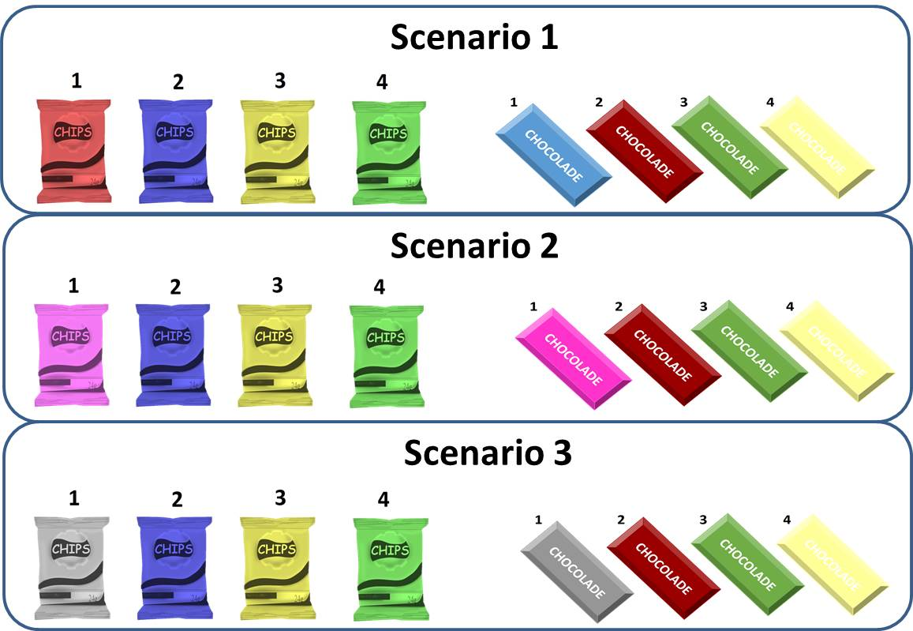
Figure 3: The three different scenarios of the questionnaire
The main question in this paper is what happens to buying intention when product packaging ‘breaks’ with color conventions in the chips and chocolate category. To analyze potential differences in buying intention of normal packaging versus buying intention of changed packaging, a control group gives an idea about buying intention, attention and attitudes towards normal packaging. Scenario 1 represents packaging with normal used coloring in the chips and chocolate product categories in The Netherlands. Data from respondents in this scenario can be used to compare results from this group to the results of the respondents in scenario 2 and 3.
What can be seen in scenario 2 and 3 is that for this analysis only the colors of one package per category is changed and all other conditions like size, shape and graphics are remained constant. Reason for this is to make sure that potential differences in attention, attitudes or buying intention between groups can be explained as the result of a change in colors, instead of a change of other elements like text, size or shape. For the chips category, the naturel chips changed from red to pink (scenario 2) and from red to grey (scenario 3). For the chocolate category, the milk chocolate changed from blue to pink (scenario 2) and blue to grey (scenario 3). The reason to add two scenarios was already explained in the theory part. The idea is to analyze if there is a difference in change of perceptions between using bright colors (Pink, scenario 2) and dark colors (grey, scenario 3). For example, it seems logic that changing package colors in bright coloring attract more attention compared to using dark colors. Because of the use of three scenarios there is the possibility to analyze these potential differences.
To get an idea about differences in attention, the first question respondents had to answer was which packaging was noticed by the respondents the most. To make sure respondents did not know which question they had to answer, they were first showed the four packages for which was mentioned to look at it carefully. The taste of the chips and chocolate were not included to make sure respondents would base their choice solely on the differences in package coloring. After clicking further in the questionnaire, they had to make a choice between one of the four packages or the possibility no packaging noticed them more or less. To assess the buying intention of consumers towards the different options in both categories they were showed once again the four options were they got the question which of the bags of chips and which of the bars of chocolate they would buy. A fifth answer choice was added with the answer choice none of the showed packages chips and chocolate would be bought. The difference with the question on attention is that here flavors were added underneath the different bags of chips and chocolates, because respondents cannot base their decision solely on package coloring. They may be attracted by a certain color, but could choose a different pack of chips based on flavor preference or habitual purchase of a certain flavor.
To assess the perception of attitudes towards a package, respondents were showed the naturel chips and milk chocolate of their scenario for which another subset of questions were asked. Respondents who answered questions from scenario 1 were showed a red chips bag with the text ‘naturel’ under it, for scenario 2 a pink bag with ‘naturel’ was showed and for scenario 3, a grey bag with the same text was presented. Respondents had to rate the bag of chips and bar of chocolate on a scale from 1 to 7 on taste, quality, combination of color with the flavor and their perception of noteworthiness of the packaging. Also here a question on buying intention was asked on a scale from 1 to 7 where 1 stands for ‘very likely to buy’ and 7 for ‘very unlikely to buy’.

3.2.1 Statistical tests per hypothesis
To assess if the hypotheses are supported or rejected by the data, some statistical tests need to be executed. First, the statements which were asked on the strength of color associations, involvement in a product category and consumer attitudes towards a product are measured on reliability and correlation. These tests will be executed separately for both categories. Reason for this is that involvement level may differ per category for each of the individuals.
For the first hypothesis, the effect of breaking with color conventions on attention is measured. This will done by creating dummy variables per condition. By creating dummy variables, the analysis can explain potential differences in attention per condition (condition with normal colors, condition with striking colors and condition with non-striking colors). Because the dependent variable for this hypothesis (attention towards a package) is measured on a categorical scale (0 = did not select the naturel package as the most noticeable versus 1= did select the naturel package as most noticeable), Hypothesis 1, 3a and 4a will be measured by running a logistic regression analysis on the data. For the second hypothesis and hypothesis 3b and 4b almost the same tests can be used, with the only difference that a linear regression is more appropriate here. The dependent variable in this hypothesis (consumer attitudes towards the package) is measured on an interval scale for which linear regression can be used to provide explanations.
As well as attitudes, buying intention towards the package is measured on a seven-point scale. Therefore, a linear regression will be done to assess the influence of attention and attitudes towards buying intention (hypothesis 6 and 7). Because buying intention of consumers can also be caused by habitual purchasing, an extra independent variable will be included as a control variable. With habitual purchasing is meant that consumers who always buy a certain flavor will most likely buy the same flavor regardless of a change in package coloring. In the questionnaire this control variable is covered by the questions which flavor participants normally buy when they buy chips or chocolate in the supermarket.
Next to the measurement of buying intention on a 7-points scale, another question in the questionnaire can also be explained as a measurement for buying intention. For this question, the four packages of chips and chocolate of the assigned scenario were showed to respondents with the question which chips or chocolate they would buy. An example of scenario 2 can be seen in figure 4. The results of this model will be discussed as well in the next chapter.
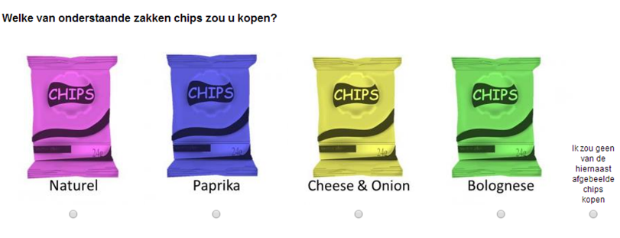

Figure 4: Question on buying intention of scenario 2

3.3 Selection of participants
For each of the three scenarios a different group of respondent are chosen. By using three different groups of respondents, variables per scenario can be compared to variables of other scenarios. A minimum of 25 respondents per scenario is chosen as the minimum amount of respondents needed per scenario. If the number of respondents falls below 25 it becomes harder to generate significant results per group of respondents.
For this paper, no selective sampling is used to target specific groups of consumers. This means that everyone who is willing to participate in the questionnaire is allowed to take the survey. The survey is written in Dutch which means only Dutch-speaking people are able to take the survey. Main reason to write the questionnaire in Dutch is the color associations consumers might have with the two product categories for investigation. Like explained before, the same colors per flavor in both categories are used by different brands. Previous discussed papers argued that color associations can be country- or culture-specific and to exclude potential difficulties with respondents from different countries with different color associations the choice is made to write the survey in Dutch and include only Dutch-speaking participants.
Experience out of previous papers show that most likely people between the ages of 18 and 30 will represent the majority of respondents. Also in this research the chance of a majority of respondents coming from this age group is existing. The survey is distributed via Facebook, Twitter and E-mail for which people who read the post will most likely be younger individuals. In the next chapter, details will be given about the number of respondents, their age and gender.

4. Results
In this chapter, some descriptive statistics about the variables of interest will be given. After this, the data patterns and the hypotheses of this paper will be statistically tested. Because this paper focusses on the influence of color in the chocolate and chips category, the hypotheses will be tested separately for each category. The main purpose of the study is to identify if it could be an opportunity for brands to break with color conventions in product categories to increase buying intentions towards their products. To identify possible opportunities to increase sales, first the effect of breaking with color conventions will be tested on attitudes and attention. Also the influence of the strength of color associations and product involvement will be taken into account in this analysis. After this, the results of the effect of attention, attitudes and habitual purchasing on buying intention will be given.

4.1 Participant in this study
Participants were invited to collaborate in this research mainly via social media. The data program Qualtrics was used to distribute the survey and save responses from respondents. In total, 108 people participated in the questionnaire for which 92 people answered all questions from their scenario. The respondents with missing values were deleted out of the questionnaire to ensure that interacting variables could be measured correctly. For example, the beginning of the questionnaire was used to measure involvement level and the strength of associations, while at the end questions were asked on attitudes and buying intention. All respondents who stopped prior to the end of the questionnaire had missing values on attitudes and buying intention for which the relationships between these variables could not be measured for these individuals. In the table below more details are given about the 92 respondents per scenario. 31 responses were received for scenario 1 and 2, while scenario 3 received 30 full responses. From all responses, 48 participants are male, while 44 participants are female. The majority of respondents falls into the category between 16 and 30 years old, which was also expected prior of the data collection.
 | Scenario 1  Control group | Scenario 2  Striking colors | Scenario 3  Non-striking colors
Number of respondents | 31 | 31 | 30
Male/female | 15/16 | 19/12 | 14/16
Between 0-30 years old | 25 | 25 | 25
Between 31-60years old | 6 | 6 | 5
Table 3: Statistics about the respondents per scenario

4.2 Involvement & strength of color associations
Two moderating variables in this study are involvement and the strength of color associations. Like explained in the previous chapter, multiple statements were given on both variables for the chocolate and chips category. To assess reliability and correlations between the different statements per variable, a factor and reliability analysis was executed per variable. Factor analysis has the capability to explain the maximum amount of common variance, using the smallest number of explanatory constructs and is therefore used for this analysis.

4.2.1 Chips category
To assess the involvement level of consumers in the chips category, six statements were given on a 1 to 7 Likert-scale. After running a factor analysis, output shows that the six statements can be summarized in three factors based on the idea that eigenvalues have to be greater than 1 (see table below and appendix II for the SPSS output). The Cronbach’s Alpha values are given in the last column of table 4.
Factor | Statements | Cronbach’s Alpha
1 | - Before I buy chips, I search actively for information about different brands of chips  - Before I buy chips, I compare ingredients of the different brands of chips | 0.610
2 | - I experience differences between different brand of chips  - I have a preference for a certain brand of chips | 0.742
3 | - Before I go into the supermarket, I know which brand of chips I am going to buy  - Before I go into the supermarket, I know which flavor of chips I am going to buy | 0.837
Table 4: Factor and reliability results of statements on involvement chips
The value for the Cronbach’s Alpha is the highest for factor 3 (0.837). These statements however, were added in a later stage to see if they would correlate with the four conditions given by Zaichkowsky to assess involvement level (1985). Based on the results of the factor analysis, all statements cannot be combined to assess involvement level. Factor 3 may have the highest Cronbach’s Alpha, but following the literature the statements from factor 2 are taken as input for the regression model. The Cronbach’s Alpha of these statements is 0,742 which indicates a relatively good result for the actual reliability of these statements.
To assess the validity of the three statements on the strength of color associations per individual the same tests were executed as for involvement level. The factor analysis shows all three statements load on one factor with an eigenvalue greater than 1 (see appendix II). The Cronbach’s alpha of the three statements combined is 0,757 which can also be considered as a relatively good result for reliability. Therefore, the averages of the three statements on the strength of color associations are combined as input for the regression model to assess the influence of these associations on attention and attitudes.

4.2.2 Chocolate category
The statements which respondents had to answer for the chips category were also asked for the chocolate category. A factor analysis is used to investigate which statements can be combined. The rotated component matrix in appendix III shows that the six statements load on two factors for which the four statements of Zaichkowsky (1985) load on one factor. Taking the results of the factor analysis into account, these four statements can be used as input to assess involvement level for the chocolate category. However, to prevent differences in results from the involvement construct for the two categories will appear, also for this category statement 3 and 4 are taken into account as input for the regression model. Cronbach’s alpha of these two statements is 0,788 which can be considered as a relatively good result for reliability. The three statements on the strength of color associations in the chocolate category also provide a decent Cronbach’s Alpha of 0,842 (see appendix III). Therefore, the average of the three statements on color associations can be used as input for the regression model of chocolate.

4.2.3 Chips versus chocolate category
After assessing which statements are used to assess involvement and the strength of color associations, the differences between the chips- and chocolate category is analyzed. In the table below the mean values of involvement level and the strength of color associations are summarized.
 | Chips category | Chocolate category
Involvement level | 5.424 | 4.12
Color associations | 4.946 | 4.29
Table 5: means of color associations and involvement level for both categories
What can be seen in table 5 is that the average for involvement level for chips is 5.424, while involvement level on chocolate is 4.12. Running a t-test results in the finding that the two means significantly differ from each other, t(91) = 6.286 p > .001. Respondents are more involvement in the chips category, compared to the chocolate category. The same is done for the strength of color associations. Results of a t-test for this variable also indicates that there is a significant difference in means between the chips and chocolate category, t(91) = 4.565 p > .001. The results of this analysis show that involvement is higher and the strength of color associations are stronger for the chips category in comparison to the chocolate category.

4.3 The effect of breaking with color conventions on attention
The first hypothesis which is tested in this analysis is the effect of breaking with color conventions on attention. The hypothesis suggests that packaging which breaks with color conventions will gain more attention in comparison to packaging which does not break with these conventions. According to hypothesis 3 and 4 the strength of color associations and involvement in a category have a moderating effect on the attention towards a package. To capture the effect of involvement and color associations on attention, interacting variables between the dummies and color associations and the dummies and involvement level are created. Based on these relationships, the following model is made for the chips category:
Attention_Chips $≅$ Z = $β0$ + $β$1 dummy_pink + $β$2 dummy_grey + $β$3 dummy_pink * Involvement_level + $β$4 dummy_grey * involvement_level + $β$5 dummy_pink * strength_color_association + $β$6 dummy_grey * strength_color_association
A binary logistic regression was executed to test the effect of the different variables on attention for the chips category. For the chocolate category the same model can be applied. Also for this category a logistic regression is used to test the model. This model can be summarized as follows:
Attention_Chocolate $≅$ Z = $β0$ + $β$1 dummy_pink_choc + $β$2 dummy_grey_choc + $β$3 dummy_pink_choc * Involvement_level_choc + $β$4 dummy_grey_choc * Involvement_level_choc + $β$5 dummy_pink_choc * strength_color_association_choc + $β$6 dummy_grey_choc * strength_color_association_choc

4.3.1 Chips category
The output of the SPSS analysis for the effects of each variable on attention in the chips category is showed in the table below. The summary of the regression model show a value of 0.280 and 0.374 for Cox & Snell R-square and Nagelkerke R-square (Appendix IV). These numbers indicate a modest improvement in fit over the baseline model (The model without taking the independent variables into account).
 | B (SE) | Wald | Significance
Constant | -1.910 (.536) | 12.703 | .000
Dummy_pink | 3.053 (.713) | 18.348 | .000
Dummy_grey | 2.349 (.673) | 12.180 | .000
Dummy_pink * Involvement_level | -.309 (.471) | .430 | .512
Dummy_grey * Involvement_level | -.240 (.466) | .265 | .607
Dummy_Pink * Strength_color_association | .664 (397) | 2.794 | .095
Dummy_grey * Strength_color_association | .330 (.458) | .518 | .471
Table 6: Regression results of consumer attention towards different packaging (chips)
Most important finding is that for a striking color as well as the non-striking a significant positive effect on attention is measured. In other words, chips packages which were colored pink and grey were noticed more in comparison to the normal colored red naturel packages. Hypothesis 1a and 1b is thereby supported by the data. Beta’s (3.053 versus 2.349) show a stronger effect on the positive change in attention for a pink package compared to a grey package. This corresponds with the hypothesis 1c which states that striking colored packages will gain more attention in comparison to non-striking colored packages. However, results from an independent t-test show that there is an insignificant effect to assume differences between groups, t (59) = 0.89, p = .376 with averages of 0.71 for attention to the striking colored package and 0.6 for the non-striking colored package. Therefore hypothesis 1C is not supported by the data for the chips category.
The moderating effect of involvement on attention is not supported by the results. For both colors, results are insignificant to support hypothesis 3a. The influence of the strength of color associations’ show mixed results. At a significance level of 0.1 the positive influence of color associations is supported for the striking colored packages. This means when color associations are relatively strong, a pink colored package will be noticed more by consumers in comparison to consumers for which color associations are relatively weak. A significant effect of the influence of color associations on non-striking colored packages cannot be found.

4.3.2 Chocolate category
For the chocolate category, the same tests are executed to assess the influence of breaking with color conventions on attention. Results are comparable to the regression results of the chips category. Cox & Snell R-square (0.410) and Nagelkerke R-square (0.548) show a relatively good fit of the overall model (Appendix IV).
 | B (SE) | Wald | Significance
Constant | -3.401 (1.017) | 11.195 | .001
Dummy_pink | 5.018 (1.141) | 19.334 | .000
Dummy_grey | 3.667 (1.082) | 11.492 | .001
Dummy_pink * Involvement_level | -.056 (.438) | .017 | .898
Dummy_grey * Involvement_level | .090 (.391) | .053 | .817
Dummy_Pink * Strength_color_association | .568 (.463) | 1.509 | .219
Dummy_grey * Strength_color_association | .112 (.403) | .078 | .781
Table 7: Results of the influence of attention in the chocolate category
For this category, the striking colored package (pink) and non-striking colored package (grey) both show significant results in the effect of breaking with color conventions on consumer attention. There is a difference in betas with 5.018 for the pink colored package versus 3.667 for the grey colored package. An independent t-test shows there is a significant difference to assume differences between the two groups, t(59) = 2.058 p > .001 with an average for attention of .81 for the striking colors and .57 for the non-striking colors. Respondents who are confronted with a striking colored package will notice this more in comparison to consumers who are confronted with a non-striking colored package. Therefore, for the chocolate category hypothesis 1C is supported by this data.
For the moderating influence of involvement and the strength of color associations on consumer attention almost the same conclusions can be drawn as for the chips category. For packages which break with color conventions, no evidence can be found that both variables have a moderating effect on consumer attention. So for hypothesis 3a and 4a only hypothesis 4a, which state that stronger color associations will increase the effect on attention when different colored packages are showed, is supported for the chips category.

4.4 The effect of breaking with color conventions on attitudes
In the hypotheses in chapter 2, the effect of breaking with color conventions on attitudes was explained as a potential negative influence. The idea is that consumers will be more aware of packaging if it is different than normally used coloring but consumer attitudes towards these products will be negatively changed. Consumers are used to certain coloring for product packaging and if this will be changed, consumers may have different perceptions of beliefs and different attitudes towards these products. Like explained in the previous chapter, four statements were asked to assess consumer attitudes towards products. The idea was to test the perception of ‘taste’ and ‘quality’ separately. However, the two statements correlate with each other and factor analysis shows three out of the four statements load one factor which are next to the statements on quality and taste the statement about the combination of the color of the package with the actual taste. The fourth statement about noteworthiness of the packaging did not correlate with the other three statements so this statement is therefore taken out of the analysis for both categories. The average of the three statements is calculated and taken into account as consumer attitudes towards the product. The influence of breaking with color conventions on product packaging can be summarized in a model. For the chips and chocolate category these are the following:
Attitudes_Chips $≅$ Z = $β0$ + $β$1 dummy_pink + $β$2 dummy_grey + $β$3 dummy_pink * Involvement_level + $β$4 dummy_grey * involvement_level + $β$5 dummy_pink * strength_color_association + $β$6 dummy_grey * strength_color_association
Attitudes_Chocolate $≅$ Z = $β0$ + $β$1 dummy_pink_choc + $β$2 dummy_grey_choc + $β$3 dummy_pink_choc * Involvement_level_choc + $β$4 dummy_grey_choc * Involvement_level_choc + $β$5 dummy_pink_choc * strength_color_association_choc + $β$6 dummy_grey_choc * strength_color_association_choc
The models for attitudes are comparable with the models for attention. Also in the above models the possible moderating effect of involvement and color associations on attitudes will be investigated. Like explained in chapter 3, consumer attitudes are measured on a 1 to 7 Likert-scale. Therefore, linear regression will be executed to test the models.

4.4.1 Chips category
The ANOVA table of the linear regression gives a p-value of 0.000 which indicates there is a good fit between the model and the data (appendix V). The adjusted R-Square gives a value of 0,242 which means 24,2% of the variation in attitudes towards chips may be explained by the variation of the independent variables.
Table 6 below provides an overview of the results of the regression analysis. The results are comparable to the results of the influence of breaking with color conventions on consumer attention. Both dummies have a significant effect on the dependent variable which in this case is attitudes. Both B-values are negative and therefore correspond with hypothesis 2 that a change in color for product packaging has a negative influence on consumer attitudes towards the product. For the chips category, hypothesis 2a and 2b are therefore supported by the data.
 | B (SE) | Standardized beta | Significance
Constant | .713 (.156) |  | .000
Dummy_pink | -.901 (.227) | -.428 | .000
Dummy_grey | -1.241 (.230) | -.585 | .000
Dummy_pink * Involvement_level | .094 (.142) | .061 | .510
Dummy_grey * Involvement_level | -.091 (.185) | -.046 | .624
Dummy_Pink * Strength_color_association | -.025 (-.142) | -.016 | 863
Dummy_grey * Strength_color_association | .183 (.193) | .087 | .346
Table 8: Regression results of change in attitudes in the chips category
Different than expected are the beta-values for the pink and grey dummy. Where pink colored packages gain more attention in comparison to grey colored packages (greater values for betas of the pink dummies), the change in attitudes towards packaging is the strongest for the grey colored packaging. The expectation was that packaging which would gain the most in attention would also be the most negatively influenced in attitudes. The data does not support this statement. The results out of this questionnaire show that striking-colored packages gain relatively more in attention, but the change in attitudes is the greatest for the non-striking colored packages. A t-test between the means of the grey and pink dummy (Appendix V) rejects the idea that there is a significant difference between the grey and pink dummy in attitudes towards the packaging, t(59) = 1.428 p = .372 with an average for attitudes of 3.84 for scenario 2 and 3.4 for scenario 3. In correspondence with the regression results on attention, the potential moderating influence of involvement and color associations on consumer attitudes is not supported by the data.

4.4.2 Chocolate category
For the chocolate category, the same analysis was performed to analyze the effect of the different package coloring on attitudes. Results are comparable to the results of the chips category. The model has an adjusted R-Square of 0.288 which is a slight improvement compared to model of the chips category. The beta-values for the independent variables also show similarities which is shown in table 9 below.
 | B (SE) | Standardized beta | Significance
Constant | .743 (.152) |  | .000
Dummy_pink | -.947 (.216) | -.450 | 0.000
Dummy_grey | -.1334 (.216) | -.629 | 0.000
Dummy_pink * Involvement_level | -.106 (.142) | -.066 | .458
Dummy_grey * Involvement_level | .039 (.164) | .022 | .813
Dummy_Pink * Strength_color_association | -.177 (.154) | -.103 | .253
Dummy_grey * Strength_color_association | .139 (.168) | .078 | .408
Table 9: Regression results of change in attitudes in the chocolate category
The grey and pink dummy show a significant negative effect on attitudes, so for this category hypotheses 2a and 2b are supported as well. Also in this category the negative effect on attitudes is stronger for the grey dummy (A B-value of -1.334 for the grey dummy versus -.947 for the pink dummy). An independent T-test indicates there is no significant difference between the grey and pink dummy towards the dependent variable, t(59) = 1.778 p = .402 with an average for attitudes of 3,82 for scenario 2 and 3,27 for scenario 3. Also for this category, the moderating effect of involvement and the strength of color associations cannot be supported by the data.

4.5 The effect of attention and attitudes on buying intention
The main research objective in this paper is to find evidence if it would be useful for brands to choose their own coloring for their products instead of copying competitor color choices. Therefore for the last two hypotheses, the effect of attention and attitudes on buying intention is measured. Buying intention was measured via two different questions. In the first question on buying intention, respondents were forced to make a choice between the four different kind of chips and chocolate where they had to indicate which chips they would like to buy. Figure 4 in chapter 3 gives an example of this question of scenario 2. In the second question on buying intention, respondents had to indicate on a 1 to 7 scale how likely it was they would buy the chips and chocolate of their scenario. For example in scenario 1 (control group) respondents were shown a blue milk chocolate and a red naturel chips, while in scenario 2 a pink naturel chips and a pink milk chocolate was showed to the respondents.
The difference between both questions is that the question on a 1 to 7 scale is more general in which respondents have to rate the packages of their scenario. In the other question on buying intention, respondents have to make an actual choice which chips or chocolate they would buy. The results of both questions will be analyzed in this paper to investigate potential differences in results. The question with different pictures, as shown in chapter 3, will be called ‘buying intention I’ and the relative general question on a 1 to 7 scale will be called ‘buying intention II’.
Habitual purchasing is taken into account as a control variable for this analysis. Habitual buying behavior occurs when differences between brands are small and when involvement is low. Consumer may not form a strong attitude towards a brand or product but will select it because it is familiar to them. So to put it in context of this analysis, it means that consumers will buy a certain product regardless of the color, graphics or other packaging elements. For example, consumers who always buy paprika chips may buy this chips regardless of the appearance of a new and different colored package of naturel chips. To take the potential influence of habitual purchasing into account this variable is added to the equation. It is measured on a nominal level where 1 means respondents have chosen naturel chips or milk chocolate as the flavors they mostly buy (the flavors from which colors are changed in the different scenarios) and 0 in case they choose other flavors as the flavor they mostly buy.
The equations for the chips category are therefore as follows:
Buying_intention_I_Chips $≅$ Z = $β0$ + $β$1 Attention + $β$2 Attitudes + $β$3 Habitual purchasing
Buying_intention_II_Chips $≅$ Z = $β0$ + $β$1 Attention + $β$2 Attitudes + $β$3 Habitual purchasing
The same principles can be applied for the chocolate category. The following two equations are therefore made for this category:
Buying_intention_I_Chocolate $≅$ Z = $β0$ + $β$1 Attention_choc + $β$2 Attitudes_choc + $β$3 Habitual purchasing_choc
Buying_intention_II_Chocolate $≅$ Z = $β0$ + $β$1 Attention_choc + $β$2 Attitudes_choc + $β$3 Habitual purchasing_choc

4.5.1 Chips category
For the chips category, the model for buying_intention_I will first be analyzed. The answers of respondents are recoded as 1 in case they would buy the naturel chips and 0 in case they would not buy the naturel chips. A logistic regression is executed for this model. Results give 0.285 for the Cox & Snell R-square and 0.385 for the Nagelkerke R-square (See appendix VI). There are two explanatory variables which show a significant effect on buying intention, which are attention and habitual purchasing. Attitudes towards the packaging show no significant effect on buying intention for this equation. The results of this model are summarized in the table below.
 | B (SE) | Wald | Significance
Constant | -2.273 (.524) | 18.972 | .000
Attention | 2.340 (.564) | 17.194 | .000
Attitudes | -.200 (.253) | .628 | .428
Habitual purchasing | 1.700 (.576) | 8.703 | 0.003
Table 10: variable scores on buying_intention_I_chips
For the second model on buying intention (buying_intention_II), a linear regression was executed. Where in model I the dependent variable was recoded into 1 and 0, for the second model buying intention was measured on a 1-7 scale for which linear regression can be used. The adjusted R-square gives a value of 0.257 for which 25,7% of variance in the model can be explained by the independent variables. The results of buying intention II are the opposite of the first model on buying intention. Where in the first model, attention and habitual purchasing show an effect on buying intention, in this model attitudes is the only explanatory variable which show a significant effect on buying intention (see table 11 for all values).
 | B (SE) | Standardized beta | Significance
Constant | 3.406 (.220) |  | 0.000
Attention | -.273 (.281) | -.089 | .333
Attitudes | .776 (.141) | .501 | .000
Habitual purchasing | .428 (.293) | .132 | .148
Table 11: variable scores on buying_intention_II_chips
The differences in the results of the two models can be explained by looking at the differences in the two questions. Respondents are forced to choose a package of chips in the model of Buying_intention_I. For example, it makes sense that consumers who normally buy (habitual purchasing) paprika chips will choose for paprika chips in this model, regardless of a change in color. This explains the significant effect of habitual purchasing in this model. In the second model, attitudes show a significant effect on buying_intention_II, mainly because this question gives respondents the change to value one bag of chips on the likelihood they would buy it, instead of being forced to choose between different bags of chips with different flavors.
Taking the results of the two models into account, the second question on buying intention can be seen as a value judgment, rather than a question which measures the real buying intention. For example, respondents who choose naturel chips for model I based on habitual purchase or because they noticed it the most may give low scores for buying intention in the second model because of the strange color of the chips (grey or pink). These arguments explain the differences in significances for the variables in the two different models. Model I gives respondents a real choice of choosing between different alternatives, where model II gives explanations how people respond to a certain bag of chips. Analyzing the correlation between attitudes and buying_intention_II underlines this idea. A strong relationship exists between the two variables in this model (0.506, see appendix VI).
Taking the results of both models into account, all three variables are supported by the data. Hypothesis 5, which state more attention leads to increased buying intention, is supported by the data of model I. Also habitual purchasing plays a significant role in the buying intention for consumers in model I. Consumer attitudes (hypothesis 6) does not show a significant effect in this model, but in model II (see table 11) this is the only variable which show significance. Because two different models on buying intention are used it is complex to state which variable has the strongest effect on buying intention. Model I may look like a more realistic model in a way the respondents can choose between different alternatives, but in real life more options are available than only the four options showed in this experiment.

4.5.2 Chocolate category
The same tests were executed for the chocolate category. For the first model (buying_intention_1_Chocolate) a logistic regression was executed. Values for Cox & Snell (0.262) and Nagelkerke (0.486) R-square show small improvements of the model fit in comparison to the logistic regression for the chips category. For the chocolate category, habitual purchasing shows the biggest effect on buying intention with a beta of 3.648. This means, respondents who normally buy a certain flavor of chocolate, will most likely buy this chocolate again, regardless of change in colors. This also explains the relative small beta for attention in the influence on buying intention for the chocolate category which does not give significant results.
 | B (SE) | Wald | Significance
Constant | -3.577 (.846) | 17.880 | .000
Attention | -1.012 (.885) | 1.310 | .252
Attitudes | .890 (.519) | 2.937 | 0.087
Habitual purchasing | 3.648 (.940) | 15.070 | 0.000
Table 12: variable scores on buying_intention_I_chocolate
The results for the second model (buying_intent_II_chocolate) are similar to the chips category. Adjusted R-square gives a value of 0.531 which show a relatively big improvement compared to the linear regression model of the chips category. Also in this category, attitudes have the biggest effect on buying intention. At a 0.1 level, habitual purchasing shows a significant result in the second model as well. This underlines the findings of model I that habitual purchasing can be considered as a strong predictor for buying intention in the chocolate category.
 | B (SE) | Standardized beta | Significance
Constant | 3.028 (.182) |  | .000
Attention | .285 (.268) | .083 | .290
Attitudes | 1.282 (.133) | .743 | .000
Habitual purchasing | .509 (.285) | .130 | .078
Table 13: variable scores on buying_intention_II_chocolate
Overall, the results of the two categories show that consumers are more ‘flavor-loyal’ in the chocolate category which explains the differences in results between the two categories. With ‘flavor-loyal’ is meant that consumers who are attached to a certain flavor of chocolate will buy this chocolate, regardless of changes in product coloring. So for the chocolate category, hypothesis 5 cannot be proven by the data mainly because of the strong effect of habitual purchasing. In comparison with the chips category, attitudes are supported as a predictor for buying intention in model II. This means hypothesis 6 which state that negative consumer attitudes leads to a decrease in buying intention towards the new package is supported by the data in the chocolate category.

4.6 Differences in responses between groups on buying intention I and II
Because the above analysis does not provide clear answers on the question what happens to buying intention when product packaging changes, an ANOVA-analysis is added to provide more details about differences in responses between the different scenarios. For the first model (Buying_intention_I) a significant difference in buying intention is found for the chips category between scenario 1 (normal colored packaging) and scenario 2 (striking colored packaging). Buying intent significantly increases when a striking colored package is showed between the different alternatives in the chips category, F (2, 89) = 4.31, p = .016. No significant differences in means were found for the chocolate category, F (2, 89) = 1.07, p = .347 (See Appendix VII for ANOVA and Post Hoc tests).

Figure 5: differences in means between groups (* = means are significantly different compared to control group)

Also for the second model, the means between groups are compared. Significant differences in responses were found in both categories (Chips category: F (2, 89) = 4.98, p = .009 and Chocolate category: F (2, 89) = 5.662, p = .005). What can be seen at the means in the figure below is that for scenario 2 and 3, buying intention significantly decreases compared to scenario 1 in both categories. This means that the respondents, who had to rate a bag of chips and chocolate which was different than the colors which are normally used (scenario 1), responded more negatively in their likelihood of actually purchasing the product.

Figure 5: differences in means between groups (* = means are significantly different compared to control group)

The results of the above two figures correspond to the results found in the regression analysis. Where a positive significant difference in buying intention was found for the chips category in model I, Model II shows a negative significant difference on buying intention for both categories. In regression model I, the positive effect of attention on buying intention was only found for the chips category. These results corresponds with differences in means which is also only found for this product category. Model II shows the negative effect of changed coloring on buying intention. In regression model II, the negative effect of attitudes on buying intention was found in both categories and these results correspond with the significant negative change in means of both scenarios.

4.7 Summary of the results
The results of the statistical analysis show that attention for packaging which breaks with color conventions is significantly higher than attention for packaging in normal coloring. These results were measured for both categories. Attention itself show a significant effect on buying intention in the chips category. This means that the increase in attention may lead to increased buying intention in this category. The moderating effect of the strength of color associations on attention was only found for the chips category. These results correspond with the results found on the strength of color associations between the two product categories. In the chips category, results showed that color associations are stronger in comparison to the chocolate category. So because of these stronger color associations, the breaking with color convention leads to a further increase in attention. In other words, if consumers have specific colors in mind for a flavor of chips and it turns out that for that particular flavor there is a change in color it will increase their attention towards that bag of chips. Unfortunately, no results were found on the moderating effect of involvement on attention or attitudes. It is hard to pinpoint the exact role of attitudes versus attention and their influence on buying intention. Attention get changed positively and attitudes get changed negatively when packaging breaks with color conventions. When the results of both models on buying intention are taken into account, attitudes in both categories and attention in the chips category show a significant effect. Because of the use of two models it is hard to give conclusions on the relative importance of the two variables on the actual buying intentions of consumers.

5. General discussion
One main question and six sub questions were introduced in the beginning of this paper. The first three sub questions questioned the influence and strength of involvement and color associations in the chips and chocolate category. Next to that, questions were asked about attention and attitudes and their influence on buying intention. Together these questions provide explanations on the main question which questioned what happens to buying intention when product packaging ‘ breaks’ with color conventions in the chocolate and chips category. This chapter begins with the findings on the main question of this paper. After this, the answers to the sub questions will be discussed to provide more details about the different variables which were analyzed in this study. This chapter ends with implications and limitations of this study and areas for future research.

5.1 Research questions
The main question of this paper is: ‘what happens to buying intention when product packaging ‘breaks’ with color conventions in the chocolate and chips category?’. The easiest answer which could be given is to conclude that buying intention increases or decreases when packaging breaks with color conventions. Unfortunately, an answer like this cannot be given because mixed results were found. Based on differences between groups can be stated that when multiple alternatives are showed, buying intention get changed positively for the chips category. Differences in means show a positive change in buying intention if a striking-colored chips package is showed. On the other hand, when only one bag of chips or chocolate is showed, buying intention get negatively changed in both categories. Most likely these mixed results are found because of the differences in questioning. If one alternative is showed, consumers will become more aware of changes in packaging and because of this respond more negatively in their intentions to buy it. Consumers will also be aware of changes in packaging if multiple alternatives are showed, but less focus is put on the packaging which changed its coloring. Because of the mixed results, it is complex to fully state buying intention increases or decreases when product packaging breaks with color conventions in the chips and chocolate category.
Based on this research, the conclusion can be made that packaging which breaks with color conventions generate a positive effect on attention and that attention itself has a significant positive effect on buying intention. For both categories, attention increased when different colored packaging was showed to the respondents of this study. Next to that, in the chips category, attention gave the highest value out of the three variables which influences buying intention. This research also shows, that consumer attitudes gets negatively changed when product packaging breaks with color conventions. Consumer attitudes itself have an effect on buying intention, so buying intention decreases when product packaging breaks with color conventions. The third variable which is studied in this paper is the influence of habitual purchasing on buying intention and for both categories, the results show that habitual purchasing has positive values in both categories. This means, consumers in both categories tend to buy the same products repeatedly over time without taking much effort in taking changes in packages into account. It is complex to analyze if the positive effect of attention on buying intention is stronger than the negative effect of breaking with color conventions on buying intention. In this study, two different dependent variables were used to assess the influence of the three variables on buying intention. In one model, attention shows the strongest effect, while in the other model attitudes show the strongest effect on buying intention.
As a conclusion on the main question can be stated that buying intention may increase if brands break with color conventions in the chocolate and chips category. The negative effect on consumer attitudes is mostly caused by ignorance of consumers. They are unknown with the used packaging and create therefore negative attitudes towards the product. For example, a marketing campaign could help to give consumers information about a brand or product to reduce the negative effect of breaking with color conventions on consumer attitudes. The positive effect on attention would still exist, because of the different used coloring for a product in comparison to competitors. Therefore, it may seem like an opportunity to break with color conventions to increase buying intention.
Especially in the chips category, where lower values on habitual purchasing were found, an opportunity exists to break with color conventions to boost sales. In the chocolate category, a higher value on habitual purchasing was found which means consumers tend to care less about colors of packaging. Breaking with color conventions in this category would therefore reduce the positive effect of attention on buying intention because of the relative high value for habitual purchasing.

5.1.1 Involvement and color associations
In this paper, three questions were asked on the influence of involvement and color associations in the chips and chocolate category. The first two questions were: ‘how involved are consumers in the chips and chocolate category?’ and ‘how strong are existing color associations in the chips and chocolate category?’. These questions were mainly included because previous studies on involvement and color associations concluded that especially involvement is an important variable to consider when product categories are investigated.
According to previous studies, the involvement level of consumers in product categories is an important determinant in the consideration how much information about a product is actually processed by consumers. The theories argued that in low involvement decisions, elements like graphics and coloring become more important because they are relatively easy processible by consumers. Results in this study show that involvement level and color associations are the strongest for the chips category in comparison to the chocolate category. Statements can be made on involvement level relatively to each other, but no information exists about involvement level and the strength of color associations in other product categories. Therefore it is hard to assess if the involvement level and strength of color associations can be seen as high or low for both categories. On a 1 to 7 scale, values for the chips category are above average and values for the chocolate category are below and around average. So consumers are relatively involved and have strong color associations in the chips category, compared to the chocolate category.
One of the reasons why color associations are weaker for the chocolate category could be that there are already brands which break with color conventions in this category. An example of this is the Dutch brand ‘Verkade’. In sales they belong to the larger brands in the industry. For their chocolate they choose to package their pure chocolate in blue packaging and their milk chocolate in red packaging. So if consumers are aware of this it could affect the strength of their color associations and could therefore be explained as a possible reason for the lower strength of color associations in this category.
The third sub question about these topics was: ‘What is the effect of involvement level and color associations on the actual breaking with color conventions?’. In this research, no evidence was found of the influence of involvement level on attention and attitudes. Both involvement level and color associations were analyzed as potential moderators on attention and attitudes but the results did not show results of these potential moderating effects. The only effect which was found is a small moderating effect of the strength of color associations on consumer attention towards a striking colored package. This result shows that attention towards a striking colored package increases when there are strong color associations. So in other words, consumers are more aware of changes in package coloring for chips when their color associations are relatively strong.

5.1.2 Attention & attitudes
The next sub question in this paper is: ‘can breaking with color conventions leads to more attention towards a product?’. Evidence is found that for the chips and chocolate category, breaking with color conventions leads to more attention. For both categories there is in an increase in attention found towards packaging which breaks with color conventions. In previous chapters is already explained that a distinction is made between breaking with striking colored packaging and breaking with non-striking colored packaging. Both colors show a significant positive change in attention compared to normally colored packaging. As expected, the values for the increase in attention towards striking colored packages are higher in comparison to non-striking colored packages. This means, it would be most useful to break with color conventions with striking colors to gain the most from the increase in attention from consumers.
The next question which was raised was: ‘What is the impact of breaking with color conventions on consumer attitudes towards a product?’. Evidence in this paper suggests that consumer attitudes will be negatively affected by the breaking with color conventions. Both for the striking and non-striking colored packages a decrease in consumer attitudes is measured. Expectation was that the decrease in attitudes would be the highest for the category which would gain the most in attention, but this is not the case. Results show that packaging which breaks with non-striking colored packaging experience the biggest decrease in consumer attitudes. The negative effect of breaking with color conventions on consumer attitudes is mainly caused by the ignorance of consumers. Consumers are used to certain coloring for certain flavors and the use of a different colored package causes their beliefs about taste and quality to decrease.

5.1.3 The influence of attitudes and attention on buying intention
The main findings on buying intention were already presented in the beginning of this chapter. The last sub question relates to this by not only looking at buying intention, but also takes the chance of a possible increase of purchases into account. The last sub question is: ‘Does the effect of breaking with color on consumer attitudes and attention leads to higher purchases?’.
This paper provide evidence that there is a possibility purchases will increase if packaging breaks with color conventions. The possibility of an increase in purchases is dependent on the interaction between the increase in attention and the decrease in attitudes. If the increase in attention is higher than the decrease in attitudes, the possibility exists to increase buying intention and thereby increase purchases by consumers. If a brand or product has the possibility to create awareness of a product which breaks with color conventions, the negative effect on attitudes can be minimized, while the positive effect of attention on buying intention is remained. If a brand does not succeed in this, the negative effect on attitudes may also lead to decreased buying intention, so an analysis of the real effect on attitudes is needed to assess the possibility to break with color conventions to increase purchases by consumers.

5.2 Implications and limitations
The main conclusion of this study is that it could be an opportunity for brands or products to break with color conventions to increase buying intention and thereby purchases. One of the business implications of this is how likely it is brands will actually choose to do this. For example, imagine that multiple brands would create their own product coloring instead of copying each other in their color choices. If this would happen, color conventions would disappear and it would not be possible anymore to break with color conventions to increase attention. Next to that, this would only create chaos for consumers and the advantage breaking with color conventions has on attention would disappear. In that sense, breaking with color conventions may be most appropriate for new brands or products who want to enter a market with an existing flavor where multiple brands use the same coloring for this flavor. For example, a new brand wants to enter the Dutch market with a naturel chips. To boost attention and thereby buying intention, this brand could choose to color their product packaging in a striking colored package like pink or purple. If a marketing campaign would be built around it which creates awareness for the product and its coloring it would help to reduce the negative effects on consumer attitudes.
A new brand does not have the disadvantage that a marketing campaign should solely focus on color. An existing brand could have this disadvantage, because it is possible consumers already created color associations between the brand and a product. Like explained in the theory section with the example of Pepsi, to create new associations between a brand and product based on its coloring cost time and money which could be a possible burden for companies with existing products in a product category.
Another business implication of this study is its transferability to other product categories. Not every product category has color conventions for every flavor like it exists in the chips and chocolate category. Next to that, involvement level and the strength of color associations may not show significance for the two product categories of this study, other studies showed the importance of involvement level in the evaluation of products by consumers. Therefore, if limited information is known about involvement level and color conventions and associations in other product categories, the transferability of this study could be limited.
One of the limitations of this study was the complexity to disguise the purpose of this study to the participating respondents. The difficulty of this study was to make sure the respondents would answer question in the experiment in the most unbiased and natural way. This means, capturing responses of respondents like they would be standing in front of the shelf in a supermarket. The main problem with this experiment is that respondents will become aware of what actually is tested and may react differently in comparison to their response when they would be standing in a supermarket.
Another limitation of this study is that results do not provide answers on the interaction between attention and attitudes on buying intention. Both variables have an effect on buying intention, but because two models were used to assess buying intention the relative importance of the two variables cannot be given. Therefore, it is not possible to provide an answer based on the results if the negative effect on consumer attitudes can be limited by the positive effect that breaking with color conventions has on attention. Only assumptions can be made about the possible interaction between the two variables.

5.3 Areas for future research
Color literature in the context of marketing is still in its infancy. Many studies focus on involvement level and the overall consumer behavior towards consumer goods rather than on a single element like product coloring. This also explains why limited literature on the role of product coloring in marketing was discussed in the literature section. This study showed that breaking with color conventions may lead to increased buying intention of consumers. In future research more studies could investigate the influence of product coloring on consumer behavior.
More research needs to be conducted about the relations between several packaging elements like color, graphics and size. Several studies showed the importance of efficient packaging to attract consumers, but not many papers studied what consumers actually attract the most. Future research could focus on that to provide explanations for the actual importance of package coloring relatively to other elements of product packaging. Discussed papers in the theory section emphasized the importance of packaging in the communication of a product and therefore more research in this direction could help companies in finding what the best way of communication via packaging can be.
Creating a field experiment could be a next step in gaining more knowledge about the role of different elements of packaging and in particular the role of package coloring in marketing. The main advantage a field experiment has is that outcomes are observed in a naturel setting, rather than a controlled setting like in this experiment. The creation of such an experiments is complex, but if benefits are created for each stakeholder it seems possible. A possible solution would be to focus on house brands of supermarkets to investigate if it is possible to increase sales of these brands by breaking with color conventions. By this, benefits are created for scientists, supermarkets and brands of supermarkets to participate in such an experiment.

Reference List
Ampuero, O. and Vila, N. (2006), “Consumer perceptions of product packaging” . Journal of Consumer Marketing, Vol. 23, p102-114
Bauer, H.H., Sauer, N.E. and Becker, C. (2006) “Investigating the Relationship Between Product Involvement and Consumers Decision-Making Styles”. Journal of Consumer Behavior, Vol. 5, p 267-279
Birren, F. (1973), “Color preference as a clue to personality”. Art Psychotherapy, Vol. 1, p13-16
Cook, T. (1987), “Six Points Tell You How Good Your Packaging Is”. Marketing News, Dec, Vol. 21, p7-12
Costeley, C.L. (1988), “Meta-Analysis of Involvement Research”. Advances of Consumer Research, Vol. 15, p554-562
Duncan, C. P. and Olshavsky R.W. (1982) “The role of Consumer Beliefs” Journal of Marketing research, Vol 19, p32-43
Dyllick, T. (1989), “Ecological Marketing Strategy for Toni Yoghurts in Switzerland”. Journal of Business Ethics, Vol. 8, P657-662
Fandos, C. and Flavian, C. (2006), “Intrinsic and extrinsic quality attributes, loyalty and buying intention: An analysis for a PDO product”. British Food Journal, Vol. 108, P646-662
Garber, L.L. (1995), “The package appearance in choice”. Advances in Consumer Research, Vol. 22, p653-661.
Gray, V. and Guthrie, J. (1990), “Ethical Issues of Environmentally Friendly Packaging”. International Journal of Physical Distribution & Logistics Management, Vol. 20, p31-6
Grossman, R.P. and Wisenblit, J.Z. (1999), “What we know about consumers’ colour choices”. Journal of Marketing Practice: Applied Marketing Science, Vol. 5 p78-88
Heath, R.P. (1997), “The wonderful world of color”. Marketing tools, Vol. 4, P44
Herrington, J.D. and Capella, L.M. (1995), “Shopping reactions to perceived time pressure”.
International Journal of Retail & Distribution Management, Vol. 23, p13-20
Holmes, C.B. and Buchanan, J. (1984), “Color preference as a function of the object described”. Bulletin of the Psychonomic Society, Vol. 22, p 423-5.
Hoyer, W.D. (1984), “An Examination of Consumer Decision Making for a Common Repeat Purchase Product”. Journal of Consumer Research, Vol. 11, p822-829
Kardes, F.R. (1988), “Spontaneous inference process in advertising: the effects of conclusion omission and involvement of persuasion”. Journal of Consumer Research, Vol. 15, September, p225-233
Kupiec, B. and Revell, B. (2001), “Measuring consumer quality judgments”. British Food Journal, Vol. 103, p7-22

Livingstone, S. and Sparks, L. (1994), “The New German Packaging Laws: Effects On Firms Exporting To Germany”. International Journal of Physical Distribution & Logistics Management, Vol. 24, p15-25
Lockamy, A. (1995), “A Conceptual Framework for Assessing Strategic Packaging Decisions”. International Journal of Logistics Management, Vol. 6, P 51-60
Lysonski, S., Durvasula, S. and Zotos, Y. (1996), “Consumer decision-making styles: A Multi-country Investigation” . European Journal of Marketing, Vol. 30, p 10-21
Luscher, M. and Scott, I. (1969), “The Luscher Color Test”. Random House, New York, NY
Middlestadt, S.E. (1990), “The effect of background and ambient color on product attitudes and
beliefs”. Advances in Consumer Research, Vol. 17, P244-9
Mitchell, V. W., and Bates, L. (1998), “UK Consumer Decision Making Styles”. Journal of Marketing Management, Vol. 14, p199-225
Nancarrow, C., Wright, T.L. and Brace, I. (1998), “Gaining competitive advantage from
packaging and labeling in marketing communications”. British Food Journal, Vol. 100, p110-118
No. 2, pp. 110-8
Prendergast, P.G. and Marr, N.E. (1997), “Generic products: who buys them and how do they
perform relative to each other?”. European Journal of Marketing, Vol. 31, p94-109
Prendergast, G. and Pitt, L, (1996), “Packaging, Marketing, Logistics and The Environment: Are There Trade-Offs?”. International Journal of Physical Distribution & Logistics Management, Vol. 26, p60-72
Raghubir, P. and Krishna, A. (1999), “Vital dimensions in volume perception: can the eye fool the
stomach?”. Journal of Marketing Research, Vol. 36, p313-326
Rettie, R. and Brewer, C. (2000), “The verbal and visual components of package design”. Journal of product & brand management, Vol. 9, p56-70
Robertson, G. L. (1990), “Good and Bad Packaging: Who Decides?”. International Journal of Physical Distribution & Logistics Management, Vol. 20, p37-40
Schoormans, J.P.L. and Robben, H.S.J. (1997), “The effect of new package design on product attention, categorization and evaluation”. Journal of Economic Psychology, Vol. 18, p-271-287
Shimp, T.A. (1991), “Neo-Pavlovian conditioning and its implications for consumer theory and
research”, Handbook of Consumer Behavior, Prentice-Hall, New York, NY
Silayoi, P. and Speece, M. (2007), “The Importance of packaging attributes: A conjoint analysis approach”. European Journal of Marketing, Vol. 41, p1495-1507
Sproles, G.B. and Kendall, E.L. (1986), “A Methodology For Profiling Consumers Decision-Making Styles”. The Journal of Consumer Affairs, Vol. 20, p267-279
Vakratsas, D. and Ambler, T. (1999), “How advertising works: what do we really know?”. Journal
of Marketing, Vol. 63, p26-43
Wandel, M. (1997), “Food Labelling from a consumer perspective”. British Food Journal, Vol 99, p212-219
Zaichkowsky, J. L. (1985), “Measuring the involvement construct”. Journal of Consumer research, Vol 12, p341-251

Appendix I (questionnaire, scenario 1)

Bedankt voor uw bezoek en interesse in deze vragenlijst. De vragen na de volgende klik gaan over producten in de chips- en chocolade-categorie. Het invullen van de vragenlijst kost een aantal minuten van uw tijd en het helpt mij enorm bij het afronden van mijn masterscriptie.
Mijn dankbaarheid is groot!
- Leeftijd
- Geslacht: man/vrouw
- Emailadres*:

Koopt u weleens chips in de supermarkt?
- Nooit
- Minder dan 1 keer per 6 maanden
- 1 keer per 6 maanden
- 1 keer per 3 maanden
- 1 keer per 2 maanden
- 1-2 keer per maand
- 3-4 keer per maand
- Meer dan 4 keer per maand
Geef op een schaal van 1 tot 7 aan in hoeverre u het eens/oneens bent met de volgende stellingen:
- Voordat ik chips koop, zoek ik actief naar informatie over verschillende merken chips
- Voordat ik chips koop, vergelijk ik de ingrediënten van verschillende merken chips
- Ik ervaar verschillen tussen verschillende merken chips (bijv. tussen naturel chips van Lays en naturel chips van Croky)
- Ik heb voorkeur voor een bepaald merk chips (bijv. chips van Lays, Croky of Doritos)
- Voordat ik de supermarkt inga, weet ik welk merk chips ik ga kopen
- Voordat ik de supermarkt inga, weet ik welke smaak chips ik ga kopen

Welke kleuren komen in u op als u de volgende smaken chips ziet?
(gelieve een streepje neerzetten als er geen kleur bij u opkomt)
• Naturel chips
• Paprika chips
• Cheese & Onion Chips
• Bolognese
Overige opmerkingen*: ____
*niet verplicht om in te vullen

Geef op een schaal van 1 tot 7 aan in hoeverre u het eens/oneens bent met de volgende stellingen:
- Ik vind dat naturel chips verpakt moet zijn in een rode verpakking
- Ik zou het verwarrend vinden als een naturel chips verpakt is in een blauwe verpakking
- De combinatie van smaak met de kleur van een chips verpakking is belangrijk voor mij
Welke smaak chips koopt u normaal gesproken?
- Dit verschilt per keer dat ik chips koop
- Naturel chips
- Paprika chips
- Cheese & Onion Chips
- Bolognese
- Anders, namelijk _____

Koopt u weleens chocola in de supermarkt?
- Nooit
- Minder dan 1 keer per 6 maanden
- 1 keer per 6 maanden
- 1 keer per 3 maanden
- 1 keer per 2 maanden
- 1-2 keer per maand
- 3-4 keer per maand
- Meer dan 4 keer per maand

Geef op een schaal van 1 tot 7 aan in hoeverre u het eens/oneens bent met de volgende stellingen:
- Voordat ik chocola koop, zoek ik actief naar informatie over verschillende merken chocola
- Voordat ik chocola koop, vergelijk ik de ingrediënten van verschillende merken chocola
- Ik ervaar verschillen tussen verschillende merken chocola (bijv. tussen pure chocola van Verkade en pure chocola van Milka)
- Ik heb voorkeur voor een bepaald merk chocola
- Voordat ik de supermarkt inga, weet ik welk merk chocola ik ga kopen
- Voordat ik de supermarkt inga, weet ik welke smaak chocola ik ga kopen

Welke kleuren komen in u op als u de volgende smaken chocola ziet?
(gelieve een streepje neerzetten als er geen kleur bij u opkomt)
• Witte chocola
• Pure Chocola
• Melk chocola
• Hazelnoot chocola
Overige opmerkingen*: ________
*niet verplicht om in te vullen
Geef op een schaal van 1 tot 7 aan in hoeverre u het eens/oneens bent met de volgende stellingen:
- Ik vind dat melk chocola verpakt moet zijn in een blauwe verpakking
- Ik zou het verwarrend vinden als een melk chocola verpakt is in een rode verpakking
- De combinatie van smaak met de kleur van een chocola verpakking is belangrijk voor me
Welke smaak chocola koopt u normaal gesproken?
- Dit verschilt per keer dat ik chocola koop
- Witte chocola
- Pure chocola
- Melk chocola
- Hazelnoot chocola
- Anders, namelijk _____
Hieronder ziet u een afbeelding met 4 chips verpakkingen. Zodra u de verschillende verpakkingen bekeken heeft kunt u doorklikken naar de volgende pagina:
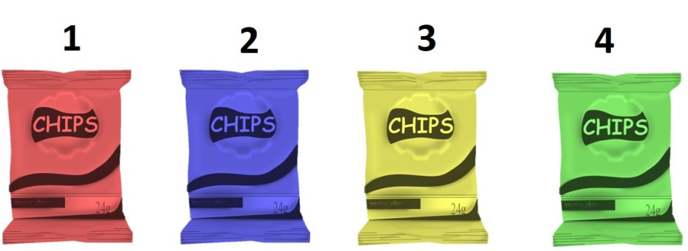
Welke chips viel u het meeste op?
- De chips in de rode verpakking
- De chips in de blauwe verpakking
- De chips in de gele verpakking
- De chips in de groene verpakking
- Er was geen chips die mij meer of minder opviel
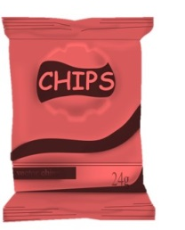

Naturel
Kunt u aangeven wat u verwacht en vindt van bovenstaande chips op de volgende punten:
Zeer slecht slecht matig neutraal redelijk goed zeer goed
Smaak
kwaliteit
Combinatie van de smaak en kleur verpakking
opvallendheid verpakking
Hoe aannemelijk is het dat u bovenstaande chips zou kopen?
- Het is totaal helemaal niet aannemelijk dat ik deze chips zou kopen
- Het is niet aannemelijk dat ik deze chips zou kopen
- Het is weinig aannemelijk dat ik deze chips zou kopen
- Neutraal
- Het is enigszins aannemelijk dat ik deze chips zou kopen
- Het is aannemelijk dat ik deze chips zou kopen
- Het is heel erg aannemelijk dat ik deze chips zou kopen
Hieronder ziet u een afbeelding met 4 chocola verpakkingen. Zodra u de verschillende verpakkingen bekeken heeft kunt u doorklikken naar de volgende pagina:
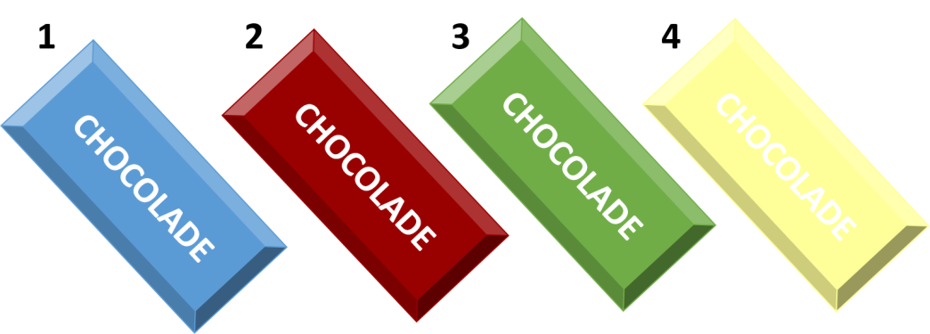

Welke chocola viel u het meeste op?
- De chocola in de blauwe verpakking
- De chocola in de rode verpakking
- De chocola in de groene verpakking
- De chocola in de gele verpakking
- Er was geen chocola die mij meer of minder opviel
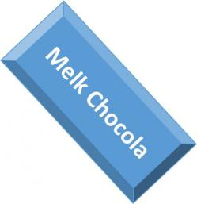

Kunt u aangeven wat u verwacht en vindt van bovenstaande chocola op de volgende punten:
Zeer slecht slecht matig neutraal redelijk goed zeer goed
Smaak
kwaliteit
Combinatie van de smaak en kleur verpakking
opvallendheid verpakking
Hoe aannemelijk is het dat u bovenstaande chocola zou kopen?
- Het is totaal helemaal niet aannemelijk dat ik deze chocola zou kopen
- Het is niet aannemelijk dat ik deze chocola zou kopen
- Het is weinig aannemelijk dat ik deze chocola zou kopen
- Neutraal
- Het is enigszins aannemelijk dat ik deze chocola zou kopen
- Het is aannemelijk dat ik deze chocola zou kopen
- Het is heel erg aannemelijk dat ik deze chocola zou kopen

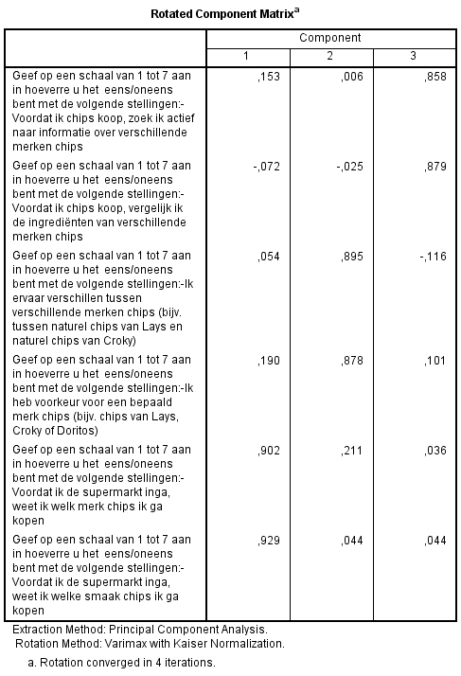
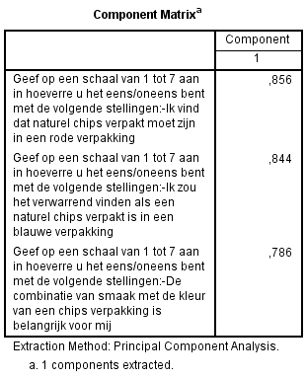
Appendix II (factors of involvement level and strength of color associations to chips)

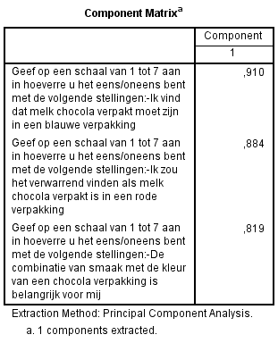
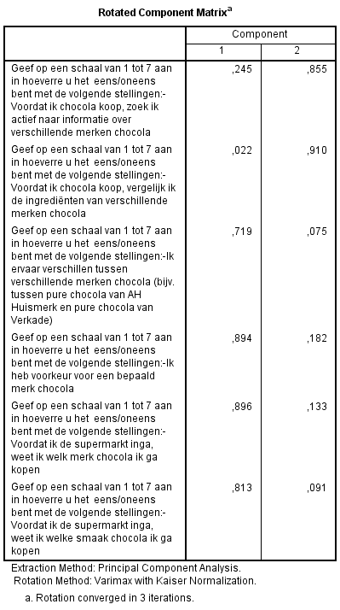
Appendix III (factors of involvement level and strength of color associations to chocolate)

Appendix IV (attention)
Output of the chips category
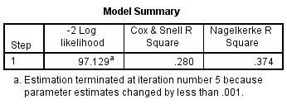

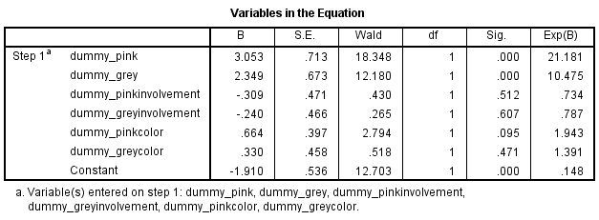

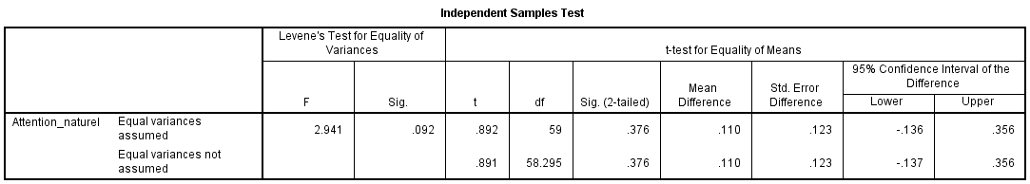
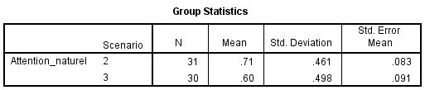
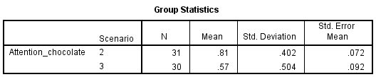
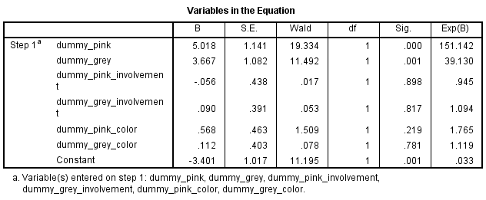
Output of the chocolate category
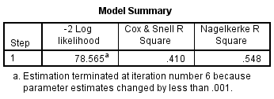
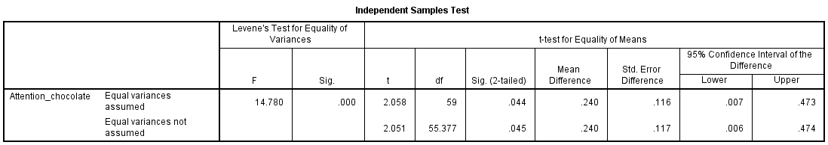

Appendix V (Attitudes)

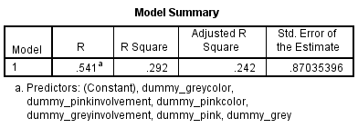
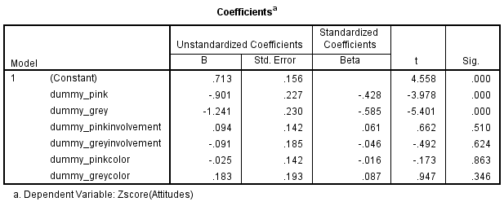
Output of the chips category

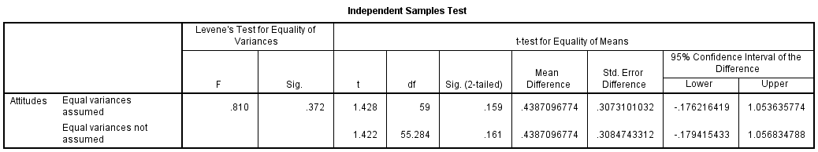
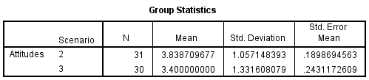

Output of the chocolate category
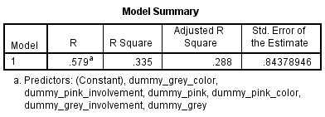
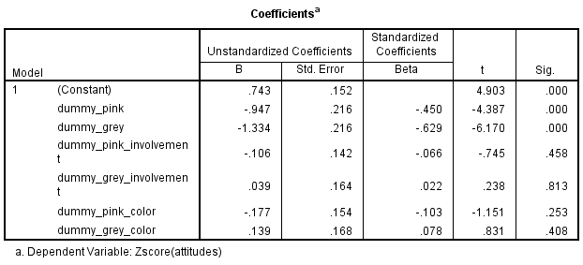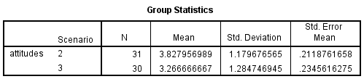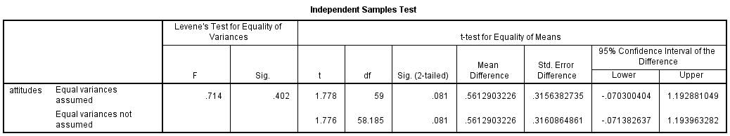

Appendix VI (buying intention)
Output of the chips category
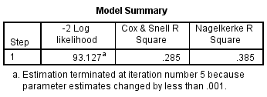
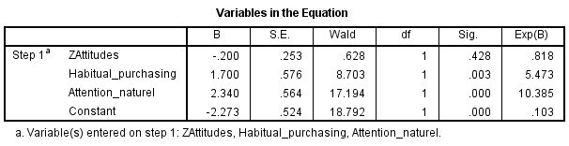

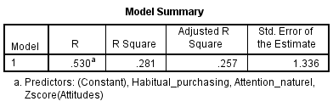
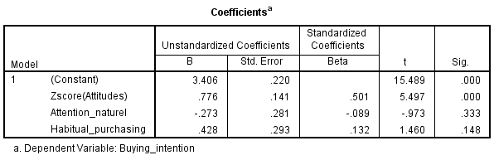
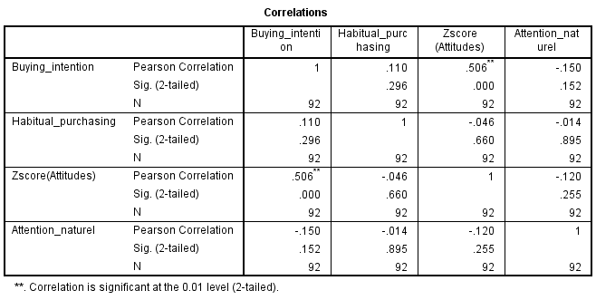

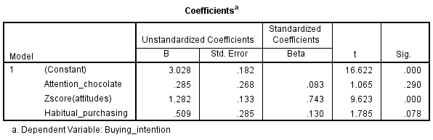
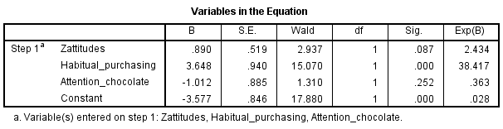
Output of the chocolate category
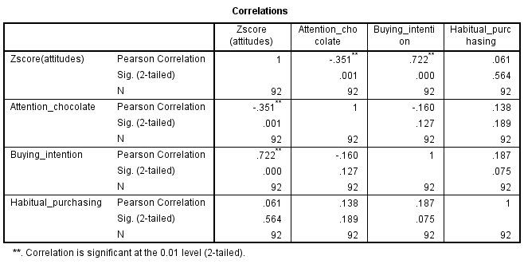
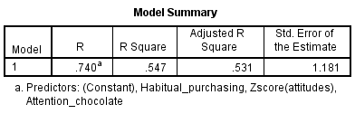
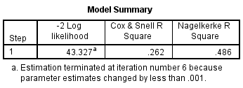

Appendix VII (Anova analysis, differences between means)

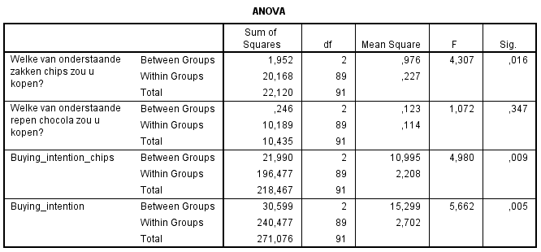

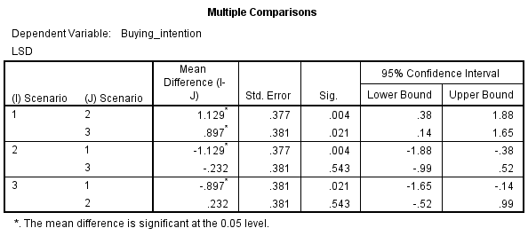
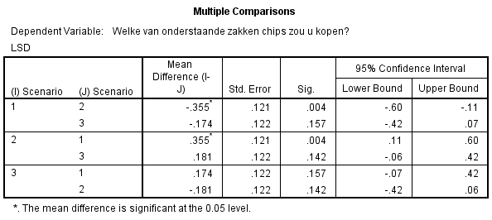
Post hoc tests buying intention model I Post hoc tests buying intention model II
