Erasmus Universiteit Rotterdam
Urban, Port and Transport Economics
Master Thesis

Urban scaling at neighbourhood level: Business start-ups in Amsterdam and Rotterdam

Allard ten Hoopen
402662

Supervisor: Jan-Jelle Witte
Index

1. Introduction 3
1.1 Urban scaling 3
1.2 Scaling at neighbourhood level 4
1.3 Research question and hypothesis 6
1.4 Policy relevance 7
1.5 Organisation 7
2. Business creation at neighbourhood level 8
2.1 Agglomeration effects 8
2.2 The mechanisms of urbanisation effects 9
2.3 The close ties of the neighbourhood and entrepreneurs 13
2.4 Theory and practice: the neighbourhood and business start-ups 17
2.5 Demographics and business creation at neighbourhood level 20
3. Data and methodology 22
3.1 Data and availability 22
3.2 Explained and explanatory variables 28
3.3 Control variables 31
3.4 Methodology 35
3.5 Models 36
4. Results 37
5. Conclusions 40
6. References 42
Appendix: Random effects models 45

Introduction

Urban scaling
The existence of cities may seem like a paradox if one considers their disadvantages. Compared to the countryside that surrounds them they are generally congested, noisy, polluted, suffer from high crime rates, housing is expensive and, for much of their history, were extremely unhealthy to live in. Why would anyone want to live in such a place? And yet they have existed since the dawn of civilization and for one very good reason: cities allow more, and more effective social interactions than when people are living scattered across the land. When large numbers of people are concentrated in a small geographical area, this gives them better access to ideas, services and economic opportunities. Clearly, for many these advantages outweigh the drawbacks of city living. What is more, the relationship between such advantages and city size is thought to be nonlinear. This means that when a city doubles in size its economic performance more than doubles. Generally by an additional 5-15% over what could be expected from a simple doubling (Bettoncourt et al. 2010 and Cervero 2001). Rosenthal and Strange (2004) in their review come up with a slightly lower number of an additional growth of 3-8% specifically for the relationship between population size and productivity.
The number of metrics of urban performance to which these scaling laws have been shown to apply is large. An overview is given in Bettoncourt et al. (2007) that shows scaling effects are particularly strong for indicators related to innovation. Other economic indicators such as wages, total bank deposits and GDP also grow faster than city size. Bettoncourt et al. (2007) also report that infrastructure, such as the amount of road surface or total length of electric cabling, grows slower than city size. This indicates that larger cities are more efficient with their infrastructure than smaller ones. Not all scaling effects are beneficial however, serious crime rates also go up faster than the overall population of a city.
It is important to note that all of these scaling effects are usually measured at the level of the city or even the metropolitan area, so a system of cities. What happens at the lower level of that of the neighbourhood is typically not taken into account. In this thesis it is argued that having a closer look at scaling at the level of the neighbourhood might nevertheless be worthwhile.

Scaling at neighbourhood level
Although urban scaling is well established in economic literature, on its own it actually says little about what cities that benefit from scaling effects look like, other than that they are big. This is somewhat unsatisfying as it just seems counterintuitive that the impact of scaling effects only applies at the level of the city and not at that of the neighbourhoods it is comprised of. Can two cities, each of equal total population, really be expected to perform the same if one consists of largely low-density neighbourhoods while the other is much more densely populated? Probably not. After all, if one argues that the success of larger cities depends on closer proximity to, and therefore easier access to, people, ideas and opportunities, would it then not seem likely that a city with more densely populated neighbourhood offers even better access to more people, more ideas and more opportunities? Therefore it makes sense to want to investigate how population density impacts performance, not just between cities, but within cities; at the level of the neighbourhood.
Nevertheless research into scaling effects at below the level of the metropolitan area is very rare. Cervero (2001) does look at super-districts within the larger San Francisco Bay metropolitan area and finds some evidence for a positive relationship between employment density and productivity. Yet these super districts still represent rather large units that cannot really be compared with the neighbourhoods in the sample used in this thesis. However, the lack of empirical work in the area of scaling effects at neighbourhood level is most likely not due to a lack of interest, but at least partly due to the problem of collecting adequate data. In any case, for the Dutch context suitable data at this level is only available for the last decade or so and anyone wishing to perform research in this area at neighbourhood level at an earlier time would have had considerable difficulty doing so. With the newly available data come new opportunities for research and therefore I believe that the question of whether scaling laws apply at neighbourhood level is one that is now worth looking into in further detail.
So what kind of neighbourhood performance indicator should be the subject of this research? The literature on urban scaling offers a wide range of possible metrics to choose from: average disposable income, employment levels, benefit recipients, crime rates, wages or worker productivity are all interesting in their own right but in practice all come with problems attached. In some cases, the neighbourhood level simply does not seem relevant. In others issues arise from limited data availability or from spatial dependence that sees effects spilling over into other neighbourhoods where they become difficult to detect. Compared to research done at city level, spatial dependence is of particular concern due to the fact that neighbourhoods within a city far less resemble a closed system than a city within a country.
In the end the most promising performance indicator for finding scaling effects at neighbourhood level seems to be the relationship between neighbourhood population density and the number of start-up companies per capita per year. The most important reason is that there is a sufficient basis to suggest that neighbourhood characteristics are important for beginning entrepreneurs, while the geographical reach of their activities is often relatively limited. This should hopefully mean that spatial dependence will be less of a problem.
The economic literature offers a fair bit of encouragement for using business start-ups to find scaling laws at neighbourhood level. On the empirical side, based on earlier theoretical work by Krugman (1991), Acs et al. (2009) show a significant positive effect on entrepreneurship rates from being located in an urban environment. This finding does in itself not indicate much about neighbourhoods, but could still be an indication that more densely populated areas see a relatively high numbers of start-ups. The same is true for Reynolds et al. (1994) who find that at a regional level there is a positive relationship between firm births and population density in the majority of countries they investigated.
Bosma et al. (2008), reporting on Dutch regions, find that density is positively related to start-ups, particularly when they are a subsidiary of an existing business. Raspe et al. (2010) and Sleutjes et al. (2012) are both examples of studies that find at least some evidence that neighbourhoods can have a positive influence on the number of businesses founded there. The strong ties between the neighbourhood and the aspiring entrepreneur are emphasized in Schutjens et al. (2007), suggesting that problems with spatial dependency should be less severe than for the other indicators that could possibly have been used.
On the theoretical side, the literature on agglomeration effects describes how economic activity in general benefits from the proximity of a large number of other people and businesses as found in cities, which should also stimulate start-ups. In particular through knowledge spillovers (Jaffe et al. 1993; Shane 2001). It should be interesting to test whether or not this theoretical framework will also apply at neighbourhood level. A more specific theoretical basis explaining the relevance of high density neighbourhood locations for firm creation is provided by the incubator hypothesis, as first described by Vernon and Hoover (1959) and further expanded upon by Leone and Stuyck (1976). On the practical side it was crucial that complete datasets that include the number of start-ups per year at neighbourhood level could be constructed for both Amsterdam and Rotterdam, thereby automatically determining the choice for these two cities as the location of the research.

Research question and hypothesis
Now that a choice on what should be the explained variable has been made, the following research question can be formulated:
1) What is the relationship between the number of start-up businesses per capita per year and population density and does that relationship provide evidence for scaling effects at neighbourhood level?
Density does not need to be expressed only in terms of population. The presence of existing businesses in the neighbourhood is also potentially relevant to start-ups, motivating to the second research question:
2) What is, at the scale of the neighbourhood, the relationship between the number of start-up businesses per capita per year and density of businesses and do scaling laws apply?
For both of these research questions the following hypothesis applies:
1) That a higher density neighbourhood would be expected to generate more start-ups per capita per year than a lower density one.
In addition, in order to be consistent with the literature on urban scaling the following hypothesis must be confirmed:
2) That the number of start-ups per capita per year will increase faster than the neighbourhood density.

Policy relevance
If these hypotheses could be sufficiently supported, the outcome of this research would have some bearing on what form future urban development should take. From an environmental and efficiency standpoint there have long been arguments to build more compact cities. For example on the negative environmental impacts of urban sprawl, Johnson (2001) mentions among others: a loss of environmentally fragile lands, reduced regional open space, greater air pollution, higher energy consumption, decreased aesthetic appeal of the landscape, loss of farmland, reduced diversity of species, increased runoff of rain, increased risk of flooding, excessive removal of native vegetation and ecosystem fragmentation. Burchell et al. (2002) point to the cost of providing infrastructure and public services under scenarios of uncontrolled urban sprawl. Despite these arguments, also in the Netherlands, many new neighbourhoods continue being built on the edge of existing towns. Part of the reason that such locations are appealing for planners is probably that developing such a ‘greenfield’ sites is, at least in terms of the initial investment, cheaper than redeveloping the existing urban area, where existing property rights, ground pollution and citizen activism can all be complicating factors. If this research can show that apart from environmental and infrastructure costs, high density neighbourhoods could be expected to show stronger economic performance, this could be an additional argument for decision takers to change the way they plan the cities under their responsibility.

Organisation
The remainder of this thesis is organised as follows: section 2 will discuss the theory behind agglomeration effects and the interactions between entrepreneurs and their neighbourhood. Section 3 will start with a description of the relevant variables, then discuss the appropriate estimation methods, before arriving at the final models. Section 4 will discuss the results of these models, while section 5 will hold the conclusions. Finally, the appendix will develop and discuss another set of models that use random effects as an alternative estimation method.

Business creation at neighbourhood level
Obviously people don’t become any more productive, don’t get higher wages, don’t commit more crimes and don’t start more businesses simply because of the fact that they live in close proximity to a large number of other people. Instead population size and density, should be considered proxies for the increased opportunities for social and economic interactions made possible by this proximity. To better understand what these interactions are thought to mean in practice, the following paragraph will give a brief overview of the different types of what are known in the economic literature as ‘agglomeration effects’, or, perhaps somewhat more descriptively, as ‘urban external economies of scale’.

Agglomeration effects
The theory on agglomeration effects is well established; Marshall (1920) already described such fundamental concepts as labor market pooling, input sharing, and knowledge spill overs. Agglomeration effects can be subdivided into two broad categories: ‘localisation effects’ and ‘urbanisation effects’. The difference lies in the fact that localisation effects are defined as external economies of scale that are limited to other firms operating within the same industry. When instead the external economies of scale, resulting from the proximity of large numbers of people and/or businesses, transcend industry boundaries and benefit persons and firms regardless of their particular activities, this is known as urbanization effects.
While many of the suggested mechanisms underlying both localisation- and urbanisation effects (input sharing, knowledge spillovers, labor matching) are largely similar, both views differ markedly in what the resulting urban economy can be expected to look like. Following Marshall (1920), localization effects will lead to specialization of production and a focus on cost savings. Following Jacobs (1969), an area characterised by strong urbanization effects is thought to have a great diversity in people and businesses that can complement each other with a variety of skills, talents and capabilities, facilitating innovation. Which of these views best describes reality is still a matter of debate and in fact evidence suggests that localisation- and urbanisation effects may apply at the same time, although depending on time and place, one may be stronger than the other. In the setting of the Netherlands, which is most relevant for this thesis, Van der Panne (2004) finds that innovation benefits more from specialization than diversity. Bosma et al. (2008) (also for the Netherlands) report that while urbanisation effects do have a positive effect on independent start-ups, the effect of localization effects is stronger. Yet the impact of urbanisation effects is stronger for the formation of subsidiary start-ups.
It is clear however that for the purpose of this thesis the focus must lie with urbanisation effects. This is appropriate because the literature on urban scaling mainly looks at the effects of large concentrations of people, as do urbanisation effects. Localisation effects on the other hand have no real bearing on the research question as by definition, the strength of localization effects is not related to the size of a city or neighbourhood as a whole, but only to the size of the specific local industry cluster. This isn’t to say that localisation effects can’t be a powerful force at neighbourhood level. Clusters of businesses from a particular industry may occur in a neighbourhood sized area that is part of a larger city, as is the case in Grabher (2001), and be important for start-up creation there. However, in this case the setting within a high density neighbourhood is more coincidental and not a prerequisite for localisation effects to apply. In fact, Henderson (1986) observes that industries in which localisation effects are strong will actually tend to concentrate in smaller, highly specialized cities.

The mechanisms of urbanisation effects
In this paragraph the mechanisms by which urbanisation effects are thought to apply will be discussed. However, because the different mechanisms for urbanisation effects were proposed mainly with whole cities and metropolitan areas in mind and not neighbourhoods, apart from just describing how a particular benefit might be derived, it is also necessary to evaluate to what extent they can be expected to apply at neighbourhood level.
Although input sharing (Marshall 1920) usually seems to be taken as a localization effect, it is also possible to find examples of input sharing that are urbanization effects (O’Sullivan 2012). Firms operating in close proximity of each other can share between them all kinds of services, such as banking, accounting and insurance as well as public infrastructure like highways, mass transit, ports, airports and universities regardless of what industry they operate in. Of course as the scale of a city increases such facilities can also benefit from economies of scale making possible lower prices and/or a better range of services. In many cases however neighbourhoods are probably too small to really influence such scale economies. Airports for example are designed to service a whole region or country as are universities. On the other hand it seems entirely reasonable to expect a densely populated neighbourhood to have superior access to public transport and might have superior telecommunications infrastructure. For other types of services the effect of the neighbourhood may vary. Some financial services may be highly specialized and only take place at one central location, but other, less advanced, activities may be more decentralized with access probably best in the denser areas of a city.
Another advantage of higher concentrations of people and businesses is a deeper labor pool. This means that firms seeking to hire new employees can pick from a larger group with a greater variety of skills, making finding the right person for the job a lot easier (Helsley and Strange 1990). A similar advantage can be supposed to extend to job seekers as an area with more businesses should make it easier to find a place of work that matches their skills and interests. However, the labor marker for example is thought to be regional; people are willing to travel substantial distances for the right job (McCann and Simonen 2005). Also according to Marlet and Van Woerkens (2008) the vast majority of employees the Netherlands don’t work in the neighbourhood they live in, the labor market can be considered as operating at city level. Therefore being located in a dense neighbourhood may not be a particular advantage in terms of better access to the labor market.
A further form of urbanisation economies work through knowledge spillovers. In general the close proximity of large numbers of people with diverse backgrounds and talents drives more innovation by more easily allowing the combination, from different sources, of existing pieces of knowledge into something new; a process made famous by Schumpeter (1934) using the German phrase ‘Neue Kombinationen’. In a related way, more knowledge spillovers may be derived by people actively working together on a project through collaborative learning. What this means is that new knowledge can be created by having people solving problems jointly (Dillenbourg 1999). It stands to reason that opportunities for such joint learning should be expected to be higher in denser areas. Furthermore, client feedback, particularly in a business to business setting can be valuable to perfect a new product and this often requires high intensity (face to face) interaction between manufacturer and customer. This makes a location with many potential users closeby that can give feedback advantageous to an innovative company.
While knowledge spillovers should benefit economic activity in general, more significantly for the purpose of this paper, they would seem to play a particularly important role in new firm creation (Dumais, Ellison and Gleaser 2002; Jaffe et al. 1993; Shane 2001). For example through entrepreneurs setting up a spinoff business based on discoveries made by R&D at established firms but not commercialized by them (Cassiman and Ueda 2006). Knowledge exchanges are of course not restricted to the neighbourhood level; in fact technology provides ever expanding opportunities to share information with vast amounts of people across the globe. Still, it is argued by Storper and Venables (2004) that even in the age of the internet face-to-face contact is unmatched as a way to efficiently exchange ideas. This is especially true for what is known as ‘tacit knowledge’; a kind of knowledge that is not easily codified, such as by writing it down, and is only transmitted through social interaction. This explains why local concentrations of talented people will remain important for developing new ideas. The vital role face-to-face contact plays in innovation is also emphasized in McCann and Simonen (2005). The question then becomes one of the extent of the geographical reach of these physical knowledge exchanges. Of course it is possible to travel great distances to meet someone, but the more regular contact needs to be, the more practical it becomes to be living in close proximity to each other. It is also entirely plausible that key contacts are made during neighbourhood activities, like when bringing the children to school or when having a drink in the local bar. Such contacts could also be made outside of the neighbourhood, but such encounters should be more likely in areas where people come often anyway: close to where they live. It may therefore well be the case that for much face-to-face knowledge exchanges the neighbourhood is indeed an important level and that such exchanges are more intense in high density neighbourhoods.
A special case of shared inputs comes in the form of access to venture capital. Although it is possible in principle to invest in something from anywhere in the world, before putting money in a new (high risk) project or business, investors typically will want to speak to the entrepreneurs in person, see their business plan and inspect the facilities already present (Sorensen and Stuart 2001). Close proximity might also help investors better understand what the local market looks like to get a better idea about the opportunities and risks of a particular venture. Even once the initial investment has been made it remains desirable to keep a close eye on the operations of the business, which is likely to require a substantial degree of face-to-face involvement on the part of the venture capitalist. However it seems that the level at which venture capitalists operate is generally higher than that of the neighbourhood. The reason for this, it seems, is not that face-to-face contact is not important, but that suitable investment opportunities are too rare at the local level, forcing investors to look further afield (Fritsch and Schilder 2006). Fritsch and Schilder also provide evidence that venture capitalists in Germany work all across the country, while Petersen and Rajan (2002) find that in the US the distances over which small firms are able to obtain loans are increasing. Therefore it seems unlikely that the characteristics of the neighbourhood will have much influence on the amount of potential investors local entrepreneurs will be able to contact. If an entrepreneur can come up with a worthwhile project it seems venture capitalists are willing to do the necessary legwork to monitor their investment and distance will be less of an issue.
One more type of urbanization effect is known as the home market effect. Moving goods and services over long distances can be costly and therefore it should often be beneficial for a business to locate close to a large concentration of consumers of its products (Krugman 1980). The main prediction of Krugman’s model is that production of a particular good will, given increasing returns to scale, concentrate in a country with the highest domestic demand for that good. Although Krugman was principally interested in explaining patterns of international trade, it seems that this idea can be transferable to the city level for those businesses that only have the city as their target market. Even when the target market of a business is just the city level, it still makes sense to choose a location where the demand for its product is highest, minimizing the effort taken travelling to and from it. And it is not difficult to argue that the areas within the city where demand is likely to be highest are those areas that have the highest concentrations of potential customers. And these are of course to be found in high density neighbourhoods. Therefore, the home market effect seems quite likely to also have an impact at neighbourhood level.
Ultimately the question of to what extend urbanisation effects occur at the level of the city or at that of the neighbourhood is one of geographical reach, as it seems there can be little doubt that urbanisation effects occur at some level, but what level dominates depends highly on how much time people are willing to spend travelling in order to physically meet another person. This of course also depends on the kind of activity involved. However the more intense and diverse the need face-to face contact becomes, the lower the geographical reach of people is likely to be. Otherwise too much time is lost travelling. For activities that require intensive personal interaction, the neighbourhood therefore might still be a highly relevant level of analysis.

The close ties of the neighbourhood and entrepreneurs
In the previous section it was shown that although clearly not all types of urbanisation effects identified in the literature can be expected to apply (fully) at neighbourhood level there are still enough mechanisms by which high density could plausibly be beneficial to the economic performance of a neighbourhood. These effects might apply to a wide range of metrics but finding scaling effects for them may in many cases be problematic. However, this may be less of an issue with regards to the number of start-ups per year per capita, as the literature suggests that, especially in the early phase, entrepreneurship is tied strongly to highly local factors (Johannisson 2011). This does not imply that influences from outside the neighbourhood do not have any bearing on start-up decisions, but it does mean that, more than for other indicators of economic performance, the neighbourhood matters. In what ways it matters is the subject of this section.
One aspect that might cause new entrepreneurs to be relatively strongly influenced by factors at the neighbourhood level is that for over 50% of business start-ups, the home of the entrepreneur is chosen as start-up location. The reasons are that the home is cheap, involves little risks and allows work to be conveniently combined with other activities (Schutjens et al. 2007). Because they live and work in a relatively limited geographical area, there should be a high chance that productive exchanges that (prospective) entrepreneurs might have will involve people from the same neighbourhood. The number and quality of such opportunities offered by the neighbourhood, which should be highest in a densely populated one, might therefore be an important factor.
Moreover, the frequency with which the home is chosen as a start-up location is probably increasing. Sleutjes et al. (2012) give three reasons why this might be the case. First, they note a trend by larger companies to outsource certain activities to freelancers (see Figure 1). It is clear that both the absolute number of freelancers as well as their relative share of the total work force has indeed been increasing steadily over the last decade or so, with little indication of this trend slowing down. The increase of freelancers means an increase of small scale firms, focussed primarily on business services, which will often operate from home. Second, the internet decreases importance of location and the need for a formal shop or office. Third, people increasingly seem to appreciate the independence and flexibility of being an entrepreneur that allows them to combine their work with other tasks. As more businesses are being started from home, the local factors of the neighbourhood should become more important to more entrepreneurs.

Figure 1: Development over time of the number and share of freelancers in the Netherlands (source: CBS (2014))

The relatively limited geographical reach of entrepreneurs is further illustrated in Malecki (1997) who finds that most of their interactions with business contacts take place inside an area that can be reached within 30 minutes of travel time. The actual distance that can be covered within that time will of course depend on the topography of the land and the quality of the infrastructure and will most likely not be the same in every direction. Clearly though, in most cities the area that can be reached in 30 minutes will extend beyond the boundaries of the neighbourhood. On the other hand, it is clear that the neighbourhood and the directly adjacent areas will make up a substantial part of the area that entrepreneurs are apparently typically willing to travel. Therefore, this reinforces the idea that the neighbourhood should be a suitable level to measure scaling effects, although inevitably some interaction with other neighbourhoods will occur.
Of course the counter argument might be made here that with such a large share of businesses being started from home, it might seem that the decision to locate in a particular neighbourhood is often based simply on the fact that the entrepreneur is living there already anyway and that the characteristics of the neighbourhood don’t matter so much in firm creation as in many cases the starting location is already given. However, provided that the geographical reach of urbanisation effects is indeed short, for the people who happen to live in a neighbourhood with favourable characteristics, the decision to become an entrepreneur could be relatively easy as their location gives them better access to opportunities that would not have been available had they been living somewhere else. Therefore, despite the fact that choice of where to start a business will often be subject to constraints it still seems a reasonable expectation to think that the neighbourhood can make a difference to entrepreneurs.
At this point reader might consider the number of start-ups per capita a useful indicator of neighbourhood performance, but still be unsure about why this and not some other measure is being used. What makes start-ups such a practical measure is that the assumption that entrepreneurs live and work in places and interact with contacts that are for the most part located within the same neighbourhood means that the (prospective) entrepreneur is not just a passer-by, but someone who is continuously interacting with and being influenced by the neighbourhood. Therefore, it can be reasonably expected that the characteristics of their neighbourhood as measured will indeed be an accurate representation of the forces affecting these entrepreneurs and their decision to start a business. This is in contrast to some of the other measures of neighbourhood performance where the relationship between a particular variable and observed economic outcome might be more accidental. To illustrate this problem, take for example the average neighbourhood income. The common conception of a high-wealth neighbourhood would probably be one of low to medium density areas which is at odds with the idea that high density neighbourhoods generate more wealth. That there could well be a problem trying to use income as explained variable seems to be confirmed in figure 2 that shows the relationship between population density and average income in 2012 for all four major Dutch cities, Amsterdam, Rotterdam, Den Haag and Utrecht. Apparently, persons with a high income will tend to prefer living in low to medium density areas. Yet, even though they may live elsewhere, high income people may still benefit from the opportunities offered by high density areas. It just makes it very difficult to find the relationship, making income a less practical choice to use as explained variable. Issues also exist with some other potential indicators of neighbourhood performance. Employment will be problematic because people typically don’t work in the same neighbourhood they live in (Marlet and Van Woerkens 2008); innovation rate has difficulties with data availability. Given these problems, the choice for the number of start-ups per year per capita as dependent variable was a relatively easy one.

Figure 2: Population density and average disposable income in major Dutch cities (source: CBS (2014))

Theory and practice: the neighbourhood and business start-ups
Having established that aspiring entrepreneurs are likely to be closely tied to their neighbourhood, it is time to look at this relationship more closely. A common theme in the literature on business start-ups is that although a large share of firms may be started in high density central locations, not that many actually survive and grow there. It seems the role of the neighbourhood in the life-cycle of a business is mostly one of a breeding ground and not so much as one of a place where they come to maturity.
The incubator hypothesis, originating with Vernon and Hoover (1959), focusses specifically on why high density central locations within a city might act as breeding grounds for new businesses. They believe such areas best provide what a newly founded company needs: ample rentable production space, access to raw materials, labour, and other services. This idea is further expanded upon in Leone and Struyk (1976). Using data from the New York City Metropolitan Area they hypothesize that central urban locations will be characterized by a relatively large number of new businesses being founded and a tendency by successful mature firms to relocate to more decentralised locations in order to find more space for expansion. Leone and Struyk find that while the number of businesses founded in core areas is large, it is not disproportionately higher compared to other areas. Nevertheless, they conclude that central (so rich in both people and businesses) neighbourhoods may play a vital role in creating economic growth as they find that plants founded in the central business district of over three years old that move to a new, more peripheral, location show the highest growth of all businesses they investigated. This last finding is an indication that the opportunities offered by a central urban location could represent important advantages for newly founded businesses inside a central business district, even if these only become apparent in the data after the business has moved elsewhere. It is also apparent that according to this view, high density locations are not necessarily optimal for all businesses in any phase of their existence, but can be so, particularly for newly established firms
Although the overall effect of the neighbourhood is not very big compared to the individual characteristics of the start-up business, the above findings are for the most part confirmed in Raspe et al. (2010), but with one key difference. Studying Dutch urban neighbourhoods (with a minimum population of 500), it is found that the number of start-ups in urban neighbourhoods is relatively high compared to other areas within the Netherlands, providing empirical evidence to suggest that high population areas may indeed be better at generating new businesses, although the link with density is not explicitly made. It is true however that the businesses involved are mostly small- or medium-sized and like in Leone and Struyk most of them do not grow very much until after they move away from the neighbourhood from which they originate. Within the neighbourhood itself, while there are relatively many new businesses being started, many others are being closed, so the net effect of business creation on employment inside the neighbourhood is marginal. It would be an interesting topic for further research to see if business founded in high density neighbourhoods fundamentally differ from those founded elsewhere in their degree of innovation, growth and employment. However, such a comparison of quality vs. quantity of newly established businesses is beyond the scope of this thesis.
While there is then some evidence that urban locations see more businesses being established (although not whether differences in density between neighbourhoods have any effect), after reading all these findings one may start to wonder if urban neighbourhoods are actually a good place to start a business. However, the high closure rates, lack of growth and migration of successful start-ups do not necessarily indicate that something is wrong. Firstly, the large number of business closures in neighbourhoods is most likely just a result of the high numbers of business being founded there as new businesses in general have a higher probability of failure than more mature ones. As mature businesses tend to move away from central locations, such areas have a relatively high share of companies in the most vulnerable phase of their existence, hence the high closure rates. Secondly, the low growth of businesses in urban neighbourhoods is in many cases either entirely in line with the ambitions of the founders or due to limited space for expansion. Lack of space to expand may seem like a disadvantage, but large premises are not really a priority for start-up businesses. In fact, as noted before, many entrepreneurs initiate their business from their own residence as this is simply the most convenient and cheapest way to get some work space. This means that, of course depending on the type of industry, in order to fulfil the role of breeding ground for new businesses neighbourhoods may not need large scale office developments or business parks. Those are for more mature businesses. For start-up entrepreneurs it may often be enough to have couple of rooms in the private home and in this respect neighbourhoods with a residential character should offer more opportunities than locations more specialized in formal business accommodations.
One issue that remains is whether the number of start-ups depends primarily on the demographics of the neighbourhood, or mainly on the number of businesses that already exist there. An arguments in favour of the latter view is that depending on the type of target market of the start-up, other businesses may be among its potential customers and may also offer increased opportunities for knowledge spillovers and input sharing. It also turns out that many entrepreneurs like to establish their new business near locations where they have worked previously as an employee (Trettin and Welter 2011), thereby increasing the likelihood of new businesses being founded near already established firms. Raspe et al. (2010) remark however that former employees starting a new business close by to their old employer is unlikely to be an important factor in firm creation at neighbourhood level because most people do not actually work in the same neighbourhood they live in. Instead they consider it likelier that the number of start-ups depends more on the size of the workforce as this determines the number of potential entrepreneurs. Following this reasoning, the number of businesses in the neighbourhood might be a relevant factor, but at least as important are the demographic factors of the workforce that determine the likelihood of people becoming entrepreneurs. These demographics are the subject of the next section.

Demographics and business creation at neighbourhood level
Apart from population density there are a number of other demographic characteristics commonly used in empirical research that could plausibly affect the rate of business creation at neighbourhood level. Specifically: age, education level, average household income, neighbourhood employment level, diversity and ethnic composition. As these might make useful control variables, the purpose of this section is to explore in what way they might be expected to influence the number of start-ups.
The first demographic indicator describing the chance of people becoming entrepreneurs is the age structure of the workforce of the neighbourhood (Raspe et al. 2010; Acs et al. 2009; Sleutjes et al. 2012). People are not at every time in their life equally likely to begin their own business. Younger persons may lack the relevant work experience and necessary capital. Conversely, older people may no longer be as creative as they once were and may a have reduced capacity for acquiring new skills. These factors combine to make people around 40 years of age the most likely age group to start a business (Bönte et al. 2009).
Another factor is the education level of the workforce (Raspe et al. 2010; Sleutjes et al. 2012). The underlying idea is that a higher amount of human capital enables a person to better identify economic opportunities and exploit them successfully. Education level is considered to be an imperfect proxy for human capital as it doesn’t take into account work experience and other informal training, but is still seen as a useful indicator (Raspe et al. 2010).
The next factor is neighbourhood household income. It is obvious that starting a business costs money and that raising the necessary capital will be easier for someone with a higher income. However, people that hold a well-paying job may be less inclined to face the uncertainties of being an entrepreneur (Bosma et al. 2008). Neighbourhood income may also be important in another way as Sleutjes et al. (2012) argue that higher income neighbourhoods may be particularly attractive to entrepreneurs given that it has a population that has ample money to spend and the generally lower amount of social problems in the area.
The neighbourhood employment level might be another way demographics influence stat-up creation, however whether the overall effect is positive or negative is unclear (Storey 1991). On the one hand, unemployed persons may see entrepreneurship as an opportunity to become active again when the chances of finding a job appear low. That this can actually happen (although not specifically investigated at neighbourhood level) is supported in Evans and Leighton (1990) and Reynolds et al. (1994). On the other hand, the ‘discouraged worker effect’ suggests that unemployed people may not really be motivated to become an entrepreneur by the fact that they are without a job. Moreover, related to the income argument, even if he wished to do so, an unemployed person may often lack the financial means to begin a business. Among studies that report a negative relationship between unemployment rates and business creation are Raspe et al. (2010) that looks specifically at the neighbourhood level and Audretsch (1995).
Building on Jacobs (1969), diversity within a geographical area may also play a role in promoting higher rates of entrepreneurship. The argument is that more diversity, of people and firms, also means that a greater diversity of knowledge is available and so the ideas of one person might be more easily complemented by those of another, leading to increased knowledge spillovers. Insofar as knowledge spillovers indeed contribute to business creation at neighbourhood level this should mean that more diverse neighbourhoods have more start-ups.
A final factor, at least in the Dutch context, that may influence the amount of start-ups in a neighbourhood is ethnicity (Van den Tillaart 2007). For a variety a reasons, people from certain ethnic backgrounds may be more likely to begin a business than other, even after controlling for all other factors already mentioned in this section. With data on the ethnic composition of the neighbourhood available this might be an interesting control variable.

Data and methodology

Data and availability
The research subjects of this thesis are the neighbourhoods of the cities of Amsterdam and Rotterdam. The choice for these two cities was driven firstly by the wish to investigate urban scaling in a Dutch context and secondly by data availability. CBS Statline is a convenient source of data for neighbourhoods in all municipalities in the Netherlands. However, some of the key variables used in the model, like the number of start-ups itself, were not available from there. The municipalities of Amsterdam and Rotterdam both possess their own research and statistics departments that do collect the necessary data and were kind enough to make this available to me. Obtaining data for other cities proved less successful and while this will of course have some implications for the validity of extrapolating any results, at least the sample size available for Amsterdam and Rotterdam should still be enough to make statistically significant estimation results possible, provided there are any to be found. Also, Amsterdam and Rotterdam, being the largest cities in the Netherlands, have some of the most urbanized areas in country. Therefore, if urbanization effects are going to be found at all, it should be in the neighbourhoods of these cities. The observation period is for the years 2004-2010. Data on earlier years was simply not available, while later years had some data, but this did not include all neighbourhoods for Amsterdam and for Rotterdam there was some indication that the recording of the number of start-ups had not yet been fully completed. To avoid any potential complications due to data reliability it was deemed better to drop these later observations.
One limitation due to data compared to earlier studies on business creation at neighbourhood level, specifically Raspe et al. (2010) and Sleutjes et al. (2012), is the unavailability of detailed information on businesses at neighbourhood level form the LISA foundation. This makes it impossible to control for the specific characteristics of the businesses in a neighbourhood, but unfortunately this could not be helped. Another limitation is that a good indicator of education levels at neighbourhood level is lacking, so this rather important factor could not be controlled for. Also, unemployment is not measured at neighbourhood level. Using the share of unemployment benefit recipients would have seemed a good alternative, but it was dropped from the final models because it was consistently highly statistically insignificant. This doesn’t necessarily mean that unemployment levels are unimportant, it could also be that benefit recipients are somehow not a very good alternative.
Next, it is necessary to define what an ‘urban neighbourhood’ actually is, because not every area within a city is suitable for inclusion in the sample even though it is officially classified as a neighbourhood. The reason for this is that the forces driving business creation in very low population areas are likely to be very different from those in higher population ones. For example the uninhabited Maasvlakte area in Rotterdam will attract many business owing to its excellent port facilities. Including such an area in the sample could lead to the dubious conclusion that low population density is good for business creation while in fact urbanisation effects simply do not apply there. One, somewhat arbitrary, definition for a neighbourhood sometimes used in other works is given by Wittebrood and Van Dijk (2007). They define an urban neighbourhood as a four-digit zip code area with at least 500 residences in it. The neighbourhoods that are used as the geographical unit in this thesis are probably on average slightly larger. Nevertheless I’ve chosen to use a minimum of 500 residences as cut-off point for inclusion in the sample as this number seems to do a reasonable job at getting rid of those areas that are mostly rural or industrial or that include extensive port facilities.
The resulting data sample takes the form of panel data and includes a total number of distinct neighbourhoods of 90 for Amsterdam and 67 for Rotterdam. The subdivision of the two cities into neighbourhoods is shown in figures 3 and 4. Red neighbourhoods fall below the 500 residence threshold and are not included in the sample. In principle all blue neighbourhoods are included in the sample, but some neighbourhoods were only created after the 2004 observation starting date and therefore could not be included for all years.
Looking at table 1 to make a quick comparison between the two cities in the sample, it is noticeable that neighbourhoods in Amsterdam are generally considerably denser than those in Rotterdam. There are on average more start-ups per capita, more people, more businesses and more addresses. The population of Rotterdam is on average a bit younger and has a higher share of non-western immigrants. Meanwhile Amsterdam has more western immigrants and housing prices are on average substantially higher. Accessibility, by road and by train, seems to be almost equal although of course the data does not tell much about the quality of the reported infrastructure. In all, considering these differences, urbanisation effects, if any exist, are probably stronger and more likely to be found in Amsterdam than in Rotterdam.
One important variable from a theoretical standpoint that simply could not be included due to lack of data was education. This is unfortunate because this variable might have helped make a stronger model, but there is little that can be done about this.

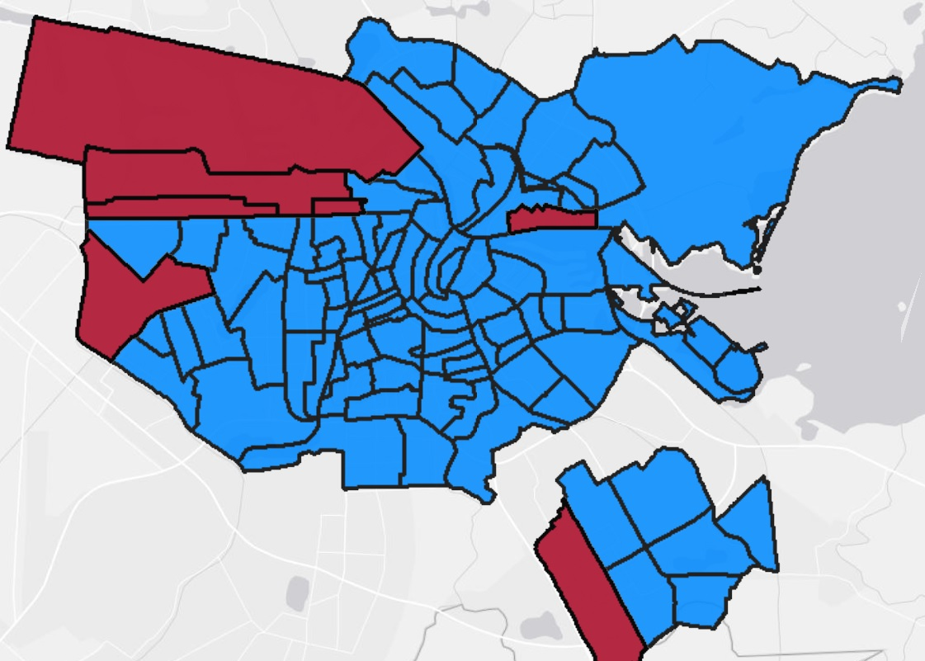
Figure 3: Neighbourhoods of Amsterdam according to CBS.
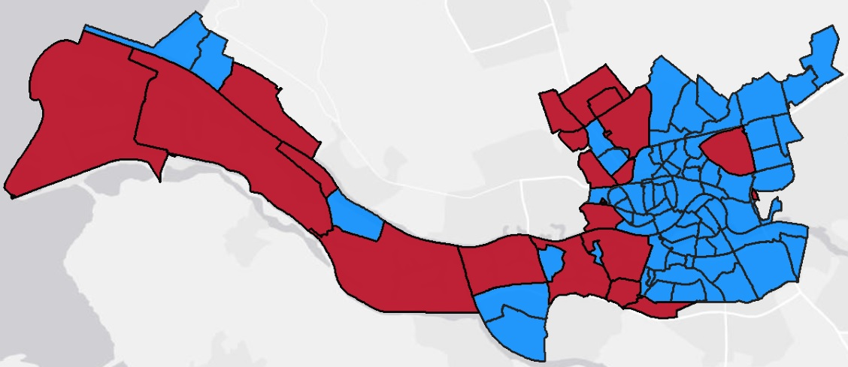
Figure 4: Neighbourhoods of Rotterdam according to CBS.

Table 1: Definition, sources and summary statistics of explained and explanatory variables
 |  | Rotterdam |  |  | Amsterdam
Variable | Definition | Source | Mean | Standard deviation | Source | Mean | Standard deviation
Start-ups per year per capita | Yearly number of newly founded businesses per capita in the neighbourhood. | RIC | 0.0042262 | 0.004534 | O+S | 0.0093 | 0.0055
Businesses density (km²) | Total number of businesses in the neighbourhood on January 1 divided by land surface area. | RIC | 3.541709 | 3.043118 | O+S | 11.3872 | 10.6946
Population density (km²) | Neighbourhood population on January 1 divided by land surface area. | CBS | 8689.7 | 5443.9 | CBS | 11371.0 | 7054.8
Average addresses per km² | For every addresses the density of addresses within a 1 km radius is calculated. Then for all addresses within the neighbourhood the average is taken. | CBS | 3815.2 | 1920.5 | CBS | 6040.0 | 3296.4
Income | Average disposable household income. | RIC | 28833.9 | 8111.0 | N/A | - | -
Population age | Share of neighbourhood population in age bracket 25-45 on January 1. | CBS | 33.0 | 7.7 | CBS | 36.9 | 8.5
Immigrants | Immigrants on January 1 as percentage of total neighbourhood population. | CBS |  |  | CBS
 | Total western |  | 10.9 | 3.6 |  | 15.6 | 6.1
 | Total non-western |  | 34.6 | 20.6 |  | 28.7 | 18.7
Table 1 (continued): Definition, sources and summary statistics of explained and explanatory variables
 |  | Rotterdam |  |  | Amsterdam
Variable | Definition | Source | Mean | Standard deviation | Source | Mean | Standard deviation
Housing value | Average housing value (in €1000) according to tax evaluation per January 1. | CBS | 156.4 | 76.1 | CBS | 233.4 | 111.7
Distance to train station | Average road distance to nearest train station for all residents. | CBS | 2.8 | 2.0 | CBS | 2.6 | 1.5
Distance to main road | Average road distance to nearest main road for all residents. | CBS | 2.1 | 1.0 | CBS | 2.1 | 1.0
Note: CBS: Centraal Bureau voor de Statistiek; O+S: Bureau Onderzoek en Statistiek; RIC: Rotterdam in Cijfers

Explained and explanatory variables
This section will give a short overview of the main variables to be used in the various models.
The variable that is to be explained is of course the number of start-ups per year per capita (in short: start-up density). Three explanatory variables will be considered: population density; businesses density and the average number of addresses per km². If a positive relationship can be found with the dependent variable, this would provide evidence in favour of urbanisation effects at neighbourhood level. To also be in line with results on urban scaling their coefficient should at least be larger than 1. Population density and business density simply measure what their name suggests, and can be used in a model as complements. However, the address density, used in a separate set of models, may need some elaboration. This variable is calculated by measuring, for every address in the neighbourhood, the number of addresses (of both businesses and residences) within a 1 km radius. These numbers are then averaged across all neighbourhoods to calculate the address density. Significantly this also includes addresses located outside of the neighbourhood, thereby taking into account spatial dependency issues. Of course the downside is that the impact of the density of businesses and population can’t be separated using this measure, which is why the impact of business and population density is estimated as well in a separate model.
In order to get a more intuitive feel for the relation between the start-ups per capita and the explanatory variables, this is shown for all years in the scatter plots in figures 5, 6 and 7. Notably, at first sight only for business density does the relationship appear to be clearly positive. For population density and address density the relationship is much less clear.
Maybe it’s good to take one step back at this point and ask why one would use measures based on density and not just the absolute values, i.e. start-ups per year, population size or the number of businesses? The reason for this is that in a nice illustration of the modifiable areal unit problem as described by Openshaw (1983), for example
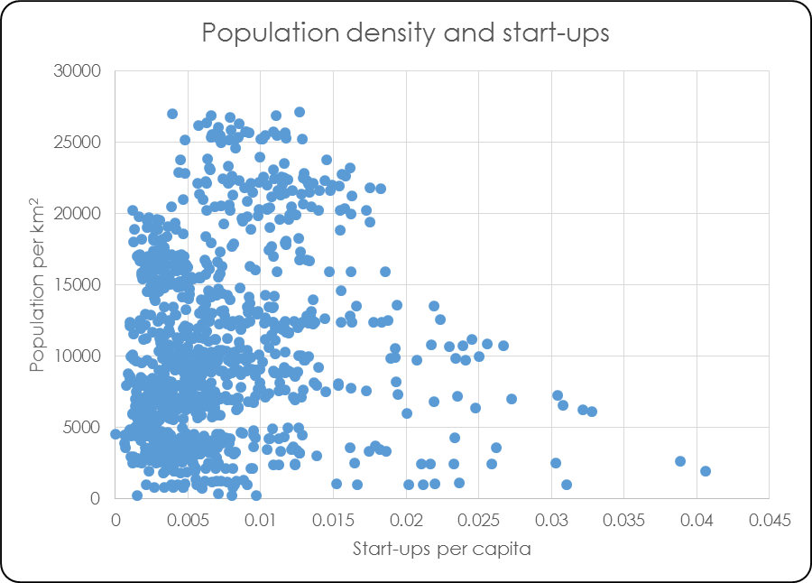
Figure 5: Population per km² and start-ups per year per capita
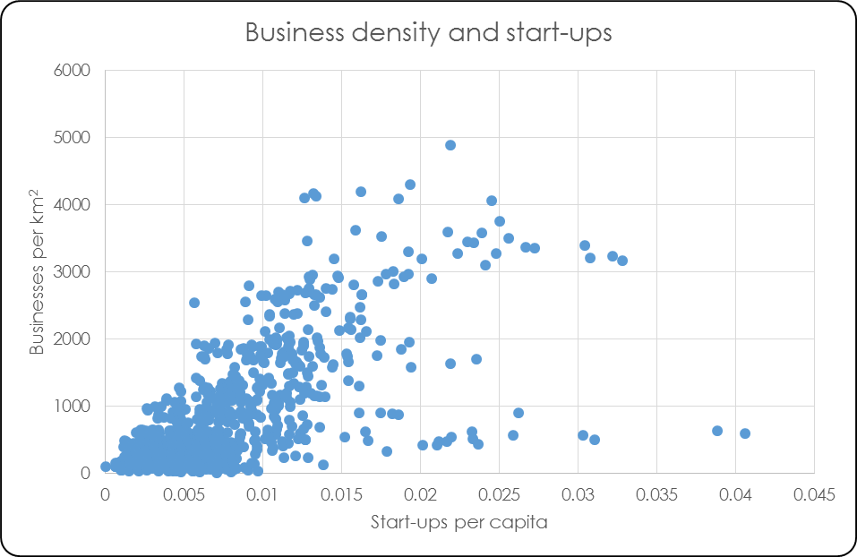
Figure 6: Businesses per km² and stat-ups per year per capita
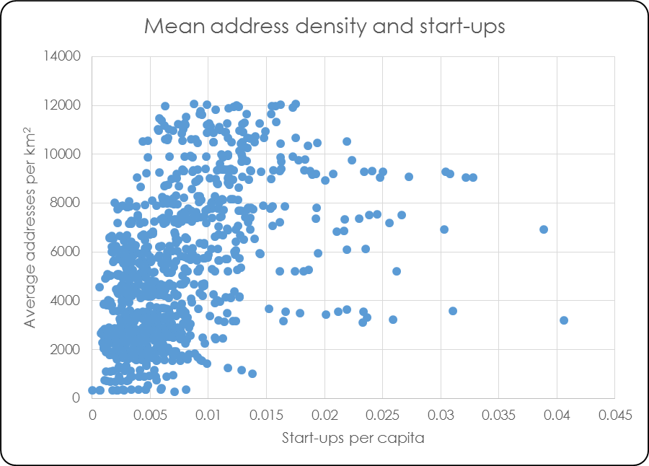
Figure 7:Average addresses per km² and start-ups per year per capita

population size itself, means very little at neighbourhood level because it depends on an arbitrary subdivision of the city that could have been done differently without any changes to the actual characteristics of the area. Imagine a city that is divided into two neighbourhoods of equal size and density, and the border between them is located in the middle. Then both neighbourhoods would have the same number of residents. If the border is then moved, one would become larger at the expense of the other. Of course it would make no sense to suppose that the performance of either neighbourhood would have changed in any meaningful way as a result of such an adjustment even though one is now more populous than the other. Therefore, a measure of density should be taken for the main variables to correct for the arbitrary size of neighbourhoods.
Using density based variables (although apparently not of the kind used in this thesis) to study agglomeration effects has some precedent in the literature. One is found in Ciccone and Hall (1996) who report how employment density benefits worker productivity. However they work with data from the USA at county level, so results are difficult to compare directly to those in this thesis. Carlino and Hunt (2009) also use employment density and find that a higher density considerably boosts the number of patents granted, and work on the level of whole metropolitan areas.

Control variables
In addition to the explanatory variables a number of control variables should be included in the models to account for factors that could influence the number of business being established that have nothing to do with the density of the neighbourhood. The theory behind these has for the most part already been discussed in section 2.4. This section is only meant to give a short description of how these theoretical concepts are operationalized with variables in the model and discusses the expected direction of the effects they might have (see table 2) on start-up rates. Note that the final three variables (distance to train station, distance to main road and Amsterdam) are only used in the random effects estimations in the appendix, but they will nevertheless be discussed here briefly.
The age structure of the neighbourhood population is taken into account by including the percentage of the population in the age bracket of 25 to 45 years of age; the group that is most likely to start a business. The higher the share of this age group within the total neighbourhood population, the more business can be expected to be founded.
The size of ethnic groups as a share of the total neighbourhood population can be used to control for the possibility that certain immigrant groups may be especially likely to become entrepreneurs. Although more detailed data on ethnic composition was available, high correlation between the presence of various ethnic groups meant that it was impractical to include every one of them separately into the model. Instead, two broader categories are included, western and non-western
Table 2: Expected Signs of explanatory and control variables
Explanatory variable | Expected sign
Businesses density (km²) | +
Population density (km²) | +
Average addresses per km² | +
Share of population aged 25-45 | +
Share non-western immigrants | +
Share western immigrants | ?
Housing value | ?
Distance to train station | -
Distance to main road | -
Amsterdam | +

immigrants. Of these, the literature would suggest that members of certain non-western groups are especially likely to start a business, so a positive relationship would be expected. For western immigrants the expected effect is not as clear, but since the data is available it would be interesting to see its effect in the model.
As data on average neighbourhood income was not available due to a break in measurement method halfway the observation period, the average housing value will be used as a substitute as these two factors appear to be highly correlated. As noted earlier, arguments can made as to how the wealth of a neighbourhood can work to both encourage and discourage business formation and so what net effect of this variable should be expected is an open question.
The final three variables can only be used for random effects estimations because they (almost) do not vary over time and will therefore be dropped from the estimation in a fixed effects model.
To measure the accessibility of a neighbourhood that could affect its attractiveness as a location for founding a business, the distances to both the nearest main road and the nearest train station can be used. The measure is somewhat imperfect because such a value does not take into account the number of connections available at that train station or the number of places that can be reached in a convenient amount of time along that main road, but no better measure was available. One minor concern is that for both cities the distances to main roads and railway stations are not measured annually. In order to avoid too many missing data points these have been extrapolated using the nearest known values. This seems acceptable as variables such as these are unlikely to change very rapidly, but this could nevertheless cause some inaccuracies. Overall a shorter distance to important infrastructure should be better for accessibility which is why both variables are expected to show a negative sign.
The variable ‘Amsterdam’ is included in the random effects model as a dummy to differentiate between neighbourhoods in Amsterdam and Rotterdam and control for factors that might make the one or the other more likely to generate new businesses.
The final variables to be included are year dummies that control for factors that may make one year more likely to see businesses founded than others such as changes in regulation or fluctuations in GDP growth. Another reason start-up numbers might change from year to year might be the increasing amount of freelancers. Because of this later years are likely to have more start-ups compared to earlier ones.
In order to check for potential issues with multicollinearity a correlation matrix is provided in table 3. If some of the explanatory variables are highly correlated (so with a correlation close 1 or -1) with each other this could cause the estimated coefficients of these variables to shift by a large degree based on relatively minor changes in the data. That would in turn make it uncertain what part of the combined effect should be attributed to the one or the other variable. However, the highest correlation between variables that are included together in a model is that between ln(business density) and ln(population density) is only 0.7232. This is probably not high enough to cause problems, although there is no commonly agreed cut off point to decide whether collinearity is a problem or not.
Table 3: Correlation matrix of all used variables
 | ln(start-ups/cap) | ln(Bus. dens) | ln(Pop. dens) | ln(M. addr./km²) | ln(Dist. station) | ln(Dist. road | ln(Pop. 25-45) | ln(M. housing val.) | ln(Share non-west. imm.) | ln(Share west. imm.) | Amsterdam
ln(Start-ups per capita) | 1
ln(Businesses density (km²)) | 0.6907 | 1
ln(Population density (km²)) | 0.1458 | 0.7232 | 1
ln(Mean addresses per km²) | 0.5035 | 0.8716 | 0.7559 | 1
ln(Distance to train station) | -0.313 | -0.4279 | -0.2597 | -0.4952 | 1
ln(Distance to main road | 0.1353 | 0.3424 | 0.2742 | 0.2355 | -0.0986 | 1
ln(Population between 25-45) | 0.5545 | 0.6897 | 0.5223 | 0.6386 | -0.3863 | 0.1235 | 1
ln(Mean housing value) | 0.6229 | 0.335 | -0.1621 | 0.1183 | -0.1176 | 0.0555 | 0.1009 | 1
ln(Share non-western immigrants) | -0.236 | -0.0365 | 0.3598 | 0.1592 | -0.0534 | 0.0356 | 0.0784 | -0.583 | 1
ln(Share western immigrants) | 0.7238 | 0.7172 | 0.1966 | 0.581 | -0.3952 | 0.1732 | 0.5413 | 0.632 | -0.4332 | 1
Amsterdam | 0.5646 | 0.4485 | 0.1728 | 0.3122 | -0.0246 | -0.0731 | 0.223 | 0.4357 | -0.1109 | 0.4175 | 1

Methodology
Having established what variables are to be used, it is time to look at the appropriate method of estimating a model that uses them. As the data is organised as a panel there are two alternatives on how to estimate the model, the fixed effects (FE) method and the random effects (RE) method, but in this case, both come with problems attached. As virtually any model will inevitably not include every variable affecting the explained variable, FE estimations are often preferred because then at least such missing variables will not lead to estimation biases in the variables that are included. The downside is that that variables that do not change (or only change very little) over time are averaged out and cannot be estimated. This clearly is a problem since many of the neighbourhood characteristics will only change slowly over time, if at all. This means that it is a priori quite likely that an FE estimation will not be able to generate statistically significant outcomes for some variables. This is especially so in the case of the measures for accessibility and the dummy for which city the neighbourhood is located in, but potentially could also affect the variables of interest.
This clearly is highly unsatisfying, but the alternative estimation method is not without problems either. The counterpart of FE is known as the random effects (RE) estimator. It is thought to be more accurate than FE with a correct model specification and unlike FE, RE can be used make estimations for variables that remain unchanged over time. However, the estimated coefficients are vulnerable to biases resulting from missing variables. Unfortunately there is no way to test whether are not such biases actually represent a problem. The best that can be done is trying to come up with effective control variables in order to minimize the chance of biased results as much as possible, but when using RE-estimators, even when the results seem plausible, some uncertainty will always remain about their accuracy.
Clearly both FE and RE estimation have their disadvantages. In cases such as this it is common to prefer the unbiasedness of the FE estimation over that of the RE method that could have a bias. Basically, this choice means accepting a higher chance of not finding any significant results over the risk of finding a significant result that is wrong. Therefore, for the remainder of this paper I will develop and discuss a model using FE estimators. However, since the RE estimates could still give some useful insights, these will be provided in appendix A.
Of course given that using FE, no dummy can be used for determining whether a neighbourhood is located in Amsterdam or in Rotterdam, clustering becomes an issue, leading to incorrectly calculated standard errors. All FE models will therefore have to be estimated using the appropriate correction for clustering.
Finally, it was decided that for ease of interpretation all variables should be transformed logarithmically so that the estimated coefficients are an elasticity, i.e. the change in percent of the dependent variable when the independent variable changes by 1%, ceteris paribus.

Models
All of the above leads to four models. Model A estimates the effect of business density and population density on the number of start-ups per year per capita along with a few control variables. Model B adds to that the controls for the ethnic composition of the neighbourhood
Model A:
ln(start-ups/capita)_{it}=β₀+β₁ln(population density)_{it}+β₂ln(business density)_{it}+ β₃ln(age 25-45)_{it}+β₄ln(mean housing value)_{it}+β₅2005_{t}+…+β₁₀2010_{t}+a_{i}+u_{it}
Here the variables 2005_{t} to 2010_{t} are the year dummies. The variable a_{i} is a feature of fixed effect models and captures the unobserved effects that do not change over time, but do affect the number of start-ups per year. This way, missing variables, even though their effect cannot be directly estimated, will not bias the coefficients of the variables that are included. Meanwhile u_{it} is the idiosyncratic error term that accounts for unobserved effects that do change with time; comparable with the error term also found in other estimation methods.

Model B:
ln(start-ups/capita)_{it}=β₀+β₁ln(population density)_{it}+β₂ln(business density)_{it}+ β₃ln(age 25-45)_{it}+β₄ln(mean housing value)_{it}+β₅ln(share non-western immigrants)_{it}+ β₆ln(share western immigrants)_{it}+β₇2005_{t}+…+β₁₂2010_{t}+a_{i}+u_{it}
Model C and D are very similar to model A and B but substitute the average address density as a single explanatory variable.
Model C:
ln(start-ups/capita)_{it}=β₀+β₁ln(mean address density)_{it}+β₂ln(age 25-45)_{it}+ β₃ln(mean housing value)_{it}+β₄2005_{t}+…+β₉2010_{t}+a_{i}+u_{it}
Model D:
ln(start-ups/capita)_{it}=β₀+β₁ln(mean address density)_{it}+β₂ln(age 25-45)_{it}+ β₃ln(mean housing value)_{it}+β₄ln(share non-western immigrants)_{it}+
β₅ln(share western immigrants)_{it} β₆2005_{t}+…+β₁₀2010_{t}+a_{i}+u_{it}

Results
The estimation results for the models specified in section 3.5 can be found in table 4. One thing immediately apparent is that these outcomes don’t look good for the hypotheses. Business density is not statistically significant in either model A or B, suggesting that the concentration of businesses in a neighbourhood has no impact at all on the number of businesses being started there. Even more surprizing, the impact of population density is somewhat statistically significant in both models, but the effect has the wrong sign suggesting that more densely populated neighbourhoods see in fact less start-ups than more sparsely populated ones. Model A estimates that, ceteris paribus, a 1% increase in population density reduces the number of start-ups by 0.40%. In model B the drop is still 0.19%. This last result is in line with what is found for the estimates in model D, where the impact of the mean address density on the number of start-ups is found to be statistically significant and also negative. In this case the effect is slightly smaller but still lowers the number of start-ups by 0.11% for a 1% increase in address density.
Using the alternative measure of neighbourhood density, does not lead to results more supportive to urban scaling. In fact only in model D is the estimate statistically significant, and then only barely, and the sign is again negative indicating that a 1% increase in address density deceases the number of start-ups in a neighbourhood by 0.11%.
Table 4: Fixed effects regression results (Dep. var: ln(Start-ups per capita))
 | Model A |  | Model B |  | Model C |  | Model D
ln(Population density (km²)) | -0.395966** |  | -0.1902699*
 | (0.041) |  | (0.081)
ln(Business density (km²)) | 0.0293056 |  | -0.0538675
 | (0.756) |  | (0.398)
ln(Mean addresses per km²) |  |  |  |  | -0.3103856 |  | -0.1130857*
 |  |  |  |  | (0.106) |  | (0.069)
ln(Population between 25-45) | 0.7458338** |  | 0.8489267** |  | 0.76192** |  | 0.8723099*
 | (0.027) |  | (0.020) |  | (0.016) |  | (0.079)
ln(Mean housing value) | -0.2089733 |  | -0.3040686** |  | -0.2107215 |  | -0.3204874**
 | (0.133) |  | (0.036) |  | (0.134) |  | (0.039)
ln(Share non-western immigrants) |  |  | -0.4610183* |  |  |  | -0.5093413**
 |  |  | (0.074) |  |  |  | (0.022)
ln(Share western immigrants) |  |  | -0.2638626 |  |  |  | -0.3157132
 |  |  | (0.403) |  |  |  | (0.403)
2005 | 0.2534994 |  | 0.30865 |  | 0.2555271 |  | 0.3177622
 | (0.273) |  | (0.265) |  | (0.265) |  | (0.254)
2006 | 0.3889227* |  | 0.4535059* |  | 0.3963013* |  | 0.4645462*
 | (0.056) |  | (0.079) |  | (0.051) |  | (0.071)
2007 | 0.5203764** |  | 0.5999953*** |  | 0.5333921** |  | 0.6143932**
 | (0.021) |  | (0.005) |  | (0.024) |  | (0.012)
2008 | 0.530778 |  | 0.639889 |  | 0.5475111 |  | 0.6551056
 | (0.312) |  | (0.282) |  | (0.304) |  | (0.270)
2009 | 0.6888873** |  | 0.8229216*** |  | 0.7054758** |  | 0.8369473***
 | (0.019) |  | (0.003) |  | (0.013) |  | (0.003)
2010 | 0.803556*** |  | 0.9572633** |  | 0.8201615** |  | 0.9645101**
 | (0.000) |  | (0.018) |  | (0.010) |  | (0.013)
Constant | -3.851793* |  | -3.002433 |  | -4.706927* |  | -3.819403**
 | (0.099) |  | (0.139) |  | (0.088) |  | (0.035)
N | 1032 |  | 1032 |  | 1032 |  | 1032
* p < 0.10; ** p < 0.05; *** p < 0.01 (p-values between brackets)
p-values estimated using clustering adjusted standard errors

The message is that contrary to what the theory and hypotheses would predict, densely populated neighbourhoods are relatively unpopular as places to start a business, while the number of start-ups in a neighbourhood is independent of the number of businesses present. Using the address density to take into account the density of adjacent neighbourhoods does not change this impression. The most liekly explanation for a lack of urbanisation effects is that neighbourhoods are simply too small a scale for them to apply and that the process of business creation depends too much on factors that have no direct relationship with the characteristics of the neighbourhood but with those of the city or even region. This is broadly in line with the finding in Raspe et al. (2010) that the characteristics of the neighbourhood have only a very minor impact on the businesses located within them. The negative impact of high population density could be caused by insufficient suitable business space and maybe also by unobserved social problems that might be more prevalent in denser neighbourhoods and that are not modelled explicitly.
Moving on to the control variables, the share of the population between the age of 25 and 45 does in all models have a significant and positive impact on the number of start-ups per capita. This result is in line with expectations, showing that a 1% increase in the share neighbourhood population in that age category will raise the number of start-ups there between 0.74% (model A) and 0.87% (model D).
Curiously, the effect of the mean housing value is only statistically significant in models B and D; those where the shares of immigrants are included. A good explanation for this is lacking, but for those two models a 1% increase of the average housing price in a neighbourhood would seem to decrease the number of start-ups by a little above 0.30%. This suggests that affluent neighbourhoods tend to be unsuitable locations to start a business.
Contrary to expectations, the share of immigrants of the total neighbourhood population generally seems to have a negative impact on the number of start-ups, but only for non-western immigrants is this statistically significant. Having a 1% higher share of non-western immigrants in a neighbourhood will decrease the number of start-ups by 0.46% (model B) to 0.51% (model D). This result can be interpreted in a number of different ways. Firstly, it could be that non-western immigrants are really much less entrepreneurial than some of the literature suggests. Secondly, these immigrants might be more likely (or at least not less) to start a business after all, but their presence in the neighbourhood somehow discourages other businesses being founded there. Thirdly, higher rates of entrepreneurship might occur mainly with second generation descendants of immigrants, who have had more time to settle in their new home country. As a result, these entrepreneurs are perhaps not counted as immigrants. Lastly, it could be that increased entrepreneurism is limited to very specific ethnic groups whose share in the overall neighbourhood population is not much correlated to the total share of non-western immigrants.
The year dummies are generally statistically significant and are consistent with a steady increase in the numbers of business being founded on a yearly basis. Comparing the last year, 2010, to base year 2004, the number of start-ups has almost doubled. This is somewhat counter intuitive as the later years of the sample correspond to the economic crisis and would therefore seem to be a poor time to establish a businesses. Perhaps as a reaction to the economic hardships firms are increasingly avoiding to offer fixed contracts to employees and instead are preferring to work with freelancers to improve their flexibility. An alternative explanation is that people, having difficulty finding a regular job, see entrepreneurship, even when ambitions are perhaps often quite limited, as an attractive alternative to unemployment.

Conclusions
The main conclusion of this thesis must be that no evidence was found that indicates that urban scaling laws apply at the level of the neighbourhood and the hypotheses therefore must be rejected. This is of course in itself an interesting result indicating that at least as far as business start-ups are concerned, a denser neighbourhood is not better than a less dense one. In fact the results suggests that a high population density in particular could be even be detrimental to the number of start-ups a neighbourhood generates, although the underlying causes of this remain unclear. For policy makers trying to increase entrepreneurship with a neighbourhood based strategy this finding means that this goal cannot be achieved by developing highly compact neighbourhoods. Instead there will need to be further study into what programs can make a neighbourhood into an attractive location to begin a business. One could think for example of measures to prevent crime or investing in an aesthetically pleasing urban landscape, among many other policy options. As far as exploiting urbanisation effects is concerned however, it seems the focus should be on the level of the city, not the neighbourhood.
The results of this thesis suggest furthermore that some neighbourhoods will generate less start-ups simply because they have relatively few people in the age group that is most likely to start a business. Compared to the impact of other variables the effect seems to be relatively strong, but is difficult to see what policy could do about this. And from the point of view of business creation at least, it seems unwise to have neighbourhoods with very high concentrations of non-western immigrants.
Of course this thesis only explored one of several possible urbanisation effects that could apply at neighbourhood level and it could simply be that I picked the ‘wrong’ one that does not produce any appreciable effect while other ones, like employment levels or income might still yield different results. Using LISA data would also open up the possibility to not only look at start-up rates, but also track the subsequent performance of firms and perhaps denser neighbourhoods are better at supporting businesses later in their life cycle than generating new businesses in the first place. As far as further research on business start-ups and neighbourhood density is concerned one strategy could be to differentiate much more between types and sizes of the various business start-ups. It is at least plausible that despite what was found in this thesis, urbanisation effects do in fact apply at neighbourhood level, but only for certain kinds of businesses, probably smaller ones with a limited geographical reach, but that these results are being overwhelmed by the fact that for the majority of businesses start-ups the density of the neighbourhood is not so important. This approach requires more detailed data on the businesses in a neighbourhood than was available for this research. Better data on some potentially important control variables, like education and unemployment could also be of help to future researchers.

References
Acs, Z. J., Braunerhjelm, P., Audretsch, D. B., & Carlsson, B. (2009). The knowledge spillover theory of entrepreneurship. Small business economics, 32(1), 15-30.

Audretsch, D. B. (1995). Innovation and industry evolution. Mit Press.

Bettencourt, L. M., Lobo, J., Helbing, D., Kühnert, C., & West, G. B. (2007). Growth, innovation, scaling, and the pace of life in cities. Proceedings of the National Academy of Sciences, 104(17), 7301-7306.

Bettencourt, L. M., Lobo, J., Strumsky, D., & West, G. B. (2010). Urban scaling and its deviations: Revealing the structure of wealth, innovation and crime across cities. PloS one, 5(11), e13541.

Bönte, W., Falck, O., & Heblich, S. (2009). The impact of regional age structure on entrepreneurship. Economic Geography, 85(3), 269-287.

Bosma, N., van Stel, A., & Suddle, K. (2008). The geography of new firm formation: Evidence from independent start-ups and new subsidiaries in the Netherlands. International Entrepreneurship and Management Journal, 4(2), 129-146.

Burchell, R. W., Lowenstein, G., Dolphin, W. R., Galley, C. C., Downs, A., Seskin, S., ... & Moore, T. (2002). Costs of sprawl--2000. NATIONAL ACADEMY PRESS, WASHINGTON, D.C.

Carlino, G., Hunt, R., Duranton, G., & Weinberg, B. A. (2009). What explains the quantity and quality of local inventive activity?. Brookings-Wharton Papers on Urban Affairs, 65-123.

Cassiman, B., & Ueda, M. (2006). Optimal project rejection and new firm start-ups. Management Science, 52(2), 262-275.

Cervero, R. (2001). Efficient urbanisation: economic performance and the shape of the metropolis. Urban Studies, 38(10), 1651-1671.

Ciccone, A., & Hall, R. E. (1996). Productivity and the density of economic activity (No. w4313). National Bureau of Economic Research.

Dillenbourg, P. (1999). What do you mean by collaborative learning? Collaborative-learning: Cognitive and Computational Approaches., 1-19.

Dumais, G., Ellison, G., & Glaeser, E. L. (2002). Geographic concentration as a dynamic process. Review of Economics and Statistics, 84(2), 193-204.

Evans, D. S., & Leighton, L. S. (1990). Small business formation by unemployed and employed workers. Small business economics, 2(4), 319-330.

Fritsch, M., & Schilder, D. (2006). Does venture capital investment really require spatial proximity? An empirical investigation (No. 2006, 07). Freiberg working papers.

Grabher, G., (2001). Ecologies of creativity: The village, the group and the heterarchic organisation of the British advertising industry. Environment and Planning A (33): 351–374

Henderson, J. V. (1986). Efficiency of resource usage and city size. Journal of Urban economics, 19(1), 47-70.

Helsley, R. W., & Strange, W. C. (1990). Matching and agglomeration economies in a system of cities. Regional Science and urban economics, 20(2), 189-212.

Hoover, E. M., & Vernon, R. (1959). Anatomy of a metropolis. The changing distribution of people and jobs within the New York Metropolitan Region.

Jacobs, J. (1969). The economy of cities. Random House, New York.

Jaffe, A. B., & Trajtenberg, M. (1993). Geographic localization of knowledge spillovers as evidenced by patent citations. Quarterly Journal of Economics,108(3).

Johannisson, B. (2011). Towards a practice theory of entrepreneuring. Small Business Economics, 36(2), 135-150.

Johnson, M. P. (2001). Environmental impacts of urban sprawl: a survey of the literature and proposed research agenda. Environment and Planning A, 33(4), 717-735.

Krugman, P. (1980). Scale economies, product differentiation, and the pattern of trade. The American Economic Review, 950-959.

Krugman, P. (1991). Increasing Returns and Economic Geography. Journal of Political Economy, 99(3).

Leone, R. A., & Struyk, R. (1976). The incubator hypothesis: evidence from five SMSAs. Urban Studies, 13(3), 325-331.

Malecki, E. J. (1997). Entrepreneurs, networks, and economic development: A review of recent research. Advances in entrepreneurship, firm emergence and growth, 3, 57-118.

Marshall, A. (1920). Principles of Economics. Macmillan, London.

Marlet, G.A. & C.M.C.M. van Woerkens (2008),‘Werk voor de wijk’, in Atlas voor gemeenten
2008, Utrecht: Stichting Atlas voor gemeenten.

McCann, P., & Simonen, J. (2005). Innovation, knowledge spillovers and local labour markets. Papers in Regional Science, 84(3), 465-485.

Openshaw, S. (1983). The modifiable areal unit problem (Vol. 38). Norwich: Geo Books.

Petersen, M. A., & Rajan, R. G. (2002). Does distance still matter? The information revolution in small business lending. The Journal of Finance, 57(6), 2533-2570.

Raspe, O., Weterings, A., Van den Berge, M., Van Oort, F., Marlet, G., Schutjens V., & Steenbeek, W. (2010), Bedrijvigheid en leefbaarheid in stedelijke woonwijken. Den Haag: Planbureau voor de Leefomgeving.

Reynolds, P., Storey, D. J., & Westhead, P. (1994). Cross-national comparisons of the variation in new firm formation rates. Regional Studies, 28(4), 443-456.

Rosenthal, S. S., & Strange, W. C. (2004). Evidence on the nature and sources of agglomeration economies. Handbook of regional and urban economics, 4, 2119-2171.

Santarelli, E., & Vivarelli, M. (2007). Entrepreneurship and the process of firms’ entry, survival and growth. Industrial and Corporate Change, 16(3), 455-488.

Schumpeter, J. A. (1934). The theory of economic development: An inquiry into profits, capital, credit, interest, and the business cycle (Vol. 55). Transaction publishers.

Schutjens, V. A. J. M., Korteweg, P., & Mackloet, A. (2007). De woning als bedrijfslocatie. Van springplank naar anker. De stadsbuurt. Ontwikkeling en betekenis. Assen: Van Gorcum.

Shane, S. (2001). Technological opportunities and new firm creation. Management Science, 47, 205-220.

Sleutjes, B., Oort, F. V., & Schutjens, V. (2012). A PLACE FOR AREA‐BASED POLICY? THE SURVIVAL AND GROWTH OF LOCAL FIRMS IN DUTCH RESIDENTIAL NEIGHBORHOODS. Journal of urban affairs, 34(5), 533-558.

Sorenson, O., & Stuart, T. E. (2001). Syndication networks and the spatial distribution of venture capital investments1. American Journal of Sociology, 106(6), 1546-1588.

Storey, D. J. (1991). The birth of new firms—does unemployment matter? A review of the evidence. Small business economics, 3(3), 167-178.

Storper, M., & Venables, A. J. (2004). Buzz: face-to-face contact and the urban economy. Journal of economic geography, 4(4), 351-370.

O’Sullivan, A. (2012). Urban Economics (8th edition), McGraw-Hill International Edition, New York.

Trettin, L., & Welter, F. (2011). Challenges for spatially oriented entrepreneurship research. Entrepreneurship & Regional Development, 23(7-8), 575-602.

Van der Panne, G. (2004). Agglomeration externalities: Marshall versus Jacobs. Journal of Evolutionary Economics, 14(5), 593-604.

Van Eck, J.R., Van Oort, F., Raspe, O., Daalhuizen,F. & Van Brussel, J. (2006). Vele steden maken nog geen Randstad. Planbureau voor de leefomgeving.

Van den Tillaart, H. (2007). Etnisch ondernemerschap in Nederland: ontwikkelingen en perspectieven. Migrantenstudies, 23(2), pp 76-98

Wittebrood, K. & T. van Dijk (2007), Aandacht voor de wijk. Effecten van herstructurering op de leefbaarheid en veiligheid, Den Haag: Sociaal en Cultureel Planbureau.

Appendix: Random effects models
As noted in section 3.4 on methodology, fixed effect (FE) estimations cannot be used to estimate the impact of variables that do not change over time. This meant that some of the variables that would have made sense to include couldn’t be and also that some variables that change only little over time were likely to be found statistically insignificant. The random effects (RE) estimation method does not have these limitations, but does suffer from bias in case of missing variables. And it is certain that some potentially relevant variables will be missing. The first that comes to mind being education that was left out due to a lack of data. Keeping in mind this caveat, it nevertheless would be worthwhile to run the RE estimations, if only as a check of the FE results and because this is the only way to estimate coefficients for variables that really don’t change over time.
As testing indicated heterogeneity might be a problem, robust standard errors had to be used to correct for this. Using this method, four models were estimated that are very similar to the ones used for the FE estimations. All RE models include a dummy variable indicating whether the neighbourhood is located in Rotterdam, with value 0, or Amsterdam with value 1. Model B and D also include two measure of neighbourhood accessibility that where not useable in the FE estimations: the distance to the nearest train station and the distance to the nearest main road.
Model A:
ln(start-ups/capita)_{it}=μ+β₁ln(population density)_{it}+β₂ln(business density)_{it}+ β₃ln(age 25-45)_{it}+β₄ln(mean housing value)_{it}+β₅amsterdam+β₆2005_{t}+…+β₁₁2010_{t}+a_{i}+u_{it}
Model B:
ln(start-ups/capita)_{it}=μ+β₁ln(population density)_{it}+β₂ln(business density)_{it}+
β₃ln(age 25-45)_{it}+β₄ln(mean housing value)_{it}+
β₅ln(share non-western immigrants)_{it}+
β₆ln(share western immigrants)_{it}+β₇amsterdam+β₈2005_{t}+…+β₁₃2010_{t}+a_{i}+u_{it}
Model C:
ln(start-ups/capita)_{it}=μ+β₁ln(mean address density)_{it}+β₂ln(age 25-45)_{it}+ β₃ln(mean housing value)_{it}+β₄amsterdam+β₅2005_{t}+…+β₁₀2010_{t}+a_{i}+u_{it}
Table 5: Random effects regression results (Dep. Var: start-ups per capita)
 | Model A |  | Model B |  | Model C |  | Model D
ln(Population density (km²)) | -0.5945894*** |  | -0.6329712***
 | (0.000) |  | (0.000)
ln(Business density (km²)) | 0.5433604*** |  | 0.589964***
 | (0.000) |  | (0.000)
ln(Mean addresses per km²) |  |  |  |  | 0.1360337*** |  | 0.031054
 |  |  |  |  | (0.000) |  | (0.585)
ln(Population between 25-45) | 0.8859861*** |  | 0.8864194*** |  | 1.130319*** |  | 1.024594***
 | (0.000) |  | (0.000) |  | (0.000) |  | (0.000)
ln(Mean housing value) | 0.0263055 |  | 0.1093489 |  | 0.5171012*** |  | 0.1986642**
 | (0.697) |  | (0.127) |  | (0.000) |  | (0.049)
ln(Share non-western immigrants) |  |  | 0.0364714 |  |  |  | -0.1244155***
 |  |  | (0.147) |  |  |  | (0.009)
ln(Share western immigrants) |  |  | -0.1444315* |  |  |  | 0.2866443**
 |  |  | (0.062) |  |  |  | (0.018)
ln(Distance to train station) |  |  | -0.0169904 |  |  |  | -0.1038393*
 |  |  | (0.473) |  |  |  | (0.053)
ln(Distance to main road) |  |  | 0.0041434 |  |  |  | 0.111005**
 |  |  | (0.887) |  |  |  | (0.025)
Amsterdam | 0.3484913*** |  | 0.3302654*** |  | 0.4314657*** |  | 0.5082456***
 | (0.001) |  | (0.000) |  | (0.000) |  | (0.000)
2005 | 0.1490391*** |  | 0.1115363** |  | -0.0732221 |  | 0.0715385
 | (0.000) |  | (0.014) |  | (0.132) |  | (0.220)
2006 | 0.2776344*** |  | 0.2391669*** |  | 0.0771398 |  | 0.2199959***
 | (0.000) |  | (0.000) |  | (0.110) |  | (0.000)
2007 | 0.3942258*** |  | 0.351897*** |  | 0.1894594*** |  | 0.3435807***
 | (0.000) |  | (0.000) |  | (0.001) |  | (0.000)
2008 | 0.3526981*** |  | 0.301498*** |  | 0.1383821** |  | 0.3176954***
 | (0.000) |  | (0.000) |  | (0.033) |  | (0.000)
2009 | 0.4663383*** |  | 0.4072302*** |  | 0.249162*** |  | 0.4416783***
 | (0.000) |  | (0.000) |  | (0.000) |  | (0.000)
2010 | 0.5198563*** |  | 0.4619094*** |  | 0.3629189*** |  | 0.5535624***
 | (0.000) |  | (0.000) |  | (0.000) |  | (0.000)
Constant | -6.944183*** |  | -7.005128*** |  | -13.38949*** |  | -10.99184***
 | (0.000) |  | (0.000) |  | (0.000) |  | (0.000)
N | 1032 |  | 1030 |  | 1032 |  | 1030
* p < 0.10; ** p < 0.05; *** p < 0.01 (p-values between brackets)
p-values estimated robust standard errors

Model D:
ln(start-ups/capita)_{it}=μ+β₁ln(mean address density)_{it} +β₃ln(age 25-45)_{it}+
β₄ln(mean housing value)_{it}+β₅ln(share non-western immigrants)_{it}+
β₆ln(share western immigrants)_{it}+β₇amsterdam+β₈2005_{t}+…+β₁₃2010_{t}+a_{i}+u_{it}

The results of the RE regressions are shown in table 5. The impact of population density on the number of start-ups per capita is highly statistically significant in both model A and B. It is estimated that a 1% increase in population density will, ceteris paribus, decrease the number of start-ups by about 0.6%, an even stronger negative impact than that was found with the FE regressions. This therefore reinforces the earlier conclusion that population density at neighbourhood level does not increase levels of entrepreneurship and in fact impacts it negatively.
Model A and B do show a statistically significant and positive effect of business density on start-up rates. The coefficient therefore has to predicted sign, yet the size of the estimated effect, a 1% increase in business density that raises the number of start-ups by 0.54% (model A) to 0.58% (model B), is too low to be consistent with the theory on urban scaling. That predicts that as business density doubles, the number of start-ups should more than doubles. In fact, in this scenario, the model predicts an increase in the number of start-ups of only about 50%.
In contrast to the FE regression, model C finds that the average address density does have a significant and positive effect on the number of start-ups. Again however, the effect, 0.14% for a 1% increase in address density, is much too small to be anywhere near what is predicted for urban scaling. Moreover, in model D it is not even statistically significant.
Looking at the control variables, the rather strong estimated effect of the share of the population between ages 25 and 45 is noticeable. For model C and D a 1% increase will raise the number of start-ups by more than 1% and even for model A and B this is still around 0.88%. This supports the assumption that the age structure of a neighbourhood is an important factor in predicting the number of start-ups.
Only for model C and D is the effect of the average housing prices in a neighbourhood statistically significant. Contrary to what was found for the FE models, according to these estimates a higher housing price predicts a higher number of business start-ups. There is no obvious explanation for this difference, but given the limitations of RE estimations the FE result should probably be preferred.
The effect of the share of non-western immigrants on the number of start-ups in the neighbourhood is only significant in model D estimating a 0.12% decrease for a 1% increase of immigrants. Although the negative effect is much smaller than in the FE models this does still suggest that having many non-immigrants in a neighbourhood is not that good for entrepreneurship.
The results for the share of western immigrants are contradictory, model B finding a statistically significant negative effect, while model D reports a statistically significant positive impact. As there is no real theoretical basis to predict what the sign should be, it is impossible to say which of these outcomes is the more plausible.
Next are the three variables that couldn’t be estimated with the FE model because they are (almost) constant over time. The distance to the train station and the distance to the main road are only estimated to be statistically significant in model D and only the distance to the station has the expected negative sign suggesting that being located closer to a train station does make a business being started in the neighbourhood more likely. To be exact, being 1% further from the train station decreases the number of businesses founded in the neighbourhood by 0.10%. In contrast, a longer distance to the main road seems to benefit the number of start-ups in that neighbourhood, with a 1% longer distance increasing business establishment by 0.11%. This result is counter intuitive but may perhaps be explained by supposing that neighbourhoods that are further from the main road also tend to be less densely populated, which as has been reported earlier, seems to negatively impact the number of start-ups
Compared to Rotterdam, being located in Amsterdam does seem to considerably increase the number of businesses being started in a neighbourhood. In all models the effect is highly statistically significant with the lowest estimate, in model B, indicating that a neighbourhood in Amsterdam has on average a 33% higher number of start-ups per year than one in Rotterdam. For the highest estimate, in model D, the effect is as much as 51%. Many possible explanations may be considered for this outcome, but as Amsterdam as a whole is bigger than Rotterdam, this result may actually be an indication of an urbanisation effect at the level of the city, even when one cannot be shown to exist at the level of the neighbourhood.
Finally, the year dummies, as with the FE model, suggest a rising trend in the number of start-ups, although in comparison the strength of these effects is generally estimated to be somewhat lower.
Although they should be interpreted with caution, the RE estimations by and large confirm the findings already made using the FE method. The most important addition is that the impact of the number of businesses on start-ups may in fact be positive, something the FE estimates could not confirm with any statistical significance. Some odd results did come up, in particular the ambiguous effect for the share of western immigrants. These may just be artefacts of the data or indeed due to the missing variable bias that the RE method is vulnerable to. In any case, the main conclusion from the FE model is supported here as well: on the basis of this evidence there is no indication that, as the density of a neighbourhood increases, this leads an even faster increase of the number of businesses being founded there. On the contrary, a more densely populated neighbourhood will see the number of new businesses go down, while increased business density will only lead to a growth of the number of start-ups that is less than the increase in density. Therefore, also on the basis of the RE estimations, there is no evidence that urban scaling laws apply at neighbourhood level, rejecting the main hypotheses.

Super-districts are units below that of the level of the county which in turn are the units make up the state. Compared to the neighbourhoods in the data-set of this thesis, they are both more populous and cover a much larger surface area. For example, San Francisco County with a population of over 800,000 is subdivided into only 4 super-districts. One of the cities investigated in this thesis, Amsterdam, which is not dissimilar in population size has almost 100 neighbourhoods. This means that super-districts are likely to much more resemble a closed unit than the neighbourhoods that are the subject in this thesis.
Even within the Randstad area of the Netherlands which is often thought to function as a single city, economic exchanges between cities are far less common than between neighbourhoods within cities (Van Eck et al. (2006)).
Typically in the form of a specialized manufacturer producing intermediate inputs for multiple firms operating within the same industry. One example might be a tire manufacturer located within a cluster of car manufacturers.
Or in case of firms operating in a B2B market, a neighbourhood with a high density of businesses.
The quality of the urban infrastructure therefore becomes important as it determines how easily residents of the city have access to the rest of the population and therefore to what extend they are able to benefit from being located within the same city. It is one thing to have a city filled with talented people, but if getting to them is very time consuming, not many useful interactions will happen. This suggests that the neighbourhood should be particularly important in cities with poor infrastructure as in that case it is the neighbourhood that most closely resembles the area that people can reach within a practical amount of time. In cities with better infrastructure, urbanisation effects will be most prominent at city level and the characteristics of the neighbourhoods will be relatively insignificant. Unfortunately this topic cannot be covered in this thesis because specific data is lacking and because Amsterdam and Rotterdam are in any case likely to be rather similar in this respect.
This particular trend may also have a negative effect of the relevance of the neighbourhood as a starting location. On the one hand, the increased possibilities for working from home may help to make a residential neighbourhood a more viable starting location. On the other hand, if online contact replaces (or at least reduces) the need for face-to-face contacts for certain types of interactions, the geographical reach of entrepreneurs will increase enormously. This would reduce the importance of benefits derived from having large numbers of other people and businesses close by in the neighbourhood as the entrepreneur may now reach everybody in the world with an internet connection. This means that if at one point in time the neighbourhood is the appropriate level for finding scaling effects, as a result of this development they might need to be evaluated at city, national or even higher levels.
It is not clear how travel times are distributed within the 30 minutes that Malecki (1997) claims to be the limited of travel time for the majority of business contacts. Yet it seems likely that given the choice the entrepreneur will prefer contacts that are located as close by as possible. In that case it seems reasonable to assume that travel times will be more or less normally distributed, with the majority of contacts concentrated even closer than 30 minutes to location of the firm. In other words, within their own neighbourhood.
Vernon and Hoover developed their hypothesis based on experience with small manufacturing firms in New York City in the 1950’s. This may make some of their reasoning somewhat specific to that particular time, place and type of industry. However, it would seem that their argument is general enough that much of it could apply equally well to businesses in present day neighbourhoods in the Netherlands.
In their review of the economic literature on entrepreneurship Santarelli and Vivarelli (2007) note that between 20-40% of start-ups fail before the end of the second year and that 50-60% do so before the start of the eighth year.
However, Sleutjes et al. (2009) also remark that the increased competition that results from wealthy neighbourhoods being attractive start-up locations may in the end have a negative impact on firm survival. If entrepreneurs realize this beforehand this may deter them from choosing such a place to begin their business.
Centraal Bureau voor de Statistiek: http://statline.cbs.nl/Statweb/
Bureau Onderzoek en Statistiek: http://www.os.amsterdam.nl/
Rotterdam in Cijfers: http://www.rotterdamincijfers.nl/
http://www.lisa.nl/home
Although it should be less of a problem than for absolute population size, even for population density the arbitrary subdivision of a city into neighbourhoods can affect the measured value. For example a green area that is allocated to a neighbourhood could significantly change the observed population density, presumably with little effect on actual neighbourhood performance, causing unwanted measurement inconsistencies compared to neighbourhoods that don’t include such an area. To counter this there are two options. First is to use the amount of land used for urban purposes as a control variable. later on an alternative measure of density will be introduced: the neighbourhood average of the number of addresses within a 1 km² radius. For ease of reading, for now I shall simply keep using the terms ‘population density’ or just ‘density’.
The Hausman test that is often used to decide between using FE or RE models is of no use in this case. It compares the FE-estimates (known to be consistent) with those of the RE estimation (known to be more efficient, but only if the model is correctly specified). If the difference between the estimated coefficients of the two is sufficiently small, RE is preferred because of the apparent lack of a (significant) missing value bias and therefore the greater precision of the RE-estimator. However, given the nature of the data it is known beforehand that FE is unlikely to be able to generate a significant result, making such a test redundant.

