Erasmus University
How consumer knowledge plays a role in the discrepancy between similarity and preference judgments
- Pohan Simandjuntak
4/10/2015
This thesis explores the effect of knowledge on the discrepancy between preference and similarity judgment. A better understanding of the discrepancy between preference and similarity judgment, can help marketers to recognize markets and situations when they have to focus on similarity with the market leader or preference over the competitor. Three different product related attributes have an influence on preference and similarity judgment: characteristic attributes, beneficial attributes, and imagery attributes. A quantitative research is conducted where participants had to describe their reasons underlying a preference judgment and a similarity judgment. These describes reasons were categorized in characteristic, beneficial and imagery attributes. Knowledge was split in two dimensions, expertise and familiarity. In this thesis, it is found that consumers with high product expertise base their preference judgment more on imagery attributes while participants with a low knowledge of the product use more characteristic attributes. This is a reason for researcher who use data of preference and similarity to prevent effects of knowledge in the data collection stage or accommodate for the effects during analysis stage.

Introduction
Products which are similarly perceived are often not similarly preferred. Take for instance Coca Cola Light and Coca Cola Zero. A man might perceive the products as very similar in taste and need fulfillment, but might have a strong preference for Coca Cola Zero due to the image of Zero. The value expression of Coca Cola Zero are more corresponding with the self-image of the man in the example. The discrepancy between preference and similarity judgment has been a subject for multiple researches. They assume that these judgments are differently influenced by the attribute dimensions of the product. The three product dimensions of these researches are describes as: imagery, characteristic and beneficial. First the imagery product attributes describe psycho-social and or hedonic aspects of product usage; they pertain to how the product represents the user to others or the self, and are user referent, like in the Coca Cola example (e.g. brand, country of origin, style). Second, the physical objective product attributes, referred to as product characteristics, pertain to the physical properties of the product (e.g. Gigabyte, size, weight). And last, the beneficial product attributes are the benefits the user can get from the product (e.g. store memory, easy to carry, easy to use).
Lefkoff-Hagius and Mason (1993) investigated the effect of the three product related attributes (characteristics, benefits, and image) on similarity and preference judgments. They found that consumers use characteristics to base their similarity judgment on, and the other attributes to base their preference judgment on. This research investigates the effect of knowledge in the nature of similarity and preference judgments. Knowledge, in terms of expertise and familiarity, can help consumers to get a better understanding of the characteristics and therefore could explain the discrepancy between the two judgments. Also consumers with different levels of knowledge of a particular brand and/or product can use different attributes to base their judgments on. Novices are more likely to use image attributes, and experts are more likely to use the characteristics.
A clearer understanding of the nature of similarity and preference judgments can help marketers to make the right decision on these marketing problems, especially on positioning and advertising. Lefkoff-Hagius and Mason (1993) concluded that “me-too” strategy is ineffective when preferences are driven by beneficial and image attributes, because similarity with the market leader will not be reached. When we know how these attributes are driving consumer preference judgments, we may select markets or segments when a strategy to copy the market leader may be effective. The level of knowledge of your consumers can be different on every channel and with the insights in this research you can find ways to improve sales if you know on which product attribute you have to focus to convince the customer. Also managers can indicate when to focus on image and beneficial attributes to differentiate from a competitor, or produce a state-of-the-art product to gain differential advantage. To investigate the nature of difference between similarity and preference judgments and reach the just mentioned goals for managerial and scientific implications, the next research question is formulated:
How does product knowledge affects the relative importance of product attributes on similarity and preference judgments?
The following sub questions are formulated to make the main research question manageable. The first few sub questions help to develop the conceptual framework. They are mainly focused on definitions and finding relations that can affect the discrepancy.
How do product attributes affect similarity and preference judgments?
What is the difference between similarity and preference judgments?
Which product attributes can be distinguished?
How can product knowledge be defined?
How can knowledge affect similarity and preference judgments?
In the next chapter, the managerial and academic relevance is described. Followed by a literature review with the conceptualization of the attributes, similarity judgment, preference judgments and knowledge. From then, the methodology is explained and the results are presented. I will end with a conclusion and discussion.

Relevance

1.1 Academic relevance
Market research focuses on understanding consumers’ product preference. Most research aims to measure the utility a consumer perceives depending on the product attributes. Hereby, utility maximization leads to a preference. Perceptual data is often used to gain insight into the attributes that determines preference, so the evaluative dimensions underlying preference do not become confused with differences in perceptions (Green, 1975). Similarity measures are used to obtain perceptual data. When the nature between the similarity and preference judgment is clearer, it may be possible to identify conditions when to measure preference judgments or not. Also finding mediating variables can help explain the relationship between similarity and preference judgment. Models of similarity and preference can be adjusted to more corresponding models. For example, involvement has shown to influence the incongruence (Derbaix & Sjöberg, 1994).

1.2 Managerial relevance
When considering managerial relevance, similarity assessment plays an important role in attraction effect (Malaviya & Sivakumar, 1998), brand extension evaluation (Gierl & Huettl, 2011), image quality (Li & Bovik, 2010) and much more. Similarity assessment is used to obtain spatial representations with multidimensional scaling (Cooper, 1983) or tree representations with clustering procedures (Desarbo, 1993). This helps managers to position the products in the right way. Therefore, a clearer understanding of the relationship between similarity and preference judgements is useful for positioning strategies. It has been found that similarity across brands affects the perceived positioning of products (Dube & Schmitt, 1999) (Arabie, Carroll, Desarbso, & Wind, 1981). Product extensions that fit the positioning of the product line are perceived more similar. The consumer may assimilate the brand extension with the existing successful brand and have a better attitude towards the extension (Lien-Ti, Chia-Hsien, & Yung-Cheng, 2011). By knowing how similarity assessment and preference judgments are influences, managers can improve the perceived similarity of product extensions.
However, managers can also choose to use this investigation to reduce cannibalism, because it results from too close identification of a new product with older products and established markets (Copulsky, 1976).
Based on the findings in this research managers can create the right advertising message. They can understand when to focus on characteristic, beneficial or imagery attributes when positioning their brand. It helps to consider when to choose from a close identification with the market leader or positioning far away from competitors.

Theory
2.1 Attributes and typologies
It has long been recognized that attributes are used by consumers to evaluate a product (Baerden & Shimp, 1982; Cordell, 1997; Lee & Lou, 1996; Olsen & Jacoby, 1972; Richardson, Dick, & Jain, 1994). A common approach has been to separate attributes to intrinsic and extrinsic in order to examine their relative impact on decision making and evaluation (Agrawal & Kamakura, 1999; Cordell, 1997; Lee & Lou, 1996; Olsen & Jacoby, 1972). Intrinsic cues are physical attributes of a product (e.g. Gigabyte storage, size, weight, style), whereas extrinsic cues are product relates but no physical attributes (e.g. brand name, price, country-of-origin) (Olsen & Jacoby, 1972). Typologies of attributes existed after realizing that consumers do not buy a product feature, but are buying a solution. Next to product features, benefit features are a key selling point. Over time different typologies have been created to distinguish these product dimensions. While the approach of distinguishing intrinsic and extrinsic is common as discussed before, most typologies show three attribute dimensions; a attribute that describes the physical appearance of the product, another attribute that describes the advantages that the consumer gets from the product (outcome or task), and an attribute that considers the symbolic aspect of the product. The symbolic attributes of a product reveal how product ownership associates the consumer with a group, role, and/or self-image (Sirgy, 1982). Howard and Sheth (1969) acknowledged two attribute dimensions and called them denotative, for the physical appearance, and connotative for the task or outcome for the user. Enis and Roering (1980) refered to the physical appearance as “product offering” and the benefits as “core product”. They call the symbolic attribute the “augmented product”. While Hirschman uses “intangible product” to specify the symbolic attribute (Hirschman, 1980). Lefkoff-Hagius and Mason (1993) used the typology by Myers and Shocker. The “Product Characteristic” describes the physical appearance and “Beneficial Product attributes” the benefits or outcome of the product. They referred to the symbolic features as “imagery product attributes” (Myers & Shocker, 1981). Because this research is an extension of the research of Lefkoff-Hagius and Mason (1993), I use the same typology of Myers and Shocker. This typology was preferred because it divides the more subjective abstract product in beneficial and imagery attributes. Creusen and Schoormans (1997) also note that there is a linkage between the attributes. In particular, physical attributes are often linked to the beneficial attributes. For example, presence of airbags, automatic stop system for passengers by foot, and so on might imply the beneficial attribute safety. Also physical attributes may be linked to imagery attributes in the case where a grille implies exclusiveness and status. Finally, Beneficial and imagery attributes may be linked. The benefit of fast acceleration projects a sport image. The next few paragraphs are used to indicate the factors, namely knowledge in terms of familiarity and expertise, that influences those attributes and links.
2.2 Preference judgment
Preference judgment is the outcome of an individual’s evaluation process. To measure customer judgments, multi attribute scaling and attitude models are created (Ratchford, 1975). These models base preference on combinations of utilities which consumers get from product attributes (Lancaster, 1971). By measuring an individual’s recent attribute consumption history and the relative preferences for each attribute, and combining this information with a hypothesized decay function, one can predict choice behavior among a set of brands (Johnson & Puto, 1987).
The way that an individual processes information and evaluates the products attributes differ for every individual. However, regardless of the specifics of the evaluation process, the benefits consumers realize from the physical products are believed to be the primary motivations underlying their preferences for various products (Ratchford, 1975).
The importance of intangible attributes is higher in preference judgment than in similarity judgment (Lefkoff-Hagius & Mason, 1990). This is also exemplified in a research using twin models where two exactly identical car models from the same manufacturer are sold by different brands and therefore differ in brand name. Consumers are willing to pay different prices for ‘the same car’ with a different brand name (Sulivan, 1998). Common to all multi-attribute attitude models is the fact that they usually only include utilitarian or performance-related attributes in modelling brand attitude, but symbolic and value-expressed attributes play an important role in brand attitude (Sirgy, Johar, Samli, & Claiborne, 1991). When predicting brand preference, the self-congruity theory is a common used concept. The theory proposes that consumer behavior is partly determined by an individual’s comparison of their self-image with the image they associate with a brand, as reflected in the stereotype of a typical user of the brand. (Birdwell, 1968; Dolich, 1969; Grubb & Hubb, 1968). Self-congruity affects consumer behavior throught different motives, for example self-esteem and self-consistency.
2.3 Similarity judgment
Consumers are frequently asked to judge pairwise similarities between brands and products. While judging the similarity between brands, the consumer retrieves attribute values from their memory, and infers information from the stimuli presented during the similarity judgment task (Rao V. , 1972). Two common approaches to similarity are spatial analysis and feature set approaches. A spatial analysis can be derived by, for example, performing a multidimensional scaling analysis. It defines the related difference between stimuli in a dimensionally organized metric space. Feature set approaches assume similarity increases when there are common stimuli and decreases when there are distinctive stimuli of the compared products. Attributes on which two brands have values that are about equal will cause the pair to be perceived as relatively similar, whereas attributes on which two brands have values that are highly different will cause the pair to be perceived as relatively dissimilar (Tversky, 1977).
Lefkoff-Hagius and Mason show that characteristic attributes are relatively more important in similarity judgment than in preference judgment (Lefkoff-Hagius & Mason, 1990). When subjects are provide with little information or are unfamiliar with the brands, they tend to rate them as dissimilar. Therefore familiarity should be added as an effect in the analysis stage (Bijmolt, Wedel, Pieters, & Desarbo, 1998).

Conceptual Development
3.1 Replication
Lefkoff-Hagius and Mason (1993) used verbal product descriptions and, later on, Creusen and Schoormans (1997) extended this study with actual products (desk-lamps and coffee makers) and let respondents write down the reasons underlying their preference and similarity judgment in a conjoint framework. Lefkoff-Hagius and Mason (1993) supported the hypothesis that more consumers base preference judgments on beneficial attributes than similarity judgments. Unlike Lefkoff-Hagius and Mason (1993), Creusen and Schoormans (1997) found support for the hypothesis that consumers use image attributes more often in preferences judgments than in similarity judgments. The hypothesis that characteristic attributes are used more often in similarity judgments than in preference judgments was supported by Lefkoff-Hagius and Mason (1993), but only partially supported by Creusen and Schoormans (1997). They concluded that the hypothesis that imagery attributes are used more for preference judgment than similarity judgment was not supported. Because the manipulation of imagery attributes was not successful because Lefkoff-Hagius and Mason (1993) used verbal product descriptions instead of real products. However, it has been proven that the effect of imagery attributes depends on the degree the product is used publicly (Lawson, 1983). This thesis replicates the three hypotheses from these prior researches, but instead of desk lamps and coffee makers I use mobile phones. Phones are used in public and therefore the imagery attributes should have a stronger effect on the judgments.
H1: Similarity judgments are more often based on characteristic attributes than are preference judgments.
H2: Preference judgments are more often based on beneficial attributes than are similarity judgments.
H3: Preference judgments are more often based on imagery attributes than are similarity judgments.

3.2 Knowledge
Knowledge has shown to have impact on many consumer judgments. For example, knowledge has an effect on consumer search behavior (Brucks, 1985), brand preference (Jamal & Al-Marri, 2007), attraction effect (Malaviya & Sivakumar, 1998), and much more. Knowledge has also shown effects on the degree to which different attributes are utilized in the evaluation of product performance (Cordell, 1997) (Lee & Lou, 1996) (Park & Lessig, 1981). Because knowledge has an effect on different judgments, it may also have impact on preference and similarity judgments. In this research, two types of knowledge are considered: Experience and Expertise (Jacoby, Kuss, Troutman, & Mazursky, 1986). Experience (From now on Familiarity to prevent misunderstandings) is defined as the number of product-related experiences that have been accumulated by the consumer. Expertise is defined as the ability to perform product-related tasks successfully. Familiarity, is mentioned in broad senses that includes, advertising exposure, information search, interaction with salespersons, choice and decision making, purchase, and usage. Expertise is a reflection of the knowledge and skills of a person. An expert is able to perform product-related tasks as information filtering and analyzing, automatic detection of the brand, memory, etc. (Alba & Hutchinson, 1987).
According to a number of studies, consumers’ reliance on different types of attributes in evaluation is moderated by Familiarity (Park & Lessig, 1981; Lee & Lou, 1996) and Expertise (Andreassen & Lindestad, 1998; Cordell, 1997; Mattila & Wirtz, 2002; Rao & Monroe, 1988; Rao & Sieben, 1992).
To begin with, expertise leads to the ability to learn new information and to discriminate between relevant and irrelevant information. Experts examine and process other sorts of information than novices (Brucks, 1985). While novice users seek information from imagery values such as brand image, experts connect product attributes to product performance (Jamal & Al-Marri, 2007). Knowledge also has been recognized as a moderator of brand similarity assessment (Lien-Ti, Chia-Hsien, & Yung-Cheng, 2011). Consumers with high expertise have the ability to effectively process information and therefore increases the ability to form well-established memory presentation. Alba & Hutchinson (1987) suggested that novices are more likely to use non-functional attributes, as brand names, to process information in making a decision. Alternatively, experts process information driven from functional attributes and are aware of the potential importance of the attributes (Brucks, 1985). Sullivan (1998) used twin models to capture the effect of, a non-functional attribute, parent brand. Twin models are produces by the same manufacturer and have the same physical attributes but different brand names. While experts compare physical attributes and assess the twin models as very similar, novices uses brand names to make inferences about brand performance. Another study argued that experts process information about alternative brands in greater depth than novices (Alba & Hutchinson, 1987). Therefore, experts must have the ability to assess the performance of a product from the Characteristic Attributes (Andrew & Dacin, 1996).
Now we know what kind of abilities are accompanied with expertise, we can examine links between the different attributes and therefore explain the discrepancy between similarity and preference judgments. I expect that expertise affects the discrepancy between judgments because experts have the ability to link characteristic attributes to beneficial attributes and therefore recognize more benefit in one product than novices. An expert consumer therefore will give more characteristic attributes as a reasoning for buying a product, because this attributes contains meaning in benefits for him/her.
H4: Expert Consumers use more Characteristic Attributes than novices to base their preference judgments on.
However, novices use primarily the imagery attributes to base their preference judgments (Jamal & Al-Marri, 2007). Also in processing information, novices tend to use imagery attributes more than experts (Alba & Hutchinson, 1987, Brucks, 1985). Therefore I expect that when the expert level is lower, imagery attributes are used for preference judgments more than consumers with a high expert level. Besides, when expertise on the product-class is low, we can expect it has effect on the similarity assessment. Because the consumer has little knowledge on what the Characteristic Attributes do (e.g. what does 20 extra in Horse Power mean), I expect that processing information on these attributes occurs less often. Therefore, novices rates the product pair more similar and create discrepancy between the two judgments.
H5: Consumers with a low level of expertise use the Imagery Attributes more than expert consumers to base their preference judgments on.
H6: Consumers with a low level of expertise uses less information of the Characteristic Attributes than expert consumers to base their similarity judgments on.
Familiarity with the product-class can have substantial effects on similarity and preference judgments. It has been found that familiarity is associated with the relevant importance of functional attributes, rather than non-functional attributes (Devlin, 2011). When the familiarity on the product-class increases, it is most likely that also the expertise increases. Because of more interactions with a product-class, the consumer has a different frame of reference for evaluations. These frames influence the future judgments of consumers (Söderlund, 2002). Prior literature discusses how different frames affect the consumer evaluation. When the consumer has a mere exposure of a product, the consumer changes his/her attitude towards the product (Zajonc, 1968). An additional exposure produces increased liking towards the product provided that the exposure produces nonnegative attitudes (Suedfeld, Epstein, Buchanan, & Landon, 1971). Familiarity with a product influences the evaluative direction of a product (Tesser, 1978). It is assumed that the final evaluation of a product is a function of the summed positive evaluations with a product when encountering the product. If so, a consumer prefers the product that has a higher sum of positive evaluations over the product with lower positive evaluations or even negative evaluations. The level of familiarity therefore has an effect on behavioral attitudes as repurchase intention and word-of-mouth intentions (Söderlund, 2002). If an individual is presented a pair of products and has to give his/her preference, the individual searches in his/her memory for past evaluations. When the consumer has more positive experiences with one option, is it likely that option is also preferred (Tesser, 1978). Another study showed that a consumer is more interested in a product where s/he is more familiar with.
H7: Consumers have a higher preference for products with high familiarity than for the products with low familiarity.
Besides, there is some evidence that unfamiliarity with one or two brands of the comparing pair affect the similarity judgment (Bijmolt et al, 1998). Consumers who are unfamiliar with the pair tend to rate them less similar then pairs they are familiar with. One explanation for this dissimilarity, is that consumers base their judgment on relatively distinctive attributes. Considering all is concluded, the next hypothesis is formulated:
H8: Consumers with low familiarity for one or both products rate the products less similar than consumers with high familiarity on both products.

The conceptual framework has become as shown in figure 1.
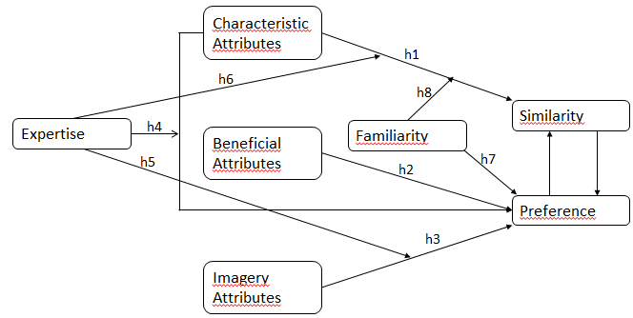
Figuur 1: conceptual framework

Methodology

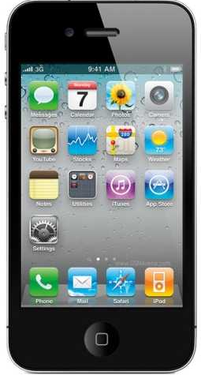
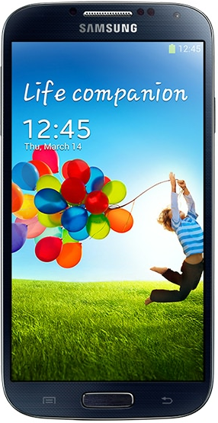
4.1 Product-class
Several selection criteria are used for the product-class. To begin with, there needs to be readily accessible individuals were either very knowledgeable or have little knowledge about the product-class. This gives the opportunity to test hypothesis 5, 6, 7, and 8. Furthermore, to test whether there exists a link between the attributes, it has to be a product-class where characteristic attributes lead to advantages. This has to support hypothesis 4. The products need to have at least five characteristic attributes and five beneficial attributes. Finally, the product-class need to have a large number of attributes in order to find effects of the attributes on the judgments, but also to find whether knowledge has an effect on the recognition of attributes. This helps to support hypothesis 1 till 3 that are replications from the two prior studies on this subject.
Figuur 2: Apple
Considering all the selection criteria, mobile phones is selected as the product-class. However, mobile phones have clearly more characteristic attributes than the products used in the previous researches. This brings the disadvantage that characteristic attributes are mentioned easier. The three mobile phones in this thesis are: Apple IPhone 4s, Nokia Lumia 900 and Samsung Galaxy S 4.
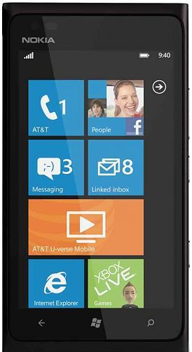
4.2 Subjects
Figuur 3: Samsung
The survey was pretested by five respondents. Any bugs in the survey were removed afterwords. Respondents of the main survey are collected via social media and social contacts. No particular selection in made in the respondents. One gift card with a value of 20 euros was raffled among the participants. In total 142 respondents pressed the link to start the survey, 51 did not respond to any question, 26 did not complete the questionnaire, resulting in a total of 65 completed questionnaires.
Figuur 4: Nokia
4.3 Measures
Creusen and Schoormans (1997) had two groups of subjects where one group assessed on similarity and the other on preference. For both judgments (similarity and preference) they used a five-point Likert scale After each judgment, subjects had to write down the three most important reasons underlying this judgment. The procedure of Lefkoff-Hagius and Mason (1993) differs in the way they grouped subject. They made two groups, one which first did a preference judgment followed by a similarity judgment, and one group which judged in the reversed order. This way any order of task effect is counterbalanced. Because this did not leaded to any difference, it is not replicated in this study.
Because I used two new effects of expertise and familiarity, an exact replication of the study by Lefkoff-Hagius and Mason (1993) is not appropriate. They offered beneficial attributes and imagery attributes which a subjects had to use in order to form a judgment on similarity and preference. In this study expertise and familiarity should give the subject the ability to come up with the attributes underlying the judgment. However, a useful method that can be replicated is to make the subjects give reasons underlying their judgments like in the study of Creusen and Schoormans (1997). Their procedure was to make a judgment and then write down the three most important reasons underlying that judgment. Then the reasons were categorized in the three types of attributes. The categorization was performed independently by two judges. Because the product in this study contain more characteristics, it is better to give the opportunity to give five reasons.
I used the same five-point Likert scale ranging from 1: ‘strongly prefer alternative X’ to 5: ‘strongly prefer alternative Y’. When giving the judgment, the respondent had to give up to five reasons underlying his/her judgments. The difficulty of having more opportunities to give reasons, is that subjects may not be able to fill in five reasons, but it brings the advantage that subjects have to think of more attributes than only the characteristics. This is necessary when having many characteristic attributes. Creusen and Schoormans (1997) also found the problem that subjects mostly responded with characteristic attributes. This method may solve that problem partially. For the similarity judgment a five-point Likert scale ranges from 1: ‘Do not resemble each other at all’ to 5: ‘Resemble each other strongly’ is used. Because the judgments are individual specific and I want to investigate the discrepancy between the two judgments a within subject design was used.
The categorization lead to a number of each kind of attribute underlying the subjects judgments. Way of categorization can be found in Appendix A. I test the hypotheses by checking whether subjects mentioned more characteristics underlying the similarity judgments (H6), and subjects mentioned more beneficial attributes(H7), or image attributes(H8) for their preference judgments. The hypotheses are checked using a paired sample t-test. Objective expertise is split in two levels, experts and non-experts. The total number of correct answers is counted, in total six point could be awarded. A cut-point of 50 percent of the subjects is taken to split the groups. This lead in the expert group had 5 or 6 correct answers, the non-expert group 4 or less correct answers. The interaction effect of expertise is checked by using an ANOVA. Expertise is added as an interaction effect on characteristics (H1) and image (H2) with dependent variable preference judgment and main effects of characteristics, beneficial, and image attributes. Afterwards Familiarity (H4) is added as a main effect on preference judgments and characteristics attributes as a main effect on similarity judgment with familiarity (H5) as an interaction effect controlled with a T-test. Also expertise as an interaction effect on characteristics (H3) is added. Finally, the number of image attributes mentioned by evaluating computers should be lower than when evaluating mobile phones (h9). The difference between the two products is checked with a Chi-square.
4.4 Familiarity
I obtained measures of familiarity with the products after the judgments. The measurement was done in two stages. One which measured the cumulative product usage in year, almost similar to the approach of Bettman & Park (1980) and Johnson & Russo (1984). Subjects were presented with a list of actions with they had to indicate how often they used them (e.g. installation, buying, years of ownership). Then the subjects had to indicate whether they possess and/or used one of the brand of the product set.
4.5 Expertise
Expertise is measured in two ways: objective and subjective expertise. Whereas subjective expertise is the level the subject thinks he/she possesses and objective expertise was a measuring by task performance. Objective expertise was measured with a task where subjects had to answer 6 questions with a yes/no/don’t know response. Subjects received point for each correct answer which ranked their expertise level. The approach is similar to the one of Park, Mothersbaught & Feick (1994). Questions included ‘Nokia is an operating system’ and ‘1 GB is equal to 1024 MB’. Subjective expertise was measured using a four-item scale from Chiou, Droge & Hanvanich (2002) similar to that employed by Park et al. (1994). Four scale items included the following questions: 1) compared with the average person, my knowledge of mobile phones is very extensive; 2) compared with the average person, I know more about how to purchase a mobile phone; 3) I have accessed many different aspects of information on mobile phones; and 4) I completely understand mobile phones. A seven-point Likert scale was used to measure the subjective expertise with 1: ‘strongly disagree’ and 7: ‘strongly agree’.
4.6 Procedure
The questionnaire contained three different parts (appendix C). In the first part subjects were asked to imagine a buying moment where they had to choose between two products. Subjects assigned a preference and similarity judgments between the three product comparisons and give the five most important reasons of their underlying judgment. This is more than the previous research because these products have more attributes that the ones used in that research. Figure 5 shows how the questions are formulated.
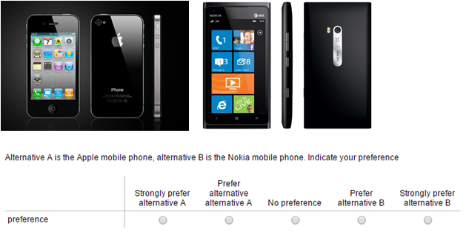
Figuur 5: questionnaire comparison

Because I used three products (just as the two previous studies), subjects had to judge on three pairs for preference judgment and the same three pairs for similarity judgment. In the second part I measured the level of subjective and objective familiarity. Here I measure cumulative usage of the product by asking possession of current and past brands in order to capture the objective familiarity (e.g. What is the brand of your current mobile phone?). The subjective familiarity is measured by asking to rate the familiarity with the brands. Both familiarity and expertise measurements are further explained in the next paragraph. The third and final part was used to measure demographic aspects of the respondent (age, gender, and education.)

Analysis and results

In this thesis quantitative research was preferred over qualitative research. The direction of the study is clear and has an objective nature, adding knowledge as an interaction effect in an existing conceptual model, and therefore a qualitative research with an subjective, exploring nature was not appropriate. Qualitative research would have been more appropriate when this research had a more exploring nature for example when I was looking for opinions and judgments of consumers.
The research question was to find how knowledge affects the discrepancy between preference and similarity judgment. With qualitative research, it was possible to show how knowledge affects relative importance of characteristic, beneficial and imagery attributes on the discrepancy.
The mean age of the respondents is 27 with the youngest having an age of 16 and the oldest having an age of 69. 57% of the respondents were females. Most of the participant had a bachelor degree as highest education (46%), followed by a master degree (32%), 14% were high school graduates and the others had a higher education than a master degree.
To begin with, discrepancy between similarity and preference judgment is found in the data. Appendix B shows the difference between the judgments by subtracting the similarity judgment of the preference judgment. In only a few cases the judgments were exactly the same (Nokia vs. Apple 26.2%, Nokia vs. Samsung 13.8%, Samsung vs. Apple 24.6%). More important is the reasoning underlying the judgments.
The attributes mentioned by the subjects are categorized in characteristic, beneficial or imagery attributes and counted for each judgment. In that way, subjects could name multiple kinds of attributes, for example, three characteristics, one benefit and one image attribute. This differs with the research performed by Creusen and Schoormans (1997), where the mentioned attributes were binary coded showing whether an attribute was mentioned or not during the judgment. In this study, mobile phones have a lot of attributes to base a judgment on. Therefore a count of the mentioned attributes is fairer.
Every subject could mention five attributes per product comparison. Because every subject judges on three product comparisons the maximum mentioned number of attributes is fifteen. As shown in table 1, subject did not use all fifteen opportunities to mention an attribute. With preference judgment in average 13.431 attributes were mentioned, meaning in average 4.477 attributes per product comparison. When performing the similarity judgment task the mean number of mentioned attributes was 12.278. Clearly characteristic attributes were mentioned the most.
Table 1: Mean of the number of attributes mentioned by subjects categorized by preference en similarity judgment.
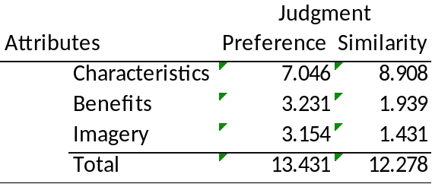
To test the first three hypotheses, a paired sample t-test is used. The difference in the mean number of characteristic attributes named in similarity and preference judgment is tested for H1. Table 2 shows the means per judgment and table 1 shows the difference between those means.
Table 2: Mean difference of the attributes on preference and similarity judgment.
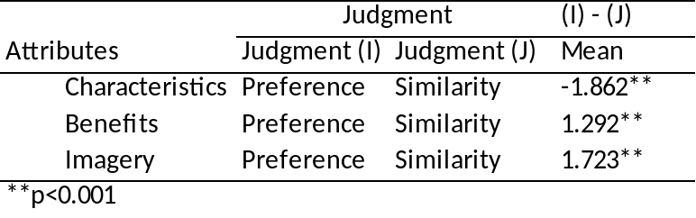
The mean of the characteristics mentioned for the similarity judgment was significantly higher than the mean for the preference judgment (p=0.000). This supports the first hypothesis. The second hypothesis is also supported, the mean of the benefit attributes is higher when judging for preference than for similarity (p=0.000). Also imagery attributes are more often used to judge preference than to judge similarity (p=0.000). This supports the final hypothesis of the replicated research.
Expertise and familiarity are used to find more explanation for the discrepancy between preference and similarity judgment. In the procedure, both objective and subjective expertise are measured. Objective expertise did not lead to a clear variation in expertise. One reason for that, could be that the answers were to obvious. All point of the subjective expertise were counted and everyone with 0-10 points were assigned to the novices group (N=18) and everyone with 18-28 points were assigned to the expert group (N=18), where 0 is the lowest score and 28 the highest. To test hypothesis 4, 5, and 6 an independent sample T-test is performed.
Table 3: Mentioned attributes for judgments divided in two groups, novices and experts
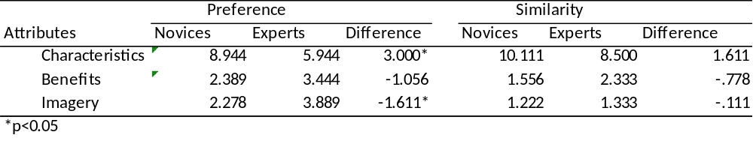
The test of hypothesis 4 showed that experts consumers did use less characteristic attributes to base their preference on. A mean difference of 3.0000 higher (p=0.006) for the novices group. Therefore, H4 is rejected and gave new insights in the effect of expertise on preference judgment using characteristic attributes. Also H5 seems to have a reversed effect than expected. Experts had a significantly higher mean of mentioned imagery attributes when judging preference (p=0.033). H6 formulates that expert consumers use less characteristics when performing a similarity judgment. The mean difference supports this effect, however, it is not significant (p=0.153).

For the next two hypothesis current en last mobile phone brand possession was recorded. For H7 the data was binary coded, saying whether a subject is familiar with the brands (Apple, Samsung, and Nokia). Because I wanted to measure familiarity and a subject could be familiar with multiple brands, binary coding fits this analysis. For H8 the data was binary coded as not familiar with the product pair. In this case I could make two groups, one familiar with at least one of the brands of the comparison and not familiar with both of the brands.
Table 4: Mean preference score for the three pairs divided by familiarity of the brands.
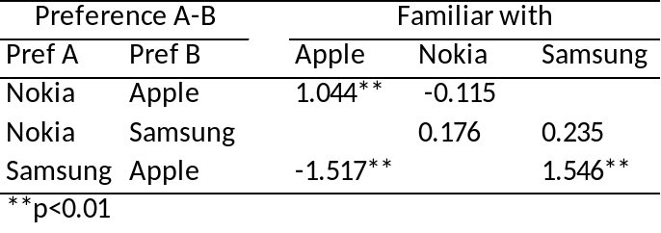

Table 5: Mean difference in similarity judgment
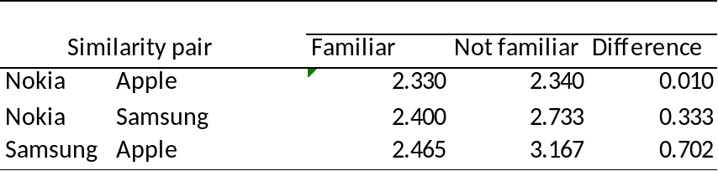
Tabel 4 presents the results of the test. Product comparisons shows the mean preference judgment between a subject who is familiar with and not familiair with the brand. The first pair, Nokia vs. Apple, the subjects who are familiar with Apple rated significanty 1.044 higher on the scale towards Apple (p=0.003). The same effect was found for subject familiar with Nokia, they rated 0.115 point higher towards Nokia, however, this is a small effect and was not found significant (p=0.811). Regarding the second pair, Nokia vs. Samsung, also the effect of familiarity with Nokia was not significant (p=0.550). The effect of familairity with Samsung did cause a higher rate for Samsung with a mean difference of 0.235 but was also not significant (p=0.342). The final comparison, Samsung vs. Apple, shows the highest differences. Subject who are familiar with Apple, rated their preference for Apple with a mean difference of 1.517 compared to subjects who are not familiar with Apple (p=0.000). Also subjects who are familiar with Samsung compared to subject who are not, rate 1.546 higher towards Samsung (p=0.000).
To test H8 three independent T-tests were performed for the product comparisons (table 6). Participants gave their opinion on a five point Likert scale with 1 meaning: Do not resemble each other at all’, to 5: ‘resemble each other strongly’. On the first pair Apple vs. Nokia, no difference between the mean of similarity judgment was found. With the second pair, the effect in a reversed way present with a mean difference of 0.333 but was not significant (p=0.237). The last comparison also showed the same effect as hypothesized of 0.702 but was also not significant (p=0.075). It can be rejected that customers who are not familiar with brands judge them as less similar.

Discussion

6.1 Conclusion

This thesis shows that expertise and familiarity have influence on two outcomes, similarity and preference judgments. This is shown with a replication and extension of research about the discrepancy between preference and similarity judgment. The study which is replicated was performed by Lefkoff-Hagius and Mason (1993). Already a replication study about this phenomenon was performed by Creusen and Schoormans (1997), but both failed to cover the all the hypotheses. In this study all three replicated hypotheses are supported. Similarity judgments are more often based on characteristic attributes than preference judgments. Preference judgments are more often based on beneficial and imagery attributes than similarity judgments. Here the research question is answered:
How does product knowledge affects the relative importance of product attributes on similarity and preference judgments?
Experts consumers used less characteristic attributes to base their preference and experts had a significantly higher mean of mentioned imagery attributes when judging preference. However, it was hypothesized the other way around because Alba & Hutchinson (1987) suggested that novices are more likely to use non-functional attributes, as brand names, to process information in making a decision. Alternatively, Experts process information driven from functional attributes and are aware of the potential importance of the attributes (Brucks, 1985). There can be a few reasons why this research found a significant effect that is reversed. First of all, participants had to mention more than one reason for their preference. Because a brand can only be mentioned once as a reason, participants can use characteristics to fill in the rest. But this does not completely support the opposite effect, because experts did use more image attributes than novices. It is clear that more characteristic attributes are used in this research, however, novices used more characteristics than experts. It is more likely that experts have the ability to come up with more benefits and are aware of the image of each brand, while novices have only the information they see and cannot link it to benefits or translate the brand name in anything they state for. There was no significant difference in the evaluation of beneficial attributes between novices and experts. Expertise also did not seem to have an effect on the use of attributes when judging for similarity. Considering the effect on similarity judgment, the same effects as seen with preference judgments were found, but were not significant.
Familiarity had an effect on the preference judgment in two of the three product comparisons. In both comparisons containing the Apple phone, subjects who are familiar with Apple, had a higher preference for Apple. This effect was also present when subjects familiar with Samsung compared Samsung with Apple. However, when comparing Samsung with Nokia no significant effect was found. Being familiar with Nokia, showed no significant effect on the preference judgment in both the comparisons. This is due to the fact that almost none of the subjects currently owned a Nokia and only 14% had a Nokia as previous phone. As with Expertise, familiarity showed no effect on similarity judgment.
6.2 Relevance
The relative importance of the attributes on the judgments were significantly different. This means that when researchers use data of preference and similarity they should either prevent these effects in the data collection stage or accommodate for the effects during analysis stage. When selecting participants for research on preference and similarity judgments, researchers have to be careful not to select only participants with a high knowledge of the product. For example, when a technical university only uses students of the university and collects data on the relative importance of the attributes when performing a judgment on a product as software or computers. According to this study, more imagery attributes will be mentioned on preference judgment. Another example in the selection stage, when collecting participants for a questionnaire on preference judgment, more attention is required for the acquisition message: for example: “Searching participants for a research on mobile phones”, can lead to participants who have knowledge about the product.
Lefkoff-Hagius and Mason (1993) concluded that “me-too” strategy is ineffective when preferences are driven by beneficial and image attributes, because similarity with the market leader will not be reached. However, the same characteristics attributes as the market leader can easily be reached by producers. In markets where expertise and familiarity with the products in low, me-too strategies have a better chance since characteristics attributes play a more important role in the preference judgment in this situation.
Since knowledge and familiarity have an effect on the relative importance of the attributes during judgments, marketers can identify consumer touch points where knowledge and familiarity have different levels. For example, a fan site is probably visited by consumers who are familiar with your product and have knowledge about your product and company. This should not be a place where you want to communicate constantly about the specifications of a new product, but more about how this enlightens the brand or strengthens the brand position since these experts are more focused on your brand than the characteristics of your product.
When having a sales conversation with a customer for example in a mobile phone shop a salesman is able to identify whether the customer is an expert or a novice on mobiles. When the salesman has an expert in front of him, he may be tempted to point out all the specifications of the phones to impress the customer. However, naming imagery attributes can have a better effect on the preference of the customer whenever it is a expert.
6.3 Limitations & future research
The measurement of the attributes happened in a different way than in the study by Lefkoff-Hagius & Mason (1993) and therefore this study is not an exact replication. However, this study shows significant results between the attributes used for the judgments. The procedure had the major disadvantage that it took most of the participants almost 20 minutes to finish the survey. Naming multiple reasons underlying the judgment, took time to think and write down from the participants. This resulted in a large percentage of the surveys insufficient for analysis due to unfinished surveys. This could have resulted in less experienced mobile phone users who quit the survey halfway because they are less interested. Secondly, most participants who finished the survey were students. Students can have the tendency to find imagery attributes important since they are constantly surrounded by mobile phones of friends and study mates. A clearer difference in knowledge between these groups makes it easier to find support for the hypotheses. Despite the higher volume of knowledgeable subject, two groups could be formed into high expertise and low expertise. The same was not found with objective expertise. The five questions should measure the knowledge the subjects had about mobile phones. However, most of the participant had 4 or 5 out of 7 correct what did not result in a clear distinct between experts and novices.. The questions were either too easy and everyone had it correct or too hard what even the ‘subjective experts’ did or could not know.
Not many people own a Nokia currently and only 14% had a Nokia as their previous phone. Significant difference between the groups familiar and not familiar with Nokia, could not be found with pairs including Nokia.
This study takes a first step in expanding the framework of the discrepancy between similarity and preference judgment. Future research can be focused on the public use of the products, preferably with a larger sample size. It has been proven that the effect of imagery attributes depends on the degree the product is used publicly (Lawson, 1983). It could be that the more the product is used publicly the more imagery attributes influences the judgments. Second, the research can be conducted with an improved measurement of objective expertise.
To identify product groups where a me-too strategy might have a better chance of gaining a significant market share, this research can be conducted with different product groups. Product groups can differ in level of public use and level of involvement (fast moving consumer goods).

Appendix A: product attributes classification, sample of most common
physical | Benefit | imagery
design | free apps | style
weight | usability interface | trustful
Price | Operating system | image
camera quality | usability | reliability
resolution | display supports multiple languages | cool
dimensions (e.g. size) | synchronization with other devices | hate apple
 | fits in pocket
 | music sounds good
 | quality of pictures
 | quality of screen during movies
 | battery longer

Appendix B: difference between preference and similarity
Nokia - Apple
Difference | Frequency | Percent | Cumulative Percent
-3 | 5 | 7,7 | 7,7
-2 | 5 | 7,7 | 15,4
-1 | 16 | 24,6 | 40
0 | 17 | 26,2 | 66,2
1 | 7 | 10,8 | 76,9
2 | 13 | 20 | 96,9
3 | 1 | 1,5 | 98,5
4 | 1 | 1,5 | 100
Total | 65 | 100
Nokia - Samsung
Difference | Frequency | Percent | Cumulative Percent
-1 | 4 | 6,2 | 6,2
0 | 9 | 13,8 | 20
1 | 9 | 13,8 | 33,8
2 | 20 | 30,8 | 64,6
3 | 15 | 23,1 | 87,7
4 | 8 | 12,3 | 100
Total | 65 | 100
Samsung vs Apple
Difference | Frequency | Percent |  | Cumulative Percent
-4 | 1 | 1,61 |  | 1,6
-3 | 4 | 6,45 |  | 8,1
-2 | 6 | 9,68 |  | 17,7
-1 | 14 | 22,58 |  | 40,3
0 | 16 | 25,81 |  | 66,1
1 | 11 | 17,74 |  | 83,9
2 | 6 | 9,68 |  | 93,5
3 | 4 | 6,45 |  | 100
Total | 62 | 100

Appendix C: Survey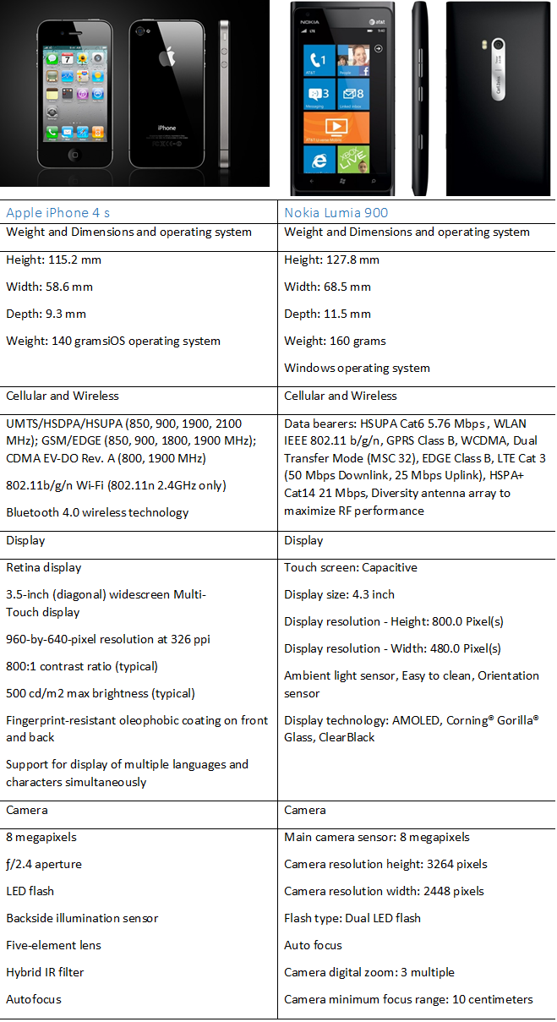

Alternative A is the Apple mobile phone, alternative B is the Nokia mobile phone. Indicate your preference
 | Strongly prefer alternative A | Prefer alternative alternative A | No preference | Prefer alternative B | Strongly prefer alternative B
preference

Name five reasons underlying your preference judgment. You can type anything here, from the list above till any reason why you gave your preference.
Reason 1…………………………………………………………………………………………….
Reason 2…………………………………………………………………………………………….
Reason 3…………………………………………………………………………………………….
Reason 4…………………………………………………………………………………………….
Reason 5…………………………………………………………………………………………….

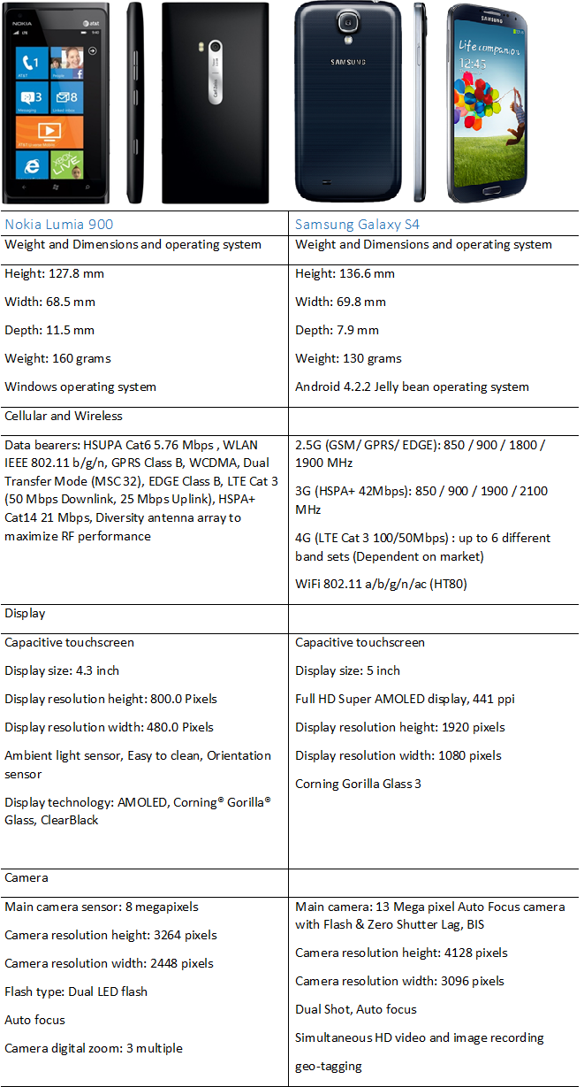

Alternative A is the Nokia mobile phone, alternative B is the Samsung mobile phone. Indicate your preference
 | Strongly prefer alternative A | Prefer alternative alternative A | No preference | Prefer alternative B | Strongly prefer alternative B
preference

Name five reasons underlying your preference judgment. You can type anything here, from the list above till any reason why you gave your preference.
Reason 1…………………………………………………………………………………………….
Reason 2…………………………………………………………………………………………….
Reason 3…………………………………………………………………………………………….
Reason 4…………………………………………………………………………………………….
Reason 5…………………………………………………………………………………………….

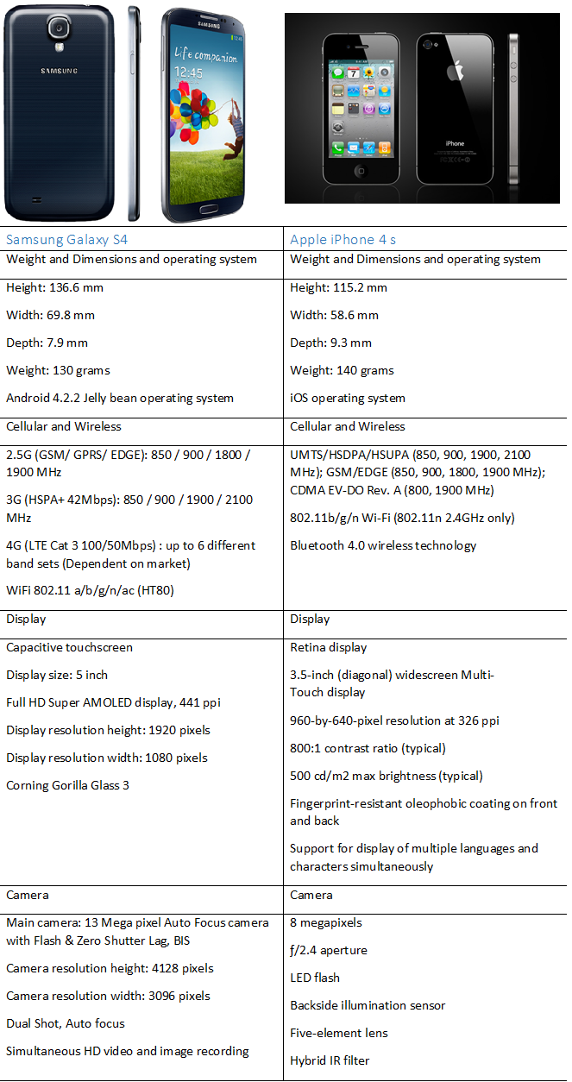

Alternative A is the Samsung mobile phone, alternative B is the Apple mobile phone. Indicate your preference
 | Strongly prefer alternative A | Prefer alternative alternative A | No preference | Prefer alternative B | Strongly prefer alternative B
preference

Name five reasons underlying your preference judgment. You can type anything here, from the list above till any reason why you gave your preference.
Reason 1…………………………………………………………………………………………….
Reason 2…………………………………………………………………………………………….
Reason 3…………………………………………………………………………………………….
Reason 4…………………………………………………………………………………………….
Reason 5…………………………………………………………………………………………….

Alternative A is the Apple mobile phone, alternative B is the Nokia mobile phone. How similar are the mobile phones according to you?
 | Do not resemble each other at all | Do not resemble each other | Slightly resemble each other | Resemble each other | Resemble each other strongly
Similarity

Name five reasons underlying your similarity judgment. You can type anything here, from the list above till any reason why you gave your similarity judgment.
Reason 1…………………………………………………………………………………………….
Reason 2…………………………………………………………………………………………….
Reason 3…………………………………………………………………………………………….
Reason 4…………………………………………………………………………………………….
Reason 5…………………………………………………………………………………………….

Alternative A is the Nokia mobile phone, alternative B is the Samsung mobile phone. How similar are the mobile phones according to you?
 | Do not resemble each other at all | Do not resemble each other | Slightly resemble each other | Resemble each other | Resemble each other strongly
Similarity

Name five reasons underlying your similarity judgment. You can type anything here, from the list above till any reason why you gave your similarity judgment.
Reason 1…………………………………………………………………………………………….
Reason 2…………………………………………………………………………………………….
Reason 3…………………………………………………………………………………………….
Reason 4…………………………………………………………………………………………….
Reason 5…………………………………………………………………………………………….

Alternative A is the Samsung mobile phone, alternative B is the Apple mobile phone. How similar are the mobile phones according to you?
 | Do not resemble each other at all | Do not resemble each other | Slightly resemble each other | Resemble each other | Resemble each other strongly
Similarity

Name five reasons underlying your similarity judgment. You can type anything here, from the list above till any reason why you gave your similarity judgment.
Reason 1…………………………………………………………………………………………….
Reason 2…………………………………………………………………………………………….
Reason 3…………………………………………………………………………………………….
Reason 4…………………………………………………………………………………………….
Reason 5…………………………………………………………………………………………….

Answer the following questions:
 | Strongly Disagree | Disagree | Somewhat Disagree | Neither Agree nor Disagree | Somewhat Agree | Agree | Strongly Agree
Compared with the average person, my knowledge of mobile phones is very extensive
Compared with the average person, I know more about how to purchase a mobile phone
I have accessed many different aspects of information on mobile phones. (computer magazines)
I completely understand mobile phones

Answer the following questions, if you do not know the answer, use the don't know button and do not guess. Do not search information to answer these questions.
 | Yes | No | Don't know
One GB is equal to 1000 MB
Nokia is an operating system
The acronym GSM means Global System for Mobile communication
A PUK-code is used to download paid apps from the appstore
The Iphone uses iOS as an operating system
Android is a store to buy application

What is the brand and version of the mobile phone you own at the moment (or phones)?

What was the brand and version of the mobile phone you owned before?

What is your age?

What is your Gender?
- Male
- Female

Highest level of education
- Primary school
- High school graduate
- Bachelor
- Master's
- Other, Higher

Bibliography
Agrawal, J., & Kamakura, W. (1999). Country of origin: a competitive advantage. Internation Journal of Research in Marketing, 255-267.
Alba, J., & Hutchinson, J. (1987). Dimensions of Consumer Expertise. Journal of Consumer Research, 411-454.
Andreassen, T., & Lindestad, B. (1998). Consumer loyalty and complex services. International Journal of Services Industry Management, 7-23.
Andrew, M., & Dacin, P. (1996). the assessment of alternative measures of consumer expertise. Journal of Consumer Research, 219-239.
Arabie, P., Carroll, D., Desarbso, W., & Wind, J. (1981). Overlapping clustering: A new method for product positioning. Journal of Marketing Research, 18: 310-317.
Baerden, W., & Shimp, T. (1982). The use of extrinsic cues to facilitate product adoption. Journal of Marketing Research, 229-239.
Batra, R., Homer, P., & Kahle, L. (2001). Values, susceptibility to normative influence, and attribute importance weights: A nomological analysis. Journal of Consumer Psychology, 115-128.
Bettman, J., & Park, C. (1980). Effects of prior knowledge and experience of the choice process on consumer decision processes: a protocol analysis. Jounral of Consumer Research 7 (3), 234-251.
Bijmolt, T., Wedel, M., Pieters, R., & Desarbo, W. (1998). Judgments of brand similarity. Journal of Research in Marketing, 249-268.
Birdwell, A. (1968). A study of the influence of image congruence on consumer choice. Journal of Business, 76-88.
Brucks, M. (1985). The Effects of Product Class Knowledge on Search Behaviour. Journal of Consumer Research, 1-16.
Chailan, C. (2008). Brands portfolios and competitive advantage: an empirical study. Journal of Product & Brand Management, 254-264.
Chattopadhyay, A. (1998). When Does Comparative Advertising Influece Brand Attitude? The Role of Delay and Market Position. Psychology & Marketing, 461-476.
Chiou, J., Droge, C., & Hanvanich, S. (2002). Does customer knowledge affect how loyalty is formed. Jounral of Services Research, 113-124.
Cooper, L. (1983). A review of multidimensional scaling in marketing research. Applied Psychological Measurement 7, 427-450.
Copulsky, W. (1976). Cannabalism in the marketplace. Journal of Marketing, 103-105.
Cordell, V. (1997). Consumer knowledge measures as predictors in product evaluation. Psychology and Marketing, 241-260.
Creusen, M., & Schoormans, J. (1997). The nature of differences between similarity and preference judgements A replication with extension. International Journal of Research in Marketing, 81-87.
Cupchik, G., Rickert, M., & Mendelson, J. (1982). Similarity and preference judgments of musical stimuli. Scandanavian Journal of Psychology, 273-282.
Derbaix, C., & Sjöberg, L. (1994). Movie stars in space: A comparison of preference and similarity judgments. J. of Research in Marketing, 261-274.
Desarbo, W., Manrai, A., & Manrai, L. (1993). Non-spatial tree models for the assessment of competitive market structure: An integrated review of the marketing and psychometric literature. Amsterdam: Operations Research and Management Science, Vol. 5, Marketing Elsevier.
Devlin, J. (2011). Evaluative cues and services: the effect of consumer knowledge. Journal of Marketing Knowledge, 1366-1377.
Dolich, I. (1969). Congruence relationships between self-images and product brands. Journal of Marketing Research.
Doyle, P. (1975). Brand Positioning Using Multidimensional Scaling. European Journal of Marketing, 20-34.
Dube, L., & Schmitt, B. (1999). The effect of a similarity vs. a dissimilarity focus in positioning strategy: The moderating role of consumer familiarity and product involvement. Psychology & Marketing, Vol. 16(3):211–224.
Enis, B., & Roering, K. (1980). Product Classification Taxonomies Synthesis and Consumer Implications. American Marketing Association, 186-189.
Gierl, H., & Huettl, V. (2011). A closer look at similarity: The effects of perceived similarity and conjunctive cues on brand extension evaluation. Journal of Research in Marketing, 120-133.
Givechi, R., & Velasquez, V. (2004). Design and Emotion: The Experience of Everyday Things. Taylor & Francis, Londen, 43-47.
Green, P. (1975). Marketing applications of MDS: Assessment and Outlook. Journal of Marketing, 24-31.
Green, P., & Rao, V. (1971). Multidimensional Scaling and Individual Differences. Journal of Marketing Research, 71-77.
Grubb, L., & Hubb, G. (1968). Perception of self, generalized stereotypes and brand. Journal of Marketing Research, 58-63.
Hauser, J., & Clausing, D. (1988). The House of Quality. Harvard Business Review, 63-73.
Hirschman, E. (1980). Attributes of Attributes and Layer of Meaning. Advances in Consumer Research Vol. 7, ed. Jerry C. Olson, Ann Arbor, MI: Association for Consumer Research, 7-12.
Howard, J., & Sheth, J. (1969). The Theory of Buyer Behavior. New York: Wiley.
Jacoby, J., Kuss, A., Troutman, T., & Mazursky, D. (1986). Experience and Expertise in Complex Decision Making. Advances in Consumer Research, 469-475.
Jamal, A., & Al-Marri, M. (2007). Exploring the effect of self-image congruence and brand preference on satisfaction: the role of expertise. Journal of Marketing Management, 23:7-8, 613-629.
Johnson, E., & Russo, J. (1984). Product familiarity and learning new information. Journal of Consumer Research, 11 (March), 542-550.
Johnson, M., & Puto, C. (1987). A Review of Consumer Judgment and Choice. Review of Marketin.
Joseph Sirgy, M., Johar, J., Samli, A., & Claiborne, C. (1991). Self-Congruity Versus Functional Congruity:. Journal of the Academy of Marketing Science, 363-375.
Lancaster, K. (1971). Consumer demand: A new approach. Colombia University Press.
Lawson, B. (1983). How designers Think. Westfield NJ: East view Editions.
Lawson, B. (1983). How Designers Think. Westfield, NJ: East view Editions.
Lee, M., & Lou, Y. (1996). Consumer reliance on intrinsic and extrinsic cues in product evaluation: a conjoint approach. Journal of Applied business Research, 21-28.
Lefkoff-Hagius, R., & Mason, C. (1990). The Role of Tangible and Intangible Attributes In Similarity and Preference. Advances in Consumer Research.
Lefkoff-Hagius, R., & Mason, C. (1993). Characteristics, beneficial, and image attributes in consumer judgements of similarity and preference. Journal of Consumer Research, 100-110.
Li, C., & Bovik, A. (2010). Content-partitioned structural similarity index for image quality assessment . Image Communication, 517-526.
Lien-Ti, B., Chia-Hsien, C., & Yung-Cheng, S. (2011). Positioning brand extensions in comparative advertising: An assessment of the roles of comparative brand similarity, comparative claims, and consumer product knowledge. Journal of Marketing Communications, Volume 17, Issue 4, pp. 229-244.
Malaviya, P., & Sivakumar, K. (1998). The Moderating Effect of Product Category Knowledge and Attribute Importance on the Attraction Effect. Marketing Letters, 93-106.
Mattila, A., & Wirtz, J. (2002). The impact of knowledge types on the consumer search process: an investigation in the contect of credence services. International Journal of Service Industry Management, 214-230.
Myers, J., & Shocker, A. (1981). The Nature of Product-related Attributes. Research in Marketing, 211-236.
Navarro-Bailón, M. (2012). Strategic consistent messages in cross-tool campaigns: effects on brand image and brand attitude. Journal of Marketing Communications, 189-202.
Olsen, J., & Jacoby, J. (1972). Cue utilization in the quality perception process. In Venkatesan, M. Advances in consumer research, 167-179.
Park, C., & Lessig, V. (1981). Familiarity and its impact on consumer decision biases and heuristics. Journal of Consumer Research, 223-230.
Park, C., Mothersbaugh, D., & Feick, L. (1994). Consumer knowledge assessment. Journal of Consumer Research, 71-82.
Rao, A., & Monroe, K. (1988). The moderating effect of prior knowledge on cue utilization in product evaluations. Jounral of Consumer Research, 253-264.
Rao, A., & Sieben, W. (1992). The effect of prior knowledge on price acceptability and the type of information examined. Journal of Consumer Research, 256-270.
Rao, V. (1972). Changes in explicit information and brand. Journal of Marketing Research, 209-213.
Ratchford, B. (1975). The New Economic Theory of Consumer Behavior: An Interpretive Essay. Journal of Consumer Research.
Richardson, P., Dick, A., & Jain, A. (1994). Extrinsic and intrinsic cue effects on perceptions of store brand quality. Journal of Marketing, 28-36.
Sirgy, M. (1982). Self-Concept in Consumer Behavior: A Critical Review. Journal of Consumer Research, 287-300.
Smith, R., & Deppa, B. (2009). Two dimensions of attribute importance. Journal of Consumer Marketing, 28-38.
Söderlund, M. (2002). Consumer familiarity and its effect on satisfaction and behavioral intentions. Psychology & Marketing, 861-880.
Suedfeld, P., Epstein, Y., Buchanan, E., & Landon, P. (1971). Effect of the set on the "effect of mere exposure". Journal of Personality and Social Psychology, 121-123.
Sulivan, M. (1998). How Brand Names Affect the Demand for Twin Automobiles. Journal of Marketing Research, 154-165.
Taylor-West, P., Heather, F., Reed, G., Story, V., & Saker, J. (2008). Familiarity, expertise and involvement: Key consumer segmentation factors. Journal of Consumer Marketing, 161-168.
Tesser, A. (1978). Self-generated attitude change. Advances in experimental social psychology (vol. 11), New York: Academic Press.
Tumbusch, J. J. (1987). How to Design a Conjoint Study. Sawtooth Software Conference Proceedings, 283-287.
Tversky, A. (1977). Features of similarity. Psychological Review, 327-352.
Tversky, A., & Gati, I. (1978). Studies of similarity. In E. Rosch and B. B. Lloyd. Cognition and categorization. Hillsdale, NJ: Erlbaum.
van Harreveld, F., & van der Pligt, J. (2004). Attitudes as stable and transparent constructions. Journal of Experimental Social Psychology, 666-674.
Yang, C.-C. (2011). Constructing a hybrid Kansei engineering system based on multiple affective responses: Application to product form design. Computers & Industrial Engineering, 760-768.
Zajonc, R. (1968). Attitudinal effect of mere exposure. Journal of Personality and Social Psychology, 1-27.

