Framing effect on performance, cooperation and stealing
ERASMUS UNIVERSITY ROTTERDAM
Erasmus School of Economics
Department of Economics
Course year 2014-2015

Supervisor: Susanne Neckermann
Name: Danny Hsu
Exam number: 304780
E-mail address: dannyhsu1986@gmail.com

Abstract: Framing a reward in a gain frame or a loss frame lets individuals act differently. Performance of the individual has often been the main topic in studies, but (unmonitored) spillover behavior outside the given task has not been studied much and might be affected as well. In this real effort task experiment it is found that the performance does not differ significantly between the treatment group and the control group. Looking at spillover effects, the proportion of cooperative individuals does not differ significantly. However, once an individual does cooperate, the degree to which an individual is cooperative differs between the treatment group and the control group. Also, the proportion of individuals stealing and the amount of things stolen while at it, differ significantly.

1. Introduction
This study is inspired by an event that occurred January 2014. Employees of a firm were expecting their annual bonus, but because of disappointing firm results, they only received half compared to the year before. This led to frustration, anger and disappointment among the employees. The following day all employees showed up at work and acted like nothing happened, but there was a subtle air of discontent noticeable. A bonus is usually a device to reward people, but in this firm it was strangely experienced as a punishment. Would the employees behave differently in case they received the bonus they expected, and if this were the case, in what way would they behave differently compared to the current situation?
The economic literature knows that gains and losses are evaluated with respect to some reference point (Abeler et al., 2011; Apostolova et al., 2013). Often the reference point is what people expect to receive (Kahneman & Tversky, 1979; Fennema & Wakker, 1997). In my example above, employees expected the bonus, so the absence of the bonus was probably perceived as a loss. This is an interesting aspect for incentive theory that has so far only looked at the incentive effect of variable pay (piece rates, bonuses, promotions etc – Lazear, 2000; Kachelmeister et al., 2008; Bertraind & Mullainathan, 2001), generally concluding that variable pay is effective at increasing effort up to a point. However, little attention has been devoted to what happens when reward schemes that were instituted are taken away.
In this paper, I will look into this topic. I will investigate how the framing of rewards affects, not only performance, but organizational behavior in general. The example above, does not directly translate into a gain or loss frame. The reason is, that employees were in a gain frame and a promised gain was taken away from them. Nevertheless, learning about how employees behave under those two frames, will shed light into the issue above too, assuming that the absence of the promised bonus corresponds to a loss frame more generally.
I opted for a more comprehensive measure of performance than most other studies, as I think that for an organization to function and thrive, not only main task performance is important but also how dedicated employees are. This refers to whether or not employees are willing to “go the extra mile” to serve the employer, and whether or not they are willing to engage in detrimental behavior to enrich themselves.
There is a substantial literature on gains and losses that will inform my design and hypotheses. From this point the finding of Kahneman & Tversky (1979) might be interesting. They say that the way how the compensation is framed, either as a reward or a punishment, has an effect on people, even if the pay-out is the same in both framings. Abeler et al. (2011) found evidence that expectations set a reference point. Several studies have looked at the influence of framing on the performance of workers in simple task environment, e.g. Hossain & List (2012) claim an improvement in worker productivity with the introduction of both the carrot (reward) and stick (punishment) in which the stick shows an 1% higher result than the carrot. Fryer at al. (2012) performed a framing field experiment in schools and found that students performed better when teachers were incentivized via a loss frame. Mixed results can be found when the task becomes more complicated, e.g. Frederickson & Waller (2005) find in their negotiation experiment that their reward group performs near optimum whereas the punish group does not. However, previous research on framing is either theoretical (Kahneman & Tversky,1979; Fennema & Wakker, 1997), focused on only the effects of the performance of a worker (Hossain & List, 2012; Frederickson & Waller, 2005; Apostolova et al., 2013) or the effects in very specific situations (De Geest & Dari-Mattiacci, 2013; Johnson et al., 1993) and less on the behavior that is unrelated to the core job.
Workers do more in a firm than just their core job. Contracts are often incomplete and cannot cover all aspects of a job, sometimes not even the core job performance can be completely fixed contractually (Merchant, 1982; Banker & Srinivasan, 2000). According to Kovach (1987) and Kerr (1975) most employers claim they know, but most actually do not know what drives and motivates an employee. This can cause employees to feel underappreciated and act no longer in the best interest of the employer. It therefore is important to understand what drives types of behavior on the work floor. Interesting behavior to understand are 'voluntary helping behavior' ( like staying an hour longer if there is much to do or helping a colleague) and, the other side of the same coin, 'detrimental behavior' (like stealing or lying). In this study I would like to use rewards in a gain and loss frame as I expect this might affect the performance and its spillover effects on 'voluntary work behaviors' and 'detrimental behaviors'. I do not believe this link has been studied yet.

The main research question is:
"Is there a framing effect on behavior of individuals besides performance?"

In order to get the data, a computer experiment in cubicles was performed at the Erasmus University Rotterdam. The experiment was based on the matrix experiment of Abelere at al. (2011). In total 320 students participated in the experiment. The results show that there is no significant difference in the performance of the subjects in the treatment group compared to the control group. Looking at spillover effects, the proportion of individuals cooperating does not differ significantly. However, once an individual does cooperate, the degree to which he is cooperative differs between the treatment group and the control group; individuals in the treatment group are significantly at a lower degree cooperative compared to individuals in the control group. A significant larger proportion of individuals stealing is present in the treatment group, but it appears they would take less than the ones stealing in the control group. To my surprise there is no significant difference in happiness or experience of fun nor fairness in the two groups.
In the second part I will discuss the relevant theory and hypotheses. The third part will discuss the experimental design and methodology. The fourth part will show the results. The fifth part will present the conclusion and limitations of this study.

2. Theory and Hypothesis
Kahneman & Tversky (1979) say people are not always rational and do not maximize expected utility. Instead, the way something is explained (framed) influences the way how people react to it. The prospect theory tells that an agent's net utility can be described as a value function that is measured over deviations from a reference point. Losses are convex and gains are concave, additionally it is also steeper for losses than for gains. Hossain and List (2012) used the following for a representative agent who derives benefits and costs and explains the above said mathematically:
V(w, e, w^{r}) = u(w) + v(e) + R(w,w^{r})

u= utility over income (increasing concave in w)
v= utility over effort (decreasing concave in e)
r= value function of prospect theory
R= utility derived in relation to a reference point
R(w,w^{r}) = r(w,w^{r}) if w≥w^{r},
s(w,w^{r}) if w<w^{r},
r=increasing concave
s=increasing convex
According to Tversky and Kahneman (1991) the estimate of the ratio -s(-x) / r(x) ≅ 2

To put this into perspective with this study: a subject receives 'w' before the experiment starts and has to perform 100 tasks (g=100). In case he is in the gain frame, he will receive €0.00 before the experiment starts (w = 0.00) and €0.10 for each task performed correctly (0.10g).
His net utility is u(0.00 + 0.10g) + r(0.10g)

In case he is in the loss frame, he will receive €10.00 before the experiment starts (w = 10.00) and he loses €0.10 for every task performed incorrectly.
His net utility is u(10.00 + 0.10g) + s(0.10g - 10.00)

Since -s(-x) / r(x) ≅ 2, the net payoff difference will be zero when all tasks are performed correctly and will be at largest when none of the tasks are performed correctly. Considering this, one can expect that the loss framing will evoke subjects to put more effort in the tasks and subjects might find the loss framing less pleasant.

Hypothesis 1:
H₀ : There is no performance difference between the treatment group and control group, Mean_{PerformanceControl} = Mean_{PerformanceTreatment}
H₁ : Performance is higher in the treatment group compared to the control group, Mean_{PerformanceControl} < Mean_{PerformanceTreatment}

We know very little about how rewards for a core performance affect other types of behavior in organizations. One exception is a study by Neckermann et al. (2014) who show that in a call center, award winners subsequently engage in more voluntary helping behavior. In my experiment I focus on cooperation and cheating/stealing. Here is what we know about these two types of behaviors:
Cooperation: Fischbacher et al. (2001) performed a public good experiment and found that cooperation among subjects is conditional to other subjects' contributions, but cooperation will spiral down over time. Falk & Fischbacher (2006) state that reciprocity is a response on an action that depends whether it is perceived kind or unkind. Loss incentives might be perceived as unfair i.e. unkind, hence cooperation might be affected. In a field experiment by Burks et al. (2009), it was found that performance pay would decrease the cooperation among workers.
Cheating: Previous research on cheating shows the effect of an individual’s reputation concern on lying (Scharfstein & Stein, 1990), the tendency of individuals to lie to gain budgetary slack (Jensen, 2003), claiming credit for lucky outcomes (Bertraind & Mullainathan, 2001) show that cheating the game has a negative influence on both short and long term. Houser et al. (2012) found that in case of a dictator game when people feel being treated unfair, they will more likely cheat and steal compared to when they feel being treated fair. Fischbacher & Heusi (2008) discovered in their dice rolling experiment without monitoring, subjects would cheat in order to receive a higher pay-out. Cameron and Miller (2009) found that a loss frame increases cheating behavior. Gravert (2013) performed an experiment in which she shows that subjects who earned their payoff according to performance were much more likely to steal than subjects who received a fixed reward. Scheitzer et al. (2004) proof that subjects who did not meet their goals are likely to cheat.
Cooperation and cheating seem to be correlated as McCusker and Carnevale (1995) stated; loss aversion creates less cooperation and heightens exploitation among the test subjects in a public game and dictator game. According to Mazar et al. (2008) being honest or dishonest is related to the 'self-concept maintenance'. People like to think of themselves as good individuals and want to maintain that perception. It would be interesting to see if the above observed behavior would also show in a setting in which subjects do not compete with each other, but work on a task and the only manipulation would be the framing of the reward.

Hypothesis 2:
H_{o} : There is no difference in the proportion of subjects cooperating between the treatment group and control group,
Proportion_{CooperationControl} = Proportion_{CooperationTreatment}
H₁ : The proportion of subjects cooperating is lower in the treatment group compared to the control group,
Proportion_{CooperationControl} > Proportion_{CooperationTreatment}

Hypothesis 3:
H_{o} : There is no difference in the proportion of subjects stealing between the treatment group and control group,
Mean_{StealingControl} = Mean_{StealingTreatment}
H₁ : The proportion of subjects stealing is higher in the treatment group compared to the control group,
Mean_{StealingControl} < Mean_{StealingTreatment}

Hypothesis 4:
H_{o} : There is no difference in degree of cooperation for subjects who cooperate in the treatment group compared to the control group
Mean_{Cooperate1CooperationControl} = Mean_{Cooperate1CooperationTreatment}
H₁ : Subjects in the treatment group who cooperate, cooperate at a lower degree compared to the subjects in the control group who cooperate,
MeanCooperate1CooperationdegreeControl > MeanCooperate1CooperationdegreeTreatment

Hypothesis 5:
H_{o} : There is no difference in the amount of stealing for subjects who steal in the treatment group compared to the control group
Mean_{Stole1StealingdegreeControl} = Mean_{Stole1StealingTreatment}
H₁ : Subjects in the treatment group who steal, steal more compared to the subjects in the control group who steal,
Mean_{Stole1StealingControl} < Mean_{Stole1StealingTreatment}

3. Experimental Design and Methodology
The experiment was conducted at the Erasmus University from 14th November till 5th December 2014 between 09:00 and 17:00. A session was held each hour. For the experiment it was important that subjects did not feel being observed as this may cause preventing the subjects to steal or feel pressure to fill in the voluntary survey (Merchant, 1982; Mazar et al., 2008) Therefore it took place in the 8-person and sometimes in the 12-person computer lab with soundproof cubicles and the window in the doors covered (see appendix picture 1 and 2). I would start and stop the experiment from the central computer in a different room (see appendix picture 3). The experiment was programmed and conducted with the software z-Tree (Fischbacher, 2007). Test subjects were mainly students from the Erasmus university who registered themselves into the ORSEE mailing pool for participating in experiments. In total 362 students registered and 320 students actually participated in the experiment of which 191 were male and 129 female. The control group consisted of 159 subjects and the treatment group 161 subjects. The control group had a 'normal' gain frame for the reward and the treatment group a loss frame for the reward.
Subjects were seated in a cubicle (see appendix picture 4) with instructions, obligatory questionnaire, voluntary survey and a box with office utensils (see appendix for 'instructions a', 'instructions b', 'obligatory questionnaire', 'voluntary survey' and picture 5 for office utensils). In case of the treatment group, subjects received €10.00 before the experiment started and had to sign a 'payment receipt' (see appendix 'payment receipt') in which they declared receiving the €10.00. The subjects were told the experiment consisted of three parts. The first part was a set of 5 trial tasks in which subjects could familiarize themselves with the task. The second part was a set of 100 tasks in which the final payment to the subject depended on his or her individual performance.
Subjects in the control group were informed they would receive €0.10 for doing each task correct. They had the possibility to be rewarded €0.00 if they failed every task or with €10.00 if they did every task correctly or something in between. The subject would see a green colored screen after he performed a task correctly (see appendix picture 6), otherwise a neutral screen.
Subjects in the treatment group were informed they would lose €0.10 for every mistake they made. They had the possibility to lose €10.00 if they failed every task or €0.00 if they did every task correctly or something in between. The subject would see a red colored screen after he performed a task incorrectly (see appendix picture 7), otherwise a neutral screen. Note that subject did not know their actual performance until they came to me for their final payment.
The third part was filling in the obligatory questionnaire related to the tasks using the office utensils provided. The subjects were informed that there was an additional survey which had nothing to do with the experiment they were in. Participation in the survey was on voluntary basis and there would be no reward of punishment for it.
After the subjects finished the experiment, they had to leave the cubicles and bring the obligatory questionnaire to me at which they were informed about their performance and the final payment was arranged. Subjects had to sign a receipt before leaving with the reward (see appendix receipt). The data provided by the obligatory questionnaire, was used to check for framing effects on the subjects. Filling in the additional voluntary survey was used as a proxy for 'cooperation' and the degree of how detailed the answers were in the voluntary survey, was used as a proxy for 'degree of cooperation'. After each session, I checked whether office utensils were missing in the cubicles, which was used as a proxy for 'stealing', and how much was missing, was used as a proxy for 'degree of stealing'. After that, I replenished the office utensils for the next session.
The task that I used, was based on the experiment of Abeler et al. (2011) in which subjects had to count the amount of zero’s in a 3x15 matrix with randomly ordered zero’s and ones. Subjects received ten seconds for each task. In order for the subjects to participate in the experiment no prior knowledge was needed, there is little to no learning effect and performance is easily measurable. The task is boring and, in the eyes of the subject, serves no other goal than to determine the reward in the end. Although the purpose of Abeler et al.'s research is different to mine, the design of their experiment is, with some modifications, useful to what I want to research; whether there is a difference in performance, cooperation and stealing behavior between the gain frame and loss frame. In Abeler et al. (2011) subjects were allowed to stop with the experiment whenever they wanted. In my experiment this would have caused a difference in treatment among the subjects. Therefore this option was removed from the experiment.
Table 1 reports summary statistics by control and treatment group for pre-treatment characteristics. The pre-treatment characteristics include Dummy variable 'Male' to identify gender, 'Age' refers to the age of the subject and 'Year' to amount of years the subject is a student. The 'Study' dummies refer to what study program the subject is enrolled in. 'StudyDouble' refers to subjects enrolled in two programs and 'StudyOther' in case the subject is enrolled in a different program. The days in the regression are dummies for what day the subject participated in the experiment. The 'Session' dummies refer to what time a subject participated in the experiment.
The treatment group is generally balanced, the only significant difference at the 10% significance level is the proportion 'StudyDouble' (t(290) = 1.953, p = 0.052). There are more subjects enrolled in two programs in the treatment group compared to the control group.

Table 1 Baseline Characteristics
 | Control |  | Treatment
N | 159 |  | 161
Male | 0.59 |  | 0.6
 | (0.493) |  | (0.491)
Age | 21.76 |  | 22.04
 | (2.628) |  | (3.858)
Year | 3.25 |  | 3.22
 | (1.572) |  | (1.572)
StudyEconomics | 0.69 |  | 0.7
 | (0.466) |  | (0.459)
StudyBusiness | 0.15 |  | 0.1
 | (0.359) |  | (0.3)
StudyPsychology | 0.01 |  | 0.01
 | (0.112) |  | (0.079)
StudyLaw | 0.04 |  | 0.02
 | (0.191) |  | (0.136)
StudyDouble | 0.06 |  | 0.12*
 | (0.232) |  | (0.324)
StudyOther | 0.05 |  | 0.06
 | (0.219) |  | (0.23)
Monday | 0.14 |  | 0.19
 | (0.346) |  | (0.396)
Tuesday | 0.14 |  | 0.1
 | (0.346) |  | (0.3)
Wednesday | 0.1 |  | 0.14
 | (0.302) |  | (0.345)
Thursday | 0.33 |  | 0.29
 | (0.471) |  | (0.453)
Friday | 0.3 |  | 0.29
 | (0.458) |  | (0.453)
Session0900 | 0.09 |  | 0.14
 | (0.29) |  | (0.351)
Session1100 | 0.27 |  | 0.2
 | (0.445) |  | (0.405)
Session1300 | 0.23 |  | 0.27
 | (0.422) |  | (0.444)
Session1500 | 0.22 |  | 0.22
 | (0.414) |  | (0.418)
Session1700 | 0.19 |  | 0.16
 | (0.394) |  | (0.369)
Note: The table reports group means (Age, Year) and proportions (all other variables) for the control group and treatment group. Standard deviations are reported in parentheses. Asterisks indicate a difference of means/proportions (compared to pooled control with standard errors) significant at the 10/5/1 percent level.
4. Results
4.1 Experiment
Table 2 shows the mean of performance (MoneyEarned) in units of €0.10, which ranges from 0 to 100. In order to identify a subject who cooperated, I use the dummy 'Survey' and to report to what degree a group was willing to cooperate the variable 'Surveydegree' ranging from 0 to 4, in which '0' stands for 'not filled in', '1' for 'only multiple choice', '2' for 'multiple choice and some open questions', '3' for 'multiple choice and all open questions' and '4' for 'multiple choice, all open questions and additional suggestions'. In order to identify a subject who stole something, I use the dummy 'Stole' and to report how a much office utensils was stolen, I use the variable 'Stoletotal'.
The Mann-Whitney test is an independent non-parametric test that can be used to detect whether there is a significant difference between two groups by ranking all the data, disregarding from which group the data is, from lowest (ranking it 1) to highest (ranking it up). If there is no difference between the groups, then the expectation is to find a similar number of high and low ranks in each group. Specifically, if the ranks are added up, then the expectation is to find the summed total of ranks in each group to be about the same.

Table 2 Treatment Effects Experiment (Total)
 | Control |  | Treatment |  | Control |  | Treatment
 | (1) |  | (2) |  | (3) |  | (4)
N | 159 |  | 161 |  | 159 |  | 161
MoneyEarned | 85.7 |  | 86.22 |  | 159.76 |  | 161.23
 | (11.181) |  | (9.939) |  | 89 |  | 88
Survey | 0.7 |  | 0.64 |  | 162.39 |  | 152.73
 | (0.461) |  | (0.483) |  | 1 |  | 1
Surveydegree | 1.43 |  | 1.18 |  | 161.4 |  | 142.79**
 | (1.125) |  | (1.089) |  | 2 |  | 1
Stole | 0.12 |  | 0.24 |  | 151.12 |  | 169.76***
 | (0.325) |  | (0.426) |  | 0 |  | 0
Stoletotal | 0.57 |  | 0.73 |  | 151.74 |  | 169.15***
 | (1.983) |  | (2.019) |  | 0 |  | 0
Note: Columns (1) and (2) reports group means (MoneyEarned, Surveydegree, Stoletotal) and proportions (Survey, Stole) for the control group and treatment group. Standard deviations are reported in parentheses. Columns (3) and (4) report the mean ranks in italic and group median in bold. Asterisks indicate a difference of means/proportions/group significant at the 10/5/1 percent level in a 1-tailed setting.

The performance levels (MoneyEarned) between subjects in the treatment group (mdn = 88) and control group (mdn = 89) did not differ significantly from each other in a 2-tailed setting. The same is the case in a directional 1-tailed setting (U = 12681.5, z = -0.143, p = 0.444, r = 0.008).

Result 1: The performance of the students in the loss framing (treatment group) is not significant higher compared to the students in the gain frame (control group).

Although the mean of the performance (MoneyEarned) is higher in the treatment group, it seems the difference is not big enough to be noted significant. The H₀ of hypothesis 1 cannot be rejected according to the Mann-Whitney test. This result contradicts the prospect theory of Kahneman & Tversky (1979) and the findings of Hossain & List (2012), Apostolova et al. 2013) and others.
The Mann-Whitney test shows that although the proportion of cooperative subjects (survey) in the treatment group (mdn = 1) is not significantly different in a 2-tailed setting nor significantly lower in an 1-tailed setting compared to the control group (mdn = 1) (U = 11564, z = -1.154, p = 0.15, r = -0.065), Cooperation levels (Surveydegree) in the treatment group (mdn=1) is significantly lower than in the control group (mdn=2) (U=10065.5, z=-1.924, p=0.027, r= -0.111)

Result 2: Although there is no significant evidence that less students in the loss frame (treatment group) were cooperative compared to the gain frame (control group), there is significant evidence that there is a lower degree of cooperation in the loss frame (treatment group) compared to the gain frame (control group).

The H₀ of hypothesis 2 cannot be rejected according to the Mann-Whitney test. Result two suggests that there is no difference in the proportion of students willing to cooperate between the groups, but that there seems to be a significant difference in how far each student will go in cooperating.
The proportion of subjects stealing (Stole) is significantly higher in the treatment group (mdn = 0) compared to the control group (mdn = 0) (U = 11308, z = -2.720, p = 0.005, r = -0.152). Also, the amount of office utensils stolen (Stoletotal) is higher in the treatment group (mdn = 0) compared to the control group (mdn = 0) (U = 11406.5, z = -2.525, p = 0.006, r = -0.141).

Result 3: There is significant evidence that more students in the loss frame (treatment group) were stealing office utensils than in the gain frame (control group) and there is significant evidence that more office utensils in the loss frame got stolen (treatment group) compared to the gain frame (control group).

The H₀ of hypothesis 3 has to be rejected. However, it is not clear whether the higher amount of office utensils stolen in the treatment group is due to the larger proportion of subjects stealing in the treatment group or whether each subject stole proportionally more. In order to check for that, another test will be conducted.

Table 3 Treatment Effects Experiment (Survey = 1)
 | Control |  | Treatment |  | Control |  | Treatment
 | (1) |  | (2) |  | (3) |  | (4)
N | 108 |  | 101 |  | 108 |  | 101
MoneyEarned | 85.66 |  | 87.42 |  | 100.6 |  | 109.7
 | (11.132) |  | (9.267) |  | 89 |  | 90
Surveydegree | 2.06 |  | 1.86 |  | 108.00 |  | 93.49**
 | (0.722 |  | (0.777) |  | 2 |  | 2
Stole | 0.13 |  | 0.25 |  | 99.05 |  | 111.37***
 | (0.337) |  | (0.434) |  | 0 |  | 0
Stoletotal | 0.52 |  | 0.69 |  | 99.4 |  | 110.99**
 | (1.694) |  | (1.666) |  | 0 |  | 0
Note: Columns (1) and (2) reports group means (MoneyEarned, Surveydegree, Stoletotal) and proportions (Stole) for the control group and treatment group. Standard deviations are reported in parentheses. Columns (3) and (4) report the mean ranks in italic and group median in bold. Asterisks indicate a difference of means/proportions/group significant at the 10/5/1 percent level in a 1-tailed setting.

Table 3 shows the treatment effect compared to the control group when we only look at proportion of subjects who cooperated. The subjects in the treatment group filled in the survey at a significant lower degree compared to the control group in a one-tailed setting. (Surveydegree) treatment (mdn = 2) control (mdn = 2) (U = 4315.5, z = -1.897, p = 0.029, r = -0,134)

Result 4: When only looking at the students who were cooperative, the students in the loss frame (treatment group) showed a significant lower degree of cooperation compared to the students in the gain frame (control group).

The H₀ of hypothesis 4 has to be rejected. This result also supports result 2. Even though there is no significant difference in the proportion of subjects who cooperated, the fact that the cooperative subjects in the treatment group were less cooperative explains the difference in the degree of cooperation between the treatment group and control group.
Furthermore, the cooperative subjects in the treatment group (mdn = 0) were significantly more likely to steal (Stole) compared to the control group ( mdn = 0) (U = 4811, Z = -2,181, p = 0,00185, r = -0,151) and the subjects in the treatment group (mdn = 0) stole significantly more office utensils (Stoletotal) compared to the control group (mdn = 0) (U = 4849.5, z = -2.037, p = 0,021, r =-0,141 ). The subjects who were not cooperative did not show any significant difference between treatment group and control group.

Table 4 Treatment Effects Experiment (Stole = 1)
 | Control |  | Treatment |  | Control |  | Treatment
 | (1) |  | (2) |  | (3) |  | (4)
N | 19 |  | 38 |  | 19 |  | 38
MoneyEarned | 82.16 |  | 86.18 |  | 26.03 |  | 30.49
 | (12.558) |  | (8.989) |  | 87 |  | 87.5
Survey | 0.78 |  | 0.69 |  | 29 |  | 26.75
 | (0.428) |  | (0.467) |  | 1 |  | 1
Surveydegree | 1.72 |  | 1.26 |  | 30.56 |  | 24.35
 | (1.127) |  | (1.053) |  | 2 |  | 1
Stoletotal | 4,74 |  | 3.08 |  | 34.18 |  | 26.41**
 | (3.694) |  | (3.191) |  | 4 |  | 2
Note: Columns (1) and (2) reports group means (MoneyEarned, Surveydegree, Stoletotal) and proportions (Survey) for the control group and treatment group. Standard deviations are reported in parentheses. Columns (3) and (4) report the mean ranks in italic and group median in bold. Asterisks indicate a difference of means/proportions/group significant at the 10/5/1 percent level in a 1-tailed setting.

Table 4 shows the treatment effect compared to the control group when we only look at proportion subjects who stole. The subjects in the treatment group stole significantly less compared to the control group in a 1-tailed setting. (Stoletotal) treatment (mdn = 0) control (mdn = 0) (U = 262.5, z = -1.727, p = 0,042, r = -0.229)

Result 5: When only looking at the students who stole something, the students in the loss frame (treatment group) stole a significant fewer amount of office utensils compared to the students in the gain frame (control group).

The H₀ of hypothesis 5 has to be rejected according to the Mann-Whitney test. This result puts some nuance to result 3 which states that significantly more subjects in the treatment group steal and that more office utensils were stolen compared to the control group. It seems the higher amount of missing office utensils is solely due to the higher amount of subjects stealing in the treatment group. The proportion subjects who did not steal did not show any significant difference between treatment group and control group.

4.1.1 Regression
Regressions have been made as well to see whether other factors might confound the treatment effect. There are two regressions for each dependent variable. The first regression only has 'LossTreatment' as independent variable and the second regression includes control variables which are all earlier mentioned in table 1. See table 5 for the regressions.
For the performance (MoneyEarned) the 'LossTreatment' shows a positive, but no significant effect in both regressions. This supports the previous finding that the treatment group does not perform better or worse than the control group. However, 'Male' is positively significant, meaning males earn 3.576*€0,10 more than females. Apostolova et al. (2013) concluded the same. 'Age' also has a significant impact on the performance, the older a subject, the worse he performs.
For cooperation (Survey) the 'LossTreatment' seems to have a small negative effect, but this is not significant. This supports the previous finding that the proportion subjects stealing does not differ between the treatment group and control group. 'Age' shows that older subjects are more likely to participate in the voluntary survey.
For the 'degree of cooperation' (SurveyDegree) the 'LossTreatment' shows no significance, but the sign is negative. This corresponds with the previous finding that the treatment group cooperates at a lower degree than the control group. Furthermore, male subjects are less likely to cooperate. However, the older a subject is, the more willing he is to help. An additional ordinal logit regression has been performed for the 'degree of cooperation' (see appendix table 9 and 10). If we only look at 'LossTreatment'. We see that it is significant at the 10% significance level and that the estimate is positive for the gain frame (estimate = 0.402, Wald = 3.726, p = 0.054). This means that in the gain frame higher cumulative 'degree of cooperation' is more likely than in the loss frame. When the additional control variables are included, we see that age en gender are significant at the 5% significance level and the framing is significant at the 10% significance level. The age has a positive effect, higher cumulative degree of cooperation is more likely (estimate = 0.097, Wald = 4.367, p = 0.037). Female subjects are more cooperative compared to male subjects (estimate = 0.526, Wald = 5.066, p = 0.24) and the gain frame heightens the likelihood to cooperate (estimate = 0.394, Wald = 3.162, p = 0.075). The ordinal logit regression gives the same results as the OLS regression.
For stealing (Stole) the 'LossTreatment' has a significant impact. Subjects in the treatment group are more likely to steal something. This supports our previous finding. Furthermore when students participate in the experiment at 13:00 (B = 0.148, p = 0.059) and 15:00 (B = 0.235, p = 0.003), they are more likely to steal, but the likeliness for students to steal something is lower on Fridays (B = -0.128, p = 0.07).
For the degree of stealing (Stoletotal) the 'LossTreatment' is positive and not significant. The positive sign supports the previous finding that more office utensils are taken by subjects in the treatment group, but as showed, this is most likely due to the fact that a larger proportion of subjects in the treatment group takes something with them. Not due to that subjects in the treatment group take relative more than subjects in the control group.
Since not all dependent variables are parametric, Spearmann's Rho is also used to identify the correlation with 'LossTreatment' (see appendix table 8). The results correspond with the previous findings; 'MoneyEarned' is positive and not significant (ρ = 0.008, p = 0.887), 'Survey' is negative and not significant (ρ = -0.065, p = 0.249), 'SurveyDegree' is negative and significant at the 10% significance level (ρ = -0.111, p = 0.054), 'Stole' is positive and significant (ρ = 0.152, p = 0.006) and 'Stoletotal' is positive and significant(ρ = 0.141, p = 0.011).

Table 5: Treatment Effect on MoneyEarned, Survey, Surveydegree, Stole and Stoletotal
 | MoneyEarned |  |  | Survey |  |  | Surveydegree |  |  | Stole |  |  | Stoletotal
 | (1) | (2) |  | (3) | (4) |  | (5) | (6) |  | (7) | (8) |  | (9) | (10)
LossTreatment | 0.839 | 0.587 |  | -0.056 | -0.083 |  | -0.225 | -0.235 |  | 0.117*** | 0.114** |  | 0.172 | 0.112
 | (1.171) | (1.196) |  | (0.055) | (0.057) |  | (0.129) | (0.133) |  | (0.043) | (0.044) |  | (0.225) | (0.235)
Male |  | 3.576*** |  |  | -0.084 |  |  | -0.313** |  |  | 0.047 |  |  | 0.137
 |  | (1.261) |  |  | (0.06) |  |  | (0.14) |  |  | (0.047) |  |  | (0.248)
Age |  | -0.561** |  |  | 0.023** |  |  | 0.062** |  |  | 0.001 |  |  | 0.023
 |  | (0.246) |  |  | (0.012) |  |  | (0.027) |  |  | (0.009) |  |  | (0.048)
Year |  | 0.787 |  |  | -0.024 |  |  | -0.079 |  |  | -0.013 |  |  | -0.093
 |  | (0.517) |  |  | (0.025) |  |  | (0.057) |  |  | (0.019) |  |  | (0.102)
Control for study | No | Yes |  | No | Yes |  | No | Yes |  | No | Yes |  | No | Yes
Control for day | No | Yes |  | No | Yes |  | No | Yes |  | No | Yes |  | No | Yes
Control for time | No | Yes |  | No | Yes |  | No | Yes |  | No | Yes |  | No | Yes
Constant | 85.752*** | 94.35*** |  | 0.69*** | 0.427* |  | 1.401*** | 0.387 |  | 0.11*** | 0.064 |  | 0.503*** | 0.047
 | (0.84) | (5.367) |  | (0.04) | (0.255) |  | (0.093) | (0.594) |  | (0.031) | (0.199) |  | (0.161) | (1.056)
Note: The table reports OLS estimates for the LossTreatment effect on five outcome variables: 'MoneyEarned", "Survey", "Surveydegree", "Stole" and "Stoletotal". Columns (1), (3), (5), (7) and (9) are without controls and Columns (2), (4), (6), (8) and (10) are with controls. Dummy variable 'Male' refers to the sex of the subject. 'Age' refers to the age of the subject and 'Year' to amount of years the subject is a student. The 'Study' dummies refer to what study program the subject is enrolled. 'StudyDouble' refers to subjects enrolled in two programs and 'StudyOther' in case the subject is enrolled in a different program. 'StudyEconomics' is omitted. The days in the regression are dummies for what day the subject participated in the experiment. 'Monday' is omitted. The 'Session' dummies refer to what time a subject participated in the experiment. 'Session0900' is omitted. Standard deviations are reported in parentheses. Asterisks indicate significance at the 10/5/1 percent level.
4.2 Obligatory Questionnaire
Table 6 shows the results of the obligatory questionnaire each subject had to fill in after the experiment. Subject had to rate their happiness (Happy) after the experiment, how much fun (Fun) they had during the experiment, how fair (Fair) they thought the experiment was and how much effort (Effort) they exerted during the experiment on a scale of 1 to 7. Subjects were also asked to guess (Guess) how many tasks they performed correctly. This shows what expectation the subject has about his performance. I also asked whether they would refer a friend to participate in this experiment (Friends) and whether they would like to participate in this experiment again (Back). The last two questions are another proxy for willingness to cooperate.
Table 6 show the mean rank and sum of ranks in both the control group and treatment group. The difference in the sum of ranks for treatment group compared to the control group is: happiness after experiment (Happy) = 736, having fun during experiment (Fun) = -515, thinking the experiment was fair (Fair) = 252, amount of effort exerted in the experiment (Effort) = 2406, guessing how much task performed correctly (Guess) = 3290, referring a friend to participate in the same experiment (Friends) = -453, participating in the same experiment again (Back) = -1251.
Table 6 Obligatory Questionnaire Descriptive Statistics (Total)
 | Control |  | Treatment |  | Control |  | Treatment
 | (1) |  | (2) |  | (3) |  | (4)
N | 159 |  | 161 |  | 159 |  | 161
Happy | 4.97 |  | 4.96 |  | 159.19 |  | 161.79
 | (1.15) |  | (1.32) |  | 5 |  | 5
Fun | 4.16 |  | 4.09 |  | 163.13 |  | 157.9
 | (1.577) |  | (1.671) |  | 4 |  | 4
Fair | 5.52 |  | 5.4 |  | 160.72 |  | 160.29
 | (1.237) |  | (1.497) |  | 6 |  | 6
Effort | 5.56 |  | 5.92 |  | 146.64 |  | 161.31*
 | (1.605) |  | (1.191) |  | 6 |  | 6
Guess | 78.86 |  | 81.55 |  | 151.16 |  | 169.72**
 | (16.428) |  | (15.248) |  | 80 |  | 85
Friends | 0.87 |  | 0.84 |  | 162.93 |  | 158.1
 | (0.34) |  | (0.386) |  | 1 |  | 1
Back | 0.94 |  | 0.88* |  | 165.44 |  | 155.62**
 | (0.232) |  | (0.324) |  | 1 |  | 1
Note: Columns (1) and (2) reports group means (Happy, Fun, Fair, Effort and Guess) and proportions (Friends and Back) for the control group and treatment group. Standard deviations are reported in parentheses. Columns (3) and (4) report the mean ranks in italic and group median in bold. Asterisks indicate a difference of means/proportions/group significant at the 10/5/1 percent level in a 1-tailed setting.

The happiness (Happy) between subjects in the treatment (mdn = 5) and control group (mdn = 5) did not differ significantly from each other in an 1-tailed setting (U = 12592, z = -0.262, p = 0.397, r = -0.015).

Result 6: There is no significant difference in the happiness of the students when they are in the loss framing (treatment group) compared to the students in the gain frame (control group).

There are also no significant differences when comparing the treatment effects for happiness (Happy) in the proportion of subjects being cooperative (Survey=1) and the proportion of subjects stealing (Stole=1).
The fun (Fun) between the subjects in the treatment (mdn = 4) and control group (mdn = 4) did not differ significantly from each other in an 1-tailed setting (U = 12381.5, z = -0.513, p = 0.309, r = -0.029)

Result 7: There is no significant difference in the fun the students experienced for participating in the experiment when they are in the loss framing (treatment group) compared to the students in the gain frame (control group).

It seems subjects answered the question 'how happy are you now?' and 'how much fun did you think this experiment was?' the same, but closer inspection shows that when looking at the proportions 'Survey=0', 'Survey=1', 'Stole=0' and 'Stole=1', the subjects in the treatment group report being more happy, but think of the experiment as less fun compared to the control group. The results are not significant, but might provide some food for thought.
The degree of fairness (Fair) between the subjects in the treatment group (mdn = 6) and control group (mdn = 6) did not differ significantly from each other in an 1-tailed setting (U = 12765, z = -0.043, p = 0.483, r = -0.002)

Result 8: There is no significant difference in the fairness experienced by the students when they are in the loss framing (treatment group) compared to the students in the gain frame (control group).

Result 8 even holds true when looking at the proportions (non)cooperative or (non)stealing subjects. Houser et al. (2012) concluded how fair the subjects perceived a treatment would determine whether they would cheat or steal. It seems this does not hold true in this study.
The degree of effort exerted (Effort) between the subjects in the treatment group (mdn = 6) and control group (mdn = 6) did not differ significantly from each other in a 2-tailed setting, however with a significance level of 10% and testing for Effort_{Control}<Effort_{Treatment}, there is a significant difference (U = 10655, z = -1.514, p = 0.065, r = -0.086).

Result 9: There is significant more effort experienced by the students when they are in the loss framing (treatment group) compared to the students in the gain frame (control group) at the 10% significance level.

This holds true for the proportion subjects cooperating (Survey=1) in the treatment group (mdn = 0) compared to the control group in an 1-tailed setting (mdn = 0) (U = 4348, z = -1.776, p = 0.038, r = -0.125) and also for the proportion subjects stealing (Stole=1) in the treatment group (mdn = 0) compared to the control group in an 1-tailed setting (U = 244, z = -1.699, p = 0.045, r = -0.231). The other proportions (Survey=0 and Stole=0) show no significance. This finding does support the loss aversion theory. Subjects experience the loss more severe than a gain of an equal monetary unit and thus exert more effort to prevent the loss from happing compared to the gain.
The degree of guessing how much tasks performed correctly (Guess) is significantly different in the treatment group (mdn = 85) compared to the control group (mdn = 80) (U = 11315, z = -1.799, p = 0.036, r = -0.101).

Result 10: Students in the loss framing (treatment group) guess significantly more tasks done correctly compared to the students in the gain frame (control group).

Subjects in the treatment group had higher expectations about their performance compared to subjects in the gain group, but the actual performance in the treatment group and control group was not significant different. Therefore it can be said that there subjects in the loss treatment actually have higher expectations given the same performance.
Referring a friend to participate in this experiment (Friend) is not significantly lower in the treatment group (mdn = 1) compared to the control group (mdn = 1) (U = 12412.5, z = -0.75, p = 0.231)

Result 11: There is no significant evidence that fewer students in the loss framing (treatment group) refer friends to participate in this experiment compared to the students in the gain frame (control group).

Significant less subjects in the treatment group (mdn = 1) are willing to participate in this experiment again (Back) compared to the subjects in the control group (mdn = 1) (U = 12013.5, z = -1.941, p = 0.026, r = -0.109)

Result 12: There is significant evidence that fewer students in the loss framing (treatment group) are willing to participate in this experiment again compared to the students in the gain frame (control group).

Result 12 seems to only hold for the proportion of subjects who did not fill in the survey and who did not steal. Subjects who filled in the survey and were in the treatment group would still like to participate in the experiment just as much as the subjects who filled in the survey and were in the control group. The same goes for the proportion of subjects stealing.

4.2.1 Regression
Regressions have been made as well to see whether other factors might confound the treatment effect. There are two regressions for each dependent variable. The first regression only has 'LossTreatment' as independent variable and the second regression includes control variables which are all earlier mentioned in table 1. See table 7 for the regressions.
For the happiness (Happy), the subjects in the treatment group did not feel significantly less happy compared to the control group, but subjects who are enrolled in a business program or a law program felt significantly less happy after the experiment compared to subjects enrolled in other programs.
For 'having fun during the experiment' (Fun) 'LossTreatment' has a negative sign, but is not significant. Older subjects had more fun than younger subjects, but for each additional year a subject was a student, he found the experiment less fun.
For 'fairness of the experiment' (Fair) 'LossTreatment' is not significant in the first regression (B = 0.001, p = 0.993) and in the second regression it even changes its sign (B = -0.042, p = 0.802). It appears that the p-value is quite high and the group means do not differ at all. Furthermore, subjects enrolled in a business program (StudyBusiness) consider the experiment significantly less fair (B = -0.534, p = 0.035)
For 'effort exertion in the experiment' (Effort) 'LossTreatment' has a positive sign and is significant in both regressions. Furthermore, subjects state they exerted significantly less effort on Thursday (B = -0.519, p = 0.048) and Friday (B = -0.773, p = 0.005).
When subjects were asked to guess how much tasks they performed correctly (Guess), the 'LossTreatment' shows to be positive and significant at the 10% significance level in both regressions. Furthermore, male subjects guess significantly more tasks done correctly compared to female subjects, older subjects guessed they performed less tasks done correctly and with each additional year a subject is enrolled in a program he guessed significantly more tasks done correctly.
Subjects in the treatment group will not refer significantly different from the subjects in the control group a friend to participate in this experiment. However, subjects enrolled in a business program are less likely to refer a friend to participate in this experiment compared to subjects enrolled in other programs (B = -0.138, p = 0.044).
Subjects in the treatment group are less likely to return to participate in the experiment again, but this is also not significant (B = -0.048, p = 0.159). Subjects enrolled in a law program (StudyLaw) are significantly less likely to re-participate in the experiment at the 10% significance level (B = -0.174, p = 0.094)
An additional Spearmann's Rho is also used to identify the correlation with 'LossTreatment' (see appendix table 9). The results correspond with the previous findings; all is not significant except for 'Guess' (positive and significant ρ = 0.101, p = 0.072) and 'Back' (negative and significant ρ = -0.109, p = 0.052) at the 10% significance level.

Table 7 Treatment Effect on Happy, Fun, Fair, Effort, Guess, Friends and Back

 | Happy |  | Fun |  | Fair |  | Effort |  | Guess |  | Friends |  |  |  | Back
 | (1) | (2) | (3) | (4) | (5) | (6) | (7) | (8) | (9) | (10) | (11) |  | (12) |  | (13) |  | (14)
LossTreatment | 0.049 | -0.016 | -0.027 | -0.046 | 0.001 | -0.042 | 0.391** | 0.321* | 3.259* | 3.008* |  | -0.018 |  | -0.025 |  | -0.048 |  | -0.048
 | (0.143) | (0.149) | (0.189) | (0.193) | (0.159) | (0.166) | (0.164) | (0.17) | (1.731) | (1.753) |  | (0.043) |  | (0.045) |  | (0.033) |  | (0.034)
Male |  | 0.034 |  | -0.155 |  | -0.126 |  | -0.037 |  | 6.952*** |  |  |  | -0.016 |  |  |  | -0.015
 |  | (0.157) |  | (0.204) |  | (0.175) |  | (0.179) |  | (1.85) |  |  |  | (0.047) |  |  |  | (0.036)
Age |  | 0.005 |  | 0.074* |  | -0.006 |  | -0.034 |  | -1.029*** |  |  |  | 0.005 |  |  |  | 0
 |  | (0.031) |  | (0.04) |  | (0.034) |  | (0.035) |  | (0.36) |  |  |  | (0.009) |  |  |  | (0.007)
Year |  | -0.054 |  | -0.227*** |  | 0 |  | -0.077 |  | 1.811** |  |  | -0.031 |  |  |  | -0.01
 |  | (0.064) |  | (0.084) |  | (0.072) |  | (0.073) |  | (0.758) |  |  | (0.019) |  |  |  | (0.015)
Control for study | No | Yes | No | Yes | No | Yes | No | Yes | No | Yes | No |  | Yes |  | No |  | Yes
Control for day | No | Yes | No | Yes | No | Yes | No | Yes | No | Yes | No |  | Yes |  | No |  | Yes
Control for time | No | Yes | No | Yes | No | Yes | No | Yes | No | Yes | No |  | Yes |  | No |  | Yes
Constant | 4.945*** | 5.084*** | 4.131*** | 3.604*** | 5.421*** | 5.923*** | 5.531*** | 7.208*** | 79.462*** | 93.64*** | 0.855*** |  | 0.907*** |  | 0.938*** |  | 1.002***
 | (0.103) | (0.669) | (0.136) | (0.868) | (0.114) | (0.746) | (0.118) | (0.762) | (1.243) | (7.87) | (0.031) |  | (0.202) |  | (0.023) |  | (0.153)

Note: The table reports OLS estimates for the LossTreatment effect on seven outcome variables: 'Happy", "Fun", "Fair", "Effort", "Guess", "Friends" and "Back". Columns (1), (3), (5), (7), (9), (11) and (13) are without controls and Columns (2), (4), (6), (8), (10), (12) and (14) are with controls. Dummy variable 'Male' refers to the sex of the subject. 'Age' refers to the age of the subject and 'Year' to amount of years the subject is a student. The 'Study' dummies refer to what study program the subject is enrolled. 'StudyDouble' refers to subjects enrolled in two programs and 'StudyOther' in case the subject is enrolled in a different program. 'StudyEconomics' is omitted. The days in the regression are dummies for what day the subject participated in the experiment. 'Monday' is omitted. The 'Session' dummies refer to what time a subject participated in the experiment. 'Session0900' is omitted. Standard deviations are reported in parentheses. Asterisks indicate significance at the 10/5/1 percent level.

5. Discussion and Conclusion
In this study I found that the framing of a reward actually does affect the behavior of an individual. However, no significant evidence has been found for performance enhancement contrary to Fryer et al. (2012), Fredericksen & Waller (2005) Hossain (2012) and Levitt et al. (2012). There was also no significant evidence for difference in likeliness to cooperate. In all the tests the subjects were equally likely to fill in the voluntary survey. However, what I did find, was that the framing of the rewards did actually affect to what degree a subject was willing to cooperate. In the loss frame subject skipped the open questions more often and gave far less detailed answers. Furthermore, the proportion of subjects stealing in the loss frame was significantly larger than the proportion in the gain frame. Also, in the loss frame there were more office utensils missing in total.
When only looking at the proportion subjects who cooperated, the results are similar to when we look at the whole sample. More interesting is when we only compare the proportion of subjects stealing in the loss frame to the gain frame. The subjects in the loss frame actually took less than the subjects in the gain frame. The missing of more office utensils in the loss frame therefore was solely due to the higher proportion of subjects stealing, not due to that each subjects took more office utensils.
It seems subjects experienced the gain frame as more kind as Falk & Fischbacher (2006) would suggest, but the results of the obligatory questionnaire argue this. It was surprising to see that subjects in the treatment group did not perceive the experiment significantly less fun or fair compared to the control group. What did differ in the two groups, was the amount of effort that was exerted in order to do the tasks. Subjects in the treatment group stated significantly more exerted effort compared to the control group. This could be seen in the regression and in lesser degree in the Mann-Whitney test and Spearman's Rho. The performance in the treatment group and control group was not significantly different, so it might be the case that the framing caused the subjects to be more anxious and frustrated which might have caused a spill-over effect to a lower degree of cooperation and a higher degree of stealing. Although this shows support to the prospect theory of Kahneman & Tversky (1979) and the findings of Hossain and List (2012), it does contradict the findings of Falk & Fischbacher (2006) and of Houser et al. (2012) that perceived kindness or fairness would be the main determent for stealing and cooperation.

The found results also might support the finding of Scheitzer et al. (2004) that subjects who did not meet their goals are more likely to cheat. In the obligatory questionnaire I made subjects guess how much tasks they think they performed correctly. The subjects in the loss frame guessed a significantly higher number than de subjects in the gain frame even though there is no significant difference in performance. Subjects in the loss frame therefore might have set a higher goal for themselves which was harder to meet. The results of stealing in this real effort task experiment correspond with the findings of McCusker and Carnevale (1995) of less cooperation and heightened exploitation in a loss framing.

Real world application
The employees in the firm which inspired this study, most likely behaved differently because of the retraction of the bonus. Although the performance might not significantly suffer (at this point it is not clear to say) and employees would still help each other out when asked, but they will be less willing to go 'the extra mile' for their employer and are more likely to conduct acts of detrimental behavior for their own personal benefit. Whether this induced behavior outweighs the cost benefit of paying out only half the expected bonuses is worth a new study.

Limitations
No significant influence of framing was found on performance in this study. This might have been due to the task and not of the framing. The fact that all tests show that performance (MoneyEarned) is on average slightly higher in the treatment group compared to the control group (group means, Mann-Whitney test, regressions and Spearmann's Rho) support this. The task might have been too easy, subjects had to count the amount of zero's in a 3x15 matrix. In the experiment of Abeler et al. (2011) the probability of a zero appearing in each position was not equal to 50%, but far less. Since this worked his experiment, I only wanted to change as little as possible; the probability of a zero appearing was raised slightly towards 40%. It is interesting to see if there are differences noticeable in the performance between the gain frame and the loss frame when the probability of a zero appearing would be equal to 50%.
The same notion can be made for the 'fun' and 'fair' measure. It might be interesting to redo the experiment with the task slightly harder and studying the relationship between the degree of how much fun and fair the subjects find the experiment in each group.

6. References
Abeler, J., Falk, A., Goette, L. & Huffman, D. (2011) Reference Points and Effort Provision.
American Economic Review 101, 470-492
Apostolova Maria, Cooper William, Hoyt Gail, Marshall Emily (2013) Heterogeneos Gender effects under loss aversion in the economics classroom: a field experiment. Working paper.
Banker, R.D., Potter, G. & Srinivasan, D. (2000). An empirical investigation of an incentive plan that includes nonfinancial performance measures. The Accounting Review 75, 65- 92.
Bertraind, M. & S. Mullainathan (2001) Are CEOS Rewared for luck? The ones without principals are. Quarterly Journal of Economics. August 2001, 901-932
Burks, S., Carpenter, J. & L. Goette (2009) Performance pay and worker cooperation: Evidence from an artefactual field experiment. Journal of Economic Behavior & Organization. 70, 458-469
Cameron, J.S., Miller, D.T. (2009). Different ethical standards in gain versus loss frames. Psychological Perspectives on Ethical Behavior and Decision Making. , 91-106.

De Geest, G. & G. Dari-Mattiacci (2013) The Rise of Carrots and the Decline of Sticks. The University of Chicago Law Review. 80:341-389.
Falk, A. & U. Fischbacher (2006) A theory of reciprocity. Games and Economic Behavior. 54, 293-315
Fennema, H. & P. Wakker (1997) Original and cumulative prospect theory: a discussion of empirical differences. Journal of behavioral decision making. Vol 10, 53-64.
Fehr, E. & U. Fischbacher (2003) The nature of human altruisme. Nature. Vol 425, 785-791.
Fischbacher, U., (2007): z-Tree: Zurich Toolbox for Ready-made Economic Experiments,
Experimental Economics 10(2), 171-178
Fischbacher, U., Gachter, S. & E. Fehr (2001) Are people conditionally cooperative? Evidence from a public goods experiment. Economic Letters. 71, 397-404
Fischbacher, U. & F. Heusi (2008) Lies in Disguise; an experimental study on cheating. Research Paper Series. 40, 1-20
Frey, B.S. & Jegen, R. (2001). Motivation crowding theory. Journal of Economic Surveys 15, 589-611.
Frederickson, J. R. & W. Waller (2005) Carrot or stick? Contract frame and use of decision- influencing information in a principal-agen setting. Journal of Accounting Research. 43(5), 709-733
Fryer, Jr. R.G., Levitt S.D., List, J & Sadoff, S. (2012) Enhancing the efficacy of teacher incentives through loss aversion: a field experiment. National Bureau of Economic Research. Working paper 18237
Gravert, C. (2013). How luck and performance affect stealing. Journal of Economic Behavior and Organization. 93, 301-304.
Hecht, G., Tafkov, I. & Towry, K.L. (2012). Performance spillover in a multitask environment. Contemporary Accounting Research 29, 563-589.
Heyman, J. & Ariely, D. (2004). Effort for payment: A tale of two markets. Psychological Science 15, 787-793.
Hossain, T. & J. A. List (2012) The behavioralist visits the factory: increasing productivity using simple framing manipulations. Management Science (2012). 1-17
Jensen, M.C. (2003). Paying people to lie: the truth about the budgeting process. European Financial Management 9, 379-406.
Johnson, E.J., Hershey, J., Meszaros J. & Kunreuther, H. (1993) Framing, probability distortions and insurance decisions. Journal of Risk and Uncertainty. 7, 35-51
Kachelmeier, S. J., Reichert, B.E. & Williamson, M.G. (2008). Measuring and motivating quantity, creativity, or both. Journal of Accounting Research 46, 341-373.
Kahneman, D. & A. Tversky (1979) Prospect Theory: An Analysis of Decision under Risk. Econometrica, 47(2): 263-292.
Houser, D., Vetter,S. and Winter, J. (2012) Fairness and cheating. European economic Review. 56, 1645-1655
Kovach, K.A. (1987) What motivates Employees? Workers and Supervisors Give Different Answers. Business Horizons/ September-October 1987. 58-65
Kerr, S. (1975). On the folly of rewarding A, while hoping for B. Academy of Management Journal 18, 769-783.
Lazear, E.P. (2000). Performance pay and productivity. American Economic Review 90, 1346- 1361.
Levitt, Steven D., List John A., Neckermann Susanne, Sadoff Sally (2012) The Behavioralist goes to school: Leveraging behavioral economics to improve educational performance. NBER Working paper series.
Mazar, N., Amir O., & D. Ariely (2008) The Dishonesty of honest people; A theory of self- concept maintenance. Journal of markerting Research. 45(6)
Merchant, K.A. (1982). The control function of management. Sloan Management Review (Summer 1982), 43-55.
McCusker, C. & P.J. Carnevale (1995) Framing in resource dilemmas: Loss aversion and the moderating effects of sanctions. Organizational behavior and human decision processes. Vol. 61, no. 2, february, pp. 190-201, 1995
Neckermann, S., Cueni, Reto & Frey, Bruno (2014). Awards At Work. Labour Economics,31, 205-217
Scharfstein, D.S. & J.C. Stein (1990) Herd Behavior and investment. The American Economic
Review. Vol 80(3), 465-479
Tversky A & D. Kahneman (1991) Loss aversion in riskless choice: A reference-dependent model. Quart. J. Econom. 106(4):1039–1061.
Schweitzer, M.E., Ordóñez, L., Douma, B. (2004). Goal setting as a motivator of unethical behavior. Academy of Management Journal 47, 422-432.

8. Appendix

Table 8
Correlations
Spearman's rho |  |  | LossTreatment | MoneyEarned | Survey | Surveydegree | Stole | Stoletotal
 | LossTreatment | Correlation Coefficient | 1 | 0,008 | -0,065 | -0,111 | ,152** | ,141*
 | LossTreatment | Sig. (2-tailed) |  | 0,887 | 0,249 | 0,054 | 0,006 | 0,011
 | LossTreatment | N | 320 | 320 | 314 | 303 | 320 | 320
 | MoneyEarned | Correlation Coefficient | 0,008 | 1 | 0,073 | 0,031 | -0,067 | -0,067
 | MoneyEarned | Sig. (2-tailed) | 0,887 |  | 0,199 | 0,594 | 0,233 | 0,23
 | MoneyEarned | N | 320 | 320 | 314 | 303 | 320 | 320
 | Survey | Correlation Coefficient | -0,065 | 0,073 | 1 | ,852** | 0,055 | 0,046
 | Survey | Sig. (2-tailed) | 0,249 | 0,199 |  | 0 | 0,334 | 0,417
 | Survey | N | 314 | 314 | 314 | 303 | 314 | 314
 | Surveydegree | Correlation Coefficient | -0,111 | 0,031 | ,852** | 1 | 0,052 | 0,045
 | Surveydegree | Sig. (2-tailed) | 0,054 | 0,594 | 0 |  | 0,364 | 0,434
 | Surveydegree | N | 303 | 303 | 303 | 303 | 303 | 303
 | Stole | Correlation Coefficient | ,152** | -0,067 | 0,055 | 0,052 | 1 | ,994**
 | Stole | Sig. (2-tailed) | 0,006 | 0,233 | 0,334 | 0,364 |  | 0
 | Stole | N | 320 | 320 | 314 | 303 | 320 | 320
 | Stoletotal | Correlation Coefficient | ,141* | -0,067 | 0,046 | 0,045 | ,994** | 1
 | Stoletotal | Sig. (2-tailed) | 0,011 | 0,23 | 0,417 | 0,434 | 0
 | Stoletotal | N | 320 | 320 | 314 | 303 | 320 | 320
**. Correlation is significant at the 0.01 level (2-tailed).
*. Correlation is significant at the 0.05 level (2-tailed).

Table 9
Correlations
Spearman's rho |  |  | LossTreatment | Happy | Fun | Fair | Effort | Guess | Friends | Back
 | LossTreatment | Correlation Coefficient | 1,000 | ,015 | -,029 | -,002 | ,087 | ,101 | -,042 | -,109
 | LossTreatment | Sig. (2-tailed) |  | ,794 | ,609 | ,966 | ,130 | ,072 | ,454 | ,052
 | LossTreatment | N | 320 | 320 | 320 | 320 | 307 | 320 | 320 | 320
 | Happy | Correlation Coefficient | ,015 | 1,000 | ,437** | ,286** | ,191** | ,223** | ,302** | ,192**
 | Happy | Sig. (2-tailed) | ,794 |  | ,000 | ,000 | ,001 | ,000 | ,000 | ,001
 | Happy | N | 320 | 320 | 320 | 320 | 307 | 320 | 320 | 320
 | Fun | Correlation Coefficient | -,029 | ,437** | 1,000 | ,221** | ,176** | ,108 | ,399** | ,255**
 | Fun | Sig. (2-tailed) | ,609 | ,000 |  | ,000 | ,002 | ,053 | ,000 | ,000
 | Fun | N | 320 | 320 | 320 | 320 | 307 | 320 | 320 | 320
 | Fair | Correlation Coefficient | -,002 | ,286** | ,221** | 1,000 | ,178** | ,269** | ,235** | ,176**
 | Fair | Sig. (2-tailed) | ,966 | ,000 | ,000 |  | ,002 | ,000 | ,000 | ,002
 | Fair | N | 320 | 320 | 320 | 320 | 307 | 320 | 320 | 320
 | Effort | Correlation Coefficient | ,087 | ,191** | ,176** | ,178** | 1,000 | ,088 | ,207** | ,177**
 | Effort | Sig. (2-tailed) | ,130 | ,001 | ,002 | ,002 |  | ,124 | ,000 | ,002
 | Effort | N | 307 | 307 | 307 | 307 | 307 | 307 | 307 | 307
 | Guess | Correlation Coefficient | ,101 | ,223** | ,108 | ,269** | ,088 | 1,000 | ,146** | ,175**
 | Guess | Sig. (2-tailed) | ,072 | ,000 | ,053 | ,000 | ,124 |  | ,009 | ,002
 | Guess | N | 320 | 320 | 320 | 320 | 307 | 320 | 320 | 320
 | Friends | Correlation Coefficient | -,042 | ,302** | ,399** | ,235** | ,207** | ,146** | 1,000 | ,302**
 | Friends | Sig. (2-tailed) | ,454 | ,000 | ,000 | ,000 | ,000 | ,009 |  | ,000
 | Friends | N | 320 | 320 | 320 | 320 | 307 | 320 | 320 | 320
 | Back | Correlation Coefficient | -,109 | ,192** | ,255** | ,176** | ,177** | ,175** | ,302** | 1,000
 | Back | Sig. (2-tailed) | ,052 | ,001 | ,000 | ,002 | ,002 | ,002 | ,000
 | Back | N | 320 | 320 | 320 | 320 | 307 | 320 | 320 | 320
**. Correlation is significant at the 0.01 level (2-tailed).
*. Correlation is significant at the 0.05 level (2-tailed).

Table 10
Parameter Estimates
 |  | Estimate | Std. Error | Wald | df | Sig.
Threshold | [Surveydegree = 0] | -,491 | ,157 | 9,753 | 1 | ,002
Threshold | [Surveydegree = 1] | ,337 | ,156 | 4,681 | 1 | ,031
Threshold | [Surveydegree = 2] | 1,812 | ,191 | 90,134 | 1 | ,000
Threshold | [Surveydegree = 3] | 5,929 | 1,008 | 34,575 | 1 | ,000
Location | [LossTreatment=0] | ,402 | ,208 | 3,726 | 1 | ,054
Location | [LossTreatment=1] | 0ª | . | . | 0 | .
Link function: Logit.
a. This parameter is set to zero because it is redundant.

Goodness-of-Fit
 | Chi-Square | df | Sig.
Pearson | 4,684 | 3 | ,196
Deviance | 5,082 | 3 | ,166
Link function: Logit.

Test of Parallel Linesª
Model | -2 Log Likelihood | Chi-Square | df | Sig.
Null Hypothesis | 36,718
General | 31,636 | 5,082 | 3 | ,166
The null hypothesis states that the location parameters (slope coefficients) are the same across response categories.
a. Link function: Logit.

Table 11
Parameter Estimates
 |  | Estimate | Std. Error | Wald | df | Sig.
Threshold | [Surveydegree = 0] | 1,515 | 1,094 | 1,917 | 1 | ,166
Threshold | [Surveydegree = 1] | 2,401 | 1,098 | 4,777 | 1 | ,029
Threshold | [Surveydegree = 2] | 3,960 | 1,115 | 12,614 | 1 | ,000
Threshold | [Surveydegree = 3] | 8,074 | 1,497 | 29,107 | 1 | ,000
Location | Age | ,097 | ,046 | 4,367 | 1 | ,037
Location | Year | -,118 | ,096 | 1,500 | 1 | ,221
Location | [LossTreatment=0] | ,394 | ,222 | 3,162 | 1 | ,075
Location | [LossTreatment=1] | 0ª | . | . | 0 | .
Location | [Male=0] | ,526 | ,234 | 5,066 | 1 | ,024
Location | [Male=1] | 0ª | . | . | 0 | .
Location | [Study=1] | ,065 | ,517 | ,016 | 1 | ,900
Location | [Study=2] | -,456 | ,585 | ,607 | 1 | ,436
Location | [Study=3] | 1,896 | 1,237 | 2,349 | 1 | ,125
Location | [Study=4] | -,098 | ,823 | ,014 | 1 | ,905
Location | [Study=5] | -,068 | ,615 | ,012 | 1 | ,911
Location | [Study=6] | 0ª | . | . | 0 | .
Location | [DateDum=1] | ,081 | ,355 | ,052 | 1 | ,819
Location | [DateDum=2] | ,518 | ,366 | 2,004 | 1 | ,157
Location | [DateDum=3] | ,373 | ,368 | 1,023 | 1 | ,312
Location | [DateDum=4] | ,166 | ,286 | ,338 | 1 | ,561
Location | [DateDum=5] | 0ª | . | . | 0 | .
Location | [TimeDum=1] | -,172 | ,412 | ,174 | 1 | ,677
Location | [TimeDum=2] | ,055 | ,340 | ,026 | 1 | ,872
Location | [TimeDum=3] | ,053 | ,339 | ,024 | 1 | ,877
Location | [TimeDum=4] | -,347 | ,344 | 1,020 | 1 | ,313
Location | [TimeDum=5] | 0ª | . | . | 0 | .
Link function: Logit.
a. This parameter is set to zero because it is redundant.

Picture 1
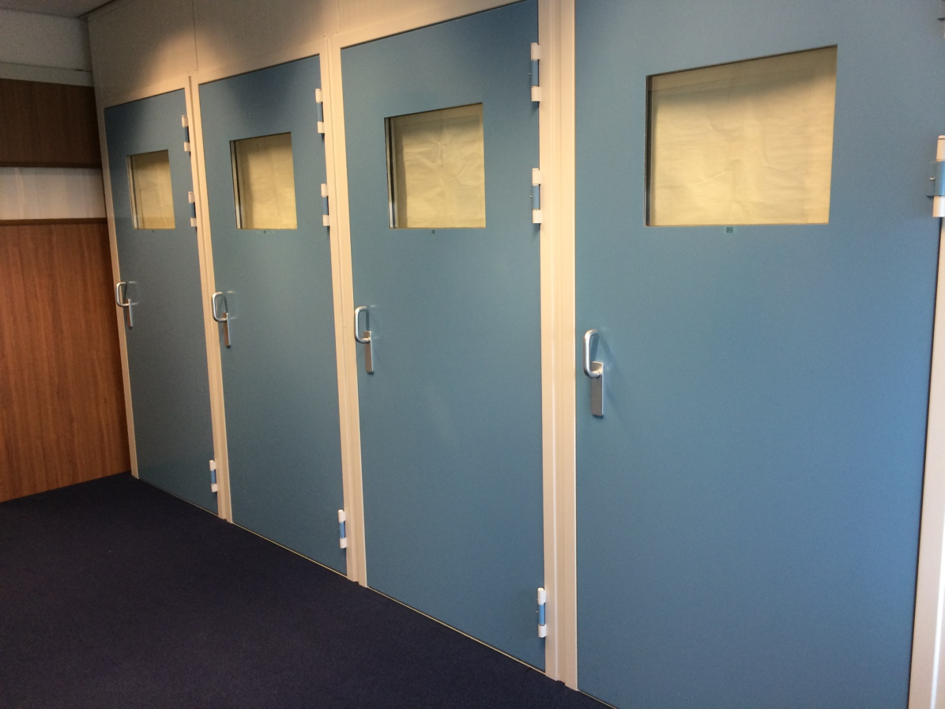

Picture 2
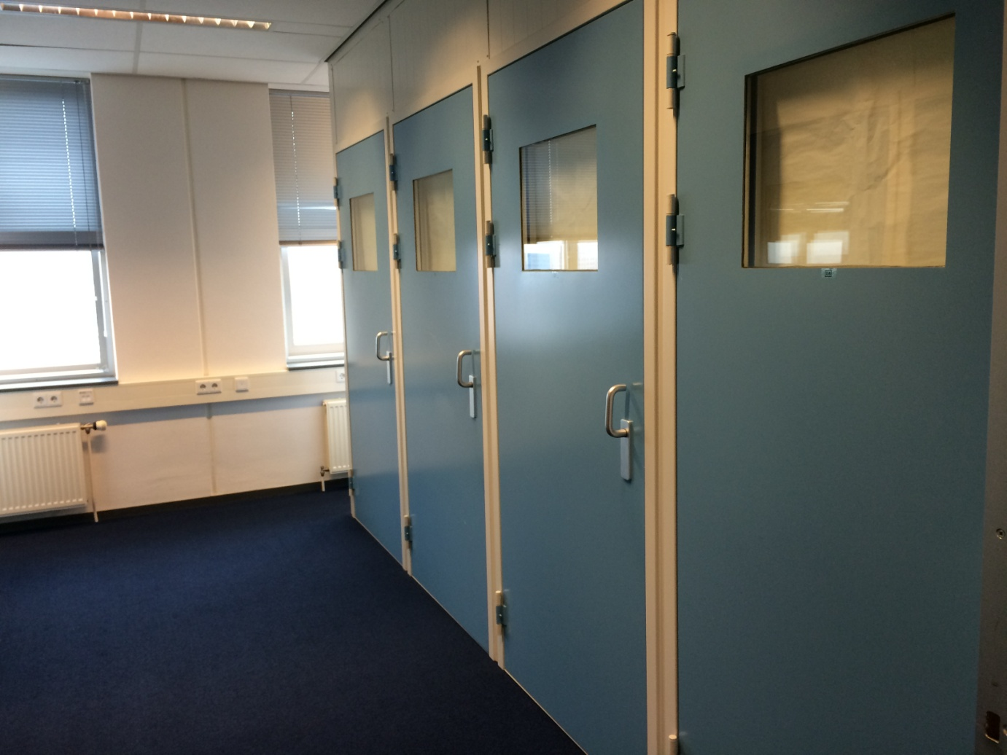

Picture 3


Picture 4
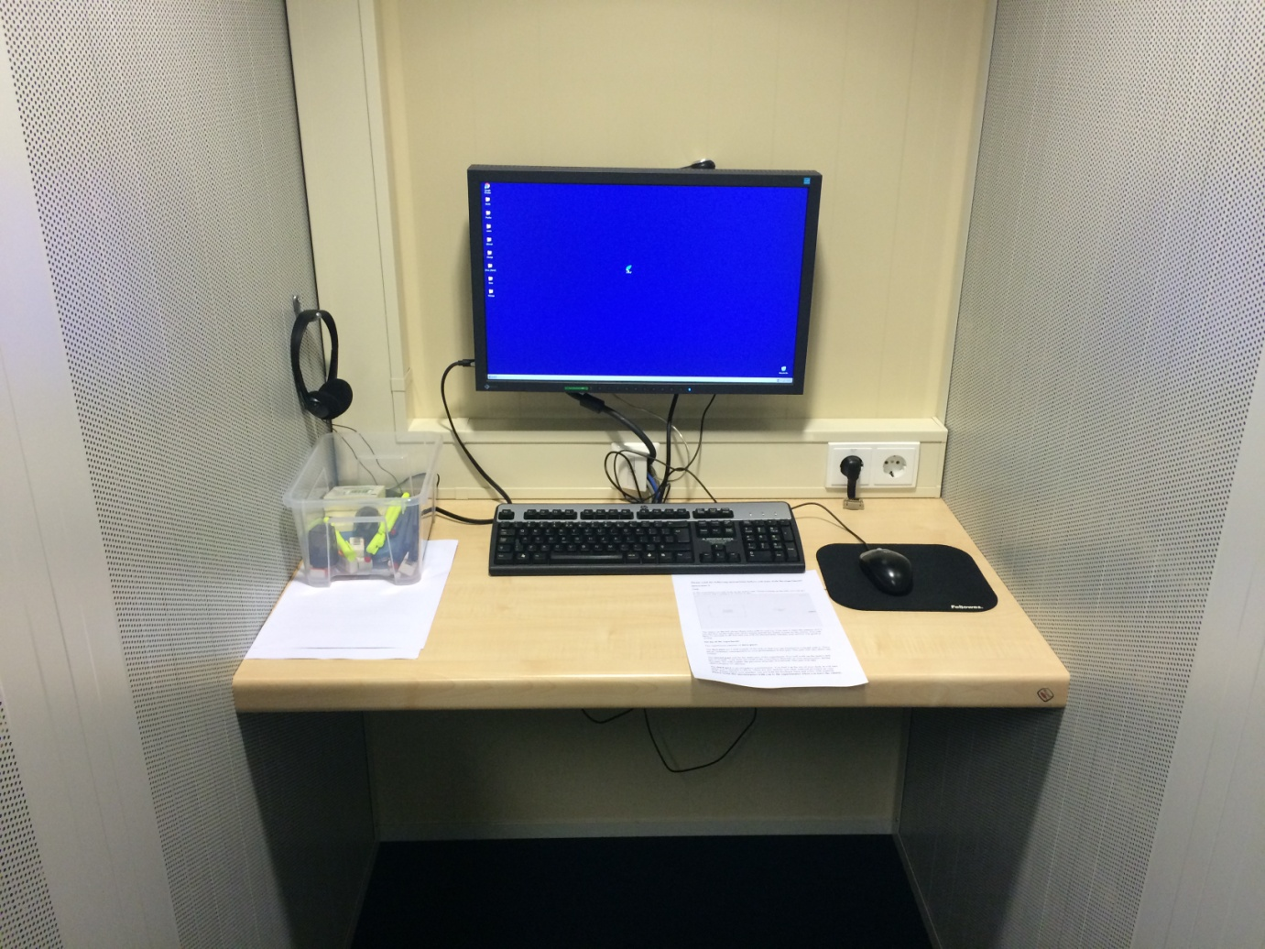

Picture 5
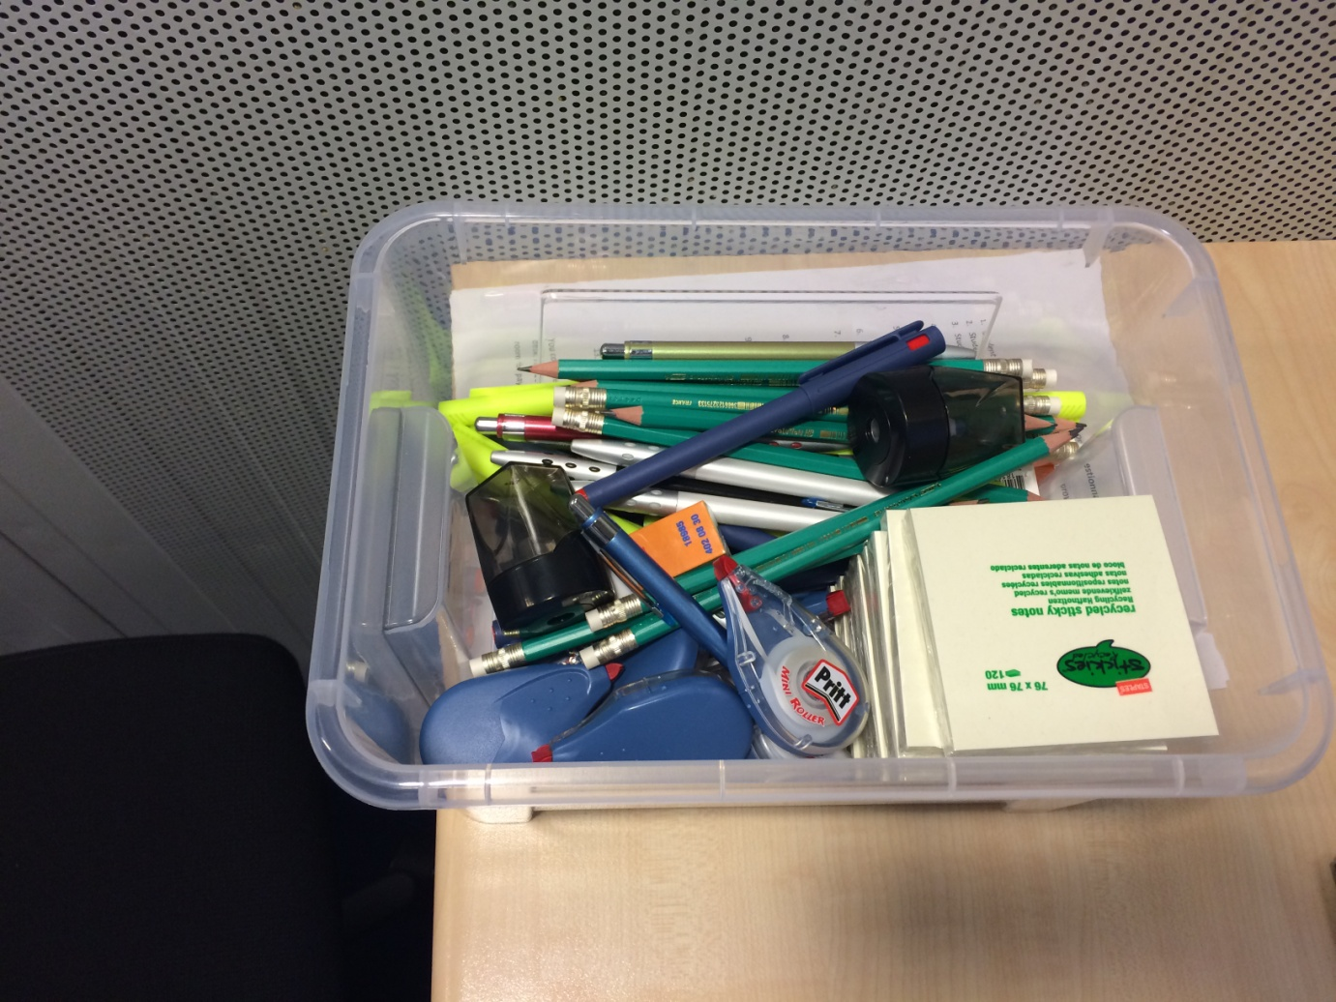

Picture 6
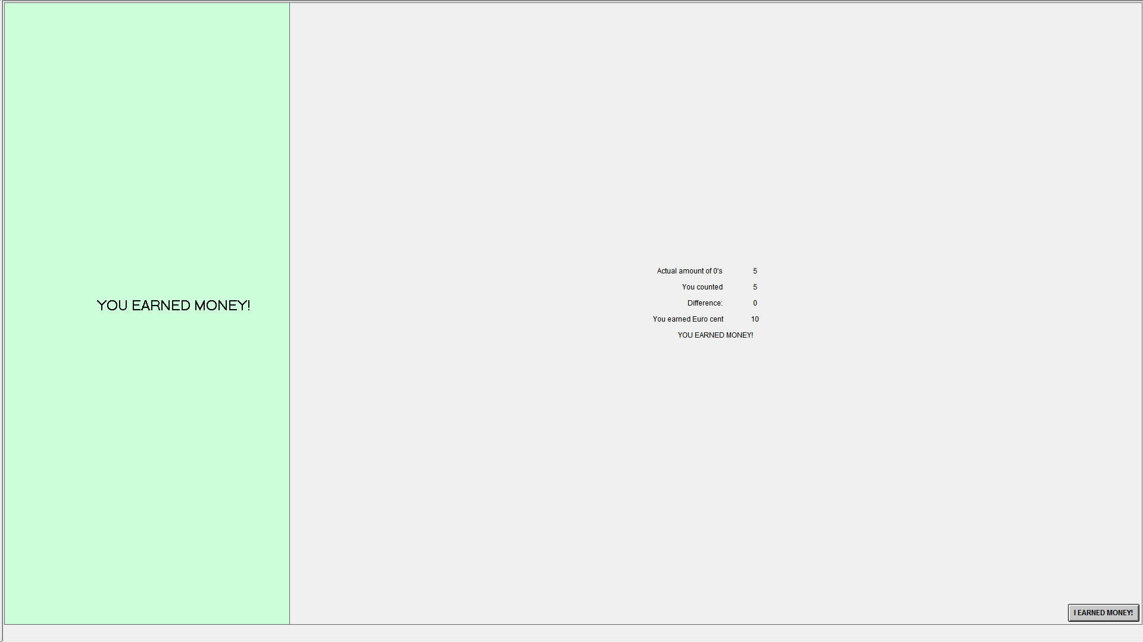

Picture 7
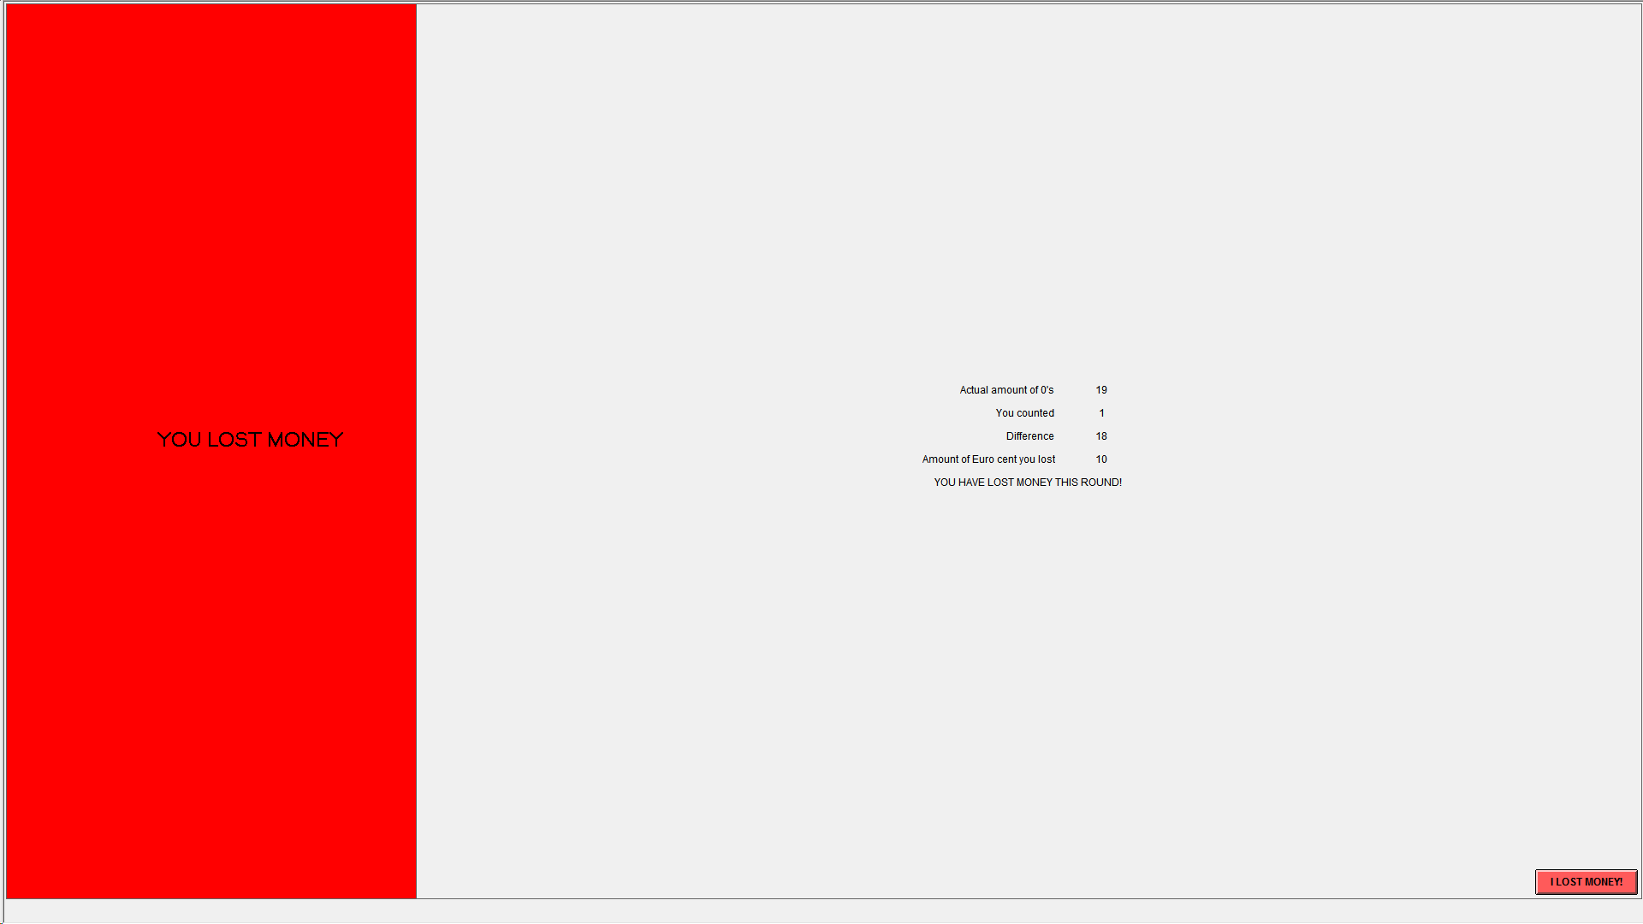

Protocol
Session preparation
- Print material
  - Payment receipt
  - 10 Euro receipt
  - Instructions
  - Voluntary survey
  - Obligatory questionnaire
- Bring paper and tape to close windows
- Bring stapler to staple surveys
- Bring money box and keys

Prepare cubicles:
- Set- up main computer
- Start cubicle computers
- Put boxes with material in (everything 10, sharpeners 3)
- Number questionnaires with Session and cubicle, put under the box upside down
- Number survey with session and cubicle number, put under the questionnaire
- Close windows with paper and tape
- Start all computer IN ORDER OF EXPERIMENTAL CUBICLE number; only do not start cubicle 8: then ztree subject numbers correspond with cubicle numbers that are noted on questionnaire and survey

At the start of the experiment:
- Go to waiting room
- Say: “ Who is here for the experiment Matrix please raise your hand? Welcome, I am Danny and conduct this experiment. I will now read the list of registered participants. Please raise your hand when I read your name and show me your student ID”
- {if there are too many subjects}: We only need 8 students for the experiment. X of you therefore cannot participate, but will receive a x Euro show-up fee. Anyone who voluntarily wants to leave? [if no]: then I will send X and Y home as they registered last for the experiment. You can participate in future sessions of the experiment if you want.
- Please follow me to the cubicle lab now and pick a cubicle. Please leave the door open for the moment.
- [loss treatment]: I will now go from cubicle to cubicle handing out 10 Euros that you receive for the experiment. These 10 Euros are yours and belong to you. Please sign the receipt form.
- I will now read out the instructions. You have a copy of the instructions in front of you. Please read along with me.
- [READ INSTRUCTIONS]

Experiment starts:
Adjust the client to number of people who showed up.
As people are working prepare the receipts with date, name and student number to save time

Experiment ends:
- Ask people to wait in hall and come to the experimenter one by one for payment
- Check questionnaire for completeness, if not complete: make them complete it
- Read cubicle number of questionnaire and see how much they earned
- Fill in date and amount earned into the receipt
- Hand the receipt to the student to fill in info and sign it
- Count money and hand it to students
- In ORSEE indicate the students who showed up;

After payment:
- See if there was stealing; if so: replenish the box
- Re-set experimental room for next session
- Enter info from feedback forms into database
- Enter whether or not subject filled in the survey

End of experimental day
- Count all receipts, including the 2 euro show-up receipts for those sent home; sum it
- Count money in cash registry
- Calculate outflow of cash registry and compare the sum with what you have from receipts
- Document in the cash registry excel file
- If money flows in, mark the inflow
- Have a general book keeping file and update it with money “spent” on stolen material; and money that is transferred to you by Susanne

Inviting subjects:

Invite subjects about five days prior to a session
Open all sessions on 2 days; so that subjects can choose between all different time slots on two different days.
When registration for 1 day closes, we open registration for the next session day by entering these sessions into the system .
We invite 2 subjects extra per session.
Subjects who come and that we have to send home receive 2 Euros.

ORSEE:
Register sessions:
- We send reminder 24 hours ahead
- Rule: send reminder no matter what
- We have to watch registrations and potentially manually cancel session by sending bulk email to registered participant of that session encouraging them to sign up for another one of the existing sessions that are still not full.
Assigning subjects:
- I also click number 2: less than 2 no shows
- Click WITHOUT participants from our pilot sessions (that is point number 10): click our experiment AND click the field below the number 10.
- I now assigned 400 subjects
Inviting subjects:
- Topic: incentives
- Length: 45 minutes
- Payment: on average 8 Euro
- I added a sentence right before “best regards,”: “If you encounter any problems or have questions, please contact neckermann@ese.eur.nl”
- We apply the rule (when sending the invitation) that invitation is sent to people who have not yet participated and have not yet registered (point “3.”)

Payment Receipt

Date: …………………………………..

Student name: …………………………………..

Studentnumber …………………………………..

I hereby confirm the receipt of 10 Euros before the start of the experiment. These are mine and belong to me.

Signature:……………………….

Please read the following instructions before you start with the experiment!

Instructions A

Set-up of the experiment

The experiment consists of three parts.

The first part are 5 trial rounds of the task so that you can familiarize yourself with it. There are no monetary consequences to your performance in this part. This part will take about one minute.

The second part will be the main part of the experiment. You will work on the task for 100 rounds. Your final payment in the experiment depends on your performance during this part. We will explain the payment structure below. This part will take approximately 25 minutes.

The third part is an obligatory questionnaire. You find it at the top of your desk under the container with the pencils. It is one page long and will take about 1 or 2 minutes to fill in. There are also pencils and other material provided on your desk. Please check now whether you see both the questionnaire and a box with material. Please bring this questionnaire with you to the experimenter when you leave the cubicle.

Finally, you could help with a different survey. Participation in this additional survey is voluntary and there will be no reward or punishment for it. If you are willing to help, feel free to fill in the survey that you find under the questionnaire.

Task
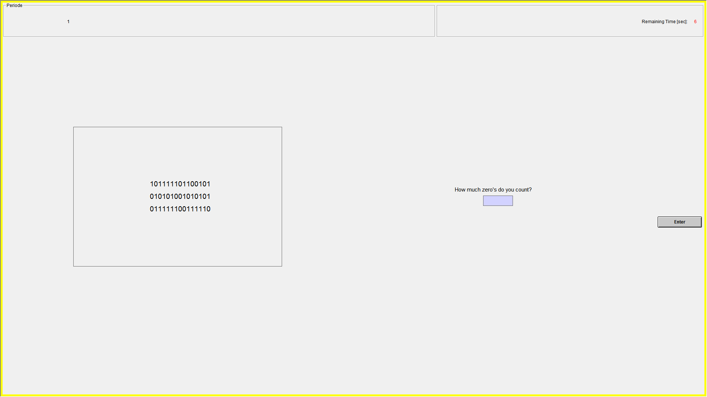
In this experiment you will work on the matrix task. When working on the task, you will get to see a screen that is going to be similar to this:

The object on the left shows rows with 0's and 1's. Your task is to enter the amount of 0 's into the box on the right side of the screen and you have to press the “Enter” button on the screen. Only then will your answer be registered in the system. You will have 10 seconds to do this.
Right after that you will see a screen which shows you the correct answer, your answer, and the payoff consequences of this. Please press the button at the bottom of the screen to proceed. Otherwise, the program will continue automatically after 10 seconds.

Payment structure

Your payment depends on your performance in the second part of the experiment. For every task that you do correctly, you earn 10 cents. At the end of the experiment, you will receive the sum of earnings from all your correct answers.
For example, if you solve 50 matrices correctly, you will earn 5 Euros, which you will receive in cash at the end of the experiment.

The experimenter will remain in the experimenter room throughout the entire experiment. If you have a question, please go ask him there.

If you use the computer in an improper way you will be excluded from the experiment and from any payment.

Please close your door. The experiment will automatically start in a few seconds.

Please read the following instructions before you start with the experiment!

Instructions B

Set-up of the experiment

The experiment consists of three parts.

The first part are 5 trial rounds of the task so that you can familiarize yourself with it. There are no monetary consequences to your performance in this part. This part will take about one minute.

The second part will be the main part of the experiment. You will work on the task for 100 rounds. Your final payment in the experiment depends on your performance during this part. We will explain the payment structure below. This part will take approximately 25 minutes.

The third part is an obligatory questionnaire. You find it at the top of your desk under the container with the pencils. It is one page long and will take about 1 or 2 minutes to fill in. There are also pencils and other material provided on your desk. Please check now whether you see both the questionnaire and a box with material. Please bring this questionnaire with you to the experimenter when you leave the cubicle.

Finally, you could help with a different survey. Participation in this additional survey is voluntary and there will be no reward or punishment for it. If you are willing to help, feel free to fill in the survey that you find under the questionnaire.

Task

In this experiment you will work on the matrix task. When working on the task, you will get to see a screen that is going to be similar to this:

The object on the left shows rows with 0's and 1's. Your task is to enter the amount of 0 's into the box on the right side of the screen and you have to press the “Enter” button on the screen. Only then will your answer be registered in the system. You will have 10 seconds to do this.
Right after that you will see a screen which shows you the correct answer, your answer, and the payoff consequences of this. Please press the button at the bottom of the screen to proceed. Otherwise, the program will continue automatically after 10 seconds.

Payment structure

For participating in this experiment you have already received €10,00. These are yours. However, for every task that you do not do correctly, you incur a loss of €0,10. At the end of the experiment, the sum of all your wrong answers will be deducted and you will have to pay the experimenter back from the money that you already received.
For example, if you solve 10 matrices incorrectly, you have to pay €1,00 in cash to the experimenter. Cash change is available.

The experimenter will remain in the experimenter room throughout the entire experiment. If you have a question, please go there to ask him.

If you use the computer in an improper way you will be excluded from the experiment and from any payment.

Please close your door. The experiment will automatically start in a few seconds.

Obligatory Questionnaire
(pencils and other material are provided on desk)

- Student name: ………………………………………………………………………………………………
- Student number: …………………………………………………………………………………………….
- Student age: ……………………………………………………………………………………………….....
- What year of study are you in?
__ Bachelor 1 __ Bachelor 2 __ Bachelor 3 __ Pre-Master __ Master __ Post-Master
- What is your field of study?
__ Economics __ Business __ Psychology __ Law __ Other: …………………………….
- What is your gender? __ male __ female
- We will invite some people back for another round of the same experiment within the next few weeks. Do you want to participate again?
___ yes; email address: _________________________ ___ no
- On a scale of 1 to 7, how happy are you now?
(1: not happy at all; 7: very happy) _____
- On a scale of 1 to 7, how much fun was part two of the experiment?
(1: no fun at all; 7: a lot of fun) _____
- Out of the 100 matrices you were presented with, how many counts do you think you got right in total? _____
- On a scale of 1 to 7, how adequate/fair do you perceive the payment?
(1: completely unadequate/unfair; 7: completely adequate/fair) _____
- On a scale of 1 to 7, how hard did you work on the task?
(1: not hard at all; 7: as hard as I could) _____
- Would you suggest to your friends to participate in this experiment?
__ yes __ no
You could help us with another research project by filling in the survey that you find on your desk. It should take approximately 5 minutes. Otherwise, please proceed to experimenter room for payment.


Survey
-- Voluntary --

Please fill in all fields. Only completed surveys can be evaluated. Your survey responses are anonymous and will not be linked to any personal data.

- What is your gender?
- Male
- Female

- In what year were you born? ____

- What is the highest degree you have obtained?
- No degree
- High school
- Bachelor
- Master
- PhD
- Other: _________________________________________

The following questions are about your general opinion about motivation factors at work. For the answer, t is not necessary that you are currently working!
4a. How important are the following factors in a job to you?
Not important | 1 2 3 4 5 6 7 | important
Dynamic environment | □ □ □ □ □ □ □
High wage | □ □ □ □ □ □ □
Good work relationship with colleagues and superiors | □ □ □ □ □ □ □
Small gestures (eg, small gifts for a birthday or Christmas) | □ □ □ □ □ □ □
Possibility to get additional leave-time | □ □ □ □ □ □ □
Acces to unlimited trainings | □ □ □ □ □ □ □
Appreciation and recognition from superior | □ □ □ □ □ □ □
Doing something good for the world | □ □ □ □ □ □ □
Flexible work hours | □ □ □ □ □ □ □
Opportunity to work from home | □ □ □ □ □ □ □

4b. Companies are looking for committed and motivated employees. Imagine you have a job you greatly enjoy. In what way will the following factors affect your job performance?
Performance No Performance
decreases effect increases
1 2 3 4 5 6 7
No monitoring |  | □ □ □ □ □ □ □
Flexible work hours |  | □ □ □ □ □ □ □
Possibility to work from home | □ □ □ □ □ □ □

4c. Imagine you have a job you do not enjoy. In what way will the following factors affect your job performance?
Performance No Performance
decreases effect increases
1 2 3 4 5 6 7
No monitoring | □ □ □ □ □ □ □
Flexible work hours | □ □ □ □ □ □ □
Possibility to work from home | □ □ □ □ □ □ □

4d. What do you think are other factors that are generally critical to employee motivation? (the more detailed your reply, the more helpful)
______________________________________________________________________________________________________________________________________
5. Imagine you have a job in which you can work from home.
Which statement best describes you?
- I would (almost) always work from home
- I would still work partly at the company
- I would still work mainly at the company
If you would still go the company to work, what are your main reasons?

 | I fully disagree | 1 2 3 4 5 6 7 | I fully agree
I can focus more on the job in the company. |  | □ □ □ □ □ □ □
I like to have personal contact with my colleagues. |  | □ □ □ □ □ □ □
I find it hard to motivate myself to work at home. |  | □ □ □ □ □ □ □
I let myself be distracted very easily while working at home. |  | □ □ □ □ □ □ □

Other reasons: __________________________________

6. Imagine you had a job as an employee, in which you needed to work fixed, predetermined hours (as in most professions). Now your employer allows you (to some extent) to freely decide when you want to work (time of day and day of week) as long as your total working hours remain the same. Which statement best describes your reaction:
- I would probably use the freedom to adjust the work hours to my needs.
- I would probably keep working on the fixed, predetermined schedule.
In the latter case, what is your motivation?
- I like routine and stucture.
  - I am not good at time management.
Other reasons: __________________________________
Please only fill in this page, if you are currently employed or have been employed at some point in the past; if you have never worked, you are done filling in this survey!
7a. What kind of work do you do now or have you been practicing mainly in the past?
Please provide the exact title of your occupation, e.g. 'Salesman' instead of 'employee' or 'police officer' instead of 'public sector’. If you are following a trainee- or apprenticeship, please enter that.

7b. Does your job allow flexible working hours, such as "Flextime"?
- Yes, I have flexible working hours.
- No, it would be possible in my profession, but my employer does not offer it.
- No, it would not be possible in my profession.
7c. Do you have the possibility to work from home?
- Yes
- No, it is possible, but my employer wants me to be at the company during work hours
- No, it is not possible (eg because I have to be at the production site or at the customer).
If 'Yes’, to what extent? days per week
If 'No’, would you like to work more from home?
  - Yes days more per week
  - No
7d. How satisfied are you with your current job?
1 2 3 4 5 6 7
Not satisfied at all Very satisfied
□ □ □ □ □ □ □

7e. How much do you enjoy your current job?
No enjoyment at all | 1 2 3 4 5 6 7  □ □ □ □ □ □ □ | I enjoy it a lot

Experiment Counting Matrix Organisation: dr. S. Neckermann and D. Hsu
Date:
RECEIPT

I declare to have received € ______ for participation in the Experiment.
Name:
Student-number:
Signature:

Included are 3 pencil sharpeners and 10 of each: pencil, eraser, yellow marker, fine liner red, fine liner blue, post-it notes, pen, pritt.

