Erasmus University Rotterdam Erasmus School of Economics Master Thesis MSc International Economics
The effect of Internet on income inequality
Wouterlood, C.W.A. 328793
Abstract
This research makes an inquiry into the effects of Internet on within country income inequality. Using data from the World Development Indicators, the Standarized World Income Inequality Database and the World Income Inequality Database an empirical model is estimated. The outcome of these models is that Internet has an increasing effect on income inequality. It is argued that this is due to (social) globalization and the fact that some people better utilize the capacities of the Internet than others.

Introduction 3
Literature review 4
Drivers of inequality 4
Drivers of Internet diffusion 7
The effect of Internet diffusion on income inequality 8
Methodology & Data 10
The data 10
The model 12
Robustness Checks 15
Hypothesis 16
Results 18
Benchmark models 18
Subsample models 21
Observed differences 26
Discussion 27
Conclusion 29
References 30
Appendix 32
Appendix 1 32
Appendix 2 32
Appendix 3 32
Appendix 4 33
Appendix 5 35
Appendix 6 35

1 Introduction
21 years ago, the Internet was opened-up for public use. It has, in this relatively short period of time, revolutionized our way of living and doing business. A large and ever increasing amount of information has become accessible to people who use Internet. The generation and distribution of information counts as one of the main drivers of endogenous growth (Lucas, 1988). Czernich et al. (2009) estimated that the younger sibling of the Internet, broadband Internet, alone counts for 2.7 - 3.9 % higher GDP growth in 25 OECD countries. On a macroeconomic level, most researchers agree that (broadband) Internet has enhanced economic growth of countries that have implemented it.
Internet is more that an economic-growth driver, it is also a form of globalization. It connects people with each other in ways that they have not been connected before. However, globalization does not solely have growth enhancing effects. Often it is found that globalization also has income inequality enhancing effects (Bergh & Nillson, 2010).
The effects of Internet on economic growth have been widely studied. A few studies have been conducted which make an inquiry into the combined effects of Internet and income inequality on economic growth, whilst other studies have argued for the “digital divide”, meaning that Internet is not equally accessible for everyone. However, the topic of the relationship between income inequality and Internet diffusion is a field, which is relatively unexplored. Focusing on Internet diffusion is important because it allows us to specifically identify the effect of Internet on income inequality with respect to the degree of Internet penetration. This study will contribute to the literature by aiming to further clarify and identify this effect.

Using panel data for 124 countries over the period 1990-2013, the impact of Internet on within country income inequality is explored. Using various regression models, control variables and subsamples this thesis identifies the following question:

What is the effect of Internet diffusion on within country income inequality?

This research proves that Internet has an income inequality increasing effect.

The paper is organized as follows. Section two gives a brief overview of the existing literature. Section three addresses the data and methodology used for this research. Section four presents the results and finally section five and six offering points of discussion and concluding remarks as well as points of discussion.

2 Literature review

Drivers of inequality
This chapter will briefly identify the main drivers of differences between labor income, which can be identified as the foremost driver of within-country income inequality. These findings will partially contribute to the empirical model, which is present in section four of this paper.

In this research, within country income inequality is defined as the uneven distribution of income amongst individuals living within the same country. One of the most frequently used measures for income inequality in economic research is the Gini coefficient. For a completely egalitarian society (where everyone has the same income) the Gini coefficient takes the value zero. If one person in a society were to hold all of the income, the Gini coefficient of this society would be equal to one. However, it can also be displayed at as a value from 0 tot 100, as is done in this research.
Within-country income inequality is observed in all countries throughout the world. Economic theory argues that this inequality has several advantages, like the presumption that people are more incentivized to work harder when they can gain a better economic position relative to others. Some theories have even suggested that happiness is partially dependent on this: ‘Keeping up with the Joneses’-effect. This effect describes how people use their neighbors as benchmark for their socio-economic status. Being less affluent than your neighbors is perceived as socio-economic inferiority and causes disutility.
In addition to this, the International Monetary Fund has argued that income inequality also has negative effects on long-term economic growth, since it deprives poorer people of important ways of developing themselves, like attending higher levels of education (Berg & Ostry, 2011).

The OECD (2012) distinguishes three key factors that drive within country labor income inequality. The first factor to contribute to this is the dispersion of hourly earnings among those people who have a full-time job. The second factor is the difference in hours worked between workers, especially part-timers versus full-timers. Thirdly, the non-employment rate is also of a great influence to within country income inequality. The above stated factors can be explained by a number of drivers. The first factor, the dispersion between hourly earnings of full-time workers, is the key factor to be explained, since it can be explained by differences in productivity.
The differences in productivity, which cause income inequality, can be explained by a number of factors. Technical change is one of the main contributors to differences in productivity and thus an increase or decrease of income inequality. An increase in income inequality could be caused by the fall in demand for medium-skilled workers, whose work can be computerized to a certain extend due to the technical advancements. This fall in demand causes the wages for medium-skilled workers to decrease. In addition to this, the productivity of high-skilled workers increases due the technical change, increasing their wages, which in its turn will further increase within country income inequality. Furthermore, the tasks of high- and low-skilled workers are not that easily replaced by computerizing it, therefore there will be an increase in the demand for these type of workers. Due to the increase in the demand for these types of workers, their wages will also increase.
Another well-known driver of within-country income inequality is globalization. It has two effects that offset an increase in income inequality. The first effect is that of import competition. This effect is mainly applicable for firms that have a low-productivity, meaning that a more efficient firm, which is located abroad, can sell the same product for lower prices, assuming that import-tariffs do not nullify the price difference. Due to the competition, the less efficient firm is forced to either reduce cost by decreasing wages or reduce its workforce, either one of those increasing within-country income inequality. The second effect is the outsourcing of production activities, which are not relatively skill intensive for a rich country, but are relatively skill intensive for a poor country. These shifts cause an increase in the demand for skilled labor in both countries. Due to this increase in demand for skilled labor, the wage difference between skilled and unskilled workers will widen and offset an increase in the within-country income inequality in both countries.
The effect of education can either increase or decrease income inequality, depending on the degree of education that is obtained. An increase in the number of people with a secondary education has an income inequality decreasing effect, since secondary educated workers tend to be higher skilled than primary educated workers. This difference in skill and productivity is reflected in the wage difference. The effect of tertiary education is ambiguous. An increase in the portion of the population whom are tertiary educated increases the portion of high-income earners in the population, which causes the income gap to widen and income inequality to increase. On the other hand it causes an increase in the supply of high-skilled workers and thus a decrease in the wage premium for these types of workers, making the wage gap between high-skilled and low-skilled workers smaller.
Other factors that contribute to a lower degree of income inequality are a high degree of union membership, a relatively high minimum wage and well-designed job protection: workers on a temporary contract earn less than their colleagues with a permanent contract. Finally, immigration can also be named as one of the drivers of income inequality. Often is found that immigrants have a lower degree of education and face a language barrier. Although the effect of immigration on income inequality is ambiguous after correcting for educational differences, there remain indicators that a higher degree of immigration affects the income distribution and cause a larger gap in incomes. This could be explained by the possibility that immigrants have attended lower-quality levels of education and lack working experience in the country to which they have immigrated (OECD,2012).

Katz & Murphy (1991) also made inquiries into the drivers of within-country income inequality. They acknowledge many of the drivers that the OECD defined, like the effect of education, the state of the technology, the effect of unions and the level of the minimum wage. They define three important types of drivers for income inequality, namely labor supply shifts, labor demand shifts and institutional drivers.
There are several effects that cause changes in the labor supply to have an impact on income inequality. Age difference between workers is an important factor: younger workers tend to be less experienced and thus less productive, thus the wages for younger people are lower. In addition to this, when there is an increase in the number of young and relatively low-paid workers, this will cause a further decrease of the wages for young workers, which causes income inequality to increase. A second important characteristic is the gender of the workers. It is well known that there is a wage-gap between men and women. Partially this can be explained because of the fact that some women have different jobs than men, which are less-paid. The last characteristic of this group is the level of education that workers have enjoyed. Like stated by the research of OECD (2012), the effect of especially tertiary can be income inequality increasing.
In addition to the effects caused by changes in the labor supply, there are also effects that influence income inequality that can be attributed to the shifts of the demand side of labor. Like stated above, the state of technical change within an economy is an important factor. Another important contributor to the level of income inequality is the type of final goods that are requested by the consumers. A high level of demand for final goods, which require high-skilled workers for the production, will result in an increase in the demand for high-skilled workers and a lower demand for low-skilled workers. This change in demand causes the wage premium for high-skilled workers to increase, whereas it decreases for low-skilled workers. This causes income inequality to increase. On the other hand, when the demand for final goods that require relatively low-skilled workers increases, the demand for low-skilled workers increases and the demand for high-skilled workers decreases. This effect causes the wage premium for high-skilled workers to decrease and thus the income gap to decrease. This goes hand in hand with the technical state of the economy, since this also affects the skills required from the workers who have to manufacture the goods.
The third driver consists of the so-called ‘institutional’ factors, which includes two of the drivers named by the OECD (2012), namely the level of the minimum wage and the presence of labor unions. The OECD paper (2012) argued that a higher degree of union membership can work inequality decreasing, although this effect is ambiguous and depends on several factors. Important factors which influence if an union has an income inequality in- or decreasing is the bargaining power of the union and which type of workers, high- or low-skilled, it represents. An union with a powerful bargaining position, which represents high-skilled workers, can induce an increase in the wages for high-skilled workers, which causes the income gap to widen and within-country income inequality to increase. However, Friedman (1962) argues that the efforts of labor unions do not contribute to an efficient economic output, but rather increase the wages of some workers, the union members, at the expense of other workers. This increase in wages causes the firms to increase prices, since marginal cost have increased due to higher wages, which will result in lower demand for the produced goods. This will inevitably result in a reduction of the production and thus in an increase in unemployment and lower wages due to a decrease in the demand for labor. However, this neoclassical believe is not shared by all. Freeman and Medoff (1984) argue that through the efforts of labor union improvements in management, productivity and skill development can be achieved. In addition to this, a labor union provides protection for workers, which can increase the work ethics. This causes the firm to work more efficiently and thus produce at a lower cost (and lower price), which can be beneficiary for the wage of the workers in the long run.
The final contributor to the institutional factors is the interest rate. An increase in the interest rate will cause a decrease in the demand for goods, which will eventually lead to a decrease in production and employment. Like discussed above, both the reduction of production as the reduction of the number of employees have negative effects on income inequality. Katz & Murphy (1991), Friedman (1962) and Taylor (1993).

Drivers of Internet diffusion
This chapter will briefly identify the main drivers of Internet diffusion at a macro-economic level.

The diffusion of many different technological advancements has been widely studied in the literature. Since Internet is a key driver of economic growth, it is relevant for researchers and policymakers to understand the drivers of its adoption in order to facilitate, amongst other things, economic growth. The diffusion of Internet is defined as the percentage of people who use the Internet.

Andres et al. (2007) show that there are large differences in the adoption rate of Internet across different countries. The estimated S-shaped adoption curve is skewed towards high-income countries. This means that the adoption rate of Internet in high-income countries is lower than in low-income countries. However, high-income countries have overall a higher percentage of people who are already Internet users than low-income countries. This could indicate that the low-income countries are ‘catching-up’ with the high-income countries. One of the explanations for this can be that it’s relatively cheap for these countries to adopt Internet, due to for instance lower labor cost and more accessibility of the necessary technology.
In addition to this, Andres et al. (2007) identify the key drivers of Internet diffusion in high- and low-income countries. The foremost driver is the network effect: the utility of using the Internet becomes higher once there are more people who use it. An important indicator for this is the number of Internet users in the preceding years.
Furthermore is the level of competition amongst the Internet Service Providers an important driver: the more competition, the higher the adoption rate. This could be explained by the fact that more competition tends to lead to lower market prices, which increases demand. The effect of higher levels of competition is higher in high-income countries than in low-income countries.
The final key driver of Internet diffusion is related to the network effect: language externalities. The number of Internet users that speak the same language intensifies the impact of the network effect. For instance, a not-English speaking person might have less utility from the Internet than an English speaking person if the Internet were to be dominated by the English language.

The effect of Internet diffusion on income inequality
This research aims to identify the impact of Internet on income inequality. Therefore it is important to study the literature related to this subject, along with theoretical models describing possible effects. The findings of this chapter will be used in formulating our hypothesis.

So far, the literature on the effect of Internet on within-country income inequality has provided contra dictionary findings. Acemoglu (2002) argues that an increase in income inequality in many OECD countries can be explained due to an increased wage premium for ICT related activities, caused by diffusion of information technology. Martin & Robinson (2004) add to this by claiming that the diffusion of Internet is polarized due to income inequality, which in combination with the ICT-premium would create a downward sloping spiral with respect to income for those who lack ICT-skills. Noh & Yoo (2007) show that countries that have a high level of inequality experience a slower diffusion rate with respect to Internet.
This is disputed by Lloyd-Ellis (1999), claiming that the diffusion of Internet has decreased income inequality by increasing the productivity of workers and thus increasing the wages.

More empirical based studies find that Internet diffusion has a positive effect on income inequality. Bergh & Nilsson (2010) identify the effects of different dimensions of economic globalization and liberalization on income inequality in various stages of economic development. One of these dimensions of globalization is social globalization, which captures factors like the number of Internet users, telephone traffic and the presence of large firms like IKEA per capita. The article presents findings that social globalization, along with other factors, has an increasing effect on within-country income inequality.
Yi & Choi (2005) find that the Internet has lowered inflation, which could be the effect of the increase in productivity Internet has caused.
Noh & Yoo (2007) investigate the ‘digital divide’, which is defined as “a gap in access and ability to use ICT”. They introduce an Overlapping Generations Model, which constitutes that both income inequality and Internet diffusion have a positive effect on growth. Subsequently, they test this theoretical model using panel data from the World Bank. They find that both Internet and within-country income inequality have a postive effect upon growth. However, the interaction term is negative. This indicates that the positive effect of Internet diffusion is reduced by income inequality.

Jung et al. (2001) study the demographics of people with different Internet Connectedness Index scores (ICI). The Internet Connectedness Index indicates to what extend an individual uses the Internet. The higher the value of the ICI, the more a person utilizes the possibilities of the Internet. They find that people with a higher ICI-score tend to be higher educated, more affluent, younger and less likely to be female than those who have a lower ICI-score.
This could provide a possible explanation for the effect that Internet has on income inequality. If the Internet is being better utilized, which can cause monetary gain, by a group that is already more affluent this could widen the income gap and thus increase in income inequality.

3 Methodology & Data
This section provides in a description of the data. Furthermore will it provide in the empirical specification of the regression model that will be used for our analysis and an explanation regarding the robustness checks.

The data
The research of this paper is based on panel data drawn from 124 countries over the period of 1990 till 2013. The data that provides in the Gini coefficient is obtained from the World Income Inequality Database and the Standardized World Income Inequality Database. The data regarding the Internet variable, along with the other control variables is obtained from the World Development Indicators from the World Bank.

Gini coefficients can be calculated based on different types of income or expenditure. The most common ways of calculating Gini coefficient are based on gross income, net income or consumption. These different ways of calculating form a shortcoming in the comparability of Gini coefficients over time and between different countries. There are a number of datasets which offer a widely available range of Gini coefficients. Among the best-considered options are the Luxembourg Income Study (LIS), which has the drawback that it only covers thirty, almost exclusively rich countries (Bergh & Nilsson, 2010).
In recent years the World Income Inequality Database (WIID) has combined the Luxembourg Income Study with other databases, like those of the OECD, the Socio-Economic Database for Latin America and the Caribbean and National Survey Statistics. These combining efforts ensured that the WIID covered more countries than for instance the LIS. However, the downside of the WIID is that it combines many Gini coefficients that are obtained from different sources and calculated in different ways. Therefore the Gini coefficients obtained from the WIID are hardly comparable with each other.
Solt (2008) provides the Standardized World Income Inequality Database (SWIID), which aims to make the Gini coefficients more comparable through estimating the ratios between the different types of Gini coefficients and corrects for these differences. Furthermore the SWIID aims to make more data available through a multiple imputation model, which adds missing data points to the dataset. By applying the ratios described above on the Gini coefficients, the SWIID provides a better comparable inequality measure. This standardization and ‘interpolating’ cause the SWIID to have more available data points, which are better comparable to each other. The drawback of this database is that it “provides plausible data but not sufficiently credible data”, due to, amongst other things, concerns regarding the imputation model (Jenkins, 2014).
Considering all, this research will use different models in order to compare the effects and compare the outcomes. We expect that the model of the SWIID has a greater explanatory power than the model based upon the WIID data set, since this latter is expected to have a higher number of diverging observations.

Figure 1 and 2 present the development of the Gini coefficient of both the SWIID respectively the WIID over time.
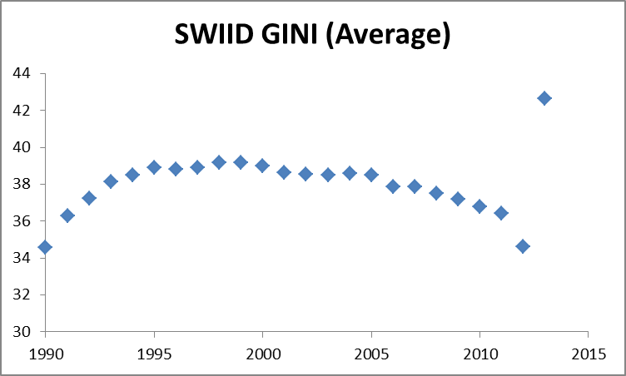
Figure 1: The evolution of the Gini coefficient over time (SWIID-dataset)
Figure 1 shows an inverted U-shaped development of the average Gini coefficient. The outlier of 2013 is caused due to limited availability of Gini coefficients in that particular year. The inverted U-shape of the average Gini coefficient indicates that over the past 25 years income inequality has on average initially increased, after which it started to decline around the year 2000.
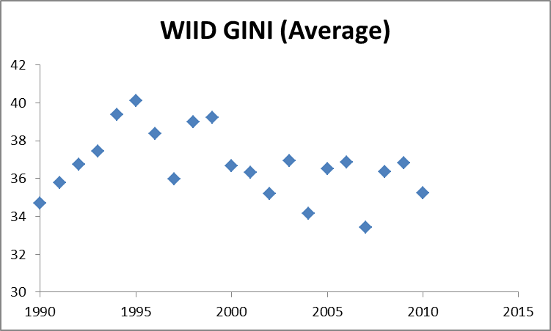
Figure 2: The evolution of the Gini coefficient over time (WIID-dataset)

Figure 2 shows a less obvious trend, although an increase in the average Gini coefficient can be observed in the early '90s, after which the average Gini coefficients starts to decline around the year 2000, similar to the trend in Figure 1.

The Internet variable was obtained from the World Development Index, which is published by the Worldbank. The diffusion of Internet is measured by indicating the number of users per 100 people. This data covers over 124 countries over a period from 1990 till 2013. Figure 3 below shows the diffusion over the period of 1990-2013.
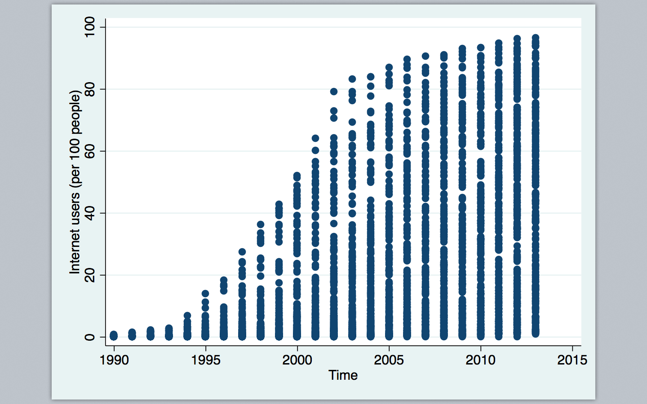
Figure 3: The diffusion of Internet users (per 100 people)
Figure 3 shows an upward trend of the diffusion of Internet. The graph shows a non-linear, but S-shaped type of growth of Internet diffusion, which is to be expected since services and products tend to grow exponential in the early stages after which saturation sets in and the growth rate declines. As of the early years of decade 2000-2010, this growth rate reduces sharply.

The model
This chapter provides explanation about the model that will be used to estimate the effect of Internet on income inequality. Initially, the variables, which are included in the model, will be presented. Additionally, there are some summary statistics presented with respects to the relevant variables and finally will the regression equation for the benchmark model be presented.
Table 1, below, presents the variables which are included in the models used for this research.

Main variables
GINI | GINI-Index (Gini coefficient from either SWIID or WIID)
INT | Internet users (per 100 people)
LN_GDP | Logarithm of the GDP per capita (In US $)
AGRI | Employment in agriculture (% of the total employment)
CAPITAL | Gross capital formation (% of GDP)
LN_TRADE | Logarithm of trade (% of GDP)
UNEMPL | Unemployment (% of total labor force)
LN_FDI | Logarithm of Foreign Direct Investment, net inflow (% GDP)
LN_POP_DENS | Logarithm of Population density (people per KM² of land area)
EDU1 | Labor force with primary education (% of total)
LN_TELE | Logarithm of the telephone lines (per 100 people)
LN_MOBI | Logarithm of the mobile cellular subscriptions (per 100 people)
BROADB | Fixed broadband internet subscribers (per 100 people)
Table 1: Variables
Table 2 provides in an overview of the summary statistics of main variables that were used in both models.
Summary statistics
Variable | Description | Obs | Mean | Std. Dev. | Min | Max
GINI (SWIID) | Gini coefficient | 2357 | 37.808 | 9.190 | 17.548 | 66.560
GINI (WIID) | Gini coefficient
INT | Internet | 2357 | 16.636 | 24.342 | 0.000 | 96.547
LN_GDP | Log of GDP | 2347 | 8.131 | 1.649 | 4.682 | 11.627
LN_TRADE | Log of Trade | 2328 | 4.294 | 0.537 | 2.679 | 6.086
LN_FDI | Log of FDI | 2266 | 3.938 | 5,706 | -55.066 | 76,327
CAPITAL | Capital formation | 2320 | 22.241 | 7.148 | -2.424 | 74.822
UNEMP | Unemployment | 2218 | 9.065 | 6.306 | 0.600 | 39.300
AGRI | % Working in agriculture | 1605 | 17.939 | 17.661 | 0.000 | 92.200
LN_POP_DENS | Log of Population density | 2338 | 174.997 | 609.316 | 1.479 | 7589.143
EDU1 | Primary educated | 1001 | 30.364 | 17.079 | 0.000 | 80.400
LN_TELE | Log of # telephone lines | 2351 | 2.258 | 1.660 | -2.845 | 4.314
LN_MOBI | Log of # of mobile cells | 2239 | 2.041 | 2.604 | -8.979 | 5.342
Table 2: Summary statistics

In appendix 1 and 2 the correlation tables for either one of the datasets are presented. Some variables are highly correlated, with correlations coefficients above 0.7.This includes the telecommunication variables (Internet and logarithm of telephone lines) that are highly correlated with the GDP variable. Furthermore the telecommunication variable (logarithm of telephone lines) is highly correlated with population density variable. The first two are to be expected, since high-income countries have more ways to pay for the necessary infrastructure. The latter correlation can be explained by fact that agriculture activities usually take place on large premises. Ideal locations for this are less dens populated areas.
The regression formula, which will be used for the benchmark model of this research, is displayed below in Equation 1. This equation is based on the model that was used by Bergh & Nilsson (2010) and is completed with additional variables based on the research of the OECD (2012) regarding important drivers for income inequality, along with drivers for Internet diffusion. This equation is estimated for a panel of 124 countries for a period of 24 years. Using a panel data has some advantages compared to doing an cross section analyses on the over-year-averages. This latter does make the data less sensitive, but also has several drawbacks. Solely using a cross section analyses on averages makes the outcome of the regression more volatile to the omitted variable bias. In addition to this, leads to a reduction of data points.

$${GINI}_{i t}={β_{0 i}+ β}_{1}*{INT}_{i t-1}+ β_{2}*{L{N_{GDP}}_{i t-1}}_{}+β_{3}*L{N_{TRADE}}_{i t-1}+ β_{4}*{LN_{FDI}}_{i t-1}+ β_{5}*{CAPITAL}_{i t-1}+ β_{6}*{UNEMP}_{i t-1}+ β_{7}*{AGRI}_{i t-1}+ β_{8}*LN_PO{P_{DENS}}_{i t-1}+ a_{i}+t_{t} + ε_{it}$$
In the model presented in Equation 1, GINI is the variable that measures income inequality. The number of Internet users per 100 people is represented by INT. LN_{GDP} stands for the natural logarithm of GDP per capita. LN_{TRADE} stands for the logarithm of the percentage of trade (as a percentage of GDP). LN__{FDI} represents the net inflow of Foreign Direct Investment, measured as a percentage of GDP. CAPITAL is the variable which measures the capital formation as a percentage of GDP. UNEMP is the variable which represents the level of unemployment, as a percentage of the total labor force. AGRI is the percentage of people that work within the agricultural sector and finally LN__{POPDENS} stands for the population density. Country specific effects are represented by $a_{i}$ and the time fixed effects by $t_{t}$. Finally, ${ β}_{0}$ is the constant term in the model and $ε_{it}$ is the error term.

Robustness Checks
All of the models in this study are estimated using year ($t_{t})$- and country ($a_{i})$ - fixed effects. Country- fixed effects control for time-invariant, unobserved characteristics between two particular countries. Year-fixed effects take unobserved effects varying across years into account. Plotting a model with country-fixed effects in a graph would therefore generate an identical slope for all countries, This way, country-fixed and year-fixed effects allow to study the heterogeneous effects across countries and time.
As an extension of the benchmark model presented in Equation 1, the model is supplemented with additional variables that affect the level of income inequality or strongly relate to the number of Internet users.
The level of Income inequality is strongly affected by the degree of schooling a person has enjoyed according to the literature. For this reason, a variable covering this educational effect will be added to the model. Furthermore will the effects of the number of telephone lines and mobile cellular subscribers be added to the model. Reason for this is that, like stated above, Internet connections make use of the infrastructure of telephone lines. The usage of mobile cellphones can be a good indicator for the level of technological advancement of a country, which is also a key driver of the Internet diffusion rate. Finally the additional explanatory effect of a variable covering broadband Internet will be explored. Broadband Internet is in many ways similar to Internet, apart from the speed of it (which is higher than 64 kbit/s).
In addition to these more extensive models, the model is applied to subsamples of the two data sets. This allows to more specifically identifying the effects per type of country, such as high- middle- and low-income countries. There are three different subsamples: one applying a minimum threshold for the number of Internet users (>25), one for high-income countries and one for low- and middle-income countries. As displayed in Figure 3, the growth of Internet over the last three decades looked exponential. Applying a threshold will ensure that the linearly estimated coefficient will not be under- or overestimated. In Appendix 6 there are cross sectional regressions presented for the years 1990, 1995, 2000, 2005 and 2010. As expected, the coefficient for the Internet variable declines (in absolute terms) in time because at the same time the value of the variable increases. This leads to a combined similar effect, but highly differing coefficient estimates at the points in time. Similar to this, creating a subsample for high- and middle- and low-income countries will clarify the possible different effects that exist between different countries. The determination of the relevant income levels is identical to that of the World Bank; > $12746 for high-income countries.

Hypothesis
The previous section has identified the drivers of income inequality, Internet diffusion and the effect of Internet on income inequality as described in the literature section. These findings are combined into a number of hypotheses regarding the expected effect of Internet on income inequality with an extensive argumentation.

This research aims at identifying the effect of Internet on income inequality. Based on the findings of Bergh & Nilsson (2010) that social globalization has an increasing effect on income inequality along with the fact that globalization is identified as one of the key drivers of income inequality by the study of the OECD (2012) and considering that Internet is a type of globalization, we expect that Internet has an increasing effect on income inequality. In addition to this, the findings by Jung et al. (2001), indicate that better educated and more affluent people more optimally utilize the Internet, which could explain the widening income gap. This can be caused by the fact that the Internet is an important driver for economic growth according to Czernich et al. (1999) and it seems logical that the people who optimally utilize this growth driver have more economic gain from it than the people who do not utilize this driver to the fullest extent. If the people who stand more to gain from the Internet are already more affluent than people who gain less from the Internet, it is a logical result that income inequality increases.

According to the World Bank, OECD countries have a more equal income distribution than non-OECD countries. See also appendix 5 for a graph of the average Gini coefficient per country plotted against the average GDP per country indicating a negative correlation such that we find that the higher GDP, the lower the GINI coefficient tends to be. This could be explained by several factors, among which the fact that people in OECD countries tend to be better educated and enjoy a higher quality of education. Furthermore could the fact that there are higher minimum wages set along better-designed job protection contribute to this explanation. Based on this observation we expect the effect of a higher GDP to have a decreasing effect on the income inequality. The same goes for subsamples of the high-income countries.

Another key driver of income inequality described in the literature is unemployment. Since unemployed people have no income or rely on social security for their income, a higher level of unemployment will cause the income gap to widen. Therefore we expect that the relationship between the employment rate and income inequality is of a positive nature.

According to the Rybczynski theorem an increase in the capital stock will cause Capital/Labor-ratio to increase and along with this the production of the capital intensive good. This will also lead to an absolute decrease of the production of the good which uses other production factors, like labor. This decrease in labor output and demand will cause the wages to drop and will widen the income gap, hence increasing the income inequality.

Baldwin & Cain (1994) were one of the first studies that described the effect between trade and income inequality. They found that over the period 1977-1987 trade accounted for 9 percent of the increase in income inequality. These empirical findings are backed by the theoretical explanation given by Richardson (1995). Therefore the relationship between income inequality and trade is expected to be of a positive nature.

Another key determinant in the level of income inequality is the type of final goods demanded and the state of the technology. In the model of this research, the variable describing this is the employment in the agricultural sector. Like explained in the literature review, the type of final goods requested implies what type of labor is mostly demanded: high- or low-skilled. Since agriculture tends to have many low-skilled workers, the relationship between the percentage of people working within agriculture and income inequality is expected to be negative.

FDI causes investment in a specific branch within a country and is thus likely to create jobs within this branch. In addition to this, FDI brings foreign ‘know-how’ to the domestic market and thus generates an increase in local productivity. Dependent on whether or not this branch is relying on mostly low- or high-skilled workers, this increased productivity might increase (decrease) income inequality since the income gap now widens due to a more wide (narrow) dispersion of productivity amongst workers. The income inequality decreasing effect is expected to be dominant.

Finally, we expect the effect of population density on income inequality to be positive, due to the argument of urbanization.

4 Results
This section provides the results of the estimated models as discussed earlier in this research. It states the findings of the benchmark models based on the SWIID and WIID dataset. Furthermore it also presents the findings regarding the subsamples. Finally, there is a brief summary of the main differences observed between these models and how our findings relate to the hypotheses stated in the previous section.

Please note that the interpretation, which is given below, is based on the reasoning that a lower GINI coefficient means a more equal distribution of income. Therefore, a positive correlation between the GINI variable and the other variables in the models will be interpreted as an income inequality increasing effect.

Benchmark models
Table 4 below presents the findings of the model estimated for the benchmark model as stated in Equation 1 based on the SWIID.
 | (0) | (1) |  | (2) |  | (3) |  | (4) |  | (5)
Variables
INT | 0.0389*** | 0.0370** |  | 0.0608*** |  | 0.0133 |  | 0.0211
 | (0.0135) | (0.0167) |  | (0.0189) |  | (0.0226) |  | (0.0157)
BROADB |  |  |  |  |  |  |  |  |  | 0.125***
 |  |  |  |  |  |  |  |  |  | (0.0246)
LN_GDP |  | 0.0584 |  | -0.437 |  | 0.510 |  | -0.154 |  | -1.155
 |  | (1.273) |  | (1.126) |  | (1.442) |  | (0.931) |  | (0.918)
LN_TRADE |  | -1.374 |  | -1.861 |  | -1.381 |  | -1.735 |  | -1.028
 |  | (1.656) |  | (1.403) |  | (1.694) |  | (1.167) |  | (1.278)
LN_FDI |  | 0.107 |  | 0.142 |  | 0.134 |  | -0.0377 |  | -0.0246
 |  | (0.118) |  | (0.107) |  | (0.107) |  | (0.0866) |  | (0.0792)
CAPITAL |  | 0.0470 |  | 0.0465 |  | 0.0507* |  | 0.0300 |  | 0.00284
 |  | (0.0290) |  | (0.0285) |  | (0.0280) |  | (0.0356) |  | (0.0344)
UNEMP |  | 0.0598 |  | 0.0603 |  | 0.0563 |  | 0.107* |  | 0.0158
 |  | (0.0604) |  | (0.0563) |  | (0.0601) |  | (0.0595) |  | (0.0530)
AGRI |  | -0.0419 |  | -0.0353 |  | -0.0392 |  | -0.0176 |  | -0.0122
 |  | (0.0340) |  | (0.0344) |  | (0.0347) |  | (0.0385) |  | (0.0486)
LN_POP_DENS |  | -2.361 |  | -2.994 |  | -3.836 |  | -6.829 |  | -12.12***
 |  | (4.082) |  | (3.962) |  | (3.823) |  | (4.368) |  | (3.509)
LN_TELE |  |  |  | 1.751 |  |  |  | -1.710 |  | -1.546
 |  |  |  | (1.187) |  |  |  | (1.077) |  | (1.035)
LN_MOBI |  |  |  |  |  | -0.461* |  | -0.0415 |  | 0.815***
 |  |  |  |  |  | (0.257) |  | (0.237) |  | (0.300)
EDU1 |  |  |  |  |  |  |  | -0.00221 |  | -0.0134
 |  |  |  |  |  |  |  | (0.0134) |  | (0.0118)
Constant | 37,61*** | 50.17* |  | 54.35** |  | 51.64* |  | 72.60*** |  | 103.5***
 | (1.897) | (27.29) |  | (24.28) |  | (26.74) |  | (23.35) |  | (21.33)
Observations | 2,357 | 1,378 |  | 1,378 |  | 1,364 |  | 862 |  | 650
R-squared | 0.096 | 0.084 |  | 0.110 |  | 0.098 |  | 0.168 |  | 0.289
Number of Country1 | 150 | 124 |  | 124 |  | 124 |  | 87 |  | 85
Country FE | YES | YES |  | YES |  | YES |  | YES |  | YES
Year FE | YES | YES |  | YES |  | YES |  | YES |  | YES
Robust standard errors in parentheses; *** p<0.01, ** p<0.05, * p<0.1
Table 4: Estimated output benchmark SWIID model
Table 4 above presents the benchmark model for the SWIID models. Column 0 shows a model that has no control variables. It shows a highly significant, positive effect of Internet on income inequality. This model is presented in column 1 and is based on Equation (1). In the columns 2 – 5 there are control variables added to this benchmark model. In the benchmark model in column 1 we find an increase in 1 additional Internet users (out of a 100 people) will cause the Gini coefficient to increase with nearly 0.04, meaning that Internet increases income inequality. Considering that the mean of the GINI coefficient in the SWIID model is 37.808, this is a minor increase. None of the other control variables have a significant effect on income inequality.
The same results were found in the model that is presented in column 2, which is the benchmark model with additional control variables. The income inequality increasing effect of Internet in this model is more severe than in the previous one, which was presented in column 1.
In the models that are presented in columns 3 and 4 there is no significant effect of Internet on income inequality found. The model in column 3 finds income inequality increasing effects for the capital accumulation and income inequality decreasing effects for the number of mobile cellphone subscribers.
In the model presented in column 5 there has been an inquiry into the effects of broadband Internet on income inequality. Broadband Internet also has an income inequality increasing effect, but this effect is larger than the effect of Internet in the previous models discussed in table 4. An additional broadband Internet user will lead to an increase in the GINI coefficient of 0.125. The population density has an income inequality decreasing effect. This effect appears to be quite large in size, but please note that this is based on a logarithmic scale. Finally we find that in this model, the number of mobile cellphone subscribers has an income inequality increasing effect, which is noteworthy because it had the opposite effect in the model which was presented in column 3.

Table 5 below presents the findings of the estimation of the benchmark model and a number of additional variables as stated in Equation 1 based on the WIID.

 | (0) | (1) | (2) | (3) | (4) | (5)
Variables
INT | 0.136*** | 0.153*** | 0.170*** | 0.153** | 0.212***
 | (0.0318) | (0.0401) | (0.0503) | (0.0598) | (0.0616)
BROADB |  |  |  |  |  | 0.280*
 |  |  |  |  |  | (0.155)
LN_GDP |  | 0.0360 | -0.434 | -0.143 | 0.405 | 4.394
 |  | (3.323) | (2.863) | (3.762) | (2.518) | (4.794)
LN_TRADE |  | 11.02** | 10.33** | 9.232* | 4.189 | 5.146
 |  | (5.480) | (5.140) | (5.060) | (3.883) | (6.255)
LN_FDI |  | -0.345 | -0.327 | -0.366 | -0.595 | -1.401
 |  | (0.511) | (0.509) | (0.525) | (0.641) | (0.970)
CAPITAL |  | -0.158 | -0.157 | -0.195 | -0.101 | -0.207
 |  | (0.128) | (0.128) | (0.124) | (0.125) | (0.194)
UNEMP |  | -0.000 | -0.006 | -0.065 | 0.166 | 0.088
 |  | (0.248) | (0.246) | (0.235) | (0.214) | (0.319)
AGRI |  | -0.357* | -0.350* | -0.348* | -0.166 | -0.126
 |  | (0.187) | (0.188) | (0.185) | (0.191) | (0.236)
LN_POP_DENS |  | -4.863 | -5.933 | -0.641 | -10.80 | -5.337
 |  | (9.263) | (8.318) | (8.636) | (11.460) | (20.890)
LN_TELE |  |  | 1.386 |  | -0.027 | 0.868
 |  |  | (2.791) |  | (2.519) | (2.969)
LN_MOBI |  |  |  | 0.145 | 0.440 | 0.798
 |  |  |  | (0.647) | (0.695) | (2.381)
EDU1 |  |  |  |  | -0.045 | 0.052
 |  |  |  |  | (0.103) | (0.130)
Constant | 34.56*** | 24.23 | 31.59 | -16.72 | 69.880 | -7.774
 | (1.842) | (65.43) | (55.50) | (65.99) | (61.41) | (122.9)
Observations | 1,467 | 1,065 | 1,065 | 1,056 | 706 | 521
R-squared | 0.069 | 0.112 | 0.112 | 0.100 | 0.126 | 0.127
Number of Country1 | 163 | 108 | 108 | 107 | 85 | 83
Country FE | YES | YES | YES | YES | YES | YES
Year FE | YES | YES | YES | YES | YES | YES
Robust standard errors in parentheses; *** p<0.01, ** p<0.05, * p<0.1
Table 5: Estimated output benchmark WIID model
Column 0 shows a model that has no control variables. It shows a highly significant, positive effect of Internet on income inequality. In the model presented in column 1 the benchmark model is presented again. Both Internet and trade have an income inequality increasing effect. The income inequality increasing effect of Internet in this model is larger than that of the benchmark model presented in table 4. Furthermore does the number of people who are employed in the agricultural sector have an income inequality decreasing effect.

In the additional columns 2-5 in table 5, some extensions of the benchmark model are being presented. In column 2 and 3 we have similar findings for the variables that were described above. No additional variables had a significant impact in this model. In the model presented in column 4 only one variable has a significant effect on income equality, which is Internet. The effect of Internet on income inequality is more severe than in the previous three models that are being presented in this table.

In model that is presented in column 5 there has been measured what the effect of broadband Internet on Income inequality is. The other variables are the same as the ones in the model presented in column 4. We find that broadband Internet also has an income inequality increasing effect, which is similar to the findings of the model in column 5 of table 4.

Subsample models
This chapter presents the findings of three different subsamples of the benchmark model presented in Equation 1. The first subsample is for countries that have at least 25 Internet users per 100 people. The second and third subsample are subsample based on country income, we distinguish high-income countries and middle- and low-income countries.
The models that present the estimates for the subsample for countries (see Appendix x) for a list of the countries included) that have at least 25 Internet users per people or more can be found in Appendix 3 and Appendix 4. In none of these models the effect of Internet is significant. The sign is, like expected, positive. However, these results should be interpreted with caution due to the low number of observations these models are based on.
Table 6 below presents the findings of the subsample model for high-income countries based on the SWIID dataset.

 | (1) | (2) | (3) | (4)
Variables
INT | 0.0300* | 0.0289* | 0.00579 | 0.00339
 | (0.0163) | (0.0169) | (0.0167) | (0.0188)
LN_GDP | -1.839 | -1.365 | -1.581 | -0.158
 | (1.260) | (1.208) | (1.228) | (1.187)
LN_TRADE | -1.099 | -0.415 | -0.712 | 0.486
 | (1.310) | (1.436) | (1.481) | (1.471)
LN_FDI | 0.0607 | 0.0717 | 0.0235 | -0.0662
 | (0.0845) | (0.0876) | (0.0941) | (0.0852)
CAPITAL | -0.0186 | -0.0219 | -0.0355 | -0.0346
 | (0.0486) | (0.0499) | (0.0520) | (0.0460)
UNEMP | 0.0366 | 0.0384 | 0.0132 | 0.0175
 | (0.103) | (0.100) | (0.101) | (0.0922)
AGRI | 0.217 | 0.200 | 0.177 | 0.512***
 | (0.190) | (0.171) | (0.169) | (0.128)
LN_POP_DENS | 1.556 | 1.981 | -0.308 | -2.554
 | (3.893) | (4.194) | (3.855) | (3.299)
LN_TELE |  | -2.822* |  | -1.701
 |  | (1.526) |  | (1.183)
LN_MOBI |  |  | -1.027** | -0.833*
 |  |  | (0.407) | (0.477)
EDU1 |  |  |  | -0.0143
 |  |  |  | (0.0198)
Constant | 43.60* | 45.15** | 48.80** | 46.64**
 | (22.85) | (21.43) | (21.80) | (18.69)
Observations | 491 | 491 | 491 | 415
R-squared | 0.272 | 0.314 | 0.326 | 0.382
Number of Country1 | 37 | 37 | 37 | 37
Country FE | YES | YES | YES | YES
Year FE | YES | YES | YES | YES
Robust standard errors in parentheses; *** p<0.01, ** p<0.05, * p<0.1
Table 6: Estimated output subsample high-income countries SWIID model
Similar to the previous tables in this section, the model in column 1 of table 6 presents the findings of the benchmark model. We find that Internet has a significant, income inequality increasing effect. However, this effect is not as severe as it was in the benchmark models presented in tables 4 and 5.
In column 2 we a similar effect for Internet, but also an income inequality decreasing effect by the number of telephone lines (per 100 people). Again, note that this is a logarithmic scale, which explains the relative large size of the coefficient.
The models in columns 3 and 4 show no significant effects for the Internet variable, but do show income inequality decreasing effects for the number of mobile cellphone subscriptions. In addition to this, the model presented in column 4 presents income inequality increasing effects by the number of people who are working within the agricultural sector. Note that in the previous estimates, in models in tables 4 and 5, these effects were opposite.
Table 7 below presents the estimates of the subsample for high-income countries based on the WIID dataset.
 | (1) | (2) | (3) | (4)
Variables
INT | 0.0575 | 0.0726 | 0.122** | 0.132*
 | (0.0581) | (0.0611) | (0.0529) | (0.0694)
LN_GDP | 14.00*** | 11.89** | 13.01*** | 5.979
 | (4.913) | (5.100) | (4.765) | (5.022)
LN_TRADE | 10.28* | 7.988 | 9.284* | 7.278
 | (5.361) | (5.711) | (5.139) | (7.126)
LN_FDI | -0.526 | -0.549 | -0.444 | -0.381
 | (0.730) | (0.738) | (0.722) | (0.731)
CAPITAL | 0.0392 | 0.0612 | 0.125 | 0.0656
 | (0.147) | (0.149) | (0.128) | (0.186)
UNEMP | 0.338 | 0.353* | 0.438** | 0.439**
 | (0.206) | (0.189) | (0.175) | (0.214)
AGRI | 1.084* | 0.973 | 1.116* | 1.227*
 | (0.567) | (0.596) | (0.636) | (0.677)
LN_POP_DENS | -15.05 | -15.96* | -10.74 | -11.10
 | (11.87) | (8.958) | (10.95) | (10.49)
LN_TELE |  | 9.278*** |  | 6.520*
 |  | (2.882) |  | (3.379)
LN_MOBI |  |  | 2.656*** | 1.523
 |  |  | (0.932) | (0.966)
EDU1 |  |  |  | -0.238***
 |  |  |  | (0.0526)
Constant | -110.2* | -108.6* | -100.9 | -61.89
 | (64.36) | (62.52) | (60.74) | (60.04)
Observations | 413 | 413 | 413 | 352
R-squared | 0.114 | 0.129 | 0.125 | 0.170
Number of Country1 | 38 | 38 | 38 | 37
Country FE | YES | YES | YES | YES
Year FE | YES | YES | YES | YES
Robust standard errors in parentheses; *** p<0.01, ** p<0.05, * p<0.1
Table 7: Estimated output subsample high-income countries WIID model
The model in column 1, the benchmark model for this subsample, shows a significant, income inequality increasing effect for Internet, GDP, trade and the number of people employed within the agricultural sector. Again, it is noteworthy that the sign of the variable covering the number of people working within the agricultural sector is positive, whereas it was negative in the models in table 4 and 5.
The model presented in column 2, the benchmark model that is complemented with an additional variable regarding the number of telephone lines also shows an income inequality increasing effect for Internet and GDP. In addition to this, it shows that unemployment and the number of telephone lines tends to increase income inequality. The population density however has an income inequality decreasing effect. The sign of the variable explaining the effect of the number of telephone lines is noteworthy, since this was negative in column 2 of table 6.
The models presented in column 3 and 4 do not show a significant effect of Internet on income inequality, but do show a significant, increasing, effect for unemployment and the number of people working within the agricultural sector. In addition to this, the model presented in column 3 shows an income inequality effect for GDP and the number of mobile cellphone subscribers. This latter is noteworthy, since this sign was negative in the model presented in column 4 in table 6 and was both positive and negative in models presented in table 4. Finally, the model in column 4 in table 7 presents income inequality increasing effects for the variable covering the number of telephone lines and income inequality decreasing effects for the attendance level of primary education.
Table 8 below presents the estimated coefficients for the benchmark model as defined in Equation 1 for the subsample of middle- and low-income countries based on the SWIID dataset.

 | (1) | (2) | (3) | (4)
VARIABLES
INT | 0.0114 | 0.0680 | -0.00830 | 0.0193
 | (0.0415) | (0.0419) | (0.0451) | (0.0353)
BROADB
LN_GDP | 0.811 | -0.0501 | 1.112 | 1.311
 | (1.774) | (1.482) | (1.875) | (1.029)
LN_TRADE | -0.983 | -1.789 | -1.150 | -2.516
 | (1.943) | (1.515) | (1.967) | (1.616)
LN_FDI | 0.0894 | 0.208 | 0.156 | 0.0495
 | (0.191) | (0.168) | (0.162) | (0.158)
CAPITAL | 0.0664* | 0.0676* | 0.0737** | 0.0394
 | (0.0376) | (0.0345) | (0.0361) | (0.0460)
UNEMP | 0.00215 | 0.0118 | -0.00146 | 0.0652
 | (0.0657) | (0.0590) | (0.0650) | (0.0744)
AGRI | -0.0390 | -0.0265 | -0.0363 | 0.00273
 | (0.0338) | (0.0336) | (0.0339) | (0.0393)
LN_POP_DENS | -4.118 | -4.812 | -6.076 | -9.244
 | (6.108) | (5.559) | (5.795) | (8.276)
LN_TELE |  | 2.940** |  | -0.933
 |  | (1.246) |  | (1.426)
LN_MOBI |  |  | -0.488 | -0.219
 |  |  | (0.317) | (0.365)
EDU1 |  |  |  | -0.0171
 |  |  |  | (0.0186)
Constant | 56.72 | 59.48* | 59.36* | 76.72**
 | (39.72) | (33.21) | (34.75) | (36.14)
Observations | 857 | 857 | 843 | 423
R-squared | 0.119 | 0.183 | 0.131 | 0.250
Number of Country1 | 101 | 101 | 101 | 64
Country FE | YES | YES | YES | YES
Year FE | YES | YES | YES | YES
Robust standard errors in parentheses; ; *** p<0.01, ** p<0.05, * p<0.1
Table 8: Estimated output subsample middle- and low-income countries SWIID model
All of the models in table 8 do not show a significant effect of Internet on income inequality. In the models presented in the columns 1 to 3 there is a significant, income inequality increasing effect of the capital accumulation.
Table 9 below presents the estimated coefficients for the benchmark model as defined in Equation 1 for the subsample of middle- and low-income countries based on the WIID dataset.
 | (1) | (2) | (3) | (4)
VARIABLES
INT | 0.121 | 0.169 | 0.173 | 0.295**
 | (0.0973) | (0.103) | (0.116) | (0.133)
LN_GDP | 0.886 | -0.0493 | 0.432 | 2.389
 | (4.456) | (3.811) | (4.874) | (3.815)
LN_TRADE | 15.22** | 13.75** | 13.20** | 12.72*
 | (6.690) | (6.315) | (6.087) | (6.986)
LN_FDI | -0.0628 | -0.00876 | -0.227 | -0.828
 | (0.816) | (0.829) | (0.873) | (1.487)
CAPITAL | -0.227 | -0.222 | -0.270* | -0.285
 | (0.160) | (0.160) | (0.157) | (0.227)
UNEMP | -0.169 | -0.185 | -0.289 | -0.0310
 | (0.342) | (0.337) | (0.322) | (0.349)
AGRI | -0.384** | -0.368** | -0.391** | -0.252
 | (0.181) | (0.183) | (0.181) | (0.219)
LN_POP_DENS | -8.344 | -10.34 | 3.587 | -5.143
 | (14.26) | (13.35) | (13.70) | (24.15)
LN_TELE |  | 2.730 |  | -1.575
 |  | (3.407) |  | (4.624)
LN_MOBI |  |  | 0.766 | 3.103*
 |  |  | (0.981) | (1.845)
EDU1 |  |  |  | 0.144
 |  |  |  | (0.133)
Constant | -12.01 | 0.437 | -51.42 | 11.41
 | (89.45) | (78.62) | (85.66) | (103.7)
Observations | 629 | 629 | 620 | 333
R-squared | 0.152 | 0.154 | 0.138 | 0.195
Number of Country1 | 80 | 80 | 79 | 58
Country FE | YES | YES | YES | YES
Year FE | YES | YES | YES | YES
Robust standard errors in parentheses; *** p<0.01, ** p<0.05, * p<0.1
Table 9: Estimated output subsample middle- and low-income countries WIID model
Only in the last model, which is presented in column 4, there is a significant and positive effect of Internet on income inequality. Furthermore does this model show income inequality-increasing effects caused by trade and the number of mobile cellphone subscribers.

Observed differences
This chapter summarizes the main differences that can be observed between the models as presented in the previous chapter.
When comparing the SWIID models with the WIID models, it is clear that the SWIID based models have more observations and cover more countries than the WIID based models. Furthermore it can be found that the estimated positive effect of Internet on income inequality in the WIID models has a bigger impact than the estimated coefficient in the SWIID model.
Within the SWIID and the WIID benchmark model and their subsamples a number of things stood out. First of all was the fact that the effect of Internet on income inequality in middle- and low-income countries is less often significant than in high-income countries. Furthermore the effect of agricultural employment in high-income countries is income inequality increasing, while it is income inequality decreasing in middle- and low-income countries, along with the benchmark models.
Table 10 below gives an overview of the predicted signs of the different variables and the observed signs in the two benchmark models from table 1 and 2. Only significant signs are taken into account for this table. It shows that for all but the mobile cellphone variable, the result is in line with the expected sign.
 |  | Benchmark models
Variable | Predicted sign | Observed sign
 |  | SWIID | WIID
INT | + | + | +
BROADB | + | + | +
LN_GDP | -
LN_TRADE | + |  | +
FDI | -
CAPITAL | + | +
UNEMP | + | +
AGRI | - |  | -
POP_DENS | + | -
LN_TELE | -
LN_MOBI | - | +/-
EDU1 | -
Table 10: Hypotheses vs. observed signs (Only significant signs are taken into account)

5 Discussion
This section discusses the results as presented in the previous section along with its implications and its limitations.

This research has identified the effect of Internet on income inequality to be positive: a higher degree of Internet penetration in a country will cause the within country income inequality to increase. The effect of the younger sibling of Internet, Broadband Internet, on income inequality was also positive and more severe. We believe that the reason for this is twofold. First of all, like explained in the literature, Internet is a form of social globalization. Globalization tends to increase income inequality since it can increase competition and makes it easier to outsource certain tasks abroad.

The second reason for the observed increase in income inequality due to Internet is derived from the research of Jung et al. (2001), which presented findings that better educated, more affluent and younger people tend to better utilize Internet. In an era in which you can rent out your car, apartment or other goods via Internet using companies like Airbnb, Snappcar or Ebay you can earn or save money using the Internet. This will enable people who know how to use these functions of the Internet, to increase their income or reduce their expenditures. Since Jung et al. (2001) found that the people who know how to do so, tend to be higher educated, which is also an important driver for income inequality, and already more affluent, it is to be expected that the strength of the found relationship between Internet and income inequality will further increase.

Possible limitations reducing robustness of this research exist. The first limitation is the lack of data. The regression models of this research were based on a period of 24 years and cope with a limitation in the number of available observations, especially for education and comparable Gini coefficients. A more extensive dataset, covering more years, would help to make more robust estimates of the effect of Internet on income inequality. However, the used data shows that more historic information further back in time means very low use of Internet. This reduces the usefulness of more historic data. Therefore, a revision of this research in the future with more data available would be the best way to increase the value of the research.
Furthermore there is also a lack of variables. Not all the drivers of Internet diffusion and income inequality were represented in the model. This was due to lack of availability of these variables or due the fact that some variables are hard to measure, like job-protection across countries.
Finally, there is also the possibility that the presented models suffer from endogeneity. Since high-income countries, which in general have a more equal dispersion of income, have more resources to pay for Internet infrastructure.

6 Conclusion
This research has identified the effects of Internet on income inequality using data from both the World Income Inequality Database as the Standardized World Income Inequality Database for different Gini coefficients and World Development Indicators for the Internet variable and other control variables. In accordance with many of the researches discussed in the literature review, it was established that Internet has an income inequality increasing effect. It is argued that two effects cause this. The first effect is the fact that it is a form of globalization, which increases competition on the domestic market, especially for less productive firms. Furthermore do we also argue that people who are better educated and already more affluent, know better how to utilize the Internet and thus can widen income gap by doing so.

References
Acemoglu, D. (2002). Technical change, inequality and the labor market. Journal of economic literature, vol. 40(1), pp. 7-42.

Andres, L., Cuberes, D., Diouf, M.A., & Serebrisky, T. (2007). Diffusion of the Internet: A Cross-Country Analysis. Policy research working paper, 4420.

Baldwin, R. & Cain, G. (1994). Shifts in U.S. relative wages: the role of trade, technology and factor endowments. NBER working paper series, vol 5934.

Berg, A. & Ostry, J. (2011). Equality and Efficiency. Finance and Development (International Monetary Fund) 48 (3). Retrieved July 13, 2014.

Bergh, A. & Nilsson, T. (2010). Do liberalization and globalization increase income inequality?, European Journal of Politcal Economy, vol. 26, pp 488-505.

Czernich, N., Falck, O., Kretschmer T., & Woessman, L. (2009). Broadband infrastructure and economic growth (CESifo).

Friedman, M. (1962). Capitalism and freedom, The American Economic Review, vol 53 (3), pp 458 - 460

Jenkins, S.P. (2014). World Income Inequality Databases: an assessment of WIID and SWIID, ISER Working Paper Series.

Jung, J., Kim, Y. & Qui, J. (2001). Internet Connectedness and Inequality, Communication Research, vol 28(4), pp 507-535

Katz, L.F. and K.M. Murphy (1991). Changes in Relative Wages, 1963-1987: Supply and Demand Factors, National Bureau of Economic Research, Working Paper, 3927.

Lloyd-Ellis, H. (1999). Endogenous technological change and wage inequality, The American economic review, vol 89(1), pp 47-77.

Lucas, R.E. (1988). On the mechanics of economic development, Journal of Monetary Economics, vol. 22(1), pp. 3–42.

Martin, S.P., & Robinson, J.P. (2007). The income digital divide: trends and predictions for levels of internet use, social problems, vol 54(1), pp. 1-22.

Solt, F. (2008). Standardizing the world income inequality database. Social Science Quarterly 90, pp. 231 – 241.

Noh, Y. & Yoo, K. (2007). Internet, inequality and growth, Journal of policy modeling, vol 30, pp. 1005-1016.

OECD. (2012). Inequality in labour income- What are its drivers and how can it be reduced?, OECD Economics Department Policy Notes, No. 8. January 2012.

Taylor, J.B. (1993). Discretion versus Policy Rules in Practice, Carnegie-Rochester Conference Series on Public Policy 39, pp.195–214.

United Nations University. (2014). Finland [Data]. Retrieved December 1st 2014 from World Income Inequality (WIID3.0b)’, September 2014.

Yi, M.H. & Choi, C. (2005). The effect of internet on inflation: panel data evidence. Journal of Policy Modeling, 27, pp. 885-889

World Bank Group. (2014). United Kingdom [Data]. Retrieved December 1st 2014 from World Development Indicators (WDI) database.

Appendix

Appendix 1
Correlation table SWIID
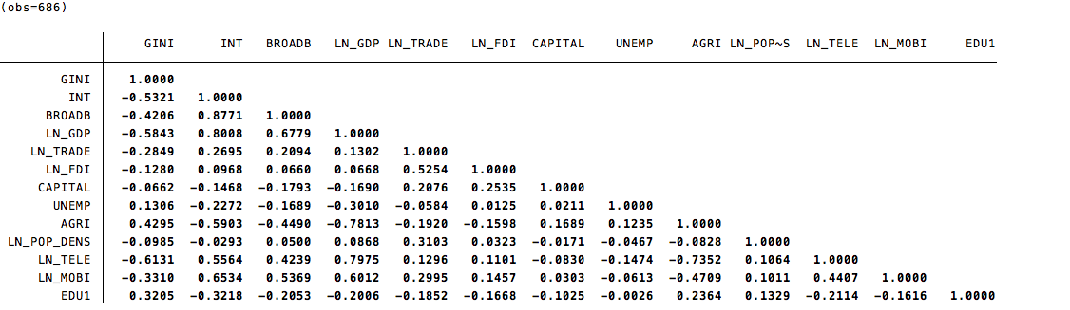

Appendix 2
Correlation table WIID
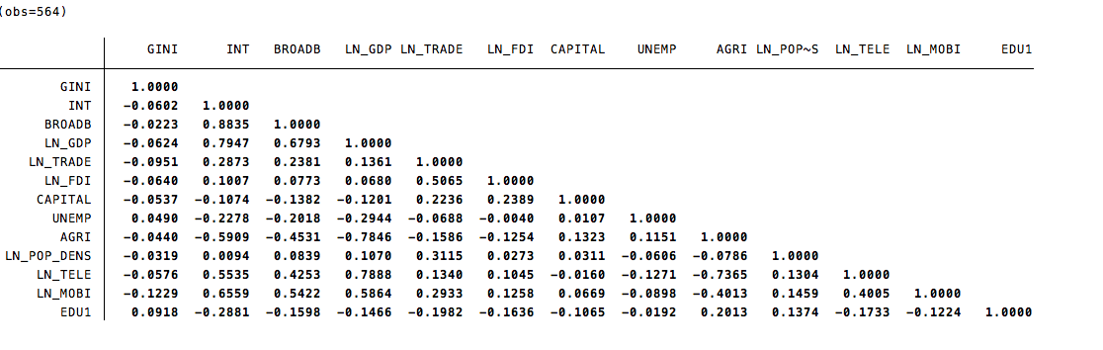

Appendix 3
Estimated output SWIID model (INT > 25)
 | (1) | (2) | (3) | (4)
VARIABLES | Model 6 | Model 7 | Model 8 | Model 9
INT | 0.0112 | 0.0126 | 0.0126 | 0.0124
 | (0.0178) | (0.0183) | (0.0185) | (0.0180)
BROADB
LN_GDP | -2.551** | -2.510** | -2.666** | -2.596*
 | (1.232) | (1.212) | (1.191) | (1.352)
LN_TRADE | -2.480 | -2.464 | -2.406 | -1.598
 | (1.576) | (1.580) | (1.635) | (1.384)
LN_FDI | -0.116* | -0.116* | -0.117* | -0.1000
 | (0.0663) | (0.0674) | (0.0658) | (0.0611)
CAPITAL | 0.0657** | 0.0660* | 0.0676** | 0.0549
 | (0.0327) | (0.0330) | (0.0320) | (0.0357)
UNEMP | 0.0803* | 0.0848* | 0.0847* | 0.0679
 | (0.0467) | (0.0483) | (0.0458) | (0.0501)
AGRI | -0.0737 | -0.0737 | -0.0684 | 0.00971
 | (0.116) | (0.114) | (0.120) | (0.121)
LN_POP_DENS | -3.527 | -3.613 | -3.491 | -4.180
 | (3.971) | (3.946) | (3.899) | (3.794)
LN_TELE |  | -0.630 |  | -0.0688
 |  | (1.210) |  | (1.068)
LN_MOBI |  |  | 0.296 | 0.823
 |  |  | (0.765) | (0.824)
EDU1 |  |  |  | -0.00291
 |  |  |  | (0.0196)
Constant | 82.30*** | 84.17*** | 81.25*** | 75.19***
 | (24.23) | (24.63) | (24.48) | (21.29)
Observations | 465 | 465 | 465 | 410
R-squared | 0.132 | 0.134 | 0.133 | 0.146
Number of Country1 | 64 | 64 | 64 | 61
Country FE | YES | YES | YES | YES
Year FE | YES | YES | YES | YES

Appendix 4
Estimated output WIID model (INT > 25)
 | (1) | (2) | (3) | (4)
VARIABLES | Model 6 | Model 7 | Model 8 | Model 9
INT | 0.122 | 0.120 | 0.0914 | 0.158
 | (0.0903) | (0.0903) | (0.0985) | (0.109)
BROADB
LN_GDP | -0.329 | -0.640 | 1.774 | -2.172
 | (6.002) | (6.055) | (5.333) | (6.452)
LN_TRADE | 4.193 | 4.014 | 3.641 | -4.771
 | (8.141) | (8.184) | (8.370) | (10.13)
LN_FDI | -0.445 | -0.437 | -0.421 | -0.620
 | (0.880) | (0.880) | (0.891) | (0.969)
CAPITAL | -0.0760 | -0.0783 | -0.0935 | -0.130
 | (0.237) | (0.240) | (0.238) | (0.227)
UNEMP | 0.407 | 0.390 | 0.297 | 0.206
 | (0.304) | (0.303) | (0.343) | (0.347)
AGRI | 0.588 | 0.574 | 0.359 | 0.325
 | (0.472) | (0.485) | (0.484) | (0.674)
LN_POP_DENS | -4.276 | -4.167 | -7.770 | -19.17
 | (17.33) | (17.08) | (20.36) | (17.77)
LN_TELE |  | 2.254 |  | 0.225
 |  | (5.200) |  | (6.144)
LN_MOBI |  |  | -7.914 | -10.96
 |  |  | (7.088) | (8.432)
EDU1 |  |  |  | -0.168
 |  |  |  | (0.112)
Constant | 11.49 | 7.379 | 51.12 | 193.7
 | (139.0) | (139.1) | (161.2) | (179.2)
Observations | 378 | 378 | 378 | 339
R-squared | 0.107 | 0.107 | 0.114 | 0.141
Number of Country1 | 64 | 64 | 64 | 60
Country FE | YES | YES | YES | YES
Year FE | YES | YES | YES | YES

Appendix 5
Average Gini coefficient vs. Average GDP per country
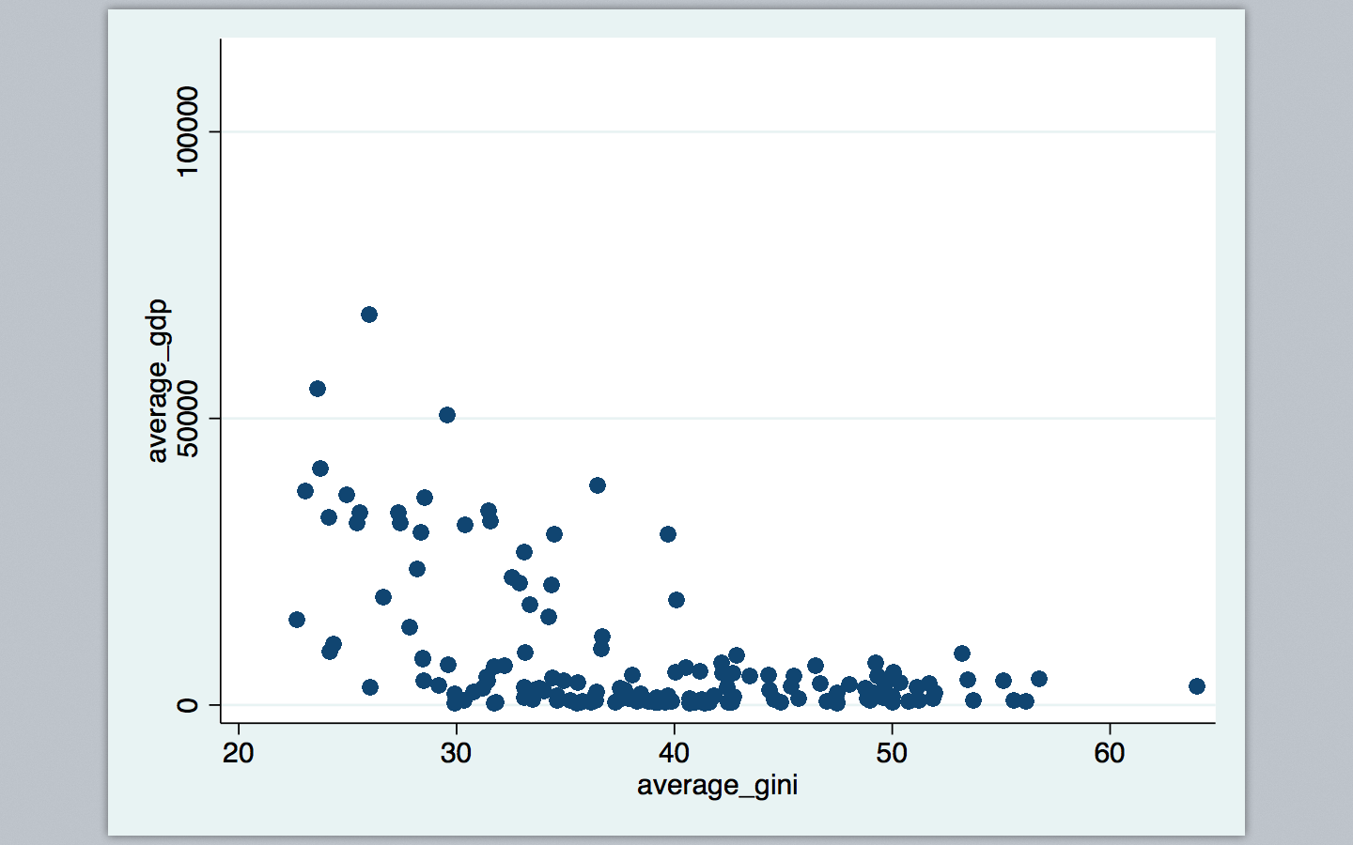

Appendix 6

 | (1) | (2) | (3) | (4) | (5)
VARIABLES | 1990 | 1995 | 2000 | 2005 | 2010
INT | -15.42*** | -1.974*** | -0.337*** | -0.202*** | -0.185***
 | (4.471) | (0.370) | (0.0381) | (0.0193) | (0.0239)
Constant | 35.37*** | 40.09*** | 42.13*** | 42.83*** | 44.97***
 | (1.165) | (0.982) | (0.853) | (0.879) | (1.535)
Observations | 98 | 98 | 130 | 135 | 91
R-squared | 0.050 | 0.223 | 0.253 | 0.309 | 0.368
Robust standard errors in parentheses
*** p<0.01, ** p<0.05, * p<0.1

