ERASMUS UNIVERSITY ROTTERDAM
ERASMUS SCHOOL OF ECONOMICS
MSc Economics & Business
Master Specialisation Financial Economics

The Interactions between Monetary Policy and Option-based Implied Volatility: Evidence from Europe

Author: M. M. D. Gehrend
Student number: 413243
Thesis supervisor: dr. Lorenzo Pozzi
Finish date: 9th June 2015
Abstract
I investigate the interactions between monetary policy and option-based implied volatility of stock markets indices in Germany, the Eurozone and Switzerland. Implied volatility constitutes an important economic variable as it incorporates information on the expected volatility of a stock index and on investors’ risk aversion. The analysis is performed using a VAR methodology. I control for the business cycle and in the case of Switzerland, also for the exchange rate. The results mostly indicate that expansionary monetary policy, measured by nominal and real interest rates, significantly decreases implied volatility. In addition, I find that the ECB accommodates positive implied volatility shocks by lowering interest rates. Opposed to this, I do not find evidence that the Swiss National Bank reacted in a similar way to implied volatility prior to the Great Recession, nor do I find evidence that the German Bundesbank did so prior to the introduction of the euro. When measuring the monetary policy stance using the growth rate of monetary aggregates, I obtain more mixed results. However, the findings based on interest rates should be of greater importance, given that central banks nowadays mostly use this tool to implement their policy.

Keywords: monetary policy, option-based implied volatility, risk aversion, uncertainty, European markets.

NON-PLAGIARISM STATEMENT
By submitting this thesis the author declares to have written this thesis completely by himself/herself, and not to have used sources or resources other than the ones mentioned. All sources used, quotes and citations that were literally taken from publications, or that were in close accordance with the meaning of those publications, are indicated as such.

COPYRIGHT STATEMENT
The author has copyright of this thesis, but also acknowledges the intellectual copyright of contributions made by the thesis supervisor, which may include important research ideas and data. Author and thesis supervisor will have made clear agreements about issues such as confidentiality.

Electronic versions of the thesis are in principle available for inclusion in any EUR thesis database and repository, such as the Master Thesis Repository of the Erasmus University Rotterdam.

Table of Contents

Title page i
Abstract ii
Table of contents iii

1. Introduction 1

2. Literature review 3
2.1. Monetary policy and implied volatility 3
2.2. The information content of implied volatility indices 4
2.3. Monetary policy and stock markets 5
2.3.1. The effect of stock prices on monetary policy 6
2.3.2. The effect of monetary policy on stock prices 9
2.4. Monetary policy and risk-taking 10
2.5. Uncertainty, the business cycle and monetary policy 12
2.6. Institutional features of the Bundesbank, the ECB and the SNB 14

3. Methodology and data 17
3.1. Implied volatility 17
3.2. Decomposing OIVIs 19
3.3. Structural VAR models 22
3.4. Measuring monetary policy 24
3.4.1. Unconventional monetary policy 25
3.4.2. Monetary policy in Germany 26
3.4.3. Monetary policy in the Eurozone 28
3.4.4. Monetary policy in Switzerland 30
3.5. The business cycle 31
3.6. Exchange rates for Switzerland 31
3.7. Summary of the variables employed 33

4. Results 36
4.1. The benchmark models 36
4.1.1. Results for Germany 37
4.1.2. Results for the Eurozone 40
4.1.3. Results for Switzerland 41
4.2. Robustness 42
4.2.1. Summary of the interactions for Germany 43
4.2.2. Summary of the interactions for the Eurozone 44
4.2.3. Summary of the interactions for Switzerland 45
4.2.4. Assessment 47

5. Conclusion 48
5.1. Summary of the results 48
5.2. Limitations and directions for future research 48
5.3. Concluding remarks and implications 49

References 51

Appendix A: Decomposing OIVIs 55
A1. Decomposing the VDAX-New 55
A2. Decomposing the VSTOXX 57
A2. Decomposing the VSMI 59

Appendix B: Impulse response functions for Germany 61
B1. Germany (1992 M1-2014 M12) 61
B2. Germany (1992 M1-1998 M12) 71
B3. Germany (1999 M1-2008 M8) 81
B4. Germany (1999 M1-2014 M12) 91

Appendix C: Impulse response functions for the Eurozone 101
C1. Eurozone (1999 M1-2014 M12) 101
C2. Eurozone (1999 M1-2008 M8) 112

Appendix D: Impulse response functions for Switzerland 129

1. Introduction
The aim of this paper is to investigate the interactions between monetary policy on one hand, and stock market uncertainty and risk aversion on the other hand. The analysis is performed for Germany, the Eurozone and Switzerland using data on option-based implied volatility indices (OIVIs). Such indices incorporate information on the expected future volatility of a stock market index and on investors’ risk aversion (Bekaert et al., 2013; henceforth BHD). Indeed, investors should be willing to pay more for options that straddle a stock index when they expect high volatility and when they are more risk averse. Thereby, implied volatility increases. Hence, if monetary policy affects implied volatility, it can directly influence market uncertainty and risk aversion. Given that OIVIs might serve as a proxy for general economic risk aversion and/or uncertainty (e.g. Bloom, 2009), this in turn constitutes an important transmission channel that might need to be considered by central banks.
Regarding previous studies, BHD find that, in the US, loose (tight) monetary policy has a negative (positive) effect on both variables summarised by the VIX index, the OIVI for the S&P 500. In addition, their findings suggest that the Federal Reserve might react to uncertainty and a risk aversion shocks. However, these results are not always significant. Their analysis is performed using VAR models.
The present paper largely follows the approach adopted by BHD. The ultimate goal is to clarify if the connections between monetary policy and implied volatility unveiled by BHD also exist in Europe. More precisely, I investigate if monetary policy affects OIVIs and if central banks react to implied volatility shocks. By doing so, I also provide a robustness check for the results reported by BHD.
Figure 1 below depicts the cross-correlograms between real short-term interest rates and implied volatility for Germany (LHS) and the Eurozone (RHS). For Switzerland, the cross-correlogram resembles that for the Eurozone. Two observations can be made. First, high real interest rates are followed by high implied volatility. This is especially true for the Eurozone. Second, high implied volatility is followed by low real interest rates. This might constitute preliminary evidence that implied volatility is affected by monetary policy and that central banks react to implied volatility.
In the next section, the relevant literature is discussed. In section 3, the methodology and the employed data are described. In section 4, the results are presented and discussed. Finally, in section 5 conclusions from this study are drawn.
Figure 1: Cross-correlations of real interest rates and implied volatility for Germany (left) and the Eurozone (right)
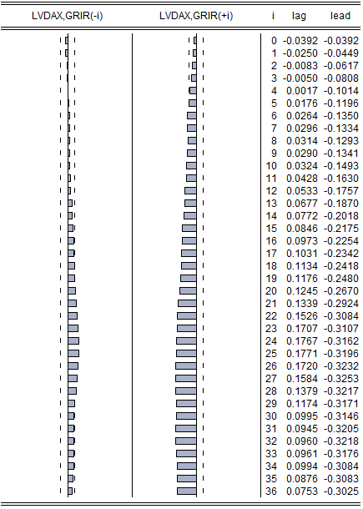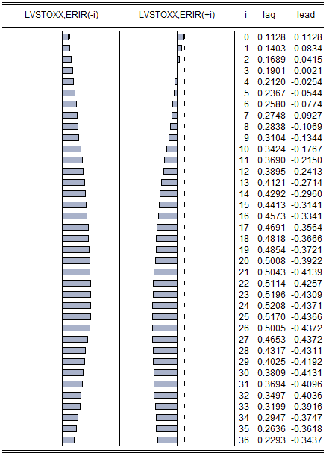
Notes: (1) End-of-month data. (2) GRIR and ERIR stand for German, respectively Eurozone real 3-month rate. LVDAX and LVSTOXX stand for the log of the VDAX-New, respectively the VSTOXX. VDAX-New is the OIVI for the German DAX index. VSTOXX is the OIVI for the Eurozone EURO STOXX 50 index. (3) Sample range for Germany: 1992 M1-2014 M12, sample range for the Eurozone: 1999 M1-2014 M12. (4) The first column for each economy presents the lagged cross-correlogram and the second the lead cross-correlogram, Dashed vertical lines show the 95% confidence intervals. (5) Data sources: Bundesbank, Bloomberg, Eurostat, Federal Statistical Office of Germany.

2. Literature review
In this section, I give an overview on the relevant literature. In subsection 2.1., the aforementioned study by BHD is described in more detail. In subsection 2.2., it is explained in detail why OIVIs measure market uncertainty as well as risk aversion. In 2.3., the previous literature on stock markets and monetary policy is presented. In subsection 2.4., the more recent literature on monetary policy and risk-taking that emerged since 2008 is presented. In 2.5., it is argued why central banks would react to implied volatility. This is important to justify the VAR set-up chosen in the empirical part. Finally, in 2.6., the institutional features of the central banks relevant for this study are described.

2.1. Monetary policy and implied volatility
The aforementioned study by BHD on implied volatility and monetary policy serves as benchmark for this paper, since it outlines the general approach. The authors start by decomposing the VIX index into an uncertainty and a risk aversion proxy. To do so, they first construct an estimator for the expected future variance of the S&P 500. This variable should measure the uncertainty part contained in the VIX. Second, they subtract this expected future variance measure from the squared VIX and consider the obtained residual, the so-called variance premium, as a measure for risk aversion.
To analyse the dynamic links between uncertainty, risk aversion and monetary policy, BHD estimate VAR models with monthly data for the time spans January 1990-July 2007 and January 1990-August 2010. In their benchmark model, they include 4 variables with a business cycle variable ordered first, then the real federal funds rate, and the two aforementioned variables derived from the VIX ordered last. This is motivated by the fact that stock market variables are immediately responding to monetary shocks while business cycle variables are more sluggish to adapt. An alternative identification strategy that is also considered, involves the assumption that monetary policy has no long-run effect on the business cycle variable.
Concerning the VAR results, BHD find that lax monetary policy decreases both risk aversion and uncertainty in the future. Conversely, high uncertainty and risk aversion lead to looser monetary policy in the future. However, the latter effects are not always statistically significant. The results generally hold up for different measures of the business cycle (industrial production and employment growth, as well as the ISM index), for different measures of the monetary policy stance (real/nominal federal funds rate, Taylor rule deviations and M1 growth), for alternative orderings of the variables, and when estimating a 6 variable VAR including the nominal federal funds rate as well as price levels measured by CPI and PPI. The results are also robust to alternative methodologies involving the use of federal funds rate futures data (BHD).

2.2. The information content of implied volatility indices
BHD decompose the VIX index into an uncertainty and a risk aversion proxy. In this section, this approach is discussed in more detail. Modern OIVIs such as the VIX, the VDAX-New, the VSTOXX or the VSMI represent the implied volatility of the underlying stock market index over the following 30 calendar days. The three latter indices are calculated the same way as the VIX. Unlike older indices such as the VDAX or the VXO (the old VIX), which rely on the Black and Scholes (1973) method and on prices of at-the-money options to calculate implied volatility, the modern OIVIs consider a broader set of at- as well as out-of-the-money options and do not rely on an option pricing model. They are calculated using a weighted average of European-style call and put option prices that straddle a 30-day maturity (BHD; Carr & Wu, 2006; CBOE, 2014; Deutsche Börse, 2007; EUREX, 2014; SIX Swiss Exchange, 2014).
The implied volatility from these indices is often referred to as ‘risk-neutral’, as opposed to the actual ‘physical’ expected volatility (BHD). This means that the latter volatility uses the actual probabilities, whereas OIVIs are calculated from risk-neutral probabilities. These risk-adjusted probabilities give more weight to states of the world where marginal utility is high (bad states) (Bekaert & Hoerova, 2014).
The reason why OIVIs represent risk-neutral expected volatilities lies in their computation method (BHD). It relies on the theoretical result that options can be used to span and price any payoff (e.g. Bakshi & Madan, 2000). Building on this result, Bakshi et al. (2003) show that it is possible to determine the risk-neutral expected volatility of a stock index using option prices.
As risk-neutral expected volatility measures, OIVIs not only include information on actual expected stock market volatility but also on investors’ risk aversion. Therefore, the VIX is often referred to as the ‘fear index’ (BHD).
To see why, it is helpful to consider the following trading scheme involving the S&P 500 as underlying asset. An investor may acquire a return variance swap. This asset has zero net market value at entry. At maturity, the investor pays the swap’s pre-fixed constant price, and receives the realised variance of the S&P 500 as payoff. In the absence of arbitrage possibilities, the price of the swap equals the risk-neutral expected variance, which in this case corresponds to the squared VIX (Carr & Wu, 2009). The difference between the swap’s price (the squared VIX) and its expected payoff (the expected actual variance) is usually called the variance premium. As indicated by Drechsler and Yaron (2011), the variance premium is nearly always positive. This implies that the swap provides a hedge against macroeconomic risks. Investors are essentially willing to pay an insurance premium (Drechsler & Yaron, 2011). In this context, Bekaert and Hoerova (2014) point out that the variance premium is increasing with aggregate risk aversion in a multitude of realistic economic settings.
Hence, the more risk-averse investors are, the higher the insurance premium they are willing to pay should be, and in turn the higher the VIX should be. In line with this reasoning, BHD decompose the VIX index into an uncertainty and a risk aversion proxy.

2.3. Monetary policy and stock markets
Since the late 1990s, an extensive body of literature has focused on the links between stock prices (or returns) and monetary policy. In this context, expected volatility and risk aversion have only recently gained more attention. Nevertheless, earlier literature concerned with stock prices also has important implications for risk aversion and uncertainty since booming (contracting) stock markets are generally associated with low (high) option-based implied volatility (see table 1 below).
This implies that if monetary policy reacts to rising stock prices, it simultaneously reacts to some extent to high risk appetite and low uncertainty. Conversely, if monetary policy reacts to high option-based implied volatility, it also reacts to some degree to falling stock prices.

Table 1: Correlation between monthly returns and average monthly implied volatilities for selected index pairs
Region | Stock index | OIVI | Sample period | Correlation
US | S&P 500 | VIX | 1990 M1-2015 M2 |  | -0.28***
 | DJIA | VXD | 1997 M10-2015 M2 |  | -0.25***
 | NASDAQ 100 | VXN | 2001 M2-2015 M2 |  | -0.31***
 | Russell 2000 | RVX | 2004 M1-2015 M2 |  | -0.32***
Europe | DAX | VDAX-New | 1992 M1-2015 M2 |  | -0.25***
 | EURO STOXX 50 | VSTOXX | 1999 M1-2015 M2 |  | -0.30***
 | SMI | VSMI | 1999 M1-2015 M2 |  | -0.37***
 | CAC 40 | VCAC | 2000 M1-2015 M2 |  | -0.32***
 | FTSE 100 | VFTSE | 2000 M1-2015 M2 |  | -0.33***
Asia Pacific | Nikkei 225 | VXJ | 1998 M1-2015 M2 |  | -0.42***
 | Hang Seng | VHSI | 2001 M1-2015 M2 |  | -0.23***
 | S&P/ASX 200 | SPAVIX | 2008 M1-2015 M2 |  | -0.38***
Notes: (1) Country/region of origin: S&P 500, DJIA, NASDAQ 100, Russell 2000 (US), DAX (Germany), EURO STOXX 50 (Eurozone), SMI (Switzerland), CAC 40 (France), FTSE 100 (UK), Nikkei 225 (Japan), Hang Seng (Hong Kong), S&P/ASX 200 (Australia). (2) Average monthly implied volatilities are calculated from end-of-day values over a month. (3) Sample periods are determined by data availability for OIVIs. (4) 10%, 5% and 1% significance levels are denoted by *, ** and *** respectively. (5) Data sources: Bloomberg, SIX Swiss Exchange.

2.3.1. The effect of stock prices on monetary policy
At the beginning of this century, the question whether central banks should react to asset prices enjoyed much attention. On one hand, Bernanke and Gertler (2000, 2001) assert that asset price bubbles tend to raise both output and inflation. Therefore, it should be sufficient that a central bank reacts to these two variables. On the other hand, Cecchetti et al. (2000) argue that the unwinding of asset price misalignments may induce pronounced macroeconomic turmoil. Consequently, central banks should respond to asset prices. Borio (2011) notes that the debate is still not settled as the focus has now shifted on the question whether implementing a macroprudential framework is sufficient to guarantee financial stability or if monetary policy should have its role in it as well.
Regarding empirical evidence if monetary policy reacts to asset prices, Rigobon and Sack (2003) provide a first major contribution on the topic. They investigate how US monetary policy reacts to stock price changes. They start from the premise that higher interest rates should ceteris paribus decrease stock market prices because future dividends are discounted more heavily. At the same time, the central bank might raise interest rates when stock prices are high. Hence, in the interest rate-stock price space, the monetary policy and stock market response functions should be upward and downward sloping respectively. The higher the variance of stock price shocks, the closer the interest rate-stock price realizations should fit the monetary policy reaction function (see figure 2).

Figure 2: Periods of high stock market volatility and the monetary policy response function
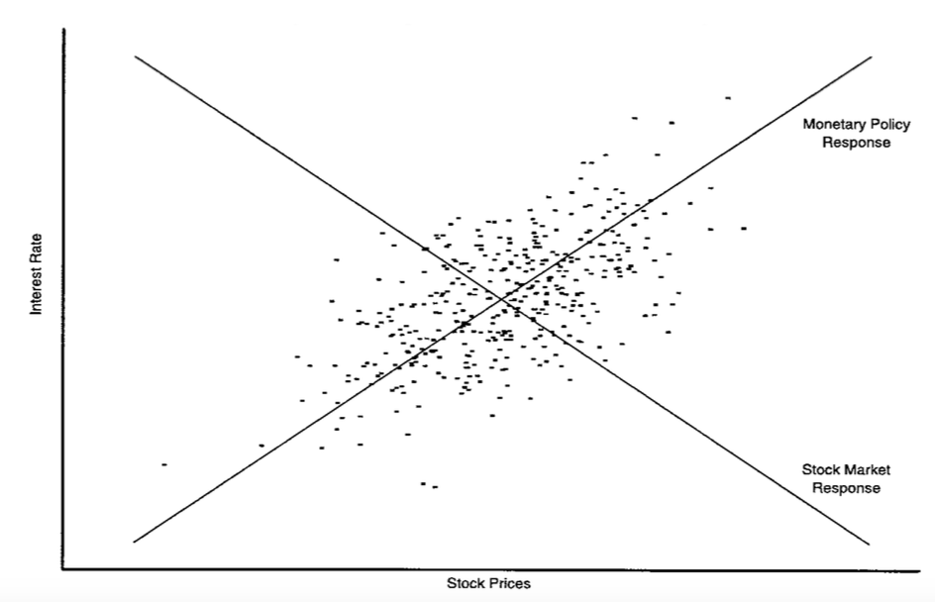
Source: Rigobon and Sack (2003)

In line with this reasoning, the authors exploit the heteroskedasticity of stock return shocks as an instrument to identify the slope of the policy response function in a VAR model. This procedure is used in order to allow interest rates and stock returns to react contemporaneously to each other. Opposed to this, the traditional VAR literature usually assumes that one of the two variables cannot immediately react to the other in order to achieve identification. Relying on US data covering 1985 to 1999, the authors find that a 5 per cent increase (drop) in the S&P 500 increases the probability of a 25 basis point hike (cut) in the interest rate by around a half (Rigobon & Sack, 2003). In line with this finding, BHD allow monetary policy to react to uncertainty and risk aversion in stock markets.
Bjørnland and Leitemo (2009) confirm the Rigobon and Sack (2003) result for real returns using a different methodology. They consider data from 1983-2002 and estimate a monthly VAR model including five variables and ordered as follows: first industrial production, second the inflation rate, third commodity prices, and fourth real S&P 500 returns as well as the federal funds rate. Here again, the last two variables can contemporaneously react to each other. Hence, an additional identifying restriction is needed. Therefore, the authors assume that monetary policy has no long-run effect on real stock prices (Bjørnland & Leitemo, 2009).
However, when the Rigobon and Sack (2003) methodology is applied to other US samples, the result seems to only partially hold up. Furlanetto (2011) considers different periods between 1988 and 2007. All samples start after 1987 in order to verify if the previous results are driven by the Federal Reserve’s reaction to the stock market crash that year. He finds a much smaller effect of stock returns on monetary policy, especially for 2003-2007.
When considering a broader index of financial variables, Castro (2011) even finds that the Federal Reserve mostly did not react to asset prices during the period 1982-2007. He extends the forward-looking Taylor rule framework introduced by Clarida et al. (1998, 2000) to allow for a nonlinear reaction function and includes a financial conditions index. The latter variable corresponds to a weighted average of the real effective exchange rate, real share and property prices, as well as credit and futures interest rate spreads. In fact, the Federal Reserve seems to have followed a rather standard forward-looking linear Taylor rule during the period in question (Castro, 2011)
Turning to international evidence, Furlanetto (2011) extends his research to the European Monetary Union (EMU) and six inflation targeting countries (Australia, Canada, New Zealand, Norway, Sweden and the UK). The EMU sample spans 1999-2006, and for the other countries the samples start at the earliest in 1993 and generally end in 2007. Australia is the only country that reacted significantly to stock markets. Nevertheless, the reaction has also been much weaker than in the US (Furlanetto, 2011). In line with these results and using a similar methodology, Bohl et al. (2007) find that the Bundesbank did not react to German stock markets during the period 1985-1998.
Castro (2011) also confirms Furlanetto’s (2011) results for the Bank of England. However, for the ECB during 1999-2007, he finds that its reaction function can be best described by a nonlinear forward-looking Taylor rule including a financial conditions index (Castro, 2011).
Overall, the results indicate that most central banks such as the Bundesbank did not significantly react to stock market developments. For the Federal Reserve however, the results are more ambiguous. The findings differ, depending on the empirical approach and the samples considered. For the ECB, the results indicate that it did not specifically react to nominal stock prices but there is evidence that it reacted to broader financial conditions. This study should also help to clarify this issue. In addition, the above results partially suggest differentiating between the Bundesbank’s and the ECB’s reaction function when considering the German case.

2.3.2. The effect of monetary policy on stock prices
Regardless of whether central banks react to stock market developments, it is likely that monetary policy affects stock prices. Bjørnland and Leitemo (2009) mention three possible channels. Higher interest rates may increase the rate at which future dividends are discounted, temporarily decrease output and increase borrowing costs. Thereby, they should decrease stock prices.
Regarding empirical evidence on the effect of monetary policy on stock markets, Thorbecke (1997) is one of the first to document the relationship for the US. He estimates a monthly VAR including the following variables: industrial production growth, the inflation rate, commodity prices, the federal funds rate, non-borrowed reserves, total reserves, and stock returns. The variables are ordered as they are listed above. For the stock returns, data for 22 industry and 10 size portfolios ranging from 1967 to 1990 is used. The author finds that a positive one standard error shock in the federal funds rate lowers stock returns on average by 0.8% per month, while a similar shock to non-borrowed reserves increases stock returns on average by 1.79% per month (Thorbecke, 1997).
These results seem to hold up when monetary policy is allowed to react contemporaneously to stock prices. Rigobon and Sack (2004) follow an approach similar to the one used in their aforementioned 2003 paper. In this paper, they exploit the heteroskedasticity of monetary policy shocks to estimate the slope of the asset price response function. Using US data for 1994-2001, they find that a 25 basis point increase in the three-month interest rate leads to 1.7% drop in the S&P 500 and a 2.4% decline in the NASDAQ index (Rigobon & Sack, 2004). Using the VAR model that was described in the previous subsection, Bjørnland and Leitemo (2009) report similar findings for real S&P 500 returns.
The results are also robust to the use of higher frequency data. For example, Bernanke and Kuttner (2005) estimate the effect of unexpected monetary policy shocks on stock markets in the US by following an event study approach. They use changes in futures prices for the federal funds rate occurring the day after policy actions took place to estimate these unanticipated shocks. The sample includes 131 days from 1989-2002 during which the federal funds target was changed. They find that an unexpected 25 basis point cut in the federal funds rate increases the CRSP value-weighted index by 1%.
In a recent study, Galí and Gambetti (2015) challenge the commonly accepted view that contractionary monetary policy decreases stock prices. They estimate a quarterly VAR model with time-varying coefficients for the US. Six variables are included: the GDP growth rate, the inflation rate, the change in a commodity price index, the federal funds rate, as well as real returns and real dividends on the S&P 500. Two time spans are considered, namely 1960-2007 and 1960-2011. Monetary policy is assumed to not affect GDP, inflation and dividends contemporaneously. Furthermore, in the base line model it is presumed that monetary policy does not immediately react to stock price changes. The authors find that tight monetary policy first depresses real stock prices and then persistently increases them. This result contradicts previous findings (Galí & Gambetti, 2015). Galí (2014) provides a potential theoretical explanation for this finding: the bubble component of a rational asset price bubble grows in equilibrium at the rate of interest. Higher interest rates might hence increase asset prices.
However, when following Rigobon and Sack (2003) by allowing monetary policy to contemporaneously respond to stock prices, Galí and Gambetti (2015) find a negative effect. Nonetheless, in light of the findings by Furlanetto (2011) that monetary policy only weakly reacts to stock prices, the authors express doubts that this specification is relevant (Galí & Gambetti, 2015).
Overall, the evidence clearly indicates that monetary policy affects stock prices. Most authors also find that contractionary (expansionary) monetary policy has a negative (positive) effect on stock markets. Nevertheless, the new evidence reported by Galí and Gambetti (2015) casts some doubts on this result. If one assumes that real, like nominal stock returns, are negatively correlated with OIVIs, their finding then implies that tight monetary policy lowers uncertainty and risk aversion. This line of reasoning evidently contradicts the results reported by BHD. The present study hence aims to clarify this issue.

2.4. Monetary policy and risk-taking
Prior to the Great Recession, the economic literature did not pay much attention to the potential links between monetary policy and risk-taking behaviour in financial markets. The topic has since gained in popularity. In this context, Borio and Zhu (2012) direct attention to the so-called risk-taking channel of monetary policy, which might operate in at least three different ways.
First, a decrease in interest rates boosts asset and collateral values, as well as incomes and profits, thereby potentially reducing risk perceptions and increasing risk tolerance.
Second, interest rate cuts may increase risk tolerance and induce a behaviour coined as ‘search for yield’ because of sticky rate-of-return targets. Such sticky targets can for instance be found in the pension and insurance fund industries.
Third, a central bank may also affect risk-taking behaviour through its communication policy and its reaction function. By becoming more transparent, central banks reduce uncertainty about the future. In addition, economic agents might believe that monetary policy reacts to financial turmoil and thereby eliminates large downside risks (Borio & Zhu, 2012).
Empirical literature concerned with the risk-taking channel concentrates entirely on banks. Studies either focus on large international banks, or on one country while using extensive micro-data.
Gambacorta (2009) provides an example for the first type of studies. He investigates if loose monetary policy, as measured by the number of consecutive quarters where the interest rate was below the level implied by the Taylor rule and below the smooth trend of past interest rate levels, affects the expected default frequency of banks. His sample includes EU and US banks during the 2007-2008 crisis period. Consistent with the risk-taking channel hypothesis, interest rates remaining 10 consecutive quarters below benchmark increased the probability of default of an average bank by 3.3% (Gambacorta, 2009). Altunbas et al. (2014) find similar results for the period 1999-2008.
Delis and Kouretas (2011) estimate the relationship between different interest rates and the riskiness of banks’ asset holdings using a sample of 16 EMU banks during 2001-2008. They find a strong negative relation between risk-taking in the banking sector and different types of interest rates (short-term, long-term, central-bank, and bank-level lending rates).
Jiménez et al. (2014) complement the previous findings by providing evidence from a micro-level. They investigate how monetary policy affects the riskiness of bank loans in Spain. Their dataset ranges from 2002 to 2008 and includes over 130,000 firms and 200 banks at any moment in time. A two-stage model is estimated where the first stage examines the granting of loans and the second stage the loan volume. They find that lower overnight interest rates induce banks to issue riskier loans. Especially low-capitalized banks grant more loans, with higher volume, while demanding less collateral to ex-ante risky firms. These loans are also more likely to default ex-post. Other variables like long-term interest rates, the degree of loan securitization and capital inflows from abroad do not have a comparable effect (Jiménez et al., 2014). Ioannidou et al. (2015) report similar findings for Bolivia during 1999-2003.
To sum up, there is abundant evidence that loose monetary policy enhances bank risk-taking. Evidently, as banks are not the only actors active in stocks markets, this does not necessarily translate into a generally higher risk appetite in these markets. Nevertheless, the findings by BHD suggest that this is the case. The present paper therefore aims to further investigate this topic.

2.5. Uncertainty, the business cycle and monetary policy
Apart from the risk aversion of stock markets participants, the other variable considered by BHD is uncertainty. This section elaborates on the links between uncertainty, the business cycle and monetary policy. As pointed out by Bloom (2009), political and economic uncertainty might constitute a significant driver of business cycle fluctuations. One reason may be that firms temporarily stop investing and hiring when uncertainty is high. To investigate this, the author estimates a monthly VAR model for the US with data from June 1962 to June 2008. The following variables are included: the S&P 500 index, a stock market volatility indicator, the federal funds rate, average hourly earnings, consumer prices, hours worked, employment and industrial production. The variables can react to each other in that order. The stock market volatility indicator is a dummy variable taking the value of 1 for each of the 17 shocks listed in figure 3 below, and 0 otherwise.

Figure 3: Monthly US stock market volatility
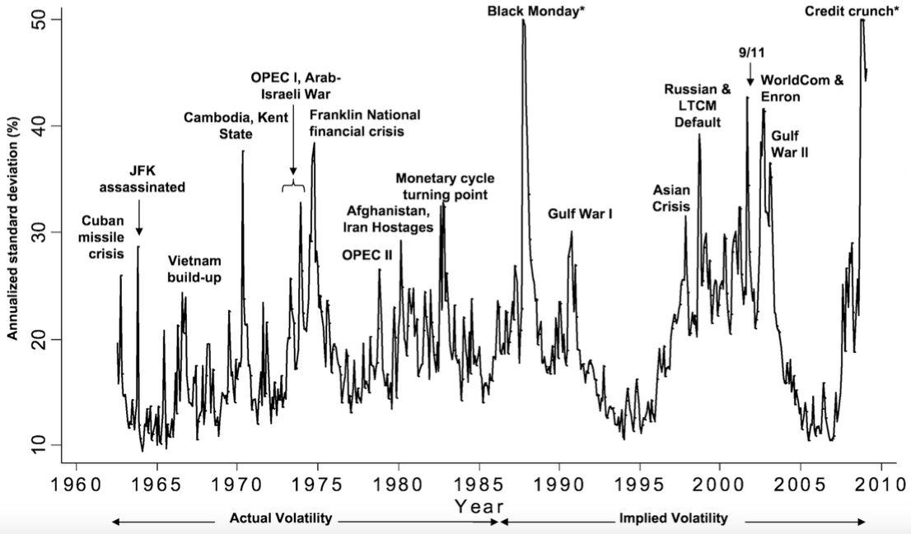
Notes: (1) Implied volatility (from 1986 onwards) is from the VXO index (the old VIX). Before 1986, the VXO is unavailable. Therefore the actual volatility is calculated as the monthly standard deviation of the daily S&P 500 index normalised to the same mean and variance as the VXO index when they overlap from 1986 on. (2) The VXO was capped at 50. The true values were higher during Black Monday (58.2) and the credit crunch (64.4). (3) Source: Bloom (2009)

The author finds that a volatility shock leads to a 1% drop in industrial production after 4 months with a subsequent recovery. Comparable results are found for employment.
Denis and Kannan (2013) perform a similar exercise for the UK with a simpler monthly VAR model. In the baseline version, the model includes a measure for uncertainty, the unemployment rate and an economic indicator. One of the measures for uncertainty is the implied volatility from options on the FTSE 100 index, calculated by the Bank of England using the Black and Scholes (1973) method and the other the dispersion of the one-year-ahead GDP forecasts. The data runs from June 1984 to September 2011. Following an implied volatility shock, industrial production peaks at -0.6% after five months while GDP reaches a low of -0.3% after nine months (Denis & Kannan, 2013).
Popescu and Smets (2010) augment the uncertainty-business cycle framework with a financial risk aversion index. They use data for Germany over the period 1992-2008 and estimate a monthly 6-variable VAR. Industrial production and the unemployment rate are ordered first, then the CPI, followed by the interest rate. Their uncertainty variable, which measures the dispersion of macroeconomic variable forecasts, is ordered fifth, and a financial risk premium index, which includes information on interest rate spreads and the VDAX (old OIVI of the DAX), is ordered last. The authors find that positive output shocks decrease uncertainty and risk aversion, that uncertainty shocks have a small temporary impact on output and risk aversion, and that positive risk aversion shocks have a large persistent negative effect on the economy (Popescu & Smets, 2010).
In all the aforementioned studies, OIVIs are either treated as a proxy for risk aversion or for uncertainty. However, as argued in subsection 2.2., OIVIs in fact incorporate information on both variables. Independently of this distinction, it is conceivable that if high implied volatility hampers real economic activity, then monetary policy might be inclined to react to it (BHD).
Furthermore, central banks are often viewed as the guardians of financial stability (Bohl et al., 2007). Therefore, they might also react to implied volatility in order to avoid financial turmoil. This would be consistent with the ‘Greenspan put’ concept, which postulates that in the past the Federal Reserve systematically stepped in to calm turbulent markets. As pointed out by Miller et al. (2002), examples supporting this view are the interest rate cuts and the ample provisions of liquidity after the 1987 stock market crash and the 1998 Russian and LTCM defaults.
Such considerations support the VAR set-up chosen by BHD.

2.6. Institutional features of the Bundesbank, the ECB and the SNB
The samples considered in the empirical part of the present paper start in 1992 for Germany and in 1999 for the Eurozone and Switzerland. Thus, three central banks are of interest for this study; the German Bundesbank, the ECB and the Swiss National Bank (SNB). In this subsection, the specificities of these three institutions are briefly discussed.
Before the introduction of the euro, monetary policy in many European countries was constrained by a system of (semi) fixed exchange rates. This should have hampered the Bundesbank’s ability to pursue an independent monetary policy. However, as pointed out by Clarida et al. (1998), such a constraint did not exist as Germany effectively acted as leader in this framework. As early as the mid-1970s, the Bundesbank pursued an inflation-focused monetary policy (Bernanke & Mishkin, 1997). It did so by officially targeting different monetary aggregates and more specifically from 1988 on M3 (Clarida & Gertler, 1997). Nonetheless, in practice the Bundesbank’s conduct of monetary policy was very similar to that of a classical inflation targeter and its reaction function has been well approximated by a linear forward-looking Taylor rule (Bernanke & Mihov, 1997; Clarida et al., 1998). This suggests that the daily management of monetary policy was more concerned with setting short-term interest rates than with managing monetary aggregates (Clarida & Gertler, 1997). Therefore, I consider short-term interest rates as the main measurement of the Bundesbank’s policy stance.
After the introduction of the euro in 1999, the ECB’s monetary policy conduct seems to have resembled that of the Bundesbank (Fatum, 2006). For instance, Sauer and Sturm (2007) find for the period 1999-2003 that the ECB’s coefficient on inflation in a forward-looking Taylor rule was not significantly different from that of the Bundesbank. In addition, Castro (2011) finds for the period 1999-2006 that the ECB primarily focused on keeping inflation low and only reacted to the output gap when expected inflation was well below 2.5%. It also adopted the Bundesbank’s focus on monetary aggregates since it officially states that it would raise interest rates if M3 growth is higher than 4.5% (Castro, 2011). Since the start of the Great Recession, the ECB has also been more reluctant to implement unconventional monetary policy. It only announced a large-scale QE programme in January 2015. I come back to this point in subsection 3.4., as unconventional monetary policy makes the measurement of the policy stance more difficult.
Regarding the expected results for the Bundesbank, Bohl et al. (2007) suggest from reading its monthly reports that stock market developments were not essential for the conduct of monetary policy. In addition, due to institutional differences the Federal Reserve was probably more likely to take into account stock market considerations than the Bundesbank. Their empirical findings confirm this intuition (Bohl et al., 2007). In line with this, the Bundesbank’s reaction to risk aversion and uncertainty in stock markets might also have been weaker than the findings by BHD suggest for the US.
Concerning the ECB’s reaction to asset prices, as mentioned before, Furlanetto (2011) reports that it did not react to nominal stock prices but Castro (2011) finds that it did react to broader financial conditions including real share prices and credit spreads. This indicates that the ECB might put more attention on stock market developments than the Bundesbank did. Therefore, an analysis of a full German sample starting in 1992 and covering the euro introduction of 1999 might incorporate a structural break on that date. To assess if this is the case, subsamples for the Bundesbank-period and the ECB-period are considered in this study.
Additionally, even if the ECB and the Bundesbank react, or rather reacted, in a similar way to implied volatility in stock markets, the ECB might still focus on the Eurozone market as a whole, rather than on the German market in particular. Nevertheless, in light of different empirical findings, it seems reasonable to assume that the ECB might react specifically to the VDAX-New if it is concerned with implied volatility. For instance, Mylonidis and Kollias (2010) report for the period 1999-2009 that the German stock market affected the three other major stock markets in the EMU (France, Italy and Spain) but not vice-versa. Moreover, the degree of convergence seems to have been the highest between the German and the French market, the latter corresponding to the second biggest economy in the EMU (Mylonidis & Kollias, 2010). Furthermore, Äijö (2008) finds for the period 2000-2004 that the VDAX-New term structure Granger causes the VSTOXX term structure and accounts for 65% of its forecast error variance. Hence, if the ECB is concerned with implied volatility, it might even predominantly react to the VDAX-New because of the leading role of the German market in the EMU. This makes the analysis of a full German sample plausible.
The third central bank of importance for this study is the SNB. Like the Bundesbank, it has a long-standing record of pursuing an inflation-focused monetary policy. It also started to primarily focus on price stability in the mid-1970s and similarly considered itself a monetary targeter. However, in practise and also like the Bundesbank, its policy conduct was very close to that of an inflation targeter. (Bernanke & Mishkin, 1997). In 2000, the SNB even officially abandoned its money supply target and switched to a standard inflation targeting regime with the 3-month CHF LIBOR as its main policy rate (SNB, 1999: Svensson 2002). After 2008, a further major policy shift occurred. While interest rates hit the zero lower bound, the SNB introduced a series of unconventional policy measures. These culminated in September 2011, as it announced that it would prevent further appreciations of the Swiss franc vis-à-vis the euro. It fixed the minimum exchange rate at 1.20 francs per euro (SNB, 2011). As a consequence, between 2007 and 2014, the volume of assets held by the SNB more than quadrupled. In January 2015, and prior to the ECB’s official announcement of a QE programme, the exchange rate policy was abandoned (SNB, 2015).
The SNB’s post-2008 reaction indicates that exchange rate considerations are an important factor when setting monetary policy. Indeed, Perruchoud (2009) finds for the period 1975-2007 that the SNB reacted to deviations of the exchange rate from its trend while Markov and Nitschka (2013) find for 2000-2012 that the SNB’s reaction function is best approximated by a Taylor rule including a term for nominal effective Swiss franc appreciations. This is taken into consideration when analysing the Swiss case.
Concerning, the SNB’s reaction to stock market developments, there is, to my knowledge, no study that treats this question. The Bundesbank and the ECB have both enjoyed much more attention in the literature. Hence, this paper might give some interesting insights into the topic since it is unclear which results to expect for the SNB.

3. Methodology and data
To investigate the interactions between monetary policy on one hand and risk aversion and uncertainty in European stock markets on the other hand, I rely on VAR models, as in BHD. In the following subsections, details regarding these models and the variables entering them are discussed.

3.1. Implied volatility
The sample ranges considered in this paper are determined by the availability of OIVI data. The index employed for Germany is the VDAX-New. Data is available from 1992 on. Figure 4 depicts it evolution over time and also includes the VIX index used by BHD for comparison.

Figure 4: VDAX-New and VIX
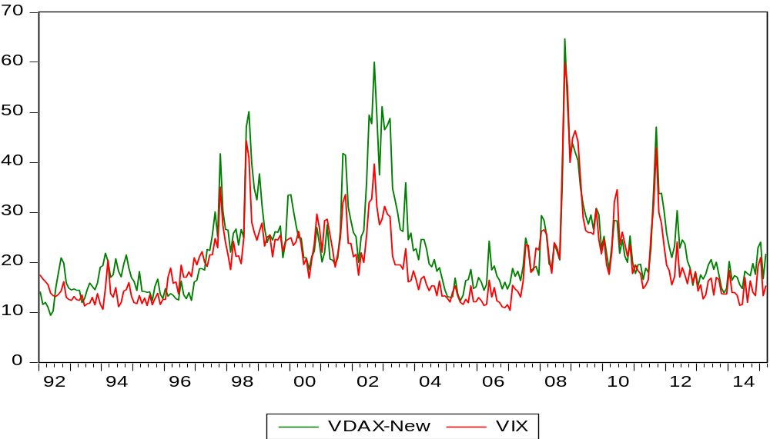
Notes: (1) End-of-month observations for both OIVIs between January 1992 and March 2015. (2) Data source: Bloomberg.

It is apparent in figure 4, the VDAX-New and the VIX moved closely together throughout the sample, especially after 1996. This suggests that both markets were often subject to the same shocks. However, it stands out that while during the recent crisis episodes, the spikes of both indices were approximately of similar height, they were considerably higher for the VDAX-New between 1998 and 2004. This earlier period coincided with a general phase of economic weakness in Germany. At that time, the country was often referred to as the ‘sick man of Europe’ (Dustmann, 2014). Throughout the sample, the correlation between end-of-month observations for both OIVIs was 0.87.
The OIVIs employed for the Eurozone and Switzerland are the VTSOXX and the VSMI. Figure 5 depicts the evolution of these two indices together with the VDAX-New between 1999 and 2015.

Figure 5: VDAX-New, VSTOXX and VSMI
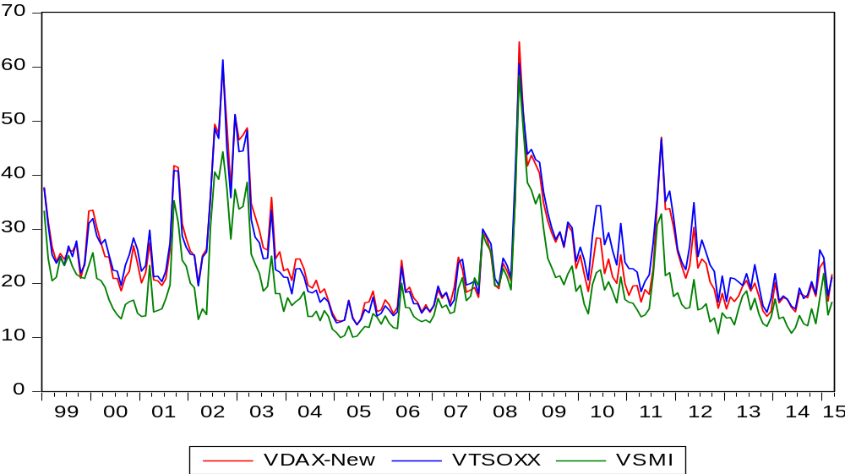
Notes: (1) End-of-month data for the period January 1999 to March 2015. (2) Data sources: Bloomberg, SIX Swiss Exchange.

As figure 5 illustrates, the VDAX-New and the VSTOXX moved closely together between 1999 and 2015. However, from 2010 on the spikes in the VSTOXX were more pronounced than in the VDAX-New. One reason might have been that Germany was not directly hit by the European sovereign debt crisis while Italy and Spain were much more severally affected. The VSMI also strongly co-moved with the other two indices. However, its level has been consistently lower. This indicates a lower degree of risk aversion and uncertainty in the Swiss market, compared to its European peers. Overall, the correlations between the three indices are extremely high. This is shown in table 2.

Table 2: Correlations between the OIVIs
 | VDAX-New | VSTOXX | VSMI | VIX
VDAX-New | 1
VSTOXX | 0.98 | 1
VSMI | 0.95 | 0.93 | 1
VIX | 0.86 | 0.90 | 0.88 | 1
Notes: (1) End-of-month data for the period January 1999 to March 2015. (2) Data sources: Bloomberg, SIX Swiss Exchange.

In terms of implied volatility, the German and the Eurozone markets share the highest degree of integration. Likely explanations for this are that German stocks account for a third of the EURO STOXX 50 on a weighted basis and that Germany constitutes the biggest economy of the EMU. Overall, the European markets seem more integrated between each other than with the US market. Nevertheless, correlations between the European OIVIs and the VIX are also very high.
Apart from the arguments outlined in 2.6., the extremely high correlation between the VSTOXX and the VDAX-New further supports the assumption that if the ECB reacts to Eurozone stock markets, it simultaneously reacts to German developments.

3.2. Decomposing OIVIs
In this subsection, some problems related to the decomposition of OIVIs are discussed. As mentioned in the literature review, BHD split the VIX index into an uncertainty and a risk aversion proxy. To do so, they first need an estimator for the one-month-ahead expected actual monthly variance of the S&P 500. BHD consider this variable as an uncertainty proxy. As usual in the literature, squared five-minute returns over a month are summed up to obtain a measure of the monthly realised variance. The authors then conduct a horserace between different estimators to determine the best in terms of forecasting performance. They regress the realised monthly variance at a daily frequency onto a set of variables lagged 22 trading days. The authors use daily data on monthly variances since this typically improves the forecasting performance. The lagged variables they employ are the realised variance itself, the squared VIX, the real three-month T-bill rate and the dividend yield. They come up with the following model:
${RVAR}_{t}=\begin{matrix} \\ -0.00002 \\ (0.00012)\end{matrix}+\begin{matrix} \\ 0.299 \\ (0.067)\end{matrix}{×VIX}_{t-22}^{2}+\begin{matrix} \\ 0.442 \\ (0.130)\end{matrix}{×RVAR}_{t-22}+e_{t}$ (1)
$RVAR$ stands for realised monthly variance, ${VIX}^{2}$ corresponds to the squared VIX divided by 12, and $e_{t}$ is an error term. Standard errors are reported in parentheses below the coefficients and are corrected for autocorrelation using 30 Newey-West (1987) lags.
As five-minute return data for the DAX, the EURO STOXX 50 and the SMI is not available to me, I have to rely on squared daily returns over a month to calculate the realised variances of the respective indices. However, when using daily instead of five-minute returns for the S&P 500 to calculate the realised variance and reproducing the exercise performed by BHD, I find considerably larger uncertainty proxies than they do.
Figure 6 shows the uncertainty proxy calculated by BHD by relying on five-minute returns and using equation (1). In figure 7, I include two estimates of the uncertainty proxy for the S&P 500. First and for illustrative purposes only, I also use equation (1) and plug in the realised variance calculated from daily returns. Second, I re-estimate equation (1) myself using daily return data. I come up with equation (2).
${RVAR}_{t}=-\begin{matrix} \\ 0.521 \\ (1.942)\end{matrix}+\begin{matrix} \\ 0.474 \\ (0.123)\end{matrix}{× VIX}_{t-22}^{2}+\begin{matrix} \\ 0.388 \\ (0.188)\end{matrix}{× RVAR}_{t-22}+e_{t}$ (2)

Figure 6: The uncertainty proxy for the S&P 500 as found by BHD using model (1) and relying on five-minute return data
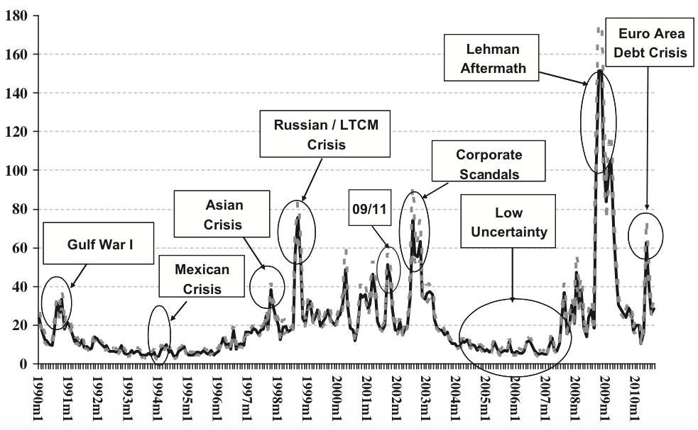
Notes: (1) The unit is monthly percentages squared. (2) Gray dashed lines represent 90% confidence intervals. (3) The sample period is January 1990-August 2010. (4) Source: BHD.

Figure 7: Uncertainty proxies for the S&P 500 as found by using model (1) and (2) while relying on daily return data
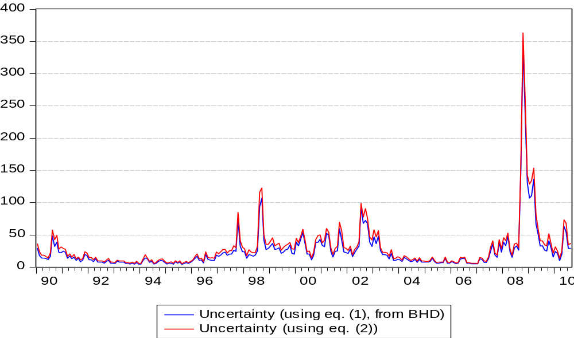
Notes: (1) The unit is monthly percentages squared. (2) The sample period is January 1990-August 2010. (3) Data source: Bloomberg.

I find consistently higher uncertainty proxies than BHD. This becomes especially clear when comparing the respective spikes. This is consistent with findings by Drechsler and Yaron (2011). For the period 1990 M1-2007 M3, they report a higher average variance of the S&P 500 when using daily returns (20.69) than when using five-minute returns (14.74).
Given that the uncertainty proxy from daily returns is higher than the one from five-minute returns, it follows that the risk aversion proxy (calculated by subtracting the uncertainty proxy from the squared VIX) will be lower than the one estimated by BHD.
This seems to be a problem that generally occurs when using daily returns. Indeed, Bollerslev et al. (2011) note that the use of realised volatilities from daily data (instead of realised volatilities from five-minute returns) generally leads to biased and inefficient estimates of the variance premium (risk aversion proxy). This seems relevant for this study, as illustrated above. Apparently, using variances calculated from daily returns puts an upward bias on the uncertainty proxy, and hence a downward bias on the risk aversion proxy.
In addition, when decomposing the VDAX-New, the VSTOXX and the VSMI into risk aversion and uncertainty components, both variables are highly correlated. This is shown in table 3.
Table 3: Correlations between the risk aversion and uncertainty proxies for the VDAX-New, the VSTOXX and the VSMI
 | Pre-crisis sample | Full sample
VDAX-New | 0.87 | 1.00
VSTOXX | 0.96 | 0.86
VSMI | 1.00 | 0.88
Notes: (1) Daily data. (2) The VDAX-New samples start in January 1992. The VSTOXX and VSMI samples start in January 1999. (3) The pre-crisis samples end in August 2008. The full samples end in December 2014. (4) Data sources: Bloomberg, SIX Swiss Exchange.

These results indicate that apart from the problem of biased estimates for both proxies due to the use of daily data, using them in an econometric set-up would not necessarily add additional information compared to the use of raw OIVI data. Therefore, I abstract from using the risk aversion and uncertainty proxies and rather rely on the OIVI data as it is. Similarly to BHD, I use end-of-month observations for the implied volatility.

3.3. Structural VAR models
The interactions between monetary policy and implied volatility are analysed using VAR models and relying on monthly data. I mostly employ 3-variable models including a monetary policy variable ${(MP}_{t})$, a business cycle indicator $({BC}_{t})$, and the log of the implied monthly variance $({IV}_{t})$. OIVIs usually indicate the annualised 30-day implied volatility. Hence, to obtain the implied monthly variance, OIVI data needs to be squared and then divided by 12. This transformation is performed to make the results more comparable to the ones obtained by BHD, since they use implied monthly variance data in their decomposition exercise. As pointed out by BHD, the business cycle should constitute the most relevant control variable as a weakening economy might simultaneously lead to looser monetary policy and increase people’s risk aversion. In addition, given the small size of Switzerland and since the SNB seems to put great attention to exchange rate considerations, I also employ 4-variable VAR models for this country including the log of an exchange rate variable $({ER}_{t})$.
The results are presented under the form of impulse response functions (IRFs). Therefore, structural VAR models specified as follows are considered:
$Ay_{t}=A_{0}^{*}+A_{1}^{*}y_{t-1}+…+A_{p}^{*}y_{t-p}+ε_{t}$ (3)
In general, $y_{t}=\left[{BC}_{t}, {MP}_{t}, {IV}_{t}\right]'$ while for some Swiss models, $y_{t}=\left[{BC}_{t}, {MP}_{t}, {IV}_{t}, {ER}_{t}\right]'$. $A$ is a full rank 3x3, respectively 4x4 matrix and $E\left[ε_{t}ε_{t}^{'}\right]$ is a diagonal matrix with positive diagonal elements. Since (3) cannot be estimated in an unbiased way, the structural VAR models need to be transformed to the standard form:
$y_{t}=A_{0}+A_{1}y_{t-1}+…+A_{p}y_{t-p}+u_{t}$ (4)
(4) is obtained by pre-multiplying (3) with $A^{-1}$. Thus, $u_{t}=A^{-1}ε_{t}$. To determine the appropriate lag order $p$, I rely on the Akaike information criterion (AIC). According to Ivanov and Kilian (2005), this criterion tends to select the VAR models with the most appropriate IRFs for monthly data samples. After selecting a model based on the AIC, the Breusch-Godfrey LM test for autocorrelation of the residuals is executed (see Lütkepohl & Krätzig, 2004). The test is performed on eight lags and includes a correction for small samples. If the null-hypothesis of no autocorrelation can be rejected at a 10%-level, the lag order is increased until the test cannot be rejected at this level. This procedure works well for all German and most Eurozone samples. However, for the vast majority of the Swiss samples and the remaining Eurozone samples, I reject the null-hypothesis of no autocorrelation even for models including 10 to 12 lags. Even larger models are not feasible, given that the samples they are based on only include 116 observations. Due to this sample size, the lag order is restricted to be six at most. By doing so, most autocorrelation, as judged from a visual analysis of the autocorrelation plots is removed. Indeed, most autocorrelation bars lie inside the $±2/\sqrt{T}$ band, except for some models where the 10th and/or the 12th lag exceed(s) this threshold. Although this solution might not be perfect, it eliminates the largest part of the autocorrelation and seems more reasonable than working with excessively large models which also fail to reject the formal test.
After the determination of the VAR lag order, the moduli of the eigenvalues from the reverse characteristic polynomials are assessed. They always prove to be larger than one, implying that all VAR models are stable.
Following the estimation of the reduced form VAR models, their structural versions need to be identified in order to obtain IRFs. To do so, I follow BHD by imposing a Cholesky decomposition. This makes $A$ a lower triangular matrix. As in BHD, ${BC}_{t}$ is always ordered first to catch the fact that the business cycle is adjusting relatively more slowly to shocks. In the vast majority of the models, ${MP}_{t}$ is ordered second since financial markets are assumed to adjust immediately to shocks. However, specifications where ${MP}_{t}$ is ordered after ${IV}_{t}$ are also considered for robustness. Consequently, in the 3-variable VAR models, ${IV}_{t}$ is mostly ordered last. In the 4-variable VAR models for Switzerland, ${IV}_{t}$ and ${ER}_{t}$ are alternately ordered last. These orderings impose three zero restrictions on the 3-variable models and six on the 4-variable models.
To visualise the impulse response functions, orthogonalised shocks to the systems are simulated. In order to assess if the obtained IRFs are significant, I follow BHD by using bootstrapped 90% confidence intervals based on 1000 replications. Regarding the specific bootstrapping approach, I use the ‘percentile’ confidence interval described in Benkwitz et al. (2001), which incorporates a correction for potential biases in the impulse response point estimates.
To control for possible structural breaks in the relationships in question, different subsamples are analysed. For Germany, the full sample ranges from January 1992 to December 2014. Subsamples include the period January 1992-December 1998 when the Bundesbank was responsible for setting monetary policy, as well as the pre-crisis period covering January 1999-August 2008 and the period January 1999-December 2014 when the ECB took over as policy setting institution. For the Eurozone, the full sample runs from January 1999 to December 2014 while the pre-crisis sample ends in August 2008. For Switzerland, I only consider the period January 1999-August 2008 since SNB reacted very aggressively to the crisis, making the measurement of the monetary policy stance difficult. Details regarding these choices are given in the next subsection.
Regarding the proxies for ${BC}_{t},$ ${MP}_{t}$ and ${ER}_{t}$, I rely on different measures. Business cycle variables include industrial production growth, employment growth and indicators published by research institutions. Monetary policy measures comprise different real and nominal interest rate measures, as well as M1 and M3 growth rates. For the Swiss exchange rate, export-weighted nominal and real exchange rates are considered. The following sections are devoted to the choice of these variables for the respective economies.

3.4. Measuring monetary policy
The benchmark measure for the monetary policy stance used by BHD is the real interest rate. It is defined as the end-of-month federal funds target rate minus the annual inflation rate (the growth rate of the CPI relative to the same month a year earlier). Alternative measures also employed are the nominal federal funds target rate, the growth rate of the monetary aggregate M1, and deviations from the original Taylor rule proposed in Taylor (1993).
BHD point out that it is more difficult to measure the monetary policy stance after December 2008 when the federal funds target rate hit the zero lower bound, since the Federal Reserve embarked on a series of quantitative easing (QE) programmes thereafter. Therefore, they use the interest rate calculated from the Taylor rule as a proxy for the ‘true’ federal funds rate after December 2008. However, their benchmark sample runs from January 1990 to July 2007.

3.4.1. Unconventional monetary policy
Concerning the problems linked with the measurement of the monetary policy stance since 2008, the situation in the US and Switzerland is somewhat similar. On the other hand, the ECB’s policy stance after 2008 is relatively easier to quantify for at least two reasons.
First, Eurozone nominal interest rates hit the zero lower bound much later than in the US or Switzerland. The ECB even increased nominal rates in 2011. They only started to stay close to zero for a prolonged amount of time in July 2012. In addition, interest rates near zero represent not a problem per se for the measurement of the monetary policy stance as long as a central bank does not introduce additional measures like QE programmes to decrease the ‘true’ interest rate further.
Second, while the Federal Reserve started its first large-scale QE programme in late-2008, the ECB only did so in January 2015. As pointed out by Fratzscher et al. (2014), the two most important unconventional measures implemented before that date were LTROs (Long Term Refinancing Operations) and the SMP (Securities Market Programme). The LTROs took place between March 2008 and December 2011 and aimed at providing collateralised loans at longer maturities than usual to banks, while the SMP lasted from May 2010 to September 2012 and consisted of buying sovereign bonds of the peripheral EMU countries most hit by the European sovereign debt crisis. Importantly these purchases were sterilised, meaning that the resulting money supply increase was neutralised by removing liquidity from circulation through other channels. The programme was eventually replaced by the OMT (Outright Monetary Transactions) mechanism, which has not yet been used to purchase additional sovereign bonds (Fratzscher et al., 2014).
As a result of this more conservative approach, the ECB’s balance increased much less after 2007 than those of the Federal Reserve and the SNB (see figure 8). Since the end of the SMP programme, its balance sheet even returned back more or less to the level reached at the end of 2008. The ECB only announced a large-scale QE programme in January 2015.

Figure 8: Assets held by the Federal Reserve, the ECB and the SNB (December 2007=100)
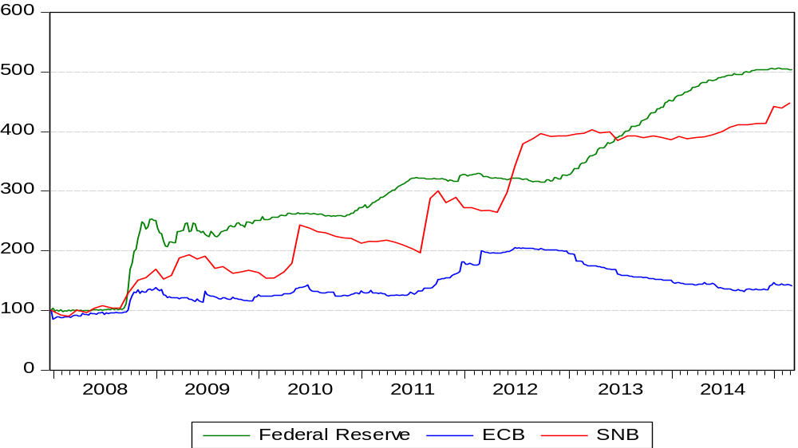
Notes: (1) sample period: December 2007-February 2015. (2) Weekly data for the Federal Reserve and the ECB, monthly data for the SNB. (3) Sources: Federal Reserve, ECB, SNB.

For this reason, real interest rates should offer a fairly realistic measurement of the monetary policy stance in Germany and the Eurozone after 2007. The longest samples considered end in December 2014, before the announcement of a QE programme by the ECB. For Switzerland, I only consider samples ending in August 2008 since the SNB implemented a massive expansion of its balance sheet since then, similar to the Federal Reserve.

3.4.2. Monetary policy in Germany
Since the German sample spans a period over which the Bundesbank and later the ECB set monetary policy, the challenge is to find an appropriate set of interest rates. Since there is no single rate that was directly set or officially targeted by the Bundesbank and which the ECB still sets or targets, the best proxies for a continuous measurement of the policy stance should be interbank rates. Figure 9 depicts a set of interest rates for Germany and from 1999 on for the Eurozone.

Figure 9: Central bank and interbank interest rates for Germany/the Eurozone
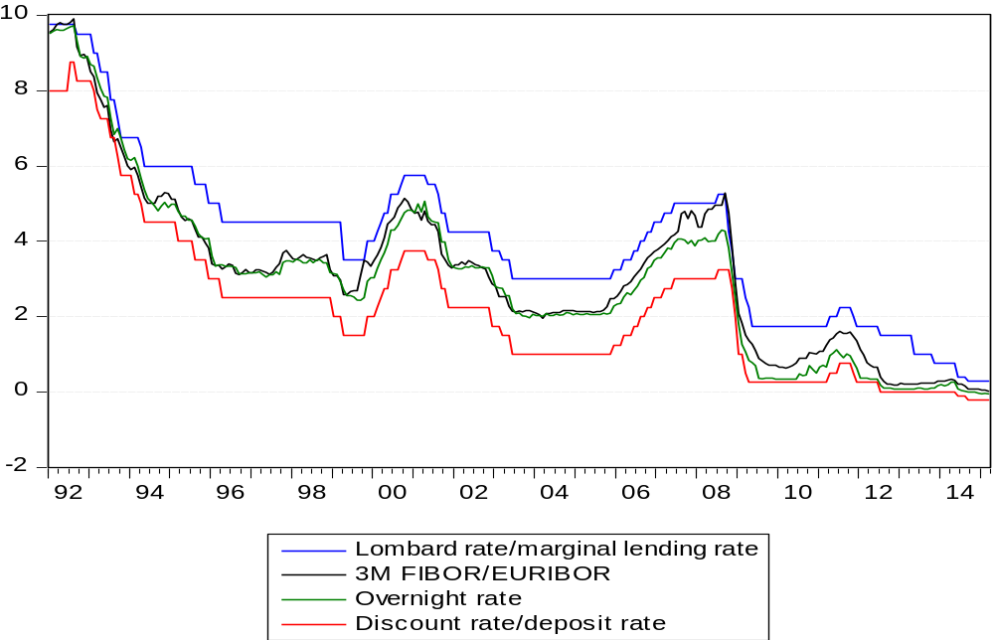
Notes: (1) The Bundesbank set the Lombard rate until December 1998. The ECB started to fix the marginal lending rate in January 1999. (2) The 3-month FIBOR (Frankfurt Interbank Offered Rate) is the German precursor of the 3-month EURIBOR that was introduced in January 1999. (3) Between January 1992 and June 1996, the overnight rate corresponds to the money market rate reported by Frankfurt banks to the Bundesbank. Between July 1996 and December 1998, the overnight rate corresponds to the official overnight FIBOR, and from January 1999 on it corresponds to its Eurozone successor, the EONIA rate. (4) The Bundesbank set the discount rate until December 1998. From January 1999 on, the ECB set the deposit rate. (5) The overnight rate corresponds to a monthly average of daily quotations. All other rates are end-of-month rates. (6) All rates are expressed in per cent p.a. (7) Data source: Bundesbank.

The Lombard rate and discount rate shown in figure 9 were essential for the Bundesbank’s monetary policy before 1985. At that time, banks could receive credit up to a fixed amount at the lower discount rate, while additional liquidity was available at the higher Lombard rate. In 1985 then, the Bundesbank changed its operating procedure by mainly relying on repurchase agreements. Lombard credit lost its importance. Nevertheless, the Lombard rate remained relevant until 1999 since it served as a signal for the German monetary policy stance (Clarida & Gertler, 1997). As depicted in figure 9, the 3-month FIBOR (Frankfurt Interbank Offered Rate) and the German overnight rate (from July 1996 on the official overnight FIBOR) moved closely inside the Lombard rate-discount rate corridor. Although the ECB does not set interest rates that are directly comparable to the Bundesbank’s rates, it still fixes two rates that form a corridor for interbank rates. The lower deposit rate is paid on money parked overnight at the ECB, while the higher marginal lending rate is applied to overnight credits made by the ECB to Eurozone banks. The successors of the 3-month and the overnight FIBORs, the 3-month EURIBOR and the EONIA rate (Eurozone overnight rate) also moved closely inside the band set by the ECB.
Thus, German and later Eurozone interbank rates should constitute the best proxies for the monetary policy stance in Germany as they are conceptually identical and move inside corridors formed by central bank rates. Regarding the question whether to use 3-month or overnight interbank rates, Bohl et al. (2007) favour the use of the former since the latter might be subject to large fluctuations because of liquidity shortages. In addition, the SNB’s main policy rate is the CHF 3-month LIBOR. Hence, the different results in this study would be more comparable when using the longer-maturity rates. However, overnight rates might be conceptually closer to the federal funds target used in BHD. Therefore, the 3-month rate serves as benchmark, but the overnight rate is also considered for robustness. I rely on end-of-month data, as in BHD, for the 3-month rates and on monthly averages of daily quotations for the overnight rates in order to even out large fluctuations due to liquidity shortages.
Following BHD, the main measures for the monetary policy stance are real interest rates calculated by subtracting the annual German CPI inflation rate from the overnight and the 3-month nominal rates. Apart from real interest rates, I also rely on nominal interest rates as well as the growth rate of German M1 as alternative monetary policy measures. In addition, I consider the growth rate of German M3 since both the Bundesbank and the ECB attached, or still attach great importance to this aggregate (Castro, 2011; Clarida & Gertler, 1997). Although empirical evidence points out that neither of them effectively targeted this quantity (Bernanke & Mihov, 1997; Castro, 2011), it might provide an additional robustness check for the results. Contrary to BHD, I do not use Taylor rule residuals as a further monetary policy measure since this requires an assumption about the natural real interest rate level as well as the estimation of potential output in order to calculate the output gap. Unlike, for the US, such data is not readily available for Germany or the Eurozone in official databases.

3.4.3. Monetary policy in the Eurozone
As for Germany, I use the 3-month EURIBOR and the overnight rate (the EONIA rate) as interest rates for the Eurozone. Furthermore, I also use the rate for main refinancing operations (RMRO) set by the ECB itself. This rate is charged on the majority of the liquidity provided by the ECB to the banking sector. Figure 10 shows the RMRO in addition to the four rates shown in figure 9 for Germany.

Figure 10: Central bank and interbank interest rates for the Eurozone
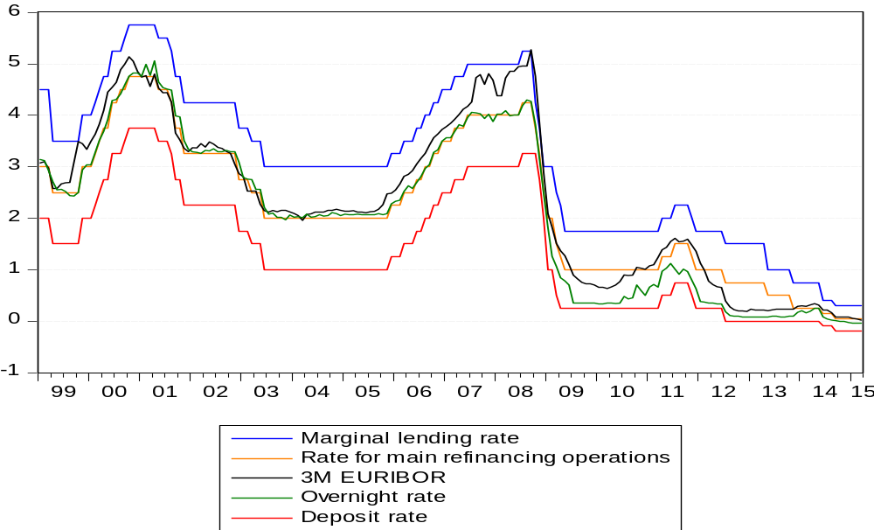
Notes: (1) The ECB fixes the marginal lending rate, the rate for main refinancing operations and the deposit rate. (2) The overnight rate corresponds to the official EONIA rate. (3) The overnight rate corresponds to a monthly average of daily quotations. All other rates are end-of-month rates. (6) All rates are expressed in per cent p.a. (7) Data source: Bundesbank.

It stands out that the RMRO and the overnight rate moved closely together until the start of the Great Recession. Since then, the RMRO has been consistently higher. As for the 3-month EURIBOR I use end-of-month data for the RMRO.
Real interest rates for the Eurozone are obtained by using the annual Eurozone HICP inflation rate. This price index is calculated from data taking into account the changing composition of the EMU over time. For example, Lithuania is only included in the HICP since January 2015.
As for Germany, nominal interest rates as well as M1 and M3 growth constitute alternative monetary policy measures. However, available EMU money supply data is calculated for the Eurozone in changing composition, as for the HICP. Therefore, it might for instance be possible that M1 growth was negative between December 2014 and January 2015 for the 18 countries already member in 2014, but that the addition of Lithuania in January 2015 produces the impression that it was positive. Consequently, dummy variables for the months where one or more countries joined the EMU are included in order to prevent artificial hikes in the M1 and M3 growth rates.

3.4.4. Monetary policy in Switzerland
As mentioned earlier, the SNB started to officially target the 3-month CHF LIBOR in January 2000. Figure 11 depicts its evolution over time, alongside the corridor set by the SNB.

Figure 11: Three-month CHF LIBOR and the corridor fixed by the SNB
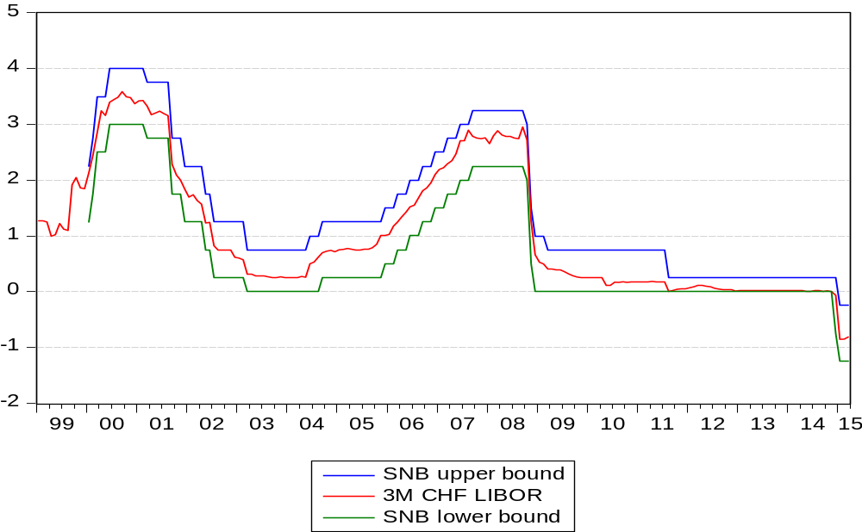

Notes: (1) End-of-month data.(2) sample period: January 1999-March 2015. (3) Data sources: Bloomberg, SNB.

The relevant period for this study begins in 1999. However, as noted before, the SNB only introduced the 3-month CHF LIBOR as its target rate in 2000. Nonetheless, in 1999, its policy stance should also be well approximated with this rate since, according to Svensson (2002), it effectively acted quite similarly to an inflation targeter prior to 2000. Hence, the real 3-month CHF LIBOR, obtained by subtracting the Swiss CPI annual inflation rate, is the main policy measure. As before, the nominal rate, M1 growth and M3 growth are considered for robustness. I also use the latter variable to compare the results with those of the other two economies and because the SNB has traditionally been a monetary targeter.
As mentioned before, the effects of the substantial unconventional monetary policy measures introduced by the SNB after 2008 are potentially very hard to measure and probably beyond the scope of this paper. Therefore, I abstract from considering the period after August 2008 for Switzerland.

3.5. The business cycle
As in BHD, the main business cycle variable for Germany and the Eurozone considered in this paper is industrial production (IP) growth. Specifically, I rely on production data of the manufacturing sector (MF) as main variable and consider total industrial production (TIP), which also includes output of the mining and quarrying, the construction, as well as the electricity, gas, steam and air conditioning supply sectors for robustness.
In addition, BHD consider the log of the ISM index and employment growth. For Germany I use the log of the Ifo Business Climate index (Ifo index) published by the Ifo Institute for Economic Research, as well as employment growth. For the Eurozone I solely rely on the European Commission Euro Area Business Climate Indicator (EC index) for robustness, as employment data is only available at quarterly frequency. It should be noted that the EC index does not enter as log since it can take negative values.
One drawback of using IP data for the Eurozone is that it is only available for the area as it is composed since January 2015, namely including 19 countries. This has the disadvantage that earlier measurements of industrial production include countries that were not part of the EMU at that time. However, the countries that joined after 1999 are relatively small. Thus, the effect should not be too substantial.
For Switzerland, IP and employment data is only available at a quarterly frequency. Therefore, I have to solely rely on the log of the KOF Economic Barometer (KOF index) published by the Swiss Economic Institute as business cycle measure.

3.6. Exchange rates for Switzerland
Figure 12 depicts the nominal and the real export-weighted exchange rates for Switzerland. For robustness, the log of both variables enters separately in augmented versions of the baseline Swiss VAR.

Figure 12: Nominal and real export-weighted exchange rates for Switzerland
(January 1999 = 100)
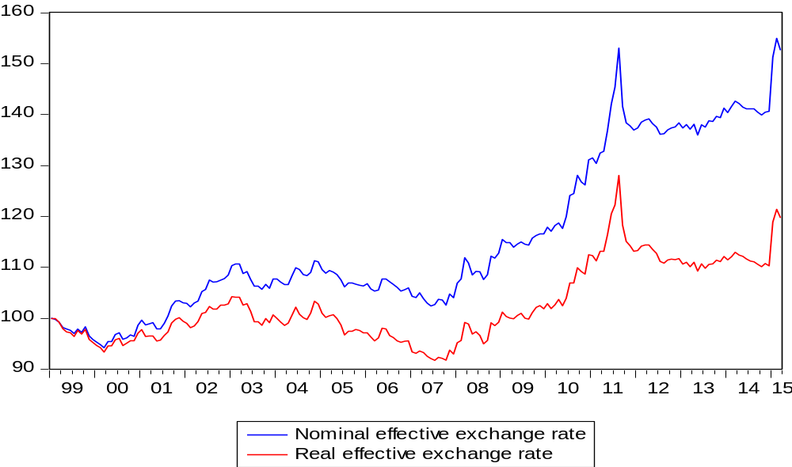
Notes: (1) Monthly data, index with January 1999 = 100. (2) Upward (downward) movements correspond to an appreciation (depreciation). (3) Source: SNB.

As illustrated in figure 12, the Swiss franc was rather stable both in nominal and real terms before the start of the Great Recession. However, from 2008 on it appreciated at a very high pace. This was probably due to the fact that Switzerland is seen as a ‘safe haven’. The appreciation then stopped between 2011 and 2014 when the SNB pegged the franc to the euro and it restarted after the peg was abandoned.

3.7. Summary of the variables employed
Table 4: Summary of the variables for Germany
Variable | Description | Source
Implied variance | log(VDAX-New²/12) | Bloomberg
Nominal 3M rate | 3-month FIBOR (1992 M1-1998 M12),  3-month EURIBOR (1999 M1-2014 M12) | Bundesbank
Nominal ON rate | unofficial overnight rate (1992 M1-1996 M6),  overnight FIBOR (1996 M7-1998 M12),  EONIA rate (1999 M1-2014 M12) | Bundesbank
Inflation rate | annualised CPI growth rate relative to the same month a year earlier | Federal Statistical Office of Germany
Real rates | nominal rates minus the inflation rate | /
M1 growth | month-on-month growth rate of M1 | Bundesbank
M3 growth | month-on-month growth rate of M3 | Bundesbank
MF growth | month-on-month log difference of manufacturing production | Eurostat
TIP growth | month-on-month log difference of total industrial production | Eurostat
Ifo index | log(Ifo index) | Ifo Institute
Employment growth | month-on-month log difference of total employment | Federal Statistical Office of Germany
Notes: (1) Overnight rate data constitutes the monthly average of daily observations. All other data are employed at an end-of-month frequency. (2) CPI, M1, M3, MF, TIP, Ifo index and employment series are deseasonalised.
Table 5: Summary of the variables for the Eurozone
Variable | Description | Source
Implied variance | log(VSTOXX²/12) | Bloomberg
Nominal 3M rate | 3-month EURIBOR | Bundesbank
Nominal ON rate | EONIA rate (overnight rate) | Bundesbank
RMRO | ECB rate for main refinancing operations | Bundesbank
Inflation rate | annualised HICP growth rate relative to the same month a year earlier | Eurostat
Real rates | nominal rates minus the inflation rate | /
M1 growth | month-on-month growth rate of M1 | ECB
M3 growth | month-on-month growth rate of M3 | ECB
MF growth | month-on-month log difference of manufacturing production | Eurostat
TIP growth | month-on-month log difference of total industrial production | Eurostat
EC index | European Commission Euro Area Business Climate Indicator | European Commission
Notes: (1) The overnight rate variable is calculated as the monthly average of daily observations. All other data are employed at an end-of-month frequency. (2) HICP, M1, M3, MF, TIP and EC index series are deseasonalised.

Table 6: Summary of the variables for Switzerland
Variable | Description | Source
Implied variance | log(VSMI²/12) | Bloomberg, SIX Swiss Exchange
Nominal 3M rate | 3-month CHF LIBOR | Bloomberg
Inflation rate | annualised CPI growth rate relative to the same month a year earlier | SNB
Real rates | nominal rates minus the inflation rate | /
M1 growth | month-on-month growth rate of M1 | SNB
M3 growth | month-on-month growth rate of M3 | SNB
KOF index | KOF Economic Barometer | Swiss Economic Institute
Nominal ER | Export-weighted nominal exchange rate, index with basis 100 in January 1999 | SNB
Nominal ER | Export-weighted nominal exchange rate, index with basis 100 in January 1999 | SNB
Notes: (1) All data are employed at an end-of-month frequency. (2) CPI, M1, M3 and KOF index series are deseasonalised. (3) An increase in the exchange rate variables corresponds to an appreciation.

4. Results
The present section discusses the results of the analysis. First, in subsection 4.1., the results for the different economies using a benchmark model are presented and discussed. In a second step, in subsection 4.2., the robustness of these results is assessed.

4.1. The benchmark models
In this subsection, the IRFs obtained from benchmark 3-variable models for Germany, the Eurozone and Switzerland are presented and discussed. These models include a business cycle measure, a real interest rate variable and the log of the implied variance. As business cycle variable, manufacturing growth is included for Germany and the Eurozone. For Switzerland, the log of the KOF index is used. As real interest rate measure, I rely on the 3-month rates. The German, Eurozone, and Swiss models are estimated over four, two, and one period respectively.
The IRFs presented in this subsection only focus on the interactions between monetary policy and implied variance, as these are the relations of interest for this study. The complete IRFs are provided in appendix B1-B4 for Germany, in appendix C1-C2 for the Eurozone, and in appendix D for Switzerland. For the interactions of secondary interest I find mostly the following results: loose monetary policy has a positive effect on the business cycle variable, a positive business cycle shock increases real interest rates, a positive shock to implied variance has a negative effect on the business cycle, and a positive shock to the business cycle increases implied variance. The first three results are intuitively appealing, while the last result is more puzzling. Nevertheless, it should not be overemphasised as the effect is mostly small and insignificant. It is only significant in the Eurozone model covering the period 1999 M1-2008 M8. Overall, these findings are in line with the results reported by BHD.
In subsections 4.1.1., 4.1.2., and 4.1.3., the results for Germany, the Eurozone, and Switzerland are discussed, respectively.

4.1.1. Results for Germany
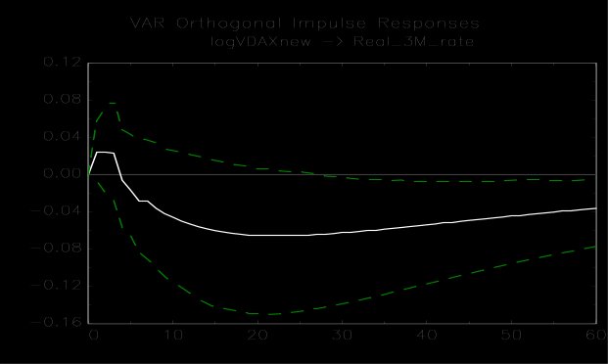
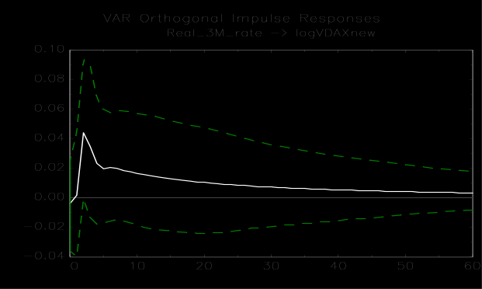
Figure 13A: IRFs for the sample period 1992 M1-2014 M12
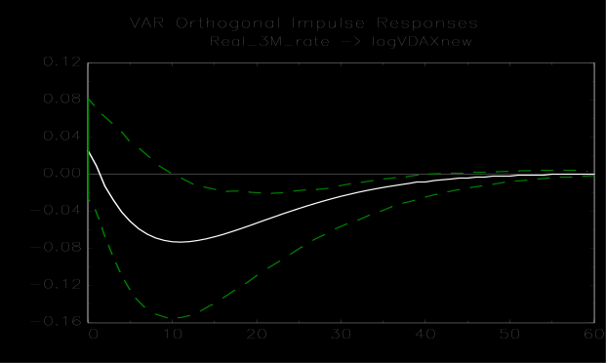
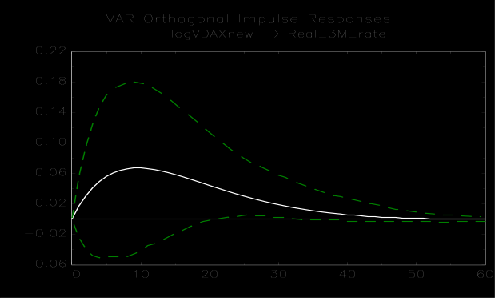
Figure 13B: IRFs for the sample period 1992 M1-1998 M12
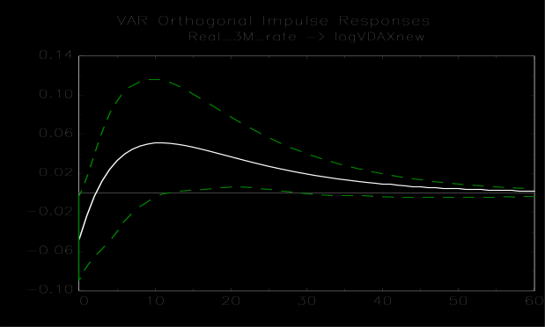
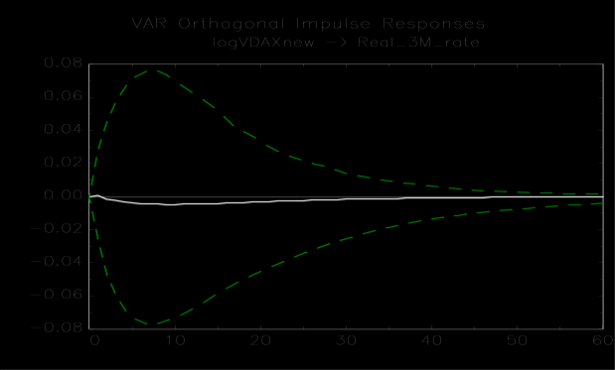
Figure 13C: IRFs for the sample period 1999 M1-2008 M8
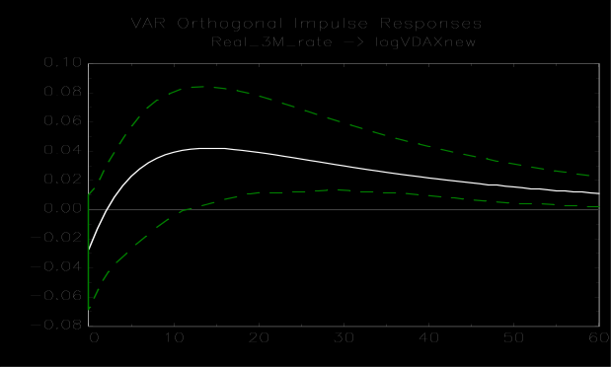
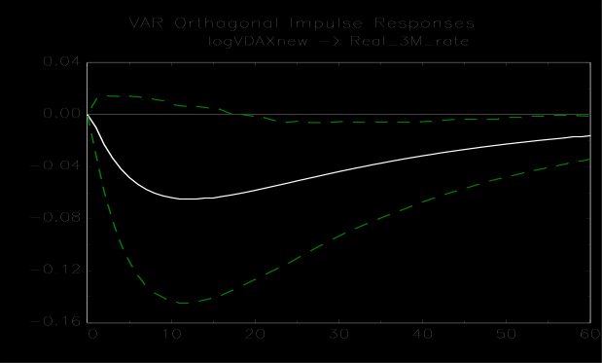
Figure 13D: IRFs for the sample period 1999 M1-2014 M12
Notes: (1) White lines represent the estimates of the IRFs and green dashed lines the 90% bootstrapped confidence intervals. (2) The underlying models are the 3-variable VARs with lag order 4 for 1A and lag order 1 for 1B-1D. They include the variables ordered as follows: manufacturing growth, real 3-month rate, log(VDAX-New²/12). (3) The left panels show the response of log(VDAX-New²/12) to a 1 S.E. shock in the 3-month real rate. The right panels show the opposite scenario.
Figures 13A-13D illustrate the results for Germany. It is evident that they depend substantially on the period under consideration. For the full sample, a positive but insignificant effect of real rate shocks on implied variance is found. For the Bundesbank sample covering 1992-1998, a significant negative effect is found. It is significant for nearly 30 months. This result implies that a positive real interest rate shock lowers implied variance. This stands in strong contrast with the findings reported by BHD. For the pre-crisis ECB sample, a marginally significant positive effect is found. The effect is significant for 14 months, starting approximately one year after the initial one standard error (S.E.) shock in the real rate. For the full ECB sample, comprising the Great Recession episode, the effect becomes more persistent. The IRF starts to be significant after about one year, and lasts nearly four years. The effect size is also economically significant as it is situated between 0.04 and 0.01. This is equivalent to a 1-4% rise in the implied monthly variance of the DAX. Overall, in figure 13A the significant negative and positive effects respectively found for the Bundesbank and the ECB subsamples seem to cancel each other out.
Regarding the effect of the VDAX-New on the German real interest rate, a significant negative response is found for the full sample. The IRF starts to be significant at around 30 months following the shock in implied variance. The effect seems to be small but still economically significant. Indeed, the initial one S.E. shock significantly decreases the real interest rate by approximately 4-6 basis points over two and a half years. As before, the effect reverses if one considers only the Bundesbank sample. However, the IRF is rather small during the period where the effect is found to be significant. For the pre-crisis ECB sample, an implied variance shock has no effect at all. The IRF is slightly negative and more importantly, it is highly insignificant. For the full ECB sample, the results change considerably. A one S.E. implied variance shock has a negative effect on the real interest rate, which starts to be significant after 18 months. The effect is situated between -1 and -6 basis points.
Concerning the counter-intuitive results for the period 1992-1998, it is difficult to argue why the Bundesbank would have increased real interest rates in response to a positive shock in the implied variance of the DAX. Given the rather conservative approach of the Bundesbank and the findings reported by Bohl et al. (2007), it might make sense that it did not react to implied variance. On the other hand, raising rates as a response seems unlikely. Similarly, the result that contractionary monetary policy would lower the VDAX-New is at odds with the findings of BHD and the effects found for the other samples. However, given the significant negative correlation of the VDAX-New and the DAX, this result would to some extent be in line with the findings of Galí and Gambetti (2015) who report a positive effect of contractionary monetary policy on real stock prices. Nevertheless, the results might also be due to the small sample size. More specifically, the sample only contains 84 observations and does not cover a full interest rate cycle during which policy was loosened and tightened. Therefore, the true underlying dynamics might not be adequately captured.
However, this cannot explain why the response of the VDAX-New to the real interest rate seems to have become more significant over time. It is insignificant for the full sample including the period 1992-1998, marginally significant for the intermediate period 1999 M1-2008 M8 and more clearly significant for the full ECB sample. Interestingly, this contrasts with the findings by BHD who report a weaker and less significant effect of real rate shocks on uncertainty and risk aversion for the sample covering 1990 M1-2010 M8 than for the sample comprising only 1990 M1-2007 M7. A possible explanation for the insignificant result when considering the full sample might be that expansionary monetary possible had a negative effect on risk aversion and uncertainty throughout the 1990s, but that option markets in Germany were potentially less developed during this decade. Thereby they could have incorrectly reflected market participants’ expectations about future volatility and their risk aversion. Nevertheless, the results might also be valid as they are presented in figures 13A to 13D, and expansionary monetary policy had a positive effect on implied variance in the pre-euro period and a negative effect thereafter. However, it is not clear why this might be the case.
Regarding the real rate’s response to implied variance after 1998, it strongly differs from the one found for the Bundesbank sample. For the ECB sample ending prior to the Great Recession, the result that the real rate is unaffected by implied variance shocks lends support to the finding of Furlanetto (2011). He finds that the ECB did not react to stock prices before 2007. It is not in line with Castro’s (2011) result that the ECB’s pre-crisis reaction function included a financial conditions index incorporating for instance information on real share prices and credit spreads. However, despite the importance of Germany for the Eurozone economy and of the DAX for other European stock markets, the result still needs to be treated with caution. The ECB might have reacted to the VSTOXX, rather than to the VDAX-New before the Great Recession. In addition, the VAR models underlying 13A-13D are based on German, rather than Eurozone real rates and industrial production.
For the full ECB sample, as previously mentioned, the real rate decreases significantly in response to positive implied variance shocks. This result is likely to be driven by the sharp interest rates cuts implemented after September 2008.
4.1.2. Results for the Eurozone
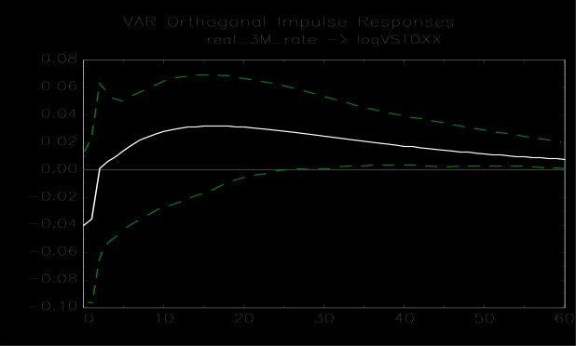
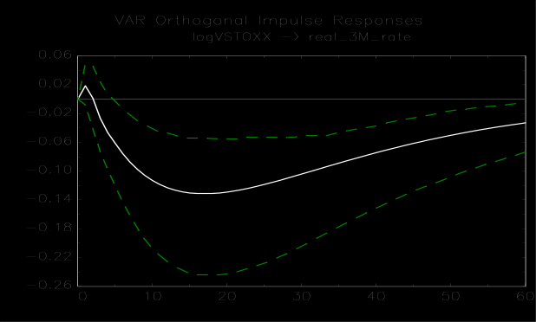
Figure 14A: IRFs for the period 1999 M1-2014 M12
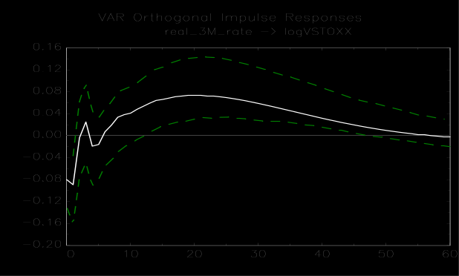
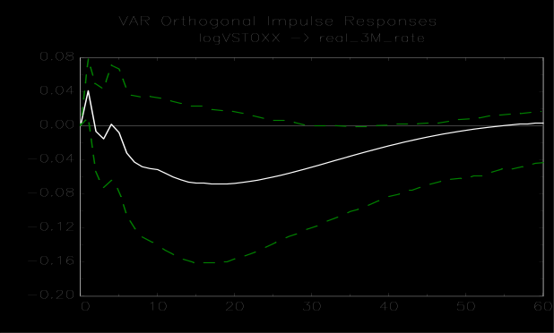
Figure 14B: IRFs for the period 1999 M1-2008 M8
Notes: (1) White lines represent the estimates of the IRFs and green dashed lines the 90% bootstrapped confidence intervals. (2) The underlying models are the 3-variable VARs with lag order 3 for 2A and lag order 5 for 2B. They include the variables ordered as follows: manufacturing growth, real 3-month rate, log(VSTOXX²/12). (3) The left panels show the response of log(VSTOXX²/12) to a 1 S.E. shock in the 3-month real rate. The right panels show the opposite scenario.

For the Eurozone as well, the importance of considering different time periods is evident. Regarding the effect of real rate shocks on implied variance, it stands out that it is more clearly significant for the pre-crisis sample than for the full sample. This contrasts with the findings from the corresponding German samples for which the opposite is true. For the full sample, a one S.E. shock to the real rate only has a marginally significant effect after approximately 30 months. The effect size is situated between 0.01 and 0.03. For the pre-crisis sample, the corresponding IRF becomes clearly significant after one year and stays significant for nearly three years in total. The maximum effect of more than 0.07 is reached after 20 months. This effect is also economically significant since it corresponds to an approximate 7% increase in the implied monthly variance of the EURO STOXX 50.
The results also indicate that the ECB did react to shocks in the VSTOXX. While the effect is only borderline significant for the pre-crisis sample, it is clearly significant for the full sample. For this latter period, the IRF becomes significant after 6 months and reaches a minimum of -0.13 after 17 months. This corresponds to a real rate cut of 13 basis points. As for the German sample, this result can most likely be attributed to the ECB’s crisis response.
Overall, the effects of real rate shocks on implied variance are in line with results of BHD. Indeed, I find a less significant effect when including the Great Recession episode in the sample. However, as previously mentioned, this differs with the results for Germany where the opposite holds.
Concerning the effect of implied variance shocks on the real rate, the findings slightly differ from those of BHD. They report only marginally significant effects of uncertainty or risk aversion shocks on the real rate. Figure 14B indicates a similar result for the pre-crisis period while for the full sample, the effect of an implied variance shock on the real rate is highly significant. It is also more significant than the reaction found for Germany. Given that the Eurozone specification relying on EMU rather than German manufacturing, inflation and implied volatility data should be more relevant to assess the ECB’s reaction to implied variance, the evidence indicates that it does indeed take into account stock market uncertainty and risk aversion when setting interest rates. This finding is consistent with the result by Castro (2011) that the ECB’s reaction function includes a financial conditions index. It contrasts to some extent with the findings by Furlanetto (2011) that the ECB did not react to stock prices prior to the Great Recession.

4.1.3. Results for Switzerland
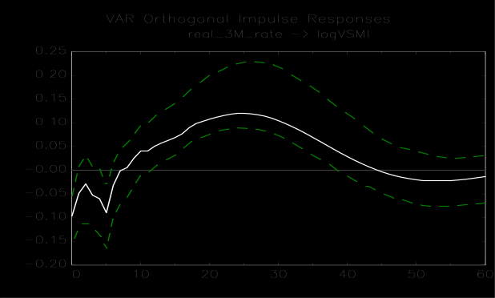
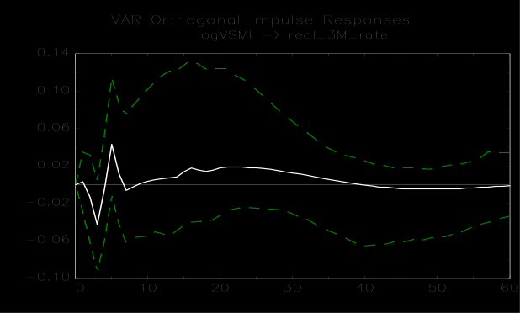
Figure 15: IRFs for the period 1999 M1-2008 M8
Notes: (1) White lines represent the estimates of the IRFs and green dashed lines the 90% bootstrapped confidence intervals. (2) The underlying model is the 3-variable VAR with lag order 6. It includes the variables ordered as follows: log(KOF index), real 3-month rate, log(VSMI²/12). (3) The left panels show the response of log(VSMI²/12) to a 1 S.E. shock in the 3-month real rate. The right panels show the opposite scenario.

For Switzerland, I also find a significant positive effect of real interest rate shocks on implied variance over the period 1999 M1-2008 M8. More precisely, a one S.E. shock to the real rate has first a short-lived significant negative effect and then a significant positive effect after one year. It reaches its maximum of more than 0.10 after slightly more than two years and stays significant until three years after the shock. The maximum effect translates into an approximate 10% hike in the implied variance of the SMI. Compared to the Eurozone the effect seems to be more short-lived, while being relatively intense.
On the other hand, implied variance shocks do not have a significant effect on the real rate. This indicates that the SNB did not react to VSMI shocks, at least prior to the Great Recession. This finding is in line with the German real rate response to VDAX-New shocks over the same period while it differs from the marginally significant effect found for shocks in the VSTOXX on the Eurozone rate.

4.2. Robustness
To assess the robustness of the aforementioned results, a vast set of different models is estimated for the three economies in question. The results are presented under the form of tables which summarise the models and indicate the direction of the effect given by the IRF with its significance. The complete models including the IRFs and the results of the autocorrelation tests are provided in appendix B1-B4 for Germany, in C1-C2 for the Eurozone, and in D for Switzerland. If the null-hypothesis of no autocorrelation is rejected, then the autocorrelation graphs are also provided in the appendix.
In 4.2.1., 4.2.2., and 4.2.3., the results are summarised for Germany, the Eurozone, and Switzerland, respectively. In 4.2.4., the robustness of the results is discussed.

4.2.1. Summary of the interactions for Germany
Table 7: The effect of an expansionary monetary policy shock on the VDAX-New (- indicates a decrease)
Variables |  | Sample
Monetary pol. | Business cycle | Full |  | Bundesbank |  | Pre-crisis ECB |  | Full ECB
Real 3M rate | MF growth |  | - |  | +* |  | -* |  | -*
Real ON rate | MF growth |  | - |  | +* |  | -* |  | -*
Nom. 3M rate | MF growth |  | - |  | + |  | -* |  | -*
Nom. ON rate | MF growth |  | -* |  | + |  | -* |  | -*
Real 3M rate | log(Ifo index) |  | - |  | +* |  | -* |  | -*
Real 3M rate | Empl. growth |  | - |  | +* |  | -* |  | -*
Real 3M rate | TIP growth |  | - |  | +* |  | -* |  | -*
Real 3M rate¹ | MF growth |  | - |  | +* |  | -* |  | -*
M1 growth | MF growth |  | + |  | + |  | +* |  | +*
M3 growth | MF growth |  | +* |  | +* |  | +* |  | +*
Notes: (1) * indicates that the IRF is significant at 10% over at least 5 consecutive months. (2) 3M stands for 3-month, ON for overnight, MF for manufacturing and TIP for total industrial production. (3) The business cycle variable is always ordered first. The monetary policy variable is ordered second except in the model denoted by ¹, where it is ordered third.

Table 8: The effect of a positive implied variance shock on monetary policy in Germany (+ indicates looser monetary policy)
Variables |  | Sample
Monetary pol. | Business cycle | Full |  | Bundesbank |  | Pre-crisis ECB |  | Full ECB
Real 3M rate | MF growth |  | +* |  | -* |  | + |  | +*
Real ON rate | MF growth |  | +* |  | -* |  | + |  | +*
Nom. 3M rate | MF growth |  | +* |  | - |  | +* |  | +*
Nom. ON rate | MF growth |  | +* |  | - |  | +* |  | +*
Real 3M rate | Log(Ifo index) |  | + |  | - |  | - |  | +*
Real 3M rate | Empl. growth |  | + |  | -* |  | + |  | +*
Real 3M rate | TIP growth |  | +* |  | -* |  | + |  | +*
Real 3M rate¹ | MF growth |  | +* |  | -* |  | + |  | +*
M1 growth | MF growth |  | + |  | - |  | + |  | +*
M3 growth | MF growth |  | -* |  | - |  | - |  | -*
Notes: (1) * indicates that the IRF is significant at 10% over at least 5 consecutive months. (2) 3M stands for 3-month, ON for overnight, MF for manufacturing and TIP for total industrial production. (3) The business cycle variable is always ordered first. The monetary policy variable is ordered second except in the model denoted by ¹, where it is ordered third.

4.2.2. Summary of the interactions for the Eurozone
Table 9: The effect of an expansionary monetary policy shock on the VSTOXX (- indicates a decrease)
Variables |  | Sample
Monetary pol. | Business cycle | Pre-crisis | Full |  | Notes:  (1) * indicates that the IRF is significant at 10% over at least 5 consecutive months.  (2) 3M stands for 3-month, ON for overnight, RMRO for the ECB’s rate for main refinancing operations, MF for manufacturing, EC for the European Commission and TIP for total industrial production.  (3) The business cycle variable is always ordered first. The monetary policy variable is ordered second except in the model denoted by ¹, where it is ordered third.
Real 3M rate | MF growth | -* | -*
Real ON rate | MF growth | -* | -
Real RMRO | MF growth | -* | -
Nom. 3M rate | MF growth | -* | -*
Nom. ON rate | MF growth | -* | -*
Nom. RMRO | MF growth | -* | -*
Real 3M rate | EC index | -* | -*
Real 3M rate | TIP growth | -* | -*
Real 3M rate¹ | MF growth | -* | -*
M1 growth | MF growth | + | +
M3 growth | MF growth | + | +

Table 10: The effect of a positive implied variance shock on monetary policy in the Eurozone (+ indicates looser monetary policy)
Variables |  | Sample
Monetary pol. | Business cycle | Pre-crisis | Full |  | Notes:  (1) * indicates that the IRF is significant at 10% over at least 5 consecutive months.  (2) 3M stands for 3-month, ON for overnight, RMRO for the ECB’s rate for main refinancing operations, MF for manufacturing, EC for the European Commission and TIP for total industrial production.  (3) The business cycle variable is always ordered first. The monetary policy variable is ordered second except in the model denoted by ¹, where it is ordered third.
Real 3M rate | MF growth | +* | +*
Real ON rate | MF growth | +* | +*
Real RMRO | MF growth | + | +*
Nom. 3M rate | MF growth | +* | +*
Nom. ON rate | MF growth | +* | +*
Nom. RMRO | MF growth | + | +*
Real 3M rate | EC index | +* | +*
Real 3M rate | TIP growth | +* | +*
Real 3M rate¹ | MF growth | +* | +*
M1 growth | MF growth | - | -
M3 growth | MF growth | -* | -*

4.2.3. Summary of the interactions for Switzerland
Table 11: The effect of an expansionary monetary policy shock on the VSMI (- indicates a VSMI decrease)
Variables |  |  | Variable ordered last | Effect
Monetary pol. | Business cycle | Exchange rate | Variable ordered last | Effect
Real 3M rate | log(KOF index) | / | log(VSMI²/12) | -*
Nom. 3M rate | log(KOF index) | / | log(VSMI²/12) | -*
Real 3M rate | log(KOF index) | / | Real 3M rate | -*
M1 growth | log(KOF index) | / | log(VSMI²/12) | -*
M3 growth | log(KOF index) | / | log(VSMI²/12) | -*
Real 3M rate | log(KOF index) | log(NER) | log(NER) | -*
Real 3M rate | log(KOF index) | log(NER) | log(VSMI²/12) | -*
Real 3M rate | log(KOF index) | log(RER) | log(RER) | -*
Real 3M rate | log(KOF index) | log(RER) | log(VSMI²/12) | -*
Nom. 3M rate | log(KOF index) | log(NER) | log(NER) | -*
Nom. 3M rate | log(KOF index) | log(NER) | log(VSMI²/12) | -*
Nom. 3M rate | log(KOF index) | log(RER) | log(RER) | -*
Nom. 3M rate | log(KOF index) | log(RER) | log(VSMI²/12) | -*
Notes: (1) * indicates that the IRF is significant at 10% over at least 5 consecutive months. (2) 3M stands for 3-month, NER for export-weighted nominal exchange rate and RER for export-weighted real exchange rate. (3) The business cycle variable is always ordered first. The monetary policy variable is ordered second except in the third row.

Table 12: The effect of a positive implied variance shock on monetary policy in Switzerland (+ indicates looser monetary policy)
Variables |  |  | Variable ordered last | Effect
Monetary pol. | Business cycle | Exchange rate | Variable ordered last | Effect
Real 3M rate | log(KOF index) | / | log(VSMI²/12) | -
Nom. 3M rate | log(KOF index) | / | log(VSMI²/12) | +
Real 3M rate | log(KOF index) | / | Real 3M rate | +
M1 growth | log(KOF index) | / | log(VSMI²/12) | +*
M3 growth | log(KOF index) | / | log(VSMI²/12) | +
Real 3M rate | log(KOF index) | log(NER) | log(NER) | +
Real 3M rate | log(KOF index) | log(NER) | log(VSMI²/12) | +
Real 3M rate | log(KOF index) | log(RER) | log(RER) | +
Real 3M rate | log(KOF index) | log(RER) | log(VSMI²/12) | -
Nom. 3M rate | log(KOF index) | log(NER) | log(NER) | +
Nom. 3M rate | log(KOF index) | log(NER) | log(VSMI²/12) | -
Nom. 3M rate | log(KOF index) | log(RER) | log(RER) | +
Nom. 3M rate | log(KOF index) | log(RER) | log(VSMI²/12) | -
Notes: (1) * indicates that the IRF is significant at 10% over at least 5 consecutive months. (2) 3M stands for 3-month, NER for export-weighted nominal exchange rate and RER for export-weighted real exchange rate. (3) The business cycle variable is always ordered first. The monetary policy variable is ordered second except in the third row.

4.2.4. Assessment
As can be seen in tables 7-12, the findings for the benchmark models are predominantly confirmed by alternative specifications under the condition that I rely on interest rates to measure the monetary policy stance. Indeed, the results are mostly robust to using alternative business cycle measures, different nominal or real short-term interest rates, incorporating exchange rate variables in the case of Switzerland, or altering the ordering of the variables.
However, when monetary aggregates are used to measure the monetary policy stance, I obtain some more puzzling results. A positive shock to M1 or M3 growth has mostly a significant positive effect on the implied variance in Germany, has no significant effect for the Eurozone, and has a significant negative effect in Switzerland. The latter finding is consistent with the results reported by BHD. However, for Germany this implies that a higher money growth rate increases implied variance. I can only speculate why this might be the case. One reason might be that Germany is considered a ‘safe haven’ in Europe in times of crises. A positive shock to German money growth might then be a predictor of financial turmoil, as measured by the VDAX-New, because money from forward-looking investors might flow in from other European countries. This would increase the money growth rate when a crisis is looming. In line with this reasoning, the effect is most significant for the full ECB sample including the Great Recession and the European sovereign debt crisis. This raises the question why the same would not hold for Switzerland too, which is also often considered a ‘safe haven’. One reason might be that inflows to Switzerland appreciate the franc, thereby making additional inflows more costly. This is not the case for Germany because its currency is the euro. However, other explanations might be valid as well.
For the effect of positive implied variance shocks on M1 growth, I find that it is mostly insignificant and in some cases positively significant, as for the German full ECB sample and for Switzerland. However, I also find that positive implied variance shocks have a mostly significant negative effect on M3 growth for Germany and the Eurozone. This might be due to the fact that M3 cannot be easily controlled by central banks, despite the importance attached to it by the Bundesbank and the ECB. As pointed out by BHD, M1 should be under tight control of the monetary policy authority. However, this must not be the case for the broader M3 aggregate as it includes money market fund shares, repurchase agreements, and debt securities with a maturity up to two years (according to the ECB’s definition). Hence, rather than being set exogenously, it might be determined endogenously and decrease if risk aversion and uncertainty go up.
5. Conclusion
5.1. Summary of the results
The present study has a number of important findings. First, expansionary (contractionary) monetary policy, measured by short-term nominal and real rates, mostly has a negative (positive) effect on the implied variance of the German, Eurozone and Swiss stock markets. This implies that loose (tight) monetary policy decreases (increases) risk aversion and uncertainty in these markets. The findings are robust to a large set of specifications. However, for the German market, the results are overturned when the period from 1992-1998 is included in the analysis. Nevertheless, the majority of the findings are in line with those reported by BHD.
Second, I find evidence that the ECB did react to positive (negative) implied variance shocks in the DAX and the EURO STOXX 50 by lowering (increasing) interest rates. This is especially true for the period since the Great Recession. On the other hand, I do not find evidence that the SNB reacted to Swiss implied variance for the period prior to the Great Recession. For the Bundesbank, I find that it reacted to positive implied variance shocks by increasing interest rates. However, this seems very implausible and the results might be due to the small sample size. In any case, there is now evidence that the Bundesbank loosened monetary policy as a reaction to heightened implied variance.
Third, positive money growth shocks seem to increase implied variance in Germany, have no effects in the Eurozone, and decrease implied variance in Switzerland. The result for Germany is puzzling and not easy to interpret. In addition, positive implied variance shocks have a negative effect on M3 growth in Germany and the Eurozone. This might be due to the fact that central banks cannot easily control the M3 aggregate. It follows that it is not necessarily very useful as a monetary policy stance measure, despite the importance attached to it by the ECB and the Bundesbank. Regardless, the results obtained using interest rates should be of greater importance as central banks nowadays mainly rely on these rates to implement their policy.

5.2. Limitations and directions for future research
The first obvious limitation of this study is that restricted data availability prevented a proper decomposition of the VDAX-New, the VSTOXX and the VSMI into uncertainty and risk aversion components that are unbiased. This would have made it possible to clearly discern the interactions between risk aversion, uncertainty and monetary policy. In addition this would have enabled a more close comparison with the BHD results.
A second limitation concerns the measurement of the monetary policy stance. Apart from interest rates and monetary aggregates, I could also have relied on Taylor rule deviations. Nevertheless, as mentioned before, this measure is also not unproblematic as it requires an assumption on the natural real interest rate level and on potential output.
Third, the considered samples are rather small and include more or less severe structural breaks, as illustrated by the differing results for several sub-periods. Unfortunately, OIVIs are a rather new index class and as such, data is not available for very long time spans. The VDAX-New constitutes an exception. However, the introduction of the euro in 1999 complicates the analysis of this full sample.
The first and the second limitation constitute suggestions for future research. In addition, it might is also be possible to employ other OIVIs in the analysis of the US. Possible underlying indices could be the Dow Jones Industrial Average, the NASDAQ 100 and the Russell 2000 for which data are available starting in 1997, 2001 and 2004 respectively. The Russell 2000 might be of particular interest as it incorporates stocks of smaller firms, as opposed to the ones included in the blue-chip indices of this study. Nonetheless, sample size might constitute a problem as well when using these indices.
To investigate the interactions between risk aversion, uncertainty and monetary policy in general, one may also rely on other variables such as credit spreads. This would be closer to the study performed by Popescu and Smets (2010) who consider OIVI data and interest rate spreads simultaneously.

5.3. Concluding remarks and implications
The results presented in this study mostly support the findings by BHD. At least for the period after 1998, they clearly indicate that reducing (increasing) nominal and real short-term interest rates decreases (increases) the implied variance in European stock markets. This finding lends support to the existence of a risk-taking channel of monetary policy, as described by Borio and Zhu (2012), since implied volatility contains information on risk aversion. It also complements the extensive findings documenting the links between loose monetary policy and heightened risk-taking in the banking sector. Additionally, given the negative correlation of OIVIs and stock returns, the results indirectly support the findings of the ‘traditional’ literature which reports that loose monetary policy boosts returns. Opposed to this, there is no clear support for the findings reported by Galí and Gambetti (2015).
From a policy perspective, the results suggest that authors such as Bernanke and Gertler (2000, 2001) or Gilchrist and Leahy (2002), who argue that monetary policy should not react to asset prices, may underestimate the panoply of effects that the former has on financial markets. If monetary policy affects risk aversion and uncertainty, then central banks might be well advised to consider this when setting interest rates. Hence, the results rather support the more activist view put forward by Cecchetti et al. (2000). In practice, they further imply that the ECB did accommodate implied variance shocks by adjusting monetary policy, especially since 2008. This might be somewhat surprising, given that the ECB was largely build on the example of the Bundesbank (Fatum, 2006), which was not known for reacting to stock markets (Bohl et al., 2007). Additionally, unlike for the ECB, the present study finds no evidence for an accommodating response of the Bundesbank. For the SNB, the pre-crisis analysis indicates that it did not react to implied variance shocks. This policy conduct is more consistent with the view highlighted by Bernanke and Gertler (2000, 2001), or Gilchrist and Leahy (2002).

References
Äijö, J. (2008). Implied volatility term structure linkages between VDAX, VSMI and VSTOXX volatility indices. Global Finance Journal, 18(3), 290-302.
Altunbas, Y., Gambacorta, L., & Marques-Ibanez, D. (2014). Does monetary policy affect bank risk? International Journal of Central Banking, 10(1), 95-135.
Bakshi, G., Kapadia, N., & Madan, D. (2003). Stock return characteristics, skew laws, and the differential pricing of individual equity options. Review of Financial Studies, 16(1), 101-143.
Bakshi, G., & Madan, D. (2000). Spanning and derivative-security valuation. Journal of Financial Economics, 55(2), 205-238.
Bekaert, G., & Hoerova, M. (2014). The VIX, the variance premium and stock market volatility. Journal of Econometrics, 183(2), 181-192.
Bekaert, G., Hoerova, M., & Lo Duca, M. (2013). Risk, uncertainty and monetary policy. Journal of Monetary Economics, 60(7), 771-788.
Benkwitz, A., Lütkepohl, H., & Wolters, J. (2001). Comparison of bootstrap confidence intervals for impulse responses of German monetary systems. Macroeconomic Dynamics, 5(1), 81-100.
Bernanke, B. S., & Gertler, M. (2000). Monetary policy and asset price volatility (NBER Working Paper 7559). Cambridge, MA: National Bureau of Economic Research.
Bernanke, B. S., & Gertler, M. (2001). Should central banks respond to movements in asset prices? American Economic Review, 91(2), 253-257.
Bernanke, B. S., & Kuttner, K. N. (2005). What explains the stock market's reaction to Federal Reserve policy? The Journal of Finance, 60(3), 1221-1257.
Bernanke, B. S., & Mihov, I. (1997). What does the Bundesbank target? European Economic Review 41(6), 1025-1053.
Bernanke, B. S., & Mishkin, F. S. (1997). Inflation targeting: A new framework for monetary policy? The Journal of Economic Perspectives, 11(2), 97-116.
Bjørnland, H. C., & Leitemo, K. (2009). Identifying the interdependence between US monetary policy and the stock market. Journal of Monetary Economics, 56(2), 275- 282.
Black, F., & Scholes, M. (1973). The pricing of options and corporate liabilities. Journal of Political Economy, 81(3), 637-654.
Bloom, N. (2009). The impact of uncertainty shocks. Econometrica, 77(3), 623-685.
Bohl, M. T., Siklos, P. L., & Werner, T. (2007). Do central banks react to the stock market? The case of the Bundesbank. Journal of Banking & Finance, 31(3), 719-733.
Bollerslev, T., Gibson, M., & Zhou, H. (2011). Dynamic estimation of volatility risk premia and investor risk aversion from option-implied and realized volatilities. Journal of Econometrics, 160(1), 235-245.
Borio, C. (2011). Rediscovering the macroeconomic roots of financial stability policy: Journey, challenges and a way forward. Annual Review of Financial Economics 3, 87- 117.
Borio, C., & Zhu, H. (2012). Capital regulation, risk-taking and monetary policy: A missing link in the transmission mechanism? Journal of Financial Stability, 8(4), 236-251.
Carr, P., & Wu, L. (2006). A tale of two indices. Journal of Derivatives, 13(3), 13-29.
Carr, P., & Wu, L. (2009). Variance risk premiums. Review of Financial Studies, 22(3), 1311-1341.
Castro, V. (2011). Can central banks’ monetary policy be described by a linear (augmented) Taylor rule or by a nonlinear rule? Journal of Financial Stability, 7(4), 228-246.
CBOE (2014). The CBOE volatility index VIX [White paper].
Cecchetti, S. G., Genberg, H., Lipsky, J., & Wadhwani, S. (2000). Asset prices and central bank policy. London, UK: International Center for Monetary and Banking Studies.
Clarida, R., Galí, J., & Gertler, M. (1998). Monetary policy rules in practice: Some international evidence. European Economic Review, 42(6), 1033-1067.
Clarida, R., Galí, J., & Gertler, M. (2000). Monetary policy rules and macroeconomic stability: Evidence and some theory. Quarterly Journal of Economics 115(1), 147- 180.
Clarida, R., & Gertler, M. (1997). How the Bundesbank conducts monetary policy. In C. D. Romer & D. H. Romer (Eds.), Reducing inflation: Motivation and strategy (pp. 363- 412). Chicago, IL: University of Chicago Press.
Delis, M. D., & Kouretas, G. P. (2011). Interest rates and bank risk-taking. Journal of Banking & Finance, 35(4), 840-855.
Denis, S., & Kannan, P. (2013). The impact of uncertainty shocks on the UK economy (IMF Working Paper 13/66). Washington, DC: International Monetary Fund.
Deutsche Börse (2007). Guide to the volatility indices of Deutsche Börse [White paper].
Drechsler, I., & Yaron, A. (2011). What's vol got to do with it. Review of Financial Studies, 24(1), 1-45.
Dustmann, C., Fitzenberger, B., Schönberg, U., & Spitz-Oener, A. (2014). From sick man of Europe to economic superstar: Germany’s resurgent economy. Journal of Economic Perspectives, 28(1), 167-188.
EUREX (2014). Volatility derivatives at EUREX exchange [White paper].
Fatum, R. (2006). One monetary policy and 18 central bankers: The European monetary policy as a game of strategic delegation. Journal of Monetary Economics 53(4), 659- 669.
Fratzscher, M., Lo Duca, M., & Straub, R. (2014). ECB unconventional monetary policy actions: market impact, international spillovers and transmission channels. Paper presented at the 15th Jacques Polak Annual Research Conference, Washington, DC.
Furlanetto, F. (2011). Does monetary policy react to asset prices? Some international evidence. International Journal of Central Banking 7(3), 91–111.
Galí, J., & Gambetti, L. (2015). The effects of monetary policy on stock market bubbles: Some evidence. American Economic Journal: Macroeconomics, 7(1), 233-257.
Galí, J. (2014). Monetary policy and rational asset price bubbles. American Economic Review, 104(3), 721-752.
Gambacorta, L. (2009). Monetary policy and the risk-taking channel. BIS Quarterly Review, December, 43-53.
Gilchrist, S., & Leahy, J. V., (2002). Monetary policy and asset prices. Journal of Monetary Economics, 49(1), 75-97.
Ioannidou, V., Ongena, S., & Peydró, J. L. (2015). Monetary policy, risk-taking, and pricing: Evidence from a quasi-natural experiment. Review of Finance, 19(1), 95-144.
Ivanov, V., & Kilian, L. (2005). A practitioner's guide to lag order selection for VAR impulse response analysis. Studies in Nonlinear Dynamics & Econometrics, 9(1), Article 2.
Jiménez, G., Ongena, S., Paydró, J. L., & Saurina, J. (2014). Hazardous times for monetary policy: What do twenty-three million bank loans say about the effects of monetary policy on credit risk-taking? Econometrica, 82(2), 463-505.
Lütkepohl, H., & Krätzig, M. (2004). Applied time series econometrics. Cambridge, UK: Cambridge University Press.
Markov, N., & Nitschka, T. (2013). Estimating Taylor rules for Switzerland: Evidence from 2000 to 2012 (SNB Working Paper 2013-8). Zürich, CH: Swiss National Bank.
Miller, M., Weller, P., & Zhang, L. (2002). Moral hazard and the US stock market: Analysing the ‘Greenspan Put'. The Economic Journal, 112(478), C171-C186.
Mylonidis, N., & Kollias, C. (2010). Dynamic European stock market convergence: Evidence from rolling cointegration analysis in the first euro-decade. Journal of Banking & Finance, 34(9), 2056-2064.
Newey, W., & West, K., (1987). A simple, positive semi-definite, heteroskedasticity and autocorrelation consistent covariance matrix. Econometrica 55(3), 703-708.
Perruchoud, A. (2009). Estimating a Taylor rule with Markov switching regimes for Switzerland. Swiss Journal of Economics and Statistics 145(2), 187-220.
Popescu, A., & Smets, F. (2010). Uncertainty, risk-taking and the business cycle in Germany. CESifo Economic Studies 56(4), 596-626.
Rigobon, R., & Sack, B. (2003). Measuring the reaction of monetary policy to the stock market. Quarterly Journal of Economics 118(2), 639–669.
Rigobon, R., & Sack, B. (2004). The impact of monetary policy on asset prices. Journal of Monetary Economics, 51(8), 1553-1575.
Sauer, S., & Sturm, J. E. (2007). Using Taylor rules to understand European Central Bank monetary policy. German Economic Review, 8(3), 375-398.
SIX Swiss Exchange (2014). Guide governing volatility index VSMI [White paper].
SNB (1999, December 10). Monetary policy decisions of the Swiss National Bank for 2000 [Press release].
SNB (2011, September 6). Swiss National Bank sets minimum exchange rate at CHF 1.20 per euro [Press release].
SNB (2015, January 15). Swiss National Bank discontinues minimum exchange rate and lowers interest rate to -0.75% [Press release].
Svensson, L. E. (2002). Inflation targeting: should it be modeled as an instrument rule or a targeting rule? European Economic Review, 46(4), 771-780.
Taylor, J. B. (1993). Discretion versus policy rules in practice. Carnegie-Rochester Conference Series on Public Policy, 39, 195-214.
Thorbecke, W. (1997). On stock market returns and monetary policy. The Journal of Finance, 52(2), 635-654.

Appendix A: Decomposing OIVIs
I follow the BHD approach to decompose the VDAX-New, the VSTOXX and the VSMI into uncertainty and risk aversion proxies. For the three indices, I conduct a horserace between 6 models and compare them in terms of forecasting performance. The main evaluation criterion, as in BHD, is the root mean squared error (RMSE). All models are nested in the general form:
${RVAR}_{t}=α+β_{1}{IVAR}_{t-22}+β_{2}{RVAR}_{t-22}+e_{t}$ (5)
$RVAR$ stands for realised monthly variance, $IVAR$ corresponds to the squared OIVI divided by 12, and $e_{t}$ is an error term.

A1. Decomposing the VDAX-New
Table 13: Equation (5) estimated for the DAX and the VDAX-New over the full sample
Model | (1) | (2) | (3) | (4) | (5) | (6)
Restrictions |  | $$β_{1}=0$$ | $$β_{2}=0$$ | $$α=0$$ | $$α=0$$  $$β_{1}=0$$ | $$α=0$$  $$β_{2}=0$$
RMSE | 39.73 | 44.37 | 39.74 | 39.75 | 46.03 | 39.75
Notes: (1) The sample period is January 1992-December 2014. (2) Data source: Bloomberg.

Model (1) is the best model in terms of forecasting performance of the realised monthly variance of the DAX. It takes the following form:
${RVAR}_{t}=\begin{matrix} \\ 1.478 \\ (2.903)\end{matrix}+\begin{matrix} \\ 0.848 \\ \left(0.094\right)\end{matrix}{× IVAR}_{t-22}-\begin{matrix} \\ 0.020 \\ (0.076)\end{matrix}{× RVAR}_{t-22}+e_{t}$ (6)
Standard errors are reported in parentheses and are corrected for autocorrelation using 18 Newey-West (1987) lags, as chosen by the AIC. From equation (6) I can obtain the uncertainty proxy for the DAX (the conditional expected variance). By subtracting this quantity from the squared VDAX-New divided by 12, I obtain the monthly risk aversion proxy. Figure 16 illustrates both series.

Figure 16: Uncertainty and risk aversion for the DAX over the full sample
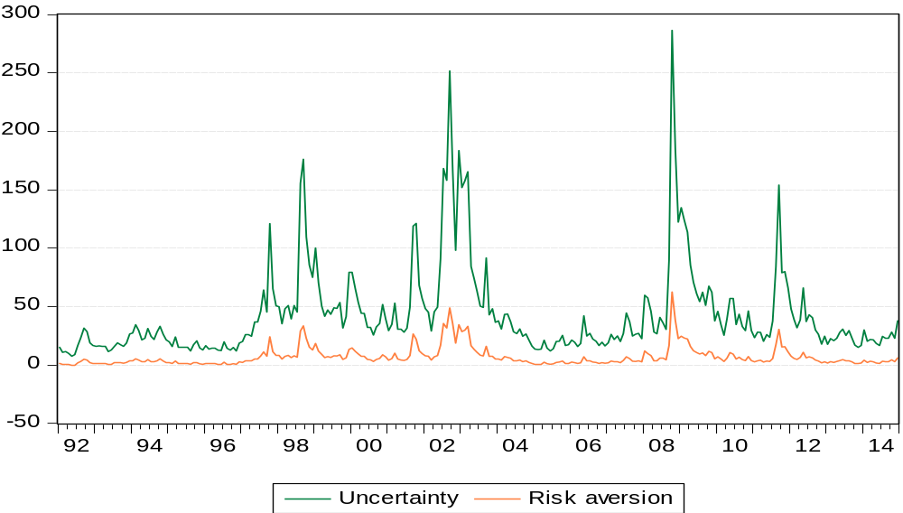
Notes: (1) decomposition of the squared VDAX-New divided by 12 into an uncertainty and a risk aversion part. (2) End-of-month data. The unit is monthly percentages squared. (3) The sample period is January 1992-December 2014. (4) Data source: Bloomberg.

Table 14: Equation (5) estimated for the DAX and the VDAX-New over the pre-crisis sample
Model | (1) | (2) | (3) | (4) | (5) | (6)
Restrictions |  | $$β_{1}=0$$ | $$β_{2}=0$$ | $$α=0$$ | $$α=0$$  $$β_{1}=0$$ | $$α=0$$  $$β_{2}=0$$
RMSE | 32.54 | 39.10 | 32.69 | 32.55 | 40.63 | 32.69
Notes: (1) The sample period is January 1992-August 2008. (2) Data source: Bloomberg.

For the pre-crisis sample, model (1) is also the best. It takes the following form:
${RVAR}_{t}=\begin{matrix} \\ -1.004 \\ (2.821)\end{matrix}+\begin{matrix} \\ 0.984 \\ \left(0.115\right)\end{matrix}{× IVAR}_{t-22}-\begin{matrix} \\ 0.126 \\ (0.083)\end{matrix}{× RVAR}_{t-22}+e_{t}$ (7)
Standard errors are reported in parentheses and are corrected for autocorrelation using 16 Newey-West (1987) lags, as chosen by the AIC.

A2. Decomposing the VSTOXX
Table 15: Equation (5) estimated for the EURO STOXX 50 and the VSTOXX over the full sample
Model | (1) | (2) | (3) | (4) | (5) | (6)
Restrictions |  | $$β_{1}=0$$ | $$β_{2}=0$$ | $$α=0$$ | $$α=0$$  $$β_{1}=0$$ | $$α=0$$  $$β_{2}=0$$
RMSE | 44.95 | 47.83 | 45.25 | 45.02 | 49.71 | 45.27
Notes: (1) The sample period is January 1999-December 2014. (2) Data source: Bloomberg.

Again model (1) is the best model in terms of forecasting performance. It takes the following form:
${RVAR}_{t}=\begin{matrix} \\ 3.700 \\ (2.814)\end{matrix}+\begin{matrix} \\ 0.611 \\ \left(0.094\right)\end{matrix}{× IVAR}_{t-22}+\begin{matrix} \\ 0.175 \\ (0.094)\end{matrix}{× RVAR}_{t-22}+e_{t}$ (8)
Standard errors are corrected for autocorrelation using 15 Newey-West (1987) lags, as chosen by the AIC. From equation (8), I can calculate the uncertainty proxy. By subtracting it from the squared VSTOXX divided by 12, I obtain the risk aversion proxy. Figure 17 illustrates both series.

Figure 17: Uncertainty and risk aversion for the EURO STOXX 50 over the full sample
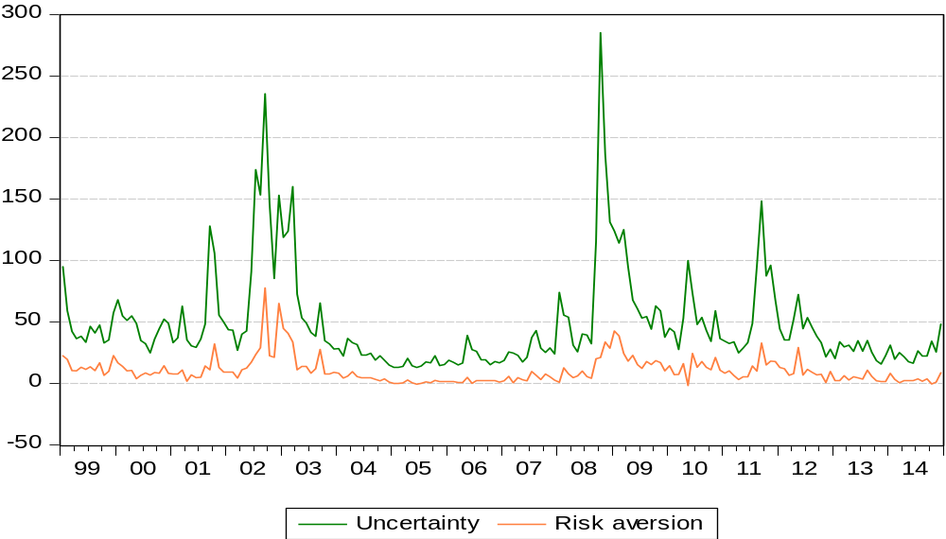
Notes: (1) decomposition of the squared VSTOXX divided by 12 into an uncertainty and a risk aversion part. (2) End-of-month data. The unit is monthly percentages squared. (3) The sample period is January 1999-December 2014. (4) Data source: Bloomberg.

Table 16: Equation (5) estimated for the EURO STOXX 50 and the VSTOXX over the pre-crisis sample
Model | (1) | (2) | (3) | (4) | (5) | (6)
Restrictions |  | $$β_{1}=0$$ | $$β_{2}=0$$ | $$α=0$$ | $$α=0$$  $$β_{1}=0$$ | $$α=0$$  $$β_{2}=0$$
RMSE | 33.60 | 37.89 | 33.68 | 33.60 | 39.28 | 33.69
Notes: (1) The sample period is January 1999-August 2008. (2) Data source: Bloomberg.

Here also model (1) performs best in terms of the RMSE. I obtain the following model:
${RVAR}_{t}=\begin{matrix} \\ -0.869 \\ (3.205)\end{matrix}+\begin{matrix} \\ 0.723 \\ \left(0.131\right)\end{matrix}{× IVAR}_{t-22}+\begin{matrix} \\ 0.091 \\ (0.160)\end{matrix}{× RVAR}_{t-22}+e_{t}$ (9)
Standard errors are corrected for autocorrelation using 13 Newey-West (1987) lags, as chosen by the AIC.

A3. Decomposing the VSMI
Table 17: Equation (5) estimated for the SMI and the VSMI over the pre-crisis sample
Model | (1) | (2) | (3) | (4) | (5) | (6)
Restrictions |  | $$β_{1}=0$$ | $$β_{2}=0$$ | $$α=0$$ | $$α=0$$  $$β_{1}=0$$ | $$α=0$$  $$β_{2}=0$$
RMSE | 29.64 | 32.13 | 29.64 | 29.73 | 33.96 | 29.74
Notes: (1) The sample period is January 1999-August 2008. (2) Data sources: Bloomberg, SIX Swiss Exchange.

For the SMI, model (1) is also the best. The equation takes the form:
${RVAR}_{t}=\begin{matrix} \\ 3.777 \\ (2.526)\end{matrix}+\begin{matrix} \\ 0.724 \\ \left(0.124\right)\end{matrix}{× IVAR}_{t-22}+\begin{matrix} \\ 0.018 \\ (0.131)\end{matrix}{× RVAR}_{t-22}+e_{t}$ (10)
Standard errors are corrected for autocorrelation using 13 Newey-West (1987) lags, as chosen by the AIC. From equation (10), I can calculate the uncertainty proxy. By subtracting it from the squared VSMI divided by 12, I obtain the risk aversion proxy. Figure 18 illustrates both series.

Figure 18: Uncertainty and risk aversion for the SMI
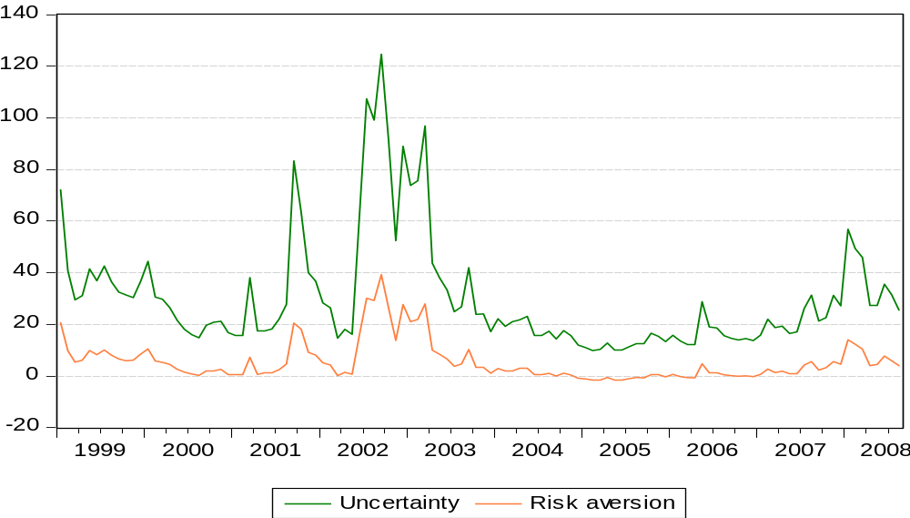
Notes: (1) decomposition of the squared VSMI divided by 12 into an uncertainty and a risk aversion part. (2) End-of-month data. The unit is monthly percentages squared. (3) The sample period is January 1999-August 2008. (4) Data sources: Bloomberg, SIX Swiss Exchange.

Table 18: Equation (5) estimated for the SMI and the VSMI over the full sample
Model | (1) | (2) | (3) | (4) | (5) | (6)
Restrictions |  | $$β_{1}=0$$ | $$β_{2}=0$$ | $$α=0$$ | $$α=0$$  $$β_{1}=0$$ | $$α=0$$  $$β_{2}=0$$
RMSE | 40.20 | 41.12 | 40.31 | 40.42 | 42.86 | 40.59
Notes: (1) The sample period is January 1999-December 2014. (2) Data sources: Bloomberg, SIX Swiss Exchange.

Again, model 1 is the best and takes the following form:
${RVAR}_{t}=\begin{matrix} \\ 7.798 \\ (3.320)\end{matrix}+\begin{matrix} \\ 0.458 \\ \left(0.144\right)\end{matrix}{× IVAR}_{t-22}+\begin{matrix} \\ 0.199 \\ (0.077)\end{matrix}{× RVAR}_{t-22}+e_{t}$ (11)
Standard errors are corrected for autocorrelation using 15 Newey-West (1987) lags, as chosen by the AIC.

Appendix B: Impulse response functions for Germany
Appendix B contains all IRFs for Germany. Appendix B1, B2, B3, and B4 contain the results for the sample periods 1992 M1-2014 M12, 1992 M1-1998 M12, 1999 M1-2008 M8, and 1999 M1-2014 M12, respectively. White lines represent the IRFs and green dashed lines the 90% confidence intervals.

Appendix B1
Germany (1992 M1-2014 M12)
Variable ordering: manufacturing growth, real 3-month rate, log(VDAX-New²/12)
Lag order: 4
Breusch-Godfrey LM test for autocorrelation with small sample adjustment, on 8 lags ($H_{0}$: no autocorrelation): p-value = 0.5071
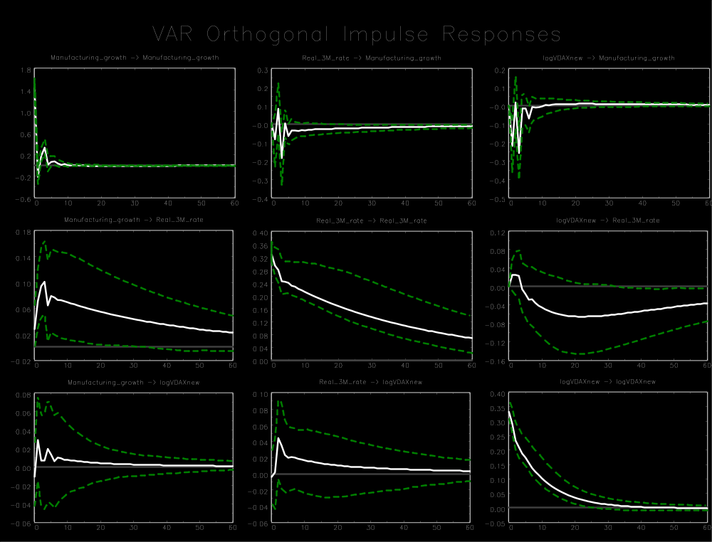

Appendix B1
Germany (1992 M1-2014 M12)
Variable ordering: manufacturing growth, real overnight rate, log(VDAX-New²/12)
Lag order: 4
Breusch-Godfrey LM test for autocorrelation with small sample adjustment, on 8 lags ($H_{0}$: no autocorrelation): p-value = 0.4334
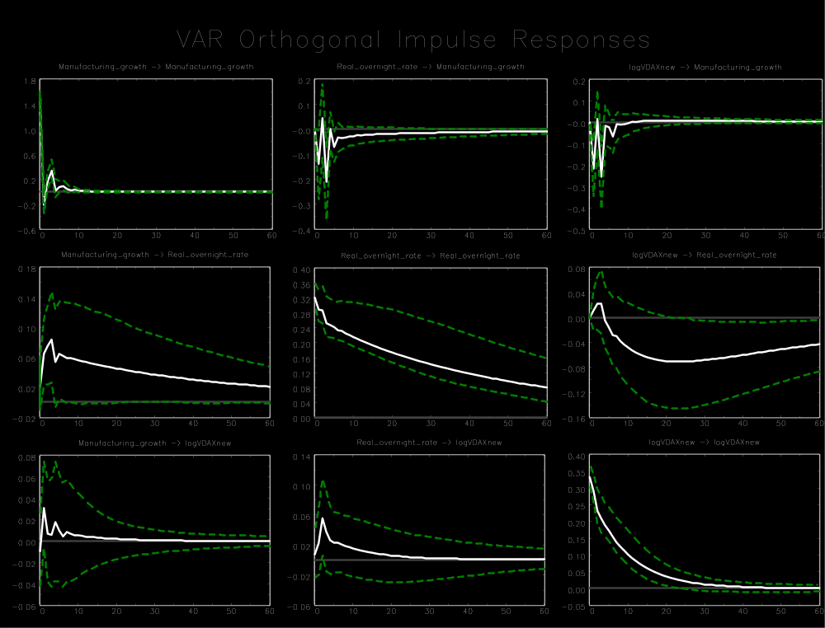

Appendix B1
Germany (1992 M1-2014 M12)
Variable ordering: manufacturing growth, nominal 3-month rate, log(VDAX-New²/12)
Lag order: 6
Breusch-Godfrey LM test for autocorrelation with small sample adjustment, on 8 lags ($H_{0}$: no autocorrelation): p-value = 0.1025
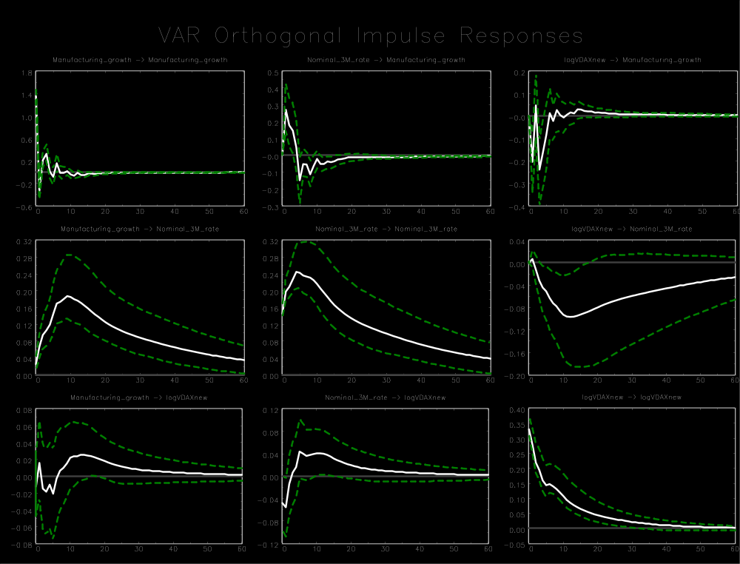

Appendix B1
Germany (1992 M1-2014 M12)
Variable ordering: manufacturing growth, nominal overnight rate, log(VDAX-New²/12)
Lag order: 6
Breusch-Godfrey LM test for autocorrelation with small sample adjustment, on 8 lags ($H_{0}$: no autocorrelation): p-value = 0.6383
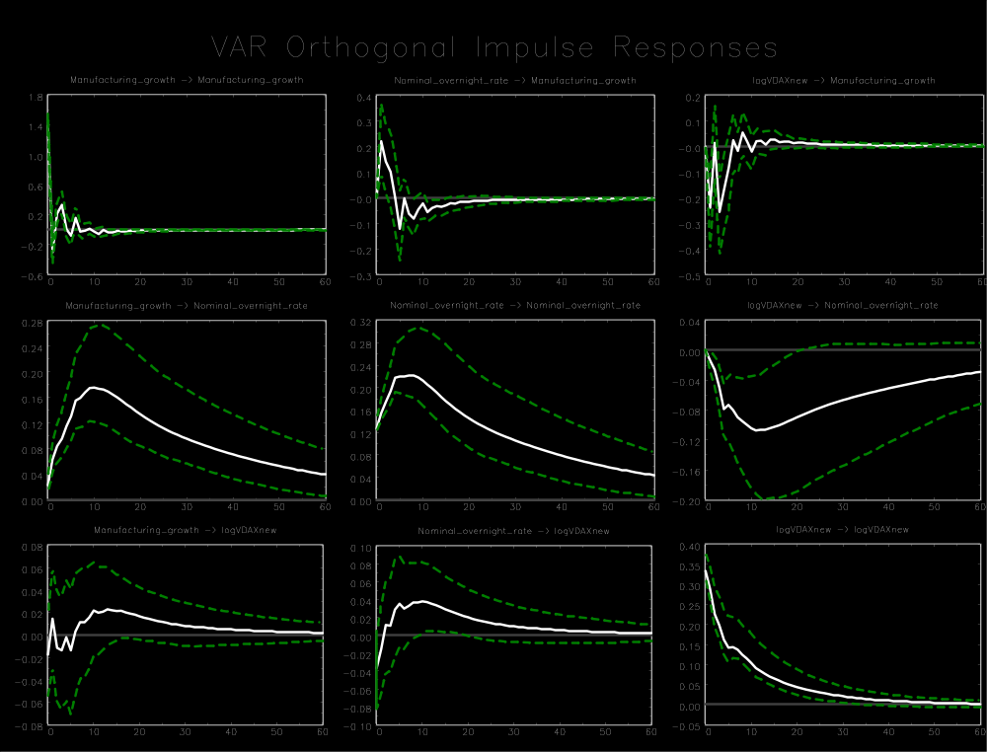

Appendix B1
Germany (1992 M1-2014 M12)
Variable ordering: manufacturing growth, M1 growth, log(VDAX-New²/12)
Lag order: 3
Breusch-Godfrey LM test for autocorrelation with small sample adjustment, on 8 lags ($H_{0}$: no autocorrelation): p-value = 0.2200
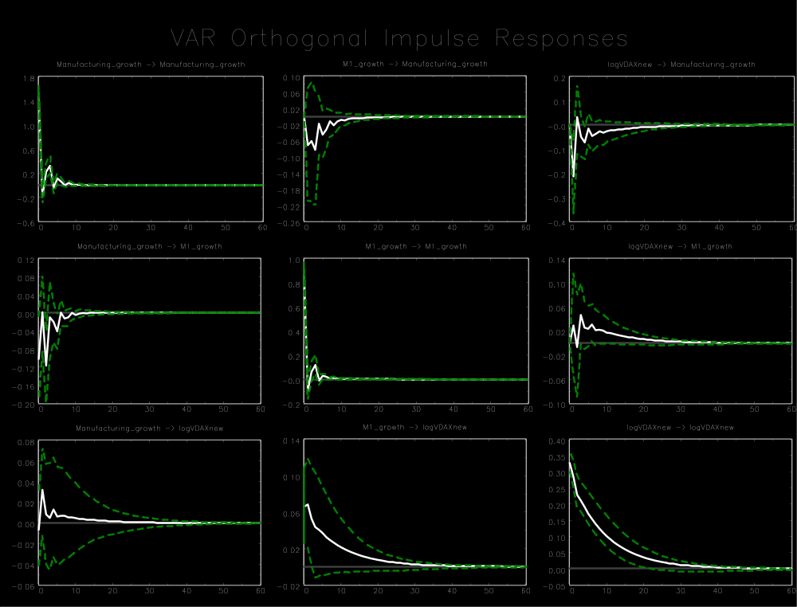

Appendix B1
Germany (1992 M1-2014 M12)
Variable ordering: manufacturing growth, M3 growth, log(VDAX-New²/12)
Lag order: 4
Breusch-Godfrey LM test for autocorrelation with small sample adjustment, on 8 lags ($H_{0}$: no autocorrelation): p-value = 0.8906
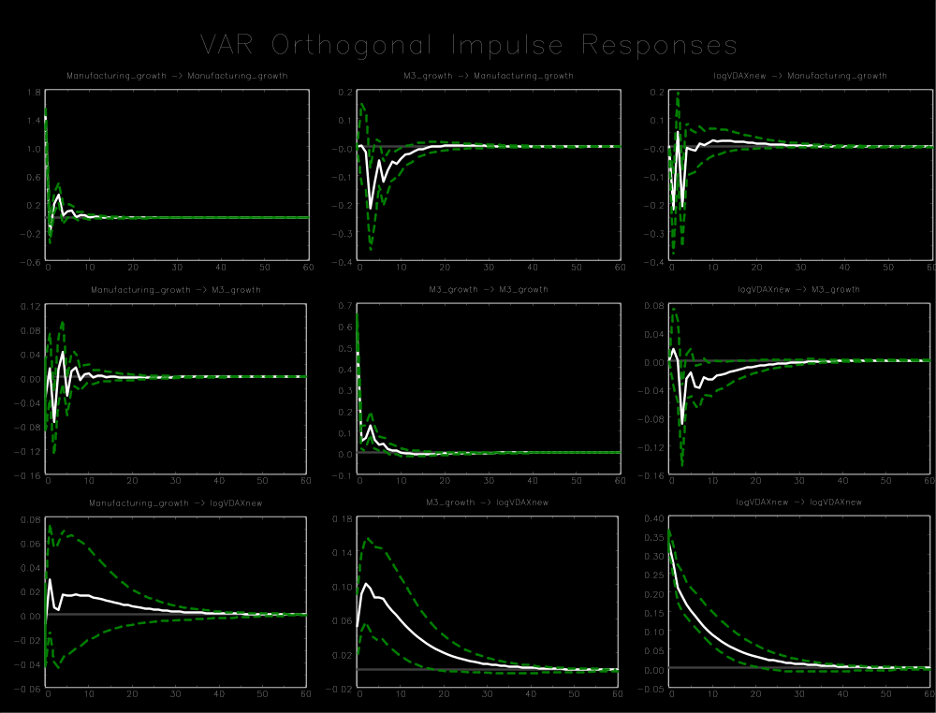

Appendix B1
Germany (1992 M1-2014 M12)
Variable ordering: log(Ifo Index), real 3-month rate, log(VDAX-New²/12)
Lag order: 4
Breusch-Godfrey LM test for autocorrelation with small sample adjustment, on 8 lags ($H_{0}$: no autocorrelation): p-value = 0.1997
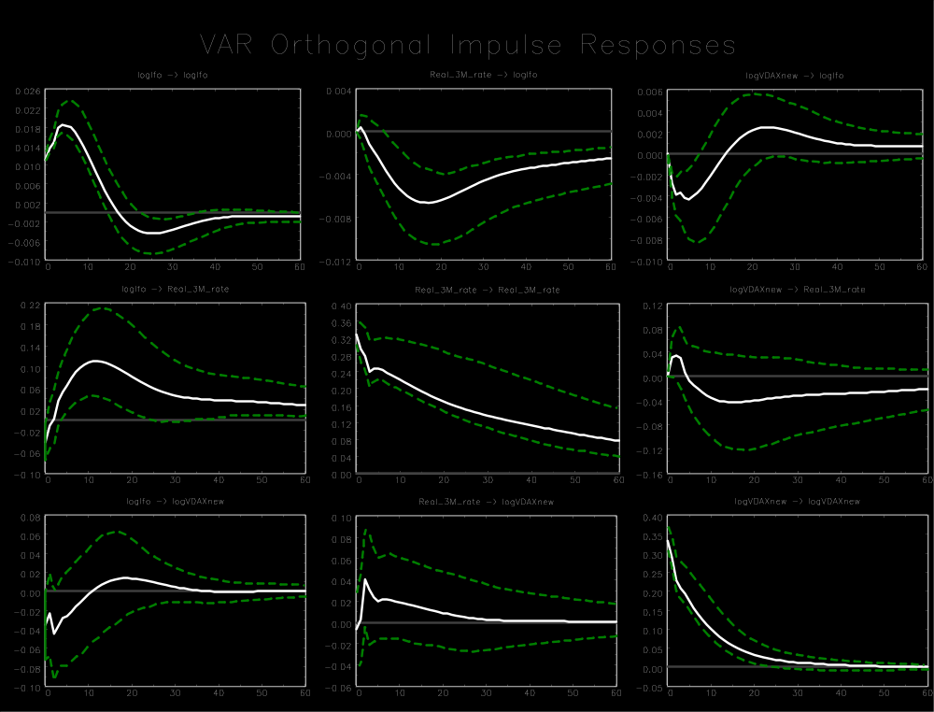

Appendix B1
Germany (1992 M1-2014 M12)
Variable ordering: Employment growth, real 3-month rate, log(VDAX-New²/12)
Lag order: 1
Breusch-Godfrey LM test for autocorrelation with small sample adjustment, on 8 lags ($H_{0}$: no autocorrelation): p-value = 0.1140
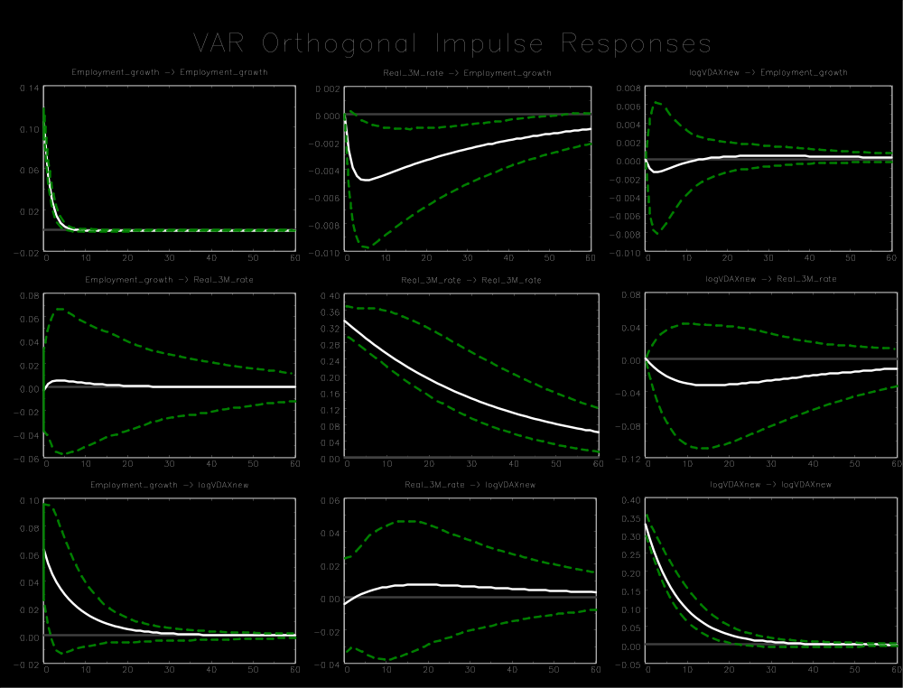

Appendix B1
Germany (1992 M1-2014 M12)
Variable ordering: Total industrial production growth, real 3-month rate, log(VDAX-New²/12)
Lag order: 4
Breusch-Godfrey LM test for autocorrelation with small sample adjustment, on 8 lags ($H_{0}$: no autocorrelation): p-value = 0.3764
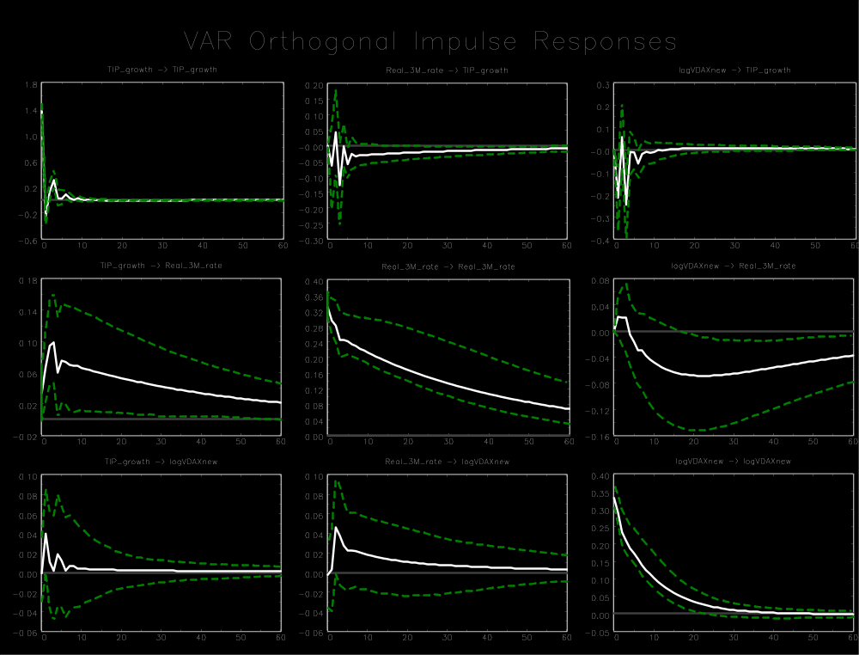

Appendix B1
Germany (1992 M1-2014 M12)
Variable ordering: manufacturing growth, log(VDAX-New²/12), real 3-month rate
Lag order: 4
Breusch-Godfrey LM test for autocorrelation with small sample adjustment, on 8 lags ($H_{0}$: no autocorrelation): p-value = 0.5071
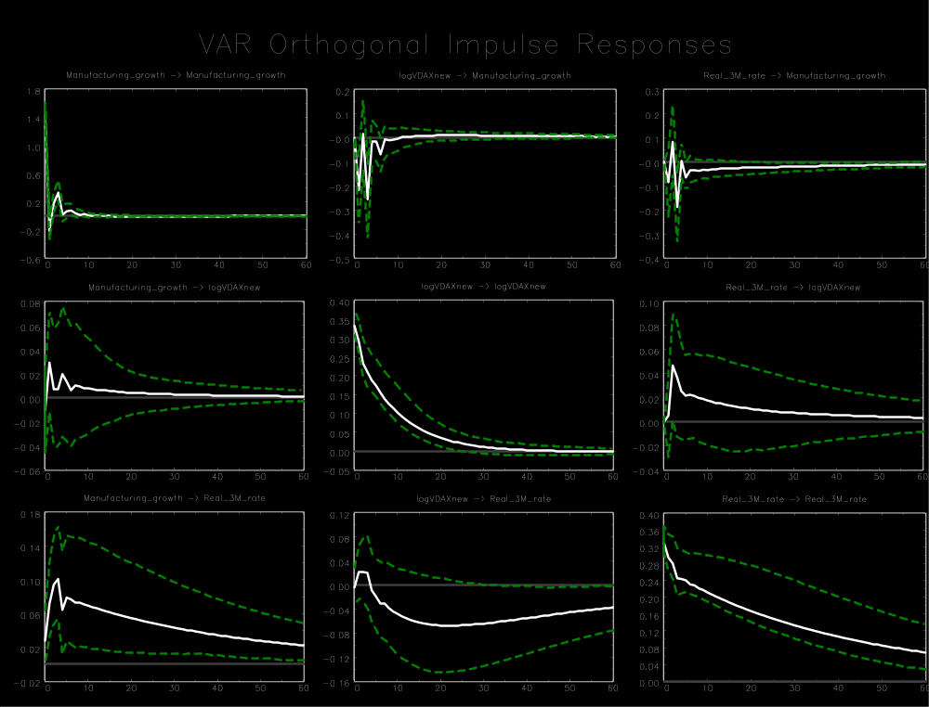

Appendix B2
Germany (1992 M1-1998 M12)
Variable ordering: manufacturing growth, real 3-month rate, log(VDAX-New²/12)
Lag order: 1
Breusch-Godfrey LM test for autocorrelation with small sample adjustment, on 8 lags ($H_{0}$: no autocorrelation): p-value = 0.4810
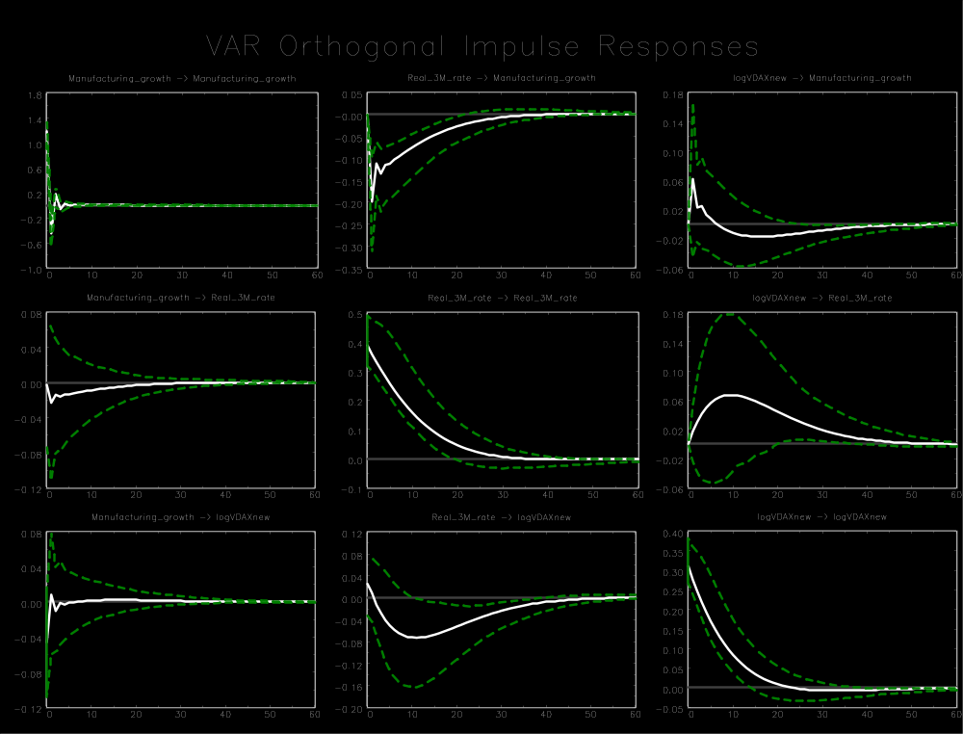

Appendix B2
Germany (1992 M1-1998 M12)
Variable ordering: manufacturing growth, real overnight rate, log(VDAX-New²/12)
Lag order: 1
Breusch-Godfrey LM test for autocorrelation with small sample adjustment, on 8 lags ($H_{0}$: no autocorrelation): p-value = 0.6258
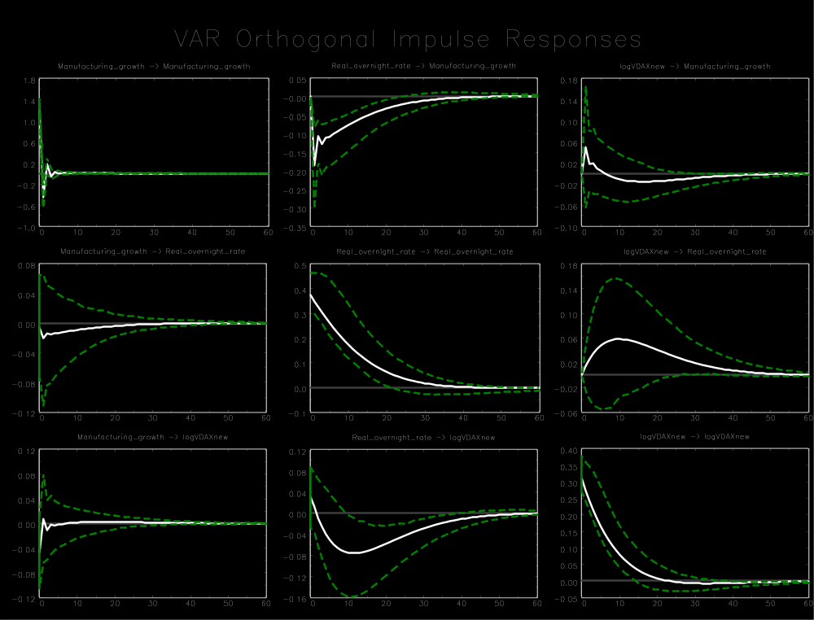

Appendix B2
Germany (1992 M1-1998 M12)
Variable ordering: manufacturing growth, nominal 3-month rate, log(VDAX-New²/12)
Lag order: 1
Breusch-Godfrey LM test for autocorrelation with small sample adjustment, on 8 lags ($H_{0}$: no autocorrelation): p-value = 0.7320
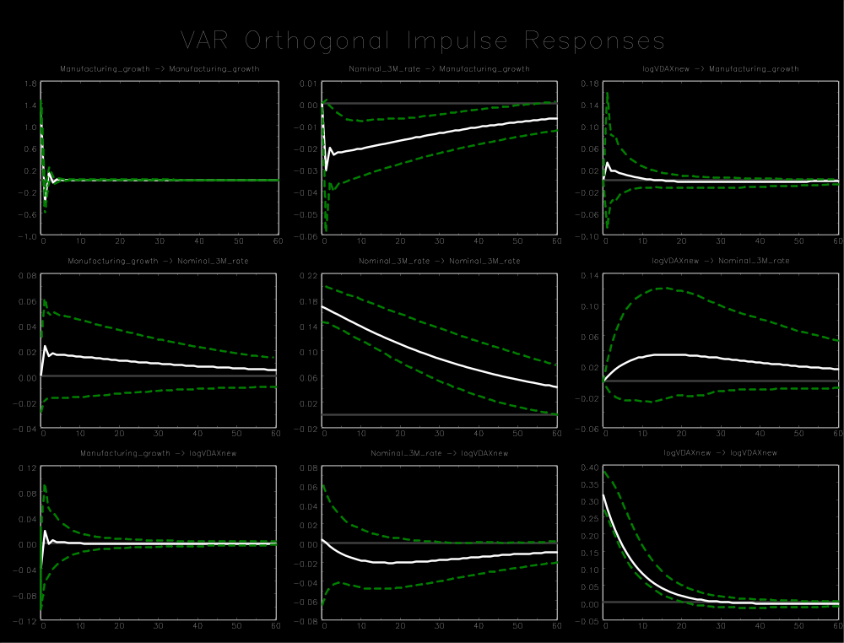

Appendix B2
Germany (1992 M1-1998 M12)
Variable ordering: manufacturing growth, nominal overnight rate, log(VDAX-New²/12)
Lag order: 1
Breusch-Godfrey LM test for autocorrelation with small sample adjustment, on 8 lags ($H_{0}$: no autocorrelation): p-value = 0.5887
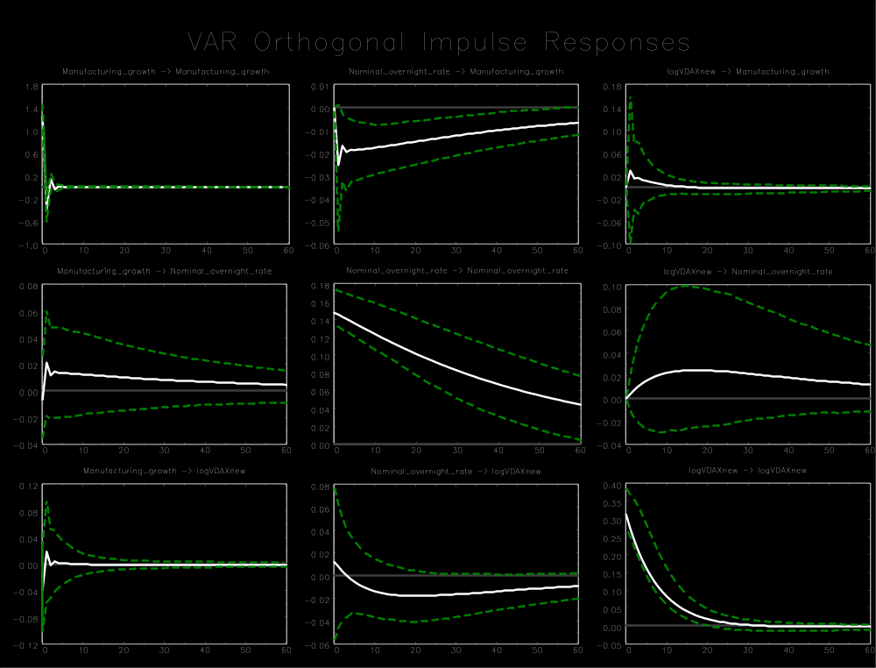

Appendix B2
Germany (1992 M1-1998 M12)
Variable ordering: manufacturing growth, M1 growth, log(VDAX-New²/12)
Lag order: 1
Breusch-Godfrey LM test for autocorrelation with small sample adjustment, on 8 lags ($H_{0}$: no autocorrelation): p-value = 0.7397
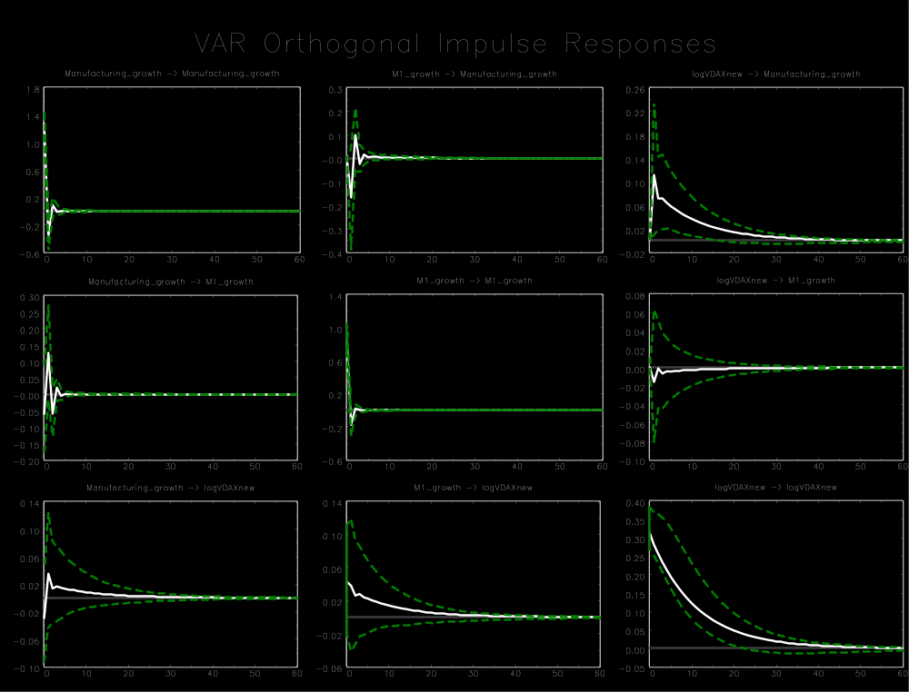

Appendix B2
Germany (1992 M1-1998 M12)
Variable ordering: manufacturing growth, M3 growth, log(VDAX-New²/12)
Lag order: 1
Breusch-Godfrey LM test for autocorrelation with small sample adjustment, on 8 lags ($H_{0}$: no autocorrelation): p-value = 0.4512
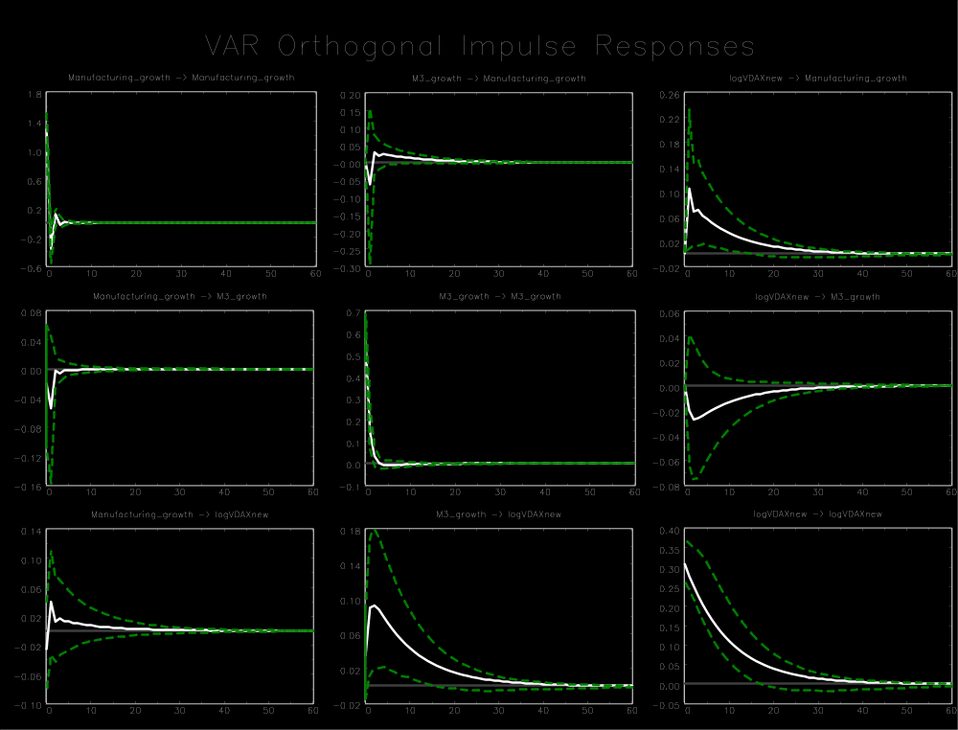

Appendix B2
Germany (1992 M1-1998 M12)
Variable ordering: log(Ifo index), real 3-month rate, log(VDAX-New²/12)
Lag order: 1
Breusch-Godfrey LM test for autocorrelation with small sample adjustment, on 8 lags ($H_{0}$: no autocorrelation): p-value = 0.1300
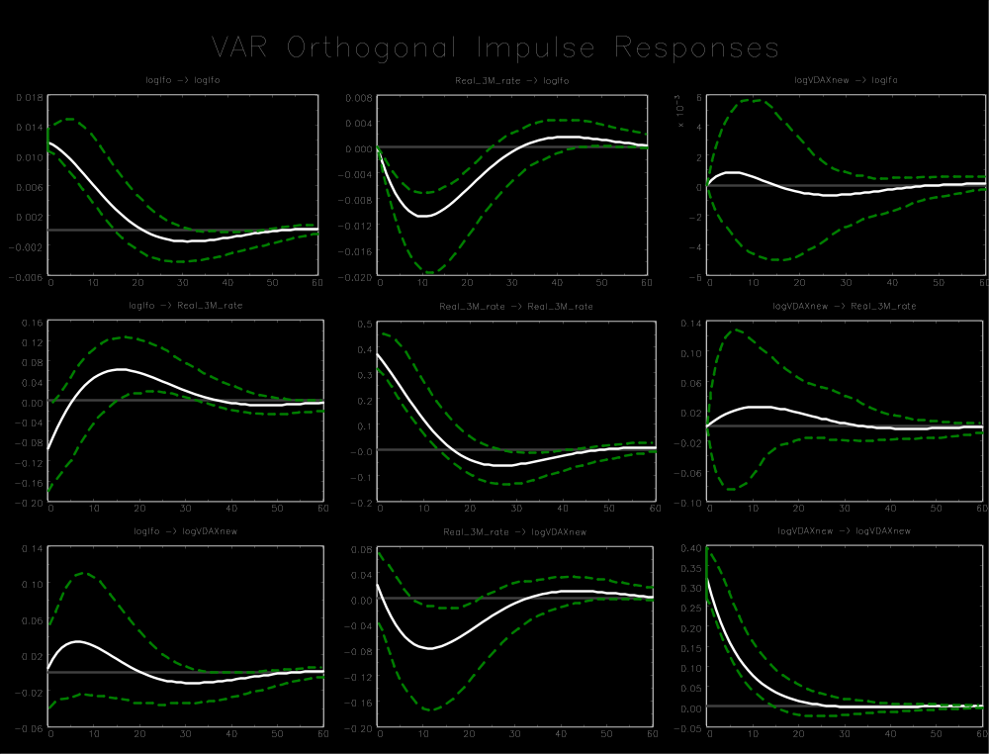

Appendix B2
Germany (1992 M1-1998 M12)
Variable ordering: employment growth, real 3-month rate, log(VDAX-New²/12)
Lag order: 1
Breusch-Godfrey LM test for autocorrelation with small sample adjustment, on 8 lags ($H_{0}$: no autocorrelation): p-value = 0.8499
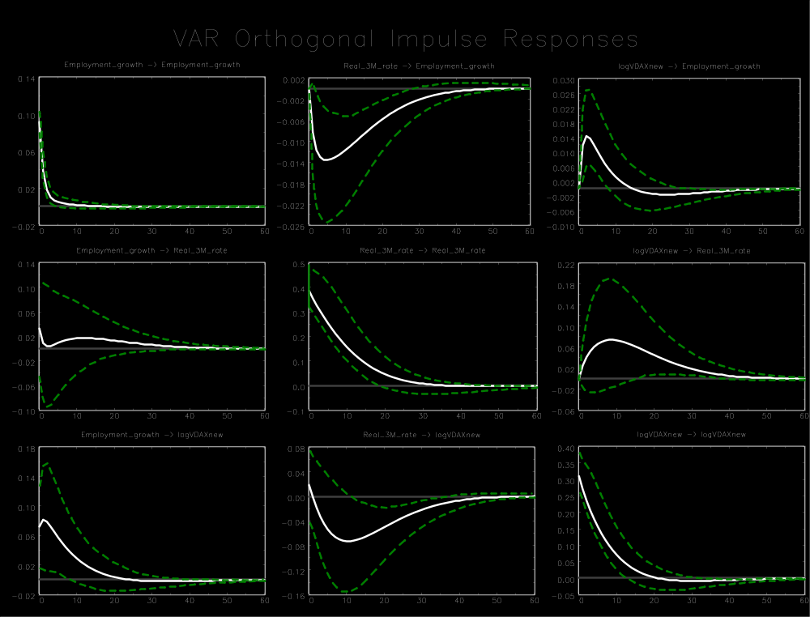

Appendix B2
Germany (1992 M1-1998 M12)
Variable ordering: total industrial production growth, real 3-month rate, log(VDAX-New²/12)
Lag order: 1
Breusch-Godfrey LM test for autocorrelation with small sample adjustment, on 8 lags ($H_{0}$: no autocorrelation): p-value = 0.5386
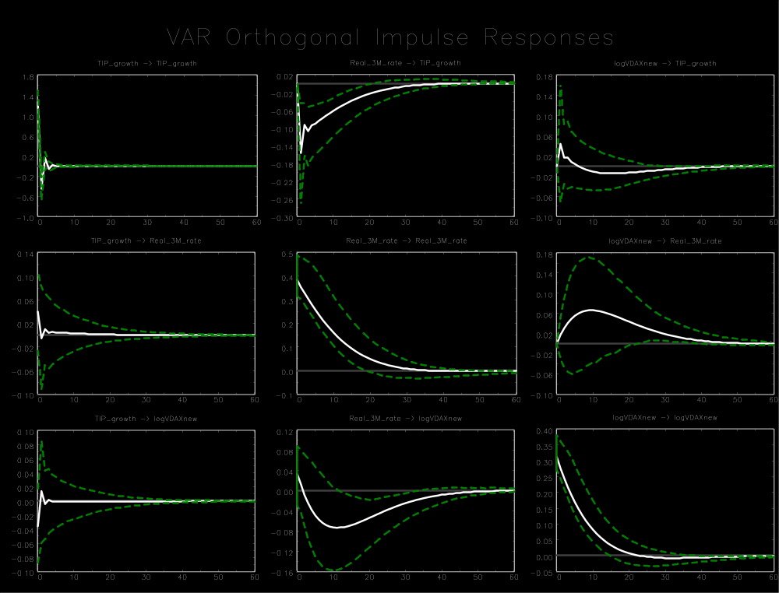

Appendix B2
Germany (1992 M1-1998 M12)
Variable ordering: manufacturing growth, log(VDAX-New²/12), real 3-month rate
Lag order: 1
Breusch-Godfrey LM test for autocorrelation with small sample adjustment, on 8 lags ($H_{0}$: no autocorrelation): p-value = 0.4810
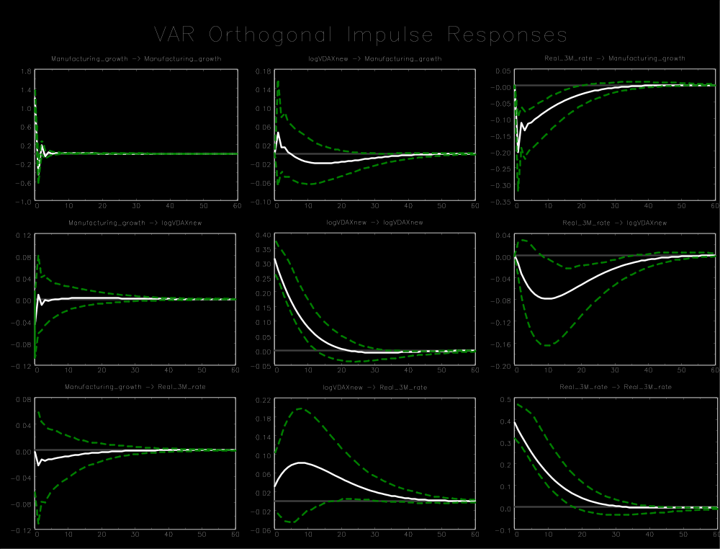

Appendix B3
Germany (1999 M1-2008 M8)
Variable ordering: manufacturing growth, real 3-month rate, log(VDAX-New²/12)
Lag order: 1
Breusch-Godfrey LM test for autocorrelation with small sample adjustment, on 8 lags ($H_{0}$: no autocorrelation): p-value = 0.2374
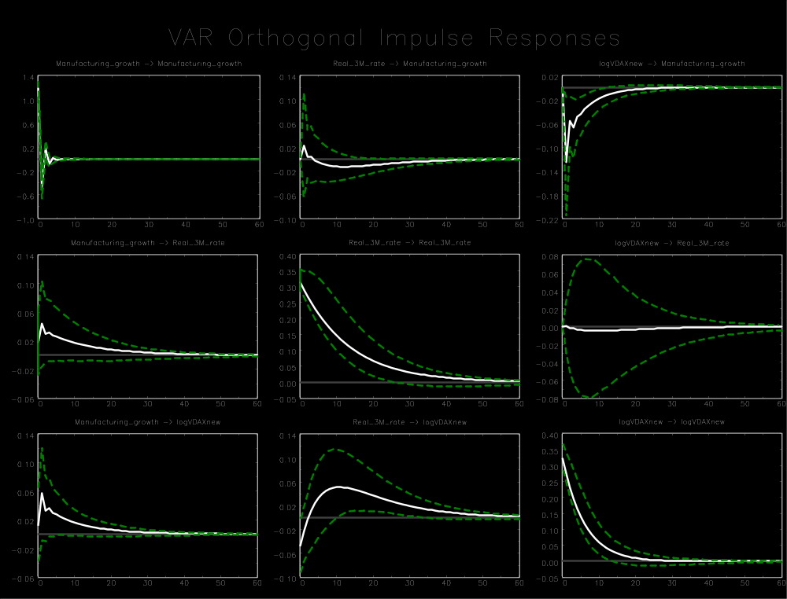

Appendix B3
Germany (1999 M1-2008 M8)
Variable ordering: manufacturing growth, real overnight rate, log(VDAX-New²/12)
Lag order: 1
Breusch-Godfrey LM test for autocorrelation with small sample adjustment, on 8 lags ($H_{0}$: no autocorrelation): p-value = 0.5420
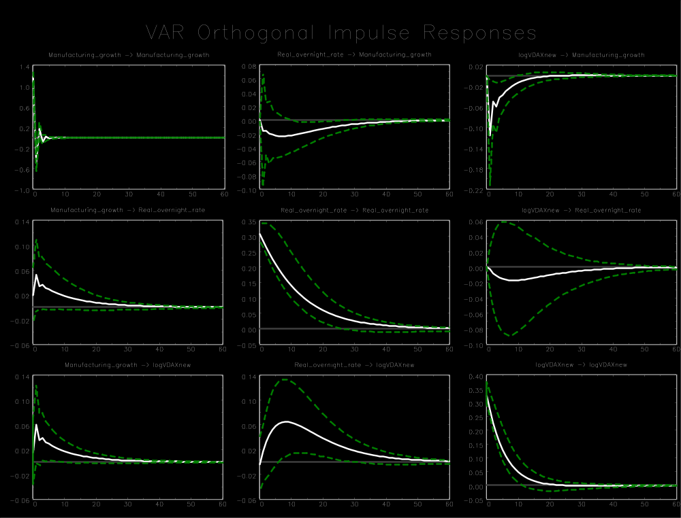

Appendix B3
Germany (1999 M1-2008 M8)
Variable ordering: manufacturing growth, nominal 3-month rate, log(VDAX-New²/12)
Lag order: 2
Breusch-Godfrey LM test for autocorrelation with small sample adjustment, on 8 lags ($H_{0}$: no autocorrelation): p-value = 0.3805
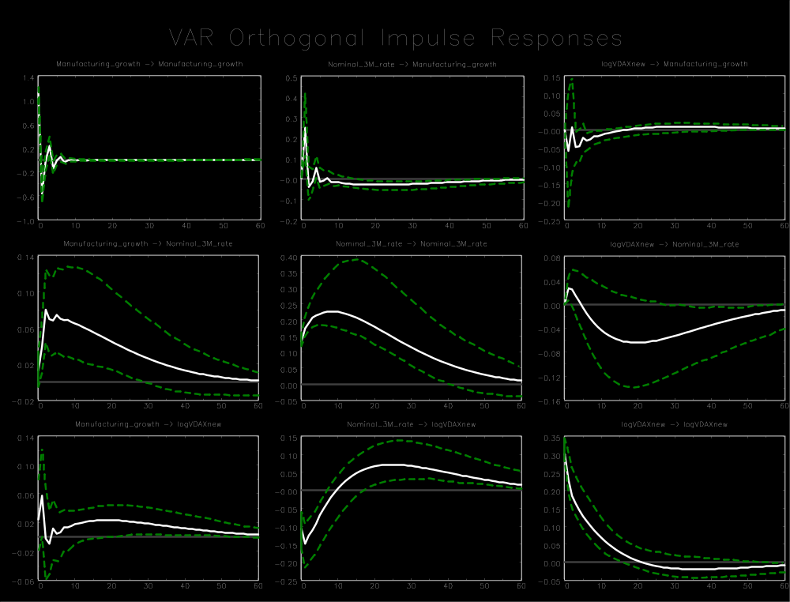

Appendix B3
Germany (1999 M1-2008 M8)
Variable ordering: manufacturing growth, nominal overnight rate, log(VDAX-New²/12)
Lag order: 3
Breusch-Godfrey LM test for autocorrelation with small sample adjustment, on 8 lags ($H_{0}$: no autocorrelation): p-value = 0.5350
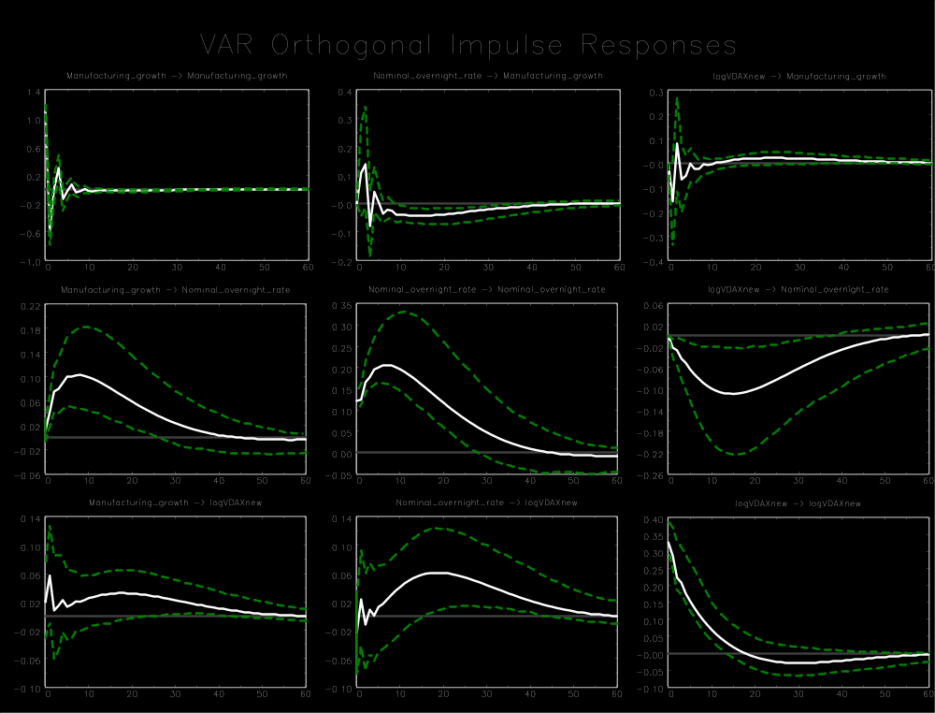

Appendix B3
Germany (1999 M1-2008 M8)
Variable ordering: manufacturing growth, M1 growth, log(VDAX-New²/12)
Lag order: 1
Breusch-Godfrey LM test for autocorrelation with small sample adjustment, on 8 lags ($H_{0}$: no autocorrelation): p-value = 0.9659
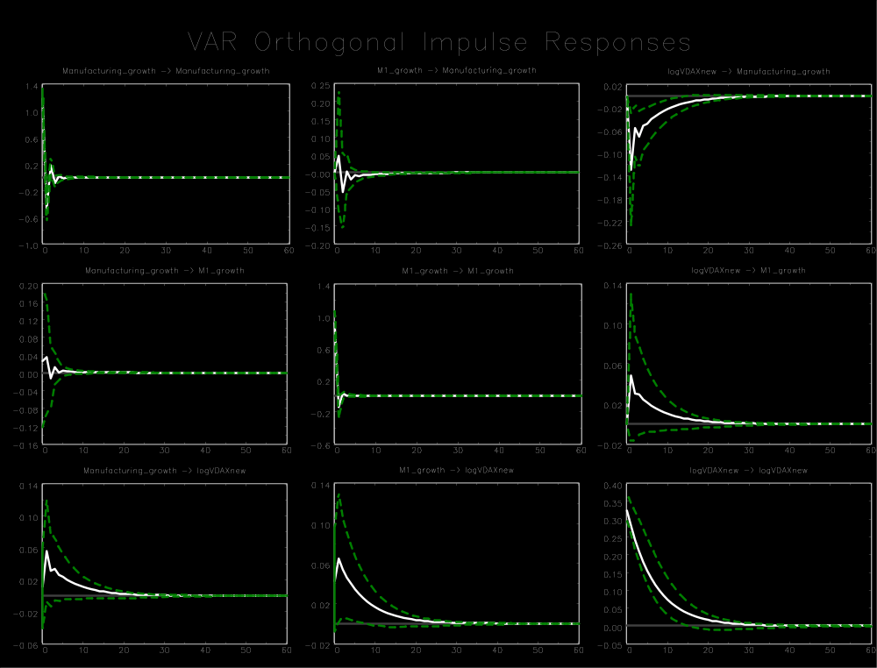

Appendix B3
Germany (1999 M1-2008 M8)
Variable ordering: manufacturing growth, M3 growth, log(VDAX-New²/12)
Lag order: 2
Breusch-Godfrey LM test for autocorrelation with small sample adjustment, on 8 lags ($H_{0}$: no autocorrelation): p-value = 0.4188
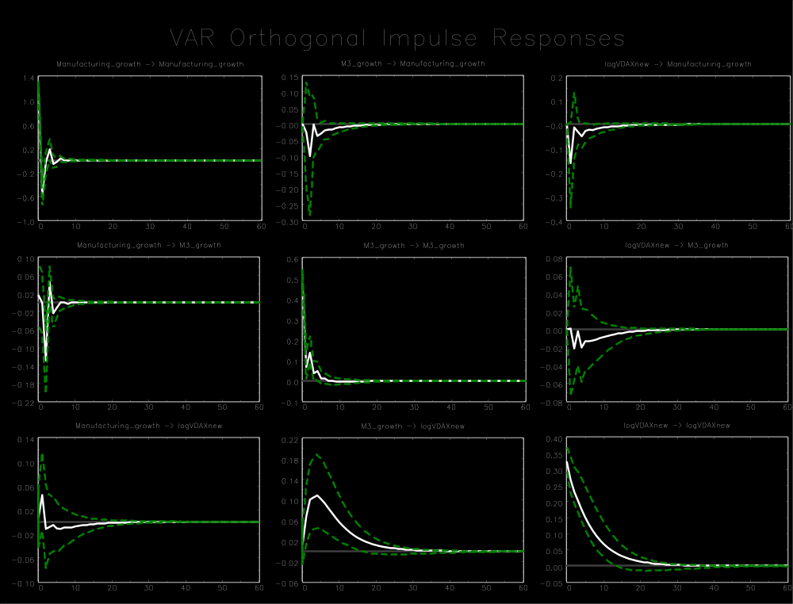

Appendix B3
Germany (1999 M1-2008 M8)
Variable ordering: log(Ifo index), real 3-month rate, log(VDAX-New²/12)
Lag order: 2
Breusch-Godfrey LM test for autocorrelation with small sample adjustment, on 8 lags ($H_{0}$: no autocorrelation): p-value = 0.9211
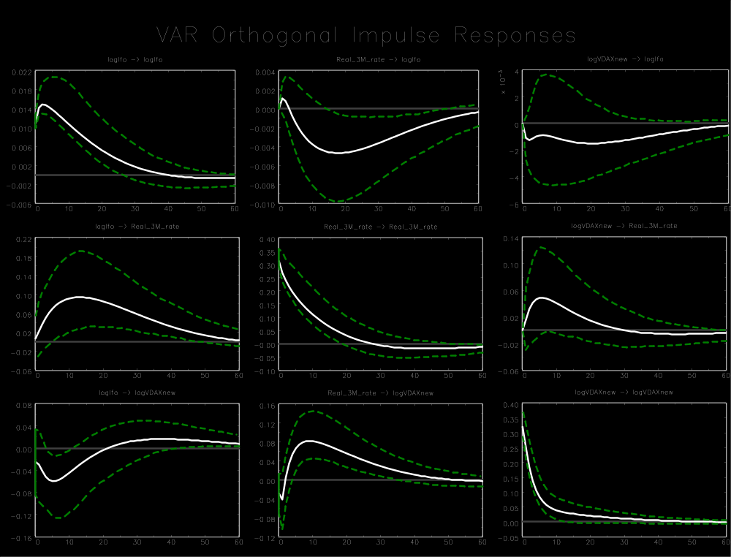

Appendix B3
Germany (1999 M1-2008 M8)
Variable ordering: employment growth, real 3-month rate, log(VDAX-New²/12)
Lag order: 1
Breusch-Godfrey LM test for autocorrelation with small sample adjustment, on 8 lags ($H_{0}$: no autocorrelation): p-value = 0.8095
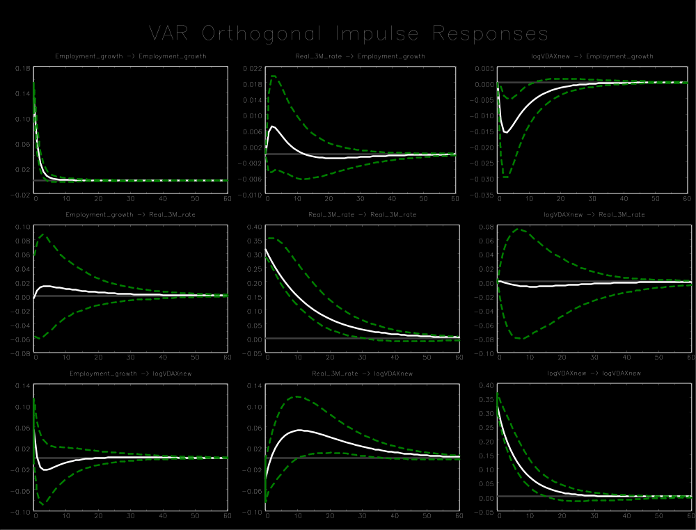

Appendix B3
Germany (1999 M1-2008 M8)
Variable ordering: total industrial production growth, real 3-month rate, log(VDAX-New²/12)
Lag order: 2
Breusch-Godfrey LM test for autocorrelation with small sample adjustment, on 8 lags ($H_{0}$: no autocorrelation): p-value = 0.7006
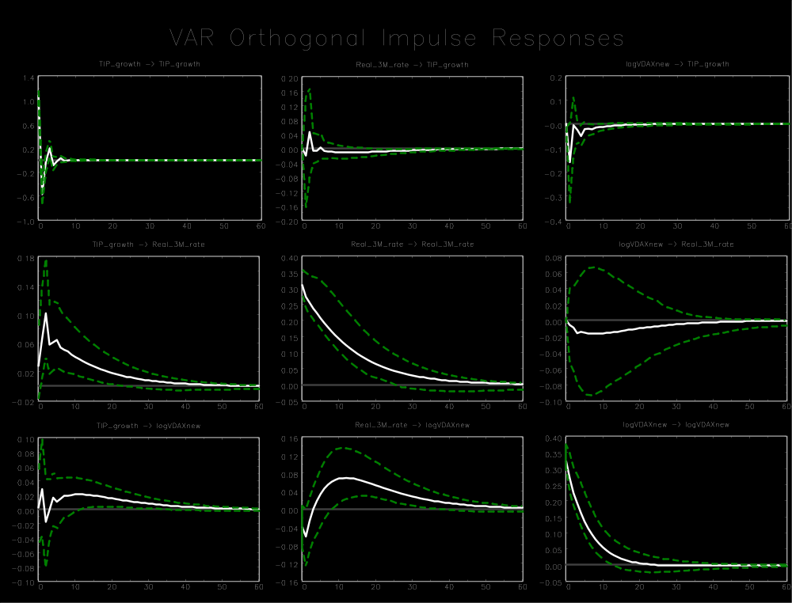

Appendix B3
Germany (1999 M1-2008 M8)
Variable ordering: manufacturing growth, log(VDAX-New²/12), real 3-month rate
Lag order: 1
Breusch-Godfrey LM test for autocorrelation with small sample adjustment, on 8 lags ($H_{0}$: no autocorrelation): p-value = 0.2374
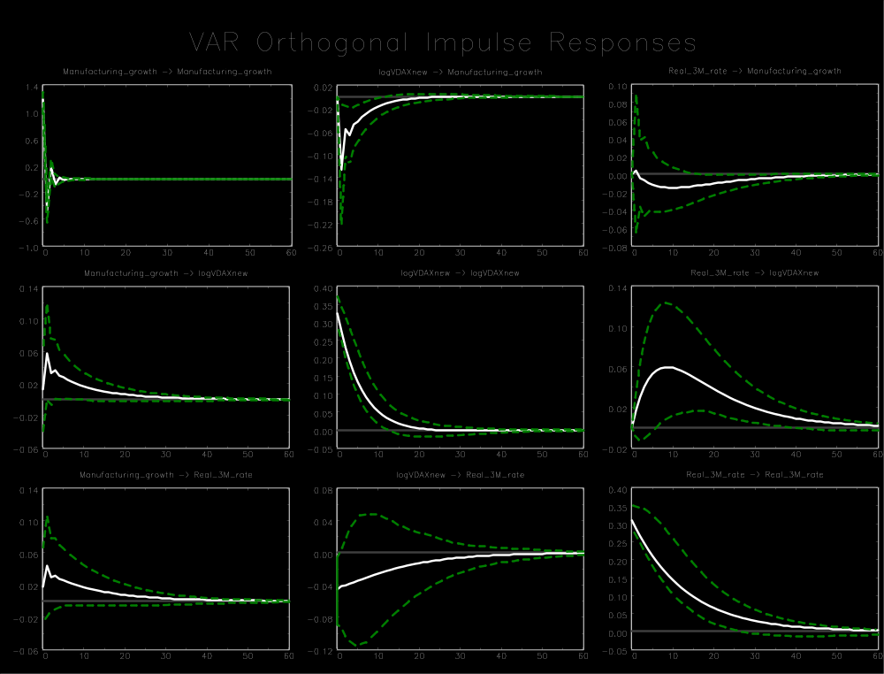

Appendix B4
Germany (1999 M1-2014 M12)
Variable ordering: manufacturing growth, real 3-month rate, log(VDAX-New²/12)
Lag order: 1
Breusch-Godfrey LM test for autocorrelation with small sample adjustment, on 8 lags ($H_{0}$: no autocorrelation): p-value = 0.1051
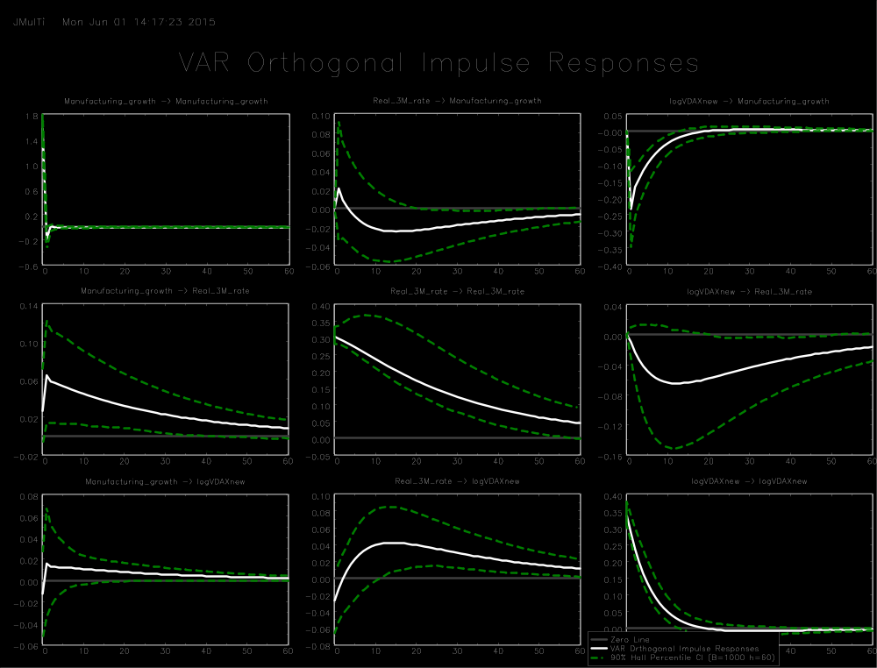

Appendix B4
Germany (1999 M1-2014 M12)
Variable ordering: manufacturing growth, real overnight rate, log(VDAX-New²/12)
Lag order: 1
Breusch-Godfrey LM test for autocorrelation with small sample adjustment, on 8 lags ($H_{0}$: no autocorrelation): p-value = 0.1735
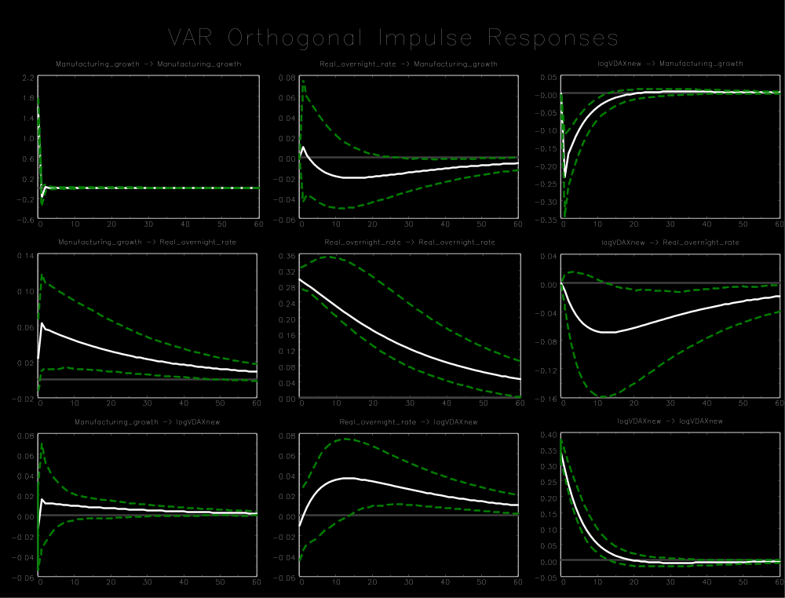

Appendix B4
Germany (1999 M1-2014 M12)
Variable ordering: manufacturing growth, nominal 3-month rate, log(VDAX-New²/12)
Lag order: 3
Breusch-Godfrey LM test for autocorrelation with small sample adjustment, on 8 lags ($H_{0}$: no autocorrelation): p-value = 0.1704
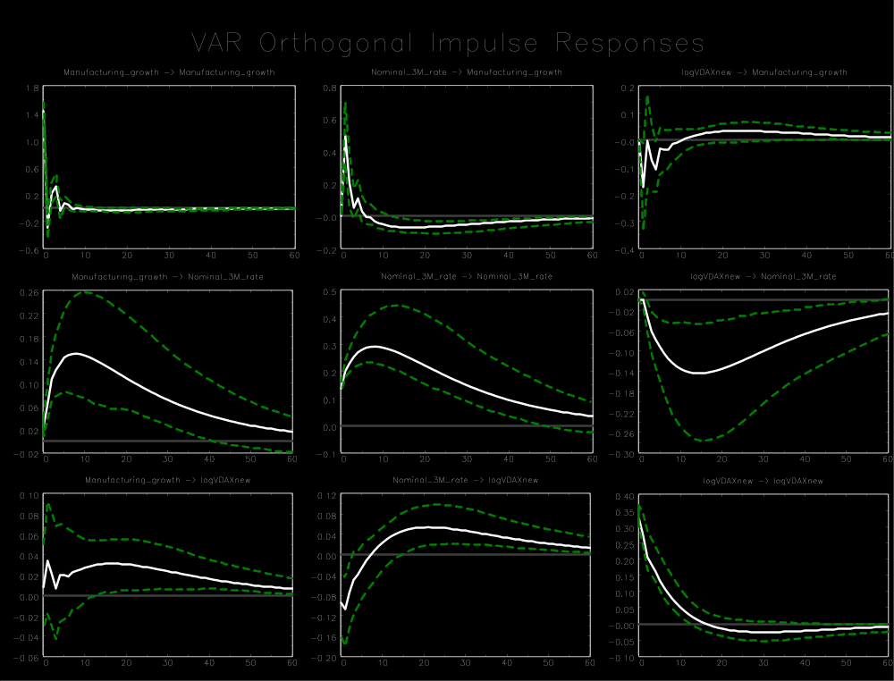

Appendix B4
Germany (1999 M1-2014 M12)
Variable ordering: manufacturing growth, nominal overnight rate, log(VDAX-New²/12)
Lag order: 3
Breusch-Godfrey LM test for autocorrelation with small sample adjustment, on 8 lags ($H_{0}$: no autocorrelation): p-value = 0.2400
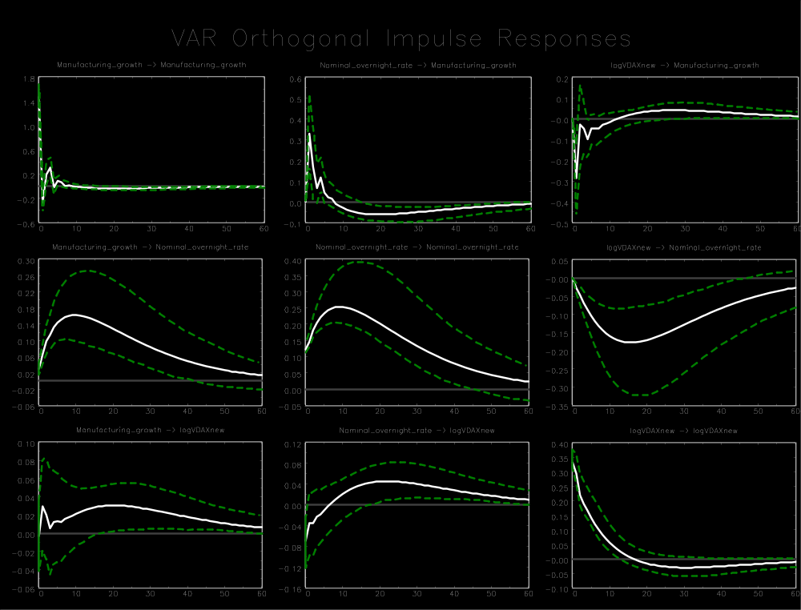

Appendix B4
Germany (1999 M1-2014 M12)
Variable ordering: manufacturing growth, M1 growth, log(VDAX-New²/12)
Lag order: 1
Breusch-Godfrey LM test for autocorrelation with small sample adjustment, on 8 lags ($H_{0}$: no autocorrelation): p-value = 0.1762
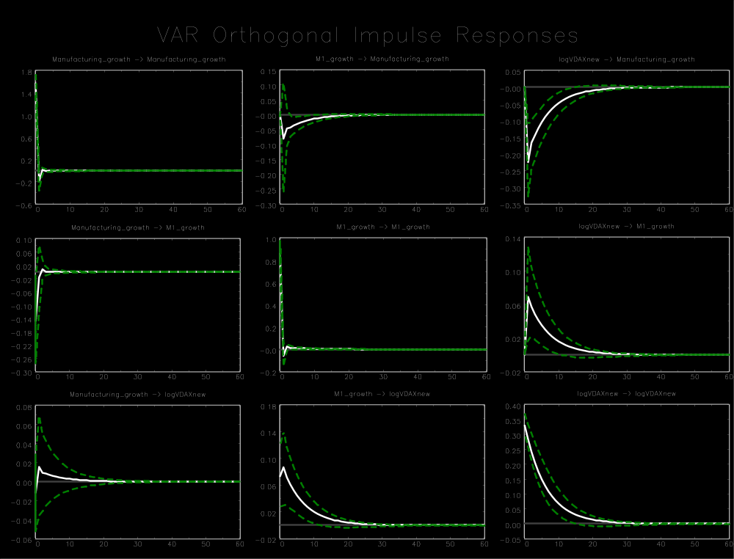

Appendix B4
Germany (1999 M1-2014 M12)
Variable ordering: manufacturing growth, M3 growth, log(VDAX-New²/12)
Lag order: 3
Breusch-Godfrey LM test for autocorrelation with small sample adjustment, on 8 lags ($H_{0}$: no autocorrelation): p-value = 0.6948
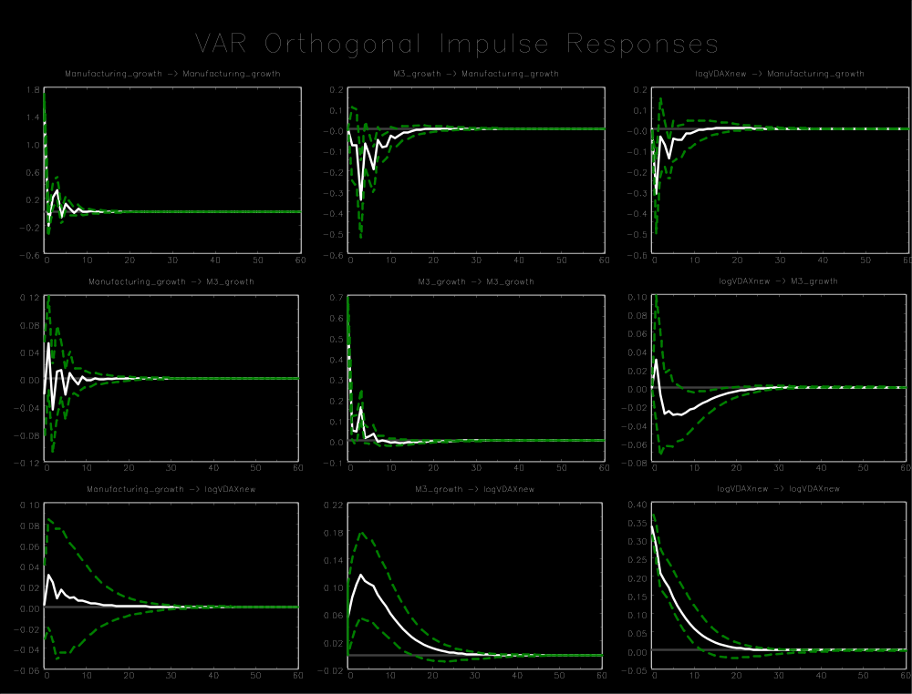

Appendix B4
Germany (1999 M1-2014 M12)
Variable ordering: log(Ifo index), real 3-month rate, log(VDAX-New²/12)
Lag order: 2
Breusch-Godfrey LM test for autocorrelation with small sample adjustment, on 8 lags ($H_{0}$: no autocorrelation): p-value = 0.1685
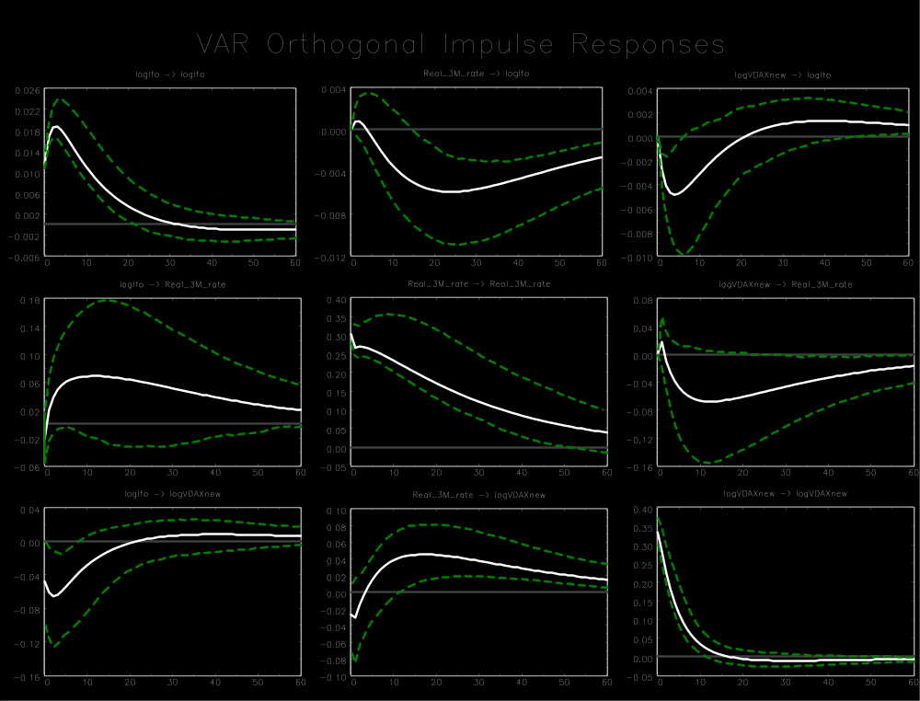

Appendix B4
Germany (1999 M1-2014 M12)
Variable ordering: employment growth, real 3-month rate, log(VDAX-New²/12)
Lag order: 4
Breusch-Godfrey LM test for autocorrelation with small sample adjustment, on 8 lags ($H_{0}$: no autocorrelation): p-value = 0.1811
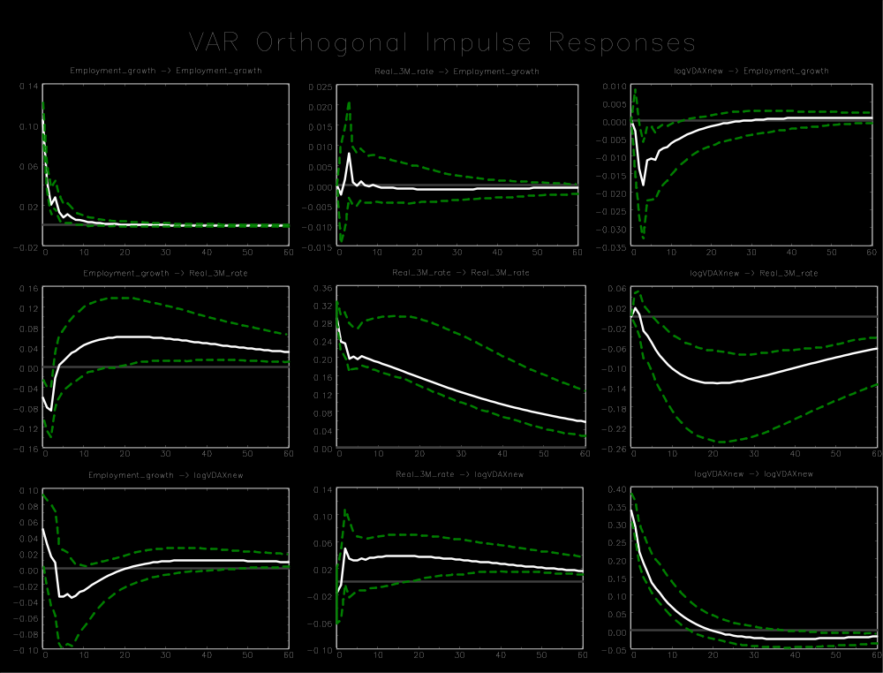

Appendix B4
Germany (1999 M1-2014 M12)
Variable ordering: total industrial production growth, real 3-month rate, log(VDAX-New²/12)
Lag order: 2
Breusch-Godfrey LM test for autocorrelation with small sample adjustment, on 8 lags ($H_{0}$: no autocorrelation): p-value = 0.1285
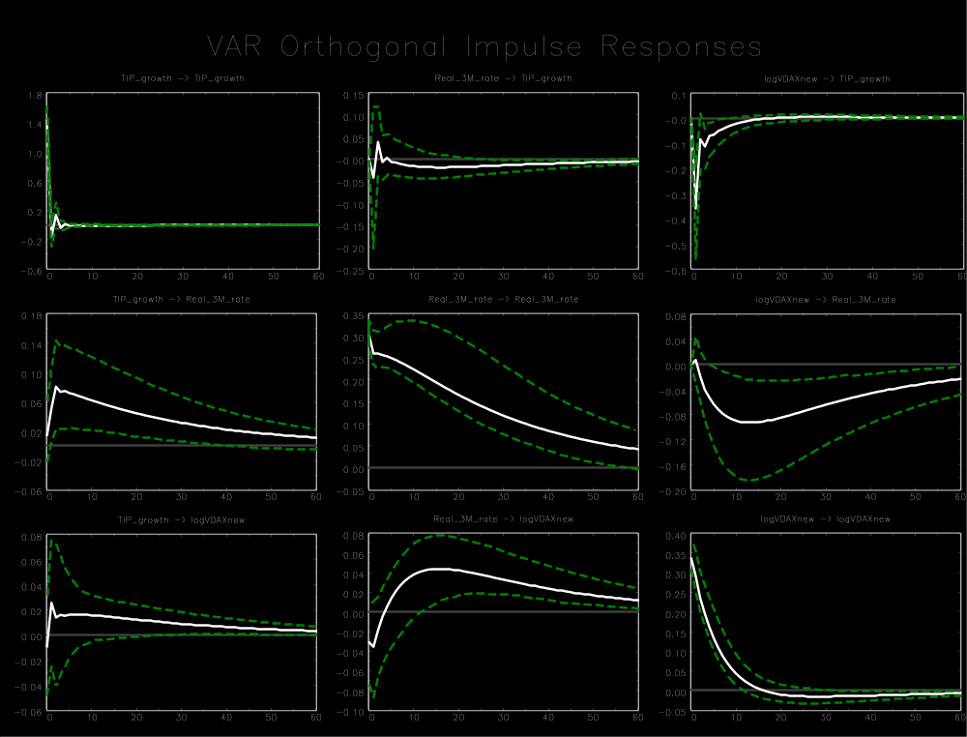

Appendix B4
Germany (1999 M1-2014 M12)
Variable ordering: manufacturing growth, log(VDAX-New²/12), real 3-month rate
Lag order: 1
Breusch-Godfrey LM test for autocorrelation with small sample adjustment, on 8 lags ($H_{0}$: no autocorrelation): p-value = 0.1051
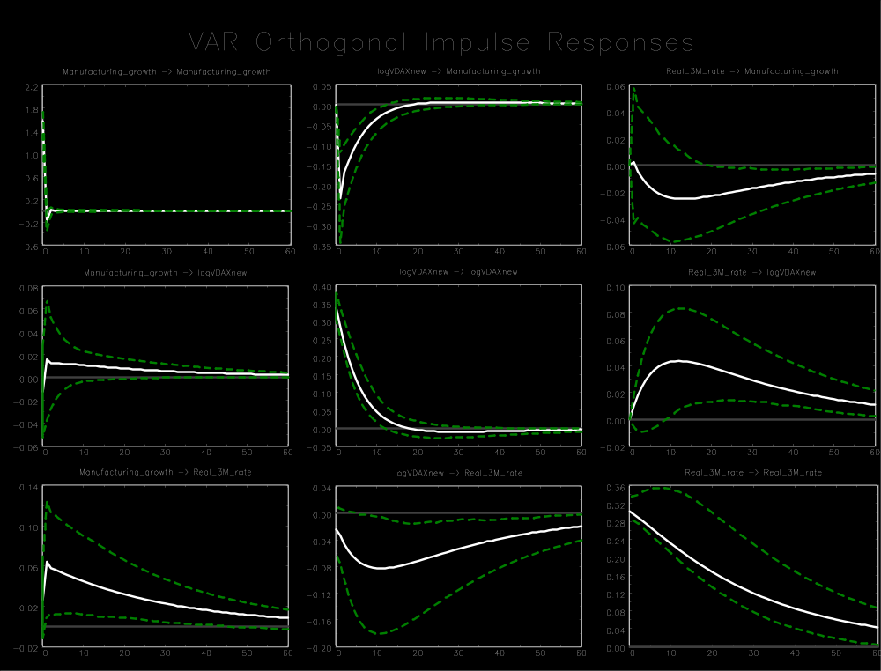

Appendix C: Impulse response functions for the Eurozone
Appendix C contains all IRFs for the Eurozone. Appendix C1 and C2 contain the results for the sample periods 1999 M1-2014 M12 and 1999 M1-2008 M8 respectively. White lines represent the IRFs and green dashed lines the 90% confidence intervals.

Appendix C1
Eurozone (1999 M1-2014 M12)
Variable ordering: manufacturing growth, real 3-month rate, log(VSTOXX²/12)
Lag order: 3
Breusch-Godfrey LM test for autocorrelation with small sample adjustment, on 8 lags ($H_{0}$: no autocorrelation): p-value = 0.1587
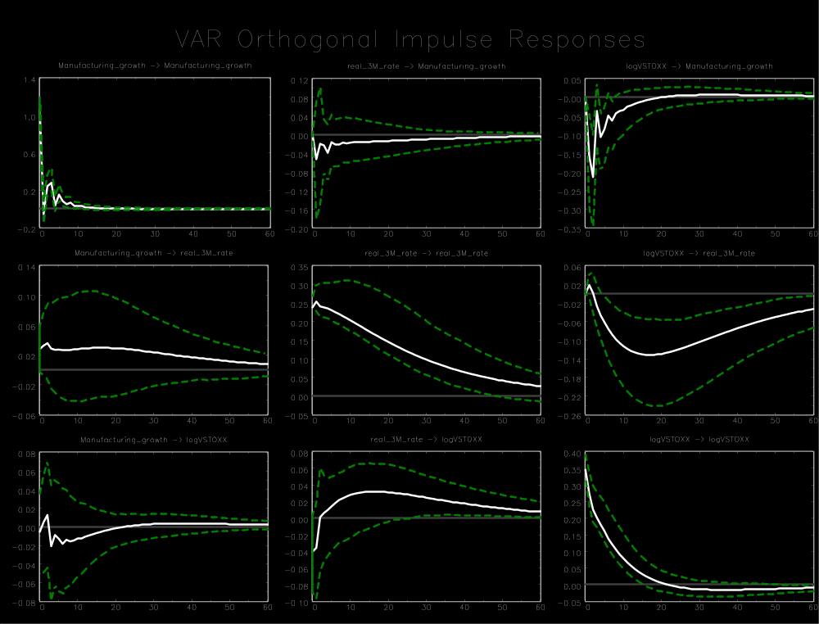

Appendix C1
Eurozone (1999 M1-2014 M12)
Variable ordering: manufacturing growth, real overnight rate, log(VSTOXX²/12)
Lag order: 3
Breusch-Godfrey LM test for autocorrelation with small sample adjustment, on 8 lags ($H_{0}$: no autocorrelation): p-value = 0.6538
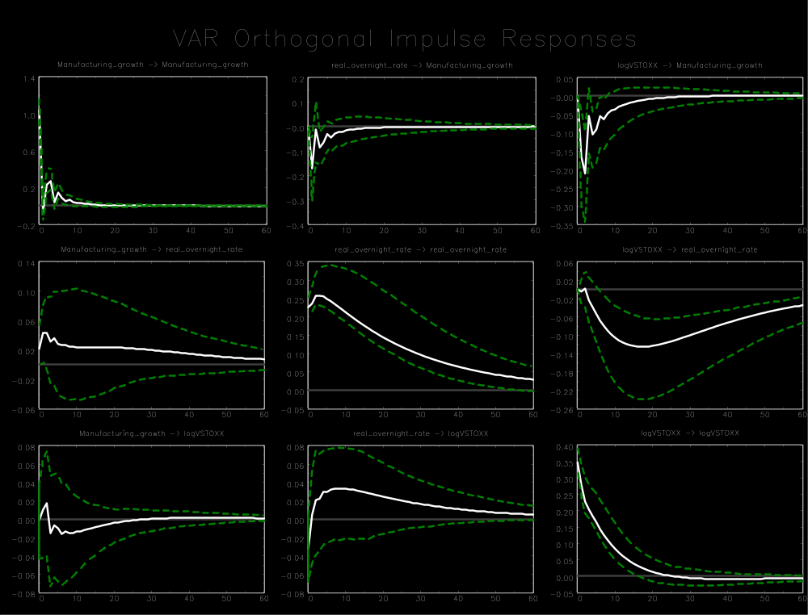

Appendix C1
Eurozone (1999 M1-2014 M12)
Variable ordering: manufacturing growth, real rate for main refinancing operations (RMRO), log(VSTOXX²/12)
Lag order: 3
Breusch-Godfrey LM test for autocorrelation with small sample adjustment, on 8 lags ($H_{0}$: no autocorrelation): p-value = 0.7674
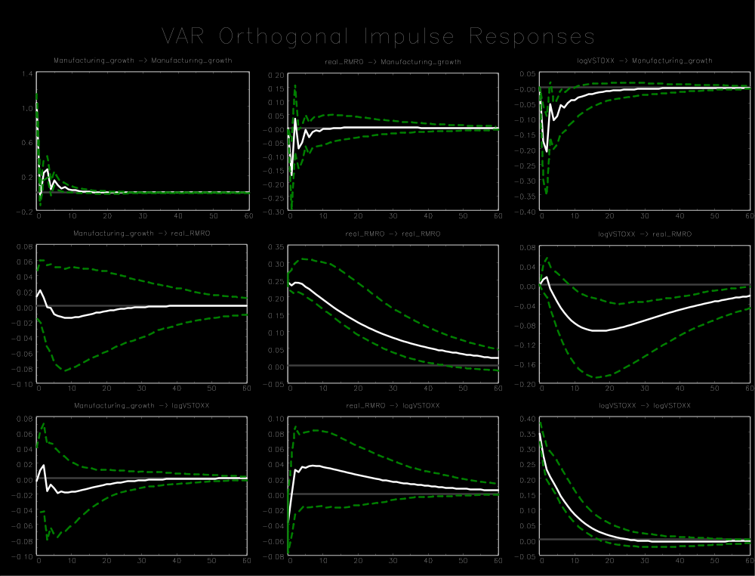

Appendix C1
Eurozone (1999 M1-2014 M12)
Variable ordering: manufacturing growth, nominal 3-month rate, log(VSTOXX²/12)
Lag order: 3
Breusch-Godfrey LM test for autocorrelation with small sample adjustment, on 8 lags ($H_{0}$: no autocorrelation): p-value = 0.3028
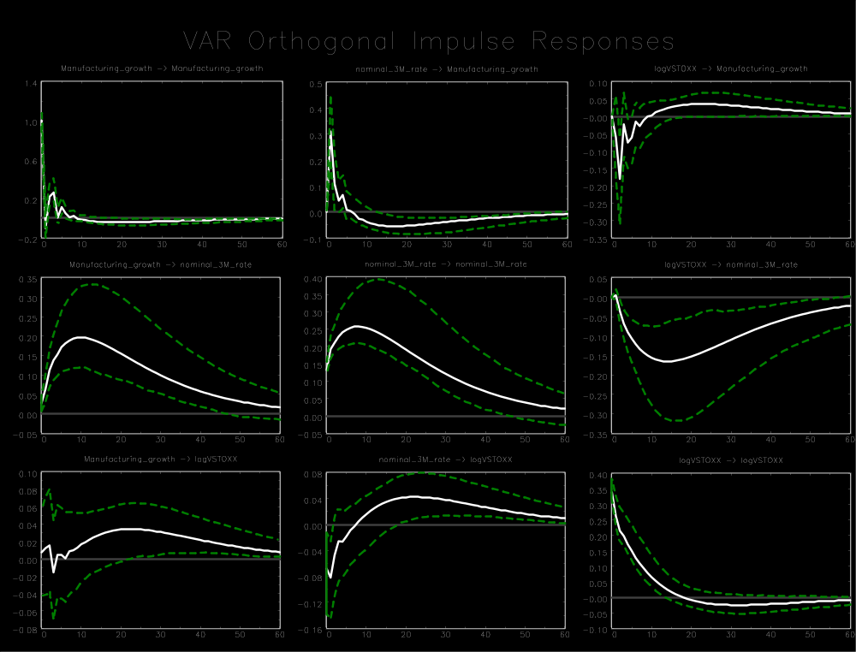

Appendix C1
Eurozone (1999 M1-2014 M12)
Variable ordering: manufacturing growth, nominal overnight rate, log(VSTOXX²/12)
Lag order: 3
Breusch-Godfrey LM test for autocorrelation with small sample adjustment, on 8 lags ($H_{0}$: no autocorrelation): p-value = 0.4725
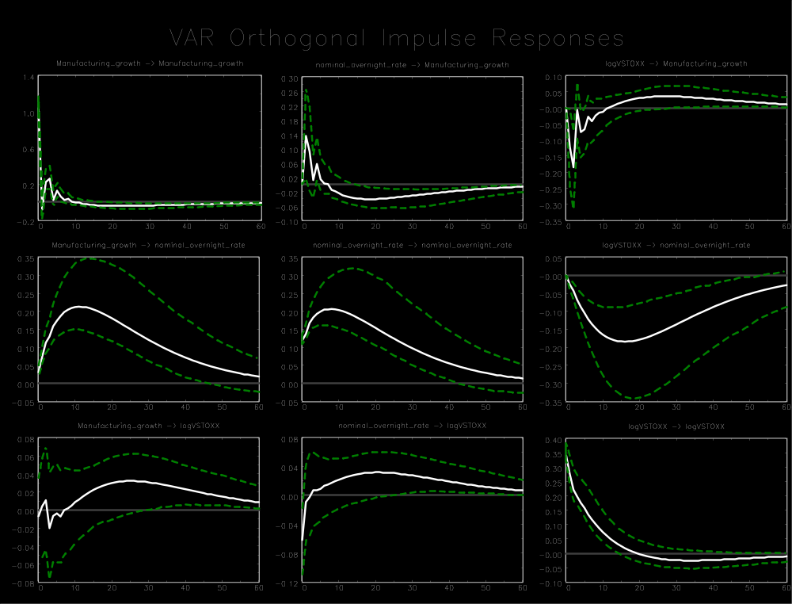

Appendix C1
Eurozone (1999 M1-2014 M12)
Variable ordering: manufacturing growth, nominal rate for main refinancing operations (RMRO), log(VSTOXX²/12)
Lag order: 5
Breusch-Godfrey LM test for autocorrelation with small sample adjustment, on 8 lags ($H_{0}$: no autocorrelation): p-value = 0.9039
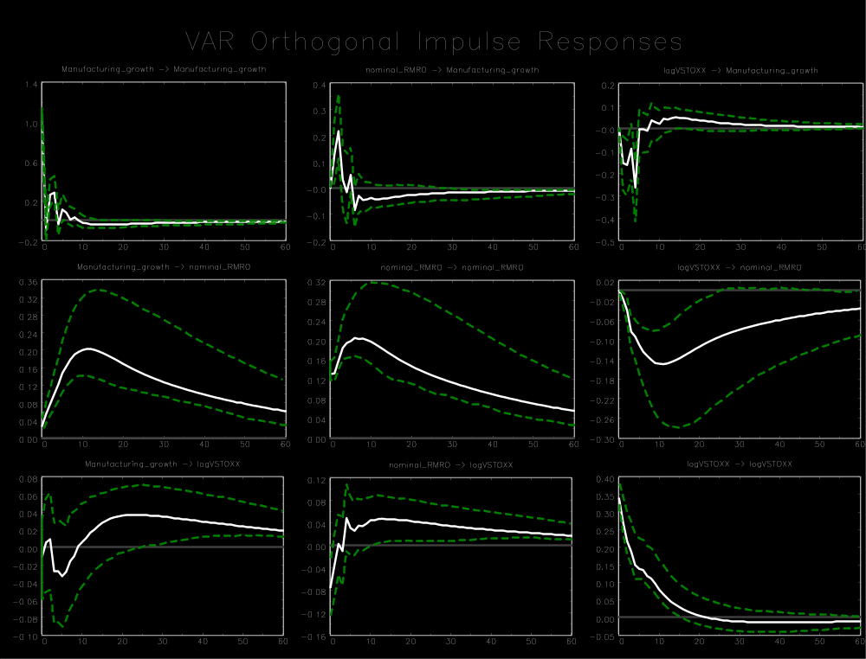

Appendix C1
Eurozone (1999 M1-2014 M12)
Variable ordering: manufacturing growth, M1 growth, log(VSTOXX²/12)
Lag order: 3
Breusch-Godfrey LM test for autocorrelation with small sample adjustment, on 8 lags ($H_{0}$: no autocorrelation): p-value = 0.9591
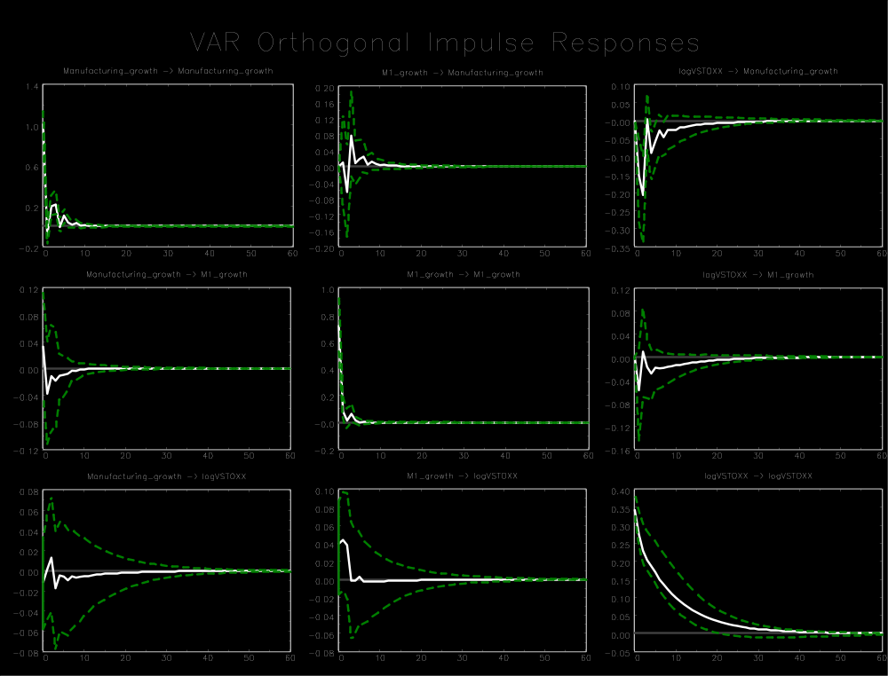

Appendix C1
Eurozone (1999 M1-2014 M12)
Variable ordering: manufacturing growth, M3 growth, log(VSTOXX²/12)
Lag order: 4
Breusch-Godfrey LM test for autocorrelation with small sample adjustment, on 8 lags ($H_{0}$: no autocorrelation): p-value = 0.4851
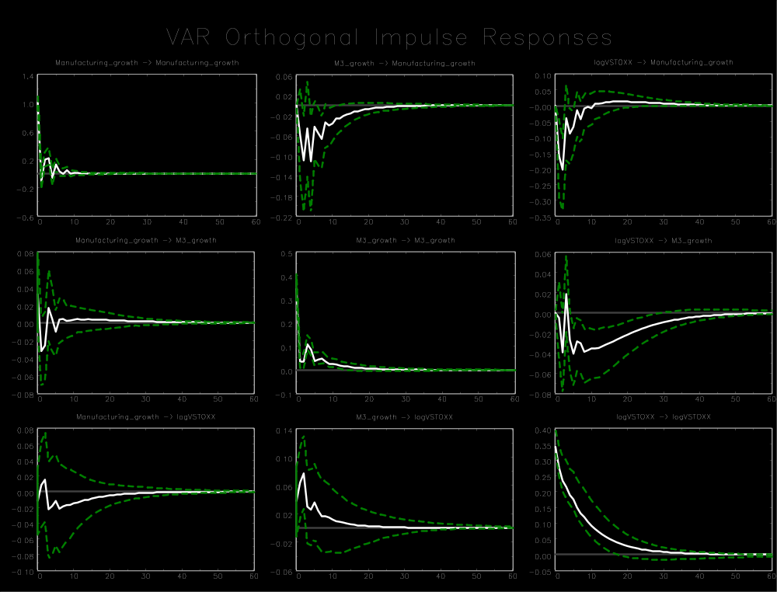

Appendix C1
Eurozone (1999 M1-2014 M12)
Variable ordering: European Commission Euro Area Business Climate Indicator (EC index), real 3-month rate, log(VSTOXX²/12)
Lag order: 4
Breusch-Godfrey LM test for autocorrelation with small sample adjustment, on 8 lags ($H_{0}$: no autocorrelation): p-value = 0.2078
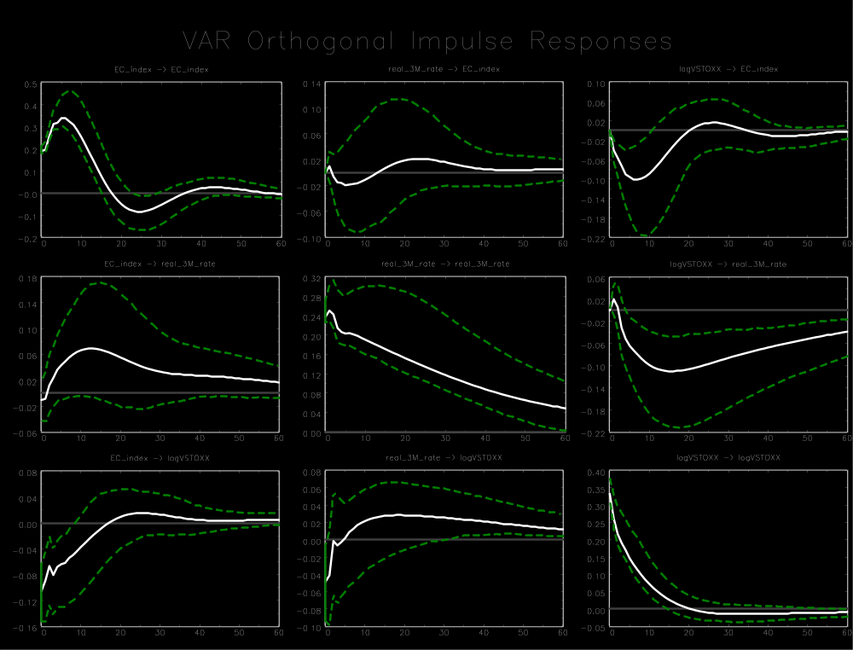

Appendix C1
Eurozone (1999 M1-2014 M12)
Variable ordering: total industrial production growth, real 3-month rate, log(VSTOXX²/12)
Lag order: 3
Breusch-Godfrey LM test for autocorrelation with small sample adjustment, on 8 lags ($H_{0}$: no autocorrelation): p-value = 0.2556
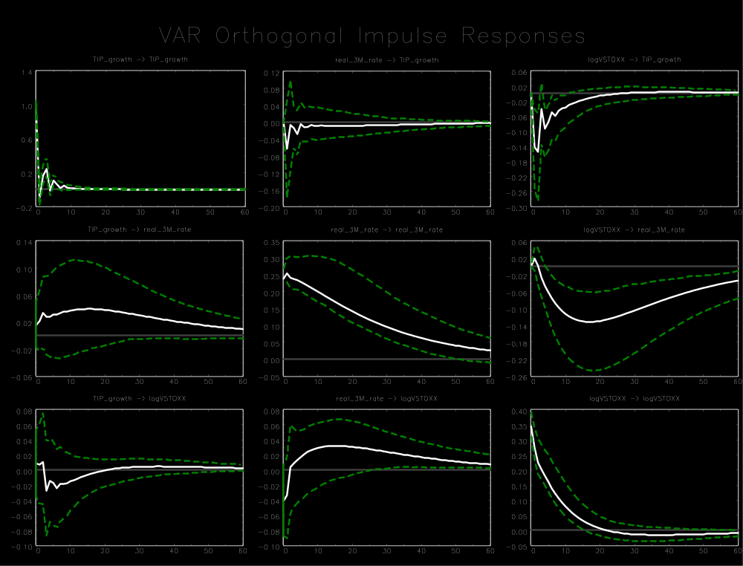

Appendix C1
Eurozone (1999 M1-2014 M12)
Variable ordering: manufacturing growth, log(VSTOXX²/12) , real 3-month rate
Lag order: 3
Breusch-Godfrey LM test for autocorrelation with small sample adjustment, on 8 lags ($H_{0}$: no autocorrelation): p-value = 0.1587
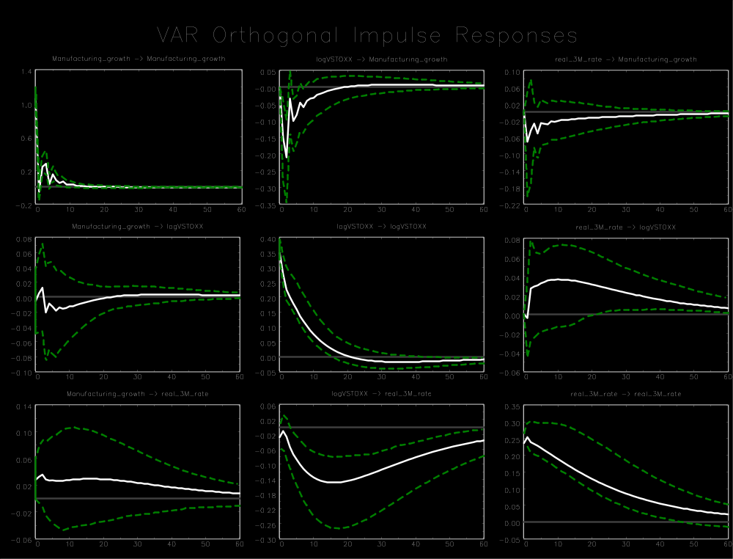

Appendix C2
Eurozone (1999 M1-2008 M8)
Variable ordering: manufacturing growth, real 3-month rate, log(VSTOXX²/12)
Lag order: 5
Breusch-Godfrey LM test for autocorrelation with small sample adjustment, on 8 lags ($H_{0}$: no autocorrelation): p-value = 0.0810
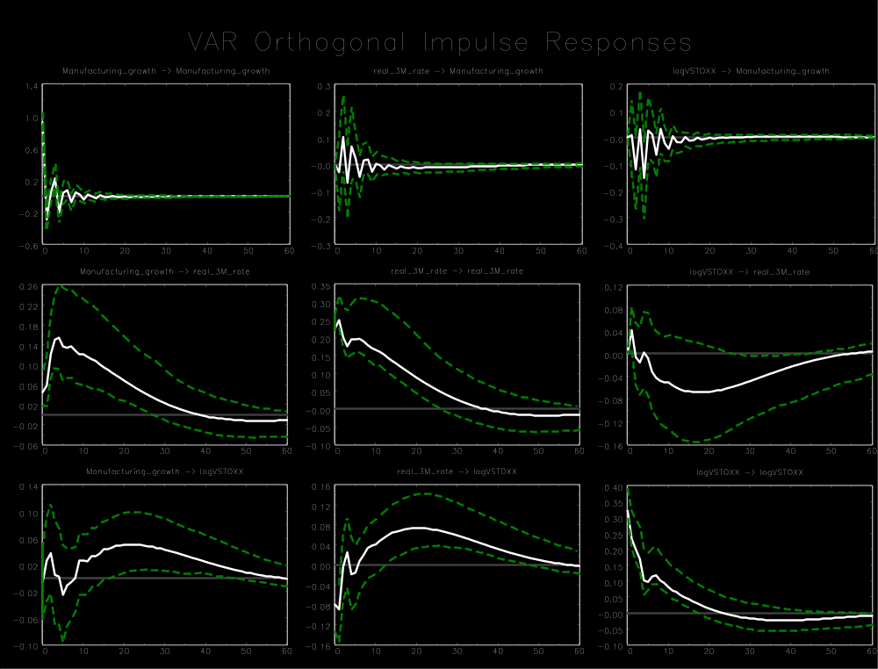

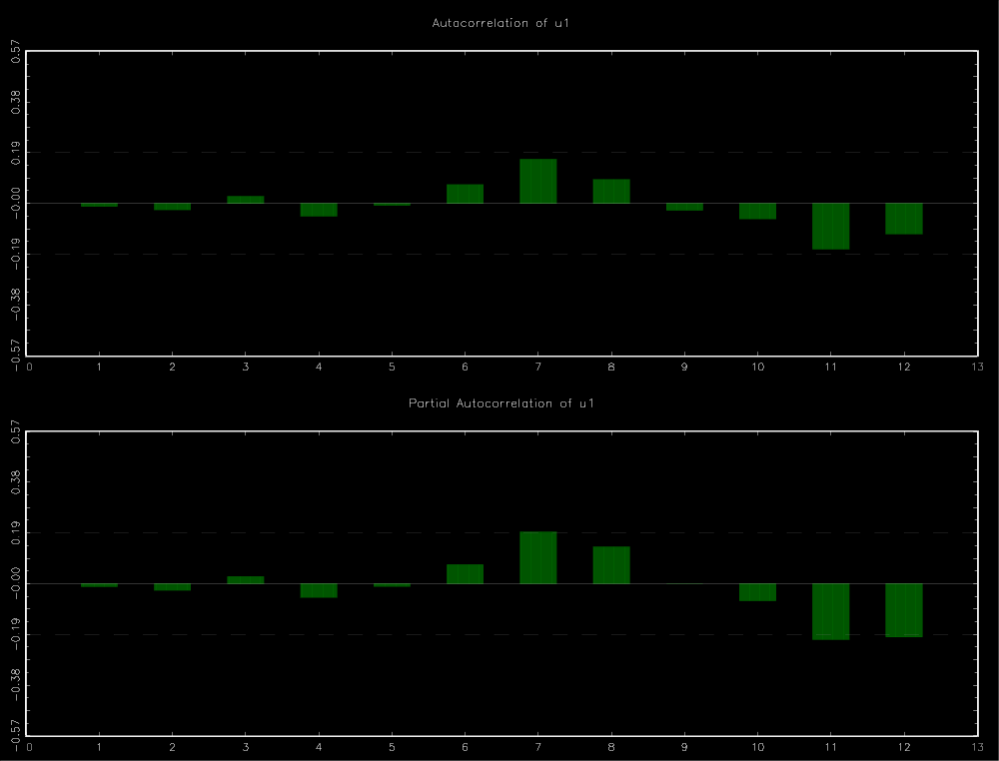
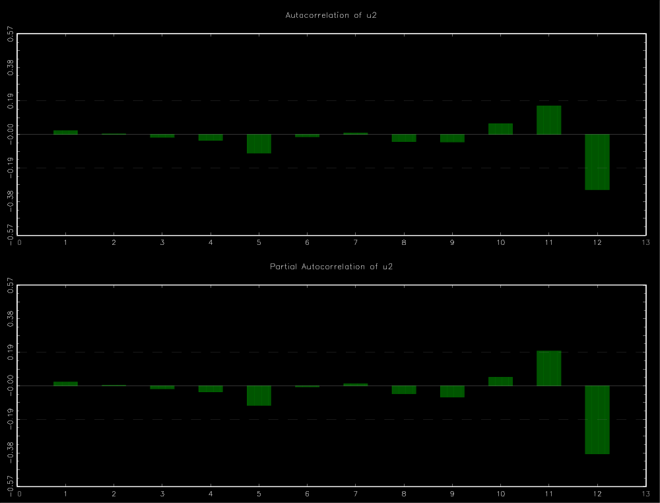
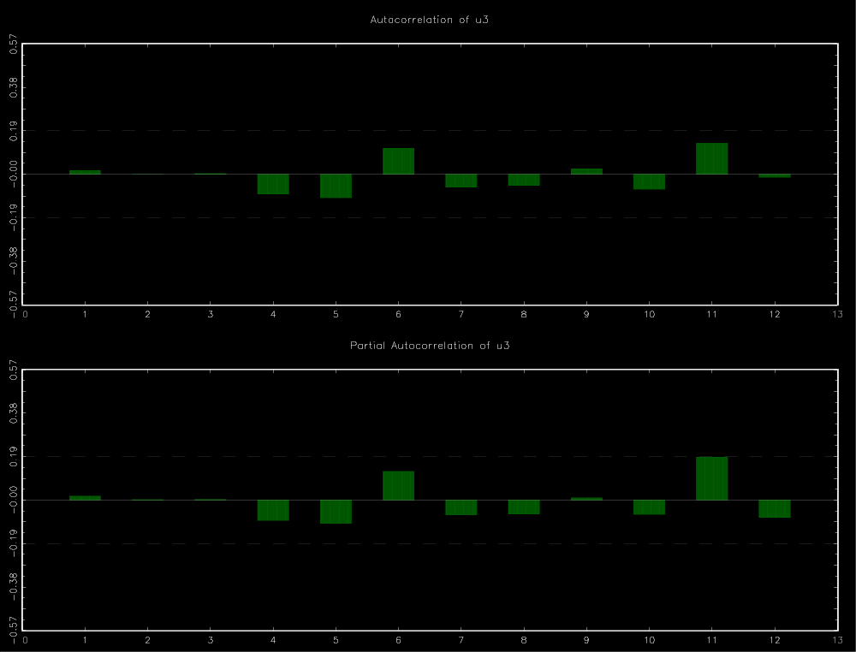

Appendix C2
Eurozone (1999 M1-2008 M8)
Variable ordering: manufacturing growth, real overnight rate, log(VSTOXX²/12)
Lag order: 2
Breusch-Godfrey LM test for autocorrelation with small sample adjustment, on 8 lags ($H_{0}$: no autocorrelation): p-value = 0.5832
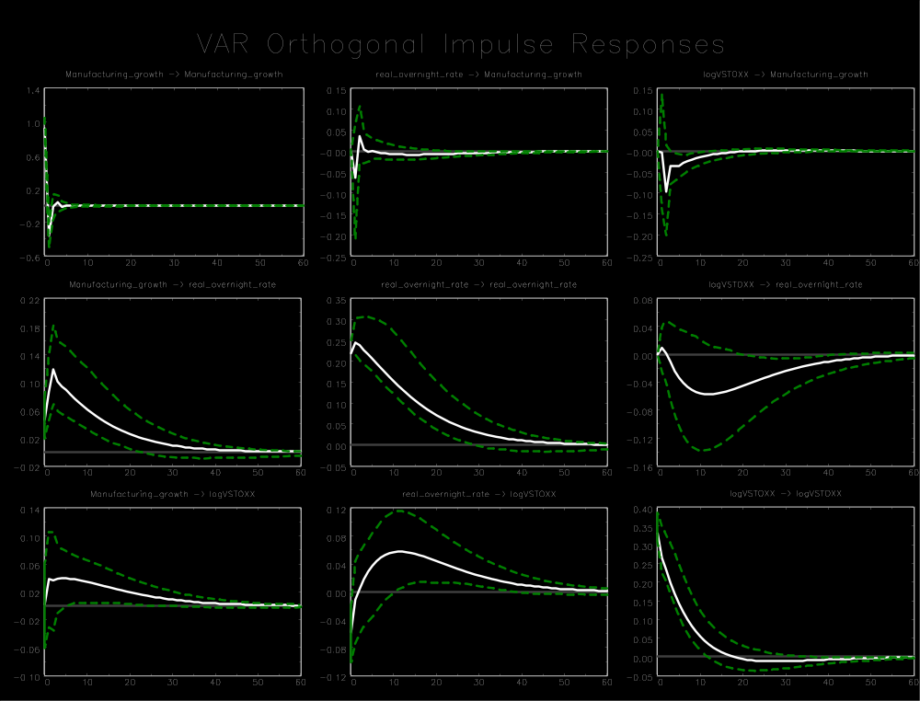

Appendix C2
Eurozone (1999 M1-2008 M8)
Variable ordering: manufacturing growth, real rate for main refinancing operations (RMRO), log(VSTOXX²/12)
Lag order: 1
Breusch-Godfrey LM test for autocorrelation with small sample adjustment, on 8 lags ($H_{0}$: no autocorrelation): p-value = 0.6686
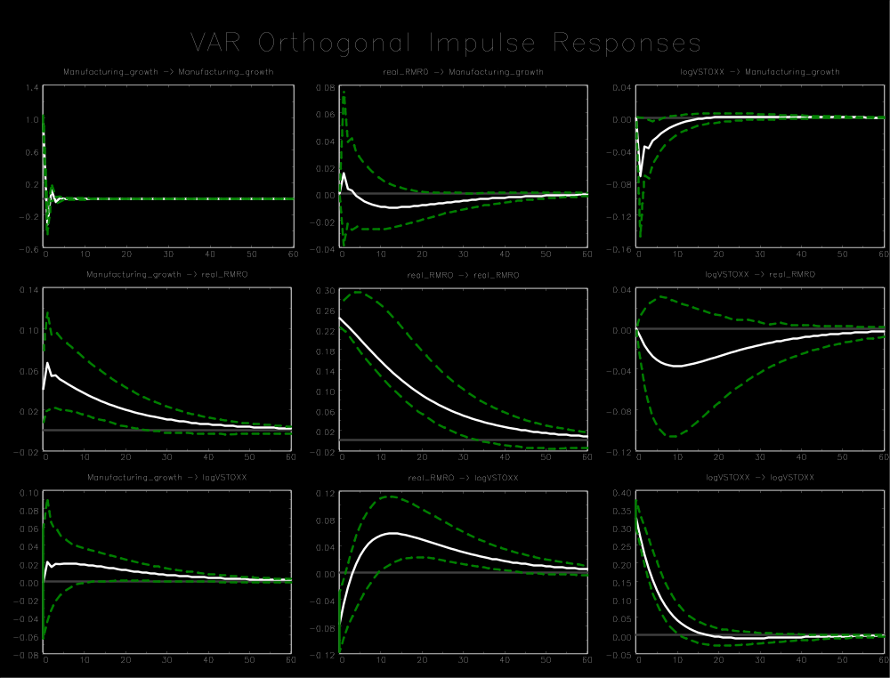

Appendix C2
Eurozone (1999 M1-2008 M8)
Variable ordering: manufacturing growth, nominal 3-month rate, log(VSTOXX²/12)
Lag order: 2
Breusch-Godfrey LM test for autocorrelation with small sample adjustment, on 8 lags ($H_{0}$: no autocorrelation): p-value = 0.1305
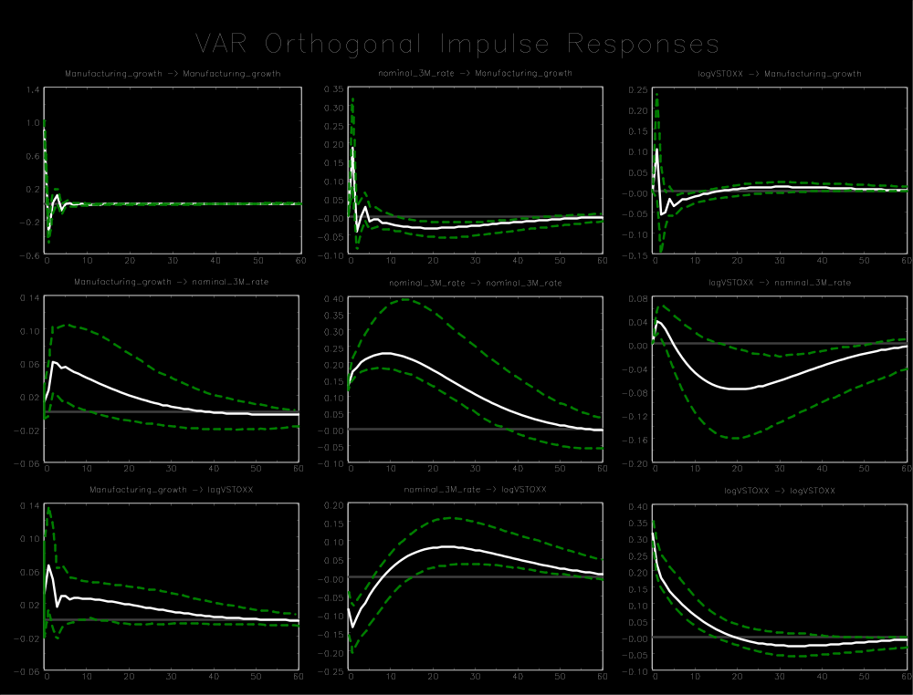

Appendix C2
Eurozone (1999 M1-2008 M8)
Variable ordering: manufacturing growth, nominal overnight rate, log(VSTOXX²/12)
Lag order: 3
Breusch-Godfrey LM test for autocorrelation with small sample adjustment, on 8 lags ($H_{0}$: no autocorrelation): p-value = 0.1911
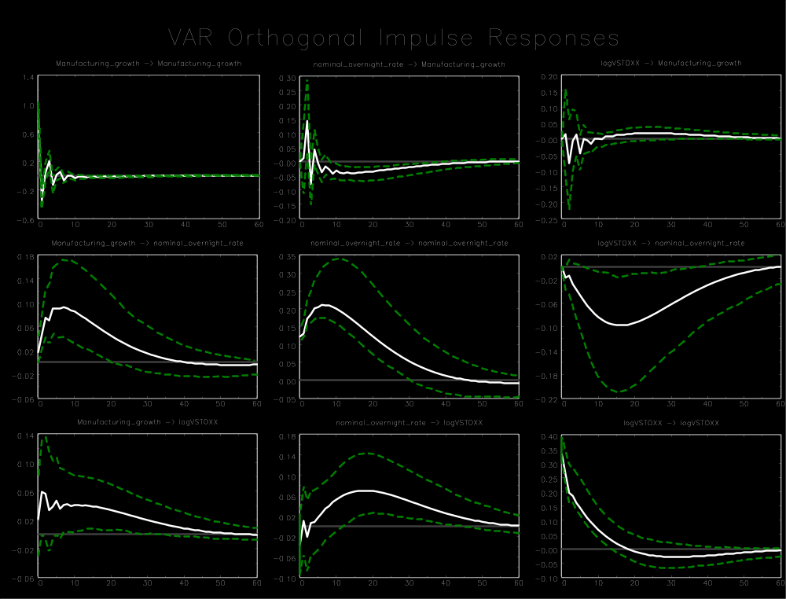

Appendix C2
Eurozone (1999 M1-2008 M8)
Variable ordering: manufacturing growth, nominal rate for main refinancing operations (RMRO), log(VSTOXX²/12)
Lag order: 4
Breusch-Godfrey LM test for autocorrelation with small sample adjustment, on 8 lags ($H_{0}$: no autocorrelation): p-value = 0.0084
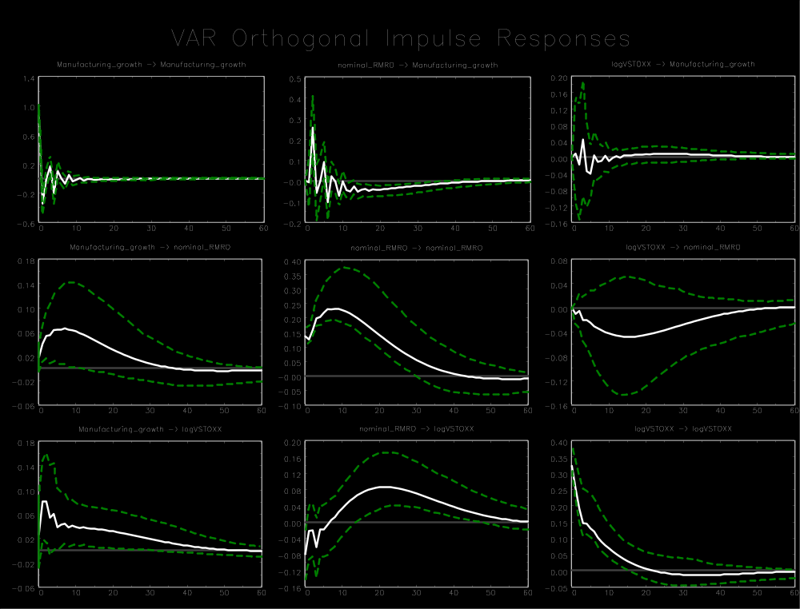

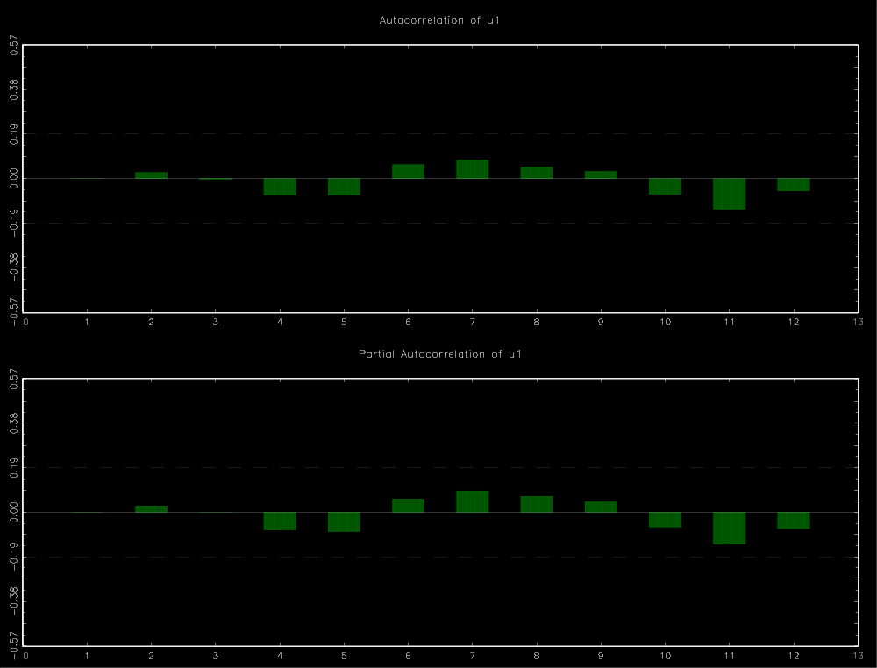
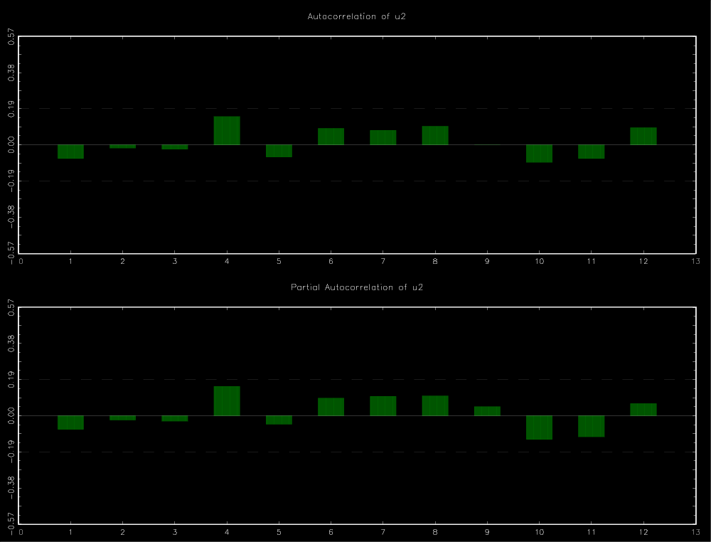
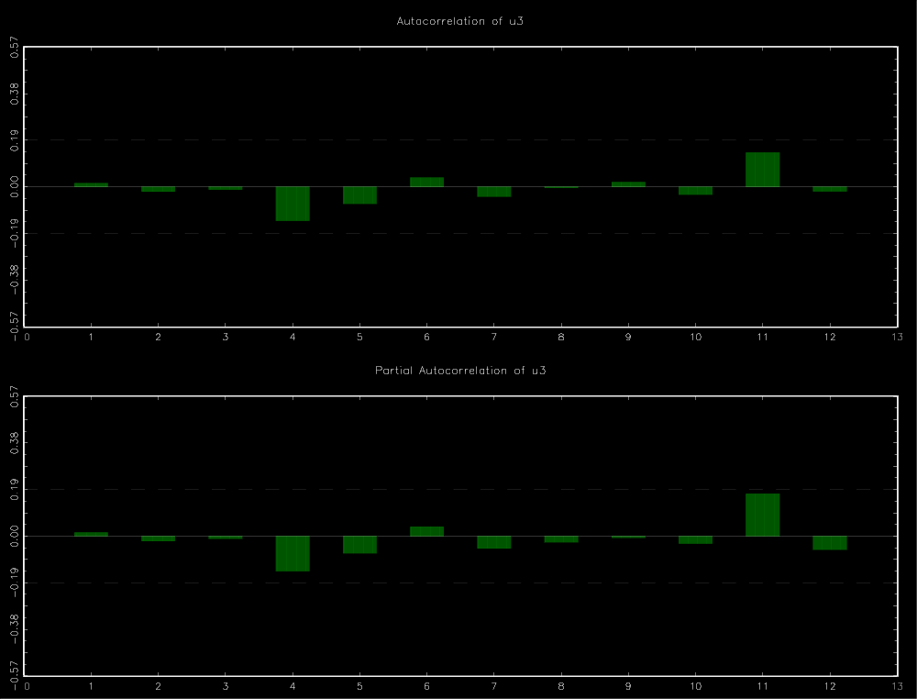

Appendix C2
Eurozone (1999 M1-2008 M8)
Variable ordering: manufacturing growth, M1 growth, log(VSTOXX²/12)
Lag order: 1
Breusch-Godfrey LM test for autocorrelation with small sample adjustment, on 8 lags ($H_{0}$: no autocorrelation): p-value = 0.9079
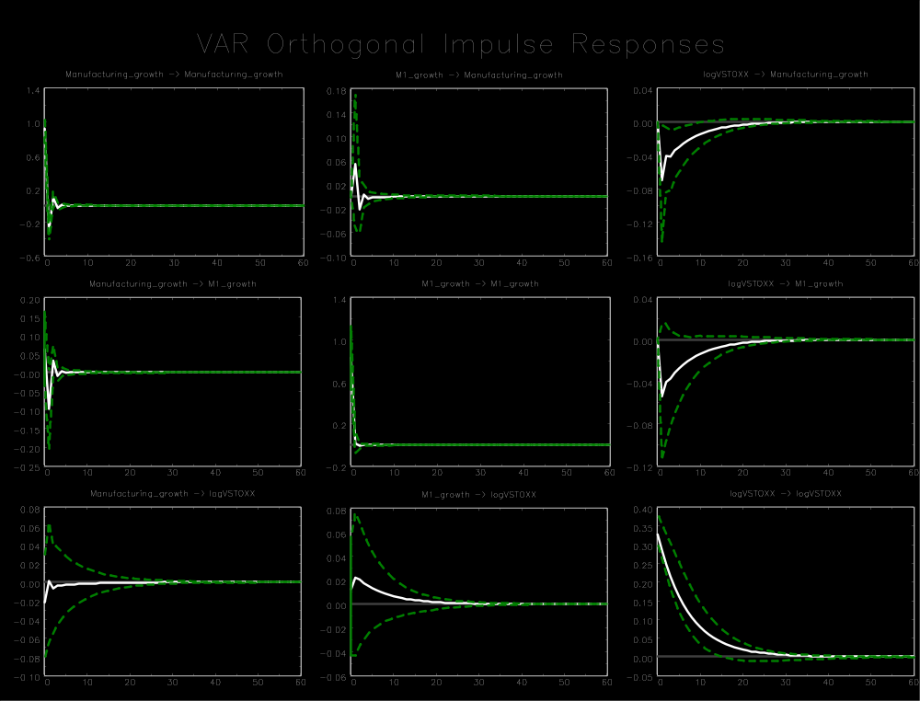

Appendix C2
Eurozone (1999 M1-2008 M8)
Variable ordering: manufacturing growth, M3 growth, log(VSTOXX²/12)
Lag order: 5
Breusch-Godfrey LM test for autocorrelation with small sample adjustment, on 8 lags ($H_{0}$: no autocorrelation): p-value = 0.1785
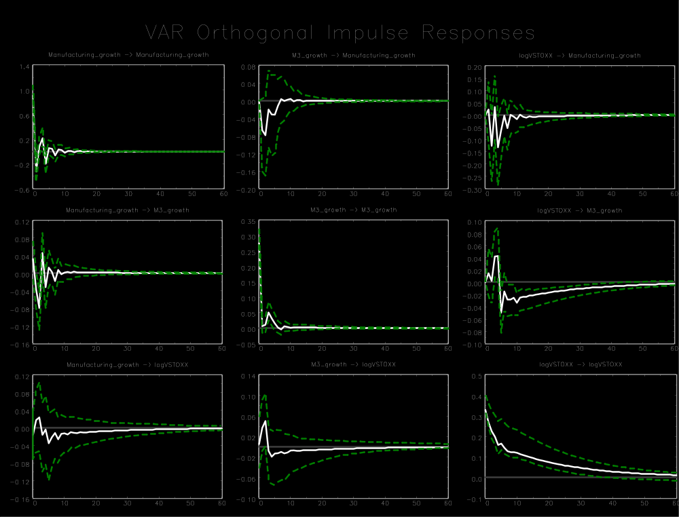

Appendix C2
Eurozone (1999 M1-2008 M8)
Variable ordering: European Commission Euro Area Business Climate Indicator (EC index), real 3-month rate, log(VSTOXX²/12)
Lag order: 4
Breusch-Godfrey LM test for autocorrelation with small sample adjustment, on 8 lags ($H_{0}$: no autocorrelation): p-value = 0.3913
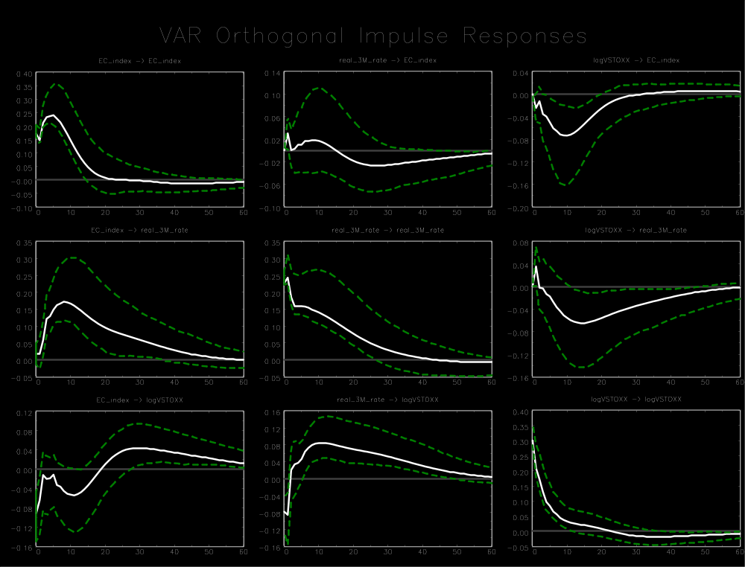

Appendix C2
Eurozone (1999 M1-2008 M8)
Variable ordering: total industrial production growth, real 3-month rate, log(VSTOXX²/12)
Lag order: 3
Breusch-Godfrey LM test for autocorrelation with small sample adjustment, on 8 lags ($H_{0}$: no autocorrelation): p-value = 0.2526
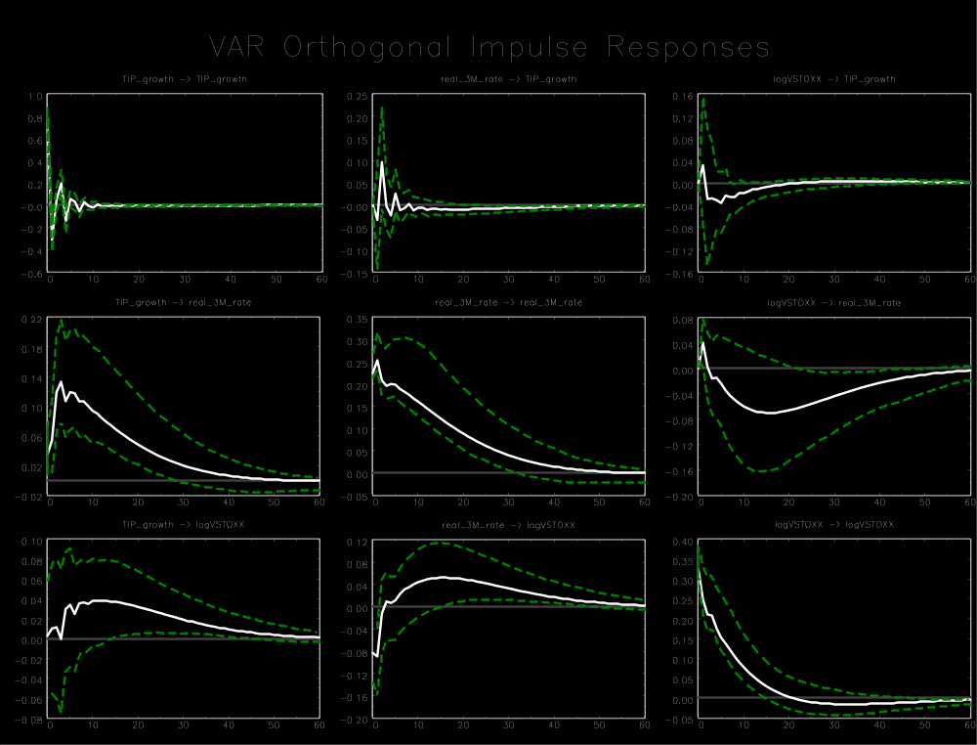

Appendix C1
Eurozone (1999 M1-2008 M8)
Variable ordering: manufacturing growth, log(VSTOXX²/12) , real 3-month rate
Lag order: 5
Breusch-Godfrey LM test for autocorrelation with small sample adjustment, on 8 lags ($H_{0}$: no autocorrelation): p-value = 0.0810
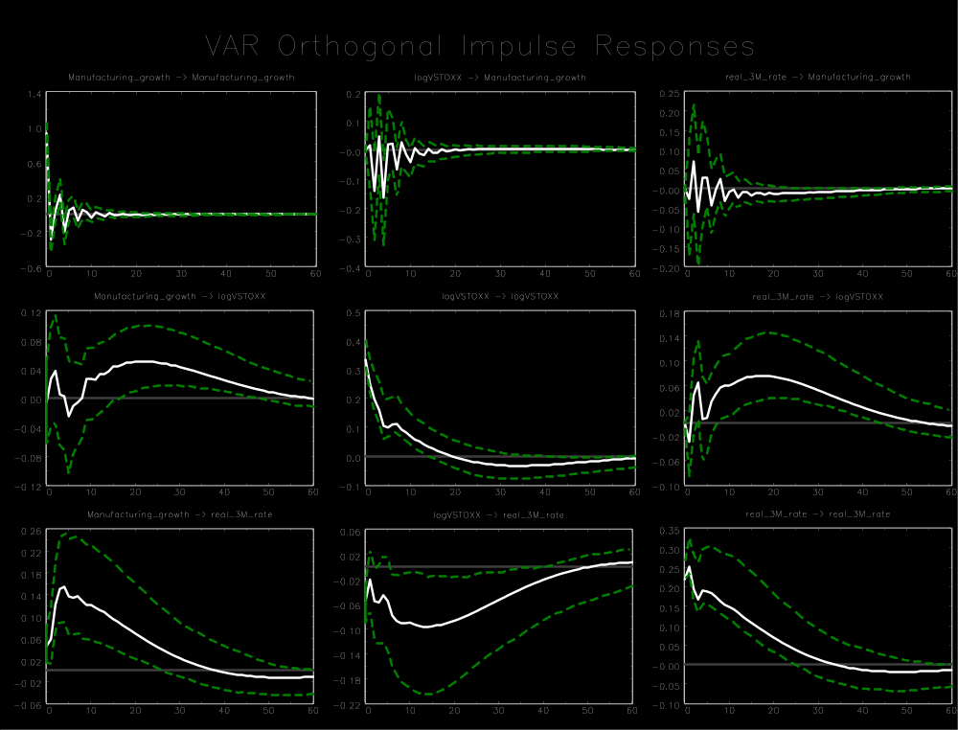

Appendix D: Impulse response functions for Switzerland
Appendix D contains all IRFs for Switzerland. The sample periods 1999 M1-2008 M8. White lines represent the IRFs and green dashed lines the 90% confidence intervals.

Appendix D
Switzerland (1999 M1-2008 M8)
Variable ordering: log(KOF index), real 3-month rate, log(VSMI²/12)
Lag order: 6
Breusch-Godfrey LM test for autocorrelation with small sample adjustment, on 8 lags ($H_{0}$: no autocorrelation): p-value = 0.0145
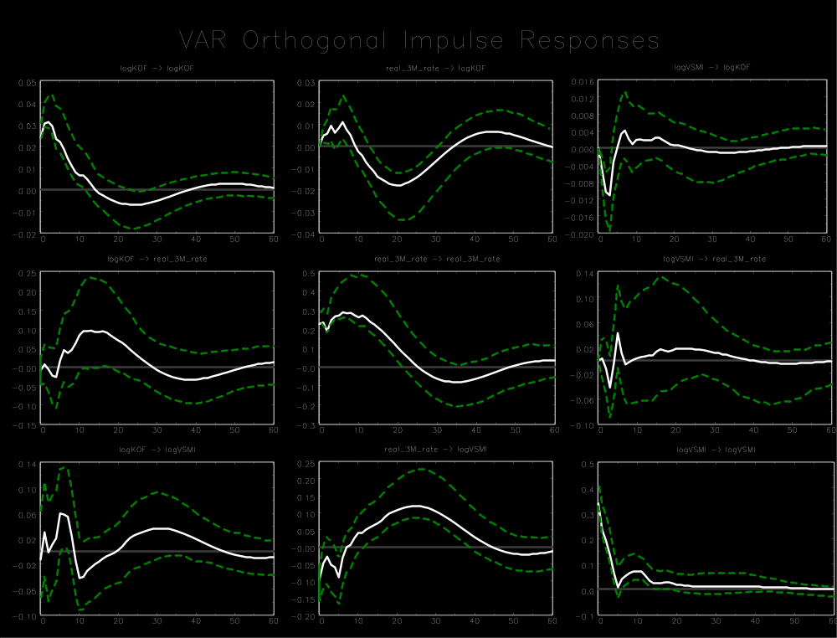

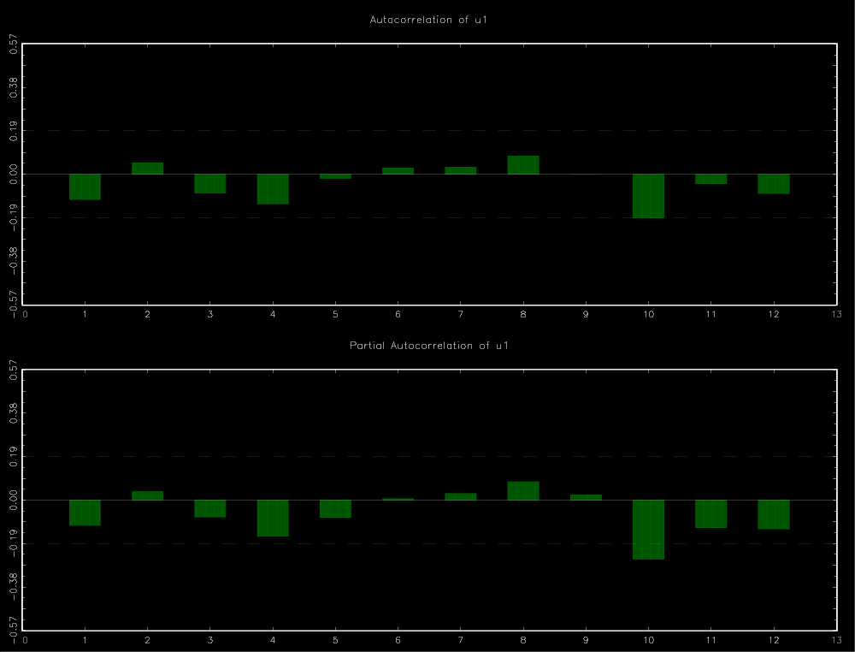
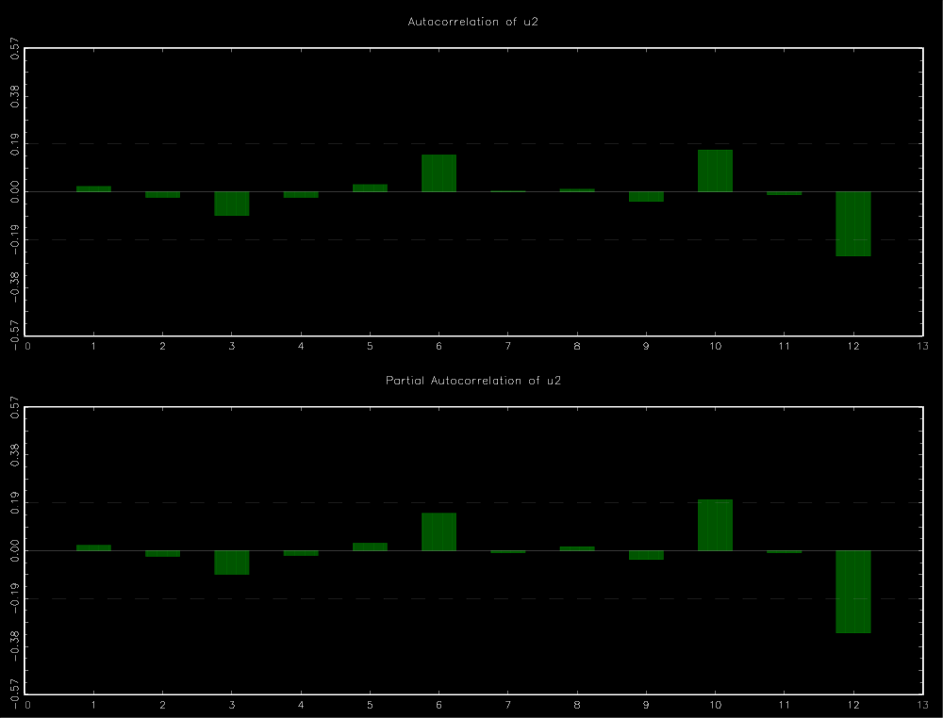
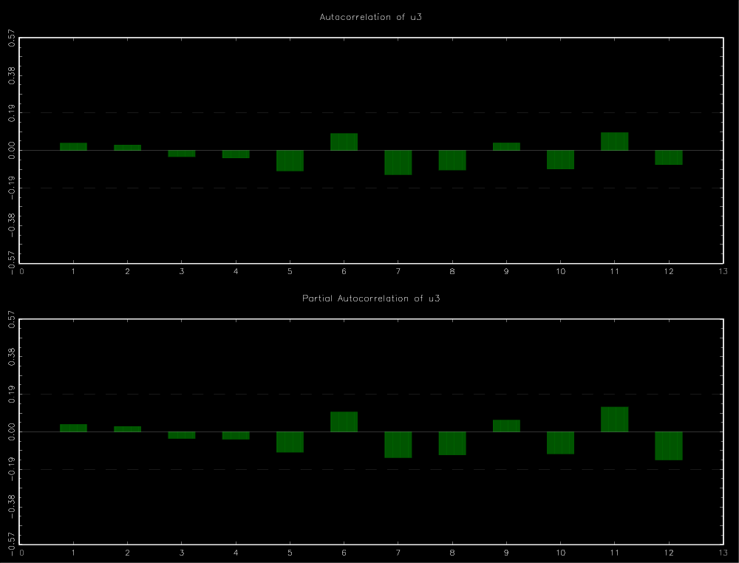

Appendix D
Switzerland (1999 M1-2008 M8)
Variable ordering: log(KOF index), nominal 3-month rate, log(VSMI²/12)
Lag order: 6
Breusch-Godfrey LM test for autocorrelation with small sample adjustment, on 8 lags ($H_{0}$: no autocorrelation): p-value = 0.000
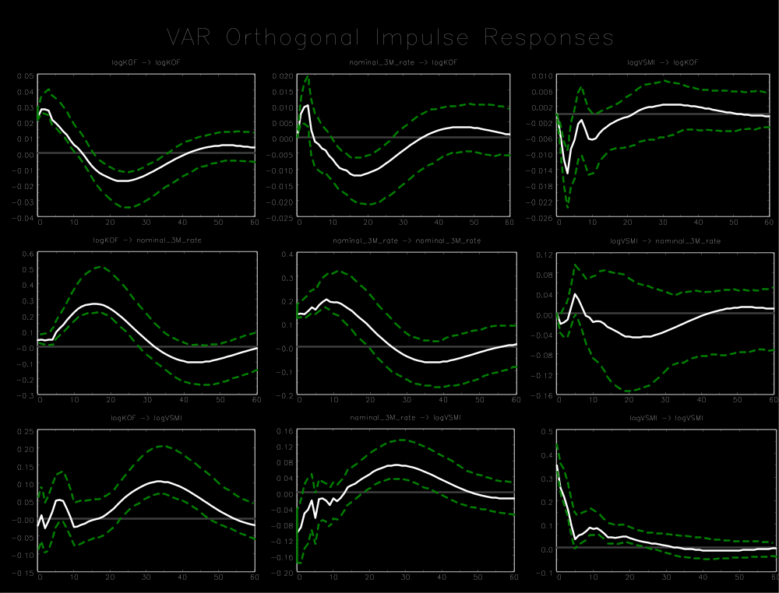

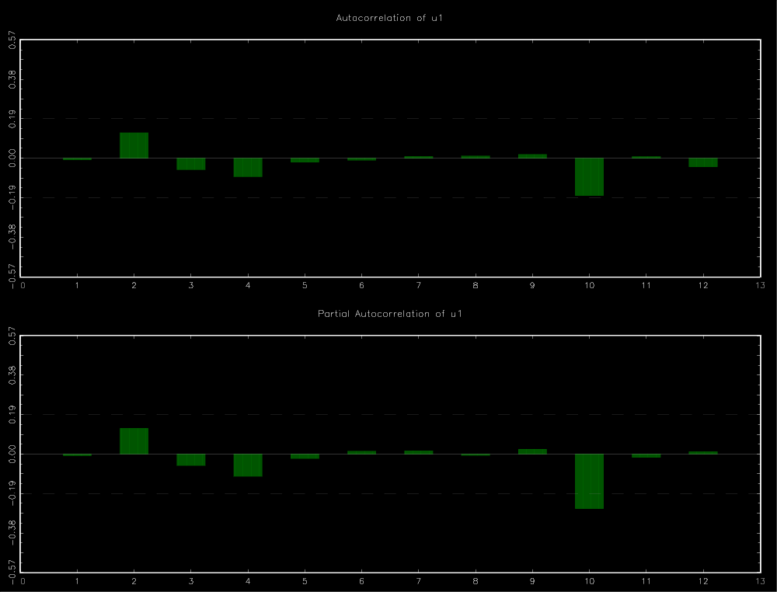
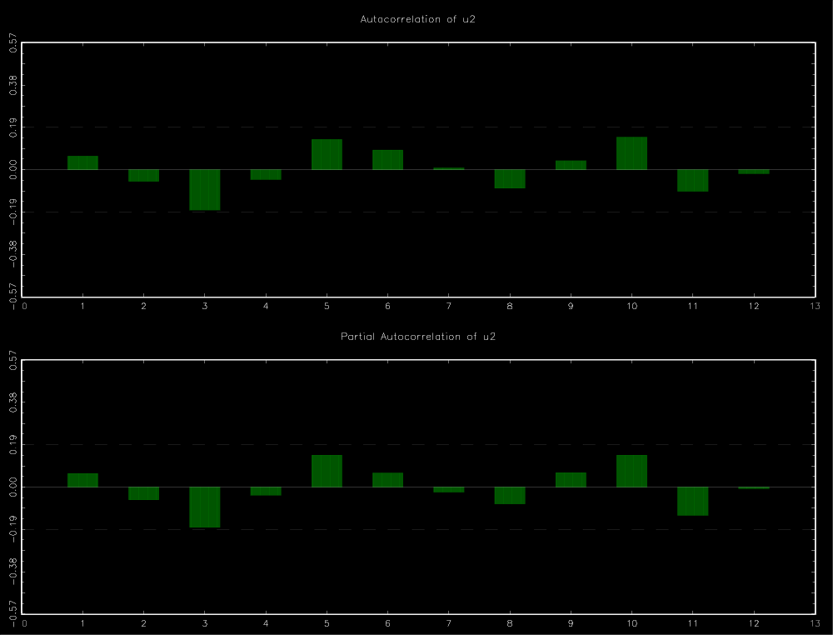
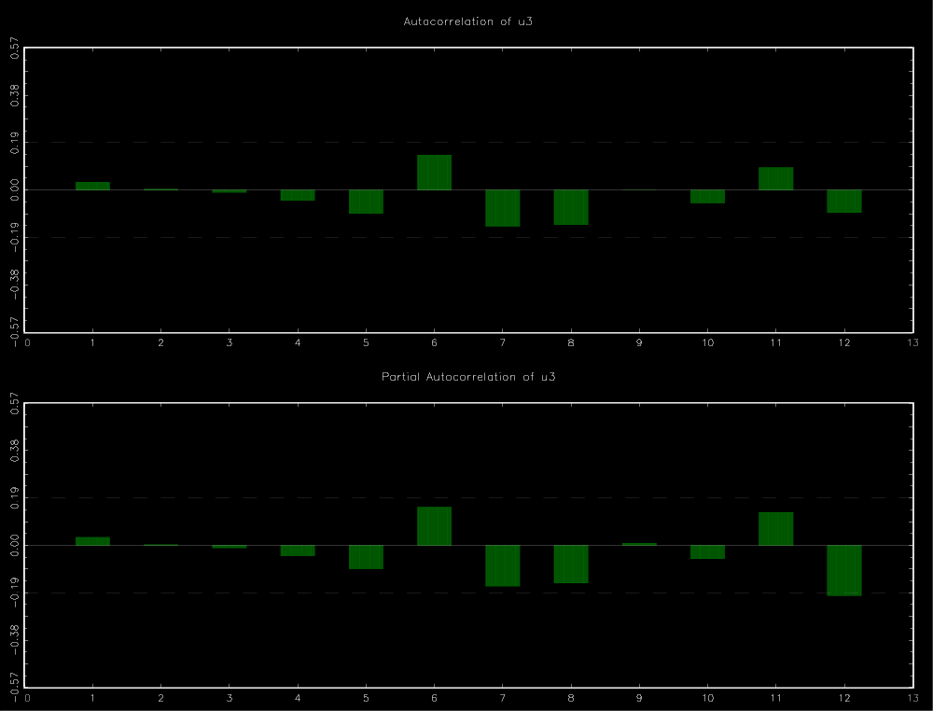

Appendix D
Switzerland (1999 M1-2008 M8)
Variable ordering: log(KOF index), M1 growth, log(VSMI²/12)
Lag order: 6
Breusch-Godfrey LM test for autocorrelation with small sample adjustment, on 8 lags ($H_{0}$: no autocorrelation): p-value = 0.0807
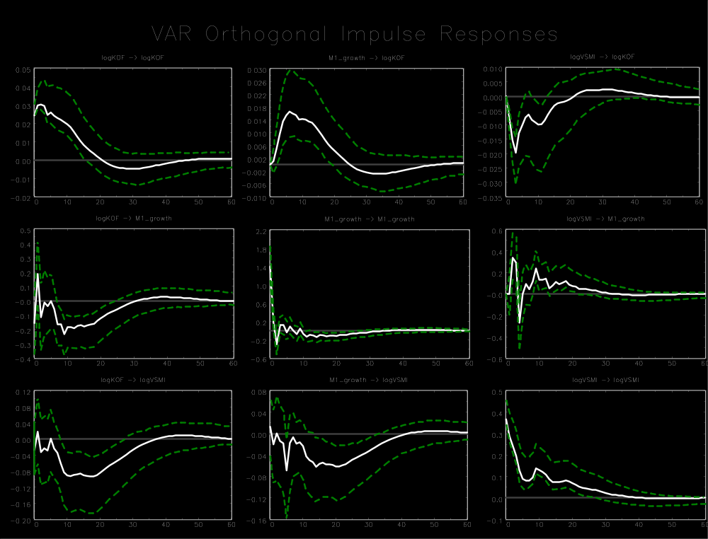

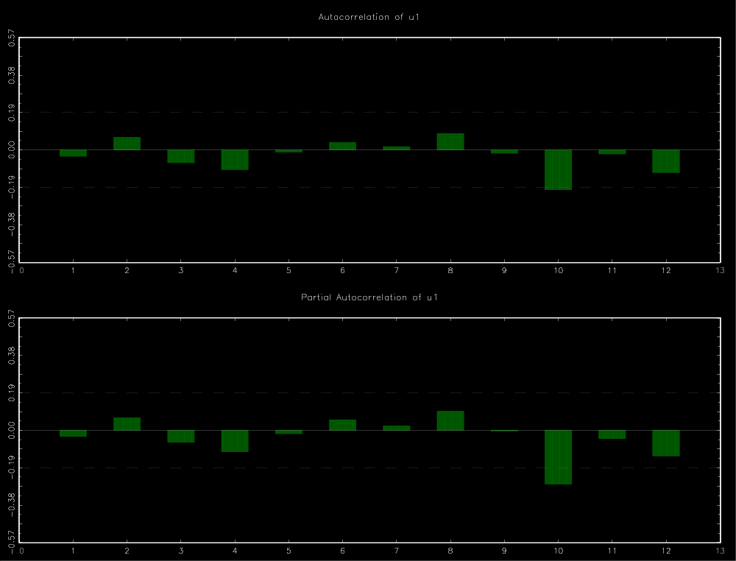
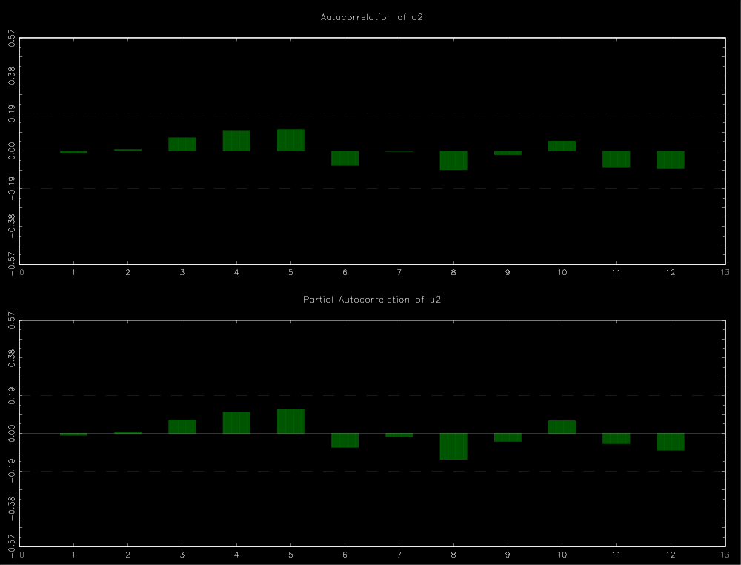
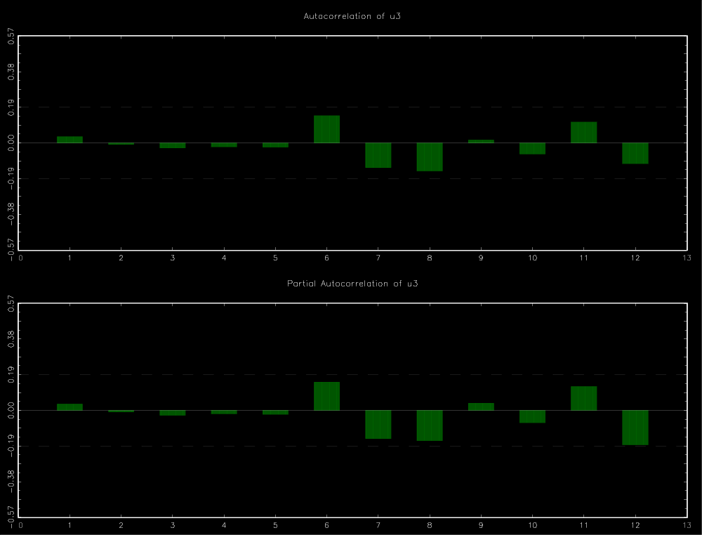

Appendix D
Switzerland (1999 M1-2008 M8)
Variable ordering: log(KOF index), M3 growth, log(VSMI²/12)
Lag order: 5
Breusch-Godfrey LM test for autocorrelation with small sample adjustment, on 8 lags ($H_{0}$: no autocorrelation): p-value = 0.2434
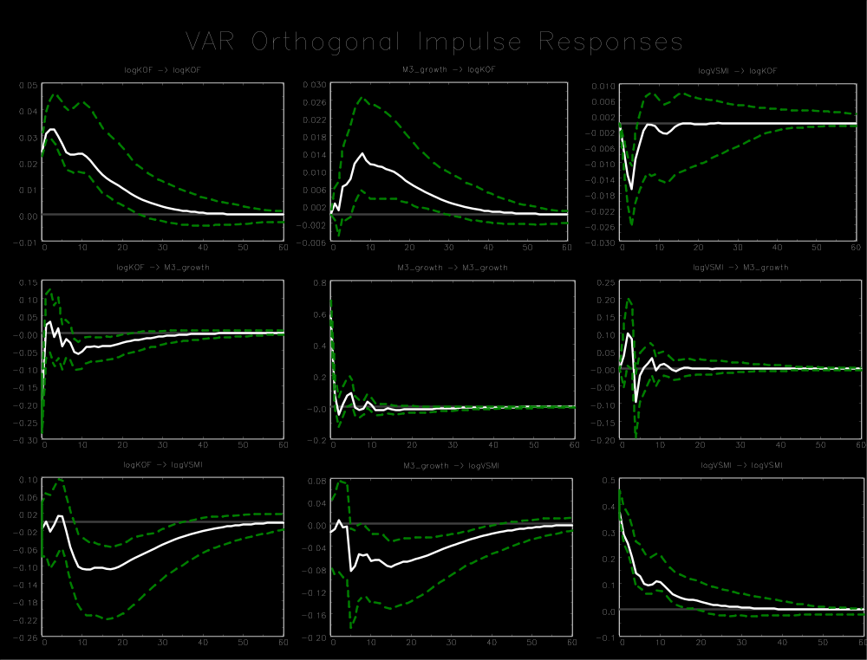

Appendix D
Switzerland (1999 M1-2008 M8)
Variable ordering: log(KOF index), log(VSMI²/12), real 3-month rate
Lag order: 6
Breusch-Godfrey LM test for autocorrelation with small sample adjustment, on 8 lags ($H_{0}$: no autocorrelation): p-value = 0.0145
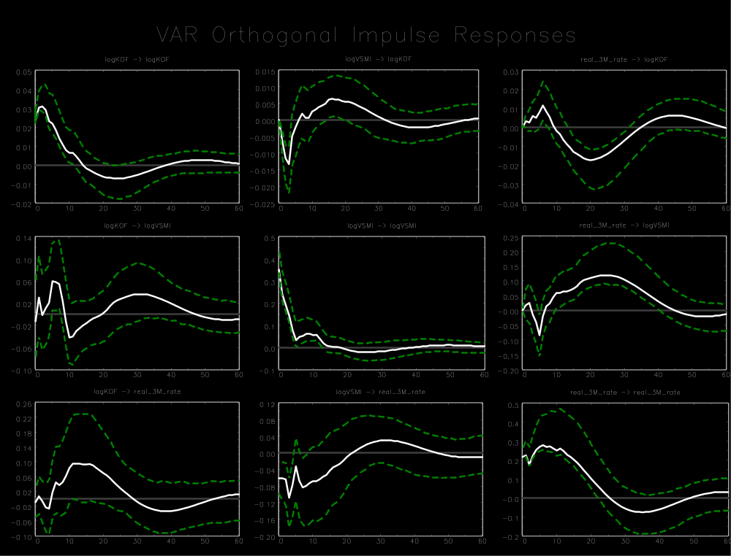

Appendix D
Switzerland (1999 M1-2008 M8)
Variable ordering: log(KOF index), real 3-month rate, log(VSMI²/12), log of the export-weigthed nominal exchange rate (logNER)
Lag order: 6
Breusch-Godfrey LM test for autocorrelation with small sample adjustment, on 8 lags ($H_{0}$: no autocorrelation): p-value = 0.0229
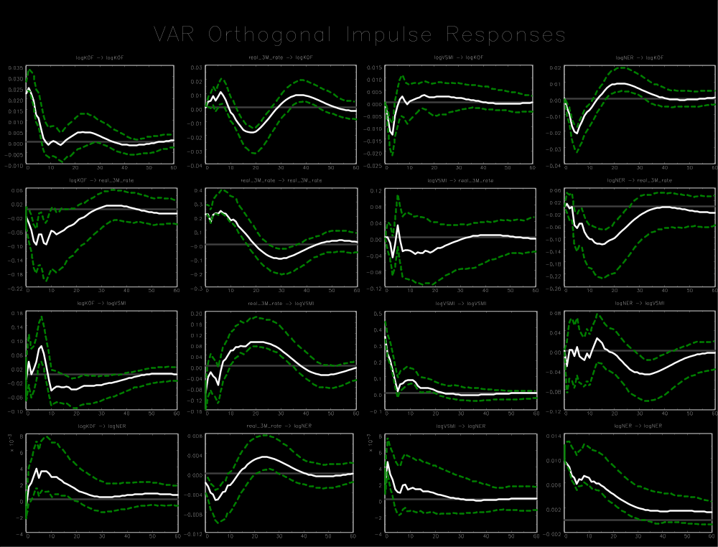

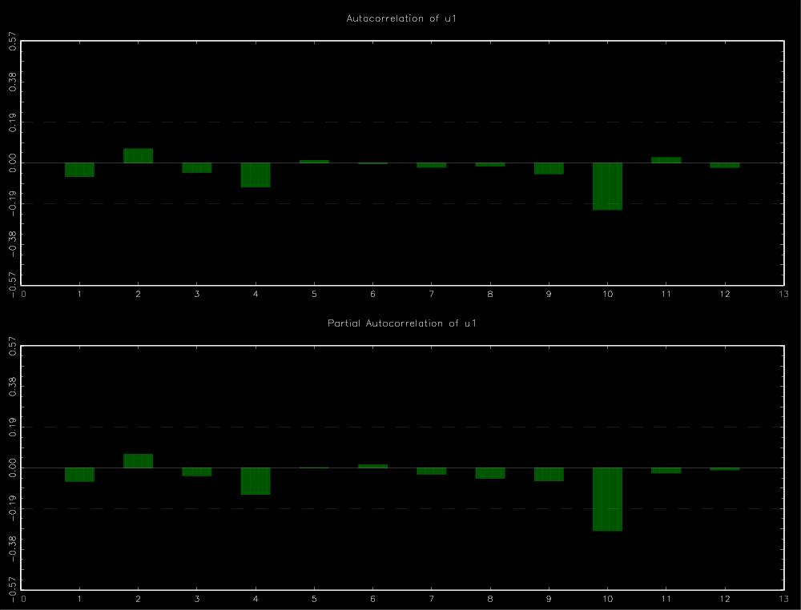
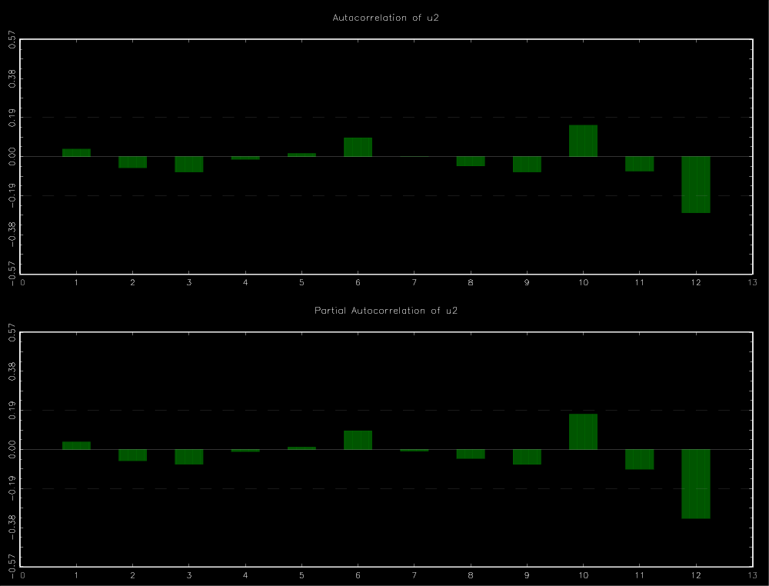
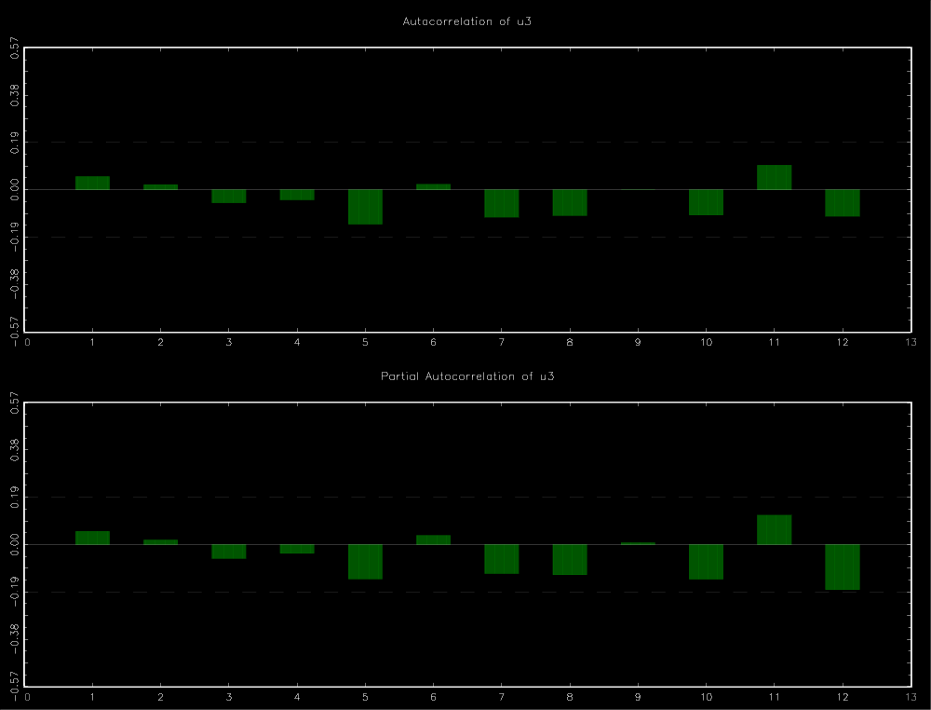
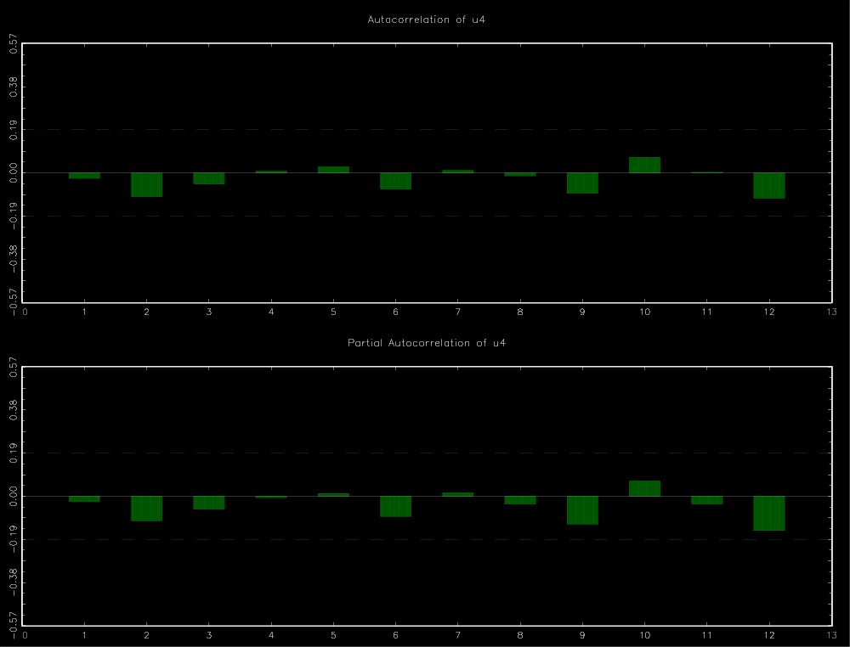
Appendix D
Switzerland (1999 M1-2008 M8)
Variable ordering: log(KOF index), real 3-month rate, log of the export-weigthed nominal exchange rate (logNER), log(VSMI²/12)
Lag order: 6
Breusch-Godfrey LM test for autocorrelation with small sample adjustment, on 8 lags ($H_{0}$: no autocorrelation): p-value = 0.0229
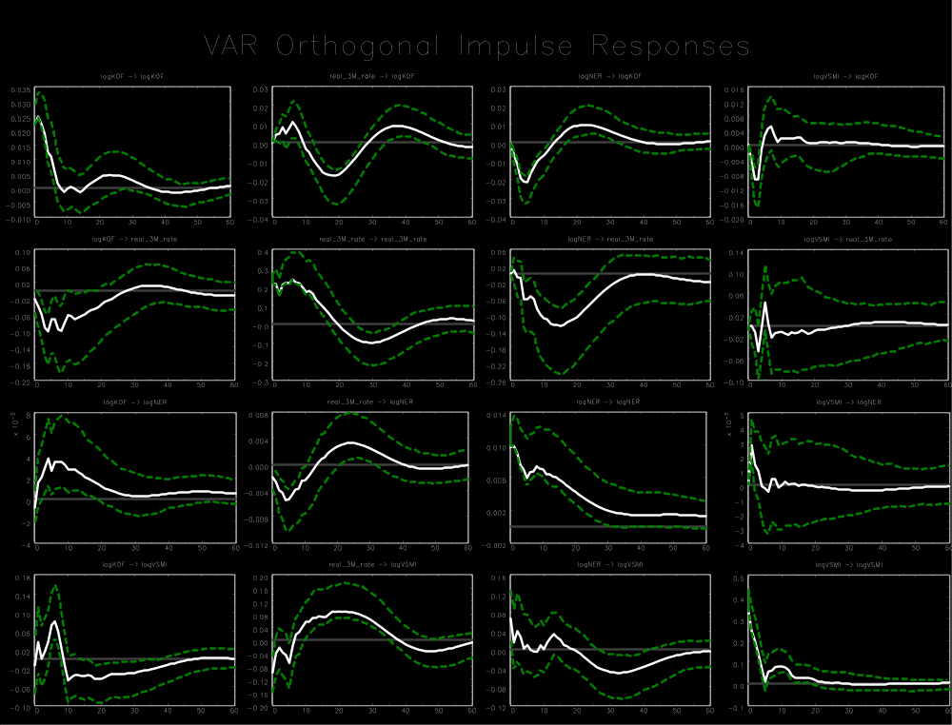

Appendix D
Switzerland (1999 M1-2008 M8)
Variable ordering: log(KOF index), real 3-month rate, log(VSMI²/12), log of the export-weigthed real exchange rate (logRER)
Lag order: 6
Breusch-Godfrey LM test for autocorrelation with small sample adjustment, on 8 lags ($H_{0}$: no autocorrelation): p-value = 0.0374
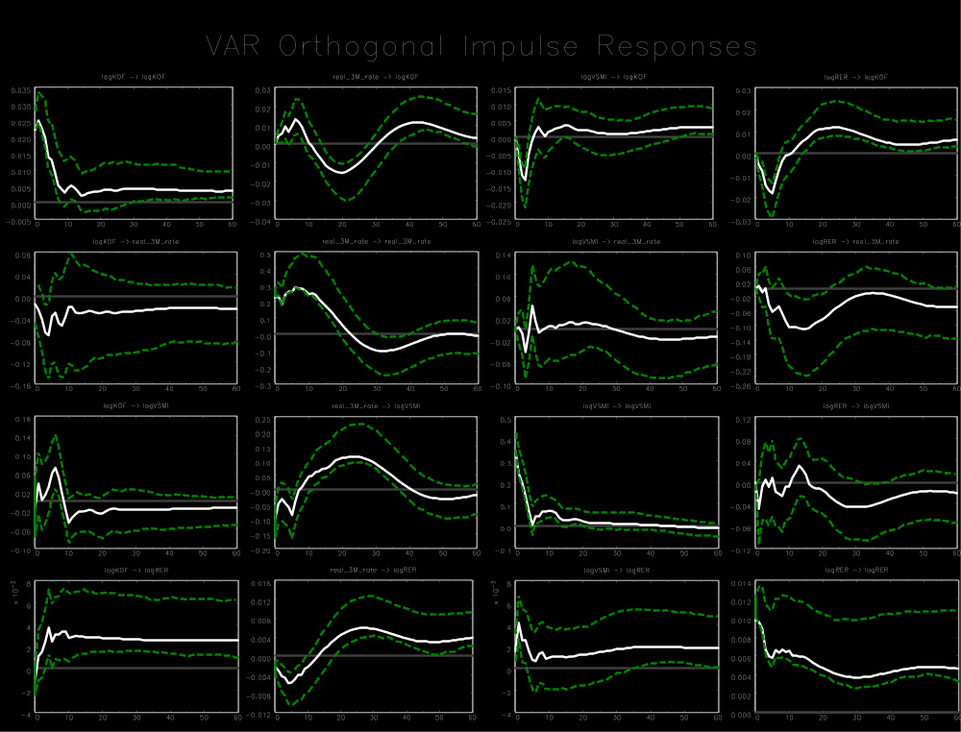

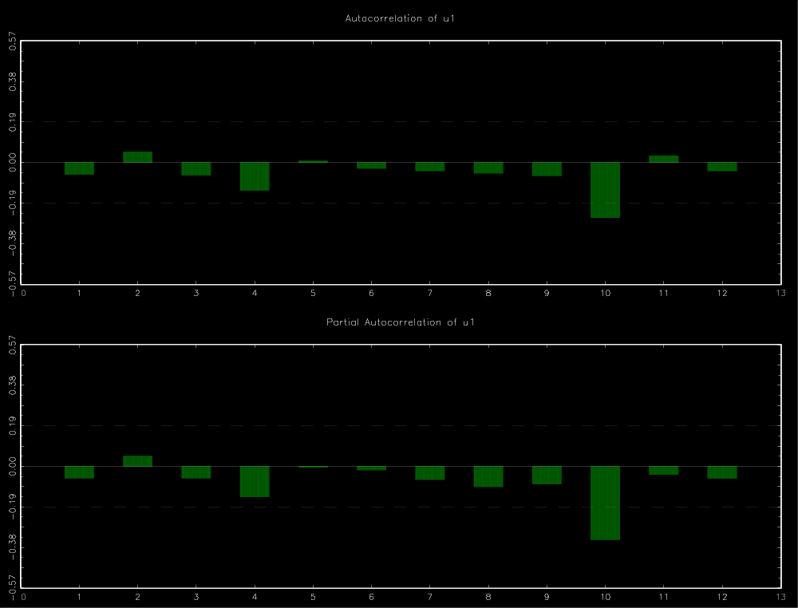
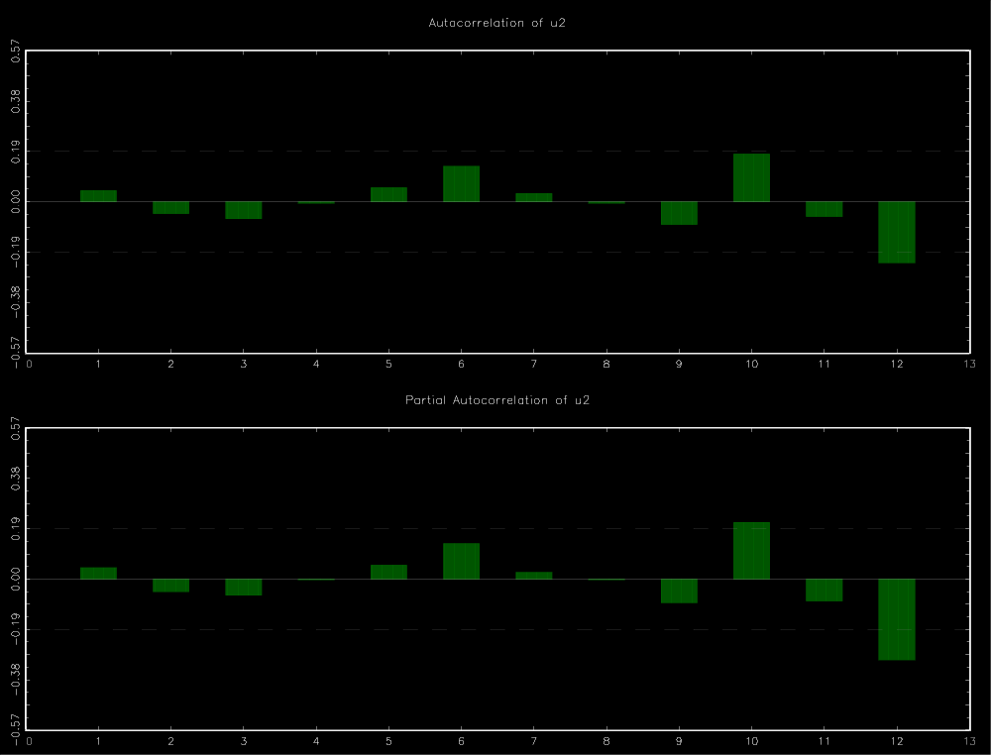
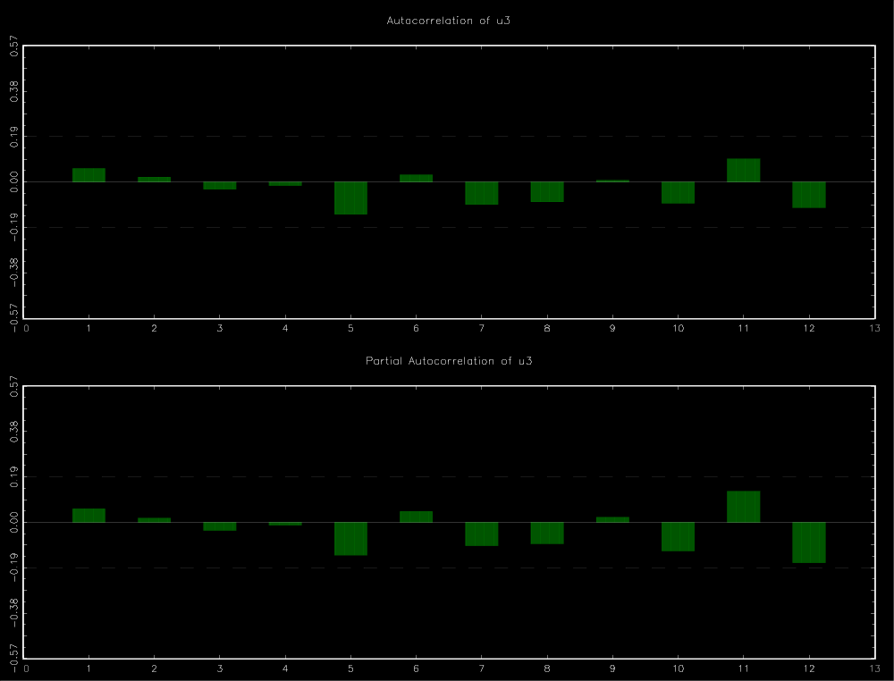
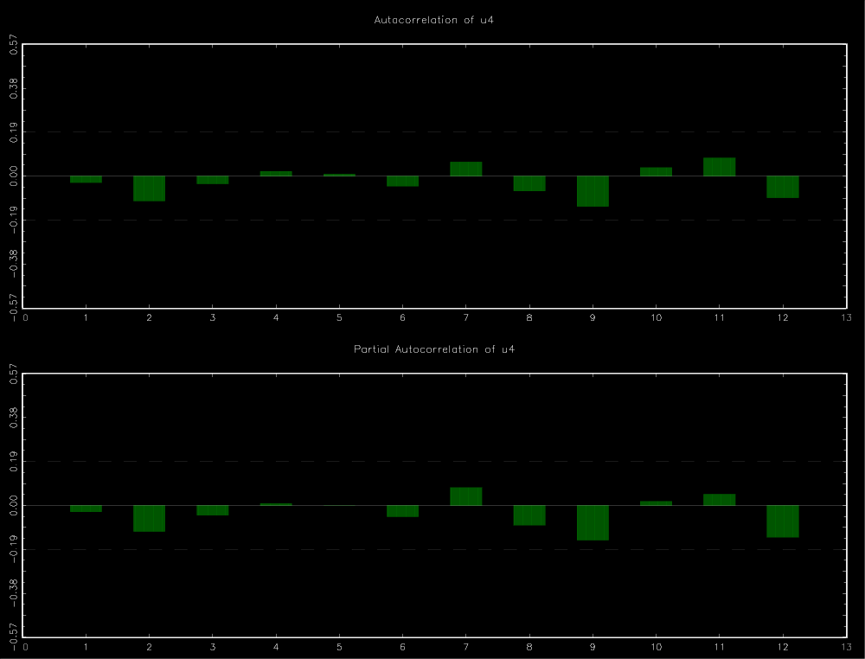
Appendix D
Switzerland (1999 M1-2008 M8)
Variable ordering: log(KOF index), real 3-month rate, log of the export-weigthed real exchange rate (logRER), log(VSMI²/12)
Lag order: 6
Breusch-Godfrey LM test for autocorrelation with small sample adjustment, on 8 lags ($H_{0}$: no autocorrelation): p-value = 0.0374
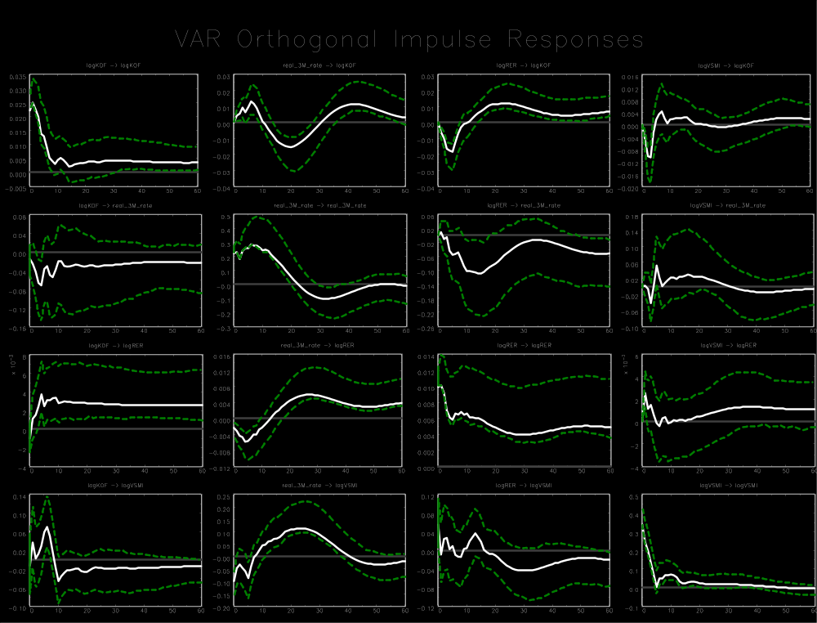

Appendix D
Switzerland (1999 M1-2008 M8)
Variable ordering: log(KOF index), nominal 3-month rate, log(VSMI²/12), log of the export-weigthed nominal exchange rate (logNER)
Lag order: 6
Breusch-Godfrey LM test for autocorrelation with small sample adjustment, on 8 lags ($H_{0}$: no autocorrelation): p-value = 0.0028
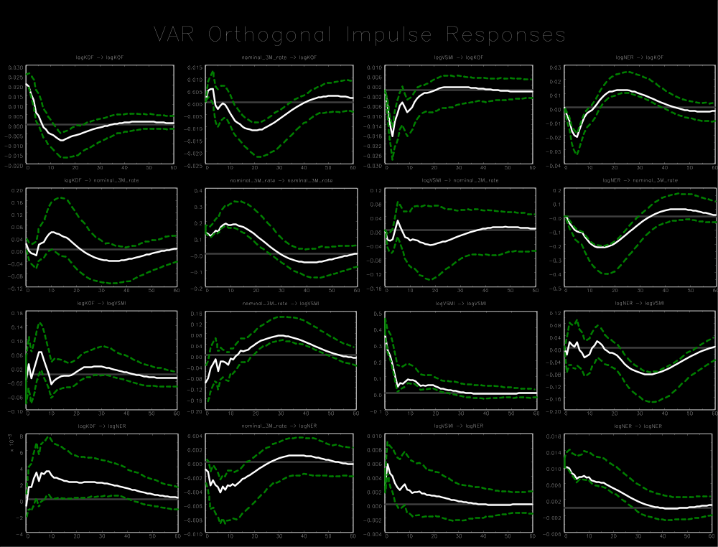

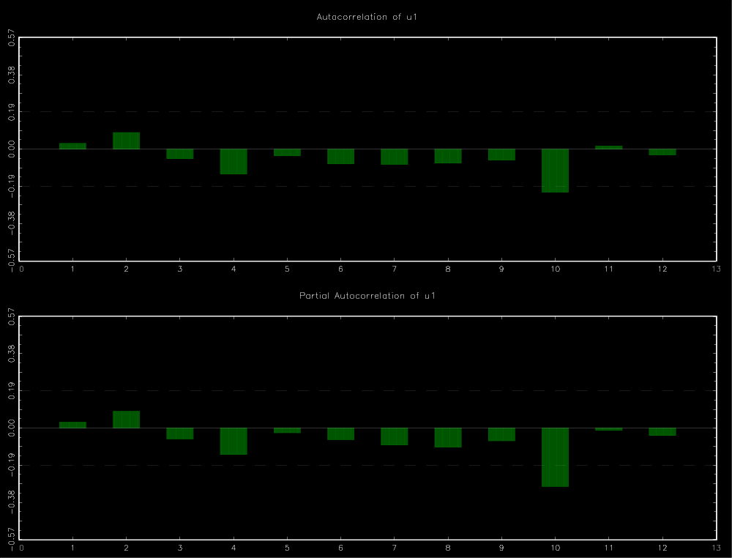
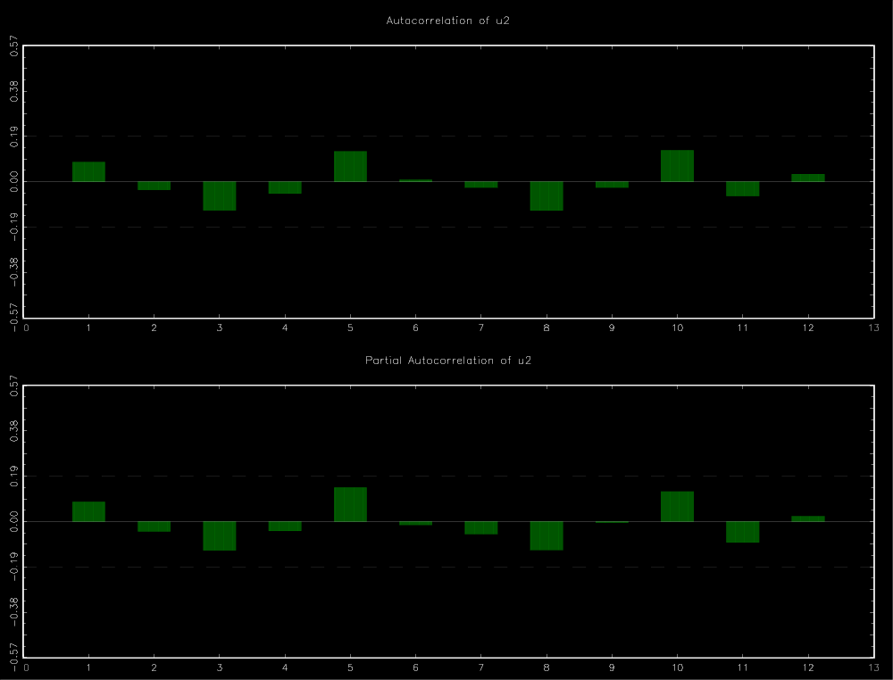
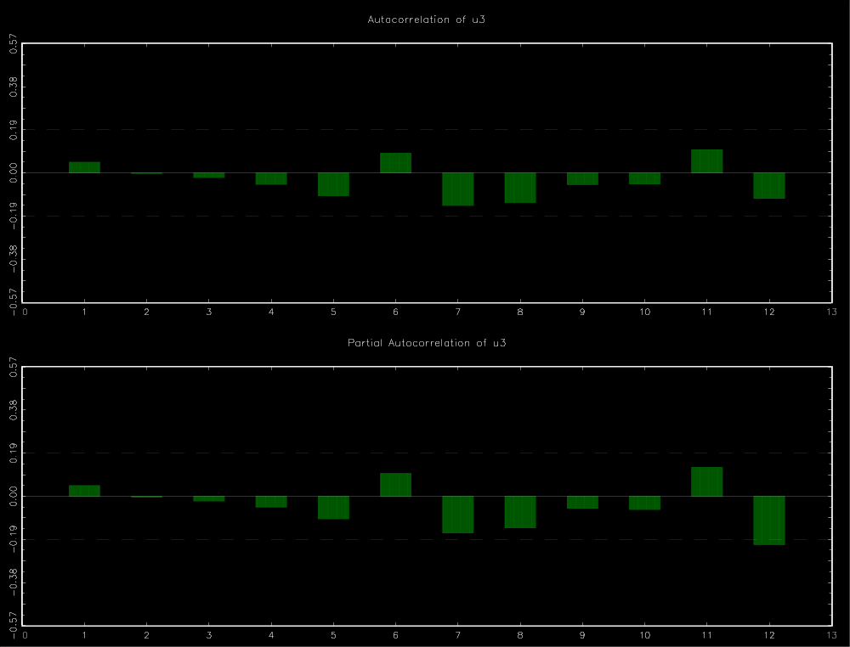
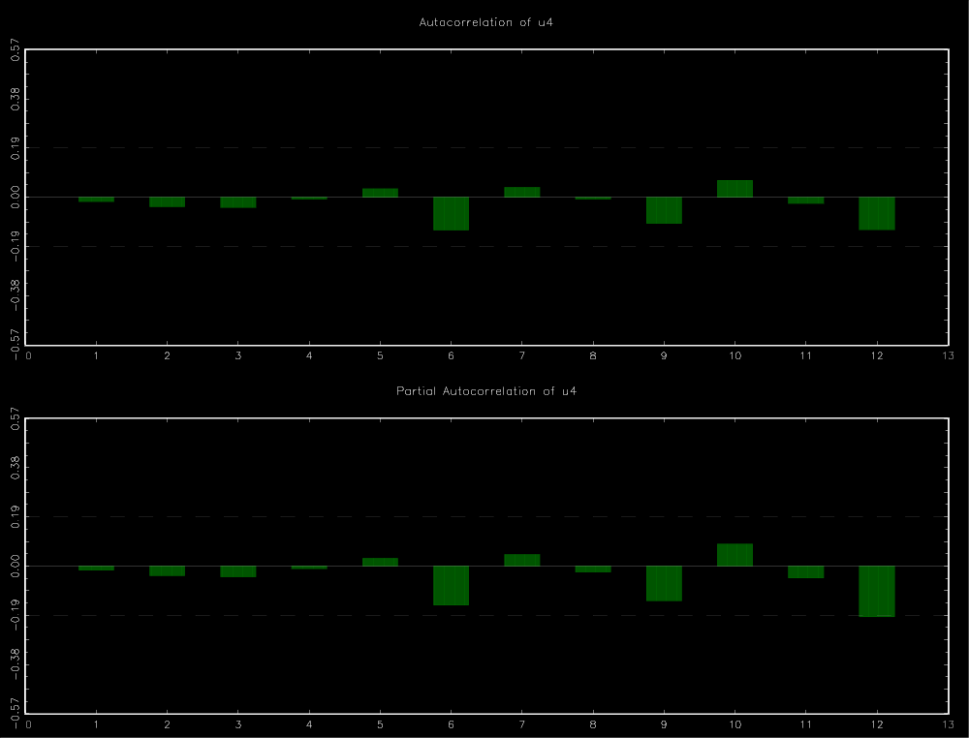
Appendix D
Switzerland (1999 M1-2008 M8)
Variable ordering: log(KOF index), nominal 3-month rate, log of the export-weigthed nominal exchange rate (logNER), log(VSMI²/12)
Lag order: 6
Breusch-Godfrey LM test for autocorrelation with small sample adjustment, on 8 lags ($H_{0}$: no autocorrelation): p-value = 0.0028
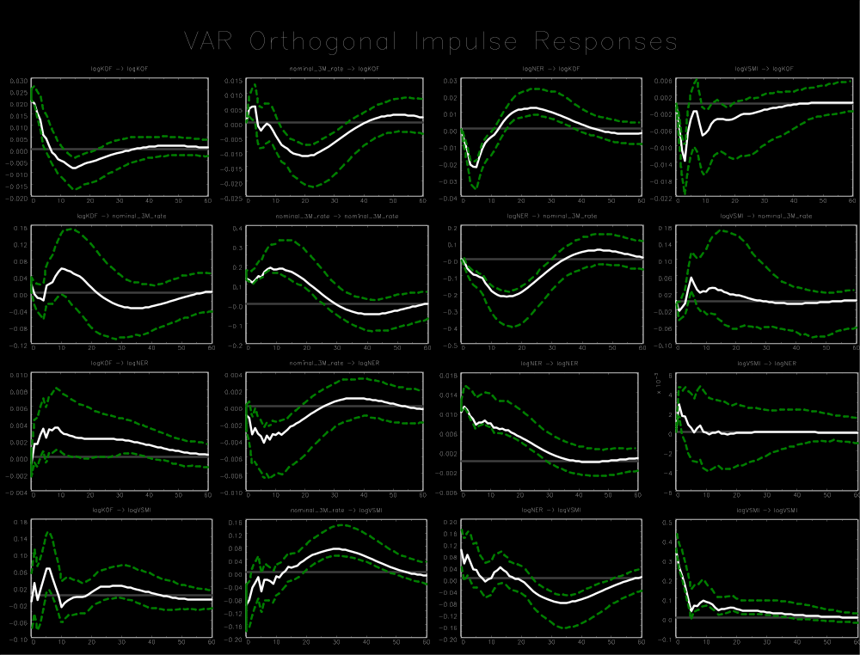

Appendix D
Switzerland (1999 M1-2008 M8)
Variable ordering: log(KOF index), nominal 3-month rate, log(VSMI²/12), log of the export-weigthed real exchange rate (logRER)
Lag order: 6
Breusch-Godfrey LM test for autocorrelation with small sample adjustment, on 8 lags ($H_{0}$: no autocorrelation): p-value = 0.0014
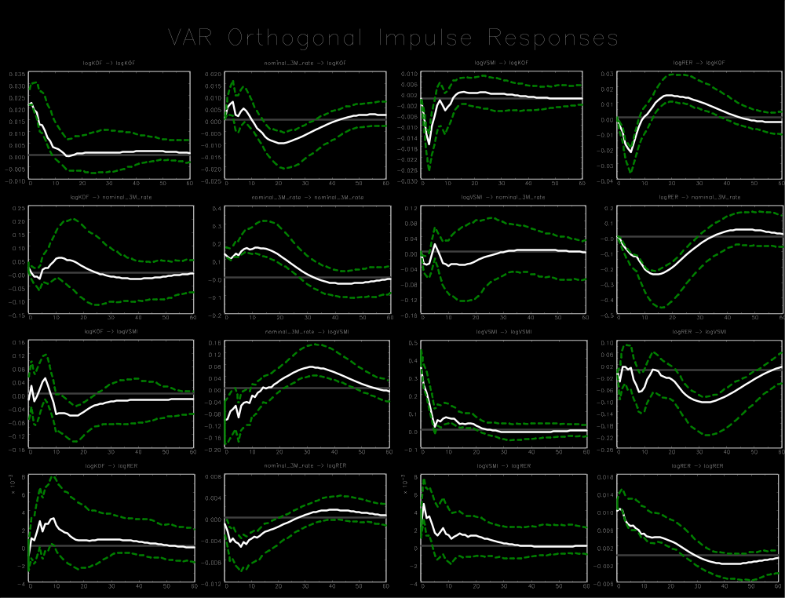

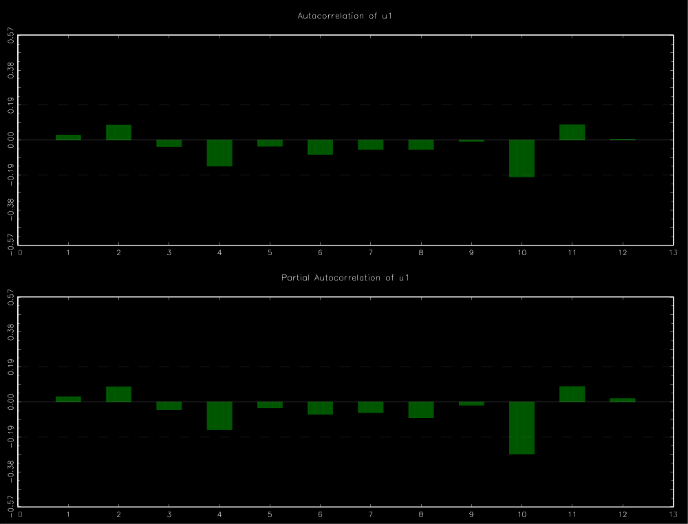
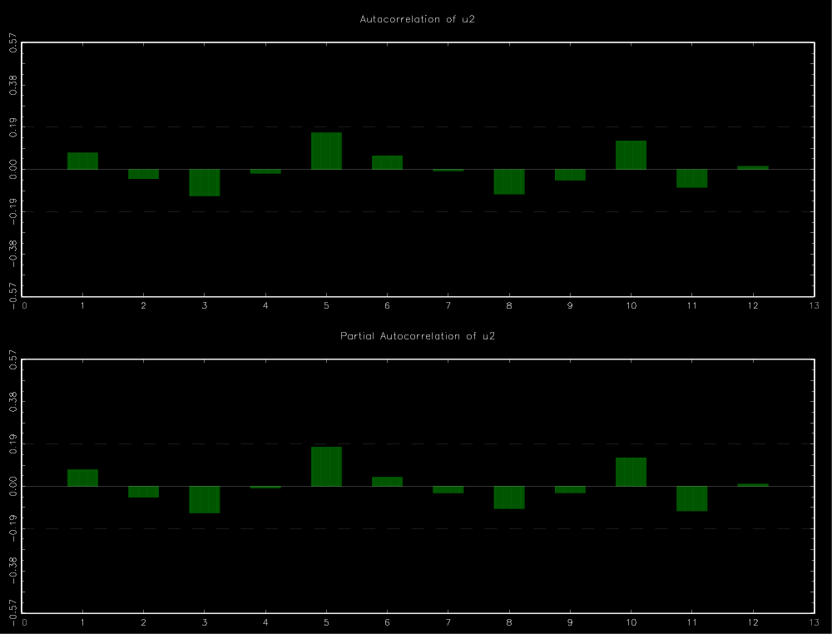
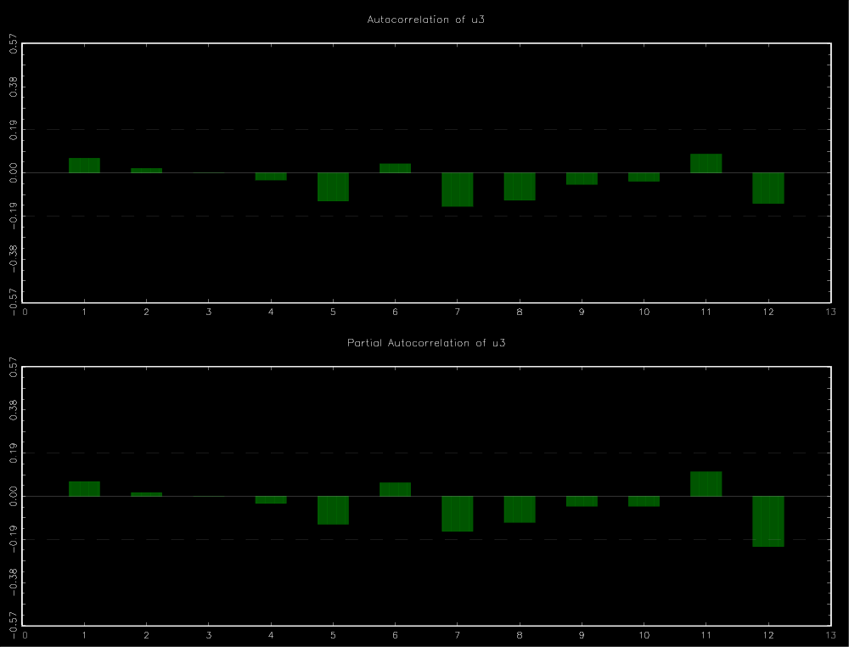
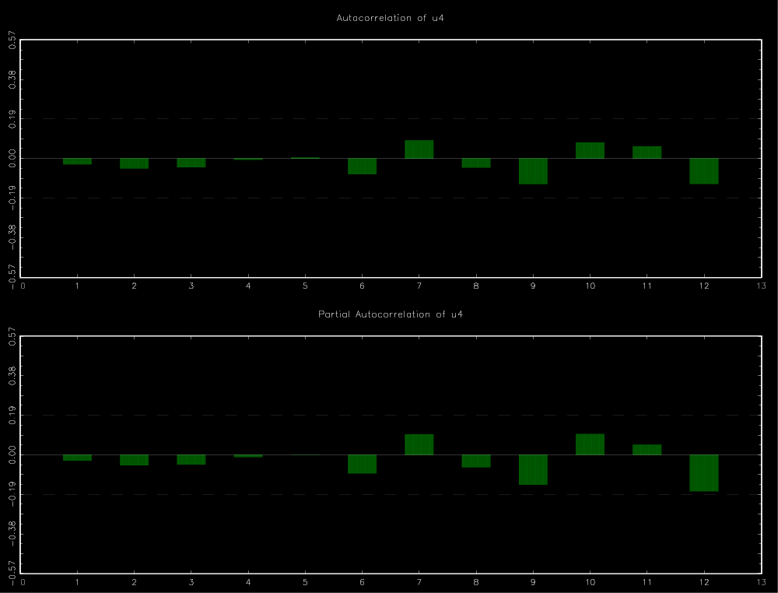
Appendix D
Switzerland (1999 M1-2008 M8)
Variable ordering: log(KOF index), nominal 3-month rate, log of the export-weigthed real exchange rate (logRER), log(VSMI²/12)
Lag order: 6
Breusch-Godfrey LM test for autocorrelation with small sample adjustment, on 8 lags ($H_{0}$: no autocorrelation): p-value = 0.0014
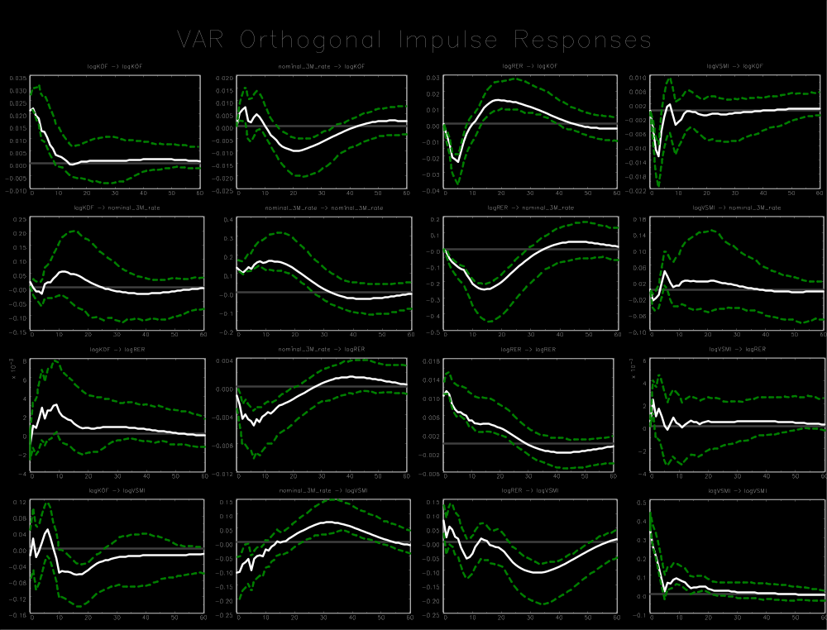

Stock market index (OIVI): DAX (VDAX-New), EURO STOXX 50 (VSTOXX), Swiss Market Index/SMI (VSMI).
As of 2015, 11 of the 50 companies included in the EURO STOXX 50 came from either Italy or Spain.
Details regarding these decompositions are provided in appendix A.
With 10 lags, there are 93 coefficients to estimate in the standard 3-variable VAR models.
The relevant plots are shown in appendix C2 for the Eurozone and in appendix D for Switzerland.
These months are January of 2001 (Greece), 2007 (Slovenia), 2008 (Cyprus and Malta), 2009 (Slovakia), 2011 (Estonia) and 2014 (Latvia). The addition of Lithuania in 2015 is not considered as the longest sample employed ends in December 2014.
Germany: 1992 M1-2014 M12, 1992 M1-1998 M12, 1999 M1-2008 M8, 1999 M1-2014 M12. Eurozone: 1999 M1-2014 M12 and 1999 M1-2008 M8. Switzerland: 1999 M1-2008 M8.
These findings are consistent with Bloom (2009), Denis and Kannan (2013), and Popescu and Smets (2010).
The aforementioned studies on the topic are Altunbas et al. (2014), Delis and Kouretas (2011), Gambacorta (2009), Ioannidou et al. (2015), and Jiménez et al. (2014).

