

Exploring the stock market participation of the Dutch population
21 June 2015

Abstract. Replicating and extending a 2014 paper written by Dimmock, Kouwenberg and Wakker, this study investigates the relation between stock market participation and ambiguity attitudes along with several demographic variables. The extension involves the introduction of interaction terms between gender and ambiguity and risk attitudes in the regression analysis. Most notably, women are found to be more risk averse than men, while men exhibit higher stock market participation. The analysis of the data also indicated that ambiguity aversion does not differ between Dutch men and women, and holds no significant explanatory power over stock market participation. In contrast, household income, gender, risk aversion and household size are significant predictors for stock market participation. Lastly, estimations of the interaction terms showed that neither risk nor ambiguity attitudes have a significant impact on the gender gap in stock market participation decision.

Joren Verbunt
Erasmus School of Economics
Rotterdam, The Netherlands
Student number: 322291
Email: 322291jv@student.eur.nl
Academic year: 2014-2015

Acknowledgments
I would like to thank Ilke Aydogan, my thesis supervisor, for his ideas, comments and support. I’m sure that without him this thesis would not have reached the quality I aspired to. Furthermore I would like to thank Nikita Hompus for her kind words of support and the time she took to correct my thesis.

Contents
Introduction 2
1 Literature Review 3
1.1 Ambiguity Attitudes 3
1.1.1 History of ambiguity 3
1.1.2 Possible explanations for ambiguity aversion 3
1.2 Ambiguity Attitudes and Stock Market Participation 5
1.3 Gender Differences in Risk/Ambiguity 7
1.3.1 Interpretation of a risky situation 7
1.3.2 Overconfidence 8
1.3.3 Emotion 8
1.3.4 Exceptions 8
1.3.5 Conclusion 9
1.4 Gender Differences in Stock Market Participation 9
3 Data Description 12
3.1 Data Origin 12
3.2 Variables 12
3.2.1 Demographic variables 12
3.2.2 Ambiguity and Risk Attitudes 13
4 Results 15
4.1 Descriptive Statistics 15
4.2 Econometric Analysis 15
4.2.1 Demographic Predictors for Stock Market Participation 15
4.2.2 Demographic Predictors for Ambiguity Attitudes 16
5 Discussion 21
6 Conclusion 24
References 25
Appendix 1 27

Introduction
The first mention of ambiguity, the situation in which objective probabilities are unknown to the decision maker, occurred in 1921 by F.H. Knight (1921). He thus distinguished ambiguity from risk where objective probabilities are known to the decision maker. After this novel approach many papers have been written on the subject. The subject is fascinating in that it occupies a central role in our existence, for we have to deal with unknown probabilities while making decisions every day. For decades, researchers have suspected that ambiguity plays a role in the decision whether or not to participate in the stock market. Interestingly, not many studies have managed to prove that ambiguity attitudes influence stock market participation.
In 2014, Dimmock, Kouwenberg and Wakker investigated the ambiguity attitudes of the Dutch population. After a pilot study with students they studied a large test panel with the help of the LISS data survey. The goal of their study was to measure the ambiguity attitudes of subjects and then investigate if those findings could predict investment behavior. They introduced a simple method for measuring ambiguity attitudes and concluded that their findings correlate with the economic decisions of the subjects. The results of Dimmock et al. (2014) are convincing, but there are extensions possible. Because Dimmock et al. (2014) used a large representative sample of subjects, it is possible to verify hypotheses that can be generalized to the population of a country. This opens up all kinds of interesting possibilities. For example, it is possible to investigate which gender exhibits higher stock market participation. Moreover, other interesting research possibilities are the gender differences in risk aversion and ambiguity aversion. In particular, whether male and female subjects are affected by risk and ambiguity to the same degree in decision of stock market participation is an open intriguing question that the current study will try to address.
This current paper aimed to recreate the research done by Dimmock, Kouwenberg and Wakker and extend it further by examining gender differences by estimating models to predict stock market participation and ambiguity attitudes. This study finds that both genders are equally ambiguity averse, but that women are more risk averse and less likely to participate in the stock market compared to men. Moreover, while ambiguity aversion is not a significant predictor for stock market participation, risk aversion is found to affect the decision to participate in the stock market. However, neither risk nor ambiguity attitudes are found to have a significant impact on the observed gender difference in stock market participation decision.
The outline of this paper is as follows. The relevant economic literature will be reviewed in chapter 1. In section 2 the research question and hypotheses will be elaborated. In chapter 3 the used data will be described. In section 4 the results will discussed. Chapters 5 and 6 contain a discussion and a conclusion.

1 Literature Review

1.1 Ambiguity Attitudes

1.1.1 History of ambiguity
The first mention of ambiguity (unknown probabilities) occurred in 1921 by Knight who distinguished risk from uncertainty (Knight, 1921). He stated that risk included known probabilities and that uncertainty is fundamentally different. Camerer and Weber (1992) define ambiguity as follows:
“Ambiguity is uncertainty about probability, created by missing information that is relevant and could be known.”
In a brilliant paper, Ellsberg (1961) expanded on the ambiguity problem and named it the ‘Ellsberg paradox’. He explained the paradox on the basis of an experiment, later called the 2-color problem. The experimental set-up is as follows: there are two urns, one urn with 50 red balls and 50 black balls, and one urn with 100 balls in an unknown proportion. The participant is promised a 15 dollar payout if a ball with his color of choice is drawn and then chooses the urn from which a ball to draw. Expected utility theory tells us that the odds of either color is identical for both urns, since there could be any variation between 100 red balls and 100 black balls in the ambiguous urn, so the mean for either color is 50 balls. Ellsberg noticed however that many people preferred betting on the known urn, which violates expected utility theory.

1.1.2 Possible explanations for ambiguity aversion
Over the years many studies have tried to explain the possible motivations behind ambiguity attitudes. According to Einhorn and Hogarth (1992), subjects use the information available to them to form an opinion. They suggest that subjects initially settle on an ambiguous probability and will gradually adjust their opinion as more information becomes available. To illustrate, if three witnesses claim that a robber wore a red vest and one witness claims the vest was blue, a subject is likely to hold the opinion that the robber wore a red vest even though he or she was not present during the robbery.
Heath and Tversky (1991) tried to find an explanation for ambiguity attitudes by expanding on the two-color problem set forth by Ellsberg (1961). They suggested that perceived competence plays a role in decisions made under uncertainty and named this the competence hypothesis. This hypothesis is summarized as follows: “If people consider themselves knowledgeable about a subject, they tend to prefer to bet on a situation related to that subject rather than on a comparable unambiguous event.” For example, people who knew a lot about football preferred betting on a game of football rather than on a game of chance with comparable odds. These results were confirmed by Keppe and Weber (1995).
Heath and Tversky (1991) proposed two explanations for the competence hypothesis. The first proposed explanation is that people believe that being relatively competent and knowledgeable about a topic increases their perceived chance of winning. Such beliefs may stem from lifelong experience that they achieve better results within their fields of expertise.
The second explanation proposed by Heath and Tversky (1991) is more complex. They suggest that losing a bet will be interpreted differently by a knowledgeable person than an ignorant person. The cause for this is that knowledgeable people will credit their knowledge for winning an ambiguous event (e.g. betting on a football game) while considering it bad luck when they lose. People who consider themselves not so knowledgeable will likely credit their ignorance on the topic for the loss while considering a win ‘lucky’. Winning or losing the comparable game of chance is likely to be considered luck by both ignorant and knowledgeable people.
In conclusion, competence or ignorance will influence how people feel after their bet on the ambiguous event. Since knowledgeable people are generally better at taking their loss into perspective, attributing it to bad luck for example, they will not feel as badly about it. Winning the bet on an ambiguous event will likely be attributed to their competence, enabling the subject to take credit for it. Ignorant people however will not be able to take credit for a winning bet, since they have likely guessed the outcome. A loss will be even worse for them, as they will consider their ignorance the cause of their misjudgment. As Heath and Tversky (1991) summarize it:
“Competence or expertise, therefore, helps people take credit when they succeed and sometimes provides protection against blame when they fail. Ignorance or incompetence, on the other hand, prevent people from taking credit for success and exposes them to blame in case of failure.”
As demonstrated by Heath and Tversky (1991), knowledge about a topic influences the willingness to bet on ambiguous events, but relative competence seems to be equally crucial. Relative competence can be explained as the amount of knowledge available to the subject compared to what can be known according to the subject.
Rothbart and Snyder (1970) studied the behavior of subjects who were asked to predict the roll of a die, either before the die was cast or after the die had been cast. A significant portion of the subjects preferred betting before the die was cast. Rothbart and Snyder suggest that their subjects behaved as if they could influence the cast of the die, though only when the cast of the die will happen in the future, not if the cast of the die happened in the past. An explanation for this could be that subjects prefer to avoid giving an incorrect prediction for an event that had already happened. Since it is possible for someone to know the die roll before the prediction takes place, the relative ignorance of the subject is high while betting on the past event.
This reasoning can be applied to the Ellsberg (1961) experiment. Since the content of the ambiguous urn can be known (to the researcher for example) the relative ignorance of the subject is relatively high. It is therefore possible that choosing an urn is ‘wrong’ even before the drawing of a ball, for example: betting to draw a red ball from an urn that contains 100 black balls. People dislike betting on the ambiguous urn because the content is unknown to them, but can be known to others.

1.2 Ambiguity Attitudes and Stock Market Participation
The stock market participation puzzle takes a prominent place in financial literature. Why do households not invest in equities when it is certainly profitable to do so? Several papers have been written on the subject and all have tried to find a plausible explanation for this phenomenon. Gouskova, Juster and Stafford (2004) state that: “Costs are not a major consideration to participate in the stock market, and some behavioral or other explanation might be needed”. This was confirmed by Mankiw and Zeldes (1991) who observed that of families who owned $100.000 or more, only 47.7% own stocks.
Due to renewed interest in the subject of ambiguity attitudes thanks to Golboa and Schmeidler (1989) and Schmeidler (1989), Dow and Werlang (1992) investigated if ambiguity could provide a solid explanation for the stock market participation puzzle. After careful examination of the Ellsberg paradox they suggested that for ambiguity averse subjects, the subjective probabilities of the mutually exclusive events do not add up to one. That is to say, ambiguity averse people consider the odds of drawing a red ball from the ambiguous urn plus the odds of drawing a black ball from the ambiguous urn less than a hundred percent. Ceteris paribus, ambiguity seeking people might consider those odds to be higher than a hundred percent.
This concept is quite abstract and can be clarified with the help of simple algebra. Suppose the event that a black ball is drawn from the unknown urn to be B_{U}, and the event that a red ball is drawn from the unknown urn to be R_{U}. Here P(B_{U}) + P(R_{U}) = 1, since these events are mutually exclusive. But an ambiguity averse subject interprets these odds differently, since these odds are unknown to the subject. Because of ambiguity attitudes these probabilities are transformed in a non-linear way with a matching probability function. For example, the matching probability function for an ambiguity averse subject would look like this: m(P(B_{U})) + m(P(R_{U})) < 1. Thus, ambiguity attitudes can be captured by this m(.) function. This matching function is called ‘ambiguity function’ in Dimmock, Kouwenberg and Wakker (2014), and was used to investigate the ambiguity attitudes of the Dutch subjects.
Dow and Werlang (1992) take the matching probability hypothesis a step further and apply it to stock market participation. To illustrate the idea of Dow and Werlang we need to examine conventional expected utility theory first. Suppose prices for equity can be arranged over an interval. A subject that is ambiguity neutral and risk neutral would buy equity at a price lower than the expected value. The same subject would sell (or ‘short’) equity at prices higher than the expected value. The interval would look something like this:
Figure 1
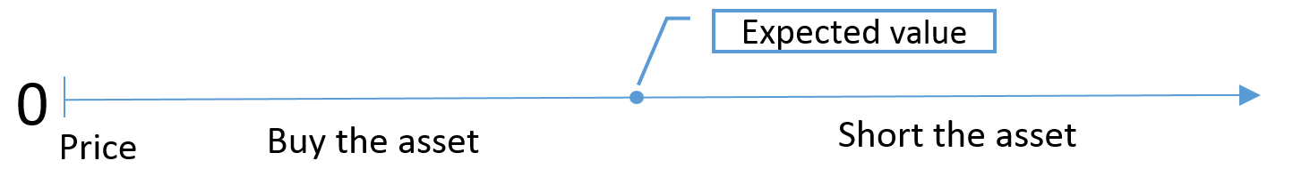

An ambiguity averse subject would behave differently in this situation because he or she values the same equity differently. There is a part on the interval on which the subject would neither buy nor sell the equity. At any price lower than this interval the subject would buy equity, at any price higher than this interval the subject would short equity. The interval would look something like this:
Figure 2
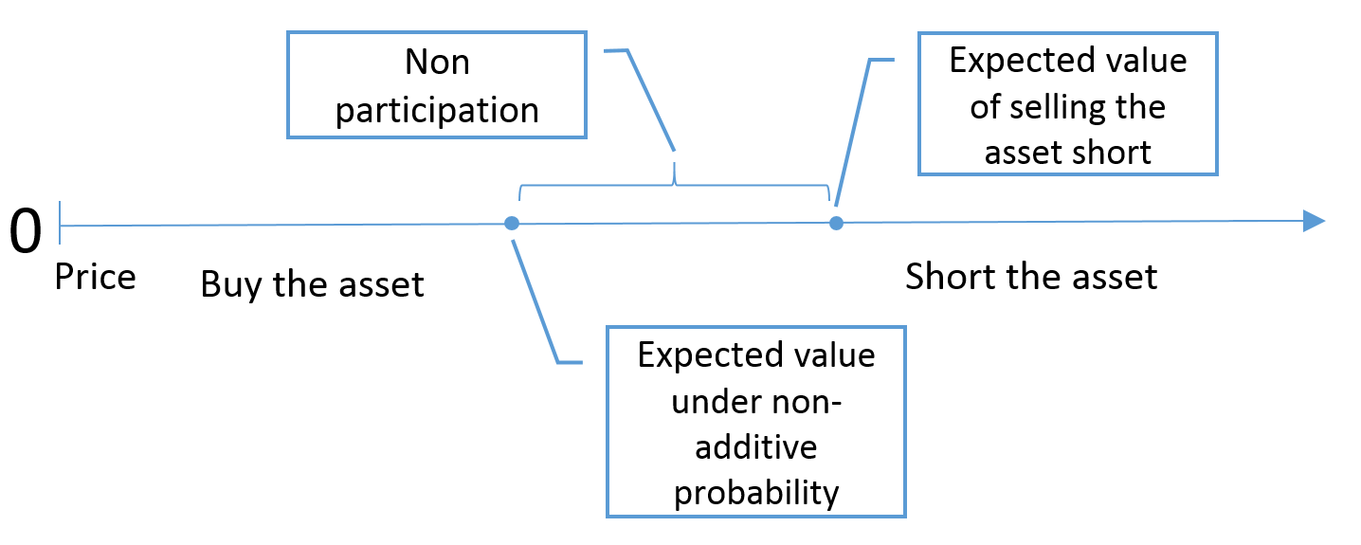

Ambiguity aversion is causing the discrepancy between the two points. Since ambiguity aversion is heterogeneous across the population it can plausibly explain the stock market participation puzzle. For the subjects that perceive the expected value of the equity to fall into the interval, there is an unambiguous alternative, insured deposits at a bank for example, and they will therefore choose not to invest in the stock market.
Following from this literature review it is logical to assume a negative relation between ambiguity aversion and stock market participation. This assumption will be tested in the statistical part of this paper.

1.3 Gender Differences in Risk/Ambiguity
There is a wide array of psychological and economic papers on the subject of gender differences and decision making under risk. As summarized by Eagly (1995) most psychological studies confirm that differences exist between genders, although the causes of these differences are left unexplained. Johnson and Powell (1994) state that findings of these psychological studies were causal in the forming of stereotypical beliefs concerning men and women in financial and business decision making. Although recent papers contradict some of these findings, a conclusion that was consistently found in the literature was that women are more risk averse than men. Moreover, Croson and Gneezy (2009) found that women are more averse to competition than men. Women were also found to be more ambiguity averse than men (Powell & Ansic, 1997). Several explanations for these conclusions are proposed in the literature and the most prominent ones will be summarized below.

1.3.1 Interpretation of a risky situation
One aspect that influences the preferences of genders is the interpretation of a risky situation. The description and setting of a risky situation have an influence on the subject’s mindset and decision making (Bromiley & Curley, 1992).
Schubert, Brown, Gysler and Brachinger (1999) state that the setting of a risky situation influences the decision behavior. They conclude that men and women are equally risk averse in a contextual setting but that women are more risk averse in a purely hypothetical setting. Another finding by Schubert et al. (1999) was that women are more ambiguity averse than men when considering an investment setting, but they recognized that both genders are equally ambiguity averse when considering an insurance setting.
Dickson (1981) confirms the notion that the interpretation of a risky situation influences decision behavior. He discovered that risk aversion was more prominent when the questions were framed in terms of losses rather than gains. Croson and Gneezy (2009) take that hypothesis a step further and suggest that males are more likely to consider a risky situation a challenge while females will consider it a threat. This results in different behavior.

1.3.2 Overconfidence
Another aspect that influences the preferences of genders relates to confidence. Croson and Gneezy (2009) state that men are more often overconfident in their success in ambiguous situations compared to women. They also found that women were less confident in their investment decisions than men. According to Niederle and Vesterlund (2007), overconfidence in their performance is common among men. Men are significantly more overconfident in their performance than women. Such overconfidence can lead to overestimation of the odds to win a bet and will make it more likely for men to accept risk than women.

1.3.3 Emotion
The last aspect that influences the preferences of genders has to do with the difference in emotional reactions to risky situations. Croson and Gneezy (2009) state that women experience more fear and nervousness when anticipating a negative outcome. This could lead to more risk aversion. Another significant difference between men and women is that women tend to experience fear in situations where men tend to experience anger. Lerner, Gonzalez, Small and Fischhoff (2003) found that anger influences the subjective interpretation of odds. They conclude that odds were considered less risky when subjects were angry compared to subjects that were in a fearful state of mind.

1.3.4 Exceptions
Although the general consensus in the literature is that women of the general population are more risk averse than men, quite a few papers highlight an exception to this rule. The hypothesis that women are more risk averse than men does not apply to business majors and managers in the field of finance. These findings are supported by the conclusion of Schubert et al. (1999), who used business undergraduates to perform their study and found no apparent differences in risk preferences between both genders. Powell and Ansic (1997) and Croson and Gneezy (2009) reached similar conclusions.
There are two possible explanations for this exception. First is that these women may have learned through education and experience to rationalize losses which leads to less risk aversion. The second explanation is that there is an apparent degree of self-selection which ensures that women with similar preferences to men work in financial management positions. Sapienza, Zingales and Maestripieri (2009) state that of out female business majors 36% chose risky careers while 57% of the men chose risky careers.

1.3.5 Conclusion
After examination of the existing literature, it would seem that women are in general more risk averse than men. There are several factors that contribute to this difference in preferences. Firstly, men and women respond differently to risky situations. Secondly, men are more confident in their relative performance than women, which causes them to overvalue their odds to win a bet. And thirdly, men and women experience different emotional reactions to losses and wins.
An important exception to the fact that women are more risk averse than men concerns business majors and financial managers. Since the discrepancy in preferences between the general population and financial managers has been recently discovered, it is possible that older studies on the general population were wrongly applied to financial managers. This could have led to the forming of stereotypical beliefs that women are less competent managers than men.
Although this exception is not particularly relevant for this study, since the sample is representative of the general population, it did warrant inclusion as a possible further research direction.

1.4 Gender Differences in Stock Market Participation
Van Rooij, Lusardi and Alessie (2007) found that women participate significantly less in the stock market. They suggest lower female financial literacy as a plausible cause. Almenberg and Dreber (2012) studied this hypothesis and came to the conclusion that the hypothesis of Van Rooij et al. was correct. Almenberg and Dreber (2012) found that basic financial literacy can plausibly explain the gender difference in stock market participation. Particularly striking is that Van Rooij et al. based their research on a sample that is representative of the Dutch population, just like Dimmock et al.

2 Hypotheses
The sample used by Dimmock et al. (2014) is large and representative for a population, which makes it excellent for future research. Since a larger sample includes more variation within the demographic variables, it better reflects a population. This allows generalization of the empirical findings which means that the behavioral characteristics of a population can be studied. In short, the large sample used by Dimmock et al. (2014) provides an excellent opportunity to investigate the Dutch population.
Following from the extended literature, it is logical to suspect differences between genders. Most studies find that women are more risk averse and more ambiguity averse than men (Powell & Ansic, 1997) (Croson & Gneezy, 2009), some studies find that women participate less in the stock market (Almenberg & Dreber, 2012) (van Rooij, Lusardi, & Alessie, 2007). This leads to the first hypothesis: ‘Women are more ambiguity averse, more risk averse and less likely to participate in the stock market.’ Another presumption following from the literature is a negative relation between stock market participation and risk and ambiguity aversion (Dow & Werlang, 1992). In order to investigate this relation, a second hypothesis is proposed: ‘Risk aversion and ambiguity aversion are significant predictors for stock market participation.’ When the previous hypotheses are examined closely, an interesting new research avenue presents itself. If ambiguity aversion and risk aversion have a significant influence on the decision to participate in the stock market, and ambiguity aversion and risk aversion are higher among women, could it be possible that women are more affected by risk and ambiguity in their decision to participate in the stock market? This leads to the third hypothesis: ‘The impact of risk and ambiguity in stock market participation is more pronounced on women than men, i.e. women are affected more by risk and ambiguity in decision of stock market participation.
To summarize, the following hypotheses are proposed:
- Women are more ambiguity averse, more risk averse and less likely to participate in the stock market.
- Risk aversion and ambiguity aversion are significant predictors for stock market participation.
- The impact of risk and ambiguity in stock market participation is more pronounced on women than men, i.e. women are affected more by risk and ambiguity in decision of stock market participation.
These hypotheses lead to the following research questions of this paper:
“Are risk aversion and ambiguity aversion different for men and women? How do these attitudes affect stock market participation? If ambiguity and risk attitudes are different between genders, is it possible that risk attitudes and ambiguity attitudes affect genders differently in the decision to participate in the stock market?”

3 Data Description

3.1 Data Origin
The dataset used in this study originates from the Longitudinal Internet Studies for the Social sciences (LISS). The LISS datasets are maintained by CentERdata, a research institute based in Tilburg, the Netherlands. CentERdata has selected 8000 individuals based on a true probability sample which was estimated to be a general representation of the Dutch population. The panel is composed of approximately 5000 households who are asked to participate in an online questionnaire every month. The reliability and large pool of subjects make the panel ideal for conducting research.
Dimmock et al. (2014) chose the LISS panel particularly for these two properties. In January 2010, they send 2491 subjects a questionnaire to which 1935 subjects responded. For this study, the background variables and financial information from core LISS datasets were added to the responses Dimmock et al. received. This was done to control for demographic variables. The background data originates from February 2015, the financial information used originates from wave 2, 2010.
Of the original 1935 subjects, 939 were paid real incentives (€7650 total). In order to keep the study as close to real life decisions as possible, the subjects that did not receive real incentives were omitted. Of the remaining subjects, 144 were omitted because of missing financial information. This resulted in a sample pool of 795 subjects.

3.2 Variables

3.2.1 Demographic variables
The control variables provided by the LISS background variables dataset are extensive. Information is available ranging from age, gender and marital status to household income, education and household size. The financial information provided by LISS was thoroughly constructed, although the many missing entries made the dataset less useful. The dataset created by Dimmock et al. (2014) contained the coded answers to the questions posed during their research. These answers were coded into usable variables which are described in section 3.2.2. Unfortunately there was no information available on the profession of the subjects. A complete list with the coding of each used variable can be found in Appendix 1.

Table 1.1 Summary Demographic Variables

The presented numbers in table 1.1 are means, either of the entire sample, only of the stock market participants or only of the stock market non-participants. For example, the mean age of stock market participants was 54.71 years. Stock market participation is a dummy variable, since a subject either owns stocks or a subject doesn’t own stocks. Female (gender) and ‘living with a partner’ are also dummy variables. The income presented is the monthly mean gross income on the household level in euros. Education is an ordinal variable with 6 categories, ranging from primary school to a university degree. The bracketed abbreviations indicate the equivalent counterpart within the Dutch educational system.
Variable | All | Stock Market Participants | Stock Market Non-Participants
Stock Market Participant | 18,87% | 100% | 0
Gross Household Income | € 3.810,66 | € 4.766,56 | € 3.588,84
Age | 50,11 years | 54,71 years | 49,04 years
Female | 53% | 35% | 57%
Household Size | 2,47 | 2,31 | 2,51
Living with a Partner | 73% | 76% | 72%
Education
Low (Primary school) | 4,8% | 1,3% | 5,6%
Low / Intermediate (VMBO) | 28,6% | 18,0% | 31,0%
High / Intermediate (havo/VWO) | 10,6% | 8,7% | 11,0%
Vocational 1 (MBO) | 20,5% | 20,0% | 20,6%
Vocational 2 (HBO) | 21,4% | 29,3% | 19,5%
University | 8,8% | 19,3% | 6,4%
As a first impression, gross monthly income appears to be higher among stock market participants. The male/female proportion seems to be distorted among stock market participants. Stock market participants appear to have completed higher levels of education. Stock market participants appear to be older, although this difference is unlikely to be significant.

3.2.2 Ambiguity and Risk Attitudes
The ambiguity and risk attitudes were derived from several questions posed by Dimmock et al. (2014) Ambiguity aversion 0.5 for example was derived from a question inspired by the Ellsberg paradox. Two urns are presented, one urn contains 50 red balls and 50 blue balls and the second urn contains red and blue balls in an unknown proportion. The subject is to select a color and is promised a payout if a ball of that color is drawn from an urn. The subject is then to select an urn to draw a ball from. If the subject selects the known urn, the subject is coded as ambiguity averse, since he or she avoided the ambiguous urn. If the subject chose the ambiguous urn, the subject is coded ambiguity seeking. Indifference between the urns was pooled with ambiguity seeking.
A similar question was used to derive ambiguity aversion 0.1, only the known urn contained 10 balls of 10 different colors. The unknown urn contained 100 balls of 10 colors in an unknown proportion. The subject was rewarded when a ball with his color of choice was drawn. An identical setup was proposed in the question that was used to derive ambiguity aversion 0.9, only now the subject was rewarded when a ball with his color of choice was not drawn.
Risk aversion was derived from a seemingly similar, but fundamentally different question. Two urns were presented to the subject, one urn containing 100 blue balls and one urn containing 50 blue and 50 red balls. The subject is promised a payout whenever a blue ball is drawn, but the payouts differ between urns. The subject is promised 500 euros when a blue ball is drawn from the all blue ball urn, but 1000 euros when a blue ball is drawn from the fifty-fifty urn. If the subject chose the all blue ball urn, the subject is coded risk averse. If the subject chose the fifty-fifty urn, the subject is coded risk seeking. Indifference between the urns was pooled with risk seeking.
Table 1.2 Ambiguity and Risk Aversion Attitudes
Variable | All | Stock Market Participants | Stock Market Non-Participants
Ambiguity Averse 0,1 | 31,57% | 34,00% | 31,01%
Ambiguity Averse 0,5 | 62,14% | 64,67% | 61,55%
Ambiguity Averse 0,9 | 46,92% | 52,67% | 45,58%
Risk Averse | 57,86% | 65,3% | 56,1%
The ambiguity aversion variables presented in table 1.2 are derived from the previously discussed questions posed in the questionnaire Dimmock et al. created. All of the 4 variables are dummy variables, with 1 meaning that a person exhibited ambiguity aversion and 0 meaning either indifference or ambiguity/risk seeking behavior. As a first impression, risk aversion seems to be higher among stock market participants.

4 Results

4.1 Descriptive Statistics
The result of the chi-square comparison tests (see tables 2.1 - 2.5) can be interpreted as follows. Women exhibit lower stock market participation compared to men. This finding is significant even on the 1% level. Women are also more risk averse than men. Although this finding is in correspondence with the existing literature, the result is only significant at the 10% level, which weakens the power of this conclusion. As for the three ambiguity attitudes, there was no significant difference found between men and women.
The hypotheses that women are more risk averse and less likely to participate in the stock market cannot be rejected. The hypothesis that ambiguity aversion is higher among women compared to men must be rejected.

4.2 Econometric Analysis

4.2.1 Demographic Predictors for Stock Market Participation
The binary logistic regressions with stock market participation as the dependent variable yield interesting results (see table 3.1). Gross household income is highly significant across all regressions. Although the coefficient might seem insignificant at 0.001, keep in mind that it will be multiplied by the gross household monthly income. The gross household income squared is less interesting as the coefficient is even smaller at 0.000 and only significant at the 10% level.
Gender is highly significant across all regressions. The dummy variable was coded 0 for males and 1 for female, which means that the outcome for males is not influenced by the coefficient. The negative sign indicates that females have lower stock market participation. This finding confirms and augments the conclusion of the chi-square test.
Household size is significant across all regressions, but only on the 10% level. The coefficient is negative for all regressions which means that stock market participation decreases as household size increases. This is a categorical variable which means that as the household size increases, the effect becomes stronger.
Education is highly significant across all regressions. As mentioned, this is an ordinal variable, with 1 indicating that a subject completed primary school and 6 indicating that a subject completed university. This result indicates that better education increases stock market participation. This finding confirms the presumption raised in the data description.
Risk aversion is highly significant in both regressions, although the interaction term is not significant and provides no additional explanatory value. The risk aversion coefficients are positive which strangely indicates that it is more likely for a person to participate in the stock market when they are risk averse. Although strange, this conclusion confirms the presumption raised in the data description that stock market participants exhibit higher risk aversion.
There was a slight significant relation found between stock market participation and ambiguity attitudes, but this is not sufficient to draw a robust conclusion. The addition of interaction terms between gender and ambiguity attitudes did not add significant explanatory value.
The hypothesis that risk aversion is a significant predictor variable for stock market participation cannot be rejected. The hypothesis that ambiguity aversion is a significant predictor variable for stock market participation must be rejected. The hypothesis that risk aversion and ambiguity aversion affect women more in decision of stock market participation must be rejected.

4.2.2 Demographic Predictors for Ambiguity Attitudes
The results of the binary logistic regressions with ambiguity attitudes as the dependent variable (see table 3.2) are less straightforward to interpret. Risk aversion for example is highly significant as a predictor for ambiguity attitude 0.5 and ambiguity attitude 0.9 but holds no explanatory value over ambiguity attitude 0.1.
Gross household income on the contrary is highly significant as a predictor for ambiguity attitude 0.1, but holds no explanatory value over ambiguity attitudes 0.5 and 0.9. Household size is even less consistent as a predictor, being highly significant for AA 0.1, not significant at all for AA 0.5 and slightly significant for AA 0.9.
There is no significant relation between ambiguity attitudes and age, gender, education or whether or not the subject lived with a partner. The addition of interaction terms between gender and risk aversion did not have an effect.
These findings confirm and augment the results of Sutter et al. (2013), who found no relation between ambiguity aversion and demographic variables.

Descriptive statistics tables:
Table 2.1: Risk Aversion and Gender
Below the chi-square statistics for Risk Aversion*Gender. 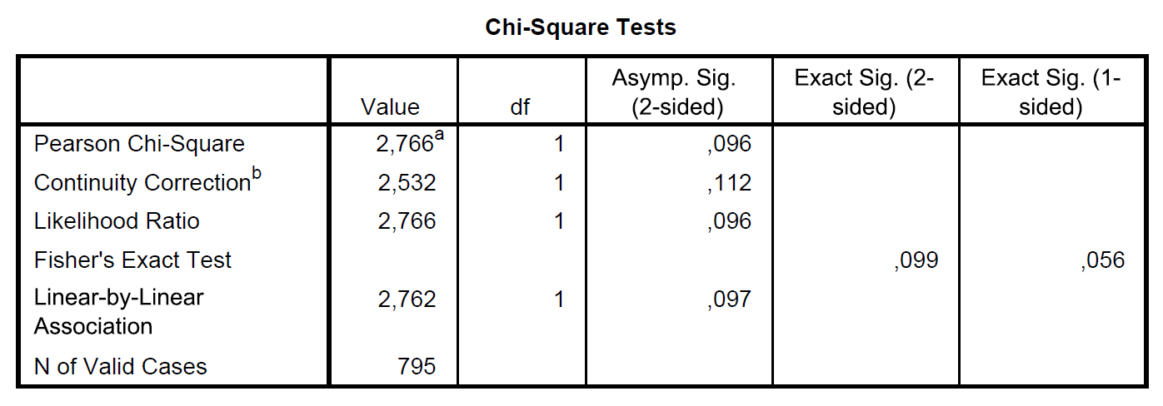
Table 2.2: Stock Market Participation and Gender
Below the chi-square statistics for Stock Market Participation*Gender. 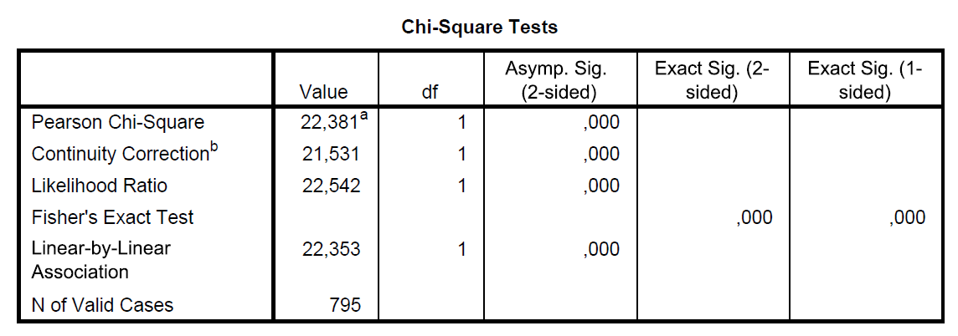

Table 2.3: Ambiguity Attitude 0.5 and Gender
Below the chi-square statistics for Ambiguity Attitude 0.5*Gender. 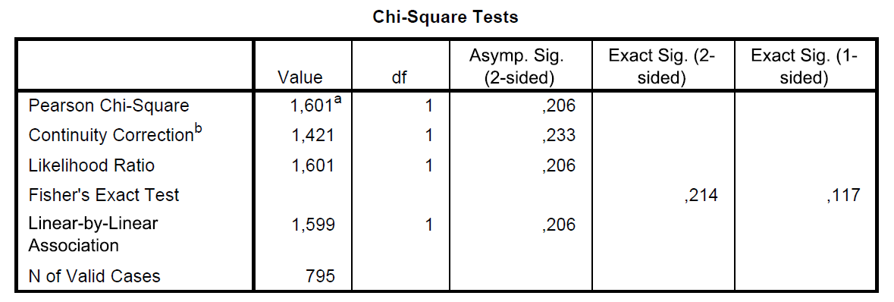
Table 2.4: Ambiguity Attitude 0.1 and Gender
Below the chi-square statistics for Ambiguity Attitude 0.1*Gender. 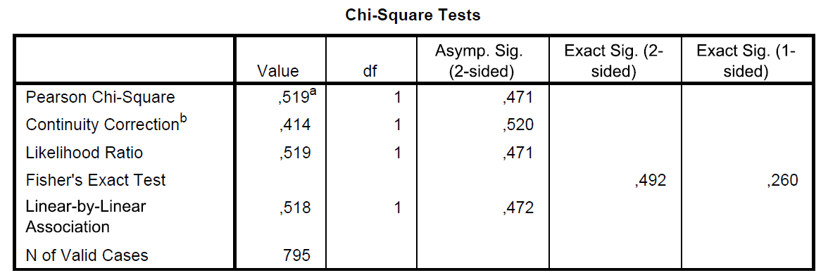
Table 2.5: Ambiguity Attitude 0.9 and Gender
Below the chi-square statistics for Ambiguity Attitude 0.9*Gender. 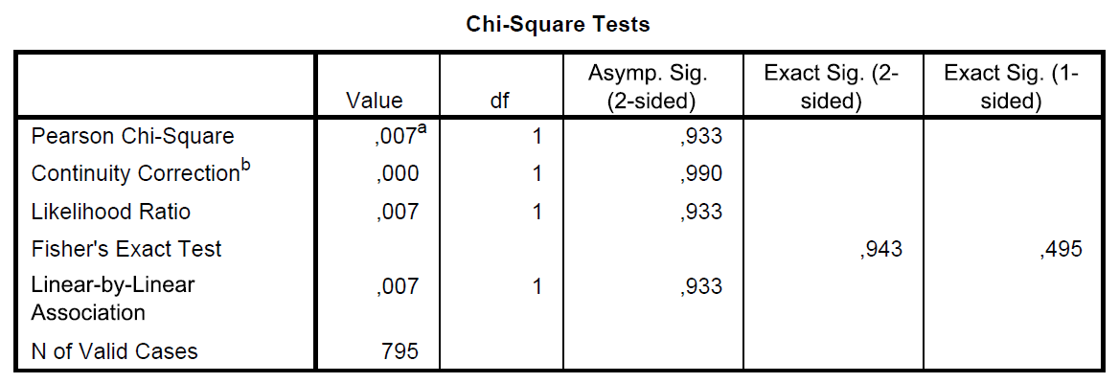

Econometric Analysis Tables:
 | 7 |  | 8 |  | 9 |  | 10 |  | 11
Constant | -5,190 | *** | -5,478 | *** | -5,462 | *** | -5,381 | *** | -5,620 | ***
Ambiguity Aversion 0,1 |  |  | 0,262 |  | 0,223
Ambiguity Aversion 0,5 |  |  | 0,174 |  | 0,450
Ambiguity Aversion 0,9 | 0,072 |  | 0,216 |  | -0,145
AA 0,1 * Gender |  |  |  |  | 0,091
AA 0,5 * Gender |  |  |  |  | -0,632
AA 0,9 * Gender | 0,072 |  |  |  | 0,857 | *
Risk Aversion |  |  |  |  |  |  | 0,558 | *** | 0,799 | ***
RA_Gender |  |  |  |  |  |  |  |  | -0,601
Gross Household Income | 0,001 | *** | 0,001 | *** | 0,001 | *** | 0,001 | *** | 0,001 | ***
Gross Household Income Squared | 0,000 | * | 0,000 | * | 0,000 | * | 0,000 | * | 0,000 | *
Age | 0,057 |  | 0,056 |  | 0,058 |  | 0,054 |  | 0,056
Age Squared | 0,000 |  | 0,000 |  | 0,000 |  | 0,000 |  | 0,000
Gender | -1,056 | *** | -0,695 | *** | -0,779 | ** | -0,721 | *** | -0,334
Household Size | -0,242 | * | -0,259 | * | -0,258 | ** | -0,247 | * | -0,240 | *
Live with Partner | -0,223 |  | -0,191 |  | -0,238 |  | -0,212 |  | -0,204
Education | 0,186 | *** | 0,192 | *** | 0,184 | *** | 0,186 | *** | 0,185 | ***
# Observations | 795 |  | 795 |  | 795 |  | 795 |  | 795
Table 3.1 Ambiguity/Risk Attitudes and Stock Market Participation
 | 1 |  | 2 |  | 3 |  | 4 |  | 5 |  | 6
Constant | -4,981 | *** | -5,281 | *** | -5,370 | *** | -5,139 | *** | -5,107 | *** | -5,331 | ***
Ambiguity Aversion 0,1 |  |  |  |  |  |  | 0,379 |  | 0,278
Ambiguity Aversion 0,5 |  |  | 0,299 |  | 0,429
Ambiguity Aversion 0,9 |  |  |  |  |  |  |  |  |  |  | 0,345 | *
AA 0,1 * Gender |  |  |  |  |  |  |  |  | 0,243
AA 0,5 * Gender |  |  |  |  | -0,332
Gross Household Income | 0,001 | *** | 0,001 | *** | 0,001 | *** | 0,001 | *** | 0,001 | *** | 0,001 | ***
Gross Household Income Squared | 0,000 | * | 0,000 | * | 0,000 | * | 0,000 | * | 0,000 | * | 0,000 | *
Age | 0,051 |  | 0,054 |  | 0,054 |  | 0,052 |  | 0,052 |  | 0,056
Age Squared | 0,000 |  | 0,000 |  | 0,000 |  | 0,000 |  | 0,000 |  | 0,000
Gender | -0,689 | *** | -0,702 | *** | -0,491 |  | -0,688 | *** | -0,769 | *** | -0,691 | ***
Household Size | -0,244 | * | -0,250 | * | -0,245 | * | -0,269 | ** | -0,267 | * | -0,235 | *
Live with Partner | -0,171 |  | -0,188 |  | -0,199 |  | -0,155 |  | -0,170 |  | -0,204
Education | 0,197 | *** | 0,192 | *** | 0,194 | *** | 0,196 | *** | 0,195 | *** | 0,194 | ***
# Observations | 795 |  | 795 |  | 795 |  | 795 |  | 795 |  | 795
Below are logit regressions with stock market participation as the dependent variable. The figures presented here are estimated coefficients for the predictor variables. The stars indicate on what level the coefficient is significant. * = 10% level, ** = 5% level, *** = 1% level.
Table 3.2: Demographic Predictors for Ambiguity Attitudes
Below are logit regressions with various ambiguity attitudes as the dependent variables. The figures presented here are estimated coefficients for the predictor variables. The stars indicate on what level the coefficient is significant. * = 10% level, ** = 5% level, *** = 1% level.
Dependent Variable | AA 0,1 |  | AA 0,1 |  | AA 0,5 |  | AA 0,5 |  | AA 0,9 |  | AA 0,9
Constant | -0,439 |  | -0,407 |  | 0,958 |  | 0,933 |  | 0,661 |  | 0,599
Risk Aversion | -0,214 |  | -0,275 |  | 0,512 | *** | 0,556 | ** | 0,535 | *** | 0,643 | ***
RA_Gender |  |  | 0,117 |  |  |  | -0,086 |  |  |  | -0,210
Gross Household Income | 0,000 | *** | 0,000 | *** | 0,000 |  | 0,000 |  | 0,000 |  | 0,000
Gross Household Income Squared | 0,000 | ** | 0,000 | ** | 0,000 |  | 0,000 |  | 0,000 |  | 0,000
Age | -0,021 |  | -0,012 |  | -0,028 |  | -0,028 |  | -0,027 |  | -0,027
Age Squared | 0,000 |  | 0,000 |  | 0,000 |  | 0,000 |  | 0,000 |  | 0,000
Gender | 0,018 |  | -0,048 |  | 0,141 |  | 0,188 |  | -0,092 |  | 0,031
Household Size | 0,292 | *** | 0,291 | *** | 0,081 |  | 0,082 |  | -0,144 | * | -0,142 | *
Live with Partner | -0,093 |  | -0,095 |  | 0,102 |  | 0,103 |  | 0,374 | * | 0,376 | *
Education | 0,039 |  | 0,040 |  | 0,058 |  | 0,058 |  | 0,043 |  | 0,041
# Observations | 795 |  | 795 |  | 795 |  | 795 |  | 795 |  | 795

5 Discussion
The answer to the research questions of this paper: “Are risk aversion and ambiguity aversion different for men and women? How do these attitudes affect stock market participation? If ambiguity and risk attitudes are different between genders, is it possible that risk attitudes and ambiguity attitudes affect genders differently in the decision to participate in the stock market?” can be summarized as follows. Men and women exhibit comparable levels of ambiguity aversion, while women are more risk averse than men. Risk aversion is a good predictor for stock market participation, ambiguity aversion is not however. Risk attitudes and ambiguity attitudes do not affect men and women differently in decision of stock market participation.
The first hypothesis that women are more risk averse, ambiguity averse and participate less in the stock market can be partially rejected. Women participate significantly less in the stock market. This result was confirmed with chi square comparison tests. The chi square comparison tests also showed that women are more risk averse than men. This finding is consistent with existing literature (Croson & Gneezy, 2009) (Powell & Ansic, 1997). Both genders do not differ in ambiguity aversion.
The second hypothesis that risk aversion and ambiguity aversion are significant predictors for stock market participation can also be partially rejected. Risk aversion is a highly significant predictor variable, although the interaction term between gender and risk aversion did not add significant explanatory value. Ambiguity aversion is rarely a significant predictor variable for stock market participation, and the addition of interaction variables between gender and ambiguity attitudes did not add significant explanatory value.
The third hypothesis that women are more heavily influenced by ambiguity and risk attitudes in decision of stock market participation must be rejected.
An additional finding is that household income is a highly significant predictor for stock market participation. A possible explanation for this is that people with excess wealth are more likely to have the opportunity to expand that wealth through stocks. There is also a significant positive relation between education and stock market participation. This finding confirms and augments the conclusion of García and Tessada (2013). There were no consistent predictors for ambiguity attitudes found.
As expected, women in this study are more risk averse than men. This finding is only significant at the 10% level however, which leads to the logical conclusion that this hypothesis is not true for all women. A possible explanation is that female managers exhibit levels of risk aversion comparable to male managers, as noted in chapter 1.3. Unfortunately there was no information available concerning the occupation of the subjects, which made it impossible to verify this presumption.
An interesting finding is that household size is a significant predictor for stock market participation. A possible explanation for the negative relation between the two variables could be the substantial costs of raising a child (over $ 250.000 according to the U.S. Department of Agriculture, birth through age 17) (Lino, 2012). These costs lead to less excess wealth which in turn could limit stock market participation.
Another noteworthy aspect of the regression with stock market participation as the dependent variable is the positive coefficient for risk aversion. This would indicate that a risk averse subject is more likely to hold stocks than a risk neutral or risk seeking subject. Relevant economic literature would expect a negative relation between stock market participation and risk aversion. Therefore it is quite strange that the regression would output a positive variable for risk aversion. A possible explanation for this could be the pooling of indifference with risk seeking, which might skew the results.
The irregular results of the binary regressions with ambiguity attitudes as the dependent variable are also noteworthy. Risk aversion for example is highly significant as a predictor for ambiguity attitude 0.5 and ambiguity attitude 0.9 but holds no explanatory value over ambiguity attitude 0.1. This is not entirely unexpected since there are three different ambiguity attitudes.
In comparison to Dimmock et al., the variables used in this paper are mostly identical, with a few differences. Indifference between two urns was pooled with ambiguity/risk seeking. Some variables were omitted from the regressions because of missing information. Interaction terms between gender and ambiguity aversion and gender and risk aversion were added to investigate whether risk/ambiguity attitudes affect genders differently in the decision to participate in the stock market. Several comparisons were drawn to investigate gender differences in risk attitudes, ambiguity attitudes and stock market participation. In correspondence with Dimmock et al. this paper did not find strong evidence for the hypothesis that ambiguity attitudes can plausibly predict stock market participation. Possible explanations for this are a lack of relation between the two variables, or inaccuracies in the measuring method of ambiguity attitudes. This paper was able to replicate the finding of Dimmock et al. that gender is a strongly significant predictor variable for stock market participation. Additionally, this paper found a positive relation between stock market participation and gross household income, this was not found by Dimmock et al. They also found no relation between stock market participation and education.
Future studies should look into the negative relation between household size and investments. There are also improvements possible for the measure that was used to determine ambiguity attitudes. Another interesting research avenue could be to investigate the ambiguity and risk attitudes of female business managers.

6 Conclusion
This paper investigated the relation between stock market participation, ambiguity and risk attitudes and several demographic variables. This study replicated and extended a 2014 paper written by Dimmock, Kouwenberg and Wakker. They used a simple questionnaire to measure ambiguity attitudes in a large representative sample. The extension involved the introduction of interaction terms between gender and ambiguity aversion as predictor variables, and comparisons between genders.
The most important findings of this study are that in comparison, woman are more risk averse than men and men exhibit higher stock market participation. There are several significant predictors for stock market participation. These include gender, education, household size, household income and risk aversion. Ambiguity attitudes and the added interaction terms did not provide additional explanatory value towards stock market participation. There were some significant predictor variables found for ambiguity aversion, but these results were not sufficient to draw a robust conclusion.
This study confirms and augments the notion that women are more risk averse and less likely to participate in the stock market. A more surprising result is that ambiguity holds no significant explanatory power over stock market participation of the general population. This is in stark contrast with existing literature on the subject. The negative relation between stock market participation and household size was also unexpected but provides possibilities for future research.

References
Almenberg, J., & Dreber, A. (2012). Gender, Stock Market Participation and Financial Literacy. Stockholm, Sweden: Working Paper.
Bromiley, P., & Curley, S. (1992). Risk-Taking behavior. Wiley series in human performance and cognition. Oxford, England: John Wiley & Sons.
Camerer, C., & Weber, M. (1992). Recent Developments in Modeling Preferences: Uncertainty and Ambiguity. Journal of Risk and Uncertainty, 325-370.
Croson, R., & Gneezy, U. (2009). Gender Differences in Preferences. Journal of Economic Literature, 448-474.
Dickson, G. (1981). A comparison of attitudes towards risk among business managers. Journal of Occupational Psychology, 157-164.
Dimmock, S., Kouwenberg, R., & Wakker, P. (2014). Ambiguity Attitudes in a Large Representative Sample. Netspar Discussion Paper, No. 06/2011-054.
Dow, J., & Werlang, S. (1992). Uncertainty Aversion, Risk Aversion, and the optimal choice of portfolio. Econometrica, 197-204.
Eagly, A. (1995). The science and politics of comparing women and men. American Psychologist, 145-158.
Ellsberg, D. (1961). Risk, Ambiguity, and the Savage Axioms. The Quarterly Journal of Economics, 643-669.
García, R., & Tessada, J. (2013). The Effect of Education on Financial Market Participation: Evidence from Chile. Santiago, Chile: Working Paper.
Gilboa, I., & Schmeidler, D. (1989). Maxmin expected utility with non-unique prior. Journal of Mathematical Economics, 141-153.
Gouskova, E., Juster, T., & Stafford, F. (2004). Exploring the Changing Nature of U.S. Stock Market Participation 1994-1999. University of Michigan: Working Paper.
Heath, C., & Tversky, A. (1991). Preference and Belief: Ambiguity and Competence in Choice under Uncertainty. Journal of Risk and Uncertainty, 5-28.
Hogarth, R. M., & Einhorn, H. J. (1992). Order effects in belief updating: The belief-adjustment model. Cognitive Psychology, 1-55.
Johnson, J., & Powell, P. (1994). Decision Making, Risk and Gender: Are Managers Different? British Journal of Management, 123-138.
Keppe, H.-J., & Weber, M. (1995). Judged knowlege and ambiguity aversion. Theory and Decision, 51-77.
Knight, F. (1921). Risk, Uncertainty and Profit. New York: Houghton Mifflin Company.
Lerner, J., Gonzalez, R., Small, D., & Fischhoff, B. (2003). Effects of Fear and Anger on Perceived Risks of Terrorism. Psychological Science, 144-150.
Lino, M. (2012). Expenditure on Children by Families. Washington D.C.: U.S. Department of Agriculture.
Mankiw, G., & Zeldes, S. (1991). The consumption of stockholders and nonstockholders. Journal of Financial Economics, 97-112.
Niederle, M., & Vesterlund, L. (2007). Do Women Shy Away from Competition? Do Men Compete Too Much? Quarterly Journal of Economics, 1067-1101.
Powell, M., & Ansic, D. (1997). Gender differences in risk behavior in financial decision-making: An experimental analysis. Journal of Economic Psychology, 605-628.
Rothbart, M., & Snyder, M. (1970). Confidence in the prediction and postdiction of an uncertain outcome. Canadian Journal of Behavioral Science, 38-43.
Sapienza, P., Zingales, L., & Maestripieri, D. (2009). Gender differences in financial risk aversion and career choices are affected by testosterone. Chicago: The University of Chicago.
Schmeidler, D. (1989). Subjective Probability and Expected Utility without Additivity. Econometrica, 571-587.
Schubert, R., Brown, M., Gysler, M., & Brachinger, H. W. (1999). Financial Decision-Making: Are Women Really More Risk-Averse? The American Economic Review, 381-385.
Sutter, M., Kocher, M., Glätzle-Rüetzler, D., & Trautmann, S. (2013). Impartience and Uncertainty: Expertimental Decisions Predict Adolescents' Field Behavior. American Economic Review, 510-531.
van Rooij, M., Lusardi, A., & Alessie, R. (2007). Financial literacy and stock market participation. Frankfurt, Germany: Working Paper.

Appendix 1

Variable | Name | Coding
Number of household member encrypted | nomem_ecr | None
Stock market participant | Recoded_bm10a133 | 0 = stock market non-participant, 1 = stock market participant
Ambiguity Aversion 0,1 | Recoded_bm10a48 | 0 = ambiguity seeking and indifferent, 1 = ambiguity averse
Ambiguity Aversion 0,5 | Recoded_bm10a29 | 0 = ambiguity seeking and indifferent, 1 = ambiguity averse
Ambiguity Aversion 0,9 | Recoded_bm10a70 | 0 = ambiguity seeking and indifferent, 1 = ambiguity averse
Risk Aversion | Recoded_bm10a99 | 0 = risk seeking and indifferent, 1 = risk averse
Interaction effect 0,1*gender | AA_0,1_Gender | None
Interaction effect 0,5*gender | AA_0,5_Gender | None
Interaction effect 0,9*gender | AA_0,9_Gender | None
Gender | geslacht | 0 = male, 1 = female
Age | leeftijd | None
Age Squared | Age_Squared | None
Household size | aantalhh | 1 = one person, 2 = two persons, 3 = three persons, 4 = four persons, 5 = five persons, 6 = six persons, 7 = seven persons, 8 = eight persons, 9 = nine or more persons
Living with a partner | partner | 0 = no, 1 = yes
Gross household income in euro's | brutohh_f | None
Household income squared | Household_Income_Squared | None
Education | oplmet | 1 = primary school , 2 = intermediate secondary education/vmbo, 3 = higher secondary education/havo/vwo, 4 = intermediate vocational education/mbo, 5 = higher vocational education/hbo, 6 = university

