Erasmus School of Economics

Master Thesis

To obtain the academic degree of
Master of Science in Economics & Business
Specialization in Marketing

Mobile Applications, which factors influence the demand for mobile applications across different operating systems in The Netherlands?

Author: Oliver Tom Michael Klos
E-mail: oliver.klos@gmail.com
Supervisor: Bruno Jacobs
Study Program: International Business & Economics
Specialization: Marketing
Word Count: 9808
Date: 23/06/2015

Abstract
This thesis explores the drivers behind downloads of applications across three operating systems in The Netherlands. This thesis also contributes to the current literature by looking at various variable such as, price, monetization and category to see which aspect influence its downloads. The research found that application that had a trial period where more favoured for downloading that an application that was free and had an in-app purchasing feature. This most probably has to do with the fact that consumers get to try and explore a fully functioning application without any drawbacks, except the fact that it the app has a trial period. Also, applications that are now paid for but once had a free period were also favoured. This could be associated with the freemium strategy developers use to gain app exposure. Allowing consumers to leave reviews and ratings for other users. From this study it would appear that the category of an application contributes little to the drive of downloads. Other factors such as rating and comments that have not been considered in this thesis could be vital for further research on what helps to drive downloads of an application.

Table of Contents
Abstract 2
Abbreviations 4
1. Background & Problem Statement 5
1.2 Scientific and Managerial Relevance 7
1.3 Structure of the Thesis 7
2. Literature Review 8
3. Conceptual Framework 12
3.1.1 Number of Downloads 12
3.1.2 Operating System (OS) 12
3.1.3 OS * Monetization 13
3.1.2 OS * Month 13
3.1.3 OS * Category 14
3.1.4 Is Local 14
3.1.5 Price 14
4. Research Methodology 16
4.1 Data Collection and Preparation 16
4.2 Tests and Interpretation 19
4.2.1 Independent-Samples T-Test 19
4.2.2 One-Way ANOVA 19
4.2.3 Descriptive Statistics 20
4.2.4 Consistency Checks 21
5. Data Analysis and Results 26
5.1 Preparing the Data 26
5.1.1 Independent-Samples T-Test 26
5.1.2 One-Way ANOVA 26
5.2 Descriptive Statistics 27
5.3 Consistency Checks 30
5.3.1 Scatterplots 30
5.3.2 Outliers 30
5.3.3 Correlation Matrix 31
5.3.4 Cross-tabulation 31
5.4 Regression Analysis 32
6. Conclusion 35
6.1 General Discussion 35
6.2 Academic Contribution 36
6.3 Managerial Implications 36
6.4 Limitations and Directions for Future Research 36
Appendix 38
Reference List 47

Abbreviations
In case of many abbreviations and tables, figures, a list will be provided of abbreviations and a list of tables, figures, etc. to improve ease of reading.
App - Mobile Application
OS – Operating System
PDA – Personal Digital Assistant

1. Background & Problem Statement
Over the last three decades the mobile phone has evolved from being a large, clunky, simple device to slim, easily portable, multifunctional device. Before smartphones came onto the market, many of the built in features were items that had to be carried around separately. For example, our music (CD’s/cassettes), photo/video camera, games, etc. the list goes on. Smartphones have allowed people to pack all these items into one device by means of applications and added on features.
The Motorola Dynastic 8000X, released in 1983, was the first mobile phone available for commercial use. At a price of $3,995 and weighing in at a little over a kilogram with a total talking time of just over a half hour this phone only had a simple contacts application. Many of the first generation phones were designed and developed in great secrecy. Developers who wanted to participate in writing applications for these devices had to be part of the company’s inner circle. Nokia was one of the first to add casual gaming to their phones, including titles such as tic-tac-toe, Tetris and most famously Snake. People started thinking differently about communication as reception area increased, battery longevity rose, and more and more people started using and owning a handheld device. As popularity increased customers began demanding more features. Manufactures would had to spend huge amounts of resources if they would have wanted to incorporate each and every individual wish in terms of features to their products. A portal was needed to that would allow customers to get these features without having to tamper with their product. It is at this point in time where the Internet started to become a major player in the mobile area. However, phones in the late 1990s were not designed to be able to load a webpage. Their screens lacked the resolution, storage and processing power. Over the ensuing years, memory prices started to drop, battery power increased and devices such as phones and PDAs began to run on simple, yet familiar, versions of Windows and Linux. When this occurred manufacturers grasped the idea that they would need to share more information about the internal workings of their device if they wanted the developers to actively create applications for them. Together with the Internet and the manufactures application portal, developers were able to create apps and load them to a virtual store. These stores have allowed people to develop applications, in directly on the behalf of manufacturers, to satisfy the growing needs for diverse applications that people wish for.
The greatest change in mobile technology has occurred over the past eight years or so. The finger touchscreen technology went from sci-fi movies into our pockets, and this allowed for major changes in how we use our devices and applications. The touchscreen experience paved the way for innovations.
Along with the developments of our mobile technology there also has been fierce competition in terms of which operating system is most favourable. Windows made a brief appearance on the mobile OS market in the mid 2000s, but was considered un-user-friendly. Some years later, Microsoft launched Zune in 2008. In a partnership with Nokia, Windows OS has been getting more popular. In September of 2013, Microsoft bought the patents of Nokia. Officially making Nokia mobile device the face of Zune OS. Apple, in line with their iMacs and MacBook’s OS made a simple, stylish and user-friendly iOS for mobile devices. Initially brought onto the market with their revolutionary MP3 player, the iPod, iOS did not get the name till 2007 with the launch of the first iPhone. To join the competition Google purchased and helped develop Android. In 2007, Google announced to provide Android as an open source OS. Companies such as Sony, HTC and Samsung used Android and created their own ‘cover’. Late 2008, HTC was the first company to launch a commercial phone running on Android.
Even though Google’s Android has a larger market share than Apple’s iOS, 75% versus the 17.3% respectively (IDC, 2013), iOS is still known more as the ‘game-machine’. There is, however, little research done about what factors lay behind the success of a mobile application. Therefore, this research will be looking at various aspects of a mobile application across three operating systems, Android, iOS & Zune (Windows). The thesis will try to investigate what drives downloads, while considering the influences of month, monetization and category.
To formalize, the research question is:
Which factors influence the demand for mobile applications across different operating systems in The Netherlands?

Objectives:
The main objective of this thesis will be to look at various elements of an application that may reveal what influences its download. To achieve this, the top 150 free and paid applications will be examined over a 12-month period across three OSs, Android, iOS & Zune. With the aid of SPSS the nine hundred apps of each month, consisting of nine variables, will be analysed. Factors such as monetization type and category are just a few aspects that will be investigated for this research. Studying these aspects will allow for insight on how downloads behave.

1.2 Scientific and Managerial Relevance
Mobile apps are a relatively recent development with little examination. When looking at past research gaps can be found in what factors help drive the number of downloads. Even though the topic has been explored using other variables this thesis will encompass additional variables.
In terms of managerial relevance this paper will give insight on how to place an application on the market in-order to maximize its potential to be downloaded, and if applicable, how to drive earnings. The conclusions of this thesis could be useful for both casual and serious developers who want to make sure their application may possibly be among the top 150 applications in The Netherlands.

1.3 Structure of the Thesis
The thesis will be structured in the following way: First a literature review will be provided to give insight on past research and how their finds help contribute to this thesis. Following this section a conceptual model will be presented with the dependent variable, key independent variables, their interactions and hypotheses. The following section, the methodology, will explain how the data was collected and coded and which methods will be used to analyse the data. Furthermore, this section will describe the various tests, why they will be performed, what they will measure and how the tests are conducted. The subsequent section, the results, will, as the name suggests, study the outcomes of the various tests and their implications. Lastly, the conclusion, this section will consist of a general discussion about the results followed by its academic and managerial relevance and consider and limitations of this research and what further research could be done in the future.

2. Literature Review
This section of the thesis will cover a range of literature that touches base with the variables presented in the conceptual model.
A widely used and new mobile technology is the mobile application (App). This novel innovation is overturning the tradition business model of the mobile industry [and] also creates new avenues of mobile market opportunities. Although mobile pay-per-use services have attracted increased attention in recent years, few studies have provided limited insight into mobile technology adoption in pay-per-use services (Wang et al. 2013). In 2007, Apple’s iPhone created a shift in consumers with their Apps driven product and steered the demand for application stores up. Apple's App Store created new mobile value-added services (VAS), moreover, Apple boasts it as a new service type to meet the needs of mobile phone users-"whatever you want to do, there is an App for it" (Topology Research Institute: TRI, 2010). According to Gartner forecasting, worldwide mobile application store revenue is projected to surpass $15.1 billion in 2011, both from end users buying applications and applications themselves generating advertising for their developers. Gartner also forecast over 185 billion applications will have been downloaded from mobile App stores since the launch of the first one in July 2007 (Gartner, 2011). This is plausible if taking the following into account: In March 2012 3.1 billion apps were downloaded worldwide from Apple App Store and Google Play (Xyologic, 2012). Research2Guidance estimates that the annual global app revenue will go up from $1.94 billion in 2009 to $15.65 billion in 2013, and that along side that growth smartphones users would increase from 100 million to 970 million (Jahns, 2010). It is therefore also understood that apps may provide a pronounced role as a perspective revenue source in the mobile industry. While Apps has gotten a lot of attention in recent years, it is also important to understand the user base for providers and the factors that drive their downloads.
In a research paper by Kajanan et al.: Takeoff and Sustained success of Apps in Hypercompetitive Mobile Platform Ecosystems: An Empirical Analysis. They discuss the daunting task of discovering and assessment of an application in a market with millions of apps. Also they discuss the ease at which consumers can delete an application from their device. The purpose of their paper is to address competitive strategies in hypercompetitive market and to provide innovative solutions for app positioning, developer actions and user engagement (Kajanan, 2012).
There have been many calls for a deeper understanding and the dynamics behind mobile ecosystems (Digitalinspiration, 2011; BusinessInsider, 2011) to aid developers and companies who take part in app development. Mobile applications exist in a two-sided platforms ecosystem. These two sides consist of developers (supply) and consumers (demand). However, the difference between a common good and an application is that consumers can, with ease, download more applications than they need for everyday use and also remove them at a whim. According to the results from this study user engagement and quality perceptions have a strong influence on sustained success of an application. These results backup prior finding that user perceived quality reaches others quickly in the form of word-of-mouth and significantly effect a products success. (Chesvalier, and Mayzlin, 2006; Dellarocas, 2003; Dellarocas and Narayan, 2006)
Another manner in main factor that consumers use to judge whether an application is worthy of downloading is by the reviews it has gotten. App stores usually display their ratings with a 5 star measure and comments from other users. These are accessible by to all consumers who look up any particular application for their device. These rating and review provide for a valuable indicator about the apps quality and user engagement. (Marketing NPV 2008; O'Brien et al., 2008). Also improving the applications visibility increases the demand for it (Anderson, 2004). With an abundance of applications in each App Store, to be seen by consumers, must become an essential part of a developers marketing.
The drive of demand has also been studied in the paper of Ghose et al. 2012, “Estimating demand for mobile application in the new mobile economy”. They looked the Apple App Store and Google play for four month in the South Korean market. They found that a number of factors drove demand such as, app size, age, description length and number of screen shots. Their research also showed that gaming apps have a positive impact on the number of download while multimedia and educational apps had a negative impact. One of the main reason as to why app age plays a significant role is because according to software literature (Arnold, 1993) mature software has had ample time to be fixed and adjusted to consumer needs and wants while working out any bugs the software may contain. The paper also speculates that screenshots may play prominent role because of Ghose el al. found that visual images of hotels near a beach influences a consumers decision when booking a hotel. Therefore, the same may apply to apps and app demand (Ghose, 2012).
Category:
The main focus of this thesis is to help determine the types of users across the three mobile giants: Apple iOS, Google Android & Windows Zune. One way to explore the types of users is to examine the categories of applications downloaded by consumers across the three platforms. NewsRx claims that games remain the largest mobile applications category by publication and download (revenue increased 72% year-over-year) followed by social and personalization application segment. This is most probably due the attractiveness of new technology by younger generations who are stepping away from classical gaming devices such as Sony PlayStation & Microsoft X-Box, and get their game ‘fix’ on the go.
Recently large companies are starting to adopt the ‘flex-work place’ meaning that employees can work from home or on the go. One way to provide this possibility is by creating work related applications. Nokia boasts to be ‘the world’s best business smartphone’ offering built-in Microsoft Office and security that’s fit for business (Nokia.com). The demand for access to business information and applications through mobile technologies such as the Apple iPhone and iPad, devices running Google Android and Windows 7 Mobile or using RIM Blackberry is surging as consumer preferences and behaviour spill over into the business workforce. (Strategic Growth Concepts, 2014)
Price:
In this thesis, three of the variables that will be examined are related to price. These three variables are: Monetization type, Had Paid/Free Period & Price. With the development of App stores, such as Apple’s App Store & Google Play, it has been very easy for developers to expand the product diversity available to consumers. One reason for increased product variety on the Internet is the ability [for] online retailers to catalogue, recommend, and provide a large number of products for sale. (Brynjolfsson, Hu & Smith) In article of Brynjolfsson, Hu & Smith, Consumer Surplus in the Digital Economy, their analysis [indicated] that the increased product variety of online [goods] enhanced consumer welfare by $731 million to $1.03 billion in the year 2000, which is between 7 and 10 times as large as the consumer welfare gain from increased competition and lower prices in this market.
Liu et al. (2012) discuss the notion of Freemium application on Google Play and it’s positive association to sales volume and revenue of paid apps. Sales and review ratings up of the free version of a mobile app both lead to increased sales of the paid version. The idea was that the free version provides for more exposure, however it was the quality of the application that drove sales. The concept of freemium strategy in the software marketplace is been extensively analysed (Cheng and Tang 2010; Faugere and Giri Kumar 2007; Haruvy and Prasad 2001). Beside the positive brand building effects (Kapil and Robert 2004), this method is often used to take advantage of economic benefits (Gallaugher and Wang 2002).
Is Local:
All data that has been gathered originates from Apps stores from The Netherlands, therefore one of the parameters that will be looked at is whether or not the application is local or not. In the paper of ResearchMoz (2014) states that consumer preferences differ with country, age group, occupation, level of income etc. that makes it difficult for publisher to keep leadership in the app category. Hence, publishers have adopted the strategy of publish locally to address the local preference parity.

3. Conceptual Framework

Figure 1: Conceptual Framework: Interaction of OS & three variables on # of downloads.

3.1.1 Number of Downloads
“# of Downloads” is to be considered as the dependent variable and to be directly influenced by the below mentioned independent variables. To be able to measure the interactions of this concept with the other independent variables, “# of Downloads” will be quantified by the “number of downloads.” It therefore can be determined that the higher the number of downloads the higher an application will be ranked. This variable shows the Number of downloads produced by an app in a monthly period in a certain app store and country (Xyologic Mobile Analysis GmbH, 2013). For this research Android, iOS & Windows Phone (Zune) app stores will be chosen in The Netherlands. App stores do not give actual figures therefore most of the researchers use aggregated data. It is believed that this variable is proved to be influenced by a number of independent variables which define it success (Ghose and Han, 2011; 2012).

3.1.2 Operating System (OS)
The variable OS will measure the number of downloads for each operating system. Since this variable will be contrasted as a dummy variable it can be seen that Android OS will be in the baseline model, while Apples iOS and Windows Zune OS will be measure separately. It should be noted that both iOS and Zune have significantly less market share than Android. It is clear that this hypothesis may seem redundant, baring this in mind the following two hypothesis are created:
H.1.a iOS will cause for less downloads than Android, but more than Zune.
H.1.b Zune will have the least number of downloads compared to the other two OS.

3.1.3 OS * Monetization
There are several ways to acquire applications by users. When accessing an app store customers have the choice between free and paid applications. Even within these two categories there are differences. Free applications can be either fully free with all features available or they come with an in-app purchase option.
Therefore the first hypothesis is:
H.2.a Fully free applications will have a stronger positive influence on the number of downloads than those with an in-app purchase option.
Paid applications come with several monetization options, namely trial, paid and paid + in-app purchase. Trial implies that an application can be used for a period of time free of charge before the user has to pay to keep using the application. Paid implies that all features of the application are unlocked. Finally paid applications with an in-app purchase option. These are applications that need to be purchased from an app store and to for users to unlock other features a further payment is needed.
The second hypothesis will be:
H.2.b Trial applications will have a strongest positive affect on the number of downloads followed by paid, then paid + in-app purchase.

3.1.2 OS * Month
Month will measure the number of downloads over each month. There should not be any reason that a specific month could cause more downloads than another. Since new devices are released throughout the year by various brands, it can be concluded that there should be an even spread of downloads each month. With the exception of iOS, Apple tends to release their new iPhone on the market every year in September.
H.3 There is no month that causes more downloads than another for Android and Zune, September and October may see a spike with iOS downloads due to the release of their new device.

3.1.3 OS * Category
This variable can be divided into several fields of interest such as: Education, Lifestyle, Social, Tools & Productivity, Games, etc. the list goes on. Even though there are many categories from which users can choose to the download apps from there are usually a couple that are more popular than others, and thus have a stronger influence on the rank of an application. These categories will namely be: Music & Video/Entertainment, Tools & Productivity and lastly, Games.
Therefore the underlying hypothesis is:
H.4 Specific categories such Entertainment, Tools & Productivity and Games will yield higher number of downloads in comparison to the other categories.

3.1.4 Is Local
The data gathered is all from the Dutch app market. Therefore the apps which are specifically for the local market, be it free or paid, will have a strong positive affect on downloads. This will be due to the fact that these applications will be catering to the needs of the local community.
H.5 Is Local will have a positive effect on downloads

3.1.5 Price
Compared to free application, paid applications have considerably less downloads. The main reason to this phenomenon is that people are more inclined to download and try an application that is free than one that is paid. Paid applications prices range from €0.99 to €999.99, there is a wide range of prices between those two values.
H.6 Lower prices will have a positive affect on downloads
In the table below, all main variables part of the conceptual model have been summarized. (Table 1)

Table 1: Summary of the Main Variables
Variable | Definition | Literature
Downloads | The number of times an application has been downloaded.
Operating System (OS) | The various Operating systems for this research, Android, iOS & Zune.
Price | The monetary cost for a consumer to acquire a particular application (€). | Lui et al. (2012)
Month | The different months of the year 2013.
Monetization Type | The manner in which a consumer can obtain a specific application. | Ghose, (2012)
Had Free/Paid Period | Whether the application in its past had been free or had to be purchased. | Ghose et al. (2006)  Kapil et al. (2004)
Is Local | Whether an application is only intended for the local Dutch market. | ResearchMoz, 2014
Paid | Whether an application is paid for or free with initial download. | Lui et al. (2012)  Kapil et al. (2004)
Category | The group a particular application belongs to.

4. Research Methodology
This part of the thesis will connect the research methodology to the above-mentioned hypothesis. The first part will explain how the data was gathered and a sample will be presented of the data. Successively, an explanation will be given about the various tests that will be conducted and their interpretation.

4.1 Data Collection and Preparation
The data for this research has been gathered from the following secondary online source: www.xyo.net. XYO is a company that re-imagines how people discover apps and tracks downloads across an array of app stores. In most of these stores 10% of the apps generate 90% of all downloads. With that in mind, data has been collected over a span of twelve months from the top three market share holders, namely: Android, Apple and Windows. From each the top 150 free & paid apps were collected. The data is provided by Xyologic Mobile Analysis generates historical data regarding app performance, downloads, categories, monetization type, price, etc. XYO App Store Search Engine outlines an app's success by the number of downloads it generates (Xyologic Mobile Analysis GmbH, 2014).
XYO publishes a monthly report with details such as downloads, price, category, etc. for both free & paid apps. More specifically the reports provide the following information details for free downloadable applications in each operating system: Country Rank, Downloads this month, Number of Apps Published, Monetization Type, App vs. Game, Had Paid Period, Is Local & category.
For paid applications the reports offer the following details: Country Rank, Downloads this month, Price, Number of Apps Published, Monetization Type, App vs. Game, Had Free Period, Is Local & category. It should also be noted here that number of downloads is rounded to the nearest 100th, and that no open source can provide exact number of downloads from a given app-store.
All the reports offered by XYO are in a PDF format. Therefore the first step will be to convert all the data into an excel file. In order to help distinguish the assorted groups three additional columns will be added to the data, namely, Month, OS and Free/Paid. This will help later on in SPSS to distinguish which OS the application originates from, from which month and whether it was a free or paid application. SPSS is predictive analytical software that can predict outcomes with confidence, in order to solve problems and to make smarter decisions (IBM, 2014). Below a table (Table 2) is provided on how each variable will be coded in order to make analysis in SPSS easier, these coded variables will be used as dummy variables. Dummy coding is a way of representing groups using only zeros and ones (Field, 2009). When conducting a regression this will allow to show the interaction effect each variable on the number of downloads.
Table 2: How the data has been coded:
Month | Code |  | Category | Code
January | 1 |  | Action & Adventure | 1
February | 2 |  | Arcade | 2
March | 3 |  | Casino | 3
April | 4 |  | Casual | 4
May | 5 |  | Entertainment | 5
June | 6 |  | Health & Fitness | 6
July | 7 |  | Kids & Family | 7
August | 8 |  | Libraries & Demo | 8
September | 9 |  | News | 9
October | 10 |  | Puzzle & Trivia | 10
November | 11 |  | Sports | 11
December | 12 |  | Tools & Productivity | 12
 |  |  | Travel | 13
Monetization Type | Code |  | Utilities | 14
Free | 0
Free + In-app purchase | 1 |  | OS | Code
Trial | 2 |  | Android | 0
Paid | 3 |  | iOS | 1
Paid + In-app purchase | 4 |  | Zune | 2
 |  |  | Local | Code
 |  |  | No | 0
 |  |  | Yes | 1

Therefore once the excel is placed into SPSS each of the above variables need to be converted into dummies. For example if we take a look at OS, we want to know what the effect is on the number of downloads if only one of the variables is activated. In order to do so two of the OS proverbially needs to be ‘turned off’. This can be done in SPSS by transforming and recoding the variables. The table (Table 3) below gives an example of how SPSS will then interpret the recoded variable:
Table 3: Coding of OS variable
OS | Dummy Variable 1 | Dummy Variable 2 | Dummy Variable 3
Android* | 1 | 0 | 0
iOS | 0 | 1 | 0
Zune | 0 | 0 | 1
*Part of the dependent variable. When coding the only N-1 will need to be coded, the above table is to show how it will be represented in the regression.
As previously mentioned, this is done for each of the eight variables listed above. Once completed the data set is primed and ready for statistical analysis.

4.2 Tests and Interpretation
Before a regression analysis can be conducted a number of tests need to be conducted before hand to check the data for any anomalies. For all the conducted tests a p-value of 0.05 will be held as a threshold.

4.2.1 Independent-Samples T-Test
The first test that will be conducted is an Independent-Samples T-Test. This test allows for the comparison of two means. In the case of this research the mean number of downloads will be compared between free and paid applications. This is done in order to make sure that there is a significant difference between the two groups.

The formula for the this test is as follows:

X₁ = Mean of the first sample
X₂ = Mean of the second sample
S²₁ = Standard deviation of the first sample
S¹₂ = Standard deviation of the second sample
N = Total sample size

4.2.2 One-Way ANOVA
ANOVA stands for Analysis of Variance. The One-Way ANOVA test allows the comparison of any number of means by a technique that generalizes the two-sample t while sharing its practicality and robustness. One-Way ANOVA classifies populations of interest according to a single categorical explanatory variable called a factor. (Moore, McCabe, Duckworth, Alwan, 2009). For the purpose of this thesis the ANOVA test that will be conduct will compare the mean number of downloads across the three OSs. This is done to check that there is a statistically significant difference between the three groups.
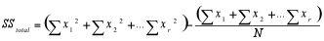

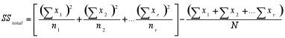
SS_{within} = SS_{total} - SS_{among}
df_{among} = r-1 | df_{within} = N-r

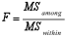



x = individual observation
r = number of groups
N = total number of observations (all groups)
n = number of observations in group
(Source: Hall, 1998)
A post hoc test will be conducted as well, using the Tukey HSD model. Studies have proved that Tukey’s HSD test accurately maintains alpha level at their intended value as long as the assumption of the statistical model hold (independence, normality and homogeneity) The test was created for a situation where the sample sizes are equal per group, however it can also be applied to unequal sample sizes as well.
The Tukey formula is:
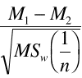

M = group mean
n = number per group
(Source: Hall, 1998)

4.2.3 Descriptive Statistics
The descriptive statistics part will provide a general table outlining basic information about the categories used for this thesis. The content will be based on the number of download and will include the following aspects: Number apps in said category (N), Min, Max, Mean and Standard deviation.
The table will look as follows:
Table 4: Example of descriptive statistics table
Category | N | Min | Max | Mean | Standard Deviation
xx | xx | xx | xx | xx | xx
xx | xx | xx | xx | xx | xx

A second table will also be presented which will depict the various variables. The table will illustrate the frequencies of each aspect of a variable and percentage they allocate for. This will provide a clear breakdown of each variable.
The table will look as follows:
Table 5: Example of frequency and percentage table.
Variables |  | Frequency | Percent
OS | Android | xx | xx
OS | iOS | xx | xx
OS | Zune | xx | xx
Total |  |  | xx
Top 150 | Free | xx | xx
Top 150 | Paid | xx | xx
Total |  |  | xx
App Type | Game | xx | xx
App Type | Other | xx | xx

4.2.4 Consistency Checks
This section will be subdivided into three smaller sections, namely: Scatterplots, Outliers & Correlation Matrix. The reason to conduct these consistency analyses is to see whether there are any variables that may strongly influence the results in such a manner that they will skew the data. To prevent this from happening theses tests need to be conducted.

4.2.4.1 Scatterplots
Scatterplots show whether there is a positive or negative linear relationship between two variables. Because the Number of Downloads is the dependent variable, y-axis, this will be plotted against two continuous variables, namely # of Apps Published and Price, x-axis. The results will give an indication of the relationship and whether they hold true to their respective hypotheses. Table 6 below depicts the sample scatterplot with a negative correlation.
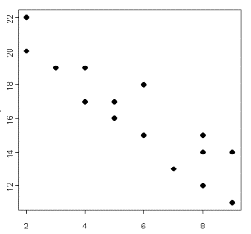
Table 6: Sample scatterplot with a negative correlation:

4.2.4.2 Outliers
Outliers are variables that, as the name suggests, are significantly different from the rest of the data points and influence the results. To check for any outlier that may influence the results a univariate analysis is conducted, more specifically a histogram. A histogram is a bar chart that represents the frequency occurrence of that data. For the purpose of this research a histogram will be conducted on Number of Downloads vs. frequency and Month vs. Number of Downloads. These two histograms will show whether any particular application has a significant different number of downloads compared to the rest and whether any particular month stands out.

4.2.4.3 Correlation Matrix
The correlation matrix is a practical tool to discover statistical relationships among variables and to discover multicollinearity (Field, 2009: 656-662). To be able to report any correlation between two variables, they cannot be coded. For the purpose of this thesis Number of Apps Published and Price will be checked for correlation to Number of Downloads, as they have not been coded. The correlation variable is listed as the Pearson Correlation, which will always be 1 when comparing the variable to it self.
Table 7: Sample of how the correlation Matrix will be presented:
 |  | AppsPublished | PriceinEUR | DownloadsThisMonth
Apps  Published | Pearson Correlation | 1 | xx | xx
Apps  Published | Sig. (2-tailed) | xx | xx | xx
Apps  Published | N | xx | xx | xx
Price in EUR | Pearson Correlation | xx | 1 | xx
Price in EUR | Sig. (2-tailed) | xx | xx | xx
Price in EUR | N | xx | xx | xx
Download  This  Month | Pearson Correlation | xx | xx | 1
Download  This  Month | Sig. (2-tailed) | xx | xx | xx
Download  This  Month | N | xx | xx | xx

4.2.4.4 Cross-tabulation
Cross-tabulation allows for co-occurrences between variables to be detected. This will be done between the variables monetization type and free/paid period. SPSS will allow this test to be conducted by checking if there is an over lap in occurrences between those two variable. This model will look like the following:
Table 8: Example of the cross-table:
MonetizationType * Free Crosstabulation
Count
 |  | Free/Paid Period |  | Total
 |  | Free | Paid
Monetization Type | Free | X | X | X
Monetization Type | FreeInAppPurchase | X | X | X
Monetization Type | Trial | X | X | X
Monetization Type | Paid | X | X | X
Monetization Type | Paid InAppPurchase | X | X | X
Total |  | XXX | XXX | XXX

4.2.5 Regression
The regression will be the main focus for this thesis. In this thesis a linear regression will be conducted with a number of dummy variables. A simple way to look at the regression model is as follows:
Outcome_{i} = (model) + error_{i}
Meaning that the outcome that is sought for can be predicted by some model + an error term. Usually the model is written as follows:
Y_{i} = (β₀ +β₁X_{i}) + e_{i}
Dummy variables make it possible to see the effect an independent variable has on the dependent variable. It gives insight on the interaction between the two variables. When coding for a dummy variables it allows for variables to be split into two distinct groups.
D = 1, if the criterion is satisfied
D = 0, if not
E.g. Operating System
Table 9: Example of how the data has been coded:
 | Dummy Variable 1 | Dummy Variable 2 | Dummy Variable 3
Android* | 1 | 0 | 0
iOS | 0 | 1 | 0
Zune | 0 | 0 | 1
*Part of the dependent variable. When coding the only N-1 will need to be coded, the above table is to show how it will be represented in the regression.
This is how SPSS will see and measure the differences in number of download, for examples, across the three operating systems. Each variable is either activated or not.
For the purpose of this research several variables will be converted into dummies: Operating System, Month, Monetization Type, App, Had Paid/Free Period, Is Local, Paid & Category. Once the regression is conducted the interaction effect of these variables will be measured on the outcome. To be able to see which of the variables has been converted into a dummy, a capital D is placed in front of the variable, e.g.: DiOS, DZune.
Therefore, in this research β₀ will be ‘capturing’ various variables, and when considering the other dummy variables the interaction effect can be measured.
After conducting a simple regression analysis with dummy variables, a second regression analysis will be conducted looking at interaction effects. This means taking one dummy variable and multiplying it with a regular variable. This will then show how the results change when looking at how those interactions affect the number of downloads. For example, taking the dummy variable of the operating system iOS and multiplying it with price. This interaction will give insights on how the influence of price with a single OS has on the number of downloads.

5. Data Analysis and Results
This chapter will present a thorough outline on how the data has been prepared, along with descriptive statistics, outliers, a one-way ANOVA analysis and the results of the linear regression that has been conducted. All of which will be used to draw conclusions for this research. In order to make sure that the results are both valid and sound a robustness check will be performed, this in turn will also provide deeper in-sights considering the outcomes.

5.1 Preparing the Data
Before the data can be analysed it should be prepared in such a way to allow for easy analysis in SPSS. To enhance the interpretability of the results, all of the results in the text have been scaled to ‘normal’ levels, i.e. thousands. Once the data had been transferred from Excel to SPSS, a number of dummy variables had to be created in order to see the differences within the different aspect of the variables. Therefore the following variables were transformed into dummies:
OS, Month, Category & Monetization Type.

5.1.1 Independent-Samples T-Test
There was a significant difference in the number of downloads for free applications (M=73.914, SD=550.002) and paid applications (M=2.659, SD=6.498) conditions; t(10798)=9.52, p=0.00. (Appendix 1 & 2) This is confirmed with the aforementioned results, it can therefore be stated that the paid and free application can be treated independently.

5.1.2 One-Way ANOVA
When comparing the mean number of downloads among the three operating systems the following results were determined. A one-way between subjects ANOVA was conducted to compare the effect of Number of Downloads on operating system in Android, iOS & Zune. There was a significant effect on the number of downloads at a p<0.05 level for the three operating systems [F(2,10797)=34.244, p=0.00]. Post hoc comparisons using Tukey HSD test indicates that the mean score of Android (M=79583.389, SD=672387.377) was significantly different to both iOS and Zune operating system, (M=30.404, SD=51.016) & (M=4.872, SD=8.732) respectively at p=0.00. However, even though the difference between iOS and Zune were still significant, it was slightly less with p=0.015. (Appendix 3 - 5) This indicates that the mean score of downloads is significantly different among the three operating systems. In plain terms, for each operating system, the total number of downloads differed from one and other.
Moreover, for the purpose of the research question a one-way ANOVA is conducted to compare the effect of Number of Downloads on application categories. There was a significant effect on the number of downloads at a p<0.05 level for the different categories [F(13,10786)=2.327, p=0.004]. This proves that there is a difference in downloads between the various categories.

5.2 Descriptive Statistics
A univariate analysis describes the data in its simplest quantitative form. The intention to do this is to explore if the variables consist of errors, missing values of outliers. The table below gives a detailed overview of the variables before performing a linear regression analysis, this will also show the differences between the three operating systems, and the distinction between free & paid applications. The mean, standard deviation, min & max are shown for the separate variables.
For this research the Number of Downloads is the dependent variable. From the table below the various means and standard deviations can be seen for each of the downloaded categories, rounded to two decimal places.
Table 10: Breakdown of each mobile category of the data and their respective count.
Category | N | Min | Max | Mean | Standard Deviation
Action & Adventure | 1084 | .100 | 1,133 | 22.513 | 51.089
Arcade | 1445 | .100 | 623 | 35.160 | 62.651
Casino | 382 | .100 | 327 | 24.864 | 43.390
Casual | 799 | .100 | 4,039 | 79.702 | 217.911
Entertainment | 1388 | .100 | 9,990 | 31.652 | 279.499
Health & Fitness | 359 | .100 | 403 | 10.961 | 26.866
Kids & Family | 231 | .100 | 247 | 22.357 | 30.653
Libraries & Demo | 502 | .100 | 269 | 18.756 | 37.284
News | 344 | .100 | 552 | 19.995 | 50.344
Puzzle & Trivia | 425 | .100 | 301 | 14.383 | 26.320
Sports | 281 | .100 | 696 | 33.285 | 70.005
Tools & Productivity | 1783 | .100 | 36,663 | 69.856 | 907.761
Travel | 355 | .100 | 335 | 18.160 | 40.363
Utilities | 1422 | .100 | 1,789 | 34.678 | 100.590
It can be noted that many of the mean values roughly lay around the same range. However, there are a select few cases where the mean looks significantly higher, such as for Casual and for Tool & Productivity. This could be due to an outlier that skews the data. Especially for the category Tools & Productivity it can be noted that the standard deviation is a lot larger than that for the other categories, this is due to the extremely high maximum number of downloads.
The following table, table 11, gives insight on the nominal variables within the research, providing a detailed account of variables used to control for the effects on the number of downloads. As described about, 10800 applications where used for this research, with an even split between the three operating system and between free & paid applications. A little less that half the applications that ended up in the top 150 downloads over the 12 month period were games (42.5%). However, the largest category is that of Tools & Productivity (16.5%), followed by Arcade (13.4%) and Entertainment (12.9%). Almost all of the application did either not have a free or paid period (94%), meaning that most of the applications did not switch from being free to paid or vice verse. It should also be noted that among the Top 150 downloads during the course of 2013, 89.3% of all the applications were not local applications. Indicating the influence of the foreign application market.
Table 11: Break down of each variable used in the data and their respective % of the total sample
Variables |  | Frequency | Percent
OS | Android | 3600 | 33.3
OS | iOS | 3600 | 33.3
OS | Zune | 3600 | 33.3
Total |  | 10800 | 100
Top 150 | Free | 5400 | 50
Top 150 | Paid | 5400 | 50
Total |  | 10800 | 100
App Type | Game | 4585 | 42.5
App Type | Other | 6215 | 57.5
Total |  | 10800 | 100
Category | Action & Adventure | 1084 | 10
Category | Arcade | 1445 | 13.4
Category | Casino | 382 | 3.5
Category | Casual | 799 | 7.4
Category | Entertainment | 1388 | 12.9
Category | Health & Fitness | 359 | 3.3
Category | Kids & Family | 231 | 2.1
Category | Libraries & Demo | 502 | 4.6
Category | News | 344 | 3.2
Category | Puzzle & Trivia | 425 | 3.9
Category | Sports | 281 | 2.6
Category | Tools & Productivity | 1783 | 16.5
Category | Travel | 355 | 3.3
Category | Utilities | 1422 | 13.2
Total |  | 10800 | 100
Monetization Type | Free | 3488 | 32.3
Monetization Type | Free + In-App Purchase | 1919 | 17.8
Monetization Type | Trial | 1696 | 15.7
Monetization Type | Paid | 2530 | 23.4
Monetization Type | Paid + In-App Purchase | 1167 | 10.8
Total |  | 10800 | 100
Had Free/Paid Period | No | 10156 | 94
Had Free/Paid Period | Free Period | 568 | 5.3
Had Free/Paid Period | Paid Period | 76 | 0.7
Total |  | 10800 | 100
Is Local | No | 9647 | 89.3
Is Local | Yes | 1153 | 10.7
Total |  | 10800 | 100

5.3 Consistency Checks
Before the regression analysis can be conducted, correlations within variables should be checked along with scatterplots to evaluate any outliers that may skew the results.

5.3.1 Scatterplots
The Number of Downloads is the dependent variable this will be plot against two continuous variables, namely # of Apps Published and Price. The results may indicate a different relationship than hypothesized. The section below will present the results from the conducted scatterplots.
The first scatterplot, appendix 6, explores the relationship between # of Apps Published and Number of Downloads. From the scatterplot it can be deduced that there is a negative relationship between how many applications a published had created and the number of downloads their application has gotten. This would reject the original hypothesis, H3.
The second scatterplot maps out the relationship between Price and Number of Downloads. The initial Hypothesis states “Lower prices will have a positive affect on downloads”, according to the results this Hypothesis holds true. Lower priced applications appear to receive more downloads than those with higher prices.

5.3.2 Outliers
To check for any outlier that may influence the results a univariate analysis is conducted, more specifically a histogram. From the outcome, appendix 7 & 8, it can be seen that there could a number of outlier skewing the data. Case number 3001, which is a free application for Android that tops all downloads with 36,663,000 downloads is causing for the data to be skewed. In order to eliminate its influence on the regression, this case will be removed.
To double check for any other outlier that may have been over shadowed by case number 3001, a second histogram is plotted, appendix 9. Even though this has made for a slight correction, the data is still positively skewed due to the fact that 29.4% of all downloads are 500 or less, table 10.

5.3.3 Correlation Matrix
The correlation matrix is a practical tool to discover statistical relationships among variables and to discover multicollinearity (Field, A., 2009: 656-662). To be able to report any correlation between two variables, they cannot be coded. Therefore, Number of Apps Published and Price can be checked for correlations to Number of Downloads. From appendix 12 it can be noted that only Price and Number of Downloads had a significant, slight negative, correlation (r=-0.042, p=0.00). This is due to the fact that free applications, price 0, tend to have more downloads than those that are paid for. Number of Apps Published did not have a significant relationship to the Number of Downloads, (r=0.009, p=.362) Meaning there is no significant relationship between the number of application published by a developer and the number of downloads an application has received.

5.3.4 Cross-tabulation
A Cross-tabulation was conducted to measure whether or not there is an overlap in the data regarding the monetization type and free/paid applications. The following results were concluded.
Table 12: Cross-Tabulation of Free/Paid Apps vs. Monetization Type
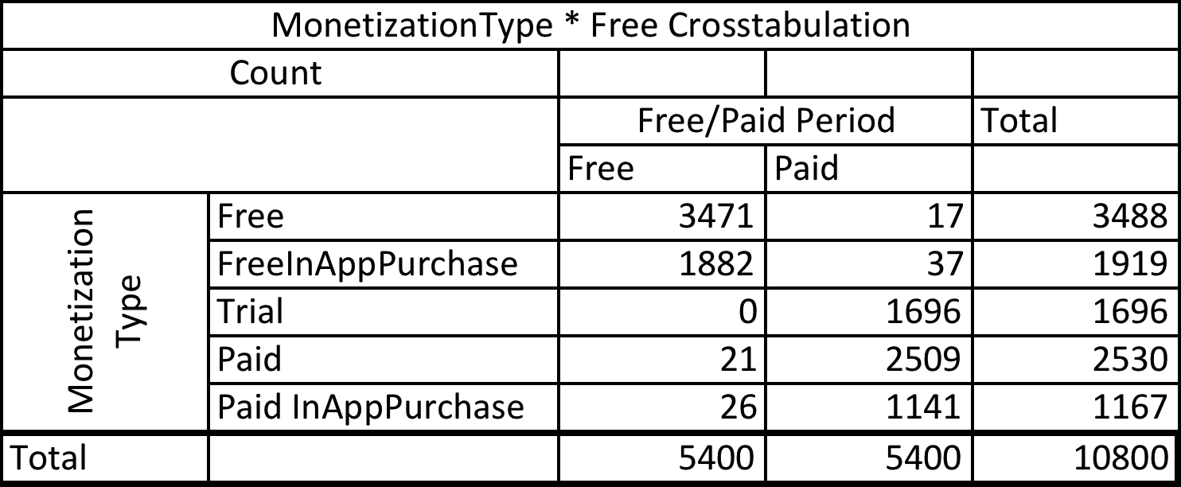

It can be noted here that there is a strong overlap for both the free/paid period and the monetization type. Therefore, the free/paid period will be omitted from the regression conducted later on. The co-occurrences between these two variables may decrease the explanatory power.

5.4 Regression Analysis
For the regression analysis a complete look is made at the effects for multiplying the OS dummies with each explanatory variable. Refer to Appendix 15 for full regression.
The R² value explains the percentage of variation on the dependent variable, in this case the R² = 0.899, appendix 13. This implies that 89.9% of the variability in this model is explained by the explanatory variables. With conducting this analysis, the explanatory power of the independent variable is at the point that any conclusions drawn will have a significant relevance to the research.
Furthermore, the F statistic from the ANOVA table reads as follows, F(85,10714)=1125.010, p=0.000 (Appendix 13). This implies that the null-hypothesis can be accepted and that there is a significant relationship between the independent and dependent variable. In other words, there is a statistically significant relationship between the independent and dependent variables.
Below the aforementioned hypothesis will be either confirmed or rejected based on the regression.
H.1.a iOS will cause for less downloads than Android, but more than Zune.
This hypothesis is rejected. When looking at the results it can be indicated that there is a reduction in downloads with Android when compared with iOS. The only exception to this is AndroidFree, the reason for this could be because Android has a larger user base than iOS does.
H.1.b Zune will have the least number of downloads compared to the other two OS.
Partially confirmed, while it is clear that by looking at the total number of downloads and market share of Zune that it has less downloads than its competitors. The regression does highlight a few categories where Zune generates more downloads than both iOS and Android, those are: ZuneKidsFamily, ZuneNews & ZunePuzzleTrivia. A possible explanation for this could be that the user who have a Windows device primarily download apps within those categories.
H.2.a Fully free applications will have a stronger positive influence on the number of downloads than those with an in-app purchase option.
Partially accepted. For Android this hypothesis is accepted, the number of downloaded app is higher. For iOS and Zune this cannot be confirmed or denied. The result for iOSFree was not significant. The result for ZuneFree cannot be determined, as SPSS has rejected it from the regression. This may be the result of perfect multicollinearity.
H.2.b Trial applications will have a strongest positive affect on the number of downloads followed by paid, then paid + in-app purchase.
Partially accepted. This hypothesis is true for Zune downloads across ZuneTrial and ZunePaid, ZunePainInAppPurchase was omitted by SPSS.
AndroidTrial and Android Paid were left out by SPSS, interestingly AndroidInAppPurchase had a significant positive affect on downloads. This may again be attributed to the fact that Android has a large user base. This would mean that there is a group of users who are willing to pay to unlock certain features.
iOSTrial was neglected by SPSS. Nevertheless, iOSPaid caused for less downloads than iOSInAppPurchase. A possible explanation for this might be that people are hesitant to pay for an app. However, once an app has been bought consumers may be more inclined to pay a little more again to unlock features they otherwise would not have access to.
H.3 There is no month that causes more downloads than another for Android and Zune, September and October may see a spike with iOS downloads due to the release of their new device.
Hypothesis rejected. Compared to the baseline constant AndroidMonth has less downloads, implying that downloads are not month dependent for Android OS.
Zune variable are mostly insignificant, this could be due to the fact that there is a small user base of Zune and thus no reliable conclusions can be drawn. Irrespectively, both ZuneJanuary and ZuneFebruary are significant and show a drop in downloads compared to the baseline constant.
iOS has a positive significant affect with each month. There is however no spike in downloads in either September or October. Contrary to the hypothesis the latter half of the year seems to incur less downloads than the first. iOSApril shows a spike, there is no logical explanation for this occurrence, as Appendix 10 shows there is a higher mean number of downloads in November.
H.4 Specific categories such Entertainment, Tools & Productivity and Games will yield higher number of downloads in comparison to the other categories.
Rejected, many of the application that would be considered to fit into the “game” category actually lead to a decrease in download compared to the baseline constant. The few exceptions would be for iOSArcase and iOSCasual, ZuneKidsFamily and ZunePuzzleTrivia. Both AndroidCasino and AndroidLibrariesDemo have a strong decrease in downloads with -.444 and -.417 respectively.
H.5 Is Local will have a positive effect on downloads.
Rejected, there are insufficient results statistically significant to be able to answer this hypothesis.
H.6 Lower prices will have a positive affect on downloads.
Partially accepted, the results are statistically insignificant to answer this hypothesis for Android and Zune. iOS confirms the hypothesis, indicating that higher prices will yield in lower downloads, with a Beta of -.014 per Euro cent increase.
Please find the full results table in Appendix 16

6. Conclusion
The research has provided for a number of insights on the behaviour of downloads for mobile applications across three operating systems. In the subsequent section the outcomes will be discussed.

6.1 General Discussion
The conclusions that can be drawn from this research give slightly more insight into this relatively new and unexplored area of the mobile application market. Despite the fact that some of the results came out to be insignificant, there are still relevant conclusions that can be made.
Unfortunately, no clear answer can be given to the initial research question, however other conclusion can be made. Downloads among Android users are the highest. This has to do with the large market share that Android has compared to iOS and Zune. Unlike iOS and Zune, Android is a freeware that has been distributed by Google, thus a solid foundation that many phone developers use and personalize. November appears to be a popular month for downloads. This could be because a lot of new phone releases are done in fall. Therefore, when people get their new phones they immediately start downloading applications. (This would also allow for an interesting research on the behaviour of how people search and download applications). It is also interesting to note that it appears that people are not willing to spend money on applications, paid applications tend to have fewer downloads than free, for obvious reasons. Even if downloading a free application that has an in-app purchase feature causes for a decline in downloads. This is again signalled with Trial applications. Trial applications increase downloads by roughly 56,174. This indicates that people would rather try a full-fledged application than download a free application and pay for additional features. Another noteworthy finding is that if paid applications had a free period this would increase the number of downloads by roughly 20,734. Again confirming that people are only willing to pay for an application when it has gotten positive reviews. Most probably, people who downloaded the application when it was free left many positive comments and rating for the application that it normally would not get, thus giving the application more popularity in a app-store. This increased attention may have helped convince people to acquire the application once it became paid.

6.2 Academic Contribution
There has been little research conducted in the field of mobile applications and whether there are differences in usage and download patterns across various mobile operating systems. This paper has shed some light on these matters. From this study it would appear that the category of an application is irrelevant, but that the monetization of an application plays a lager role.

6.3 Managerial Implications
This research has shown that how an application in monetized plays a significant role on downloads. This means that if new application is to be launch starting off as a free application is a company’s best bet. Using Lui, 2012 study and strategy of freemium applications. Though it could mean your application is an investment, a sunken cost or filled with advertisements. Though over time can be converted to a paid application, and then start generating revenue.

6.4 Limitations and Directions for Future Research
The research that has been conducted on this area has a number of limitation and areas that can be corrected for in the future. Even though the data had been collected for a period of one year, it would be beneficial to gather data on a larger time span. This would allow the future research to take more factors into account, such as the launch date of new phones onto the market and also reduce the element of any bias. On that note, in this research the size of the market share has not been accounted for, thus no conclusions can be made in relative terms. Seeming as Windows phone market is growing, this means that either or both Android and iOS are losing market share.
There could also be a case made for the reliability of this data. It has been gathered from one source only, and not been crosschecked with any other sources. Thus the reliability of the data can be questioned. The conclusions made can only said in terms of the data gathered from XYO. Even though more data could have been gathered from XYO, there was a limitation on getting access to the historical data. XYO would provide historical data at a high price. The data that has been collected here was the free monthly release. Even though I could continue collecting data it would mean that graduation would have been postponed.
There is also a lack of research that has been conducted in this field. Making it hard to cite prior studies, which is the foundation for understanding the research problem. Therefore further research in app download trends needs to be conducted in order to be able to lay a stronger foundation.

Appendix
**For convenience none of the results below were scaled to thousands, this was done to preserve the original results from SPSS.
Appendix 1 T-Test
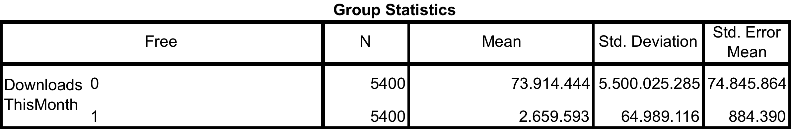

Appendix 2 Independent Samples T-Test
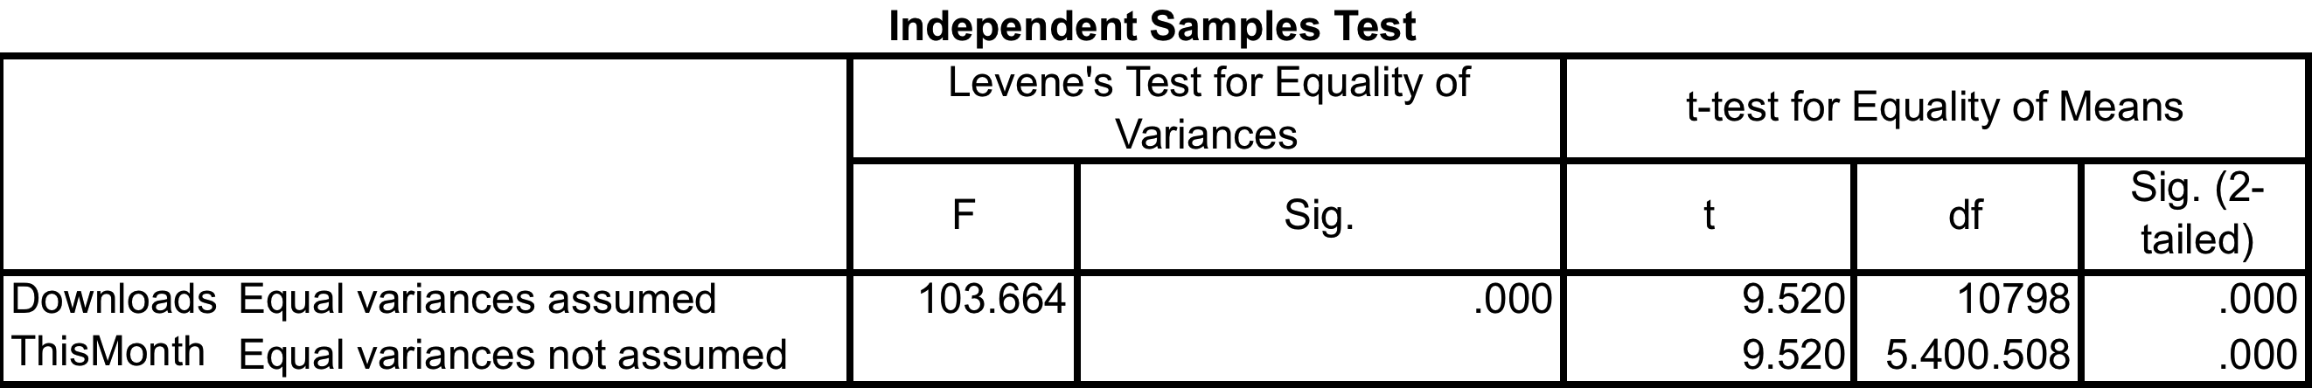

Appendix 3 One-Way ANOVA
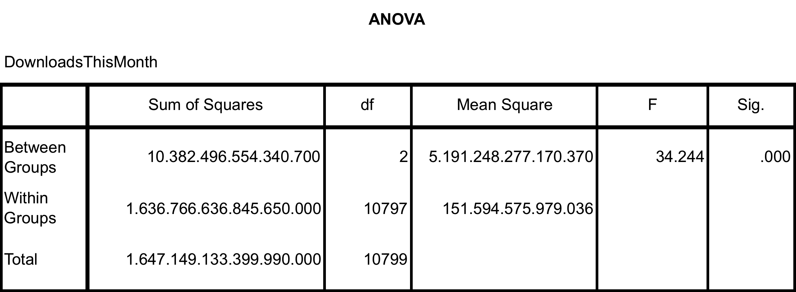
Appendix 4 Descriptive statistics from the three OS, Android (0), iOS (1), Zune (2)
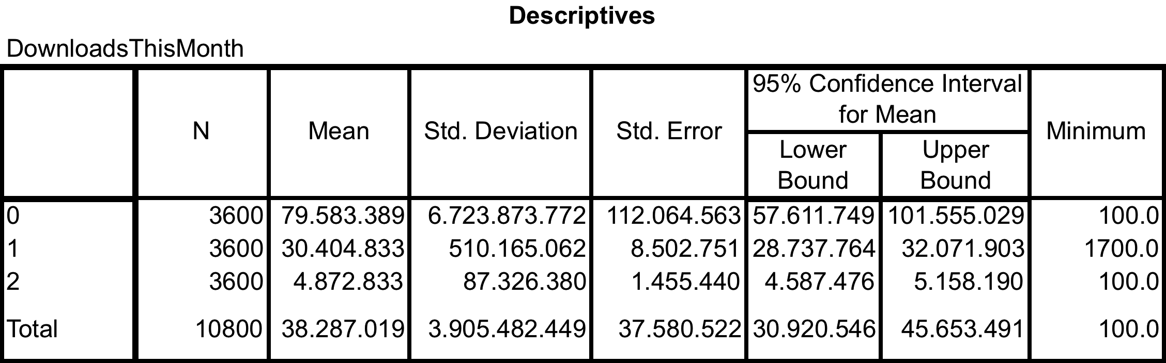

Appendix 5 Tukey Test
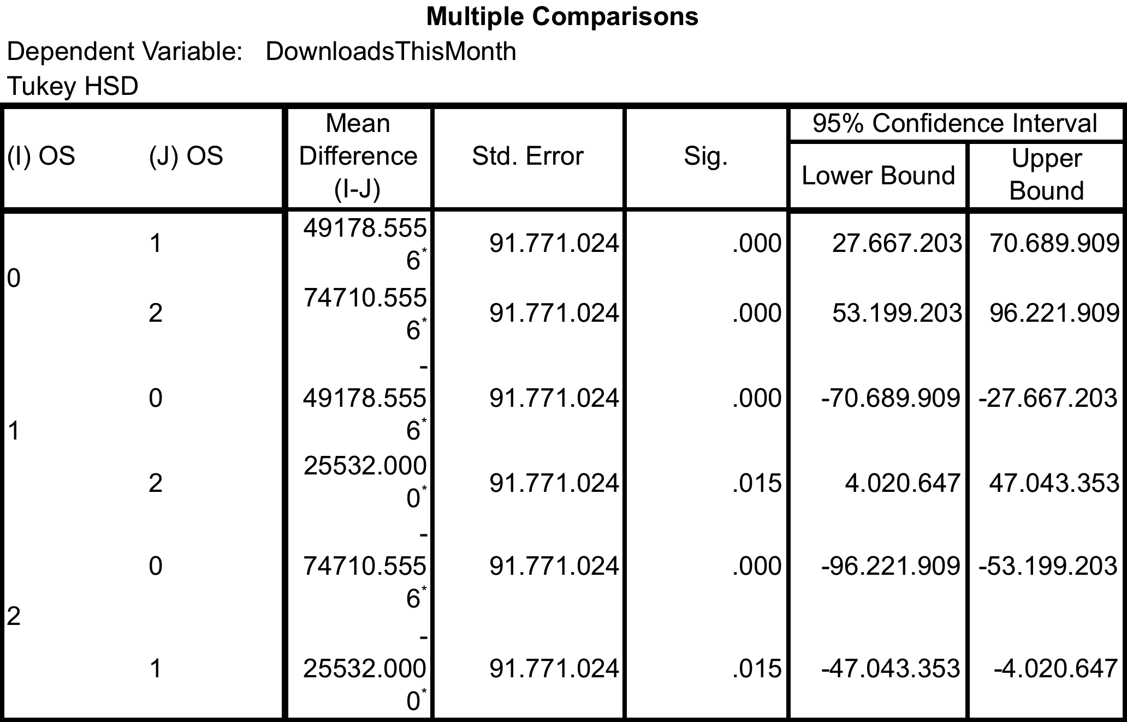

Appendix 6 Downloads / Apps Published for each OS
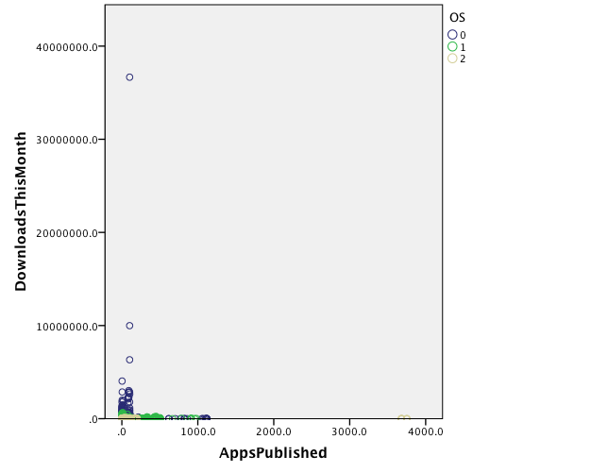

Appendix 7 Histogram of Downloads / Month

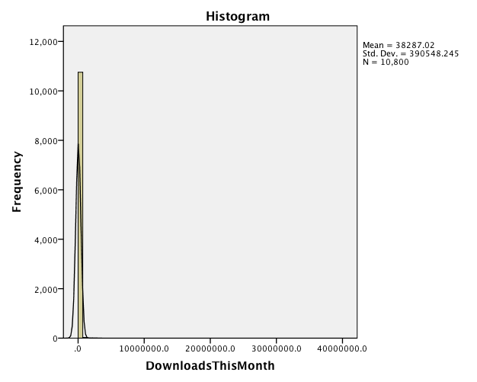

Appendix 8 Downloads / Category
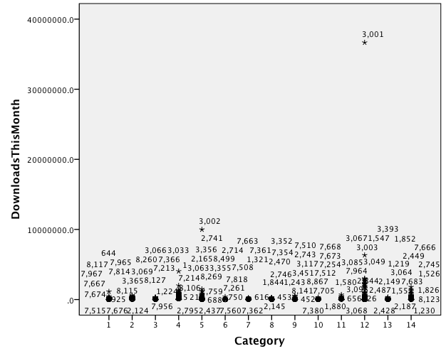

Appendix 9 Adjusted Histogram
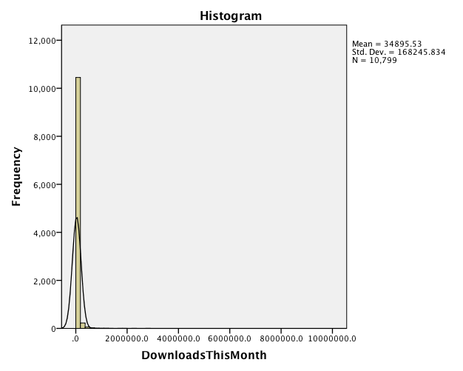

Appendix 10 Mean downloads / Month
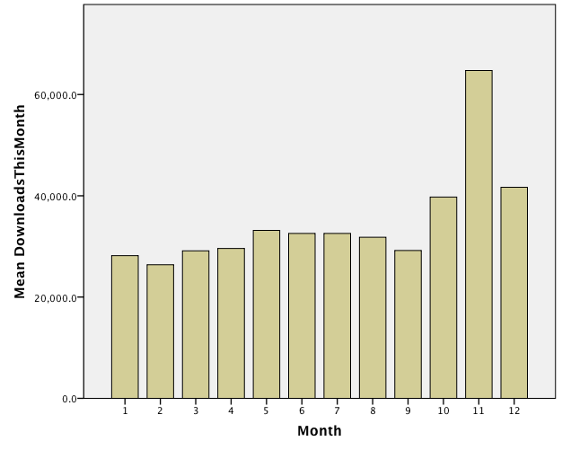

Appendix 11
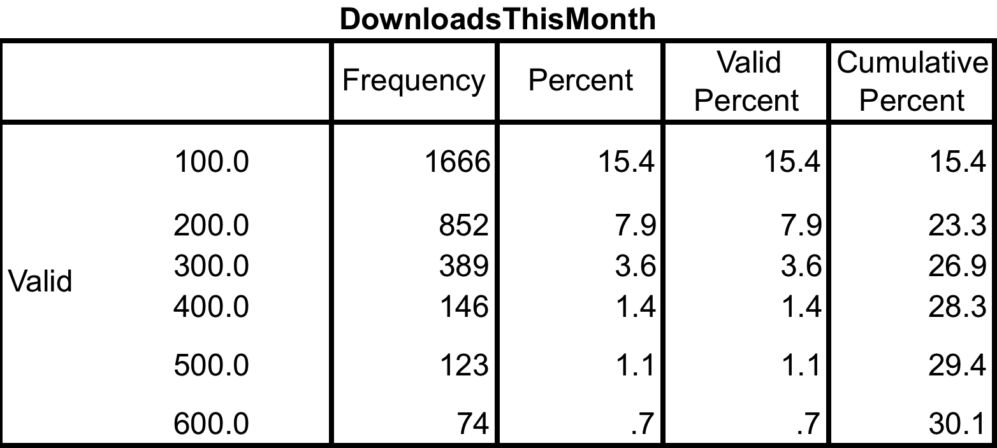

Appendix 12 Correlation Matrix of Price, Apps published, and Downloads
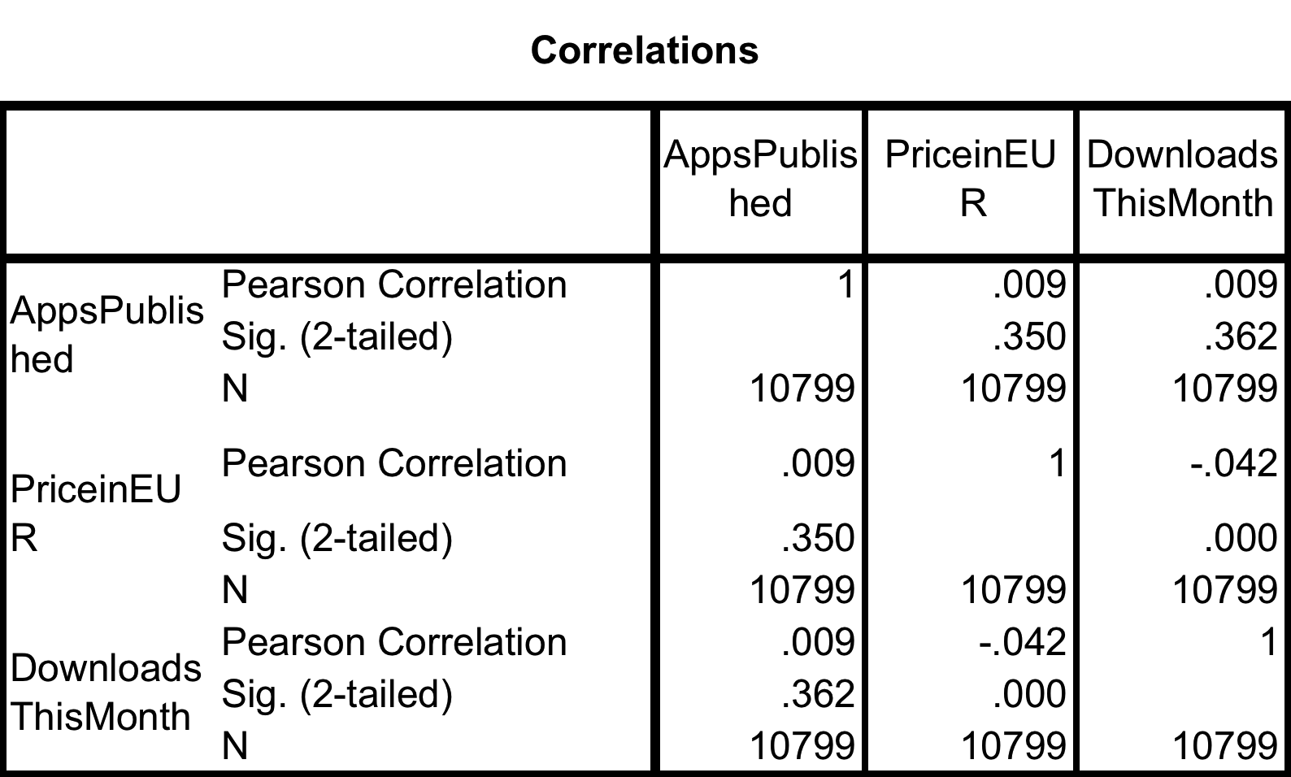
Appendix 13: R-Square for the regression analysis
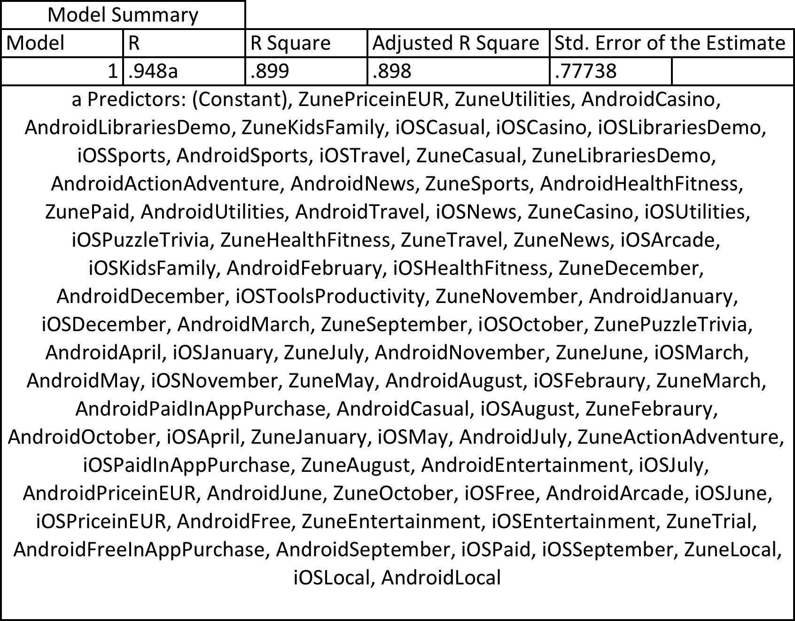

Appendix 14: ANOVA/Degree of Freedom for the regression analysis
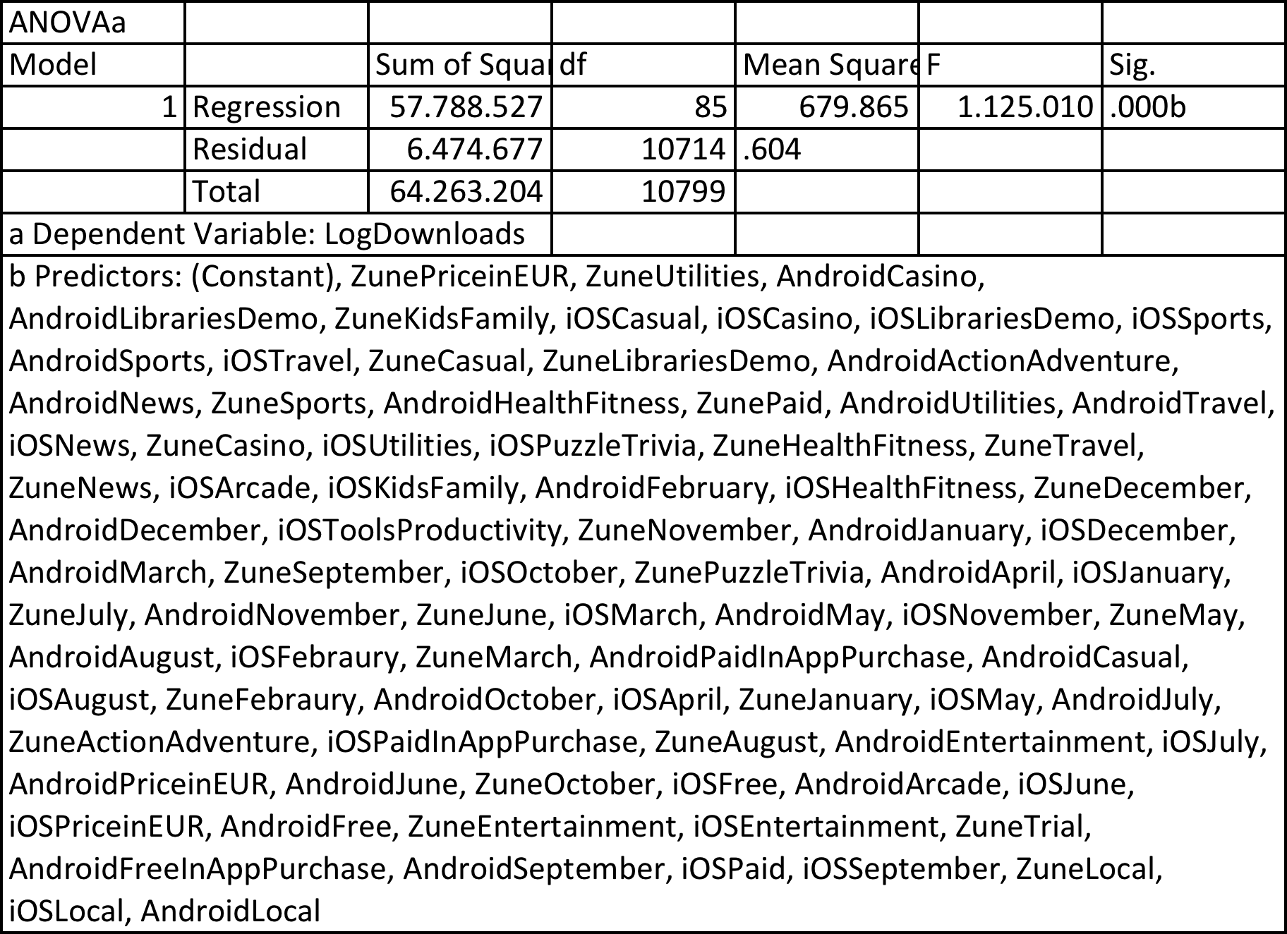

Appendix 15 - Regression equation
$Y_{i}=β_{0}+ β_{1}DAndroidFree+β_{2}DiOSFree+β_{3}DAndroidFreeInAppPurchase+β_{4}DiOSFreeInAppPurchase+β_{5}DZuneTrial +β_{6}DiOSPaid + β_{7}DZunePaid+ β_{8}DAndroidPaidInAppPurchase+ β_{9}DiOSPaidInAppPurchase+ β_{10}DAndroidJanuary+β_{11}DiOSJanuary+ β_{12}DZuneJanuary+β_{13}DAndroidFebruary+β_{14}DiOSFebruary+ β_{15}DZuneFebruary+ β_{16}DAndroidMarch+β_{17}DiOSMarch+ β_{18}DZuneMarch+β_{19}DAndroidApril+ β_{20}DiOSApril+ β_{21}DAndroid{May+β}_{22}DiOSMay+ β_{23}DZuneMay+β_{24}DAndroidJune+β_{25}DiOSJune+β_{26}DZuneJune+β_{27}DAndroidJuly+β_{28}DiOSJuly+β_{29}DZuneJuly+β_{30}DAndroidAugust+β_{31}DiOSAugust+β_{32}DZuneAugust+{β_{33}DAndroidSeptember+β}_{34}DiOSSeptember+β_{35}DZuneSeptember+β_{36}DAndroidOctober+β_{37}DiOSOctober+β_{38}DZuneOctober+β_{39}DAndroidNovember+β_{40}DiOSNovember+β_{41}DZuneNovember+ β_{42}DAndroidDecember+β_{43}DiOSDecember+β_{44}DZuneDecember+{β_{45}DAndroidActionAdventure+β_{46}DZuneActionAdventure+β}_{47}DiOSArcade+ β_{48}DAndroidCasino+β_{49}DiOSCasino+β_{50}DZuneCasino+β_{51}DAndroidCasual+β_{52}DiOSCasual+β_{53}DZuneCasual+β_{54}DAndroidEntertainment+β_{55}DiOSEntertainment+ β_{56}DZuneEntertainment+β_{57}DAndroidHealthFitness+β_{58}DiOSHealthFitness+β_{59}DZuneHealthFitness+β_{60}DiOSKidsFamily+β_{61}DZuneKidsFamily+β_{62}DAndroidLibrariesDemo+β_{63}DiOSLibrariesDemo+β_{64}DZuneLibrariesDemo+β_{65}DAndroidNews+β_{66}DiOSNews+β_{67}DZuneNews+β_{68}DiOSPuzzleTrivia+β_{69}DZunePuzzleTrivia+β_{70}DAndroidSports+β_{71}DiOSSports+β_{72}DZuneSports+β_{73}DiOSToolsProductivity+β_{74}DAndroidTravel+β_{75}DiOSTravel+β_{76}DZuneTravel+β_{77}DAndroidUtilities+β_{78}DiOSUtilities+β_{79}DZuneUtilities+β_{80}DAndroidLocal+β_{81}DiOSLocal+β_{82}DZuneLocal+β_{83}DAndroidPrice+β_{84}DiOSPrice+β_{85}DZunePrice+$ei

Appendix 16 Regression results
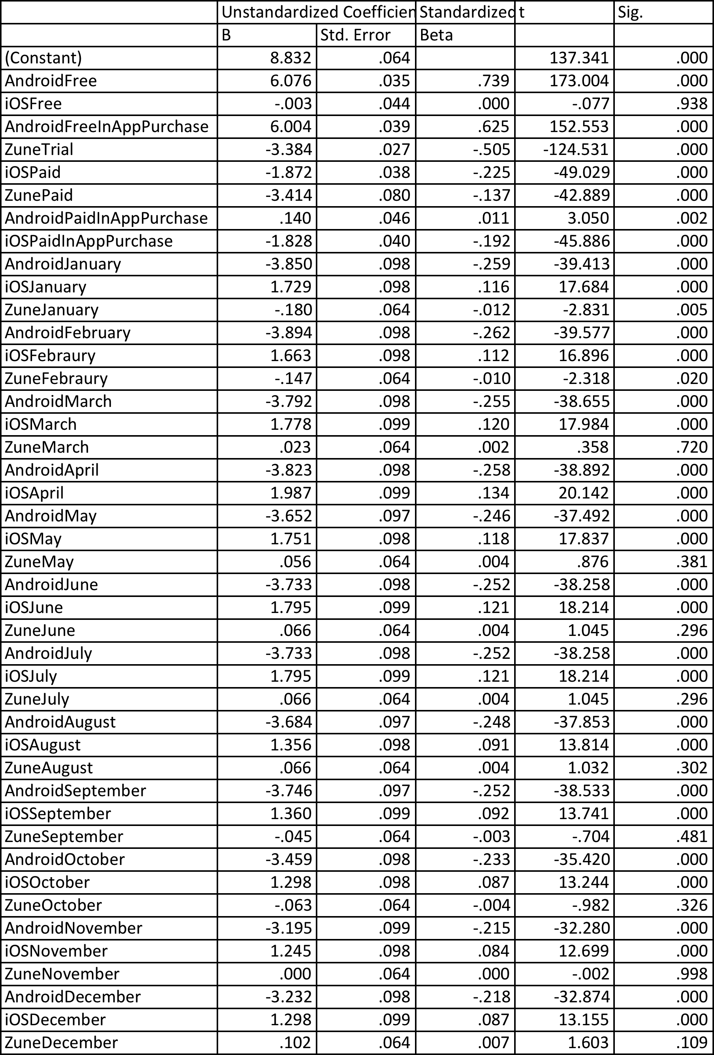
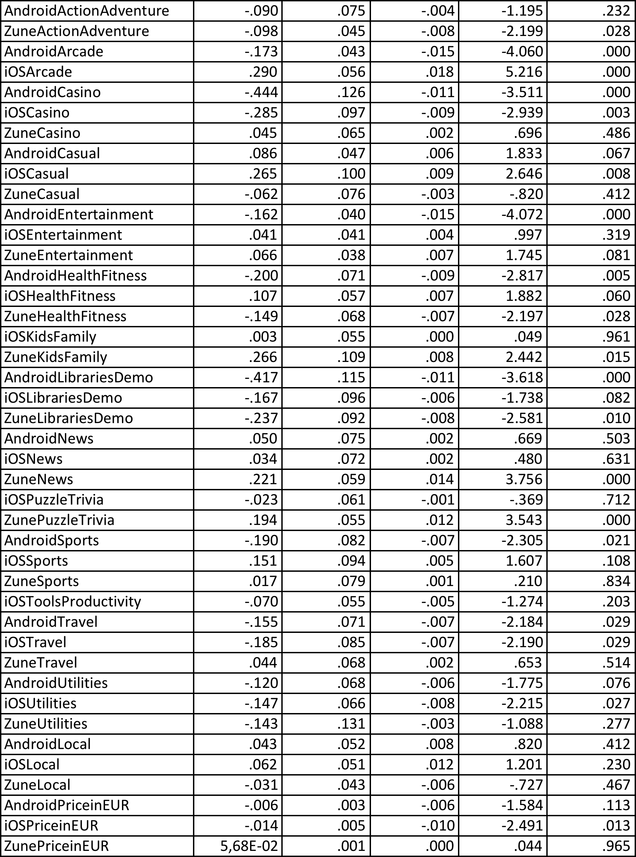

Reference List
Anderson, C. 2004. "The Long Tail," in: Wired Magazine.
Arnold, R. 1993. Software Engineering. IEEE Computer Society Press, Los Alamitos, California.
Businessinsider 2011. “Why Native App Stores Like iTunes And Android Marketplace Are Bad For Mobile Developers,” http://www.businessinsider.com/why-native-app-stores-like-itunes-and-andoidmarketplace_are-bad-business-for-mobile-developers-2011-5 (last accessed August 15th, 2014)
Brynjolfsson, E., Hu, Y. (Jeffrey), and Smith, M. D. 2003. Consumer Surplus in the Digital Economy: Estimating the Value of Increased Product Variety at Online Booksellers, Management Science (49:11), pp. 1580–1596.
Cheng, H.K., and Tang, Q.C. 2010. "Free Trial or No Free Trial: Optimal Software Product Design with Network Effects," European Journal of Operational Research (205:2), pp. 437-447.
Chevalier, J., and Goolsbee, A. 2003. "Measuring Prices and Price Competition Online: Amazon.Com and Barnesandnoble.Com," Quantitative Marketing and Economics (1:2), pp. 203-222.
Chevalier, J.A., and Mayzlin, D. 2006. “The effect of word of mouth on sales: Online book reviews,” Journal of Marketing Research (43:3), pp. 345-354.
Digitalinspiration 2011. “Would You Like to Try Android Apps Before Buying?,” http://www.labnol.org/internet/android-apps-try-before-buying/19422/ (last accessed August 15th, 2014).
Dellarocas, C. 2003. “The Digitization of Word-of-Mouth: Promise and Challenges of Online Reputation Systems,”Management Science (49:10), pp. 1407-1424
Dellarocas, C. and Narayan, R. 2006. “A Statistical Measure of a Population’s Propensity to Engage in Post-Purchase Online Word-of-Mouth,” Statistical Science (21:2), pp. 277-285
Faugere, C., and Giri Kumar, T. 2007. "Designing Free Software Samples: A Game Theoretic Approach," Information Technology & Management (8:4), pp. 263-278.
Field, A. (2009), Discovering Statistics Using SPSS, SAGE Publications Ltd.

Gallaugher, J.M., and Wang, Y.-M. 2002. "Understanding Network Effects in Software Markets: Evidence from Web Server Pricing," MIS Quarterly (26:4), pp. 303-327.
Gartner (2011). Gartner says worldwide Mobile Application Store Revenue Forecast to Surpass $15 Billion in 2011. Available at: http://www.gartner.com/it/page.jsp?id=1529214 (Accessed on August 15th, 2014)

Ghose, A., S. Han. (2011). A Dynamic Structural Model of User Learning on the Mobile Internet. Working Paper, Available at: <http://ssrn.com/abstract=1485049,> (Last accessed on 26th July 2014)

Ghose, A., S. Han. (2012). Estimating Demand for Mobile Applications in the New Mobile Economy. Thirty Third International Conference on Information Systems, Orlando 2012
Ghose, A., Ipeirotis, P., Li, B. 2012. Designing ranking systems for hotels on travel search engines by mining user-generated and crowd-sourced content, forthcoming, Marketing Science.
Ghose, A., and Sundararajan, A. 2006. "Evaluating Pricing Strategy Using E-Commerce Data: Evidence and Estimation Challenges," Statistical Science (21:2), pp. 131-142.
Hall, R. 1998. “Between-Subjects One-Way ANOVA,” http://web.mst.edu/~psyworld/anovasteps.htm (last accessed August 16th, 2014)
Hall, R. 1998. “Tukey's HSD Post Hoc Test,” http://web.mst.edu/~psyworld/tukeyssteps.htm (last accessed August 16th, 2014)
Haruvy, E., and Prasad, A. 2001. "Optimal Freeware Quality in the Presence of Network Externalities: An Evolutionary Game Theoretical Approach," Journal of Evolutionary Economics (11:2), pp. 231-248.
Jahns, R.G. 2010. "Smartphone Application Market to Reach Us$15.65 Billion in 2013," in: Global
Kapil, B., and Robert, S. 2004. "The Effects of Free Sample Promotions on Incremental Brand Sales," Marketing Science (23:3), p. 345.
Liu C. Z. (2012). An Empirical Study of the Freemium Apps: Evidence from the of the Google Play Market. Thirty Third International Conference on Information Systems.
Marketing NPV “How Do You Measure Engagement? Start by Defining It in the Right Context”. Journal of MarketingNPV , (1), pp. 3–7.
Nokia, 2014, “http://www.nokia.com”. (last accessed on June 22, 2014)
O'Brien, H. L., Toms, E. G., Kelloway, E. K., and Kelley, E. 2008. “Developing and evaluating a reliable measure of user engagement,” In Proceedings of Am. Soc. Info. Sci. Tech. (45), pp. 1-10.
ResearchMoz 2014. “Global Mobile Applications (Free, Paid & Ad Supported) Market By Stores, Category, Platform, Brands And Stakeholders (2012 - 2017),” https://www.linkedin.com/today/post/article/20140609064142-173774513-mobile-applications-app-market-research-report-2012-2017 (last accessed August 15th, 2014)
Sangaralingam Kajanan et al. (2012). “Takeoff and Sustained Success of Apps in Hypercompetitive Mobile Platform ecosystems: An Empirical Analysis”, Thirty Third International Conference on Information Systems.
Smartphone Application Market Report 2010. Available online at: http://www.research2guidance.com/smartphone-application-market-to-reach-us15-65-billionin-2013: Research2Guidance.
Strategic Growth Concepts 2014. “Mobile Technology for Increased Productivity & Profitability,” http://www.strategicgrowthconcepts.com/growth/increase-productivity--profitability.html (last accessed August 15th, 2014)
TRI. (2010). Retrieved from http://www.topology.com.tw/tri/ (last accessed August 15th, 2014)
Wang, Hsiu-Yu; Liao, Chechen; Yang, Ling-Hui, 2013. “What Affects Mobile Application Use? the Roles of Consumption Values,” International Journal of Marketing Studies http://www.questia.com/library/journal/1P3-3069574291/what-affects-mobile-application-use-the-roles-of (last accessed August 15th, 2014)
Xyologic. 2012. Global App Download Reports. http://www.xyologic.com/app-downloads-reports.

