- Immigration and Labor Market Outcomes: An Analysis on the Effects of Immigration on the Dutch Labor Market
- ERASMUS UNIVERSITY ROTTERDAM
- Erasmus School of Economics
- Department of Economics

- Supervisor: Dr. J. Delfgaauw

- Name: Rashid Mokhtar Mohamed Amin Salem
- Exam number:365943
- E-mail address:365943rs@student.eur.nl

- Abstract
- Immigration has become increasingly important in the Dutch political sphere, as well as around the world. An important topic that is discussed is the effects of immigration on the labor market of the host nation. This thesis studies the effects of incoming immigrants on the Dutch labor market between the years 1981 and 2013. Using the method of OLS regressions, I examine the effect of the influx of immigrants on the employment rate of natives as one group and separately for high-skilled and low-skilled laborers and the results show a positive but non-significant relationship between the dependent and independent variables. I then use OLS regressions again to study the effect of immigration on the change in wages per hour. Again, the results show a positive, yet highly insignificant relationship between immigration and wages.
1. Introduction 3
2. Literature Review 6
2.1 Theory 6
2.2 Empirical Research 10
2.2.1 The U.S. 11
2.2.2 The Netherlands 13
2.2.3 Other 15
3. Data 18
3.1 Immigration and The Netherlands 18
3.2 Defining the Variables 22
4. Methodology 26
4.1 Employment Rate 26
4.2 Wages 29
4.3Hypotheses 30
5. Results 32
5.1 Employment Rates of Dutch natives 33
5.2 Employment Rates of High Skilled Workers 36
5.3 Employment Rates of Low Skilled Workers 38
5.4 Wages 40
5.5 Net Migration 41
6. Conclusion 43
6.1 Limitations 45
6.2 Further Research 46
Appendix 1 50
Appendix 2 55
Appendix 3 57
Appendix 4 59
Appendix 5 61
Appendix 6 63

1. Introduction
- In the early part of the 1960s, “the Netherlands switched from an emigration to immigration country” (Zorlu & Hartog, 2001, p. 2). This means that less Dutch people were leaving, compared to foreigners moving into The Netherlands. This has become common with relatively rich countries around the world and especially in Europe. As a result, over the years, the topic of immigration has become an increasingly debated matter in social and political circles. Some people support the influx of immigrants, whilst others believe incoming immigrants have an adverse effect on the native labor market.

- The topic of immigration is hotly debated in Dutch politics and news. In the recent local elections, at some point, “Wilders, whose tough line on immigration has made him one of the most popular Dutch politicians, holds a slim lead on Rutte’s VVD” (Deutsch, 2015). This could mean that there is an increase in support for a tough line against immigration. However, this could also be due to other views that Wilders has preached. Dutch politician Lodewijk Asscher “likened rising migration to a “Code Orange”, Dutch parlance for a severe flood warning” (The Economist, August 24th, 2013). There has also been complaints from Dutch construction workers that they are unable to compete with foreigners who are more willing to accept lower wages (The Economist, August 24th, 2013). In addition, in 2011, it was reported that immigration laws made The Netherlands tougher when it comes to immigration (Wilson, 2011). More support for less immigration came from Christian Democrats in 2012 by claiming that the multi-cultural experiment has failed (The Economist, February 16th, 2012).

- Even though immigrants are usually seen as having a negative influence on the labor market and the economy in The Netherlands, common economic theory provides support to the idea that immigration may actually have a positive effect. According to Borjas (2013), the native labor market may end up being better off after an influx of immigrants if the immigrants and the natives are complements. As a result, natives are more productive and are allowed to specialize, which increases the demand for them, and employment rates and wages increase as a result. Borjas (2013) also claims that immigration within the country, from one city to another for example, usually offsets the effect of the incoming immigrants, and wages are not severely affected by immigration as a result.

- Over the years, academics and economists have tried to determine the actual impact of immigration on host nations’ labor market in an attempt to add to the debate between policy makers and theory. This research studies this subject using different methods and techniques and is applied in different markets around the world. The research shows mixed effects, sometimes but not always, providing support for the prediction that immigration has significant effects on the labor market of the host nation. This ambiguity likely stems from the number of different methodologies used in the different papers, but the actual effect may also be country-specific. Hence, the literature does not offer a clear-cut solution to the debate on the effects of immigration to The Netherlands.

- In this thesis, I analyze the relationship between immigration into The Netherlands on the one hand, and the employment rates and wages of Dutch natives on the other hand. This could add significant results to the wide range of sources about the same topic. One motivation behind this paper comes from the fact that this type of research has not been carried out in the Dutch labor market. Some have attempted to study the effect on wages alone, while others attempted to study the effect on employment rates, but not together. (Zorlu & Hartog 2011, Roodenburg , Euwals, & ter Rele, 2003). These papers will be further discussed later. This thesis will attempt to answer the following research question:

- What is the effect of immigration on the Dutch labor market between 1980 and 2013?

- Through the use of OLS regressions, this paper will examine the relationship between the influx of immigrants that arrived between the years 1980 and 2013 on the Dutch labor market. The data will be collected from The Central Bureau of Statistics of The Netherlands. Data will be collected on the number of immigrants, the employment rates, wages, and the number of high skilled and low skilled workers in the labor force along with the number of native Dutch workers in the labor force. This data will be used to run the regressions.

- The regressions will be split into four groups depending mainly on the dependent variable. First, the dependent variable will be the employment rate of Dutch natives in general. The second group will have the employment rate of high skilled workers as the dependent variale while the third group will include the employment rate of low skilled workers as the dependent variable, and the final group will take the change in wages per hour as the dependent. The aim of these regressions will be to determine the nature of the relationship between the dependent variable and the incoming influx of immigrants, and whether there is a positive or negative correlation present. The independent variable will be the immigration supply shock and its one year lagged value to study whether the relationship changes in time. In addition, the same regressions will be used again, but immigration will be replaced with a variable that includes net migration instead, and this is done as robustness check.

- This paper is structured in the following manner: first a literature review will be presented where both theory and empirical research will be discussed. Second, the Data and Methodology will be presented, where more details about the data collected and methodology to be used will be conversed. Then, the data will be analyzed and the resulting findings will be presented in the subsequent section named Results. Finally, the final section is the Conclusion and will include a discussion about the findings and limitations of the paper along with further suggestions on how to improve this research.

2. Literature Review

2.1 Theory
- There exist a number of theories in Labor Economics that try to examine the effect of immigrants on the labor market. According to a simple model of immigration, where immigrants and natives are perfect substitutes, the short-run impact of immigration includes a shift in the supply curve rightwards which in turn increases overall employment and decreases wages (Borjas, 2013). This can be seen more clearly through a graph:
- 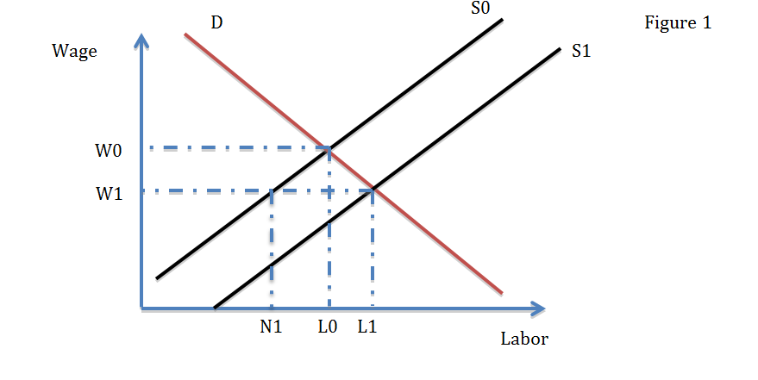

- The above graph shows how the increase in immigrants affects the labor market in the short run. The influx of immigrants causes the supply curve to shift from S0 to S1, causing wages to drop from W0 to W1 and employment to rise from L0 to L1. However, due to the drop in wages, some of the native workers are unlikely to be willing to work at these lower wages and native employment decreases to N1. However, this drop in employment is sufficiently covered by hiring more immigrants, which then leads to L1 in the graph above (Borjas, 2013). Therefore, in the short run, given that immigrants and native are perfect substitutes, the native workers are worse off.

- However, the assumption of perfect substitutes is unreliable. If immigrants and natives are not perfect substitutes, they are not competing in the same labor market. Accordingly, the natives are likely to become more productive as they become more specialized and this causes the demand curve to shift outwards:
- 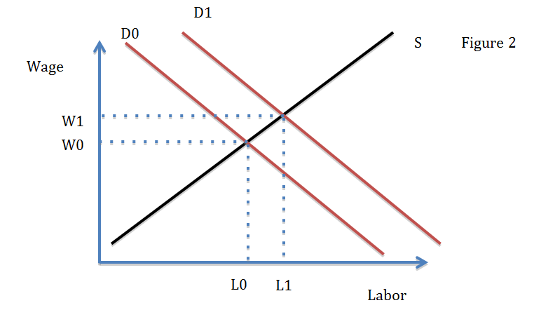
- The specialization of native workers increases their productivity which in turn leads to an outward shift in the demand curve as seen above. Employment increases from L0 to L1 along with wages that increase from W0 to W1 due to the influx of immigrants (Borjas, 2013). Therefore, economic theory states that the impact immigration has on the native labor force mainly depend on the substitutability between immigrants and natives in the labor market. However, these are only the short-run effects of increased immigration. It is also imperative to take into account the long-run effects.

- Assuming that immigrants and natives are indeed perfect substitutes, the lower wages resulting from the increased competition will likely lead to higher profits to the firms and this will encourage them to expand. This means that the demand for labor will increase and the demand curve will shift outwards, and this brings the wages back to the original level, which will encourage more native employment. In other words, in the long run, the labor market will re-adjust and return to the previous state (Borjas, 2013). However, in this case, it is imperative to determine by how much the demand for labor increased. The demand for labor must increase substantially in order to reach the pre-immigration equilibrium:
- 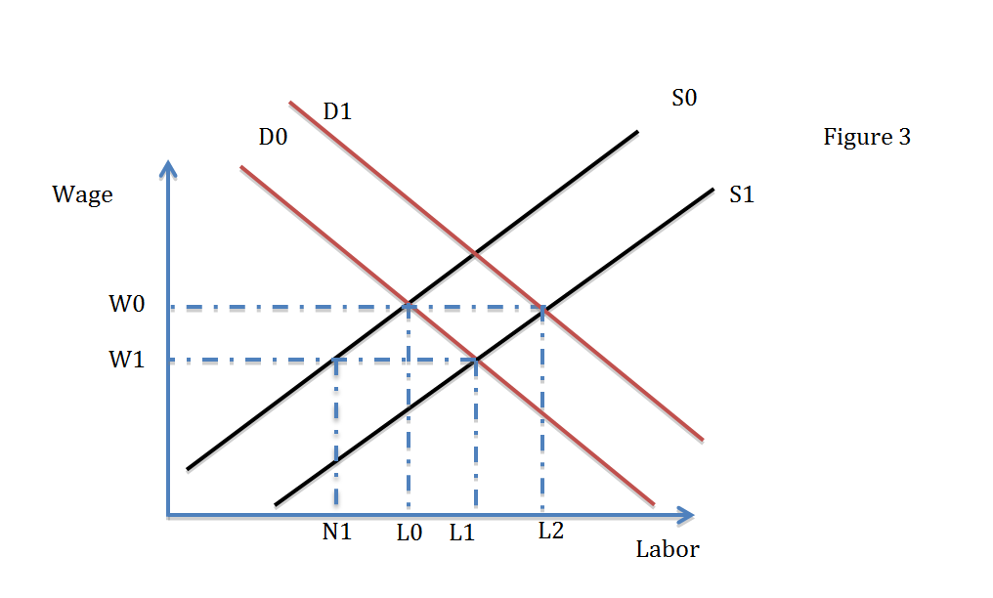

- The above graph illustrates the theoretical situation that is likely to occur in the long run. The demand curve needs to shift rightwards enough in order to intersect the new supply curve, S1, at the point that reverts the labor market to the situation before immigration. Therefore, it is possible to conclude that the effect of immigrants on native workers is non-existent in the long run due mainly to the rise in profits of firms (Borjas, 2013).

- Another theory attempts to explain why studies have found that wages are not greatly changed after an influx of immigrants. Borjas (2013) states that wages are not severely affected because the native labor force tends to respond to the increase in immigration by altering their behavior. He assumes that natives and the incoming immigrants are perfect substitutes and uses two cities, Los Angeles and Pittsburgh, in order to support his claims. If Los Angeles witnesses an increase in the number of immigrants, then due to the substitutability with the natives, the wages and subsequently the employment rate of American workers based in Los Angeles will decrease. In the same time, immigration in Pittsburgh does not change and the labor market remains the same. This encourages Americans in Los Angeles to move to Pittsburgh. As they leave, the wages in Los Angeles rise again, but do not reach pre-immigration levels. Simultaneously, as more people move to Pittsburgh, the supply increases and the wages in Pittsburgh fall. If immigration is without cost, this inter-city mobility of Americans will continue until wages in both cities are the same, which leads to a situation where Americans in both cities are in the same position. However, on the aggregate level, all natives are negatively affected from the increase in immigration, as wages are still lower than before immigration (Borjas, 2013). In other words, with inter-city mobility, natives can make decisions that may make the individual better off, but don’t necessarily improve the labor market situation on the aggregate level. This can be seen in the following figure:
- 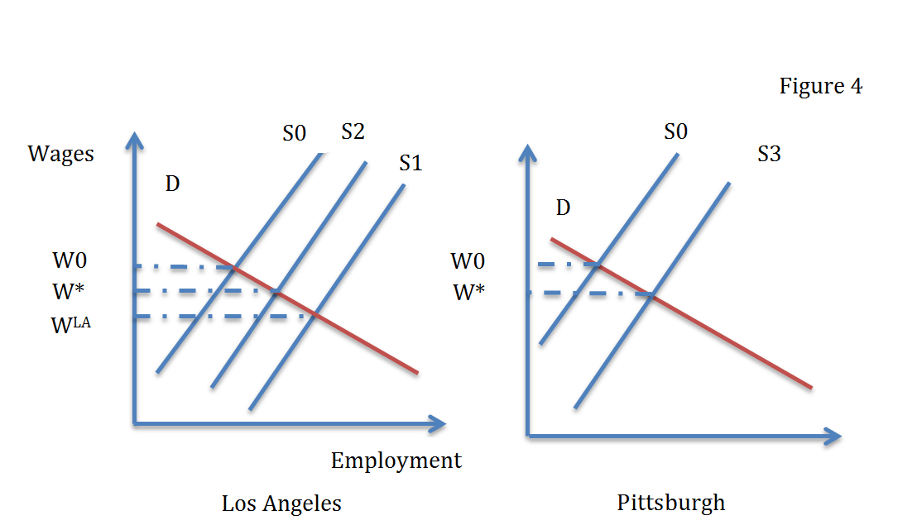
- Immigrants arrive in Los Angeles, which leads to a movement from S0 to S1 and a drop in wages from W0 to W^{LA} . However, as Americans react and move to Pittsburgh, the labor force in Pittsburgh increases to S3 while the labor force in Los Angeles decreases back to S2. The resulting wages W* are lower than initial wages W0, but are the same in both cities (Borjas, 2013).

- Other theories exist that attempt to explain how immigrants affect the rest of the economy. Ehrenberg and Smith (2006) claim that consumers benefit from the cheap labor as this translates into reduced prices. They also claim that cheap labor increases profitability, which encourages employers to increase investment and this in turn increases capital and also increases the number of employers. The increase in capital and employers eventually drive down profits, but leaves the country with a higher stock of capital and this provides workers with more opportunities to become owners themselves, and therefore become self-employed. (Ehrenberg and Smith, 2006). Natives are likely to be better placed to take advantage of this increase in capital due to a number of reasons, such as being in a better financial position than the incoming immigrants and having more access to the necessary resources. The net effect on natives can be seen as positive since immigration allowed them to become owners and not unemployed. In addition, by becoming owners of capital, they will likely seek labor and this will increase the overall employment rate. Ehrenberg and Smith (2006) also argue that immigrants may affect the native work force through public subsidies. Most countries have public programs that aim at providing benefits to immigrants. If these immigrants are paying enough taxes to sufficiently cover what they receive from the public programs, then this does not affect natives’ disposable income. However, if the taxes paid by immigrants do not cover the benefits, this will likely have an adverse effect on the disposable income of natives.

2.2 Empirical Research
- According to economic theory, incoming immigrants have ambiguous effects on the labor markets of natives in the host market. Resulting academic and scientific literature have attempted to discover the actual effects of immigration on the native labor market. Empirical studies have attempted to solve this conundrum through different methods in different countries. Immigration effects may be different in European labor markets than American labor markets because European markets are seen as more rigid (Zorlu & Hartog, 2005). It would therefore be advisable to compare empirical studies carried out in the United States to those carried out in Europe. This creates a wide range of literature, and the following section will give an overview of the existing literature.

2.2.1 The U.S.
- David Card uses “1990 census data to study the effects of immigrant inflows on occupation-specific labor market outcomes” (Card, 2001, p. 22). This is different from other papers as it allows for inter-city mobility and focuses on results in occupation-specific labor markets. He uses an OLS regression in order to generate results. He runs two regressions, one has wages as the dependent variable while the other includes participation rate as the dependent variable Card (2001) finds that, although native mobility rates between cities is not significantly affected by the inflow of immigrants, the employment rates and wages of low skilled natives are reduced due to immigration, especially in cities which have a high concentration of immigrants. However, these effects were observed to be very small. Another paper studies the impact of immigration in The United States through regressions and data from 1960 until 1990 (Borjas, 2003). He assumes that workers with similar educational backgrounds, but differing levels of experience are not considered perfect substitutes in the national labor market. The difference here is that Borjas (2003) takes into consideration work experience, something that is not common in the studies to be mentioned in this paper. Regression analysis is used where there are three separate dependent variables, the mean log of annual earnings, mean log of weekly earnings and the average of the amount of time worked (Borjas, 2003). Independent variables are split into three different vectors: one indicates educational attainment, the second indicates work experience and the last indicates time period. Interactions between the vectors are also included in the model. The regression analysis consistently finds that immigration leads to a reduction in wages and labor supply of the native workers, and this supports the prevalent economic theory that was presented earlier in this paper.

- Fairlie and Meyer (2001) attempt to deviate from the previously mentioned papers by instead examining impact on self-employed natives. They implement a general equilibrium model that attempts to study the nature of the relationship between changes in the number of immigrants and the self employment rates and earnings of the native population. Their model is split into two sectors, a sector that includes the self-employed individuals and a wage/salary sector. Also, they do not assume natives and immigrants are perfect substitutes and are allowed to differ in their skills. Contrary to previously mentioned papers, they assume that only a single type of skill is present in each sector and they allow for different occupations (self-employments vs. normal employment). Their analysis suggests that incoming self employed immigrants took the place of self employed natives, but immigration did not have a signifcant, negative effect on the earnings of the self employed natives (Fairlie and Meyer, 2001). This contradicts the theory previously presented in this paper that claims that an influx of immigrants allows more capital to be available, which may lead to more natives becoming self-employed.

- Butcher and Card (1991) attempt to determine whether immigration in the United States leads to significant changes in the earnings of native workers, specifically those with low skills. By treating different cities in the US as separate labor markets, they endeavor to answer the question through comparing changes in wages between cities that have a high concentration of immigrants with cities that have a considerably lower concentration of immigrants. This paper is different as they do not use regressions, a common tool for studying this particular topic, instead, Butcher and Card (1991) calculate the log wage distributions for the 10th and 90th percentiles for the all the cities. They then use this to compare the changes in wages across the labor markets in question. They also look to determine the effect of increased immigration on the different percentiles, and control for several factors such as population growth rate and initial level of wages along with initial number of immigrants already in each city. An analysis of their results does not show any significant, negative effect of immigration on wages, even those with wages in the lowest percentile (Butcher and Card, 1991).

2.2.2 The Netherlands
- In their book, Roodenburg, Euwals and Ter Rele (2003), use a stylized model in order study how different policies with regards to immigration affected the Dutch economy. They take into consideration a competitive economy that consists of three main production factors: capital, along with low and high skilled labor. The stylized model presented by them is static, which allows them to present two equilibriums, one before and one after and influx of immigrants. To get better results, the authors first assume that all immigrants are low skilled and then assume all immigrants are high skilled. In addition, they add a third less extreme scenario where the immigrants have similar skills to the natives. Based on the three previous scenarios, the researchers perform several simulations in order to produce their empirical results. Through their study, these simulations allowed them to reach two conclusions. The first is that the income of residents is unlikely to increase greatly, and may even decrease due to immigration and their assumptions about the skills of the immigrants allowed them to conclude that if immigrants are substitutes of the native workers, the natives will likely lose (Roodenburg et al., 2003). This stylized model and the resulting analysis come with many flaws. First, the assumptions that labor supply is fixed and the labor market is competitive are seen as unrealistic for the Dutch market. Second, the model they put forth does not model international trade, which is not possible for a country that considers international trade important. Third, the model does not take into account regional mobility, even though this constitutes part of the theory about immigration as natives may react to immigration and move to other parts of the host country. In addition, the model only focuses on two general skill levels. Finally, certain shortages of skills on the labor market are not taken into account, which is likely to have an effect on the labor market. Nevertheless, their findings support theory that claims that if immigrants are substitutes for the residents; these same residents are unlikely to gain.

- Zorlu and Hartog (2005) study how immigrants affected wages in three different European countries, specifically Norway, The Netherlands and the United Kingdom. Their study differs from the one carried out by Roodenburg et al. (2003) in a number of ways. Instead of a stylized model, they extend upon an already proposed two factor, partial equilibrium model and take tree different skill levels instead of two. Instead of assuming that there are only low skilled and high skilled workers, they add medium skilled workers to their model. An OLS regression is run with the log of wages as the dependent variable while the share of immigrants is the independent variable along with other explanatory variables such as human capital and family, job and individual characteristics, and these explanatory variables are assumed to be exogenous (Zorlu & Hartog, 2005). In order to avoid an endogeneity problem, they use an instrumental variable estimation. Endogeneity arises when there exists a correlation between one explanatory variable in the model and the error term. When this happens, the explanatory variable in question is considered an endogenous variable. This leads to a biased and inconsistent OLS estimation. Endogeneity can be solved through the Instrumental Variable (IV) approach. This works by introducing another variable, the IV, in the equation, given that this variable has no direct effect on the dependent variable, is uncorrelated with the error term, but strongly correlated with the endogenous variable. The IV allows for correctly estimating the relationship between the independent variable and dependent variable since the IV does not affect the dependent (Hill, Griffiths, & Lim, 2008). Zorlu and Hatrog (2005) use the IV technique in order to solve their endogeneity problem by including a great number of potential variables, namely the percentages of immigrants from different origins. More specifically, they use the percentages of EU natives, Moroccans, Turks, Surinamese and other non-Dutch natives as instruments. However, after comparing the estimations with the OLS regressions, they found that the problem of endogeneity is not distinctively existent. From the results, it was concluded that immigrants had a very small effect on the wages of native in each of the three countries, but have a much bigger effect on wages of other immigrants. In the Dutch labor market, “the effect of ethnic minorities on the wages of native Dutch workers is very small, with wage elasticities up to 0.12. However, the effect on the wages of ethnic minorities is relatively larger (up to 0.31), suggesting that both substitution and complementarity among ethnic minorities is stronger than between Dutch and ethnic minorities” (Zorlu & Hartog, 2005, p. 12). The results from this paper, in a way, contradict the prevalent economic theory previously presented, due to the suggestion that there is almost no effect on the wages of natives.

2.2.3 Other
- Angrist and Kugler (2003) look to determine how increased immigration affects the employment rates of natives in the EU, while taking into account differences in the characteristics of institutions. The authors use OLS regressions, like most of the papers about this topic, where the independent variable is the share of immigrants. Through their analysis, they reach two main conclusions. First, they find that an increase in the share of immigrants leads to small reduction in native employment rate, and their second conclusion claims that a less flexible market is likely to lead to more adverse effects on the employment rate of natives (Angrist and Kugler, 2003). This gives support to the reasoning behind comparing the US and Europe, since they differ in market flexibility.

- Zimmerman, Bauer and Lofstrom (2000) attempted to determine the effects of immigrants on the host country and especially the sentiments of natives towards immigrants and concluded that capital owners of native background are likely to gain from migration, given that incoming immigrants do not bring their own capital with them. This gives support to the aforementioned theory that states that incoming immigrants may increase profits of capital owners. In Dustmann, Fabbrim and Preston (2005), a spatial correlations’ approach is used to study the effects of immigration on the labor market in the UK. The aim is to identify how immigration affects the labor market by analyzing the spatial correlation between incoming immigrant workers and the native labor market outcome. This differentiates this study from the previous ones, as they are focusing more on a cross-sectional relationship between immigration supply shocks and the employment rates and wage levels. They do not find sufficient evidence for the claim that immigration adversely affects natives. More specifically, Dustmann, Fabbri, & Preston (2005) show that there may be a negative effect on those natives who only received an intermediate education, but this is aggregately offset since those with higher education were positively affected.

- Holger Bonin (2005) uses regression analysis in order to study how an immigrant shock affects the labor market of natives in Germany. Data is used between the years 1975 and 1997 to analyze the impact on the native labor market by immigration through exploitation of the differences in the foreign labor supply across groups of workers that are similar in their level of education but differ in their work experience. The regression led to results that show that if the share of immigrants in the total workforce increases by 10%, this would generally reduce wages by less than 1%, and will not increase unemployment. In other words, an increase in the share of immigrants does not significantly have negative effects on the labor market. This study is similar to Borjas (2003) as it allows for differences in work experience and not only level of education, but was carried out in Germany instead. Consequently, the results from Bonin (2005) contrast those of Borjas (2003). Veilling and Pischke (1997) attempt to study how increased immigration impacts the native workforce and their results show no significant effect of immigration on the native labor market and they find no damaging effect of immigration. However, this study is differentiated from all the other previous studies by incorporating unemployment rate in the regression analysis. Their regression equation attempts to determine the effects of immigration on the employment and unemployment of natives, and lagged unemployment rate is added as a dependent variable in the regression equation. This is done since they assume that inflows of immigrants are dependent only on previous levels of unemployment and not on current or future levels. A difference between this paper and others that have incorporated unemployment rates is that this paper analyzed periods where unemployment was decreasing (Veilling & Pischke, 1997). Another paper finds no significant, negative effect after estimating the effect of immigration, both legal and total, on the wages and employment rates of the native workforce (Carrasco, Fimeno, & Ortega, 2008). The authors attempt to differentiate how immigrants affect the native labor market in the short and long run, which is a different approach than the aforementioned papers. They run two regressions, one has employment rate as the dependent variable, while the second has wages as the dependent variable. The regressions are straightforward with immigration supply shock as the main independent variable. They find a positive relationship in the short run, but a negative relationship in the long run (Carrasco, Fimeno, & Ortega, 2008).

- Clearly, the topic of immigration and its effects on labor markets is widely debated and researched in the academic world. Several academics attempted to determine whether immigrants significantly affect the labor market of the host nations, specifically employment rates and wages. Some of these papers studied how the American labor market reacts to immigration, while other papers are more focused on countries in Europe. The results usually differ when comparing the reactions of labor markets in both regions and this is most likely due to the European markets being more rigid. This means that European labor markets do not react, as quickly as American markets, to changes. This could explain any differences in results, especially since in Europe, some of the studies show no significant changes in the labor market outcomes, while in the U.S, some papers show significant changes in the outcomes. Out of all these papers, none have attempted to directly study the impact of incoming immigrants on the Dutch labor market with regards to both native wages and employment opportunities. This paper aims to answer this question using a methodology loosely inspired by previously mentioned papers, specifically by the study carried out in Spain (Carrasco, Fimeno, & Ortega, 2008). This is mainly because their use of immigration supply shock as the main independent variable is appealing as it allows for focus on the actual effects of immigration on employment rates and wages. Another reason behind the use of this paper is the straightforwardness of their regression models, which focus specifically on how the immigrants affect the labor market. The methodology and data that will be used to study this subject will be discussed in the following section.

3. Data

3.1 Immigration and The Netherlands
- The data that will be presented, and analyzed in this paper is collected from the Central Bureau of Statistics in The Netherlands (CBS), the bureau which collects data and figures, mainly concerning The Netherlands, that are later processed and published for public use. In order to get a clear picture on the how immigrants impacted the labor market, the time span chosen for this study is 1980 up until 2013. Starting from 1980 gives room for comparison of the Dutch labor market before and after the increase in immigration. The time period is halted at the year 2013 since data from the years 2014 and 2015 that is necessary for this analysis is still not readily available.

- In order to get a clear picture on the development of migration to and from The Netherlands, the flow of immigration is graphed alongside the flow of emigration in graph 1:

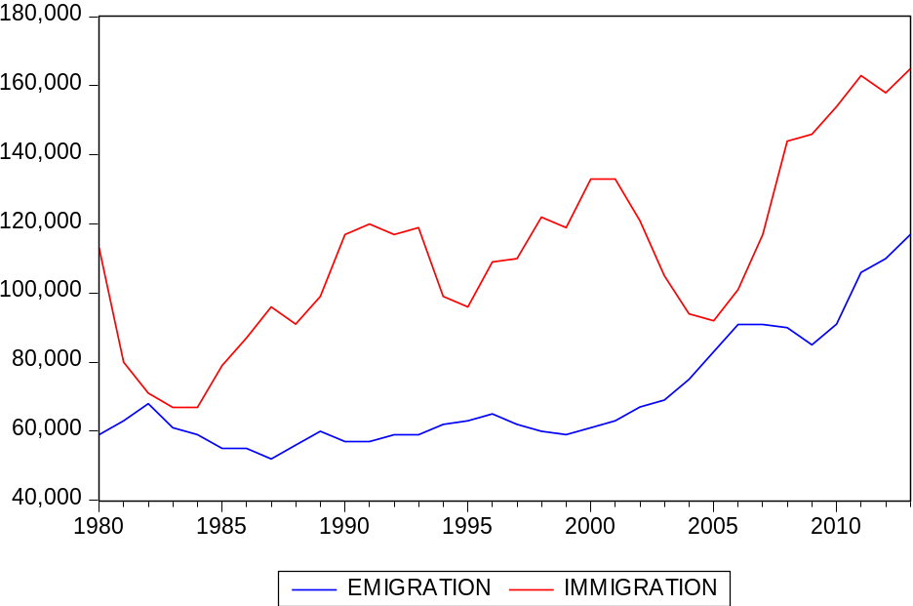
Graph 1

- For clarification, immigration here is defined as the number of people moving from other countries to The Netherlands, these people include all western and non-western immigrants and of all genders and ages (CBS, 2015). In other words, it is the number of people with nationalities other than Dutch that moved to The Netherlands during the given year. For example, in 1981, 80,000 people moved to live in The Netherlands from different countries from around the world. In contrast, emigration is defined as the number of people leaving The Netherlands for another country, and this also includes people from all nationalities, genders and ages (CBS, 2015). Therefore, in the year 1981, 59,000 people left The Netherlands to live somewhere else.

- It is evident that starting from the year 1980 immigration dropped, but regained momentum starting from 1985, and aside from the temporary drops around 1995 and 2005, immigration has steadily increased. This supports the claim made by Zorlu and Hartog (2001) and provides reason to specifically study the impact of immigration between the years 1985 and 2013. At the same time, emigration has remained relatively steady with no major spikes or troughs up until 2003. From 2003, emigration started to increase steadily, peaking in 2006 and 2011. Nevertheless, during the time span modeled above, emigration has remained relatively low compared to immigration, bar the year 2006, and this means that during that time period the labor force in The Netherlands suffered a supply shock due to the inflow of immigrants being considerably higher than the outflow of emigrants. This could be seen more clearly by illustrating net migration in graph 2:

- 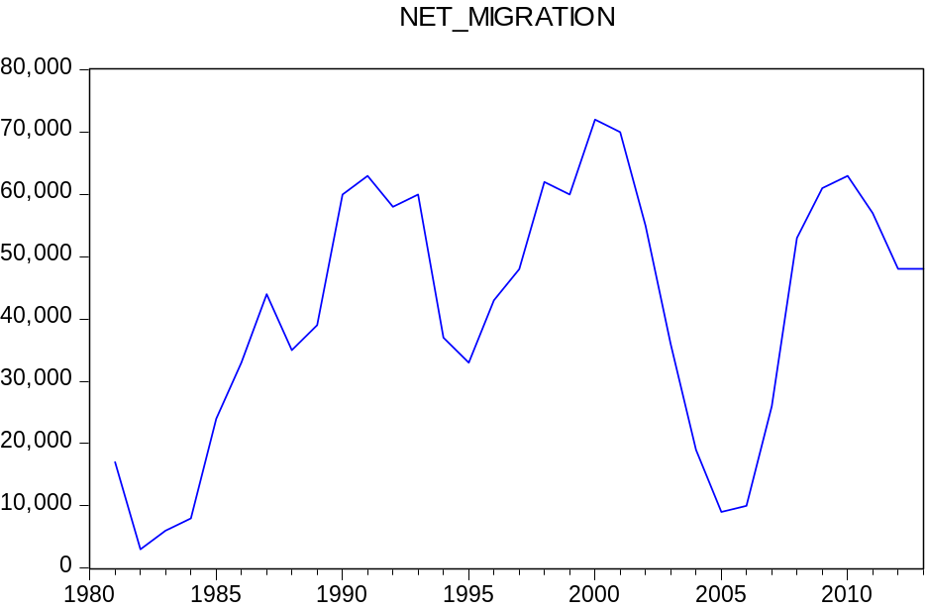
Graph 2

- It is evident that net migration has been increasing starting from 1985, even though there have been significant drops in the years 1988, 1995 and 2005-2006. Yet, the net migration remains positive during those years, meaning the flow of immigrants is still higher, and these drops have proven to be temporary. Net migration drops again in 2012, but is still considerably high. It is therefore clear that immigrants have been increasing over the years and offsetting the migrants in The Netherlands, which is likely to have an effect on the existing labor force. In order to get an even better idea on how the labor force in The Netherlands changed over the years, the development of the total labor force is shown alongside the development of the Dutch labor force in graph 3:

- 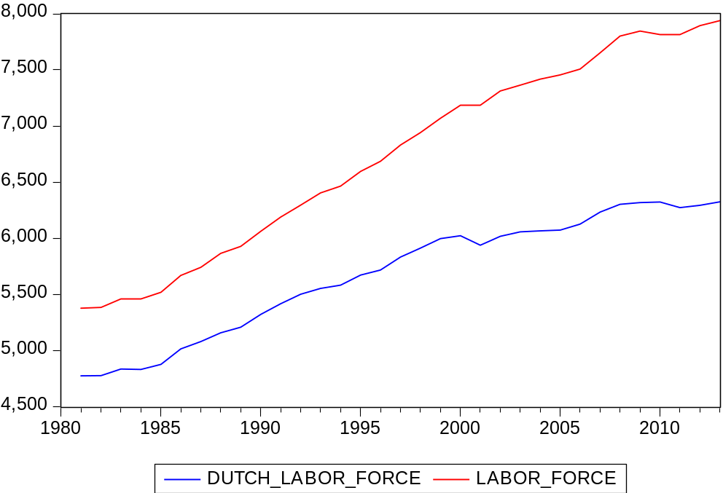
Graph 3

- Labor force will be defined as the total number of people between the ages 15 and 64 that have paid work, accepted paid work, or are actively seeking for paid work. The Dutch labor force in this graph represents all the people in the labor force that have a native Dutch background (CBS, 2015). It is obvious that the total labor force has been on the rise starting from the year 1980, however the Dutch labor force has followed a similar path. Therefore, only those of native Dutch background could have caused any shocks to the labor force during that time. This paper will aim to determine whether the difference between the lines shown above, which is attributed to the number of immigrants in the labor force, had any significant effect on the Dutch labor market.

3.2 Defining the Variables
- Attempting to determine whether immigrants have affected the employment opportunities and wages of native Dutch people is relatively straightforward, yet many variables will need to be incorporated in order to provide an in-depth analysis of the Dutch labor market. In order to generate better results, the labor force will be separated by skills to determine whether the influx of immigrants have different effects on people with differing sets of skills. The skills of the labor force is separated according to level of education, where people with low levels of secondary education or lower are considered low skilled, and those with a higher level of secondary education or tertiary education are considered high skilled. More specifically, anyone with a vmbo, mbo1, avo or primary education will be classified as low skilled while those havo, vwo, mbo, hbo and wo will be classified as high skilled. The specific variables chosen for this analysis are presented in table 1 below:

- Immigration Supply Shock (ISS) | - $ISS=\frac{m_{t}}{n_{t}+m_{t}}$ where m and n are, respectively, the number of incoming immigrants and the number of residents that have paid work and are of a native Dutch background, at a certain year.  Table 1
- Total Dutch Labor Force (LFD) | - $\frac{\begin{aligned}Total number of people in the Labor Force that are \\ of Dutch native background\end{aligned}}{1000}$
- Total High Skilled Labor Force (HSLF) | - $\frac{Total High Skilled Labor Force}{Total Labor Force}$
- Total Low Skilled Labor Force (LSLF) | - $\frac{Total Low Skilled Labor Force}{Total Labor Force}$
- Employment Rate Low Skilled (ER_{LS}) | - $\frac{Employed Low Skilled Labor Force}{Total Labor Force}$
- Employment Rate High Skilled (ER_{HS}) | - $\frac{Employed High Skilled Labor Force}{Total Labor Force}$
- Wages | - Index of wages per hour compared to the base year, 2000, where wages per hour is equal to 100.
- Employment Rate (ER) | - $\frac{Employed Dutch Labor Force}{Total Dutch Labor Force}$

- The Dutch labor force is divided by 1000 to make the interpretation of the analysis more straightforward. For the variables HSLF, LSLF, ER_{LS} and ER_{HS,} the labor force is only divided according to skills. In other words, the high skilled and low skilled labor force include both people from Dutch and foreign backgrounds. Therefore, any significant change in the employment rate of high skilled or low skilled workers will be assumed to affect mostly the Dutch natives due to immigrants not making up a major portion of the population. The use of Immigration Supply Shock and Employment Rate in the forms presented above is inspired by the work of Carrasco, Fimeno and Ortega (2008). However, instead of using the total native population as the denominator in Employment Rate, the total number of natives in the labor force is used due to lack of population data between the years 1980 and 1995.
- For the data on wages, only indices are made available. The index in this case compares wages per hour of the period in question with the year 2000, which will be equal to 100. For example, an index of 110 represents a 10% increase in wages per hour compared to the base year, whilst an index of 40 would indicate a 60% decrease compared to the base year (CBS, 2015). Another limitation with the data collection is that it was not possible to separate the data on wages by origin. In other words, it was not possible to determine hourly wages of only those from a native Dutch background. Nonetheless, again, any significant change in wages over the years will be assumed to affect mostly Dutch workers since immigrants can be considered a relatively small and non-significant portion of the population.

- The variables were chosen in order to study the relationship between the immigration supply shock and the Dutch labor market, specifically wages and employment opportunities. All the other variables are included in order to control for external effects and highlight the effects incoming immigrants had on the native Dutch labor force between the years 1980 and 2013. However, the data in the CBS database is not available for the year 1980, which leads to the removal of the year 1980 from this study. All in all, from the years between 1981 and 2013, there will be 33 observations. The descriptive statistics for all 33 observations of each variable is presented in table 2 below:

- Descriptive Statistics
Table 2

 | - N | - Minimum | - Maximum | - Mean | - Std. Deviation
- SupplyShock | - 33 | - .015 | - .027 | - .020 | - .0032
- LF_D | - 33 | - 4.78 | - 6.32 | - 5.68 | - .53
- ER_Low_Skilled | - 33 | - .176 | - .455 | - .29 | - .07
- ER_High_Skilled | - 33 | - .505 | - .782 | - .67 | - .08
- ER | - 33 | - .90 | - .97 | - .94 | - .019
- Wages | - 33 | - -37.6 | - 31.6 | - -5.17 | - 22.32
- Low_Skilled_LF | - 33 | - .201 | - .495 | - .32 | - .084
- High_Skilled_LF | - 33 | - .505 | - .782 | - .67 | - .080
- Valid N (listwise) | - 33

- The mean of the immigration supply shock ranges from 1.5% to 2.7%, with a mean of 2.0%, while the number of employed Dutch has an average of 5.68 with a maximum of 6.32 and a minimum of 4.78. Employment rate, the proportion between the number of employed Dutch natives and total number of Dutch natives in the labor force, has a mean of 94%. The minimum employment rate is 90% and the maximum employment rate is 97%. This could mean that even if immigration did affect the employment rate of natives over the years, there still remained on average a high employment rate for the Dutch. However, this will be studied in more detail in later sections. Wages per hour peak at 31.6%, meaning the maximum increase in wages per hour compared to the base year is 36.1%. The minimum for wages, which is the most decrease in wages compared to the base year, is -37.6. The mean change is -5.17%, and this means that, on average, the wages per hour during those years were 5.17% below the wages in the base year.

4. Methodology
- The main purpose of this paper is to determine whether immigration has significantly impacted the Dutch labor market, specifically the wages and employment of native Dutch people. Economic theory claims the effect immigrants have on the labor market of the host nation mainly depends on whether the incoming immigrants are substitutes or complements to the native workforce. However, the conclusion is that in both cases, the immigrants should significantly affect the natives, whether positively or negatively. Instead, the empirical research that has been conducted over the years has led to mixed results, with some claiming significant effects, while others claim non-significant effects. Through a number of regressions, this thesis will attempt to determine the nature of this relationship in The Netherlands. The methodology used is also partly inspired from the works of Carrasco, Fimeno and Ortega (2008), but adapted to fit the data available. One important difference between them is that the paper by Carrasco, Fimeno and Ortega (2008) uses micro data while this paper uses macro data.

4.1 Employment Rate
- For the sake of determining the exact relationship between incoming immigrants and the employment rate of Dutch natives, a regression equation will have to be formulated which includes the immigration supply shock as an independent variable, and the employment rate as the dependent variable. Additionally, the lagged variable of the immigration supply shock will also be included to allow for a more thorough analysis. The reasoning behind the inclusion of the lagged variable is that immigrants might need a year before being able to work. This could be due to legal reasons, such as obtaining work permits, or other reasons such as the time needed to find a job and settle in their new surroundings. There is likely to be a correlation between ISS and its lagged value since an increase of immigrants in The Netherlands may encourage more immigrants to move to The Netherlands as well. For example, if an immigrant moves to The Netherlands and was able to settle in, this person could encourage his friends and family to join. Therefore, the number of immigrants already in the country may be correlated with the number of people that come a year later. The exact correlation coefficient is 0.72, which indicates a high and positive correlation between the number of immigrants already in the country and new comers. In pursuance of a richer analysis on the relationship, there will be three different regression equations, in the following form:

- ${ER}_{t}=β_{1}{ISS}_{t}+β_{2}LFD_{t}+ϵ_{t}$ (1)
- ${ER}_{t}=β_{1}ISS_{t-1}+β_{2}LFD_{t}+ϵ_{t}$ (2)
- ${ER}_{t}=β_{1}{ISS}_{t}+β_{2}ISS_{t-1}+β_{3}LFD_{t}+ϵ_{t}$ (3)
- The separation into three different regressions should allow for a more in-depth analysis on whether including a lagged variable of the immigration supply shock significantly changes the relationship being studied. The immigration supply shock is represented by ISS in the above equations.

- The dependent variable is the employment rate of natives as described in the previous section. LFD is the variable corresponding to total number of Dutch natives in the labor force, both employed and unemployed. This is included in the regression in order to control for the competition that takes place between Dutch natives, and allows for the assessment of how only the incoming immigrants affect the dependent variable.
- To get a more detailed view on how the Dutch labor market changed after the inflow of immigrants, more regressions will be performed, but this time separated depending on the skill levels. The following regressions will study the effect on the employment rate of the high skilled labor force:

- ${\left({ER}_{hs}\right)}_{t}=β_{1}{ISS}_{t}+β_{2}HSLF_{t}+ϵ_{t}$ (4)
- ${\left({ER}_{hs}\right)}_{t}=β_{1}ISS_{t-1}+β_{2}HSLF_{t}+ϵ_{t}$ (5)
- ${\left({ER}_{hs}\right)}_{t}=β_{1}{ISS}_{t}+β_{2}ISS_{t-1}+β_{3}HSLF_{t}+ϵ_{t}$ (6)

- Again, there are 3 regressions to allow for the analysis on the introduction of the lagged variable changes the relationship being studied. Equations (4), (5), (6) aim to determine whether immigrants have a significant effect on the change in employment rate of high skilled Dutch natives. Here, the dependent variable takes into account the total number of people and not only the Dutch workforce due to the lack of available data. However, since the immigrants represent only a non-significant portion of the total population, it is safe to conclude that any major change in the dependent variable will mainly affect the Dutch. HSLF, representing the ratio of high skilled workers to the total labor force, is included in the regression equations in order to control for the effect of the already existent labor force with similar skills.

- Similar regressions have been drawn up, but instead include the employment rate of low skilled workers as the dependent variable:
- ${\left({ER}_{ls}\right)}_{t}=β_{1}{ISS}_{t}+β_{2}LSLF_{t}+ϵ_{t}$ (7)
- ${\left({ER}_{ls}\right)}_{t}=β_{1}ISS_{t-1}+β_{2}LSLF_{t}+ϵ_{t}$ (8)
- ${\left({ER}_{ls}\right)}_{t}=β_{1}{ISS}_{t}+β_{2}ISS_{t-1}+β_{3}LSLF_{t}+ϵ_{t}$ (9)

- Equations (7), (8), (9) aim to determine the nature of the relationship between the employment rate of low skilled workers and incoming immigrants. Again, the dependent variables include information on the total labor force and not only Dutch natives. As a result, any major changes will be assumed to mainly affect those of native Dutch origin. LSLF, the ratio of low skilled workers to the total labor force, is included to control for the effect of the already existent labor force with similar skills.

4.2 Wages
- ${wages}_{t}={β_{1}ISS}_{t}+β_{2}LFD_{t}+ ϵ_{t}$ (10)
- ${wages}_{t}=β_{1}ISS_{t-1}+β_{2}LFD_{t}+ ϵ_{t}$ (11)
- ${wages}_{t}={β_{1}ISS}_{t}+β_{2}ISS_{t-1}+β_{3}LFD_{t}+ ϵ_{t}$ (12)

- The above regressions will be used in order to determine the nature of the relationship between the change in wages and the immigration supply shock. Here, the dependent variable, which is the change in wages, is not classified by origin of workers due to the lack of data. However, since the incoming immigrants do not constitute a major part of the population, any significant changes in wages will likely affect mostly the natives. LFD is once again included to allow for a better analysis on how immigrants affect the labor market, and specifically the wages.

- OLS regressions will be used in order to produce the necessary output that allows for a reliable conclusion. However, before reaching any conclusions, the regressions will be tested for the heteroskedasticity, and auto regression in order to allow us to reach more reliable conclusions. The hypotheses that will be tested using the above regressions are presented in the following section.

4.3Hypotheses

- The use of OLS regressions allows for a thorough and in-depth analysis of how the influx of immigrants between the years 1981 and 2013 affected the native workers in The Netherlands. The various aforementioned regressions are all created in order to solve the following hypotheses:

- Hypothesis 1(a): Immigration has no significant effect on the employment rate of Dutch natives.
- Hypothesis 1(b): Immigration has a significant effect on the employment rate of Dutch natives.

- The above hypotheses will be tested using equations (1), (2), and (3). The regressions will be run and the output will then be analyzed in order to determine whether ISS and its lagged value significantly affect the dependent variable. This will be determined by observing the standard errors of the relevant variables.

- Hypothesis 2(a): Immigration has no significant effect on the employment rate of high-skilled workers in the Dutch labor market
- Hypothesis 2(b): Immigration has a significant effect on the employment rate of high-skilled workers in the Dutch labor market

- The above hypotheses will be tested by running regression equations (4), (5), and (6) and will determine whether there exists a significant relationship between ISS and its lagged value and the employment rate of high skilled workers. If a significant relationship is found, it will then be assumed that the native Dutch workers have been affected the most.

- Hypothesis 3(a): Immigration has no significant effect on the employment rate of low-skilled workers in the Dutch labor market
- Hypothesis 3(b): Immigration has a significant effect on the employment rate of low-skilled workers in the Dutch labor market

- Hypothesis 3, mentioned above, will be tested similarly to hypothesis 2, but in this case the equations (7), (8), and (9) will be used to determine the significance of the relationship.

- Hypothesis 4(a): Immigration has no significant effect on the change in wages in the Dutch labor market
- Hypothesis 4(b): Immigration has a significant effect on the change in wages in the Dutch labor market

- Hypothesis 4 will be tested by running the regressions equations (10), (11) and (12). Again, any significant effect will be assumed to mainly affect the Dutch native due to immigrants not making up a large portion of the population.

- After analyzing all the hypotheses using the set regressions equations, the results will be presented and discussed in the coming section. Then, the conclusion will be presented along with the limitations of the paper and suggestions for further research in the last section.

5. Results
- The aim of this section is to present the resulting estimates from running the regressions. The main focus will be on the coefficients and standard errors of the different independent variables for each model. This section will be divided into four sub-sections based on the dependent variable. In each sub-section, a table will be presented with the required estimates. Each row in the tables represents different regression models, and the numbers correspond to the numbers assigned in the Methodology section. Each column in the tables provided represents different independent variables, and there will be two values provided for each variable. The one outside brackets represents the value of the coefficient, while the value inside the brackets represents the standard error of the corresponding coefficient.

- The adjusted R² is also presented in the tables in order to have a better understanding of the model. R² is used to measure the goodness-of-fit of the regression model, and if the value of the R² is close to 1, then the data can be considered a good fit of the model. Adjusted R² is usually considered because the value of the R² tends to increase when more independent variables are added to the model. Since, the lagged value is being added to the model being studied here, the adjusted R² is considered. In addition, heteroskedasticity and serial correlation will be tested for in order to test the robustness of the model.

- Serial correlation, or autocorrelation, is thought to exist in a certain model when error terms, of the regression model are correlated (Hill, Griffiths, & Lim, 2008). If this occurs, it violates the assumption that error terms are uncorrelated, and OLS, as a result, is not the best linear unbiased estimator. The same occurs if there is heteroskedasticity in the model, as it violates another assumption of OLS. Heteroskedasticity occurs “when the variances for all observations are not the same (Hill, Griffiths, & Lim, 2008, p. 198). Therefore, in order to determine whether OLS is the best estimator for the model in question, the Breusch-Godfrey and the White tests will be conducted respectively to account for autocorrelation and heteroskedasticity.

- The Breusch-Godfrey is a LaGrange multiplier (LM) test, which tests for autocorrelation by y on x and the lagged value of the error term. For this test, the null hypothesis assumes no autocorrelation, and if it is rejected, it is safe to conclude that the model is serially correlated (Hill, Griffiths, & Lim, 2008). In this thesis, the LM test will be done for only two lagged variables. The White test is conducted by regressing the variances of y on a set of explanatory variables, and their squares, assuming these variables are actually equal to the independent variables in the original model. If the null hypothesis of this test were rejected, then it would be possible to conclude that there is heteroskedasticity in the model.

5.1 Employment Rates of Dutch natives
- This section provides the estimates for the regressions models that include the employment rate of Dutch natives as the dependent variable. The main aim of these models is to determine the significance and type of relationship that exists between incoming immigrants and the rate of employment of those in the labor force with a native Dutch origin. Three different models are presented, in order to understand how the inclusion of the lagged value of the supply shock affects the model. Table 3 below illustrates the results from running the regressions:

Table 3

 | - OLS
 | - C | - ISS | - ISS(-1) | - LFD | - Adjusted R²
- (1) | - 0.787(0.022) | - 0.281(0.758) | - - | - 0.026(0.004) | - 0.599
- (2) | - 0.768(0.021) | - - | - -0.073(0.722) | - 0.030(0.004) | - 0.681
- (3) | - 0.769(0.021) | - 0.852 (1.166) | - -0.794(1.226) | - 0.030 (0.004) | - 0.676

- The above table shows only values of coefficients, standard errors and adjusted R². For the first model, there is a positive relationship between ISS and ER, where a one percent increase in ISS would increase employment rates of Dutch natives by 0.281. LFD, the total number of labor force with a Dutch native background, is highly significant with a coefficient of 0.026. This means a one unit increase in LFD leads to a 2.6% increase in the employment rate of Dutch natives. In the second model, there is a negative relationship, where a one unit increase in the lagged value of ISS would decrease ER by 0.073. Finally, the same relationships exist for the model with both variables, but the coefficients increase. However, it is evident from the values represented above that the both the immigration supply shock and its lagged value are highly insignificant at the 5% level, with standard errors of 0.758 and 0.722 respectively. This is determined by calculating the 95% confidence interval. The same conclusion is reached again when both the variable and the lagged value are included in the same regression model, and are both again highly insignificant with respective standard errors of 1.166 and 1.226.

- From the table above, the values of the adjusted R² change when the independent variables are manipulated. According to the output, the model with only the lagged value as an independent has the best fit of data, while the one without the lagged value has the worst fit for data. However, the difference between the data is not big enough to be of major concern.
- After running both tests on each regression model separately, the conclusion is that all the models are serially correlated but homoscedastic. The resulting output from these tests can be found in Appendix 2. Therefore, due to the autocorrelation, OLS is no longer considered the best option for these models, and a HAC regression will be more appropriate. The HAC regression includes heteroskedasticity and autocorrelation consistent standard errors since due to the existence of autocorrelation, the standard errors of a normal least squares estimation can no longer be considered correct (Hill & Campbell, 2012). The results from the HAC regression are presented in table 4 below:
Table 4

 | - HAC
 | - C | - ISS | - ISS(-1) | - LFD | - Adjusted R²
- (1) | - 0.787(0.030) | - 0.281(0.928) | - - | - 0.026(0.004) | - 0.599
- (2) | - 0.768(0.027) | - - | - -0.073(0.956) | - 0.030(0.003) | - 0.681
- (3) | - 0.769(0.028) | - 0.852 (0.926) | - -0.794(0.843) | - 0.030 (0.003) | - 0.676

- The coefficient values of the independent variables and their signs did not change much compared to the OLS regression. There is a change in the values of the standard errors, but there is still no significant relationship between the immigration supply shock and the employment rate of Dutch natives. In other words, the influx of immigrants that moved to The Netherlands between the years 1981 and 2013 did not significantly affect the employment opportunities and subsequently rates of those with a native Dutch background. It is evident from comparing the results in both the HAC regression and the OLS regression, that the values of the coefficients of ISS and ISS(-1) in equation (3) are much higher than those in equations (1) and (2). This major change in the values of the coefficients could be due to multi-collinearity between both variables as seen in Appendix 1. In order to get a more detailed account on how the Dutch labor market was affected, the employment rates are divided according to the level of education.

5.2 Employment Rates of High Skilled Workers
- This section is dedicated to interpret the results from equations (4), (5) and (6), which attempt to determine the nature and significance of the relationship between the immigration supply shock and the employment rate of the high skilled labor force in the Dutch labor market. The results are presented in table 5 below:

- OLS
Table 5
 | - C | - ISS | - ISS(-1) | - HSLF | - Adjusted R²
- (4) | - -0.035(0.012) | - 0.167(0.516) | - - | - 0.996(0.021) | - 0.990
- (5) | - -0.041(0.012) | - - | - -0.205(0.526) | - 1.015(0.021) | - 0.989
- (6) | - -0.040 (0.013) | - 0.758(0.851) | - -0.843(0.890) | - 1.011(0.022) | - 0.989

- It is important to note that the dependent variable includes both natives and foreigners due to lack of data, and if there is a significant effect, it will be assumed that the Dutch natives are those affected most. Also, an earlier version of the models above included the total number of Dutch workers in the labor force as a control variable, but was removed due to multi-collinearity, and more information about this is found in Appendix 1.

- An interesting difference between the models presented above and those where the dependent variable is simply the employment rate of Dutch natives is that the sign of the coefficient of the constant is now negative. This means that if the values of all independent variables in a given equation are set to 0, the employment rate of high skilled workers is below 0. This is particularly interesting because the mean value of ERHS is not negative. Nevertheless, the sign of the constant should not change the interpretation of the model. However, this has not affected the significance of ISS and ISS(-1). Again, ISS seems to affect the dependent variable in a positive manner, meaning as immigrants increase, the employment rate of the high skilled workers increase. This could be due to the fact the immigrants in question have complementary skills to the high skilled labor force, who according to Borjas (2013) would become more specialized and the demand for them would increase. On the other hand, the lagged value of ISS still has a negative effect on the dependent variable, meaning that a year after they arrive, immigrants have an adverse effect on the labor market for high skilled workers. Nonetheless, both coefficients of ISS and ISS(-1) are still highly insignificant at the 5% level, which allows for the conclusion that immigration has no significant effect on the employment rate on the high skilled workers. The high values for the adjusted R² show a good fit for the data, however this could be misleading since ER and HSLF are likely to be highly correlated.

- The Breusch-Godfrey and White tests are conducted to test for serial correlation and heteroskedasticity. Once again the tests shows that the models are serially correlated, but homoscedastic. Consequently, OLS is no longer the best estimator and a HAC regression will be performed:
Table 6
 | - HAC
 | - C | - ISS | - ISS(-1) | - HSLF | - Adjusted R²
- (4) | - -0.035(0.016) | - 0.167(0.608) | - - | - 0.996(0.016) | - 0.990
- (5) | - -0.041(0.015) | - - | - -0.205(0.640) | - 1.015(0.016) | - 0.989
- (6) | - -0.040 (0.016) | - 0.758(0.752) | - -0.843(0.797) | - 1.011(0.013) | - 0.989

- The HAC regression did not lead to any major changes in the variables being studied. ISS and ISS (-1), respectively, still have a positive and a negative relationship with the dependent variable while they are still highly significant as well. Again, in both the HAC and OLS regressions, the coefficient values for ISS and ISS(-1) greatly change when including both variables together, and this is likely to due to multi-collinearity (see Appendix1). Therefore, it is possible to conclude that, after correcting for robustness issues, immigration has no significant effect on the employment rate of high skilled workers.

5.3 Employment Rates of Low Skilled Workers
- This section will examine the relationship between incoming immigrants and the employment rates of the low skilled labor force. Again, due to lack of data, the dependent variable represents the whole labor force and not only Dutch natives, and therefore the results will be interpreted similarly to the previous section. LSLF is included in order to control for the effects of the already existing low skilled labor force. Also, LFD was excluded due to multi-collinearity (Appendix 1). The equations being studied here are (7), (8) and (9):

Table 7
 | - OLS
 | - C | - ISS | - ISS(-1) | - LSLF | - Adjusted R²
- (7) | - 0.007(0.013) | - 0.410(0.460) | - - | - 0.851(0.017) | - 0.990
- (8) | - 0.015(0.011) | - - | - 0.287(0.417) | - 0.830(0.016) | - 0.991
- (9) | - 0.014(0.012) | - 0.298(0.685) | - 0.035(0.715) | - 0.832(0.016) | - 0.991

- There are two stark differences when the above models are compared to the ones in the previous sections. First, the constant is insignificant, which is the opposite of what was found before. Second, the sign of ISS(-1) changed, meaning the lagged value of the immigration supply shock now positively affects the dependent variable. Other than those two differences, the results from these regression models are largely similar to the previous models. ISS and ISS(-1) are still highly insignificant at the 5% level, meaning immigration has no significant effect on the employability of low skilled labor. Again, it is necessary to check for heteroskedasticity and autocorrelation, and the White and Breusch-Godfrey tests are run once again. Appendix 4 includes the details for the tests run for each model.

- For model (7), we reject the null for both tests, concluding that the model is both serially correlated and heteroskedastic. However, for models (8) and (9), there exists no heteroskedasticity yet there is still autocorrelation. As a result, a HAC regression is produced one more time for the above models:
Table 8

 | - HAC
 | - C | - ISS | - ISS(-1) | - LSLF | - Adjusted R²
- (7) | - 0.007(0.010) | - 0.410(0.467) | - - | - 0.851(0.020) | - 0.990
- (8) | - 0.015(0.008) | - - | - 0.287(0.515) | - 0.830(0.012) | - 0.991
- (9) | - 0.014(0.009) | - 0.298(0.554) | - 0.035(0.625) | - 0.832(0.012) | - 0.991

- The results from the HAC regression do not differ greatly from the results from the OLS regression. The constants are still insignificant, along with ISS and ISS(-1), at the 5% significance level. However, the HAC standard errors take into account autocorrelation and heteroskedasticity, and this allows for a more valid conclusion.
- According to the above results, the immigration supply shock, and the lagged value, enjoy a positive, yet insignificant relationship with the employment rate of the low skilled labor force. This allows for the conclusion that immigration has no bearing, or significant effect, on the employability of workers that are considered low skilled. This, in turn, means that immigration does not significantly change the employment rates of the Dutch natives that are low skilled. Again, the sudden change in the coefficient values of the independent variables when including both in the equation is likely due to the high collinearity between them (Appendix 1).

5.4 Wages
- In this section, an index of wages per hour is the dependent variable. Wages are used as a dependent variable in order to continue the analysis on the Dutch labor market, and determine whether the influx of immigrants affected the wages. Again, the wages are for the entire population, not only those of native Dutch origin, and therefore any significant changes in the dependent variable will be assumed to affect mainly Dutch workers for the same reason as mentioned in the previous two sections. The results of the regressions are illustrated in table 9 below:
Table 9

 | - OLS
 | - C | - ISS | - ISS(-1) | - LFD | - Adjusted R²
- (10) | - -233.78(12.617) | - 158.26(429.481) | - - | - 39.67(2.656) | - 0.911
- (11) | - -236.53(13.510) | - - | - 78.55(456.880) | - 40.42(2.743) | - 0.905
- (12) | - -236.16(13.758) | - 263.45(743.483) | - -144.22(781.326) | - 40.20(2.855) | - 0.902

- The constant here is again negative, meaning that if all independent variables are set to 0, the change in wages per hour is negative. This, however, is expected since the mean value of the dependent variable is negative as well, as shown in Table 2. In (10), ISS positively affects the dependent variable, and the same occurs in (11) with the lagged variable. However, an interesting change to note is that the sign of ISS(-1) changes to negative when both ISS and ISS(-1) are included in the same model. This means that immigrants arriving a certain year increase the wages per hour, while those that arrived on year before decrease the wages per hour. The increase, however, outweighs the drop as evident by the coefficients of the independent variables in (12). Nevertheless, the independent variables in question still have highly insignificant coefficients, meaning that there exists no significant relationship between them and the dependent variable.

- Once more, the Breusch-Godfrey and White tests are conducted and the resulting output is found in Appendix 5. For (10) and (11), where ISS and its lagged are separated, the null hypotheses of both tests are rejected, leading to the conclusion that the models are both heteroskedastic and auto-correlated. However, model (12) is only auto-correlated since the null hypothesis of the White test is not rejected. All the same, a HAC regressions is still necessary in order to achieve better and more reliable results:
Table 10

 | - HAC
 | - C | - ISS | - ISS(-1) | - LFD | - Adjusted R²
- (10) | - -233.78(21.479) | - 158.26(658.027) | - - | - 39.67(3.377) | - 0.911
- (11) | - -236.53(23.972) | - - | - 78.55(682.258) | - 40.42(3.596) | - 0.905
- (12) | - -236.16(23.910) | - 263.45(606.504) | - -144.22(620.893) | - 40.20(3.657) | - 0.902

- It is clear that there have been no significant changes to either the coefficients or the standard errors. Therefore, it is safe to conclude that immigration has no significant effect on the change wages in the Dutch labor market. In other words, incoming immigrants do not have any bearing on the wages of Dutch natives, while LFD, the Dutch labor force, has a significant relationship. This means that the existing Dutch labor force, on the other hand, have a quite significant and negative effect on the changes in wages per hour.

5.5 Net Migration
- As mentioned before, the variable ISS will be replaced with another variable that includes net migration, and this will be used as a tool to determine in what way results change with regards to the main specifications. The exact same regressions were run, with the only change being the independent variable. First, OLS regressions are produced, and these are then checked for autocorrelation and heteroskedasticity. If either problem is found, then HAC regressions are produced instead to get less biased results. The results of these regressions are presented in Appendix 6.

- By checking the results, it is evident that the significance of the independent variable changes. When the employment rate of Dutch natives, ER, is the dependent variable, net migration is significant in all the models, while it lagged value is not. This means that there is a significant, and positive relationship between net migration and ER. If net migration increases, the employment rate of Dutch natives follows suit. When employment of high skilled workers is the variable of interest, the results are similar, as net migration again has a significant and positive coefficient, while it lagged value does not. The results differ when the dependent variable is the employment rate of low skilled workers. If net migration is the only independent variable, the coefficient is significant, but when its lagged value is included in the model, it is not significant anymore. However, compared to the model where only immigration is taken into account, the coefficient is more significant. When wages per hour is the dependent variable, both net migration and it’s lagged value have highly significant coefficients when they are alone in the model, but both lose significance when included together in the same model. Such a change is most likely due to the collinearity between both variables. In addition, the sign of the independent variables in this case is now negative as opposed to the situation where immigration was the independent variable.

- Although in some cases the independent variable or its lagged value is still non-significant, there are still many cases where they are highly significant. Therefore, even though there is no evident, significant relationship between immigration and the Dutch labor market outcomes, this changes when emigration is taken into account. This change in both the significance and signs of the independent variables is quite surprising. Graph 1 shows that compared to immigration, emigration is relatively insignificant. Therefore, the addition of emigration to our analysis should not lead to significant changes in the results, which makes the actual changes in our results surprising. The change in the results could be due to instances when immigration and emigration were very similar, which occurs in 1982 and 2006.

6. Conclusion
- Over the years, immigration has developed into a hotly debated topic around the world. Specifically in The Netherlands, where the political debate was, at times, dominated with this topic for years. The main debate was mostly concerned with how the labor market of the host nation changes due to the increasing immigration. Even though certain economic theories argued against the claim that increasing number of immigrants negatively affect labor markets, there are still some that believe in the exacerbating effects of this phenomenon. This discussion led economists and academics to attempt to determine the exact relationship that exists between immigration and the labor market affected.

- A great deal of empirical research can be found that study the effect of immigrants on different aspects of the economy they are joining, specifically the effect on the employability and wages of the native workforce. The results from the studies differed depending on the country of interest and the method of analysis. Some found that immigrants might significantly affect the natives, while others have found no significant effects. This lack of agreement provided motivation for producing this thesis, which aims at finding the direct relationship between incoming immigrants to The Netherlands and the employment rates and wages of the native Dutch labor force. The period investigated extended from 1981 to 2013.
- In order to establish this relation, regression models were formulated, where the dependent and control variables were changed, while the independent variable remained the same. The first three regression models focused on how the influx of immigrants affected the employment rate of the whole Dutch labor force. The results from these regressions, after being corrected for autocorrelation, show that there is no significant relationship between immigration and employment rates. The second and third set of models attempted to find the type of relationship between immigration and employability of both high and low skilled workers. Again, after accounting for both serial correlation and heteroskedasticity, no significant relationship was found. Finally, the last set of models regressed immigration on the change in wages per hour, where again no significant relationship was found between wages and the immigration supply shock.

- As a robustness check, the same exact models were used for regressions, except the independent variable that was replaced with net migration. This allows for comparing and determining how the relationships change when emigration is also taken into account. The results show that the coefficients have increased in significance in almost all the models, and this means that emigration does in fact play a role in how immigration and the Dutch labor market are related. In addition, the signs of the variables sometimes changed. For example, the sign of the independent variable when regressing against wages changed from positive in the model with immigration as the independent variable, to negative with net migration as the independent variable.

- The results found may have an imperative impact on the public policy in the Netherlands, since, according to the models, the increase in immigration that took place in the past 30 years had no bearing on the Dutch labor market, in terms of both employment opportunities and wages. Therefore, the debate prevalent in the political scene that immigrants adversely affect the Dutch labor market and the Dutch natives may not be valid anymore. However, every economic research comes with limitations, and there are few with this one that need to be discussed.

6.1 Limitations
- Firstly, a limitation with this paper is the time period, since 33 years between 1981 and 2013 may not be considered enough to provide conclusive proof. Addition of more years may provide more insight, as well as increase sample size for the statistical purposes. Another inadequacy with the study is the limited number of independent variables. For example, it could be helpful to control for age or gender as these factors affect the dependent variable. This could have been possible when micro data instead of macro data is used. As mentioned before, this paper does not use micro data, as opposed to most of the academic research on this topic. The use of this type of data would have allowed for a better analysis. It would have been possible to determine whether the relationship being studied differed when compared between more subgroups, such as age, gender, and location within the country as these are all variables that affect the labor market. This could have been done through the use of dummy variables. Another major limitation of this paper was the lack of available data, and this may have had a bearing on the results. For example, no data was found on the total native population leading up to 1995. Also, there were no available data points that filtered the employment rate of the labor force by both origin and level of education. As a result, the employment rate was separated only by skills, but included both Dutch natives and foreigners. A separation by origin as well as skills would have provided better awareness on how immigration directly affects Dutch natives and may have led to a different conclusion. The same occurred with wages, as the data provided by CBS did not separate wages by either origin or skills, and availability of this data could again have led to different conclusions and better answer the research question. Also the use of micro data may help solve these problems.

6.2 Further Research
- Further research on this topic is recommended with focus on providing more evidence to be used in policy analysis. A good starting point would be to study how the effect of immigrants changes depending on the length of their stay in The Netherlands. This could be done by splitting the immigrants into groups depending on how long they have been in The Netherlands. Another suggestion would be to use micro data as the main source of statistics as this allows for controlling more variables and providing better analyses. Finally, it would be worth investigating to split the immigrants depending on their origin. For example, non-westerners may affect Dutch natives differently than westerners due to a number of factors, such as culture or level of education. Further research could also examine the relationship between immigration and inter-municipality moves. More specifically, how increasing immigration affects the movement within The Netherlands since people could seek to move away from the regions where immigrants are attracted to and relocate places with less competition. Finally, future research could provide a deeper analysis on how net migration is related to the employment and wages of natives.

- Bibliography
- Angrist, J. D., & Kugler, A. D. (2003). Protective or Counter-Productive? Labour Market Institutions and The Effect of Immigration on EU Natives. The Economic Journal, F302-F331.
- Bonin, Holger, Wage and Employment Effects of Immigration to Germany: Evidence from a Skill Group Approach (December 2005). Institute for the Study of Labor Discussion Paper No. 1875. Available at SSRN:http://ssrn.com/abstract=870272
- Borjas, G. (2003). The Labor Demand Curve is Downward Sloping: Reexamining the Impact of Immigration on the Labor Market. Quarterly Journal of Economics , 118 (4), 1335-1374.
- Borjas, G. J. (2013). Labor Economics (6th ed.). New York, NY: McGraw-Hill Education
- Butcher, K. F., & Card, D. (1991). Immigration and Wages: Evidence from the 1980's. The American Economic Review, 81(2), 292-296.
- Card, D. (2001). Immigrant Inflows, Native Outflows, and the Local Market Impacts of Higher Immigration. Journal of Labor Economics , 19 (1), 22-64.
- Carrasco, R., Fimeno, J., & Ortega, A. C. (2008). The effect of immigration on the labor market performance of native-born workers: some evidence for Spain. Journal of Population Economics, 21(3).
- CBS (Centraal Bureau voor Statistiek, May 2015). Statline. http://www.cbs.nl/
- Deutsch, A. (2015, March 15). Party of Dutch PM Rutte extends opinion poll lead before election. Reuters
- Dustmann, C., Fabbri, F., & Preston, I. (2005). THE IMPACT OF IMMIGRATION ON THE BRITISH LABOUR MARKET. The Economic Journal , 115, 324-341.
- Ehrenberg, R. G., & Smith, R. S. (2006). Modern Labor Economics: Theory and Public Policy. New York City: Pearson Education.
- Fairlie, R. W., & Meyer, B. D. (2001). The Effect of Immigration on Native Self-Employment. Journal of Labor Economics , 21 (3), 619-650.
- Hill, R. C., & Campbell, R. C. (2012). Using SAS for Econometrics. New York: Wiley.
- Hill, R. C., Griffiths, W. E., & Lim, G. C. (2008). Principles of Econometrics. Wiley.
- Immigration in The Netherlands: Shop An Immigrant. (2012, February 16). The Economist. Retrieved from http://www.economist.com/blogs/newsbook/2012/02/immigration-netherlands

- O’brien, R. M. (2007). A Caution Regarding Rules of Thumb for Variance Inflation Factors. Quality and Quantity, 41(5), 673-690.

- Roodenburg , H., Euwals, R., & ter Rele, H. (2003). Immigration and the Dutch Economy. The hague: CPB Netherlands Bureau for Economic Policy Analysis .
- Velling, J., & Pischke, J. S. (1997). Employment Effects Of Immigration To Germany: An Analysis Based On Local Labor Markets. Review of Economics and Statistics,79(4). doi:10.1162/003465397557178
- Wilson, J. (2011, April 12). Netherlands to Immigrants: Learn Dutch or Fear Deportation.Time.
- Worries about workers from eastern Europe are changing Dutch politics. (2013, August 24). The Economist
- Zimmermann, K. F., Bauer, T. K., & Lofstrom, M. (2000). Immigration Policy, Assimilation of Immigrants and Natives' Sentiments towards Immigrants: Evidence from 12 OECD-Countries. Social Science Research Network , 4.
- Zorlu, A., & Hartog, J. (2001). Migration and Immigrants: The Case of the Netherlands.European Economic Review.
- Zorlu, A., & Hartog, J. (2005). The effect of immigration on wages in three european countries. Journal of Population Economics , 18 (1), 113-151.

Appendix 1

- This appendix is dedicated to illustrate the process through which equations (4), (5) and (6) was formulated. In the beginning, these equations were produced to include LFD as another control variable and take the following form:

- ${\left({ER}_{hs}\right)}_{t}=β_{1}{ISS}_{t}+β_{2}HSLF_{t}+β_{3}LFD_{t}+ϵ_{t}$ (4)
- ${\left({ER}_{hs}\right)}_{t}=β_{1}ISS_{t-1}+ β_{2}HSLF_{t}+β_{3}LFD_{t}+ϵ_{t}$ (5)
- ${\left({ER}_{hs}\right)}_{t}=β_{1}{ISS}_{t}+β_{2}ISS_{t-1}+ β_{3}HSLF_{t}+β_{4}LFD_{t}+ϵ_{t}$ (6)
- The reason behind this was to control for the existing Dutch labor force, LFD, in order to only determine how incoming foreigners affect the employment rate of high skilled workers. This should allow for better interpretation on how only ISS and ISS(-1) affect the dependent variable. However, HSLF, which is the total number of high skilled workers, is likely to be linked and also correlated with LFD, which would affect the regressions. As a result, a test on the relationship between LFD and HSLF to determine whether the extent of multicollinearity that exists between both variables.

- Multicollinearity occurs when the variables in a regressions model move together in a systemic way and this makes it difficult to isolate the variable of interest (Hill, Griffiths, & Lim, 2008). Collinearity have numerous effects, such as increasing “estimates of parameter variance” and “yield models in which no variable is statistically significant” (O'brien, 2007, p. 673). In order to detect multicollinearity, the Variance Inflation Factor (VIF), which measured the multicollinearity between two independent variables, will be used (O'brien, 2007). After running the regression models presented above, the coefficient diagnostics of these models were checked, specifically the VIF, and the resulting output is presented below:

- Variance Inflation Factors
Model (4)
- Date: 06/03/15 Time: 11:50
- Sample: 1981 2013
- Included observations: 33
 | - Coefficient | - Uncentered | - Centered
- Variable | - Variance | - VIF | - VIF
- C | - 0.000341 | - 314.9510 | - NA
- ISS | - 0.149875 | - 57.92789 | - 1.449234
- HSLF | - 0.006966 | - 2957.233 | - 40.22603
- LFD | - 0.000159 | - 4773.180 | - 40.15509
Model (5)
- Variance Inflation Factors
- Date: 06/03/15 Time: 11:50
- Sample: 1981 2013
- Included observations: 32
 | - Coefficient | - Uncentered | - Centered
- Variable | - Variance | - VIF | - VIF
- C | - 0.000361 | - 319.2890 | - NA
- ISS(-1) | - 0.167052 | - 60.36927 | - 1.363749
- HSLF | - 0.009340 | - 3850.858 | - 45.72484
- LFD | - 0.000203 | - 5894.860 | - 45.93884
- Variance Inflation Factors
- Date: 06/03/15 Time: 11:51
Model (6)
- Sample: 1981 2013
- Included observations: 32
 | - Coefficient | - Uncentered | - Centered
- Variable | - Variance | - VIF | - VIF
- C | - 0.000346 | - 319.7742 | - NA
- ISS | - 0.414964 | - 162.2335 | - 4.051192
- ISS(-1) | - 0.455365 | - 172.2761 | - 3.891738
- HSLF | - 0.009037 | - 3900.547 | - 46.31484
- LFD | - 0.000195 | - 5926.298 | - 46.18383
- By observing the above models, the Centered VIF, the value of interest, for HSLF and LFD are significantly high, ranging from 40 to 46. This takes away from the value of the regression models due to the high multicollinearity, meaning that both variables likely move together in a systemic way. As a result, the variable LFD is removed from the model, and only HSLF is kept in the model, which is used in this paper. The VIF of ISS and ISS(-1) in model (6) can also be seen as a high value, but this is accounted for by provding three models, to see the effect of adding the lagged value on the regression model
- The same process is carried out for the following equations, where the employment rate of low skilled workers is the dependent variable:
- ${\left({ER}_{ls}\right)}_{t}=β_{1}{ISS}_{t}+ β_{2}LSLF_{t}+β_{3}LFD_{t}+ϵ_{t}$ (7)
- ${\left({ER}_{ls}\right)}_{t}=β_{1}ISS_{t-1}+ β_{2}LSLF_{t}+β_{3}LFD_{t}+ϵ_{t}$ (8)
- ${\left({ER}_{ls}\right)}_{t}=β_{1}{ISS}_{t}+β_{2}ISS_{t-1}+ β_{3}LSLF_{t}+β_{4}LFD_{t}+ϵ_{t}$ (9)
- LFD is again included to attempt to control for the Dutch labor force, but this leads to the risk of multicollinearity. As a result, the VIF of the variables is calculated for these models to detect multicollinearity, and the resulting output is presented below:

- Variance Inflation Factors
Model (7)
- Date: 06/03/15 Time: 14:09
- Sample: 1981 2013
- Included observations: 33
 | - Coefficient | - Uncentered | - Centered
- Variable | - Variance | - VIF | - VIF
- C | - 0.009110 | - 10196.99 | - NA
- ISS | - 0.123228 | - 57.76063 | - 1.445049
- LSLF | - 0.006094 | - 753.4126 | - 47.21762
- LFD | - 0.000155 | - 5633.517 | - 47.39280

- Variance Inflation Factors
- Date: 06/03/15 Time: 14:10
Model (8)
- Sample: 1981 2013
- Included observations: 32
 | - Coefficient | - Uncentered | - Centered
- Variable | - Variance | - VIF | - VIF
- C | - 0.010360 | - 12274.49 | - NA
- ISS(-1) | - 0.124712 | - 60.40220 | - 1.364493
- LSLF | - 0.007188 | - 904.9964 | - 52.57854
- LFD | - 0.000175 | - 6826.506 | - 53.19918
- Variance Inflation Factors
Model (9)
- Date: 06/03/15 Time: 14:11
- Sample: 1981 2013
- Included observations: 32
 | - Coefficient | - Uncentered | - Centered
- Variable | - Variance | - VIF | - VIF
- C | - 0.010613 | - 12414.65 | - NA
- ISS | - 0.328438 | - 162.2969 | - 4.052777
- ISS(-1) | - 0.362342 | - 173.2648 | - 3.914073
- LSLF | - 0.007377 | - 917.0324 | - 53.27781
- LFD | - 0.000179 | - 6867.733 | - 53.52046
- Again, the above output reveals significantly high values for the Centered VIF for all three regression models, where the values range from 47 to 53. This means that these variables are likely moving together in a systemic way and there is high multicollinearity. As a result, the variable LFD is removed from the models, while LSLF remains as the sole control variable.

Appendix 2

- Breusch-Godfrey and White Tests ${ER}_{t}=β{ISS}_{t}+ LFD_{t}+ϵ_{t}$:
- Breusch-Godfrey Serial Correlation LM Test:
- F-statistic | - 10.63948 | - Prob. F(2,28) |  | - 0.0004
- Obs*R-squared | - 14.24961 | - Prob. Chi-Square(2) |  | - 0.0008

- Heteroskedasticity Test: White
- F-statistic | - 1.475951 | - Prob. F(5,27) |  | - 0.2304
- Obs*R-squared | - 7.083586 | - Prob. Chi-Square(5) |  | - 0.2145
- Scaled explained SS | - 7.527923 | - Prob. Chi-Square(5) |  | - 0.1842

- Breusch-Godfrey and White Tests for ${ER}_{t}=βISS_{t-1}+ LFD_{t}+ϵ_{t}:$

- Breusch-Godfrey Serial Correlation LM Test:
- F-statistic | - 20.63498 | - Prob. F(2,27) |  | - 0.0000
- Obs*R-squared | - 19.34436 | - Prob. Chi-Square(2) |  | - 0.0001

- Heteroskedasticity Test: White
- F-statistic | - 1.660354 | - Prob. F(5,26) |  | - 0.1796
- Obs*R-squared | - 7.744691 | - Prob. Chi-Square(5) |  | - 0.1709
- Scaled explained SS | - 7.861229 | - Prob. Chi-Square(5) |  | - 0.1641

- Breusch-Godfrey and White Tests for ${ER}_{t}=β{ISS}_{t}+βISS_{t-1}+ LFD_{t}+ϵ_{t}$ :

- Breusch-Godfrey Serial Correlation LM Test:
- F-statistic | - 17.34081 | - Prob. F(2,26) |  | - 0.0000
- Obs*R-squared | - 18.28910 | - Prob. Chi-Square(2) |  | - 0.0001

- Heteroskedasticity Test: White
- F-statistic | - 1.467042 | - Prob. F(9,22) |  | - 0.2211
- Obs*R-squared | - 12.00192 | - Prob. Chi-Square(9) |  | - 0.2132
- Scaled explained SS | - 13.38911 | - Prob. Chi-Square(9) |  | - 0.1458

Appendix 3

- Breusch-Godfrey and White Tests for ${\left({ER}_{hs}\right)}_{t}=β{ISS}_{t}+ HSLF_{t}+ϵ_{t}$
- Breusch-Godfrey Serial Correlation LM Test:
- F-statistic | - 25.21183 | - Prob. F(2,28) |  | - 0.0000
- Obs*R-squared | - 21.21784 | - Prob. Chi-Square(2) |  | - 0.0000
- Heteroskedasticity Test: White
- F-statistic | - 1.779651 | - Prob. F(5,27) |  | - 0.1508
- Obs*R-squared | - 8.179850 | - Prob. Chi-Square(5) |  | - 0.1466
- Scaled explained SS | - 8.367657 | - Prob. Chi-Square(5) |  | - 0.1371

- Breusch-Godfrey and White Tests for${\left({ER}_{hs}\right)}_{t}=βISS_{t-1}+ HSLF_{t}+ϵ_{t}$

- Breusch-Godfrey Serial Correlation LM Test:
- F-statistic | - 58.53225 | - Prob. F(2,27) |  | - 0.0000
- Obs*R-squared | - 26.00269 | - Prob. Chi-Square(2) |  | - 0.0000

- Heteroskedasticity Test: White
- F-statistic | - 1.659097 | - Prob. F(5,26) |  | - 0.1799
- Obs*R-squared | - 7.740248 | - Prob. Chi-Square(5) |  | - 0.1711
- Scaled explained SS | - 8.336002 | - Prob. Chi-Square(5) |  | - 0.1387

- Breusch-Godfrey and White Tests for ${\left({ER}_{hs}\right)}_{t}=β{ISS}_{t}+βISS_{t-1}+ HSLF_{t}+ϵ_{t}$
- Breusch-Godfrey Serial Correlation LM Test:
- F-statistic | - 33.20818 | - Prob. F(2,26) |  | - 0.0000
- Obs*R-squared | - 22.99726 | - Prob. Chi-Square(2) |  | - 0.0000
- Heteroskedasticity Test: White
- F-statistic | - 1.090061 | - Prob. F(9,22) |  | - 0.4085
- Obs*R-squared | - 9.868974 | - Prob. Chi-Square(9) |  | - 0.3612
- Scaled explained SS | - 12.08482 | - Prob. Chi-Square(9) |  | - 0.2086

Appendix 4

- Breusch-Godfrey and White Tests for ${\left({ER}_{ls}\right)}_{t}=β{ISS}_{t}+ LSLF_{t}+ϵ_{t}$
- Breusch-Godfrey Serial Correlation LM Test:
- F-statistic | - 10.36425 | - Prob. F(2,28) |  | - 0.0004
- Obs*R-squared | - 14.03779 | - Prob. Chi-Square(2) |  | - 0.0009
- Heteroskedasticity Test: White
- F-statistic | - 3.143692 | - Prob. F(5,27) |  | - 0.0231
- Obs*R-squared | - 12.14251 | - Prob. Chi-Square(5) |  | - 0.0329
- Scaled explained SS | - 12.72906 | - Prob. Chi-Square(5) |  | - 0.0261

- Breusch-Godfrey and White Tests for ${\left({ER}_{ls}\right)}_{t}=βISS_{t-1}+ LSLF_{t}+ϵ_{t}$
- Breusch-Godfrey Serial Correlation LM Test:
- F-statistic | - 12.83696 | - Prob. F(2,27) |  | - 0.0001
- Obs*R-squared | - 15.59719 | - Prob. Chi-Square(2) |  | - 0.0004
- Heteroskedasticity Test: White
- F-statistic | - 1.728363 | - Prob. F(5,26) |  | - 0.1634
- Obs*R-squared | - 7.982784 | - Prob. Chi-Square(5) |  | - 0.1572
- Scaled explained SS | - 6.287770 | - Prob. Chi-Square(5) |  | - 0.2792

- Breusch-Godfrey and White Tests for ${\left({ER}_{ls}\right)}_{t}=β{ISS}_{t}+βISS_{t-1}+ LSLF_{t}+ϵ_{t}$
- Breusch-Godfrey Serial Correlation LM Test:
- F-statistic | - 13.01245 | - Prob. F(2,26) |  | - 0.0001
- Obs*R-squared | - 16.00766 | - Prob. Chi-Square(2) |  | - 0.0003
- Heteroskedasticity Test: White
- F-statistic | - 1.149472 | - Prob. F(9,22) |  | - 0.3723
- Obs*R-squared | - 10.23482 | - Prob. Chi-Square(9) |  | - 0.3318
- Scaled explained SS | - 8.022420 | - Prob. Chi-Square(9) |  | - 0.5319

Appendix 5

- Breush-Godfrey and White tests for ${wages}_{t}={βISS}_{t}+LFD_{t}+ ϵ_{t}$
- Breusch-Godfrey Serial Correlation LM Test:
- F-statistic | - 124.5756 | - Prob. F(2,28) |  | - 0.0000
- Obs*R-squared | - 29.66608 | - Prob. Chi-Square(2) |  | - 0.0000

- Heteroskedasticity Test: White
- F-statistic | - 3.687416 | - Prob. F(5,27) |  | - 0.0113
- Obs*R-squared | - 13.39047 | - Prob. Chi-Square(5) |  | - 0.0200
- Scaled explained SS | - 4.434956 | - Prob. Chi-Square(5) |  | - 0.4886

- Breusch-Godfrey and White Tests for ${wages}_{t}=βISS_{t-1}+LFD_{t}+ ϵ_{t}$
- Breusch-Godfrey Serial Correlation LM Test:
- F-statistic | - 78.96855 | - Prob. F(2,27) |  | - 0.0000
- Obs*R-squared | - 27.32814 | - Prob. Chi-Square(2) |  | - 0.0000
- Heteroskedasticity Test: White
- F-statistic | - 2.590139 | - Prob. F(5,26) |  | - 0.0498
- Obs*R-squared | - 10.63966 | - Prob. Chi-Square(5) |  | - 0.0590
- Scaled explained SS | - 3.669464 | - Prob. Chi-Square(5) |  | - 0.5979

- Breusch-Godfrey and White Tests for ${wages}_{t}={βISS}_{t}+βISS_{t-1}+LFD_{t}+ ϵ_{t}$

- Breusch-Godfrey Serial Correlation LM Test:
- F-statistic | - 73.99939 | - Prob. F(2,26) |  | - 0.0000
- Obs*R-squared | - 27.21836 | - Prob. Chi-Square(2) |  | - 0.0000

- Heteroskedasticity Test: White
- F-statistic | - 2.135111 | - Prob. F(9,22) |  | - 0.0709
- Obs*R-squared | - 14.91925 | - Prob. Chi-Square(9) |  | - 0.0932
- Scaled explained SS | - 4.706950 | - Prob. Chi-Square(9) |  | - 0.8591

Appendix 6

- This appendix is dedicated to the robustness check that was carried out by replacing immigration with net migration. The process is identical to the one presented in methodology and the same regression models are used in the same order, except for the independent variables. The independent variables here are net migration and its one year lagged value. Also, the control variables do not change. Below, the output is presented, separated depending on the dependent variable.

- Employment Rate of Dutch Natives
- First, OLS regressions were produced, and then checked for both autocorrelation and heteroskedasticity, and if either was found, a HAC regression was performed for better results.
Table 11
 | - OLS
 | - C | - netmigration | - netmigration(-1) | - LFD | - Adjusted R²
- (1) | - 0.794(0.020) | - 1.420(0.594) | - - | - 0.024(0.003) | - 0.661
- (2) | - 0.775(0.019) | - - | - 1.187(0.544) | - 0.028(0.003) | - 0.726
- (3) | - 0.773(0.018) | - 1.765 (0.857) | - -0.214(0.854) | - 0.027 (0.003) | - 0.753
Table 12
 | - Autocorrelation and Heteroskedasticity
 | - BG Test | - White Test
- (1) | - 0.0019 | - 0.3852
- (2) | - 0.0000 | - 0.4763
- (3) | - 0.0016 | - 0.7811

- This table shows the critical values for the Breusch-Godfrey and White tests that are used to check for Autocorrelation and Heteroskedasticity. If the value is less than 0.005, we reject the null hypothesis.
Table 13

 | - HAC
 | - C | - netmigration | - netmigration(-1) | - LFD | - Adjusted R²
- (1) | - 0.794(0.029) | - 1.420(0.612) | - - | - 0.024(0.005) | - 0.661
- (2) | - 0.775(0.023) | - - | - 1.187(0.744) | - 0.028(0.004) | - 0.726
- (3) | - 0.773(0.023) | - 1.765 (0.702) | - -0.214(0.948) | - 0.027 (0.004) | - 0.753

- Employment Rate of High Skilled Workers
Table 14

 | - OLS
 | - C | - netmigration | - netmigration(-1) | - HSLF | - Adjusted R²
- (4) | - -0.031(0.011) | - 0.886(0.411) | - - | - 0.987(0.017) | - 0.991
- (5) | - -0.040(0.012) | - - | - 0.540(0.417) | - 1.003(0.019) | - 0.990
- (6) | - -0.041(0.011) | - 1.394 (0.656) | - -0.565(0.653) | - 1.001(0.018) | - 0.991
Table 15
 | - Autocorrelation and Heteroskedasticity
 | - BG Test | - White Test
- (4) | - 0.0000 | - 0.1291
- (5) | - 0.0000 | - 0.2118
- (6) | - 0.0000 | - 0.6335

Table 16
 | - HAC
 | - C | - netmigration |  | - netmigration(-1) | - HSLF | - Adjusted R²
- (4) | - -0.031(0.015) |  | - 0.886(0.453) | - - | - 0.987(0.024) | - 0.991
- (5) | - -0.040(0.013) |  | - - | - 0.540(0.579) | - 1.003(0.024) | - 0.990
- (6) | - -0.041(0.014) |  | - 1.394 (0.592) | - -0.565(0.820) | - 1.001(0.024) | - 0.991

- Employment Rate of Low Skilled Workers
Table 17

 | - OLS
 | - C | - netmigration | - netmigration(-1) | - LSLF | - Adjusted R²
- (7) | - 0.008(0.006) | - 0.853(0.365) | - - | - 0.853(0.014) | - 0.991
- (8) | - 0.013(0.005) | - - | - 0.867(0.301) | - 0.837(0.013) | - 0.993
- (9) | - 0.012(0.005) | - 0.706(0.495) | - 0.305(0.492) | - 0.837(0.012) | - 0.993
Table 18
 | - Autocorrelation and Heteroskadsticity
 | - BG Test | - White Test
- (7) | - 0.0018 | - 0.0021
- (8) | - 0.0011 | - 0.0838
- (9) | - 0.0051 | - 0.0621
Table 19
 | - HAC
 | - C | - netmigration |  | - netmigration(-1) | - LSLF | - Adjusted R²
- (7) | - 0.008(0.007) |  | - 0.853(0.378) | - - | - 0.853(0.022) | - 0.991
- (8) | - 0.013(0.007) |  | - - | - 0.867(0.452) | - 0.837(0.017) | - 0.993
- (9) | - 0.012(0.007) |  | - 0.706(0.488) | - 0.305(0.658) | - 0.837(0.017) | - 0.993

- Wages
Table 20

 | - OLS
 | - C | - netmigration | - netmigration(-1) | - LFD | - Adjusted R²
- (10) | - -238.801(10.998) | - -1023.696(316.225) | - - | - 42.410(2.024) | - 0.934
- (11) | - -241.299(12.334) | - - | - -855.853 (335.790) | - 42.603(2.256) | - 0.922
- (12) | - -240.673(11.991) | - -893.780(542.240) | - -146.140(540.225) | - 42.743(2.194) | - 0.927

Table 21
 | - Autocorrelation and Heteroskadsticity
 | - BG Test | - White Test
- (10) | - 0.0000 | - 0.0099
- (11) | - 0.0000 | - 0.0093
- (12) | - 0.0000 | - 0.0069

Table 22
 | - HAC
 | - C | - netmigration | - netmigration(-1) | - LFD | - Adjusted R²
- (10) | - -238.801(16.242) | - -1023.696(301.109) | - - | - 42.410(2.024) | - 0.934
- (11) | - -241.299(17.435) | - - | - -855.853 (285.061) | - 42.603(3.073) | - 0.922
- (12) | - -240.673(17.348) | - -893.780(458.860) | - -146.140(397.024) | - 42.743(3.118) | - 0.927

As a robustness check, ISS was replaced with net migration as the independent variable and the same regressions were run. Net migration is defined as the number of immigrants less the number of emigrants. The variables takes the following form: $ISS=\frac{nm_{t}}{n_{t}+nm_{t}}$ , where nm is net migration. The output will be discussed at the end of Results section and the output is presented in Appendix 6.
These regression equations were first formulated to include the variable LFD in order to control for the effects of the already existent native Dutch workforce on the dependent variable. However, due to high multi-collinearity with HSLF, the variable was removed. A more detailed description and the resulting output can be found in Appendix 1.
Again, the variable LFD is removed from these equations due to high multi-collinearity with LSLF. More information is available in Appendix 1.

