An analysis of the incentives of entrepreneurs for engaging in business conference visits.



Maurits Odekerken 342681
Bachelor: Economics & Business economics
Professor R. Thurik
Table of contents

Abstract 2
Introduction 3
Theoretical Framework 5
Methodology 10
Data Analysis 14
Discussion 19
Further research 21
Contributions and limitations 22
Bibliography 23
Appendix 25
Appendix Further research 28

Abstract
In this paper the motivations of why attendees engage in business conference visit has been researched. The data has been gathered at The Next Web Conference on the 23rd and 24th of April; with the use of face-to face interviews during the conference. The data analysis explicitly focuses on 173 entrepreneur-attendees; who are shown to be different from average attendees and shown to be a heterogeneous group. The motivations are divided into pleasure-seeking motivations and professional motivations; and are constructed through factor analysis. The paper shows that entrepreneurs are goal-oriented in engaging in business conference visit and that financial weaker times do not change the number of business conferences they visit. Entrepreneurs are divided in the dataset into the classification of business experience and type of entrepreneur. This presents to be valuable to evaluate the preferences in business conference visit for them. The most important conclusion is that financial capital is the least favorable form of capital for all classifications of entrepreneurs; in particular established entrepreneurs do not value to pursue financial capital at business conferences. This information can be implemented to more efficiently organize business conferences to the needs of the entrepreneur-attendees in order to keep them satisfied and to keep them as customers.

Introduction
Since the late 19th century, as industrialization spread through the US and Western Europe, the need for meetings between business leaders and other entrepreneurs emerged. Several factors that facilitated this rapid expansion were the growing middle class and rise of professions in many countries and the advances in transport technology. (Davidson & Rogers, 2006). Meeting tourism has become globally recognized through this for its valuable economic contribution to tourism destinations and its significant growth potential (Dwyer, 2012). The chief activity in conferences and meetings is business rather than leisure, and this component of the tourism industry is the least responsive to price changes and helps reduce shoulder the seasonal patterns (Malekmohammadi, Mohamed, & Ekiz, 2011). An important feature of conference visit is the location of the conference. When it comes to Europe, Amsterdam is the most-booked business travel destination, with dominance over the cities Paris and Dublin; where many large corporations are headquartered. (PR newswire).
This paper is about my research taken in the business conference industry in Amsterdam, The Netherlands. Research has been done at The Next Web Europe Conference; a business conference with more than 2500 attendees. People from all continents visit the conference to listen to well-known speakers talking about innovation and business, to watch start up firms who are exhibiting their companies and to chat with other attendees (The Next Web).
Besides the aspect of the location of the conference there are more important aspects for conference visit. The study performed at a business conference in Singapore in 2011 has shown that people are more likely to attend conferences, which have a good overall status in terms of exact location, weather, safety and more. Next to that, professional attributes of conferences are found to be important. This contains motivations about the quality and the value of the business conferences (Malekmohammadi, Mohamed, & Ekiz, 2011).
Until now there has been no research constructed about the reasons why entrepreneurs in particular go to business conferences. However there are significant differences between an average attendee and an entrepreneur who go to conferences. We define entrepreneurs as business owners in this research; and average attendees as all people who attend business conference; as in managers, CEO’s, freelancers, job searchers and general employees. An important aspect is that entrepreneurs are the ones who actually pay for entrance to the conference and business travel. Entrepreneurs have to pay for themselves and for their employees and want to make money in some way through engaging in conference visit. This is because entrepreneurs want value for their money because they are running a company. Furthermore entrepreneurs have high levels of achievement motivations, higher than employees and managers (Stewart & Roth, 2010). In this research paper the focus lies on motivations why entrepreneurs engage in business conference visit. To examine the difference between entrepreneurs and average attendees, the dataset of the research in Singapore will be compared with my research in Amsterdam. Furthermore there will be an intra data-analysis made to examine the differences between types of entrepreneurs.
The scientific relevance of this paper is that it examines the behavior of entrepreneurs in engaging in conference visit; something that has not been examined before and therefore is to address the research gap. The social relevance of this paper is the fact that conference visit has a big economic contribution to society. Not just for the event organizing company, but also for the city and the country as a whole; the food service industry, the hotel industry, the airline companies are all entities that contribute from business travel. The fear of failure of new entrepreneurs in The Netherlands to set up a firm has risen the last period to 43 % of the new entrepreneurs in 2013; alongside the perceived capabilities and perceived opportunities people are unchanged over the last ten years. These numbers can be explained by the economic crisis; however we don’t see a drop back in business travel in the Netherlands. (van Stel, Span, & Hessels, 2014). Because of this the fact whether or not financial weaker times have consequences for entrepreneurs engaging in business conference visit will be examined as well in this paper. Because of my research, constructed as an intern of The Next Web, there will be shown what the important motivations are for different types of entrepreneurs for engaging in business conference visit. This could contribute in improving the conference in order to create a more efficient program and contribute to The Next Web Company in sales and reputation.

Theoretical Framework
In this paper the main problem will be examined; the motivations of why different types of entrepreneurs engage in business conference visit. At first the results of this dataset will be compared with the dataset of the research which has taken place in Singapore. Secondly, there will be an intra data-analysis made among the different types of entrepreneurs.
There could be a multiple of underlying motivations why attendees engage in business conference visit. The research done at the conference in Singapore has shown that pleasure-seeking motivations are a key component of conference visits. In our research we will compare our results with this paper to examine the fact whether or not pleasure seeking is also a key component of entrepreneurs to engage in conference visit .What we expect to see is that entrepreneurs care less about pleasure-seeking than the average attendee; because entrepreneurs are the ones who pay for the business travel and are more goal-oriented than average people. Entrepreneurs see the visiting of conferences as a business cost and want to make a return on investment. (Stewart & Roth, 2010) In the benchmark research of Singapore there is shown that pleasure-seeking was even the most important component for visiting business conferences. However; only nineteen percent of the attendees in this research had paid for their own trip and conference ticket. In conclusion we expect that that entrepreneurs care less about pleasure seeking than the average attendee. This brings us to our following hypothesis:
Hypothesis 1: Entrepreneurs are more goal-oriented for engaging in business conference visit than average attendees.
In order to make a valid conclusion about the motivations of entrepreneurs engaging in business conference visit, there will be a distinction made among groups of entrepreneurs and types of grouped motivations. In this research the entrepreneurs are grouped in three different sets of entrepreneurs and two groups of business experience. This has been done because there are specific characteristics adhered to the different sets of entrepreneurs and also adhered to the entrepreneurs classified in business experience level.
Subsequently to that the underlying motivations of conference visit will be segmented in three groups of capital and one group of pleasure-seeking motivations; the same group used in the research conducted in Singapore.
The different sets of entrepreneurs
Grouped in entrepreneurial types
First of all, it is important to distinguish between the different sets of entrepreneurs; because it is undeniable that entrepreneurs are a heterogeneous group. Like individuals in general, entrepreneurs are likely to differ from each other in their mindsets. Heterogeneity of motives, behavior and outcomes among entrepreneurs could differ due to this (Westhead & Wright, Novice, portfolio, and serial founders: are they different?, 1998).
We could divide the different entrepreneurial types in two groups; with one group subdivided. At first, the novice entrepreneurs are defined as first time entrepreneurs, who have no prior business experience. Novice entrepreneurs are those that have no prior entrepreneurial experience as a founder, an inheritor, or a purchaser of a business (Westhead, Ucbasaran, Wright, & Binks, 2005).
On the other side, we have the habitual entrepreneurs; they can be divided in two different types of entrepreneurs. Firstly, the portfolio entrepreneur is an entrepreneur who owns multiple businesses at the same time. In our research we have defined the portfolio entrepreneur as individuals who currently have a majority stake in at least two companies. The second type of habitual entrepreneur is the serial entrepreneur. A serial entrepreneur is someone who have sold their minority or majority stake in a company and has a minority or majority stake in a different new founded company now (Westhead, Ucbasaran, Wright, & Binks, 2005). In contrast to the novice entrepreneur, the habitual entrepreneur does have prior business experience and should be for this reason distinguished from the novice entrepreneur.
Grouped in business duration levels
Another distinction among entrepreneurs can be made through difference in their business duration level. Again we here have two different groups how we can classify the entrepreneur; one without business experience and one with business experience.
The definition of a young business entrepreneur is an individual who has a business longer than three months running but shorter than forty two months running. Next to that established entrepreneurs are defined as individuals who have a business running for more than forty two months. The percentage of adult population in the European Union of established entrepreneurs is 6.4% in 2013 against a percentage of 4.8% of young business entrepreneurs in the European Union.
Financial, social and human capital as conference visits motivations
Besides the pleasure-seeking motivations of why attendees engage in conference visit, we are going to take a look to the professional reasons. There are three different types of capital found valuable in creating well established long term prospective firms; these three capitals are used in a lot of literature reviews about entrepreneurship.
Firstly, human capital is the collection of education, skills, experience, intelligence and knowledge embedded in people. It is called human capital because people cannot be separated from these (Economy Library, 2015)
Secondly social capital is becoming more recognized lately as an important capital for starting firms. Social capital is defined by the OECD as ‘’networks together with shared norms, values and understandings that facilitate co-operation within or among groups’’. We can think of networks as real world links between groups and/or indivivisiduals. (OECD, 2015).
Human and social capital is closely related to each other; social capital promotes the development of human capital because with a broader network you could improve more in knowledge and skills. Research has shown that business ownership experience; a kind of human capital; appears essential to learn to build relationships with experienced managers and potential equity investors (Mosey & Wright, 2007). Habitual entrepreneurs and established entrepreneurs gained a lot of business experience and social capital through their year in the industry; according to this we expect to see that young business entrepreneurs and novice entrepreneurs pursue more social and human capital in conferences than established and habitual entrepreneurs do. The experience and contacts developed in a similar business may lessen the liability of newness of the new venture for young business entrepreneurs and novice entrepreneurs, leading to less trial as the venture gets started. It also represents a key resource for enhancing high growth; especially industry-specific experience and industry-specific contacts are strong predictors of future business success for young business entrepreneurs (Cooper, Gimeno-Gascon, & Woo, 1994). This brings us to our following hypotheses:
Hypothesis 2: Young business entrepreneurs pursue more social capital and human capital at business conferences than established entrepreneurs do.
Hypothesis 3: Novice entrepreneurs pursue more social capital and human capital at business conferences than habitual entrepreneurs do.
Finally, financial capital is the economic resources measured in terms of money that companies use to invest in their companies. It is capital in form of money, credit or other funds (USeconomy). There is found for startup firms that human capital appears to increase the probability of pursuing self-employment, but not the probability of succeeding at it. Financial capital, on the other hand, seems to makes it easier to both start a business and to keep it running (Montgomery, Johnson, & Faisal, 2005). However research has shown that in general social capital has to be attained before becoming favorable to get financial capital. This phenomenon is explained by Birley in 1992 with his credibility carousel (Figure 1). This is because first have to overcome the liability of newness; the lack of credibility to customers and suppliers with no ‘track record’. Entrepreneurs first have to make use of their social resources before they can really establish the business (Storey & Greene, 2010). When firms have built credibility they have a good foundation to obtain and pursue financial capital.
Habitual entrepreneurs and established entrepreneurs in general have a lot more connections and credibility than novice entrepreneurs and young business entrepreneurs have. This is because they gained business experience and useful connections through their experience in the business industry. This is why we expect that according to the credibility carousel they are most eager to pursue financial capital at business conferences. This brings us to the following hypotheses:
Hypothesis 4: Financial capital is the most important capital for established entrepreneurs.
Hypothesis 5: Financial capital is the most important capital for habitual entrepreneurs.

Figure 1 Credibility carousel (Storey & Greene, 2010):
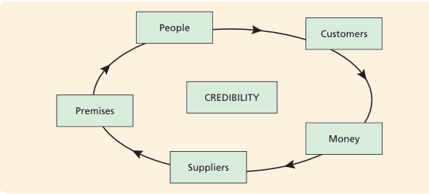
In general we expect to see that mostly young business entrepreneurs go to business conference; this is because they can gather the most forms of capital. Financial, social and human capital is all very important for young business entrepreneurs and is vital for business survival as well as business growth. This is why we assume to see that most entrepreneur-attendees are indeed young business entrepreneurs instead of established entrepreneurs. Also we are going to examine the role of the financial and economic crisis of 2008 that began in the United States. Due to the economic crisis, the funds of firms decreased a lot and businesses had to be more careful with their funds. This is why we could expect that people attend less business conferences in financial weaker times than in regular financial times. On the other hand a business conference could be seen as a way out to better times; and to have better prospects for the future. Following the study done by Malekmohammadi, Mohamed & Ekiz and the fact that business tourism is the least responsive to price changes, we expect to see that there is no real change in conference visits through financial weaker times. (Malekmohammadi, Mohamed, & Ekiz, 2011). This brings us to the following hypothesis.

Hypothesis 6: There is no change in business conference visits for entrepreneurs through financial changing times.

Methodology
Questionnaire Design
The questionnaire design is constructed through literature review. Through extensively researching relevant literature review this survey was set up; the survey is only focused on people with their own business, defined as entrepreneurs. Relevant economic theories, characteristics of entrepreneurs and business travel are all incorporated in the research.
During The Next Web Europe conference on 23th and 24th April the survey was personally distributed to the participants by me and a volunteer of the conference. In total 173 participants have filled in the face-to face questionnaire. Data has been gathered by walking through the venue of the conference searching for entrepreneur-attendees. An amount of 2500 attendees visited the conference on both days; however we only questioned entrepreneurs on a random basis. Nearly 90 % of the questioned entrepreneur-attendees filled out the survey.
Measuring Instruments
The questionnaire focused firstly on the basic demographic and background data of the respondents. This section asked about the personal income, the gender, the place of residence and the age of the respondents. The second part made the distinctions about the business duration and the type of entrepreneur. The third past consisted of seventeen possible motivations for the respondents to engage in business conference visits. At last the question was asked if people attend more or less conferences in financial weaker times.
To examine the motivations of entrepreneurs to go to business conferences there were seventeen possible motivations listed in the survey. The participants had to answer all of these questions on a 5-point Likert-Scale. The Likert-Scale is chosen because it is an effective tool to measure the attitudes of people (Mcleod, 2008). The ordinal scale measure levels were: not important at all, not important, neutral, important and very important. The following question was asked: ‘’the reasons for me to attend business conferences are’’? All the possible answers to this question were:

- To listen to the speakers
- To find investment opportunities
- To find investors
- To find financial resources
- To be informed about the industry
- Gaining new experiences
- To show my company
- To maintain relationships
- Getting away from home
- Gaining new knowledge and skills
- To find suppliers
- Meeting like-minded people
- To find talented employees
- To create partnerships
- Visiting a new destination
- To learn from potential customers
- To create new connections with people

The possible answers: gaining new experiences, getting away from home, gaining new knowledge and skills and visiting a new destination were chosen in this survey because these has been used in the survey conducted in Singapore and we want to make a comparison with that research. In this survey these questions created the motivational-factor group of pleasure-seeking. In this way we can examine whether or not pleasure-seeking is more or less important for entrepreneurs than for average attendees for engaging in conference visit. The rest of the possible answers are chosen because they are connected with professional motivations people will attend business conferences. After the data is collected a factor analysis is made of the possible answers. Four main factors were extracted from the factor analysis; all with the condition Eigen value greater than 1. After that only the possible answers that had a big enough factor loading are included in the data; this is why we deleted the following explanations for conference visit: to find investment opportunities, to find suppliers and to find talented employees. Lastly the matching factor loadings were grouped with each other and the following motivational- groups for conference visit are created (Figure 2). According to the result of the Kaiser-Meyer-Olkin test of sampling adequacy our analysis is suitable to do factor analysis (Kaiser, 1974).

Figure 2 Factor analysis The Next Web Amsterdam:
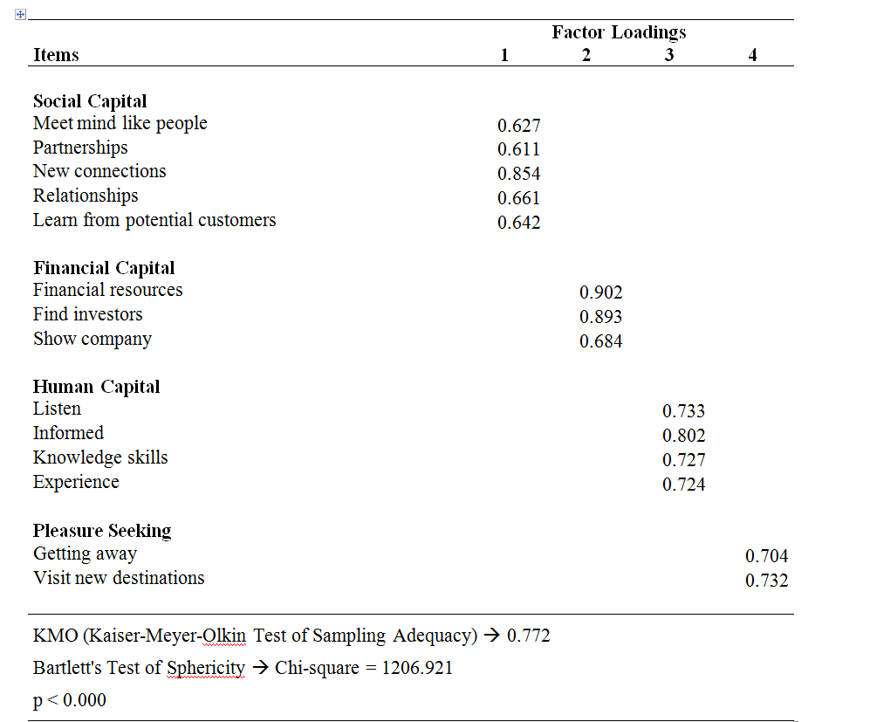
Now we have reduced the data to the factors of Social capital, financial capital, human capital and pleasure seeking and have classified the factors, we can examine the dataset in order to answer our hypotheses (Statsoft). The data will be analyzed through descriptive statistics.

Demographic Breakdown
In total there were 2500 attendees at The Next Web Europe conference on April 23 and April 24 in Amsterdam (TheNextWeb, 2015). In our data collection we have only researched the entrepreneurs attending the conference. The total amount of participants was 173 (Figure 2). The majority of the participants were male (93.64 %) and the majority’s home place was Europe (89.02 %). The median of the income level is between $50.000 and $100.000. In contrast to the research of the average attendees in Singapore this is much higher (Malekmohammadi, Mohamed, & Ekiz, 2011). This could be explained by the fact that entrepreneurs are in charge of the firm and are not paid by wages and salaries. More money can be made through capital gains, dividends and partnerships than by working for a salary; for example the IRS Statistics of Income Division reported that only 8.6% of the wealthiest people in the United States of America made their money by wages and salaries. (IRS, 2010). We observe the fact that the sample group sizes of type of business and business duration level are big enough to perform our measuring instruments in order to answer our hypotheses. There are more young business entrepreneurs (116) than established entrepreneurs (57); something we had expected because there is more to gain at business conferences for young business entrepreneurs than for established entrepreneurs. The rest of the results can be seen in Figure 3.

Figure 3 Demographic Breakdown:
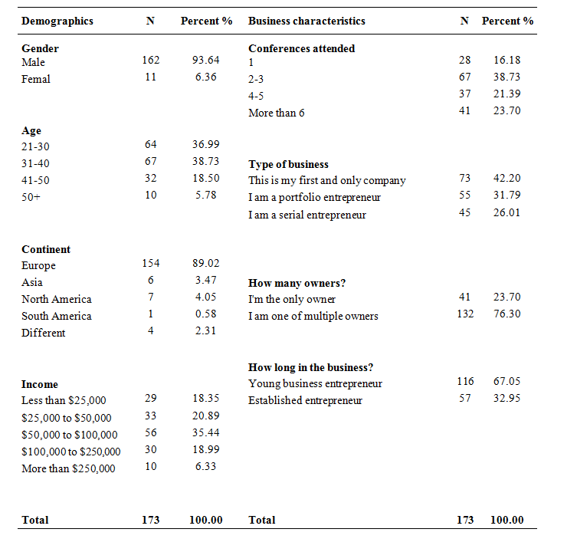

Data Analysis
Inter-data analysis
Hypothesis 1: Entrepreneurs are more goal-oriented for engaging in business conference visit than average attendees
Now we have selected the measuring instruments and have established the dataset; the data will be analyzed. First a general analysis is made of the total sample of our dataset. In Figure 4 a descriptive statistics table of our total dataset is given; the data is analyzed on a 5-point Likert-Scale. The mean of the scale is thus 2.5. Furthermore the statistics of the Standard Deviation, Median, Minimum, Maximum and Cronbach Alpha are estimated. The Cronbach Alpha coefficient tells us the reliability of the variables; the Cronbach Alpha of social capital, financial capital and human capital are all over 0.7. This means that the reliability of the variables is good. The coefficient of the pleasure seeking variable is 0.611; this is between 0.6 and 0.7; this means that the reliability of the variable is acceptable. Now we have established that the variables are reliable, we can look to our values; we see that our values of capital are all above 3.0. In particular pursuing social capital (3.816) and human capital (3.724) are important motivations for entrepreneurs to go to business conferences. However we see that pleasure seeking has only a mean of 2.121 and a median of 2.0. In contrast to the research in Singapore we see that pleasure seeking is not important for entrepreneurs to engage in business conference visit. In the benchmark research of Singapore there was shown that pleasure seeking was really important for the attendees to go to business conferences; it was even more important than professional reasons to go to business conferences (Figure 5). In order to compare the two datasets to each other, one on a 5- point Likert scale and one on a 7-point Likert scale; we have computed Z-values. The Z-value of this papers data-set is -0.333(value pleasure seeking minus mean divided by standard deviation: 2.121-2.5/1.136); this means that the variable pleasure seeking is 1/3 standard deviation below the mean. The Z-value of the data-set in Singapore is 1.086; this means that the variable of pleasure seeking in this survey is 1.086 times the standard deviation above the mean that has the status neutral.
Comparing this research with the research in Singapore we have enough significant evidence to answer our first hypothesis. It is undeniable to establish that entrepreneurs care less about the pleasure-seeking component in business conference visit than average attendees do. This is why hypothesis 1: Entrepreneurs are more goal-oriented in business conference visit than average attendees is accepted.

Figure 4 Descriptive table dataset The Next Web Amsterdam:
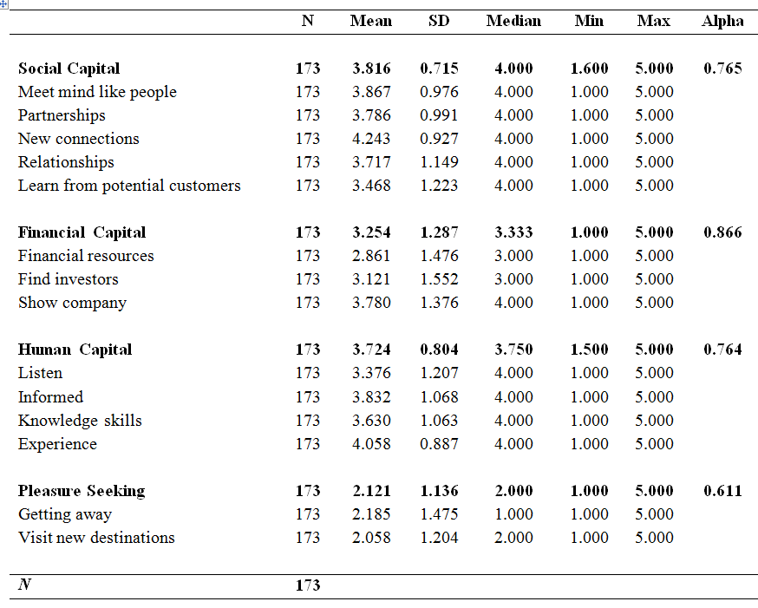
Figure 5 Descriptive table dataset Singapore:
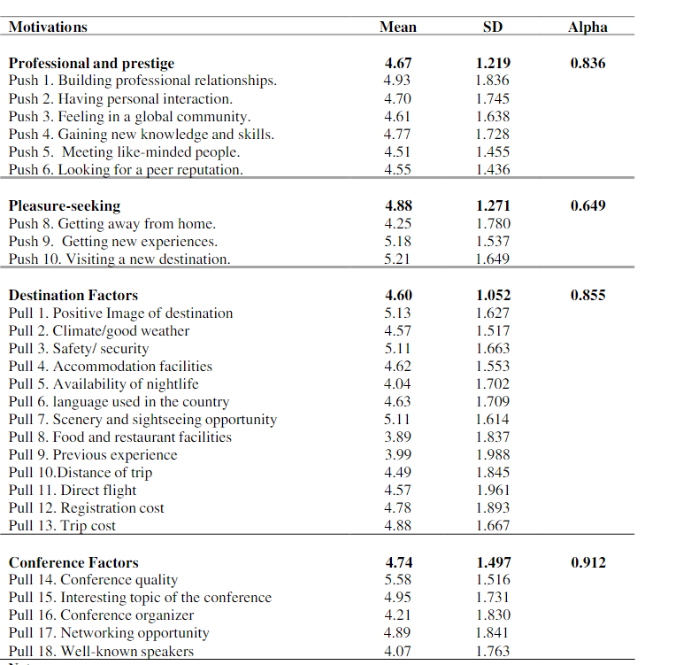
Intra-data analysis
Hypothesis 2: Young business entrepreneurs pursue more social capital and human capital at business conferences than established entrepreneurs do.
Now we have established the fact that there is a significant difference between average attendees and entrepreneurial-attendees, we are going to take a closer look to our own dataset via intra-data analysis.
An independent sample T-test is performed in our analysis to check whether or not young business entrepreneurs pursue more social and human capital at business conferences than established entrepreneurs do. In Appendix 1A and Appendix 1B the descriptive tables are given of established and young business entrepreneurs. In Figure 6 the independent sample T-test is performed on the means of the motivational factors; here can be seen that young business entrepreneurs pursue more social capital and financial capital on a 5-percent significance level. However we do not see a significant difference in pursuing human capital. This is why we cannot accept the whole second hypothesis; however we establish the fact that young business entrepreneurs pursue more social capital and financial capital at business conferences than established entrepreneurs do.
Figure 6: T-statistics. Difference between duration levels:
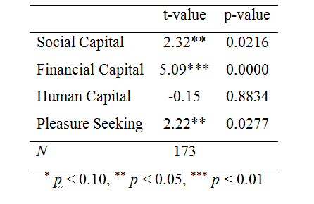

Hypothesis 3: Novice entrepreneurs pursue more social capital and human capital at business conferences than habitual entrepreneurs do.
Now the differences between young business entrepreneurs and established entrepreneurs have been examined we are going to take a look among the differences in aspect of the type of entrepreneur. To examine the differences there is a descriptive table made of the entrepreneur types: Novice (Appendix 2A), portfolio (Appendix 2B) and serial entrepreneurs (Appendix 2C). After that the portfolio entrepreneur type and serial entrepreneur type is combined to get the habitual entrepreneur descriptive table (Appendix 2D). Again the Independent sample T-Test (Figure 13) is performed between the novice entrepreneur and habitual entrepreneur on the means of the motivational factors. What can be seen is a huge significant difference in the pursuing of human capital. We do not see a significant difference in the pursuing of social capital; so we cannot accept our third hypothesis. We establish the fact that novice entrepreneurs pursue more human capital at business conferences than habitual entrepreneurs do.
Figure 7: T-statistics. Difference between types entrepreneur:
 | t-value | p-value
Social Capital | -0.359 | 0.72
Financial Capital | 0.100 | 0.92
Human Capital | -3.1834 *** | 0.0017
Pleasure Seeking | -0.1145 | 0.909
N | 173
* p < 0.10, ** p < 0.05, *** p < 0.01

Hypothesis 4: Financial capital is the most important capital for established entrepreneurs.
Hypothesis 5: Financial capital is the most important capital for habitual entrepreneurs.

Analyzing our total sample descriptive table (Figure 3) we can conclude that pursuing financial capital is the least favorable type of capital for entrepreneurs at business conferences. However according to the credibility carrousel we expect to see that pursuing financial capital is the most important motivation for habitual entrepreneurs and established entrepreneurs at least. This is because attaining financial capital is the last thing in the credibility carousel, and we assume that habitual and established entrepreneurs already have gained social and human capital through their business years.
Analyzing our descriptive tables of established entrepreneurs (Appendix 1B) and habitual entrepreneurs (Appendix 2D) we can see that our hypotheses about pursuing financial capital are wrong. Financial capital is the least important capital for established entrepreneur and habitual entrepreneur. This brings us to our fourth and fifth hypothesis. We can conclude that pursuing financial capital is not the most important motivation for habitual entrepreneurs and established entrepreneurs. We cannot accept our fourth and fifth hypothesis.
Hypothesis 6: There is no significant change in business conference visit for entrepreneurs through financial weaker times.
At last we are going to look to whether or not there is a significant change in conference visit for entrepreneurs-attendees through financial weaker times. Our data showed that 71.28 % of the participants didn’t attend more or less business conferences in financial weaker times (Figure 8). This is why we can conclude that there is no significant change in conference visits for entrepreneur-attendees in financial weaker times. We accept our sixth hypothesis.
Figure 8 Pie-chart business conference visits:
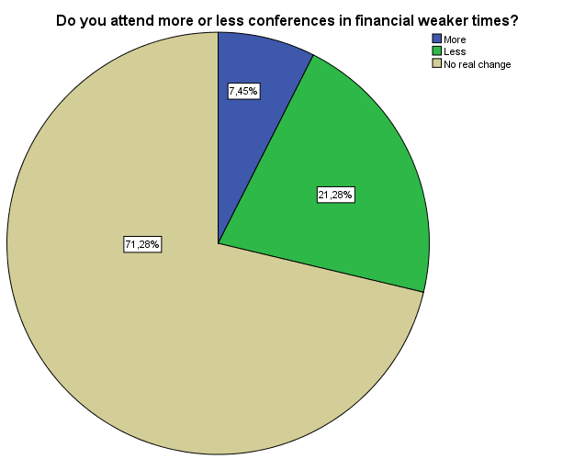
Discussion
In this paper research has been conduced about the motivations of various classified entrepreneurs for engaging in business conference visit. Because entrepreneurs are a heterogeneous group, they are classified in three groups of business experience and two groups of types of entrepreneurs in this paper. Alongside the motivations are divided into pleasure-seeking motivations and into professional motivations; the different types of capitals. This paper seeks to make a contribution to the business conference industry through explaining the various incentives of entrepreneurs for engaging in business conference visit. Through analyzing the results, this can lead to efficiently planning of business conferences and to have a better understanding of the heterogeneity of entrepreneurs.
Firstly, in this paper there is made an inter data-analysis comparison with a research conducted in Singapore. In this paper there is found that pleasure-seeking motivations are the most important incentives of attendees to engage in business conference visit. The first hypothesis in this paper has been accepted; entrepreneurs are more goal-oriented for engaging in business conference visit than average attendees. This has been proven by the fact that entrepreneurs care less about pleasure-seeking motivations for engaging in business conferences than average attendees do. Also there is found, that the means of the professional reasons are very high; this means that all the professional reasons seem to be important for entrepreneurs for engaging in business conference visit.
In the second part of the paper, an intra data-analysis has been constructed about the heterogeneity of the entrepreneurs. There is shown that there are significant differences among the different types of entrepreneurs; the second hypothesis that young business entrepreneurs pursue more social and human capital at business conferences than established entrepreneurs do; cannot be accepted however. Despite that it is useful to make the statement that there is found that young business entrepreneurs pursue more social capital and financial capital at business conferences than established entrepreneurs do. Young business entrepreneurs are in the same business for maximum 42 months and have to deal more with the liability of newness than entrepreneurs who are in the same business for a minimum amount of months of 42 (Coleman, 2004). This can be explained by the fact that young business entrepreneurs have less business experience and less saved up funds than established entrepreneurs have. There is found that especially the difference in pursuing financial capital is immense (mean of 3.58 for young business entrepreneurs and a mean of 2.59 for established entrepreneurs).
After this, there is made a division among the type of entrepreneur and here again we see that the heterogeneity of the entrepreneur plays a big role in the examining of business conference visit incentives. The third hypothesis stated that novice entrepreneurs pursue more social capital and human capital at business conferences than habitual entrepreneurs do. There is shown that there is a significant difference in pursuing human capital; however there is no significant difference found in the pursuing of social capital. Novice entrepreneurs are defined in this paper as entrepreneurs who are running their first business; with no regarding to time. The fact that there is no significant difference found between the types of entrepreneurs in the pursuing of social capital; can be explained by the fact that they have gathered social capital through their business years just like habitual entrepreneurs. This can explain why they are still pursuing more human capital than habitual entrepreneurs do; because they don’t have gathered the knowledge and skills through experience of other businesses started by them (Westhead & Wright, Novice, portfolio, and serial founders: are they different?, 1998).
Another important conclusion is that financial capital is the least favorable type of capital for entrepreneurs to gain at business conferences. Hypothesis 4 and 5 together however stated that financial capital is the most important type of capital for established entrepreneurs and for habitual entrepreneurs. Not only are these hypotheses rejected through analyzing our data, we also observe the fact that financial capital is the least important professional motivation for these various groups of entrepreneurs to engage in business conference visit. This means that the sequence of the credibility carousel, which is described in the theoretical framework, is not that strict as forecasted by this paper (Storey & Greene, 2010). A possible explanation of this can be that habitual entrepreneurs and established entrepreneurs have already built up enough connections and financial capital through their business years.

The sixth hypothesis regarded the entrepreneurs as one group again, and presented the statement that there is no significant change in attending business conferences for entrepreneur-attendees through financial weaker times. This hypothesis is accepted in this paper through analyzing our results of our dataset of 173 people. This finding can be explained with the fact that the industry of business conferences is inelastic to financial changing times (Economics Online).

Further research

After having performed the calculations of the original research, more research is done to try to support the findings and conclusions there are made. In the first place a Correlation matrix is constructed (Figure 1 Appendix Further research). He we can see that all the variables in the research are connected with each other. Support is given for the fact that all professional reasons for engaging in business conferences (Social capital, Human capital and Financial capital) are related with each other.

In the intra-data analysis there is found that young business entrepreneurs pursue more social capital and financial capital at business conferences than established entrepreneurs do. To examine this conclusion two OLS-regression are made; one with dependent variable Social capital (Figure 2 Appendix Further research) and one with variable Financial capital( Figure 3 appendix Further research). In the regression; the young business entrepreneur is the reference group; clearly there can be seen that in both regressions the change to the business duration ‘’Established entrepreneur’’; results in a lower score for pursuing financial capital(-0.990) and social capital(-.0.625). This means that there is also support given for this conclusion; made in the original research.

Furthermore, the conclusion is made in the original research that novice entrepreneurs pursue more human capital at business conferences than habitual entrepreneurs do. To seek for support for this conclusion another OLS-regression is made; with dependent variable Human capital. In the OLS-regression table(Figure 4 Appendix Further research) there can be seen that the constant of the reference group: Novice entrepreneur is high(3.799). In addition to this; the change to the entrepreneurial type ‘’Portfolio entrepreneur (-3.09) or ‘’Serial entrepreneur’’(-0.038) results clearly in a negative effect on the pursuing of human capital by the entrepreneurs. This means that all these conclusions made in the original research; can be supported by OLS-regressions.

Contributions and Limitations

In this paper there are some important conclusions drawn about the motivations of entrepreneurs for engaging in business conference visit. These conclusions can be used to improve conference planning so as to satisfy more the needs of the customers in this industry. The fact is established that entrepreneurs are more goal-oriented than average people; this is because we presented that pleasure-seeking is not important for entrepreneurs to engage in business conference visit. This could be employed to organize the business conference in a more professional way. Additional to this, there is shown that financial capital is the least favorite capital of all different groups of entrepreneurs. This can contribute to the business conference to focus more on the important incentives such as relationship building and knowledge building. Lastly, there is no need to discount tickets for business conferences in financial weaker times; there is shown that there is no significant change in business conference visit through financial weaker times. In conclusion, business conference planners have to plan the business conference through focusing on professional incentives for the attendees; in particular on human capital and social capital reasons; and do not have to acknowledge financial changing times in their event planning.

All these conclusions have to be accepted with caution. The data sample of 173 entrepreneurs is large enough, together with a response rate of 90 %. However the subsample groups of the various grouped entrepreneurs are relatively small; this leads to a high standard deviation of a subsample and can lead to biased conclusions. Nonetheless this fact is taken into account in the calculations; and we can clearly see the heterogeneity of the entrepreneurs through their incentives for engaging in business conference visit.

Bibliography

USeconomy. (n.d.). Retrieved from www.useconomy.about.com
Westhead, P., Ucbasaran, D., Wright, M., & Binks, M. (2005). Novice, serial and portfolio entrepreneur behaviour and contributions. Small Business Economics , 109-132.
Westhead, P., & Wright, M. (1998). Novice, portfolio, and serial founders: are they different? Journal of business venturing , 13 (3), 173-2014.
van Stel, A., Span, T., & Hessels, J. (2014). Global entrepreneurship monitor The Netherlands 2013 National Report. Zoetermeer: Panteia.
Coleman, S. (2004). The "liability of newness" and small firm access. The Journal of Entrepreneurial Finance , 9 (2), 37-60.
Cooper, A. C., Gimeno-Gascon, F. J., & Woo, C. Y. (1994 йил September). Initial human and financial capital as predictors of new venture performance. Journal of Business Venturing , 371-395.
Economy Library. (2015). Retrieved 2015 йил May from www.econlib.org
Economics Online. (n.d.). From www.economicsonline.co.uk
Davidson, R., & Rogers, T. (2006). Marketing destinations and venues for conferences, conventions and business meetings. Oxford: Elsevier Ltd.
IRS. (2010). IRS . Retrieved 2014 from http://www.irs.gov/pub/irs-soi/09intop400.pdf
Kaiser, H. (1974). An index of factorial simplicity. Psychometrika , 39, 31-36.
Malekmohammadi, A., Mohamed, B., & Ekiz, E. H. (2011). An analysis of conference attendee motivations:case of international conference attendees in Singapore. Journal of Travel and Tourism Research , 50-68.
Mcleod, S. (2008). Simplypsychology. From http://www.simplypsychology.org/
Montgomery, M., Johnson, T., & Faisal, S. (2005). What kind of capital do you need to start a business: financial or human? The Quarterly Review of Economics and Finance , 45 (1), 103-122.
Mosey, S., & Wright, M. (2007). From human capital to social capital: a longitudinal study of technology-based academic entrepreneurs. Entrepreneurship Theory and Practice , 31 (6), 909-935.
OECD. (2015). OECD: insights of human capital.
PR newswire. (n.d.). From www.prnewswire.co.uk
Statsoft. (n.d.). From www.statsoft.com
Stewart, W. H., & Roth, P. L. (2010). A meta-analysis of achievement motivation differences between entrepreneurs and managers. Journal of Small Business Management , 401-424.
Storey, D. J., & Greene, F. (2010). New entrepreneurs and social networks. In D. J. Storey, Small business and entrepreneurship (pp. 124-137).
The Next Web. (n.d.). From www.thenextweb.com

Appendix

Appendix 1A Descriptive table young business entrepreneur: 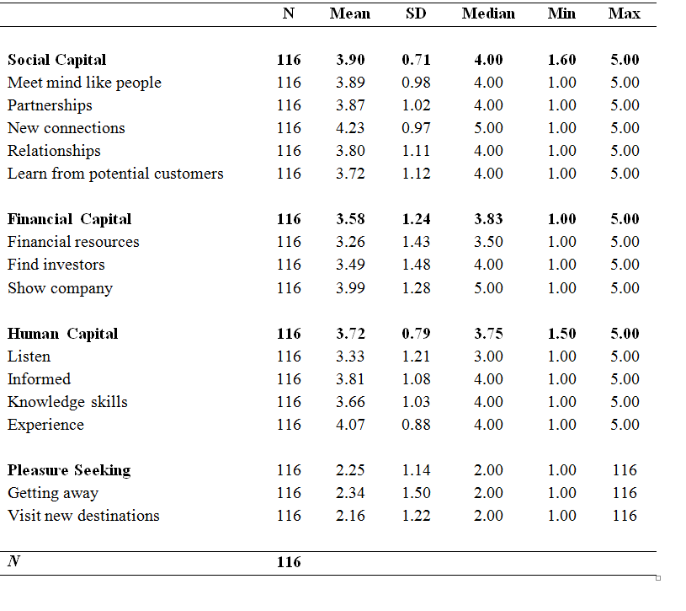
Appendix 1B Descriptive table established entrepreneur:
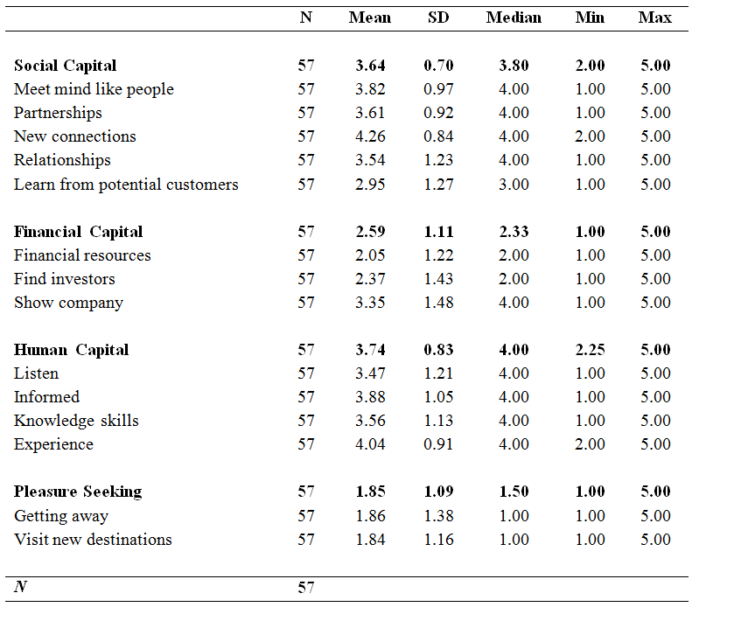
Appendix 2A Descriptive table novice entrepreneur:
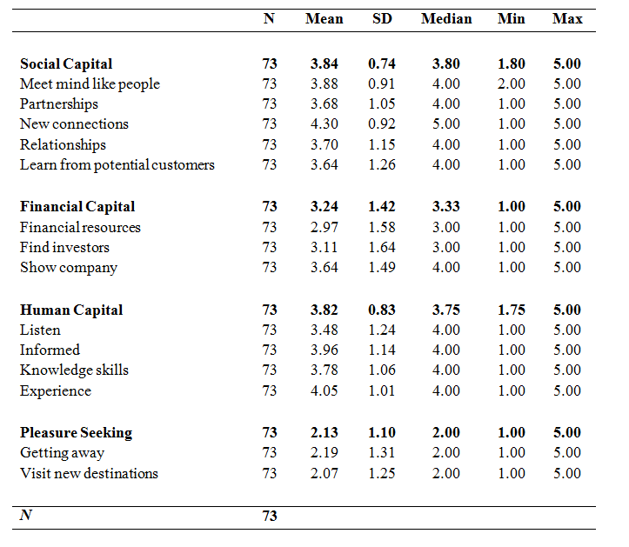
Appendix 2B Descriptive table portfolio entrepreneur:
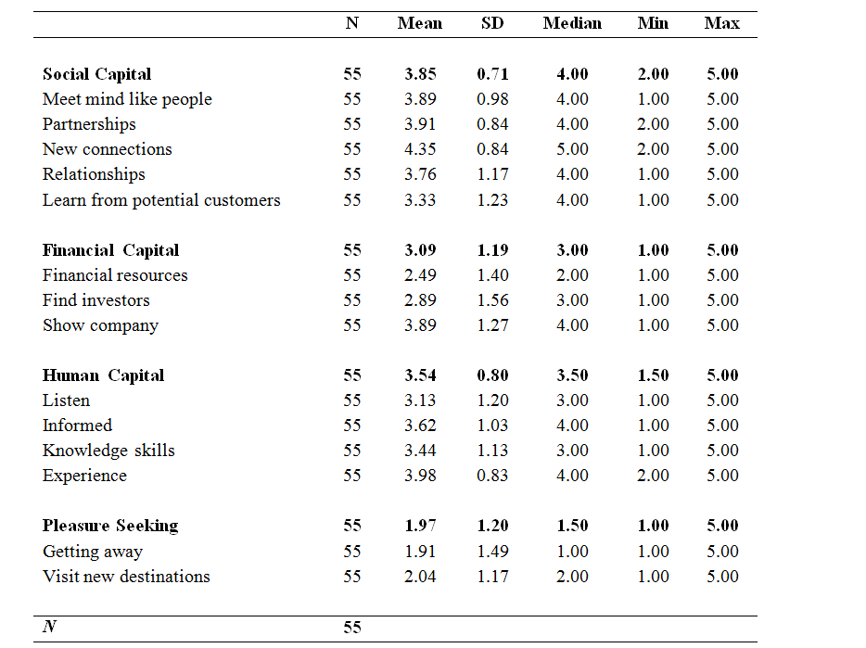

Appendix 2C Descriptive table serial entrepreneur:
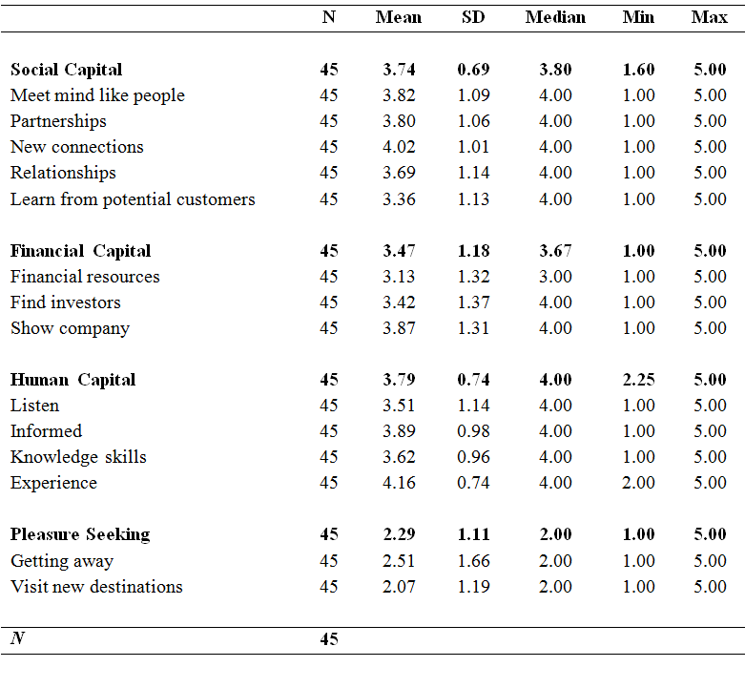
Appendix 2D Descriptive table habitual entrepreneur:
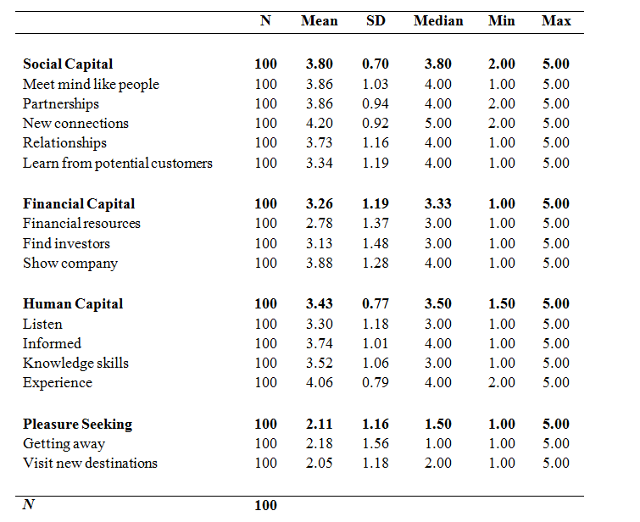

Appendix Further research

Figure 1 Correlation Matrix

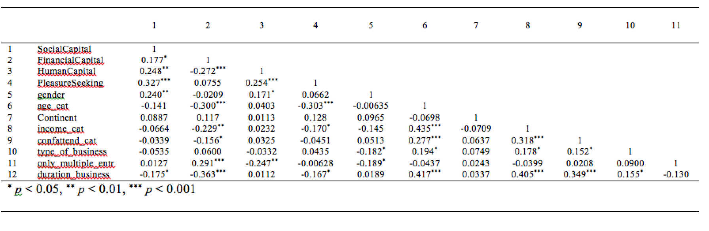

Figure 2 OLS-regression dependent variable Social capital

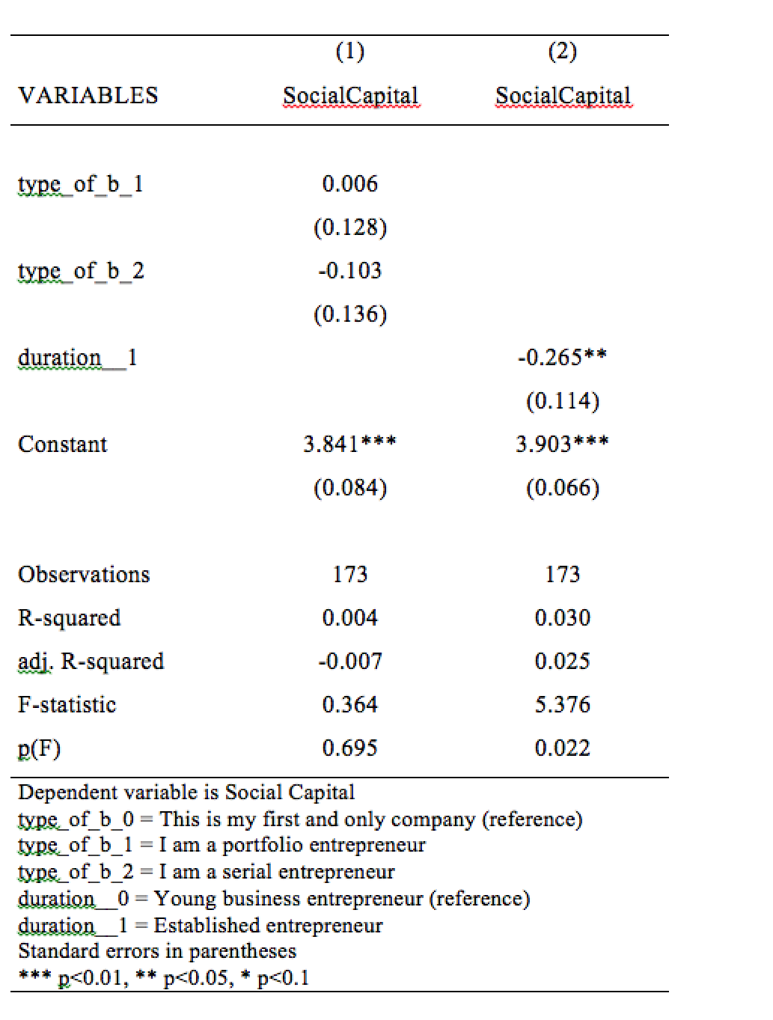

Figure 3 OLS-regression dependent variable Financial capital

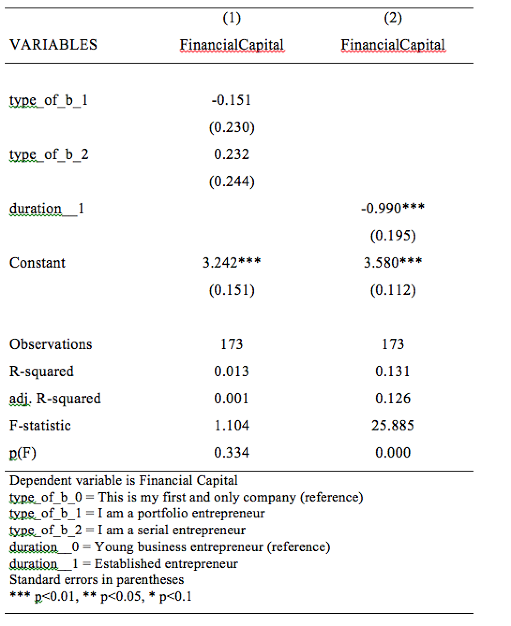

Figure 4 OLS-regression dependent variable Human capital

