Gerrymandering, incumbents and their vote share in the United States of America
An empirical research on the electoral effect of gerrymandering

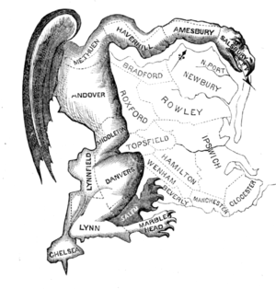

Name: Kimberly Hallink
Student number: 354034
Thesis supervisor: Benoit Crutzen
Bachelor thesis
Erasmus school of economics
Rotterdam, 15-07-2015
Table of contents
Preface and abstract 3
Introduction 4
Review on the existing literature 7
Data 10
Methodology 14
Results 16
Conclusion 20
Discussion 21
Bibliography 23
Appendices 25

Preface
This was my very first investigation that I did from the beginning. My only experience with investigations thus far were investigations where I already knew what to investigate, how to do it and with which programs. In the beginning, I instantly noticed how hard it can be to collect data. This part took the most of the time I put in my thesis. It made me proud that I was able to collect the correct data for my own investigation with some help from others. Doing the actual investigation was sometimes pretty difficult, since working with the program of Stata was new for me. With help from my thesis supervisor and the online platform of statalist, I could do what I wanted to do. Writing a thesis actually was more fun than I thought it was. Doing an investigation on your own, from the beginning idea until the conclusion, is a process in which you learn a lot of new things.
My sincere thanks are for my thesis supervisor, Benoit Crutzen, because he always helped me with my questions and answered them real quick, so I could move on. Without him, working with new statistical software to do my own investigation, would not have worked out so well.
I also want to thank my husband, Bart Wagemans, who helped me with the lay-out and is just there for me when I am stressed out or do not know how to move on with my thesis.
Last but not least, I would like to thank the Erasmus University, for a nice bachelor in economics which I ended with my very own investigation on a topic that had my interest since I first heard about it.
Abstract
This paper investigated the effect of gerrymandering on the vote share of incumbents in the United States of America. Gerrymandering is the practice of redistricting to have an advantage during the next elections. This research is done because gerrymandering still is an issue today and the incumbent re-election rate in the last elections was 95%. This raises the question where this high re-election rate comes from. It is interesting to see whether gerrymandering helped incumbents to win in the past. The data used consist all the winner of district elections between 1974 and 2008. For every district we looked up if redistricting took place in redistricting years, which are always the third year of a decade. To see whether cases of redistricting were actually gerrymandering, the Reock Ratio is used. The first step to look into this issue was to check when gerrymandering is done. Redistricting processes only take place every ten years and are typically done by incumbents who think they might lose the next elections. This fact is checked upon and correct, because by a probit regression we found that incumbents who face a larger vote share loss, have a higher probability to gerrymander. Next, the electoral effect of gerrymandering were investigated. To do this, a sensitivity analysis is made to check whether gerrymandering has an influence for a longer period than only the elections after redistricting took place. Since the results did not give enough reasons to believe it did, we concentrated on the years around redistricting. For these years the effect of gerrymandering on vote share were either not significant, very small or even negative. This result is consistent with earlier research on this topic.

Introduction
In 2012 people in the United States of America could vote for congress. The Republicans won this election with 234 to 201 seats for the democrats. However, the democrats got 1.4 million more votes than the Republicans (Wang, 2013). This could in part be due to Gerrymandering. Gerrymandering is the process of drawing new boundaries of an electoral district, to give your party an advantage over another party (Ingraham, 2015). There are several ways to Gerrymander: packing, cracking, Hijacking and kidnapping (Pierce, Larson & Beckett, 2012). Packing is the practice of putting voters with similar preferences together in one district, so they will only win that district. Cracking is the opposite: a large majority is cracked into a few districts to make them minor in most of these districts. Hijacking means putting an incumbent in a district where he or she is hardly known. And kidnapping means putting two or more incumbents in one district so they will have to fight for this district together. There are also two levels on which Gerrymandering is done: Bipartisan and partisan (Owen & Grofman, 1988). Bipartisan is done by two parties together (In the USA the democrats and the republicans), to make sure that they will have such a majority that a third party will never make it. This way they know they will be the only two major parties in US politics. Partisan means that only one party gerrymanders, so that they have more confidence of winning the elections.
There are rules which politicians have to obey when they change the boundaries of districts. There are two main rules that count for the entire country. These are the federal rules on gerrymandering. Those are:
- The districts have to have approximately the same population. You cannot make two districts, where one district has 1500 people and the other 20,000 for example.
- Redistricting on base of race or ethnicity is prohibited. This rule is made permanent in the voting rights act of 1982.
The second rule might seem obvious, but it turns out that racial gerrymandering still is a big issue nowadays. As will be shown in the next section, racial gerrymandering still happens and it is hard to prove when someone would go to court. Racial gerrymandering is mostly done by republicans, since it is known that a lot of people with another ethnicity vote for the Democratic Party.
Next to gerrymandering, every state has his own rules on redistricting. Iowa uses a computer system to draw the boundaries of districts. This is the most independent way of redistricting, since a computer makes equal states based on population. This makes Iowa an interesting state to look at, since it has not always used a computer to redistrict. The computer is used since 1981. (Curtis, McMillan & Racheter, 2013). The question that arises directly is why other states did not do the same. In Iowa, the republicans had the power to redistrict nearly all the time. So the democrats decided to go to court to prove gerrymandering was a big issue in Iowa. By the pressure of the court, Iowa changed into the computer system used nowadays. Another reason why Iowa did this is the republican candidates at the bottom of the party. These candidates could be easily gerrymandered out as well. So to reduce this risk, they actually supported the democrats for a system change. Nowadays, it seems unlikely that other states will follow the same path as Iowa did (Curtis et all, 2013).
Other states have committees to redistrict. Normally, such a committee exist of an equal number of republican and democrat politicians and some independent people next to that. Off course the question that rises is if complete independence is possible. People can negotiate and the independent part of the committee will probably have their own ideas on politics as well (Ballotpedia, 2011)
Usually, redistricting is done every ten years, so not every incumbent has the possibility to gerrymander (Friedman & Holden, 2007)
There is a lot of debate whether gerrymandering really matters that much and if it really helps parties getting a majority (Friedman & Holden, 2007). For example, the 2012 congress elections named above is an exception. Since World War II, it only happened ones that a party won more seats in congress with less votes than its opponent (Wang, 2013).
On the other hand, the chance of an incumbent to be re-elected has risen to 95% over the last 50 years (Friedman & Holden, 2007). Although the research of Friedman & Holden does not give prove that this really happens because of gerrymandering (it suggests that the effect of gerrymandering is negative), it is still interesting to see the behaviour of incumbents near redistricting years. Moreover, this re-election rate does not come from nothing, there has to be a reason behind it.
This paper will look if gerrymandering has an influence on the vote share a competitor gets after a gerrymandering year. The research question is therefore:
“What is the influence of gerrymandering on the vote share of a competitor in upcoming elections?”
All the states of America are used, with the exception of Alaska, Delaware, Montana, North Dakota, South Dakota, Vermont and Wyoming, since these States have only one district. California and Texas are not used either. These states are so big, that finding correct redistricting data proved to be very difficult. Data from before 1981 is hardly available for free. Moreover, California has a lot of large cities, which changed a lot over time. This makes it hard to see the difference between ‘good’ redistricting (so redistricting to make the districts more equal to each other in terms of population and ethnicity) and gerrymandering. Without California and Texas, there are still 333 districts left, so the number of observations is high enough for a statistical investigation.
In Iowa, redistricting was possible before 1981. Therefore Iowa is taken into account in this research, although gerrymandering is not possible anymore.
The research of Friedman and Holden would suggest that gerrymandering would not help an incumbent to stay in office longer. However, Friedman and Holden look at the re-election rate, but not at the vote share. It might be that the vote share itself does increase because of gerrymandering. And if it decreases, like Friedman and Holden suggested in their research, it is interesting to think why this might happen.
A lot of solutions for the gerrymandering problem are discussed in the past. The system Iowa uses would seem legitimate, but as explained above, all the other states do not want a computer to redistrict. Independent commissions are another solution, but checking on independence is a difficult, time consuming and expensive task. Corruption cannot be excluded completely. Another solution would be ‘fair majority voting’. This simply counts up all the votes in a country or state and the one with the most votes gets the lead on that country or state. This way, winning the majority of votes cannot mean that you still lose because of district borders (Barinski, 2008). Still America works with districts, while the above solution is not new and most certainly not hard to implement. There is probably a good reason to stick to the redistricting procedure. Gerrymandering can be this reason.
This paper follows this structure: In the next section, there will be a review on existing literature. Investigations on gerrymandering and incumbency are discussed and the missing parts in these investigations are revealed.
After that, the data used for this investigation is given. The most important tables, outcomes and statistical data are shown in this section, including the sources where this data comes from. All the other statistical output, tables and graphs are to be found in the appendix.
Next, the methodology is discussed. The types of regressions used and the reasons why these types are chosen is revealed. There will be an exact explanation of the steps followed to come to the results.
In the result section, the results of the investigation are shown. Here there will be a discussion about the outcomes of data and methodology and, if possible, conclusions are given. The results will be interpreted to give an answer on the research question stated above.
In the last part, there will be a discussion on this investigation. There will be a critical look on the outcomes. In this section there is also an explanation of things that were not investigated because of missing data, or other problems. There will be suggestions given for further research in the future.

Review on the existing literature
The main article where this research is based on is the article of Friedman and Holden (2007). As mentioned in the introduction, they did a regression on the re-election rate of incumbents if they gerrymander. The result they found on gerrymandering was negative. If an incumbent decides to gerrymander, he reduces his chance to be re-elected. However, the re-election rate of incumbents is very high, up to 95% each time. Friedman & Holden try to find other logical explanations for this high percentage. They think it might be the rules on gerrymandering. These rules became stricter over time and there is less room to gerrymander. In the introduction, the federal rules where mentioned already. On top of that, most of the states that were researched by Friedman & Holden have a set of extra rules above the federal rules, so gerrymandering is not that easy anymore.
Friedman & Holden searched for another effect of gerrymandering as well. They found a relationship between retirement and redistricting. In a year where redistricting is done, more incumbents seem to retire. This supports the fact that incumbents do not like redistricting procedures and certainly do not take advantage of them by gerrymandering.
This research suggests that gerrymandering is not helping incumbents at all. But Friedman & Holden only look at the chance of being re-elected. They have not compared between incumbents that do gerrymander in a redistricting year and incumbents that do not. This paper will make this comparison, by first looking at which states redistrict and which did not in a certain year and compare the outcomes with each other to see if incumbents stayed in office longer. Also there will be a comparison with years where redistricting was not an issue.
Moreover, Friedman & Holden suppose that every case of redistricting is a case of gerrymandering for sure. In this paper, redistricting and gerrymandering are not necessarily the same, as will be explained in the data section.
McDonald did an investigation in 2004, to see whether gerrymandering is actually a problem at all. He looked at the redistricting process which ended in 2003. His investigation aimed at finding differences between states that have a commission and states where the leading party has the right to gerrymander. If a commission is formed to redistrict, bipartisan swaps are made more often. This means that both parties have something to say about the redistricting process and they deliberated to a form where both parties benefit and a third party will probably not make it if it would try to enter politics. In states where gerrymandering is done by the leading party, a partisan redistricting process is clearly to be found. Although this might seems obvious, it is important to check on, because this means redistricting in favour of a party still happens and so gerrymandering is still an issue today.
King And Gelman have already looked at the advantage of incumbents in 1991. They also try to find reasons why incumbents have such a big chance to be re-elected. Although they do not find a direct link with redistricting years, they think redistricting might be important through the incumbent advantage, since it scares new opponents (see also the article of Mann below) and incumbents do have the power to redistrict. The interesting part of this article is that King And Gelman found that republican incumbents have a larger advantage than democratic incumbents. Since 1986 this advantage seems to shift from republicans to democrats, but there are simply more democratic incumbents. When they correct for this difference in number, they still found that republicans have a higher chance of getting re-elected than democrats. It is not sure whether they have a better knowledge of redistricting or if there are other reasons behind this advantage. It might be that racial gerrymandering plays a role in this. Since racial gerrymandering probably is done more often by republicans, because for example, Afro-Americans tend to vote democratic more often. See also below for some investigation into racial gerrymandering cases.
In an article written by Thomas E Mann (2007) another problem of gerrymandering arises. Gerrymandering on itself does not seem to be a big problem at all. See for example the article of Wang (2013) mentioned in the introduction. Since World War II it only happened twice that possible gerrymandering made the house won by the party who did not have the most votes. In the research of Friedman & Holden above, gerrymandering does not seem to give a lot of advantages as well. However, the problem Mann describes should be taken seriously. He states that gerrymandering may scare other competitors off going into politics at all. If an incumbent has the right to redistrict (and so to gerrymander) there might be a reason to not even start in politics since a competitor might think he does not stand a chance at all. This also counts for a bipartisan gerrymandering, where republicans and democrats work together to stop a third party from entering politics in the first place. This article suggests other problems of gerrymandering, even when the visible outcomes of gerrymandering do not seem so big.
In 2009, Forgette, Garner and Winkle investigated empirically if the assumptions Mann did on gerrymandering and its influence on the elections were true. They found a significant (but not very big) effect of gerrymandering on elections. Right after redistricting years, in states were redistricting was done, there are more elections were there is only one competitor. So nobody even took the change that year to go into the elections. They also found that redistricting let parties win more often the next elections than when redistricting did not take place. In contrast to Friedman and Holden they did not look at incumbents but at parties as a whole. Since there are only two parties in the U.S.A. competing this investigation is done more easily than looking at every incumbent itself. Moreover, an incumbent that retires or decides for other reasons not to not run for the elections the next time, still can redistrict (gerrymander) for the party he or she is seated for, so his successor will have a bigger shot at winning the next elections. This article does suggest that gerrymandering still has some effect on the elections. Although the effects were not huge, if there is an effect at all gerrymandering is still important to discuss.
In another article Forgette and Winkle (2006) found that partisan gerrymandering is a bigger issue than bipartisan gerrymandering. So in states where redistricting is done by the leading party, gerrymandering has a bigger effect on the elections. The effect is especially bigger for competitiveness, so where partisan gerrymandering is done, electoral competition is smaller. So more incumbents win with a vote share of 100% in states where partisan gerrymandering is possible. Since this seems a bigger issue than bipartisan gerrymandering, the first step into improving this competitiveness would be independent commissions, since they cannot do a partisan gerrymander (though they can do a bipartisan one, but this seems a smaller issue considering this article).
The majority of the existing literature on gerrymandering compares federal elections of different years (For example, Lions & Galderisi, 1995), or states in the same year (for example Squire, 1985). There has not been a lot of research on incumbents in redistricting years compared to not redistricting years, so this research will aim on that as well.
Another important part of investigations on gerrymandering looks at racial gerrymandering. Although this investigation does not look at racial gerrymandering, mentioning it shortly is important, since it is a big issue in redistricting policy. It is noted in the two federal rules of gerrymandering that racial gerrymandering is forbidden, but it still seems to happen a lot. People of other ethnicity tend to vote more often for democrats, the biggest group is Afro-American (Apple, 1996). In a article by Mark Bernstein (1996). A seat loss of at least 20 seats for the democrats is stated, because of racial gerrymandering. This makes it a big enough issue for U.S. Politics to leave it unmentioned in this paper.
Moreover, Mixon and Upadhyaya (1997) have investigated whether gerrymandering is done less since 1982. 1982 is the year where the voting act that stated that racial redistricting is forbidden became permanent. If racial gerrymandering really stopped after this voting act, gerrymandering as a whole should have decreased. Mixon and Upadhyaya did not find evidence of such a decrease of gerrymandering at all. This probably means that racial gerrymandering still happens. A possible explanation is that finding evidence that redistricting was really on an ethnic base is very difficult, expensive and time consuming. Moreover, if nobody complains, nobody will have a look at it. Because racial gerrymandering seems to be such a large share of total gerrymandering, it could not be ignored in this paper.
Cottrill and Peretti (2013) did an investigation to see if an independent commission that will redraw district borders will solve the problem of gerrymandering. A lot of states these days work with an independent commission, so an incumbent does not have the right to gerrymander on his own. Since gerrymandering still seems an issue today, the answer seems clear. Independent commissions do not seem to work. The logic behind this is that nobody is really independent. Members in a commission vote as well and have an own preference. What is interesting about the investigation of Cotrill and Peretti is that so called independent commissions are a trigger to gerrymander even more for an incumbent. These commissions do nothing else than researching on districts and have all their time saved for that. This gives them time to investigate where republicans and where democrats live, time an incumbent itself does not have. So by making use of this commissions (for example, by paying them for their work), gerrymandering is made easier instead of harder.

Data
The data used in this investigation consists out of three parts. First of all, redistricting for every district is shown. With help of the sites census.gov and nationalmap.gov it can be seen easily whether a district changed over time or not. 1963 is used as a base year, so from 1973 on till 2003, every ten years redistricting is done. If a state has the same shape after those ten years, so if it did not redistrict, it certainly did not gerrymander. The other way around is more complicated. If a state did change, it might be gerrymandering but it might also be redistricting because of a population, or other kind of, change. The 5 most and 5 least redistricted states over time are shown in Table 1
Most redistricted | Percentage redistricted
Arizona | 100%
Utah | 100%
Indiana | 92%
Oklahoma | 80%
Illinois/Mississippi | 75%
Least redistricted
Hawaii | 0%
Idaho | 0%
Maine | 0%
New Hampshire | 0%
Rhode Island | 0%
Table 1, most and least redistricted states, from 1973 till 2003
In the above table, a score of 100% means that every district changed between 1971 and 2001. A score of 0% means that all the districts stayed exactly the same over time. It might seem strange that Iowa is not in the list of least redistricted states while Iowa is the only state with a computer that redistricts, but the explanation is simple. Iowa did redistrict before 1981 and the computer does redistrict as well. It seems obvious that the latter surely is not a case of gerrymandering. The states with a score of 0% are all states with only two districts. Redistricting seems harder when there are only two districts. That sounds logic, considering that redistricting in a state with only two districts directly seems like gerrymandering, if there are not a lot of changes in population. The most redistricting states are more interesting to look at. Arizona and Utah never stayed the same. This does not have to mean that all this redistricting is done for the purpose of incumbents winning the district and thus gerrymandering. As can be seen in the gerrymandering part, the percentage of Arizona for example decreases dramatically from 100% to 12,5%.
The second part of the data is about gerrymandering. Redistricting and gerrymandering is not necessarily the same. It is easy to find out whether a district is redistricted or not. If its shape changed over time, redistricting took place. To see whether this redistricting is gerrymandering is more difficult. It is obvious that an incumbent, state or the country as a whole does not have an open document that states which redistricting is gerrymandering and which is not. Every incumbent that redistricts will defend himself by saying it was necessary to obey the rules on district population and ethnicity. So gerrymandering must be discovered in another way. In the past, four different ratios are used to see if gerrymandering took place. The first two, the ‘Polsby-Popper’ and the ‘Schwarzberg’ ratio look how close a district resembles a circle (Avazea, 2012). The problem with this ratio is that most districts are squares and there is nothing wrong with a square district. Moreover, these ratios cannot distinguish for districts that are near natural borders, like the sea and the mountains. A district can look very different from a circle in these areas, without it having anything to do with gerrymandering. The other two ratios, the ‘Convex Hull’ and ‘Reock’ look at how dispersed a district is (Avazea, 2012). Districts that are widely spread across a certain area in odd shapes will have a high score in these ratios. Geography is still a problem here, but it is smaller because although districts near natural borders have odd shapes, they do not have to be much dispersed. In some cases geography gives a large problem. As an example, consider figure 1 and figure 2 below. Figure 1 shows a really dispersed district that is unnecessarily formed this way. Figure 2 shows a district that has an odd shape because of the ocean next to it, but this is not because of gerrymandering. In fact, Rhode Island (figure 2) is in the top 3 most dispersed states by the Reock ratio. For this investigation this is not a problem, because first of all, redistricting is checked upon and since Rhode Island did not redistrict at all, it certainly did not gerrymander. In other words, only districts that have been redistricted over years are tested with the Reock ratio.
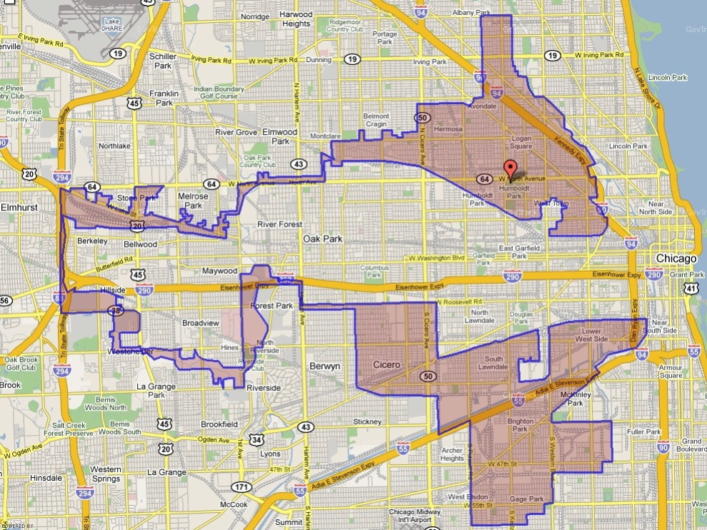
Figure 1: 4th district of Illinois
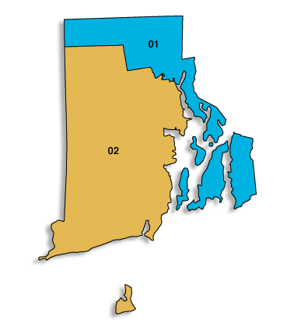
figure 2: Districts Rhode Island
The ratio is calculated as follows: Draw a circle around a district. Compare the spanning of the circle, with the area of the district (Avazea, 2010). For every district that has redistricted in 1973, 1983, 1993 or 2003, this ratio is estimated, since calculations for every district are very hard to make. Where possible, former investigations are used. If the ratio drops below .35, gerrymandering probably took place. The outcomes differ from those that looked purely at redistricting. The five states where redistricting was 0% off course did not change, but more states have a score of 0% now. The states that were most redistricted are not the same as those who have the most gerrymandering cases. The top 5 states in gerrymandering are listed below in table 2, together with all the states that score 0% on gerrymandering Utah was in the top 5 most redistricted states, but none of this seems to be gerrymandering. Illinois and Oklahoma were also in the top 5 most redistricted and they reappear in the top 5 most gerrymandered states, considering the Reock ratio. The percentage stated is not how much of the redistricting cases turned out to be gerrymandering, but how much of the observations per state (number of districts times the four time periods) were gerrymandering cases. So of all the redistricting cases the percentage of gerrymandering is even higher.
Between 1973 and 2003, there were 1456 possibilities to redistrict. Redistricting took place 660 times, which is 45%. Gerrymandering (as calculated by the Reock ratio) took place 249 times. This is 17% of the total number of observations and 38% of all the redistricting cases. The other 62% of redistricting consists of other reasons, like creating new districts or the growth of a large city (for example, Las Vegas in Nevada).

No Gerrymandering
Idaho
Iowa
Nevada
New Hampshire
Nebraska
Hawaii
Rhode Island
Utah
Most Gerrymandering | Percentage
Illinois | 42%
Massachusetts | 39%
Oklahoma | 35%
New Jersey | 31%
Maryland | 31%
Table 2: Most and least gerrymandered states between 1973 and 2003
The last part of the data consists of who won the elections per district per year and who is the runner up. This dataset consists of all the house elections between 1960 and 2008, and is courtesy of James Snyder Jr. of Harvard University (via Benoit Crutzen). Since 1963 is the base year in this investigation, only the elections from 1974 till 2008 are used, since 1974 is the first election where the redistricting and gerrymandering of 1973 has an influence. The average vote share for winning (so the average above 50%) is 70%. In this percentage the elections where there was only one competitor are included. Off course this increases the percentage because the vote share with one competitor is 1 by definition. If all the elections with just one competitor are left out, the average vote share above 50% is 65%.
The datasets are combined in three different ways. The first way gives redistricting and gerrymandering only power in the first year after an election. So for every redistricting and gerrymandering that took place in 1973, 1983, 1993 and 2003, the elections of the year after in the districts that have been gerrymandered or redistricted are given a one. All the rest is zero.
The problem with this first way of categorizing our data is that the amount of zeros will be very high, since elections take place every two years and all the other years and elections are given zeros. The second way of combining the data sets tries to tackle this issue. Here, gerrymandering and redistricting cases are expected to have influence on all the elections to come until the next redistricting year. Probably, the truth is somewhere in between. Gerrymandering and redistricting most certainly will have power longer than one year, but it is doubtful if this power last for the entire period of ten years. It is hard to distinguish how long this power lasts, so that is why both datasets are used in a regression.
In the third way, the most common approach to the problem of how long gerrymandering has an influence is used. Here, only the years before and after redistricting are used, all the other observations are deleted from the data.
Most of the former investigations on this subject only use the elections after the redistricting year to base the outcomes on. Other years are not taken in account. This investigation does this, because redistricting only happens every ten years and probably has an influence on more than one election, since the districts stay the same in these ten years.
Methodology
To make working with above data possible, first a Cross Section ID was created in Stata. In this Cross Section ID, a number is given to every competitor, so in this way those who run in the elections more than ones are recognized by the program as the same person. This Cross Section ID is considered to be the panelvariable. The timevariable is Year.
The actual research that is done consists of two parts. In part 1, we tried to find out what determines gerrymandering. To do this, a new variable is created. This variable measures the change in vote this year compared to the year before. It is created in this way:
- Delta_vote_G = vote_G[t]-vote_G[t-1]
Where vote_G is the voteshare en t is time.
After this creation the following probit regression is done:
- Probit(gerrymandering)= α+βDelta_vote_G+εt
This regression is only done for the vote shares below 1. If an incumbent has a vote share of one it means he or she did not have an opponent. That his vote share is very high than does not have anything to do with gerrymandering and or redistricting.
The aim of this regression is to find out when an party or incumbent decides to gerrymander. If you are very sure you will win the elections, gerrymandering is not necessary, so it is expected that gerrymandering is mostly done by incumbents that see a drop in their vote share. They think they are in trouble and therefore will try to gerrymander to still win the next elections.
This regression is computed five times. To check whether gerrymandering has an influence on more than one election, a sensitivity analysis is done. This sensitivity analysis consists of 5 datasets. In the first set, only the election after a redistricting year, a competitor that redistricted or gerrymandered is given a one. All the other years have the value zero for redistricting and gerrymandering. In the second set, the two elections after redistricting the values for gerrymandering and redistricting are one. This goes one until the fifth dataset, where the whole decade is taken into account. So in the last dataset, gerrymandering and redistricting is supposed to have an influence on elections the entire ten years after redistricting. Because it seems logic that gerrymandering and redistricting has the biggest influence during the first elections afterwards, but it probably has influence for a longer time than only one year, this sensitivity analysis is performed. The results can be found in the next section.
The second part of this research looks at the electoral effects of gerrymandering. First a new variable had to be created again, to see whether someone is an incumbent or not. An incumbent is someone who competed in the last elections as well, for the same district. If someone did, he or she gets the value one for being an incumbent, otherwise zero.
After this, the following regressions are made:
- Vote_G= α+β1Gerrymandering+β2redistricting+βIncumbent+ε
- Vote_G=α+β1Gerrymandering+ β2Incumbent+ε
- Vote_G=α+β1Gerrymandering+β2Incumbent+β3(Gerrymandering*incumbent)+ε
As can be seen, equations (3) and (4) look at the effects of gerrymandering, redistricting and incumbency on the vote share. (5) Also looks at the interaction between gerrymandering and incumbency and their effect on vote share.
Different approaches are used to check the influence of gerrymandering. First of all, the same sensitivity analysis as discussed above for the probit regression, is also used in this part. This means we have a look at only the years after redistricting, but also at a longer period of time. Since we can be only sure that gerrymandering has influences on the next election after redistricting, those regressions are the most important to look at.
After just looking at the effect of the regressors gerrymandering, redistricting and incumbency, we also make a regression where the interaction between incumbency and gerrymandering is added. This is done because gerrymandering is typically done by an incumbent. Again, a sensitivity analysis is performed.
After this, something is done to reduce the amount of zeroes from the data. Most of the former investigations on gerrymandering only take the years before and after redistricting to look for effect of gerrymandering. To see what difference that approach will make, we will do the same. Again, all the regressors are used and an interaction term between gerrymandering and incumbency is created.
Since gerrymandering probably has some effect on elections that are further away from the redistricting year, and since the zeroes on gerrymandering have information too, both approaches described above are used.
The results can be found in the next section. The exact variable list can be found in Appendix B.

Results
In this section, the results for both parts in the previous section are discussed. First, the minimum, maximum, mean and standard deviation of the variables gerrymandering, incumbency, vote_G and redistricting are given. See the table below.
Variable | Minimum | Maximum | Mean | Standard deviation
Gerrymandering | 0 | 1 | 0.038 | 0.191
Redistricting | 0 | 1 | 0.073 | 0.259
Vote_G | 0.5000663 | 1 | 0.704 | 0.150
Incumbency | 0 | 1 | 0.766 | 0.424
Table 3: Descriptive statistics of the variables which are used in the regressions

Part 1. What determines gerrymandering
The probit regression discussed in the methodology section is done for all the five datasets. The five corresponding results can be found in the appendix B.1. Here, we take a closer look to the first regression. This one only looks at the elections after redistricting took place. This is because gerrymandering probably has the biggest effect on these elections. The probit regression looks like this:
Variable, gerrymandering | Coefficient | Standard error | P-value
Delta_Vote_G | 0.440083 | 0.2282071 | 0.054
Constant | -1.778429 | 0.0337942 | 0.000
Table 4: Probit regression for only the elections after the redistricting year
Number of observations: 6270
To interpret these results, the margin is taken of delta_vote_g, since interpreting a probit regression directly is not possible. Only the sign of the coefficient tells something already in a probit regression, but for further interpretation the margin command is needed. For the regression above, this is the outcome:
Variable | Dy/Dx | Standard error | P-value
Delta_Vote_G | 0.0366814 | 0.019107 | 0.055
Table 5: The margins of table 3
Number of observations: 6270

Since the coefficient is positive, it actually gives the result which was expected. The coefficient means that the chance that an incumbent gerrymanders increases when his or her vote share goes down. This means that if an incumbent feels he or she is in trouble, gerrymandering is done more often.
To see whether gerrymandering is actually done more often when the drop in vote share is bigger, a summary of statistics on the change in vote share is done. Table 5 provides the results.

Variable | Mean | Standard deviation
Delta_Vote_G, if gerrymandering=1 | 0.0345988 | 0.1432537
Delta_Vote_G, if gerrymandering=0 | 0.0136367 | 0.1456636
Table 6: summary statistics for the change in vote share
Number of observations: 6270
As can be seen, the value for the drop in vote share is higher when gerrymandering is done. The probability that an incumbent will gerrymander, is higher when the drop in vote share is larger. This means that a small drop in the vote share is not enough to decide to gerrymander. Only when an incumbent considers being in such trouble that he or she might lose the next elections, gerrymandering is done.
These results give a clear view into why gerrymandering is done. It is used as a last resort to win the elections. Therefore is it interesting to see if gerrymandering actually helps to win. The next part will have a close look at this.
Part 2, what are the electoral effects of gerrymandering?
In this section, the electoral effects of gerrymandering are investigated. All the output from the regressions can be found in the Appendix B. The most important outcomes are discussed. As can be seen from the output, the sensitivity analysis that is performed does not give better results than only looking at the years around redistricting. Although gerrymandering probably has an influence for a longer period, it is hard to measure the exact number of elections where it has an influence. Therefore, this section elaborates most on the regressions that only give gerrymandering a value 1 in the years after redistricting. The regressions where only the years before and after redistricting are used and the rest is simply deleted from the data set, are discussed in this section. Although this throws away some information, it is also a way to reduce the amount of zeroes and so gives a better look at the real effects of gerrymandering.
First, the influence of redistricting, gerrymandering and incumbency on the vote share is regressed for the dataset where all the years between 1974 and 2008 are used. This regression is compared to the one where the same variables are used, but here all the years that were not before or after redistricting are deleted. The output of both regressions can be found in table 7 and 8.
Variable, Vote_G | Coefficient | Standard Error | P-Value
Redistricting | 0.0058988 | 0.0057321 | 0.303
Gerrymandering | -0.0007483 | 0.0082141 | 0.927
Election_incumbent | 0.0710988 | 0.0033629 | 0.000
Constant | 0.6406035 | 0.0038186 | 0.000
Table 7: The influence of redistricting, gerrymandering and incumbency on the vote share. Gerrymandering and redistricting cases only get the value one for the years right after redistricting
Number of observations: 6270

Variable, Vote_G | Coefficient | Standard Error | P-Value
Redistricting | -0.0215302 | 0.0075359 | 0.004
Gerrymandering | -0.0089045 | 0.0097985 | 0.363
Election_incumbent | 0.0408217 | 0.0052628 | 0.000
constant | 0.6783844 | 0.0037553 | 0.000
Table 8: The influence of Redistricting, gerrymandering and incumbency on the vote share. Only the years before and after are included
Number of observations: 2870
The results show no significant effect for gerrymandering on the vote share. Incumbency has a highly significant effect and it is positive. This is found in all the regressions that were computed. This means that being an incumbent actually helps you to get a higher vote share, which is consistent with the fact that incumbents nowadays have a high chance to be re-elected. This results suggest that this re-election rate does not have anything to do with the practice of gerrymandering. The only significant value in these regressions is the redistricting value in table 7. This value is negative, which means redistricting on itself also does not have a positive influence on one’s vote share either.
Next, the interaction term between gerrymandering and incumbency is added to the regressions. Because only the effects of incumbency and gerrymandering are compared to each other here, redistricting is left out of these regressions. Again, the regression with all the data included is compared to the one where only the years before and after redistricting are used. Table 9 and 10 provide the results
Variable, Vote_G | Coefficient | Standard Error | P-Value
Gerrymandering | 0.0210314 | 0.011564 | 0.069
Election_incumbent | 0.0514122 | 0.0023116 | 0.000
Interaction | -0.029954 | 0.0130151 | 0.021
Constant | 0.6105307 | 0.0027102 | 0.000
Table 9: The influence of gerrymandering, incumbency and the interaction between both regressors on vote share. Only the elections after the redistricting year are given value 1 for gerrymandering cases. All the data is included
Number of observations: 6270

Variable, Vote_G | Coefficient | Standard Error | P-Value
Gerrymandering | -0.0506443 | 0.0136676 | 0.000
Election_incumbent | 0.0211606 | 0.0029642 | 0.000
Interaction | 0.0555416 | 0.0151527 | 0.000
Constant | 0.6369947 | 0.002554 | 0.000
Table 10: The influence of Gerrymandering, incumbency and the interaction of both regressors on vote share. Only the years before and after redistricting are used.
Number of observations: 2870
Table 9 shows that gerrymandering has a positive effect on one’s vote share. The interesting part is that being an incumbent who gerrymanders gives a negative effect. So it seems that although gerrymandering lifts your vote share, it is neutralized by the fact that gerrymandering as an incumbent gives a drop in vote share. It might be that gerrymandering is helpful if a party does it for a new candidate, but if an incumbent does it himself he is punished by the voters for doing so.
However, when we have a look at table 10, it tells the exact opposite. Here, gerrymandering on itself has a negative influence on one’s vote share, but when you do it as an incumbent it increases your vote share. Nevertheless, also in this case the two facts neutralise each other mostly.
To reduce the amount of zeroes even further, there are also some regressions done were only the year after redistricting is used. This means only the years 1974, 1984, 1994 and 2004 are in the data, all the other years were dropped. As can be seen in Appendix B, this did not give any significant results on the relevant variables and therefore is not taken into consideration for this result section. Nevertheless, for completeness the results are included in the Appendix B.
The main conclusion that can be taken out of these regressions therefore is that gerrymandering does not give an incumbent a high advantage during the next elections. The found influence of gerrymandering on one’s vote share is never high, sometimes even negative and a lot of times not significant.

Conclusion
Redistricting and gerrymandering in the US is still an issue up to today. Media reports about gerrymandering practices every ten year again and will do in the future if the system does not change. Sometimes people even call it a threat to democracy. This investigation is done to see if gerrymandering actually is a big issue and if the threat is severe enough to worry about. The results in this research suggest that the influence of gerrymandering on vote share are rather marginal. It does not help an incumbent to gerrymander, it even seems to be negative to do so when an incumbent feels he or she is in trouble. Redistricting itself does not have large effects either. This is actually a good result, because redistricting which is done because it is necessary (like for population change) should not have a big effect on vote share of incumbents. If it does, it looks like another form of gerrymandering after all.
The results in this investigation are similar to most of the other investigations on this subject. Other researchers also found that gerrymandering does not provide help to win the elections. It seems to be that redistricting years and the topic of gerrymandering creates a lot of fuss every decade, while the results of gerrymandering in practice are very marginal. The probit regressions shows that incumbents have a higher tendency to gerrymander when they see a larger drop in their vote share. This is consistent with the idea that incumbents gerrymander when they feel they are in trouble. However, gerrymandering does not seem to solve their problems.
The biggest effect on vote share found is that of the variable election incumbent. This means that being an incumbent increases your vote share already. In this case with 7%, which is quite large. This supports the fact that the incumbent re-election rate is rather high. None of this is related to gerrymandering considering the results of this paper. The interaction between gerrymandering and incumbency is negative in most regressions. When it turned out to be positive, the variable gerrymandering itself was negative so the positive effect is directly neutralized.
This paper does not look at racial gerrymandering. If some of the reported gerrymandering cases after 1982 (because before, it was not in the federal rules that racial gerrymandering is prohibited) have a racial base, this off course is illegal and therefore a problem. To investigate this is outside the scope of this paper.
The main conclusion of this paper is therefore that the significant effects of gerrymandering are very small. Redistricting which was not considered gerrymandering does not have significant positive effects either, so even when certain redistricting cases were not seen as gerrymandering cases but actually were gerrymandering, is also did not provide certain incumbents or parties with a higher vote share. Like in most of the former researchers, gerrymandering does not have much of an effect and it certainly will not ensure a politician to win the elections.

Discussion
In this research the effects of gerrymandering were very marginal and sometimes even not significant. As can be seen in the Appendix part B, the declaration power of most of the models was not very high. This is probably due to omitted variables. The dataset we worked with, did not come with more variables, but a lot of things might influence the vote share of an incumbent as well. Age, gender, charisma, time in office are variables that probably increase or decrease vote share. For future investigation, one might consider to take these variables into account as well, to see what this does to the vote share, but also to gerrymandering in particular. There are probably relationships between gerrymandering and the omitted variables. It is possible that an older person that is in office for a long time and who is trusted by a lot of people, might get away easier with the practice of gerrymandering, than someone who only won one election before, for example. Some of these omitted variables take time to find, but are possible, like age and gender. Charisma is very hard to measure, so making the model complete is nearly impossible. However, giving the model some more declaration power is something that could be done in future research.
Unfortunately, a lot of results were not significant. Although it could be that gerrymandering simply does not have a significant result on the vote share, it is possible that other problems cause this. The way we decided to look at gerrymandering, was by the Reock ratio, which was estimated. In the data section, the flaws on the Reock ratio are already mentioned, the ratio does not take into account natural and state borders for example. Although we tried to take these borders into account, there still might be some errors in the data. The redistricting data is better, since there are documents that keep track of when and where redistricting took place. For future research, a better way to define gerrymandering could be used. This way, the data might be cleaner and other results can be found. The dataset that is used had data untill 2008. For the future, it is interesting to look what happened during the last redistricting year (2013).
Future research can also have a look at the incumbency re-election rate. This research and some other researches (like the one of Friedman & Holden) suggest that the re-election rate of incumbents is not so high because of gerrymandering. It is interesting to try to find out what makes this re-election rate so big then. The reason that incumbents are familiar for the districts cannot be the only reason, because this is not different in the past, but in the past the re-election rate was not as high as it is nowadays.
Since most investigations found that gerrymandering does not help an incumbent to stay in office longer, or to higher its vote share, other aspects of gerrymandering should get deeper investigation. Since the public still sees it as a big problem, it might be interesting to see whether gerrymandering costs a lot of money. If parties pay money to gerrymander (and they probably will, since they have to investigate what people vote, to make redistricting ideal) it is still an issue that should be taken into consideration. Because first of all, gerrymandering indeed is not something you want in a democracy. Second, if gerrymandering does not matter, the money is spent for nothing, even not for the party who did the gerrymandering in the first place.
To make an effect of gerrymandering more visible, we decided to reduce the amount of zeroes by simply deleting data that was too far from redistricting years. Off course, this way probably valuable information got lost. Since our sensitivity analysis did not give a clear view on how long gerrymandering has en influence, this was a decision we had to make. In the future, it might be interesting to try to overcome this problem. Maybe the effects of gerrymandering are different from the ones in this and other investigations, but the right way to define gerrymandering and its influence might not be found yet.
Above issues are outside the scope of this paper, but should have consideration when research on gerrymandering is done in the future.

Bibliography
Apple, R. W. (1996, September 19). G.O.P. Tries Hard to Win Black Votes, but Recent History Works Against It. New York Times. Retrieved from http://www.nytimes.com/1996/09/19/us/gop-tries-hard-to-win-black-votes-but-recent-history-works-against-it.html
Azavea, A. (2006). Gerrymandering index.
Ballotpedia. (n.d.). Redistricting. Retrieved from http://ballotpedia.org/Redistricting
Barinski, M. (2008). Fair Majority Voting (or How to Eliminate Gerrymandering). The American Mathematical Monthly, 115(2), 97-113. Retrieved from http://www.maa.org/programs/maa-awards/writing-awards/fair-majority-voting-or-how-to-eliminate-gerrymandering
Beckett, L., Larson, J., & Pierce, O. (2011, November 1). Redistricting, a devil\'s dictionary. Retrieved from http://www.propublica.org/article/redistricting-a-devils-dictionary
Bernstein, M. F. (1996). Racial gerrmymandering. Public interest, 122(12), 59.
Browning, R. X., & King, G. (1987, July 1). Seats, Votes, and Gerrymandering: Estimating Representation and Bias in State Legislative Redistricting. Law & Policy, 9(3), 305-322.
Cottrill, J.B., Peretti, t.J., Election Law Journal: Rules, Politics, and Policy. September 2013, 12(3): 261-276. doi:10.1089/elj.2012.0176.
Curtis, C., McMillan, B., & Racheter, D. (2013, October). Mal-apportionment and the Miracle of Iowa. Retrieved from http://www.limitedgovernment.org/brief20-30.html
Forgette, R., Garner, A., & Winkle, J. W. (2009). Do Redistricting Principles and Practices. State policitics and policy, 1159(2), 151-175. Retrieved from http://spa.sagepub.com/content/9/2/151.full.pdf+html
Forgette, R., & Winkle, J. W. (2006). Partisan Gerrymandering and the Voting Rights Act. Social science quarterly, 87(1), 155-173. Retrieved from http://onlinelibrary.wiley.com/doi/10.1111/j.0038-4941.2006.00374.x/full
Frank, W. M. (2006). Help wanted: The Constitutional Case against Gerrymandering to Protect Congressional Incumbent. Retrieved from http://heinonline.org/HOL/Page?handle=hein.journals/onulr32&div=17&g_sent=1&collection=journals
Friedman, J. N., & Holden, R. T. (2009, April). The Rising Incumbent Reelection Rate: What’s Gerrymandering Got to Do With It?*. The Journal of Politics, 71(2), 593-611. Retrieved from http://journals.cambridge.org/action/displayFulltext?type=1&fid=5470116&jid=JOP&volumeId=71&issueId=02&aid=5470108&bodyId=&membershipNumber=&societyETOCSession
Grofman, B., & Owen, G. (1988, January). Optimal partisan gerrymandering. Elsevier, 7(1), 5-22.
Ingraham, C. (2015, March 1). This is the best explanation of gerrymandering you will ever see. Retrieved from http://www.washingtonpost.com/blogs/wonkblog/wp/2015/03/01/this-is-the-best-explanation-of-gerrymandering-you-will-ever-see/
King, G., & Gelman, A. (1991). Systemic Consequences of Incumbency Advantage in the U.S. House.. American journal of political science, 35(1), 110-138.
Lyons, M., & Galderisi, P. F. (1995). Incumbency, Reapportionment, and U.S> house redistricting. Political research quarterly, 48(4), 857-871.
Mann, T.E. (2007). Polarizing the House of Representatives: How much does gerrymandering matter?
McDonald, M. P. (2004). A Comparative Analysis of Redistricting Institutions in the United States, 2001–02. State politics and policy, 4(4), 371-395. Retrieved from http://spa.sagepub.com/content/4/4/371.full.pdf+html
Mixon, F. G., & Upadhyaya, K. P. (1997). Gerrymandering and the voting rights act of 1982: Public choice analysisof turnover in the U.S. House of representatives. Public choice, 93(3), 357-371.
Morrill, R. L. (1987, July). Redistricting, region and representation. Elsevier, 6(3), 241-260.
Nivola, P. S., & Brady, D. W. (2006). Red and blue nation?. Baltimore, USA: Brookings institution press.
Retreat, S. (2014, December 2). When is gerrymandering actually gerrymandering? [Blog post]. Retrieved from http://www.skepticink.com/smilodonsretreat/2014/12/02/when-is-gerrymandering-actually-gerrymandering/
Squire, P. (1985). Results of partisan redistricting in 7 U.S. states during the 1970\'s. legislative studies quarterly, 10(2), 259-266.
Wang, S. (2013, February 2). The great gerrymander of 2012. The New York Times. Retrieved from http://www.udel.edu/johnmack/frec324/gerrymandering.pdf

Appendix A – Variables
Gerrymandering | Value one if competitor gerrymandered, otherwise zero
Redistricting | Value one if competitor redistricted, otherwise zero
Delta_Vote_g | Difference between vote share on t and t-1
Election_incumbent | Value 1 if someone competed the elections before, for the same district and won, otherwise zero
Interaction | Gerrymandering*Election_incumbent

Appendix B – Tables
Part 1. What determines gerrymandering
Table 1.1: Probit regression for only the elections after the redistricting year
Number of observations: 6270
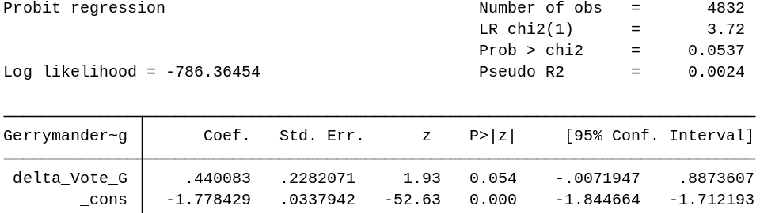
Table 1.2 Margins of table 1.1
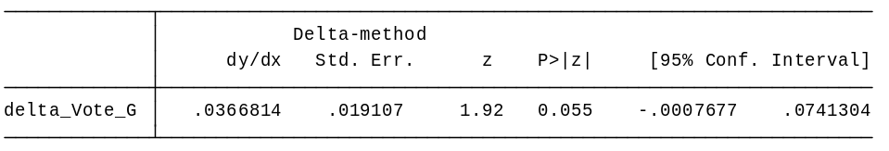
Table 2.1: Probit regression for the two elections after the redistricting year
Number of observations: 6270
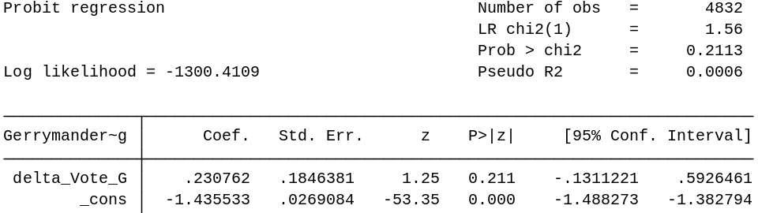
Table 2.2: Margins for table 2.1
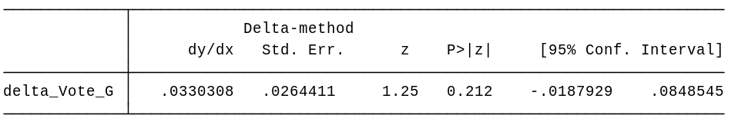
Table 3.1: Probit regression for the three elections after the redistricting year
Number of observations: 6270
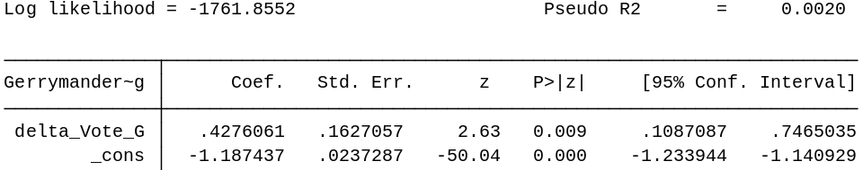

Table 3.2: Margins for table 3.1
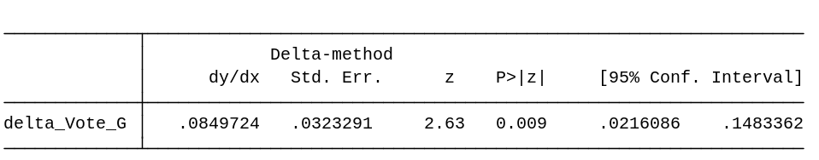
Table 4.1: Probit regression for the four elections after the redistricting year
Number of observations: 6270
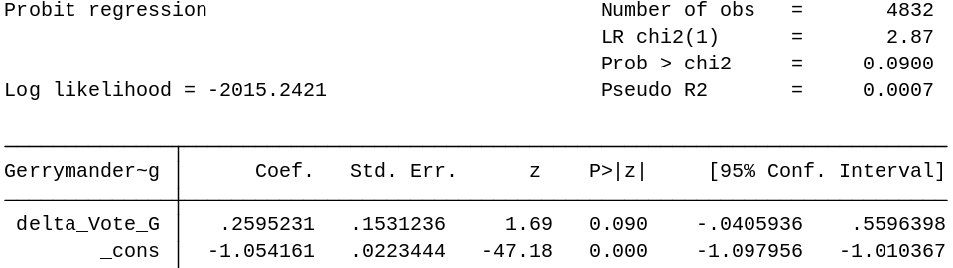
Table 4.2: Margins for table 4.1
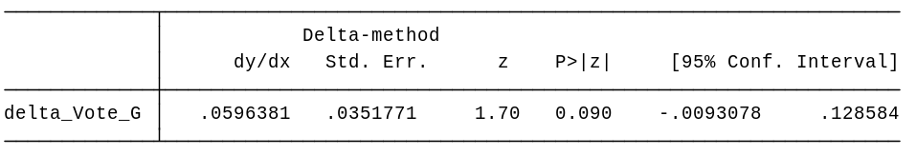
Table 5.1: Probit regression for the five elections after the redistricting year
Number of observations: 6270

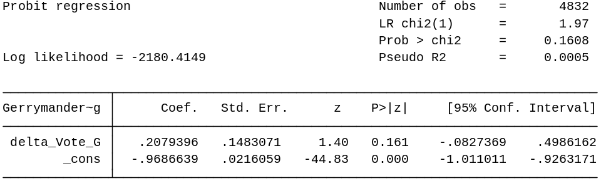
Table 5.2: Margins for table 5.1
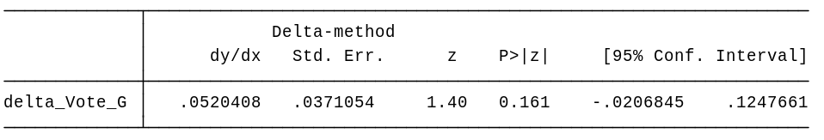

Part 2 what are the electoral effects of gerrymandering?
2.1 All the variables
Table 6: Only the elections after the redistricting year
Number of observations: 6270
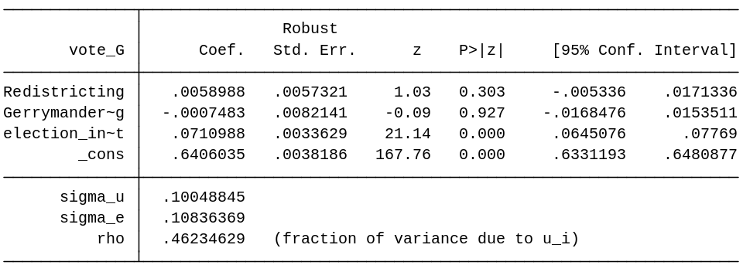
Table 7: The two elections after the redistricting year
Number of observations: 6270
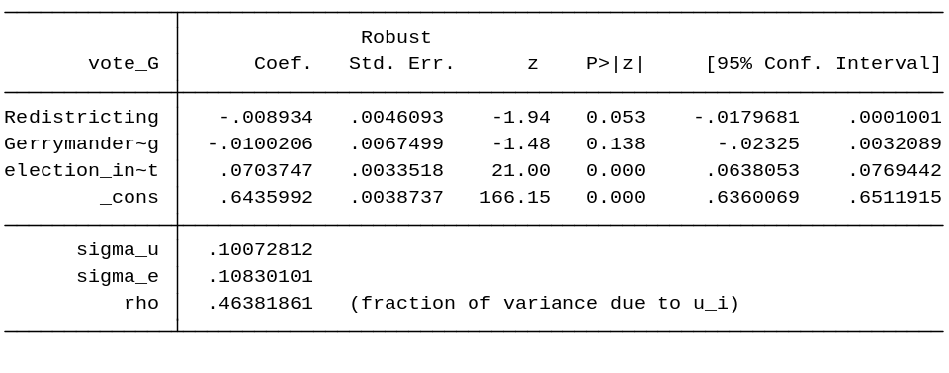
Table 8: The three elections after the redistricting year
Number of observations: 6270

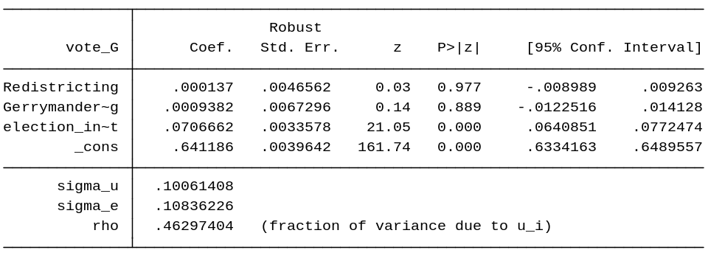

Table 9: The four elections after the redistricting year
Number of observations: 6270

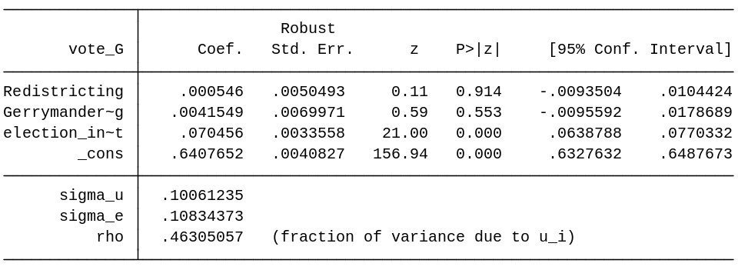
Table 10: The five elections after the redistricting year
Number of observations: 6270

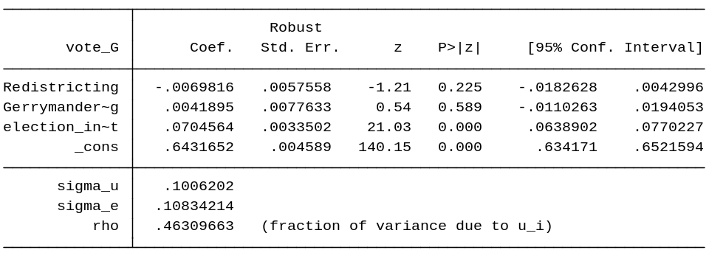
2.2 Variables gerrymandering and election incumbent
Table 11: only the elections after the redistricting year
Number of observations: 6270

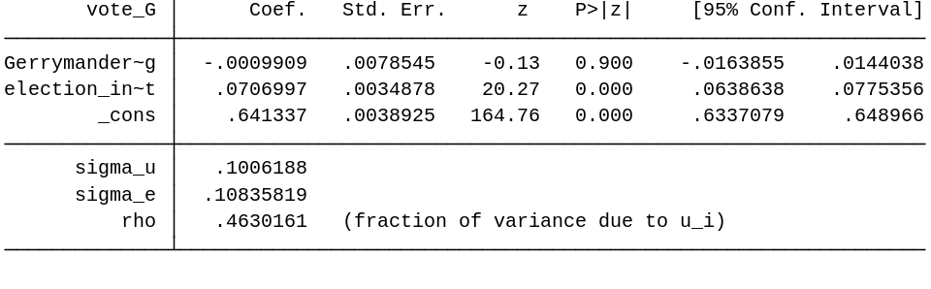

Table 12: The two elections after the redistricting year
Number of observations: 6270

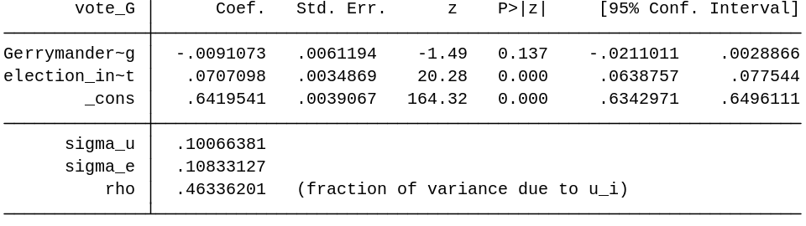
Table 13: The three elections after the redistricting year
Number of observations: 6270

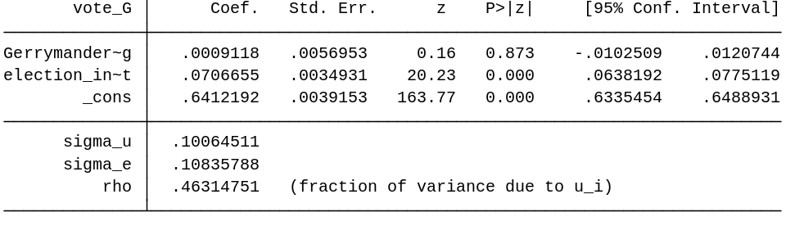
Table 14: The four elections after the redistricting year
Number of observations: 6270
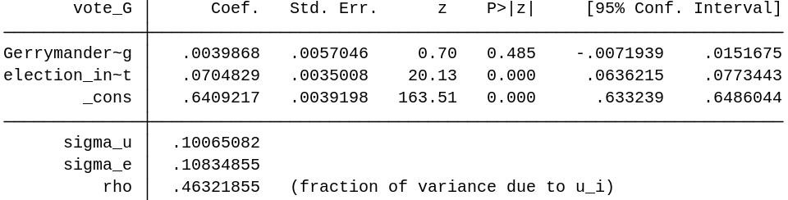
Table 15: The five elections after the redistricting year
Number of observations: 6270
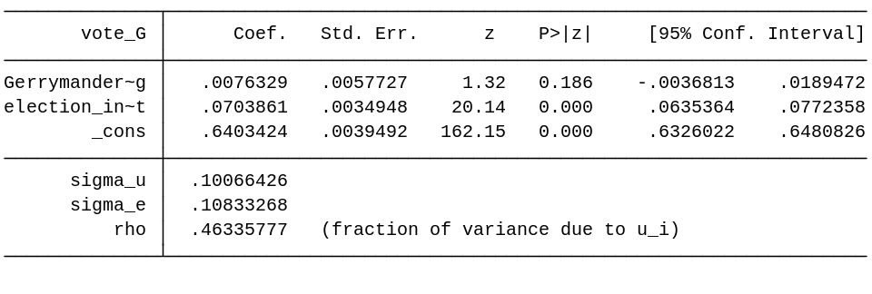
2.3 Variables Gerrymandering, Election_incumbent and interaction between the two (voteshare <1)
Table 16: Only the elections after the redistricting year
Number of observations: 6270
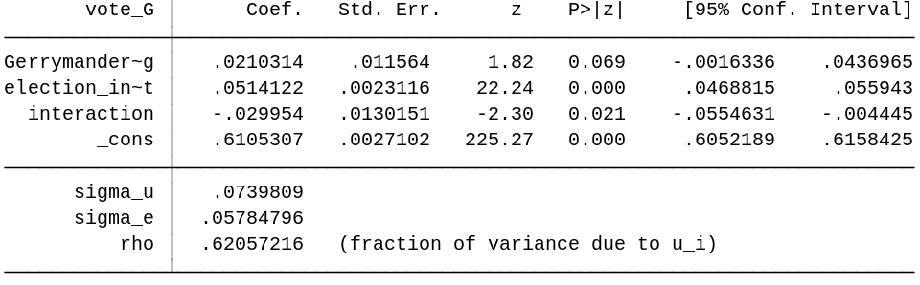

Table 17: The two elections after the redistricting year
Number of observations: 6270
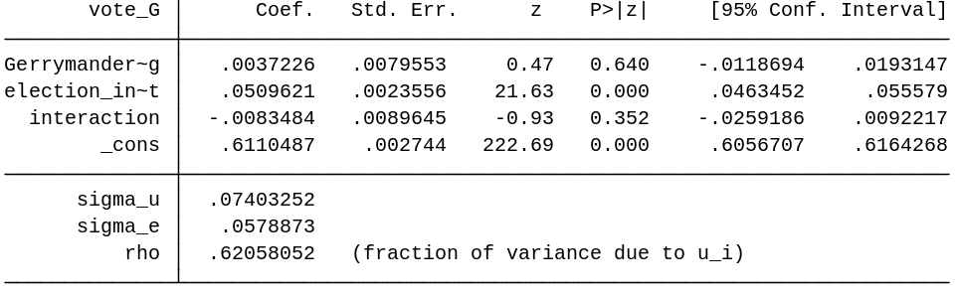
Table 18: The three elections after the redistricting year
Number of observations: 6270
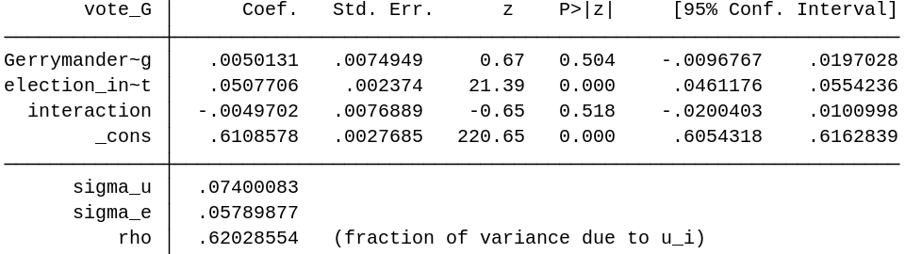

Table 19: The four elections after the redistricting year
Number of observations: 6270
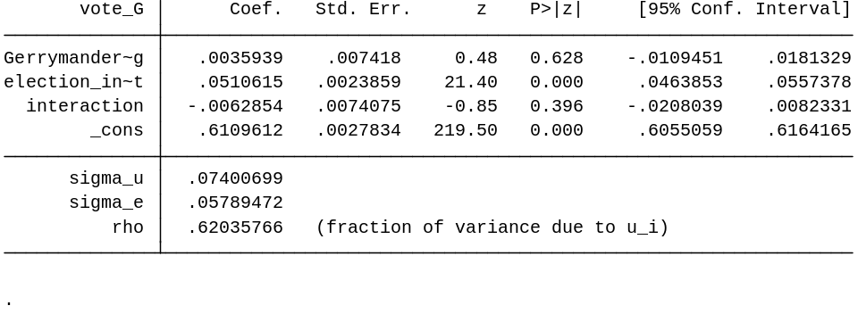
Table 20: The five elections after the redistricting year
Number of observations: 6270
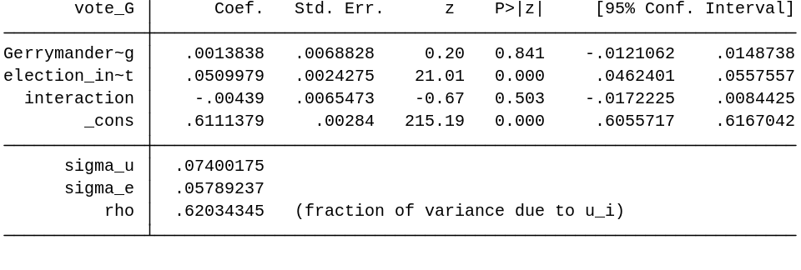

2.4 All the variables. Only the years before and after redistricting are used.
Table 21: Redistricting, gerrymandering and incumbency for the years before and after redistricting
Number of observations: 2870
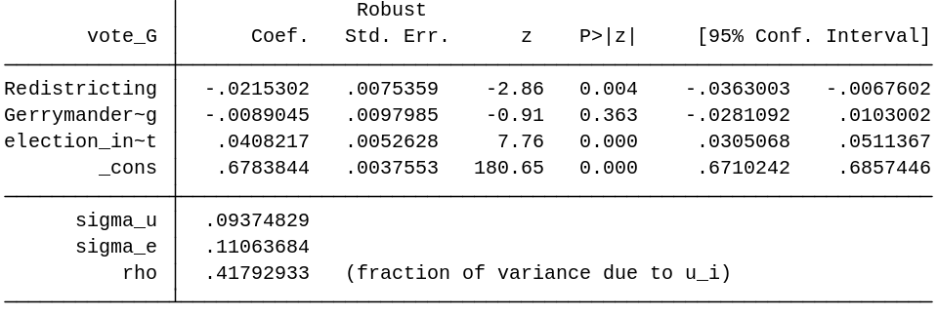

Table 22: Gerrymandering and incumbency. Only the years before and after redistricting
Number of observations: 2870
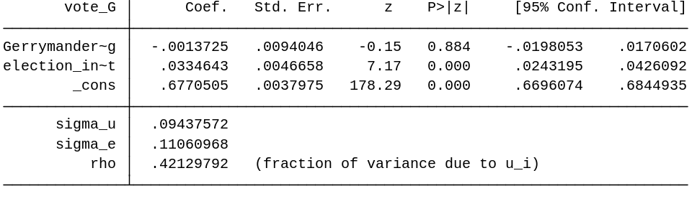
Table 23: Gerrymandering, incumbency and the interaction term. Only the years before and after redistricting
Number of observations: 2870
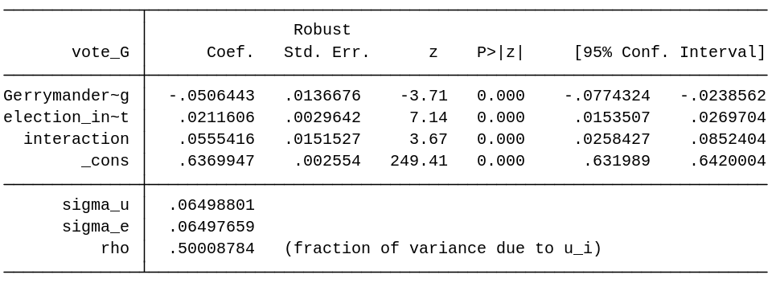

2.5 All the variables, only the year after redistricting is used
Table 24: Redistricting and gerrymandering for only the year after redistricting
Number of observations: 1430
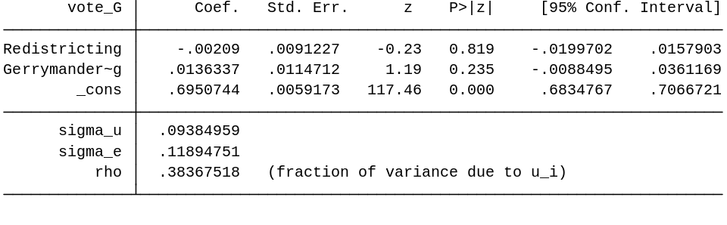

Table 25: gerrymandering and incumbency for only the year after redistricting
Number of observations: 1430
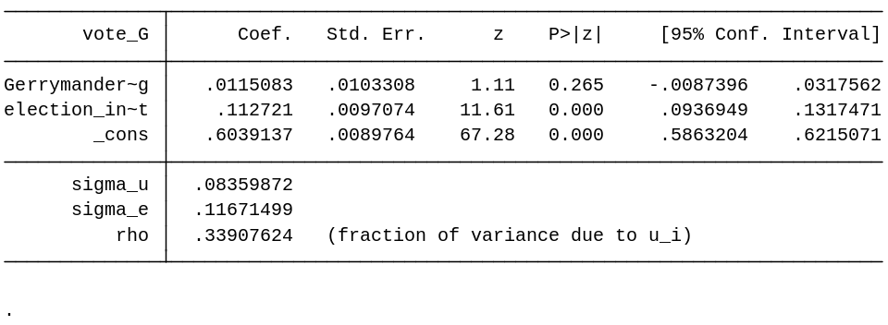
Table 26: gerrymandering, incumbency and the interaction term for only the year after redistricting
Number of observations: 1430
