Olympic Results on the Stock Market
Vincent van Noort
349138
7/21/2015

Contents
1. Introduction 3
2. Literature review 4
2.1. Modern finance 4
2.2. Behavioural finance 6
2.3. Mood and decisions 8
2.4. Sports and mood 9
2.5. Sports and stock markets 9
2.6. Olympic Games and stocks markets 10
3. Hypotheses 10
4. Data 12
4.1. Market Indices 12
4.2. Medals 13
4.3. Other variables 16
5. Methodology 16
5.1 Abnormal Returns 16
5.2 Testing Hypotheses 18
6. Results 21
6.1. Medals effect 21
6.2. Major sports 23
6.3. Time 25
6.4. Hosts 28
6.5. Robustness checks 29
7. Discussion 33
8. Conclusion 35
9. Bibliography 36
10. Appendix A: Countries 40
11. Appendix B: Sports 41
11.1. Winter Games 41
11.2. Summer Games 42

1. Introduction
Since the beginning of research in the field of behavioural finance a lot of studies investigated various factors, thought to be irrelevant, that could influence financial decisions made by investors or managers. Factors that a lot of research focused on are the mood and emotions of people and how they are influenced when making decisions. Examples of factors that influence the mood of people are the temperature (Cao & Wei, 2005), the amount of daylight (Kamstra, Kramer, & Levi, 2003) or sport results (Bizman & Yinon, 2002; Boyle & Walter, 2003; Schwarz, Strack, Kommer, & Wagner, 1987). Because irrelevant factors influence the buy and sell decisions made by investors on the stock market it can therefore also influence the returns on the stock market. By now many studies have indeed shown proof that factors, that seem completely irrelevant, are able to influence returns on the stock market by affecting the mood of a large group of investors.

Edmans, García and Norli (2007) also did research on the relation between stock returns and a variable that could influence the mood of investors. They gathered results of major international tournaments in football and a few other sports and used them to explain returns on the stock market the following day. Their results showed that the return in a country was significantly lower on a day after the national team had lost a match. The explanation for this effect was that investors are less happy after a defeat which influences their decision making. The change in their decision making makes investors more likely to sell than they are to buy. Edmans et al. (2007) did not find an opposite effect for days following a win. One of the possible arguments they give for not finding an opposite effect is that a win in these tournaments often means that the team merely advances to the next round. Nothing is won yet at that stage.

According to that argument countries should experience significantly higher returns on a day after their team won the final of the sport event. That is exactly what I will test. Edmans et al. (2007) mainly used results from the World Cup of Football and continental football tournaments. Since these tournaments are held once in the four years these tournaments give only one data point in four years to test this argument. Also the major events of the other sports they used give not nearly enough data to do my research well. Therefore instead of football tournaments I will use results of Olympic Games. Although there are also only one Summer Olympics and one Winter Olympics held in four years there are many events during Olympics which results in enough data. In short I will test whether the return in stock markets is higher in countries that won Olympic medals on the previous day. If there is indeed a relation between Olympic medals and returns it would be another example of irrelevant factors that influence the stock market. It would also show that investors let their emotions influence their financial decisions and therefore do not make fully rational decisions. Irrational investors can often create opportunities for rational investors to make profits. A relation between medals and returns would make the stock market predictable which can indeed be exploited by rational investors. Based on the expected winners of medals it could be predicted in which countries the stocks will perform the best. With this knowledge trading strategies can be created to systematically beat the market during Olympics. Such a trading strategy could be used by any investor not only professional investors. So a relation between Olympic medals and stock returns would be yet another addition to already existing evidence that the market is not as efficient as economists once thought.

The rest of this paper will look as follows. Section 2 is a review of the existing relevant literature. The differences between modern finance and behavioural finance are discussed as well as the various relations between sport events, mood and stock returns. Section 3 contains the hypotheses that will be tested. Next section 4 and 5 will describe the data and methodology that will be used in this research respectively. The results and answers to the hypotheses are reported in section 6. These results and their implication are discussed in the section 7. Finally section 8 will conclude.

2. Literature review

2.1. Modern finance
For decades the main stream in finance research has been modern finance. Building on the belief that agents are so called homo economicus, researchers came to the thought that markets are efficient. A homo economicus is thought to know about all available information and change his beliefs correctly according to this information. Furthermore they are supposed to be rational and make their decisions based on self interest (Andrikopoulos, 2005). Based on this belief modern finance came up with the efficient market hypothesis (EMH). According to the EMH stock prices should reflect all available relevant information at all times (Fama, 1970). Assuming that investors have all information and update their valuations correctly it would imply that the prices are equal to the fundamental value (Beechey, Gruen, & Vickery, 2000). This should indeed be the case in the strongest form of the EMH. Jensen (1978) later added that the prices would only be equal to the fundament value if trading on the information leads to a positive net return. Otherwise investors would not trade based on that information and prices would not change. Since information should be incorporated in the prices very quickly it would, according to the EMH, be impossible to consistently outperform the market. Even for professional investors (Andrikopoulos, 2005; Malkiel, 2005). The EMH consists of three different forms. These forms each represent a different interpretation for all available information.

First there is the weak form which only takes historical prices in account as available information (Fama, 1970). This form is probably the most tested form of the EMH, often with random walk models. According to the EMH all information is quickly incorporated in the price. Therefore the movement of the stock prices the day before cannot predict the future direction it moves in. The directions prices move in on a day depend on the information of that same day. Since information is unpredictable future price changes are also unpredictable, thus prices should follow a random walk (Malkiel, 2003). An example of the many studies of this form is a study of the European stock markets by Borges (2010). She tests the weak form EMH in six European countries and finds that this form can be rejected in some countries. However in other countries such as Germany and Spain the weak form EMH cannot be rejected.

The second form is the semi-strong form. In this form information that is very clearly available to everyone is added to the historical prices. By now this form also has been extensively tested. Most studies focus on one specific kind of information to test. Kinds of information that can be thought of are for instance seasoned equity offerings and earning announcements (Fama, 1970). Although most of these studies confirm that stock prices adjust quickly to new information there are also results that indicate it takes a longer period before all information is incorporated in the prices (Beechey et al., 2000).

Last is the strong form where all relevant information is included in the model. This form is often seen as unrealistic, because it also includes information that is only available for a small group of investors. So this form of the EMH suggests that even information that is not available to the majority of investors should quickly and correctly be reflected in the prices. It implies that it would be impossible for any investor to systematically beat the market. Different studies indeed show that some investors can beat the market and therefore this form is unrealistic and can be rejected (Fama, 1970; Niederhoffer & Osborne, 1966).

2.2. Behavioural finance
According to the efficient market hypothesis, only relevant information should be incorporated in prices. Aspects such as emotions and the mood of investors were thought to have no influence on the stock market. However in the last two decades the field of behavioural finance gained popularity. Research in this field shows that irrelevant factors can influence stock prices. Where modern finance use fully rational agents as a basis for their findings, behavioural finance says that agents behave at least not fully rationally (Barbaris & Thaler, 2003). Criticism usually heard against behavioural finance is that it often focuses on only one aspect of investors’ behaviour. As a consequence they are therefore not able to come up with one complete theory that explains most of what happens. Although it might be true that most studies focus on one aspect these studies seem to be better able to explain behaviour of investors than modern finance has so far (Subrahmanyam, 2007). Multiple studies have proven that in most cases investors make the same mistakes systematically. Because the mistakes are made systematically it can cause stock prices to become predictable in some situations and create anomalies modern finance cannot explain. Perhaps the best known anomaly is momentum and its long term reversal. Momentum is the phenomenon that the best performing stocks of the past year are also the best performing stocks in the next year. On the other hand the worst performing stocks will also continue to be the worst performing stocks in the next year. The long term reversal means that on the longer term the best performing stocks will become the worst performing stocks and the other way around. Modern finance was not able to explain momentum or its long term reversal but Hong and Stein (1999) managed to explain it using a model with agents that are not fully rational. These agents cause stock prices to underreact on the short term and overreact on the long term making stock prices predictable.

As mentioned a behavioural finance study usually focuses on one aspect. Often findings from psychology are used to explain anomalies found in stock markets. Many different studies have led to new theoretical models covering separate aspects such as overconfidence and sentiment (Burnside, Han, Hirshleifer, & Wang, 2011; Barbaris, Shleifer, & Vishny, 1998). Besides this theoretical research behavioural finance also contributed a lot to testing the semi-strong form of the EMH. This form of the EMH is mostly tested using event studies. They look at certain events and calculate the abnormal returns on the days surrounding that date. Although modern finance found a lot of evidence supporting the semi-strong form of the EMH there is also evidence that rejects it. Ikenberry, Lakonishok and Vermaelen (1995) showed some of this evidence around the announcements of share repurchases. The EMH states that this information is quickly incorporate in the price but they found that there is a four year abnormal return of 12.1% following such announcements. Proving that it takes quite a long time before all information is reflected in the price. There is also similar evidence that shows that it takes awhile before profit announcements are fully reflected in the price (Beechey et al., 2000).

Something else that can be done in behavioural finance is to test whether the residuals of modern finance models can be explained by behavioural factors. That is exactly what also will be done in this study with the emotions and mood of investors. That such factors have an influence has already been proven. An example is a research done by Kamstra et al. (2003) who find that the amount of daylight has an effect on stock prices. They argue that this effect is due to the fact that more people suffer from depression in those times leading to less risk taking. Other studies also show evidence that the weather affects the mood of investors and thereby also influences stock prices. More sunshine would result in a better mood and higher returns (Hirshleifer & Shumway, 2003; Saunders, 1993).

2.3. Mood and decisions
The reason mood can have an effect on the stock market is that the mood of people influences the decisions they make. Decisions can be influenced in multiple ways, for instance because of the way new information is perceived or how options are evaluated. Experiments prove that the mood of individuals determines the probability they assign to certain events happening. Happy individuals give higher probabilities to positive events happening to them and lower probabilities to negative events. For unhappy individuals it is the other way around (Wright, 1992). Happier individuals are also more likely to use stereotypes because they evaluate new information with already existing general knowledge in their mind. Unhappy individuals on the other hand tend not to think about general knowledge when receiving new information (Bless, Schwarz, & Kemmelmeier, 1996). Another impact mood can have is on the endowment effect. Normally the price individuals want to give up something is higher than what they are willing to pay to obtain it. If individuals are sad however it is proven that this effect is reversed. So they are willing to pay more to obtain something than they would want to receive for giving it up (Lerner, Small, & Loewenstein, 2004). Mood also has an effect in the retrieval of information. Individuals in a happy mood are more likely to remind positive information than negative information. The opposite happens with individuals in a negative mood. A similar effect occurs when people learn new information. When individuals are happy they are more likely to remember the happy aspects later on. Perhaps most important is the evidence that happy individuals tend to evaluate most things more positively. This tendency has been found to be the case for consumer goods and new people (Bagozzi, Gopinath, & Nyer, 1999). It is also likely that happy investors evaluate stocks more positively.

All these studies prove that mood can influence decision making in individuals and how it can happen. To make this influence visible in the entire stock market in a country there must be a variable that affects a very big part of the investors and also all in the same direction (Edmans et al., 2007).

2.4. Sports and mood
That sport events and results are able to have an influence on mood of individuals has already been proven in research. American basketball fans for instance indicate to feel better when their team has just won and sad when they lost (Boyle & Walter, 2003). Fans even appear to have a higher self-esteem when their team has just won a match compared to when they lost (Bizman & Yinon, 2002). A German study came with similar results. Individuals were asked to rate their global well-being, and their work and income satisfaction both before and after a football game. When the match was won the rates were more positively after the game than before. However after a game that resulted in a tie the rates were lower after the match (Schwarz et al., 1987).

2.5. Sports and stock markets
So that sport events are able to change the moods of individuals seems clear. There is however room for discussion whether the influence sport events have is big enough to show in stock markets the following day. As said the sport must influence most of the investors in the same way to show in the stock market. Therefore it is unlikely to see results after national matches since the investors probably all have different preferences. This is indeed proven in Turkey where matches of the biggest national football clubs do not influence the market (Berument, Ceylan, & Gozpinar, 2006). But different studies looking at international sport events still give very different answers to the question whether there is a relation or not. Boyle and Walter (2003) test it with the national rugby team in New Zealand. In New Zealand rugby is the most important sport and therefore most likely to show in the stock market in that country. The results however indicate no relation at all between the results of the rugby matches and the stock market the following day. On the opposite side is a study of matches of the English national football team. This study shows a positive return the day after a win and a negative return the day after a loss (Ashton, Gerrard, & Hudson, 2003). In between are the results of a study by Edmans et al. (2007). They do find a negative return after a loss in football, basketball, cricket and rugby but they do not find a positive return after wins in these sports. Both Ashton et al. (2003) and Edmans et al. (2007) find that the effects become bigger when the games get more important.

2.6. Olympic Games and stocks markets
So far there has been little research regarding the effect of Olympic Games on the stock market. There has been some research after the announcement of the host cities. Again multiple studies give different results. When the announcement for the 2000 Games in Sydney was studied there was no effect found on the overall stock market, only in specific sectors. Especially the industry and construction sectors in Australia experienced a positive impact (Berman, Brooks, & Davidson, 2000). The benefits for these sectors from the announcement is however completely rational. The high returns in the industry and construction sectors are justified by the fact that there are new stadiums and better infrastructure needed which creates new opportunities in those sectors. A study on the 2004 Games in Athens however did show a positive influence on the Athens Stock Exchange as a whole. Besides the industry and construction sectors also the bank and insurance sectors experienced higher returns (Veraros, Kasimati, & Dawson, 2004). Since Olympic Games do not lead to more profits for the bank and insurance sectors the higher returns are irrational. Therefore the decision making of investors seems to be affected by emotions. Furthermore the stock prices of sponsors of the 2004 Athens Games have been studied. These studies reveal positive returns for most of the firms who are announced to sponsor the Olympic Games (Floros, 2010; Samitas, Kenourgios, & Zounis, 2008). These findings are not surprising because sponsors are usually seen quite much around Olympics it is likely that they profit from the increased awareness that follows. More profits make the higher returns rational. More interestingly however Floros (2010) also looked at results of the competition. He studied the effect of medals for Greek athletes on the Athens stock exchange (ASE). Here he found a positive return on the general index of the ASE after gold and silver medals for Greek athletes. As explained this effect is irrational and should not exist according to modern finance. No firm or sector benefits from medals won by athletes from their country and therefore there should be no influence on the return at all.

3. Hypotheses
So far Floros (2010) is the only one who studied the relation between winning Olympic medals and the stock market. His findings indicate more irrationality on the stock market. Therefore it is interesting to study the relation between medals and the stock market in more detail. First step is to see if the results of Floros (2010) can be confirmed with a bigger dataset than only athletes from the hosting country. The first hypothesis will be as follows:

- Gold medals won during the Olympic Games have a positive influence on the stock market the next day

The first hypothesis is simply a test to see if winning an event has an impact. If this hypothesis is confirmed it is also interesting to see if silver and bronze medals also have an (smaller) effect.

After the first hypothesis I will test the findings in more detail to see if the effect is caused by specific sports. As explained the event has to influence a huge part of the investors to have an impact on the stock market. So it is reasonable to assume that if the sport is bigger in a country more investors are affected and therefore a reaction on stock market can be bigger. So the second hypothesis will test whether major sports have a bigger impact or not:

- Medals won in one of the country’s major sports has a bigger impact on the stock market

The third hypothesis will test the changes in the effect over time. Olympic Games have become bigger and bigger over the past forty years. The growth of Olympics includes more events, better broadcasting and more commercialization. This is illustrated by, for instance, the growth of global viewing figures in the last decade. Viewing figures grew from 2.1 billion viewers for the Salt Lake City 2002 Games to 3.5 billion viewers for the most recent Games in Sotchi (Statista, 2014). Therefore the third hypothesis will be:

- The impact of medals has increased over time

The fourth and last hypothesis will, like Floros (2010), focus on the medals won by athletes from the hosting country. His results that gold and silver medals for Greek athletes influenced the ASE can be explained by the fact that people are usually more interested in Games in their home country. The increased interest for Games in their home country shows in TV viewing figures. In the USA the most watched opening ceremonies for Summer Games were by far the Games which were held in the USA. The opening ceremonies in Los Angeles (1984) and Atlanta (1996) exceeded the 23 million. That is over 5 million more than the next opening ceremony on the list, that of Beijing (2008) (Statista). The hypothesis will be:

- The impact of medals on the stock market is biggest for the hosting country

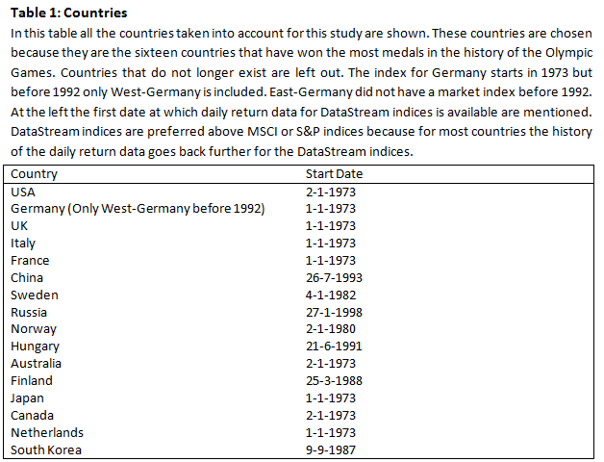

4. Data

4.1. Market Indices
Most important data needed for this research are the total returns of the market indices and the medals won for all countries which are included (See Table 1). These countries are the top sixteen still existing countries on the all time medal list of Olympic Games. The indices that will be used are DataStream indices. These indices are preferred above the MSCI and S&P indices because those indices only have daily data from 2001 onwards. Depending on the availability of daily data the sample period starts in 1973 and goes on to the end of 2014. For countries that do not have daily data dating back that far it starts from the moment as soon as daily data becomes available. In the case of Germany it starts at 1973 but includes only West-Germany before 1992. Table 2 states there are a total of 146,602 days across the sixteen countries with an average return of 0.049%. Besides the indices of all the countries also the total return of the World index is necessary. How and why the indices are used is explained in more detail in the methodology section.

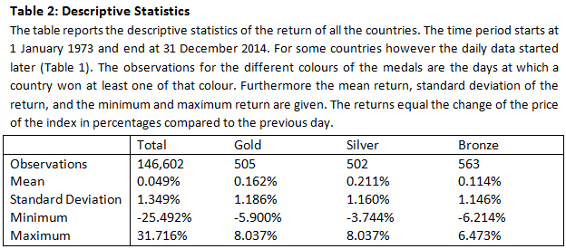

4.2. Medals
Data of medal winners is all obtained online. Important note is that not all sports are included, only the most popular (See Appendix B). For the winter games the ten sports that are included are from a list by theactivetimes.com (Rosenbrock, 2014) which is based on expert list, TV ratings, Internet data, and recent media buzz. For the Summer Games sports included are based on two lists from topendsports.com. The first list is based on the number of articles published worldwide about a sport during the Games of 2004 and the second list is which sports are most visited on the IOC website (Most Popular Olympic Sports). Most of the sports have a lot of different events at the Olympics; judo for instance had seven different weight classes for both men and women at most of the Olympics giving a total of 14 judo events at those Olympic Games (Table 3). Not all the sports were already played in 1976 and if a certain event was played as a demonstration event it is also not included. In the end it brings the total number of events for the Winter Games between 27 (in 1976) and 68 (in 2014). For the Summer Games it is between 92 (in 1992) and 128 (in 2012). A full list of all the sports, events, and the years these events where contested can be found in Appendix B.

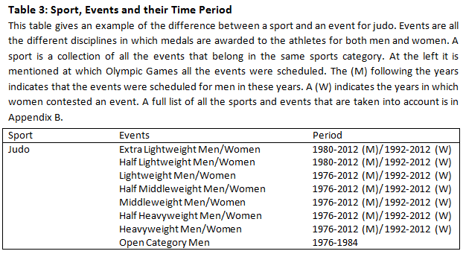

The medal winners are obtained from the official Olympic Games website (Official Olympic Games Results, 2014) and the schedules of the sports are obtained from official reports from the same website if possible. If the reports did not contain the schedules, then sports-reference.com (Olympic Games; Olympics) was used to obtain the schedule. I assigned the medals to a country on the day that the country knew which medal they won. This is important for some team sports which were played in a competition format. On a couple of occasions a country was already sure of the gold medal before they played all their matches. In cases where the results were changed later, due to for instance doping, the initial results on the day of the event itself were used so the athletes that were later removed from the results are still included. As much of these situations as possible were obtained from internet (Here Are All The Olympic Athletes Who Lost Medals For Doping Since 1968, And All The Drugs They Took, 2014). It is however not entirely sure if this source covers all these situations. The reason the original results are used is because this study is about the emotions of investors at that time. Original results reflect the emotions better than results that were changed later. Figure 1 shows that the USA has won the most medals by a long stretch. The reason that countries such as Russia and Germany are so far behind is that the medals won by East Germany and Soviet Union are not counted. On the other hand Sweden, Norway, Finland and Hungary stay a little behind regarding the number of medals in recent year.

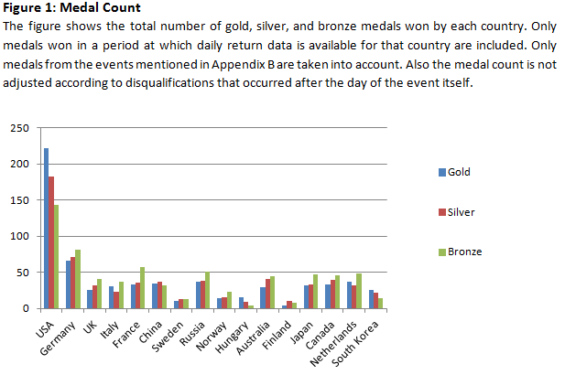

By constructing the variables the results of events on the previous day were used and separate variables are used for gold, silver, and bronze medals. These variables are constructed in two different ways. First there are the variables Dummy Gold, Dummy Silver, and Dummy Bronze. These variables will be dummies so the variable Dummy Gold will have a one for country i if country i won at least one gold medal on the day before. Secondly the variables Gold, Silver, and Bronze will be used. Those variables are constructed by taking the total number of medals of that colour won the previous day. Medals won on days where the following day is not a trading day are not used. As a consequence medals won on Fridays and Saturdays are not counted. This is done because during Olympic Games the events all follow quickly on each other. So after events on Friday there are so many other events played that these results are unlikely to still have an impact on Monday.

4.3. Other variables
Remaining variables that are used are dummies for the days Monday through Thursday and some dummies specifically for some hypotheses. For the second through fourth hypothesis there will be a subset of variables. These variables contain the number of medals won in a sport that qualifies as a major sport for that country. For instance the major sports in Norway are ice hockey, ski jumping, and football. And in Australia it is football, cycling, and basketball. A full list of all the major sports of all the countries can be found in Appendix A. For most countries major sports will be determined by top ten lists of the most visited sport sites in a country (Biggest Global Sports by Country/Region, 2014). For the remaining countries there was no list with visits to specific sites so other lists are used mostly based on the participants in a sport or Google search terms used in those countries. Eventually there are three variables for the second hypothesis named Gold Major, Silver Major, and Bronze Major. The third hypothesis requires the medal variables to be divided over all the years. This division will be done by creating separate variables with the medals won for all of the different years. The fourth and last hypothesis will also be tested with a subset of variables for all the countries hosting the Olympic Games. The variables with the number of medals won by hosting countries will be named Gold Host, Silver Host, and Bronze Host.

5. Methodology

5.1 Abnormal Returns
The methodology of this study follows the one used by Edmans et al. (2007) in their study on the impact of the World Cup. According to modern finance theory factors as the mood of investors caused by sports results should not influence stock prices. As a result it should be possible for stock returns to be predicted by any model. Therefore the following regression will be estimated first:

$R_{it}=α+β_{i1}R_{it-1}+β_{i2}R_{wt-1}+β_{i3}R_{wt}+β_{i4}R_{wt+1}+β_{i5}{Day}_{t}+ϵ_{it}$ (1)

Where R_{it} stands for the return in country i on day t and R_{it-1} for the return in that same country one day earlier. The return on the world index is indicated by R_{wt}. R_{wt-1} and R_{wt+1} are that same return but respectively that of the day before and that of the following day. These indices are included because some countries may lag the world index and some countries lead it. The world economy likely affects the local market. When the world index goes up (down) it creates more (less) opportunities for local markets. As a result the local index will also react by going up (down) and will therefore lag the world index. Other countries which are very important in the world economy such as the USA may precede the world index. If something happens which causes the index in the USA the go up (down) it is likely that it will have consequences for most of the other countries. The world index will then react by also going up (down). The last variables, indicated by Day, are the dummies for the days Monday through Thursday. To estimate the model for all countries in one time there are separate variables for all the countries. So for instance there will be sixteen different versions of the variable${ R}_{it-1}$, one for each country. All the other variables will also have sixteen different versions.

The model above will not be estimated using linear regressions but instead a panel corrected standard errors (PCSE) model with fixed effects will be used. This model allows for heteroskedasticity and contemporaneous correlation across countries in the error term. Linear regressions would assume homoskedasticity which means that the all error terms have the same variance. Because of the differences between the countries it is unlikely that the variances will be the same. Contemporaneous correlation indicates that the error terms of the different countries are at times correlated with each other. Because most countries experience higher (lower) returns at the same time it is likely that there is contemporaneous correlation between countries. Since both heteroskedasticity and contemporaneous correlation is likely it is necessary to use a PCSE model which allows for these factors. Using a fixed effects model means that for all the countries there is a separate intercept calculated.

The model described above has one problem; it assumes constant volatility over time. However the returns on stocks do not have constant volatility but time varying volatility (French, Schwert, & Stambaugh, 1987; Campbell & Hentschel, 1992). This could possibly bias the results if for instance the Olympics fall in a time period with high volatility. To correct for this issue the stock index returns will be normalized. These returns will be normalized using a generalized autoregressive conditional heteroskedasticity (GARCH) model. The stock index returns will be normalized using the volatility of the error term in the first regression. Eventually there is a new variable where the returns have a mean of zero and the standard deviation is one. The first regression will then be run again but this time with the new normalized returns as dependent variable. With the new residuals that are obtained the constant volatility assumption is no problem anymore.

So for clarity there will eventually be two sets of residuals. The first are the raw residuals obtained with the raw returns. Raw returns are equal to the change of stock prices in percentages on one day. The second set is the normalized residuals which are obtained after performing equation (1) with the normalized returns. The normalized returns are the returns after they are restructured in a way that the volatility of the returns is constant over time.

5.2 Testing Hypotheses
To control whether results in the Olympics indeed have no effect the residuals (ϵ_{it}) of the regression above will be used. If stock returns are influenced by the mood of investors these residuals can be explained by the medals won. Therefore the regression below is estimated:

$ϵ_{it}=α+β_{1}{Gold}_{t-1}+β_{2}{Silver}_{t-1}+β_{3}{Bronze}_{t-1}+u_{it}$ (2)

This model will aim to explain the residuals by the medals won on the previous day. It will be done in two different ways. The first is where the dummy variables Dummy Gold, Dummy Silver, and Dummy Bronze are used. In the second way the variables Gold, Silver, and Bronze are used to display the total number of medals in that colour won on the previous day. Since the more successful countries usually win more than one medal on each day the variables with the total number of medals hold more information. For equation (2) PCSE models will also be used to take heteroskedasticity and contemporaneous correlation across countries into account.

The method for hypotheses 2 through 4 is very similar to the methodology for the first hypothesis. For all hypotheses both the raw and normalized residuals obtained with equation (1) are needed again. For the second hypothesis the variable Gold Major is added to equation (2):

$ϵ_{it}=α+β_{1}{Gold}_{t-1}+β_{2}{Gold Major}_{t-1}+u_{it}$ (3)
In the results the total effect of gold medals won in major sports will be equal to the coefficient for the variable Gold plus the coefficient of the variable Gold Major. Although this hypothesis will mainly focus on the effect of gold medals the tests will also be done with silver and bronze medals included.

In the tests for the change in the effect over time all independent variables in equation (2) will change. Instead of one variable for all the medals of one colour these variables will be split up.

$ϵ_{it}=α+β_{1}{Gold76}_{t-1}+β_{2}{Gold80}_{t-1}+…+β_{16}{Gold14}_{t-1}+u_{it}$ (4)

Each year that contained at least one Olympics will have a variable for the number of gold medals. The last two digits of each variable indicate in which year the medals are won. This model will also be run with the silver and bronze from all the years included.

The test for the last hypothesis about the influence of medals for host countries is almost exactly the same as the tests for major sports. But instead of the variable Gold Major there will be an extra variable named Gold Host; leading to equation (5).

$ϵ_{it}=α+β_{1}{Gold}_{t-1}+β_{2}{Gold Host}_{t-1}+u_{it}$ (5)

Again the effect of the hosting country is equal to the coefficient for the variable Gold plus the coefficient for the variable Gold Host. As was the case for the previous hypotheses this hypothesis will also be tested with silver and bronze medals included. The last three hypotheses will however not use the variables Dummy Gold, Dummy Silver, and Dummy Bronze. Only variables with the total number of medals of each colour will be used in the last three hypotheses.

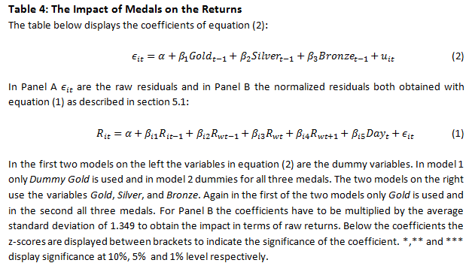

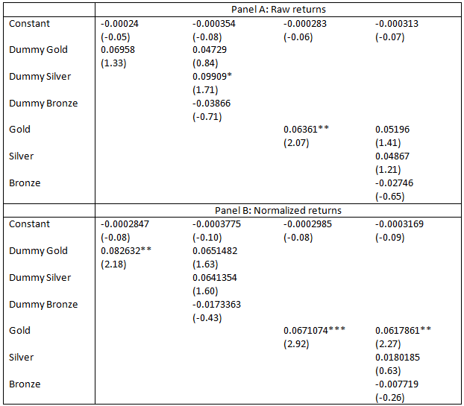

6. Results

6.1. Medals effect
Panel A of table 4 shows the estimated effect the medals can have on the stock return and in brackets the z-statistic. In the first column the model only contains the variable Dummy Gold and the second model also contains Dummy Silver and Dummy Bronze. The next two models are the same but do not use the dummies but the variables Gold, Silver and Bronze with the real number of medals. All four models use the raw returns to test the impact of the medals. As the table shows the models with the dummies give some unexpected results. Not necessarily because the small impacts the medals have, the effect of gold medals is barely 0.07%, but because the second model indicates that the effect of silver medals is about twice as big as that of gold medals. Normally people would be happier if someone from their country won a gold medal compared to a second place. On top of that the dummy for silver medals is the only one that is significant at any level, that of 10%. The models with the actual number of medals as variables show more expected results. In model three with only gold medals the effect is even significant as well. For each gold medal won the return on the following day would be 0.06% higher. When the silver and bronze medals are however added none of the medals seem to be able to explain the returns as all coefficients are insignificant.

The four models in panel B of table 4 show the same models as the previous four but with the normalized returns as dependent variable. As explained the constant volatility assumption with the raw returns could bias the results. The significance values show that the use of normalized returns in most cases results in more statistical power, especially for the variables with gold medals. As a result of the normalized returns the interpretation of the coefficients in these models is slightly different. The first model indicates that any number of gold medals does have a significant influence on the return the next day. The coefficient here is 0.083 which means that the return the following day is 0.083 standard deviations higher than its mean. For the interpretation the standard deviation of the stock returns is needed. However as explained earlier the standard deviation of returns varies over time and between countries. For clarity the average standard deviation will be used from now on. When normalized returns are used the coefficient has to be multiplied by the standard deviation of the returns to get the impact in raw returns. The average standard deviation of the returns is 1.349 (Table 2), so in terms of raw returns the return is roughly 0.083*1.349=0.11% higher than normally. When however the dummies for the other medals are added to the model all variables are insignificant again. Results are different when the variables Gold, Silver, and Bronze are used. Again the effect of gold medals is significant but now it does not change much when the silver and bronze medals are added. The impact stays about the same (about 0.09% in terms of raw returns) and for the gold medals it is still significant, albeit at a slightly lower level. The impact of silver and bronze medals is insignificant in all these models and therefore statistically not different from zero. These results show that people usually only care about winning and are not so much interested in athletes finishing second or third. So only when an event is won it can possibly influence the stock returns on the next day. There could however be a multicollinearity problem. Because of the many of events on the same day it would not be surprising if a country wins gold, silver and bronze medals on the same day. If that happens a lot, the three variables for those medals can be correlated. To test for multicollinearity the Variance Inflation Factors (VIF) are used. The VIF calculates how much of the variance of a regression is caused by collinearity. In most cases it is said that when the VIF is 10 or higher there is a collinearity problem. In this case the VIFs for the three variables Gold, Silver, and Bronze are all between 1.3 and 1.41 so multicollinearity is not much of a problem here.

From the table can be seen that the impact of the gold medals is about twice as big when normalized returns are used. The reason for this difference in impact is that when the returns are normalized the countries with very volatile indices are given less weight. Therefore these countries will have a smaller impact on the estimations of these models. Since returns have time-varying volatility the normalized returns give better estimations, therefore the remainder of this paper will mainly focus on the estimations based on normalized returns. The estimations with raw returns will still be mentioned in tables but will not be discussed in detail. There is also a clear difference between the use of dummies or the total number of medals. Dummies indicate that there is not much difference in the impact between gold and silver medals (or silver medals have an even bigger impact). On the other hand gold medals clearly have a bigger impact when the total number of medals is used. In the remainder only the total number of medals will be used and no more dummies. The main reason to only use the total number of medals is the many events on one day during the Olympics. Many of the countries in this study win multiple medals of the same colour on the same day. With the use of dummies these medals can cancel each other out even if there are for instance more gold medals won than silver medals on that day. This would be less the case with the use of the number of medals. Also as said the results in table 4 show that in almost all cases the coefficients for silver and bronze medals are statistically insignificant. So winning does have an impact but all other medals seem to have no impact at all on the returns on the following days. Therefore the main focus from here on will be on models with only gold medals. As with the models with raw returns these results will be mentioned but not discussed in detail.

6.2. Major sports
Sport results have to influence many investors in the same way to have an effect on the stock market. The biggest chance of an influence would theoretically be when events in one of the major sports are won. The major sports in a country usually attract more interest than sports in which the most people in a country are not interested. Therefore major sports are also more likely to influence stock returns than other sports. Major sports are for most countries determined by the most visited sports websites. Those numbers give a reasonably good representation of how many people are interested in each sport. However there does not seem to an increased effect for medals in major sports as the results in table 5 show. The effect of gold medals in general is remarkably almost exactly the same as in the previous tests. The coefficient of Gold Major on the other hand is insignificant and therefore not different from zero. So medals won in major sports have the same influence as medals won in other sports.

The same can be concluded when the raw returns are used. The effect of medals in major sports is very small and insignificant. More surprising results occur when the silver and bronze medals are also included. Not so much when the normalized returns are used, only the variable Gold is still significant. Other results look surprising but they are still insignificant. The coefficient for silver medals in major sports is however suddenly significant when raw returns are used. On the other hand silver medals in general still have a negative and insignificant effect according to these results.

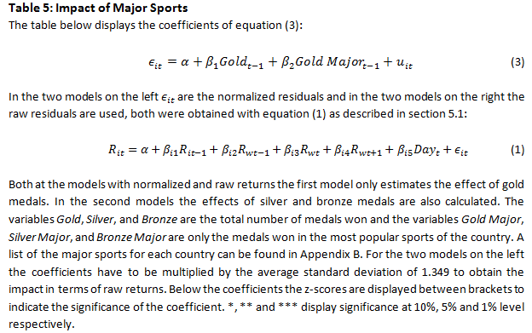
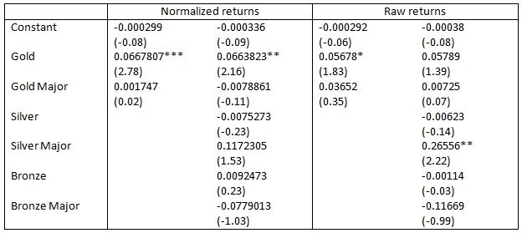

So overall the results are similar to the tests where no distinction is made between major sports and other sports. When normalized returns are used, only gold medals have a significant effect. There is however a good explanation for the results that major sports have no extra effect. Usually the major sports in a country are also the sports that are most played in that country. More athletes in a sport will often lead to more participants in Olympics in that sport and possibly also a higher quality of the athletes. Therefore the biggest chances on medals for a country are in those major sports. This is especially the case for the smaller countries in terms of sports. The Netherlands have for instance won almost all their medals during Winter Games at speed skating events. And Hungary on the other hand has won many of their medals at swimming events. Given that most of the medals are won in the major sports the variables Gold and Gold Major are very similar. Because the variables are similar it can lead to the results as shown in table 5 where the coefficients for medals in major sports are mostly insignificant.

6.3. Time
Olympic Games have grown a lot over the last forty years therefore I will test whether the impact of winning Olympic events has increased over time. To test this hypothesis there will be separate variables for each year with Olympic Games. Since the Olympics have become much bigger and more important since 1976 the impact could have increased. Over the years the broadcasting has become better and more extensive. In the seventies people had to be satisfied with the events that were broadcasted on television. Nowadays everyone can follow every single event live on the internet. Besides that the increasing viewing figures show that more people watch it as well. Therefore a bigger part of the investors could be affected by the results of Olympic events. The results in figure 2 however show that it is not the case. This figure shows the impact of gold medals in all the years. Although the impact differs a lot over the years these changes in impact seem to be quite random. In this figure the coefficients for normalized returns are already multiplied by the standard deviation of 1.349 so that line represents the influence on stock returns in percentages. These results however do not tell us much since out of all the sixteen years it is only significant in 1984, 1998 and 2002. The use of raw returns gives very similar results. With raw returns the impact seems to be even more volatile over the years and also negative more often. Besides that the z-score is also lower showing less statistical power as could be expected although exactly the same years are still significant. Although not reported the addition of silver and bronze medals does not change much either. In all these models the impact differs a lot over the years but it varies whether it is higher or lower.

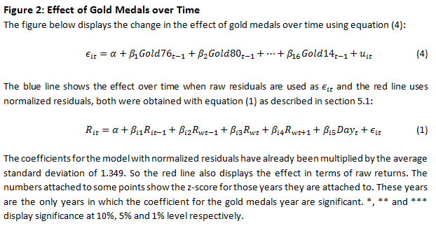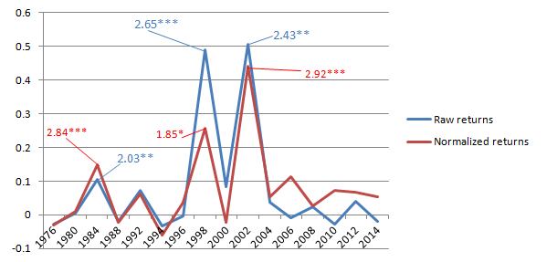

The small number of years where the impact is significant is probably due to the small amount of data for medals in all these separate years. The years after 1992 only have one Olympics each year and therefore a maximum of two weeks for the medals won. So for each country there are only about 10 data points each year. To solve this problem the medals are not divided into all the separate years but into three different periods. These periods are first all the Olympics from 1976 to 1990, then all the Olympics in the 1990s, and last a period that contains all the Olympics after 2000. These three periods are chosen because they contain approximately the same number of Olympics. These new periods lead to the following equation where the residuals are obtained from equation (1).

$ϵ_{it}=α+β_{1}{Gold76-89}_{t-1}+β_{2}{Gold90-99}_{t-1}+β_{3}{Gold00-14}_{t-1}+u_{it}$ (6)

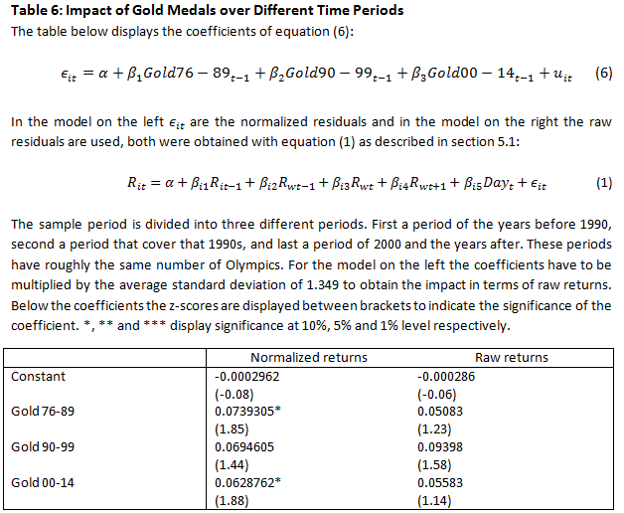
As table 6 shows this change has the effect that at least the first and last periods are now significant. Over these three periods there is also a trend visible in the magnitude of the impact. This trend however moves downward and not upward as would be expected according to the hypothesis. According to these results the effect of gold medals has shrunk from 0.10% (0.074*1.349) in the 1970s and 1980s to 0.08% (0.063*1,349) in the period after 2000. So because in most models many coefficients are not statistically different from zero; and in the models where the coefficients are significant there is a downward trend instead of an upward trend the third hypothesis can be rejected. The impact of gold medals won during Olympics on the stock returns has apparently not grown over time.

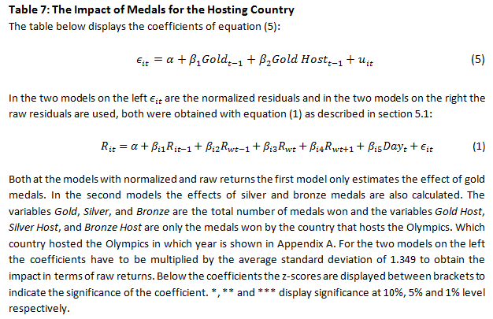

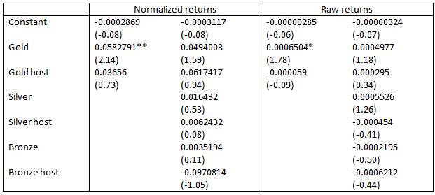

6.4. Hosts
The Olympic Games are one of the biggest sport events in the world and that is shown in the attention it gets. All over the world people follow the events closely. But the attention of people for such sports events seems to be even bigger when the event is held in the country they live in. As already said the viewing figures in a country are usually the highest for the Games they hosted themselves. Again the fact that more people follow the events could mean that the effect on the stock market is even bigger. However, as was also the case with major sports, the tests show very different results (Table 7). Although the effect of medals for hosting countries is positive it is also insignificant again. The effect of gold medals in general is still significant but it has slightly decreased compared to earlier tests.

The addition of silver and bronze medals to the model gives similar results as previous tests which involved Silver and Bronze. The results are especially very similar to the results shown in Table 4. Most importantly all these coefficients are also still insignificant. The use of raw returns instead of normalized returns also leads to insignificant coefficients for gold medals for the hosting country.

A possible reason for these insignificant results could again be the lack of data for hosting countries. Of the 21 Olympic Games from which results are taken the hosting countries are five times not part of this study. Besides a further six times the hosting country won less than five gold medals, in two cases the hosting county did not even win a single gold medal. Only five of the hosting countries won more than ten gold medals during the Games they hosted. Another reason could be that not the medals result in higher stock returns but the hosting of the sport event itself gives the mood of investors a boost. In this case hosting the Olympic Games would lead to a period of higher returns. This has been proven to be the case with big sports events such as the World cup of football (Kavetsos & Szymanski, 2010). However models with a dummy for the hosting country regardless of medals all show insignificant results. So hosting the Olympic Games does not seem to lead to higher returns.

6.5. Robustness checks
There are several statistical issues that could have influenced these results positively. Making some estimates significant while there is no relation at all in reality. It will be controlled whether the results are not influenced or at least not in a big way. Thereby proving that the relation which was found between gold medals and stock returns does exist in reality.

One of the issues which can always have an effect in studies with stock returns is the effect of outliers. Extremely high (low) returns on certain days can have a very big influence in the estimates making it higher (lower) and giving it more statistical significance. These outliers are removed to make sure that on days during the Olympics they did not improve the statistical power of the results too much. In total there are 505 days on which countries won at least one gold medal. Of these 505 observations the 5% with the lowest abnormal return and the 5% with the highest abnormal return on those days are removed. In total the 50 most extreme observations are removed. Remarkable is that a lot of the removed observations come from the Summer Olympics in 2000 and in 2008 and not from the years 1998 and 2002 which seemed to drive the results the most according to the analysis of the effect over time. Reason that most outliers come from these years is that those Olympics were held at the start of the burst of the dotcom bubble and the start of the credit crunch respectively. With the remaining observations regression 2 is ran again with only a variable for the total number of gold medals. The results can be seen in the Panel A of table 8 below. Comparing these results with the results in table 4 it can indeed be seen that the statistical significance is a bit lower. Using the raw returns the significance of gold medals has even disappeared completely. The results with normalized returns are however still significant, albeit at a 5% level instead of the 1% level in earlier tests. It can also be seen that in both situations the estimates are lower than the results with the complete sample. The effect with normalized returns is now only 0.06% (0.0471*1.349). The fact that the effect is now lower indicates that the first results were more influenced by the positive outliers than the negative outliers.

Another issue that can cause problems with statistical significance has to do with the Olympic Games. Every Olympic Games are always held within two weeks. As a result the most important observations are all grouped together in very short time periods. There is a possibility that the model that is used does not take the correlation between the returns of several countries on the same day completely into account. If this is the case the statistical significance might be positively influenced and thereby again showing false relationships. To solve this problem the same approach as Edmans et al. (2007) is used. Following each day at least one event was played during the Olympics the average abnormal return is taken of all countries that won at least one gold medal that day. So in the end there will be only one observation for each day a gold medal is won. In the end there are only 192 observations left. These observations are used in a t-test with the null hypothesis that the mean is equal to zero. With this test it can be determined whether there is still a relation between gold medals and stock returns the following day. The results are shown in the Panel B of table 8. Again with both raw and normalized returns the statistical significance has dropped a bit compared to the initial results. However for the normalized returns the results are still significant, again at the 5% level. As in the previous tests the model with raw returns lost its significance again. The estimate with the use of normalized returns also changed quite a bit again. But this time the estimate has increased to 0.11% (0.083*1.349).

The last robustness check is to control whether the impact exists for both Winter Games and Summer Games. The Summer Games are much bigger in terms of numbers of athletes and events and it also receives a bit more attention. Therefore it is possible that the results were driven by the Summer Games and that the Winter Games do not have an impact at all. The first step is again to get the abnormal returns using equation (1). The abnormal returns are then used in the following equation:

$ϵ_{it}=α+β_{1}GoldWinter+β_{2}GoldSummer+u_{it}$ (7)

The results of equation (7) are shown in Panel C of Table 8. The coefficients for both the Winter Games and the Summer Games are significant at the 5% level. So the impact is present for all the Olympic Games. Remarkable is however that the impact of Winter Games (0.11656*1.349=0.16%) is more than twice as big as the impact of Summer Games (0.05187*1.349=0.07%). Given that the Summer Games usually get more attention it was expected to be the other way around. So although the difference in impact is quite surprising this test shows that there is a relation between returns and all the Olympic Games. The results are a little bit different however when the raw returns are used. As in all of the tests with raw returns the power of the test is much lower. The lower power results in lower z-score making the coefficients insignificant at all levels.

After these tests it can be concluded that the results seem statistically robust. The results of normalized returns are all still statistically significance at a 5% level after all the tests. Therefore there seems to be a relation between winning gold medals at the Olympics and stock returns the following day.

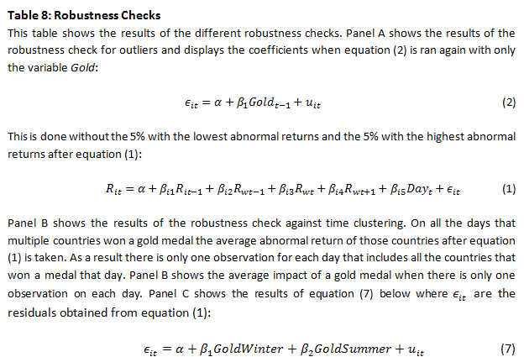
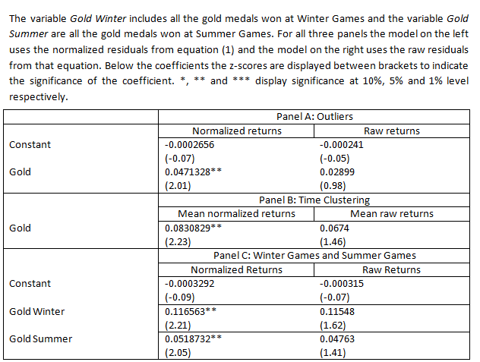

7. Discussion
The results above show that winning gold medals improve the returns on the stock market for that country. According to these results it should therefore theoretically be possible to make a profitable trading strategy based on the expected results during Olympic Games. It is however not as easy as it appears. First of all it is important to make clear that the results do not indicate that the returns after gold medals are positive. It merely indicates that they are higher compared to the returns after days on which no gold medals were won. If the Olympics are being held in a period of economic downturn the returns in countries winning lots of gold medals will therefore probably still be negative. So someone investing in American stocks assuming the USA will win a gold medal every day could lose a lot of money if the American economy is not doing well. Next to that the many events held on one day during the Olympics could pose another problem. A possible trading strategies based on international sport events often involve going long in the expected winner and short in the expected loser. Since the return in the winning (losing) country will be higher (lower) there can be made a profit here. During the Olympics however a country could cover losing an event by winning other events on the same day. For instance an investor could go long in the USA and short in Australia anticipating an USA win in the basketball final. If however Australia wins on that same day two gold medals in other events this investor could make a loss because Australia would have won more gold medals than the USA despite losing the basketball final. Therefore to make a profit one would have to find a country that will win at least one event but also a country that you are absolutely sure will not win any event on that specific day.

So it can be very hard to come with a trading strategy based on the results of this study. Above mentioned problems though could easily be covered by taking a close look to all the events and its favourites at a day. With good research it should theoretically be possible to make profits using the long-short trading strategy mentioned earlier. It is however not entirely sure that this theoretical profit can also be made in practice. There are various constraints concerning short selling which could make it impossible to go short in a certain country. Besides as can be seen in panel B in table 4 the profit that can be made due to one gold medal is only 0.09% which is not very big. This study did not take costs for short selling or other trading costs in account. It is possible that all these costs will offset the possible profits from the gold medals. To get an answer on that problem future research would be necessary. Another problem might be caused by possible differences in economic environments between countries. Country-specific economic news could cause a higher return in a country that does not win gold medals that day or lower returns in a country that does win gold medals. This would lead to a negative return for a trading strategy based on the Olympic Games. So one would need two countries with very similar economies for such a trading strategy. Finding two of such countries might be hard to achieve on some occasions.

It is clear that a lot of factors need to be thought of when creating a trading strategy based on Olympic Games. There is however a trading strategy that is able to cover some of the problems to a certain extent. Trading costs can be lowered by going long and short in the same country over the course of a whole Olympics. During Winter Games one could go long in countries that perform traditionally well at Winter Games such as Norway or other Scandinavian countries. At the same time one could go short in countries such as Australia or Hungary that win almost all their medals during Summer Games. For Summer Games it could be turned around, long in Australia and short in Scandinavia. Over the full two weeks of an Olympics this strategy should result in profits although it could happen that on some days a small loss is made. Beside the likely profit over two weeks this strategy also has severely lower trading costs since it is not necessary to buy and sell every day.

Although this strategy looks promising more research on strategies based on Olympic Games is still needed. As mentioned one interesting part for further research could be the inclusion of various trading costs. It would be wise to know whether the profits of gold medals are high enough to cover these costs. Another suggestion for more research would be adding more countries. This study only used the sixteen most successful countries in the history of the Olympics. All these countries are nowadays reasonably developed. Results might be different in third world countries. People in these countries often have more severe problems and might not be able to enjoy or follow international sport events as much as people in developed countries. Problem however might be that most third world countries have not won many medals during Olympics. Countries that could be thought of for further research are Kenya, Ethiopia, and Jamaica. These countries have won a fair amount of gold medals especially in the last decade and are not as developed as any of the sixteen countries in this study. A last factor that could influence the results but is not taken into account in this study is the expectation before the events. Perhaps medals that are anticipated to be won before the event have a smaller effect on the stock market afterwards. The best way to test the effect of the expectation before the event is probably by using the odds on the betting market. With the odds it can be easily seen which athlete is anticipated to win an event. Besides it is very likely that odds can nowadays be found for all the events during Olympic Games.

8. Conclusion
Previous research has shown that investors also tend to use irrelevant information in their decision making. As a result the EMH is not always held and that the stock market is influenced by factors that should not have an influence. The mood of investors is one of those factors that influence their decision making. Research also shows that the mood of these investors can be determined by the outcome of major sport events. Based on the negative return on stock markets in countries after elimination from international sports, this study tests the effect of winning medals during Olympic Games on the stock market.

Results show that winning gold medals during Olympic events lead to a return that is about 0.09% higher on the following day. Silver and bronze medals on the other hand have no effect on the stock market at all. Evidence suggests that these results hold for every sport tested in this study and not just the important sports in a country and that hosting the Olympics does not result in an even higher return. Dividing the sample into three different periods shows that these positive returns after a gold medal are slightly decreasing since the mid seventies and eighties. These results also appear to be statistically robust to tests against outliers or the time clustering caused by the small periods in which Olympic Games are held. The effect is also present for both Winter Games and Summer Games.

The most profitable trading strategy according to these results seems to go long in countries that excel in winter sports and short in countries that are good in summer sports during the Winter Games. For the Summer Games it should be turned around, short in winter countries and long in summer countries. Although this trading strategy looks promising it has to be said that there is still a lot of research that has to be done. There are some (economic) factors that were not taken into account in this study. It could very well be possible that some of these factors change the results from this study. Therefore it would even for professional investors be very hard to trade based on the expected results during Olympic Games.

9. Bibliography
Andrikopoulos, P. (2005, June). Modern Finance vs Behavioural Finance: An Overview of Key Concepts and Major Arguments. Opgehaald van SSRN: http://ssrn.com/abstract=746204
Ashton, J. K., Gerrard, B., & Hudson, R. (2003). Economic Impact of National Sporting Success: Evidence from the London Stock Exchange. Applied Economic Letters, 783-785.
Bagozzi, R. P., Gopinath, M., & Nyer, P. U. (1999). The Role of Emotions in Marketing. Journal of the Academy of Marketing Science, 184-206.
Barbaris, N., & Thaler, R. (2003). A Survey of Behavioural Finance. In Handbook of the Economics of Finance (pp. 1053-1128).
Barbaris, N., Shleifer, A., & Vishny, R. (1998). A Model of Investor Sentiment. Journal of Financial Economics, 307-343.
Beechey, M., Gruen, D., & Vickery, J. (2000). The Efficient Market Hypothesis: A Survey. Reserve Bank of Australia, Economic Department.
Berman, G., Brooks, R., & Davidson, S. (2000). The Sydney Olympic Games Announcement and Australian Stock Market Reaction. Applied Economic Letters, 781-784.
Berument, H., Ceylan, N. B., & Gozpinar, E. (2006). Performance of Soccer on the Stock Market: Evidence from Turkey. Social Science Journal, 695-699.
Biggest Global Sports by Country/Region. (2014). Opgehaald van Biggest Global Sports: http://biggestglobalsports.com/by-countryregion/4585580681
Bizman, A., & Yinon, Y. (2002). Engaging in Distancing Tactics Among Sport Fans: Effects on Self-esteem and Emotional Responses. Journal of Social Psychology, 381-392.
Bless, H., Schwarz, N., & Kemmelmeier, M. (1996). Mood and Stereotyping: Affective States and the Use of General Knowledge Structures. European Review and Social Psychology, 63-93.
Borges, M. R. (2010). Efficient Market Hypothesis in European Stock Markets. The European Journal of Finance, 711-726.
Boyle, G., & Walter, B. (2003). Reflected Glory and Failure: International Sporting Success and the Stock Market. Applied Financial Economics, 225-235.
Burnside, C., Han, B., Hirshleifer, D., & Wang, T. Y. (2011). Investor Overconfidence and the Forward Premium Puzzle. Review of Economic Studies, 523-558.
Campbell, J. Y., & Hentschel, L. (1992). No News is Good News: An Assymetric Model of Changing Volatility in Stock Returns. Journal of Financial Economics, 281-318.
Cao, M., & Wei, J. (2005). Stock Market Returns: A Note on Temperature Anomaly. Journal of Banking and Science, 1559-1573.
Edmans, A., García, D., & Norli, Ø. (2007). Sports Sentiment and Stock Returns. Journal of Finance, 1967-1998.
Fama, E. F. (1970). Efficient Capital Markets:A Review of Theory and Emperical Work. Journal of Finance, 383-417.
Floros, C. (2010). The Impact of the Athens Olympic Games on the Athens Stock Exchange. Journal of Economic Studies, 647-657.
French, K. R., Schwert, W. G., & Stambaugh, R. F. (1987). Expected Stock Returns and Volatility. Journal of Financial Economics, 3-29.
Here Are All The Olympic Athletes Who Lost Medals For Doping Since 1968, And All The Drugs They Took. (2014, February 16). Opgehaald van Huffington Post: http://www.huffingtonpost.com/2014/02/16/olympics-drug-testing-medals-stripped_n_4789565.html
Hirshleifer, D., & Shumway, T. (2003). Good Day Sunshine: Stock Returns and the Weather. Journal of Finance, 1009-1032.
Hong, H., & Stein, J. C. (1999). A Unified Theory of Underreaction, Momentum Trading, and Overreaction in Asset Markets. The Journal of Finance, 2143-2184.
Ikenberry, D., Lakonishok, J., & Vermaelen, T. (1995). Market Underreaction to Open Market Share Repurchases. Journal of Financial Economics, 181-208.
Jensen, M. C. (1978). Some Anomalous Evidence Regarding Market Efficiency. Journal of Financial Economics, 95-101.
Kamstra, M. J., Kramer, L. A., & Levi, M. D. (2003). Winter Blues: A SAD Stock Market Cycle. The American Economic Review, 324-343.
Kavetsos, G., & Szymanski, S. (2010). National Well-Being and International Sport Events. Journal of Economic Psychology, 158-171.
Lerner, J. S., Small, D. A., & Loewenstein, G. (2004). Heart Strings and Purse Strings Carryover Effects of Emotions on Economic Decisions. Psychological Science, 337-341.
Malkiel, B. G. (2003). The Efficient Market Hypothesis and Its Critics. Journal of Economic Perspectives, 59-82.
Malkiel, B. G. (2005). Reflections on the Efficient Market Hypothesis: 30 Years Later. The Financial Review, 1-9.
Most Popular Olympic Sports. (sd). Opgehaald van topendsports.com: http://www.topendsports.com/world/lists/popular-sport/olympics.htm
Most Popular Olympic Sports. (sd). Opgehaald van topendsports.com: http://www.topendsports.com/world/lists/popular-sport/ioc-website.htm
Niederhoffer, V., & Osborne, M. F. (1966). Market Making and Reversal on the Stock Exchange. Journal of the American Statistical Association, 897-916.
Official Olympic Games Results. (2014). Opgehaald van Official Website of the Olympic Movement: http://www.olympic.org/olympic-results
Olympic Games. (sd). Opgehaald van Official Website of the Olympic Movement: http://www.olympic.org/olympic-games
Olympics. (sd). Opgehaald van Sports-reference: http://www.sports-reference.com/olympics/
Rosenbrock, K. (2014, January 23). The 10 Most Popular Winter Olympic Sports. Opgehaald van The Active Times: http://www.theactivetimes.com/10-most-popular-winter-olympic-sports
Samitas, A., Kenourgios, D., & Zounis, P. (2008). Athens' Olympic Games 2004 Impact on Sponsors' Stock Returns. Applied Financial Economics, 1569-1580.
Saunders, E. M. (1993). Stock Prices and Wall Street Weather. American Economic Review, 1337-1345.
Schwarz, N., Strack, F., Kommer, D., & Wagner, D. (1987). Soccer, rooms, and the quality of your life: Mood Effects on Judgment of Satisfaction with Life in General and in Specific Domains. European Journal of Social Psychology, 69-79.
Statista. (2014). Number of Olympic Games TV viewers worldwide from 2002 to 2014 (in billions). Opgehaald van Statista: http://www.statista.com/statistics/287966/olympic-games-tv-viewership-worldwide/
Statista. (sd). U.S. Household Television Ratings of the Summer Olympic Opening Ceremony from 1972 to 2008. Opgehaald van Statista: http://www.statista.com/statistics/237452/us-tv-ratings-of-the-summer-olympics-opening-ceremony/
Subrahmanyam, A. (2007). Behavioural Finance: A Review and Synthesis. European Financial Management, 12-29.
Veraros, N., Kasimati, E., & Dawson, P. (2004). The 2004 Olympic Games Announcement and its Effect on the Athens and Milan Stock Exchanges. Applied Economic Letters, 749-753.
Wright, W. F. (1992). Mood Effects on Subjective Probability Assessment. Organizational Behavior and Human Decision Processes, 276-291.

10. Appendix A: Countries
Country (Hosts) | Start Date | Popular sports
USA  (Winter 1980, Summer 1984, Summer 1986, Winter 2002) | 2-1-1973 | -Basketball  -Ice Hockey  -Football
Germany (Only West-Germany before 1992) | 1-1-1973 | -Football -Ice Hockey  -Basketball -Downhill Skiing  -Cycling
UK  (Summer 2012) | 1-1-1973 | -Football  -Cycling
Italy  (Winter 2006) | 1-1-1973 | -Football -Volleyball  -Basketball -Downhill Skiing  -Cycling
France  (Winter 1992) | 1-1-1973 | -Football -Athletics  -Basketball -Downhill Skiing  -Cycling -Swimming
China  (Summer 2008) | 26-7-1993 | -Football -Volleyball  -Basketball -Swimming  -Athletics
Sweden | 4-1-1982 | -Ice Hockey  -Football  -Athletics
Russia  (Summer 1980, Winter 2014) | 27-1-1998 | -Football -Volleyball  -Ice Hockey -Athletics  -Basketball -Figure Skating
Norway  (Winter 1994) | 2-1-1980 | -Ice Hockey  -Ski Jumping  -Football
Hungary | 21-6-1991 | -Football  -Swimming
Australia  (Summer 2000) | 2-1-1973 | -Football  -Cycling  -Basketball
Finland | 25-3-1988 | -Ice Hockey -Football  -Ski Jumping  -Athletics
Japan  (Winter 1998) | 1-1-1973 | -Football  -Athletics  -Volleyball
Canada  (Summer 1976, Winter 1988,Winter 2010) | 2-1-1973 | -Ice Hockey  -Basketball  -Football
Netherlands | 1-1-1973 | -Football  -Cycling  -Speed Skating
South Korea  (Summer 1988) | 9-9-1987 | -Football -Figure Skating  -Basketball -Swimming  -Volleyball -Gymnastics

11. Appendix B: Sports

11.1. Winter Games
Sport | Event | Period
Bobsleigh | Four Men | 1976-2014
 | Two Men | 1976-2014
 | Two Women | 2002-2014
Luge | Singles Men/Women | 1976-2014
 | Doubles Men | 1976-2014
 | Team Relay Mixed | 2014
Short Track | 500m Men/Women | 1994-2014 (M)/ 1992-2014 (W)
 | 1000m Men/Women | 1992-2014 (M)/ 1994-2014 (W)
 | 1500m Men/Women | 2002-2014
 | 3000m Relay Women | 1992-2014
 | 5000m Relay Men | 1992-2014
Speed Skating | 500m Men/Women | 1976-2014
 | 1000m Men/Women | 1976-2014
 | 1500m Men/Women | 1976-2014
 | 5000m Men/Women | 1976-2014 (M)/ 1988-2014 (W)
 | 3000m Women | 1976-2014
 | 10000m Men | 1976-2014
 | Team Pursuit Men/Women | 2006-2014
Ski Jumping | Normal Hill Individual Men/Women | 1976-2014 (M)/ 2014 (W)
 | Large Hill Individual Men | 1976-2014
 | Large Hill Team Men | 1988-2014
Ice Hockey | Men/Women | 1976-2014 (M)/ 1998-2014 (W)
Alpine Skiing | Downhill Men/Women | 1976-2014
 | Super G Men/Women | 1988-2014
 | Slalom Men/Women | 1976-2014
 | Giant Slalom Men/Women | 1976-2014
 | Combined Men/Women | 1988-2014
Freestyle skiing | Moguls Men/Women | 1992-2014
 | Aerials Men/Women | 1994-2014
 | Ski Cross Men/Women | 2010-2014
 | Superpipe Men/Women | 2014
 | Slopestyle Men/Women | 2014
Snowboarding | Parallel Slalom Men/Women | 2014
 | Giant Slalom Men/Women | 1998-2014
 | Half Pipe Men/Women | 1998-2014
 | Snowboard Cross Men/Women | 2006-2014
 | Freestyle Men/Women | 2014
Figure Skating | Singles Men/Women | 1976-2014
 | Pairs | 1976-2014
 | Ice Dancing | 1976-2014
 | Team Event Mixed | 2014

11.2. Summer Games
Sport | Event | Period
Swimming | 50m Freestyle Men/Women | 1988-2012
 | 100m Freestyle Men/Women | 1976-2012
 | 200m Freestyle Men/Women | 1976-2012
 | 400m Freestyle Men/Women | 1976-2012
 | 800m Freestyle Women | 1976-2012
 | 1500m Freestyle Men | 1976-2012
 | 100m Backstroke Men/Women | 1976-2012
 | 200m Backstroke Men/Women | 1976-2012
 | 100m Breaststroke Men/Women | 1976-2012
 | 200m Breaststroke Men/Women | 1976-2012
 | 100m Butterfly Men/Women | 1976-2012
 | 200m Butterfly Men/Women | 1976-2012
 | 200m Individual Medley Men/Women | 1984-2012
 | 400m Individual Medley Men/Women | 1976-2012
 | 4*100m Freestyle Relay Men/Women | 1984-2012 (M)/ 1976-2012 (W)
 | 4*200m Freestyle Relay Men/Women | 1976-2012 (M)/ 1996-2012 (W)
 | 4*100 Medley Relay Men/Women | 1976-2012
 | 10km Freestyle Men/Women | 2008-2012
Athletics | 100m Men/Women | 1976-2012
 | 200m Men/Women | 1976-2012
 | 400m Men/Women | 1976-2012
 | 800m Men/Women | 1976-2012
 | 1500m Men/Women | 1976-2012
 | 3000m Women | 1984-1992
 | 5000m Men/Women | 1976-2012 (M)/ 1996-2012 (W)
 | 10000m Men/Women | 1976-2012 (M)/ 1988-2012 (W)
 | 110m Hurdles Men | 1976-2012
 | 100 Hurdles Women | 1976-2012
 | 400m Hurdles Men/Women | 1976-2012 (M)/ 1984-2012 (W)
 | 3000m Steeplechase Men/Women | 1976-2012 (M)/ 2008-2012 (W)
 | 4*100m Relay Men/Women | 1976-2012
 | 4*400m Relay Men/Women | 1976-2012
 | High Jump Men/Women | 1976-2012
 | Pole Vault Men/Women | 1976-2012 (M)/ 2000-2012 (W)
 | Long Jump Men/Women | 1976-2012
 | Triple Jump Men/Women | 1976-2012 (M)/ 1996-2012 (W)
 | Shot Put Men/Women | 1976-2012
 | Discus Throw Men/Women | 1976-2012
 | Hammer Throw Men/Women | 1976-2012 (M)/ 2000-2012 (W)
 | Javelin Men/Women | 1976-2012
 | Pentathlon Women | 1976-1980
 | Heptathlon Women | 1984-2012
 | Decathlon Men | 1976-2012
 | Marathon Men/Women | 1976-2012 (M)/ 1984-2012 (W)
Gymnastics | All-Around Team Men/Women | 1976-2012
 | All-Around Individual Men/Women | 1976-2012
 | Floor Men/Women | 1976-2012
 | Vault Men/Women | 1976-2012
 | Horizontal Bar Men | 1976-2012
 | Parallel Bars Men | 1976-2012
 | Pommel Horse Men | 1976-2012
 | Rings Men | 1976-2012
 | Balance Beam Women | 1976-2012
 | Uneven Bars Women | 1976-2012
Judo | Extra Lightweight Men/Women | 1980-2012 (M)/ 1992-2012 (W)
 | Half Lightweight Men/Women | 1980-2012 (M)/ 1992-2012 (W)
 | Lightweight Men/Women | 1976-2012 (M)/ 1992-2012 (W)
 | Half Middleweight Men/Women | 1976-2012 (M)/ 1992-2012 (W)
 | Middleweight Men/Women | 1976-2012 (M)/ 1992-2012 (W)
 | Half Heavyweight Men/Women | 1976-2012 (M)/ 1992-2012 (W)
 | Heavyweight Men/Women | 1976-2012 (M)/ 1992-2012 (W)
 | Open Category Men | 1976-1984
Cycling | Road Race Men/Women | 1976-2012 (M)/ 1984-2012 (W)
 | Individual Time Trial Road Men/Women | 1996-2012
 | Team Time Trial Road Men | 1976-1992
 | Keirin Men/Women | 2000-2012 (M)/ 2012 (W)
 | Omnium Men/Women | 2012
 | Team Pursuit Men/Women | 1976-2012 (M)/ 2012 (W)
 | Individual Sprint Men/Women | 1976-2012 (M)/ 1988-2012 (W)
 | Team Sprint Men/Women | 2000-2012 (M)/ 2012 (W)
 | Points Race Men/Women | 1984-2008 (M)/ 1996-2008 (W)
 | Individual Pursuit Men/Women | 1976-2008 (M)/ 1992-2008 (W)
 | 500m Time Trial Track Women | 2000-2004
 | 1km Time Trial Track Men | 1976-2004
 | Madison Men | 2000-2008
Volleyball | Indoor Men/Women | 1976-2012
 | Beach Men/Women | 1996-2012
Basketball | Men/Women | 1976-2012
Football | Men/Women | 1976-2012 (M)/ 1996-2012 (W)

