Erasmus university rotterdam
The effect of the 2008 economic crisis on the health of residents in the United States of America
The change in health outcomes, health behaviors and health status
Bachelor Thesis
Msc. M.H. Coveney
Erasmus School of Economics

Tara Ramlal
Economie en bedrijfseconomie
7/17/2015
Abstract
It is very important that people have a good health and remain a good health. But the effect of a crisis on health is not clear. It could have a positive effect, but most people belief that a crisis has a negative impact on the health of people. This research investigates what kind of effect the 2008 economic crisis has on the health of people in the USA. The research is executed on an MSA (Metropolitan Statistical Area) level with multiple regressions and fixed effect regressions. Different health behaviors and health outcomes are regressed on unemployment, reflecting the crisis. A distinction is made between health behaviors and health outcomes, because the crisis can affect the health of people directly measured with the health outcomes, but it also influences the health behaviors. This study first investigates the effect on health behaviors and then moves on to health outcomes. To test if the results remain the same in another context, an additional analysis is implemented; a difference-in-differences analysis on state and national level. Both methods can take into account for time-invariant unobserved factors, reducing the endogeneity that could occur during the study. This study did not find a clear effect on an MSA level, as the 2008 crisis influenced the health behaviors and health outcomes both in a positive and negative way. But on a state and national level it appears that the crisis of 2008 improves the health of people in the USA.

Table of contents

Introduction 5
Importance and theoretical approach 8
Literature review 10
Income as reflection of the crisis 10
Unemployment as reflection of the crisis 10
Data 14
Definition of an MSA 14
Sources of the data 15
Summary of the variables 17
Methodology 20
The reason for a fixed effect model 20
The reason for a difference-in-differences 21
Structure of the statistical research 21
Results OLS and fixed effect regressions 26
Health behaviors 26
Health outcomes 29
Results additional analysis; difference-in-differences 31
State level 31
National level 32
Discussion 34
Discussion of the research 34
Robustness of the results 35
Limitations 36
Ideal experiment 37
Conclusion 39
Summary 39
Answer on the research question 39
Recommendations 41
References 42
Appendix 44
A. Multiple OLS regressions output 44
B. Fixed effect regressions output 49
C. Difference-in-differences output 54
D. Summary variables 60

Introduction

The economy of a country is driven by its residents. They work in the companies that contribute to the economic growth of that country. That is why it is important that the residents feel good and have a good health, so that they can perform at their best. But what happens with the residents if an economic crisis occurs?

The last economic crisis in the United States of America (USA) officially began in December 2007. The effects of the crisis were felt in 2008 and went on until 2012. The world’s financial system was almost brought down during this crisis. Stock markets, banks and even the housing market were extremely affected. The 2008 crisis evolved in the euro crisis which is still ongoing. As a result of the crisis companies were forced to reorganize and big rounds of layoffs started. Many people were fired and a lot of people that still had their job were afraid to get fired. It was a time with a lot of stress and pressure that could not be good for the health of people. It seemed like the crisis had a negative impact on the health of the people in the USA. But was this really the case?

Many studies already investigated the effect of the 2008 crisis on the health of people in the world. But the opinions of scientists differ substantially. Most scientists think that the health of the residents in a country hit by a crisis will decline because of the crisis. Research in Europe about the effect of the economic crisis on the health of the people in Europe showed that there were more premature deaths and intentional violence (Stuckler, Basu, Suhrcke, Coutts, & McKee, 2009). Other research in Greece showed that the self-reported health is negatively associated with the economic crisis (Zavras, Tsiantou, Pavi, Mylona, & Kyriopoulos, 2012). As the USA is the world’s most important economy, a lot of research has already been done using US data regarding the effect of a crisis on health. Some studies found a negative relationship while others showed a positive relationship. It is still not clear what the effect of the 2008 crisis was on the health of people in the USA. This research will try to find a relationship between the crisis and health and set a foundation for further research in the USA. The question in this research is therefore stated as followed: What effect did the economic crisis of 2008 have on the health of residents in the USA?

It could be possible that the economic crisis has no effect on the health of the residents in the USA. But it is likely that there will be an effect, based on research that already has been done in this field in the USA and other geographical areas. The ideal way of investigating this research question would be following people over time regarding their health in all states of the USA and interviewing them on a regular basis. The people would be selected using randomization.

A part of this research will be performed on a metropolitan statistical area (MSA) level to account for differences between the MSAs and make this research more precise and reliable. To answer the research question, the 2008 economic crisis will be reflected by unemployment rates. The unemployment rates are provided by The Bureau of Labor Statistics, a part of the United States Department of Labor. Unemployment rates are published monthly for MSAs, states and on national level. The data is available till February 2015 and goes back to 1998 (Metropolitan Area Employment and Unemployment (Monthly) Archived News Releases). The crisis will not only affect health outcomes directly, but also health behaviors. People can drink and smoke more during unemployment or they could spend more time on exercising. This study will try to find the effect of unemployment rates first on health behaviors, and then move on to health outcomes themselves, so that the effect of the crisis on health can be retrieved. So there will be two groups of variables for health; (1) the health outcomes and (2) the health behaviors. The health outcomes will be myocardial infarction (MI) and self-assessed health and the health behaviors are overweight, exercise, alcohol and tobacco. The data about the health of the residents in the MSAs will be retrieved from Centers for Disease Control and Prevention. On this website one can find data about different categories of health for several years (SMART: BRFSS City and County Data). It is also important to control for demographics between the MSAs. This is why the control variables age and gender will be added in this research. The data for the control variables is derived from American FactFinder that is part of the United States Census Bureau. On this website one can find data for different geographical areas (AGE AND SEX, 2013).

The research question will be answered in different parts. First, multiple regressions will be generated on an MSA level with each health variable as an outcome variable and unemployment, age and gender as independent variables. The variable of interest is unemployment and age and gender are control variables. Afterwards, a fixed effect model will be implemented on an MSA level where each health variable again will become an outcome variable and the independent variables remain the same as in the multiple regression. With a fixed effect model one takes into account for time-invariant factors on a MSA level, so that the results will be more precise. An economic crisis will be defined as high unemployment rates.

In the last part of this thesis an additional analysis will be performed; a difference-in-differences analysis at a state and national level. The most important reason for this analysis is to see if the results of the fixed effects are also present in another context such as this one. The fixed effect model takes into account for the differences between MSAs, but there could still be differences between the MSAs that are not accounted for in the model. Endogeneity could still be present. To take into account for these differences and improve the results, the difference-in-differences is implemented on state level and national level. The differences of MSAs as groups and as one group will now also be accounted for. The control group used in this analysis is Canada which has a comparable health status as the USA. The self-reported health status represents the health in this part. It will be tested if the self-reported health status was roughly the same for the USA and Canada before the economic crisis. If this is the case, Canada can be used as a control group. Canada is a good country to compare the USA with because it was relatively affected less than the USA.

The remainder of this paper contains an importance and theoretical approach on the effect of a crisis on the health of people. Afterwards a thorough review is given of literature that already exists in this field to get background information about the topic. Then the statistical part of this research starts with a summary of the variables used and the methodology behind the statistical research. After that the results of this research about the effect of the 2008 economic crisis on the health of people in the USA will be represented. Then a discussion will be given about this research and its results, as every research has its lacks and limitations. Finally, the conclusion of this research will be given with an answer on the research question mentioned before.

Importance and theoretical approach

Research in the field of the crisis and its effect on the environment is important. Time has shown that business cycles keep occurring and crises can appear suddenly. Understanding the cause and the consequences of a crisis will be an advantage because people can act and prepare for this hard time or maybe even can prevent a crisis from happening. For people it is important to stay healthy to keep the economy running and get past a crisis as quick as possible. That is why it is preferred to remain in good health during a crisis.

The economic crisis can be reflected with income, unemployment, investments, bankruptcies and many more variables. It would be preferred if a research could include all these reflections of the crisis, but that would affect a clear overview of a research. In this context income or unemployment would be good indicators of the crisis because the link between health and those variables is clearer. However, one’s income can be influenced by many things and the manner to spend income is different for every person. That is why the unemployment rate is chosen in this research. One can argue that the unemployment too can be related to many different causes, but income is more sensitive than the unemployment rate since people can influence it with less effort. The health variables were chosen on availability and the way the health behaviors were related to the health outcomes.

The economic crisis can influence health in two different ways. It could either increase or decrease the health of people. This research therefore has three different possible outcomes; the crisis (1) increases the health of people, (2) decreases the health of people or (3) has no effect on the health of people. Big rounds of layoffs could cause a lot of stress, pressure and tension. People try their best to perform at their best to avoid being fired. When one still gets fired, he could worry too much or even get depressed. This could again cause people to smoke or drink more, stay at home and have no social contact anymore. One would go to the doctor less because he has fewer resources. The health behaviors would in this case change in a negative way. On the contrary, when one gets fired it could be a relief to him. He would be more aware of his health, have more time to make doctor appointments, exercise more, drink or smoke less or not because he has not enough money for it and have more social contact just because he has the time for it. Car accidents involving alcohol would fall, more people will stop smoking and one would feel healthier than before. So the influence of an economic crisis on the health of people depends on the characteristics of this person. This is hard to take into account for in a research, as there are many different characteristics and every person has its own character.

The possible outcomes are practically seen as very restricted. The crisis can influence some health variables in a positive way and others in a negative way. To give an overall effect for crisis on health is thus not plausible. The results in this research will have some space to state the difference of the effect of the crisis on the health of the people in the USA, but the conclusion will give an overall effect for the clarity of this paper.

Literature review

The effect of an economic crisis on the health of people is an important and therefore popular topic. A lot of research has been conducted in this field. In this review some papers will be discussed that are linked to the research of this paper to get a background of what researchers already found about the effect of a crisis on health.

Income as reflection of the crisis
Economic crisis can be reflected in many ways. In this paper the crisis will be reflected by unemployment rates. However, a lot of research is done too with income as a reflection for crisis. In this case a negative income shock can be an indicator of a recession. The paper of Frijters, Haisken-DeNew and Shields (2005) found that increased income leads to improved health satisfaction, but the quantitative size of the effect is small. This suggests that during an economic crisis, the health of people can be negatively influenced. The method the authors use in this paper is a fixed-effects model (Frijters, Haisken-DeNew, & Shields, 2005). In the paper of Lindahl (2005) lottery prizes were used as a positive shock in income. This research showed a strong positive relation between income and health status and a negative relation with mortality for people that won lottery prizes. Using lottery prizes as a shock in the income is appealing because the winners are randomly chosen. All participants have the same change of winning. In this paper the author used OLS and IV regressions (Lindahl, 2005). Benzeval and Judge (2001) try to find out what the relationship is between income and health. The method used in this paper is a logistic regression. The authors found a causal relationship between low income and poor health (Benzeval & Judge, 2001). In times of an economic crisis where it is possible that people are facing a lower income, their health can be negatively affected by the lower income.

Unemployment as reflection of the crisis
Negative impact on health
Economic crisis can likewise be reflected by unemployment rates. In research about the effect of the 2008/2009 economic recession on myocardial infarction the authors found that rising unemployment rates contributed to the increasing myocardial infarction occurrences in the low socioeconomic neighborhoods during the recession. Residents of low socioeconomic neighborhoods had a higher risk for myocardial infarction, which was partially attributable to the higher unemployment rates. Other factors that contributed to this finding were the lower education levels, less knowledge of cardiovascular diseases and limited access to healthcare resources because of relatively lower household income. However, this research was only executed in the socioeconomic areas of Raritan Bay region, New Jersey, and it is therefore questionable if the results will hold for larger areas or even a country. The method used in this research is correlation, the Spearman Rank Correlation to be specific, to investigate if there is a relationship between myocardial infarction and unemployment rates. The residents of the Raritan Bay region were grouped based on their average income before the correlation was investigated (Lo, et al., 2014).

The paper of Stuckler et al. (2009) found that rises in unemployment rate were associated with significant short-term increases in premature deaths from intentional violence. The sensitivity of mortality to economic crisis varied across countries, but this was partly due to the differences in social protection that a country gave. The method used in this paper was a multivariate regression with added control variables like population aging, past mortality trends and employment trends. The authors used 26 European Union countries between 1970 and 2007 to get an idea how the effect of unemployment on health changed with other types of government expenditure (Stuckler, Basu, Suhrcke, Coutts, & McKee, 2009). Two years after this research the authors come together one more time to analyze if their results actually occurred during this period of time. They found that indeed a rise in unemployment caused an increase in premature deaths. But the authors also observed the contrast of this occurrence. This can be explained by the level of formal and informal social protection such as strong social support networks a country might have. But again, the contradiction was found. Finland and Austria both have a strong social safety net. Finland experienced an increase in suicides while Austria experienced a decline in suicide when unemployment rose in both countries. It is still not sure what the effect of a crisis really has on the health of people. The authors discuss that early indicators of a crisis have an effect on the trend of suicides even before the crisis occurs. Further investigation in why some individuals, communities and countries are more resilient to economic shocks is desired as well as how different policies can affect the health of people (Stuckler, Basu, Suhrcke, Coutts, & McKee, Effects of the 2008 recession on health: a first look at European data, 2011).

Ásgeirsdóttir et al. (2012) exploit the 2008 economic crisis in Iceland to find what the effect of a recession is on health behaviors like smoking, heavy drinking, sleep and other health behaviors. This study used longitudinal survey data that contained data about the same individuals before and during the 2008 economic crisis. This allows them to control for person-specific differences and time-varying factors. Besides the health behaviors, the authors investigated changes in work hours, real income, wealth and mental health too, as these could be important factors that influence health behaviors. The authors accounted for price changes as well, what made this study more interesting and stronger. The method used in this study is an individual fixed effects model that takes into account for time-invariant individual-level characteristics and cross-period correlation in standard errors. The study found that the crisis had its negative impact on health, but also led to a positive impact on some health behaviors. During the crisis a decrease in smoking, heavy drinking and fast food was stated and more people were getting the recommended amount of sleep. But consumption of fruit and vegetables reduced too. Changes in work hours, real income, wealth and mental health had an influence on some of the health behaviors, but not all. More interesting is the fact that price changes played a large role in getting the effect on the crisis on the health behaviors. Health-promoting behaviors like fish oil and fruit and vegetables were overall less sensitive to price changes than health-compromising behaviors like smoking, drinking and fast food. This effect could be smaller in other countries due to the fact that prices raised a lot in Iceland during the crisis (Ásgeirsdóttir, Corman, Noonan, Ólafsdóttir, & Reichman, 2012).

The paper of Ariizumi and Schirle (2012) investigates the relationship between business cycles and the crisis too in Canada. The authors use research that is already performed in the USA. This study found that the health of people in the USA increased during a crisis. The authors of this paper use a fixed effects model with provincial data from 1977 to 2009. They try to find the effect of unemployment rates on mortality rates specified by age and gender. The study finds a procyclical pattern in the mortality rates for middle-aged people in Canada. In contrast to studies in the USA, this paper does not find a significant cyclical pattern for infants or seniors in Canada. The authors argue that this might be explained by the quality of care, especially for the elderly. The system and quality of care for the elderly differs between Canada en the USA and requires more thorough study (Ariizumi & Schirle, 2012).

Research in the self-reported health status in Japan showed a similar result as the two papers discussed above. The average self-reported health of people from the middle and higher class declined following the crisis relative to the lower class. Also, unemployed people were more likely to report a poor health relative to the people of a high class during the recession. This second result is an important observation for this research because it suggests that the self-reported health status declines if you are unemployed. During times of economic crisis and thus high unemployment rates, the average self-reported health status of people is likely to be lower than in times of economic growth. The authors used a repeated cross-sectional survey design with two pooled datasets that were analyzed separately. An important limitation of this research is that the authors only use self-reported health status. However, it is a strong predictor for mortality and other health indicators (Kondo, Subramanian, Kawachi, Takeda, & Yamagata, 2008).
Positive impact on health
So far the papers stated that high unemployment rates show a negative impact on the health of people. However, research also showed that the economic crisis could have a positive effect on the health of people. In his paper Christopher J. Ruhm (2000) found that a one percentage point rise in the state unemployment rate is associated with a 0.5 to 0.6 percent decrease in total mortality or a reduction of around 11000 fatalities annually. This research used a fixed-effects model and was performed in Columbia (Ruhm, 2000). As a lengthening piece on the research of Ruhm the authors Miller, Page, Stevens and Filipski (2009) try to explore the mechanisms behind the finding that the crisis has a positive effect on the health of people. It implements the same methods as Ruhm did while changing the regressions with other variables and applying some extensions like a Poisson count data model. The authors also investigate the effect of unemployment rates by age and cause. In this way the authors of the paper are able to make important suggestions for further research. First they found that it is unlikely that an individual’s labor force status, work or health behaviors are the main determinants of aggregate mortality changes. Changes in mortality among working-age individuals are mostly explained by additional motor vehicle accidents. The second observation they make is that when one looks closer at age and cause of death to find procyclical mortality, it is important to understand mortality patterns among the elderly before making any conclusions. Next to these findings, the authors of the paper state the important fact that factors like pollution changes and changes in the quality, quantity and nature of health care inputs are also important for future research (Miller, Page, Stevens, & Filipski, 2009). Are the results of the research generalizable to other countries? One should also take into account that there are different kinds of countries in different states of development. Results of a research in a particular country can only be generalized in countries with the same state of development.

It is clear that there is a lot of discussion about the effect of an economic crisis on the health of people. Research shows different outcomes and it is not clear what the real effect is or if the state of the economy even has an impact on the health of people. But all the articles have their own limitations and could do better either in their methods of investigating as in the data availability. Conclusions in this paper will be made on basis of the own research and the conclusions of the literature described in this part.

Data

In this section the sources of the data are described and the different variables will be explained briefly. But first, the definition of an MSA will be given.

Definition of an MSA
A country can be divided in different regions which are called states or provinces. These states can be divided in different regions too. Regions where areas are linked to each other because of workflows and recreation are called MSAs (Metropolitan Statistical Areas). The regions that are not linked to each other stay independent. An MSA can be a city with an urban area around it and sometimes even the countryside can be accounted to it. The MSAs of a state together represent this state in a statistical way. If information is retrieved from people living in MSAs belonging to a state, this information is assumed to represent the whole state, so including the independent regions in that state or province. The MSAs are formed for statistical purposes. It makes it easier to investigate different regions. To make it more clear what an MSA is, see the USA in figure 1. The state Washington will be used as an example. The colored areas in Washington are MSAs and the grey areas are the independent regions. The colored MSAs together represent the state Washington in statistical analysis.

Figure 1
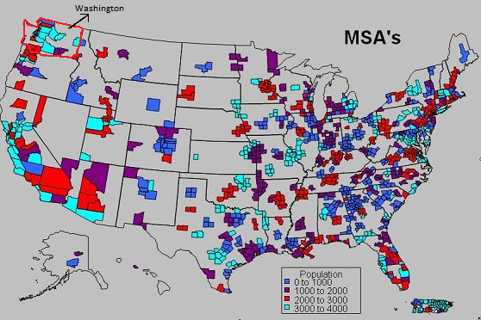
Source: Mapland; MSA Metropolitan Statistical Areas

Sources of the data
There are 13 different variables present in the dataset. The variables are divided in five different groups. Table 1 gives an overview of the variables used in this research.

Table 1
Group | Variables | Description
Variable of interest | - Unemployment rate | Per MSA. The influence of unemployment on the different health variables is studied. When generating the regressions, the coefficient of the unemployment is the main interested effect.
Control variables | - Age per  - Gender | Per MSA. The variables will control for differences in age and gender between the MSAs.
Health behaviors | - Overweight  - Exercise  - Alcohol  - Tobacco | Per MSA. The variables will be directly affected by the change in unemployment rates.
Health outcomes | - MI  - Self-assessed health | Per MSA. The variables are directly affected by the change in unemployment rates, but also indirectly through the health behaviors.
Fair and poor self-assessed health | - Fair and poor self-assessed health Canada  - Fair and poor self-assessed health USA | Both on state and national level for the USA and Canada. The variables are used for the difference-in-differences analysis.

The unemployment rates per MSA are provided by The Bureau of Labor Statistics (BLS). It is the principal Federal agency that is responsible for measuring labor market activity, working conditions and price changes in the economy of the USA. Its mission is to collect, analyze and spread essential economic information to ensure that public and private decision-making is possible in a rapidly changing country and global economy. They provide information that is objective, timely, accurate and relevant (About BLS, 2015). On the website of BLS national unemployment rates can be found as well as unemployment rates by MSAs. The unemployment rates on BLS are provided from 1998 to March 2015 and are available annually or monthly.

The data about the health of people in the USA can be found on the website The Centers for Disease and Control and Prevention (CDC). The health outcomes and behaviors variables per MSA are retrieved from this website. The CDC is one of the major operating components of the Department of Health and Human Services in the USA. It serves as the national focus for developing and applying disease prevention and control, environmental health, and health promotion and health education activities designed to improve the health of the people of the United States. CDC tries to accomplish this goal by defining health problems and maintaining active surveillance of diseases through investigations and data collection, analysis and distribution (Official mission statements/organizational charts). Every state or MSA needs to have at least 500 respondents before the data is published. The number of respondents keeps growing and people use the data on CDC more and more for information and research (SMART: BRFSS City and County Data). The health data is available for the whole of USA, at the state level or for MSAs.

The variables age and gender per MSA are retrieved from the website Census Bureau; American FactFinder. The Census Bureau is a part of the U.S. Department of Commerce. Its mission is to be the leading source of quality data about the nation’s people and economy. American FactFinder provides access to data about the United States, Puerto Rico and the Island Areas. The data in American FactFinder come from several censuses and surveys. It wants to provide the best mix of timeliness, relevancy, quality and cost for the data it collects and services provided (Census Bureau; About the Bureau, 2015). The data is available for numerous geographical areas.

The fair and poor self-assessed health of Canada comes from the website Statistics Canada. It produces statistics that help Canadians better understand their country. The statistics are very divers, from statistics about the population, economy and resources to statistics about the society and culture. Next to a survey that is held every year, there are 350 surveys active about all aspects of Canadian life. Providing statistics is a federal responsibility in Canada. The information is available for the whole of Canada and each of the provinces and territories (Statistics Canada; About us, 2015).

The fair and poor self-assessed health of the USA is retrieved from the website Health Indicators Warehouse (HIW). It wants to provide access to high quality data to improve the understanding of a community’s health status and determinants. The HIW is maintained by the CDC, where the health outcomes and behaviors per MSA come from. The data of HIW is retrieved from the websites of its partners. The data is available for different geographic areas (HIW; About the HIW, 2015).

Summary of the variables
Table 2 presents the summary over the years for the unemployment rate, the control variables, the health behaviors and the health outcomes. The numbers in the table represent the means of the variables. The unemployment rate shows an increase in 2009, a year after the economic crisis of 2008 began. The unemployment rate is thus a good indicator for the crisis. The value of the age components stay roughly the same and the median age does not differ too much on a national level. It is important to add age in the regression, as older people have a greater chance to get an MI or report a poor health. The proportion of males and females is roughly equally divided. One has to take into account for gender as relatively more men than women get an MI. Besides that women live relatively longer with a relatively better health compared to men which could affect the self-assessed health.

The health behaviors miss observations for the years 2005 and 2006. For overweight the percentage is given of people who report having overweight. Overweight reduces the quality of life and increases the chances on an MI or a poor (self-assessed) health. For exercise the percentage of people who do not exercise is given. Exercise activities increase the quality of life as the condition of one increase. Changes in the patterns of exercise for people in the USA can affect the chances on an MI or poor health. The summaries for alcohol and tobacco are self-explanatory. The variable alcohol is given in the percentage of people that drink alcohol. The variable tobacco shows the percentage of people that do use tobacco. These variables increase the chance of getting an MI. It also can affect the chance on reporting a poor health, as people see alcohol and tobacco as things that affect your health in a negative way.

Table 2

Summary variables (1)
Means of variables
 | 2005 | 2006 | 2007 | 2008 | 2009 | 2010 | 2011 | 2012 | Total
Unemployment rate | 6,397076 | 5,9060172 | 5,8519886 | 5,8457386 | 9,302521 | 9,5102703 | 8,8727027 | 8,0224324 | 7,4974144
Age
- 70 years and over | 8,898538 | 9,2501433 | 9,296875 | 9,3761364 | 9,3577143 | 9,3734082 | 9,5074906 | 9,6730337 | 9,3258445
- 25 to 69 years | 56,188596 | 55,513754 | 55,623295 | 55,744886 | 55,303714 | 55,577903 | 55,576404 | 55,645693 | 55,649764
- median age | 36,341228 | 36,14298 | 36,310795 | 36,465341 | 36,442571 | 36,866667 | 36,940449 | 37,151311 | 36,543833
Gender - male | 48,93 | 49,24 | 49,27 | 49,22 | 49,28 | 49,3 | 49,29 | 49,34 | 49,23
Overweight - yes | - | - | 62,709231 | 63,164957 | 63,943443 | 64,470192 | 63,354717 | 63,869231 | 63,552709
Exercise - no | - | - | 22,412308 | 24,142735 | 23,42377 | 24,340385 | 25,334906 | 22,781731 | 23,692826
Alcohol - yes | - | - | 5,3746154 | 5,2094017 | 5,0032787 | 4,6865385 | 6,8526316 | 6,0783505 | 5,483609
Tobacco - yes | - | - | 19,572308 | 18,505983 | 18,498361 | 18,402885 | 21,51619 | 19,947115 | 19,375367
Myocardial infarction - yes | - | - | 4,0084615 | 4,0504274 | 3,7877049 | 4,4019231 | 4,269 | 4,4178218 | 4,1364985
Poor self-assessed health | 3,9669811 | 3,8880734 | 4,0892308 | 3,8307692 | 3,8377049 | 4,4769231 | 4,6770833 | 4,914 | 4,1835973

For the health outcomes the variable MI misses observations for the years 2005 and 2006. After 2008 the proportion of individuals who have an MI decreases and then increases in 2010. During the crisis more people report that they have had a heart attack. The poor self-assessed health shows an increase in the proportion of individuals that report a poor health. As the self-assessed health is a good indicator for the actual health of an individual, this variable has been chosen next to an MI to represent the health outcomes.

Table 3 shows the summary over the years for the fair and poor self-assessed health in the USA and Canada. The numbers in the table represent the means of the variables. For Canada the fair and poor health for the years 2002, 2004 and 2006 are missing. For the USA the fair and poor health for the years 2011 and 2012 are missing. This could affect the results of the difference-in-differences analysis, but not in a huge way.

Table 3
Summary variables (2)
Means of variables
 | Canada - fair & poor health | USA - fair & poor health
2002 | - | 15,133333
2003 | 11,123077 | 14,974510
2004 | - | 15,138
2005 | 11,615385 | 15,376471
2006 | - | 15
2007 | 11,092308 | 15,182353
2008 | 11,753846 | 14,864706
2009 | 10,838462 | 14,523529
2010 | 11,369231 | 14,715686
2011 | 11,815385 | -
2012 | 11,138461 | -
Total | 11,343269 | 14,98952

Methodology

To give an answer on the research question of this paper, three parts of investigation will be implemented. The first part will be performed on the MSA level with multiple regressions. In the second part the fixed effect model will be implemented with the same regressions as in the first part. This is also on the MSA level. In the third part an additional analysis will be performed; a difference-in-differences regarding the self-assessed health status on state level and national level with Canada as a control country. But first the reasons behind the fixed effect model and difference-in-differences analysis will be discussed.

The reason for a fixed effect model
When investigating the effect of the unemployment rate on the health variables, it could be that there are other factors that influence this effect. These factors are most of the time unobserved within the model. This is called endogeneity. Take for example education or intelligence. When people are more educated or have a higher IQ, they will consider drinking or smoking more carefully than people that are less educated or have a lower IQ. This is because they can link the consequences of some actions better and the effect of that on their lives or their environment. When one has an environment that is aware of the consequences, he will think twice before doing something. This is called a spillover effect. Education or intelligence can also affect the unemployment rate, as people with a better education or higher IQ might have a lower change to be unemployed than others. Another example is the background of a person. It is well-known that some people have a higher risk on certain health outcomes because of their background, like having a heart attack or the chance of having cancer. When it runs in the family, one has a higher risk of being exposed to some health related outcomes. This could also affect the unemployment rate, as companies prefer healthy people above people with an illness. The factors can influence both the unemployment rate and the health outcomes. Like these examples, different market conditions between MSAs could affect both unemployment and health. A multiple regression is a good start for this research, but does not take into account for such unobserved factors. A fixed effect model can take into account for the unobserved factors. An important assumption is that the unobserved factors have to be time-invariant. The constant of the regression will capture all the time-invariant unobserved factors. Next to that, the dataset can be arranged as a panel data set. For every MSA data is available for more than two years. A fixed effect model can deal with panel data.

The reason for a difference-in-differences
After the fixed effect estimations an additional analysis will be performed. A difference-in-differences will be implemented on state level and national level. The results of the fixed effect estimations will be compared with the results of this additional analysis to see if the outcome differs. Both fixed effect as difference-in-differences can take into account for time-invariant unobserved factors. Another important reason for the additional analysis is the problem of endogeneity mentioned above. The fixed effect can solve a part of the problem of endogeneity, but not completely. The model takes into account for differences between MSAs as research is done on an MSA level. However, it is possible that there are effects on state level or national level that this model does not account for. To solve for effects between states or at a level of one group research is performed on the state level and national level. This will be investigated with a difference-in-differences. In this way one can investigate if the derived effect of a crisis on the health of people changes in another context, as the research is on a different level and another method is used. This additional analysis is executed as a type of robustness check and in order to improve the overall results.

Structure of the statistical research
First a multiple OLS regression will be made to find correlations, with the health variables as the dependent variable and unemployment and the control variables age and gender as independent variables. These variables can have an influence on the health outcome variables and need to be accounted for. The regressions can be divided in two groups. The first group contains the regressions with the health behaviors as the dependent variable and the second group contains the regressions with the health outcomes as the dependent variable. This means that there will be six OLS regressions and six fixed effect regressions. The following general regression will be applied for all the different outcome variables:

$$Y_{i}=α+ β*{unemployment rate}_{i}+γ_{1}*{age}_{i}+γ_{2}*{gender}_{i}+ε_{i}$$

$Y_{i}$ represents the outcome variable. For the effect of the unemployment rate on the outcome β is used and for the effect of the two control variables on the outcome $γ$ is used. The difference in the naming of the coefficients is to separate the effect this research wants to estimate and the effect of the control variables that need to be included. To get the fixed effect model, the following equation is obtained:

$$Y_{it}=α_{i}+ β*{unemployment rate}_{it}+γ_{1}*{age}_{it}+γ_{2}*{gender}_{it}+ε_{it}$$
The difference between this equation and the first equation is the fixed effect. $α_{i}$ captures all time-invariant unobserved characteristics in MSA i, so α may be different for every MSA. Both equations estimate the effect of unemployment rate on the health variables on the MSA level in the USA. Twelve regressions are obtained; six OLS regressions and six fixed effect regressions.

Health behaviors regressions
Multiple OLS regression:
$${Health behavior}_{i}=α+β*{unemployment rate}_{i}+γ_{1}*{age70}_{i}+γ_{2}*{age2569}_{i}+$$
$$γ_{3}*{gender}_{i}+ε_{i}$$

Fixed effect regression:
$${Health behavior}_{it}=α_{i}+β*{unemployment rate}_{it}+γ_{1}*{age70}_{it}+γ_{2}*{age2569}_{it}+$$
$$γ_{3}*{gender}_{it}+ε_{it}$$

Figure 2
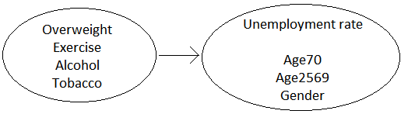

Health outcomes regressions
Multiple OLS regression:
$${Health outcome}_{i}=α+β*{unemployment rate}_{i}+γ_{1}*{age70}_{i}+γ_{2}*{age2569}_{i}+$$
$$γ_{3}*{gender}_{i}+ε_{i}$$

Fixed effect regression:
$${Health outcome}_{it}=α_{i}+β*{unemployment rate}_{it}+γ_{1}*{age70}_{it}+γ_{2}*{age2569}_{it}+$$
$$γ_{3}*{gender}_{it}+ε_{it}$$

Figure 3
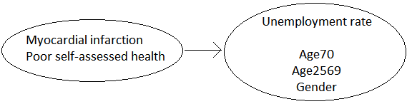
Additional analysis
In the third part of this paper a difference-in-differences is performed with the fair and poor self-assessed health status of people in the USA and Canada. It is important to have data before and after the crisis when one wants to implement a difference-in-differences. For all the variables in the dataset data is available before 2008 and in and after 2008. With a difference-in-differences one can take into account for time-invariant unobserved factors, like the fixed effect model. With the difference-in-differences one can investigate whether there is a difference in the trend of a variable in the interested country compared to the control country. Applied to this research, one can investigate whether there is a difference in the trend of the fair and poor self-assessed health due to the 2008 crisis in America. The trend that America has to follow in absence of the crisis will be roughly the same as the trend in the fair and poor health in Canada. If the trend differs after 2008 in America, it can be investigated with a difference-in-differences whether this is because of the crisis of 2008. So the main interested variable in the regression will be the interaction effect between America and the crisis.

When performing a difference-in-differences it is important that your data meets the requirement of the Parallel Trend Assumption (PTA) for the area you are investigating. In this case the USA and Canada have to be the same in the area of health. To see if the trend of the self-assessed health is sufficiently similar, the self-assessed fair and poor health of the USA and Canada will be shown in figure 4.

Figure 4
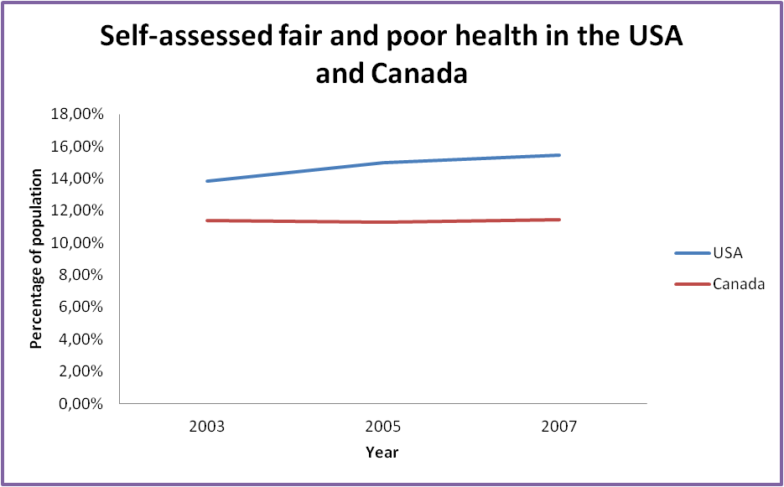

The trend of the self-assessed fair and poor health before the economic crisis of 2008 for the USA and Canada is roughly the same. To be sure that Canada can be used as a control group, the trend of overweight, exercise, smoking and health expenditures as a percentage of the GDP in the countries are also shown in figure 5.

Figure 5
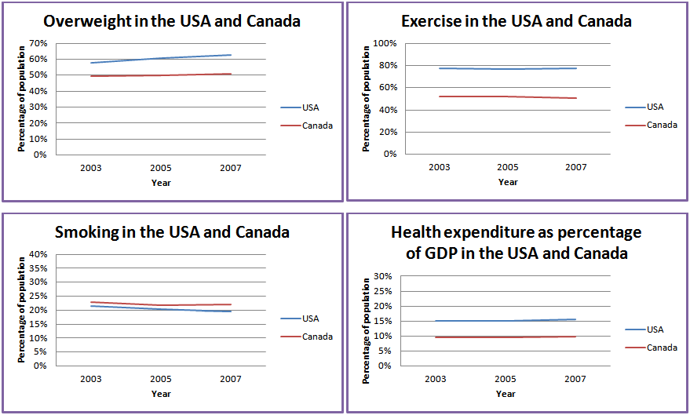
Source: Statistics Canada

All the variables show roughly the same trend for both countries before the economic crisis in 2008. Canada can be used as a reference country. To implement the difference-in-differences, the following regression is generated:

${Fair and poor \left(self­assessed\right) health}_{i}$=
$$α+δ_{1}*crisis+δ_{2}*America+ β*(America*crisis)+ε_{i}$$

The variable crisis is a dummy variable for the crisis of 2008. This variable is 1 for the years 2008 till 2012 and 0 for the years 2002 till 2007. The variable America is a dummy variable for the country America. It equals 1 if the country is America and 0 when the country is Canada. The variable America*crisis is the interaction effect between America and crisis. It equals 1 if the country is America and when America is in the time of the crisis, the years 2008 till 2012. It equals 0 for all the other situations. The difference-in-differences will be performed on state and national level. It could be the case that the effect found by this analysis does not really reflect the effect of the crisis. The crisis could not really have affected the health of people in the USA. The trend of a change in the health of people can already be there in 2007. To investigate if the effect found by the difference-in-difference analysis is really caused by the 2008 economic crisis, a placebo effect is implemented. In this placebo effect analysis it is assumed that the economic crisis started in 2007 instead of 2008. The difference-in-difference will be performed again and if a similar result is generated as the original difference-in-differences, it may be the case that there was already a change present in the health of people in the USA. This would mean that the crisis did not (entirely) have an impact on the health of people in the USA. The placebo effect is implemented on both state and national level.

Results OLS and fixed effect regressions

In this section the first results of this research will be represented. First the results of the health behaviors will be discussed, for both multiple regressions and fixed effect regressions. Then the health outcomes will be discussed in the same order.

Health behaviors
Table 4 shows the results of the multiple OLS regression and fixed effect regression for the health behaviors. Each of the health behaviors is regressed as an outcome variable to see what effect the unemployment has on each health behavior. In the table you can see the coefficient of the unemployment rate. Also added in this table are the coefficients for the control variables and the constant for each regression. The unemployment rate shows a positive relationship with the first variable, overweight. If the proportion of the unemployment rate increases with 1 percent, the proportion of individuals who have overweight increases with 0.36 percent within an MSA. This result is significant. An age of 70 and over increases the proportion of individuals who have overweight with 0.01 percent within an MSA. However this result is not significant, so it is not likely that this coefficient will be different from zero. An age of 25 to 69 and male decreases the proportion of individuals who have overweight significantly within an MSA. When the fixed effect is implemented, the result for the unemployment rate stays the same as well as an age of 70 and over. The coefficients of an age of 25 to 69 and male are positive with a fixed effect model, but not significant anymore. So it is not likely that the coefficients will be different from zero. From the results it seems that more people have overweight during the crisis within the MSAs.

The unemployment rate shows a positive relationship with exercise for both the OLS and fixed effect regression, it increases the proportion of individuals who do not exercise with 0.33 respectively 0.05 percent within an MSA with one unit change. An age of 70 and over shows a positive relationship with exercise too for both OLS and fixed effect regressions. An age of 25 to 69 and male show a significant negative relationship with exercise in the OLS regression, but age of 25 to 69 becomes positive in the fixed effect regression. Both variables are not significant anymore in the fixed effect regression. The unemployment rate shows a positive relationship with alcohol in both regressions, but the results are not significant. Despite the fact that the results are not significant, the effect of unemployment on alcohol stays negative. This is interesting and could be the first sign that the consumption of alcohol decreases during times of the crisis, like shown before in other studies.

Table 4

Results health behaviors
 | 1 |  | 2 |  | 3 |  | 4
 | Overweight |  | Exercise |  | Alcohol |  | Tobacco
 | OLS | Fixed effect | OLS | Fixed effect | OLS | Fixed effect | OLS | Fixed effect
Unemployment | .3626118*** | .1665273*** | .3267377*** | .0509799 | -.0234734 | -.0260935 | .1076408 | -.1074157
Age 70+ | .0121684 | .1027616 | .187537** | .2238342 | .1477091*** | .5751267*** | .3425187*** | .7338929**
Age 25-69 | -.2239152*** | .1494816 | -.2652935*** | .0778645 | .103598*** | .1477999 | .2555305*** | .1949911
Male | -1.137619*** | .2140962 | -1.599932*** | -.1494786 | .1876584** | .3215578 | -.582788*** | .1795835
Constant | 129.4976*** | 42.58177** | 113.41*** | 24.36526 | -10.79479** | -23.6686* | 29.89876*** | -6.221188

* = significant at the 0.1 level
** = significant at the 0.05 level
*** = significant at the 0.01 level

The control variables show a positive relationship with alcohol in both regressions and only an age of 70 and over stays significant in the fixed effect regression. The OLS regression for tobacco shows a positive relationship between unemployment and tobacco, but the fixed effect regression shows a negative relationship. Both coefficients are not significant, so it is not likely that the coefficients will be different from zero. The effect of unemployment on tobacco thus remains unclear. When taking into account for unobserved time-invariant factors, the relationship between unemployment and tobacco becomes negative. This interesting observation could be the first sign of a negative relationship between unemployment and tobacco. Age in general has a positive relationship with tobacco, but only an age of 70 and over remains significant in the fixed effect regression. Male has a significant negative impact on tobacco in the OLS regression, but when implementing the fixed effect the impact becomes negative. However, this result is not significant anymore.

The relationships between the unemployment rate and the health behaviors are not significant in almost all cases. Despite this fact, the results can still give us a lot of information about the relationships with the unemployment rate. Overweight and exercise both showed a positive relationship with the unemployment rate for both OLS and fixed effect regressions. When accounting for unobserved time-invariant factors, the relationship stayed positive. This could tell that there is indeed a positive relationship between the crisis and overweight and exercise. During times of the crisis, more individuals will have overweight and will not exercise within an MSA. This would affect their health in a negative way. The unemployment rate shows a negative relationship with alcohol as an outcome variable. This means that during the crisis, less people will consume alcohol. The relationship remained negative in the fixed effect regression, expecting that this effect will keep negative in other cases. This result is in line with other studies that already had shown a fall in the consumption of alcohol during the crisis, possibly lowering the chance of fatalities because of drunk drivers. The effect of the unemployment rate on tobacco is not clear. In the OLS regression the coefficient is positive, but when implementing the fixed effect the impact becomes negative. It seems that when accounting for more other factors, the effect of unemployment on tobacco becomes negative. This would mean that in times of the crisis, individuals would smoke less within an MSA. This result together with the result of alcohol would imply that people do pay more attention to their health. However, this cannot be said for sure since the coefficients are not significant and the results for overweight and exercise imply the contrary.

Health outcomes
Table 5 shows the results of the OLS and fixed effect regressions for the health outcomes MI and poor self-assessed health. For the variable MI the OLS regression shows that the unemployment rate has a significant positive relationship with the proportion of individuals who have had an MI. When the proportion of the unemployment rate rises with 1 percent, the proportion of individuals who have an MI rises with 0.04 percent within an MSA. In the fixed effect regression, the relationship between the unemployment rate and MI becomes negative. If the proportion of the unemployment rate rises with 1 percent the proportion of individuals that have an MI falls with 0.02 percent within an MSA. The fixed effect regression seems to show a decline in the amount of individuals that experience an MI during the crisis. But the negative relationship in this regression is not significant and thus not likely to be different from zero. Both the OLS and fixed effect regressions show a positive relationship between the unemployment rate and the poor self-assessed health. In the OLS regression when the proportion of the unemployment rate increases with 1 percent, the proportion of individuals who report a poor health increases with 0.18 percent. This result is significant. For the fixed effect regression when the proportion of the unemployment rate rises with 1 percent, the proportion of individuals who report a poor health rises with 0.03 percent. However, this result is not significant so it is not likely that the coefficient is different from zero. It cannot be stated for sure that the positive relationship is true for the unemployment rate and the poor health. But the fact that the relationship is still positive is interesting. The results suggest that during the crisis the self-assessed poor health will increase. As literature has shown, the self-assessed health is a good indicator of one’s actual health. This increases the beliefs in the results between the unemployment rate and poor self-assessed health. To check whether unemployment really affects the self-assessed health, the other variants of the self-assessed health are set as an outcome variable too with unemployment and the control variables age and gender as the independent variables. The unemployment rate showed a positive relationship for fair and good health and a negative relationship for very good and excellent health. This implies that during the crisis a larger proportion of individuals report a poor, fair or good health which will be at the cost of the proportion of individuals that report a very good or excellent health within an MSA. This confirms that the unemployment rate has a positive relationship with poor self-assessed health. During the crisis the proportion of individuals who report a poor health increases within an MSA.

Table 5
Results health outcomes
 | 5 |  | 6
 | MI |  | Poor (self-assessed) health
 | OLS | Fixed effect | OLS | Fixed effect
Unemployment | .038579** | -.0240363 | .1756507*** | .0288243
Age 70+ | .2062189*** | .2287429* | .1057841*** | .3228734***
Age 25-69 | .0122646 | .030824 | -.0749997*** | .0909186
Male | -.1644357*** | -.1271175 | -.3632082*** | -.2173203*
Constant | 9.40869*** | 6.757788 | 24.17026*** | 6.714194

* = significant at the 0.1 level
** = significant at the 0.05 level
*** = significant at the 0.01 level

The results for the health outcomes are significant in the OLS regressions, but for the fixed effect regressions the results become not significant. The OLS regression shows a positive relationship between the unemployment rate and MI, the fixed effect a negative relationship. It is not clear how the crisis will affect the proportion of MI within an MSA. As a fixed effect takes into account for more factors, it seems that the crisis decreases the proportion of individuals who have a heart attack within an MSA. As alcohol and tobacco increase the chance of getting a heart attack for an individual, this result seems to be in line with the results of these health behaviors. On the contrary, overweight and exercise increases the proportion of individuals who have a heart attack within an MSA. This could be the reason why the negative relationship between unemployment and MI is not significant. The poor health shows a positive relationship in both regressions. During the crisis the proportion of individuals who report a poor self-assessed health within an MSA seems to increase. As self-assessed health is a good indicator of one’s actual health, the coefficients of both MI and poor health are not significant and the sign of the coefficients of MI change, it would be logical to make the conclusion that unemployment has a negative impact on health outcomes.

Results additional analysis; difference-in-differences

In this section the results of the additional analysis of difference-in-differences will be discussed. First the results of the original state level difference-in-differences with the crisis beginning in 2008 will be discussed. Next the placebo effect on state level with the crisis beginning in 2007 will be discussed. After this the results of the difference-in-difference on national level will be discussed for both the original analysis as the placebo effect.

State level
Table 6 presents the results for the state level analysis. The intercept of the state level difference-in-differences has a value of 15.039 and is significant. For the variable America the coefficient has a value of 0 for the country America and -3.901 for Canada. This coefficient is significant. This result means that in Canada the proportion of individuals reporting a fair and poor health decreases with 3.901 percent. People within the provinces in Canada seem to report an overall better health compared to people within the states in the USA. The interaction effect of America and Crisis has a coefficient of -0.520 and is not significant. The coefficient implies that the proportion of individuals who report a fair and poor health decreases with 0.520 percent when they are living in America during the crisis. This would mean that the crisis has a positive effect on the health of people in the USA within the states. However, because this coefficient is not significant it is not likely that it will be different from zero and it cannot be stated that the crisis indeed has a positive effect on the health of the people in the USA within the states.

For the placebo effect on the state level, assuming that the crisis started in 2007, the same effect was found for the interaction effect of America and crisis. The coefficient is -0.248 which means that the proportion of individuals who report a fair and poor health decreases with 0.248 percent when they are living in America during the crisis. A positive effect of the crisis on the health of people in the USA within states is found again. This coefficient is not significant. Compared to the original analysis, the coefficient of the placebo effect has a higher insignificant result. It is more likely that this coefficient will not be different from zero than the original coefficient. This implies that there was no change present in the health of people in the USA before the crisis started, which makes the original difference-in-differences analysis more reliable.

Table 6
Results difference-in-differences
 | State level |  | National level
 | Original | Placebo | Original | Placebo
America*crisis | -.520 | -.248 | -.520* | -.248
Intercept | 15.039*** | 14.945*** | 15.040*** | 14.945***
America | 0 | 0 | 0 | 0
Canada | -3.901*** | -3.806*** | -3.900*** | -3.805***
* = significant at the 0.1 level
** = significant at the 0.05 level
*** = significant at the 0.01 level

National level
To see if the results within the states hold on national level too, the difference-in-differences is applied on national level. The results of the national level analysis can also be found in table 6. The table shows that the intercept of the national difference-in-differences has a significant coefficient of 15.040. For the variable America the value is 0 for the country America and -3.900 if the country is Canada. This coefficient is significant. The coefficient of -3.900 implies that if one just lives in Canada, the proportion of individuals reporting a fair and poor health decreases with 3.900 percent. It suggests that people in Canada report an overall better health compared to the USA on national level. This is the same result for the variable America as in the state level difference-in-differences regression. The interaction effect of America and Crisis has a coefficient of -0.520 and is significant with a significance level of 10 percent. The interaction effect tells one that when you live in America during the crisis, the proportion of individuals who report a fair and poor health decreases on national level. The crisis thus affects health in a positive way during the crisis on national level. To make the result of the difference-in-differences more clear on the national level, figure 6 shows the graph of the fair and poor self-assessed health in the USA and Canada. The fair and poor self-assessed health in Canada has roughly the same trend and does not differ substantially. In the USA one can notice a drop in the proportion of individuals that report a fair and poor self-assessed health during the crisis. This drop for the fair and poor health in the USA is thus substantially different from the trend that it had to follow with a significance level of 10 percent. The crisis affects the self-assessed health significantly and in this case in a positive way.

Figure 6
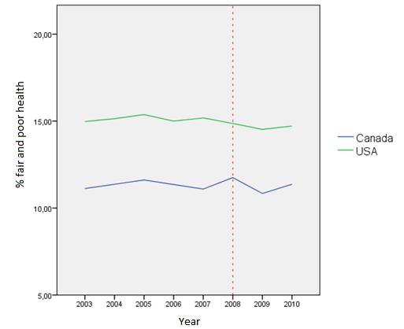

For the placebo effect on national level the interaction effect of America and crisis shows an coefficient of -0.248. This implies that the crisis has a positive effect on the health op people in the USA, like the original analysis on national level. However, this coefficient is not significant at all while the original coefficient was significant which implies that it is not likely that the coefficient is different from zero. This means that there was no change present in the health of people in the USA before the crisis started, which makes the original difference-in-differences analysis more reliable.

Discussion

In this section some discussion about the research in general will be given. Next the robustness of the results will be presented briefly. After that the limitations will be discussed of this research to stimulate further research. Then some thoughts will be shared for an ideal experiment to investigate the effect of a crisis on health in general.

Discussion of the research
This research tried to find the effect of the 2008 economic crisis on the health of people in the USA. For the health behaviors it is not clear what the effect is. Overweight and exercise show a negative effect of crisis on the health of people on an MSA level, while alcohol and tobacco show a negative effect of the crisis on the health of people on an MSA level. For the health outcomes MI shows a positive effect of the crisis on health on an MSA level, while the self-assessed health shows a negative effect of the crisis on health on an MSA level. The additional difference-in-differences analysis on state level and national level shows that the crisis has a positive effect on the health of people in the USA.

The results of this study are very similar to the results of the paper of Ruhm (2000) that found a positive effect on the health of people during the crisis. Mortality decreased during the crisis due to fewer fatalities annually. The results of this paper are also comparable to the paper of Ásgeirsdóttir et al. (2012). This paper found that the crisis had different effects on the health behaviors; some were positively related to the crisis and others negatively. It found a reduction in smoking and heavy drinking that is in line with the reduction in the consumption of alcohol and tobacco in this research. This is again in line with the paper of Ruhm (2000) that implied fewer fatalities in traffic because less people were driving drunk. When the self-assessed health is evaluated, it seems that the crisis has a negative impact on the self-assessed health which is in line with the paper of Kondo et al. (2008). The paper found that the self-reported health status declined when one was unemployed. This research found the same thing as self-assessed health worsened during the crisis. The results of this paper seem to summarize parts of the papers mentioned above, as this research found something that is similar to these papers.

It seems like the consumption of some goods like alcohol and tobacco decline during the crisis. This could either be because people have less financial capacity to buy such goods or they are more aware of their health because they have more time left to spend on other things like their health. This also explains the reduction in MI during the crisis, as people have more time left for their health. On the other hand, it seems some people stop exercising or get overweight during the crisis. This could either be because they spend more time on their job due to pressure of the crisis or they get depressed and stop engaging in activities. This is in line with the increase in the proportion of individuals that report a poor health. But then again the analysis on national level shows a positive effect of the crisis on the health of people in the USA. This suggests that the positive effect is greater than the negative effect of the crisis on the health of people in the USA.

When the focus lies on the significance of the results, overweight is the only variable that shows that the unemployment rate is significant and has a negative effect on overweight; the proportion of individuals that have overweight increases during the crisis of 2008. The other variables do not show promising significant results for the unemployment rate. For the control variables, age of 70 and over is the variable that is significant most of the time. A high age is thus influencing health behaviors and health outcomes in a significant way. This is logical as when one gets older his health is starting to decline and he is less capable of doing activities that help him maintain a good health. When the focus lies on the difference in the results of the various methods, the OLS regressions have more significant results than the fixed effect regressions and the difference-in-differences. This is probably because the fixed effect method and the difference-in-differences method take into account for endogeneity. When one takes into account for unobserved factors between MSAs or states, the effect of the unemployment rate seems to decrease. The effect of the crisis on health is getting fuzzier because of this. The unobserved factors therefore seem to have a great impact when one wants to investigate the effect of the crisis on the health of people in general. The importance of trying to account for all observed and unobserved factors rises remarkably because of this empirical finding.

Robustness of the results
The R-squared of the regressions performed in this research are most of the time very low. The difference-in-differences regression on national level shows a high R-squared. The higher the R-squared, the better the data fits the model. It seems like the data does not fit the models used in this research. However, a high R-squared does not always mean that the results do not give important relationships. A significant coefficient stills shows the mean change if the independent variable changes with one unit. So the results can still be of great value despite a low R-squared.

Limitations
This research is a good foundation for investigating the effect of the crisis on the health of people, but there are some things within this research that limited the research itself. The unemployment rate is a good indicator of the crisis. But there could be other factors that influence the unemployment rate and have nothing to do with a crisis. This is also the case for health; there could be factors that influence one’s health because of other reasons. Someone can get a disease that would affect both the unemployment rate and his health. The company can fire this person because he is sick for too long. A disease also influences one’s health in a negative way. The health of someone therefore declines, not because of a crisis but because of the disease. However, it is very difficult to take into account for such situations as the information about this is not available most of the time. When it is available, it would make the research more complicated and even obscure.

The dataset that was used in this research was clear and reliable, but had it lacks too. There were missing observations in the dataset. For example an MSA could have information in 2007, but was not reported in 2008 because it had less than 500 observations or no observations at all. In the statistics these missing observations were left out so that they could not influence the results, but it would have been better to have complete information without missing observations. Also, the information about MI only went back till 2007. More information in the years before the crisis would be preferred as the regression would take more years into account and the results would be more precisely. This also holds for the fair and poor health for the USA and Canada in the difference-in-differences section, which were missing in some of the years.

A general limitation of this research is that it could be that there are some exogenous effects during the years 2002 till 2012, affecting one of the variables that are used in this research. The exogenous effects could be clearly present and logical, but for some of the effects one does not even know that the link is present. It is hard to take into account for such exogenous effects. It could be that an action could affect the chance on an MI, but science has not discovered this yet. This limitation is something beyond this research’ and beyond people’s knowledge and makes it more difficult to find a causal relationship between the crisis and the health of people in general.

This research uses a multiple regression, a fixed effect model and a difference-in-differences. Each of the methods has its limitations itself. A multiple regression has the advantage that one can find the correlation between variables. However, the regression has two great disadvantages. The first one is that it is almost impossible to measure and include all relevant variables that can have an effect on the outcome variable. There are always unobserved variables that influence the outcome variable. This causes selection bias. The second disadvantage is the assumption of linearity. It can be that there are omitted variables that are not included in the regression. The Conditional Independence Assumption will not hold, so the assumption of linearity will not hold. The fixed effect model is a good way to get a better estimate of the real effect of unemployment rate on health, because one can take into account for unobserved time-invariant factors. However, with fixed effect one only uses within individual variation. Besides that one can only estimate the effect of time-varying variables that are observed. The fixed effect cannot estimate the effect of unobserved time-varying factors and does not take into account such factors. This is also the case for difference-in-differences. It can only measure an effect if the unobserved variables are time-invariant; this is called the Parallel Trends Assumption. Another great disadvantage of the difference-in-differences estimate is that this research uses Canada as a control group because the self-assessed health has the same trend. It is assumed that Canada is not affected by the 2008 economic crisis, while it actually was affected but relatively less. It is likely that the self-assessed health of Canada is therefore also affected by the economic crisis of 2008. Because it is assumed that Canada is not affected, the results of the difference-in-differences are biased. A part of the effect on the crisis is already present in the trend of the self-assessed health. This effect is not added in the results of the difference-in-differences. Therefore it is likely that the results are underestimated and actually have a higher value than this research found. Next to that the USA and Canada do not have the same health regulations for all circumstances. The service of health and health insurance are very different in the USA and Canada. It is hard to find a country that is exactly the same in everything and especially health in general and for the USA. But the USA and Canada are both large countries with different provinces and they are developed countries. Also they are graphically close to each other. So even though there is a limitation to comparing these countries, if the trend of the self-reported health has the same trend before the economic crisis of 2008, Canada is a good control country for the USA.

Despite of the limitations of this research, the information and methods used are a good approach to get the effect of the 2008 economic crisis on health.

Ideal experiment
The ideal experiment to get the effect of economic crisis on health is in a world where one can randomize economic crisis, which is more unemployed, in a country. During this process all people need to be monitored and they all have to be prepared to answer questions regarding their health. But assigning economic crisis random is unethical. One cannot force someone to be unemployed because of the disadvantages this person gets compared to being employed. An alternative could be that everyone is closely monitored, employed and unemployed. On a bigger scale two countries can be compared that are similar in development and situations of health. One country is affected by an economic crisis while the other is not. One keeps observing the people, until the economy grows again in the country hit by a crisis. An important assumption here is that people are fine with being observed and they co-operate in the interest of the study. Another idea that is more limited and specific but could identify important relationships, is observing twins where one twin has a job and the other twin has not. One monitors both and investigates whether there is a difference in health between the one with a job and the one without. The twins have the same background and same circumstances, but one is in ‘economic growth’ and the other is in an ‘economic crisis’. To study the real effect of an economic crisis on health is really difficult in this world because of the ethical issues, difficult circumstances and the limited information.

Conclusion

In this last part of the research a brief summary will be given. After that the research question will be answered and finally some recommendations will be given for further research.

Summary
It is very important that people have a good health and remain a good health. Especially during a crisis people can be very sensitive regarding to their health. A good health is important to get out of a crisis as soon as possible. But the effect of a crisis on health is not clear. It could have a positive effect, but most people belief that a crisis has a negative impact on the health of people. This research tried to investigate what kind of effect the 2008 economic crisis has on the health of people in the USA. A lot of studies already investigated the effect of the crisis on the health of people. Some found a positive relationship, others a negative relationship. So it is still not clear what the effect is of the crisis, a lot of discussion still exists about this field. This research tried to find the effect of the crisis on health with unemployment reflecting the 2008 economic crisis. The unemployment rate was regressed with health behaviors and health outcomes. This is because the crisis can have a direct effect on the health behaviors, which will have an effect on health outcomes. But the crisis can also have a direct effect on health outcomes. That is why the unemployment rate was regressed with both health groups. The research has three parts and each part has its own method. The first method is a simple multiple regression, to get the correlation of unemployment with the health variables. Then a fixed effect model was implemented in the same regressions to take into account for unobserved time-invariant factors. Both the methods are performed on an MSA level. After that the difference-in-differences was performed on state and national level, to investigate whether this method gave the same results as the multiple and fixed effect regressions. The statistical research will give an answer on the research question, which is: What effect did the economic crisis of 2008 have on the health of residents in the USA?

Answer on the research question
For the health behaviors overweight and exercise both showed a positive relationship with the unemployment rate for both OLS and fixed effect regressions. The proportion of individuals who have overweight and do not exercise increases within an MSA during the crisis, which implies that the crisis has a negative impact on the health of people within an MSA for these variables. Alcohol showed a negative relationship with unemployment. The proportion of individuals who consume alcohol would decrease within an MSA during the crisis, affecting the health of people in the USA in a positive way. The relationship of tobacco and the unemployment rate is not clear as the OLS and fixed effect regressions both show a different relationship. However, when accounting for more factors, there is a negative relationship between tobacco and the unemployment rate which implies that the proportion of individuals who smoke decreases within an MSA during the crisis. So the crisis influences overweight and exercise in a negative way and alcohol and tobacco in a positive way.

The health outcomes MI and poor self-assessed health both show different results regarding the unemployment rate. The unemployment rate first has a positive relationship with MI in the OLS regression and then a negative relationship in the fixed effect regression. It is unclear what effect the crisis has on MI, but it seems that the proportion of individuals who have an MI falls within an MSA during the crisis. As alcohol and tobacco increase the chance of getting a heart attack for an individual, this result seems to be in line with the results of these health behaviors. On the contrary, overweight and exercise increases the proportion of individuals who have a heart attack within an MSA. The poor health showed a positive relationship in both regressions. The proportion of individuals who report a poor health increases within an MSA during the crisis. This result is very important as the paper of Kondo et al. (2008) stated that the self-assessed health is a very good indicator of one’s actual health.
The multiple and fixed effect regression showed that the 2008 economic crisis had a negative impact on the health behaviors overweight and exercise, but also a positive effect on the health behaviors alcohol and consumption. People seem to pay attention in what they consume or use, but their lifestyle itself does not improve, it deteriorates. For the health outcomes the effect is also not clear as the crisis has a positive impact on MI and a negative impact on the poor self-assessed health.

The difference-in-differences analysis showed that for just living in the USA one’s health was worse compared to Canada. At both state and national level the fair and poor health shows a negative relationship with unemployment. This means that the proportion of individuals who report a fair and poor health falls during the crisis on both state and national level in the USA. At the state level this result was not significant, but on the national level this was significant with a significance level of 10 percent.

The effect on an MSA level was not clear, as the crisis influenced the health both in a positive and negative way. But on a state level and national level it is clear that the crisis improves the health of people in the USA. That is why it can be concluded that the economic crisis of 2008 had a positive effect on the health of residents in the USA.

Recommendations
As this research has some lacks and limitations, further research in the field of the effect of the 2008 economic crisis on the health of people in the USA is needed. More punctual and precisely information has to be made available so that one can take into account for more variables. Also, the problem of missing observations would not be an issue in that case. The methods used in this research are good to get first impressions of the effect of the 2008 economic crisis on the health of people in the USA, but other methods would improve the quality of the results. A time fixed effect model would contain a dummy for time and perform a fixed effect over the time. This would make the results more precise and reliable. But then one still cannot take into account for unobserved time-varying factors, so other methods should be considered too.

References

- About BLS. (2015, February 2). Opgeroepen op April 30, 2015, van The Bureau of Labor Statistics: http://www.bls.gov/bls/infohome.htm
- AGE AND SEX. (2013). Opgeroepen op May 19, 2015, van American FactFinder: http://factfinder.census.gov/faces/tableservices/jsf/pages/productview.xhtml?pid=ACS_13_5YR_S0101&prodType=table
- Ariizumi, H., & Schirle, T. (2012). Are recessions really good for your health? Evidence from Canada. Social Science & Medicine , 1224-1231.
- Ásgeirsdóttir, T. L., Corman, H., Noonan, K., Ólafsdóttir, Þ., & Reichman, N. E. (2012). Are Recessions Good for Your Health Behaviors? Impacts of the Economic Crisis in Iceland. NBER Working Paper Series .
- Benzeval, M., & Judge, K. (2001). Income and health: the time dimension. Social Science & Medicine , 1371-1390.
- Census Bureau; About the Bureau. (2015, April 21). Opgeroepen op June 11, 2015, van United States Census Bureau: http://www.census.gov/about/what.html
- Frijters, P., Haisken-DeNew, J. P., & Shields, M. A. (2005). The causal effect of income on health: Evidence from German reunification. Journal of Health Economics , 997-1017.
- HIW; About the HIW. (2015, May). Opgeroepen op June 11, 2015, van Health Indicators Warehouse: http://www.healthindicators.gov/About/AboutTheHIW
- Kondo, N., Subramanian, S. V., Kawachi, I., Takeda, Y., & Yamagata, Z. (2008). Economic recession and health inequalities in Japan: analysis with a national sample, 1986-2001. Journal of Epidemiology and Community Health , 869-875.
- Lindahl, M. (2005). Estimating the Effect of Income on Health and Mortality Using Lottery Prizes as an Exogenous. The Journal of Human Resources , 144-168.
- Lo, Y., Rukshin, I., Pan, F., Sen, S., Islam, M., Yousif, A., et al. (2014, May 6). The Impact of the 2008-2009 Economic Recession on Acute Myocardial Infarction Occurrences in Various Socioeconomic Areas of Raritan Bay Region, New Jersey. North American Journal of Medical Sciences , 215-218.
- Metropolitan Area Employment and Unemployment (Monthly) Archived News Releases. (sd). Opgeroepen op April 15, 2015, van Bureau of Labor Statistics: http://www.bls.gov/schedule/archives/metro_nr.htm#2013
- Miller, D. L., Page, M. E., Stevens, A. H., & Filipski, M. (2009). Why Are Recessions Good for Your Health? The American Economic Review , 122-127.
- Official mission statements/organizational charts. (sd). Opgeroepen op April 30, 2015, van Centers for Disease Control and Prevention: http://www.cdc.gov/maso/mab_Charts.htm
- Ruhm, C. J. (2000). Are Recessions Good for Your Health? . Oxford Journals , 617-650.
- SMART: BRFSS City and County Data. (sd). Opgeroepen op April 15, 2015, van Centers for Disease Control and Prevention: http://apps.nccd.cdc.gov/BRFSS-SMART/SelMMSAPrevData.asp
- Statistics Canada; About us. (2015, May 26). Opgeroepen op June 11, 2015, van Statistics Canada: http://www.statcan.gc.ca/eng/about/about?MM=
- Stuckler, D., Basu, S., Suhrcke, M., Coutts, A., & McKee, M. (2011). Effects of the 2008 recession on health: a first look at European data. The Lancet , 124-125.
- Stuckler, D., Basu, S., Suhrcke, M., Coutts, A., & McKee, M. (2009). The public health effect of economic crises and alternative policy responses in Europe: an empirical analysis. The Lancet , 315-323.
- Zavras, D., Tsiantou, V., Pavi, E., Mylona, K., & Kyriopoulos, J. (2012). Impact of economic crisis and other demographic and socio-economic factors on self-rated health in Greece. The European Journal of Public Health , 206-210.

Appendix

A. Multiple OLS regressions output

A. I. Health behaviors

1.${Overweight}_{i}=α+β*{unemployment rate}_{i}+γ_{1}*{age70}_{i}+γ_{2}*{age2569}_{i}+γ_{3}*{gender}_{i}+ε_{i}$

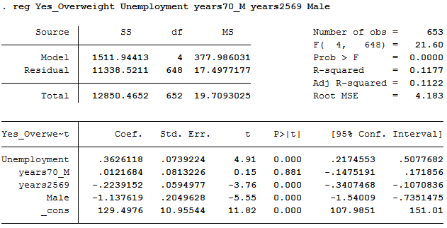

2. ${Exercise}_{i}=α+β*{unemployment rate}_{i}+γ_{1}*{age70}_{i}+γ_{2}*{age2569}_{i}+γ_{3}*{gender}_{i}+ε_{i}$

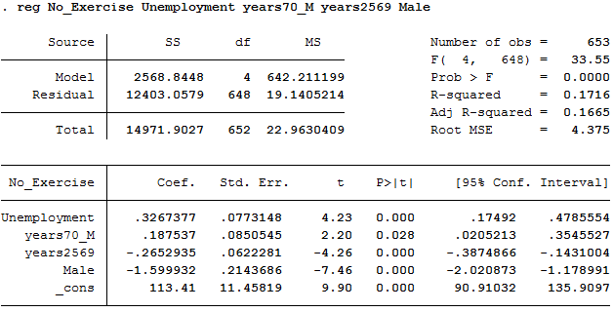
3. ${Alcohol}_{i}=α+β*{unemployment rate}_{i}+γ_{1}*{age70}_{i}+γ_{2}*{age2569}_{i}+γ_{3}*{gender}_{i}+ε_{i}$

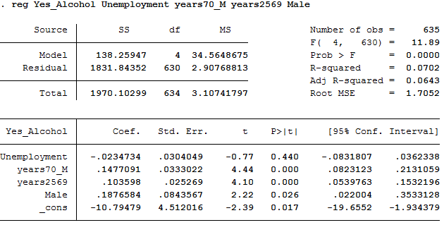

4. ${Tobacco}_{i}=α+β*{unemployment rate}_{i}+γ_{1}*{age70}_{i}+γ_{2}*{age2569}_{i}+γ_{3}*{gender}_{i}+ε_{i}$

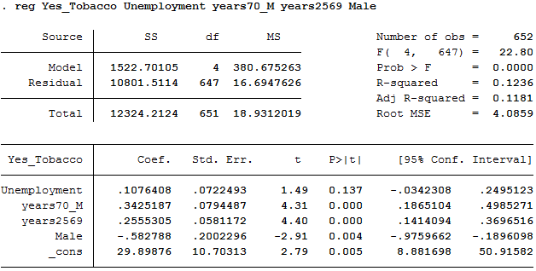

A. II. Health outcomes

5. ${Myocardial infarction}_{i}=α+β*{unemployment rate}_{i}+γ_{1}*{age70}_{i}+γ_{2}*{age2569}_{i}+γ_{3}*{gender}_{i}+ε_{i}$

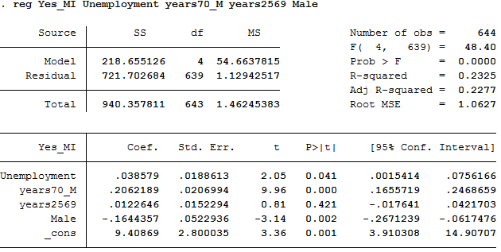

6. ${Self­assessed health}_{i}=α+β*{unemployment rate}_{i}+γ_{1}*{age70}_{i}+γ_{2}*{age2569}_{i}+γ_{3}*{gender}_{i}+ε_{i}$

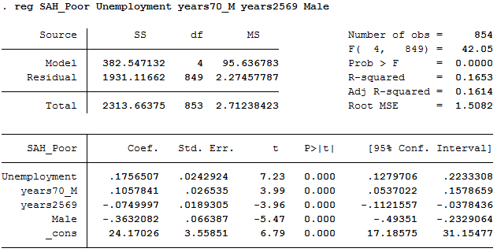
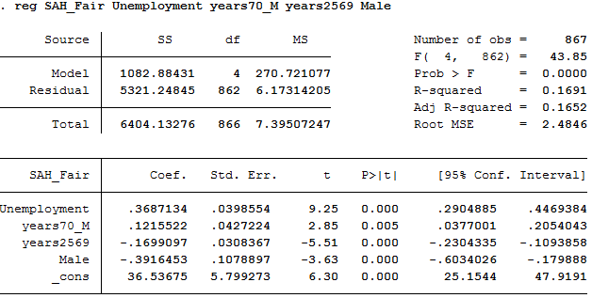

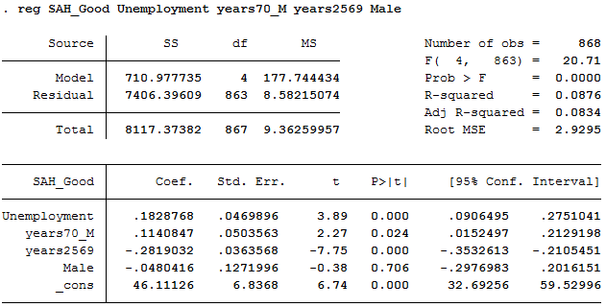

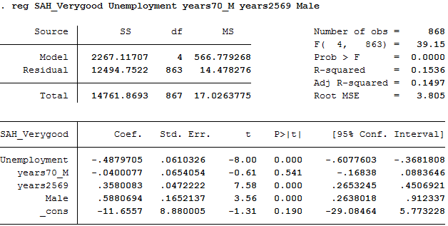

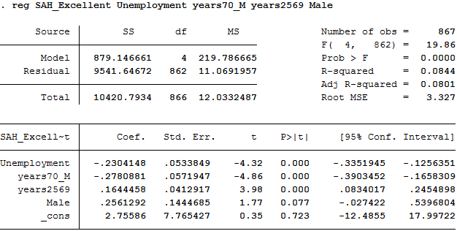

B. Fixed effect regressions output

B. I. Health behaviors

1. ${Overweight}_{it}=α_{i}+β*{unemployment rate}_{it}+γ_{1}*{age70}_{it}+γ_{2}*{age2569}_{it}+γ_{3}*{gender}_{it}+ε_{it}$

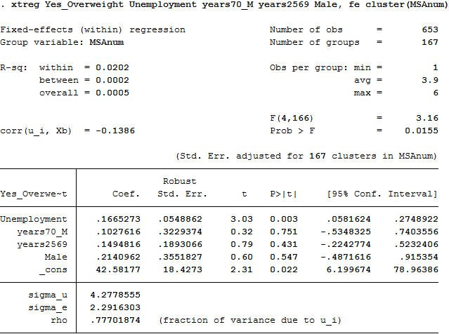

2. ${Exercise}_{it}=α_{i}+β*{unemployment rate}_{it}+γ_{1}*{age70}_{it}+γ_{2}*{age2569}_{it}+γ_{3}*{gender}_{it}+ε_{it}$

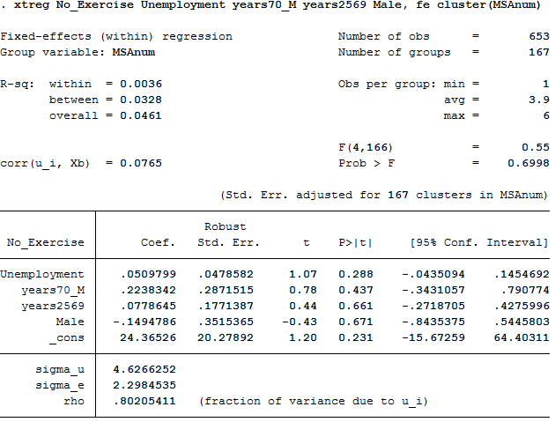
3. ${Alcohol}_{it}=α_{i}+β*{unemployment rate}_{it}+γ_{1}*{age70}_{it}+γ_{2}*{age2569}_{it}+γ_{3}*{gender}_{it}+ε_{it}$

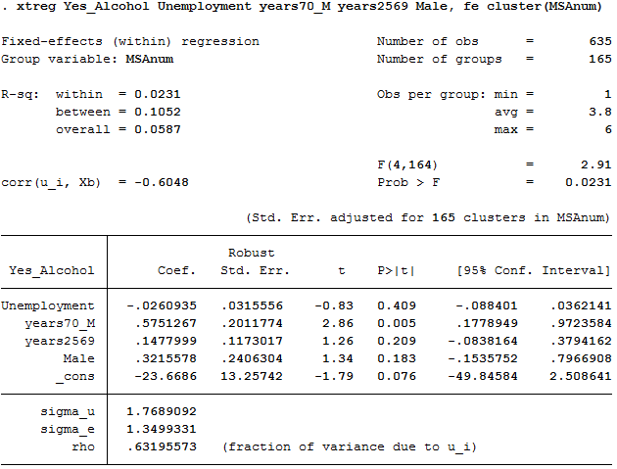

4. ${Tobacco}_{it}=α_{i}+β*{unemployment rate}_{it}+γ_{1}*{age70}_{it}+γ_{2}*{age2569}_{it}+γ_{3}*{gender}_{it}+ε_{it}$

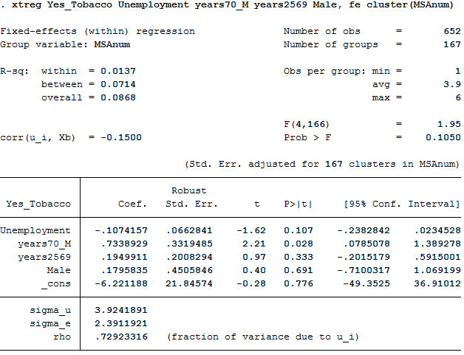
B. II. Health outcomes

5. ${Myocardial infarction}_{it}=α_{i}+β*{unemployment rate}_{it}+γ_{1}*{age70}_{it}+γ_{2}*{age2569}_{it}+γ_{3}*{gender}_{it}+ε_{it}$

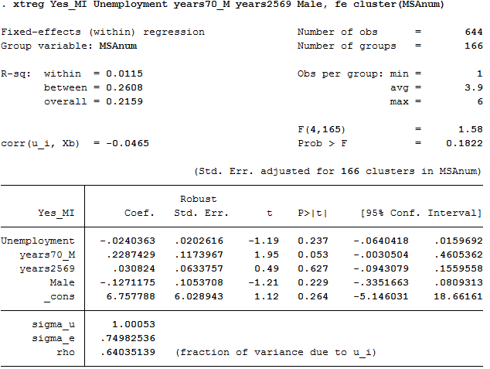

6. ${Poor \left(self­assessed\right) health}_{it}=α_{i}+β*{unemployment rate}_{it}+γ_{1}*{age70}_{it}+γ_{2}*{age2569}_{it}+γ_{3}*{gender}_{it}+ε_{it}$

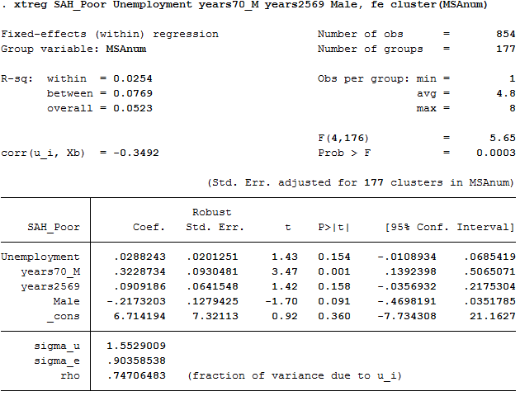

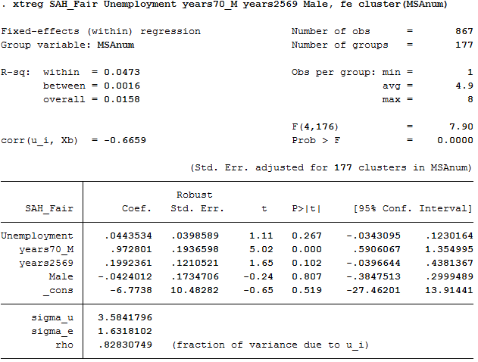

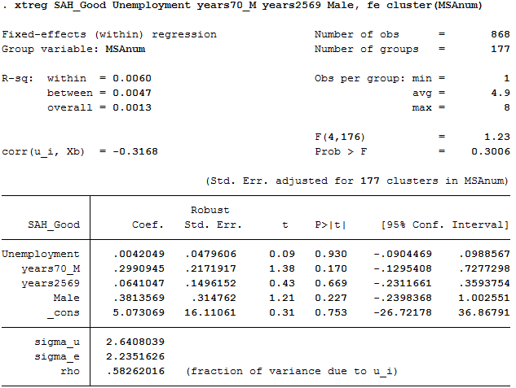

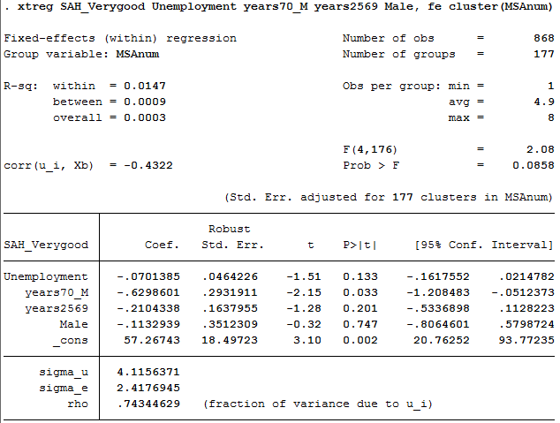

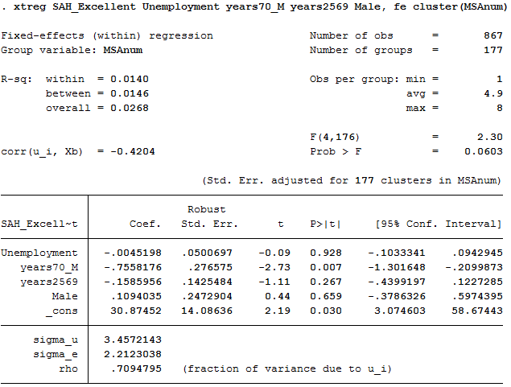

C. Difference-in-differences output

C. I. State level

Original analysis

Between-Subjects Factors
 |  | N
year | 2002 | 51
year | 2003 | 64
year | 2004 | 50
year | 2005 | 64
year | 2006 | 51
year | 2007 | 64
year | 2008 | 64
year | 2009 | 64
year | 2010 | 64
year | 2011 | 13
year | 2012 | 13
America | 0 | 104
America | 1 | 458

Tests of Between-Subjects Effects
Dependent Variable: fairorpoor
Source | Type III Sum of Squares | df | Mean Square | F | Sig.
Corrected Model | 1163,266ª | 12 | 96,939 | 10,691 | ,000
Intercept | 43268,525 | 1 | 43268,525 | 4772,128 | ,000
year | 17,359 | 10 | 1,736 | ,191 | ,997
America | 472,905 | 1 | 472,905 | 52,157 | ,000
America_Crisis | 4,203 | 1 | 4,203 | ,464 | ,496
Error | 4977,742 | 549 | 9,067
Total | 121301,890 | 562
Corrected Total | 6141,007 | 561
a. R Squared = ,189 (Adjusted R Squared = ,172)

Parameter Estimates
Dependent Variable: fairorpoor
Parameter | B | Std. Error | t | Sig. | 95% Confidence Interval
 |  |  |  |  | Lower Bound | Upper Bound
Intercept | 15,039 | ,995 | 15,121 | ,000 | 13,086 | 16,993
[year=2002] | ,094 | 1,080 | ,087 | ,931 | -2,028 | 2,216
[year=2003] | -,055 | 1,012 | -,054 | ,957 | -2,043 | 1,933
[year=2004] | ,099 | 1,082 | ,091 | ,927 | -2,027 | 2,224
[year=2005] | ,366 | 1,012 | ,361 | ,718 | -1,623 | 2,354
[year=2006] | -,039 | 1,080 | -,036 | ,971 | -2,161 | 2,083
[year=2007] | ,105 | 1,012 | ,103 | ,918 | -1,883 | 2,093
[year=2008] | ,400 | 1,012 | ,395 | ,693 | -1,588 | 2,388
[year=2009] | -,058 | 1,012 | -,057 | ,955 | -2,046 | 1,931
[year=2010] | ,203 | 1,012 | ,201 | ,841 | -1,785 | 2,192
[year=2011] | ,677 | 1,181 | ,573 | ,567 | -1,643 | 2,997
[year=2012] | 0ª | . | . | . | . | .
[America=0] | -3,901 | ,540 | -7,222 | ,000 | -4,962 | -2,840
[America=1] | 0ª | . | . | . | . | .
America_Crisis | -,520 | ,764 | -,681 | ,496 | -2,021 | ,980
a. This parameter is set to zero because it is redundant.

Placebo effect

Between-Subjects Factors
 |  | N
year | 2002 | 51
year | 2003 | 64
year | 2004 | 50
year | 2005 | 64
year | 2006 | 51
year | 2007 | 64
year | 2008 | 64
year | 2009 | 64
year | 2010 | 64
year | 2011 | 13
year | 2012 | 13
America | 0 | 104
America | 1 | 458

Tests of Between-Subjects Effects
Dependent Variable: fairorpoor
Source | Type III Sum of Squares | df | Mean Square | F | Sig.
Corrected Model | 1159,913ª | 12 | 96,659 | 10,653 | ,000
Intercept | 35798,372 | 1 | 35798,372 | 3945,580 | ,000
year | 22,715 | 10 | 2,272 | ,250 | ,991
America | 300,165 | 1 | 300,165 | 33,083 | ,000
Ame_Crisis | ,851 | 1 | ,851 | ,094 | ,760
Error | 4981,094 | 549 | 9,073
Total | 121301,890 | 562
Corrected Total | 6141,007 | 561
a. R Squared = ,189 (Adjusted R Squared = ,171)

Parameter Estimates
Dependent Variable: fairorpoor
Parameter | B | Std. Error | t | Sig. | 95% Confidence Interval
 |  |  |  |  | Lower Bound | Upper Bound
Intercept | 14,945 | 1,066 | 14,023 | ,000 | 12,851 | 17,038
[year=2002] | ,189 | 1,146 | ,165 | ,869 | -2,063 | 2,440
[year=2003] | ,021 | 1,057 | ,019 | ,984 | -2,056 | 2,097
[year=2004] | ,193 | 1,148 | ,168 | ,866 | -2,061 | 2,448
[year=2005] | ,441 | 1,057 | ,417 | ,677 | -1,636 | 2,518
[year=2006] | ,055 | 1,146 | ,048 | ,962 | -2,196 | 2,307
[year=2007] | ,378 | ,989 | ,382 | ,703 | -1,566 | 2,321
[year=2008] | ,259 | ,989 | ,262 | ,794 | -1,684 | 2,202
[year=2009] | -,199 | ,989 | -,201 | ,841 | -2,142 | 1,744
[year=2010] | ,062 | ,989 | ,063 | ,950 | -1,881 | 2,005
[year=2011] | ,677 | 1,181 | ,573 | ,567 | -1,644 | 2,998
[year=2012] | 0ª | . | . | . | . | .
[America=0] | -3,806 | ,662 | -5,752 | ,000 | -5,106 | -2,506
[America=1] | 0ª | . | . | . | . | .
Ame_Crisis | -,248 | ,810 | -,306 | ,760 | -1,840 | 1,344
a. This parameter is set to zero because it is redundant.

C. II. National level

Original analysis
Between-Subjects Factors
 |  | N
America | 0 | 8
America | 1 | 9
year | 2002 | 1
year | 2003 | 2
year | 2004 | 1
year | 2005 | 2
year | 2006 | 1
year | 2007 | 2
year | 2008 | 2
year | 2009 | 2
year | 2010 | 2
year | 2011 | 1
year | 2012 | 1

Tests of Between-Subjects Effects
Dependent Variable: fairorpoor
Source | Type III Sum of Squares | df | Mean Square | F | Sig.
Corrected Model | 57,584ª | 12 | 4,799 | 172,924 | ,000
Intercept | 2090,055 | 1 | 2090,055 | 75317,299 | ,000
America | 22,815 | 1 | 22,815 | 822,162 | ,000
year | ,934 | 10 | ,093 | 3,364 | ,127
America_Crisis | ,203 | 1 | ,203 | 7,308 | ,054
Error | ,111 | 4 | ,028
Total | 3052,866 | 17
Corrected Total | 57,695 | 16
a. R Squared = ,998 (Adjusted R Squared = ,992)

Parameter Estimates
Dependent Variable: fairorpoor
Parameter | B | Std. Error | t | Sig. | 95% Confidence Interval
 |  |  |  |  | Lower Bound | Upper Bound
Intercept | 15,040 | ,215 | 69,935 | ,000 | 14,443 | 15,637
[America=0] | -3,900 | ,136 | -28,673 | ,000 | -4,278 | -3,522
[America=1] | 0ª | . | . | . | . | .
[year=2002] | ,090 | ,272 | ,331 | ,757 | -,665 | ,845
[year=2003] | -,045 | ,215 | -,209 | ,844 | -,642 | ,552
[year=2004] | ,100 | ,272 | ,368 | ,732 | -,655 | ,855
[year=2005] | ,410 | ,215 | 1,906 | ,129 | -,187 | 1,007
[year=2006] | -,040 | ,272 | -,147 | ,890 | -,795 | ,715
[year=2007] | ,045 | ,215 | ,209 | ,844 | -,552 | ,642
[year=2008] | ,475 | ,215 | 2,209 | ,092 | -,122 | 1,072
[year=2009] | -,150 | ,215 | -,697 | ,524 | -,747 | ,447
[year=2010] | ,215 | ,215 | 1,000 | ,374 | -,382 | ,812
[year=2011] | ,680 | ,236 | 2,886 | ,045 | ,026 | 1,334
[year=2012] | 0ª | . | . | . | . | .
America_Crisis | -,520 | ,192 | -2,703 | ,054 | -1,054 | ,014
a. This parameter is set to zero because it is redundant.

Placebo effect
Between-Subjects Factors
 |  | N
America | 0 | 8
America | 1 | 9
year | 2002 | 1
year | 2003 | 2
year | 2004 | 1
year | 2005 | 2
year | 2006 | 1
year | 2007 | 2
year | 2008 | 2
year | 2009 | 2
year | 2010 | 2
year | 2011 | 1
year | 2012 | 1

Tests of Between-Subjects Effects
Dependent Variable: fairorpoor
Source | Type III Sum of Squares | df | Mean Square | F | Sig.
Corrected Model | 57,422ª | 12 | 4,785 | 70,122 | ,000
Intercept | 1728,956 | 1 | 1728,956 | 25336,166 | ,000
America | 14,478 | 1 | 14,478 | 212,161 | ,000
year | ,942 | 10 | ,094 | 1,380 | ,405
America_Crisis | ,041 | 1 | ,041 | ,598 | ,482
Error | ,273 | 4 | ,068
Total | 3052,866 | 17
Corrected Total | 57,695 | 16
a. R Squared = ,995 (Adjusted R Squared = ,981)

Parameter Estimates
Dependent Variable: fairorpoor
Parameter | B | Std. Error | t | Sig. | 95% Confidence Interval
 |  |  |  |  | Lower Bound | Upper Bound
Intercept | 14,945 | ,369 | 40,454 | ,000 | 13,919 | 15,971
[America=0] | -3,805 | ,261 | -14,566 | ,000 | -4,530 | -3,080
[America=1] | 0ª | . | . | . | . | .
[year=2002] | ,185 | ,452 | ,409 | ,704 | -1,071 | 1,441
[year=2003] | ,003 | ,346 | ,007 | ,995 | -,957 | ,962
[year=2004] | ,195 | ,452 | ,431 | ,689 | -1,061 | 1,451
[year=2005] | ,458 | ,346 | 1,324 | ,256 | -,502 | 1,417
[year=2006] | ,055 | ,452 | ,122 | ,909 | -1,201 | 1,311
[year=2007] | ,216 | ,333 | ,649 | ,551 | -,708 | 1,141
[year=2008] | ,386 | ,333 | 1,160 | ,311 | -,538 | 1,311
[year=2009] | -,239 | ,333 | -,717 | ,513 | -1,163 | ,686
[year=2010] | ,126 | ,333 | ,379 | ,724 | -,798 | 1,051
[year=2011] | ,680 | ,369 | 1,841 | ,139 | -,346 | 1,706
[year=2012] | 0ª | . | . | . | . | .
America_Crisis | -,248 | ,320 | -,774 | ,482 | -1,136 | ,641
a. This parameter is set to zero because it is redundant.

D. Summary variables

D. I. Unemployment rate

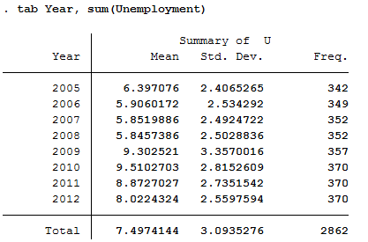

D. II. Control variables

Age

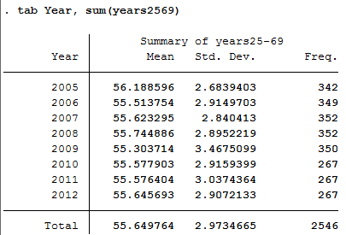

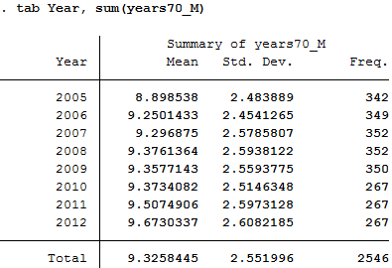

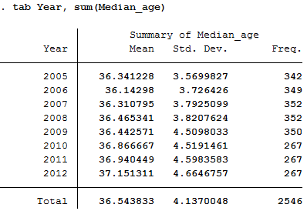

Gender

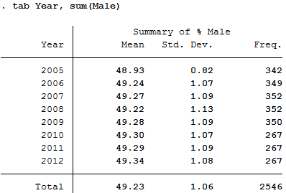

D. III. Health behaviors

Overweight

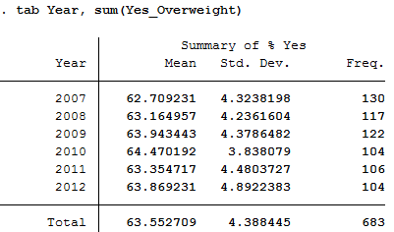

Exercise

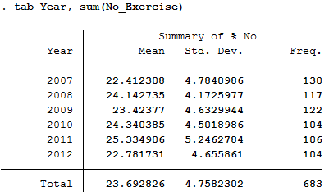

Alcohol

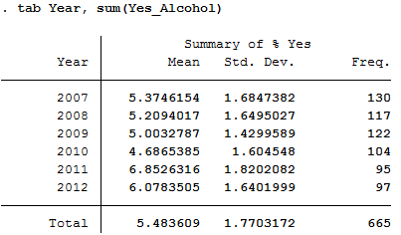

Tobacco

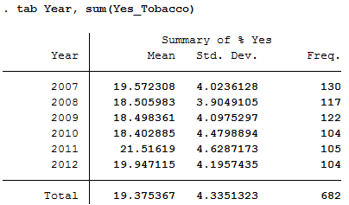

D. IV. Health outcomes

Myocardial infarction (MI)

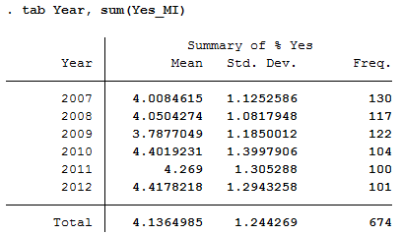

Self-assessed health

Poor
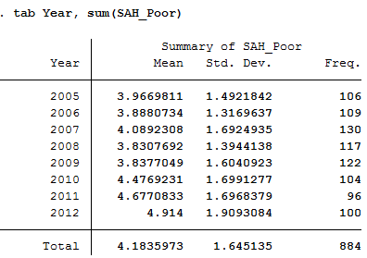

Fair
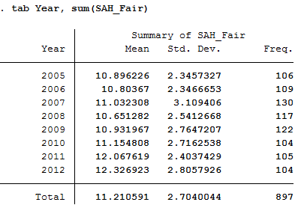

Good
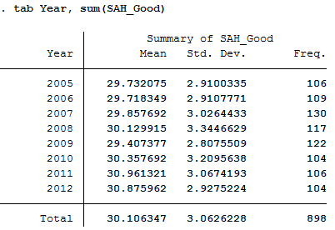

Very good
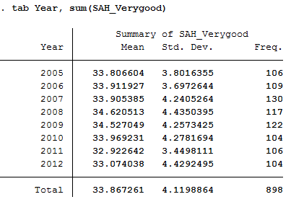

Excellent
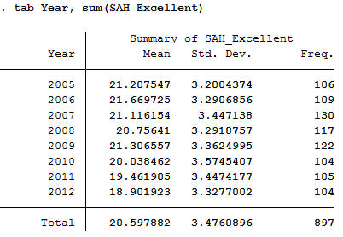

D. V. Fair and poor self-assessed health in Canada and the USA

Canada
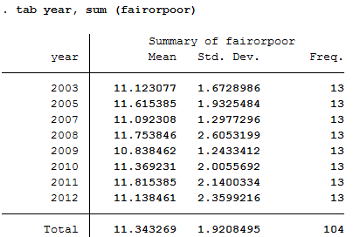

The USA
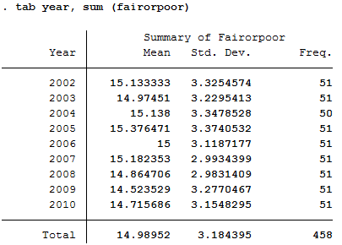

In this paper ‘the crisis’ refers to the economic crisis of 2008
The full dataset of the unemployment rate per MSA for the USA can be found at the following address: http://www.bls.gov/schedule/archives/metro_nr.htm
The full dataset of health for people in the USA can be found at the following address: http://www.cdc.gov/brfss/smart/smart_data.htm
The full dataset of age and gender in the USA can be found at the following address: http://factfinder.census.gov/faces/tableservices/jsf/pages/productview.xhtml?pid=ACS_13_1YR_S0101&prodType=table
The full dataset for self-reported health in Canada can be found at the following address: http://www5.statcan.gc.ca/cansim/a05?lang=eng&id=01050501
The full dataset for the self-reported health in the USA can be found at the following address: http://www.healthindicators.gov/Indicators/Fair-or-poor-health-adults-percent_5/Profile/Data
Notice the values of the y-axis
The other situations are (1) when the country is America for the years 2002 till 2007, (2) when the country is Canada for the years 2002 till 2007 and (3) when the country is Canada for the years 2008 till 2012.
From 2008 onwards
The trend of Canada

