
Urban, Port and Transport Economics
MASTER THESIS

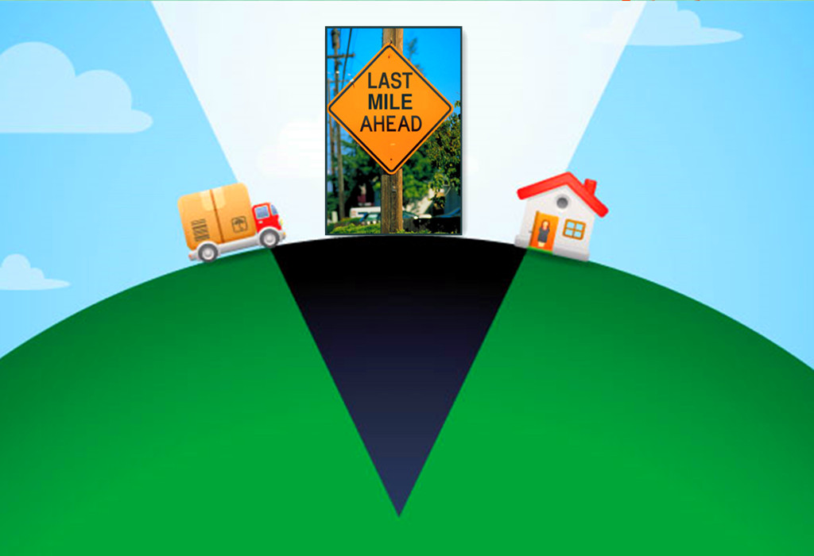
The last mile delivery in China
Adoption of last mile delivery modes by customers

Author: Zhuhe Huang
Student Number: 379263
Supervisor: Dr. Erwin van Tuijl
Date: July 2015

Preface
I am hereby gladly to present you my master thesis. This thesis is the final product for the completion for the master of Urban, Port and Transport Economics, a program at Erasmus School of Economics. During this final journey of my student life in Erasmus University Rotterdam, I have learnt quite some knowledge about last mile delivery and also had a lot fun. This thesis would not have been finished without certain people’s help; I would like to thank them here.
Firstly, my sincere thank goes to my thesis supervisor Dr. Erwin van Tuijl. He is such a great teacher who is always patient to his students and helps them with his academic expertise. Each time I handle in my thesis draft, he gives detailed comments and suggestions, challenging me to think on higher level. Besides, he has been so encouraging, which has influenced me positively along the research process.
I would like to thank my dear friends and everyone that were kindly to help me with the survey and interviews. It is your valuable contributions that added luster to my thesis. I may not know all of you, but I wish you all a happy life.
Last but definitely not the least; I give my deepest gratitude to my family. Dad and mom, you have always been so supportive ever since I was a child. You teach me to make my own decisions and take responsibilities; you encourage me to embrace life with enthusiasm, now I have grown to a person that I could never be if that is without your unconditional love. Grandma, bravest and kindest person I know, thank you for your love and devotion to this family, your optimism and persistence have and will always be the light of my life. Thanks to my better half for your positive distraction like always. Thanks to everyone in this family, I am so lucky to born and be raised with your love.
Two enjoyable years have passed very fast, I have learnt a lot during my study here in Rotterdam. And now it is time to roll up sleeves and actually carry the knowledge from black and white to real life. I will keep my mind open and build my own dream house.

July 2015
Zhuhe Huang

Abstract
E-commerce as the fruit of internet and commerce has been growing with a rapid speed in China these years. It has not only contributed to economy, but also has shaped people’s way of living, especially with the service of home delivery. Consumers enjoy the various choices of products with reasonable prices and the convenience of receiving parcels with a single click on the mouse. Meanwhile, the problem of not-at-home and repeated delivery have caused trouble for both consumers and logistic providers. Therefore, it takes a lot of cooperation and innovations to build this convenience, which we call ‘last mile delivery’.
This thesis is aiming at exploring the solutions to bottlenecks in last mile delivery in China under the background of growing popularity of e-commerce from the perspective of consumers. Since consumers’ needs are in the central of e-commerce and last mile delivery, thus to see how consumers adopt different modes in last mile delivery will give important direction and implication for logistics providers.
In the thesis, we first established a literature review of e-commerce, last mile delivery and how western countries (The UK, the Netherlands and Germany), with which we formulated a theoretical framework of exanimating last mile delivery. Followed with the theoretical framework, we conducted a desktop research of China using empirical findings and a case study of Chengdu, a western first-tiered Chinese city with the primary data generated from a survey and three individual interviews, and secondary data from published reports and news. Lastly, we compare the findings western countries and China, and the findings of Chengdu to China in general to give answers to research question.
Concluding it can be argued that, there is an increasing trend of using indirect modes in last mile delivery by consumers in China. These indirect last mile delivery modes have removed constrain of receiving parcel at home and have decreased the delivery failure in last mile delivery.

Keywords: last mile delivery; e-commerce; China

Table of content
Preface 1
Abstract 2
List of tables 5
List of figures 6
1. Introduction 7
1.1. Relevance 7
1.2. Research purpose and question 8
1.3. Data and Method 10
1.4. Thesis outline 11
2. Literature review 12
2.1. E-commerce 12
2.1.1. Definition of e-commerce and B2C 12
2.1.2. Online-shopping process 13
2.1.3. Strategic reasons for using third party logistics services 15
2.1.4. Conclusion 16
2.2. Last mile delivery 16
2.2.1. Overview of online shopping supply chain 16
2.2.2. Concept of last mile delivery 19
2.2.3. Bottlenecks in last mile delivery 21
2.2.4. Conclusion 22
2.3. Solutions to last mile delivery bottlenecks in western countries 23
2.3.1. Home access 24
2.3.2. Home reception box 24
2.3.3. Collection and delivery point 26
2.3.4. Conclusion 28
2.4. Summary and the theoretical framework 30
3. Methodology 32
3.1. Research approach 32
3.2. The case study of Chengdu 33
3.3. Data collection 34
3.4. Questionnaire design and collection 35
3.5. Interview design and collection 36
3.6. Summary 36
4. Current status of last mile delivery in China 38
4.1. Bottlenecks in last mile delivery 38
4.2. Solutions to last mile bottlenecks in China 40
4.3. Conclusion 42
5. The case study of Chengdu 45
5.1. Bottlenecks in last mile delivery 45
5.2. Circumstance in last mile delivery in Chengdu 49
5.3. Solutions to last mile delivery bottlenecks in Chengdu 50
5.4. Results from interviews 56
5.5. Conclusion 57
6. Discussion and conclusion 59
6.1. Comparison between western countries and China 59
6.2. Comparison between China and Chengdu 62
6.3. Conclusion 64
6.4. Implications for express company 65
6.5. Limitation and further research 67
Reference 68
Appendix A-Questionnaire design 74
Appendix B-Interview questions 78
Appendix C-Cross table 78

List of tables
Table 1, Key components of sales and delivery in e-fulfilment 19
Table 2, Characteristics of E-commerce Delivery 22
Table 3, Strengths and weakness of locker point and service point 27
Table 4, CDP companies in Germany, the UK and The Netherlands 28
Table 5, Comparison of intelligent lockers and service point 30
Table 6, Findings of last mile delivery in western countries 32
Table 7, Current delivery modes of last mile in China 43
Table 8, The current situation of last mile delivery in China 45
Table 9, The rate of important factors in last mile delivery 49
Table 10, The most urgent bottlenecks in last mile delivery 50
Table 11, The usage of last mile delivery modes 52
Table 12, Valuation of last mile delivery modes 53
Table 13, Benefits of using indirect last mile delivery modes 57
Table 14, Willingness to use last mile delivery modes in the future 57
Table 15, The current situation of last mile delivery in Chengdu 60
Table 16, Summary of last mile delivery in China and western countries 62
Table 17, Summary of last mile delivery in China and Chengdu 65

List of figures
Figure 1, Conceptual map of thesis 9
Figure 2, The descriptive model of online shopping process 12
Figure 3, Four stages in e-fulfilment 15
Figure 4, the transportation chain 17
Figure 5, Indirect last mile delivery modes 22
Figure 6, DHL Pack Station 27
Figure 7, Structure of data used in three parts of study 35
Figure 8, Parcels outside Minzu University of China, Beijing 38
Figure 9, Distribution of professions 44
Figure 10, Cross table of online shopping frequency and online shopping problems 45

- Introduction
  - Relevance
The annual rate of Chinese GDP has surpassed 10 percent in the past decades. And it is forecasted that China would turn to the second largest economy in the world within 20 years (The Economists, 2001). Nowadays, we are witnessing a new era, where e-commerce is booming. Until 2012, the market size of Chinese e-commerce has reached 7.85 trillion yuan, which shows a year-on-year growth rate of 30.83% and a weight of 15% in GDP (China E-government). When adopted under operation environment, e-commerce is mainly established through the models of Business-to-Business (B2B), Business-to-Customer (B2C) and Customer-to-Customer (C2C). In China, there is a rapid adoption of online purchasing, with the online retail sales accounting for 8.04% of total retail sales of consumer goods (100EC.CN). On the single day of 11th of November 2014, the transaction volume of Tmall, a well-known Chinese e-commerce company, ended up a total amount of 50 billion yuan due to the annual promotion (taobao.com).
E-commerce is embedded in IT technology and the Internet has shaped business with a new channel of distribution. The most obvious requirement with online purchasing is that the trade goods and services are tangible and need to be stored and transported to the final consumer (Fernie & McKinnon, 2009). According to Park and Regan (2004), the largest impact of e-commerce on logistics service is the increase in last mile delivery with smaller size shipment. The key issue of how to deliver the commodity to consumers in a reliable and solid way is therefore very important and it should not be neglected. Besides, the increase in the complexity of transactions and rise in the demand of speedy and accurate deliveries reinforced the need for quality logistics services.
In reality, over the past five years, China’s domestic express has increased by a CAGR (Compound Average Growth Rate) of 3.7% on the back of boom in e-commerce transactions. China has become the second largest express market in the world in 2013 with a total volume of about 9 billion packages handled and the total express industry revenue came to 144.2 billion yuan (Tang & Liu, 2014).
While the quantity seems large, the quality of delivery in China is still poor. There is a lag between the fast growing popularity of e-commerce and logistics service, especially in last mile delivery, which according to Roel et al. (2011), accounts for a high ratio of total operational cost, while the efficiency is the lowest. This lag is partly resulted from a trust worthy logistics industry has not yet been developed (Taniguchi & Thompson, 2013). And more importantly, the fact that last mile delivery is a process that deals with customers directly makes customers a crucial factor on the quality of last mile delivery. But duo to the varied situation of large amount of customers, there exist a lot of difficulties in achieving successful delivery. For example, no one is home, no permits for couriers to get into the named address.
On one hand, these problems lead to the failures on in-time delivery, which attribute additional cost to express companies. Lee& Whang (2001) also pointed out that the last mile delivery problem is more severe during the holidays or seasonal shopping periods, a considerable part of delivery cannot be done in time and service quality is lower than usual. On the other hand, because consumers are increasingly using the Internet to purchased products that were originally sourced through traditional retail outlets, product delivery issues have become more salient to consumers (Esper et al., 2003). And it is well recognized now that the effectiveness with which express companies are able to fulfill orders in online transactions is a significant determinant of customer satisfaction and retention (Shenton, 2002; Newton, 2000).
Thus we can say that customers play an essential role in last mile delivery, and how can these logistical problems be better solved has a significant meaning on not only winning customers satisfaction, but also equipping express company with competitive advantage.
  - Research purpose and question
There are quite a lot academic researches about the integration of e-commerce and last mile delivery problems.
Foresight (2000) and Browne (2001) have discussed that the collection-and delivery points (CDPs) as a solution for home delivery failure. Casey et al. (2014) highlighted the Vehicle Routing Problem, where the customers are not willing to pay the full cost caused by inefficiency of transport system. Xiao et al. (2013) made an empirical study on whether E-commerce companies should develop a self-built delivery system or outsource to third party express. Wang et al. (2014) conducted a mathematical cost analysis study on different models in last mile delivery and based on this revealed the operation efficiency of models in different scenarios. However, there are only a few consider about the last mile delivery problem from the perspective of customers, and according to Reynolds (2001), different countries and regions should choose the specific last mile delivery models that suit themselves best, so that high proficiency can be reached.
Combined with the argument about the importance of customers we settled before, the author thinks it might be interesting to conduct an exploratory research on last mile delivery problems from the view of customers in China under the background of growing popularity of online purchasing. This paper is aiming at presenting an in-depth picture of last mile delivery in China, trying to dig out the problems and providing sound suggestions for third party express company in offering required service of customers.
Followed by these statements, the main research question in this thesis is introduced:
- How are the Last-mile delivery modes adopted by consumers in the era of e-commerce in China?
To help concentrating on research question and gaining comprehensive knowledge about the issue, several sub questions are brought up to restrict the research:
- What is e-commerce?
First of all, it is important to have an idea about how is e-commerce defined.
- How is last mile delivery defined?
Secondly, the concept and common issues of last mile delivery is introduced along with online shopping supply chain.
- What are the modes to last mile delivery in western countries?
Thirdly, since logistics services in western countries have developed for way longer time than in China, it is useful to learn how they handle this problem.
- What is the current situation and main bottlenecks of last-mile delivery in China?
Fourthly, take our eyes back to China and present the picture of last mile delivery, including the problems and solutions that have been established.
- What are the existing solutions to last mile problem and how are they adopted by customers.
In the last stage, the existing modes in last mile delivery will be valued. To be more specific, a case study will be conducted, seeking to reveal how customers use these modes and give implication to express companies.
  - Data and Method
In implementing the research, the research strategy of case study will be employed to give solid answers to the main research question. The case study is focused on Chengdu, the largest city in the west of China. Primary data is collected through a survey of online shoppers and secondary data from literature, quality news and published data is included as well to serve strengthening the argument. Both qualitative and quantitative method will be used in this research to get insight of the data. Qualitative part contains the review of academic literatures, in-depth interviews and online news sources; quantitative part includes the analysis and interpretation of data obtained from the survey. All together sound answers to research question will be given step by step.

  - Thesis outline
Figure 1, Conceptual map of thesis

Figure 1 shows the basic conceptual map of this thesis. The first chapter is the overall introduction of thesis and contains relevance, the purpose and research question, data and method and outline of thesis. The second chapter is literature review, with building the theoretical framework, the sub questions of one to three will be answered here respectively. Chapter three explains the methodology used in detail. From chapter four, we take an eye on last mile delivery in China by examining current status of last mile delivery. In chapter five the case study is presented to show how the modes of last mile delivery are adopted by consumers. Chapter six includes the analysis part of results and sub question five will be answered by drawing the conclusion and implication for logistics providers.

- Literature review
This chapter provides the related theoretical knowledge of e-commerce business, last mile logistics service and findings of last mile development in western countries. The aim is to review the fundamental concepts and some up to date information which will be used as the basic conceptual line in further analysis. The chapter is divided into three components; firstly, introducing the definitions of e-commerce; secondly, giving concepts of last mile; lastly the solutions to last mile problems in western countries is presented. By filling up each component, the drawn sub questions one to three will be answered respectively, and the chapter will end with a theoretical framework, which will be used for further analysis.
  - E-commerce
The rapid growing technology of internet has permeated almost every aspects of our life. It is such a powerful tool that has shaped business since it provides unlimited opportunities and potions for both companies and customers (Markellou, Rigou & Sirmakessis, 2006). And this is how the concept of “electronic commerce” is quickly adopted in business transactions (Cho, et al., 2008).
    - Definition of e-commerce and B2C
There is not a standard definition of “e-commerce” since it varies in different context and is adjusted to match a certain circumstance (Ngai & Wat, 2003). While in a general way, e-commerce according to Kalakota & Whinston (1997), is recognized as the transmission of information products or services using computer networks or telephones from a communication perspective. In the same content, Tian & Stewart (2006) stated that e-commerce is the transaction of goods and services through electronic communications. Besides, the concept of e-commerce can be understood on other perspective given by Kalakota and Whinston (1997). From a business process perspective, it is the application of technology towards the automation of transactions and work flows; and from a service perspective, it is a tool that emphasizes on cutting cost while providing the speed and quality of service to satisfy the desire of firms, consumers and management.
E-commerce differs from traditional business in many ways, one of the most distinguished one is that e-commerce makes it much easier to reach global market for various kinds of goods and services with the flexible communication between producers, suppliers and customers (Egea & Menéndez, 2006). According to Delfmann et al. (2002), e-commerce can be taken up by almost every possible economic relationship such as B2B (business to business), B2C (business to customer), C2C (customer to customer). For the research purpose, we focus on B2C.
B2C is more popular than other types. It is a business model that companies sell products and services directly to consumers via electronic media, by eliminating the process in the middle, company can reduce the price and achieve great benefits (Anumba, 2002). Even though B2C is the most familiar category to consumers, it takes a small part of the total e-commerce market revenue for now, the dominate market share is taken up by B2B. Nevertheless, B2C is rapidly growing and will take a great share of e-commerce ultimately (Zheng, 2010).
    - Online-shopping process
As mentioned section 2.1.1, e-commerce is different from traditional business because of its nature of electronics, thus the way it operates is also distinguished from other type of business. A model of online shopping process was given by Chen and Chang (2003).

Figure 2, The descriptive model of online shopping process
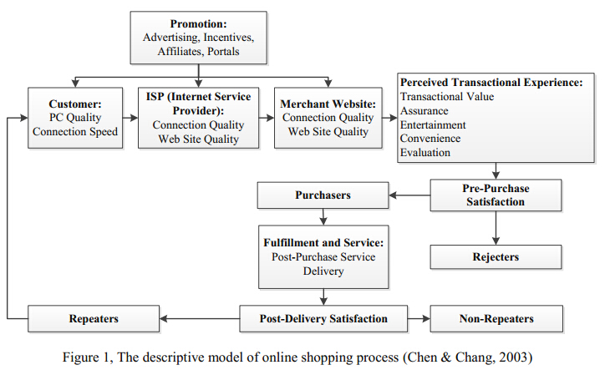
Sourcing: Chen & Chang, 2003
From figure 2 it can be seen that the strategies before per-purchase are focusing on how to market the brand and make potential customers become purchasers. Once the purchase is made, the order fulfilment has large impact on customer satisfaction, which decides whether customers will retain their loyalty or just quit.
Chen and Chang (2003) accomplished a survey and they showed that interviewees are concerned about the delivery schedule and options, the handling fees and return services. One transaction might be terminated because of failure on any one of these factors. It is determining of post-sales services and related support on quality of fulfillment component.
According to a report by Bughin et al. (2011), the reasons behind the ever increasing trend of online shopping is that value and convenience. Internet provides readily access for consumers to search and compare prices of products, together with the experience of visual and operational design of website during selection process; these elements compose the compound perception of product value, and this value decides how much consumers desire for this product. Until here, the online purchasing is only half way done. Not like traditional retailing, customers visit shops to purchase; online shopping makes it possible that product is delivered right to your house. Therefore, convenience means the speed and accuracy of product delivery, and the moment customer receives the parcel puts a period to the transaction (Whang, 2001). This service is very important because it determines whether the expected value can be perceived by customer, and customer puts trust in this process. Living up to the promise of efficient delivery will certainly add value to online shopping experience and it pushes the whole chain into a beneficial circle.
    - Strategic reasons for using third party logistics services
Duo to the importance and complexity of the post-sale service, namely logistics service, e-commerce companies usually outsource it to third part logistics provider. By outsourcing, companies gain competitive advantages. A literature overview of reasons for outsourcing logistics activities is provided by Wilding & Juriado (2004), and the reasons are mainly categorized in five parts, namely cost or revenue related, service related, operational flexibility related, business focus related and asset utilization related. While in fact, to be concise to the point, these five reasons can be summarized into two advantages that can be achieved by outsourcing logistics activities.
First one is cost reduction. This is the most important strategic reason for outsourcing according to Wilding & Juriado (2004). Logistics activities need sophisticated IT support, and third part logistics providers can offer expertise and most up to date software and hardware. Therefore, by outsourcing, companies can avoid high cost of operation and IT cost. A decrease of 10 to 50 percent in the cost can be achieved (Lacity & Hirscheim, 1995).
Second one refers to focus on core competences and gain flexibility. One of the most mentioned benefits for outsourcing is companies are allowed to better focus on its core competencies. Considering about business management, it is not worthwhile for a company to build its own logistics service system if the complexity of business is not high enough. What is more important is that it is normal that a person cannot master the knowledge in every business fields. By outsourcing, managers are able to draw concentration on the core competencies which they are good at while obtain guaranteed service from logistics expertise (Simchi-Levi et al., 2008).
Third party logistics service is estimated to bring the upgrade of company’s performance with respect to reduction in inventory levels, accuracy in order delivery, increase in customer satisfaction, etc. (Blanchard, 2008). As a result, e-commerce companies can improve efficiency and provide more flexible service with the help of third party logistics provider, which is economically beneficial for both parties.
    - Conclusion
To conclude, e-commerce is de facto a network connects enterprises and personal consumers by using the advanced IT technology. It focuses on electronic commercial activities including information and commodity exchange. It is a way of living that takes up a large part of everyday life nowadays, thanks to the internet, consumers can get access to a wide range of products and services online and purchase with a reasonable price. Companies can serve more customers with the help of logistics services, which is like a bridge between a simple click on the keyboard and a parcel right at your door. To make successful online business, a professional logistics service is fundamental in e-commerce, and they both should grow at a comparable step.
  - Last mile delivery
In this section, we are going to introduce the concept of last mile and the main issue in last mile delivery.
    - Overview of online shopping supply chain
To shed light on last mile delivery, we first take a look at the overall online purchasing supply chain. In the paper of Agatz, Fleischmann and Nunen (2008), a concept of “e-fulfilment” from a perspective of supply chain is come forward, contrasting and supporting general online shopping process.

Figure 3, Four stages in e-fulfilment

Sourcing: Agatz, Fleischmann and Nunen, 2008
The term e-fulfilment donates the collection of the four stages as shown in figure 3. And each stage is explained from the perspective of retail.
- Purchasing: is the domination of all supply process, namely ordering of final products;
- Warehousing: concerns about storage and handling function, it might be shifted to an upstream party depending on the supply chain’s decoupling point;
- Delivery: deals with the physical move of product to customer;
- Sales: denotes all process related to customer demand, such as pricing, forecasting.
This structure emphasizes on the physical distribution of products in B2C e-commerce, it differs from B2B e-commerce, where the exchange of information is the focus, it also differs from the traditional retail supply chain including long-term program planning, medium-term pricing and short-term order promising, because now delivery is part of the offering (Agatz et al., 2008). Features of these tasks as shown in figure 3 may change in E-fulfillment process and the key planning issues may arise. For example, in-store pick up are combined with home delivery to deal with problems in deliver service design. Companies need to maintain a high level of transportation capability while operating at a corresponding price. These activities all need the cooperation of multi channels in supply chain.

Table 1, Key components of sales and delivery in e-fulfilment
Planning task | E-fulfillment
Delivery service design | Last-mile service, delivery time window, return options
Forecasting and pricing | Delivery fees, dynamic pricing, Cross-selling
Order promising and revenue management | Delivery yield management, cost and revenue
Transportation planning | Routing for home delivery, dynamic routing
Sourcing: Agatz, Fleischmann and Nunen, 2008
While e-commerce provides rich opportunities, how to cooperate multi channels confronts complexities and difficulties. Most of the value of e-commerce comes from providing products in the long run (Brynjolfasson et al, 2003). Thus, when adapting to e-commerce, balancing multiple channels provides more competitive advantages to companies (Wallance et al, 2004).
Agatz et al, (2008) also mentioned that now the e-commerce is witnessing a shift from customers buying stand-alone physical products to customers seeking total solution, meaning a bundle of physical product and related services. To deliver products up to the promises accounts for a large part of service valuation. Thus in the online shopping supply chain, delivery is of key importance. In table 1 we can see that there are mainly four aspects of delivery and sales planning, challenges arise in each component. In this study we focus on last mile delivery, which belongs to delivery service design, the crucial part of the entire delivery arrangement. Moreover, as the option of customization has made customer a “co-maker” of the product, companies have to be able to tailor their serving process to satisfy customers’ needs. The fact that customer is gaining significant influence on company process has, from another side proved that it is of great meaning to manage multi channels effectively and highlight the delivery service will keep a company at high operation capability.
It is not the scope of this paper to cover all the channels in online shopping supply chain, we will focus on the last mile delivery according to the research purpose, however it can be invalid and incomplete without sketching the whole picture of online shopping supply chain, where the delivery problems embedded in.

    - Concept of last mile delivery

Now that the concept of online shopping supply chain has been introduced, we zoom in to delivery part. In the paper of Inaugural Lecture of Van Woensel (2012), he separated the delivery channel of e-commerce into three parts.
Figure 4, the transportation chain
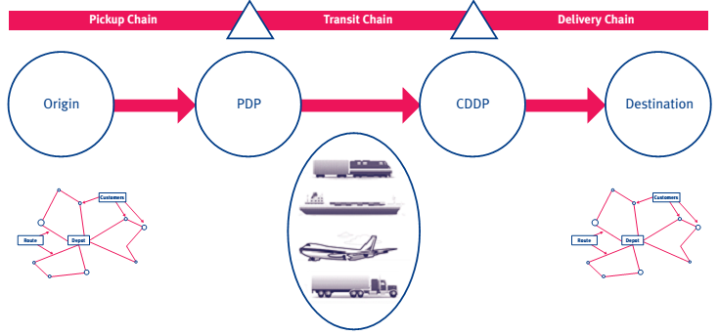
Sourcing: Van Woensel, 2012
As presented in figure 4, the forward transport chain is divided into three parts. The collection point varies between different parts. Pickup Chain equals to the first stage of order fulfilment, which is responsible for assorting the products from (nearest) warehouse and sending to Pick-up Decoupling Point (PDP). Transit Chain is network of transport and the link of POP and CDDP (Customer Delivery Decoupling Point) however not necessarily all the products are needed to go through the network path (same city delivery). And Delivery Chain, the last mile delivery, meaning handling the product to the final customer. It is the only stage that has direct contact with customers and accounts for high cost duo to its complexity, therefore last mile delivery is the leading factor in the structure of the transport chain and drives the efficiency of the whole transport chain.
A summarized definition of last mile is given by Wohlrab et al., (2012, p.8):
‘Last mile logistics is the last part of a B2C delivery process. It takes place within a predefined delivery area (e.g. urban area); including the upstream logistics to the last transit point until the destination point of the parcel. It involves a series of activities and processes, of critical value to all the involved stakeholders (e.g. Customer, Industry and Institution) within the delivery area’.
Lindner, (2011) also named that last mile delivery is the final stage of a delivery service, which consists of several activities and procedures that are essential from the distribution center to the final receiver. Punakivi et al., (2001) argued that it is a logistics problem which deals with the trade-offs between routing efficiency and customer convenience. Donegan, (2000) from another view, pointed out that human force is a key performance pf last mile delivery, as a courier who brings the product to the door is the only person that a consumer would meet during the online shopping service. An online shopping experience could be easily influenced by a poor deliver experience. Bromage (2001) considered last mile as the most important component of the order fulfillment process, since on-time delivery is evaluated in high importance by 89% of online consumers.
It is noticeable that today e-commerce, especially B2C model has shaped last mile delivery because of its own characteristics. From table 2 we can tell the contrast of traditional delivery and the delivery in e-commerce, products delivery in e-commerce evidentially has higher requirement in each aspect.

Table 2, Characteristics of e-commerce Delivery
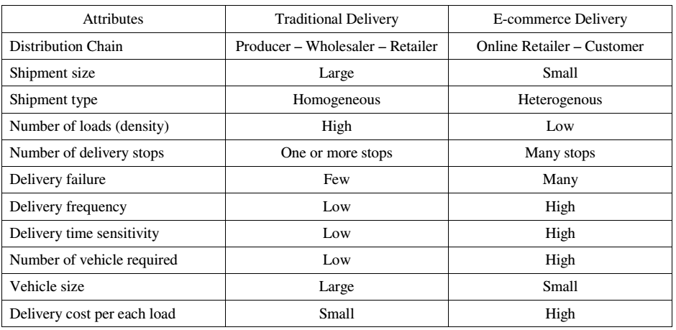 Sourcing: Park and Regan, 2004
The large variety of products results to different shipment size; mostly they are smaller than those in traditional delivery. Moreover, because now the final destination of delivery is widespread customers instead of comparably fixed retailers, the shipment frequency is very high, and the distribution of parcels becomes complicated and intense. Parcels are required to be delivered within a specific time, thus customers have a higher expectation of speed. In a word, the volume of delivery is increasing duo to the disappearing effect of bundling, the delivery is becoming more customized and time-specific but at the same time, the rate of delivery failure is higher than in traditional delivery.
    - Bottlenecks in last mile delivery
Although nowadays last mile delivery is highly appreciated by online shopping consumers, there are issues existing in this service, and these issues consequently result in low efficiency and dissatisfaction of services.
Visser et al., (2014) pointed out the issues from the point of view of consumer and carriers. For consumers, the main issues are not on-time; not at home or forced to stay at home; high delivery charge and long delivery time. From the view of carriers, they claimed additional cost for repeated delivery; 12% of delivery has to be done a second time (UK, 2010) and non-deliverables (around 2%).
Park and Regan (2004) have concluded that the major factor that affects the successful home delivery operation is ‘not-at-home’ problem. Most home delivery services inform the consumer a time range on a day that the products will be delivered, but it is this time that most of people are at work or outside. For parcels that fit the mailbox this does not seem to be problem, while for most parcels that do not fit, this means a delivery failure. As a result reported in an investigation, 30% of small packages dispatched to customer homes fail to be delivered at first time (Fernie & Mckinnon, 2004). This long empty window period lead to poor customer services and logistics inefficiencies.
There are cases as foods home delivery, where online retailers and consumers can make a prior arrangement for a time window of delivery, even this may not guarantee, by the time of delivery, that customer will be at home. And this is not the normal model for most last mile deliver, because such pre-arrangement would increase the inflexibility of carriers’ fleet operation, bringing about a very high cost for both retailers and logistics providers (Cairns, 1996).
    - Conclusion
Under the background of e-commerce, a new channel of distribution is settled up. The development of this new channel has led to some new challenges for logistics service provider. Of these challenges, last mile delivery is the most crucial one; it refers to a delivery stage that reaches the final customer. Last mile delivery accounts around 50 percent of the total cost of one delivered parcel yet the efficiency is low. Often the failure is caused when no one is not at home to receive parcel duo to some external factors. So, the alternatives other than direct home delivery are urgent to be applied. Besides, customer, plays a central role in the online shopping supply chain from the ‘first click’ to ‘last mile’, there preferences and requirements have largely shaped the delivery service to an extent where they should perform up customer’s expectation, otherwise the evaluation of value received in online shopping will be ‘discounted’. Thus we say that the performance of delivery affects customers’ perception of online shopping experiences. We should understand the key role of last mile delivery in e-commerce value chain and that the problems in last mile delivery should be solved in a way that integrated with customers’ needs.
  - Solutions to last mile delivery bottlenecks in western countries
To deal with the general issues arise in last mile delivery we have discussed, and to release customers from tight time windows, during which they have to stay at home to receive parcels, some alternatives to direct home delivery is developed in western countries. Here by saying western countries, we mainly mean The UK, The Netherlands and Germany. It is not realistic to cover all western countries in this study, so we pick these three countries that are very representative of last mile delivery development. Mckinnon and Tallam (2003) have verified these different modes used in UK from the angle of the risk of theft of parcels, but we can also categorize these modes into indirect delivery modes in last mile (see figure 5). The indirect deliver modes consists mainly of home access system, reception box and collection and delivery point, we will elaborate more on these different mode in the following.
Figure 5, Indirect last mile delivery modes Sourcing: McKinnon and Tallam, 2003

    - Home access
A prototype family visit system is employed in English Midlands. The system adopts the telephone-linked electronic keypad, which is in control of opening and closing of garage door. The key pad communicates with the central server, allowing the ‘home access agency to change of pin code right after each delivery. And the key pad equipment generates another code to confirm the accomplishment of delivery once the driver shuts the door. In the meanwhile, a confirmation message will be sent to customer's phone or E-mail address (Mckinnon and Tallam , 2003).
It is found that this system can reduce the average drop time from 10 to 4 minutes, achieving a productivity level (to achieve A week drops) of 84% higher than a typical attendance per car Delivery operation under the condition of a four-hour time window (Rowlands, 2001). Despite the advantages of these operations, this system was terminated in Midlands. Since then two other access System has been launched in the UK, one involved pin number - activated that release a physical door from a safe box, the other one is integrated into the lock. In both systems, carrier is accessible either to the home or outbuilding (Rowlands, 2007). So far there is limited use to these systems and the main concern is the risk of home security and the problem of stealing parcels by later carriers.
    - Home reception box
Fixed, integral and external boxes
The fixed internal boxes are original type that is built in some high-end house in the United Kingdom. The system is made up for ambient, chilled products and provides direct access into the kitchen. And it works the same as home access system, the door is open and shut by a constantly pin changing keypad. These boxes are well designed for long term use and security, however the adoption seems very low since few examples can be found for the transformation of these boxes to fit in common neighborhood (Fernie, 2009). In short/medium, an acceptance of external box is observed. The house structure does not need to be modified to install these boxes, making the costs much cheaper than internal ones (Rowlands, 2006).
Mobile reception boxes
Clearly, mobile reception boxes emphasis on ‘mobility’. They are filled up by the supplier in its premise, then delivered to the customer's home and secured to the wall. This type of box employs a technology system that has been operated many years in UK, steel cable is used as a tool to connect the box to an electronic device that resembles an intercom. Once box is empty, it is repossessed by suppliers or carriers for any return items. These boxes are unlike home external reception boxes that mainly cater non-food, they are large enough to restore a week’s food for a family, and thus it is more fit to online grocery shopping. But these boxes seem not commercially feasible in the UK B2C market after a trial with a major UK supermarket chain (McKinnon and Tallam, 2003).
Communal reception boxes
The boxes described above are obviously not suitable for apartment blocks. Communal reception boxes consisting of banks of lockers are developed. They adopt the luggage locker technology that has been widely used in high dense population locations like railway and airports. A special console is designed attached to the locker, bounding a control center that issues pin code for carriers and customers to fetch delivered goods. Three locker banks of this type are being trailed in UK (in hospital, railway station and business park). No locker banks are installed in residential complexes (McKinnon and Tallam, 2003).
To conclude, we see that duo to the reasons of safety, convenience and cost, the promotion of home access and home reception box is not as successful as expected. The payback period of investment on providing reception boxes by logistics provider increases with the comparable growth of customer in the same area, making the payback time too long from the perspective of providers (Punakivi et al., 2001). These defects weaken the convenience of home shopping with additional costs and risks, besides also deducts possibility of wide adoption of such new alternatives for consumers.
    - Collection and delivery point
A collection-and-delivery point (CDP) is place that has a different address from the residence of consumers. It can be close to the residence and customers can pick up and return online purchases. Someone may argue that in this way, the convenience of home shopping is deducted since you have to pick the parcel up yourself. But the inconvenience can be solved by customer choosing a collection point that during the trip they already make, a “trip chaining” as explained by Weltevreden (2008).
There are two types of CDPs: locker points (unattended) are basically a bank of intelligent lockers where customers can collect and return parcels; and service points (attended) is a concept of shop-in-shop, of which the parcel is sent to a store, post office or petrol station where customers can pick up as well. Both have their own pros and cons as shown in the study of Weltevreden (2007a).
Table 3, Strengths and weakness of locker point and service point
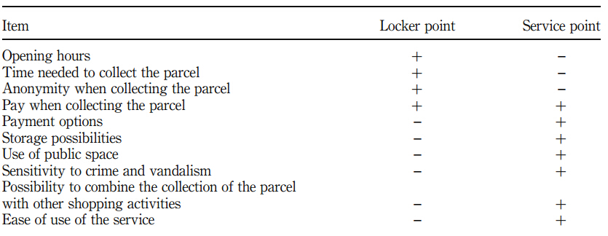 Sourcing: Weltevreden, 2007a
It is apparent that service point is more time-sensitive because it integrated with human collaboration, while locker point has less time constrain. Besides this, service points seem to have more advantages than locker points. According to Weltevreden (2008), service points are more flexible to receive any size of parcel and store personnel are helpful to assist customers that are not familiar with locker machine operations (for example old people); moreover service point allow customers to combine the parcel collection with shopping, as most service points are located in stores. This way around ensures that stores are always willing to handle the parcel service because it yields extra profit (Foresight, 2000).
Table 4, CDP companies in Germany, the UK and The Netherlands
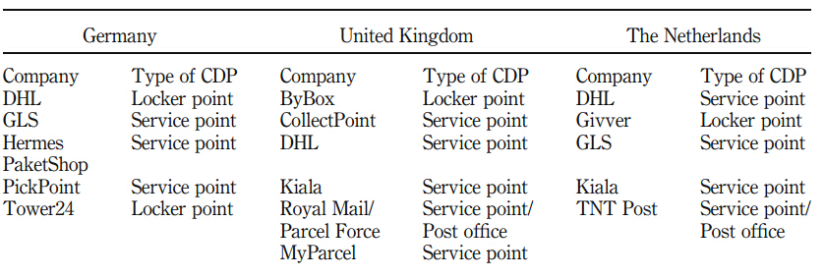 Sourcing: Esser and Kurte 2007; Rowlands, 2006) Weltevreden, 2007a
After 2000, there is a trend of establishing networks of CDP in European countries for B2C market. Policy makers of logistic companies are aware of using CDP as a means to decrease the freight transport in online shopping since it saves the additional costs of second or third time delivery. In table 4 we can see the main adoptions of CDP in Germany, the UK and The Netherlands, and it is within expectations that service points are the most common form given the strengths and weaknesses above. McLeod et al. (2006) studied customers’ attitude of 790 households in Winchester in the UK regarding the service point. The result showed that 83% of respondents were in favor of the idea of service points instead of carrier’s depots. And in France, 20% of online shopping are shipped to service points other than home, it has become a well-established modes that has a nationwide network covering urban, suburbs and rural areas (Morganti et al., 2014).
CDP companies need sufficient resources to build the network that is large enough to attract the customers, but unfortunately not all the companies listed above are successful. Locker point companies Tower24 and Givver only obtain a prototype of their service (Esser and Kurte, 2007). The UK Company CollectPoint was shut down in 2007 and bought by Redpack, and Redpack is making use of the network of ColletPoint as a channel mainly in B2B market (RedPack, 2007).
Nevertheless, this does not mean that locker points have faded away from being an attractive option. DHL has placed over2500 Pack Station (see figure 6) since 2000, and most of them are in Germany. Furthermore, Esser and Kurte (2007) argued that more than 25,000 registered customers have used the 33 locker points of DHL in the Cologne region. DHL claimed that 90% of the German population is within 10 minutes of a packing station (DHL, 2009). And there were 8.8 million parcels delivered in Germany in 2011, apart from 51% were direct home delivery, 23% were done at service point and 18% were picked up at Pack Station, the rest 8% is others.
Figure 6, DHL Pack Station
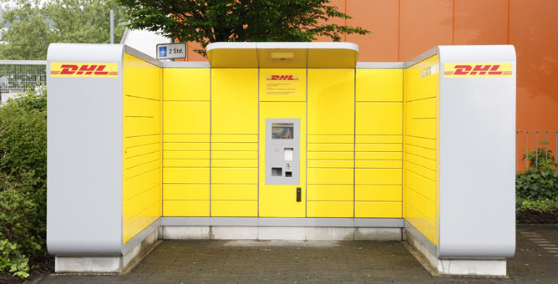
    - Conclusion
In this section we have discussed the main modes that are used in last mile delivery in western countries in order to deal with the problem of failure on direct home delivery. The reason why home access and reception box are not so successful is the relatively high cost for installation and concerns for safety. In some countries like Belgium, there is experiment of using car trunk as a drop-off point going on, but whether this will be successful is still left to a question mark. Besides, considering about the theft risk, large difficulty seems exist in promoting it to wide use. From the data available we see that intelligent lockers and service point right now are the most popular ones. The adoption of intelligent lockers and service points decrease the risk of delivery failure and related costs and ease the pressure on transportation. To emphasis on these alternatives and give a review of the main components, we made a table of summary including the advantages and disadvantages of these modes (see table 5).
Table 5, Comparison of intelligent lockers and service point
Service Type | Locations | Examples | Advantages | Disadvantages
Home access/reception box | - House garage  - House kitchen  - Neighborhood sidewalks | - Some high-end neighbors in UK  - Homeport  - Bybox | - Reduce average drop time  - Storage function | - Risk of home security  - High cost  - Risk of theft
Inteligent Locker | - Transport nodes  - Work places with dense employees  - Neighborhoods | - DHL Packstation  - E-box  - Tower24 | - 24/7 self-service  - Parcels are secured  - Real-time info  - No labor cost  - Optional payment  - Return of parcel | - Long time for location designing  - Parcel size limitation
Service Point | - Convenient stores  - Patrol stations  - Tobacco shops  - Supermarket | - Kiala  - GSL  - Coles delivery  - Paketshops | - Use of public resource  - Additional service provided  - Business growth for shop owners  - Return of parcel | - Time limitation  - Labor cost

Although direct home delivery reflects the spirit of convenience and conciseness of online shopping, remaining as the primary choice of customers, the uncertainty in time ranges from order making to parcel delivering weakens the effectiveness of last mile delivery (Edwards et al., 2010). Consolidating deliveries to CDP gives express company the benefits of higher successful first-time deliveries; optimizing delivery rounds and lowering operational costs (Morganti et al., 2014), but we should also know that such success is under some certain conditions.
All these western countries (Germany, the UK, The Netherlands) have been engaged in developing e-commerce for a comparably long time and are highly advanced in economy with complete and well-established infrastructures in both transport and ICT system, which are decisive for planning deliveries in express industry; besides, the density of population, for example, in Germany is low but the ownership of private cars is high, people would accept a self-pickup as long as it is within certain driving distance, which leaves a relatively loose standards for DHL when designing the network; furthermore all citizens are registered at city hall with home address and ID, meaning that your parcel is traceable even if it is delivered to one of neighbors, thus the risk of theft is avoid to a large extent. All these circumstances are precedent to making alternatives like CDP in last mile feasible options, but whether this is the same situation in China is yet another story to tell, and we will look into that in next chapter.
  - Summary and the theoretical framework
To wrap up, in previous chapters, we have looked through some important and relevant concepts from e-commerce to last mile delivery, the models used to solve last mile delivery problem in western countries are introduced and the sub questions one to three are answered in the end of each section. We can now say that e-commerce and last mile delivery are intra-related and are mutually affected by the development of each other, and customers play a central role this online purchasing process.
To highlight the main findings, we include the most crucial elements in a table (see table 6). The function of this table is the basic theoretical framework for further research and analysis in coming chapters. The framework is made up of three components, namely bottlenecks, solutions and circumstance in last mile delivery, which are generated from literature review. It is with these three important indicators that we will use as guideline to examine and to compare situation of last mile delivery in western countries, China and Chengdu in chapter four, but before that we will firstly make some detailed explanation of method used in this study in Chapter three.
Table 6, Findings of last mile delivery in western countries
 | Western Countries
Bottlenecks in last mile | - Not-at-home problem  - Long time window  - Repeated delivery
Circumstance | - munificent technical force  - Long time of internet development  - solid economic foundation
Solutions to last mile delivery problem | - Home access/ reception box  - Service Point  - Intelligent lockers
Effectiveness | - CDP is a widely used mode now and very successful

- Methodology
This chapter is aiming at describing and explaining the research method employed in this thesis.
  - Research approach
The widely used research purposes are categorized into three types: descriptive, explanatory and exploratory. In order to implement the research purpose, we defined research approach adopted in this study as explorative case study research.
Exploratory research, as the name shows, is designed to explore a problem that has not been extensively studied before, and thus gives fresh insights from different perspectives, simply to say, exploratory research is about ‘what is going on’(Robson, 2002). Sandhusen (2000) pointed out that exploratory study is different from conclusive study since it generates a range of causes and alternatives for a solution to a certain problem. Moreover, exploratory research is flexible and adaptable to a large extent. The directions can be shifted according to the collected information and data during process, and new knowledge can be developed (Saunders et al., 2007). An exploratory study may have less rigorous methodology compared to other types of study and the sample size maybe smaller, but it helps providing the initiatives and possibilities for further study and major decisions (Nargundkar, 2003, p.41).
The reason of choosing explorative research we have stated in first chapter, with an eye on the fast growth rate of both e-commerce and express industry, this thesis aims at studying the customers’ current adoption of last mile delivery modes in China. There are plenteous studies on either e-commerce logistics or last mile delivery problem, however only a few of these studies are carried out from a customer-oriented focus, therefore the author concludes that there is possibility that new discovery and knowledge can be gained on this topic.
Furthermore, in order to give a more specific and accurate answer to research question, the strategy of case study is chosen to blend in the research approach. Yin (2013) stated that case study is more suitable for study with “how” and “why” question of contemporary social phenomenon.
Regarding the key objective in this study is to shed light on how last mile delivery modes are adopted by consumers in China, and the fact that China is too large a country that one cannot do a study that covers all cities in China with limited time and fund, we will conduct a desktop research of China in general and then make a case study of the largest city in western China is accessible and it gives in-depth analysis rather than general results.
  - The case study of Chengdu
Chengdu is the capital city of Sichuan province and hub of economy, business, logistics and education in south-western China. According to Sichuan Province Department of Commerce, the total amount of online retailing is over 180 billion Yuan. Online purchasing accounts for 51.2% of the total on-line commerce applicant activities for Chengdu citizens, a rate of 8.3% higher than the average level in China and is almost even to mega cities like Beijing and Shanghai, which are 54% and 56% respectively (Chengdu Internet Development Report, 2012). According to the official record of Taobao in the sales report of “Double Eleven” shows that, two districts in Chengdu climbs to the top three ranks regarding the average expenditure of online shopping in nationwide.
These figures have shown that people here share a large interest in online purchasing. Furthermore, though Chengdu is a city that is developing with each passing day, it is still a city in western of China, where less attention has been paid to when compared to Eastern of China. Combining these reason, this study chooses Chengdu the study area to take a closer look at how last mile delivery modes are adopted here by customers.

  - Data collection
There are mainly two ways of collecting and studying research information and data, namely qualitative and quantitative method. In order to complete the research purpose of this thesis, both methods are chosen to get insight of how customers adopting alternatives in last mile delivery in China. The quantitative method, according to Bryman (1984), primarily focuses on making the features classified and countable, and using statistical methods to explain the observed facts. While qualitative method describes in greater depth of social situation without directly using numbers (Baxter & Jack, 2008), usually they are generated from various resources, one should be careful when collecting these data, because the overwhelming amount of data that required organizing and analyzing can result to “lost” in the data.
Both the desktop research of China and the case study of Chengdu are analyzed by filling the three components of our theoretical framework. The data used for desktop research of China is mainly from secondary data. The case study of Chengdu is based on primary data, which contains a survey and three individual interviews and secondary data, where data for “bottlenecks” and “solutions” are from the data collected by questionnaire while data for “circumstance” is more from secondary data.
Primary data
A survey is defined, regards to William and Barry (2007, p. 188) as a way of collecting data through a set of well-designed questions with a representative sample of individuals. And the answers are expected to sketch one certain targeted activity. Therefore, a questionnaire is designed in this study to collect the primary data. And duo to the limited time and funds, online survey is chosen as the tool to complete the survey for its conveniences to get participates involved in a short period of time.
In addition, since this is an explorative study, we also include three individual interviews to detail consumers’ adoption of last mile delivery in Chengdu. The interviews are aiming to explore the detail information about consumers’ behaviors, which will provide supplementary context to survey result and draw a complete picture of the adoptions of last mile delivery.
Secondary data
Besides the primary data, this study also takes some other data into consideration. The secondary data contains the location of the service points of different express companies and from the website of express company itself in Chengdu. Moreover, duo to the fact that the last mile problem is refreshing on a very fast rate for the close relationship with expanding internet popularity, the qualified up-to-date news are also part of the important data that will be included. These secondary data complements the primary data, by combining various empirical materials we hope to build a valid and trustworthy study.
  - Questionnaire design and collection
It is the aim of the questionnaire to collect the first hand data to server the analysis of current situation of last mile delivery in Chengdu. The questionnaire is broken down to three parts according to the theoretical framework. In the first part of the questionnaire, the general information of the respondents will be presented. The second part gathers the online shopping experience of respondents is obtained. In this part we investigate how long have they been using online shopping and what kind of problems have they met during online shopping. In the third part, opinions of customers’ perception of logistics service and the experience of which modes consumers use to receive their parcel are asked. We will examine which modes have they used, why they choose to these modes and what are their perceptions and feedbacks about these last mile delivery modes.
The questionnaire is initially designed in English and considering about the practicability we translate the questionnaire into Chinses. The web site Sojump, the largest online survey website with variety of survey software package, is chosen as the questionnaire platform. The questionnaire is sent out to citizens that live in Chengdu via E-mails and Wechat. Firstly the author sends the questionnaire to her friends and alumni who live in Chengdu, from them the questionnaire is spread out to their families, friends and colleagues who also live in Chengdu as well. Meanwhile, to increase the variety of the sample, the author asks her parents to send out the questionnaire to their friends and colleagues in Chengdu as well. In this way, the respondents of questionnaire are collected by snowball effect. The original number of the people that the author sent the questionnaire to is 28, and it is estimated that on average each person can collect at least 10 respondents, in this way the sample size is expected to be from 25o to 300.
The collection of respondents stated on 4th July and finished on 7th July with 303 submitted answer sheets in total, after review, eight respondents were uncompleted, so the final valid respondents were 295 in total. 96.27% of the respondents were submitted through Wechat, and only 3.73% were via E-mails.
  - Interview design and collection
The three in-depth interviews were conducted after complement of survey. In order to obtain the representativeness and variety of respondents, we have chosen three interviewees that are from different professions among all the respondents. Two of them are in the age of 20-30 years old and one is 30-40 years old. The questions asked during interview were mainly to get insight of the reasons behind their choices in the survey, meaning there were mostly “why” question and open-minded question.
The interviews were started on 16th July and finished on 17th July. And the interviews were conducted by video calls through Wechat; the entire dialogues were recorded for reviewing. The average lengths of video calls were 30 minutes. All results are in Chinese and translated by the author to English. These data are used to elaborate on the answers given in the survey.

  - Summary
In this chapter we have presented the research approach in the thesis, which defined as explorative case study research, where the desktop research of China and case study of Chengdu is combined. There are several of data used in this thesis, we have made a path to indicate the data and resources used in three parts (see figure 7), namely western countries, China and Chengdu. In complementing the research, we follow the basic theoretical framework generated from chapter two and apply it to China and Chengdu; data are collected from different resources and we will make analysis of these data by filling them into the three primary components in the framework. In the coming chapters, we will see whether there are some other stories to be told in China regarding to last mile delivery, and then continue to case study of Chengdu.
Figure 7, Structure of data used in three parts of study

- Current status of last mile delivery in China
Apart from the issues like ‘long time window’ and ‘not at home’ in last mile delivery, there are some systematic bottlenecks in China that has trapped express industry from further development. Currently in China, direct home deliver is adopted in almost all B2C commerce, resulting to a sharp increase in express business volume. To give a more intuitive idea, we can access the data of the performance of express industry from China Post. The transaction volume of packages handled in 2013 was 9.2 billion, showing a year-on-year growth rate of 61.6%. It has tripled from 2006 to 2013 with an annual growth rate of 36%. Faced with such a huge market, the lately-developing express industry seems not sufficient enough to satisfy the market demands, leading to a disproportionate situation between e-commerce and last mile delivery.
  - Bottlenecks in last mile delivery
- Express companies
By now, 10 top express companies: EMS, SF, STO, YT, ZTO, Yunda, Tiantian, HTKY, ZJS and CCES dominate the market with 87% of overall business volume in China. Apart from them, there are so many other smaller express companies competing to get a piece of cake. However, lacking of systematic knowledge and regulatory operations in most Chinese express companies has caused many scandals under the eager to exploit profits without taking company’s capability and customers’ requirements into account.
In the report of Goh et al. (2011), some major express companies are separated into two groups: companies with large networks and small networks. The former ones have nationwide networks but do not provide complex service like scheduled returns, exchanges or collect on delivery (COD). And most of them are franchised and sub-contracted structured, exposing risks of services and financial performance. Shunfeng is one exception; it has more than 2,000 fully-owned high quality services locations and lead in the express market, but the charges is slightly higher that others; government-owned EMS has the largest network with more than 20,000 locations, but the speed and service are incredibly low. The smaller network companies are mostly competing on a regional level but they offer customized services on B2C market. Foreign express companies take only a small part of overall market share.
- Low efficiency delivery
Duo the fact that trucks are not allowed in the city because of the overwhelming traffic jams and pollution problems, and the regulations that some type of vans are not allowed to transport goods, the option left to express companies are mainly electric tricycle which has a fairly large capacity to transport parcels, but sometimes they also get caught and fined by policy for illegal conversions of tricycle, leading to delay of delivery and huge operational cost to express company.
Moreover, in order to implement property management in neighborhoods and communities of high density of residents, carriers usually are not allowed to go inside residence buildings to distribute the parcels to every customer considering about the safety reasons. Same situation happens when it comes to universities, since in China, it is mandatory for university students to live in student housing in campus. As a result, carriers can only wait outside for customers to pick the parcel, sometimes when there is a large amount of parcel and more than one express company is making the delivery, it becomes a chaos where everyone is searching for their own in piles of parcels (see figure 8). As for people who are not able to pick up, the parcel will be delivered again or they are asked to fetch the parcel at company branch themselves (Zhang et al., 2013).

Figure 8, Parcels outside Minzu University of China, Beijing
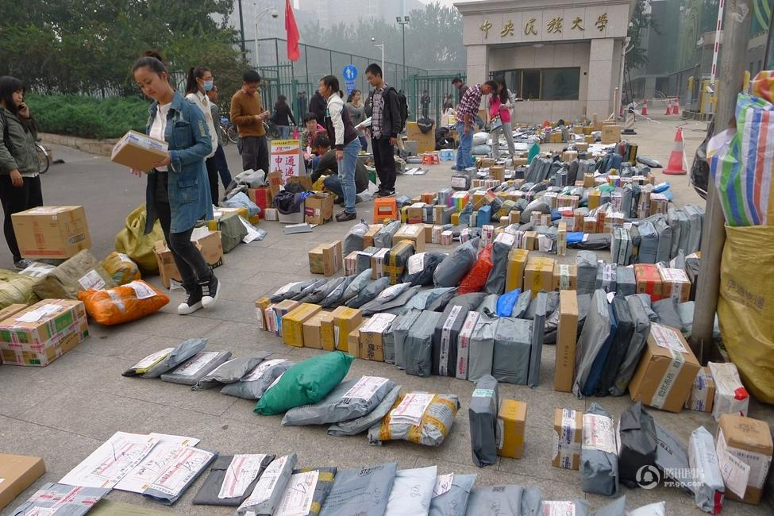
Sourcing: Tencent News
Let alone these unorganized and unpleasant pickup points, the risk of damaging and theft of parcels come along with extensive deliveries are issues that affects the final drop as well. And all these problems have chain effect on last mile delivery, leading to not-on-time delivery and additional deliveries.
  - Solutions to last mile bottlenecks in China
E-commerce has developed late in China and most of the express companies started up in 1990s, so there are not so many valuable studies about last mile delivery and nearly no literature relates to this issue before 2007.
Zhang (2012) brought up a suggestion of 24-hour community service on the analysis of difference between last mile delivery and traditional delivery, it serves a small radius, can be used for short delivery node and pick up station, but the difficulty remains how to manage these networks. Fang Xi et al. (2012) summarized the weakness and strengths of four common models used to solve last mile delivery in China, which includes courier retail stores, metro mail room, neighborhood mail room and 24-hours intelligent package lockers. But the policy implications are mainly for government. Guo (2010) studied the bottlenecks of last mile problems and put forward the solution of the third party community logistics alliance, inviting property management company of community to a joint venture with express company, given the variety of express and property management company, the practice of this innovation is yet remain concern.
Despite of academic researches, it is evidential that policy makers have become serious on solving the issues in last mile delivery. From table 7, the endeavor of various innovations are observed in different cities in China, most of which are still in trail, but perform well so far, these are service point in universities and convenient stores in neighborhood. Two (City 100 and Shouhuobao) have been proved successful are both the third party companies (besides customers and express companies) that consolidate the resources of express companies. They operate the last mile delivery once the parcel has arrived in the city, and they have their own service points in a wide range of urban areas, in this way the risk of delay and congestions is shaved off.
Table 7, Current delivery modes of last mile in China
Project Name | Start Time | Scope | Description | Status
Shunfeng  service point | 10.2011 | Shenzhen | Cooperation with convenient store 7-11 to provide pickup and return of parcel | In trail
City 100 | 12.2011 | Beijing, Changsha | Integrated the parcel delivery of various express companies and provide value-added service | Successful
Jingdong Subway service point | 12.2011 | Some metro stations in Beijing | Service point | failed
Express Supermarket | 05.2012 | Sichuan Foreign Language University | Concentrated parcel drop-off point in campus (student entrepreneur) | In trail
Sposter | 03.2012 | 22 cities in China | Intelligent lockers in neighborhoods | In trail
Yuantong Community | 07.2012 | Communities in Shanghai | Collaborated with property management company to set up the service point | In trail
Ali mini post | 08.2012 | Some universities | Self-pickup and intra campus delivery | In trail
Tmall service point | 10.2012 | Some cities in China | Community self-pick point | In trail
Shouhuobao | 11.2012 | Beijing, Shanghai | Third party service platform, cooperate with Tmall | Successful

  - Conclusion
In this section, we have led an overview through current situations of last mile delivery in China. In table 8 we have summarized the main findings of last mile delivery of China and filled them in the theoretical framework.
Firstly, the services quality is varied between companies; most companies are focusing on wild growth on quantity but not on upgrading service level. Secondly, the information and data control of parcels is low because of the underdeveloped ICT system construction in express industry; most carriers are not equipped with PDA and customers sometimes cannot track the in-time information of parcel. These problems have locked in the express company from providing satisfying services.
Meanwhile, the policy makers have noticed the added costs in inefficient last mile delivery, several alternatives to direct home delivery have been put into practice, showing the pro-active attitudes towards express companies. The wide spread using of pack stations intelligent lockers in western countries is not detected in China, which indicates there might be a large room for improvement. The adoption of service points is observed in urban areas and universities, and there is a rise for third party companies who consolidate parcels of different express companies and complete the last mile delivery. Constrained by the social economy development, there is still a long way to overcome last mile delivery bottlenecks.
Table 8, The current situation of last mile delivery in China
 | China
Bottlenecks in last mile | - Not-at-home problem  - Long time window  - Repeated delivery  - Immature express industry  - Low delivery efficiency  - Out-dated technology  - Lack of professionals
Circumstance | - Unbalanced economic development  - Insufficient technology infrastructure  - Short period of internet adoption  - Large variance in city size  - Vast population and high density
Solutions to last mile delivery problem | - Service points  - Intelligent lockers  - Express outlets  - Platform with property management company  - Third party delivery mode
Effectiveness | - Most of the innovations are in trail but have performed well, only two are financially successful so far

- The case study of Chengdu
Now that the current situations between China and western countries have been presented, and we discovered some interesting findings and the reason behind these phenomenons, it is time to continue the journey to Chengdu. The task of this chapter is to conduct the analysis of the situation of last mile delivery following the theoretical framework; the resources are based on the primary and secondary data. In the first section we examine the existing bottlenecks of last mile delivery in Chengdu; then the circumstance of Chengdu will be introduced in the second section; followed closely we will see the adoptions of different last mile delivery modes in the third section.

  - Bottlenecks in last mile delivery
There are in total 295 valid respondents during for the survey, of which 63% are female and 37% are male. From figure 9 we can see the distribution of respondents’ professions. 36% respondents are company employees and followed by civil service workers, which is 19%, the rest account almost even. Moreover, the numbers of age group 20-30, 30-40 and 40-50 account for around 92% of the total respondents. Altogether, the range of professions and the distribution of age have indicates that the sample size are reliable and can reveal the situation of primary online shopping customers, thus we will make analysis based on this survey.
Figure 9, Distribution of professions
In order to see what kind of problems have consumers met during online shopping, we use a cross table of the ‘the frequency of online shopping’, where the result is single choice and ‘the problems customer have with online shopping’, where multiple choice is possible. The formula of the calculation is X/Y, where X equals to the number of choice of problems, Y equals to the subtotal of each online shopping frequency, because of multiple choices, and thus it is possible that the sum of result in each frequency category is larger than 100%.
Figure 10, Cross table of online shopping frequency and online shopping problems
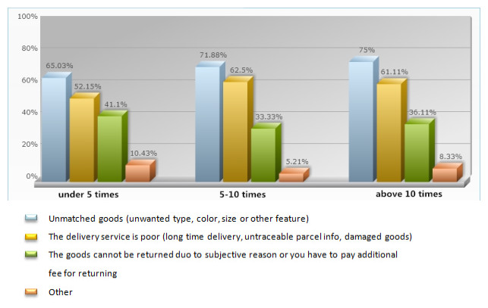
In figure 10 it is evidential to see that in each category of online shopping frequency, ‘unmatched goods’ seems to have the highest percentage, but this is problem is caused by online seller. Followed closely is the problem of ‘delivery service’, which represents for issues that happened during delivery. On one hand, with this fact that we can confirm our previous statement that the logistics service is a very important element in online shopping process that deserves serious attention. On the other hand it reveals that there are flaws in the express service of online shopping in Chengdu, and this problem appears to increase with the growth of frequency of online purchase.
From this entry point, we will go deep into the last mile delivery service to examine what precisely are the bottlenecks and to which extents do they affect consumers’ perception. The respondents were asked to evaluate the factors that they think are important in parcel delivery by using a five-point scale (results are shown in table 9), where 1-Strongly disagree, 2-Disagree, 3-Undecided, 4-Agree, 5-Strongly Agree. If the calculated mean is below 3 of the factor, it means respondent think this factor is not important, alternatively if the given value is above 3, it means this factor is of importance in parcel delivery from the view of consumer.
Table 9, The rate of important factors in last mile delivery
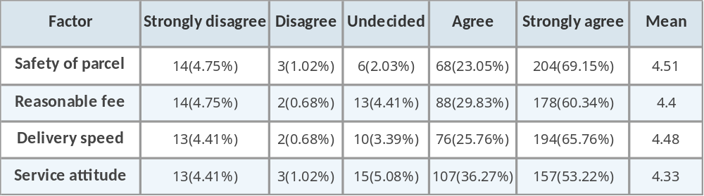
From table 9 we see that all four factors scored very high, which means that consumers think these factors have large influence on perception of last mile parcel delivery service. ‘Safety of parcel’ is ranking in the top position out of the four, which verify the statement in previous chapter that options like drop in neighbor’s home is not feasible because there is large population mobility thus uncertainty exist the leaving parcel to the neighbor that you barely know. ‘Delivery speed’ was valued at 4.48, scoring the second important factor. Third one is ‘reasonable fee’ and the last one is ‘Service attitude’.
In respect to testify whether the last mile delivery service has performed up to what consumers concern about, we asked respondents to value what the bottlenecks are in last mile delivery that need to be solved immediately using a five-point scale as well (1-Strongly disagree, 2-Disagree, 3-Undecided, 4-Agree, 5-Strongly Agree). The result can be seen in table 10.
Table 10, The most urgent bottlenecks in last mile delivery
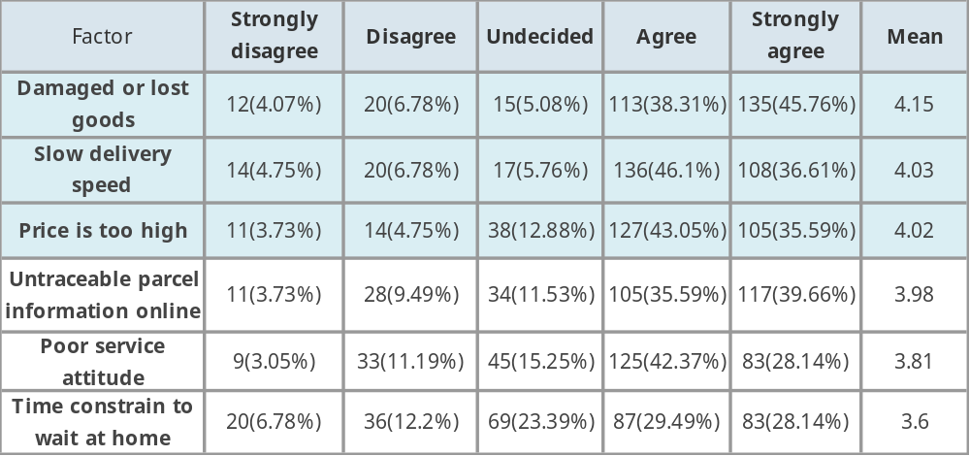
Interestingly we find that from table 10 that the options of first three highest score are the same ranking as the factor in table 9 correspondingly, meaning that there are for sure bottlenecks in the aspects that consumers value the most and large room left for improvement in order to satisfy customers’ needs.
Unlike UPS or DHL equipped with secured trucks, most of the express companies use smaller transportation means like bikes to distribute parcel in last mile. And parcel can be stolen during the time carriers make deliveries in resident buildings while the bike or tricycle that used for carrying parcels are ride away by others, such news are not fresh any more. No doubt this makes the bottlenecks ‘damaged or lost goods’ the most urgent problem to be solved in last mile delivery. ‘Slow delivery speed’ comes the second, indicating the low efficiency of delivery. High price is yet another problem, but for this study, it is not the scope to analysis this problem. For the rest, we can see that these are common bottlenecks in China that generating from the immature express industry. What surprising is that ‘Time constrain to wait at home’ scored 3.6, the lowest one, showing that actually people do not necessarily need to be at home to receive the parcel, which to some extent represents that the last mile delivery has performed good in this aspect.

  - Circumstance in last mile delivery in Chengdu
The express business volume in Chengdu has break through 300 million in 2014, weighs out eighty percent of the total volume in Sichuan province, ranking the ninth in nation; the income of express business reached 3.5 billion yuan, showing a year-on-year growth rate of 63.91% and ranking the tenth in the nation. Chengdu is the only middle and eastern city that has positioned in first ten given respect to express delivery business and business income. According to Sichuan government official report, the Conference of E-commerce and Business of China has been held in Chengdu this year, which indicates that Chengdu has become more important in development of both e-commerce and express industry.
The government has noticed the vast growth of e-commerce and its related service industry thus has speed up the construction of ICT infrastructure and provided incentives for innovations of both e-commerce company and express company. The first fully automatic sorting line of EMS is now put into use in Chengdu, likewise the large scale of logistics parks of ZTO, Shunfeng and YTO are under construction in Chengdu. Furthermore, both governments and express company are making endeavors of making last mile delivery in online shopping more efficient in express service. The first trail of cooperation with chain supermarkets ‘Wudongfeng’ was launched in 2012, now they are promoting the intelligent lockers in neighborhoods and transportation nodes.
Chengdu has been called ‘The fourth city’ in respect to Internet development (which is after Beijing, Shenzhen and Hangzhou); the city is famous for its creativity in internet development. As we have argued, the development of information highway and the capability of data processing are the key fundamentals in e-commerce and express logistics. Although now there is still a distance between Chengdu and eastern cities, but this distance can surely be shorten by all these efforts. Therefore, in the next section we are going to see how last mile delivery modes are adopted by citizens in Chengdu and explore reasons behind.
  - Solutions to last mile delivery bottlenecks in Chengdu
Based on our finding in chapter four, there are some alternatives to solve the most mentioned bottlenecks in last mile delivery, therefore we asked consumers about how they have employed different modes in last mile delivery and how they value these modes.
Table 11, The usage of last mile delivery modes
Options | Subtotal | Percentage
Direct home delivery | 235 | 79.66%
Property management company | 235 | 79.66%
Service points | 165 | 55.93%
Lockers points in the neighborhoods | 146 | 49.49%
Other | 8 | 2.71%
Valid respondents | 295

Given the answers of respondents (here multiple answers were possible), we can see that ‘property management company’ weighs as much as ‘direct home delivery’ in table 11, which confirms that this indirect mode suits specific urban structure in China. Almost every neighborhood is run by a certain management company, in order to execute a organized and satisfying management, property management company usually sets a department that is in charge of collecting and storing residents’ parcels on their behave. In some neighborhoods, parcels are directly sent to property management company because carriers are not allowed go inside the residency buildings.
‘Service points’, which includes the outlet of express company and cooperation with supermarket and convenient stores is the second widely used mode by customers and ‘locker points’ comes very close in the third place. In the review of answers of “other”, most of which are ‘parcels are signed by reception desk in the company’, however this is not a long-term solution, because company regard receiving parcels during working hour as a disruption.
Among the valuation of different modes in last mile delivery we used a five-point scale (see table 12), where 1-No use at all 2-Very little use 3-Undecided 4-Useful somewhat 5-Very useful. If the calculated mean is under 3, means that the mode is not useful to consumers and if it is above 3, means that consumers think the mode in helpful in receiving parcels. If that is below 3, then using the mode does not give consumer convenience. ‘Direct home delivery’ scored 4.16, which is within expectation considering this is the main form of last mile delivery service. But what we concern more is indirect modes, so we will elaborate on those modes.
Table 12, Valuation of last mile delivery modes
Options | No use at all | Very little use | Undecided | Useful somewhat | Very useful | Mean
Lockers points in the neighborhoods | 7(2.37%) | 3(1.02%) | 27(9.15%) | 98(33.22%) | 160(54.24%) | 4.36
Direct home delivery | 10(3.39%) | 16(5.42%) | 26(8.81%) | 107(36.27%) | 136(46.1%) | 4.16
Property management company | 6(2.03%) | 20(6.78%) | 22(7.46%) | 136(46.1%) | 111(37.63%) | 4.11
Service points | 16(5.42%) | 27(9.15%) | 44(14.92%) | 130(44.07%) | 78(26.44%) | 3.77

Service points
‘Service point’, scored 3.77, the lowest one in the list, which is not so good considering the various advantages we have stated in the literature review. The reasonable explanations can be that the disadvantages have out weighted advantages in last mile delivery in Chengdu.
On average every 400 meters there is a small supermarket or convenient store on the street, in downtown area the density is even higher, one might argue that this is exactly why collaborating with these stores makes it easier for customers to do parcel pick-up, but the result might not exactly so. Think from another side, unlike western countries, supermarket is where people do daily shopping, sometimes even just a bottle of water or bread you may have to buy it in the supermarket. While in China, so does in Chengdu, people can purchase the same thing in chain convenient stores, self-owned grocery and cigarette stores as in supermarket, the supermarket for parcel pick up might not be the one that is close to your home, so the advantage of “do shopping while pick up parcel” and “close to home” becomes less obvious. Moreover, there is possibility that customers have to wait to pick up parcels when there are more ordinary consumers in the supermarket. And there are certain opening hours for supermarkets and convenient stores, which refrain consumers to pick up parcels during business hour.
Property management company
The score of 4.11 by ‘Property management company’ has in fact proved that this mode is widely accepted by consumers. The reasons might be, firstly the risk of parcel theft is avoided; secondly, the density of residents has made non-residents (unless invited guests) are not permitted in the neighborhood a standard regulation of property management, besides residents also feel more comfortable and safer in this way around; thirdly, in residents’ eyes, collecting parcels is part of the responsibility of property management because they have paid for the services, and property management should adapt to the fact that more and more people are making online purchase now.
According to Chengdu Property Management Institution, the average daily express parcel of an ordinary residential area with resident family of 1000 is 150 to 500, about 5000 parcels or more monthly. This number will increase by 50% to 80% after the peak (discount season) of online purchase. In order to set a standard operation procedure, a serial of agreement that clearly states the obligation, responsibility within this service has been set out and signed by residents who authorize property management to collect parcels. All in all, this is a win-win choice for both parties, as so for express company since it decreases the distributing time.
Locker points in the neighborhoods
‘Locker points in the neighborhoods’ scored 4.36, which is the highest of all the modes, contrasting the percentage of usage of this mode in table 10, we can conclude that this mode is the one that receives highest approval by consumers, meaning the existing locker points in the neighborhoods have been an initial market success. And Chengdu has stepped ahead of the average of Chinese cities given this initiative.
With curiosity we widely search the data about the locker points in Chengdu neighborhoods and found out that one of the largest companies that run the business of intelligent lockers named Sposter is based in Chengdu. So far it has facilitated 1200 sets of intelligent lockers in about 1000 neighborhoods in Chengdu and each set of complete intelligent lockers has a capacity of 81 cabinets. On average there are 30,000 people using the lockers daily, the accumulated total users in Chengdu is 200 million. Different from DHL Packstaion, Sposter is completely independent third party company. In the early stage of promotion, the service is Sposter is free to use for both carrier and consumer. Recently it has ended the free trail and started to charge for the fee, which is 0.3 Yuan for carrier for each parcel and 1 Yuan per day for consumer if the parcel is not collected within 24 hours. According to China Express Association, a decline of use of Sposter was expected because on average carrier earns about 1 Yuan out of delivering one parcel, now 0.3 Yuan has to go to Sposter, which does not sound like a bargain to carrier. And for consumers, additional cost might occur if the parcel is not collected in time. But the truth is beyond expectation; the usage stays steady and now Sposter is marching to cover almost 72 cities in China.
From the Report of China's online shopping market research (2013) we notice that nowadays consumers are becoming stricter on parcel delivery service, among the requirements, ‘same-day delivery’ becomes popular. For express company who offers this service, penalty exists for carrier if the parcel is failed to deliver in time. To delivery in time is now more important than spending 0.3 Yuan on Sposter under this condition, besides the more parcels carrier deliver the more they earn, and actually using Sposter saves the time of distributing, the extra parcel they deliver makes up to the fee of using Sposter. As for consumers, the service is basically free of charge, and 1 Yuan per day for exceed of 24 hours is definitely an affordable and it is a safe way of receiving parcels.
Consequently with the above arguments we can make two essential conclusions about the adoption of last mile delivery modes. One is that customers are located in the central of online shopping process; their demand is the leading factor of logistics service, which is in line with our theoretical findings (Agatz et al, 2008). The other one is that intelligent lockers is a suitable solution in last mile delivery because of its inherent advantages such as 24/7 service and security of parcels.
Moreover, even though acceptances of indirect delivery modes in last mile delivery vary to some extent, 270 out of 295 respondents agree that using indirect delivery modes bring them convenience and help making their online shopping a better experience. From table 13 we can see what matters most is that by using indirect delivery modes, they have less worry of not receiving parcel while outside home, and they have recognized that indirect modes contribute a lot with respect to this benefit. They also confirm parcel are secured by using these modes, further ‘doing shopping’ scored lower verifies our speculation of why service point is a less preferred choice. Among the few that do not think using indirect modes gives them convenience, the most significant reason is that the purchased goods are valuable that unboxing check and confirmation are required by signee. Overall satisfying feedbacks on using indirect delivery modes can be observed.
Table 13, Benefits of using indirect last mile delivery modes
Options | Totally disagree | Disagree | Undecided | Agree | Totally agree | Mean
Less time constrain | 5(1.85%) | 3(1.11%) | 13(4.81%) | 99(36.67%) | 150(55.56%) | 4.43
Less risk of parcel theft | 7(2.59%) | 20(7.41%) | 25(9.26%) | 112(41.48%) | 106(39.26%) | 4.07
Do home shopping at the same time | 9(3.33%) | 11(4.07%) | 82(30.37%) | 81(30%) | 87(32.22%) | 3.84

In asking which modes do consumers would like to use in future online shopping delivery (multiple choices were possible), we see that the willingness of locker points has surpassed direct home delivery (see table 14) with a result of 71.86%. This number has proved the value of locker points and its high potential in last mile delivery. This is also the ambitious of companies like Sposter. With the unceasing growth of online purchasing, the widely adoption of intelligent lockers is to be seen in the near future. Perhaps of less valuation, but the modes of property management company and service points also make decent supplements. Together we can see the indirect modes in last mile delivery have been accepted by consumers and have now play indispensable roles in last mile delivery.
Table 14, Willingness to use last mile delivery modes in the future
Options | Subtotal | Percentage
Lockers points in the neighborhoods | 212 | 71.86%
Direct home delivery | 198 | 67.12%
Property management coompany | 163 | 55.25%
Service points | 131 | 44.41%
other | 0 | 0%
Valid respondents | 295

  - Results from interviews
From the three in-depth interviews, we are acknowledged that the neighborhoods where three interviewees live are all facilitated with intelligent lockers of Sposter. They live in three different districts in Chengdu, from which we can see that the coverage of Sposter is considerably high. The property management is also functioning for receiving parcels because if an express company that is not in cooperation with Sposter then the carrier cannot use intelligent lockers but send parcels to property management company. These express companies are mostly small local express company. The interviewees also pointed out, before intelligent lockers are facilitated, parcels were all sent to property management, which works fairly good but the only limitation is the opening hour is injunction with interviewees’ working hour.
They generally do not fancy service points that much. The top reason is that usually they have to walk 5-10 minutes to service points, and sometimes it becomes quite annoying when the parcel size is large and they have to carry it home. Besides, one interviewee also said that the staffs at some service points that cooperate with lottery selling shop or other small shops are not professional. They do not know how to handle parcels properly, which gives customers negative impression.
All three interviewees have high praise of these intelligent lockers. The mostly talked reason is that they can pick up parcels whenever they want; just simply inputting the phone number and pin code saves the trouble of settling meeting time with carrier or going to property management company. Moreover, these intelligent lockers are located in the first floor of residents’ building, which is extremely close to their home already. In asking whether they have problems with using intelligent lockers. They said very few, and it was not caused by the machine but the carrier put the phone number wrong so that they cannot open the locker. After they call the customer service of Sposter, the problem was easily solved.
Moreover there are some interesting findings. In asking how they pay for the fee if picking up exceeds 48 hours. Interviewees said it can be paid either with inserting coin to the machine or with Payment by Wechat. In further chatting we find out that intelligent lockers are closely bonded to Wechat, once you have used Wechat to pay Sposter, it records your data and will send you parcel information automatically next time, where we see a trend of integration of last mile and financial tools. And there are advertisements in the screen of intelligent lockers; mostly are advertisements for express companies and take-out food service.

  - Conclusion
In this chapter we focused on last mile delivery modes are adopted by consumers in Chengdu. The findings are summarized in table 15 below.
Following with the theoretical framework we first identified the bottlenecks in last mile delivery from consumers’ eyes, where they consider the safety of parcels and delivery speed are of great importance, showing that keeping the parcel intact and sending it to customers as soon as possible is the priory task of express company. Decreasing the rate of delivery failure contributes to more efficient last mile delivery.
Furthermore, we can conclude from the survey and interviews that property management is for now the most commonly used mode in last mile delivery, the evaluation of this mode is fairly good but the only limitation is that consumers are not able to pick up parcels anytime they want but only during business hour. Service points are less valued duo to the fact that they might not be on the way of every consumers home or to work, additionally numbers of supermarkets and convenient stores have weaken the advantage of shopping while picking up parcels.
Intelligent lockers in neighborhoods are highly praised by consumers; the safety of parcel is ensured by using this mode and it gives consumers more time flexibility in picking up parcels. Even though intelligent locker points are not yet facilitated in every neighborhood in Chengdu, it has received considerably positive evaluation. Moreover, we can see the trend of integration of finance services by other companies with intelligent lockers, with which they set up the data base of customers and create a comprehensive eco-business circle of e-commerce. This does not only will solve last mile delivery bottlenecks, but also gives consumers more value-add experiences.
Table 15, The current situation of last mile delivery in Chengdu
 | Chengdu
Bottlenecks in last mile | - Slow delivery speed  - Poor service attitude  - Untraceable online info  - Damaged goods  - Time constrain
Circumstance | - Economy and transportation hub in western China  - Fast growth in e-commerce  - Insufficient infrastructure of express industry  - Government support
Solutions to last mile delivery problem | - Service points  - Intelligent lockers  - Property management company
Effectiveness | - The indirect modes are accepted by consumers, especially for intelligent lockers

- Discussion and conclusion
The task of this chapter is to discuss the main finding of last mile delivery. We will firstly make comparison of China and western countries to see commonalities and differences between the two, and then we will zoom in to make comparison of China and Chengdu to see whether what we have found in Chengdu is in line with the general situation of last mile delivery in China. The discussions are based on the theoretical framework. After the discussion of these three parts, we will come to the final conclusion of the research question in this thesis. Further, the implication for express companies is presented based on our analysis.
  - Comparison between western countries and China
To better analyze the situation of last mile delivery in China, we fit the empirical findings into the table with western countries (see table 16), some similarities and differences in each component can be observed, and we will explain them one by one in detail.
For bottlenecks in last mile delivery, besides the issues of not at home, long time window and repeated delivery, China seems have more endogenic problems resulting from the young express industry. The e-commerce and express industry are growing at a rocket speed in China, but they both are still in the initiative phrase compared to western countries. Thus the industry inevitably fall into the trap of wild growth, focusing on price and profit while put aside the development of “software” of itself. The outcome is that the overall profit and service quality of entire industry is decreased because of the vicious competition.
As for Circumstance for last mile delivery, we see the main difference is the economic foundation. Western countries are economically advanced than China; no doubt they are capable to provide sophisticated technology for data processing. While China has a promising GDP growth rate but the economic development and social wealth is unbalanced from region to region; as to technology, it will take huge cost to build a nationwide data processing system for express logistics service, yet we see some positive initiatives. Alibaba group recently invested 300 billion Chinses Yuan in integrating the some large express companies in China to build a shared data base and processing center named Cainiao network, in a way they hope that in the future this will be the foundation for logistics for online shopping. Furthermore, the urban structure of western countries like the Netherlands, Germany and the UK are similar and has relatively less variety; while the city size and structure varies to a large extent in China, and the population is obviously huge as well.
Resulting from these facts, we see the difference between the solutions to last mile delivery problem in western countries and China, specifically, China seems has more solutions. Locker points and service points are observed in both China and Western, but reception box is not used in China, instead, the adoption of property management and third party delivery platform are quite popular and successful. This is duo to the fact that the residence density is pretty high in Chinese cities and these two countermeasures take advantage of it and decrease the parcel delivery failure rate by consolidating parcels. Nonetheless, we can conclude that the successful modes in last mile delivery are those fit the specific situation of one country and wisely make use of its advantages and that China is making an effort to improve the quality of last mile delivery even if it is baby step.
Table 16, Summary of last mile delivery in China and western countries
 | Western Countries | China
Bottlenecks in last mile | - Not-at-home problem  - Long time window  - Repeated delivery | - Not-at-home problem  - Long time window  - Repeated delivery  - Immature express industry  - Low delivery efficiency  - Out-dated technology  - Lack of professionals
Circumstance | - munificent technical force  - Long time development of internet  - solid economic foundation | - Unbalanced economic development  - Insufficient technology infrastructure  - Short period of internet adoption  - Large variance in city size  - Vast population and high density
Solutions to last mile delivery problem | - Home access/ reception box  - Service Points  - Intelligent lockers | - Service points  - Intelligent lockers  - Express outlets  - Platform with property management company  - Third party delivery mode
Effectiveness | - Service points and intelligent lockers are successful | - Most of the innovations are in trail but have performed well, only two are financially successful so far

  - Comparison between China and Chengdu
Now that we have finished discussing last mile delivery of western countries and China, we can add Chengdu the summary table (see table 17) to give a more detailed and specific information about the adoption of last mile delivery modes in China.
Firstly, we can see that the bottlenecks that reflected by consumers in last mile delivery in Chengdu are generated from the immature express industry of China in general, which indicates that these bottlenecks are common in Chinese express industry and are needed to be solved urgently.
Secondly, Chengdu as the largest city in western China has been experiencing a large transformation from a second-tiered city into one of the most important cities of economy, education and transportation in the west. The growth of e-commerce popularity and express volume is therefore to be seen. Government has realized the dynamics of e-commerce in driving forward regional economy, and thus is providing various incentives to attracting more e-commerce and express companies to locate in Chengdu. But the base of infrastructure of ICT and systematic knowledge of express industry is still lacking, the same situation as most Chinese cities.
Thirdly, there are three main indirect last mile delivery modes used by citizens in Chengdu, while the mode of third party delivery is not observed here. Property management company is in line with China in general considering the common fact that the average population density is very high. But unlike most of Chinese cities that are not yet familiar with intelligent lockers, Chengdu has made this mode a success, though we see that these intelligent lockers are run by third party company, not express company itself. And different from the widely usage of service points in western countries, the valuation of this mode is not that high in Chengdu duo to different urban structures.

Table 17, Summary of last mile delivery in China and Chengdu
 | China | Chengdu
Bottlenecks in last mile | - Immature express industry  - Not-at-home problem  - Long time window  - Repeated delivery  - Low delivery efficiency  - Out-dated technology  - Lack of professionals | - Slow delivery speed  - Poor service attitude  - Untraceable online info  - Damaged goods  - Time constrain
Circumstance | - Unbalanced economic development  - Insufficient technology infrastructure  - Short period of internet adoption  - Large variance in city size  - Vast population and high density | - Economy and transportation hub in western China  - Fast growth in e-commerce  - Insufficient infrastructure of express industry  - Government support
Solutions to last mile delivery problem | - Service points  - Intelligent lockers  - Express outlets  - Platform with property management company  - Third party delivery mode | - Service points  - Intelligent lockers  - Property management company
Effectiveness | - Most of the innovations are in trail but have performed well, only two are financially successful | - The indirect modes are accepted by consumers, especially intelligent lockers

  - Conclusion
Last mile delivery as the only phrase that has direct contact with customers in e-commerce, not only accounts for a large cost duo to its complexity, but also has influence on the experience of online shopping. China as a giant country that is on the way of rapid growth of e-commerce, leaving last mile delivery becomes a problem that cannot be neglected. An interesting question rise is that: how are the last mile delivery modes adopted by consumers under this era? In this thesis, we have answered the question by using literature review to formulate a theoretical framework and then use it to conduct a case study.
We can see from the comparisons that the theory of e-commerce and logistics are indeed integrated and they have mutual influence on each other’s development (section2.1.4) is verified by our findings of China. The increasing popularity of e-commerce needs reliable express service; otherwise it will drag e-commerce from further development. The overall development of express logistics service is still in its initiative stage in China. The economic base and technology infrastructure is not advanced as western countries, which result to immature express industry and leaves quite bottlenecks in last mile delivery. Yet the police makers have realized the importance of last mile delivery and have made effort to improve last mile delivery service. And in order to solve these bottlenecks we observe that there are some differences between western countries and China, where last mile delivery modes that need more personized design like home access and reception boxes are not seen in China duo to large population and dense urban structure. Instead mode like property management company is adopted in practice. These observations are in line with our theoretical knowledge (Reynolds, 2001), where the adoption of last mile delivery modes is very specific to each country or even each city.
Under such circumstance, we find the answer to our main research question. There is an increasing trend of using indirect modes in last mile delivery by consumers in China, and we expect that the use of indirect modes will surpass the use of indirect home delivery one day in the very short future. The growing popularity of e-commerce is becoming a push factor for developing indirect delivery modes since the frequency of receiving parcels will upswing and consumers simply do not desire to arrange the delivery time with carriers time after time. This is the reason why indirect last mile delivery modes are welcomed by consumers because by using indirect modes they are no longer constrained to delivery time. Though the valuations of different indirect modes vary, they all help releasing the pressures on parcel delivering and receiving. Particularly we see that intelligent lockers are widely accepted for its convenience. While in some less dense neighborhoods, the property management company might suit well more. Therefore, the use of indirect modes differs from each neighborhood and each city, but in all they give convenience to consumers in online shopping.
  - Implications for express company

From our conclusion we see that indirect modes can be the ways to solve last mile delivery and can make good use of social resources. At present, the rapid growth of e-commerce transactions has caused tremendous pressure on express logistics service. Meanwhile, considering about complexity of customer group duo to the large population in China, therefore in line with the attitude of promote the healthy development of e-commerce and express service, we advocate the implement indirect delivery modes in last mile delivery, and in order to promote indirect modes, there are some principles to be followed.
First of all is convenience, which is a fundamental attribute of the e-commerce. The ability to provide users with convenient pickup service is the key determinate of the success of indirect delivery modes. Generally, convenience includes the content of time and space. Convenience of time refers to the service time of pickup point can be well covered Cover the user's desirable pickup time. Convenience of the space refers to that user can easily reach the pickup point pickup, without spending too much time on transportation.
Secondly, as we have argued, the cost of last mile account for a large portion of total delivery cost. The main cause of this situation is the scattered receiving addresses, which makes last mile delivery a difficult task. Although indirect delivery modes can transform to the dispersed delivery into consolidated, reducing the difficulty of delivery. It takes large cost to establish operate pickup points in initial phrase. Moreover the cost of different indirect modes varies; the construction has to be taken into account within the total operational cost.
Thirdly, there is a trend of ‘User experience’ in last mile delivery. This term is generally accepted in design product, now it has also been widely used in e-commerce duo to the development of e-commerce has given consumers more choices, only by upgrading ‘User experience’ can one win out. Last mile delivery, as the final destination of an online shopping journey, can be concentrating more value-added functions to make better ‘User experience’.
Taking the intelligent lockers for instance, picking up parcels can be the basic function for customers, which is now the main income of express company. The requirements of ‘pay when receive’ and ‘unboxing check’ are expected to be realized in the future to maintain the quality of ‘User experience’. Meanwhile, as the intelligent lockers can be used as a computer terminal, the payment of gas, water and other finance service is yet to be seen in the future. Furthermore, as the customer group is growing, intelligent lockers can be served for advertisement service, which will no doubt add more income for company who owns these properties. Yet we see that the most successful company (Sposter) that runs this business in China is a third party company, meaning that no express company is willing or capable to establish such networks for intelligent lockers. With the growth of intelligent lockers usage, Sposter might get control of the parcel delivery by ally some express companies, while crossing out others. Express companies can either adapt to this situation or establish their own alliances.
In order to survive severer competition in this more and more subdivided market, express company has to foresee these opportunities, making more efficient last mile delivery and upgrading service capability.
  - Limitation and further research
The limitation contains two aspects. Firstly, the questionnaire of the e-commerce and last mile delivery is based on theoretical framework literature and some self-experience of last mile delivery, and thus may not guarantee its comprehensiveness and integrity. Secondly, the survey was sent out through popular social software and e-mail to citizens in Chengdu, while most of the respondents were completed by the author’s social networks, therefore the range of sample may not cover all walks of life; besides, Chengdu is a large city, and in order to provide more precise result, the sample size should be increased.
This thesis has provided the knowledge of the adoption of different last mile delivery modes by consumers, and from this standing point there are some more detailed area needed to be researched. Setting the network of intelligent lockers and service points need a large amount of research and analysis, since the initial cost is very high. The usage of indirect modes has to be maximized by targeting the needs of different customer groups. Moreover, as express companies have come to realize the importance of last mile delivery, some of them (Shunfeng) is try to set up express outlets that has integration of parcel sending or pick-up, off-line shopping and finance service. More research need to be done in the future to investigate whether this will win out in last mile delivery or just fade away.

Reference
Agatz, N. A., Fleischmann, M., & Van Nunen, J. A. (2008). E-fulfillment and multi-channel distribution–A review. European Journal of Operational Research,187(2), 339-356.
Baxter, P., & Jack, S. (2008). Qualitative Case Study Methodology: Study Design and Implementation for Novice Researchers. The Qualitative Report, 13(4), 544-559.
Blanchard, D., 2008. Strategic Reasons for Using a 3PL. Industry Week, Jun, p. 80.
Bromage, Neil (2001), “Keep the Customer Satisfied,” Supply Management, Vol. 6, No. 10, pp. 34-36
Browne, M. (2001), “E-commerce and urban transport”, paper presented at the OECD/ECMT Seminar the Impact of e-Commerce on Transport, Paris, June 5-6.
Bryman, A. (1984). The debate about quantitative and qualitative research: a question of method or epistemology? British Journal of Sociology, 75-92.
Brynjolfsson, E., Hu, Y.J., Smith, M.D., (2003). Consumer surplus in the digital economy: Estimating the value of increased product variety at online booksellers. Management Science 49 (11), 1580–1596.
Bughin, J., Corb, L., Manyika, J., Nottebohm, O., Chui, M., de Muller Barbat, B., & Said, R. (2011). The impact of Internet technologies: Search.McKinsey&Company, High Tech Practice.
C.J. Anumba, K. Ruikar. (2002) Electronic commerce in construction-trends and prospects. Automation in Construction, pp. 265–275
Cairns, S., Delivery Alternatives: Successes and Failure of Home Delivery Services for Food Shopping. Transport Policy 3 (4), 1996, pp. 155-176.
Casey, N., Rao, D., Mantilla, J., Pelosi, S., & Thompson, R. G. (2014). Understanding Last Kilometer Freight Delivery in Melbourne's Central Business District. Procedia-Social and Behavioral Sciences, 125, 326-333.
Cho, J. J.-K., Ozment, J. & Sink, H., 2008. Logistics Capability, Logistics Outsourcing and Firm Performance in an E-Commerce Market. International Journal of Physical
Distribution & Logistics Management, April, pp. 336-359.
David Simchi-Levi, D., Kaminsky, P. and Simchi-Levi, E. (2008). Designing and Managing the Supply Chain: Concepts, Strategies, and Cases (3rd Ed.). Boston, Mass: McGraw-Hill/Irwin.
Delfmann, W., Albers, S., & Gehring, M. (2002). The impact of electronic commerce on logistics service providers. International Journal of Physical Distribution &
Logistics Management, 32 (3), 203–222.
Edwards, J. B., McKinnon, A. C., & Cullinane, S. L. (2010). Comparative analysis of the carbon footprints of conventional and online retailing: A “last mile” perspective. International Journal of Physical Distribution & Logistics Management, 40(1/2), 103-123.
Egea, J. M. O. & Menéndez, M. R., 2006. Global Marketing on the Internet. In: M. Khosrow-Pour, ed. Encyclopedia of E-commerce, E-government, and Mobile Commerce. Hershey: Idea Group Inc., p. 530.
Esper, T. L., Jensen, T. D., Turnipseed, F. L., & Burton, S. (2003). The last mile: an examination of effects of online retail delivery strategies on consumers. Journal of Business Logistics, 24(2), 177-203.
Fang, X (2012). Innovation in last mile delivery. China Express Forum.
Fernie, J. and McKinnon, A.C. (2004). The development of e-tail logistics, Logistics and Retail Management, 2nd ed., London: Kogan Page, pp. 164-87.
Fernie, J., & McKinnon, A. (2009). The development of e-tail logistics. Logistics & Retail Management, Emerging Issues and New Challenges in the Retail Supply Chain, Kogan Page, London and Philadelphia, 207-232.
Foresight (2000), The (R) etail (R) evolution: From a Nation of Shopkeepers to a World of Opportunities, Department of Trade and Industry, London.
Gevaers, R., Van de Voorde, E., & Vanelslander, T. (2011). Characteristics and typology of last-mile logistics from an innovation perspective in an urban context. City distribution and urban freight transport: multiples perspectives, Northampton, Edward Elgar Publishing, pp. 56-71.
Guo, M. (2010). Study of last mile solutions in e-commerce. Management Research, 35, 90-102.
Kalakota, R. & Whinston, A.B. (1997). Electronic Commerce: A Manager’s Guide. USA: Addison Wesley Longman.
Lacity, M. C., & Hirschheim, R. (1995). Beyond the information systems outsourcing bandwagon: the insourcing response. John Wiley & Sons, Inc.
Lee, H.L. & Whang, S., (2001). “Winning the Last Mile of E-Commerce”. MIT Sloan Management Review, Vol. 42, No. 4, pp. 54-63.
Markellou, P., Rigou, M. & Sirmakessis, S., 2006. A Closer Look to the Online Consumer Behavior. In: M. Khosrow-Pour, ed. Encyclopeida of E-commerce, Egovernment, and Mobile Commerce. Hershey: Idea Group Inc., p. 106.
McKinnon, A C and Tallam, D (2003) unattended delivery to the home: an assessment of the security implications, International Journal of Retail & Distribution Management, 31, (1), pp 30–41.
McLeod, F., Cherrett, T. and Song, L. (2006), “Transport impacts of local collection/ delivery points”, International Journal of Logistics: Research and Applications, Vol. 9 No. 3, pp. 307-17.
Morganti, E., Seidel, S., Blanquart, C., Dablanc, L., & Lenz, B. (2014). The Impact of E-commerce on Final Deliveries: Alternative Parcel Delivery Services in France and Germany. Transportation Research Procedia, 4, 178-190.
Nargundkar, R. (2003). Marketing Research-Text & Cases 2E. Tata McGraw-Hill Education.
Newton, C.J., (2001). Home delivery can make or break a B2C. Supply Chain Management Review 5 (1), 21–24.
Ngai, E.W.T, Wat, F.K.T. (2002). A literature review and classification of electronic commerce research. Information and Management, 39, 415–429.
Park, M., & Regan, A. (2004). Issues in emerging home delivery operations. University of California Transportation Center
Punakivi, M., Yrjola, H. and Holmstrom, J. (2001), “Solving the last mile issue: reception box or delivery box?” International journal of Physical Distribution & Logistics Management. Vol. 31 No. 6, p. 427.
Qin, Z. (2010). Introduction to E-commerce. Springer Science & Business Media, pp. 28
Reynolds, J. (2001). Logistics and Fulfillment for e-Business. CMP books
Robson, C. (2002). Real world research (Vol. 2). Oxford: Blackwell publishers.
Rowlands, P (2001) Why access is the key, Elogistics Magazine, 15, Nov/Dec.
Rowlands, P (2006) Unattended delivery solutions – finally picking up? Efulfilment Magazine, Spring.
Rowlands, P (2007) Delivering to people who aren’t at home – how you can deal with it, Efulfilment Magazine, Spring.
Sandhusen, R. L. (2000). Marketing. Third edition. Hauppauge, NY: Barron’s Educational Series.
Tsay, A.A., Agrawal, N., (2004). Modeling conflict and coordination in multi-channel distribution systems: A review. In: Simchi-Levi, D. et al. (Eds.), Modeling in the E-Business Era. Kluwer, Boston, pp. 557–606.
Wallace, D.W., Giese, J.L., Johnson, J.L., (2004). Customer retailer loyalty in the context of multiple channel strategies. Journal of Retailing 80 (4), 249–263
Wang, X., Zhan, L., Ruan, J., & Zhang, J. (2014). How to Choose “Last Mile” Delivery Modes for E-Fulfillment. Mathematical Problems in Engineering, 2014
Weltevreden, J. W. (2008). B2c e-commerce logistics: the rise of collection-and-delivery points in The Netherlands. International Journal of Retail & Distribution Management, 36(8), 638-660.
Whang, S. (2001, November). E-business and supply chain integration. Stanford, CA: Stanford Global Supply Chain Management Forum.
Wilding, R., & Juriado, R. (2004). Customer perceptions on logistics outsourcing in the European consumer goods industry. International Journal of Physical Distribution & Logistics Management, 34(8), 628-644.
William, G. Z, & Barry, J. B. (2007). Exploring Marketing Research (9th ed.). Mason, OH: South-Western
Wohlrab, J., Harrington, T.S. and Srai, J.S. (2012). Last Mile Logistics Evaluation - Customer, Industrial and Institutional Perspectives UK, Cambridge: Cambridge
University Press. P5-20.
Xiao, X., Liu, Y., Zhang, Z., & Guan, X. (2013). The Analysis to the Logistics Mode Decision of B2C. In LISS 2012 Springer Berlin Heidelberg, pp. 1129-1134
Zhang, J (2012). Avant-garde in last mile: to boost the cooperation between express and e-commerce. China Express Forum.
ZHANG, M. M., GUO, C. K., YANG, Z. S., LIU, S., & CHENG, P. H. (2013). The Customer Opinion Surveys Report under the Spring of Express Industry’floor Delivery-mainly for College Students, Staff, Delivery Companies. Logistics Engineering and Management, 5, 056.

Internet Sources:
Ali mini post
http://it.sohu.com/20120910/n352722586.shtml [last visited on 22-05-015]
Chengdu Internet Development Report, 2012
http://www.iscd.org.cn/detail/?zhongid=619 [last visited on 08-05-015]
China E-commerce Government
http://www.e-gov.org.cn/ [last visited on 08-05-015]
China E-commerce Research Center
http://www.100ec.cn/zt/14-15bgzhd/ [last visited on 08-05-015]
City 100 http://www.bjcs100.com/c36417/default.asp [last visited on 22-05-015]
DHL (2009). Packstationen. Available from: http://www.dpdhl.com/de/presse/pressemitteilungen/2009/dhl_packstation_an_2500_standorten.html [visited on 14.05.2015]
Donegan, P. (2000). The logistics of the last kilometer, Available at:
http://www.thefreelibrary.com/The+logistics+of+the+last+kilometer.-a068707154
[visited on 14.05.2015]
Esser, K. (2008). Last mile logistics – E-commerce and its impact on transport in urban areas and innovative approaches in city logistics for solving the last mile issue, available at: http://www.bestufs.net/download/BESTUFS_II/national_seminar/Abgesagter_Termin/BESTUFS_Presentation_Berlin.pdf [visited on 14.05.2015]
Esser, K. and Kurte, J. (2007), Strategies for Optimizing Pick-up and Delivery Traffic of Internet Commerce – Packstations in Cologne (OPTIMAL), KE-Consult, Cologne, available at:http://www.dpdhl.com/content/dam/dpdhl/mlm.nf/dpwnew/presse/news_ab_03_2007/packstation_umweltstu_156a6.pdf [visited on 14.05.2015]
Express Supermarket in Sichuan
http://cqcbepaper.cqnews.net/cqcb/html/2012-05/17/content_1532498.htm [last visited on 22-05-015]
Goh, M., Gan C., Chen, K. and Zhang, Y. (2011). Distribution gains importance as
online markets heat up in China. Available at:
http://www.atkearney.com/transportation/featured-article/-/asset_publisher/S5UkO0z
y0vnu/content/chinas-e-commerce-market-the-logistics-challenges/10192 [visited on 14.05.2015]
Jingdong Pai University Service Point.
http://jd-ex.com/news/detail/55152eb2d09f47b5e18ce9f6.html[last visited on 22-05-015]
RedPack (2007), Redpack Network Inc. announces expansion to the United Kingdom and acquires assets of Collectpoint, available at: www.redpackit.com/ [visited on 14.05.2015]
Shenton, J., (2002). E-Business brings e-Fulfillment.
http://www.globalmillenniamarketing.com/article_efulfillment_ecommerce_ebusiness.htm. [Last visited on 08-05-015]
Shouhuohao http://www.shouhuobao.com/index.html [last visited on 22-05-015]
Shunfeng & 7-11 service point.
http://finance.sina.com.cn/chuangye/internet/20111210/011510969051.shtml [last visited on 22-05-015]
Sichuan Province Department of Commerce
http://www.sccom.gov.cn/xxfb/page/ [last visited on 08-05-015]
T. Van Woensel (2012), Inaugural lecture at Eindhoven University of Technology. http://alexandria.tue.nl/extra2/redes/woensel2012.pdf [last visited on 08-05-015]
Tang, O.T. & Liu, T., (2014). China logistics
http://www.kimeng.com.hk/upload/research_reports/ChinaLogistics_20140723_IC.pdf [last visited on 08-05-015]
Taniguchi, E. & Thompson, R., (2013). City Logistics: Mapping the Future. Retrieved fromhttps://books.google.nl/books [last visited on 08-05-015]
Tmall service point http://www.tmall.com/go/act/sale/tmfwzmfds.php [last visited on 22-05-015]
Weltevreden, J.W.J. (2007a), Winkelen in het Internettijdperk [Shopping in the Internet Age], Nai Uitgevers & Ruimtelijk Planbureau, Rotterdam, available at http://www.pbl.nl/sites/default/files/cms/publicaties/Winkelen_in_het_internettijdperk.pdf [visited on 14.05.2015]
The Report of China's online shopping market research (2013) https://www.cnnic.net.cn/hlwfzyj/hlwxzbg/201409/P020140901332431510284.pdf [visited on 09.07.2015]

Appendix A-Questionnaire design
Part1: General Info
- What is your gender?

- Male
- Female

- What is your age?

- Under 20
- 20-30
- 30-40
- 40-50
- Above 50

- What is your income per month (¥)?

- Under1500
- 1500-3000
- 3000-5000
- Above5000

- What is your professional?

- University student
- Civil Service
- Public institutions employee
- Company Employee
- Self-employed
- other

- Where do you live?
Shuangliu District/Gaoxin District/Qingbaijiang District/ Xindu District/Longquanyi District/ Wenjiang District/ Pixian/ Jinniu District/Qingyang District/ Chenghua District/ Wuhou District/ Jingjiang District
Part2: Online shopping experience
- What is your frequency of online shopping per month?

- under5
- 5-10
- Above10

- How long have you used online shopping?

- under2 years
- 2-5 years
- Above 5 years

- What is the most attractive factor of online shopping for you? (multiple answers possible)

- Reasonable Price
- On-door delivery
- less time and location-limited
- abundant products

- What problems have you met with during online shopping? (multiple answers possible)
1-Strongly disagree 2-Disagree 3-Undecided 4-Agree 5-Strongly Agree
- Unmatched goods (the type, color, size or other feature is not what you have demanded
- The delivery service is poor (Problems like long time delivery, untraceable parcel info, damaged goods)
- The goods cannot be returned duo to subjective reason or you have to pay additional fee for returning
- Other, (please specify)
Part3: Delivery service experience
- Do you agree that the following factors are important in the last mile parcel delivery service for online shopping? (please rate each of the answer from 1-7)
1-Strongly disagree 2-Disagree 3-Undecided 4-Agree 5-Strongly Agree

- Safety of parcel
- Reasonable fee
- Delivery speed
- Service attitude

- Do you think that the following problems are urgent to be solved in last mile parcel delivery s? (please rate each of the answer from 1-7)
1-Strongly disagree 2-Disagree 3-Undecided 4-Agree 5-Strongly Agree
- Slow delivery speed (Long time duration before you finally receive the parcel)
- Poor service attitude (For example: dump the parcel roughly, no uniform outfits, leak of personal info)
- Untraceable information of parcel (cannot track where the parcel is)
- Damaged or lost goods (the goods you received are damaged during delivery process)
- Time constrain to wait at home (Situations that you have to stay at home to receive parcel)
- Price is too high (The fee of parcel delivery service is too high)
- Which one of these delivery modes do you know? (multiple answers possible)
- Direct home delivery (Parcel are delivered directly to your home)
- Service points (You go to supermarket or convenient store to pick up the parcel yourself using ID)
- Locker Points at neighborhood (Self Pick-up at the locker banks in the neighborhood using pin code)
- Property Management Company (You go to the neighborhood property management company to pick up the parcel yourself using ID)
- Which of these delivery modes have you used? (multiple answers possible)
- Direct home delivery
- Service points
- Locker Points at neighborhood
- Property Management Company
- Other, (please specify)
- Which one of these delivery modes are you considering to use? (multiple answers possible)
- Direct home delivery
- Service points
- Locker Points at neighborhood
- Property Management Company
- Other, (please specify)
- How do you rate each of these delivery modes? (please rate each of the answer from 1-5)
1-No use at all 2-Very little use 3-Undecided 4-Useful somewhat 5-Very useful
- Direct home delivery
- Service points
- Locker Points at neighborhood
- Property Management Company
- Do you think using the modes other than direct home delivery (service point, locker point and property management company) gives you more convenience?
- YES (Please go to question 17)
- No (Please go to question 18)
- How would you value the convenience of using these modes? (please rate each of the answer from 1-7)
1-Strongly disagree 2-Disagree 3-Undecided 4-Agree 5-Strongly Agree
- Less time constrain
- Less risk of parcel theft
- Do home shopping at the same time
- What do you think are the reasons that you do not desire an indirect delivery? (please rate each of the answer from 1-7)
1-Strongly disagree 2-Disagree 3-Undecided 4-Agree 5-Strongly Agree
- Inconvenient to pick up yourself
- Additional cost
- Purchased product has be to examined and signed
- What functions do you think a pick up point should have? (multiple answers possible)
- Pay on delivery
- Short distance from home
- Shopping for daily supplies
- Parcel can be picked up at anytime
- Unpacking parcel check
- Pay fees for electricity, gas and water
- Other, (please specify)

Appendix B-Interview questions
- Can you introduce yourself?
- Do you like online shopping? And why?
- Could you please tell me what you chose in question 14 and 15 in questionnaire, and why?
- Would you give me an example?
- Do you prefer service points or intelligent locker, and why?
- Can you elaborate more on that?
- What kinds of problems have occurred to you when using intelligent lockers?
- Is there anything more you want to say about the mode that you most favored?

Appendix C-Cross table

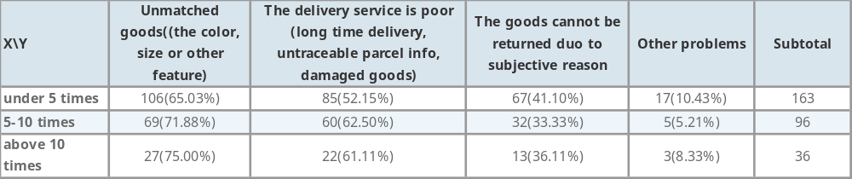

PDP is a consolidation point where the control of goods is moved to transport operator; CDDP is a link point to a specific customer, where goods are handle to deliver operator.
http://www.proactiveinvestors.com.au/genera/files/companies/tzl__presentation.pdf [last visited on 06.01.2015]
http://www.dhl.de/de/paket/pakete-empfangen/packstation.html [last visited on 06.01.2015]
Resource from www.taobao.com
The questionnaire can be seen in appendix A
The interview questions can be seen in appendix B.
China Post is the government agency that in charge of postal service of China. http://www.chinapost.gov.cn/ [last visited on 06.08.2015]
Data from China Post http://www.chinapost.gov.cn/ [last visited on 06.08.2015]
News report by Xinhua News Agency, state government’s official press, http://jjckb.xinhuanet.com/2014-11/11/content_526906.htm [last visited on 06.08.2015]
http://news.qq.com/a/20141010/009028.htm?tu_biz=1.114.2.1 [last visited on 06.08.2015]
The information is retrieved from the office website of City 100, http://www.bjcs100.com/c36417/default.asp
The chart is summarized by author according to literatures and online resources.
The detailed result of cross table can be seen in the appendix 3.
Chengdu daily http://cdrb.newssc.org/html/2015-04/07/content_2187574.htm [last visited on 07.08.2015]
Resource from Baidu map http://xmwb.news365.com.cn/jd/201412/t20141203_1488880.html
Chengdu Property Management Institution http://www.cdpma.cn/Estate/News/Default.aspx [last visited on 07.08.2015]
Resource from Largest web portal in China: Sina http://tech.sina.com.cn/i/2014-07-23/09269512287.shtml [last visited on 07.08.2015]
The most commonly used App for chatting in China, now it has more functions, the most distinguished one is Wechat payment, with which you can pay for basically everything.
Forum of Taobao. http://bbs.taobao.com/catalog/thread/154521-317499450.htm

