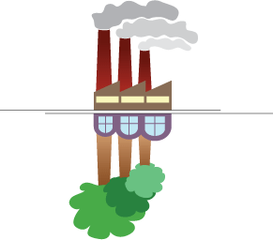

Towards a sustainable chemical industry
The impact of pipeline infrastructure and sustainability initiatives on the bilateral trade of chemicals in Europe

Master Thesis Urban, Port and Transport Economics
July 2015

Erasmus University Rotterdam
Erasmus School of Economics
Student: Theofilos Papasternos
Student number: 357295
Supervisor: Dr. Peran van Reeven
Abstract
The competitiveness of the European chemical industry is challenged by the cost pressure stemming from higher feedstock prices, lower product prices of competitors and higher operational costs due to stringent environmental regulations. In the face of these challenges and with a clear focus to enhance the sustainable development of the industry in relation to the environment and the society while maintaining and upgrading its competitive advantage, this thesis performs a quantitative analysis that measures the impact of pipeline infrastructure and sustainability initiatives on bilateral trade of chemicals and concludes that a wider European network of chemicals pipelines accompanied by coherent sustainability initiatives would have a significant positive impact on intra-EU trade volumes, improve clusters’ performance, decouple industry’s growth from environmental degradation, boost innovative capacity and hence strengthen the competitive position of the European chemical industry as a whole.
Keywords: Bilateral trade, chemicals, pipelines, environment, regulation, sustainability, infrastructure, clusters, competitiveness

Preface
I would like to wholeheartedly thank my professor Mr. Peran van Reeven for his valuable teachings and his continuing support throughout the years, and my professor Mr. Bart Kuipers for his inspiring insights on the future of circular economy.
Theofilos Papasternos
Rotterdam, July 2015

Contents

Abstract 2
Preface 2
1 Introduction 5
1.1 Research background 5
1.2 Outline 6
2. Problem analysis and research scope 6
2.1. Research questions 7
3. Theoretical background 9
3.1 The role of infrastructure in trade 9
3.2 The impact of environmental regulations on trade 10
4. The European chemicals industry 12
4.1 Industry profile 12
4.2 Chemical clusters and competitiveness 16
4.3 Pipeline networks 22
4.4 Sustainability initiatives 27
5. Methods and Data 33
5.1 Hypothesis 33
5.2 Model specification 33
5.3 Terminology and measurement 35
5.3.1 Trade of chemicals 35
5.3.2 Economic development of the chemicals industry 36
5.3.3 Distance 36
5.3.4 Common language and common borders 37
5.3.5 Sustainability initiatives 37
5.3.6 Pipelines 38
6. Empirical results 38
6.1 Data analysis 38
6.2 Regression analysis 40
6.3 Discussion 43
7 Limitations to the research 44
8 Conclusions 45
9 Bibliography 48
10 Appendix 50
10.1 Appendix Section I 50
10.2 Appendix Section II 54

1 Introduction

1.1 Research background

The intuition behind this research arises from the critical role of the chemicals industry as a catalyst to a sustainable future. The world population is expected to raise to 9 billion by 2050 compared to almost 7 billion nowadays, a fact that combined with ageing population and higher life expectancy will apply enormous pressure on the available natural resources and the overall quality of life in the future. In order to tackle these challenges, countries have been cooperating worldwide so as to drastically address issues such as sustainable energy production and consumption, diversification of raw material base, access to clean water and better nutrition. The role of a sustainable chemicals industry is indeed crucial in addressing these global issues. “The industry continually develops innovations, generated by research in chemistry and other sciences, for a wide range of practical applications. At the same time, it has an important responsibility for the move towards a sustainable use of natural resources, reduction of energy demand, pollution, waste and emission of greenhouse gases, and, last but not least, for the safety of chemical products and their application” (High Level Group, 2007, p.3).
Towards this direction, this master thesis will try to explore the current status of the European chemical industry and investigate how future opportunities for growth can be seized through the wider development of pipeline networks in parallel to the adaptation of initiatives that promote sustainability across the value chain. For the past decade the European chemical industry has been trying to maintain its competitive advantage as it struggles against dual cost pressure; on one side feedstock prices and particularly oil have been continuously rising while on the other side emerging economies like China and Middle East are attracting global investments due to their lower production costs. The questions that this research sets derive from and are in accordance to the efforts of the chemical industry to enhance its competitiveness by improving the value chain, inducing higher cluster integration and boosting investments in “green” infrastructure. The research focuses on the impact of pipeline infrastructure and sustainability initiatives on the bilateral trade of the four main producers of chemicals in Central Europe namely Germany, France, Italy and Netherlands. Useful insights concerning clusters’ integration and competitiveness in regards to interconnecting pipeline networks will be offered by the analysis of the dominant ARRR (Antwerp-Rotterdam-Rhine-Ruhr) chemical cluster.
The goal of this research is to measure the impact of sustainability initiatives on intra-EU trade of chemicals and highlight the importance of pipeline infrastructure for the competitiveness of the chemical industry. The outcomes and conclusions are expected to reveal the significant importance of sustainability initiatives for the competitiveness of chemicals clusters, outline the need for smarter and more efficient cluster integration through the development of interconnecting pipeline networks as well as present opportunities for collaboration between the relevant stakeholders in the European chemical industry.

1.2 Outline

The thesis consists of two sections: the theoretical and the empirical part. To begin with, the problem analysis and research scope of this study are presented in Chapter 2 followed by the presentation of the research questions. Then the literature review is presented in Chapter 3, providing the theoretical backgrounds of this research in regards to the impact of transportation infrastructure and environmental regulation on trade and sustainable development. Chapter 4 is dedicated to the presentation of the European chemicals industry with a special focus on chemical clusters, sustainability initiatives and pipeline networks. The theoretical part is summarized in Chapter 5 which acts as the stepping stone to the empirical analysis. Chapter 6 describes the methods and data of the research. The empirical results of the quantitative analysis are discussed in Chapter 7 while chapter 8 provides the summary of the empirical part. The last part of the thesis is dedicated to the limitations (Chapter 9) and the conclusions (Chapter 10).

2. Problem analysis and research scope

As mentioned above, this research examines the bilateral trade of chemicals between the four largest producers of chemicals in Europe namely Germany, France, Italy and the Netherlands. These countries represent the backbone of the industry hence the outcomes of the research are valuable in drawing conclusions in regards to the efficiency of sustainability initiatives and integrated pipeline networks.
The OECD has defined sustainable chemistry as: “the design, manufacture and use of efficient, effective, safe and more environmentally benign chemical products and processes. Within the broad framework of sustainable development, government, academia and industry should strive to maximize resource efficiency through activities such as energy and non-renewable resource conservation, risk minimization, pollution prevention, minimization of waste at all stages of a product life-cycle, and the development of products that are durable and can be re-used and recycled.” However as production and consumption facilities of the chemical industry are mostly separated, green transportation becomes a critical necessity. Understanding the importance of green transportation, the European Chemical Industry Council (Cefic) published in 2010 a study carried out by McKinnon that analyzes the measurement and management of CO2 emissions in European chemicals transport. The study acted as the base for the development of industry guidelines that offer a “common methodology for the calculation of transport emissions and provide a generic overview of opportunities and approaches for companies to reduce their emissions” (McKinnon, 2010). Even though less than 1% of all EU GHG emissions come from the chemical sector’s transport operations, companies can now “better understand their carbon footprint and develop low-carbon strategies for their logistics operations”.
In regards to the challenge of improving the competitiveness of the chemical industry and maintaining a sophisticated value chain in Europe, “integration of clusters and connectivity by pipelines is essential”.

2.1. Research questions

The introductory sections above have highlighted the framework of this research. The main focus of the thesis is to explore the link between intra-EU trade of chemicals, sustainability initiatives and transportation via pipelines. Taking into consideration the above, the following general research question has been developed:
To what extent do sustainability initiatives and pipeline infrastructure applying to the European chemicals industry have a significant impact on intra-EU chemicals trade volumes?
In order to break down the research question and allow for a clear approach towards the final conclusions, the following questions have been developed:
1. Which countries can be identified as leaders in the European chemical industry and hence frame the area of analysis?
2. How does pipeline infrastructure affect the competitiveness of chemical clusters and chemicals trade?
3. What is the significance of interconnecting pipeline infrastructure with respect to trade volumes?
4. How do sustainability initiatives applying to the European chemicals industry affect chemicals trade?
5. Which sustainability initiatives applying to the chemicals industry can be identified over the period 2000-2013?
6. What is the significance of the adaptation of sustainability initiatives with respect to trade volumes?
Questions 1, 2, 4 and 5 will be answered by the theoretical analysis while the empirical analysis will provide the answers to questions 3 and 6. A comprehensive aggregation of those findings will result to the final answer of the research question in the concluding part of this thesis.

Section 1
Theoretical analysis

3. Theoretical background

3.1 The role of infrastructure in trade
The scope of this part of theoretical background is to address the role of quality infrastructure in reducing transportation costs and allowing for higher profitability through the enhancement of operational efficiency.
Recent empirical evidence on the relation between the quality of infrastructure and trade costs have been presented in two studies by Clark et al. (2004) and Limao and Venables (2001). The latter finds that effective infrastructure and services could lead to lower transport costs. Depending on the region and commodity handled these costs vary which is partly due to local infrastructure, policies, geography and other variable factors. Transport costs are about 50 percent higher averagely for a country that is landlocked, than countries that have direct access to the sea. Limao and Venables (2004) also used three different data sets to investigate how transport depends on geography and infrastructure. They introduced a number of indicators of infrastructure that have an impact on transaction costs in international trade and they developed bilateral indicators for the quality of infrastructure, assuming that the combined quality of infrastructure in pairs of trading partners matters for bilateral trading costs. Their key findings were that the quality of infrastructure has indeed a significant and relatively large impact on bilateral flows and that the importance of distance is not diminished when the quality of infrastructure is included.
However “infrastructure quality does not just have a one-way effect on trade”(WTO, 2004). High quality infrastructure increases the ability to deliver products through direct roads and in time. This has a positive effect on trade as it lowers transport costs. Furthermore, multiple research findings have showed that public infrastructure can “affect trade through its effect on a country’s comparative advantage” (WTO, 2004). This includes transport related to infrastructure (Yeaple & Golub, 2002). The findings show that better infrastructure correlates to higher trade volumes, which counts for all transport modes including water, air, and land. Transport over land applies not only to roads but also to rail transport and pipelines. Just as with sea freight rates, costs of moving goods over land depend heavily on the regions between which transport takes place. Even though transport over sea is estimated to be cheaper on the average than inland transport, this cannot change the fact that the demand for land transport is growing. Just-in-time delivery becomes more and more important and land transport is the most time-certain transport mode (WTO, 2004).
A study by Yeaple and Golub (2002) found that differences in the quality of public infrastructure between countries can explain differences in total factor productivity. Regional scientists (Christaller, 1933; Losch, 1940; Isard, 1956; Biehl, 1986; Vickerman, 1989, 1990) and economic historians (Chinitz, 1960) have long studied the role of infrastructure in regional development and in the process of industrial concentration. As emphasized by Krugman (1993), these studies suggest interesting directions of research that economists can build upon. Considerable efforts have been made to understand the composition and the volume of nations' exports and imports (see, e.g., Warner and Kreinin 1983). In their study on the determinants of bilateral trade flows (Srivastava and Green, 1986) the authors extended Linneman’s (1966) multivariate approach on the determinants of trade and found that additional variables that have never used before like political instability and cultural proximity have strong impact on bilateral trade flows.
In order to optimize transport costs “integrated transport and communication links are essential” (WTO, 2004, p.120). However efficient logistic solutions not only lower transport costs but can also lower the production costs of industries as operational efficiency and higher profitability is achieved. This can induce the comparative advantage of a region and increase trade flows. Furthermore the WTO research showed that trade flows between neighboring countries are higher than two countries that are far away due to the distance and the costs that this distance entails (WTO, 2004). Distance has significant impact on transport, not only in terms of excessive kilometers and time, but also in regard to the cost of time.
One key finding that would be important to highlight is that “transportation infrastructure has both spatial and economic properties” (Thomas et al., 2003, p.424). In addition to facilitating trade, infrastructure can also “unlock” enclosed areas and hence “acts as a facilitator to increase the participation of land-locked and peripheral regions in global production and logistics networks” (Notteboom, 2009, p.48). Furthermore, infrastructure can also affect “transport costs within and between regions” (Evers et al., 2009, p.30).
Martin and Rogers (1995) found that firms tend to locate in countries with the best domestic infrastructure when trade is integrated in order to take advantage of economies of scale. They showed that better domestic infrastructure implies a lower price and a higher relative demand for the goods produced in these countries. Moreover, they found that infrastructure interacts in “an interesting way with the other determinants of industrial location” examined in the economic geography literature (Krugman, 1991; Krugman and Venables, 1990; Bertola, 1992). On the whole, a higher level of international infrastructure will amplify concentration effects of differentials in domestic infrastructure.

3.2 The impact of environmental regulations on trade
Theories regarding the impact of environmental regulations on bilateral trade have been developed among others by Anderson and Blackhurst (1992), Dean (1992), Van Beers and Van den Bergh (1996), Xing and Kolstad (1996) and Harris et.al (2002). The different scopes of these studies are numerous, ranging from the environmental determinants of trade, through the impact of trade on the environment and the effects of environmental policy on trade, to the substitution or complementarily of trade and environmental policy measures (Van Beers and Van den Bergh, 1996, p. 143).
It has been widely argued that the heavy polluting industries of a country which imposes more stringent environmental regulations than its trading partners are likely to suffer a significant increase in production costs. As a result these industries either become less competitive on the international level hence lose some of their market share or they migrate to countries with laxer environmental standards in order to avoid this loss of competitiveness. As a result exports of pollution-intensive commodities of a country with relatively stringent environmental regulations decrease, while their imports are expected to increase.
However Tobey (1990) found that “the stringent environmental regulations imposed on industries in the late 1960s and early 1970s by most industrialized countries have not measurably affected international trade patterns in the most polluting industries” (Tobey, 1990, p. 192). Also Porter and Van der Linde (1995) argue that a country with relatively stringent environmental regulations can benefit from the improvement in environmental quality and is likely to develop new comparative advantages in the environmentally more sensitive industries. These advantages, “in the long run, might more than offset the short-term losses”. Moreover, even in the short run, as Van Beers and Van den Bergh (1997) point out, “the negative effect of stringent environmental regulations on export flows and its positive effect on import flows can be blurred by government interventions, such as subsidies to pollution intensive industries, and import restrictions on foreign products which do not meet the higher than average domestic environmental standards”. In addition to these environmental cost factors, industry location is also driven by other economic fundamentals such as access to resources and markets, the supply and quality of labour, and transportation costs. Indeed, the effect of these economic fundamentals may outweigh that of environmental cost factors. According to Van Beers and Van den Bergh (1997, p. 30), “the effects of differences in strict environmental regulations on trade flows between countries may cancel out as multilateral trade is an aggregate of bilateral trade flows. However this drawback is not present in case of a bilateral trade flows model”.
Lenz et al. (1992, p.132) have analyzed the determinants of chemicals trade in the US economy. They found the key factors that affect the performance of chemicals industry, maybe the most globalized manufacturing industry as they argue, are namely i)US and world economic growth rates, ii)US and global chemical supplies, iii)continuous globalization of chemicals production, iv)comparative costs of compliance with environmental regulations, v)comparative feedstock and energy costs, and vi)the dollar exchange rate. Chemicals industry is a capital-intensive industry and its production processes heavily depend on industrial machinery. Hence high reliability and quality of machinery is of critical importance as a potential malfunction or damage would be lengthy and costly to resolve. An additional key driver of international trade growth for the chemicals industry as expressed by Lenz et al (1996, p.80) is the “high profit levels and rates of return that can motivate the required high levels of R&D and domestic investment and provide the capital for growing amounts of foreign investments”.
Except for regulatory and self-regulatory frameworks, the chemicals industry is also a field where cooperative platforms arise in order to induce innovative capacity in highly complex processing and production systems. In their study on how collaboration can increase innovation capacity in the chemicals industry, Lager and Frishammar (2012) showed that in a buyer-supplier relationship, the complexity of the product or equipment is one factor that has been recognized as a determinant for collaboration intensity; the greater the complexity, the greater the need for stronger forms of collaboration/cooperation (Eriksson, 2008, Olsen et al., 2005).
Taking into account the highly complex nature of the chemical industry and its value chains, this thesis will examine the impact of regulatory, self-regulatory and cooperative initiatives that aspire to push the chemicals industry towards a greener and safer future. These sustainability initiatives will be described in detail in Chapter 4.4.

4. The European chemicals industry

This research focuses on the link between sustainable transportation and trade of chemicals. In order to offer an interpretation of what these concepts actually mean, this section will begin in Chapter 4.1 by providing an analysis that covers the relative dimensions of the chemicals industry in regards to its characteristics, its strengths and its “green” evolution. The critical role and functions of chemical clusters will be reviewed in detail in Chapter 4.2 while Chapter 4.3 will focus on the importance of pipeline networks. Last but not least Chapter 4.4 will offer the review of the sustainability initiatives undertaken by the countries of the model. More specifically, in order to acquire a holistic knowledge of the European chemical industry a top-down approach will be used. First the general characteristics of the industry will be presented. The analysis will start off by comparing trends in Europe and globally; global production, trade flows and investment trends will be presented. In addition, the regional shifts of global production and changes of comparative advantage will be analyzed in order to understand the motives of change in production allocation (mainly ‘carbon leakage’). Deductively, the research will emphasize on the EU area. The next step will focus on a cluster-level approach (ARRR) where the impact of infrastructure on cluster growth and integration will be investigated. At this point specific attention will be given to the inspiring “Trans European Olefins Pipelines Network Project” where the benefits of interconnected clusters to the competitiveness and sustainability of the industry will be presented. The last part of this section will be dedicated to the analysis of “sustainability initiatives”, a combination of regulatory, self-regulatory and cooperative initiatives that aspire to turn the chemical industry into a smart, clean and green industry.

4.1 Industry profile

Eurostat (2006) has classified the chemical industry as one of the main manufacturing industries, with an added value of 156 billion Euros and a production value of 482 billion Euros. According to Cefic Chemdata International (p12, 2013), during the last 20 years the EU chemicals sales have almost doubled while the EU’s market share has halved (Figure 1).
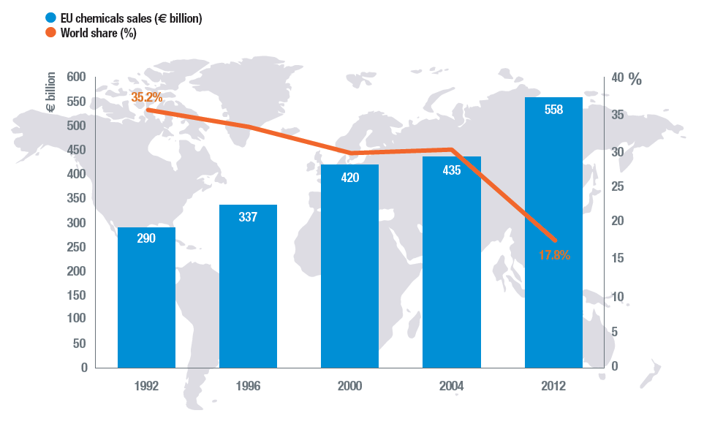
Fig.1 Source: Cefic Chemdata International (2013), excluding pharmaceuticals
The European chemicals industry has witnessed severe changes. Out of a global turnover of €3,127 billion in 2012, EU countries account for a 17,8% market share with a turnover of €558 million . Even with an average growth rate of 7% over the past decade, EU has lost its top ranking in sales to China as seen in the Figure 2 below.
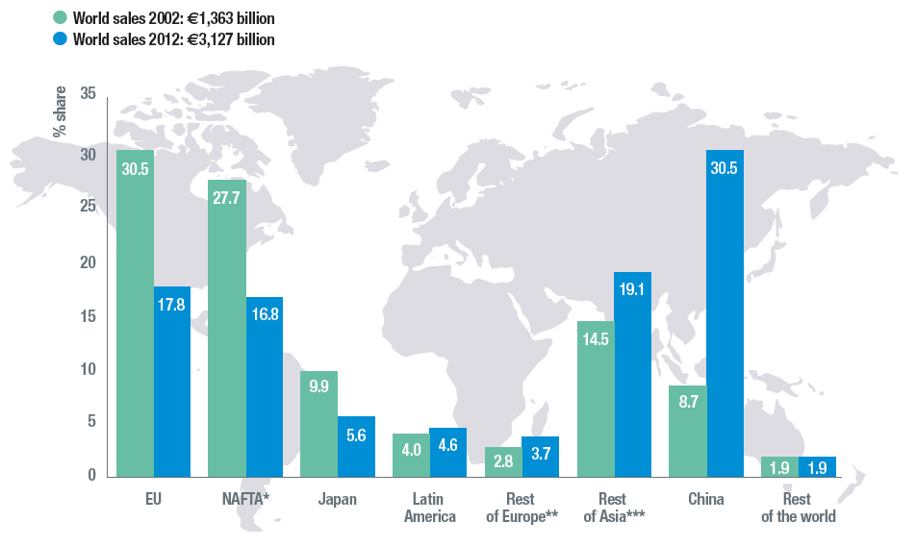
Fig.2 Source: Cefic Chemdata International (2013), excluding pharmaceuticals
China reached a 30,5% market share in 2012, the same share that EU chemical industry held in 2002. In addition, the rest of Asia has managed to climb to second position with a market share of 19,1%. These new players have focused on “resource monetization and economic development, in contrast to the classic shareholder value-creating goals that have historically informed the strategies of top players. Not only are these newcomers playing by different rules, but they are also better placed to benefit from the key dynamics driving the industry’s future: control of advantaged feedstock in a high-oil-price world, and privileged access to the most attractive consumer-growth markets”. An additional reason behind the swift to the East has been credited to the “carbon leakage” effect. As described by the European Commission under its Climate Action Policy, “carbon leakage is the term often used to describe the situation that may occur if, for reasons of costs related to climate policies, businesses were to transfer production to other countries which have laxer constraints on greenhouse gas emissions”. The concept of “carbon leakage” and its effect on the competitiveness of the industry will be discussed in more detail in Chapter 4.2.
The output from the EU chemical industry covers three main product categories: base chemicals, specialty chemicals and consumer chemicals. Base chemicals include petrochemicals and their derivatives as well as basic inorganics which are the main building blocks of the chemical industry value chain. Base chemicals are produced in large volumes across approximately 70 locations in Europe (steam crackers, refineries) and are mostly sold within the chemical industry itself. In 2012, base chemicals represented 63.1 per cent of total EU chemicals sales. Specialty chemicals include paints and inks, the auxiliaries for industry, crop protection, dyes and pigments. On the contrary, specialty chemicals are produced in smaller volumes; however they made up 25.4 per cent of total EU chemicals sales in 2012. Consumer chemicals are sold to final consumers, such as soaps, detergents, perfumes and cosmetics. Altogether they represented 11.5 per cent of total EU chemicals sales in 2012. For the purposes of this research, special attention will be given to the production and transportation of base chemicals as they represent almost two thirds of the industry’s sales and are mostly sold within the EU industry. (see Figure 3)
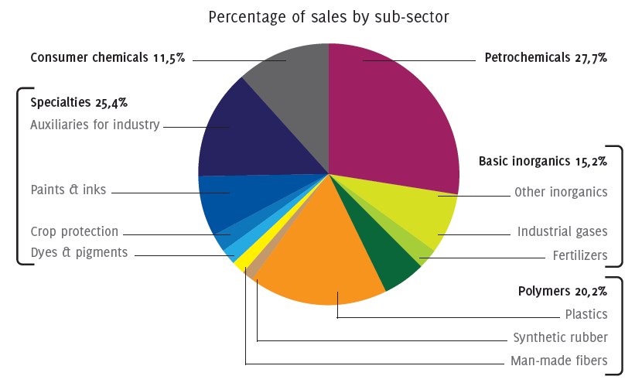
Fig.3 EU Chemicals industry by sub-sector (Source: Cefic, 2012)

The breakdown of sales by destination in Figure 4 below shows a significant growth of intra-EU exports during the decade 2002-2012. Both intra-EU and extra-EU exports have almost doubled during the decade while home sales have decreased by €33 billion. Intra-EU exports make up for almost half of the total chemicals sales revealing the growth of the chemicals industry due to the EU East enlargement. According to the Cefic Report (2013) “removing both trade and non-trade barriers inside the European Union helped boost growth and competitiveness in the EU chemical industry between 2002 and 2012”. An additional determining factor for the EU chemical industry competitiveness is the internal market which numbers more than 500 million consumers. The accession of new EU member states in 2004 and 2007 gave the internal market an extra boost for intra-EU trade. Total EU chemicals sales were worth €558 billion in 2012. Intra-EU sales climbed up from €157 in 2002 to €270 in 2012 – a 72 per cent increase during the last 10 years. By 2012, intra-EU sales – excluding domestic receipts – accounted for 48 per cent of total EU chemicals sales.
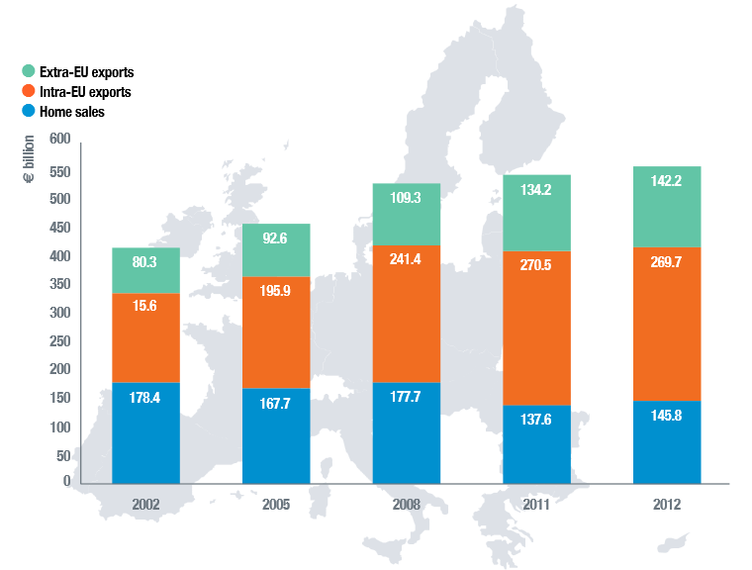
Fig.4 EU Chemicals sales driven by internal market (Source: Cefic, 2013, excl. pharma)
Regarding the immense growth of intra-EU sales, this thesis will analyze the determinant factors behind this boom and investigate how infrastructure and regulation can affect the overall competitiveness of the industry. In chapter 2.1 a series of complementary questions were described that will deductively lead to the answer of the main research question of this thesis. More specifically, the first question was:
1. Which countries can be identified as leaders of the European chemical industry and hence make up the area of analysis?
In order to answer this question the following data are presented in Figure 5 below.
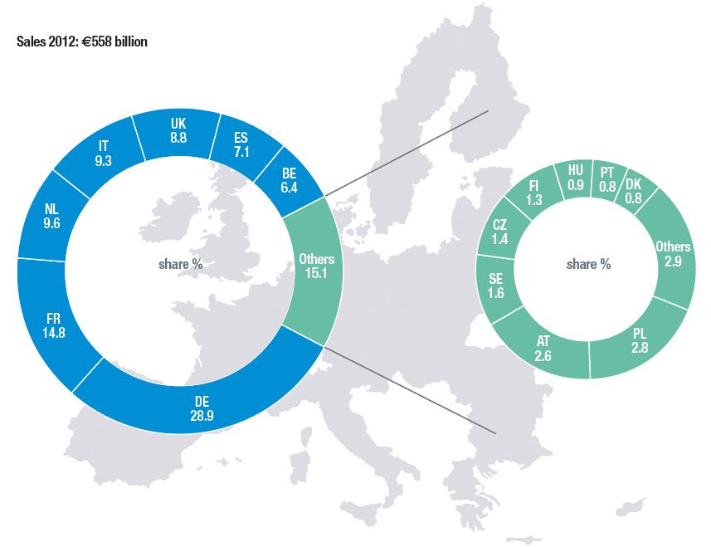
Fig.5 Chemical sales by member state (Source: Cefic Chemdata International 2013, excl. pharma)

As seen in the figure above, Germany is the largest chemicals producer in Europe, followed by France, Netherlands and Italy. Altogether these four countries generated 62.6 per cent of EU chemicals sales in 2012, valued at €349 billion. Furthermore Figure 6 below reveals the leading role of the top 4 European countries. Concentrating investments of more than $1 billion per country until 2030, the 4 countries form the backbone of the European chemicals industry and drive the innovative growth that will allow Europe to compete for investment attraction with Russia and Brazil.
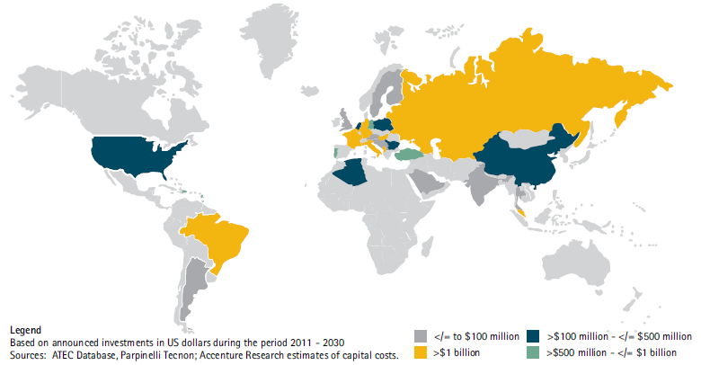
Fig.6 European chemical companies’ investment, total announced between 2011 and 2013 (based on data for more than 100 petrochemicals) Source: Accenture Looking Ahead
Taking into consideration the abovementioned, the geographical scope of this analysis will include the top 4 chemical producers in Europe namely Germany, France, Netherlands and Italy. These central European countries form the backbone of the chemical industry, have long history in innovation and can therefore act as the catalyst towards a sustainable future of chemical production and distribution in Europe.

4.2 Chemical clusters and competitiveness

Clusters are defined by Porter (1998) as “geographic agglomerations of companies, suppliers, service providers, and associated institutions in a particular field.” Their two key characteristics are thus the proximity of individual activities in terms of geography and value creation. The chemical industry is characterized by geographical concentration and industrial co-location. Basic chemicals like ethylene are so difficult to transport that consumers locate close to the production sites; hence oil refineries and chemical crackers are operating within arm’s reach while derivatives can be distributed more easily to downstream users and consumers across the value chain.
In terms of value creation, innovation is the key. As Kiriyiama (2010, p.5) discussed in the OECD report on trade and innovation in the chemical sector, “different sub-segments of the industry, i.e. basic industrial chemicals, speciality and fine chemicals and consumer chemicals all have very diverse innovation characteristics. Basic industrial chemicals have limited opportunities to introduce new products and compete mainly on costs, whereas product innovation, responding to evolving customer needs transmitted through supply chains, is essential for speciality and fine chemicals. Process innovation is important for both of these sub-sectors to reduce costs, to improve sustainability (e.g. industrial biotechnology) or to pursue differentiation”.
In his study “Staying Power of Europe’s Chemical Industry”, Arthur Little (2005) compared the production costs of Europe’s sites to those in China, Middle East, India and the US. The study conducted both a qualitative and a cost based assessment of the operating environment in which chemical companies deliver value. The four determinants found to critically affect the quality of the operating environment were i)demand conditions, ii)technological advancement and innovation, iii)environmental regulations, and iv)the formation of clusters. The study showed that except for the environmental regulations for which “governments must improve cooperation with companies to develop environmental efficiency at low administrative cost”, all other factors are well established in Europe, including the presence of strongly integrated clusters.
The majority of the 300 European production sites are located in 30 clusters. According to EU’s Final Report of the High Level Group on the Competitiveness of the European chemicals industry (2009), “the high integration of most of the European chemicals industry along the product value chain is one of its main competitive advantages”. It is this integration which until now largely allowed the European industry to compensate for its less favorable feedstock position and higher energy costs. In addition, the Final Report suggests that “complete supply chain integration within clusters is often not yet achieved and the interconnection between clusters is insufficient. Consequently, clusters considered economically viable should be supported in their development, while complying with state aid rules”.
Another author that provided critical insights regarding the competitiveness of the European chemicals industry was Christian Ketels from Harvard University. In his report “The role of clusters in the chemical industry” Ketels (2007) argued that the “competitiveness upgrading has moved from a model of internal optimization within companies to a model of cluster-based optimization across networks of co-located activities”. Ketels also showed that cluster efforts have a dual focus; improvements on supply chain and development of a “broad-based agenda of improving competitiveness at the level of companies, the cluster, and the cluster-specific business environment”.
Following the same path, Fred du Plessis (2010) showed in his report that “strengthening Europe’s chemical clusters will lead to improved competitiveness of the European chemical industry overall”. He argued that this enhancement could be initiated through i) improved cost competitiveness from integration along the product value chains, ii) synergy benefits from shared utilities, services and infrastructure, iii) increased investment due to improved cost competitiveness, iv) lower logistics costs due to a competitive offering of services within the cluster, v) better risk management, vi) increased cluster critical mass, vii) collaboration mindset of cluster members to collective advantage that can allow viii) total cluster performance to be better than the sum of the individual cluster members performance on a stand-alone basis.
Fred du Plessis (2010) also analyzed the key attributes and performance criteria of successful chemical clusters. A consolidation of these findings is presented in Table 1 below.


The report of du Plessis concluded with the argument that “the chemical industries’ competitiveness can be improved by improving the logistics infrastructure within and between the European chemical clusters”. Kettels (2007) drew the same conclusion regarding the logistics infrastructure of the chemical industry arguing that “with raw materials being the main input to the chemicals industry, their immediate availability through ports, refineries, and pipelines is of prime importance, as well as the opportunity to develop derivative products at the lowest possible logistics cost”. In addition his report highlights the critical importance of supply chain to the efficiency of chemical clusters and views it as a lever “to the continued global competitiveness of European chemical manufacturing”.
Furthermore Ketels (2007) provided a conclusion that is on the same direction with the scope of this thesis. He discussed that as the “port and pipeline infrastructure facilitates upstream supply chain operations and economics, the high level of integration and interconnectivity between the cluster participants creates significant opportunities to benefit from efficiencies through reduced transportation intensity (i.e. lower freight costs, reduced risk from the movement of hazardous products, reduced emissions), more effective utilization of assets, and efficient use of working capital”.
Fred du Plessis (2010) seems to acknowledge that “Europe may be expensive; the surprising conclusion was that it still remains one of the most competitive regions in the world”. His study challenges the hypothesis that significant relocation of European-based chemicals manufacturing operations is likely to happen in order to serve developing and developed markets at reduced cost. However recent data on the Trade Competitiveness Indicator (TCI) – an indicator that compares the trade balance to total trade activity of a region – reveals the “deteriorating competitiveness of the overall EU chemical industry”. This means that total chemicals imports are growing faster than total chemicals exports (Cefic Facts & Figures 2013).
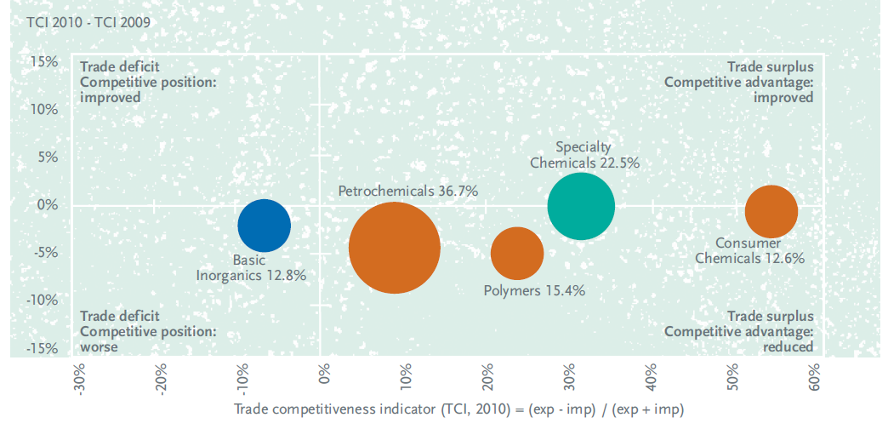
Fig.7 EU chemicals trade competitiveness indicator (Source, Cefic Chemdata International 2010)
Carbon leakage is identified by many as one of the factors that have contributed to the deterioration of the competitiveness of the petrochemical industry. Carbon leakage is the term often used to describe the situation when for reasons of costs related to climate policies, businesses transfer production to other countries which have laxer constraints on greenhouse gas emissions. EU’s Final Report of the High Level Group on the Competitiveness of the European chemicals industry (2009) has expressed the fears that “relocation of parts of the chemicals industry’s production capacity due to different climate change mitigation commitments in different parts of the world would cause unemployment and economic loss in Europe”. The report also suggests that relocation would also “increase global GHG emissions and pollution if major parts of the industry move to areas, namely China and India, with a problematic energy mix and low efficiency in energy generation and use”. However in the absence of a global climate policy agreement (including a global carbon market), “concepts for scenarios with limited global climate action must include maintaining effective carbon leakage prevention measures whilst fostering domestic innovation and infrastructure investment”. Towards this direction and in order to prevent such negative outcomes European policy makers have opted for a Directive amending the greenhouse gas emissions allowance trading system (‘ETS Directive’) that contains special provisions to reduce the risk of carbon leakage, while maintaining the level of commitment to reduce emissions. According to the provisions in Article 10a of the ETS Directive “several significant subsectors of the chemicals industry could fulfill the criteria of a sector deemed to be exposed to a significant risk of carbon leakage. They would be allocated allowances free of charge at 100% of the quantity of emissions based on Community-wide ex ante benchmarks”.
China, India and the Middle East have capitalized on laxer constraints on GHG emissions, cheaper feedstock, economies of scale and proximity to vast consumer markets hence attracted major investments, secured high market shares in global sales and weakened the competitive position of the European petrochemical industry. Even though there has been a clear trend in outgrowing the EU chemicals industry, it is going to be rather challenging to also outsmart it. The defining characteristic of the European chemicals industry “is and remains its innovative strength associated with enormous productivity increase potential” (The Global Chemical Industry, 2011). Germany and France stand out both in terms of innovative capacity and practical application in the industry ranking in the top positions globally respect to patents share, being surpassed only by the US and Japan as seen in Figure 8 below.
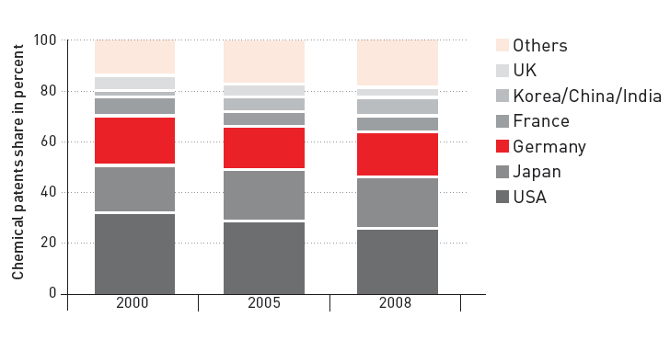
Fig.8 Chemical patents share by country excl. pharma (Source: Germany Trade & Invest 2012)
Cluster infrastructure plays a catalytic role in enhancing innovative capacity and smart specialization thus contributing to higher productivity and upgraded value chains. A good example of the positive effect of infrastructure on innovation is the Bio-Innovation Growth Cluster (BIG-C), a “cross-border Smart Specialization initiative aiming at transforming Europe’s industrial mega cluster in the Belgium region of Flanders, The Netherlands and the German state of North Rhine-Westphalia into the global leader of biobased innovation growth”. BIG-C leverages the four pillars of competitiveness (namely infrastructure, institutions, macroeconomic environment and human capital) found in the Antwerp/Rotterdam/Rhine-Ruhr (ARRR) mega-cluster in order to turn the region into the “global leader of biobased innovation growth”. The ARRR mega cluster has for “decades been a powerhouse of industrial innovation in the chemistry sector” and can therefore lead the paradigm shift to the transition to the bio-economy.
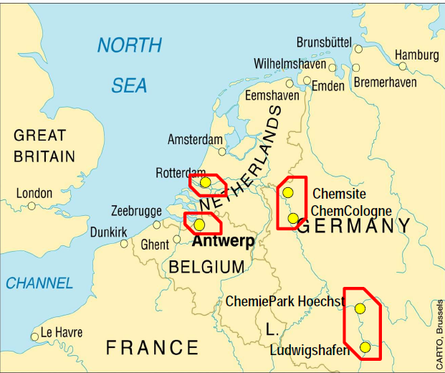
Fig.9 Clusters forming the ARRR mega cluster (Source: Fred du Plessis, 2010)
The ARRR mega cluster produces almost two thirds of Europe’s chemicals (Fred du Plessis, 2010). A highly developed infrastructure in highways and railways facilitates the high-volume shipping of feedstock and manufactured goods. In addition, a complex system of pipelines starting from sea ports connects industrial production sites with each other, especially those of the chemical industry. With raw materials being the main input to the chemicals industry, their immediate availability through ports, refineries, and pipelines is of prime importance, as well as the opportunity to develop derivative products at the lowest possible logistics cost (EPCA, 2007). This extremely versatile logistic system not only serves the mega cluster itself but runs further down the river to the Rhine-Main area around Frankfurt, Ludwigshafen (home of BASF) and finally to the Swiss chemical industry around Basel as well as linking up with the French Lyon Area (Figure 10).
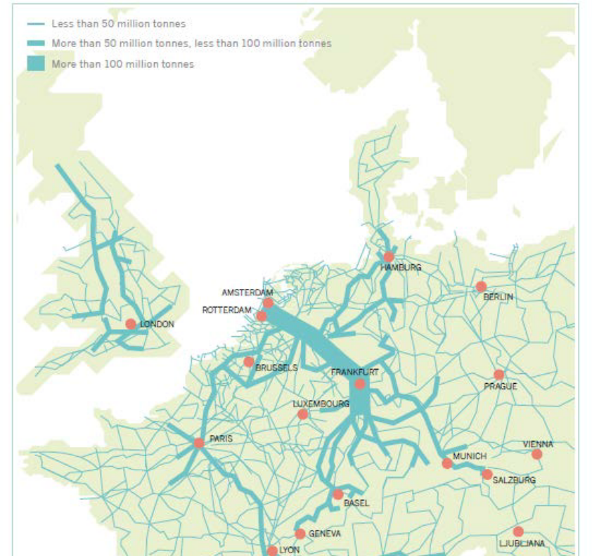
Fig.10 Accumulated yearly volumes in European logistics incl. pipelines (Dutch Inland Shipping Information Agency, The power of inland navigation, April 2009)
Having addressed the critical role of infrastructure in enhancing trade flows, cluster growth and productivity as well as its contribution in creating significant impact on innovation and value chain integration, the next part of the thesis is going to focus on pipeline networks.

4.3 Pipeline networks
Long distance transport is the rule in the chemicals sector thus improving the logistics infrastructure within and between chemical clusters is of high importance. Research has showed that the share of road transport of chemicals is too high and decoupling growth from road transport is therefore a necessity (McKinnon 2011). The European Commission addressed the need for efficient, competitive and sustainable logistics for the future development of the European chemical industry. In its White Paper strategy towards a competitive and resource efficient transport systems, the Commission highlighted that “many European companies are world leaders in infrastructure…, but as other world regions are launching huge, ambitious transport modernization and infrastructure investment programs, it is crucial that European transport continues to develop and invest to maintain its competitive position”. Furthermore the Commission addressed the fact that “transport infrastructure investments have a positive impact on economic growth, create wealth and jobs, and enhance trade” and that “it has to be planned in a way that maximizes positive impact on economic growth and minimizes negative impact on the environment”.
Based on the directions of the White Pater, Cefic and Deloitte created the joint report “Chemical Logistics Vision 2020” which addresses the need for sustainable logistics strategies and related activities that respond to the EC’s strategy for competitive and resource efficient transport systems. The scope of the report encompassed chemical logistics by all modes of transport in Europe while depicting the future from three different perspectives: the chemical industry, the logistics industry and external factors (sustainability and regulations). The report concludes by arguing that challenges presented by the EC goals of lowering carbon emissions from transport by 60% by 2050 create an “urgent need to invest and shift in greener transportation modes”. Figure 11 depicts one of the key findings of the report; pipelines is the second most used channel of chemicals transportation in terms of volume and the cleanest one with CO2 emissions close to zero percent.
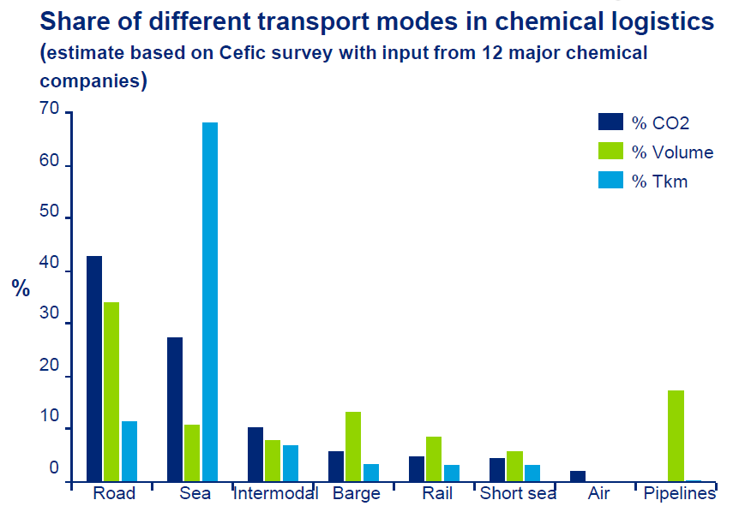
Fig.11 Share of transport modes in chemical logistics (Source: Cefic and McKinnon 2011)

In his report McKinnon(2011) analyzed the five key parameters that could allow for an efficient decarbonization of the chemicals transport sector namely modal split, supply chain structure, vehicle utilization, fuel efficiency and carbon intensity of fuel. Based on those key parameters McKinnon proposed a set of decarbonization measures for which he ran a cost-effectiveness analysis. The findings of this analysis can be seen on the Table 2 below.

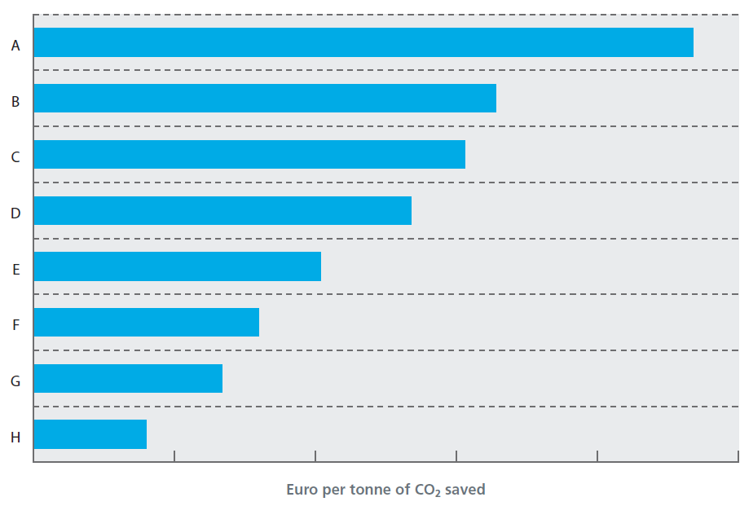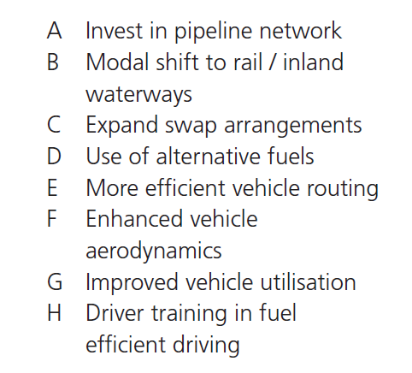
Table 2, Variations in relative cost-effectiveness of decarbonisation measures (Source: McKinnon 2011)
Investing in pipeline network has been found to be the most cost-effective measure of the decarbonization strategy, followed by the modal shift to rail and inland waterways. The significantly high cost-effectiveness of pipeline investments could be explained by the long lifetime of pipeline infrastructure, its high share (17,56%) in the transport mix (Figure 12) and its notably low CO₂ emissions (5gCO₂/tone-km) (Table 3).
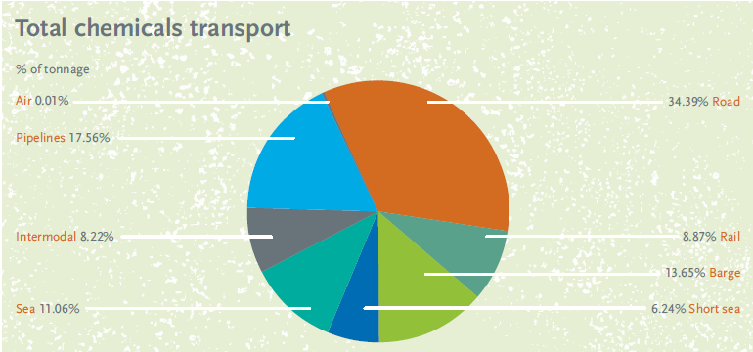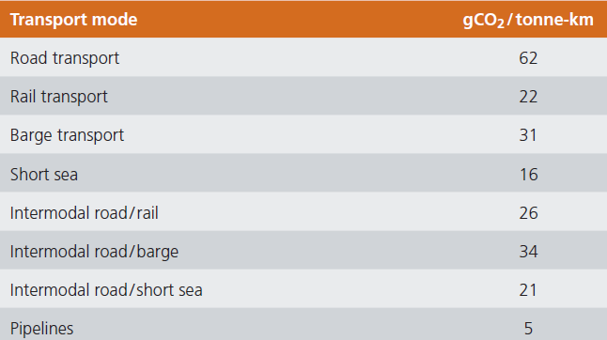
Fig.12 Total chemicals transport (Cefic 2011) Table 3 Co2 emissions by modes of chemicals transport(McKinnon 2011)
However investments on pipeline networks “cannot be justified purely on decarbonisation grounds. There must also be a commercial case for it and this is often lacking” (McKinnon, 2011). Taking into consideration the average cost of a pipeline project (€450.000/km), the long payback and the low constant returns for the single operator (APPE, 2004), it is clear that the attractiveness of projects for external finance operators is limited. Furthermore the fact that the pipeline infrastructure has to be financed by the pipeline users themselves means that any existing pipeline is built or operated only for the benefit of the pipelines owner(s) (limited access) and not for the entire industry or society as a whole (APPE, 2004). However the inclusion of olefins pipelines in TEN-E revision proposal recognizes olefins pipelines as infrastructure of European interest and states that “full account should also be taken of the objectives of the Community's transport policy and specifically the opportunity to reduce road traffic by using pipelines for natural gas and olefins” thus paving the road for public-private partnerships (PPPs) that will “allow olefins pipelines projects to access to same policy, organizational and financial advantages vis-a-vis other modes of transport (road, rail, gas, inland waters networks)” (APPE, 2008).
Currently there are 5 separate pipeline systems in Europe in UK, France, ARRR cluster region, Italy and Eastern European. These systems however are not interconnected to form a complete network (see Fig.24 Appx.I). Compared to the US situation where almost 100% olefins capacity interconnected by pipelines, European ethylene capacity (see Table 11 Appx.I) in only 50% interconnected while propylene pipelines are only developed in the ARRR part of Germany and the Benelux area (see Figure 13 below and also Figure 25 in Appx I).
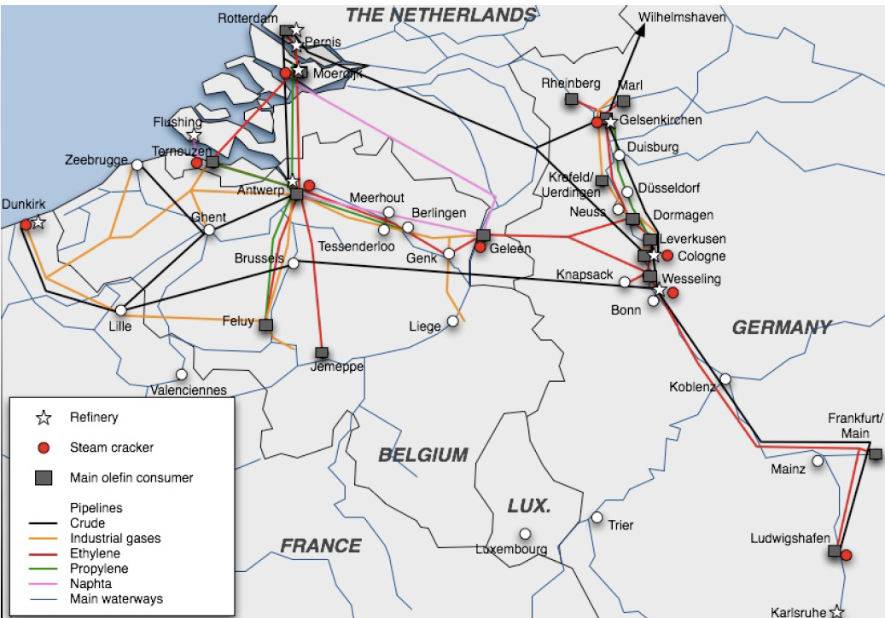
Fig.13 Pipelines in the ARRR cluster (Source: APPE,2004)
Stemming from this limited distribution capacity that severely “limits the flexibility of operation and results in reduced margins in Europe when compared to the US” (APPE, 2004), a vision of a trans-European olefins pipelines network (see Figure 26 Appx.I) was developed by the Association of Petrochemicals Producers in Europe (APPE) in cooperation with Cefic in 2003 and further elaborated by Skelley (2008) for the High Level Group on the Competitiveness of the Chemical Industry Energy. It was also ranked as a “strategic objective” in the European Regional Development Fund SWOT analysis of chemical logistics in Central and Eastern Europe. The economic benefits of a trans-European network analyzed in the abovementioned reports have been aggregated and presented in the Table 4 below:
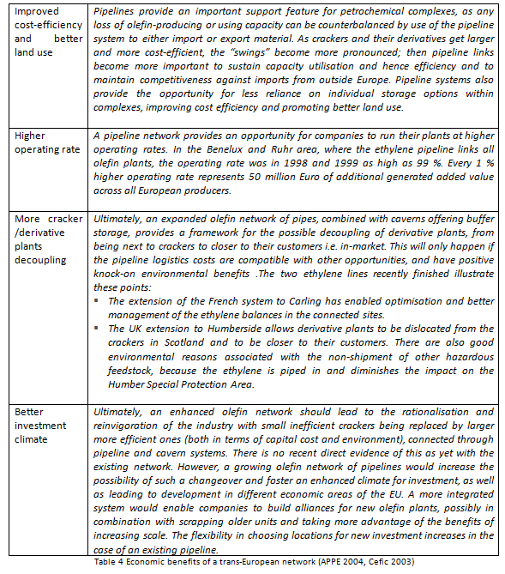

Creating a sustainable future for the chemicals industry will not only require breakthrough changes in “hard” factors like infrastructure. A wider engagement of the industry players will be necessary in order to facilitate cooperation on “soft” factors that will diffuse sustainable practices throughout the chain. Furthermore environmental regulation has to be in place in order to provide a common set of rules and procedures that the industry’s players will have to abide with. The next part of this thesis discusses the key regulations, soft laws and voluntary initiatives that have been applied to European chemical industry.

4.4 Sustainability initiatives
The OECD defines sustainable chemistry as: “the design, manufacture and use of efficient, effective, safe and more environmentally benign chemical products and processes. Within the broad framework of sustainable development, government, academia and industry should strive to maximise resource efficiency through activities such as energy and non-renewable resource conservation, risk minimisation, pollution prevention, minimization of waste at all stages of a product life-cycle, and the development of products that are durable and can be re-used and recycled.” Sustainable development in the chemicals industry can be induced by achieving a balance that enables the three pillars (3P’s) -People, Planet, Profit- to prosper. However for the chemical industry, “there’s another “p” which is fundamental to its existence: products” (Cefic Sustainability Report, 2012). As the chemicals industry is one of the main emitters of greenhouse gases releasing (mainly) CO2, methane and NOX achieving sustainable development is inherently a great challenge. However in regards to creating sound strategies to address climate change, the industry has already undertaken measures that have shown positive effects. During 1990-2009 the industry managed to decouple production from energy consumption (Figure 15) and reduce GHG intensity by 68% (Figure 16).
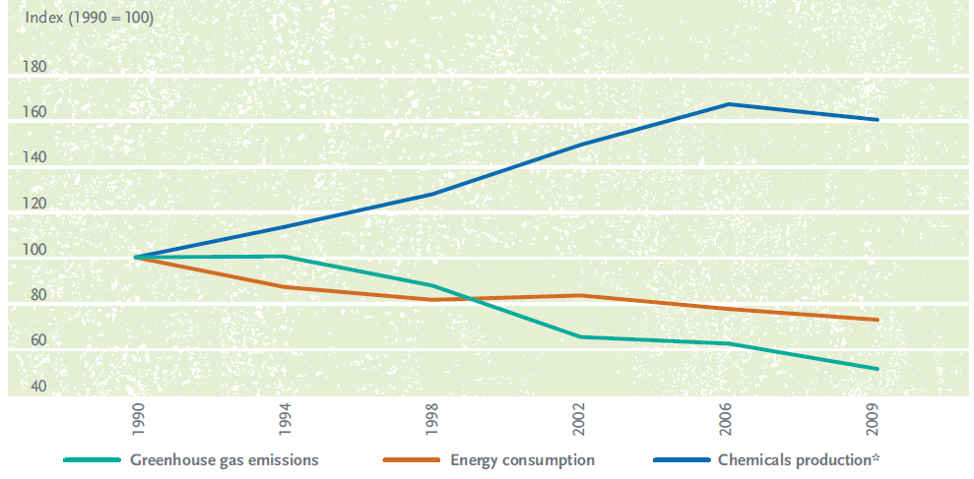
Fig.15 Tracking GHG’s in the chemical sector (Source, Cefic 2012)
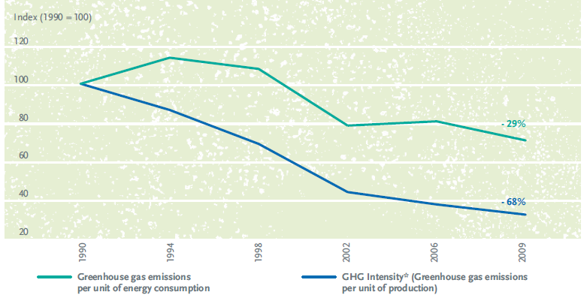
Fig.16 Greenhouse gas intensity of the chemical sector (Source, Cefic 2012)

Significant progress has been made in the reduction of emissions and energy use, however, the generation of waste and especially toxic waste can be very harmful for the environment and for the health of human beings. The chemical industry generates about 40 million tons of waste of which 8 million tons or 20% is hazardous waste (Greenovate, 2011).
Reviewing relevant bibliography and sustainability reports in regards to the regulatory and voluntary self-regulatory initiatives that entered into force over the time period 2000-2013, three main initiatives were identified and will be discussed in the section below.
REACH
The European Commission published in 2001 its White Paper, A Strategy for a Future Chemicals Policy in which a new regulatory structure for the chemical industry is proposed in order to increase the protection for human health and the environment from the effects of harmful chemicals. Stemming from this strategy, the Registration, Evaluation, Authorisation and Restriction of Chemicals (REACH) directive entered into force on 1 June 2007. REACH is a “regulation of the European Union, adopted to improve the protection of human health and the environment from the risks that can be posed by chemicals, while enhancing the competitiveness of the EU chemicals industry. It also promotes alternative methods for the hazard assessment of substances in order to reduce the number of tests on animals”. In addition REACH has substantial impact on downstream industries as well. As Cefic points out these industries i) seek targeted dissemination of risk assessments, ii) seek a full understanding and sharing of information relating to the environmental footprint of chemicals along the supply chain from manufacturing to disposal based on a life cycle approach and iii) require innovative, high-quality products that deliver the best possible functionality and translate into consumer benefits (Cefic Sustainability Report, 2012). Cefic suggests that the fact that chemical companies meet stringent requirements in terms of products and processes, can be seen as a way for companies to differentiate and “use this as a selling point in response to demands by increasingly affluent and well-informed local populations for products based on strong, properly enforced chemicals management standards” (Cefic Sustainability Report, 2012).
However the REACH directive that requires the registration and testing of more than 30,000 chemical substances has been very controversial. Various studies (see Table 12 in Appx. II) that assessed the implementation costs of REACH have concluded that the cost estimations range from $500 million to $150 billion (Lorenz et al, 2008). Even though a recent survey by INSEAD showed that the chemical industry is “still very pessimistic about the long-term impact of REACH on the competitiveness of the European manufacturing base”, the study of Lorenz (2008) showed that the impact on future product innovation as well as on Europe’s cost competitiveness in global markets “will most probably be minor”.
Responsible Care
Responsible Care (RC) is a global self-regulation initiative of the chemical industry that aspires to “improve health, environmental performance, enhance security, and to communicate with stakeholders about products and processes”. The initiative was launched in Canada in 1985 and it engages all levels of a chemical company, from top management to plant workers. The core principles of Responsible Care are designed to i)improve the safety, health and environmental performance, ii)use resources efficiently and minimize waste, iii)openly report on difficulties and achievements, iv)engage in dialogue with stakeholders, v)cooperate with regulators and set standards that go beyond regulation, and vi)provide help and advice to foster the responsible management throughout the value chain. Responsible Care is an integral part of the industry’s contribution to Strategic Approach to International Chemicals Management developed within the United Nations Environmental Program. The European Association of Chemical Distributors (Fecc) developed its own complementary European Responsible Care program which has been approved by Cefic in 2009 while in 2010 its member federations adopted the European Responsible Care Security Code. Each national federation is responsible for developing, managing and overseeing implementation of its own Responsible Care program while companies have to provide annual reports on their performance on Key Performance Indicators (KPI’s) that have to be approved and verified by Fecc’s RC Manager (see Figures 30, 31, 32 Appx II).
The added value that RC brings to the operational efficiency stems also from the fact that “all links up and down the value chain can cooperate in a life cycle approach. This avoids ‘problem-shifting’: it helps ensure that improvement in one part of a product or service’s life cycle does not simply create a different problem in another place or time, or in another part of the environment” (Cefic Sustainability Report, 2012).
SusChem
The European Technology Platform for Sustainable Chemistry (SusChem) is a “forum that brings together industry, academia, governmental policy groups and the wider society. Its mission is to initiate and inspire European chemical and biochemical innovation to respond effectively to society’s challenges by providing sustainable solutions”. SusChem was launched in 2004 as one of the first European Technology Platforms (ETPs) with a vision to make sustainable chemistry the catalyst for a more competitive and innovative Europe. SusChem has been creating significant added value to the chemical and biotechnological ecosystem through its support in securing European funding for innovative projects; “approximately €300 million each year has been invested in various projects supporting these industries over the first five years of FP7” (Townsend, 2013). Following the shift of Europe’s strategy as expressed through the alteration of FP7 to Horizon 2020, Suschem has accordingly adopted a focus to output rather input hence gravitating towards innovation rather than research. As Townsend (2013) argues, “research is about turning money into knowledge and ideas, whereas innovation is about turning knowledge and ideas into money”. This implicit scope towards knowledge valorization is expected to have a significant impact on innovative capacity and marketability thus affecting all stages along the value chain. A substantial part of Horizon 2020 priorities are identified and focused via major Europe 2020 “flagship innovation initiatives” in which Suschem has been actively involved and will continue to contribute by creating value (see Figure 33 Appx II).
Taking the discussion to a cluster level, it can be generally said that eco‐innovation and environmental targets do not form part of the cluster organization’s main strategies and objectives (Barsoumian et al, 2011) but are rather perceived as “very stringent” and “major barriers for more eco-innovation”. Beyond just complying with existing legislation and standards, the motivation for more eco-innovation is rather low “unless it has positive implications on costs, such as energy and resource efficiency” (Greenovate, 2011, p.32) while voluntary environmental schemes and initiatives exist mostly at the company level instead of cluster level. As presented in the Greenovate qualitative report (2011) which required participating members of chemical cluster organizations or service providers to select the key external incentive which drive eco‐innovation within their cluster, legislation is the most important driver followed by voluntary programs. These findings “validate conclusions drawn concerning the pivotal role of strict legislative standards placed on the chemical sector across member states”. The fact that voluntary programs are the second highest driver “confirms the opinion of cluster organizations that eco‐innovation is not driven by competitiveness but mainly legislation, as any additional initiatives are therefore purely based on voluntary actions rather than economic development”.
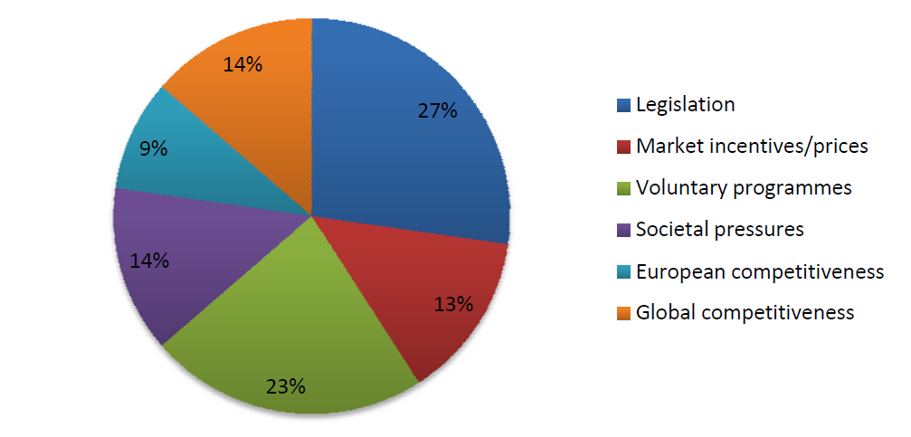
Fig.17 Key eco-innovation drivers in chemical cluster organizations (Source: Greenovate, 2011)
The report also found a correlation between the existence of a prominent cleantech industry and cluster policies that target the “establishment of cleantech clusters to further contribute to the economic competitiveness of the eco‐innovation sector”. In other cases such as the Bio Innovation Growth mega cluster (BIG-C) in the ARRR region for which innovation has become an economic competitiveness factor, there is a bottom-up approach where innovation goals (or environmental performance goals) are horizontally integrated in cluster’s organization activities in a variety of sectors. This fuels the strengthening of the cluster’s economy performance as well as induces the further development of the four pillars of competiveness by smart specialization. Hence BIG-C “will not only transform technical value chains, but will prepare and develop ARRR’s four pillars of competitiveness to be ready for implementing bioeconomy value chains”.

Section 2
Empirical Analysis

5. Methods and Data
Having set the theoretical background and framework of the research, this section continues with the design of the empirical model that will test the hypothesis and provide the answers to the research questions. To begin with, the hypothesis that will lead to the development of the econometric model is presented followed by the model specification. The chapter closes with the definition of each variable and its data collection source.

5.1 Hypothesis
The goal of this research is to verify whether or not the “sustainability initiatives and pipeline infrastructure applying to the European chemicals industry have a significant impact on intra-EU bilateral trade volumes”.
In order to provide an answer to the research question of this study the hypotheses that need to be tested can take the following form:
H0: Sustainability initiatives and pipeline infrastructure applying to the European chemicals industry have no impact on intra-EU bilateral trade volumes.
H1: Sustainability initiatives and pipeline infrastructure applying to the European chemicals industry have a significant positive impact on intra-EU bilateral trade volumes.
The following part describes the way the model is designed so as to estimate the hypotheses. In case the empirical analysis provides no sufficient evidence to confirm H1 we will fail to reject H0.

5.2 Model specification
Taking into consideration the scope of this thesis, the foundation of the analysis is based on the determinants of transportation costs. In their gravity model for the analysis of the role of infrastructure on regional trade, Limao and Venables (2001) suppose that the transport cost can be expressed by the formula:
Tij= T(xij, Xi, Xj, μij)
where Tij represents the unit cost of transportation, xijis a vector of characteristics related to the journey between countries i and j, Xi and Xj are vectors of characteristics of countries i and j respectively while μij represents all unobservable variables. For the journey (xij) the authors use the following two measures: distance between the countries and the presence of common borders. For country characteristics they use geographical and infrastructure measures. Gravity is considered to explain trade among countries and obtain important details on trade connections (Anderson, 2008; WTO, 2004).
To begin with, the model that will be tested in Stata11 with a regression analysis has therefore the following format:
Yij = β0 + β1 * X1ij + … + βk * Xk,ij + εij
where
Yij is the dependent variable (DV) for the bilateral trade between country i and country j; Xk,ij are the independent and control variables (IVs & CVs); βk is the coefficient for the IVs and CVs; εij is the error term.
More recently, gravity models have been used to estimate “the influence of regional agreements on trade patterns” (Cipollina & Salvatici, 2010, p.64). According to the authors “the standard formulation of the gravity equation expresses bilateral trade between country i and country j as:
lnTij = β0 + β1 * ln(Yi) + β2 * ln(Yj) + β3 * ln(Distij) + β4 * Adjij + β5 * Langij + γ * RTAij + εij
where
Tij is the country pair’s trade flow; Yi(j) indicates GDP or GNP of i and j; Distij is the distance between i and j; Adjij, Langij and RTAij are binary variables for common land border, language and reciprocal trade agreements, respectively; and εij is the error term” (Cipollina & Salvatici, 2010, p.64).
In addition, Nordas and Piermartini (2004, p.12) adopted the methodology of Limao and Venables (2001) but also included more individual indicators in order to measure the impact of the quality of infrastructure on bilateral trade. Their model was:
ln M_{ij}= a₀ + a₁ ln y_{i}+ a₂ ln y_{j}+a₃ln d_{ij} + a₄ border_{ij} + a₅ lang_{ij} + a₆ island_{ij} + a₇ landlock_{ij} +
a₈ ln(1+t_{ij}) + a₉ ln infr_{i} + a₁₀ ln infr_{j}
where M_{ij} denotes country i imports from country j, y denotes GDP in PPP, d distance, border and lang are dummy variables that assume value of one if trading countries i and j share a border and speak a common language respectively and zero otherwise, island and landlocked also represent dummy variables. They are equal to one if either country i or country j is an island or is a landlocked country respectively, and zero otherwise. Finally, t is the applied bilateral tariff rate and infr denote the quality of infrastructure.
For the specific purposes of this research the variables of the gravity model have been adapted based on the abovementioned approaches in order to measure for the bilateral trade of chemicals. Hence trade flows include chemicals trade, national output includes chemical sales, and the variable on infrastructure is expressed by the binary pipelines while the binary variable of regional trade agreement has been replaced by sustainability initiatives. The core working function of the model as well as the essence of the analysis remains however the same. More specifically, the model that will be used in this study is the following:
tradeij = β0 + β1 * salesi + β2 * salesj + β3 * distanceij + β4 * borderij + β5 * languageij + β6 * pipelinesij + β7*Sustainij + εi
To correct for possible non-normally distributed data and for the ease of calculation and interpretation the non-binary variables are transposed into logarithms leading to the adapted model:
lntradeij = β0 + β1 *lnsalesi + β2 * lnsalesj + β3 * lndistanceij + β4 * borderij + β5 * languageij + β6 * pipelinesij + β7*Sustainij + εi
A description of all the variables follows below in Table 5:
Description | Measurement | Abbreviation
Trade of chemicals | Bilateral imports plus exports of chemicals | trade
Economic development of the chemical industry | Gross domestic production of chemicals | sales
Distance | Distance between country i and j (weighted) | distance
Common border | Dummy | border
Common language | Dummy | language
Interconnecting olefin pipelines | Dummy | pipelines
Sustainability initiatives | Multiple dummy variables | Sustain:  suschem  reach  respcare
Table 5 Description of variables
Initially the model also included two additional variables that were later excluded as they created significant problems of multicollinearity. More specifically these 2 independent variables described the weighted size of chemicals clusters of countries i and j respectively based on data drawn from the European Cluster Observatory for the years 2000-2013.

5.3 Terminology and measurement
All the variables that are included in the model were defined above in Table 5 while the theoretical links and concepts were analytically presented in Section 1. A presentation of how measurements are connected to the theoretical backgrounds follows below.

5.3.1 Trade of chemicals
Trade of chemicals is the dependent variable of this analysis. Countries engage in international trade in order the economically exploit their competitive advantage achieved by means of lower production costs, higher product differentiation or higher added value created in integrated clusters. International trade can induce industrial development and create higher economic growth for countries. Furthermore international trade of chemicals can also optimize the operational capacity of chemicals clusters and lead to a more sustainable allocation of resources. In order to incorporate the concept of international trade into the independent variable, data on bilateral trade of chemical products will be used for the 4 main producers in Europe. Data refers to the aggregation of imports and exports of the reporting country countryi in reference to its trade partner countryj. The value of bilateral chemicals trade is in USD ($) in order to avoid complications of valuation as crude oil (the main feedstock of the chemical industry) is globally traded in USD. Otherwise an adjustment based on USD-EUR currency rates would be necessary. Chemicals and related products is a commodity that is classified by the Standard International Trade Classification under the SITC Rev.3 code 5 (Figure 34 Appx.II). All the data on chemicals sales in this research exclude medicinal and pharmaceutical products (SITC Rev.4 code 54) as these products refer to a different niche market and are not part of the chemical industry as described in the framework of this research. Data on bilateral trade of chemicals were acquired by the UN Comtrade Database for the years 2000-2013.

5.3.2 Economic development of the chemicals industry
The national production of chemicals is the variable that has been used in order to measure the size of the respective industry of each country. As described in Section 1 the European chemical industry has been facing dual cost pressure and due to international competitiveness its share of global trade has been drastically reduced. On the other hand it was also shown that at the same time the intra-EU trade of chemicals has been increasing hence revealing the growth capacity of the chemical industry inside European borders and along a sophisticated value chain. Various reports and studies produced by the main representatives of the industry’s stakeholders have come to the conclusion that “the high integration of most of the European chemicals industry along the product value chain is one of its main competitive advantages” (High Level Group, European Commission, 2009). More specifically “it is this integration which until now largely allowed the European industry to compensate for its less favorable feedstock position and higher energy costs. The majority of the 300 European production sites are located in 30 clusters. The success of these clusters depends on having a valid combination of key assets in place, among them shared use of infrastructure and services, access to major transport modes and proximity to markets and customers. Companies in well performing clusters benefit from an optimized cost structure and a better access to resources.” (High Level Group, European Commission, 2009, p.6). Hence the level of integration and interconnection of chemicals clusters is indeed a critical factor of the industry’s economic development. In order to incorporate the concept of economic development of the chemicals industry into a variable, this research has used data provided by Cefic that measure the development of chemicals sales (in USD, excluding medicinal products and pharmaceuticals) for the countries at stake. The variable shows the sales growth of the countries’ chemicals industries in dollar value terms between the years 2000-2013.

5.3.3 Distance
Another variable that has been used in the model is distance. Distance affects trade as it has a positive impact on transportation costs thus increasing the final price of the product. The data for distance across the 4 countries of the model has been acquired by the CEPII database. The database incorporates two different measures for distance, one in absolute values between a city in country i and a city in country j, and a weighted distance that calculates the inter-city distances of principal regions weighted by the city’s population to the national population. The gravity model of this research uses the weighted distances as described by Mayer and Zignago (2005) over the period of 2000-2013. An attempt was made to show the correlation between the population density and the location of chemical clusters in each of the European countries of the model by examining the respective maps. Even though this correlation seems to exist in many cases when using the qualitative comparative approach, it cannot be backed by scientific justification.

5.3.4 Common language and common borders
In accordance to the gravity model, variables controlling for common language and common borders have been used. These variables have the form of a dummy; common language has been created by comparing the official languages of each country while common borders represent the adjacency. Here, there were some indications of language similarities i.e. between Germany and the Netherlands. However as Dutch is not an official German language and vice versa, the common language dummy has no time differentiation across the model, thus it was omitted.

5.3.5 Sustainability initiatives
As analyzed in chapters 3.4 and 4.4 sustainability initiatives have been defined for the purposes of this research as a set of regulatory and self-regulatory measures undertaken by the European chemicals industry in an effort to promote the four-bottom-line approach (4 P’s-People, Planet, Profit, Products) and enhance its competitive position in the global market. The selection of three initiatives that are well recognized by the industry has been made taking into consideration the way that these initiatives aspire to reduce the negative impact of production and transportation of chemicals on the environment and the society while strengthening innovative capacity. These initiatives are the ‘Responsible Care’, a self-regulatory model which focuses on transport security and trade controls, the ‘REACH’ that focuses on safe manufacturing and marketing and lastly the ‘Sustainability Chemistry’ which focuses on the creation of knowledge and innovation. The impact of the sustainability initiatives on bilateral trade of chemicals will be tested via the 3 dummy variables in the model which incorporate the duration of each initiative through the years 2000-2013 as seen in Figure 18 below.

Fig.18 Year of sustainability initiative implementation

5.3.6 Pipelines
The last variable of the model was created with a focus on chemicals transportation. Taking into account the latest data on olefin pipeline infrastructure in Europe the dummy variable describes the presence of pipeline connections between the countries of the model. Thus the model will be able to check for a potential impact of interconnecting olefin pipelines on chemicals bilateral trade. Data was collected by the Association of Petrochemicals Producers in Europe (APPE), Ceficand European Chemical Site Promotion Platform (ECSPP) and are presented in Appendix I. The only direct olefin pipeline connection between countries is the one between the Netherlands and Germany in the ARRR chemical cluster. France and Germany are indirectly connected through Belgium (Figure 28 Appx.I); however this gravity model only examines the direct connections between two specific countries.

6. Empirical results

The model of this research will measure the impact of pipelines and sustainability initiative on bilateral trade. In order to do so a regression analysis will be used in the statistical program STATA11. The model specification as well as the terminology and measurements that were used are described analytically in the paragraphs 6.2 and 6.3 above.

6.1 Data analysis

The data used in this research are in the form of panel data and refer to the 4 countries of analysis namely Germany, France, Italy and the Netherlands. The direction of the countries pairing is based on the descending order of chemicals production of each country. As the model controls for bilateral trade between these countries, 6 pairs of countries have been created. The time period of the analysis is 14 years (2000-2013). Thus the total number of observation in the model is 6*14=84, as described in Table 6 below.
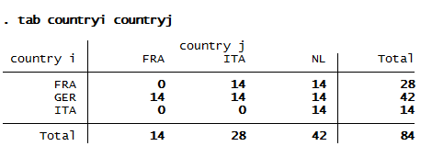
Table 6 Country pairs
Furthermore Table 7 presents the descriptive statistics of the variables used in the model except for the dummy variables on sustainability incentives and pipeline networks. The average bilateral trade of chemicals is close to $14,5 billion while the median p50 is close to $11,5 billion. The variation of bilateral trade of chemicals is substantial ranging from the minimum $3 billion up until the maximum of $41 billion dollars. The values for national production show that the mean for country i is close to $97,5 billion while for country j it lies close to $49,8 billion. This difference in values is expected as the choice for the reporting country i has been made following a descending order of importance in accordance to national sales (as shown above in Table 6). The distance between the countries of the model is a weighted measure that calculates the distance between the main cities of the countries at stake. Here the mean is close to 818km while the spread ranges from minimum 379km to maximum 1174km. Finally the dummy variable border that checks the adjacency of the countries is explained by the range from 0 to 1. Overall the presence of outliers in the dataset is not confirmed as the differences between the mean and median are not substantial.
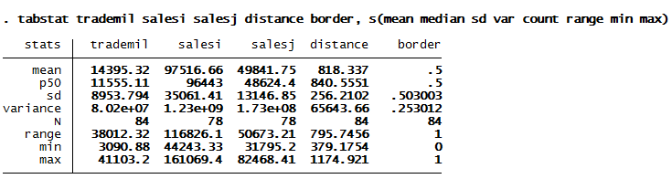
Table 7 Descriptive statistics
In order to enhance the interpretational ability of the model the variables of bilateral trade and national production have been transformed into logarithms. Hence the coefficients of the regression will be interpreted as elasticities. Figure 19 below shows the bilateral trade flows of chemicals between the respective country pairs. All flows follow a positive growth trend over time with the pair GER-NL revealing a substantial increase. This is a really interesting fact as Germany and the Netherlands are the only countries that are interconnected by olefin pipelines. The regression analysis that follows will reveal whether the presence of pipelines is indeed significant and positive.
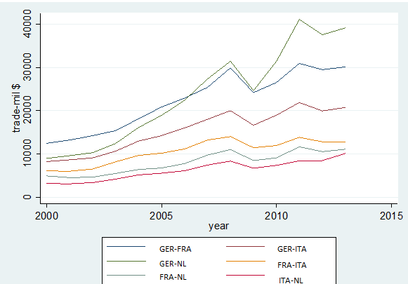
Fig.19 Bilateral chemicals trade between countries

Lastly in order to check which model should be used for the regression, the Breusch-Pagan test for OLS versus random effects has been run and revealed that OLS regression model should be used (Table 8).
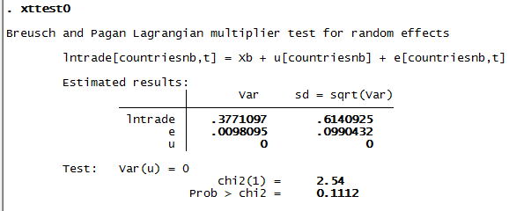
Table 8 Breusch-Pagan test

6.2 Regression analysis

The results from the regression are presented in Table 9 below. The logarithms on national sales are both significant with very large coefficients. This high positive effect of national sales on bilateral trade was indeed expected. Distance is marginally insignificant with a low positive effect of 11% while adjacency has a significantly positive coefficient with a rather low effect of 16%. Almost all of the dummy variables have significantly positive coefficient. More specifically two out of three sustainability initiatives, namely ‘Sustainable Chemistry’ and ‘REACH’, have significantly positive coefficients with an effect of 28% and 23% respectively. Moreover the dummy ‘Responsible Care’ is insignificant with a negative effect. Pipelines have a significantly positive coefficient with a high effect of 41% as expected. The constant β0 is significantly negative with a very large value. Last but not least, the R-squared has a large value indicating that 97% of the variance in the dependent variable can be explained by the independent variables of the model.
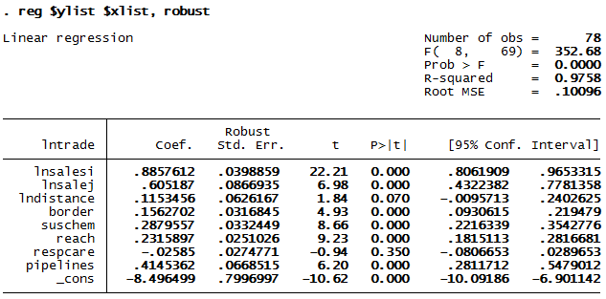
Table 9 Regression results

In order to check for the robustness and reliability of the model a series of regression diagnostics will be applied that will test the assumptions of normality, homoscedasticity and independence. The diagnostics begin by testing for normality, an assumption that presumes errors to be normally distributed. First the Kernel density estimate is presented against the normal distribution and the histogram. Figure 20 reveals that the residuals (green line) follow rather closely the normal distribution (blue line) and are slightly skewed to the right.
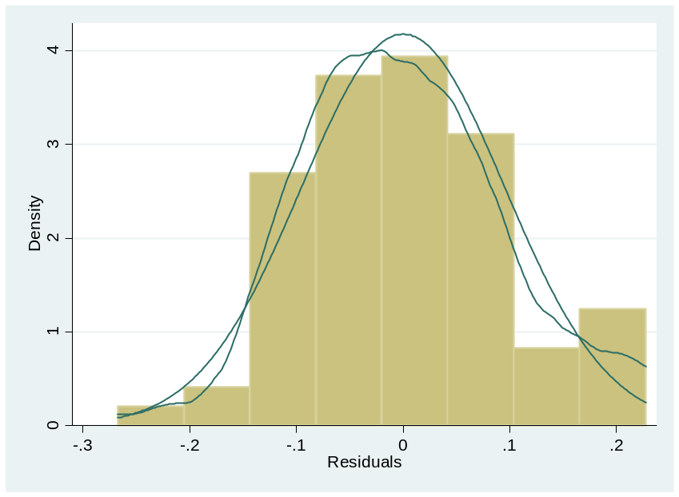
Fig.20 Kernel density against normal and histogram

The two figures that follow, Figure 21 and Figure 22, present plots on the normality of the residuals.
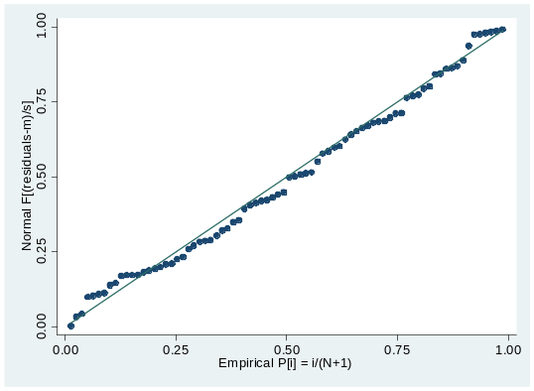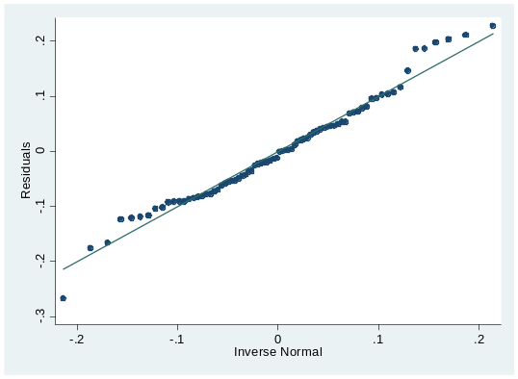
Fig.21 pnorm plot Fig.22 qnorm plot
Figure 21 represents the standardized normal probability plot (pnorm) and Figure 22 represents a quintile-normal plot (qnorm). The pnorm command is sensitive to non-normality in the middle range of data while qnorm is sensitive to non-normality near the tails. Both figures show no indication of non-normality as the residuals follow the 45 degree fairly normal. However the qnorm reveals a slight deviation from normal at the upper tail, as can be seen in the Kernel estimate of Figure 20. Overall the normality of residuals seems to be confirmed.
In order to test for multicollinearity of the independent variables a vif-test (variance inflation factor) is performed. Table 10 shows the results of the vif-test; all vif values are below the limits of vif>10 or 1/vif<0.10 thus multicollinearity is not assumed. Hence all independent variables are not perfectly multicollinear.
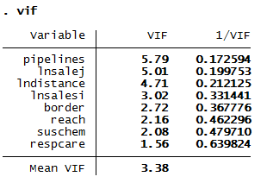
Table 10 vif test
The last check for the robustness of the model is the test for homoskedasticity which involves the verification that the variances of the estimates of the standard errors in the regression model are constant and do not depend on the x-variable(s). STATA by default assumes homoskedasticity thus the regression of the model incorporated the command robust which adjusts the model for heteroskedasticity. The rvf-plot presented below in Figure 23 shows no patterns in the data, only a slight clustering on the right side of the plot. Nevertheless, no clear structure can be identified.
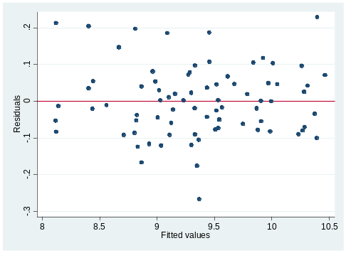
Fig.23 rvf plot
All the regression diagnostics that were performed by the tests above indicate that the assumption of the OLS regression have been met thus the model has been verified as robust, stable and reliable.

6.3 Discussion
Reviewing the results from the regression we see that national sales are both significant and with very large coefficients. The growth of the chemical industry in reporting country i has a strong effect of 88% on the bilateral trade while the respective effect of country j is 60%. This high positive effect of national sales on bilateral trade was indeed expected. The higher impact of country i can be explained by the country pairing process which took the strongest country as the reporter. Big nations with strong chemical industries can enjoy the benefits of bilateral trade but we should not forget that at the same time they compete against each other on the global market. What is important to understand is how each country strategically positions its chemical industry in regards to product differentiation along higher value chains. EU moves to a more knowledge based economy by supporting innovation and knowledge valorization instead of exhausting cost competitiveness on base chemicals industries. We might see significant restructuring in the industry as refineries and crackers could become economically unviable and obsolete. This restructuring process accompanied with a strategic pivot to the sustainable development will free major resources that could be allocated to more productive and cutting-edge technologies and processes.
Distance is marginally insignificant with a low positive effect of 11% while adjacency has a significantly positive coefficient with a rather low effect of 16%. As described in the theoretical part, small distances can significantly lower transaction costs and costs of time. Common borders can facilitate efficiency upgrades in terms of timely production, marketing and distribution. Adjacency can also increase cooperation through faster communication and trust building, integration of knowledge networks and faster/better access to sensitive business intelligence.
In regards to sustainability initiatives two out of three, namely ‘Sustainable Chemistry’ and ‘REACH’, have significantly positive coefficients with an effect of 28% and 23% respectively. Despite the heavy compliance costs, the chemical industry managed to adopt and implement sustainability regulation and even joined forces in cooperative self-regulatory schemes that aspire to make sustainability a “business as usual” in the upcoming decades. The positive effect can be justified by the significant reduction of costs related to risk management, the horizontal impact on cooperation and exchange of information, the support towards innovation and eco technologies that increase resource efficiency as well as by the smart financial support provided strategically by the EU towards valorization of ground breaking knowledge. Last but not least, a soft factor on the improvement of bilateral trade could be that a safe and environmentally conscious chemical industry has improved its reputation and thus attracted better talent and got wider acceptance by the public opinion. However the ‘Responsible Care’ variable is insignificant with a negative effect. The reason behind it could be that Responsible Care was adopted at early 2010, peak time of the financial crisis that severely injured the chemical industry as well. We remain optimistic that with a recent evaluation of the responsible care program, the effect is going to be positive.
Pipelines have a significantly positive coefficient with a high effect of 41% as expected. Pipelines offer reduced operating expenses and risks, can provide fast and in-time delivery and allow for decoupling growth from congestion and pollution. However a really important finding here is the only countries of the model that have a direct connection with olefin pipelines are Germany and Netherlands. Those two countries not only have common borders and similarities in the language, but interestingly they are integral parts of the same mega cluster (ARRR). This finding could also provide a stepping stone for further research that will measure the impact of pipelines inside cluster formations and not among countries. Last but not least the high percentage of pipeline networks in the transportation mix of chemicals is perceived to have had a potentially high explanatory power on the large coefficient. If we take into consideration that pipelines are only operated by private companies, a common carrier approach should be developed in order to allow more participants to operate in a safe and efficient environment but also to further integrate value chains.
The constant β0 is significantly negative with a very large value. However this doesn’t affect the rationale behind model specification as the values of the dependent variables are too large and cannot even get close to zero. Research on negative coefficients of constant variables in similar bilateral models has also suggested the irrelevance of the negative coefficient in such high values of independent variables.
Last but not least, the R-squared has a large value indicating that 97% of the variance in the dependent variable can be explained by the independent variables of the model. All the regression diagnostics that were performed by the tests above indicate that the assumption of the OLS regression have been met thus the model has been verified as robust, stable and reliable.

7 Limitations to the research
In order to secure coherent and sound results, the collection of data and the specification of the model proved to be really challenging tasks. A lot of iteration and testing took place but the outcome seems to agree with the initial expectations, both in terms of the explanatory power of the model and in terms of the conclusions that the model allowed to be made. However in this research process there were some limitations. To begin with and with regards to the data collection process, it proved to be immensely difficult to find data on chemical volumes that are transported via pipelines. Pipelines are operated by private companies; the concept of common carrier is not evident here. Hence even though major chemical companies were contacted, the results were disappointing as no private company seemed to be willing to give access to these sensitive data. Nevertheless, through the creation of a binary variably that measures the existence of interconnecting pipelines, the bilateral trade model was able to work efficiently and provide the empirical justification for the high importance of pipelines on trade.
In regards to the sustainability initiatives in the model, these were factored taking into account the year of adoption within the respective time horizon of the analysis. Concerning Responsible Care which was the only binary variable that had insignificant impact on the model, the percentage levels of national implementation are presented in the Appendix. However the respcare variable could not incorporate the variation of national implementation throughout the time period for two main reasons: i) national data and time series were only available for a small number of years (2009-2001) and ii) the variation of implementation levels was too small (roughly 1,8% per year) to significantly impact the model.
Last but not least, an attempt was made initially to dive into the financing side of infrastructure development. In order to justify the need for investments, sound arguments had to be presented that would support with evidence the economic viability of such projects. However, as the industry moves from bulk to specialty chemicals, higher value prototypes are developed in laboratories, knowledge in valorized in a more efficient manner and investments are thus targeted to increase the innovative capacity of the sector, and not its primary-bulk commodities. At this point, the argument that pipeline infrastructure is not a public good and thus it should not be financed by taxpayers’ money seems to gain credibility. Taking into consideration the sustainability pivot that the industry is going through and its continuous loss of market share in the base chemicals segment, financing large infrastructure projects like pipelines that capitalize on high volumes may not be the case for EU at this stage. However concepts like circular economy and industrial ecology have been on the rise, as the need for sustainable manufacturing is increasing immensely. Recent projects that have recently been developed like the Rotterdam port pipeline mark the way for a new vision of pipeline infrastructure. This research aspires to provide a stepping stone for researchers that would like to take this subject further, towards a cleaner and greener future of the European chemicals industry.

8 Conclusions
The intuition behind this research was to address the critical role of the chemicals industry as a catalyst to a sustainable future. The main research question that has been developed and will be answered here is the following:
To what extent do sustainability initiatives and pipeline infrastructure applying to the European chemicals industry have a significant impact on intra-EU chemicals trade volumes?
In order to maintain a clear approach towards providing the final conclusion, the following sub-questions will be answered based on the findings of the theoretical and the empirical analysis.
1. Which countries can be identified as leaders in the European chemical industry and hence frame the area of analysis?
This research examined the bilateral trade of chemicals between the four largest producers of chemicals in Europe namely Germany, France, Italy and the Netherlands. These countries represent the backbone of the industry hence the outcomes of the research are valuable in drawing conclusions in regards to the efficiency of sustainability initiatives and integrated pipeline networks in European chemicals industry.
2. How does pipeline infrastructure affect the competitiveness of chemical clusters and chemicals trade?
The first part of the thesis showed in detail how the quality of infrastructure has indeed a significant and relatively large impact on bilateral flows. Infrastructure can “affect trade through its effect on a country’s comparative advantage” but it can also create differences in total factor productivity between countries. The thesis also presented that beyond economic properties infrastructure has also spatial properties as it “unlocks” growth in remote areas. Being one of the main pillars of clusters’ competitiveness, infrastructure can play a catalytic role in cost and process optimization, value chain integration and induced productivity. In particular pipelines, as described in the theoretical part, can increase the flexibility of operations and contribute to the strengthening of profitability. Investing in pipeline network has been found to be the most cost-effective measure of the decarbonization strategy, followed by the modal shift to rail and inland waterways. The significantly high cost-effectiveness of pipeline investments could be explained by the long lifetime of pipeline infrastructure, its high share (17,56%) in the transport mix and its notably low CO₂ emissions (5gCO₂/tone-km). However the inclusion of olefins pipelines in TEN-E revision proposal recognizes olefins pipelines as infrastructure of European interest and states that “full account should also be taken of the objectives of the Community's transport policy and specifically the opportunity to reduce road traffic by using pipelines for natural gas and olefins” thus paving the road for public-private partnerships (PPPs) that will “allow olefins pipelines projects to access to same policy, organizational and financial advantages vis-a-vis other modes of transport (road, rail, gas, inland waters networks)” (APPE, 2008). Furthermore
3. What is the significance of interconnecting pipeline infrastructure with respect to trade volumes?
Resulting from the regression analysis, pipelines have a significantly positive coefficient of 41%. This high effect reveals the immense added value that interconnected pipeline networks can contribute to bilateral trade and economic growth. To get a holistic understanding of how pipeline networks can leverage the chemical industry, we will have to think not only of their direct positive impact on sales but also of their carbon footprint as a transport mode which is close to zero, their effects on value chain sophistication and product/process innovation, their role as an enabler of cluster integration and their capacity to provide the European chemical industry with a strong cost-competitive advantage over its global competitors.
4. How do sustainability initiatives applying to the European chemicals industry affect chemicals trade?
As described in the theoretical part, environmental regulation has been accused by many of imposing high costs on heavy polluting industries and thus driving them out of business or making them migrate to mostly developing countries with laxer environmental controls (carbon leakage). On the other hand, there have been researchers who found that imposing stringent environmental controls has no effect on international trade patterns in most polluting industries. On the contrary, they argue that for the long-term viability of the industry, regulation could shift the focus towards environmentally sensitive businesses which can spur growth through their high profitability and capacity to attract global investments. By developing its eco-comparative advantage the industry will be able to offset the short term loses of market share with new revenues coming from sophisticated added valued products, cost savings related to risk management and mitigation, higher qualified human resources and much stronger innovative capacity that would attract global investments and new resources into the system.
5. Which sustainability initiatives applying to the chemicals industry can be identified over the period 2000-2013?
For the purposes of this research three sustainability initiatives have been defined as a set of regulatory and self-regulatory measures undertaken by the European chemicals industry in an effort to promote the four-bottom-line approach (4 P’s-People, Planet, Profit, Products) and enhance its competitive position in the global market. The selection of three initiatives that are well recognized by the industry has been made taking into consideration the way that these initiatives aspire to reduce the negative impact of production and transportation of chemicals on the environment and the society while strengthening innovative capacity. These initiatives are the ‘Responsible Care’, a self-regulatory model which focuses on transport security and trade controls, the ‘REACH’ that focuses on safe manufacturing and marketing and lastly the ‘Sustainability Chemistry’ which focuses on the creation of knowledge and innovation.
6. What is the significance of the adaptation of sustainability initiatives with respect to trade volumes?
In accordance to the regression analysis that was performed, two out of three sustainability initiatives, namely ‘Sustainable Chemistry’ and ‘REACH’, have significantly positive coefficients with an effect of 28% and 23% respectively. This reveals a rather strong impact of those two initiatives on bilateral trade of chemicals. The binary variable ‘Responsible Care’ was found insignificant and with a negative effect.

Taking into consideration the hypotheses that were tested in order to answer the main research question of the thesis and as the empirical analysis provides sufficient evidence to confirm H1, the research question of this thesis has been answered successfully.

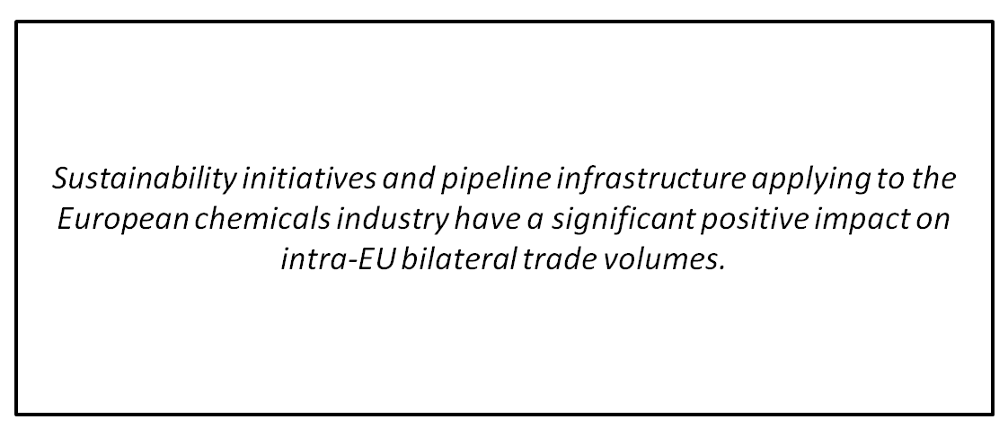

9 Bibliography
Afonso, O. (2001). The impact of international trade on economic growth. Working paper. University of Porto, Faculty of Economics. No 106, May 2001.

Anderson, J.E. (2008). International trade theory. The New Palgrave Dictionary of Economics. Second Edition. Eds. Steven N. Durlauf and Lawrence E. Blume. Palgrave Macmillan, 2008.

Baldwin, R. (1984). Trade policies in developed countries. In Jones, R. and Kenen, P., Handbook of International Economics, Vol. I, North-Holland, pp. 571-61.

Cipollina, M., & Salvatici, L. (2010). Reciprocal trade agreements in gravity models: a meta analysis. Review on International Economics, 18-1, 63-80.

Commission of the European Communities – CEC (2005). Trans-European transport network: TEN-T priority axes and projects 2005. Office for Official Publications of the European Communities, Luxembourg
Crainic, T, & Kim, K. (2007). Intermodal transportation. In: Barnhart, C., & Laporte, G. (Eds.),
Transportation. Handbooks in Operations Research and Management Science. Elsevier, Noord-Holland, Amsterdam, 14, 467–532 (Chapter 8).

Crozet, M. & Koening, P. (2008). Structural gravity equations with intensive and extensive margins. CEPII, no 2008-30 December. Working paper.

Dornbusch, R., Fischer, S. & Samuelson, P. A. (1977). Comparative Advantage, Trade, and Payments in a Ricardian Model with a Continuum of Goods. The American Economic Review, 67:5, 823-839.

Ethier, W.J., 1982, National and International Returns to Scale in the Modern Theory of International Trade. The American Economic Review, 72:3, 389-405.

European Spatial Planning Observation Network – ESPON (2006). Territorial State and Perspective of the European Union: Towards a Stronger European Territorial Cohesion in the Light of the Lisbon and Gothenburg Ambitions. Draft. Based on the Scoping Document discussed by Ministers at their Informal Ministerial Meeting in Luxembourg in May 2005, A Background Document for the Territorial Agenda of the European Union.

European Union – EU (2010). TEN-T Policy Review: Commission Consultation Document and Background Papers. Brussels, June 2010.

European Union – EU (2011). Key figures on Europe, 2011 edition. Publication Office of the European Union, Luxembourg.

Evers, D., Tennekes, J., Borsboom, J., Van Den Heiligenberg, H., & Thissen, M. (2009). A Territorial Impact Assessment of Territorial Cohesion for the Netherlands. The Netherlands Environmental Assessment Agency.

Krugman, P.R. (1987). Is Free Trade Passé? The Journal of Economic Perspectives, 1:2, 131-144.
Krugman, P.R. (1992), Does the New Trade Theory Require a New Trade Policy? The World Economy, 15:4, 423-442.

Limão, N. & Venables, A. (2001). Infrastructure, Geographical Disadvantage, Transport Costs and Trade. World Bank Economic Review, 15, 451-474.

Notteboom, T. (2009). Economic analysis of the European seaport system. Report to the European Sea Ports Organization, ITMMA; University of Antwerp, Belgium.

Organisation for Economic Cooperation and Development – OECD (2010). Transcontinental infrastructural need to 2030/2050: North West European gateway area – Port of Rotterdam case study, Rotterdam workshop, final report. International Futures Programme, November 2010.

Porter, M. (1990). The competitive advantage of nations. Harvard Business Review 90211.

Rodriguez, F., and Rodrik, D. (2000). Trade policy and economic growth; a skeptic’s guide to the cross-national evidence. .
Shi, X., & Vanelslander, T. (2010). Design and evaluation of transportation networks: Constructing transportation networks form perspectives of service integration infrastructure investment and information system implementation. Netnomics, 11:1, 1-4.

Smith, A. (2005). An inquiry into the nature and causes of the wealth of nations. Pennsylvania State University, Electronic Classics Series. Based on Adam Smith, 1776.

Statistics Netherlands (2011). Internationalisation Monitor 2011. CBS, The Hague/Heerlen, 2011.
TA2020, Territorial Agenda of the European Union 2020: Towards an Inclusive, Smart and Sustainable Europe of Diverse Regions. EU May 2011, Hungary.

Witlox, F.; Dullaert, W.; & Jourquin, B.A.M. (2007). Fostering transport and logistics research in the Benelux. Transportation Planning and Technology, 30:4, 325-329.

WTO, World Trade Organisation (2004). World trade report 2004: Exploring the linkage between domestic policy environment and international trade.
WTO, World Trade Organisation (2009). World trade report 2009: Trade policy commitments and contingency measures.

Yannikaya, H., 2003, Trade openness and economic growth: a cross-country empirical investigation. Journal of Development Economics, 72, 57-89.

Yeaple, S. & Golub, S.S. (2002). International Productivity Differences, Infrastructure and Comparative Advantage. Mimeo, University of Pennsylvania, under review in Journal of International economics.
Yun, Y. & Park, K. (2012).
Pillai, Jayarethanam (2006), Importance of Clusters in Industry Development: A Case of Singapore’s
Petrochemical Industry, Asian Journal of Technology Innovation, Vol. 14, No. 2.

O’Mahony, Mary and Bart van Ark (ed.) (2003), EU productivity and competitiveness: An industry
perspective, European Commission: Brussels.

Patel, Mitesh (2004), Competitiveness of Singaporean Petrochemical Industry, paper presented at
the Bottom Line Improvement Conference, Singapore.

Chapman, Keith (2005), From ‘growth center’ to’cluster’: restructuring, regional development, and the
Teeside chemical industry, Environment and Planning A, Vol. 37, pp. 597 – 615.

Croufer, Edouard, Pieter-Jan Mermans, and Christian Weigel (2005), The Staying Power of Europe’s
Chemical Industry, Arthur D. Little, Prism, Vol. 1, p. 29 – 43.

Sikorski, Douglas (1997), Public Enterprise in the International Petrochemical Industry: The case of
Singapore, Energy Resources, Vol. 19, pp. 309 – 323.

Wang, Jason H J, Henry Wai-chung Yeung (2000), Strategies for global competition: transnational
chemical firms and Singapore's chemical cluster, Environment and Planning A, Vol. 32, pp. 847 – 869.

He, Canfei, Yehua D. Wei, and Xieuzhen Xie (2006), Globalization, Institutions, and Industrial
Location: Economic Transition and Industrial Location in China, Regional Studies, forthcoming.

Koch, Thomas (2004), Global Chemicals: China remakes an industry, McKinsey Quarterly, 2004
special edition.

Patel, Mitesh (2004), Competitiveness of Singaporean Petrochemical Industry, paper presented at
the Bottom Line Improvement Conference, Singapore.

O’Mahony, Mary and Bart van Ark (ed.) (2003), EU productivity and competitiveness: An industry
perspective, European Commission: Brussels.

EPCA Think Tank (2007), A Paradigm Shift: Supply Chain Collaboration and Competition in and
Between Europe’s Chemical Clusters, EPCA: Brussels.
Patti, Anthony L. (2006), Economic clusters and the supply chain: a case study, Supply Chain
Management, Vol. 11, No. 3, pp. 266–270.
Janne, Odile E.M. (2002), The emergence of corporate integrated innovation systems across regions:
The case of the chemical and pharmaceutical industry in Germany, the UK and Belgium, Journal of
International Management, Vol. 8, pp. 97–119.

Mariani, Myriam (2000), Networks of inventors in the chemical industry, mimeo., MERIT

McCann, T.J. (1999), Chemical industry integration, Journal of Business Administration and Policy
Analysis.

European Chemical Industry Council (2004), Chemical Industry 2015; Roads to the Future, CEFIC:
Brussels.

Bathelt, Harald (2000), Persistent structures in a turbulent world: the division of labor in the German
chemical industry, Environment and Planning C, Vol. 18, pp. 225 – 247.

Ketels, Christian, Jeffrey Fear (2006), Cluster Development in Mitteldeutschland, HBS Case 707-004,
Harvard Business School Press, Boston.

Michael E. Porter with Christian Ketels and Mercedes Delgado, Building the MicroeconomicFoundations of Prosperity: Findings from the Business Competitiveness Index, in: The Global Competitiveness Report 2006-2007. New York: Palgrave

Michael E. Porter, Clusters and the New Economics of Competition, in: On Competition. Boston: Harvard Business School Press, 1998

Örjan Sölvell, Göran Lindqvist, and Christian Ketels, The Cluster Initiative Greenbook. Stockholm: Ivory Tower, 2003

P. Skelley, The Trans European Olefins Pipelines Network Project – Benefits to the European Industry, High Level Group on the Competitiveness of the Chemical Industry Energy, Feedstock, Logistics, February 2008

Trans European Olefins Pipeline Network (TEPN), Cefic, Appe, April 2004

Eco innovation in eu chem clusters, Greenovate 2011

10 Appendix

10.1 Appendix Section I

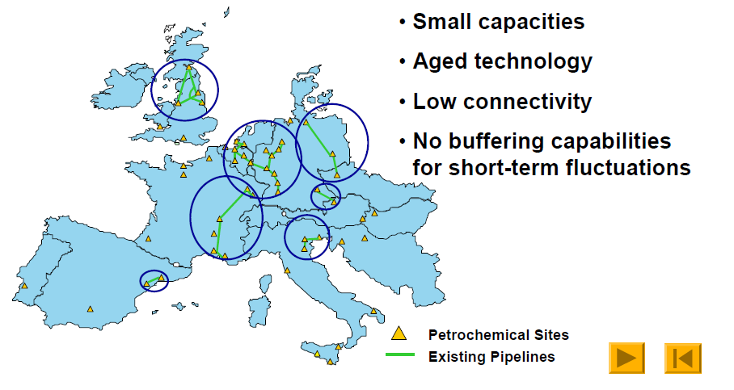
Fig.24 The Petrochemical landscape in Europe (Source: APPE, 2004)

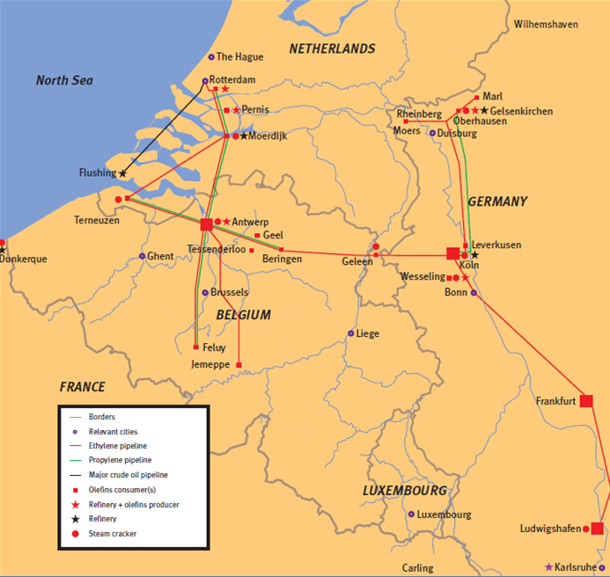
Fig.25 Refineries, pipelines and crackers in the ARRR mega cluster (Source: APPE, 2004)
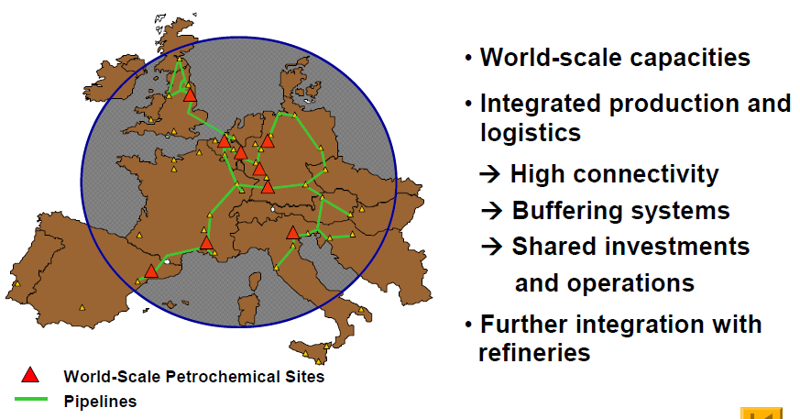
Fig.26 The vision of a trans-European olefin pipeline network (Source: APPE, 2004)


Fig.27 Olefine pipeline connections in Europe (Source APPE, 2004)
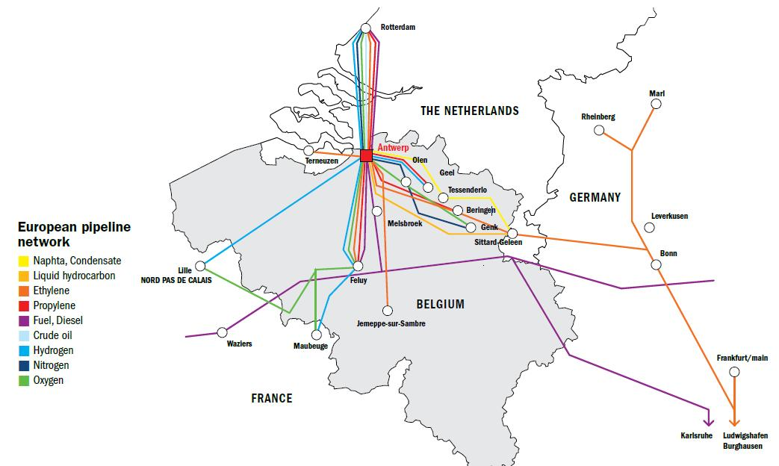
Fig.28 Pipeline network in the ARRR region (Source: Port Authority Antwerp)

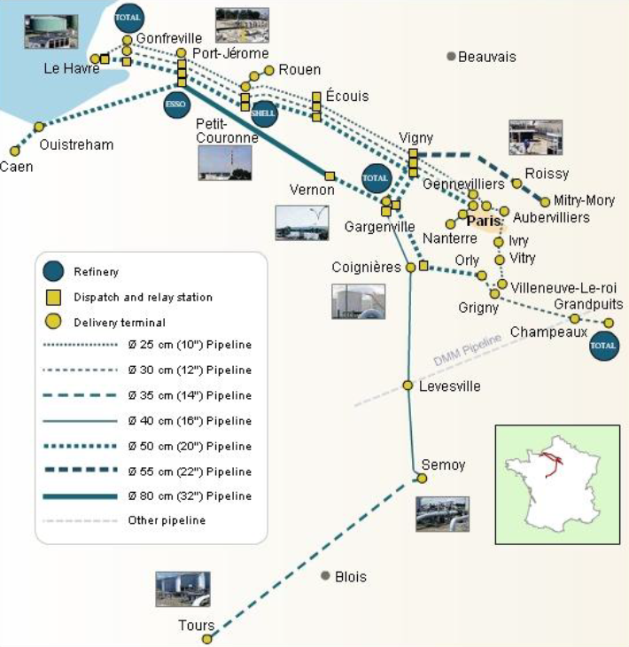
Fig.29 The Le Havre-Paris (LHP) network for refinery products (Source: Trapil)

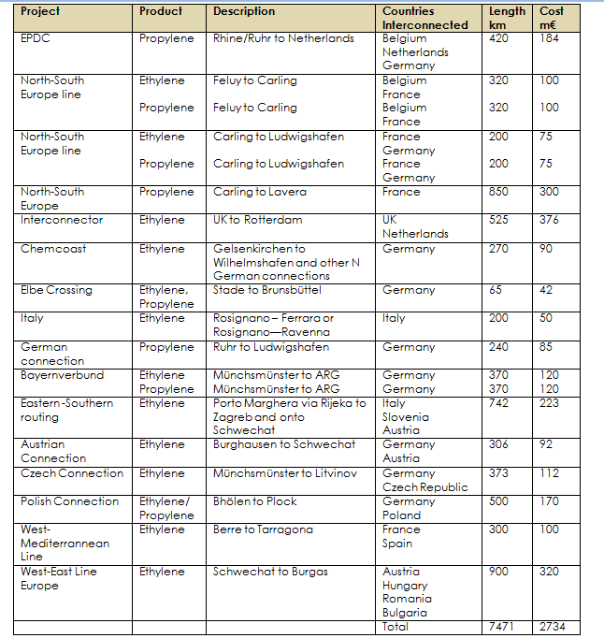
Table 11 Investing in pipeline networks integration (Source: APPE 2004)

10.2 Appendix Section II
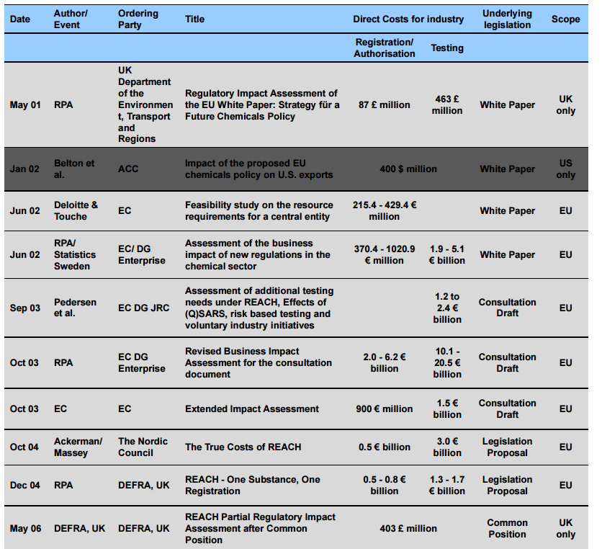
Table 12 Estimates of REACH direct costs (Source, Insead 2008)

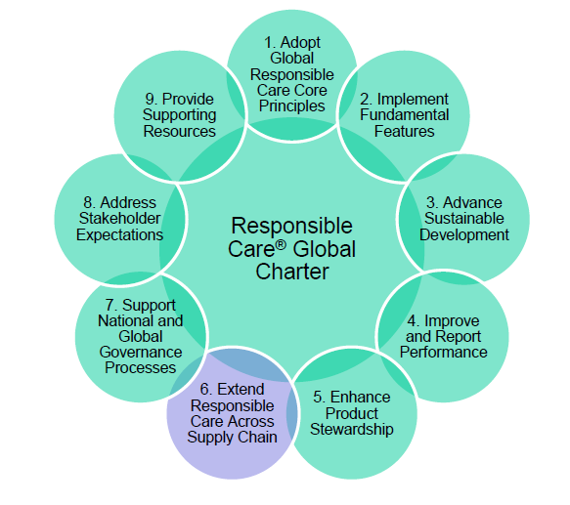
Fig.30 Responsible Care Global Charter (Source: Cefic Respcare)
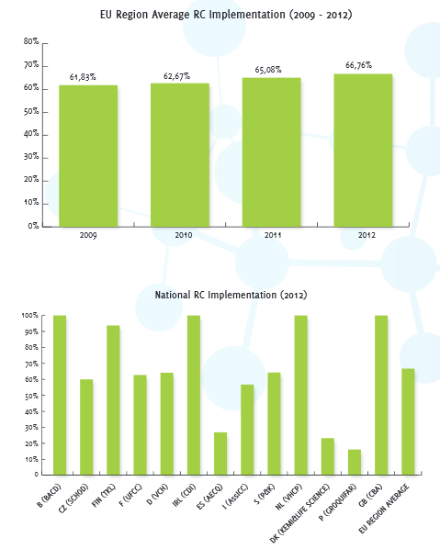
Fig.31 Implementation of Responsible Care Source: Fecc, 2013)

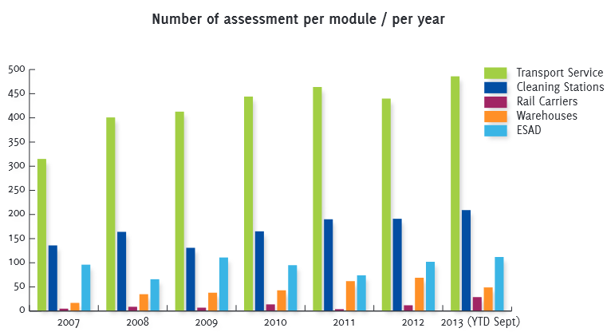
Fig.32 Implementation of Responsible Care Source: Fecc, 2013)

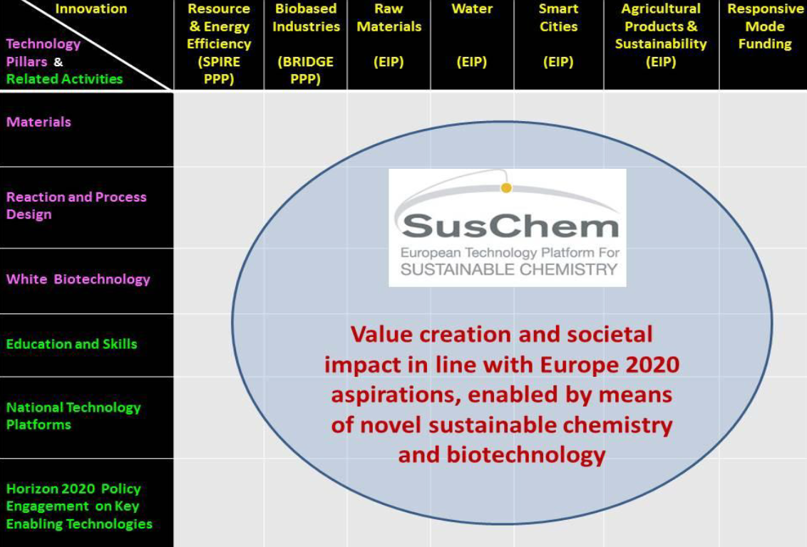
Fig.33 Matrix depiction of the contributions that SusChem is making to the Europe 2020 agenda with the columns representing Innovation Flagship initiatives where SusChem is already intimately and actively involved and the rows defining the areas of current activity within SusChem where it aims to create value (Townsend, 2013)

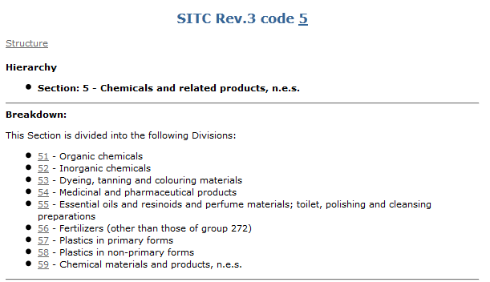
Fig.34 Chemicals Standard International Trade Classification (Source: UN Stats)
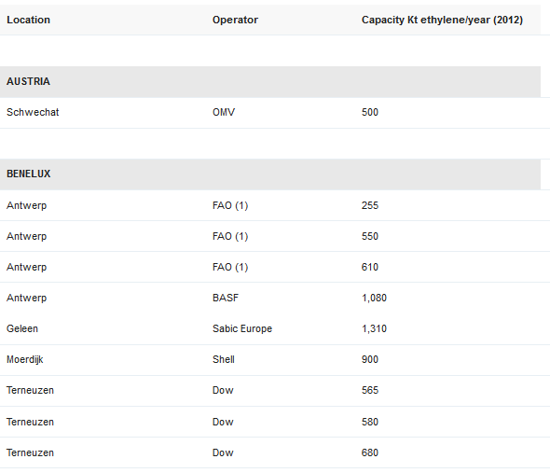
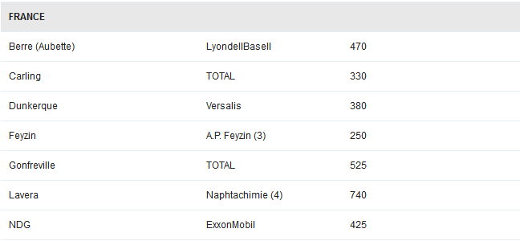
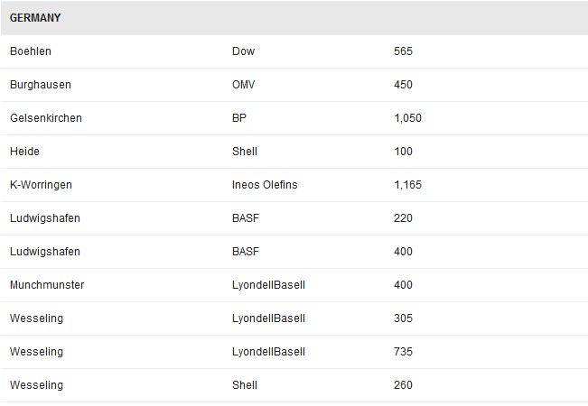
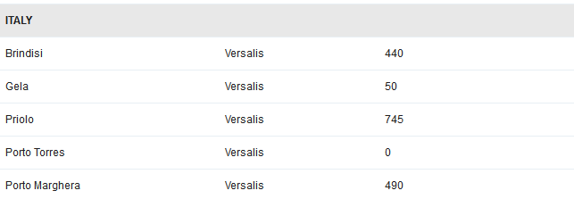
Table 13 Crackers ethylene capacity (Source: http://www.petrochemistry.eu/about-petrochemistry/facts-and-figures/crackers-capacities.html)

http://www.oecd.org/env/ehs/risk-management/sustainablechemistry.htm
Cefic Sustainability Report 2012
High Level Group on the Competitiveness of the Chemical Industry-Energy , Feedstock, Logistics - Ad hoc meeting 29 February 2008
Cefic Facts & Figures,2013
McKinsey report on Chemicals 2011, p.4
http://ec.europa.eu/clima/policies/ets/cap/leakage/index_en.htm
Cefic Facts & Figures,2013
Cefic Facts & Figures,2013
http://www.cefic.org/Documents/PolicyCentre/Cefic_position_low_carbon_economy_2050.pdf
http://ec.europa.eu/clima/policies/ets/cap/leakage/index_en.htm
http://www.fi-sch.be/nl/wp-content/uploads/Version-180414-BIG-C-position-paper.pdf
http://ec.europa.eu/transport/themes/strategies/doc/2011_white_paper/white_paper_com(2011)_144_en.pdf
http://www.cefic.org/Industry-support/Transport--logistics/Chemical-Logistics-Vision-2020/
http://www.europarl.europa.eu/sides/getDoc.do?pubRef=-//EP//TEXT+REPORT+A6-2005-0134+0+DOC+XML+V0//EN&language
http://ec.europa.eu/enterprise/sectors/chemicals/files/pdf_docs/energy_feedstock_conclusions_of_the_discussion_en.pdf
http://lsa-st38.sachsen-anhalt.de/chemlog/files/ClPFb_ChemLog_Final_Brochure_130112.pdf
http://research.fh-ooe.at/files/publications/1450_swot.pdf
http://www.oecd.org/env/ehs/risk-management/29361016.pdf
http://ec.europa.eu/enterprise/sectors/chemicals/documents/reach/archives/white-paper/index_en.htm
http://echa.europa.eu/web/guest/regulations/reach/understanding-reach
http://www.insead.edu/facultyresearch/research/doc.cfm?did=24428
http://www.cefic.org/Responsible-Care/
http://www.ecta.com/media/749/2.b._thier.pdf
https://sustainabledevelopment.un.org/content/documents/SAICM_publication_ENG.pdf
http://www.suschem.org/documents/document/20121122090946-suschem_new_strategy.pdf
www.clusterobservatory.eu
http://comtrade.un.org
http://www.cefic.org/Facts-and-Figures
www.cepii.fr
Cefic Sustainability Report, 2012
http://www.petrochemistry.eu
http://www.cefic.org
https://chemicalparks.eu
http://www.europarl.europa.eu/sides/getDoc.do?pubRef=-//EP//TEXT+REPORT+A6-2005-0134+0+DOC+XML+V0//EN&language
Cefic Sustainability Report, 2012

