Bachelor thesis
The Seasoned Equity Offering
An empirical investigation in the firms’ motives to issue equity
Name: Bram van Wickeren
Student Number: 368274

This thesis aims to find the driving factors behind the issuance of equity. A sample of S&P500 companies is researched for the years 2000 until 2010. It is found that companies base their decision to issue equity on their internal cash generating ability and the amount of financial distress. The results are in line with the pecking order model. Surprisingly, capital structure is found to be not a driving factor in issuing equity. This result is contradictory to the trade-off theory.
Supervisors: Dr. S. Xia
Prof. Dr. S. Gryglewicz
Date: 25-7-2015
Contents
1. Introduction 2
2. Theoretical framework 4
2.1 The pecking order theory 4
2.2 The trade-off theory 5
2.3 The need for external finance 7
3. Data & Methodology 8
3.1 Sample 8
3.2 Match Sample 8
3.3 Descriptive Statistics 9
3.4 KZ-Index 10
3.5 QRATIO 11
3.6 Z-Score for Financial Distress 11
3.7 Propensity Score Matching (PSM) 13
3.8 Probit model 14
4. Results 15
4.1 Descriptive Statistics 15
4.2 KZ-Index, QRATIO and Z-Score 16
4.3 Propensity Score Matching (PSM) 17
4.4 Probit model 19
5. Conclusion 20
5.1 Summary 20
5.2 Research question 21
5.3 Shortcomings and recommendations 22
Bibliography 23
Appendix 24
Appendix A – descriptive statistics SEOs 24
Appendix B – descriptive statistics dataset 25
Appendix C – T-test difference in means, whole match sample 26
Appendix D – nearest neighbor matching 27
Appendix E – nearest neighbor matching 28
Appendix F – Propensity score matching 29
Appendix G – Probit model predicting equity issuance 31

1. Introduction
In the literature the debate about the importance of financing decisions starts in the famous paper written by Modigliani and Miller (Modigliani & Miller, 1958). Their paper states that in a world with no bankruptcy costs, taxes, agency costs or asymmetric information the firms value is unaffected by the capital structure it possesses. This idea is also called proposition I of Modigliani and Miller. From this point on the studies in the field of corporate finance has created new theories about capital structure. These theories mostly suggest that the choice of financing and capital structure is in fact relevant due to the fact that the restrictions imposed by Modigliani and Miller do not hold in reality.
The pecking order theory is a dominant model in explaining the reasoning behind the financing of companies. The theory suggests that the source of financing is subject to a strict hierarchy between the different ways of financing due to adverse selection. Pecking order theory states that companies prefer internal financing over external financing and that issuing debt is preferred over issuing equity. The pecking order theory is viewed as part of the most influential theories of corporate leverage and financing decisions. After the theory was suggested in a paper written by Myers and Majluf (Myers & Majluf, 1984), the theory is formed as we know it now in a paper written by Myers (Myers S. C., 1984). This paper is a turning point for financing theory. Prior to the Myers paper the trade-off theory was the dominant model when it comes to explaining financing decisions. The trade-off theory will be discussed in the theoretical framework. Myers suggests a different model in their paper based on asymmetric information, the pecking order theory.
Myers has followed up his formation of the pecking order theory with researching empirical evidence for the theory (Shyam-Sunder & Myers, 1999). Myers researched if the deficit in financing using internal cash flows is financed using predominantly debt or if equity is also used. Using their sample, the researchers find that an unexpected need for cash is generally paid for using debt. The results also suggest that anticipated deficits will be accounted for using debt.
The pecking order theory is largely investigated in the field of corporate finance. In one paper supporting the theory with empirical evidence, it is suggested that there should be an equilibrium based signaling model (Baskin, 1989). This implies that there would be equilibrium when it comes to adverse selection cost, and the subjective nature of information asymmetry could be incorporated in a model based on the pecking order theory. Furthermore statistical evidence is found that companies deviate from the static optimal capital as imposed by the trade-off theory and rather just prefer debt over equity.
The Pecking order theory is rejected in another paper (Frank & Goyal, 2003). Frank and Goyal use a large sample of firms and conclude that equity issuance is not dominated by debt issuance. This is contradictory to the pecking order theory. They do however not fully exclude the theory as a factor in financing decisions. They find that for a subsample of large firms the hierarchy of the choice of financing is most present.
In the literature contradicting results are found for the pecking order theory. One suggestion is that the pecking order theory could be supplementary to a generalized trade-off theory model, and that a model with an adverse selection based trade-off can be incorporated in the classical trade-off theory. The question arises what the influence of the pecking order theory is in the financing choice is for firms. This thesis will investigate what the characteristics of firms that issue equity. Using a large sample of data about the S&P500 companies this thesis will support a broad view of the reasons a company would issue equity. The main research question will be based on the pecking order theory. The theory implies that firms issue equity only when they have no other option, since it is the last choice of financing. The research question for this thesis is stated as follows:
'To what extend is the issuance of equity the last resort for financing?'
The pecking order theory will be tested using the research question, if evidence is found that firms issue equity as a last resort, the pecking order hypothesis finds more support. If the main research question is rejected or partially rejected, the choice of financing must be based upon something else. Alternative theories and factors will also be tested to find the reasoning behind the issuance of equity. The alternatives for the main research question will be discussed in the theoretical framework.
The structure of the rest of this paper is as follows. Section 2 presents the theoretical framework. Section 3 describes the data and section 4 the methodology. In section 5 the results of the empirical tests are presented and in section 6 the conclusion is given.

2. Theoretical framework

2.1 The pecking order theory
As previously discussed, the pecking order theory is a dominant theory when it comes to the choice of financing. As stated in 'the capital structure puzzle', pecking order theory suggests that there should be a strict order in the choice of financing (Myers S. C., 1984). First, a company would want to use internal funds for financing. Second, debt should be chosen. The last choice for financing should be equity. This strict order in financing is explained due to the existence of adverse selection costs caused by asymmetric information.
Internal funds are preferred over external funds due to the fact that internal funds have no signaling effect to investors. Debt on the other hand signals that the firm is unable to finance their activities using internal funds; these are the adverse selection costs associated with issuing debt (Berk & DeMarzo, 2014). Debt also reduces the taxation on income on the corporate level (Baskin, 1989).
According to the pecking order theory, equity issuance should be the last choice of financing, since it has the highest amount of adverse selection costs. Aside from the fact that equity issues have higher transaction costs than debt issues, equity issues are met with large stock price declines (Billett & Xue, 2004). Pecking order theory explains this with the information content associated with equity issuance for investors. Investors perceive equity issues as a signal that the stock price is on average overvalued, because value maximizing managers would not issue undervalued stocks (Berk & DeMarzo, 2014). Because of the destruction of current shareholder value as a result of the price decline and the dilution of voting control the pecking order theory suggests that equity issuance should only be a source of financing as a last resort.
Issuing equity as a last resort implies that firms that issue equity will have no other option. These firms should have low internal cash flow and funds available and be financially distressed, meaning attracting debt would be very costly. The first hypothesis of this thesis is stated as follows:
‘Firms issuing equity are less profitable and have low internal funds available to finance their activities’
With this hypothesis the preference for the choice of financing is investigated. If firms only resort to equity when the internal funds are low, more evidence is found to support the idea of equity financing as a last resort.

2.2 The trade-off theory
Like the pecking order theory, the trade-off theory explains the optimal leverage for a firm. According to the trade-off theory, the optimal leverage is found as a trade-off between the benefits of debt versus the costs of debt. Before further discussing the trade-off theory, leverage will be defined.
Leverage represents the way a firm is financed. The firm can finance their assets using equity and debt. Leverage is a relative ratio between debt and equity and is defined as follows:
$Leverage= Total Debt/Market value of Equity$$CITATION Ber14 \backslash l 1043 (Berk \& DeMarzo, 2014)$$.$
Total debt=Total liabilities
Market value of Equity=Number of common stocks outstanding * common share price + Number of preferred stocks outstanding * Preferred share price
A distinction is made between the market value of equity and the book value of equity. The market value of equity represents the current stock price multiplied by the number of outstanding stocks while the book value of equity represents the historical amount of issued stocks multiplied by the historical price of the stocks. The difference between these two values is that the market value of equity represents the amount investors are willing to pay for the firm’s equity, and reflects their valuation of the company. The difference between the two definitions of equity is often given is the book-to-market ratio and is found by dividing the book value of equity by the market value of equity.
The lower the book-to-market ratio, the larger the premium investors give to the book value of assets. This is the reason the book-to-market ratio is used as a measure for growth opportunities.
The higher the firms leverage, the higher debt level the firm has relative to the market value of equity. Leverage is an important measure the ability for a firm to attract new debt and the cost of that new debt.
The trade-off theory combines the benefits of debt with the costs of debt in one model. The benefits of debt are the tax advantages of having debt. Firms pay taxes on their income, after deducting interest expenses. Having more debt therefore results in a higher deductible amount on taxable income. This benefit of debt is known as the tax shield of debt. The total tax shield can be calculated by multiplying the total interest payments with the corporate tax rate. Having debt does not only hold benefits for the firm. When a firm finances itself with debt, an obligation to repay the debt is put on the firm. If a firm is not able to repay their debt, bankruptcy can be the consequence because the firm is in default. This gives the debtholders rights to the assets of the firm and after the debt is paid to the debtholders, the equity holders receive what is left. The firm is not legally obligated to repay their equity holders. The cost of debt therefore is predominantly the risk of default. When a firm is unlikely to be able to meet their liability obligation the firm experiences financial distress costs. Naturally, the risk of default and financial distress costs are higher when a firm has relatively more debt. It follows that the higher the firms leverage is, the higher the cost of debt is. Moreover, it is found that the market-to-book ratio has significant influence in the cost of financial distress (Rajan & Zingales, 1995). This is explained by the fact that companies with a lower book-to-market ratio have more to lose if they would be facing risk of default, since these types of companies have high growth opportunities.
The trade-off theory defines the optimal capital structure as a trade-off between the benefits and costs of debt. The optimal leverage is the leverage where the benefits of debt minus the costs of debt is at a maximum. The trade-off theory is an alternative explanation for why a company would issue equity. If the trade-off theory applies, a firm issues equity due to the fact that the costs of benefit outweigh the benefits of debt since the firm would want to reduce the leverage. The second hypothesis of this thesis is stated as follows:
‘Financially distressed firms are more likely to issue equity’
Like pecking order theory, trade-off theory is broadly researched in the field of corporate finance. Once again, mixed results are also found regarding the trade-off theory. Trade-off theory suggests, contrary to pecking order theory, that firms have a target leverage. In a survey to 392 CFOs it is found that firms for the most part (81%) firms have a somewhat flexible to very strict target leverage (Graham & Harvey, 2001). This is in favor of the trade-off theory. One study was done on small to medium sized companies, both investigating pecking order and trade-off theory. While the theory is that for these types of companies information asymmetry should be high, it is found that trade-off theory still is the best in explaining the capital structure decisions for these types of companies.
One large fact in practice however does contradict the trade-off theory. Large mature profitable should have a high leverage according to the trade-off theory, since their financial distress cost and risk of default are generally low. It can be found however that these types of companies maintain a low level of debt and do not profit fully from the tax shielding possibility of debt (Shyam-Sunder & Myers, 1999).

2.3 The need for external finance
A factor influencing the firms’ decision to issue equity can be the need for external finance (Billett & Xue, 2004). Firms that have a higher need for external finance are presumed to have more investment opportunities. Therefore investment opportunities and the need for external finance will be investigated as another potential factor for the firm to issue equity. The third hypothesis of this thesis is as follows:
‘Firms issuing equity have a higher need for external finance and more investment opportunities’
Following Billett and Xue the investment opportunities will be measured by the KZ-Index, which will be later discussed in the data & methodology section. The investment opportunities will be measured by the QRATIO. The premium investors give to the book value of assets and equity is a measure of the firms’ investment opportunities. The QRATIO will be further discussed in the data & methodology section.

3. Data & Methodology

3.1 Sample
Following Loughran and Ritter (Loughran & Ritter, 1997) a sample is taken from the COMPUSTAT database for the years 2000-2010. For this research, S&P500 companies are investigated. Based on TIC codes, the S&P500 companies are gathered from the COMPUSTAT database. Like previous research, SEO data is taken from the SDC database. The equity offering data is added to the annual COMPUSTAT data. Like Loughran and Ritter, SEOs by the same firm within five years of the previous SEO are excluded. This is done to prevent that one company has too large of an impact on the sample of issuing firms. It is required that the financial data needed to perform the statistical analysis is present in the COMPUSTAT database for the sample of issuing firms. Lastly, outliers and incorrect data is extracted from the sample. The preceding procedure results in a sample of 156 firms that perform an SEO.
An overview of the calendar years of issuance is given in Appendix A. In Appendix A the average size of the SEOs is found to be 634 (x1000$) and on average the SEO size divided by the market value of equity is 6.7%. This percentage represents the size of the SEO compared to the already existing market value of equity.

3.2 Match Sample
In order to find the reasons why a company issues equity, the firms that issue equity are matched with the group of non-issuing firms based on control variables. Following Bilett and Xue (Billett & Xue, 2004), sample of issuing firms is matched based time, size (market value of equity) and book-to-market. For the firms in the match sample, it is required that no SEO is performed in the years 2000-2010.
Using a matching group based on timing of issuance will mostly eliminate time-based problems. This research focuses on issuing-firms characteristics and differences with non-issuing firms. The matching method mitigates possible selection bias effect due to timing differences.

3.3 Descriptive Statistics
In the appendix a general overview of the dataset is given in Appendix B. The sample of firms that issue equity is compared with the firms that do not issue equity. Under pecking order theory it is expected that the firms that issue equity will show signs that they are in general more financially constraint and have less internal cash available.
Firstly, in Appendix C an overview is given of the means and differences in means between the sample of issuing firms and the whole sample of non-issuing firms. The whole sample of non-issuing firms consists of 3683 data points. The leverage for the issuing firms is not significantly different from the average leverage of non-issuing firms. Furthermore the total assets are not significantly different. It is however found that issuing firms have a significantly lower EBIT/Assets implying that issuing firms are on average less profitable than non-issuing firms. The cash amount spend on capital expenditures relative to total assets is not significantly different between these two groups. Before matching, the difference between the book-to-market ratios for issuing firms compared to the book-to-market ratios for non-issuing firms is significantly different. The book-to-market is found by dividing the book value of equity by the market value of equity. As discussed above, the book-to-market ratio is a measure for the growth opportunities of the firm, where a lower book-to-market ratio implies higher growth opportunities. Lastly it is found that the cash and short-term investments relative to total assets is not significantly different.
In the Appendix E a comparison is made between the sample of issuing firms and the matched firms using STATA. Using nearest neighbor matching, the issuing firms are matched with the non-issuing firms. The treatment variable is given in a dummy variable named EquityIssuance. Using this dummy variable the data is categorized in the group of firms that issues equity and the group of firms that does not issue equity. The independent variables are calendar year, market value of equity and book-to-market ratio. For the match sample it is required that an exact match is found for calendar year. Furthermore there is a correction made for possible large sample bias for the control variables market value of equity and book-to-market ratio. With each issuing firm, three non-issuing firms are matched.
In Appendix E it is found that the leverage of the issuing firms is not significantly different than the leverage of the non-issuing matched firms. This suggests that firms that issue equity are presumably on average not higher levered.
The next measure of comparison is total assets. Total assets is like market value of equity a measure of size and total assets is compared after matching on market value of equity. The difference in total assets between the issuing firms and the matched firms is not significant.
Between the issuing firms and the matched non-issuing firms the difference in EBIT/assets is still significant. On average, firms that issue equity have 4.2% lower EBIT/assets. This implies that non-issuing firms are more profitable than firms that issue equity.
Aside from the KZ-index and the QRATIO, which will be discussed below, the capital expenditures divided by total assets can provide information about the need for external financing for a firm. There is no statistical significant difference between the two groups for capital expenditures.
Furthermore the cash and short-term investments divided by total assets provides information about the liquidity of the firm. This variable represents the amount of liquid assets a firm has. The higher the amount of cash and short-term investments, the more flexible a company is in financing their activities. Non-issuing firms are on average not more flexible when it comes to liquid assets available.

3.4 KZ-Index
To investigate the motives for a firm to issue equity, it is necessary to know the financial situation of the company. More specifically it is important to know the need for external finance. If a firm is highly in need for external finance, it is more likely the firm will issue equity.
The KZ-Index is a measure to find the need for external finance. The index uses five accounting measures. The higher the KZ-Index, the higher the need for external finance for a company is (Lamont, Polk, & Saá-Requejo, 2001). The KZ-Index, as specified by Lamont, Polk and Saa-Requijo is defined as follows:
KZ-Index = -1.002 CFt/At-1 - 39.368 DIVt/At-1 - 1.315 Ct/At-1 + 3.139LEVt
CF=Cash Flow
A=Total Assets
DIV=Dividends
C=Cash and short-term investments
LEV=Leverage

3.5 QRATIO
A proxy for the firm’s investment opportunities and therefore the need for financing is given by the QRATIO (Billett & Xue, 2004). The QRATIO is defined as the sum of the market value of equity and the book value of debt divided by the book value of total assets. Like the book-to-market ratio, the QRATIO measures the investment opportunities for the firm. This measure therefore can also tell something about the need for financing for a company, since more investment opportunities imply a higher need for internal financing.

3.6 Z-Score for Financial Distress
The Z-Score is a measure for financial distress (Altman, 2000). The pecking order theory suggests that for a company to resort to financing by issuing equity, the firm has to be financially distressed. A financially distressed firm has a hard time to finance itself using internal finance and by issuing debt. The trade-off theory predicts that a firm is more likely to issue equity when a firm is relatively more financially distressed due to the fact that the cost of debt is relatively higher. The Z-Score is a proxy of financial distress by using accounting measures. The lower the Z-score, the more financially distressed a firm is. The original Z-Score model as defined by Altman is found by the following formula:
Z-Score = 1.2X₁ + 1.4X₂ + 3.3X₃ + 0.6X₄ + 1.0X₅

X₁ = Working Capital/Total Assets
X₂ = Retained Earnings/Total Assets
X₃ = EBIT/Total Assets
X₄ = Market Value of Equity/Total Liabilities
X₅ = Sales/Total Assets
In the model, X₁ is a measure of liquid assets relative to total capitalization of the firm. If a company is more financially distressed, the company has on average less liquid assets in relation to the size of the company. X₂ is the variable that provides information about the profitability of the company. A more profitable firm is less financially distressed. X₃ is a measure of the true productivity of the firm’s assets, since it is independent of tax or leverage factors. The fourth variable, X_{4,} shows how much the firm’s assets can decline in value before the liabilities exceed the assets and the firm becomes insolvent. X₅ is known as the capital-turnover ratio and gives an impression of the sales generating ability of the firm.
Al the variables in the model have a positive relation with the Z-Score. This follows naturally for the fact that X₁ through X₅ have a negative effect on the amount of financial distress for the firm.
The pecking order theory suggests that firms that issue equity have a lower Z-Score than firms that do not issue equity due to the fact that issuing firms must be more financially distressed to resort to issuing equity.
The trade-off theory predicts the same. For a firm to issue equity, the cost of debt must exceed the benefits of debt. Since financially distressed firms have a higher cost of debt, these types of firms will choose to issue equity more than the firms that are not financially distressed.

3.7 Propensity Score Matching (PSM)
PSM, or Propensity Score Matching, is a relative new technique to match two different groups of data. When using PSM, groups are divided in a group that receives a particular treatment and a group that does not receive the treatment (Espen Eckbo, 2007). PSM estimates, given specific characteristics, what the probability of undergoing treatment is for a particular unit. This probability is also known as the propensity. The group that receives the treatment is matched with the group that does not receive treatment based on specific characteristics. In this thesis the matching group of companies is found by matching on calendar year, size and book-to-market ratio. The propensity score matching technique can predict the effect of a variable on the probability of undergoing treatment. In this case the treatment is issuing equity. For each of the variables of interest it can be found what the effect on the treatment is.
Using PSM the influence of each variable on the probability for a firm to issue equity in the next year is investigated, since the data used is on a yearly base. The confounder variables will be the measures associated with the pecking order theory and trade-off theory. From a theoretical base it is expected that firm’s which are financially distressed, have low internal cash flow, high investment opportunities and high leverage, the probability that those firms issue equity will be relatively high.
Financial distress will be measured by the previously discussed Z-Score. If a firm has a higher probability of issuing equity when it is more financially constraint, the PSM method should represent a positive relation negative relation with the Z-Score.
Internal cash flow will be measure by a profitability measure of EBIT divided by total assets. Internal cash flow is also measured by the amount of cash and short-term investments relative to the total assets.
The need for external finance is estimated with the KZ-Index. If the need for external finance is a factor in the probability for a firm to issue equity, a positive relation must be found with the KZ-Index.
The investment opportunities will be measured by QRATIO. It is expected that the more investment opportunities a firm has, the more likely the firm is to issue equity.
Leverage is another measure of financial constraint and the trade-off theory predicts that the higher a firm is levered, the more likely the firm is to resort to equity financing. Leverage therefore should have a positive relation with the probability for a firm to issue equity.

3.8 Probit model
This thesis focusses on the reasons a firm issues equity. The best method to see how individual variables influence the probability that the firm issues equity in the next year is by estimating a probit model. The probit model is a logistic regression with the dummy variable EquityIssuance as outcome variable. For all the variables in the model the effect on the probability that the firm issues equity can be found. In the probit model, the firms that issue equity are compared with the entire sample of firms that do not issue equity. Therefore the effect of the book-to-market ratio can also be added to the model. The book to market ratio represents the premium given by investors to the book value of assets and therefore provides information about the growth opportunities for the firm.

4. Results

4.1 OLS Regression
To set a benchmark for further tests a basic OLS regression is performed for the entire sample with all variables. The results of this regression can be found in Appendix D. The dependent variable for the OLS regression is the dummy variable Equityissuance. With this dummy as outcome variable, every independent variable can be examined on significance with equity issuance. EBIT/Assets, QRATIO and Z-Score are found to be significant in the regression. This implies that from an OLS point of view, the profitability, the investment opportunities and the amount of financial distress have significant influence on equity issuance.
Furthermore it is found that the leverage is not significant. The capital structure therefore has no significant influence on equity issuance. The reason for this can lie in the fact that pecking order theory predicts capital structure to be a residual in financing decisions. From the OLS regression KZ-Index is also shown to be not significant, implying that the need for external finance is not a significant factor for equity issuance. The size measured by total assets is not significantly related with equity issuance as well as the cash and short-term investments relative to total assets. A fourth significant variable is the capital expenditures relative to total assets. Like the QRATIO, here another sign that investments and investment opportunities have a significant impact in the decision to issue equity. Lastly it is found that the book-to-market ratio is not significantly related with equity issuance. Since book-to-market measures growth and investment opportunities, mixed results are found regarding investments thus far.
From this point on the data is matched on market value, book to market ratio and time to further investigate the significant factors in equity issuance and to find if the significance of the variables changes by matching. Finally a general probit model is estimated for the full sample and the marginal effects for the driving factors of equity issuance are estimated and discussed.

4.2 Descriptive Statistics
This thesis aims to find out if a company issues equity as a last resort. The descriptive statistics of the data could give an impression of the differences between the sample of firms that issued equity and the matched sample of firms that did not issue equity.
With a first glance over the tables in Appendix B the signs seem to point out that the proposed hypotheses about issuing firms are correct. In Appendix C it is found however that the differences between the issuing firms and the non-issuing firms are for the most part not significant. For the measures that represent the need for financing as book-to-market ratio and CAPEX/assets no statistical significance is found in the differences between the two groups.
The same holds for the measure leverage. This measure provides information about the way a company is financed. It was expected that firms that have a high leverage are more likely to resort to equity financing. From a descriptive statistics point of view, this seems to not hold.
The internal cash flow is measured by a performance index given by EBIT/assets and cash and short-term investments/assets. Here it is found that there is a statistical significant difference between the two groups of firms. The difference in EBIT/assets is significant and for the difference in cash and short-term investments it is found that the difference is not significant. This result implies that the idea of a firm to resort to equity financing when the internal cash flow is relatively low holds in terms of profitability. Evidence is found to partially accept the first hypothesis. It is found that issuing firms are more profitable but do not have lower internal cash available to fund their activities. The reason for the cash and short-term investments relative to assets not being significant could be due to a causality problem. The firms issuing equity could have performed the issuance and therefore have high cash and short-term investments relative to assets.

4.3 KZ-Index, QRATIO and Z-Score
For a more broad insight in the financial situation in the firm, more advanced measures are used. In appendix F, the differences for the KZ-Index, QRATIO and Z-Score are given. The issuing firms are compared with the matched non-issuing firms. For these measures, the nearest neighbor matching technique is used.
As previously discussed, KZ-Index uses a broad perspective to give insight in the need for external finance for a firm. In Appendix F the P-value for the difference between the two groups is found to be 0.249. For the KZ-Index it therefore holds that there is no statistical significant difference between the firms that issue equity and the matched firms that do not issue equity. It can be concluded that based on the KZ-Index, firms that issue equity are not more in need for external finance than firms that do not issue equity. This still leaves the reasons for a firm to issue equity unanswered.
The Z-Score for financial distress can provide insight for the choice of equity external financing as opposed to debt external financing. Firms that are more financially distressed have a harder time to finance using debt, since it is harder to obtain and more costly. The cost of debt is higher for firms that are financially distressed. In Appendix F it is found that issuing firms are in fact relatively more financially distressed than firms that do not issue equity. The differences in Z-Score are significant at the 1% level. With this information the second hypothesis is answered. Evidence is found that firms that are financially distressed are more likely to issue equity and a likely explanation is that firms outweigh the cost and benefits of debt in their financing decisions in line with the trade-off theory. Another explanation for this fact is that firms that are more financially distressed simply have no other option than to resort to equity financing, since debt financing is no longer an option due to inability to receive new funds by debt. Both the pecking order theory and trade-off theory suggest this result.
Another reason for a firm to issue equity could be that firms that issue equity have relatively more investment opportunities. The QRATIO is a proxy for the firms’ investment opportunities since it uses the premium investors give to the book value of assets and therefore represents the perceived growth opportunities for the firm. In Appendix F the QRATIO is examined for the two groups. The P-value for the difference is found to be 0.098. For the QRATIO no significant difference between the issuing firms and matched non-issuing firms is found. With this information the third hypothesis can be answered. For the difference between the issuing firms and the matched non-issuing firms no statistical significant difference in the KZ-Index and the QRATIO is found.
This implies that the need for external finance and the investment opportunities for the firm are not significant factors for a firm to issue equity.
It is now established that the firm that issues equity needs to resort to external financing since it has less internal funds and is more financially distressed.

4.4 Propensity Score Matching (PSM)
Using STATA, the PSM method is applied to the data. The results can be found in appendix section G. For eight variables the effect on the probability of issuing equity is researched. In all of the tests, the issuing firms are matched with the non-issuing firms based on time, book-to-market ratio and market value of equity. For the calendar year it is required that an exact match is found. Furthermore, every issuing firm is matched with three non-issuing firms.
It is already established that firms issuing equity have less internal cash and are more financially distressed. In appendix G it is found that both internal cash measures EBIT/Assets and cash and short-term investments divided by assets are both have a significant effect on the probability of issuing equity. As expected, the higher the profitability of the firm is, the less likely the firm is to issue equity. Surprisingly, the same is not true for the cash and short-term investments relative to assets. For this measure, a positive relation is found with equity issuance. This implies that the higher the cash and short term investments are, the higher the probability of equity issuance. This result is surprising due to the fact that firms with more cash at hand were expected to be less likely to use external financing. A possible explanation could be the causality. Firms could have issued equity in the same calendar year and therefore have high cash and short term investments. Another explanation can be that these types of firms have more investment opportunities and this is also represented in the short-term investments.
The investment opportunities and the need for external finance are given by the measures KZ-Index, Capex/Assets and QRATIO. For all these measures no significant influence at the standard 5% level is found in the probability of issuing equity. This result implies that cash needed to fund the firms’ activities is not a significant factor in the motives for the firm to issue equity.
As discussed before the amount of financial distress is investigated with the Z-Score. In the results the financial distress turns out to be of significant influence in the probability for a firm to issue equity. The negative relation implies that firms which are more financially distressed choose equity over debt more when it comes to external financing. The higher the financial distress for a firm, the higher the probability the firm issues equity. This is once again in line with both the pecking order theory and the trade-off theory.
Lastly the PSM method is applied on leverage. Surprisingly the results show that leverage is not of significant influence on the probability of issuing equity. This is contradictory to the trade-off theory. The trade-off theory states that the choice of external financing is a trade-off between the costs and benefits of debt. Therefore the amount of leverage is of importance since the higher the leverage, the more the costs of debt will be relative to the benefits of debt. The result in the propensity score test shows however that leverage is not of significant influence in the probability of issuing equity.
To summarize evidence is found that the amount of internal cash available to fund the firms’ activities and the amount of financial distress are significant factors in the probability of issuing equity. There is no significant relation found between the probability of issuing equity and the investment opportunities. Finally no relation between the probability of issuing equity and the leverage is found.
This result shows that important factors that constrain the choice of financing for the firm have significant influence for the probability that a firm issues equity. Firms with low internal cash and financial distress are likely to resort to external financing with equity.

4.5 Probit model
To find out how individual factors influence the probability that a firm issues equity, a probit model is estimated. The results for this probit model can be found in appendix H. For the probit model the sample of 156 issuing firms is compared with a sample of 3683 non-issuing firms.
Again the results show that the EBIT/Assets measuring profitability have a significant positive relation with the probability that a firm issues equity. For the cash and short-term investments relative to assets no significant relation is found. This could be due to the prior stated causality issues. From this result it can be concluded that the internal generating cash flow ability has a significant influence in the firms’ decision to issue equity.
Furthermore this model shows that the QRATIO is of significant influence in the firm decision to issue equity. This result implies that the investment opportunities are in fact a significant factor, as opposed to the results after matching. The same applies to the CAPEX/Assets measure. In the probit model this measure is of significant influence on the probability of issuing equity. This implies that the amount spent on capital is relevant for the issuance of equity.
The Z-Score is for this model also significant. The negative relation implies that the higher the financial stress for a firm, the more likely a firm issues equity.
The KZ-Index measuring the need for external finance still remains not significant. The book-to-market ratio is also not a significant factor as well as the total assets implying the equity issuance decision is unrelated to the firms’ size.
Finally this model again shows the surprising result that leverage is not a significant factor in the probability that a firm issues equity. There is no evidence that the capital structure is a factor to choose for equity financing. Only the financial distress costs that flow partially from the capital structure are found to be a significant factor.

4.6 Marginal effects
In order to measure the size of the effects on equity issuance the marginal effects for the different factors in the probit model are estimated. The marginal effects can be found in Appendix I. The marginal effects at the mean and the average marginal effects are estimated. For the significant factors the signs and the size will be discussed.
The first significant factor in issuing equity is EBIT/Assets representing the profitability of the firm. In Appendix I it is found that the average EBIT/Assets for the full sample is 14.6%. The marginal effect at the mean is estimated at -0.16. This number implies that firms that increase their EBIT/Assets with one percent will be 16% less likely to issue equity at the mean. The average marginal effect estimates that for firms increasing their EBIT/Assets with one percent will on average be 19% less likely to issue equity. From these results it follows that profitability has a large impact on equity issuance since a small change in profitability results in a large change in the probability the firm issues equity.
The next significant factor is the QRATIO measuring the investment opportunities. The marginal effect for the QRATIO at the mean is 0.003, meaning a one percent increase in the QRATIO will make it 0.3% more likely that the firm issues equity. As expected the investment opportunities have a significant positive relation with the probability that the firm issues equity. The magnitude of the effect however is found to be relatively small since the marginal effect at the mean is 0.3% and on average 0.4%. Together with the fact that in the other tests and the descriptive statistics the QRATIO was found to not be a significant factor it can be concluded that the investment opportunities do not have a large impact on the probability that the firm issues equity.
Another factor that has been significant in all the tests is the Z-Score measuring financial distress. The marginal effect for the Z-Score at the mean is that a one percent increase in the Z-Score makes it 1.4 percent less likely that equity issuance occurs. This is a logical result, since the higher the Z-Score, the lower the amount of financial distress. The average marginal effect is found to be -0.016.
The last significant factor of interest is the CAPEX/Assets factor representing the amount spent on capital relative to total assets. A one percent increase in CAPEX/Assets makes it 14% more probable that the firm issues equity. For CAPEX/Assets the marginal effects show that the magnitude for this factor is large. The average marginal effect is a 16% increase in the likelihood of issuing equity.
For the marginal effects the results show that the largest factors are found to be EBIT/Assets, the Z-score and the CAPEX/Assets. These are the factors that are the largest effect on the probability that the firms issues equity.

5. Conclusion

5.1 Summary
This thesis has done research in the motives for a firm to issue equity. The driving factors for issuing equity are found by propensity score matching and a general probit model is formed to estimate the probability the firm issues equity in the next year. For the research data about the S&P 500 companies is used for the years 2000 until 2010.
For the stated hypothesis mixed results are found. It was expected that firms issuing equity would on average have low internal cash and therefore had to rely on external financing. The pecking order theory suggests that internal cash problems would have as a consequence that firms resort to external financing. For external financing debt would then be preferred due to the adverse selection costs associated with issuing equity. In the results it is found that firms that are more profitable are significantly less likely to issue equity. All the results support this finding. This implies that profitable firms are less likely to resort to external financing, in line with the pecking order theory.
No such significant relation is found with the cash and short-term investments relative to assets. A plausible explanation for this finding is the earlier discussed causality problem. Overall the conclusion can be drawn that the internal ability to generate cash is a driving factor in the firms’ decision to issue equity.
Secondly the investment opportunities and the need for external finance were investigated using the KZ-Index, QRATIO, CAPEX/Assets ratio and book-to-market ratio. The QRATIO is significant in the probit model. It is found however that the marginal effect for the QRATIO is relatively small to the other factors and not a dominant factor in equity issuance. This does however make it not possible to fully exclude the idea that the investment opportunities are not significantly related with the probability that a firm issues equity. The CAPEX/Assets measure is found to be a large significant factor in the probability that the firm issues equity. If the capital expenditures are one percent higher relative to total assets, the firm is 16% more likely to issue equity. For the KZ-Index and the book-to-market ratio are not found to be significant factors. Overall for the investment opportunities and the need for external finance mixed results are found.
Thirdly the financial distress was investigated as a reason for issuing equity. Both the pecking order theory and the trade-off theory suggest that the financial distress is a relevant factor in a companies’ decision to issue equity. In the results it is found that the Z-Score measuring financial distress is a significant factor in all the tests. Therefore it can be concluded that the higher the financial distress is for a firm, the more likely the firm is to issue equity. On average it is found that a one percent increase in the Z-Score makes it 1.4% less likely that equity issuance occurs.
Lastly the capital structure of the firm was examined in relation with the issuance of equity. The trade-off theory suggests that the firm weights the costs and benefits of debt in their decision of financing. The capital structure therefore is a starting point in the decision to issue equity or to not issue equity. The results however show that there is no relation with the firms’ leverage and the decision to issue equity. Leverage therefore seems to be more as a residual of financing decisions rather than a factor in making the decision.
5.2 Research question
The research question for this thesis was stated as follows:
'To what extend is the issuance of equity the last resort for financing?'
By investigating the driving factors behind issuing equity the research question is answered. The driving factors behind issuing equity are found to be the internal cash generating ability of the firm, the capital expenditures relative to total assets and the amount of financial distress. The conclusion that the firm would issue equity as a last resort only cannot be drawn from the results. What can be concluded however is that the two most constraining factors are found to be relevant in the choice to issue equity. The pecking order theory states that internal funds are preferred over external funds and that debt is preferred over equity. The results show that more profitable firms are less likely to resort to equity financing and therefore external financing. It can therefore be concluded that firms prefer internal financing and resort to external financing when the internal cash generating ability is low.
For the external financing decision financial distress is a driving factor. If the financial stress is high for a company, the ability to generate cash using external debt becomes very costly or not possible. The results show that the higher the financial distress is, the more likely it is that the firm issues equity. It can therefore be concluded that firms resort to equity financing when they are constrained in their internal financing and external debt financing.
Equity financing can therefore be seen as the least preferred option when it comes to financing, in line with the pecking order theory. Although equity financing may not always be the last resort, the factors that drive the choice of equity financing are the factors that constrain the other two ways of financing. The less profitable a firm is, the lower the ability to use internal funds and the more financially distressed the firm is, the lower the ability to use external debt financing.

5.3 Shortcomings and recommendations
Although this thesis has done a broad research on potential factors for issuing equity, more theories can be researched. One of these theories is the market timing theory (Baker & Wurgler, 2002). This theory suggests that the issuance of equity is based on the valuation of the stock price. The theory states that firms issue equity when the stock price is high, such that a premium is received on the stocks. No stock data is incorporated in this research and for further research the market timing hypothesis is a theory that can provide more potential important factors in the decision to issue equity.
Another theory that is not investigated in this thesis is the management entrenchment theory (Jung, Kim, & Stulz, 1996). This theory states that managers often deviate from the pecking order model when choosing their capital structure. The entrenchment theory is an agency model. It explains equity issuance as being driven by agency considerations. This potential managerial behavioral treat of equity decisions are not incorporated in this thesis. For further research a more complete view of the motives for a firm to issue equity can be made when these theories are incorporated in the researched factors.
Lastly this thesis did not research lagged variables as an influence of equity issuance. Equity issuance is a process that can take years from the announcement until the selling of the last new share. For further research the significance of lagged accounting figures can be estimated.

Bibliography
Altman, E. I. (2000). Predicting financial distress of companies: revisiting the Z-Score and ZETA Models.
Baskin, J. (1989). An Empirical Investigation of the Pecking Order Hypothesis. Financial Management, 18, 26-35.
Berk, J., & DeMarzo, P. (2014). Corporate Finance. London: Pearson Education.
Billett, M. T., & Xue, H. (2004). Share repurchases and the Need for External Finance.
Espen Eckbo, B. (2007). Handbook of Corporate Finance. Amsterdam: Elsevier.
Frank, M. Z., & Goyal, V. K. (2003). Testing the pecking order theory of capital structure. Journal of Financial Economics, 67, 217-248.
Graham, J. R., & Harvey, C. R. (2001). The theory and practice of corporate finance: evidence from the field. Journal of Financial Economics, 61, 187-243.
Lamont, O., Polk, C., & Saá-Requejo, J. (2001). Financial Constraints and Stock Return. The Review of Financial Studies, 529-554.
Loughran, T., & Ritter, J. R. (1997). The Operating Performance of Firms Conducting Seasoned Equity Offerings. The Journal of Finance, 52, 1823-1850.
Modigliani, F., & Miller, M. H. (1958). THE COST OF CAPITAL, CORPORATION FINANCE AND THE THEORY OF INVESTMENT. The American Economic Review, 39, 261-297.
Myers, S. C. (1984). The Capital Structure Puzzle. The Journal of Finance, 39, 575-592.
Myers, S. C., & Majluf, N. S. (1984). Corporate financing and investment decisions when firms have information that investors do not have. Journal of Financial Economics, 13, 187-221.
Rajan, R. G., & Zingales, L. (1995). What Do We Know about Capital Structure? Some Evidence from International Data. The Journal of Finance, 50, 1421-1460.
Shyam-Sunder, L., & Myers, S. C. (1999). Testing static tradeoff against pecking order models of capital structure. Journal of Financial Economics, 51, 219-244.

Appendix

Appendix A – descriptive statistics SEOs

Year | Number of SEOs
2000 | 18
2001 | 24
2002 | 20
2003 | 26
2004 | 8
2005 | 6
2006 | 10
2007 | 7
2008 | 12
2009 | 25
Total | 156

Average Size SEO (x1000 $) | Size/Market Value of Equity
633,9180128 | 0,066897597

Appendix B – descriptive statistics dataset

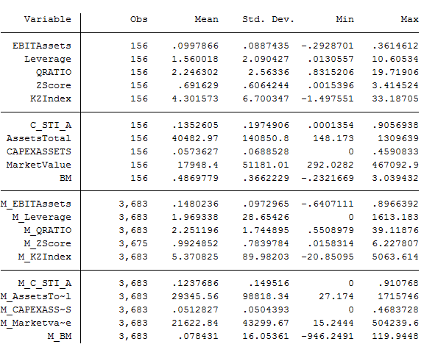

Appendix C – T-test difference in means, whole match sample

 | Issuing firms mean | All non-issuing firms mean | P value T-test difference in means | Singificant at 5%
Leverage | 1,560018414 | 1,969337757 | -0,834860787 | no
Total Assets | 40482,97294 | 29345,5645 | 0,977942405 | no
EBIT/Assets | 0,099786642 | 0,14802358 | -6,650340415 | yes
CAPEX/Assets | 0,057362746 | 0,051282665 | 1,091175654 | no
Book-to-Market | 0,48697795 | 0,347517433 | 2,088510592 | yes
Cash and ST Investments/Assets | 0,135260464 | 0,123768629 | 0,720777253 | no

Appendix D – OLS Regression

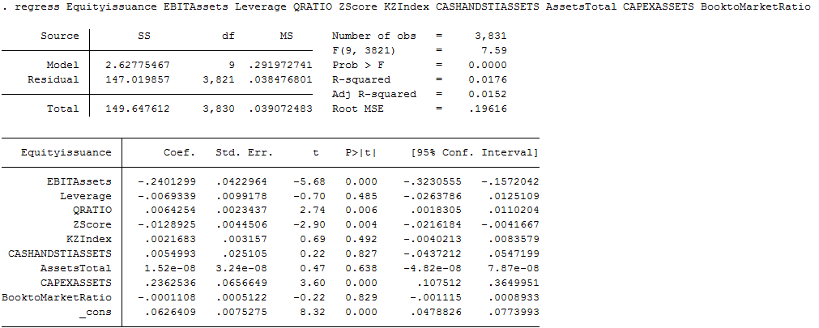

Appendix E – nearest neighbor matching

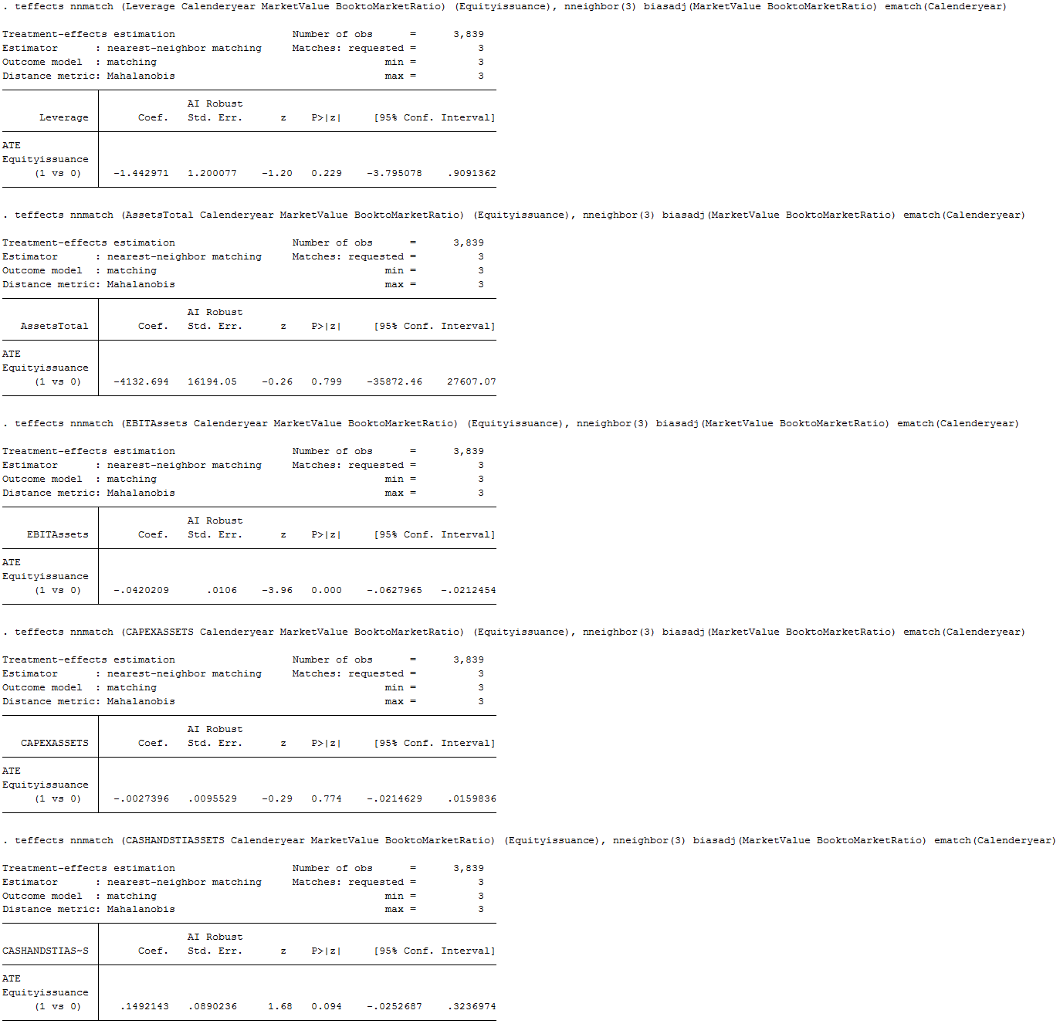

Appendix F – nearest neighbor matching
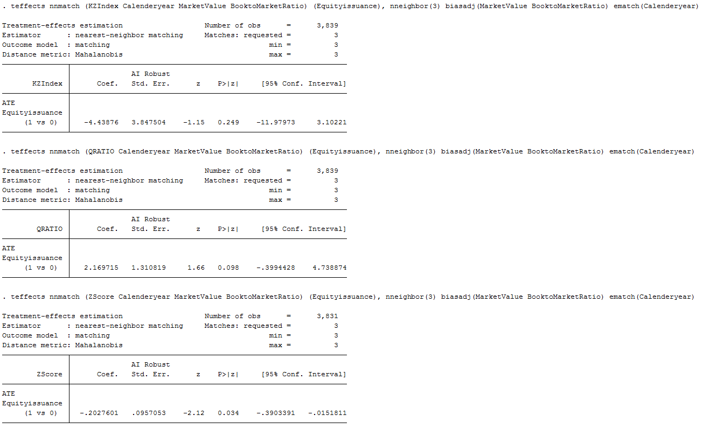

Appendix G – Propensity score matching

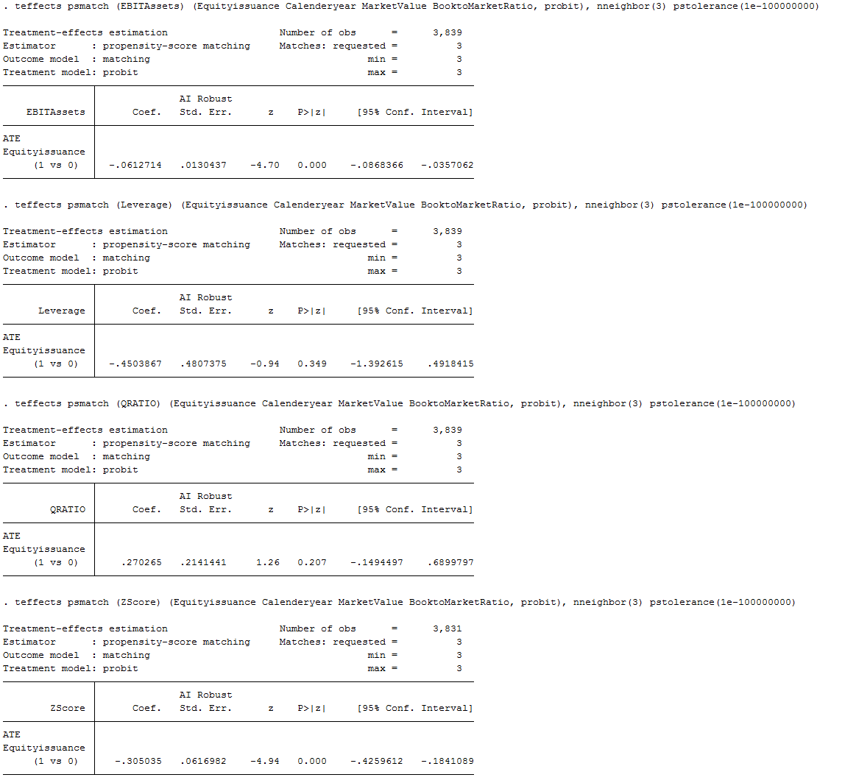

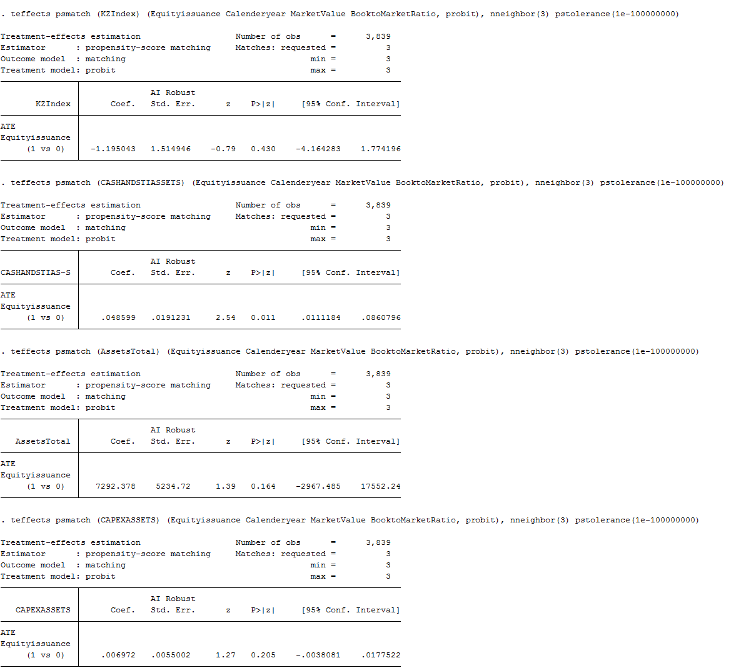

Appendix H – Probit model predicting equity issuance

Model Summary
Step | -2 Log likelihood | Cox & Snell R Square | Nagelkerke R Square
1 | 1240,654ª | ,016 | ,057
a. Estimation terminated at iteration number 10 because parameter estimates changed by less than ,001.

Classification Tableª
 | Observed |  | Predicted
 |  |  | Equity issuance |  | Percentage Correct
 |  |  | 0 | 1 | Percentage Correct
Step 1 | Equity issuance | 0 | 3673 | 2 | 99,9
Step 1 | Equity issuance | 1 | 156 | 0 | ,0
Step 1 | Overall Percentage |  |  |  | 95,9
a. The cut value is ,500

Variables in the Equation
 |  | B | S.E. | Wald | df | Sig. | Exp(B)
Step 1ª | EBITAssets | -4,175 | ,961 | 18,855 | 1 | ,000 | ,015
Step 1ª | Leverage | -,808 | ,467 | 2,989 | 1 | ,084 | ,446
Step 1ª | QRATIO | ,091 | ,042 | 4,702 | 1 | ,030 | 1,096
Step 1ª | ZScore | -,495 | ,164 | 9,158 | 1 | ,002 | ,609
Step 1ª | KZIndex | ,248 | ,147 | 2,839 | 1 | ,092 | 1,282
Step 1ª | CASHANDSTIASSETS | ,088 | ,597 | ,022 | 1 | ,883 | 1,092
Step 1ª | AssetsTotal | ,000 | ,000 | ,230 | 1 | ,631 | 1,000
Step 1ª | CAPEXASSETS | 3,697 | 1,336 | 7,657 | 1 | ,006 | 40,324
Step 1ª | BooktoMarketRatio | ,101 | ,142 | ,503 | 1 | ,478 | 1,106
Step 1ª | Constant | -2,482 | ,190 | 169,993 | 1 | ,000 | ,084
a. Variable(s) entered on step 1: EBITAssets, Leverage, QRATIO, ZScore, KZIndex, CASHANDSTIASSETS, AssetsTotal, CAPEXASSETS, BooktoMarketRatio.

Appendix I – Marginal Effects Estimation

