Is broader health coverage good for a nation’s health? Revisiting the evidence from country level panel data in the new millennium.

Erasmus University Rotterdam

  - Wessel van Rietschoten

  - Supervisor: E. van Doorslaer
Co-Reader: E. van de Poel

  - 11-08-2015

Table of Contents
Introduction 3
This research 4
Theoretical Framework 7
Effects of health coverage on population health 7
Effect of governance on the efficacy of health coverage 7
Effects of extending the research 9
Endogeneity 10
Literature Review 12
Cross-country studies on health care coverage 12
Panel data studies on health care coverage 13
Two-step instrumental variable approach 15
Methodology 16
Moreno-Serra & Smith (2015) method explained 16
Confounders 16
Reverse causality 17
Alternative model 18
Sensitivity analysis 19
Data 22
Independent variables 22
Original dependent variables and instruments 22
Dependent variables alternative model 23
Results 25
Differences investigated 25
Alternative research 27
Sensitivity analysis 29
Conclusion 34
Discussion & Limitations 37
Further Research Suggestions 39
Bibliography 41
Appendix 43

Introduction
Health care coverage has been and still is an important goal to be reached globally. The World Health Organization (WHO) defines universal health coverage (UHC) as ensuring that all people can use the promotive, preventive, curative, rehabilitative and palliative health services they need, of sufficient quality to be effective, while also ensuring that the use of these services does not expose the user to financial hardship. (World Health Organization, 2014)

The United Nations recognizes the importance of universal health coverage to enhancing health, social cohesion and sustainable human and economic development in their general assembly resolution of 2012. They pledge to strengthen health systems towards the provision of equitable universal coverage. “We call for the involvement of all relevant actors for coordinated multi-sectorial action to address urgently the health needs of the world’s population.” (United Nations, 2012).

Essential is to monitor the progress made in countries towards UHC. In order to track progress the WHO has developed guidelines. The WHO guidelines state that indicators for UHC can be found in two different areas: Health service coverage and financial protection. The indicators for health service coverage are prevention and treatment. For financial protection those are impoverishing expenditures and catastrophic expenditures. Next to the aggregate levels of these indicators also equity in them is important for UHC. (WHO, Worldbank Group, 2014)

So far it became clear that UHC is an import point on the agenda in many developing countries. Assumed is that health coverage will have a positive effect on health outcomes. This is investigated in many micro (single country) level studies. For example Card et al. (2005) investigated the effect of Medicare in the United States. Every elderly gets free Medicare insurance after the age of 65. This results in an increase of insurance coverage and as their results have shown a positive effect on health outcomes. (Card, Dobkin, & Maestas, 2005)

Although plenty of micro level studies are available on the effects of specific coverage interventions on health outcomes, empirical research on the average macro (multiple countries) level effects however is scarce. The main problem with macro level empirical studies is the reverse causality bias that exists when estimating the effect of coverage indicators on mortality. This is the reverse effect of mortality rates on those coverage indicators, meaning that countries with higher mortality rates may tend to spend more on healthcare. This may cause the estimates of coverage indicators on mortality rates to be biased. Early studies that did not correct for this bias therefor found no or little beneficial effect of coverage on mortality. (Musgrove, 1996)

A recent study by Moreno-Serra and Smith (2015) does manage to correct for the reverse causality by using a two-step instrumental variable approach (IV). The IV’s used are CO2 emission and conflict deaths. In their study a panel dataset of 221 countries from 1995-2008 is used. They estimate the effects of several health coverage indicators on under-five mortality, female mortality and male mortality. One of their indicators is government health spending per capita. Using their regression estimates and some straightforward calculations they calculate the marginal costs of saving a year of live. Surprisingly they find fairly low CERs: on average around $1,000 in the whole sample of countries, and $145 for a low or middle-income country. These numbers suggest that especially in low and middle-income countries there still is a large amount of life years to gain for a fairly low amount of money. (Moreno-Serra & Smith, 2015)

This research
The aim of this research is to revisit the empirical evidence of the effect of coverage indicators on mortality rates in the new millennium. The first part of this research will reproduce and expand the study done by Moreno-Serra and Smith (2015). The original study will be redone with the currently available data. The second step is to expand the data with 4 additional years (2008-2012). However because of unexpected differences already in the first phase of recreating the original study over the years 1995-2008 the second step could not be executed. Instead this research tries to investigate and explain the differences with the original study.

The second part of this research uses the updated data set to estimate a different model on the effect of health care coverage on mortality rates. This alternative method estimates the effects of government health spending per capita (as % of GDP), GDP an immunization rate on under5-, male- and female- mortality over a time period of 1995 - 2012. This model in contrast to the original model does not succeed in overcoming the reverse causality bias. Causing the results to potentially suffer from upward bias as is observed in previous studies. (Moreno-Serra & Smith, 2015) Meaning that government health spending appears to be less beneficial than when corrected for this bias. Because of this the baseline estimates do not hold reliable insights. Therefore, instead the model is re-estimated with several different specifications. Although still the results will be biased it will give more reliable insights when looking at the differences between the baseline model and the models used in the sensitivity analysis.

The first test will be to examine the differences in effect for the whole sample of 211 countries and a subsample including only low- and middle- income countries. This is done to test the hypothesis that the effect of government health spending is more beneficial for less developed countries. Secondly the model is re-estimated twice, once for countries with a negative governance score and again for those with a positive governance score. This will shed light on the hypothesis that government health spending has a more beneficial effect on mortality rates in countries with good governance. (Moreno-Serra & Smith, 2012) The last hypothesis that will be tested is about economic development and health care coverage. The model will be re-estimated over two different time periods of eight years each, 1995-2003 and 2004-2012. Under the assumption that in general countries are more economically developed in the more recent time period it will test the hypothesis of diminishing marginal returns of GDP on mortality.

Theoretical Framework

Effects of health coverage on population health
As discussed in the introduction increasing health care coverage is an important policy goal in many developing countries. The concept of health care coverage consist of health service coverage and financial protection. Health service coverage is measured as the access to effective services by individuals. Next to physical access to care also the financial part is important, health coverage also means that an individual should not lead impoverishing or catastrophic expenditures from seeking care. (WHO, Worldbank Group, 2014) Although it is not straightforward to measure UHC, a lot of studies use government health spending as indicator for UHC. In theory this idea is straightforward: it is assumed that an increase in government or public health care spending will lead to better coverage, which in turn will lead to better health outcomes. However empirical research on the macro level so far, which will be discussed in the literature review, has shown ambiguous results on the claims of increased public health spending to decrease mortality rates.

A literature review done by Moreno-Serra and Smith does confirm these positive effects of the movement towards health care coverage on population health. They argue that overall increasing coverage has a positive effect on population health, but the magnitude of this effect depends on other factors such as the governance in a country. They also show that lower income countries benefit most from increased coverage. (Moreno-Serra & Smith, 2012)

Effect of governance on the efficacy of health coverage
Governance plays an important role in the efficacy of government health spending. In the literature review empirical studies that test the role of governance on the efficacy of government spending will be discussed in more detail. One of those studies developed a theoretical framework that expresses this relation as chain from public spending to health status (see figure 1). (Filmer & Pritchett, 1999) According to their theory there are three possibility as to why, even though there is a potential for health improvements it is not observed. First the health production function, the improvement in health status is dependent on the consumption of health services. Within the health production function there is a difference in effectiveness in improving health status. Secondly the net public sector impact matters, even though some publicly provided health services might be cost effective it does not guarantee a health improvement. The provision of these services by the government might crowd out private provision causing the net beneficial health effect of this government intervention to be small. Lastly the public sector efficacy is important when it comes to public health spending. The impact of public spending will depend on the degree to which public spending is able to create effective public services. So in order for public spending to improve health it must first create effective health services. Second the existence of those services has to change the total amount of effective health services consumed by the population. Third the additional services have to be cost effective in improving health. If any of these conditions is not met the actual cost effectiveness of public health interventions can be very high. (Filmer & Pritchett, 1999)

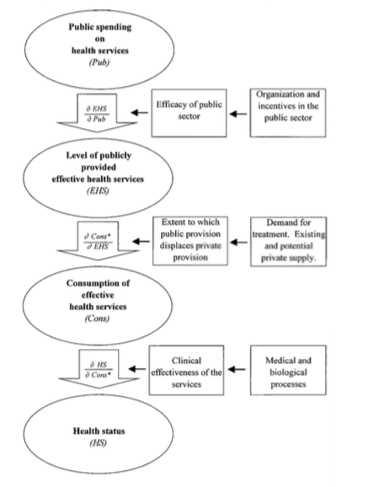
Figure 1: Chain from public spending to better health. (Filmer & Pritchett, 1999)

Effects of extending the research
The original time period of the panel data ranges from 1995 to 2008. This research will add the years 2009 to 2012, to see how this influences the results. Previous research has shown that the effects of health coverage on population health are largest for low-income countries. (Moreno-Serra & Smith, 2012) As countries develop it is reasonable to assume that on average the effect will fall and that the cost of a life year saved will have increased.

Samuel H. Preston showed already in 1975 a connection between a country’s GDP and life expectancy. The Preston curve shows a concave relation between GDP and life expectancy. (Preston, 1975) The diminishing returns to scale of GDP increase on mortality suggest an increase in costs per life years saved when countries are more economically developed. More recent literature confirms that this theory still holds true for current times. (Deaton, 2003) (Bloom & Canning, 2007). Following this theory it is likely to observe less beneficial effects of GDP and government health spending on mortality rates for the more recent time periods because of the diminishing returns to scale.

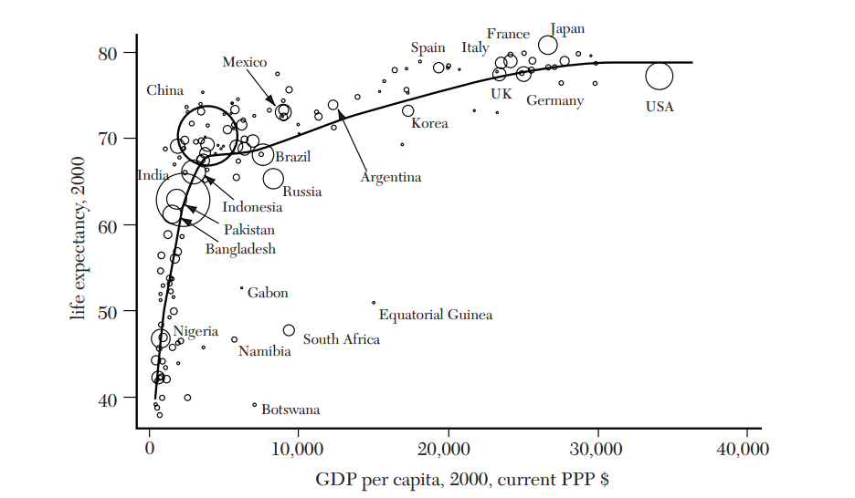
Figure 2: Preston Curve (Deaton, 2003)

Moreno-Serra and Smith (2015) have already investigated the effects of exclusion of earlier years in the original research. They showed that exclusion of the observations of the years before 1999 hardly had any influence on their estimates. While they do not provide an explanation for this, and nor they do mention that there are only 61 countries with usable data from the period before 1999. (Moreno-Serra & Smith, 2015)

Endogeneity
A major problem that occurs when investigating the effects of coverage indicators on health outcomes in a country level study is the problem of endogeneity, with confounders and reverse causality as the main issue. Confounders are variables that correlate with both the independent and the dependent variables, if those variables can be observed they can be controlled for by including them in the regression. Reverse causality occurs when there is an effect of the independent variable on the dependent variables. In this case this means an effect of mortality rates on government health spending or GDP per capita. This effect can exist in two ways. Increases in life expectancy are associated with economic growth. Besides it can be argued that people living longer use more care in their lifetime, thereby increasing health care expenditures. This is graphically represented in the figure below. (van Baal, Parida, Brouwer, Nusselder, & Mackenbach, 2013)
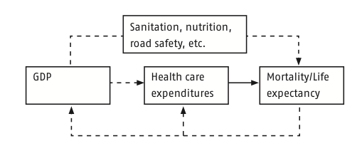
Figure 3: Causal chain running from GDP to mortality and back. (van Baal, Parida, Brouwer, Nusselder, & Mackenbach, 2013)

The reverse effect of mortality on GDP is expected to bias the estimates of a straightforward OLS model. Because higher mortality rates can lead to governments spending more money on health care this bias is upwards. Meaning that the results from a simple OLS regression will not show clear causal effects of health spending on mortality. Most likely the results will be less negative or even positive, suggesting additional health spending increases mortality, because of this bias.
In order to overcome this reverse causality problem Instrumental variable approaches are often used. Good IVs have to fulfil two criteria:
1. They have to be external to both dependent and independent variables and
2. They must be orthogonal to the independent variables. Which means the only effect of the IV on the independent variables can be through the effect on the dependent variable.

In the methodology is explained whether and how these endogeneity issues will be addressed in this research.

Literature Review
In order to put this research in perspective a brief review of the most important related studies is provided below.

Cross-country studies on health care coverage
In 1996 Philip Musgrove was commissioned by the World Bank to study the different contributors to a health system. The aim of the study was to investigate the balance between public and private health care spending. Three different justifications of government intervention in the health care market are present in economic theory. Government intervention to assure the optimal production of public goods; to correct for market failures; or to guarantee access to health care to the less wealthy. He argues that a combination of public intervention and private activity leads to most effective health sectors. In theory public health activities are most important at low-income levels, especially public financing may be crucial for health in poor countries. However empirically in a cross-country study he found little evidence of a systematic effect of public health care spending on mortality. Instead he found that the state role in financing tends to expand as income increases. (Musgrove, 1996)

Methodological issues flawed the empirical results of this early research. Despite the biased results it did show the complexity of the relation between government spending and mortality. A more rigorous empirical study by Filmer and Pritchett (1999) aimed to further investigate this relation. They used cross-national data to examine the impact of public spending and some non-health factors on under-5 and infant mortality. Their empirical strategy consisted of a straightforward equation with the natural log of mortality as dependent variable and as explanatory variables the natural log of GDP per capita, public spending as a fraction of GDP and some socio-economic variables. Besides a simple OLS also a two stage least squares regression with neighbors’ public and military spending as instruments was executed. Both regressions resulted in a very small and insignificant impact of public spending on health of less than one-seventh of 1%. These estimates imply public spending per child death averted in a developing country to be between $50.000 and $100.000. This in large contrast to the typical cost effectiveness of medical interventions to avert child mortality in developing countries, which ranges between $10 and $4000. (Filmer & Pritchett, 1999)
By the use of an instrumental variable technique the study by Filmer and Pritchett (1999) tried to overcome the endogeneity issues. However still their results were small and insignificant. Apart from questioning the validity of the instruments used they developed a framework (figure 1) to explain their findings. They argue that the total impact of public spending on health status depended on all the elements in the chain. (Filmer & Pritchett, 1999) This framework provides an explanation for the lack of significant effect of public spending on health services as discussed in the theoretical framework.

In 2007 another research commissioned by the World Bank has studied the links between public spending governance and outcomes. Their study shows empirically that the differences observed in efficacy of public spending can for a large part be explained by the governance of a country. Their empirical results show that public health spending lowers child mortality more in countries with good governance. In their conclusion they even claim that public spending has hardly any impact on health and education outcomes in poorly governed outcomes. (Rajukmar & Swaroop, 2007)

Panel data studies on health care coverage
More recently some econometric studies using panel data did manage to find positive effects of publicly pooled spending on mortality. In 2004 Wagstaff and Claeson came to the conclusion that extra government health spending does decrease mortality. However, the magnitude of this effect was found to be highly dependent on the level of governance in a country. They used data on 120 countries, finding reductions ranging between 0.8% and 1.5% in under-5 mortality for a 10% increase in government health expenditure relative to GDP. In their study they used the same instruments as Filmer and Pritchett (1999), besides they added a third instrument: the country policy of institutional assessment (CPIA) score of neighboring countries. (Wagstaff & Claeson, 2004)
Despite these somewhat more promising results the importance of good governance and allocation is stressed. For additional spending to lead to the desired mortality rates as stated in the millennium development goals impressively large increases in the share of GDP devoted to government health spending are necessary. In order for the extra money to have the desired effect targeting programs, better policies and improvements in health service delivery are essential. (Wagstaff & Claeson, 2004)

Another panel data study executed in 2007 provides even more convincing econometric evidence linking countries per capita government health expenditures and income to under-5 and maternal mortality. By using military expenses of neighboring countries as an instrument for government health expenditures to overcome the issue of reverse causality. This study found for a 10% increase in government per capita health expenditures on average a reduction of 3.3% in under-5 mortality. For maternal mortality this leads to an even larger reduction of on average 5.0%. (Bokhari, Gai, & Gottret, 2007)

Reviewing relevant literature it has become clear that finding straightforward links between health care coverage (government health spending) and mortality is challenging. Early empirical research has failed to discover causal effects of coverage on health, mostly due to methodological issues. Later studies managed to correct for the reverse causality by adopting an instrumental variable approach. This led to more optimistic estimates of the effect of coverage on mortality, however those studies do stress the importance of good governance for the efficacy of health spending. In the reviewed literature military expenses of neighboring countries is often used as instrument, this in line with the use of battle related deaths in the Moreno-Serra and Smith (2015) study. Although these studies indeed found significant beneficial effects of government health spending on (under-5) mortality, compared with the study by Moreno-Serra and Smith (2015) they found fairly small effects. This difference in magnitude might also be partly due to differences in the econometric techniques used.

Two-step instrumental variable approach
The study by Moreno-Serra and Smith (2015) makes use of a two-step instrumental variable approach to deal with the reverse causality issue. In the methodology part their application will be further explained. This approach has been previously applied in a different context in the study “On the simultaneity problem in the aid and growth debate” by Brückner (2011). For completeness this study and the use of this approach is reviewed bellow.

The aim of the study by Brückner (2011) was to estimate a causal effect of foreign aid on per capita GDP growth. He faced the problem that foreign aid is endogenous to per capita GDP growth, causing a reverse causal relation similar as the one faced in this research. A straightforward OLS regression therefore would suffer from downward bias due to the reverse negative effect of per capita GDP growth on foreign aid. To overcome this problem first the effect of per capita GDP growth on foreign aid is estimate using rainfall data as IV. The second step is to use these estimates to construct adjusted foreign aid series where the reverse effect as estimated in the first step is eliminated. Now the causal effect of foreign aid on per capita GDP growth is estimated and is by definition free from reverse causality bias. Using this approach they find (in contrast to previous literature) a significant positive average effect of foreign aid on per capita GDP growth. (Brückner, 2011)

Methodology

Moreno-Serra & Smith (2015) method explained
The first part of this research follows the methodology as used by Moreno-Serra and Smith (2015) in “Broader health coverage is good for the nation’s health: evidence from country level panel data”. In their study they use a strategy to address both the problem of reverse causality and confounders.

Confounders
The start is a simple model where the population health outcome of interest in country i at time t, y_{it}, depends on a vector C_{it} containing indicators of the level of health system coverage, and a vector X_{it} of covariates that might potentially influence both the outcome and health coverage. Population health is measured through mortality rates, and coverage through health spending measures and immunization rates. This simple model can be written as

y_{it} = βC_{it} + δX_{it} + e_{it} (1)

Where e_{it} is an error term capturing unobservable variables and random noise. The error term in equation (1) can be decomposed into three components that account for different sources of endogeneity. Let the error term be denoted as:

e_{it} =α_{i} +θ_{t} +ε_{it} (2)

In this formulation, α_{i} is a country-specific effect that captures time invariant unobservables that are potentially correlated with the levels of coverage and mortality observed in a given country. The term θ_{t} is a period-specific intercept that captures aggregate shocks affecting mortality outcomes in all countries at the same time. If all potential sources of endogeneity have been accounted for in the previous two components, ε_{it} represents a random, idiosyncratic error component. This formulation of the error term leads, by substituting equation (2) into equation (1), to the model:

y_{it} =βC_{it} +δX_{it} +α_{i} +θ_{t} +ε_{it} (3)

This model can be estimated through a fixed effects approach. The within-country variation in outcomes and regressors over time is used to obtain the coefficients of interest. Since the country-specific effect α_{i} is fixed over time, the effects of time invariant unobservables captured by α_{i} are eliminated in the estimation. Fixed effects estimations with longitudinal data require the estimated standard errors to be adjusted for arbitrary types of serial correlation and heteroscedasticity. To control for this, panel robust standard errors are clustered at the country level.

Reverse causality
Next step is to solve the problem of possible reverse causality. In order to do so the two-step IV approach, which has been discussed before in the context of the study by Brückner (2011), is used. The first steps estimates any reverse causal effects of mortality outcomes on coverage indicators, to adjust for these effects directly when estimating the effects of health coverage on mortality in a second step.

Consider a potential reverse causality of mortality outcomes leading to increased coverage. Let this relationship be expressed as:

C_{it} =λy_{it} +φX_{it} +γ_{i} +ω_{t} +μ_{it} (4)

For each pairwise combination of mortality and coverage indicators, a separate version of equation (4) is estimated to obtain consistent estimates of the reverse causal effect of mortality on coverage, λ. This is done by a method called two-step generalized method-of-moments (method IV-GMM).
By inspecting the sign and statistical significance of λ, the direction of the bias that would affect the coefficients of the coverage variables can be estimated. A positive λ would mean that higher mortality causally leads to higher coverage, thus resulting in an estimated coverage coefficient β in equation (3) that is biased upwards. Conversely, a negative λ would imply a negative causal effect of mortality on coverage, leading to a standard fixed effects estimate of the effect of coverage in equation (3) that is biased downwards.

The results from the consistent estimation of equation (4) are used to avoid the potential simultaneity and other biases that were described above. This is done, in a second step, by estimating equation (3) through an IV procedure that purges the reverse effect of mortality on coverage measures. The IV mortality coefficients λ estimated from equation (4) are used to construct adjusted series of coverage indicators C* for each country, subtracting the effect of mortality on each coverage indicator:

C*_{it}=C −λy_{it} (5)

Then C* is used as an instrument for the corresponding coverage indicator in equation (3). Since this procedure leads to only one constructed instrument for each coverage measure, equation (3) is estimated through the two-stage least squares (IV-2SLS) approach. Lastly variables such as GDP and primary education enrollment rate are added to the model that correct for within-country variations in socio-economic and demographic factors, to solve for remaining possible correlation in the error terms.

Alternative model
Because of unexpected differences between the updated dataset and the original data used by Moreno-Serra and Smith (2015) it has been chosen to build an alternative model rather than to redo the study. This new model is econometrically less advanced but nonetheless does make some attempts to overcome some of the endogeneity issues.

The baseline model that will be estimated is equal to equation (3) in the above part. With the time- and country- specific effect α_{i} is fixed over time and the use of panel robust standard errors clustered at the country level this equation can be reduced to the following:

y_{it} =βC_{it} +δX_{it} +ε_{it} (6)
Equation (6) implies a linear relation between the mortality outcomes and the coverage indicators. However from theory it is know that a concave relation between GDP and life expectancy exists. (Preston, 1975) Estimating a linear model would thus not be a good fit to the data. In order to overcome this the natural logarithm of the coverage indicators is used. To simplify interpretation of the coefficients also the mortality outcomes are transformed into their natural logarithm, making equation (7) an estimation of elasticity’s:

ln (y_{it}) =β ln (C_{it}) +δX_{it} +ε_{it} (7)

Equation (7) is similar to the model that is used in the Filmer & Pritchett (1999) study. In their research they found similar results using OLS and a two-stage least squares (2SLS) regression with military and public expenses of neighboring countries as instruments. Although they found little difference between the OLS and 2SLS model it is likely for reverse causality to be present as shown in Moreno-Serra and Smith (2015). Because of the lack of a more reliable instrument this research only estimates the OLS model. On the downside this means that the model is likely to suffer from reverse causality. However on the other hand the use of a model that is similar to the Filmer & Pritchett (1999) study allows for comparison of the results.

Sensitivity analysis
After estimating the baseline model some modifications are made to see how the model performs when assumptions are changed.

First of all the model will be estimated with the natural logarithm of per capita public health care spending as coverage indicator. The baseline model uses the natural logarithm of per capita public health care spending (as % of GDP) as coverage indicator. Because the model also includes GDP per capita the correlation between the two might cause the estimates to be insignificant. In order to test for the effect of this correlation the baseline model is re-estimated with the actual values of per capita public health care spending rather than as a fraction of GDP.

The second modification to the baseline model will be to split up the dataset in high versus low/middle income countries (LMIC). The most up to date threshold by the World Bank categorizes countries with a GDP per capita up to $12735 as LMIC. (World Bank, 2015) As already discussed in the theoretical framework the effect of government health spending is likely to be more beneficial to mortality rates in low and middle income countries. The original study by Moreno-Serra and Smith (2015) did also make a separate regression with only LMIC (GDP per capita up to $12195), finding much larger effects than their full sample estimates.

The third test will be to re-estimate the model including only the larger countries with a population of 1 million and above. Because the dataset consist of 221 countries and no selection is made based on the sizes of a country. This means that the baseline regression is influenced equally by data from a small island like Barbados and the whole of the United States of America. Because the size of a country does matter for their health system the baseline estimation is repeated with only countries that have over 1 million inhabitants.

Next the dataset will be divided up into high and low governance based on their average governance score. Governance is measured over six dimensions yearly by The World Bank Group and presented in the so-called “Worldwide Governance Indicators”. The six measures of governance all get a score from -2.5 (very low) to +2.5 (very high). The six different measures are: voice and accountability, political stability and absence of violence/terrorism, government effectiveness, regulatory quality, rule of law and control of corruption. (The World Bank Group, 2014) The average over these six measures is taken to construct a single governance score on a scale ranging from -2.5 to +2.5. This test will re-estimate the model with a sub-sample of countries with a negative governance score and once with those who have a positive governance score. The division between high and low governance is done to gain insights on the effect of governance on government health spending. Since previous research has shown the beneficial effects of additional government health spending to be conditional upon good governance. (Filmer & Pritchett, 1999)

Lastly the baseline model will be re-estimated for the time period 1995-2003 and 2004-2012. Separating the model into two time periods of 8 years will give information on if the effect of government health spending on mortality has been stable over time. Here it is expected that the effect has lessened in the most recent 8 years because countries have become more economically developed.

Data

Independent variables
The independent variable used in both the models is population health measured in mortality. Three separate models for under-5 mortality (deaths per 1000 live births), female and male mortality are estimated. According to literature (Under-5) mortality rates are considered an important indicator for population health. (Reidpath & Allotey, 2003) The under-5 mortality rates are retrieved from the “Global Health Data Exchange” coordinated by the Institute of Health Metrics and Evaluation. (Institute for Health Metrics and Evaluation, 2013) The male and female mortality rates from the “World Development Indicators”, which is an annual data collection project by the World Bank (World Bank, 2015)

Original dependent variables and instruments
A list of dependent variables used in the original study by Moreno-Serra and Smith (2015) is given in the Appendix (Table A1). The same data sources are used for this research but the time period is extended from 1995-2008 to 1995-2012. Next to the median immunization rate, five health spending variables are used: government health expenditure per capita, private pre-paid plans (VHI) health expenditure per capita, private out of pocket (OOP) health expenditure per capita, private out of pocket (OOP) health expenditure as a share of total health expenditures and total health expenditures per capita. All of these are retrieved from the “Global Health Observatory”. (World Health Organization, 2015) Besides those health system coverage indicators some socio-economic and demographic variables are used in the regression. These variables are: GDP per capita, primary education enrollment rate, share of the population age 0-14 an share of the population 65+, all retrieved from the “World Development Indicators”. (World Bank, 2015)

The instruments variables used are CO2 emission per capita from the “World Development Indicators” and battle related conflict deaths from the “Upsala Conflict Data Program”. (World Bank, 2015) These instrumental variables are used for the estimation of the reverse effect of mortality on the coverage indicators as given in equation (4). For CO2 emission and conflict deaths to be valid IV instruments they are required to be external to both mortality and coverage. Besides the only effects on health coverage allowed must be through their effect on mortality.

The effect of CO2 emission on mortality is expected to be ambiguous. On the one hand higher emission rate will have a positive effect on mortality rates as more CO2 emission will lead to more respiratory diseases, leading to higher mortality rates. On the other hand CO2 emission can also be seen a proxy for urbanization. Compared to rural areas urban areas are less exposed to waterborne diseases and diseases related to vector density, which will lead to a negative effect on mortality. Conflict deaths are a small fraction of total mortality for most countries, apart from those countries that have been in conflicts in the period of the analysis.

For both instruments the assumption is made that their only influence on the coverage indicators is through their effect on mortality. For CO2 emission this can for instance be more government health care spending resulting from the increase in mortality caused by respiratory diseases. Increase in battle related mortality often triggers an increase in (donor-) funds for health care. It seems reasonable to assume that system coverage responses to variations in CO2 emissions and battle-related deaths will be caused primarily by the health effects of the indicators for CO2 emissions and battle-related deaths. However also other effects are plausible such as for instance and effect of CO2 emission through GDP. Since the model corrects for GDP and other time invariant country factors these indirect effects of the IV do not invalidate them.

Dependent variables alternative model
The alternative model will again use the three different mortality rates as outcome variable, however this time transformed into their natural logarithm. The coverage indicators used as dependent variables differ from the Moreno-Serra and Smith (2015) study. As health system coverage indicators next to median immunization rate the natural logarithm of GDP per capita (World Bank, 2015) and government health expenditures per capita as a fraction of GDP. (World Bank, 2015) For comparability reasons these health system coverage indicators are the same as used in the study by Filmer & Pritchett (1999). However in the first sensitivity analysis the natural logarithm of per capita government health expenditures is used as coverage indicator. (World Health Organization, 2015) Next to these different coverage indicators the total population size per country per year is added, in order to separate larger from small countries as will be done in the sensitivity analysis. Also retrieved from the “World Development Indicators”. (World Bank, 2015) The same socio-economic and demographic variables as above are used in the regressions. The period of analysis for this the data used in this part is from 1995 up to and including 2012.

Results

Differences investigated
Using the dataset and Stata commands file provided by Moreno-Serra and Smith (2015) it was straightforward to recreate the results of their “Broader health coverage is good for the nation’s health: evidence from country level panel data”. However when accessing the sources to expand the dataset with the additional 4 years it became clear that some variables had changed. The most prominent one was the change of GDP per capita based on purchasing power parity (PPP) in constant 2005 international dollar to the 2011 equivalent. This change in unit of measurement caused the GDP per capita values to be on average 43% higher than in the original dataset. Because of this and the possibility that some of the other variables could have changed in retrospect it was decided to recreate the dataset over the years 1995-2008 first before expanding it. This decision was made to make the research as reliable as possible, otherwise the possibility existed to find changes in effects based on units of measurement or data changes only.

When recreating the dataset it became clear that not only GDP per capita had changed. The data as available at the time of the Moreno-Serra and Smith (2015) and during this study had changed significantly, although the same data sources are used. In table 1 the descriptive statistics from the original study are presented. (Moreno-Serra & Smith, 2015) The same descriptive statistics generated with the updated dataset are given in table 2. Already from these descriptive statistics it becomes clear that not only GDP per capita had been retroactively changed. The male and female mortality rates together with some of the coverage indicator also appear to be different from the original dataset.

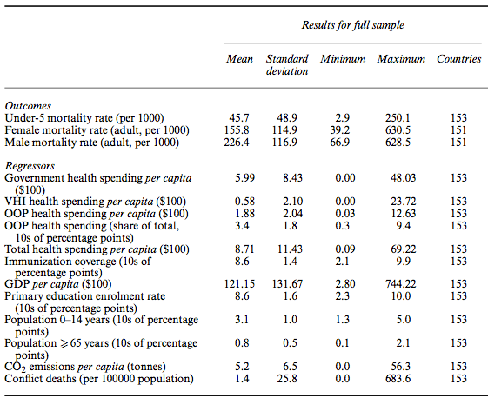
Table 1: Descriptive statistics (Time period is 1995-2008) (Moreno-Serra & Smith, 2015)
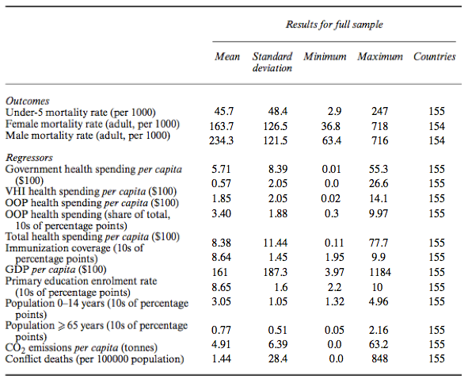
Table 2: Descriptive statistics with updated dataset (Time period is 1995-2008)
Despite the differences the main results of the Moreno-Serra and Smith (2015) study are recreated by using the Stata command file provided. The original results are shown in table A2 of the appendix, the ones estimated with the updated dataset in table A3 of the appendix. Because the estimations with the new dataset fail to find results similar to the original it is decided that simply expanding their dataset with another 4 years was not an option, for reasons explained above. Instead a careful look at the dataset was taken to investigate where the differences originate.

Investigating the data it became clear that none of the variables had remained exactly the same. However the median immunization rate, socio-economic and demographic variables differed minimally. The differences observed in GDP per capita are due to change in unit of measurement. The remaining differences in mortality rates and coverage indicators were more challenging to explain. Part of the difference might be explained by additional data entries, which were apparently not available at time of data collection for the Moreno-Serra and Smith (2015) study. This is also visible in table 1 and 2 as there are more countries included in the new dataset. However even when these countries are excluded again the differences remain. Even after double-checking and confirming the sources and units of measurement of the data it remains unclear what causes the differences between the datasets.

Alternative research
Because of the unexpected differences between the datasets an alternative model is estimated with the new dataset, rather than the expanded original study data. The first step was to estimate a linear relationship between the coverage indicators and mortality rates. In line with Moreno-Serra and Smith (2015) for this panel dataset a least squares fixed effect with panel robust standard errors clustered at the country level is used as estimation approach. The use of fixed effects is supported by the significance of a Hausman test (see appendix table A4). The Hausman test tests the null hypothesis of no systematic difference between the fixed and random effects model. As this test rejects the null hypothesis the fixed effects model is the most efficient estimator. In table 3 these results are presented for under-5, female and male mortality.

 | Under-5 mortality | Female mortality | Male mortality
Government health spending per capita (% of GDP) | 0.307  (0.682) | 2.468  (0.393) | 2.116  (0.396)
GDP per capita | 0.000  (0.574) | -0.000  (0.636) | -0.000  (0.436)
Immunization coverage | -3.527  (0.000) | -1.374  (0.602) | -2.498  (0.288)
Country fixed effects | Yes | Yes | Yes
Year fixed effects | Yes | Yes | Yes
F-statistic | 17.42 | 11.04 | 14.47
F-statistic (p-value) | 0.000 | 0.000 | 0.000
R-squared (overall) | 0.034 | 0.000 | 0.076
Number of countries | 162 | 161 | 161
Observations | 1869 | 1785 | 1785
Table 3: Linear regression model. Time period is 1995-2012. The regressions control for primary education rate, the share of population aged 0-14 years and the share of population aged over 65 years. Entries in italics indicate coefficients that are statistically significant at the 10% level of confidence or below. Stata output in Appendix table A5.

As already discussed in the methodology the linear model is not a good fit to the data. This is confirmed by the low R-squared, F-statistics and insignificance of all three regressions. Because of the poor fit of the model the estimates in table 3 are not very reliable. As suggested by previous literature a log linear model is expected to be a better fit to the data (Filmer & Pritchett, 1999). The baseline results of the log linear model are presented in table 4 below.

 | Under-5 mortality (ln) | Female mortality (ln) | Male mortality (ln)
Government health spending per capita (ln of % of GDP) | 0.010  (0.535) | 0.024  (0.184) | 0.032  (0.090)
GDP per capita (ln) | -0.167  (0.007) | -0.014  (0.748) | -0.006  (0.890)
Immunization coverage | 0.000  (0.937) | 0.003  (0.674) | -0.003  (0.652)
Country fixed effects | Yes | Yes | Yes
Year fixed effects | Yes | Yes | Yes
F-statistic | 42.90 | 23.86 | 22.93
F-statistic (p-value) | 0.000 | 0.000 | 0.000
R-squared (overall) | 0.806 | 0.573 | 0.209
Number of countries | 162 | 161 | 161
Observations | 1869 | 1785 | 1785
Table 4: Log linear regression model. Time period is 1995-2012. The regressions control for primary education rate, the share of population aged 0-14 years and the share of population aged over 65 years. Entries in italics indicate coefficients that are statistically significant at the 10% level of confidence or below. Stata output in appendix table A6.

Both the higher R-squared and F-statistics for all the regressions suggest a better fit of the log linear model. However still the coefficients are mostly insignificant. A similar result of non-significance is found by several previous studies. (Bokhari, Gai, & Gottret, 2007) (Filmer & Pritchett, 1999) The results as shown in table 4 suggest a positive coefficient for the natural logarithm of health care spending per capita (as % of GDP) on all three mortality rates. This positive partial association is most likely due to the simultaneity bias. Although a positive effect is not to be expected it is not uncommon, previous literature has found the regression estimates to become (more) negative when correcting for reverse causality bias. (Moreno-Serra & Smith, 2015)

Sensitivity analysis
A possible explanation for the insignificance of the estimates as found in the baseline model could the correlation between the natural logarithm of GDP per capita and the natural logarithm of government health care expenses per capita (as % of GDP). To control for this the model is re-estimated with the natural logarithm of GDP per capita and the natural logarithm of government health care expenses per capita as coverage indicator. Since government health expenses are now no longer measured as a fraction of GDP the correlation between the coverage indicators is assumed of less importance. However also the estimates of this model remain mostly insignificant (see appendix table A7).

Because the baseline regression results themselves do not provide very valuable insights on the overall relationship between health coverage indicators and mortality below some sensitivity test are executed. The aim of these tests is to observe changes when the same relationship is re-estimated for subsets of countries or time periods. Row (a) to (d) in table 5 show the same log linear model as before, however countries are excluded based on certain characteristics. Row (e) and (f) show the results of dividing the dataset into two time periods of each eight years.

Low- and middle-income countries (LMIC)
Test (a) in table 5 shows the log linear regression model including only countries with GDP per capita of up to $12735. After applying this upper threshold the dataset is restricted to 116 LMIC countries only remaining on which the estimates are based. Compared to the base line results the sign change in the estimate of under-5 mortality is most striking. A 10% increase of government health spending per capita is associated with a decrease in under-5 mortality of 0.4%. However this estimate is still highly insignificant. For male and female mortality this sign reversal is not observed, the LMIC estimates are even more positive than the baseline estimates. This would suggest that higher government health spending per capita is associated with higher male and female mortality in LMIC compared to the full sample. When it comes to GDP per capita the association is more negative than the baseline model for all three mortality outcomes. Already in the full sample baseline results higher GDP per capita is associated with lower mortality rates, for the LMIC sub sample this negative association is even larger. An increase of 10% in GDP per capita in a LMIC is associated with a significant (on a 10% level) reduction of 1.8% in under-5 mortality. The more beneficial effect of the coverage indicators for under-5 mortality of the LMIC subsample is in line with previous literature. Also the weaker link with the other mortality outcomes in this setting is observed before. (Moreno-Serra & Smith, 2015)

Population size
The next test, row (b) in table 5 excludes all countries with less than 1 million inhabitants. This leaves a sample of 133 countries with a population of over 1 million. Exclusion of the smaller countries does not alter the estimates very much. The negative effect of GDP per capita has decreased in magnitude for all mortality outcomes. This is most likely caused by the characteristics of the smaller countries that are excluded. Looking at summary statistics (see appendix table A8) of the full sample compared with the excluded countries it becomes clear that the mortality rates have a lower mean in those small countries. Combined with their mean GDP per capita and mean government health spending per capita being higher than in the full sample it explains the decrease of the effect of GDP per capita.

Governance
To investigate the influence of governance on the estimates the data sample is divided up into countries with a negative governance score and countries with a positive score. The log linear model is re-estimated with 75 countries that have high governance (row(c), table 5) and 101 countries with low governance (row(d), table 5). For all three mortality rates a sign reversal is observed in the government health spending per capita. Although the estimates are still highly insignificant it does give some confirmation of the claim that governance is important for government health spending to be effective in lowering mortality rates. (Filmer & Pritchett, 1999) For GDP per capita the opposite is observed however this is most likely due to high correlation (0.64) between GDP per capita and governance. As also can be seen in the summary statistics in appendix table A8. Because of this the GDP per capita estimates when controlled for governance are biased.

 | Under-5 mortality (ln) | Female mortality (ln) | Male mortality (ln)
Government health spending per capita (ln of % of GDP)
Baseline | 0.010  (0.535) | 0.024  (0.184) | 0.032  (0.090)
(a) LMIC | -0.004  (0.800) | 0.028  (0.095) | 0.032  (0.052)
(b) Population > 1 million | 0.021  (0.194) | 0.022  (0.270) | 0.032  (0.111)
(c) High governance | -0.009  (0.885) | -0.001  (0.993) | -0.024  (0.766)
(d) Low governance | 0.012  (0.323) | 0.022  (0.104) | 0.032  (0.037)
(e) Years 1995-2003 only | -0.003  (0.858) | 0.009  (0.624) | 0.014  (0.377)
(f) Years 2004-2012 only | 0.026  (0.161) | -0.007  (0.603) | -0.009  (0.444)
GDP per capita (ln)
Baseline | -0.167  (0.007) | -0.014  (0.748) | -0.006  (0.890)
(a) LMIC | -0.188  (0.019) | -0.083  (0.274) | -0.084  (0.192)
(b) Population > 1 million | -0.104  (0.041) | -0.001  (0.986) | 0.011  (0.818)
(c) High governance | -0.138  (0.266) | 0.034  (0.666) | 0.063  (0.332)
(d) Low governance | -0.124  (0.013) | -0.067  (0.220) | -0.063  (0.144)
(e) Years 1995-2003 only | -0.119  (0.064) | -0.329  (0.547) | -0.124  (0.030)
(f) Years 2004-2012 only | -0.101  (0.089) | -0.038  (0.356) | 0.002  (0.939)
Immunization coverage
Baseline | 0.000  (0.937) | 0.003  (0.674) | -0.003  (0.652)
(a) LMIC | -0.006  (0.422) | -0.000  (0.990) | -0.006  (0.322)
(b) Population > 1 million | -0.002  (0.797) | -0.002  (0.797) | -0.007  (0.350)
(c) High governance | 0.020  (0.377) | -0.158  (0.288) | -0.015  (0.241)
(d) Low governance | -0.004  (0.598) | 0.002  (0.719) | -0.005  (0.451)
(e) Years 1995-2003 only | 0.005  (0.376) | -0.003  (0.653) | -0.002  (0.650)
(f) Years 2004-2012 only | -0.003  (0.638) | 0.000  (0.993) | -0.005  (0.296)
Table 5: Sensitivity analysis for the baseline effects of health coverage on mortality. All the regressions control for primary education rate, the share of population aged 0-14 years and the share of population aged over 65 years. Test (a) includes only countries with GDP per capita of up to $12735. Test (b) includes only countries with a population of more than 1 million inhabitants. Test (c) includes only countries with a positive average governance score. Test (d) includes only countries with a negative average governance score. Test (e) includes only the observations over the years 1995 up to and including 2003. Test (f) includes only the observations over the years 2004 up to and including 2012. Entries in italics indicate coefficients that are statistically significant at the 10% level of confidence or below.

Time Periods
The last test, rows (e) and (f) in table 5 provide the estimates of the log linear model over the first and last eight years separately. Over the time period of 1995-2003 data on 146 countries is available. For the period 2004-2012 the sample size is 153 countries. This was done to test the assumption of a concave relationship between GDP and life expectancy as explained in the theoretical framework. (Preston, 1975) If this assumption was to hold the negative effect of GDP per capita on mortality rates is expected to be larger in the first eight years than in the later. This because the countries are expected to make economic progress over the years, meaning they move upwards to the more horizontal part of the Preston curve. This indeed seem to be the case when looking at the results, the effect of GDP per capita was larger in the time period 1995-2003 than in 2004-2012. For under-5 mortality the difference is small, however for male and female mortality the differences are of substantial magnitude. In the time period 1995-2003 a 10% increase in GDP per capita is associated with a 3.29% decrease in male mortality. This association diminished to a decrease of 0.38% in the time period 2004-2012. This is a decrease of the association by more than eight times. For female mortality 1.24% reduction in mortality was associated with a 10% increase in GDP in the years 1995-2003. This effect changed sign in the next time period into a 0.02% increase of female mortality associated with again a 10% increase in GDP. Although these estimates are mostly insignificant it does give an indication that the assumption of a concave relationship with diminishing returns between GDP and mortality holds.

Conclusion
The first part of this research attempted to recreate and expand the study by Moreno-Serra and Smith (2015) with an additional eight years of data. Because of unexpected differences in recreating the original dataset this part of the research wasn’t executed. Instead the data was investigated to see where the differences originated. Despite the failed attempt of recreating this study it does lead some interesting conclusion. The main conclusion that can be drawn from this experiment is that it is very challenging to replicate a study when open sources are used. Although this study (to the best of my knowledge) has used exactly the same data sources as the original study it did not succeed in recreating the same or similar results. Possible causes for this can be retroactive changes in the available data or changes in for example unit of measurement. To be more certain about the cause of these differences contact with the original authors Moreno-Serra and Smith is required, however this was not feasible due to time issues.

The second part of this research estimated a model resembling the study by Filmer and Pritchett (1999). This model fails to overcome the reverse causality bias leading to (mostly imprecise) associations rather than causal effects. In line with previous empirical studies that did not correct for the positive effect of mortality on government health spending this study also found a seemingly positive association of health spending on mortality. (Filmer & Pritchett, 1999) (Musgrove, 1996) Implying that additional government health spending leads to higher mortality rates. However empirical studies that have succeeded in correcting for the reverse causality bias show the opposite effect. (Moreno-Serra & Smith, 2015) Because of this it is not possible to draw reliable conclusions upon the baseline estimates, however the sensitivity analysis do add some valuable insights.

The first test was aimed to overcome possible correlation between the coverage indicators. However changing government per capita health expenditures as a fraction of GDP to their absolute numbers did not result in more significant estimates.
Secondly to investigate the hypothesis that additional government health spending is more beneficial in low- and middle- income countries. Re-estimating the model for low- and middle- income countries indeed resulted in more negative association of GDP per capita on mortality rates for all three categories. Besides for under-5 mortality a sign change was observed in the effect of government health spending. Although this evidence is not significant it does suggest a more beneficial effect of the coverage indicators on mortality compared to the full sample.

The third hypothesis concerns the dependence of the beneficial effect of government health spending on the level of governance. Multiple previous studies claim that government health spending is more beneficial when the level of governance in a country is higher. (Filmer & Pritchett, 1999) (Wagstaff & Claeson, 2004) To test this two separate models were estimated dividing the sample in high and low governance countries. From these results it can be concluded that indeed the level of governance influence the estimates. For all three mortality rates a positive effect of government health spending is observed in the countries with low governance. For the countries with high governance a sign change is observed meaning that government health spending succeeds in lowering the mortality rates. Because of the reverse causality issue it cannot be concluded that government health spending is not beneficial for low governance countries. But it can be concluded that it is more beneficial in countries with high governance.

Lastly a test was performed to investigate how difference time periods changed the baseline results. The model was re-estimated again, first over the years 1995-2003 only and after for the years 2004-2012. This was done to test the hypothesis that the effect of government health spending and GDP on mortality rates would be less beneficial in the later time periods because of overall economic growth. The theory is that when countries become more economically developed the returns of GDP on mortality gains decrease. (Preston, 1975) This research indeed confirms this effect as the estimates for the for first time period show a larger beneficial effect of GDP on mortality rates as in the later time period. For government health spending this effect however is less clear.

Discussion & Limitations
The aim of this research was to investigate the effect of health care coverage on a nation’s health. This was done by revisiting the evidence of country level panel data in the new millennium. As became clear when reviewing previous literature the main challenge in estimating the effect of coverage indicators on mortality is the reverse causality bias. Because of the positive effect of mortality rates on government health spending a simple OLS regression is likely to result in unreliable estimates. Overcoming this bias has proven to be a challenge, however Moreno-Serra and Smith (2015) did manage this by using an advanced econometric technique. This led to estimates of far more beneficial effects of government health spending on mortality rates than those found before. Because of those promising results this study attempted to replicate and expand their study, to investigate how this effect had changed over more recent years. However already when recollecting data from the same sources over the same years substantial differences in estimates were observed. Very different results were found when re-estimating the model of Moreno-Serra and Smith (2015) with the new data set. This was a major drawback for this research. Instead of expanding the research with additional years the differences had to be investigated. Unfortunately our investigation remained inconclusive, quite a few of the variables showed large unexplainable differences. Some because of a change in unit of measurement however for the majority of variables it remains unclear why the data is different although the same sources are used.

Because using the method of Moreno-Serra and Smith (2015) was not feasible with the new dataset an alternative model was used to estimate the effect of health coverage on mortality, which was econometrically not as advanced as the original. Together with the absence of a suitable instrumental variable this caused the model to be unable to overcome the reverse causality issue. Already in the baseline results it became clear that the estimates appeared to be biased. The positive coefficients suggest an increase in mortality caused by additional health care spending. This is however in line with previous empirical studies that also did not correct for the reverse causality. Studies that do succeed in correcting for the reverse causality do find the expected negative causal effect in which additional government health spending lowers mortality rates. (Moreno-Serra & Smith, 2015)

Since the baseline estimates of the alternative model were biased and mostly insignificant it became difficult to draw reliable conclusions. Therefore instead of interpreting the signs and magnitude of the baseline results we rather focused on the differences between those and the sensitivity analysis was focused on. Various versions of the baseline model were used to test the various hypotheses. The results from these test were again biased and mostly insignificant. However by focusing on the differences rather than magnitudes combined with the evidence from previous empirical studies most of the hypothesis can be confirmed with some degree of certainty. However hard evidence on the magnitude of the effects is not provided, limiting the reliability of the conclusions drawn in this research.

Further Research Suggestions
The failure to reproduce the original study provides an interesting start for further studies. Although this research already tried to explain the differences between the datasets it remains unclear why some variables are different. Further investigation of what has caused the differences between the original dataset and the reproduction from the same sources might explain this. Even more interesting might be to investigate how robust the results provided by Moreno-Serra and Smith (2015) are. Since this study fails to find similar results questions can be raised about the robustness of their findings. Besides this also the original goal of this study to expand their research with additional years of data and observe how the effects as found have changed over the years remains an interesting field for further research. But this was beyond the scope of this study.

Also the alternative model provides some suggestions for further research. First off all this research together with previous literature concludes that the beneficial effect of government spending on lowering mortality rates is larger for low- and middle- income countries. Further research on the beneficial effects of government health spending on mortality conditional on the GDP of a country might provide a cutoff point up to which additional government health spending is cost effective. This also relates to the test with the time periods as performed in this research. Since it is assumed that countries become wealthier over time the beneficial effect of government health care spending diminishes. This implies that in the future all countries will reach a certain wealth level for which government health spending becomes less efficient. Additional research on the effects of health coverage in the future can shed light on this issue. Main concern here is the cost benefit tradeoff, as government health spending becomes less efficient in lowering mortality rates is it still a good investment or are governments better of spending their money differently in the future.

Another conclusion of this and previous research was that government health spending is more beneficial when the level of governance in a country is high. This insight also offers opportunities for further research. For policy makers it might be very valuable to know at what levels of governance additional government health spending becomes cost effective in lowering mortality rates. Especially in developing countries resources are scarce, spending a lot of government money on health means less money to spend on other government tasks. If this money is not well allocated because of poor governance it might be more efficient to invest in better governance first. Further research might be able to provide guidelines or even a threshold of the level of governance in a country after which health spending becomes cost effective.

Bibliography
Bloom, D., & Canning, D. (2007). Commentary: The Preston Curve 30 years on: Still Sparking Fires. International Journal of Epidemology, 498-499.
Bokhari, F., Gai, Y., & Gottret, P. (2007). Government Health Expenditures and Health Outcomes. Health Economics (16), 257 - 273.
Brückner, M. (2011). On The Simultaneity Problem In The Aid And Growth Debate . Journal of Applied Econometrics (28), 126 - 150.
Card, D., Dobkin, C., & Maestas, N. (2005, May). Outcomes, The Impact of Health Insurance Status on Treatment Intensity and Health. RAND Labor and Population working paper series.
Deaton, A. (2003). Health, Inequality, and Economic Development. Journal of Economic Literature , 113-158.
Filmer, D., & Pritchett, L. (1999). The impact of public spending on health: does money matter? Social Science and Medicine(49), 1309 - 1323 .
Institute for Health Metrics and Evaluation. (2013). The Global Burden of Disease Study 2013. Retrieved 2015, from http://ghdx.healthdata.org/
Moreno-Serra, R., & Smith, P. C. (2012). Does progress towards universal health coverage improve population health? The Lancet, 380, 917–23.
Moreno-Serra, R., & Smith, P. C. (2015). Broader health coverage is good for the nation’s health: evidence from country level panel data. Journal of the Royal Statistical Society, 178(1), 101-124.
Musgrove. (1996). Public and Private Roles in Health: Theory and Financing Patterns. World Bank. Washington D.C.: World Bank.
Preston, S. H. (1975, July). The Changing Relation between Mortality and Level of Economic Development. Population Studies, 29(2), 231-248.
Rajukmar, A. S., & Swaroop, V. (2007). Public spending and outcomes: Does governance matter? Journal of Development Economics, 96-111.
Reidpath, & Allotey. (2003). Infant mortality rate as an indicator of population health . (57), 344 - 346.
The World Bank Group. (2014). Worldwide Governance Indicators. Retrieved 07 2015, from http://info.worldbank.org/governance/wgi/
Unicef. (2014). Committing to Child Survival: A Promise Renewed.
United Nations. (2012). The Further We Want, UN General Assembly Resolution. Rio the Janairo: United Nations.
van Baal, P., Parida, O., Brouwer, W., Nusselder, W., & Mackenbach, J. (2013). The influence of health care spending on life expectancy. Tilburg: Netspar.
Wagstaff, A., & Claeson, M. (2004). The Millennium Development Goals for Health: Rising to the Challenges. Washington: The World Bank.
WHO, Worldbank Group. (2014). Monitoring progress towards universal health coverage at country and global levels. Geneva : WHO Press.
World Bank. (2015). World Development Indicators. Retrieved from http://data.worldbank.org/data-catalog/world-development-indicators
World Health Organization. (2014, December). What is universal health coverage? Retrieved from http://www.who.int/features/qa/universal_health_coverage/en/
World Health Organization. (2015). Global Health Observatory. Retrieved 2015, from http://www.who.int/gho/database/en/

Appendix
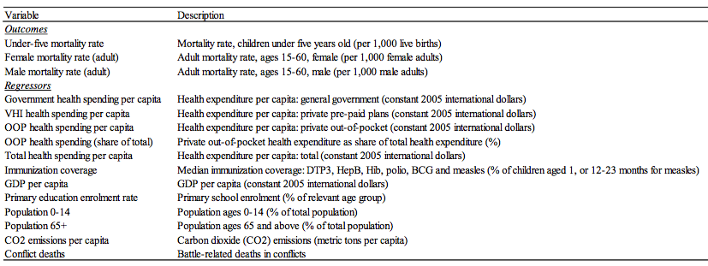
Table A1: Overview of variables used in “Broader health coverage is good for the nation’s health: evidence from country level panel data” by Moreno-Serra and Smith (2015).

Table A2: Original regression results (Moreno-Serra & Smith, 2015):
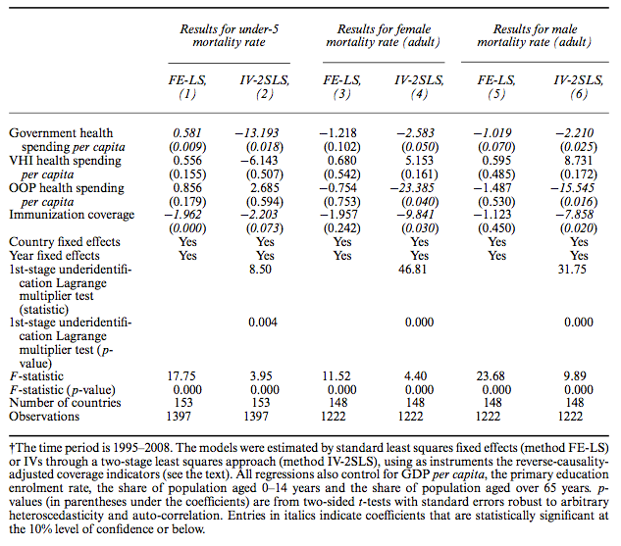
Table A3: Updated dataset regression results:
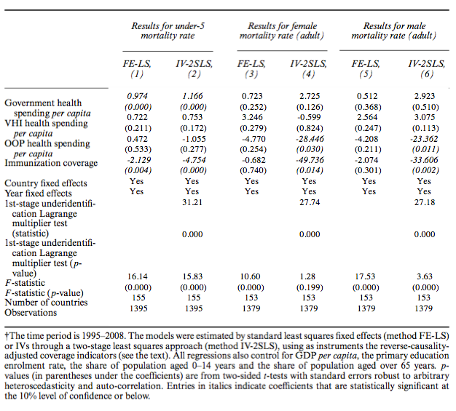

Table A4: Hausman Test for systematic differences random effects and fixed effects model.
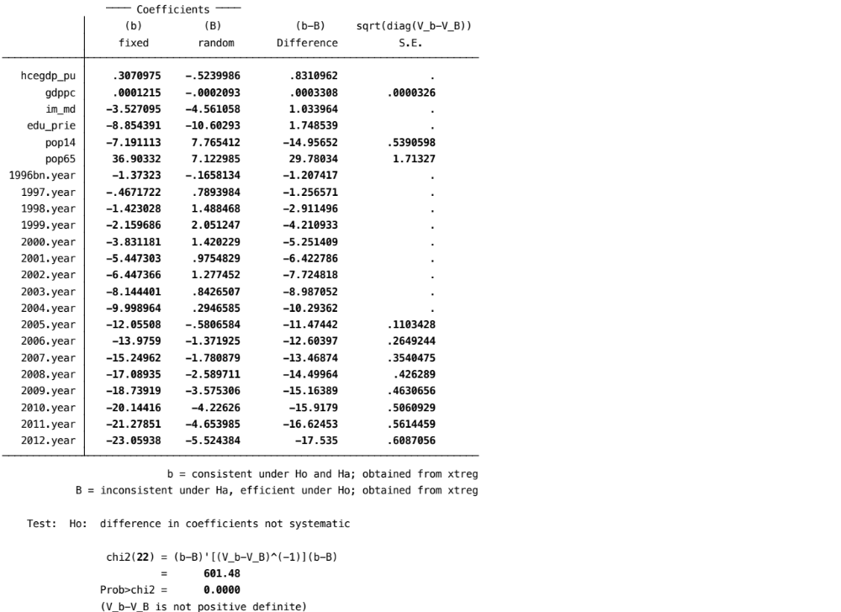

Table A5: Stata output linear regression.
Under-5 mortality: Female mortality:
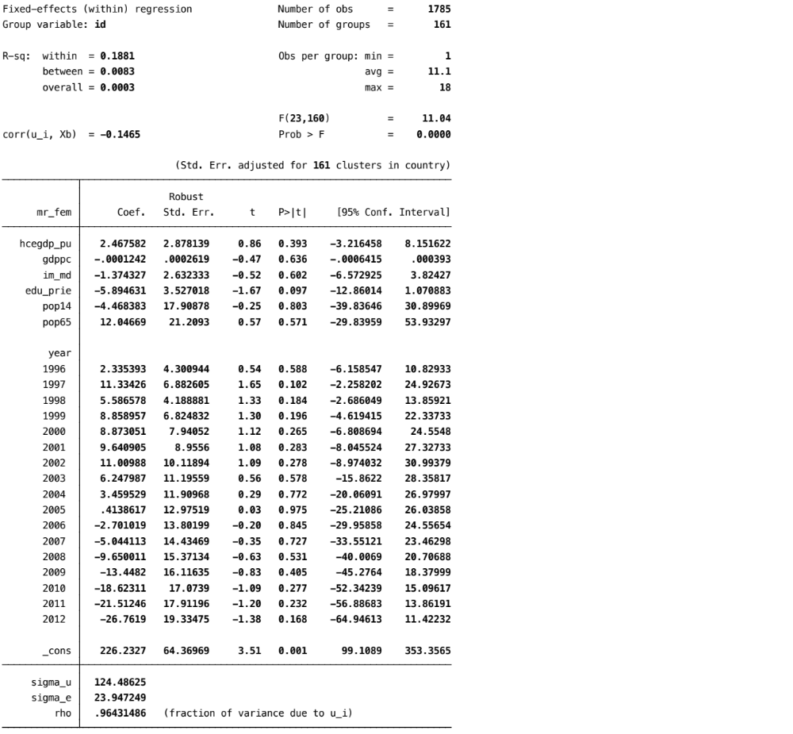
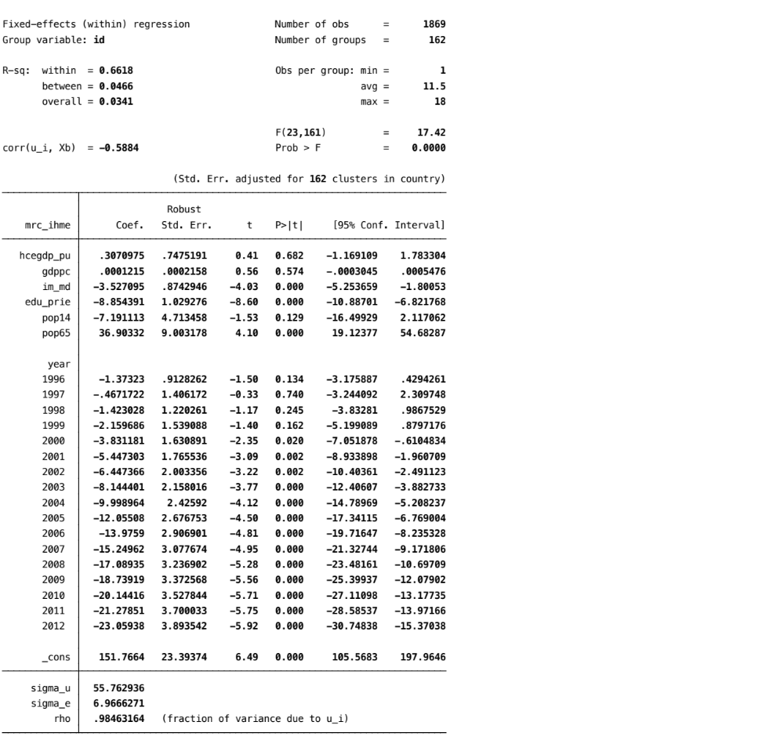

Male mortality:
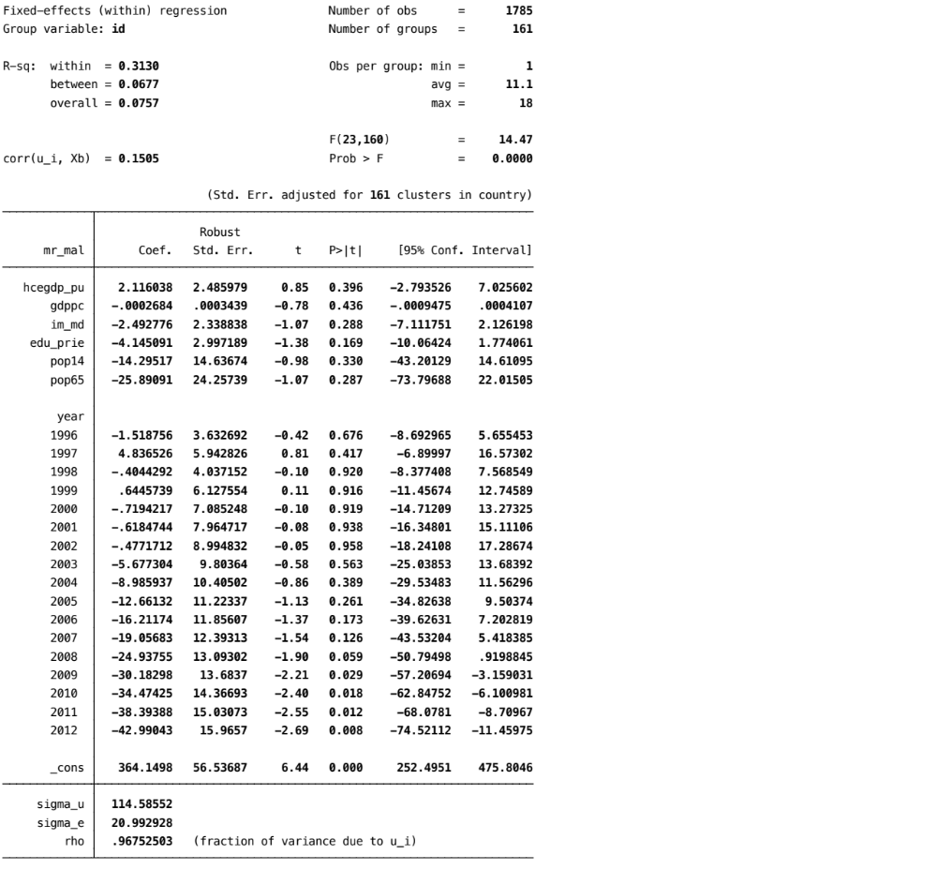

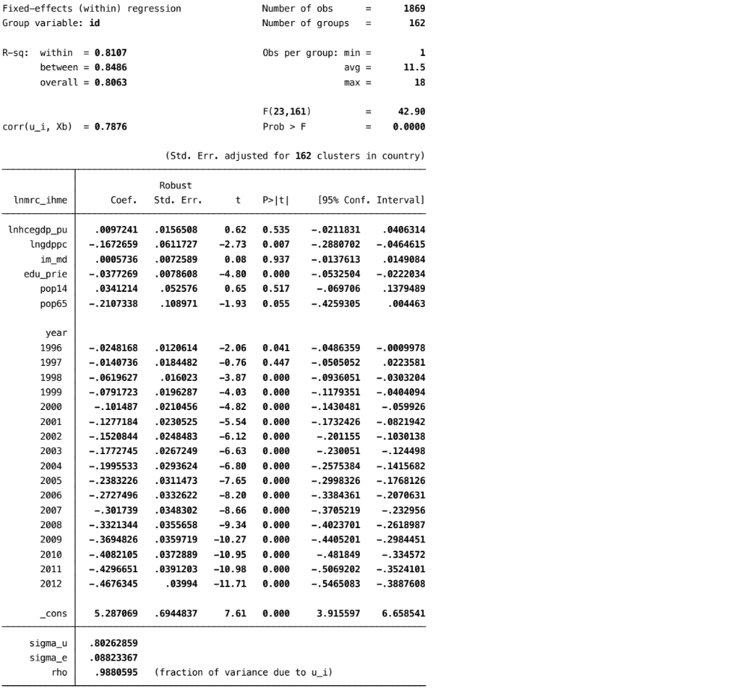
Table A6: Stata output log linear model
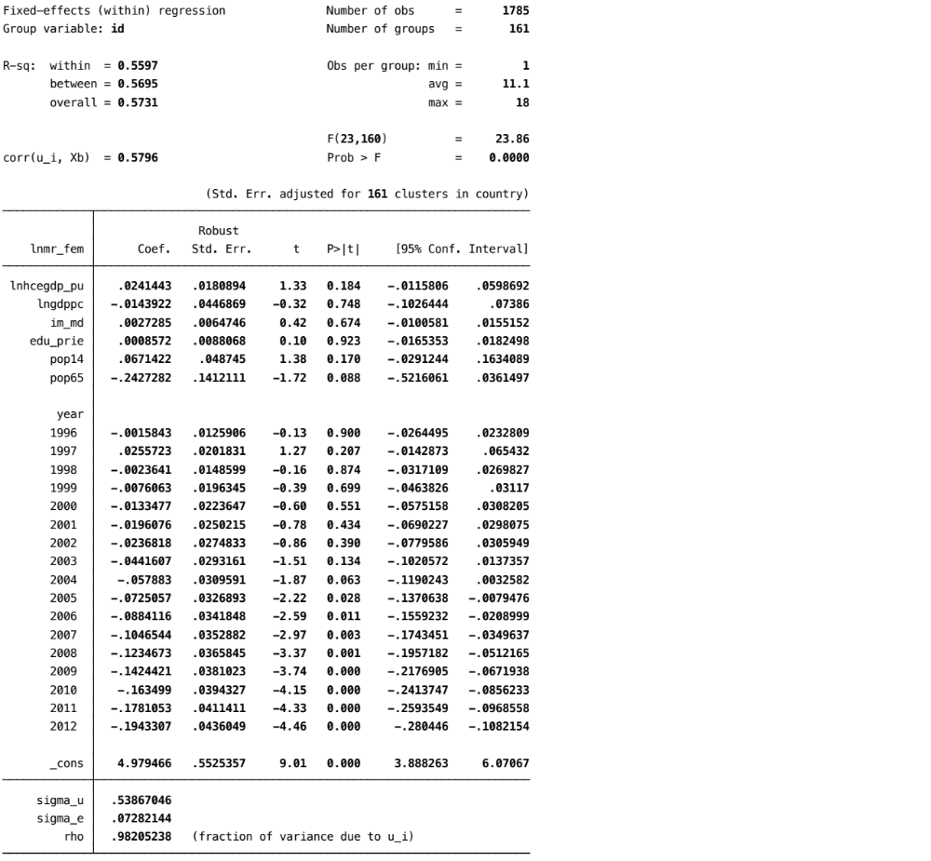
Under-5 mortality (ln) Female mortality (ln)

Male mortality (ln)
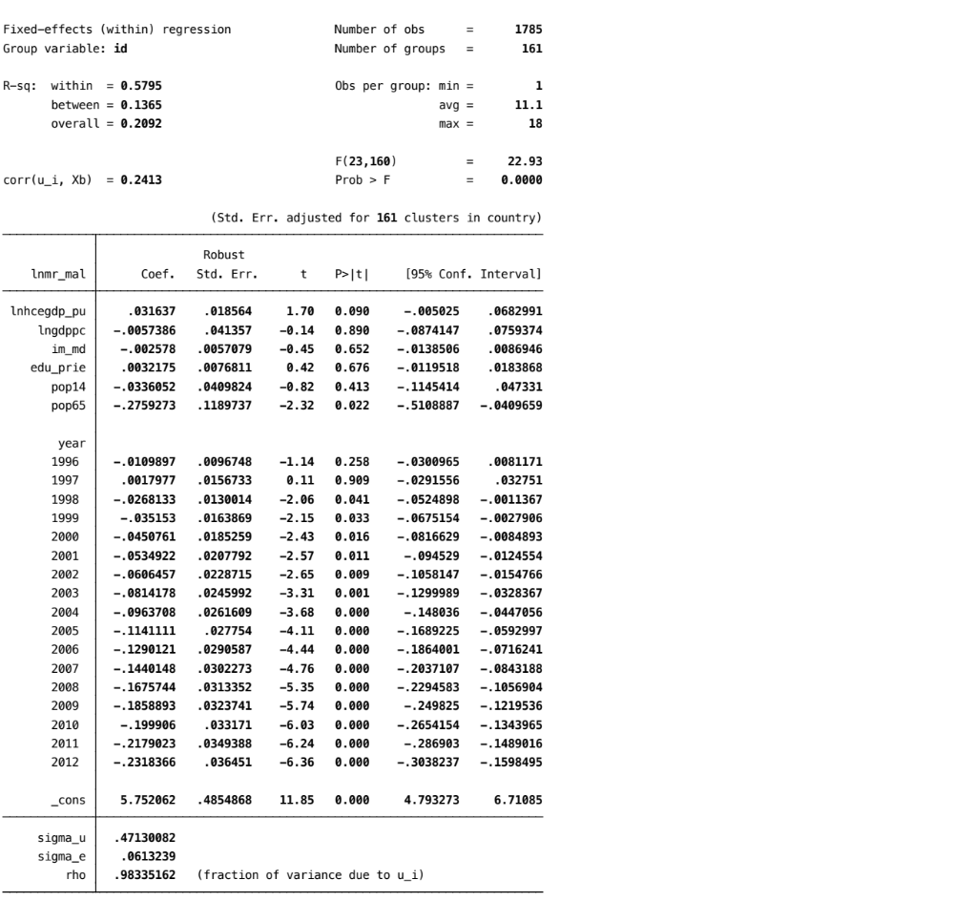

Table A7: Stata output log linear model with the natural logarithm of government health care expenditures per capita as coverage indicator.
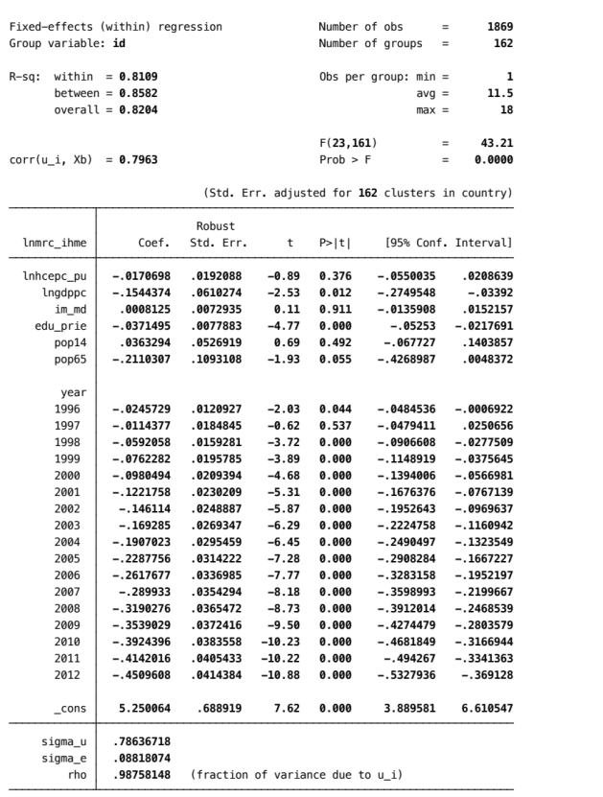
Under-5 mortality (ln) Female mortality (ln)
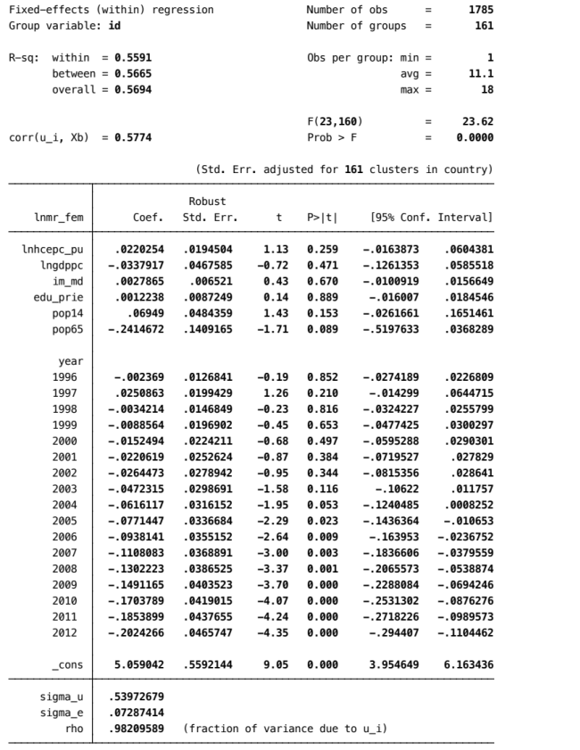

Male mortality (ln)
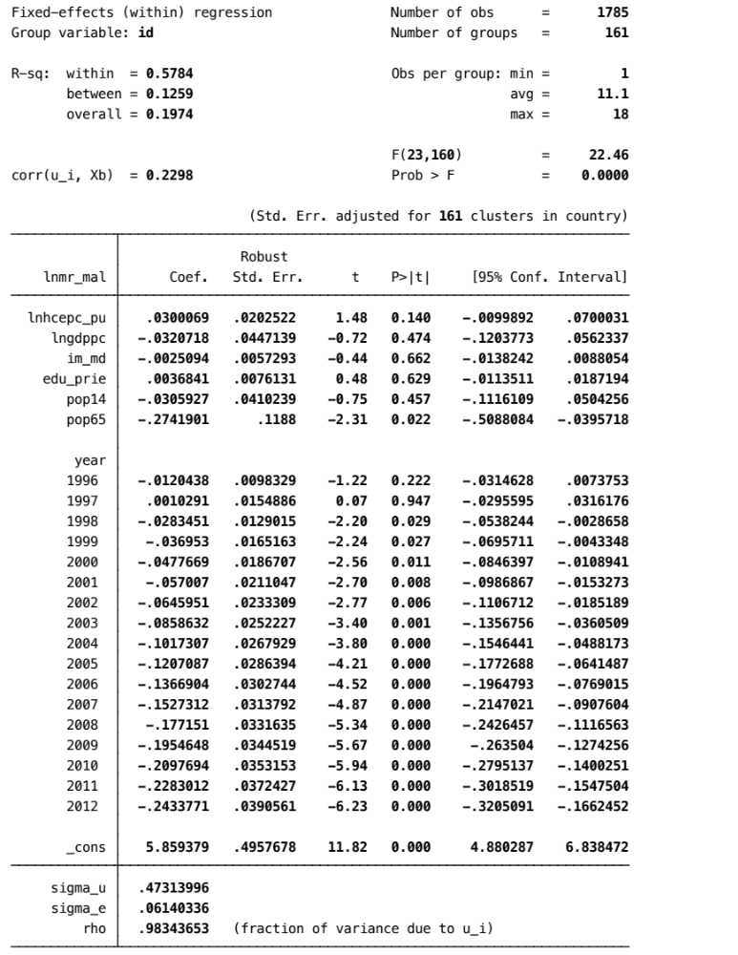

Table A8: Summary statistics of mortality rates, GDP per capita and government health spending per capita (as % of GDP)
Full sample:
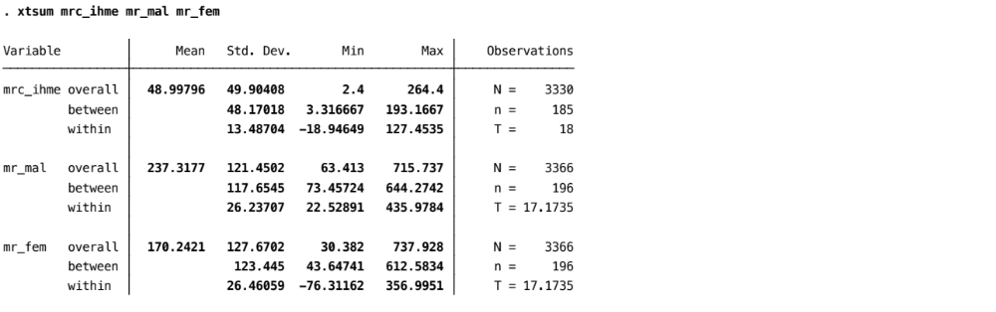
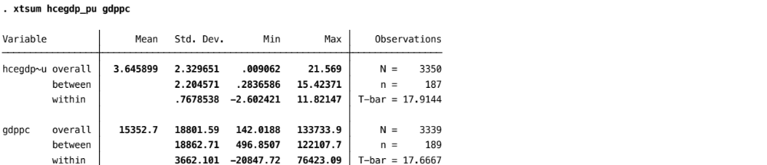

Subsample population < 1 million:
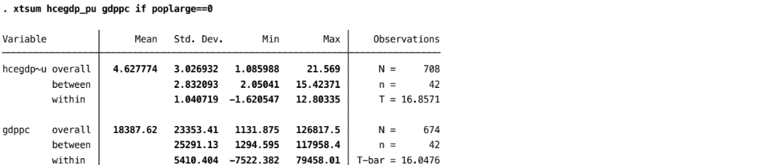
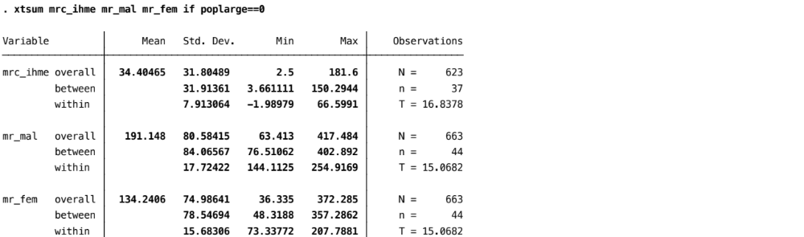

Subsample high governance:
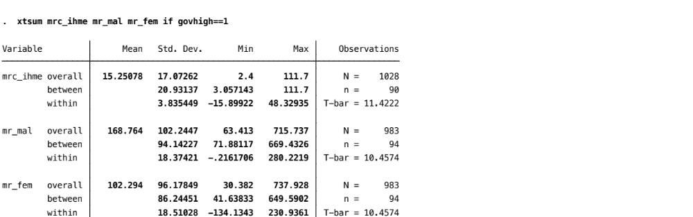
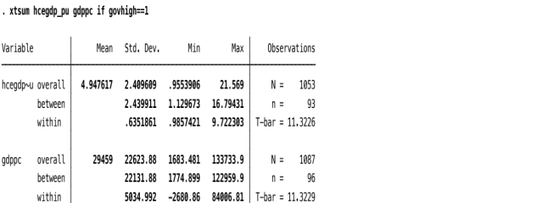

Subsample low governance:
