FFP and Salary Caps in the Eredivisie
Abstract: The Financial Fair Play (FFP) regulations created by UEFA are comparable to salary caps in the United States. I investigate the effects of an imposition of the FFP rules in the 2012/2013 Eredivisie season compared to an application of typical American style salary caps in the same year. The Eredivisie is first discussed, followed by an explanation of the FFP and typical salary caps. An analysis on the effect of changed team payrolls due to the FFP or salary caps indicate that both regulations decrease overall wage spending and payrolls and thus increase team profits. Analysis also reveals that the FFP “sticks” the position of the large teams at the top of the table while salary caps increase competitive balance thereby indicating that the FFP is used as a tool for financial rather than sporting regulation.

By: Sebastiaan Candel Andara
Student number: 357863
Major: Entrepreneurship and Organization
School: Erasmus School of Economics
Name of Advisor: Thomas Peeters
August 2015
Acknowledgments: First and foremost, thanks to my supervisor Thomas Peeters for his support, guidance and patience during the whole process. A special thanks to Mischa Kraft and Tom Hendry from their help and to my parents for their support.
Table of Contents
Introduction 3
Eredivisie 4
Financial Fair Play 7
Salary Cap 10
FFP vs. Salary Cap 12
Methodology 12
Model 12
Data 14
Results 15
Conclusions 21
Limitations 23
Appendix 23
Bibliography 25

1. Introduction
For many people around the world, football is considered a religion. Football is now as popular as ever; with more and more countries becoming interested in the sport and many leagues around the world becoming more competitive. The business of football is also growing tremendously: the Premier League in England just signed a record breaking TV deal worth £5.14 billion (BBC, 2015) and Manchester United signed a shirt sponsorship deal with American car manufacture Chevrolet for another record breaking deal worth £53 million per season. (Baxter, 2014) In 2014 Deloitte reported that the European football market grew to $25bn in revenues, for the first time ever. (El Hassan, 2014) With all this money flowing in and out of the sport, it is hard to imagine European clubs being in financial turmoil. However, this seems to be just the case. According to an UEFA report published in 2009 more than half of UEFA’s 655 top division teams reported a loss. (Clegg, 2011) This led UEFA in September 2009 to agree to the Financial Fair Play (FFP): a set of regulations designed by UEFA to bring financial discipline and responsibility to European football.
The most important aspect of the FFP is the so-called “break-even rule”. This rule only permits clubs to spend on football expenditures according to what they make from football revenue if they want to be a part of UEFA competitions. Since these tournaments hand out large amounts of cash in terms of prize money, all clubs do want to take part. This rule has been the most controversial part of the FFP because it implies changes to the status quo of clubs is either impossible or very difficult. Small clubs can no longer be funded by wealthy owners who use their personal wealth to compete with the large city teams. Additionally, clubs who are already large and powerful have an advantage on clubs who aren’t: large clubs can already spend more simply because they already earn more.
The FFP can be considered a type of salary cap – a limit on how much teams can spend on their player’s salaries. Salary caps have long been in place in American sports (the MLS has a salary cap) but have yet to be truly imposed in European football. The FFP differs from traditional salary caps because the FFP imposes spending rules which change per club, while a typical salary cap makes each team’s spending limit the same. Salary caps are made to improve the competition, the competitive balance, within the league. (Lindholm, 2010) But as the FFP restricts clubs based on their own resources, it is challenging to see how the FFP will improve the competitive balance unless it is seen as making the football world more even and fair because no club can simply “buy its way” to glory now. Initial analysis on the FFP leads me to believe that clubs affected by the FFP will have to reduce football costs (most likely wages), and since many clubs are in financial peril, there can be a great deflationary effect of player’s wages. This, coupled with same level revenues means more profits for clubs and a larger share of rent received by the owners. Initial analysis on salary caps indicates that the same effect on players wages can be expected, but with a greater compensation to consumers in terms of greater competitive balance because all teams have to work within the same limits.
In this paper I will analyze the effects of the financial fair play and a salary cap on the Eredivisie – the highest division of Dutch football. I want to see how the FFP or a salary cap would change league ranking and team finances. The Eredivisie is a mid-range league in Europe (ranked 10th by UEFA in Europe) and can be a good indicator of the effect of the FFP to the many other similar level leagues in Europe. To see these effects I will simulate the introduction of the FFP and salary caps to the Eredivisie for the 2012/2013 season. During that season, the FFP had already been announced but was not still in full force. The expectations of the FFP are that it will lower wages and team spending across the Eredivisie without changing much in the league table. The salary cap (which will be applied in 2 different cap levels -- €30 and €20 million caps) is expected to bring the teams closer competitively while also reducing wages across the league. The next section will discuss the Eredivisie in more depth, and then I will move on to the FFP and salary cap. Next, the methodology and data will be discussed and finally, I will present the results and finish with the conclusions and limitations.
2. Eredivisie
The Eredivisie is the premier and highest division of professional football in the Netherlands. It has been the top division of Dutch football since its first season in 1956. Dutch football peaked during the 70’s: Feyenoord won the Champions league (then called the European Cup) in 1970 and Ajax obtained three consecutive Champions League titles in 1971, 1972 and 1973. With their revolutionary Total Football tactics, the Dutch national team was runners-up in both the 1974 and 1978 World Cups with squads that were almost all Eredivisie players. Despite Eredivisie teams slowly losing power in the 80’s and 90’s, PSV won the Champions League in 1988, Ajax again in 1995 and the national team won the 1988 European Championship with all but 5 Eredivisie players. Since then the league has failed to match up to the top 5 leagues in Europe in almost all areas and has become a stepping-stone league for talent looking to make it big in Europe.
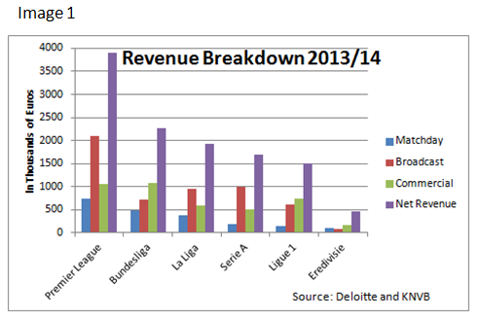
The Eredivisie consists of 18 teams each playing each other twice, once in each team’s home stadium. A team is awarded 3 points for a win, 1 for a draw and 0 for a loss. At the end of the season, the teams are ranked according to their points obtained over the course of the season. Ranking is important because it determines the immediate future of the club. The first placed team in the Eredivisie is crowned as champions and is given an automatic berth into the group stage of next season’s UEFA Champions League. The second place team goes into the 3rd round of qualification (out of 4 rounds) for a spot in next year’s Champions League. Depending on which team wins the Dutch Cup, position 3 and/or 4 enter into the Europa League 3rd qualifying round (the Cup winner enters the group stage automatically). If the Cup winner is in the top 8 places in the league ranking, the 3rd best team enters the 3rd qualifying round of the Europa League and positions 4-7 play each other in a two legged playoff to determine who goes into the 2nd qualifying round of the Europa League. European competitions offer lots of money for competing, let alone winning, so qualifying for continental competitions is a big deal. The Eredivisie also hold relegation playoffs – two legged ties to determine who gets relegated to the Eerst Divisie (Dutch second division). The last placed team in the Eredivisie gets automatic relegation to the lower league while two Eredivisie teams play 8 Eerst Divisie teams for two spots in next seasons Eredivisie; the rest play in the Eerst Divisie. This European and relegation playoff system has been in place since the 2005-2006 season and was designed as a way to increase the number of competitive games, increasing the games with ‘something at stake’. (Koning, 2014) Playoff games can be seen by fans as “finals”: games that decide big winners and losers. Fans love important and competitive games and the playoff structure has been adopted to increase the number of important matches and increase the possibility of outcomes of which teams gets to play in Europe and which team gets relegated.
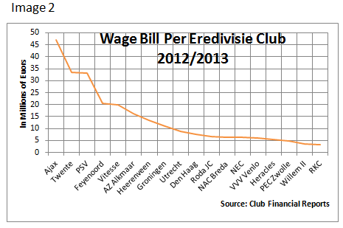
The reasons for the playoffs have been the hopes of catching up to the top 5 European football leagues. Although the Eredivisie was at a similar level to other European leagues in the past, now it has fallen behind in almost all statistics. Its attendance is only at about 19,000 fans per game – same as the MLS. In the 2013/14 season the Eredivisie made €441.5 million in revenue (KNVB, 2015), which is nothing compared to the €3.9 billion of the Premier league or even the near €1.5 billion made by Ligue 1 in France, which is the lowest of the top 5. And when the revenue is broken down more, we can see staggering differences between the countries. Deloitte reported that last year the Eredivisie made about €78 million from media and broadcasting rights while La Liga, Serie A and the Premier League made €949 million, €1.001 billion and €2.104 billion, respectively. (Jones et al, 2015) We can see the differences in revenue breakdown per league in Image 1, on the previous page. The Eredivisie is far behind the other leagues in terms of revenue and this simply means Eredivisie teams have lower revenues than other clubs in other leagues. Even for the big 3 top teams (Ajax, PSV Eindhoven and Feyenoord) it is very difficult to compete with clubs from leagues and countries that have so many more people than the Netherlands and make so much more money than the Eredivisie makes. Image 2 shows the payroll per Eredivise team for the 2009/2010 season. For comparison it is important to note that in La Liga, for example, bottom table clubs spent around €10-15 million in wages, mid-level around €40 million and big clubs near the €200 million mark. (Arshad, 2013) The numbers from the Premier League, though, are much higher. It is no surprise to find out that we have to go back to the 2006-2007 season to find a Dutch team who made it past the group stage of the Champions League. Dutch teams are in a worse position financially than their European counterparts, clearly. Knowing their unfavorable position, the KNVB (Dutch Football Federation) has demanded financial check-ups and accounting controls of Dutch clubs to ensure the longevity and financial/sportive safety of Dutch football.
The KNVB has increased financial control and scrutiny over Dutch clubs in the last couple years. Now, the KNVB has a system of tri-annual checkups where “clubs every November, March and June provide financial information to the KNVB, which includes full-year results for the previous year, half-year results, financial projections and budgets for the forthcoming year. A licensing committee then reviews the financial information and declares a club to fall into three categories: either ‘economically inadequate’, ‘adequate’ or ‘excellent’.” (Chapman, 2012) If a club is deemed to be inadequate, the KNVB creates an economic plan which the club must follow, alongside the help and support of the KNVB. Sanctions for non-compliance can be point deductions, fines or ultimately the withdrawal of a club’s license. (Koning, 2014) And it’s working: in 2011, 13 clubs were deemed financially inadequate. After one year, seven of those clubs had increased their status to ‘adequate’ (Chapman, 2012).
The introduction of the FFP in theory seems to be in line with what the Eredivisie has already. There is no break-even rule as such (more on this in the next section) but Dutch clubs have closely been monitored and watched over the past years, like they will be by UEFA. They have had to provide their financial predictions and prove to the KNVB that they are on a healthy and stable plan to successfully manage their clubs. The FFP will most likely not throw off the Eredivisie teams because they are used to close monitoring and with the Dutch regulations have been living within their means for the past few years now – which is just the goal of the FFP.
3. Financial Fair Play
The Financial Fair Play (FFP) is a system of financial regulations imposed by UEFA on clubs seeking to register for European competitions and is designed to prevent clubs from being financially irresponsible. Financial irresponsibility has been a problem in European football since its beginning as clubs are not usually run as a business in search of profit but instead as a community symbol in search of glory and success, even if that means at a large short run cost. In the Serie A operating losses increased by more than €800 million in 5 years, from 1995 to 2001. In Scotland, the 2 largest teams and most popular teams (Celtic and Rangers) have been facing problems for years, with Rangers currently in administration. In Holland, HFC Haarlem ended their 121-year existence in 2010 and in 2009 the 2008/2009 Dutch champions AZ Alkmaar were being run by administrators. In Spain, total debt between the top 2 clubs, Real Madrid and Barcelona, totaled €1 billion with Atletico Madrid owing €300 million and Valencia owing €600 million. (Kennedy & Kennedy, 2013) These trends have led UEFA President Michel Platini to speak of an “explosion of both sectoral and corporate interests at both league and club level. These initiatives are designed to benefit one element, particularly if it is powerful and rich. Attempts are made to reduce a discipline to a show, to demean a sport in order to convert it into a product. It is becoming more important to make a profit than to win trophies.” (Kennedy & Kennedy, 2013) It was Platini himself who announced and championed the FFP regulations with the hopes of bringing football back to its roots.
Any club looking to register for UEFA competitions will need to comply with certain criteria in order to obtain a license to participate. Club license regulations apply minimum requirements on infrastructure, sporting, administrative, legal and financial activity, but the most important aspect of the FFP is the “break-even rule.” (Muller et al, 2012) The break-even rule states that football clubs must “break-even” on football-related activity. The break-even rule is complex because football expenses and revenues are not the same as accounting expenses and revenues and thus a club could in theory declare a financial profit while failing to meet UEFA’s break-even requirement. “Football” income is generally defined as revenue from ticket sales, sponsorship, merchandising and broadcasting/media rights. Football expenses are generally defined as money spent on player wages and transfers. (Peeters & Szymanski, 2014) Youth, training or stadium investments are not counted as part of football-related activity and therefore can be what cause a club to make an accounting loss while still remaining within the break-even requirement on football activity.

The break-even requirement is assessed by a control panel of UEFA for a three-year monitoring period. For example, the monitoring period in assessment for a license for season 2015/2016 includes the three previous seasons: 2012/2013, 2013/2014 and 2014/2015. The only exception is the monitoring period for the 2013/2014 license because it only covers the previous two seasons. Thus, in general, teams must break even for a moving average over three consecutive years. A moving average restriction makes sure there is a continuous limit while providing some leeway so that the club’s management can make adjustments within a given period of time to avoid irregular, unpredictable or chaotic occurrences. (Vöpel, 2011)

Exceptions to this rule are also allowed and the acceptable aggregate deviation from the break even requirement is €5 million. This deviation can exceed €5 million up to €45 million starting in the 2013/14 season if the losses are covered by equity investments by the owner. For the 2015/2016 season the deviation allowed is €30 million, and this number drops down to €15 million in 2018. This temporary exception to the €5 million rule allows those clubs that are primarily financed by donors and private investors to change their management policy so as to comply with the new regulations within a reasonable period of time. (Vöpel, 2011)
The main objectives of the FFP can be claimed are twofold – fairness and financial stability.
Most importantly, they aim to achieve financial fair play in UEFA club competitions and in particular (as defined by UEFA):
“a) to improve the economic and financial capability of the clubs, increasing their transparency and credibility;
b) to place the necessary importance on the protection of creditors and to ensure that clubs settle their liabilities with employees, social/tax authorities and other clubs punctually;
c) to introduce more discipline and rationality in club football finances;
d) to encourage clubs to operate on the basis of their own revenues;
e) to encourage responsible spending for the long-term benefit of football;
f) to protect the long-term viability and sustainability of European club football.” (UEFA, 2015)

The main problems the FFP wish to address are the financial irresponsibility in football, the growing number of “sugar daddies” and the inflationary trend of player wages. (Peeters & Szymanski, 2014) Financial irresponsibility is the main point UEFA wants to fix: 56% of analyzed 2010 clubs in an UEFA report suffered significant losses aggregating to 2.036 billion Euros. (Muller et al, 2012) “Sugar daddies” are club owners who inject huge amounts of money into their clubs and ceaselessly spend hoping to achieve sporting success. To the dismay of many fans who think this practice of “buying” trophies is unsportsmanlike, sugar daddies have been showing up more and more in European football. The most famous examples of sugar daddies include Roman Abramovich of Chelsea FC, Sheik Mansour Bin Zayed Al Nahyan of Manchester City and Nasser Al-Khelaifi of PSG. This point also has to do with financial “fairness” – the fact that some clubs simply get lucky by attracting a rich owner and end up winning without any true sporting merit. Finally, player wages have risen to exorbitant heights in recent years. UEFA has estimated that net transfer and salary costs of top division European clubs has grown by on average 15% per year over 5 years from 2005 to 2010. (Muller et al, 2012) UEFA wants clubs to spend more carefully and know that a club’s greatest cost is wages so limiting wages would be a great way of making clubs spend less.

The Financial Fair Play has received mixed reviews on all fronts. Fans have applauded its efforts to save football financially while condoning its restrictions for new owners to achieve glory. Owners like Al-Khelaifi of PSG have come out against it while Platini claims most ECA member are in favor. (Franck and Lang, 2012) have found situations where the FFP increases welfare while the FFP has been criticized by (Lindholm, 2010) for its legality under EU law. (Muller et al, 2012) justify the FFP by claiming that allowing owners to spend on their clubs using their own funds damages the competition’s integrity and is anti-sportsmanlike behavior. (Peeters & Szymanski, 2014) claim that the FFP decreases competitive balance by reducing challenges to the top teams due to the impossibility of clubs being funded by new wealthy owners. (Peeters & Szymanski, 2014) also claim that the FFP increases profitability due to a decrease in player wages but also claims this shift in rents in passed on mostly to the owners and not the consumers. The largest criticism with the FFP is that it limits clubs’ spending in relation to its resources, which vary largely across Europe. In this paper we will test the effect of the FFP in a league with clubs whose resources vary just as greatly.

4. Salary Cap
The Financial Fair Play is in essence, a salary cap. Salary caps are limits clubs can spend on wages in a given season. (Larsen et al, 2006) This concept has been long installed in American sports with the NBA imposing the first cap in the 1980’s, but is not standard in Europe. Salary caps can be what is considered a “hard” or a “soft” cap. A soft cap is one where teams can, through loopholes or exceptions, exceed the cap. (Staudohar, 1998) A hard cap is one where teams can no matter what not exceed the cap—no exceptions. Caps can differ between absolute and relative caps. An absolute cap is one that is set at a specific value and teams can’t go over that value. A relative cap is a cap that is a percentage of something else (or a value relative to something else) and is different for each club. (Lindholm, 2010)

The main purpose of a salary cap is achieving competitive balance. (Lindholm, 2010) This is very applicable to football. As (Peeters & Szymanski, 2014) claim, one to four teams dominate most European football leagues and the UEFA Champions League can partly explain why. The expansion of the tournament to include non-champions and the portion of prize money awarded according to the size of the club nation’s TV market has caused all but one of the tournament winners since 1996 to be from one of the top 4 European leagues. It has been supported in previous research that wages and sporting performance are highly correlated in football (Hall et al, 2002) and thus, regulating wage spending closes the gap more between large and small clubs. The payroll ceiling decreases the difference in talent teams have on the pitch and therefore increases the competition of the league. Salary caps permit the greater spreading of talent across a league because large teams cannot endlessly buy all the talent. Other papers have studied salary caps more in-depth and have reached similar conclusions. (Dietl et al, 2009) have found that salary caps increase competitive balance and decrease payrolls. They have also found that salary caps can increase or decrease social welfare and depends on the preference of fans for either aggregate talent maximization or competitive balance. (Peeters & Szymanski, 2014) have found in their paper that salary caps increase competitive balance while (Larsen et al, 2006) reach the same conclusion; finding that a concentration of talent decreases competition among teams and a salary cap would increase competitive balance.

European football has yet to see a true salary cap, similar to those in American sports. There are two reasons for the lack of an American-style salary cap in Europe: 1) the cultural differences in sport between the US and Europe and 2) structural differences within sport organization. Firstly, most European countries have left the bulk of sport regulation in the hands of their national sport associations. As (Dietl et al, 2009) put it, “this self-regulation of sports is seen as an important expression of European civil society.” Football clubs in Europe began as football clubs: clubs with the intention of playing football. Through professionalism they grew and eventually, in agreement with other clubs, started a league in order to compete. It is no surprise to see in Europe, thus, that clubs are run as independent entities and are treated as such. There is a hierarchal system in European football: clubs run themselves but have to adhere to the rules of their league, which is run by their Football Association, which is governed by UEFA which is then governed by FIFA. This is a vertical restraint system that has been in place for many years. The American leagues have a horizontal restraint system – agreements from competitors in the same level. In the United States, it was/is common to create leagues initially, and franchise clubs who are actually owned by the league. For example, the NBA was created and founded as a league, with teams being created to be a part of the established league. Decisions are made as a league with all owners having to agree to any big decisions. Therefore, decisions are made with the approval of all parties and through collective bargaining and therefore are exempt from American antitrust regulation. In Europe, however, such decisions like salary caps are restrictions placed on clubs by other entities and thus face challenges from EU legal rights. (Lindholm, 2010)

4.1 FFP vs. Salary Cap
FFP can be considered a relative, hard salary cap. Teams cannot under no exception spend more than €5 million more over 3 years on football than they earn from football. It can be claimed that competitive balance is not a rationale for the FFP, but because the FFP restricts the proper use of “sugar daddies”, it can also be claimed the FFP increases competitive balance because certain high-profile teams will not be able to “buy” silverware anymore and will have to spend money similarly to the other, less powerful clubs. However, there is one huge difference between a typical American-style salary cap and the FFP. Typically, salary caps assign the cap at an absolute value or at a value relative to league objectives. This means that all clubs have the same spending limit and thus cannot spend more than that figure. The FFP, on the other hand, assigns the spending limit at a value relative to the individual team. This means that a club who earns much more than another can spend much more on wages than the other. Since resources differ drastically in European football (Peeters & Szymanski, 2012), it is clear that teams will not have the same limits on spending. This means that some teams can have higher payrolls than other, effectively ruling out the point of competitive balance within the FFP and makes a claim that it will “stick” big clubs at the top and small clubs at the bottom.

It is clear that the root of the FFP lies in controlling costs and saving football financially. While controlling costs is part of the logic of a salary cap, much more of it lies in achieving greater competitive balance. This cannot be said for the FFP since it limits club spending differently per club. Since typical salary caps have proven greater competitive balance and lower costs, the test of the FFP will be how it affects competition and league results while delivering on its promise for greater financial outcomes.

5. Methodology
In this section I will explain the model and statistical methods used in analyzing and interpreting the data. I will first describe the basic model used in this paper and explain how the FFP and salary cap regulations cause reactions by clubs that change match outcomes.

5.1. Model
The base of the model used in this paper is the wage-sporting success correlation. Past papers (Szymanski & Smith, 1997; Forrest & Simmons, 2002) have proven that payrolls and team success are strongly correlated over the course of a season. The main driver of a team’s on field success is the talent and skill of the players. If team A’s overall playing talent is greater than team B’s, it is no surprise that, all else equal, team A is more likely to win the match than team B. Since wages are a measure of a player’s talent, ability or skill, teams that field better players will likely have higher wages, higher chances of winning and thus a correlation between wages and winnings is found. Obviously wages and playing talent are not the only factors that affect football matches. Team effort, productivity and luck all play important roles in deciding outcomes. However, since in the majority of cases, better teams (usually associated with higher payrolls) usually win more, this basic model is based on the positive wage-win effect.

Clubs want to win as much as possible and therefore change certain factors every year with the hopes of winning more in the future. For example, clubs every year decide to fire or hire employees, increase or decrease squad size, increase or decrease payrolls, expand the stadium, build new training grounds or invest in a marketing project. Before the FFP, clubs could basically lose money every year and still survive because they could just secure a new loan, have money injected into the club by the owner or get bailed out by banks or governments because the club brand is “too big to fail.” With the introduction of the FFP, clubs can no longer do this. As we know, clubs have to be financially responsible and balance their books. With the FFP regulations in place, clubs must now change football expenditures if they are not within the acceptable deviation of losses. This means that if a club has not followed the UEFA-announced regulations, it must decrease its football expenditure (usually wages) in order to comply with the rules. Since we know wages are the primary driving factor in deciding football matches, the change in club wages will cause changes in match outcomes. The model used here predicts an average of points won per match between two teams based on the relative wage difference between two teams. Over the course of a season, the model predicts how many points a team will get overall and thus we can determine season league ranking changes based on wage changes. Also, match outcome deviations over the course of a season lead to different position finishes and different prize money – meaning other changes in wages. Therefore, the break-even rule of the FFP will cause changes in competition by restricting and limiting the quality of talent teams can play. Logically speaking, this gives way to an upward or downward spiral. If a club must decrease wages, it on average will lose more matches, meaning it must decrease wages, and lose more, and so on and so forth. The same goes for the teams that win, gain more money, and can field higher payrolls, leading to more wins and higher payrolls for that club. In the next section I will present the data and results from the analysis of this model to the Eredivisie, state the conclusions found and then present the limitations encountered.

6. Data
To analyze the FFP and salary cap in the Eredivisie I gathered information on the match results and financial results of all Eredivisie teams from 2009/2010 to 2013/2014. This 5-year period was chosen because I believe it provided enough information to make a truthful assessment. The match results of all Eredivisie teams during this period were found on football-data.co.uk which is a website that provides match and betting results for the major leagues around Europe. The financial results were gathered through each club’s financial records, which were usually listed on their website. Some clubs don’t publish their financial reports on their website and these had to be found via other databases or Eredivisie reports. I have the full match and financial information for 96% of games played in the Eredivisie during the sample period.
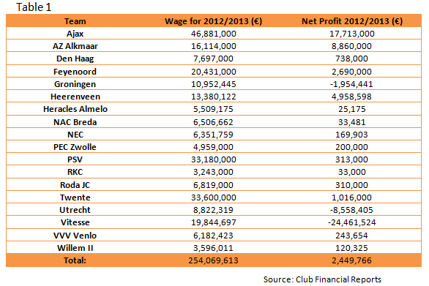
Table 1 shows the wages and profits of all Eredivisie teams in the 2012/2013 season. It is clear that there are big spending differences between the teams. Ajax leads the league in payroll at €46.8 million while RKC Waalwijk is at the bottom with a €3.2 million. Exactly half of the teams in the league have a payroll of at least €10 million while 4 teams exceed the €20 million mark. With regards to net profit, 3 teams lost money that year, with the greatest losses being made by Vitesse, at €24.5 million. 5 teams made more than €1 million in profit. The greatest profit was turned by Ajax at almost €18 million, probably due to the sales of star players Jan Vertonghen, Vurnon Anita and Gregory Van der Wiel. As a whole, the Eredivisie teams spent about €254 million in wages for the 2012/13 season and made a €2.5 million profit.

7. Results
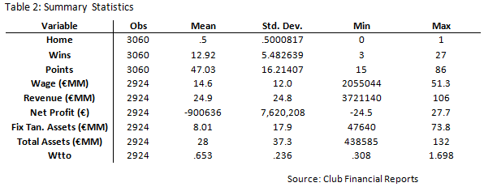
Table 2 takes a look at the chosen summary statistics for the Eredivisie during the 5-year period. The first 3 variables are sports related such as the number of wins a team gets on average during a season and the average points obtained during a season. The next 6 variables are financial-related: wage, revenue, net profit, fixed tangible assets, total assets and wage to turnover ratio (wtto) – a very important measure of a team’s wage spending. From looking at the table, we can see that on average an Eredivisie team wins about 13 games a season to make about 47 points. Average wage in the Eredivisie is €14.6 million, but as can be seen from the standard deviation, this can change a lot. Excelsior had the lowest wage in the sample period at just over €2 million while Ajax had the highest wage at €51.3 million. Revenues also differ quite drastically, with mean revenue totaling almost €25 million and a standard deviation of also about €25 million, showing just how imbalanced the Eredivisie is. Again, Excelsior had the lowest revenue in the sample period at €4 million in 2012 with Ajax again at the top, obtaining €105 million in revenue in 2012. From the table we can also see that an average Eredivisie team will lose on average about €900,000 over the sample data, which we can tell is not the sufficient loss necessary to induce a change in wages or football spending. There are also big differences throughout the league with respect to fixed tangible assets. Fixed tangible assets for football clubs are made up mostly of stadium, training facilities and/or land. Finally, the wtto is a measure of sales vs. salaries and the average wtto for an Eredivisie team in the sample is 0.65, which is a normal amount for a football club. This, however, can also change drastically, as the min and max columns indicate that the wtto can go from 0.308 (PSV) to 1.698 (Vitesse) among the different clubs. What jumps out from the data are the different amounts of resources within the Eredivisie. Some teams (like Ajax, PSV and Feyenoord) clearly have more money and revenues to play with, while other clubs (like Excelsior, Willem II or RKC Waalwijk) simply cannot compete at that economic level, making the break-even rule logically challenging to competitive balance.
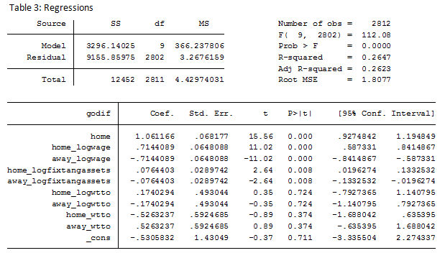
Table 3 shows the regression of goal difference to home factor, the log of the home and away wage, the log of the home and away fixed tangible assets, to the log of the home and away wtto and to the home and away wtto. The most glaring part of this table is the very high coefficient of goal difference to the log of the home wage. This coefficient of about 0.71 means that home wage and goal difference are highly correlated, which is natural. This means that in the Eredivisie, a change of 1% in the home wage will increase home goal difference by 0.83%, or in other words, increasing home wage by one Euro increases home goal difference by 0.83 of a goal. This indicator is also significant at the 0.05 level because its P-value is less than 0.05. The goal difference is not highly correlated to the log of the fix tangible assets, at 0.076, or the log of the wtto, at 0.17. Also, these indicators are not significant at the 0.05 level. The r-squared of 0.2647 indicates that the regression or statistical model doesn’t fit this data too well, in other words, that there is a large amount of deviation that can’t be explained by this relationship. Since these regressions are done from the point of view of the home team, the away team is basically the opposite of the home team, leading to an exact same but negative coefficient.

Once wage spending is modified it is expected that match outcomes change according to the change in wages of the competing teams. Firstly, it is important to know what would be the expected season-end Eredivisie table without applying any wage changes to see what is expected to occur with just the wages and information at hand over the sample period. Leaving wages unchanged for the 2012/13 season gives us a season-end Eredivisie table as such:
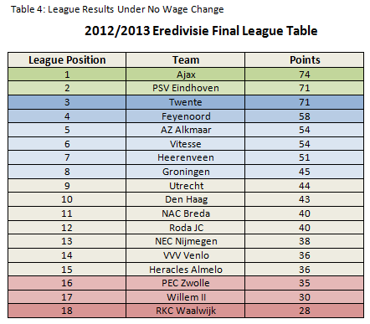

Table 4 shows the predicted 2012/13 final match day Eredivisie league table based on the wages in my data being applied as such to the point predicting model used in this paper. For any Eredivisie fan, Table 4 seems like any other year in the Eredivisie: with Ajax as champions and the big teams all on the top of the table way ahead of the others. The colors on the table represent the next season outcome for the team. Dark green means automatic qualification to the Champions’ League group stage, light green (2nd place) means entering the CL in the third qualifying round, dark blue (3rd) means qualification to the Europa League playoff round, lighter blue (4th) means entering the Europa League in the third qualifying round and light blue (positions 5-7) mean qualification to European competition playoffs. The dark red (18th) means automatic relegation to the Eerst Divisie while light red (16 and 17) mean qualification to the relegation playoffs. In this scenario, nothing is changed in the team data and thus is a very expected table result.
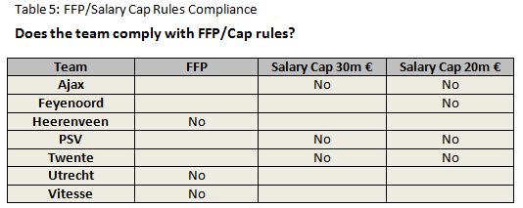
The following are the teams that do not comply with the break even requirement or salary caps and would have to lower profits (by reducing wages):

Table 5 shows that Heerenveen, Utrecht and Vitesse have lost more than 5 million € in the previous monitoring period and thus, do not comply with the break-even rule. Therefore, these teams must lower costs (in this model wages only) to reach the acceptable deviation. Teams such as Ajax, PSV and Twente pass the break-even rule, but would not comply with a €30 million salary cap if it were to be imposed in the Eredivisie. These 3 teams, along with Feyenoord exceed the €20 million salary cap. These cap levels were chosen because they provide an expected result comparable to those of the FFP.
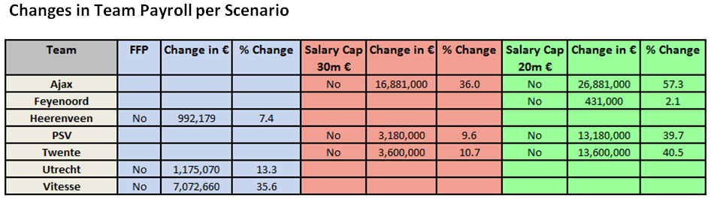
Decreasing the wage bills on the teams that don’t comply with the break-even requirement or salary cap would change the league outcome. Table 6 is an extension of Table 5 and summarizes the wage bill changes per team:
The seven teams shown in Table 6 are the seven teams that in at least one scenario must change their payrolls to comply with the scenario rules. We can see that the biggest wage change in the FFP scenario is done by Vitesse, who had to lower their wages by about 35%, or about €7 million. Utrecht and Heerenveen also had to lower their wages, but by about 13% and 7% respectively. In the €30 million salary cap scenario, and actually in all salary cap scenarios, Ajax had the biggest changes in wages, which is normal, as they had the highest wage bill in the Eredivisie. Ajax had a 36% decrease in wages in the €30 million cap scenario while PSV and Twente, who had similar wage levels, decrease by similar amounts: around 10% and 11%, respectively. In the €20 million cap scenario Feyenoord also had to decrease wages, but only by €431,000 or 2.1%. Ajax, PSV and Twente all had to decrease wages by a further €10 million that the previous scenario.
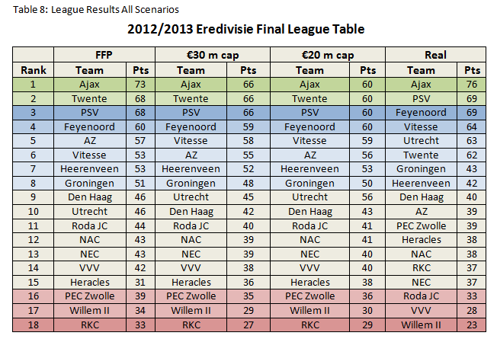
These wage decreases change the competition in the league and offer new possibilities in league standings. Table 8 shows the 2012/13 league table under all scenarios.
Table 8 presents the final league rankings in the following order of scenarios: under the FFP regulations if the FFP were fully enacted for the 2012/13 season, under an Eredivisie €30 million salary cap, under a €20 million salary cap and finally, the real final Eredivisie standings for the 2012/2013 season. What is most immediately visible is that Ajax comes at the top of the table (or at least tied for 1rst) in every scenario, including in real life. We can also see that there is not a huge amount of difference between all the scenarios except for final points per team. Excluding the “real”, actual standings that year, we can see that only a few teams change position. While Ajax wins the league in the FFP scenario, it ends up tied for first under both salary cap situations which is logical because the top teams in these scenarios all have the same wage and thus, have the same change of winning. Among the simulated scenarios we can see that AZ and Vitesse switch places into the salary caps as do Den Haag and Utrecht. Other than that, all teams remain in the same league position. However, the point gap between the teams is noteworthy. Under the FFP scenario, the points are very spread out over the table – the difference between first and 5th place is 16 points. Under the €30 million cap this difference is 8 points and under the €20 million cap it is 1 point. It is clear that the salary caps push the teams much closer together; there is only a 10 point difference between 1rst and 8th place. Under the FFP and €30 million scenario there are 22 and 18 points difference, respectively. When comparing the two salary cap scenarios, we can see that a tighter salary cap increases the points won for every team except the top three, making the league more competitive. The only team that increases points from the FFP to the €30 million cap is Vitesse, probably because of its high wages that had to be brought down under the FFP regulations. Upon looking at all tables it is clear that the salary caps are the scenarios that create the tightest competition and the lower the salary cap the more competitive the league. Comparing the simulated results to those of the real season, we can see that things are similar except for a couple teams that do way worse (Twente, AZ and Roda JC) and a couple teams that do way better (RKC and PEC Zwolle). Under the simulated scenarios RKC and PEC Zwolle were both expected to be in the bottom 3 but in real life avoided relegation playoffs. The similarities between the simulation and real life imply first-hand truth in the theory of wages being the primary factor of success since these simulations were based only on wages. Next, the conclusions based on these findings will be presented.
8. Conclusions
The FFP was created by UEFA as a means to make clubs more financially responsible. Part of the rationale of the FFP, it could be said, is in the name – financial “fair play”. This means clubs are not able to be financed by a wealthy owner, thus in a way making all teams a bit more equal. Salary caps also are in line with financial responsibility and controlling costs but put much more emphasis on competitive balance. The goal of this paper was to investigate and analyze the financial and sporting effects of the FFP and salary caps in the Eredivisie. Both the FFP and salary caps are similar in controlling costs (wages) and thus increasing club profits. In all scenarios, some clubs had to cut wages. And with no real reason for a short run decrease in revenue, this means more profits for the clubs that did. The FFP is much more volatile in how much wages can change because it is different for each club – and not on their existing wage but on overall football-related activity profits. Thus, teams can spend huge amounts on wages if they can earn huge amounts in revenue as well. Some clubs, even if they spend very little on wages will have to cut back simply because of financial distress. This means that a competitive balance rationale is not applicable to the FFP because it shows no real changes in league results and logically supports no challenge to the short run status quo. The salary caps do change the point gaps between teams – pushing teams closer together. Obviously, the smaller the salary cap the smaller the gap is between the clubs.
The fact that the FFP reduces wages and increases club profits without much change to competition or competitive balance can be viewed in a positive or a negative light. On a positive note, football stays the same but simply has more money now. As the rents shift from players to clubs (or owners) there is a higher chance that the money will be re-invested in football and thus increase the longevity and success of the sport. On the other hand, the FFP can be seen as unnecessary restrictions on an open market and a lot of rules for no added benefit to the consumer, who is essentially the driver of the sport. Salary caps do the same as the FFP except add more competition and intensity to the league, which is welcomed by fans and owners alike. It is hard for European football to apply an American style salary cap because of different legal and social rules in Europe vs. the United States. However, an attempt by UEFA to somewhat emulate it can be seen as a step forward in this sense. If European football needs a salary cap or restriction of any sort is up to the discussion of football lovers around the world.
The claim that the FFP can “stick” teams to their current league positions is not false. Since short term revenues are hard to change if teams don’t bring in new players or attractions, clubs that are already earn plenty will have a leg-up on smaller clubs. It is hard to imagine Ajax, PSV or Feyenoord losing lots of revenue especially since other Eredivisie teams don’t have enough financial leeway to purchase star new players and attract new fans. Whether football needs regulatory help to remain successful and popular is up for debate. What is not up to debate is that the FFP, like salary caps, reduce wages and increase profits but unlike salary caps do not deliver much in terms of competitive balance. Since the announcement of the FFP was made, UEFA has faced many lawsuits and huge amounts of criticism. This has caused UEFA in 2015 to re-analyze their position and soften the FFP rules. We have to wait and see if the FFP will actually benefit football and increase the sport’s popularity and success. As of now the only things that can be drawn from it are the larger amounts of money in club owner’s pockets and the great amount of heat UEFA has received because of it.
9. Limitations
The first limitation I came across was the relatively small amount of data gathered. Although there was a lot of individual data, 5 years is little to study trends and correlations in sports. Obviously 10, 15 or 20 years would have provided a much more complete and robust analysis, but there is also a time trade-off with this. Another limitation was the attempt at using a basic model to explain match results. As we all know, wages explain a lot but not everything. Teams can have other advantages that were not taken into account. This shows in the salary cap analysis as the top teams, all having the same wages, ended up with the same number of points. While this is not an exact representation of real life, it does however show how if big team’s wages are controlled they will not be able to achieve such great amounts of superiority over other teams. Also, using data from after the FFP’s announcement made judging the FFP more difficult. Although teams didn’t fully apply the rules yet, and didn’t have to, teams did take into account their future when making decisions and thus acted in ways that would be more FFP-friendly. Using information from a decade before the FFP announcement, for example, would have made the FFP results more truthful. All in all, although several limitations took out some realistic aspects to the analysis, the overall study was based on true figures and theories.
10. Appendix
In this section I will provide results on a €15 million salary cap level. This cap was excluded from the paper due to an unrealistic 4 way tie at the top of the table and due to the unrealistic nature of a €15 million salary cap in a top European professional league.
The table on the next page shows the FFP/ salary cap compliance for all scenarios plus the €15 million salary cap.

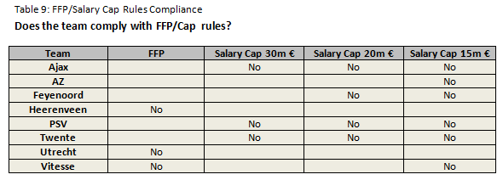

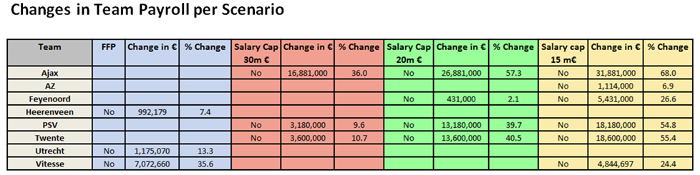
Table 10 shows the changes in team payrolls for all scenarios including the final €15 million salary cap.
Table 11 shows the League Standings in all scenarios including the €15m salary cap:
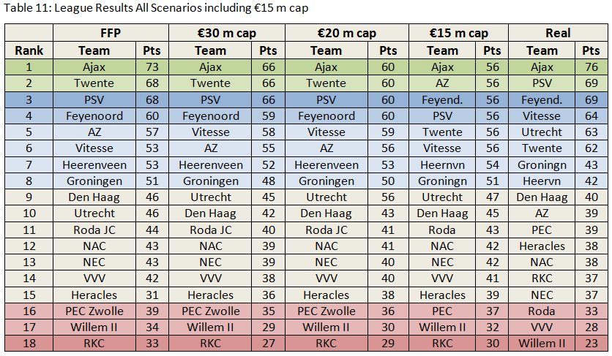
The €15 million salary cap has the same effect on the league as the other caps just more intensely. It decreases the point gaps between the teams and makes the league much more competitive than in the other scenarios.
Bibliography
Andreff, W., & Staudohar, P. (2000). The Evolving European Model Of Professional Sports Finance. Journal of Sports Economics, 1(3), 257-276.
Arshad, S. (2013, November 30). Spanish La Liga Players Salaries 2014 (Wage Bill of Each Club). Retrieved July 20, 2015, from http://www.tsmplug.com/football/spanish-la-liga-players-salaries/
Chapman, D. (2012). Going Dutch : Financial Regulation of clubs. Retrieved July 14, 2015, from http://fullcontactlaw.co.uk/2012/05/dutch-approach-financial-regulation-football/
Clegg, J. (2011, January 12). Soccer Clubs Warned Over Finances. Retrieved July 13, 2015, from http://www.wsj.com/articles/SB10001424052748703791904576075982800093382
Dietl, H., Lang, M., & Rathke, A. (2009). The Effect Of Salary Caps In Professional Team Sports On Social Welfare. The B.E. Journal of Economic Analysis & Policy, 9(1).
El Hassan, N. (2014, June 8). $25bn for the first time, with the ‘big five’ leagues surpassing the $12bn mark. Retrieved July 10, 2015.
Foraker, S. (1985). The National Basketball Association Salary Cap: An Antitrust Violation? Southern California Law Review, 59, 157-181.
Forrest, D., & Simmons, R. (2002). Team Salaries and Playing Success in Sports: A Comparative Perspective. Zeitschrift für Betriebswirtschaft (4).
Franck, E. (2014). Financial Fair Play in European Club Football - What is it All About? SSRN Electronic Journal SSRN Journal.
Franck, E., & Lang, M. (2012). What is Wrong with Sugar Daddies in Football? A Theoretical Analysis of the Influence of Money Injections on Risk-Taking. University of Zurich, Center for Research in Sports Administration, Working paper 46.
Hall, S., Szymanski, S., & Zimbalist, A. (2002). Testing Causality Between Team Performance And Payroll: The Cases Of Major League Baseball And English Soccer. Journal of Sports Economics, 3(2), 149-168.
Jones, D., Houlihan, A., & Bull, A. (2015). Annual Review of Football Finance. Retrieved July 8, 2015.
Kennedy, P., & Kennedy, D. (2013). Football supporters and the commercialisation of football: Comparative responses across Europe. New York, NY: Routledge.
Kesenne, S. (2000). Revenue Sharing And Competitive Balance In Professional Team Sports. Journal of Sports Economics, 1(1), 56-65. doi:10.1177/152700250000100105
Kesenne, S. (2000). The Impact Of Salary Caps In Professional Team Sports. Scottish Journal of Political Economy, 47(7), 422-430.
Koning, R. (2007). Post-Season Play and League Design in Dutch Soccer. In Governance and competition in professional sports leagues (pp. 190-200). Oviedo, Asturias: Servicio de Publicaciones de la Universidad de Oviedo.
Koning, R. (2014). Professional Soccer in the Netherlands. In Handbook on the economics of professional football (pp. 336-350). Cheltenham: Edward Elgar Publishing.
KNVB. (2015, February 5). BVO's presenteren 'Seizoen in Cijfers 2013/14’. Retrieved June 22, 2015.
Lago, U., Simmons, R., & Szymanski, S. (2006). The Financial Crisis in European Football: An Introduction. Journal of Sports Economics, 7(1), 3-12.
Larsen, A., Fenn, A., & Spenner, E. (2006). The Impact Of Free Agency And The Salary Cap On Competitive Balance In The National Football League. Journal of Sports Economics, 7(7), 374-390.
Lindholm, J. (2010). The Problem With Salary Caps Under European Union Law: The Case Against Financial Fair Play. Texas Review of Entertainment and Sports Law, 12(2), 189-213.
Morrow, S. (2003). The people's game?: Football, finance, and society. Houndmills, Basingstoke, Hampshire: Palgrave Macmillan.
Müller, C., Lammert, J., & Hovemann, G. (2012). The Financial Fair Play Regulations of UEFA: An Adequate Concept to Ensure the Long-Term Viability and Sustainability of European Club Football? International Journal of Sport Finance, 7(2), 117-140.
Peeters, T., & Szymanski, S. (2012). Vertical restraints in soccer: Financial Fair Play and the English Premier League.
Peeters, T., & Szymanski, S. (2014). Financial fair play in European football. Economic Policy, 28(78), 343-390.
Preuss, H., Haugen, K., & Schubert, M. (2014). UEFA financial fair play: The curse of regulation. EJSS Journal, 2(1), 33-51. doi:10.12863
Staudohar, P. (1998). Salary Caps in Professional Team Sports. Compensation and Working Conditions.
Szymanski, S., & Smith, R. (1997). The English Football Industry: profit, performance and industrial structure. International Review of Applied Economics , 11 (1), 135-153.
Terpstra, E. (2013, May 13). Retrieved June 14, 2015, from http://www.stadiumguide.com/the-2012-13-eredivisie-season-in-attendances/
UEFA. (2015, June 1). Financial Fair Play: All you need to know. Retrieved July 7, 2015.
Vöpel, H. (2011). Do We Really Need Financial Fair Play in European Club Football? An Economic Analysis. CESifo Dice Report, 9(3), 54-60.

