The impact of new product releases on established products

Jasper Ris
Supervisor: Ajay Bhaskarabhatla
Coreader: Enrico Pennings

Abstract
Many markets today are characterized by a fast evolving range of products, constantly pushing the technological boundaries to gain the upper hand when it comes to the latest, most modern product. But what happens to the products that are replaced? They don’t just disappear, but take a backseat in a firms offering. So how do their prices and sales quantities develop when faced with newer products? Previous literature either suggests that consumers have no real preference when it comes to ‘newness’ (Gruen, 1960) or that they do, with new offerings cannibalizing on earlier products of the same type (Haynes, Thompson, & Wright, 2014). In this paper we further explore the effects of new product introduction on prices and trading volumes of older products by analysing data gathered from the Steam community market, an online market place where people can buy and sell digital items. Our analysis shows that prices and trading volumes of older products are not influenced by the introduction of new products, with a significant relationship between introduction and price or trading volume only existing in about a quarter of the cases, suggesting that consumers on this market have no preference for newer products and the technological advantages that they offer. Another possible explanation could be that consumers value these goods purely for their aesthetic value. We also briefly explore the possibility of the betting community influencing prices but again find no compelling evidence.
Table of contents
Introduction 4
The Steam Market 6
Introducing new items 8
Theoretical framework 9
Different kinds of items 12
The expected impact of succession. 14
Data 17
General characteristics 20
Chests 20
Arcana’s 21
Methodology 21
Results 23
Dota 2 dataset 23
Table 1 (The value in the parentheses after the variable name lists the generation to which the item belongs, starting at 1, this also holds for the other tables listing regression results) 24
Table 2 26
TF2 dataset 27
CSgo dataset 27
table 3 28
Table 4 29
Table 5 30
Table 6 31
Arcana dataset 31
Table 7 32
Table 8 33
Table 9 34
Conclusion 34
Further experiments with the data 38
Table 10 41
Bibliography 42
Appendix A, Graphs 44
Dota 2 44
TF 2 46
CS:go 48
Arcana 50
Appendix B, Regression results tables 52
Dota 2 52
Tf2 54
CS:go 56
Arcana 58
Appendix C, Regression result table for betting analysis 60
Appendix D, overview of names 61

Introduction
Innovation is seen as the engine of the economy. Firms always strive to improve their products, putting out newer products to keep up with or ahead of competition. The advantage is obvious, people want the latest, most advanced product. The flip side of the process of creative destruction is of course the older products put out by a firm becoming outdated and losing their relevance in the market. New products can easily cannibalize on the sales that previously were attributed to their predecessors. This may be a benefit to some customers, as the older products will generally drop in price as they become less attractive, which gives people who previously could not afford them the possibility of buying them. For the most part however it is a cumbersome process for the firms innovating, therefore there is merit to knowing how older products behave in the market so a firm can make use of its full range of offerings, even the outdated ones.
The process of creative destruction becomes more interesting if we consider the market for certain digital goods that are offered today. If we consider in-game purchases that are a popular earnings model for some game distributors today some of the benefits of innovation cease to exist. Products offered here do not get ‘outdated’ in the same sense that physical goods do. There is no technological superiority in newer products, nor do old products ‘wear out’ and require replacement. What we are left with in this case is simply the preference of newer products as opposed to something that has been around for longer, which is what we shall focus on. We will expand on this later in the paper.
The market for digital goods is fairly new. Game distributor Electronic Arts Games was one of the first to try out the “play 4 free” concept with their 2009 title ‘Battlefield Heroes’, a spin-off of the eponymous war game franchise. The idea was very new at the time. Traditionally game distributors would charge customers for the whole game, once it was purchased they had full access to all of its content. Some distributors of MMO (massive multiplayer online) titles charged a fixed fee per month, others charged the customer one time. The new earnings model concept by Electronic Arts involved making the game itself completely free of charge. Anyone interested in playing it would simply go to their website and download it at no cost. Money would be earned by micro transactions within the game, where players would pay a small amount of money in exchange for being able to have their chosen character wear a silly hat, observable by other players. The silly hat is just an example, the offerings ranged from hats and sunglasses to animations that made the characters wave at the camera. The concept was an experiment for the game’s developers, and one that faced serious problems throughout it early life. By 2011 however the game achieved a 50% profit margin, a resounding success (Nutt, 2011). This paved the way for other distributors to try out this new business model. The smartphone in particular turned out to be a great platform for these types of games. ‘Candy Crush’, by developer King has seemingly perfected the idea and rakes in an estimated one million US dollar each day (Think Gaming, 2015). Of course the success would not be limited to just mobile devices, and a big player on the PC games market, Valve co., would also try its hand at the new way to earn money.
In this thesis we examine the impact that the introduction of new digital products have on the prices and trading volumes of products that are already established. In order to do this, we take advantage of the Steam market, and the information it offers regarding the selling and purchasing of digital goods. We use the data that we extracted on prices and trading volumes of digital goods to run a series of regressions which will indicate whether or not we find the expected effects from introductions of new products. The thesis is organized as follows. The following section will elaborate on the Steam market, what it is and how it was formed. In the subsequent chapter we develop the theoretical framework, explaining how we analyse the data to form our results. After this is done we will discuss the data itself, how it was obtained and how it was manipulated to make it suitable for our analysis. After that, in the methodology section, we provide a more detailed explanation of our analysis procedure. We then list the results of our analysis in the results section that follows and discuss these results in the conclusion section.

The Steam Market
Steam originally started as a fully online game distribution platform, operated by Valve. It worked much the same as any other online retail store. The main differences are that the goods purchased are fully digital, with no physical goods ever being shipped to the customer, and the possibility of having prepaid funds ready to use for purchasing on the platform, with no need to access an additional paying service like a bank. For a time Valve only used Steam to sell games, since it was very easy to use and allowed for users to access and play their games on any computer that had a working internet connection it grew rapidly in popularity, sparking imitations by rival game distributors like EA and Ubisoft, who launched similar platforms called Origin and U-play to compete with Steam. With the advent of mobile games for smartphones, a new business model for game companies was gaining grounds. It was based on micro transactions and the idea was that the game itself would be free to play, but users could pay small amounts of money on in-game items. A prime current example is Candy Crush, available on smartphones. One of the first computer games to use this model was Battlefield Heroes by EA, a spinoff of their Battlefield franchise. Valve decided to try this approach with Team Fortress 2, using Steam as a retail platform for both the game and the in game purchases. After 4 years Valve decided to make Team Fortress 2 into a free to play game in order to attract more players and potential customers for the in game items, which the community soon dubbed as ‘hats’. When Valve made ‘Dota 2’ they decided to follow the same recipe, with the game itself being completely free, but with the option of buying ‘hats’. Dota 2 is now Valve’s biggest title (Steamcharts) and in game items were also introduced into ‘counter strike: go’, Valve’s port of the popular game counter strike: source, although CS:go is not a free to play game.

With the introduction of more in game items and players being able to trade items via a direct barter system implemented in Steam, trading of items soon started. Of course barter economies are very inefficient, and one item, the so called ‘key’ soon emerged as the common denominator for the value of all other items, acting as currency in trades. The keys themselves had intrinsic value, as they could be used in combination with another common item, called a chest, to receive an in game item from a predefined list. The chests themselves had less value since they had a chance of being received randomly and free of charge while playing. The barter system of trade was aided by several third party websites that facilitated trade by storing a list of items that a player wished to sell or buy and allowing others to search all these lists to find a buyer or seller to trade with. An example of one of these websites is ‘dota2lounge.com’. In December 2012 Valve added a new feature to Steam, called the community market. This feature allowed users to sell and buy to and from other users directly via Steam. Users no longer had to work through third party websites and more importantly, could sell and buy using actual money, removing the disadvantages of a barter economy. The way it works is simple. If user A is in possession of an item ‘X’ that he didn’t want he can put the item up for sale at a price that he chooses. The item will be removed from his inventory and placed on the community market where other users can see it. When player B decides to buy item ‘X’ from the community market he searches for it and is presented a list of sellers along with the prices. He can then choose the seller with the lowest price and buy the item from him. Funds are deducted from his Steam wallet and placed into the wallet of the seller, with a small percentage going to Valve. The item is removed from the community market and placed into the inventory of the buyer.

Introducing new items
Valve continuously adds new items to their games to make revenue. Items are not only added directly to the online store, but can also be obtained via the chests discussed earlier. When new items are released, a new chest comes along with it that drops a random item from its ‘droplist’, which typically contains the new items that are released along with a small chance for a bonus item. The new items often replace older items that were introduced earlier in time (both in the sense that the older and newer items can’t be used in conjunction and in the sense that the new item is now perceived as ‘new and shiny’). With the new items competing against the older items it is reasonable to expect some kind of effect on the market for the older items whenever newer items are introduced. Both items are sold by Valve and create revenue, therefore it is interesting to have a general understanding on the magnitude of this effect. This leads to the research question of this paper:
“Are prices and trading volumes of items on the Steam community market impacted by the introduction of new items?”
Why the Steam market in particular? Firstly because Steam has a lot of users (Peel, 2014) so there is some size to the market. Secondly because we have access to data on this market. There is also the unique characteristics of the goods traded here, including the fact that goods here do not deteriorate over time. Since the Steam community market is such a new market the research presented here will be explorative in nature. There will be no attempt to draw a conclusion that bridges the gap to physical goods markets, or even other digital goods markets. This research is meant to enhance our basic understanding of the way this market works.

Theoretical framework
Most goods markets are constantly evolving due to technological innovation. As new production processes are invented and the quality of materials improve, so too will the quality of a product improve over time. This incremental type of innovation leads to different versions of products, each of a different generation, with the latest generation being the best in terms of quality, as it combines all that was good in previous generations with new technology that wasn’t around when the previous generation was conceived. One particular area where this effect can be clearly observed is the market for computers and consumer electronics (Haynes, Thompson, & Wright, 2014). Despite products in this market being easy to imitate there exists a strong incentive for producers to innovate in this market segment. This is in part because innovation in this area has been shown to effectively create a new market segment (Bresnahan, Stern, & Trajtenberg, 1997)and in part because of the influence of a certain type of consumers who are willing to pay a premium for the latest products (Geroski, 2003). These consumers, who are dubbed ‘gadget-geeks’ have a strong preference for the newest product. This may be due to certain bragging rights they wish to obtain as the first to obtain a certain piece of equipment, or they may have a strong preference for products that are technologically superior. A striking example is the market for smartphones, where each new generation promises a higher technological standard (for example the latest Iphone with its 2 billion transistors (Anthony, 2014)).
There may be several other incentives for firms to innovate. An obvious one is to create cost advantages in a firms production process. As Arrow (1962) noted, an inventor (this can be of course a firm), that realizes a cost reduction in a competitive or monopolistic market can capture part of the savings that are realized when his invention is implemented. Although he noted that the incentive was less than socially desirable he nevertheless showed that the incentive existed (Arrow, 1962). Another incentive is to gain ‘first mover’ advantages. These can derive from technological leadership, pre-emptive acquisition of assets and buyer switching costs. (Lieberman & Montgomory, 1988). Advantages from technological leadership can come in the form of the learning curve or successes in patent races, allowing for monopolistic behaviour and/or lower production costs in comparison to competing firms.
Buyer switching costs arise when consumers in the market familiarise themselves with a particular brand and consequently find it hard to justify the effort needed to win information on other brands that may offer better solution to their particular needs. This form of brand loyalty increases demand for the first mover and therefore lead to higher profits. Innovation is an important factor for firms then, but what happens to the older products? They are most likely less sophisticated than their newer counterparts and are therefore inferior. The older generations do not disappear however. While the technology behind them will be slightly outdated they can still be used. Using smart phones as an example once again: old smart phones can serve a variety of purposes, being used as a smartphone, or reused in other ways, such as an educational device, where it is estimated that they can be used for several years after they become ‘outdated’(Li, X et al. 2010). Moreover the older generations will likely be cheaper than their newer counterparts. Any learning curve in the production process will have likely been climbed, making production cheaper, and the manufacturer is no longer able to charge a premium on its older product for providing the user with the latest and best generation. Earlier generation products are also likely to be more readily available in the second hand market, further depressing prices and thus keeping them somewhat competitive with the new product, at least in theory.
We end up with three different factors that drive down prices of earlier generations of products and possible keeping them competitive in this way. First, there is the technological factor. As older technology slowly becomes obsolete, products that were made using this technology become relatively less and less appealing, simply because superior products are available. Gadget geeks will move away to newer products and even consumers who are somewhat neutral towards the latest technology may find it less appealing to have outdated products. Second is the influence of the second hand market, where the same products that are available from the manufacturer can be bought much cheaper if one can accept some wear and tear. Even if the majority of people dislike the second hand market so much that they would almost never purchase from it we can still expect its existence to lower prices somewhat due to the fact that it is, in its simplest form, extra supply being added to the market. Thirdly, we have the psychological factor, or the preference of consumers to have the newest product available, regardless of other features. Writings of Fromm (1956) and Whyte (1955) paint the picture of the (American) consumer as “that of a person who is sensitive to those around him, who wants to keep up-to-date and deny himself any behavior which might be at variance with that of his peers.” (Gruen, 1960).
The notion that consumers may prefer the latest product simply for the fact that it is the latest product is not new then. Gruen (1960) attempted to test this by presenting test subjects with pictures of somewhat homogenous products, such as small cars, coffee and clothing items, accompanied by labels with the year in which they were released by the manufacturers, and asking them which they preferred based on no other information than what they saw and the year of release. Gruen found little evidence for the notion that the ‘newness’ of a product is an important criterion for consumers when making a choice amongst products. One problem with Gruen’s analysis is that cars and other practical goods are not truly homogenous. While the sample used in our analysis also consists of somewhat homogenous goods the same can be said about it, as each subsequent generation experiences a slight rise in quality originating in the increasing skill of the artists involved in creating them. This rise in quality is likely one of the important factors in the continuing success of this line of ‘goods’. After all, Valve is a natural monopolist on its own market so there is no first mover advantages to be gained. Despite this, the data shows that Valve releases many generations of items, sometimes releasing multiple generations in a week’s time. In the absence of first mover advantages we must assume that Valve seeks to appeal to the gadget geeks, or to capture new niches of its own market by diversifying its products and offering a wide range of items to the customers in order to appeal to everyone’s taste. Of course in doing so, Valve runs the risk of cannibalizing on sales of items that it previously launched. In regular markets these kinds of incremental innovation also aims to steal some customers from rivals, but since Valve is the only supplier in this market it must necessarily cannibalize on its own sales. Under these kinds of conditions we can assume that new product launches are spaced in time in such a way that profit is still maximed (Haynes, Thompson, & Wright, 2014).
We have already established that the time between the launch of several generations of items can be as short as several days. To better understand the problem of how to space these launches out over time, and to understand why Valve decides to make this spacing so short at times, we wish to investigate the effects of introductions on the price and quantity of earlier items. This is an important area to gain understanding in as this kind of market is very new and likely to evolve further. Entrants will surely benefit from the increased knowledge base in this respect. Below we will discuss the characteristics of the items that are the focus of our analysis.

Different kinds of items
We already mentioned some characteristics of chests, we will now briefly discuss them in more depth along with another kind of item that we distinguish in this paper. Chests can be seen as a lottery ticket of sorts. When opened they will yield an item from a predetermined list that varies for each chest, this list can contain any other type of item in any combination (although chests do not drop new chests as an unwritten rule). The item received by the player by opening the chest is then available to him as if he had bought the item directly from Valve in their store. In Team Fortress 2 or CS:go, in order to open a chest, a player needs another special item, called a key. This key is available for purchase in the store, whereas the chests can be received at random while player the game, and can’t be obtained directly from the store, although they can be bought from the Steam market if someone decides to sell theirs. By handing out free chests at random to players, Valve obviously hopes for some of the players to buy a key from their store in order to open it, thus providing Valve with some revenue.
In Valve’s most popular title, Dota 2, chests follow slightly different rules. From June until October 2014, Valve made a few changes to the Dota 2 economy and specifically to how chests were obtained and opened. Chests would now be available in the store, but no longer required a key to open. Some could still drop randomly and later another way to obtain them by completing certain in game objectives was also introduced. In all other aspects the chests in Dota 2 follow their counterparts inTeam Fortress 2 and CS:go
They are attractive as a tool for analysis for a few reasons. First of all the way that they are obtained means that they are very numerous and thus traded in large volume relative to other items, at least in TF2 and CSgo. Second of all, because multiple items (and sometimes even chests themselves) are often released at the same time we would have to look at the effects of new introductions of each item separately. Because chests can be seen as holding a collection of items they can capture all these effects at the same time, simplifying our analysis. Chests holding a possibility of items has another benefit, namely that the risk of our analysis being spoiled by qualitative differences between items is reduced due to the fact that items are grouped in the chests that we analyse. Fourth of all, chests are not sold directly by Valve, except for the ones in Dota 2, only the items within them. This means that their price can move freely on the market, whereas other items have a soft upper bound equal to the price Valve charges for the same item in their store. We can also limit the time period of our analysis to further eliminate qualitative improvements to items within the chests that might have occurred over time as Valve’s artists became better at matching their offers to the customers desires and at creating high quality content. This, coupled with the fact that there is no deterioration of the items when they are sold second hand, means that an analysis on these items can truly capture the psychological effect that we are interested in.
The second type of item that we are analysing is called an Arcana, they differ from chests in a few ways. Unlike chests, they are available for purchase from the in game store, which is the primary way to obtain them. They can drop randomly in the same way that chests can, but the chance is very small. They are also much more expensive than chests. Their price in the store is 35 US dollar, as opposed to the chests which never cost more than a few bucks. Because they are so expensive they are also more rare than chests are. We are however still interested in taking a look at this type of item for two reasons. Firstly because the patterns of succession is even more clear than that of the chests, which sometimes sees multiple chests released at the same time, making data analysis harder because it creates collinearity in our regressions. The second reason is to see whether or not the results that are obtained in the analysis of the chests also hold up when we consider an expensive, high quality item (Arcana’s have more effort put into them by Valve’s artists to warrant their high price). There is one potential problem with this item that may ‘colour’ our results and it involves the betting community. We will return to this problem in the conclusion.

The expected impact of succession.
We wish to find out what the effect on prices and trading volumes of ‘old’ generations are when a new generation is introduced. We expect the effect (if any effect is present) to be negative for four reasons. Firstly there is the impact of technological superiority, we expect newer products to be superior in the technological sense or in other words, for older generations to be inferior. This inferiority should drive down demand as better products are available upon the release of a new generation. The second reason is the impact of the second hand market. While this may sound strange considering the second hand market for these items is the source for our data, it is still a relevant relationship since it is, in essence, extra supply. This should drive down prices further while increasing the overall trading volume (that is to say, trading volume from the regular market and the second hand market). How severely the trading volumes on the second hand market are impacted because of this is hard to tell since we don’t have information on how sales are split between the store and the Steam market. Thirdly there is the influence of the gadget geek type consumer, who will always prefer the newest generation of item simply because it is new, and lastly we consider the possibility of some consumers moving to the newer products as they fit their niche better. We will use data that we obtained from the Steam market and analyse it using least squares regression. We have data on prices and trading volumes on multiple series of items that were released in succession. Using this data we will estimate the following equations:
(1) P_Item_{x} = C + B1*D_Item_{x+1} + B2*D_Item_{x+2} + ... + Bn*D_Item_{x+n} + e
(2) Q_Item_{x} = C + B1*D_Item_{x+1} + B2*D_Item_{x+2} + ... + Bn*D_Item_{x+n} + e
P_Item_{x} and Q_Item_{x} are the price and trade volume, respectively, of item ‘x’, which means it is considered to be the first generation item. This doesn’t necessarily mean it is the first item of the type to ever been released, it only means that it is the first item in the sample size for that particular regression. We use a constant because it makes sense for goods to have some sort of baseline price at which it will always be traded. The error term captures all variety that can’t be attributed to the independent variables. The coefficients B1 through Bn capture the effects of the dummy variables. There is one dummy variable for each item (or generation) that is released after the first one in the sample size. The dummy variables are set to 0 at all dates before they are introduced to the market, and set to 1 for all the dates thereafter. This leaves us with a number of coefficients that tell us something about the ‘newness’ preference of consumers in the Steam market.
If we assume that there is indeed a preference for new products over old products we can construct the following two hypotheses to test:
- “When a new item is introduced to the Steam market, this will have a negative impact on the price of items that were introduced earlier”
- “when a new item is introduced to the Steam market, this will have a negative impact on the trading volume of items that were introduced earlier”
We can test these hypotheses by using the regressed estimates of the coefficients B1 through Bn in equations 1 and 2. If there is indeed a preference for ‘newness’ than this should lead to a drop in overall demand for older items when new ones are released. Such drops in demand should, under regular market conditions, lead to a decrease in price as well as a decrease in trading volume and our hypotheses will prove to be true in that case. We can test our hypotheses by using the estimates from equation 1 and 2. If a preference for newness is indeed present, the demand shock from the introduction of a new item, indicated by the dummy variables, will lead to lower prices and quantities, which will express itself in coefficients B1 through Bn having a negative sign.

Data
All information regarding the steam community market is stored on Valve’s servers. They keep track on current prices and listings and who listed individual items. They also keep track of historical sales and prices. The first step was to find exactly where the required information is stored, and whether or not it is accessible. Valve likely uses this information themselves and will be reluctant to just hand the information out to the public. Luckily Valve does show some statistics on individual items which is exactly what we need. The fact that the steam community market is an online market works in our favour, as the page for each item that is sold is accompanied by some statistics. Amongst these statistics that are displayed when viewing an item in the steam community market is a histogram containing prices and trade volumes. Since this information is transferred to your computer in order to be displayed it can be downloaded, this is done by using the ‘WinHTTrack website copier’ program (available for free at https://www.httrack.com ). This program can download a webpage by entering its URL and will create a copy of it in HTML format. The URL’s for the items we are interested in can be obtained by enabling the option “display Steam URL address bar when available” within the steam interface settings, or by simply using any web browser as they always show an address bar. The URL’s of the web pages that we are interested in contain unique names so we can not generate large numbers of these URL’s by copying them and changing one number, as would be possible if each URL followed a simple format such as “item_1, item_2 etc. Instead each URL has to be obtained individually by visiting the steam market, selecting the item and then copying the displayed URL, so that our website copier knows what to download. In selecting the items to analyse, we wanted to have an actual series. This was rather important for our purposes, if we want to analyse the effects of successor items on their predecessor we need to have an actual series of items, released in succession to analyse. Since these games have a large player base almost everything about it is very well documented, including release dates of every item ever put out by Valve. Lists of items that were released in order are available on the various wiki’s for review. For the Dota 2 dataset not all items were downloaded as they are quite numerous. The series we looked at starts at number 67 (“Treasure of the Tangled Keepsake”) and ends at number 97 (“Treasure of the Spring Blossom”). Some of the items had to be eliminated because they had unique characteristics, such as being available only through special events, or were not released worldwide. All the others are included. For the other datasets, all the items had their information downloaded as there are less active items currently in circulation (‘active’ meaning that Valve has not removed them from the shop or the drop system). With a list of URL’s complete, we downloaded all the web pages. The next step was the sort through the HTML files to find the actual information that we are interested in. The website copier seemed to download a lot of clutter such as copies of the page in different languages and small snippets of code related to links on the page so first the correct files had to be found. They were discovered deep in a series of sub maps. For example the information on “weapon case 1” was placed in ‘/cs go chests/steamcommunity.com/market/listings/730/CS GO Weapon Case.html’. All items followed a similar pattern however, so sniffing the other ones out was not hard and all the files could be gathered and scanned for the relevant information.
After all the files were collected they were converted to text files and examined to see where the data was stored. Near the bottom of each text file was a large block of numbers in parentheses which were found to be the data points of the histogram that was displayed when the web page was opened in HTML. These data points were what we were after since they contained all of the information on sales price and trade volumes that we needed. A single data point in the text file looked like this: ["May 02 2014 01: +0",8.861,"38626"]. As is evident, each data point is separated by brackets and corresponds to a unique point in time. The numbers inside of the brackets, which are separated by commas and quotation marks contain that time as well as the trade volume and the price for that time. The data points were found to follow the following format: “[“Month Day Year Hour: +0”,Price,”Quantity”]. The purpose of the +0 indication is unknown, but may relate to the time zone. The blocks of numbers were isolated and imported into excel, where they were split 2 times. Once to create an individual entry for each date, and once more to split the entry into price, quantity, month, year, day and hour. This was done for each item until we had and excel sheet for each dataset containing all the data points for each item.
Once all the data was imported into excel this way it was almost ready for analysation in Stata. First however, the month variable had to be changed to a numeric value so Stata could read it more easily. Once this was done the data was imported to Stata, one item at a time and transformed. First all the date variables were combined into a single date variable that was readable by Stata. The price data was slightly corrupted as the original data used a combination of dots and commas to indicate non-integer values. Stata reads these differently and imported the entire variable as a string variable, so it had to be converted first into a numeric variable and then all integer values had to be divided by a factor of one thousand to compensate for them being read as an integer value by Stata. Hourly data was collapsed into daily data in a number of steps. Trade volumes were simply added up to create a daily total. Prices were first weighted by multiplying them with the hourly volume, then added up and divided again by the total trade volume for that day to create a weighted average daily price. This process was repeated for each item in every dataset until each one had its own work file containing all the information and was workable with Stata. Then all of the files were merged together and sorted according to their date, creating one big file that could be used to analyse the price/quantity data.

General characteristics

Chests
The names used to indicate certain items in this paper are shortened from their full names, an overview of all the full names with their corresponding shortened names can be found in appendix D. The graphs in appendix A, under the header ‘Dota 2’ show the development in price (figures 2 and 3) and trade volume (figures 4 and 5) of the first three items in the Dota 2 dataset over time. We can see that the prices behave erratically, with lots of spikes in the data. The quantity data seems much smoother, starting at a high point and then quickly dropping to a lower level where it generally stays, although some spikes are still observed. The straight lines indicate the points in time where a new item was introduced to the market. Please note that the first item in this dataset, Eternal Alliance (or ‘Treasure of the Eternal Alliance’ in full) was introduced at the same time as a few other items. We have set this item in particular as the first generation item as it had the largest trading volume. Under the header ‘TF 2’ we find the development of prices (figures 6 and 7) and quantities (figures 8 and 9) over time in the TF 2 dataset, again for the first three items. This time we observe prices as starting high and dropping quickly to a lower point where they stay, this lower point seems to be the minimum price of 3 cents. The prices fluctuate between this point and several higher points. Quantities fluctuate more but seem to do so around a mean. Straight lines once again indicate the introduction of new items. Several items in this dataset were introduced at the same point in time. We follow the same procedure here, when several items were introduced at the same time we picked the one with the largest trading volume as the ‘representative’ item and used it in our analysis. The graphs under the header ‘CS:go’ show price (figures 10 and 11) and quantity (figures 12 and 13) developments in the CS:go dataset. Like the prices seen in the TF2 dataset, prices in the CS:go dataset seem to start high and then drop quickly to a lower mean. Quantities fluctuate more, but this time don’t seem to do so around a mean. Straight lines indicate the points in time where a new item was introduced.

Arcana’s
The graphs under the header ‘Arcana” show how prices (figures 14 and 15) and quantities (figures 16 and 17) behave for the arcana dataset. It can be seen that both price and quantity fluctuate a lot. The key difference concerning the quantities is that they don’t start high and drop down to a lower level but rather start from zero and climb up. Once again, straight lines indicate new introductions.

Methodology
To test whether or not the release of new items has the expected impact on prices and trade volumes of the older items that are present we first construct a number of dummy variables d_i, where i is the name of the item to which the dummy variable relates. This variable is to zero in the time period before it is introduced to the market. After it has been introduced, the value is set to 1. The dependent variables are thereafter regressed on these dummy variables, estimating the equations:
q_genx =C + B1*d_genx+1 + B2*d_genx+2 +.... + e
p_genx = C + B1*d_genx+1 + B2*d_genx+2 +... + e
Where the dependent variable ‘genx’ is meant to be the specific item we are looking at, or generation 0, and the dummy variables relate to the generations that come after it. This will provide an indication as to how the introduction of new items influences the prices and trading volumes of the older items. Only part of the data is analysed at a time, we expect the introduction to have an initial effect which will be harder to spot is the time period increases. Other items introduced during that time will also have a possible effect which makes the effect of the direct successors harder to identify. At the same time we must take care not to choose a time period so small that external effects have too high an impact on the results of the regression. In the end we settled for a time period of 6 months, short enough that it focuses on the immediate impact of the new introductions to the market but not so short that chance occurrences dictate the entire outcome. Limiting the time frame of each individual regression also deals with the possibility that as time goes on, the skill involved in creating the items increases, which would substitute for a technological advancement and influence our results. The regressions are repeated through every sample, using the first three generations in each sample as generation x. This means we first set the first generation that we have information for as generation x, than we set its successor as generation x, and then its successor. This lets us see if any effect persists through time and various generations of the items. The 6-month period for each regression starts at the date at which the item represented in the dependent variable was introduced to the market, for example the first chest in the dota 2 sample was introduced on the 4th of July 2014, so the regression used data from that date until the 4th of January 2015. Its successor was introduced 4 days later so the regression for that item used a sample size stretching from the 8th of July 2014 to the 8th of January 2015. This procedure meant that not all of the dummy variables are used in every regression. Only dummy variables related to items that are introduced during the 6month period starting from the date on which the first generation item is released are included in the regression. This means the dependent variables are regressed on a slightly different set of independent variables each time.
When all the regressions have been carried out we will have a total of 100 coefficients. These will form the basis of our conclusion. Firstly we eliminate all the coefficients that are not statistically significant. We will then be left with a number of significant coefficients which we expect to have a negative sign. If they are indeed found to have negative sign in most cases we can accept our hypotheses and conclude that there is indeed a preference for newness. Obviously there is some arbitrage involved in choosing how many of the coefficients should have the correct sign in order to accept our hypotheses. While strict prudence would reduce the risk of drawing a false positive conclusion it would likely also bring a great risk of drawing a false negative conclusion. There are after all likely to be more factors influencing prices and trading volumes within the samples. We therefore choose a simple ‘more often than not’ approach to handle this problem. Meaning we will accept our hypotheses if more than 50% of the coefficients support them, that is to say if more than 50% of the coefficients have the correct sign and are statistically significant.

Results

Dota 2 dataset
Table 1 on the next page lists the results of regressing the prices of the first three items in the dataset on the dummy variables (indicated by d_) that indicate the introduction of new items. It can be noted that 13 of the 30 coefficients are significant at the 5% level, and only 5 of these have the correct sign. What is interesting is that the coefficients that are significant and also have the correct sign all relate to items that bridge several generations. This suggests that prices in this dataset are not negatively impacted by the introduction of new items.
Table 2 provides an overview of the results of regressing trading volumes on the dummy variables that indicate new introductions. Here we find that 6 coefficients are statistically significant at the 5% level and have the expected sign. Unlike the case with the prices, significant results regarding the trading volumes do not skip several generations, as can be seen from the first listed coefficient for each regression. Despite this the lack of significant results suggests that trading volumes are also not negatively impacted by new item releases.

Table 1: regression of price, dota 2 dataset
The value in the parentheses after the variable name lists the generation to which the item belongs, starting at 1, this also holds for the other tables listing regression results.
 | (1) | (2) | (3)
VARIABLES | Eternal Alliance Price(1) | Trove Carafe Price(2) | Lockless Luckvase Price(3)
d_trovecarafe(2) | 0.0343
 | (0.124)
d_locklessluckvase(3) | -0.167 | -0.0720
 | (0.138) | (0.246)
d_heroheirloom(4) | 0.0553 | 0.0393 | -0.0430
 | (0.239) | (0.426) | (0.697)
d_championchest(5) | -0.00158 | -0.0242 | -0.0794
 | (0.211) | (0.377) | (0.616)
d_menderpalm(6) | -1.320*** | -1.401*** | 1.763***
 | (0.0697) | (0.124) | (0.203)
o.d_onyxeye(7) | - | - | -
d_fracturedprism(8) | 0.586*** | 0.572*** | 0.742***
 | (0.0678) | (0.121) | (0.197)
d_forgedfury(9) | -0.297*** | -0.316*** | 1.683***
 | (0.0479) | (0.0854) | (0.140)
d_defendervision(10) | -0.0244 | -0.0623 | -1.406***
 | (0.0485) | (0.0865) | (0.141)
d_frostedflame(11) | 0.257*** | 0.547*** | 0.00426
 | (0.0878) | (0.157) | (0.256)
d_nestedcache(12) | -0.0640 | 1.809*** | -0.0413
 | (0.0985) | (0.167) | (0.258)
 |  | -
Constant | 4.244*** | 4.295*** | 4.239***
 | (0.104) | (0.123) | (0.348)
Observations | 185 | 185 | 185
R-squared | 0.831 | 0.806 | 0.841
Rank | 11 | 10 | 9
ll_0 | -129.8 | -224.5 | -334.6
Ll | 34.44 | -72.98 | -164.4
r2_a | 0.821 | 0.796 | 0.834
Rss | 7.465 | 23.84 | 64.06
Mss | 36.62 | 98.80 | 339.2
rmse | 0.207 | 0.369 | 0.603
r2 | 0.831 | 0.806 | 0.841
F | 85.35 | 80.58 | 116.5
df_r | 174 | 175 | 176
df_m | 10 | 9 | 8
Standard errors in parentheses
*** p<0.01, ** p<0.05, * p<0.1

Table 2: regression of trade volume, dota 2 dataset
 | (1) | (2) | (3)
VARIABLES | Eternal Alliance trading volume(1) | Trove Carafe trading volume(2) | Lockless luckvase trading volume(3)
d_trovecarafe(2) | -362.1***
 | (26.60)
d_locklessluckvase(3) | -34.44 | -1,722***
 | (29.51) | (492.7)
d_heroheirloom(4) | -4.667 | -21.67 | -10,850***
 | (51.11) | (853.4) | (880.2)
d_championchest(5) | 19.67 | 16.62 | -1,081
 | (45.18) | (754.3) | (778.0)
d_menderpalm(6) | 117.8*** | 189.9 | -887.5***
 | (14.89) | (248.6) | (256.4)
o.d_onyxeye(7) | - | - | -
d_fracturedprism(8) | -97.07*** | -164.2 | -128.6
 | (14.49) | (241.9) | (249.5)
d_forgedfury(9) | 5.643 | -9 | -37.66
 | (10.25) | (171.1) | (176.4)
d_defendervision(10) | -21.33** | -52.99 | -9.736
 | (10.37) | (173.2) | (178.6)
d_frostedflame(11) | -23.31 | -21.12 | -7.746
 | (18.77) | (313.5) | (323.3)
d_nestedcache(12) | 4.571 | -16.79 | 5.577
 | (21.05) | (334.9) | (326.0)
 |  | -
Constant | 413.3*** | 1,814*** | 13,015***
 | (22.13) | (246.4) | (440.1)
Observations | 185 | 185 | 185
R-squared | 0.670 | 0.213 | 0.833
Rank | 11 | 10 | 9
ll_0 | -1061 | -1502 | -1651
Ll | -958.0 | -1479 | -1486
r2_a | 0.651 | 0.173 | 0.826
Rss | 340951 | 9.560e+07 | 1.020e+08
Mss | 691958 | 2.590e+07 | 5.120e+08
rmse | 44.27 | 739.1 | 762.3
r2 | 0.670 | 0.213 | 0.833
F | 35.31 | 5.270 | 110.1
df_r | 174 | 175 | 176
df_m | 10 | 9 | 8
Standard errors in parentheses
*** p<0.01, ** p<0.05, * p<0.1

TF2 dataset
Table 3 on the next page lists the regression results for the price analysis of the TF 2 dataset. There are fewer generations in this dataset and it can be seen from the table that none of the coefficients are significant at the 5% level, suggesting that prices are not influenced by the introduction of new items. This result however is likely influenced by the prices of these items already resting (apart from spikes) at the minimum level of 3 cents, meaning if prices were negatively impacted by the introduction of new items, it would not show from the analysis. Table 4 lists the results for the trading volume analysis for the TF2 dataset. Here we find that 3 out of the 4 variables are significant at the 5% level and also have a negative sign, suggesting that the trading volume of these items is negatively impacted by the introduction of new items.

CSgo dataset
Table 5 lists the results for the price analysis for the CSgo dataset. The first coefficient in each regression is statistically significant and has the expected sign. None of the other coefficients are significant at the 5% level however, which suggests that prices are not negatively impacted by the introduction of new items. Table 6 lists the results for the trade volume analysis for the CSgo dataset. 7 out of 12 coefficients in this table are significant at the 5% level and have the correct sign. This suggests that trading volumes in this dataset are negatively impacted by the introduction of new items, although only one of the significant coefficients that has the correct sign relates to an item that directly succeeded the item related to the dependent variable.

Table 3: regression of price, TF2 dataset
 | (1) | (2) | (3)
VARIABLES | Mannco no.57 price (1) | Mannco no.59 price(2) | Mannco no.71 price(3)
d_60 (3) |  | -0.0434
 |  | (0.0688)
o.d_71(3) |  | -
d_75 (4) |  | 0.0787 | -0.0333
 |  | (0.122) | (0.0249)
o.d_76(4) |  | - | -
o.d_77(4) |  | - | -
d_59(2) | 0.0295
 | (0.0215)
Constant | 0.0602*** | 0.122** | 0.0786***
 | (0.0146) | (0.0529) | (0.0169)
Observations | 185 | 184 | 185
R-squared | 0.010 | 0.004 | 0.010
rank | 2 | 3 | 2
ll_0 | 93.93 | -108.6 | 66.75
ll | 94.88 | -108.2 | 67.65
r2_a | 0.00482 | -0.00735 | 0.00428
rss | 3.883 | 34.93 | 5.213
mss | 0.0401 | 0.128 | 0.0510
rmse | 0.146 | 0.439 | 0.169
r2 | 0.0102 | 0.00366 | 0.00970
F | 1.891 | 0.332 | 1.792
df_r | 183 | 181 | 183
df_m | 1 | 2 | 1
Standard errors in parentheses
*** p<0.01, ** p<0.05, * p<0.1

Table 4: regression of trade volume, TF2 dataset
 | (1) | (2) | (3)
VARIABLES | Mannco no.57 trading volume(1) | Mannco no.59 trading volume(2) | Mannco no.71 trading volume(3)
d_60(3) |  | -203.8***
 |  | (40.76)
o.d_71(3) |  | - | -
d_75(4) |  | -73.42 | -147.8276***
 |  | (72.12) | (33.75)
o.d_76(4) |  | - | -
o.d_77(4) |  | - | -
d_59(2) | -42.64**
 | (21.32)
Constant | 229.3*** | 359.5*** | 198.31***
 | (14.54) | (31.36) | (22.88)
Observations | 185 | 184 | 185
R-squared | 0.021 | 0.142 | 0.0949
rank | 2 | 3
ll_0 | -1184 | -1297
ll | -1182 | -1283
r2_a | 0.0160 | 0.133
rss | 3.829e+06 | 1.230e+07
mss | 83664 | 2.034e+06
rmse | 144.6 | 260.5 | .16878
r2 | 0.0214 | 0.142
F | 3.999 | 14.99
df_r | 183 | 181
df_m | 1 | 2
Standard errors in parentheses
*** p<0.01, ** p<0.05, * p<0.1

Table 5: regression of price, CSgo dataset
 | (1) | (2) | (3)
VARIABLES | Weapon case 1 Price (1) | Operation Bravo price (2) | Weapon case 2 price (3)
d_opbravo(2) | -1.416***
 | (0.157)
d_weaponcase2(3) | -0.0492 | -2.901***
 | (0.152) | (0.296)
d_winteroff(4) | 0.176 | -0.473* | -0.573***
 | (0.147) | (0.285) | (0.177)
d_weaponcase3(5) | 0.268 | 0.266 | 0.00212
 | (0.517) | (0.527) | (0.327)
d_opphoenix(6) |  | 0.417 | 0.0545
 |  | (0.557) | (0.323)
d_commcapsule(7) |  |  | 0.0792
 |  |  | (0.368)
o.d_huntsman(8) |  |  | -
Constant | 1.528*** | 3.544*** | 0.609***
 | (0.116) | (0.204) | (0.133)
Observations | 185 | 182 | 182
R-squared | 0.386 | 0.495 | 0.067
rank | 5 | 5 | 5
ll_0 | -243.7 | -378.5 | -235.7
ll | -198.7 | -316.3 | -229.3
r2_a | 0.372 | 0.484 | 0.0462
rss | 92.77 | 344.6 | 132.5
mss | 58.26 | 338.0 | 9.562
rmse | 0.718 | 1.395 | 0.865
r2 | 0.386 | 0.495 | 0.0673
F | 28.26 | 43.40 | 3.194
df_r | 180 | 177 | 177
df_m | 4 | 4 | 4
Standard errors in parentheses
*** p<0.01, ** p<0.05, * p<0.1

Table 6: regression of trade volume, CSgo dataset
 | (1) | (2) | (3)
VARIABLES | Weapon case 1 trading volume (1) | Operation Bravo trading volume (2) | Weapon case 2 trading volume (3)
d_opbravo(2) | 1.615
 | (496.1)
d_weaponcase2(3) | -6,297*** | 5,290***
 | (482.8) | (696.8)
d_winteroff(4) | -952.6** | 7,821*** | -3,787***
 | (464.1) | (669.9) | (867.9)
d_weaponcase3(5) | -678.6 | -7,779*** | 10,312***
 | (1,636) | (1,240) | (1,607)
d_opphoenix(6) |  | -4,866*** | -7,807***
 |  | (1,311) | (1,587)
d_commcapsule(7) |  |  | -5,362***
 |  |  | (1,809)
o.d_huntsman(8) |  |  | -
Constant | 12,821*** | 5,962*** | 12,516***
 | (368.9) | (478.7) | (656.1)
Observations | 185 | 182 | 182
R-squared | 0.702 | 0.739 | 0.249
rank | 5 | 5 | 5
ll_0 | -1802 | -1851 | -1802
ll | -1690 | -1729 | -1776
r2_a | 0.695 | 0.733 | 0.232
rss | 9.310e+08 | 1.910e+09 | 3.200e+09
mss | 2.190e+09 | 5.400e+09 | 1.060e+09
rmse | 2274 | 3282 | 4252
r2 | 0.702 | 0.739 | 0.249
F | 105.8 | 125.4 | 14.70
df_r | 180 | 177 | 177
df_m | 4 | 4 | 4
Standard errors in parentheses
*** p<0.01, ** p<0.05, * p<0.1

Arcana dataset
Tables 7 and 8 show the results for the final regressions, those of the arcana dataset. Table 7 shows that a relationship is only found in the first regression, suggesting prices are not negatively impacted by the introduction of new items. Table 8 shows no significant coefficients with the correct sign, suggesting that trading volumes are not impacted by the introduction of new items.

Table 7: regression of price, arcana dataset
 | (1) | (2) | (3)
VARIABLES | Fiery Soul price (1) | Blades price(2) | Fractal Horns price (3)
Dblades(2) | -2.272***
 | (0.431)
Dfractal(3) | -1.629** | 0.0664
 | (0.683) | (1.338)
Dswine(4) |  |  | 5.813
 |  |  | (3.771)
Constant | 31.95*** | 58.94*** | 68.34***
 | (0.210) | (1.206) | (0.556)
Observations | 181 | 160 | 184
R-squared | 0.250 | 0.000 | 0.013
rank | 3 | 2 | 2
ll_0 | -436.0 | -528.1 | -631.0
ll | -410.0 | -528.1 | -629.8
r2_a | 0.241 | -0.00631 | 0.00746
rss | 983.8 | 6897 | 10128
mss | 327.5 | 0.108 | 132.2
rmse | 2.351 | 6.607 | 7.460
r2 | 0.250 | 1.56e-05 | 0.0129
F | 29.63 | 0.00246 | 2.376
df_r | 178 | 158 | 182
df_m | 2 | 1 | 1
Standard errors in parentheses
*** p<0.01, ** p<0.05, * p<0.1

Table 8: regression of trade volume, arcana dataset
 | (1) | (2) | (3)
VARIABLES | Fiery Soul trading volume (1) | Blades trading volume (2) | Fractal Horns trading volume (3)
Dblades(2) | -1.969
 | (2.155)
Dfractal(3) | 0.00452 | 10.03*
 | (3.414) | (5.375)
Dswine(4) |  |  | 48.47***
 |  |  | (12.33)
Constant | 30.20*** | 40.85*** | 73.28***
 | (1.051) | (4.765) | (1.813)
Observations | 181 | 182 | 185
R-squared | 0.006 | 0.019 | 0.078
rank | 3 | 2 | 2
ll_0 | -701.8 | -876.5 | -859.9
ll | -701.2 | -874.8 | -852.4
r2_a | -0.00511 | 0.0135 | 0.0729
rss | 24562 | 159382 | 108831
mss | 149.8 | 3086 | 9194
rmse | 11.75 | 29.76 | 24.39
r2 | 0.00606 | 0.0190 | 0.0779
F | 0.543 | 3.485 | 15.46
df_r | 178 | 180 | 183
df_m | 2 | 1 | 1
Standard errors in parentheses
*** p<0.01, ** p<0.05, * p<0.1

Table 9 shows a summary of tables 1-8.

Table 9: summary of tables 1-8
Results | TF2 dataset | CSgo Dataset | Dota 2 dataset | Arcana dataset | Totals
Prices:
Number of significant coefficients with correct (negative) sign | 0/4 | 3/12 | 5/30 | 2/4 | 10/50
Quantities:
Number of significant coefficients with correct (negative) sign | 3/4 | 7/12 | 6/30 | 0/4 | 16/50
Total number of significant coefficients with correct (negative) sign | 3/8 | 10/24 | 11/60 | 2/8 | 26/100

As can be seen from the table, the results vary among the datasets. Following the ‘more often than not’ approach, we can not accept either of our hypotheses if we look at the totals only. If we look at each dataset and each hypothesis separately, we can accept them in some cases. We can accept our hypothesis regarding the behaviour of prices in only one of the datasets, that of the Arcana’s. We must reject this hypothesis in all of the other samples. Regarding our other hypothesis, about the behaviour of trading volumes, we can accept it in both the TF2 dataset as well as the CSgo dataset. `
Overall, we find that 26% of our coefficients suggest that consumers in the Steam markets have a preference for newer items.

Conclusion
When Gruen (1960) published his work on the subject of newness preference he found that twelve percent of his subjects showed a strong preference for new products, which led him to question whether ‘newness’ was a criterion by which people judge a product. He also found that 15% of his subjects seemed to prefer older products, making it seem that the twelve percent that preferred newer products did so out of motives other than a preference for newness.
Upon concluding our own analysis we find that we have a somewhat stronger case for the preference of newness with 25% of our coefficients suggesting a significant negative impact on prices or trading volumes upon the release of a newer product. 25% however is still a rather small percentage. There are several factors which may have contributed to this small amount. As mentioned earlier, the chests in the dota 2 dataset have a few characteristics that they don’t share with their counterparts in the other games. Their availability in the store puts a soft upper limit to the prices they can command on the Steam market, as the price rising above the price in the store means consumers will buy it directly from Valve instead. Many chests are also not distributed via the random drop system, which limits the amount of chests that is put up for sale on the market. These differences mean that they are less suited for our analysis than the other chests are. Furthermore the changes to the dota 2 economy happened around the same time that our data set begins. These changes and the uncertainty of the expectations following them may have influenced the prices and trading volumes in some unknown way. If we were to exclude this dataset from our analysis we would improve the result, with an overall 32,5% of the remaining coefficients suggesting that there is a preference for newness. 32,5 is still not enough to accept our hypotheses however, and the exclusion of this dataset would more than halve our sample size. We are also dealing with a market that is, as a whole, growing in terms of the number of consumers. The player base of Dota 2 and CSgo have grown over the last few years (Steamcharts). Only the player base in TF2 has remained somewhat stable. This means that newer items will have been released at a time where there were more people to witness that release (which is accompanied by a special spot in the store where it is more noticeable). This is remedied somewhat by our choice of a 6 month period for each of the regressions, but the effect may still be present.
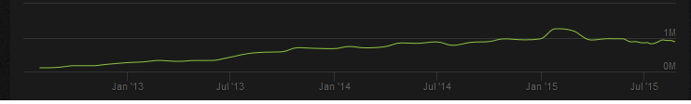
1: This graph shows the development of the playerbase in dota2, the leftmost value is about 100.000 people whereas the peak value is 1,2 million. (source:http://steamcharts.com/app/570#All)
Also there is the problem of variance seeking behaviour (Lattin & Mcalister, 1985). We did not account for the possibility of variance seeking behaviour among consumers in the Steam market. If there is variance seeking behaviour in this market then consumers will prefer new items not just because they are new, but because they hadn’t had a chance to consume these items yet, leading to higher utility gains when consuming these new goods. This would mean that we may find ‘evidence’ for our hypotheses and wrongly attribute this relationship to a newness preference. If we assume that there is some amount of variance seeking behaviour among consumers in the Steam market we will further weaken our results. Lastly there is the problem of the betting community, which was mentioned earlier in this paper. To understand why this is a problem one needs a brief introduction to the online betting market that exists in esports. Like many other scenes in which there is competition, esports has an active betting community. Betting on the outcome of an esports match is not necessarily done with money however, but rather with the in game items that have been the focus of our analysis. People who possess an in game item may choose to use it as a ‘chip’, as you would in a casino. Particularly suited for this purpose are the arcana items, because they are valuable and can thus be easily employed in high stake bets, because the betting website ties the value of any betted items to its price on the market. This means that the websites will start paying out more of a certain arcana that has a relatively low price when a more expensive one is used to place the bet. When users then wish to ‘cash out’ they will supply this cheap arcana in relatively greater numbers to the market, leading to a decrease in price and an increase in trading volume. The decrease in price resulted by this behaviour may lead us to draw a false positive conclusion whereas the increase in trade volume may lead to a false negative. This does not matter for our overall conclusion as even excluding the arcana dataset and the dota2 dataset would still lead to only 37,5% of coefficients to be significant and with the correct sign.
Another thing to consider is the amount of technological improvement between various generations of items. Returning to our earlier examples of handheld consumer electronics like smartphones, it is easy to give an objective measure of improvement between generations. We could look at such things as number of transistors in the hardware components, or the amount of pixels on the screen or any other objective measure and notice improvement. When Haynes (2014) conducted his study on new model introduction he used data on digital cameras and found that the cannibalization effect was the strongest when a new camera was introduced that had the same format (i.e. shared an important characteristic) as an older model camera (Haynes, Thompson, & Wright, 2014). If we consider the items that are sold on the Steam market it becomes a lot harder to objectively measure improvement. One possibility might be to look at the amount of polygons, however there is reason to assume that the polygon count doesn’t change much since this would start taking up too much space on digital storage devices. Indeed the workshop page for TF2 (http://www.teamfortress.com/workshop/) , a source from Valve themselves states that the polygon count of submissions should be “similar to what’s already in the game”. The term submissions here refers to independent artists who can create their own items and submit these to Valve. If Valve likes the item(s) they will put them in the game and remunerate the artist who created them. This process is another reason why it is hard to pinpoint an objective increase in quality between generations, the items may be created by entirely different artists who are more or less proficient at creating high quality items it might help explain our results, for if there is no real improvement in quality there is much less incentive for the gadget geeks to prefer them, lessening their aggregated appeal. This also means that new items may likely compete with older items on, for the most part, aesthetics. Of course this is a highly subjective matter and would mean that consumer would prefer one product over another for entirely different reasons than their relative newness. It also means that newer products may not share important characteristics with older generations and thus do not cannibalize on the sales of these older products. This may explain why our findings are not in line with Haynes’s earlier work on the subject. Instead our results agree more with the conclusion of Gruen, in that it seems that consumers on the Steam market have no particular preference for the newness of products.

Further experiments with the data
We already mentioned the betting community as a potential problem in our data analysis, we now return to this phenomenon to see if we can find any evidence about the occurrence of betting driven price and trade volume changes. We already discussed why the arcana type items are suitable for using as high value chips on third party betting websites, we will therefore focus exclusively on this dataset. As can be seen from the tables in appendix B, the variable ‘dailypfiery’ is negatively impacted as its successors are released, meaning that the price of the item corresponding to this variable (the ‘Fiery soul of the demon slayer’ arcana) is dropping, possibly as a result from newer arcana’s being released. If we assume that the drop in price is the result of a decrease in overall demand (this in turn being a result of some potential buyers for arcana’s switching to new ones) we can expect a drop in trading volume as well, as displayed graphically in the graph below.
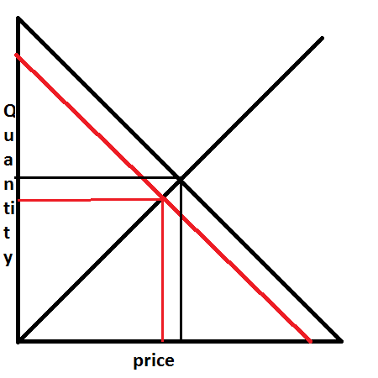
graph 1: basic demand and supply curves in a competetive market
The graph represents what happens to prices and trading volumes in a simple market model. Supply and demand meet at a certain point (the equilibrium) which corresponds to a certain price and trading volume of the good being bought and sold, indicated with the thin black lines. If the market for this good experiences a demand shock where demand goes down, we get the new demand curve in red. The new intersect, indicated by the thin red lines, corresponds to a lower price and trading volume than the old intersect did. We already noted a decline in prices for the ‘Fiery soul’ arcana. When faced with the dropping price of this item, we expect the betting community to start offering more of it to the market. The reason being that the amount betted and payed out is represented in the aggregate value of the items involved in the bet. This means that betters who have a lot of this item in inventory will be inclined to sell them in order to convert them into different items which aren’t experiencing a drop in prices. Also, if a better has won an amount of money and wishes to cash out, he will do so by selling the items that he won. If the items that were paid out are relatively cheap he would have received more of them and thus offers them in a higher quantity. If these effects are strong enough we can expect the trading volume to rise as the price of an item goes down, we therefore estimate the equations:
Totaltradingvolume = C + Bi*p_i + e
Trading volume = C + Bi*price_i + e
The first equation is a regression of the total trading volume of all items in the dataset on the prices of the individual items. The coefficient estimates should provide us with some insight into whether or not the betting community has the expected impact (negative coefficients means volume grows as prices drop, in line with our expectation). The second equation focuses on the trading volume of just one item. We regress it on the prices of all items in the dataset, positive coefficients would support our expectation, except for the coefficient for the price of the fiery soul arcana itself, which should have a negative coefficient. We repeated the second estimation for the trading volumes of the next first three items in the dataset, Fiery soul, Blades and Fractal. The results for both regressions can be seen in table 10 below.

Table 10: regressions of trading volumes on prices for the arcana dataset
 | (1) | (2) | (3) | (4)
VARIABLES | Total Trading volume | Fiery Soul trading volume | Blades trading volume | Fractal Horns trading volume
Blades price | 75.20*** | 11.90*** | 2.080 | 12.08***
 | (28.40) | (3.715) | (1.589) | (3.806)
Demon price | 21.52 | 4.046 | 1.545 | 1.541
 | (21.78) | (2.849) | (1.219) | (2.918)
Fiery soul price | -102.8*** | -21.06*** | -3.612*** | -12.27***
 | (21.44) | (2.805) | (1.200) | (2.873)
Fractal horns price | 7.313 | 1.966 | 0.632 | 1.499
 | (9.800) | (1.282) | (0.548) | (1.313)
Frost price | -144.6** | -19.33** | -7.068** | -17.21**
 | (58.71) | (7.679) | (3.285) | (7.866)
Manifold price | -66.44*** | -7.735** | -2.633** | -7.721**
 | (23.51) | (3.075) | (1.315) | (3.150)
Swine price | -40.07 | -8.473* | -1.773 | -4.832
 | (38.49) | (5.035) | (2.154) | (5.158)
Constant | 4,757*** | 651.0*** | 229.1*** | 355.0***
 | (768.1) | (100.5) | (42.98) | (102.9)
Observations | 111 | 111 | 111 | 111
R-squared | 0.431 | 0.580 | 0.301 | 0.334
rank | 8 | 8 | 8 | 8
ll_0 | -838.0 | -629.1 | -506.6 | -606.2
ll | -806.7 | -581.0 | -486.7 | -583.6
r2_a | 0.392 | 0.552 | 0.254 | 0.289
rss | 1.340e+07 | 228494 | 41808 | 239750
mss | 1.010e+07 | 315948 | 18017 | 120119
rmse | 360.1 | 47.10 | 20.15 | 48.25
r2 | 0.431 | 0.580 | 0.301 | 0.334
F | 11.13 | 20.35 | 6.341 | 7.372
df_r | 103 | 103 | 103 | 103
df_m | 7 | 7 | 7 | 7
Standard errors in parentheses
*** p<0.01, ** p<0.05, * p<0.1

The first regression yields three coefficients that are in line with our expectation, out of a total seven, suggesting that total trading volumes for these items is not rising as a result of dropping prices. The regression estimates for the second equation also do not yield a result that is in agreement with our expectation. This suggests that the actions of the betting community are not a factor in determining trading volumes. The results are also indicative that a basic substitution effect is not present in this market, indicated by the many negative coefficients. It is possibly that there is some external factor determining prices and trading volumes that we haven’t accounted for.
While we fail to draw a positive conclusion from our data we believe that there is merit to studying the Steam market, mainly because of its observability and the unique characteristics of the goods traded there, which allow for assumptions beyond those possible in a real goods market.

Bibliography
Anthony, S. (2014, September 10). Apple’s A8 SoC analyzed: The iPhone 6 chip is a 2-billion-transistor 20nm monster. Opgehaald van Extremetech: http://www.extremetech.com/computing/189787-apples-a8-soc-analyzed-the-iphone-6-chip-is-a-2-billion-transistor-20nm-monster
Arrow, K. (1962). Economic Welfare and the Allocation of Resources . In U.-N. Bureau, The Rate and Direction of Inventive Activity: Economic (pp. 609-626). Princeton university press.
Bresnahan, T. F., Stern, S., & Trajtenberg, M. (1997). Market segmentation and the sources of rents from innovation: personal computers in the late 1980's. Rand journal of economics, 28, s17-s44.
Geroski, P. A. (2003). The evolution of new markets. Oxford: Oxford university press.
Gruen, W. (1960). preference for new products and its relationship to different measures of conformity. journal of applied psychology, 361-364.
Haynes, M., Thompson, S., & Wright, P. W. (2014). new model introductions, cannibalization and market stealing: evidence from shopbot data. The manchester school, 82(4), 385-408.
Lattin, J., & Mcalister, L. (1985, August). Using a Variety-Seeking Model to Identify Substitute and Complementary Relationships among Competing Products. Journal of marketing research(vol. 22, No. 3), 330-339.
Lieberman, B. M., & Montgomory, B. D. (1988). First-Mover advantages. Strategic manegement journal, 41-58.
Nutt, C. (2011, March 4). GDC 2011: Perfecting The Free-To-Play Battlefield Heroes. Opgehaald van Gamasutra: http://www.gamasutra.com/view/news/123779/GDC_2011_Perfecting_The_FreeToPlay_Battlefield_Heroes.php
Peel, J. (2014). Steam active userbase doubles in two years to 100 million. Opgehaald van pcgamesn: http://www.pcgamesn.com/steam-active-userbase-doubles-in-two-years-to-100-million
Steamcharts. (sd). Opgehaald van Steamcharts: http://steamcharts.com/
Think Gaming. (2015, July 12). Candy Crush Saga. Opgehaald van Think Gaming: https://thinkgaming.com/app-sales-data/2/candy-crush-saga/

Li, X., Ortiz, P. J., Browne, J., Franklin, D., Oliver, J. Y., Geyer, R., ... & Chong, F. T. (2010, September). Smartphone evolution and reuse: Establishing a more sustainable model. In Parallel Processing Workshops (ICPPW), 2010 39th International Conference on (pp. 476-484). IEEE.

Appendix A, Graphs

Dota 2
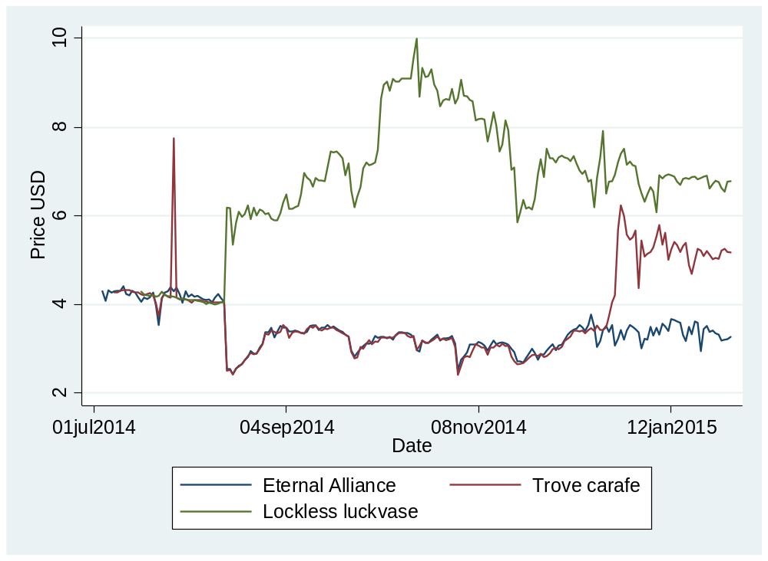
Figure 2: price developments for the first three chests in the dota 2 dataset
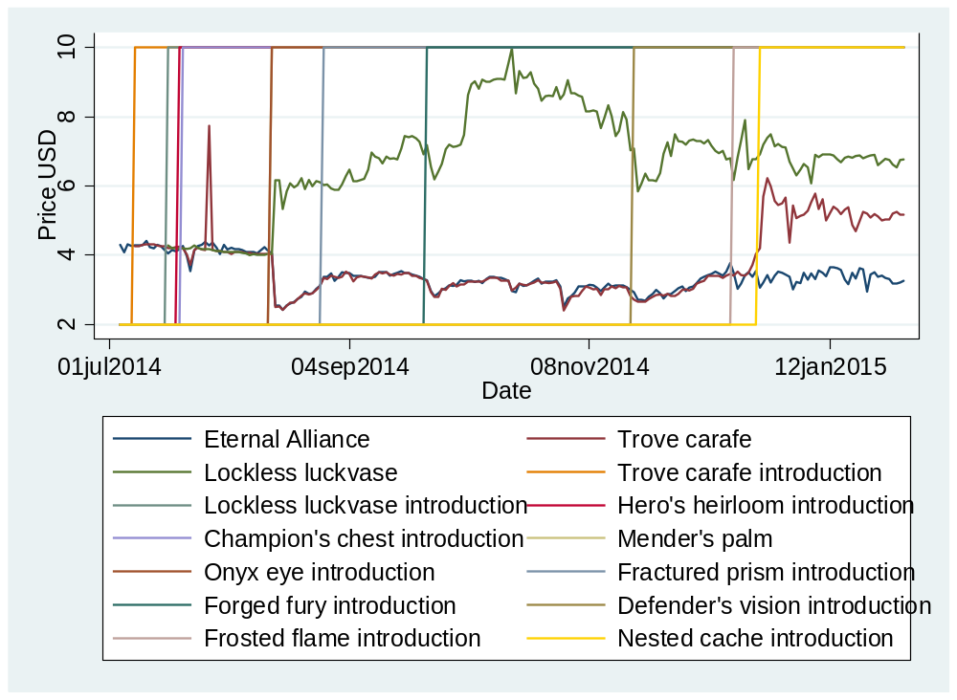
Figure 3: price developments for the first three items in the dota 2 dataset. vertical lines indicate a point in time where a new item was introduced.
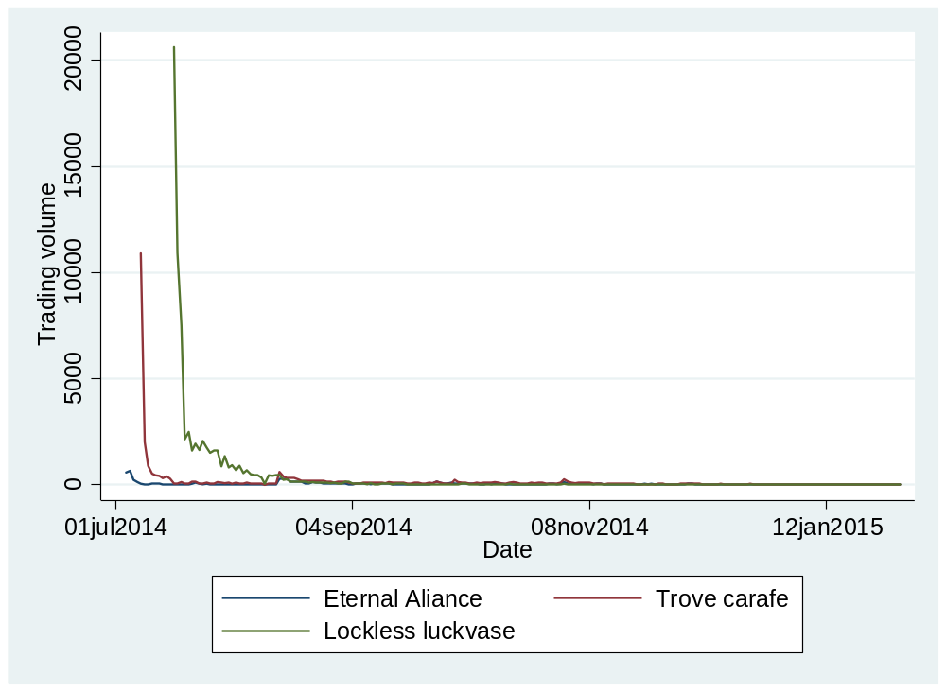
Figure 4: the trading volume over time of the first three items in the dota 2 dataset
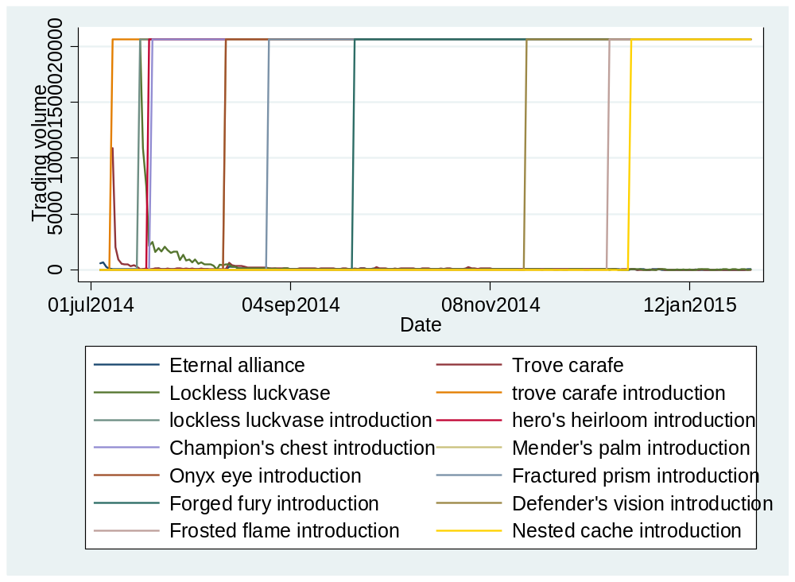
Figure 5: the trading volume over time of the first three items in the dota 2 dataset. vertical lines indicate a point in time where a new item was introduced

TF 2
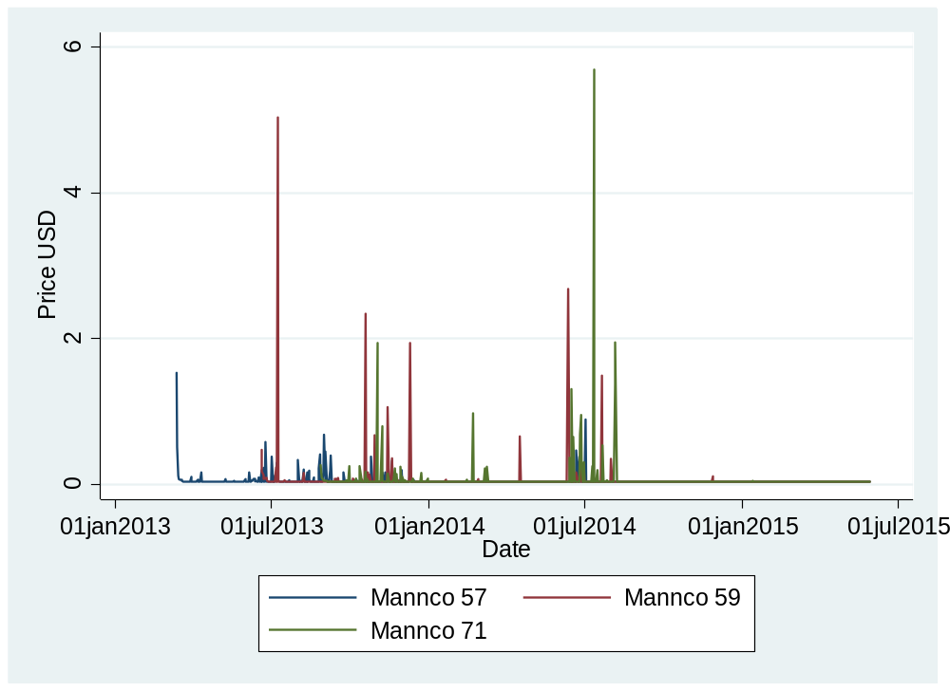
Figure 6: price developments over time for the three analysed items in the TF2 dataset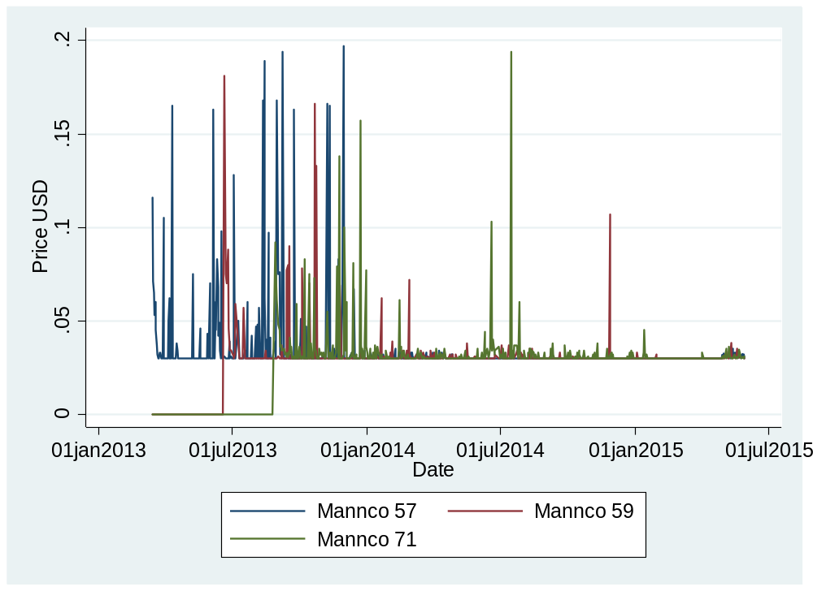
Figure 7: close up of figure 6. this graph makes it more clear that the price stays at 3 cent and regularly spikes up from that level.
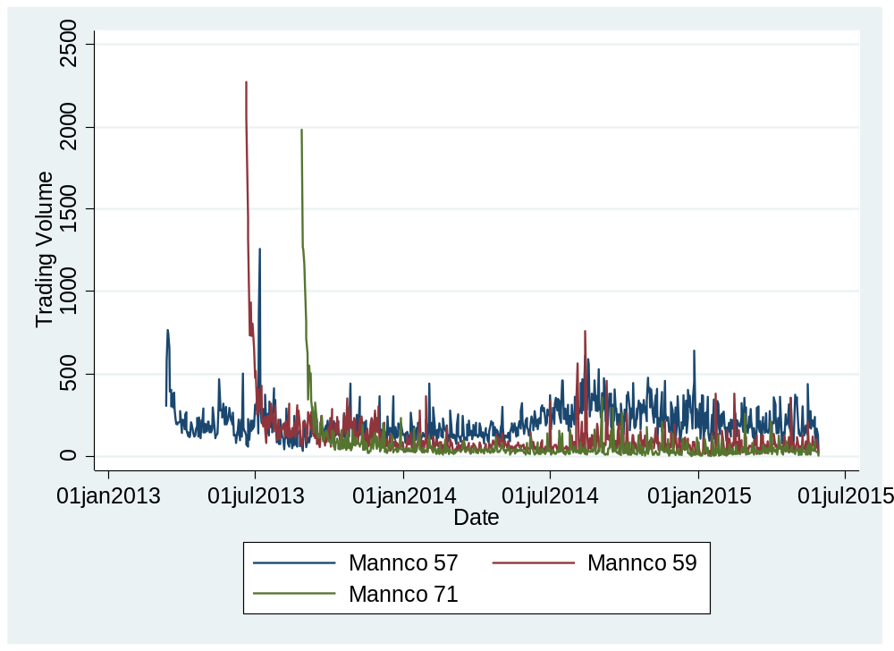
Figure 8:the development of trading volume over time for the three analysed items in the tf2 dataset
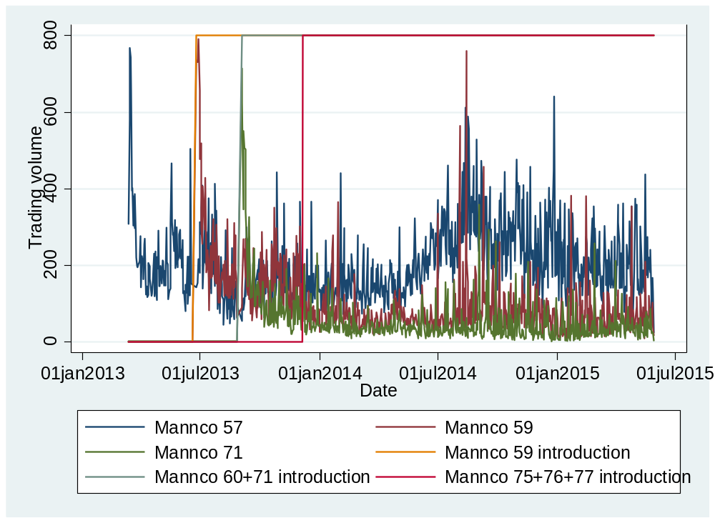
Figure 9: the development of trading volume over time for the three analysed items in the tf2 dataset. vertical lines indicate a point in time where a new item is introduced. note that two of these points correspond to a simultaneous release of multiple items

CS:go
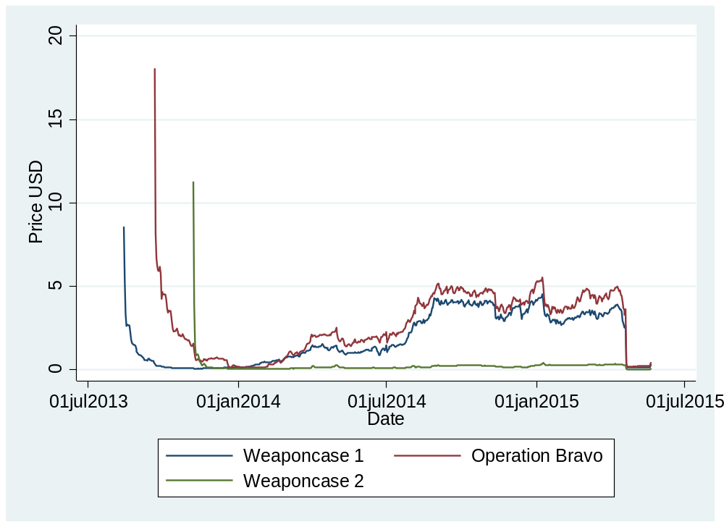
Figure 10: price developments over time for the first three items in the csgo dataset
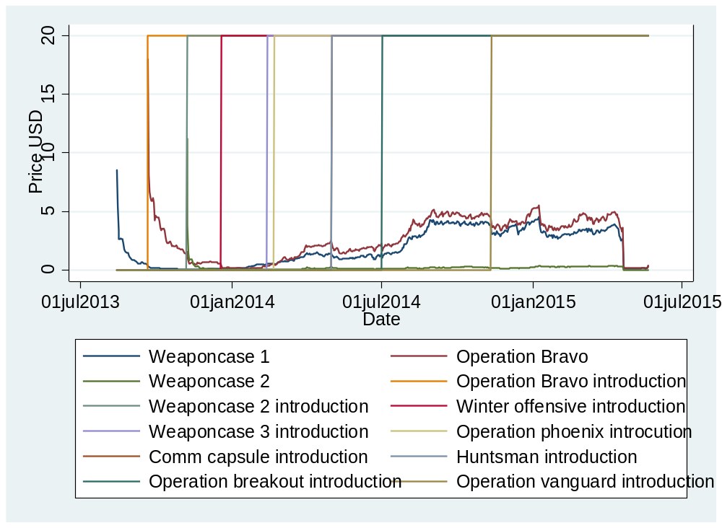
Figure 11: price developments over time for the first three items in the csgo dataset. vertical lines indicate points in time where a new item was introduced.
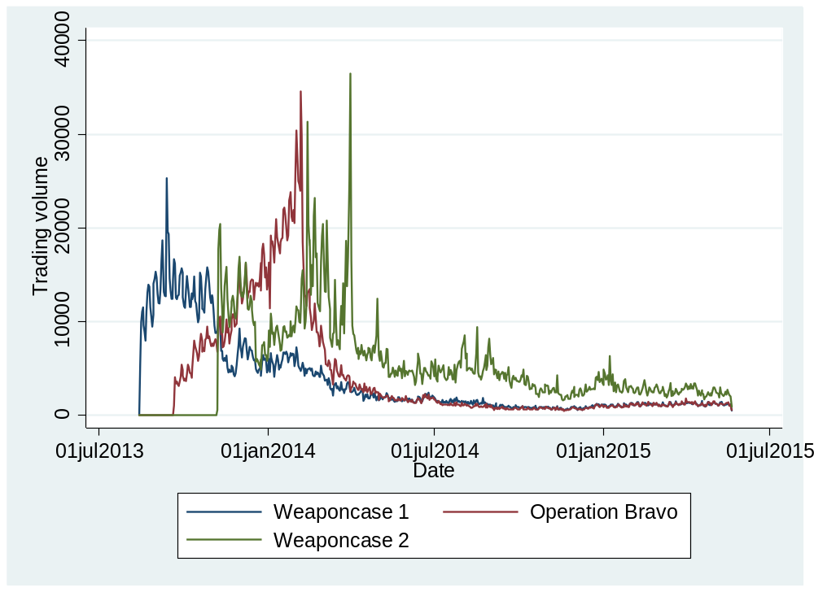
Figure 12: the development of trading volumes over time for the first three items in the csgo dataset
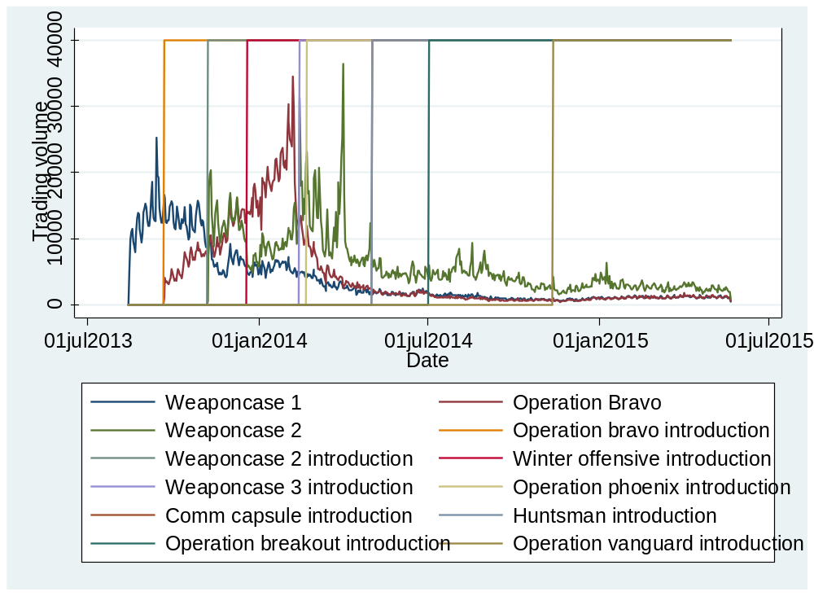
Figure 13: the development of trading volumes over time for the first three items in the csgo dataset. vertical lines indicate a point in time where a new item was introduced.

Arcana
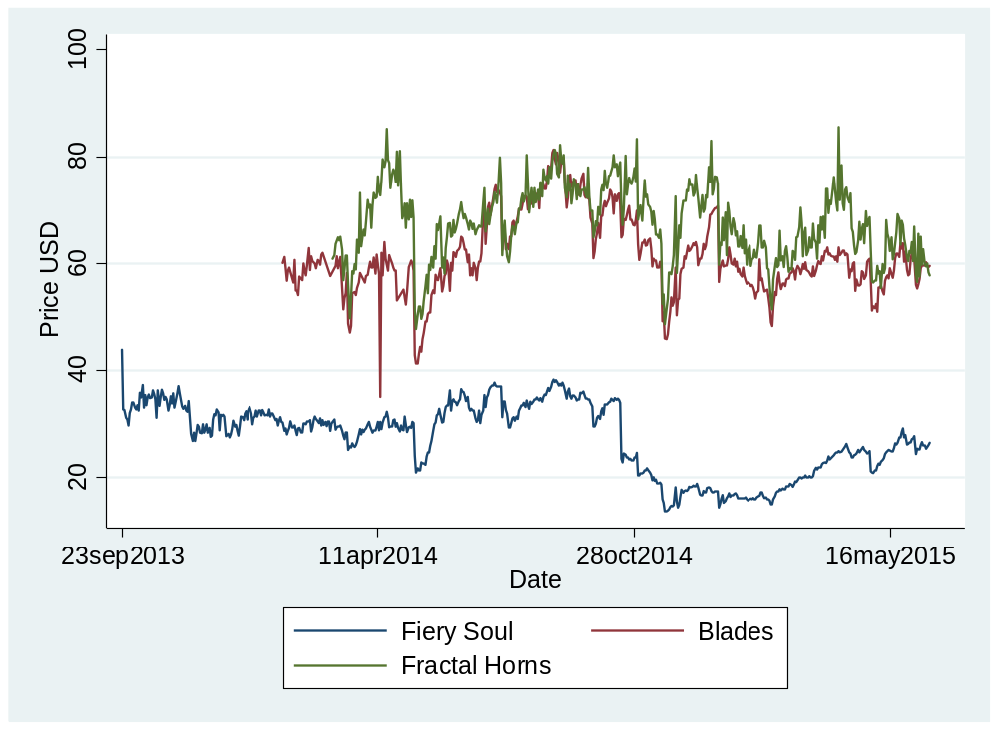
Figure 14: price developments over time for the first three items in the arcana dataset.
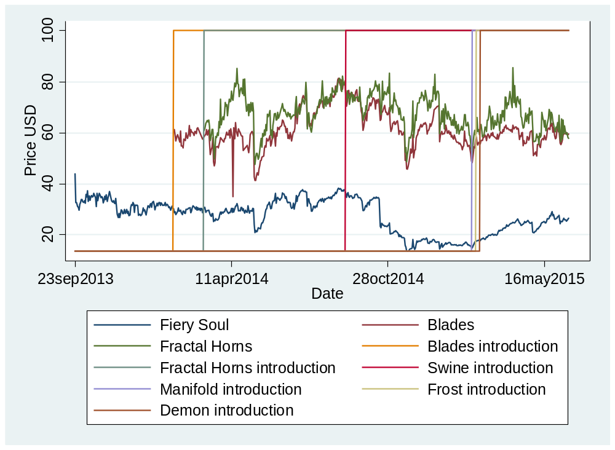
Figure 15: price developments over time for the first three items in the arcana dataset. vertical lines indicate a point in time where an item was introduced.
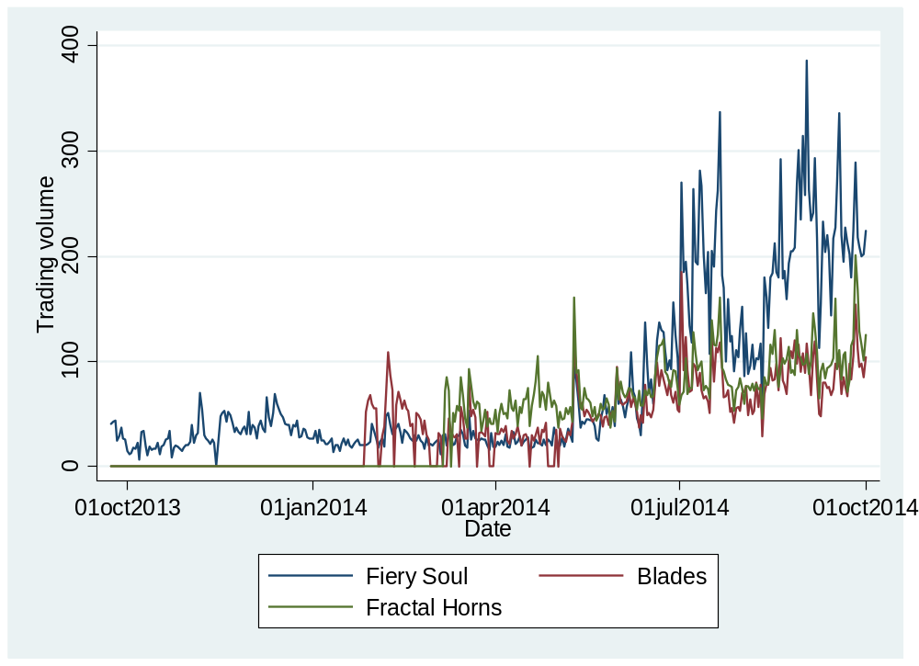
Figure 16: the development of trading volumes over time for the first three items in the arcana dataset
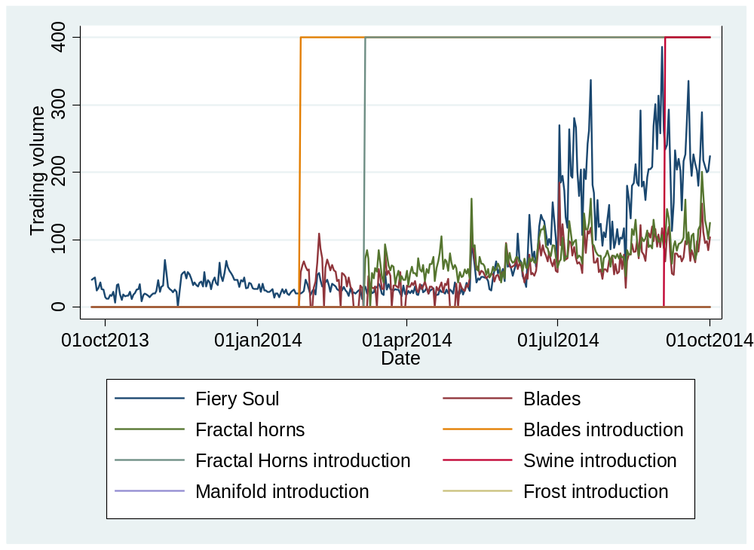
Figure 17: the development of trading volumes over time for the first three items in the arcana dataset. vertical lines indicate a point in time where an item was introduced

Appendix B, Regression results tables

Dota 2
 | (1) | (2) | (3)
VARIABLES | eternalalliance_p | trovecarafe_p | locklessluckvase_p
d_trovecarafe | 0.0343
 | (0.124)
d_locklessluckvase | -0.167 | -0.0720
 | (0.138) | (0.246)
d_heroheirloom | 0.0553 | 0.0393 | -0.0430
 | (0.239) | (0.426) | (0.697)
d_championchest | -0.00158 | -0.0242 | -0.0794
 | (0.211) | (0.377) | (0.616)
d_menderpalm | -1.320*** | -1.401*** | 1.763***
 | (0.0697) | (0.124) | (0.203)
o.d_onyxeye | - | - | -
d_fracturedprism | 0.586*** | 0.572*** | 0.742***
 | (0.0678) | (0.121) | (0.197)
d_forgedfury | -0.297*** | -0.316*** | 1.683***
 | (0.0479) | (0.0854) | (0.140)
d_defendervision | -0.0244 | -0.0623 | -1.406***
 | (0.0485) | (0.0865) | (0.141)
d_frostedflame | 0.257*** | 0.547*** | 0.00426
 | (0.0878) | (0.157) | (0.256)
d_nestedcache | -0.0640 | 1.809*** | -0.0413
 | (0.0985) | (0.167) | (0.258)
o.d_trovecarafe |  | -
Constant | 4.244*** | 4.295*** | 4.239***
 | (0.104) | (0.123) | (0.348)
Observations | 185 | 185 | 185
R-squared | 0.831 | 0.806 | 0.841
rank | 11 | 10 | 9
ll_0 | -129.8 | -224.5 | -334.6
ll | 34.44 | -72.98 | -164.4
r2_a | 0.821 | 0.796 | 0.834
rss | 7.465 | 23.84 | 64.06
mss | 36.62 | 98.80 | 339.2
rmse | 0.207 | 0.369 | 0.603
r2 | 0.831 | 0.806 | 0.841
F | 85.35 | 80.58 | 116.5
df_r | 174 | 175 | 176
df_m | 10 | 9 | 8
Standard errors in parentheses
*** p<0.01, ** p<0.05, * p<0.1

 | (1) | (2) | (3)
VARIABLES | eternalalliance_q | trovecarafe_q | locklessluckvase_q
d_trovecarafe | -362.1***
 | (26.60)
d_locklessluckvase | -34.44 | -1,722***
 | (29.51) | (492.7)
d_heroheirloom | -4.667 | -21.67 | -10,850***
 | (51.11) | (853.4) | (880.2)
d_championchest | 19.67 | 16.62 | -1,081
 | (45.18) | (754.3) | (778.0)
d_menderpalm | 117.8*** | 189.9 | -887.5***
 | (14.89) | (248.6) | (256.4)
o.d_onyxeye | - | - | -
d_fracturedprism | -97.07*** | -164.2 | -128.6
 | (14.49) | (241.9) | (249.5)
d_forgedfury | 5.643 | -9 | -37.66
 | (10.25) | (171.1) | (176.4)
d_defendervision | -21.33** | -52.99 | -9.736
 | (10.37) | (173.2) | (178.6)
d_frostedflame | -23.31 | -21.12 | -7.746
 | (18.77) | (313.5) | (323.3)
d_nestedcache | 4.571 | -16.79 | 5.577
 | (21.05) | (334.9) | (326.0)
o.d_trovecarafe |  | -
Constant | 413.3*** | 1,814*** | 13,015***
 | (22.13) | (246.4) | (440.1)
Observations | 185 | 185 | 185
R-squared | 0.670 | 0.213 | 0.833
rank | 11 | 10 | 9
ll_0 | -1061 | -1502 | -1651
ll | -958.0 | -1479 | -1486
r2_a | 0.651 | 0.173 | 0.826
rss | 340951 | 9.560e+07 | 1.020e+08
mss | 691958 | 2.590e+07 | 5.120e+08
rmse | 44.27 | 739.1 | 762.3
r2 | 0.670 | 0.213 | 0.833
F | 35.31 | 5.270 | 110.1
df_r | 174 | 175 | 176
df_m | 10 | 9 | 8
Standard errors in parentheses
*** p<0.01, ** p<0.05, * p<0.1

Tf2
 | (1) | (2) | (3)
VARIABLES | mannco57_p | mannco59_p | mannco71_p
d_60 |  | -0.0434
 |  | (0.0688)
o.d_71 |  | -
d_75 |  | 0.0787 | -0.0333
 |  | (0.122) | (0.0249)
o.d_76 |  | - | -
o.d_77 |  | - | -
d_59 | 0.0295
 | (0.0215)
Constant | 0.0602*** | 0.122** | 0.0786***
 | (0.0146) | (0.0529) | (0.0169)
Observations | 185 | 184 | 185
R-squared | 0.010 | 0.004 | 0.010
rank | 2 | 3 | 2
ll_0 | 93.93 | -108.6 | 66.75
ll | 94.88 | -108.2 | 67.65
r2_a | 0.00482 | -0.00735 | 0.00428
rss | 3.883 | 34.93 | 5.213
mss | 0.0401 | 0.128 | 0.0510
rmse | 0.146 | 0.439 | 0.169
r2 | 0.0102 | 0.00366 | 0.00970
F | 1.891 | 0.332 | 1.792
df_r | 183 | 181 | 183
df_m | 1 | 2 | 1
Standard errors in parentheses
*** p<0.01, ** p<0.05, * p<0.1

 | (1) | (2) | (3)
VARIABLES | mannco57_q | mannco59_q | Mannco71_q
d_60 |  | -203.8***
 |  | (40.76)
o.d_71 |  | - | -
d_75 |  | -73.42 | -147.8276***
 |  | (72.12) | (33.75)
o.d_76 |  | - | -
o.d_77 |  | - | -
d_59 | -42.64**
 | (21.32)
Constant | 229.3*** | 359.5*** | 198.31***
 | (14.54) | (31.36) | (22.88)
Observations | 185 | 184 | 185
R-squared | 0.021 | 0.142 | 0.0949
rank | 2 | 3
ll_0 | -1184 | -1297
ll | -1182 | -1283
r2_a | 0.0160 | 0.133
rss | 3.829e+06 | 1.230e+07
mss | 83664 | 2.034e+06
rmse | 144.6 | 260.5 | .16878
r2 | 0.0214 | 0.142
F | 3.999 | 14.99
df_r | 183 | 181
df_m | 1 | 2
Standard errors in parentheses
*** p<0.01, ** p<0.05, * p<0.1

CS:go
 | (1) | (2) | (3)
VARIABLES | weaponcase1_p | opbravo_p | weaponcase2_p
d_opbravo | -1.416***
 | (0.157)
d_weaponcase2 | -0.0492 | -2.901***
 | (0.152) | (0.296)
d_winteroff | 0.176 | -0.473* | -0.573***
 | (0.147) | (0.285) | (0.177)
d_weaponcase3 | 0.268 | 0.266 | 0.00212
 | (0.517) | (0.527) | (0.327)
d_opphoenix |  | 0.417 | 0.0545
 |  | (0.557) | (0.323)
d_commcapsule |  |  | 0.0792
 |  |  | (0.368)
o.d_huntsman |  |  | -
Constant | 1.528*** | 3.544*** | 0.609***
 | (0.116) | (0.204) | (0.133)
Observations | 185 | 182 | 182
R-squared | 0.386 | 0.495 | 0.067
rank | 5 | 5 | 5
ll_0 | -243.7 | -378.5 | -235.7
ll | -198.7 | -316.3 | -229.3
r2_a | 0.372 | 0.484 | 0.0462
rss | 92.77 | 344.6 | 132.5
mss | 58.26 | 338.0 | 9.562
rmse | 0.718 | 1.395 | 0.865
r2 | 0.386 | 0.495 | 0.0673
F | 28.26 | 43.40 | 3.194
df_r | 180 | 177 | 177
df_m | 4 | 4 | 4
Standard errors in parentheses
*** p<0.01, ** p<0.05, * p<0.1

 | (1) | (2) | (3)
VARIABLES | weaponcase1_q | opbravo_q | weaponcase2_q
d_opbravo | 1.615
 | (496.1)
d_weaponcase2 | -6,297*** | 5,290***
 | (482.8) | (696.8)
d_winteroff | -952.6** | 7,821*** | -3,787***
 | (464.1) | (669.9) | (867.9)
d_weaponcase3 | -678.6 | -7,779*** | 10,312***
 | (1,636) | (1,240) | (1,607)
d_opphoenix |  | -4,866*** | -7,807***
 |  | (1,311) | (1,587)
d_commcapsule |  |  | -5,362***
 |  |  | (1,809)
o.d_huntsman |  |  | -
Constant | 12,821*** | 5,962*** | 12,516***
 | (368.9) | (478.7) | (656.1)
Observations | 185 | 182 | 182
R-squared | 0.702 | 0.739 | 0.249
rank | 5 | 5 | 5
ll_0 | -1802 | -1851 | -1802
ll | -1690 | -1729 | -1776
r2_a | 0.695 | 0.733 | 0.232
rss | 9.310e+08 | 1.910e+09 | 3.200e+09
mss | 2.190e+09 | 5.400e+09 | 1.060e+09
rmse | 2274 | 3282 | 4252
r2 | 0.702 | 0.739 | 0.249
F | 105.8 | 125.4 | 14.70
df_r | 180 | 177 | 177
df_m | 4 | 4 | 4
Standard errors in parentheses
*** p<0.01, ** p<0.05, * p<0.1

Arcana
 | (1) | (2) | (3)
VARIABLES | dailypfierysoul | dailypblades | dailypfractal
dblades | -2.272***
 | (0.431)
dfractal | -1.629** | 0.0664
 | (0.683) | (1.338)
dswine |  |  | 5.813
 |  |  | (3.771)
Constant | 31.95*** | 58.94*** | 68.34***
 | (0.210) | (1.206) | (0.556)
Observations | 181 | 160 | 184
R-squared | 0.250 | 0.000 | 0.013
rank | 3 | 2 | 2
ll_0 | -436.0 | -528.1 | -631.0
ll | -410.0 | -528.1 | -629.8
r2_a | 0.241 | -0.00631 | 0.00746
rss | 983.8 | 6897 | 10128
mss | 327.5 | 0.108 | 132.2
rmse | 2.351 | 6.607 | 7.460
r2 | 0.250 | 1.56e-05 | 0.0129
F | 29.63 | 0.00246 | 2.376
df_r | 178 | 158 | 182
df_m | 2 | 1 | 1
Standard errors in parentheses
*** p<0.01, ** p<0.05, * p<0.1

 | (1) | (2) | (3)
VARIABLES | dailyqfierysoul | dailyqblades | dailyqfractal
dblades | -1.969
 | (2.155)
dfractal | 0.00452 | 10.03*
 | (3.414) | (5.375)
dswine |  |  | 48.47***
 |  |  | (12.33)
Constant | 30.20*** | 40.85*** | 73.28***
 | (1.051) | (4.765) | (1.813)
Observations | 181 | 182 | 185
R-squared | 0.006 | 0.019 | 0.078
rank | 3 | 2 | 2
ll_0 | -701.8 | -876.5 | -859.9
ll | -701.2 | -874.8 | -852.4
r2_a | -0.00511 | 0.0135 | 0.0729
rss | 24562 | 159382 | 108831
mss | 149.8 | 3086 | 9194
rmse | 11.75 | 29.76 | 24.39
r2 | 0.00606 | 0.0190 | 0.0779
F | 0.543 | 3.485 | 15.46
df_r | 178 | 180 | 183
df_m | 2 | 1 | 1
Standard errors in parentheses
*** p<0.01, ** p<0.05, * p<0.1

Appendix C, Regression result table for betting analysis
 | (1) | (2) | (3) | (4)
VARIABLES | totaltradingvolume | dailyqfierysoul | dailyqblades | dailyqfractal
dailypblades | 75.20*** | 11.90*** | 2.080 | 12.08***
 | (28.40) | (3.715) | (1.589) | (3.806)
dailypdemon | 21.52 | 4.046 | 1.545 | 1.541
 | (21.78) | (2.849) | (1.219) | (2.918)
dailypfierysoul | -102.8*** | -21.06*** | -3.612*** | -12.27***
 | (21.44) | (2.805) | (1.200) | (2.873)
dailypfractal | 7.313 | 1.966 | 0.632 | 1.499
 | (9.800) | (1.282) | (0.548) | (1.313)
dailypfrost | -144.6** | -19.33** | -7.068** | -17.21**
 | (58.71) | (7.679) | (3.285) | (7.866)
dailypmanifold | -66.44*** | -7.735** | -2.633** | -7.721**
 | (23.51) | (3.075) | (1.315) | (3.150)
dailypswine | -40.07 | -8.473* | -1.773 | -4.832
 | (38.49) | (5.035) | (2.154) | (5.158)
Constant | 4,757*** | 651.0*** | 229.1*** | 355.0***
 | (768.1) | (100.5) | (42.98) | (102.9)
Observations | 111 | 111 | 111 | 111
R-squared | 0.431 | 0.580 | 0.301 | 0.334
rank | 8 | 8 | 8 | 8
ll_0 | -838.0 | -629.1 | -506.6 | -606.2
ll | -806.7 | -581.0 | -486.7 | -583.6
r2_a | 0.392 | 0.552 | 0.254 | 0.289
rss | 1.340e+07 | 228494 | 41808 | 239750
mss | 1.010e+07 | 315948 | 18017 | 120119
rmse | 360.1 | 47.10 | 20.15 | 48.25
r2 | 0.431 | 0.580 | 0.301 | 0.334
F | 11.13 | 20.35 | 6.341 | 7.372
df_r | 103 | 103 | 103 | 103
df_m | 7 | 7 | 7 | 7
Standard errors in parentheses
*** p<0.01, ** p<0.05, * p<0.1

Appendix D, overview of names
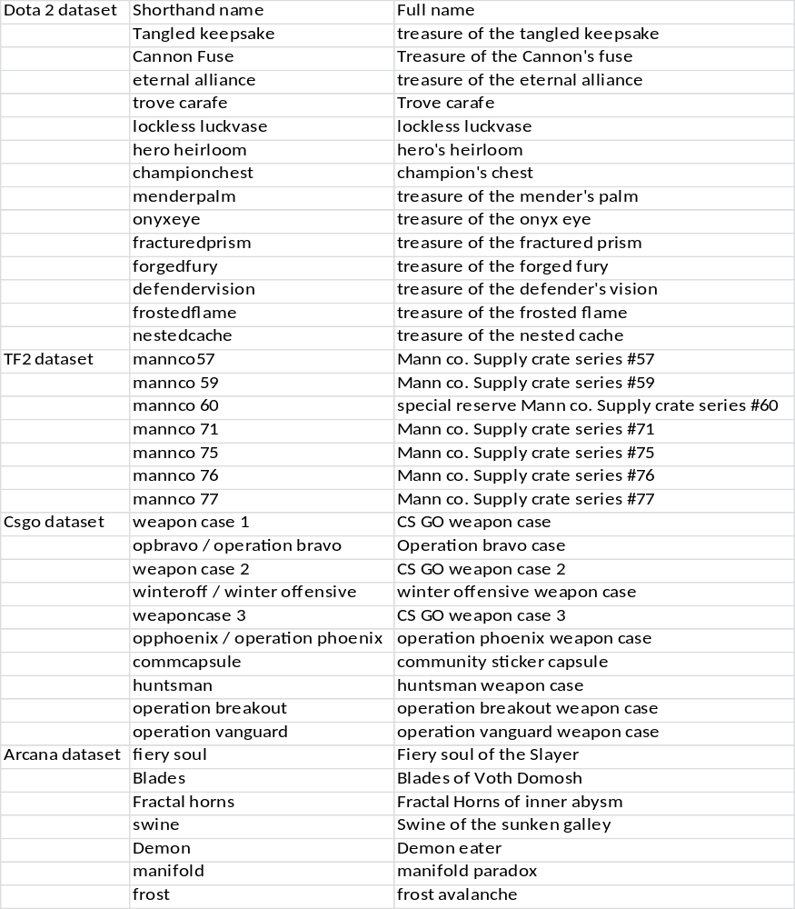

http://dota2.gamepedia.com/Category:Active_Treasures; http://dota2.gamepedia.com/Arcana; https://wiki.teamfortress.com/...Crate/Active_series; http://counterstrike.wikia.com/wiki/Category:Container

