EU Sovereign Bond Yields and Deviations from Long-Run Equilibrium

To what extent do sovereign bond yields of certain EU members deviate from the LR equilibrium indicated by underlying macroeconomic fundamentals between 2000 and 2014?

Bachelor Thesis International Bachelors Economics and Business
Marloes L.C. Spanjersberg
Supervisor: Dr. Y. Adema
26th of August, 2015
Abstract
The aim of this thesis is to empirically investigate the dynamic relationship between sovereign bond yields, macroeconomic fundamentals and risk proxies for each of 7 different Euro Area (EA) members between 2000 and 2014. In order to uncover the long-run equilibrium effect of a set of independent variables on sovereign bond yields, I utilize a multivariate Vector Error Correction Model. To gauge the time duration of deviations from their respective long-run sovereign bond yield level, an Impulse Response Function is used. The main finding is that each country’s sovereign bond yield has a significantly different dynamic relationship with underlying fundamental characteristics. In fact, during periods of economic uncertainty and/or economic distress, the relationship between sovereign bond yields and underlying fundamentals can alter drastically and almost instantaneously. The effect of exogenous shocks can alter the underlying relationship with sovereign bond yield to such an extent that the propagation of the yield movement has altered its long-run pathway. This process of deviation adjustment can persist for an extended period of time and is marked by fluctuating sovereign yields with oscillations of different magnitude around the long-run equilibrium. Finally, Dynamic OLS models will give further evidence for the lack of coordinated coherence in the relationship between fiscal/macroeconomic fundamentals and sovereign bond yields.

Keywords: Sovereign bond yield, VECM, macroeconomic fundamentals, short run deviation.
TABLE OF CONTENTS

1. Introduction 2
2. Theoretical Framework 8
2.1 Theoretical Considerations 9
2.2 Types of Risk 11
3. Literature Review 13
4. Data 17
4.1 Data Sources 17
4.2 Descriptive Statistics 17
4.3 Variables under Consideration 18
5. Methodology 24
5.1 Statistical/Econometric Models 24
6. Results 28
6.1 Group ADF Unit Root Tests 28
6.2 Johansen’s Multivariate Cointegration Analyses 29
6.3 Multivariate Vector Error Correction Models 30
6.4 VEC Granger Causality/Block Exogeneity Wald Test 33
6.5 Impulse Response Functions 36
6.6 Dynamic Ordinary Least Squares 37
7. Conclusion 38
References 39
Appendix

- Introduction
On the 9th of March 2015, the European Central Bank [ECB] commenced its block-buster bond-purchase program (Expanded Asset Purchase Program [EAPP]) in order to fulfil its price stability mandate. The program is a structured extension of the Asset-Backed Securities Purchase Program [ABSPP] and the Covered Bond Purchase Program [CBPP3], the latter of which was launched in 2014. The EAPP will contrive to achieve monthly bond purchases in the secondary market of Eurozone sovereign bonds amounting to €60 billion. At the culmination of the ECBs Quantitative Easing program by September 2016, up to €1.1 trillion in securities will have been purchased of European institutions that in turn can acquire other assets and ensure widespread credit availability in the real economy. Furthermore, close to €1.5 trillion of longer-maturity debt originating in the Euro area pays negative yields. Ad nauseam, the notion that yields’ natural floor is at the 0% mark was considered to be an aphorism, a universally accepted truth. Nevertheless, recent events have indicated that holding on to negative-yielding bonds is acceptable as long as the yield is expected to fall further, and thus attain capital gains. Currently, the natural floor of bond yields within the Euro area has been set equal to the ECBs negative deposit rate of -0.20%. The Main Refinancing Operations interest rate, which provides the largest share of liquidity to the European banking system, has remained positive but close to zero at approximately 0.05%.
As nearly €220 billion of bank reserves faces negative deposit rates, and more are soon to follow in the wake of the EAPP, government bonds with negative-yields may prove a viable alternative to paying even more in order to store cash on deposits. This development has already led to the stockpiling of $3.6 trillion of negative-yielding government bonds worldwide (approximately 16% of the global sovereign bond markets). To gauge the implications of recent developments and the run-up to the Financial Crisis and the subsequent Sovereign Debt Crisis, this thesis shall focus on the determinants of sovereign bond yields within a selection of countries belonging to the Eurozone. Determinants include macroeconomic/fiscal fundamentals and several risk proxies (see Section 2: Theoretical Framework). Furthermore, I shall endeavour to elucidate how changes in the underlying fundamentals cause short-run deviations from long-run sovereign bond yields and the duration of the abovementioned short-run deviations via Johansen’s Multivariate Cointegration Analysis, Vector Error Correction Models and their associated Impulse Response Functions. If one understands the driving forces imbedded in the system, we can better gauge how they may dictate policy choice during the post-crisis adjustment period.
In order to understand the current Eurozone sovereign bond market environment one must understand its evolutionary pathway. The EU finally gained traction with the abolishment of exchange rate controls and liberalization of capital movement between EU member states. This was to be the first step on the road towards financial, economic and political integration across the EU. Thus, an imperative part of the establishment of the Economic and Monetary Union (EMU) was the European Exchange Rate Mechanism (ERM). The ERM was an EU Target Zone Model based on a de jure central rate referred to as the European Currency Unit, e.g., weighted average of a basket of currencies of participating members. The target bands were initially set at 2.25% on either side of the central parity to ensure a form of allostasis with respect to exchange rate fluctuation, i.e., adaptation to a range (rather than a single point) within a dynamic exchange rate process to attain monetary stability. Nevertheless, the Deutschmark rapidly became the de facto lead currency rate within the ERM prior to 1999. Simultaneously, sovereign bond yields began to converge to the German Bunds, partly due to the elimination of exchange rate risk and inflationary pressure. Contemporaneously many European governments also endeavoured to reduce their budgetary deficit and outstanding debt levels to fulfil the Maastricht treaty criteria in order to be eligible as a member state for the adoption of the Euro. Between 1999 and mid-2008, sovereign bond yields showed a high degree of homogeneity and fluctuated vis-à-vis the ten-year German bund yield with 15 basis points on average. A peculiar finding as fiscal solidity differed enormously between the same countries and ought to have led to yield divergence. Conversely, it is a hallmark of prolonged periods of low macroeconomic volatility where investors’ risk aversion is at an all-time low as they felt insulated from macroeconomic upheavals and the idea that any Eurozone government could reach its fiscal limit, i.e., government can no longer finance higher debt levels, was deemed preposterous and unfounded. Similarly, the expansion and diversification of global FOREX reserves and market depth of the euro government bond markets created the misconception that sovereign bond demand was infinite. The depth of market refers to a security’s ability to withstand swift execution of large market orders without creating large swings in a security’s price. Bond markets that are typified by high market depth do not require market makers to facilitate sufficient liquidity.
However, during the onset of the Credit Crunch (2007-2009), government bond yields began to diverge and for certain countries (e.g., Spain, Greece, Italy and Ireland) they were subject to soaring and vagarious premia owing to fear of contagion and ‘market mania’. The Financial Crisis (2007-2012) directly contributed to the sovereign debt crisis in the Eurozone as governments were called upon to bail-out the largest banks under their respective supervision in order to assure financial stability and prevent a banking system collapse and/or another credit crunch from emerging. Thus Eurozone countries began to amass major debt burdens as evidenced by a worsening debt-to-GDP ratio for most member states involved. During the subsequent European sovereign debt crisis (2009-present), fiscal sustainability in advanced economies became the crux of economic intervention by ‘Troika’ (triumvirate, e.g., International Monetary Fund, European Commission and the European Central Bank). Several advanced economies with time-honoured and exceptional credit ratings (up to and including AAA) have faced severe downgrading by leading credit rating agencies such as Standard & Poor, Moody’s and Fitch (together they comprise 95% of total market share), due to accelerating government debt burdens and unsustainable government budget deficits. As government debt rises, sovereign bond yields should go up in recognition of the higher associated default risk, economic depreciation and inflationary pressure. Concurringly, many EU member states have witnessed a plummeting sovereign bond yield. Negative yields are now offered on sovereign bonds spread out over a spectrum of maturities; these countries include Germany, Denmark, the Netherlands, Austria, Sweden, France, Belgium, Finland and Switzerland. To prevent debt deflation (originated during the financial crisis) from turning into a liquidity trap, one can either turn to fiscal policy measures or Gesell taxes. Debt deflation occurs when collateral of asset-backed securities declines in value and heightens risk of default. Subsequent margin calls and bankruptcies lead to mounting deleveraging pressure, which may develop into a full-fledged ‘fire sale’ of assets. This causes a further fall in asset prices and thus leads the economy into a downward spiral. Similarly, a liquidity trap occurs when short-term nominal interest is set to zero and monetary policy is rendered ineffective. In order to escape from a liquidity trap economic agents can either utilize expansionary fiscal policy or set negative interest rates for the deposit facility at the ECB. The latter is based on Gesell’s idea of ensuring a negative effective return rate on currency in order to deal with excess reserves that are the result of the ‘nuclear’ option that is quantitative easing (QE).
The effectiveness of monetary policy and the stability of sovereign debt markets are intricately and fundamentally linked. Government bonds are the medium-term financing vehicles that form the basis of the monetary policy transmission mechanism via four channels; the interest rate channel, collateral channel, banks’ balance sheet channel and the wealth channel.
Prior to the financial crisis, sovereign bonds were considered as risk-free and relatively liquid instruments whereby only a change in current or expected policy rates could alter the sovereign bond yield curve. Long-term sovereign bond yields influenced bank lending rates, municipal and corporate bond yields via the process of arbitrage and bond pricing approximations. Sovereign bonds can serve as a hedge in investors’ portfolios against interest rate risk and stock market deterioration and are often the go-to solution during financial crises. However, there seem to be time-varying elements present in the bond market that lead to periods of negative and positive correlations between stock and bond markets. When both markets move as a cointegrated pair, treasury bonds may in fact increase macroeconomic risk exposure of investors. Particularly during periods of financial distress, long-run relationship between government bond yields and macroeconomic fundamentals can break down and persist for an extended period of time. During this period country-specific factors may come to the fore and influence sovereign bond yield movements. For example, despite the stockpiling of government debt in the US, fears of a ‘fiscal cliff’ (budgetary spending cuts across-the-board and abolishment of Bush-era tax-relief provisions) and a fast-approaching US recession; US T-bill rates have remained at a relatively low level for months.
Academic relevance of this thesis would include a dissection of government bond yield determinants and the level of asymmetry between the included countries in terms of the impact of macroeconomic fundamentals on sovereign bond yields. Also, most research in the field has been geared towards high-yield corporate bonds while sovereign bonds have mainly been researched in emerging market economies. This paper will venture into the uncharted territory of time-varying parameters, their propagation in terms of short-run deviations of sovereign bond yields in advanced economies and the length of deviation in time units. To understand the behaviour exhibited by sovereign bond yields during periods of financial distress is imperative, for sovereign bonds have become one of the bedrocks of investment portfolios of large financial institutions.
Economic relevance includes recent QE measures taken by the ECB, for example the one trillion euro rescue package to counter the ‘European malaise’ and their immediate effect, e.g., EU bond credit spread compression. Conversely, the EU bonds market may be another asset bubble in the making. Borrowing costs for peripheral economies (i.e., Spain or Ireland) have steadily declined amidst plummeting interest rates in the Eurozone. Bond prices have moved in the opposite direction and have (on average) continued to climb for close to 24 consecutive months. The ECBs announcement of further measures to combat the deflationary spiral has rendered more than €1.7 trillion of the Euro zone’s government bonds in the negative yield spectrum. Also, 1-year and 2-year EU sovereign bond yields have been negative since August 2014 for many member states including the Netherlands, Germany and France.
Sovereign bond investments can aid economic agents with the preservation of capital whilst earning a predictable return by creating a steady income stream (coupons) prior to maturity. Simultaneously, they also feature heavily in hedging strategies as protection against volatile stock market movements, or as a ‘safe haven’ during periods of financial turmoil. Sovereign bonds from certain EU governments are considered the safest in the world as they are usually characterized by transparency of public budgets, reliable principal repayments, sustainable fiscal policy and sufficiently strong output growth. Thus, sovereign Eurozone bonds retain a pivotal status in many investment strategies and it is imperative that we understand the underlying determinants of the bond markets’ risk and price movements in order to gauge the extent of short-run sovereign bond yield deviation from its long-run level as ascertained by underlying macroeconomic fundamentals. As the research performed in this thesis shall indicate the altered relationship of underlying fundamentals that drive sovereign bond yields in advanced economies (in the Eurozone) and the propagation of time-varying parameters that result in deviations from the sovereign bond yield, the research ‘an sich’ contributes towards a deeper understanding of the nature of the temporary disturbances and/or permanent changes regarding the driving factors of long-run sovereign bond yields. The Impulse Response Functions will indicate how rapidly the influence of a shock in the underlying variables dissipates over time. Based on this my main research question and hypotheses were crafted and shall be illuminated below.

The main research question concerns the interaction between sovereign bond yields and the possible deviation from their long-run level as indicated by underlying macroeconomic fundamentals. The time period under consideration will be from the 1st of January 2000 till the 31st of December 2014. This period was chosen as it enables me to study the relationship of underlying variables with sovereign bond yields and their juxtaposition, i.e., prior to and during a period of economic distress. Furthermore, until recently negative bond yields and deposit rates were considered mere theoretical constructs and not valid representations of reality. Thus the main research question is as follows:

“To what extent do sovereign bond yields deviate from their long-run level as indicated by underlying macroeconomic fundamentals from 2000-2014?”

It will prove interesting to see whether relationships between variables and the sovereign yield have altered, disappeared or endured during our current climate typified by extreme economic conditions in contrast to their relation before the financial crisis (2007-2009). In order to answer the main question I have devised two hypotheses that ought to guide us towards an informed answer. The first is concerned with differences between countries’ sovereign bond yields in terms of their susceptibility to fiscal- and macroeconomic underlying factors. Thus the first hypothesis is as follows:

Hypothesis 1: There exists no asymmetry in the respective countries’ sovereign bond yields responsiveness to changes in underlying fundamental factors.

Presumably, the higher the degree of substitutability between sovereign bonds (i.e., assumption of homogeneity), the greater the symmetry of their response will be with respect to altering fundamentals. In order to gauge the abovementioned hypothesis I shall utilize Johansen’s Multivariate Cointegration Analysis and multivariate VECM separately for each respective country.
The second hypothesis is concerned with the time duration of sovereign bond yield deviations from their respective long-run level. If deviations are more persistent than initially anticipated, it ought to be taken into consideration when one devises a more long-term solution to ensure (fiscal) sustainability then for the ECBs current QE measures. Hence, the second hypothesis is as follows:

Hypothesis 2: The time duration of deviations from long-run sovereign bond yields as indicated by macroeconomic fundamentals are negligible.

This shall be analysed via a Vector Error Correction Model and the associated Impulse Response Functions. Concisely, if the time duration of shocks or deviations from the long-run level are significant then the elemental relationship between sovereign bond yields and macroeconomic fundamentals may have altered due to severe economic conditions in which the bond markets currently operate. If the dynamics of the underlying fundamentals and sovereign bond yields can change so drastically we might have to revise an array of investment strategies and bond portfolio theories.
The remainder of the paper is structured as follows. Section 2 elucidates the theoretical framework. Section 3 focuses on the current body of literature on sovereign bonds and associated yield movements. Section 4 consists of the elucidation of the variables under consideration, including the risk proxies evident in the models. Finally, Section 5 will consist of the Methodology and includes data sources, descriptive statistics and the models utilized for the purpose of this thesis. Empirical analysis will be conducted in Section 6 where the Johansen Multivariate Cointegration model and a Vector Error Correction model will be employed to trace long-term equilibrium and short-run deviations in the relationship between sovereign bond yields and a selection of macroeconomic fundamental variables. A VEC Impulse Response Function is also featured here in order to gauge duration of shocks in variables and their time-dependent effect on sovereign yields. Conclusions drawn from the empirics using these aforementioned models will be illuminated in Section 7.

- Theoretical Framework
In this section I shall endeavour to elucidate the theoretical considerations of this thesis and the types of risk I expect to have a bearing on sovereign bond yield movements in the Eurozone. The theoretical framework as explicated in Section 2.1 is partly derived from neoclassical economic theory with respect to the presumed relationship between sovereign bond yields and macroeconomic fundamentals; whereas bond investors’ behaviour and/or motivation are assumed to be governed by a term structure theory and a specific bond investment strategy. Furthermore, the 7 most common types of risk associated with sovereign bonds will be highlighted in Section 2.2.

2.1 Theoretical considerations:

For investors whom trade in bonds to achieve capital-gains we assume they adhere to a term structure theory called the Preferred Habitat Theorem (PHT), which postulates that different bond investors have a specific maturity preference and can only be induced to deviate from their preferred maturity range if the yield deviation sufficiently compensates them. The PHT is a synthesis of the pure expectations theory (ET) and the Market Segmentation Theory (MST). ET purports that long-term yields are naught but a close approximation of future short-term yields. Thus bond investors are solely concerned with yield and have no maturity preference. This is indicative of a flat term structure, where nominal interest rates are not expected to rise.
Conversely, MST postulates that bonds characterized by different maturities are not perfect substitutable, hence short-run interest rates are determined separately from long-term interest rates. Bond prices and thus yields are determined by the forces of supply and demand in separate market segments, and ‘never the twain shall meet’. If current interest rates are high we anticipate a future decline in interest rates, which feeds demand for long-term bonds (anticipated future capital gains) whilst limiting its supply (bond issuers do not wish to lock-in at high interest rates). Vice versa would be the case if investors anticipate a future increase in interest rates.
On a standalone basis, both the MST and the ET do not suffice as adequate explications of observed bond market phenomena. The PHT claims that investors tend to prefer a certain term structure and risk, but they are willing to opt for a different maturity range if they are duly compensated via risk premia. The latter expounds the readily observed upward-sloping yield curve that is oft found during ‘normal’ periods of economic growth, e.g., no political or financial distress. Under an upward-sloping yield curve, investors expect interest rates to remain close to their current level. If the yield curve is downward-sloping then short term interest rates are expected to fall. Higher maturities are characterized by even lower interest rates than the current level despite the former’s associated risk premia. A flat yield curve indicates that investors expect a moderate fall in interest rates. Nevertheless, according to the PHT, investors will always prefer short term fixed income securities over long term bonds if they carry the same interest rate. Also, long term bond yields are expected to be higher than short term bonds.
Dynamic Asset Allocation Theory (DAAT) assumptions will apply to investors whom attain bonds that are held-for-collection. DAAT is a portfolio investment strategy whereby an investor enters into a long-term investment of asset classes or securities and periodically actively rebalances the positions via purchasing and selling of securities (active rebalancing) to ensure the asset mix remains in line with its long-term target. DAAT involves the use of Constant Proportion Portfolio Insurance (CPPI). CPPI is a ‘convex’ strategy that relies on a capital guarantee against downside risk whilst retaining exposure to upside potential (capital gains). The capital guarantee is based on a position in sovereign bonds, e.g., the floor; the position in the risky asset is usually highly leveraged and is calculated as follows:

$$\left(Current Portfolio Value – Floor\right)*predetermined multiple$$

This portfolio strategy is superior provided that the following criteria are met:
i) Asset returns are serially correlated.
ii) Existence of transaction costs.
iii) Multi-stage rebalancing occurs via a stochastic-time path.
iv) No sudden ‘jumps’ in asset prices.

Furthermore, we shall assume that the relationship between sovereign bond yields and underlying macroeconomic fundamentals adheres to the principles expounded by New Keynesian economic theory. Thus, financial markets are segmented to the extent of investors’ risk attitude. Also, the theory advocates that prices and wages exhibit sluggish adjustment and thus give rise to short-term economic fluctuations. These small nominal (temporary) deviations may have severely amplified macroeconomic consequences. Under New Keynesianism, central bank’s interest rate decisions are seen as the factotum of macroeconomic procedures, as aggregate demand is receptive to interest rate changes. Pivotal is that the money market (short-term) interest rate and the long-term bond yield are seen as separate entities. Furthermore, it is assumed that if general wealth level or sovereign bond market liquidity increases, then bond demand will rise; whilst an increase in expected interest rates, expected inflation or risk, leads to a fall in demand for sovereign bonds. On the supply side, if public deficit and/or debt levels become unsustainable, then bond supply rises. Nevertheless, an increase in expected inflation or expected growth rates will lead to a rise in sovereign bond supply.
It is assumed that the default risk rises as the financial market conditions deteriorate, leading to faltering investment spending and a contraction of GDP. As monetary policy tightens, credit tightening and disintermediation may give rise to higher liquidity risk and subsequently more insolvencies. Credit market disturbances may also reflect forecasts of future monetary policy decisions, as Euribor movements do not perfectly match monetary policy shocks.

2.2 Types of Risk:
There are numerous types of risk associated with investing in sovereign bonds. The importance of specific risk factors tends to be strongly time-dependent and country- or region-specific. Nevertheless, the most commonplace types of risk will be described in detail below. The first type of risk is exchange rate risk, which occurs when an investor purchases a bond that is denominated in a foreign currency. As principal and coupon payments are in a foreign currency, the investor may find that the value of his sovereign bond holdings has diminished due to an appreciation of his home currency or a depreciation of foreign currency. One usually turns towards the Uncovered Interest Rate Parity condition (UIRP) or the Covered Interest Rate Parity condition (CIRP). Nevertheless, since the countries under consideration have all joined the EMU, only the real effective exchange rate will be considered for the models featured in this thesis.
Another type of risk is inflation risk, also referred to as Purchasing Power Risk. It refers to the erosion of value of cash flows from securities due to inflationary pressure. Thus the real return of the interest payment on the bond is equal to the coupon rate (nominal) minus the inflation rate. Treasury Inflation-Protected Securities (TIPS) ensure that the principal (and thus the coupon amount) is periodically adjusted to the Consumer Price Index. At maturity either the original or the adjusted principal is paid out depending on whichever one is greater. Real and nominal interest rates will feature as independent variables along with expected and nominal inflation.
Thirdly, taxation risk refers to the level of tax paid on each interest payment of a bond. Certain municipal bonds are typified by their tax-exempt status. Nevertheless, due to the high degree of financial integration within the EMU, lack of market segmentation and lack of intra-Eurozone capital controls we can safely assumed that differences in sovereign yield sensitivity did not stem from tax treatment practices.
Fourthly, general market risk entails the risk that the sovereign bond market as a whole would suffer from plummeting prices, which would reduce the value of individual securities regardless of their fundamentals. Market risk will also feature as one of the risk proxies in this thesis’ models, thus it is further elucidated below.
Penultimately, liquidity risk refers to the depth of the market of a particular security. Liquidity indicates how readily an investor can buy or sell bonds in the market without shifting the market prices to a notable degree. Concisely, liquidity indicates the ease with which an investor can convert the security into cash or cash-equivalents. If the market is illiquid an investor cannot engage in loss minimization by quickly reducing a position. Similarly, the practice of marking-to-market for bonds may render revaluation a costly endeavour in an illiquid market. Thus illiquid fixed-income securities require a higher risk premium that compensates investors for the added liquidity risk. Conversely, Bernoth et al (2012) purports that liquidity premiums in the Eurozone have been all but vanquished due to membership of the EMU and the financial integration which accompanied it. Financial market integration alongside capital controls abolishment has essentially pooled all Eurozone members’ bond markets to create one cohesive fixed-income security market. Existence of liquidity risk in the sovereign bond markets of Eurozone members remains ambiguous at best. Thus it will be corrected for via a liquidity proxy during the actual research.
Finally, credit risk is an inherent part associated with the holding of any fixed-income security. It is concerned with the risk that the issuer of the bond will not be able to make interest- and or principal payments at their due date and thus may default on them. Normally, sovereign bonds from the Eurozone are considered risk-free due to their longstanding creditworthiness as indicated by their credit ratings (AAA). Credit ratings are essentially a relative rank order that is indicative of the associated probability of default. Conversely, due to recent financial upheaval and unsustainable fiscal imbalances, certain types of sovereign bond are no longer deemed impervious to default and have indeed been downgraded by leading credit rating corporations (e.g., Moody’s, Fitch and S&P).
Volatility risk will not be considered as it is associated with Embedded Options, e.g., Call and Put options have been incorporated in the bond structure. For Callable bonds the risk is that volatility increases, whereas for Puttable bonds the risk is that volatility decreases. No Embedded Option bonds will be included in the data and thus this type of risk can be safely disregarded.
- Literature Review
What follows in this section is the illumination of the current body of evidence pertaining to the economic analysis of sovereign bond yields worldwide, though the focal point will be sovereign bond yields of the EA-countries.
Codogno et al (2003) discovered with their Seemingly Unrelated Regression Analysis (SUR) of government bond spreads, that yield differential fluctuations are predominantly determined by international risk factors. Conversely, domestic fiscal fundamentals, i.e., a country’s fiscal position, were found to be the main determinants of sovereign bond spreads for Spain and Italy. Thus, I expect to find different significant determinants of sovereign bond yields in countries adhering to the Mediterranean Region of Southern Europe compared to the Western European Region.
Au contraire, studies that emphasize credit risk, have indicated the high relevance of liquidity risk for the explication of sovereign bond spreads of EA-members during particular time periods, e.g., the introduction of the Euro and upheaval in financial markets. Interestingly, they also indicated that sovereign bond yield spreads saw larger increases during the Credit Crunch if the country in question had high deficits and debt ratios prior to the financial crisis. Conversely, the size of the proposed national bank rescue packages did not contribute to the widening of sovereign bond spreads. Thus, the Financial Crisis may have instigated a flight-to-quality as investors began to discriminate between sovereign borrowers based on their creditworthiness. Nevertheless, it can be expected that the announcement of a bank bailout will affect the investors’ acuity with respect to a country’s credit risk.
Similarly, Gilchrist et al. (2009), has purported that the credit spreads on senior unsecured corporate bonds has greater predictive power with respect to future economic activity than default-risk proxies, e.g., t-bill spreads, high-yield credit spreads etcetera. Similarly, shocks to corporate bond spreads determine large swings in real interest rates for up to a four-year horizon. This is consistent with the idea that an unexpected tightening of the credit markets may cause a long-term crippling effect on the economy. This occurrence can be explicated by the superior information content inherent in credit market spreads and thus better signals that function as a portent of future bond yield movements. Along similar lines, Correa & Sapriza (2014) found that the interconnectedness of sovereigns and the banking sector inherently destabilizes the banking system by amplifying exogenous shocks and facilitating contagion. The so-called sovereign-bank negative feedback loop affects sovereign bond yields, as sovereign bailouts raise concerns regarding fiscal sustainability (Laeven and Valencia, 2010). The extent to which financial costs are transferred to taxpayers strongly depends on the resolution regime that is adopted, i.e., recapitalization, asset relief programs or liquidity guarantees. Nevertheless, as Acharya et al. (2013) pointed out, provision of ‘blanket guarantees’ on deposits by the Irish government in 2008 instantly led to plummeting credit default swap (CDS) premia for the banking sector whilst increasing the CDS premia on government bonds from 100 bps to 400 bps within 6 months. This constitutes a risk transfer from the banking system to the government. Also, Berenguer et al. (2013) discovered that bond turnover and duration are negatively correlated with the variance of errors, whilst the error mean is correlated with estimated variance. Thus, the neoclassical yield curve model that is utilized by most investors during the investment decision-making process may be inaccurate as it fails to account for liquidity-induced heteroscedasticity.
Furthermore, preservation of government debt sustainability affects the optimal monetary and/or fiscal policy response to prevent a liquidity trap, e.g., Keynesian principle whereby an injection of cash into the private banking system (increase in money supply) by a central bank renders monetary policy ineffective. Burgert and Schmidt (2014) found that under optimal time-consistent policies, government spending is negatively correlated with the amount of outstanding sovereign debt even if short-run nominal interest rates are zero-bound. Simultaneously, monetary policy ought to become more expansionary as the level of government debt rises. Nevertheless, the crux of the model is that real interest rates continue to decline as sovereign debt rises despite the zero-bound constraint of nominal interest rates, thus economic agents dealing with liquidity traps typified by high debt burdens ought to forego fiscal stimulus packages and endeavour to guarantee more buoyant future nominal interest policies.
On the whole, determinants of sovereign bond yields strongly depend on the period analysed. Yet, Barbosa and Costa (2010) wrote a paper on EMU sovereign bonds and the impact of the financial crisis and purported that despite market upheaval, investor risk aversion and credit risk remain the main determinants of sovereign yields and yield spreads. Conversely, Gerlach et al (2010) found evidence for an emerging linkage between the banking sector and public government budgets. Sovereign debt, deficit ratios and other fiscal variables all show greater positive correlation with sovereign bond yields starting at the onset of the financial crisis. The importance of macroeconomic fundamentals during the sovereign debt crisis was echoed by Bernoth and Erdogan (2012), and Borgy et al (2011). Whilst Codogno et al (2003) and Manganelli and Wolswijk (2009) found some evidence to indicate the explanatory power of global risk factors when determining sovereign bond yields, Barrios et al (2009) purported that global factors only played a small part as investors are more concerned with country-specific fundamentals. In general, fiscal fundamentals seem to come to the fore when global risk is at its peak. This is clearly indicative of a contagion factor impelled by altering market sentiment.
Another important finding was put forward by Schuknecht et al (2009). Bond markets often fail to include fiscal burden considerations as long as the governments in question adhere to a fiscal transfer agreement. Thus, the credibility of no bail-out clauses featured in international agreements become imperative for the pricing of inherent riskiness of a sovereign bond. For example, the Maastricht Treaty forbids any EU member from assuming the commitments or debt liabilities of another EU member state. The mere existence of a no bailout clause, ipse facto, is insufficient as evidenced by the founding of the European Financial Stability Facility (EFSF) in 2010 and the ECBs Asset-Backed Securities-, Covered Bond- and Expanded Asset Purchasing Programs. The EFSF was a temporary crisis resolution mechanism that operated as a special purpose vehicle financed and guaranteed by Eurozone members. During its lifetime it provided financial assistance to Portugal, Greece and Ireland.
A permanent bailout fund called the European Stability Mechanism (ESM) has subsumed the responsibilities of the EFSF and has already provided assistance to Spain and Cyprus via bond issuance and other debt instruments.
According to Poghosyan (2012), long-run real sovereign bond yields depend on potential output growth and level of outstanding sovereign debt. The latter affects real government bond yields via a bifurcated mechanism. Firstly, during periods of rapid fiscal expansion, private investment may be crowded out resulting in higher marginal product of capital due to a reduced capital stock; thus driving up real interest rates. Secondly, soaring government debt levels give rise to higher default risk premia that ipse facto amplify sovereign bond yields. Manasse et al (2003) argue that the default risk of a country alters with the government’s debt-to-income ratio. Both indicate a long-run positive correlation between real sovereign bond yields and government debt.
Additionally, Abad et al (2009) investigated the importance of systematic Eurozone risk and global risk for explicating the difference in sovereign bond yield spreads in the Eurozone and for those originating in non-EMU countries. They discovered that Eurozone countries were more impervious to global risk factors and were more closely connected with Eurozone-specific risk factors. Non-EMU countries are less financially integrated and thus adhere more readily to country-specific fundamentals and global risk factors.
Similarly, Faini (2006) studied 10 Eurozone countries between 1979 and 2002 (pre-crisis). At this particular point in time, long-term government bond yields were impervious to public debt in single-country regressions; though a 1% increase in the debt-to-GDP ratio for the entire region translated into a 3bps rise in long term government bond yields when one allows for cross-country effects. Meanwhile, Hauner and Kumar (2009) attempted to solve the enigma of low government bond yields and high (unsustainable) fiscal imbalances in G7 countries after the credit crunch. They found that foreign capital inflows counteracted the upward pressure on sovereign bond yields as the G7 countries were considered a ‘safe haven’. Nevertheless, this momentary ‘panacea’ will fade and a long-run upward correction of sovereign bond yields is inevitable.
Risk characteristics of nominal sovereign bonds are not time-consistent. If one utilizes a habit formation asset pricing framework, i.e., risk premia may vary in response to prevailing macroeconomic conditions, then sovereign bond yield movements may be amplified or curtailed beyond the levels indicated by standard Keynesian economic theory. For example, supply-side shocks tend to move inflation and output in opposite directions, thus rendering bond returns pro-cyclical. Monetary policy may counteract this effect leading to high nominal bond betas. Nevertheless, it may also reinforce low volatility of shocks and thus render nominal bond betas negative, as occurred in 2001 in the USA. The size and transience of monetary policy shocks appears to be pivotal for the sign and magnitude of bond betas. High volatility of persistent shocks strongly contributed to the negative bond betas in the early 2000s. Concisely, the effect of changing fundamental factors can be amplified via time-variation in risk premia; the latter can be either countercyclical or pro-cyclical by nature.
Concisely, most empirical studies on countries belonging to advanced economies find support for the theoretical relationship between sovereign debt, macroeconomic fundamentals and government bond yields. However, the underlying relationship seems prone to alteration over time. Sovereign bond yields seem to be more sensitive when fiscal imbalances become unsustainable and when there is an implicit bailout guarantee. During periods of financial distress, the long-run relationship between sovereign bond yields and macroeconomic/fiscal fundamentals can be temporarily weakened due to foreign capital inflows. Nevertheless, temporary deviations must eventually revert to their long-run equilibrium. The question remains whether these corrections will be marked by overreaction or whether they revert in increments.

- Data
In this section I shall elucidate the data sources of each variable utilized and the descriptive statistics. Furthermore, the dependent variable, e.g., sovereign bond yield, as well as the independent variables under consideration and the reason for their inclusion in the aforementioned econometric models, shall be explicated in the following section.

4.1 Data Sources
The research in this thesis is concerned with empirical analysis. Data utilized was procured via Datastream (Thomson Reuters), Bloomberg, OECD (Organisation for Economic Co-operation and Development) database, Federal Reserve Economic Data (FRED), World Bank DataBank, the Bank for International Settlements (BIS) database and Eurostat. The exact data source per variable and further details are described in Table A4.1 in the Appendix.
The time period under consideration is from the 1st of January 2000 till the 31st of December 2014. Seven Eurozone countries were selected, e.g., France, Germany, Italy, Spain, Belgium, Greece and the Netherlands.

4.2 Descriptive Statistics
For an overview of the descriptive statistics of each country, see Table A4.2 in the Appendix. Government balance ratios seem to have exceeded that of the current account balance ratios in terms of magnitude for all countries. Nevertheless, debt-to-GDP ratios soared for the Mediterranean countries; whereas the Western European region’s government debt relative to GDP was significantly lower. Yet, despite their innate differences in terms of general level of debt-to-GDP, all countries saw a marked increase in the aforementioned ratio in the run-up to and during the sovereign debt crisis in particular. Most noticeable was that Greece has suffered significant unsustainable debt-to-GDP ratios for years, as it has remained above 100% of total Greek GDP between 2001 and the end of 2011. Currently it stands at approximately 177%, which is close to its mean over the period 2000-2014.

4.3 Variables under Consideration
In this subsection I shall first describe the dependent variable, e.g., sovereign bond yield. Then I shall focus on the independent variables that will be used during the analyses performed in this thesis. Last but not least, I turn to the risk proxies that will account for liquidity risk, credit risk and aggregate/market risk respectively.

Dependent Variable:

Sovereign Bond Yield:
A sovereign bond is a fixed-income security or an interest-bearing debt instrument that is issued by the central government of a country. Interest payments, i.e., coupons, are paid out periodically and are guaranteed by the country of origination. Due to the latter, the degree of default risk is deemed lower than that of a municipal bond (issued by municipalities) and corporate bonds (issued by corporations). Similarly, the sovereign bond yield is the return an investor realizes on a government bond. Several types of bond yield exist, though the most common is the nominal yield. A bond’s nominal yield is equal to the annual interest payment divided by the par value of the bond. The current yield concerns the annual interest payments divided by the bond’s current market price. Real bond yields are simply inflation-adjusted.
In this respect, the sovereign bond yield refers to the long-term interest rate of each respective country for sovereign bonds with a 10-year maturity. In this case they originate in Germany, France, Italy, Spain, Belgium, the Netherlands and Greece. Capital repayment is guaranteed by the issuer and by en large by the ECB due to its aggressive bond-purchasing programs. Long term interest rates are oft indicators of corporate investment. Persistently low LR interest rates encourage capital investments, the latter of which is a major drive of future economic growth.
Even minor bond yield changes can have far-reaching consequences for governments as the cost of borrowing may alter drastically. According to Codogno et al (2003), sovereign yield differentials are viewed as reliable indicators of fiscal unsustainability as viewed by the bond market. Higher sovereign bond yields indicate greater debt service costs for the government involved. Even small increases in government bond yield may have severe implications for a government’s cost of borrowing due to implied amplification. Yield differentials equivalent to 10bps can increase government debt expenditure by more than one-tenth of a percent of GDP per annum. For the purpose of this thesis, sovereign bond yields were collected for France, Germany, Italy, Spain, Netherlands, Belgium and Greece over the period of 01/01/2000-31/12/2014.

Independent Variables:

Debt-to-GDP Ratio
It is the ratio of a country’s national outstanding debt compared to its GDP, indicative of the country’s ability to fulfil its current and future external debt service obligations without recourse to debt refinancing needs and without sacrificing economic growth. Thus the debt-to-GDP ratio is oft viewed as a debt sustainability or financial leverage parameter. If the ratio rises too much, then the country may find it difficult to pay off its external debts and creditors will demand high risk premiums due to excessive default risk. Debt-to-GDP ratio has also been cited as one of the Convergence Criteria under the Maastricht Treaty, i.e., debt-to-GDP ratio < 60%.

Real GDP
Real Gross Domestic Product is an inflation-adjusted indicator of the market valuation of final goods and services produced by a country during a specific time period. It is often utilized as an indicator of the standard of living within a nation. Nominal GDP within the Euro area is adjusted for inflation via the Harmonised Index of Consumer Prices (HICP), which is based on a selected basket of goods and compiled by Eurostat. In this case real GDP will be measured on a monthly basis. Both HICP and real GDP serve as a guiding tool for the ECBs formulation of its monetary policy.

Real GDP Growth Rate
Also referred to as the real economic growth rate, which measures the rate of change of a nation’s GDP from one period to the next. According to consensus, 2.5-3% real GDP growth per annum is the most economically viable. It ensures healthy economic growth, a sustainable unemployment rate and only mild inflationary pressure. Real GDP growth rate is also used to indicate when an economic recession has occurred, i.e., two consecutive quarters of negative GDP growth.

Real Effective Exchange Rate
The REER is calculated monthly for each country under consideration as the inflation-adjusted geometric weighted-average of bilateral exchange rates with 34 OECD and 15 non-OECD countries. The base year of the index is 2005. REER indicates a country or region’s external competitiveness in terms of exports and imports vis-à-vis its major trading partners. Intra-EA18 trade alongside trade with non-euro area EU member states makes up nearly 70% of total exports in the region; indicative of a regional trade integration that is unrivalled by any of the major country blocks in the world. Trade of intra-EA and other EU member states vis-à-vis the outside world accounts for just over 10% of total world trade.

Government Budget Balance Ratio
The government’s budget balance is equal to the government receipts minus its total government disbursements, also referred to as net lending. The ratio is equal to the government budget balance divided by GDP. If the ratio increases, we expect sovereign bond yield to be reduced due to the government budgetary balance surplus.

Current Account Balance Ratio
The CAB is equal to the trade balance, net income from abroad and net current transfers. If CAB > 0, then the nation is a net lender and thus it accumulates foreign assets by the amount of the surplus. Conversely, some advanced economies, e.g., the United Kingdom, Spain and Portugal, until recently suffered from chronic current account deficits (CAB < 0) that may have become pivotal for investors during periods of economic uncertainty. The CAB ratio is equal to the CAB divided by the nation’s GDP. As the CAB ratio improves, then we expect sovereign bond yields to fall due to reduced associated sovereign default risk.
“Twin deficit debacles”, i.e., a nation has both a current account deficit and a government budget deficit, can curb a nation’s economic growth. Partly due to the elevated cost of borrowing for the government and partly due to fiscal and monetary automatic stabilizers incorporated in the financial system. Similarly, the aftermath of economic recessions and financial crises is oft typified by large-scale and prolonged current account adjustments.

Inflation Rate
A country’s inflation is measured via the Consumer Price Index (CPI) of each respective country under consideration. CPI tracks changes in general price level of a representative basket of consumer goods and services purchased by households. If inflation rises above the nominal interest rate, then real interest rates will be negative as can easily be gleaned from the Fisher Equation: $\left(1+R_{nominal}\right)=\left(1+π\right)\left(1+R_{real}\right)$.
Inflation reduces the real burden of fixed-rate debt and principal repayments and for most advanced economies the target inflation rate is near the 2% mark. Conversely, prolonged periods of deflation may cripple an economy as consumers delay purchases due to lower price expectations in the near-future (note that more than 50% of any advanced economy is consumer-driven), bank lending drops sharply due to slashed interest rates and the economy may end up in a ‘liquidity trap’, e.g., occurs in an environment of low (in this case negative) interest rates where monetary policy is rendered ineffective in terms of its ability to stimulate consumer spending and investment. As inflation rises, bond investors anticipate a hike in interest rates (as interest rate rises, then bond price falls) and thus are dissuaded from holding vast positions in (sovereign) bonds.

Expected Inflation
Expected Inflation is simply calculated by taking the current inflation rate and adjusting it via the Moving Average Method. In this case the moving average will be based on the 3 periods preceding the actual inflation rate, i.e., 3 months or one quarter of a year. The effect of a rise in expected inflation on sovereign bond yields will depend on the starting point of price levels, i.e., are we currently experiencing deflation, disinflation or inflation?

Nominal Short-Run Interest Rate
The nominal SR interest rate refers to the money market rate, in this case the 3-month EURIBOR (European Interbank Offered Rate). It is the rate at which interbank lending occurs between banks belonging to the ECB Lending and Deposit System, i.e., the Eurozone members, for any shortage or excess of liquidity. The SR interest rate is set exogenously by the ECB; currently it stands at -0.014%.

Change in Government Debt Ratio
Government debt refers to the entire stock of direct sovereign fixed-term contractual obligations outstanding at a particular date. These include domestic and foreign liabilities consisting of currency and money deposits, debt securities and loans. Concisely, it is the gross amount of government liabilities minus equity and financial derivatives currently in possession of a national government. The change in government debt ratio is equal to:

$$∆GDR=\left(\frac{{gross government debt}_{t}}{{total debt originating in a single nation}_{t}}\right)-\left(\frac{{gross government debt}_{t-1}}{{total debt originating in a single nation}_{t-1}}\right)$$

As sovereign bonds become more prevalent in comparison to corporate bonds, then liquidity of sovereign bonds has risen and thus sovereign bond yields ought to be lower.

Risk Proxies:

Market/Aggregate Risk
Aggregate (Global) Risk is usually measured by looking at the spread between US Treasury bills and BBB-rated corporate bonds, whereby the former was considered to be equivalent to the risk-free interest rate. However, in October of 2013, Dagong Global Credit Rating downgraded US treasury bonds from A to A-. Simultaneously, Fitch warned it may slash US credit ratings due to continued strife over the federal debt ceiling. Egan-Jones has consistently downgraded the US Treasury bond ratings starting on July the 16th, 2011, when it slashed credit ratings from AAA to AA+. Subsequently, they did so a second time back in April 2012, from AA+ to AA citing concerns with respect to the rise in debt-to-GDP ratio and a lack of progress regarding its resolution. Thus I opted for the BBB-AAA spread on US corporate bonds as a proxy for market risk, which is a conventional method (e.g., Codogno et al (2003), Bernoth and Erdogan (2010)). During periods of economic distress, investors tend to be more risk-averse and thus the risk premium that must be paid to induce investors to opt for riskier BBB corporate bonds is wider vis-à-vis the comparatively safer AAA corporate bonds. Another aggregate risk proxy is the VIX, i.e., a key measure of implied near-term volatility of a wide range of options based on the S&P500 index. It mirrors the market’s prediction of short-term price volatility, thus it is also colloquialistically referred to as the ‘Investor Fear Gauge’. As option premiums rise, then ceteris paribus, the market expects future volatility of the underlying S&P index to increase and this in turn entails higher implied volatility (i.e., the VIX rises). I also included the European counterpart of the VIX, i.e., the European Union Economic Policy Uncertainty Index (EUEPUI).

Liquidity Risk
As liquidity refers to the ability to unwind or maintain a position without contracting excessive transaction costs or price deteriorations, I shall utilize the TED-spread as a proxy for liquidity, i.e., the difference between T-bill rate and the European interbank rate of the same maturity (3 months). Thus, as the TED-spread rises we expect liquidity to be reduced as counterparty risk increases. Simultaneously, interbank credit markets will shrink due to the associated increased default risk. Another often utilized liquidity proxy is Moody’s seasoned Baa corporate bond yield vis-à-vis the US Treasury bond yield with a maturity of 10 years.

Credit Risk
As a proxy of credit risk the Credit Default Swap (CDS) spread will be utilized. A CDS is a credit derivative contract that transfers credit exposure/default risk of fixed-income securities to the seller of the CDS. Those who purchase the swap are obligated to make periodic payments to the seller until maturity of the contract, whilst the seller agrees to pay out the par value of the contract should the third party default on its payments. As CDS spreads narrow, then perceived risk of default is falling. If spreads widen, then perceived risk of default is on the rise. Data from the S&P/ISDA Eurozone Developed Nation Sovereign CDS will be utilized for the purpose of my research. The index tracks the performance of developed sovereign nations in the Eurozone that feature in the S&P/Citigroup International Treasury Bond Index via daily-priced 5-year CDS contracts on the underlying fixed-income securities. A market weighting method is employed so that individual weights approximate the weights of their corresponding bond index.

- Methodology
In this Section I shall elucidate the econometric and statistical models that will be utilized to answer the hypotheses of this thesis. The main models under consideration are the JMC and the VECM and its associated IRFs.

5.1 Statistical/Econometric Models
The three main models (JMC, VECM and IRFs) shall be described in detail below. Conversely, prior to the usage of these models, rigorous stability and robustness checks will be performed to ascertain whether the choice of models is allowed or even correct.

Johansen’s Multivariate Cointegration Analysis, ADF test and Information Criterion
A normal regression model for non-stationary variables in time series analysis inevitably gives rise to spurious relations, e.g., a confounding or ‘lurking’ variable gives the false impression that two or more variables are causally connected. Conversely, if the linear combination of dependent and independent variables eliminates the stochastic trend, then the resulting residuals are stationary. If this occurs then the variables are cointegrated and a regression model will provide reliable estimates. Cointegration simply refers to the long-run equilibrium relationship between separate variables.
The JMC allows one to test for cointegration by studying the number of independent linear combinations (k) for a set of variables that would yield a stationary process. Due to the high degree of financial integration one would expect to find many cointegrating vectors and thus one should turn to the JMC as it allows for the complex structures and interactions of causality that are typical of any mature securities market, including the Eurozone sovereign bond market. Prior to usage of the JMC, the augmented Dicky-Fuller test must be run to ascertain whether variables contain a unit root. The null hypothesis indicates that there is a unit root ~ I(1), while the alternative hypothesis indicates that the variable is stationary and thus adheres to a random walk. Serial correlation is automatically corrected for by setting the lag order (m) of the autoregressive procedure equal to the correct value (presumably 12 as we are dealing with monthly data). Nevertheless, to ascertain whether the selection of lag order equal to 12 is correct, I shall utilize the Akaike’s Information Criterion. For further in-depth knowledge regarding the construct of Akaike’s Information Criterion, seen Appendix A5.1.
The augmented DF test is run even though Johansen’s model does not require the a priori distinguishing of I(0) and I(1) variables. The reason for this is that if not all variables under Johansen’s model are pure unit-root I(1) variables, it may lead to irrelevant restriction of cointegrated vectors. If the group DF test refutes the alternative hypothesis we take the first difference and run the same test again to ascertain whether variables have now become I(0). The augmented DF test (for a group of variables) is preferred over a test run of DF tests for individual variables as the former ensures errors are uncorrelated. If this is the case we can use these variables in the JMC.
To determine the cointegrating rank of a certain number (n) of I(1) variables in a dynamic system, we can ascertain there are up to n-1 cointegrating relationships between them. According to Stock and Watson (1993), each cointegrating relationship constitutes a common trend that is exhibited by some or all time series variables in the model. To uncover the actual number of cointegrating relationships (k) within the model we utilize the JMC.
The JMC consists of two likelihood ratio test statistics; the trace test statistic and the maximum eigenvalue statistic. Under the trace test the null hypothesis states that there is no cointegration, the alternative hypothesis states that there is at least one cointegration relationship, i.e., $H_{0}: K=0 \left(no cointegration\right)$
$H_{a}: K>0 \left(at least one cointegrating relationship\right)$
K indicates the number of linear combinations that yield a stationary process. If p < α, then we reject the null hypothesis and thus there is at least one cointegrating relationship between variables. Similarly, the Max Eigenvalue test also features the same null hypothesis of no cointegration, whilst the alternative hypothesis states that K=1.
$H_{0}: K=0 \left(no cointegration\right)$
$$H_{a}: K=1 \left(there is one cointegrating relationship\right)$$
It is safe to assume that there will be more than 1 cointegrating relationship and thus one can safely disregard the Max Eigenvalue test. For the sake of completeness however, it shall be included.
If we have determined whether $k=0$ is rejected we proceed with a repetition of the same test with an altered null hypothesis where we test $H_{0}:K≤1$ versus$H_{a}:K≥2$, etcetera, until we uncover K which is the smallest value at which we fail to reject the null hypothesis. As we suspect that the relationship between the sovereign bond yield and its underlying macroeconomic fundamentals display at least a degree of cointegration, we shall favour the Vector Error Correction model over the Vector Autoregressive model. Though, the latter must be observed to highlight the suitability of the VECM.
Also, in the presence of cross-unit cointegration, the null hypothesis of a unit root is rejected too often. Thus beware with respect to interpretation of the unit root tests.

Multivariate VAR/VEC Models and Granger Causality
The VEC is a multivariate dynamic model that incorporates at least one long-run cointegrating relationship between its variables and operates from the assumption that any deviation from the dependent variable’s long-run pathway will have an impact on its short run dynamics; it shall estimate the speed at which sovereign bond yields will return to their equilibrium level after a change in one of the underlying variables. As it concerns a multivariate VEC, more than one error correction term will have to be inserted into the equation. Conversely, as the VEC is analogous to a VAR model of non-orthogonal variables with error corrections, I decided to elucidate the multivariate VAR(m) model first.
Under the multivariate VAR(m) model with n endogenous variables, the following equation is utilized:
$$y_{t}=\sum_{i=1}^{m}{(Φ_{i}y_{t-i})}+υ_{t}$$
Let $y_{t}$ be the n-dimensional vector of endogenous variables, $Φ_{i}$ the coefficient matrices for i [1,...,m] and $υ_{t}$ as the error vector that is typified as ‘white noise’, e.g., time invariant definite covariance matrix as ${E(υ}_{t})=0$ and $E\left(υ_{t}{υ^{'}}_{t}\right)=\sum{υ}$.
White noise essentially indicates the presence of serially uncorrelated variables where μ=0 and σ²=finite. Conversely, the VEC incorporates error correction terms depending on its cointegration rank (k). The multivariate VEC(m) for cointegrating rank (k) can be written as follows:
$${∆y}_{t}=Πy_{t-1}+\sum_{i=1}^{m-1}{(Φ_{i}^{*}{∆y}_{t-i})}+υ_{t}$$

Here let ${∆y}_{t}$ be equal to vector of first differences of variables, i.e., ${∆y}_{t}=y_{t}-y_{t-1}$. The error-correction matrix $Π=AB^{'}=AB^{T}$ is thus equal to the matrix of A (loading matrix, e.g., weighting factor) multiplied by the transpose of matrix B (long-run coefficient matrix). Under the VEC(m) model, $Φ_{i}^{*}$ has been transformed into the matrix of cumulative long-run momentum. Now the board is set for the Granger Causal/Block Exogeneity Wald (GCBEW) test to attest the existence of Granger causality amongst variables and the associated direction of causality.
Granger causality can be defined as the extent to which past values of variable X can help predict the current value of variable Y, given that one has already accounted for the effect that past values of Y may have on the current level, and vice versa. The multivariate Granger Causality test is also referred to as Block Exogeneity Wald test as it allows us to test joint significance of each lagged endogenous variable and to test the joint significance of all endogenous variables under consideration. The null hypothesis states that all lagged efficient of an endogenous variable are equal to zero, i.e.,$H_{0}: \sum{β_{i}}=0 (no Granger Causality)$. There are four possible outcomes for each set of tested variables considered; no granger causality, bidirectional (i.e., “feedback”) or unidirectional granger causality for either x or y (see Table A6.1) in the Appendix.

Impulse Response Functions
To analyze dynamic interactions amongst variables in a post-sample period we shall conduct Impulse Response Functions (IRF) techniques. IRFs are utilized by macro-econometricians to identify the marginal dynamic effects of an exogenous shock of a single variable on the dynamic pathway of adjustment of the other variables in the model over an extended period of time. According to Engle and Granger (1987), IRF will often yield better results compared to more traditional models. In the IRF we use the one standard deviation shock (σ) in order to overcome measurement issues inherent in a unitary shock. IRFs are equivalent to the $(n×n)$ matrix of marginal effects of a one-standard deviation shock to one variable (q) on itself or on another variable (r): $\frac{∂y_{t+s}^{r}}{∂ε_{t}^{q}}$
Thus, as time (t) increases by increments of s, then the IRF should converge to zero as long as the VEC function is stable. Also, singular shocks ought not to have a permanent effect under normal circumstances and thus will decay to zero as s progresses, i.e., $\lim_{s→∞}\left(\frac{∂y_{t+s}^{r}}{∂ε_{t}^{q}}\right)=0$. Conversely, the sooner the IR to decays (approaches zero), the more transitory the effect of the shock is. The identification assumption, i.e., ‘ordering’ of variables as determined by the VECM, ensures that shocks to variables that are ‘near-the-bottom’ will have no current-period effect on variables that enjoy a higher-order ranking. Concisely, IRFs constitutes an advantageous method of determining the momentum of the shock at impact and its dissipation rate whilst allowing for interdependencies (e.g., cointegration).
Note that we have to turn the VECM into a VAR-model and increase the lag with one in order to utilize the correct IRF with analytic asymptotic bands based on Cholesky dof-adjusted.

- Results
In this section I shall elucidate the analysis as follows; first I shall go over the ADF Unit Root test in Section 6.1 for all variables, followed by the JMC for each country in Section 6.2, provided that the unit root tests indicate the appropriateness of using JMC. Then we shall move on to the actual VECM (Section 6.3) that shall elucidate the long-run (equilibrium) values of each significant variable. Subsequently, a Granger Causality test (Section 6.4) can be performed, e.g., the GCBEW. Last but not least, a set of IRFs shall be run in Section 6.5 to gauge the duration of a one-time exogenous shock in each variable.

6.1 Group ADF Unit Root Tests
A group ADF test was run for each separate country, the results of which are displayed in Table A6.2 of the Appendix. All ADF tests indicated that the variables were I(1) and thus non-stationary as Fisher’s Chi square did not reject the null hypothesis of the presence of a unit root in the levels specification, whilst it was rejected for each country when the 1st difference was taken, thus rendering the latter variables as ~I(0). Thus, I conclude that a JMC would be appropriate if not essential. Furthermore, this result is echoed by the Im, Pesharan & Shin W-test statistic for unit roots, except for the Netherlands. Nevertheless, the abovementioned is a strong indication of non-stationarity in variables and thus supports the use of the JMC.

6.2 Johansen’s Multivariate Cointegration Model
The results of the JMC test shall be explicated in the subsequent section. The summary of JMC results is displayed in Table A6.3 and can be found in the Appendix. The optimal lag length for each model (per country) was estimated by utilizing the VAR Lag Order Selection Criteria option. Akaike’s and Hannan-Quinn’s information criterion were taken as the clearest indication of the optimal lag length. Also, each JMC was set to allow for a linear deterministic trend in data with an intercept. If the Max-Eigenvalue and the Trace test indicate a different cointegrating rank$k$, then we opt for the cointegration rank indicated by the Trace test, a common practice. The cointegration rank must be calculated via the Johansen procedure prior to the utilization of a multivariate VECM.
The optimal lag length was 4 for Germany as indicated by the Optimal Lag Length test results. As indicated by Table A6.3, the Trace statistic finds evidence for 6 cointegrating equations at 0.05 significance and 4 cointegrating equations at the 0.01 significance level. Similarly, the Max-Eigen Statistic indicates the presence of 6 cointegrating equations at both the 0.05 and the 0.01 significance level.
The optimal lag length for the Netherlands was 4. The JMC indicates that the number of cointegrating relationships in the model is equal to 8 according to the Trace statistic and equal to 6 according to the Max-Eigen Statistic, both at the 0.05 significance level. Concisely, the Cointegrating rank for VECM was set at 8. The largest lag length was set at 12 for the country of Belgium, whilst the shortest lag order was 1 for both Spain and Italy. Also, the JMC uncovered 4 cointegrating equations for Spain’s sovereign bond yield under both test statistics, which both were significant at the 0.05 significance level. At the 0.01 significance level, only 3 cointegrating equations were detected. Concisely, the Cointegrating rank for VECM was set at 4 for Spain.
Compendiously, rather than a VAR(n) model we must utilize a multivariate VECM in order to correct for the resulting disequilibrium of the cointegrating relationships via Error Correction Terms (ECT). Also, we shall adhere to the number of cointegrating equations indicated by the Trace test at the 0.05 significance level when operating multivariate VECMs in the next section.

6.3 Vector Error Correction Models
The cointegration rank option was set equal to the number of cointegration relationships uncovered by the JMC for each country-specific multivariate VECM. As we know that the sovereign bond yield of each country is the dependent variable we only have to look at the results of the CointEq1 for both the model and the Error Correction Terms. The results of the VECMs for each respective country can be found under Table A6.4 in the Appendix. Below I quickly describe the penultimate LR equilibria that govern the sovereign bond yield in each country. The short-run dynamics are highlighted by the ECTs, as they indicate the direction of the adjustment effect as expounded by ECTs and the associated magnitude of the (partial) reversal of yield deviation within one period, e.g., a month. Concisely, information obtained from these ECTs indicates the inherent speed of adjustment of the dynamic system towards its long-run equilibrium.

Long-Run Equilibria
As can be seen in Table A6.4, the Change in Government Debt, BBB-AAA spread and the absolute value of government debt are statistically independent from sovereign bond yields in the LR for all 7 countries. Similarly, as expected due to its innate nature, the short-run interest rate has no statistically significant correlation with sovereign bond yields in the LR. Also, expected inflation and the government budget balance ratio remain uncorrelated with the long-run pathway of sovereign bond yield propagation. This is a surprising finding as one would expect that a stable government budget balance would reduce the sovereign default risk and thus entails lower real sovereign bond yields in the LR. Similarly, as expected inflation is rising, then one ought to anticipate a hike in interest rates. Nevertheless, this may only be a foremost concern for sovereign bond investors in the medium term and inflation risk is often hedged a priori at any rate. For the remainder of the LR equilibria, I shall only discuss the variables that are statistically significant.
First of all, Moody’s seasoned Baa corporate bond vis-à-vis the US Treasury bond yield spread is statistically significant at the 5% level in the LR for Greece and Belgium, where the LR coefficients are 6.951 and 6.739 respectively. This indicates that as liquidity risk increases (Baa-10yRF increases by 1 percentage point (pcp) a month), then the sovereign bond yield of Greece and Belgium will increase by 6.951pcp and 6.739pcp in the LR. The widening of the abovementioned spread may be indicative of destabilizing credit markets and deteriorating economic data, particularly in light of investors’ contagion fears over the European sovereign debt crisis since early 2012.
The CDS spread was a long-run indicator of sovereign bond yield in Greece only. Nevertheless, the magnitude of this coefficient was small though significant. As the coefficient is negative (-0.03), Greece’s sovereign bond yield falls as the CDS spread widens. A strange occurrence, for if the CDS spread widens it implies a greater perceived risk of sovereign default, and yet Greece’s sovereign bond yield would fall by 0.03pcp if CDS spread rose by 1pcp.
As for the ‘investor fear’ gauges, e.g., the VIX and the EUEPUI, a 1pcp increase in the VIX would lead to a rise of 0.294pcp in the Dutch sovereign bond yield, whereas a 1pcp increase in the EUEPUI would raise Spain’s sovereign yield by 0.007pcp . Other countries were not susceptible to investor sentiment in the LR as modulated by the VIX and EUEPUI. Thus only the sovereign bond yields of the Netherlands and Spain were correlated with general market risk in the LR.
Current inflation had opposite effects on the sovereign bond yield of Germany and the Netherlands. For the former, a 1pcp increase in inflation would ultimately result in 10.06pcp fall in the LR sovereign bond yield. This is counterintuitive at face value as one expects high inflation must be compensated for via higher sovereign bond yields. Nevertheless, Germany has a long track-record of incredibly low inflation, i.e., annual inflation has been below 4pcp since 1983 except for the period 1991-1993. Thus high current inflation may lead investors to suspect a strong reversal towards its low long-run average and thus sovereign bond yields are expected to fall in the LR as reversal towards the mean is in progress. As for the Netherlands, a 1pcp increase in current inflation leads to a 0.875pcp rise in sovereign bond yield. Thus compensation is less than the value eroded by inflation, largely because the Netherlands have also retained comparatively low and stable inflation rates over the past few decades.
If CDS spread rises by 1pcp then Germany will enjoy a 17.84pcp fall in sovereign bond yields. This can be explained via the pivotal role of German 10Y Bunds as a ‘safe haven.’ Amidst fears over sluggish global growth, mounting credit default risk and the severe selloff in equities paired with spreading geopolitical uncertainty, a flight-to-safety has ballooned demand for assets that are safe (low volatility), liquid and are considered high quality (only marginal default risk); all three characteristics have been ascribed to German 10Y Bunds.
As GDP growth rises by 1pcp in a quarter, then sovereign bond yields of Germany and France will rise by 17.72pcp and 7.85pcp respectively. Thus, as bonds are an alternative investment option to equity and private capital, they become less attractive during periods of excessive growth. During periods of strong economic growth, private sector saving tends to be reduced and investors opt for higher return investments. As a result, sovereign bond demand falters, bond prices plummet and hence yields invariably climb higher.
Last but not least, as Debt-to-GDP ratio rises by 1pcp, then Germany sees a fall of 17.84pcp in its LR bond yield. A result similar to that of Japan, where despite a debt-to-GDP ratio of 230%, high level of savings in the private sector has continued to feed demand for Japanese government bonds (and thus implied lower bond yields).

Short-Run Dynamics
I shall only discuss the variables that have negative coefficients and are statistically significant. If an ECT has a positive value, then the model results in chaos as there is continual divergence and thus the interpretation of said ECTs would be remiss.
For Germany, a deviation of the sovereign bond yield from its long-run equilibrium, the opposite adjustment occurs with 11.9pcp per month in the SR. Thus any sovereign yield deviation from its LR level has been completely reversed, ceteris paribus, between 8 and 9 months time. Similarly, deviation due to economic policy uncertainty (EUEPUI) is eradicated by almost 25pcp every month and thus the effect has been eroded away within 4 months.
Similarly, the Netherlands has a 10.2pcp monthly correction for isolated deviations from LR sovereign bond yields, and departure from its LR level does not persist for more than a year. Similarly, the divergence of government budget balance ratio from its underlying fundamental level is almost instantaneously corrected for, i.e., in under a month. As the adjustment rate is above 100pcp (i.e., 142.7pcp), it is clear that an overreaction in response to the disequilibrium state occurs and hence it oscillates around its LR value in the SR subsequent to a shock or disruption.
Belgium and France did not have sound short-run dynamics (ECTs) that could be interpreted. Nevertheless, Spain adjusts more slowly in the SR to a departure from LR GDP growth (7.1pcp reduction of degree of deviation per month), than for Debt-to-GDP ratio (156.9pcp per quarter).
Similarly, Italy’s sovereign bond yield recovered slightly quicker than the others after an exogenous deviation, for its adjustment rate stands at 13.7pcp per month. Also, Italy and Greece were the only countries that exhibited short-run adjustment of the CAB ratio towards its LR state; the adjustment rates were equivalent to 18.7pcp and 13.9pcp per quarter respectively. Thus the LR equilibrium pathway is regained after less than 8 consecutive quarters. In this respect, a deteriorating current account can function as a signal that a gap exists between savings and investment levels and thus will lead to higher sovereign bond yields.
Last but not least, Greece also exhibits short-run adjustments due to deviations of the Debt-to-GDP ratio, where the speed of adjustment is equivalent to less than a month and is hallmarked by inherent overreaction.
Concisely, each country has a different set of underlying variables and proxies to which the sovereign bond yield is susceptible in the short-run. The direction of causality can be gauged by turning towards the GDBEW in the next section.

6.4 Granger Causality/Block Exogeneity Wald Test
In the following subsection 6.4, I shall explicate the direction of Granger Causality between the variables conditioned by the VECM of each respective country. Significance is based on the $α$equal to 0.05. GCBEW also includes short-run effects of the dynamic interplay between each variable under consideration. A compendium of GCBEW test results can be found in the Appendix (Table A6.5). If variable x Granger causes variable y, then the time series of variable x necessarily contains information that aids in the prediction of variable y. Thus, Granger causality is a statistical concept based on the notion of predictive power of past values in determining the accuracy of forecasts and hence may be indicative of the (non-) existence of short-run relationships between variables and the innate direction of its sphere of influence.

Germany
As can be gleaned from Table A6.5 in the Appendix, Germany’s sovereign bond yield is statistically independent from all included variables, both separately and as a group. A possible explanation for this is that the Granger-causality function can only track linear signals/inter-variable relationships and thus fails to capture potential non-linear effects that certain fiscal fundamentals and risk factors may exhibit. A logical explanation as German Bunds have long served as the crux for financial integration as other Eurozone members attempted to converge on the German Bund yield. Due to the complex structures that are inherent in any mature securities market, I expect that causality interactions are non-linear by nature and thus could not be detected via the GCBEW method. Nevertheless, the JMC does allow for a more complex innate structure and indicated the existence of 6 cointegrating relationships. Thus, the GCBEW and JMC test results for Germany are incongruous and hence inconclusive. I shall turn towards Impulse Response Functions in the next section in order to further assess the existence of (long-run) causality.

Netherlands
The sovereign bond yield was GC by the CDS spread, inflation and the REER. Nevertheless, the CDS spread was not GC by any of the other variables and for inflation idem ditto. For the Netherlands, there were certain unidirectional causality relationships that indicated that past values of the sovereign bond yield were a clear indication of current GDP growth, Real GDP, Government Budget Balance Ratio and the VIX. This is logical as the sovereign bond yield is essentially the government’s cost of borrowing and feeds directly into future GDP and GDP growth by expanding the country’s economic productivity frontier via capital investments. As the Netherlands rely heavily on international trade for economic prosperity, exchange rate movements have a marked impact on the associated risk of holding onto Dutch bonds. Thus, as uncertainty about future exchange rates increases, foreign investors that could not hedge against significant exchange rate exposure require higher yield compensation for holding on to the Euro-denominated sovereign bonds. Furthermore, many factors that determine sovereign bond yields also directly influence the pathway of the REER.

Belgium
In Belgium the sovereign bond yield was GC by the short run interest rate and the BAA-10YRF spread. Whilst the short run interest rate was exogenous, the BAA-10YRF spread was GC by the short-run interest rate, inflation, CDS spread and the REER. As Belgium is a relatively small country in economic terms, they are typified by an illiquid sovereign bond market and hence the sovereign yield is impacted by any change in the liquidity risk proxy, i.e., the Baa-10yRF spread. On the whole, the independent variables as a group are GC with respect to the Belgian sovereign bond yield.

France
Sovereign bond yield was not GC by any of the included variables. Nevertheless, the sovereign bond yield was strongly GC for the Debt-to-GDP ratio. An unusual result as normally the debt-GDP ratio is indicative of a country’s ability to make future repayments on its currently outstanding debt. The abovementioned mechanism then ought to affect the country’s borrowing cost. Nevertheless, the cost of borrowing may have had a marked effect on Debt and/or GDP if we view the sovereign bond and its associated yield as an investment opportunity that will come to fruition in the long-run. Conversely, as a group the independent variables were not sufficiently GC with respect to the sovereign bond yield.

Italy
In Italy, the sovereign bond yield was GC by short term interest rates and expected inflation. Current inflation tends to have a significant short-run effect on real long-term sovereign bond yields, whilst higher inflation expectations would imply a future rise in real interest rates. Evidence for Italy’s comparative sensitivity towards inflation expectations remains inconclusive. The fact that short-run interest rates have a significant effect on Italy’s sovereign bond yield supports the theory expounded in Section 3 and Section 2.1.

Greece
Greece is the only country with a bi-directional GC relationship. In this case, sovereign bond yields and debt-to-GDP ratio share a so-called ‘feedback loop’. This indicates the co-dependence of sovereign bond yields and fiscal fundamentals, i.e., in this case the debt-to-GDP ratio. Similarly, Greece’s sovereign yield also unidirectionally GC EUEPUI, perhaps due to increased concerns with respect to Greece’s current fiscal dilemma and political instability. As a group, the independent variables can partly explicate Greece’s sovereign bond yield pathways.

Spain
For Spain, the sovereign bond yield was not GC by any of the included independent variables. In fact, only Debt-to-GDP ratio was GC by the sovereign bond yield; presumably for similar reasons as explicated above. Nevertheless, the grouped independent variables did have predictive power with respect to the sovereign bond yield.

6.5 VEC Impulse Response Functions
In this subsection I shall look at the effect of an exogenous shock in one of the independent variables and the magnitude, sign and time duration of its effect on sovereign bond yields. As Granger-causality often leads to inconclusive evidence, we may wish to gauge the dynamic interactions between variables with a method that allows for a higher dimensional system. In this thesis it takes into account how a one standard deviation ‘impulse’, i.e., an unexpected shock, of the independent variables will affect the sovereign bond yield. If an impulse leads to a response in another variable, then we have ascertained that there is a causal relationship between them. Impulse Response Functions are often referred to as multiplier analysis. The Impulse variables included in the combined IRF graphs that can be found in the Appendix (see Figure A6.1), were opted for based on the preliminary separate IRFs. Thus, only those that had a marked effect on sovereign bond yields were included in the combined graphs.

Germany
An exogenous shock in short run interest rates has the biggest positive impact on sovereign yields, whilst, GDP growth and CDS spread widening have an adverse impact on sovereign bond yields. Between 30 and 40 months after the unexpected shock, the process reverses and the signs change. Conversely, the short-run deviations persist for an extended period of time. Ten years after the shock, these fundamental variables still hold sway over sovereign bond yields, though they seem to be converging towards zero (and thus stability) once more.

Netherlands
An exogenous shock of one standard deviation in Debt-to-GDP ratio, EUEPUI and SR interest rate instantly leads to a fall in sovereign bond yield, with effects that endure for at least 36 months. An increase in GDP growth and the government budget balance ratio lead to a persistently higher sovereign bond yield and ergo a new equilibrium level that persists for at least 50 months. In the SR a shock in CDS spread, Inflation and change in government debt ratio will lead to an increase in sovereign bond yield during the first 12 months. Conversely, this process is then reversed and overshoots its prior equilibrium level and settles at a new plateau or intermittent equilibrium level that is lower than the original equilibrium state. The plateau is reached around 20-25 months after the original exogenous shock.

Belgium:
Dynamic shocks all exhibit oscillatory, but increasingly divergent behaviour in terms of the sovereign bond yield. Hence, none of the variables were of particular interest for explicating underlying dynamic relationships between sovereign bonds and country-specific fundamentals.

France:
A one-time shock in expected inflation leads to a spike in sovereign bond yield for the first 5-6 months before it converges on zero and the effect is slowly eroded away over time. Nevertheless, GDP growth, CDS spread and the REER in particular seem to increase sovereign bond yield to a higher equilibrium level that persists for more than 36 months. An unexpected increase in government debt, government budget balance ratio and inflation equivalent to one standard deviation led to a persistently lower sovereign bond yield.

Spain:
The CAB ratio likely exhibits the behaviour as displayed in Figure A6.1 due to a process similar to that of the J-curve effect. As the CAB ratio increases, initially sovereign bond yields rise as the widening gap between capital investment and private/public saving may be construed as additional risk. Conversely, after the transition phase, the sovereign bond yield starts to fall as the country accumulates foreign assets by the amount of the current account surplus. The associated reduction of associated sovereign default risk leads to a fall in sovereign bond yield. The impact of a shock in SR interest rates dissipates within 24 months.

Italy:
Dynamic shocks do not die out and thus Italy’s sovereign bond market is dynamically unstable according to this model. The largest positive impact on sovereign yields comes from an unexpected change in the CAB ratio, though this positive effect last for a period of 48-108 months after the initial shock, prior to and beyond this period the sovereign bond yield fell due to the exogenous shock in the CAB ratio. Nevertheless, as time progresses, the magnitude of oscillations falls slowly, though not fast enough to be realistic.

Greece:
No significant revelations are uncovered from Greece’s VEC-based IRF, other than that exogenous shocks in several variables led to a permanent change in the sovereign yield’s equilibrium level. Increases in CDS spread and debt-to-GDP ratio invariably led to a lower sovereign bond yield within one month, a development which persists well past the 20 month marker. The shock to the other variables led to a permanent increase in sovereign bond yield of less than 0.25%; a level that was reached after only 3 months to 4 months.

Compendiously, there is evidence to support that exogenous shocks in certain country-specific fundamentals can have a marked effect on sovereign bond yields that persists into the long-run. Nevertheless, due to inherent dynamic divergence of a number of independent variables, one must be cautious to conclude anything based on the IRFs.
6.6 Dynamic Ordinary Least Squares
In this section I shall elucidate the models created by utilizing the Dynamic Ordinary Least Squares (DOLS) method. According to Saikkonen (1991), the DOLS augmented via inclusion of leads and lags of the first difference of I(1) independent variables, is tantamount to an asymptotic optimality model that accurately gauges cointegrating regressions and dynamic characteristics exhibited by the data. Thus based on the independent variables that were deemed statistically significant by the VECM and with the number of lags equivalent to that indicated by the JMC and with one lead, a dynamic model was generated. The compendium of the results can be found in Table A6.6 of the Appendix. For each country, only the model with the best fit and statistically significant variables was chosen.
As one can see, each country has a plethora of different independent variables that, combined, explicated sovereign bond yields. Nevertheless, certain independent variables were a common sight, e.g., short-run interest rates were significant for all 7 countries involved. Surprisingly, the Debt-to-GDP ratio was only statistically significant for Germany, Greece and Spain. This may be explicated by focusing on the fact that Germany is a ‘safe haven’ and thus it would not do to allow for fiscal imbalances, whilst Greece and Spain have a history of periods marked by towering debt burdens. Similarly, the Baa-10yRF was of no consequence for Belgium, France and Germany.
Concisely, the adjusted R² of the dynamic models were all above 0.85 and thus much of the variance in sovereign bond yield movements has been explained via the dynamic movements and interactions of the independent variables included.
I can conclusively state, that while there is some common ground with respect to the driving forces of sovereign bond yields in each respective country, there are also significant and inescapable differences in terms of their impact (magnitude) on sovereign yield movements and their direction (sign). For example, an increase in expected inflation would lead to a fall in sovereign bond yield for the Netherlands and Germany, whilst it would increase the sovereign bond yields of Italy and Greece.
Thus, overall I can conclude that there is a level of asymmetry in sovereign bond yields’ responsiveness to underlying fundamental factors. Each country showed that country-specific characteristics dominate sovereign bond yield pathways during and after large-scale financial distress, e.g., the Credit Crunch and subsequent Sovereign Debt Crisis.

- Conclusion
The empirical evidence in this thesis indicates that Hypothesis 1: There exists no asymmetry in the respective countries’ sovereign bond yields responsiveness to changes in underlying fundamental factors; can be soundly rejected. The JMC, the VECM long run coefficient equation, Granger Causality/Block Exogeneity Wald and the VEC Impulse Response functions have all indicated that country-specific characteristics seem to determine the underlying dynamic relationship between variables that ultimately drives the dependent variable, in this case the sovereign bond yield. Deviations from the long-run equilibrium of sovereign bond yields can persist for a period of more than 24 months and are driven by different fundamental characteristics for each country. Furthermore, the high level of cointegration between variables in the LR and dynamic interactions between independent variables in the short- and medium term give rise to erratic sovereign bond yield pathways and departure adjustments that are largely oscillatory by nature. It seemed that as the financial crisis ensued, investors desperately began to reassess the downside of amassing too much risk and demanded high yields on bonds (a practice oft referred to as ‘topping-and-tailing’).
Similarly, Hypothesis 2 is also rejected as time duration of deviations from long-run sovereign bond yield levels was extensive and significant. (Short-run) departures from the equilibrium levels persisted for extended periods of time and the ECTs indicated that the reversal of deviations could take at least a year in many cases. This will have far-reaching consequences for the sovereign bond market as a whole, for coordinated economic policies to target the EU sovereign debt crisis will be rendered ineffective or even harmful for a sub-set of different EU countries.
Thus this thesis has shown that sovereign bond yields did markedly deviate from their long-run level between 2000 and 2014 as indicated by underlying macroeconomic fundamentals and sovereign bond yields were determined largely by country-specific factors. The ECBs aggressive bond buying policy and programmes will not incentivize EU members to severely reduce their own public budget or revise long-standing, country-specific fiscal policies, thus hampering a move towards greater economic and fiscal integration.
In contrast to previous literature, all variables seem to have a different magnitude and order depending on the country of origin of the bond in question as reinforced by the findings of the Dynamic OLS in Section 6.6.
In the future I should like to undertake further research pertaining to a longitudinal study with respect to bonds in the corporate sector and include an extensive dummy variable analysis to isolate the effects of financial distress on sovereign bond yields.
References:

Abad, P. Chuliá, H. and Gómez-Puig, M. 2010. “EMU and European government bond market integration.” Journal of Banking and Finance 34: 2851–2860.

Abiad, A. Mody, A. Schadler, S. and Leigh, D. 2007. “Growth in the Central and Eastern European Countries of the European Union.” IMF Occasional Papers, 252.

Acharya, V. Drechsler, I. and Schnabl, P. 2013. “A Pyrrhic Victory? Bank Bailouts and Sovereign Credit Risk.” Journal of Finance 69(9): 2689-2739.

Banerjee, A., Merugu, S., Dhillon, I.S. and Ghosh, J. 2005. “Clustering with Bregman Divergences.” Journal of Machine Learning Research 6: 1705-1749.

Barbosa, L. and Costa, S. 2010. “Determinants of Sovereign Bond Yield Spreads in the Euro Area in the Context of the Economic and Financial Crisis.” Working Paper w201022. Banco de Portugal.

Barrios, S. Iversen, P. Lewandowska, M. and Setzer, R. 2009. “Determinants of intra-euro area government bond spreads during the financial crisis.” European Economic Papers 388. European Commission: Directorate General Economic and Monetary Affairs.

Beber, A. Brandt, M.W. and Kavajecz, K.A. 2009. “Flight to Quality or Flight to Liquidity? Evidence from the Euro-Area Bond Market.” Review of Financial Studies 22(3): 925-957.

Berenguer, E., Gimeno, R. and Nave, J. 2013. “Term structure estimation, liquidity-induced heteroskedasticity and the price of liquidity risk.” Working Paper No.1308. Banco de España.

Bernoth, K. and Erdogan, B. 2010. “Sovereign Bond Yield Spreads: A Time-Varying Coefficient Approach.” Discussion Paper No. 1078. Deutsches Institut für Wirtschaftsforschung Berlin.

Bernoth, K. von Hagen, J. and Schuknecht, L. 2012. “Sovereign risk premiums in the European government bond market.” Journal of International Money and Finance 31(5): 975-995.

Borgy, V. Laubach, T. Mésonnier, J.S. and Renne, J.P. 2011. “Fiscal Sustainability, Default Risk and Euro Area Sovereign Bond Spreads Markets.” Document de travail No.350. La Banque de France.

Burgert, M. and Schmidt, S. 2014. “Dealing with a liquidity trap when government debt matters: Optimal time-consistent monetary and fiscal policy.” Journal of Economic Dynamics and Control 47(C): 282-299.

Campbell, J.Y., Pflueger, C. and Viceira, L.M. 2013. “Monetary Policy Drivers of Bond and Equity Risks.” Working Papers 14-031. Harvard Business School.

Codogno, L., Favero, C. and Missale, A. 2003. “Yield spreads on EMU government bonds.” Economic Policy Review. 18: 211-235.

Cont, R. and Tankov, P. 2009. “Constant Proportion Portfolio Insurance in presence of jumps in asset prices.” Journal of Mathematical Finance 19(3): 379-401.

Correa, R. and Sapriza, H. 2014. “Sovereign Debt Crises.” International Finance Discussion Papers No. 1104. Board of Governors of the Federal Reserve System.
Culbertson, J. M. 1957. “The Term Structure of Interest Rates.” Quarterly Journal of Economics 71: 485-517.
Engen, E.M. and Hubbard, G. 2005. “Federal Government Debt and Interest Rates.” NBER Macroeconomics Annual Conference 2004.

Engle, R.F. and Granger, C.W.J. 1987. “Co-integration and error-correction: representation,
estimation, and testing.” Econometrica 55(1):251-276.

Faini, R. 2006. “Fiscal Policy and Interest Rates in Europe.” Economic Policy 25: 443–89.

Gerlach, S. Schulz, A. and Wolff, G.B. 2010. “Banking and sovereign risk in the euro area.” CEPR Discussion Paper No. 7833. Centre for Economic Policy Research.

Gesell, S. 1916. “Die natürliche Wirtschaftsordnung durch Freiland und Freigeld.” Les Hauts-Geneveys: Selbstverlag.

Giese, J., Anderson, H., Bush, O., Castro, C., Farag, M. and Kapadia, S. 2014. “The Credit-to-GDP and Complementary Indicators for Macro-Prudential Policy: Evidence from the UK.” International Journal of Finance & Economics 19(1): 25-47.

Gilchrist, S., Yankov, V. and Zakrajsek, E. 2009. “Credit market shocks and economic fluctuations: Evidence from corporate bond and stock markets.” Journal of Monetary Economics 56(4): 471-493.

Hauner, D. and Kumar, M. 2009. “Fiscal Policy and Interest Rates: How Sustainable is the New Economy?” IMF Working Paper 06/112. International Monetary Fund.

Hill, R.C. Griffiths, W.E. and Lim, G.C. 2008. Principles of Econometrics, 3rd Edition. John Wiley & Sons.

Houben, A.C.F.J. 2003. The Evolution of Monetary Policy Strategies in Europe (1st edition). Boston, MA, USA: Kluwer Academic Publishers.

Kingston, G. 1989. “Theoretical Foundations of Constant-Proportion Portfolio Insurance.” Economics Letters 29(4): 345-347

Laeven, L. and Valencia, F. 2010. “Resolution of Banking Crises; The Good, the Bad, and the Ugly.” IMF Working Papers 10/146. International Monetary Fund.

Longstaff, F.A. 2004. “The Flight-to-Liquidity Premium in U.S. Treasury Bond Prices.” Journal of Business 77(3): 511-526.

Lutz, F. A. 1940. “The Structure of Interest Rates.” Quarterly Journal of Economics 55: 36-63.
Manasse, P., Roubini, N. and Schimmelpfenning, A. 2003. “Predicting Sovereign Debt Crises.” IMF Working Paper WP03221. International Monetary Fund.

Manganelli, S. and Wolswijk, G. 2009. “What drives spreads in the Euro area government bond market?” Economic Policy Review 24(4): 191-240.

Modigliani, F. and Sutch, R. 1966. “Innovations in Interest Rate Policy.” American Economic Review 56(2): 178-197.

Nguyen, H.T. 2011. “Exports, Imports, FDI and Economic Growth.” Working Paper No. 11-03. University of Colorado at Boulder.

Picerno, J. 2010. Dynamic Asset Allocation: Modern Portfolio Theory Updated for the Smart Investor. John Wiley & Sons.

Poghosyan, T. 2012. “Long-Run and Short-Run Determinants of Sovereign Bond Yields in Advanced Economies.” IMF Working Papers 12-271. International Monetary Fund.

Saikkonene, P. 1991. “Asymptotically Efficient Estimation of Cointegration Regressions.” Economic Theory 7(1): 1-21.

Schuknecht, L. von Hagen, J. and Wolswijk, G. 2009. “Government risk premiums in the bond market: EMU and Canada.” European Journal of Political Economy 25(3): 371-384.

Shleifer, A. and Vishny, R. 2011. “Fire Sales in Finance and Macroeconomics.” Journal of Economic Perspectives 25(1): 29-48.

Stedman, E. C. 1895. A Victorian Anthology. Cambridge: Riverside Press.

Stock, J.H. and Watson, M.W. 1993. “A Simple Estimator of Cointegrating Vectors in Higher Order Integrated Systems.” Econometrica 61(4): 783-820.

Appendix:

Table A4.1: Data Sources and Variables - Short Description
Sample Period: 01/01/2000 - 31/12/2014. Number of observations per variable: 180.

Table A4.2: Descriptive Statistics

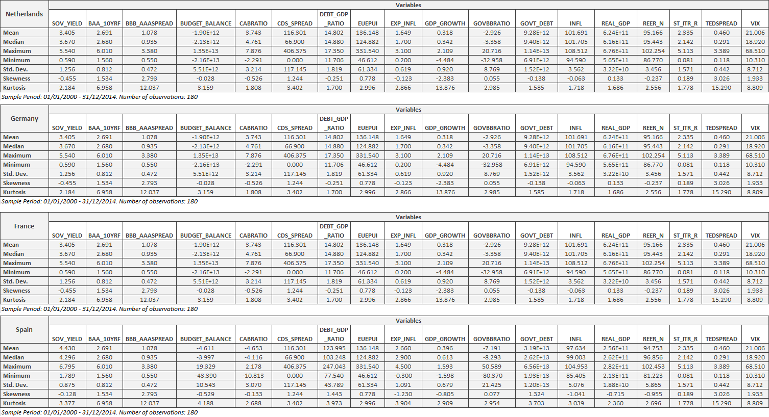

Table A4.2: Descriptive Statistics (Continuation)

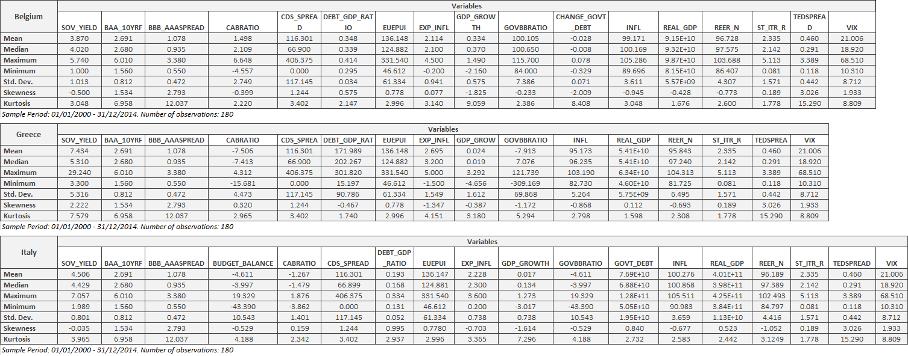

A5.1: Akaike’s Information Criterion

The AIC is an estimator of the Kullback-Leibler Divergence (KLD) one can expect between the ‘true’ model and a fitted statistical model. KLD is non-symmetric, convex function that measures the ‘distance’ between two probability distributions, where distance (d) is equal to:
$$d=\sum_{k}{p_{k}\log^{2}}\left(\frac{p_{k}}{q_{k}} \right)$$
Two assumptions are instantly made; P is viewed as the ‘true’ distribution, whereas Q is the distribution implied by the ‘fitted’ model. KLD is often referred to as relative entropy, e.g., average uncertainty of all possible occurrences minus the true uncertainty apparent before observation (Shannon entropy).
The Multivariate AIC itself is equal to:
$${AIC}_{cm}=AIC+2 \frac{k(ǩ+1+p)}{n-ǩ-1-p}$$
Where $k = ǩp + \frac{p(p+1)}{2}$ and$AIC=-2\ln\left(L\right)+2k$. In turn, L is equal to the maximized value of the maximum likelihood ratio. The number of lags that minimizes the AICcm will be selected.

For the augmented DF test, the test equation is as follows:
$$∆y_{t}=α+γY_{t-1}+\sum_{i=1}^{m}{a_{i}∆y_{t-1}+υ_{t}}$$
As $H_{0}: γ=0 (ρ=1)$ and${ H}_{a}: γ<0 (ρ<1)$; if $H_{0}$ is rejected then we conclude that the series is stationary.

Table A6.1: Granger Causality Potential Outcomes

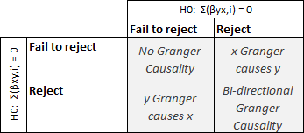

Table A6.2: Group Unit Root Tests
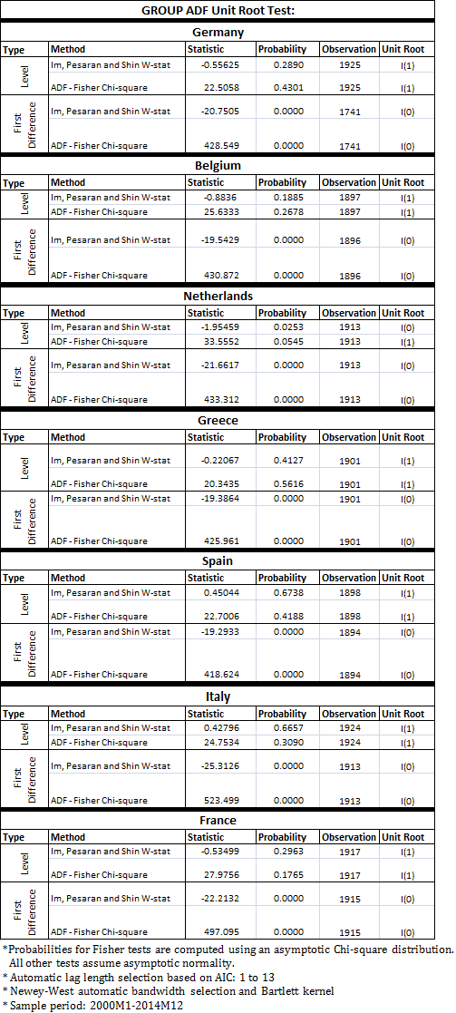

Table A6.3: Johansen’s Multivariate Cointegration Results

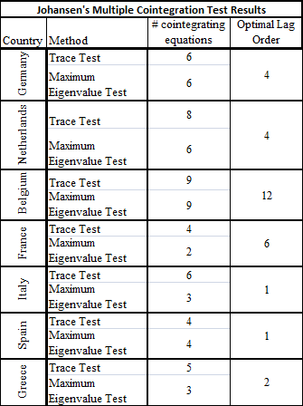

Table A6.4: Multivariate Vector Error Correction Models – Long Run Equilibria

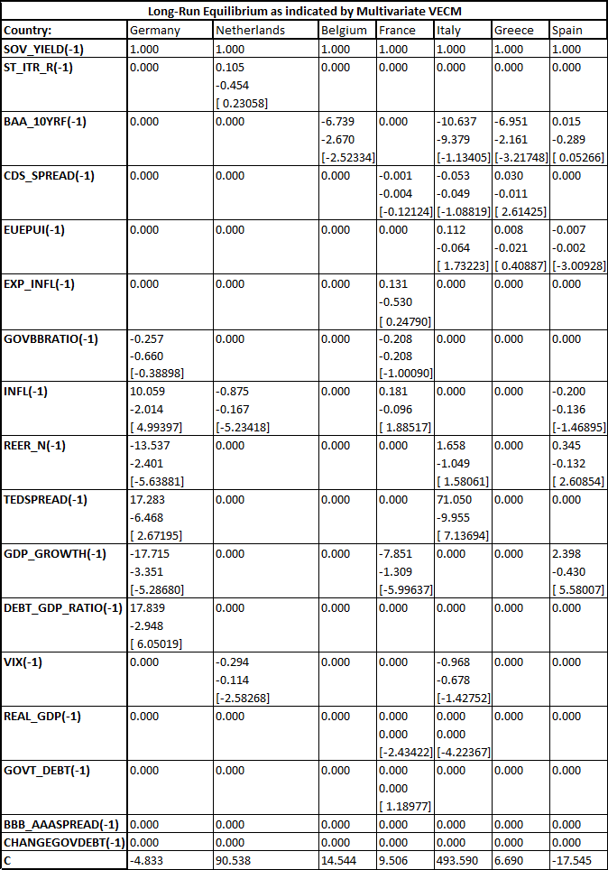
* The first term is the long-run coefficient of each respective variable (if above zero). The second term (below the first) indicates the
standard errors. Whilst the term in parentheses indicates the t-statistic.
** Any t-statistic above |2.7|, |2| and |1.684| is significant at the 1%, 5% and 10% level respectively.
Table A6.4: Multivariate Vector Error Correction Models (Continuation) – Error Correction Terms Part I

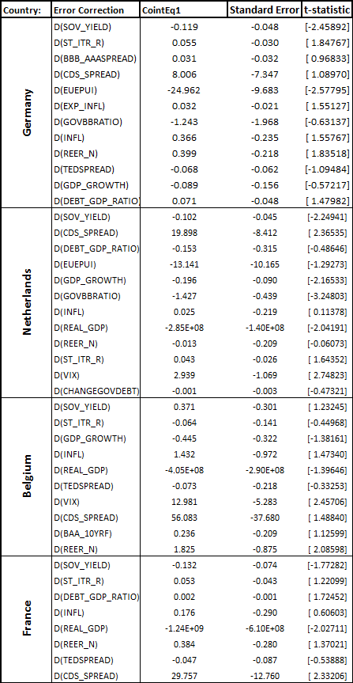
* Any t-statistic above |2.7|, |2| and |1.684| is significant at the 1%, 5% and 10% level respectively.
Table A6.4: Multivariate Vector Error Correction Models (Continuation) – Error Correction Terms Part II

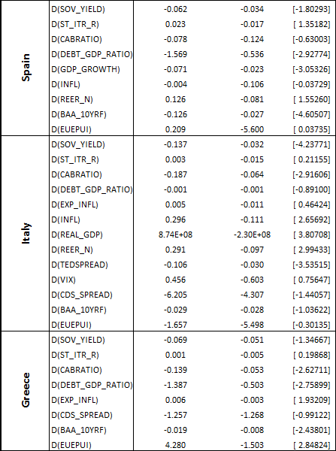
* Any t-statistic above |2.7|, |2| and |1.684| is significant at the 1%, 5% and 10% level respectively.

Table A6.5: VEC Granger Causality/Block Exogeneity Wald Tests
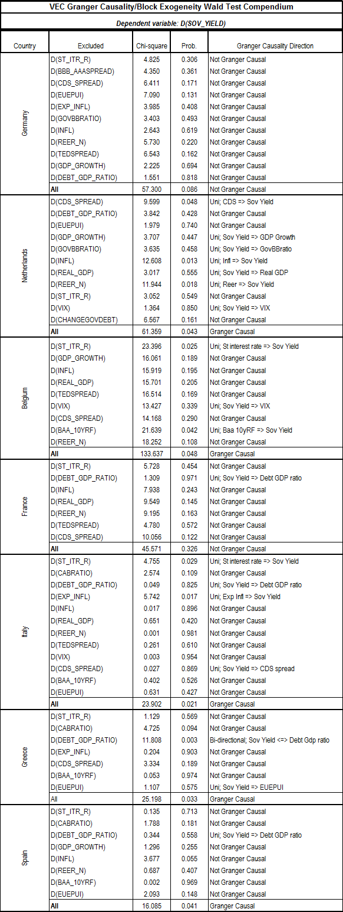

Figure A6.1: Impulse Response Functions

Germany:

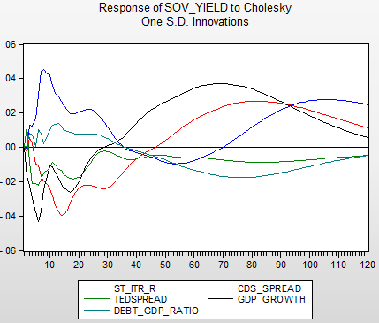

Netherlands:

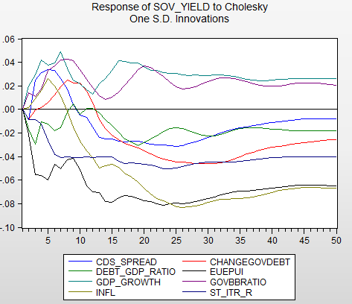

Belgium:

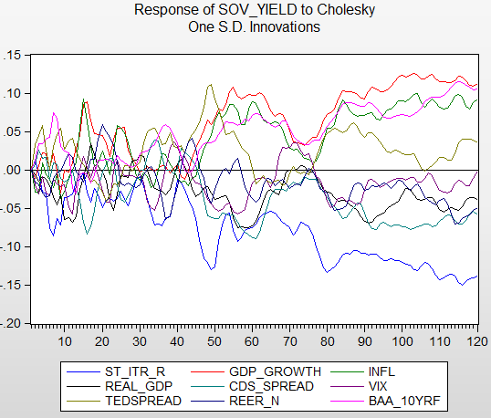

France:

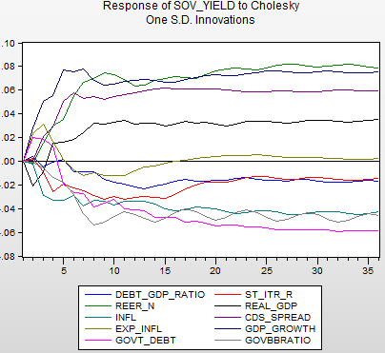

Spain:
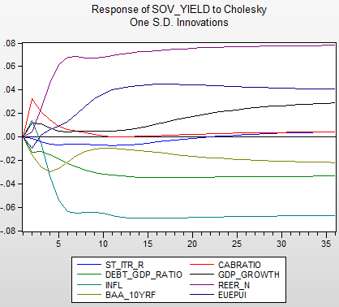

Italy:
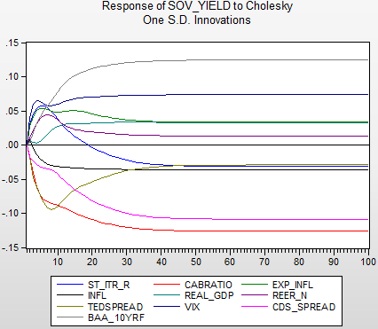

Greece:
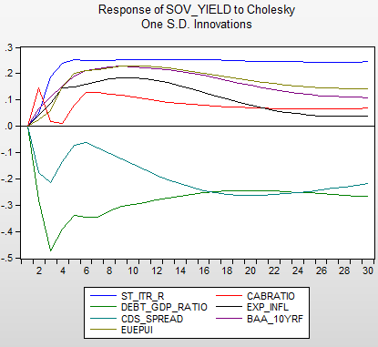
Table A6.6: Dynamic OLS – Compendium Results

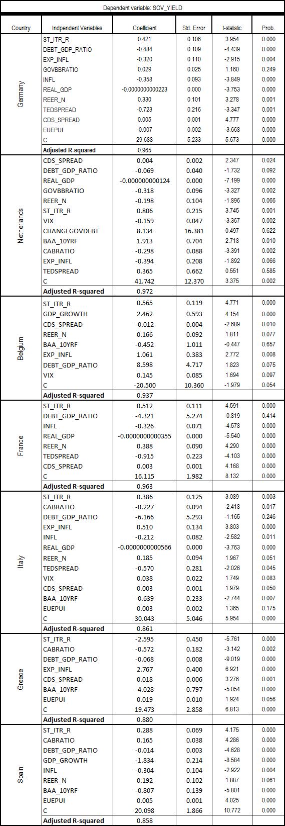

Student at the Erasmus School of Economics (student number: 329676ms), Erasmus University Rotterdam, contact via e-mail: marloesspanjersberg@gmail.com
Erasmus School of Economics, Erasmus University Rotterdam
https://www.ecb.europa.eu/mopo/implement/omt/html/index.en.html
https://www.ecb.europa.eu/press/pr/date/2015/html/pr150122_1.en.html
http://www.bloomberg.com/news/articles/2015-01-22/draghi-commits-ecb-to-trillion-euro-qe-plan-in-deflation-fight
http://blogs.wsj.com/moneybeat/2015/02/02/why-all-the-talk-of-negative-bond-yields
https://www.ecb.europa.eu/stats/monetary/rates/html/index.en.html
https://clubbrb.wordpress.com/tag/zero-lower-bound
http://www.zerohedge.com/news/2015-01-31/16-global-government-bonds-now-have-negative-yield-here-whos-buying-it
Houben, (2003)
Shleifer and Vishny, (2011)
Gesell, (1916)
Attanasi et al., (2009)
Modigliani and Sutch, (1966)
Lutz, (1940)
Culbertson, (1957)
The Ballad of East and West, Rudyard Kipling, (1889); published as part of Stedman’s A Victorian Anthology, (1895)
Picerno, (2010)
Kingston, (1989)
Cont and Tankov, (2009)
Longstaff, (2004)
Beber et al., (2009)
Engen and Hubbard, (2005)
Campbell et al., (2013)
Giese et al., (2014)
Abiad et al, (2007)
30/06/2015: courtesy of Euribor EDF Organization.
Principles of Econometrics, 3rd Edition. Authors: Hill, R.C. Griffiths, W.E. and Lim, G.C. 2008.
Banerjee et al., (2005)
Nguyen, (2011)
Stock and Watson, (1993)

