Erasmus University Rotterdam
Electricity market liberalization and renewable electricity innovation
An empirical analysis
Thesis author: Jan Quist
Student number: 364627
Study: Economie en Bedrijfseconomie; Erasmus Universiteit Rotterdam

Thesis supervisor: Brigitte Hoogendoorn

8/10/2015

This thesis studies the effects of electricity market liberalization on renewable electricity innovation in the European Union from 1990 to 2013 from an economic point of view. The transition to renewable electricity sources is an effective and efficient solution to environmental problems, and one of the most important solutions available. Innovation is required to attain the benefits of renewable electricity generation. The effect of electricity market liberalization on renewable electricity innovation should therefore bother policy makers in the European Union, although it is an underexposed aspect in liberalization research. This study aims to fill the gap.

Abstract
This thesis studies the effects of electricity market liberalization on renewable electricity innovation in the European Union from 1990 to 2013 from an economic point of view. The transition to renewable electricity sources is an effective and efficient solution to environmental problems, and one of the most important solutions available. Innovation is required to attain the benefits of renewable electricity generation. The effect of electricity market liberalization on renewable electricity innovation should therefore bother policy makers in the European Union, although it is an underexposed aspect in liberalization research. This study aims to fill the gap.
Previous work on the topic of electricity market liberalization identified positive effects for consumers, energy efficiency and prices. Two effects of electricity market liberalization on innovation are a market failure in basic R&D (Jamesb & Pollitt, 2008) and a switch from long term (and in particular cleaner, environmentally preferred energy supply R&D) to more customer-oriented product- and organizational innovations (Dooley, 1998). However, it is unclear whether these effects are initial or long term. The effect of electricity market liberalization on entry in renewable electricity innovative activities remained unstudied so far, as well as the effect on innovative quality.
OECD data on product market regulation for the electricity sector are used in this study to quantify electricity market liberalization. Patent data from the Orbis database provides insight in entry, innovative quantity and quality.
The major findings of this study are a positive association between electricity market liberalization and the quantity of innovative output in renewable electricity innovation; a negative association between electricity market liberalization and the quality of innovative output in renewable electricity innovation, and positive association between electricity market liberalization and entry in renewable electricity innovation. These findings are similar for studies on electricity innovation in general; and therefore seem to contradict with the theory presented in previous studies that liberalization is likely to be related with a decrease of long-term (and in particular renewable electricity) innovation (Dooley, 1998).

Contents
Abstract 1
Introduction 3
Social Relevance 3
Overview of knowledge 3
Problem statement 4
Research gap 4
Research question and objective 4
Set up 4
Contribution 5
Results 5
Structure 5
Chapter one: Literature review & Hypotheses 6
Trends 6
Niche 8
Hypotheses 8
Chapter two: Methodology & Data description 10
Measures 11
Sample description 14
Data analysis techniques 17
Chapter three: Results 19
Chapter four: Conclusion & Discussion 22
Summary and interpretation 22
Discussion 23
Answer research question 23
Bibliography 25

Introduction

Social Relevance
During the 90’s, most of the electricity markets were monopolized in the EU. The energy sector has liberalized since 1998. The EU aims for a single European electricity market, reliable energy supplies at reasonable prices for businesses and consumers and with the minimal environmental impact. The EU divides the electricity sector in a non-competitive part (e.g. operating networks) and a competitive part (e.g. supply to customers). Three sets of liberalization directives were introduced: a first set became operative in 1998, a second set in 2004, and a third set in 2007 (EU commission, 2012). These liberalization directives directly influenced competition and market structure of the electricity market in a way that is beneficial for consumers and more efficient for producers (Jamesb & Pollitt, 2005).
However, these benefits may come at a cost. Liberalization may influence innovation in renewable energy. Renewable energy is important because it is an efficient and effective solution to environmental problems, and one of the most important solutions available. Some of the most important environmental problems are: acid penetration, stratospheric ozone depletion, global climate change and the greenhouse effect. The benefits of renewable energy are not limited to environmental benefits; it also has energy, economic and flexibility benefits. In order to attain the benefits, innovation needs to be conducted as required (Dincer, 2000). A negative effect of liberalization on renewable electricity innovation could therefore have dramatic effects on the world and its future. But why would we expect a negative influence of the liberalization on renewable electricity innovation and what effects do we observe in practice?

Overview of knowledge
Research identified four effects of electricity market liberalization with respect to innovation. First, recent research on energy market liberalization has identified a drastic cut in R&D investments. At the same time, the number of patent applications increased considerably. We do not know whether these effects are temporary or a long lasting feature of liberalization (Jamesb & Pollitt, 2008).
Second, it affected the scope of innovation. The increased scope in variation may reduce path dependency, thus increase the likelihood of radical innovations to develop. Firms share less knowledge with one another, making imitation of innovations harder, therefore increasing the incentive to innovate (Markard & Truffer, Innovation processes in large technical systems: Market liberalization as a driver for radical change?, 2006).
Third, it affected the focus of innovation management. The focus of innovation management switches from incremental, technology-oriented innovation to more radical, customer-oriented product innovations and organizational innovations (Markard & Truffer, Innovation processes in large technical systems: Market liberalization as a driver for radical change?, 2006). This short-termism as result of market liberalization is also recognized in the telecommunications industry (Calderini, Garrone, & Sobrero, 2003).
Fourth, electricity market liberalization is associated with increased rates of entry in the product market. Higher rates of entry are associated with higher rates of innovation and increase in efficiency. For more recently deregulated industries, entry encourages incumbents to drastically cut slack from their operations, which results in increasing efficiency (Geroski, 1995).

Problem statement
The benefits of electricity market liberalization may come at a cost. Traditional electricity production relies on fossil fuels, which the world is running out of. The transition to renewable energy sources is essential if electricity consumption stays constant or increases. The transition requires innovation, which might be effected by the liberalization of the electricity market.

Research gap
Research on product market liberalization covers several aspects of liberalization. First, Dooley (1998) studied the effect of electricity market liberalization on R&D expenditures to electricity in the United States. Sanyal & Gosh (2013) studied the effect of electricity market deregulation on patent applications in the United States from 1980 to 2000. Cambini et al (2015) studied the effect of electricity market liberalization in Europe on R&D expenditures to electricity and the effect of electricity market liberalization on patenting statistics. All these studies look at the effect of innovation in the entire electricity sector. The important and uncovered aspect of renewable electricity innovation remains to be studied in this work.

Research question and objective
What are the effects of electricity market liberalization on renewable electricity innovation in the European Union?
The objective of this study is to quantify the effect of electricity market liberalization on renewable electricity innovation.

Set up
The set up for this study is the following. First, a proxy for electricity market liberalization will be used to approach the development of the liberalization. Second, patent statistics will be used to quantify renewable electricity innovation. Besides a basic patent count measure, this study will also look at entry of firms in the innovative process and add patent value to adjust the results for patent and innovation quality.

Contribution
The contribution of this study is covering an important and under-exposed part of liberalization research: the effect on renewable energy innovation.

Results
The major findings of this study are a positive association between electricity market liberalization and the quantity of innovative output in renewable electricity innovation; a negative association between electricity market liberalization and the quality of innovative output in renewable electricity innovation, and positive association between electricity market liberalization and entry in renewable electricity innovation. These findings are similar for studies on electricity innovation in general; and therefore seem to contradict with the theory presented in previous studies that liberalization is likely to be related with a decrease of long-term (and in particular renewable electricity) innovation (Dooley, 1998).

Structure
This paper is organized as follows. Chapter one reviews literature and presents the hypotheses. Chapter two specifies the methodology and describes the data. Chapter three presents the results and provides estimates for the effects of variables of interest on renewable electricity innovation. Chapter four concludes.

.

Chapter one: Literature review & Hypotheses
This chapter will describe the overall trends in liberalization research with regards to innovation. First, it will describe the general effects of electricity market liberalization on innovation. Second, it will describe how the effects are heterogeneously for different types of firms and industries. After that, the hypotheses will be presented.

Trends
Recent research on energy market liberalization has identified a drastic cut in Research and Development (R&D) investments (Jamesb & Pollitt, 2008). The authors link much of this decline to market reforms. Their claim goes even further:
“Most reform steps such as competition, unbundling, and private ownership, appear to have contributed to market failure in basic R&D” (p. 1007)
The market failure exists, according to Jamesb et al, due to positive externalities from R&D. More specific, spillovers and limits to appropriation of benefits reduce the returns from R&D expenditure to private investors. As a result, the specific effect of this market failure may cause a switch from the focus from long-term ‘green’ innovation to short term competitive innovation. This view can also explain why innovative output, such as patenting and organizational adjustment, appears to have improved despite a cut in R&D expenditure. R&D produces more output in the short run, going along with a decrease in long-term technological progress and innovation. Another explanation for the apparent improvement in terms of patent applications is the concept of entry deterrence. This concept states that preemptive patenting can be used to deter entrance for new products (Smiley, 1988).
The idea of market failure in basic R&D is also supported by a qualitative study by Markard & Truffer (2006). Their work addresses the question how market liberalization has altered the way innovations are handled in the electricity supply system. This is a qualitative research on the lock-in phenomena, the path-dependency of innovation and the notion of technological regimes, which guide innovation processes. Besides that the authors perform a case study on three radical innovations in the electricity sector. They find an effect of market liberalization on innovation in the electricity sector in at least two respects: the scope of variation and the focus of innovation management. First, the increased scope of innovation may reduce path dependency, thus increase the likelihood of radical innovations to develop. Firms share less knowledge with one another, making imitation of innovations harder, therefore increasing the incentive to innovate. Second, the focus of innovation management switches from incremental, technology-oriented innovation to more radical, customer-oriented product innovations and organizational innovations.
Dooley (1998) finds the same. His major conclusion is that long term energy R&D (and in particular cleaner, environmentally preferred energy supply R&D) is unlikely to be supported by individual utilities in a competitive, deregulated utility market. On top of that, nations’ public R&D support declined at a rate of 23%. These combined effects create concerns about the future of renewable energy supply.
Electricity market liberalization is associated with increased entry in the product market (Joskow, 2008). Geroski (1995) summarized what empirically-minded economists know about entry in general. His literature review results in a list of stylized facts about entry. Entry barriers are high, high rates of entry are often associated with high rate of innovation and increases of efficiency. Entry in newly deregulated industries encourages incumbents to drastically cut slack from their operations (Geroski, 1995).
The following section will describe how the effects of liberalization on innovation are heterogeneously for firms, industries and markets. Aghion et al (2009) investigate the effect of entry on incumbent innovation incentives and productivity. They analyze UK data of several industries on innovation (patenting) and entry. They find a positive effect of entry on incumbent innovation for firms close to the technology frontier, and a negative effect for firms far from the technology frontier (Aghion, Blundell, Griffith, Howitt, & Prantl, 2009)
We know that firms respond heterogeneously to changes in their environment regarding patenting. A firm is more likely to apply for patents if it is larger, has more innovation output (e.g. sales of innovative products), has more R&D collaboration agreements and operates in a high technology sector. Smaller firms have a smaller probability to patent due to patent cost and lack of information about the possibilities of the patent system (Brouwer & Kleinknecht, 1999).
Large firms have an innovative advantage in industries which are capital-intensive, concentrated and advertising-intensive. Small firms tend to have an advantage in early stages of the life cycle, where the industry is innovative-intensive, where total innovation and the use of skilled labor play a large role (Acs & Audretsch, 1987).
To summarize, the literature identifies a market failure in basic R&D, a switch from long-term (and in particular cleaner, environmentally preferred energy supply R&D) to more customer-oriented product- and organizational innovations.

Niche
The results from previous work mentioned above do not answer a very relevant, under-exposed aspect of electricity market liberalization: the effect on renewable electricity innovation.

Hypotheses
CCGT (combined cycle gas turbine, a very efficient generator for electricity and heat) was invented for the use in planes. Larger versions became more and more efficient in generating electricity. Such cross-industry innovation or knowledge-spillover is more productive (in terms of sales from innovative products) and more prevalent if a market has lower entry barriers (Sheremata, 1997). The liberalization of the electricity sector opened up the possibility of entry. Lower entry barriers to the electricity market are therefore also likely to lower entry barriers for renewable electricity innovation. Electricity market liberalization is therefore likely to be associated with more entry in the renewable electricity innovation process.
At the same time, Dooley (1998) states that in particular long term, environmentally preferred energy supply R&D is unlikely to be conducted by individual firms in competitive markets. R&D activity can be recognized as an innovative activity (Pavitt, 1982). This links R&D to the renewable electricity innovation process. The electricity market liberalization increased competition (Jamesb & Pollitt, 2005). Hence, electricity market liberalization is unlikely to be associated with more entry in the renewable electricity innovation process. The first hypothesis aims to test these conflicting theories:
Hypothesis 1a: Electricity market liberalization is associated with more entry in the renewable electricity innovation process.
Hypothesis 1b: Electricity market liberalization is associated with less entry in the renewable electricity innovation process.
The association between electricity market liberalization and innovation can be further studied by looking at the development of the quantity and quality of innovative output. Innovative output is a measure of innovation, and therefore useful to study innovation. A three-step argumentation links electricity market liberalization to quality of innovative output. First, patents can be seen as a measure of innovative output (Brouwer & Kleinknecht, 1999). Patents vary enormously in their technological and economic importance, and the distribution of such “values” is extremely skewed (Hall, Jaffe, & Trajtenberg, 2005). This makes it more important to analyze the value of patents, in order to make conclusions about innovation.
Second, a firms’ propensity to patent can be influenced by market structure. Patents were designed to protect innovators from predators to copy their innovation. In practice however, patents can also be used to block or hinder competition. This is an incentive for especially large firms to hoard patents to protect against the risk of getting blocked (Blind, Edler, Frietsch, & Schmoch, 2006). If there is no (threat of) competition, there is less reason to protect your inventions and to hoard patents. Competition increases the incentive to hoard patents.
Third, electricity market liberalization is associated with increased competition (Joskow, 2008). Therefore it is associated with increasing incentives to patent. Since patenting is a measure of innovative output, electricity market liberalization is linked to innovation. It is even possible to argue in which direction this association works. Before liberalization, companies and innovators did already patent some of their innovations. It makes sense to assume that they patented their most valuable inventions in terms of expected returns. If a firm patents more after liberalization, it will patent relatively more innovations with lower expected returns than it did before liberalization. This leads to hypothesis two:
Hypothesis 2: Electricity market liberalization is associated with:
- An increase in the quantity of renewable electricity innovative output and
- A decrease in the quality of renewable electricity innovative output.

Chapter two: Methodology & Data description
Two main data sources will be used in this study. Data on electricity market liberalization comes from the International Regulation database. Data on renewable electricity innovation comes from the Orbis database. Both databases will be discussed in the sections below. After that, a brief description and some descriptive statistics of the variables used in this study will be provided.

International Regulation database
The International Regulation database is a public available database from the Organization for Economic Co-operation and Development (OECD). Its purpose is to provide quantitative indicators for qualitative data on laws and regulation. The International Regulation database provides product market regulation (PMR) indicators for several ranges: economy-wide regulation, sector regulation, internet regulation and competition law and policy. The sector regulation dataset contains information about network sectors, retail trade and professional services. The network sectors are described in the ETCR (Energy, Transport and Telecommunications Regulation) indicator. The electricity sector is part of the energy sector. PMR indicator values are available for the electricity sector, taking into account all of the following: entry barriers, the vertical structure of the market, the market share of the dominant player(s), the presence of the state as a shareholder and the presence of regulatory controls (Cambini, Caviggioli, & Scellato, 2015). The index and each of its components can take continuous values between 0 and 6, with higher values indicating less openness. The data is collected in questionnaires in 2013, 2007, 2003 and 1998, and have been extensively checked by OECD and government experts. Yearly data is available from 1975 to 2013 and covers 47 countries, of which 34 are the current OECD members (OECD, 2013). The other 13 countries are Brazil, Bulgaria, Canada, China, Croatia, Cyprus, India, Indonesia, Latvia, Lithuania, Malta, Romania and South Africa.

Orbis database
This study relies on patent data from the Orbis database (Bureau van Dijk, 2015). The database contains information on companies, mergers & acquisitions, reports and patents. The relevant data comes from the patent section. This section contains data on all patents filed to all national patent offices in Europe, to the EPO and to other patent offices in the world.
Patent data are directly collected by the EPO. Companies and individuals can apply for a patent directly at the EPO. Inventions meet the requirements for patenting if it was not known to the public in any form, is not obvious to a person skilled in the art, and can be manufactured or used industrially. Patent applications can be filed at the European Patent Offices in Berlin, The Hague and Munich, or at the national patent office of a member’s country. All countries on the European continent are members of the EPO, including Turkey, Cyprus, Malta and Morocco. The process from application to grant has several stages. Once an invention is applied for a patent, the EPO starts the examination on filing and formal requirements. Next stage is a search relating to state of the art, which basically checks the innovativeness of the invention. This part of the process is completed within 18 months from application. At this point, the application will be published. After that, the examination of the application will take place. Other parties are allowed to take opposition to the application. Finally, the patent will be granted after 24 months if it survives all stages (European Patent Office, 2015).
The Orbis database collects information from the EPO on the following relevant parameters: patent grants, the date at which the patent application is published, the inventors’ and current owners’ country, the inventor’s name, and the number of citing and cited documents. EPO does not record the number of cited documents for granted patents. Each patent application can have multiple inventors and owners. Inventors and owners can both be private or business parties. Most business parties in the Orbis database are linked to an identifier, the Bureau van Dijk Identifier (BvDID), named after the company that maintains the Orbis database. This identifier is constructed for all business firms in the database, and allows to link patents to companies. Patent applications by universities, private parties and other institution are not linked to this BvDID.

Measures
In this section will be described and explained what variables are used to test the hypotheses mentioned in the literature section. Five concepts will be operationalized: liberalization, renewable electricity innovation, entry, and the quality and quantity of innovative output.

Liberalization
Electricity market liberalization has been captured in previous studies by the PMR index (Cambini, Caviggioli, & Scellato, 2015), (Nesta, Vona, & Nicolli, 2014), interviews (Markard, Truffer, & Imboden, 2004) and renewable energy policies (Johnstone, Haščič, & Popp, 2010), (Nesta, Vona, & Nicolli, 2014). In this study, electricity market liberalization is operationalized with the PMR index for the electricity sector, because it is a quantitative measure for a qualitative concept, specific for the electricity market, and in line with previous literature.

Renewable electricity innovation
Research on innovation generally uses two types of measures: input and output measures. An example of an input measure of innovation is R&D investments, and an example of an output measure is patent applications. Secondary measures like the European Innovation Scoreboard are also available, making use of data on R&D investments and the Community Innovation Survey.
Renewable electricity innovation has been captured in previous studies by patent selections (Nesta, Vona, & Nicolli, 2014) (Cambini, Caviggioli, & Scellato, 2015) (Johnstone, Haščič, & Popp, 2010). This study also captures renewable electricity innovations based on patent selections. Every patent application gets labeled according to its field of technology, based on the World Intellectual Property Organization’s (WIPO) International Patent Classification (IPC) system (WIPO, 2015). The IPC system is organized in sections A-H, where for example section E covers Fixed Constructions, section G covers Physics and section H covers Electricity. Section H is subdivided in H01-H05 and H99, where for example H01 covers basic electric elements, and H02 covers Generation, Conversion, or Distribution of Electric power. All these subdivisions are further specified to fields of technology. A patent application can be labeled with multiple IPC codes.
These IPC codes can be used to select only those patents with at least one IPC code relating to renewable electricity innovation. The relevant IPC codes are the same for this study as for previous research on renewable electricity (Johnstone, Haščič, & Popp, 2010) (Nesta, Vona, & Nicolli, 2014). One of the main benefits of using IPC codes to select renewable electricity patents is the ease of selection. One problem is the risk of selecting patents that do have one of the relevant IPC codes, but in fact are not related to renewable electricity innovation. In this case, the search selects more patents than those related to renewable electricity innovation. The patent office is responsible for assigning IPC codes to a patent application, and therefore this risk can be assumed to be non-substantial. At the same time, it is possible to miss innovations that are in fact related to renewable electricity innovation, but not recognized as such by the patent office.

Entry
As innovation is already a slippery concept, entry in innovation may seem even trickier to define and interpret. As mentioned in the literature section, the purpose of studying entry in renewable electricity innovation is to test for two theories: knowledge spillovers increase renewable electricity innovation, and competition decreases it. It is beyond the scope of this study to disentangle these two effects if both exist. This study aims to determine the net result of liberalization on entry in the innovative process. The following section will first define entry, and after that provide two measures of entry in the renewable electricity innovation process.
In this study, firms are defined to enter the renewable electricity innovation process if they file a patent application in the field of renewable electricity technology. It is unobservable when firms put effort in innovation. It is however probable that firms enter the renewable electricity innovation process when they put effort in it. Data on R&D efforts is (limited) available, but even firms do not know if their innovative effort results in renewable electricity innovation. A definition of entry, based on output measures of innovation, is therefore much easier to quantify and defend. The first measure of entry is the total number of firms that file a patent application in a given year. An increase in the total number of firms that file a patent application indicates an increase in entry in the renewable electricity innovation. The second measure of entry is the average number of patent applications per firm in a given year. An increase in the total number of firms that file a patent application could also be explained by an increase of the total market size (e.g. total number of patent applications). An increase in the average number of patent applications indicates a relative decrease in entry, since the market size increases at a higher rate than the total number of firms in the market.

Quantity and Quality of innovative output
The quantity of innovative output is easy to define as the total number of patent applications in a given year. The quality of patents can be defined as the economic impact of a patent.
“Patents are a flawed measure (of innovative output); particularly since not all new innovations are patented and since patents differ in their economic impact”. (Pakes & Griliches, 1980, p. 5)
One of the most powerful proxies of patent quality is patent litigation (Allison, Lemley, Moore, & Trunkey, 2004). However, this proxy does not enter this study because it is too time consuming to study. Other measures of patent quality are patent family size (in how much countries give the patent protection), renewal fee payments, patent grants and patent citations (Harhoff, Scherer, & Vopel, 2002). This study relies on grants and citations.

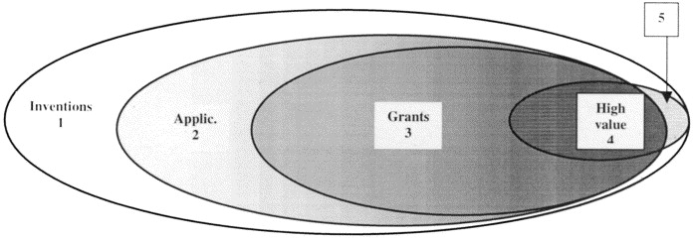
Whether a patent application gets granted or not, may say something about its value (Guellec & Pottelsberghe de la Potterie, 2000). Patent applications are made for a proportion of all inventions. Of these applications, a proportion is granted. High value inventions are more likely to be patented, and applications with high value are more likely to be granted. This makes patent grants a valuable proxy for a general analysis of the development of patent value over time, according to Guellec & Pottelsberghe de la Potterie (2000). It is also worth noting that a proportion of the high value inventions are not patented.
Figure 1: Inventions, patent applications, patent grants and the value of inventions. The darker area represents more valuable inventions (Guellec & Pottelsberghe de la Potterie, 2000).
With regards to patent citations, literature often makes a distinction between citations to other patents as prior art (backward citations) and citations by other patents (forward citations). Forward citations has the most explanatory power of the two (Harhoff, Scherer, & Vopel, 2002). In this work, forward citations are used as one measure for patent quality.
Electricity consumption in the European region (EU28) is used as control variable to weigh for the total size of the electricity market (Eurostat, 2015). Table 2 provides an overview of all variables in the dataset, a description of the variables and a reference to their respective sources.

Sample description
This section will give an impression of the datasets used in this study. First, it will describe the characteristics and a summary of the Product Market Regulation (PMR) index. Second, it will discuss the patent dataset, providing summary statistics and a discussion of the measures mentioned in the previous section.

PMR index
For the PMR index (table 1), most countries start in the 80’s with a low degree of openness (PMR index score ~6). Data for Croatia, Cyprus, Latvia, Lithuania and Romania is only available for 2013. The low degree of public ownership in Germany (index score of 3.0 from 1975 to 1996) is the reason for the lower PMR index score of 5.0. The same holds for Belgium, which has a public ownership index score of 1.73 from 1975 to 1998, and for Norway, with a public ownership index score of 4.5 from 1975 to 2013. United Kingdom has an entry index score of 5.0 from 1975 to 1989. Beside these exceptions, all countries start on this index with the lowest degree of openness, with a score of 6.0. Index scores start to fall in the 90’s. UK, Spain, Sweden and Norway take the lead, followed by almost all other countries before 2000. Iceland, Slovak Republic, Slovenia, Greece and Poland are the latest market reformers.
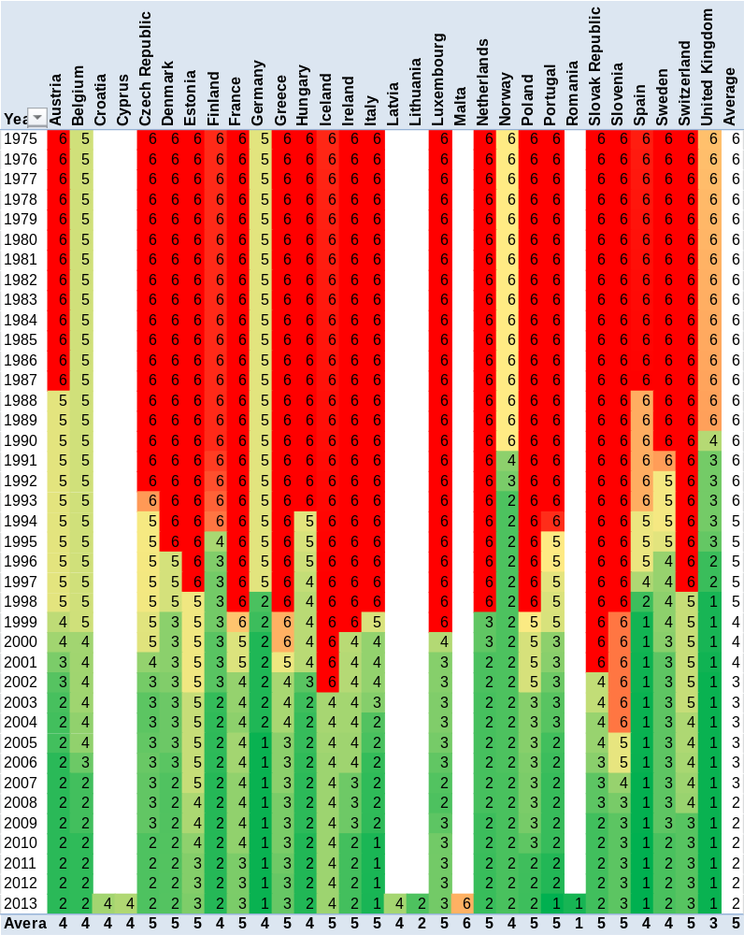
There is one example where the index score increased after a temporary decrease. In Luxembourg, the index score is below 3.0 in 2006-2009 (below 2.5 only in 2007 and 2008), and above 3.0 in 2010-2013. This effect is entirely caused by a change in the market structure indicator. This indicator is constructed with the following three questions: “What is the market share of the largest company in the sector for each of the following: electricity generation, supply and import?” For each of these questions, there are only four possible answers: Smaller than 50%, between 50% and 90%, greater than 90%, or sector does not exist. In the case of Luxembourg, the answers for supply and import in 2008 were ‘smaller than 50%’, and in 2013 ‘between 50% and 90%’. This indicates a decrease in market openness, and therefore an increase in the PMR index score.
Table 1: PMR index for the electricity sector, per country from 1975 to 2013 (OECD, 2013).

Patents
The parameters related to entry and patent quality will be discussed after a brief description of the patent dataset.
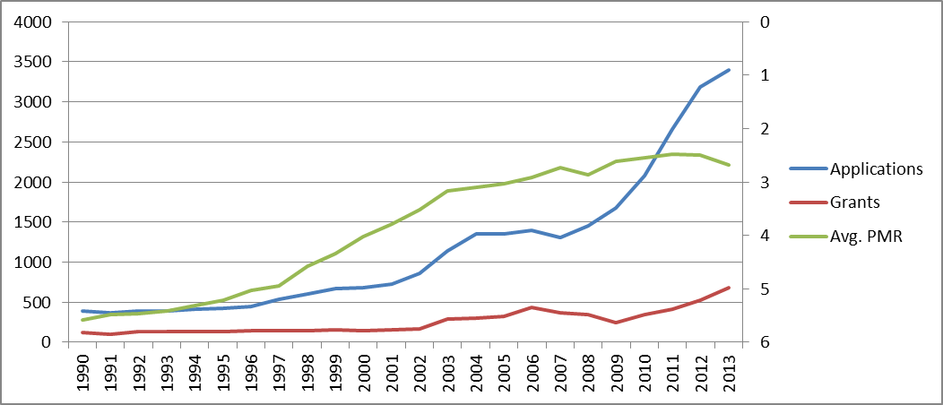
The patent dataset contains 29980 patent applications from 1990 to 2014. The data contains information on inventor’s country. Every patent has on average 1.1 inventors. In cases where the EPO mentions more than one inventor, only the first mentioned inventor enters the dataset. This allows assigning patents to countries, and avoids double counting of patents when they are assigned to countries. The top 10 inventor’s countries are Germany, Japan, United States, Denmark, United Kingdom, France, Italy, Spain, the Netherlands and Switzerland. These count for 79% of all patent applications. 7.5% of all patent applications have no information available for inventor country. The figure below shows the overall trend of the number of patent applications and grants from 1990 to 2013. An increase in the value of Avg.PMR indicates an increase in market openness. This figure shows clearly that an increase in market openness precedes an increase in the total number of patent applications.
Figure 2: Trend in applications (left axis), grants (left axis) and PMR indicator value (right axis, inverted scale) from 1990 to 2013
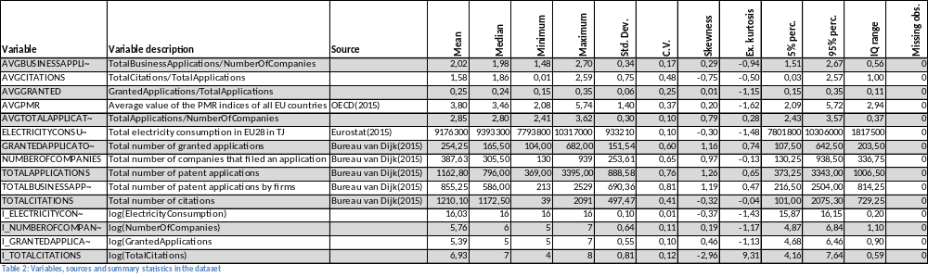
Entry can be extracted from the BvDID data. Over the years, on average 73% of the patent applications have data available on current owners BvDID; 81% for granted patents, 70% for non-granted patent applications. Note that there is no data available on inventors’ BvDID. Patent quality is related to grants and citations. 21.8% of the patent applications have been granted (standard deviation of 5.9%). 21% of the patent applications get cited (6373 applications), with a total number of 29042 citations to these patents. Each cited patent application gets on average 4.5 citations (standard deviation of 6.1, minimum of 1 and maximum of 95); every patent application gets on average 0.97 citations.

Data analysis techniques
Patent counts have the specific property that it is count (non-negative integer) data. The variable total number of firms (hypothesis 1) has the same property, following a Poisson distribution (Hausman, Hall, & Griliches, 1984). The appropriate data analysis technique is a special case of the general linear model, the Poisson regression. Models with dependent variables like average number of citations (AvgCitations) can be estimated with the least squares method, because the dependent variable is not limited.
Hypothesis one will be tested with three dependent variables, each dependent variable in a separate model: total number of companies that (co)filed a patent application at the EPO, average number of patent applications per firm, and the logarithm of the total number of companies that (co)filed a patent application at the EPO. Hypothesis two will be tested with seven models, each with one of the following dependent variables: the total number of granted patent applications at the EPO, the percentage of patent applications that got granted, the log of the total number of granted patent applications at the EPO, the total number of forward citations, the average number of citations relative to the total number of applications, the log of the total number of citations, and finally the log of the total number of applications. A variant with one-year lagged independent variables will be estimated for all models as well. For all models, the independent variables are the average PMR score of all European countries, the log of the total electricity consumption in the European Union and a constant (intercept). An extra model will be estimated for hypothesis one with regards to average number of patent applications per firm. This model adds the log of the total number of applications to the EPO, to adjust for possible trends in the propensity to patent.

Chapter three: Results
This section reports the models and econometric results of the analysis.
The first model estimates the effect of changes in openness of the electricity market, proxied by the PMR index, on the total number of companies that filed a patent application in the field of renewable electricity in Europe. The data provides the PMR indices per country. The index for Europe is the average of the national indices (see figure 1). The model specification is the following:
$$NumberOfCompanies= β_{0}+β_{1}{\left(PMR Index\right)}_{t}+ β_{2}{(logConsumption)}_{t}+ε_{t}$$
where t=1, 2 … t represent the years, β₀ is the intercept, and β₁ and β₂ are the regression coefficients. Table 3 summarizes the estimates for the models used to test the first hypothesis. Note that the model specification for model 5 and 6 is the following:
$$NumberOfCompanies =β_{0}+β_{1}{\left(PMR Index\right)}_{t}+ β_{2}{\left(logConsumption\right)}_{t}+$$
$${β_{3}(logTotalApplications)}_{t}+ε_{t}$$
where $β_{3}$ is the regression coefficient for the parameter logTotalApplications.
Dependent variable | NumberOfCompanies | NumberOfCompanies | AvgBusinessApplications | AvgBusinessApplications | AvgBusinessApplications | AvgBusinessApplications | LogNumberOfCompanies | LogNumberOfCompanies
Model | 1 | 2 | 3 | 4 | 5 | 6 | 7 | 8
Statistical Method | Count | Count | OLS | OLS | OLS | OLS | OLS | OLS
Number of Lags |  | 1 |  | 1 |  | 1 |  | 1
AvgPMR | -0,84*** | -0,82*** | -0,25* | -0,37** | 0,27* | 0,01 | -0,71*** | -0,66***
 | (0,04) | (0,03) | (0,14) | (0,13) | (0,14) | (0,18) | (0,13) | (0,11)
logConsumption | -5,32*** | -4,97*** | -0,47 | -1,75 | 2,50* | 0,27 | -3,67** | -2,97*
 | (0,50) | (0,49) | (1,84) | (1,70) | (1,41) | (1,64) | (1,70) | (1,45)
logTotalApplications |  |  |  |  | 0,62*** | 0,53**
 |  |  |  |  | (0,13) | (0,19)
(McFadden) Rsq | 0,85 | 0,91 | 0,76 | 0,80 | 0,89 | 0,86 | 0,94 | 0,96
Adj Rsq | 0,88 | 0,91 | 0,74 | 0,78 | 0,87 | 0,83 | 0,94 | 0,95
Obs. | 24 | 23 | 24 | 23 | 24 | 23 | 24 | 23
Table 3: Summary of the estimates for model 1-8. Significance levels: *10% **5% ***1%. Standard errors in parenthesis
A similar setup will be followed for the second hypothesis. This time, 14 models will be estimated. Model 9-14 test the effect of changes in market openness, proxied by the PMR index, on patent grants. Model 15-20 test the effect of changes in market openness on patent citations. Model 21 and 22 test the effect of changes in market openness on the quantity of innovative output, proxied by the total number of patent applications.
Dependent variable | TotalGrants | TotalGrants | AvgGrants | AvgGrants | LogGrants | LogGrants
Model | 9 | 10 | 11 | 12 | 13 | 14
Statistical Method | Count | Count | OLS | OLS | OLS | OLS
Number of Lags |  | 1 |  | 1 |  | 1
AvgPMR | -0,39*** | -0,65*** | 0,09*** | 0,04 | -0,37* | -0,61***
 | (0,04) | (0,04) | (0,03) | (0,04) | (0,20) | (0,17)
logConsumption | -0,14 | -3,65*** | 0,81* | 0,07 | -0,35 | -3,48
 | (0,62) | (0,61) | (0,42) | (0,49) | (2,71) | (2,25)
(McFadden) Rsq | 0,70 | 0,77 | 0,62 | 0,51 | 0,80 | 0,86
Adj Rsq | 0,69 | 0,77 | 0,59 | 0,46 | 0,78 | 0,85
Obs. | 24 | 23 | 24 | 23 | 24 | 23
Table 4: Summary of the estimates for model 9-14.Significance levels: *10% **5% ***1%. Standard errors in parenthesis
Dependent variable | TotalCitations | TotalCitations | AvgCitations | AvgCitations | LogCitations | LogCitations | LogTotalApplications | LogTotalApplications
Model | 15 | 16 | 17 | 18 | 19 | 20 | 21 | 22
Statistical Method | Count | Count | OLS | OLS | OLS | OLS | OLS | OLS
Number of Lags |  | 1 |  | 1 |  | 1 |  | 1
AvgPMR | 0,67*** | 0,94*** | 1,07*** | 1,13*** | 1,18* | 1,78*** | -0,84*** | -0.82***
 | (0,02) | (0,02) | (0,27) | (0,23) | (0,61) | (0,56) | (0,16) | (0.13)
logConsumption | 10,30*** | 13,49*** | 8,20** | 8,97*** | 15,75* | 23,06*** | -4,8** | -4.47**
 | (0,31) | (0,03) | (3,59) | (3,09) | (8,19) | (7,53) | (2,19) | (1.70)
(McFadden) Rsq | 0,25 | 0,34 | 0,81 | 0,86 | 0,15 | 0,33 | 0,92 | 0.95
Adj Rsq | 0,24 | 0,34 | 0,79 | 0,85 | 0,07 | 0,27 | 0,92 | 0.95
Obs. | 24 | 23 | 24 | 23 | 24 | 23 | 24 | 23
Table 5: Summary of the estimates for model 9-14.Significance levels: *10% **5% ***1%. Standard errors in parenthesis
The estimates indicate an overall negative and significant association between the PMR index and the entry and grants measures, except model 5 and 6, which indicate a positive association between the PMR index and the average number of business applications. The values of the (adjusted) R-squared indicate that a high proportion of the variance in the entry and grants measures can be explained with the models. Further, the estimates indicate a positive and significant association between the PMR index and patent citations. Here, the values of the (adjusted) R-squared indicate that a low proportion of the variance in the citation measures can be explained with the models. Generally, models with a one-year time lag report higher (adjusted) R-squared values.
When looking at the parameter estimates, it is important to notice that higher values of the PMR index are associated with a lower degree of market openness.
The estimates of the two measures for the first hypothesis (total number of companies and average number of applications per company; model 1-8) have consistent implications for the first hypothesis. An increase in the total number of companies indicates an increase in entry, which would reject the null hypothesis of no effect. At the same time, an increase in the average number of applications per company (model 3 and 4) indicates a relative decrease in entry, which does as well reject the null hypothesis of no effect. Adding the log of the total number of patent applications (model 5 and 6) switches the sign of the relationship, and makes the relationship between the PMR index and the average number of applications per company less significant. However, the results of model 5 indicate a relative increase in entry, which makes the results consistent with model 1-8.
The estimates of the four measures innovation quality (total number of granted patents, granted patents as percentage of total applications, total number of patent citations and average number of patent citations per application; models 9-22) have contradicting implications for the second hypothesis. Estimates for patent grants indicate a higher quality of innovative output when looking at the absolute number of grants, but a lower quality of innovative output when looking at the granted patents as percentage of total applications. Estimates for patent citations consistently indicate a lower quality of innovative output. Therefore, hypothesis two (null hypothesis: no effect of liberalization on innovative quality, alternative hypothesis: decrease of innovative quality) can be rejected, indicating a negative association between electricity market liberalization and innovative quality. The estimate for the measure of innovation quantity (total number of patent applications; model 19) indicates a negative and significant association between the PMR index and innovative output. Therefore, the null hypothesis of no association between the PMR index and the quantity of innovative output can be rejected.

Chapter four: Conclusion & Discussion
This section first summarizes and interprets the major findings of this study. After that, a brief discussion of the limitations of this study and an answer to the research question will be provided.

Summary and interpretation
The major findings of this study are a positive association between electricity market liberalization and the quantity of innovative output in renewable electricity innovation; a negative association between electricity market liberalization and the quality of innovative output in renewable electricity innovation, and positive association between electricity market liberalization and entry in renewable electricity innovation. For the latter, the total number of firms is positively association with electricity market liberalization. Adding the (log of) total number of applications as independent variable does not change this result. The average number of patent applications per firm is positively associated with electricity market liberalization as well, indicating a relative decrease in entry. However, adding the (log of) total number of applications switches the sign of the association, which then indicates a relative increase in entry. In general, models with one year lagged independent variables explain more of the variance in dependent variable. This means that changes in the openness of the electricity market take some time to influence renewable electricity innovation. This is inherent to the use of patent data, because patent applications take 18 months from application to publication.
The positive association between electricity market liberalization and entry in the innovative process can be explained by the theory presented in hypothesis one (Sheremata, 1997). The positive association between electricity market liberalization and the quantity of innovative output, and the negative association with the quality of innovative output, confirm the theory presented in the second hypothesis. Overall, the findings seem to contradict the idea of short-termism, which states that the focus of innovation management switches from long term, environmentally-preferred innovation to short term, customer oriented innovation (Markard & Truffer, 2006). Renewable electricity innovation might be considered customer oriented innovation in for example solar generation. Most fields of renewable electricity innovation however have a rather long term character, and this study finds more entry and more output in the renewable electricity innovation process. At the same time, the quality of innovative output decreases, which does in fact support the idea of short-termism.
One possible explanation for the positive association between electricity market liberalization and entry and innovative output is the idea of entry deterrence; or: the use of patents to hinder competition (Blind, Edler, Frietsch, & Schmoch, 2006). Firms file patent applications to protect their share of the market, and therefore enter the renewable electricity innovation process. This can explain the decrease in quality of innovative output and the increase in the quantity of innovative output as well.

Discussion
One of the main problems of this study is the calculation of the PMR index for the European region. This study used the unweighted average of the national indices. A weighted average by national electricity consumption, population or GDP would account for the relative importance and size of the countries. A closely related opportunity for further research would be to assign patent applications to countries; which has been done before (Cambini, Caviggioli, & Scellato, 2015). In such an approach, the country values of the PMR index can be used.
One important consideration might be the role of foreign innovators that want to patent their innovation in Europe. From 1990 to 1995, the joined share of US and Japan patent applications was 37% of the total number of applications, and from 2005 to 2010 30%. How is this change related to the innovative climate in Europe? Is there a relation between this change and electricity market liberalization?
Electricity market is still a complex market, with both production and supply to customers as separated markets. However, it is very difficult to collect data on these markets, and especially to distinguish innovative activities because many companies are active in both markets and the patent data in this study were not sufficient.
The statistical part of this study has some weaknesses as well. Testing for autocorrelation, checking residuals and robustness of the models would improve the quality of the statistical work in this study. Some sample bias in the company counts may have entered the study, because Bureau van Dijk assigns their BvD Identifiers manually to companies. This bias would probably relatively underestimate the number of companies in early years, under the assumption that those identifiers are more frequently assigned in recent years. If this is the case, our study overestimates the positive association between liberalization and entry.

Answer research question
What are the effects of electricity market liberalization on renewable electricity innovation in the European Union?
This study identifies three main effects of electricity market liberalization on renewable electricity innovation. First, market liberalization is associated with more entry in the renewable electricity innovation process. Second, it is associated with more innovative output in terms output in terms of patent applications. Third, it is associated with lower innovative output quality. These associations were predicted in the literature with respect to regular innovations and seem to hold for innovation in renewable energy as well. They are relevant to policy makers in the European Union, because renewable electricity is an efficient and effective solution to environmental problems. Renewable electricity innovation is essential to make progress in implementing this solution and increase its effect and efficiency.

Bibliography
Acs, Z. J., & Audretsch, D. B. (1987). Innovation, market structure and firm size. The Review of Economics and Statistics, 567-574.
Aghion, P., Blundell, R., Griffith, R., Howitt, P., & Prantl, S. (2009). The effects of entry on incumbant innovation and productivity. The Review of Economics and Statistics, 20-32.
Allison, J. R., Lemley, M. A., Moore, K. A., & Trunkey, R. D. (2004). Valuable Patents. Georgetown Law Journal, 434-494.
Blind, K., Edler, J., Frietsch, R., & Schmoch, U. (2006). Motives to patent: Empirical evidence from Germany. Research Policy, 655-672.
Brouwer, E., & Kleinknecht, A. (1999). Innovative output, and a firm's propensity to patent.: An exploration of CIS micro data. Research Policy, 615-624.
Bureau van Dijk. (2015, 6 1). Orbis. Consulté le 6 16, 2015, sur Orbis: Company information accross the globe: https://orbis.bvdinfo.com/version-2015626/List.FormatEdition.serv?_CID=590&BackServiceid=List&context=4LEZBF99EMJG4RZ&databaseContext=Patents
Calderini, M., Garrone, P., & Sobrero, M. (2003). Liberalization and the balance of R&D activities: an empirical analysis. Dans E. Elger, Corporate Governance, Market Structure and Innovation. Cheltenham: Edward Elger Publishing Limited.
Cambini, C., Caviggioli, F., & Scellato, G. (2015). R&D, Patenting and Market Regulation: Evidence from EU Electricity industry. Milano: IEFE.
Dincer, I. (2000). Renewable energy and sustainable development: a crucial review. Renewable and Sustainable Energy Reviews, 157-175.
Dooley, J. (1998). Unintended consequences: energy R&D in a deregulated energy market. Energy Policy, 547-555.
European Patent Office. (2015, 7 29). Applying for a patent. Consulté le 7 29, 2015, sur European Patent Office: https://www.epo.org/applying.html
Eurostat. (2015, 04 27). Supply, transformation and consumption of electricity - annual data. Consulté le 8 9, 2015, sur Eurostat: http://ec.europa.eu/eurostat/web/energy/data/database
Geroski, P. (1995). What do we know about entry? International Journal of Industrial Organisation, 421-440.
Guellec, D., & Pottelsberghe de la Potterie, B. v. (2000). Applications, grants and the value of patents. Economics Letters, 109-114.
Hall, B. H., Jaffe, A., & Trajtenberg, M. (2005). Market Value and Patent Citations. The RAND Journal of Economics, 16-38.
Harhoff, D., Scherer, F. M., & Vopel, K. (2002). Citations, family size, opposition and the value of patent rights. Research Policy, 1-21.
Hausman, J., Hall, B. H., & Griliches, Z. (1984). Econometric models for count data with an application to the patents-R&D relationship. Econometrica, 909-938.
Jamesb, T., & Pollitt, M. (2005). Electricity Market Reform in the European Union: Review of Progress toward Liberalization & Integration. Cambridge: Centre for Energy and Environmental Policy Research.
Jamesb, T., & Pollitt, M. (2008). Liberalisation and R&D in network industries: The case of the electricity industry. Research Policy, 995-1008.
Johnstone, N., Haščič, I., & Popp, D. (2010). Renewable Energy Policies and Technological Innovation: Evidence Based on Patent Counts. Environmental and Resource Economics , 133-155.
Joskow, P. L. (2008). Lessons learned from electricity market liberalization. The Energy Journal, 9-42.
Markard, J., & Truffer, B. (2006). Innovation processes in large technical systems: Market liberalization as a driver for radical change? Research Policy, 609-625.
Markard, J., Truffer, B., & Imboden, D. M. (2004). The impacts of market liberalization on innovation processes in the electricity sector. Energy & Environment, 201-2014.
Nesta, L., Vona, F., & Nicolli, F. (2014). Environmental policies, competition and innovation in renewable energy. Journal of Environmental Economics and Management, 396-411.
OECD. (2013). Product Market Regulation Database. Consulté le 7 1, 2015, sur OECD: www.oecd.org/economy/pmr
Pakes, A., & Griliches, Z. (1980). Patents and R and D at the Firm Level: A First Look. Economic Letters, 377-381.
Pavitt, K. (1982). R&D, patenting and innovative activities: A statistical exploration. Research Policy, 33-51.
Sanyal, P., & Gosh, S. (2013). Product market competition and upstream innovation: evidence from the U.S. electricity market deregulation. The Review of Economics and Statistics, 237-254.
Scherer, F. (1983). The propensity to patent. International Journal of Industrial Organization, 107-128.
Sheremata, W. A. (1997). Barriers to innovation: a monopoly, network externalities, and the speed of innovation. The Antitrust Bulletin, 937-972.
Smiley, R. (1988). Empirical evidence on strategic entry deterrence. International Journal of Industrial Organization, 167-180.
WIPO. (2015, 01 01). International Patent Classification. Consulté le 07 26, 2015, sur WIPO: http://www.wipo.int/classifications/ipc/en/

(OECD, 2013)
(Bureau van Dijk, 2015)
OECD does not specify how the annual data is extracted from the questionnaires.
2014 is excluded, because not all applications made in 2014 have been published yet
The effect of the size of the market is already captured by the independent variable log of the electricity consumption. Adding the log of total number of applications as independent variable may have the risk of collinearity in the explanatory variables. This study did not test for collinearity.

