Bachelor Thesis


What is the impact of IFRS adoption on accounting quality worldwide?

Abstract
The purpose of this literature review is to identify whether the adoption of International Financial Reporting Standards (IFRS) has led to an improvement in accounting quality worldwide. Accounting quality is measured by three dimensions, namely earnings management, timely loss recognition and value relevance. Several studies are observed throughout this paper concerning IFRS adoption in Australia and the EU. The findings reveal mixed evidence regarding the impact on accounting quality following the adoption of IFRS. These findings may be useful for capital market participants who seek knowledge about each country individually. Furthermore, this paper could contribute to the ongoing discussion on whether the International Accounting Standards Board (IASB) has succeeded to obtain its objective of accounting quality enhancement, through the issuance and adoption of IFRS globally.
Keywords: Accounting quality, IFRS adoption, Earnings management, Timely loss recognition, Value relevance, Australia, EU, IASB

Student name: Guy M. Muller
Student number: 371627
Department: Accounting, Auditing & Control
Table of Contents
Chapter 1: Introduction 3
Chapter 2: What is Accounting Quality? 6
2.1 Earnings Management 6
2.1.1 Earnings Management: Definition 7
2.1.2 Earnings Management: Incentives 9
2.1.3 Earnings Management: Forms 12
2.2 Timely loss recognition 13
2.3 Value Relevance 14
2.4 Conclusion 14
Chapter 3: What is IFRS and what accounting theories are relevant to the transition? 15
3.1 The History of IFRS 15
3.2 The Conceptual Framework 16
3.3 Principles-Based and Rules-Based Accounting Standards 20
3.3 Conclusion 23
Chapter 4: How is accounting quality measured? 24
4.1 Earnings management metrics 24
4.2 Timely loss recognition metric 29
4.3 Value relevance metrics 29
Chapter 5: What does prior research reveal about the impact of IFRS adoption on accounting quality? 31
5.1 Chua et al. (2012) 31
5.2 Lin et al. (2012) 33
5.3 Paglietti (2009) 35
5.4 Dimitropoulos et al. (2013) 37
5.5 Summary of the findings 38
5.6 Review on the empirical findings 39
Summary 40
Chapter 6: Conclusion 42
Limitations and recommendations 44
Bibliography 45
Appendices 49

Chapter 1: Introduction
In the past decade, the worldwide adoption of the International Financial Reporting Standards (IFRS) has been a central topic among researchers and economists. Of particular interest has been the impact on accounting quality arising from transition to IFRS. The International Accounting Standards Board (IASB) aims to develop, in the public interest, a single set of high quality, understandable, enforceable and globally accepted financial reporting standards based upon clearly articulated principles (IASPlus, 2015). In turn, this should enhance high quality, transparent and comparable information in financial statements and other financial reporting, by means of assisting investors and other capital market participants to make economic decisions. In order to achieve the abovementioned objectives, the IFRS which are issued by the IASB, is being implemented worldwide through the convergence of national accounting standards and the IFRS.
The process of IFRS development began in 1973 by IASB’s predecessor, the International Accounting Standards Committee (IASC), which was established by accounting bodies worldwide (Ball, 2006). Standards issued by the IASC were referred to as International Accounting Standards (IAS), and consequently incorporated into IFRS, which in turn led to the international accounting standards currently being used. Although the practice of IFRS development occurred for a relatively long period, the adoption process by each country varied in time. In recent years, numerous countries have adopted the IFRS including Australia, Brazil, the European Union (EU), South Africa and more (PwC, 2013). The extensive adoption on a global scale gave rise to the increasing interest in IFRS among capital market participants, whom are concerned with the impact of the transition to the new standards on accounting quality changes.
Regarding the scientific relevance of this thesis, the consequences of shifting from domestic Generally Accepted Accounting Principles (GAAP) to the IFRS has been a central focus for research in recent years. Given that most countries applied their own national GAAP prior to IFRS adoption, the impacts of the transition may vary by country. Therefore, the necessity to understand the consequences of IFRS adoption on accounting quality has become of great importance for capital market participants as well as stakeholders of a company which undergoes a shift to IFRS. The focus of research differs in the nature of the IFRS adoption, namely whether the adoption is voluntary or mandatory. For each of these types of adoption, the consequences of the transition are examined based on data from before and after the adoption. According to a study conducted by Barth et al. (2008), it is found that in general the application of IFRS is associated with higher accounting quality. Nevertheless, this research was conducted during a period of voluntary IFRS adoption, and was therefore exposed to self-selection bias by firms voluntarily adopting the new standards in their favor. Hence, it is debatable whether such findings can be generalized to the case of mandatory IFRS adoption, which occurred in subsequent years. The pioneers in making the IFRS adoption mandatory are Australia and the EU, which both required the application of the IFRS to be effective from January 1, 2005 (Chua et al., 2012). In contrast to the case of voluntary adoption, a firm that is mandated to apply the IFRS could face undesirable consequences to its financial statements, which may negatively impact the firm as a whole.
Furthermore, as discussed in his paper, Beest (2011) suggests that the adoption of IFRS as a principles-based approach in place of national GAAP as rules-based approach (in some cases), is associated with more opportunities for earnings management practices. This is due to the reason that principles-based approach leaves more room for professional judgment, which enables higher subjectivity by managers.
Regarding the social relevance of this thesis, accounting scandals such as Enron, WorldCom and A-hold have led to an increasing public interest in the quality of financial reporting among companies (Blom, 2009). Financial statements are used by companies’ stakeholders to make investment decisions and these scandals could cause them a substantial loss. The introduction of the IFRS by the IASB intends to enhance the reliability, usefulness, comparability and understandability of financial statements for decision making. In turn, this should enhance the public trust in financial statements as reported by firms. Nevertheless, after the implementation of the IFRS, complaints have emerged stating that transparency as well as comparability with competitors has deteriorated, hence the intended results failed to be achieved. Further complains stated that IFRS are too fixed and complex, which led to financial statements being difficult to understand even by experts. These complaints were raised by European managers, which in turn gave rise to new research ideas concerning the impact of accounting standards on quality of financial statements.
Since the initial mandatory adoption of the IFRS in Australia and the EU, numerous research papers focused on the impact of the switch to IFRS on accounting quality of reported financial statements. Accounting quality is described in international accounting literature as a broad concept with numerous dimensions, although a sequence of studies focused on three main dimensions which are earnings management, timely loss recognition and value relevance (Burgstahler et al., 2006; Barth et al., 2008). These three dimensions also entail corresponding measurement methods, from which it is possible to analyze the impact on each of these aspects, and eventually draw a conclusion concerning accounting quality. An advantage of similar methods being used in several studies enables to compare between the findings, and in turn draw a conclusion on the impact of IFRS adoption on accounting quality based on evidences worldwide. Hence, this thesis attempts to investigate the following research question:
What is the impact of IFRS adoption on accounting quality worldwide?
The scope of this research lies around the adoption of the IFRS in Australia and the EU, and shall focus on specific cases within the EU including Italy, Germany and Greece. The comparison between the various cases is based on similar methodologies used in analyzing each country, and will enable to observe the similarities and differences between each case. An answer to the research question may contribute to the ongoing discussion, whether the IASB has succeeded to obtain its objective of accounting quality enhancement, through the issuance and adoption of IFRS worldwide. In order to examine the research question, a set of sub questions shall be answered, and are introduced next.
The remainder of this paper is structured as follows. In chapter 2, the various dimensions of accounting quality are outlined and discussed and a connection is made to the transition to IFRS. Hence, the first sub question:
- What is accounting quality?
In chapter 3, by means of understanding what the IFRS entailed as the new accounting standards, the history as well as relevant accounting theories behind the IFRS are introduced and explained. Hence, the second sub question:
- What is IFRS and what accounting theories are relevant to the transition?
In chapter 4, the methods used to measure the different dimensions of accounting quality are presented. In addition, an explanation is provided on how these methods are intended to capture the consequences of the transition to IFRS. Hence, the third sub question:
- How is accounting quality measured?
In chapter 5, previous research papers concerning the impact of IFRS adoption on accounting quality, which are based on the methods introduced in the preceding sub question, shall be overviewed and reviewed. An overview of previous studies refers to the comparison of their findings, while a review refers to critically assessing the extent to which these findings are reliable. Hence, the fourth sub question:
- What does prior research reveal about the impact of IFRS adoption on accounting quality?
After analyzing each of these sub questions, the paper shall be summarized as means of providing an answer to the four sub questions. Subsequently, in chapter 6 the main findings of this paper will be presented in the conclusion, and finally the limitations of this paper will be discussed as well as suggestions will be made for future research.
This bachelor thesis is a literature review, which means that prior research is being analyzed and compared in order to obtain an answer to the research question. As opposed to an empirical research, this paper does not provide any empirical study, but rather overviews and reviews empirical studies conducted by others. Therefore, a major limitation of this paper is that it does not provide new insights into the concept of accounting quality and IFRS. A further limitation of this literature review concerns the lack of similarity in the methods for measuring accounting quality, as used by each study observed.

Chapter 2: What is Accounting Quality?
In order to understand what is meant by accounting quality, it is necessary to interpret the various dimensions this concept consists of. The broad concept of accounting quality is composed of numerous dimensions, although for the scope of this paper the main three dimensions will be observed, namely: earnings management, timely loss recognition and value relevance. In this chapter, each one of these dimensions will be introduced and thoroughly explained. This will not only clarify the research question, but also help to interpret the solutions discussed in subsequent chapters.

2.1 Earnings Management
Of the three accounting quality dimensions, earnings management is mostly being examined as a proxy for accounting quality (Blom, 2009). Earnings management by itself is a relatively large concept in accounting and has attracted attention in recent years concerning the consequences of adopting IFRS in place of the previously used standards. Hence, earnings management will be observed in detail throughout this chapter, including its definition, the incentives to manage earnings, and the forms in which it can exist.

2.1.1 Earnings Management: Definition
Due to the reason that earnings management is such a broad concept, it is difficult to form a single and precise definition. Providing precise definitions for a broad topic is likely to be inadequate at best, and could be positively misleading (Ronen & Yaari, 2008). Financial statements are used by managers to keep their stakeholders informed about the performance of their firm. In an optimal situation, financial reporting aids the relatively better performing companies to differentiate themselves from poorer performers, and in turn lead to more efficient resource allocation (Healy & Wahlen, 1999). Managers are able to employ the knowledge and information they possess to enhance the effectiveness of reported financial statements, in order to communicate with existing as well as potential investors, lenders and creditors. In turn, this should enable investors and other capital market participants to make better investment decisions. However, in order to reveal such valuable information about the financial position of the entity, managers are enabled to exercise judgments in various cases (Xiong, 2006). Judgments are exercised when managers are required to estimate possible future events which are reflected in reported financial statements. Such estimations may include: forming provisions for future obligations like research and development (R&D) expenditures, determining expected useful lives and salvage values of long-term assets, losses from bad debts, benefit obligations for pension and post-employment benefits, deferred taxes, and impairment of assets (Healy & Wahlen, 1999). In more general terms, managers are given the opportunity to disclose valuable information that consequently provides financial statement users additional information about the expected future state of the firm (Scott, 1997).
On the other hand, even though managers could exercise judgment to provide useful information to capital market participants, they could also use this opportunity to manage and manipulate financial statements in their favor. This leads to the general view of the concept of earnings management, as a deliberate misstatement of earnings reflected numbers and figures that would have been otherwise in the case of no manipulation (Mohanram, 2003). For the reason that numerous definitions of earnings management exist, Ronen & Yaari (2008) formulated the various definitions into three categories: white, gray, or black. Beneficial earnings management (white) improves the transparency of reports; the gray is manipulation of reports although within accepted boundaries of bright-line standards, being either efficiency enhancing or opportunistic; the pernicious (black) entails a complete misrepresentation and fraudulent action. This is represented in Figure 1 below.
Figure 1
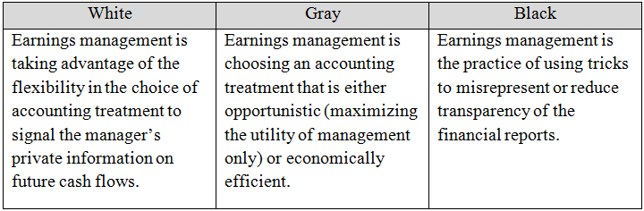
Source: Ronen & Yaari 2008, p. 25
The three categories help to clarify the possible nature of earnings management, whether being in compliance with standards or fraudulent, and whether the accounting treatment is economically efficient or opportunistic. The definition of earnings management which will be used in this paper is based on a combination of two definitions which are frequently used in literature of this topic.
Initially, Schipper (1989, p. 92) provided a definition of earnings management as:

Healy and Wahlen (1999, p. 368) subsequently provided the following definition:
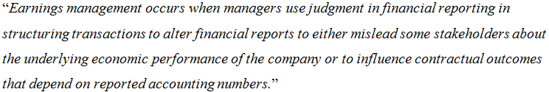
Based on these two definitions, earnings management is interpreted as a purposeful intervention by managers in the form of judgment or structuring transactions, with the intention to mislead stakeholders about the financial situation of the company or influence contractual outcomes which are based on reported numbers.
Conclusively, the use of judgment among management in financial reporting has both its potential costs and benefits (Healy & Wahlen, 1999). The potential costs entail the misallocation of resources arising from misleading stakeholders by earnings management. Conversely, the potential benefits entail enhancement in managers’ credible communication to external stakeholders of private information, hence allow efficient allocation of resources.

2.1.2 Earnings Management: Incentives
Managers are engaged in earnings management in case they have incentives to do such manipulative actions (Stolowy & Breton, 2004). The incentives among managers can be divided into two groups (Blom, 2009). The first group is related to the positive theory, which is concerned with firms’ internal contractual incentives to use different accounting methods. The second group is related to capital market incentives, which are concerned with the comprehensive usage among investors and other capital market participants of reported accounting information. According to Healy and Wahlen (1999), there are three main incentives for which managers engage in earnings management namely, contracting motivations, capital market motivations, and regulatory motivations. In this section these three earnings management incentives are described based on previous studies.

2.1.2.1 Compensation Contracts Incentives
In order to measure the performance of a manager, accounting data is required by means of observing data such as net income and sales rate (Yanqiong, 2010). Therefore, accounting data is used for monitoring and determining contractual compensation plans among firms’ stakeholders. There are both explicit as well as implicit management compensation contracts used in order to align the objectives of internal management and external stakeholders (Healy & Wahlen, 1999). Since the compensation plans are based on the success measures represented in the accounting data, managers may be incentivized to manipulate accounting data by earnings management to meet the contract requirements. According to Watt and Zimmerman (1978) these compensation contracts may further incentivize managers to engage in earnings management, as it is costly for compensation committees and creditors to observe the presence of earnings management.
A number of studies examined whether compensation awards which are based on minimum and maximum target levels of earnings, lead to earnings management incentives of managers. Study conducted by Healy (1985) revealed that earnings are managed correspondingly with maximizing manager’s earnings-based compensation awards. On the one hand, in case earnings are lower than the minimum level required for the bonus award, managers manipulate earnings upwards such that the minimum is reached and the bonus is awarded. On the other hand, given that earnings are above the maximum level where no additional bonus is awarded, managers manipulate earnings downwards. In that case, managers save the extra earnings that will not earn them additional bonus in current period, for later period. However, in case earnings are between the minimum and maximum boundaries, managers manipulate earnings towards the maximum level in order to maximize the compensation award in current period. A similar study conducted by Guidry et al. (1999) provides evidence that divisional managers in a large multinational company, are likely to defer income in case the earnings target for the current period will not be achieved. These findings suggest that managers not only are engaged in earnings management to maximize their current compensation awards, but also consider their future benefits, which indicates on short-term as well as long-term incentives to manipulate earnings.
Different types of studies examined whether implicit compensation contracts have an impact on managers’ earnings management incentives. In particular, these studies tested whether the frequency of earnings management activities increase during periods in which job security of top management is being threatened, or when their period in charge is expected to be short (Healy & Wahlen, 1999). According to DeAngelo (1988) managers in charge are engaged in earnings manipulation during a period of a proxy contest, in order to improve reported earnings. Study conducted by Dechew and Sloan (1991) reveals that CEOs reduce research and development spending in their final years in office by means of increasing reported earnings. The authors further claim that such actions are consistent with the short-term compensation plans of CEOs along with their short horizons. These findings indicate that managers are incentivized to manage earnings in order to increase their job security as well as compensation awards.

2.1.2.2 Capital Market Incentives
As stated by to Yanqiong (2010), capital market incentives are considered the main reason for managers to engage in earnings management. The widespread use of accounting data in the valuation process of stocks among capital market participants such as investors or analysts, may incentivize managers to manipulate earnings (Healy & Wahlen, 1999). There are several areas of study concerning the relationship between capital markets and earnings management, including situations like management buyout, meeting expectations and initial public offering (IPO).
A number of studies examined earnings management during a period preceding a management buyout. According to a study conducted by DeAngelo (1988), accounting information concerning earnings is essential for valuation in a situation of management buyout, and based on that hypothesizes that managers of buyout firms are motivated to understate earnings. In turn, this would reduce the stock price and hence enable managers to purchase the stocks at a cheaper price during the buyout. However, little evidence was found of earnings management by buyout firms, based on examination of accruals change. On the other hand, findings from a study conducted by Perry and Williams (1994) reveal that accruals manipulation of revenues and depreciable capital was used to lower reported income before a management buyout.
Several other studies examined the relationship between earnings management and financial analysts’ forecasts. Various studies reveal that managers engage in earnings management in order to meet analysts’ estimations (Payne & Robb, 2000). On the same note, a study conducted by Kasznik (1999) indicates on similar findings, and additionally reveals that managers use unexpected accruals to manipulate earnings upward in case of possibly not reaching the analysts’ expectations.
Furthermore, different studies examined managers’ involvement in earnings management during a period prior to IPO. According to Teoh et al. (1998), managers manipulate earnings by unexpected accruals to increase reported income before the company’s IPO. These findings indicate that earnings are being managed upwards before the company’s shares are offered on the stock market, in order to obtain more funds to the firm.

2.1.2.3 External Requirements Incentives
Firms are involved in external agreements in the form of contracts, including debt contracts, dividend covenants and supply contracts (Yanqiong, 2010). For the reason that accounting information is used in external contracts, managers may be incentivized to manage earnings in order to meet contractual requirements. According to Xiong (2006), firms are restricted by their creditors on several activities including share repurchases, dividend payments and on taking additional loans, in order to ensure their repayment of principle and interest. These restrictions are usually presented as specific ratios or accounting numbers, which provides managers precise benchmarks that need to be met to satisfy the requirements. However, a study conducted by Sweeney (1994) reveals that earnings management is not being practiced to avoid violation of debt covenants, but rather after the violation has occurred in order to reduce the possibility of future contractual violations.

2.1.3 Earnings Management: Forms
For the scope of this paper, two forms of earnings management will be observed, namely earnings smoothing and managing towards positive earnings. As discussed in the previous section, managers may engage in earnings management by means of maximizing their own bonuses in the current period, while some also consider the long-term consequences. According to Blom (2009) the most appealing form of earnings management is the practice of income smoothing.
A firm’s income pattern may be smooth either naturally or intentionally smoothened by management in order to satisfy their particular interests (Eckel, 1981). As defined by Barnea et al. (1976), income smoothing is the practice of “deliberate dampening of fluctuations about some level of earnings which is considered to be normal for the firm.” According to Albrecht and Richardson (1990) intentional smoothing is divided into real smoothing and artificial smoothing. On the one hand, real smoothing exists when managers purposely structure the firm’s economic events to create a smooth income pattern. On the other hand, artificial smoothing exists when the timing of accounting entries is being manipulated by managers in order to obtain a smooth income trend. As argued by Stolowy and Breton (2004), the practice of income smoothing has a clear purpose of generating a consistent pattern of growing profits for the company. This implies that managers attempt to diminish the variances in profits over time, which makes the income stream appear smooth. However, it is rather complex to externally identify whether these alternations are in fact manipulation practices or an application of managerial discretion (Blom, 2009). Since it is difficult to attribute such alternations to deliberate manipulation, this enables managers who are engaged in earnings management to get away with their actions.
Several studies examined the impact of income smoothing on capital markets in terms of perceived risk. According to Heemskerk and van der Tas (2006), the greater the fluctuation and hence variance in profits, the higher the risk involved. Larger risk implies higher capital costs and therefore managers are incentivized to engage in income smoothing (Blom , 2009). A study conducted by Goel and Thakor (2003) points out that those firms with higher uncertainty about income variances are more likely to be involved in smoothing practices. In turn, these findings indicate that managers are engaged in income smoothing by means of misleading capital market participants about the underlying economic performance of the firm.
Concerning the other form of earnings management, managing towards positive earnings, refers to the idea that managers urge to report small positive net income instead of negative net income (Barth et al., 2008). Past research indicates that a common target among firms of earnings manipulation is to disclose positive net income and thus avoid reporting losses (Burgstahler & Dichev, 1997).
Considering what has been discussed about earnings management, it is argued that less earnings management is an indication of higher accounting quality (Barth et al., 2008). With regard to the first form of earnings management in relation to accounting quality, higher variance of the change in net income is interpreted as less earnings management of smoothing practices, and hence higher accounting quality. While for the second form lower frequency of small positive net income is interpreted as less earnings management of manipulation towards positive earnings, and therefore higher accounting quality. The inspection of these two forms of earnings management before and after the adoption of IFRS, will enable to depict the impact of IFRS adoption on accounting quality, from the perspective of earnings management.

2.2 Timely loss recognition
Timely loss recognition is the second dimension of accounting quality which is examined in this paper. This concept is referred to the timeliness of recognizing a loss by firms (Barth et al., 2008). A characteristic of higher accounting quality is the recognition of large losses as they occur instead of being deferred to subsequent periods (Ball et al., 2000). As discussed in previous sections, managers attempt to enhance their own performance measures, by generating higher net income. In order to do so, manager could defer the recognition of current large loss, and in turn obtain higher net income in present period. The deferral of loss recognition is therefore considered as lower accounting quality as the accounting data does not accurately reflect the underlying economic performance of the firm (Lang, 2003). For the purpose of this paper, timely loss recognition shall be observed before and after IFRS adoption among firms, which will enable to interpret the impact of IFRS adoption on accounting quality from this perspective.

2.3 Value Relevance
The last dimension of accounting quality which is observed in this paper is the concept of value relevance. The concept of value relevance is referred to the association between stock prices and accounting data (Lang, 2003). The specific elements of accounting data that are being used for this purpose relate to the economic concept of profit such as returns and further equity book value. The higher the association between the share price and returns, the higher the accounting quality of the firm (Barth et al., 2008). This is because the accounting data better explains the price of the stock and hence indicates on higher accounting quality. More precisely, when higher association exists between stock prices and accounting data, it implies on higher accounting quality as the accounting information better reflects the underlying economic performance of the firm (Barth et al., 2001). By observing the value relevance before and after the adoption of IFRS, it will be possible to interpret the impact of IFRS adoption on accounting quality from this perspective.

2.4 Conclusion
In summary, accounting quality is examined in this paper based on three of its dimensions namely, earnings management, timely loss recognition and value relevance. Earnings management is the mostly used proxy for accounting quality, and was therefore outlined in more detail in this chapter. The widely recognized definition of earnings management is referred to the purposeful intervention by managers, with the intention to mislead stakeholders about the firm’s economic performance or influence contractual outcomes based on reported numbers. Managers’ motivation to manipulate earnings can arise from three incentives. Firstly, compensation awards may incentivize managers to manipulate earnings in order to maximize their own benefits. Secondly, capital markets incentives may drive managers’ earnings manipulation to meet analysts’ forecasts, raise funds during IPOs and lower their expenditures for managerial buyouts. Thirdly, external requirements incentives refer to the contractual requirements managers need to meet, and in case these requirements are not attained in reality managers may engage in earnings management to reach such requirements. The forms in which earnings management can exist are income smoothing which entails reduction of income fluctuations, and the management of earnings towards positive net income. Evidence of less earnings management is an indication of higher accounting quality. Thereafter, the second dimension of accounting quality, timely loss recognition was outlined. This dimension refers to the timeliness of recognizing large losses, such that a deferral of recognition is perceived as lower accounting quality. Finally, the third dimension of accounting quality which is value relevance, was described as the relation between stock prices and accounting data, such that higher association is interpreted as higher quality of accounting.
In the following chapter IFRS will be discussed in terms of its development throughout history as well as its application nowadays. In addition, theoretical perspectives associated with the transition to the IFRS from previously used national GAAP will be outlined.

Chapter 3: What is IFRS and what accounting theories are relevant to the transition?
In order to understand what IFRS is, it is first necessary to explain the development of IFRS throughout history, as will be discussed in the first section of this chapter. Subsequently, the theory behind the IFRS, namely the conceptual framework shall be observed by means of understanding the idea behind the issuance and introduction of IFRS worldwide. This illustration shall provide the basis for the final part of the chapter, in which the type of IFRS as principles-based accounting standards is compared with rules-based accounting standards.

3.1 The History of IFRS
As briefly mentioned in the introduction, IFRS are accounting rules that are issued by the IASB, which is an independent organization (Ball, 2006). The organization’s objective is to develop a single set of standards that would be equally applied to financial reporting by public companies worldwide. A public company is a firm that is listed on at least one stock exchange where its shares or other securities are being traded (Picker et al., 2013). Between the years 1973 and 2000 the predecessor organization of the IASB, the IASC, initially issued international standards. The IASC was a body established in 1973 by professional accountancy bodies in countries worldwide including Australia, Canada, France, Germany, Japan, Mexico, Netherlands, United States, United Kingdom and Ireland. At the time, the IASC’s rules were named as “International Accounting Standards” (IAS). In April 2001, IASC’s successor the IASB was appointed to take over the function of standards issuance. Subsequently, the standards issued by IASB were named “International Financial Reporting Standards” (IFRS), while the previously issued standards by the IASC (namely the IAS) remained acceptable. In contrast to the IASC, the IASB is funded and staffed better as well as more independent.

3.2 The Conceptual Framework
The Framework for the Preparation and Presentation of Financial Statements, also known as the Framework, was adopted in 1989 by the IASC (Picker et al., 2013). Subsequently, in 2010 this document was replaced by the Conceptual Framework for Financial Reporting, also known as the Conceptual Framework, which was issued by the IASB. The conceptual framework provides the concepts that determine the basis for the preparation and presentation of financial statements, and hence form the fundamentals of the IFRS (IFRS, 2015). The objective of the conceptual framework is to provide a comprehensive set of principles. These principles should essentially accomplish the following: assistance to standard setters in establishing consistent set of accounting rules, assistance to preparers of financial statements in applying the accounting standards and coping with irregular cases, assistance to auditors in obtaining an opinion regarding the compliance with standards, and assistance to financial statements users in interpreting the provided information. The conceptual framework consists of four chapters:
- Chapter 1: The objective of general purpose financial reporting
- Chapter 2: The reporting entity
- Chapter 3: The qualitative characteristics of useful financial reporting
- Chapter 4: The framework (1989): the remaining text
Currently, the IASB jointly operates with the Financial Accounting Standards Board (FASB) in the United States (US) for the completion of the conceptual framework as some chapters are still under development. For the purpose of this paper, chapter one and chapter three of the conceptual framework will be discussed.
The first chapter of the conceptual framework, refers to the idea that financial statements are intended to satisfy the necessary information to various users, who are incapable of directing the preparation of reports towards their own needs (Picker et al., 2013). As stated in paragraph OB2 of the IASB conceptual framework, the objective of general purpose financial reporting is as follows:
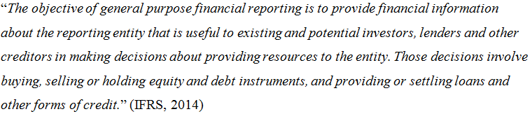
This objective portrays a number of value judgment made by the IASB in combination with the FASB, concerning the role of financial statements (Picker et al., 2013). As argued by the IASB and the FASB, this objective can be achieved in case financial statements are prepared from the perspective of the firm instead of the perspective of the firm’s equity investors or other financial statement users. Financial statements should therefore be focused on the firm’s resources and changes occurring to their resources, and not on the firm’s existing or potential investors being the providers of resources. In turn, preparing financial statements from the perspective of the firm compels the firm to have its own substance, independent from that of its investors. In addition to these arguments, the key financial statement users are capital providers, which include existing as well as potential investors and lenders. Economic resources are obtained by the company from those capital providers, whom in return have claims on such resources. Due to their claims, capital providers are at most vital and critical need for the firm’s financial information, and the various groups of capital providers share common information needs. In contrast to the previous version of the IASB conceptual framework, the focus of the financial statements has narrowed down towards the capital providers rather than other potential users such as government, regulatory bodies and employees. In turn, this should also aid in reaching the objective set by the IASB. However, the qualitative characteristics of financial information have to be specified first, before the IASB’s objective of general purpose financial reporting can be enforced fundamentally.
The qualitative characteristics of financial reporting information are outlined in chapter three of the conceptual framework. This chapter of the conceptual framework discusses the qualitative characteristics of financial information which are divided into two groups, namely fundamental qualitative characteristics and enhancing qualitative characteristics.
Firstly, the fundamental qualitative characteristics shall be outlined. In order for financial information to be useful in decision making, the two fundamental qualitative characteristics that have to be present are relevance and faithful representation (Picker et al., 2013). Information is said to be relevant in case it can make a difference in capital providers’ decisions, as financial statement users. Information is also relevant in case it has predictive value, confirmatory value or a combination of both. Predictive values exist when the information provided impacts user’s forecasts about the future, and is used in the decision models of users. Confirmatory value occurs when provided information is used as feedback that either confirms or changes past or current expectations which are based on past evaluations. Additionally, information is considered relevant in case it can make a difference whether that information is actually used by users or not. Generally, information concerning the present financial situation and past performance is frequently used as the basis for forecasting future performance and economic situation which users are mainly interested in. Other aspects of which users have direct interest in include future share prices, future dividends, and the ability of the firm to repay its debts when required. It is further suggested that if irregular transactions or events are disclosed separately in the income statement or other comprehensive income, the predictive ability of information may be enhanced. The second fundamental qualitative characteristic of financial information is faithful representation. Faithful representation is accomplished in case the portrayal of the economic situation is complete, neutral, and contains no material error. In turn, this leads to the portrayal of the underlying economic substance of the reporting firm. A portrayal is said to be complete in case it contains all information indispensable for faithful representation. Neutrality exists in case there are no predetermined results that are intended to be obtained through bias practices. This implies that managers should not manage earnings by making judgments towards sought results. In order to achieve faithful presentation, it might be essential for managers to additionally report information regarding the degree of uncertainty in their judgments and valuations. In general, the two characteristics collaborate, such that either irrelevance or unfaithful representation lead to information that is not useful for decision making.
Secondly, the enhancing qualitative characteristics which are complementary to the fundamental characteristics shall be discussed as follows. There are four enhancing qualitative characteristics recognized by the conceptual framework (Picker et al., 2013):
- Comparability
- Verifiability
- Timeliness
- Understandability
These enhancing characteristics enable to differentiate between information that is more useful and less useful. Comparability is referred to the ability to compare between different sets of provided economic information and observing similarities and differences. This allows users to make enhanced decisions about an entity based on various aspects, in case it is comparable to information provided by other firms. Verifiability is referred to the reassurance to users that the reported financial information is faithfully representing the underlying economic substance it presumes to portray. This is obtained through independent observers indicating on the same general conclusion that the information reported faithfully represents the economic situation of the entity or that valuation methods have been correctly applied. Timeliness is referred to having access to information necessary for decision making before it loses its capability to impact decisions. In case the information loses this capability, the information becomes irrelevant, although it may be used in the long term for trend analysis. Understandability is referred to the ability of users to interpret the meaning of reported information. Financial information could be more understandable for its users in case it is classified, characterized and displayed clearly.
As the qualitative characteristic of the IASB’s conceptual framework were explicitly defined, it shall lead to a more comprehensive understanding of the formal objectives of the IASB. The objectives of the IASB are:
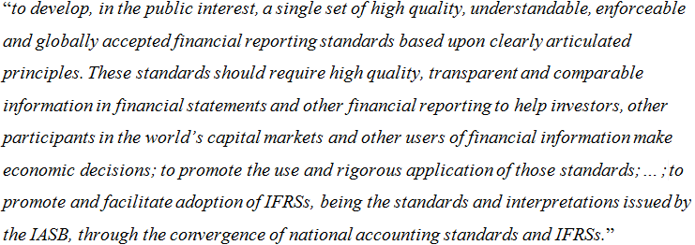
(UKAccountingPlus, 2015).
It is possible to notice that the qualitative characteristics which were previously defined, are directly incorporated into the objective of the IASB. In simple terms, the aim of the IASB is to increase the usefulness of financial information by enhancing the qualitative characteristics through the adoption of the IFRS. It is important to bear in mind these objectives, as later in this paper it shall be observed whether the IASB succeeded to enhance these qualities through the adoption of IFRS.
Conclusively, the IASB’s conceptual framework illustrates the underlying concepts that form the basis for preparing and presenting financial statements in conformity with the IFRS. It indicates that the objective of financial statements is to provide information concerning the economic situation, performance and changes in financial position of the firm, which is useful for decision making by existing and potential investors and other capital providers. The conceptual framework also indicates on the fundamental qualities which make financial information useful to its users, namely relevance and faithful presentation. Subsequently, the usefulness of financial information can be enhanced by the enhancing qualities consisting of comparability, verifiability, timeliness and understandability.

3.3 Principles-Based and Rules-Based Accounting Standards
The IASB’s IFRS and conceptual framework which were outlined in previous sections are principles-based standards rather than rules-based standards (Picker, 2013). The transition to the IFRS from previously used national GAAP could be associated with a shift from rules-based standards to principles-based standards (Beest, 2011). The main difference between the two approaches of accounting standards, concerns the aspect of professional judgment, while under principle-based standards it is permitted, under rules-based standards it is not. However, it is also possible that a country’s national GAAP is also principles-based, in which case the transition is not associated with fundamental changes. In this section the theories of principles-based and rules-based settings as well as their various aspects will be provided and discussed.
Principles-based accounting standards enforce a broad depiction of an accounting aspect, with relatively few additional requirements (Beest, 2011). In his paper, Beest provides a definition of a principle, as a general statement that aims to enhance truth as well as fairness, and serves as a guide to action for various stakeholders. In fact, it is stated that principles-based standards are ultimately represented by the conceptual framework, which implies on the importance of professional judgment in portraying the qualitative characteristics of useful financial reporting. A principles-based standard intends to support reliability and faithful representation as well as to assist in the recognition of events and transactions. Principles-based accounting standards entail an essential concept which is called ‘substance over form’. This concept suggests that a deviation from the legal form (accounting rules) by management and auditors is permitted, as long as this deviation leads to an enhanced representation of financial insights regarding the underlying economic reality of the firm. In other words, substance over form is referred to the reflection of the economic substance of financial information over its legal form (Psaros & Trotman, 2004). For the reason that substance over form, economic reality and true and fair value are all socially constructed concepts, no set definition exist for these. Hence, there should be a generally agreed upon level of accordance between assets and liabilities values and the underlying event intended to be represented (Palliam & Shalhoub, 2003). It is suggested by Krishnan and Parsons (2008) that in case disclosed earnings are in accordance with the economic activities during the reporting period, economic reality is highly reflected. True and fair view is referred to a neutral view of economic reality, risks and benefits, which is represented in financial statements and in turn assists users in financial decision making and therfore in allocation of resources (IASB, 2008). Conclusively, Beest (2011, p. 33) provides a definition of principles-based accounting standards as: “a system of financial reporting, which is primarily based on the fundamentals of accounting (decision usefulness, true and fair view, going concern, substance over form) with an appropriate level of specificity.”
Conversely, rules-based accounting standards are said to be on the other side of the continuum (Beest, 2011). The boundaries for financial reporting are evaluated by the accounting standards. This means that information is provided by the accounting standards regarding an account’s definition, recognition, measurement method, presentation and disclosure, such as for account receivables or account payables. The reason rules-based accounting standards are said to be a continuum, is because standards are fundamentally principles-based, although the addition of requirements leads to a more rules-based accounting standards. Such additional requirements could be in form of specific criteria, bright line thresholds, implementation guidance, exceptions and scope restrictions. In turn, it is deduced by Nelson et al. (2003) that accounting standards evolve into more rules-based with each additional requirement. As opposed to principles-based, rules-based accounting standards entail thorough and explicit details about what actions are permitted or not (Alexander & Jermakowich, 2006). The requirements requested from chief financial officers (CFOs) are described as highly specific in wording and direct under rules-based accounting standards (Psaros & Trotman, 2004). Moreover, according to Maines et al. (2003), under the ultimate rules-based standards there is no room for professional judgments or disagreement, which is depicted as ‘unequivocally rigid’. For the reason that no professional judgment is allowed under rules-based standards, but simply complying with the strict accounting rules which specifically describe how accounting events should be recognized, rules-based standards are therefore characterized as ‘form over substance’. Conclusively, Beest (2011, p.33) provides a definition of rules-based accounting standards as: “a system of financial reporting, which is based on detailed provisions of methods for most accounting problems, where it is unambiguously clear how and when it is to be applied.”
The transition to IFRS from previously used national GAAP, may entail a shift from rules-based to principles-based accounting standards, as mentioned previously. This implies on more room for professional judgment by managers which suggests on higher ability to manipulate earnings through judgment and hence lower the accounting quality (Beest,2011). However, this would contradict the objective of the IASB to provide high quality of financial statements through the implementation of the IFRS, as discussed in previous chapter. Conversely, it is suggested that under rules-based settings, managers are more likely to engage in earnings management through transaction decisions than under principles-based settings. As a result of these uncertainties and institutional developments within the IASB and FASB, it was debated among standard setters on the convenient level of accounting rules to be included in their standards. On the one hand, it was considered by the FASB to move from their rules-based standards (US GAAP) towards more principles-based standards. On the other hand, the IASB extensively raised their accounting requirements following the introduction of the IFRS, which indicates on a slight move towards a more rules-based setting. The following figure illustrates the formulation of moderate rules-based / principles-based accounting standards, as currently applied by the IFRS, as means of obtaining an appropriate level of accounting rules.
Figure 2: Principles-based and Rules-based accounting standards
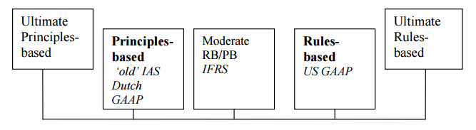
Source: Beest, 2011

3.3 Conclusion
In summary, in order to answer the second sub question, a number of aspects concerning the IFRS were discussed in this chapter including the history of the IFRS, the conceptual framework, and the concept of principles-based and rules-based accounting standards. the IFRS are accounting rules that are issued by the IASB organization which intends to develop a single set of accounting standards that would be applied by public companies worldwide (Ball, 2006). The IASB is the successor organization of the IASC which was established in 1973 and issued standards named as IAS, and though the IASB continued to use these standards, the newly issued standards were named as IFRS. Consecutively, the Conceptual Framework for Financial Reporting was along with the IFRS issued by the IASB. The conceptual framework outlines the concepts that determine the fundamentals for the preparation and presentation of financial statements, with the objective to provide a comprehensive set of principles to be achieved through IFRS adoption (IFRS, 2015; Picker et al., 2013). The principles are intended to assist standard setters, auditors, and users of financial statements each for their own needs. The conceptual framework consists of four chapters whereby only the first and third chapters were discussed, which are named the objective of general purpose financial reporting, and the qualitative characteristics of useful financial reporting, respectively. The first chapter concerns the importance of financial reporting in providing useful information about the reporting entity to existing and potential investors and other creditors, which is effective for their financial decision making process. Subsequently, the third chapter concerns the qualitative characteristics which are necessary in generating useful financial information. These are divided into two groups, namely fundamental qualitative characteristics and enhancing qualitative characteristics. After understanding the conceptual framework and its main attributes, the concepts of principles-based and rules based accounting standards were outlined. The transition from previously used national GAAP to the IFRS could be associated with a shift from rules-based to principles-based accounting standards, as the latter is based on the conceptual framework of the IASB. Principles-based setting is interpreted as a general description of the fundamental objectives of accounting, reflected by the conceptual framework to stress the concept of substance over form, and enables management’s professional judgment (Beest, 2011). Rules-based setting is interpreted as a precise and strict set of accounting rules that need to be complied with, where there is no room for professional judgment and the concept of legal over form is emphasized. Despite the differences between the two approaches of accounting standards, the IFRS is moderately principles-based/rules-based, by means of obtaining a convenient level of accounting rules.
In the following chapter the method in which accounting quality is measured shall be illustrated and discussed. For each of the three accounting quality dimensions, accounting methods are attributed, and the ideas behind each method will be explained. This will enable to understand how accounting quality is measured in practice by its three dimensions, and consequently it will enable to interpret the outcomes presented in chapter five.

Chapter 4: How is accounting quality measured?
In order to answer the third sub question of this paper, the three dimensions of accounting quality shall be observed in terms of their individual measurement methods, or alternatively known as metrics. The methods that will be presented in this section, were used in a number of studies which examined accounting quality in different countries worldwide. These metrics were initially presented and used by Lang et al. (2003) and subsequently developed and used in studies conducted by Barth et al. (2008), Chua et al. (2012) and more.

4.1 Earnings management metrics
There are four metrics that are used to measure earnings management, which capture the two forms of earnings management, namely earnings smoothing and managing towards positive earnings, as were discussed in chapter two. For the reason that earnings management cannot be directly identified and the effect of accounting differences cannot be simply disentangled from the underlying economics, evidence here could possibly be circumstantial (Lang et al.,2003). Hence, several metrics are used in order to reduce the possibility of obtaining circumstantial results (Chua et al., 2012). In addition, the measurements are based on controlling for the effect of factors which are not related to the accounting standards, but rather for those factors that reflect the underlying economics of the firm and the environment in which it operates (Paglietti, 2009). This is done in an attempt to reduce the underlying economic differences, and in turn to identify accounting differences arising from accounting standards. Three of the four earnings management metrics are attributed to the form of earnings smoothing and one to the form of managing towards positive earnings.
The first earnings smoothing metrics measures the variability of a change in annual net income scaled by total assets, noted as ΔNI (Chua et al., 2012). This metric attempts to identify the presence of earnings smoothing through variability of earnings, such that lower variability is interpreted as evidence of earnings smoothing, all else being equal. Hence, the fluctuation in earnings is measured by the change in annual net income scaled by assets. Due to the fact that earnings could be sensitive to various factors that are attributable to IFRS adoption, the regression of the change in net income is on control variables which are intended to mitigate the confounding impact of these factors. Obtaining this regression allows to consecutively measure the variability of change in net income, based on the residuals, which are assumed to be unrelated to the control variables. This implies that the interpretation of the regression is focused on the residuals which are established from the relevant regression, instead of focusing on the reported earnings themselves. The first earning smoothing metric is therefore measured by the variance of the residuals (ΔNI*) (equation (1)), which is obtained from the regression of the change in annual net income scaled by total assets (ΔNI) (equation 1a), presented as follows (Chua et al., 2012):
Variability of ΔNI* = σ² _{Error(ΔNI)i} , (1)
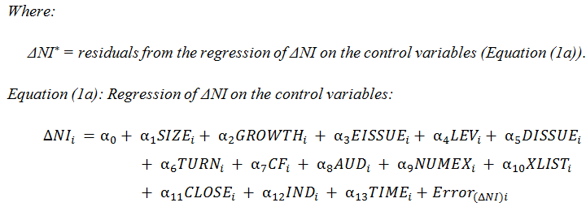
(1a)
Where:
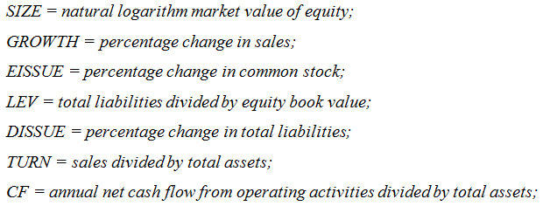
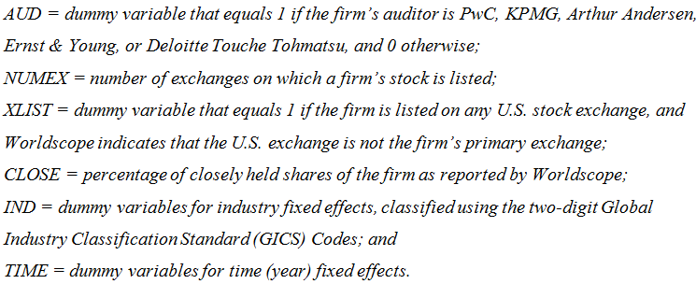
The regression presented above (1a) is run individually for periods before the adoption (pre-adoption) and after the adoption (post-adoption) of the IFRS (Chua et al., 2012). This is established by collecting yearly observations of each firm before and after the adoption period. In turn, there are two sets of residuals obtained for which the variance of the residuals is calculated for each time period, and consequently these are compared using a variance ratio F-test.
The second metric of earnings smoothing concerns the ratio between the variance of the annual changes in net income and the variance of the annual change in operating cash flows (Paglietti, 2009). The idea of this metric is to extend the analysis of the first metric, by benchmarking the annual change in net income against the volatility of cash flows. This is based on the assumption that more volatile cash flows, is expected to be associated with more volatile net income. The volatility of cash flows is calculated as the variance of the residuals (ΔOCF*) (equation (2)) obtained from a regression of the change in operating cash flows scaled by total assets (ΔOCF) (equation (2a)), which is executed similarly to the first metric (Chua et al., 2012):
$\frac{Variability of {ΔNI}^{*} }{Variability of {ΔOCF}^{*}}=\frac{σ_{Error(ΔNI)i}^{2} }{σ_{Error(ΔOCF)i}^{2} }$ (2)
Where:
$$Δ{OCF}_{i} =α_{0}+ α_{1}{SIZE}_{i}+ α_{2}{GROWTH}_{i} + α_{3}{EISSUE}_{i}+ α_{4}{LEV}_{i}+ α_{5}{DISSUE}_{i} + α_{6}{TURN}_{i} + α_{7}{CF}_{i} + α_{8}{AUD}_{i} + α_{9}{NUMEX}_{i} + α_{10}{XLIST}_{i} + α_{11}{CLOSE}_{i} + α_{12}{IND}_{i} + α_{13}{TIME}_{i}+{Error}_{(ΔOCF)i}$$
(2a)
Similar to the first regression, in this case as well the regression is run individually for the periods before and after the IFRS adoption, based on yearly observations collected for the required time periods (Chua et al., 2012). Hence, there are two sets of residuals obtained for which the variance of the residuals is calculated for each time period, and consequently the ratios are calculated for the pre-adoption and post-adoption periods. However, in this case there is no specific statistical test which compares the difference between the variance ratios of before and after the adoption. An alternative method proposed by Lang et al. (2003) is to test if the ratio of variances is significantly less than 1 for each time period, based on a variance ratio F-test.
The final earnings smoothing metric measures the interdependence between accruals and cash flows (Paglietti, 2009). This is calculated using a Spearman correlation test between accruals and cash flows. The idea behind this metric is to detect the use of accruals as evidence of engagement in earnings management by managers, particularly in periods of poor cash flows as means of smoothing cash flows fluctuations (Chua et al., 2012). According to Lang et al. (2003), the larger the negative correlation between the variables, the higher the likelihood of earnings smoothing practices. This is because of the intentionally increase of accruals by managers in order to smooth the earnings during periods of low cash flows. Both cash flows (CF) and accruals (ACC) are individually regressed on the same control variables as used in the previous metrics. In turn, the Spearman correlation (equation (3)) between the two variables is based on the residuals (CF* and ACC*) which are obtained from the regressions (equations (3a) and (3b)) of each variable (Chua et al., 2012):
$$Spearman correlation between cash flows {CF}^{*} and accruals {ACC}^{*}=CORR({Error}_{\left(CF\right)i}{Error}_{\left(ACC\right)i})$$
(3)
Where:
$${CF}_{i} =α_{0}+ α_{1}{SIZE}_{i}+ α_{2}{GROWTH}_{i} + α_{3}{EISSUE}_{i}+ α_{4}{LEV}_{i}+ α_{5}{DISSUE}_{i} + α_{6}{TURN}_{i} + α_{7}{AUD}_{i} + α_{8}{NUMEX}_{i} + α_{9}{XLIST}_{i} + α_{10}{CLOSE}_{i} + α_{11}{IND}_{i} + α_{12}{TIME}_{i}+{Error}_{(CF)i}$$
(3a)
$${ACC}_{i} =α_{0}+ α_{1}{SIZE}_{i}+ α_{2}{GROWTH}_{i} + α_{3}{EISSUE}_{i}+ α_{4}{LEV}_{i}+ α_{5}{DISSUE}_{i} + α_{6}{TURN}_{i} + α_{7}{AUD}_{i} + α_{8}{NUMEX}_{i} + α_{9}{XLIST}_{i} + α_{10}{CLOSE}_{i} + α_{11}{IND}_{i} + α_{12}{TIME}_{i}+{Error}_{(ACC)i}$$
(3b)
Where: ACC_{i} = NI_{i} – CF_{i}
The correlation is calculated for before and after the IFRS adoption, and subsequently the two correlations repressing each time period are compared in order to assess the change in earnings smoothing practices arising from the adoption. The statistical significance test that is used to for the comparison in this case was proposed by Sheskin (2004).
In order to examine the second form of earnings management, namely managing towards positive earnings, the frequency of small positive earnings is measured in the pre-adoption and post-adoption periods. A dummy variable is placed in the model indicating on whether small positive earnings (SPOS) were reported. In case reported annual net income scaled by total assets is within the range of 0 and 0.01, the dummy is set to 1 and is set to 0 otherwise. This is also the dependent variable of the model, while the control variables are consistent with those used in previous models, and additionally includes a dummy variable which indicates on the period being either pre-adoption or post-adoption of IFRS (POST). Hence, the model used in this case is a logit regression, which enables to measure the change from before to after IFRS adoption in the probability of reporting small positive earnings. This is interpreted by observing the coefficient β₁ from the following model which is obtained from Chua et al. (2012):
$${SPOS}_{i} =β_{0}+ β_{1}{POST}_{i}+{β_{2}SIZE}_{i}+ β_{3}{GROWTH}_{i} + β_{4}{EISSUE}_{i}+ β_{5}{LEV}_{i}+ β_{6}{DISSUE}_{i} + β_{7}{TURN}_{i} + β_{8}{CF}_{i} + β_{9}{AUD}_{i} + β_{10}{NUMEX}_{i} + β_{11}{XLIST}_{i} + β_{12}{CLOSE}_{i} + β_{13}{IND}_{i} + β_{14}{TIME}_{i}+{Error}_{i}$$
(4)
Where:
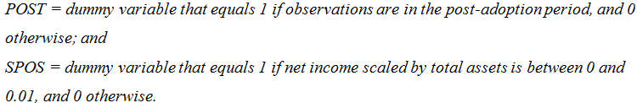

4.2 Timely loss recognition metric
As discussed in chapter two of this paper, managers are reluctant to report large losses as they occur and prefer to defer such losses to future periods (Lang et al., 2003). Therefore, the metric used to identify whether large losses are recognized on a timely manner is based on a dummy variable which is set to 1 if net income (scaled by total assets) is within a range of
-0.20 to 0 and is set to 0 if not. This is in fact the dependent variable which is referred to as frequency of large losses (LNEG), and it is estimated based on a logit regression, where its control variables are the same as in equation (4). Similar to equation (4), the coefficient λ₁ in the following model indicates on the change from before and after IFRS adoption in recognition of large losses (Chua et al., 2012):
$${LNEG}_{i} =λ_{0}+ λ_{1}{POST}_{i}+{λ_{2}SIZE}_{i}+ λ_{3}{GROWTH}_{i} + λ_{4}{EISSUE}_{i}+ λ_{5}{LEV}_{i}+ λ_{6}{DISSUE}_{i} + λ_{7}{TURN}_{i} + λ_{8}{CF}_{i} + λ_{9}{AUD}_{i} + λ_{10}{NUMEX}_{i} + λ_{11}{XLIST}_{i} + λ_{12}{CLOSE}_{i} + λ_{13}{IND}_{i} + λ_{14}{TIME}_{i}+{Error}_{i}$$
(5)
Where:

4.3 Value relevance metrics
As discussed in chapter two, higher accounting quality is expected to increase the association between accounting data and the stock price, known as value relevance. There are three metrics which focus on the change in value relevance, resulting from the IFRS adoption. The first metric examines the explanatory power of the stock price regression, noted as R². A two-stage regression method is applied, in order to calculate the adjusted R² which is controlled for industry and time variables. Initially the regression of share price (P) on industry and time variables is performed to gather the residuals (P*), where subsequently these residuals are regressed on net income per share (NIPS) and book value of equity per share (BVEPS) variables. Hence, the regression is presented as follows (Chua et al., 2012):
$$P_{i}^{*}=δ_{0}+δ_{1}{BVEPS}_{i}+δ_{2}{NIPS}_{i}+{Error}_{i}$$
(6)
Where:
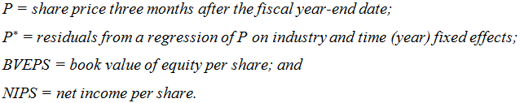
Similar to previously observed metrics, the above regression is applied before and after the IFRS adoption, which enables to assess the impact of the adoption on value relevance.
A “reverse” return regression of net income per share on the variable annual share price return, is used for the second and third metrics by means of assessing the explanatory power (Basu, 1997). Separate regressions are run for entities with “good news” (non-negative annual share return and entities with “bad news” (negative annual share returns), where additionally controlling for industry and time as previously displayed (Barth et al., 2008). This is illustrated by the following regression (Chua et al., 2012):
$${[NI/P]}_{i}^{*}=δ_{0}+δ_{1}{RETURN}_{i}+{Error}_{i}$$
(7)
Where:
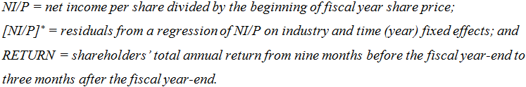
Consistent with previous metrics, this regression is run individually for periods before and after IFRS adoption, and for both “good news” and “bad news” firms, which enables comparability.
In the following chapter the impact of IFRS adoption on accounting quality shall be analyzed, based on empirical finding which applied the metrics presented in this chapter. Several studies will be compared as well as reviewed.

Chapter 5: What does prior research reveal about the impact of IFRS adoption on accounting quality?
In this chapter, empirical research will be examined in order to evaluate whether the adoption of the IFRS has led to enhancement of accounting quality among listed companies. For the reason that a number of studies followed similar methodologies in assessing the change in accounting quality due to IFRS adoption, this enables to compare between the findings. Hence, this was considered when choosing specific papers over others. This paper discusses four empirical studies conducted on the topic of IFRS adoption impact on accounting quality. The findings of the researches shall be individually overviewed and subsequently an evaluation and a review of the studies will be provided.

5.1 Chua et al. (2012)
Chua el al. (2012) measure the impact of compulsory IFRS adoption on accounting quality in Australia. The adoption of the IFRS was mandatory in Australia and the EU as of January 1, 2005, whereby Australia was the first non-EU country which fully disallowed an early adoption of the IFRS (Jeanjean & Stolowy, 2008). In turn, this enabled to conduct a study including only compulsory adopters, which avoids the need to control for voluntary adopters for possible self-selection bias. The study was based on a sample of 1,376 firm-year observations which is composed of 172 Australian listed firms observed over a total period of 8 years, 4 years before and 4 years after the IFRS adoption (172*8=1,376). It is important to stress that the previously applied Australian GAAP, is considered to be principles-based accounting standards, which might suggest that Australia had already accomplished high-quality accounting reporting practices (Kaufmann et al., 2008). Therefore, it is interesting to examine how accounting quality has changed as a result of transitioning from Australian GAAP to IFRS while both are principles-based accounting standards. Based on the changes that are ought to be made by the switch to IFRS, the authors expected that the accounting quality shall increase after the adoption of IFRS. The methodology used in their study is based on the metrics presented in previous chapter. The findings of their paper are discussed as follows.
Concerning earnings management, the results presented in Panel A of Table 1 (Appendix 1) are mostly consistent with the expectation of the authors that IFRS adoption had a significant impact on accounting quality in Australia. As discussed in previous chapter, the three metrics for earnings management relate to earnings smoothing and are focused on the residuals from the regressions, of which each dependent variable is regressed on consistent control variables.
With regard to the first metric, it was found that variability of change in net income significantly increased as a result of IFRS adoption, such that in the post-adoption period and pre-adoption period the results were 0.0072 and 0.0056 respectively. This suggests that income smoothing practices decreased after IFRS adoption. With regard to the second metric of earnings smoothing, it was found that the ratio of the variance of the change in net income to the variance of the change in operating cash flows has substantially increased after IFRS adoption, where in the post-adoption and pre-adoption the results were 1.325 and 0.807 respectively. The analysis reveals that the results in the pre-adoption period were significantly smaller than 1 (at the 0.01 level), which indicates on higher volatility in post-adoption period implying that earnings smoothing practices decreased after IFRS adoption. With regard to the third metric of earnings smoothing, the correlation between accruals and cash flows became less negative after IFRS adoption, such that in the post-adoption period and pre-adoption period the results were 0.4499 and 0.4553 respectively. Even though these findings suggest that earnings smoothing practices decreased after IFRS adoption, the difference between the correlations is not statistically significant in contrast to the first two measures. Regarding the final metric of earnings management which relates to managing towards positive earnings, it was found that the coefficient for POST (1.84) was significant in the regression of SPOS. This indicates that earnings manipulation through managing towards positive earnings has significantly increased from the pre-adoption period to post-adoption period. However, these finding are found to be insignificant in case financial firms are removed from the sample. Financial firms are removed since it was revealed that the significant results are mainly compelled by these firms. Conclusively, the results for the earnings management metrics suggest that compulsory adoption of IFRS has generally led to improvement in accounting quality, mainly through less earnings smoothing practices.
Concerning timely loss recognition, the results presented in Panel B of Table 1 (Appendix 1) reveal that the coefficient for the POST variable (2.0834) is positive and significant, as obtained from the logit regression. This means that after the adoption of IFRS, the probability of large losses being reported in a timely manner is higher than in the pre-adoption period where Australian GAAP was applied. This implies that there is an improvement in accounting quality after the adoption of IFRS, which is consistent with the previous findings regarding earnings management.
Regarding the findings for value relevance, the results are presented in Panel C of Table 1 (Appendix 1) and there are two metrics used to examine this dimension of accounting quality. Concerning the first metric, the explanatory power of the price model, the adjusted R² has increased after the adoption of IFRS, where in the post-adoption period and pre-adoption period the results were 53.96 percent and 48.27 percent respectively. For the second metric, the association between accounting income and the release of “bad news” (negative annual share returns) has increased. These findings from both metrics indicate that value relevance and in turn accounting quality improved after the adoption of IFRS, which is consistent with previous findings of timely loss recognition and earnings management.
Overall, the results display that there is an improvement in accounting quality after the adoption of IFRS in Australia, which is consistent with the expectations of the researches. Hence, it is evident that a transition from principles-based to principles-based accounting standards is associated with an improvement in accounting quality.

5.2 Lin et al. (2012)
Lin et al. (2012) measure the impact of mandatory adoption of IFRS on accounting quality among German high-tech firms. The research concerns German firms which voluntarily applied US GAAP prior to the mandatory adoption of IFRS in 2005, and therefore provides interesting findings about potential consequences of switching from US GAAP to IFRS. The study examined the accounting quality among 63 listed firms which were observed from 2000 to 2010 as means of obtaining results 5 years before and 5 years after the adoption of IFRS, however for several metrics a different number of firms were used due to some constraints. As previously discussed in chapter three, US GAAP is considered rules-based accounting standards as opposed to IFRS which is considered principles-based (Beest, 2011). It was suggested that accounting quality may deteriorate due to more discretionary behavior opportunity under IFRS, although accounting quality could also improve as a result of more faithful representation of underlying economic reality of the firm as enhanced by IFRS. Therefore, the findings of this research may provide evidence of possible implications of switching to IFRS from US GAAP, which has still not occurred in the US. The metrics used in this research are consistent with those presented in chapter four.
Regarding earnings management, the results obtained from the metrics can be found in Panel A of Table 1 (Appendix 2). In terms of the first metric, the results reveal that variability of change in net income has significantly decreased after the adoption of IFRS, from 0.2689 in the pre-adoption period to 0.1493 in the post-adoption period. This implies on higher income smoothing in the post-adoption period. The second metric displays a significant increase in the ratio of variance of change in net income to variance of cash flow after IFRS adoption, from 1.5243 to 2.2819, which indicates on higher income smoothing. The third metric of income smoothing reveals that the correlation between accruals and cash flows had a significant negative increase after IFRS adoption, which is consistent with the first two metrics indicating that income smoothing increased after IFRS adoption, hence lowering the accounting quality. Concerning the metric of managing towards positive earnings, the results are presented in Panel B of Table 1 (Appendix 2). The results display that the coefficient for POST is significant and negative (-1.0983), which indicates that under IFRS firms are less engaged in managing towards positive earnings and therefore suggest on higher accounting quality. Hence, these findings contradict the findings obtained for income smoothing. Conclusively, considering all findings it is suggested that there is generally higher earnings management in the post-adoption period under IFRS than in the pre-adoption period under US GAAP.
Regarding timely loss recognition, the results from the metric are presented in Table 2 (Appendix 2). The results reveal that the coefficient of POST is negative and significant (-0.734) which suggests that large losses are recognized in a more timely manner prior to IFRS adoption. Additionally, other metric measure presented in Panel B of Table 2 (Appendix 2) display that after the switch to IFRS there is a lower degree of conservatism used. Overall, considering these results it is suggested that accounting quality has deteriorated after the adoption of IFRS.
In terms of value relevance, Table 3 (Appendix 2) displays the results obtained from the related metrics. The findings reveal that the explanatory power of the value relevance model, the adjusted R², has significantly decreased after the adoption of IFRS. Additional findings concern the ERC, which refers to the sum of the first two regression coefficients, display a significant decrease after the adoption of IFRS. This implies that accounting data appears to be more useful for investors in the pre-adoption period than in the post-adoption period, and hence suggests that accounting quality has deteriorated after IFRS adoption.
Overall, the results display that there is deterioration in accounting quality after the adoption of IFRS among high-tech companies in Germany. Hence, it is evident that a transition from rules-based to principles-based accounting standards is associated with deterioration in accounting quality.

5.3 Paglietti (2009)
Paglietti (2009) measures the impact of mandatory adoption of IFRS on accounting quality in Italy. As previously mentioned, effective from January 1, 2005, listed EU companies are required to comply with IFRS accounting standards. The study examines accounting quality among 92 Italian listed firms in the years 2002 to 2007, which is 3 years before and after the compulsory adoption of IFRS, and results in 552 firm-year observations (92*6=552). Prior to IFRS adoption, the accounting standards applied among listed Italian firms was Italian GAAP (I-GAAP), which are considered significantly different. Under I-GAAP the measurement criterion is mainly based on conservatism and the historical cost, which are aimed to protect creditors. In contrast, IFRS differs from this accounting perspective whereby it aims to have a stronger economic and business orientation, particularly in focusing on capital markets information needs. Therefore, I-GAAP is considered to be rules-based accounting standards as opposed to IFRS being principles-based accounting standards (Valentinetti & Rae, 2013). Hence, Paglietti expected that after the adoption of IFRS the accounting quality in Italy should improve among listed firms. The metrics used to examine accounting quality in this research are similar to those discussed earlier in this paper.
Concerning earnings management, the findings for the four metrics can be found in Table 1 of Appendix 3. In terms of the first metric, the findings reveal that variability of a change in annual net income decreased significantly after the adoption of IFRS, whereby the results for the post-adoption and pre-adoption periods were 0.050 and 0.061 respectively. This indicates on an increase in earnings smoothing. The findings for the second metric display a significant decrease in the ratio of variance in net income to variance in cash flow after IFRS adoption, whereby the ratio in the post-adoption period and pre-adoption period were 0.941 and 1.231 respectively. This indicates on higher income smoothing after adopting IFRS. The final metric of earnings smoothing displays a significance negative increase in the correlation between cash flow and accruals, indicating on an increase in earnings smoothing. Regarding the metric for managing towards positive earnings, there is no significant evidence of a change in earnings management after the adoption of IFRS. Conclusively, the empirical findings reveal that earnings smoothing increased among listed Italian firms after IFRS adoption which implies on deterioration in accounting quality. It is suggested that this change may be due to the flexibility characterizing principles-based accounting standards and their lax enforcement, as argued by Barth et al. (2008).
Regarding timely loss recognition, the summarized findings can be found in Table 2 of Appendix 3. It is revealed that Italian firms are significantly less likely to recognize large losses in a timely manner after the adoption of IFRS, which indicates on a decrease in accounting quality. However, it is found that under IFRS firms proportionally exhibit higher timeliness in recognizing economic losses relative to gains. Although considering all findings taken together, it is evident that timely loss recognition decreases after the adoption of IFRS, which implies on deterioration in accounting quality.
In terms of value relevance, the results are presented in Table 3 of Appendix 3. The results reveal that the explanatory power of the value relevance model, the adjusted R² has increased after the adoption of the IFRS from 0.49 in the pre-adoption period to 0.54 in the post-adoption period. The increase is significant as validated by the Chow F-statistic. Further models of value relevance which measure the association between accounting data and stock prices indicate on an increase of R², implying that accounting numbers are more informative for investors after IFRS adoption. Overall, considering all results obtained for value relevance it is indicated that the adoption of IFRS improves accounting quality, as means of providing useful information to investors for their decision making process.
Overall, the results display that there is deterioration in accounting quality after the adoption of IFRS among Italian companies, which is inconsistent with the author’s expectations. Hence, it is evident that a transition from rules-based to principles-based accounting standards is associated with deterioration in accounting quality, which is consistent with the findings in the German case.

5.4 Dimitropoulos et al. (2013)
Dimitropoulos et al. (2013) measure the impact of mandatory as well as voluntary adoption of IFRS on accounting quality in Greece. The results are separated between the mandatory adopters and voluntary adopters which enable to compare between the different consequences for accounting quality. The study consisted of 101 listed companies of which 76 mandatorily adopted the IFRS on January1, 2005, and the other 25 were voluntary adopters. These firms were observed for a total of eight years, as means of 4 years before and 4 years after the mandatory adoption, resulting in 808 firm-year observations (101*8=808). Prior to the adoption of IFRS, Greek companies applied the national Greek GAAP, which is considered to be substantially different from IFRS. Greek GAAP is mostly concerned with the protection of stakeholders, conservatism, and financial reporting conformity with tax rules. In turn, Greek companies intended to minimize tax expenses by misrepresenting their underlying economic reality which reduces accounting quality. The most fundamental implication of adopting IFRS was the application of fair value principle to asset valuation and liability recognition, which replaced the historical-cost valuation method. The idea behind fair value measurement is that the reported accounting quantities more accurately reflect the underlying economic substance by assessing market values. Additionally, the switch to IFRS implied on technical changes in terms of presentation of financial statements, segment reporting and such, which intended to promote ‘true and fair’ presentation of financial information and in turn assist investor in their financial decisions. Along with these fundamental differences, it was stated by Ding et al. (2007) that Greek GAAP has the highest divergence of issues from IFRS, which makes it particularly interesting to examine the impact of the switch on accounting quality. Consequently, Greek GAAP is considered to be rules-based accounting standards as opposed to IFRS (Collis et al., 2012). The authors expected to observe an improvement in accounting quality in the post-adoption period. The metrics used in this research are partly similar to the metrics presented in chapter four.
In terms of earnings management, the relevant findings are presented in Table 1 (Appendix 4). The metric for the ratio between the variance of the change in net income to the variance of the change in cash flow, reveals that the ratio significantly increased among mandatory adopters after IFRS adoption. This implies on less earnings smoothing practices in the post-adoption period. Another metric used for assessing earnings management which was not introduced in this paper is based on the estimation of the model presented in Table 2 (Appendix 4). This model consists of the absolute value of performance-matched discretionary accruals as the dependent variable. The results of this metric display that the coefficient of the IFRS dummy variable is negative and significant (-0.181), indicating on less performance-matched discretionary accruals after the adoption of IFRS, and hence less earnings management. The findings from these two metrics suggest that mandatory adopters are less engaged in earnings management, which indicates on accounting quality improvement after adopting IFRS.
Concerning timely loss recognition, the findings from the relevant metrics are presented in Table 4 (Appendix 4). The findings from two models suggest that after the adoption of IFRS, Greek firms recognize losses as they occur rather than being deferred to following periods. This indicates on recognizing losses in a more timely manner after IFRS adoption, and hence an improvement in accounting quality.
Regarding value relevance, the findings from the corresponding metrics can be found in Table 5 (Appendix 4). The findings reveal that the explanatory power of the value relevance model, the adjusted R², increased significantly after the adoption of IFRS. Additional findings display that the relative coefficient for mandatory adopters is positive and significant in the post-adoption period, which indicates on a positive impact on value relevance. These results point out that value relevance has increased after the adoption of IFRS, suggesting that accounting quality has improved.
Overall, the results display that there is an improvement in accounting quality after the adoption of IFRS Italian companies, which is consistent with the authors’ expectations. Hence, from these findings it is evident that a transition from rules-based to principles-based accounting standards is associated with an improvement in accounting quality, which is inconsistent with the findings in the German and Greek case.

5.5 Summary of the findings
The findings generally display inconsistency in terms of the impact on accounting quality arising from a switch to IFRS. The first study conducted by Chua et al. (2012) concerned the transition from Australian GAAP to IFRS, and indicated on an improvement in all three dimensions of accounting quality following the adoption of IFRS. The second study conducted by Lin et al. (2012) regarded the switch from US GAAP to IFRS among German companies, and suggested that all three dimensions of accounting quality deteriorated after the adoption of IFRS. These results are inconsistent with those presented by the first study. The third study conducted by Paglietti (2009) concerned the transition from Italian GAAP to IFRS, and pointed out that earnings management and timely loss recognition worsened, although value relevance improved following the adoption of IFRS. These results are partly consistent with the previous studies. The final study conducted by Dimitropoulos et al. (2013) regarded the switch from Greek GAAP to IFRS, and indicated on an improvement in all three dimensions of accounting quality. These findings are again inconsistent with the former studies, and hence based on these it is difficult to deduce how accounting quality changes as a result of IFRS adoption.

5.6 Review on the empirical findings
The purpose of this chapter is to initially provide an overview on the studies which examined the impact of a transition to IFRS on accounting quality worldwide. Consecutively, in this section a review on the empirical findings shall be provided. For each research overviewed, information was given concerning the differences and similarities between the previously applied local GAAP and IFRS. Based on this information, the authors developed expectations on what would be the impact of the switch on accounting quality. The measurements of the three dimensions of accounting quality, namely earnings management, timely loss recognition and value relevance, differed between the studies conducted. There are several potential reasons for these differences. The first possible reason discussed in this section refers to the reliability of the methodologies used in the studies. According to Chua el al. (2012) it is impossible to ascertain whether the metrics that were used in the studies, precisely measure accounting quality per se. This is because accounting quality is a multi-dimensional concept, and while some metrics can be used to measure specific attributes of accounting quality, interpretations of the results may differ. For instance, engagement in earnings smoothing based on a specific metric is interpreted in this paper as evidence of earnings management and hence lower accounting quality. However, a different research may interpret the same results from the identical metric as evidence of high predictability to investors provided by managers who communicate additional information through smoothed earnings, hence indicate on high accounting quality (Ewert and Wagenhofer, 2010). Therefore, depending on the interpretation, different conclusions can be drawn about the impact on accounting quality.
Additional issue that could doubt the reliability of the findings relates to sensitivity of the metrics to the financial reporting system and to external factors. Since the metrics only include certain control variables and do not observe differences in other factors over the period of investigation, it cannot be determined with certainty that the impact of adopting IFRS on accounting quality is causal (Barth et al., 2008). Such unobserved factors may include changes in the economic environment and reporting incentives among managers. Concerning managers’ incentives, it is possible that a trend of compensation plans have changed in a certain country which led to similar patterns of earnings management practices among managers, which cannot be related to the impact of adopting IFRS. For instance, if a change in compensation plans trend was made around the time of IFRS adoption in Greece, the results could be misinterpreted leading to incorrect conclusions. Furthermore, due to the fact that each study was based on a single country, the research is constrained to any limitation that exists within that country, and therefore it is questionable whether the findings can be generalized to other cases of IFRS adoption. Another issue that may question the reliability of the findings is related to the fact that the researches vary in their time and number of observations (firm-year observations). While the study conducted by Paglietti (2009) concerned six years, the study conducted by Lin et al. (2012) was based on ten years, which could doubt the comparisons made between the studies, and hence the conclusions made. Additionally, the number of firms observed could question the reliability and possible comparisons between the studies. For instance, the study conducted by Chua et al. (2012) incorporated 172 firm observations, while the study by Lin et al. (2012) included only 63 firms. This may further question the soundness of the relative studies. Therefore, based on the potential issues aforementioned, doubts raised over the reliability of the researches and their possible comparisons.
This chapter presented empirical findings on the impact of adopting IFRS on accounting quality based on evidence from countries worldwide. Subsequently, these findings were summarized and eventually the conducted researches were reviewed. In the following section the main points of this paper shall be summarized, and an answer to each of the four sub question will be provided.

Summary
The aim of this paper is to contribute to the ongoing discussion, whether the IASB has succeeded to obtain its objective of accounting quality enhancement, through the issuance and adoption of IFRS worldwide. This is essentially achieved by analyzing the impact of a transition to IFRS on accounting quality in several countries, which should enable to compare between the findings and draw a conclusion. In order to compare these empirical studies, it is necessary to first understand the concepts of accounting quality and IFRS. Hence, the first sub question: What is accounting quality?
Accounting quality is understood through its three main dimensions which are namely earnings management, timely loss recognition, and value relevance. Earnings management is generally referred to as the manipulation of financial reporting by managers with the intention to mislead stakeholders about the underlying economic reality of the firm. Hence, absence of earnings management implies on high accounting quality. Timely loss recognition is referred to the timeliness of recognizing a loss by a firm. Accounting quality is considered high when losses are being recognized as they occur rather than being deferred. Lastly, value relevance is referred to the reflection of accounting data on the stock price of the firm. The higher the association between accounting data and stock price is indicative of higher accounting quality. Hence, outlining these dimensions provides an explanation of what accounting quality is.
To analyze the reason for which accounting quality could change, the second sub question was as follows: What is IFRS and what accounting theories are relevant to the transition?
IFRS is referred to the accounting rules that are issued by the IASB, with the intention to develop a single set of standards that would be equally applied to financial reporting by public companies worldwide. In order to thoroughly understand the concept of IFRS, the development through history and the conceptual framework were outlined. IFRS is considered to be principles-based accounting standards, and a switch to such setting can be associated with substantial differences. The major difference between the theories of principles-based and rules-based accounting standards relates to the use and reinforcement of professional judgment under principles-based settings, which is intended to enhance accounting quality.
After having explained the concepts of accounting quality and IFRS, the paper illustrated how the impact of IFRS adoption on accounting quality can be measured, hence the third sub question was: How is accounting quality measured?
The different metrics which are used to measure each dimension of accounting quality were outlined. The idea behind each metric was discussed in order to interpret the reasoning of the methodology. Earnings management as the dominant dimension of accounting quality contained four metrics, three for income smoothing and one for managing towards positive earnings. For timely loss recognition and value relevance there were one and three metrics outlined, respectively.
Following the explanation about the metrics which are used to test the interaction between the accounting quality and IFRS, empirical evidence was necessary to display this in practice. Therefore the fourth sub-question was: What does prior research reveal about the impact of IFRS adoption on accounting quality?
Four studies were examined by means of identifying the impact of IFRS adoption on accounting quality worldwide. The countries which were involved in the studies were Australia, Italy, and Greece that previously adopted their national GAAP, while the German companies that were examined applied US GAAP prior to the IFRS adoption. The findings provided mixed evidence and inconsistency about the change in accounting quality after the adoption period. Consecutively, the relative studies were reviewed as means of identifying potential issues with the researches, which included discrepancy in interpretations, unobserved factors, and generalization concerns.
This section has summarized the main concepts discussed throughout the paper and the relevant findings. The following section will draw a conclusion on the findings, and in turn aim to answer the research question: What is the impact of IFRS adoption on accounting quality worldwide?

Chapter 6: Conclusion
The subject of international accounting standards and their consequences for accounting quality has been a key research topic in the past number of years. Numerous studies have pointed out that high-quality accounting standards should lead to an improvement in accounting quality information (Dimitropoulos et al., 2013). Following this matter, two distinctive views have been developed. Regarding the first view, it has been claimed by researchers that IFRS improves the reliability of financial reporting by restricting their strategic managerial discretion. Conversely, others argue that the flexibility inherent in IFRS along with lax enforcement could potentially enlarge the opportunities to engage in earnings management (Barth et al., 2008). Following the debate between the two views, this paper aimed to provide an overview and a review on empirical evidence regarding the impact of IFRS adoption on accounting quality worldwide. In turn, this evidence could also provide an answer to whether the IASB has succeeded in establishing higher accounting quality through the issuance and adoption of IFRS worldwide.
The empirical researches presented in this paper provided mixed evidence on the impact of IFRS adoption on accounting quality. The relative studies measured the impact on accounting quality based on its three dimensions, namely earnings management, timely loss recognition, and value relevance. The findings reveal that in three out of the four studies observed, the impact on the three dimensions of accounting quality were in the same direction. However, due to the reason that the findings are mixed, it cannot be stated that the adoption of IFRS has a consistent impact on accounting quality worldwide. Rather, the conclusion made in this paper is that the impact of IFRS adoption on accounting quality is specific for each country, possibly depending on the previously applied accounting standards. This implies that based on the particular similarities and differences between the previously applied accounting standards and the IFRS, the consequences for accounting quality varies for each case. Additionally, it is also concluded that based on the particular divergence between the standards, the impact on the three dimensions of accounting quality is mostly in the same direction. Therefore, concerning the question whether the IASB has succeeded to achieve its objective to enhance accounting quality by the issuance and adoption of IFRS worldwide, one cannot form a coherent answer as the findings are ambiguous.
Concerning capital market participants as well as other financial statements users, evidence such as provided in this paper could potentially have consequences on their future use of financial reporting. For instance, investors in Australia may rely more on firms’ financial statements after the adoption of IFRS than before, when making investment decisions, due to the evidence that displays an improvement in accounting quality after IFRS adoption. Conversely, investors in countries where the opposite holds might be less reliant on financial statements when making investment decisions.
Furthermore, considering the fact that IFRS adoption worldwide is still occurring, this could potentially be an advantage for countries which have not yet adopted IFRS. Countries that are currently undergoing the adoption process could raise expectations about the impact on accounting quality, based on cases which have already completed the adoption process and previously applied similar accounting standards. An example of this, which has been referred to in this paper is the German high-tech companies that have applied US GAAP prior to the IFRS adoption. The findings from that research could suggest on the implications for the US when adopting the IFRS. Hence, financial statements users can raise expectations about the future impact of IFRS adoption on accounting quality in the US, based on the findings about the German high-tech companies.

Limitations and recommendations
Despite the conclusions drawn, throughout this paper the author encountered a number of limitations. Due to the fact that this paper is a literature review, the selection of studies which have to be reviewed is highly important. The collected studies for the scope of this literature review, examined the same dimensions of accounting quality which enabled to compare between the findings. However, despite the fact that in most cases the metrics that were used by each research were similar, they were not always identical, which implies that in some cases the comparison is exposed to certain limitations. These constraints could lead to wrong interpretations by each study, and in turn the comparison between the findings might be unreliable. Besides, the metrics that were outlined in chapter four are based on the metrics which were used by Chua et al. (2012), whose findings are presented and discussed in chapter five. Therefore, metrics that were used by the other researches were not explicitly outlined in this paper which could limit the understandability of the reader in interpreting the results. Additional limitation lies within the number of studies examined in this literature review. Four different researches were examined in chapter five of this paper, although no specific pattern could be identified from the findings. It is believed that in case this paper had analyzed more papers, more comprehensive conclusions could have been drawn. Having mentioned that, there are relatively few studies which examined the three dimensions of accounting quality concurrently. Instead, many researchers examined only one of the dimensions, which constraints the ability to compare between findings and consecutively draw conclusions.
Following the completion of this paper, the author has established a number of recommendation points for future research. Concerning the metrics used in studies, researches could agree on one set of metrics to be used in order to apply the same methods for each case, thereby enabling to reliably compare between findings. On the same note, a number of countries switched to the IFRS in recent years and there seems to be no research done about the impact on accounting quality. This could be a great opportunity to apply identical metrics to the individual cases and subsequently draw more comprehensive conclusions about the impact of IFRS on accounting quality and possibly identify specific patterns. Additionally, future research could be more narrowed down in terms of examining which specific IFRS accounting rules lead to a change in accounting quality and in what direction. This could substantially be used by the IASB as means of evaluating their current standards, and possibly make alternations if necessary.

Bibliography
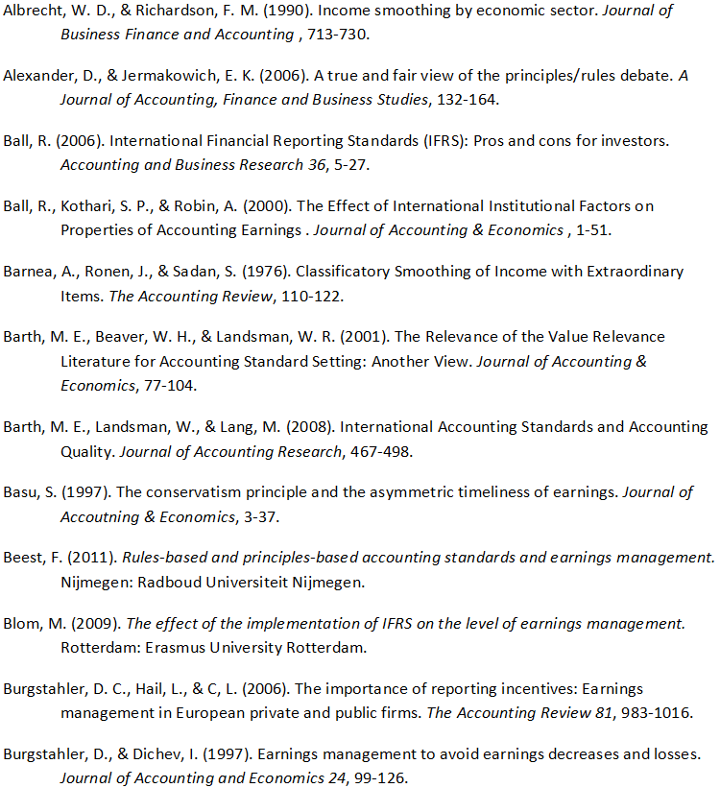
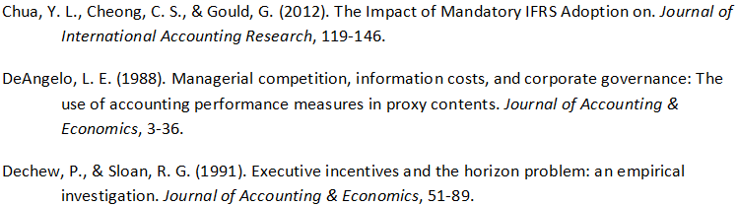

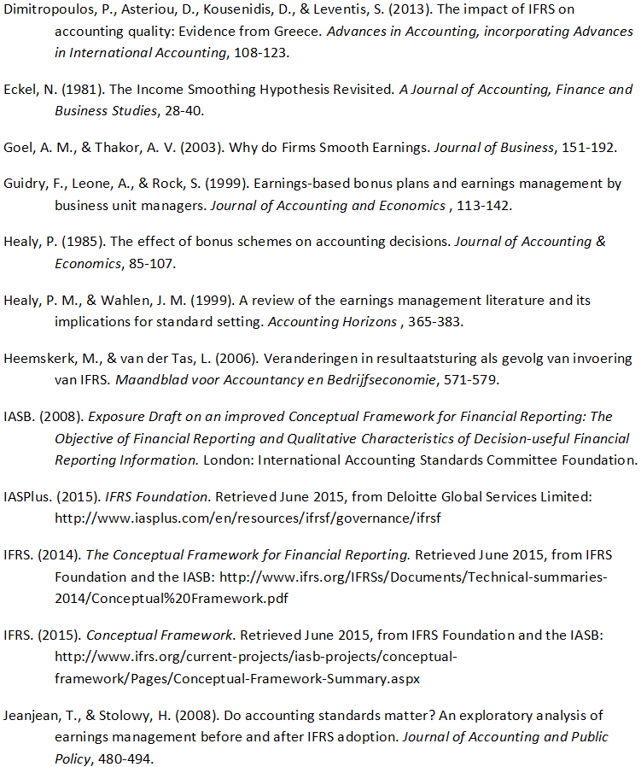
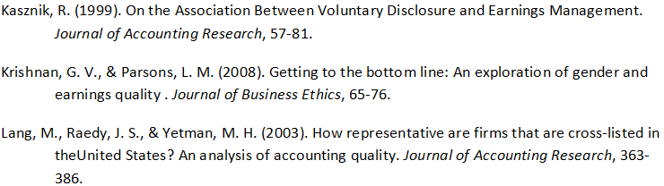
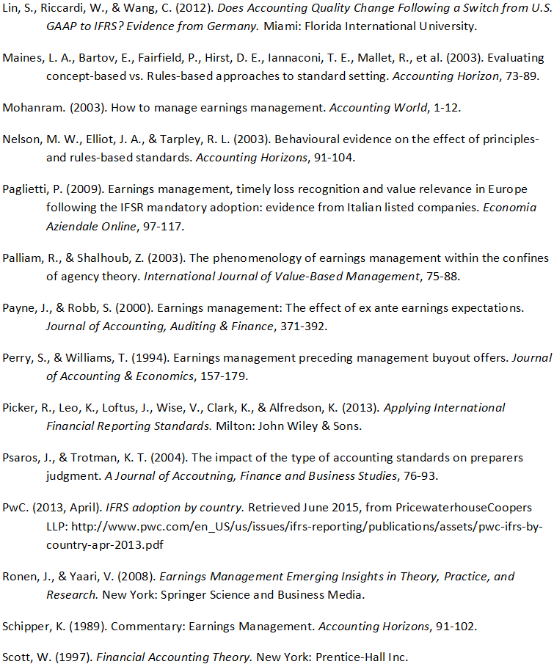
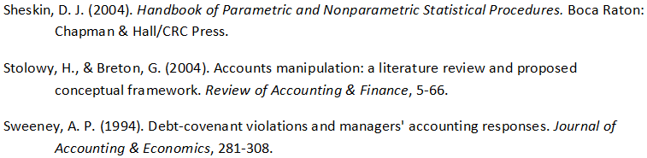

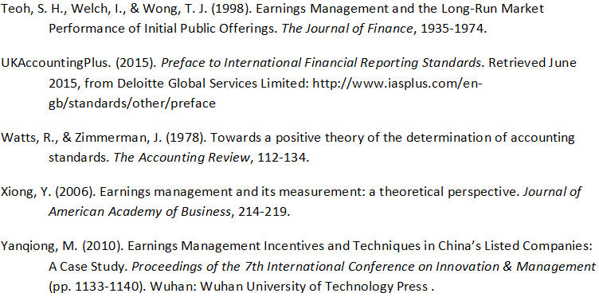

Appendices
Appendix 1

Table 1: Accounting standards switch from Australian GAAP to IFRS
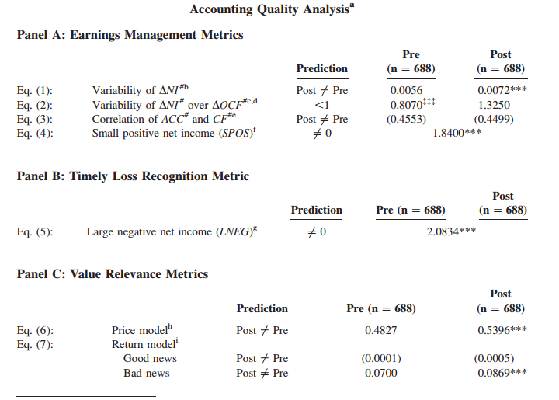
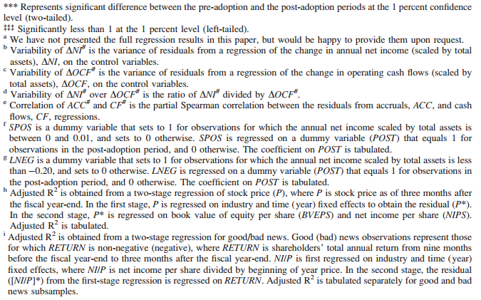
Source: Chua et al., 2012

Appendix 2

Table 1:Earnings management

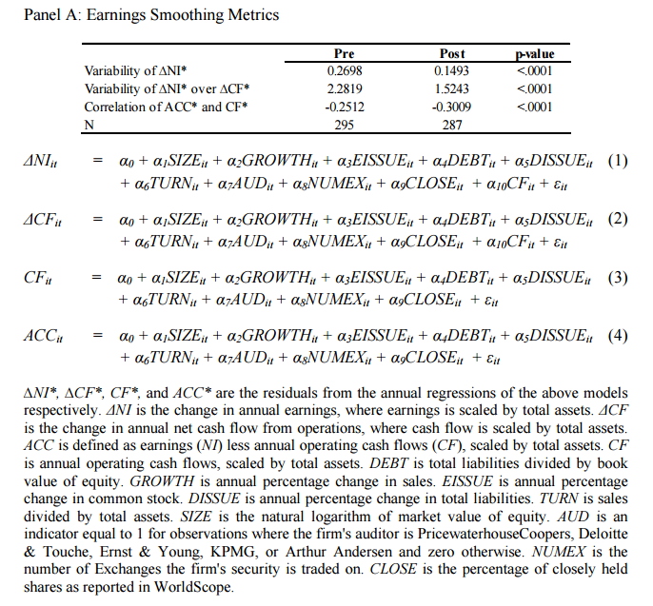
Source: Lin et al., 2012
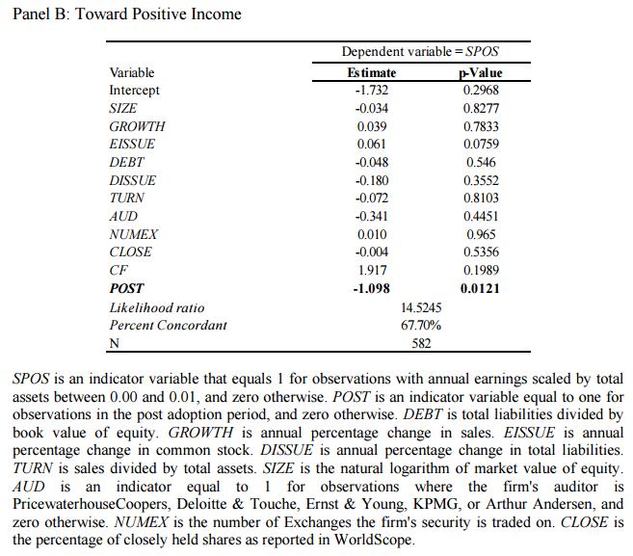
Source: Lin et al., 2012

Table 2: Timely Loss Recognition
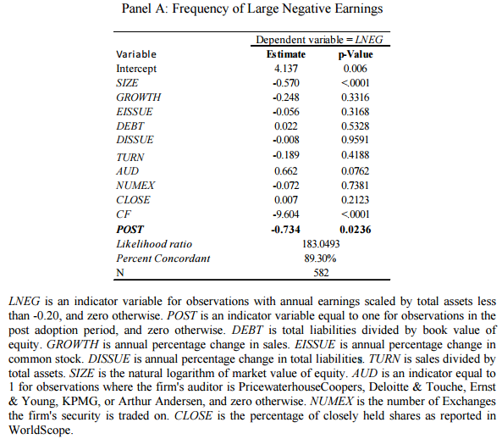
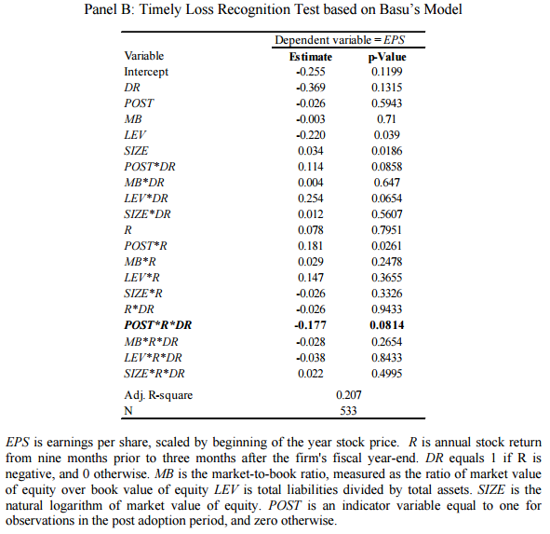
Source: Lin et al., 2012
Table 3: Value Relevance

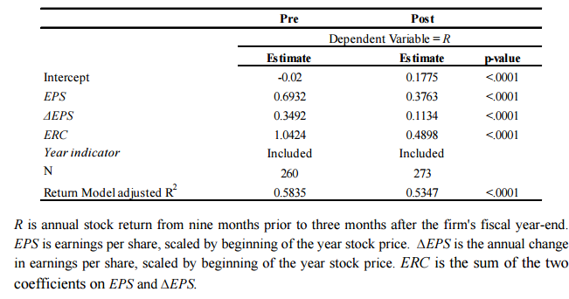
Source: Lin et al., 2012

Appendix 3

Table 1: Earnings Management
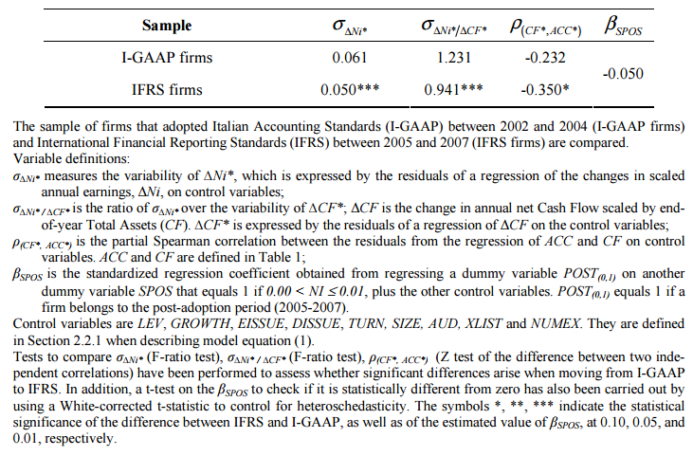
Source: Paglietti, 2009

Table 2: Timely Loss Recognition
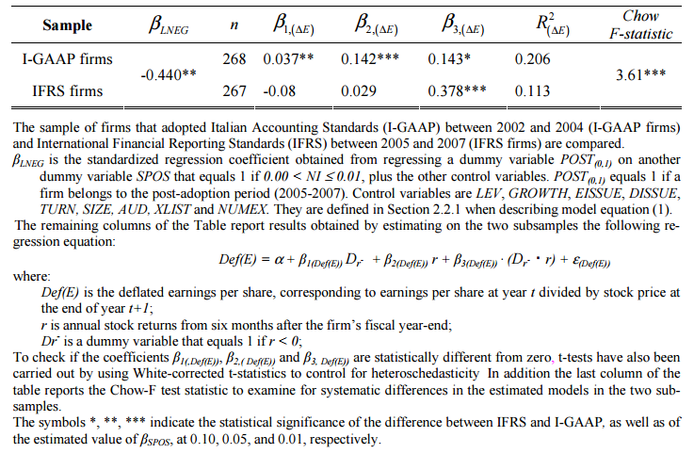
Source: Paglietti, 2009

Table 3: Value Relevance
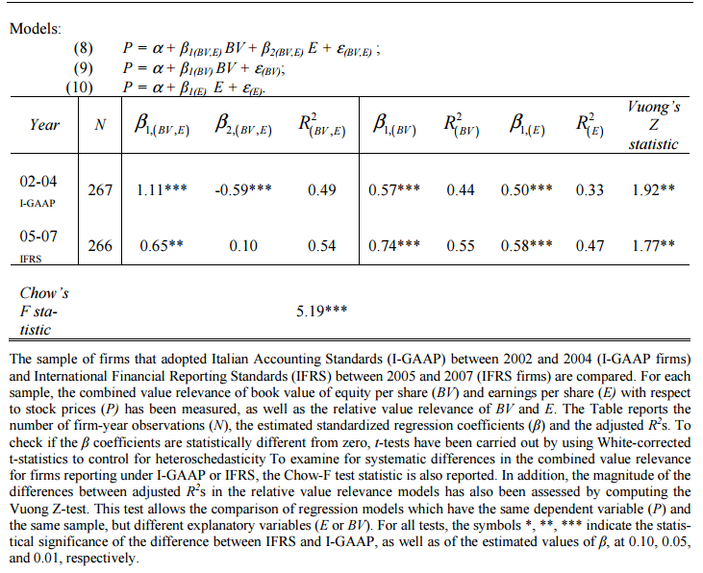
Source: Paglietti, 2009

Appendix 4

Table 1: Earnings Smoothing
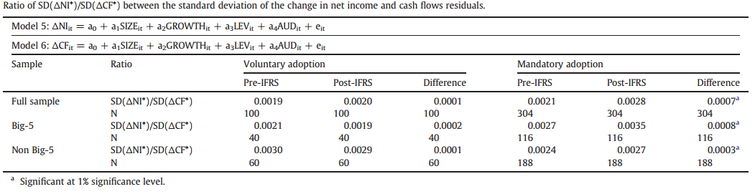
Source: Dimitropoulos et al., 2013

Table 2: Earnings Management
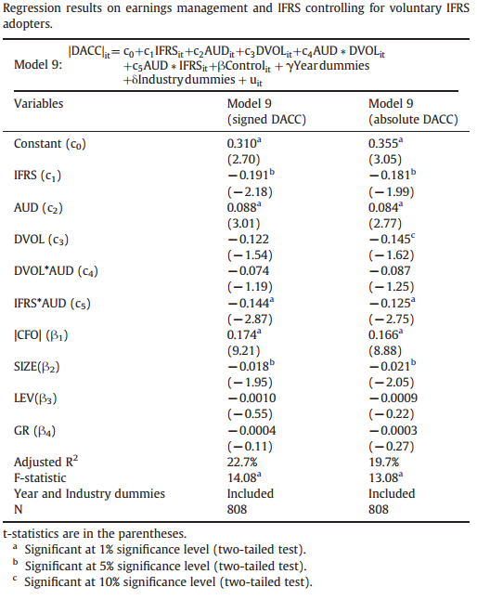
Source: Dimitropoulos et al., 2013
Table 3: Timely Loss Recognition
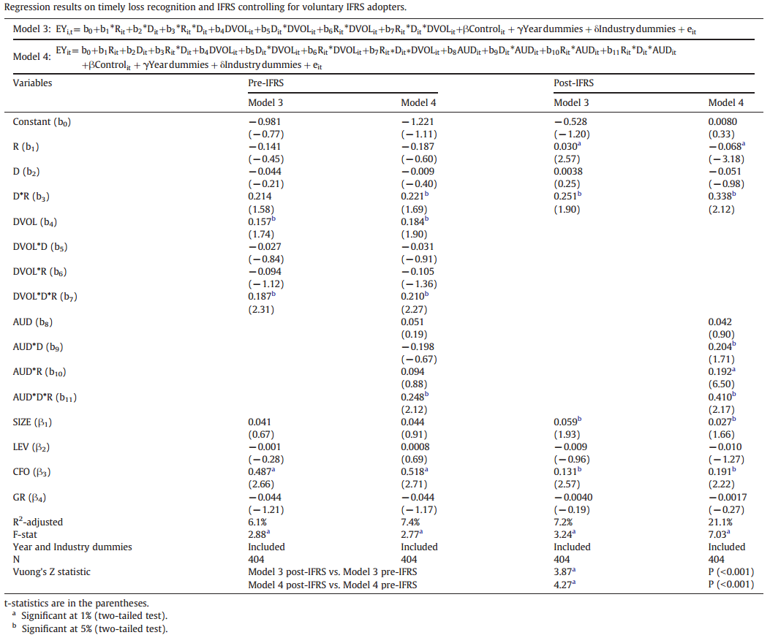
Source: Dimitropoulos et al., 2013

Table 4: Value Relevance
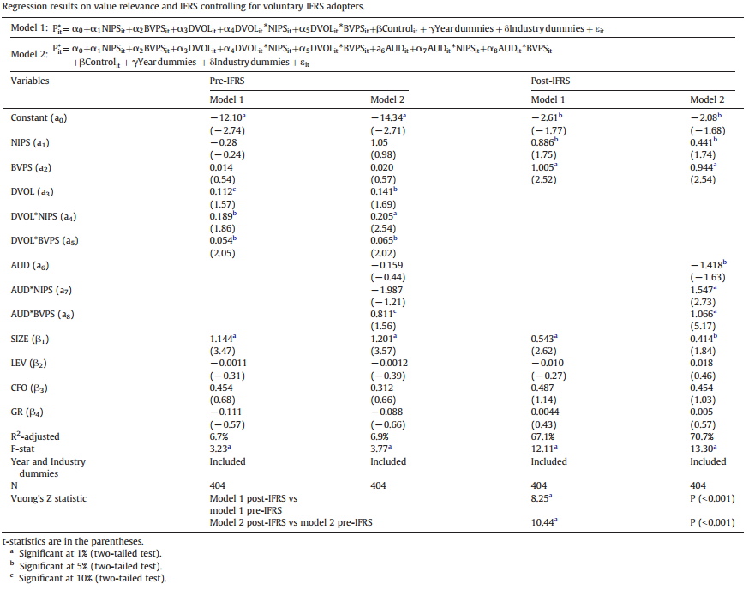
Source: Dimitropoulos et al., 2013

