

European innovative regions: Are leader firms essential?

Marcel van Alphen
Urban, Port and Transport Economics
Table of Contents
Abstract 2
Introduction 3
Data & Methodology 13
Empirical Results 21
Conclusion, Discussion and Recommendation 25
Reference list: 27
Appendix 1 30
Appendix 2 32
Appendix 3 33
Appendix 4 34

Abstract
Innovation is one of the main drivers of economic growth in the Western world, but it is still very intangible. What are the main drivers of innovation? Although the amount of literature on innovation is rising in the last decades it is still not clear which factors, besides R&D, are important for innovation. In this study the role of leader firms on innovation in European NUTS 3 regions will be examined. The main question of the study is: are leader firms essential or are there other ways to be among the most innovative regions in Europe. The outcome of this study can be important for policy makers as it shows what influence they can have on innovation. The 37 most innovative regions of Europe are combined in this study and data is used between 2000 and 2011. As no real definition of a leader firm exist one is created out of the amount of patents that a leader firm produces in the region. Other variables included in the study are; R&D expenditure, population density, education and research facilities and the size of service sector. Results show that regions with a leader firm have more patents than regions without a leader firm, although insignificant in the full model. But because 16 out of the 37 regions have no leader firm the conclusion is that leader firms are not essential to be among the most innovative regions in Europe. There are other ways to be among the innovation leaders as a region.
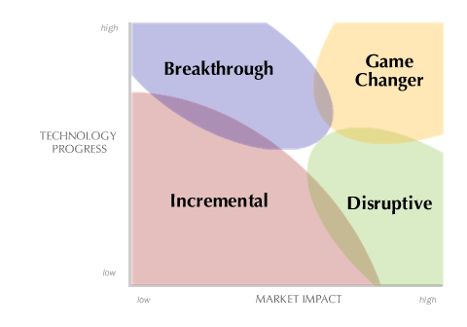
Introduction
Innovation is an important driver for economic growth in the Western world. High income economies are unable to compete on labor and input prices with developing economies. Therefore innovation is one of the main drivers of economic growth (Tushman, 1997). One of the main questions in research on innovation is; How can a region/country be or become innovative? Throughout the last twenty years more and more studies are conducted to discover the main factors that drive innovation (Fagerberg & Verspagen, 2009). The outcomes of this studies show different influences. Most studies focus on the creation of new start-ups and there role for innovation (Clarysse et al., 2011; Fritsch & Aamoucke, 2013; Helmers & Rogers, 2011). Other studies find that the type of entrepreneurship a firm adheres is an important driver for innovation (Bergfeld & Weber, 2011; Sadner & Block, 2011; van Winden et al., 2014). There is a large difference between innovation leaders and innovation followers when it comes to R&D expenditure and patents applications (Sadner & Block, 2011). One of the key factors in studies on the type of entrepreneurship is the size of R&D budgets and their link to innovation. Results show that R&D expenditure has a positive influence but studies also mention that there are other factors that play an important role (Fritsch & Slavtchev, 2011). Although many studies are conducted there is no consensus about which factors, besides R&D, are most important when it comes to innovation. The recent book of van Winden et al. (2014) on innovative regions in Europe suggests that leader firms play an important role for innovative regions. The examples of the Eindhoven and Stockholm region in the book of van Winden et al. (2014) show that leader firms played a huge role in the development of the region. The leader firms attracted both educational institutions and businesses to the region and created important spin-off firms (van Winden et al., 2014). A list of most innovative regions in the world by Forbes magazine in 2013 confirms that these regions are among the top of innovative regions in the world, taking 1st and 5th place (Forbes, 2013). But how important is the role of leader firms? In this study a quantitative research on the role of leader firms in European innovative regions will be examined. By using the 37th most innovative NUTS 3 regions in Europe and see what role leader firms have in this regions. Are leader firms essential for innovative regions? Or are there other means to be one of the most innovative regions in Europe? The results of this study can be important for policy makers. Can they enhance innovation in there region or are their important external factors, like leader firms, that determine the innovativeness of a region?
First will be looked at patent applications of regions with leader firms and patent applications of regions with no leader firm. Is there a significant different amount of patents between those regions? Or are regions with leader firms as innovative as regions without a leader firm? A model will be created with a dummy variable for regions with leader firms and control variables will be added into the model to see the influence of leader firms on patents when these variables are included in the model.
One of the most important features of this research is to see if the number of patents of regions with leader firms are influenced by other factors then in regions with no leader firms, as this would indicate that policy measures can be helpful to became innovative. An important question for policy makers is: Are patents in regions with leader firms influenced by the same factors as patents in regions with no leader firm or are there differences between regions with a leader firm and regions with no leader firm? By creating two models, one with leader firms and one without leader firms, and see what influences different variables have on these two models it can become clear whether there are differences between regions with a leader firm and regions with no leader firm.
The structure of the study is as follows. First innovation will be explained. Then important factors that influence innovation will be discussed, the focus will be on regional innovation and factors that are important for innovation on a regional level. Next the data and methodology will be discussed followed by the analyses of the data on the 37th most innovative regions in Europe. Finally the conclusion, discussion and recommendation of the study are given.
Literature review
Innovation is a complicated subject that needs to be clarified. First of all the difference between an invention and an innovation needs to be explained. When a company is developing a new technology and it finds a breakthrough this is called an invention. If this invention is used in a new product and comes on the market than the invention becomes an innovation (Roberts, 2007). Some inventions are not used (yet) in new products and therefore not all inventions lead to innovations. The reason for firms to innovate is to stay ahead of competition and gain large market shares (Lovins, 2004). This will lead to higher profits and keeps the company on top of the market. But spending on R&D means making costs with uncertain outcomes. Therefore spending on R&D bears some risk, which not all firms are willing to take. Consequently the companies on the market can be divided in innovation leaders and innovation followers. When eventually a technological breakthrough is found a company (innovation leader) want to protect it from being easily copied by competitors (innovation followers). To protect inventions from being used by others, without any costs for developing, the innovators can apply for a patent. This patent only holds for a certain amount of years and after these years the invention can be used freely by everyone on the market. Therefore companies that want to use the invention of another company have two options; Either wait until the patent expires and then use the invention in their new product, with the risk that the market is taken by other firms, or pay to the innovators to make use of the invention. As patents indicate the development of new products they are found to be one of the main used factors to measure innovation. Because all patents are being registered and companies, universities, etc. apply for patents when they find a technological breakthrough, this can indicate innovation. Some example studies that used patents to measure innovation are Moreno (2005), Moser (2013), Roper & Hewitt-Dundas (2015), Archibugi & Planta (1996) and Acs et al. (2002). But patents are not the only way to measure the innovative performance. Some studies use the percentage of people employed in Science and Technology(S&T) (Feldman et al., 2012). One of the downsides of measuring by people employed in S&T is that other sectors also can be innovative but are not taken into account. While by using the number of patents all sectors are considered.
The downside of measuring innovation by patents is that it’s unknown which impact these patents have, but this is also the case when measuring innovation by the people employed in S&T. The impact of patents depends on the technological progress and how this influences the development of new products (Damanpour, 1987). In figure 1 the different kind of innovations are shown. The biggest group of innovations are incremental innovations, these type of innovations are small in both technological progress and market impact. The breakthrough innovations are technological breakthroughs, but with small market impact. Disruptive innovations are innovations that consist of small technological progress that have a large influence on the market. Finally there are the game changing innovations. These innovations consist of large technological breakthroughs with a big impact on the market. Although different innovations have different influences on the market. In this study those differences will not be taken into account as this is a panel study and it is very hard to measure the market influence for such an amount of innovations. Therefor it could be the case that some regions can be found to be very innovative but these innovations are mostly incremental and thus make a small difference both in market impact and technology progress. Other regions, with game changing innovations, are found to be not that innovative while their innovations have a big influence in day to-day life.
Figure 1: Impact of different innovation on the market. (Kalbach, 2012)
One of the most important features of studies on innovation now-a-days is the forming of clusters (Fagerberg & Verspagen, 2009). Clusters are formed when companies of the same industry locate in the same region. Examples of these clusters are the biotech cluster in Boston and the high-tech cluster in Silicon Valley. The main reason for companies of the same industry to cluster is the effect of knowledge spillovers (Fritsch & Slavtchev, 2011). Knowledge spillovers can occur in places where employees of different companies interact with each other. One of the main ways of interaction is face-to-face contact (Storper & Venables, 2004). This face-to-face contact takes place when companies are located in the vicinity of each other. Employees of different companies will interact with each other in bars, sport clubs, etcetera. Through this interaction they exchange knowledge that can be valuable for either companies (Storper & Venables, 2004). Because of this knowledge spillover effect companies cluster together in one region to gain from each other’s knowledge (De Propris & Driffield, 2006). Because companies form these clusters, certain regions become specialized in a specific sector. This has a big influence on the regional economy as specialization can lead to higher employment (Kowalewski, 2011). Furthermore research in Germany by Kowalewski (2011) shows that when a region becomes the center of a cluster this can lead to economic growth in the region. As a regional policy maker you want to have low unemployment and economic growth as this will lead to more prosperity. Therefore innovation policies and cooperation on a regional level has become more important in the last decades. But what factors influence the location of knowledge clusters? There are already many studies conducted on this subject and the most important factors of these studies will be discussed below. The contribution of this study to the already existing studies will be on the role of leader firms in innovative regions.
Leader firms
Leader firms of a region can be described as important employers in the region with a large impact on the economic performance of a region. Often these companies are closely associated with the region or main city of the region. Examples of such firms are; Philips in the Eindhoven region, BASF in the Ludwigshafen region and the ABB group in the Zurich region. These firms attract suppliers to the region and are, to a large share, responsible for the forming of a cluster (He & Fallah, 2011). Innovative firms are often leader firms of a region as they come up with new technologies and products and therefore lead the market. Therefore a way to locate leader firms in regions is to look at patent applications by firms done in the region. Leader firms often have the majority of patent applications done in the region. For some regions this is one firm, for other regions more firms are leader firms in the region while yet other regions don’t have any leader firms at all.
One of the important features of leader firms are their substantial R&D budgets (Segerstrom & Zolnierek, 1999; García-Manjón & Romero-Merino, 2012). This can be expected as the development of new products has made them leader in the first place, but R&D expenditure is still high after the development of new products. One of the main reasons according to Segerstrom & Zolnierek (1999) for this high amount of R&D expenditure is that leader firms can more easily improve their products than other firms can as knowledge of the developed product is very high. Another explanation is that some companies are more focused on the development of new technologies and therefore will always have high R&D expenditure. In the book of van Winden et al. (2014) the role of Anton Philips in the development of new technologies by the Philips N.V. is very important. Mr. Philips was convinced that R&D was one of the main drivers of his company and therefore R&D budgets were larger and more widely spread than in most other companies. Research on German family owned firms by Bergfeld & Weber (2011) show a similar role for these families in creating new products and technologies. This shows that the way of leading a company is important for becoming leader firm. Furthermore innovative companies create more spin-off firms than non-innovative companies (Clarysse, 2011). This leads to more employment in a region and helps the cluster of a region to develop further. As a consequence innovation leaders have a positive influence on the regional innovation score while innovation followers probably have a smaller impact on the attractiveness of a region to locate in for knowledge spillover effects. Therefore the expectation is that leader firms have a positive influence on the number of patents in the NUTS 3 regions.
Science education Facilities
Other regions in Europe seem to depend more on science education for innovation (Moreno et al., 2005; Caniëls & van den Bosch, 2011). An important feature of these regions is that they don’t have one or two leader firms that dominate the region both by patents or R&D expenditure. These regions can be find all around Europe a few examples are; Isere (France), Delft (Netherlands), Skane Ian (Sweden) and Karlsruhe (Germany). None of these regions have a clear leader firm although all have large science education institutions. These institutions seem to play a role in the regions innovative leadership. First of all these institutions create new knowledge and technologies on their own and apply for patents on this knowledge. This has a positive influence on the innovative score of a region when measured by patents. Secondly one in six spin-off firms are created from universities (Dahlstrand, 1997). Although this is not as high as the number of spin-offs from companies, it is still a significant value and can influence the innovative position of a region. Furthermore the study of Meyer (2000) shows there is a connection between patents and science education. Scientific research is important background knowledge in patents and thus plays an important role in innovation (Meyer, 2000). The study of Lissoni et al. (2008) estimates that about 5% of all patents filled in Europe are filled by academics. Although this percentage is fairly low, when taken into consideration that there are much more companies than universities, it can still have a big impact on regional innovation. Therefore it is expected that science education facilities in a region will positively influence the number of patents in the used NUTS 3 regions.
Urbanization Externalities
According to Fritsch & Slavtchev (2011) population density has a positive influence on innovation. This indicates that R&D activities are more productive in urban areas than in rural areas. The higher the population density the more firms will be located in an area because the number of potential customers are higher, infrastructure is better and the labor pool is bigger than in remote regions. The research of van Geenhuizen & Soetanto (2013), on innovation in regions in larger urban agglomerations compared to remote regions, show that larger urban regions benefit more from innovation which are done outside the region than remote regions. Remote regions are more internal focused and there economy is mostly built on innovation done in the region. Urban areas experience more competition from neighboring regions and are therefore more competitive (Geenhuizen & Soetanto, 2013). Regions in urban areas are more open to innovations which are done outside the region. By using innovations which are done outside the area companies can ensure they will be among the leading firms in the market. This competition urge companies to stay ahead of the market and therefore leads to more innovations. While in remote areas firms experience less competition and therefore feel less need to be innovative. Leading companies don’t have the urge to move to the remote region because of small population and less developed infrastructure. So expectations are that the more densely populated an area is the higher the number of patents will be.
R&D expenditure
As mentioned before R&D is critical for innovation. By spending money on R&D firms and universities can create inventions (Sadner & Block, 2011; Segerstrom & Zolnierek, 1999). Therefore it is expected that regional R&D expenditure in the public and private sector will have a positive influence on the number of patents.
Employment in Service sector
Research has shown that the service sector has almost no incentive to apply for and be granted patents (Hipp & Grupp, 2005; Bode, 2004) . This would indicate that the size of the service sector has a negative influence on innovation. Although the service sector can be innovative if there is no incentive to apply for patents then this will have a negative influence on the number of patents in a region. Other studies mention that a high share of employment in the service sector can indicate a good infrastructure in a region and therefor enhances innovation (Feldman & Florida, 2004). So there is no consensus among researchers what the influence of size of the service sector is on patents. Some studies show a negative relationship while others find a positive relationship. The result of a similar study to this study on innovative regions by Fritsch & Slavtchev (2011) show that there is a negative relation between the size of the service sector and innovation. The higher the share of employment in the service sector is the lower the number of patents will be. As this is a similar research the expectations of this research will be based on the outcome of Fritsch & Slavtchev (2011). Therefore expectations are that the share of employment in the service sector will have a negative influence on the number of patents in a region.
Expectations
As mentioned in the introduction there are two models in this research. The first model will include a dummy variable for leader firms. The hypothesis is that the dummy variable leader_firm will have a positive influence on the number of patents. The leader_firm variable and all other variables that are used in this model are given in table 1 with their expected influence on patents. Only the employment in the service sector is expected to have a negative influence on the number of patents in the NUTS 3 regions. All other variables are expected to have a positive influence on the number of patents in NUTS 3 regions.
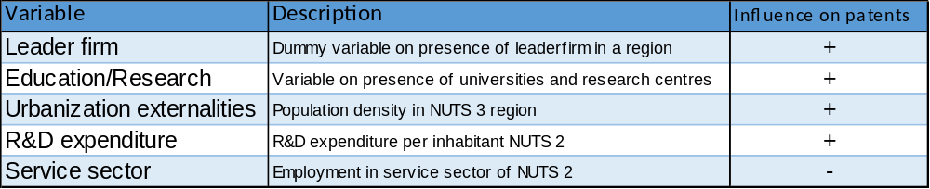
Table 1: Expected influence of independent variables on dependent variable in model 1.
The second model will split on regions with a leader firm and regions with no leader firm. The hypothesis for this model is that regions with a leader firm are influenced by the same factors as regions with no leader firm. The second model will be conducted on the same variables as model one except for the dummy variable leader firm as the model will be split on the values of this variable.
Data & Methodology
Data
In this study the 37th most innovative regions in Europe are combined. The 37th most innovative European NUTS 3 regions included in the study were found in the following nine countries: Austria , Belgium, France, Germany, Italy, the Netherlands, Sweden, Switzerland and the United Kingdom. Two regions in Denmark and one in Germany have been excluded from the data due to a lack of availability of data. Therefore the number of regions is thirty-seven instead of forty. Figure 2 shows the number of regions per country included in the study. The data used is over a twelve year consecutive period from 2000 until 2011 unless stated otherwise. Some data was not available for all regions every year. For all data, except the dummy variable leader_firm and the categorical variable education_research_facilities, logs are created to correct for outliers in the data.
Patents
The data on patents for the 37th most innovative NUTS 3 regions is obtained from Eurostat. As this research focusses on the role of leader firms in innovation some adjustments need to be made in the regions. First of all only the regions with more than 100.000 inhabitants and more than 100 patents in the year 2011 are selected to overcome the problem that regions with small population and some innovative firms are included in the data, while no international leader firms exist in these regions and their impact on the national economy is small. When only the regions with more than 100.000 inhabitants in the year 2011 were included 114 regions were selected. When only the regions with more than 100 patents in the year 2011 were included 57 regions remained. Of this 57 regions the forty with the highest number of patents per 10.000 residents have been selected to be included in the study. The reason that patents per 10.000 residents are used to select regions is because this indicates the innovativeness better than total patents per region. Otherwise regions with more inhabitants like London will be selected due to a large population and therefore a larger total patents, while using patents per 10.000 residents will make sure that regions are selected on a fair base. Because the NUTS 3 regions are not the same size and regions are divided differently around Europe some adjustments had to be done to make the regions compatible. For example the NUTS 3 regions in Germany, Switzerland, France and the UK are different from the NUTS 3 regions elsewhere in Europe. The NUTS 3 regions in these four countries can contain only cities while in the rest of the selected countries NUTS 3 regions contain cities and the surrounding areas, this is especially the case for most German regions and for some regions in the other mentioned countries. This could bias the results and therefore most German and some Swiss, France and UK NUTS 3 regions are combined. This is done to create compatible regions throughout Europe. All the combined regions can be found in appendix 1 in both the figure and table the used regions are given. If regions were combined both the population and the number of patents were combined and new calculations of patents per 10.000 residents have been made. Most regions still were among the most innovative when made compatible to all other NUTS 3 regions. Some regions have been dropped due to a to low number of patents per 10.000 residents after including neighboring regions. These regions are replaced by the highest scoring regions which were not included in the study before.
Figure 2: The distribution of European innovative regions used in this study.
Leader firms
The range of the number of leader firms in this study is between zero and two. Some regions will not have a leader firm while others will either have one or two leader firms. More than two leader firms could indicate that there is no specific firm(s) that dominates the market and therefore only one or two leader firms will be used in this study. To be a leader firm the firm has to be the spill of specialization in the region. For measuring the role of leader firms the number of patents granted in that region to the company will be taken. The number of patents of the company will be divided by the total number of patents in the region and will be expressed as a percentage. When a company has an average above 25% of all patents in a region between 2000 and 2011 it will be seen as a leader firm. When there is no company with a patent percentage above 25% but there are two companies that have a combined average above 35% of all patents in a region they will be marked as the leader firms. To make it clear this will only be done when there is no leader firm with a percentage of total patents above 25%. A dummy variable is created which has the value of 1 for regions with a leader firm and the value of zero for regions with no leader firm. In this case regions with two leader firms and regions with one leader firm will be combined in the dummy value of one as there are only two regions with two leader firms in the study and this is not enough to make a distinguish between them and to do an analyses on. As a result the dummy variable consist of 16 regions with the value of zero and 21 regions with the value of one.
Today the different patent offices in Europe are integrated into one European Patent Office (EPO). The EPO works together with other big patent offices in the world; the United States Patent and Trademark Office (USPTO), the Japan Patent Office (JPO), The Chinese Patent office and the Korean Patent office (EPO, 2014). Together they handle the majority of patent applications in the world. This makes it easier for companies to protect their new technologies abroad, although not all countries are included. When a patent is assigned by the EPO its term is 20 years from the date of filling (EPO, 2013). This means the owner of the patent has right to benefit from the use of his/her innovative technology until 20 years after its application. All patents from leader firms are obtained from the EPO website and need to be registered in the region to count for the region. The date of publication of patents are used as this is the date when patents are first published and this is also used by Eurostat for data on the regions. Some regional leader firms have more patents than the region itself has in one year. The reason for this is that the EPO includes patents that are created by cooperation between companies in all regions while Eurostat counts these patents only for the first filed company.
Figure 3: The distribution of regions with and without leader firms in this study.
Control variables
Education/research facilities
The Education/Research variable: edu_res_facilities is a categorical variable. When there is no university or research institute in the area the value of the variable is one and has the name edu_res_facilities1. When there is either a science university or a research institute the value will be two and the name of the variable is edu_res_facilities2. If there are both a science university and a research institute in the region the value will be three and the name of the variable is edu_res_facilities3. When there are more science universities and research institutes located in an area the value of the categorical variable will be four and the name of the variable will be edu_res_facilities4. An example of science institutions are the Max Planck institutes and the Frauenhofer institutes in Germany, Austria, the Netherlands and Switzerland. As most countries have other names for their research institutions mainly national websites are used to see where they are located and what their contribution to research exactly is. All used websites can be found in appendix 2.
R&D Expenditure
log_rdexpenditure is a control variable on NUTS 2 level as it is not available on NUTS 3 level. The variable is obtained from Eurostat. The R&D expenditure data are the R&D expenditure per resident of the NUTS 2 region. Although not on the same level as most other data it is still expected to have an influence on the number of patents on NUTS 3 level. Eurostat had no data for all six Swiss regions. As this would lead to too much missing data there is a proxy used by using the national data on R&D expenditure per resident for all Swiss regions for the period 2000 until 2011. All other regions had at least data for a minimal period of 7 consecutive years.
Urbanization Externalities
The data of log_population_density is obtained by dividing the population of NUTS 3 regions by the area of NUTS 3 regions in year X.
$$Population density NUTS 3 year x=\frac{Population NUTS 3 level in year x}{Area NUTS 3 level in km in year x }$$Both the data on Population of NUTS 3 regions and the area of NUTS 3 regions is obtained by Eurostat. Again some of the regions in Germany, Switzerland, the UK and France are combined to get compatible data throughout all countries. For the exact regions see appendix 1. For all regions data is available for at least 8 consecutive years between 2000 and 2011.
Service sector
The variable log_service_sector is obtained from Eurostat. The variable is only available on nuts 2 level. It is created by the following formula:
$$employment in the service sector=\frac{employment in services \left(Nace G-Q\right)(NUTS2)}{Economically active population (NUTS2)}$$
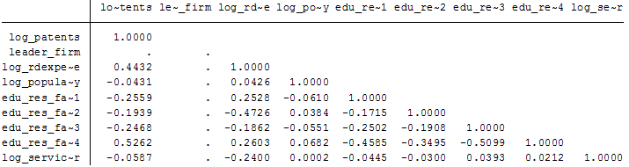
NACE group G consist of wholesale and retail activities and repair of motor vehicles and motorcycles while NACE group Q consist of human health and social work activities. A log is created to correct for outliers. Data is missing for the period 2009 until 2011.
Methodology
The data is paneled between 2000 and 2011 therefore an OLS regression for panel data is used. A Hausman test is performed to see if a fixed effects or random effects model fits data best. The results in appendix 3 show that the fixed effects fits data best as H0 is rejected. The problem with the fixed effects model is that it drops dummy variables and categorical variables that do not change over time. Which means that in model 1 the role of leader firms and education research facilities cannot be found as these variables would be omitted by a fixed effects model because they don’t change over time. In model 2 this would lead to a drop of the categorical variable on education facilities only. As these are two of the main variables of the study it is decided to use the random effects model, as otherwise the study will lose its added value of leader firms and education research facilities. Although the random effects model will probably lead to more biased estimations as the fixed effects model for this data set, in this research it is taken for granted as otherwise the influence of leader firms and education research facilities cannot be detected. Robust standard errors are used to overcome heteroscedasticity in the error terms. Figure 4 shows the correlation among the variables used in the model. The highest correlation is between edu_res_facilities4 and the log_patents with a value of .5262. This value is still acceptable to leave both variables in the model.
Figure 4: Correlation table for used variables in full model
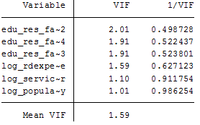
To see if there is multicollinearity in the data a test on multicollinearity of the independent variables is performed with the regression post estimation estat vif. As can be seen in figure 5 no value is above 2.01 and therefore there is no sign of high multicollinearity among the independent variables. This indicates that none of the independent variables is explaining the same variation on such a high level that it is better to omit the variable from the model and have a higher omitted variable bias than to leave it in. The models used to test if leader firms have a positive influence on the number of patents in a region are as follows:
Figure 5: Estat vif multicollinearity test on all included variables.
First a model with control variables is made to see if the dummy variable leader_firm has an influence when other variables are added to the model. Model 1:
xtreg log_patents leader_firm log_rdexpenditure log_population_density edu_res_facilities log_service_sector, re robust
Furthermore two separate models for regions with and without leader firms are created to see which variables influence innovation in these regions. Model 2:
drop if leader_firm ==0
xtreg log_patents log_rdexpenditure log_population_density edu_res_facilities log_service_sector, re robust
Model 3:
drop if leader_firm ==1
xtreg log_patents log_rdexpenditure log_population_density edu_res_facilities log_service_sector, re robust

Empirical Results
Model 1 is created to see the influence of the dummy variable leader_firm. In appendix 4 the creation of the model and the influence of each added variable can be seen. First a model is created with only the dependent variable log_patents and the dummy variable leader_firm. The influence of leader_firm is significant at a 5% level and has a value of .616. Meaning that when a region has a leader firm patents will be on average .616*100= 61.6% higher compared to regions with no leader firm. Throughout the adding process of the model the variable leader_firm is significant at a 10% level as can be seen in appendix 4. Only when the variable log_service_sector is added to the model leader_firm becomes insignificant at a 10% level. But because the value of log_rdexpenditure becomes more significant when the variable log_service_sector is added to the model it is decided to leave log_service_sector in the model. The results of the full model can be seen in table 1, this model has the highest R-squared value of all models with an overall R-square of .6074, although it needs to be mentioned that the r-squared in a xtreg model is not that intuitive as in a normal regression. The model shows that leader_firm has a positive influence on log_patents, but as the value is insignificant nothing can be said about the size of the variable. Log_rdexpenditure has a positive value of .413 and is significant on at a 1% significance level. This means that a higher value of R&D expenditure has a positive influence on the number of patents. When the variable log_rdexpenditure rises with 1% this will lead to a rise in patents of 0.421%. The variable log_population_density has a positive influence on patents and is significant at a 1% significance level. Population density has a value of .418 indicating that when population density rises with 1% this will lead to a rise in patents of 0.418%. Education and research facilities is a categorical variable with four different values. Edu_res_facilities4 is omitted from the model as it is the reference group for the other three variables. All three education/research facilities variables are significant at a 1% level. As edu_res_facilities4 is the reference group all three other variables are measured in comparison with the influence of edu_res_facilities4 on log_patents. All three variables have a negative value. This is expected because edu_res_facilities4 indicates the highest value given to regions for education and research facilities. Compared to edu_res_facilities4 edu_res_facilities3 has a value that is .666 lower. The value of edu_res_facilities2 is .680 lower than edu_res_facilities4 and edu_res_facilities1 is .864 lower than the reference group edu_res_facilities4. As can be seen the lower the group number the bigger the gap with edu_res_facilities4 becomes. This is understandable as the lowest group number indicates the least education/research facilities. The more facilities there are in a region the higher the influence on the number of patents is. The variable log_service_sector has a positive value of .121 and is significant at a 5% level. The value of service sector indicates that when the size of the service sector grows with 1% this will lead to a 0.121% rise in patents, this is contrary to expectations. The constant is negative but insignificant. The results of model one indicates that hypothesis one is rejected although the dummy variable leader_firm seems to have a positive influence on patents it is insignificant and therefore we need to reject hypothesis one.
Table 1 | (1)
VARIABLES | log_patents
leader_firm | 0.318
 | (0.200)
log_rdexpenditure | 0.413***
 | (0.103)
log_population_density | 0.418***
 | (0.0907)
edu_res_facilities1 | -0.864***
 | (0.170)
edu_res_facilities2 | -0.680***
 | (0.217)
edu_res_facilities3 | -0.666***
 | (0.218)
o.edu_res_facilities4 | -
log_service_sector | 0.121**
 | (0.0514)
Constant | 0.356
 | (0.806)
Observations | 354
Number of regionnumber | 37
Robust standard errors in parentheses
*** p<0.01, ** p<0.05, * p<0.1
The results of model 2 and 3 are given in table 2. The group with a leader firm consist of 21 regions and the group without a leader firm consist of 16 regions. There are some differences between both groups. First of all patents in regions with a leader firm are influenced by all variables but the constant on a significance level of 1%. While the patents in regions with nog leader firm are only significantly influenced by the R&D expenditure variable on a 1% level and by the categorical variable edu_res_facilities on a 5% level, all other variables are not significant at a 10% level. There is also a difference in the size of the variables. When a closer look is taken on the size of the variable log_rdexpenditure, it can be seen that when 1% extra R&D is invested in regions with no leader firm this will lead to a growth in patents of 0.639%. While regions with a leader firm only have an increase in patents of 0.296% when 1% extra R&D is invested. For both leader firm and none leader firm regions it seems that population density has a positive influence on patents. Due to the insignificant value for regions with no leader firms nothing can be said about the size of this variable. For regions with leader firms the results are highly significant indicating that when the population density of a region rises with 1% this will lead to a 0.530% rise in patents in that region. The results on the education and research variable are all significant for regions with leader firms. In this model the reference group is the same as in model 1. All three values of the other edu_res_facilities variables are negative, meaning that more education and research facilities lead to more patents. It needs to be mentioned that the negative value of edu_res_facilities2 is smaller than of edu_res_facilities3. This is somewhat unexpected because it indicates that regions with only a university or a research centre create more patents than regions with both universities and research centres. For regions with no leader firm only the value of edu_res_facilities1 is significant at a 5% level. The negative value of .701 indicates that regions without education/research facilities have a smaller influence on the number of patents than regions with multiple universities and/or research facilities. Both other groups are negative but insignificant. The results on the service sector are again contrary to expectations. Expectations were that the size of the service sector would negatively influence patents in a region. Both results show that the influence of the size of the service sector is positive, although insignificant for regions with no leader firm. The impact of the service sector on patents is much smaller than of the other variables. For regions with a leader firm an increase of the service sector with 1% will only lead to a 0.175% increase in patents. Due to the insignificant value for regions with no leader firm nothing can be said about the size of the variable. The constant is positive for both regions but is not significant at a 10% level. When looking at these results hypotheses two can be rejected patents in regions with a leader firm are not influenced by the same factors as regions with no leader firm.
Table 2 | Leader firm | No Leader firm
VARIABLES | log_patents | log_patents
log_rdexpenditure | 0.296*** | 0.639***
 | (0.0958) | (0.230)
log_population_density | 0.530*** | 0.0954
 | (0.0807) | (0.209)
edu_res_facilities1 | -0.996*** | -0.701**
 | (0.179) | (0.277)
edu_res_facilities2 | -0.873*** | -0.224
 | (0.262) | (0.347)
edu_res_facilities3 | -0.920*** | -0.394
 | (0.229) | (0.264)
o.edu_res_facilities4 | - | -
log_service_sector | 0.175*** | 0.0566
 | (0.0563) | (0.101)
Constant | 0.882 | 0.587
 | (0.826) | (1.861)
Observations | 207 | 147
Number of regionnumber | 21 | 16
Robust standard errors in parentheses
*** p<0.01, ** p<0.05, * p<0.1

Conclusion, Discussion and Recommendation

Conclusion
To immediately answer the main question of this research: Are leader firms essential for regions to be innovative? The answer to that question is no. Out of the 37 regions in this research 16 regions had no leader firm according to the definition of a leader firm in this study. Although leader firms are not essential for regions to be among the most innovative in Europe it most certainly helps to have a leader firm in the region. As the results show that regions with leader firms have a higher amount of patents than regions with no leader firm, although this becomes insignificant when the service sector is added to the model. For regions with no leader firm one factor plays an important role: R&D expenditure. R&D expenditure is highly significant and the coefficient is more than double the value then in regions with a leader firm. It is striking to see that educational/research facilities play a larger role in regions with a leader firm than in regions with no leader firm. One reason for this can be that regions with no leader firm already have a large educational/research sector while regions with a leader firm can benefit more from locating educational/research facilities in there region, due to a less developed educational/research sector. This could also explain why regions with no leader firm can benefit a lot from extra investments in R&D. As in these regions the R&D is probably lacking behind compared to regions with large R&D expending leader firms. The positive influence of the size of the service sector on patents is not what was expected beforehand. But as mentioned in the literature review, the discussion on the influence of the service sector on patents is still undecided and ongoing, therefore the positive outcome of the variable service sector is not that strange.
Discussion
One of the main problems of the research is the definition of a leader firm. There are almost no studies that use this concept and no other definitions of a leader firm was found. Therefore the definition is created by looking at data on patents. Another problem is the amount of regions that are used in the second hypothesis. Due to the split of data in regions with leader firms and regions with no leader only 21 and 16 regions remain which can be a low amount to base results on. Furthermore the lack of some data for the Swiss regions, six in total, could have biased the results although the nearest proxies available are used. Another problem of the study is the use of the random effects model. Due to the use of a dummy variable and a categorical variable it was not possible to use the fixed effects model. Although the Hausman test indicated that a fixed effects model would probably lead to less biased estimations.

Recommendations for further research
This study focused on leader firms in Europe, it would be interesting to see a study on leader firms at a global level. As Europe only has a certain amount of leader firms an international study could have different outcomes then a study on Europe alone. Furthermore more regions need to be add in future studies to see if the result of this study are also found on a larger scope. It would also be interesting to see when other definitions for leader firms would be used what influence this would have on the outcomes of the study.

Reference list:
Acs, Z. J., Anselin, L., & Varga, A. (2002). Patents and innovation counts as measures of regional production of new knowledge. Research policy, 31(7), 1069-1085.
Archibugi, D., & Planta, M. (1996). Measuring technological change through patents and innovation surveys. Technovation, 16(9), 451-519.
Bergfeld, M. M. H., & Weber, F. M. (2011). Dynasties of innovation: Highly performing German family firms and the owners’ role for innovation.International Journal of Entrepreneurship and Innovation Management, 13(1), 80-94.
Bode, E. (2004). The spatial pattern of localized R&D spillovers: an empirical investigation for Germany. Journal of Economic Geography, 4(1), 43-64.
Caniëls, M. C., & van den Bosch, H. (2011). The role of higher education institutions in building regional innovation systems. Papers in Regional Science, 90(2), 271-286.
Clarysse, B., Wright, M., & Van de Velde, E. (2011). Entrepreneurial Origin, Technological Knowledge, and the Growth of Spin‐Off Companies. Journal of Management Studies, 48(6), 1420-1442.
Dahlstrand, Å. L. (1997). Growth and inventiveness in technology-based spin-off firms. Research policy, 26(3), 331-344.
Damanpour, F. (1987). The adoption of technological, administrative, and ancillary innovations: Impact of organizational factors. Journal of management, 13(4), 675-688.
De Propris, L., & Driffield, N. (2006). The importance of clusters for spillovers from foreign direct investment and technology sourcing. Cambridge Journal of Economics, 30(2), 277-291.
EPO. (2013). Legal text. retrieved from: http://www.epo.org/law-practice/legal-texts/html/epc/2013/e/ar63.html
EPO. (2014). Guidelines for examination. Retrieved from: http://documents.epo.org/projects/babylon/eponet.nsf/0/56911A5DDF284B55C1257D81005FA359/$FILE/guidelines_for_examination_2014_en.pdf
Fagerberg, J., & Verspagen, B. (2009). Innovation studies—The emerging structure of a new scientific field. Research policy, 38(2), 218-233.
Feldman, M. P., Link, A. N., & Siegel, D. (2012). The economics of science and technology: an overview of initiatives to foster innovation, entrepreneurship, and economic growth. Springer Science & Business Media.
Feldman M. P. & Florida R. (1994) The geographic sources of innovation: technological infrastructure and product innovation in the United States, Annals of the Association of American Geographers 84, 210–229
Forbes. (2013). World’s 15 most inventive cities. Retrieved from: http://www.forbes.com/sites/williampentland/2013/07/09/worlds-15-most-inventive-cities/
Fritsch, M., & Aamoucke, R. (2013). Regional public research, higher education, and innovative start-ups: An empirical investigation. Small Business Economics, 41(4), 865-885.
Fritsch, M., & Slavtchev, V. (2011). Determinants of the efficiency of regional innovation systems. Regional Studies, 45(7), 905-918.
García-Manjón, J. V., & Romero-Merino, M. E. (2012). Research, development, and firm growth. Empirical evidence from European top R&D spending firms.Research Policy, 41(6), 1084-1092.
He, J., & Fallah, M. H. (2011). The typology of technology clusters and its evolution—Evidence from the hi-tech industries. Technological Forecasting and Social Change, 78(6), 945-952.
Helmers, C., & Rogers, M. (2011). Does patenting help high-tech start-ups?. Research Policy, 40(7), 1016-1027.
Hipp, C., & Grupp, H. (2005). Innovation in the service sector: The demand for service-specific innovation measurement concepts and typologies. Research policy, 34(4), 517-535.
Kalbach, J. (2012) Clarifying Innovation: Four zones of innovation. Experience information. Retrieved from: https://experiencinginformation.wordpress.com/2012/06/03/clarifying-innovation-four-zones-of-innovation/
Kowalewski, J. (2011). Specialization and employment development in Germany: An analysis at the regional level*. Papers in Regional Science, 90(4), 789-811.
Lissoni, F., Llerena, P., McKelvey, M., & Sanditov, B. (2008). Academic patenting in Europe: new evidence from the KEINS database. Research Evaluation, 17(2), 87-102.
Lovins, A. B. (2004). Winning the oil endgame: innovation for profits, jobs and security. Rocky Mountain Institute.
Meyer, M. (2000). Does science push technology? Patents citing scientific literature. Research policy, 29(3), 409-434.
Moreno, R., Paci, R., & Usai, S. (2005). Geographical and sectoral clusters of innovation in Europe. The Annals of Regional Science, 39(4), 715-739.
Moser, P. (2013). Patents and innovation: evidence from economic history.The Journal of Economic Perspectives, 23-44.
Roberts, E. B. (2007). Managing invention and innovation. Research-Technology Management, 50(1), 35-54.
Roper, S., & Hewitt-Dundas, N. (2015). Knowledge stocks, knowledge flows and innovation: Evidence from matched patents and innovation panel data. Research Policy, 44(7), 1327-1340.
Sandner, P. G., & Block, J. (2011). The market value of R&D, patents, and trademarks. Research Policy, 40(7), 969-985.
Segerstrom, P. S., & Zolnierek, J. M. (1999). The R&D incentives of industry leaders. International Economic Review, 40(3), 745-766.
Storper, M., & Venables, A. J. (2004). Buzz: face-to-face contact and the urban economy. Journal of economic geography, 4(4), 351-370.
Tushman, M. L. (1997). Winning through innovation. Strategy & Leadership,25(4), 14-19
Van Geenhuizen, M., & Soetanto, D. P. (2013). Benefitting from learning networks in “open innovation”: Spin-off firms in contrasting city regions.European Planning Studies, 21(5), 666-682.
Van Winden, W., Braun, E., Otgaar, A., & Witte, J. (2014) Urban Innovation Systems; What makes them thick. Regional studies Association. Routledge.

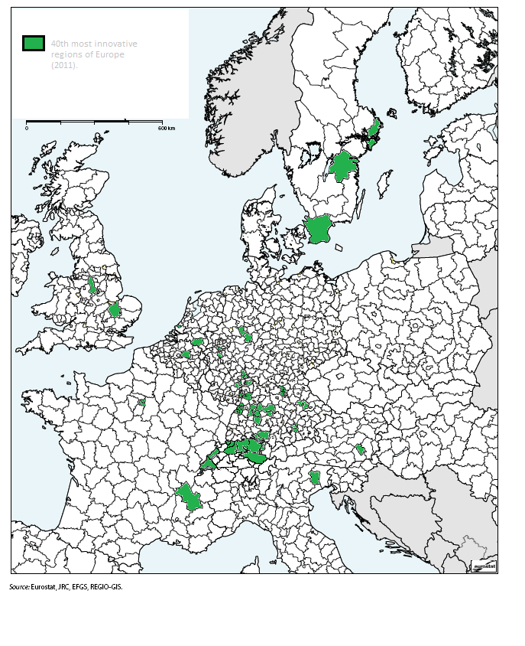
Appendix 1
Figure 12: The geograpical location of the 37 most innovative regions in Europe.

NUTS 3 regions in study | Country | Extended with
Aargau | CH
Leuven | BE
Basel-Stadt | CH | Basel-Landschaft
Bodenseekreis | DE
Cambridgeshire CC | UK
Darmstadt-Dieburg | DE | Darmstadt, Kreisfreie Stadt
Delft en Westland | NL
Derby | UK | South & West Derbyshire
Erlangen, Kreisfreie Stadt | DE | Erlangen-Höchstadt
Frankfurt am Main, Kr. Stadt | DE | Hochtaunuskreis
 |  | Main-Taunus-Kreis
 |  | Offenbach am Main, Kr. Stadt
Graz | AU
Gütersloh | DE
Hauts-de-Seine | FR | Paris
 |  | Val-de-Marne
 |  | Seine-Saint-Denise
Heidenheim | DE
Isère | FR
Karlsruhe, Stadtkreis | DE | Karlsruhe, Landkreis
 |  | Rastatt
Mainz-Bingen | DE | Mainz, Kreisfreie Stadt
Mannheim, Stadtkreis | DE | Heidelberg, Stadtkreis
 |  | Rhein-Neckar-Kreis
Mettmann | DE | Düsseldorf, Kreisfreie Stadt
München, Kreisfreie Stadt | DE | München, Landkreis
Neuchâtel | CH
Nordsjælland | DK
Nürnberg, Kreisfreie Stadt | DE | Fürth, Kreisfreie Stadt
 |  | Fürth, Landkreis
Ostalbkreis | DE
Östergötlands län | SE
Paderborn | DE
Pordenone | IT
Ravensburg | DE
Regensburg, Kr. Stadt | DE | Regensburg, Landkreis
Reutlingen, Landkreis | DE
Rheinisch-Bergischer Kreis | DE
Rheintal-Bodenseegebiet | AT
Skåne län | SE
St. Gallen | CH
Stockholm | SE
Stuttgart, Stadtkreis | DE | Ludwigsburg
 |  | Böblingen
 |  | Esslingen
 |  | Rems-Murr-Kreis
Vaud | CH
Vestjylland | DK
Zuidoost-Noord-Brabant | NL
Zürich | CH

Appendix 2
Switzerland | http://www.myscience.ch/en/research/research_institutions
 | http://www.studyinginswitzerland.ch/universities-of-switzerland.htm
Belgium | http://www.researchportal.be/index.html
 | http://www.topuniversities.com/where-to-study/europe/belgium/guide
Austria | http://www.studyineurope.eu/study-in-austria/higher-education-institutions#courses-catalogs--austria/?view_154_page=3
Germany | https://www.fraunhofer.de/de/institute-einrichtungen.html
 | http://www.mpg.de/institutes
France | http://www.cnrs.fr/en/aboutCNRS/institutes.htm
 | http://about-france.com/universities.htm
Italy | http://www.cspn.units.it/en/
 | http://www.lunghezzadonda.com/en
Netherlands | https://www.tno.nl/en/
 | http://www.thecompleteuniversityguide.co.uk/international/europe/netherlands/
 | http://www.narcis.nl/search/coll/organisation/Language/NL
Sweden | https://www.universityadmissions.se/en/All-you-need-to-know1/Studying-in-Sweden/Swedish-universities/Contact-information-for-Swedish-universities/
 | http://www.ri.se/en/research-institutes
UK | http://www.bbsrc.ac.uk/about/institutes/institutes-of-bbsrc/
 | http://www.bbsrc.ac.uk/about/institutes/institutes-of-bbsrc/

Appendix 3

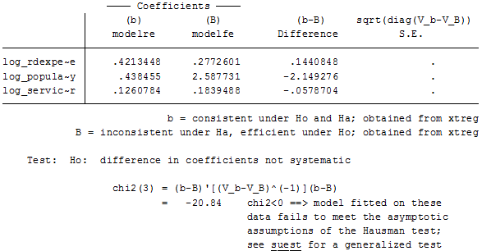
Figure 6: Hausman test on variables in the used model.

Appendix 4
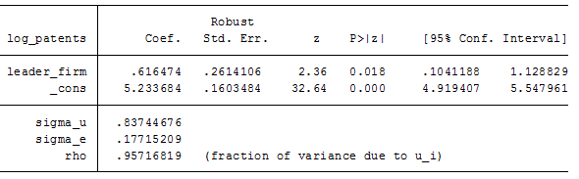
Figure 7: Basic model with only dummy variable leader_firm a constant and depend variable log_patents. With random effects..
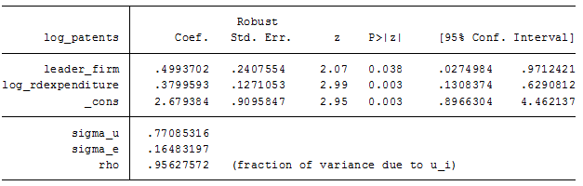
Figure 8: log_rdexpenditure is added to the model

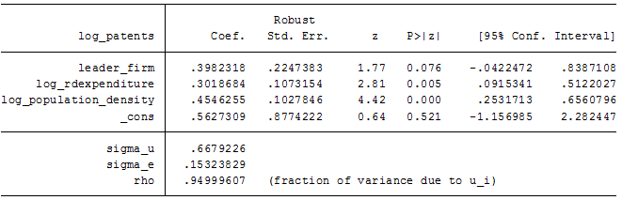
Figure 9: Log_population_density is added to the model
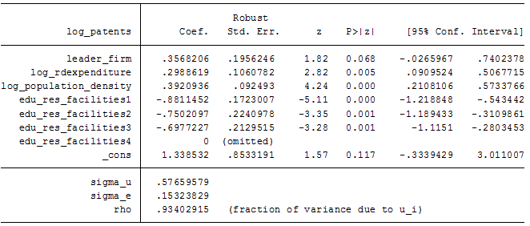
Figure 10: edu_res_facilities is added to the model

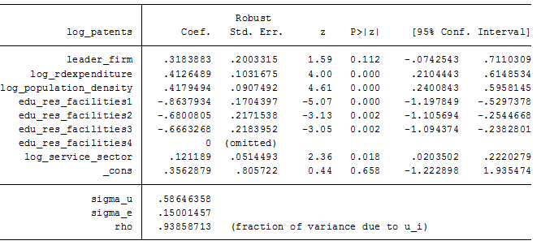
Figure 11: log_service_sector is added to the model.

