External shocks on a dollarized economy: an empirical evidence from Ecuador
ERASMUS UNIVERSITY ROTTERDAM
Erasmus School of Economics
Department of Economics

Supervisor: MSc Barbara Sadaba

Name: Elena Cristina Zambrano Córdova
Exam Number: 410474
E-mail address: ezambranoc@miradoreconomico.com

External shocks on a dollarized economy: an empirical evidence from Ecuador
Elena Zambrano Cordova
October 2015

ABSTRACT

Theory suggests that countries within a dollarized regime –known as super-fixed exchange rate- will have problems responding to external shocks since these countries lack of monetary policy. Empirical research about this kind of costs -and dollarization’s experience in general- is based mainly on the case of Panama, since the country adopted dollarization since 1904. However, since 2000 another Latin-American country, very vulnerable to external disturbances through its dependence on oil exports and personal remittances, adopted the regime as well: Ecuador.

In order to contribute to the empirical evidence about one disadvantage of the dollarized regime, this thesis examines how changes in terms of trade and personal remittances affect the economy of Ecuador in comparison to the other dollarized and non-dollarized countries in the Latin-American region. The aim is to test if whether externals shocks result in greater costs –in terms of lower GDP per capita growth- to the Ecuadorian economy.

Performing an EGLS panel model, the findings suggest that these externals shocks have not led to major repercussions to Ecuador in comparison with the entire region. Furthermore, within the dollarized countries, changes in terms of trade leads to higher costs on Panama and El Salvador than in Ecuador. Furthermore, between these two countries a “resource curse” seems to be present as improvements in terms of trade leads to a decrease in economic growth.

- INTRODUCTION

Exchange rate regimes play an important role in open macroeconomic models. This is the case in the Mundell-Fleming model where “the behaviour of an economy depends on the exchange-rate system it has adopted”. Within the different types of systems, not all of them allow the economies to react appropriately to external shocks. According to the theory, the adjustment process in this kind of setting will be more “costly”, in terms of growth, wages or unemployment, in the case of fixed exchange rate regimes.

For example, in the case of a demand shock that leads to a decrease in the exports of a country, a flexible exchange rate regime could help to offset the negative impact on the economy. The fall in the exports will translate into a fall in the demand for national currency; consequently it will turn out into the depreciation of the exchange rate. This depreciation will help to increase the exports since now the products become “cheaper” to the outside market and the exporter now receives more domestic currency for every unit of foreign currency. Notwithstanding, in the case of a fixed exchange rate, the adjustment mechanism will be different: it will be done through a reduction in wages and prices, or even an increase in unemployment.

Within the types of fixed exchange rate regimes, the more severe or extreme case is dollarization. In this case a country gives up its national currency and adopts a foreign one as legal tender, typically the US dollar; this is called “official or full dollarization”. We also have the case of “partial or de facto dollarization”, that is when the country maintains its national currency, but transactions can also be made in foreign currency, leading the country to a bi-currency system. (Quispe-Angoli and Elena, 2006)

The current literature on the topic is more extensive in the case of partial dollarization, since more countries maintain this regime. Research on full dollarization is more limited and focus mainly on the experience of one single country: Panama. The latter principally because the country adopted dollarization a long time ago –since 1904- and is very important in terms of international trade due to its Canal.
Nevertheless, there is another dollarized country within the Latin-American region that also deserves to be a subject of study, especially for to have more empirical evidence on one of the disadvantages of the exchange rate system: the difficulty to accommodate external shocks. This country is Ecuador; a country that regardless of not having as many years in a dollarized system as Panama, it is a more representative economy in comparison to other independent countries that also use another nation´s currency. Furthermore, an important reason is that the country on one hand lacks of monetary and exchange rate policy as an instrument to adjust the economy, but on the other hand, presents a strong dependence on revenues -oil exportation and personal remittances- highly vulnerable to external circumstances.

Ecuador adopted the US dollar as legal currency in January of 2000, after undergoing its major financial and economic crisis. After adopting dollarization the country gained some level of stability and economic progress: As illustrate in figures #1, #2 and #3 (see Appendix), GDP growth, inflation, and unemployment have presented important improvements. But despite the latter, the country present some particular characteristics that combined with a dollarized system, can exacerbate the fact of not having monetary policy to react to external shocks.

First, Ecuador depends heavily on oil exportation: they represent about fifty percent of its total exports and, on average, 30% of the total incomes of the state budget during the past six years. According to Acosta (2009), the importance is such that a single reduction of one dollar in the price of the Ecuadorian oil barrel translates into a net decrease of fiscal revenues of approximately 57.8 millions of dollars. Notwithstanding, the problem with this particular commodity is the volatility of its price, especially in times of economic turmoil. This volatility translates into variability in terms of trade of the country, affecting the purchasing power of its exports, and hence the real level of income.

Second, it is a country with a large population of immigrants, therefore, received an important flow of capital due to the personal remittances sent by the immigrants to their families that still live in the country (see figure #5 in Appendix). Several Ecuadorian economists such as Alberto Acosta, Rafael Correa, Carlos Larrea, among others, consider that remittances sent by the immigrants were one of the principal factors that help boost the economy after de financial crisis and helped to sustain dollarization. For an overview of the importance of the remittances for the country, during 2007 which was the year with the highest peak of remittances registered, they represent about 6.5% of GDP, 10.2% of the households’ consumption and 59.9% of the non-oil exports. (Banco Central del Ecuador, 2007)

However, as these two variables have the power to boost the economy, they can also pull it down.
In this line, the aim of the present thesis is to test whether changes in terms of trade and personal remittances levels have been more “costly” to Ecuador in comparison to the other dollarized and non-dollarized countries in the region. To do so, following the work of Edwards (2001), I use a fixed-effect panel regression model, base on data from 17 Latin-American countries for the period 2000-2013. This time frame and geographical selection is chosen since Latin America is the region with most of the officially dollarized countries in the world, and they share characteristics related to the shock variables: exportation based mainly on primary products and large amounts of immigration. Furthermore, since 2000 two of the three dollarized countries adopted the regime –El Salvador and Ecuador-.

The results suggest that during its dollarized period, external shocks did no lead to major negative repercussions to the Ecuadorian economy in comparison to the overall region of Latin America. Furthermore, among the three dollarized countries, changes in terms of trade have bigger impacts on the economies of Panama and El Salvador, despite the fact that they do not rely so much on the exportation of one single product, as is the case of Ecuador with oil. Regarding personal remittances, the results did not show evidence to confirm that changes in this variable have stronger impacts on the economy of El Salvador, even with large amounts of remittances received with respect to its GDP.

These thesis’ findings, as the ones of Edwards (2001) for the case of Panama, bring empirical evidence to the theory of fixed exchange rates, in the costs that a country incurs when abandoned its local currency to adopt a dollarized regime. Furthermore, this study attempts to be the first empirical work to study the effect of external shocks within the Ecuadorian economy, in a comparative perspective with other countries of the region.

Finally, the thesis is structured as follows: Section 2 introduces some previous studies on the topic of dollarization based mainly on the experience of Panama, Section 3 explains the three proposed hypotheses of the thesis, Section 4 illustrates the empirical strategy used to test the hypothesis, Section 5 describe the selected data, Section 6 provides the main estimation results and finally, Section 7 the conclusions.

- LITERATURE REVIEW

Giving up national currencies could seem like a very extreme measure. However, for countries with a history of repeated currency crisis such as Latin-American countries, this measure can prove to be necessary sometimes. Therefore, economists claim that dollarization can help these countries providing macroeconomic stability through several channels: a lower inflation rate, fiscal discipline as the central bank cannot act as “lender of last resort,” a decrease in domestic interest rates, facilitates financial international integration, increase amounts of investments, among others. However, there is a downside to such a policy: loss of flexibility in macroeconomic policy management to react to external shocks, the loss of the lender of last resort to be able to respond to financial system emergencies, loss of seigniorage, among others. (Duncan, 2003)

Meanwhile, there is an extensive literature on “unofficial” or partial dollarization, academic research on the economic performance and the experience itself of officially dollarized countries is somehow limited. However one country did receive some attention from the academic community: Panama. This country adopted the regime since 1904 and has an important geopolitical attribute, the Canal Zone.

For example, Bogetic (2000) shows that Panama´s financial system, with a significant presence of foreign banks, was the responsible for counteracting the potential effects of the major shocks that the country suffered since 1970. The author states that the withdrawal of domestic deposits was, in most of the cases, offset by an increase of domestic credit by private banks. This massive presence of foreign banks can be attributed to the country´s geographic position and in particular to the Canal Zone. Furthermore, he argues that even Panama´s macroeconomic performance has been solid during the last couple of decades, there has been no systematic banking crisis in the country.

The focus on Panama´s financial sector plus a dollarized economy continues in other papers. Moreno-Villalaz (1999) focuses on financial integration, explained as the “indifference of banks between allocating their resources in the local or foreign market” in the paper. He argues that financial integration leads to a competitive macroeconomic market (economic stability, adjust to shocks without major disequilibrium, low-interest rates, among others). Even though this financial integration cannot be achieved by a dollarized regime alone, it facilitates the way to accomplish it. He concludes that Panama´s experience should serve as an example for other countries, especially Latin-American ones, who should consider a unified currency as a feasible exchange rate system.

Regarding empirical studies in the topic, Goldfajn and Olivares (2001) performed a VAR analysis on Panama, Costa Rica and Argentina to compare the effect of external confidence shocks and real shocks on the following domestic variables: growth, interest rates, and RER. The authors chose the J.P. Morgan´ Latin Emerging Market Bond Index Plus (EMBI) as a proxy for the confidence in Latin American Countries and an index of industrial production of industrial countries in order to represent the world´s level of activity. Their results show that an external confidence shock affect more the activity level of Costa Rica and Argentina rather than Panama by looking at the variance decomposition analysis. One possible explanation for their findings according to the paper could be that “the credibility gained in a dollarized economy may contribute to insulate the economy from adverse shocks”. On the other hand, a real shock seems to affect more the level activity of Panama and Costa Rica than Argentina. One conclusion from this results is that the adoption of a rigid exchange regime such as full dollarization could help to minimize the effect of a confidence shock, while this does not need to be the case for a real shock.

Another empirical study regarding accommodation of external disturbances under dollarization is the one performed by Edwards (2001). Even though the author states that first he wanted to use data from more dollarized countries, that was not possible and ended performing the investigation on Panama since the country was the only one with complete data for all the variables of interest. He focuses on how external shocks affected the dollarized economy, choosing as shocks´ variables the current account reversals and terms of trade shocks and investigate their impact on economic growth. As Goldfajn and Olivares (2001), he made the analysis in a comparative perspective -emerging markets and Latin-American countries- but he used a panel data from 1970-1998. Edwards (2001) findings suggest that external shocks have affected in a major way (in terms of lower GDP growth) to Panama in comparison to the other countries. One of his conclusions is that empirically, we know very little about the costs and benefits of dollarization.

Finally, with respect to the Ecuadorian case, the empirical analyzes are very scarce yet. One of these is the one published by Soto (2008), in which he argues that even though dollarization has brought economic growth and stability to the country, the labor market has not reacted in the same way. Using an econometric model to analyze the impact of GDP growth, real wages, the cost of capital and real exchange rate on employment during the period 1991-2006 he found that even economic growth has impulse labor demand, it has had at the same time a negative impact on employment creation. The latter because of the increase of real minimum wages and the decrease of the price of imported intermediate goods and the cost of capital. He argues that this has brought a “substitution effect” for labor force towards production processes that rely more on capital and technology.

- HYPOTHESES

This thesis aims to establish if external shocks channeled to the economy through terms of trade and personal remittances, have a greater impact on Ecuador than the other dollarized and non-dollarized countries of the region. To do so, I decide to test the following hypothesis:

First Hypothesis

H₀: External shocks affect more the economy of Ecuador than the rest of Latin-American countries

H₁: External shocks do not affect more the economy of Ecuador than the rest of Latin-American countries

The theory explained in the previous sections tell us that due to the lack of monetary policy for an exchange rate adjustment in a situation of terms of trade shock, the Ecuadorian economy should suffer more than the non-dollarized economies of the region. In other words, it should impact more the economic growth of the country. Besides of not having own currency to offset this kind of shocks, Ecuador is a country that depends heavily on one single export product –oil-, which price is very unstable, and on the remittances sent by the immigrants outside the country in order to maintain the liquidity of the economy.

Summarizing the argument for the first hypothesis to test: A combination of a dollarized economy plus a non-diversify export sector and a strong dependence on personal remittances, made Ecuador suffer more when external shocks hit the economy.

Second Hypothesis

H₀: Among the dollarized economies of the region, terms of trade changes will impact harder to Ecuador

H₁: Among the dollarized economies of the region, terms of trade changes will not impact harder to Ecuador

Third Hypothesis

H₀: Among the dollarized economies of the region, changes in personal remittances will affect more to El Salvador

H₁: Among the dollarized economies of the region, changes in personal remittances will affect more to El Salvador

Even though the three countries share the same fixed exchange rate regime, each one has different macroeconomic characteristics that could translate into output different results, especially in periods of economic crisis and external disturbances. In the case of Panama for example, the country has a massive presence of foreign banks that help to maintain the level of liquidity and domestic credit in case that economic problems arise. In the case of this country, there is also another particular aspect that makes it more resilient in difficult times: As Edwards (2001) mention in his paper, the International Monetary Fund (IMF) has always been willing to help the country in difficult periods, in several times. This kind of “considerations” are clearly not for all the countries per se. The author argues that Panama´s stability is of great importance for the United States, because on its territory lies the Canal of Panama.

In the case of El Salvador, personal remittances also constitute an important currency income; even more than Ecuador. After suffering two decades of armed civil conflict, El Salvador has a large amount of population living and working in the United States; accordingly to Teodora Ramos et al. (2013), there is 2.8 million of salvadoreños living outside the country. And 90% of this amount live in the United States. This resported amounts are important if we consider that El Salvador´s population is about 6.5 million of people.
In this vein, the remittances sent by the immigrants seems to be transcendental for the dollarized economy: As expose on figure #7 (see Appendix) while in 2006 for example, personal remittances as percentage of GDP represented for El Salvador 18,77%, during the same year for Ecuador was 6,26% and for Panama 0,91%.

Therefore, I expect that trade of terms changes affects in greater magnitude to Ecuador, and personal remittances to El Salvador. This will be test in the second and third hypothesis.

- EMPIRICAL STRATEGY

In order to test the hypotheses explained in the previous section, I start as initial framework building the following simple equation:

GROWTH _{T} = β₀ + β₁ TOT_{T} + β₂ PER_REMITT_{T} + ξ_{T} (1)

As dependent variable, we have “GROWTH” as the growth of GDP per capita during the year t, and as independent variables “TOT” as terms of trade and “PER_REMITT” as personal remittances.

At this starting point, the first problem that my empirical approach will face will be of misspecification, as other unobserved variables could also affect the GDP per capita growth. Furthermore, my interest is that β₁ and β₂ to be as accurate as possible for to have an unbiased estimate of the effects of the external shocks on output growth. If the objective is to have an unbiased estimator, problems of endogeneity or omitted variable bias should not arise.

In order to include the correct set of explanatory variables that help to explain more accurate the model, I decide to extend the model of equation (1) following Edwards (2001) growth´s equation, including the following explanatory variables: investment, human capital, government consumption and foreign trade. Including this “standard” control variables of growth regressions, and country-specific constants -which will be explain further down-, according to Keller (2006) help to reduce potential problems with omitted variables.

Moreover, since the period of analysis starts from 2000 until 2013, there are not so many observations available for the study. Due to the fact that I need more observations to gain power and robustness for the subsequent results, and also to be able to interpretat them on a comparative perspective, the method suggested by the literature for these cases is to apply a panel data model. The sample selected for this are the Latin-American countries.

In this vein, the new equation is corrected and expanded as follows:

GROWTH _{T,J} = β₀ + β₁ INV_{T,J} + β₂ EDU_{T,J} + β₃ GOV_CONS_{T,J} + β₄ OPENNESS_{T,J} +

β₅ TOT_{T,J} + β₆ PER_REMITT_{T,J} + ξ_{T,J} (2)

In equation (2) I have as dependent variable “GROWTH” as growth of GDP per capita in the country j during the year t, and as independent variables the following ones: “INV” referring to investment, “EDU” to education as a proxy for human capital, “GOV_CONS” will be government consumption and “OPENNESS” will capture the level of foreign trade of a country. Finally as mentioned before, as external shocks´ variables will be used “TOT” as terms of trade and “PER_REMITT” the level of personal remittances.

With this type of regression model, the options are to use a pooled regression, a fixed effect model or a random effect model. In the case of a pooled regression, it assumes certain kind of homogeneity among the units, or in this case among the Latin-American countries. Which will be a mistake to assume, since even if they are in the same region, the economies are different. The latter even among the dollarized economies (Panama, El Salvador, and Ecuador).

In order to allow for heterogeneity between the countries of the selected sample, it is possible to use fixed or random effect models. The main focus here will be β₀ which, in this case, capture the individual or unobserved effect, or time-invariant heterogeneity of each country. According to Gujarati (2004) is appropriate to use a fixed effect model when this “individual effect” could be correlated with one or more regressors, or when the error term ξ_{T,J} could also be correlated with one or more of the control variables included in the model. In this thesis an individual or unobserved characteristic of a specific country could be related to the explanatory variables; for example Bolivia´s particular characteristic of not having access to the ocean could affect the level of foreign trade or the amount of government expenditure in a certain region of the country. If I decide to use a random effect model, this correlation could lead to endogeneity problems. Furthermore, random effect models assume the use of a random sample of cross-section units, which is not the case neither. I have a particular interest in the Latin-American countries selected for the study, there is no random selection.

Finally, since I work with an unbalanced panel dataset, according to Edwards (2001) the best method to use in theses cases to estimate equation (2), is a feasible generalized least squares procedure (FGLS) or also called estimated generalized least square (EGLS). The GLS is a more accurate and efficient OLS estimator since it weight each observation according to its error variance; i.e. observations that provide the most (less) precise information about the parameters of the model are the ones that receive the higher (smallest) weights (Verbeek 2012). GLS estimator can be computed only if we know the form of the variance of the error term and how it vary with the independent variable. In practice, is not common to know it, so it is estimated (EGLS). The estimation is made by assuming some model for heteroskedasticity, for example in the case of a panel data, the presence of cross-section heteroskedasticity.

- DATA DESCRIPTION

For the empirical analysis, as mentioned before, in this thesis I use data from all Latin-American countries from the period 2000 until 2013. Furthermore, the main source of the dataset is the World Development Bank Indicators and all the variables present an annual frequency.

The list of the included countries is the following: Mexico, Argentina, Bolivia, Brazil, Chile, Colombia, Ecuador, Paraguay, Peru, Uruguay, Venezuela, Costa Rica, El Salvador, Guatemala, Honduras, Nicaragua, and Panama.

In line with the existing literature, my dependent variable in eq. (2) is defined as GDP per capita as a measure of economic growth. For the independent variables, a brief explanation of each one is as follows:

Investment.- Gross capital formation/GDP, both variables expressed in current USD dollars.

Education.- As a proxy for human capital, Edwards (2001) used the variable of secondary education attainment, which for the selected period of analysis, the data was quite incomplete. Notwithstanding, finding a complete data set for education variables of Latin-American countries turned out to be a complicated task. Following previous empirical works (Awaworyi Churchill, et al. 2015; Baldacci, et al. 2008; Keller, 2006) on regressing education on growth´s equations and the availability of the current data, the selected variable is government expenditure on education/GDP.

Government Consumption.- General government final consumption expenditure/GDP, both variables expressed in current USD dollars.

Openness.- To measure the level of foreign trade of the countries, the McKinnon’s Openness Parameter (McKinnon, 1963) is including: (total exports + total imports)/GDP. The three variables are measured in current USD dollars.

Terms of Trade.- This variable is measured as the Export Value Index/Import Value Index X 100. If the result is above 100, terms of trade of the country have improved; meaning that for each unit of export sold, it can buy more units of import. An improvement means a rise in a country´s real income level, measured as the purchasing power of its exports in world markets (Reinhart and Ostry, 1992). Moreover, if it is below 100, they are getting worse, and the country should experience a decrease in real income.

It is important to clarify that I decide to use terms of trade as one of the variable sources of shocks, since according to Backus and Crucini (1998), “large part of the variability of terms of trade is associated with extreme movements in oil prices.” The oil market is by far the biggest and the most relevant commodity market worldwide. Its price volatility not only affect the disposable income of oil export countries, it also has the power to affect different sectors of the economy worldwide. The latter due to its substitutability properties -increase demand for other energy commodities, for example-, or since it is used as an input for the production of many other commodities. A very important propagation channel for its price variations is that it is used for most of the transportation activities (Coudert, et al. 2013). Nevertheless, the magnitude of impact in terms of lower economic growth in each country is what I want to capture through the terms of trade variable.

Personal Remittances.- Personal remittances, received/GDP, both variables expressed in current USD dollars.

The main interest of this thesis is the coefficients of the terms of trade and personal remittances, product of the regression´s result of equation #2. In the case of the first one, I expect the coefficient to be positive: this means that a positive term of trade shock –an increase of price exports relative to imports- will have a positive impact on the GDP per capita. In the case of negative shock, the impact will be negative as well.

Nevertheless, in the case of the personal remittances, the coefficient could be positive, negative or even not significant. I assume this since there is still a debate about its impact on economic growth in the current literature (theoretical and empirical investigations). According to Catrinescu, et al. (2006), in some countries remittances have increased national disposable income, alleviated poverty and provided capital to households. Despite their findings of a positive relationship between remittances and growth, the authors state that there is also evidence that it has been harmful to economic growth, especially in the medium and longer term: increase of inflation, reduce labor market participation rates or even by an appreciation of the exchange rate. In this vein, Chami, et al. (2005) found a negative relationship between the two variables of interest, and concluded that it seems that remittances has not provided capital to strength economic development, it has served as a compensation for poor economic performance.

- RESULTS

This section exposes the results of a Panel EGLS for equation (2). First, in order to check for multicollinearity among the independent variables, I perform a correlation matrix as shown in Table #1 (see Appendix). The results deny the presence of multicollinearity. Second, I check for non-stationarity of the variables, to avoid spurious results. A non-stationary variable is not mean-reverting and, therefore, contains unit roots. Applying two different methods for panel unit root tests, according to the results of Table #2 (see Appendix), the presence of non-stationary variables is weak: only terms of trade and government consumption are dubious since only in one of the two tests applied both present unit root.

A common solution to correct for non-stationarity is taking the first difference of the variable –integrated of order one, I(1)- (Verbeek, 2012). Even the presence of non-stationary variables is somehow dubious, as a robustness check, the results will also be reported in first differences for the case of the two variables mentioned before.

Once non-stationarity has been check, the variables are ready for the estimation. In this line, in order to analyze the coefficients of personal remittances and terms of trade for the case of Ecuador, Panama and El Salvador, a dummy variable for each country is added to the model. First, Table #3 (see Appendix) illustrates the results including only dummies for Ecuador, in order to test the first hypothesis.

The first finding is that none of the coefficients result significant, i.e. changes in terms of trade and personal remittances do not have a greater impact in Ecuador than the other Latin-American countries. Now, Table #4 and Table #5 (see Appendix) show the same regression result but with the interactions of the other two countries´ dummies. These tables are relate to the second and third hypothesis.

On these results, the findings confirm that terms of trade changes do have major repercussions in Ecuador than the other two dollarized countries in the region (neither for Panama nor El Salvador the coefficient is significant), but the coefficient present a negative sign. This mean that an increase in the relative price of the exports to imports of the country will lead to a GDP per capita decrease; i.e. when the purchasing power of Ecuador´s exports increase, it impact in a negative way to the country´s income. Moreover, regarding the variable of personal remittances, the results determine a negative and significant impact of personal remittances on Ecuador and on the other hand, a positive and significant impact on Panama.

Even though the most common view of the existing literature of terms of trade, suggest that it has a positive impact on economic growth, exist a few empirical works that confirm the opposite. Hadass and Williamson (2001) argues that an improvement in terms of trade had a different impact on primary-product exporting countries and manufacturers exporting countries. They conducted a country-specific panel database with countries of the center and periphery from 1870-1940 to analyze the impact of relative price shocks on the individual economies. The study found that an improvement in terms of trade had asymmetric effects on economic performance in the center and periphery: primary-product countries’ improvement on terms of trade is mainly caused by the increase of the commodity price in which they based its exportation. They argue that theses are rich countries in natural resources, but that suffer for the famous “Dutch Disease” or resource curse. They conclude that while on the countries of the center an improvement in terms of trade reinforced industrialization, in the periphery is the opposite, it leads to a de-industrialization and strength even more the resource curse. The works of Sachs and Warner (2001, 1995) also confirm these findings on country’s natural resource-based exports.

Robustness checks

In line to confirm the previous results, some robustness checks are performed:

First, I eliminate the fixed effect specifications in order to gain more degrees of freedom, following the suggestions of Caselli et al. (1996). In order to control for heterogeneity between the countries of the sample, I include the variable of initial level of GDP per capita of 2000 for each country. The consequent results are expose in Table #6, #7 and #8 (see Appendix). Furthermore, as mentioned previously, both methods are reported in the first difference in order to take into account the presence of unit roots before drawing conclusions about it.

A summary of all the results concerning the variables of terms of trade and personal remittances –significance and signs- for the three countries regarding the three hypothesis to test, are exposed on Table #9 (see Appendix). The results with the first differences change completely: both estimation methods find a robust result on a significant and negative effect of changes in terms of trade on GDP per capita growth for the countries of Panama and El Salvador. Even the value of the coefficients did not vary as much between the two methods: from (-5.39) to (-5.31) in the case of terms of trade of El Salvador, and for Panama from (-2.19) to (-2.05).

Summary of main results

Summarizing the findings of this section, there is no evidence that changes in terms of trade and personal remittances have been more “costly” to Ecuador than the other countries in the Latin-American region. It seems that its particular characteristics of not having own currency, strong dependency on oil exportation and important inflow of personal remittances did not make the country more vulnerable to adverse disturbances in comparison to the overall region. Hence, the first hypothesis is rejected.

Among the three dollarized countries of the region, there is robust evidence that changes in terms of trade affect economic growth more to Panama and El Salvador than Ecuador, not the other way around. Furthermore, the findings expose that improvements of terms of trade carry to a decrease in economic growth, and there is evidence on the previous literature that this could be related to the ‘resource curse” that many primary exporting countries suffered. Therefore, the second hypothesis is also rejected.

Finally, in the case of personal remittances, there is no evidence that changes in this variable affect more to El Salvador than the other two dollarized countries of the region. In order to conclude, the third hypothesis is rejected.

- CONCLUSIONS

The literature on fixed exchange rate regimes states that countries that lack of monetary policy will have problems in order to accommodate external shocks. For example, they do not have the capacity to depreciate/appreciate their currencies in order to offset this kind of disturbances. Within this type of regime, dollarization is known as the more extreme case since it represents to abandon national currency in order to adopt US dollars as legal currency.

There are not so many countries in the world that have adopted an officially dollarized regime. Therefore, the empirical evidence that support its benefits/costs is not very extensive. Within these few studies, most of them are based on the experience of Panama, since the country has more than 100 years with the dollar as legal currency. Notwithstanding, since 2000 two other Latin-American countries adopted dollarization as well: Ecuador and El Salvador.

Ecuador present two particular characteristics that could exacerbate one of the disadvantages of not having own currency: the difficulty to react and adjust the economy against external disturbances. These characteristics are the strong dependence on oil exportations and personal remittance, variables highly exposed to external shocks.

In this vein, in order to contribute to the empirical evidence of one disadvantage of the dollarized regime, by studying a country very vulnerable to external shocks, this thesis examine how changes in terms of trade and personal remittances affect the economy of Ecuador in comparison to the other dollarized and non-dollarized countries in the Latin-American region. The objective is to test if whether externals shocks result in greater costs –in terms of lower GDP per capita growth- to the Ecuadorian economy.

Performing an EGLS panel regression on a growth equation -including the shocks variables representing by terms of trade and personal remittances- for 17 Latin-American countries for the period 2000-2013, the results lead to find no evidence of greater costs for Ecuador in terms of lower economic growth in comparison with the entire region. Within the dollarized countries, changes in terms of trade lead to higher costs on Panama and El Salvador than in Ecuador. Between these two countries, a “resource curse” seems to be present as improvements in terms of trade leads to a decrease in GDP per capita growth.

To conclude, this thesis’ findings did not provide empirical evidence to confirm that the lack of monetary policy in order to offset external shocks has been more “costly” for a country like Ecuador within the Latin-American region. Future researchers can test if the current results holds if the dataset is extended to more comparison groups as the OPEC countries, for example, or to the entire American continent, including the United States.

APPENDIX

Figures

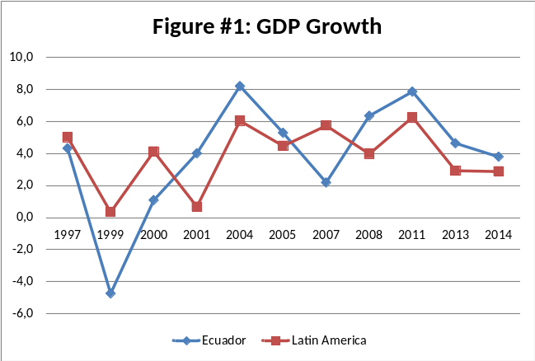
Notes: Annual Growth Rate at constant prices
Source: Comisión Económica para América Latina y el Caribe CEPAL

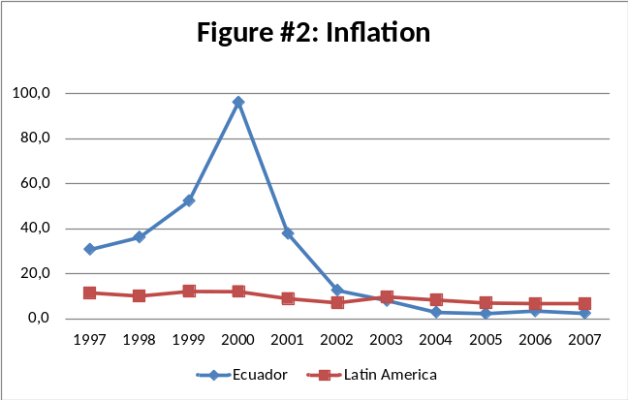
Notes: Variations of CPI, anual averages
Source: Comisión Económica para América Latina y el Caribe CEPAL

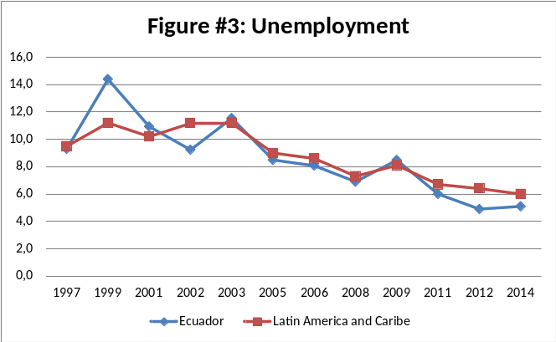
Notes: Average annual rate
Source: Comisión Económica para América Latina y el Caribe CEPAL

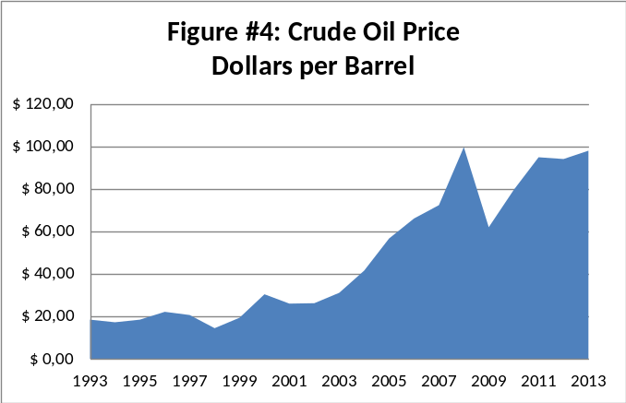
Notes: Average annual prices
Source: U.S. Energy Information Administration

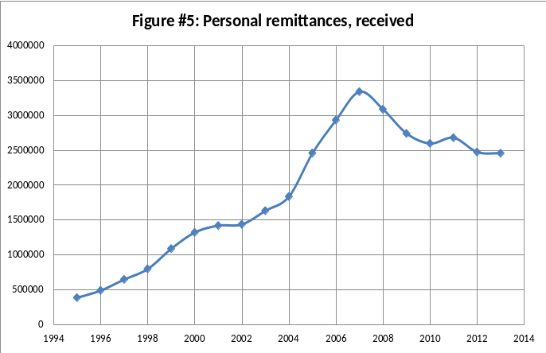
Notes: Current USD, Thousands
Source: World Development Indicators

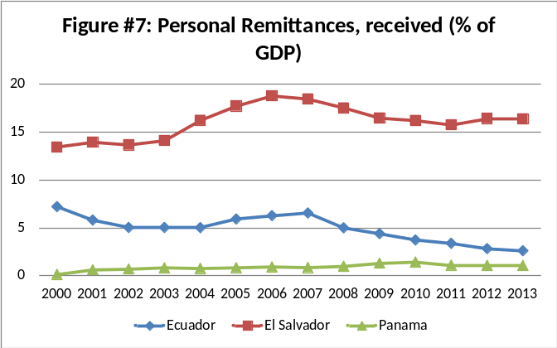
Source: World Development Indicators

Tables

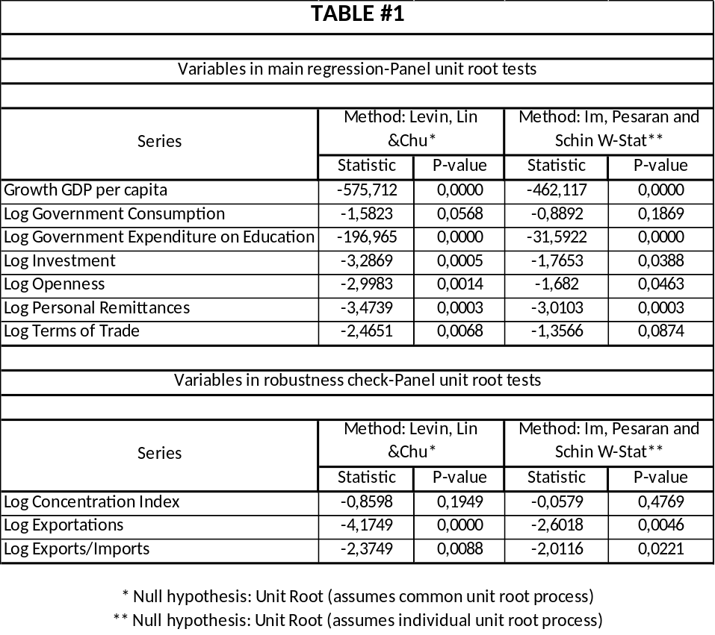

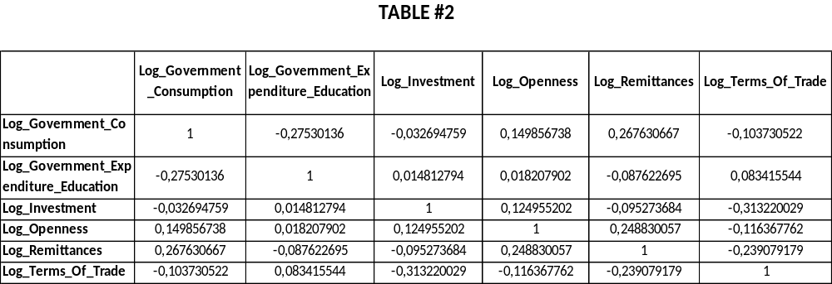

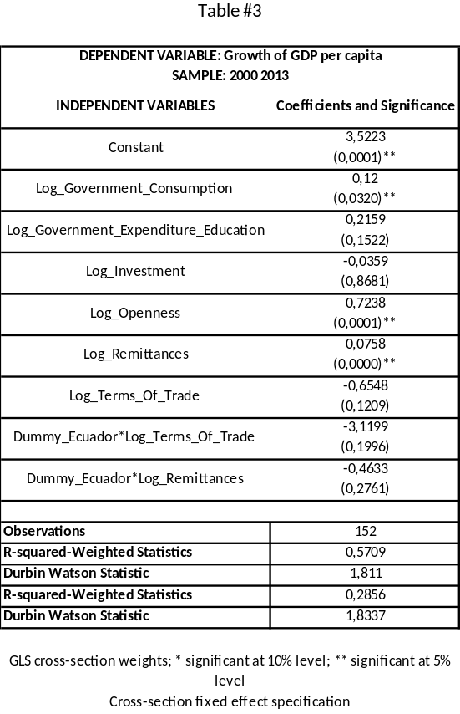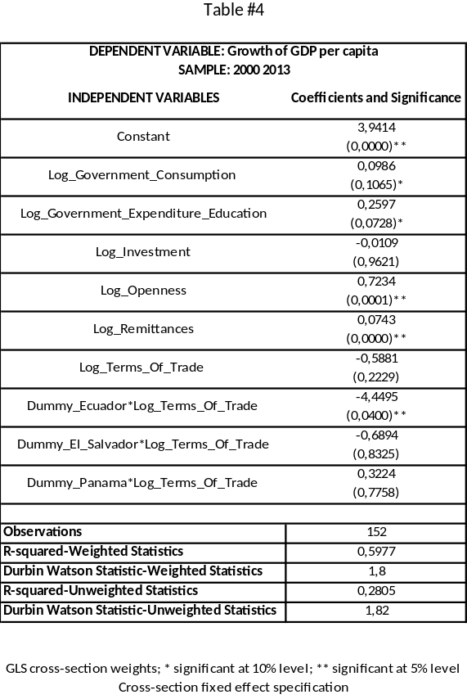
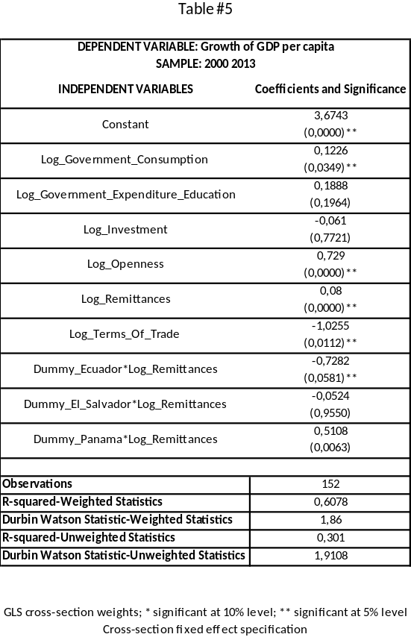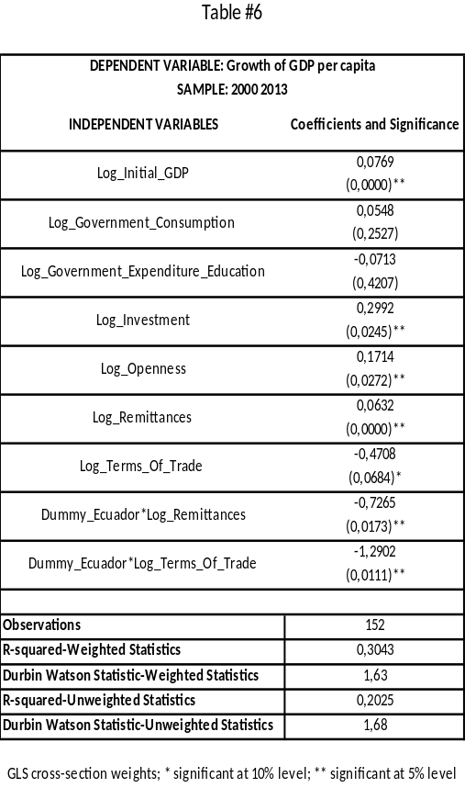

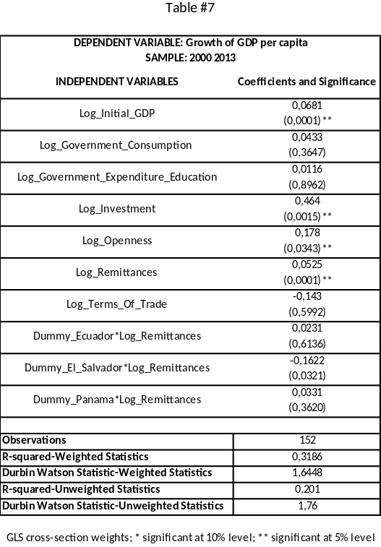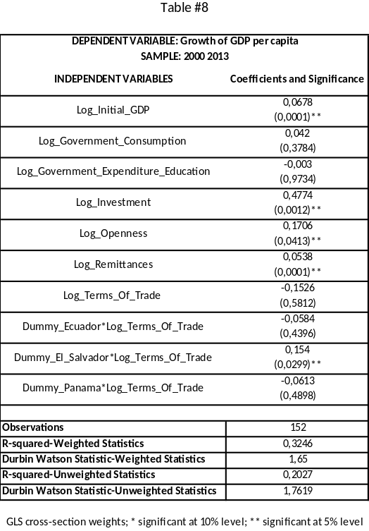

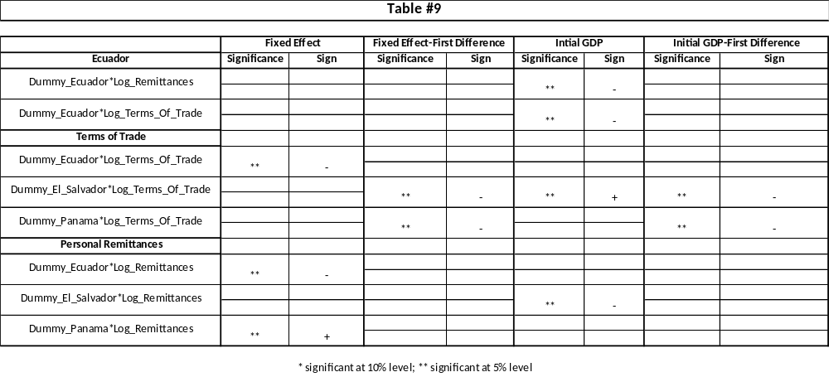

References

Abrego, L., Flores, E., Pivovarsky, A., & Bjoern, R. (2006). Ecuador: Selected Issues. Washington D.C.: International Monetary Fund.
Acosta, A. (2005). El aporte de las remesas para la economía ecuatoriana. United Nations Secretariat.
Acosta, A. (2009). Ecuador: ¿Un país maniatado frente a la crisis? ILDIS.
Agénor, P.-R., & Khan, M. (1996). Foreign currency deposits and the demand for money in developing countries.
Awaworyi Churchill, S., Yew, S. L., & Ugur, M. (2015). Effects of Government Education and Health Expenditures on Economic Growth: A Meta-analysis. Leibniz Information Centre for Economics.
Backus, D., & Crucini, M. (1998). Oil prices and the terms of trade. NBER Working Paper Series.
Baldacci, E., Clements, B., Gupta, S., & Cui, Q. (2008). Social Spending, Human Capital, and Growth in Developing Countries. Elsevier.
Banco Central del Ecuador. (2007). Publicaciones de Banca Central.
Bogetic, Z. (2000). Official Dollarization: Current Experiences and Issues. Cato Journal.
Caselli, F., Esquivel, G., & Lefort, F. (1996). Reopening the Converge Debate: A new look at Cross-Country Growth Empirics. Journal of Economic Growth.
Catrinescu, N., Leon-Ledesma, M., Piracha, M., & Quillin, B. (2006). Remittances, Institutions and Economic Growth. IZA Discussion Papers.
Chami, R., Fullenkamp, C., & Jahjah, S. (2005). Are immigrant remittance flows a source of capital for development? IMF Staff Papers.
Christiansen, L., Prati, A., Ricci, L., & Tressel, T. (2009). External Balance in Low Income Countries. IMF Working Paper.
Clements, B., & Schwartz, G. (1993). Currency substitution: The recent experience of Bolivia.
Coudert, V., Couharde, C., & Valérie, M. (2013). On the impact of oil price volatility on the real exchange rate-terms of trade nexus: Revisiting commodity currencies. CEPII.
Duncan, R. (2003, February). Exploring the Implications of Offical Dollarization on Macroeconomic Volatility. Working Papers of Central Bank of Chile.
Economics Online. (s.f.). Recuperado el 30 de Septiembre de 2015, de http://www.economicsonline.co.uk/Global_economics/Terms_of_trade.html
Edwards, S. (2001, May). Dollarization and Economic Performance: An Empirical Investigation. NBER Working paper series.
Flodén, M. (2010, January). The Open Economy Revisited: The Mundell-Fleming. Stockholm School of Economics.
Goldfajn, I., & Olivares, G. (2001). Full Dollarization: The case of Panama.
Gujarati, D. (2004). Panel Data Regression Models. En Gujarati: Basic Econometrics, Fourth Edition. The McGraw−Hill Companies.
Hadass, Y., & Williamson, J. (2001). Terms of trade shocks and economic performance 1870-1940: Prebisch and Singer Revisited. National Bureau of Economic Research.
Herrera, G., Carrilo, M. C., & Torres, A. (2005). Las cifras de la emigración. In La migración ecuatoriana: transnacionalismo, redes e identidades (p. 20). Quito.
Joy, J. (2010). MetriScient. Recuperado el 1 de Octubre de 2015, de http://metriscient.com/pooledreg.htm
Keller, K. (2006). Investment in Primary, Secondary and Higher Education and the Effects on Economic Growth. Contemporary Economic Policy.
Lenzner, R. (2013). The Recessions of 1973,1980,1991,2001,2008 Were Caused By High Oil Prices. Forbes.
Mansfield, E., & Reinhardt, E. (2008). International Institutions and Terms of Trade Volatility .
Mark, N. C. (2001). The Mundell-Fleming Model. In N. C. Mark, International Macroeconomics and Finance (pp. 179-188). Blackwell Publishers.
McKinnon, R. (1963). Optimum Currency Areas. The American Economic Review.
Moreno-Villalaz, J. L. (1999). Lessons from the monetary experience of Panama: A dollar economy with with financial integration. Cato Journal.
Moreno-Villalaz, J. L. (2005). Financial Integration and Dollarization: The case of Panama. Cato Journal.
Quispe-Angoli, M., & Elena, W. (2006). Offical Dollarization and the Banking System in Ecuador and El Salvador. Federal Reserve Bank of Atlanta, 57.
Reinhart, C., & Ostry, J. (1992). Saving and Terms of Trade Shocks: Evidence from Developing Countries. University of Maryland.
Sachs, J., & Warner, A. (1995). Natural Resource Abundance and Economic Growth. National Bureau of Economic Research.
Sachs, J., & Warner, A. (2001). The curse of natural resources. European Economic Review.
Savastano, M. (1996). Dollarization in Latin America: Recent Evidence and Some Policy Issues.
Soto, R. (2008). Dollarization, Economic Growth and Employment. Instituto de Economía, Pontificia Universidad Católica de Chile.
Teodora Ramos, E., Campos Moran, S., Jasmin Bolaños, H., & Calles Minero, C. (2013). Perfil Actual de la Persona Migrante en El Salvador. Universidad Tecnológica del El Salvador.
Verbeek, M. (2012). A Guide to Modern Econometrics. John Wiley & Sons, Ltda Publication.
World Trade Organization. (2015). Agreement on Safeguards. Recuperado el 25 de May de 2015, de https://www.wto.org/english/tratop_e/safeg_e/safeint.htm

Small city-states as Monaco, San Marino or Andorra.
According to Ecuador ´s Central Bank statistics and information of capital flows and income of central government budget. December 2014.
Herrera et al. (2005) reports that 837.062 Ecuadorians left the country during the period 1997-2004 and have not returned.
Actual president of Ecuador.
See Agénor & Khan, 1996; Savastano, 1996; Clements & Schwartz, 1993 for some examples.
In 1970 a banking law was introduced, liberalizing the financial market of the country, which facilitated the entrance of foreign banks.
Real Exchange Rate.
Ecuador adopted dollarization regime since 2000 and the latest data available for the selected control variables is 2013.
Excluding the Caribbean countries, Suriname and Guyana.
Export values are the current value of exports (f.o.b.) converted to U.S. dollars and expressed as a percentage of the average for the base period (2000). In the case of the import vale index will be the same methodology but with the current value of imports (c.i.f.). Both are reported by the World Development Bank Indicators as well.
Organization of the Petroleum Exporting Countries

