

Identifying the macroeconomic factors influencing country’s container throughputs:
The evidence from Poland
Master’s thesis, December 2015

Author: Tomasz Kaplan
Supervisor: Onno de Jong
Co-reader: Erwin van Tuijl

Erasmus University
Erasmus School of Economics
Urban, Port and Transport Economics

Table of contents

ABSTRACT 5
CHAPTER I. INTRODUCTION 6
1.1. Overview 6
1.2. Research question 8
1.3. Outline of the thesis 10
CHAPTER II. CONTAINERIZATION AND CONTAINER PORT SYSTEMS 11
2.1. Phenomenon of containerization 11
2.2. Global container system 13
2.3. European container system 15
2.4. Baltic container system 18
2.4.1. Norway 20
2.4.2. Sweden/Denmark 20
2.4.3. Finland 21
2.4.4. Russia 22
2.4.5. Baltic States 22
2.4.6. Germany 23
2.4.7. Poland 23
CHAPTER III. LITERATURE REVIEW 27
3.1. The relationship between trade and the economic development 27
3.1.1. GDP multiplier 28
3.2. The relationship between trade and the geographical location 29
3.3. The relationship between trade and the transport infrastructure 30
3.4. The relationship between trade and the institutional quality 32
CHAPTER IV. EMPIRICAL REVIEW 35
4.1. Economy 35
4.2. Foreign Direct Investments 39
4.3. Foreign Trade 41
4.3.1. The biggest exporting and importing industries 47
4.4. Business environment 52
4.5. Transport and logistics systems 54
CHAPTER V. SHIFT SHARE ANALYSIS 59
5.1. Methodology 59
5.2. Dataset 60
5.3. Results 62
5.3.1. The European perspective 62
5.3.2. The Baltic/Scandinavia range perspective 68
CHAPTER V. CONCLUSIONS 80
APPENDIX 84
REFERENCES 87
LIST OF FIGURES 93

ABSTRACT

Political and economic changes in Central and Eastern Europe, such as the fall of the Wall in 1989, the enlargement of the European Union in 2004, have affected recent conditions for development of transport and trade in Europe. In addition, the containerization, the increasing size of container vessels and other maritime patterns have strengthened these changes and have enabled efficient transportation of goods with low shipping and handling costs. Recently these patterns also relate to the smaller ports, which until now were not acknowledged as global players.
The focus of this thesis lies on investigating whether the economic development and its components of the Central and East European (CEE) countries had an impact on the port development and the increased container traffic of their ports. The aim primarily lies on the Baltic countries, more precisely on Polish ports in the Bay of Gdansk.
The shift-share analysis used in this study examines the European container ports’ dynamics with the eventual goal to identify to what extent the Baltic countries have managed to attract container volumes from the overall growth in the European industry.

CHAPTER I. INTRODUCTION
  - Overview
The current global trade flow patterns reflect growing flows of manufactured goods. Due to trade liberalization, globalization of production and introduction of containers, the international flow of manufactured goods has been facilitated. The international trade has expanded as the overall production costs decreased worldwide and the transportation became easier and cheaper.
Nowadays, the size and power of the economies is measured in terms of volume and value of exported and imported goods. In other words, the participation in international trade is one of the most important indicators of the economic development of a country. As more than 90% of the international transportation is carried by ships, it is acknowledged that the international trade is driven to a large extent by container transportation. Going deeper, the economic development of a country is to a large extent dependent on a country’s ability to accommodate containerships in its ports. The picture below shows that since 1980s the containerized trade has been significantly growing and increasing its share until now. It has been the fastest growing industry of all maritime sectors within last two decades. This steep growth results from several economic factors, like trade liberalization, globalization and outsourcing, which highly contribute to use containerships as a transport mode (Notteboom, 2008). As the chart below depicts, from the beginning of the third millennium the containerized cargo has almost tripled its volumes, while the total international trade increased by only 50%.

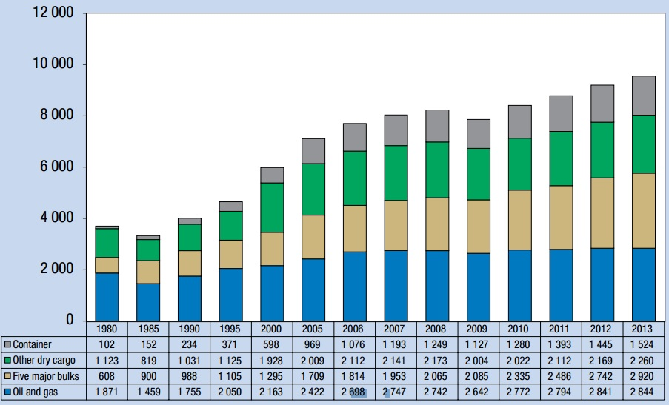
Figure 1. International seaborne trade, selected years (millions of tons)
Source: UNCTAD, Review of Maritime Transport, 2013

Besides, the international geography reveals dominance of a small number of ports in terms of number of handled containers, with a growing share of domination of Asian ports. More clearly, the global maritime network is characterized by a high polarization, represented by Rotterdam and Hamburg in Europe, United States ports and Shanghai and Hong Kong in Asia. Due to many factors hampering their development, it is extremely hard for the medium and small size ports to appear in the world stage. Yet in Europe, significant political changes, which happened after 1989, influenced trade environments in this area. The Central and Eastern European countries integrated with Western economy and this was even strengthen by the accession to the European Union in 2004. As a result, the trade barriers have been eliminated, the access to foreign market has been facilitated and the economies opened their markets to the international trade.
In 2014 it has passed 25 years since the shadow of communism faded to allow the CEE countries flourish, become democratic and economically stable. The political and economic transition from the central conducted economy to the democracy and capitalism, and ultimately to the economic integration with the EU have entailed the boost of the economies concerned and stimulated them in the participation in the international trade. This, in turn, increased the national income as local market were exposed to the larger supply and demand markets. In fact, the economic growth and the international trade are positively correlated (Frankel & Romer, 1999). Recently, the dynamics of the economic growth of the Central and Eastern European countries are much higher than of the Western ones.
The ports in Baltic region, on which the primary focus of this paper lays, face also a steep increase in container throughputs. On the one hand, it may appear that the small market and limited hinterlands of Baltic countries reduce the attractiveness of their ports. On the other hand, the introduction of Gdansk, the biggest and the only port with the capacity to handle the biggest ships in Poland, into Maersk route networks indicates that Baltic ports can participate in a global network and be one of the important players.
Indeed, during 25 years after communism fell, Poland has changed unrecognizably. It became economically stable and one of the biggest trade partners in Europe. Poland, as the richest and most powerful economy in the Central and Eastern Europe, with almost 40 million population, and a high growth of both GDP and port traffic, is the case study of this thesis. Poland and its ports of Gdansk, Gdynia and Szczecin/Swinoujscie, which are described in details, are achieving the sharpest growth in Europe in terms of container throughputs. Since 2001 the Polish ports have witnessed the growth of almost 750% in the container traffic. The report of United Nations Conference on Trade and Development (UNCTAD, 2014) shows that Poland advanced from 51st to 45th position in the world in the container port traffic ranking. The total yearly throughput was almost 2.3 million TEUs in 2014. According to the same source that containerized cargo flows and port traffics are expected to grow further in Poland.

  - Research question
As the CEE countries become richer and develop faster than the rest of the old continent the container traffic flow faces a new pattern, namely geographical shift from the West to the East within the European Union. Each year more and more containers are accommodated to the CEE seaports and one of the fundamental aims of this thesis is to assess whether there is an increase not only in volumes but also in the share of handled containers in Central and East Europe in comparison to the West Europe. The data collected from European Seaport Organization, particular port authorities and national statistic offices provides an evidence that over the years 2001-2014, the seaborne container cargo flow rose by almost 100% in whole Europe while the share of container movements in the Baltic region slightly grew from 7 to 10% of the total European share. Yet worth noticing, the growth in volume of containers handled in the Baltic area only is impressive, because over the same period as above it has almost tripled (the increase from 3.5 to 10 million TEUs). However even if the hub or gateway flows may slightly shift among the nodes, the European network properties remain rather stable (Ducruet & Notteboom, 2012).
Yet, it is interesting to see the extent of the geographical shift, to identify the underlying macroeconomic factors of the port development and the aforementioned geographical trend, and to examine what is the link between port system and economic development. This paper focuses mainly on Polish ports development, and their appearance on a maritime global stage with a special attention devoted to the economic reasons that stood behind this event. The shift-share analysis was used in this study twice. First, to assess what are the shifts of containerized cargo in whole Europe. Second, to estimate the container shifts within the Baltic range.
In the light of the background given on Central and Eastern European countries, container port systems and highlighting the significant changes of the port sector in this area, leads us to the research question of this paper:

What are the underlying macroeconomic factors of the geographical shift in terms of container flows from Western to Eastern European countries?

In order to structure and to give a complete answer, the research question was divided into the following sub-questions:
- What is the effect of economic development on container traffic?
- What are the other relevant factors that influence port developments?
- What are the economic reasons that stood behind the increased container traffic in Poland?
- What share of the overall European container volumes growth has been attracted by the Baltic/Scandinavia range during the years 2001-2014? And going further, what part of the overall increase in the Baltic/Scandinavia range has been attracted by the Polish ports over the same period?
In order to provide conclusive answers to the research question and its sub-questions both qualitative and quantitative researches were conducted. The qualitative research refers to the literature review. The most recent as well as the most acknowledged scientific articles were analyzed and used as references in this thesis. The quantitative research refers to the collecting of container throughputs data from 107 biggest ports in Europe and analyzed them under the methodology of the shift-share analysis.

  - Outline of the thesis
The remainder of this thesis consists of six chapters. The chapter one is an introduction to the thesis and describes in short the problems undertaken in this thesis.
The second gives an insight on the overall containerization phenomenon and characterizes in details different container systems. The short history of containers is given with an emphasis on its global effects. Further, the description of global, European and Baltic container systems leads to the detailed description of Polish ports.
The chapter three is the literature review of the most recent as well as the acknowledged papers regarding the issues of international trade and macroeconomic factors influencing it. Among them the most important are: the economic development, the geographical location, the transport infrastructure and the institutional quality of a country.
The empirical revision of the issues undertaken in the literature review is provided in the chapter four. The Polish economic development, foreign direct investments, foreign trade, import/export industries, institutional environment, transport infrastructure and logistics sectors were carefully analyzed.
In the chapter five the shift-share analyses of the European container system and the Baltic/Scandinavia range are performed. This chapter provides useful information on the methodology, dataset and the results of the analysis.
The paper is summarized in the chapter six, which provides the conclusive answers to the research question and its sub-questions.

CHAPTER II. CONTAINERIZATION AND CONTAINER PORT SYSTEMS
The chapter two provides the qualitative descriptions of containerization phenomenon and different container port systems are provided. This issue is narrowing down by taking into account the global, European, Baltic, and finally Polish container port systems. The design of this chapter including the main issues structures as follows:

Geographical level Main issue
The global container system | Specifics
European container system | Traffic dynamics
Baltic Sea container system | Location, capacity, access
Polish container system | Competitive power

Figure 2. The structure of chapter II
Source: own elaboration

  - Phenomenon of containerization
Over last 50 years, the maritime industry experienced significant changes in terms of international trade. It does not concern only the volume of transported cargo, but also technological advancements, mainly the adaptation of containers, which has simplified vastly the transshipment from one mode of transportation to another and consequently developed the intermodal transport. There is no doubts that containerization has significantly reshaped the port and shipping industry, and shrunk the globe. Since its introduction in 1950s, containers greatly reduced the costs of freight transport, and facilitated and increased the speed of the international trade flow, especially of consumer goods and commodities. The growth of container shipping was accompanied by increasing vessel capacity, trade growth and improved financial performance of the companies concerned (Slack & Fremont, 2009).
Containerized shipping was first introduced in the United States in the 1950s. At the turn of 1960s/70s the containers became popular on the U.S.-Europe and the U.S.-Japan routes. Finally, this phenomenon touched developing countries in the beginning of 80s. The reason behind this seemingly slow pattern of diffusion lies to a big extent in the large fixed costs of adoption. The full use of containerization required container-ready ocean liners and ports with specialized cranes, storage areas etc. This explains why containerization was first adopted on the most heavily traded routes, which ensured the economies of scale. Although, at the turn of 80s and 90s the container ports were developing all over the world, the impact of containerization became more transparent after the China export boom in the beginning of the third millennium. The shift from trans-Atlantic to trans-Pacific trade illustrates this effect the best. The growth of Chinese container traffic triggered the intense competition to attract the cargo between ports and expanded supply chains all over the world. Nowadays, the port of Shanghai is three times larger than the biggest European port of Rotterdam and 10 out of 10 biggest ports in the world are ports located in the Far East. Asia leads the demand for container port services, especially China, which share is about 25% of worldwide container throughput (UNCTAD, 2013).

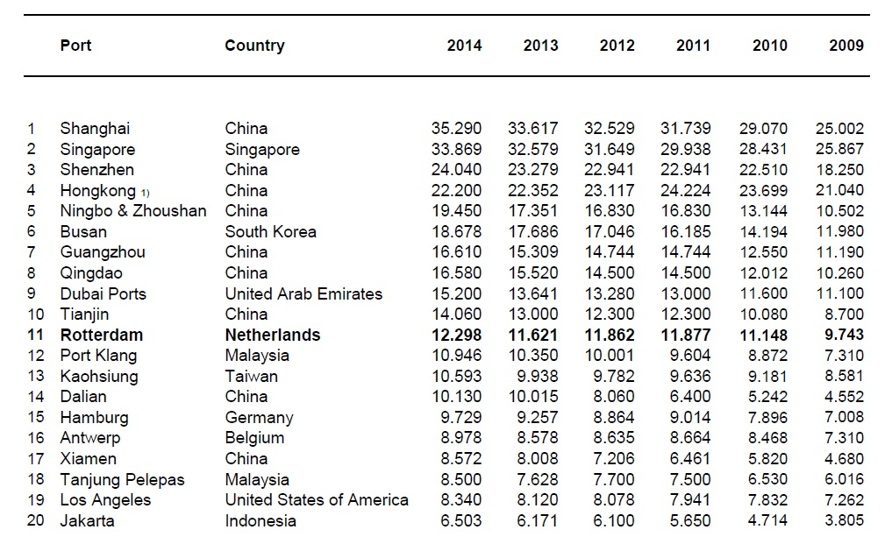
Figure 3. Top 20 world container ports, 2009-2014 (in thousands TEUs)
Source: Port Authority of Rotterdam
The use of standardized container box provides cost savings by allowing goods to be packed once and moved over long distances via a variety of transport modes without being unpacked or repacked. The containers are handled in standardized ways. In this manner, containerization reduces direct port costs, such as stevedoring and storage, as well as indirect costs during long port stops (i.e. depreciation of transported goods). One may say that containers are small warehouses for the goods transported. Containerization also creates cost reductions on the ocean, namely larger and faster ships substantially reduce the price per ton-mile due to economies of scale (Hummels, 2007). In turn, the reduced costs of transportation stimulate the international trade. The evidence found shows that the relationship is bilateral and both are influenced by geography, technology, infrastructure and fuel costs (Behar & Venables, 2010). Therefore, the containerization was one of the main factors responsible for the boom of international trade.
Also, the worldwide introduction of containers has resulted in evolution concerning port development, from regional market oriented ports to the global seaports characterized by high competition to attract the cargo volume and to expand to the hinterland. Containers have allowed large cost reductions in cargo handling, increasing cargo transshipment and therefore national and international cabotage. In turn, this increase in cabotage has induced the creation of hub ports (Clark, Dollar & Micco, 2002).
To sum up, containerized shipping is responsible for decreasing the transportation costs and stimulating the international trade. Moreover, it is thought by many scholars and practitioners to be one of the most important transportation revolutions in twentieth century (Hummels, 2007; Slack & Fremont, 2009). Furthermore, its importance has recently been re-emphasized and the authors of UNCTAD report acknowledged that containers have even had a stronger impact on globalization than trade liberalization (UNCTAD, 2013).

  - Global container system
The ocean shipping stands out as the most energy and cost efficient mode for long-distance transport for large quantities of goods. The seaborne transport has several features that distinct it from other transportation modes. Generally, most of the ships can be classified into three types: bulk dry carriers, oil tankers and container ships. These three groups distinguish not only ships’ characteristics but also movement patterns. The latter follow regularly repeating paths (regular liner shipping services) between ports, while the two former categories operate in a tramp market (Kaluza, Kolzsch, Gastner & Blasius, 2010). Thus, the global container system is mainly affected by liner shipping network.
The structure and complexity of liner shipping networks, which involve container ports and sea-roads between them, evolved over time. The substantial increase of cargo volume transported, the rising number of container ports, the growth in size and speed of containerships, and finally mergers, acquisitions and alliances between liner shipping companies explain this evolution (de Langen, van der Lugt & Eenhuizen, 2002). Also, container ports as elements in liner shipping had to answer to this change and are not anymore just nodes in a transport chain. Thus, their role switched from a place for exchanging cargo between ships and shores into an element in a value-driven chain systems (Robinson, 2002).
Nowadays, more than 90% of international cargo is hauled by ships, and 80% of seaborne consumer goods move in containers (Cho & Yang, 2011). These numbers show the importance of seaborne trade, particularly trade by containers. Containers capture the largest growth of all commodities handled in seaports, and the worldwide throughput reached over 650 million TEUs in 2013.
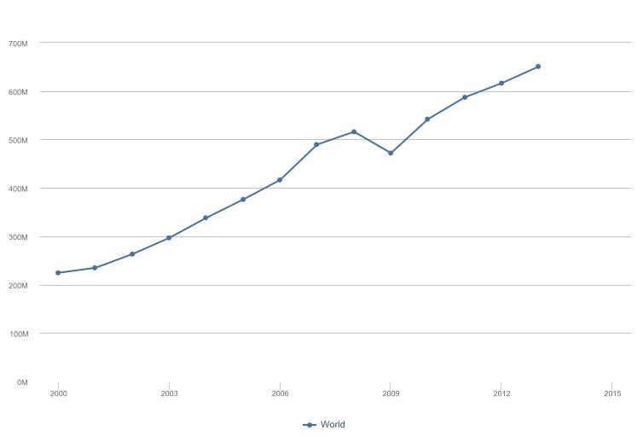
Figure 4. Total global container ports traffic 2000-2014
Source: World Bank database, World Development Indicators, access: November 2015

  - European container system
Europe is advantaged with a long coastline from the Baltic through North and Mediterranean to Black Sea. The European port system cannot be considered as a homogenous set of ports as their sizes and functions vary (Notteboom, 2012). It consists of established large-, medium- and small-sized ports with different characteristics in terms of hinterland market orientation, commodity handled and location qualities. European container port system is perceived as one of the busiest port systems in the world and it counts around 130 seaports handling containers of which around 40 accommodate intercontinental services. Container throughput represented 95.2 million twenty-foot equivalent units (TEUs) in 2012 (Notteboom, 2012). The distribution of containers between port ranges differs significantly. The figure below depicts the traffic shares of port ranges in the European container port system based on 79 biggest ports during the period 1985-2011.

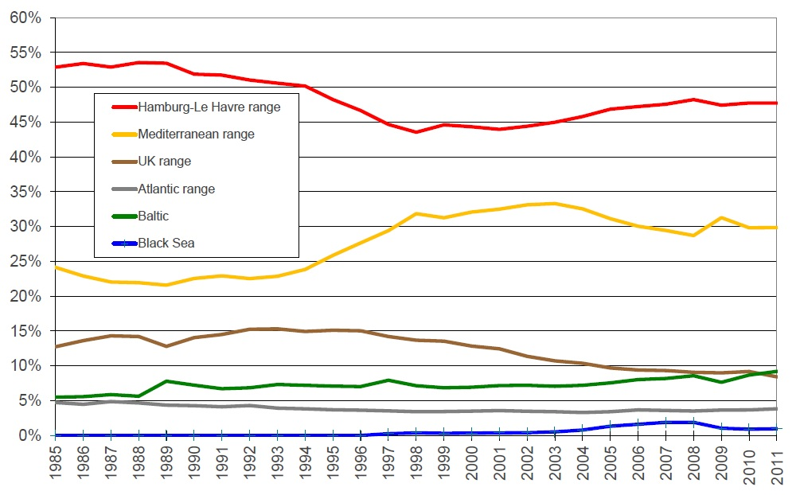
Figure 5. Market shares in the European container system 1985-2011
Source: Notteboom, T. (2012). Dynamics in port competition in Europe: implications for North Italian ports. Milano: Workshop ‘I porti del Nord’

The biggest container ports in the EU, Rotterdam, Hamburg and Antwerp located in Hamburg – Le Havre (HLH) range operate by combining the gateway function and transshipment center. Container ports in this range handle about 40% of the total European container throughput. However since 2008 we may observe that the hegemony of the container ports in the North-West of Europe slightly shrinks in favor to other rising ranges. The observed deconcentration process in container traffic is deeply discussed in the next chapter.
The second biggest port range in Europe is the Mediterranean range stretching from the south-eastern shore of Spain and ending in Greece. The market share of the Mediterranean ports grew significantly in the late 1990s at the expense of the ports in the United Kingdom and HLH range. The significant increases of the market share of the Mediterranean was mainly the result of the introduction of the transshipment ports. In the beginning of the third millennium, the position of the North-West ports has been gradually improving, while Mediterranean (Med) ports and the UK port system lost market share. The crisis has hampered this trend and since 2009 the market share Med range seems to be stable and accommodates approximately 30% of the European container throughput.
The United Kingdom ports in turn are gradually losing their significance. Once the third container power in Europe now loses its position mainly to emerging Baltic port range. In the beginning of 2000s UK ports faced capacity shortage, while the new capacity became available only moderately. Another reason of losing the ground by the UK ports is the fact that the shipping lines tended to transship the UK flows in the European mainland instead of calling directly (Notteboom, 2012). Thus, the lion’s share of containers is provided by feeder services mainly from HLH range. The recent share of the UK ports of the overall container flow in Europe approximates 8%.
The situation in the Atlantic range remains quite stable since the middle of 1980s and hardly any structural changes could be observed since that time. A special attention requires the Portuguese port system, which aims for a hub status. Apart from developing their transshipment role these ports are vying to expand their businesses through the improvement of railway and dry ports networks. The overall goal is to win a bigger share in the Spanish market, especially in the Madrid area. All other ports in this region are rather minor players. The ports in the Atlantic range capture approximately 5% of the overall European container traffic.
The lowest share of container traffic in Europe is captured by the Black Sea region. Before the third millennium the Black Sea port range attracted practically no traffic to the European market. However the huge investment projects in port of Constanta aimed to make this port one of the major gateways to the European market. The crisis ended brutally these ambitions and the port of Constanta has witnessed a dramatic decrease in a container throughput. The Bulgarian ports are of a smaller importance in the container market. The share of all the ports in the Black Sea area balances of around 2%.
Finally, the Baltic ports are gradually getting more and more importance. Recently, the market share of handled containers has exceeded 10% of the European container traffic. The Baltic ports and their position are described deeper in the next subchapter.

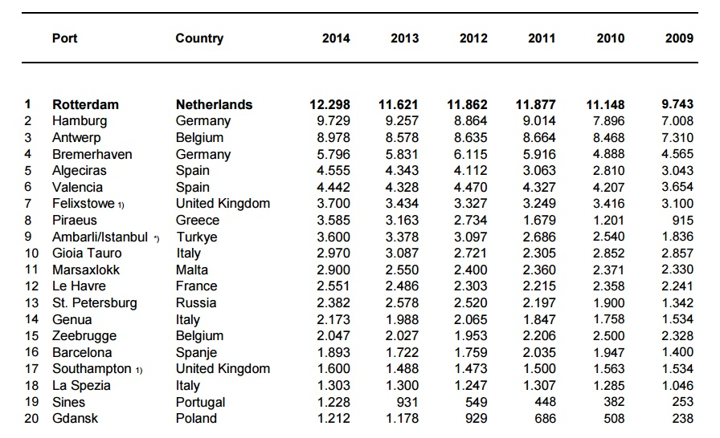
Figure 6. Top 20 European container ports, 2009-2014 (in thousands TEUs)
Source: Port Authority of Rotterdam

In order to shed more light on the high polarization of the two biggest European container ranges it is worth to analyze the top 10 European container ports table. The top 4 container ports belong to the Hamburg – Le Havre range with the port of Rotterdam outperforming all the other ports. The other four ports in top 10 are the ports from the Mediterranean range (Algericas, Valencia, Piraeus and Gioia Tauro). The remaining two are the British port of Felixstowe and the Turkish port of Ambarli. In the top 20 we can find also two ports from the Baltic region – Saint Petersburg (13th position) and Gdansk (20th position).
  - Baltic container system
Containerization has changed the overall pattern of moving goods as well as stimulated the international trade. Political changes in the late 80s, such as the fall of the Wall, the transition of the political systems of Poland and the appearance of Baltic States after the Soviet Union fall, also influenced the trade patterns within the Europe. The latter were even enhanced by the join of the above mentioned countries to the European Union in 2004.
The Baltic Sea is a mediterranean sea located between Central and Northern Europe. It is bounded by the Swedish part of the Scandinavian Peninsula, the mainland of North-Eastern and Central Europe, and the Danish straits. The Baltic Sea is also connected by artificial waterways to the White Sea through the White Sea Canal, and to the North Sea through the Kiel Canal. The central part, also called the Baltic Proper, is bordered on its northern edge by the Gulf of Bothnia, on its north-eastern edge by the Gulf of Finland, and on its eastern edge by the Gulf of Riga. In the southern part lies the Bay of Gdansk, which is the focus of this thesis and is described in the next subchapter.
The Baltic Sea as a basin for ocean-going vessels is in some ports restricted by physical constraints. A vessel entering to the Baltic Sea has to pass the Danish straits. However, in the era of globalization the location and the distance are no longer the main determinants in the port choice decision (Behar & Venables, 2010). The integration of port of Gdansk to the Maersk’s network is a perfect proof for this statement. The ability of handling new big containerships shows the readiness of Baltic ports to participate and compete in a global network.
Baltic port region has greatly strengthened its traffic position in the past few years. Many academic researchers focused recently on this phenomenon (Lorentzon, 2014; Grushevska, 2013; Notteboom, 2010). Among them Theo Notteboom performed a shift-share analysis which confirmed that Baltic seaports is gaining more and more of the European container market share in comparison to other ports in Europe. Same results were noted for German ports, which acted as a feeder ports for Baltic area, and took the advantage of the economic growth Central and Eastern European countries. Until recent times it was well known that the status of Baltic seaport was mainly determined by feeder services of Western ports, especially of Hamburg. Yet because of current changes in this area, Baltic ports are gaining more independent role.
The rise of economic centers in the Baltic area has created opportunities for several ports to develop the transport networks. Containerization in the Baltic Sea is developing at one of the European’s fastest rates – since the 2008 the container throughputs not only recovered from the crisis but also managed to increase the throughputs by another 30%. However the challenge to accommodate this ever growing container flow is not just a matter of expanding the existing or building new container terminals but also to invest in the port’s infrastructural links. The pressure is put especially on improving rail-transport-based intermodal systems in order to avoid overloading less eco-friendly road links. It is also acknowledged that countries in the Central Europe, such as Poland, Czech Republic and Hungary, have strong railway networks enabling the penetration of the hinterlands (Notteboom, 2010). Thus the Central European countries are potentially well prepared to accommodate the expected increases in container transportation.
There are over 200 ports in the Baltic basin however almost two third of all goods pass through the 20 biggest ports in this area (Rozmarynowska & Ołdakowski, 2011). The top 20 ports are depicted in the table below.

Lp. | Port | Country | 2001 | 2008 | 2013 | 2014
1 | Sankt Petersburg | Russia | 481 | 1987 | 2514 | 2375
2 | Gdansk | Poland | 18 | 183 | 1189 | 1232
3 | Gdynia | Poland | 230 | 611 | 728 | 937
4 | Göteborg | Sweden | 698 | 863 | 858 | 837
5 | Hamina/Kotka | Finland | 295 | 807 | 627 | 575
6 | Klaipeda | Lithuania | 51 | 373 | 403 | 450
7 | Aarhus | Denmark | 307 | 458 | 406 | 424
8 | Helsinki | Finland | 438 | 420 | 406 | 401
9 | Riga | Latvia | 123 | 207 | 381 | 388
10 | Kaliningrad | Russia | 21 | 157 | 322 | 325
11 | Rauma | Finland | 84 | 172 | 259 | 276
12 | Tallinn | Estonia | 78 | 182 | 254 | 261
13 | Helsingborg | Sweden | 108 | 177 | 208 | 219
14 | Oslo | Norway | 142 | 190 | 202 | 213
15 | Gavle | Sweden | 49 | 109 | 127 | 150
16 | Kopenhagen/Malmo | Denmark | 108 | 165 | 139 | 144
17 | Lubeck | Germany | 81 | 214 | 102 | 116
18 | Ust-Luga | Russia | 0 | 0 | 64 | 107
19 | Szczecin/Swinoujscie | Poland | 18 | 65 | 61 | 87
20 | Fredericia | Denmark | 9 | 33 | 68 | 85
Figure 7. Top 20 container ports in the Baltic/Scandinavia range
Source: Own elaboration, based on the data from European Seaport Organization, Central Statistics Offices and Port Authorities’ websites
As the Baltic Sea is bordered by Denmark, Sweden, Finland, Russia, Estonia, Latvia, Lithuania, Poland, and Eastern Germany, the main container ports of these countries will be shortly described. Apart from several pure gateways of main importance in terms of container throughput four multi-port gateway regions can be identified, namely Kattegat/The Sound, Helgoland Bay (partially), South Finland and Gdansk Bay. Also for the purposes of this thesis the Norwegian ports were taken into account and included in Baltic/Scandinavia range. All the main container ports within the Baltic/Scandinavia range were briefly discussed in the following subsections.

    - Norway
The port of Oslo is the leading cargo and passenger port in Norway. Also when it comes to containers it handles above 200k TEUs which stands for almost 50% of all the Norwegian container throughput. This can be explained by the fact that within three hours drive from Oslo almost one third of the whole Norwegian population can be reached. The other Norwegian container ports are rather of a smaller importance from the European perspective. Each of the ports of Larvik, Alesund, Moss and Borg handles slightly more than 50k TEUs and serves the local markets. Although all the Norwegian ports are located by the North Sea, they were taken into the analysis and included in the Baltic/Scandinavia range. This logic can be argued by the fact that the part of the hinterlands served by the Norwegian ports is shared with the Swedish and Danish ports. Besides the whole Norwegian range is rather small and slightly affects the overall results.

    - Sweden/Denmark
Located at the entrance of the Baltic Sea the Swedish/Danish ports offer an easy access to the North Sea and consequently to the ocean-going ships. Goteborg and Helsingborg along with the biggest Danish container ports – Aarhus and Copenhagen/Malmo – create together the Kattegat/The Sound multiport gateway. Among the container ports at the mouth of Baltic Sea the biggest one is Goteborg. The total container throughput in this port is decreasing since several years and in 2014 accounted for 837k TEUs. However the case of Goteborg serves as a great example of the development of the intermodal network. Almost 50% of the container volume is transported to the hinterland through an extensive rail network. Helsingborg, the second biggest Swedish container port, handles around 220k TEUs annually. Besides, the port of Gavle located in the north from Stockholm is recently facing a steep growth. This port handled more than 150k TEUs in 2014. The last and the smallest port taken into the analysis is the port of Stockholm. In 2014 its throughputs have reached the level of 51k TEUs. The Danish biggest container port - Aarhus – accommodated 424k TEUs in 2014. The last port in Kattegat/The Sound gateway is in fact a merger between the ports of Copenhagen and Malmo. Since 2001 the Copenhagen/Malmo port is a precedence and serves as a successful case of a cross-border port merger. In 2014 it attracted approximately 144k TEUs. Also the Danish ports of Fredericia and Aalborg were included the analysis. The former accommodated 85k TEUs last year, while the latter faced an almost 40% decrease in container throughputs and handled only 62k TEUs. Although easy access to the oceans would suggest that the geographical position is reforged into competitive advantage, the Swedish/Danish ports (as well as the Kattegat/the Sound gateway) show rather a declining market. The overall container throughput in this area accounts for around 2% of the total European market, which can be translated to almost 2 million TEUs.

    - Finland
The two biggest container ports of Finland located by the Gulf of Finland in the south of this country, create together a multiport gateway – South Finland. Helsinki and the Hamina/Kotka handle together approximately 1 million TEUs on a yearly basis. Also the port of Turku, which handled 2k TEUs only in 2014, is perceived by some scholars as a part of South of Finland multiport gateway. The biggest Finnish port - Hamina/Kotka – was established in 2011. Similarly to the case of the port of Copenhagen/Malmo, the ports of Hamina and Kotka were merged after the approval of the city councils. In 2012 it attracted more than 575k TEUs. This domination in terms of handling containers can be explained by the fact that it is located only 35 km to the West from the Russian border and acts as a natural import/export node between Russia and the rest of Europe. Port of Helsinki is the second largest container port of this country and captures around 400k TEUs annually. Also the port of Turku is perceived by some scholars (Notteboom, 2010) as a part of South of Finland multiport gateway. The port of Turku is of minor importance though since it handled barely 2k TEUs in 2014. The multiport gateway South Finland attracts around 1% of the total European container flows and gradually is losing ground in the European context. The two ports located outside of the South Finland gateway are the ports of Rauma and Hanko. The formed is a leading in paper industry harbor and is the biggest container port on the west coast of Finland with a throughput of 276k TEUs. The port of Hanko shows a slight growth in containers and recently has attracted the throughput of 54k TEUs.

    - Russia
The three biggest Russian container ports were included in this thesis. Although Russia is not a part of the European Union, they play a major role in the Baltic/Scandinavia range. Especially of the main importance is the port of Saint Petersburg which together with the port of Ust-Luga forms the multiport gateway – Saint Petersburg and Ust-Luga – identified by Lorentzon (2014). The port of Saint Petersburg is the biggest port in the Baltic basin and handles alone more than 2.3 million TEUs, which stands for approximately 24% of all the container traffic in the region. Together with Ust-Luga, which appreared in the container maps in 2012, it attracts almost 2.5 million TEUs. The container throughputs of Russia are facing recently a decrease in volumes. This is mainly explained by the sanctions and embargoes imposed by the European Union on Russia due to the military invasion on Ukraine. The most recent figures indicate a 7.5% decrease in handled containers in the January-September 2015 period as compared to the previous year. The third Russian container port is the port of Kaliningrad. In 2014 it was the tenth biggest port in the Baltic/Scandinavia area as it handled 325k TEUs. For the same reason as above the container throughputs in port of Kaliningrad are recently decreasing.

    - Baltic States
However Estonia, Latvia and Lithuania appeared on the international maps just after 1989, the position of the biggest ports of Baltic States is undeniable. Since 2001 the volume of handled containers in these countries quadrupled. Acting as a stand-alone gateways Klaipeda, Riga and Tallinn captured almost 1.1 million TEUs in 2014.. The Lithuanian port of Klaipeda is the biggest among the Baltic States. In 2014 it attracted the volume 450k TEUs, which is a great performance as for only near 3 million populated market. The port of Klaipeda offers hinterland connections to the neighboring countries (Russia, Belarus, Ukraine) as well as further to the east (Kazakhstan, China) (Lorentzon, 2014). The Latvian port of Riga was the biggest port in this region at the beginning of the third millennium, yet lose its ground in favor to the port of Klaipeda. Recently, it handles approximately 400k TEUs. Since 2009 its container volumes increased by more than 100%. The well-developed hinterland connections help the port of Riga to act a link with the European markets and trans-Siberian railway (Lorentzon, 2014). The port of Tallinn in turn attracted slightly over 260k TEUs in 2014. Similarly to the port of Riga it faced an over 100% growth in container throughputs since 2009. The favorable location of the port port of Tallinn facilitates the hinterland connections enabled by excellent links such as the motorway to Hamburg or the railway connection to the German port of Lubeck (Lorentzon, 2014). The effective management of all the Baltic States’ port authorities, advantageous geographical location, economic development and the huge infrastructural investments carried in these ports, such as building new terminals and integrating into rail and road networks, can explain this phenomenon

    - Germany
Although the biggest German container ports are located by the North Sea and they are not directly under the discussion in this thesis, one of the German seaports is located on the Western coast of Baltic Sea (Eastern part of Germany). The port of Lubeck is connected to his bigger ‘brothers’ – Hamburg and Bremerhaven/Bremen – not only by Elbe-Lubeck Canal, but also by excellent road and rail networks. It functions especially as an important turntable between the third largest container port in Europe, Hamburg, and the whole Baltic Sea region. The port of Lubeck acts as a departure base for feeder ships and offers departures to Scandinavia, Russia, Baltic States and Poland. Over 115k TEU is handled in Lubeck on yearly basis, which makes it the biggest and the only German port in the Baltic Sea area that was taken into consideration for the analysis.

    - Poland
Poland is the largest economy in the Baltic Sea region (among the EU countries) and is dependent on transports inclusively via the Baltic to reach the oceans by the seaways. In order to compete with other European ports Poland invests heavily in modern infrastructure enabling handling cargo in the most efficient way. Polish actors push also for the development of infrastructure for the purpose of transport corridor Baltic-Link. In the last couple of years, the ports in the Bay of Gdansk have witnessed a significant growth and captured an increasing container traffic share in Europe. In 2013, the port of Gdansk and the port of Gdynia have attracted 1.7% of the overall container traffic share in Europe in comparison to 0.9% in 2008 and to 0.5% in 2004 (Notteboom, 2013).
For many years, Polish ports were bounded to their feeder status imposed mainly by well-established port of Hamburg, which competed for Polish hinterland. However, due to the accession to the European Union and opening the market to the foreign investors, the Polish ports became attractive in the eyes of shipping lines. This in turn affected the regional feeder market. The numbers of vessels trading in this business fell from 137 in the middle of 2014 to 119 in August 2015 (Blus, 2015). Also, advantages such as ice free navigation (as opposite to the ports of Saint Petersburg and Klaipeda), shorter sailings for large ships and low handling costs contributed to the ongoing positioning Polish ports on the main trade European routes map. The issue of establishment of a hub in the Baltic Sea has been raised already in 2008 during the Baltic Container Conference. The Deepwater Container Terminal (DCT) in Gdansk was chosen as the best spot in Baltic Sea area at which cargo from huge container ships could be trans-shipped onto smaller feeder vessels.
In the Bay of Gdansk the ports of Gdansk and Gdynia compete to attract container shipping. The DCT in Gdansk became operational with the arrival of the first commercial ship in June 2007. The port of Gdansk offers regular services and direct calls by Maersk Line to many ports in the Far East, such as Shanghai and Hong Kong. In 2014 the terminal handled more than 1.2 million TEUs. Due to the agreement on building second Deepwater Container Terminal (DCT2) the port’s targeted capacity rate will reach circa 4 million TEUs by the end of 2016. From the European perspective the port of Gdansk was ranked in 20th position among biggest port in EU with a container throughput of 1.2 million TEUs in 2014. In comparison to Rotterdam and Hamburg port of Gdansk provides savings of 10% and 15% respectively in terms of cargo handling costs (Lorentzon, 2014). Taking this into consideration the lower transportation cost to Gdansk, which is similar to other European ports, it provides substantial savings to distribute the containers from Gdansk to other Baltic seaports, especially to Finland and Russia (Grushevska, 2013). Gdansk besides being the biggest port in Poland is the only Polish port capable to handle the new big ships. The average size of the handled vessels increased by 70% over the past 8 years. In August 2013, the biggest ship in the world, Mærsk Mc-Kinney Møller, with a depth of 14.5 meters, arrived to the port of Gdansk. The introduction of very big container vessels underlines the importance of ports with big capacity and deep dredge. The favorable location of Gdansk in the corridor linking Baltic Sea in the north and Adriatic Sea in the south raises questions whether Gdansk can improve its position as a hub in this Baltic-Link corridors. Some scholars already have acknowledged the port of Gdansk’s role as a hub for the Baltic basin and anticipate that the importance of Polish container market will further grow (Lorentzon, 2014). The port of Gdansk is the second biggest port in the Baltic basin and systematically decreasing the gap to the biggest and for many years matchless port in this area – Saint Petersburg. These results stem from the still improving quality of handling the goods, great port infrastructure and hinterland connections (Port of Gdansk, 2014). Summing up, the port of Gdansk is focusing on the improving its transshipment potential and becoming a very serious player in the Baltic market. The recent numbers are confirming the growth trend occurring over the last decade. What’s striking for the last ten years the container throughputs increased by more than 1700%.
In turn the port of Gdynia, which is adjacent to Gdansk, had a throughput of 937k TEUs in 2014. Recently in terms of container volumes it outperformed the Swedish port of Goteborg and holds the third position in the Baltic area. The port runs series of projects to become a key part of the container supply chains serving Central and Eastern Europe, among others dredging works, building new terminals and investments in modern infrastructure. In the period 2003-2014 The Port of Gdynia Authority S.A. placed around EUR 260 million invested in port’s modernization of which 70% was invested in improving the port’s infrastructure. Within the total amount, about 22% was donated by European Funds, mostly by EU Cohesion Fund (Port of Gdynia, 2014). The value of investments planned for the period 2015-2017 is another substantial amount of more than EUR 150 million. The port’s infrastructure will be again the major beneficiary (89%) while the 11% should be dedicated to construction and modernization of the stacking area, warehouses and office space. The main strategic goals for the Port of Gdynia are: to improve port’s facilities enabling accommodation of ocean going container vessels, to keep high position of Gdynia as important ferry/ro-ro Baltic port and to strengthen port’s universal character with growing logistics/warehousing capacity (Port of Gdynia, 2014). Combining with the Deepwater Container Terminal in Gdansk, these two ports can have an opportunity to lure deep-sea container ships to make direct calls in the Baltic and skip established hubs. Thereby it is expected that the Bay of Gdansk multiport gateway will attack the established position of big ports such as Hamburg and Rotterdam.
The port of Szczecin/Swinoujscie is the smallest Polish container port taken into account in this analysis. It is located in the western border of Poland next to Germany, by the Odra river estuary. In 2014 it handled 78k TEUs, which was a record score for this port. This figure is translated to almost 25% increase when comparing the container volumes to the year before. Also the huge investments are carried out in the port of Szczecin/Swinoujscie. Among others, the modernization of railways, dredging the canals and the development of new terminals stand for the most important investments. Over the period 2007-2014 the port authority has invested over EUR 150 million in port infrastructure. It is forecasted that another EUR 300 million will be invested in the next seven years (Port of Szczecin and Swinoujscie, 2014).
The case of port of Gdansk provides an evidence that despite its feeder status it can be a viable node in a supply chain network. While Gdynia has benefitted from volume gains, Gdansk has attracted most attention as its volume increased from 163k TUE in 2008 to 928k TEU in 2012. Some scientists noticed that Polish ports are gearing up to welcome direct connections of mainline vessels (Notteboom, 2013), while the others have already acknowledged the position of Gdansk as a hub in the Baltic Sea (Lorentzon, 2014). Some of the biggest shipping liners noticed these changes and inserted direct port calls between the Far East and Baltic region. The ship brings goods not only from the Far East but also picks up American container flows in other ports before coming to Bay of Gdansk. The future will be very interesting for the Polish ports. Huge investments carried out by the Polish port authorities have brought outstanding results in terms of attracting containers. Their role is getting more and more significant, while the Port of Saint Petersburg is slowly losing its ground.

CHAPTER III. LITERATURE REVIEW
This chapter three provides a revision of academic topics relevant for this thesis and identifies the major measurable macroeconomic factors influencing container throughputs. The literature review presents a theoretical foundations for the central part of this thesis, namely investigating the relationship between the macroeconomic drivers on countries’ container flows.
Amongst the most important of the topics described in this chapter is the discussion on the real effect of the international trade on gross domestic product. This aspect has been widely discussed in the literature and remains the bone of contention among the researchers. While some academic researchers agree on the fact that country’s economic development is strongly related to the container throughput, the other group claims the current decoupling between these two variables.
The other part of the literature review focuses on issues related to macroeconomic factors affecting trade. More precisely, the issues of geographical location, transport infrastructure and institutional quality are deeply examined. The main assumption is that all these factors stimulate the container throughput in a port.
The third chapter of this thesis consists out of two pillars. The first is the discussion on the relationship between the GDP and the international. The second pillar identifies other macroeconomic factors affecting seaport competitiveness.

  - The relationship between trade and the economic development
As the demand for transportation services (in case of this thesis – container services) depends on the trade flows and is derived from demand for consumer goods, it is a logical step to start the literature review with examination of the relationship between gross domestic product and trade. Since many years the relationship between economic growth and trade has attracted the attention of academic researchers (Frankel & Romer, (1999); Liu, Burridge, & Sinclair, (2002); Irwin & Tervio, (2002); Noguer & Siscart, (2005); Rodrik, Subramanian, & Trebbi, (2004); and Freund & Bolaky, (2008)).
Frankel and Romer (1999) in their paper have tried to answer to the seemingly easy question – does trade cause growth? The results derived from Frankel’s model and several regressions confirmed expectations and have established the general dependence: trade increases income. This conclusion is confirmed and proved by many other researchers. For instance, Liu et al. (2002) displayed that this relationship ship is twofold and based on China’s case gave a proof of the reinforcement of these two factors. Also, the results of Irwin and Tervio (2002) and Noguert and Siscart (2005) follows Frankel’s work and his methodology but enriches the results with more accurate data set. Their more robust regressions confirm former findings and show that the increase in trade leads to better economic performance.
While the literature described above in general finds only positive aspects of the increased trade on country’s economy, the results are not always robust, especially while taking into consideration the quality of institutions and country’s policies. This in turn has leaded to some controversy about trade’s impact on GDP. Rodrik et al. (2004) prove in their article that that the quality of domestic institutions distorts the results of his regression. While controlling the institutional quality variable the trade has a negative impact on country’s income. Also, the results of Freund and Bolaky (2008) imply that there is a primacy of institution bodies over trade. The institutional environment does not only depress the income but in some cases prevents trade from improving the standards of living. However it is worth to mention that the quality of institution variable was created based on investors’ and other observers’ ratings on institutional environments. These kind of evaluations always matter but the results of them are not updated on a frequent basis and are vulnerable to opportunistic behaviors of evaluators. Although the papers of Rodrik et al. (2004) and Freund and Bolaky (2008) has indeed shed a light on the real effect of trade’s influence on GDP. While the effect of one on another may vary in different scientific articles one fact remains undeniable. The trade and the income of country are strongly correlated.

    - GDP multiplier
Going deeper, the GDP is also one of the main pillars while forecasting country’s container port throughputs since these variables are strongly correlated. One of the most often used ratios describing this relationship is so-called global GDP multiplier. The global GDP multiliplier is a ratio between world TEU growth and world GDP growth and indicates the level of association of these two variables. The relation between GDP and TEU throughput are positively attached to each other. It means that the higher the growth of global GDP, the higher the demand on the global container market. Over the years the global GDP multiplier has fell from 3.5 in the mid-90s to 2.1 in the last few years (Alphaliner, 2013). However the relation is still positive, the multiplier tends to decrease over the years. In the past when global economies were developing faster than today, the container throughputs were booming drastically. Nowadays, in the times of economic stagnation of mature economies, this container flows have also slowed down. From the global perspective it can be explained by the fact that the mature economies have limited their imports of manufactured goods from developing countries.
When it comes to the European GDP multiplier it seems to be recently growing. It can be explained by the fact that European economies slowed down after the crisis more than container flows. The GDP multiplier clearly shows a complex relation between these two variables. Basically more mature economies in Europe turned into economies driven by services more than agriculture or production. In fact the latter two face an increasing international competition. Furthermore, the container environments discussed in the previous subchapter also have changed the picture of container market.

  - The relationship between trade and the geographical location
What is also worth to mention, all the papers explaining the relationship between the international trade and economic development focused additionally on the geographical location of a country researchers (Frankel & Romer, (1999); Liu, Burridge, & Sinclair, (2002); Irwin & Tervio, (2002); Noguer & Siscart, (2005); Rodrik, Subramanian, & Trebbi, (2004); and Freund & Bolaky, (2008). This attribute was treated as an instrumental variable, correlated with trade but uncorrelated with GDP, aiming at avoiding biasness of the trade variable. Logically, how far is one country from its trade partners provides a considerable information on the volume of trades. Some countries trade more just because they are near well-populated and wealthier markets (i.e. Belgium), and some trade less because they are landlocked or remote from major markets (i.e. New Zealand). In other words, the more attractive is the geographical location of a country, the more it trades. Some of the researchers come up with a conclusion that the geographic isolation may make much more difficult if not impossible for isolated developing countries to succeed in promoting manufactured exports (Radelet & Sachs, 1998).
The distance factor between trade partners was investigated as well by Nordas and Piermartini (2004). Their findings are also in accordance to the previous ones. While investigating the relationship of quality of infrastructure and international trade (which is discussed in the next section) the distance parameter was robust. Since the distance is a proxy for trade costs and trade costs are diminished by improvements in transport and telecommunication infrastructure, it is indeed surprising. Thus, the paper provides an evidence that the distance factor is unlikely to ‘die’ even with the improvements in transport and telecommunication sectors. This implication is of high importance for this thesis and the geographical location cannot be omitted while investigating the container throughputs in Europe.
The distance is also the most obvious and most studied determinant of transport costs. The greater the distance between two markets the higher the expected transport cost is. The higher the latter the more it hampers the bilateral trade between the countries (Clark, Dollar, & Micco, 2004).

  - The relationship between trade and the transport infrastructure
The trade is indeed one of the determinants of demand for transportation and the growth in the international trade stimulates the growth in transportation services demand. The question is how does the transport affect the trade and vice versa. The recent literature has emphasized the importance of transport infrastructure in explaining trade.
In order to accommodate the container flows a good quality transportation infrastructure has to be ensured. It does not concern only the port infrastructure but also the well-developed and smooth logistics links between different transport modes. The transport infrastructure is indeed perceived as one of the most important sectors in every economy, since it can benefit from transport facilities by accelerating access to the services, increasing the market mobility, saving time and reducing business costs (Farhadi, 2015). Besides investments in transport infrastructure, shipbuilding and cargo handling lower the costs of production, exporting and importing (Nguyen & Tongzon, 2010). Some other researchers (Francois & Manchin, 2013) even state that trade strongly depends on the good access to the good quality transport infrastructure. Low infrastructural quality hampers the trade flows and the benefits resulting from the increased goods exchange between the countries. There is a huge number of publications on positive influence of transportation on trade and international trade.
The theorists perceive infrastructural investments as a stimulator in production and cost reducing technology. These two drivers are acknowledged by some researchers (Bougheas, Demetriades, & Morgenroth, 1999; Nordas & Piermartini, 2004 )as a natural mechanisms through which the infrastructure affects the volume of trade. When it comes to the econometric results, (Esfahani & Ramirez, 2003) found that the contribution of infrastructure services to GDP is substantial and, in general, exceeds the cost of provision of those services. Boopen (2006) in turn highlighted the importance of transport investments as more important to the growth as any other type of investment in African countries. He pointed that ad hoc infrastructural spending cuts might have a harmful effect on private investments and economic development. Also Melo et al. (2013) have confirmed the positive relationship between economic development and transportation, however their research has brought far more modest results than the previous researches. In addition to that Farhadi’s (2015) cross-country research, which took into account almost 140 years, has confirmed that the public spendings on transportation do not contribute the economic growth substantially. He found out that an increase of 10% in public investment in transport infrastructure is associated with an increase in country’s income of only about 0.5%.
Some other academic workers (Beyzatlar, Karacal, & Yetkiner, 2014) in turn investigated the reverse causality between trade and transportation. In other words, the economic growth can lead to development of the transport system as well as result from it. Since, the transportation is an essential part of service sector it is logical to assume that these variables have a strong positive effect on each other. For instance, Nguyen and Tongzon (2010) have realized that economies like Hong Kong and Singapore have partially grown because their superior investments in transportation have facilitated trade. On the other hand, China’s growth was mainly driven by their exports, which brought substantial changes in its transportation and logistics networks. The latter two researchers have found unidirectional dependence between trade and GDP in case of bilateral trade between Australia and China.
Narrowing down the literature review, it turns out that these dependencies also apply to the maritime industry. Vasiliauskas and Barysienė (2008) have found that increases in containerised trade cause higher demand for container terminals, logistics services and technical equipment. According to them the increased in containerized trade also indirectly affects the transport and logistics sector by promoting competition within this sector. Similar results were revealed by Wilson et al. (2005), who investigated the relationship of trade facilitations on international trade on a sample of 75 countries. All of the four measures of trade facilitation developed by these scholars – port efficiency, customs environment, regulatory environment and service sector infrastructure – have a positive influence on country’s imports and exports. What is the most interesting the port efficiency factor, which was designed to measure the quality of maritime and air infrastructure, is positively associated with trade. While comparing the effect of ports’ efficiencies for importers and exporters it occurred that the effect is stronger for exports than imports (0.92 vs 0.31). This implies that the international trade boosts more when the exporter’s port infrastructure is ameliorating.
Furthermore, the paper of Nordas and Piermartini (2004) looks as well at the relationship between the quality of the infrastructure on total bilateral trade. What is the most essential, the obtained results highlight the importance of port infrastructure, which appears to have the largest impact on the trade among all the other determinants (road, airport and telecommunication). Although their findings are entirely comparable, since the port efficiency variable drops all the observations of the landlocked countries, they found that a 10% increase in the port infrastructure quality is related to a 6% increase in bilateral trade. Furthermore, controlling for port infrastructure quality reduces the significance of distance between trade partners, common border and common language as well as increase the explanatory power of the model. These results suggest that the port efficiency is indeed the most important determinant in bilateral trade flows.
This section provides a theoretical evidence on the positive relationship between the international trade and quality of transport (port) infrastructure. Regardless what is the actual effect of transportation on trade or how these two variables interact with each other, all the studies above clearly indicate a strong positive relationship between trade and transportation. This phenomenon also applies to the maritime industry. The better the maritime infrastructure quality the more cargo the country attracts.

  - The relationship between trade and the institutional quality
Some trade specialists (Francois and Manchin, 2013) also find that the institutional quality is an essential determinant of trade. Recent trade literature focuses on the phenomenon that better working institutions can foster trade and be a source of comperative advantage between countries in terms of trade.
For instance, Levchenko (2007) proved that institutions act as a source of trade. On the one hand, the imperfect institutions result in market distortions and unequally distributed benefits derived from trade. On the other hand, his empirical results based on the U.S. data provided an evidence that institutional differences (property rights, stakeholder protection and contract enforcement) are an important determinant of trade flows.
Also Anderson and Marcouiller (2002) point out that the inadequate institutions constrain the trade. The countries with low security of exchanging goods suffer from poor enforcement of contracts and lack of economic policy transparency. Also the bribery is considered to be one of the most important obstacle in the business world. From the broader perspective it seems to be obvious that the countries with high security of exchange are not willing to trade with non-reliable partners. The robust findings of Anderson et al. provide an evidence that the increase of 10% in the transparency of country’s economic policy results in the increase of 5% in its imports.
Going deeper, Ranjan and Lee (2007) also came up with a conclusion that reliable institutions play an important role in shaping the international trade between the countries. They have analysed the institution qualities from the perspective of contract enforcements for differentiated and homogenous goods. The ability to enforce contracts is a fundamental characteristic of properly functioning markets. The reducing uncertainty by assuring that contractual rights will be enforceable by local courts is a necessary precondition for trading parties (Doing Business, 2010). The contract enforcement measures stand out as a good benchmark for the institutional quality of a country since they indicate the level of security of the parties involved in bilateral trade. The authors highlight that the measures of contract enforcements in importing and exporting countries positively affect the bilateral trade in all type of goods. More precisely, their results present the robust evidence that the measures of contract enforcements in exporting countries have a larger impact on bilateral compared to the measures of contact enforcements of importing countries.
Finally, the mentioned in the previous section article of Wilson et al. (2005) investigates also the effect of regulatory environment on the international trade. The regulatory environment is translated as a combination of transparency of governmental policies and the control of corruption. Similarly to the results of the port efficiency, the relationship of regulatory environment on trade appeared to be positively associated with each other. The coefficients for importers and exporters were 0.28 and 0.62, respectively. This positive relationship might be explained by the fact that the regulatory transparency and control of the corruption reduce the unnecessary information costs and decrease the barriers for the private business sector.
This chapter provided a theoretical foundations on the main problem of this thesis, which is “what are the underlying macroeconomic factors affecting container flows within the European Union?”. The recent trade literature has identified several drivers affecting container throughputs. Among them the most important ones are the gross domestic product, geographical location, transport infrastructure and the institutional quality of a country.

CHAPTER IV. EMPIRICAL REVIEW
Since this Master’s thesis focuses on the case of Poland, the chapter four provides the link between the previous chapter and the Polish reality. The accession to the European Union has significantly impacted and changed the latter. The harmonization and adjustments have been made mainly in the areas of: customs, banking, accounting, taxation, rules of competition, consumer and environment protection, as well as transportation. The transformation carried out by Poland has been appreciated by World Bank and Poland was chosen as one of top 10 reformers in the world in 2013 (Ministry of Foreign Affairs, 2014).
The empirical review has been prepared based on the European Union papers, relevant global and Polish financial institutions’ reports, consulting companies’ assignments and economic newspapers. This chapter consists of five subdivisions: the overall economic picture of Poland, the foreign direct investments, the description of the foreign trade of Poaldn with the depiction of main exports industries, the business environments, and the developments in the transport and logistics system. Since all the available data in Eurostat for Poland begins in 2004, the year when Poland accessed the European Union, the empirical review also covers the same period.

  - Economy
In the course of last ten years Poland has become a major political and economic player within the European Union structures. This 40 million population country, which ranks as the 35th largest country in the world and the 6th economic power in the EU, has the fastest growth rate among the EU countries. Although, the GDP per capita still is far from the wealthiest countries in the EU, the Polish economy, alike Slovakian, has reached the highest growth of all the Members States in the years 2004-2013. The economy of Poland grew by almost half, and outperformed in terms of dynamics all the economies of EU-27 of which total average growth accounted for only 11% during this period. This is even more breathtaking when comparing to the average of all the Members in the Central and Eastern Europe region, which accounted for 27%. It is worth to emphasize the all New Members, except Hungary, has reached a higher growth than the average of Old Members.

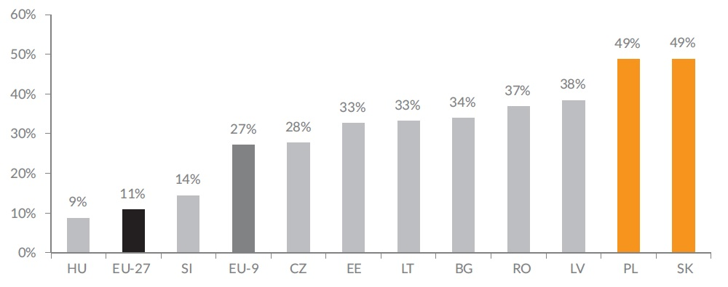
Figure 8. Cumulative GDP growth in the CEE region 2004-2013 (2003 = 100)
Source: Ministry of Foreign Affairs of Poland (2014); 10 years of Poland in the European Union Report

The analysis of the changes in Polish Gross Domestic Product should be made separately for the two periods: 2004-2008 and for the years after the crisis. The consequences of economic crunch, which began in 2008 and turned out to be a public debt crisis in Europe, are still being felt in the European countries.
During the first period Poland was developing in a very good condition. The government has been investing in infrastructure and education of its workforce and modernizing economic processes. These activities stabilized economic environment of the country, reduced the risk of doing business in Poland and fostered foreign direct investments (MSZ, Report). All these factors influenced the economic growth, which was increasing approximately 5% on a year-to-year basis.
When it comes to the global economic downturn period and the years after, Poland was the only country in the EU, which has survived the crisis without experiencing the recession. After a modest slowdown in 2009 it enjoyed a steep upswing in 2010-2011 followed by a still and solid growth in 2012 and 2013. Paradoxically, one would risk the statement that Poland took the advantage of the economic crisis in Eurozone, since its ever-increasing GDP helped to diminish the development gap between Western and Polish markets. Noteworthy, during the last whole decade, economic growth of Poland continued to be above the EU average and in 2008–2013 period it exceeded the average of New Member States. In the latter period Poland’s economy grew over 20% and this was the best outcome in the EU (Country Report Poland, EC 2015). The advantageous factors during the crisis, like floating exchange rate, stable bank sector, relatively less open market and accurate strategic government decisions, helped to maintain stable economic growth (Ministry of Foreign Affairs, 2014).

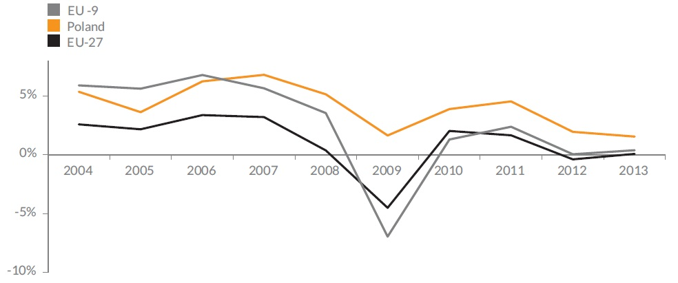
Figure 9. Change in GDP in the years 2004–2013 (preceding year = 100)
Source: Ministry of Foreign Affairs of Poland (2014); 10 years of Poland in the European Union Report

Also the European co-financing was an essential factor of the economic development of Poland. The success of Poland was to a big extent stimulated by the European Structural and Cohesion Funds (ESCF). The funds accounted from 11 to 25% of the CEE countries’ Gross Domestic Products and aimed for social and economic cohesion, through the investments in diverse industries and sectors (Proppé, 2014). Among them, the most important for this thesis are the investments in minor and major infrastructure, sustainable transport, improving human capital and introducing institutional reforms. In the years 2007-2013, the highest budget was allocated for Poland, which has the biggest population of all the countries concerned. The EU funds available only for Poland amounted to nearly €68 billion. Together with Czech Republic the funds for Poland accounted for more than 50% of all the budget for development for CEE countries. What is important, the vast majority of the funds has been invested mainly in infrastructure, aiming at bringing the quality of living in Poland to the Western standards. The funds had a positive influence on the national GDP, strengthened the national competitiveness and mitigated the negative influence of the global crisis. In addition to that the inflow of the EU funds to Poland will increase in the years 2014-2020, as the EU budget for this period set the funds allocation for Poland at EUR 72.9 billion under the Cohesion Policy framework.
Growing faster than its environment, Poland is quicker narrowing the gap between the Eastern and Western countries. Poland’s GDP per capita in 1995 was 43% of the average of EU countries, in 2000 it was 48%, and in 2013 it reached the level of 67%.

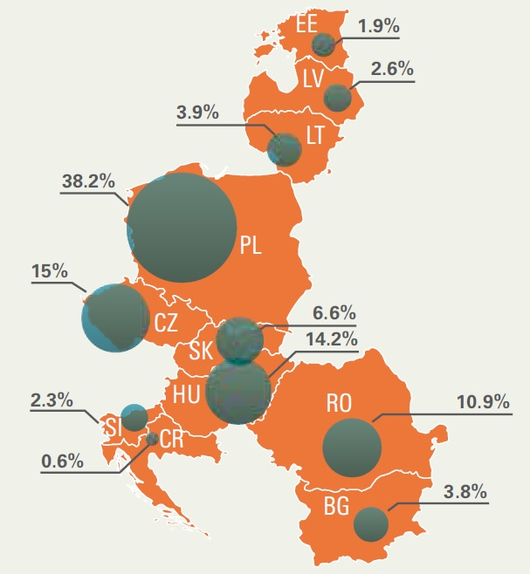
Figure 10. Breakdown of EU funds in 2007-2013 by country
Source: Proppé, M. (2014). EU Funds in Central and Eastern Europe. Warsaw: KPMG.

  - Foreign Direct Investments
The accession of Poland to the European Union brought also benefits in terms of foreign direct investments’ inflows. It has accelerated Poland’s investment credibility and helped to attract foreign investments. In 2012 the aggregated value of FDIs was estimated at the level of EUR 178 billion, an almost 300% growth in comparison to the year 2003, when the FDI stock accounted for EUR 48 billion (Ministry of Foreign Affairs, 2014). What is also important, since 2003 the rate of investments to the GDP has increased almost twice. It is clear that Polish economy is improving its attractiveness in terms of FDIs, since the accession to the EU ensured the investors that Poland is an increasing market with a stable legal system.

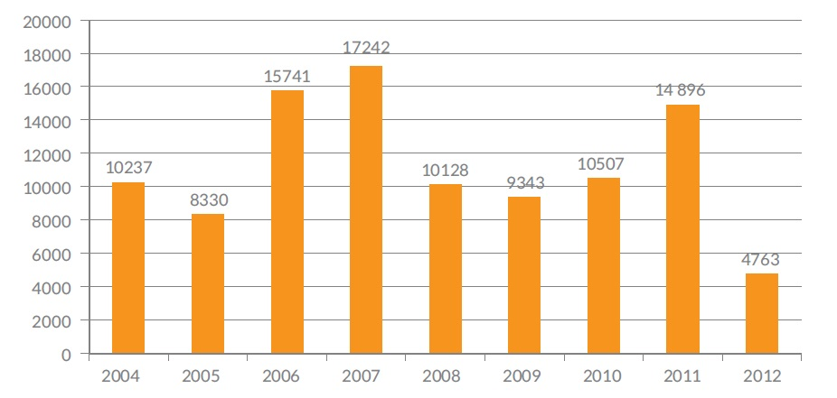
Figure 11. FDI Inflow to Poland in 2004-2012 (in EUR million)
Source: Ministry of Foreign Affairs of Poland (2014); 10 years of Poland in the European Union Report

The great majority, approximately 85% of the FDI inflows, came from the EU Members. Poland is the leader in the Central and Eastern Europe in terms of foreign direct investment inflows. Although over the year 2004-2013 Poland attracted around 34% of all EU Members’ FDIs in the CEE region, it is still slightly below the Polish potential, since its GDP ratio to the other countries in the region accounts for 38%. Even though the potential is not fully exploited, it brought undeniable benefits to the Polish economy. Since Polish domestic companies do not rely on the foreign funding, they have survived the global crisis in a better shape than those depending on foreign investments (Ministry of Foreign Affairs, 2014)..
The companies, which benefitted from foreign direct investments, have easily increased their productions and expanded their exports in the European markets. The FDIs continue to be a strong incentive for the Polish exports. The group of leading exporters mainly comprises the companies with foreign capital. While the companies with foreign capital account only for 30%, the total share of their exports approximates 59% (Ministry of Foreign Affairs, 2014). It has to be also emphasized that while the export structure of foreign capital entities is deteriorating, the opposite trend has been observed for the companies with Polish capital only. The domestic companies also felt the pressure from the foreign companies and were forced to restructure their productions. This phenomenon was even enhanced by the EU funding discussed in the previous subchapter. Thanks to these factors Polish companies became more competitive and innovative and Poland itself has become a leading producer and exporter in key exporting industries. This relates especially to the vehicles manufacturing, and manufacturing of metal, non-metal and plastics products.

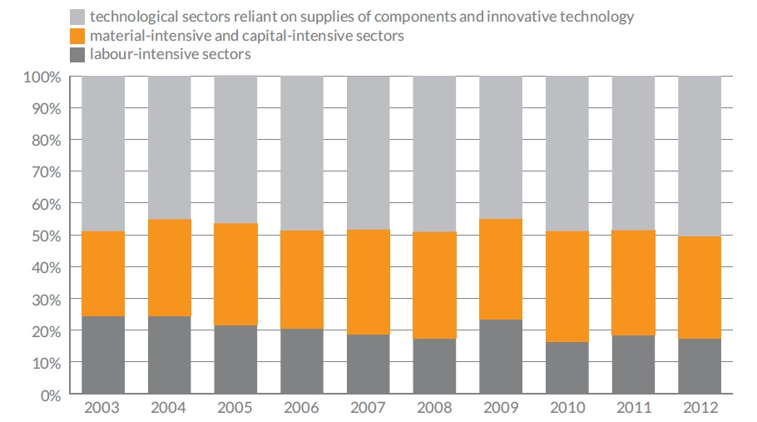
Figure 12. Foreign capital structure in Poland according to technological intensity
Source: Ministry of Foreign Affairs of Poland (2014); 10 years of Poland in the European Union Report

After acceding the EU, Poland has switched from low to high tech manufacturing. Recently, the share of FDIs are on the rise especially in medium tech and high tech industries, such as production of computers, pharmaceuticals, medical and optical instruments. Poland is becoming also the leader in the CEE region in software development and aviation sector. The chart above depicts exactly the gradual movement from labor-intensive and material-intensive sectors to capital- and technology-intensive ones. The industrial structure of Poland is being transformed now, since the foreign capital gives rise to modern industry branches. The foreign companies are investing in research and development. Almost 14% of all the expenditures are spent in this branch (Ministry of Foreign Affairs, 2014).
In addition to all the above-mentioned observations, Bloomberg has identified Poland as one of the most attractive market for foreign investments. In their ranking in 2010 Poland was 6th most attractive economy in terms of FDI in the world and in the same time the most attractive in CEE and Central Asia region. The sharp rise from the 22nd position in 2007 was mainly attributed due to stable economy growth, especially during the crisis period. According to Bloomberg, foreign investors were particularly appealed by Poland's relatively lower wages and extensive investment opportunities through the government's aggressive privatization program (Reinhardt, 2014). Moreover, the Global Finance Magazine confirms Bloomberg’s enthusiasm. It forecasts that Poland will be the second, behind Turkey, most desired destination for FDIs in the world in the next 25 years (Keay, 2012).
The Polish attractiveness in terms of foreign direct investments is mainly caused by several factors, among others big internal market, political stability, stable currency, modernization of transport infrastructure and the highest increase in labor productivity between 2009 and 2012 of all OECD countries (Ministry of Foreign Affairs, 2014). Poland remains one of the biggest beneficiaries in terms of FDI inflows in the region. Also, the more FDIs are inflowing to Poland, the more its economy is becoming modernized.

  - Foreign Trade
The great success of Polish economy can explained be to a large extent by the dynamically growing participation in the foreign trade. During the years 2004-2014 the exports grew twice as fast as the GDP itself. This is an indirect consequence of the fact that Polish economy has been becoming more and more competitive and the demand for Polish products and services abroad is increasing. In 2004 Poland opened its market to the foreign ones and the exports have become even more a driving force of the Polish economy growth.
However trade volumes have been increasing in both Polish relations - with the EU and non-EU partners - the main engine was the trade with the European Union, since approximately three fourth of Polish exports go there. In 2013 the total exports attained the level EUR 155 billion, increasing 2.6 times in comparison to 2004, when the exports amounted to EUR 60 billion. In the same time the value of imports has increased 2.2 times, reaching EUR 157 billion comparing to EUR 71 billion in the first year of accession to the EU (Ministry of Economy, 2014).
The exports to non-EU countries also improved greatly over the years 2004-2014. They increased four times and reached EUR 38.6 billion in 2013 (Ministry of Foreign Affairs, 2014). This phenomena was related to the growth of potential of Polish exporting companies and increased accessibility to new markets. The EU membership allowed Poland to become party to trade agreements with non-EU countries. However, the trade balance between Poland and third countries deteriorated and generated a deficit of EUR 27 billion. This negative balance is mainly due to an increase in imports of crude materials and mineral fuels.

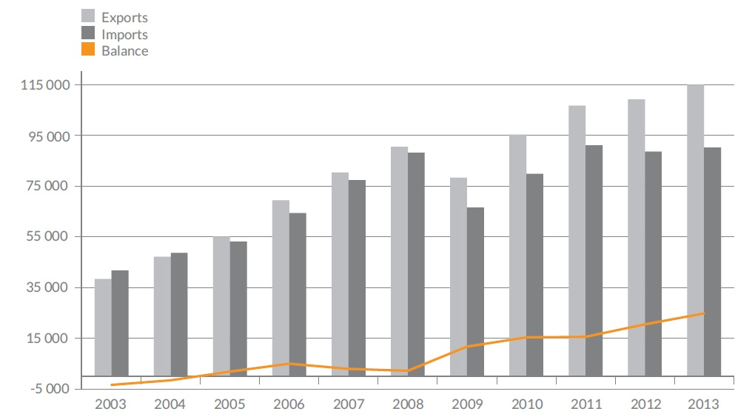
Figure 13. Value of Poland’s trade with European Union Member States (in EUR million)
Source: Ministry of Foreign Affairs of Poland (2014); 10 years of Poland in the European Union Report

The exports to the entire European Union increased slightly slower (2.4 times) than all the exports. Going deeper the dynamics of exports to the old-EU countries increased 2.2 times reaching the value of almost EUR 90 billion, while the exports to new Member States grew by 3.3 times to attain the value of EUR 26 billion. It can be explained by the fact that over the last decade Poland established closer economic ties with New Members. Almost 17% of all the exports go to the latter ones. It is also worth noting that the higher dynamics of exports than of imports from the EU has allowed to convert the deficit in trade balance into systematically growing surplus. Since 2004 the exports have been growing continuously with an exception in 2009, when the trade with the EU declined due to the crisis. The trade balance has been improving during the last decade to reach the record positive balance. In 2013 the exports and imports accounted for EUR 114 billion and EUR 90 billion, respectively, which effect in a trade balance surplus of more than EUR 24 billion (see the chart above). Only in 2013 the surplus in balance with the old members reached a level of EUR 13 billion and with new members amounted to EUR 11 billion. This surplus almost allows to compensate completely the deficit with regarding the import of raw materials from third party countries and goods from Asian market (in particular Chinese and South Korean markets). Thanks to that the total trade deficit was only about EUR 2 billion in 2014 (Ministry of Economy, 2014).

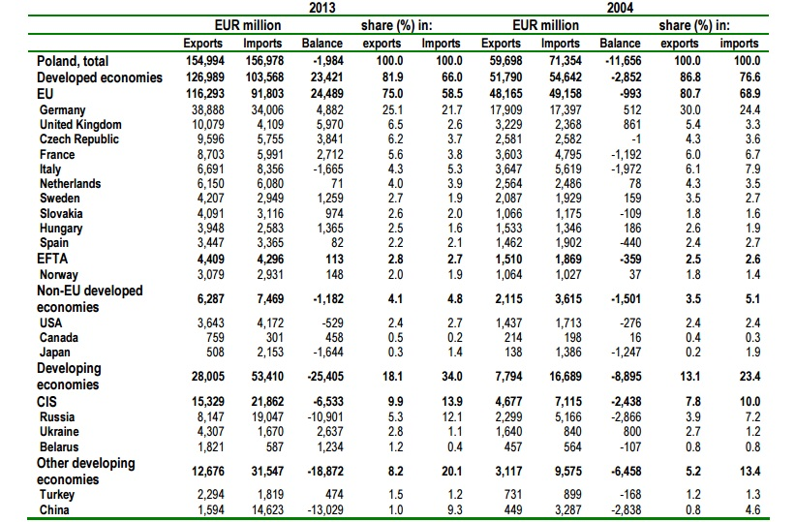
Figure 14. Changes in the geographical structure of trade in goods (in EUR million)
Source: Ministry of Economy of Poland. (2014); Report on Foreign Trade

The table above depicts the biggest Polish trade partners. Germany remains the leader in this classification. Since 2004 the exports to the biggest European neighbor have been raising from the level of almost EUR 18 billion in order to reach almost EUR 39 billion in 2013. This value can be translated to slightly over than 25% of all the Polish exports. When it comes to the imports they also have been growing over the same period from the value of EUR 17 billion to slightly over EUR 34 billion, which accounts for 21.7% of all Polish imports. Even though the volumes to and from Germany have increased over the past decade the share has decreased. It clearly shows that Polish entrepreneurs successfully found new export markets and diversified their customers’ portfolios. Recently, the surplus in the trade between Poland and Germany increased almost 10 times in favor to Poland to reach the level of almost EUR 5 billion in 2013.
The second most significant market is the United Kingdom. The UK advanced from the fourth place in 2004 and the share of the export and import amounted from 5.4% and 3.3% to 6.5% and 2.6% respectively. Poland started to sell more to the UK market and in the same time it decreased its share of imports. The trade surplus with respect to the UK attained the level of EUR 6 billion in 2013.
The increase in cooperation with the Visegrad Group countries is especially visible while looking at the trade balance. The Czech Republic has become our third biggest partner (behind Germany and UK) with a share of 6.2% of all the Polish exports, which accounts for EUR 9.5 billion. In 2004 the Czech Republic ranked for a fifth biggest partner with a total share of 4.2% Polish exports. Slovakia and Hungary also made a great progress. Both countries advance to 10th and 11th spots with a shares amounting to 2.6% and 2.5% accordingly. The total exports to the Visegrad Group accounted for almost EUR 18 billion in 2013. At the same time the imports from these three countries reached the level of 7.3% of all the imports. The surplus in the trade balance with the group accounts for EUR 6.2 billion (Ministry of Economy, 2014).
In the case of Poland the exports and imports to non-EU developed economies are of a minor importance in the big picture. The biggest recipients of goods are the United States (ca. 2.4% of the whole Polish exports), Canada (0.5%) and Japan (0.3%). These countries also remain the biggest sellers to the Polish market among this group. The total contribution of exports and imports accounts for 4.1% and 4.8% respectively, which can be translated to the value of EUR 6.3 billion and EUR 7.5 billion. The deficit of trade is caused mainly by a greater activity of Japanese entities in exports to Poland than in imports.
Also almost 10% of all the exports of Poland go to Commonwealth of Independent States (CIS) market, particularly to Russia, Ukraine and Belarus. During the last decade the exports to this group of countries grew by 330% in order to reach the value of EUR 15.3 billion. After 10 years Russia still remains the biggest non-EU recipient of Polish goods. The sales to the Russian Federation have been growing by more than 350% to reach the level of more than EUR 8 billion. Over the same period the imports from Russia to Poland grew by almost 370% and reached the value of EUR 19 billion. Russia is the second (behind Germany) biggest seller of the goods to Poland. This number is mainly obtained due to the raw materials and resources (natural gas) imported to the Polish market. In addition to the Russian Federation, the biggest CIS partners are Ukraine and Belarus. Since 2004 the export grew by 260% and 400% respectively and attained the levels of EUR 4.3 billion and EUR 1.8 billion. The CIS markets have been perceived as a great opportunity for growth for Poland, however the economic slowdown caused by military conflict in Donbas in 2014, has cooled down the cooperation enhancing attempts. Recently, the exports to the Russian and Ukrainian markets have been slowed down.
Moreover during the last decade the exports to other developing countries (than CIS) have increased fourfold attaining the value of EUR 12.7 billion in 2013. The total share of exports and imports reached the levels of 8.2% and 20.1% respectively, which can translated to the value of EUR 12.7 billion and EUR 31.6 billion. This big deficit might be explained mainly by the imports from the Far East, in particular from China and South Korea. China remains the third biggest exporting to Poland market. In 2013 the imports to Poland were 445% bigger than in 2004. The Chinese exports to the Polish market have recently exceeded the value of EUR 14.6 billion. In turn Poland have sold only EUR 1.6 billion of goods to the Chinese market in 2013. Also Turkey appears to be one of the biggest trading partners in this group of countries. Almost 1.5% of Polish exports goes to Turkey and 1.2% of imports comes from this country. Moreover the exports to the Middle East countries have recently grown enormously. This event might be explained by the fact that exporters are seeking other than primary trading markets. The current situation behind the Polish Eastern border, the economic recession and the European Union’s embargos on Russia have pushed Polish entrepreneurs to look for higher flexibility in terms of trading partners. This resulted in expanding the export activities of many enterprises to include new, more distant markets (Ministry of Economy, 2014). Among them the biggest increases in terms of exports have been encountered by United Arab Emirates (750%, to the level of EUR 570 million) and Saudi Arabia (almost 400%, to the level of EUR 380 million).
The accession of Poland to the European Union, and consequently the free movement of goods within this region, has also allowed to improve the trade balance with the countries in the Central and Eastern Europe region. During the period concerned exports to these countries grew from around EUR 6 billion to over EUR 25 billion (Ministry of Foreign Affairs, 2014). Over the same period the Polish exports have increased their share in exports within the European Union from 2% to 4%, while the share of Poland in the global exports grew from 0.5% to 1.1%. The other countries in CEE region have been increasing their shares in a slower pace.
In terms of the value of the exported goods, Poland is in the first place among all the CEE countries with a share of 27%. Yet, there is still room for improvements since the Polish economy is the biggest accounts for 39% of all the economies in the Central and Eastern Europe.

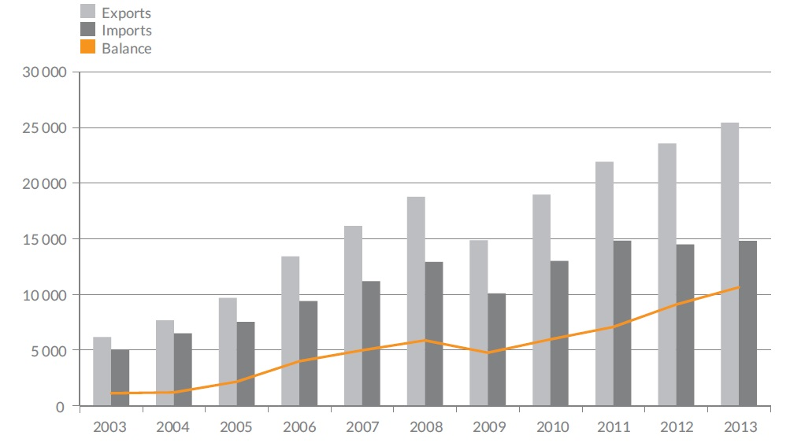
Figure 15. Value of Poland’s trade with European Union Members in the CEE region (in EUR million)
Source: Ministry of Foreign Affairs of Poland (2014); 10 years of Poland in the European Union Report

    - The biggest exporting and importing industries
In the years 2004-2013 the structure of the Polish foreign trade has greatly evolved. The rapid growth rate during the last decade was caused by the modernization and qualitative improvement of the structure of Polish exports. The increase in quality and value of exported products is the natural answer for the higher demands and standards of new trading partners.
Among the products that Poland is exporting the electromechanical machinery ranks the highest. In 2013 this group stood for over than 39% of all the exports. Over the past decade the value of exported electrical machineries rose from EUR 23.9 billion to EUR 61 billion. In the same time the imports have been growing on a slower pace and accounted for EUR 56 billion in 2013. The EUR 5 billion deficit in this sector in 2004 turned into EUR 4 billion surplus in 2013. This is a primarily effect of the improvement in the balance with respect to the trade of boilers, machinery, vehicles and their parts as well as electrical machinery and equipment.
During the same period the leader of exports growth were agricultural products and foodstuffs, which grew four-fold reaching the value of EUR 20.4 billion by the end of the year 2013. It is worth to emphasize that Poland has been achieving a systematical growth in this industry effecting in EUR 6.1 surplus in 2013 compared to the modest EUR 0.8 billion in 2004. This undeniable success was mainly achieved due to the improvement of the structure of trade of animal products, especially meat and edible meat offal, which grew by 540% reaching the level of EUR 3.4 billion. The food and agricultural products enjoy the high quality and good reputation among the foreign consumers. Almost 82% of the exports goes to the customers in developed countries.
Chemical industry products and metallurgical products are also two another important groups, which grew by 330% and 250% respectively over the last decade. These product groups generated the income of almost EUR 22 billion and EUR 17 billion respectively in the last year and accounted for 25% of all the exports. The chemical group holds the second position in the Polish foreign trade in terms of value. The substantial increase in volumes helped to slightly diminish the deficit in trade balance from EUR 6.4 billion to EUR 5.7 billion. The metallurgical products faced less dynamic growth but this resulted in a stable increase of the trade balance of this commodity from EUR 99 million in 2004 to over EUR 650 million in 2013.
From the overall perspective the significant improvements in the trade balance in dominant commodities’ groups allow for the almost full compensation of the high deficit of chemical industry and mineral goods. In 2013 the deficit only of the latter amounted EUR 11.9 billion. However the generated surpluses in the main commodity groups testify about the great condition of Polish industries, the demand for mineral goods is too high and not covered. In 2013 the overall deficit accounted for almost EUR 2 billion.

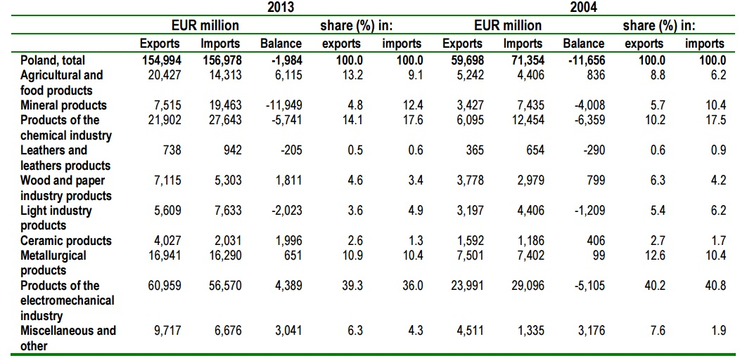
Figure 16. Changes in exchange of commodities aggregated in 10 commodity groups (in EUR million)
Source: Ministry of Economy of Poland. (2014); Report on Foreign Trade

Given the fact that over 75% of Poland’s exports go directly to the European Union it is important to look at the structure of the foreign sales from this perspective. When we look more specifically in the exporting commodity structure to the EU, the biggest share have cars and their components. Together these two groups stands for 9% of all the exports. Also, of main importance are furniture, cosmetics, TV sets, petroleum oils and their products, data processing machines, household appliances, copper and copper alloys. The top 10 export commodities account for 30% of total exports to the EU (Ministry of Foreign Affairs, 2014).
Before acceding the European Union, Polish companies were unsure if they withstand the increased competition from the foreign rivals. Yet it turned out that Polish entrepreneurs in fact took the advantage of the opportunities offered by the extended European market and promoted themselves in the common market. When we look at the statistics it becomes clear that the implementation of the uniform law turned out to be advantageous for businessmen and entrepreneurs. During the last decade Polish companies grew much faster (148%) than the average of the EU (120%).
In the period of 2004-2012 the number of entities exporting their goods was growing twice as fast as the total number of companies (ca. 38% as compared to 19%) and now almost one out of three Polish companies is an exporter. The greatest number of exporters is in industry (52%), trade (25%), transport (6%), professional, service and technical activity (5%) and constructions (3%). Although, the biggest share of the exporters is still represented by large companies, the highest growth of small exporters (up to 49 employees) might be observed. Moreover between 2003 and 2012 exporters generated almost 200% higher profits. These fact clearly show the rise of internationalization of Polish companies.
The industrial output also grew significantly over last decade. This was caused mainly due to direct investments and higher demand for Polish goods on foreign markets, which led to a higher increase in exports. The biggest share of exports in the revenues of companies in the industrial sector was recorded by manufacturers of motor vehicles, computers, electronic and optical appliances, furniture and electrical appliances. Many Polish enterprises have established their brand and goodwill in a global market. Large companies like Boryszew, Solaris, Amica, Tele-Fonika Cables, Can-Pack and many others have generated almost half of their revenues from the exports (Ministry of Foreign Affairs, 2014).
In the automotive sector, which is one of the most important Polish industry and accounts for almost 12% of total exports to the EU, almost 75% of the revenues is derived from the exports. The total revenue of around EUR 27 billion was generated by companies selling cars, car parts and specializing in auto repairs. Since 2003 the exports grew threefold and in 2013 recorded a surplus of EUR 2.8 billion in trade balance. Although Poland lost the position of the leader in the CEE in exporting automotive products to Czech Republic, it remains the biggest exporter of delivery vehicles, trucks and road tractors. Also the FDIs greatly contributed to the growth of demand for services provided by Polish companies in this industry. Multinational companies like Volkswagen, Fiat and Opel have made their investments in Poland. Over the last decade the investments in automotive sector grew by over 200% to reach the level of €20 billion.
Poland is also one the world’s major furniture exporters and the biggest in the region. Almost 40% of the furniture exported in the CEE region comes from Poland. In 2013 the share of furniture in overall exports amounted to 5% and accounted the value of EUR 7.5 billion. It is of a high importance to stress that the imports of furniture value only at around €1.2 billion. The Polish furniture manufacturers are recognizable in the EU and beyond, which helps to promote Polish economy. The whole production of furniture in Poland represents approximately 10% of the overall production of this commodity in the EU.
Since the accession to the EU, Poland has become one the leaders of household producers and exporters. Thanks to the high level of foreign direct investments the production of washing machines, refrigerators, dishwashers, oven and cookers in Poland has increased its share from 5% before joining the common market to the current level of 22% of all the household goods produced in the old continent. Although Poland is the EU leader in terms of volume, it is still second to Germany in terms of the value. In 2012 the Polish market has manufactured the appliances of approximately EUR 3 billion value, while Germany has generated EUR 4 billion in this sector in the same year. Polish exports almost 80% of the household appliances, reaching the value of almost EUR 3.4 billion in 2012. Noteworthy, over the last decade this value has tripled, since the exports in 2004 were worth EUR 850 million. The trade surplus in 2012 in this commodity sector was about EUR 2.4 billion. The biggest recipients of the exported goods are the EU countries led by Germany (25%), France (15%) and the United Kingdom (13%).
In addition to that one of the most important export industries are the consumer electronics. After joining the common market Poland has become one of the biggest manufacturers of TV sets, their components and subassemblies. In 2012, the value of the TV sets sold exceeded EUR 4 billion and this might be translated to over 20 million of TV sets produced in the EU. In relation to the year before the accession to the EU, these numbers have increased threefold. Noteworthy, a considerable part of the production, namely 80%, is marketed abroad, mainly in the EU. In the CEE region only Slovakia exports more products in this group.
Another main source of the exports is the cosmetics industry. Recently, Poland holds the 6th position in the cosmetics market in the European Union and is the leader in the Central and Eastern Europe. The share of produced cosmetics in the CEE region accounts for almost 50%, which is a way more than Polish potential. These phenomena were especially enhanced the by accession to the internal market and adoption of EU standard (like ‘Cosmetics Directive’). The whole cosmetics market was valued at EUR 3.4 billion in 2013. Since 2004 the exports of cosmetics in Poland has more than quadrupled and reached the value of EUR 2.1 billion in 2013, which accounts for over 60% of the whole production. Over the period discussed the exports only to the EU countries have increased 5 times from the moderate value EUR 0.3 billion to EUR 1.4 in 2013. Exports to the third countries also has drastically grown from the level of EUR 0.2 billion to almost EUR 0.8 billion during the same period. Since cosmetics were established one of the 15 champion’s industry in Poland the exports to the third countries have gained even a greater momentum - only in 2013 they increased by 35%. The total production and the overall export of cosmetics are facing now more dynamic increase that other biggest EU producers – the UK, Germany, France, Italy and Spain. This is directly connected with greater innovation of cosmetics companies. They allocate almost 20% of their expenditures in R&D (Ministry of Foreign Affairs, 2014).
And last but not least critical in terms of volume and dynamism export sector was the agro-food industry. Since 2004 the agro-food products exports’ increase fivefold to reach the value of EUR 20 billion in 2013. Before the accession to the EU Polish companies in the sector felt threaten by the foreign competitors. Yet it quickly turned out that Polish producers have built a goodwill and positioned themselves strongly in the European market. At present, almost 75% of Polish exports from this sector goes to the European countries. The surplus generated by this competitive branch of the economy grew steadily since 2004 in order to reach EUR 3.5 billion surplus in 2013. In the CEE region Poland remains the leader in the agro-food business. Almost 45% of exports in the region belong to the Polish entities. Among the most frequently exported products in this industry are: meat and edible meat offal, dairy products, eggs and honey, tobacco, and cereals, vegetables and fruits.

  - Business environment
The business environment highly improved over the last decade. Poland has encountered a steep rise in the number of business environment institutions. Between 2000 and 2012 this number raised from 260 to 820, among others 40 technology parks, 73 academic business incubators, 69 technology transfer centers and over 300 training and advice centers (European Commission, 2015). Although these institutions heavily rely on the public aid, they provide basic services and consultancy to the entrepreneurs.
Also over the recent years the situation of Poland has been gradually improving in the international rankings examining business environments. This is an evident prove that the changes occurring in the Polish economy are going into the right direction. Undoubtedly these rankings provide an essential information to investors and other stakeholders while making decisions. According to one of the most acknowledged competitive studies – the World Bank Doing Business Report – Polish business environments is systematically improving its position. The report is linked mainly to the microeconomic aspects of business activity, like paying taxes, enforcing contract or starting a business. In the most recent Doing Business ranking Poland has taken the 25th place in the ranking of 189 economies with an improvement of 3 places in comparison to the previous year. Polish business environment outperformed the Netherlands, Switzerland and France. Apparently the business environment highly improved, since Poland held the 76th position in the world in 2009. In the CEE region it stands 3rd, behind Lithuania and Latvia. What is outstanding Poland has been acknowledged first in the world in the category of trading across the borders. Short time to export/import, low costs of transportation as well as quick and reliable transport system were the main indicators of this score. Poland has obtained also high scores in the categories of getting a credit (19th in the world), efficiency of bankruptcy law (32nd), and protecting investors (49th). Regarding the enforcement of contracts, Poland holds the 55th position. According to the report analysts, the period of time necessary to enforce contractual obligation amounted to 830 days in 2012. In the most recent ranking this period has been shortened to 685 days, while the average of OECD countries is 529 days. In the CEE region the highest scores were obtained by Lithuania and Latvia, while in the whole EU the leaders are Denmark and the United Kingdom (Doing Business, 2015).
In the EY 2014 European Attractiveness Survey, which aims at benchmarking of attractiveness of European economies and their competitors as regards investments, Poland was ranked as the most attractive country in the CEE region. Almost one third of respondents (foreign investors) chose Poland as the best market for FDIs. Noteworthy, ranks first in R&D investments in the region and third in Europe in terms of newly created jobs. The report points that half of the investments was made in the processing industries, mainly automotive and plastics sectors.
On the other hand the Global Competitiveness Report prepared on yearly basis by World Economic Forum places Poland on the 42nd position among 148 states in 2014. Poland is ahead of all the CEE countries, but still lagging behind all the big Western economies. According to the report the best results were obtained by Poland in the following categories: market size, higher education and training, and financial market development. The infrastructure, the labor market efficiency and macroeconomic environment were identified as the ones that still have to be improved. When it comes to the business environment and its barriers Poland still have to overcome the complex tax and labor market regulations and unfavorable tax rates.
The common part of all the selected reports is the fact that over the last decade Polish economy has improved significantly. Although the results are still far from desired and Polish market is lagging behind the Western ones, the forecasts are rather positive. Some experts expect that the Polish economy will boom and become a by 2025 and advanced economy competing on global stage (McKinsey Report, 2015).

  - Transport and logistics systems
A suitable level of individual components of the transport infrastructure contributes to capital inflow and trade, increasing the investment attractiveness of the country and the global competitiveness. The well distributed and effective transport network improves the efficiency of the market and reduces the negative impacts on the environment. However in the same time the underdeveloped system might be one of the biggest barriers hampering the economy to growth. Although the Polish transport system has grown over the last decade, it still calls for the improvements. Also the Polish freight transport system is characterized by the domination of road and railway transportation. The inland waterways are of marginal importance, but the seaports have developed significantly in terms of volume handled. Undeniably, the imbalanced modal split must be improved and Poland has to make a bigger use of its rivers.
The transport system is one of the fields that benefitted the most from the accession to the European Union. During 2004 and 2006 over 8% of the whole cohesion funds designed for Poland, which accounted for more than EUR 1 billion was allocated on developing the transport system in Poland. This was even more critical in the following year up to 2013, when almost 42% (EUR 28 billion) was allocated in development of infrastructure. Yet the infrastructure is still one of the most underdeveloped in the European Union and calls for huge investments in modernization and improvement of efficiency. Between 2007 and 2015 EUR 16 billion was invested in building motorways and expressways. Between 2006 and 2016 the length of motorways and expressways increased by 1700km and now the density of road network is in line with the EU average (European Commission, 2015). This is a huge leap taking into account that before acceding the EU Poland had had only 405 km of highways and 226 km of expressways. According to the PwC report in 2007 was the EU leader in the construction of motorways, as the number of kilometers built in Poland grew by 106% (PwC, 2015). Further investments from the EU are scheduled for the incoming years and will be implemented on the similar scale as so far.
In 2013 all modes of transport carried 1.85 billion tons of goods, which is 3.3% more than in the previous year. This number can translated to almost 348 tkm. The increase of the carriage of goods was especially visible in the road and rail transport. The volume of goods carried by the road transport reached the level of 1.55 billion tons of goods in 2013, which is 4% more than in the previous year. Thanks to the opportunities offered by the common market, Poland became an undisputed leader in international road transport in Europe. Since Poland’s accession to the European Union, the number of commercial participants in the road market has grown threefold, up to 25.000 entities in 2012. The total volumes transported by Polish companies reached 133 billion ton-kilometers outperforming Spain (66 billion tkm) and Germany (53 billion tkm), which hold the second and third position accordingly. When we translate these numbers to percent we observe that almost one fourth of all the international transports in the EU is carried by Polish haulers. Including domestic services Poland (222 billion tkm) is second in the European market, only with Germany (307 billion tkm) ahead. The market domination is even more visible in the CEE region, where almost every second ton of transported goods is hauled by Polish carriers (MSZ Report). The biggest partner in road exports as well as in imports if Germany. The exports and imports to this country in terms of volume account for 39% and 41% respectively. The second biggest partner is the Czech Republic which share is approximately four time smaller than of the leading Germany.
During the last 25 years the underinvested railway transport has been suffering from considerable degradation, closure of lines and traffic restrictions. Only in 2013 the railway network shortened by more than 750 km. The degradation of the role of the railway network is a natural effect of the transition from resource based economy to process manufacturing (Ślubowski, 2007). In the same time the road transport increased its share in the total cargo volumes shipped. Although the railway network accounts for 19.300 km and it is one of the longest in Europe, its infrastructure is still more than far from good. Despite the gradual degradation of the importance of the rail transport over the last ten years we might observe a slight of improvement of the quality of the railway conditions. For instance in the period concerned the length of railways adjusted to the high speed trains grew by 700 km. The railways market, which was controlled for many years by the government, has been liberalized in the past years. The archaically managed, state-owned companies have been sold to the private actors and many new players has entered the rail market. Nowadays the rail market is again on the growth and it is expected that will be increasing its share in the incoming years, especially in the container market (Ślubowski, 2007). In the 2007-2013 period over EUR 5 billion were allocated in improving the railway system, mainly the ones in the TENT-T network. In turn in the 2014-2020 financial perspective the railway funding is to be increased by 85% to EUR 10 billion. The funding aims at helping to reverse the negative trends in freight and passenger transportation (European Commission, 2015). In terms of the volume of goods carried by the rail transport Poland ranks second in the European Union between Germany and France (Central Statistics Office, 2014). In 2013 the total rail transport carried 233 million tons of goods and increased by 0.7% in comparison to 2012. When we look at the statistics more carefully this increase was stimulated mainly by the growth in the international trade, which raised by 5.8% comparing to the previous year and balanced the drop in domestic transport, which accounted to 1.3%. Going deeper the growth in international trade was a direct result of the increase in exports, which grew by 16.2%, while the imports dropped by 1.5%. The latter can be explained by the restricted international trade with Russia, which was in the past years the biggest exporter to Poland.
The inland shipping is of a minor importance in Poland. In 2013 barges carried only 5 million tons, and this can be translated to 0.2% of all Polish transports in terms of volume of cargo transported. The total length of all the inland waterways accounts for 3660 km, but does not create a transport network. The waterways are not connected to each other. More to that the inland transport system suffers from the lack of investments and only 5.5% of the waterways are classified as of the international importance (fourth and fifth class) (Ministry of Infrastructure and Development, 2014).
Poland also has four seaports of a national importance. Gdansk and Gdynia are the biggest ones and are located in the Bay of Gdansk. Also Swinoujscie and Szczecin located in proximity to the German border are perceived as ports of a high importance. All these ports serve on a regular basis to the international ship calls and belong to the transeuropean transport network. Thanks to the favorable location and high efficiency the Polish ports might compete with the other north-European ports. The best and a flagship example is the port of Gdansk, which thanks to the new Deep Water Container terminal became the first hub in the Baltic Sea area. The efficient and high quality infrastructure owned by the biggest ports in Poland indicates that Polish ports become to be seen as very attractive, especially when we compare them to the nearest competitors in Baltic Sea area. The poor connectivity from the land side (roads and rails) remains to be still a challenge (Ministry of Infrastructure and Development, 2014).
The investments in the logistics infrastructure have boomed after the accession to the European Union. The total warehousing space has experience a dramatic growth. Only between 2005 and 2010 it increased by 360%. At the beginning of 2014 the modern warehouse space stood at the level of 7.9 mln sqm. When comparing to the other countries in the CEE countries it turns that it was the highest growth in the region. This phenomena is mainly a result of an advantageous geopolitical location of Poland. Only in 2013 the total warehouse space increased by 500.000 sqm, which is twice as much as in the prior year (Ministry of Treasury, 2014). Since 2014 the most important logistics hub were Warsaw, Wroclaw and Poznan. Warsaw maintains the status of the biggest storage market in the industry. The whole warehouse space in Warsaw is accounted for 635.000 sqm. The latter two areas became of a national importance thanks to the Amazon’s entry into to the Polish market in 2014. The Amazon’s distribution centers accounts for the half of the whole storage space in Wroclaw (ca. 224.000 sqm) and one fourth in Poznan (ca. 100.000 sqm). According to the experts, the Polish market is ready to accept the role of a global leader in e-commerce and other companies like Amazon may follow the suit (Ministry of Treasury, 2014). Moreover the published by World Bank Logistics Performance Index Report ranks Poland in the 31st place among 160 economies. The LPI takes into account several factors influencing the logistics market, like the efficiency of customs clearance, the quality of infrastructure, the quality of logistics services, and the supply chain’s reliability. It is clear that Polish logistics market improved and Poland is diminishing the gap to the top countries, since in 2007 – the first year when the report was published – Poland held the 40th position.
Summing up the ever increasing GDP, foreign direct investments and the growing in terms of importance role of Central and Eastern European countries are the factors, which increase the competitiveness of Poland. Poland becomes a logistics center for the Central and Eastern European markets and it is best evidenced by the recent growth in the storage facilities. The case of Amazon shows that Poland can offer services on a global level. Although the positive trend in the logistics market, the transport infrastructure hampers the potential growth of Polish market. Despite the huge investments the transport (road, rail and inland shipping) infrastructure quality still leaves a lot to be desired.
This chapter has provided an insight on the macroeconomic events which have been happening in Poland over the last decade. The GDP has been greatly growing in line with the foreign direct investment inflows. The foreign trade, which is one of the biggest driving forces of the economic development, also increased significantly. Although the trade deficit was around EUR 2 billion in 2013, it systematically diminishes on the year-to-year basis. Also Poland has increased its trade flexibility the number of trading partners in order not to depend on the partners from one region only. And last but not least, the transport system also greatly improved. However the transport infrastructure still calls for big investments, which hampers the Polish market to exploit fully the opportunities, Poland is perceived as a leader in logistics services in the Central and Eastern Europe.

CHAPTER V. SHIFT SHARE ANALYSIS
The core part of this Master’s thesis is the shift-share analysis, which aims at shedding some light on the container traffics within the European ports. The analysis determines what portion of the overall growth was attracted by particular port ranges. It also allows to understand in which periods the competition between ports was fiercer than in the others. The data used for the shift-share analysis was the container throughputs collected from 107 biggest European container ports from three different sources: European Seaport Organization (ESPO), Central Statistical offices and Port Authorities of particular ports. The chapter V is structured as following: the description of the methodology, the approach regarding collection of the data, and finally the analysis and the main results stemming from it.

  - Methodology
The shift share analysis was initially invented in the framework of regional economics, yet as Notteboom proved (1997, 2010) it is also easily applicable for analyzing the port traffics. As he pointed the analysis itself cannot reflect the external environments or conditions, yet it is useful in dividing the decline or the growth of the main variable (which in that case is the container traffic) into two segments – the shift and the share effects. The share effect reflects the expected potential change of the container port (range) as if it would maintain the same rate of change as the whole range (system). In other words it determines what would be the port container throughput under the presumption that the individual port will capture the same portion of the growth or the decline in the succeeding period. The shift effect in turn reflects the total number of containers that the particular port has actually won or lost to the competing ports among the same range or system with the expected change with the expected container traffic (share-effect) as a reference. The shift effect can be translated into a difference between the real and expected container throughput change. The net shift enables a better comprehension of a port’s (range) competitive position since it eliminates the growth of the overall port range (system), i.e. only the net volume of TEU shifts between ports remains. The sum of the shift effects of all the ports considered in the analysis equals zero. Periods characterized by high net volume shifts refer to a considerable degree of dynamics and competition within the container port system. The shift share analysis is a useful tool to assess whether the port players are losing some ground in favor to others.
Mathematically the equation of the shift-share analysis can be written down as following:
$$ABSGR\text{i} = TEU\text{it1} – TEU\text{it0} = SHARE\text{i} + SHIFT\text{i}$$

$$SHARE\text{i}=\left(\frac{\sum_{i=1}^{n}{TEU\text{it1}}}{\sum_{i=1}^{n}{TEU\text{it0}}}-1\right)×TEU\text{it0}$$

$$SHIFT\text{i}=TEU\text{it1}-\frac{\sum_{i=1}^{n}{TEU\text{it1}}}{\sum_{i=1}^{n}{TEU\text{it0}}}×TEU\text{it0}$$

The ABSGRi is the absolute growth of container traffic in port (range) i for the period t0 – t1, expressed in TEU. The SHAREi stand for the share-effect of the port (range) i for the period t0 – t1, expressed in TEU. The SHIFTi in turn is the shift of port i for the period t0 – t1, expressed in TEU. The TEUi is the container traffic of the port i, and n is the number of ports in the container port system.

  - Dataset
The data needed for the shift-share analysis was collected from three different sources – Eurostat, ESPO and particular port authorities. The appendix 1 presents all the container throughputs for individual ports with a distinction on the country and the port range.
This paper is a natural follow-up of the work of Theo Notteboom, who has analyzed several times in his papers the container throughputs in Europe. His latest update was released for the workshop “I porti del Nord” in 2012 and covers the data until the year 2011. The analysis in this Master’s thesis enriches Notteboom’s findings by adding the data of the three succeeding years until 2014. Besides the dataset was extended by another 30 European ports, which in the period 2001 – 2014 at least once passed the level of 50k TEU handled on a yearly basis. All the ports that have not been able to attract this quantity of cargo were recognized as minor and irrelevant in this analysis. The Portuguese ports of Azores and Spanish Canarias Islands were excluded, since they are not a natural gateways to Europe and serve more as a transshipment turntables. Nevertheless, it was feasible to collect the data from all 103 European ports. Including the Russian ports present in the Baltic basin and the Turkish port of Ambarli this number amounts to 107 European ports. This Master’s thesis also analyses the shift of the container shares of every single country present within the Baltic/Scandinavia area. This has never been done in the literature and the results are exceptional.
Since the main aim of this thesis is to analysis the most recent changes within the European container system, the data has been collected for the period 2001-2014. Almost all the figures before 2001 were hardly reachable.
Moreover the port ranges were structured exactly in the same way as Notteboom indicated in his European Commission paper (Notteboom, 2014). Six main port ranges were distinct. The details about the container ranges and the individual ports within the ranges were listed in details in the appendix 1. The picture below shows all the above mentioned port ranges on the map of Europe.

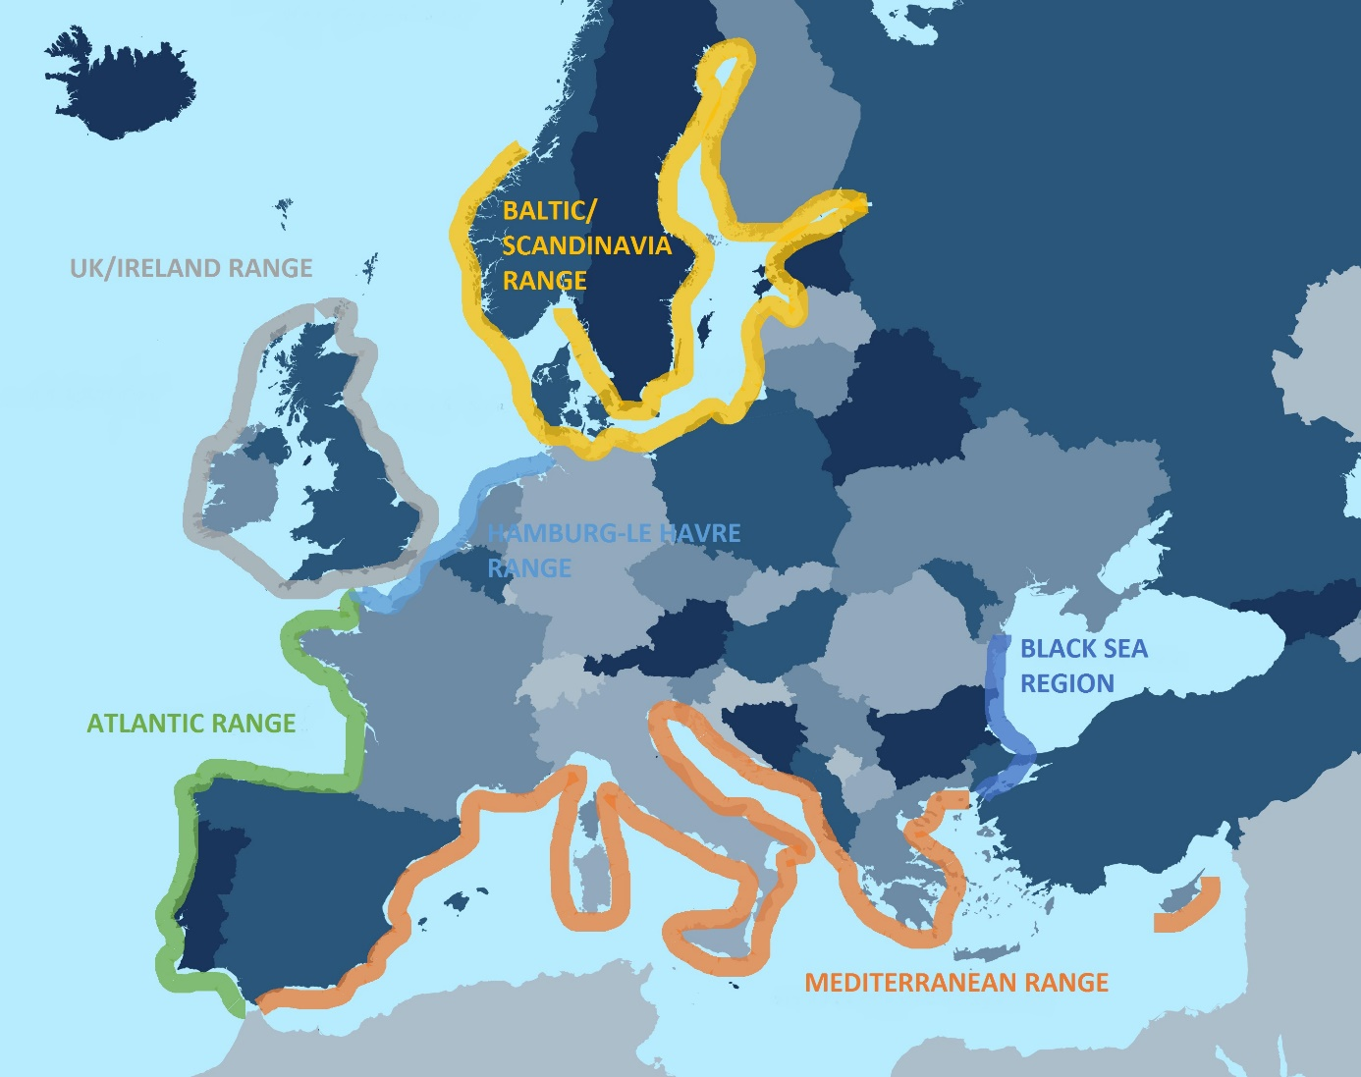
Figure 17. Map of European container port ranges
Source: Own elaboration

  - Results
In order to investigate the container throughputs the shift-share analysis was performed several times. First the analysis was ran to see the shifts of the container shares in the whole European industry among the different port ranges. The ranges were constructed based on the work of Theo Notteboom (1997, 2010) and the whole European container system was divided on six different ranges: the Black Sea range, the Mediterranean range, the Atlantic range, the Hamburg-Le Havre range, the UK/Ireland range and the Baltic/Scandinavia range. After running the analysis on a year-to-year basis, the analysis before and after 2008 was performed. The year 2008 was assumed as a breakthrough year in the container shipping industry, since it was the beginning of the global crisis, which entailed significant changes in the port systems. The same logic was applied to the shift-share analysis related to ranges within the Baltic/Scandinavia region. The whole area was divided on 10 ranges, which represented the ports of every single country in this region. Thus the Baltic/Scandinavia range was divided as following: Norwegian ports, Swedish ports, Finnish ports, Russian ports, Estonian ports, Latvian ports, Lithuanian ports, Polish ports and East German ports. This subchapter provides the description of the main results stemming from the performed analyses.

    - The European perspective
In the fourteen year long period the container throughputs of all the major ports in Europe were analyzed. The first impressive observation is that over the last 14 years the container flows within Europe have almost doubled. In 2001 the overall container throughput slightly leveled out 50 million TEUs, while in 2014 it almost reached 100 million TEUs.

Figure 18. Container throughputs by European port ranges (in 1000 TEUs)
Source: Own elaboration, based on the data from European Seaport Organization, Central Statistics Offices and Port Authorities’ websites

Despite this fact, the general patterns among the ranges remained rather the same. The Hamburg-Le Havre (HLH) range is still the leader outnumbering all the other ranges as nowadays it handles alone still more than 40% of all the containers arriving to Europe. Apparently the HLH range had the strongest position just before the crisis in 2008, since then its position is slightly weakening in favor to players. The Mediterranean range is losing consequently some ground to other ranges since 2001. At the beginning of a new millennium it handled approximately 35%, while in 2014 its share was at the level of 29% of all the European throughputs. The third position is held still by the UK/Ireland range, which together handle around 10% of all the containers in Europe, which can be translated to more than 10 million TEUs on yearly basis. The third position is almost ex-aequo shared with Baltic/Scandinavia port range, which also in 2014 passed the level of 10 million TEUs. The Baltic/Scandinavia has held the third position in the years 2012 and 2013, but in the last year of this analysis, the third position was regained by UK/Ireland range. The Black Sea region, which consists of ports of Romania, Bulgaria and Turkey, holds the fifth position. Over the period analyzed it strengthened its position by increasing the container throughput share from 1% to 5%. The last place belongs to the Atlantic range which at the beginning of the third millennium was losing its share, but starting from 2008 it strengthened its position and recently handles 4% (3.7 million TEUs) of the whole European container flow.

Figure 19. Container throughput share by European port ranges (in %)
Source: Own elaboration, based on the data from European Seaport Organization, Central Statistics Offices and Port Authorities’ websites

Although we cannot see a significant change in terms of container throughputs among the container ranges, the process of deconcentration is pending. The biggest ranges are slowly losing their shares in favor to other ones. The major winners in the European field is the Baltic/Scandinavia and the Black Sea range, which improved their container throughput shares by 3% and 4%, respectively.
The core of this thesis is the shift-share analysis, which provides more detailed information on port competition and dynamics. The annual shifts for the port ranges depicted on the graph below indicate the gain or loss with a reference to the expected potential change. In other words the following chart reflects the relation between the real and the expected change of particular port range under the condition of keeping the same share of growth/decline as the total European container system. The positive sign (on the right side of the chart) indicates that the particular port range outperformed the expected container throughput and grew faster than the total European container system. Analogically, the negative sign stands for the loss of the share in favor to other port ranges. The sum of the gains and losses in every single year equals zero.

Figure 20. Container net shifts between European port ranges, 2001-2014, year-to-year (in thousands TEUs)
Source: Own elaboration, based on the data from European Seaport Organization, Central Statistics Offices and Port Authorities’ websites

The results of the shift-share analysis are in line with the former share analysis. The chart above depicts the container flow changes among the European ports with a distinction on the port range. The most interesting thing stemming from the chart above is the year 2008-2009 when the port competition was the fiercer. The shift of shares between the port ranges was the biggest and the greatest winner of the crisis turned out to be Mediterranean range, which captured almost 2 million TEUs more than the expected change of shares. Noteworthy, the average dump of the container flows within Europe was around 14% and for the Mediterranean ports it was only 7%. Another interesting fact is that since 2003, with only exception to 2008 and 2014, the Baltic range was capturing more container flows than other port ranges. The steepest growth was recorded in 2009-2010 period, when the port of Gdansk opened its Deepwater Container Terminal. This huge increase in container throughputs in the Baltic range was compensated by an enormous drop in the container throughputs in the Mediterranean range in this period. The similar results to the Baltic range can be observed for the Black Sea range, which is the second major winner of the competition among the European port ranges. Before the crisis the Hamburg-Le Havre range was attracting more cargo than the overall European container system. This trend ceased at the turn of the years 2008-2009. Since that moment, the HLH range is performing below its potential, with a small increases in the performance in the period 2009-2011. The abovementioned Mediterranean ports took the advantage of the economic crisis in 2008-2009 and the Med ports were performing better than the other ranges. Yet, the crisis turned to be disastrous for this range in 2009-2010, where the Med ports performed below the rate of change of the European container system. The Med ports in the years during and after crisis were characterized by a big fluctuations in terms of attracting container cargos. Despite this fact the next years were characterized rather by a modest changes in share. The year 2014 resulted in a big loss in container throughputs, since this range attracted only 600k TEUs more than in the preceding year. The UK was consequently losing its share since the beginning of the analyzed period. The crisis even deepened In spite of the 1.5 million TEUs drop in container throughputs at the turn of 2008/2009 and the period 2009-2013 characterized by very modest growth, the UK range managed to attract 1.3 million more TEUs in 2014 than 2013. This was guaranteed mainly by the steep increases in container throughputs in the ports of Felixstowe (+637 TEU) and Southampton (+407k TEU). The least change in the shift of shares over the discussed period could be observed in the Atlantic range. The turn of the years 2008/2009 brought the smallest drop of containers share in Europe, as they shrank only by 7%. Since that time the throughputs in this range have been consequently growing with the steepest increase in 2012/2013 by 16% reaching the level 3.4 million of handled TEUs. Noteworthy, the shift of the container share within this region staid positive since 2008. One may conclude that the container throughputs of the Atlantic range are closely correlated with the throughputs of the whole European system.
Since the period 2008-2009 was a breakthrough in terms of shift of shares, it is wise to analyze all the port ranges in before and during and after the crisis. The chart below depicts the shifts of container flows shares in the cumulated periods before and after 2008. In the period preceding the global crisis we observe a fiercer competition than after. The cumulated shift of the shares of particular ranges are reaching almost 8 mln TEUs. The Hamburg-Le Havre range turned out to be the best performer during the years 2001-2008. As expected the Baltic and the Black Sea ranges were also among the outperformers. The UK/Ireland and the Mediterranean ranges have been significantly losing their shares, while the Atlantic range has been performing only slightly below the expected rate.

Figure 21. Container net shifts between European port ranges, before and after 2008 (in thousands TEUs)
Source: Own elaboration, based on the data from European Seaport Organization, Central Statistics Offices and Port Authorities’ websites

What is more interesting is the analysis of the period after 2008. The competition between the ranges was rather modest, while compering to the period 2001-2008. However this time the HLH range turned out to be the biggest loser. Still in 2013 the container throughput for this range was only slightly higher (by 14k TEUs) than in 2008. Finally the year 2014 brought a steeper growth of container flows, when they grew by more than 1.5 million TEUs. According to this analysis we might observe that the crisis was more hurtful to the Western economies which are deeply dependable on the global economy. The Mediterranean and the UK ranges were also performing below the expected rate. It took four years to recover from the crunch and recapture the same volume of container as in 2008 for the former and six years for the latter. Although during the both analyzed periods these two ranges were attracting less containers than the expected rate of change, the period during and after the crisis turned out to be less painful than the one before the crunch. This once again might be explained by a great performance of the ports of Felixstowe and Southampton in the UK range. In the Med range in turn a big fluctuation could be observed over the analyzed years, resulting in an overall performance below the rate of change of the European container system.
The period during and after the crisis turned out to be beneficial for the Atlantic, Black Sea and Baltic ranges in terms of shifting the container shares. Although the Atlantic range has increased its share of container throughputs from 3% to 4%, this level was mainly achieved by the port of Sines in Portugal, which over the last six years increased its container throughput by 427% and reach more than 1.2 million TEUs in 2014. The rest of the ports were characterized by a stagnation. Due to this phenomena the Atlantic ports captured 1.1 million TEUs more than the expected rate of change and the total throughputs reached the level of 3.7 million TEUs in 2014. The Black Sea range in turn hampered its substantial growth in container throughputs. Although the Turkish biggest container port of Ambarli did not suffer significantly during the crisis, the second port in the range – Constantza – lost more than 50% of its containerized cargo at the beginning of the crunch. Its container throughput decreased from almost 1.4 million TEUs to around 600 thousands TEUs. Since that time the port of Constantza couldn’t recapture the former performance and by the end of the analyzed period it attracted only 668 thousands of TEUs. The Bulgarian ports suffered also from the crisis but they managed to recover by the end of 2014. During the period 2008-2014 the Baltic range turned out to be the biggest winner. The range itself and the changes within it will be discussed more in-to-depth in the next subchapter.

    - The Baltic/Scandinavia range perspective
This subchapter provides detailed information regarding the Baltic/Scandinavian container ports range. The overall container throughputs and patterns are deeply discussed here. The throughputs, shares and shift of shares are discussed from both European and the range perspective. The figure below shows the different ranges analyzed in this subchapter.
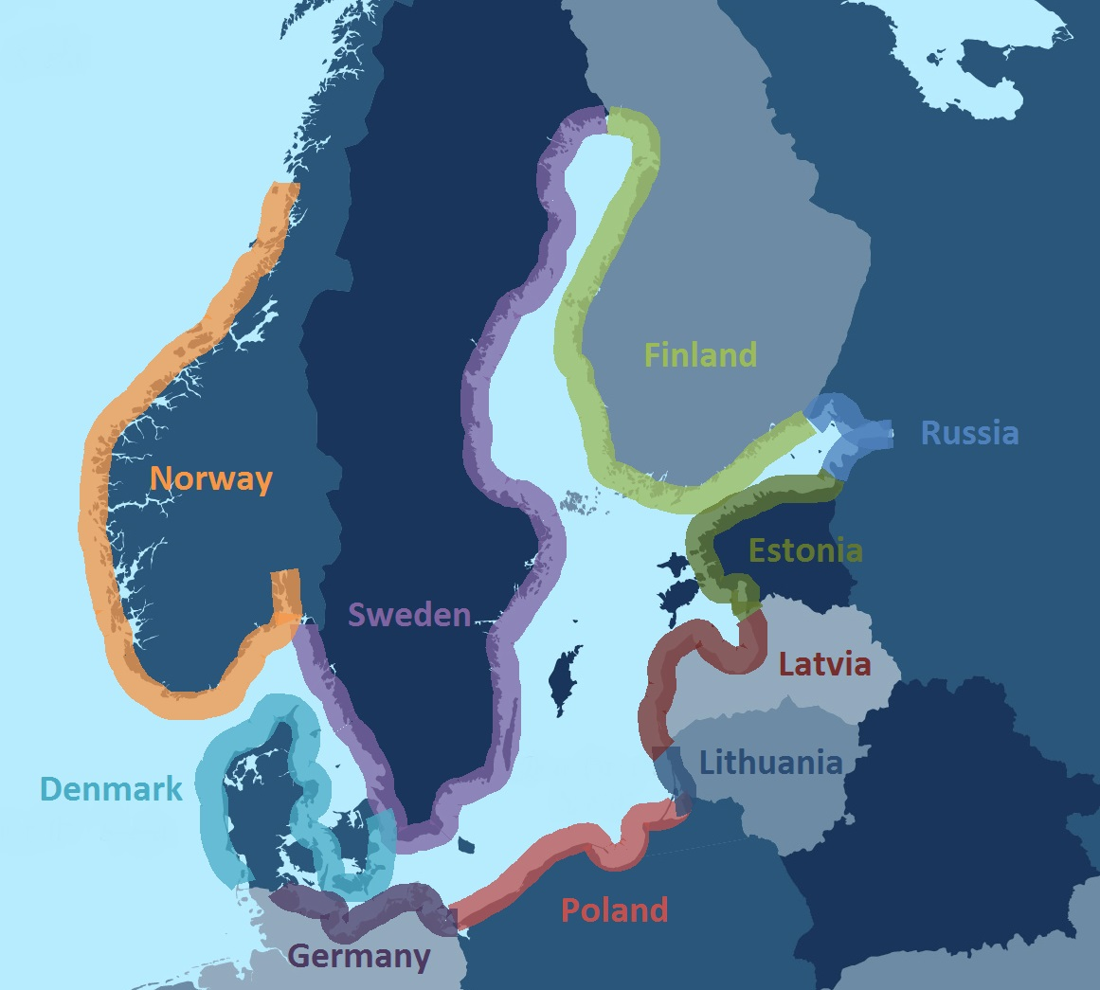
Figure 22. Map of Baltic/Scandinavia port ranges
Source: Own elaboration

Since 2001, the container throughputs within the Baltic range have been steadily growing with the only exception in 2009. At the beginning of the analyzed period the total container flows were reaching 3.6 million TEUs, while at the end they exceeded the threshold of 10 mln TEUs. This 179% growth is especially impressive when we take into account three aspects. First, the total container throughputs have dropped by 23.4% in 2008-2009 period. This was the second biggest fall in Europe, just after the Black Sea region which encountered a drop of almost 30%. In terms of the volume of handled TEUs the Baltic container range experienced the third biggest slope (ca. 1.8 million TEUs) among all the ranges. Only the biggest ones – Hamburg Le Havre and Mediterranean ports ranges – faced bigger losses of containerized cargo. Noteworthy the Baltic range recovered the quickest from all the ranges and captured already one million TEUs more in 2011 than in 2008. Second, the total European container system has been increasing on almost twice slower pace and grew by 94% over the period. The Baltic port range was the second region growing the fastest. Again in terms of percentage change the Black Sea region was developing the fastest. However in terms of volume handled the Baltic region attracted 6.4 million TEUs, while the Black Sea region 3.9 million TEUs. This steady growth helped to jump on the third position among all the European ranges and degrade the UK range to the fourth position in the period 2012-2013. And finally third, the overall container share of all the Baltic ports increased from 7% to 10% from the European perspective, which also stands as the second best result (after the Black Sea region). Worth to note, this increase was wrenched from the biggest European container ranges.
One of the main aims of this thesis is to look deeper into the Baltic ports and analyze the competition within this range. The Baltic (Scandinavia) range consists of ports of 10 countries: Russia, Poland, Finland, Sweden, Denmark, Norway, Estonia, Latvia, Lithuania and Germany. It is useful also to look at the container ports within the Baltic range. The chart below depicts the changes over the years of total container throughput of every single country within the Baltic range.

Figure 23. Container throughputs by Baltic/Scandinavia countries (in 1000 TEUs)
Source: Own elaboration, based on the data from European Seaport Organization, Central Statistics Offices and Port Authorities’ websites

The highest container volumes are still attracted by three container ports of Russia: Kaliningrad, Ust-Luga and Saint Petersburg. Together they handled approximately 2.8 million TEUs in 2014. The biggest Russian and simultaneously Baltic port, Saint Petersburg, handled alone above 2.3 million TEUs in the last year of analysis. In 2001 the Russian Baltic ports handled together slightly above 500k TEUs. In 2008 they crossed the border of 2.1 million TEUs. This was mainly due to a sharp increase in container throughputs in Saint Petersburg, which over this period enhanced by 313% and almost reached the level of 2 million TEUs. The year 2008 brought a big downturn and the Russian ports lost almost one third of their throughputs. Although, quickly recovered and even outperformed already the result from 2008 in 2011, since that time the Russian Baltic container ports are rather stable. Their share was captured by the other Baltic countries. In 2011 the Russian ports were responsible for 31% percent of the total Baltic, recently it is only 28%. This is a direct effect of the military invasion on Ukraine and economic sanctions imposed by the European Union.

Figure 24. Container throughput share by Baltic/Scandinavia countries (in %)
Source: Own elaboration, based on the data from European Seaport Organization, Central Statistics Offices and Port Authorities’ websites

The second position in terms of volume of handled container belongs to Poland. In 2014, the three (four) biggest Polish ports, Gdansk, Gdynia and Szczecin/Swinoujscie, attracted together almost 2.3 million TEUs. This result is striking due to the fact that at the beginning of the third millennium handled together 266k TEUs, which can be translated to 7% of the overall Baltic share. Until 2008 Poland has been steadily increasing its position among the other countries and have reached the level of 11% of total Baltic container throughputs. The crisis has brought a 23% downturn in handled containers, which is exactly the same as the total downturn of the entire Baltic port system. This explains why in 2009 the cumulated share of all the Polish ports remained the same as in the previous year. The next years has brought a steep increases in container volumes. For instance since in 2010 the Polish port noted a growth of 57% in comparison to the previous year. In general since 2009 the level of handled TEUs soared from 660k to almost 2.3 million. This phenomenon can be partially explained by both the opening of new container terminal in port of Gdansk and a great performance of its adjacent port of Gdynia. Since 2007, the year of the opening the Deepwater Container Terminal, the former has managed to accommodate an increase of handled container by 1.1 million TEUs, which stands for almost 1200% increase of its throughput. The latter in turn is approaching to the level of 1 million TEUs. In 2014 port of Gdynia knocked down the port of Goteborg from the third position in the Baltic region. The third Polish port – Szczecin/Swinoujscie – has managed to attract 87k TEUs in 2014 and entered to the top 20 biggest Baltic ports. Recently, the Polish ports handle 23% of the overall Baltic container share.
The two biggest ranges at the beginning of a third millennium – Sweden and Finland – handled together almost 50% of the all container throughputs in 2001. Since that moment their shares have been gradually dropping and reach the level of 13% each in 2014. Although their shares increase by approximately 400k TEUs each, they did not catch the pace of development of the whole range. The best examples illustrating this stagnation are the ports of Goteborg and Helsinki. Once the biggest ports in the Baltic range, they did not sustain the competition from the developing neighbors. Recently, their container volumes are approximately the same as in 2001. Over the analyzed period the container throughputs of the port of Goteborg increased by 139k TEUs to reach the level of 837k, while the port of Helsinki declined by 37k TEUs and handled 401k TEUs in 2014. The smaller ports of Sweden, like Helsingborg and Gavle, and Finnish ports, Hamina-Kotka (which is now bigger than Helsinki) and Rauma, were the true engines of growth in these countries. Yet combined with the moderately performing biggest ports couldn’t keep the pace of the overall growth of the Baltic region.
Similar to Swedish and Finnish, the Danish and Norwegian ports has been systematically losing their shares over the analyzed period. In 2001 the Dannish ports were the fourth Baltic power, which handled 13% of all the container within the region, which can be translated to almost 470k TEUs. Despite the favorable position at the entrance to the Baltic basin, the container throughputs of all together Danish ports increased only by 52%, which is way below the total Baltic dynamics. Recently, the Denmark is responsible for 7% of all the Baltic container throughputs container. The Norwegian ports in turn were handling 7% of all the container entering to the Baltic range in 2001. The container throughputs amounted from 258k TEUs to 451k TEUs over the analyzed period, but the share declined to 5% only.
Lithuania, Latvia and Estonia are represented in this analysis only by one biggest port of each of these countries. The smaller ports were excluded from the analysis due to the insignificant container flows. The Lithuanian port of Klaipeda has managed to improve its throughputs 782% over the analyzed period. Recently, it handled 450k TEUs, which is more than 4% of the overall Baltic range performance. Similar performance in terms of volumes handled can be observed by port of Riga. In 2014 it attracted almost 390k TEUs, which stands for almost 4% share. The port of Tallinn, the biggest Estonian container port has increased its container throughputs by 235% in the period 2001-2014. Nowadays it handles more than 260k TEUs, which can be translated to almost 3% of Baltic container throughputs. Together the three biggest ports of Baltic States are handling 11% of all the Baltic container flows. This is a 4% improve in share and 847k TEUs more in terms of volumes attracted by them.
Germany are also represented by only one port – Lubeck. Since 2001 its container throughputs were gradually growing to reach the record level of 234k TEUs in 2006. The crisis has significantly weakened the container flows attracted by port of Lubeck. Since 2011 the container volumes fluctuate around the level of 110k TEUs. Recently Germany are handling slightly more than 1% of the overall Baltic container volumes.
The chart below depicts the shift of the container shares among the Baltic countries. At beginning of the analyzed period the competition between ports was rather small and no significant shift could be observed. Since that moment the competition and the shift of shares were gradually growing bigger. We can withdraw three main conclusions stemming from this graph. First, the biggest winners in Baltic competition are Russia and Poland. Until the year 2010 the biggest beneficiary was the Russian region, which was mainly stimulated by the steep increases in container throughputs in the Port of Saint Petersburg. The Polish region began to grow significantly since the period 2009-2010 and during the last three analyzed periods they were capturing almost the whole positive shift in container shares. Second, the Swedish and Finnish ports turned out to be the biggest losers in this competition. With the only exception for the period 2008-2009 for the Swedish region, they were consequently losing their shares in favor to the neighboring countries. Finally third, unlike the European shift-share analysis discussed in the previous chapter, the biggest competition can be observed at the turn of the years 2009 and 2010 and almost 600k TEUs was redistributed among different Baltic regions. This can be explained by the fact that the Polish and Russian ports have sharply oared after the drop caused by the global crisis, while in the meantime Swedish ports, which were the least touched by the decrease of volumes did not keep the pace of development of its competitors.

Figure 25. Container net shifts between Baltic/Scandinavia countries, 2001-2014, year-to year (in thousands TEUs)
Source: Own elaboration, based on the data from European Seaport Organization, Central Statistics Offices and Port Authorities’ websites

Analyzing more detailed, in 2001-2002 the biggest beneficiary was Russia which captured which improved it shares by 59k TUEs than the expected rate of change. The periods 2002-2003 and 2003-2004 were characterized by the big drop in shares in container volumes handled by Swedish and Danish ports. This loss was mainly spread among Russian, Polish and Lithuanian ports. The next two periods brought the significant positive shift of shares for Russian and Lithuanian ports. The lion’s share was captured by Russian ports, which outperformed the whole range and attracted 440k TEUs in 2004-2006 period. All the other countries during these period were losing their share, with Finnish ports as pioneers. The change in the years 2006-2007 was the most beneficial for Polish ports. The newly opened Deepwater Container Terminal in Gdansk turned out to be a very successful investment and the containerized cargo started to grow exponentially. Since that moment, with the only exception for the years 2008-2009, the Polish ports were attracting a lot more containers that the expected rate of the growth of the whole Baltic system. This effect was even enhanced in the last three periods when Poland was attracting almost the whole shift of shares. The years 2007-2008 were characterized by the same pattern as the previous period. The Port of Lubeck has faced a big loss in terms of share of containers, since it lost almost 70k TEUs referring to the expected growth rate. The biggest winners remained the same – Russia, Poland and Lithuania. Finally the first period of the global crisis brought more significant changes in the structure of shifting the container shares. The container volumes in Russia drastically dropped by over 200k TEUs more than the overall Baltic range. The Finnish and Lithuania ports were also affected by the effects of the crunch. Although the container throughputs shrank for all the Baltic countries, the Swedish, Norwegian and Danish ports turned out to be the biggest winners. The Swedish ports have faced the downturn of only 7%, which was way over the Baltic average. This effected in the increase from 15% to 19% of the total Baltic share. Yet, the Scandinavian ports did not exploit the full opportunity of this sudden switch of the structure, since the next period has brought the restoration of the old patterns. Since that moment till 2014 the structure of this analysis was rather the same. The biggest winners were Russian, Polish and Baltic States’ ports. The Finnish, Scandinavian and Germany turned out to be the beaten ones in the container attraction competition. What is interesting the last two periods of this analysis brought the evidence that Russian ports are performing below the expected rate of change.
Following the structure of the previous subchapter it is useful to analyze the Baltic region with a distinction on the periods before and during and after the crisis. This analysis can give a broader perception about the competition within the discussed range. The chart below provides the information about the shifts of container shares in the Baltic basin before and after 2008.

Figure 26. Container net shifts between Baltic/Scandinavia countries, before and after 2008 (in thousands TEUs)
Source: Own elaboration, based on the data from European Seaport Organization, Central Statistics Offices and Port Authorities’ websites

The results are going in line with the results stemming from the year-to-year analysis. The down right side of the chart indicates that in the period before the crisis Russian, Polish and Lithuanian ports were the winners in the competition. All these countries attracted more containers than the expected rate of change. Russia itself attracted 1 million TEUs more, than it was expected based on the share from 2001. The three Polish ports and the port of Klaipeda have attracted almost the same amount of shifted cargo. This result is striking especially for the port of Klaipeda, which is the only Lithuanian container port and a stand-alone gateway. What is also interesting and visible from this analysis, the German port of Lubeck and the Estonian port of Tallinn among these ports, which had a slightly bigger share of handled containers than in 2001. On the other side of the chart we observe the countries which underperformed in the period before the crisis. The biggest loss in container share was noted by the Swedish ports. If they would resist the competition and maintain the same share as in 2001, they would handle almost 740k TEU more in 2008. The results for the other countries losing their shares – Finland, Denmark and Norway – were less striking, yet significant. Although, the Latvian port of Riga turned out to be underperforming and lost in the competition with its neighbors, its loss was the smallest.
In the second analyzed period, the massive advantage of Polish ports can be observed. Altogether, the ports of Gdansk, Gdynia and Szczecin/Swinoujscie attracted more cargo than as if it would stem from the expected rate of change. The Polish ports accommodated more than 1.1 million TEUs, which is a better results than Russia in the previous period. The Latvian and Estonian ports also repaired their statistics and improved their shares, by respectively 120k TEUs and 26. On the right side of the chart we can also see a very slight positive change in share for Russia. This means that the Russian ports hold the same share as they had in 2008. On the other side of the chart we find all the Scandinavian, Finnish, German and Lithuanian ports. In the period after 2008 the biggest loss of share was noted by Finland, which lost the potential growth of 600k TEUs. Also the Swedish, Danish and German ports have lost quite significant shares. Respectively they lost 275k, 216k and 160k TEUs. The losses of the ports of Lithuania and Norway were the smallest.
According to the shift-share analysis in the Baltic region, it is clear the biggest beneficiaries are the Polish and Russian ports. The Polish share increased by 16% and is the second biggest container power in this area. This tendency is still positive and it will be interesting to observe the development of these ports, especially taking into account that the Russian’s share is shrinking recently due to economic sanctions imposed by the European Union. The port of Saint Petersburg, which remains the biggest in the Baltic area, is facing a recession in containers volumes recently. Besides, the Baltic States also improved their shares over the discussed period. The combined share of their throughputs amounts to 10% of all the container volumes, which is more than the share of Denmark. It appears that the Finnish and the Scandinavian ports are the biggest losers of the competition in the Baltic Sea region. They lost significant shares in handled container volumes and did not sustain the increased competition from the neighboring countries. The latter was a direct effect of the accession to the EU by Eastern economies. The German port of Lubeck, which had had a promising beginning of the third millennium, neither exploited its opportunities and every lost its share in this competition.
CHAPTER V. CONCLUSIONS
Recently, the dynamics of the economic growth of the Central and Eastern European countries are much higher than of the Western ones. As the trade is one of the biggest engines of the economic growth, it is a natural step that the CEE countries face a steep increase in transport services. The container throughputs in the Baltic region tripled since the beginning of the third millennium. This paper has shown to what extent this increase was attracted by the Baltic/Scandinavia countries and eventually by Poland and what were the underlying macroeconomic factors stimulating this increase.
This Master’s thesis provided a precedential insight on the Baltic/Scandinavia area in terms of analyzing the shift of the container shares. The results are striking and it seems that the volumes attracted by the Polish ports are one of the most outstanding in the whole Europe. Since opening the Deepwater Container Terminal in Gdansk the Polish container throughputs faced a steep increase in container volumes. After 2008 they were the biggest beneficiaries and attracted the lion’s share of the shifts among the Baltic ports. Since 2001 the share of Polish ports in container volumes increased from the level of 7% to 23%, which can be translated to the growth by almost 2 million TEUs. The port of Gdansk, the second biggest port in the Baltic/Scandinavia range, is recently handling more than 1.2 million TEUs. Since 2004 it generated an increase of more than 1700% in terms of handled containers. The port of Gdynia overtook the third position in the Baltic basin in 2014, as it attracted 937k TEUs. The port of Szczecin/Swinoujscie, which is of a minor importance in this Master’s thesis, also generated in 2014 a growth of 25% when comparing to the year before. The series of huge investments carried out in the Polish ports are aiming in improving further these numbers.
According to the most recent and acknowledged literature this phenomenal performance by Polish ports can be explained by several macroeconomic factors. First, the Polish economy is one of the fastest growing in the whole Europe. Since the accession to the European Union in 2004 the Polish GDP grew by 49%, which is the best (along with Slovakia) result in Europe. Also, over the same period the foreign direct investments reached the level of EUR 178 billion, an almost 300% growth in comparison to the year 2003. These two factors resulted in the improved the participation of Poland in the foreign trade. In 2013 the total exports attained the level EUR 155 billion, increasing 2.6 times in comparison to 2004. In the same period the value of imports has increased 2.2 times, reaching EUR 157 billion. It is expected that for the first time in the modern history Poland will have a positive trade balance in 2015. Also what is important the business environment highly improved in Poland. The position of Polish business environment in the most acknowledged rankings such as Doing Business is increasing. In 2015 Poland was acknowledged as the 25th best place in the world for setting up a company. Among the factors influencing the overall position the highest possible score was obtained for the procedures and costs of trading across the borders. This results in the fact that more and more domestic companies are being opened while the foreign entities are more willing to set up their subsidiaries in Poland, which is perceived as the key economy in the CEE region. Last, but not least, the transit location of Poland and still being improved transport infrastructure have also contributed to the increasing container throughputs in Poland. Poland is acknowledged to be the logistics center in the CEE region. Besides huge infrastructure investments are being carried out in order to improve the connectivity between Poland and neighboring countries.
It is extremely interesting to see what the next years will bring. Some scholars claim that the Baltic region reached the peak and no further steep growths are expected (Blus, 2015). This is somehow contradictory with the plans of port of Gdansk about the opening the new Deepwater Container Terminal 2 (DCT2) in 2016. The development of the first DCT resulted in steep increases in container volumes in the Bay of Gdansk. On the other hand, the container traffic through Russia’s Baltic seaports plummeted 32% in the first half, showing that even Russian ports that serve as gateways to the country’s most important cities, like Moscow and St. Petersburg, will not be able to escape the wrath of the Russian recession (Gerden, 2015). The container volume through port of Gdansk plunged 16.7% year-over-year in the first half, highlighting the broader decline in trade between Poland and Russia as the latter’s economy struggles (Gerden, 2015). Poland, the 12th largest exporter to Russia, experienced a fall in value of exported goods to Russia by 45% ($3.5 billion to $2 billion) in the first half of 2015. Russian exports to Poland, the 10th largest importer of its goods and materials, fell by 43% (to $9 billion) in the same period (Gerden, 2015). No matter what the reality will be, all the eyes of the European container industry will be looking with a big dose of curiosity at the Polish ports in the incoming years.

APPENDIX
The total container throughputs by individual, 2001-2014 (in thousand TEUs)
Port | Country code | Range | 2001 | 2002 | 2003 | 2004 | 2005 | 2006 | 2007 | 2008 | 2009 | 2010 | 2011 | 2012 | 2013 | 2014
Aalborg | DK | Baltic/Scandinavia | 45 | 50 | 52 | 52 | 61 | 63 | 64 | 65 | 58 | 64 | 109 | 110 | 101 | 62
Aarhus | DK | Baltic/Scandinavia | 307 | 308 | 330 | 341 | 397 | 427 | 502 | 458 | 385 | 446 | 431 | 404 | 406 | 424
Alesund | NO | Baltic/Scandinavia | 33 | 34 | 35 | 35 | 34 | 35 | 42 | 42 | 49 | 60 | 61 | 58 | 58 | 62
Alicante | ES | Mediterrinean | 134 | 137 | 146 | 154 | 159 | 173 | 179 | 151 | 132 | 147 | 154 | 158 | 148 | 139
Algeciras | ES | Mediterrinean | 2152 | 2229 | 2517 | 1934 | 3179 | 3255 | 3414 | 3324 | 3043 | 2810 | 3601 | 4113 | 4350 | 4555
Ambarli | TR | Black Sea | 358 | 564 | 775 | 1078 | 1186 | 1446 | 1940 | 2068 | 1836 | 2540 | 2625 | 3024 | 3378 | 3600
Amsterdam | NL | Hamburg-Le Havre | 48 | 45 | 45 | 52 | 66 | 306 | 386 | 436 | 203 | 60 | 49 | 69 | 65 | 57
Ancona | IT | Mediterrinean | 90 | 94 | 85 | 86 | 85 | 97 | 106 | 119 | 106 | 110 | 121 | 142 | 152 | 165
Antwerp | BE | Hamburg-Le Havre | 4218 | 4777 | 5445 | 6064 | 6488 | 7019 | 8176 | 8663 | 7310 | 8468 | 8664 | 8635 | 8578 | 8978
Barcelona | ES | Mediterrinean | 1411 | 1461 | 1652 | 1916 | 2071 | 2318 | 2590 | 2569 | 1797 | 1948 | 2035 | 1759 | 1722 | 1893
Baleares | ES | Mediterrinean | 265 | 481 | 252 | 220 | 197 | 201 | 194 | 176 | 128 | 78 | 68 | 58 | 62 | 70
Belfast | UK | UK/Ireland | 176 | 187 | 210 | 228 | 217 | 236 | 264 | 255 | 213 | 214 | 219 | 211 | 205 | 211
Bilbao | ES | Atlantic | 454 | 455 | 449 | 469 | 504 | 523 | 555 | 557 | 443 | 531 | 573 | 610 | 607 | 631
Bordeaux | FR | Atlantic | 52 | 48 | 46 | 51 | 50 | 55 | 65 | 55 | 80 | 55 | 61 | 63 | 56 | 56
Borg | NO | Baltic/Scandinavia | 36 | 38 | 41 | 41 | 42 | 43 | 34 | 39 | 39 | 36 | 38 | 41 | 45 | 51
Bremen/Bremenhaven | DE | Hamburg-Le Havre | 2915 | 2999 | 3191 | 3469 | 3736 | 4450 | 4912 | 5529 | 4565 | 4889 | 5915 | 6115 | 5831 | 5796
Brest | FR | Atlantic | 14 | 13 | 20 | 29 | 29 | 25 | 29 | 34 | 33 | 43 | 54 | 48 | 59 | 52
Bristol | UK | UK/Ireland | 84 | 95 | 100 | 111 | 115 | 96 | 85 | 68 | 72 | 69 | 63 | 76 | 94 | 106
Burgas | BG | Black Sea | 11 | 13 | 19 | 27 | 25 | 26 | 31 | 47 | 24 | 24 | 29 | 46 | 49 | 63
Cagliari-Sarroch | IT | Mediterrinean | 26 | 74 | 314 | 501 | 639 | 688 | 547 | 308 | 737 | 629 | 603 | 628 | 702 | 717
Cadiz | ES | Mediterrinean | 99 | 104 | 151 | 114 | 138 | 155 | 144 | 126 | 106 | 109 | 92 | 96 | 92 | 85
Cardif | UK | UK/Ireland | 46 | 39 | 45 | 53 | 56 | 67 | 48 | 34 | 15 | 20 | 20 | 18 | 18 | 19
Cartagena | ES | Mediterrinean | 35 | 45 | 37 | 28 | 38 | 40 | 47 | 47 | 59 | 64 | 72 | 67 | 81 | 89
Castellon | ES | Mediterrinean | 25 | 29 | 33 | 35 | 44 | 72 | 102 | 88 | 67 | 104 | 131 | 161 | 194 | 207
Civitavecchia-Fiumicino-Gaeta | IT | Mediterrinean | 16 | 21 | 25 | 36 | 35 | 34 | 31 | 25 | 28 | 42 | 38 | 51 | 54 | 64
Clyde | UK | UK/Ireland | 55 | 59 | 79 | 63 | 64 | 65 | 76 | 60 | 72 | 82 | 95 | 91 | 76 | 86
Cork | IE | UK/Ireland | 118 | 121 | 137 | 155 | 164 | 182 | 197 | 187 | 148 | 147 | 157 | 166 | 170 | 191
Constantza | RO | Black Sea | 119 | 136 | 206 | 386 | 768 | 1037 | 1411 | 1381 | 594 | 557 | 663 | 684 | 661 | 668
Drogheda | IE | UK/Ireland | 45 | 63 | 61 | 48 | 48 | 35 | 30 | 7 | 7 | 0 | 0 | 0 | 0 | 0
Dublin | IE | UK/Ireland | 435 | 456 | 496 | 541 | 590 | 681 | 744 | 677 | 548 | 554 | 524 | 528 | 516 | 569
Dunkerque | FR | Hamburg-Le Havre | 150 | 161 | 162 | 200 | 205 | 205 | 198 | 214 | 212 | 201 | 273 | 260 | 290 | 312
Durres | AL | Mediterrinean | 2 | 2 | 5 | 8 | 15 | 22 | 33 | 47 | 69 | 72 | 72 | 81 | 109 | 100
Felixstowe | UK | UK/Ireland | 2 839 | 2 684 | 2 482 | 2 717 | 2 760 | 3 030 | 3 343 | 3 132 | 3 021 | 3 415 | 3 249 | 3 367 | 3 434 | 4 072
Forth | UK | UK/Ireland | 154 | 176 | 187 | 215 | 230 | 245 | 256 | 275 | 231 | 217 | 245 | 264 | 261 | 259
Fredericia(OgShell-Havnen) | DK | Baltic/Scandinavia | 9 | 10 | 12 | 18 | 12 | 20 | 25 | 33 | 37 | 56 | 63 | 71 | 68 | 85
Gavle | SE | Baltic/Scandinavia | 49 | 52 | 55 | 55 | 56 | 75 | 76 | 109 | 118 | 108 | 129 | 125 | 127 | 150
Gdansk | PL | Baltic/Scandinavia | 18 | 20 | 23 | 44 | 70 | 76 | 95 | 183 | 233 | 510 | 685 | 933 | 1189 | 1232
Gdynia | PL | Baltic/Scandinavia | 230 | 252 | 309 | 377 | 400 | 459 | 612 | 611 | 376 | 477 | 591 | 659 | 728 | 937
Genova | IT | Mediterrinean | 1527 | 1531 | 1606 | 1629 | 1625 | 1657 | 1855 | 1767 | 1534 | 1739 | 1847 | 2065 | 1988 | 2173
Ghent | BE | Hamburg-Le Havre | 16 | 21 | 29 | 32 | 31 | 36 | 61 | 63 | 64 | 83 | 80 | 88 | 70 | 37
Gijon | ES | Atlantic | 18 | 10 | 10 | 4 | 5 | 8 | 14 | 26 | 27 | 42 | 36 | 49 | 63 | 54
Gioia Tauro | IT | Mediterrinean | 2488 | 3009 | 3149 | 3261 | 3209 | 2938 | 3445 | 3468 | 2857 | 2852 | 2305 | 2721 | 3094 | 2970
Goole | UK | UK/Ireland | 128 | 92 | 28 | 45 | 119 | 82 | 63 | 69 | 56 | 70 | 60 | 1 | 0 | 0
Göteborg | SE | Baltic/Scandinavia | 698 | 756 | 666 | 736 | 788 | 820 | 841 | 863 | 818 | 880 | 887 | 900 | 858 | 837
Grimsby & Immingham | UK | UK/Ireland | 69 | 180 | 125 | 137 | 151 | 137 | 144 | 160 | 133 | 110 | 125 | 174 | 152 | 229
Hamburg | DE | Hamburg-Le Havre | 4689 | 5374 | 6138 | 7003 | 8088 | 8862 | 9890 | 9737 | 7008 | 7896 | 9014 | 8864 | 9257 | 9729
Hamina/Kotka | FI | Baltic/Scandinavia | 295 | 334 | 376 | 470 | 526 | 629 | 766 | 807 | 454 | 513 | 613 | 631 | 627 | 575
Hanko | FI | Baltic/Scandinavia | 26 | 28 | 35 | 38 | 52 | 48 | 48 | 60 | 38 | 50 | 56 | 46 | 44 | 54
Helsingborg | SE | Baltic/Scandinavia | 108 | 113 | 112 | 74 | 142 | 175 | 231 | 177 | 142 | 177 | 205 | 208 | 208 | 219
Helsinki | FI | Baltic/Scandinavia | 438 | 457 | 472 | 500 | 460 | 417 | 431 | 420 | 357 | 400 | 392 | 405 | 406 | 401
Hull | UK | UK/Ireland | 204 | 157 | 267 | 310 | 252 | 268 | 304 | 262 | 182 | 203 | 220 | 244 | 255 | 227
Ipswich | UK | UK/Ireland | 43 | 66 | 75 | 84 | 15 | 10 | 4 | 17 | 0 | 1 | 0 | 0 | 0 | 0
Kaliningrad | RU | Baltic/Scandinavia | 21 | 28 | 45 | 72 | 113 | 151 | 252 | 157 | 95 | 231 | 318 | 360 | 322 | 325
Klaipeda | LT | Baltic/Scandinavia | 51 | 72 | 118 | 174 | 214 | 232 | 321 | 373 | 248 | 295 | 382 | 381 | 403 | 450
Kopenhagen/Malmo | DK | Baltic/Scandinavia | 108 | 114 | 116 | 121 | 132 | 150 | 165 | 165 | 126 | 132 | 141 | 143 | 139 | 144
Koper | SI | Mediterrinean | 93 | 115 | 126 | 153 | 180 | 219 | 306 | 354 | 343 | 477 | 587 | 566 | 596 | 676
LA SPÉZIA | IT | Mediterrinean | 975 | 975 | 1007 | 1040 | 1024 | 1137 | 1187 | 1246 | 1046 | 1285 | 1307 | 1247 | 1300 | 1303
Larvik | NO | Baltic/Scandinavia | 22 | 29 | 36 | 43 | 44 | 40 | 51 | 56 | 55 | 58 | 69 | 62 | 64 | 65
Le Havre | FR | Hamburg-Le Havre | 1523 | 1720 | 1985 | 2132 | 2119 | 2138 | 2656 | 2489 | 2241 | 2358 | 2215 | 2304 | 2486 | 2554
Leixoes | PT | Atlantic | 297 | 304 | 320 | 349 | 352 | 378 | 433 | 450 | 453 | 483 | 514 | 633 | 626 | 667
Limassol | CY | Mediterrinean | 259 | 243 | 234 | 298 | 320 | 361 | 377 | 414 | 357 | 349 | 345 | 308 | 277 | 308
Lisboa | PT | Atlantic | 438 | 488 | 554 | 515 | 513 | 513 | 555 | 556 | 501 | 513 | 542 | 486 | 549 | 502
Liverpool | UK | UK/Ireland | 512 | 487 | 566 | 603 | 612 | 613 | 675 | 672 | 588 | 662 | 664 | 635 | 623 | 666
Livorno | IT | Mediterrinean | 502 | 520 | 541 | 579 | 601 | 622 | 656 | 696 | 536 | 628 | 638 | 523 | 527 | 577
London | UK | UK/Ireland | 752 | 873 | 911 | 979 | 735 | 743 | 844 | 962 | 647 | 733 | 736 | 687 | 945 | 1 065
Lubeck | DE | Baltic/Scandinavia | 81 | 81 | 108 | 132 | 170 | 234 | 205 | 214 | 185 | 153 | 117 | 116 | 102 | 116
Malaga | ES | Mediterrinean | 3 | 2 | 2 | 63 | 203 | 442 | 532 | 429 | 290 | 298 | 477 | 336 | 296 | 88
Marsaxlokk | MT | Mediterrinean | 1165 | 1244 | 1300 | 1461 | 1 321 | 1 485 | 1 901 | 2 334 | 2 261 | 2 371 | 2 360 | 2 538 | 2 745 | 2 869
Marseille | FR | Mediterrinean | 742 | 809 | 833 | 913 | 906 | 946 | 1003 | 851 | 877 | 953 | 944 | 1061 | 1099 | 1180
Medway | UK | UK/Ireland | 493 | 530 | 518 | 632 | 707 | 605 | 519 | 773 | 423 | 440 | 402 | 293 | 243 | 179
Moss | NO | Baltic/Scandinavia | 25 | 26 | 30 | 32 | 36 | 47 | 57 | 55 | 44 | 52 | 62 | 61 | 61 | 60
NANTES-ST-NAZAIRE | FR | Atlantic | 111 | 110 | 119 | 124 | 132 | 133 | 147 | 149 | 146 | 166 | 178 | 185 | 183 | 161
Napoli | IT | Mediterrinean | 430 | 446 | 433 | 348 | 374 | 444 | 460 | 482 | 502 | 532 | 527 | 547 | 477 | 432
Oslo | NO | Baltic/Scandinavia | 142 | 150 | 165 | 179 | 172 | 173 | 197 | 190 | 179 | 202 | 209 | 203 | 202 | 213
Piraeus | GR | Mediterrinean | 1166 | 1405 | 1605 | 1542 | 1395 | 1403 | 1373 | 434 | 665 | 513 | 491 | 626 | 675 | 598
Portsmouth | UK | UK/Ireland | 41 | 44 | 54 | 50 | 54 | 57 | 77 | 58 | 57 | 52 | 57 | 52 | 57 | 54
Rauma | FI | Baltic/Scandinavia | 84 | 97 | 110 | 116 | 120 | 169 | 175 | 172 | 143 | 165 | 223 | 239 | 259 | 276
Ravenna | IT | Mediterrinean | 158 | 161 | 160 | 169 | 169 | 162 | 207 | 214 | 185 | 183 | 215 | 208 | 227 | 223
Riga | LV | Baltic/Scandinavia | 123 | 127 | 132 | 148 | 158 | 168 | 212 | 207 | 183 | 254 | 303 | 362 | 381 | 388
Rijeka | HR | Mediterrinean | 13 | 17 | 28 | 61 | 76 | 94 | 145 | 169 | 131 | 137 | 151 | 152 | 170 | 192
Rotterdam | NL | Hamburg-Le Havre | 6096 | 6506 | 7144 | 8292 | 9287 | 9653 | 10791 | 10785 | 9743 | 11148 | 11877 | 11866 | 11621 | 12298
Rouen | FR | Hamburg-Le Havre | 148 | 144 | 126 | 139 | 161 | 165 | 159 | 142 | 122 | 130 | 131 | 128 | 102 | 97
Salerno | IT | Mediterrinean | 321 | 374 | 417 | 412 | 418 | 360 | 385 | 330 | 269 | 234 | 235 | 209 | 263 | 320
Sankt Petersburg | RU | Baltic/Scandinavia | 481 | 581 | 656 | 777 | 1121 | 1450 | 1698 | 1987 | 1344 | 1931 | 2365 | 2525 | 2514 | 2375
Savona-Vado | IT | Mediterrinean | 50 | 55 | 54 | 84 | 220 | 231 | 243 | 253 | 196 | 196 | 170 | 75 | 78 | 82
Setúbal | PT | Atlantic | 6 | 9 | 12 | 20 | 13 | 16 | 12 | 20 | 26 | 51 | 77 | 49 | 71 | 104
Sines | PT | Atlantic | 0 | 0 | 0 | 19 | 50 | 122 | 150 | 233 | 253 | 382 | 447 | 553 | 931 | 1228
Southampton | UK | UK/Ireland | 1 170 | 1 275 | 1 374 | 1 446 | 1 382 | 1 500 | 1 869 | 1 617 | 1 381 | 1 564 | 1 590 | 1 473 | 1 488 | 1 895
Stockholm | SE | Baltic/Scandinavia | 35 | 36 | 34 | 32 | 38 | 37 | 43 | 37 | 27 | 26 | 29 | 36 | 50 | 51
Szczecin/Swinoujscie | PL | Baltic/Scandinavia | 18 | 20 | 22 | 29 | 37 | 41 | 56 | 65 | 52 | 55 | 55 | 57 | 61 | 87
Tallinn | EE | Baltic/Scandinavia | 78 | 89 | 101 | 141 | 129 | 153 | 182 | 182 | 131 | 152 | 198 | 228 | 254 | 261
Taranto | IT | Mediterrinean | 198 | 472 | 658 | 763 | 717 | 892 | 756 | 787 | 741 | 582 | 604 | 263 | 197 | 149
Tarragona | ES | Mediterrinean | 39 | 53 | 57 | 17 | 9 | 12 | 47 | 47 | 221 | 255 | 226 | 189 | 147 | 37
Tees & Hartlepool | UK | UK/Ireland | 79 | 125 | 133 | 133 | 138 | 133 | 154 | 155 | 178 | 252 | 263 | 252 | 248 | 304
Thessaloniki | GR | Mediterrinean | 234 | 240 | 270 | 336 | 366 | 338 | 443 | 239 | 270 | 273 | 296 | 318 | 322 | 350
Trieste | IT | Mediterrinean | 201 | 185 | 120 | 175 | 198 | 220 | 266 | 336 | 277 | 281 | 393 | 408 | 459 | 511
Turku | FI | Baltic/Scandinavia | 22 | 25 | 30 | 21 | 17 | 20 | 22 | 23 | 17 | 14 | 12 | 10 | 3 | 2
Tyne | UK | UK/Ireland | 46 | 56 | 43 | 42 | 34 | 37 | 53 | 60 | 37 | 57 | 72 | 65 | 59 | 48
Ust-Luga | RU | Baltic/Scandinavia | 0 | 0 | 0 | 0 | 0 | 0 | 0 | 0 | 0 | 0 | 0 | 11 | 64 | 107
Valencia | ES | Mediterrinean | 1507 | 1821 | 1993 | 2145 | 2410 | 2612 | 3043 | 3602 | 3654 | 4207 | 4327 | 4470 | 4328 | 4442
Valetta | MT | Mediterrinean | 27 | 26 | 28 | 31 | 34 | 34 | 42 | 57 | 55 | 66 | 67 | 77 | 70 | 76
Varna | BG | Black Sea | 45 | 59 | 65 | 79 | 84 | 94 | 100 | 155 | 113 | 119 | 123 | 128 | 131 | 133
Venezia | IT | Mediterrinean | 246 | 262 | 284 | 291 | 290 | 317 | 330 | 379 | 369 | 394 | 458 | 430 | 447 | 456
Vigo | ES | Atlantic | 138 | 155 | 161 | 190 | 205 | 227 | 244 | 248 | 194 | 213 | 212 | 199 | 209 | 204
Waterford | IE | UK/Ireland | 141 | 147 | 175 | 180 | 181 | 185 | 186 | 173 | 119 | 71 | 64 | 39 | 40 | 36
Wilhelmshaven | DE | Hamburg-Le Havre | 0 | 0 | 0 | 0 | 0 | 0 | 0 | 0 | 0 | 0 | 0 | 0 | 76 | 67
Zeebrugge | BE | Hamburg-Le Havre | 911 | 1000 | 1052 | 1240 | 1411 | 1653 | 2021 | 2210 | 2328 | 2500 | 2207 | 1953 | 2026 | 2047
TOTAL | - | - | 50587 | 55592 | 60482 | 66336 | 72338 | 78430 | 88663 | 89538 | 76488 | 84800 | 90084 | 91711 | 94051 | 98416

REFERENCES

Alphaliner. (2013, April 14). Weekly Newsletter Issue 17.
Anderson, J. E., & Marcouiller, D. (2002). Insecurity and the pattern of trade: an empirical investigation. The Review of Economics and Statistics.
Behar, A., & Venables, A. (2010). Transport costs and International Trade. Handbook of Transport Economics.
Beyzatlar, M. A., Karacal, M., & Yetkiner, H. (2014). Granger-causality between transportation and GDP: A panel data approach. Transportation Research.
Blus, M. (2015). Over the peak? Baltic Transport Journal.
Bogdan, W., Boniecki, D., Marciniak, T., Nowacki, M., & Labaye, E. (2015). Poland 2025: Europe's new growth engine. 2015: McKinsey.
Boopen, S. (2006). Transport Infrastructure and Economic Growth: Evidence from Africa Using Dynamic Panel Estimates. The Empirical Economics Letters.
Bougheas, S., Demetriades, P. O., & Morgenroth, E. L. (1999). Infrastructure, transport costs and trade. Journal of International Economics.
Business, D. (2010). CESifo DICE Report 1/2010. Doing Business.
Central Statistics Office. (2014). Transport. Activity Results in 2013. Warsaw: Central Statistic Office.
Cho, H., & Yang, K. (2011). Identifying Country Environments to Increase Container Volumes. The Asia Journal of Shipping and Logistics.
Clark, X., Dollar, D., & Micco, A. (2002). Maritime Transport Costs and Port Efficiency. World Bank Report, Washington, DC.
Clark, X., Dollar, D., & Micco, A. (2004). Port efficiency, maritime transport costs, and bilateral trade. Journal of Development Economics.
Commission, E. (2015). Country Report Poland 2015. Brussels: European Commission.
de Langen, P., van der Lugt, L., & Eenhuizen, J. (2002). A stylised container port hierarchy: a theoretical and empirical exploration. IAME Panama 2002 International Steering Committee.
Doing Business. (2015). Doing Business 2016. Washington: International Bank for Reconstruction and Development / The World Bank.
Ducruet, C., & Notteboom, T. (2012). The worldwide maritime network of container shipping: spatial structure and regional dynamics. Global Networks Volume 12, 395-423.
Esfahani, H. S., & Ramirez, M. T. (2003). Institutions, infrastructure, and economic growth. Journal of Development Economics.
Farhadi, M. (2015). Transport infrastructure and long-run economic growth in OECD countries. Transportation Research.
Francois, J., & Manchin, M. (2013). Institutions, Infrastructure, and Trade. World Development.
Frankel, J., & Romer, D. (1999). Does Trade Cause Growth? The American Economic Review,.
Freund, C., & Bolaky, B. (2008). Trade, regulations, and income. Journal of Development Economics.
Gerden, E. (2015, September 8). Gdansk port volume drops by double digits amid expansion. Retrieved from Journal of Commerce: www.joc.com
Gerden, E. (2015, September 04). Russia’s Baltic ports can’t escape falling volumes. Retrieved from Journal of Commerce: www.joc.com
Grushevska, K. (2013). Competition among ports on the Eastern coast of the Baltic Sea for the Russian and Eastern European market. Contemporary Economy Electronic Scientific Journal Wspolczesna Gospodarka.
Hummels, D. (2007). Transportation costs and international trade in the second era of globalization. The Journal of Economic Perspectives, 131-154.
Irwin, D., & Tervio, M. (2002). Does trade raise income? Evidence from the twentieth century. Journal of International Economics.
Kaluza, P., Kolzsch, A., Gastner, M., & Blasius, B. (2010). The complex network of global cargo ship movements. Journal of the Royal Society.
Keay, J. (2012, July 16). Top 25 Lists: 25 Past, Present And Future Destinations For Foreign Direct Investment. Retrieved from Global Finance Magazin: https://www.gfmag.com/magazine/25th-anniversary/top-25-lists-25-past-present-and-future-destinations-for-foreign-direct-investment
Levchenko, A. A. (2007). Institutional Quality and International Trade. The Review of Economic Studies .
Liu, X., Burridge, P., & Sinclair, P. (2002). Relationships between economic growth, foreign direct investment and trade: evidence from China. Applied Economics.
Lorentzon, S. (2014). Containerization of the Baltic Sea - a competitive perspective. Centre for Regional Analysis, School of Business, Economics and Law at University of Gothenburg.
Melo, P. C., Graham, D. J., & Brage-Ardao, R. (2013). The productivity of transport infrastructure investment: A meta-analysis of empirical evidence. Regional Science and Urban Economics.
Ministry of Economy of Poland. (2014). Poland 2014. Report on Foreign Trade. Warsaw: Ministry of Economy.
Ministry of Economy of Poland. (2014). Report on Economy. Warsaw: Ministry of Economy.
Ministry of Foreign Affairs of Poland. (2014). Poland’s 10 years in the European Union Report. Warsaw: Ministry of Foreign Affairs.
Ministry of Infrastructure and Development. (2014). The transport development strategy until 2020 (with a perspective to 2030). Warsaw: Ministry of Intrastructure and Development.
Nguyen, H.-O., & Tongzon, J. (2010). Causal nexus between the transport and logistics sector and trade: The case of Australia. Transport Policy.
Noguer, M., & Siscart, M. (2005). Trade raises income: a precise and robust result. Journal of International Economics.
Nordas, H., & Piermartini, R. (2004, August). INFRASTRUCTURE AND TRADE. World Trade Organization; Economic Research and Statistics Division.
Notteboom, T. (1997). Concentration and load centre development in the European container port system. Journal of Transport Geogrpahy, 99-115.
Notteboom, T. (2008). The relationship between seaports and the intermodal hinterland in the light of global supply chains: European challenges. Paris: Research Round Table.
Notteboom, T. (2010). Concentration and the formation of multi-port gateway regions in the European container port system: an update. Journal of Transport Geography.
Notteboom, T. (2012). Dynamics in port competition in Europe: implications for North Italian ports. Milano: Workshop ‘I porti del Nord’ .
Notteboom, T. (2013). Recent traffic dynamics in the European container port system. Port Technology International, Issue 58.
Notteboom, T. (2014). Partim transshipment volumes. Portopia. European Commission.
Port of Gdansk. (2014). Annual Report. Gdansk: Port of Gdansk.
Port of Gdynia. (2014). Annual Report. Gdynia: Port of Gdynia.
Port of Szczecin and Swinoujscie. (2014). Port of Szczecin and Swinoujscie. Szczecin: Port of Szczecin and Swinoujscie.
Proppé, M. (2014). EU Funds in Central and Eastern Europe. Warsaw: KPMG.
PwC. (2015). Road building in Poland. The facts and the myths, experience and practice. Warsaw: PwC.
Radelet, S., & Sachs, J. (1998). Shipping Costs, Manufactured Exports, and Economic Growth.
Ranjan, P., & Lee, J. Y. (2007). Contract Enforcement and International Trade. Economics & Politics.
Reinhardt, A. (2014). Top 25 Countries for Overseas Investment. Retrieved from Bloomberg Business: http://www.bloomberg.com/ss/10/03/0305_top_overseas_investments_countries/index.htm
Robinson, R. (2002). Ports as elements in value-driven chain systems: the new paradigm. Maritime Policy and Management.
Rodrik, D., Subramanian, A., & Trebbi, F. (2004). Institutions Rule: The primace of Institutions over Geography and Integration in Economic Development. Journal of Economic Growth.
Rozmarynowska, M., & Ołdakowski, B. (2011). Development perspectives for small and medium Baltic Sea ports. Elblag: TransBaltic and Baltic Ports Organization’s seminar “Development perspectives for small and medium Baltic Sea ports”.
Slack, B., & Fremont, A. (2009). Fifty years of organisational change in container shipping: regional shift and the role of family firms. GeoJournal.
Ślubowski, S. (2007). The transport and logistics market. ING Bank Polski.
Treasury, M. o. (2014). Logistics and warehouse market in Poland. Warsaw: Ministry of Treasury.
UNCTAD. (2013). Review of Maritime Transport. United Nations Publication.
UNCTAD. (2014). Review of Maritime Transport. United Nations Publication.
Vasiliauskas, A. V., & Barysienė, J. (2008). An economic evaluation model of the logistic system based on container transportation. Transport.
Wilson, J. S., Mann, C. L., & Otsuki, T. (2005). Assessing the Benefits of Trade Facilitation: A Global Perspective. The World Economy.

LIST OF FIGURES

Figure 1. International seaborne trade, selected years (millions of tons) 7
Figure 2. The structure of chapter II 11
Figure 3. Top 20 world container ports, 2009-2014 (in thousands TEUs) 12
Figure 4. Total global container ports traffic 2000-2014 14
Figure 5. Market shares in the European container system 1985-2011 15
Figure 6. Top 20 European container ports, 2009-2014 (in thousands TEUs) 17
Figure 7. Top 20 container ports in the Baltic/Scandinavia range 19
Figure 8. Cumulative GDP growth in the CEE region 2004-2013 (2003 = 100) 36
Figure 9. Change in GDP in the years 2004–2013 (preceding year = 100) 37
Figure 10. Breakdown of EU funds in 2007-2013 by country 38
Figure 11. FDI Inflow to Poland in 2004-2012 (in EUR million) 39
Figure 12. Foreign capital structure in Poland according to technological intensity 40
Figure 13. Value of Poland’s trade with European Union Member States (in EUR million) 42
Figure 14. Changes in the geographical structure of trade in goods (in EUR million) 44
Figure 15. Value of Poland’s trade with European Union Members in the CEE region (in EUR million) 47
Figure 16. Changes in exchange of commodities aggregated in 10 commodity groups (in EUR million) 49
Figure 17. Map of European container port ranges 61
Figure 18. Container throughputs by European port ranges (in 1000 TEUs) 63
Figure 19. Container throughput share by European port ranges (in %) 64
Figure 20. Container net shifts between European port ranges, 2001-2014, year-to-year (in thousands TEUs) 65
Figure 21. Container net shifts between European port ranges, before and after 2008 (in thousands TEUs) 67
Figure 22. Map of Baltic/Scandinavia port ranges 69
Figure 23. Container throughputs by Baltic/Scandinavia countries (in 1000 TEUs) 71
Figure 24. Container throughput share by Baltic/Scandinavia countries (in %) 72
Figure 25. Container net shifts between Baltic/Scandinavia countries, 2001-2014, year-to year (in thousands TEUs) 75
Figure 26. Container net shifts between Baltic/Scandinavia countries, before and after 2008 (in thousands TEUs) 77

