Socioeconomic Inequity in Long-Term Care (LTC) Use and Unmet Need in Europe
A cross-country analysis that compares inequities in LTC with the nature of the corresponding LTC system

Abstract
Governments face great challenges in establishing long-term care (LTC) policies that are accessible, that ensure quality and that are financially sustainable at the same time. These challenges often lead to socioeconomic inequities in the use of LTC services. However, these inequities may differ across countries, based on the nature of the implemented LTC system in that country. The aim of this paper is to research horizontal inequities in LTC use and unmet need in eight European countries to i) evaluate how these inequities differ across countries to ii) compare these with the nature of the corresponding national LTC system. The horizontal inequities are measured with the concentration index. The main results show that the use of formal (informal) care is not per se positively (negatively) correlated with income. However, socioeconomic inequities in LTC use are present and indeed vary greatly between countries, while inequities in most countries seem to follow the nature of the corresponding LTC system. Finally, inequities in unmet need of LTC services are for all countries concentrated among the poor, indicating that socioeconomic status does play a role in receiving sufficient long-term care services.

Miriam Belhaine – 384170
ERASMUS UNIVERSITY ROTTERDAM
Supervisor: Hao (H.) Zhang
12th of July, 2016
Table of Contents
1. Introduction 3
1.1 Equality and Equity Explained 4
2. Institutional Backgrounds 5
3. Data 8
3.1. Variables Defined 8
3.2. Descriptive Statistics 10
4. Methodology 12
5. Results & Comparisons
5.1. Determinants of Long-Term Care Use 14
5.2. Horizontal Inequities in Long-Term Care Use 15
5.2.1 Horizontal Inequity in Formal Care Use 15
5.2.2 Horizontal Inequity in Informal Care Use 17
5.3. Inequity in Unmet Need 18
6. Conclusion and Discussion 19
7. Bibliography 21
8. Appendix
8.1 Decomposition analysis: contributions to inequality in long-term care use 23

1. Introduction
Many European countries face demographic, social and technological changes that lead
to challenges for long-term care (LTC) policy makers (Allen, et al., 2011). For example, the expected increase of the share of older (65+) people is likely to lead to an increased dependence in total population on LTC. Further, factors such as raised public expectations and needs for improved quality, and achieving financial sustainability in tough economic times make it difficult for governments to impose LTC systems that ensure equal access to appropriate LTC services, while aiming for equity and good quality at the same time (Mackenbach, 2006).
In order to be able to respond to the challenges named above, it is important to identify the obstacles that complicate access to LTC services for part of the population in need of such services and to discover how these obstacles are distributed among socioeconomic groups. One way of doing this is to see how the nature of current LTC systems matches the socioeconomic distribution of LTC use and unmet needs.
In a paper written by Garcia-Gómez et al. (2014) inequity in LTC use and unmet needs is researched in Spain. This paper finds, after controlling for a wide set of need variables, that there is no equal distribution of use and unmet need of LTC services in Spain, where socioeconomic status plays an important role in access to LTC. Further, they find that individuals at the top of the income distribution relatively utilize a larger share of formal care services, provided by a professional, while intensive informal care, provided by friends and family, is distributed among the lowest end the income distribution. These results could most likely be extrapolated to Italy, Hungary and Poland, which like Spain, heavily rely on informal care and have not yet implemented fully comprehensive national LTC systems (García-Gómez, Hernández-Quevedo, Jiménez-Rubio, & Oliva, 2014).
However, this is only one example of inequity in LTC in developed countries in Europe. A paper on governance and finance of LTC across Europe researches the nature of LTC in different countries and divided the LTC system of several European countries in four groups according to certain macroeconomic characteristics (Allen, et al., 2011). In order to capture the four different ‘types’ of LTC systems, the countries researched in this paper are: Belgium, Czech, Denmark, France, Italy, the Netherlands, Spain and Sweden.
This paper first aims to qualitatively sketch to what extend national LTC policies are based on equality, in other words, till what extend access to LTC depends on socioeconomic status, and whether access is publicly (or privately) funded or not at all. Next, inequity in LTC use and unmet needs are quantitatively measured to first see how equity levels differ among different countries in Europe and secondly to see how these different outcomes per country could be linked to the nature of the corresponding LTC system in that specific country. The research question of this paper is thus:
What are the cross-country differences in socioeconomic inequity in long-term care (LTC) use and unmet needs in Europe and how do they relate to the nature of the corresponding LTC system in that country?
The data used in this paper is taken from the easySHARE dataset wave 2 (Gruber, Hunkler, Orban, Stuck, & Neumann, 2015). It contains all the health, socioeconomic, demographic and other variables for each country that are needed for this research.
In order to measure the socioeconomic inequity in LTC use across different countries in Europe, this paper makes use of the concentration index and inequity are graphically presented by the concentration curve (O'Donnell, van Doorslaer, Wagstaff, & Lindelow, 2008). The concentration index quantifies the degree of income related inequity in long-term care use including formal care and, informal care, as well as unmet needs. However, since this research analyses inequities for a bounded (dichotomous) health variable, this paper uses a corrected concentration index (CCI) (Erreygers, 2009). The CCI is computed via a regression in the statistical programme STATA that allows for the use of control variables. A wide set of non-need and need dummy variables is added to account for omitted variable bias. Finally, as we are mostly interested in inequality between people with the same needs, the horizontal concentration index (CHI) is computed. This is further explained in the methodology section.
As explained above, this paper measures horizontal inequity in LTC use, but also inequity in unmet needs. Yet, this paper distinguishes itself most, to my knowledge, by comparing the per country inequity results with the nature of their corresponding LTC system. As LTC systems are often based – or at least supposed to be based- on the preferences of the population in that country (Mackenbach, 2006), it will be interesting to see whether the results found in this paper actually match the nature of the different LTC systems.
The rest of the thesis is organized as follows. Section 1 describes how this paper defines and interprets different types of (in)equality and (in)equity. Section 2 describes the institutional background of the LTC system per country. Section 3 describes the data and variables and shows the descriptive statistics. Section 4 explains the methodology. Section 5 shows the results and comparisons. Section 6 discusses and concludes.

1.1 Equality and Equity Explained
Before being able to research (in)equality and/or (in)equity, the difference between the two has to be made clear. When a policy aims for equity, it tries to give people what they need to enjoy full and healthy lives. On the other hand, equality policies aim to ensure that everyone gets the same things in order to enjoy full and healthy lives (Clow, Hanson, & Bernier, 2014). Both concepts promote fairness and justice, yet arguably equality can only work if everyone starts from the same place and needs the same things. In the case of long-term care, this distinction can be seen as well. In Canada for example, their publicly funded LTC system is based on equality (Clow, Hanson, & Bernier, 2014). It is designed in a way that everyone has the same access to LTC services regardless of their ability to pay for care. However, ensuring everyone has the same access to LTC assumes that everyone has the same health status and LTC needs. From several bodies of literature we know that this is not the case. It is often shown that people in the lower end of the income distribution face more health problems (Mackenbach, 2006). As a consequence, they might relatively need and depend more on health services and programs to offset the impact of worse living conditions, less access to healthy food and exposure to unsafe environments. In other words, inequities are inequalities that can be deemed unfair, unnecessary and avoidable (Rodrigues, Ilinca, & Schmidt, 2014). Therefore, this paper focuses on quantifying and comparing LTC inequity based on a horizontal inequity analysis, so that the ‘ unfair’ inequity (i.e., difference in access- utilization to LTC among people with the same needs) can be indicated per country.

2. Institutional Backgrounds
The eight countries studied in this research - Belgium, Czech Republic, Denmark, France, Italy, the Netherlands, Spain and Sweden- all have different national long-term care systems, with some overlapping- and some distinct characteristics. In general, aims of LTC systems are quality of care, accessibility of care, equity, a manageable total burden of care and lastly improving the functional ability & minimising the need for LTC (Mot, Faber, Geerts, & Willemé, 2012). To see whether these aims are met, first a brief discussion of the different LTC systems is provided in combination with a table that shows country-specific LTC risk coverage. The country-specific LTC systems are categorized into four groups based on some general macroeconomic characteristics (Kraus, Riedel, Mot, Willemé, Röhrling, & Czypionka, 2010). This makes it easier to compare the results between countries and enables us to analyse whether countries with a similar LTC system also have similar levels of inequity.
Table 1 is based on LTC systems in the middle 2000s. The following discussion is therefore based on this time period. Table 1 shows important cross-country differences regarding the coverage of LTC risks provided by the social protection systems (Rodrigues, Ilinca, & Schmidt, 2014). Countries such as Denmark, the Netherlands and Sweden have universal LTC systems. Hence, where access to benefits is based on needs and not on income. France has a universal LTC system as well, but the amount of benefits did not gradually change with income, but is rather bound to a step adjustment. On the other hand, Czech Republic and Spain mostly have means-tested systems. However, nursing care in Spain for example - that is provided through the LTC system- is not means-tested. Further, Italy has a dual LTC system, where mean-tested services also included a universal cash benefit. Lastly, Belgium has some universal components of LTC such as nursing care (delivered through the LTC system). But others, like home help (responsibility carries by regional authorities), are means-tested (cash benefits) or require income-based contributions (Mot et al., 2012).
There are also noticeable cross-country differences that can be found in table 1 with respect to the share of people who receive publicly funded LTC (this can be cash or in-kind) and public expenses as a percentage of GDP. However, countries with apparent similar approaches as discussed above, seem to have similar expenditure percentages. Denmark, the Netherlands and Sweden are the highest spending countries, while Spain is the lowest spending country. Also regarding population coverage, measured as the share of people aged 65+ with moderate and severe activity limitations that use LTC (Rodrigues, Ilinca, & Schmidt, 2014), Denmark, the Netherlands and Sweden have the highest share of frail older people who receive publicly funded LTC. In contrast, the Czech Republic and Spain have relatively large shares of their old frail population that either did not receive or were not eligible for publicly funded care. Lastly, the data on private expenditure on LTC (resembling out-of-pocket payments and private insurance) are imperfectly measured. For example, low percentages here are more likely to be an indicator for the inability of gathering information by statistical offices than that they can be used for valid cross-country comparisons. It is known, however, that most of the private expenditure in LTC goes to institutional care. Nevertheless, private expenditure is high in France, Italy and Spain compared to the low expenditure shares in Denmark and Sweden.
Table 1: Coverage of long-term care risks per country
 | Co-payments and | Share (%) of frail | Public expenditure | Private expenditure
 | importance of privately | old people with publicly | on long-term care | on long-term care
Country | paid home care services | funded long-term care (a) | (% of GDP) (a) | (% of GDP) (a)
Belgium | Income-related with disc- | 29.2 | 1.7 | 0.2
 | ounts for severe needs
Czech | Market prices (limited | 25.9 | 0.3 | Not Available
 | availability of home care);
 | Privately paid services
 | are predominant
Denmark | Limited co-payments; | 49.9 | 2.7 | 0.2
 | Privately paid services
 | are marginal
France | Income-related; Sizeable | 23.1 | 1.0 | 0.32
 | private insurance;
 | Privately paid services
 | have some importance
Italy | Market prices (limited | 21.7 | 1.7 | 0.64(b)
 | availability of home care);
 | Privately paid services
 | (including migrant carers)
 | are predominant
Netherlands | Privately paid services | 69.1 | 3.5 | Not Available
 | (with cash benefits) have
 | limited importance
Spain | Market prices (limited | 12.3 | 0.3 | 0.2
 | availability of home
 | care); Privately paid
 | services are predominant
Sweden | Limited co-payments; | 48.4 | 3.6 | 0.2
 | Privately paid services
 | (e.g. home help) have
 | some importance

Source : (Colombo et al. 2011 ; Huber et al. 2009 ; Rodrigues et al. 2012; Rodrigues & Schmidt 2010 ; Tediosi & Gabriele 2010)
*Notes : (a) Includes institutional care, (b) home care only

Next, the typology of LTC system models in European countries that is shown in table 2 is developed by the European research consortium ANCIEN (Kraus et al., 2010). This typology is re-characterised by various arrangements for the provision and financing of care organisation. It has a specific and practical focus on long-term care organisation that tries to provide further insight into national characteristics and clusters. The results found in this table are surprising as, for example, the German and Slovak LTC systems are allocated to the same category. The same goes for countries as different as Austria, England, Finland, France and Spain that also seem to show the same design of LTC service use and financing. However, as LTC systems in many European countries are just emerging, it may bias results in this table and has the consequence that indicators for comparisons at an aggregate level still remain vague (Allen, et al., 2011). Nevertheless, as it is the best option there is at the moment –that at the same time fits the researched years of the sample- comparisons is based on this typology.
Table 2: Typology based on use and financing of long-term care
according to ANCIEN typology
Nature of the system |  |  | Countries |  |  | Characteristics
Oriented towards informal |  |  | Belgium, *Czech Republic, |  |  | Low spending, low private
care, low private financing |  |  | Germany, Slovakia |  |  | funding, high IC use, high IC
 |  |  |  |  |  | support, cash benefits modest
Generous, accessible and |  |  | Denmark, the Netherlands, |  |  | High spending, low private
Formalised |  |  | Sweden |  |  | funding, low IC use, high IC
 |  |  |  |  |  | support, cash benefits modest
Oriented towards informal |  |  | Austria, England, Finland, |  |  | Medium spending, high
care, high private financing |  |  | France, Spain |  |  | private funding, high IC use,
 |  |  |  |  |  | high IC use, high IC support,
 |  |  |  |  |  | cash benefits high
High private financing, |  |  | Hungary, Italy |  |  | Low spending, high private
informal care seems a |  |  |  |  |  | funding, high IC use, low IC
Necessity |  |  |  |  |  | support, cash benefits
 |  |  |  |  |  | Medium
Source: Kraus et al., 2010: 39.- Note: *)medium spender.

3. Data
The data used in this thesis comes from the EasySHARE dataset (Gruber, Hunkler, Orban, Stuck, & Neumann, 2015)and contains variables on demographics, household composition, social support & network, childhood conditions, health and health behaviour, functional limitation indices and variables on work and money. Observations from wave 2 of this dataset are used as this is the most recent wave that contains the respective long-term care utilization variables needed for this research. This wave contains observations of the years 2006 and 2007, with most observations concentrated in the year 2007.

3.1. Variables Defined
Long-term care use
The sample includes data on 15,889 individuals for whom valid information is available on LTC use based on formal care and informal care, monthly income level and other variables of interest. The formal care variable indicates whether the respondent has received formal home care during the last twelve months. This variable is a combination of home care and having been in a nursing home variables and includes professional or paid nursing or personal care and professional or paid home help, such as meals on wheels and paid home help from private providers (Gruber, Hunkler, Orban, Stuck, & Neumann, 2015). The informal care variable indicates whether the respondent has received unpaid personal care (e.g., help with dressing, bathing, eating, getting out of bed, using the toilet), practical household help (e.g., with home repairs, gardening, transportation, shopping, household chores) and help with paper work such as settling financial or legal matters from either someone living in- or outside the household. These caregivers are in particular family members, friends or neighbours. The probability of using formal or informal care services is expressed as a binary variable for both LTC types. In other words, the variables can take either value 1(yes, received care) or 0(no, did not receive care).
Unmet need
Lastly, to capture unmet needs, this analysis follows García-Gómez et al. (2014) and uses a relatively objective measure of unmet need that captures whether a person with a limitation in at least one (instrumental) daily living activity, has received any type of LTC. In addition to their method, this paper uses an indicator of unmet needs for formal care separately, to get an indication of inequities in paid care only. However, reasons for resorting to informal care may differ across countries, which makes cross-country comparisons difficult. For example, the dominant motivation in one country might be that people find it more comfortable to be taken care of by family and friends, even when they can afford formal care or the system offers cheap formal care, while in other countries the main motivation for resorting to informal care could be that people cannot afford formal care. Despite different motivations per country and within countries, it is still interesting to see what the socioeconomic distribution of such inequities according to this indicator of unmet need is, even though it does not provide strong evidence on the inequity of the corresponding LTC system. Further, because data on the more subjective measure, self-perceived LTC need, is not available, it is not possible to evaluate how sensitive the results are to this particular measure. Potential bias may arise because this more objective measure fails to capture individuals receiving insufficient LTC. However, this measure has an important advantage of isolating actual forgone LTC use from no LTC use due to dissatisfaction with available services, which is not possible using self-perceived LTC need.
Socioeconomic variable
The income distribution is based on household income divided by the number of household members to get the per capita income for respondents who participated in wave 2. This variable is harmonized between all countries and can thus be used for comparisons between countries.
Need variables
Since LTC use highly depends on the care needs of an individual, the inequity analysis accounts for health status and fragility by using several proxies:
i) an indicator for whether an individual has at least one chronic disease. Out of simplicity and because this measure shows the strongest link with LTC use, the chronic illness variable is a dichotomous variable based on whether an individual suffers from one or more chronic illness(es) or not. ii) An indicator for poor mental health. In this case poor mental health is identified as values above three on the Euro-D scale that denote the level of depression, to make a clearer distinction between whether an individual is ‘really’ depressed or not (Rodrigues, Ilinca, & Schmidt, 2014). iii) A measure of limitations in one basic or instrumental daily living activity, which indicates disability; and iv) an indicator for less than good self-reported health.
Secondly, other studies in the literature (Bago d’Uva et al, 2009; Van de Poel et al, 2012; García-Gómez et al, 2014) also include age and gender as need variables besides health status. The ages in this sample range from 50 to 102.1, with the mean age being 65.4. I allow for a flexible age-function that consists of four age groups (50-55, 55-65, 65-75, 75+) that is interacted with gender (García-Gómez et al., 2014).
Non-need variables
Further, there are several other variables that are recognized in the literature as determinants of health and long-term care utilization, but which are not directly related to need for LTC (Rodrigues, Ilinca, & Schmidt, 2014). These variables can roughly be classified in two categories: i) an indicator for four different levels of education: primary school, 1st stage of secondary school, 2nd stage of secondary school and higher education (UIS, 2015); ii) various household characteristics, such as marital status, whether the respondent lives with a partner or not, household size and the number of children. Employment status is left out in this research because it turned out to have no or small effect on the dependent and explanatory variables.

3.2. Descriptive Statistics

Before running the final regressions, it is helpful to see how the different variables relate to each other. Two main tables are discussed in the descriptive statistics section. The first table shows the differences in LTC use per country, divided into formal and informal care, to see how LTC use differs among countries. The second table tries to sketch a more general image of the health status of the whole sample based on income level and shows how health status (and LTC need) relates to actual use of LTC services. A table that contains general statistics of all variables used in this analysis can be found in the Appendix.

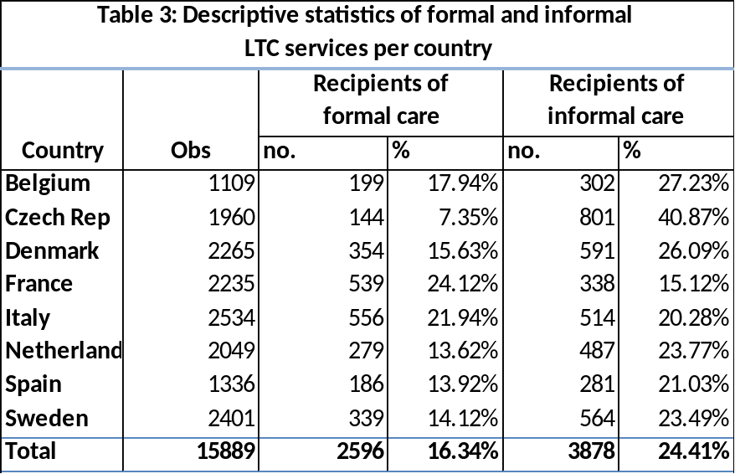
Table 3 shows the share of the population that uses LTC services, for both formal and informal care, per country. For all countries, except France and Italy, the share of the population that uses informal care is around 10 percentage points higher than the share of the population that uses formal care. In the case of Czech Republic, this difference between formal and informal care use is even more than 30 percentage points. As can be seen from Table 1 and 2 in the ‘Institutional Background’ section, the Czech government only spends 0.3% of its GDP on LTC and its system is mostly focused on informal care. France’s and Italy’s LTC is also focused on informal care according to section 2, however the statistics of the sample above show otherwise. Yet, they do differ in comparison to Czech with respect to having a higher private funding. In general, these differences in shares of type of care use could be explained by various reasons. The most logical reason would be that the help of family members and friends is the most straightforward solution when an individual is in need of help. Getting formal care might be a too drastic measure when there is family around that could easily help, especially for practical household help such as doing groceries. Secondly, informal care use could be higher because the need for intensive LTC is less in general. Hence, individuals might make less use of formal care services simply because they are not in need of intensive care that requires professional help. Thirdly, the low percentages of formal care could be due to the income level of an individual. In this case, shares of formal care use are lower because people in need of formal care cannot afford it. There are several other possible reasons for this LTC use distribution that could be related to previously mentioned variables such as the age distribution, education levels and employment percentages of the population in a country. The weight of these different possible reasons will become clearer in the results section.
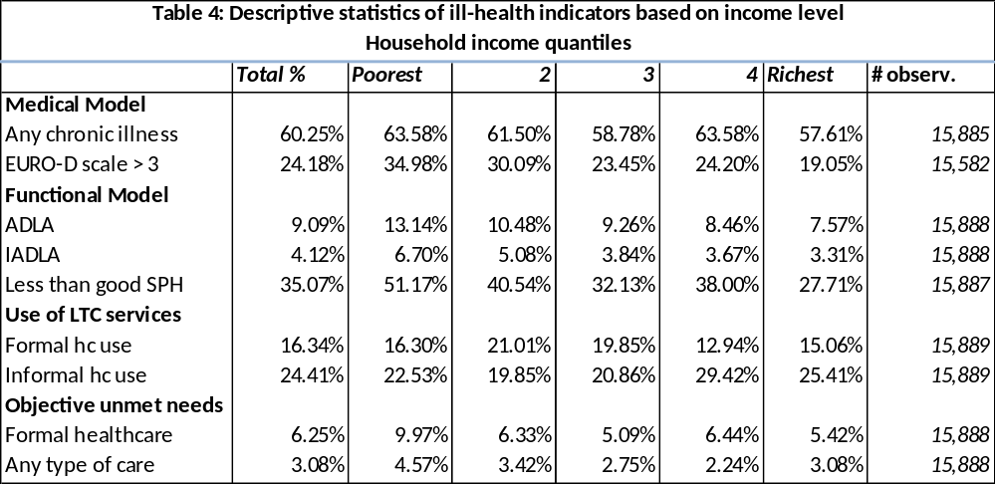 * weights are applied here
Table 4 is divided in four categories: a medical model, a functional model, a model based on LTC use, and a model based on unmet needs (O'Donnell, van Doorslaer, Wagstaff, & Lindelow, 2008). Firstly, it seems that for the two ill-health indicators- the medical and the functional model- ill-health decreases with income. Hence, the poorer an individual is, the worse the health status of that individual is and the more he/she seems to be in need of LTC. Further, when looking at chronic illnesses compared to the other ill-health indicators in the medical model and the functional model, the percentages of chronic illnesses are substantially higher and remain high even for the richest people in the sample. These high percentages are not surprising considering that the minimum age in the sample population is 50. Additionally, when comparing chronic illnesses with the use of LTC services, the chronic illness percentages are more than twice as high. This could be explained by the fact that the chronic illness(es) captured is (are) not that ‘bad’ and does (do) not per se have to be correlated with LTC use and needs. Another important thing to note is, when looking at the actual use of LTC services, formal care use is mostly concentrated in the 2nd and 3rd quantiles (i.e. the middle class) and informal care use is mostly concentrated in the last two quantiles (i.e. the upper class) of the income distribution. When ignoring all other factors, this could indicate that access to LTC does not have a gradient relationship with income. However, when looking at unmet needs (based on limitations in daily living activities), it seems to indicate that unmet need is mostly concentrated among poor individuals. Thus, while use of LTC services is neither positively nor negatively correlated with income, the fact that poor people might be more in need of these services indicates that access to these LTC systems is not equitable. Lastly, one should be cautious of these statistics since they represent the data of all eight countries combined. Hence, they are a weighted average and might contain completely opposite outcomes that combined show an equal distribution. The differences in inequity among countries will become clearer in the results section.

4. Methodology
The methodology of this analysis to measure income-related horizontal inequity of long-term care use and need using concentration curves and concentration indices. The concentration index is one of the most commonly used method for indicating inequalities and inequities (Wagstaff & van Doorslaer, 2000). The concentration indices are graphically observed with the concentration curve to see how the summary value of the CIs is made up of negative and positive values and how it is divided over the distribution. The concentration curve shows the ill-health variable on the Y-axis, accounted for by the cumulative proportions of individuals in the population ranked from poorest to richest on the X-axis (O'Donnell, van Doorslaer, Wagstaff, & Lindelow, 2008). The further the curve is above the 45 degree equality line, the more concentrated is the health variable among the poor.
In general, the CI is defined by two times the area between the concentration curve and the equality line. When the CI is zero there is no socioeconomic inequality. Further, the CI is negative when the concentration curve is above the equality line which means that there is a disproportional concentration of the (ill-)health variable among the poor (Wagstaff & van Doorslaer, 2000). The most convenient algebraically expressed CI for this analysis is the following formula:
$$CI=\frac{2}{μ}cov\left(y_{i},R_{i}\right) (1)$$
and shows that the value of CI is equal to the covariance between an indicator of LTC use ($y_{i}$) & the relative ranking of individuals in the sample based on their socioeconomic status ($R_{i}$), divided by the average of the respective health variable ($μ$). Finally, the whole expression is multiplied by 2 to make sure that the CI has a range between -1 and 1 (García-Gómez et al., 2014).
However, the CI was initially developed for continuous variables, yet this analysis consists of a dichotomous variable whether an individual used long-term (in)formal care services or not. Fortunately, it is possible to calculate a corrected form of the CI for binary or bounded variables (Erreygers, 2009) and this corrected concentration index is used for the probability of using (in)formal care services:
$$CCI=4*μ*CI\left(y\right) (2)$$
where CCI is the corrected concentration index, $μ$ is the average of the respective health variable and CI(y) stands for the conventional concentration index.
However, since we are also interested in horizontal equity, that is, equality in LTC access adjusted for need variables (Kakwani, Wagstaff, & van Doorslaer, 1997) the formulas have to be adjusted. From the assumption that $y_{i}$ is a linear and additively distinguishable function of need and non-need covariates, the following formula follows:
$$y_{i}=a+\sum_{k}{βx_{k}}\sum_{p}{δz_{p}}+ɛ_{i} (3)$$
in which the CI is written as the weighted sum of the CIs of the explanatory health variables with respect to income (Wagstaff, et al, 2003). The weights represent the sensitivity of LTC use and need with respect to each explanatory variable. Then this formula is extended to the CCI and CHI via indirect standardization, shown in the equations (4) and (5) (Van de Poel et al, 2012):
$$CCI=4*\left[\sum_{k}{β{\overline{x}}_{k}CI_{x}+\sum_{p}{δ{\overline{z}}_{p}CI_{z}+GC_{ε}}}\right] (4)$$Here ${\overline{x}}_{k}$ represents the mean of the need-variables and ${\overline{z}}_{p}$ represents the mean of the non-need variables, with the corresponding concentration indices on socioeconomic status $CI_{x}$ and $CI_{z}$. Next, the horizontal concentration index is obtained by:
$$CHI=CCI-4*\sum_{k}{β{\overline{x}}_{k}{CI}_{x}} (5)$$
CHI values that are greater than 0 indicate, if we assume that all individuals have the same need level of accessing such LTC services, that actual access is concentrated among the richest individuals in the income distribution. Similarly, a CHI lower than 0 indicates inequity in access to LTC services in favour of the poorest individuals in the income distribution, while a CHI of 0 indicates that there is no inequity (O'Donnell, van Doorslaer, Wagstaff, & Lindelow, 2008).
Lastly, this paper distinguishes between the CCI and CHI for the different dependent health variables. Inequity regarding formal and informal care use is measured with the CHI, as it is regarded as ‘ fair’ that people with different LTC needs can have different access / utilization levels to such LTC services, but it is regarded as unfair if people with different socioeconomic backgrounds (e.g. income and education) have different access possibilities. Subsequently, the horizontal inequity index shows inequity for the portion that would be regarded as unfair inequity. However, in the case of unmet needs, it would be hard to justify that individuals with different levels of need have different levels of unmet needs (García-Gómez et al., 2014), as ideally, regardless of the level of need, unmet needs should be zero for everybody.

5. Results & Comparisons
5.1. Determinants of long-term care use
In order to get the CHIs of LTC use, one first has to regress both formal and informal care use on the socioeconomic, need and non-need variables, by using a linear probability model (see Appendix table A1 & A2). When looking at both the regression results of formal and informal care, it is noticeable that there is no clear relationship between the level of log income and the probability of using LTC. One would expect that formal care would positively depend on income and informal care negatively on income, however this does not seem to be the case. These results actually match the descriptive statistics table 4, where access to LTC services seems not to depend on income too much. However, there are some clear relationships between the probability of LTC use and need variables such as age & gender and limitations in daily living activities. LTC use of both types of care seem to be mainly positively related with males and females of 75 years and older. For 4 out of the 8 countries these coefficients are significant at the 5% level. The coefficients indicate that both 75+ males and females are more likely, in comparison to 50-55 year old males and females, to use LTC. Yet, the most important predictors of LTC use are the basic and instrumental limitations of daily activity indicators. When comparing the composition of formal and informal care use, the coefficients of (I)ADLA are largest for informal care use in France, Italy and Spain. This bigger correlation of (I)ADLA with informal care might be related to the fact that LTC in these countries mostly depends on informal care, because of their relatively low public expenditure on LTC. Hence, people with an (I)ADLA in these countries might be more likely to get informal care than formal care. In contrast, the coefficients of limitations in daily activities for Sweden and the Netherlands are largest for formal care use, which could be explained by the generous and accessible nature of their LTC systems (see section 2). The other need variables (less than good self-perceived health, having one or more chronic diseases and poor mental health) all have a weaker, but a positive relationship with both types of LTC use as well.
For education, higher education seems to have the largest positive effect, in comparison to primary education, on formal care use in Italy and Spain and a significant negative effect on informal care use in France. This variable again might indicate some socioeconomic inequities in these countries. However, the higher education variable is also significantly positive for formal care in the Netherlands. Next, regarding the household composition, the number of children does not correlate much or mostly negatively correlates with formal care in most countries, while it positively correlates with informal care use. Also, when a partner is living in the same household, this has a negative relationship with formal care use. This all seems logical, as it makes informal care utilization more straightforward. However, this does not hold for informal care, where there is a negative relationship with informal care use and the partner variable. The latter may be due to the fact that the informal care variable mainly consists of observations regarding informal care from outside the household (because of missing variables in the informal care from within the household variable) , and underestimates the contribution to informal care of family members living inside the household.

5.2 Horizontal Inequities in Long-Term Care Use
The indices and curves that are presented below represent the horizontal inequity in long-term care in a country. Hence, it represents whether or not individuals with the same level of need of these services experience a different level of long-term care utilization and access.
5.2.1 Horizontal Inequity in Formal Care Use
Table 5: Horizontal inequity indices (CHI) in probability to use formal care
Country | Belgium | Czech | Denmark | France | Italy | Netherlands | Spain | Sweden
CHI | 0.0397 | -0.0162 | 0.0105 | -0.0458 | 0.0891 | 0.0062 | 0.0303 | -0.0059
Note: Statistically significant values in bold (P < 0.05). Weighted results.
Looking at table 5 and the corresponding curves, one can see that the inequalities differ quite a lot between countries. Yet, for five out of eight countries, formal care utilization after standardizing for the various need variables, is still concentrated among the rich. Meaning that among a population with the same needs, more affluent people are more likely to receive formal care. This holds especially in Belgium, Italy and Spain, with statistically significant indices from zero in Belgium and Italy who have the largest pro-rich inequities. Looking at the corresponding LTC systems, these indices seem logical for Spain and Italy where privately paid services that function under market prices are predominant. Public financing in Belgium is a bit higher, but section 2 still indicates that LTC in Belgium is mainly oriented towards informal care. Next, In the ‘generous, accessible and formalised’ countries (Denmark, the Netherlands and Sweden), the indices are indeed closer to zero, indicating an equitable distribution. Yet, formal care use in Denmark seems to be concentrated mostly among the middle class and less among the poorest and richest people. The Swedish curve almost completely follows the equity line, while the Dutch curve mainly follow this line for the poorest and richest individuals of the country. But, no large inequities are visible from these results.
Graph 1: Concentration Curves for the Probability of Formal Care Use
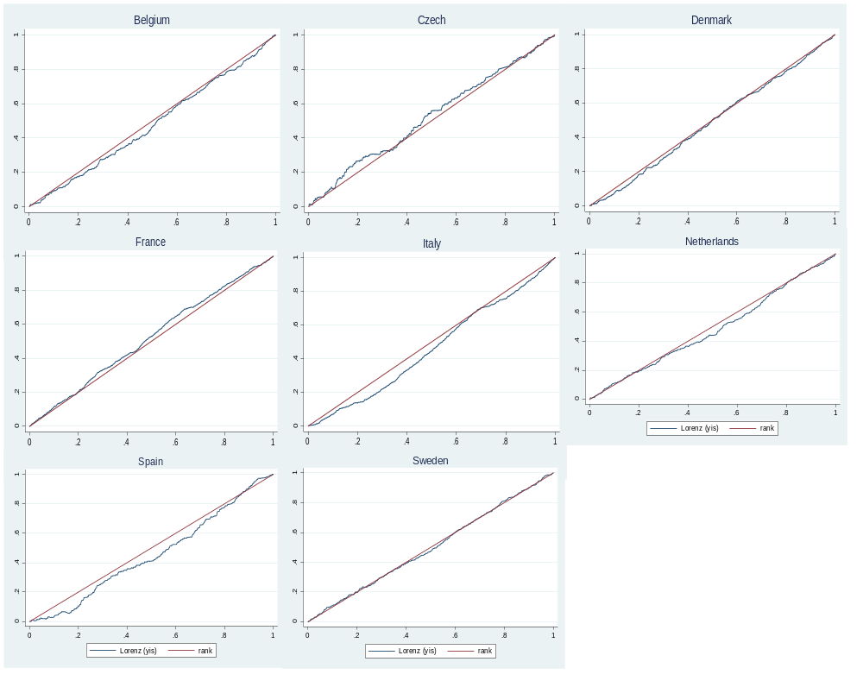Note: the x-axis represents the cumulative shares of the population ranked according to income and the y-axis represents the corresponding cumulative shares of formal care utilization.
Further, in Czech and France, formal care utilization seems to be mainly concentrated among the poor. In Czech the probability seems to be the highest in the lowest quintile of the socioeconomic distribution. The latter contradicts section 2 quite a bit, that shows that LTC in Czech has low public financing and where long-term care is mostly oriented towards informal care. However, as formal care use in general is really low in Czech (7%, table 3), these results might be biased due to the limited amount of people who actually use / have access to formal care services.
5.2.2 Horizontal Inequity in Informal Care Use
Comparing table 5 with table 6, it can be seen that for all countries (except for the Netherlands and France) the CHIs are lower for informal care use. Meaning that informal care use is relatively more concentrated among the poor than is the case with formal care use This corresponds with the speculations on informal care made in section 3, which in general indicated that informal care is relatively ‘easier’ to access.
Table 6: Horizontal inequity indices (CHI) in probability to use informal care
Country | Belgium | Czech | Denmark | France | Italy | Netherlands | Spain | Sweden
CHI | 0.0331 | -0.0012 | -0.0421 | -0.0191 | 0.0781 | 0.0082 | -0.0392 | -0.0296
Note: Statistically significant values in bold (P < 0.05). Weighted results.
Graph 2: Concentration Curves for the Probability of Informal Care Use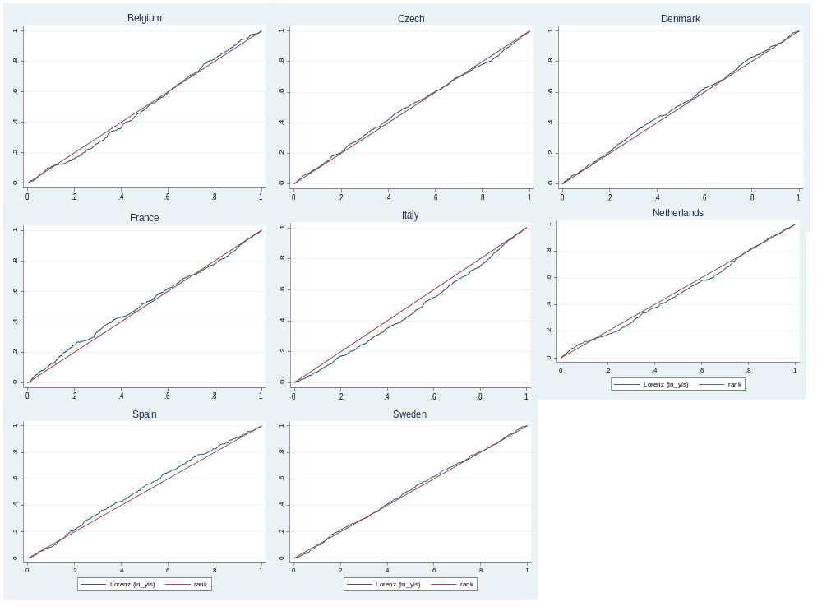Note: the x-axis represents the cumulative shares of the population ranked according to income and the y-axis represents the corresponding cumulative shares of informal care utilization.
The probability to use informal care is highest among the poor in the countries Denmark, Spain and Sweden. Section 2 would have predicted these results for Spain, where need for LTC is mostly covered by informal care and formal care requires high private funding, so that informal care seems a better solution for poorer people. Also, Spain is the only country that has the biggest inequity according to these indices. Hence, as concluded in García-Gómez et al.’s (2014) paper, formal care in Spain is pro-rich while informal care is pro-poor. Further, even though section 2 also indicates that informal care use is low in Denmark and Sweden, these indices say nothing about whether the service is used frequently, but indicate that among people with the same needs, less affluent people are more likely to make use of informal care services. Next, the probability to receive informal care seems to be most equitable in Czech and the Netherlands. In the case of The Netherlands, this result fits the description of section 2, where the Netherlands is pictured as an equitable country. In contrast, one would expect that informal care in Czech to be mostly concentrated among the poor according to section 2. However, this equitable distribution could be explained by the fact that a big share of the Czech sample uses informal care (40%, table 3), which already excludes the possibility of informal care only being used in the lowest income quintile. Most surprising is the result of Italy, which indicates a significant pro-rich distribution of informal care use that contradicts the descriptions from section 2. Lastly, France is the only country where there is a big difference between the indices of formal and informal care in the opposite direction. In other words, in France, less affluent people are relatively more likely to use formal care services in comparison to informal care services.

5.4. Inequity in Unmet Need
Despite the various equitable indices and pro-poor formal care indices seen in section 5.2, unmet needs still seem, especially for formal care, to be highly concentrated among the poor (table 7).
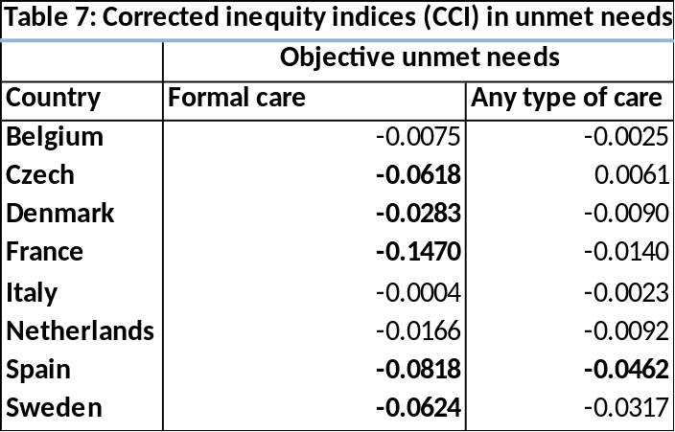
Note: statistically significant values in bold (P<0.05). Weighted results.
Pro-poor inequity for unmet needs in formal care is highest and significantly different from zero in Czech, Denmark, France, Spain and Sweden. Especially the highly negative index of Sweden is surprising as the description of the nature of the LTC systems Sweden would predict otherwise. Still this result is in line with the index of table 6 that show that informal care still mostly used by poorer people, which could mean that while the index for formal care is quite equitable, current formal care does not cover all needs. Another surprising result is, is that according to this measure there almost seems to be no inequity for Italy. Further, when looking at the unmet needs for any type of care, it seems that most of these needs are covered by informal care, which substantially reduces the pro-poor inequity in unmet needs.

6. Conclusion and Discussion
First of all, the descriptive statistics showed that the use of formal (informal) care was not per se positively (negatively) linked with income. These statistics already refute the expectation of informal care being mostly used by poor people and formal care being mostly used by rich people. But, as discussed before, this does not imply that no inequities are present, because these numbers do not take the needs for LTC services of individuals into account. Yet, according to the linear probability estimates there was also no clear pattern of income on LTC use visible. From the rest of the result section it turned out that pro-rich (pro-poor) horizontal inequities actually were present in formal care (informal care), indicating that access to formal care may be easier for richer people, while poorer people are more likely to resort to informal care. However, this is definitely not the complete picture. About half of the countries did not follow this trend and turned out to be equitable or even show opposite results. Further, the results were not always similar with the nature of the corresponding LTC system in that country. Especially Czech and Italy showed surprising results. The LTC services in Czech turned out to be quite equitable according to table 5 and 6, while section 2 told a different story. Also, even though formal in Italy requires mostly private funding and is supposed to be oriented towards informal care, informal care utilization was still concentrated among the rich individuals. On the other hand, among the generous, accessible, and formalised countries, all three countries (Denmark, the Netherlands and Sweden) seemed to follow this description. Similarly, the results of Spain were in line with the nature of the LTC system and followed the results of the paper of García-Gómez et al. (2014). With respect to both unmet needs measures, this paper shows a clear pro-poor inequity, indicating that the LTC services per country fail to satisfy the needs of the poorer individuals.
Despite big efforts, there are still some areas in which this paper can be improved on. Firstly, there are a lot of missing variables in the informal care from within the household variable, which may have biased results towards a more pro-rich inequitable distribution. One would expect informal care to be concentrated among the poor, yet the statistics show otherwise. This could be caused by the missing values of 2/3rd of the observations of our within household indicator. Considering how the informal care utilization variable is composed in this paper, an individual with value zero for informal care from outside the household and a missing value for informal care from within the household would take on the value zero in the informal care use indicator. However, it could be that this individual actually does receive informal care from within the household. Unfortunately, it is not known in what direction, if at all, the outcomes would have changed if the data would be more complete. Secondly, the formal care variable mainly consists of home care, which leaves room for research on institutional care. Thirdly, the more objective measure used for unmet needs is not completely objective as it is reported by participants themselves, so the results may still suffer from reporting bias. For example, individuals that have severe limitations in daily activities might underestimate their limitations and indicate a low number on the scale. Likewise, individuals could overestimate their limitations. Especially relevant for this paper is that studies have shown that there are cross-country differences in self-reported health (Jürges, 2006). If one then allows for a categorical indicator, conclusions based on comparisons between countries would not be reliable. However, as the unmet needs indicator takes one for observations on limitations in daily activities with a number higher than zero, any reporting biases varying from 1-5 are cancelled out. Unfortunately, the major drawback of this measure is that the extend of the unmet need is ignored. Fourthly, as explained in the data section and section 5.4, the unmet needs inequities for formal care are not cross-country comparable. However, while they do not show the motivation behind resorting to informal care, the inequities of unmet needs in formal care do show a clear pro-poor socioeconomic distribution for all countries. Fifthly, the data in this research is from 10 years ago, so the results in this paper might not be up to date. Lastly, this study focuses on multiple countries and the samples per country are not very big.
For future research, country specific studies might be able to capture more country specific characteristics and would therefore perhaps give more accurate results. Further, having more accurate indicators of unmet need (e.g., subjective measures based on satisfaction of LTC services and objective measures that are not based on self-reported statistics), might provide more valid results. Finally, as socioeconomic inequities are still present and the share of elderly people in the population is increasing, the challenge for policy makers to achieve equity remains. This challenge is clearest from the indication that unmet needs of formal care (despite the drawbacks of this measure) and any type of care are concentrated among the poor for all countries. Socioeconomic status seems to thus play a role in receiving sufficient LTC services.

7. Bibliography

Allen, K., Rastislav, B., Campbell, L., Dieterich, A., Hirsch Durett, E., Emilsson, T., et al. (2011). Governance and finance of long-term care across Europe. Birmingham & Vienna: Interlinks.
Allin S, Grignon M, Le Grand J. 2010. Subjective unmet need and utilisation of health care
services in Canada: what are the equity implications? Social Science & Medicine
70: 465-72
García-Gómez, P., Hernández-Quevedo, C., Jiménez-Rubio, D., & Oliva, J. (2014). Inequity in long-term care use and unmet need: two sides of the same coin. York, UK: HEDG working papers, Health Econometrics and Data Group.
Gruber, S., Hunkler, C., Orban, A., Stuck, S., & Neumann, J. (2015). Guide to easySHARE release 2.0.0. Munich, Germany: easySHARE.
Hurley J, Jamal T, Grignon M, et al. 2008. The relationship between self-reported unmet need for health care and health care utilization. Hamilton: McMaster University
Jürges, H. (2006). True Health vs. Response Styles: Exploring Cross-Country Differences
in Self-Teported Health. Health Economics , 163-178.
Kraus, M., Riedel, M., Mot, E., Willemé, P., Röhrling, G., & Czypionka, T. (2010). A Typology of Long-Term Care Systems in Europe. ENEPRI.
Mackenbach, J. P. (2006). Health Inequalities: Europe in Profile. Rotterdam: UK Precidency of the EU.
Mot, E., Faber, R., Geerts, J., & Willemé, P. (2012). Performance of Long-Term Care Systems in Europe. ENEPRI.
O'Donnell, O., van Doorslaer, E., Wagstaff, A., & Lindelow, M. (2008). Analyzing Health Equity Using Household Survey Data - A Guide to Techniques and Their Implementation. Washington: World Bank Institute.
Rodrigues, R., Ilinca, S., & Schmidt, A. (2014). Analysing equity in the use of long-term care in Europe. Brussels: European Commission.
UIS. (2015, December 21). ISCED Mappings. Retrieved on May 15, 2016, from UNESCO Institute for Statistics: http://www.uis.unesco.org/Education/ISCEDMappings/Pages/default.aspx
Van de Poel E, Van Doorsaler E, O’Donnell O. 2012. Measurement of equity in health care
with heterogeneous response of health to need. Journal of Health Economics
31(4): 676- 689.

8. Appendix
8.1 Decomposition analysis: contributions to inequality in long-term care use
Formal care
Table A1: Linear probability estimates on the probability of formal care use
Contribution of | Belgium | Czech | Denmark | France | Italy | Netherlands | Spain | Sweden
CHI | 0.0397 | -0.0162 | 0.0105 | -0.0458 | 0.0900 | 0.0062 | 0.0303 | -0.0059
log of equiv. Income | 0.01319 | -0.00170 | 0.00815 | -0.02376 | 0.00935 | -0.00900 | -0.00595 | -0.00982
55-64 years old male | -0.10697 | -0.00407 | 0.04057 | -0.01048 | -0.01314 | -0.00332 | 0.05189 | 0.06008
65-74 years old male | -0.05323 | -0.03013 | 0.03484 | 0.01745 | 0.01527 | -0.00981 | -0.03839 | 0.07877
>75 years old male | 0.11566 | 0.04159 | 0.11206 | 0.12982 | 0.04135 | 0.14687 | 0.01643 | 0.15010
55-64 years old female | -0.07227 | 0.03021 | 0.38737 | 0.00672 | 0.06792 | 0.04065 | 0.01582 | 0.07159
65-74 years old female | 0.03908 | 0.02866 | 0.17596 | 0.02088 | 0.04330 | 0.02211 | 0.04454 | 0.05897
>75 years old female | 0.10288 | 0.05435 | 0.19254 | 0.13246 | 0.06828 | 0.23537 | 0.02009 | 0.18234
one or more ADLA | 0.21846 | 0.06736 | 0.25799 | 0.15359 | 0.10592 | 0.23798 | 0.18079 | 0.02008
one or more IADLA | 0.20296 | 0.28191 | 0.15668 | 0.15241 | 0.11685 | 0.19156 | 0.09364 | 0.34864
one or more chronic | 0.07111 | 0.03138 | 0.02095 | 0.04128 | 0.07565 | 0.04051 | 0.04418 | 0.01780
Diseases
poor mental health | 0.01657 | 0.04975 | 0.03026 | 0.05467 | 0.06918 | 0.06628 | 0.03892 | 0.04868
less than good SPH | 0.06013 | -0.00647 | 0.07593 | 0.14342 | 0.05529 | 0.06671 | 0.03779 | 0.03348
1st stage of secondary | 0.03494 | -0.03167 | -0.00682 | 0.02366 | 0.07649 | -0.00479 | 0.00120 | -0.00111
Education
2nd stage of secondary | 0.05382 | -0.02461 | -0.02768 | 0.02361 | 0.16871 | 0.02010 | 0.06739 | 0.00698
Education
higher education | 0.05486 | 0.00699 | -0.02231 | 0.04653 | 0.17475 | 0.07869 | 0.12613 | 0.02268
# of children | 0.01336 | -0.01059 | -0.01510 | 0.00017 | -0.00741 | -0.00185 | -0.00663 | 0.00301
household size | 0.00355 | 0.00372 | 0.01880 | 0.00238 | -0.02463 | 0.01063 | -0.01353 | 0.00617
partner living in household | -0.09038 | -0.00761 | -0.10204 | -0.05123 | 0.01491 | -0.10701 | -0.00676 | -0.07034
Note: Statistically significant values indicated in bold (P < 0.05). Weighted results.

Informal care
Table A2: Linear probability estimates on the probability of informal care use
Contribution of | Belgium | Czech | Denmark | France | Italy | Netherlands | Spain | Sweden
CHI | 0.0331 | -0.0012 | -0.0421 | -0.0191 | 0.0781 | 0.0082 | -0.0392 | -0.0296
log of equiv. Income | -0.01228 | 0.01036 | -0.01798 | 0.00126 | 0.01633 | -0.02159 | -0.01457 | -0.00440
55-64 years old male | -0.00507 | -0.06686 | -0.03888 | 0.02776 | -0.02630 | 0.00005 | 0.03225 | -0.02960
65-74 years old male | -0.03112 | 0.06194 | -0.07485 | 0.01850 | 0.01005 | -0.03371 | 0.00957 | -0.06382
>75 years old male | 0.20846 | 0.13790 | -0.03111 | 0.12631 | 0.09301 | -0.00376 | 0.10395 | 0.02796
55-64 years old female | 0.02453 | -0.00790 | 0.01731 | 0.03021 | -0.00804 | 0.05078 | 0.04689 | 0.01052
65-74 years old female | 0.01242 | 0.05751 | -0.04172 | 0.02966 | -0.01825 | 0.03003 | 0.03169 | 0.03063
>75 years old female | 0.09863 | 0.11093 | -0.00160 | 0.18687 | 0.07619 | -0.04260 | 0.06572 | 0.08116
one or more ADLA | 0.24316 | 0.20303 | 0.16715 | 0.20216 | 0.25667 | 0.13329 | 0.23833 | 0.13004
one or more IADLA | 0.25473 | 0.24464 | 0.19507 | 0.30881 | 0.14061 | 0.16072 | 0.24135 | 0.07843
one or more chronic | 0.07717 | -0.00390 | 0.03332 | 0.01746 | 0.06983 | 0.00941 | 0.07596 | 0.01732
Diseases
poor mental health | 0.02319 | 0.10198 | 0.00505 | 0.04521 | 0.05417 | 0.08560 | 0.05001 | 0.11980
less than good SPH | 0.06603 | 0.06023 | 0.06487 | 0.05824 | 0.07589 | 0.08510 | 0.04629 | 0.03451
1st stage of secondary | -0.04103 | -0.06842 | -0.06038 | -0.05998 | -0.00234 | -0.01605 | -0.03986 | -0.03560
Education
2nd stage of secondary | 0.00116 | -0.07363 | -0.00275 | -0.05753 | 0.02732 | 0.02792 | -0.06225 | -0.07871
Education
higher education | -0.04092 | 0.04876 | 0.01691 | -0.07158 | 0.05607 | 0.05333 | 0.05943 | -0.03745
# of children | 0.01333 | 0.02266 | 0.02333 | 0.00619 | -0.00294 | 0.00233 | -0.00112 | 0.02759
household size | -0.04622 | 0.01831 | -0.00131 | 0.00068 | -0.00810 | -0.03068 | -0.00316 | 0.01950
partner living in household | -0.08389 | -0.12034 | -0.14192 | -0.09272 | -0.06291 | -0.16842 | -0.03714 | -0.17282
Note: Statistically significant values indicated in bold (P < 0.05). Weighted results.

Benefits that are available only to individuals whose income is below a certain level (Mackenbach, 2006).
Note here that both Czech and Spain have had significant reforms in their LTC systems (Colombo et al, 2011, Rodrigues et al, 2012), including introduction of universal benefits for LTC in both countries. In comparison with the information provided here, these reforms have somewhat changed the nature of the systems. Fortunately, the data from table 2 has taken these reforms into account.
Conclusions based on these indices should be taken with caution as they might not be the result of unmet need in formal care, but may be caused by non-socioeconomic motivations of resorting to informal care. Further, these motivations may vary greatly between countries (see section 3.1, unmet need).

