Factors Affecting the Company to Adopt and Sustain with the Use of Budget: Literature Review

Richard Handoko Mawardi
429398

Bachelor Thesis
Under the supervision of Agapi-Thaleia Fytraki
International Bachelor of Economics and Business Economics
Erasmus School of Economics, Erasmus University Rotterdam
July 2016

Table of Contents
- Introduction 4
1.1 Research Problems & Motivation 4
1.2 Research Objectives 5
1.3 Research Methodology 6
2. Theoretical Framework 7
2.1 Definition of Budget 7
2.2 Different Types of Budgets and Their Characteristics 7
- Literature Review 9
3.1 Management View on Budgets 9
3.2 Roles of Budget 13
3.2.1 Planning Role of Budget 13
3.2.2 Budget as a Control Tool 16
3.2.3 Ritual Role of Budget 18
3.3 The Advantages of Budget 22
3.3.1 Coping with Ambiguity 22
3.3.2 Budget Influence on Job Satisfaction and Job-Related Tension 24
3.3.3 The Advantages of Budgetary Slack 26
3.4 The Disadvantages of Beyond Budgeting 31
4. Discussion & Conclusion 34
4.1 Discussion 34
4.2 Research Limitations and Suggestions for Future Research 36
4.3 Conclusion 36
Bibliography 38

List of Tables

Table 1: Summary of Literature Reviewed on Management View on Budget 12
Table 2: Summary of Literature Reviewed on the Roles of Budget 21
Table 3: Summary of Literature Reviewed on the Advantages of Budget 30

Chapter 1
Introduction

Budgeting has become a subject of criticism among academics (Hope & Fraser, 2003; Wallander, 1999). Many researchers argue that the cost of budgeting exceed the benefits gained from budgeting and therefore should be abandoned (Hope & Fraser, 2003; Wallander, 1999). However, despite criticism from academics, budgeting is popular and widely used among practitioners (Libby & Lindsay, 2010; Hansen, Otley, & Van der Stede, 2003). This conflicting evidence indicates that there is a gap between budgeting theory and practice. This paper aims to bridge the gap by identifying factors which influence the company to adopt and sustain with the use of budget despite the criticism addressed by the academics.

1.1 Research Problems & Motivation
Some scholars have long criticized budgeting. Wallander (1999), for example, describes the budget as an unnecessary evil while Libby & Lindsay (2010) argue that the budgeting process is too costly, time-consuming and reduces the company’s flexibility. Furthermore, researchers claim that budgets should be abandoned because they believe that budgets bring dysfunctional effects to the firm such as demotivation of the managers, creation of internal gaming and myopia. Hope and Fraser (2003) state that the existence of budget can discourage managers from achieving beyond the maximum point of his or her reward plan. In other words, traditional budgeting only motivates the manager to perform between the minimum point when he or she starts to get rewards and the maximum point when he or she no longer receives additional rewards. Furthermore, Anthony et al. (2014) argue that the nature of the budgetary target which focuses on short-term achievement may create internal gaming and myopia in the company. Many researchers have offered alternatives as replacement for budgets. Waal (2005), for example, states that companies should consider to abandon budget and switch to beyond budgeting. However, most of the practitioners believe that the solution to problems related to budget is not budget abandonment but budget improvement (Libby & Lindsay, 2010)
Despite recommendations from the academics to abandon budget, however, only a few company opt to leave the budget. According to CIMA survey published in January 2010, about 95% of the organizations surveyed used budgets as a control tool leaving only 5% of the sample which opt to go beyond budgeting. Ahmed et al. (2003) conducted a study about the use of budgets in Malaysian companies finding that budget are still widely used in Malaysian firms. Sandalgaard (2012) conducted similar research in companies in Denmark revealing that budgets are still commonly used control tool.
The evidence provided above shows that there is a gap between accounting research and practice. Thus, this research aims to answer the following question:
What factors influence the company to adopt and sustain the usage of budgets?
The answer to this question is important for the improvement of the practicability of existing theories of budget alternatives. The findings of this research will also be off assistance in evaluating and improve the current budgeting, planning, and forecasting practice. Finally, this research may also provide an introduction for the practitioners about the available alternatives to budgets which may be used to improve the company’s performance.

1.2 Research Objectives
The objective of this research is to identify factors which influence a company to stick with the budget despite its disadvantages and criticism from the academics. This research objective will be achieved by separating the internal factors (e.g. the use of budget to motivates managers) with the external factors (e.g. the disadvantage of the alternatives to budget) and relate on how each of the factors may encourage firms to stick with budget.

1.3 Research Methodology
This research is a literature review. This research will look through the existing journal to achieve the research objectives. The review will begin by building a theoretical framework as a basis for the analysis of the chosen literature. The theoretical framework discusses the definition of budget, theory of budgets, alternatives of budgets and the role of the budget in a company. To build a robust theoretical framework, only high-quality literatures that will be used. The journal selection method will be explained in detail in the next paragraph. This literatures used are mainly journals and books from management and accounting fields as budgets are a topic of both these fields. Ranking developed by Lowe & Locke (2006) are used to identify high-quality accounting journals and SCImago database for the management journals.
To find relevant journals, this research used a method proposed by Webster and Watson (2002). Google Scholar’s database was used as a primary database to locate relevant journals. Upon finding relevant journals, backward and forward search is applied to find other relevant journals. Backward search is applied by reviewing articles cited by prior articles and forward search is applied by reviewing the articles which cite the prior article (Webster & Watson, 2002).
The findings from the relevant literature collected will be discussed alongside with the theoretical framework with the aim of answering the research objectives. Thus, the content of the discussion part will discuss how are the factors discussed in the selected articles may affect certain functions or roles of budget and consequently, the company’s decision to apply budgeting. In addition, this part will also discuss the influence of external factors on the company’s decision to stick with the budget. A table presenting the summary of the discussion will be presented at the end of discussion part.

Chapter 2
Theoretical Framework

2.1 Definition of Budget
A budget is often used as a planning & control tool in management control systems. It is a future financial plan which identifies the firm’s objectives and how to achieve them. It is not only a plan (future oriented) but it also serves as a control (monitoring actual activity) (Hansen & Mowen, 2007). It will encourage the manager to formulate the organization’s overall direction, identify potential problems and develop the future policies. Meanwhile, as a control, it compares actual results to the budgeted result periodically. Large variance will indicate that the company is out of control. (Hansen & Mowen, 2007)

2.2 Different Types of Budgets and Their Characteristics
According to Neely, Bourne & Adams (2003), there are three approaches to budgeting:
- Traditional budgeting: Traditional budgeting refers to the periodical process in which organizations define their operational income and forecast income for the upcoming period (usually one-year) (Neely, Sutcliff, & Heyns, 2001). In traditional budgeting, the budget is created by discussion and agreement between top management and front-line managers. As the result, traditional budgeting involves both top-bottom and bottom-up communication. (Neely, Sutcliff, & Heyns, 2001). Since most organizations have a lot of layers in their organizational structure, the process of budgeting may consume a lot of time. This approach assumes that managers and employees do not have the skill sets, motivation, or honesty to act in a way that supports company objectives and needs to be coerced and directed. Thus, it uses a static budget (a budget for a particular level of activity) to control the workers. It sees the budget as an important control tool to the bring company towards its target
- Better budgeting: this approach is an improvement of the traditional budgeting system. It has a more flexible approach which can overcome the disadvantages of the prior system. Examples of this approach are activity-based budgeting and rolling forecasts.
- Beyond budgeting: This approach has emerged as a result of dissatisfaction among some academics and practitioners. The proponents of beyond budgeting believe that budgeting brings dysfunctional effects to the organization and therefore should be abandoned (Hope & Fraser, 2003; Wallander, 1999). Proponents of beyond budgeting proposes the different methods to replace the budget such as the use of benchmarking, peer to peer review, and non-financial performance measurement as well as financial performance measurement In this paper, the term budget or budgeting refers to the traditional budgeting and better budgeting since both these types of budget utilize the budget as a control tool (Hope & Fraser, 2003).

Chapter 3
Literature Review

3.1 Management View on Budget
One important reason for a company to adopt and sustain with the use of budget is because the managers of the company see that the benefits of the budget exceeds its cost. Research conducted by Libby and Lindsay (2003) on the views of North American practitioners towards budgets indicated that managers find budgets to be an important and useful tool in controlling the company. The results of this research indicated that 90% of these managers see the budget as a value added tool for the company by giving a mean score above 50 out of 100. This result is further supported by the evidence where 94% of the sample managers are indicating no plan to abandon budget. This finding agrees with the earlier reported findings by Umapathy (1987). In her survey on 402 North-American manufacturing and service firms, Umapathy (1987) found that 83% of the sample still used budget as a control tool
Similar studies in different countries have also provided the same result. Ekholm & Wallin (2000) conducted a survey on the view of the management of Finnish companies on the usefulness of budget. 86% of the sample perceived budget as a value added tool and therefore they are not planning to abandon them. Additionally, Ahmed, Sulaiman, & Alwi (2003) conduct a similar study in Malaysian firms finding that Malaysian managers still see budget as a useful tool for planning and control purposes. These combined findings confirm that budgets are still seen as a useful planning and control tool by practitioners across different countries.
Although remaining popular among many practitioners, most academics and some practitioners argue that budgets brings dysfunctional effects to an organization. Some academics argue that budgets prevent an organization from allocating their resources effectively and efficiently (Hope & Fraser, 2003; Wallander, 1999). The existence of budgetary targets has also been accused of causing short-term oriented decision making and budget gaming inside companies. (Hope & Fraser, 2003) Furthermore, there are academics who argue that budgeting does not help a company to implement its organizational strategy, and that it consumes too much time, and reduces company flexibility. (Hansen, Otley, & Van der Stede, 2003; Neely, Sutcliff, & Heyns, 2001).
Despite agreeing that budgets are useful and important tool for the organization, most of the managers also agreed that budgets have some drawbacks. The disadvantages addressed by the academics are similar with to drawbacks experienced by practitioners. Ekholm & Wallin (2000) compiled ten criticism on budgets expressed by academics and asked practitioners whether they agreed with the criticism. Out of ten criticism, six received overall mean ratings above the middle point of 3 out of 5. These criticism were that budgets: cannot signal changes in the competitive environment; may lead to incremental thinking; are too rigid; are too time-consuming; are limited to calendar year; and are based on uncertain forecast. Umapathy (1987) had similar findings in a survey of a US company. The main disadvantage highlighted was that budget consumes too much managerial time that could be devoted to other value added activities. Her findings suggest that the budgeting process consumes about 21%-40% of management's time.
Libby & Lindsay (2003) also found that in North-American companies, the existence of budget gaming caused by the use of budgets is real. About 60% of their sample admitted that they do the following budgetary gaming either occasionally or frequently:
- Spending unspent money at the end of the budget period so as not to lose it in the next budget period
- Deferring necessary expenditures to meet budgetary targets
- Incurring bigger expenses where budgetary targets are not going to be achieved so that budgetary targets will be easier to achieve in the next period
- Negotiating for easier budgetary targets
All of the aforementioned studies confirm that budgeting does have some costly disadvantages that are in accordance with criticism from academics. However, it cannot be ignored that most companies still choose to use budgeting as a planning and control despite dissatisfactions and have no plans to abandon the budget. Many practitioners believe that the solution to the problem is budget improvement, not abandonment. Libby & Lindsay (2003) highlighted four budget improvements that practitioners expect to make: rolling forecast, bottom-up orientation, strategy alignment with the budget, and a less detailed budget. Rolling forecast and less detailed budget are important to make the budget more flexible. Hence, this improvement aims to increase the company’s flexibility to deal with the uncertain business environment. Bottom-up orientation is needed to adjust the company’s strategy according to feedback given by front-line managers. Ekholm & Wallin (2000) also conducted a survey on management view of rolling forecasts in companies in Finland with a minimum turnover of 16.7 million euros. The survey indicated that managers consider rolling forecasts as a replacement to budgets that would increase the company’s flexibility and producing better variance reports. This result is comparable to a survey by Umapathy (1987) who also recommends the use of rolling forecasts to improve the current budgeting practice
The evidence presented above may not reveal the truth about the usefulness of budgets. This is because these studies gathered data through surveys of managers in different companies. A survey may result in an invalid conclusion because individuals surveyed may not develop their true attitudes but possess a series of autonomous and often inconsistent reactions to the question asked by pollsters (Zaller & Feldman, 1992). In the other words, managers may express their view on the usefulness of a budget, but, the truth about the usefulness of budget cannot be concluded solely from the manager’s view on budgeting. Thus, the evidence above only reveals the manager’s preference to sustain and improve the current budgeting. Regardless, management view on budget remains an important factor for the company to adopt and sustain with the use of budget as management plays an important role in the company.
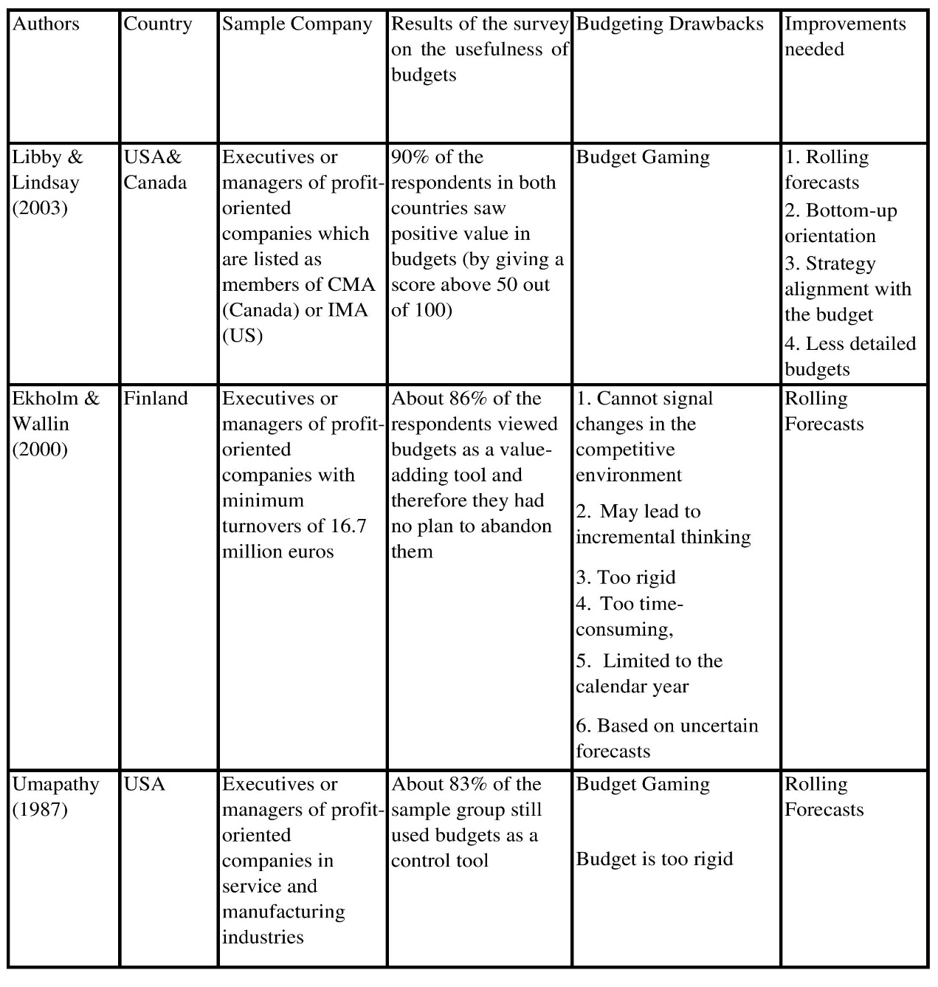
In summary, the evidence presented above indicates that although the use of budgets is popular among practitioners, dissatisfactions on budgeting practice does exist. Most of the practitioners surveyed believe that the solution to such problems is not budget abandonment. Instead, practitioners believe that improvement on budget should be made to make budget more useful. This finding is in contrasts with most of the academics view who recommend abandoning budgets. This finding is becoming one of the reason why budgets are still widely used by practitioners nowadays. , However, the evidence above doesn’t indicate that the real benefit of budget truly exceeds its cost. It only means that from the manager’s perspective, the benefit of budget outweighs its cost. Therefore, to further understand this issue, the next section will discuss the advantages and roles of budgeting which encourage managers to stick with budgets as well as with the disadvantages of beyond budgeting which makes practitioners reluctant to abandon budgets.
Table 1: Summary of Literature Reviewed on the Management View on Budget

  - Roles of the Budget
3.2.1 Planning Role of the Budget
In this role, budgets give direction in the form of short-term goals for the organization during the budgeted period. This planning role, according to Anthony et al. (2014), is divided into 2 parts: resource distribution role and coordination role. Coordination role refers to the functions of the budget that ensure every part of the organization follows the same plan (Anthony, Govindarajan, Hartmann, Kraus, & Nilsson, 2014). As this type of role is closely related to control role, the coordination role will be explained alongside with the control role of budget in the next section. The resource distribution role refers to the allocation of the amount and the costs of resources to each department (Anthony, Govindarajan, Hartmann, Kraus, & Nilsson, 2014). The budget helps the higher manager to allocate resources in terms of monetary value. The allocation process is often completed by a negotiation process between higher and lower manager. In an experimental research on 185 undergraduate students, Fisher et al. (2000) highlighted the role of budget negotiation between lower and higher manager as an influential factor in the planning role of the budget. They found that final budgetary targets set by a negotiation process were lower than the budgetary targets set unilaterally by top managers. Furthermore, Fisher et al. (2000) also indicated that budgetary slack introduced by the lower manager was higher when there was an agreement between lower and higher managers. This is reasonable because the manager will try to negotiate for a lower budget. Merchant and Manzoni (1989), in their survey of managers in 12 different companies which operate in different industries, provided reasons for lower managers to negotiate for lower budgetary targets. These were to (a) increase an expected bonus; (b) protect management credibility and autonomy; (c) increase the chance to attain the budgetary targets; (d) increase operating flexibility; (e) and avoid over-consuming resource. However, in this research, Fisher et al. (2000) did not investigate the reason why higher managers were willing to lower budgets as lowering the budget may result in a worse overall performance. Furthermore, they did not take into account the situation of the company where, in most of the cased, they only had limited resources.
Fisher, et al. (2002a) in their experimental study on 104 undergraduate students, highlighted the existence of information asymmetry between higher and lower managers as a factor for the superiors to lower the budgetary targets. Fisher et al. (2002a) hypothesized that when information symmetry is present, the higher manager will make lower concessions in the budget negotiation process. In the analysis section, Fisher et al. (2002a) accepted this hypothesis. Their results indicated that superiors conceded 53.85% of the difference on the initial budget proposal under information asymmetry and 25.71% under information symmetry when negotiations end in agreement. The conclusion that can be drawn from this finding is that when there is agreement, information asymmetry can be a factor which influences the managers to lower the budgets. This occurs because when information asymmetry is present, superiors do not know the capabilities of the lower manager thus making it easier for the higher manager to make concessions. However, further analysis suggested that when negotiations did not end in agreement, superiors conceded 23.37% of the difference on the initial budget proposal under information asymmetry and 69.48% under information symmetry. This finding, in particular, indicates an area for further research on factors that lead to a situation of agreement and those that lead to no agreement. Another factor that creates reluctance for higher managers to lower the budget is because their personal experience of pressure to achieve the budgetary targets from superiors (Lukka, 1988). Lukka (1988) argues that too much pressure to achieve high budgetary targets may demotivate the manager. As a result, managers are willing to lower the budgetary targets in order to motivate subordinates.
The process of assigning resources to each department is considered important as the amount of resources that a company has is limited. Managers of each business unit want to acquire as many resources as possible as acquiring more resources increases the probability of achieving the budgetary targets. As the budgetary targets are more likely to be attained, the lower manager will be most likely to receive higher compensation. Fisher et al. (2002b) in their experimental research on one hundred seventy-four undergraduate students discovered that when the top-manager allocate resource for the subordinates, the lower managers will have the incentive to submit higher budget proposals to obtain the scarce resource. The submission of a higher budget proposal means that the lower manager then needs to increase their performance in order to achieve the higher budgetary targets. Further research by Fisher et al. (2002b) indicated that increased performance by the lower managers is not actually caused by a higher amount of resources obtained. Instead, the higher achievement is caused by higher motivation of the lower manager to achieve the submitted (higher) budgetary targets. Furthermore, when a lower manager submit higher initial budget proposals, the budgetary slack committed by the lower manager is lower (Fisher, Frederickson, & Peffer, 2002a). Despite these findings, Fisher et al. (2002b) did not examine the negative effects caused by the submission of higher initial budget submitted by lower managers. Other research argues that higher budgetary targets will reduce the learning and innovation process since lower managers will not be willing to take risks that may reduce their probability of achieving the targets (Sprinkle, Williamson, & Upton, 2008). Consequently, further research is needed to confirm whether this argument is valid in cases where a lower manager submits the initial budget proposal.
All of the research presented above was conducted through an experimental studies. The weakness of this type of research is that the result of experimental study might be different when conducted in the real world. According to Mill (1874), this difference might happen because, in the deductive study, such as in economics, the real world is too complex to be simplified in an artificial situation created in experimental research. As a result, the result of experimental study sometimes cannot represent the reality. Therefore, further empirical research on practitioners is needed to confirm these findings.
Despite the drawbacks, these studies provide evidence that a budget might be useful for manager to help allocating resources to subordinates, thus providing a reason for the manager to continue to use the budget.

3.2.2 Budget as a Control Tool
The budget is widely used as a control tool in companies. A survey conducted by Libby & Lindsay (2010) showed that 80% of Canadian managers used budgets for control purposes. While in the US, 77% of the respondents used budgets as a control tool. The result is comparable to the previous finding by Umapathy (1987) who reported that 83% of her respondent used budgets as a control tool and Hansen & Van der Stede (2004) in their survey on CAM member manager. Ekholm & Wallin (2000) on their survey on Finnish companies also found that managers still find budget as a useful control tool by giving a mean score of 4.14 out of 5. The evidence presented above indicate that budget is widely used as a control tool in an organization.
In this topic, control is defined as a systematic process where organization’s top managers influence the lower managers to work towards organizational goals (Anthony, Govindarajan, Hartmann, Kraus, & Nilsson, 2014). The control function of the budgets helps the higher manager to align lower manager with the organizational strategy. It serves as a standard performance evaluation system and enhancing managerial motivation (Libby & Lindsay, 2010). The budget act as a benchmark for the top manager to evaluate the lower manager’s performance and as a basis to assign financial compensation to managers (Umapathy, 1987; Demski & Feltham, 1978)
Research suggests that the use of a budget can enhance motivation. Sprinkle, Williamson & Upton (2008) in their experimental research on sixty undergraduate students, established that there is an inverted U-shaped relations between budget levels and manager motivation and effort. Budgetary target and manager motivation and effort are positively correlated until the budgetary targets become too difficult resulting in demotivation of the manager. Sprinkle, Williamson & Upton (2008) study, however, has some limitations. The type of this research is experimental research. This means that some assumptions were made to reach the conclusion due to the limitation of experimental studies. Consequently, the result of this research may be different with what happen in reality. Furthermore, the study uses undergraduate students as their sample who may not represent the real business practitioners. However, despite the disadvantage above, it appears that Sprinkle, Williamson & Upton (2008) findings are supported by another study. In interviews with 54 profit center manager and controllers from different companies, Merchant & Manzoni (1989) highlighted the importance of assigning challenging but the achievable targets in order to motivate managers. Assigning unachievable budgetary target, or too easily achievable, budgetary targets will only demotivates managers. Thus, assigning the right budgetary targets and proper rewards, may positively influence managers to achieve budgetary targets.
In addition to the the advantages above, the use of budget as a control tool has also been associated with a negative effects on companies. Sprinkle, Williamson & Upton (2008) in their experimental study argued that when managers are assigned with high budgetary targets, they are more likely to avoid risky project to ensure the budget attainment. In contrast, when managers are assigned with low budgetary targets, they will be most likely to choose project with a bigger risk. In most of the cases, bigger risk also means higher potential return. In other words, assigning manager with higher budgetary target may increase manager motivation to achieve the target at the expense of company’s opportunity to obtain a higher income. In addition, the use of budgets as a control tool are often criticized due to its heavy reliance on financial measures. Reliance on financial measures can lead to dysfunctional behavior. Some academics argue that the use of budget may cause data manipulation and myopia (Hope & Fraser, 2003; Wallander, 1999). Myopia happens because budget are often based on the calendar year which can result in s manager neglecting the long term impact of his or her decision. Data manipulation may happen because of the tendency of managers to overstate their achievements in order to get rewards. Merchant (1990) has provided evidence for this claim. In situations where high pressure to meet budgetary targets exist, he found that the use of a budget and myopia are positively correlated. Merchant (1990) argued that the presence of budget can discourage a manager from focusing on long-term investments. However, Merchant (1990) did not find significant relation between the use of budgetary targets and data manipulation in a situations where the high pressure to achieve the budgetary target exist. The failure to find a significant relations between the budgetary target and data manipulation might be attributed to the size of the sample that the author used, which was only two companies.
Although the use of budgets as a control tool has been associated with some drawbacks, this doesn’t necessarily mean that budget should be abandoned as a control tool. Instead, managers can improve this function of budget by including nonfinancial performance measures in the performance evaluation system. One of the well-known performance evaluation systems which integrates traditional budgeting with nonfinancial performance measures is Balance Scorecard developed by Kaplan & Norton (1996). The use of Balance Scorecard can arguably switch the manager’s focus to longer-term targets. The Balance Scorecard also considers the customer’s perspective and innovation perspective. As increasing customer satisfaction may bring long-term benefit for the company, inclusion of this perspective in the performance evaluation system provides an incentive for the manager to enhance customer satisfaction (Banker, Potter, & Srinivasan, 2000; Ittner. & Larcker, 1998). Inclusion of innovation measurement in the performance measurement system may also be beneficial for the company’s sustainability and hence bring longer-term benefits (Ittner, Larcker, & Rajan, 1997). This evidence indicates that the use of nonfinancial performance measurement may reduce the drawbacks brought by budget. Thus, the budget, combined with nonfinancial performance measures, might be a more useful control tool than the budget alone.

3.2.3 Ritual Role of Budgets
In this role, the budget is no longer being implemented as a control but for other reasons (Anthony, Govindarajan, Hartmann, Kraus, & Nilsson, 2014). In this role, the budget is used as a symbol rather than as management control tool to achieve the goals of the company. One of the reasons for a company to use the budget as a ritual is for legitimacy reason.
Legitimacy reason in budgeting refers to the use of the budget to cope with the requirements from external parties. Moll & Haque (2001) in their study on an Australian university, gave an example of the use of the budget for the legitimacy reason. The university analyzed had undergone a significant expansion by diversifying and enlarging their educational offers through a number of mergers. In response to the continuous development, the vice chancellor of the university decided to implement a new budgetary system. In this case, Moll & Haque (2001) highlighted the ritual purpose of the budget as the purpose of this new budgetary system which was used to reassure the staff and the third parties that the university’s financial system was adapting to the growth in size and to complying with regulation from DEST (institution who provide funding for universities in Australia). Moll & Haque (2001) found that in practice, the vice chancellor allowed overspending and underspending from the budget. In this case, the budget was not used as a tool of management control purpose as the superiors allowed subordinates to deviate from the budget. Instead, the budget was built to reassure external parties about the size of the university and the ability to get funding from the DEST.
Another example of the use of budgets in a ritual role was presented by Perez & Robson (1999). Perez & Robson (1999) conducted a case study on the subsidiary of a North American based multinational company located in Spain (in the articles the company is referred to as “Delta”). Delta introduced budget participation in their budgeting process in 1991. This new policy required the lower manager to submit an initial budget proposal before being reviewed and accepted by their superior. When superiors reviewed the budget, they tended to increase the budgetary target with the argument that the target increase would reduce budgetary slack introduced by the lower managers. However, observations by Perez & Robson (1999) indicates that the budgetary target set by the superiors was unachievable since it exceeded the production capacity of the firm. Furthermore, the superiors in the negotiation process of budget always tried to negotiate for a budget that would results in a break-even point, even when they were aware that achieving such a budget was impossible due to the market factors. The evidence above indicated that Delta used the budget for ritualistic reason rather than control and planning reason. This can be seen from the budget negotiation process in which the superiors set unrealistic targets.
The evidence provided above shows that there are incentives for managers to use budgets for purposes other than planning and control. The manager can use the budget to obtain funds from a third party and signal the professionalism of the organization to the society. It can be seen, in these cases that the ritual role is dysfunctional. However, in the papers reviewed above, the authors did not propose the possible solutions to the dysfunctional effect, leaving the area open for further research.

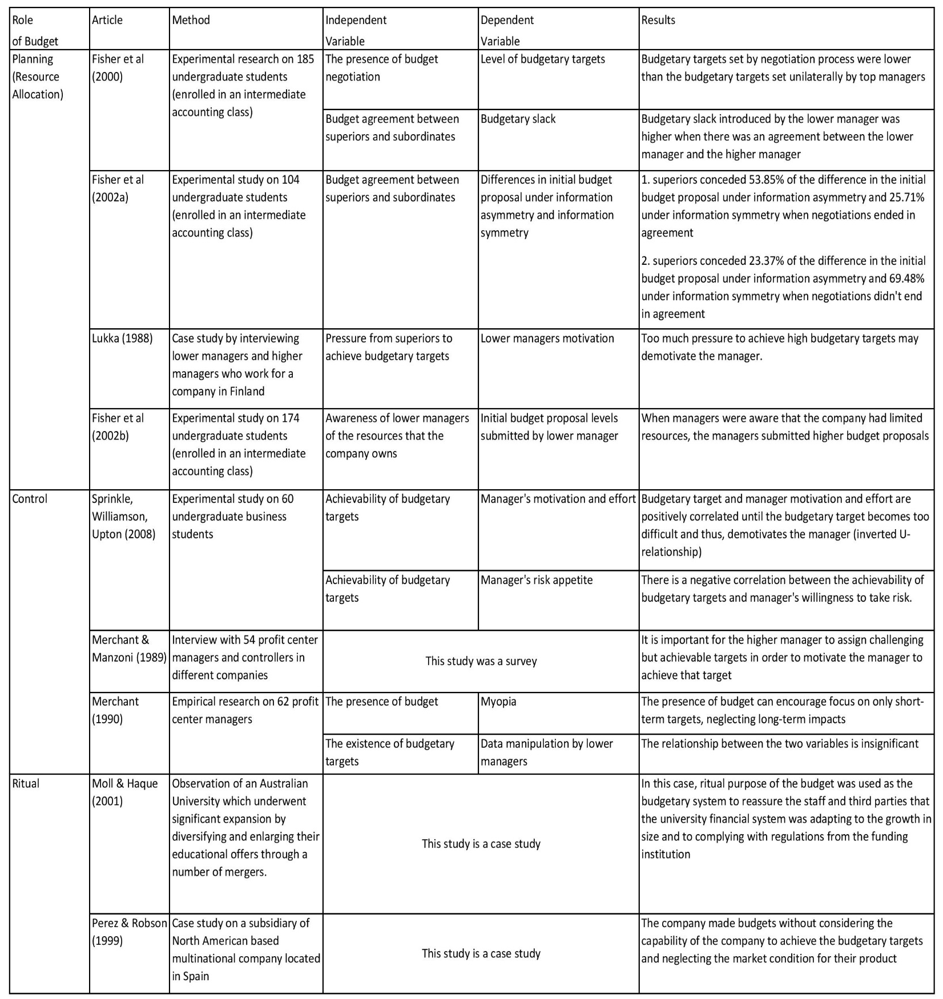
Table 2: Summary of Literature Reviewed on the Roles of Budget

3.3 The Advantages of Budget
In the previous section we established that although budgeting has some drawbacks, practitioners still perceive budgets as an important control tool. This is because the practitioners believe that the benefits offered by the budget outweigh the costs. In this section, we will look at these benefits of budgeting, mentioned by the practitioners in more detail.

3.3.1 Coping with Ambiguity
Role ambiguity happens when people are uncertain about the expectations surrounding his or her role in an organization. It may happen when a person’s responsibilities, goals, and expectations are unclear. The existence of role ambiguity is often associated with negative impacts on job performance and job satisfaction. Therefore, when the role ambiguity surrounding a job is high; a manager tend to perform poorly (Jackson & Schuler, 1985; Marginson & Ogden, 2005; Tubre & Collins, 2000). Given the disadvantage above, role ambiguity may become a company problem which affects the manager performance and consequently, the company’s performance. As a result, the presence of role ambiguity must be minimized or better still, erased completely.
Marginson & Ogden (2005) conducted a case study on a major UK based organization which operate in the communications business. In this research, Marginson & Ogden (2005) hypothesized that: (1) individuals who experience high level of role ambiguity will more likely to meet the budgetary target than who don’t experience role ambiguity; (2) Performance is inversely related to role ambiguity; (3) Commitment to achieve the budgetary targets will lead to higher performance. The result of the research confirmed that there is a strong correlation between the variables, providing support for all of the hypotheses. The confirmation of the first hypothesis confirmed that the existence of role ambiguity in a managerial position makes the manager feel less secure about his or her job. In this case, meeting the budgetary target will gives a feeling of security to the manager (Roberts, 1991) These findings deny Hope & Fraser’s (2003) criticism on budgeting. In their paper, Hope & Fraser (2003) argue that individuals would revert to their old behaviors once the incentive (reward or punishment) to meet the budgetary targets was abolished. However, these findings indicate that there are other incentives such as goals clarity and job security for the managers to meet the budgetary targets.
The confirmation of the second hypothesis indicated that the existence of role ambiguity may bring negative impact to the manager’s performance. These findings are in line with the research mentioned in the first paragraph. However, the acceptance of the last hypothesis indicated that budgets can be used as an effective tool to cope with uncertainty and thus enhance company’s performance. A similar finding was also suggested by Marginson, McOulay, Roush, van Zijl (2014) in their study on managers employed by Newcom (a major organization in telecommunication industry).
Chenhall & Brownell (1988) also highlighted the significance of role ambiguity as an intervening factor between the use of a budget and job performance. In their study on middle-managers who worked in large manufacturing companies, Chenhall & Brownell (1988) observed that the use of participatory budgeting can reduce role ambiguity experienced by managers and thus enhance the manager’s performance. Furthermore, Brownell & Dunk (1991) conducted a similar study on manufacturing companies in Sydney, Australia and found similar findings with Chenhall & Brownell findings. However, this indirect positive relations is not followed by a direct positive relation between participatory budgeting and job performance. Some researchers have suggested that the use of participatory budgeting can result in budgetary slack which in turn results in lower job performance (e.g. Stedry, 1960; Bryan Locke, 1967). By involving lower level managers in the budgeting process, the lower-level managers have an opportunity to introduce budgetary slack by negotiating for lower budgetary targets (Libby & Lindsay, 2010). This negative correlation with budgetary slack makes the real effects on budgetary targets towards and job performance ambiguous. A similar finding was also suggested by Chenhall & Brownell (1988). The result of their study indicates that there is a negative insignificant direct correlation between budgetary targets and job performance. Although participatory budgeting can be problematic, the absence of participatory budgeting can also result in an inadequacy of resources for subordinates to perform the job (Nouri & Parker, 1998)
The discussion above provides an explanation of how role ambiguity act as a mediating factor that can enhance organizational performance. Although the use of participatory budgeting may result in lower job performance, the evidence presented above suggested that budget can be used as a tool to cope with role ambiguity and thus enhance job performance. This reason becomes one of the reasons for the companies to stick with budget

3.3.2 Budget Influence on Job Satisfaction and Job-Related Tension
The use of budgets is not only related to higher job performance. It is also associated with higher job satisfaction and lower job-related tension (Chenhall & Brownell, 1988; Lau & Sholihin, 2005; Lau. & Buckland, 2001). Chenhall & Brownell (1988) found that there is an indirect positive relation between the use of a budget and job satisfaction with role ambiguity as a mediating factor. Lau & Sholihin (2005) in their study on managers employed by manufacturing companies listed in the Indonesian Capital Market Directory, hypothesized that there is an indirect relation between the use of financial performance measures and job satisfaction with fairness in the performance evaluation procedure and trust in their higher manager acting as intervening factors between these two variables. The results of their study showed support for the hypothesis meaning that job satisfaction can be enhanced by the use of budgets.
The presence of role ambiguity may trigger managers to demand for structure and certainty (Kahn, Wolfe, Quinn, Snoek, & Rosenthal, 1964) The presence of a budget arguably provides this structure and certainty demanded by managers and thus reduces role ambiguity and increases job satisfaction (Lau & Sholihin, 2005). Budgetary targets can provide goal clarity because budgetary targets specify the goals which should be achieved by managers in the form of financial terms. Providing better clarity of expectations and goals that the manager should achieve will lead to higher job satisfaction and thus enhance managerial and company performance. In this case, budgets act as guidance for the manager to work towards organizational strategy and goals by providing the manager with clear expectations and goal clarity and thus, job security.
It is important for the top managers to build a fair performance evaluation procedure. Providing a fair performance evaluation system can be done by assigning achievable budgetary targets and decent rewards for achieving the budgetary targets. Although some previous experimental research has indicated that managers will be more motivated if they are assigned to highly unachievable targets (e.g. Otley (1987); Dunbar (1971); Horngren and Foster (1987)), Merchant & Manzoni (1989) argued that the results of these experimental studies are invalid in this case due to the short-term nature of the studies. In contrast with the experimental research findings, Merchant & Manzoni (1989) in their interviews with 54 profit center managers and controllers in different companies, found that setting highly achievable but challenging targets increase the motivation of departmental managers. Furthermore, the results of their interviews also suggested that 87% of the managers surveyed saw the probability to achieve their budgetary targets is equal to 75% or more. This evidence indicates the awareness of the superiors to assign a fair budgetary target to subordinates. Superiors who employed unfair budgetary targets were unlikely to be perceived as acting benevolently toward their subordinates and thus, unlikely to be trusted by subordinates and as a result, lowering subordinates job satisfaction (Magner. & Welker, 1994; Magner, Welker, & Campbell, 1995)
Zand (1997) defines trusting behavior as a willingness to increase vulnerability by relying on another person whose their behavior can not be controlled. Trust can be either constructive or destructive. Constructive trust forms if both of the parties agreed to collaborate to solve the problems together thus increasing the effectiveness and efficiency. However, trust can be destructive if someone chooses to deviate from the agreements. Zand (1997) described that in situations where a party abuses the agreement, the trusting person is the one who will most likely to receive less potential benefit than potential loss.
Constructive trust between subordinates and their top managers can bring positive effects to the organization. When trust is present, subordinates will be more likely to be open to their superior thus gaining the opportunity to discuss their thoughts on the budgetary targets that they are required to achieve while their superiors can also increase their understanding of how their company is operating. The communication between top management with lower management will lower stress and job-related tension and thus lead to higher job satisfaction (Lau. & Buckland, 2001).
The discussion above highlights the role of budgets in improving trust and reducing job-related tension. The budget can improve trust between lower managers and top managers by improving communication between superiors and subordinates. Communication between top management and lower management is vital in determining company success. Similarly, maintaining low job-related tension is important to reduce subordinates anxiety and stress which will, in turn, have a positive impact on the subordinates performance. Enhancing trust and reducing job-related tension can be realised by creating a fair performance evaluation system (budget). By doing so, thus, job satisfaction can be improved and job-related tension can be reduced. The improvement of job satisfaction and the minimization of job-related tension will ultimately be beneficial to company performance, providing another reason for the companies to stick with budgets.

3.3.3 The Advantage of Budgetary Slack
The use of budgets as a control tool has been criticized for bringing dysfunctional effects to a company (Wallander, 1999; Hope & Fraser, 2003). One of these dysfunctional effects that might be caused by budget is budgetary slack. Budgetary slack is defined as an intentional action by lower managers to set the budgetary target lower than the actual forecast in order to increase the probability of achieving the budgetary target (Lukka, 1988). Dysfunctional effects of budgetary slack include isolating organizational members from the motivational function of the budget, limiting the effort exerted by organizational members and inefficient use of organizational resources (Fisher, Frederickson, & Peffer, 2002a; Fisher.., Frederickson, & Peffer, 2000).
In contrast, some researchers have found that budgetary slack can bring benefits to the company (Merchant. & Manzoni, 1989; Lukka, 1988; Davila & Wouters, 2005). Organization through the top management can deliberately create a budgetary slack to affects lower managers. Davila & Wouters (2005) conducted a case study in budgeting practices on four logistic centers located in America, Asia, Europe, and Southeast Asia owned by a technological company. They hypothesized that higher levels of activity are associated with larger budgetary slack. In the paper, a higher level of activity refers to the existence of multiple targets that should be achieved by the managers. In their analysis, they found support for this hypothesis indicating that higher managers tended to lower the budgetary targets, allowing budgetary slack to happen when multiple goals were present. Allowing managers to focus on multiple targets means that they should not only focus on achieving financial targets, but also nonfinancial targets such as customer satisfaction, innovation, and learning. Devoting some of the managerial focus to achieve nonfinancial targets is argued to be important for ensuring the company’s long term sustainability (Kaplan & Norton, 1996).
Additionally, Van der Stede (2000) in his study on large diversified firms in Belgium, found support for his hypothesis which stated that there is a negative relations between budgetary slack and manager short-term orientation. In other words, he found that when there was lower budgetary slack, the manager was more likely to focus on short-term budgetary targets rather than long-term targets and hence, neglecting the long term consequences. Conversely, as discussed in the previous section, Sprinkle, Williamson & Upton (2008) found evidence which showed that lower budgetary targets encourage the manager to take on more risk. The risk described by Sprinkle, Williamson & Upton (2008) referred to activities such as research and development which involve higher uncertainty on the return. However, when research and development successfully invents a new product, the benefit that the company receives will be huge.
Another advantage of allowing budgetary slack is because it helps the lower manager to cope with uncertainty (Merchant. & Manzoni, 1989). Merchant and Manzoni (1989), in their survey on managers in 12 different companies operating in different industries, found that one of the benefits of budgetary slack was increased flexibility. Merchant & Manzoni (1989) argued that flexibility is important for the lower manager to cope with business environment which often involve uncertainty. Furthermore, it allows the lower manager to make discretionary expenses which may bring future benefits without waiting for approval from the superior. Lukka (1988), in her interviews on different level of managers employed by US based companies, argued that allowing budgetary slack could increase subordinate motivation. This finding agrees with Sprinkle, Williamson & Upton (2008) findings in their experimental research on sixty undergraduate students, which established that unachievable budgetary targets demotivates the manager. The pressure to achieve high budgetary targets causes demotivation while lowering the budgetary targets increases the manager’s motivation.
The results of these studies imply that budgetary slack can be used as a useful tool for the company to cope with the different situations faced by the company. When the company faces high uncertainty which often associated with high risk, top managers can encourage the lower manager to take less risk by assigning higher budgetary targets (Davila & Wouters, 2005; Sprinkle, Williamson, & Upton, 2008). The cost, however, is that the organization’s spending on activities that are useful in the long term will be decreased. Long-term impact of implementing this policy may be harmful for company’s future since focusing only on short-term achievement may harm the sustainability of the company. In situation of stability, top managers should encourage the lower managers to pursue multiple targets by assigning lower budgetary targets. These multiple targets can include research and development and customer satisfaction which both play important roles in company’s long-term sustainability. Other benefits of allowing budgetary slack are: (1) increasing subordinate motivation; and (2) increasing company’s flexibility. These findings indicate that allowing budgetary slack may bring benefits to the company. However, managers must fully aware of company’s and subordinate’s situation before making decision to allow budgetary slack

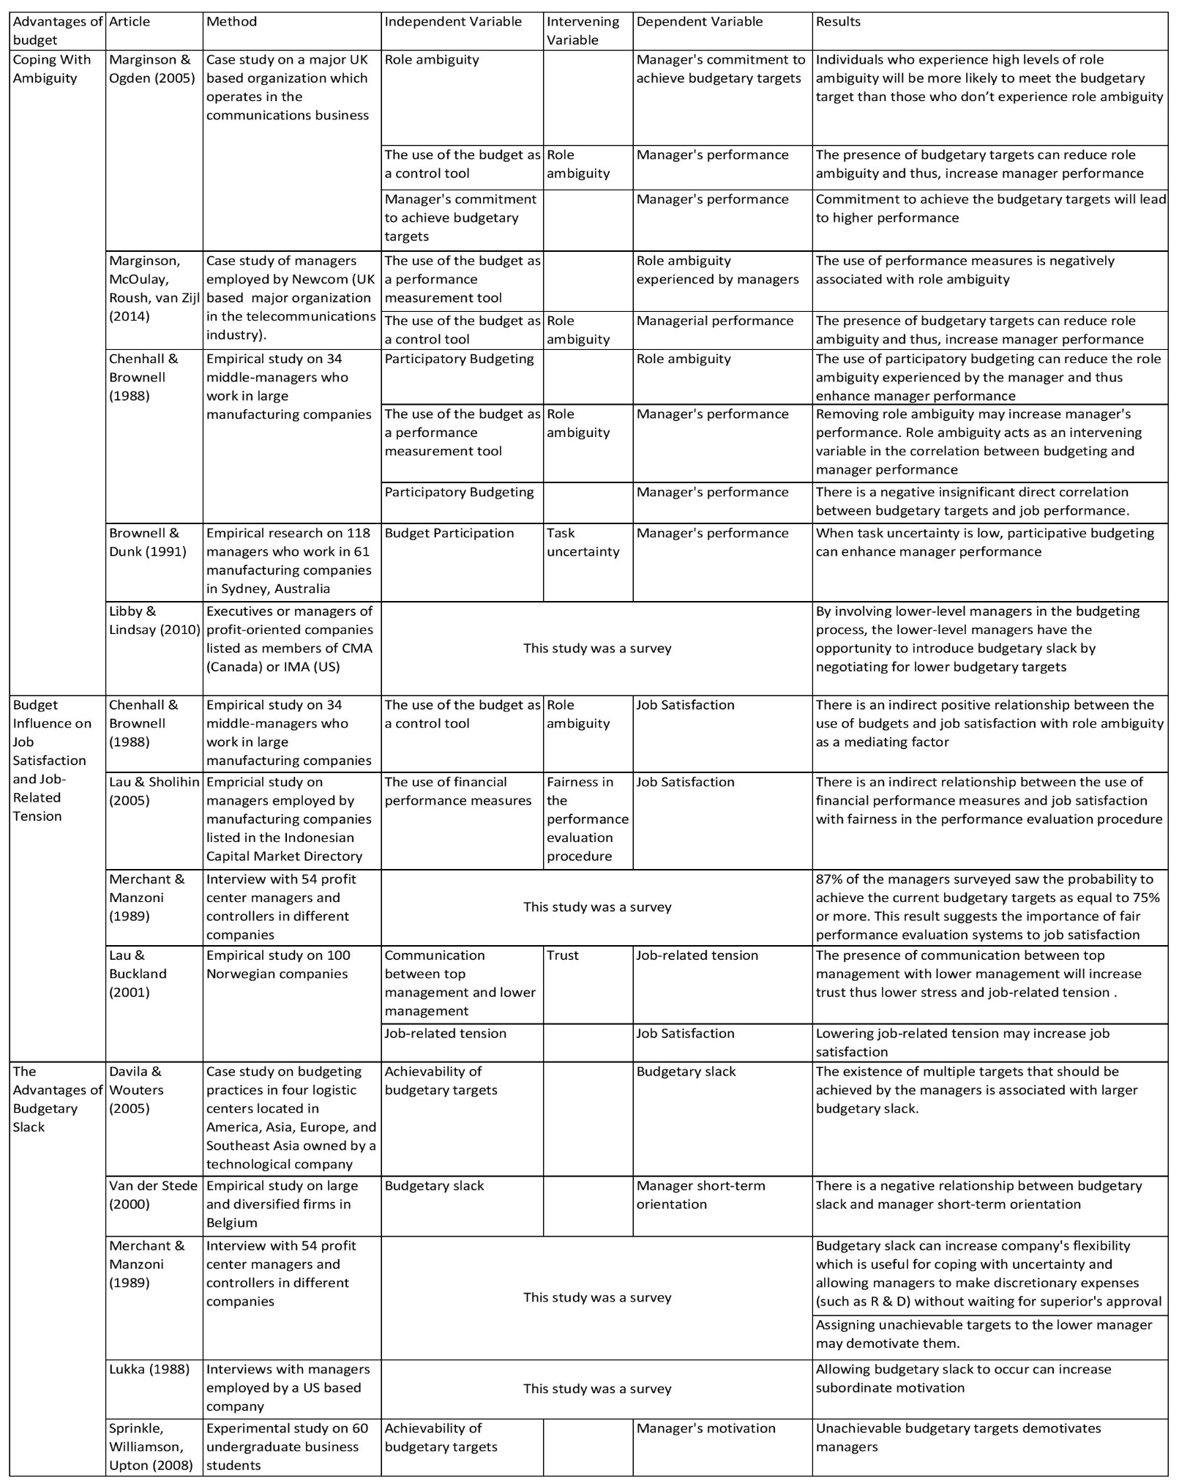
Table 3: Summary of Literature Reviewed on the Advantages of Budget

3.4 The Disadvantages of Beyond Budgeting
The beyond budgeting concept is often regarded as one of the possible solutions to the dysfunctional effect caused by budgets. Hope & Fraser (2003) argue that the application of beyond budgeting can solve the problem of budgetary gaming caused by the use of budgets. They also argue that the use of budget may discourage the manager to achieve more in a situation when maximum compensation is already achieved. Furthermore, Hope & Fraser (2003) argue that beyond budgeting can eradicate myopia by the lower managers by abandoning the use of budgetary targets. Despite the advantages proposed by academics, beyond budgeting, unlike other managerial accounting concepts, has not been widely adopted by practitioners (Ostergren & Stensaker, 2011; Libby & Lindsay, 2010; Ekholm & Wallin, 2000).
Ostergren & Stensaker (2011) argue that the reason practitioners have not adopted beyond budgeting is that the drawbacks of the beyond budgeting model have not been fully uncovered. Most of the executives are not willing to take risks by switching to beyond budgeting. Furthermore, Ostergren & Stensaker (2011) in their empirical study on a multidivisional company which applied beyond budgeting, have proposed two possible challenges faced by beyond budgeting users: unrealistic targets and gaming problems.
The problem of the unrealistic budget is related to the use of benchmarking as one of the important components in the performance evaluation system of beyond budgeting model. Benchmarking refers to the performance evaluation model that evaluates subordinates performance by comparison with competitor’s performance (Anthony, Govindarajan, Hartmann, Kraus, & Nilsson, 2014). Ostergren & Stensaker (2011) argue that superiors may then become over-motivated to sit at the top of the table. This kind of motivation is good when a company has enough resources to achieve such targets, but the outcome is different when the company does not have the resources required to achieve the budgetary target. In this situation, pressure from superiors on subordinates to attain the unachievable budgetary targets will demotivate the subordinates, thus lowering the company’s performance (Sprinkle, Williamson, & Upton, 2008; Lau & Sholihin, 2005; Ostergren & Stensaker, 2011)
It has been argued that the use of budgets may result in budgetary gaming by subordinates (Hope & Fraser, 2003). This argument later becomes one of the reason for academics to propose beyond budgeting to replace traditional budgeting. However, Ostergren & Stensaker (2011) argue that beyond budgeting may also result in different type of gaming. Since, the beyond budgeting model prescribes less financial performance measures and more nonfinancial performance measures, the performance evaluation within the company can become more subjective. This subjectivity can allow multi-interpretation of the budgetary targets and open up opportunities for budgetary gaming to be done by subordinates.
Another disadvantage has been suggested by Becker (2014) who conducted a case study in four different companies which applied the beyond budgeting model as their planning and control tool. Two of these four companies opted to reapply budgeting and abandon beyond budgeting. The reason for the companies to reapply budgeting as their planning and control tool were: (1) they underwent a crisis (2) departure of key personnel (3) management were not accustomed to beyond budgeting.
Becker (2014) study found that the budget is useful when the company is in crisis. Respondents from companies who have opted to reintroduce budgets, argue that in the light of crisis, the budget can be used as a kind of contract between superiors and subordinates to limit their expenses. As a result, the use of a budget can provide certainty in the light of crisis. Additionally, lower managers surveyed felt that the existence of budgetary targets in times of crisis provided clarity and job security. These findings are consistent with previous findings by Marginson & Ogden (2005) and Marginson et al. (2014). Moreover, in both of the cases, Becker (2014) also highlighted the departure of key personnel as a key factor for the company to reintroduce the budget. The decision to the abandon budget has been made by the old management but, it became apparent that not all managers were accustomed to beyond budgeting. As a result when the old managers depart, the new management chose to reintroduce model. Additionally, Becker (2014) noted that when problems relating to planning and control occurred, the old managers who were still with the company tended to see the budget as the solution. This finding indicates that even though some of the practitioners argue for the abandonment of the budget, most of the practitioners are still not accustomed to the situation where the budget is absent. This indicates that the understanding of practitioners toward beyond budgeting is still low and therefore they opt to stick with budgets. However, despite the findings above, the sample used by the authors make the authors unable to investigate the usefulness of beyond budgeting model in the absence of uncertainty thus providing an opportunity for further research.
In summary, despite the academics arguments regarding advantages of budget, the evidence indicates that the beyond budgeting model, in practice, also have some disadvantages. Alongside with practitioners unfamiliarity with beyond budgeting model, these become factors which make the company sustain with the use of budget. However, as the concept of beyond budgeting is relatively new, further research is needed to decide whether beyond budgeting is capable of replacing the budget.

Chapter 4
Discussion & Conclusion
4.1 Discussion
This paper aims to identify factors which influence most of the practitioners to adopt and sustain the use of budget given the criticism from the academics. Based on the review, most of the managers argued that budgeting still play an important role as a planning and control tool. Although most of the managers agreed that budget is a useful tool, they were also aware that budget brings some negative effects on the company, such as providing an incentive for lower managers, to negotiate for lower budgets, resource and time consuming, reducing company’s flexibility and providing an incentive for the lower manager to conduct budget gaming. Despite the disadvantages above, the results of our review indicate that the solution to such problems is not budget abandonment. Instead, most of the managers argued that improvement on budgeting practice should be made. The improvement that should be made including rolling forecast, less detailed budgets, and aligning the budget with company’s strategy.
Our review also indicates that the budgeting still plays important roles in the company. Budgeting plays an important role as a tool to help the manager to allocate resources by allowing a budget negotiation between superiors and subordinate to take place. Budget negotiation processes, if they are designed correctly, can enhance lower manager motivation. Enhancing manager’s motivation to achieve budgetary targets is important for aligning managerial action with the company’s strategy and goal. Our review indicates that providing the lower manager with challenging but achievable target can increase lower manager’s motivation and effort. On the other hand, over-challenging budgetary targets can discourage managers to take the risks (including discretionary expenses and long term investments which may bring benefit for the company in the future). Despite the positive role of budget mentioned above, our review also found some negative impact of budget. Budgets are often developed not for management control purposes. Instead, they are developed for other reasons such as complying with regulations and signaling professionalism. Even if the budget was developed for planning and control purposes, in some cases, managers fail to use budget according to the initial purposes. As a result, budget were used for ritualistic and symbolic reason rather than for control and planning reason.
Besides its roles in the company, budgeting is also associated with various advantages. First, it has been argued that budgets can be used to cope with role ambiguity. Budgets can eliminate role ambiguity by providing goal clarity which provides direction about things that they should achieve. Eliminating role ambiguity is important since it is argued to be able to enhance manager’s job performance and thus company’s performance. Second, the literature reviewed have indicated that the use of a budget can indirectly increase job satisfaction by providing a fair performance evaluation system and also indirectly reduce job-related tension with trust as an intervening variable. The trust can be enhanced by improving the communication between lower managers and higher managers. As the trust between lower managers and higher managers increases, job-related tension will decrease. Third, the budget is still used by companies because it allows managers to introduce budgetary slack. Budgetary slack has been argued to bring negative impacts to company’s performance. However, the literatures reviewed suggest that when higher managers are fully aware of the trade-off between the achievability of budgetary targets and myopia, the budget can be used as a tool to influence manager behavior. In a situation of uncertainty, the higher managers can assign a challenging target but achievable target, encouraging managers to take less risky action. In the relatively stable situation, higher manager can assign an easy target which is useful to reduce myopia,
Another reason for a company to adopt and sustain with the use of budget is because they are unfamiliar with the alternatives to budget, such as beyond budgeting. Most of the managers are accustomed to the use of budget. As a result, when the budget is abandoned, there will be a lack of guidance for the managers on what should they achieve. Furthermore, it is also argued that the use of the beyond budgeting model can create other problems such as the assignment of unrealistic targets as a result of the application of benchmarking and new forms of budget gaming.
  - Research Limitations and Suggestions for Future Research
This research has also have some limitations. First, there are some limitations related to the methodology. The type of this research is a literature review. Therefore, it only reviews the existing articles without providing any empirical evidences. Second, the articles reviewed in this research are limited. They have been sourced from only management or accounting journals. Meanwhile, the topic of budgeting is widely discussed by other disciplines. Therefore, it provides an opportunity for future research to investigate this topic with wider samples of article from different disciplines. Furthermore, most of the articles reviewed are based on empirical evidence from profit-oriented Europe and North American based companies. As a result, the generalizability and the practicability of the outcomes of this study might be limited due to the differences in culture and different types of companies. Therefore, further research is needed to review the factors affecting the companies in the nonprofit oriented companies and different regions. Third, in this research, it is identified that some of the relations between independent and dependent variables are indirect. This means that in order to influence dependent variables, independent variables must be able to affect the intervening variables. However, it needs further research whether there are a direct relations between the independent and dependent variables. If such relations exist, it is also important to investigate how the direct relations link the independent and dependent variables.

4.3 Conclusion
Overall this review provide four reasons for the manager to adopt and sustain the use of budget: (1) the management view on budget, (2) the roles of budget, (3) the advantages of budget, and (4) the disadvantages of beyond budgeting as an alternative to budget. However, not all of these reasons positively influence the company. This is evident from manager’s complaint regarding the dysfunctional effect of budget. Furthermore, in some cases, our review identified that managers are using budget for other than planning and control reason. They often use it for a ritualistic and symbolic reasons. Despite the negative impacts of budget to the company, most of the managers argued that the solution to budgeting problems are not budget abandonment. Most of the managers argued that the solution to such problems are budget improvements.

Bibliography
Ahmad, N. N., Sulaiman, M., & Alwi, N. M. (2003). Are Budget Useful? A Survey of Malaysian Companies. Managerial Auditing Journal, 18(9), 717-724.
Anthony, R. N., Govindarajan, V., Hartmann, F. G., Kraus, K., & Nilsson, G. (2014). Management Control System European Edition. New York: McGraw-Hill Education.
Banker, R. D., Potter, G., & Srinivasan, D. (2000). An Empirical Investigation of an Incentive Plan That Includes Nonfinancial Performance Measures. The Accounting Review, 75(1), 65-92.
Becker, S. (2014). When Organisations Deinstitutionalise Control Practices: A Multiple-Case Study of Budget Abandonment. European Accounting Review, 23(4), 593-623. doi: 10.1080/09638180.2014.899918
Brownell, P., & Dunk, A. S. (1991). Task Uncertainty and Its Interaction With Budgetary Participation and Budget Emphasis: Some Methodological Issues and Empirical Investigation. Accounting, Organization and Society, 16(8), 693-703.
Chenhall, R. H., & Brownell, P. (1988). The Effect of Participative Budgeting on Job Satisfaction and Performance: Role Ambiguity as an Intervening Variable. Accounting, Organization, and Society, 13(3), 225-233.
CIMA. (2011, March). Survey: Why don't more company use beyond budgeting? Retrieved from http://www.cimaglobal.com/Thought-leadership/Newsletters/Insight-e-magazine/Insight-2011/Insight-March-2011/Why-dont-more-companies-use-beyond-budgeting/
Davila, T., & Wouters, M. (2005). Managing budget emphasis through the explicit design of conditional budgetary slack. Accounting, Organizations and Society, 30, 587-608.
Demski, J. S., & Feltham, G. A. (1978). Economic incentives in budgetary control systems. The Accounting Review, 53, 336-539.
Ekholm, B.-G., & Wallin, J. (2000). Is The Annual Budget Really Dead? The European Accounting Review, 9(4), 519-539.
Fisher, J., Frederickson, J. R., & Peffer, S. A. (2002a). The eﬀect of information asymmetry on negotiated budgets: an empirical investigation. Accounting, Organizations and Society, 27, 27-43.
Fisher., J., Frederickson, J. R., & Peffer, S. A. (2002b). The eﬀect of information asymmetry on negotiated budgets: an empirical investigation. Accounting, Organizations and Society, 27, 27-43.
Fisher.., J. G., Frederickson, J. R., & Peffer, S. A. (2000). Budgeting: An Experimental Investigation of the Effects of Negotiation. The Accounting Review, 75(1), 93-114.
Hansen, D. R., & Mowen, M. M. (2007). Managerial Accounting (8 ed.). Ohio: South-Western Cengage Learning.
Hansen, S. C., Otley, D. T., & Van der Stede, W. A. (2003). Practice Developments in Budgeting: An Overview and Research Perspective. Journal of Management Accounting Research, 15, 95-116.
Hope, J., & Fraser, R. (2003). New Ways of Setting Rewards: The Beyond Budgeting Model. California Management Review, 45(4), 104-119.
Ittner, C. D., Larcker, D. F., & Rajan, M. V. (1997). The Choice of Performance Measures in Annual Bonus Contract. The Accounting Review, 72(2), 231-255.
Ittner., C. D., & Larcker, D. F. (1998). Are Nonfinancial Measures Leading Indicators of Financial Performance? An Analysis of Customer Satisfaction. Journal of Accounting Research, 36(3), 1-35.
Jackson, S. E., & Schuler, R. S. (1985). A Meta-analysis and Conceptual Critique of Research on Role Ambiguity and Role Conflict in Work Settings. Organizational Behavior and Human Decision Processes, 36, 16-78.
Joseph G Fisher, L. A. (2002). Using Budgets for Performance Evaluation: Effects of Resource Allocation and Horizontal Information Asymmetry on Budget Proposals, Budget Slack, and Performance. The Accounting Review, 77(4), 847-865.
Joseph G Fisher, L. A. (2002b). Using Budgets for Performance Evaluation: Effects of Resource Allocation and Horizontal Information Asymmetry on Budget Proposals, Budget Slack, and Performance. The Accounting Review, 77(4), 847-865.
Kahn, R. L., Wolfe, D., Quinn, R., Snoek, J., & Rosenthal, R. (1964). Organizational stress: studies in role conflict and role ambiguity. New York: Wiley.
Kaplan, R. S., & Norton, D. P. (1996). The Balanced Scorecard—translating strategy into action. Boston: Harvard Business School Press.
Lau, C. M., & Sholihin, M. (2005). Financial and nonﬁnancial performance measures: How do they affect job satisfaction? The British Accounting Review, 37, 389-413.
Lau., C. M., & Buckland, M. (2001). Budgeting - the Role of Trust and Participation: A Research Note. ABACUS, 37(3).
Libby, T., & Lindsay, R. M. (2010). Beyond budgeting or budgeting reconsidered? A survey of North-American Budgeting Practice. Management Accounting Research, 21, 56-75.
Lowe, A., & Locke, J. (2006). Constructing An 'Efficient Frontier' of Accounting Journal Quality. The British Accounting Review, 38, 321-341.
Lukka, K. (1988). Budgetary biasing in organization: theoretical framework and empirical evidence. Accounting Organizations and Society,, 13(5), 281-301.
Macintosh, N. B. (1995). Management accounting and control systems: an organizational and behavioral approach. New York: Wiley.
Magner, N., Welker, R. B., & Campbell, T. L. (1995). The interactive effect of budgetary participation and budget favorability on attitudes toward budgetary decision makers: a research note. Accounting, Organizations and Society, 20, 611-618.
Magner., N., & Welker, R. B. (1994). Responsibility center manager’s reactions to justice in budgetary resource. Advances in Management Accounting, 3, 237-253.
Marginson, D., & Ogden, S. (2005). Coping with ambiguity through the budget: the positive eﬀects of budgetary targets on managers’ budgeting behaviours. Accounting, Organization, and Society, 30, 435-456.
Marginson, D., McAulay, L., Roush, M., & Zijl, T. v. (2014). Examining a positive psychological role for performance measures. Management Accounting Research, 25, 63-75.
Merchant, K. A. (1990). The effects of financial control on data manipulation and management myopia. Accounting, Organizations, and Society, 15(4), 297-313.
Merchant., K. A., & Manzoni, J. (1989). The Achievability of Budget Targets in Profit Centers: A Field Study. The Accounting Review, 64(3), 539-558.
Mill, J. S. (1874 [1843]). A System of Logic, Ratiocinative and Inductive. New York: Harper & Brothers.
Moll, J., & Haque, Z. (2011). Budgeting for legitimacy: The case of an Australian university. Accounting, Organizations and Society, 36, 86–101.
Neely, A., Bourne, M., & Adams, C. (2003). Better Budgeting or Beyond Budgeting? Measuring Business Excelence, 7(3), 22-28.
Neely, A., Sutcliff, M., & Heyns, H. (2001). Driving Value Through Strategic Planning and Budgeting. New York: Accenture.
Niezen, M. G., Busschbach, J. J., Cohen, J. P., & Stolk, E. A. (2009). Finding legitimacy for the role of budget impact in drug reimbursement decisions. International Journal of Technology Assessment in Health Care, 25(1), 49–55.
Nouri, H., & Parker, R. J. (1998). The Relationship Between Budget Participation and Job Performance: The Roles of Budget Adequacy an Organizational Commitment. Accounting, Organisation, and Society, 23(6), 467-483.
Ostergren, K., & Stensaker, I. (2011). Management Control without Budgets: A Field Study of ‘Beyond Budgeting’ in Practice. European Accounting Review, 20(1), 149-181.
Perez, L., & Robson, K. (1999). Ritual legitimation, de-coupling and the budgetary process: managing organizational hypocrisies in a multinational company. Management Accounting Research, 10, 383-407.
Roberts, J. (1991). The possibilities of accountability. Accounting, Organization, and Society, 16(4), 355-368.
Rose, T., & Manley, K. (2011). Motivation toward ﬁnancial incentive goals on construction projects. Journal of Business Research, 64, 765-773.
Sandalgaard, N. (2012). Uncertainty and budgets: an empirical investigation. Baltic Journal of Management, 7(4), 397-415.
Sprinkle, G. B., Williamson, M. G., & Upton, D. R. (2008). The eﬀort and risk-taking eﬀects of budget-based contracts. Accounting, Organizations and Society, 33, 436-452.
Stede, W. A. (2000). The relationship between two consequences of budgetary controls: budgetary slack creation and managerial short-term orientation. Accounting, Organizations and Society, 25, 609-622.
Tubre, T. C., & Collins, J. M. (2000). Jackson and Schuler (1985) Revisited: A Meta-Analysis of the Relationships Between Role Ambiguity, Role Conflict, and Job Performance. Journal of Management, 26(1), 155-169.
Umapathy, S. (1987). Current Budgeting Practice in US Industry. New York: Quorum Books.
Waal, A. A. (2005). Is your organization ready for beyond budgeting? Measuring Business Excellence, 9(2), 56-67.
Wallander, J. (1999). Budgeting - an unnecessary evil. Scandinavian Journal of Management, 15, 405-421.
Webster, J., & Watson, R. T. (2002). Analyzing The Past to Prepare For the eFuture: Writing A Literature Review. MIS Quarterly, 26(2), xiii-xxiii.
Zaller, J., & Feldman, S. (1992). A Simple Theory of the Survey Response: Answering Questions versus Revealing Preferences. American Journal of Political Science, 36(3), 576-616.
Zand, D. E. (1997). The Leadership Triad: Knowledge, Trust, and Power. New York : Oxford University Press.

