Erasmus University Rotterdam
Erasmus School of Economics

Master thesis
The effect of facial attractiveness in social media on people’s attitudes.

July 3rd, 2019
Student: Rutger van Noort
Student Number: 415785
Thesis supervisor: Dasha Kolesnyk
Second Reader: Dr. Michiel van Crombrugge

Summary
This research focuses on the effects of beauty in social media. Specifically, facial attractiveness. Social media is ubiquitous these days and some people cannot even imagine a life without it anymore. Some people even earn their money with it as social media influencers and companies use it to further advertise their products. Of course, it is important for these influencers and companies to have a ‘reach’ that is as big as possible (reach meaning how many people see your posts). This can be increased by increasing the amount of followers. But, the attractiveness of people shown in these posts matters. For example, most companies tend to advertise (on social media) using an attractive person, rather than an unattractive person. This is most likely because attractive people are more associated with favorable personality traits than unattractive people (Miller, 1970), (Eagly et al., 1991). However, the effects of this could differ per person and have not been extensively researched yet, therefore the research question is as follows:
Does facial attractiveness of social media users influence the attitudes of their audience?
This question was tested using 6 hypotheses.
Hypothesis 1 tested whether the attractiveness of social media users affected their chances to be followed. This was done using a multi-level regression which is explained in detail in the methodology. The results show that their attractiveness indeed affects their chances to be followed on social media.
The second hypothesis tested whether young respondents have a different view on attractiveness compared to middle-aged and older respondents, specifically whether young respondents rated the attractiveness of all faces lower or not. The results indicate that this is not the case and that they rate the attractiveness of all faces equal to middle-aged and older respondents.
The third and fourth hypothesis tested whether female social media users’ ‘likelihood to be followed score’ is affected by the gender of the respondent. Specifically, whether male respondents rate the ‘likelihood to be followed’ score higher for attractive female social media users and lower for unattractive female social media users, compared to female respondents. The outcomes indicate that this is not true. Male respondents do not seem to rate the ‘likelihood to be followed’ score higher for attractive female social media users or lower for unattractive female social media users compared to female respondents.
The fifth and sixth hypotheses tested the effects of possible moderators. These possible moderators are self-esteem and happiness. I tested whether respondents’ self-esteem and happiness moderate the effect of the attractiveness rating given by respondents to social media users on respondents’ likelihood to follow those social media users. The results show that both these variables do not moderate the effect of attractiveness on ‘likelihood to be followed’.
People’s attitudes do seem to change based on the facial attractiveness of social media users. Attractiveness directly influences the chances of being followed on social media. However, no evidence for moderation could be found. Male respondents also do not seem to value beauty in women (female social media users) more than female respondents. But, even the same type of research with different questions (or inferences) asked could produce different results (Eagly et al., 1991). This means that this type of research is very sensitive to changes and it could almost always prove valuable or interesting to do more research on this topic.
Table of content
Inhoud
1. Introduction 5
2. Literature overview and hypotheses 8
3. Conceptual model 11
4. Methodology 12
4.1 Survey and study design 12
4.2 Variables 13
4.3. Analysis 16
4.4 Assumptions of the model 19
5. Results 21
5.1 The effect of attractiveness 21
5.2 The differences of age 23
5.3 Male vs female valuation 25
5.4 Moderating variables 29
6. Conclusion 33
6.1 Summary and conclusion 33
6.2 Shortcomings, improvements and recommendations 34
References 37
Appendix 39

1. Introduction
This thesis will discuss the effects of facial attractiveness on people’s attitudes. Of course, this kind of research in the offline context has already been done before, and that is why this research will be done in a social media context.
There have been numerous articles researching various effects of beauty. For example Dion, Berscheid and Walster (1972) conclude in their article that “what is beautiful is good”. Eagly et al. (1991) discuss this ‘beautiful is good’ stereotype. This stereotype suggests that people tend to ascribe more favorable personality traits and more successful life outcomes to attractive persons than to unattractive persons. However, this does depend on the exact questions asked to respondents. Eagly et al. (1991) also name quite a lot of other articles/reviewers that confirm the stereotype, but conclude that the stereotype is actually “not as strong or general as suggested by the often-used summary phrase what is beautiful is good”. Benson et al. (1976) researched the effects of attractiveness, race and sex on the chance to receive help. They concluded that attractiveness and race did have a significant effect, but gender did not.
With the rise of social media in the 21st century it is possible that some of these effects or attitudes have changed. For instance, Benson et al. (1976) mentioned that there is no effect of gender on the chance to receive help, but maybe that has changed throughout the years. Maybe the “beautiful is good” stereotype is not really a stereotype anymore. It is possible that social media would play a role in these (possible) changes. We see a lot more people on a daily basis nowadays looking at our phone or computer screens and maybe that changes our attitudes towards attractive/unattractive persons. This is why I want to investigate the effect of attractiveness of social media users on the attitudes of their audience. Therefore the research question that will be addressed in this paper is:
Does facial attractiveness of social media users influence the attitudes of their audience?
Of course, not all social media platforms are the same. That is why I will use four different platforms in my research. These are: Instagram, Facebook, Twitter and Snapchat. The option ‘other’ was also added to provide an option for respondents that use social media but are not active on the four specific platforms given. These four platforms were chosen because I don’t want the platforms to differ too much and these four are very well known (with Facebook being the number one most popular platform¹) and similar to each other. I want to focus only on casual platforms, since more professional platforms, such as LinkedIn, could bear different results because they are associated with more professionality and attractiveness might not play a (big) role in that case.
By now, almost everyone is familiar with Facebook, having over 2.38 billion monthly active users². It is a social site where you can post pictures, comments, videos, etc. and interact with your friends. Instagram is very similar to this, with the addition of Instagram stories; short videos that disappear after 24 hours. (stories were also added to Facebook while writing this paper). Snapchat basically only has this story feature. Twitter is also very similar to Facebook, although it seems to be treated more like a blogging site than Facebook even though the features are more or less the same. The ‘other’ platforms in the survey are mostly wechat or tumblr but, there are also some respondents that have filled in linkedin. This is why it could be possible for the ‘other’ platform to have different results than the rest. More of this will be described in the methodology.
The purpose of this study is to find evidence for whether people are more inclined to follow attractive people on social media compared to unattractive people.
To test this a survey has been made in which pictures of people (social media users) were shown and respondents needed to answer how attractive they think those people (social media users) are as well as other questions regarding respondents’ own self-esteem etc. More of this will be explained in the methodology. But, first, a literature overview will be given along with the hypotheses that will be tested, followed by a conceptual model and all the variables used in this research. After that the methodology will explain exactly how the data were analyzed and the results section will present the detailed findings of those analyses. Lastly, the conclusion will give a short summary of the results along with some shortcomings and further improvements that can be made upon this research.

2. Literature overview and hypotheses
As mentioned, numerous articles in literature describe the various effects of physical attractiveness on people’s perceptions of other people. Mostly the respondents’ perceptions in these studies of attractive people differ from their perceptions of unattractive people. As mentioned, Eagly et al. (1991) discuss the “beautiful is good” stereotype and can confirm it. However they do find it to be highly variable and mention that “the results indicate that the beauty-is-good effect depends crucially on the type of inference the perceiver is asked to make”. Because of this ‘beautiful is good’ stereotype and Eagly and his colleagues describing numerous literature works and reviewers which also confirm this stereotype and with the findings of Benson et al. (1976) my first hypothesis will be a simple one, but interesting nonetheless.
H1: The more attractive a person is, the more likely they are to be followed on social media.
A factor that can be of importance when testing this hypothesis is age. By this, I mean the age of the respondents, since I cannot reliably estimate the age of the subjects (social media users) used in the survey and there is already a lot of research concluding that age affects someone’s attractiveness. But, there does not seem to be a very clear answer when it comes to the respondent’s age and whether that has an effect. Foos and Clark (2011) are one of the few that did do some research on this and found that young and middle-aged people find younger faces more attractive than older faces and older people rated all aged faces equally when it comes to attractiveness. However, overall, young raters (respondents) gave all faces lower overall rating compared to middle-aged and older raters (respondents). This means that the young raters in their study rated the attractiveness of faces lower than middle-aged and older raters. Based on Foos and Clark’s (2011) work, my second hypothesis will be:
H2: Younger respondents will, on average, rate attractiveness of all social media users (pictures/faces) lower compared to middle-aged and older respondents.
Foos and Clark (2011) used a ‘young’ category that consisted of people aged 17 to 25, the middle-aged category was aged 35 to 55 and the older category was aged between 60 and 87. The categories used in this research will be slightly different, but this will all be explained in the methodology section. Also, their research was not done in an online context, but rather by physically filling in a piece of paper on which pictures of people were shown and social media played no part in it.
It is also possible that there is a gender effect when it comes to the likelihood of being followed on social media. In ‘The Evolution of Human Mating’ (Buss, 2007) Buss concludes that men value beauty and youth more than women when it comes to mating. This means that, in relation with my research, men’s attitudes towards (un)attractive women could be different than women’s attitudes. Specifically, male respondents would value attractive women more than female respondents. It is possible for this ‘value’ to be represented by my variable ‘likelihood to be followed’. Since I have no other variables that could be considered a ‘value’ it is, of course, also possible that this will not be entirely accurate, but I want to test whether this holds up for ‘likelihood to be followed’ as well compared to a somewhat abstract ‘value’ variable. As hypothesis 1 states, I expect that the more attractive the person, the higher their likelihood to be followed will be, but since male respondents will probably differ from female respondents when it comes to female subjects my next hypotheses will be:
H3: Male respondents are more likely to follow attractive female social media users compared to female respondents.
Since men seem to value attractiveness more than women (Buss, 2007) (they think it is more important) it is also possible that the reverse is also true. Male respondents might value unattractive women less than female respondents. Therefore my next hypothesis will be:
H4: Male respondents are less likely to follow unattractive female social media users compared to female respondents.
Something that could possibly (and might even be likely to) moderate the effect of physical attractiveness on the likelihood to be followed are personality traits of the respondents. In particular, how one feels about oneself in relation to the person shown. For example, self-esteem could moderate the effect of attractiveness on the likelihood to be followed. Thornton and Maurice (1999), for example, found that women’s self-esteem seemed to be lower after seeing pictures of women with idealized physiques. Of course, this is after they saw pictures of other women (not before), but it does imply that self-esteem is related to how someone views others in relation with themselves. It is very much possible that self-esteem could be a factor when assessing someone’s attractiveness. Perhaps people with low self-esteem underrate the attractiveness of others since they might be more likely to be jealous of attractive people because they do not feel good about themselves or perhaps people with high self-esteem are more likely to exaggerate someone’s attractiveness because they are not insecure and willing to admit that someone is more attractive than them. This is what I want to find out and therefore my fifth hypothesis will be:
H5: Respondents’ self-esteem moderates the effect of the attractiveness rating the respondents give on their likelihood to follow other social media users.
Another factor that could be of importance is happiness. De Vries and Kühne (1999) found in their research that “Facebook use was related to a greater degree of negative social comparison”. This negative social comparison, however, seemed to be weaker for happier individuals. This implies that happiness is related to how people see themselves and others on social media. This is why I think that happy people are more inclined to follow someone on social media compared to unhappy people. That is why my sixth hypothesis will be:
H6: Respondents’ happiness moderates the effect of the attractiveness rating the respondents give on their likelihood to follow other social media users.

3. Conceptual model
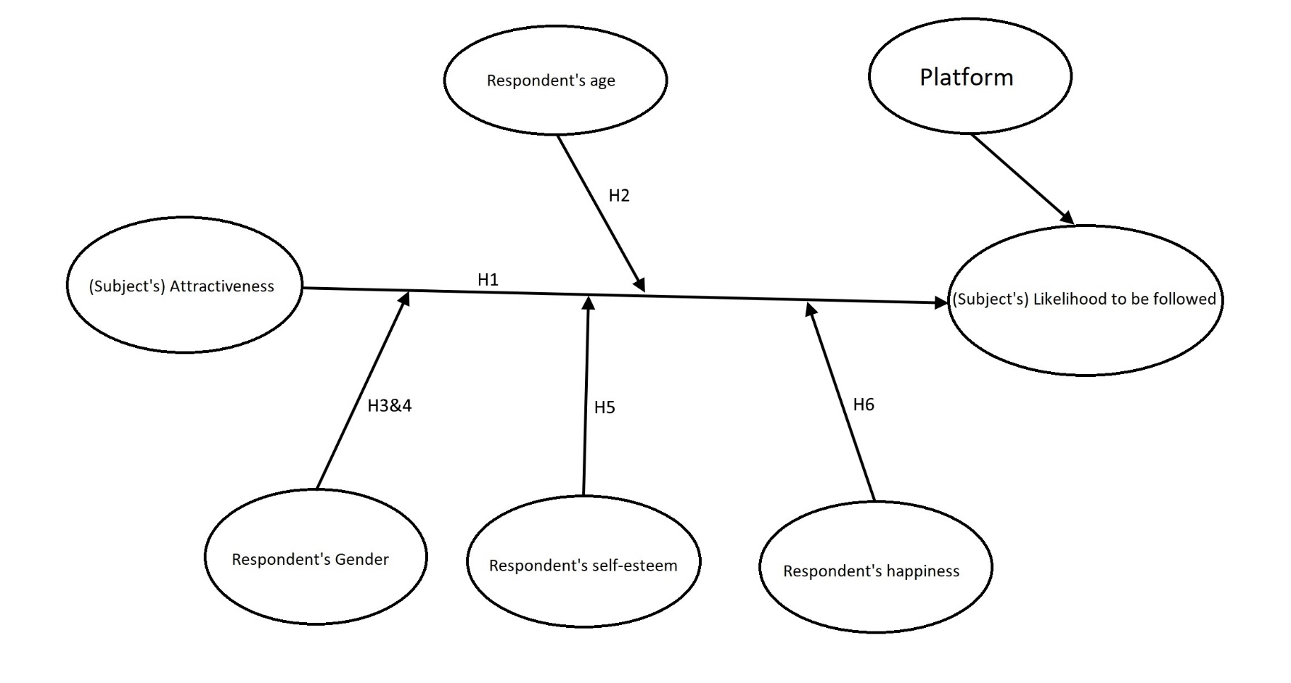

4. Methodology
For this research a survey has been used to gather the information needed for the analyses. This survey has been distributed online and to a number of people from different nationalities (although most are Dutch). The amount of respondents is 131.

4.1 Survey and study design
The survey that I have used contains multiple question categories. The first three questions are demographics questions and ask respondents their age, gender and relationship status. Question 4 asks respondents on which social media platforms they are active. For this, five options were provided: Instagram, Facebook, Twitter, Snapchat and ‘other’. Because all of these platforms are slightly different I expect to see some differences in the results as well. Question 5 asks respondents how much time they spend on these social media. Given the answer to this question they will receive the questions “how likely are you to follow this person on (insert any and all answers from question 4)” with pictures of a person’s face (social media user). They will also have to rate how attractive they think the person in the question is on a scale of 0-100. However, respondents will only get to see 5 faces when they take the survey. A total of 20 faces are in the survey but they are divided into 4 categories and each respondent only gets to see one of those categories. These categories are assigned to the respondent randomly. After this there will be an assessment of the general happiness of respondents based on the Happiness Measure by Fordyce (1988) and an assessment of self-esteem based on the Rosenberg self-esteem scale (Rosenberg, 2015). The survey is a 2x2 between subjects design with attractiveness and gender of the subject as the main variables. This means that I have created four categories as mentioned: unattractive males, unattractive females, attractive males and attractive females. However, these categories are not mentioned or used in the results section since they are subjective. These categories were only created so that respondents were not aware of the differences between these categories. In fact, they were not even aware that there were any categories. This way each participant was exposed to only one experimental condition.

4.2 Variables
Likelihood to be followed: The likelihood that a respondent will follow a social media user. Dependent variable. Value will be between 0 and 100. Nearing 0 means very unlikely, nearing 100 means very likely.
Social media user’s attractiveness: a score rated by the respondents on a scale of 0-100.
Respondent’s gender: value of 1 when respondent is female, 0 otherwise.
Instagram: A dummy variable indicating whether the platform chosen was Instagram (value of 1) or not (value of 0).
Facebook: A dummy variable indicating whether the platform chosen was Facebook (value of 1) or not (value of 0).
Snapchat: A dummy variable indicating whether the platform chosen was Snapchat (value of 1) or not (value of 0).
Twitter: A dummy variable indicating whether the platform chosen was Twitter (value of 1) or not (value of 0).
Age respondent: the age of the respondent in years.
Respondent’s self-esteem: a score of the respondent’s self-esteem based on the Rosenberg self-esteem scale (Rosenberg, 2015).
Respondent’s happiness: a score of 1-10, based on the Happiness Measure by Fordyce (1988).
Time Spent: A control variable for the amount of time spent on social media. Less than an hour is equal to a value of 0, 1-2 hours is a value of 1, 2-3 hours is a value of 2, 3-4 hours is a value of 3 and more than 4 hours is a value of 4.
Relationship status: A control variable for the respondent’s relationship status. It is equal to 1 if the respondent is in a relationship and equal to 0 if not.
Education: A control variable for the respondent’s highest obtained education level. It is a dummy variable where 1 equals ‘higher education’ (hbo and up) and 0 equals ‘lower education’ (mbo and below).
Education Dummy 2: A second dummy variable for education. (there were three values of education)
Friends: A control variable for the amount of friends and people that the respondents are following across all social media on which the respondents are active.
Self-esteem*Attractiveness: an interaction variable of self-esteem and attractiveness to measure moderation
Happiness*Attractiveness: an interaction variable of happiness and attractiveness to measure moderation.
Note: The ‘other’ platform is not included in the list of variables since it has been taken as the baseline for the platform variables.
The reason for using these control variables is that more intense Facebook use among emerging adults is related to more frequent social comparison as found by Lee (2014) and De Vries and Kühne (2015). It is possible that this also counts for other age groups and since it could have a direct effect on the likelihood to be followed I need to control for it. Relationship status may also have a direct effect on the likelihood to be followed. Although there seems to be no evidence for this in literature, one could imagine that someone with a partner would be less likely to follow someone of the opposite sex, because of possible jealousy of the partner, or a disinterest in the social media user. When it comes to education, different people have different mating strategies. So even if, for example, highly educated people and lower educated people find a person equally attractive, one of them might give a lower ‘likelihood to be followed’ score. Blackwell and Lichter (2000) show that married and cohabiting couples are highly homogamous when it comes to education. Buunk et al. (2002) found that “the lower the level of relationship involvement, the lower were the preferred levels of education” and that older people tend to set higher standards for a mate’s education. Just like these articles, there are other numerous articles and researches that imply that education has some effect when selecting a partner. It is possible that this effect is also present when respondents have to rate the ‘likelihood to be followed’ in my survey. Hence, the control variable. As for the amount of friends and people the respondents follow on social media, it is possible that some respondents are quicker to follow someone on social media than others. For instance, someone with 5000 friends on Facebook might make another friend without even thinking about it, whereas someone with 50 friends might be very selective if they see a friend request. That is why I will also control for the amount of friends and followed people of respondents on social media.

4.3. Analysis
The results were analyzed with a multilevel regression using the respondents as groups and the people shown in the pictures (social media users) as the individual level. This means there are 2 levels. Every respondent has rated multiple pictures. This means every respondent can be seen as a ‘group’; after all, there are multiple answers per respondent. These answers refer to the people that were shown in the pictures (social media users) in the survey. Because all of these answers are unique (to a certain degree) I can view the pictures shown (which the answers belong too) as the individual level. In more technical terms, this means that the variable Attractiveness (rating) is the level 1 variable and ID is the level 2 variable. Below, I have included a table as an example to clarify how this works.

Example of model:
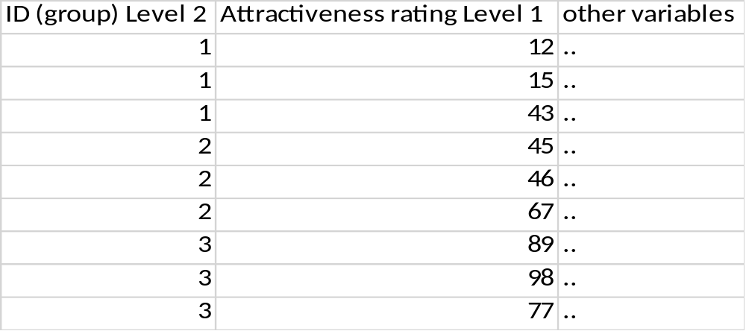This multi-level regression was used using individuals (ID) as groups and the pictures shown in the survey (attractiveness rating answers) as individuals. This was fit by a maximum likelihood estimation.

The table shows an example of what the data look like. The ID (group) is the grouping variable. Every group is one individual. The attractiveness rating is the level one variable, since those are all different answers of that individual. The ‘other variables’ would be all the other variables included in the data analysis.

As mentioned in the variables section there are multiple dummies for the platforms used and for education, since there were multiple values for these variables that were not a ratio or interval. For the platforms these are Instagram, Facebook, Snapchat, Twitter and Other as described in the variables section (note that other is the baseline and is not in the actual regression model). For education these values are: lower, higher and other. The education value for other was also coded as high and as low to test if there is any difference and whether the ‘other’ value really had an effect and it did. That is why the extra dummy is used.

For clarity, the exact model used is described here:
$$LTBF=α+β1*Attractiveness+β2*Gender+β3*Instagram+β4*Facebook+β5*Snapchat+β6*Twitter+β7*Age+β8*TimeSpent+β9*Friends+β10*Relationship+β11*Education+β12*Education_dummy2+β13*SelfEsteem+β14*Happiness+β15*SelfEsteem*Attractiveness+β16*Happiness*Attractiveness+ε$$

For Hypothesis 2, I will use almost the same ‘young’ category as Foos and Clark (2011). Since there are a few respondents in the data aged 15 and 16, they will be included in the young category rather than excluding them completely. There is no need to create other categories since I am only interested in the difference between the young category and the rest, because the rest is expected to be the same on average, as was concluded in Foos and Clark’s (2011) research. After that the means will be examined and a Mann-Whitney U test will be performed to find out whether there is a statistically significant difference between the means of the groups
For hypotheses 3 and 4, a Mann-Whitney U test will also be performed, after comparing the means, to find out whether there is a statistically significant difference between the means of the groups used in the analyses of these hypotheses.
Hypothesis 5 and 6 will be tested using the interaction variables of the respective hypothesized moderator variable and attractiveness. These results stem from the multilevel regression (mixed model) used in hypothesis 1.

4.4 Assumptions of the model
For all assumptions the model described earlier will be used.
Linearity: All variables used in the model are expected to have a linear relationship with the dependent variable (Likelihood to be followed). For Attractiveness hypothesis 1 can be used as a reason. For both Time Spent and Friends I would argue that the more someone is active on social media the likelier they will be to follow someone as well, suggesting a linear relationship. For Self-esteem and Happiness I would argue that the happier someone is and the better they think of themselves the less they will be jealous of or intimidated by others on social media and will thus also be likelier to follow someone the higher this score is. The only problem that might occur is Age, since hypothesis 2 states that younger people will, on average, rate the attractiveness of people lower compared to middle-aged and older respondents and this might affect the likelihood to be followed score indirectly. However, after close examination this does not seem to be the case and a linear relationship is assumed nonetheless (further explanation in the results).
Normality: The normality assumption seems to be (very) lightly violated. When looking at the P-P plot of the standardized residuals, the data should be normally distributed if the data points closely follow the horizontal line. This seems to be the case, except for the middle where it is slightly off the line. Fortunately, this should not be a very big concern, especially since it is only lightly violated, and hence I will still use a confidence interval of 95% when interpreting the results.

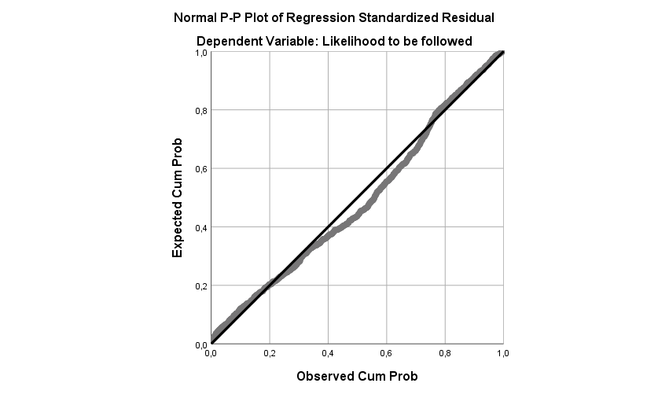

Homoscedasticity: As the scatterplot suggests, the model does not seem to violate the assumption of homoscedasticity, since the residuals are all on a fairly equal distance of the plotted line.
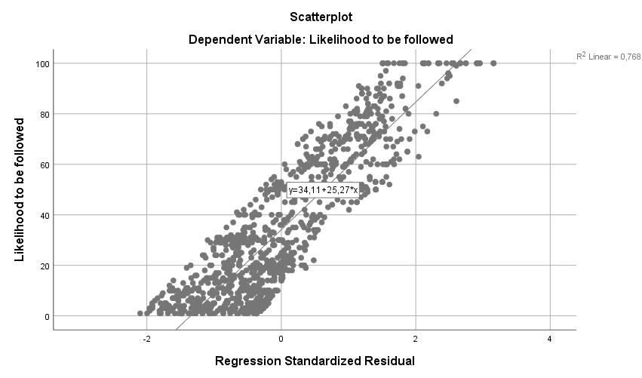

Independence of observations: This is technically violated since every respondent has multiple answers. But this is in theory fixed by using the multilevel regression and using the respondents as groups, since multi-level regressions are equipped to handle this violation.

5. Results
Now the results will be discussed. Each hypothesis will be discussed one at a time where the findings will be analyzed and explained. However, hypotheses 3 and 4 and hypotheses 5 and 6 are connected so there will be some overlapping there. The survey was done by approximately 175 respondents but some observations had to be deleted due to incomplete answers. In total the survey was completed by 131 respondents.

5.1 The effect of attractiveness
As mentioned earlier, H1 is a simple hypothesis based on the ‘beautiful is good’ stereotype.
H1: The more attractive a person is, the more likely they are to be followed on social media.
This hypothesis was tested with a multilevel regression (mixed model). The design of this regression is explained in the methodology. Basically, it views the respondents as groups and their (multiple) answers as individuals (this is also more accurately explained in the methodology).
Naturally, ‘likelihood to be followed’ was used as the dependent variable in this model and ‘attractiveness’ was used as the independent variable with all the other variables mentioned in the ‘variables’ section of this paper as control variables. The results can be seen in the table below.
Fixed effects:
Estimate Std. Error t value
(Intercept) 45.4522 8.2238 5.527
ZAttractiveness 21.2372 4.0814 5.203
Gender -6.2189 3.8731 -1.606
Instagram 5.0294 1.9116 2.631
Facebook 0.7402 1.8808 0.394
Snapchat -0.3342 2.1731 -0.154
Twitter 5.2166 2.4176 2.158
Age -0.2293 0.1617 -1.418
Time_Spent -1.1851 1.9130 -0.620
Friends 1.0124 1.4575 0.695
Relationship -4.8852 4.2019 -1.163
Education -3.8197 4.2627 -0.896
EducationDummy2 9.8496 9.2534 1.064
ZRosenberg_Score 5.9986 2.5232 2.377
ZHappyMeasure -3.7628 2.5415 -1.481
ZSelfEsteem*Attr -8.9429 4.6727 -1.914
ZHappy*Attractive -0.7645 3.1581 -0.242
Results of multilevel regression fit by maximum likelihood estimation

The table above are the results of the multi-level regression. Most variable names are clear but some are shortened for convenience. The ZRosenberg_Score is the self-esteem score, the ZHappyMeasure is the happiness score, the ZSelfEsteem*Attr is the interaction variable of self-esteem and attractiveness and the ZHappy*Attractive is the interaction variable of happiness and attractiveness. As can be seen, attractiveness has a high coefficient and t-value. This means that attractiveness is significant (t>1.96) and has a large effect on y; the likelihood to be followed on social media. Since the variables used were standardized the output must be interpreted a little bit differently than usual. This table shows that 1 standard error shift in ‘attractiveness’ leads to an increase (or decrease) in ‘likelihood to be followed’ score by 21 points. This standard error shift can both be downwards or upwards (or left or right on a graph). A downwards shift of the standard error means that ‘likelihood to be followed’ goes down by 21 points whereas an upwards shift means the reverse; an increase of 21 points down to a minimum of 0 and up to a maximum of 100. So, this does mean that if ‘attractiveness’ goes up, so does ‘likelihood to be followed’.
This then indeed means that the more attractive a person is, the more likely they are to be followed on social media, as the hypothesis states. So, as expected, H1 is supported.

5.2 The differences of age
H2 is about the differences in age for the respondents.
H2: Younger respondents will, on average, rate attractiveness of all social media users (pictures/faces) lower compared to middle-aged and older respondents.
Foos and Clark (2011) concluded that younger respondents rated the attractiveness of people lower than middle-aged and older respondents. In the multilevel regression that was used for hypothesis 1, age didn’t have a significant effect, thus already indicating that this might not be the case for my research.
As mentioned in the methodology, I have tried to keep my method as close as possible to Foos and Clark’s work, but since some of the respondents were aged 15 and 16, those respondents were also included in the analysis, rather than excluding them, even though Foos and Clark’s ‘young’ category consisted of people aged 17-25.
The table below shows the means of the ‘likelihood to be followed’ of the young category and the older category. As described the young category contains people aged 15-25 and the older category contains all people aged older than that. The distribution of these categories is not equal, but still quite close to each other with 68 observations for the young category and 63 observations for the older category.
Age | Mean Attractiveness | N | Standard deviation
Young | 45,94 | 68 | 23,820
Older | 47,40 | 63 | 21,834

Since the original data had no independence of observations the averages of every respondent had been calculated before the means were compared. This was done to remove the multiple observations per respondents and not let any respondent have a bigger or smaller influence than another. So, technically, there is now independence of observations.

As can be seen, the mean for the young category is indeed lower than for the older category implying that there is a difference. But for there to be a statistically significant difference another test had to be performed.

To test whether younger respondents actually rate attractiveness of people lower or not and thus finding out whether there is a statistically significant difference, compared to older respondents, a Mann-Whitney U test was used. The Mann-Whitney U test was specifically used because the data is not entirely normally distributed; the normality assumption is lightly violated. As explained, a multi-level regression was used for hypothesis 1 so that the violation of the independence of observations assumption doesn’t matter. After all, multi-level regressions are used to deal with that violation. However, when comparing means no such regression is used and the violation of the independence of observations assumption becomes an important thing to take into account. That is why the averages of all respondents were calculated before performing this test, as explained above. The results of the Mann-Whitney U test can be found in the table below.
 | Attractiveness
Mann-Whitney U | 2043,000
Asymp.Sig. (2-tailed) | 0,648

As can be seen the difference between the two groups is not significant. (asymptotic significance is greater than 0.05). For certainty an ANOVA has been performed as well but it gave the same results (found in appendix A1). I can thus conclude that there is no difference between younger and older respondents regarding the ‘Attractiveness’ score. Therefore, H2 is not supported.

5.3 Male vs female valuation
Buss (2007) already stated that men value beauty more than women when it comes to mating. The third and fourth hypotheses are based on this. First, the third hypothesis will be discussed on its own, then the fourth hypothesis and after that a short summary of these two hypotheses will be given, since they are so closely connected, before proceeding to the next hypothesis.
H3: Male respondents are more likely to follow attractive female social media users compared to female respondents.
To test this hypothesis, along with the fourth hypothesis, it needs to be clear what is considered ‘attractive’ and ‘unattractive’. These groups were separated for H3 and H4, containing the ‘attractive’ females (social media users) for H3 and the ‘unattractive’ females (social media users) for H4. Attractive was considered to be a score of 60 and up and unattractive was considered to be a score of 40 and below. These are more or less arbitrarily chosen numbers, since they are quite subjective. That is also the reason why any females with an attractiveness rating between 40 and 60 were not included, since this would probably have been too close to the ‘average beauty’, and might have given less accurate results.
After that, the hypothesis was tested in two steps. First, it needed to be clear whether there was a difference in means between men’s and women’s (respondents’) ratings of likelihood to be followed for attractive female social media users. As can be seen in the table below there is indeed quite a big difference between the two.
Gender | Mean LTBF | N | Standard deviation
Male | 58,04 | 26 | 24,221
Female | 45,57 | 19 | 30,127

Just as in H2, the means of every respondent were calculated to make sure there was independence of observations.

The mean of likelihood to be followed for attractive female social media users of the male respondents is 58,04 and that of the female respondents is 45,57. This is a difference of 12,47.
But to test the significance of the difference between these two means, another test had to be performed; the Mann-Whitney U test. Just as in H2, this test was performed since the data is not entirely normally distributed.

 | Likelihood to be followed
Mann-Whitney U | 175,000
Asymp.Sig. | 0,098

As can be seen in the table above, the asymptotic significance is 0,098 (higher than 0,05) and thus there is no significant difference between the means of male and female respondents when it comes to the likelihood to be followed scores. For certainty a t-test has also been performed (found in appendix A2) but it gave more or less the same results as the Mann-Whitney U test.
With the mean of ‘likelihood to be followed’ for attractive female social media users of male respondents being higher but there being no significant difference, I cannot conclude that male respondents rate the likelihood to be followed for attractive female social media users higher compared to female respondents and thus H3 is not supported.

As was mentioned, for H4 an attractiveness rating of 40 and lower will be used to test the difference between male and female respondent’s likelihood to be followed score given to unattractive female social media users.
H4: Male respondents are less likely to follow unattractive female social media users compared to female respondents.
Of course, H4 was tested in the same way as H3. First a difference in means had to be established. As can be seen in the table below there is a very small difference between the likelihood to be followed score of male and female respondents regarding unattractive female social media users.

Gender | Mean LTBF | N | Standard deviation
Male | 24,97 | 26 | 22,120
Female | 24,81 | 23 | 27,070

The mean of the likelihood to be followed score regarding unattractive female social media users among the male respondents is 24,97. For female respondents that mean is 24,81. The mean among females is thus 0,16 lower. This isn’t as big of a difference as in H3, in fact it is very small. However, the difference is in the opposite direction as hypothesized. The mean for female respondents is lower whereas H4 states that the mean would be lower for male respondents. Nevertheless, it is still interesting to see whether this difference could be statistically significant.

So, for the second part a Mann-Whitney U test had to be performed again, to test whether that difference of 0,16 is statistically significant.
 | Likelihood to be followed
Mann-Whitney U | 290,000
Asymp.Sig. | 0,857

As can be seen in the table above, the Asymptotic significance equals 0,857 which is greater than 0,05. The difference in the likelihood to be followed score regarding unattractive female social media users between male and female respondents is thus not statistically significant. Again, for certainty, a t-test was also performed for this hypothesis (found in appendix A3), but it gave more or less the same results as the Mann-Whitney U test. This means that, with the mean higher for male respondents, that male respondents do not rate the likelihood to be followed lower for unattractive female social media users compared to female respondents. Therefore, H4 is not supported.
H3 and H4 are thus both not supported. Male respondents do not rate the ‘likelihood to be followed’ score for attractive female social media users higher nor do they rate it lower for unattractive female social media users compared to female respondents. This is in not line with what Buss (2007) concluded when he stated that men value beauty more than women when it comes to mating. Technically, this is not in the context of mating, dating or any other aspect of relationships, but in an online (social media) context. But, it might play a part in it. Also, the dependent variable used (likelihood to be followed) might not be an accurate representation of ‘value’ and this might be why my conclusion is not in line with Buss’ (2007)

5.4 Moderating variables
In the ‘literature review and hypotheses’ chapter two variables were discussed that could moderate the effect of attractiveness on likelihood to be followed. These variables were self-esteem and happiness. Both variables are discussed in separate hypotheses with a short summary at the end, starting with H5.
H5: Respondents’ self-esteem moderates the effect of the attractiveness rating the respondents give on their likelihood to follow other social media users.
To test this hypothesis the multi-level regression results used in hypothesis 1 must be reviewed. The table below provides the same results as those shown in the discussion of hypothesis 1.
As can be seen in the table below, the t-value for the Rosenberg score (ZRosenberg_Score) which measures the self-esteem of respondents is greater than 1.96, which means it is statistically significant. But this does not mean that self-esteem moderates the effect of attractiveness on likelihood to be followed. From this the only conclusion that can be made is that self-esteem has a direct effect on likelihood to be followed. To find evidence for moderation the interaction variable of self-esteem and the independent variable ‘attractiveness’ must be examined.
Fixed effects:
Estimate Std. Error t value
(Intercept) 45.4522 8.2238 5.527
ZAttractiveness 21.2372 4.0814 5.203
Gender -6.2189 3.8731 -1.606
Instagram 5.0294 1.9116 2.631
Facebook 0.7402 1.8808 0.394
Snapchat -0.3342 2.1731 -0.154
Twitter 5.2166 2.4176 2.158
Age -0.2293 0.1617 -1.418
Time_Spent -1.1851 1.9130 -0.620
Friends 1.0124 1.4575 0.695
Relationship -4.8852 4.2019 -1.163
Education -3.8197 4.2627 -0.896
EducationDummy2 9.8496 9.2534 1.064
ZRosenberg_Score 5.9986 2.5232 2.377
ZHappyMeasure -3.7628 2.5415 -1.481
ZSelfEsteem*Attr -8.9429 4.6727 -1.914
ZHappy*Attractive -0.7645 3.1581 -0.242
Results of the multi-level regression.

As can be seen, the interaction variable of these two variables (ZSEInormal) has a t-value of less than 1.96. The t-value is, however, quite close to the threshold of 1.96 and combined with the fact that the self-esteem on its own is significant this could imply that there is a moderation effect. However, this is not the case because to prove moderation the interaction variable needs to be statistically significant and the moderator variable on its own has no meaning for moderation. Since I have chosen to work with a confidence interval of 95% (t-value of 1.96), I cannot reliably say that there is moderation of self-esteem on ‘likelihood to be followed’ in this case.
From all this I can thus conclude that there seems to be no moderation effect of self-esteem, even though self-esteem does directly influence the dependent variable ‘likelihood to be followed’. Therefore H5 is not supported.
H6 discusses the effect of happiness and whether there is a moderation effect of this variable or not.
H6: Respondents’ happiness moderates the effect of the attractiveness rating the respondents give on their likelihood to follow other social media users.
The table shown below is again output of the multi-level regression of hypothesis 1 and thus the same as on the previous page.
As can be seen in the table below the effect of happiness (ZHM_combination) is insignificant, since the t-value is lower than 1.96. Even though it is still relatively close to the value of 1.96, it doesn’t affect anything since the interaction effect of happiness with attractiveness, the most important variable to measure moderation, is highly insignificant with a t-value of 0,242.

Fixed effects:
Estimate Std. Error t value
(Intercept) 45.4522 8.2238 5.527
ZAttractiveness 21.2372 4.0814 5.203
Gender -6.2189 3.8731 -1.606
Instagram 5.0294 1.9116 2.631
Facebook 0.7402 1.8808 0.394
Snapchat -0.3342 2.1731 -0.154
Twitter 5.2166 2.4176 2.158
Age -0.2293 0.1617 -1.418
Time_Spent -1.1851 1.9130 -0.620
Friends 1.0124 1.4575 0.695
Relationship -4.8852 4.2019 -1.163
Education -3.8197 4.2627 -0.896
EducationDummy2 9.8496 9.2534 1.064
ZRosenberg_Score 5.9986 2.5232 2.377
ZHappyMeasure -3.7628 2.5415 -1.481
ZSelfEsteem*Attr -8.9429 4.6727 -1.914
ZHappy*Attractive -0.7645 3.1581 -0.242
Results of the multi-level regression.

With this information I can thus conclude that happiness does not seem to moderate the effect of attractiveness on likelihood to be followed. In fact, happiness does not seem to have an effect on likelihood to be followed at all, not even on its own. Therefore H6 is not supported.
It thus seems that both hypotheses for moderation are not supported. Although there does seem to be an effect of self-esteem, which is in line with Thornton and Maurice’s (1999) work, it does not moderate ‘likelihood to be followed’. As for happiness, De Vries and Kühne (2015) found that happiness has an effect on negative social comparison (as described earlier), but with the way it is incorporated it in this research it doesn’t seem to have an effect at all. Apparently happiness does not affect the likelihood for people to follow other, attractive or unattractive, social media users.

6. Conclusion

6.1 Summary and conclusion
To summarize: H1 was supported and H2, H3, H4, H5 and H6 were not supported. This means that, as expected, someone’s attractiveness does indeed affect the chance for that someone to be followed on social media. However, respondent’s age does not seem to have an effect on other social media users’ attractiveness score or their ‘likelihood to be followed’ by those respondents. This is not exactly in line with what Foos and Clark (2011) concluded, but my research was done under different circumstances and maybe those circumstances negated the effect of age. Specifically, the main difference between my research and that of Foos and Clark (2011) is the social media context. Maybe that changes the perspective of people, maybe it makes them think a little differently compared to when they just have to answer how attractive they think a person is. Also, based on research by Buss’ (2007), male respondents were expected to value female social media users’ beauty more than female respondents. However, there was no difference in the likelihood to follow an attractive female social media user between the two genders.
H5 and H6, the moderation hypotheses, were not supported. This could be for a number of reasons. For example, there could be a lack of power (sample size was 131). Perhaps if similar research was done on a bigger scale with more respondents and thus more observations there could be a moderation effect of either self-esteem or happiness. Especially self-esteem could very well have a moderating effect with more power since its t-value is already close to the 95% confidence interval threshold. However, this is not the case with the interaction variable of happiness and attractiveness. Perhaps this result is not in line with the findings of De Vries and Kühne (2015), because that research only tested whether happiness had an effect on negative social comparison on Facebook, but not on the likelihood to follow a social media user. Also, more platforms were used in my research and the functional characteristics of those platforms could explain the difference in the results (Schweidel and Moe, 2014).
Despite there being no moderation, there is an interesting effect of respondent’s self-esteem; it directly affects the respondent’s likelihood to follow other social media users irrespective of physical attractiveness of those users. So, the way someone thinks of themselves and how confident they feel, directly influences their likelihood to follow another person on social media. This is an interesting finding, since self-esteem can be manipulated to some degree, at least state self-esteem (Heatherton and Polivy, 1991). Technically every person (and company) that owns a social media account could use this to their advantage. If they make people feel better about themselves, it is possible that those people are more likely to follow their social media account compared to others. This is definitely in the interest of companies which could potentially get more customers this way, or for social media influencers who can increase their following, reach, and thus their income through this. Perhaps this is also an interesting subject to research further.

6.2 Shortcomings, improvements and recommendations
Of course, just as with any other research this one, too, has limitations. The biggest, probably, being that there were ‘only’ 131 respondents. Initially there were more, but some had to be deleted due to incomplete results or corrupted data. Luckily, this research was set up in such a way that there were multiple observation points for all of these 131 respondents and thus I had more data to work with. However, this did result in a violation of the independence of observations assumption, so that is why a multilevel regression was used, using each individual respondent as a group as explained in the methodology. Perhaps a research of this kind on a larger scale would produce somewhat different results, and perhaps not, but it might be interesting nonetheless to try if resources and time are available.
As mentioned by Eagly et al. (1991), the results could differ depending on what type of inference the respondent is asked to make. This means that research similar to this but with different questions or a slightly different dependent (or independent) variable could make a big difference.
Another shortcoming might be, is that I have not researched if there is any kind of beauty threshold. For instance, there might be a (high) point of attractiveness where respondents are less likely to follow other social media users. The problem with this is that that threshold may be different for each individual. It may even be different per gender. For example Bower (2001) mentions some other articles that have established that some women experience negative affect by comparing themselves with beautiful models and she concluded that “when sufficient negative affect is generated as a consequence of comparison with beautiful models, evaluations of both the model as a spokesperson and the product argument may be affected adversely because of model derogation”. It might be interesting to follow up on this kind of research in an online and social media context.
Regarding this paper, improvements can be made as well. Instead of having to view respondents as groups, perhaps one could try to go for a more general approach by having respondents rate the attractiveness and ‘likelihood to be followed on social media’ of only one person. This would fix the violation of the independence of observations assumption instantly, without having to perform a multilevel regression. And again, this might produce different results. It would require more respondents though.
So, there are definitely improvements and extensions that can be made upon this research, but it did capture the essence of what I was trying to find evidence for. Facial attractiveness of social media users does indeed affect their audience’s attitudes.

References:
Benson, P. L., Karabenick, S. A., & Lerner, R. M. (1976). Pretty pleases: The effects of physical attractiveness, race, and sex on receiving help. Journal of Experimental Social Psychology, 12(5), 409-415.
Blackwell, D. L., & Lichter, D. T. (2000). Mate selection among married and cohabiting couples. Journal of Family Issues, 21(3), 275-302.
Bower, A. B. (2001). Highly attractive models in advertising and the women who loathe them: The implications of negative affect for spokesperson effectiveness. Journal of advertising, 30(3), 51-63.
Buss, D. M. (2007). The evolution of human mating. Acta Psychologica Sinica, 39(3), 502-512.
Buunk, B. P., Dijkstra, P., Fetchenhauer, D., & Kenrick, D. T. (2002). Age and gender differences in mate selection criteria for various involvement levels. Personal Relationships, 9(3), 271-278.
de Vries, D. A., & Kühne, R. (2015). Facebook and self-perception: Individual susceptibility to negative social comparison on Facebook. Personality and Individual Differences, 86, 217-221.
Dion, K. K., Berscheid, E., & Walster, E. (1972). What is beautiful is good. Journal of Personality and Social Psychology, 24, 285–290.
Eagly, A. H., Ashmore, R. D., Makhijani, M. G., & Longo, L. C. (1991). What is beautiful is good, but…: A meta-analytic review of research on the physical attractiveness stereotype. Psychological bulletin, 110(1), 109.
Foos, P. W., & Clark, M. C. (2011). Adult age and gender differences in perceptions of facial attractiveness: beauty is in the eye of the older beholder. The Journal of genetic psychology, 172(2), 162-175.
Fordyce, M. W. (1988). A review of research on the happiness measures: A sixty second index of happiness and mental health. Social Indicators Research, 20(4), 355-381.
Heatherton, T. F., & Polivy, J. (1991). Development and validation of a scale for measuring state self-esteem. Journal of Personality and Social psychology, 60(6), 895.
Lee, S. Y. (2014). How do people compare themselves with others on social network sites?: The case of Facebook. Computers in Human Behavior, 32, 253-260.
Miller, A. G. (1970). Role of physical attractiveness in impression formation. Psychometric Science, 19, 241-243.
Rosenberg, M. (2015). Society and the adolescent self-image. Princeton university press.
Schweidel, David A., and Wendy W. Moe. "Listening in on social media: A joint model of sentiment and venue format choice." Journal of Marketing Research 51.4 (2014): 387-402.
Thornton, B., & Maurice, J. K. (1999). Physical attractiveness contrast effect and the moderating influence of self-consciousness. Sex Roles, 40(5-6), 379-392.

Appendix:

A1

H2 Anova
ANOVA
Attractiveness
 | Sum of Squares | df | Mean Square | F | Sig.
Between Groups | 69,293 | 1 | 69,293 | ,132 | ,717
Within Groups | 67570,844 | 129 | 523,805
Total | 67640,137 | 130

A2
H3 T-Test
Independent Samples Test
H3 T-test |  | Levene's Test for Equality of Variances |  | t-test for Equality of Means
 |  | F | Sig. | t | df | Sig. (2-tailed) | Mean Difference | Std. Error Difference | 95% Confidence Interval of the Difference
 |  |  |  |  |  |  |  |  | Lower | Upper
LTBF | Equal variances assumed | 1,182 | ,283 | 1,540 | 43 | ,131 | 12,47715 | 8,10431 | -3,86675 | 28,82104
LTBF | Equal variances not assumed |  |  | 1,488 | 33,619 | ,146 | 12,47715 | 8,38654 | -4,57348 | 29,52777

A3
H4 T-Test
Independent Samples Test
H4 T-test |  | Levene's Test for Equality of Variances |  | t-test for Equality of Means
 |  | F | Sig. | t | df | Sig. (2-tailed) | Mean Difference | Std. Error Difference | 95% Confidence Interval of the Difference
 |  |  |  |  |  |  |  |  | Lower | Upper
LTBF | Equal variances assumed | ,001 | ,981 | ,023 | 47 | ,982 | ,15970 | 7,03073 | -13,98430 | 14,30370
LTBF | Equal variances not assumed |  |  | ,022 | 42,589 | ,982 | ,15970 | 7,11889 | -14,20092 | 14,52031

B1
Multi-level regression results
Fixed effects:
Estimate Std. Error t value
(Intercept) 45.4522 8.2238 5.527
ZAttractiveness 21.2372 4.0814 5.203
Gender -6.2189 3.8731 -1.606
Instagram 5.0294 1.9116 2.631
Facebook 0.7402 1.8808 0.394
Snapchat -0.3342 2.1731 -0.154
Twitter 5.2166 2.4176 2.158
Age -0.2293 0.1617 -1.418
Time_Spent -1.1851 1.9130 -0.620
Friends 1.0124 1.4575 0.695
Relationship -4.8852 4.2019 -1.163
Education -3.8197 4.2627 -0.896
EducationDummy2 9.8496 9.2534 1.064
ZRosenberg_Score 5.9986 2.5232 2.377
ZHappyMeasure -3.7628 2.5415 -1.481
ZSelfEsteem*Attr -8.9429 4.6727 -1.914
ZHappy*Attractive -0.7645 3.1581 -0.242
Multi-level regression results (H1)

Questionnaire/Survey
Hi, thank you for taking the time to fill in this survey. My name is Rutger and this survey is part of my master thesis. This survey will ask you your opinion of yourself and others. This is related to social media and how we view ourselves and others on social media. First I will ask you to answer some questions about yourself. After that you will get to see a few pictures of people and a few questions that you will have to answer related to these persons. All questions relating to the individuals you will see are on a scale of 0-100 so please be as honest and as precise as you can be in answering these questions.
This survey will take about 5 minutes to complete.
Be assured that all answers will be kept confidential. Your responses are completely anonymous.
If you have any questions or feedback about the survey you can contact me via my e-mail: 415785rn@student.eur.nl Thank you!

Q1 What is your age?
________________________________________________________________
Q2 What is your gender?
- Male (1)
- Female (2)
- Prefer not to say (3)
- Other (5)

Q3 What is your current relationship status?
- Single (1)
- Married, in a relationship or in a domestic partnership (2)
- Widowed (3)
- Divorced (4)
- Separated (5)

Q4 On which social media are you active? (please check all answers that apply to you)
- Instagram (1)
- Facebook (2)
- Twitter (3)
- Snapchat (4)
- Other (please, specify) (5) ________________________________________________

Q5 On average, how much time do you spend on these social media per day
- Less than an hour (1)
- 1-2 hours (2)
- 2-3 hours (3)
- 3-4 hours (4)
- More than 4 hours (5)

Q6 How many people do you follow and how many friends do you have on all of these social media combined? (If you're not sure please estimate a range).
- 0-100 (1)
- 100-300 (2)
- 300-500 (3)
- 500-1000 (4)
- 1000-2000 (5)
- 2000+ (6)

Q7 What is your highest education level? (if currently enrolled, check highest obtained degree).
- High School (1)
- MBO (2)
- HBO (3)
- Bachelor's degree (4)
- Master's Degree (5)
- PhD (6)
- Other, please specify: (7) ________________________________________________

Q8 You will now see a few pictures of some people. Please rate how attractive you think they are. (Each picture had an individual slider and only one category was shown).






Unattractive Males
 | 0 | 10 | 20 | 30 | 40 | 50 | 60 | 70 | 80 | 90 | 100

How attractive do you think this person is? | 

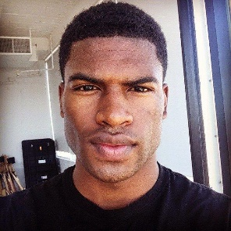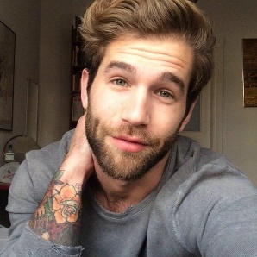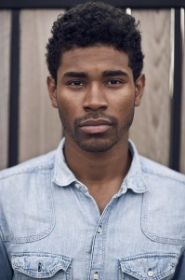

Attractive Males
 | 0 | 10 | 20 | 30 | 40 | 50 | 60 | 70 | 80 | 90 | 100

How attractive do you think this person is?



Unattractive Females
 | 0 | 10 | 20 | 30 | 40 | 50 | 60 | 70 | 80 | 90 | 100

How attractive do you think this person is?



Attractive Females
 | 0 | 10 | 20 | 30 | 40 | 50 | 60 | 70 | 80 | 90 | 100

How attractive do you think this person is?

Q9 Imagine that the persons on the next page have social media accounts about lifestyle that interests you. Please rate how likely you would be to follow each of them on every applicable social network.

(Insert previously assigned category; (un)attractive males or females)
 | 0 | 10 | 20 | 30 | 40 | 50 | 60 | 70 | 80 | 90 | 100

How likely are you to follow this person on Instagram? ()
How likely are you to follow this person on Facebook? ()
How likely are you to follow this person on Twitter? ()
How likely are you to follow this person on Snapchat? ()
How likely are you to follow this person on other social media? ()

Q10 Next you will get a few questions about yourself. Please answer these to the best of your ability

Q11 In general how happy or unhappy do you usually feel? Choose one statement below that best describes your average happiness.
- 0 Extremely unhappy (utterly depressed, completely down) (1)
- 1 Very unhappy (depressed, spirits very low) (2)
- 2 Pretty unhappy (somewhat blue, spirits down) (3)
- 3 Mildly unhappy (just a little low) (4)
- 4 Slightly unhappy (just a bit below neutral) (5)
- 5 Neutral (not particularly happy or unhappy) (6)
- 6 Slightly happy (just a bit above neutral) (7)
- 7 Mildly happy (feeling fairly good and somewhat cheerful) (8)
- 8 Pretty happy (spirits high, feeling good) (9)
- 9 Very happy (feeling really good, elated!) (10)
- 10 Extremely happy (feeling ecstatic, joyous, fantastic!) (11)

Q12 Consider your emotions a moment further. On the average, what percent of the time do you feel happy? What percent of the time do you feel unhappy? What percent of the time do you feel neutral (neither happy nor unhappy)? Write down your best estimates, as well as you can, in the spaces below. Make sure the three figures add-up to equal 100%
On the average:
The percent of time I feel happy : _______ (1)
The percent of time I feel unhappy : _______ (2)
The percent of time I feel neutral : _______ (3)
Total : ________
Q13 Below is a list of statements dealing with your general feelings about yourself. Please indicate how strongly you agree or disagree with each statement.
 | Strongly Agree (1) | Agree (2) | Disagree (3) | Strongly Disagree (4)
On the whole, I am satisfied with myself. (1)
At times I think I am no good at all. (2)
I feel that I have a number of good qualities. (3)
I am able to do things as well as most other people. (4)
I feel I do not have much to be proud of. (5)
I certainly feel useless at times. (6)
I feel that I'm a person of worth, at least on an equal plane with others. (7)
I wish I could have more respect for myself. (8)
All in all, I am inclined to feel that I am a failure. (9)
I take a positive attitude toward myself. (10)

