

WHEN THINGS GO BAD, AN APOLOGY BRINGS THE DISCUSSION TO AN END.
The interplay of brand crisis type and crisis response on consumers’ likelihood to engage in electronic word of mouth, following a corporate crisis.

Supervisor: V. Landsman-Schwartz
Student: Nikolaos Koumelas Arazos – 479520

Table of contents

Table of contents 2
1. Introduction 4
1.1 Backround 4
1.2 Research objective 6
2. Theoretical framework 7
2.1 Literature review 7
Brands 7
Brand misconduct 8
Crisis response strategies 11
New Media 14
Likelihood to engage in eWOM 16
EWOM motives 18
2.2 Literature review conclusion 21
2.3 Conceptual model 22
2.4 Hypotheses formulation 23
3. Methodology 27
3.1 Research design & method 27
3.2 Questionnaire and distribution 28
3.3 Measures 30
4. Results 32
4.1 Analysis introduction 32
4.2 Sample description 32
4.3 Descriptive statistics 34
Dependent variable 34
Independent variables 38
Control variable 38
4.4 ANCOVA 43
Outliers 43
Normality 44
Linear relationship between covariate and dependent variable 44
ANOVA 44
Homogeneity of regression slopes 46
Homogeneity of variance 47
Heteroscedasticity testing 48
Final ANCOVA descriptive 48
4.5 Hypotheses testing 52
5. Discussion 55
5.1 Summary of findings 55
5.2 Managerial implications 56
5.3 Academic contribution 58
5.4 Limitations and future research 58
6. References 60
7. Appendices 70

Introduction

1.1 Backround

Previous research highlights the importance of Web 2.0 when it comes to brand image, content creation and brand-consumer relationship. Knowledgeable, savvy, customers are now creating content and gather knowledge online, utilizing “New Media” for opinion exchange. Such media can be websites and other digital communication and information channels (platforms) in which active consumers engage in behaviors and express themselves in a way that others can receive the information either instantly or long afterwards no matter what their spatial location is. Thus, managers should focus more on such channels when they want to communicate brand related content and react in behalf of the brand, especially when sometimes corporate misdeeds lead to perceived brand misconduct actions. The need of focus on online media, has become more crucial than ever for firms, since now consumers react to stories created by corporations and not only produce their own (Muniz and Schau, 2007).
Prior research suggests that managers should invest on how to tackle post crisis consumer outbursts. That is because negative consequences occur after a corporate transgression, affecting the consumers’ responses towards and relationship with the brand (Becker-Olsen et al., 2006; Berens et al. 2005; Biehal and Sheinin 2007; Du et al. 2007; Gürhan-Canli and Batra 2004; Lichtenstein et al 2004; Luo and Bhattacharya 2006; Madrigal and Boush 2008; Sen and Bhattacharya 2001).
Negative word of mouth spreads among the consumers right after a brand transgression (Smith and Cooper-Martin, 1997), which now is easier than ever to be instantly validated and assessed by searching the web for related content (electronic word of mouth) through new media channels or just through search engines like Google. Comments, posts, reactions, shares and direct messaging are the most prevalent forms of expression in such platforms.
The ease of accessing and exchanging brand related information has now given consumers the power to seriously damage firms when they are linked to any form of crisis. Thus, it has become impossible for brands nowadays to control and manipulate such consumer generated stories. (Holt, 2002; Capozzi, 2005; Laufer and Coombs, 2006).
For instance, H&M’s racist advertisement, lead to several brand boycotts and the crisis got great volume in the social media, even brand endorsers like the famous Canadian artist “The Weekend” stopped their cooperation with the clothing brand ('Racist' H&M coolest monkey hoodie banned by eBay, BBC, 2018). It was not only the firm’s customers who engaged in electronic word of mouth, but all those who wanted to “punish” the brand for its unacceptable behaviour, since the crisis was related to social responsibility and ethics. On the other hand, performance related misconduct, like the KFC logistics crisis, when a shortage of chicken and eventually the temporary shut of the majority of the firm’s 900 UK eateries, after operational issues with their new delivery firm DHL, neither faced consumer outburst on the social media nor any form of boycott (“Don’t call the police over KFC crisis”, BBC 2018).
With so much at stake, managers should put a lot of effort, while trying to minimize the negative effects of a crisis. Thus, based on how consumers perceive crisis and firms’ crisis responses, researchers focused on providing several options of crisis responses as solutions to managers’ struggles (Siomkos and Kurzbard, 1994).

1.2 Research objective

Prior brand misconduct literature focuses more on consumers’ perceptions towards the brand or likelihood to purchase again following a crisis, however, the present study wants to shed light on how the crisis type and the brand’s response to the crisis, interplay, generating consumer electronic word of mouth on social media. Moreover, this study will have further academic relevance, since it will examine not only the effect of the crisis type and firm’s response, but it will also take into consideration the moderating effect of consumer motives to engage in electronic word of mouth during crisis. The findings of such an experiment will have academic and managerial implications as they could guide managers on making right decisions during crisis, based on the publicity and the volume of consumer reactions that they want to generate. This brings us to the main research question of this study:
What is the effect of brand misconduct type (performance related, values related) and brand’s response (diminish, deal), on consumers’ likelihood to engage in eWOM following a corporate crisis?

Research Questions:
RQ 1: How does brand misconduct type affects consumers’ likelihood to engage in eWOM?
RQ 2: How does the firm’s response strategy chosen during the crisis, affects customers’ likelihood to engage in eWOM regarding the incident?
RQ 3: How do the motives of each customer moderate the effect of a brand crisis on consumers’ likelihood to engage in eWOM on social networking sites?

2. Theoretical framework

2.1 Literature review

Brands

A brand statement, mission and vision that have been cultivated and well-maintained over successive generations and have been appreciated by several groups of stakeholders, generate commitment towards the firm. Firms, leveraging on stakeholder commitment, manage to create a brand, or brand name which serves to communicate the perceived identity and values of the organization (John M.T. Balmer and Edmund R. Gray, 2003).
The relationship between brands and consumers is interconnected, in a sense that customers need the existence of brands as well as the brands need customers, thus, managers should be aware of their organization’s brand equity, since it is converted to customer equity; which in other words means profits (Leone Robert P., Rao R. Vithala, Kevin Lane Keller, Anita Man Luo 2006).
Moreover, it was found that values, programs, and actions of the ﬁrm are reflected in the associations that might be created by a corporate brand in consumers’ minds (Keller K.L. and Aaker D.A., 1998).
With a constantly growing competition within markets, it is becoming more and more complicated for firms to sustain and communicate their comparative advantage over their competitors, meaning that the need of building a brand name is vital (Stephen King, 1991).

Brand misconduct

However, brands’ behavior is not always attuned with the consumers’ expectations. Not only product harm crises, which is the most common type of brand misconduct, but also socially or ethically debatable actions are the two broad types of brand crisis identified (Huber et al., 2009). From consumer-based brand equity to the marketing efficiency, brand image and reputation of a company, all brand related aspects can easily be affected by the several negative outcomes that a brand crisis can have. One of the most prevalent examples of such negative post crisis consequences, is brand boycott, during which consumers actively and publicly accuse the misconducting firm in a try to spread the word among consumers and pushing the brand towards drastic actions to reverse or mitigate the damage caused by the crisis (Klein et al., 2004; Davies et al., 2003; Klein et al., 2004; Dawar and Pillutla, 2000; Van Heerde et al., 2007).
Any unethical or immoral brand action, or lack of action, referring to a brand that may negatively affect the stakeholder-brand relationship, can be identified as brand misconduct. In other words, any incident that calls into question a brands aptitude to deliver ethical and psychological values (Dawar and Pillutla, 2000; Pullig et al., 2006).
Although, product attribute or performance related crises are the most common type of brand misconduct and the easiest to be identified by consumers, there are four different types of brand misconduct to be distinguished. When product quality does not meet consumers’ expectations, when a firm lacks service orientation, any symbolic-psychological misconduct and socially debatable actions. That is because consumers not only gain functional, but also societal and psychological value from engaging with brands (de Chernatony and McDonald, 1998). The aforementioned types of brand misconduct, for the sake of my experiment will be conceptualized as subtypes of the two broader crisis types, performance related misconduct and values related misconduct.
Performance-related crises normally involve malfunctioning products, or not properly delivered services and primarily reduce a brand's perceived ability to deliver functional benefits. The exploding Samsung Note 7 batteries (BBC, 2017) is an example of this crisis type. On the other hand, a values-related crisis does not directly involve the product, but social or ethical issues surrounding the values adopted by the brand. Nike's deliberate use of child labor is a representative example of a values related crisis.
Subsequently, moral evaluations play an essential role in corporate reputation development (Bromley 2001); hence, a company’s overall reputation is inherently linked to the level of the perceived ethicality reflected in its business (Bendixen and Abratt 2007) and its aptitude to remain competitive in the marketplace.

Thus, I expect that a values-related brand crisis will have a different effect on consumers’ likelihood to engage in electronic word of mouth compared to a performance related crisis, since they tap on different aspects of the brand. However, crisis response strategies of firms following their transgressions can always mitigate the undesired consequences of a brand misconduct.

Crisis response strategies

Prior research has found that the firm’s response following a crisis, can mitigate the unwanted negative effects on the consumer-brand relationship. Corporations’ response options can be distinguished among three strategies: denial, diminish and deal (e.g. Dawar and Pillutla, 2000), but since consumers are sharing their negative brand experiences with others through social media (Ward and Ostrom, 2006), brands tend to be more open and honest in their responses. Research has found that a brand may be harmed in case the company tries to evade the consequences of a crisis, while an unambiguous apology may help a brand overcome a crisis (Dawar and Pillutla 2000), since a crisis cannot be kept a secret anymore. By delicately handling the crisis and maintaining a good communication strategy, a company can quickly recover from its misconduct and even gain respect for being honest (Aaker et al., 2004). That means that consumers tend to encourage companies to be transparent and accept their mistakes.
Crisis executives can decrease the reputational damage that is followed by a crisis, by making the crisis to appear less bad. The basic response options are three and they include the deny, the diminish and the deal response. In more detail, the option of the deny response focuses on proving that there is no crisis or that the company is not responsible for the crisis. The option of the diminish response indicates the incidents that the crisis executives admit that a crisis happened, and the company is involved, however there is an effort to adjast the attributions that the stakeholders have made about the crisis, so to diminish the reputational damage. The diminish response options focuses on reducing the attributions of crisis accountability, meaning that if stakeholders associate less with the crisis responsibility to the company, then the crisis will create less reputational damage. Nevertheless, literature has evidence that if the stakeholders attribute have more responsibility to the company, then the crisis response strategy will have to admit more to the responsibility of the crisis. (Coombs and Holladay, 1996).

Lastly, the option of the deal response is when an organization takes the complete responsibility for the crisis and asks for apologies in order the brand’s stakeholder to excuse the misstep.
Corporate actions need to be attuned with the standards and anticipations of the society, based on related, existing studies (Allen and Caillouet, 1994). Thus, firms are considered genuine when they manage to align with societal norms, while brand misconduct refers to a violation of societal standards and outlooks. In order to tackle any unwanted consequences and to protect the status of the firm, administrative management has built crisis reaction mechanisms (Coombs and Holladay, 1996).
Thus, now, more than ever, firms should focus on the consumers’ growing power and their tendency to engage in brand related electronic word of mouth, when they need to respond to any sort of crisis. With the advent of new media channels, firms will need to adjust to the new era of brand-consumer communication.

New Media

Nowadays new media channels are utilized by consumers, which is risky for firms because extensive knowledge results in intensified negative implications of brand misconduct, which can be severely damaging to the firms following a crisis (Holt, 2002; Capozzi, 2005; Laufer and Coombs, 2006).
New media are websites and other digital communication and information channels in which active consumers engage in behaviors that can be consumed by others, both in real time and long afterwards regardless of their location. Also, the digital character of new media implies that consumer generated content can be spread with ease globally, since the barrier of publishers does not exist on such digital environments. Even strong relationships have been formed online (Gordon 2010; Libai et al. 2010). Thus, with the advent of social media platforms, not only brand managers are the architects of their brand stories (Kuksov et al. 2013) but also consumers.
Stories spread via traditional channels were found to have much less impact compared to consumer generated branded content published on social media platforms. That is because consumer’s expression of feelings towards brands on social media platforms are audiovisual, interactive and available in real time (Hennig-Thurau et al. 2010). Thus, in a social media environment, brand and customer relationship management are associated (Malthouse et al. 2013).
In order to become create viral content, brands now utilize data available online to build on consumers’ connections from common friends to family (Hinz et al. 2011; Van der Lans et al. 2010).
Thus, brands become more and more humanized through direct B2C communication, which elevates their image and generates more favorable consumer generated responses (Puzakova, Hyokjin, and Rocereto 2013)
Prior research found that through Facebook and Twitter, brands can create stronger bonds with consumers compared to YouTube (Smith, Fischer, and Yongjian, 2012).

Likelihood to engage in electronic word of mouth

Existing literature refers to electronic word of mouth as any form of consumer generated content available to groups of people online. Additionally, literature points out that in the majority of brand crises, negative word of mouth (WOM) occurs, which in the Web 2.0 environment, is easily converted and spread in the form of electronic WOM (Henning- Thurau et al, 2004; Smith and Cooper-Martin, 1997). Thus, awareness and empathy can be built by corporations who can efficiently take advantage of electronic word of mouth’s power (Singh and Sonnenburg 2012).
Since consumers and especially web 2.0 natives trust more and more the internet when it comes to brand information and purchase decisions, consumer generated content may affect the brands’ perceived image (Shankar et al., 2003; Bolton et al., 2013). However, not only a firm’s image is affected by consumer generated content, but also its performance such as sales and its stock price.
Thus, before entering the social media platforms, a company should first be certain of its mission and vision and should know how to communicate it through its touchpoints with the consumers. Having a clear idea of what the firm stands for, managers will be able to react to consumer generated content to prevent a potential brand damage following a brand crisis (Godes et al. 2005).
In addition, due to its more distinctive coding in memory, negative word of mouth has been found to have a stronger effect on consumer perception than positive (Ba and Pavlou, 2002).
Moreover, in a try to conceptualize electronic WOM formation in social networking sites (SNS) we may examine it through three behaviors: opinion seeking, opinion giving and opinion passing. Opinion seekers are the individuals who have a tendency to search for advice before proceeding to any purchase (Flynn et al. 1996). On the other hand, individuals with a high level of opinion-giving behavior, are the consumers who usually impact others’ behaviors and eventually, their purchase decisions (Feick & Price 1987). However, the dynamic aspects of the online environment allow consumers to take on different roles and act as opinion leaders, seekers and opinion passers with ease.
Finally, existing literature has found that word of mouth is inherently linked to the consumers’ motives, opportunity and ability to generate brand related content or engage in post crisis talks.
As far as the consumer-brand relationship is concerned, the literature indicates that customers who respect and feel for an organisation are more likely to generate WOM communication compared to those who just exhibit plain satisfaction with a product or a service (Harrison-Walker, 2001).

Electronic word of mouth motives

Consumer Brand Relationship

A strong consumer-brand relationship (CBR) leads to emotional attachment to the brand and is correlated to a higher repurchase intention. In addition, a consistent and satisfying interaction with the brand, strengthens the relationship with the consumers, since the aspects that outline CBR are just like to the aspects that define a real-life relationship. Thus, it was found that in the context of a crisis, a strong consumer brand relationship leads to less negative crisis attributions towards the brand in question.

In addition, prior studies suggest that loyal customers, by possessing greater knowledge and having created a stronger bond with a firm, will normally be more willing to engage in post crisis word of mouth. They are considered motivated to evaluate negative opinions towards their beloved firms and usually try to think of counterarguments, leading to the eventual rejection or diminish of the effect of the brand related information that run counter to their ideas regarding the firm in question. On the other hand, non-customers are less willing to engage in post crisis word of mouth, since they do not feel they are connected to the firm and they usually do not possess deep and clear knowledge regarding the misconducting firm. Based on this assumption, we consider CBR a vital factor that affects consumers’ likelihood to engage in brand related electronic WOM, especially during brand misconduct incidents, since different connection with the brand leads to different way of processing post crisis information. (Ahluwalia et al. 2000, Dawar and Pillutla 2000, Henard 2002, Wu and Shaffer 1987)

Self-involvement

The need to share positive brand related experiences so as to boost one’s image and differentiate among others is called self-involvement. It has been identified as a vital motive for post crisis word of mouth engagement. The consensus is that when consumers comment or share fashion related information about products or initiatives are perceived as fashion leaders. Thus, they enhance their selves’ image within a reference group by leading the way to the active evaluation of a brand’s actions. This construct was adopted from prior relevant studies, since self-involvement was found to be an accurate predictor of electronic word of mouth engagement (Henning-Thureu et al., 2004).

Other involvement

Other involvement is the third and last electronic word of mouth motive that will be included in my research. It is described by existing literature as the unselfish behavior of acting positively. In other words, other involvement is the altruistic assistance offered C2C so as to prevent others from engaging in faulty purchases. Knowledgeable customers, who for any reason may be unsatisfied from a product or service purchase they have made, can now easily reach potential customers and enlighten them by sharing their experiences (Sundaram et al.; 1998).
In addition to selfless motives, consumers might also notice others regarding any unpleasant experience they might have had after purchasing a product or service, in case they feel obligated to them (Gatignon & Robertson, 1985).
Fashion styling and purchase guidance represent prevalent ways of assisting others online either in blogs or in social media. The measurement of this construct has been adapted from Hennig-Thurau et al. (2004).

2.2 Literature review conclusion

Concluding, this study combines brand misconduct and crisis response literature to reveal their main and interaction effects on consumers’ likelihood to engage in electronic WOM following a brand crisis. Thus, based on previous research, this study postulates that since performance related misconduct (e.g. product crisis) affects the core performance of the brand in question, the outcome of the crisis, is more evident and does not need to be analysed further (Kahn and Meyer, 1991) . On the other hand, values related misconduct (e.g. racist advertisement), which is not integral to the core performance of a firm, is expected to generate more eWOM among the brand’s stakeholders (e.g. customers) who might feel the need to engage in online talks regarding the incident and the brand’s ethics. Moreover, existing research considers a firm’s reaction to a crisis, to be one of the most important factors mitigating the effect of the crisis on the consumer-brand relationship. However, we lack knowledge regarding the interaction effect of the crisis and the firm’s crisis response on consumers’ electronic WOM engagement likelihood. An unclear response, which still leaves the firm’s stakeholders with doubts, is expected to intensify consumers’ likelihood to discuss about the incident and reveal the actual attributions of the crisis. Also, there are robust findings proving that a sensitive and good handling of the crisis and a transparent communication by the firm’s side, in most cases, is the best way to recover and even gain respect for being sincere (Aaker et al., 2004; Huber et al., 2009). In addition, with the advent of social media it has become more complex for firms to cover-up a crisis, leading them towards more unambiguous, responsible responses. Based on the above, this study postulates that the more ambiguous the response of a firm to crisis, the more likely to generate electronic WOM in the social media, since consumers are expected to seek for answers. Finally, considering customer motives to engage in electronic WOM as described by Henning-Thureu and Fournier this study focuses on a) consumer-brand relationship, b) self-involvement and c) other-involvement, by examining their moderating effect on consumers electronic WOM engagement following a brand crisis.

2.3 Conceptual model

Inspired from the literature mentioned above and more precisely from Dwane Hal Dean (2004) and WT Coombs (1995), Henning- Thurau et al. (2004) and Huber (2009), the following conceptual model was constructed in order to test 6 hypotheses.
The model consists of a dependent variable, namely consumer likelihood to engage in electronic WOM, two independent variables, brand misconduct type and firm response to crisis and a moderator which will be labeled as consumer motives. Finally, the demographics of the participants (age, employment status, gender, nationality and education level) will be asked for a further statistical analysis.
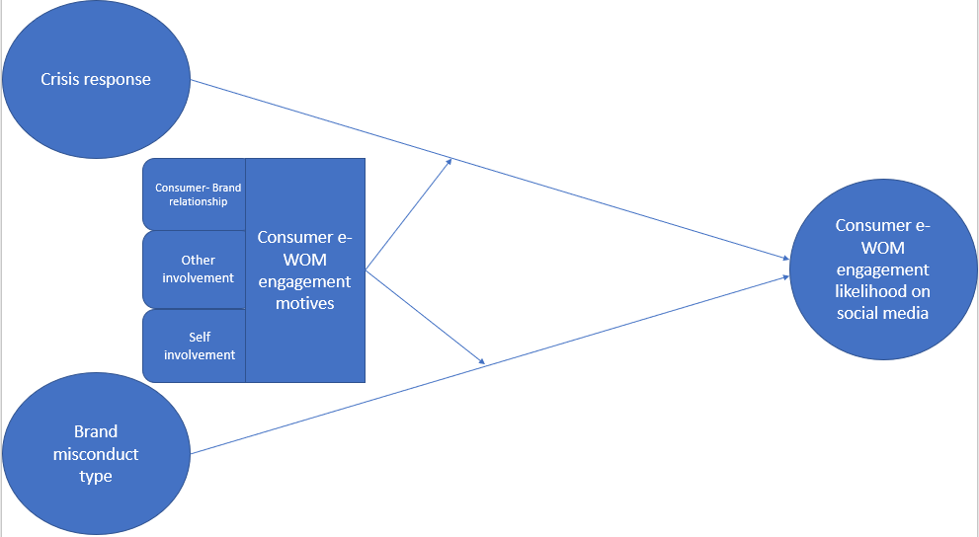

2.4 Hypotheses formulation

Based on the discussion above, the following hypotheses are tested in this study:
The first hypothesis of the model is that a values related crisis will lead to greater customer likelihood to engage in electronic WOM than the performance related misconduct. This is assumed, since prior studies found that a performance-based crisis affects the expected benefits related to brand functionality, whereas a values-based crisis impacts the brand's expected symbolic and psychological benefits. This implies that the outcomes and the attributions of a performance related misconduct are more obvious compared to values related crises, that may demand a more thorough investigation among the brand’s customers on social media and result to a greater backlash. Lastly, I postulate that a values related crisis is more likely to generate non-customer word of mouth, since they affect aspects of an entity such as its ethos and respect shown towards the society; meaning that there is no need for deep knowledge of the firm’s operations, compared to performance related ones.
H1 Brand misconduct type will differently affect consumer eWOM engagement likelihood in social media
  - H1(a) Values related brand misconduct will affect the most (positive effect) eWOM engagement
  - H1(b) Performance related misconduct will also positively affect eWOM engagement but significantly less, compared to the values related brand misconduct news.

The second hypothesis of the model postulates that the more ambiguous the firm’s response, the greater the consumer likelihood to engage in electronic WOM. This hypothesis is drawn based on prior research which found that ambiguous responses harm a brand, while unambiguous support (i.e., super effort) may help a brand to overcome a crisis (Dawar and Pillutla 2000). Thus, an unambiguous, transparent crisis response is expected to put an end to the discussions, while an ambiguous one will need further investigation, generating greater customer likelihood to engage in electronic WOM. Based on the above, a diminish crisis response option is expected to yield greater electronic WOM engagement likelihood than the deal response.
H2 Crisis response strategies differently affect consumer will engage in eWOM.
  - H2(a): The diminish response option will lead to greater eWOM engagement than the deal response option
  - H2(b): The deal response option will lead to significantly less eWOM engagement

The third hypothesis postulates that there is an interaction effect of brand misconduct type and firm’s response to crisis, affecting the consumers’ eWOM engagement likelihood.
H3: There is an interaction effect between the “Brand misconduct” and “Crisis response strategy” on consumers’ likelihood to engage in eWOM.

The following hypotheses of this study expect several motives linked with eWOM engagement, to combine in a factor which will moderate the effects of brand misconduct type, firm response and their interaction, on the consumers’ engagement in eWOM likelihood. The motives that we are going to include are (a) consumer brand relationship, (b) consumer self-involvement and (c) consumer other involvement. All of the aforementioned moderators were found to affect consumer’s engagement in eWOM in prior studies. Moreover, Ahluwalia et al. (2000), Dawar and Pillutla (2000), Henard (2002), and Wu and Shaffer (1987) who suggest that negative information about a company is processed differently by consumers regarding their relationship with the brand. However, noncustomers may be swayed by emotional cues and are unlikely to elaborate on the negative information. In addition, self-involvement is defined as the tendency to share experiences in an effort to augment one’s image among others by projecting themselves as knowledgeable and smart purchasers (Dichter, 1966).
Searching, sharing and generating brand focused content, all contribute to the perceived consumers’ status as trend setters within their reference group. Moreover, consumers who strive for self-worth were found to be more likely to engage in electronic WOM (Henning-Taurau et al. 2004). Finally, concern for others, labeled as other involvement is the genuine need of a consumer to help friends, family and other online connections with their purchasing decision making.
H4: Consumer motives will positively moderate the effect of the brand misconduct on consumers’ likelihood to engage in eWOM
H5: Consumer motives will positively moderate the effect of the firm’s response to crisis on consumers’ likelihood to engage in eWOM
H6: Consumer motives will positively moderate the interaction effect of brand misconduct type x firm response on consumers’ likelihood to engage in eWOM

3. Methodology

3.1 Research design & method

The purpose of this paper is to reveal how the different types of brand crisis interplay with the brand’s response to the crisis, affecting consumers’ likelihood to engage in brand related eWOM on social media. In addition, this study wants to examine the effect of consumer motives that based on prior literature were found to affect eWOM engagement. In the following section, the constructs used to measure the hypotheses are going to be overviewed and the design of the questionnaire that will be used is going to be analyzed. After that, a pretest of the questionnaire shows its relevance and then, after the questionnaire distribution, a data cleaning takes place. Finally, after having the data needed, we will perform the most suitable analysis, which in our case is a 2x2 ANOVA construct, followed by a 2x2 ANCOVA analysis, allowing us to compare the effects of the independent variables alone, but also their effect when our covariates are entered in the model.
Since trying to unravel the relationship between two or more factors, affecting a situation, is the main emphasis in a correlational study (Kumar, 2014); the aim of this study is to find whether, and in what way, crisis type and the brand’s response, affect consumers’ likelihood to engage in eWOM on social network sites following a corporate crisis. Thus, the research type which applies best to this study is correlational. In addition, the most appropriate research design is an experimental study. This experimental design will ease the manipulation of the independent variables as well as the isolation of the effects to be studied, since it allows the researcher to manipulate the independent variables so as to examine their effect on one or more dependent variables.
The study consists of a 2(performance related misconduct, values related misconduct) x2(diminish response, deal response) construct, making up 4 different experimental groups. The instrument used to collect data for this study, is a questionnaire of 4 screening questions, 6 attitudinal, pre-stimuli questions and 3 attitudinal post stimuli Likert scale questions. Lastly, in the end of the survey demographics are measured as well.1
According to Kumar (2014), the main disadvantages of using a questionnaire are that response rates might be low, there is a self-selecting bias (respondents who return the questionnaire might have different attitudes than the people who did not return the questionnaires), and that respondents might consult others before responding. However, when measuring attitudes, questionnaires also have advantages, since it is time efficient and much less expensive to use questionnaires to study a large population and it also provides greater anonymity to respondents which might improve the quality of the answers.

3.2 Questionnaire and distribution

The questionnaire consists of two fictitious stimuli articles (performance related misconduct and values related misconduct) which respondents read (one of the two equally distributed) with a manipulation of the firm’s response (diminish, deal) before answering questions regarding their likelihood to engage in eWOM. The manipulated information will not only be within the text but also in the header of the articles. The brand chosen for the study was Adidas, because fashion products have been recognized as closely linked to the wearers’ attitude (Goldsmith & Clark, 2008; O’Cass, 2004; Phau & Lo, 2004). Also, emotional attachment to brands is mostly relevant to fashion brands, therefore consumers’ self-concept and values should align with those of the fashion brand in order for high brand commitment to occur. In addition, Adidas’ trajectory does not include any crisis, meaning that participants will not be prejudiced towards the brand compared to others of the industry of equivalent size. For instance, Nike was linked with sweatshop labor according to existing literature (Knight, G. and Greenberg, J. 2002) which might be a bias for the participants of the survey. Moreover, before reading the stimuli text respondents are also asked about their relationship with the brand, about their self-involvement and other-involvement motives to engage in electronic WOM, so as not to be biased after reading the crisis related article. To ensure that only relevant respondents provide answers, two screening questions at the beginning of the survey screen out those who are not familiar with Adidas at all and all those who do not have at least one social media profile account. Lastly, two screening questions right after the fictitious articles, screen out the respondents who answer wrong, meaning they did not pay attention to the article.
The performance related misconduct article demonstrates a product crisis of Adidas which mentions the company’s failure to launch a new shoe successfully. To be more specific, the shoe soles of the product were found to be defective leading to an outburst of the consumers who spread the word on the social media. In the article, the response of the company is manipulated in a way that in the first version of this text the respondents will be exposed to a diminishing response of the company to the crisis, while in the second version of this article the respondents will come across a deal response strategy.
The values related misconduct article replicates Abercrombie’s real-life brand misconduct incident (Forbes,2013). Thus, it mentions a discriminant interview of Adidas CEO who stated that the brand’s designs are only for fit, cool and attractive kids. He added that a lot of people do not belong and can’t belong in their clothes and that the brand is exclusionary. As expected, a lot of people were offended by his statements. Again, Adidas’ response is manipulated in the end of the article so as in the first article, the CEO of the firm tries to diminish the crisis, while in the second version of this article, Adidas’ CEO deals with the crisis in an apologetic way.
Finally, the link to the survey will be distributed through Whatsapp, Facebook, LinkedIn as well as via mass e-mails. This way, we increase our chances to reach participants who are social media active and lie within the 18-35 age group, which is the more relevant audience for my survey, since it is more active on both social media and sports (Bolton et al., 2013).

3.3 Measures

In order to measure our dependent variable, consumer likelihood to engage in eWOM, a factor analysis will be performed on the three questions of 1-7 Likert scale adopted from Hennig-Thurau et al. (2004) and adjusted properly, so as to fit our model:
1)“I would search for more opinions online regarding the Adidas incident on my social network”
2)“I would post, comment or direct message my *contacts about the Adidas incident on my social network”
3)“I would pass along others' opinion regarding the Adidas incident to my *contacts (Share)”
By combining the results of the three questions mentioned above into one factor, we cover the three aspects of eWOM engagement, opinion seeking, opinion leading and opinion passing behaviors and create a continuous variable which suits to the 2x2 ANCOVA analysis.
Moreover, the two independent variables of the model, brand misconduct type and brand crisis response, are dichotomous variables. Brand misconduct is either “performance related misconduct” or “values related misconduct”, while crisis response is either “diminish” or “deal”. The brand misconduct type dichotomy is adapted from F.Huber (2009) and the crisis response strategy distinction is adapted from Dwane H. Dean (2004).
In addition, the moderating variables’, consumer-brand relationship, self-involvement and other-involvement, measurements are adapted from Henning- Thurau et al. (2004). Two 1-5 Likert scale questions for each moderating variable were chosen, adjusted to our model and then all six were combined into one, continuous factor, which for the sake of our study, we are going to call consumer motive to engage in eWOM:
- consumer-brand relationship: a) “I am very loyal to Adidas”, b) “Adidas plays an important role in my life”
- self-involvement: a) “My social network contributions show that I am a clever customer”, b) “My social network contributions show that I am knowledgeable about the sportswear industry”
- other-involvement: a) “I want to expose brands that behave badly”, b) “I want to warn others with my negative experiences with brands”
Finally, demographic variables such as age, employment status, gender, nationality and education level are measured at the end of the questionnaire.

4. Results

4.1 Analysis introduction

Proceeding to the analysis of our results, the descriptive statistics of the sample and variables will be presented, followed by the testing of the hypotheses of the conceptual model.

4.2 Sample description

The sample consisted of 207 respondents, however, 20 participants needed to be excluded from the analysis, since 3 of them where not familiar with Adidas at all and 7 failed to provide the correct answer to both screening questions and 10 left the questionnaire incomplete. Thus, the analysis is going to be tested on the 187 remaining respondents.
48 in the Performance related/deal response, 45 in the Performance related/diminish response, 47 in the values related misconduct/deal response, and 47 in the values related/diminish response. The gender split of respondents was relatively even, 51.3% being female and 48.7% male. In addition, the majority the respondents had either completed a bachelor’s or a master’s degree and approximately 80% of the respondents were Greek. Moreover, the target audience of this research ranged from 18 to 40 years old, in order to represent the most social-media active part of the population. Indeed, respondents’ age ranged from 20 to 35 years old, with an average of 27.08 years of age (Table 1).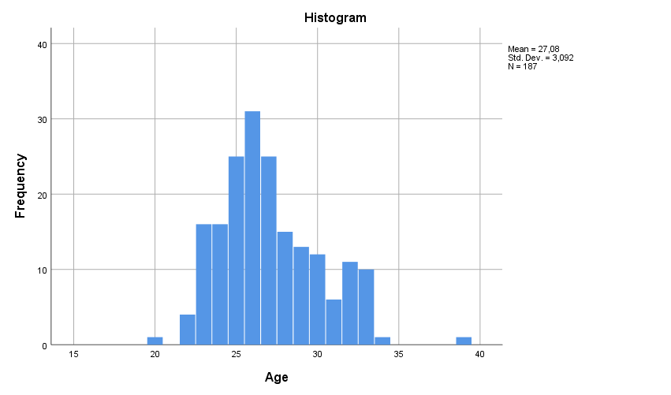

Table 1.

4.3 Descriptive statistics

Dependent variable

eWOM engagement likelihood

The dependent variable in my study captures the likelihood of the consumer to engage in eWOM on the social media regarding the incident. For its measurement we have adapted the approach of Hennig-Thurau et al. (2004) who use 5-point scales in order to capture opinion seeking, leading and passing behaviours. Thus, to make the scales more relevant to our research, we transformed the scales by extending them to 7-point (very unlikely-very likely), so as to provide more options to the participants. Therefore, the lowest likelihood to engage in eWOM that can be generated regarding the incident is 1, while the highest is 7. To ensure that the 3 scales are altogether reliable and valid measurement of the respondents’ likelihood to engage in eWOM, I performed a reliability analysis.

Reliability test

Data showed that the measurement construct had a high reliability: Chronbach’s Alpha = 0.863. Which means that 86.3% of the total variance, in the composite score of the three items, is explained, thus it is of high reliability (Table 2). Participants were asked to give their likelihood to engage in eWOM, immediately after they were exposed to the stimuli. (See Table 2, Appendices)

Factor analysis

Additionally, in order to include my dependent variable into my model, I performed a factor analysis to the 3 scales/behaviours so as to create a continuous factor, which would fit our model and analysis methodology (ANCOVA). Since the constructs are believed to be correlated to each other, we performed principal components analysis with an oblique rotation extraction method. The factor’s determinant value, Determinant = 0.227, which needs to be greater than 0.00001, meaning we are safe to continue with the analysis and since the items are pretty correlated we may proceed (Table 3). However, the questions that capture the opinion leading and opinion passing variables, show very high correlation of 0.740 (Table 3), which means that are similar behaviors, but we can still keep the questions, since 0.8 is the top cutoff of considering an item multicollinear. Then, the KMO-Bartlett’s test has a p-value= 0.714, meaning that since it is greater than 0.5 we can accept it (Table 4). Also, regarding the Bartlett’s test of sphericity, the p-value= 0.000, since it is less than 0.001, we have statistical significance (Table 5), meaning we can accept it. In addition, the generated factor explains 78.696% of the total variance (Table 5). Finally, the distribution of the dependent variable in the dataset appeared positively skewed, however, since the skewness of the dependent variable was 0.146 (Table 6), we can say we have almost symmetrically split data in our normal distribution and nearly no skewness (we have a slightly positively skewed distribution). Lastly looking at the scree plot (Scree plot 1) we can say that the 1 component we extracted perfectly captures the effect of the variability of our model since there is only one point above the value of 1 which is the cutoff of our Eigenvalue. This is also reflected at the Component Matrix 1, in which all the consumer eWOM behaviors have very high loadings in the 1 component generated to reflect the total eWOM.

Correlation Matrixª
 |  | eWOMopinionseek | eWOMopinionlead | eWOMopinionpass
Correlation | eWOMopinionseek | 1,000 | ,691 | ,608
Correlation | eWOMopinionlead | ,691 | 1,000 | ,740
Correlation | eWOMopinionpass | ,608 | ,740 | 1,000
a. Determinant = ,227
Table 3.

KMO and Bartlett's Test
Kaiser-Meyer-Olkin Measure of Sampling Adequacy. |  | ,716
Bartlett's Test of Sphericity | Approx. Chi-Square | 273,019
Bartlett's Test of Sphericity | df | 3
Bartlett's Test of Sphericity | Sig. | ,000
Table 4.

Total Variance Explained
Component | Initial Eigenvalues |  |  | Extraction Sums of Squared Loadings
Component | Total | % of Variance | Cumulative % | Total | % of Variance | Cumulative %
1 | 2,361 | 78,696 | 78,696 | 2,361 | 78,696 | 78,696
2 | ,397 | 13,221 | 91,916
3 | ,243 | 8,084 | 100,000
Extraction Method: Principal Component Analysis.
Table 5.

Statistics
eWOMtotal
N | Valid | 187
N | Missing | 0
Mean |  | ,0000000
Std. Deviation |  | 1,00000000
Skewness |  | ,146
Std. Error of Skewness |  | ,178
Table 6.
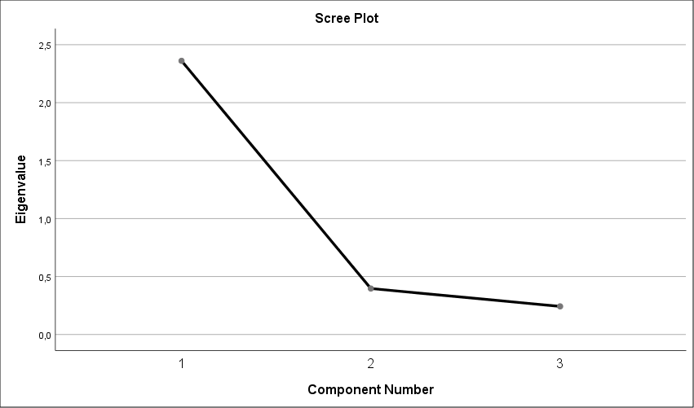
Scree Plot 1.
Component Matrixª
 | Component
 | 1
eWOMopinionseek | ,860
eWOMopinionlead | ,917
eWOMopinionpass | ,883
Extraction Method: Principal Component Analysis.
a. 1 components extracted.
Component Matrix 1.

Independent variables

Brand misconduct type

The brand misconduct type variable was added as a binomial variable to the ANCOVA. The performance related misconduct was coded as 1, while the values related misconduct was coded as 2.

Firm response

The firm response variable was also added as a binomial variable in our analysis. Thus, the diminish response was coded as 1, while the deal response was coded as 2.

Control variable

Motive

CBR

Ahluwalia et al. (2000), Dawar and Pillutla (2000), Henard (2002), and Wu and Shaffer (1987) suggest that negative information about a company is treated differently by loyal customers versus noncustomers. Thus, we include consumer-brand relationship in our model as a motive which affects positively consumers’ eWOM engagement likelihood when it comes to brand misconduct incidents. Since loyal customer possess greater knowledge and show greater affection towards a brand, they are expected to express greater willingness to engage in eWOM following a brand crisis compared to non-customers who might be indifferent regarding their concern about the firm in question. There are two 5-point Likert scale questions in the questionnaire capturing the consumer-brand relationship. Later in the analysis, the consumer-brand relationship questions are combined into one factor together with the other 4 motive questions (2 reflecting the consumer self-involvement and 2 for the consumer care for others)

Self-involvement

Hennig-Thurau et al. (2004) based on Dichter (1966), found that an important reason for people to engage in eWOM is to promote themselves and appear as knowledgeable and smart consumers. Thus, self-involvement is the second motive we consider that positively moderates the relationship between the incident (interplay of brand misconduct type and firm response to crisis) and the consumer’s likelihood to engage in eWOM related to the misconduct. Self-involvement consists also from two 5-point Likert scale questions.

Other-involvement

Hennig-Thurau et al. (2004) in their study found that another vital motive of consumers’ eWOM engagement, is caring for others. They found that people who care more for others are more likely to engage in eWOM following a brand crisis, since they want to “warn” others about defective products or about immoral companies with poor social responsibility. They postulate that by informing them they might prevent them from making the “wrong” decisions they have made. Thus, other-involvement is the third motive which we postulate that will positively affect consumers’ eWOM likelihood to engage following a brand crisis and consist from two Likert scale questions as well.

In order to generate the motive variable, we had to perform again a reliability analysis to the 6 variables (2 questions for each motive) that combine into one and create the total consumer’s motive to engage in eWOM on social media.

Reliability test

After performing a reliability test, the Cronbach’s alpha was 0.786 (Table 7, Appendices), which allows us to continue the analysis. Then, a factor analysis followed so as to generate a continuous variable that reflects the total consumer’s motivation. The determinant is 0.133 meaning we are safe to continue. However, some of the questions that capture the variables that combine into one, show slightly low correlation. In detail, “I am very loyal to Adidas”-MotiveCBR1- and “Adidas plays an important role in my life” -MotiveCBR2- correlation is 0.253, “I am very loyal to Adidas”- MotiveCBR1- and “I want to warn others with my negative experiences with brands” -MotiveOtherInv2- correlation is 0.241 and “Adidas plays an important role in my life” -MotiveCBR2- and “I want to warn others with my negative experiences with brands” -MotiveOtherInv2- have a correlation of 0.223 (Table 8). Then, the factor analysis resulted to a KMO value was 0.720 (Table 9, Appendices) which is above 0.5, which means we are fine to continue with the analysis. Also, Bartlett’s test of sphericity is shows significance with a p-value of 0.000. Finally, the extracted factor appears to explain the 48,6% (Table 10, Appendices) of the total variance, which is not adequate and means that our model needs two covariates to be extracted so as to explain the 66,95% (Table 10, Appendices) of our model’s total variance. This is also depicted on the Eigenvalues scree plot (Scree plot 2), in which there are 2 points above the Eigenvalue (Eigenvalue=1), as well as in the Components Matrix 2.

Correlation Matrixª
 |  | MotiveCBR1 | MotiveCBR2 | MotiveSelfInv1 | MotiveSelfinv2 | MotiveOtherInv1 | MotiveOtherInv2
Correlation | MotiveCBR1 | 1,000 | ,754 | ,484 | ,363 | ,253 | ,241
Correlation | MotiveCBR2 | ,754 | 1,000 | ,439 | ,340 | ,320 | ,223
Correlation | MotiveSelfInv1 | ,484 | ,439 | 1,000 | ,559 | ,287 | ,256
Correlation | MotiveSelfinv2 | ,363 | ,340 | ,559 | 1,000 | ,323 | ,390
Correlation | MotiveOtherInv1 | ,253 | ,320 | ,287 | ,323 | 1,000 | ,456
Correlation | MotiveOtherInv2 | ,241 | ,223 | ,256 | ,390 | ,456 | 1,000
a. Determinant = ,133
Table 8.

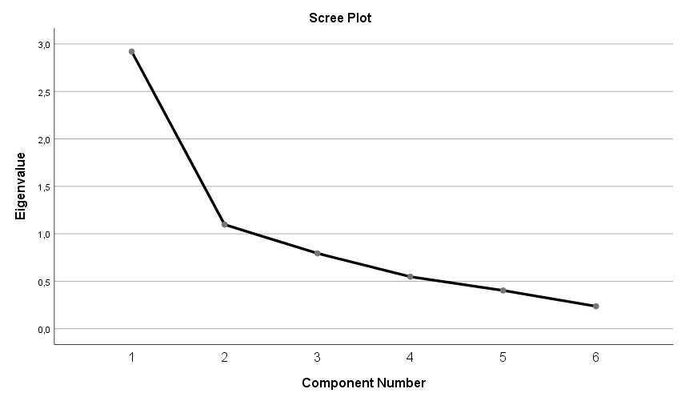
Scree plot 2.

Component Matrixª
 | Component
 | 1 | 2
MotiveCBR1 | ,772 | -,467
MotiveCBR2 | ,764 | -,439
MotiveSelfInv1 | ,742 | -,121
MotiveSelfinv2 | ,713 | ,185
MotiveOtherInv1 | ,596 | ,503
MotiveOtherInv2 | ,571 | ,620
Extraction Method: Principal Component Analysis.
a. 2 components extracted.

Components Matrix 2.

4.4 ANCOVA

The chosen method for this study is a two-way ANCOVA. The observations used in this study were 187, excluding the participants who failed to provide the right answer to both screening questions or did not finish the questionnaire. Before running the ANCOVA we need to check if our data meet the assumptions required.
The dependent variable and the covariate are measured on a continuous scale, meaning that they are a good fit for our model. In addition, our independent variables are both categorical, values related/performance related misconduct and diminish/deal response, which is also a requirement of the ANCOVA. Moreover, our data satisfy the independence of observations, since each participant was allowed to return one questionnaire only. The motives of each consumer were measured before the stimuli articles to avoid the bias caused post-stimuli and the screening questions in the beginning of the survey, screen out the participants who are not aware of Adidas as a brand, as well as those who do not own a social medium account. Lastly, the two screening questions post-stimuli, screened out the participants who failed to answer both, meaning, they did not pay attention to the text.

Outliers

Exploring our data for outliers, we want to report no outliers for both levels of the brand misconduct type; however, the apologetic response to crisis had two outliers (Outliers: 112 and 171; Tables 11,12, Appendices). Meaning we do not have extreme values of the dependent variable for any of the groups and combinations of the independent variables, except for two specific respondents who are opted out from the rest of the analysis.
Thus, after opting out case 112 and 171, our dependent variable lies within the upper and lower cutoffs for both levels of both independent variables. Thus, having no extreme values among our observations, we are safe to procced with our analysis with 185 respondents now.

Normality

The variance of the dependent variable is not equal for all the combinations of the independent variables. Meaning that we have violated the assumption of normality. That is because the Shapiro-Wilk Sig. value needs to be greater than 0.05, in our case it is statistically significant for the values related misconduct type (0.005) as well as for the diminishing firm response (0.002) meaning that our dependent variable does not follow a normal distribution in all levels of our independent variables (Tables 13,14, Appendices). It is clear though from the respective histograms (Tables15,18, Appendices) generated, that we have normal distribution at the first level (performance related crisis) of the brand misconduct type independent variable and at the second level of the firm response (deal response), while at their respective levels we do not (Tables 16,17, Appendices)

Linear relationship between covariate and dependent variable

After generating the scatterplots needed for both levels of both independent variables, we are safe to continue, since there we have in general a linear (elliptical) relationship between the covariate (total motivation) and dependent variable (eWOM total engagement; Table 19, Appendices).

ANOVA
First, we run an ANOVA without the covariate(s), to check if and how the significance values of our model are going to change.

ANOVA results:
Descriptive Statistics
Dependent Variable: eWOMtotal
BMtype | Firmresponse | Mean | Std. Deviation | N
1 | 1 | .3494072 | .84447888 | 45
1 | 2 | -.7121287 | .64922780 | 47
1 | Total | -.1928992 | .91790918 | 92
2 | 1 | .8714063 | .83788289 | 47
2 | 2 | -.5635273 | .66051196 | 46
2 | Total | .1616542 | 1.04149578 | 93
Total | 1 | .6160807 | .87666141 | 92
Total | 2 | -.6386270 | .65553354 | 93
Total | Total | -.0146643 | .99531560 | 185
ANOVA descriptive.

Tests of Between-Subjects Effects
Dependent Variable: eWOMtotal
Source | Type III Sum of Squares | df | Mean Square | F | Sig. | Partial Eta Squared
Corrected Model | 79.586ª | 3 | 26.529 | 46.758 | .000 | .437
Intercept | .035 | 1 | .035 | .061 | .805 | .000
BMtype | 5.198 | 1 | 5.198 | 9.162 | .003 | .048
Firmresponse | 72.038 | 1 | 72.038 | 126.969 | .000 | .412
BMtype * Firmresponse | 1.612 | 1 | 1.612 | 2.840 | .094 | .015
Error | 102.694 | 181 | .567
Total | 182.320 | 185
Corrected Total | 182.280 | 184
a. R Squared = .437 (Adjusted R Squared = .427)
Table 20.

The effects of Brand misconduct type (BMtype) and Firm’s response to crisis (Firmresponse), are both statistically significant (p-value= .003 and p-value= .000 respectively). However, the interaction effect of BMtype*Firmresponse has p-value .094, meaning it is not statistically significant (Table 20).
Moreover, it is obvious that the most effective variable in our model is the firm’s response to crisis with sum of squares of 72.038 compared to 5.198 which is the sum of squares of the brand misconduct type.

Homogeneity of regression slopes

To check for the assumption of homogeneity of regression slopes we need to create a an ANCOVA, including all the possible interaction effects with the covariates.

Then, we proceed with the custom ANCOVA:

Tests of Between-Subjects Effects
Dependent Variable: eWOMtotal
Source | Type III Sum of Squares | df | Mean Square | F | Sig. | Partial Eta Squared
Corrected Model | 36.623ª | 8 | 4.578 | 5.532 | .000 | .201
Intercept | .009 | 1 | .009 | .011 | .915 | .000
Firmresponse * Selfmotivation | 8.519 | 1 | 8.519 | 10.294 | .002 | .055
Firmresponse * Othermotivation | .023 | 1 | .023 | .028 | .867 | .000
BMtype * Othermotivation | .214 | 1 | .214 | .259 | .612 | .001
BMtype * Firmresponse * Selfmotivation | .255 | 1 | .255 | .308 | .579 | .002
BMtype * Firmresponse * Othermotivation | .114 | 1 | .114 | .138 | .711 | .001
BMtype * Selfmotivation | .004 | 1 | .004 | .005 | .941 | .000
Error | 145.657 | 176 | .828
Total | 182.320 | 185
Corrected Total | 182.280 | 184
a. R Squared = .201 (Adjusted R Squared = .165)
Table 21.

After generating our custom ANCOVA with all the possible interactions of the two covariates with the two independent variables, we are safe to continue, since almost all of the interaction effects are not statistically significant which is what we are looking for. The only interaction effect that appears as statistically significant is Firmresponse*Selfmotivation with p value = 0.002, meaning we have met the homogeneity of regression slopes requirement except for the Firmresponse*Selfmotivation interaction which suffers from heterogeneity of regression slopes.

Homogeneity of variance

The next assumption for our two-way ANCOVA is that we need to have homogeneity of variance. Generating the Lavene’s test of equality of error variances, we focus on the significance and we can report that it is statistically significant (p value= 0.354).
Performing our final ANCOVA analysis we get the following results:

Levene's Test of Equality of Error Variancesª
Dependent Variable: eWOMtotal
F | df1 | df2 | Sig.
1.093 | 3 | 181 | .354
Tests the null hypothesis that the error variance of the dependent variable is equal across groups.
a. Design: Intercept + Selfmotivation + Othermotivation + BMtype + Firmresponse + BMtype * Firmresponse

Table 22.

Since we have a non-statistically significant p value = 0.354, we assume we meet the assumption for homogeneity of variance, meaning that the error variance of the dependent variable is split equally across groups (Table 22).

Heteroscedasticity testing

Finally, we are testing for heteroscedasticity. Thus, we proceed to the creation of two simple scatter matrices. One for the Brand misconduct type and one for the firm’s response.

The matrices indicate that we do not have heteroscedasticity in our model, since the dots on the matrix follow a rectangular form (Tables 23a, 23b, Appendices). Meaning that our model accurately predicts the outcome at both levels of the independent variables.

Final ANCOVA descriptive

Descriptive Statistics
Dependent Variable: eWOMtotal
BMtype | Firmresponse | Mean | Std. Deviation | N
1 | 1 | .3494072 | .84447888 | 45
1 | 2 | -.7121287 | .64922780 | 47
1 | Total | -.1928992 | .91790918 | 92
2 | 1 | .8714063 | .83788289 | 47
2 | 2 | -.5635273 | .66051196 | 46
2 | Total | .1616542 | 1.04149578 | 93
Total | 1 | .6160807 | .87666141 | 92
Total | 2 | -.6386270 | .65553354 | 93
Total | Total | -.0146643 | .99531560 | 185

Table 24.

Considering the ANCOVA results, almost all the constructs, namely, Self-motivation, Other-motivation, Brand misconduct type (BMtype) and Firm’s response to crisis (Firmresponse) are statistically significant (0.000), meaning that the aforementioned variables have a main effect on our dependent variable, while the interaction effect BMtype*Firmresponse is the only construct that remains insignificant in both the ANCOVA and the ANOVA analysis. However, when we include the covariates in our model, BMtype*Firmresponse becomes even less significant (Sig.= 0.226). The firm’s response to crisis, again has the biggest impact on our model with sum of squares of 76.255, while the moderators (Selfmotivation and Othermotivation) of consumer electronic word of mouth engagement have more impact on consumer engagement in eWOM compared to the type of crisis (BMtype).

Tests of Between-Subjects Effects
Dependent Variable: eWOMtotal
Source | Type III Sum of Squares | df | Mean Square | F | Sig. | Partial Eta Squared
Corrected Model | 107.120ª | 5 | 21.424 | 51.023 | .000 | .588
Intercept | .039 | 1 | .039 | .092 | .762 | .001
Selfmotivation | 9.747 | 1 | 9.747 | 23.212 | .000 | .115
Othermotivation | 7.223 | 1 | 7.223 | 17.203 | .000 | .088
BMtype | 4.135 | 1 | 4.135 | 9.847 | .002 | .052
Firmresponse | 76.255 | 1 | 76.255 | 181.606 | .000 | .504
BMtype * Firmresponse | .619 | 1 | .619 | 1.473 | .226 | .008
Error | 75.160 | 179 | .420
Total | 182.320 | 185
Corrected Total | 182.280 | 184
a. R Squared = .588 (Adjusted R Squared = .576)

Table 25.

Following, we get from our ANCOVA output the adjusted mean estimates for both independent variables and their interaction (Tables 26, 27,28)
1. BMtype
Dependent Variable: eWOMtotal
BMtype | Mean | Std. Error | 95% Confidence Interval
BMtype | Mean | Std. Error | Lower Bound | Upper Bound
1 | -.163ª | .068 | -.297 | -.030
2 | .137ª | .067 | .004 | .270
a. Covariates appearing in the model are evaluated at the following values: Selfmotivation = .0073152, Othermotivation = -.0014740.
Table 26.

2. Firmresponse
Dependent Variable: eWOMtotal
Firmresponse | Mean | Std. Error | 95% Confidence Interval
Firmresponse | Mean | Std. Error | Lower Bound | Upper Bound
1 | .630ª | .068 | .497 | .764
2 | -.656ª | .067 | -.789 | -.523
a. Covariates appearing in the model are evaluated at the following values: Selfmotivation = .0073152, Othermotivation = -.0014740.
Table 27.

- BMtype * Firmresponse

Dependent Variable: eWOMtotal
BMtype | Firmresponse | Mean | Std. Error | 95% Confidence Interval
 |  |  |  | Lower Bound | Upper Bound
1 | 1 | .422ª | .097 | .230 | .613
1 | 2 | -.748ª | .095 | -.935 | -.561
2 | 1 | .839ª | .095 | .652 | 1.025
2 | 2 | -.564ª | .096 | -.753 | -.375
a. Covariates appearing in the model are evaluated at the following values: Selfmotivation = .0073152, Othermotivation = -.0014740.
Table 28.

Based on the results above, a values related misconduct followed by a diminish response of the firm is the combination that yields the most eWOM customer engagement likelihood with an adjusted mean of 0.839. Moreover, the performance related misconduct with a diminish response is the second most effective combination, with an adjusted mean of 0.422 (Table 28). Lastly, the deal response for both performance and values related misconduct yields the least eWOM customer engagement likelihood with adjusted means of -0.748 and -0.564 respectively (Table 28).
Thus, again in the ANCOVA, having the moderators included in our model, the firm’s response to crisis is the most effective variable with sum of squares of 76.255 compared to the effect of the brand misconduct type with sum of squares of 4.135 (Table 25). Finally, Table 29 depicts the estimated marginal means of our dependent variable of our model which clearly reflects the difference of the two independent variable’s effect.
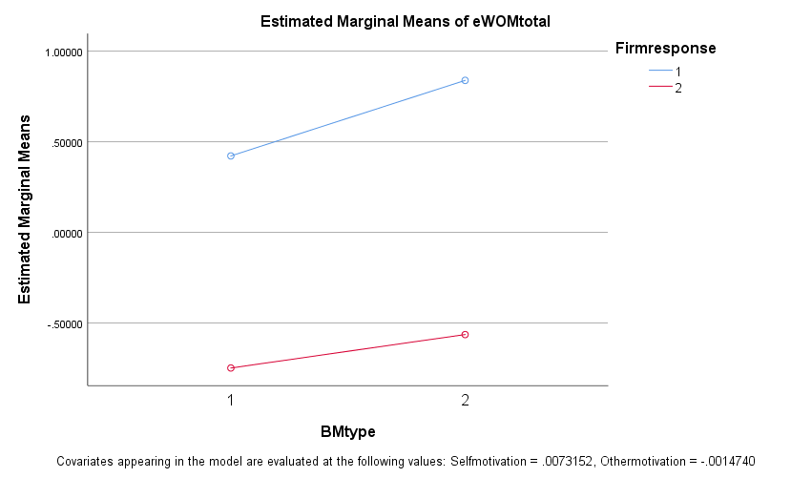

Table 29.

4.5 Hypotheses testing

The results of the ANCOVA showed that controlling for consumer motives (Other motivation and Self-motivation) both brand misconduct type and the firm’s response to crisis, have a statistically significant effect on consumer engagement in eWOM likelihood. While the interaction effect remains non-statistically significant either with the covariates or without them. Additionally, the two covariates included in the model have a statistically significant effect with a p-value = 0.000 (Table 25) for both; meaning that it was the right decision to include them in our model.
Moreover, before proceeding to my hypotheses testing, I performed several ANCOVAs utilizing and including the consumers’ demographics in my model. Indeed, none of the demographics had a statistically significant effect, meaning that it was a right decision to keep them out of our analysis (Appendices; 6) Tables and charts).

Testing of hypotheses:

Regarding the effect of the brand’s misconduct type on consumer’s likelihood to engage in eWOM, an ANOVA was performed. The statistically significant independent variable BMtype (Sig.= 0.003; Table 20) indicates that indeed, the type of misconduct influences consumer eWOM engagement likelihood. Additionally, the effect size of the brand misconduct type on our model is 0.048 (Partial Eta Sq.; Table 20), which means that 4.8% of the variation is explained by the type of misconduct alone. Lastly, the adjusted means of BMtype indicate that the values related misconduct (mean=0.1616542) was more likely to generate consumer eWOM compared to the performance related misconduct (mean=-0.1928992; ANOVA descriptive.), allowing us to accept H1(a) and H1(b).

H1(a) and H1(b) accepted.

The results of the ANOVA indicated that the firm’s response to crisis has a significant effect on eWOM engagement likelihood. With a p value = 0.000 (Table 25) we can safely assume that indeed, the firm’s response plays an important role in our study. To be more specific, the firm’s response to the crisis was the most effective variable in our model, explaining 41,2% of the total variance. The second hypothesis postulates that the more ambiguous the firm response, the greater the consumers’ likelihood to engage in eWOM following a crisis. Thus, we expect the diminish response to yield greater eWOM engagement likelihood compared to deal response. Indeed, the adjusted mean of the diminish response was calculated at around 0.6160807 compared to the -0.6386270 of the apology/deal response of the firm, allowing us to accept H2(a) and H2(b).
H2(a) and H2(b) accepted.

Firstly, regarding the third hypothesis, it is important to highlight that the interaction effect of brand misconduct type x firm response, was not statistically significant in both models (ANOVA and ANCOVA).
In the ANOVA model the interaction effect of the two independent variables had a p-value of 0.094 meaning it was not statistically significant. While, the interaction effect of the independent variables, remains non-statistically significant in the ANCOVA model (Sig 0.226) as well, only to become even less statistically significant.
Thus, we should reject H3 and H6 since the interaction effect of BM type and firm’s response to crisis is not statistically significant either in the ANOVA or in the ANCOVA.
H3 and H6 rejected

The fourth hypothesis postulates that consumer motives positively moderate the relationship between the brand misconduct type and the dependent variable. Comparing the results of the ANCOVA with the results of an ANOVA, without the covariates (self-motivation and other-motivation) we can see that there are differences in our model. In both analyses brand misconduct type is significant; however, without the covariates (ANOVA) it explains 4.8% of the variance of the eWOM engagement (Partial Eta squared= 0.073), while with the covariant (ANCOVA) it explains 5.2% of the dependent variable’s (consumers’ likelihood to engage in eWOM) variance. Thus, since the brand misconduct type remains statistically significant with an intensified effect we should accept H4.
H4 accepted

The fifth hypothesis tests the moderating effect of consumer motives on the relationship between the firm response and the dependent variable. Thus, by including the covariate in the analysis, we compare the results of the ANOVA and the ANCOVA. Without consumer motives as a covariates (ANOVA), the firm’s response to crisis explains 41.2% of the variance of eWOM engagement in our model. However, when we include Self-motivation and Other-motivation as a covariates (ANCOVA), the firm’s response to crisis effect gets intensified, explaining 50.4% of the dependent variable’s variance. Thus, H5 is accepted.
H5 accepted

5. Discussion

In the discussion section we are going to report our results and interpret their meaning. Following the results, we are going to mention the limitations of our model and suggest any alterations of the model for further research.

5.1 Summary of findings

My study, after analyzing the 185 respondents’ observations who participated to the survey, fulfilled its initial purpose to provide insights on how likely consumers are to engage in eWOM following a brand crisis, based on the crisis type and the firm’s reaction to the crisis.
Firstly, both brand misconduct type and firm response had significant main effects in our model proving that both variables have a vital role in consumers’ likelihood to engage in eWOM. The study outcomes demonstrate that the values related misconduct cases are more likely to yield consumer eWOM on social networks compared to performance related, which can be explained by the prior studies. Performance-related crises commonly involve defective products and primarily reduce a brand's perceived ability to deliver functional benefits (Dawar and Pillutla, 2000; Pullig et al., 2006; Roehm and Brady, 2007), while values-related crises do not directly involve the product or service, but mostly refer to social or ethical issues surrounding the values adopted by the brand. Thus, we can postulate that a values related crisis might demand thorough analysis among the consumers on social media so as to define the real crisis attributions, while a performance related misconduct damages the perceived brand image without much needed to be said, since it is easier for the consumers to identify the crisis attributions in such cases.
Moreover, the firm’s response to crisis appears to be the most effective variable in our model. Our results were robust, since the subjects that were exposed to the diminish response were much more likely to engage in eWOM following the crisis compared to the participants that were given the apology/deal response stimuli. For both types of misconduct, the diminish response yields greater eWOM engagement likelihood than the deal response. This finding is based on Coombs and Holladay’s (1996) theory which postulates that the more responsibility stakeholders attribute to the organization the more the crisis response strategy must seem to accept responsibility for the crisis (Coombs and Holladay, 1996). Thus, we can postulate that when the response of the firm is ambiguous consumers are more likely to discuss about the crisis wanting to “shed light” on the real acknowledgements of the crisis.
Finally, consumer motives found to moderate both the effects of the firm’s response to crisis and brand misconduct type, on eWOM engagement likelihood, based on the findings of Hennig-Thurau et al. (2004). By intensifying their effect, when included as a covariate in the ANCOVA consumer motives, found to affect positively the relationship between the firm’s response to crisis and consumers’ likelihood to engage in eWOM on social media respectively. The same stands for the relationship between the brand misconduct type and consumer’s likelihood to engage in eWOM, since it gets intensified as well.

5.2 Managerial implications

The present study not only provides managers with insights regarding the effect of the crisis type, but also demonstrates how the firm’s response to crisis affects consumers’ likelihood to engage in post crisis eWOM on social media. The values related misconduct incident was found to generate greater consumer eWOM engagement likelihood on social media, compared to the performance related misconduct. This finding is vital for managers, who should from now on expect growing consumer generated eWOM volume, mostly regarding corporate values and ethics as well as corporate social responsibility issues. However, it depends also on each firm’s willingness to put the conversations to an end. For instance, two brand crisis incidents that gained publicity lately, were the Apple’s deliberate slowing down of the older iPhones’ software and the KFC chicken shortage in UK. A common denominator of both incidents is that the crisis affected the perceived performance of the firms and that the initial response of both firms was an attempt to diminish the crisis outcome. In the first case, Apple tried to diminish the effect of the crisis, stating that the slowing down of older devices took place to save the battery life of the phones. While, in KFC’s incident, the firm tried to diminish the effect of the crisis by accusing their new logistics partner, DHL. In both cases, the diminish response of the firms lead to greater engagement of the consumers on social media eWOM. However, in the same case of KFC chicken shortage in UK, when a DHL representative was asked about the incident, he apologized and said: “Whilst we are not the only party responsible for the supply chain to KFC, we do apologise for the inconvenience and disappointment caused to KFC and their customers by this incident.” DHL took ownership of the crisis bringing the discussion to an end. Considering the aforementioned example, prior literature and the results of this study, we are fairly safe to say that it depends on crisis managers and firms, which crisis response strategy is the most suitable in each case, since the outcome differs. Crisis managers who can handle a great volume of consumer reactions and brand stories post crisis and want to generate publicity around their firms’ name might chose a more ambiguous way to respond to a crisis (diminish or denial which is not recommended). On the other hand, when crisis managers believe that the negative publicity will be uncontrollable and will only harm the firm, they should better go for more apologetic responses, dealing with the crisis by taking full ownership of the event.
Finally, my study provides insights regarding the consumers’ relationship with the brand, self-involvement and other-involvement, when it comes to post crisis consumer engagement in eWOM are based on Hennig-Thurau et al., 2004. Consumers who are more attached to a brand, are indeed more motivated and likely to engage in brand related eWOM on social media, post crisis compared to those who are not. In addition, people who need to prove themselves in their new media society(ies) as clever customers, as well as those who care more for others, are those who are more motivated to engage in brand related eWOM post crisis. Thus, crisis managers by spotting the right audience, will be able to better communicate their post crisis responses, since the more motivated consumer the more likely to engage in post crisis online discussions.

5.3 Academic contribution

My study contributes to marketing, crisis management and eWOM literature, with a focus on the sportswear fashion industry. While series of studies have applied crisis management theory to examine consumers’ perceptions towards the brand, consumers’ likelihood to repurchase and crisis outcomes in stock price terms. My research, fills a gap in the literature since it combines crisis management theory and consumer eWOM on social media studies, providing insights regarding the effects of the crisis type and brand’s response to crisis, on consumers’ likelihood to engage in eWOM post crisis. Finally, controlling for consumer motives, my study examines their moderating role in post crisis consumer eWOM. This enables academics to understand what motivates consumers the most during crises to contribute in brand related eWOM and how it affects in each case consumer’s likelihood to engage in eWOM post crisis.

5.4 Limitations and future research

In my study, I adopt the assumption that a values related brand crisis will generate greater amount of eWOM compared to performance related crises. Simply because they do not encompass specific product attributes that deliver functional benefits but calls into question the brand's capability to carry and communicate symbolic and psychological benefits (e.g., Pullig et al., 2006). Thus, I assume that a performance related misconduct is easier to be identified by the consumers, who then have no reason to further discuss neither the crisis itself, nor the firm’s response. However, further research needs to be conducted, in order to test and quantify the actual impact of the misconduct type on consumers’ post crisis eWOM generation. For instance, it would be interesting to extend this study by including several industries and not only the sportswear fashion one, so as to see if there is any significant difference in post crisis consumer generated eWOM when comparing the different industries.
Furthermore, future research needs to test if my findings apply to greater audiences as well, and not only to Greeks (mainly Greek sample approximately 80%), 20-35 age group which was my sample.
Moreover, my study examines consumers’ likelihood to engage in eWOM post crisis for some given crisis scenarios. However, it does not take into account the perceived egregiousness (gravity) of the incident, which impacts the intensity of undesirable responses (Klein et al., 2004), which may impact the consumers’ likelihood to engage in eWOM as well. Thus, we suppose that the exact same crisis incident is weighted and received differently among the consumers, since their experiences differ.
Furthermore, throughout my study I keep the brand in question constant (Adidas), meaning that not only future research might need to compare different industries when examining brand misconduct outcomes, but also it would be interesting to examine crises outcomes within the same industry. By including different companies of the same industry, future research will be able to examine the effect of other important variables such as the firm’s size or trajectory, on the consumers’ eWOM engagement likelihood post crisis.
Lastly, having removed the outliers from our analysis and having measured our control variables prior to the stimuli texts, we had no vital violation of the ANCOVA assumptions. However, looking at the respective histograms (Tables16,17) generated, we are fairly safe to say that we have no normal distribution at the second level (values related crisis) of the brand misconduct type independent variable and at the first level of the firm response (diminish response) as well. Finally, my sample slightly violates the homogeneity of regression slopes assumption, since there is only one interaction effect that appears as statistically significant (Firmresponse*Selfmotivation with p value = 0.002). The aforementioned limitations and suggestions for future research should be taken under consideration from researchers who might want to dig deeper into crisis management during the social media era.

6. References

Hennig-Thurau, T. et al. (2010) ‘The Impact of New Media on Customer Relationships’, Journal of Service Research, 13(3), pp. 311–330.
Muñiz Albert M and Schau, H. J. (2007) “Vigilante Marketing and Consumer-Created Communications,” Journal of Advertising, 36(3), pp. 35–50.
Becker-Olsen, K. L., Cudmore, B. A. and Hill, R. P. (2006) “The Impact of Perceived Corporate Social Responsibility on Consumer Behavior,” Journal of Business Research, 59(1), pp. 46–53.
Berens, G. and van Bruggen, G. H. (2005) “Corporate Associations and Consumer Product Responses: The Moderating Role of Corporate Brand Dominance,” Journal of Marketing, 69(3), pp. 35–48.
Biehal, G. J. and Sheinin, D. A. (2007) “The Influence of Corporate Messages on the Product Portfolio,” Journal of Marketing, 71(2), pp. 12–12.
Du, S., Bhattacharya, C. B. and Sen, S. (2007) “Reaping Relational Rewards from Corporate Social Responsibility: The Role of Competitive Positioning,” International Journal of Research in Marketing, 24(3), pp. 224–241.
Gurhan-Canli, Z. and Batra, R. (2004) “When Corporate Image Affects Product Evaluations: The Moderating Role of Perceived Risk,” JMR, Journal of Marketing Research, 41(2), pp. 197–205.
D.R. Lichtenstein ME Drumwright, BM Braig (2004) “The Effect of Corporate Social Responsibility on Customer Donations to Corporate-Supported Nonprofits,” Journal of Marketing, 68(4), pp. 16–32.
Luo, X. and Bhattacharya, C. B. (2006) “Corporate Social Responsibility, Customer Satisfaction, and Market Value,” Journal of Marketing, 70(4), pp. 1–1.
Madrigal, R. and Boush, D. M. (2008) “Social Responsibility As a Unique Dimension of Brand Personality and Consumers' Willingness to Reward,” Psychology & Marketing, 25(6), pp. 538–538.
Sen, S. and Bhattacharya, C. B. (2001) “Does Doing Good Always Lead to Doing Better? Consumer Reactions to Corporate Social Responsibility,” JMR, Journal of Marketing Research, 38(2), pp. 225–243.
Smith, N. C. and Cooper-Martin, E. (1997) “Ethics and Target Marketing: The Role of Product Harm and Consumer Vulnerability,” Journal of Marketing, 61(3), pp. 1–20.
Holt, D. B. (2002) “Why Do Brands Cause Trouble? A Dialectical Theory of Consumer Culture and Branding,” Journal of Consumer Research, 29(1), pp. 70–90.
Laufer, D. and Coombs, W. T. (2006) “How Should a Company Respond to a Product Harm Crisis? The Role of Corporate Reputation and Consumer-Based Cues,” Business Horizons, 49(5), pp. 379–379.
Aaker, J., Fournier, S. and Brasel, S. A. (2004) “When Good Brands Do Bad,” Journal of Consumer Research, 31(1), pp. 1–16.
Siomkos, G. J. and Kurzbard, G. (1994) “The Hidden Crisis in Product-Harm Crisis Management,” European Journal of Marketing, 28(2), pp. 30–30.
Balmer, J. M. T. and Gray, E. R. (2003) “Corporate Brands: What Are They? What of THEM?” European Journal of Marketing, 37(7/8), pp. 972–997.
Leone, R. P., Rao, V. R. and Luo, A. M. (2006) “Linking Brand Equity to Customer Equity,” Journal of Service Research: JSR, 9(2), pp. 125–138.
Keller, K. L. and Aaker, D. A. (1998) “The Impact of Corporate Marketing on a Company's Brand Extensions,” Corporate Reputation Review, 1(4), pp. 356–378.
Stephen King, (1991) "Brand building in the 1990s", Journal of Consumer Marketing, 8(4), pp.43-52.
Huber, F., Vogel, J. and Meyer, F. (2009) “When Brands Get Branded,” Marketing Theory, 9(1), pp. 131–136.
Dawar, N. and Pillutla, M. M. (2000) “Impact of Product-Harm Crises on Brand Equity: The Moderating Role of Consumer Expectations,” Journal of Marketing Research, 37(2), pp. 215–226.
Klein, J. G., Smith, N. C. and Andrew, J. (2004) “Why We Boycott: Consumer Motivations for Boycott Participation,” Journal of Marketing, 68(3), pp. 92–109.
Leenheer J, Van Heerde (2006) Do loyalty programs really enhance behavioral LOYALTY? an empirical analysis accounting for self-selecting members. Rotterdam: Erasmus Research Institute of Management (ERIM)
Smith, N. C. and Cooper-Martin, E. (1997) “Ethics and Target Marketing: The Role of Product Harm and Consumer Vulnerability,” Journal of Marketing, 61(3), pp. 1–1.
Ahluwalia, R. and Burnkrant, R. E. (2000) “Consumer Response to Negative Publicity: The Moderating Role of Commitment,” JMR, Journal of Marketing Research, 37(2), pp. 203–214.
Berry, L. L. and Parasuraman, A. (1992) “Prescriptions for a Service Quality Revolution in America,” Organizational dynamics.
De Chernatony, L. and McDonald, M. (1998) Creating powerful brands in consumer, service, and industrial markets. 2nd edn. Oxford: Butterworth-Heinemann (CIM professional).
Dennis B. Bromley, (2001) "Relationships between personal and corporate reputation", European Journal of Marketing, Vol. 35 Issue: 3/4, pp.316-334
Ward, J. C. and Ostrom, A. L. (2006) “Complaining to the Masses: The Role of Protest Framing in Customer-Created Complaint Web Sites,” Journal of Consumer Research, 33(2), pp. 220–230.
Bendixen, M. & Abratt, R. J Bus Ethics (2007) 76: 69.
Susan Fournier; Consumers and Their Brands: Developing Relationship Theory in Consumer Research, Journal of Consumer Research, Volume 24, Issue 4, 1 March 1998, Pages 343–373,
Dawar, N. and Lei, J. (2009) “Brand Crises: The Roles of Brand Familiarity and Crisis Relevance in Determining the Impact on Brand Evaluations,” Journal of Business Research, 62(4), pp. 509–509.
Michelle L. Roehm and Alice M. Tybout (2006) When Will a Brand Scandal Spill Over, and How Should Competitors RESPOND? Journal of Marketing Research: August 2006, Vol. 43, No. 3, pp. 366-373.
Roehm, M. L. and Brady, M. K. (2007) “Consumer Responses to Performance Failures by High-Equity Brands,” Journal of Consumer Research, 34(4), pp. 537–545.
Swan, J., & Combs, L. (1976). Product Performance and Consumer Satisfaction: A New Concept. Journal of Marketing,40(2), 25-33.
Barbara E. Kahn, Robert J. Meyer; Consumer Multiattribute Judgments under Attribute-Weight Uncertainty, Journal of Consumer Research, Volume 17, Issue 4, 1 March 1991, Pages 508–522
Mittal, V., Ross, W., & Baldasare, P. (1998). The Asymmetric Impact of Negative and Positive Attribute-Level Performance on Overall Satisfaction and Repurchase Intentions. Journal of Marketing, 62(1), 33-47
Mittal, V., Kumar, P., & Tsiros, M. (1999). Attribute-Level Performance, Satisfaction, and Behavioral Intentions over Time: A Consumption-System Approach. Journal of Marketing, 63(2), 88-101.
Sturges, D. L. (1994) ‘Communicating through Crisis: A Strategy for Organizational Survival’, Management Communication Quarterly, 7(3), pp. 297–316.
W. Timothy Coombs & Sherry J. Holladay (1996) Communication and Attributions in a Crisis: An Experimental Study in Crisis Communication, Journal of Public Relations Research, 8:4, 279-295
Gabriel J. Biehal and Daniel A. Sheinin (2007) The Influence of Corporate Messages on the Product Portfolio. Journal of Marketing: April 2007, Vol. 71, No. 2, pp. 12-25.
Du, S., Bhattacharya, C. B. and Sen, S. (2007) “Reaping Relational Rewards from Corporate Social Responsibility: The Role of Competitive Positioning,” International Journal of Research in Marketing, 24(3), pp. 224–241.
Donald R. Lichtenstein, Minette E. Drumwright, Bridgette M. Braig (2004) The Effect of Corporate Social Responsibility on Customer Donations to Corporate-Supported Nonprofits. Journal of Marketing: October 2004, Vol. 68, No. 4, pp. 16-32.
CAPOZZI, L. (2005). Corporate Reputation: Our Role in Sustaining and Building a Valuable Asset. Journal of Advertising Research, 45(3), 290-293.
Laufer, D. and Coombs, W. T. (2006) “How Should a Company Respond to a Product Harm Crisis? The Role of Corporate Reputation and Consumer-Based Cues,” Business Horizons, 49(5), pp. 379–379.
Libai, B. et al. (2010) ‘Customer-to-Customer Interactions: Broadening the Scope of Word of Mouth Research’, Journal of Service Research, 13(3), pp. 267–282.
Kuksov, D., Shachar, R. and Wang, K. (2013) “Advertising and Consumers' Communications,” Marketing Science, 32(2), pp. 294–309.
Malthouse, E. C., Haenlein, M., Skiera, B., Wege, E. and Zhang, M. (2013) “Managing Customer Relationships in the Social Media Era: Introducing the Social Crm House,” Journal of Interactive Marketing, 27(4), pp. 270–270.
Oliver Hinz, Bernd Skiera, Christian Barrot, Jan U. Becker (2011) Seeding Strategies for Viral Marketing: An Empirical Comparison. Journal of Marketing: November 2011, Vol. 75, No. 6, pp. 55-71.
van der Lans, R., van Bruggen, G., Eliashberg, J. and Wierenga, B. (2010) “A Viral Branching Model for Predicting the Spread of Electronic Word of Mouth,” Marketing Science, 29(2), pp. 348–365
Marina Puzakova, Hyokjin Kwak, Joseph F. Rocereto (2013) When Humanizing Brands Goes Wrong: The Detrimental Effect of Brand Anthropomorphization Amid Product Wrongdoings. Journal of Marketing: May 2013, Vol. 77, No. 3, pp. 81-100.
Smith, A. N., Fischer, E. and Yongjian, C. (2012) “How Does Brand-Related User-Generated Content Differ Across Youtube, Facebook, and TWITTER?” Journal of Interactive Marketing, 26(2), pp. 102–102.
Smith, N. C. and Cooper-Martin, E. (1997) “Ethics and Target Marketing: The Role of Product Harm and Consumer Vulnerability,” Journal of Marketing, 61(3), pp. 1–1.
Singh, S. and Sonnenburg, S. (2012) “Brand Performances in Social Media,” Journal of Interactive Marketing, 26(4), pp. 189–189.
Shankar, V., Smith, A. K. and Rangaswamy, A. (2003) “Customer Satisfaction and Loyalty in Online and Offline Environments,” International Journal of Research in Marketing, 20(2), pp. 153–175.
Bolton, R. N., Parasuraman, A., Hoefnagels, A., Migchels, N., Kabadayi, S., Gruber, T. and Solnet, D. (2013) “Understanding Generation Y and Their Use of Social Media: A Review and Research Agenda,” Journal of Service Management, 24(3), pp. 245–267.

Dhar, V. and Chang, E. A. (2009) “Does Chatter Matter? The Impact of User-Generated Content on Music Sales,” Journal of Interactive Marketing, 23(4), pp. 300–300.
Godes, D., Mayzlin, D., Chen, Y., Das, S., Dellarocas, C., Pfeiffer, B., Libai, B., Sen, S., Shi, M. and Verlegh, P. (2005) “The Firm's Management of Social Interactions,” Marketing Letters, 16(3-4), pp. 415–428.
Ba, S. and Paul A. Pavlou (2002) “Evidence of the Effect of Trust Building Technology in Electronic Markets: Price Premiums and Buyer Behavior,” MIS Quarterly, 26(3), pp. 243–268.
Flynn, L. R., Goldsmith, R. E. and Eastman, J. K. (1996) “Opinion Leaders and Opinion Seekers: Two New Measurement Scales,” Journal of the Academy of Marketing Science, 24(2), pp. 137–137.
Feick, L. F. and Price, L. L. (1987) “The Market Maven: A Diffuser of Marketplace Information,” Journal of Marketing, 51(1), pp. 83–83.
Harrison-Walker, L. J. (2001) “The Measurement of Word-Of-Mouth Communication and an Investigation of Service Quality and Customer Commitment As Potential Antecedents,” Journal of Service Research: JSR, 4(1), pp. 60–75.
Fournier, S. (1998) “Consumers and Their Brands: Developing Relationship Theory in Consumer Research,” The Journal of consumer research, 24(4), p. 343.
Huber, F., Vollhardt, K., Matthes, I. and Vogel, J. (2010) “Brand Misconduct: Consequences on Consumer-Brand Relationships,” Journal of Business Research, 63(11), pp. 1113–1113.
Dawar, N. and Pillutla, M. M. (2000) “Impact of Product-Harm Crises on Brand Equity: The Moderating Role of Consumer Expectations,” Journal of Marketing Research, 37(2), pp. 215–226. doi: 10.1509/jmkr.37.2.215.18729.
Henard, D. H. (2002) “Negative Publicity: What Companies Need to Know About Public Relations,” The public relations quarterly, 47(4), pp. 8–12.
Wu, C. and Shaffer, D. R. (1987) “Susceptibility to Persuasive Appeals As a Function of Source Credibility and Prior Experience with the Attitude Object,” Journal of Personality and Social Psychology, 52(4), pp. 677–688. doi: 10.1037//0022-3514.52.4.677.
Dichter, E. (1966) “How Word-Of-Mouth Advertising Works,” Harvard Business Review, 44(6).
Sundaram, D. S., Mitra, K. and Webster, C. (1998) “Word-Of-Mouth Communications: A Motivational Analysis,” Advances in Consumer Research, 25(1).
Price, L. L., Feick, L. F. and Guskey, A. (1995) “Everyday Market Helping Behavior,” Journal of public policy & marketing, 14(2), pp. 255–266.
Gatignon, H. and Robertson, T. S. (1985) “A Propositional Inventory for New Diffusion Research,” Journal of Consumer Research, 11(4), pp. 849–849.
'Racist' H&M coolest monkey hoodie banned by eBay, BBC, 2018
“Don’t call the police over KFC crisis”, BBC 2018
Dwane Hal Dean (2004) “Consumer Reaction to Negative Publicity: Effects of Corporate Reputation, Response, and Responsibility for a Crisis Event,” Journal of Business Communication, 41(2), pp. 192–211.
W. Timothy Coombs (1995) “Choosing the Right Words: The Development of Guidelines for the Selection of the ‘appropriate’ Crisis-Response Strategies,” Management Communication Quarterly, 8(4), pp. 447–476.
Kumar, R. (2014). Research Methodology. London: SAGE Publications.
Goldsmith, R. E. and Clark, R. A. (2008) “An Analysis of Factors Affecting Fashion Opinion Leadership and Fashion Opinion Seeking,” Journal of Fashion Marketing and Management, 12(3), pp. 308–322.
O'Cass, A. (2004) “Fashion Clothing Consumption: Antecedents and Consequences of Fashion Clothing Involvement,” European Journal of Marketing, 38(7), pp. 869–882.
Phau, I. and Lo, C.-C. (2004) “Profiling Fashion Innovators: A Study of Self-Concept, Impulse Buying and Internet Purchase Intent,” Journal of Fashion Marketing and Management, 8(4), pp. 399–411.
Knight, G. and Greenberg, J. (2002) “Promotionalism and Subpolitics - Nike and Its Labor Critics,” Management communication quarterly, 15(4), pp. 541–570.
Dwane Hal Dean (2004) “Consumer Reaction to Negative PUBLICITY: Effects of Corporate Reputation, Response, and Responsibility for a Crisis Event,” Journal of Business Communication, 41(2), pp. 192–211.
Forbes (2013) “THE PERVERSE BRILLIANCE OF ABERCROMBIE & FITCH'S CEO”
CNN (2018) Global backlash spreads over Apple slowing down iPhones

The Guardian (2018) 'People have gone chicken crazy': what the KFC crisis means for the brand

7. Appendices

- Performance related misconduct/diminish response stimuli text:

While surfing in your favorite e-news site, you come through the following article:

Adidas CEO: "We followed all the procedures and quality checks needed"

The new series of Adidas leisure shoes, “Adi-now”, where reported by thousands of consumers to be defective. To be more specific, what seems to be problematic with Adidas’ new model, is the shoe sole. Just a week after their release and the durability of the shoes' soles seems to be very poor, since they get effortlessly detached.
Unsurprisingly, a customer outburst on the social media followed exposing the brand's malpractice.

"We acknowledge the frustration that the incident might have caused among our customers, but we [Adidas] followed all the procedures and the quality checks needed. However, the particular batch will be investigated in case any damage caused during the transportation or the storage of the shoes" said the brands CEO during a radio interview.

- Performance related/ deal response stimuli text:
While surfing in your favorite e-news site, you come through the following article:

Adidas CEO: "We are really sorry for letting down our customers"

The new series of Adidas leisure shoes, “Adi-now”, where reported by thousands of consumers to be defective. To be more specific, what seems to be problematic with Adidas’ new model, is the shoe sole. Just a week after their release and the durability of the shoes' soles seems to be very poor, since they get effortlessly detached.
Unsurprisingly, a customer outburst on the social media followed exposing the brand's malpractice.
"Adidas is going to stop the production of the defective model, until we manage to resolve the issue and release the new version of the shoes; our best team of designers is already working on it", the firm's CEO said during a radio interview, "We are really sorry for letting down our customers and we promise we are going to find a solution soon and bring that shoe back to production upgraded", he added.

- Values related/diminish response stimuli text:

While surfing your favorite e-news site, you come through the following article:

Adidas CEO: "I don't believe that my words were offending"
Adidas, the famous sportswear brand was reportedly accused of discrimination. The brand does not accommodate people of all shapes and sizes. According to the company's CEO, that decision is international. Yesterday, he caused an uproar when he said on the radio: "Candidly, we go after the cool kids. We go after the attractive, all-sports kid with great attitude and many friends. A lot of people don't belong [in our clothes] and they can't belong. Are we exclusionary? Absolutely."

After a massive backlash on the social media from the consumers' side, the firm's CEO responded: "I understand that many of our customers were hurt by my words, however, I don't believe that my words were offending, I just try to promote healthy and fit lifestyle among Adidas' enthusiasts."

- Values related/ deal response stimuli text:

While surfing your favorite e-news site, you come through the following article:

Adidas CEO: "I sincerely apologise to all those who were hurt by my words"
Adidas, the famous sportswear brand was reportedly accused of discrimination. The brand does not accommodate people of all shapes and sizes. According to the company's CEO, that decision is international. Yesterday, he caused an uproar when he said on the radio: "Candidly, we go after the cool kids. We go after the attractive, all-sports kid, with great attitude and many friends. A lot of people don't belong [in our clothes] and they can't belong. Are we exclusionary? Absolutely."

After a massive backlash on the media from the consumers' side, the firm's CEO responded: " I sincerely apologise to all those who were hurt by my words; with my message I did not mean to offend anybody, but to promote healthy and fit lifestyle among Adidas' enthusiasts."

- Link to the survey : https://erasmusuniversity.eu.qualtrics.com/jfe/form/SV_3QLtKOLkBiJDLqB

- Tables and charts:

- ANCOVA results including Gender (female vs male) as an independent variable:

Tests of Between-Subjects Effects
Dependent Variable: eWOMtotal
Source | Type III Sum of Squares | df | Mean Square | F | Sig. | Partial Eta Squared
Corrected Model | 108.874ª | 9 | 12.097 | 28.839 | .000 | .597
Intercept | .004 | 1 | .004 | .010 | .922 | .000
Selfmotivation | 9.829 | 1 | 9.829 | 23.432 | .000 | .118
Othermotivation | 5.752 | 1 | 5.752 | 13.713 | .000 | .073
BMtype | 3.477 | 1 | 3.477 | 8.290 | .004 | .045
Firmresponse | 74.867 | 1 | 74.867 | 178.482 | .000 | .505
Gender | .312 | 1 | .312 | .744 | .390 | .004
BMtype * Firmresponse | .402 | 1 | .402 | .958 | .329 | .005
BMtype * Gender | 1.431 | 1 | 1.431 | 3.412 | .066 | .019
Firmresponse * Gender | 1.734E-5 | 1 | 1.734E-5 | .000 | .995 | .000
BMtype * Firmresponse * Gender | .039 | 1 | .039 | .092 | .762 | .001
Error | 73.407 | 175 | .419
Total | 182.320 | 185
Corrected Total | 182.280 | 184
a. R Squared = .597 (Adjusted R Squared = .577)

- ANCOVA including Education (master’s degree owner, no master’s degree) as an independent variable:

Tests of Between-Subjects Effects
Dependent Variable: eWOMtotal
Source | Type III Sum of Squares | df | Mean Square | F | Sig. | Partial Eta Squared
Corrected Model | 107.905ª | 9 | 11.989 | 28.211 | .000 | .592
Intercept | .072 | 1 | .072 | .168 | .682 | .001
Selfmotivation | 9.775 | 1 | 9.775 | 23.001 | .000 | .116
Othermotivation | 6.808 | 1 | 6.808 | 16.019 | .000 | .084
BMtype | 3.698 | 1 | 3.698 | 8.702 | .004 | .047
Firmresponse | 71.265 | 1 | 71.265 | 167.683 | .000 | .489
Educationdummy | .286 | 1 | .286 | .674 | .413 | .004
BMtype * Firmresponse | .441 | 1 | .441 | 1.038 | .310 | .006
BMtype * Educationdummy | .002 | 1 | .002 | .005 | .944 | .000
Firmresponse * Educationdummy | .321 | 1 | .321 | .756 | .386 | .004
BMtype * Firmresponse * Educationdummy | .132 | 1 | .132 | .310 | .578 | .002
Error | 74.375 | 175 | .425
Total | 182.320 | 185
Corrected Total | 182.280 | 184
a. R Squared = .592 (Adjusted R Squared = .571)

- ANCOVA including Employment (employed vs non-employed) as an independent variable:

Tests of Between-Subjects Effects
Dependent Variable: eWOMtotal
Source | Type III Sum of Squares | df | Mean Square | F | Sig. | Partial Eta Squared
Corrected Model | 108.733ª | 9 | 12.081 | 28.747 | .000 | .597
Intercept | .167 | 1 | .167 | .398 | .529 | .002
Selfmotivation | 8.475 | 1 | 8.475 | 20.165 | .000 | .103
Othermotivation | 7.661 | 1 | 7.661 | 18.229 | .000 | .094
BMtype | 3.638 | 1 | 3.638 | 8.656 | .004 | .047
Firmresponse | 71.302 | 1 | 71.302 | 169.658 | .000 | .492
Employdummy | .009 | 1 | .009 | .021 | .886 | .000
BMtype * Firmresponse | .534 | 1 | .534 | 1.271 | .261 | .007
BMtype * Employdummy | .288 | 1 | .288 | .684 | .409 | .004
Firmresponse * Employdummy | .045 | 1 | .045 | .106 | .745 | .001
BMtype * Firmresponse * Employdummy | 1.311 | 1 | 1.311 | 3.120 | .079 | .018
Error | 73.547 | 175 | .420
Total | 182.320 | 185
Corrected Total | 182.280 | 184
a. R Squared = .597 (Adjusted R Squared = .576)

Other tables mentioned in the analysis:

Reliability Statistics
Cronbach's Alpha | Cronbach's Alpha Based on Standardized Items | N of Items
,863 | ,864 | 3

Table 2.

Reliability Statistics
Cronbach's Alpha | Cronbach's Alpha Based on Standardized Items | N of Items
,786 | ,786 | 6

Table 7.

KMO and Bartlett's Test
Kaiser-Meyer-Olkin Measure of Sampling Adequacy. |  | ,720
Bartlett's Test of Sphericity | Approx. Chi-Square | 369,178
Bartlett's Test of Sphericity | df | 15
Bartlett's Test of Sphericity | Sig. | ,000

Table 9.

Total Variance Explained
Component | Initial Eigenvalues |  |  | Extraction Sums of Squared Loadings |  |  | Rotation Sums of Squared Loadingsª
Component | Total | % of Variance | Cumulative % | Total | % of Variance | Cumulative % | Total
1 | 2,920 | 48,669 | 48,669 | 2,920 | 48,669 | 48,669 | 2,565
2 | 1,097 | 18,291 | 66,959 | 1,097 | 18,291 | 66,959 | 2,130
3 | ,794 | 13,234 | 80,193
4 | ,548 | 9,139 | 89,332
5 | ,403 | 6,721 | 96,053
6 | ,237 | 3,947 | 100,000
Extraction Method: Principal Component Analysis.
a. When components are correlated, sums of squared loadings cannot be added to obtain a total variance.

Table 10.

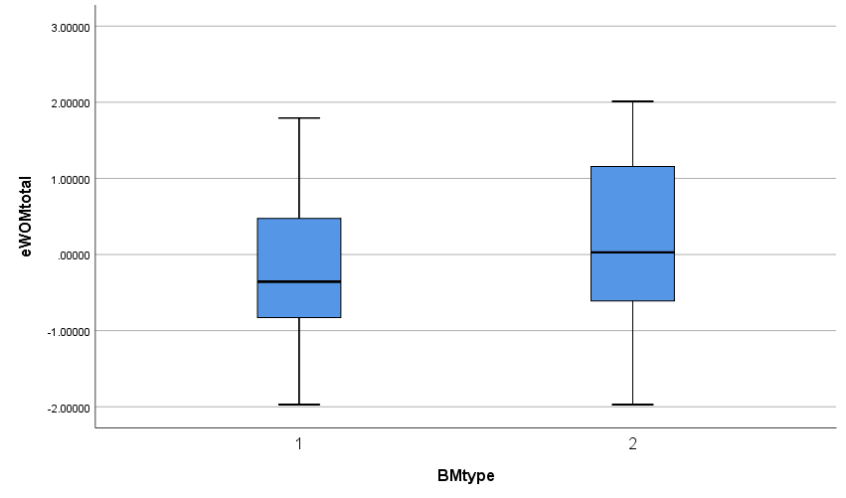
Table 11.

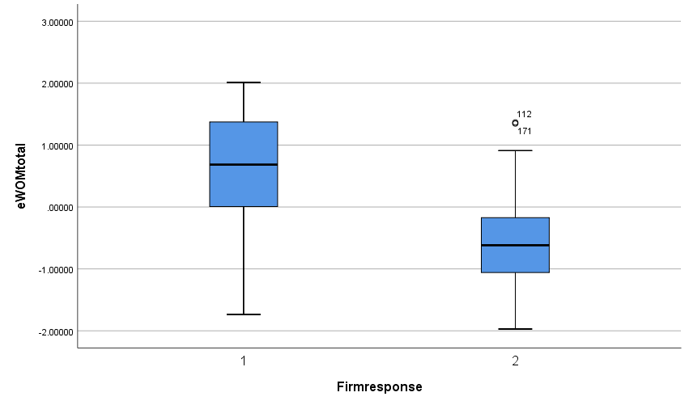Table 12.

Tests of Normality
 | BMtype | Kolmogorov-Smirnovª |  |  | Shapiro-Wilk
 | BMtype | Statistic | df | Sig. | Statistic | df | Sig.
eWOMtotal | 1 | .081 | 92 | .170 | .980 | 92 | .166
eWOMtotal | 2 | .100 | 93 | .023 | .959 | 93 | .005
a. Lilliefors Significance Correction
Table 13.

Tests of Normality
 | Firmresponse | Kolmogorov-Smirnovª |  |  | Shapiro-Wilk
 | Firmresponse | Statistic | df | Sig. | Statistic | df | Sig.
eWOMtotal | 1 | .105 | 92 | .014 | .952 | 92 | .002
eWOMtotal | 2 | .064 | 93 | .200* | .985 | 93 | .342
*. This is a lower bound of the true significance.
a. Lilliefors Significance Correction

Table 14.

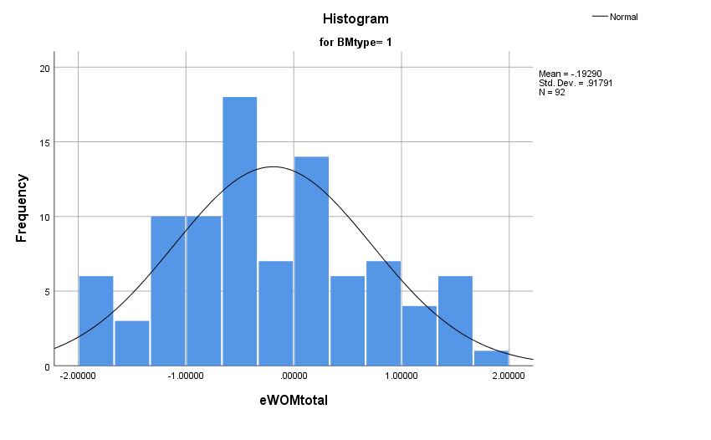Table 15.

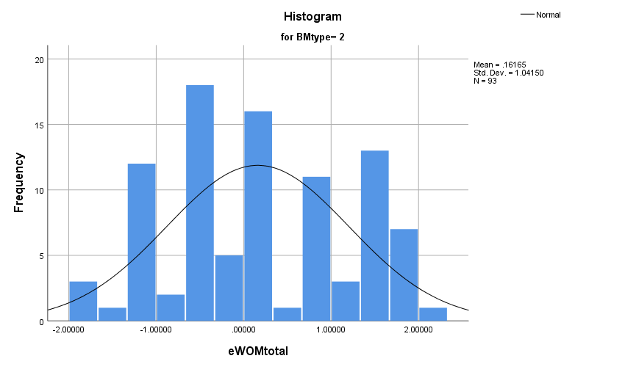
Table 16.

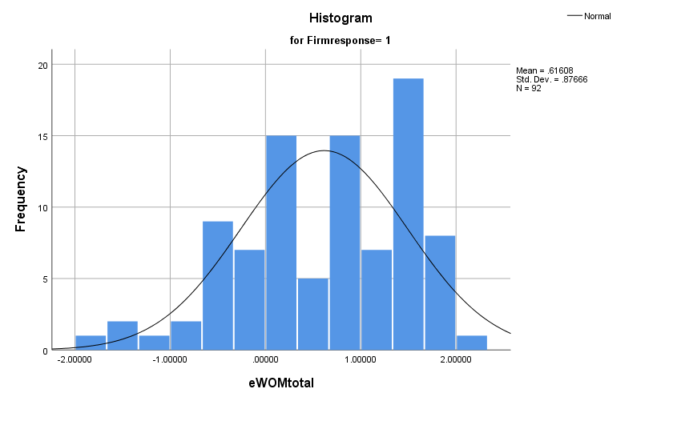

Table 17.

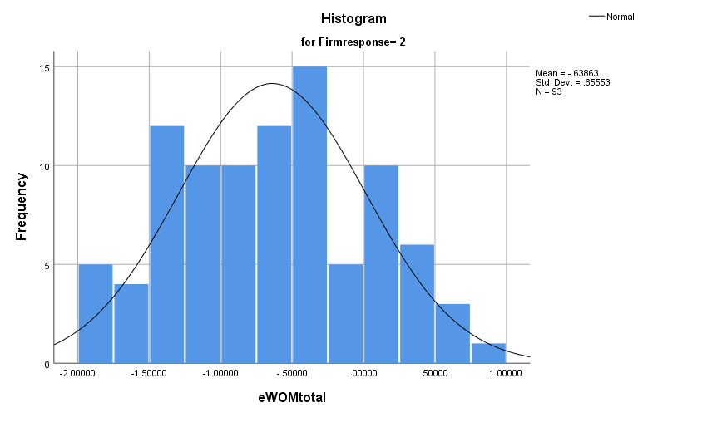
Table 18.

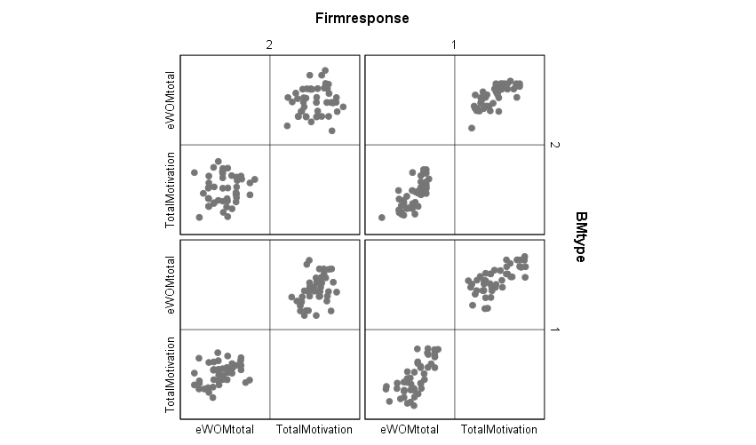

Table 19.

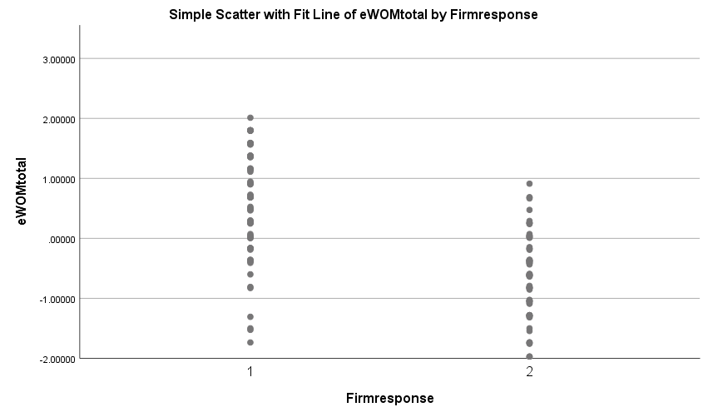
Table 23a.

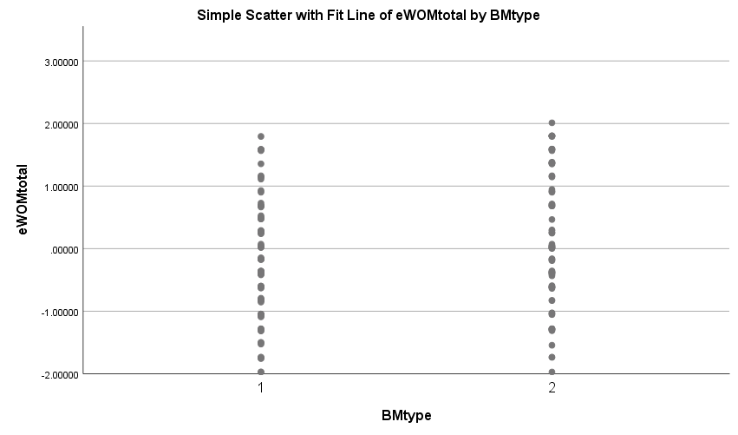
23b.

