ERASMUS UNIVERSITY ROTTERDAM
Erasmus School of Economics
Bachelor Thesis

From a Refugee Crisis to a European crisis: does the influx of asylum seekers affect attitudes towards further integration of the European Union?

ABSTRACT
The attitude towards further integration of the EU has decreased over the past decade. Meanwhile, Europe has experienced a Refugee Crisis. I have been looking into the effect of the influx of asylum seekers per thousand residents on attitudes of European citizens towards further integration of the EU. Estimating an ordered probit model, controlling for country and year fixed effects, country-specific factors, individual characteristics and the influx of immigrants per thousand residents, I found a significant, positive effect. However, this effect is rather small. Moreover, there are some concerns about omitted variables and reversed causality causing bias regarding this estimation. Therefore, I have also estimated an instrumental regression, including year and country fixed effects, controlling for the influx of immigrants per thousand residents. The increase of influx of one asylum seeker per thousand residents, significantly decreases the attitude towards European integration with 0,2 on a scale from 0 to 10. One can conclude there is small but significant negative effect.

Name student: Jan Smelik
Student ID number: 448345
Supervisor: Aart Gerritsen
Second assessor: dr. Anna Baiardi
Date final version: 22 June 2019

The views stated in this thesis are those of the author and not necessarily those of Erasmus School of Economics or Erasmus University Rotterdam.
Table of content
I. Introduction 3
II. Literature research 6
III. Data 11
IV. Methodology and validation 16
V. Results 19
VI. Discussion 26
VII. Conclusion 27
Appendix 30
References 35

I. Introduction

The 23th of June 2016, the Brits decided: the European integration has gone too far, and they voted to leave the European Union (EU) (European Council, 2017). The leader of the party in the far right of Italy responded: “now it’s our turn,”, and media are speaking about a Frexit, Nexit and Swexit (Harlan, 2019). More recently, the fundamental value of ‘an ever closer union’ is under fire (Voorhoeve, 2019), which also illustrates that further integration of the EU is not obvious anymore. What drives this seemingly increase of negative stories about European integration?
In 2005, it already had been found that anti-immigration sentiments were strong predictors for a negative attitude for European integration (De Vreese & Boomgaarden, 2005). Regarding Brexit, it appears that in regions with a lot of immigration, more people voted for ‘leave’ (Arnorsson & Zoega, 2018). One could argue that the Refugee Crisis, with its peak in 2015 (United Nations Refugee Agency, 2015), caused an increase in negative attitude of EU civilians towards further European integration (Dempsey, 2015). When the European Commission (EC) proposed to distribute 160,000 refugees (European Commission, 2015), only a quarter of these refugees were actually relocated in 2017 (Dearden, 2017). The resistance to the relocation indicates a dissatisfaction with refugees and, since the decision limited the national sovereignty, it might have enforced negative feelings towards the EU.
Data from the European Social Survey gives some insights. Figure 1 shows that the attitude towards further European integration decreased from 2008 to 2014. The number of asylum seekers per thousand residents coming to Europe does not show a conclusive association. However, the question remains if number of asylum seekers is causing the attitude to go up or down. Therefore, I would like to answer the following question:

Does an increase in asylum seekers per capita cause a more negative attitude towards further integration of the EU?

The question is going to be answered over the years 2004 to 2016 and the countries of subject will be most of the European countries. I choose for asylum seekers rather than refugees simply because the international measures of these streams of people are measured in number of asylum seekers. Answering these questions, I would like to give policy makers of the EU and European countries some building blocks to reevaluate the direction they want to steer the EU into. Answers to the question what effect the inflow of asylum seekers has on attitude towards further European integration and explaining

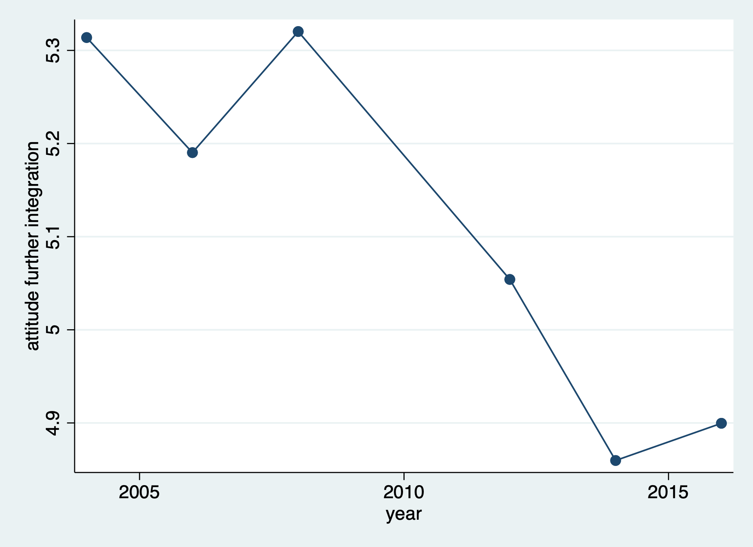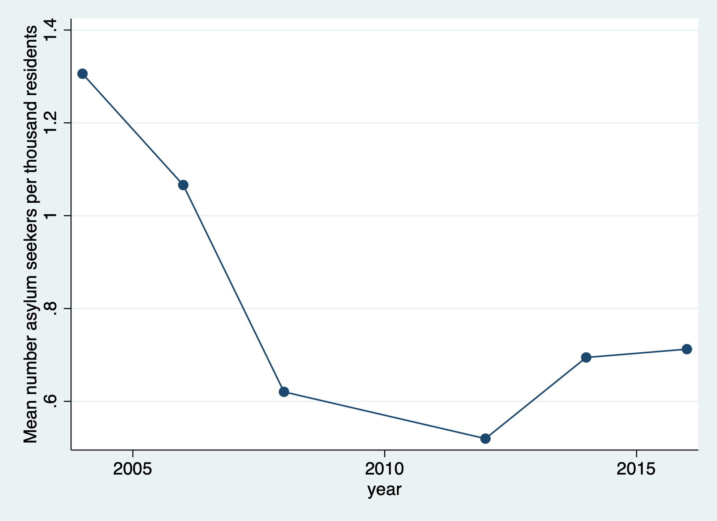
Figure 1: attitude towards further European integration (left) and number of asylum seekers per thousand residents (right) over time

how this relationship works, gives policy makers information needed to develop asylum policy. Since more studies predict even bigger refugee crises in the future due to climate change (Baldwin, 2017; Harvey, 2017) and the expected increase of population of Africa (Kugiel, 2017), is finding an answer to these questions crucial to investigate whether the EU is tenable as it is now.

I have used two methods to estimate the effect of the influx of asylum seekers per thousand residents on the attitude towards further integration of the EU. First, I estimated an ordered probit model, controlling for country and year fixed effects and other controls. Country-specific controls are social expenditures per capita to capture the governmental generosity, life expectancy as proxy for health, and GDP per capita as proxy prosperity. Individual controls are place on a political left to right scale, life satisfaction, happiness, subjective health, and education. Furthermore, I control for the influx of immigrants per thousand residents, to isolate the effect of asylum seekers from that of all immigrants.
An ordered probit model only estimates the marginal effect, therefore, the actual effect can only be interpreted by giving values to the independent variables. Given that all control variables have their average values (see table 2 in the appendix), in Austria in 2004, an increase in 1 asylum applicant per thousand persons with respect to the average number of asylum applicants, increases the likelihood of having a very positive attitude with a probability of 0,000002. So, although the effect is significant, it is rather small.
However, since there are concerns of omitted variable bias and reversed causality, I also ran instrumental variable (IV) regressions. Doing this, I isolate the effect of the influx of asylum seekers per thousand persons on the attitude towards further integration and therefore I overcome problems like omitted variable bias and reversed causality.
I have identified and quantified three factors that cause asylum seeker flows to Europe to use those as IVs. The first is the war in Syria. This war is measured in the intensity of violence in Syria and Iraq. This factor causes over 24 per cent of the influx of asylum seekers. The second factor is the drought in East-Africa. I quantify this by taking the number of affected persons in Ethiopia, Somalia and Kenya. The last factor is the political terror in Algeria and Eritrea, with data from the political terror scale. I also take into account the distance between the host and home country, and the population of the home country.
Using three instruments increases predictive power and allows me the investigate the validity of the instruments. All three instruments seem to have a strong first stage and are unlikely to affect the attitude towards further integration directly or indirectly through other factors that influence the influx of asylum seekers.
Eventually, I ran an 2SLS regression with the influx of asylum seekers per thousand residents instrumented by the three IVs, with country and year fixed effects, controlling for the influx of immigrants per thousand persons. In addition, I ran an ordered probit model as robustness check. The results are similar in sign and significance, so for simplicity it is sufficient to interpret the results of the 2SLS regression. The increase of one asylum seeker per thousand residents, significantly decreases the attitude towards European integration with 0,2 on a scale from 0 to 10.
There are three potential mechanisms that might explain the negative effect that has been found. First of all, the asylum seekers might trigger an us-them feeling under natives. Natives feel that their group identity is threatened by asylum seekers, who are having a different culture and language, and regard them as out-group. Because the EU promote the values of bringing different people and cultures together, the threatened natives might oppose to further integration of the EU when more asylum seekers are coming to their country.
A second mechanism might be through wages. If asylum seekers are mostly lower skilled, they increase the supply of low-skilled labor when coming to a country. This increase in supply will lead to a decrease of wages of low-skilled, native workers. These natives might blame the EU for this and oppose to further integration.
Third, asylum seekers could be a heavy burden on the welfare system. Asylum seekers are likely to suffer from mental and physical traumas. This lowers their economic chances and increases the costs of health care. Moreover, the costs of integration might be high for asylum seekers specifically, since they often come from countries that differ a lot from their host country.
The rest of this paper is structured as follows. Hereafter I discuss the related literature (II), then I will discuss the data used and explain how the instruments are developed (III). In section IV, I will discuss the methods used and why these methods are valid. Thereafter I will discuss the results (V). Finally, after providing a discussion (VI), I will draw some conclusions (VII).

II. Literature research

According to Kentmen-Cin and Erisen (2017), there is an increase in literature written about anti-immigration attitudes on attitudes towards the EU. However, they argue that the effect of asylum seekers as specific subgroup deserves more attention. I also came to the conclusion that there is very little written about this subject, so I decided to focus this literature research on the effect of immigration on attitudes towards further European integration and then finding out whether these findings hold for asylum seekers as well, and in what extend. I will discuss three non-exhaustive and non-exclusive categories of how immigration might affect attitudes towards further European integration. After every argument, I discuss whether this might or might not hold for asylum seekers. Finally, I discuss some confounding factors.

Brexit and the us-them argument
An important subject related to this research is Brexit, since it is the example of European disintegration. As will become clear, there is evidence that immigration has had a significant influence on the voting during the Brexit referendum. Arnorssen and Zoega (2018) studied the Brexit referendum. Their main data sources were Eurostat and the European Value Study. They used NUTS 2 level data. This is a classification of regions with 800.000 to 3 million residents. Using this regional data, they found that in regions with a low GDP per capita, low education, more elderly people and string net immigration, more people voted Leave. They also did an analysis on individual level, using a multinomial logit estimation so they could include the option ‘did not vote’ and ‘did not know what to vote’. They found association with similar signs and significances. Fidermuc, Hulényi and Börke Tunalı (2016) also used data at NUTS 2 level, containing detailed results from the Brexit referendum, published by the Electoral Commission. Adjusting for factors such as region, wage, and employment rate, they also found that more people tend to vote Leave when GDP per capita is lower. In contrary to Arnorssen and Zoega (2018), Fidermuc, Hulényi and Börke Tunalı (2016) did not find a significant effect of net immigration on the voting behavior. Furthermore, interestingly they also did not find a significant effect of net transfers of the EU to regions.
Becker, Fetzer, and Novy (2017) analysed vote and turnout shares over 380 local authority areas. In this research, the aim was to determine predictive factors, not to investigate actual causal relationships. They used a machine learning process called BSS, which regresses all possibilities with regards to the control variables while minimizing an information criterion. The best predictors for voting for Leave were having a high age, being lower educated and with less generosity from public service.
Very interesting is the research done by Goodwin & Milazzo (2017). Using similar data on individual and aggregated level from the British Election Study, they not only found that immigration was indeed a main driver for voting Leave, but they also investigated the mechanism behind it. For the first part of the analysis, they ran an OLS regression controlling the static level of ethnic diversity and various other factors that are known predictors. This analysis showed that changes immigration in the area resulted in voting Leave. They also did an analysis controlling for both changes in immigration and initial perception of immigration. It appeared that people who became more aware of the rising level of immigration in the area, where more likely to change their vote from Remain to Leave. This indicates that an important mechanism is that becoming more aware of ethnic changes in the area, for example due to the political campaigns of the far right, has triggered some kind of moral sentiment about how it is impacted the society and communities. Do these results also hold for the entire continent?

Kentmen-Cin and Erisen (2017) have been analyzing various academic works. They discuss more than 20 papers on the subject with all conclusion pointing in the same direction. I will discuss the most interesting ones. The first important paper is written by McLaren (2002). Based on survey analysis, she finds that Euroscepticism comes from the need to protect ones’ nationality. Whereas McLaren (2002) stayed on the surface, De Vreese and Boomgaarden (2005) provide an actual, thorough theoretical view. They argue that anti-immigration attitudes are not the only threat to group identity. Their conclusion is that people who think immigration is threatening their identity, tend to feel the same of people of different cultures in general. The main mechanism is, that since the EU is bringing these people closer to people from other cultures by opening the borders, these people are Eurosceptic. In addition to these arguments, McLaren (2007) argues in another theoretical work that people in countries with a higher visibility of immigrants, tend to see more cultural differences and become more Eurosceptic. Hooghe and Marks (2009) concluded the same, based on a theoretical analysis. To draw this conclusion, they assume that big issues of the society are solved by political parties who are trying to maximize their votes without having conflicts within their party and with the parties’ ideology. Boomgaarden et al. (2011) have similar conclusions. According to a psychological study (Postelnicescu, 2016), there might be a similar effect of asylum seekers: “the Refugee Crisis triggered the acceleration of an underlying conflict of visions among the European member states”
Whereas the previously discussed papers are all theoretical, Toshkov and Kortenska (2015) tested the effect of immigration on public attitudes towards further integration of Europe empirically. They used the migration of people from the central and eastern Europe, when these countries joined the Schengen area and looked at the effect on European integration. The data used is on sub-national region. They ran an OLS and a generalized additive model with country-fixed effects and various control variables like education, religiosity and unemployment. They found that immigration causes less support for integration. Unfortunately, this conclusion is hardly indicative for my research, since there could be endogeneity in the estimation and moreover, the group of immigrants is very different from the group I use.
Barbulescu and Beaudonnet (2014) did empirical research in Italy. They used data from European Values Study and ran an OLS regression controlling for various socio-economic factors. They found that one of the reasons of a more negative attitude towards further integration is immigration concerns. They also found that this effect is heterogenous across regions. Especially regions with a high immigration rate, the immigrations concerns have a stronger negative effect.
McLaren (2012) also did empirical research, using data from the European Social Survey. She looked into the relationship between immigration and political trust and trust in institution. In her regression analysis, she controlled for time and country fixed effects and other factors like GDP. She found a negative effect of immigration on political trust and trust in institutions. Moreover, she argues that this relationship is only minorly affected by the far-right political parties, but mostly is due to how modern European states are established, which has a great emphasis on common culture.
The theoretical and empirical research point in the same direction: immigration and anti-immigration attitude cause a more negative attitude toward further European integration. One of the main drivers seems to be the us-them argument. Natives feel that they are threatened by outsiders, who are having a different culture. Because the European Union promotes values of free movement, natives oppose to this and the oppose further integration. But, in what extend does will this argument hold for asylum seekers?

According to Toshkov and Kortenska (2015), the attitude towards immigrants depends on the specific group characteristics of those immigrants. Thus, if asylum seekers have specific group characteristics that are different from other immigrants, one might also find a different effect of asylum seekers on attitude towards further integration of the EU.
Do the two groups, asylum seekers and immigrants who are not asylum seekers, differ with respect to the us-them argument? Hein (1993) argues that the reason to migrate is different for asylum seekers versus other immigrants. Refugees migrate due to changes in their home country, whereas other immigrants often seek economic advantages. In that sense, natives might be more resistance to asylum seekers, since they do not come for the reason of labor policies in the host country (Sales, 2002). On the other hand, asylum seekers are “seen as more genuine and less of an economic threat”, so native will be easier on them (Louis et al, 2006). Furthermore, asylum seekers generally survived humanitarian crises, which increase sympathy towards them (Kentmen-Cin, Erisen, 2017).
Another important aspect for the us-them argument is the difference in home countries for the two groups. Table 1 in the appendix shows for example that top three countries from which asylum seekers are coming are Muslim. A quarter of all asylum seekers come from these three countries. Furthermore, most countries in the table 1 are non-western, third world countries. In contrary, the total immigration numbers include internal immigration: migration within the EU. So, the total group of immigrants is more similar to natives than the group of asylum seekers. The asylum seekers group is likely to be regarded as out-group, whereas the non-asylum immigration group has a higher probability to be regarded as in-group. Therefore, the us-them argument will be stronger for the asylum seeker group.
All in all, it is not entirely evident in what extend the us-them argument will be stronger for asylum seekers than for other immigrants, but there are indications that the argument is stronger for asylum seekers.

Pressure on wages of natives
Next to the emotional argument, economic factors could also play a role in the relationship studied. The influence of immigration on employment and wages is extensively studied. The National Academies of Sciences, Engineering, and Medicine (2017) gives a good overview of this theory, and Dustmann, Fabri and Preston (2005) describe it in technical detail. The theory is as follows. Assume there is an economy with only one good. This good is produced with capital, skilled and unskilled labor, provided that there is technology with constant returns to scale. According to this theory, migration will always have a positive effect on total welfare, but also has distributional effects. The distributional effect depends on the skill-level of the immigrants. Take for example an inflow of unskilled migrants. This will result in a higher supply of unskilled labor, and therefore the wages of unskilled labor will decrease. Capital and high skilled labor are complementary to unskilled labor, and therefore the rewards for these production factors will increase: capital gains and wages of high skilled workers go up. In the long run, capital is less rigid, and the supply of capital will increase so that the reward will be at the same level as before. One will see, that overall the economy benefits from the inflow, but unskilled workers will see their wages decline. This theory also holds when the inflow of migrants is skilled. The economy overall will gain from the immigration, but in this case unskilled workers will lose.
When this theory is empirically tested, different effects are found. Card (2009) only found a minor effect of immigration on native wages, doing a difference-in-difference between US cities with data over multiple years. However, Borjas (2003) found a negative of immigration on wages. Borjas used variation in experience for groups with the same level of education as identification strategy, with data from the US Decennial Censuses from 1960 until 1990. He argues that this strategy is more valid than commonly used difference-in-difference approach between labor markets, because these results are biased due to economic equalizing forces across regions. Borjas (2003) found a negative effect of immigration on wages. In contrary, Ottaviano and Peri (2011) found a positive effect, using a similar approach and similar data as Borjas (2003). The difference is that Ottaviano and Peri (2011) did not assume substitutability between natives and immigrants with the educational level, estimate it based on educational level and experience level. According to a literature research (Dustman, Schönberg & Stuhler, 2016), the negative effect seems to be dominating, but mostly for groups of native workers that are in direct competition with the immigrants. If asylum seekers are competing with a specific group in the job market, one might expect a negative effect on the attitude towards these asylum seekers and this might translate in opposition to the EU, since the EU forces countries to open their borders to these asylum seekers. Some evidence for this effect comes from Halla, Wagner and Zweimüller (2012). They have been researching immigration in Austria, using an instrumental variable. Looking at difference of the effect of low-, medium- and high-skilled immigrants on the number of votes for extreme-right-wing parties, they found that there is only a positive effect of the number of low- and medium-skilled workers on the number of votes for extreme-right-wing parties. For high-skilled workers, there is not effect. Since right-wing parties often have Eurosceptic attitudes, this indicates a similar effect.
Unfortunately, there is hardly any research on whether asylum seekers and other migrants differ in skill level. Cortes (2006) empirically studied the difference between immigrants and asylum seekers in the US from 1980 to 1990 and noticed greater human capital accumulation of the latter. This however is little indicative, since it does not say anything about initial skill level and the population is very different. As established before, most asylum seekers come from non-western, third-world countries (see again table 1). It is plausible that asylum seekers coming from these countries are less skilled, since education and institution are generally less advanced than in Western countries. In contrary, the non-asylum seeker group consists for a big part of internal migration (within the EU), which is known to be an “essential driver of economic efficiency” (Kuhn, 2015). Thus, although it is not proven, it could be possible that asylum seekers are lower-skilled and therefore the economic effect is bigger.

Pressure on the welfare system
Another economic mechanism could be via pressure on the welfare system. If asylum seekers receive more transfers than they pay in taxes, they will be a burden on the welfare system, which may result in a negative attitude towards them and again opposition to the EU. According to Preston (2014), it depends on factors like their skills and labor supply, their demographics and which public services they use, whether these immigrants are a burden on the host country
Again, the question is in what extend is this related to asylum seekers. Refugees have often endured heavy conditions, which cause physical and mental traumas (Chung and Kagawa-Singer 1993; Rumbaut 1985). According to Chiswick et al (2008) and Takeda (2000), this can result lower economic outcomes. Indeed, Connor (2010) found that refugees have lower wages and are often unemployed in the US. In most EU countries, less economic fortune means a higher burden on the welfare system, since most systems are progressive. In addition, medical costs could be higher due to the higher rate of physical and mental traumas and integration costs could be higher due to a bigger difference in culture. All in all, it is plausible that this mechanism is stronger for asylum seekers than for other immigrants.

Confounding factors
Dustmann (2017) has been researching some factors that are related to attitude towards further European integration. First of all, he found a positive association between not voting for populistic parties (either right- or left-wing) and attitude towards further integration. Moreover, he established that older and less educated people are more likely to oppose further integration. Macroeconomic shocks have a negative impact on the attitude. This significant, negative effect has been found by regressing attitude on GDP per capita and unemployment, controlling for time and region fixed effects and a wide range of individual characteristics. These individual characteristics include age, gender, education, minority status and city size.

III. Data

The data used in this paper is of the years 2004, 2006, 2008, 2012, 2014 and 2016. Unfortunately, there is no data from 2010, because the attitude towards further integration is missing for that specific year. There are 32 European countries of which I have data from.

Dependent variable
The data on attitude towards further integration of the EU comes from the European Social Survey (ESS). This is a survey organized every two years in most of the European countries which tries to identify opinions, attitudes and behavioral patterns. The ESS is a high-quality survey, that is used often in academic research. It is designed in British English and then translated by each national team. Sampling is according key principles from Lynn et al (2007) and Häder & Lynn (2007). Data collection goes via face-to-face CAPI (Computer Assisted Personal Interviewing). Standards on data collection include for example a response target of 70%, a non-contact target of 3% maximum, and 4 contacts attempts minimum.
The ESS gets random samples per country based on stratification. To secure the sampling is representative, an effective sample size is calculated, based on the number of residents and the expected success of the interview attempts. There are minimum sample sizes per country of 1.500 for countries with more than 2 million people and 800 for other countries. The number of approved interviews eventually varies from 500 to more than 3000 per year per country.
For the dependent variable, the question asked is: “Now thinking about the European Union, some say European integration should go further. Others say it has already gone too far. Using this card, what number on the scale best describes your position?”. Respondents could give an answer on a scale from zero to ten, with ten being very pro integration and zero very anti. On average, the value the respondents chose is slightly over 5 points, from a 0 to 10 scale, with a standard deviation of more than 2,5 points (see table 2 in the appendix). The total number of observations is over 250.000. In figure 2 in the appendix, the distribution of the given answers can be found. One can see that the median is 5 and there are little peaks at 0 and 10.

Independent variable
The variable of interest is the number of asylum seekers coming to Europe per thousand residents, per host country. This data comes from the Organization for Economic Co-operation and Development (OECD). This organization gathers data about all kinds of (economic) data. The number of asylum seekers is measured in the number of successful submissions per year per country of application. This is then divided by the population of the country of application to get the number of asylum seekers coming to Europe per thousand residents. On average, there are coming 0,8 asylum seekers per thousand residents to European countries per year (table 2 in the appendix), with a maximum of almost four and a half and a standard deviations of almost one. The average number of asylum seekers per country per year is more than twelve thousand.

Control variables
I use various individual level and macro level control variables. The reason is that I expect these variables to influence both the number of asylum seekers per thousand residents and the attitude towards integration (see figure 3 in the appendix). If this is the case, the estimation of effect of the number of asylum seekers coming to Europe on the attitude towards integration will be biased.
The most important control variable is the number of immigrants per thousand residents coming to European countries. Recall that asylum seekers are immigrants, but the entire immigrant group also consists of other kinds of immigrants, like economic immigrants. To control for the fact that asylum seekers are also immigrants, I add the number of immigrants per thousand residents. Then I get a clean estimation of the fact that these people coming to Europe are asylum seekers and might be distinct from other immigrants. Note that the measure of immigrants includes asylum seekers. The data of the number of immigrants comes from the OECD. This is measured as the total inflow of non-nationals to a country per year. The average number of immigrants coming to European countries per year is roughly 177 thousand. Divided by population, this is almost 8 immigrants per thousand residents, with a standard error of almost 7.
I also include other macro level control variables, although it will appear that not all factors are causing biasing the estimation of the effect of the number of asylum seekers on the attitude of integration. All the macro variables come from the OECD database. I include social expenditures per capita and GDP per capita. Both are measured in US dollars in 2010. I include the former because it represents the generosity of the welfare system. This might attract asylum seekers on one hand and might influence the attitude towards further integration on the other. I include the latter because it represents the prosperity of a country, which also might attract asylum seekers and might has influence on the attitude towards further integration. For the same reason I include the growth rate, measured in percentages. I include life expectancy as proxy for health. Better health might attract asylum seekers and could also influence the attitude. Life expectancy is measured as the expectancy in years at the moment of birth. Finally, the unemployment rate in percentages is included to proxy for the economic chances asylum seekers possibly have. Descriptive information about these variables can be found in table 2 in the appendix.
I also control for some individual characteristics, since they might affect the number of asylum seekers coming to a country differently. This individual level data comes from the ESS. First of all, I add some demographics like age, a dummy for gender and the years of education completed. Furthermore, I add political interest, measured on a scale from 1 to 4, with 4 being very interested. I also include data on how a person thinks he is on a scale from left to right wing, with 0 being completely left-wing and 10 being completely right-wing. I also include life satisfaction, happiness and religiosity, measured all on a scale from 0 to 10. See for information about these variables table 2 in the appendix. Do note that for some control variables quite some observations are missing.

Instrumental variables
As previously mentioned, I estimate a fixed effects model with controls and instrumental variable regressions. The reason I also use IV estimations is as follows. A simple regression of the number of asylum seekers per thousand residents on the attitude towards further integration will give the association between both variables, but there could be endogeneity in this estimation. This endogeneity is caused by confounding factors that influence both variables, and by reversed causality. Including country and year fixed effects and the selected control variables will remove a lot of this endogeneity, but it is highly unlikely this will capture all the confounding factors. Take for example migration networks to certain countries. If these exist for certain countries, this will increase the influx of asylum seekers to that country. On the other hand, natives may oppose to this migration network, because of humanitarian reasons for example. Since such networks might be possible because of the opening of borders between EU member states, natives could oppose further European integration. Secondly, it is plausible that a country which on averages opposes further integration, may discourage asylum seekers to come to that country. This reversed causality will also bias the estimation. An IV regression can deal with these problems, if the specific assumptions hold.

I will run three instrumental regressions. In this part, I am going to give some background information and discuss how I plan quantify and develop the instruments. In section IV, I will explain why the instruments are valid. The main idea is to use certain factors that determine the inflow of asylums seekers and use these factors as instrument. I will split up these determinants in push and pull factors (Kugiel, 2017). Examples of major push factors of the recent Refugee Crisis are the war in Syria and the destabilization in countries like Afghanistan and Pakistan. Pull factors are for example geography, migration infrastructure, and the generosity of EU countries (Kugiel, 2017). I use push factors as instruments, since these are less likely to have a direct effect on the attitude towards integration or are correlated with determinants of the attitude. Which push factors I will choose, depends in the following factors.
First, the push factors should be correlated with the inflow of asylum seekers. Neumayer (2005) studied which factors determine the inflow of asylum seekers in Europe. I will use his findings to identify push and pull factors. Moreover, I will use data on asylum applicants in Europe and media to determine which push factors are most suitable. Second, I choose push factors that do not influence the attitude towards further European integration directly or indirectly. Third, the push factors should vary over the period of interest. The situation in Afghanistan for example, has roughly stayed constant over the period of interest, and therefore is not suitable. Finally, it should be possible to quantify these push factors. I go deeper into detail regarding these assumptions and why they hold in part IV. I eventually came up with three push factors.
Syrian war - The first push factor is the Syrian war. The Syrian war started in 2011 and is still continuing at the moment of writing. Half a million people died (Carey, 2018). Moreover, it destroyed a big part of the country: roads, hospitals, schools and houses. For the quantification of this conflict, I will use data from the Center of Systematic Peace. The dataset is called Major Episodes of Political Violence (MEPV) and Conflict Regions, 1946-2016. This dataset contains the magnitudes and durations of major episodes of political violence and sustained use of lethal violence by organized groups. I will use the summed magnitude of all MEPV in Syria to reflect the situation in Syria and its neighbors (violence). This summed magnitude contains data about civil and ethnic violence and warfare. The war in Syria did not only affect Syria itself, but also its neighbors Lebanon, Jordan and Iraq (Marks, 2018). From the data there seems to be only a notably effect in Iraq and Syria, so I am going to use data of these two countries to represent this push factor. These two countries account for 24 per cent of the asylum applicants in the dataset. Figure 4 in the appendix shows a very clear increase in violence from 2008 to 2012 in both countries.
East-African drought - The second push factor is the drought in East-Africa that peaked in 2011. More than 12 million people were in danger of death (Entreculturas, 2011). To quantify this push factor, I will use data from EM-DAT, the International Disaster Database. I will use data about the total number of people affected by natural disasters of the year itself plus the year before (affected). I will take the year before too, because it reflects part of the push factor too. Especially for these countries, which are far away, there might be a delay between the push factor and the asylum applications. The three countries that were mostly affected by this drought were Ethiopia (Johnston, 2017), Somalia (Gatenby, 2019) and Kenya (Ombuor, 2019), so I will use data about these three countries. Roughly 5 per cent of the asylum applicants in the dataset have one of these three countries as origin. Figure 5 in the appendix shows how many people are affected over time in the three countries. In all countries, it shows a peak somewhere between 2008 and 2014 and the number of affected people increased after 2014 again.
Political terror - The last push factor will I quantify, reflects the situation in two African countries: Eritrea and Algeria. Both countries have been experiencing political instability and political violence against citizens. Algerian citizens are protesting extensively against the political situation, but the under-resourced law enforcement and military act with violence and protesters are being killed (Porter, 2019). In Eritrea, the situation is even worse. From secondary school, everybody is forced to serve in the army, sometimes for life. Moreover, the country has only known one president since its independence, who locks up citizens without justification (Sharifi, 2019). I am going to follow Neumayer (2005) in quantifying this political violence using the Political Terror Scale, collected by the Political Science Department at the University of North Carolina. Wood, Reed & Gibney (2010) discuss the Political Terror Scale extensively. Political terror (PT) is defined as “violations of basic human rights to the physical integrity of the person by agents of the state within the state in question”. It reflects the situation in Algeria, because it includes for example “killings and unlawful use of deadly force”. It reflects the situation in Eritrea because it includes for example “political imprisonment, arbitrary arrest and detention” (Haschke, 2017). The scaling is from 1 to 5, with 1 being almost no political terror and 5 extensive political terror extended to the whole population. These two countries together account for 5 per cent of the asylum applications. Figure 6 in the appendix shows how the political terror in these countries evolve over time. There are two other important factors I take into account.
First of all, the distance between the country of outflow of asylum seekers and the host country (distance). This is measured in kilometers, in a straight line from the capital of the country of origin to the capital of the host country. Neumayer (2005) found that distance is an important determinant for the number of asylum seekers. Logically, an asylum seeker will go to the closest country, if all the other factors are equal. I will take the distance into account by multiplying it with the push factors.
Second, note I am going to compare certain push factors over different countries. For example, I use political terror in Algeria and in Eritrea to reflect both in one push factor. However, political terror only measures how bad the situation is, not how many refugees it would lead to. Since both countries have different populations, the effect of the political terror on the potential outflow of asylum seekers differs. Therefore, I take into account the population of the countries of origin (similar to Neumayer, 2005). I will multiply the push factors with the fraction of the population in a specific country to the total population in both countries. One can find the calculation of the IVs below. Note that I divide the IV drought by a million to get reasonable number, since both affected and distance are very large. This does not alter the results. $t$ stands for year.

${IV}_{Syrianwar,t}=distance_{Syria}∗violenc\frac{e_{Syria,t}∗population_{Syria,t}}{population_{Syria,t}+population_{Iraq,t}}+distance_{Iraq}∗violenc\frac{e_{Iraq,t}∗population_{Iraq,t}}{population_{Syria,t}+population_{Iraq,t}}$

${IV}_{drought,t}=\frac{distance_{Somalia}∗affected_{Somalia,t}+distance_{Ethiopia}∗affected_{Ethiopia,t}+distance_{Kenya}∗affected_{Kenya,t}}{1.000.000}$

${IV}_{PT,t}=distance_{Eritrea}∗P\frac{T_{Eritrea,t}∗population_{Eritrea,t}}{population_{Eritrea,t}+population_{Algeria,t}}+distance_{Algeria}∗P\frac{T_{Algeria,t}∗population_{Algeria,t}}{population_{Eritrea,t}+population_{Algeria,t}}$

When looking at the descriptive statistics (table 2 in the appendix) of the three instruments, one can see there is a lot of variation. The IV Syrian war has an average of roughly eight thousand, with a standard error slightly higher and a maximum of almost 29 thousand. For the other IVs similar variation is notable. This variation is needed, otherwise it is not possible to get a proper estimation. Furthermore, note that there are no unexpected statistics for the distance and population variables.

IV. Methodology and validation

The association between the inflow of asylum seekers per thousand persons and the attitude towards European integration can be estimated with a simple OLS regression:

$y_{ict}=α_{1}+δ_{1}{asylumseekers}_{ct}+ε_{ict}$ (1)

With attitude towards European integration, $y_{ict}$, of person$i$ in country $c$ in year $t$. $η$ being the coefficient of interest, the number of asylum applicants per capita in country $c$ in year $t$, ${asylum}_{ct}$, and a constant $α_{1}$ and error term $ε_{ict}$. However, there are various factors that both influence the inflow of asylum seekers and the attitude towards European integration. Take for example the quality of educational institutions. This might attract asylum seekers, since it would mean that asylum seekers also might have the option to get good education. On the other hand, if residents are higher educated, they might look differently to European integration. Therefore, it is highly likely that $Cov\left({asylum}_{ct},ε_{ict}\right)≠0$, so the model should be extended to overcome this endogeneity issue.

Fixed effects model
First, it is likely that countries are heterogenous. In other words, the initial situation of countries might be different, and if these initial differences are endogenous to model (1), it will bias the results. Therefore, I will include country fixed effects $U_{c}$. Moreover, there might be time-varying factors that influence $y_{ict}$ in all countries and are correlated with ${asylumseekers}_{ct}$, such as business cycles. Therefore, I year dummies, $V_{t}$. Third, I will add some time-varying, country specific controls, that could be pull-factors for asylum seekers and influence $y_{ict}$. These factors are captured in $W_{ct}$. Fourth, I will add some individual controls, captured in $X_{ict}$. Finally, to isolate the effect of asylum seekers from the effect of immigrants, I will add $immigrants_{ct}$. Note that since I include country fixed effects, the constant is cancelled out.

$y_{ict}=δ_{1}{asylumseekers}_{ct}+U_{c}+{δ_{2}V}_{t}+δ_{3}W_{ct}+δ_{4}X_{ict}+δ_{5}immigrants_{ct}+ε_{ict}$ (2)

The number of asylum seekers in its turn might depend on $y_{}$ and an error term $θ_{}$. In what extent asylum seekers are welcome, might be correlated with the average attitude towards further European integration.

${asylum}_{}=α_{2}+ψ_{1}y_{}+θ_{}$ (3)
Since, $y_{}$ is the average of the sum of $y_{ict}$: $y_{}=\frac{\sum{y_{ict}}}{p}$, it therefore is endogenous to model (1/2) if $ψ_{1}≠0$. This is called reversed causality. In other words, if there is next to a potential effect from the influx of asylum seekers to the attitude towards further integration, but also the other way around, this will bias the results. For example, if the causality and the reversed causality both are positive, the estimation will be overstated.
All in all, the following three assumption need to hold, so that $δ_{1}$ is unbiased:
- $ψ_{1}=0$,
- $W_{ct}$ controls for all country-specific factors that influence both the number of asylum applicants and $y_{ict}$, and
- $X_{ict}$ controls for all individual factors that influence both the number of asylum applicants and $y_{ict}$.

Instrumental regression
It is unlikely that all three assumptions of the previous part hold. Reversed causality is not ruled out and it is not sure the variables I include control for all country-specific and individual-level factors. Take the example given earlier about migration networks, that might influence the dependent and independent variable. I will use an instrumental regression to isolate the effect of asylum seekers on attitude towards integration. In this part of this section I will first explain the model I am going to estimate, then I will explain which assumption have to hold for an instrumental regression and finally I will argue why these assumptions hold in this case.
Below, the model is explained that isolates the effect of ${asylumseekers}_{}$ on $y_{ict}$, with the former instrumented by the instrument $IV_{jt}$ with $j=Syrianwar,drought,PT$ in year $t$. Since the push factors are time-varying, and I will multiply them by distance, which is country-specific, I can add country and year dummies to control for country and year fixed effects. Note that in essence, a proper IV estimation isolates the effect of interest and including other control variables is not needed. The first stage estimation of predicted values of asylum seekers is as follows:

$\hat{{asylumseekers}_{}}=α_{3}+ρ_{1}IV_{jt}+{ρ_{2}U}_{i}+ρ_{3}V_{t}+ρ_{4}immigrants_{ct}$ (4)

$U_{i}$ are country dummies, $V_{t}$ the year dummies, $immigrants_{ct}$ controls for any effect of immigration, and $α_{3}$ is the constant. $ρ_{1}$is the coefficient of the instruments in the first stage. If we then estimate the main equation with the predicted values, the coefficient $δ_{1}$ will be correct estimation. This looks as follows, with constant $α_{4}$ and error term $ω_{ijct}$:

$y_{ict}=α_{4}+δ_{1}\hat{{asylumseekers}_{}}+{δ_{2}U}_{i}+{δ_{3}V}_{t}+δ_{4}immigrants_{ct}+ω_{ijct}$ (5)

If the assumptions of an instrumental regression hold, $δ_{1}$ will give the unbiased causal effect of asylum on integration. The assumptions that have to hold are the following:
- The instrument should be correlated with the endogenous variable (asylum): there should be a strong first stage.
- The instrument should not have a direct effect on the dependent variable (integration): the exclusion restriction.
- The instrument should not be correlated with other determinants of the dependent variable (integration): the independence assumption.
- The instrument should only affect the endogenous variable (asylum) in one direction: the monotonicity assumption.
Assumption d. is testable, and in the next section one will see there is proof that this assumption holds. This is in line with the expectations. Recall that I will use push factors that have been proven by Neumayer (2005) to have a significant effect on the number of asylum seekers coming to Europe or are brought up by various media as important determinants for the rising number of asylum seekers coming to Europe. Moreover, for every IV, the countries of subject contributed for at least 5 per cent of the total asylum applications over the period of interest. It is also unlikely that assumption g. is violated. All three push factors have had devastating consequences for citizens in the countries of subject. It is highly unlikely that one of these factors makes citizens want to stay in their country, rather than leaving it.
The reason I am going to estimate the effect of asylum seekers on attitude towards integration via three instruments, is to assess whether one of more of these instruments is valid. Assumptions e. and f. are not verifiable. Let us assume for simplicity, that assumptions d. and g. hold for all instruments. If assumptions e. and f. hold for all instruments as well, the estimations of asylum seekers on attitude towards integration should be the same for the three instruments. Having three instruments thus helps to assess whether assumptions e. and f. hold, by looking at the estimations. Hereafter, I will briefly discuss assumptions e. and f. for all three IVs. Keep in mind that I am going to add country and year fixed effect, so that worldwide fluctuations and non-country-specific factors are controlled for.
Syrian War - I chose push factors instead of pull factors, because push factors are far away from the daily lives of Europeans. From all three push factors however, the Syrian war is the one that affects European people the most. For example, Western people join the Islamic State in Iraq and Syria (ISIS) which is a big part of the war. Moreover, ISIS is known for its terrorism in Western countries, with 90 attacks in 21 countries (Cable News Network, 2019). This link between Europeans and the Syrian war may violate assumptions e. and f., if it has an effect on attitude towards further integration. Furthermore, some European countries are involved in the Syrian war, like Turkey, and Belgium, France, Germany, the Netherlands, and the United Kingdom via the North Atlantic Treaty Organization (Lucas, 2018). This involvement can violate assumptions e. and f. too. However, altogether it is expected that the effect on the attitude towards further integration is only small, and therefore the estimation might be only minorly biased. It at least gives a good indication of the effect.
East-African drought – First, we can rule out that there are determinants that affect both the attitude towards further integration and the instrument, since natural disasters are random over this time period. Moreover, this disaster happened far from Europe and does not affect Europe itself. The only link is through organizations like Oxfam International and the Humanitarian Coalition, trying to raise awareness for this disaster. This links seems to be weak and it is highly doubtful if this has any effect on the attitude towards further integration. Therefore, I am confident that assumptions e. and f. hold for this instrument.
Political terror – In contrary to the Syrian war, the political terror in Eritrea and Algeria are mainly internal crises, isolated from Europe. European countries have nothing to do with these crises, and the only link between Europe and these crises is via some rare media items. As with the second instrument, I am confident that assumptions e. and f. hold for this instrument too.

V. Results

Fixed effect model
In this part, one can find the estimations of model 1 and 2. In column 1 of table 3, one can find the estimations of a simple ordinary least squares (OLS) regression without any controls (model 1). There is a statistically significant correlation between asylum seekers and the attitude towards further integration of -0,158. This means, that an increase of 1 (almost 1 standard deviation) asylum applicant per 1000 citizens is associated with a decrease of attitude towards further integration with 0,158 points on a 0 to 10 scale. The sign is what one would expect based on the literature review. The standard deviation of the attitude towards further integration is roughly 2,6. Comparing this with the estimated effect, it seems that the effect is quite marginal. When we estimate a fixed effects model without controls (column 2), the standard errors inflate, the coefficient becomes positive, but insignificantly. Adding individual controls decreases the magnitude and significance even further, although in this case it is not due to the inflation of the standard errors. Adding country-specific controls (column 4) takes away all the effect, reducing the coefficient to almost zero and making the estimation of asylum seekers highly insignificant. Note that a lot of the observations are lost due to missing values in the control variables.
Table 3: Influx of asylum seekers on the attitude towards further European integration: OLS, FE & ordered probit
Outcome: attitude towards further European integration
Column | 1 | 2 | 3 | 4 | 5 | 6 | 7 | 8
Model | OLS | FE | FE | FE | FE | FE | Ord. prob. | Ord. prob.
Asylum Skrs. | -0,158 | 0,105 | 0,082 | -0,002 | 0,002 | 0,083 | -0,001 | 0,034
 | (0,006) | (0,103) | (0,095) | (0,100) | (0,095) | (0,091) | (0,007) | (0,008)
P-value | 0,000 | 0,315 | 0,400 | 0,983 | 0,980 | 0,371 | 0,871 | 0,000
Controls
Individual | No | No | Yes | Yes | Yes | Yes | Yes | Yes
Country | No | No | No | Yes | Yes | Yes | Yes | Yes
Additional | No | No | No | No | Yes | No | No | No
Immigrants | No | No | No | No | No | 0,011  (0,012) | No | 0,005  (0,001)
P-value | - | - | - | - | - | 0,362 | - | 0,000
Observations | 244.094 | 244.094 | 215.432 | 163.808 | 161.232 | 153.722 | 163,808 | 153.722
Robust standard errors are reported in parentheses. Country-specific control are social expenditures per capita to capture the governmental generosity, life expectancy as proxy for health, and GDP per capita as proxy prosperity. Individual controls are place on a political left to right scale, life satisfaction, happiness, subjective health, and education. Additional controls growth rate, unemployment rate, religious, part of a minority group, gender and age.

One can see that adding the additional controls (column 5) has almost no effect on the estimation of asylum seekers, so I leave them out of the model. Additional controls are growth rate, unemployment rate, religious, being part of a minority group, gender and age.
The influx of immigrants and asylum seekers are highly correlated (0,410). Therefore, a concern might be that some of the effect of asylum seekers on the attitude towards integration is part of the effect of immigrants on the attitude and vice versa. This means that the coefficient of asylum seekers does also reflect the fact that they are immigrants. However, I want to estimate the effect that these people are refugees and seeking asylum. With other words, the influx of immigrants is endogenous. In column 6, I estimate the model of column 4 with the influx of immigrants. The model including immigrants is estimated with roughly the same precision (standard errors are similar), but the coefficient of asylum seekers is increasing in magnitude and significance. This indicates that some effect of the influx of asylum seekers on the attitude towards further integration has been taken out by the influx of immigrants. However, the estimation still remains insignificant, so eventually one cannot conclude that there is any effect of the influx of asylum seekers on the attitude towards further European integration based on these results.
Finally, since the outcome variable is a scale from 0 to 10, a concern might be that the effect of asylum seekers on the attitude is nonlinear and the models are misspecified. If so, using a metric model on this ordinal dependent variable could lead to serious biases (Liddell & Kruschke, 2018). To check whether this concern is justified, I also ran an ordered probit model. I included both the fixed effects and the individual and country-specific controls. The outcomes without the influx of immigrants (column 7) are similar to the FE model (column 4). Both magnitudes are close to zero, although they are not comparable, since the coefficient of the probit model is the marginal effect. In other words, the equation will give a z-score, of which one can calculate the probability from. This is the probability whether the attitude towards further integration takes a value of 10 or 0. The actual effect thus depends on which values the independent and control value take on, and is therefore not easily interpretable.
When looking at the significance, one can see that the ordered probit model is slightly less insignificant. This difference in significance is probably due to the lower standard errors of the estimation of the ordered probit model. These outcomes give some confidence that the functional form only has little impact on the estimation. However, when I add the influx of immigrants to the ordered probit model (column 8), the results become more interesting. Not only the magnitude increases, but also the variable asylum seekers becomes statistically significant at a 1 per cent significance level. Based on these results, the best estimation seems to be an ordered probit model with fixed effects, individual and country-specific controls, and controlling for the influx of immigrants.
I find that there is a significant, positive effect of the number of asylum seekers coming to Europe on the attitude towards further European integration. However, the effect is still rather small. Recall that the estimations of an ordered probit model are the marginal values, and thus the actual effect differs when the independent and control variables take different values. Given that all control variables have their average values (see table 2 in the appendix), in Austria in year 2004, an increase in 1 asylum applicant per persons with respect to the average number of asylum applicants, increases the likelihood of having a very positive attitude with a probability of 0,000002. So, although the effect is significant, it is rather small.
Table 4 in the appendix shows the estimations of the control variables. One can see that only 2006 and 2016 are years that have a significant effect on the attitude towards further integration. Furthermore, only social expenditures seem to have no significant effect on the attitude. The coefficients of GDP per capita and social expenditures are very low, but that is expected since in contrary to the other variables, these variables take way higher values than the others. It is not unexpected that being right-wing has a negative association with the attitude, since it is more often that right-wing, especially far-right parties oppose to the EU. Life satisfaction, happiness and years of education all three have a significant positive association with the attitude. Especially for the educational level this association is known (Dustmann, 2017). Health has a negative association with the attitude. There is little research whether this makes sense. Finally, the influx of immigrants per capita has a small, but significant positive association with the attitude. This is interesting, but further research is needed to examine whether this effect could be interpreted as causal.

Instrumental regression
Table 5: Estimations of separate IVs
Outcome: attitude towards further European integration
Column | 1 | 2 | 3 | 4 | 5 | 6
IV | Syrian war | drought | PT | Syrian war | drought | PT
Panel A: 2SLS estimations
Asylum | 1,822*** | 15,831*** | -0,377*** | 8,452*** | 14,966*** | -0,662***
 | (0,140) | (1,733) | (0,792) | (1,003) | (1,411) | (0,077)
Immigrants | - | - | - | 0,090*** | 0,145*** | 0,014***
 |  |  |  | (0,009) | (0,012) | (0,000)
Observations | 244.094 | 244.094 | 244.094 | 215.935 | 215.935 | 215.935
Panel B: instrumented ordered probit
Asylum | 0,919*** | 2,596*** | -0,156*** | 0,044*** | 2,765*** | -0,279***
 | (0,061) | (0,051) | (0,032) | (0,011) | (0,055) | (0,031)
Immigrants | - | - | - | 0,008*** | 0,024*** | 0,006***
 |  |  |  | (0,001) | (0,001) | (0,001)
Observations | 271.424 | 271.424 | 271.424 | 236.423 | 236.423 | 236.423
Note: Statistical significance is denoted by: *** p < 0,01, ** p < 0,05, * p < 0,10. Standard errors are reported in parentheses. Robust standard errors for the 2SLS estimation.

In this part I estimated the causal effect of the influx of asylum seekers per thousand residents on the attitude towards further integration via models (4) and (5). I ran Two-Staged Least Squares (2SLS) regressions and instrumented ordered probit regressions controlled for fixed effects. For both methods, I made estimations for all three instruments individually and one with all three instruments combined. Furthermore, I made every estimation twice, once not controlling for immigrants per capita and once controlling for immigrants per capita. Doing all this, I am able to determine which model gives the most accurate and robust estimation.
Column 1, 2 and 3, panel A of table 5, give the estimations of the 2SLS without controlling for immigrants per capita. All estimations are very different, which makes it hard to interpret them. Whereas the estimation instrument with the Syrian war and the Drought IV imply a significant positive effect of asylum applicants per capita on attitude towards integration, the estimation of the PT IV implies a significant negative effect. If one controls for immigrants per capita (panel A, columns 4-6), the coefficients of the influx of asylum seekers change. When comparing the estimations of the separate IVs, something seemingly counter-intuitive appears. For the Syrian war IV, immigrants per capita seems to cause a downward bias, whereas it causes an upward bias for the Drought and PT IVs.
What could explain this difference? An instrumental regression only estimates the local average treatment effect (LATE). This means that only the effect on individuals who change their treatment status due to the instrument is captured (so-called compliers). In this particular setting, it means that only the effect of people who flee their country due to the instrument, is captured. If a person would have fled his country anyways, this effect is not captured. This LATE could differ for the instruments. If people who flee Syria due to the Syrian war have a different effect on the attitude towards further integration of European residents than people who flee Somalia because of the drought, then the estimations will be different too. Having instrument with different push factors for different countries, it is not obvious indeed that the LATE is the same for all IVs. I solved this issue by doing an estimation with all three IVs.
In panel B, I have estimated the same models using an instrumented ordered probit method. I used a Stata program written by Roodman (2009), which allows me to estimate an instrumented ordered probit model. From these estimations, the most important thing to notice, is that all the signs and significance levels of the coefficients are the same as for the 2SLS estimation. Obviously, the magnitudes have changed. As explained above, this happens because the estimations of the ordered probit model are the marginal effects. Note, that the standard errors are lower in the ordered probit estimation. These results are interesting, but because the results are contradicting each other, it is hard to give a clean interpretation. Therefore, I have done estimations with all three instruments combined.

Table 6: estimations of IVs combined
Outcome: attitude towards further European integration
Column | 1 | 2 | 3 | 4
Estimation method | 2SLS | 2SLS | IV ord. prob. | IV ord. prob.
Asylum | 0,379*** | -0,192*** | 0,132*** | -0,116***
 | (0,057) | (0,070) | (0,025) | (0,030)
Immigrants | - | 0,018*** | - | 0,007***
 |  | (0,002) |  | (0,001)
Observations | 244.094 | 244.094 | 271.424 | 236.423
Note: Statistical significance is denoted by: *** p < 0,01, ** p < 0,05, * p < 0,10. Standard errors are reported in parentheses.

Table 6 gives the results of the estimation instrumented with all three instruments combined. According to French and Popovici (2011), who have studied 60 papers from 1990 to 2009 to identify what qualifies as a good instrument approach, it is a common technique to use multiple instruments on one single endogenous variable. They qualified this technique as good way to increase predictive power. When looking at the results, something interesting is noticeable. For both the 2SLS and the instrumented ordered probit estimation, without controlling for immigrants per capita, there is a significant positive effect (column 1 and 3). When controlling for immigrants per capita, the results of both estimation methods become significantly negative (column 2 and 4), meaning that immigrants per capita was causing a strong upward bias.
Which model fits the best? Looking at all the IV estimations, it is obvious that the number of immigrants per capita would cause a serious bias if one is to leave it out of the model. Second, since the estimations of the individual IVs are contradicting each other, it makes more sense to look at the results of the estimation with the instruments combined. Third, comparing the 2SLS and the instrumented ordered probit estimations, the signs and significance levels are all similar. Although the standard errors are lower for the instrumented ordered probit estimations, the estimations are sufficiently similar to interpret the 2SLS estimation. The reason for this, is that the interpretation of a (ordered) probit model is difficult, since it only gives the marginal values. Therefore, the preferred model is the 2SLS estimation, controlled for immigrants per capita and instrument by all three instruments combined (column 2, table 6).
From the preferred model, it turns out that there is a significant negative effect of the number of asylum seekers per thousand persons on the attitude towards further integration. The increase of one asylum seeker per thousand persons (one standard deviation), decreases the attitude towards further European integration with almost 0,2 on a scale from 0 to 10. comparing this number to the standard error of the attitude, which is roughly 2,6, it becomes clear this negative effect is rather small.
The number of immigrants per thousand persons has a small, but significant positive coefficient. However, one cannot interpret this coefficient as the causal effect of the number of immigrants on the attitude towards further European integration, since the assumptions for an IV regression are not likely to hold with respect to this variable.

As explained before, an instrument should have a strong effect on the endogenous variable. In table 7, one can find the F-statistic of the IVs in the first stage. This tests assumptions d.: whether there is a strong first stage. For all three IVs, the F-statistic substantially exceeds the rule of thumb, F must be at least 10, as proposed by Staiger & Stock (1997). However, the low partial R squared raises some question. This will be explained in further detail in the Discussion.

Table 7: first stages of IVs
Outcome: attitude towards further European integration
Column | 1 | 2 | 3
IV | Syrian war | drought | PT
F-value | 1830,18 | 256,056 | 8081,61
Partial R² | 0,012 | 0,000 | 0,032
Observations | 244.094 | 244.094 | 244.094

Mechanisms
So, a negative effect of the inflow of asylum seekers on the attitude towards further European integration has been found. How can this negative effect be interpreted? As discussed extensively in the literature research, there are three mechanisms that might explain this negative effect.
First of all, the us-them argument. More immigration leads to more visibility of immigrants and natives tend to see more cultural differences (McLaren, 2007; Hooghe & Marks, 2009). Natives feel threatened by people with different cultures (De Vreese & Boomgaarden, 2005) caused by an us-them feeling. Because the EU is bringing people with different cultures closer to each other, for example due to the free movement of persons, natives who are feeling threatened become Eurosceptic (McLaren, 2007). So, this Euroscepticism comes from the need to protect ones’ nationality (McLaren, 2002). It reveals in opposition towards further European integration. Thus, due to an us-them feeling, immigration causes a more negative attitude towards further European integration.
For this argument to hold for the inflow of asylum seekers, it has to be stronger for the group of asylum seekers than for other immigrants. According to Sales (2002), natives might be less easy towards asylum seekers, since they do not come for the reason of labor policies in the host country. More importantly is that asylum seekers generally come from countries that are very different from that of other immigrants. Countries of origin of asylum seekers tend to be Muslim and third-world, whereas other immigrants often come from other European countries. This major difference in culture might explain why the effect of asylum seekers specifically is negative.
A second mechanism is that the inflow of immigrants could have an effect on wages of certain groups of workers. If the asylum seekers are generally low skilled, this results in a higher supply of low skilled labor and decreases the wages of native low-skilled workers. It might translate in opposition to further European integration, following the same argument that the EU takes over the control over asylum seekers.
The skill level of asylum seekers might be lower than that of other immigrants, since asylum seekers are generally coming from third world countries with internal problems. It is plausible that the asylum seekers have had less opportunity to develop their skillset and therefore, have a lower skill-level in general.
Third, asylum seekers can have extra pressure on the welfare system. Asylum seekers often have physical and mental traumas (Chung & Kagawa-Singer, 1993; Rumbaut, 1985) and this can result in lower economic outcomes (Chiswick et al, 2008; Takeda, 2000). This also may lead to higher medical costs. Finally, since asylum seekers come from countries with a big difference in culture, the integration process might be costly as well. This possible negative effect might translate to opposition to further European integration.

VI. Discussion

Fixed effects model
After testing various models, it appears that an ordered probit model, including fixed effects, immigrants and other controls seems to be the best fit. This is based on the comparison of the OLS and the probit regression and with and with controlling for the influx of immigrants. Note however, that this estimation only will give the unbiased causal effect of the influx of asylum seekers per thousand residents on the attitude of further European integration, if assumptions a., b. and c. hold. Unfortunately, these assumptions are not likely to hold.
First of all, it could be the case that people with a negative attitude towards further integration of the EU, have high levels of nationalist feelings. Nationalism is known for its dissatisfaction with foreigners (Fligstein, Polyakova & Sandholtz, 2012), which may result in tougher policies against asylum seekers and therefore, discourage asylum seekers. If this mechanism is in fact true, there is reversed causality and assumption a. does not hold. Other mechanisms through which reversed causality could appear are not ruled out either.
I have tried to capture the ‘attractiveness’ (pull factors) of a country for asylum seekers as good as possible by including the country-specific controls. However, it might be that there are some factors omitted. For example, I have not been able to find a good proxy for the quality of the asylum procedure and the openness towards asylum seekers. In addition, the previously given example of migration networks might bias the results as well. This and other pull factors might be missing in the model. If these variables also influence integration, then assumption b. will not hold.
Finally, assumption c. might be violated, if there are individual-level factors left out that influence both the influx of asylum seekers and the attitude. I think I have captured most of the individuals-level factors, but since there are countless unobserved variables, it is doubtful that there are no other variables causing endogeneity.

Instrumental regression
I am confident that the IV estimation is quite valid. However, there are still a few concerns. First of all, an instrumental regression only estimates the local average treatment effect (LATE). This means that only the effect on individuals who change their treatment status due to the instrument is captured. In this particular setting, it means that only the effect of people who flee their country due to the instrument, is captured. If a person would have fled his country anyways, this effect is not captured. This LATE could differ for the instruments, which might explain why the individual estimations contradict each other. Moreover, the LATE could be different than the actual Average Treatment Effect (ATE), which I am interested in. Estimating the LATE, I only estimate the effect based on the compliers, and not the so-called always-takers as well.
If people who flee Syria due to the Syrian war have a different effect on the attitude than people who flee Somalia because of the drought, then the estimation will be different too. Having instrument with different push factors for different countries, it is not obvious indeed that the LATE is the same for all IVs. For example, asylum seekers fleeing from the drought in Somalia could have a different effect on integration than political refugees from Algeria
A second concern is a possible violation of assumption d., a strong first stage. To see this, one has to dive deeper in the literature about the first stage. It is a widely known rule of thumb, that for a first stage to be strong, the F-statistic needs to be at least 10 (Staiger & Stock, 1997; Stock & Yogo, 2002). For all three IV’s, the F-statistic is sufficiently high. However, Bound, Jaeger & Regina (1995) also suggest reporting the partial R squared to test whether there is a strong first stage. As can be seen in table 7, the partial R squared values from the IVs are not very high, especially for the IV drought. This suggests that although the F-statistics are sufficiently large, assumption d. might not hold. If the assumption is violated for one or more IVs, the coefficient of asylum seekers might be biased in the same direction as with the simple OLS of model (1) (Bound, Jaeger & Regina, 1995). However, this is mostly an indication, and no formal proof. If and in what extent assumption d. is violated for any of the three IVs remains unclear, since the two statistics indicate the opposite.
Finally, assumptions e. and f. might not hold for some or all IVs. As stated before, IV Syrian war might be affecting the attitude towards further European integration through extremism. For the other IVs such mechanisms are less likely to be present, but there is no formal proof that the assumptions do hold. There is more research needed whether the link between the IVs and the attitude towards further integration is indeed missing or not and thus if assumptions e. and f. hold.

VII. Conclusion

The attitude towards further integration of the EU has decreased over the past decade. I have been looking into the effect of the influx of asylum seekers per thousand residents on attitudes of European citizens towards further integration of the EU. Estimating an ordered probit model, controlling for country fixed effects, year fixed effects, country-specific factors, individual characteristics and the influx of immigrants per thousand residents, I found a significant, positive effect. However, this effect is rather small. An increase of influx of one asylum seeker per year, one standard deviation, increases the likelihood of being very positive towards further integration of the EU with a probability smaller than 0,000. Moreover, since there are concerns of endogeneity, the estimation should be interpreted with care. Therefore, I also ran an instrumental regression with three instruments.
I have estimated an 2SLS and ordered probit estimation, including year and country fixed effects, controlling for the influx of immigrants per thousand residents. Since there is no reason to assume the ordered probit estimation is very significantly different from the 2SLS estimation, it is sufficient to interpret the latter. The increase of influx of one asylum seeker per thousand residents, significantly decreases the attitude towards European integration with 0,2 on a scale from 0 to 10.
There are some concerns about this estimation. The three estimated IVs only reflect the LATE, and especially regarding these IVs this is potentially a serious issue. Secondly, there are some concerns whether the first stages of the IVs are sufficiently strong. Although the F-statistics are high, the partial R-squared value a rather low. Third, the IVs could potentially affect the dependent variable directly or via other factors than the influx of asylum seekers. Although there is good reason to believe this is negligible, there is no way to test this formally and therefore, it remains a potential threat. However, despite these concerns, I strongly believe in the validity of the IV approach. I am confident that this estimation quite accurately reflects the actual causal effect.
There are three potential mechanisms that might explain the negative effect that has been found. First of all, the asylum seekers might trigger an us-them feeling under natives. Natives feel that their group identity is threatened by asylum seekers, who are having a different culture and language, and regard them as out-group. Because the EU promote the values of bringing different people and cultures together, the threatened natives might oppose to further integration of the EU when more asylum seekers are coming to their country.
A second mechanism might be through wages. If asylum seekers are mostly lower skilled, they increase the supply of low-skilled labor when coming to a country. This increase in supply will lead to a decrease of wages of low-skilled, native workers. These natives might blame the EU for this and oppose to further integration.
Third, asylum seekers could be a heavy burden on the welfare system. Asylum seekers are likely to suffer from mental and physical traumas. This lowers their economic chances and increases the costs of health care. Moreover, the costs of integration might be high for asylum seekers specifically, since they often come from countries that differ a lot from their host country.

So, how could policy makers use these results? Given that the support for further integration of the EU is declining, it is important knowledge to know how to regain this support. Given that I only found a minor effect of the influx of asylum seekers per thousand residents on the attitude for further integration for the EU, policy makers might want to focus on other subjects that might also influence the attitude. However, since studies predict major refugee crises in the future due to climate change (Baldwin, 2017; Harvey, 2017) and the expected increase of population of Africa (Kugiel, 2017), policy makers have to be aware of the negative impact the influx of asylum seekers has on the attitude. If the future holds major refugee crises, this might result in great pressure on the EU.
There are some possibilities to mitigate the effect. Policy makers should try to integrate asylum seekers as much as possible, so that natives do not feel threatened. Transferring moral values, culture and language onto asylum seekers should be priority. Second, policy makers might try to compensate workers who see their wages fall due to the influx of asylum seekers. In general, the economy will only gain from asylum seekers coming to their country. However, it is important to redistribute some of these gains to the losing workers, so that these workers will not feel disadvantaged. Finally, policy makers should put effort in helping asylum seekers with mental and physical traumas, so that the negative effects will not have effect on their economic chances.
Having established this negative relationship, future work could be regarding the mechanisms behind this relationship. I have given some insights regarding these mechanisms, but it would be interesting to know in if and in what extend these mechanisms actually hold. Secondly, the differences in estimations of the IVs individually, indicate that heterogenous treatment effects. In other words, certain asylum seekers have a stronger effect on the attitude of further integration than others. It is interesting to know which groups have strong negative effects, so that policy makers might monitor this groups specifically. Finally, given the small effect that I have found, there must be other factors explaining the decrease in attitude towards further integration of the EU. More research is needed to clarify this trend.

Appendix

Table 1: Top 20 refugee countries country of origin
Country of origin | Number of asylum seekers | Percentage of total
Afghanistan | 718.230 | 11%
Algaria | 70,948 | 1%
Armenia | 62.979 | 1%
Azerbaijan | 34.166 | 1%
Bangladesh | 102.714 | 2%
Bosnia and Herzegovina | 48.045 | 1%
Cameroon | 28.900 | 0%
China | 84.589 | 1%
Ivoorkust | 50.514 | 1%
Eritrea | 230.067 | 4%
Ethiopia | 38.359 | 1%
Ghana | 40.304 | 1%
Guinea | 65.969 | 1%
Iran | 228.336 | 4%
Iraq | 636.296 | 10%
Mali | 52.374 | 1%
Morocco | 40.028 | 1%
Nigeria | 204.283 | 3%
Pakistan | 240.947 | 4%
Serbia | 378.727 | 6%
Somalia | 202.123 | 3%
Syria | 929.308 | 14%
Total | 6467.863
Percentages rounded to integers.

Table 2: Descriptive statistics of variables
Variable | Observations | Mean | Std. Dev. | Min | Max
Variables of interest
Attitude integration | 250.586 | 5,115 | 2,636 | 0 | 10
Asylum | 271.424 | 12348,760 | 13784,52 | 11 | 60050
Asylum per cap. | 271.424 | 0,805 | 0,932 | 0,008 | 4,342
Immigrants per cap. | 236.423 | 7,751 | 6,599 | 0,543 | 63,247
Individual variables
Political interest | 279.039 | 2,618 | 0,912 | 1 | 4
Right-wing | 240.023 | 5,140 | 2,230 | 0 | 10
Life satisfaction | 278.388 | 6,868 | 2,314 | 0 | 10
Happy | 278.013 | 7,209 | 2,021 | 0 | 10
Health | 279.476 | 2,237 | 0,933 | 1 | 5
Religious | 277.344 | 4,667 | 3,0347 | 0 | 10
Minority | 275.546 | 0,061 | 0,239 | 0 | 1
Male | 279.656 | 0,461 | 0,499 | 0 | 1
Age | 278.770 | 48,063 | 18,594 | 13 | 100
Education | 277.093 | 12,346 | 4,073 | 0 | 56
Country-specific factors
Immigrants | 236.423 | 177.175,4 | 289.317,3 | 759 | 1.720.190
Immigrants per cap. | 236.423 | 7,751 | 6,599 | 0,543 | 63,
Social expenditures per cap. | 215.278 | 7.662,515 | 3.086,644 | 1464,75 | 18782,04
Growth | 264.541 | 2,472 | 2,481 | -5,012 | 10,458
Life expectancy | 262.471 | 79,090 | 3,293 | 66,9 | 83,7
Unemployment rate | 264.541 | 7,917 | 3,671 | 2,549 | 24,787
GDP per capita | 253.278 | 35.390,79 | 10.956,29 | 14.507,93 | 81375,31
IV variables
IV Syrian war | 277.894 | 7.981,152 | 8.825,631 | 0 | 28.865,85
Distance to Syria | “ | 2.646 | 1.033 | 100 | 5.064
Violence Syria | “ | 2,953 | 3,000 | 0 | 6
Population Syria | “ | 19,2 | 1,0 | 17,8 | 20,4
Distance to Iraq | “ | 3.271 | 907 | 881 | 5.584
Violence Iraq | “ | 2,460 | 2,500 | 0 | 5
Population Iraq | “ | 31,2 | 3,9 | 26,3 | 37,2
IV drought | “ | 4,146 | 2,231 | 1,723 | 8,450
Distance to Somalia | “ | 6.233 | 871 | 3.478 | 8.733
Affected Somalia | “ | 2,3 | 1,9 | 0,3 | 5,7
Distance to Ethiopia | “ | 5.215 | 1.073 | 476 | 7.724
Affected Ethiopia | “ | 6,7 | 4,2 | 0,1 | 12,7
Distance to Kenya | “ | 6.246 | 820 | 3.685 | 8.697
Affected Kenya | “ | 4,1 | 2,2 | 1,7 | 8,4
IV PT | “ | 7.395,785 | 2.138,738 | 3.521,414 | 14.651,32
Distance to Eritrea | “ | 4554 | 871 | 1810 | 7026
PT Eritrea | “ | 4,000 | 0,575 | 3 | 5
Population Eritrea | “ | 4,7 | 0,7 | 3,9 | 5,8
Distance to Algeria | “ | 2.021 | 688 | 714 | 3.474
PT Algeria | “ | 2,978 | 0,821 | 2 | 4
Population Algeria | “ | 36,4 | 2,8 | 32,8 | 40,6
Note that actual population is factor 1000. Asylum per cap. and immigrants per cap should be divided by 1000 to get the actual number. Political interest is measured on a scale from 1 to 4. Right-wing, life satisfaction, happiness, and religious are measured on a scale from 0 to 10, with 10 completely right-winged/satisfied/happy/very religious. All these variables are subjective. Health is subjective health on a scale from 1 to 5. Minority and male are dummies with the value of 1 when being part of a minority group and being a male respectively. Age is calculated age and education is years of education completed. Social expenditures and GDP are measured in US dollars in 2010. Unemployment rate and growth rate are both in percentages. Life expectancy is the expected years to live from birth. The population- and affected-variables are in millions, rounded to 100.000ths. Distance is rounded to full kilometers. Other variables are rounded to three decimals.

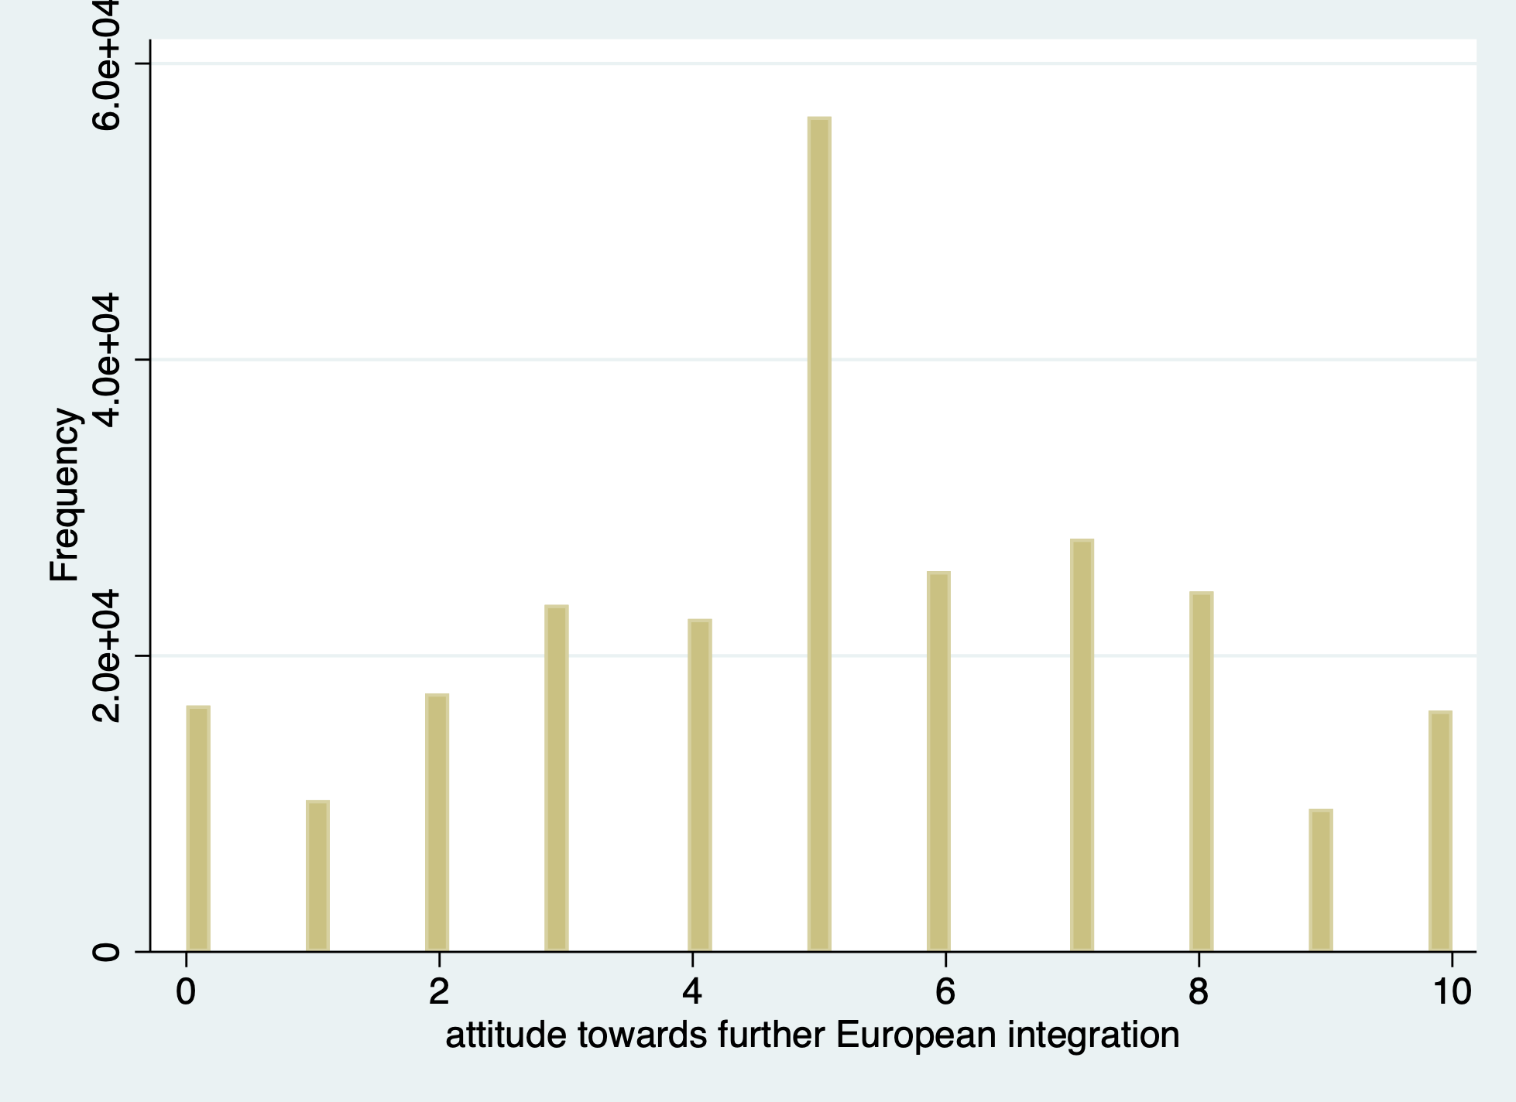
Figure 2: Distribution of attitude towards further integration
Asylum seekers per 1000 residents
Attitude towards further integration
?

Confounders:
- Social expenditures
- Life expectancy
- GDP per capita
And so on…

Figure 3: causal pathways

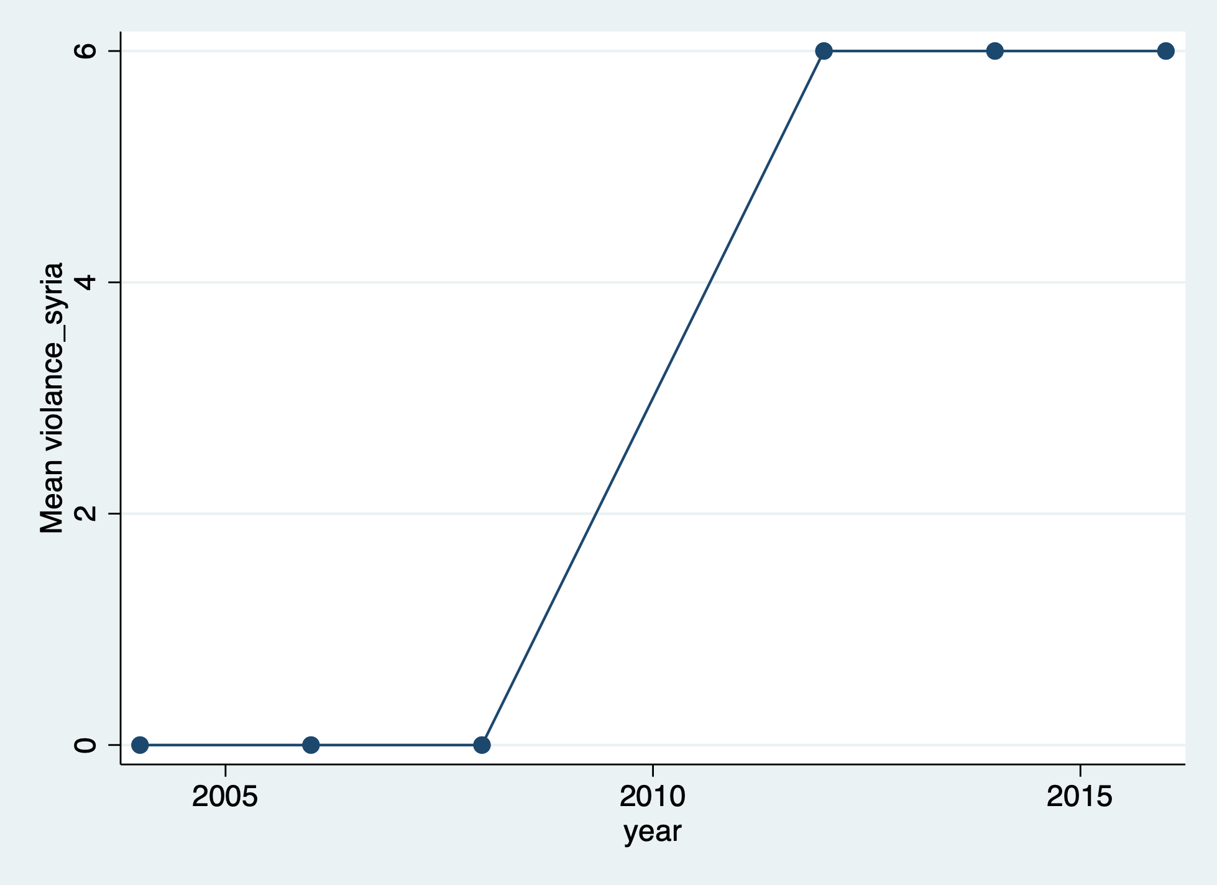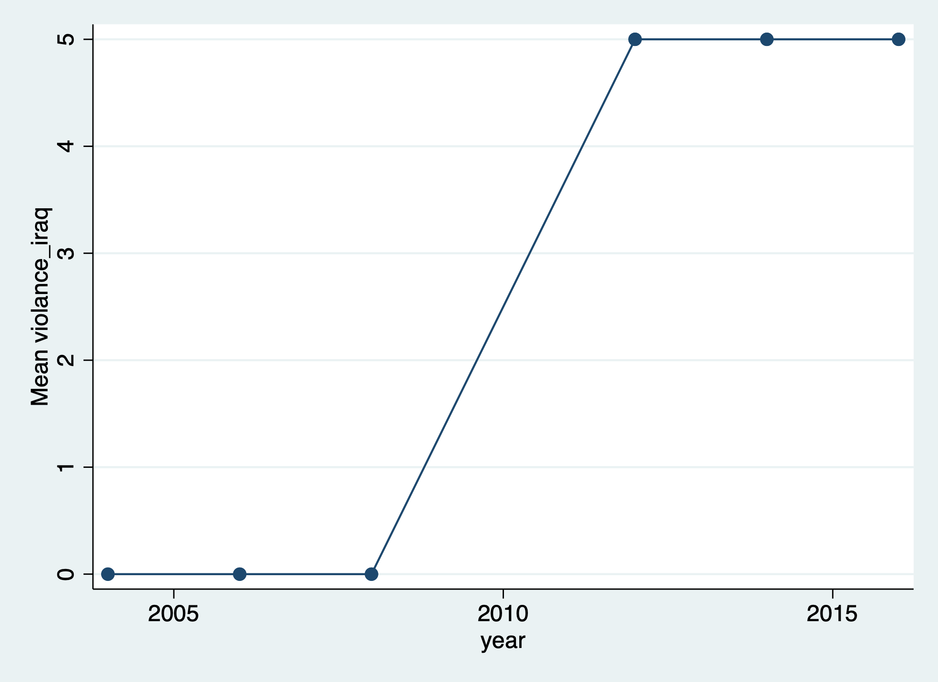
Figure 4: violence over time in Syria (left) and Iraq (right)

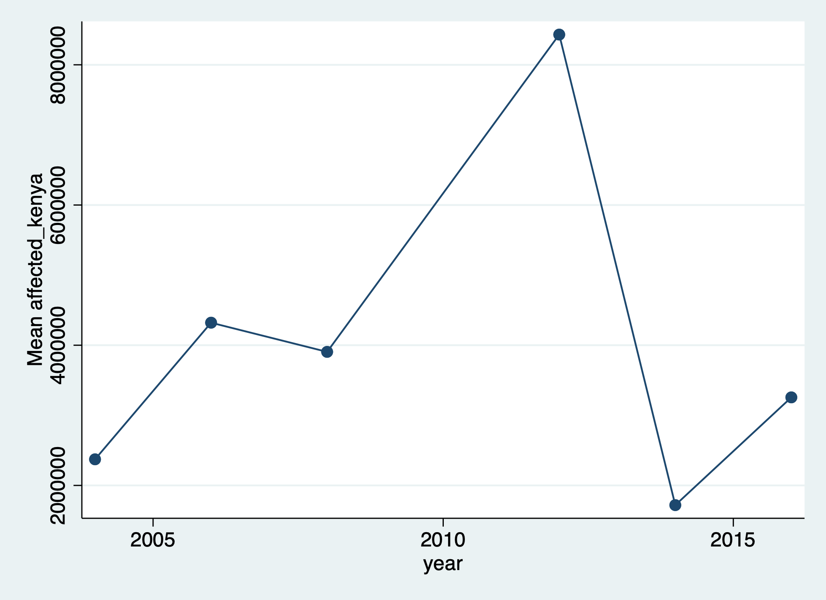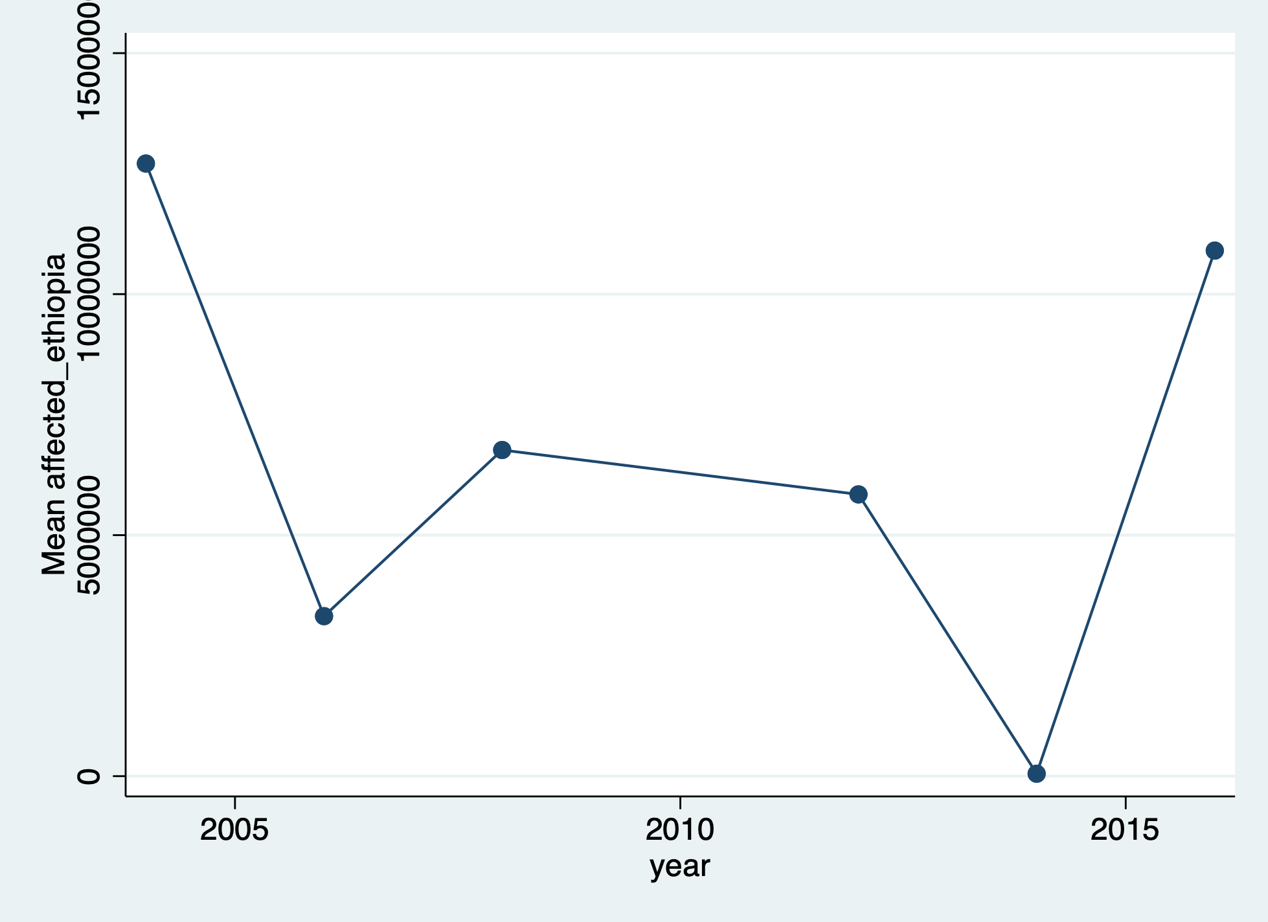
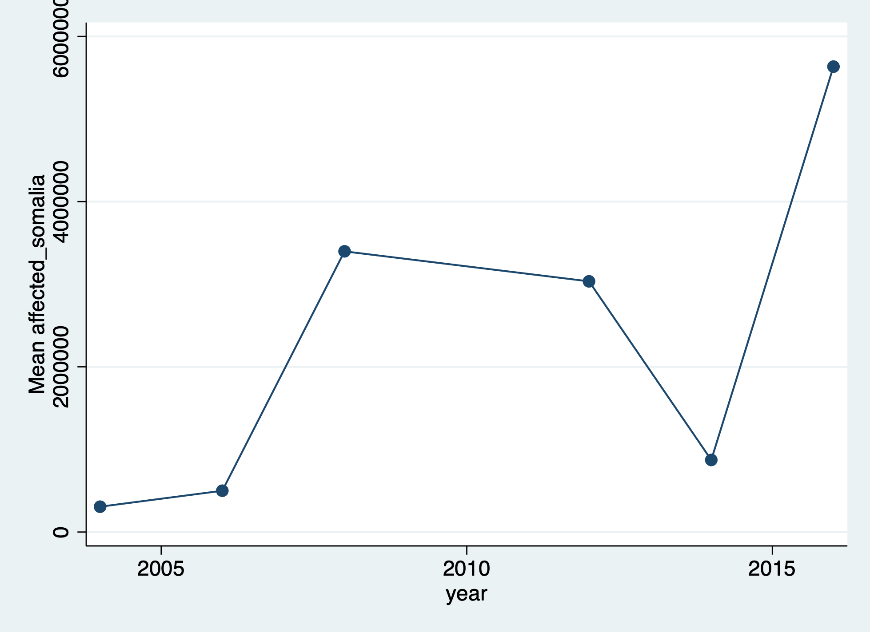
Figure 5: number of affected people by natural disasters over time in Kenya (upper left), Ethiopia (upper right), and Somalia (lower)

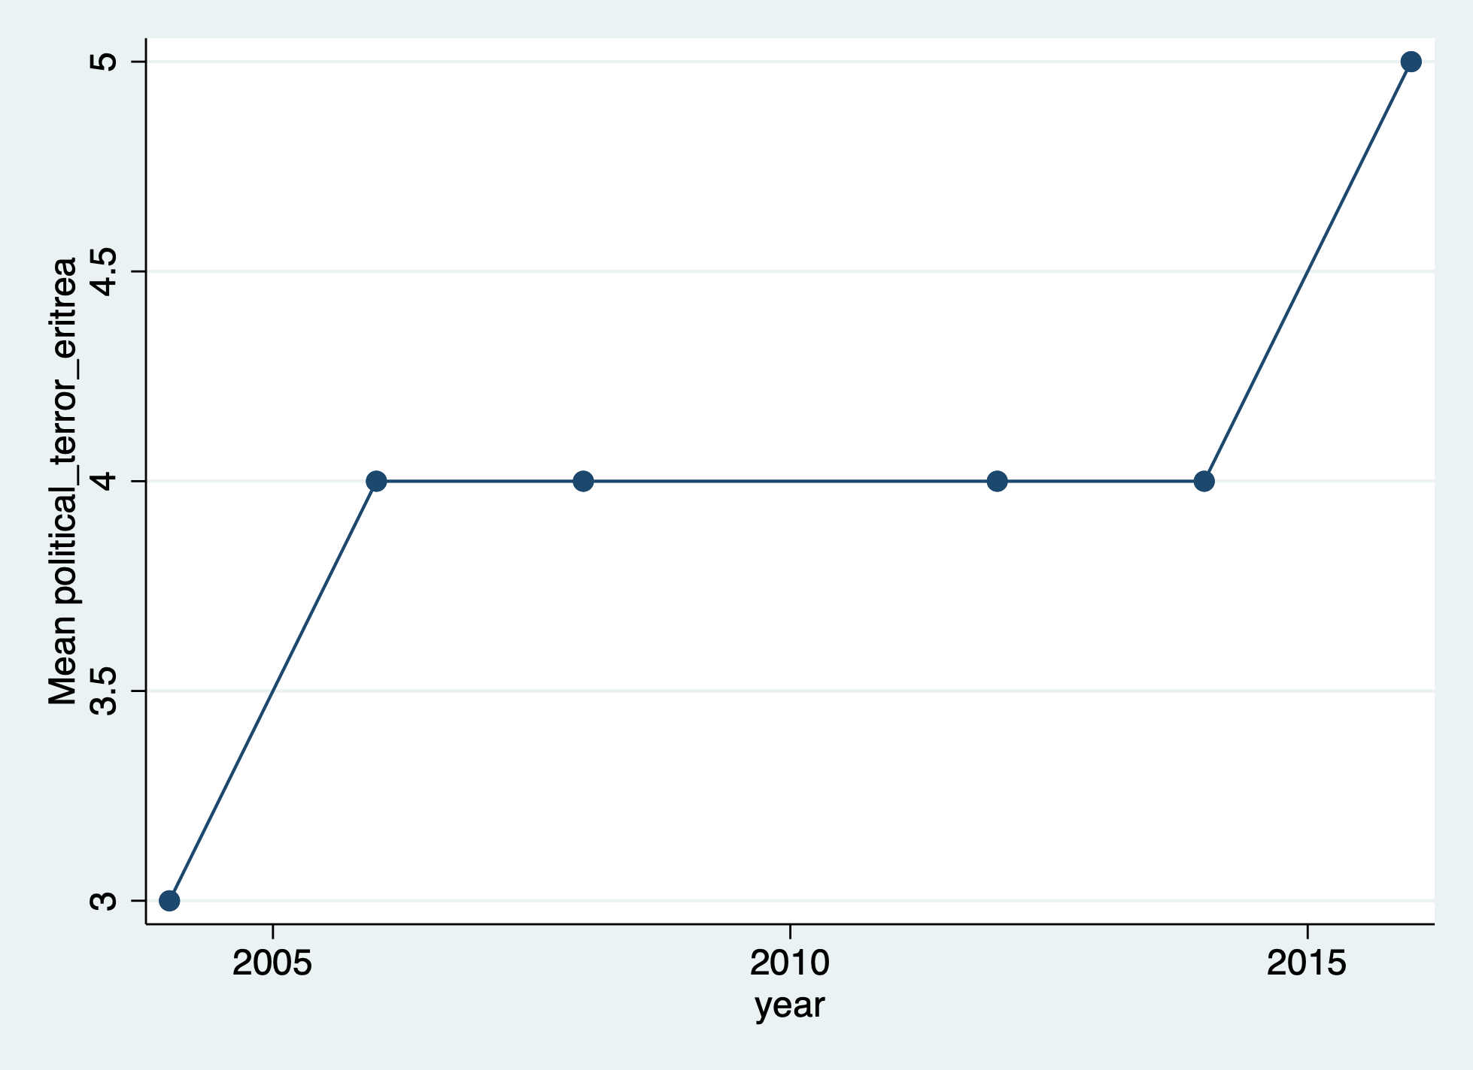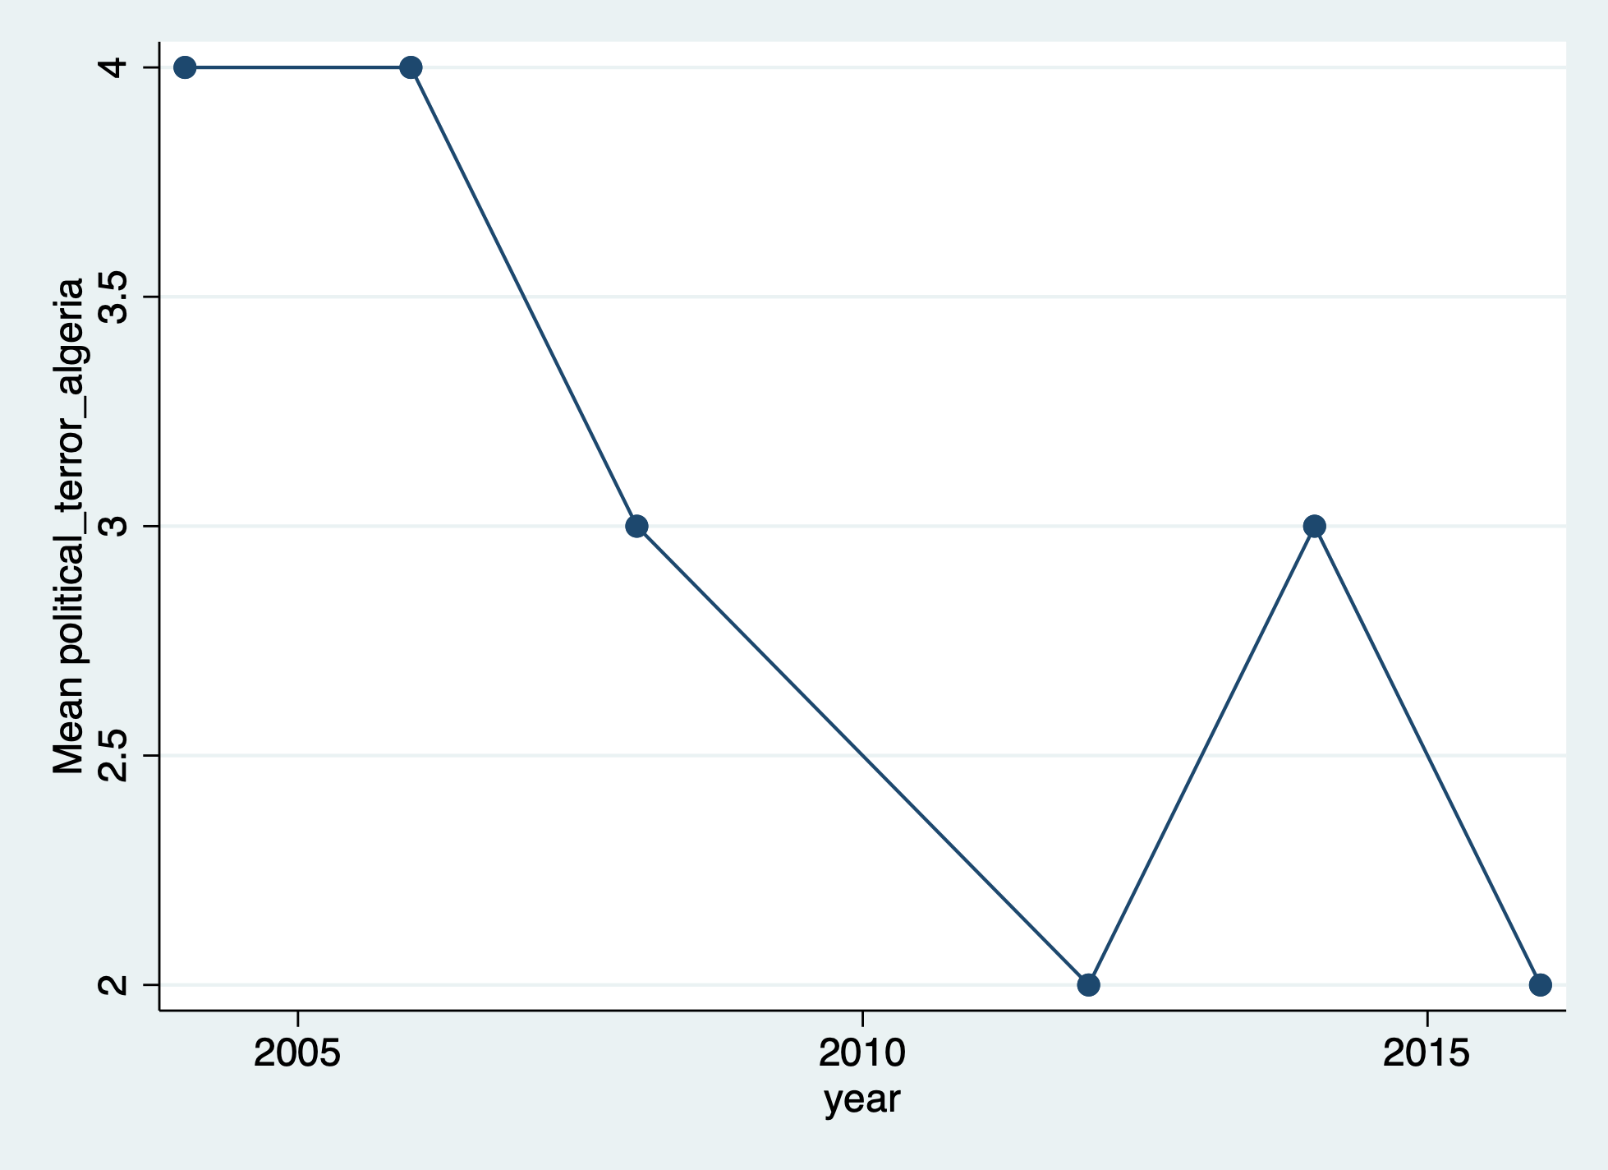
Figure 6: political terror over time in Eritrea (left) and Algeria (right)

Table 4: ordered probit regression with country and year fixed effects and controls (extension of column 8 of table 3)
Outcome: attitude towards further European integration
Asylum seekers per capita | 0,034***
Controls
2006 | -0,063***
2008 | 0,003
2012 | 0,006
2014 | 0,021
2016 | 0,115***
Social expenditures | 0,000
Life expectancy | -0,081***
GDP per capita | 0,000**
Right-wing | -0,013***
Life satisfaction | 0,029***
Happiness | 0,035***
Health | -0,041***
Years of education | 0,025***
Immigrants per capita | 0,005***
Observations | 153.722
Note: Statistical significance is denoted by: *** p < 0,01, ** p < 0,05, * p < 0,10.

References

Arnorsson, A., Zoega, G. (2018). On the causes of Brexit. European Journal of Political Economy, 55, 301-323. Retrieved from: https://www.sciencedirect.com/science/article/pii/S0176268016302701
Baldwin, A. (2017). Climate change, migration, and the crisis of humanism. WIREs Climate Change, 8(3), 460.
Barbulescu, R., Beaudonnet, L. (2014). Protecting Us, Protecting Europe? Public Concern about Immigration and Declining Support for European Integration in Italy. Perspectives on European Politics and Society, 15(2), 216-237. Retrieved from: https://doi.org/10.1080/15705854.2014.885765.
Becker, S.O., Fetzer, T., Novy, D. (2017). Who voted for Brexit? A comprehensive district-level analysis. Economic Policy, 32(92), 601-650.
Boomgaarden, H.G., Schuck, A.R.T., Elenbaas, M., De Vreese, C.H., (2011). Mapping EU attitudes: Conceptual and empirical dimensions of Euroscepticism and EU support. European Union Politics, 12(2), 241-266. Retrieved from: https://doi.org/10.1177/1465116510395411.
Borjas, G.J. (2003). The Labor Demand Curve is Downward Sloping: Reexamining the Impact of Immigration on the Labor Market. The Quarterly Journal of Economics, 118(4), 1335–1374.
Bound, J., Jaeger, D.A., Baker, R.M. (1995). Problems with Instrumental Variables Estimation When the Correlation Between the Instruments and the Endogeneous Explanatory Variable is Weak. Journal of the American Statistical Association, 90(430), 443-450.
Card, D. (2009). Immigration and Inequality. American Economic Review, 99(2), 1-21.
Carey, G. (2018, December 20). Syria’s Civil War. Bloomberg. Retrieved from: https://www.bloomberg.com/quicktake/syrias-civil-war.
Chiswick, B.R., Lee, Y.L., Miller, P.E. (2008). Immigrant Selection Systems and Immigrant Health. Contemporary Economic Policy, 26, 555-578.
Chung R. C.-Y, Kagawa-Singer M. (1993). Predictors of Psychological Distress Among Southeast Asian Refugees. Social Science and Medicine, 36, 631-639.
Connor, P. (2010). Explaining the Refugee Gap: Economic Outcomes of Refugees versus Other Immigrants. Journal of Refugee Studies, 23(3), 377–397,.https://doi-org.eur.idm.oclc.org/10.1093/jrs/feq025
Cortes, K.E. (2006). Are Refugees Different from Economic Immigrants? Some Empirical Evidence on the Heterogeneity of Immigrant Groups in the United States. Review of Economics and Statistics, 86(2), 465-480.
Dearden, L. (2017, May 16). EU plan to relocate 160,000 refugees from Italy and Greece by September failing despite record deaths at sea. Independent, world. Retrieved from https://www.independent.co.uk/news/world/europe/eu-refugee-quotas-160000-italy-greece-failing-european-commissioner-legal-cases-obligations-a7739396.html.
Dempsey, J. (2015, September 23). Judy Asks: Will the Refugee Crisis Destroy the EU? Carnegie Europe, Judy Dempsey’s strategic Europe. Retrieved from https://carnegieeurope.eu/strategiceurope/?fa=61379.
De Vreese, C.H., Boomgaarden, H.G. (2005). Projecting EU Referendums: Fear of Immigration and Support for European Integration. European Union Politics, 6(1), 59-82. Retrieved from: https://journals.sagepub.com/doi/abs/10.1177/1465116505049608?casa_token=qTxb5sXizz4AAAAA:C_UT47dxWdfixE4F2MDuhuz5TNB1RhQjLb1qufqKjK_TbCCWil8tzAYuPalc2F1R-1ZitAAupVfAVt0.
Dustmann, C., Fabbri F., Preston, I. (2005). The Impact of Immigration on the British Labour Market. The Economic Journal 115, 324–341.
Dustmann, C., Schönberg, U. and Stuhler, J. (2016). The Impact of Immigration: Why Do Studies Reach Such Different Results?. Journal of Economic Perspectives, 30(4), 31–56.
Dustmann, C. (2017). Europe’s trust deficit: Causes and remedies(Report No. 1). London, UK: Centre for Economic Policy Research.
European Commission (2015, September 9). Refugee Crisis: European Commission takes decisive action [press release]. Retrieved from http://europa.eu/rapid/press-release_IP-15-5596_en.htm.
European Council (2017, March 29). Statement by the European Council (Art. 50) on the UK notification [press release]. Retrieved from https://www.consilium.europa.eu/en/press/press-releases/2017/03/29/euco-50-statement-uk-notification/.
Fligstein, N., Polyakova, A., Sandholtz, W. (2012). European Integration, Nationalism and European Identity. Journal of common market studies, 50(1), 106-122. Retrieved from: https://doi.org/10.1111/j.1468-5965.2011.02230.x.
Fidermuc, J., Hulényi, M., Börke Tunalı, C. (2016). Money Can’t Buy EU Love: European Funds and the Brexit Referendum. CESIFO WORKING PAPER NO. 6107.
French, M.T., Popovici, I. (2011). THAT INSTRUMENT IS LOUSY! IN SEARCH OF AGREEMENT WHEN USING INSTRUMENTAL VARIABLES ESTIMATION IN SUBSTANCE USE RESEARCH. Health economics, 20(2), 127-146.
Gatenbay, V. (2019, May 19). Somalia drought: UN warns of humanitarian crisis. Aljazeera. Retrieved from: https://www.aljazeera.com/news/2019/05/somalia-drought-warns-humanitarian-crisis-190519104434490.html.
Goodwin, M., Milazzo, C. (2017). Taking back control? Investigating the role of immigration in the 2016 vote for Brexit. The British journal of Politics and International Relations, 19(3), 450-464.
Häder, S., Lynn, P. (2007). How representative can a multi-nation survey be? In R. Jowell et al. (eds.), Measuring Attitudes Cross-Nationally. Lessons from the European Social Survey. London: SAGE
Halla, M., Wagner, A.F. and Zweimüller, J. (2012) ‘Does Immigration Into Their Neighborhoods Incline Voters Toward the Extreme Right? The Case of the Freedom Party of Austria’, CEPR Discussion Papers 9102.
Harlan, C. (2019, March 19). Frexit? Italeave? After watching Brexit, other European countries say: No, thanks. The Washington Post, Europe. Retrieved from https://www.washingtonpost.com/world/europe/frexit-italeave-after-watching-brexit-other-european-countries-say-no-thanks/2019/03/29/7b6e059a-4be0-11e9-8cfc-2c5d0999c21e_story.html?noredirect=on&utm_term=.337b096a838c.
Harvey, F. (2017, December 21). Devastating climate change could lead to 1m migrants a year entering EU by 2100. The Guardian, Environment. Retrieved from https://www.theguardian.com/environment/2017/dec/21/devastating-climate-change-could-see-one-million-migrants-a-year-entering-eu-by-2100.
Hein, J. (1993). Refugees, immigrants and the State. Annual review of Sociology, 19, 43-49.
Hoeglinger, D. (2015). The politicisation of European integration in domestic election campaigns. West European politics, 39, 44-63. Retrieved from https://doi.org/10.1080/01402382.2015.1081509.
Ioannou, D., Leblond, P., Niemann, A. (2015). European integration and the crisis: practice and theory. Journal of European Public Policy, 22(2), 55-176. Retrieved from https://doi.org/10.1080/13501763.2014.994979.
n.a. (2019, May 1). ISIS Fast Facts. Cable News Network, CNN library. Retrieved from: https://edition.cnn.com/2014/08/08/world/isis-fast-facts/index.html.
Johnston, I (2017, August 19). Ethiopia drought: Millions of people urgently in need of food aid after string of natural disasters. Independent, world. Retrieved from: https://www.independent.co.uk/news/world/africa/ethiopia-drought-floods-starvation-malnourished-crisis-catastrophe-east-africa-a7901156.html.
Kentmen-Cin, C., Erisen, C. (2017). Anti-immigration attitudes and the opposition to European integration: A critical assessment. European Union Politics, 18(1), 3-25.
Kriesi, H., Grande, E. Lachat, R. Dolezal, M. Bornschier ,S. and Frey, T. (2008) West European Politics in the Age of Globalization. Cambridge, New York: Cambridge University Press.
Kriesi, H., Grande, E. (2016). 10 The euro crisis: a boost to the politicisation of European integration?. Politicising Europe, 240.
Kriesi, H. (2016). The politicization of European integration. Journal of common market studies, 54(1), 32-47. Doi: 10.1111/jcms.12406.
Kugiel, P. (2017). The Refugee Crisis in Europe: True Causes, False Solutions. The Polish Quarterly of International Affairs, 4, 41-59.
Louis, W. R., Duck, J. M., Terry, D. J., Schuller, R. A. and Lalonde, R. N. (2007). Why do citizens want to keep refugees out? Threats, fairness and hostile norms in the treatment of asylum seekers. European Journal of Social Psychology, 37, 53-73. doi:10.1002/ejsp.329
Lucas, S. (2018, April 13). Syria: who’s involved, and what do they want? The Conversation, politics & society. Retrieved from: http://theconversation.com/syria-whos-involved-and-what-do-they-want-95002.
Luedtke, A. (2005). European Integration, Public Opinion and Immigration Policy: Testing the Impact of National Identity. European Union Politics, 6(1), 83-112. Retrieved from: https://doi-org.eur.idm.oclc.org/10.1177/1465116505049609.
Lynn, P., Häder, S., Gabler, S., & Laaksonen, S. (2007). Methods for achieving equivalence of samples in cross-national surveys: the European Social Survey experience. Journal of Official Statistics, 23 (1), 107–124
Marks, J. (2018, September 14). Why Is There a Civil War in Syria? A&E Television Networks, History. Retrieved from: https://www.history.com/news/syria-civil-war-assad-rebels.
McLaren, L.M. (2002). Explaining Opposition to Turkish Membership of the EU. European Union Politics, 8(2), 155-179.
McLaren, L.M. (2007). Explaining Mass-Level Euroscepticism: Identity, Interests, and Institutional Distrust. Acta Politica, 42(2-3), 233-251.
McLaren, L.M. (2012). The Cultural Divide in Europe: Migration, Multiculturalism, and Political Trust. World Politics, 62(2), 199-241. Retrieved from: https://doi.org/10.1017/S0043887112000032.
National Academies of Sciences, Engineering, and Medicine (NAS) (2017), The Economic and Fiscal Consequences of Immigration, Washington, DC: The National Academies Press.
Neumayer, E. (2005). Bogus Refugees? The Determinants of Asylum Migration to Western Europe. International Studies Quarterly, 49(3), 389–409. Retrieved from: https://academic.oup.com/isq/article/49/3/389/1934647
Ombuor, R (2019, March 26). Drought in Kenya's Northwest Leaves Thousands Near Starvation. VOA, Africa. Retrieved from: https://www.voanews.com/a/drought-kenya-northwest-leaves-thousands-near-starvation/4848855.html.
Ottaviano, G.L.P., Peri, G. (2011). RETHINKING THE EFFECT OF IMMIGRATION ON WAGES. Journal of the European Economic Association, 10(1), 152-197.
Perruchoud, R., Redpath-Cross, J (2011). Glossary on Migration 2nd edition. International Migration Law, International Organization for Migration. Retrieved from https://publications.iom.int/system/files/pdf/iml25_1.pdf.
Porter, G.D. (2019, March 07). Political Instability in Algeria. Center for Preventive Action. Retrieved from: https://www.cfr.org/report/political-instability-algeria.
Postelnicescu, C. (2016). Europe’s New Identity: The Refugee Crisis and the Rise of Nationalism. Eur J Psychol, 12(2), 203-209. doi: 10.5964/ejop.v12i2.1191.
Preston, I. (2014). The Effect of Immigration on Public Finances. The Economic Journal 124, 569–592.
n.a. (2015, September 25). Seven Factors behind Movement of Syrian Refugees to Europe. United Nations Refugee Agency. Retrieved from http://www.unhcr.org/560523f26.html.
Roodman, D. (2009). Mixed-process models with cmp. DC09 Stata Conference 11, Stata Users Group.
Sharifi, M.N. (2019, April 4). Geen jongere die in Eritrea wil blijven. nrc.nl. Retrieved from: https://www.nrc.nl/nieuws/2019/04/04/geen-jongere-die-in-eritrea-wil-blijven-a3955796.
Rumbaut, R.G., Owan, T.C. (1985). Mental Health and the Refugee Experience: A Comparative Study of Southeast Asian Refugees. MDNational Institute of Mental Health.
Sales, R. (2002). The deserving and the undeserving? Refugees, asylum seekers and welfare in Britain. Critical Social Policy, 22(3), 456–478. https://doi.org/10.1177/026101830202200305
Staiger, D., Stock, J.H. (1997). Instrumental Variables Regression with Weak Instruments. Econometric society, 65(3), 557-586.
Stock, J.H., Yoho, M. (2002). Testing for Weak Instruments in Linear IV Regression. New York: Cambridge University Press.
n.a. (2011, August 4). The drought in East-Africa threatens the lives of 12 million people. Entreculturas. Retrieved from: https://www.entreculturas.org/noticias/drought-east-africa-threatens-lives-12-million-people.
Takeda, J. (2000). Psychological and Economic Adaptation of Iraqi Adult Male Refugees: Implications for Social Work Practice. Journal of Social Service Research, 26, 1-21.
Toshkov, D., Kortenska, E. (2015). Does Immigration Undermine Public Support for Integration in the European Union? Journal of Common Market Studies, 53(4), 910-925.
Van Spanje, J., De Vreese, C. (2011). So what’s wrong with the EU? Motivations underlying the Eurosceptic vote in the 2009 European elections. European Union Politics, 12(3), 405-429. Retrieved from: https://doi.org/10.1177/1465116511410750.
Voorhoeve, J., Brinkhorst, L.J., Ben, B., Dekker, S., Van Ekelen, W., Van Iersel, J. (2019, May 1). Halfhartigheid Rutte over Europa blijft scepsis voeden. NRC, Opinie. Retrieved from https://www.nrc.nl/nieuws/2019/05/01/halfhartigheid-rutte-over-europa-blijft-scepsis-voeden-a3958744.
Wood, Reed, M., and Gibney, M. (2010). “The Political Terror Scale (PTS): A Re-introduction and a
Comparison to CIRI.” Human Rights Quarterly, 32(2), 367–400.

The countries of which data is available.
Note that immigrant, asylum seeker and refugee are different definitions. An immigrant is the most general term, meaning a person “who changes his or her country of usual residence, irrespective of the reason for migration or legal status” (Perruchoud & Redpath-Cross, 2011). A refugee is a person who is, "owing to a well-founded fear of persecution for reasons of race, religion, nationality, membership of a particular social group or political opinions, is outside the country of his nationality and is unable or, owing to such fear, is unwilling to avail himself of the protection of that country (Art. 1(A)(2), Convention relating to the Status of Refugees, Art. 1A(2), 1951 as modified by the 1967 Protocol). An asylum seeker is someone who claims to be a refugee, but awaits the decision of his asylum application (Perruchoud & Redpath-Cross, 2011).
Austria, Belgium, Bulgaria, Croatia, Cyprus, Czech Republic, Denmark, Estonia, Finland, France, Germany, Greece, Hungary, Iceland, Ireland, Israel, Italy, Lithuania, Luxembourg, Netherlands, Norway, Poland, Portugal, Russia, Slovenia, Slovak Republic, Spain, Sweden, Switzerland, Turkey, United Kingdom, Ukraine.
Go to https://www.europeansocialsurvey.org/data/deviations_index.html for detailed information about the number of approved interviews per country per year.

