Erasmus University Rotterdam
Erasmus School of Economics

Bachelor Thesis Economie & Bedrijfseconomie

“An analysis of the global implementation of sustainable development in the corporate objectives of ports, in particular for the Port of Rotterdam, the Port of Amsterdam and the Port of Antwerp.”

Name: Wouter Kruiswijk
Student number: 452097
Supervisor: Jansen, M.
Second assessor: Saase, N. van
Date final version: 22-07-2019

Abstract
Sustainable development has become more important over the past few decades. To support the implementation of sustainable development worldwide, the United Nations (UN) initiated 17 Sustainable Development Goals (SDG’s) which are aimed to be achieved by 2030. The aim of this paper is to analyse and give an overview of to which extent ports are currently implementing these SDG’s in their corporate objectives and how they strive to contribute to them. This will result in several opportunities for ports to enhance their sustainable development. In particular, this paper analyses the implementation of the SDG’s for the Port of Rotterdam, the Port of Amsterdam and the Port of Antwerp, and discusses the progress of the implementation over the years for the separate ports. Besides, the ports are compared in terms of their implementation of the SDG’s to acquire a better understanding of to which extent and in what way the separate ports strive to contribute to the SDG’s, and which Sustainable Development Goals they claim to be the most relevant for them.

Table of contents
1. Introduction 4
1.1 Relevance 4
1.2 Research question 5
1.3 Sub questions 5
2. Methodology 6
2.1 Introduction 6
2.2 The sub questions 6
2.3 The main research question 7
3. Literature review 7
3.1 Introduction 7
3.2 The importance of sustainable development 7
3.3 Sustainable development for ports. 9
3.3.1 Why is it relevant for the port industry? 9
3.3.2. Materiality matrix 14
3.4 Programs for Sustainable Development Goals in the port sector 14
3.4.1. AIVP 17
3.4.2. WPSP 19
3.5 Implementation of SDG’s in ports 20
3.5.1. Climate and Energy 20
3.5.2. Community outreach and port-city dialogue 22
3.5.3. Governance and Ethics 23
3.5.4. Resilient Infrastructure 24
3.5.5. Safety and security 26
3.6 Opportunities of implementation 27
3.7 Conclusion 28
4. Case studies 28
4.1 Introduction 28
4.2 Port of Rotterdam 29
4.2.1 Analysis of 2015 29
4.2.2 Analysis of 2016 30
4.2.3 Analysis of 2017 31
4.2.4 Analysis of 2018 33
4.2.5 Progress over the years 34
4.3 Port of Amsterdam 35
4.3.1 Analysis of 2015 35
4.3.2 Analysis of 2016 36
4.3.3 Analysis of 2017 38
4.3.4 Analysis of 2018 39
4.3.5 Progress over the years 41
4.4 Port of Antwerp 42
4.4.1 Analysis of 2015 42
4.4.2 Analysis of 2016 44
4.4.3 Analysis of 2017 46
4.4.4 Analysis of 2018 47
4.4.5 Progress over the years 48
4.5 Conclusion 49
5. Discussion and conclusion 50
5.1 Introduction 50
5.2 Findings of the sub questions 50
5.2.1 First sub question 50
5.2.2 Second sub question 51
5.2.3 Third sub question 52
5.3 Conclusion main research question 53
5.4 Discussion and limitations 54
5.4.1 Debatable findings 54
5.4.2 Limitations 54
5.5 Potential future research 54
6. References 56
7. Appendix 61

Introduction

1.1 Relevance
Ports today not only play a role in handling cargo in the port area. Their role has emerged to being a competitive actor on a global level, across the sea and even deep into the hinterland. They deal with many different stakeholders and have to adjust their business strategies in accordance with the interests of various stakeholders (Aregall, Bergqvist & Monios, 2018).
“Ports are the locations where trade, logistics and production converge” (Loorbach & Geerlings, 2017). Ports and their related activities have been the facilitator of the world’s welfare today and have shown development into global hubs of trade and shipping over the last decade. This development is in line with the growth of the world economy. However, with the growth of the port sector emerged large scale fossil-based industries which were necessary to make the growth possible. This resulted in ports being largely based on fossil-fuels and other limited resources (Loorbach & Geerlings, 2017).
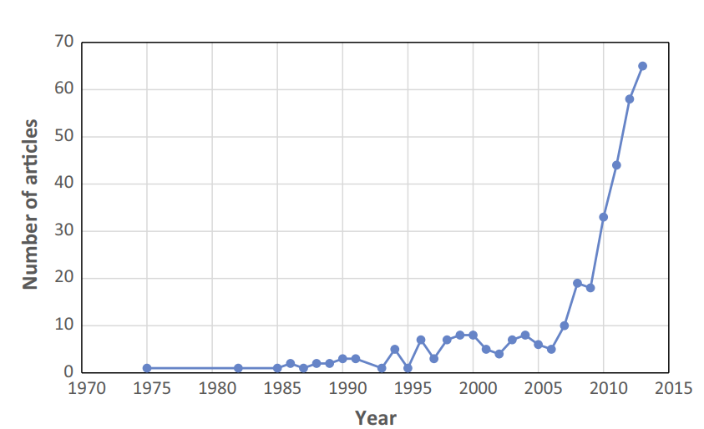
These activities resulting in negative externalities on many levels have long remained unimportant. However, over the last decades, the dialogue about the impact of port activities has increased globally. A lot of research has emerged addressing the externalities caused by ports and their business activities. The extent of the externalities is not even limited to these activities within the port area. Literature also addressed the negative externalities coming from transportation and logistics within the supply chain, and the port’s responsibility of creating awareness of the negative externalities of actors within their supply chain. The increasing awareness of the negative externalities have caused a growth in research and literature discussing various topics around the sustainable development of ports (Davarzani, Fahimnia, Bell & Sarkis, 2015). This trend is depicted in figure 1.

Figure 1. Publication trend in the area of green ports and maritime logistics.
Source: Davarzani, Fahimnia, Bell & Sarkis (2015).
Sustainable development is not only about environmental externalities. Ports must also deal with the interests of the community and stakeholders. It has become apparent that sustainable development is only possible hand in hand with the adoption of ‘inclusive growth’. Inclusive growth aims to align economic growth with social benefits for the community (Jansen, van Tulder & Afrianto). It is important for ports to align their economic growth ambitions with the interests of the community. This contributes to their reputation and could eventually result in an enhanced competitive position.
On the 25th of September 2015, the United Nations adopted the “2030 Agenda for Sustainable Development”, which consist of 17 Sustainable Development Goals and 169 different targets divided among the 17 SDG’s. They present global goals related to the society, economy and the biosphere. The goals are inseparable, as society and economy are dependent on the biosphere. “The environment can no longer be treated as an externality but rather must be treated as essential for human well-being and sustained economic growth.” (DNV GL). With this initiative, the UN strives to categorise the important issues regarding sustainability to help companies and organizations globally with the implementation of a sustainable business strategy. Many programs have been initiated, such as the World Port Sustainability Program and the International Association of Port Cities, which aim to create a platform for all global members to share their initiatives and contribute towards the global implementation of sustainable development.

1.2 Research question
Now that the urgency of sustainable development is addressed, this paper will discuss how ports strive to implement this development into their business strategy and corporate objectives, and eventually discuss how the port of Rotterdam, the Port of Amsterdam and the Port of Antwerp deal with this implementation. This leads to the main question of the paper:
“To what extent do ports implement sustainable development globally, and how are the Port of Rotterdam, the Port of Amsterdam and the Port of Antwerp comparable in this implementation?”
The aim of this question is to analyse global trends within the port sector regarding the implementation of sustainability, analyse the SDG’s and their relevancy to the port sector and discuss programs that aim to contribute to this implementation. Eventually, the paper strives to find a comparison of this implementation for the three mentioned ports.

1.3 Sub questions
Apart from the main research question, three sub questions emerge which need to be answered in order to find an answer for the main question.

Sub question 1:
“To what extent are ports currently embedding sustainable development and the SDG’s into their corporate objectives?“
Sub question 2:
“To what extent do the Port of Rotterdam, Port of Amsterdam and the Port of Antwerp implement sustainable development and the SDG’s into their corporate objectives?”
Sub question 3:
“How do the three ports compare in terms of the implementation of sustainable development and the SDG’s in their corporate objectives?”
Now that the main research question and the three sub questions have been addressed, this section will be followed by the methodology to discuss how the separate question will be answered. Next, a literature review will be held about the global implementation of sustainability and the SDG’s in the port sector. Then, case studies will be performed on the three ports to be able to make a comparison, after which a conclusion will be derived that answers the main question and the three sub questions. Finally, the paper mentions its limitations and provides possibilities for further research.

Methodology

2.1 Introduction
This section will discuss how the main question and the three sub questions shall be answered. The three sub questions will provide particular answers that will help to eventually answer the main question.

2.2 The sub questions
The first sub question will be answered through a literature review. The review will discuss sustainability and sustainable development, and how these terms can be relevant within the port sector. Also, the SDG’s will be discussed, together with their relevancy to the port sector. Furthermore, several programs will be discussed which contribute to the implementation of the SDG’s by ports globally, together with illustrations of the implementations by ports. This way the paper strives to create an overview which is useful for the next sub question.
The second sub question will be answered through specific case studies of the three ports. For every port, annual reports and other types of reports will be analysed to create an overview of their implementation of the SDG’s, their prioritisation of issues using a ‘materiality matrix’ and how they deal with the interests of stakeholders.
The third sub question will also be answered by comparing the case studies of the three ports and finding a certain progress. This will indicate how the three ports implemented the SDG’s and sustainability over the recent years and indicate the difference of this implementation between the ports.

2.3 The main research question
The main research question is eventually answered by looking at the answers of the three sub questions. After having derived a conclusion for every sub question it will be possible to analyse the difference between the three ports in terms of implementation of sustainability and the SDG’s into their corporate objectives and come with a conclusion for the main research question.

Literature review

3.1 Introduction
This part of the paper aims to create a general view on sustainable development and the importance of it, and how it is applied by ports in general. It will discuss how sustainable development of implementable for ports in general and what methods are available to do so. Next, a general overview will be given of several organizations of ports or port cities that initiated programs to contribute to the implementation of SDG’s in the business plans of ports, followed by illustrations on how ports deal with SDG’s in their business plans.

3.2 The importance of sustainable development
The most used definition of sustainable development is from the Brundtland Report:
"Sustainable development is development that meets the needs of the present without compromising the ability of future generations to meet their own needs" (World Commission on Environment and Development, 1987).
According to “A Framework for Strategic Sustainable Development”, a paper by Broman & Robèrt (2015), the world is dealing with a situation with an increasing world population, social sustainability problems and a decreasing ecosystem which all increase the risk of creating a biosphere in which it would be nearly impossible to maintain human civilization. The paper “World population prospects” written by the United Nations (2017) states the expected growth of the world population until the year 2100. This growth is illustrated in table 1.
Region | Population (millions)
Region | 2017 | 2030 | 2050 | 2100
World | 7550 | 8551 | 9772 | 11184
Africa | 1256 | 1704 | 1528 | 4468
Asia | 4504 | 4947 | 5257 | 4780
Europe | 742 | 739 | 716 | 653
Latin America and the Caribbean | 646 | 718 | 780 | 712
Northern America | 361 | 395 | 435 | 499
Oceania | 41 | 48 | 57 | 72
Table 1. The expected world population for the years 2030, 2050 and 2100.

Source: UN, Department of Economic and Social Affairs, Population Division (2017).

This growing amount of people are all individually striving to find their way in the world economy and improve their situation. This world economy is estimated to grow by 3-4% every year and brings many negative externalities, especially in terms of the environment. The existence of mankind and the economy rests on the resources provided by nature, so it would be self-evident that these resources should be maintained. The ever-growing world economy is causing an environmental crisis which is about to reach it’s tipping point (Sachs, 2015).
According to the paper of Jeffrey D. Sachs, “The Age of Sustainable Development” (2015), sustainable development tries to analyse the interaction between three different aspects; an environmental aspect, an economical aspect and a social aspect. Gupta & Vegelin (2015) also mention these three aspects and mention the trade-off between them. In order to achieve a “strong sustainable development”, there should be no trade-off between the three aspects of sustainable development. In reality, this seems very rare. This resulted in the rise of concepts which include only two out of three aspects, always leaving one out of consideration. Green economy combines the environment and the economy, ignoring the social aspect. Green society combines the social and the environmental aspect, leaving out the economical aspect. Inclusive growth implies the combination of the social and the economical aspect, leaving the environmental aspect out. And finally, there is inclusive development, which combines the social aspect with the environmental aspect, without taking the economical aspect into account. Sachs (2015) mentions the SDG’s setting a standard for sustainable development all around the world. According to his paper, the SDG’s call for socially inclusive and environmentally sustainable economic growth. This can only be achieved through good governance. Several organizations have been initiated to help companies all around the world with the implementation of the SDG’s into their business plan, including organizations specialized in ports. These organizations will be discussed later.

3.3 Sustainable development for ports.

3.3.1 Why is it relevant for the port industry?
Before this paper discusses several organizations that help ports implement the SDG’s into their business plans, it is important to understand how and why sustainable development is applicable for ports.

3.3.1.1 Growing world population in ocean areas
The growing amount of people on earth results in an increasing urbanization, especially in port cities. According to the “World Ocean Assessment” written by the United Nations Environment Program (UNEP) there are three types of ‘drivers’ that cause changes to the ocean environment; direct, indirect and principal drivers. These drivers are depicted in figure 2. Population growth and the increasing amount of urban areas in coastal regions are two of these drivers. There is an increase in population density in coastal areas causing a growth of pressure on the marine environment and the port sector. Figure 3 shows the population of coastal areas in 2015 and the expected population by 2050. Furthermore, the figure shows how many people live less than 100 kilometres from the coastline. These figures depict the increasing urban pressure on coastal areas. This increase has negative effects on the maritime physical, chemical and biological systems. Therefore, the port sector could contribute to maintaining a healthy marine environment by implementing sustainable development.
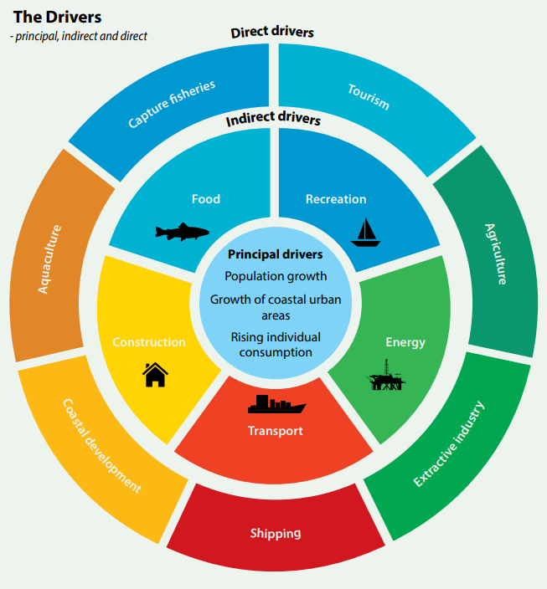

Figure 2. Direct, indirect and principal drivers of the change in marine environment.
Source: UNEP (2016).

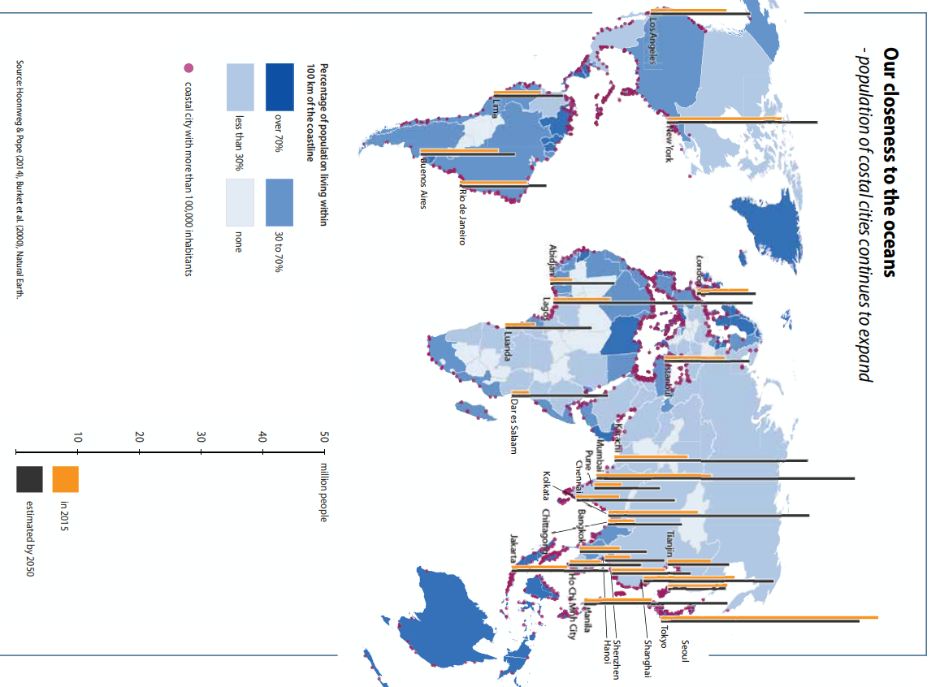
Figure 3. Overview of the increasing pressure on coastal areas.
Source: United Nations World Ocean assessment

3.3.1.2 Blue economy
As mentioned in section 3.2, one of the four concepts of sustainable development is ‘green economy’. But according to Golden, Virdin, Nowacek, Halpin, Bennear & Patil (2017), we have now reached the point where ‘blue economy’ is gaining importance. We have used the ocean like we have historically used the land. The ocean was considered as an unlimited resource and a place to leave waste from land production. Society has now reached a point of increasing awareness of the fact that the ocean environment is not actually limitless, and the industrialization of the oceans is still growing. According to Golden et al. (2017), seaborne trade will be quadrupled by 2050, marine mining will keep expanding and the overall industrialization capacity will keep growing. This applies to multiple sectors within the ocean economy, such as fishing, seabed mining, tourism, offshore oil and gas, offshore wind energy and more ocean-based industries that form the ocean economy. To give a brief overview of the industrialization of the ocean space over the last decades, figure 4 depicts the trends of the gross world product, overfishing and estimated annual plastic waste generated on land in the ocean.
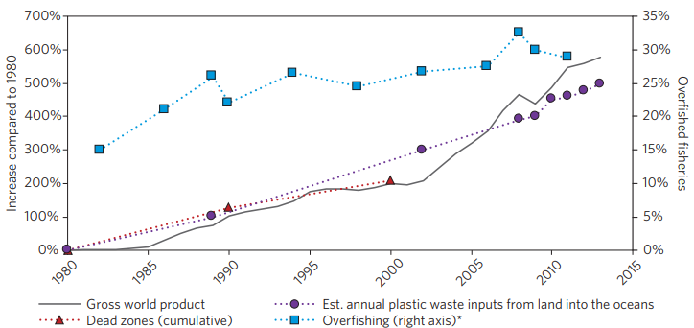
Figure 4. Overview of industrialization of the ocean over the last decades.
Source: Golden, Virdin, Nowacek, Halpin, Bennear & Patil (2017).

The ocean economy is very large. According to DNV GL, the part of the global gross value added in 2010 generated by the ocean economy was 2,5%, equal to 1.5 trillion USD. 13% of this total contribution of the ocean economy was generated by ports, as shown in figure 5. Furthermore, the ocean economy provided around 31 million full-time jobs worldwide. This contribution to the global gross value added is expected to grow to 3 trillion USD by 2030, according to the OECD. Some of the industries within the ocean industry are expected to grow even faster, including the industry of port activities. Therefore, the ocean economy is an important contributor to the Sustainable Development goals.
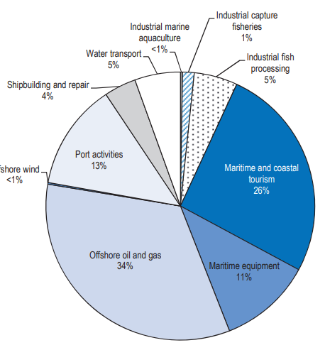
Figure 5. The contributions of different industries within the ocean economy to the total gross value added.
Source: OECD, 2016
The maritime shipping industry is a vital part of the ocean economy. The primary tasks of the shipping industry are the transportation of goods and the facilitation of other industries within the ocean economy. Ships transport more than 80% of world trade and are a key enabler for other industries within the ocean economy such as fishing, marine mining and offshore wind energy.
Ports are not only nodal points in global supply chains, they also deal with local and regional communities. Therefore, it is important for ports to respond to challenges of every scope. Global issues, but also regional issues, such as climate change, social integration, mobility and migration should all be considered, while still adding value to their supply chains. The motivation of ports to contribute to the SDG’s is driven by the increasing awareness of social and environmental issues, and the realisation of the potential impact of the port industry. With ports impacting the biosphere, society and the economy, ports could be a major contributor to achieving the Sustainable Development Goals (DNV GL).
First of all, the shipping industry has a major and direct impact on the biosphere. Emissions into the water and the air are substantial. The shipping industry is responsible for around 3% of total anthropogenic CO2 emissions, which is equal to about 900 million tonnes per year. Furthermore, the shipping industry’s effect on society is significant due to the fact that more than 80% of all goods are transported by ships and the industry increases the accessibility of society to global markets and goods. However, this generates negative effects on the environment, which is a clear example of a trade-off of sustainable development. Last, the shipping industry impacts the economical aspect of sustainable development. As previously mentioned, the gross value added by the ocean economy is equal to 1.5 trillion USD, from which 13% comes from the port industry.

3.3.1.3 Why should ports implement sustainable development?
Due to the magnitude of the ocean economy, the importance of sustainable development in ports has massively increased over the past decades. Corporate responsibility has not always been such an important factor within ports. With ports undergoing a transformation over the last decades and becoming more competitive in the local and global market, corporate responsibility has become a more important factor within the port’s business plans. The need to achieve economic growth and increase efficiency, the increase of private capital playing a role and ports becoming more corporatized or privatized are all factors contributing to the increasing urge for ports to participate in transparent corporate responsibility. There has been a major increase in society’s demand of companies justifying their actions, because most of these actions come with externalities of the port and shipping industry which could have a negative effect on the local community. To maintain or even increase their market shares, ports are obliged to undertake actions which could enhance their reputation towards the local community, their customers and their users. This could be achieved through corporate sustainability and a transparent sustainable development (Acciaro, 2015).
In terms of the environmental aspect of sustainable development, there has been a massive increase in interest of the environmental impact of ports, due to the emerging global issues regarding the environment. Not only the fact that reduced environmental impact enhances the reputation of ports among the community, their customers and users. According to a survey (Environmental Leader, 2009), 82% of the businesses taking part in that survey have mentioned that they are willing to increase the cost of their green marketing strategy. These corporations recognize the opportunity of differentiation to gain competitive advantages. Therefore, implementing a ‘green port strategy’ taking both economical and environmental growth into account, will result in a gain of economic performance and customer retention (Lam & van de Voorde, 2012). This is in accordance with the green economy aspect as mentioned in part 3.1.
In terms of the social aspect of sustainable development in ports, inclusive growth is an important factor. Inclusive growth is “a label for policy approaches to align economic growth ambitions with broader-based social benefits” (Jansen, van Tulder & Afrianto, 2018). This research mentions the importance of stakeholders in the process of inclusive economic growth. They classify port stakeholders as internal stakeholders, external stakeholders, legislative and public policy-orientated groups and community bases. Communication with all types of stakeholders is a must in order to maintain or increase social acceptance of ports. Every new initiative which brings external effects must be discussed with the all the stakeholders that are involved in the process and have to deal with the impact of the initiative (Dooms, Haezendonk & Verbeke, 2015).

3.3.2. Materiality matrix
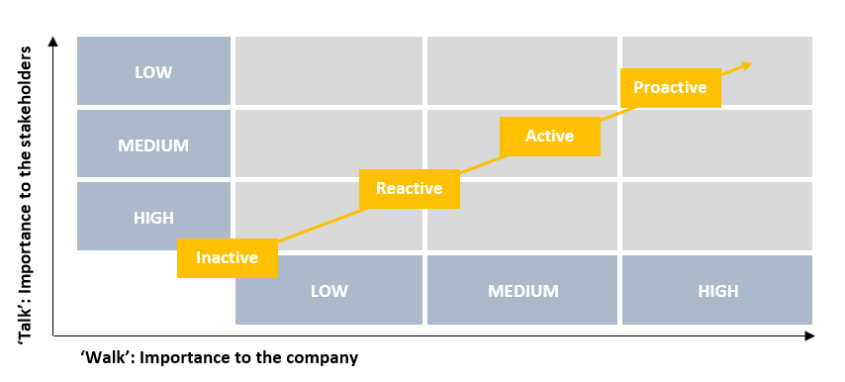
To eventually make an evaluation of the importance of multiple factors within the sustainable development plan of a company, this paper will use a ‘materiality matrix’. To explain the utility of this concept, the concept of ‘materiality’ should be clear. According to the paper “Materiality in corporate sustainability reporting within UK retailing” of Jones, Comfort & Hillier (2015), a factor is considered to be material when omitting the factor influences the decision of the engaged parties. It’s a way of prioritising the importance of several factors. This prioritisation can be depicted in a materiality matrix and is also applicable for sustainable development factors within a company. The materiality matrix prioritises the importance of issues for stakeholders on the Y-axis and the importance for the company on the X-axis. The Y-axis depicts what is important to ‘talk’ about and the X-axis shows what is important to actually realize, the ‘walk’ (Tulder, 2018). An example of the materiality matrix is shown in figure 6. Further on in the research, a materiality matrix will be applied on the port of Rotterdam, port of Antwerp and port of Amsterdam.
Figure 6. Example of a materiality matrix.
Source: van Tulder (2018).

3.4 Programs for Sustainable Development Goals in the port sector
First, it is important to get an overview of the SDG’s, state their goals and why these goals are relevant for the port sector. This overview is shown in table 2.
Table 2. Overview of the Sustainable Development Goals and its relevancy to the port sector.
SDG | GOAL | RELEVANCY TO PORT SECTOR
 | - Promote inclusive growth for sustainable jobs and equality.  - Implement social protection systems to protect from great economic risk. | - Through inclusive growth, ports can contribute to increased economic welfare of the community.  - By making the ports more accessible, local community can benefit economically.
 | - Nourish 815 million people who are hungry through investment in agriculture and sustainable food production systems. | - Ports can contribute to people having fresh food through investing in infrastructure, resulting in a more efficient and cheap way of exporting and importing food worldwide.
 | - Eradicate diseases and other health issues through funding health systems, improved hygiene and reduced pollution. | - By reducing pollution and enhancing the air quality in and around the port area, ports can contribute to reduction of diseases and deaths caused by pollution.
 | - Help impoverished families to gain access to quality inclusive education through investments. | - Through inclusive growth the community can be educated by being involved in the economic development of ports.
 | - Providing women with equal rights and access to education, healthcare, jobs and politics, and eradicate harmful events against women. | - Provide equal rights, access and pay to women working in the port sector.
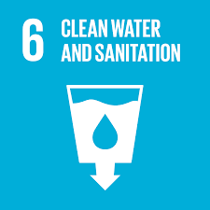 | - Clean, accessible water and sanitation must be achieved through investments in infrastructure and freshwater ecosystems. | - Ports could contribute by enhancing the water quality through better waste management and a reduction of pollution by vessels. They can minimize the industrialization of the water area.
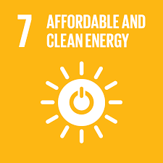 | - Ensure access to affordable and reliable energy and improve renewable energy technologies. | - Create innovative technologies increasing the use of renewable energy. Many ports strive to be a ‘zero-emission’ port by using renewable energy.
 | - To achieve sustainable economic growth there should be decent job opportunities, financial services and commitments to trade. | - By providing decent work environment for the community, ports can contribute to growing productivity and inclusive economic growth.
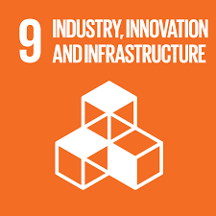 | - Achieve sustainable development, increased productivity, health and education by investing in infrastructure. | - If ports invest in infrastructure within the port area, this could result in more efficiency and industrialization, resulting in more economic growth. Both for the port as for the community.
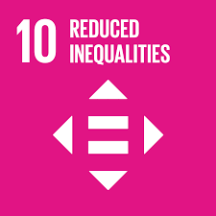 | - Reduce the inequality of access to health and education services for the less developed communities. | - Ports can reduce inequality by improving the accessibility of the port. This way, remote and developing communities acquire better economic opportunities.
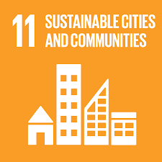 | - Create efficient urban planning and management to deal with increasing urbanization. Cities must provide opportunities for everyone. | - Through inclusive growth and better accessibility, communities will get the chance to benefit from and be educated by the port, resulting in economic growth and eventually efficient urban planning.
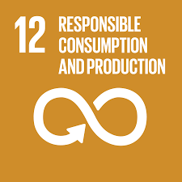 | - “Doing more and better with less”. Increasing welfare gains with less resources, pollution and degradation while increasing quality of life. | - Ports can contribute by working towards the implementation of circular economy through innovations regarding renewable energy, waste management and pollution.
 | - Work together to stop climate change and limit the global temperature rise. | - Ports can implement the use of completely renewable energy and try to reduce the emission of the activities within and around the port area.
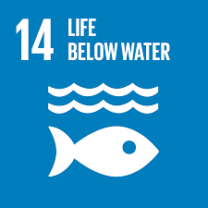 | - Actively manage marine areas and implement regulations to reduce overfishing, pollution and ocean acidification. | - Reduce the pollution of the port activities and the industrialization of the marine ecosystem. Ports can come with innovations to contribute to this reduction.
 | - Protect and manage forest and battle desertification to protect the ecosystem on land. | - Ports could stop the expansion of the port area, or completely compensate for the ecosystem on land lost due to expansion.
 | - Achieve more peaceful and inclusive societies through government investments and regulations. | - Ports could contribute through inclusive growth, resulting in more welfare and jobs in the community. This can reduce corruption and crime.
 | - Successful sustainable development requires partnership between governments, the private sector and the community. | - Ports all around the world work together in different organizations like the WPSP and the AIVP to stand stronger and contribute to achieving the SDG’s.

According to the book “The age of Sustainable Development” by Sachs (2015), achieving the SDG’s requires good governance. Sachs states that ‘governance’ does not only refer to the provisions of the national government which support the welfare of the society. Good governance also depends on powerful companies and other major social actors helping the community gain prosperity and being socially responsible. This paper discusses two major social actors that support ports in their contribution to the SDG’s. These organizations help ports all around the world to ‘walk the walk’ through good guidance, coordination and providing a platform where all partners can share their innovations and ideas. The two organizations this paper will discuss are The International Association of Port Cities (AIVP) and The World Port Sustainability Program (WPSP).

3.4.1. AIVP
The ‘Association Internationale Villes Ports’ (AIVP) is a worldwide organization that aims to bring together global ports and cities and improve relations between the actors. This association is meant to serve as a meeting point for city and port players and all partners involved. They support all partners in the implementation of sustainable strategies. They provide information about global challenges regarding sustainable development and because of the cooperation of 185 members and over 30 years of experience, AIVP can help new partners with achieving their sustainable goals.
In June 2018, members of the AIVP adopted the “Agenda 2030” program. This is a list of 10 commitments which help to contribute to the SDG’s. The AIVP divided the 17 SDG’s among the 10 commitments, indicating that, according to them, the commitments are all related to certain SDG’s. This way the AIVP strives to simplify and coordinate the initiatives undertaken by members of the program. Agenda 2030 applies the global challenges of the SDG’s on sustainable issues within the port-city context. The ten commitments of this program are shown in table 3.

Table 3. Overview of the 10 commitments of the AIVP.
GOAL | DESCRIPTION | RELEVANT SDG’S
1.  Climate change adaptation | Anticipate for the consequences of climate change. Implement warning systems to reduce human consequences of climate events and make ports more resilient for unexpected phenomena. | 1, 7, 9, 11, 13 & 14
2.  Energy transition & circular economy | Making city port territories central to energy transition and circular economy to achieve a low carbon and low resources society. | 7, 8, 9, 11, 12 & 17
3.  Sustainable mobility | Improve city port mobility and combat urban congestion by promoting the use of waterways or rail transport or other transport modes that do not use fossil fuel. For example, for commuting. | 9 & 11
4.  Renewed governance | Enhance economic and environmental performance with wellbeing of society by better representation of stakeholders, transparent management and collaborative approaches. | 10, 11, 13, 15, 16 & 17
5.  Investing in human capital | Invest in human capital to provide society with the jobs needed for personal development and training in preparation for the jobs, and promote interactions between education and the professional world. | 4, 5, 8, 9, 10, 13, 14 & 17
6.  Port culture & identity | Promote culture and identity of port cities to develop pride among society by organising cultural events, promoting better understanding of port activities and providing jobs within the port. | 4, 8, 11 & 12
7.  Quality food for all | Make port cities more important in the process of generating enough food for all by better monitoring of food transport, combating food waste and promoting fair trade production. | 2, 12 & 14
8.  Port city interface | Provide port city residents with housing, recreational amenities and cultural amenities to make the port city more appealing. | 4 & 11
9.  Health & Life quality | Improving living conditions and protecting the health of port city residents by promoting greener port facilities, protecting the water and air quality and reducing pollution. | 3, 6, 11 & 12
10.  Protecting biodiversity | Restoring and protecting biodiversity on land and at sea in port regions and cities by improving water quality, preventing destruction and promote programs aimed at restoring and developing biodiversity. | 6, 11, 14 & 15

3.4.2. WPSP
On May 12, 2017, the International Association of Ports and Harbours (IAPH) initiated a program which is expected to contribute to a better coordination of future sustainability efforts of global ports and enhance global co-operation of partners within the supply chain. This “World Port Sustainability Program” (WPSP) was officially launched on the 22nd of March 2018 and was set up to demonstrate global leadership of ports in their contribution to the “Sustainable Development Goals” (SDG’s) initiated by the United Nations (UN). The program strives to encourage ports worldwide to engage with stakeholders to create sustainable added value for the regions around the participating ports (ESPO, 2018).
Table 4. Overview of the five themes initiated by the WPSP and their relevant SDG’s
THEME | RELEVANT SDG’S
1.  Climate and energy | 7, 8, 9, 11, 12 & 13
2.  Community outreach & port-city dialogue | 1, 2, 3, 4, 6, 7, 8, 11, 12, 13, 14, 15 & 17
3.  Governance and ethics | 5, 10, 11, 12, 16 & 17
4.  Resilient infrastructure | 4, 6, 7, 8, 9, 13, 14 & 15
5.  Safety and security | 3, 8, 9, 11, 12 & 16
The American Association of Ports and Harbours (AAPA), the International Association of Ports and Harbours (IAPH), the European Sea Ports Organisation (ESPO), AIVP – The Worldwide Network of Port Cities and the World Association for Waterborne Transport Infrastructure are the official founder of the World Port Sustainability program. However, the WPSP is open and encourages international port-related organisations to partner up with the program if these organisations are approved by the Founding Partners. Each partner of the program comes up with own initiatives which are guided by the SDG’s (WPSP, 2018).

The 17 Sustainable Development Goals are the main orientation of the initiatives by the WPSP. However, considering all partners being different in their initiatives, the WPSP implemented five different themes in which all the initiatives can be divided. This enhances the coordination of sustainable efforts by partners of the WPSP, which is also one of the reasons this program was initiated in the first place (WPSP, 2018). The five themes are depicted in table 4.

3.5 Implementation of SDG’s in ports
This part will illustrate several examples of ports taking initiatives to contribute to the SDG’s. The goal of this part is to identify a pattern of opportunities for ports to implement the SDG’s into their business plans. These opportunities can be used to set up a materiality matrix for the Port of Amsterdam, Port of Rotterdam and Port of Antwerp.
The World Port Sustainability Program defined five “areas of interest” in which the 17 Sustainable Development Goals have been divided. To find the pattern of the implementation of the SDG’s into the business plans of ports in general, this paper uses the five themes to categorise the initiatives undertaken by ports. Every theme has many projects and partnerships initiated by ports to contribute to mentioned theme and corresponding SDG’s. The corresponding SDG’s are shown in table 4.
According to reports of DNV GL (2017) and Sprott Planning & Environment (2017), each goal, and therefore each area of interest, has certain opportunities for contributing to the SDG’s on environmental, social and economical level. These opportunities will be discussed after the specific case studies and applied to the actions undertaken in the case studies.

3.5.1. Climate and Energy
The general aim of this theme is to reduce the emissions coming from the ocean economy. Several projects and partnerships have been set up to make this possible and contribute to energy transition, better air quality and circular economy. There are several examples of said projects.
The Niedersachsen Port in Germany introduced “Intelligent Port Lighting”, which is a lighting system that is pre-programmed to generate an optimal amount of light in different scenarios. Furthermore, sensors are used to produce light based on activity in certain areas. This results in optimal use of light, and therefore an optimal use of energy (Wadden Seaports, 2018).
The Port of Auckland (POA) in New Zealand has set a goal to have zero emissions by 2040 in partnership with Enviro-Mark. They strive to achieve this goal by firstly improving the energy efficiency of the port and then adding more energy efficient technologies to their processes, which eventually builds up to a complete energy efficient system with zero emission in all areas within the Port of Auckland. To find the new energy-efficient technologies, the POA initiated research projects such as the DC Microgrid Research Project. This research project is in collaboration with the University of Waikato (UOW) and aims to implement a microgrid which supports Direct Current (DC) energy, coming from solar panels. Currently, most of the buildings in the port area and its freight hubs are supported by Alternating Current (AC) energy. Converting DC energy coming from the solar panels to AC energy can cause an energy loss of 10 percent. Therefore, this research projects contributes to the goal of energy efficiency and zero emission by 2040 (POAL, 2018).
The Port of Stockholm (POS) introduced an external sustainability report called the Global Reporting Initiative. This report describes the goals targets set by the port and the measurements undertaken to achieve these targets. They strive to achieve a reduction of energy consumption by 50 percent in the years between 2005 and 2025 by increasing the efficiency of energy used by the port, the buildings and the use of fuel. Besides, they aim to achieve zero emissions of fossil fuel carbon dioxide by 2025. The POS introduced “environmentally differentiated port fees”, where more environmentally friendly ships pay a discounted port fee (Ports of Stockholm, 2017). The port of Stockholm makes use of SundaHus, a tool that provides support in choosing environmentally friendly materials in future building projects. SundaHus provides quarterly reports to licensed clients which contains all information about environmentally hazardous substances used in certain products or projects (SundaHus).

3.5.1.1 Opportunities
According to the reports of DNV GL (2017) and Sprott Planning & Environment (2017), there are certain opportunities to contribute to the SDG’s in the area of Climate and Energy. These opportunities match with some of the initiatives undertaken by the ports discussed in previous case studies.
- The efficient use of energy and the use of renewable energy. Finding new technologies through research projects for energy efficiency, logistics and alternative fuels can contribute significantly to the reduction of emissions.
- Creating an infrastructure that supports or even encourages the efficient use of renewable energy.
- Financial incentives for the installation of emission-reducing technologies by shipping lines. This encourages low-carbon technologies that reduce the emission of ships and ports. The ocean space is vulnerable. Therefore, contributions to reducing the environmental impact of ship through emission is important
- Sustainable and responsible procurement of products to minimize the use of hazardous substances. Furthermore, the waste coming from said hazardous substances should be managed responsibly to minimize the environmental effect of the waste. This implies implementation of a circular economy.
- The use of natural resources should be managed as the offered resources are limited. Therefore, natural resource efficiency is important.

3.5.2. Community outreach and port-city dialogue
This area of interest focusses on the cooperation with stakeholders inside and outside the port area to solve important problems in hinterland, for example, transport, education or innovation. Ports strive to work together with urban stakeholders to enhance the port cities. According to the OECD Port-Cities Programme (2010), some ports and cities often spill economic advantages through inefficient cooperation and there are many opportunities for these ports to regain economic impact on the city. Furthermore, ports should also strive for the increase of social and environmental impacts on the city.
The Port of Açu, located in Brazil, is one of the ports that strive to enhance the environmental impact on the city and community. They initiated the “RPPN Caruara” Project. This project focusses on the conservation of a natural area located in the state of Rio de Janeiro. The project aims to sustain this ecosystem surrounding them and at the same time involve and educate the community in environmental activities. By tackling these local environmental issues together with the community and local stakeholders, the goal of the project is to raise environmental awareness within this community (Porto Do Açu, 2017).
Abu Dhabi Ports is a company owning 11 different ports. Four of these ports are the community ports Delma, Al Mirfa, Al Sila and Mugharraq located in the Al Dhafra region. Abu Dhabi Ports started an investment plan of $100 million in infrastructure which was finished in 2016 with the goal to improve the economic development in the area through tourism and support local community by enhancing their accessibility to sea transport. One of the main sources of income in the Al Dhafra area is fishing. Improving the infrastructure in this area increases the possibilities of the fishermen and access to the sea. Furthermore, local businesses need sufficient infrastructure to run a profitable business. The ports in the area weren’t accessible to receive goods for their businesses and therefore, locals received their goods through distant ports which were more accessible. The higher distance resulted in higher transport cost and environmental impact due to emission. Finally, this area includes Sir Bani Yas. An island with a lot of nature and wildlife and, therefore, attractive to tourists. The investment had several significant results, such as an increase in jobs, a decrease in CO2 emissions and road traffic, a 596% increase in cruise tourism to Sir Bani Yas and 160.000 tourist visiting Sir Bani Yas between 2016 and 2018 (IAPH).

3.5.2.1 Opportunities
According to DNV GL (2017) and Sprott Planning & Environment (2017) there are several opportunities for ports to contribute to the SDG’s related to this area of interest. These are also in line with some of the initiatives discussed in previous case studies.
- Ports should strive for community engagement in social, economical and environmental developments. Through this engagement of local stakeholders, ports could increase the awareness of environmental issues, let the community participate in social issues and gain profit together with the community. Besides, they get the opportunity to educate the community.
- Ports can contribute to sustainable tourism. Sustainable tourism benefits both the environment and local economy because of the increased attractiveness of cruise tourism.

3.5.3. Governance and Ethics
The area Governance and Ethics aims for good corporate governance. There should be high standards regarding ethics and transparency.
In April 2019, the International Association of Ports and Harbours started the development of a mentoring program for women in the maritime industry. The program strives to educate female professionals and increase their knowledge for operational roles within the port sector. Also the International Maritime Organization is promoting the increase of the share of women in the maritime community. They developed high-level training for women in developing countries and made sure there is an establishment of female professionals in maritime industries, also in developing countries. According to the research “Women in Business and Management: The business case for change” published in May 2019 by the International Labour Organization (ILO), professional women in leadership positions could contribute to better business performance. The report stated that more than 57% of the respondents mentioned an increase in business performance due to gender diversity. Besides, an increase of gender diversity resulted in an increased ease of finding talented employees (Safety 4 Sea, 2019). According to a survey with data of more than 25.000 maritime professionals globally written by HR Consulting (2018), 32% of the employees in the maritime industry were women, 52% were male and 13% are stated as “unknown”. This is shown in figure 7. This percentage hasn’t changed since previous years. Besides the insufficient representation of female professionals in the maritime industry, women are paid 45% less than men on average. An explanation of this observation could be the fact that female employees are not represented as much as men in managerial or other high-level roles (HR consulting, 2017). This is shown in figure 8.
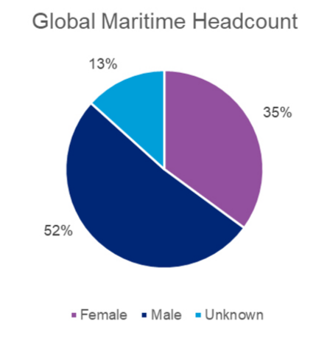
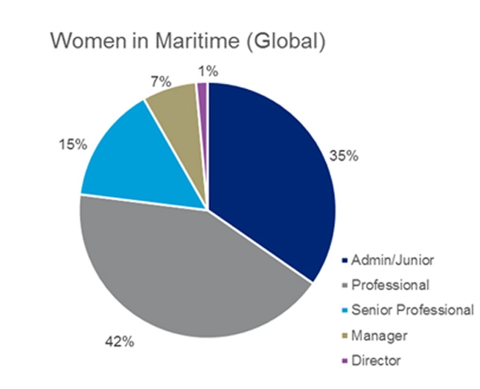
Figure 7. The division of male and female employees in the global maritime industry in 2018.
Source: HR Consulting (2018)
Figure 8. The job types of female employees in the global maritime industry in 2017.
Source: HR Consulting (2018)

3.5.3.1 Opportunities
The reports of DNV GL (2017) and Sprott Planning & Environment (2017) state several opportunities for ports to contribute to this area of interest.
- Encourage gender diversity within the maritime industry. Provide training and establishments for women to have the possibility to grow to and retain at a high professional level.
- Strive for equal pay. The maritime industry contains a large salary gap between men and women.

3.5.4. Resilient Infrastructure
According to this area of interest, the infrastructure within the port and infrastructure for other port-related transport must be resilient and able to deal with changing demand and environment. The infrastructure is aimed to be sustainable and must be resilient to potential changes in the future. “In the marine sphere, resilience is about dealing with uncertainty and being adaptive to change” (Ulrick, 2019). This development must of course be inclusive, which implicates that societal and environmental issues should be considered. According to DNV GL (2017), population growth and increasing urbanization will increase the need for sustainable and efficient infrastructure.
The Port of Mombasa in Kenya implemented the “Mombasa Port Resilient Infrastructure Programme” (MRIP). This is a program consisting of several interventions to increase productivity and efficiency of the port. The goal of the program is to transform the port towards a green and competitive port. The port started off by acquiring new machinery within the port with the aim to increase the efficiency of the infrastructure. They acquired four new mobile harbour cranes to reduce the berthing time of ships. The long berthing time resulted in higher costs and a decrease of the competitive position of the port. Due to the new machinery, the port has increased their resilience to an increase in demand because of their increased efficiency.
Resilience for environmental events is also an important factor to be considered. The Port of Maryland in the United States had major nuisance because of rain three times between 2009 and 2014. To prevent these events from causing trouble again, the Port of Maryland acquired a storm drain that is capable of storing almost 1.6 million litres of stormwater. Besides, the drain can analyse and adjust the water quality and transport the drain water towards a nearby water source. Because of this new storm drain, the port is capable of dealing with unexpected events in the future. Thus, this results in a higher resilience of the infrastructure of the port.
Abu Dhabi Ports also implemented a system to cope with unexpected disastrous events. However, this is not realized through the installation of a storm drain, but through the implementation of an IT platform. This platform protects the digital assets from natural of human-made disasters, which is important due to the increasing dependency of IT. Furthermore, they built an extra data centre which is meant to function in case of an emergency. This way, the data is protected and stored in the distant third data centre. This results in the protection of the use of the IT platform and minimize the effects of a disaster on the efficiency of the port. Therefore, this initiative contributes to the infrastructure resilience of the port.

3.5.4.1 Opportunities
According to the discussed case studies, the report of DNV GL (2017) and the report of Sprott Planning & Environment (2017), there are several opportunities for ports to contribute towards the SDG’s relevant for this area of interest.
- According to DNV GL (2017), sea transport is the most effective way of transportation. However, short distance transportation by sea has to overcome its disadvantage of being less flexible. If this is realized, transportation could become more efficient in areas where land infrastructure is bad.
- Ports must focus on increasing their capability of dealing with unexpected events in the future. By increasing their resilience, the efficiency of their infrastructure won’t be affected by said events. Port will also be able to handle a potential change in demand with a resilient infrastructure.
- Transparency and cooperation with the supply chain can contribute to a more efficient and resilient infrastructure. All parties within the supply chain can contribute to the resilience by being transparent.
- Besides being resilient to unexpected environmental events, the ports should also be able to use the externalities of these events in a positive way. Water management and the preservation of water quality are examples of positive use of externalities.

3.5.5. Safety and security
The Safety and Security area focusses on the SDG’s that relate to ensuring safety and security of operations within the port. Safety of the employees as well as the surrounding community must be ensured. Ports have taken several initiatives that contribute to the relevant SDG’s and the safety in the shipping area and the cargo handling.
JadeWeserPort and the Niedersachsen Port in Germany both introduced the use of “RapidReach”. This is a system programmed for emergency situations. The system provides all the necessary information to the people involved in the emergency through an application, dependant on the type of emergency. The system has already rolled out towards other ports in Germany and is aimed to create even more possible scenarios of emergency. The application also contacts all the relevant institutions in certain scenarios, resulting in a decrease of handling time in case of an emergency (WPSP, 2016).
The Port of Cagayan de Oro in the Philippines is constantly enhancing its safety and security level. The port has been certified with the International Ship and Port facility Security code (ISPS), which is an international standard initiated by the IMO since 2002 (NVG). The code consists of three security levels; the normal situation with standard security measures, the enhanced risk level with more strict security measures and the highest level with very strict security measures. The Port of Cagayan de Oro enhances the level of security through digitalization and innovation. Port workers are screened at the entrance, the amount of CCTV camera’s keeps increasing and there is a constant communication due to the security command centre, operating continuously (Philippine Ports Authority, 2018).

3.5.5.1 Opportunities
Several opportunities for ports to contribute to this area of interest derive from the case studies and suggestions from DNV GL (2017) and Sprott Planning & Environment (2017).
- Enhance safety and security measures. This is possible in multiple ways, such as digitalization.
- Educate personnel and other possible parties involved in emergencies about how to act in certain scenarios. Provide information to make sure they are prepared for when said scenarios occur.

3.6 Opportunities of implementation
Through analysing different implementations of the SDG’s and sustainable development and reviewing other types of literature, the aim was to find a certain pattern of the potential implementations of the Sustainable Development Goals into the business plans of ports. The pattern that was derived from the literary research is divided according to the five themes initiated by the WPSP and each theme includes several opportunities for the implementation of the SDG’s. The pattern can be used to analyse the materiality matrix of every port by looking at how the ports take said opportunities into account in their business strategy.
1.  Climate and Energy. | - The efficient use of energy and the use of renewable energy  - Infrastructure that support efficient use of energy  - Encourage environmental initiatives of partners  - Minimize the use and effect of hazardous substances  - Natural resource efficiency.
2.  Community outreach and port-city dialogue. | - Engagement of the community to educate about environmental, social and economical issues.  - Encourage sustainable tourism  - Enhance the local economy
3.  Governance and Ethics. | - Encourage gender diversity to increase equality within the maritime industry.  - Strive for equal pay within the maritime industry.
4.  Resilient infrastructure. | - Overcome the disadvantage of sea transport of being less flexible.  - Increase the resilience of ports to unexpected events and fluctuations.  - Increase transparency within the supply chain to increase the efficiency and communication.  - Use the negative externalities of said unexpected events to turn them in to positive externalities.
5.  Safety and security. | - Enhance safety and security measures.  - Educate personnel for emergency scenarios.

3.7 Conclusion
After having discussed the literature regarding sustainable development, the SDG’s and the implementation of the SDG’s into business strategies of ports, the current urgency of these topics becomes clear. The awareness of the importance of sustainable development for businesses has grown, just like the awareness of the way port activity and other business activities within the ocean economy result in negative externalities in social, environmental and economical view. Initiatives regarding the implementation of the SDG’s into business strategies emerged all around the world, and big social actors started working together to provide efficient guidance for these initiatives and a chance to share knowledge and innovations.
However, there is a difference in ‘talking’ and ‘walking’. All the initiatives undertaken by companies and big social actors all around the world are a good step towards the implementation of the SDG’s into the business plans of companies, but they must not get in the way of the main goal of every organization; economic growth. This trade-off can be depicted in a materiality-matrix, where different issues are prioritised by the importance for the stakeholder and the importance for the company. It shows the trade-off between ‘walking’ and ‘talking’. The next part of this paper will analyse this trade-off. The found pattern of opportunities to implement SDG’s into business strategies will be applied on The Port of Rotterdam, Amsterdam and Antwerp to analyse similar trends in the way they strive to contribute to the SDG’s. Their initiatives will be implemented into a materiality matrix to see the prioritisation of the different issues. Afterwards, these matrixes will be compared to gain an overview of the difference in sustainable development and the implementation of the SDG’s into the business strategies of the ports.

4. Case studies

4.1 Introduction
This part of the paper will analyse the Port of Rotterdam, the Port of Amsterdam and the Port of Antwerp in how they deal with the trade-off between the ‘walk’ and the ‘talk’. The paper will discuss how they perform in terms of sustainability by analysing the different Key Performance Indicators (KPI’s). These are indicators that measure the general performance of a company. Furthermore, a materiality matrix will be set up and analysed from 2015 to 2018 for all three ports to derive a conclusion on how the separate ports implement sustainable development and the SDG’s into their business strategy. Furthermore, the goal is to gain an overview of the way the separate ports act on international scale to contribute to increasing global sustainable development, achieving the SDG’s and helping other partners with implementing sustainable development as well.

4.2 Port of Rotterdam
This part of the paper will analyse the Port of Rotterdam for how they perform in terms of sustainability, their consideration of the SDG’s in their corporate objectives and how they deal with the trade-off between ‘walking’ and ‘talking’. This will be discussed by setting up and comparing the materiality matrices of 2015 until 2018 and analysing the progress of prioritisation of materiality issues.

4.2.1 Analysis of 2015
The Port of Rotterdam has the following CSR Statement:
“We work to build a vital, future-proof port where economic growth and improving the living environment go hand in hand. We conduct our operations in a socially responsible way, with respect for people and the environment. Our efforts are focused on the port and on our own organisation. Safe & Healthy Environment, Climate & Energy and People & Work are our key themes in this respect.” (Port of Rotterdam, 2016).
This CSR Statement was signed in 2016 by Allard Castelein, CEO of the Port of Rotterdam Authority. Before 2016, in the annual report of 2015, CSR was not represented at all. Corporate social responsibility (CSR) was mentioned for the first time in the annual report of 2016 and continued to be addressed until the latest annual report of 2018. This is the same for the representation of the Sustainable Development Goals
However, the annual report of 2015 does represent sustainability. To create an overview of the most important issues of 2015, table 1 in the appendix illustrates the KPI’s of the Port of Rotterdam in 2015. These issues are considered as important for the company; the ‘talk’ issues.
On the other hand, there are ‘walk’ issues, so the issues that are important for the stakeholders. According to the annual report of 2015 there are several important subjects for stakeholders: employment, cooperation, accessibility, safety, sustainability and environment. These subjects contain issues that are prioritised in importance for stakeholders. This prioritisation is shown in Dutch in figure 1 in the appendix.
Combining the ‘walking’ and the ‘talking’ issues of the Port of Rotterdam and its stakeholders in 2015, a materiality matrix as depicted in figure 9 can be put together, giving an overview of the prioritisation of the most important materiality issues in 2015.
HIGH | - Role of POR in hinterland network | - Attractive living environment around the port | - Safety within port area  - Quality shipping handling  - Enhance transport efficiency  - Enhance accessibility of the port
MEDIUM |  | - Clean community | - Enhance competitive position  - Contribution to sustainability and environment.  - Participate in growing markets and partnerships  - Cleaner transport in POR  - Invest in infrastructure of the port
LOW | - Innovative personality | - Increase the total port area | - Enhance appeal of the port for work  - Transparency
 | LOW | MEDIUM | HIGH
‘Walk’: Importance to the company
‘Talk’: Importance to the stakeholders

Figure 9. Materiality matrix of the Port of Rotterdam according to the annual report of 2015.

4.2.2 Analysis of 2016
The annual report of 2016 already addresses the materiality matrix. This matrix is shown in figure 10. This matrix was created by the Port of Rotterdam using a list of material issues which were then prioritised for both the stakeholders and the company. These material issues are all related to several goals, also stated in the annual report of 2016. The overview of how the materiality issues relate to the set goals in 2016 is illustrated in table 3 in the appendix. This annual report is the first to mention the consideration of the SDG’s by the port of Rotterdam. Their CSR statement of 2016 is based on the core business of the organization, stakeholder dialogue and international CSR frameworks, for example the SDG’s (Port of Rotterdam, 2016).

HIGH | - Employment opportunities | - Quality of stakeholder dialogue | - CO₂ emission  - Safety of the port and PA  - Quality of shipping handling  - New markets  - Growing markets
MEDIUM | - Education and job market  - Good governance  - Responsibility within the chain | - Excellent customer service  - Circular economy  - Hinterland networks  - Healthy port environment  - Safe and open culture  - Accessibility  - Quality of port infrastructure  - Security of port and port objects  - Conservation of existing markets | - Digitalization  - Efficient and resilient organization  - Knowledge and innovation  - Level playing field  - Quality of people
LOW | - Socially responsible employment  - Connection with growing markets | - Possibilities to grow  - Financial stability of the PA | - Partnerships
 | LOW | MEDIUM | HIGH
‘Walk’: Importance to the company
‘Talk’: Importance to the stakeholders

Figure 10. Materiality matrix of the Port of Rotterdam according to the annual report of 2016.

4.2.3 Analysis of 2017
In the annual report of 2017, the SDG’s are even more represented. They addressed the four most relevant SDG’s for economic and societal value creation by the Port of Rotterdam:
- 3 – Good health and wellbeing
- 7 – Affordable and clean energy
- 8 – Decent work and economic growth
- 9 – Industry, innovation and infrastructure
Further description of the SDG’s is shown in table 2.
In the annual report of 2017, a materiality matrix has already been set up in accordance with the main goals of the port of Rotterdam in 2017. The matrix is illustrated in figure 11. This year, however, the material issues and its corresponding goals have been connected with the four SDG’s previously mentioned, indicating a growing awareness of the implementation of the SDG’s into the corporate objectives. The overview of the connection between the main goals, the material issues and the four most relevant SDG’s for the port of Rotterdam is shown in table 3 in the appendix.
HIGH | - Healthy port environment  - Employment opportunities  - Quality of stakeholder dialogue | - Quality of shipping handling  - New markets  - Growing markets  - (Cyber)security | - Safety of the port and PA  - Energy transition
MEDIUM | - Education and job market  - Responsibility within the chain  - Good governance | - Accessibility  - Hinterland networks  - Conservation of existing markets  - Circular economy  - Partnerships  - Level playing field  - Possibilities to grow | - Quality of port infrastructure  - Knowledge and innovation  - Digitalization  - Efficient and resilient infrastructure
LOW | - Socially responsible employment | - Connection with (international) growing markets  - Safe and open culture | - Quality of people  - Financial stability of PA  - Excellent customer service
 | LOW | MEDIUM | HIGH
‘Walk’: Importance to the company
‘Talk’: Importance to the stakeholders

Figure 11. Materiality matrix of the Port of Rotterdam according to the annual report of 2017.

4.2.4 Analysis of 2018
In the annual report of 2018, the representation of the SDG’s has again increased in comparison with the previous year. In 2017, the port of Rotterdam took four most relevant SDG’s into account for their materiality issues. In 2018, they implemented one more SDG resulting in a total of five most relevant SDG’s to which they strive to become an important contributor. The five SDG’s are:
- 3 – Good health and wellbeing
- 7 – Affordable and clean energy
- 8 – Decent work and economic growth
- 9 – Industry, innovation and infrastructure
- 13 – Climate action
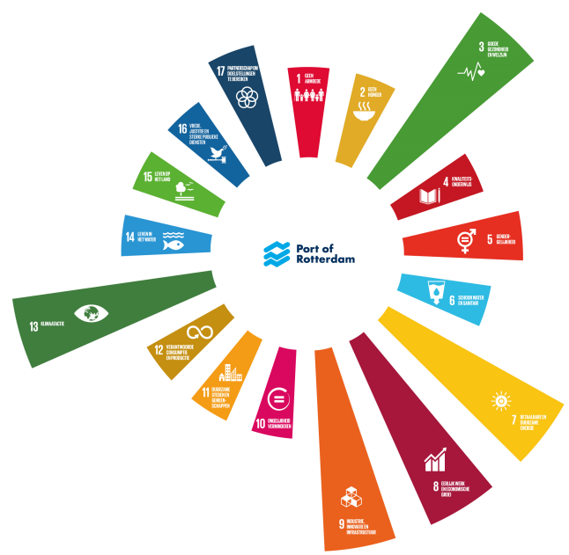
Of course, they contribute to other SDG’s as well, but the five mentioned SDG’s are the ones that they strive to have the most contribution to. This is depicted in figure 12.

Figure 12. Comparison of impact of the port of Rotterdam to the SDG’s in 2018.
Source: Port of Rotterdam Annual Report 2018.
The materiality matrix is already set up in the annual report of 2018. Furthermore, the material issues have been linked to the corresponding main goal and SDG. The same as in the annual report of 2017. The materiality matrix is shown in figure 13, and the overview of materiality issues and related goals and SDG’s is given in table 4 in the appendix.

HIGH | - Quality of stakeholder dialogue | - Hinterland networks and accessibility  - Healthy port environment  - Quality of shipping handling  - Knowledge and innovation | - Energy transition  - Safety  - Quality of port infrastructure
MEDIUM | - Good governance | - (Cyber)security  - Level playing field  - Jobs and education  - Partnerships | - Digitalization  - Development of new markets  - Good employment
LOW | - Connection of the port and the city  - (Inter)national port cooperation  - Responsibility within the chain | - Excellent customer service | - Space for transition  - Financial stability of the PA
 | LOW | MEDIUM | HIGH
‘Walk’: Importance to the company
‘Talk’: Importance to the stakeholders

Figure 13. Materiality matrix of the Port of Rotterdam according to the annual report of 2018.

4.2.5 Progress over the years
After analysing the annual reports of 2015 until 2018, it becomes clear that the representation of the SDG’s in the corporate objectives and goals is increasing. The annual report of 2015 did not mention the SDG’s at all, while the annual report of 2018 already started connecting their most relevant SDG’s to materiality issues and corporate objectives of that year. When the materiality matrices of 2015 until 2018 are compared, it is noticeable that some of the discussed materiality issues moved to another level of priority. This can be both for the stakeholders and for the company. Meanwhile, some of the issues remained on the same level of priority over all the analysed years. By looking at the materiality issues that are related to the five most relevant SDG’s for the Port of Rotterdam, this part aims to analyse the progress of prioritisation of materiality issues of 2015 to 2018.
Over the years, both the Port of Rotterdam and its stakeholder have put a high priority on Safety of the port area and the Port Authority and Energy Transition. These issues are thus considered as the most important for both actors and this indicates that they strive to contribute towards SDG’s 3, 3, 8 and 13. Furthermore, quality of the port infrastructure has increased in importance for both the stakeholders and the Port of Rotterdam, indicating that they are both striving to increase its contribution towards SDG 9.
Altogether, the port of Rotterdam clearly prioritises the materiality issues that contribute the most towards their five most relevant SDG’s. However, the trade-off between ‘walking’ and ‘talking’, as discussed previously, becomes clear in the comparison of the materiality matrices. Stakeholders put a high priority on issues like Healthy Port Environment, Quality of Stakeholder dialogue or Employment opportunities. These issues are considered ‘socially responsible’ and important to ‘talk’ about. However, the Port of Rotterdam puts more priority on financial stability, excellent customer service or efficiency, which have been given a low priority by the stakeholders. This indicates the difference between the ‘walk’ and the ‘talk’.

4.3 Port of Amsterdam
This part of the paper will analyse the Port of Amsterdam for their performance in sustainability, their consideration of the SDG’s in their corporate objectives and how they deal with the trade-off between ‘walking’ and ‘talking. This will be done by setting up and comparing materiality matrices of 2015 to 2018 and looking at the progress of the prioritisation.

4.3.1 Analysis of 2015
The annual report of 2015 of the Port of Amsterdam does not address the SDG’s. This indicates that the SDG’s are not implemented into the corporate objectives of 2015. Furthermore, they do not provide a materiality matrix or an overview of the relevant materiality issues.
They do, however, mention the implementation of ‘Vision 2030’. Vision 2030 is a program initiated by the Port of Amsterdam and aims to acquire a ‘port ecosystem’, a port network that connects port activities within the port area and the surrounding area. This way, the Port of Amsterdam strives to create more efficiency and partnership possibilities through better accessibility to important knowledge, infrastructure and connections. Vision 2030 serves as an instrument for stakeholders to determine the direction of the port of Amsterdam and a guideline for the Port of Amsterdam Authority for the allocation of people and resources. It is a guideline for future activities.
Vision 2030 has been set up through dialogue with and participation of stakeholders. Through three phases, the Port Authority and relevant partners were able to create the concept of Vision 2030. The first phase included many interviews and gatherings with many different stakeholders to determine trends, issues and scenarios. The second phase included the discussion of the most relevant issues that were derived from the first phase. The third phase combined, structured and validated all issues and resulted in the creation of Vision 2030 (Port of Amsterdam, 2015).
Vision 2030 is a program that is all about inclusive development. This is derived from the intensive dialogue with stakeholders and the community. Furthermore, they emphasise corporate social responsibility through the implementation of ‘people, planet & profit’ on three levels. The first level is integrating CSR in their own business plan. The second level is the port area, where they strive for a clean port through many sustainable innovations. The third phase is the supply chain. They aim for a sustainable chain through international cooperation (Port of Amsterdam, 2015).
Even though the annual report does not represent a clear prioritisation of material issues through the implementation of a materiality matrix, the Port of Amsterdam is aware of the need for sustainable development and CSR. They strive to maintain or even increase their competitive position and reputation through the implementation of Vision 2030 and to become resilient for future changes on economical and environmental level. However, the annual report lacks the application of SDG’s and the clear prioritisation of issues, which makes the trade-off between ‘walking’ and ‘talking’ more difficult.

4.3.2 Analysis of 2016
The annual report of 2016 mentions the SDG’s for the first time, but not to great extent. They strive to use the SDG’s as a guideline of their supply chain policy. They do not, however, clearly mention the connection between the implemented policies and the relevant SDG’s. In 2016, they initiated a sustainability agenda which gives an overview of their goals and ambitions using five themes. These themes were acquired using their materiality matrix of 2016. Furthermore, they connected the material issues represented in the matrix with the five important themes that they used in their new sustainability agenda of 2016.
First, this part creates an overview of the five themes that are addressed as most important within the sustainability agenda of the Port of Amsterdam:
- Energy transition and Circular economy. This theme is about the reduction of greenhouse gasses through the implementation of renewable energy and waste management where the waste flows from the city can be converted into raw materials and fuels for port activities
- Environmental issues and the living environment. This theme commits to the reduction of the negative environmental externalities resulting from activities within the port of Amsterdam. The aim is to create a healthy living environment without negative effects on health, noise or high dust levels
- Clean and safe shipping. This theme aims to reduce the negative effects of the increase in shipping on health and the environment. Therefore, the port of Amsterdam strives to increase clean shipping.
- Work and knowledge. Being an important hub for employment and knowledge for the region, the port aims to be a responsible employee.
- Responsible commercial chain. The port of Amsterdam wants to be involved in the complex commercial and production chains. It is their priority to be able to know the material source, their manufactures and the transportation of the resources in order to make sure everything within the chain in responsible.
The annual report of 2016 already depicts the materiality matrix and the relation between the materiality issues and the five themes. The materiality matrix is shown in figure 14, and the overview of the issues and their connection with the five themes in illustrated in figure 2 in the appendix.

HIGH |  | - Safety | - Supply chain responsibility  - Connection with the city  - Capacity for innovation
MEDIUM | - Intensifying use of available space | - Multimodal accessibility  - Clean shipping  - Accessibility  - Good employment practices  - Biobased and circular economy | - Port’s environmental impact  - Sustainable energy production  - Customer satisfaction
LOW | - Sustainable operations  - Transparency | - Labour market and training
 | LOW | MEDIUM | HIGH
‘Walk’: Importance to the company
‘Talk’: Importance to the stakeholders

Figure 14. Materiality matrix of the Port of Amsterdam according to the annual report of 2016.

4.3.3 Analysis of 2017
The annual report of 2017 already shows a higher representation of the SDG’s in the corporate objectives of the Port of Amsterdam compared to 2016. They have used their five previously mentioned sustainable themes to identify to which SDG’s the port can contribute. Figure 15 depicts an overview of the five themes and how they correlate with the most relevant SDG’s according to the Port of Amsterdam. It shows that the most relevant SDG’s are number 3, 7, 8, 9, 11, 12 & 13. The description and goal of every SDG’s can be found in table 2. The port states that these are the SDG’s to which they can contribute the most. Therefore, they related them to their sustainability themes in order to create a better overview and organization.
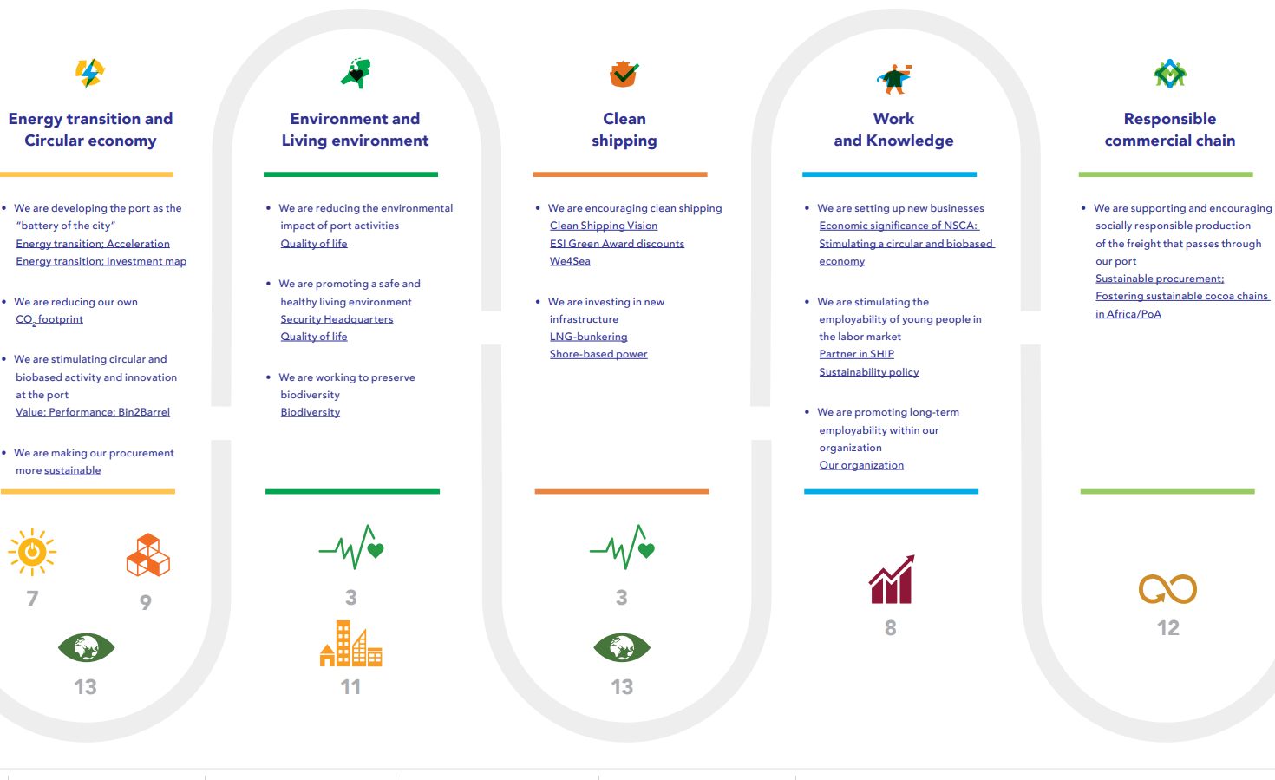
Figure 15. An overview of the five sustainability themes of the Port of Amsterdam and their corresponding SDG’s in 2017.
Source: Port of Amsterdam annual report 2017.

The annual report of 2017 also depicts an updated materiality matrix. Several issues have been added, but the existing issues have not made major shifts. According to the Port of Amsterdam, part of the reason this occurrence is the fact that reputation surveys among stakeholder groups are only held once every two years, with the most recent survey being in 2016. Figure 16 shows the materiality matrix of 2017.
HIGH | - Digital port  - Safety | - Accessibility  - Biodiversity  - Port’s environmental impact | - Supply chain responsibility  - Capacity for innovation  - Connection with the city
MEDIUM | - Transparency  - Good employment practices | - Clean shipping  - Intensifying use of the available space  - Multimodal accessibility | - Biobased and circular economy  - Sustainable energy production
LOW | - Labour market and training  - Sustainable operations | - Partnerships  - Preferred ports | - Customer satisfaction
 | LOW | MEDIUM | HIGH
‘Walk’: Importance to the company
‘Talk’: Importance to the stakeholders

Figure 16. Materiality matrix of the Port of Amsterdam according to the annual report of 2017.

4.3.4 Analysis of 2018
The annual report of 2018 states that the core activities of 2018 are based on the same SDG’s as mentioned in 2017; SDG number 3, 7, 8, 9, 11, 12 & 13. Their material issues are now divided among the themes, and the themes are then prioritised on the materiality matrix. This matrix is shown in figure 17. 2018 was the year of a new stakeholder survey. The Port of Amsterdam puts a high priority on stakeholder dialogue, and by these surveys they strive to gain a better view of the materiality of issues according to their many stakeholders. This resulted in a new materiality matrix as shown in figure 17.

HIGH | - Clean and safe shipping  - Digital port | - Work and knowledge  - Biodiversity  - Logistics and accessibility | - Responsible supply chains  - Environment and living environment  - Innovation power
MEDIUM | - Intensifying the use of available space  - Transparency | - Partnerships  - Customer satisfaction | - Energy transition and circular economy
LOW | - Sustainable operations | - Preferred port
 | LOW | MEDIUM | HIGH
‘Walk’: Importance to the company
‘Talk’: Importance to the stakeholders

Figure 17. Materiality matrix of the Port of Amsterdam according to the annual report of 2018.

In figure 17, the material issues in bold represent the sustainable themes of the Port of Amsterdam. These themes all hold several material issues as shown in table 5. The themes have previously been described. The other material issues mentioned in the materiality matrix are considered as ‘less material subjects’ according to the annual report. A description of the less material subjects is given in table 5 in the appendix.

Table 5. Overview of the five themes and their corresponding material issues for 2018.
Theme | Material issues
Energy transition and circular economy | - Increasingly sustainable operations  - Encourage innovation by removing barriers  - Strategic port development  - Cooperation, lobbying and research
Environment and living environment | - Clean in-house operations  - Cooperating with partners to reduce environmental impact  - Intensifying use of available space  - Biodiversity
Clean and safe shipping | - Safety awareness  - Emission reduction  - Regulations, supervision and enforcement  - Stimulating pricing policy  - Facilities and service that promote clean shipping  - Knowledge exchange and cooperation
Work and knowledge | - Long-term employability of staff and social engagement  - Attracting innovative entrepreneurs and the use of work/training companies  - Acting together, combining and sharing knowledge  - Provide labour opportunities for people with a disadvantage
Responsible supply chains | - Minimize the negative effects and maximize the positive effects of purchases  - Compliance to battle corruption  - In dialogue with customers and politicians  - Research and cooperation

4.3.5 Progress over the years
Despite the lack of a materiality matrix of 2015, analysing the annual report of 2015 and the matrices of the other years can still give information of the progress in prioritisation of material issues according to the Port of Amsterdam. Over the years, the representation of the SDG’s in the corporate objectives kept increasing. In the annual report of 2015, the SDG’s were not mentioned at all, while in 2018, the Port of Amsterdam chose their most relevant SDG’s and connected these with their five sustainable themes. Each theme represents several materiality issues, so every materiality issue within a theme is corresponding with an SDG. The Port of Amsterdam states that the relevant SDG’s are the ones to which they can contribute the most and, therefore, puts its focus on.
First, the issues with the highest material priority according to both the stakeholders and the company are issues regarding responsibility within supply chains, port-city dialogue and innovation. According to figure 15, this indicates that both the stakeholders and the company strive to contribute towards SDG number 3, 7, 9, 11, 12 & 13. In terms of Work and Knowledge, SDG number 8, the progress of the materiality matrices shows that this SDG is mainly highly prioritised by stakeholders and particularly by the Port of Amsterdam. Furthermore, the trade-off between ‘walking’ and ‘talking’ is noticeable in terms of safety, digitalization and transparency. These issues are highly prioritised by the stakeholders, but the Port of Amsterdam gives a low priority to these issues. According to them, these issues are apparently not as important for ‘walking’ as other issues that are highly prioritised.
Altogether, the Port of Amsterdam and its stakeholders focus on the materiality issues that contribute the most to their most relevant SDG’s. This way, they strive to contribute as much as possible to achieving these goals and being an important contributor globally. Responsibility within supply chains, reduction of the environmental impact through sustainable innovation and circular economy are the material issues that they state to be the most important.

4.4 Port of Antwerp
This part of the paper will analyse the Port of Antwerp for their performance in sustainability, their consideration of the SDG’s in their corporate objectives and how they deal with the trade-off between ‘walking’ and ‘talking’. This will be done by analysing the extent of representation of the SDG’s in their annual reports of 2015 to 2018 and their corporate objectives and by comparing materiality matrices of 2015 to 2018 and looking at the progress of the prioritisation.

4.4.1 Analysis of 2015
The annual report of 2015 of the Port of Antwerp does not mention any implementation of the SDG’s into the corporate objectives of that year. Furthermore, the report does not provide an overview of materiality issues and the corresponding materiality matrix. Therefore, it is not possible to gain an overview of the connection between important materiality issues and the most important SDG’s according to the Port of Antwerp. 2015 was the year of their third biannual ‘Sustainability Report’, a separate document that measures their sustainability in terms of several indicators (Safety4sea, 2016). More about this report will be issued in part 4.5.3.
They do, however, mention their progress of their ‘2014-2018 Business plan’. This program was initiated by the Port of Antwerp in 2013, starting in 2014, and the main mission of this business plan is:
“To ensure the greatest possible added value for the port area entrusted to us, is a sustainable way. To this end, Antwerp Port Authority fulfils active roles, both within the port area and outside it” (Port of Antwerp, 2014).
This plan was set up in accordance with all stakeholders through shared information and meetings. The dialogue eventually resulted in the 2014-2018 business plan containing the corporate objectives of this time period. The first objective is that maritime transhipment, industry and logistics must increase in efficiency to create a platform on which the most sustainable and efficient European supply chains converge. The second objective is that this platform must be world-class in terms of scale and range. The third objective aims to shift the role of the Port of Antwerp towards being an active facilitator and stimulator for its customers and stakeholders (Port of Antwerp, 2013). These objectives led to two strategic priorities:
- The port of Antwerp must pursue its commercial and operative initiatives to create opportunities for port companies to create added value. This is done by optimisation of the supply chain, creating synergies within the platform, optimising the use of space and becoming top-of-mind globally.
- Enhance the strength of the total platform with dialogue with stakeholders and the community to increase the social value of the platform. They aim to tackle social issues and enhance the sustainability of platform.
The annual report describes the progress of the 2014-2018 business plan on the hand of the main priorities of the program. These priorities are visually presented in figure 18.
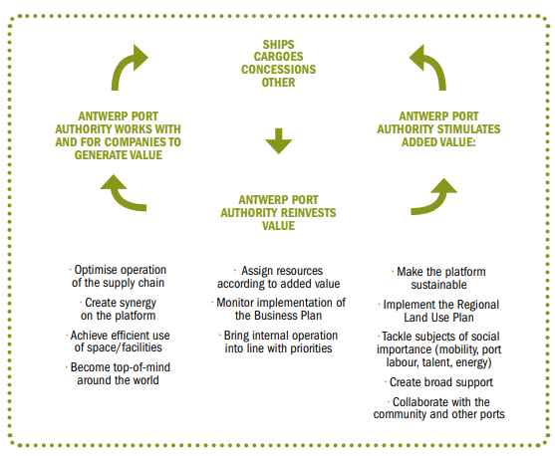

Figure 18. Strategic priorities for 2014-2018.
Source: Port of Antwerp annual report 2015

4.4.2 Analysis of 2016
Also the annual report of 2016 lacks the presence of SDG implementation and illustration of the prioritisation of materiality issues. No materiality matrix has been mentioned in the report. Therefore, the Port of Antwerp still has not been able to connect their material issues and activities in terms of sustainability with the Sustainable Development Goals of the UN.
They do mention their progress regarding the 2014-2018 business plan. Their aim of being an active stimulator for its customer and stakeholders is depicted in their initiation of the biannual ‘Sustainability Award’, handed out to the participating company with the best contribution towards sustainable development. This way, they strive to increase the awareness and importance of sustainable development among companies (Port of Antwerp, 2016).
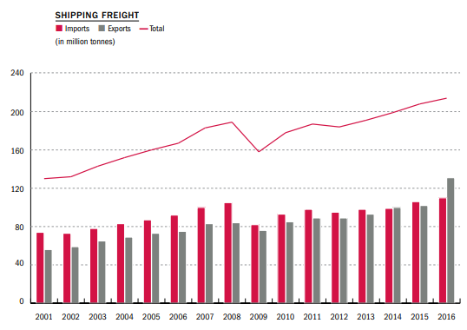
According to their annual report of 2016, their main priorities are creating a more sustainable port through more investment in sustainable initiatives, a more accessible port in terms of infrastructure, sustainability and efficient freight transport and enhancing the capacity and use of the Delwaide dock. Furthermore, their main concerns for the future are being resilient for further growth of the port. They strive to ensure additional capacity for shipping and container handling. This is due to their expected growth in terms of container and shipping freight because of the growth of previous years, as shown in figure 19 and 20.

Figure 19. Growth of shipping freight from 2001 to 2016 for the Port of Antwerp.

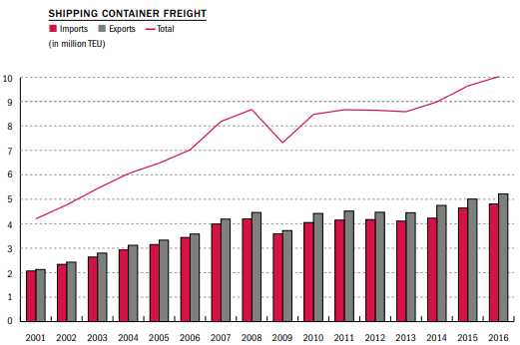

Figure 20. Growth of shipping container freight from 2001 to 2016 for the Port of Antwerp.

4.4.3 Analysis of 2017
Due to choice of policy, the Port of Antwerp decided to stop creating annual reports after the year 2016. Therefore, no materiality matrix can be found, and no overview of material issues is given. 2017 is, however, the year of the fourth edition of the Sustainability Report. In this report, the SDG’s are mentioned for the first time. The port of Antwerp initially mentioned 5 of the SDG’s as their most relevant goals to which they could contribute the most. These five SDG’s are:
- 7 – Affordable and clean energy
- 8 – Decent work and economic growth
- 9 – Industry, Innovation and Infrastructure
- 13 – Climate action
- 17 – Partnerships for the goals
However, after a stakeholder dialogue held in 2016 it became apparent that the five goals mentioned by the Port of Antwerp was not going to be enough. Due to the fact that the Port of Antwerp consists of over 900 companies and the many links between the 17 different SDG’s, they have decided to view the SDG’s as a whole, and not as 17 separate goals.
Not only did the Port of Antwerp implement the SDG’s into their report, they even linked the SDG’s to the individual subjects that are addressed in the Sustainability Report. The overview of the subjects, and their corresponding SDG’s is given in table 6.

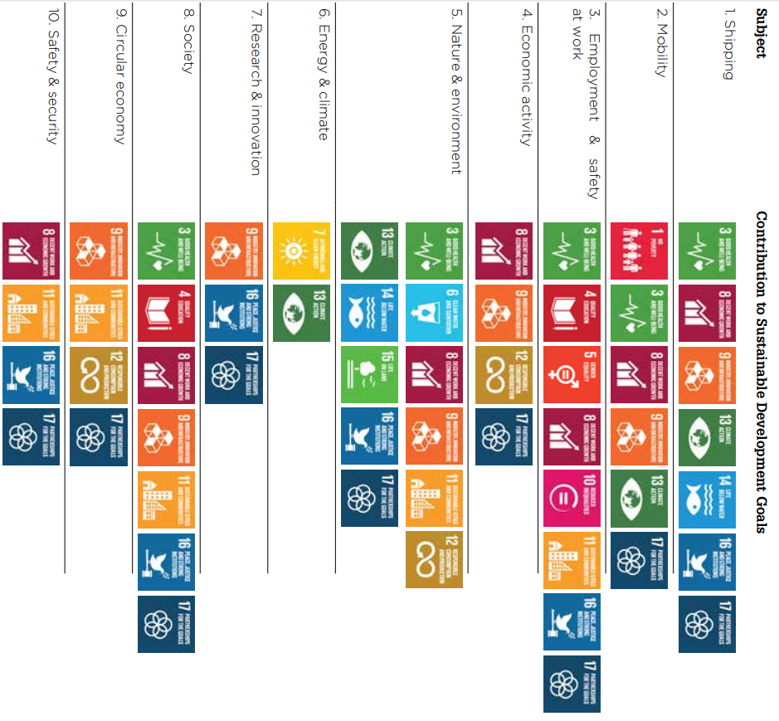
Table 6. An overview of the main subject of the 2017 Sustainability Report of the Port of Antwerp and their relevant SDG’s.
Source: Sustainability Report 2017 Port of Antwerp.

4.4.4 Analysis of 2018
The lack of an annual report in 2018 results in having no materiality matrix and no overview of the materiality issues which could be prioritised in the matrix. The Port of Antwerp aims to pursue the goals stated in the 2017 Sustainability report but does not report on the progress in a new annual report.
They do report on a new initiative; the ‘Business plan 2018-2020’. This program is a continuation on the 2014-2018 business plan and has the following purpose:
“The purpose of this business plan is to prepare the Antwerp Port Authority for the future. In order to do so we have defined a number of very concrete action plans that should enable us to be flexible and resilient in an unpredictable world which is developing at a relentless pace.” (Port of Antwerp, 2018)
The goal of the program is to provide a predictable framework and a guideline for their customers and stakeholders. Besides, they aim to achieve a shift in their role as a community builder. They strive to engage with all their stakeholder more actively to ease communication and cooperation, create more possibilities regarding innovation and investing in areas of which the market is not fully developed yet. The Port of Antwerp is even willing to commit to initiatives that do not have a clear earnings model.
According to the Business Plan 2018-2020, the Port of Antwerp aims to develop in five areas:
- Sustainable growth
- Mobility
- Transition
- Safety & Security
- Operational Excellence
These five strategic priorities will be translated in specific initiatives and programs to eventually reach their goal their mission of building a sustainable future for all of their stakeholders (Port of Antwerp, 2018).

4.4.5 Progress over the years
After having discussed the annual reports and other publications of the Port of Antwerp between 2015 and 2018, it becomes apparent that the implementation of the SDG’s into their corporate objectives did not happen until their Sustainability Report of 2017. Before this report, however, they certainly discussed their mission in terms of sustainability. They initiated the business plans of 2014-2018 and 2018-2020, with which they wanted to create a guideline or framework for the implementation of sustainable business operations. However, not until 2017 were these programs related to the Sustainable Development Goals. Therefore, they missed out on creating a globally understood and accepted categorisation by using the SDG’s.
The first time the SDG’s got into the picture was in 2017. However, this implementation was done in a separate document, apart from the economical corporate objectives. This indicates that sustainability issues are not implemented into their business plan as a whole. Besides, the lack of materiality matrices and an overview of the materiality issues from 2015 to 2018 makes it hard to analyse the trade-off between ‘walking’ and ‘talking’. They report on their future plans of sustainability, but do not mention whether these objectives, the ‘talk’, form a priority in comparison with normal economic business operations which form economic growth, the ‘walk’.

4.5 Conclusion
Now that the Port of Rotterdam, the Port of Amsterdam and the Port of Antwerp have been discussed and analysed in terms of their implementation of the SDG’s into their corporate objectives, how they deal with and report about the trade-off between the ‘walk’ and the ‘talk’, and how they strive to contribute towards achieving the Sustainable Development Goals globally, the ports can be compared in how they perform on these issues.
In terms of the implementation of the SDG’s in the corporate strategy of the ports, it appears that the Port of Antwerp lags in this issue. Both the Port of Amsterdam and the Port of Rotterdam first address the implementation of the SDG’s in their annual report of 2016. The port of Antwerp, however, first mentions the SDG’s in their Sustainability Report of 2017, a report that is separate from their business reports. All three ports, however, eventually implement the SDG’s into their reports and link them to issues or objectives, creating an overview and categorisation of their relevant issues. The port of Rotterdam and Amsterdam both mention a selection of SDG’s being seen as the most relevant for their port, while the Port of Antwerp prefers to view the SDG’s as a whole. Not as separate goals.
In terms of materiality matrices and their contribution to the SDG’s, the Port of Rotterdam and the Port of Amsterdam both sufficiently address their materiality issues and their prioritisation, making it easy to form and analyse their materiality matrix for 2015-2018. The Port of Antwerp lacks the reporting of the material issues and their prioritisation. As mentioned, Antwerp mainly focuses on reporting about what they strive to do, but not about the extent of prioritisation of the issues. In comparison, the relevant SDG’s stated by the three ports are somewhat comparable. The Port of Amsterdam appoints more SDG’s as being important compared to the Port of Rotterdam, while the Port of Antwerp deems all of them as important. But analysing the materiality matrices results in more precise issues being prioritised. For the port of Rotterdam, the analysis of the matrices shows that they mainly put emphasis on issues regarding energy transition, port safety, port infrastructure and accessibility. For the port of Amsterdam, this emphasis is put mainly on issues regarding responsibility within the supply chain, innovation and enhancing the connection with the city and the living environment. For the Port of Antwerp, materiality issues are not reported. After analysing several reports and priorities of 2015-2018, it becomes apparent that their emphasis is on optimising efficiency within the supply chain and infrastructure and tackling social issues, while maximizing the dialogue with stakeholders. However, due to the lack of materiality issues and their prioritisation, it is unclear to what extent their emphasis is ‘walking’ or ‘talking’.
After the analysis and the comparison of the Port of Rotterdam, the Port of Amsterdam and the Port of Antwerp, the next part will derive a conclusion from all the discussed parts so far. The sub questions as mentioned in the introduction will be answered and this will lead to an answer on the main question. Finally, a conclusion will be derived from these answers.

Discussion and conclusion

5.1 Introduction
This section of the paper aims to answer the sub questions and the main research question and derive a conclusion for this paper. The aim of this paper was to find an answer to the research question:
“To what extent do ports implement sustainable development globally, and how are the Port of Rotterdam, the Port of Amsterdam and the Port of Antwerp comparable in this implementation?”
First, the sub questions will be answered. Next, the main research question will be answered using the conclusions derived from the sub questions. Finally, the limitations of this research will be addressed, and potential further research will be discussed.

5.2 Findings of the sub questions

5.2.1 First sub question
“To what extent are ports currently embedding sustainable development and the SDG’s into their corporate objectives? “
To answer this question, a literature review has been performed. After an explanation of sustainable development, the SDG’s and how these could be relevant for the port sector, it became apparent that there are many possibilities for ports to contribute towards achieving the SDG’s. These possibilities are applicable for all levels of sustainable development that have been discussed. It becomes apparent that because of the urgency of the subject, many programs have emerged which aim to support ports in their goal of embedding the SDG’s and sustainability. Organisations like the WPSP and the AIVP are examples of programs that provide a platform to share and gain knowledge and work together to acquire maximum contribution to achieving the implementation of the SDG’s. These programs illustrate specific initiatives of ports worldwide and address how specific ports implement the SDG’s in their corporate objectives. However, despite the fact that it would be ideal for ports to perform all possibilities and thus achieve sustainable development, ports should not lose track of their main goal of creating added value and achieving economic growth. This results in a trade-off between what would be the best in terms of environmental or social issues, often interesting issues for stakeholders, and what would have the greatest impact on the economic performance of the company. This is mentioned as the trade-off between ‘walking’ and ‘talking’. This trade-off is best illustrated in a materiality matrix.

5.2.2 Second sub question
“To what extent do the Port of Rotterdam, Port of Amsterdam and the Port of Antwerp implement sustainable development and the SDG’s into their corporate objectives?”
To find this answer, the three ports have been analysed and compared in terms of their sustainability, their implementation of the SDG’s and which of the SDG’s are deemed most important according to the separate ports. The Port of Rotterdam started addressing the SDG’s in their annual reports since 2016. The annual report of 2015 lack representation of the SDG’s. Every annual report contained a materiality matrix in which the materiality issues have been prioritised for the stakeholders and for the company. The progress of this prioritisation shows which issues have always been deemed most important for both actors or which issues have become more important over the years. The progress of materiality for the Port of Rotterdam shows their focus on safety within the port and energy transition. This is in line with the SDG’s that they stated as most relevant for them, and to which they strive to contribute the most. Their trade-off between ‘walking’ and ‘talking’ became apparent from the analysis of the matrices. The multiple social or environmental issues that were prioritised highly by the stakeholders, were given a low priority by the Port of Rotterdam. The Port of Amsterdam also mentions the SDG’s for the first time in their annual report of 2016. Over the years, this representation increased. They mentioned multiple SDG’s which were most relevant to them and to which they strived to contribute the most. These SDG’s were connected to their materiality issues. According to the matrices, the highest priority of the Port of Amsterdam is for issues regarding responsible supply chains, port-city dialogue and innovation. These issues have been given a high priority since the first materiality matrix of 2016 and are in line with the SDG’s that they eventually mentioned as most relevant. The trade-off between ‘walking’ and ‘talking’ is noticeable in terms of safety, digitalization and transparency. These issues have been given a low priority by the company, but a high priority by the stakeholders. The Port of Antwerp only provided annual reports until 2016, unfortunately. Furthermore, these annual reports did not mention their materiality issues and did not provide a materiality matrix. The first time the SDG’s were mentioned in their reports was in 2017. They address several SDG’s as being the most relevant for them, but also mention that they interpret the 17 SDG’s as a whole. They relate the SDG’s to their sustainable program. This program states what they strive to achieve in terms of sustainability. However, due to the lack of prioritisation of their materiality issues, it is unclear how they deal with the trade-off between ‘walking’ and ‘talking’. They mention several sustainable plans related to the SDG’s, ‘the walk’, but do not mention to what extent these issues have a higher or lower priority than issues related to achieving economic growth and added value, the ‘talk’.

5.2.3 Third sub question
“How do the three ports compare in terms of the implementation of sustainable development and the SDG’s in their corporate objectives?”
In terms of implementation of the SDG’s, the Port of Antwerp only started reporting about the goals in 2017, while Amsterdam and Rotterdam first mentioned them in their annual reports of 2016. Furthermore, the Port of Antwerp lacks the provision of materiality matrices. This results in not being able to get an overview of the way they deal with the trade-off between ‘walking’ and ‘talking’. The Port of Rotterdam and the Port of Amsterdam do provide these matrices and both ports deal with this trade-off.
In terms of implementation of sustainability and SDG’s all three ports show initiatives of implementation of the SDG’s and increasing their sustainable development. While the Port of Amsterdam deems more SDG’s being relevant for them compared to the Port of Rotterdam, and the Port of Antwerp even mentions interpreting the 17 SDG’s as one, the ports do state the same SDG’s as being relevant for them. This can be seen in table 7. These are the SDG’s to which the three ports strive to contribute the most. However, after analysing the materiality matrices and other sustainability reports of the three ports it became apparent that the Port of Rotterdam puts a high priority to contributing to issues regarding safety within the port and energy transition, the Port of Amsterdam mainly focuses on supply chain responsibility, port city dialogue and innovation, and the Port of Antwerp puts the emphasis issues regarding supply chain and infrastructure efficiency, tackling social issues and maintaining excellent dialogue with their stakeholders, indicating inclusive growth. However, due to the lack of materiality matrices of the Port of Antwerp, it is unclear to which extent their sustainable aims are ‘walking’ or ‘talking’.

Table 7. Most relevant SDG’s per port.
Port | Most relevant SDG’s
Port of Rotterdam | 3, 7, 8, 9 & 13
Port of Amsterdam | 3, 7, 8, 9, 11, 12 & 13
Port of Antwerp | 7, 8, 9, 13 & 17  Interprets all goals as one after stakeholder dialogue.

5.3 Conclusion main research question
Now that the answers to the sub questions have been discussed, the main question can be answered. The sub questions made clear that there certainly is urgency and relevancy regarding the implementation of sustainability and the SDG’s in the corporate objectives of ports. Globally, many initiatives have been undertaken to contribute to achieving the SDG’s, both by ports and by partnership organisations forming a platform to share knowledge and innovations. Ports can share their initiatives on these platforms to form opportunities for other ports to copy the initiative and in that way contribute to the achievement of the SDG’s in their turn. Analysing the initiatives results in a certain framework of opportunities, which could be used to find opportunities within certain ports so they can also contribute and enhance their sustainable development. However, these opportunities must not obstruct the aim of increasing the added value and economic growth of a company. This causes the trade-off between the ‘walk’ and the ‘talk’. The initiatives are all categorised and connected to a certain SDG. This way, the programs that serve as such a platform strive to ease the way of achieving the SDG’s by 2030.
Looking at the Port of Rotterdam, the Port of Amsterdam and the Port of Antwerp, it becomes apparent that these ports all strive to contribute to increasing the sustainability and the implementation of the SDG’s in their own way. They are comparable in terms of the SDG’s they state as being relevant for their business strategy but differ in terms of the direction in which they strive to contribute. Each port has an individual direction. These directions are described in the answer of sub question 3. Furthermore, they differ in the way they report. The Port of Antwerp lacks the provision of the prioritisation of materiality issues, while both the Port of Rotterdam and the Port of Amsterdam neatly provide this prioritisation. Despite the lack of the prioritisation, Antwerp does report about their sustainability goals, and so do Amsterdam and Rotterdam. The main difference between these ports is the fact that the trade-off between ‘walking’ and ‘talking’ is clear for the Port of Rotterdam and the Port of Amsterdam, but not for the Port of Antwerp. Therefore, it is unclear to which extent Antwerp will be able to achieve their sustainable aims, while this is more clear for Amsterdam and Rotterdam.

5.4 Discussion and limitations

5.4.1 Findings
This paper contains several findings that could be further discussed. The first doubtful finding that should be addressed is the fact that is unclear to what extent the found initiatives and possibilities implemented by ports are also implemented by the port companies within said port. Just because the port authority has set up plans of implementation of the SDG’s and sustainable development will not directly mean that the port companies within that port are able or willing to integrate these plans. However, to achieve the SDG’s, it will be important that all the actors within the port, and not only the port authority, are involved in the process of sustainable development. This paper has not addressed the extent of this matter. Second, the paper neglects the fact that implementing or achieving one SDG could have a negative effect on another SDG. Ports could make reports about their contribution to several SDG’s, but they do not address the fact that other SDG’s can be negatively affected by their initiatives.

5.4.2 Limitations
There are a few limitations for this research. First, the illustrations of implementations of the SDG’s in the literature review are initiatives selected by the WPSP. This could cause a certain bias, as the projects are selected by the WPSP. Furthermore, projects selected by the AIVP have not been considered. Therefore, the illustration of global initiatives of SDG implementation could be rather limited. Next, in the case studies of the three ports, the analysis of reports is limited. This paper mainly used the annual reports of 2015-2018 and a few external sustainability reports. This could result in missing out on relevant information which could alter the outcome, also due to the size of the reports. Besides, the materiality matrices have been personally set up. Personal errors or misinterpretations could also cause a different conclusion. Lastly, the findings of this paper are completely acquired through desk research. There has been no field research to back up the findings of this paper, which could be acquired through interviews with relevant people within the ports.

5.5 Potential future research
For further research it would be possible to perform a deeper analysis on the reports, to catch for potential information that has not been considered in this paper. Next, the same analysis could be performed for other ports to see how those ports implement the SDG’s and reports about it. Other possible future research could be examining to what extent programs like the AIVP and WPSP affect achieving the SDG’s.
Following the challenges discussed in 5.2.1, potential further research could be conducted regarding the extent to which port companies are participating in the plans initiated by the port authority. This way an indication of the impact of ports in their contribution to the SDG’s could be found. The other challenge was the unclarity regarding the trade-off between SDG’s. This challenge leads to potential further research of how the implementation of one SDG affects the achievement of another SDG. Lastly, further research could be conducted on the explanation of the difference between the three ports in how they implement the SDG’s and which SDG’s they consider to be relevant.

References
Aidstream. (2019). Mombasa Port Resilient Infrastructure Programme (MRIP). Retrieved from https://aidstream.org/who-is-using/KE-RCO-CPR-2009-5689/10867
AIVP. (2018). 10 Goals for sustainable port cities. Retrieved from https://www.aivpagenda2030.com/
Broman, G.I. & Robèrt, K. (2017). A framework for strategic sustainable development. Journal of Cleaner Production, 140, 17-31. Retrieved from https://www-sciencedirect-com.eur.idm.oclc.org/science/article/pii/S0959652615015930
Biermann, F., Kanie, N. & Kim, R.E. (2017). Global governance by goal-setting: the novel approach of the UN Sustainable Development Goals. Current opinion in environmental sustainability, 26-27, 26-31. Retrieved from https://www.sciencedirect.com/science/article/pii/S1877343517300209
Club of Rome Climate Programme. (2013). Updating the future. Retrieved from https://www.portofrotterdam.com/sites/default/files/Updating-the-future-rapport.pdf
Davarzani, H., Fahimnia, B., Bell, M. & Sarkis, J. (2015). Greening ports and maritime logistics: a review. Transportation research part D: Transport and environment, 48, 473-487. Retrieved from https://www-sciencedirect-com.eur.idm.oclc.org/science/article/pii/S1361920915000991
DNV GL. (2017). Sustainable Development Goals: Exploring Maritime Opportunities. Retrieved from https://www.rederi.no/globalassets/dokumenter-en/all/fagomrader/smi/dnv-gl-sdg-maritime-report.pdf
Dooms, M., Haezendonck, E. & Verbeke, A. (2015). Towards a meta-analysis and toolkit for port-related socio-economic impacts: a review of socio-economic impact studies conducted for seaports. Maritime Policy & Management, 42(5), 459-480. Retrieved from https://www-tandfonline-com.eur.idm.oclc.org/doi/full/10.1080/03088839.2014.944238
Geerlings, H., Kuipers, B. & Zuidwijk, R. (2017). Ports and Networks. London. Retrieved from https://www-taylorfrancis-com.eur.idm.oclc.org/books/e/9781315601540
Gupta, J. & Vegelin, C. (2016). Sustainable development goals and inclusive development. International Environmental Agreements: Politics, Law and Economics, 16(3), 433-448. Retrieved from https://link-springer-com.eur.idm.oclc.org/article/10.1007/s10784-016-9323-z
International Labour Organization. (2019). The business case for change. Retrieved from https://www.ilo.org/wcmsp5/groups/public/---dgreports/---dcomm/---publ/documents/publication/wcms_700953.pdf
International Maritime Organisation. Women in Maritime. Retrieved from http://www.imo.org/en/OurWork/TechnicalCooperation/Pages/WomenInMaritime.aspx
Jansen, M., van Tulder, R. & Afrianto, R. (2018). Exploring the conditions for inclusive port development: the case of Indonesia. Maritime Policy & Management, 45(7), 924-943. Retrieved from https://www-tandfonline-com.eur.idm.oclc.org/doi/citedby/10.1080/03088839.2018.1472824?scroll=top&needAccess=true
Kang, D. & Kim, S. (2017). Conceptual Model Development of Sustainability Practices: The Case of Port Operations for Collaboration and Governance. Sustainability, 9(12). Retrieved from https://www.mdpi.com/2071-1050/9/12/2333
Lam, J.S., & Voorde, E.V. (2012). Green Port Strategy for Sustainable Growth and Development. Retrieved from https://www.semanticscholar.org/paper/Green-Port-Strategy-for-Sustainable-Growth-and-Lam-Voorde/aeeaa98296ccc6bb3a0e71f871d4b21656765705
NVG. International Ship and Port Facility Security Code (ISPS). Retrieved from https://www.nvg.nu/international-ship-and-port-facility-security-code-isps?__hstc=753710.52a3249b99915e6ad3d65509a23dbe00.1562787859267.1562787859267.1562787859267.1&__hssc=753710.1.1562787859268&__hsfp=355784916
OECD. OECD Port-Cities Programme. Retrieved from https://www.oecd.org/regional/oecdport-citiesprogramme.htm
OECD. (2016). An overview of the ocean economy: Assessments and recommendations. The Ocean Economy in 2030, 17-54. Retrieved from https://www-oecd-ilibrary-org.eur.idm.oclc.org/economics/the-ocean-economy-in-2030/an-overview-of-the-ocean-economy-assessments-and-recommendations_9789264251724-4-en
Philippine Ports Authority. (2018). Port of Cagayan de Oro. Retrieved from https://ppapmocdo.wordpress.com/2018/01/03/the-port-of-cagayan-de-oro/
Porto do Acu. (2017). RPPN Caruara. Retrieved from https://portodoacu.com.br/rppn-caruara/
Port of Amsterdam. (2015). Visie 2030 [PowerPoint Presentation]. Retrieved from https://www.portofamsterdam.com/sites/poa/files/media/projecten/strategie/ha-visie-2030-juni_2015_los.pdf
Port of Amsterdam. (2016). Jaarverslag 2015. Retrieved from https://www.portofamsterdam.com/sites/poa/files/media/pdf-nl/port_of_amsterdam_jaarverslag-2015.pdf
Port of Amsterdam. (2017). Jaarverslag havenbedrijf Amsterdam 2016. Retrieved from https://www.portofamsterdam.com/sites/poa/files/media/pdf-nl/jaarverslag-2016-port-of-amsterdam.pdf
Port of Amsterdam. (2018). Het resultaat van 2017. Retrieved from https://jaarverslag2017.portofamsterdam.com/wp-content/uploads/2018/04/Port_of_Amsterdam_Jaarverslag-2017.pdf
Port of Amsterdam. (2019). Jaarverslag 2018. Retrieved from https://jaarverslag2018.portofamsterdam.com/wp-content/uploads/2019/05/PortofAmsterdam2018_onlineversie_final.pdf
Port of Antwerp. (2014). Annual Report 2013. Retrieved from https://www.portofantwerp.com/sites/portofantwerp/files/POA-1293_Brochure%20Jaarverslag%202014_UK_0.pdf
Port of Antwerp. (2015). Annual Report 2014. Retrieved from https://www.portofantwerp.com/sites/portofantwerp/files/Annual%20Report%202014_EN.pdf
Port of Antwerp. (2016). Annual Report 2015. Retrieved from https://www.portofantwerp.com/sites/portofantwerp/files/POA-1882_AnnualReport2015_UK.pdf
Port of Antwerp. (2017). Annual Report 2016. Retrieved from https://www.portofantwerp.com/sites/portofantwerp/files/POA-2071_Jaarverslag2017_UK_WEB%20FIN.pdf
Port of Antwerp. (2017). Sustainability Report 2017. Retrieved from https://www.portofantwerp.com/sites/portofantwerp/files/duurzaameidsverslag2017_EN_LR_v2.pdf
Port of Auckland. Sustainability. Retrieved from https://www.poal.co.nz/sustainability
Port of Rotterdam. (2016). Corporate Social Responsibility Statement. Retrieved from https://www.portofrotterdam.com/sites/default/files/corporate-social-responsibility-csr-eng.pdf
Port of Rotterdam. (2016). Koers houden in een veranderende omgeving. Make it happen. Retrieved from https://www.portofrotterdam.com/sites/default/files/havenbedrijf-rotterdam-jaarverslag-2015.pdf?token=8FHxIk8A
Port of Rotterdam. (2017). Bouwen aan een duurzame toekomst. Make it happen. Retrieved from https://www.portofrotterdam.com/sites/default/files/jaarverslag-2016-havenbedrijf-rotterdam.pdf?token=4AEzXkdM
Port of Rotterdam. (2018). Hoe wij waarde creëren. Retrieved from https://jaarverslag2017.portofrotterdam.com/haven-en-havenbedrijf-rotterdam/hoe-wij-waarde-cre%C3%ABren/hoe-wij-waarde-cre%C3%ABren
Port of Rotterdam. (2018). Samenwerken aan de haven van morgen. Make it happen. Retrieved from https://www.portofrotterdam.com/sites/default/files/havenbedrijf-rotterdam-jaarverslag-2017.pdf?token=2HNsHvIq
Port of Rotterdam. (2019). Ruimte voor vandaag en morgen. Make it happen. Retrieved from https://jaarverslag2018.portofrotterdam.com/
Ports of Stockholm. (2017). Environmental measures. Retrieved from https://www.portsofstockholm.com/about-us/environmental-work/environmental-measures/
PortStrategy. (2017). Ports ready to adopt sustainable goals. Retrieved from https://www.portstrategy.com/news101/port-operations/planning-and-design/un-sdgs-to-be-adopted-by-ports
Sachs, J.D. (2015). The age of sustainable development. Retrieved from https://books.google.nl/books/about/The_Age_of_Sustainable_Development.html?id=CU23oQEACAAJ&redir_esc=y
Safety4sea. (2019). IAPH launches Women in Ports Mentoring Program. Retrieved from https://safety4sea.com/iaph-launches-women-in-ports-mentoring-program/
Spinnaker Global. (2019). Gender diversity in maritime. Retrieved from: https://spinnaker-global.com/Blog/Details/0_20-Feb-2019_gender-diversity-in-maritime
Sprott, J. (2017). Introduction to UN Sustainable Development Goals (SDGs) [PowerPoint Presentation]. Retrieved from http://www.sprottplanning.com/pdfs/Both%20Presentations%20(Greenport%202017)%20UN%20SDGs%20and%20Port%20Sector.pdf
SundaHus. SundaHus Material Data. Retrieved from https://www.sundahus.se/en/services/material-data/
Trademark EA. Mombasa Port Resilient Infrastructure Programme. Retrieved from https://www.trademarkea.com/projects/mombasa-port-resilient-infrastructure-programme/
United Nations. (2017). World Population Prospects. Retrieved from https://population.un.org/wpp/Publications/Files/WPP2017_Volume-I_Comprehensive-Tables.pdf
United Nations. About the Sustainable Development goals. Retrieved from https://www-un-org.eur.idm.oclc.org/sustainabledevelopment/sustainable-development-goals/
United Nations Environment Program. (2016). World Ocean Assessment Overview. Retrieved from https://environmentlive.unep.org/media/docs/assessments/WOA_screen.pdf
Van Tulder, R. (2018). Getting all the motives right. Rotterdam, SMO.
Wadden Seaports. (2018). Intelligent Port Lighting. Retrieved from https://www.waddenseaports.com/best_practices/intelligent-port-lighting/
WPSP. (2017). Portfolio. Retrieved from https://sustainableworldports.org/portfolio/type/port-projects/

Appendix
Table 1. The KPI’s of the Port of Rotterdam of 2015.
GOAL | KPI’s
Efficiency – Transport | - Nautic Efficiency Index  - Average travel time Maasvlakte – Vaanplein < 48 minutes  - Port roads < 2 times free-flow travel time
Efficiency – Building and maintenance costs port area | - Quay wall costs  - Realised infrastructural projects
Safety | - Number of nautical accidents  - Safety and Environmental Index
Sustainability – Rotterdam Port Authority | - Rotterdam Port Authority CO₂-footprint
Sustainability – Transport | - Modal split
Growth concepts | - Total market share  - Market share growth concept Container Port
Better competitive position | - More efficient residence time of inland shipping Rotterdam
Better maritime networks | - Enhancing the sea/sea container handling
Participation in growing markets | - Amount of participations
Global Strategic Partnerships | - Amount of Global Strategic Partnerships
Organisation – results-orientated | - Realised the goal regarding employees
Profitable organization | - Net Present Value

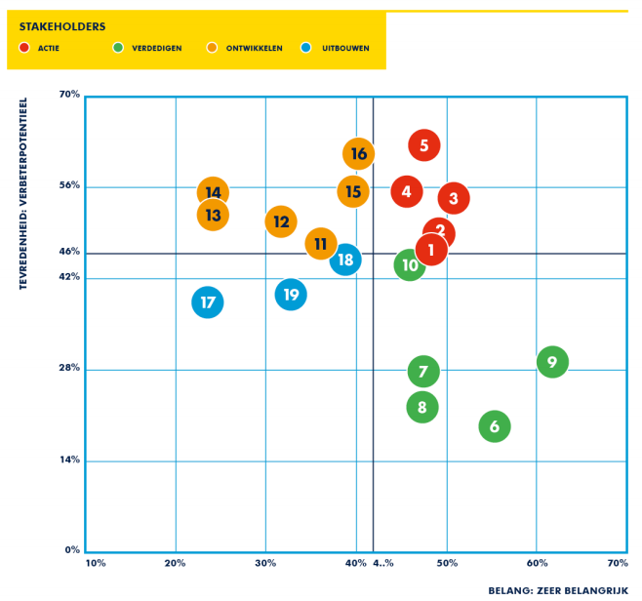

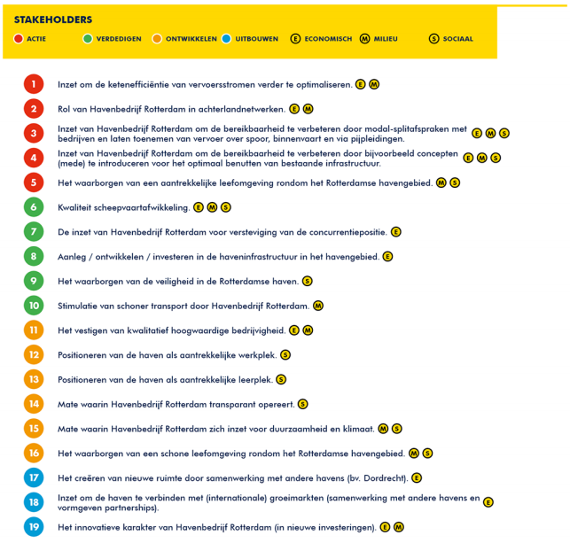

Figure 1. Prioritisation of issues according to stakeholders in 2015.

Table 2. The main goals of the port of Rotterdam and their corresponding material issues in 2016.
GOAL | Material issues
Market leader in growing markets | - Growing markets
Competitive in existing markets | - Conservation of existing markets
Leader in the development of new markets | - New markets
Value creation through port development | - Connection with international growing markets
Excellent business location | - Level playing field  - Excellent customer service  - Healthy port environment  - Accessibility  - Quality of the port infrastructure  - Possibilities to grow
Leader in chain and cluster sustainability | - CO₂ emissions  - Circular economy  - Responsibility within the chain
Most efficient and safe handling by all modals | - Safety within port and port authority  - Quality shipping handling  - Digitalisation  - Hinterland networks  - Security of port and port objects
Sufficient investing capital for the long term | - Financial stability PA
Partnerships | - Quality of stakeholder dialogue  - Partnerships
Innovation, knowledge and labour. | - Knowledge and innovation  - Employment opportunities
People and organization | - Efficient and resilient organisation  - Quality of people  - Safe and open culture  - Socially responsible employment

Table 3. The main goals of the port of Rotterdam and their corresponding material issues linked with the four relevant SDG’s in 2017.
GOAL | Material issues | Relevant SDG’s
Market leader in growing markets | - Growing markets | 9
Leader in the development of new markets | - New markets | 9
Excellent business location | - Quality of port infrastructure | 9
Leader in chain and cluster sustainability | - Energy transition | 7
Most efficient and safe handling by all modals | - Safety of the port and PA  - Quality of shipping handling  - Digitalization  - (Cyber)security | 9 & 3
Innovation, knowledge and labour | - Knowledge and innovation | 8 & 9
People and organization | - Efficient and resilient organization | 3

Table 4. The main goals of the port of Rotterdam and their corresponding material issues linked with the four relevant SDG’s in 2018.
GOAL | Material issues | Relevant SDG’s
Leader in the development of new markets | - Development of new markets  - Knowledge & innovation | 8 & 9
Excellent business location | - Quality of port infrastructure  - Hinterland networks and accessibility  - Healthy port environment | 3, 8 & 9
Leader in chain and cluster sustainability | - Energy transition | 7, 13
Most efficient and safe handling by all modals | - Safety of the port and PA  - Quality of shipping handling  - Digitalization | 8 & 3
People and organization | - Quality employment | 3 & 8

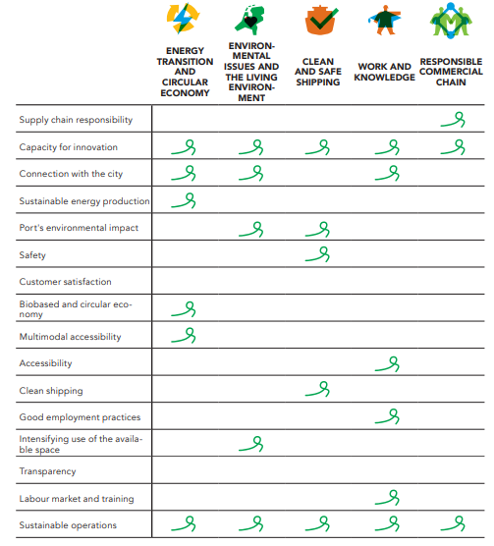
Table 4. The material issues and their corresponding themes of the Port of Amsterdam according to the annual report of 2016.

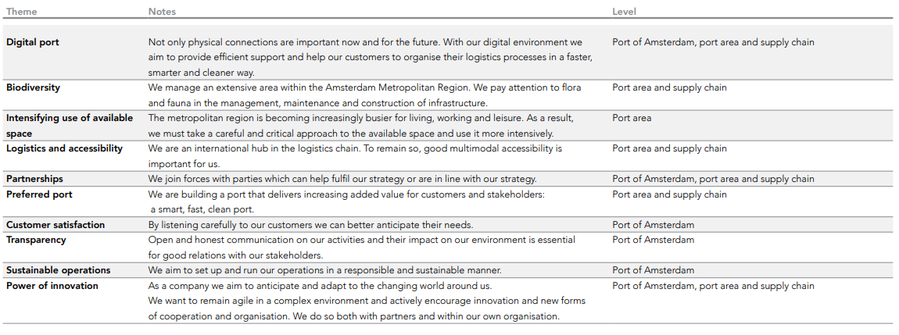
Table 5. A description of the less material subjects depicted in the materiality matrix of the Port of Amsterdam in 2018.

