 | 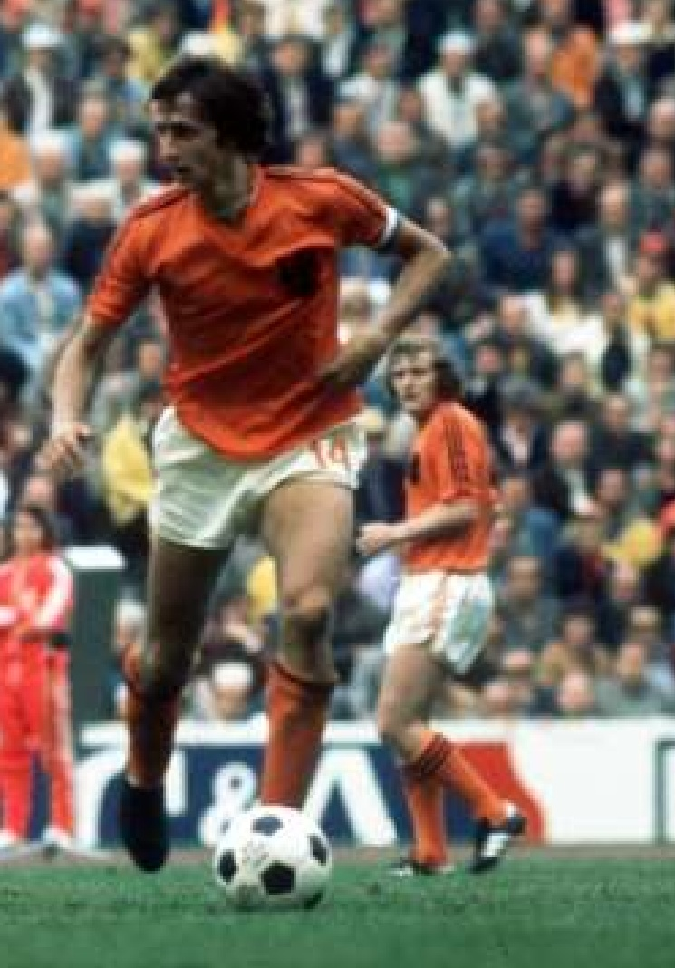
 |  | Technology in Dutch Football
 |  | How can a Dutch Football club use technology to improve club efficiency through player performance?
 | Erasmus School of Economics | Melvin Grootenboers
 |  | Bachelor Thesis Economics & Informatics
 |  | Bachelor programme  Student: Melvin Grootenboers  Student ID: 306154  Supervisor: Prof. M.W. Guah, PhD  Co-Reader: Drs. J. Bouwer  June 2009 |  |  |  | 

Abstract
Many sports are already using technology to improve the player performance. Football lies behind on this, especially in the Netherlands. This thesis is about the technologies that can be used at football and if they can improve the player performance. Winning more games will lead to more club efficiency.

This thesis is based on literature review and interviews. By reviewing the literature club performance, player performance and technology in football are looked at. There have been four interviews with experts within the football technology. The interviews have been analyzed to see if the technology nowadays really can improve the player performance.

The main research question in this thesis is: “How can a Dutch football club use technology to improve club efficiency through player performance?”

Through the technology tools training methods are changed and the training is more effective. The players can make a better plan for the upcoming match if the opponent is analyzed. They know exactly what the strengths and weaknesses are. The technology tools that are used at football right now are mostly analysis tools. The costs of the technology tools depend on what you want and how beautiful you want it. Within ten years every Dutch football club will have an analysis system.

I think that technology is not the decisive tool to win more games. There are a lot of external factors during a match, like the weather, the referee’s decisions, etc. These factors are mostly unknown. So technology will improve the player performance, but it is hard to say if it also improves the club efficiency.

Acknowledgements
Many thanks to Professor Matthew W. Guah, PhD, for the assistance and supervision on this thesis. Without Matthew it was not be possible to develop this thesis.

Many thanks to Jeffrey Bouwer for being co-reader on this thesis.

Many thanks to Max Reckers, Michel Valke, Arnold van Ree, and Frans Lefeber, for their participation. They gave me a lot of information about the technology in football.

Many thanks to my mom, my dad, my brother and Denise, for their inspiration.

Many thanks to my friends with which I always can talk a lot about football and play Pro Evolution Soccer.

Many thanks to my football team XerxesDZB 6, for their effort last season through which we didn’t lose for 10 weeks after each other.

Many thanks to Fenetre, the company where I work right now.

Abstract 2
Acknowledgements 3
INTRODUCTION 4
Introduction 4
Problem 4
Importance of Research 4
Research Model 4
Research Objective 4
Research Methodology 4
Research Method 4
Data collection 4
Literature Review 4
Interviews 4
Mode of Analysis 4
Thesis Structure 4
LITERATURE REVIEW 4
Introduction 4
Club performance 4
Player performance 4
Technology in football 4
Selected Model 4
Summary 4
CASE STUDY 4
AZ Alkmaar 4
Introduction 4
Preparation 4
Analysis 4
Training 4
Influence 4
Positive vs. negative 4
Doctor formula 4
Better Vision 4
Perspective player 4
Future of Feedback 4
Discussion 4
Future 4
View direction 4
Arms/ legs 4
Cheaper 4
Feyenoord Rotterdam 4
Introduction 4
Sportscode 4
Code Window 4
PDA 4
Team Performance Exchange 4
Costs 4
Improvements 4
Corner 4
Measure difficulty 4
Feedback 4
Technological development 4
Camera 4
Chip 4
New market 4
Ortec TSS 4
Introduction 4
At the moment 4
Interest 4
Budgets 4
Analyzing tool 4
Universal 4
Effectivity in Action 4
Observation 4
Software 4
Plan 4
Interpretation 4
Preparation 4
Traceability 4
Contribution 4
Inmotio Object Tracking BV 4
Introduction 4
Usage 4
Breeding ground 4
Technology 4
Costs 4
Target 4
Qualities 4
Coaching 4
Learning effect 4
Follow system 4
Profile 4
Scouts 4
Future 4
Competition 4
Intelligent clothing 4
Centralization of training and tests 4
CASE ANALYSIS 4
Introduction 4
Finance 4
Costs 4
Budgets 4
Future 4
Environment 4
Work floor 4
Game result 4
Feedback 4
Preparation 4
Coaching 4
Training 4
Plan 4
Performance 4
Doctor formula 4
Corner 4
Measurability 4
Upcoming Developments 4
Intelligent Clothing 4
Centralization 4
Summary 4
CONCLUSIONS 4
Introduction 4
Main Findings 4
Influence 4
Technolgy Tools 4
Costs 4
Future Vision 4
Lessons Learnt 4
Research Limitations 4
Thesis Conclusions 4
REFERENCES 4
APPENDIX A 4
Interview Max Reckers 4
Interview Michel Valke 4
Interview Arnold van Ree 4
Interview Hans Lefeber 4

INTRODUCTION

Introduction
This chapter starts with the background of the thesis: what is the problem and why is it important to do research in this field? After that the research model and the research objectives are mentioned. An important thing in this introduction is the methodology of this research. At the end the structure of this thesis is mentioned.

Problem
Almost every day football matches can be watched live on Dutch television, for example on the Eredivisie Live (Eredivisie Live, 2009) and Sport1 channels (Sport1, 2009). Football is the biggest sport in the world (Palacios-Huerta, 2004). There is a lot of money involved in football. The total revenue of the biggest club, which is Real Madrid from Spain, was 292.2 million Euros in the season 2005/2006 (Jones, 2007). During watching a match on television a lot of statistics are shown. You can see for example which team has the most ball possession, how many times a pass succeed and how many shots are on target. A lot of people are interested in these details, for example a head coach, who can give more attention to the passing skills of a player which passes don’t succeed so much.
In countries like England, Spain and Italy the level of football is much higher than it is in the Netherlands. When there is a good player discovered in a Dutch football team, he will definitely transfer within a year to a much bigger club outside the Netherlands. To prevent this, the (financial) status of a Dutch football club has to grow. Through the use of technology, they might improve the performance of a player. When the performance of a player increases the team hopefully wins more matches. The club efficiency will grow through financial gain. When a club’s income is high, they could hold players longer, because of the higher wages they can give. Another argument for the player to stay at the club would be the status. A status of a club will grow when they win prizes. So Dutch football clubs should use technology better to improve efficiency and increase their income.

Importance of Research
A business is a legally recognized organization designed to provide goods and/or services to consumers (Sheffrin and Sullivan, 2003). A football club can be seen as a business with the match as a product to provide entertainment to millions of consumers, which are the supporters. In business they make use of different information technologies (IT) for improving their organizational performance.
A football club wants to win all his matches. Through introducing information technology such as analysis systems he (the football club) could increase the chance of winning a match. If he makes good analysis of his opponent he knows their weakest skills and can put some extra pressure on that.

Research Model
This research is based on previous research of technology in football. Researchers found interesting things. Qualitative information about the performance of a player can be obtained through videos (Lieberman, Katz, Hughes, Bartlett, McClements and Franks, 2002). The tactics of an opponent can be analyzed (Hughes and Franks, 2005). The efficiency of a football club was analyzed (Sala-Garrido, Liern Carrión, Martinez Esteve and Boscá, 2009).
This research is also based on evaluation of some existing systems which the Dutch football club AZ use.
The new Dutch champion AZ is using a system which monitors physical and tactical performance of football players during training. This system is called LPM Football 3D® (Inmotio, 2009). The system supports the improving of the physical performance of the players, the increasing of the tactical inside of the players, the preventing of injuries, the developing of more efficient training methods, and the building of personal player files. AC Milan and PSV are also users of this system.
Buying and selling of players is one of the business aspects of a football club. They can make profit by selling a player for more money than its original value. Another business aspect of a football club is sponsorship deals. A lot of organizations are interested in the sponsoring of a football club, because thousands of people watch football. Income is also made by television revenues.

Research Objective
The main research question in this bachelor thesis is:
- How can a Dutch football club use technology to improve club efficiency through player performance?
To answer this main question some other questions have been answered:
- What is the influence of technology in football?
- What kind of technology tools is being used right now at football, especially in the Netherlands?
- What are the costs of the technology that improves the organizational performance?
- What is the future vision for Dutch football and the effect of technology?

Research Methodology

Research Method
The type of this research is qualitative. Qualitative research is a situated activity that locates the observer in the world. It consists of a set of interpretive, material practices that make the world visible. These practices transform the world. They turn the world into a series of representations, including field notes, interviews, conversations, photographs, recordings, and memos to the self. At this level, qualitative research involves an interpretive, naturalistic approach to the world. This means that qualitative researchers study things in their natural settings, attempting to make sense of, or interpret, phenomena in terms of the meanings people bring to them (Denzin and Lincoln, 2000).
The underlying epistemology that is used is critical assumptions. This epistemology states that social reality is historically constituted. The way people act is constrained by their Political, Social and Cultural history and this is clearly the case in the football industry.
The research method of this research is a case study. A case study is an empirical inquiry that investigates a contemporary phenomenon within its real-life context, especially when the boundaries between phenomenon and context are not clearly evident (Yin, 1994).

Data collection
Data is collected through a literature review and some interviews.

Literature Review
First some papers related to the research questions are discussed. There have been a few researchers which already investigated technology in sports. Because the bachelor is called Economics and Informatics, there is paid attention to both the economic and informatics part. The journals that are used are mostly scientific journals.
Interviews
Because the (information) technology is relatively new in football, there are not so many papers written about it. That is why there have been interviews with some people who work with technology tools in sports, especially in football. The interviews will discuss the benefits of technology tools in football. Do they think it add a lot of value to the performance? The people interviewed for this research are:
- Max Reckers, AZ Alkmaar
Background information of AZ: Established as AZ'67 on 10 May 1967. Originated from a merger between Alkmaar '54 and FC Zaanstreek, which in 1964 split off from K.F.C. (established 20 Oktober 1910). (AZ, 2009)
- Michel Valke, Feyenoord Rotterdam
Background information of Feyenoord: Feyenoord Rotterdam is founded on the 19th of July 1908. The stadium of Feyenoord is called “de Kuip”.
- Arnold van Ree, Ortec TSS
Background information of Ortec TSS: Ortec is one of the biggest providers of advanced software solutions and consultancy services for planning and optimization. Seven years ago they started to sponsor the volleyball club Nesselande. The reason for sponsoring was to make a name. During that sponsorship they thought about introducing the company expertise, namely measuring the performance or efficiency, into the sport. This lead to Ortec TSS two years ago. (Ortec, 2009)
- Frans Lefeber, Inmotio Object Tracking BV
Background information of Inmotio Object Tracking BV: Inmotio Object Tracking BV specializes in the development and marketing of systems for monitoring objects in general and athletes in particular. Inmotio is a joint venture of the Dutch research organization TNO and the Austrian company ABATEC Electronic AG. (Inmotio, 2009)

Mode of Analysis
For the mode of analysis I have used the narrative and metaphor mode. Narrative is defined as a tale, story, recital of facts, especially story told in the first person. Metaphor is the application of a name or descriptive term or phrase to an object or action to which is not literally applicable.

Thesis Structure
The next chapter features the literature review. After that the important things form the interviews are mentioned in the case studies. The four case studies are analyzed in the case analysis chapter. Finally the research question and sub questions are answered in the last chapter.

LITERATURE REVIEW

Introduction
This chapter includes conclusions of related studies. This chapter is divided in three sub parts, namely club performance, player performance and technology in sports. It ends with a short conclusion.

Club performance
A football club is more than eleven players and a coach. Every club has a lot of employees with different kind of work. For example a technical director, goalkeeping coach, fitness coach, team manager, physiotherapist, masseur, director, director finance and operations, commercial director, commercial manager, manager communications and media, financial controller, general counsel, press officer, senior manager, supporters coordinator etcetera (Feyenoord, 2009).
The mission of a football club is to win all his matches, which leads to prizes. And at prizes, money is attached. So a football club also wants to make money, cause with money they can buy new players.
Supporters are also very important for a football club. A supporter can have a season ticket or can buy a ticket for only one match. For important matches a supporter can only buy a ticket if he owns a club card.
A football club is not the same as an organisation in other sectors. It differs because for the most stakeholders of the football club the position on the league table at the end of the season is the main indication of the success of the club instead of the financial performance. In an environment in which other factors are crucial for surviving, undertaking strategic actions does contribute to the financial performance of firms (De Heij, Vermeulen & Teunter, 2006).
Football is a difficult business to economically value as it has peculiarities that make it quite different from any other business seeking to maximize (Bosća, Liern, Martínez & Sala, 2006).

Player performance
A player of a football club will train a lot to improve his football skills. There are different kinds of training, like for example fitness, tactical and technical training. During training a player will be prepared for the upcoming match. The training can be based on the next opponents’ tactics. Through a lot of training on specific things a player performance should increase. When a player is coming back from an injury, he will follow a special training to come to his normal level.

During match-play the performance of the club is related to the physical activity completed by the opponent teams as well as their competitive level. This statement should be taken into account especially when evaluating the effects of training intervention on match running performance. Match-related physical performance differs between playing position in relation to the interaction with the ball (Rampinini, Coutts, Castagna, Sassi, Impellizzeri, 2007).

For a football club to obtain points, the balance between attacking and defensive efficiency must be almost perfect. Besides that the attacking efficiency is much more important in the case of the top teams. Defensive efficiency is much more important in the case of the teams which have to fight for avoiding degradation (Sala-Garrido, Liern Carrión, Martinez Esteve and Boscá, 2009).

Audas, Dobson and Goddard (1999) concluded that a successful soccer team is created when a manager and a squad of players gel together in a manner that is difficult to predict or replicate.

Smith, Gilleard, Hammond and Brooks (2006) has found relationships within the kick field which could prove useful to coaches when instructing, and maybe useful in the development of coaching programmes related to the lofted instep kick.

Discussing the match after the match is not a common event. But it is of central importance in order to improve training. It provides feedback for the athletes, for the training process, and for the coaches’ capability in strategy development. Technologically very much the same features may be used as in the preparation for competition, the difference is only the match analyzed (Martin, 2006).

It is shown that there are two time inhomogeneous effects in the scoring process, these being a continuously increasing rate for both the home and the away teams, perhaps due to increased defensive mistakes as players become tired, and a variation due to the rate dependence on the current score. The dependence is most noticeable when the home team has a narrow lead when the home and away scoring rates decrease and increase significantly (Dixon & Robinson, 1998).

The estimates of coaching efficiency are only partially correlated with team performance. This serves to emphasize the importance of measuring coaching performance in terms of success achieved relative to the available playing talent rather than purely on match outcomes. The most successful coaches are not necessarily the most efficient coaches. Hiring and firing decisions guided only by a coach’s winning percentage are unlikely to be optimal and would benefit from the additional source of information provided by estimates of the coach’s efficiency (Dawson, Dobson and Gerrard, 2000).

Technology in football
Reilly (2006) mentioned that in sports science support work the regular monitoring of physiological responses allow for evaluation of training sessions. The exercise intensity can be regulated, for example by means of heart rate response, rather than merely monitored.

Williams (2008) stated that coaching practice has largely been based on tradition, emulation and historical precedence, but that there is a clear need to move towards a culture where evidence-based practice permeates all aspects of player development at the elite level.

Van Breukelen (2008), the goal-keeper of the Dutch national team during the European Cup in 1988, which the Netherlands won, stated that decisions in football are still taken on basis of feeling and opinion. While so much money goes around in it. He also said that a performance measurement in this world is a clubs’ last competition, nothing more and nothing less.

Selected Model
How much the technology does affect the player performance? And how much does the technology affect the club efficiency at the end? (See picture on next page)

Summary
The conclusion of this chapter is that at a football club the club performance as well as the player performance can be improved and that technology can play a major role in improving these performances.
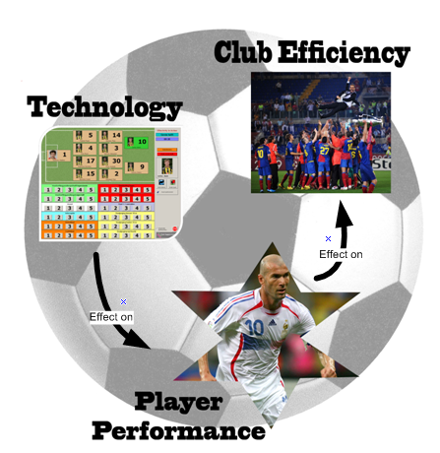
Picture 1: Selected Model

CASE STUDY

AZ Alkmaar

Introduction
Max Reckers worked as video analyst at AZ Alkmaar from 2007 till 2009. The coach in that period, Louis van Gaal, went to Bayern München and Reckers followed him. Reckers was responsible for all the analyses within the technical staff. There are a few content experts and terminal controllers. The assistant managers and Van Gaal are responsible for the knowledge. Reckers is responsible for the end product. The assistant managers and Van Gaal tell Reckers what they want to have in a presentation and he will search for videos, animation etcetera and makes a PowerPoint presentation. He worked together with Kees Verver, who is going to Ajax Amsterdam next year (Algemeen Dagblad, 2009). He is a cameraman and a data-analyst.
The vision of AZ is to do it on another way and by themselves. They want to buy young talent full players and increase their abilities through a strong good trainer coach to sell them for a high price.

Preparation

Analysis
Every training and every match is been analyzed. Through analyzing everything you will get a good overview of the abilities of a player. The day after the match, the match will be discussed with the team and the technical staff.
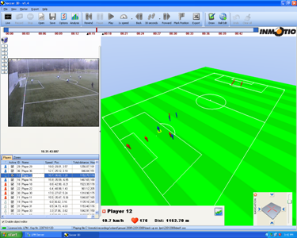
Picture 2: lpmSoccer3D®, training analysis.

Training
Training is the most important thing to prepare for a match. Three days before a match the players get a video presentation, which shows information about tactics and players individual. From that moment the players will play a match to the ‘second’ team. The second team represents the upcoming opponent. They have had instructions from the assistant manager how they have to play. This match will also be analyzed. Now we know what they are going to do, where there power is and how they create changes. The next day the training match will be discussed and played again. If the match went well for the second time, the last day the players will get an easy training, but if it doesn’t, then they we play a third training match.
Through the training and the analysis the players will be better prepared for the match. They have played the match in any case twice before it actually starts.

Influence

Positive vs. negative
If a player played a good match and the team won the match, he will be much happier than when he played an awful match and the team lost the match. When the team won the match, there is much more acceptation that the manager does it good job. So they will appreciate the analysis tools and want to work with it. But when they lose the match, they will have others things on their head. The will think the analysis doesn’t work for them and they lost their appreciation for it. So to believe in this process, a certain environment is needed. In the season 2007-2008, where AZ finished eleventh, there was not a perfect environment. There was a complete new team with a lot of foreigners, so a lot of different cultures. They had to get used to the process. If the mental state of a player is ready for it, you can reach a lot with the technology tools.

Doctor formula
The doctor of AZ and Reckers made a formula for the training intensity, based on the number of sprints, the distance walked etc. The formula gives a mark to a specific training on three groups, namely heart rate level, sprint level and bones level. During a training they can pick players out of it to prevent an injury. Through this you can decrease the chance of a selection with a lot of injuries.

Better Vision

Perspective player
The most difficult thing for a manager is to watch the match through the eyes of a player. Every coach wants to see where the player is looking at. A manager cannot watch to eleven players at the same time. Through the technologies of today a coach can see the match from the player’s perspective. The so called ‘object-tracking’ technology makes it possible to animate a match. This technology is also used by speed cameras. The 22 players and the ball can be tracked.

Future of Feedback
The introduction of the ‘object-tracking’ provides the future of feedback. How can it be handier then discussing the match with the player when having the real videos, the animated video of the whole field and the animated video from the perspective of the player? A player can more easily understand the things the manager meant.

Discussion
Through the better vision discussion can be prevented. When there is a discussion between a manager and a player about covering or not covering the players’ opponent, the videos will tell the truth. But it must not be a tool to cut someone’s head off, because then he won’t come back a second time.

Future

View direction
It isn’t possible yet to measure where a player is looking to. Without carrying something it will be very complex. During training a player can carry something, but during a match it isn’t possible yet. The FIFA (FIFA, 2009) and UEFA (UEFA, 2009) have strict rules for that.

Arms/ legs
It also isn’t possible yet to animate the separated things of player, like arms and legs. Now you can only animate the object in total. Then you can see for example how the right foot stands on the ground when the player shoots the ball.

Cheaper
Reckers said that within ten years every Dutch football clubs have a system like lpmSoccer3D®. The technology will be cheaper and there will be more proven.

Feyenoord Rotterdam

Introduction
Michel Valke works as full time video analyst at Feyenoord Rotterdam. Two years ago Feyenoord started to analyze matches of the youth. The youth and the second team play their home matches at Varkenoord. At the head field of Varkenoord stands a scaffolding from where they record the match with a camera. There is need for height to get a good view. They record as width as possible so they can see as much as possible lines. They analyze very incidental at away matches of the youth, for example against Ajax. Since this year they also analyze all the home and away matches of the first and second team. The first team plays their home matches in ‘de Kuip’.

Sportscode
Sportscode is the program Valke uses for analyzing the matches.

Code Window
It all starts with making a code window. This code window represents the demand of the manager or trainer. They have made four head moments, namely attacking, defending and conversion from ball possession to ball loss and from ball loss to ball possession. Every ball contact of the players will be coded. For example, if the number nine key on your keyboard stands for Roy Makaay, you push this button if he gets the ball. For each push on a button, you get a map of 10 seconds on the timeline.

PDA
Feyenoord also have the possibility to make buttons on a PDA. This is very handy for specific trainers like attack or defense trainers. During the match they can push buttons on the PDA. After the match Valke can read the data from the PDA into his computer and the trainers will get the information they wanted.

Team Performance Exchange
They also use an internet site which is called TeamPerformanceExchange. Valke can upload movies with the highlights of the match or individual actions to this site. Players and technical staff can login to this site and watch the movies. For example a doctor only has access to movies where an injury arises.

Costs
Sportscode has three packets. They differ in abilities and price. Gamebreaker is the cheapest, €2500, -. Feyenoord uses Sportscode Pro, which costs €7500, -. The third is the most expensive one, €15.000, -. This is only the software. Valke uses a personal computer of Apple, which costs around €2000, -, and a camera, which cost around €2500, -. Feyenoord also have 4 licenses for TeamPerformanceExchange which cost €500, - per license.

Improvements

Corner
Valke has a database with movies of opponents’ goals from corners. When you look at Feyenoord when Verbeek was the manager, they get a lot of opponents’ goals from corners. Verbeek used zone coverage, so every player covers a zone instead of a player. When Verbeek left and Vlemming took it over, they get fewer opponents’ goals. He used man coverage instead of zone coverage. So through the analysis you can more easily see what tactics you should use.

Measure difficulty
It is always difficult to measure if it really improves the performance. When you train on a header, will you win more header challenges? When you train on something, you get better in it.

Feedback
When you see yourself on a screen with comment of your coach, it is much clearer than without movies. You also have players who are denying something, but it is now black on white. And vice versa, a coach also can have it fault. As a trainer you have to be careful that you not only show negative things. Valke was also a professional football player and it isn’t nice to stay hours in a room getting information. Especially at the youth and in some cultures it works against you when you indicate faults of an individual player in the presence of the whole group. According to Valke it is wiser to pick this person apart and talk with him.

Technological development

Camera
At the head field of Varkenoord there is only a camera behind one goal. In the future Valke wants also a camera behind the other goal. Two cameras mean that you have a better overview of the match. Now, with one camera, you cannot always have everything in screen. With two cameras that would be possible.

Chip
According to Valke every players have a chip their ear within ten years. On that way you can get everything wireless. This development is now in his child shoes. There are a lot of companies busy with that development.

New market
There arise companies who try to sell their software to clubs. Through this competition they have to lower their price. The software and systems will be cheaper, so more clubs will buy and use it.

Ortec TSS

Introduction
Arnold van Ree works at Ortec TSS. Ortec is one of the biggest providers of advanced software solutions and consultancy services for planning and optimization. Seven years ago they started to sponsor the volleyball club Nesselande. The reason for sponsoring was to make a name. During that sponsorship they thought about introducing the company expertise, namely measuring the performance or efficiency, into the sport. This led to Ortec TSS two years ago.
Ortec asked Van Ree to work there because he came from the sport and has a lot of connections within the sport. He talks a lot with other coaches from other sports and within volleyball he has a lot of experience with analysis software. At the moment Van Ree is assistant national manager.

At the moment

Interest
More and more people outside the sport show their interest in what is actually happening in the sport and explore things. These people have to do it because the sport self will not. Within the sport they are only concentrated on one specific thing, which is the performance. For them performance is the only thing that counts.

Budgets
Today more and more people are responsible and dependent on what performance actually means. Budgets become larger and larger, or as in these times, are oppressed. So everybody wants to know what is happening with the money. Where does the money go? Good or bad investments? Then the people will look at what will happen with the programs on the work floor.

Analyzing tool

Universal
In almost every sport analyzing is universal. For example there is not much difference in analyzing a football match or a hockey match. They both play with eleven players and the same things are analyzed, like tactics.

Effectivity in Action
Effectivity in Action is the program made by Ortec TSS. Imagine there is a match. Number nine, for example Roy Makaay, has a list of actions. All these actions will be named. These actions can be given a kind of value judgment, for example between one and five. If Roy Makaay passes the ball to Van Bronckhorst and the pass is perfect, it is worth five points. If the ball is bad, it is worth one point. After the match there will be a list full of actions with their value judgments.
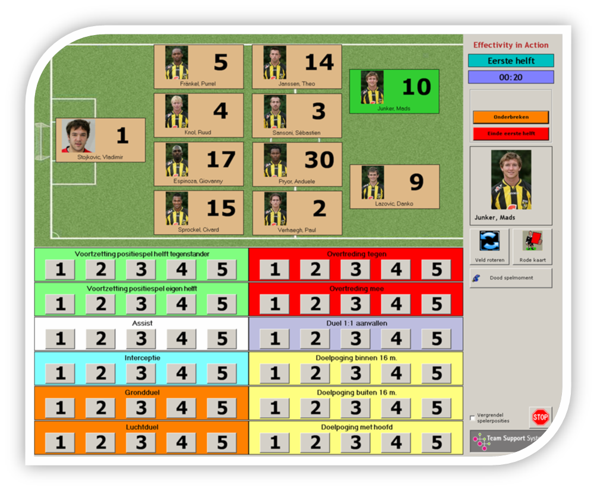
Picture 3: Input screen of Effectivity in Action.

According to Van Ree you have an excellent tool in hands with Effectivity in Action. It is visual, so people can easily follow it. And you can quite fast skip through all the data a manager need. During a game Van Ree can have contact with a computer of a data analyst. He can request interesting data immediately. When watching a game you can have presumptions, but now you have it represented on the screen of your laptop.

Observation
It must not be an opinion, but an observation. The people who do this, the analysts, must be exercised in observing and then translate it into codes. If this is been done for every player, of each action, you will get a nice image during the match about what someone is doing in the field.
The most important thing to do is that the actions of the players on the field are being captured precisely. Then you can say something about it afterwards. In football it is quite an operation. There are five people busy during a match. Two teams are watched, so two people per teams, and one person has a direction function.

Software
On the moment that smart software is invented, where you for instance can fix in the time when an action takes place, then you can easily find it back in the movies. Then you will have a whole list with actions and appreciations of actions and then you can say everything about the performance of a player.
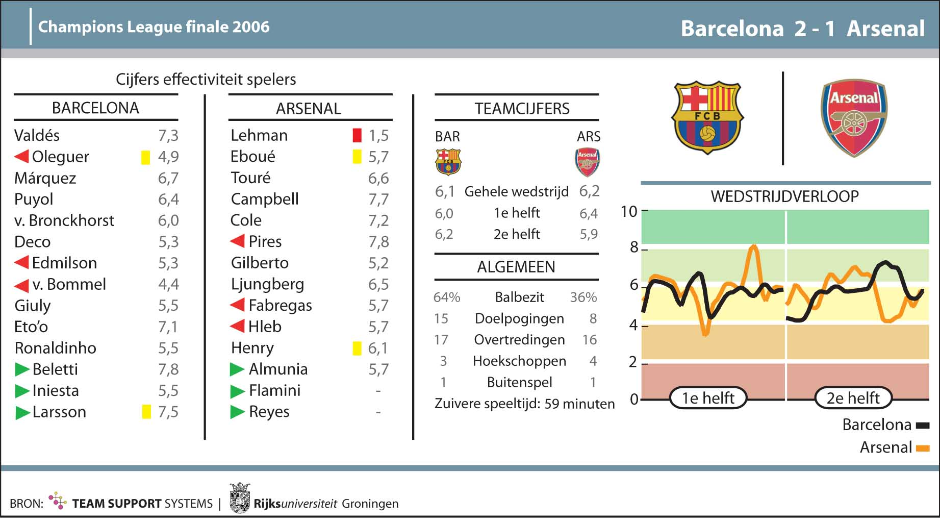
Picture 4: Marks of the effectivity of the players.

Plan

Interpretation
There is a piece observation and a piece registration. The manager brings the interpretation, where he can get his advantage. The manager can say something about the game, about the training, etcetera. An analyst can say something about the functionality of a player, but the manager exactly knows the strengths and weaknesses of his players. He knows exactly what is happening during the training, the appointments, the strategies, and the tactics.

Preparation
Through the analysis the players can make a better plan. They are better prepared. They know the tactics of the opponent and what their strengths and weaknesses are. And that end in better performances.

Traceability
Finally it improves the performance, but it is never exactly traceable how much. The same counts for good food and good training, good mental state, technical points, tactical points, etcetera. They are all ingredients, but the player must do it.

Contribution
According to Van Ree it cannot be the case that a coach totally blind speed on this work. But it can be the case that it delivers a good contribution to the performance. Take for example how a player thinks about his match. There are optimists and perfectionists. In the eyes of an optimist they do everything good and play the match faultless. Sometimes you have to face them with the facts. A perfectionist walks with his head down when making only one mistake. Sometimes they also have to be faced with the facts.

Inmotio Object Tracking BV

Introduction
Hans Lefeber works at Inmotio Object Tracking BV. Inmotio Object Tracking BV specializes in the developments of systems for monitoring objects in general and athletes in particular. Inmotio is a joint venture of the Dutch research organization TNO and the Austrian company ABATEC Electronic AG (Inmotio, 2009). Lefeber is responsible for what they deliver, for the product, for the software, for how the product works on location, for the maintenance of the product, for development of the product line they deliver. He is also responsible and busy with the product self in cooperation with sport parties, with which they have a more than normal customer-supplier relationship.

Usage

Breeding ground
According to Lefeber there must be a breeding ground. The club must want it. They can be offered the most beautiful things, but if the manager doesn’t realize what it does, it will never be used. It is a whole process and it must land on the work floor. When it doesn’t land on the work floor it is a kind of technology push where Lefeber doesn’t believe in.

Technology
There is a whole new technology by which Inmotio since a month or two are in state to track the ball. That is where the most trainers were waiting on. Physical trainers want to have it, but they do not have the ultimate control. When a head coach comes to a club and he says that he wants to have it, most of the time it happens. But they want to use it more from a tactical point of view.

Costs
It is also not a cheap product. When you have the budget of a club, you have for example a budget that is adopted to buy new players. A budget to implement technology doesn’t exist at the most clubs. That is a whole new thing in the world of football. When this kind of new technologies become more known, there will be reservations be made in the budgets.

Target

Qualities
Every sportsman has a target, for example a striker of a football team can have as target to make a lot of goals. To accomplish that target he needs certain physical, tactical and mental qualities. If he doesn’t get feedback about how he trains, the training will not be optimal. As a sportsman you want to become better and you need trainers for that. When these trainers get better instruments in hand through which they can make you better they will like it.

Coaching
What Lefeber already noticed in various sports is that through the use of their system, training methods are changed. The training is more effective, but also time saving when they do for example a sprint test. The manager doesn’t have to write anymore and can put all his time on coaching. You can see it as follows; previously a coach had a screwdriver and had to work manually. Now he has a battery drill machine in his hands. Because of this you can hit a number of improvements.

Learning effect
Inmotio is just recently able to track the ball. They hope that the 3D world that they use will give an extra didactical dimension to the trainers, through which the players understand it more easily. The learning effect of watching videos with explanation of the coach is quite small. They experienced that players make the same fault repeatedly. With for example 3D glasses you can look from the view of the player. Then you can yet better experience the proportions of distances and spaces as a player. With video it is impossible.

Follow system

Profile
PSV Eindhoven introduced a follow system. It follows not only what a player does at the training, but also what he does at school, his home situation, and etcetera. A player plays in a particular role or position. A profile is needed for this role or position. That profile is not only dependent on the players’ football skills, but also on social skills, leader skills, and etcetera. What you will see is that a player is coached in his profile. In a football teams you need to have leaders and so-called ‘bandits’.

Scouts
Scouts are watching a game with a trained eye and interpret things on an abdomen feeling. When there is the possibility to measure much more things, the scouts will make fewer mistakes. Every player has a sort of user guide. So you can compare it with a product and you can sell the product better.

Future

Competition
According to Lefeber there will come more competition within the territory of video tracking. GPS is already a competitor, but they have the disadvantage that they measure only one time per second instead of measure until thousand times per second. Lefeber already noticed that if you want to say accurate things on the tactical and physical area you must measure a lot.

Intelligent clothing
Inmotio enters a project with Adidas. They try to integrate everything in a shirt. Then it will be easier to wear, instead of multiple things like one for the heart rate, one for the body temperature. They get closed to intelligent clothing in which the measure equipment is integrated.

Centralization of training and tests
In whole Europe, also in the Netherlands, are conversations going on and sometimes more than conversations to centralize training of surrounding sport associations. That means that you will get a center where you as a team can perform measurements against payment. In Milan they are already building such a center.

CASE ANALYSIS

Introduction
In this chapter the four interviews are analyzed. I divided it in five important points: finance, environment, preparation, performance and upcoming developments. These five points are also subdivided in specific parts.

Finance

Costs
The costs differ a lot. lpmSoccer3D® is ten times the price of the most other tools. Feyenoord uses Sportscode Pro. The price of this program is €7500,-. Besides the price of such systems you of course need a laptop as analyst. A laptop from Apple, because the most applications run on apple, cost around €2000,-. To analyze you need in any case one camera. Good camera’s cost at least €2500.

Budgets
Budgets become larger and larger, or in these times, are oppressed. When you look at the money paid for players, you will think the football club can easily buy an analysis system. But that is not so easy. A club has a few budgets for special things, like a budget for buying new players and a budget for salaries. The most clubs have not yet a budget for implementing technology. That is why they don’t use it. But when the technology will be more known and there is more proven, more clubs will use it.

Future
More and more companies arise in the analysis software market. They all try to sell their stuff to the clubs. This means that there will come more competition in the analysis software market. This will result in cheaper technology.

Environment

Work floor
A club must want the technology tools. If they do not want it, they will never use it. It is a very big and long process and it has to land on the work floor. If it does not land on the work floor, it will be a technology push. I think that the technology push shall not have positive effects.

Game result
When players of a football club win a game, they will like the manager and thinks the manager does a great job. This results in appreciation for the technology tools that will be used. They will like to work with the tools. It can also be the opposite; if they lose the game, they will have other things on their head. When that is the situation they can have critic about the manager and lose appreciation for the technology tools.

Feedback
In some cultures it is not usual to discuss the negative things of an individual in the group. When a manager gives feedback with negative things to a player, he has to do this individually, not in the group. This will not decrease the mental state. If the mental state of a player is ready for it, there can be reached a lot with technology tools.

Preparation

Coaching
Lefeber told that through the use of a system the training methods are changed. The training is more effective. I agree with this because through the analysis the manager knows what are the weak points of his team, so where he has to train his team on. Teams do not have to train every day in headers when they are master in it. Besides that the training is more effective it will also be more time-saving. For example, in the past the manager needed a stopwatch when measuring sprint trainings, now it is automated with sensors. Lefeber made a nice comparison; previously a coach had a screwdriver and had to work manually, now he has a battery drill machine in his hands.

Training
The week before AZ plays a match they will play a practice match of eleven against eleven; the eleven players who start the match against eleven players who will sit on the bench or tribune on match day. The ‘second’ team will play exactly as the next opponent, with their tactics. They will do this at least two times. Through playing this practice matches, the players have ‘experienced’ the real match already twice, so they will be better prepared for the upcoming match.

Plan
Through analyzing the opponent before the team meet them, the team can get a lot of handy data. Through the analysis the team comes to know their strengths, weaknesses, tactics, and etcetera. When knowing this the team can make a better plan to start the match. With a better plan the self efficacy of the players will improve.

Performance

Doctor formula
When looking at AZ, their doctor and Reckers made a formula with gives a number for the training intensity. Now they know how hard a training activity would be. They will be informed when a player for example can only participate in a sprint activity one time more before the chance of being injured is big. Then they pick this player out of the training. On this way you can prevent unnecessary injuries.

Corner
At Feyenoord they came to the conclusion that man coverage at a corner is much better than zone coverage. So they decrease the chance of an opponent’s goal. Within football the mission is to score more goals than your opponent. With a decreased chance of an opponent’s goal, the chance of scoring more goals than your opponent is increased.

Measurability
It will improve the performance, but at this time we will not know how much, because that is not so good measurable. For example, when you train on headers, will you win all the header challenges in the match? When you eat better, do you perform better? When you in good mental state, do you perform better? It are all ingredients for the match, but the player must do it himself.

Upcoming Developments

Intelligent Clothing
Inmotio and Adidas are now busy with intelligent clothing. This is clothing where different sensors are integrated. A shirt like that is easier to wear then for example a shirt with an external heart rate and blood pressure meter. Now there are rules within the world of Football that you may not wear that during a game. I think that will change in the future. Besides that change I think FIFA will introduce a rule for watching a moment back after misunderstandings about a goal. Did the ball go over the line? Was it offside? In tennis they use a hawk-eye to see if a ball is in or out. I think it is better for football to introduce that too.

Centralization
In the future there will be sport centres where you as a team can perform measurements against payment. At this time they are building a huge centre in Milan with hotels and sport accommodations for a lot of different sports. In the future there will be building more centres like this.

Summary
The interviews gave me a lot more realization of what is actually happening with technology in football. The costs are high, but when the clubs reserve budgets and the technology will become cheaper, more clubs shall use it. There is need of a good environment to work with technology tools within football. Football players are better prepared for the match through the change of training and the better plans that can be made. Performance of players will improve, but it is hard to measure how much. In the future we will see intelligent clothing and centralization of sport measure centres.

CONCLUSIONS

Introduction
When looking at sports, football lays behind when it comes to technology. That is quite remarkable because football is the biggest sport in the world and a lot of money is involved. The level of football in the Netherlands is much lower than it is in countries like England and Spain.A football club can be seen as a business with the match as a product and the supporters as the customers. In business in the Netherlands they make use of technologies to improve their organizational performance, so technology could also be an interesting tool for Dutch football clubs. Through this research I investigated the technology at Dutch football clubs. I interviewed two people of a Dutch professional football club and two people of a company that makes technology tools for football clubs. The main question of this research was: “How can a Dutch football clubs use technology to improve club efficiency through player performance?”

Main Findings
To answer the main question first some sub questions had to be answered. The all cover another aspect about the technology within football.

Influence
The first sub-question was: “What is the influence of technology in football?” The coach can get a lot of advantage out of technology. Today with the analysis tools it is much easier to discuss a game afterwards. It is not a hard job anymore to get the videos the manager wants. In a few seconds and clicks on a computer the manager can have the videos. So it is timesaving. The introduction of object-tracking is very handy for the managers. Through this the can see the match from the perspective of a player. Nothing is handier than discussing the game when both the player and the manager see it from the perspective of the player. The training methods are changed and the training is more effective. The players can make a better plan for the upcoming match if the opponent is analyzed. They know exactly what the strengths and weaknesses are.

Technolgy Tools
The second sub-question was: “What kind of technology tools is being used right now at football, especially in the Netherlands?” The technology tools that are used at football right know are mostly analysis tools. There is Sportscode, which is used by AZ and Feyenoord. Another tool is lpmSoccer3D®. This tool is used by AZ, PSV, AC Milan and from upcoming year Bayern München. And there is a tool called Effectivity in Action. Through the use of these tools a lot of handy data will be available for the technical staff.

Costs
The third sub-question was: “What are the costs of the technology that improves the organizational performance?” The costs of the technology tools depend on what you want and how beautiful you want it. The system of Inmotio is much more expensive than for example Sportscode, but you can do a lot more with it. So when a club wants to buy a system, they first have to decide what they want to do with it. In the future the systems will be cheaper through competition so more Dutch football clubs will such a system. When there is more proven the clubs will reserve a budget for technology tools. Nowadays the most clubs have not a special budget for technology.

Future Vision
The fourth and last sub-question was: “What is the future vision for Dutch football and the effect of technology?” Within ten years every Dutch football club will have an analysis system like for example Sportscode. Besides that there will be some other technical developments. Now there are plans for intelligent clothing; clothing with integrated sensors to get live physical data of a player who is wearing it. When the FIFA abolish the rule for not wearing sensors during a match, I think the intelligent clothing will have a great future in football. In the future there will also come centre’s where teams can train and where they will be analyzed.

Lessons Learnt
Through this research I realized that technology is everywhere, even in sports. When I started this research I thought that in the Netherlands the football clubs didn’t use technology tools so much. But through the interviews I realized that football clubs indeed use technology tools. Another lesson I learned is that through the upcoming technology whole new markets arises. It is also hard to get in contact with the right people. When sending emails for inviting them for interviews, you do not know if the email goes to the right person. Nevertheless I got response from AZ within 5 minutes. The last lesson I learned is that there are not so many people busy with the tools at a club. At AZ and Feyenoord only two persons worked with the tools; one analyst and one cameraman.

Research Limitations
This research is limited to professional football in the Netherlands. I think that some conclusions also will count for professional football outside the Netherlands. Because this is a bachelor thesis it is also limited to four interviews. The bachelor thesis has to be finished within ten weeks. I have only interviewed people that working with three different systems. There exist more systems to use at football.

Thesis Conclusions
The main question of this research was: “How can a Dutch football clubs use technology to improve club efficiency through player performance?” Through the use of technology, the performance of a player of a football club will increase, but it is not exactly measurable how much. When a team wins more matches, the club efficiency will grow through financial gain. Now there is a gap in between, does the increased player performance lead to winning more matches? Let’s look at AZ Alkmaar. Since two year they are working with technology tools with the target to improve the qualities of the players. Last year they were the champions of the Eredivisie, the Dutch league. So their club efficiency is improved. Feyenoord also uses thechnology tools which improve the player performance. They ended up seventh in the Eredivisie. So their club efficiency isn’t improved so much. So I think that technology is not the decisive tool to win more games. There are a lot of external factors during a match, like the weather, the referee’s decisions, etc. These factors are mostly unknown. So technology will improve the player performance, but it is hard to say if it also improves the club efficiency.

REFERENCES
Algemeen Dagblad, 13-06-2009, “Sportwereld”, pp 2.
Audas, R., Dobson, S. and Goddard, J. (1999), ‘Organizational Performance and Managerial Turnover’, Managerial and Decision Economics, 1999, volume 20, pp 305-318
AZ, 2009, www.az.nl
Boscá, J. E., Liern, V., Martínez, A. and Sala, R. (2006), ‘Increasing offensive or defensive efficiency? An analysis of Italian and Spanish football’, Omega: The International Journal of Management Science, 2009, volume 37, pp. 63-78.
Breukelen van, H. (2008), ‘Voorwoord’, Winst! Prestaties verbeteren met behulp van de balanced scorecard, 2008.
Dawson, P., Dobson, S. and Gerrard, B. (2000), ‘Estimating coaching efficiency in professional team sports: evidence from English association football’, Scottish Journal of Political Economy, 2000, volume 47, issue 4.
De Heij, R., Vermeulen, P. and Teunter, L. (2006), ‘Strategic Actions in European Soccer: Do They Matter?’, The Service Industries Journal, 2006, volume 26, pp. 615-632.
Denzin, N. K. and Lincoln, Y. S. (2000), Handbook of Qualitative Research. Second Edition.
Dixon, M. J. and Robinson, M. E. (1997), ‘A birth process model for association football matches’, The Statistician, 1998, volume 47, part 3, pp. 523-538.
Effectivity in Action, 2009, tss.ortec.nl
Eredivisie Live, 2009, www.eredivisielive.nl
Feyenoord, 2009, www.feyenoord.nl
FIFA, 2009, www.fifa.com
Hughes, M., Franks, I. (2005), ‘Analysis of passing sequences, shots and goals in football’, Journal of Sports Sciences 23, 2005, Issue 5, 509-514.
Inmotio, 2009, www.inmotio.nl
Jones, D. (2007), ‘Welcome’, Deloitte Football Money League, 2007, 1.
Lieberman, D. G., Katz, L., Hughes, M. D., Bartlett, R. M., McClements, J., Franks, I. M. (2002), ‘Advances in the application of information technology to sport performance’, Journal of Sports Sciences, 2002, 20, 755-769.
Martin, L. (2006), ‘Coaching and Computer Science’, International Journal of Computer Science in Sport – Special Edition, 2006, volume 2, issue 5.
Ortec, 2009, www.ortec.com
Palacios-Huerta, I. (2004), ‘Structural Breaks During a Century of the World’s Most Popular Sport’, Working Paper, Brown University, March.
Rampinini, E., Coutts, A. J., Castagna, C., Sassi, R. and Impellizzeri, F. M. (2007), ‘Variation in Top Level Soccer Match Performance’, International Journal of Sports Medicine, 2007, volume 28, pp. 1018-1024.
Reilly, T. (2006), ‘SELECTED IMPACTS of COMPUTERS in the SPORTS SCIENCES’, International Journal of Computer Science in Sport – Special Edition, 2006, volume 2, issue 2.
Sala-Garrido, R., Liern Carrión, V., Martinez Esteve, A. and Boscá, J. E. (2009), ‘Analysis and Evolution of Efficiency in the Spanish Football League (2001/01 – 2007/08)’, Journal of Quantitative Analysis in Sports, 2009, volume 5, issue 1.
Shestakov, M., Kosilova, N., Talalaev, A., Zasenko, N., Zubkova, A., Averkin, A. (2007), ‘Intelligent system of tactics’ analysis in a football team’, Journal of Sports Science and Medicine Suppl. 10, 2007
Smith, C., Gilleard, W., Hammond, J. and Brooks, L. (2006), ‘The application of an exploratory factor analysis to investigate the inter-relationships amongst joint movement during performance of a football skill’, Journal of Sports Science and Medicine, 2006, volume 5, pp. 517-524.
Sport 1, 2009, www.sport1.nl
SportsCode, 2009, www.sportstec.com/Products_Sportscode.htm
Sullivan, A. and Sheffrin, S.M. (2003), ‘Economics: Principles in action’, Pearson Prentice Hall, 29.
UEFA, 2009, www.uefa.com
Williams, M (2008), ‘Science and football conference’, Liverpool John Moores University – Press Releases, 2008.
Yin, R.K., Case Study Research, Design and Methods, 2nd ed. Newbury Park, Sage Publications, 1994.

APPENDIX A

Interview Max Reckers
Name:
Max Reckers
Company:
AZ (per 1 July Bayern München)
Functional description:
Reckers is responsible for all the analyses within the technical staff. There are a few content experts and terminal controllers (= eindverantwoordelijken). The assistant trainers and Van Gaal are responsible for the knowledge. Reckers is responsible for the end product. They tell Reckers what they want to have in a presentation. He searches for videos, animation etcetera and makes a PowerPoint presentation.
Technology
What was the reason for AZ to introduce a system like lpmSoccer3D®?
Van Gaal worked his whole carrier with videos. I worked for the sales company that was selling the product. I have showed them the possibilities. Then they started. Edward Metgod, the assistant trainer in that time, started with the system. He did it for a year. Then AZ came to a point that they said to themselves: we want so much more things with this system, but we have not the time and knowledge. They hired two people, cameraman Kees Verver and I. He is also a data-analyst. He makes the most amazing reports and graphs. AZ wants to do it on another way and by themselves. That is the vision of AZ.
What does lpmSoccer3D® exactly means?
First I will tell you the process. When we have a week, the players train six days and de seventh day is the match. Suppose we had a match on Sunday. Monday morning we come together with the technical staff. I have made an analysis of the match. I analyze the match and make a packet for the technical staff. They have a look at it and Van Gaal says what he wants to discuss with the team. Then we come together with the team and discuss the match. After that the team will train and we will prepare the next match with one of the assistants. Three days before the upcoming match the preparing has to be finished. The players get a video presentation, which shows information about tactics and players individual. From that moment we play eleven against eleven. That mean that everyone who start in the upcoming match against everyone who doesn’t start. They play it exactly as explained by the assistant. The assistant is the boss of that team and Van Gaal coaches AZ. Van Gaal has an idea of how he will play against them. This training is also recorded and analyzed on the same way. Then we know what they going to do, where there power is, how they create chances etc. The day after, we discuss the training. Or Van Gaal changes his tactics of he wants to train another option. But in any case we do it again. Is it good? Then we are finished and the last day will be a easy training. Is it not good? Then we have to do it again. Van Gaal believes in it. He says that preparation is everything. The players experienced the match twice before they play the real match. They are prepared on another way than others.
With object tracking we exactly know the position of the players. We can track de opponent, the ball and the own team. Van Gaal always said: The only thing I can’t see is from the perspective of the player. Now it can.
What kind of technology tools do you use during a match? And during a training?
lpmSoccer3D®, Sportscode.
What is the influence of technology tools on the performance of a player?
I have learned the last two year that it isn’t the tool that turns the scale. There isn’t yet a tool that determines the match results. Van Gaal is a real teacher. He is continuous looking for new training methods, for new ways of teaching someone. The technological innovation can speed that up. If we win, the player has much more acceptation that the trainer does it good. If we lose, the player has other things on his head. You need a certain environment where someone believes in this process. Previous year there was a complete new team with a lot of foreigners, a lot of people with another culture who has to get used to it. If the mental state is ready for it, you can reach a lot with it.
Together with the doctor I made a formula for the training intensity. During training we can say: He must stop otherwise the chance for an injury is very big.
What are the disadvantages?
You need a trainer who wants to and can deal with the tools.
Costs
What are the implementation costs of a system like lpmSoccer3D®?
Implementation costs are very big. The basic tool is Sportscode, which is a video analysis product. The basic is the video of the whole match. We made the vision of Van Gaal in technical terms. That means that soccer is divided into four main moments: ball possession, ball possession opponent, conversion to ball possession and conversion to ball possession opponent. That is in his philosophy everything he trains. This year AZ is known for his conversion. Every contact with the ball will be captured. The coaching of Van Gaal can be much more director. That is for the most trainers a disadvantage. Why do they all have a school board instead of computer presentations? They can make a drawing and have it directly. A PowerPoint presentation has to be prepared, they have to ask someone else, and they think it’s difficult. It is a tool that makes the video that way so the trainer can use it, without a technical knowledge. Now I will control it, but Van Gaal can also do it. The implementation costs for lpmSoccer3D® are 250.000 Euros. For Sportscode it is 100.000 Euros.
What are the maintaining costs?
10 percent.
Future
What is the future vision of technology in football?
I want to measure where the player is looking to. But without carrying something it will be very complex. But we will grow to that. The goal is not to make a tool which knows everything, because I don’t believe in that, but to make a tool which can simulate things perfectly. It must not be a tool to cut someone’s head off, because then he won’t come back a second time. So you have to help the player.
Now we can imaging the object in total, but what we want is imaging the separated things, arms/legs.
What other technological development would you like to see in the future?
A hand-eye combination tool. Someone sees something and the time that it cost to let your body do that. For example when a player wants to shoot the ball in the top right corner. We tried to make a tool which can measure where the ball comes and turns on a light on that spot. If the light is on the player has to shoot. But again everything is in relation with making the player better. That is where we are looking for.
Has every Dutch football club a system like lpmSoccer3D® within ten years?
Yes, they all will have one. When the technology will be cheaper and there is more proven.

Interview Michel Valke
Name: Michel Valke
Company: Feyenoord
Function description: Full time video analyst.
Technologie
What was the reason for introducing a system at AZ?
We started with the youth two years ago. Last year someone started with it by the first team, when Bert van Marwijk was the coach. When he left my cameraman and I took it over.
We analyze all the home and away matches of the first and second team of Feyenoord. Every match which is played on the head field is also analyzed. The youth plays there. We need height to get a good view. We record as width as possible so we can see as much as possible lines. That is why they don’t work with Eredivisie Live, because they use a lot of close-ups and replays, and then you miss essential things in your analysis. A trainer wants to know what the right attacker does when the ball is on the left. At the youth we are only at home matches. Very incidental at away matches, like against Ajax, they also have a tribune where you can record from high above.
We use Sportscode. Amisco is very expensive. Only European top clubs use it. We have a contract with Amisco, we have had training. In the Kuip are 8 cameras, which register everything, that data will be collected through a computer. The data goes to France and the match will be coded. A disadvantage is that you get the data three days after match. There should be one man available to review the data, so the trainer can use it. There wasn’t manpower for that and in the future there still will not be anyone who will do that.
Peter Bosz was bowled over by Amisco. There was one nice facet, you can connect your own videos, so you can settle your cameramen central with the wide shots, or the Eredivisie Live videos. This videos will also be converted to animation. With the animation you can easily get for example the distance between the last man and the central striker.
What kind of technology tools do you use during a match?
Sportscode start with making a code window. In this code window you see the demands of the trainer. We have head moments: attacking, defending and conversion from ball possession to ball loss and vice versa. We code every ball contact of the players. Every time you push a button, you get a map of 10 seconds on the timeline. You have list with the 4 head moments, the players, the actions, offside, and chances to score. When you click on offside, you will get all the movies where an offside appears.
We have also the possibility to make buttons on a PDA. For example an attacker trainer wants specific information. We give them an PDA where they can click the buttons. After the match I will read the data in my computer. Then an extra row appears.
You can put all the ball contacts of a player one after the other. This is handy for example when there is a discussion about offer a contract or not.
With Sportcode we also have and internetsite which is called TeamPerformanceExchange. This is a site where I can upload the highlights of match and individual movies.
What kind of technology tools do you use during training?
We don’t analyze at training yet. Mario Been, the head coach next season, wants to make use of it during the training, especially the tactical training. A disadvantage is that you have to train in the Kuip, because you have to film from high above.
What is the influence of technology tools on the player performance?
We have a database of goals from an opponent’s corner. When we look at Feyenoord when Verbeek was the head coach, who used zone coverage at an opponent’s corner, you see that it didn’t work well. When Vlemmings was the head coach, who used man coverage, there were fewer goals. In that respect there is profit to retrieve.
It is always difficult to measure. It is the same as when you train on a header. Will the player win more header challenges? When you train on something, you get better in it. When you see yourself on screen with comment of your coach, it is much clearer than without movies. You also have players who are denying something, but it’s now black on white. And vice versa, a coach also can have it fault.
What are the disadvantages?
As a trainer you have to be careful that you not only show negative things. I was also a football player and it isn’t nice to stay hours in a room getting information. Especially at the youth and in some cultures it works against you when you indicate faults of an individual player in the presence of the whole group. It is wiser to pick this person apart and talk with him.
Costs
What are the costs?
Sportscode has three packets. The cheapest is €2500, which is called Gamebreaker. We have Sportscode Pro, which costs €7500. The third one is the expensive one, which costs €15000. Besides the software you also need a computer of Apple, which costs €2000. The price of a camera is €2500. So it is not cheap. But Amisco is much more expensive. The license for TeamPerformance cost €500 per license.
Future
What other technological development would you like to see in the future?
Now we have a camera behind the goal. I want a second camera behind the other goal.
Does every Dutch football club have a system within ten years?
In ten years all the players have a chip in their ear. So we can get everything wireless. This development is in his child shoes. There are a lot of companies busy with that development. There arise companies who try to sell software to clubs. Within ten years it will be cheaper.

Interview Arnold van Ree
Name: Arnold van Ree
Company: Ortec TSS. Ortec is one of the biggest providers of advanced software solutions and consultancy services for planning and optimization. Seven years ago they started to sponsor the volleyball club Nesselande. The reason for sponsoring was to make a name. During that sponsorship they thought about introducing the company expertise, namely measuring the performance or efficiency, into the sport. This lead to Ortec TSS two years ago.
Functional Description: Ortec asked me to work here because I came from the sport and have a lot of connections within the sport. I talk a lot with other coaches from other sports and within volleyball I have a lot of experience with the analysis software. At the moment I am also assistant national coach.
Technology
What was the reason for introducing the system at sportclubs?
You see that more and more people outside the sport show interest in what is actually happen. And that must because the sport self will not do it. Within the top sport they are only concentrated on one thing, performance. There are more and more people responsible and dependent on what the performance actually means. Budgets become larger and larger, or as in these times, are oppressed. Thus everybody wants to know what is happening with the money. Thus then you look at what will happen with the programs on the work floor.
What kind of technology tools do you use during a match?
The principal is everywhere quite simple. Analyzing things in sport is almost universal. You have the match and you have for example player 7 with a list of actions. You will name all the actions. You can give the action a kind of value judgment, for example between 1 and 5. If player 7 passes the ball and the pass is perfect, you give him 5 points. If the pass is bad, you give him a 1. After the match you have a whole list with his actions and value judgments.
It must not be an opinion, but an observation. The people who do this, the analysts, must be much exercised in observing and then translate it into codes. If you do this for all players, of each action, you get a quite nice image during the match about what someone is doing. On the moment that you invent smart software, where you for instance can fix in the time when an action takes place, then you can easily find it back in the movies. Then you have a whole list with actions and appreciations of actions and then you can say everything about the performance of a player.
You have a piece observation and a piece registration. Then the coach comes for the interpretation. And the interpretation of the coach, that is where a coach can get his advantage. Because he can say something about the match, about his training, etcetera. You can say something about the functionality of a player. The coach exactly knows the strengths and weaknesses of his players. He knows exactly what is happening during the training. He knows the appointments, strategies and tactics. You can provide the coach with every data he wants.
There are a number of clubs who have it to use. But what we mostly do, is analyzing all the matchs for them, and then the club can work with the data we provide to them. Mostly we use television images, or videos that the clubs made themselves. The important thing to do is that you capture very precisely the actions of the players on the field to watch if you can say something about it afterwards. That is what it is about. In football it is quite an operation. There are five people busy during a match. Two teams are watched and one has a direction function.
With this you have an excellent tool. It is visual, so people can easily follow it. And you can quite fast skip through all the data you need. During a match I have contact with a computer of a data analyst. I can request interesting data immediately. As you look to the match you have a presumption, but now you have it represented.
What kind of technology tools do you use during training?
We don’t use it during training, but it is possible, because you have the same actions.
What is the influence of technology tools on the player performance?
It is difficult to say. But you see that the players can make a better plan. They are better prepared. And that ends in better performances. Finally it improves the performance, but it is never exactly traceable how much. The same counts for good food and good training, good mental state, technical, tactical. They are all ingredients, but the player must do it.
Cost
It depends on how you want it. Development projects are very expensive. There were organizations wants more and better data about their team, these tools can contribute. It cannot be the case that a coach totally blind speed on this work. But it can be the case that it delivers a good contribution to the performance. Take only how a player thinks about its match. Some players are very optimistic. In their eyes they do everything good and nothing fault. Sometimes you have to face them with the facts. Or vice versa, a player can be a perfectionist. When they have one mistake, they walk with their head down.
Future
What is the future vision of technology in football?
In volleyball we almost were we want to be. Now it is more the combination of data, like if-then-else. How much can you predict in what comes next? That is quite difficult. But that goes from the establishment that players have particular habits. If you know there habits, you can respond to that.
Does every Dutch football club have a system within ten years?
I think so, when this kind of things can make a difference.

Interview Hans Lefeber
Name: Hans Lefeber
Company: Inmotio Object Tracking BV. Inmotio Object Tracking BV specializes in the development and marketing of systems for monitoring objects in general and athletes in particular. Inmotio is a joint venture of the Dutch research organization TNO and the Austrian company ABATEC Electronic AG. (www.inmotio.eu)
Functional Description: Within Inmotio I am responsible for what we deliver, for the product and the software, for how the product works on location, the maintenance of the product, for development of the product line we deliver. I am responsible and busy with the product self in cooperation with sport parties, with which we have a more than normal customer-supplier relationship.
Technologie
What is the reason for a football club to introduce a system of Inmotio?
There must be a breeding ground on the work floor. They must want it. You can offer the most beautiful but if the trainers doesn’t know or realize what it does, it will be never used. It is a whole process and my opinion is that is must land on the work floor. When it doesn’t land on the work floor it is a kind of technology push and I don’t believe in that. The football clubs AZ, PSV and AC Milan have already introduced it. Recently we made an accord with Bayern München.
It is a handy tool, why is it often used by football clubs?
You must realize that we are two years busy yet. It is a whole new technology by which we since a month or two are in state to track the ball. That is where the most trainers were waiting. Physical trainers want to have it but they don’t have the ultimate control. When a head coach comes to a club and he says that he wants to have it, most of the time it happens. But they want to use it more from a tactical point. It is also not a cheap product. When you have the budget of a club, you have a budget that is adopted to buy new players. Budget to implement new technology doesn’t exist at the most clubs. That is a whole new thing in the world of football. When this kind of new technologies become more known, there will be reservations be made in the budgets.
We can only work with data of a match from video systems. We can read that data with our module. Except hart activity, cause you don’t have that. During a match you can’t say something about the mental state because you need heart activity for that. Getting information about tactics and simple cases like the distance travelled is possible. But when you look to speed and acceleration, you have a problem because video analysis systems are not so accurate.
What is the influence of technology tools on the player performance?
As a sportsman you have a target. That target can be to make a lot of goals. To accomplish that target you need certain physical, tactical and mental qualities. If you don’t get feedback about how you train, then the training will not be optimal. What we already noticed in various sports is that trough the use of our system the training methods are changed, to train more effective but also time saving when you do some tests. A coach doesn’t have to write anymore and can put all the time on coaching. For example, previously a coach had a screwdriver and had to work manual. Now he has a battery drill machine in his hands. Because of this you can hit a number of improvements. In football we have seen that it contributes to improvement of training methods. If finally the team performance becomes better isn’t proven yet. We are just recently able to track the ball. We hope that the 3D world that we use will give an extra didactical dimension to the trainers, through which the players understand it more easily. The learning effect of watching videos with explanation of the coach is quite small. We experienced that they make the same fault repeatedly. With for example 3D glasses you can look from the view of the player. Then you can yet better experience the proportions of distances and spaces as a player. With video it is absolutely impossible.
What are the disadvantages?
As a sportsman you want to become better and you need trainers for that. When these trainers get better instruments in hand through which they can make you better than I think that they like it. What you hear sometimes from players is that they don’t like it to wear a heart measure instrument. The acceptation to wear a normal t-shirt is higher than a polar band.
Future
What is the future vision of technology in football?
There comes more competition within the territory of video tracking. GPS is also a competitor. They have a disadvantage that they measure only 1 time per second. We now already noticed that if you really want to say accurate things on the tactical and physical area you must measure a lot. And they are fewer accurate. We measure until thousand times per second. The GPS activities are cheaper, a tenth of our price.
Now we enter a project with Adidas, because we work together with Bayern Munchen and the German Hockey Bond, which are both sponsored by Adidas. We try to integrate everything in a shirt. Then it will be easier to wear, instead of wearing multiple things. So we get closed to intelligent clothing in which the measure equipment is integrated.
What you now see by the development of PSV is that they introducing a follow system. It follows not only what you do at the training, but also on school, home situation etc. You play often in a particular role or position. A profile is needed. That profile is not only dependent on football qualities only, but also on social capacities, leader capacities or other things. What you see more and more is that player is coached in their profile. In a football team you need to have leaders and sometimes you also need bandits. Scouts are watching a match with a trained eye and interpret things on abdomen feeling. When you can measure much more things, you will fewer mistakes. That your can better school players in their profile. Next to the person you can have a sort of user guide. In fact it is a product. And you can sell the product better.
The technology becomes more and more handy. On a certain moment a club has to invest in technology.
Does every Dutch football club have a system within ten years?
Certainly all the professional football clubs will have such a system. What you also will see in the future is centralization of training en tests. In whole Europe, also in the Netherlands, are conversations going on and sometimes more than conversations to centralize training of surrounding associations. That means that you get a center where you as a team can perform measurements against payment. In Milan they are already building such a center.

