Stock Selection Strategies to construct
inflation hedging portfolios.

Is it possible to create inflation hedging stock portfolios
by employing stock selection strategies?

Guney Ertek

This thesis investigates the possibility of constructing inflation hedging stock portfolios aiming to contribute to the Liability Hedging Portfolio (LHP) of APG Investments. Using the MSCI EU as the universe out of which individual stocks are selected, univariate and multivariate stock selection strategies have been employed in order to select firms that might have inflation hedging properties. This resulted in several long/short portfolios that were constructed by sorting firms according to a total of 13 variables in a univariate, bivariate and a multivariate setting. In contrast to previous empirical work in which stocks performed very poorly as a hedge against inflation, we have found several strategies displaying inflation hedging properties. Of the various strategies with inflation hedging properties a limited number were tested in an out of sample period based on the Sharpe ratios of the’ best’ inflation hedging strategies. Finally the stock selection strategy of sorting stocks according to their dividend yield and flow through coefficients jointly was found to be the best inflation hedging strategy in this thesis. Such a strategy generated long/short stock portfolios displaying positive correlations with inflation of 67% in the in sample period and 24% in the out of sample period. The portfolio returns of this strategy displayed significantly positive inflation betas in the in sample period as well as in the extended period including both the in sample period and the out of sample period and also obtained reasonably high returns even after extracting transaction costs.



CHAPTER 1

Introduction

Inflation and its value eroding effects have been one of the most important concerns for economic agents, aiming to protect the purchasing power of their wealth. This also applies for large institutional investors and especially for pension funds, who strive to offer their clients inflation adjusted retirement wages. In order to achieve this objective APG Investments has decided to employ a two pillar investment strategy starting in 2009. This two pillar strategy divides the spectrum of the total investment portfolio of APG into two classes; the return optimizing portfolio (ROP) and the liability hedging portfolio (LHP) .

Several developments such as increasing life expectancy causing for a disruption in the active/inactive ratio’s, especially in continental Europe, have increased the pressure on pension funds to keep pensions being affordable for the active participants. In order to avoid huge increases in contribution rates, pension funds are forced to strive for high absolute return investments, which can only be achieved by taking some mismatch risk. The portfolio consisting of such return optimizing investments is the first pillar (ROP) in the investment framework that will be employed at APG Investments.

The objective of the LHP is to engage in investments of which the returns mimic the liabilities of the pension fund as much as possible so that the mismatch risk between the assets of APG and the liabilities of its clients are brought to a minimum. Financial markets have reacted to the demands of pension funds (and other institutional investors with inflation sensitive liabilities) for financial instruments with inflation hedging properties by inventing several products that (partially) meet these demands. An important asset class in this perspective is the Inflation Linked Bond (ILB) and in an ideal world the liability hedging portfolio of APG or any other pension fund would most likely consist of solely inflation linked bonds. Because the demand for ILB’s is much greater than the supply, capital constraints make it impossible for large institutional investors such as APG Investments to focus solely on ILB’s when contemplating on composing a liability hedging portfolio.

Due to the above mentioned capital constraints regarding ILB’s, APG Investments is forced to explore new investment opportunities, which generate returns that display inflation hedging properties.

In this thesis the focus will be on creating an equity strategy that can contribute to the spectrum of investments in the liability hedging portfolio of APG Investments by generating inflation hedging stock portfolios. In this perspective the main research question of this thesis will be: “Is it possible to construct an equity strategy for APG’s LHP?”

None of the currently employed equity strategies at APG Investments belong to the LHP and are all classified under the ROP. This is not surprising, since previous empirical research has shown stocks to be a poor inflation hedge on the short and medium run. However, most of this research was based on the entire stock market rather than focusing on specific firms, who could have better inflation hedging properties than the entire stock market, based on several firm/industry specific characteristics.

In this thesis I will attempt to create stock portfolios consisting of such firms. The stock portfolios will be long/short portfolios consisting of the best/worst firms selected from the MSCI EU universe with monthly rebalancing. The firms will be ranked based on several firm specific variables assumed to be relevant in an inflation hedging context. Several tests will be conducted in order to test the inflation hedging capabilities of the portfolios, such as computing the correlations between inflation and the portfolio returns. Another test will be to conduct univariate and multivariate regressions, in which the portfolio returns will be regressed on inflation accompanied by the excess return on the market portfolio. In the case of positive correlations with inflation and/or significantly positive inflation betas combined with positive returns, portfolios will be classified as having inflation hedging properties.

The remainder of this thesis will be organised as follows:
In chapter 2 a brief explanation of the notion of inflation accompanied by the different ways of measuring inflation will be given. Furthermore I will provide some insight in the cash flow structure of Inflation Linked Bonds as the main inflation hedging asset accompanied by a brief overview of some other potential inflation hedging asset classes.
In chapter 3 an overview of the vast amount of literature on the relationship between stock returns and inflation will be provided. Chapter 4 will elaborate on the methodology aspects such as the stock selection model and the data to be used. Furthermore the variables to be used when ranking the firms will be explained as well as the methods of evaluating the portfolios in an inflation hedging context.
In chapter 5 the results of the constructed portfolios will be presented where the focus will be on the inflation hedging characteristics of the constructed portfolios as well as on the total performance of the portfolios. Finally the conclusions and recommendations for further research will be provided in chapter 6.

CHAPTER 2
Inflation & Inflation hedging

§2.1 Introduction
One of the reasons that make inflation such an important variable is the fact that it is a major source of risk for savers/investors, since inflation can erode the real value of their savings/investments. Especially for a pension fund inflation can be considered as one of the most important variables on its liabilities side since it is the ambition of pension funds to offer their clients a(n) (wage) inflation adjusted pension. This forces such investors with inflation linked liabilities to explore investment opportunities providing attractive real returns
Before elaborating further on the notion of inflation hedging portfolios, I first want to provide some insight into the terms inflation and inflation hedges. In this chapter, I will first mention the notion of inflation after which several methods of measuring inflation will be discussed. Further, I will provide some insight into the most widely used asset class to hedge inflation, being the inflation linked bond (ILB). In this perspective, special attention will be given to the French ILB, as this is the benchmark for the liability hedging portfolio of APG Investments. Finally I will discuss some other alternative asset classes that are used in an inflation hedging context.

§2.2.1 Measures of inflation
Before providing further insight into possible inflation hedging asset classes, it is important to mention various methods for measuring inflation. As the objective of this thesis is to construct inflation hedging portfolios we need to determine “which” inflation to use as reference point since there are several measures for inflation. In this perspective the ideal reference point would be the Dutch wage inflation since APG as a Dutch pension fund aims for an indexation policy of pensions based on Dutch wage inflation. However it is not possible to “buy” the wage inflation in the market in the sense that there are no financial instruments that adjust their cash flows according to the Dutch wage inflation.

Another measure for inflation, which is probably the most familiar one, is the Consumer Price Index (CPI). The CPI is a weighted (price) index compiled from the prices of goods and services that households purchase with the weights of each good/service determined by surveys regarding the expenditure behaviour of households. Wage inflation and CPI can be expected to move accordingly through time due to the fact that wage demands set by employees unions are usually based on the CPI. Because of this one can also consider the CPI as the right type of inflation to use as reference point in this perspective. In fact APG Investments uses a different variant of the CPI as the inflation reference. However before further elaborating on this it can be important to mention several drawbacks of the CPI.
First of all it is important to state that CPI is measured on a monthly basis. This makes it highly sensitive to seasonal effects such as the price of agricultural products that can show a large variance during a year in different months. This feature can be disadvantageous if one would use the CPI in order to correct for wage inflation since wage inflation is computed yearly.
Another characteristic of the CPI measure, which is considered as a drawback in measuring core inflation, is the fact that in the event of relative price changes, the CPI measure of inflation can be distorted since some sectors will react more rapid than others to such real shocks, such as for example an increase in the oil prices.
Finally one can mention the fact that price changes are usually not uniform in the sense that prices of different products will change at different times and frequencies due to the fact that there can be significant adjustment costs when changing nominal prices and these adjustment costs will differ among different goods/services. This implies that goods with high adjustment costs will have a lower frequency of adjustment, however will also be adjusted by a higher amount when adjusted causing the CPI as inflation measure on the short term to diverge from the long run trend (core inflation). In the EU this drawback is not so important since adjustment costs are not a major source of influence for firms in Europe in their decision to adjust nominal prices. The last two drawbacks are not very relevant in the context of this thesis as since these are drawbacks of the CPI in measuring core inflation. In this however the focus is more on measuring an inflation that can be used in a cost of living index context.

Besides the CPI, there are also other measures of inflation such as the GDP deflator, which is measured quarterly and is considered as the broadest measure of inflation in an economy. Furthermore it excludes price developments of imported goods, measuring only the price developments of domestically produced goods/services. Other measures are the Producer Price Index (PPI) and the Wholesale Price Index (WPI), both measuring the developments of prices received by domestic producers for their output.
However the CPI remains the best measure of inflation in the context of this thesis since it is the best suited inflation measure to act as a reference point for employees (unions) when setting wage demands based on cost of living indexation. The measure of inflation that is used as the benchmark in this case is as slightly different variant of the CPI. In the following section I will further elaborate on this inflation measure

§2.2.2 The Harmonised Index of Consumer Prices (HICP)
The measure of inflation that is used in this thesis as the benchmark to evaluate portfolios on their inflation hedging properties is a somewhat different form of the CPI, namely the Harmonised Index of Consumer Prices (HICP) for the Euro zone. This measure of inflation is chosen as the benchmark due to the fact that there are financial instruments of which the cash flows are adjusted according to the HICP for the Euro zone. The French ILB, which is also the benchmark of APG’s liability hedging portfolio, is one of these financial instruments that are linked to the HICP for the Euro zone.

Although HICP and the CPI measures will provide somewhat different results for the Euro zone inflation outcomes (and for the inflation outcomes of the individual countries), the HICP is no more than just a different form of the CPI. In fact the HICP for the Euro zone can be considered as a set of Euro zone CPI’s measured according to a harmonised methodology that is employed within all Euro zone countries. This HICP methodology has been employed in order to improve the comparability of inflation across the countries of the Euro zone and the member states.

This harmonised methodology however causes the HICP measures of inflation to differ from the CPI inflation, because the CPI methodology differs from country to country. In addition to this, it is also important to state that the purposes of both measures are different. The HICP is better suited as an index measuring the price stability since it is more based on the price developments of products chosen according to a fixed expenditure pattern. The national CPI measures on the other hand are more useful as cost of living indices. This can be considered as a drawback of the HICP in the context of this research, however the HICP has the advantage that it can be bought in financial markets on a European level as there are ILB’s that adjust their cash flows according to the Euro zone HICP.

Other difference between the HICP and national CPI measures are for instance in the treatment of subsidized healthcare and education items. In some national CPI measures these items are excluded or are recorded by the gross price. The HICP always includes these items with the net price paid by consumers for these services. Another difference between the HICP and CPI measures is that in the HICP measure all expenditures within the territory are covered both by residents as well as non residents. Many national CPI’s however only aim to include expenditures by residents both within as well as outside of the territory (country).
In this section I attempted to explain that there is no uniform inflation figure, but instead there are several measures of inflation, which all have their own computing methods and purposes. Furthermore I mentioned the most relevant measure of inflation in the context of this thesis being the HICP for the Euro zone. Now that we know the reference point of inflation that will be used in this thesis it can be of value to mention some of the methods to hedge against (this measure of) inflation. In the following section I will elaborate further on the various ways of hedging inflation.

§2.3 Inflation Hedges
An inflation hedge can be defined as an asset displaying returns that move together with inflation such that it will maintain its purchasing power despite inflation. Financial markets have invented several financial instruments that can be considered as inflation hedges throughout time. In this section I will provide a description of some of these assets of which the ILB is by far the most important one.

§2.3.1Inflation Linked Bonds
One of the most important inventions of financial markets in this perspective was the Inflation Linked Bond or the Index Linked Bond (the index being some indicator for price changes such as the CPI). An Inflation Linked Bond (ILB) can best be defined as “a bond whose value is linked to a certain price index in order to maintain its purchasing power”. ILB’s are for the greatest part issued by sovereign governments, however there are also firms nowadays issuing ILB’s.
The linking of public bonds to specific indices goes back until as far as the 1940’s and 1950’s where many different types of indices were used (wholesale prices, export prices, average earnings etc.). However since the 1990’s one can observe an increase in linking public bonds to consumer price indices in many countries in both the developed world as well as in emerging markets.

Although the notion of an ILB seems quite straightforward (being a bond whose value is linked to inflation) there are several variants of an ILB. As mentioned before the choice for an index can vary between countries. However, even if the choice for an index is the same everywhere, there still can be differences in the cash flow structure. Although there are several cash flow structures I will only provide a short explanation of the two most widely used variants.
First of all there is the Capital Indexed Bond (CIB) which is the most widely used form of ILB’s. CIB’s have fixed real coupon rates combined with a nominal principal value that rises with inflation. The coupon payments are obtained by multiplying the fixed real coupon rate by the inflation adjusted principal. The inflation adjusted principal will be repaid at maturity. (see Table 1)

Table 1
The Cash flow structure of a CIB
This table provides the cash flow structure of a CIB with a maturity of 10 years. In this example the real coupon rate has been set at 4% with varying inflation rates. The coupons that are received each year are provided in the 5th column and are computed by the product of the 2nd and 4th column. The redemption payment that is paid at the end of the bond’s maturity is computed by multiplying the compounded inflation given in the last row of column 4 by the bond’s face value.

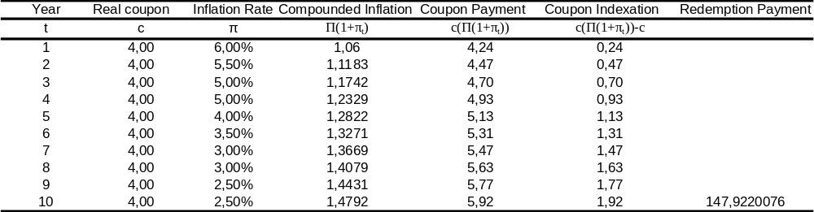

Another variant is the Interest Indexed Bond (IIB), who pays a fixed coupon together with an indexation of the fixed principal each period. The repayment of the principal at maturity in this case is not adjusted for inflation and is similar to the repayment of the principal at maturity of a common nominal bond, implying that the inflation adjustment runs completely through the coupons (see Table 2).
Table 2
The Cash flow Structure of an IIB
This table provides the cash flow structure of an IIB with a maturity of 10 years. In this example the real coupon rate has been set at 4% with varying inflation rates. The coupons that are received each year are provided in the 5th column and are computed by the sum of the 3rd and 4th column. The redemption payment that is paid at the end of the bond’s maturity is simply equal to the bond’s face value.

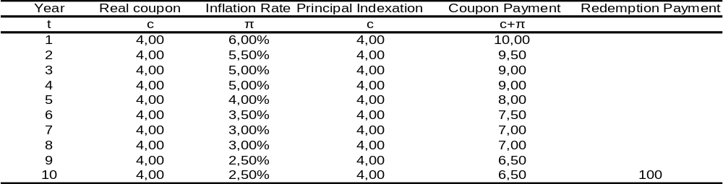

§2.3.2 The French ILB
Since the French ILB is the benchmark of APG’s liability hedging portfolio it can be worthwhile to elaborate further on this specific bond. The French ILB can be considered as a variant of the CIB. Like the CIB, the principal is adjusted for inflation and paid at maturity according to the following formula:

Redemption = IC*N (1)
IC = Indexation Coefficient = Daily inflation reference (at maturity) / Base index (2)
N = Nominal amount

The daily inflation reference can be calculated on a daily basis by means of linear interpolation of the two HICP’s published according to the following formula:

Daily inflation reference at d = 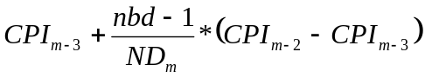 (3)
Where:
CPI_{m-2} = price index of month m-2
CPI_{m-3} = price index of month m-3
nbd = actual number of days since the start of the month
ND_{m} = Number of days in month m
d = Day d of month m

Annual coupons received by the bondholder depend on both the real coupon as well as on the IC. The real coupon is a fixed percentage of the index linked principal (IC) and determined at the issue date, remaining fixed for the rest of the bond’s lifetime. Assuming real coupons of 3% and a constant inflation of 2% the cash flow structure of the French ILB will be as in Table 3:

Table 3
The Cash Flow Structure of a French ILB
This table provides the cash flow structure of a French ILB with a maturity of 10 years. In this example the real coupon rate has been set at 3% with inflation rates assumed to be fixed at 2%. The coupons that are received each year are provided in the 5th column and are computed by the product of the 2nd and 4th column. The redemption payment that is paid at the end of the bond’s maturity is computed by multiplying the compounded inflation given in the last row of column 4 by the bond’s face value.
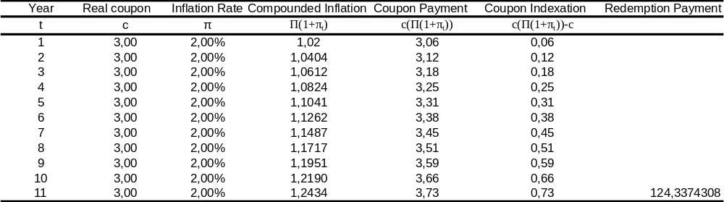

§2.3.3 Advantages of ILB’s
The ILB has been an innovation with beneficial effects for both the issuer and the buyer. With respect to the issuer as being sovereign governments, issuing ILB’s can decrease the cost of public borrowing for governments and increase their credibility with investors.
Examining government ILB’s from the perspective of the buyer, it is possible to state that these ILB’s offer investors a risk free and inflation adjusted return, enabling investors to maintain their purchasing power in the wake of (increasing) inflation. This feature is of vital importance for institutional investors with liabilities that are also linked to inflation. Pension funds as mentioned earlier are probably the most important category in this perspective, since the liabilities of pension funds are linked to wage and income inflation. However due to the absence of a tradable financial product protecting against wage inflation, ILB’s become the best alternative for pension funds as these ILB’s protect against consumer price inflation.
Although the ILB is the best alternative for a pension fund to hedge against inflation, it is impossible for pension funds to rely solely on ILB’s. This is caused by the fact that the market for such Inflation Linked Securities is simply not large enough to meet the demands of all institutional investors. Another reason why pension funds also need to consider other instruments in their liability hedging portfolio is that wage inflation at times can turn out to be higher than price inflation due to the fact employees unions might demand improvements in their wage in real terms. This real wage gap will force pension funds to seek for investment opportunities that pay inflation plus a (fixed) premium above the realized inflation and APG Investments has set its benchmark for the LHP as the return on the French ILB plus the real wage gap.

§ 2.3.4 Other inflation hedging assets
Due to the real wage gap and the capital constraints with respect to Inflation Linked Bonds pension funds are forced to explore new investment opportunities displaying inflation hedging characteristics. In this section I will discuss some of the alternative instruments that (are believed to) display inflation hedging characteristics. An alternative resembling government ILB’s are corporate ILB’s, often issued by companies with the capacity to source inflation. Due to the fact that the debt in these cases is issued by private parties, it brings along with it a certain amount of credit risk, which can enable such an ILB to generate the excess return above inflation that is needed to compensate for the real wage gap.
Real estate is another type of investment that is believed to provide a hedge against inflation. It is important to note that the liability hedging properties of real estate investments seem to depend on the specific characteristics of the real estate investments. In the future Real Estate investments at APG Investments can be found both in the liability hedging portfolio as well as in the return optimizing portfolio.
Another alternative for an inflation hedging investment can be investments in commodities or commodity derivatives. Since commodities prices are directly linked to components of inflation it can be expected that commodities can provide inflation hedging properties. Several academic studies also show that commodities are better inflation hedges than equities and bonds.
Furthermore there are many more asset classes that are possible to mention as potential inflation hedges (Infrastructure e.g.). Several pension funds have already included some of these in their investment portfolio. However the large demand for investments with an inflation hedging component forces such institutional investors to seek for new opportunities with similar characteristics, which is also the aim of this research.
Equities are in theory considered as on of the best inflation hedging asset classes. The rationale behind this is that (increasing) inflation implies that the price of real assets increase (more). Equities, being claims to these real assets, should in theory be one of the best inflation hedges. Empirical research however has proven the contrary. In the upcoming chapter an overview of the vast amount of literature regarding the relationship between inflation and stock returns will be provided.

§2.4 Conclusion
In this chapter I attempted to provide some insight into the term inflation by stating that there are several methods of measuring inflation and that the ‘best’ measure of inflation depends on the purpose of measuring inflation. With respect to this I mentioned the relevant measure of inflation in the context of this thesis. Furthermore I provided some further insight into ILB’s as the ‘best’ inflation hedges, with special attention to the French ILB as this is the benchmark of liability hedging portfolio at APG Investments. Finally I briefly discussed some other asset classes/ financial instruments that could be regarded as inflation hedges.

CHAPTER 3
Literature Review

§3.1 Introduction
In this chapter an overview of empirical and theoretical studies with respect to the relationship between stock returns and inflation will be provided. The starting point will be the Fisher theory, which argues in favour of a positive relationship between stock returns and inflation. In addition, attacks made by several authors on the Fisher hypothesis, based on empirical research, will be mentioned. Furthermore an overview will be provided of some explanations for the failure of the Fisher hypothesis in empirical studies. Finally several studies will be mentioned in which authors attempt to identify firm/industry specific variables that might be of influence to the inflation hedging properties of stocks.

§3.2 The Fisher hypothesis
There is a vast amount of academic literature that has examined the relationship between stock returns and inflation. These studies usually start with the Fisher hypothesis (1930). Fisher argued that the expected nominal rate of return on any asset will always move one for one with expected inflation. From this hypothesis one can draw rather far reaching conclusions. Nominal rates of return moving one for one with expected inflation imply that real rates of return are independent of (expected) inflation. In fact Fisher argues that there is no relation between the real and monetary sector and that real rates of return are dependant of ‘real’ variables such as productivity and risk aversion. Furthermore the Fisher hypothesis implies that any asset can be regarded as a perfect hedge against expected inflation. In the case of stocks, this would mean that conducting a regression in which stock returns are regressed on inflation one should always obtain inflation betas that are not significantly different from 1.

It is important to note that the Fisher hypothesis covers all asset classes and makes no distinction between the inflation hedging qualities of different types of assets. It simply states that every assets return has to move one for one with expected inflation, thus arguing in favour for the existence of a positive (and even perfect) relationship between (nominal) stock returns and inflation.

There is also another theoretical explanation that supports the hypothesis for a positive relationship between stock returns and inflation. According to this reasoning, equities are claims against the underlying real assets. In the case of increases in the general price level, it is the prices of these real assets that increase. Since prices of real assets increase, the value of equities as claims to these real assets should also increase. As a result of this stocks should at least maintain their real value during periods of (increasing) inflation.
Despite the two theoretical explanations mentioned above many empirical studies, beginning in the 1970’s, started to question the presumed positive relationship between stock returns and inflation.

§3.3 Attacks on the Fisher hypothesis
The first serious attacks on the Fisher hypothesis came in the second half of the 1970’s. Nelson (1976) tested the Fisher hypothesis by regressing monthly returns of a diversified stock portfolio on lagged, leaded and contemporaneous monthly inflation rates as measured by the Consumer Price Index (CPI). These regressions were conducted for various sample periods within the period running from June 1953 until February 1974.

The results were in complete contradiction to the Fisher hypothesis as the beta’s in the lagged, leaded and contemporaneous regressions in all sample periods appeared to be negative. Especially the fact that lagged inflation rates displayed negative correlations with monthly stock market returns was in sharp contradiction to the Fisher hypothesis. Due to the fact that observed inflation wasn’t considered as being the best proxy for expected inflation, Nelson also regressed monthly stock returns on solely contemporaneous and lagged inflation rate changes (log of CPI) using multiple regressions. The results were no different than in the previous test with significant negative correlations between stock market returns and inflation changes in the inflation rate.
Furthermore Nelson examined the relationship between stock market returns and unexpected inflation. Again the results opposed the Fisher hypothesis displaying a negative relationship between monthly stock market returns and (unanticipated) inflation.

Bodie (1975) tested the effectiveness of common stocks as an inflation hedge, by measuring the reduction in the variance of the real return on a risk free bond by combining the risk free bond with a well diversified portfolio of common stocks.
First he derived a formula providing the variance minimizing weights to be allocated to common stocks. Then he measured the reduction in the variance of the real return on nominal bonds, after combining nominal bonds and stocks according to minimum variance proportions.

Bodie found that real rates of return were negatively correlated with unanticipated inflation as well as with anticipated inflation. Furthermore he found that an investor could eliminate in the best case 18 per cent of the variance of the real return on nominal bonds by adding equities to his portfolio. However the portfolio weight of equities would have to be negative. So if an investor would want to hedge against inflation by adding common stocks to his portfolio he could only achieve an effective hedge by short selling common stocks and investing the proceeds in bonds.

Jaffe and Mandelker (1976) using US data for the period January 1953-December 1971 regressed the monthly returns on a market portfolio on monthly inflation rates represented by US CPI data. They divided the sample period into three sub periods and found that in two of these sub periods there is a clear negative relationship between stock returns and inflation. In one sub period (1959/1-1964/12) the relationship seems to be positive, however the coefficient in this case is not significantly different from zero. In addition to this they attempted to make a distinction between anticipated and unanticipated inflation and study the effects of both separately on stock returns. Unanticipated inflation was derived by assuming that expected inflation rates at time t are a function of realized inflation rates at t-1. Regressing nominal stock returns at time t on inflation rates with a lag of one period they found the coefficient to be negative again, clearly contradicting the Fisher hypothesis. Similarly negative betas were observed when using higher lagged values of inflation rates than only one period and when using 1 month interest rates as a proxy for expected inflation rates. Furthermore they also found a negative relationship between nominal stock returns and unexpected inflation.

Fama and Schwert (1977) examined the inflation hedging qualities of different asset classes such as US government bonds and bills, private residential real estate and common stocks. In their study they investigated whether these assets could be regarded as a (complete) hedge against expected and unexpected inflation. To this end they conducted regressions using the following model

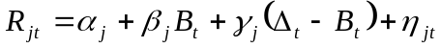 (4)

Where R_{jt} is the nominal return on asset j

In order to estimate the inflation rate they used CPI data. However, since the inflation rate in their model needed to be classified into expected and unexpected inflation, a measure for expected inflation needed to be derived. Fama & Schwert used the nominal returns on a T-bill maturing at the end of period t (B_{t}) as the measure for expected inflation. The difference between realized ex post inflation and the nominal return on a T-bill was used as the proxy for unexpected inflation (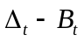).

The regression model in (3) was tested based on monthly, quarterly and semi-annual data for the period 1953-1971 for various asset classes such as: US T-bills (with maturities from 1 to 6 months), US government bonds, residential Real Estate and common stocks.

The results showed that T-bills, government bonds and privately held residential real estate all exhibited significantly positive betas. However returns on the common stock portfolio displayed significantly negative betas, clearly rejecting the Fisher hypothesis for stocks and the proposition that common stocks could be considered as a hedge against expected inflation.
With respect to unexpected inflation residential real estate was found to be the only asset class displaying significantly positive coefficients, implying that residential real estate could also be considered as a partial hedge against unexpected inflation. Common stocks with respect to unexpected inflation once more displayed significantly negative coefficients, implying a negative relationship between common stock returns and unexpected inflation.

The results of previously mentioned empirical studies were very surprising for financial economists, since they completely contradicted with the Fisher hypothesis. Furthermore the conclusions drawn by these studies were also considered counter intuitive based on the reasoning that stocks are claims on the underlying real assets and should not be adversely affected by increases in the general price level.
As a result, financial economists in the 1980 began to provide several explanations for the negative relationship between returns on common stocks and (expected) inflation.

§3.4 Explanations for the negative relation between nominal stock returns and inflation:
Various methods and explanations were put forward by academics to explain the negative relationship between stock returns and inflation. In this section a brief overview will be provided of some of these studies. These studies can be divided into the two most frequently employed hypotheses in order to explain the empirical results mentioned in §3.2, namely the Proxy hypothesis and the Long run relationship hypothesis.
§3.4.1 The Proxy hypothesis
The proxy hypothesis argued that the negative relationship between stock returns and inflation that was found in empirical studies was a spurious relationship.
Fama (1981) was the first researcher arguing for such an explanation. He stated that the seemingly negative relationship between inflation and common stock returns was not a direct relationship but that it was induced by a third variable being real activity. Due to the fact that real activity on its turn was positively related to stock returns but negatively to inflation a spurious relationship occurred between stock returns and inflation. In order to investigate the validity of his hypothesis, Fama first studied the relationship between inflation and real activity. He conducted regressions in which the inflation rate was regressed on lagged and contemporaneously rates of base growth (serving as a measure for money growth) and industrial production growth (serving as a measure for real activity growth) on a monthly, quarterly and annual basis. Using data for the period 1953-1977 he found significantly negative coefficients for the real activity growth rate coefficient confirming the existence of a negative relationship between real activity and inflation.

Then he studied the relationship between real activity and stock returns by regressing annual real stock returns on several variables serving as a proxy for real activity changes (such as changes in GNP and changes in industrial production). The results showed that there was a clear positive relationship between stock returns and real activity.

Finally he tested his hypothesis by examining whether the negative relationship between stock returns and inflation was a proxy for a different (intuitively more logical) relationship between stock returns and real activity growth. In order to test this he conducted a multivariate regression where he added measures of real activity growth (such as industrial production growth and GNP growth) and monetary growth as explanatory variables to the original regression, in which only inflation was employed as independent variable. After adding these new independent variables, the coefficients for inflation were no longer significant and in some cases became positive. The independent variables with the explanatory power in these multivariate regressions were the measures of industrial production growth and GNP growth.

Based on these results Fama concluded that the negative relation between inflation and stock returns was a spurious relationship. This spurious relationship could be explained by the fact inflation was negatively related to real activity which was the true explanatory variable for stock returns and was positively related to stock returns.

§3.4.2 Long run relationship models
Another way of explaining the negative relationship between stock returns and inflation has been to argue that, although empirical studies show a negative relation on the short and medium term, this relationship will become positive in the long run. This explanation implied that the sign of the inflation betas would depend on the horizon at which stock returns and inflation are examined. According to this he more this horizon would increase, the more positive (less negative) inflation betas will become.

The first study that argued in favour of this explanation was conducted by Boudoukh and Richardson (1993). They stated that, although most previous studies documented a negative relationship between stock returns and (ex ante) inflation, this didn’t necessarily imply that common stocks could not be considered as inflation hedges. Arguing that previous research usually focused on short term asset returns with holding periods of less than one year, they stated that one also had to focus on asset returns with holding periods of more than one year. In order to test for the long run relationship between stock returns and inflation they first studied the contemporaneous relationship between inflation and stock returns by conducting the following regressions:

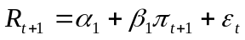 (5)

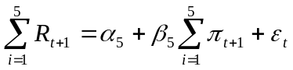 (6)

In (1) the one year stock returns are regressed on one year inflation rates, whereas in (2) 5 year stock returns are regressed on 5 year inflation rates using US data for the period 1802-1990. They found estimated values for β₁ of 0,07 and for β₅ of 0,52, which was also significantly different from zero. This implied that there indeed was a positive relationship between nominal stock returns and inflation at least in the long run, partly confirming the hypothesis that common stocks could be considered as a (in this case partial) hedge against inflation.
Furthermore they stated that in order to test for the actual Fisher hypothesis an ex ante inflation rate had to be derived. In order to derive the ex ante inflation they used an instrumental variable approach in which they attempted to identify some variable, displaying high correlation with expected inflation and a low correlation with the regression errors in the formulas above.
Several sets of instruments were used by the authors. The first set includes the one year interest rates and the long interest rate. The second set includes the past 1 year inflation rate and past 5 year inflation rate. Based on these set of instruments the authors derived four equation systems in which they use these set of instruments to form alternative instrumental variables
Again the results were in favour of a significant and positive relationship between stock returns and inflation in the long run with coefficients ranging from 0.3 to 2 in both the U.S. as well as in the U.K.

Another study in this perspective was conducted by Ahmad and Cardinale (2005). They employed a 2 step sequential hypothesis testing process in order to investigate the long run relationship between equity returns and inflation using data from the US, UK, Japan and Germany. They first examined whether lagged values of inflation affected stock returns. In this case the authors came up with mixed results finding support for a significant relationship between nominal stock returns and lagged inflation for the US, Japan, Germany and UK.
Next the authors tried to examine the long run relationship between nominal equity returns and inflation by regressing 10 year rolling equity returns on 10 year accumulated inflation. Analyzing the entire sample period the authors found significant positive betas for the UK and Japan (0.77 and 0.24). They also found positive betas for the US, however this was not significant. The beta in the German case was found to be negative. Analyzing the sub periods where inflation had been above its median the authors found similar results.
According to the authors these results failed to give clear support to the Fisher hypothesis of betas equal to 1. However the results did in some cases confirm the positive relationship between stock returns and inflation in the long run.
Finally the authors derived an alternative way to test the Fisher hypothesis specified as cointegration. Cointegration can in this context be used to determine whether there is a long run equilibrium between inflation and equity returns without having to postulate ex ante the length of the adjustment period. The overall results in this case seemed to be more in favour of the Fisher hypothesis than the authors’ earlier findings. Only in the US could the null hypothesis of no cointegration not be rejected at a 5% confidence level using lags of 1 and 10. In the UK the null could not be rejected using 10 lags but was rejected when using 1 lag. In Japan and Germany the null hypothesis of no cointegration had to be rejected at all times, again indicating that there was some evidence for the existence of a long run equilibrium between inflation and stock returns.

§3.5 Industry/Firm specific analysis of inflation hedging properties of stocks
Previously mentioned studies examined the inflation hedging properties of an entire asset class (usually stocks) without taking into consideration that there might be a possibility to make a distinction between different firms with respect to their inflation hedging abilities based on their firm or industry specific characteristics. However there have also been some studies examining the inflation hedging properties on an industry/sector level.
Since the objective of this thesis is to construct inflation hedging stock portfolios it is important to identify industry/firm specific characteristics that can be of influence with respect to the inflation hedging characteristics of individual firms. In order to determine variables that can be used in a stock selection model with the objective of constructing inflation hedging stocks portfolios I will mention several studies that have examined the cross sectional variance in the relationship between stock returns and inflation will be discussed. From these studies several firm/industry specific characteristics can be derived and employed in the stock selection strategies. In the upcoming sections I will mention some of the studies that have attempted to determine industry/firm specific characteristics that were regarded as influencing the inflation hedging properties of firms/industries.

§3.5.1 Inflation flow through rates (FL)
The first industry/firms specific characteristic one can mention in this perspective is the inflation flow through rate. The flow through rate represents the fraction of inflation flowing through to profit growth and was first introduced by Estep and Hanson (1980). It is hypothesizes that the higher the fraction of inflation flowing through to profit growth, the more the firm/industry will benefit from inflation (or the less it will be adversely affected). This feature is hypothesized to be an important factors with respect to the cross sectional variance in the inflation hedging properties of stocks.

In this perspective Asikoglu and Ercan (1992) examined the relationship between stock prices and inflation at an industry level. They computed flow through constants in order to check whether there was a difference in the relationship between stock prices and inflation among industries with varying inflation flow through abilities. Inflation flow through abilities of different industries were determined by calculating the so called flow through constants for each industry from the S&P Analysts Handbook for the period 1969-1988. In order to calculate inflation flow through capabilities of different industries they used a formula, which was derived from the simple dividend discount model (DDM) . In the simple dividend discount model the price of a stock is represented by:

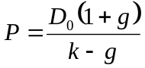 (7)
Where
P = stock price
D₀ = dividend paid in current period
g = constant expected growth rate of dividends
k = rate of return required by investors

Introducing inflation, two adjustments need to be made. First of all the required rate of return has to be adjusted:

(1+k) = (1+R)(1+I) (8)

Where
R = Real rate of return
I = expected rate of Inflation

Secondly the growth rate of dividends has to be decomposed into growth caused by inflation and real growth:
(1+g) = (1+G) (1+fI) (9)

Where
G = real growth
f = flow through

The above implies that the dividend growth rate is determined by the real growth rate of the firm and a term that represents the growth caused by inflation.
Substituting the two adjustments into the original formula for the dividend discount model the authors obtained the inflation flow through model of Estep and Hanson (1980)

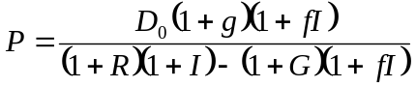 (10)

Finally solving for f in the formula that decomposes dividend growth they obtained the final formula with which the flow through coefficients can be calculated:

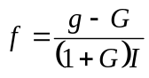 (11)

G = real growth
f = flow through
g = nominal dividend growth
I = inflation rate

After having calculated flow through coefficients for 14 industries included in the research, they classified all industries into two groups.

If f >1 then the industry is a high flow through industry
If f <1 then the industry is a low flow through industry

In order to examine whether, as hypothesized, the high flow through industries were better (or less bad) inflation hedges than low flow through industries they conducted a multivariate regression employing the following equation:

(12)

R_{i} = percentage change of stock price for industry i
I = inflation rate
DU = industry specific dummy variable
f_{i} = flow through constant for industry i

The industry specific dummy variable would take on the value of 1 when f > 1 for a specific industry. If not the dummy variable would take on the value zero. So in the case of low flow through industries the effect of inflation on stock prices would be equal to β₁. In the case of high flow through industries the effect of inflation on stock prices would be given by β₁ + β₂. The regression was conducted using data from the period 1974-1988.
The results showed that for low flow through industries the inflation beta was -1.54, again confirming the findings of earlier research. In the case of high flow through industries the total effect of inflation on stock returns (β₁ + β₂) increased to -0,56. Although the coefficient still remained negative the results did show that industries with high inflation flow through capabilities were less (negatively) sensitive to inflation in comparison to low flow through industries.

§3.5.2 Profit Margins (PM)
A firms PM can best be defined as the amount of profit a firm makes per unit of sales (output) and is computed as the ratio of profits to (net) sales. The higher a firms PM is, the more beneficial this can expected to be from an inflation hedging perspective. An intuitive explanation for this is that firms with higher PM’s have an advanced market power compared to firms with lower PM’s enabling the high PM firms to pass through increases in input prices (caused by inflation) more easily to customers.

A more theoretical explanation with respect to PM’s, using the DDM as starting point, was conducted by Fuller and Petry (1981)
They expanded the original DDM to:

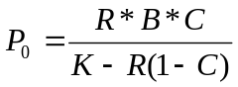 with 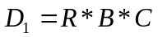 and 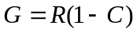

Where
P₀ = current stock price
D₁= dividend to be received in one year
K = rate of return required by investor
G = constant growth rate of dividends
R = return on stockholders equity
B = book value per share
C = constant pay out ratio

Under these conditions they showed that an increase in inflation would lead to a higher required rate of return by investors since investors want to keep the same real rate of return as before. If the return on equity of the shareholders would not rise proportionately with the increase in the required rate of return by investors the stock price will fall ceteris paribus. They also showed why corporations failed to increase their return equity on enough to offset inflation in the 1959-1979 period. They argued that since:

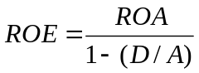 , ROA = Profit Margins*Asset Turnover

Profit Margins = Earnings/Sales
Asset Turnover = Sales / Total Assets

the problem had to be in one of the variables determining the Return on Assets (ROA). Since earnings and sales were denoted in current money whereas assets were stated based on historical costs one would expect the ROA and thus the ROE assuming no changes in the debt ratios, to increase during inflationary periods. However Fuller and Petry found that this did not happen. This was caused by the fact that, although Asset Turnovers increased during this period, Profit Margins decreased by a larger percentage more than offsetting the expected increase in Asset Turnovers and thus decreasing the ROA and ROE. From this they concluded that industries/firms could perform better as inflation hedges to the extent that they could maintain high profit margins during inflationary periods.

§3.5.3 Cyclicality
Finally I will mention the degree of cyclicality (of a firm/industry) as a factor that can influence the inflation hedging properties of firms/industries. Cyclicality in this context can be defined as the degree to which a firms/industries performance is influenced by the general economic environment. If inflation betas vary among industries one can expect that, to the extent that the general economy is correlated with inflation, the correlation between the performance of a firm/industry and inflation will depend on the cyclicality of a firm/industry.
In this perspective Boudoukh, Richardson and Whitelaw (1994) examined whether there existed cross sectional variation in inflation betas among industries. They argued that inflation betas across assets will vary depending on both the correlation between the assets expected dividend growth and expected inflation as well as on the volatility of the assets expected dividend growth. In order to investigate this, they first examined 22 industries with respect to their degree of cyclicality by computing the correlation between output growth in an industry with the aggregate output growth and aggregate inflation. Then the stock returns of the 22 different industries were regressed on expected inflation and unexpected inflation using quarterly US data over the sample period 1953-1990. They found that the low cyclical industries displayed higher expected inflation betas. In the case of the Tobacco and Food & Beverage industries the inflation betas were even positive (resp. 0.91 and 0.044). Unexpected inflation betas however were substantially negative for all industries and the average expected inflation beta for all 22 industries was -0.91. Finally the authors investigated the cross sectional variations in the relationship between inflation and stock returns for a longer time horizon using annual data for the same period as mentioned above. The results showed slightly significant changes with respect to the ranking of the different industries based on their inflation betas. Although the low cyclical industries such as Tobacco, Food & Beverage and Leather again displayed the highest betas and highly cyclical industries such as Primary Metals exhibited the lowest inflation betas, some industries had slightly gone up or down in the ranking. The most striking difference between the results obtained from the regressions using annual data in comparison with the results using quarterly data were the absolute values of the inflation betas. Using quarterly data the results displayed only two industries with a positive inflation beta and the average inflation beta for all 22 industries was -0.91. In the case of the model using annual data there were only two industries with negative inflation betas and the average inflation beta for all 22 industries was 0,77 with 7 industries displaying higher inflation betas than 1.0 and of which one was even above 2.0. This clearly indicated that besides a cross sectional variation in the correlation between stock returns and (expected) inflation the results also displayed large variations depending on the time horizon.

§3.6 Conclusion
In this chapter I attempted to provide some insight into previous theories and empirical studies with respect to the relationship between stock returns and inflation. Most empirical studies have shown that stock returns and inflation are negatively related and rejected the proposition that common stocks could be considered as an inflation hedge. Being a quite counter intuitive result rejecting the Fisher hypothesis, several academics came up with different explanations for these results. Some found that the relationship might be negative in the short run but became positive as the time horizon increased, whereas other researchers argued that the relationship between inflation and returns was a spurious one, emerging due to the fact that inflation is a proxy for a third variable being real activity.
Finally I attempted to provide some insight into studies with respect to cross sectional variations in the inflation hedging properties of stocks. From these studies the conclusion can be drawn that certain industry characteristics such as flow through rates or cyclicality can be of value when attempting to identify industries with inflation hedging properties. These industry characteristics will be used as sorting variables in the stock selection strategies in order to (attempt to) construct stock portfolios of which the returns display a positive relationship with inflation. In the following chapter the methodology of these stock selection strategies will be explained accompanied by an explanation of the derivation of the various stock selection variables. Furthermore the method of how to evaluate portfolios from an inflation hedging point of view will be discussed based on the methods (correlations and inflation betas) described in this chapter.

CHAPTER 4
Data & Methodology

§4.1 Introduction
In the previous chapter I provided an overview of the vast majority of empirical research regarding the inflation hedging qualities of equities. Most of these studies focused on the inflation hedging qualities of the entire asset class of equities rather than on the inflation hedging properties of individual firms. Several researchers have made attempts to determine industries and industry characteristics that might have some inflation hedging qualities. However these studies mostly obtained mixed results and usually were not conducted in a portfolio context consisting of individual stocks enabling investors to pick individual companies that might have inflation hedging properties in their returns.
These studies did however mention several industry characteristics that could be relevant when selecting industries/firms based on their inflation hedging qualities.

The objective of this thesis is to construct a quantitative stock selection model in order to create portfolios with inflation hedging qualities. The universe from which the stocks will be selected is the MSCI EU universe. The portfolios will be constructed by selecting individual firms on several characteristics that are believed to influence the degree to which an assets return displays inflation hedging characteristics. These variables will be selected based on the insights from the previous chapter.

In this chapter I will discuss the variables that will be used in order to select the firms that will finally make up the portfolio with the presumed inflation hedging properties. A definition of these variables will be provided as well as the rationale behind using these variables. In addition to this, the data to be used as well as the methodology of the stock selection process will be explained. The stock selection process gains an additional dimension due to the fact that stock selection occurs not only on in a univariate setting but also in a multivariate setting.

After having constructed several strategies, the portfolios resulting from these strategies will be evaluated based on their inflation hedging characteristics and overall performances. Several tests are mentioned that can be used in order to test, whether the portfolios can indeed be considered as having inflation hedging properties. A first test will be to construct the simple correlation coefficients of the returns of the derived portfolios with inflation. A second method will be to conduct multivariate regressions, where the returns of these portfolios will be regressed on inflation and on the excess returns of the market portfolio. In this thesis the second method is used as the relevant criteria. A further explanation of these tests will also be provided in this chapter.

First of all I will elaborate further on the variables that will be used in order to select the firms hypothesized to have a positive correlation with inflation.

§ 4.2 Variables
In this paragraph I will provide an overview of the variables that will be used in the stock selection process

Nominal Dividend Growth per Share (DGPS)
Starting from the simple dividend discount model one can see that the stock price of a firm is derived by the formula:

where:
P = stock price
D₀ = dividend paid in current period
g = constant expected growth rate of dividends
k = rate of return required by investors

From this one can argue that, to the extent that a firm is able to maintain a stable dividend growth during inflationary periods its stock price will be less affected by the adverse effects of inflation. Based on this reasoning, one of the selection criteria will be the nominal dividend growth that firms have displayed in the sample period. This variable is expected to be more effective with respect to the stock portfolio since bondholders do not receive any dividends. A possible drawback of using this variable as a selection criterion is that the amount of dividend paid to stockholders is sensitive to manipulations by top management as it is the top management that decides how much dividends are paid out to shareholders.

Earnings Growth (EBITDAgr)
Following the same reasoning as in the case of nominal dividend growth, I have also included earnings growth. Since dividend growth will depend on earnings growth and inflation hedging qualities of stocks can be expected to increase as firms are more able to sustain high earnings growth rates during inflationary periods, one can assume this variable to be significant. Furthermore earnings growth has an advantage in comparison to dividend growth, due to the fact that it is less vulnerable to manipulations by top management. However many measures of a firms earnings can be distorted due the fact that a firms earnings can be influenced by volatile variables such as taxes, depreciation and interest expenses. In order to circumvent this, EBITDA growth rates have been used.

Market Share (MS)
It is also possible to argue that firms with a certain degree of market power can more easily pass through increasing input prices to the customers, which would make these firms the ideal firms to invest in from an inflation hedging perspective. One can use the market share of a firm in a specific industry or sector as a proxy for its market power. In this research the percentage of the total sales of a firm compared to the total sales in the entire industry the firm belongs to, will be regarded as the relevant market share and be used as a measure for market power.

Financial Leverage (DE)
Periods with increasing inflation are often followed by increasing nominal interest rates. This can cause financial turmoil in companies who have high debt levels and often need to refinance their loans. An increase in the nominal interest rate would adversely affect these companies by increasing their current interest expenses as well as increasing the interest expenses on future refinancing. Therefore firms with lower debt levels can be expected to perform relatively better in periods of increasing inflation and thus perform relatively better as inflation hedges. Having said this one has to bear in mind that this usually holds for firms with high Short Term Debt to Total Debt ratios, since these are the firms who often need to refinance their loans.

Flow through coefficients (FL)
In the previous chapter several authors have mentioned the concept of flow through coefficients as being an important characteristic that might be useful in distinguishing firms (industries) with inflation hedging properties.
In both the studies of Estep and Hanson (1980, 1983) as well as in the work of Asikoglu and Ercan (1992) flow through coefficients are calculated on the industry level. Bearing in mind the purpose of this research, I have decided to calculate flow through coefficients on the individual firm level implying that average flow through coefficients will be calculated for all firms available in the MSCI EU.

Gross Profit Margins (GPM)
Another variable to be used in this research will be a firm’s gross profit margin. As explained in the previous chapter the rationale behind this again lies in the DDM (Fuller & Petry, 1981)
A more logical and straightforward explanation for including Gross Profit Margins as a variable that can distinguish firms with higher inflation hedging capabilities is to argue that firms with higher margins have an advanced market power compared to firms with lower margins enabling them to pass through increases in input prices caused by (increasing) inflation to customers more easily than firms with lower profit margins.

Cyclicality
One also can argue that the ability to pass through input price increases caused by inflation to customers is also determined by the cyclicality of the goods/services offered by the firm in question. Highly cyclical firms have a greater dependency towards the general economic situation, due to the fact that they sell products having a higher price elasticity of demand disabling them to pass through input price increases to the customer as easily as non-cyclical firms can.
Cyclicality however is not only important in showing whether firms can more easily pass through higher input prices to customers. It also displays the ability of firms to keep creating output in periods of economic downturn. Low cyclical firms will be less affected by economic recessions or downturns again caused by the fact that they offer products/services with a lower elasticity of demand. The characteristic of being less vulnerable to economic downturns is important in the context of selecting firms as being inflation hedges due to the fact that rising inflation has adverse effects on the general economy. Fama (1981) argued that the negative relationship between nominal stock returns and inflation, which he didn’t consider to be a direct relationship, could be explained by the negative relationship between inflation and real activity and the positive relation between real activity and nominal stock returns (see §3.3.1). Given a negative relationship between inflation and real activity one can argue that the firms who are least cyclical should perform better in periods with higher inflation.
Three proxies will be used in order to determine the extent to which a firm can be considered as pro-cyclical/anti-cyclical. These are the correlation between 3 month stock returns and quarterly GDP growth, the correlation between annual earnings growth and annual GDP growth and finally the correlation between annual sales growth and annual GDP growth. These measures will be computed and used both on the individual firm level as well as on the industry level. In the second method I will appoint all firms in the same industry with the same correlation coefficient being the correlation coefficient of the industry the firm in question belongs to. In all these cases firms with lower (higher) correlation coefficients are considered as better (worse) firms.

Dividend Yields (DY)
Although dividend yields are also considered as a value based criteria to select stocks, it can be distinguished from the other value based criteria in the context of this research. Besides being considered as a variable that can help in selecting stocks with superior returns, some practitioners have found stocks with high dividend yields to provide total returns that display high positive correlation with inflation. The correlation between dividend yields and stock returns are often explained by the fact that dividend payments in contrast to capital gains do not receive tax preference. Due to this, stocks with high dividend yields must offer investors higher ex ante returns. The rationale behind the correlation between high dividend yield stocks’ returns and inflation is not a thoroughly researched subject. However one can reason that stocks with a high dividend yield will display higher correlation with inflation because the total rates of return on high dividend yield stocks depend more on cash dividends than on capital gains in comparison to stocks with low dividend yields. The total return of a stock is determined by capital gains (price changes) as well as cash dividends. Price changes are often very volatile and are negatively correlated to inflation, whereas cash dividends are much more stable and, due to the fact that they largely depend on real factors such as earnings can be expected to be more positively correlated with inflation.

§ 4.3 Data
In this section I will provide some insight into the data that was used throughout this thesis. First I will mention several aspects (data source, time span e.g.) of the used data with respect to the firm specific variables that are used as selection criteria and on the return data. Then I will elaborate on the data regarding the alternative benchmarks and macroeconomic data.

Total returns were obtained directly from FactSet for all stocks in the MSCI EU for the period running from January 1989 until December 2007 which is the entire sample period in of this thesis. This sample period has been divided into an in sample period and an out of sample period to investigate the robustness of the results, but this is explained further in the following section.

In Table 4 several aspects with respect to the data used to derive the stock selection variables are mentioned.

The GDP growth rates that were used to compute the variable cyclicality were obtained from DataStream and represent the seasonally adjusted GDP growth rates for the entire European region aggregated. Data for EU inflation, to be used for evaluating the various portfolios (see next chapter), was obtained from DataStream and represents the Euro zone inflation derived from the Harmonised Index of Consumer Prices (HICP), which are not seasonally adjusted. The risk free rate was represented by the 1 month Interbank offered rate in the Netherlands (NIBOR) and was obtained from DataStream.

Table 4 Data sources and sexplanation of the variables
In this table the data sources, time span, and computing methods of the stock selection variables are provided. Some of the stock selection variables need some further explanation as is mentioned in the last column. Additional information with respect to the variables with a letter in the last column is provided below.

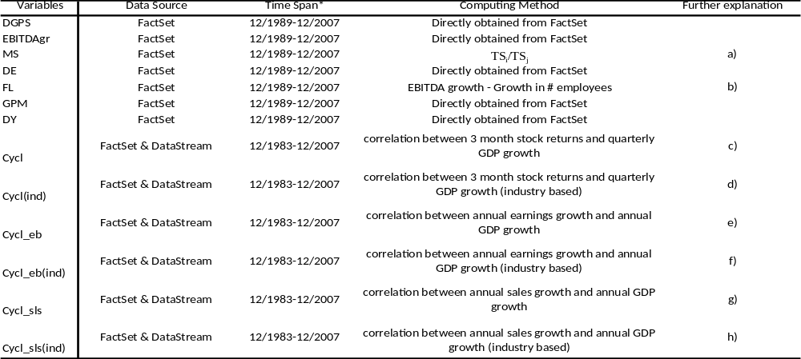
* all variables obtained from FactSet were obtained on a monthly frequency. However except for the DY and the Cyclicality variables, these were all annually announced data.

- TS_{i} = Total Sales of firm i
TS_{j} = Total Sales of industry j to which firm i belongs
Data with respect to total sales was obtained directly from FactSet.
- Flow through coefficients were computed by subtracting the growth in the number of employees from EBITDA growth, without dividing them by inflation since this would not change the outcomes.
Data w.r.t. growth in # employees was obtained from FactSet.
- In order to compute these correlations for the first time periods in the sample period additional data regarding stock returns was obtained from FactSet for the period before 1989 going back to 1983. Due to the fact that GDP growth data, obtained from DataStream, was quarterly data, 3 month stock returns were computed from monthly stock return data and then compared with GDP growth. In order to make sure that the correlation derived for a certain point in time contained valuable and sufficient information, an additional adjustment was made such that a correlation coefficient at a certain point in time would only be used if it was based on data of at least 2 years (8 quarters implying 8 observations). If this was not the case the sector average was used instead.
- In this case the sector averages of the correlations between 3 month stock returns and quarterly GDP growth were computed and all firms in the MSCI EU directly were assigned with the correlation coefficients of the industry they belong to.
- In this case correlations were computed using annual data because earnings growth was only available on annual basis. An adjustment was made such that a firm at point t got assigned its own correlation coefficient if this was based on data going back until at least t-7. If this was not the case this firm got assigned the computed correlation coefficient at time t of the sector it belonged to.
- Here the sector averages of the correlations between annual EBITDA growth and annual GDP growth were computed and all firms in the MSCI EU directly were assigned with the correlation coefficients of the industry they belonged to.
- Here the same methodology as in e was employed except for the fact that sales growth was used instead of earnings growth. Annual sales growth data was obtained directly from FactSet.
- Same methodology as in f.

§ 4.4 Stock Selection Process and Portfolio Construction
Portfolios were constructed in the first place by sorting on one of the above variables at a time. This implies that every month t all companies in the MSCI EU, which is the universe from which individual stocks are selected, were ranked from best to worse according to some variable V. If a company was on the MSCI EU at time t, but variable V is, for some reason, not available for this company at t, then the industry average of variable V for the industry the company in question belongs to was used as a proxy. It also occurred that at time t a company was on the MSCI EU and V was available and was on such a level that the company was selected in the long short portfolio at t, but for some reason the same company was no longer on the MSCI EU at t+1 and no return was available for this company. In this case the n+1st company in the ranking was included in the portfolio in place of the original company.

According to these rankings long/short portfolios were constructed by selecting the best n companies for the long portfolio and the worst n companies for the short portfolio. Monthly returns of the portfolios constructed at time t based on the levels of V at t were obtained at t+1 at which point all companies were ranked again according to V leading to the rebalancing of the long/short portfolio at t+1 obtaining monthly returns at t+2. This process was repeated every month in the period running from January 1989 until December 1998, which represented the in sample period. In total 108 monthly returns were generated during this period for each portfolio. In order to conduct back tests the entire dataset was divided into an in sample period (January 1990 – December 1998) and an out of sample Period (January 1999 – December 2007). Based on the results in the in sample period, portfolios with a (seemingly) inflation hedging character were tested in the out of sample period running from January 1999 – December 2007 and also consisting of 108 observations of monthly returns.

§4.4.1 Long/Short Portfolio
The preference for long/short portfolios instead of long only portfolios can be considered as a factor that can influence the results. Adding the possibility for portfolio managers to go short can have several advantages. In modern quantitative stock selection portfolio managers more and more use this possibility for alpha extension in order to obtain superior performance. One of the main advantages of a long/short portfolio is that it can decrease the exposure of the constructed portfolio to the market portfolio, depending on the betas of individual stocks in which long and short positions are taken. Since empirical research has documented that stock market indices returns display a negative relationship with inflation, one might expect that portfolios that are market insensitive also might have a less negative/more positive relationship with inflation.
In this case, after having ranked all firms in the MSCI EU according to V and having selected the best/worst n firms, equally weighted long/short portfolios were constructed with monthly rebalancing. This implies that the total portfolio weight and the total net amount invested were set to be zero.

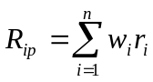

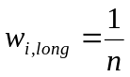 and 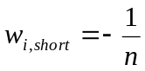

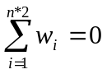

Where:
R_{ip}= Portfolio Return
r_{i}= return on stock i
w_{i}= portfolio weight of stock i
n = number of stocks in the long (short) portfolio

Additionally I checked whether long/short portfolios were more useful in an inflation hedging context and in decreasing the market sensitivity of the constructed portfolios than long only portfolios. This was done by comparing the outcomes of long/short portfolios constructed after ranking firms on one variable with the outcomes of long only portfolios.
Furthermore the results were also compared for different values of n in order to check whether portfolio results are influenced significantly by the number of firms in the portfolio. After having constructed portfolios based on ranking companies on one variable, it can also be of value to examine multivariate stock selection strategies, in which companies are sorted according to more than one variable jointly.

§4.4.2 Constructing portfolios by sorting on multiple variables
Using a multivariate approach when sorting stocks can be of value since the rankings of the individual stocks will be based on more information and thus might be able to improve the results. Multivariate stock selection strategies have been employed in several empirical studies and have often generated improving results compared to univariate stock selection strategies
The most frequently used method for multivariate stock selection is the methodology used in Lakonishok, Shleifer & Vishny (1994) and Chan, Jegadeesh & Lakonishok (1996). In this case all stocks are sorted based on some variable X and assigned to one of three equally sized portfolios at the beginning of each month. At the same time all stocks are also sorted, independently, based on variable Y and again assigned to one of three equally sized portfolios. This results in 9 portfolios and at the end each stock is assigned to one of these nine portfolios. Finally the long short portfolio is constructed by selling the stocks in the worst portfolio (L,L) and buying the socks that are in the ‘best’ portfolio (W,W). Exhibit 1 shows the nine portfolios that emerge after a 2 way sorting approach.

Exhibit 1 The 9 buckets using double sorting
This table shows the nine portfolios that emerge after a multivariate sorting of firms in which all firms are first sorted based on variable X and assigned to one of three equally sized portfolios with 1 being the basket with the best firms and 3 being the basket with the worst firms. Then all firms are independently sorted based on variables Y and again assigned to one of three equally sized portfolios. This results in 9 portfolios showed in the exhibit below with (W,W) being the basket with the firms that were ranked in the top portfolio based on both variable X as well as variable Y. The long short portfolio is constructed by selling the stocks in the (L,L) basket and buying the stocks in the (W,W) basket.

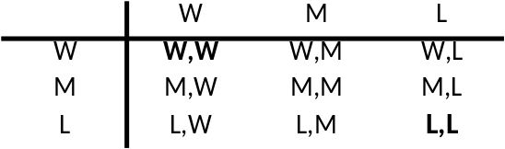

This methodology is a very frequently used way of sorting firms when employing a multivariate approach. Furthermore it enables one to identify stocks that belong to the best x% in more than one univariate ranking, implying that a firm can only be assigned to the ‘winners’ portfolio if it belongs to the best firms based on more than just one firm specific variables.

Another approach to construct portfolios based on multivariate sorting is employed by v.d. Hart, Slagter & van Dijk (2000). In their approach all variables are normalized by subtracting the median and dividing by the cross sectional median absolute deviation. Then they obtain the score for the combined strategy by adding up the normalized values of the used variables and sorting all firms based on this new score. Finally they combine the top and bottom 15% to construct a long short portfolio. Although this approach does not run the risk of ending up with an insufficient number of firms in the winners and losers portfolio after using a multivariate sorting approach, it still has some major drawbacks compared to the first method.
First of all it will take more computational effort since you will have to compute the median for all variables at each month and subtract this each month from the real value of that variable and finally divide this by the cross sectional median absolute deviation, which also has to be computed each month. This process has to be repeated every month before sorting the firms, while in the first method you can immediately start sorting and only have to determine the firms that are in the best x% based on variable 1 and variable 2.
Furthermore this method is more sensitive to extreme values of a firm with respect to one variable. A firm can have an extremely good/bad score with respect to one variable but a ‘medium’ score with respect to the other variable. In the method of v.d. Hart, Slagter & van Dijk this firm is very likely to be included in the winners/losers portfolio because the extreme value for one variable will have a greater influence on the normalized score. This is not possible in the method of Lakonishok et.al (1994, 1996) since in this case a firm is only included in the winners/losers portfolio if it belongs to the best/worst x% based on both variable X as well as variable Y.

Based on the above mentioned advantages and drawbacks of both methods I have decided to use the methodology of Lakonishok, Shleifer & Vishny (1994) and Chan, Jegadeesh & Lakonishok (1996), due to the fact that I believe that this methodology is superior to the methodology of v.d. Hart, Slagter & van Dijk (2000), since this method is more practical and less sensitive to outliers.
Employing this methodology brings with it the risk that by employing such a method you will end up with a very limited number of firms in the final winners/losers portfolio. In a bivariate approach, this doesn’t necessarily have to be a serious setback, since a double sort will result in a total of 9 buckets (see exhibit 1). Assuming a data set consisting of 500 firms the expected number of stocks to be included in the (W,W) or (L,L) portfolios is 500/9≈55. In order to check to what extent this is a serious problem in the bivariate approach I will mention the range of the number of firms in the final winners/losers portfolio for the strategies in the bivariate approach.

In addition to the bivariate approach I have also used a multivariate approach in which jointly sorts are conducted based on three variables. In this case the above mentioned threat of ending up with too few individual stocks in the winners/losers portfolio becomes more serious. Using three variables will expand the number of buckets to which each firm can be assigned to, to a number 27 compared to the 9 buckets in the bivariate approach mentioned in the previous section. Due to the increase in the number of sorts the number of stocks in a portfolio will decrease resulting to an increasing influence of idiosyncratic risk factors on portfolio returns. In order to alleviate this problem I have chosen to increase the number of buckets from which individual stocks are included in the winners and losers portfolio. In a multivariate approach using three variables this means that not only will the firms be included in the winners (losers) portfolio that were in the winners (losers) portfolio based on sorting firms on all three variables jointly. I will also include firms to the winners (losers) portfolio that belonged to the winners (losers) portfolio in two of three cases but belonged to the medium portfolio in one case. Exhibit 2 illustrates this methodology.

Exhibit 2 The 27 buckets using triple sorting
This table illustrates the 27 buckets (portfolios) that emerge after jointly sorting on three variables. If one would only include the firms in the WWW and LLL portfolios this would imply a very high risk of ending up with too few number of firms in the winners/losers portfolios. In this case this would imply for example that the expected number of firms to be included in the winners (losers) portfolio would be 500/27 = 18.5 given a universe of 500 firms. In order to tackle this problem the firms in the WMW, WWM and MWW (MLL, LML, LLM) portfolios are also included. Making such an adjustment increases the expected number of firms in the winners (losers) portfolio to (500*4)/27≈74.

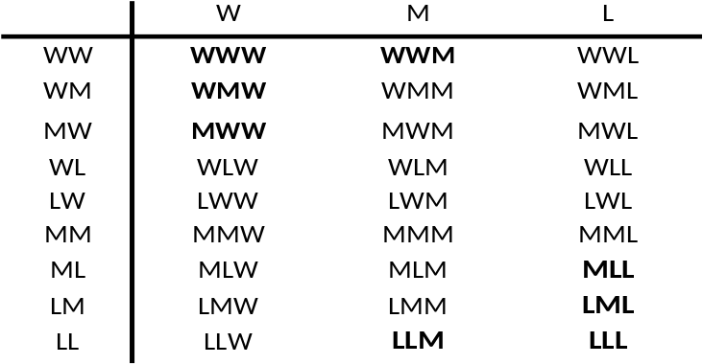

Having chosen the methodology of the multivariate stock selection it is also important to determine which variables are to be used in the multivariate stock selection strategies.

§4.4.3 Variables to be used in the multivariate stock selection approach
With respect to the question which variables to use in the multivariate stock selection there are several approaches. At one extreme one can choose to use all variables that were used in the univariate stock selection approach. However such an approach will cost (unnecessary) computational effort since it implies that all possible combinations of 13 variables (in total 78) have to be identified, computed and evaluated for the bivariate case. For the multivariate case this number increases further. On the other hand one can choose to use a very stringent criterion and only use the variables that yielded portfolios with significantly positive inflation betas in the univariate stock selection. The drawback of such an approach is that this will increase the risk of excluding some variable(s) that might have been useful in a multivariate setting. For example the univariate strategy of sorting firms on some variable X might generate a portfolio of which the returns show positive correlation with inflation, but are not significantly positively related to inflation using some confidence level. This strategy, however still can be useful when employed in a multivariate setting.
Because of this I have chosen in this case for a solution that can be considered as a compromise between the two methods mentioned above. In this perspective a limited number of variables are used in the multivariate stock selection. The 8 variables that yielded the most positive (least negative) correlations with inflation in the in sample period based on univariate stock selection will be used in the multivariate stock selection in the in Sample period. Correlations are used in this case since they can be considered as a proxy for (significantly) positive inflation betas, although this need not be necessarily true. This way we decrease the number of variables to be tested based on results of a proxy of inflation hedging properties without excluding too many variables. The advantage of such an approach will be that it spares a lot of computational effort (the number of strategies that need to be tested, computed and evaluated is brought down from 77 to 27 and avoids unnecessary computational effort without throwing away too much potentially (relevant) information since you will be including in the multivariate analysis the variables that generated the most promising results in a univariate setting.
After having determined and computed all strategies that are hypothesized to be of value in an inflation hedging setting it is now important to determine objective measures to evaluate the inflation hedging properties of the various strategies. In the next section I will further elaborate on this issue.

§4.5 Evaluating Portfolios
Due to the fact that in this thesis the main objective is to create stock selection strategies generating portfolios that display inflation hedging characteristics, the evaluation criteria in this case will differ from those used to evaluate mainstream stock selection strategies. In this thesis the constructed portfolios will be evaluated in the first place based on their inflation hedging characteristics and then on the usual risk/return based criteria.
There are several measures that can be used in order to determine whether a portfolio can be considered as displaying inflation hedging properties. In general one can think of two measures in order to evaluate the inflation hedging properties of the various strategies. These are also the measures that were used in most of the previous empirical research that was mentioned in chapter 3

§4.5.1 Correlations
First of all the correlations of the portfolio returns with overall EU inflation are examined. This will be done by focusing on yearly returns compared to contemporaneous and 6 month lagged yearly inflation. Positive correlations in this case would imply that the portfolios constructed in this context can have inflation hedging capabilities, although this need not be the case. In order to determine whether the results in the In Sample Period can be regarded as robust, the In Sample Period is cut in two periods. This implies that the In Sample Period is divided in a first sub-period (12/90-12/94) years and a last sub-period (01/95-12/98) and correlations between yearly returns and contemporaneous yearly inflation are computed for these sub-periods.

§ 4.5.2 Inflation beta’s
Another method to evaluate the strategies is by examining the inflation betas of the portfolios. Inflation betas can be estimated by conducting univariate and multivariate regressions in which:

- yearly returns are regressed on contemporaneous yearly inflation.

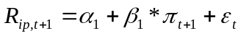 i)

By conducting regression i) it is possible to check whether there is a significant relationship between EU inflation and the returns on the constructed portfolios. If the inflation betas turn out to be significantly positive this would imply that the constructed portfolios can be considered to have inflation hedging properties.

- yearly portfolio returns are regressed on both yearly inflation and yearly market returns

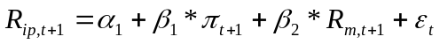 ii)

Regression ii) enables us to correct for the market portfolio (in this case represented by the return on the MSCI EU), by including the return on the market portfolio into regression i)
This can be important since one can obtain high inflation betas in regression i), however these positive inflation betas can, according to the reasoning of Fama (1981), be caused by the fact that long/short portfolios decrease the exposure to the market portfolio and as such increase inflation betas. This way it is possible to correct for such an effect. Furthermore comparing the second regression model with the first regression model can also shed some light on the question to what extent the constructed portfolios are market neutral. If the constructed portfolios are market neutral the market beta should be insignificant and the inflation beta in the second regression model will resemble the inflation beta obtained from the first regression model.

Due to the fact that inflation betas obtained from regression ii) correct for the spurious relation effect as mentioned above and in chapter 4 I have chosen to employ these inflation betas as the primary evaluation criterion for all strategies. In the remainder of this thesis inflation betas will be estimated by conducting the second regression (ii). The null hypothesis in these cases is that inflation betas are not significantly different from zero. Significantly positive inflation betas imply that the portfolio in question can be regarded as having inflation hedging properties.

Due to the fact that the yearly returns used in the regressions are monthly moving returns one can expect to observe autocorrelation in the regression results. In order to circumvent the problem of autocorrelation, which will cause the R² to be overestimated and the standard errors to be underestimated, the Newey-West method is employed, generating standard errors that are consistent in the presence of both autocorrelation and heteroskedasticity.

After having tested all strategies and having examined their inflation betas, the strategies generating portfolios with significantly positive inflation betas will be identified. Of these strategies no more than 3 will be tested in an out of sample period. If there are more than 3 strategies in the in sample period that generated portfolios displaying significantly positive inflation betas, I will evaluate these portfolios based on the more traditional performance criteria and then select the 3 most promising strategies. The next section elaborates further on these performance criteria.

§ 4.6 Other Performance Criteria
Besides evaluating the constructed portfolios on their inflation hedging characteristics it is also important to employ some of the more traditional performance criteria. After all, besides providing inflation hedging characteristics it remains important that a portfolio displays a satisfactory risk/return profile. In this perspective the following measures will be computed and provided for each portfolio in order to determine and compare the performance of the various portfolios:
- Mean Returns (annualized)
- Std Dev (annualized)
- Sharpe Ratio

The Sharpe ratio will be used as the criterion to select from the portfolios with significantly positive inflation betas, the best 3 strategies that are to be tested in the out of sample period. This implies that from the strategies generating portfolios with significantly positive inflation betas will be chosen the 3 strategies generating portfolios with the highest Sharpe ratio.
§4.7 Testing for the out of sample Period and identifying the best strategy
In order to test whether the strategies generating the ‘best’ inflation hedging portfolios in the in sample period are robust it is important to test these strategies in an out of sample period. In this perspective the (maximum of 3) strategies that yielded significantly positive inflation betas in the in sample period and displayed the highest Sharpe ratio, will be tested in the out of sample period, which runs from January 1999 - December 2007.
The strategies that yield significantly positive inflation betas when measured over the entire time span (January 1990 - December2007) can be considered as the ‘best’ inflation hedging portfolios. However it is also important that inflation betas, even if significant when measured over the entire time span, do not show substantial variances over time. In order to examine this I will also conduct the regression mentioned above with expanding time spans.
After having identified a single strategy yielding the best results in the context of this research an additional regression will be conducted in order to correct for the style value and size factors. This regression iii) will be employed in order to test to what extent the returns of the strategies obtaining the ‘best’ results in the context of this thesis are sensitive to the Fama & French factors next to inflation and the market portfolio.

iii)
In addition to this, regressions with an extending time span of 1 year will be conducted in order to examine the development of inflation betas over time. Furthermore the transaction costs related to employing the ‘best’ inflation hedging stock selection strategy will be estimated and provided
In the following chapter, the results of the various stock selection strategies will be provided, identifying the strategies that can be considered as yielding the best inflation hedging portfolios according to the three levels mentioned here.

CHAPTER 5
THE RESULTS

§5.1 Introduction
In this section the results of the various constructed portfolios will be presented and discussed. First of all the performance related statistics with regard to the univariate strategies will be presented and discussed after which regression results of these portfolios will be presented and discussed. In addition multivariate strategies will be used in order to create portfolios and in the same way the results regarding the performance and inflation hedging capabilities of these portfolios will be presented and discussed as well as the regression analyses after which conclusions will be drawn regarding the outcomes in the in Sample Period. Finally the 3 ‘best’ strategies generating inflation hedging portfolios in the in sample period will be tested in the out of sample period.

§5.2 Univariate Strategies
As mentioned before 13 variables (see Table 4 in the previous chapter) have been used as a sorting variable in order to construct portfolios. First the performance related statistics will be provided alongside with the correlations with inflation

§ 5.2.1 Performance Statistics
First we examine the results for the 13 different univariate strategies tested in the in sample period. In Table 5a and 5b the outcomes of the portfolio results are provided for these univariate strategies. Examining tables 5a and 5b we can observe that of the six various cyclicality variables Cycl_eb and Cycl_sls(ind) seem to provide mixed results with respect to both performance related criteria as well as inflation hedging characteristics. Cycl(ind) and DE show positive correlations with inflation but generates negative returns. With respect to other variables that were assumed to be of value in constructing inflation hedging portfolios one also can observe mixed results. Some of these variables such as EBITDA growth and Market Share (MS) display largely negative correlations with inflation over both the entire in sample period as well as on all sub-periods. Other variables such as Gross Profit Margins (GPM) and the Dividend Yield (DY) seem to work better as sorting variables in creating portfolios that meet to both performance as well as inflation hedging demands. Sorting firms on Flow Through coefficients (FL) and Dividend Growth per Share (DGPS) generates negative yearly correlations with inflation. However, the level of the correlation is much higher (less negative) than for the other strategies. Furthermore one can also observe that the correlation with inflation becomes positive in specific sub-periods and that sorting on FL and DGPS yields the best results with respect to the Sharpe ratio. Although it generates lower yearly returns than FL and the DGPS, sorting firms on the Gross Profit Margin (GPM) also provides promising results displaying large positive correlations with yearly inflation over the entire In Sample period as well as on all sub-periods. Another variable that was expected to perform well was the dividend yield and the results seem to confirm this belief since constructing portfolios by sorting stocks on dividend yields generates an annual return of 12,5% with the returns displaying a correlation with yearly inflation of more than 50%. One also can observe that these correlations remain positive in all sub periods as well as in the case of using 6 month lagged inflation.

Table 5a & 5b Performance Statistics Univariate Strategies
These tables provide the annualized excess returns, standard deviations, Sharpe ratios and yearly correlations with inflation for the 13 strategies based on single variable sorting. . Excess returns are computed as the time weighted average of the portfolio returns. These are zero net investment long/short portfolios (l/s =100/100), in which 25 stocks are included in the long portfolio and 25 stocks are included in the short portfolio (n=25). Results are based on the period 01/90-12/98 consisting of 108 monthly observations. Yearly correlations are computed based on 97 observations of which 48 observations belong to the 1st period and 47 to the 2nd period.

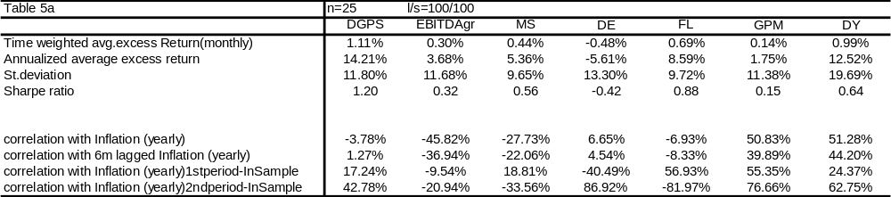
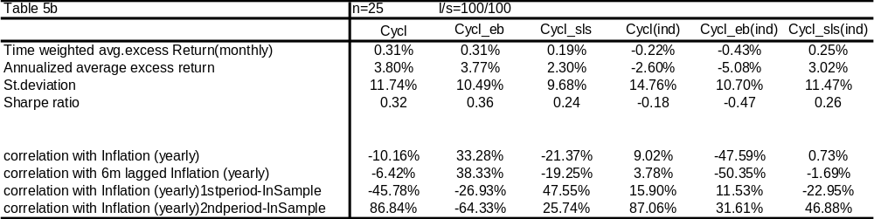

Imposing a restriction on short selling stocks can have a deep impact on the results with respect to both the performance figures as well as the inflation hedging characteristics of the portfolios (see chapter 4). In order examine these impacts, portfolios based on the same sorting variables were constructed imposing a restriction on short selling stocks. Tables 6a and 6b display the results of these long only portfolios.
After imposing the restriction to short sell stocks we observe that most of the portfolios generate higher return. Of the 13 univariate strategies 10 generate higher returns than in the case when no restrictions were imposed on short selling stocks. Standard deviations are higher when imposing the short selling restriction in all cases. Further we observe the correlations with inflation to decline substantially in the case of imposing the short selling restriction. With the exception of one portfolio all portfolios show a substantial decline in the correlation of its yearly return series with yearly inflation. In fact all correlations, except that of the dividend yield portfolio, have become substantially negative looking at the yearly correlation for the entire sample period.

Tables 6a & 6b: Performance Statistics univariate strategies (long only)
These tables provide the annualized excess returns, standard deviations, Sharpe ratios and yearly correlations with inflation for the 13 strategies based on single variable sorting. . Excess returns are computed as the time weighted average of the portfolio returns minus the risk free rate. These are long only portfolios (l/s =100/0), in which 25 stocks are included in the long portfolio (n=25 means). Results are based on the period 01/90-12/98 consisting of 108 monthly observations. Yearly correlations are computed based on 97 observations of which 48 observations belong to the 1st period and 47 to the 2nd period.

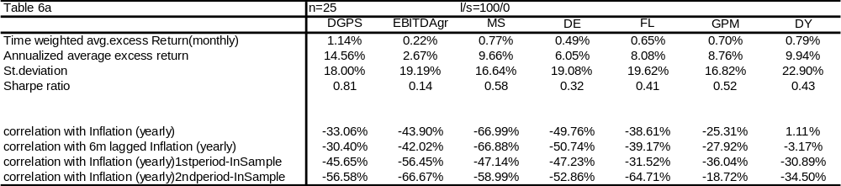
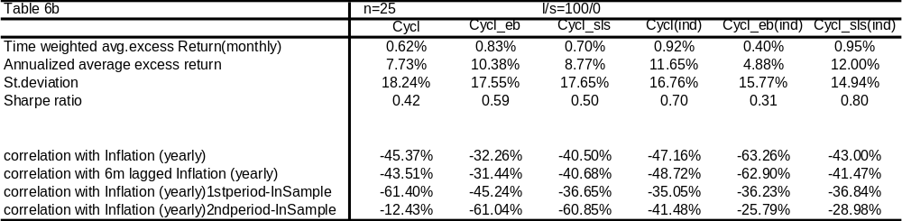

The outcomes are also tested for different levels of n without imposing any restrictions on going short. Appendices A1 and A2 show these results in which we can observe that the results resemble those of the case in which n=25. A note that can be made in this respect is that standard deviations are lower in the case of higher values for n, which is not very surprising.

§ 5.2.2 Regressions
For the sake of computational ease I will only mention the regression results of the strategies that have displayed positive correlations in the previous section and therefore can be considered as relevant in the context of displaying inflation hedging properties. In order to compute the inflation betas of these portfolios regression model ii) from §4.5.2 is employed. Table 7 displays the results for the regressions.
Examining the regression results one can observe that portfolios, constructed by sorting on DY, GPM and Cycl_eb, have significantly positive inflation betas. Furthermore with respect to these three strategies it can also be observed that the variance in yearly inflation and yearly market returns explains around the 25% of the variance in the yearly portfolios returns. The other portfolios display either negative inflation betas or insignificant betas. To further clarify the regression results, scatter plots of these 6 strategies are also provided in the appendix (see exhibit B). Another important note to be made is that DE and Cycl(ind) yield portfolios with insignificant inflation betas, however with significantly negative market betas.

Table 7: Regression results univariate strategies
This table reports the coefficients, p-values for the independent variables and the adjusted R² for the following regression:
R_{p} = Yearly return on the constructed portfolio
π = Yearly inflation
R_{m} = Yearly return on the MSCI EU

The sample period is from 12/90-12/98 consisting of 97 observations
All standard errors are heteroskedasticty and autocorrelation consistent due to the Newey-West correction.

*represents significant betas at the 1% confidence level
** represents significant betas at the 5% confidence level
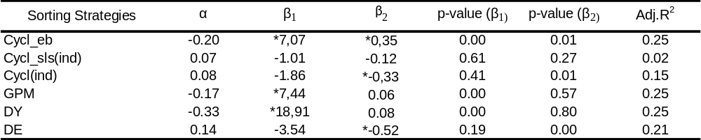

§5.3 Portfolios constructed by bivariate stock selection
Now that portfolios have been constructed by ranking companies on only one variable it can also be of use to evaluate several combinations of different variables used in the stock selection process simultaneously. In order to create portfolios based on multiple variables sorting, the 8 variables that yielded the most positive (least negative) correlations with inflation will be employed. In this perspective the following variables will be employed in the multivariate stock selection: Cycl_eb, Cycl_sls(ind), Cycl(ind), GPM, DY, DE, DGPS and FL.
From these 8 variables one can generate a total of 28 two variable (bivariate) strategies. In this section the performance statistics and the inflation hedging properties of these 28 bivariate strategies will be discussed.

§5.3.1 Performance Statistics
The results of the portfolios constructed by sorting on multiple variables jointly are displayed in Tables 8a-8d.

Tables 8a-8d Performance Statistics Bivariate Strategies
These tables provide the annualized excess returns, standard deviations, Sharpe ratios and yearly correlations with inflation for the various strategies based on multiple variable sorting. In this case no more than 2 variables have been used jointly. Excess returns are computed as the time weighted average of the portfolio returns. These are zero net investment long/short portfolios (l/s =100/100), in which a varying number of stocks (n) are included in the long and short portfolios depending on how much firms were in the (1,1) and (3,3) buckets. The range of the numbers of stocks in the long and short portfolio is also provided in the table. Results are based on the period 01/90-12/98 consisting of 108 monthly observations. Yearly correlations are computed based on 97 observations of which 48 observations belong to the 1st period and 47 to the 2nd period.
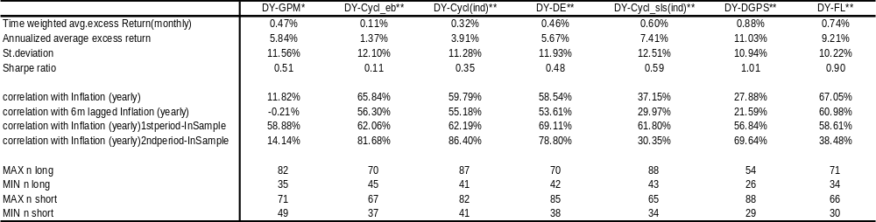

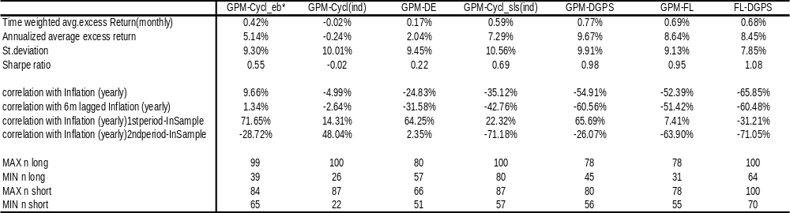
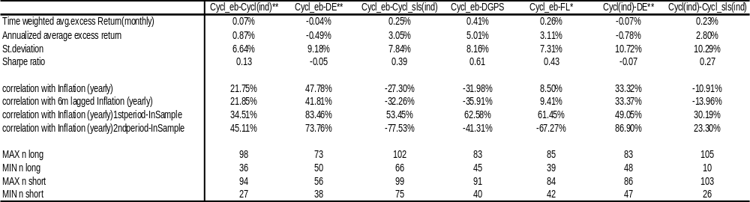
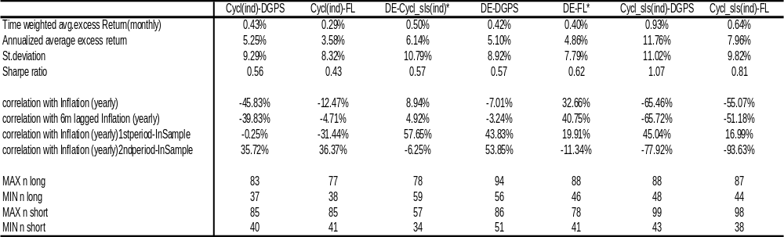

One can observe that some of the variables that yielded the ‘best’ portfolios in the previous section also seem to work better when used in a multiple variable sorting setting. Examining the results we can observe that many strategies yield portfolios with a positive correlation with inflation. Of the 28 strategies displayed in the tables above 14 stock selection strategies yield portfolio results with positive total returns and positive correlations with yearly inflation. Of these 14 strategies, 8 strategies display yearly returns that have positive correlations with inflation in all of the sub-periods and when using a 6 month lag. However the criterion for considering a portfolio as an inflation hedge is that it displays significantly positive inflation betas. Because of this we need to examine the regression results with respect to these strategies.

§5.3.2 Regressions
For the sake of computational ease I will only provide the regression results of the strategies that yielded positive correlations with inflation. The regressions with respect to these strategies are conducted as in section 5.1.2 in order to investigate to what extent the positive relationship between the portfolio returns and inflation is significant. Table 9 displays the regression results for the different strategies in the in Sample period. In the appendix scatter plots of some of these strategies can be found where yearly returns are plotted against yearly inflation.
Of these 14 strategies, 6 display significantly positive inflation betas at a 5% confidence level. Examining again the results in table 8a-8d we can see that of the 7 strategies yielding significantly positive inflation betas only one strategy yielded negative total returns. In this perspective the 6 other multivariate strategies can be considered as scoring ‘good’ as inflation hedging portfolios in the in sample period. A few remarks can be made with respect to these strategies. For instance one can observe that in the strategies providing satisfactory results in the context of this research some variables appear more than others. Of the 6 bivariate strategies with significantly positive inflation betas 5 strategies have the dividend yield as one of the sorting variables. Furthermore one can observe the variables DE, FL and several measures of cyclicality to appear in the inflation hedging portfolios constructed by bivariate sorting. With respect to the sign of the market portfolio coefficient there are mixed results. This market beta is significant at a 10% confidence level in 3 of the 14 multivariate strategies; however the sign of the coefficient is mixed. The adjusted R² values for the inflation hedging portfolios vary from 10% to 46 %, implying in the best case that the variance in the independent variables explain (at least) 46% of the variance in the dependent variable.
After having evaluated the various bivariate strategies based on inflation betas, the analysis is expanded to multivariate strategies in which three sorting variables are employed jointly.
Table 9 Regression results Multivariate Strategies
This table reports the coefficients, p-values for the independent variables and the adjusted R² for the following regression:
R_{p} = Yearly return on the constructed portfolio
π = Yearly inflation
R_{m} = Yearly return on the MSCI EU

The sample period is from 12/90-12/98 consisting of 97 observations
All standard errors are heteroskedasticty and autocorrelation consistent due to the Newey-West correction.

*represents significant betas at the 1% confidence level
** represents significant betas at the 5% confidence level
*** represent significant betas at the 10% confidence level
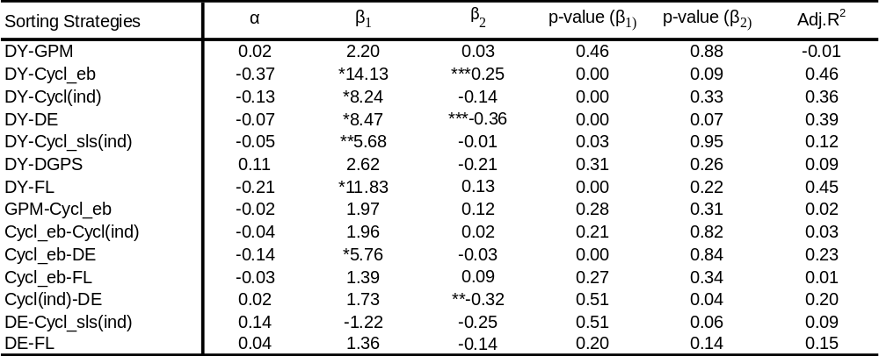

§5.4 Multivariate Strategies using three variables jointly
Finally I will provide the results from the multivariate strategies using three variables. In this case the portfolios are constructed as explained in exhibit 2 in the previous chapter. I will provide only the results of the strategies that yielded positive correlations with inflation and the maximum and minimum number of firms in the winners and losers portfolio will be mentioned.

§5.4.1Performance Statistics
Table 10a-10d provides the performance statistics and correlations with inflation for the various multivariate strategies. Examining tables 10a-10d we can notice that the results resemble those obtained in the previous section. Of the 27 multivariate strategies that generated portfolios displaying positive correlations with inflation we can see that these all are simply the bivariate strategies in the previous section, obtaining resembling results, combined with a third sorting variable. Further one can observe that the strategies with a positive correlation with inflation also display positive returns for the in sample period. As in the previous section regressions are conducted in order to examine the inflation hedging properties of the various strategies.

Table 10a-10d Performance Statistics Multivariate Strategies
These tables provide the annualized excess returns, standard deviations, Sharpe ratios and yearly correlations with inflation for the various strategies based on multiple variable sorting. In this table 3 variables have been used jointly. Excess returns are computed as the time weighted average of the portfolio returns. These are zero net investment long/short portfolios (l/s =100/100), in which a varying number of stocks (n) are included in the long and short portfolios depending on how much firms were in the WWW, WWM, WMW and MWW buckets for the long portfolio and how much firms were in the LLL, LLM, LML and MLL buckets for the short portfolio. The tables also provide maximum and minimum number of firms in both the long portfolio and the short portfolio. Results are based on the period 01/90-12/98 consisting of 108 monthly observations. Yearly correlations are computed based on 97 observations of which 48 observations belong to the 1st period and 47 to the 2nd period.
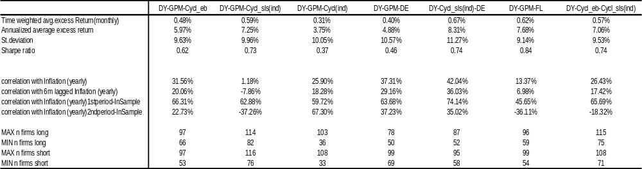
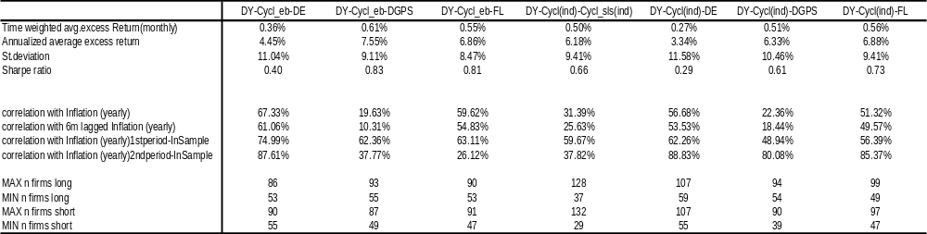
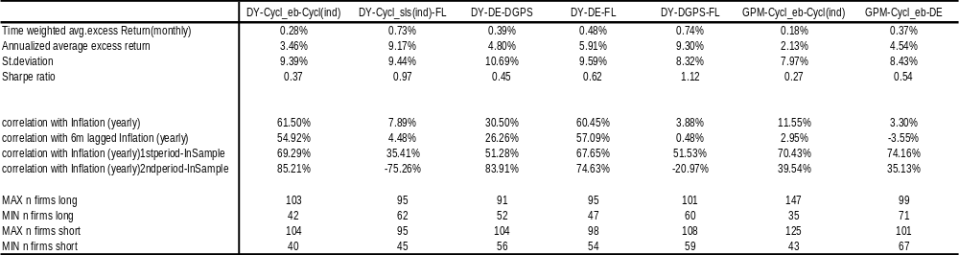
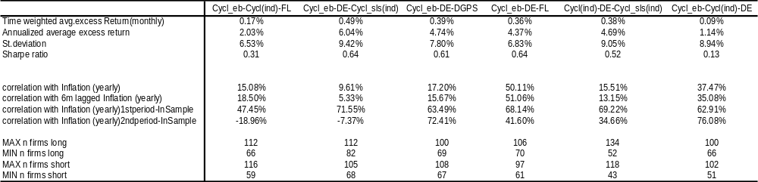

§5.4.2 Regressions
Table 11 displays the regression results for the multivariate stock selection strategies based on 3 variables. We can observe that 9 strategies in this case generate stock portfolios with significantly positive inflation betas using a 5% confidence level. In the appendix scatter plots are provided for these 9 different portfolios. As in the case for the bivariate strategies we can see that strategies including the DY as one of the sorting variables perform well in the context of this research. Of the 9 strategies with significantly positive inflation betas 8 include the DY as one of the sorting variables.

Table 11 Regression results multivariate strategies
This table reports the coefficients, p-values for the independent variables and the adjusted R² for the following regression:
R_{p} = Yearly return on the constructed portfolio
π = Yearly inflation
R_{m} = Yearly return on the MSCI EU

The sample period is from 12/90-12/98 consisting of 97 observations
All standard errors are heteroskedasticty and autocorrelation consistent due to the Newey-West correction.

*represents significant betas at the 1% confidence level
** represents significant betas at the 5% confidence level
*** represent significant betas at the 10% confidence level
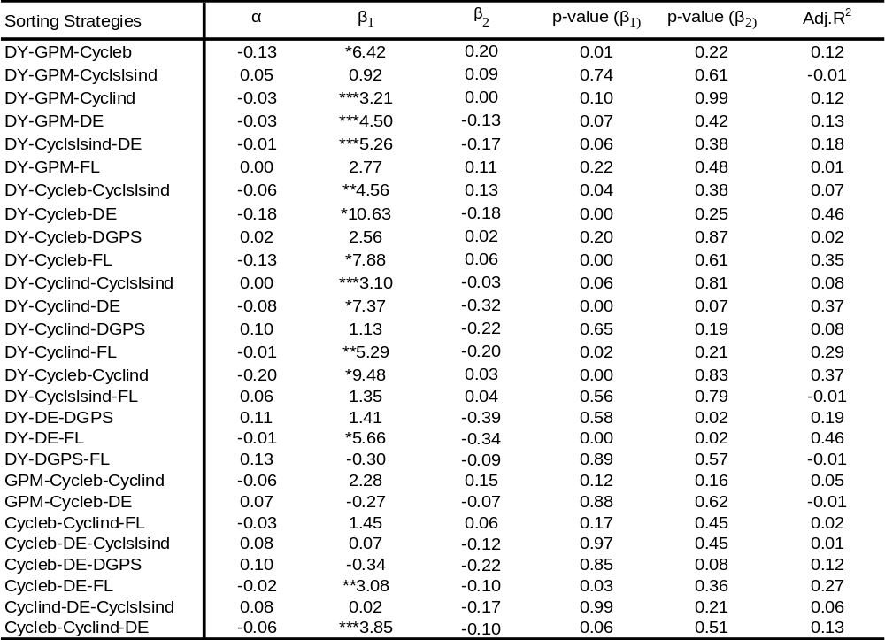

To conclude the analysis of the in sample period it is possible to state that several strategies, both in a univariate setting as well as in a multivariate setting, can be considered as effective in order to create inflation hedging stock portfolios. Based on the results mentioned above we have found a total of 18 strategies to generate portfolios displaying significantly positive inflation betas.
Next to the inflation hedging properties of the various stock selection strategies it is also important to consider the risk/return properties of these strategies in order to determine the best inflation hedging portfolios given the various strategies with significantly positive inflation betas mentioned earlier. In order to evaluate the risk/return properties of the various strategies with significantly positive inflation betas, I will use the Sharpe ratio. In this perspective the 3 stock selection strategies that generated portfolios with the highest Sharpe ratios given the fact that they displayed significantly positive inflation betas will be considered as the best inflation hedging portfolios and will be back tested in an out of sample period.

Comparing all strategies that generated significantly positive inflation betas, based on the Sharpe ratio we can identify three strategies that can be considered as generating the ‘best’ inflation hedging portfolios. These strategies are: DY-FL, DY-Cycl_eb-FL and DY-Cycl(ind)-FL. These three strategies all generate stock portfolios displaying significantly positive inflation betas at the 5% confidence level. These strategies also result in portfolios with Sharpe ratios between 0,73 and 0,90.
However in order to test the robustness of these strategies it is necessary to test these strategies in an out of sample period. In this thesis the out of sample period is the 8 years immediately after the end of the in sample period (January 1999 – December 2007). In the following section the results, with respect to the three strategies considered as generating the best inflation hedging portfolios, will be presented for the out of sample period.

§5.5 Backtesting with out of sample data
In this section the three stock selection strategies that generated the ‘best’ inflation hedging portfolios will be tested in an out of sample period. This implies that only the 3 strategies mentioned above will be taken into consideration in this section. The out of sample period is represented by the period January 1999 - January 2007. For the remainder, the outcomes will be presented in the same way as in the in sample period.

§5.5.1 Performance Statistics
First I will provide the performance statistics for the 3 strategies measured in the out of sample period
Table 12 displays the performance statistics of the portfolios that were constructed after ranking firms according to the 3 strategies that provided the best results in the in Sample period. Examining the results in Table 12 we can observe that some of the strategies that displayed very favourable characteristics with respect to inflation hedging capabilities in the in Sample Period do not seem to work (as) well in the out of sample period. Although Sharpe ratios have increased for all strategies we can also observe that correlations with inflation have decreased compared to the in sample period. Furthermore one can notice that there seems to be a discrepancy between the correlation with inflation of the portfolios in the 1st period and 2nd period of the out of sample period.

Table 12 Performance Statistics best inflation hedging strategies (out of sample)
This table provides the annualized excess returns, standard deviations, Sharpe ratios and yearly correlations with inflation for the three ‘best’ strategies based on the out of sample period . Excess returns are computed as the time weighted average of the portfolio returns. These are zero net investment long/short portfolios (l/s =100/100), in which a varying number of stocks (n) are included in the long and short portfolios depending on how much firms were in the winners and losers portfolio. Results are based on the period 01/99-12/07 consisting of 108 monthly observations. Yearly correlations are also computed based on 108 observations of which 54 observations belong to the 1st period and 54 to the 2nd period.
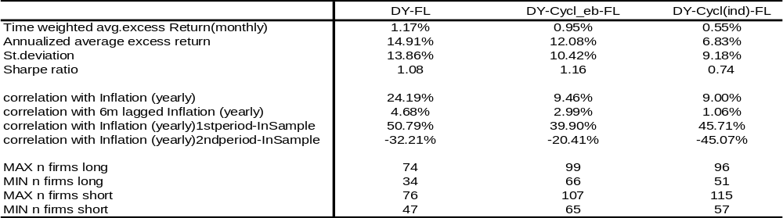

§5.5.2 Regressions
Again regressions are conducted in order to check whether the strategies above yielded significantly positive inflation betas in the out of sample period.

Table 13 Regression results ‘best’ inflation hedging strategies
This table reports the coefficients, p-values for the independent variables and the adjusted R² for the following regression:
R_{p} = Yearly return on the constructed portfolio
π = Yearly inflation
R_{m} = Yearly return on the MSCI EU

The sample period is from 01/99-12/07 consisting of 108 observations
All standard errors are heteroskedasticty and autocorrelation consistent due to the Newey-West correction.

*represents significant betas at the 1% confidence level
** represents significant betas at the 5% confidence level
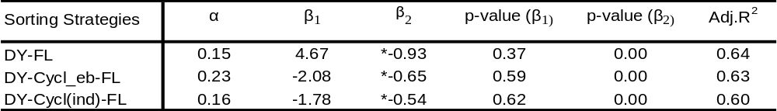

The results displayed in Table 13 show that the strategies generating significantly positive inflation betas in the in sample period do not continue to display this characteristic in the out of sample period. None of the 3 univariate strategies has significantly positive inflation betas in the out of sample. In two of the cases the inflation betas have even become negative (although not significantly). Another striking result is that in all strategies significantly negative market betas are obtained. This implies that in the out of sample period the three strategies move in opposite direction to the market portfolio, which is represented by the return on the MSCI EU 500. Having tested the ‘best’ strategies in the out of sample period, we see that although most of these strategies also displayed positive correlations with inflation in the out of sample period none of the strategies generated portfolios with significantly positive inflation betas. The final evaluation with respect to the inflation hedging portfolios will be made by estimating the inflation betas measured over an extended period containing both the in sample period as well as the out of sample period. The next section will discuss the results of the three best strategies measured over the entire period from December 1990-December 2007.

§5.5.3 Regressions with an expanding time span
Finally regressions are run for the 3 strategies using the extended period, including both the in sample period as well as the out of sample period running from December 1990 until December 2007, in order to investigate what kind of relationship holds for the extended time span.

Table 14 displays the regression results for the 3 strategies. Examining the results in Table 14 we can see that 2 of the 3 strategies generate portfolios displaying significantly positive inflation betas over the extended time span running when using a confidence level of 5%. Another interesting feature of these portfolios is that they all display significantly negative market betas. Examining the performance statistics of these strategies one can notice that all strategies generate positive Sharpe ratios. Comparing the Sharpe ratios of the two strategies that generate portfolios displaying significantly positive inflation betas one can notice that the bivariate strategy DY-FL generates stock portfolios with higher Sharpe ratio in both the in sample as well as in the out of sample period. Based on this we can draw the conclusion that the bivariate strategy of sorting stocks according to the DY and the FL jointly yields portfolios with some inflation hedging characteristics. This strategy generates a stock portfolio displaying positive correlations with inflation, significantly positive inflation betas (when measured over the in sample period and the extended time span) and Sharpe ratios of 0,90 in the in sample period and 1,08 in the out of sample period. However it remains important to note that the inflation hedging characteristics of this strategy diminishes in the out of sample period and as such is not very robust.

Table 14 Regression results ‘best’ inflation strategies extended time span
These tables report the coefficients, p-values for the independent variables and the adjusted R² for the following regression:
R_{p} = Yearly return on the constructed portfolio
π = Yearly inflation
R_{m} = Yearly return on the MSCI EU

The sample period is from 12/90-12/07 consisting of 205 monthly observations
All standard errors are heteroskedasticty and autocorrelation consistent due to the Newey-West correction.

*represents significant betas at the 1% confidence level
**represents significant betas at the 5% confidence level
*** represents significant betas at the 10% confidence level
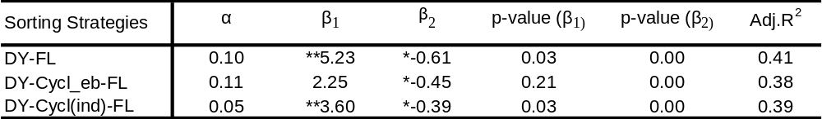

Now that a single strategy has been identified that can be considered as the best inflation hedging stock selection strategy in the context of this, several additional test will be conducted with respect to this strategy.

§5.6 Extending the analysis
In the previous section the bivariate stock selection strategy DY-FL was identified as the best inflation hedging stock selection strategy in the context of this thesis. In this section I will provide the results of some additional tests with respect to this particular stock selection strategy.
First of all I will provide the development of the inflation betas throughout time. Starting from the inflation beta obtained from the analysis of the in sample period, the time span will be increased with one year each time so that we will end up with 9 inflation betas of which the last one will be the same as displayed in table 14.
Then I will present the results of the style analysis, including the Fama & French factors to the original regression model. Finally I will further elaborate on the transaction costs of the ‘best’ inflation hedging strategy in this thesis.

Table 15 displays the inflation betas of the strategy DY-FL throughout time. Examining table 15 one can notice that after the period 1990-2000 the inflation beta decreases substantially and the p value increases, however the inflation betas always stay significant at a 5% confidence level and from the period 1990-2002 on the inflation betas stabilize at a level around 5.

Table 15 Regression results with yearly extending time spans
This table reports the inflation betas and corresponding p-values for the stock selection strategy DY-FL with an extending time spans. The time span is extended each time with one year and starts from the period 12/1990-12/1999. The inflation betas and corresponding p values are obtained by running the following regression:
R_{p} = Yearly return on the constructed portfolio
π = Yearly inflation
R_{m} = Yearly return on the MSCI EU

All standard errors are heteroskedasticty and autocorrelation consistent due to the Newey-West correction.
The three stock selection strategies that are examined here are the strategies that generated significantly positive inflation betas when measured over the entire time span.
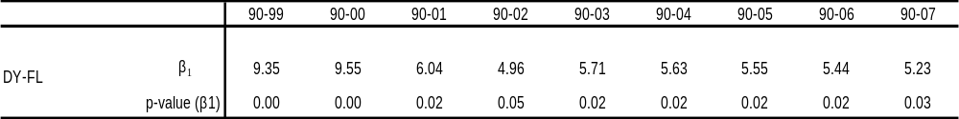

Exhibit 3 Portfolio Returns DY-FL through time
This graph displays the yearly returns of the long/short portfolio of sorting stocks jointly according to their DY and FL. Returns are yearly returns that are rolled every month.

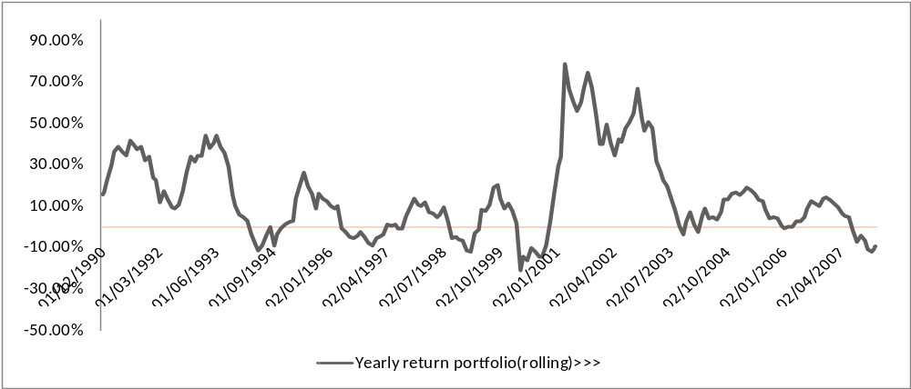

Exhibit 3 displays the yearly portfolio returns of the DY-FL stock selection strategy. One can notice that in four periods yearly returns become slightly negative. Besides this there also some periods in which the portfolio displays very high portfolio returns. This especially holds for the 2001-2003 period.
Now that we have seen that the inflation betas of the strategy DY-FL remain significantly positive during extended time spans and have examined the yearly returns of this portfolio through time, I will present the results of the style analysis. Table 16 displays the results of the 4 factor model in which the Fama & French factors are included into the earlier used regression model. Examining the results one can notice that the strategy of sorting stocks according to their DY and FL jointly can be considered as a strategy that is sensitive to the HML effect. The coefficient for the HML portfolio is significantly positive at a 1% confidence level. After including the two Fama & French factors the inflation beta remains positive and significant at a 5% confidence level, although the p-value has increased. One can also notice that the market beta also remains significantly negative. This result can be considered as not very surprising since dividend yield, as was mentioned in the previous chapter, also can be considered as a value based criteria like the HML. In order to check whether the strategy resulted in a sector bet, I added two pie charts in the appendix displaying the industry composition of the firms in the portfolio generated by the stock selection strategy DY-FL.

Table 16 Style anlaysis DY-FL strategy
This table reports the betas and corresponding p-values of the 4 factor model for the stock selection strategy DY-FL for the extended time span. The betas and corresponding p values are obtained by running the following regression:

R_{p} = Yearly return on the constructed portfolio
π = Yearly inflation
R_{m} = Yearly return on the MSCI EU
SMB = Yearly return on a small minus big firm portfolio
HML = Yearly return on a high minus low value portfolio.

The sample period is from 12/90-12/07 consisting of 205 monthly observations
All standard errors are heteroskedasticty and autocorrelation consistent due to the Newey-West correction.

*represents significant betas at the 1% confidence level
**represents significant betas at the 5% confidence level
*** represents significant betas at the 10% confidence level
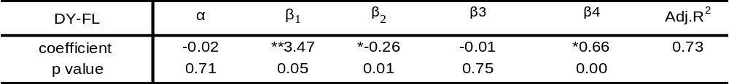

Having considered the inflation hedging properties of the stock strategy ‘DY-FL’ throughout time using inflation betas with expanding time spans and having examined the sensitivity of this strategy to the Fama & French factors, I will finally elaborate on the transaction costs of this strategy. In chapter 4 it was mentioned that portfolio rebalancing happened monthly. This can lead to very trade intensive strategies with a high turnover and corresponding high transaction costs. In order to examine to what extent these transaction costs will erode the profits of the stock selection strategy ‘DY-FL’, I have computed the turnover, transaction costs and the performance statistics after transaction costs for this stock selection strategy. To compute transaction costs, an assumption is made of average round trip transaction costs of 20 basis points. Table 17 displays the results of the best inflation hedging stock selection strategy after accounting for the transaction costs. One can observe that transaction costs do not seem to pose a serious setback to profits resulting from the stock selection strategy ‘DY-FL’. Average turnover is close to 28% and average monthly transaction costs are 0.06%. Computing the average return of this strategy we can see that on an annualized basis transaction costs reduce the average annualized return to 11.29% compared to the 12.03% return in the case of no transaction costs.
Table17
This table provides the information regarding the transaction costs of the stock selection strategy DY-FL. Turnover in month m was computed as the number of transaction conducted for the month m divided by the number of stocks in the portfolio in the preceding month (m-1). The average returns are computed for the extended period running from January 1990-December 2007. When assuming round trip transaction costs of 20bps average return are computed by extracting from the realized returns in each month the transaction costs made, due to rebalancing in that month.
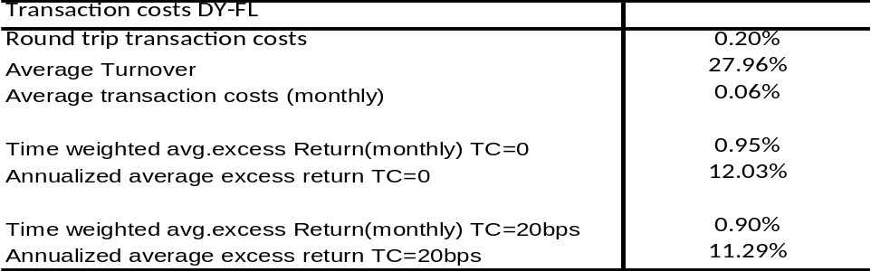

In this chapter I have presented the results of various stock selection strategies aiming to generate inflation hedging stock portfolios. The time span was divided into two parts in order to back test the results of the best inflation hedging portfolios in an out of sample period. Several strategies proved to display significantly positive inflation betas in the in sample period. Of these strategies I chose the three strategies generating portfolios with the highest Sharpe ratio in the in sample period as the best inflation hedging stock selection strategies. All of these 3 strategies contained the dividend yield as one of the sorting variables. These strategies were tested in the out of sample period and for the extended time span including both the in sample period as well as the out of sample period.
Testing for only the out of sample period resulted in inflation betas that had become insignificant for all strategies, however when using the extended time span two of the three strategies again displayed significantly positive inflation betas. Of these two strategies the one strategy generating a portfolio with the highest Sharpe ratio was considered as the best inflation hedging stock selection strategy. The bivariate stock selection strategy of sorting stocks jointly on their dividend yields (DY) and their flow through coefficients (FL) and taking long positions in the firms belonging to the winners portfolio based on these two variables and taking short positions in the firms belonging to the losers portfolio proved to be the best inflation hedging strategy in this case. Including the Fama & French factors into the regression one could notice that the returns on such a portfolio were highly sensitive to the value effect. Furthermore we noticed that the strategy remained profitable after considering transaction costs.

CHAPTER 6
CONCLUSIONS & RECOMMENDATIONS

Several decades of empirical research regarding the inflation hedging properties of common stocks showed that equities as an asset class performed very poorly as a hedge against inflation. Many researchers found negative relationships between equity returns and inflation during various periods. This was clearly in contradiction to the Fisher hypothesis, which stated that this relationship should be (perfectly) positive and the theoretical notion of stocks as being natural hedges against inflation since stocks represent claims against the underlying value of assets whose prices increase (more rapidly) in periods of high(er) inflation. Although a great part of empirical studies documented negative relationships between stock returns and inflation, this does not mean that stocks as an asset class are entirely useless in an inflation hedging context
Several researchers attempted to find explanations for the rather surprising negative relationship between inflation and stock returns. Academics such as Fama (1981) and Boudoukh & Richardson came up with different explanations in order to explain the negative relationship between inflation and stock returns. Furthermore several studies such as Boudoukh, Richardson & Whitelaw (1994) and Asikoglu & Ercan (1992) suggested that there were cross sectional differences in the relationship between inflation and stock returns. Based on such studies I attempted in this thesis to construct several univariate and multivariate stock selection strategies aiming to obtain stock portfolios with inflation hedging properties in order to contribute to the liability hedging portfolio of APG Investments.
Based on the existing literature several variables were identified as possibly valuable in this setting and employed as sorting variables by which stocks in the MSCI EU universe were ranked and allocated to a winners/losers portfolio. Finally equally weighted portfolios were constructed by selling the losers portfolio and buying the winners portfolio. This was done for 13 univariate strategies, 28 bivariate strategies and more than 40 multivariate strategies.
The results displayed various long/short stock selection strategies that generated portfolios with some inflation hedging properties. It was also shown that introducing a constraint of short selling stocks dramatically decreased the inflation hedging qualities of equities. Many of the (bivariate and multivariate) strategies with inflation hedging properties contained the dividend yield as one of the sorting variables. The best inflation hedging strategy in the context of this thesis proved to be the strategy of sorting stocks according to both their dividend yields and flow through rates jointly since this strategy obtained the highest Sharpe ratio among all strategies with a significantly positive inflation beta.
Engaging in such a strategy generated long/short portfolios displaying a yearly correlation with inflation of 67% in the in sample period and 24% in the out of sample period. More important the portfolio generated by this strategy also displayed significantly positive inflation betas measured over the in sample period and over the extended time span. The significantly positive inflation beta for the extended time span continued to exist even after the inclusion of the Fama & French factors of which the HML factor was known to be highly correlated with the returns on a portfolio constructed by sorting on dividend yields. Besides displaying inflation hedging properties, this strategy also obtained annualized returns of 9.2% in the in sample period and 14.9% in the out of sample period. The strategy remained to be profitable after transaction costs. However it is important to note that the inflation hedging properties of this strategy as well as the other strategies did not prove to very robust as the inflation hedging properties drastically diminished in an out of sample period.
Another remarkable characteristic of the above mentioned strategy is that it not only displays significantly positive inflation betas, enabling us to consider this as an inflation hedging strategy, but also significantly negative market betas. This implies that the portfolios generated by this strategy perform well in periods that the stock markets in general perform poorly. It is this last mentioned feature that becomes important in the light of the developments in financial markets in the previous year. At this moment (April 2009) financial markets throughout the world are still in the grip of the credit crisis that has lead to a collapse in stock markets worldwide. Since the stock selection strategies that have been examined here, displayed negative market betas one could argue that the world wide drop in stock markets does not necessarily have to have adverse effects on the performance of these portfolios. However it is important to note that the negative market beta arises due to the fact that we have constructed 100/100 long/short portfolios. During the credit crisis however, financial authorities in many countries imposed restrictions on short selling stocks. This would mean that taking new short positions would no longer be possible and we could no longer monthly rebalance our short portfolio for the duration of the restriction. Instead of monthly rebalancing the short positions we would have to maintain the short positions as they were in the final month before the restrictions were imposed. The result of this on the strategies’ performance and inflation hedging properties is hard to predict. As the portfolio will still be a 100/100 long/short portfolio some of the properties could be expected to remain unchanged. However the stocks in the short list will no longer be the result of a monthly update.
Although the results in this thesis show that there is some indication of the possibility to construct long/short stock portfolios with inflation hedging properties and stocks do not necessarily have to be considered useless in an inflation hedging context, there are some critical notes that have to be made. First of all the inflation hedging characteristic of the strategies mentioned do not seem to be very robust. Furthermore one should notice that the time span of this study is rather limited with only 18 years of data. In this perspective it could be interesting to conduct a similar study using US data, which might enable one to conduct this research using more years of data, improving the reliability of the conclusions to be drawn from the results. Besides the fact that when conducting this study for the US one will be able to use more years of data, one will also be able to determine to what extent the results obtained in this case can be considered as universal or a local phenomenon. If one would yield the same results using US data as obtained in this case, this would clearly indicate that the results obtained here are universal.
Furthermore it can be of value, especially for pension funds, to construct stock selection strategies that focus on another variable that is of major importance to the liabilities of pension funds, namely interest rates. In this perspective researches studying the interest rate sensitivity of various stock selection strategies can be of value.

REFERENCES

-Ahmed & Cardinale, 2005, “Does inflation matter for equity returns?” The Journal of Asset Management, vol.6, no 4, pp.259-273.
-Alford, Jones & Lim, 2003, from the book “Modern Investment Management by Litterman et al, Chapter 23 Equity Portfolio Management.
-Asikoglu & Ercan, Spring 1992, “Inflation Flow Through and Stock Prices”, Journal of Portfolio Management.
-Bodie, Winter 1990, “Inflation, Indexed-Linked Bonds and Asset Allocation”, Journal of Portfolio Management,
-Bodie, 1976, “Common Stocks as a Hedge Against Inflation”, The Journal of Finance, Vol. 31, No.2, pp.459-470.
-Bodie, Kane & Marcus, 2005, “Investments”, 6th edition, McGraw-Hill International Edition.
-Boudoukh & Richardson, Dec.1993, “Stock Returns and Inflation: A Long-Horizon Perspective”, The American Economic Review, Vol.83, No.5, pp.1346-1355.
-Boudoukh, Richardson & Whitelaw, Dec.1994, “Industry Returns and the Fisher Effect”, The Journal of Finance, Vol.49, No.5, pp.1595-1615.
-Cechetti & Groshen, 2003, “Understanding Inflation: Implications for Monetary Policy”, Chapter 7 of “Advances in Macroeconomic Theory” by Jacques Dreze.
-Chan, Jegadeesh & Lakonishok, 1996, “Momentum Strategies”, The Journal of Finance,
Vol.LI, No.5, pp.1681-1713.
-Deacon & Derry, 1998, “Inflation-Indexed Securities”, Prentice Hall Europe.
-Ely & Robinson, “Are stocks a hedge against inflation? International evidence using a long run approach”, Journal of International Money and Finance, Vol.16, No.1, pp.141-167.
-Engsted & Tanggaard, March 2000, “The relation between asset returns and inflation at short and long horizons”, Vol.12, pp.101-118.
-Estep, Hanson & Johnson, Summer 1993, “Sources of value and risk in common stocks”, The Journal of Portfolio Management.
-Fabozzi, 2000, “Bond Markets, Analysis and Strategies”, 4th Edition, Prentice Hall.
-Fama & Schwert, 1977, “Asset Returns and Inflation”, Journal of Financial Economics, Vol.5, pp.115-146.
-Fama, 1981, “Stock Returns, Real Activity, Inflation and Money”, The American Economic Review, Vol.71, No.4, pp.545-565.
-Froot, Summer 1995, “Hedging Portfolios with Real Assets, Journal of Portfolio Management.
-Fuller & Petry, Summer 1981, “Inflation, Return on Equity and Stock Prices”, The Journal of Portfolio Management.
-Geske & Roll, 1983, “The Fiscal and Monetary Linkage between Stock Returns and Inflation, Vol.38, No.1, pp.1-33.
-Gorton & Rouwenhorst, 2004, “Facts and Fantasies about Commodity Futures”, Yale ICF Working Paper, No.04-20.
-Gultekin, “Stock Market Returns and Inflation: Evidence from Other Countries”, The Journal of Finance, Vol.38, No.1, pp.49-65.
-Hart van der, Slagter, van Dijk, “Stock selection strategies in Emerging Markets”, 2001,
Tinbergen Institute Discussion Paper.
-Heer de, Koller, Schauten & Steenbeek, 2000, “The Valuation of Cyclical Companies”.
-Hoevenaars, Molenaar, Schotkamp & Steenkamp, 2005, Strategic Asset Allocation with Liabilities: Beyond Stocks and Bonds”.
-Jaffe & Mandelker, 1975, “The Fisher Effect for Risky Assets: An Empirical Investigation”, The Journal of Finance, Vol.31, No.2, pp.447-458.
-Jareño, 2005, “Flow through Capability; The Spanish Case”, Journal of Asset Management, Vol.6, No.3, pp.191-205.
-Jareño, 2007, “Spanish Stock Market Sensitivity to Real Interest and Inflation Rates: An extension of the Stone two factor model with factors of Fama and French three factor model”, Applied Economics 2007, pp.1-13.
-Jegadeesh & Titman, 2001, “Profitability of Momentum Strategies: An Evaluation of Alternative Explanations”, The Journal of Finance, Vol.56, No.2, pp.699-720.
-Jones, Spring 2008, “Analysing and Estimating Real Stock Returns”, The Journal of Portfolio Management.
-Lakonishok, Shleifer & Vishny, 1994, “Contrarian Investments, Extrapolation and Risk, The
Journal of Finance, Vol.49, No.5, pp.1541-1578
-Lee, 1992, “Causal Relations Among Stock Returns, Interest Rates, Real Activity and Inflation, The Journal of Finance, Vol.47, No.4, pp.1591-1603.
-Leibowitz & Kogelman, Winter 1993, “Inflation Adjusted ROE’s: Strong Effects even with low Inflation, The Journal of Investing.
-Lucas & Quek, December 1998, “A Portfolio Approach to TIPS”, The Journal of Fixed Income, pp.75-84.
-Ma & Ellis, Summer 1989, “Selecting industries as inflation hedges”, The Journal of Portfolio Management, pp.45-48.
-Marshall, 1992, “Inflation and Asset Returns in a Monetary Economy”, The Journal of Finance, Vol.47, No.4, pp.1315-1342.
-McFall Lamm Jr., Summer 1998, “Asset Allocation Implications of Inflation Protection Securities”, The Journal of Portfolio Management, pp.93-100.
Nijman, Swinkels & Verbeek, 2004, “Do countries or industries explain momentum in
Europe?”, The Journal of Empirical Finance, Vol.11, pp.461-481.
-Nelson, 1976, “Inflation and Rates of Return on Common Stocks”, The Journal of Finance, Vol.31, No.2, pp.471-483.
-Pearce & Roley, 1988, “Firm Characteristics, Unanticipated Inflation and Stock Returns”, Vol.43, No.4, pp.965-981.
-Reilly, Summer 1975, “How to use common stocks as an inflation hedge”, The Journal of Portfolio Management, pp.38-43
-Reilly & Brown, 1997, “Investment Analysis and Portfolio Management”, 5th edition, The Dryden Press.
-Reilly, Wright and Johnson, Spring 2007, “Analysis of the Interest Rate Sensitivity of Common Stocks, The Journal of Portfolio Management, pp.85-107.
-Siegel, 2002, “Stocks for the Long Run”, 3rd Edition, McGraw-Hill
-Stulz, 1986, “Asset Pricing and Expected Inflation”, The Journal of Finance, Vol.41, No.1, pp.209-223.
-Sweeney & Warga, 1986, “The Pricing of Interest Rate Risk: Evidence from the Stock Market”, The Journal of Finance, Vol.41, No.2, pp.393-410.
-VanderHoff & VanderHoff, 1986, “Inflation and Stock Returns: An industry Analysis”, Journal of Economics and Business, Vol.38, pp.341-352.
-Webb, Fall 1990, “On the exclusion of real estate from the market portfolio”, The Journal of Portfolio Management, pp.78-84.

APPENDIX

A1 Portfolio Returns of univariate strategies with n = 35
These tables provide the annualized excess returns, standard deviations, Sharpe ratios and yearly correlations with inflation for the 13 strategies based on single variable sorting. . Excess returns are computed as the time weighted average of the portfolio returns. These are zero net investment long/short portfolios (l/s =100/100), in which 35 stocks are included in the long portfolio and 35 stocks are included in the short portfolio (n=35). Results are based on the period 01/90-12/98 consisting of 108 monthly observations. Yearly correlations are computed based on 97 observations of which 48 observations belong to the 1st period and 47 to the 2nd period.

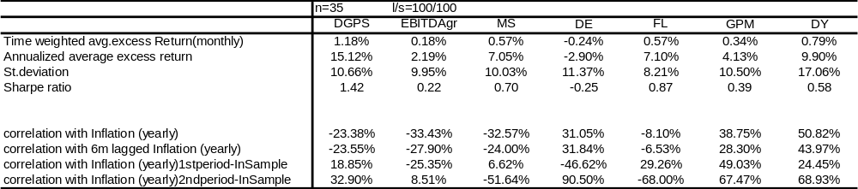
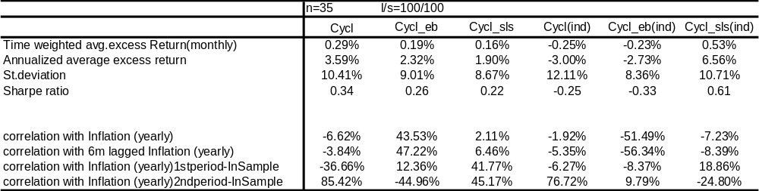

A2 Portfolio Returns of univariate strategies with n = 15
These tables provide the annualized excess returns, standard deviations, Sharpe ratios and yearly correlations with inflation for the 13 strategies based on single variable sorting. . Excess returns are computed as the time weighted average of the portfolio returns. These are zero net investment long/short portfolios (l/s =100/100), in which 15 stocks are included in the long portfolio and 15 stocks are included in the short portfolio (n=15). Results are based on the period 01/90-12/98 consisting of 108 monthly observations. Yearly correlations are computed based on 97 observations of which 48 observations belong to the 1st period and 47 to the 2nd period.
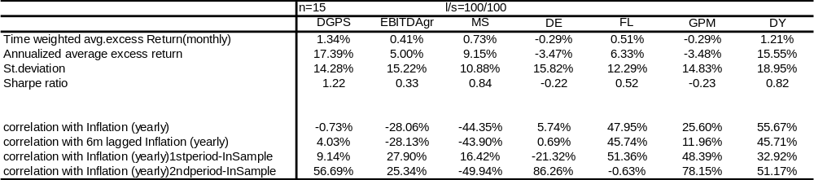
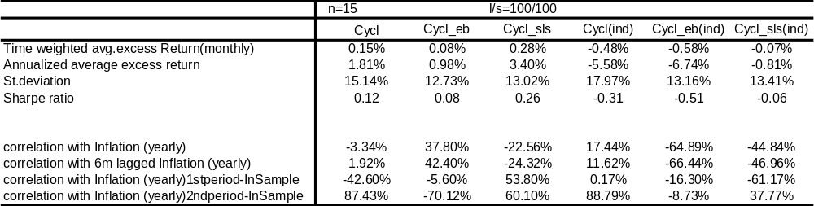
B1 Scatter plots of 6 univariate strategies
These graphs display the scatter plots of yearly returns vs yearly inflation of 6 univariate strategies for the extended time period running from December 1990 until December 2007. The scatter plot consists of in total 205 monthly observations of yearly returns and yearly inflation that roll every month.

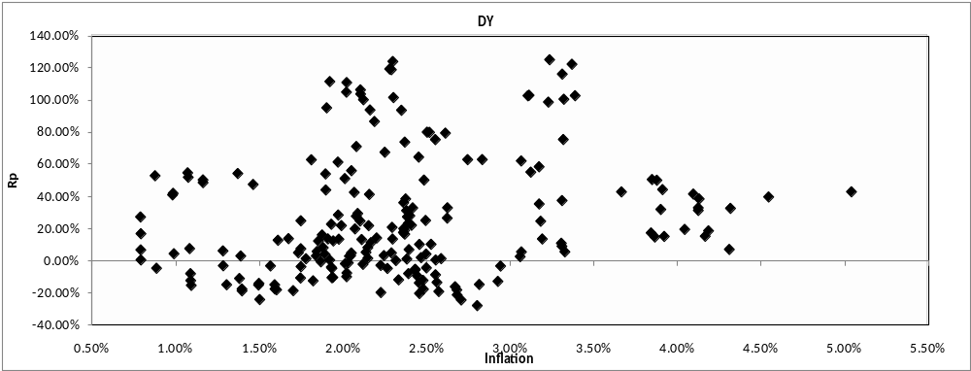

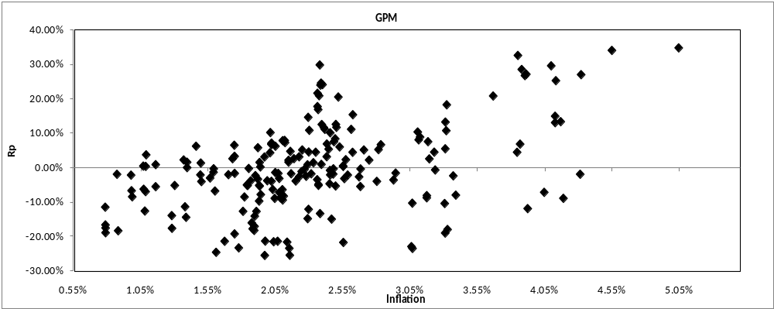

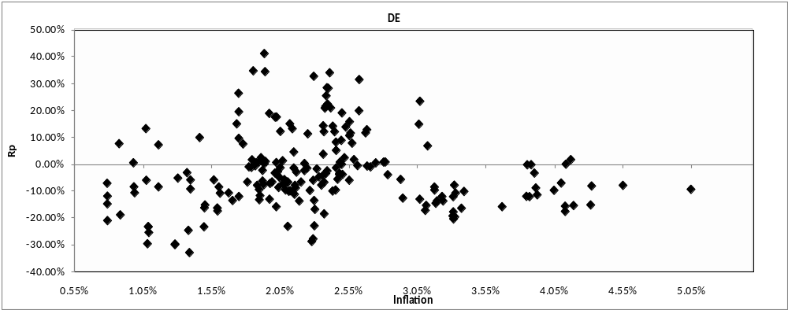

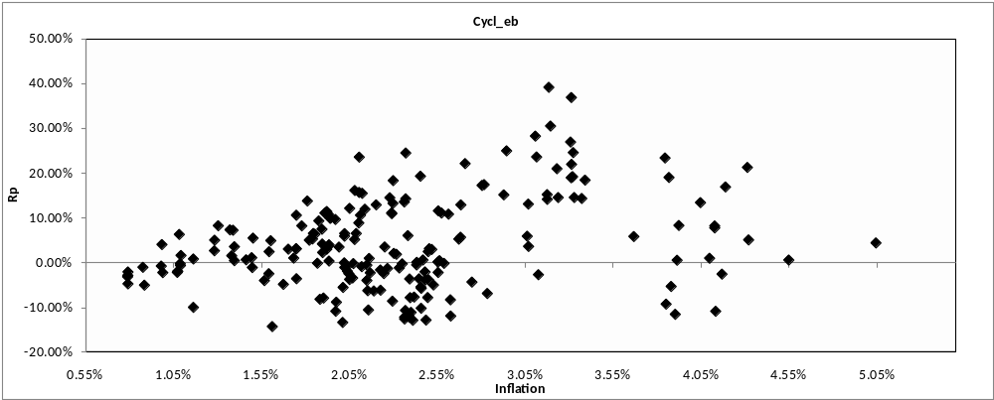

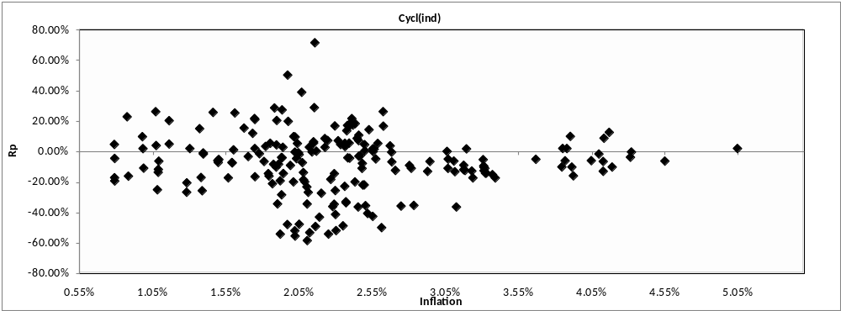

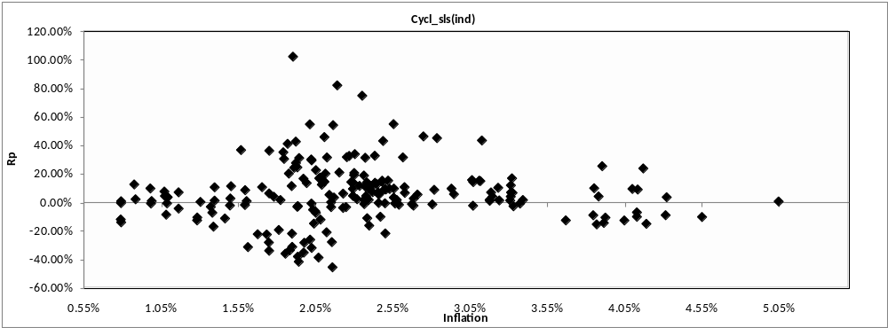

C Scatter plots of 6 bivariate strategies
These graphs display the scatter plots of yearly returns vs yearly inflation of 6 univariate strategies for the extended time period running from December 1990 until December 2007. The scatter plot consists of in total 205 monthly observations of yearly returns and yearly inflation that roll every month.

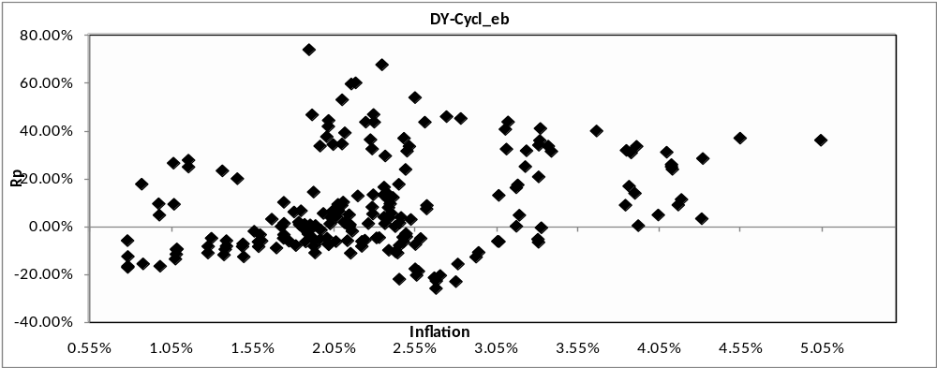

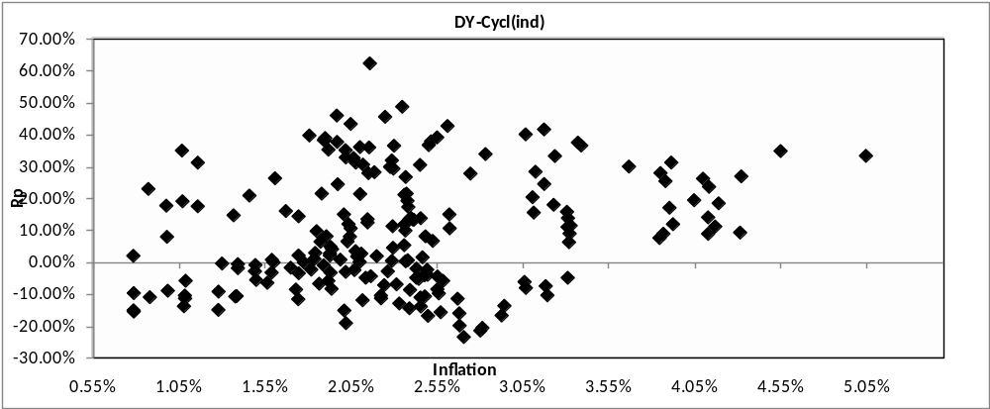

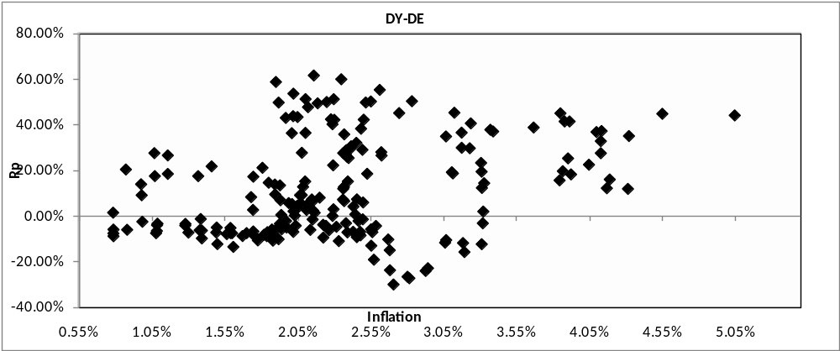

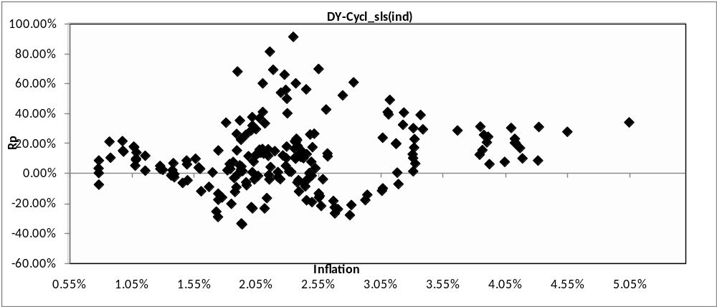

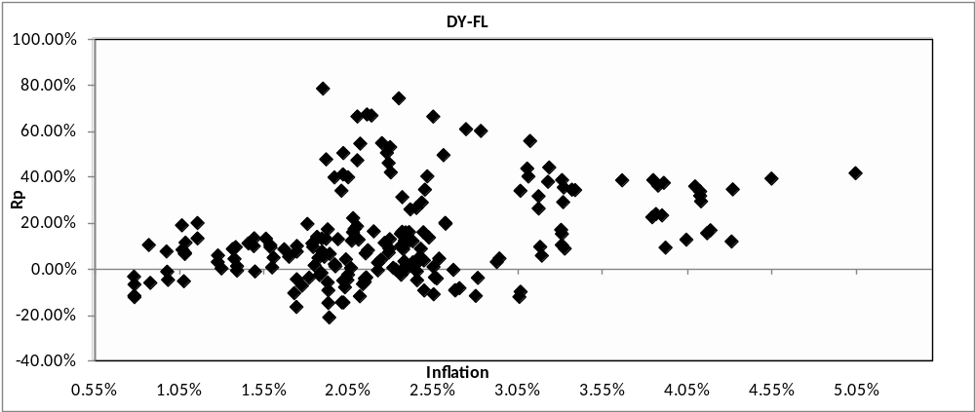

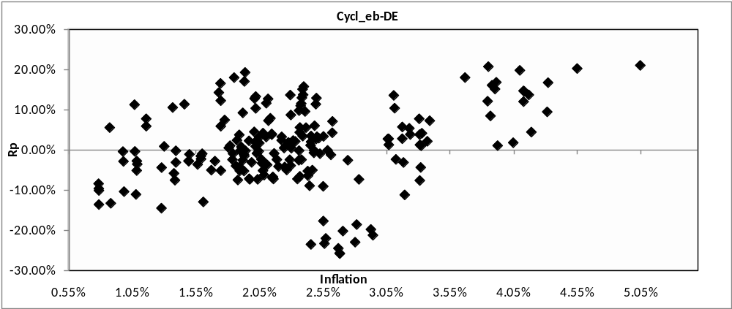

D Scatter plots of 9 univariate strategies
These graphs display the scatter plots of yearly returns vs yearly inflation of 9 multivariate strategies for the extended time period running from December 1990 until December 2007. The scatter plot consists of in total 205 monthly observations of yearly returns and yearly inflation that roll every month.

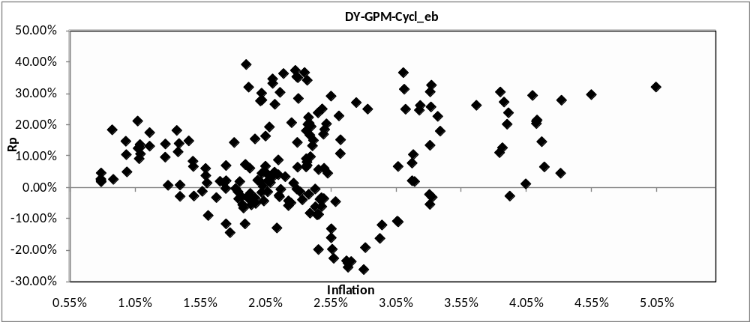

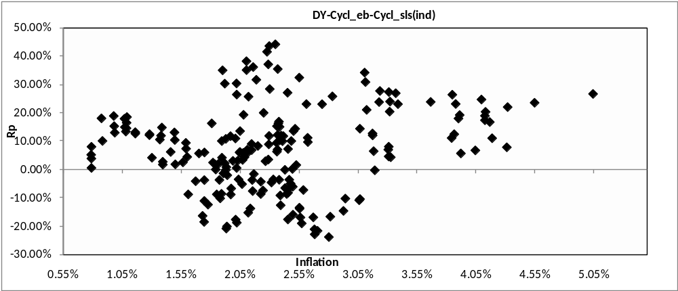

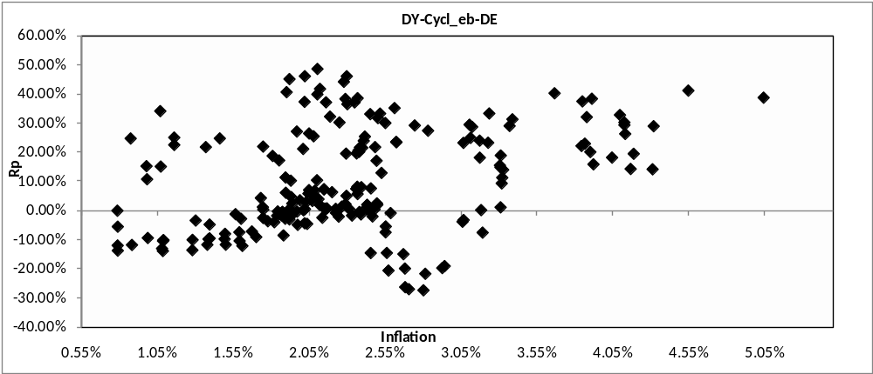
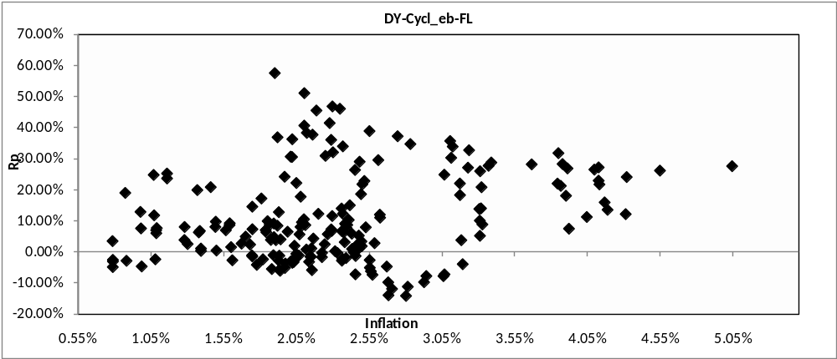

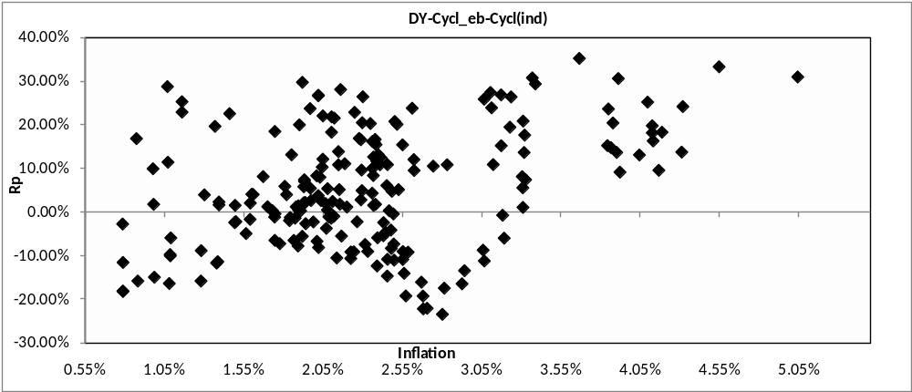

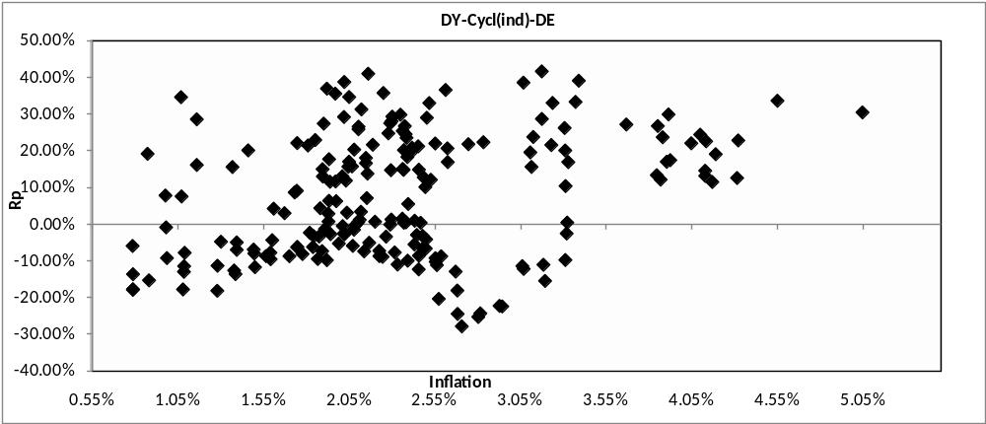

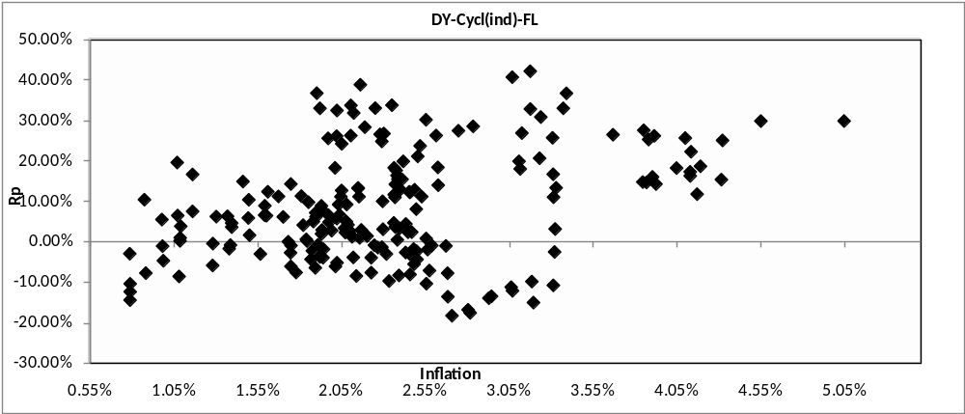

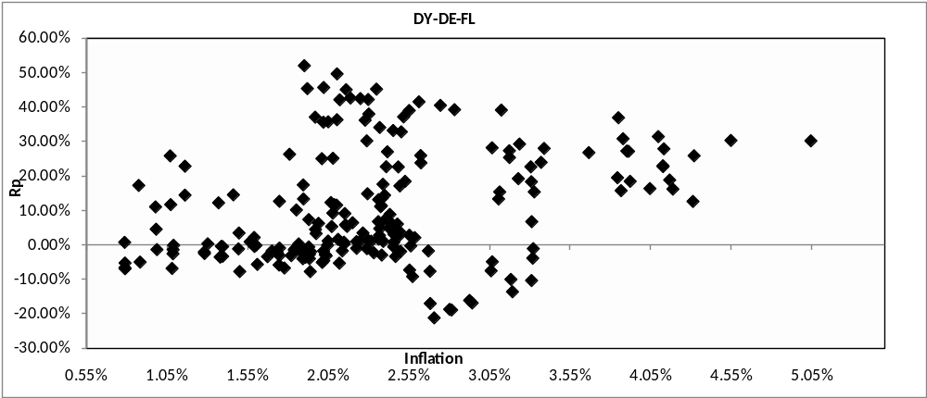

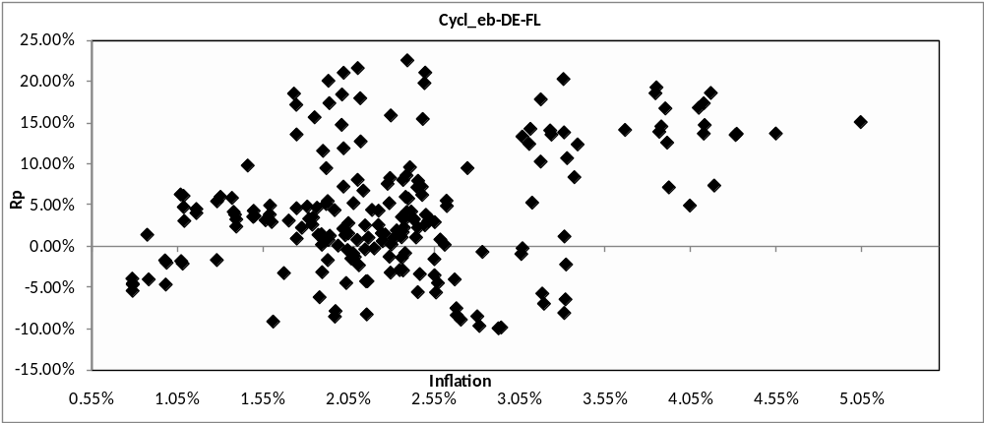

E1 Industry composition of the winner portfolio of the strategy DY-FL
This pie chart displays the industry composition of the winners portfolio from the DY-FL stock selection strategy. The percentages are obtained by computing the industry composition of the winners portfolio for each month and then taking the average of these percentages at the end of December 2007 in order to obtain these average industry composition figures.

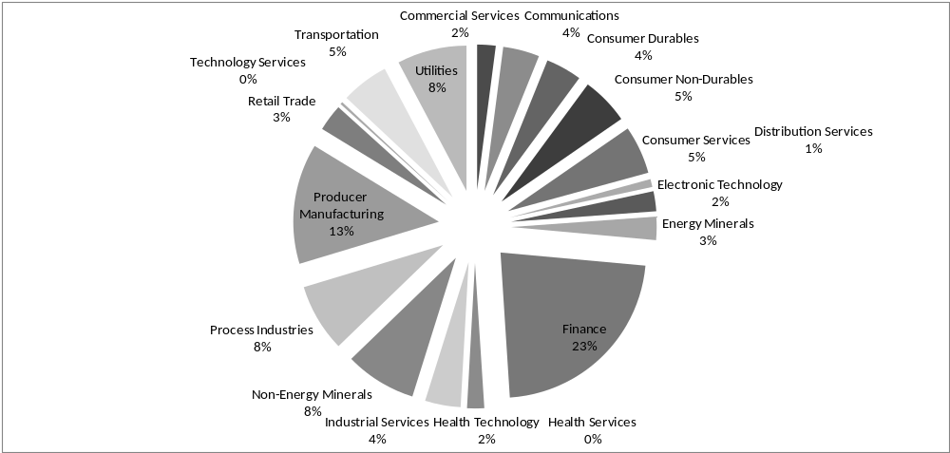

E2 Industry composition of the losers portfolio of the strategy DY-FL
This pie chart displays the industry composition of the winners portfolio from the DY-FL stock selection strategy. The percentages are obtained by computing the industry composition of the winners portfolio for each month and then taking the average of these percentages at the end of December 2007 in order to obtain these average industry composition figures.

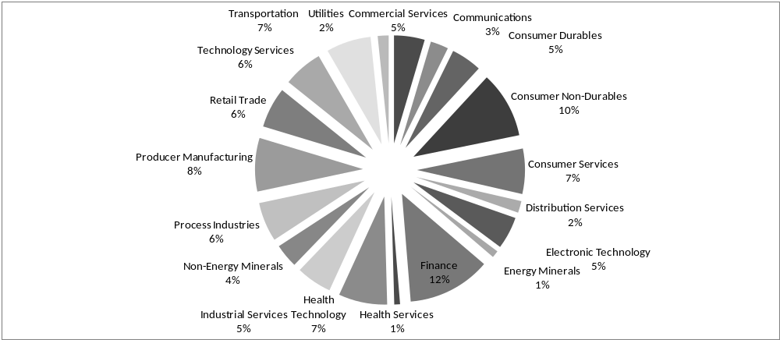

Internal LHP-ROP report of APG Investments, pg.7-22.
This was mentioned in a study by the Inflation Persistence Network (IPN), “Inflation Persistence and Price Setting Behaviour in the Euro Area”,(2008),http://www.ecb.eu/home/html/researcher_ipn_briefsummary.en.html
For a more detailed discussion of these issues see J.Dreze, “Advances in Macroeconomic Theory”, (2003) Chapter 7 “Understanding Inflation: Implications for monetary policy” by S.G. Cechetti & E.L. Groshen
For more information regarding the HICP for the Euro zone I refer to “Harmonized Indices of Consumer Prices; A short guide for users”, March 2004, published by Eurostat. http://epp.eurostat.ec.europa.eu/cache/ITY_OFFPUB/KS-BE-04-001/EN/KS-BE-04-001-EN.PDF
Article 121 of the European Union Treaty has made the harmonization of computing consumer price indices a requirement for member states.
“Harmonized Indices of Consumer Prices; A short guide for users”, March 2004, published by Eurostat, pg.4-5.
“Harmonized Indices of Consumer Prices; A short guide for users”, March 2004, published by Eurostat, pg.5.
M.Deacon & A. Derry, “Inflation Indexed Securities” (1998), pg.5.
For more detailed information with respect to the French ILB I refer to “OAT€I; The first government bond linked to the Euro zone CPI”, Agency France Tresor, http://www.aft.gouv.fr/IMG/pdf/guide_oatei2012_en.pdf
Quants no 32 – December 1998, “The Market for Inflation”, pg.5-6
Internal report LHP/ROP of APG Investments.
Internal report LHP/ROP of APG Investments pg.14
Internal report LHP/ROP of APG Investments pg.15-16
While this thesis was being written the decision was made to only include fixed income securities into the LHP for the time being with the intention to extend the LHP with several other asset classes that are believed to have inflation hedging properties.
G. Gorton & K.G. Rouwenhorst, “Facts and Fantasies about Commodity Futures” (2005)
Ely & Robinson, “Are stocks a hedge against inflation? International evidence using a long run approach”, Journal of International Money and Finance, Vol.16, No.1, pp.141-167.
Monthly stock returns were obtained from the Scholes Index of value weighted returns and from the returns on the S&P 500 Index
Regressions with contemporaneous and leaded inflation can contain unanticipated inflation; however the lagged regressions cannot and should always generate positive inflation betas that are not significantly different from one according to the Fisher hypothesis
The market portfolio in this case is represented by an equally weighted portfolio consisting of all stocks on the NYSE
1953/1-1958/12, 1959/1-1964/12 and 1965/1-1971/12
Returns of T bills were derived from the quote sheets of Salomon Brothers
Returns on US government bonds are derived with indices based on the work of Bildersee (1974)
Returns on residential real estate was derived from the Home Purchase Price component of the Consumer Price Index
Returns on common stocks are derived by constructing an equally weighted portfolio of all NYSE stocks as well as a value weighted portfolio of all NYSE stocks of which the data is obtained from the Centre for Research in Security Prices (CRSP).
Other empirical studies w.r.t. this topic with similar results were Gultekin (1983), Engsted & Tanggaard (2000), Reilly (1975) e.g.
This was computed as the return on a value weighted portfolio of all NYSE common stocks minus the annual continuously compounded inflation rate.
Another research in this context was conducted by Lee (1992)
It is important to note that the lags used in these cases were quite large (minimum of 4 years up to 10 years) and the results were dependant of the lags used and of the data series used.
Asikogu and Ercan, Spring 1992, “Inflation Flow-Through and Stock prices”, The Journal of Portfolio Management, pg.63.
To calculate flow through rates Asikoglu and Ercan used a similar method as Estep and Hanson (1980), who were the first authors to compute inflation flow through coefficients.
The high flow through industries are Chemicals, Electrical Equipment, Foods, Paper & Forest Products, Publishing, Steel, Textile Products and Tobacco.
The low flow through industries are Industrials, Coal, Machinery, Oil & Gas Drilling, Textile & Apparel and Utilities.
Reilly & Brown, 1997, “Investment Analysis and Portfolio Management”, 5th Edition, pg.390-391.
Mining and Primary Metals
Leather, Tobacco, Apparel, Electrical Machinery, Furniture, Instruments, Food & Beverage, Rubber & Plastics
Leather
Inflation in this thesis is represented by the Harmonised Index for Consumer Prices (HICP) for the EU.
The market portfolio is in this case represented by the MSCI EU.
Inflation increases the required rate of return for investors as mentioned in §3.4.2
“Investment Analysis and Portfolio Management” 5th Edition, 1997, Reilly & Brown, pg.647-648.
S. Kochugovindan,( March 2008), “Dividends: An alternative inflation hedge”, Barclays Capital Research
J.J.Siegel, (1998), “Stocks for the long run; The definitive guide to Financial market returns and long term investment strategies”
Using the annual growth rate in employees as a proxy for production growth can be considered as a rigorous method, since one has to assume constant productivity growth in order for this to hold. However a similar method was also used in “Flow-through capability: The Spanish case”, 2005, Jareno, Journal of Asset Management.
Implying that variable V is on such a level that it belongs to the top/bottom n companies.
This can create a selection bias. In this research this occurs in some months for most of the strategies. However it never occurs at an extent that profoundly affects the results.
In this case the return over the period from t to t+1 is calculated
Examples of such empirical studies are: Lakonishok, Shleifer & Vishny (1994), Chan, Jegadeesh & Lakonishok (1996) and v.d. Hart, Slagter & van Dijk (2000)
T.Nijman, L.Swinkels & M.Verbeek, “Do countries or industries explain momentum in Europe?”, (2004), Journal of Empirical Finance, pg.463
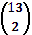 = 78
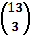 = 286
Other methods that can be employed are for example cointegration tests.
P.Kennedy, “A guide to econometrics”, 5th Edition (2003)
Eviews 5 User Guide (2004)
In this case the excess returns of Returns of the portfolios are computed as the Time weighted average of Rp-Rf. So in fact the short selling restrictions mentioned is a short selling restriction for stocks only. This is done in order to make the cases comparable
The exceptions in this case are the portfolios constructed by sorting on the variables: DY,FL and EBITDAgr.
The exception here is EBITDAgr, which already had a substantial negative correlation with inflation and displays a slightly less negative correlation with inflation.
In this case the following variables are considered: DY, GPM, DE, Cycl_eb, Cycl_sls and Cycl(ind)
Since = 28
The strategies marked with a * represent the strategies with positive total returns and positive yearly correlation with inflation.
Strategies marked with a ** represent the strategies with positive total returns, positive yearly correlations and positive correlations in all sub-periods with inflation.
Cycl_eb-DE
With respect to the winners portfolio this means the maximum (minimum) number of firms that were in the WWW, WWM, WMW or MWW buckets.
These are the strategies DY-FL and DY-Cycl(ind)-FL.
This assumption was made based on insight provided by Portfolio Managers at APG Investments.

