Black Sea Regional focus:

“Examining the factors affecting competition between the ports of Varna and Constantza”

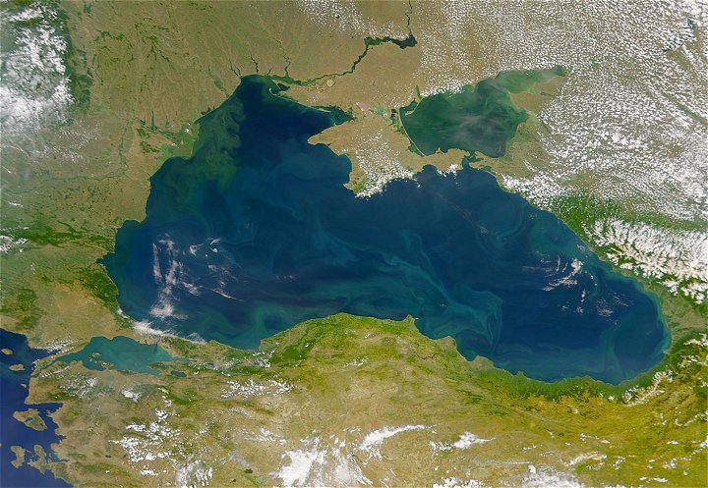

Author: Dimitar Stanchev MSc
Supervisor: Dr. W. Jacobs

Department of Applied Economics
Faculty of Regional, Port and Transport Economics
Erasmus University Rotterdam
August 2009

Preface

This Master Thesis has been written as a partial fulfillment of the requirements of the MSc Regional, Port and Transport Economics at the Department of Applied Economics - Erasmus University Rotterdam. The work has been carried out in the cities of Rotterdam, Varna and Constantza.
First and foremost, I would like to thank my supervisor in Rotterdam, Dr. W. Jacobs for his excellent support and advice. I am also especially grateful to the General Manager of CSCT terminal in Constantza Mr. Rowan Bullock and the Exploitation Director of the Port of Varna eng. Alexander Stankov for making my research possible and giving me the opportunity to gain insights of the maritime sector.
Finally, I would like to acknowledge the help of capt. Nikola Hristov (Bulgarian Association of Ship Brokers and Agents), eng. Serguey Vassilev (SENY Ltd.), the Marketing Department at the Port of Varna, and the whole management team of DPW in Constantza. Without them, the scope of my work and the insightful comments wouldn’t have been the same.

Table of content

Preface  Chapter 1. Introduction  1.1. Problem statement  1.2. Purpose  1.3. Review of literature  1.4. Methodology  1.5. Significance  Chapter 2. Theoretical framework  2.1. Introduction  2.2. The conceptual model  2.3. Port governance models  2.4. Global trends in the maritime sector  Chapter 3. Black Sea regional focus  3.1. Introduction  3.2. General ports presentation in the region  3.2.1. Ukrainian ports – Odessa and Illichivsk review  3.2.1.1. Modern requirements for the Ukrainian container terminals  3.2.2. Russian Ports  3.1.2.1. Port of Novorossiysk  3.2.3. Bulgarian Ports  3.1.3.1. Port of Bourgas  3.2.4. Romanian Sea and River Ports  3.2.5. Georgian Ports  3.2.5.1. Poti Port  3.2.5.2. Batumi Port  3.2.6. Turkish Ports  3.3. Ports’ traffic in the region and trends  3.4. Major port investments planned or currently implemented in the region  3.5. Main shipping lines routes and influence on the regional ports  3.6. Regional bottlenecks  3.6.1. The Bosphorus  3.6.2. Typical local bottlenecks affecting the Black Sea  3.7. Conclusions  Chapter 4. The ports of Varna and Constantza – a case study  4.1. Introduction  4.2. Main presentation of the port of Varna  4.2.1. Historical overview  4.2.2. Location  4.2.3. Main routes  4.2.4. Map of the port of Varna  4.3. Main presentation of the port of Constantza  4.3.1. Historical overview  4.3.2. Location  4.3.3. Main routes  4.3.4. Map of the port of Constantza  4.4. The Structure of Port Provision at the ports of Varna and Constantza  4.4.1. Physical conditions  4.4.1.1. General land and infrastructure  4.4.1.2. Number and size of the container terminals and available superstructure  4.4.1.3. IT applications  4.4.1.4. Hinterland connections  4.4.2. Institutional arrangements  4.4.2.1. Structure and heights of tariffs  4.4.2.2. Labor laws and organization, Safety and Security Stipulations  4.4.2.3. Length and type of contracts, Environmental Regulation  4.4.3. Governance structure  4.4.4. Conclusions  4.5. Possible policy and development recommendations  4.6. Competition or cooperation?  Chapter 5. Discussion and research limitations  Chapter 6. Conclusion  Literature References  Internet references  Interviews Conducted | 2  7  7  7  8  9  9  9  10  10  10  14  16  23  23  23  25  28  29  30  33  33  34  36  36  37  38  39  44  45  48  48  50  51  53  53  53  53  54  54  55  59  59  60  61  62  64  64  65  73  74  80  82  82  84  84  91  92  93  95  97  99  99  101  103  103

Chapter 1. Introduction

1.1. Problem Statement
In general, ports in Eastern Europe tend to receive less attention in terms of academic research than their Western rivals. However, Central Europe is the hinterland that both ranges fight for. While the Romanian port of Constantza has a significant share of the traffic in comparison to all the other Black Sea ports, the Bulgarian port of Varna seems to lag behind. Even though there is traffic to the “locked” (from a sea access point of view) countries in Central Europe, gathering a share of that trade does not seem easy for the two before-mentioned ports. The accession to the European Union of Bulgaria and Romania combined with their recent economic growth seems to open a range of new opportunities. Therefore, expanding cargo traffic in the next years seems to be only a matter of time even with the economic crisis heavily pushing the volumes down.
While trying to overcome the competition from the Western and Mediterranean ports, there is also one for the access from the Black Sea. And if for much of the academic research that seems to be a neglected topic, it still might show the future of the Europe port-ranges competition. Precisely the ports of Varna and Constantza can play the role of those “new gateways” to Europe, therefore investigating the problems connected with the Black Sea region and the competition in that range can be a vital task.

1.2. Purpose
The aim of the research is to gain insights on the factors affecting competition between the Black Sea ports of Varna and Constantza in order to identify their current problems when facing regional and Western rivals. Sub-questions posed during the research will be:
- What are the factors that influence the current market position of those two ports?
- Why the port of Varna is underperforming compared to the port of Constantza?
- How do the two ports fit in the regional and global supply chains?
- What factors influence the SoP (Structure of Provision) in the two ports?
- How can we understand the SoP concept and relate it to questions connected with inter-port, intra-port competition and entry barriers in Varna and Constantza?
- Which European routes are the two ports competing for and how do they perform?

1.3. Review of Literature
The core of the research will be based on papers indicating problems connected with competition between ports: the SoP approach including physical condition, institutional arrangements and governance structures in the ports of Varna and Constantza, inter and intra-port competition, and entry barriers (if any) at the chosen ports. The main literature used will be:
- Brooks, M.R. and K. Cullinane (2006), Governance models defined, In: Brooks, M.R. and Cullinane, K. (eds.) Devolution, Port Governance and Port Performance, 405-435, Dordrecht: Elsevier.
- Jacobs, W. (2007), Port Competition between Los Angeles and Long Beach. An Institutional Analysis, Tijdschrift voor de Economische en Sociale Geografie, 98, pp 360-372.
- De Langen, P.W. and Pallis, A.A. (2006), Analysis of the benefits of intra-port competition, International Journal of Transport Economics 33 pp. 69-86.
- De Langen P.W. and Pallis, A.A. (2007), Entry barriers in seaports, Maritime Policy & Management 34, pp. 427-440.
- Jacobs, W. & P.V. Hall (2007), What conditions supply chain strategies of ports? The case of Dubai, GeoJournal, 68, pp. 327-342.
- Yin, R. (2008), Case study research: Design and methods. Sage Publications
- Jacobs, W. (2007), Political Economy of Port Competition – Institutional Analyses of Rotterdam, Southern California and Dubai, Academic Press Europe - Nijmegen

1.4. Methodology
The methodology used for this research will consist of the following steps:
- Establishing a theoretical framework adopting principles from previous researches
- Data-based research on port traffic and relevant numbers through websites and port documents
- In debt interviews with port officials
- Strategic document analysis and evaluation of the questionnaires
- Making use of triangulation to achieve the final “cross examination” of all the methods applied

1.5. Significance
The planned research will investigate a topic not very well-known in the Western academic world. It may improve the knowledge about the Black Sea region, and ports like Constantza and especially Varna, which are competing for the same hinterland as those in Western Europe. Identifying the questions connected with competition between those ports will lead to answers about their future, and probably policy recommendations about possible improvements and developments.

Chapter 2. Theoretical framework

2.1. Introduction
In this chapter we will present the theoretical ground which will be used for the case studies of the ports of Varna and Constantza that will follow. First, we will get acquainted with the Structure of Provision approach and explain the categories it consist of, in order to make sound analysis of the local situation in Bulgaria and Romania later. Second, we will elaborate on the port administration models as defined by the World Bank. Third, in order to get to the regional level, we will review some global trends in the maritime sector and some questions connected with intra-port competition and entry barriers that will help us understand the current Black Sea situation.

2.2. The conceptual model
To examine the factors that affect port competition we will have to look at the problem from different angles. Regional competition like the one between the ports of Varna and Constantza does not only depend on economical factors, but also on institutional relations. As Jacobs (2007) states, “economic activity cannot be solely understood by the rational behavior of agents operating on free markets. Instead, markets and individual behavior are structured by all kinds of social, economic and political rules, procedures and conventions”. And as North (1990) clarifies - those institutions evolve incrementally in self-preserving way and that leads to place dependency and territorially rootedness. Therefore, in the current theoretical review we will present the Structure of Provision approach developed initially by Ball (1983, 1998), which was especially adapted later by Jacobs (2007) to be applied in the port sector, as well as the concept of regime politics presented by the latter author. Those two concepts will allow us to follow the process of institutional change and the role of specific agents at a certain place, and to show the dependency of the actors on the place. The conceptual model will be adapted from Jacobs, and it will represent the keystone of the research and later – the case studies.
The Structure of Provision approach was firstly developed by Ball (1983,1998) to investigate the “political economy of home ownership in the British housing market”. It refers to the “network of social relations, institutions and organizations, associated with the provision of particular types of buildings at specific points in time and space. The network of social and institutional relationships in which a particular form of building provision takes place is the ‘structure’ of that provision”. Therefore, the SoP is not static, it is dependent on “market pressures, technological innovations, tastes, policies, etc”. Stated by the author, that approach can be applied not only to the housing market, but also to virtually any kind of building provision. In our case, in order to be applied to ports, we will have to investigate the “interaction between organizations and institutions involved in the provision of specific port’s land, infrastructure and superstructure (cranes, fork lift trucks, gates etc.)”.
As Jacobs (2007) states, there are then 3 categories that have to be investigated in the Structure of Port Provision: the Physical conditions of the port – the quality of the ports’ infra and superstructure and the possible future development of the land (future projects), the Institutional arrangements – property rights, land-use planning, environmental and safety/security stipulations, port tariffs and other regulators of that regulate the use and development of the infra and superstructure, Port governance - the division of responsibilities between public and private sector, between the different levels of the state and identify what links them to the physical environment and how they coordinate. As Jacobs (2007) states, the current model as a study is more oriented to “the way the port as a whole is being governed within a multi-level network”.
Although the SoP approach is oriented to the interaction between institutions and organizations, it does “not state how that interaction unfolds, and it does not recognize the wider environment and the factors of change”. Here is where the author includes the concept of regime theory developed by the American studies on urban governance and local economic growth which explains how public and private agents join forces to boost the competitive position of cities (Logan and Molotch, 1987; Stone 1989) but later it have been moved to the emphasis on property led developments (Lauria, 1997; McGuirk, 2003). As Jacobs concludes, “regime politics can then be understood as an attempt by (coalitions of) organizations to manipulate and even change the SoP according to their strategic interests. The relationship between regimes and the SoP is that they are mutual dependent and constituting”. And to turn the issue to the port dependence he finalizes that “the focus here is not on the question whether changes in the SoP do in fact lead to better economic performance of the port in question, but to what degree port competition and regime politics lead to SoP change”.
The conceptual model of Jacobs (2007) allows us to follow the dependence of the actors on a global to local level following the interrelations caused by that interdependency. On the next figure we can see his model:
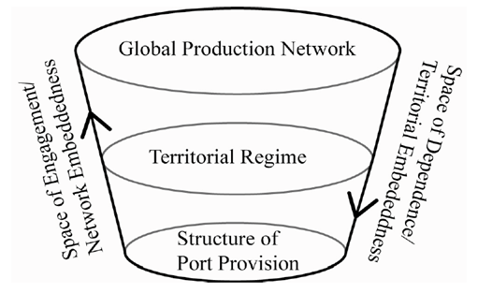
Figure 1: The Institutional Embeddedness of Ports and GPN’s (adapted from Jacobs, 2007)
The crux of Jacobs’ model is established with the interrelationship between “spaces of dependencies” and “spaces of engagements” as developed by Kevin Cox (1998). As per the words of the author, “a space of dependence refers to more or less territorialized social relations and place-specific conditions upon which actors depend for the realization of essential interest. These essential interests can be in the form of profits, jobs and wages, taxes and the personal well-being”. The factors that influence such space dependence are physical, institutional and political. Physically, they depend on the investment in the build environment. Institutionally, the actors depend on social relations and formal rules. Finally, politically they depend on the governance structure which influences their decisions. That space of dependence can “occur at different scales and on more than one scale for some actors, they are of more global character and are constantly threatened of the changing economic geographies and the mobility of capital”. In order to get more power, those place dependent agents form networks of “social power” where they “gain leverage, mobilize agents or build strategic coalitions”. Consequently, by their actions they form “networks of association”, or exactly those spaces of engagement. The dependence of the agents on a spatial scale does not necessarily correspond with their centers of social power (space of engagement), or the formal administrative territorial structure of the state. So, their relationship is of “contingent matter”. Therefore the conceptual model is structured like this – on the top we have the Global Scale (Global Production Network), then we have the Territorial Regime that the agents are dependent on, and finally the local Structure of Port Provision which we will clarify in the next paragraphs.
The Global Production Network refers to the “post-Fordist geographical organization of the capitalist economy in the form of globally organized and integrated networks of production, and GPN’s are constructed and transformed over time by agents with asymmetrical positions of influence and power”. Firms that are embedded within the GPN’s have international and global space of engagement and are linked to each other. Precisely the investments of those firms make them territorially embedded and they contribute to the local economy with them, and the other way around.
Below the GPN’s there are the territorial regimes, understood by Jacobs as “a constellation of public, collective and private agents, as well as a set of territory specific and historically developed regulatory frameworks and institutions”. These regimes depend on the state and political system, and are multi-scalar ranging from the local to the national levels. The way in which GPN’s embed in a territorial regime is dependent on how they construct their networks of engagement.
At the lowest level is the Structure of Port Provision, which we defined earlier. Its agents become dependent on the port and the way that port functions in a territorial regime. As we mentioned earlier, that is happening through physical, institutional and political factors that play their role.
However, if we consider the whole port as a unit of analysis, we will have several structures of provisions that can be defined as Jacobs (2007) concludes. This is because of the different sectors with different players that “play the game”. For example, we have a petro-chemical sector in the port, which are completely different of the container port provision. Therefore, in the next chapters we will streamline our approach and will discuss the Structure of Container Port Provision in more detail as we will pay attention to the container terminals mostly, although mentioning the general factors that affect the Structure of Port Provision.
In the next pages, we will connect the Structure of Port Provision approach with studies about the governance models used in ports and we will investigate questions connected the intra-port competition and entry barriers to acquaint the reader with the general theoretical flows connected with the port sector and factors affecting the competition between ports.

2.3. Port Governance models
That category of the port governance models is defined by Jacobs (2007) as “the system of governance that steers both infrastructure investment and maintenance, and the set of institutions underpinning service provision which in turn answers questions of what is the balance between public and private interests and when decisions about infrastructure development are made”. Moreover, it defines the procedures by which the tariffs are set, also the provision of leasing schemes and how regulatory issues are settled. The most common division of the port governance models divides them into four groups corresponding to the division of responsibilities of the public and private sector (Brooks and Cullinane, 2007; World Bank, 2001; Jacobs, 2007):
- The first model is defined as the “Service Port Model”. It is a predominantly public administrative model where the Port Authority owns all the land and all available assets. Normally controlled by the Ministry of Transportation, the port is responsible for hiring its own labor force. The chairman of the Port Authority is usually a civil servant who has a direct connection to the Minister. With that organization it is normal that the responsibility for the performance of regulatory functions, development of infra and superstructure and the execution of operational activities will be all in the hands of the same governmental entity and that leads to the lack of private involvement. Brooks and Cullinane (2007) add that because of the centralized approach there is a potential for streamlined growth but also for inefficient port and administration as the result of limited internal competition. That can lead to under-investments, services that are neither market-friendly nor market oriented, and non-economic motivations can dominate.
- The second model is described as the “Tool Port Model”. In that model the public Port Authority develops, owns and maintains the port infra and superstructure including cargo handling equipment as quay cranes, forklift trucks, etc. The equipment of the PA is operated by its own labor force, but other operations can be performed by private companies, with vessels or on the quay and apron. Brooks and Cullinane (2007) mention that those companies are mostly small, and the “fragmentation in responsibility for cargo handling can lead to conflict between those operators, and between the stevedoring companies and port administrators. This approach avoids duplication of facilities, but has the risk of underinvestment just like in the Service Port Model.
- The Landlord Model is the most spread of all the World Bank models. In this model, the land of the port is in the hands of the PA, but the infrastructure is leased to private operators. The latter employ their own labor force, they maintain, install and use their own superstructure. The responsibilities of the PA are to assure the long term development of the land, and maintain the infrastructure. According to Brooks and Cullinane (2007), that model leads to more efficiency and faster response to market changing environment. The risks are connected with excess capacity in infrastructure that can press upon expansion and private investment, and duplication of marketing efforts by the public and private.
- The Private Service Port is known with the lack of interest of the government in the port activities. The land, infra and superstructure, and labor force are privately owned or provided. The model is mostly spread in the UK. It is stated, that the port operations in this model can be flexible and market oriented, but it can result in monopolistic behavior and lack of long term economic policy or strategies.
In the next figure we can see a table that summarizes the allocation of responsibilities presented by the World Bank:
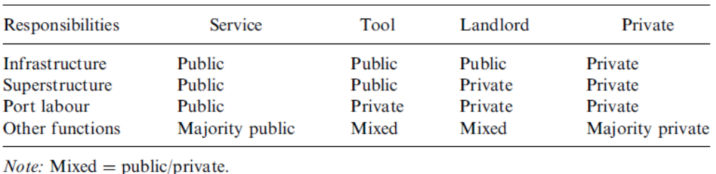
Figure 2: Allocation of responsibilities in the administrative models of the World Bank (www.worldbank.org)
Brooks and Cullinane (2007) classify the World Bank typology as a “simple approach of allocating responsibilities that fails to provide adequate guidance to a government faced with pressure to devolve port administration, taking in account local situation”. Though, the classifications are regarded as a “first step in understanding the capital investment allocations at a port”. In Chapter 3 we will investigate that allocation of responsibilities at the ports of Varna and Constantza.

2.4. Global trends in the maritime sector
The maritime world has gone through tremendous changes in the last decades. Since the introduction of the container, the volume and size of vessels are increasing every year, showing unstoppable and persisting growth. The port environment has been changing (Notteboom, 2009 – presentation Erasmus University Rotterdam), with global networks showing signs of:
- Logistics integration and one-stop shopping
- A ‘new’ breed of port customers. New ways of serving and pleasing port customers
- New challenges caused by structural changes in liner shipping.
- The emergence of integrated terminal networks
- Vertical and horizontal integration
By statistics provided by Drewry Shipping Consultants, in 2007 more than 140 mln. TEU has been handled around the world, showing the highest growth rates ever, in 2003-2004:

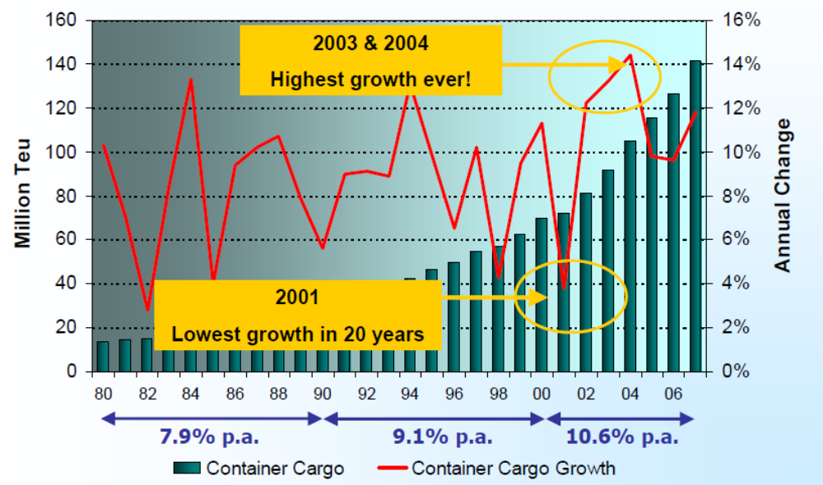Figure 3: Container market growth (Drewry, 2008)
The container cargo is rising every year and with it the shipping lines are increasing vessels. However, the modern market is leading to some radical changes in the financial status of the lines as well (Notteboom, 2009). Liner shipping has been underperforming financially and typical for them are the capital-intensive operations, high-risks associated with the possible revenues and surplus spaces onboard due to economies of scale which is in turn dragging the freight rates down. With all of those cost savings and economies of scale, it’s been the perception that the ships have to be filled “at any price” and to deploy ever larger vessels to lower the cost of TEU per capacity. In the following picture we can see the structure of the global fleet presented by Drewry:
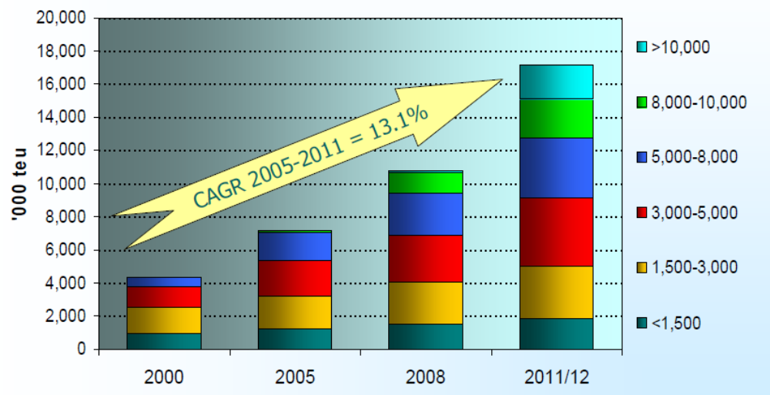Figure 4: Changing structure of the global fleet (Drewry, 2008)
Nowadays, ships like Emma Maersk have the official capacity of 11,000 TEU but can carry up to 13,500 TEU with 22 containers placed on width and the length of 400m. Capacity of ships introduced and in service is increasing by 13.1% every 3-5 years and those ships stop only in the deepest and largest terminals in the world, forming a network of transshipment hubs – the main routes of some of the biggest lines. With the world financial crisis in hand, those ships operate only on their main routes mostly in direction Asia-Europe:

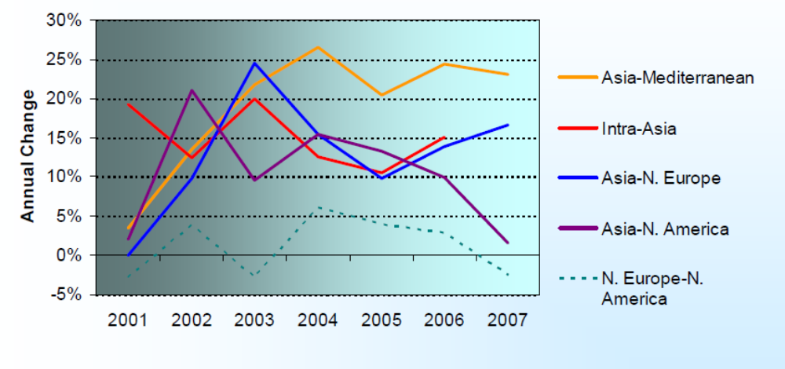Figure 5: Percentage of capacities on route (Drewry, 2008)
The most intensified routes are from Asia to the Mediterranean and Northern Europe where most of the big lines have situated their large vessels. Lines like the Grand Alliance and Evergreen have the most capacities on the routes to Europe (Fremont and Soppe, 2003). The other players like MSC, Maersk, CMA-CGM follow their lead but with more diversified route structures.
While the increases in demand are pushing the volumes up, the terminals are changing as well. It’s been the “terminalization” (Olivier and Slack, 2006) of the ports that has allowed the influence of the international operators. As the authors state, “this does not imply that we ignore the port as a politically cohesive entity, but we recognize that intermodal, logistics and institutional change have brought about a spatial fragmentation of the port based on commercial principles”. In that regard, demands by vessels increase correspond to land infra and superstructure expansions as well, pushing the small players out of the business and lead to the formation of global terminal operators (PSA, DPW, APM, etc.). Some of the players like APM have been created by vertical integration, while others like DPW have expanded their business from their own expertise in a certain place (Dubai). However, it is the aggressive approach taken by those terminal operators and the global privatization trends, which have allowed them to overcome local rivals at many places and win concessions in many parts of the world. In the next figure we can see the results of those aggressive approaches:
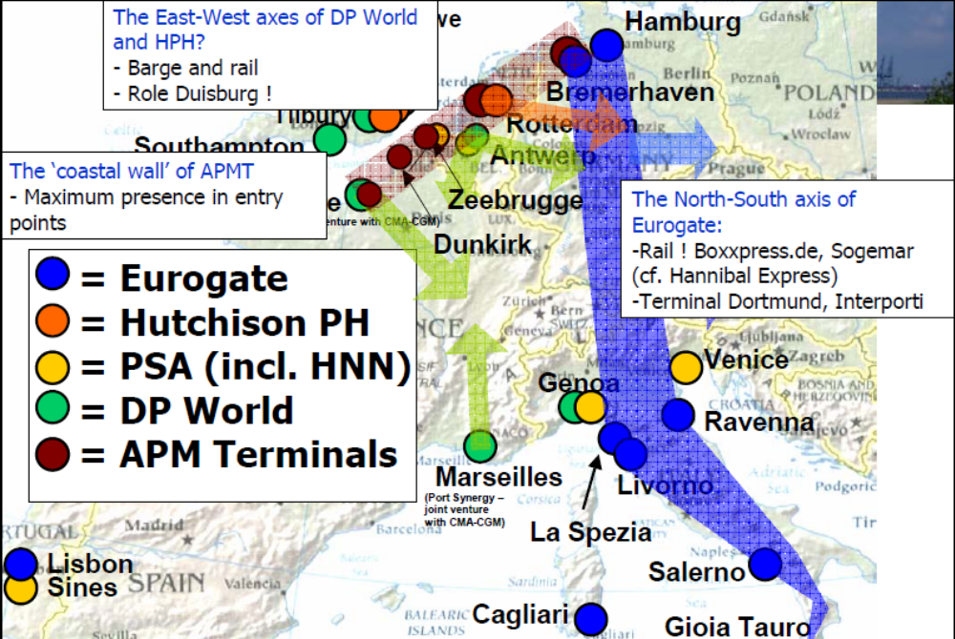Figure 6: APM terminal “wall” in Northern Europe (adapted from Notteboom, 2009)
The terminals of APM are placed in one of the two main centers of “container activity” nowadays situating their terminals in cities like Rotterdam, Bremerhaven, Zeebrugge and creating a “wall” of terminals serving the vast European hinterland – the one with the most demands. In that way Maersk has expanded from a liner shipping company into global terminal operator in only few years. The connections and expertise in the different ports, and established connections have helped the company to be of the main market players right now. The axis of HPH, DPW and Eurogate also look like a network of points that can cover whole Europe, although from different gateway points. When looking at the figure, we can clearly think of the influence of the private companies involved in the terminal business and brings us back of the theory for “terminalization”.
At the same time, the terminal operators have had an enormous effect on the performance of the whole ports in the recent years pulling the volumes in certain direction in a fight for domination. In that way, competition has become fierce and is now showing on completely different scales. It can be:
- Within a port: Individual firm - Rotterdam (ECT vs. APM)
- Within a country: port complexes – Rotterdam (Vlissingen vs Rotterdam) or Belgium (Zeebrugge vs Antwerp)
- Between countries’ port complexes – Rotterdam vs Antwerp vs Zeebrugge
- Port ranges – NW Europe vs Mediterranean
That shows the complexity of the place called port, which can be understood as territorially and institutionally embedded and as a ground for the growth of private global operators. From that come the changes in the role of the Port Authorities as well. As per Notteboom (2009), the main aims of the PA nowadays are to:
- Co-ordinate port development and manage basic infrastructure
- Lease out port land to private terminal operators
- Provide some additional services in the port
- Promote the port
- Deal with externalities, such as environment and safety
- Have a revenue base = land dues/concession fees and port dues
Many of those had been new functions that the PA had to adopt, therefore in some parts of the world the process is slow.
With the conditions for the terminals, PA’s and separate ports changing constantly, some of the local operators cannot cope with the intra-port competition that global companies are bringing with their expansions. At places entry barriers are formed (De Langen and Pallis, 2007) which allow incumbents to achieve above normal profits and absolute cost advantages. The authors separate those barriers into economic, regulatory and institutional, and location entry barriers. Economic barriers can be the structural cost advantage of the incumbent, the high switching costs or the required investments in networks by the entrants. Institutional barriers are the entry conditions set by the PA or exclusive concessions given to current operators. The unavailability of land for the entrants is classified as a location barrier. All of those barriers prevent intra-port competition and some of the global terminals enjoy beneficial position. One of those companies is DPW with their CSCT terminal in Constantza, which will be investigated later. However, it is the intra-port competition which leads to specialization, flexible adaptation and innovation (De Langen and Pallis, 2007). The authors also state that it prevents market power of port service providers and enables the normal functioning of the markets.
In the next chapters we will illustrate how the lack or presence of intra-port competition and entry barriers affect the position of certain port, especially when we have a case of strong inter-port competition when we revise the cases of Varna and Constantza. However, now we will focus on the Black Sea regional port developments and trends.

Chapter 3. Black Sea regional focus

3.1. Introduction
In this chapter the Black Sea countries and their ports will be observed. We will start by a general presentation of the main ports of the region discussing the ports of Ukraine, Russia, Bulgaria, Romania, Georgia and Turkey mentioning some specific information about their current state. After that we will analyze the regional container traffic volumes per country and some representative ports chosen by the author, having in mind the recent trends. We will review the investments that some of the countries are making in the recent years and how main shipping lines routes and direct calls affect the regional growth in containers. Finally, we will discuss the regional bottlenecks such as the Bosphorus strait and some typical ones for the Black Sea, drawing final conclusions about the regional state of container growth and how that will affect the ports.

3.2. General ports presentation in the region
In order to proceed to the local level, we have to look into the problems of the whole Black Sea region. In the last years, it has been a region with intense container traffic, which poses questions connected with contestability and fierce competition. Countries located on the Black Sea are: Turkey, Bulgaria, Romania, Ukraine, Russia and Georgia. All of those have one or numerous ports serving local and/or international interests. In the next pages we will get acquainted with the policies and recent developments pursued by the main ports in the region.
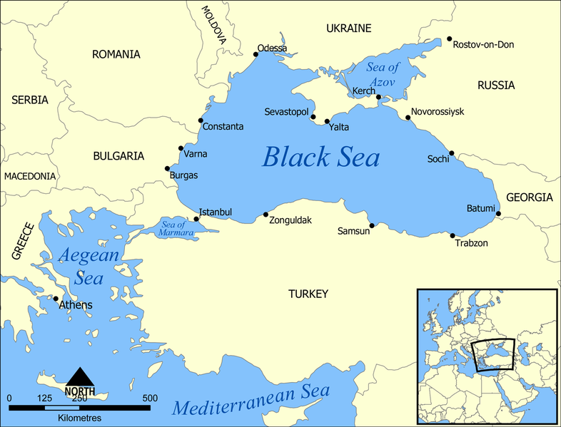
The Black Sea is open through only one “gate” – the Bosphorus, or the so called “Istanbul strait”. That obstructs or delays the movement of ships in times of intense traffic, and for many years the region did not have high growth rates. However, as we will see in the next pages, the container growth rates of the last years are the highest in the world and show that small market like this one (compared to the others in the world) can prove to be of great importance. From another point of view, it is the strait that also can pose problems from a control point of view – Turkey is currently not a member of the European Union and its connections with foreign partners may depend on customs rates and national preferences.
Typically for a small region compared with the rest of the world, the larger the population of the country on the Black Sea, the more traffic and ports we can expect. Turkey is the country having numerous ports on the Black Sea, but their importance is not the main topic of this paper, because of the lack of reliable data sources and the concentration of its ports located on the south – on the Mediterranean Sea, which makes the country less dependent on imports from the Black Sea market. Therefore, the author chose a number of ports, excluding many of the Turkish ones, which will represent the region to the reader and explain the undergoing changes. More attention will be paid to the Ukrainian and Russian ports which are the gateways to vast hinterlands – those of Eastern Europe, the Russian part of Europe and the Middle East.
The ports of Varna and Constantza will be thoroughly discussed in the next chapter where a field research has been done, therefore they will not be included in the current revision.

3.2.1. Ukrainian ports – Odessa and Illichivsk review
Ukrainian ports on the Black Sea are Odessa and Illichivsk, located close to each other on the North-West coast of the sea. Those are the main competitors to the port of Constantza in the region in terms container traffic and expansion projects. The development of those ports have been marked with the country being part of the USSR in the past and following regional rather than national interests. However, in the latest years the ports in Ukraine have started ambitious programs for the future, following the regional tendencies.
Stated by the Deputy Transport and Communications minister of the country, it is of prime importance for the country to develop the container carriages and “the development of foreign container terminals has been promoted by a legislative framework, ensuring mutually beneficial cooperation between the state and private business”. However, with the current containerization rates being only 6%, there is a huge opportunity for growth.
On the other hand, there are still some obstacles to the modernization of the container industry. That is “the procedure of establishment and liquidation of non-state form ownership marine terminals, which have been developed fast recently, and today is not virtually determined in the legislation of Ukraine. The legislative basis needs to be improved with the increased number of transactions in the field of port operations”. The national aim is to maintain the growth of 27-28% per year in the container volumes, and with the main ports of Odessa and Illichivsk passing the border of 1 mln. TEU that seems like a reasonable task having in mind the constant volume growth (almost 40% in 2007 to the last period), but it can happen only through changes in legislation and relieving customs procedures that prevent transit.
On the next figure we can see the traffic in the ports of Odessa and Illichivsk:
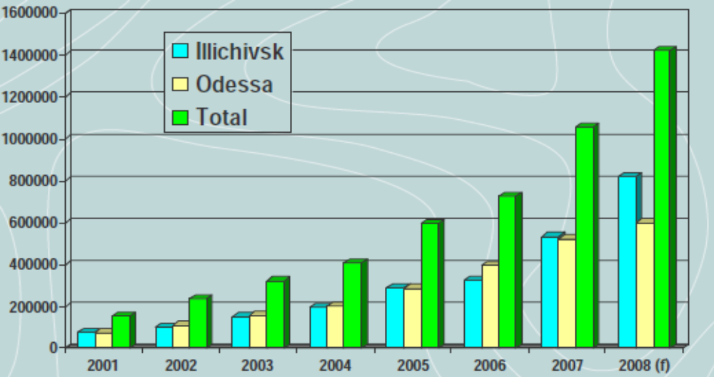
Figure 7: Container volumes in TEU for the ports of Odessa and Iliichivsk (adapted from Andrii Kuzmenko, director of TIS terminal - Ukraine)
As we can see from the figure, the volumes in the country are gradually growing with very fast rates with the port of Illichivsk exceeding the 800,000 TEU mark in the last year 2008. The total TEU mark can be compared only to that of Romania in the region, but we have to count the fact that the latter is already an EU member which enormously relieves trade. That is why, the problem with transit containers have been put on a very high priority in the local agenda. While in ports like Rotterdam, Amsterdam, Antwerp, Hamburg and Le Havre transit rates exceed 50%, such situation should become a rule for Ukraine as well, points out Yuriy Vaskov – the Deputy general manager of the port of Odessa. He mentions that “an obligatory condition to develop transit carriages is an existence of such a system in which a transit cargo, crossing the territory of Ukraine, is not affected through inconvenience, time delays, and direct financial losses furthermore and to increase the volume of transit containers that pass via Ukrainian ports is necessary to have a promotion and active position of the political department in matters of development and investment of terminals, and improve the legal basis”. To put his words otherwise – political help is needed, and more cooperation from private parties, which will guarantee the timely expansions of the terminals and reaching the capacities needed. In order to view the Ukrainian ports as hubs and an integrated part of the European transport network those prerequisites are more than needed in short time frames.
Some of the modern requirements for large post-Panamax ships in the country are met, which includes the draught of 13.5 m (however for the future more will be needed) in Illichivsk, the port accepting 5000 to 6000 TEU ships and 6 direct call services – all of those are reasons to mention the port as a transshipment hub being considered with Constantza as medium sized ports by all standards. But on Black Sea standards – those are the ports with the greatest potential in the region and inevitably the regional transshipment ports together with the port of Odessa having nearly reached the mark of 600,000 TEU in 2008.
To meet all the expectations mentioned earlier will be a giant step. Therefore, some of the recommendations for Ukraine from Andrii Kuzmenko (TIS container terminal director) are to:
- Compete for import/export by offering customers best possible combination of smooth operations, efficient tariffs and outstanding customer service
- Have extra quay capacity, backed by proper customs procedures and tariffs to win transshipment hub status.
- Have even bigger spare yard capacity, even better customs procedures and most efficient tariffs to become a gateway for Russian overland destinations.
- Have a state of the art hinterland connections – especially rail, as well as road, to be able to offer customers variety of reliable land routes to explore
In that way large investments made will be put in operation much faster when meeting country’s aim and EU standards simultaneously. That will mean oriented policy and well-recognized international partners.

3.2.1.1. Modern requirements for the Ukrainian container terminals and transit
In order to accept the growing traffic in the Ukrainian ports, the terminals and state borders have to deal with some of the country’s problems and perform with Western standards. The Director of TIS Container Terminal and the Deputy Odessa manager point out some of the necessary modern changes that need to be done:
- Depths of 15,0 ms on approach and at quay
- Absence of any navigational restrictions
- No ice at winter
- Developed infrastructure of inland transport - especially rail.
- Modern container terminal management system
- Direct and unobstructed access to main national roads and railway
- Convenient access to main centers of consumption and distribution
- Developed engineering and communication systems
- Modern and large warehousing infrastructure at adjacent territories, which are insufficient at the moment
- No ecological restrictions for any cargo handling, including hazardous cargo
- Qualified and excessive human resources
- Minimum 1.5 mln TEU capacity
- ISPS certificate
- Relieved customs procedures
- More stability in the political situation
- Cost-efficiency of the construction and operation

Some of the requirements stated are a big challenge for Ukraine having in mind the problems that the country is facing with managing EU import standards mentioned earlier. However, it is a matter of time till the traffic volumes push capacity limits and the most natural expansion of Ukraine trade is to the Western countries, so those challenges are more than an urgent task.

3.2.2. Russian ports on the Black Sea
It was in 1995, when the container cargo flows started in the South regions of Russia. Before that, there were no registered containerized cargoes on the stock list of Novorossyisk. The container segment started up in the South-Russian transport market mainly as a result of the USSR disintegration and an emergence of state frontiers between Russia and countries of the former USSR and owing to economic growth and purchasing capacity of the southern region of Russian Federation. Basically these two key factors have generated a tremendous growth of container business on the Russian Black Sea coast since the middle of nineties.
On the next figure we can see the changing South-Russian container flows presented by Global Shipping Services Ltd:
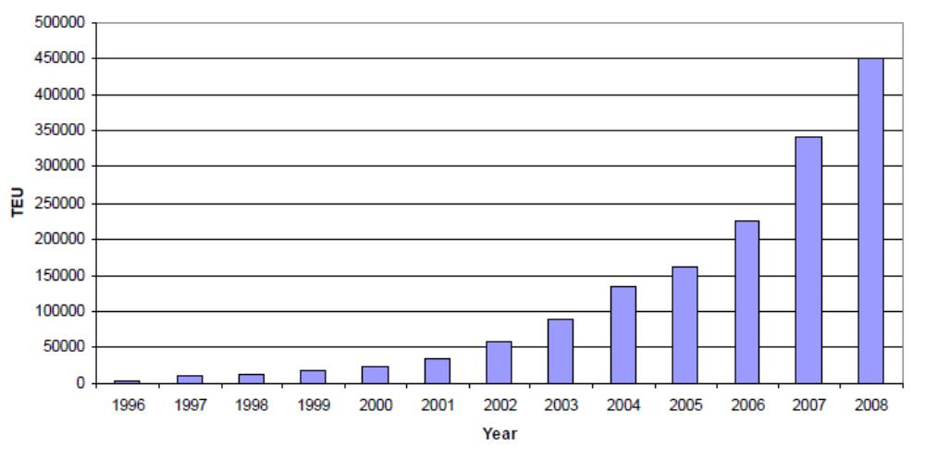Figure 8: Dynamics of the South-Russian container flows (1996-2008)(adapted from Global Container Services)
From 1996 to 2008 the container flows in South-Russia grew from 2000 TEU in 1996 to 0.45 mil. TEU in 2008. The years of tremendous growth followed the regional tendency of high containerization rates, which will be discussed later in that paper. However, the specificity of the Russian import and export (mainly outgoing oil) lifted the cargo volumes up, but the world trend of containerization did not longer delays with the Russian Federation in the Black Sea region.

3.2.2.1. The port of Novorossiysk
Today 13 ocean and 2 regional container lines work with Novorossiysk and the port is “is a key gateway for shipment of a wide range of Russian import and export cargoes, handling approximately 20% of Russia's exports and imports shipped via sea port during 2006, according to the Association of Russian Sea Ports”. So, with its vast expansion and warmer waters than the north part of Russia today, “the deep-water Port of Novorossiysk is Russia’s largest sea port in terms of cargo volume according to the Association of Russian Sea Ports, and in 2005 it was Europe's fifth largest commercial sea port by cargo volume, according to Global Insight/ISL. The Port is one of the few Russian sea ports in the Black Sea-Azov basin, which is one of only three commercially viable gateways for passage by ship between Russia and the open seas”. That makes the port of viable importance for the Russian economy and engine for economic growth, both for the Black Sea region and the country itself.
The proximity to the Asian market puts the port in a competitive position compared to some of its Western rivals in terms of time frames even if we consider the delays at Bosphorus. The opinion of some experts is that “the port’s relative proximity to the world’s major foreign markets makes it an expedient outlet for shipment of cargoes from or to southern and central Russia, Transcaucasia and Central Asia. For example, the voyage from Southeast Asia to cargo destinations in southern and central Russia via Novorossiysk is approximately eight days shorter than the route via the Rotterdam/Hamburg-St. Petersburg corridor”.
Andrey Narayevsky from Global Container Services Ltd. mentions some of the important developments in Novorossiysk through the years in a report in 2008. He points out that it is the traffic structure that has been changing over the years affecting the containerization rates. Between 1996 and 2001 the main commodities imported has been consumer goods, food and finished products. The origins of those have been Turkey, East Mediterranean and South Europe. The exports have been to the same destinations but products like non-fer metals, plastics and paper. However, there were three main reasons of the changing patterns of the Russian imports pointed out by Narayevsky:
- the phenomena of consolidation, containerization and expansion
- the entrance of main-line players – ZIM, MSC, Maersk, etc.
- investment in local production and agriculture with 20-25% annual growth
For that reason, there was a change in the inbound and outbound traffic structure between 2003 and 2008. Inbound, there were sub-products and materials (food and construction materials) from the Far-east, South-East Asia and the Mediterranean. Outbound, South Russia focused on dry and liquid bulk, sawn-timber and steel. On the next two figures we can see the destinations and percentages of trade per region pointed out by Global Container Services Ltd.
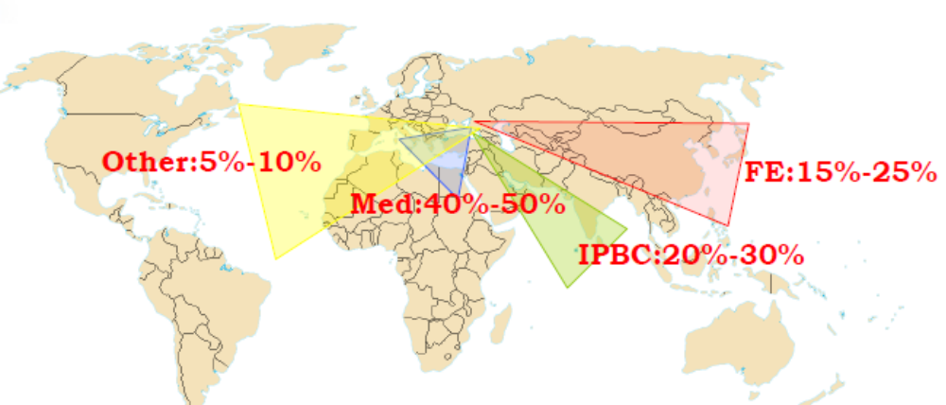 Figure 9: Outbound South-Russian traffic (adapted from Global Container Services)

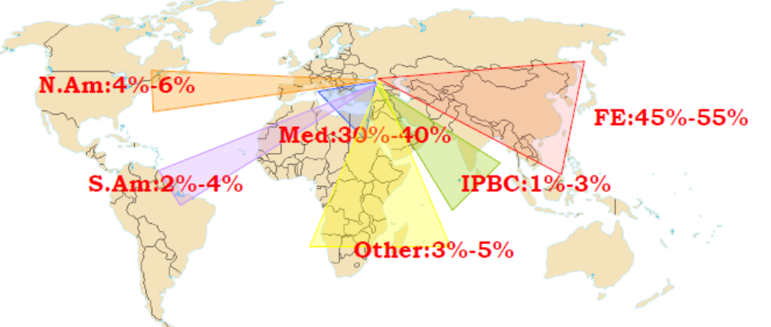
Figure 10: Inbound South-Russian traffic (adapted from Global Container Services)
The current period is characterized with fast containerization rates and more inbound traffic from Far-East Asia and the Mediterranean. There is also a containerization of more export commodities like bulk, heavy and extra-long products. The current container operator at the port is NUTEP CT with the capacity of 450,000 TEU.
The hinterland that Novorossiysk serves greatly defers from the Eastern ports on the Black Sea. It is the vast Russian land and Ukraine that the port can mainly cover. However, as Narayevsky mentions, the railway share of containers is below 5% and the in-port clearance and un-stuffing is of bigger share, as well as conventional transport. That is quite surprising but one should have in mind the regularly growing railway rates and the monopolization of that Russian sector. For example, for covering long distances, that is the most spread mode in Europe along with the barges.
As a conclusion, mentioning all the undergoing changes, we have to say that Novorossiysk has a great potential for expansion and it’s an emerging market with high volatility and the recent ever-growing rates make it one of the most promising ports in the region. The current extensions and modernization of the container terminals, which were equipped in a modern manner also show the overall Black Sea tendency for expansions.

3.2.3. Bulgarian ports
Bulgarian ports in the region are those of Varna and Bourgas, located respectively on the north and south part of the Bulgarian border with the Black Sea. Both ports operate with containers and have container terminals, and are governmental structures. While the port of Varna will be discussed later here we will mention some facts about the port of Bourgas.

3.2.3.1. Port of Bourgas
The port of Bourgas is the second biggest port in Bulgaria after the port of Varna. It’s been built in 1894 with a decree for construction signed by Prince Ferdinand I. The port is located on the TRACECA (Transport Corridor Europe-Caucasus-Asia) or also known as Corridor 8. Due to that location the port is considered as a link between Middle Asia and Europe reaching countries like FYR Macedonia and Albania as well.
The port of Bourgas has a large contribution to the Bulgarian economy in terms of volume as it is the “oil port” of the country with a large petrol terminal. However, the container feeder system is not as advanced as the northern port of the country – Varna, and Bourgas is still lacking TEU’s in numbers to reach its Northern rival. The container yard has draught of 11 m in Bourgas and the dedicated area is 60,000 sq.m. with 1330 ground slots. At present five container lines serve the port – MSC, Bulcon, ZIM, K-line and Hapag-Lloyd.
Following the national plan for the Bulgarian ports, there are big plans for future and current expansions as shown on the next figure:
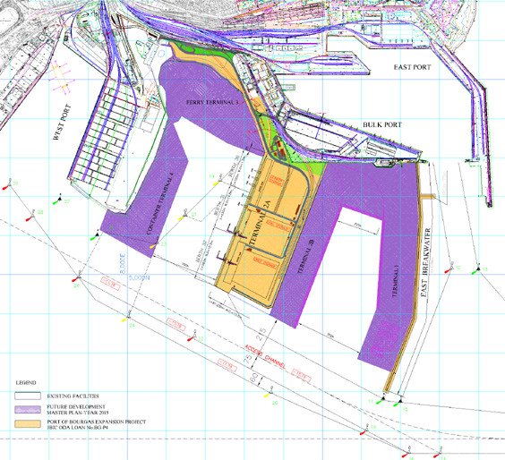
Figure 11: Port Expansion plans – Bourgas
The plan was to expand the port till year 2015 and build 4 new terminals – for general and liquid cargoes with a defending breakwater, for bulk commodities and metals which went into service in 2005, Ro-Ro and ferry terminal and a new Container terminal which will expand annual capacity with 450,000 TEU. In purple we can see the planned expansions on the figure. All the expansions are a joint effort by the National Government and the Port of Bourgas Management while the funds are guaranteed by the Japanese Investment Bank.

3.2.4. Romanian Ports
The Romanian network of ports constitutes of sea and river ports inter-connected by the Danube and channels build by the Romanian government through the years. The sea ports are Constantza, Midia and Mangalia which are located on the North-West part of the Black Sea in close proximity to the port of Varna (Bulgaria) and Odessa (Ukraine) on the North. On the following figure we can see the locations:
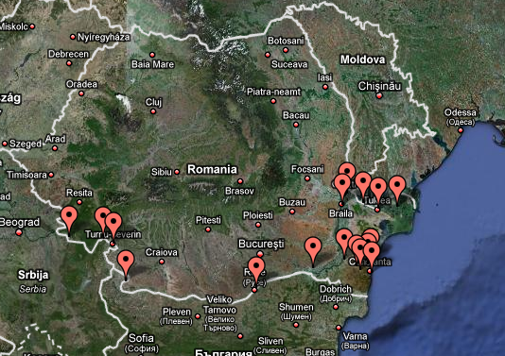
Figure 12: Satellite picture of the River and Sea ports in Romania (www.maps.google.com)
Romania has only one big port located on the Black Sea – the port of Constantza, but the sea coastline of the country is much smaller than those of Ukraine or Russia for example. It can be compared only to that of Bulgaria in terms of km (275km Romania – 378km Bulgaria) but we do not consider the river borderlines in that occasion, where Romania has a greater advantage. However, a case study of the port of Constantza will be performed in the next chapter.
The most notable river Romanian ports are:
- Orsova - performing capacity: 1.200.000 to/year, Quay length – 500 linear meters – 5 anchoring places
- Calafat - performing capacity: 350.000 to/year, Quay length – 100 linear meters –1 anchoring place
- Moldova Veche - performing capacity: 350.000 to/year, Quay length - 300 linear meters - 3 anchoring places
- Galati - performing capacity: 17.075.000 to/year, Quay length - 800 linear meters - 8 anchoring places
- Braila - performing capacity: 4.500.000 to/year, Quay length - between 400 - 700 linear meters - 9 anchoring places
- Tulcea - performing capacity: 800.000 to/year, Quay length - 400 linear meters - 4 anchoring places
The port of Galati is located in the North-East part of the country and is the largest and highly performing port from the Romania river ports. It has four main specialized sectors: Mineral port for ore, coal, coke, limestone rolled goods, Old commercial port for passengers and ballast traffic, Docuri Basin for general cargo, bulk and cereals and New Basin for timber, rolled goods, ore, coal and coke.

3.2.5. Georgian ports
Georgia has two main ports located on the Black Sea – the port of Batumi and Poti port. They both represent a crossroad of the Caucasian (TRASECA) corridor, which is connected through the Black Sea.

3.2.5.1. Poti Port
The extensive development of Poti Port expresses the global and regional tendencies. The port is built on the river Rhioni and 1858 was declared as such. In the last years there have been many projects planned, some of them are “blocking of the river Rioni and creation of a new water area. For rehabilitation of the south breakwater, the Dutch government, EU and the Black Sea bank allocated 26 mln. euro. Works for installation of wind generator in the port extensive development area are ongoing”. However, the EU is actively involved in the modernization processes as they realize that Poti port is the future in the international trade on the Black Sea. The rail ferry complex is stated as very important to the port because of the connection Poti-Illichivsk-Varna.
As they state, “nowadays the port is equipped with modern cargo handling facilities and is in line with the European standards. The port has open and closed warehouses, supportive constructions, 8 cargo handling complexes located at 15 berths of the “northern port” and “inner basin”, passenger station and berths for fishing fleet. Sea Port of Poti has all conditions to satisfy client’s different requirements regarding cargo and passenger carriage”. That also includes a container terminal with depth 8.25m having reached 209614 TEU in traffic in 2008.
The main container line services from Poti cover the whole Black Sea region as well as Malta ports, Cagliari, Volos, Piraeus and Gioia Tauro.

3.2.5.2. Batumi Port
The port of Batumi, together with Poti Port represents today the connection between Asia and Europe. It has 5 terminals with a container terminal of 300,000 TEU capacity. The rail ferry line Batumi-Varna-Illichivsk is served here as well, but it is still the general cargo and oil that have the largest percentages of the traffic. However, some of the Geo-strategic and natural advantages of the port are:
- Port is situated in natural deep water bay;
- Well secured from seaside;
- Port’s naturally big depths practically have not been changing for a long period of time that allows accepting the big sized vessels;
- No access channel, which releases the vessel from channel dues.
The container terminal is operated by Batumi International Container Terminal LLC, the subsidiary of International Container Terminal Services Inc (ICTSI), a Philippine based company, established in 1987 and widely recognized as a leading container terminal operator, innovator and pioneer in its field.

3.2.6. Turkish ports
Turkey has numerous ports on the Mediterranean and the Black Sea. Typically, investment priority is given to the South ports due to the lack of bottlenecks such as the Bosphorus. There is a general classification of the ports which are divided into: governmental, municipal and private ports.
The first group is operated by the Turkish state railways and all of them are connected with the railway network, and also the Turkish maritime organization where both structures are under the control of the Ministry of Transport, but they are acting independently. Each port has a port manager who is appointed by the related state enterprise.
The second group is the ports managed by the municipalities which are generally small and serve the needs of small towns or regions.
The special private ports are the third group, which are specially defined by the government with fixed concessions granted to the third parties.
As stated before, Turkey has many ports on the Black Sea, but very few of them are of importance to the container trade. Most of them operate with general cargo, or serve passengers. The only one with specialized container facility is the port of Trabzon which is located near the border of Georgia and it’s governed by the Turkish Maritime Organization.
Some of the other ports include – the ports of Rize, Hopa and Giresun, which are governmentally operated, others like Ordu and Samsun that are governed through the Turkish state railways, the port of Bartin is municipality governed, and the port of Erdenir is given to a local company to operate. The port of Zonguldak is given to the Transport Management Directorate to operate.
The fact that there is no private involvement, or at least no globally oriented operators to invest in the northern parts of Turkey (the Black Sea) speaks for itself about the policies pursued. It is notable that DPW operates a facility in the south port of Yarimca, where the ships are not delayed by the Bosphorus. The size of Turkey gives it an advantage in terms of hinterland choice of modality, when the land borders are open to Georgia (from there Russia), the Middle East and Europe (to Istanbul). That actually puts no pressure for serious investments on the Black Sea shore from Turkey, where all the other countries are more or less locked by a closed sea. Therefore, mentioning statistics and figures, Turkish ports will not be considered in the next pages.

3.3. Ports’ traffic in the region
There’s been a huge increase in the traffic in the region in the last decade following the containerization trends. To show the statistics of the traffic in the region, the author has chosen some presentations prepared by the largest consultancy and shipping line companies – Drewry Shipping Consultants Ltd., Ocean Shipping Consultants Ltd., and statistics from the MCA-CGM shipping line. The research is also enriched by the authors’ data search to show the changes in the year 2008.
A report prepared by Ocean Shipping Consultants Ltd. shows that the regional throughput for the Black Sea grew by 231% over 1997-2007. They state that the growth has been driven mainly by:
- the rapid expansion of transshipment
- the introduction of the Black Sea economies into the world trading system
- the organic underlying growth in regional economies resulting in steady container trade growth linked to economic development
They summarize demand and show that it has been significant during the period 2000-2007, with some of the regions showing rates as:
- Russia +1269%
- Romania +1232%
- Ukraine +700%
- Turkey +204%
- Georgia +411%
Those numbers do not have the same meaning as the development of Russia, Romania and Ukraine start at a very low base level. The ports of Bulgaria are not mentioned as the infra and super-structure expansions are currently taking place as we will see in the next pages, which will most probably affect the demand rates in the following years.
Drewry Shipping Consultants Ltd. show that in 2007 the volume (including transshipment) in the Black Sea was 7 mil. TEU compared to 35 mil. TEU in the North Mediterranean and 57 mil. TEU in Northern Europe. The Middle East shows 28 mil. TEU in volume, Africa – 17 mil. TEU compared to the large 178 mil. TEU for Asia and 67 mil. TEU for the transshipment hubs in the Indian ocean. However, those numbers do not reflect the growth rates that the Black Sea region has. On the next figure we can see the percentages of the different regions in growth rates since 2002:

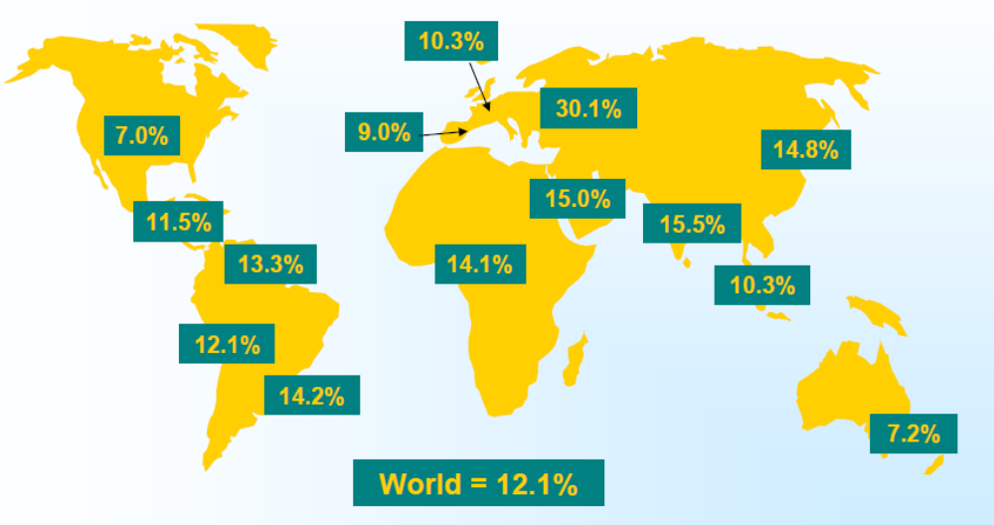Figure 13: Container Port Growth 2002-2007 (Drewry Shipping Consultants Ltd.)

The average for the world between 2002 and 2007 is 12.1% while the Black Sea region has 30.1% of growth for the stated period. We already mentioned that this is mainly because of the low base level in the start, therefore the fast rates after that. However, not taking the circumstances we have to notice that there is no other region in the world with such growth, which makes the Black Sea region a very good example of fast containerization. However, it is stated by Ocean Shipping Consultants Ltd. that if utilization rates exceed 85%+ the region will suffer from congestion and delays having in mind the ever-lasting growth in the previous years.

The total Black Sea market is presented in the next two figures with statistics used from CMA-CGM:

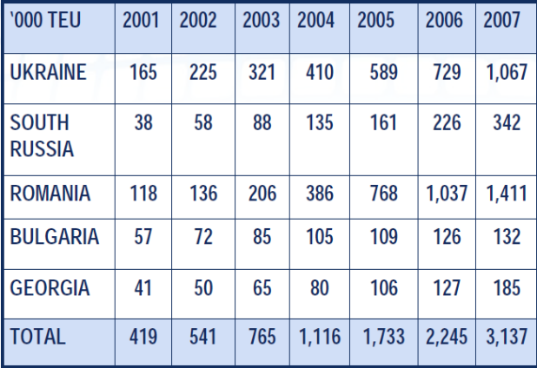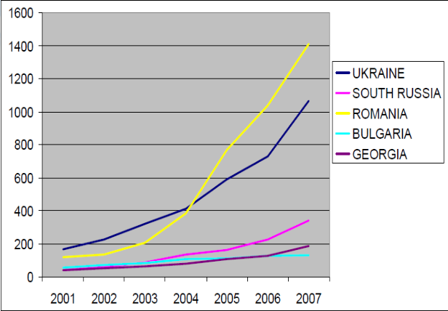Figure 14:Total Black Sea Market and Volume in ‘000 TEU (CMA-CGM statistics)

From the figures we can see that Romania and Ukraine have the largest traffic on the Black Sea. That reflects basically two things – the population of the countries and the hinterland they serve (captive or contestable), as well as the investments in infrastructure done to accommodate the traffic. The recent growth of South-Russia is still not shown in numbers but the vast hinterland of the country will sooner or later affect the position in terms of volume. Bulgaria is the country with the lowest volume due to issues that will be explained thoroughly in the next chapter by a case study.
In the next figure we can see the volumes per ports chosen by the author: Varna, Constantza, Odessa, Illichivsk, Poti port and Novorossiysk:
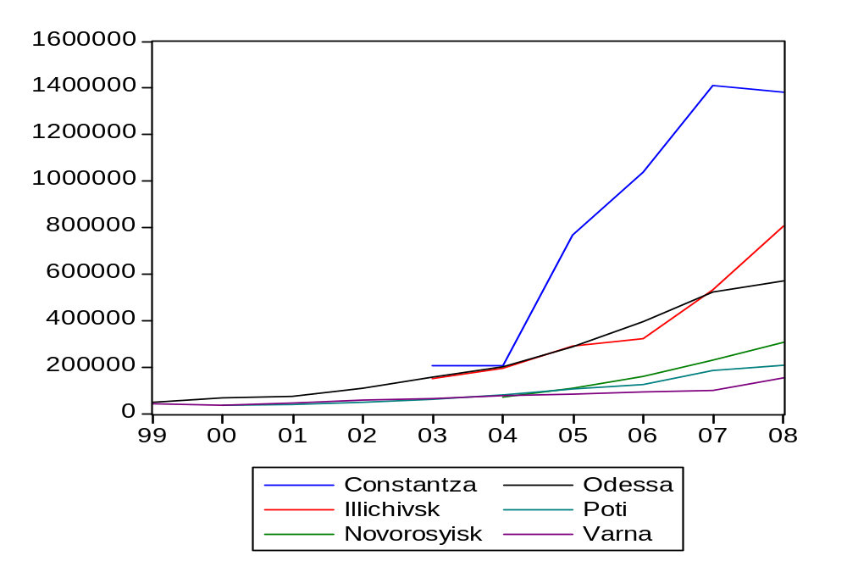Figure 15: Volumes in the Black Sea Region in TEU’s (official port sites statistics shown with EViews)
As we can see from the figure, Constantza is way ahead in terms of volume compared to the other ports in the region. The ports of Odessa and Illichivsk combined can reach the volume of Constantza, but we have to keep in mind that Constantza is the only big Romanian port on the Black Sea and there is the role of a global terminal operator (DPW) that matters as well. However, the Ukrainian ports are showing enormous growth, especially the port of Illichivsk, and while in the last year Constantza’s volumes are falling, Illichivsk is rapidly increasing TEU numbers. The ports of Poti and Novorossiysk serve different hinterland, although the Ukrainian ports can compete for the Northern parts of Russia. The port of Varna shows a constant growth in terms of volume, as the whole region, but the lack of infra and superstructure investment in the last decade has a great influence on the traffic. All of the ports actively “participate” in the growth rates of the whole region, especially the Romanian and Ukrainian ports from 2003-2004, the years of port expansions and the first direct shipping line calls.

3.4. Major port investments planned or currently implemented in the region
In order to summarize some of the recent investments that took place in the region we will divide those by countries and ports to follow all the changes taking place. In some of the countries are taken more aggressive approaches with investments in hinterland infrastructure and terminals expansions. In others is invested less but with future expectations for traffic growth. The cases of new investments in Varna and Constantza will be investigates in the next chapter. All the others are presented in the following lines:
- Bulgaria - the expansion of the container terminal has been started in Bourgas, the second biggest port in Bulgaria. With a loan from the Japanese Investment Bank, construction is expected to start in 2009 and assure capacity of 450,000 TEU when finished.
- Ukraine – in Illichivsk has been started a quay reconstruction and yard expansion by “Ukrtranskonteiner” and the terminal will able to handle 900,000 TEU and 1,5 mln. TEU in case of reaching rated capacity, with plans for extension to 3,15 mln. TEU. In Odessa has been started a Container terminal expansion from 530,000 TEU with construction coming up. The MetalsUkraine terminal capacity has been also expanded in 2007.
- Russia - NUTEP container terminal has been expanded to 465,000 TEU in Novorossiysk
- Georgia – in the port of Batumi the concession has been given to ICTSI with the capacity of 300,000 TEU, the terminal has been rebuilt
- Turkey – in the next figure we will see the expected or already implemented investments in Turkey presented by Ocean Shipping Consultants Ltd.

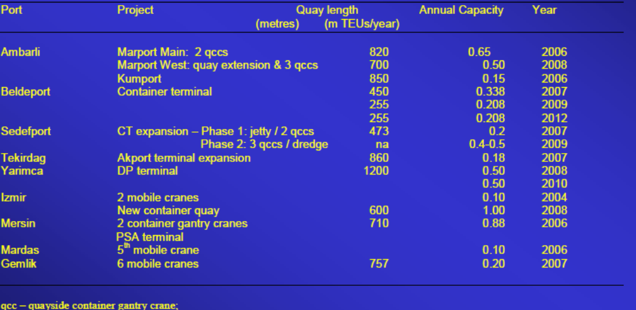Figure 16:Recent commited or planned containerport investment in Turkey (Ocean Shipping Consultants Ltd.)
Although the ports stated are not situated in the Northern part of Turkey, they represent the power of the country and the aim to expand at the south borders – to the Mediterranean, where they are not locked in the Black Sea and shipping routes are shorter. The biggest expansion is in Yarimca where DPW is heavily investing in port infra and superstructure.
However that may sound in times of global container capacity expansions, still the temps of the Black Sea show that countries are committed to the local growth aims. Even if we consider that as a global trend, the high growth rates have to relate to faster implementation of capacity expansions in the region. Only in that way the Black Sea region can be competitive in times of very fast cargo shifts. Exactly that unique quality of the containers to “flow” where the market conditions are better will keep the regional competitiveness on a high level, and more global container operators will want to get concessions at the Black Sea.

3.5. Main shipping lines routes and influence on the regional ports
In a world of trade and ever growing containerization rates, it was not before 2003 when the first direct service call was made by MCA-CGM in Ukraine. Before that, the Black Sea was served by smaller feeder lines and was suffering, being such a large gate to a vast hinterland. On the next figure we can see the direct services in the region per year (based on MCA-CGM statistics).
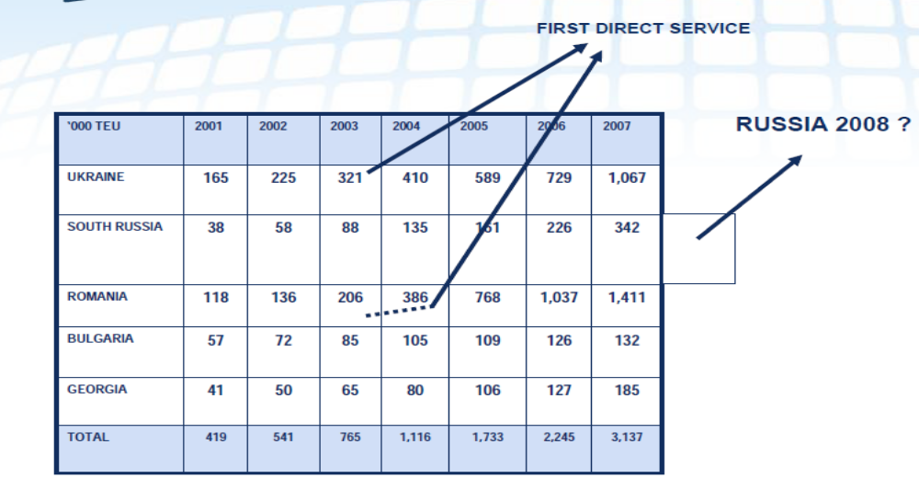Figure 17: Direct Services Initiation on the Black Sea (MCA-CGM statistics)
However, the expectations for the regional growth are enormous having in mind the high rates. In that case, more and more direct calls are expected with all the infrastructure expansions started by the before-mentioned countries. All of the latter have projects for modernization and building of new terminals which is expected to attract more direct or transshipped cargo. Notable is that the expected modernization at the port of Novorossiysk opens also the gate for a direct service to South Russia.
On the next figure we can see the direct services made by the different lines. Those figures do not reflect the world crisis in 2009 and the drop in service by certain lines. However, it is MSC (tiger) and MCA-CGM that have the largest calls in the region with Ukrainian and Romanian ports accepting them.
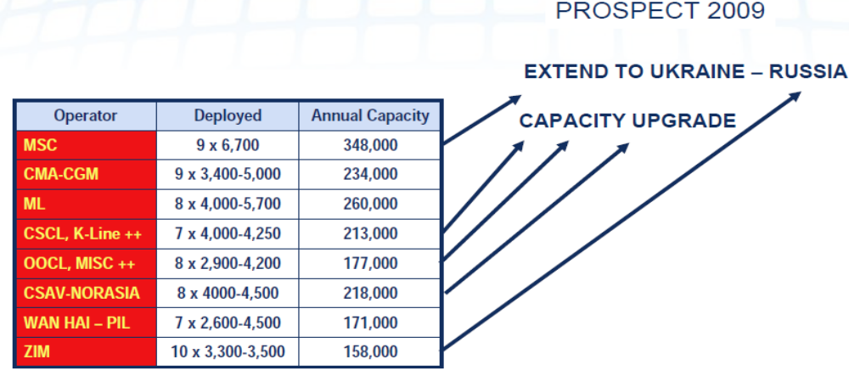Figure 18: Black Sea Direct services, sept. 2008 (MCA-CGM statistics)
With the start in 2003 many lines open their routes for the Black Sea. Those include Maersk, MCA-CGM CSCL and K-line, OOCL, CSAV-NORASIA, WAN HAI-PIL and ZIM line. The service intensified even more with the labor strikes in Thessaloniki that brought traffic from the Mediterranean Sea and attracted the lines to the Black Sea. Port interviews conducted by the author show that it is a great struggle for the Black Sea ports to keep the level of service and keep the lines loyal to the region instead of calling at the Mediterranean. However, it is the normal for the sector unwillingness of the lines to switch ports that mainly keeps the loyalty combined with a fast and reliable service provided by the host ports. On the other hand, there’s the re-routing of the lines due to port capacities, which is very common in times of uncontrolled growth.
The influence of the direct calls on the regional containerization growth has been immense. The highest regional rates have been achieved thanks to the lines calling at the Black Sea and the infrastructure expansions started by Romania and Ukraine at the first place. That opened the gates for the other ports to respond to the ever growing competition with projects for new terminals and investments in hinterland connections and more reliable service. The “pushing power” of the container lines was one of the notable reasons for the acceptance of Romania and Bulgaria in the EU for example, to open the gates for the Eastern trade coming to the Union. It was also a question of making sure that the two countries invest in infrastructure to accommodate the traffic, something that Romania has been more successful in, as we will see in the next chapter.

3.6. Regional bottlenecks
In the next pages we will explain the regional bottlenecks connected with the Black Sea and the ports being called there by the main lines. We will mention some obvious as the Bosphorus, and some specific local ones to explain the difficulties that the region is facing.

3.6.1. The Bosphorus
As discussed previously, Black Sea is sea with closed waters surrounded by six countries with only one entrance – the Bosphorus, or the “Istanbul Strait”. Described by the World Encyclopedia of Earth, it is “ the world's narrowest strait used for international navigation, which connects the Black Sea with the Sea of Marmara (which is connected by the Dardanelles to theAegean Sea, and thereby to the Mediterranean Sea). It is approximately 30 km (19 mi) long, with a maximum width of 3,700 m (12,139 ft) at the northern entrance, and a minimum width of 700 m (2,297 ft) between Kandilli and Aşiyan; and 750 m (2,461 ft) between Anadoluhisarı and Rumelihisarı. The depth varies from 36 to 124 m (118 to 407 ft) in midstream. The shores of the strait are heavily populated as the city of Istanbul (with a metropolitan area in excess of 11 million inhabitants) straddles it”. On the next figures we can see the Bosphorus from a satellite picture and next to it - highly congested by ships presented by shipping line software.

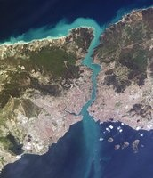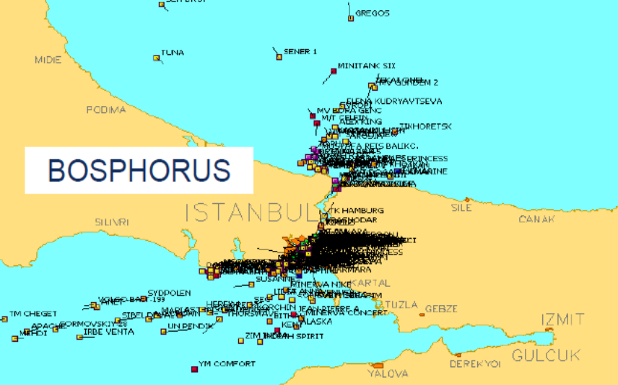Figure 19: The Bosphorus - Satellite picture (left) and through a MCA-CGM software (right)
The Bosphorus has always been of strategic importance to the countries on the Black Sea and has been subject to a number of hostilities through the years mentioning the Turkish-Russian War and in World War I. The last convention regarding the regime on the Turkish straits was in 1936 and “is still in practical force as of 2008, treating the straits as an international shipping lane, but Turkey does retain the right to restrict the naval traffic of non-Black Sea nations (such as Greece, a traditional enemy, or Algeria)”. In the recent years, with the intensified container trade, that has been a hot topic for the Black Sea region, facing the fact that Turkey is not in the EU, but most importantly – the Russian oil export is passing the Bosphorus and the Dardanelles on a regular basis. That poses a lot of questions regarding the future vulnerability of the whole Black Sea region imports and exports through the straits. Moreover, currently there’s a limitation of the vessel length of ships that can pass the strait – in times of such fast growth that brings questions about the mother vessels and how those big ships can enter into the Black Sea, and some of the lines are calling at Mediterranean ports instead. However, with the increasing capacities of the Black Sea and volumes, there is the hope that this issue will be resolved with the Turkish authorities, because that is the only gate to a growing market and many countries located in the region. Having so many ports in the Mediterranean, the closure of a strait like Bosphorus will not be of great significance to Turkey, which creates even more vulnerability to the Black Sea traffic.
Questions connected with the environment and pollution are also of great importance considering that Istanbul is a highly inhabited area. The last incident in November 10th, 2003 was when a Georgian flagged cargo ship GGC “Saint Panteleymon” ran aground off Anadolufeneri and broke into two pieces. Around 500 tons of oil spilled and caused pollution. Such incidents can often cause tension in the region and especially on a state level.

3.6.2. Typical local bottlenecks affecting the Black Sea
Some of the bottlenecks that the companies are facing in the region have been explained by the Fordon Logistics Company on the Black Sea container Summit conference 2008. Some of the obvious ones is the lack of capacity to handle the container growth that will lead to container demurrage and containerships waiting for mooring. Other bottlenecks mentioned by the company representative Mr. Sorge, were:
- the absence of an adequate legislative base;
- high taxes, port charges and other charges, rates of demurrage per day;
- the obscure and constantly changing customs and frontier rules;
- bureaucracy and monopoly of the state;
- the absence of up-to-date logistical centers, occurring everywhere;
- the shortage of sea terminals and specialized railway stations;
- the lack of cargo handling equipment, rolling stock, roads.
- the low level of development of logistical infrastructure
With the acceptance of Romania and Bulgaria in the EU some of the before-mentioned critical remarks are expected to change, because the two countries are subject to the EU law. However, for the other states on the Black Sea it is a matter of choice and policy, and national interests in the first place as the region is still characterized with a high level of governmental property in the port sector.
Nevertheless, there are some solutions that are identified and can relieve the bottlenecks, presented by the Drewry Shipping Consultants Ltd. for the region. Some of them include:
- Port and supply chain congestion is absorbing some surplus capacity
- Global trade imbalances generate a more than proportionate increase in capacity for a given two way cargo volume
- Increasing trade distances and vessel round voyage durations are assisting in absorbing capacity (eg the greater share of Transpacific cargo moving via ECNA/USG ports rather than overland from WCNA ports)
- Slow steaming can reduce costs and utilize excess capacity

3.7. Conclusions
The Black Sea region has been recognized with its intense containerization growth and booming volumes. However, that posts problems to the ports in terms of infra and superstructure expansions to accommodate the traffic. Some conclusions are made by Ocean Shipping Consultants Ltd. for the region, based on research of the future possibilities. They include some facts that are worth mentioning to explain any future actions by the ports in the region. The report states that:
- It is generally recognized that utilization rates of 85%+ will cause operational difficulties congestion, delays in the region, so immediate actions are needed
- Based on this criteria, capacity in the region is currently too low, but will recover from 2009 onwards after a surge in port investments
- However, individual pockets within the wider region may require additional capacity since not all ports can cover the whole region
- Utilization rates will most probably have reached 85% by 2020-2023
- Forecast takes no account of seasonality
Having mentioned that, it is clear that more and more lines will have direct calls at the Black Sea and the rates will grow more even in terms of crisis, so now is the best timing for the countries to invest in assets when the volumes are not in their peaks.

Chapter 4. The ports of Varna and Constantza – a case study

4.1. Introduction
In this chapter we will get acquainted with the ports of Varna and Constantza. From the regional focus on the Black Sea we will gradually get on the local level and examine the factors that affect competition between those ports. We will discuss the history of the two ports, their location, routes that the ports serve and review the current port map and port operators. Slowly we will narrow the research into the Structure of (Container) Port Provision approach where we will make a sound analysis of the physical conditions, institutional arrangements and governance structures at the places and make conclusions about competition between Varna and Constantza if such is active, in the full meaning of the word. Then, we will draw some remarks and policy recommendations that can be concluded following the analysis. Finally, questions about possible cooperation between the ports will be posted, having in mind the current local situation.

4.2. Main presentation of the port of Varna
The ports in Bulgaria are generally divided into two groups depending on the priority of the port for the country. Therefore, we have ports with national and regional significance. In the following pages is discussed the port of Varna, which is declared as a port of national significance.

4.2.1. Historical overview
The story of the port of Varna starts back in the 6th century when greek colonists establish the city of Odessos - a flourishing city within the land of Thracians, later within the Roman and Byzantine empires. In the 13th and 14th century Varna was the major port for the kingdom of Veliko Tarnovo and Dobrudja, a province on the East Bulgarian coast. Back then the trade was mainly with Venice, Genoa, Florence and Constantinople. As an important fortress and port, Varna was also vital connection for the Turkish empire between the 14th and 18th centuries. After the liberation of Bulgaria from Turkish domination, it was decided that two ports will be needed in the country, so Varna and Bourgas were built. Gradually, in the 20th century more and more terminals were built with the ports being governmentally owned and operated. It was not before 2006 that the first private concession of Balchik Port termnal was awarded to Port Balchik AD. Following the world tendencies (even with such delayed temps), 25 May 2006 was the first date of a private Bulgarian port concessioner in the country.

4.2.2. Location
Bulgaria is situated in the Eastern part of the Balkan peninsula, at the ancient trade crossroads between Asia and Europe. The neighboring countries are Turkey, Serbia, FYR Macedonia, Greece and Romania. The exact location stated geographically is 43°12'N , 27°55'E and Bulgaria has a very advantageous position for an Eastern border of the EU.
Right now Varna is the second largest city in the country with nearly 400,000 registered inhabitants, a major economic and development center. It is located on the North-East coast of the country only 470 km away from the capital Sofia and 200 km from the river port of Rousse, located on the Danube. Compared to countries like Ukraine and Russia (competitors of Bulgaria in terms of attraction of traffic), Bulgaria has the advantage of a mild climate with the Black Sea not freezing in winter. The city is called the “sea capital of Bulgaria” because of the numerous resorts situated around it, which makes it not only trade but also a tourist center with great growth potential.

4.2.3. Main routes
As mentioned previously, Bulgaria has an advantageous position being the East border of the EU which can be used in the future trade. Four main routes pass through the country and give it the unique opportunity to be the trade center of the Balkans. On the next to figures we can see the routes inside and outside the country leading to different points of Europe, coming from Asia and the Middle East:
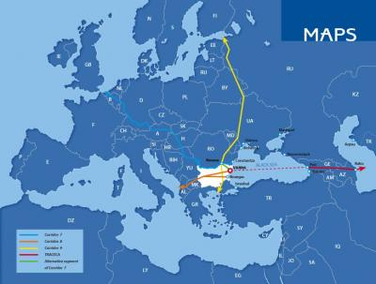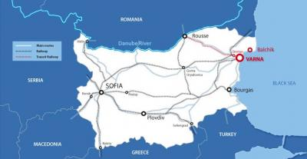Figure 20: Main routes passing through the Balkans and Bulgaria (www.maps.com)
Those basic transit corridors of importance for the Bulgarian ports are:
- European transport corridor №7 – the Danube River with Vidin, Lom, Rousse (with land diversion for Varna and connection with TRASECA) from the Bulgarian Danube ports to Greece
- European transport corridor №4 – Dresden Budapest-Arad-Craiova-Lom-Sofia with diversion to Thessaloniki
- European transport corridor №8 Duress-Skopje-Sofia-Varna/Bourgas;
- TRASECA – Caucascus corridor
With the intensified trade typical for the TRASECA corridor there is a possibility for exports from the ports of Varna and Bourgas to the locked countries in Central Europe like Serbia, Hungary, FYR Macedonia, etc.

4.2.4. Map of the port of Varna
The port of Varna consists of two main complexes which are separated from one another, and some smaller terminals. Those are the complexes of Varna-East and Varna-West. In the next figure we can see the map of the port of Varna with its complexes:

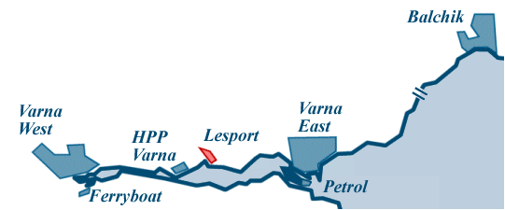Figure 21: Map of the port of Varna
The distinguishing thing about the port of Varna is its proximity to the lakes of Varna and Beloslav, which divide the complexes of Varna-East (on the seaside) and Varna-West (on the lake of Beloslav) by 30km. The sea is separated from the lakes by two canals. Between those two complexes (divided by the lakes), there are some small terminals specialized in different commodities, general cargo and passengers. On the North, the complex of Balchik is privately operated by the Port of Balchik AD and it handles cereals, vegetable oils and live animals. The city of Balchik is situated in the region of Dobrudja, which is very important because of its cereal production and export. The different terminals on the lakes of Beloslav and Varna can be classified as follows:
- Varna-East is a public transport port of national significance used to handle general and bulk cargo, containers and passengers. It is located just before entering the lakes, on the seaside
- Varna-West is a public transport port of national significance used to handle general, liquid, bulk, Ro-Ro cargo and containers
- HPP Varna is a public transport port of national significance, specialized to handle coal for HPP Varna
- Petrol is a public transport port of national significance specialized to handle petrol products
- Lesport is a public transport port of national significance used to handle general, bulk and ro-ro cargo. From 30th May 2006 the terminal is privately operated by 30 years concession period awarded to Himimport PLS, which posseses 99% of the capital.
- Ferryboat complex – Varna is a public transport port of national significance used to handle ships-ferryboats transporting wagons, ro-ro cargo and passengers
The two container terminals of the port (and one new planned) which will be discussed later, are situated respectively in Varna-East and Varna-West. On the next figure we can see the terminals located in the two complexes:
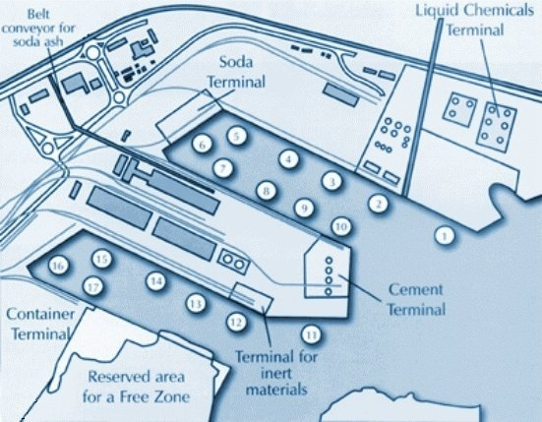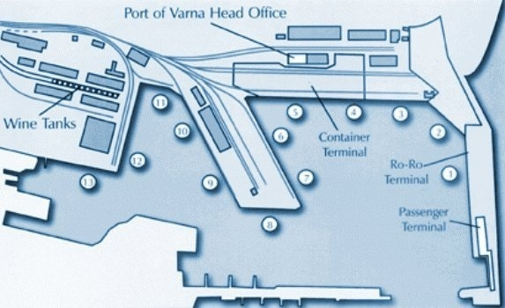Figure 22: The port complexes of Varna-West (left) and Varna-East (right)
Varna-West is the most modern complex of the Varna port and yearly handles more commodities in tones than Varna-East. The most important feature of the terminal is the presence of Devnya. Devnya is part of the Varna-Devnya Industrial Complex and a number of important heavy industry facilities are located in or near the town, making it a chemical industry centre of national importance. That includes Solvay Sodi AD – producer of sodium bicarbonate, dense and light soda ash (largest soda plant in Europe, part of the Solvay Group), Agropolychim AD – produces nitrogen, phosphate and compound fertilizers, exports to Europe (49% of output), the Americas (11%), Asia (9%), and supplying more than 50% of the Bulgarian market, Polymeri AD – producer of chemicals and Devnya Cement – producer of cement. The mentioned companies have specialized conveyer belts for direct shipment onboard which relieves the hinterland connections from excessive cargo. All of those, together with the growth in the container volumes in the last years, define Varna-West as a very important complex for the port of Varna due to the large exports, although the distance is 30 km more than the complex of Varna-East.
In Varna-East, which is situated in the center of the city and the railway station, there are terminals for containers, Ro-Ro, passengers, bulk and general cargo. The head office of the port management is located there as well. There’ve been a lot of talks in the recent years about the location of the complex and the proximity (1 km) from the city center. That makes Varna-East a threat for the peaceful life of the inhabitants and a future symbol of the waterfront redevelopment of the city. The complex is intended to move in Varna-West direction leaving the grounds to become passenger and yacht ports, and a center for recreational activities, hotels, attractions and amusement.
The other important feature of the city is the Asparoukhovo Bridge (next figure),which has been
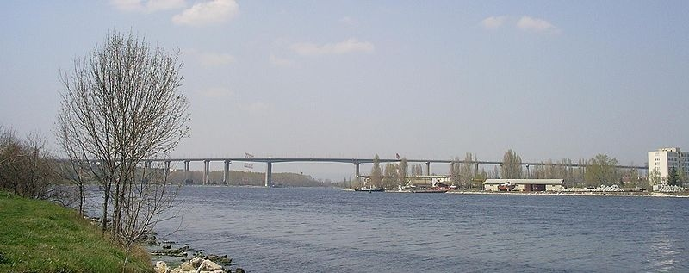Figure 23: Asparoukhovo Bridge – Varna, dividing the Black Sea from the Lake of Varna
built till 1976 and connects the districts of Asparoukhovo and Galata with the city center. The bridge relieves the traffic but creates an air draught for the visiting ships which will be commented later in the chapter.

4.3. Main presentation of the port of Constantza
The port system of Constantza consists of three integrated parts – the port of Constantza and those of Midia and Mangalia (and Tomis Marina). In the next pages those will be revised and presented, being the largest port system in the Black Sea region.

4.3.1. Historical overview
The first attestation of Constantza as a port dates back to 6th century B.C. through an archeological evidence showing the existence of the city of Tamis. In those ages the city was organized as a trade center for Greeks and locals. The years of Greek dominance continue before 1st century B.C., when the region falls under Roman occupation. For the prosperous years that were to follow, the port-city was renamed after the Roman emperor of that time – Constantin. In the byzantine period, the city was attacked numerously by barbarians who stopped the trade for long periods.
After short Romanian governance, the city lies in the hands of the Othoman empire (Turk) which rename the city to Kustendge Port. In 1857, the Turkish authorities lease the construction of the port and railway between Constantza and Cernavoda to an English company "Danube and Black Sea Railway and Kustendge harbour Company Ltd.". Constantza Port benefits of modern endowment and facilities for the first time.
The independence war in 1877 brings back the province to Romania, and the first constructions of a modern port are started. Even then, the strategic role of port was recognized by the current King Carol, who stated that the port will “become one of the most important ports of the Orient and a source of wealth for the entire nation". That is why the port is ransomed from the English company and foreign experts are hired to extend and renovate it. In 1896 was the official start of the modernization and construction, the port was presented as an engine for future growth. In the next years, “until 1909, when Constantza Port was officialy inaugurated, dredge works have been made, the breakwaters and the quays had been built; also six basins and storage tanks for oil had been developed and the cereal silos. Having these facilities, the Port of Constantza registered in 1911 a total traffic of 1.4 million tons”.
More and more facilities were built later before and between the world wars. The wars slowed down the pace, but when the Danube started to play an important role in the trade with the inauguration of the canal, the port reaches the impressive proportions of 3900 ha and 62.3 mln. tons of traffic. Right now, the port ranks in the first 10 ports in Europe in terms of traffic, which makes it of strategic national importance for Romania.
The history of the port of Constantza and the attention paid to the maritime sector from the rulers through the years, represent a long-lasting maritime community with very capable people, internationally oriented by nature. Many investments have been made through the years, millions of euro poured in the port of Constantza and its hinterland connections, as well as in the border connections with Hungary and the other gates to the EU. That is why the position of a Black Sea regional hub have always suited to the port, having in mind the oriented maritime policy of Romania.

4.3.2. Location
The port of Constantza is located on the Western Coast of the Black Sea, at 179 nM from the Bosphorus Strait and 85 nM from the Sulina Branch, through which the Danube flows into the sea. The location of the port and its development through the years make it a very important distribution center for Eastern and Central Europe, and a hub for the Black Sea region. With the accession of Romania in the EU, its geographical position opens the gate of the Eastern part of the Union.
Having in mind the connections that port has, the distances to the other big cities in Romania and the capital of Bucharest are of great importance. Constantza is 232 km away from the capital, which makes it an excellent center for national supply. The distances to some of the other big cities in the country like Timisoara, Brasov and Craiova are respectively 758 km, 380km and 451km.

4.3.3. Main routes
The routes that Constantza serves slightly differ to those of the port of Varna. On the next picture we can examine those routes and evaluate the position of the port on the Balkan and European area:
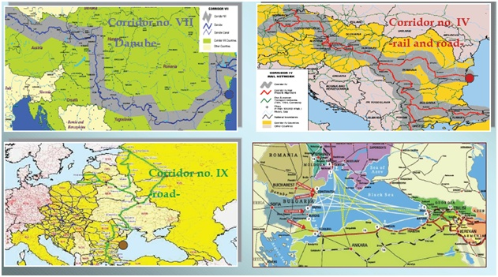Figure 24: Main routes of the port of Constantza

The favorable position of the port is emphasized by two Pan-European corridors, and some Intercontinental ones:
- Corridor VII - Danube (inland waterway)
- Corridor IV (rail-road) – to Central Europe
- Corridor IX (road) – to Northern and Eastern Europe
- TRASECA (Asia-Caucascus-Europe)
All of those routes strengthen the position of Constantza port on the European market. For some countries in Central Europe, Romania can be the most economical and time saving route for their shipments. In that regard Romania is in full way a competitor of the ports of Bulgaria, which can serve the same routes.

4.3.4. Map of the port of Constantza
As we already mentioned, the port system of Constantza constitutes of several complexes – the complex of Constanta, Midia and Mangalia (and Tomis Marina). On the next figure we can see the map of the port of Constantza:
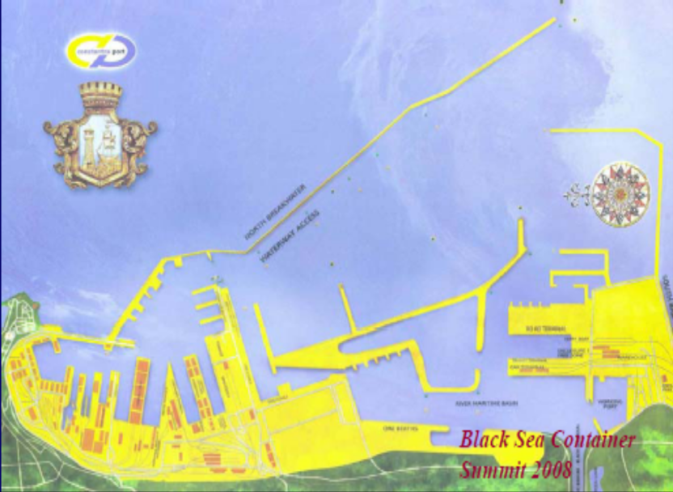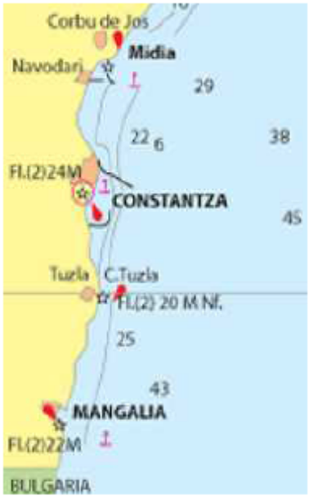
Figure 25: Map of the port of Constantza (Black Sea Container Summit 2008)
All of the terminal operators in Constantza are private and they handle different types of cargo. Generally the port is divided into South, Central and North part whereas the South part is separated by the channel to the Danube. Main terminals in the port of Constantza are:
- Container Terminals – the container terminals operating in the port are CSCT (Constantza South Container Terminal - concession to DPW), SOCEP, UMEX and APM Terminals. CSCT and APM are located in the South part of port, while SOCEP and UMEX are in the North. SOCEP and UMEX are owned by Romanian private companies, while CSCT and APM are international operators. Due to the crisis and the drop in volumes, APM is currently not operating. The container terminals of Constantza will be discussed in the next pages, paying specific attention to the terminal of DPW – the largest container terminal on the Black Sea.
- Liguid Bulk - Oil Terminal and Rompetrol Logistics Constanta Branch are the most important operators for such cargo.
- Dry Bulk - the Port of Constantza enjoys a top position as one of the major European bulk centres. Dry bulk is represented by: iron and non-ferrous ore, grain, coal, coke. Comvex and Minmetal are the main operators for these kind of cargo
- Chemical Products and Fertilizers - TTS Operator, Chimpex and MAST are the main companies that operate these categories of cargoes, being equipped with dedicated areas for operation and storage of chemical products and fertilizers, bulk phosphate and urea
- Agribulk - the most important stevedoring companies that operate agribulk in the Port of Constantza are TTS Operator, North Star Shipping, United Shipping Agency, Silotrans, Chimpex and SOCEP
- Food Stuff - Constantza Port offers competitive facilities for perishable cargo storage and reefer containers. Perishable goods can be stored in adequate conditions in refrigerated warehouses and are usually handled by two specialised stevedoring companies: Frial, Romned Port Operator and Chimpex
- Cement and Construction – SICIM
- Timber and forest products - Important quantities of timber loaded in the Port of Constantza and dispatched over sea are handled by Decirom, Rotrac, Romtrans and Phoenix
- Metallic products - Romtrans, Minmetal, SOCEP and Umex
- Ro-Ro/Ferry - The Ferry-Boat terminal is operated by SNTFM CFR MARFA
The port of Constantza is very diversified in terms of container terminals and has a large ground for future expansions. That makes it one of the most promising and prosperous ports, situated on the Black Sea and Europe. It is covered by breakwaters all along with an entrance from the South part of the port.

4.4. The Structure of Port Provision at the ports of Varna and Constantza
In the next pages we will get acquainted with the factors that affect the competition between the ports of Varna and Constantza. For that purpose we will use the Structure of Port Provision approach, discussed in Chapter 2, and we will investigate the physical conditions, institutional arrangements and the governance structure of the ports and specifically of their container terminals. We will pay more attention to CSCT – the DPW operated terminal in Constantza, as the largest and fastest growing terminal facility on the Black Sea. At the end, we will draw some conclusions based on the facts mentioned and author’s own research.

4.4.1. Physical conditions
In the next pages we will get acquainted with the physical conditions at the ports of Varna and Constantza. In the first part we will state the total land size, number of berths, depths of the ports, etc. (general land and infrastructure). Then we will investigate the number and size of container terminals and their superstructure, the IT applications and the hinterland connections. Finally we will make some conclusions and make additional comparisons.

4.4.1.1. General land and infrastructure
The ports of Varna and Constantza differ significantly in terms of land and infrastructure. The port of Varna has 32ha of open and closed storage facilities, but if we consider the lakes of Varna and Beloslav we will get 44km of sheltered inland waterfront that can be used for future growth. At the same time, the whole area of Constantza is 3962 ha, but for the building of deep sea terminals, reclamation of land in the sea has started years ago. The number of berths in Varna is 32 with a total quay length of 5,60km, while at the port of Constantza the berths are 156 (140 of them operational) with quay length of almost 30km. Constantza has breakwaters which are about 14 km in length (north+south). The depth in Varna reaches 11.5m while in Constantza there is natural depth between 8 and 18.5m.
The notable thing about the port of Varna are the two canals connecting open sea with Varna lake with depth of 11.5m and length of 2 nautical miles, and the second one connecting Varna lake with the lake of Beloslav (where is the terminal of Varna-West) with depth of 10.5m and length of 5 nautical miles.
There is also an air draught created by the Asparoukhovo bridge crossing above the canals at Varna, which is 53m high, but some additional complications lower the draught to 41.5m. That seriously obstructs the movement of container mother vessels, which cannot enter in the canals and respectively in the Lakes, where the whole port of Varna is supposed to move in the future. However, even if the canals are dredged to supply with the needed depth, to bridge can be hardly moved as it connects the different parts of Varna. That seriously complicates the future possible hub position of the port, and leaves it open only to feeders. There are some chances for finding grounds before entering through the bridge for new container terminal that will accept mother vessels, but that opportunity lies only in the hands of the port’s authority and the State Enterprise “Port Infrastructure” Co. to consider.
Compared to the port of Varna, that of Constantza is not facing the same problems, the depths of the port make it natural monopolist in terms of mother vessel incomings and constitutes its position as a regional hub. The only ports Constantza can compete in that regard are those of Ukraine – Illichivsk and Odessa. Therefore, it is not surprising the feeder function of the port of Varna, which is close to such natural monopolist attracting the main shipping lines. The port of Constantza also has a direct link to the Danube – a canal which was dredged following the national plan for the maritime sector, in order to connect the port with the river network.

4.4.1.2. Number and size of the container terminals and available superstructure
Following the facts mentioned in the general infrastructure, the number and size of the container terminals in the two ports also greatly differ.
In the port of Varna there are 2 feeder container terminals located respectively in Varna-East and Varna-West. The one in Varna-East has the capacity of 1600 TEU and is equipped with 3 conventional cranes (32T) and 1 gantry (30.5T). The other one in Varna-West is the more modern one, with 2600 TEU capacity, 2 gantry (35T) cranes. Recently, the port purchased 2 x Gottwald 100T cranes in order to accept the traffic coming from Thessaloniki because of the strikes. With the new cranes, the movements were reaching 18 per hour, which is the top for such types of cranes, 800 moves were made in some days with ships of about 2500 TEU being handled. Then, when there were 2 container vessels in the terminal of Varna-West, the second one was handled elsewhere with the mobile cranes. The problem with the modernized terminal in Varna-West and the fact that both Varna-East and Varna-West are governmentally owned and operated, was that the lines preferred to berth at Varna-West while the port authority had plans in order not to over-occupy the terminals. Therefore, in times of excess traffic the West terminal was with work load of over 65%, which caused delays and complaints from the lines, although they were initially warned for such occasions caused by their desire to unload at Varna-West. From that point of view, internal competition cannot exist in the port of Varna while the terminals are under the same management. The other small terminals – Balchik and Lesport do not even operate with containers in order to be competitive, which makes the situation even more complicated. However, with the presence of such competitors like Constantza, Thessaloniki and Bourgas for the same hinterland, internal competition does not seem to be of first priority for the port of Varna at that stage of development.
The port handled 155,326 TEU in 2008 (over 80% of the country’s container traffic) compared to 99,713TEU in 2007. It was the general manager of exploitation of the port, eng. Stankov, who stated that this was an astonishing achievement of the port having in mind that those container terminals are actually “specialized platforms” to handle the traffic, and new platforms were opened in terms of excess traffic to handle it. There is a big question concerning the capacities in the port of Varna, and the lack of investment when the land for expansion is present – the port operated at full and over-capacity in the last year. Maybe it will be the times of crisis that can slow down the growth so the future plans for the development of the terminals can be achieved without overloading current capacities disastrously.
Currently the feeder lines of MSC are calling at the terminals, as well as Maersk, ZIM, CMA-CGM and many others. The main clients are MSC and Maersk, who switch the leadership in terms of containers brought every year. Therefore, it is of top priority for the port to keep those lines coming for the future. Due to the strikes in Thessaloniki, more traffic came to Varna from those lines and stating eng. Stankov’s words - “it is of vital importance to keep those clients coming”. However, it was capt. Hristov (the chairman of the Bulgarian Association of Ship Brokers and Agents – BASBA) that mentioned the slow operation process at the terminals as the main problem for the shipping lines calling in Varna, which is more than normal having in mind the huge traffic in the last year combined with the low capacities of the port. That leads to a huge contradiction between the existing infra and superstructure and the possibilities for future growth of the port. And while it is important for the latter “to keep the clients coming”, the overloaded capacity can do exactly the opposite – keep them away. But those are two of the main factors that can be pointed out as weaknesses in a SWOT analysis for the port of Varna – the unavailability of modernized technology, and the low maintenance of the port infrastructure combined with the lack of yearly investments in that public governmental property.
However, the future of the port is bright, having in mind the recent local and regional container growth. There are plans for a new terminal to be built, which will be financed by funds from the Japanese Bank for International Cooperation (JBIC) and governmental funding, by the method BOT (Build-Operate-Transfer). The loan is for 226 mln. euros (JBIC) and 70 mln. euros will be added from the state. The sum of nearly 300 mln. euros is already granted and transferred to the State Enterprise “Port Infrastructure” Co. for the building of two new terminals – one in Bourgas and one in Varna. The terminal in Varna will be located right after the canal on the lake of Varna, on the north shore near the village of “Kazashko” – it will have the capacity of minimum 500,000 TEU and the superstructure from the other two terminals will be located there when it’s ready in 2013. The terminal will have the natural depth of 14-18m but will be limited from the air draught of the Asparoukhovo bridge. That makes it an impossible destination for the mother vessels and transshipment options as well. On the other hand, the terminal in Bourgas “is another story” – as eng. Stankov and Mr. Bullock (the general manager of DPW in Constantza) mentioned - the port is not limited in any way to accept mother vessels and may become the Bulgarian hub for transshipment, as it is a possible future ground for investments and expansions in Bulgaria. The future terminal in Bourgas will have (by initial plans) the minimum capacity of 450,000 TEU when it’s finished, following the same time frames as the one in Varna. However, it will still be a feeder terminal.
Having mentioned all those facts about the port of Varna, we have to note that the port of Constantza will be a completely different topic. The infrastructure investments by the Romanian government have been immense through the years, following the national plan concerning ports and expansions. While in Bulgaria (by the words of eng. Stankov) there’s been a major investment only once to build the complex of Varna-West long time ago - investing in channels and waterways, in Romania such investments are done on an yearly basis. There are four container operators at the port of Constantza, and all of those are private companies, with the landlord being the National Company "Maritime Ports Administration" SA which promotes the port of Constantza as European transit and distribution center.
The first of the container terminals in the port of Constantza is SOCEP – a Romanian operator in the north part of the port, which has a terminal yard area of 14.2 ha, quay length of 450m and draught of 12.5m. It operates with 3 x STS gantry cranes (1 x STS due in 2009) and 8 x Reach Stackers and Top Lift Forklifts. The terminal capacity of the SOCEP terminal is 200,000 TEU but with physical capacity restriction for expansion. The company is the oldest container terminal player at the port of Constantza.
The second container terminal in Constantza is that of UMEX – also a Romanian operator with 50,000 TEU capacity, an area of 2 ha, quay length of 220m and draught of 11m. It operates with 1 x Liebherr MH crane and 4 x Top Lift Forklifts. It is a small operator with less than 1000 containers a month by CSCT (DPW) data.
The third terminal is that of APM-Maersk which has 50,000 TEU capacity, yard area of 4.2 ha, quay length of 238m and draught of 8m. It operates with 1 x Liebherr MH crane and 2 x Reach Stackers. Due to the crisis, the terminal of APM is currently operating only as a depot – not servicing any ships.
The most important player on the Constantza container market is CSCT – Constantza South Container Terminal (located in the South part of the port near the Danube canal) and it’s managed by Dubai Ports World. The success story of the terminal starts in 2003 when it was built by the Romanian government with funds from the Japanese Investment Bank. In the beginning the terminal had the capacity of 350,000 TEU and was opened for concession bids with great expectations because of its enormous capacity expansion options, vessel turn-around quality and natural depths, all of those leading to natural monopoly in the region. The candidates for the concession were many – the local operator SOCEP, DPW and some big players like P&O ports. By the words of Mr. Bullock, SOCEP was not a large competitor because of its shareholder structure, which did not support a lot of investment (many small investors), and the other big players decided that the terminal offered too many assets for the volume predicted back then, which meant that it won’t be successful. However, DPW had a more adventurous view, as a young internationally expanding company and Constantza was high in their agenda. It was also the government that desired an international operator with high expertise to take the port and support it with large investments. That is how DPW got a 45-year concession for 88 mil. euros in a region with high expected growth rates and a place with natural monopoly. And as the statistics will show in the next pages, they were proven right in their decision about the concession.
Over the years DPW has expanded the terminal and their share of the volume has grown respectively. On the next figure we can see the volume of CSCT till 2008 and that of their competitors in the port:
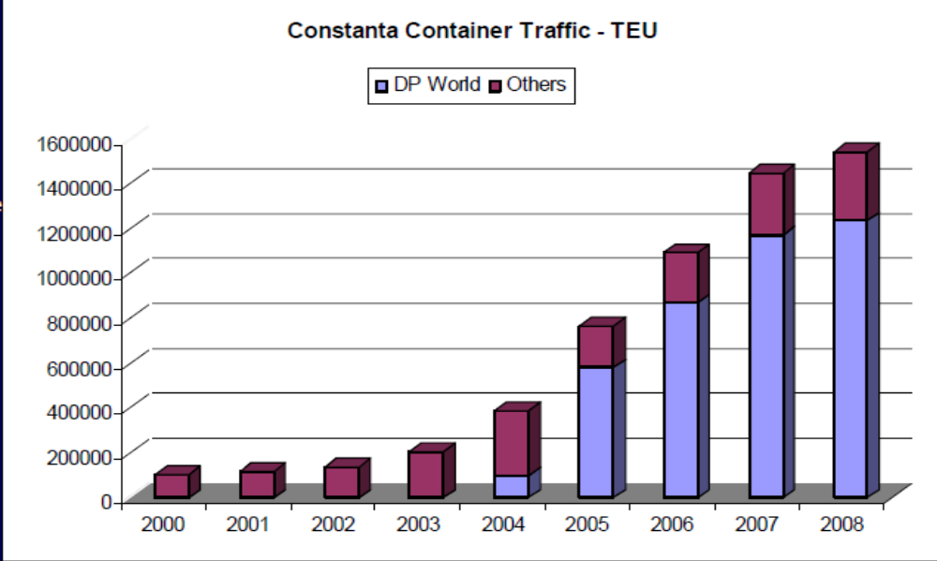
Figure 26: Constanta Container traffic in TEU (2000-2008)
In 2008 CSCT had almost 80% of the container traffic share in Constantza. SOCEP had 14%, APM – 4% and UMEX – 2%. By the words of Mr. Bullock, the expectations are to reach 90%-95% of the volume next years, as APM and UMEX are not operating or making very small volumes. Because of the crisis, in the first months of 2009, the traffic in CSCT has fallen by 52% compared with the same period last year, which poses huge questions about the future volumes.
Currently, the terminal capacity of CSCT is 1.3 mln. TEU, the yard area is 31 ha, the quay length is 1045m and the draught is 16m. The terminal operates with 5 x STS Gantry cranes (3 STS on order 2009) and 3 x MH Cranes, 15 RTG/RMG , 4 Reach Stackers, 6 ECH and has 5000 sq.m. of covered storage. The terminal operates 364 days a year, with two 30 mins meal breaks per day. However, there are huge expansion plans as mentioned earlier. The aim is to have 5 main line berths with total length of 1.7 km, 2 feeder berths with total length of 450m, 15 Ship to Shore cranes, 4 mobile harbor cranes, 50 RTG/RMG/ASC Yard Cranes, 15 ECH,15889 TEU ground slots ~70 ha with the total capacity of 4+ mln. TEU, and all of that done in different stages through only few years time. The intentions of CSCT are to use the capacity for warehouses or logistical center if the volumes continue to be so low in times of crisis. Right now the cranes are operating on 50-60 moves per hour alongside ship, with an average of 25 mph/crane, feeders and barges are served as regular ships in CSCT. All of those features create serious entry barriers for the future competitors – the favorable location with large depths and better vessel turn-around time, economies of scale and the large public investments done before awarding the concession. And while the terminal expects to have almost all the volume of the port for the next years to come, intra port competition is definitely a forgotten topic in the port of Constantza for now, with the only threats coming from the other ports on the Black Sea.
CSCT is a volume growth oriented terminal, buying cranes, systems, and training many people. That is why the current drop in volumes came unexpected. The transshipment volumes fell from 74% to 53% (and is expected to fall more) in the first months of 2009 and some of the main clients went to Ukraine – to the terminals of Illichivsk (where in May 2007 the first Maersk 5000 TEU vessel was served) and Odessa, which are the largest competitors in the region for CSCT. However, we already discussed the difficulties Ukraine is facing with transit containers and bureaucracy which actually poses little threat to CSCT. Illichivsk and Odessa are somewhat limited from capacity, which relieves the problems with future volumes coming to CSCT, by the words of the DPW Constantza manager.
The main lines calling at CSCT are almost all of the big global players without Evergreen – MSC (Tiger service), Maersk (after the closure of their terminal), CMA-CGM, ZIM, NORASIA, Grand Alliance, NWA & HANJIN, CSCL, K-Line and YML with feeder services from - UNITED Feeder Services,EMES, MSC, ZIM, CSCL and MSK Dedicated Feeders. Before the crisis, MSC used to be the main line calling at CSCT bringing the most volumes, but after January 2009 MSC stopped the calls of large vessels (8000 TEU). Also, in 2009 CMA-CGM made a consortium agreement with Maersk because of the drop of containers to deliver to Constantza. All of the big lines put smaller ships on the routes, on slow steam but in increased numbers and kept the large vessels outside the Black Sea. Therefore, the volumes of CSCT fell, explained by the behavior of the shipping lines and respectively, more calls are made directly to the port of Varna for example.
There was an interesting performance indicator formed by the Cargo Systems Ranking magazine about “Berth Productivity Ranking”. 20 major European terminals were evaluated –incl. Rotterdam, Hamburg, Constantza, Bremerhaven, Felixstowe, Antwerp, Marseille, Gioia Tauro and St Petersburg. The formula measured performance based on a berth productivity formula including a cost factor. The formula indicated:
(365 x R x N x U) / C = result in TEU per $1000 per annum
Where “C” stood for Cost per berth (capital and direct), “R” for STS crane unit working rate, “N” for STS cranes per berth and “U” for berth utilization.
The result in Cargo Systems 2008 September edition stated that the top two ports are Bremerhaven operated by CTB and CSCT operated by DPW. The results can be interpreted as a great success in CSCT’s berth productivity per number of ships handled.
CSCT is not intended to be the only successful project in the port. NC “Maritime Ports Administration” SA has started number of projects intended to strengthen the position of the port in the region. Since the completion of Pier IIS – the terminal of CSCT, the administration has the aim to build two more parcels located next to it, named Pier IIIS and Pier IVS respectively, and a new barge terminal.
Pier IIIS is expected to be of the size of 35ha and it will be build by reclamation of land into the sea. By doing that, a new container terminal is to be completed with great capacity (estimated at min 700,000 in the beginning) and the project will cost 67 mln. euros. The administration intends to offer the project for DBO or state budget financing.
Pier IV is intended to be build in 3 stages – in phase one 35ha will be reclaimed in the sea for the cost of 118 mln. euro, in phase two 55ha for the cost of 155 mln. euro and in the third phase 70ha for the cost of 140 mln. euros. In that way 3 new terminals will be created with very deep depths with great opportunities for the private parties. The administration will promote this project for state budgeting or will look for other sources.
The new barge terminal will be build because of the increase in traffic in the port of Constantza. In that way, new opportunities will be created for the Danube river link leading to the countries in Central and West Europe, and will improve the Inland Waterway Transport (IWT) which is of strategic importance. The cost of the terminal will be 24 mln. euros and the funds will come from a non-sovereign loan from EBRD (European Bank for Research and Development - 67%), state budget and own sources of the administration (33%).
The investments that are to be made by the port of Constantza cannot be compared to those of Varna and Bourgas in Bulgaria, as well as the more oriented approach taken by the port administration in Constantza. However, it is the traffic that is pushing the boundaries in Constantza, so all the new terminals are to assure the free flow of containers and other cargo through the port, and not to reduce the number of clients that the port has. In Bulgaria, as the volumes are low, and the export takes another direction (the chemical complex of Devnya at Varna-West for example), the containers have been forgotten for a long time, before starting to grow rapidly in the recent years, even through feeder ships. Exactly that initial need for growth is pushing Constantza far ahead in terms of volumes and tons of cargo. Therefore, the expansion projects as well. The private operators at the port of Constantza (like DPW) can only give that trend a boost with even larger scales of traffic.

4.4.1.3. IT applications
Because of the growing flows of containers, the port of Varna had to change the software they were operating with. Therefore, a new system for the sum of USD 500,000 was bought to coordinate the container flows. For year of operation the system made only one mistake, which was highlighted by eng. Stankov as a personal human mistake, not a software failure. It was personal software especially created for the port of Varna by Bulgarian IT specialists. All the lines have access to the database and can follow the containers and movements, and as per the latest information clients like Maersk and MSC are satisfied with the level of service.
In the port of Constantza the administration has transferred the opportunity to the private parties to arrange personal software systems. Therefore, DPW is using company software which is common for all the terminals of the company. Operating with so many containers and ships requires a unified system with access from all the partners – something that DPW have established, developed and granted to the latter parties.

4.4.1.4. Hinterland connections
The networks of hinterland connections of Romania and Bulgaria greatly differ. As a larger country, through the years Romania has established road, railway and river (canal) connections that allow speed access to the distant points of the country. Bulgaria, on the other hand, has a road and railway network but the river connections are only on the North border – the Danube.
In the port of Varna we have three main types of hinterland connections at the moment – specialized conveyer belts (22% share of the traffic, located in Varna-West for the chemical cluster), conventional transport (61%) and railways (7%). Most of the containers are transported by conventional auto transport, and small percentages are with railways. On the next figure we can see the main connections in Bulgaria:
Figure 27: Hinterland connections – Bulgaria (www.port-varna.bg)
All the terminals of the port of Varna are provided with access to the railway connections by the main operator “BDZ” (Bulgarian Railways). The company is still the national monopolist on the market. However, following the European practices, in 2002 has been created the State Enterprise “Railway Infrastructure” and in 2004 has been licensed a second operator named “Bulgarian Railway Company” which is specialized only in freights. There is also a third operator - “Bulmarket”, which operates only with freights as well. “BDZ” offers services for all type of cargoes and serves container freights owning terminals in Sofia and Rousse (on the Danube). They also provide specialized block-trains for intermodal units. The network of “BDZ” covers the main country regions like Sofia (520km railway distance), Plovdiv (390km) and Rousse (219km), but no dedicated high-speed lines are provided for container cargoes. There’s been a lot of talk about the intermodal connections and the link between Varna and Rousse in the port in recent years. Intermodal solutions are needed to fill the gap that is left, when having in mind the persistency of the Romanian government to promote the Danube barge connections. In that regard, the port of Varna is offering, in cooperation with “BDZ”, a transit intermodal connection between the ports of Varna and Rousse in order to assure that river transport is also an option for the Central European clients of the port. As one of the few options to connect the Danube with the Black Sea, the port of Varna is offering a package on a competitive price depending on the volumes. From another point of view, with the barge expansions planned in Romania that policy can only be successful if great discounts are offered to the clients coming to Varna combined with fast service (terminal operations and intermodal). Therefore, the future of that initiative without a proper plan for development and a clear marketing strategy is very uncertain. It is the words of the BASBA chairman – capt. Hristov, that Bulgaria needs more coordinated policy for the railway infrastructure (and transport policy) and only that can help it handle the increase in traffic. His words are in some way obvious having in mind that Sofia was long time served by the port of Thessaloniki which is closely connected to the main shipping line routes than Varna. However, with a transport policy and competitive prices that can be changed and the last year was the time for that having the strikes in Thessaloniki and Varna gaining some of the traffic. After all, it is the general idea of Bulgaria to be self-sufficient, with its two ports being on such favorable locations on the Black Sea.
Conventional transport has the largest share of the ports’ traffic in Varna now. There are roads connecting Varna with Bourgas (E-87), Sofia (Hemus Highway), Rousse (E-70), etc. The lakeside roads are used from Varna-East and Varna-West to reach the main roads of the country in nearly 20 minutes drive. However, in times of intense traffic (like the last year) the port can suffer from congestion with such large share of transport by trucks. It’s been a global tendency in the recent years to lower down the conventional transport, favoring the railways and barges. Especially in Europe there’s been a massive search for options in the recent years leading to switches in intermodal direction (for example “in the domestic battle between carriers for long-distance traffic to and from Hamburg, the rail has a market share of over 70%”). In that regard, more cooperation is needed between the port authority and “BDZ” to assure future investments in the country’s network and provide competitive prices, in order to lower down the conventional transport and CO2 emissions.
As we already mentioned, the size of Romania and the aggressive maritime and transport policy through the years has lead to numerous expansions and modernizations in the infrastructure compared to Bulgaria. In the next figure we can see the main hinterland connections in Romania, and respectively – the port of Constantza:

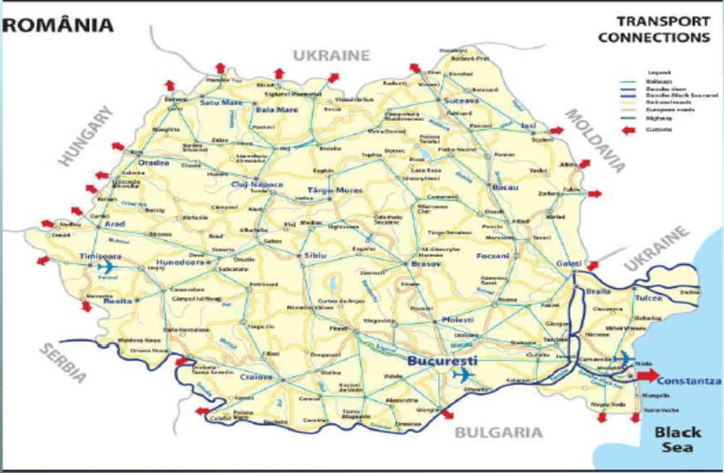Figure 28: Hinterland connections – Romania (Constantza port presentation)
The hinterland connections in the port of Constantza and the whole country are well developed, following the national plans for development of the roads, railway systems and rivers (canals) able to provide easy access and fast service.
The total length of the roads in the port of Constantza is 100km. A2 motorway (the “Sun Motorway”) that leaves the port has the length of 224km. There is a plan for the “Bridge over Black Sea –Danube Canal” project, that will connect the Port of Constantza with A2 motorway (Bucharest – Constantza).
The Danube – Black Sea canal has a class VI rating and is a “F” class inland canal with the length of 64.4km and 90m width. It has a water depth of 7m with 17.5m clearance under bridges. The new terminal for barges with close proximity to the Danube canal will greatly intensify those connections and the plans are to “even” the share of the different modes in the port – following EU port trends.
Romanian railway network constitutes of 11,300km of which 3929km are electric lines and 2,707km double lines. The unfolded length of 20,730km ranks Romania at the 7th place in Europe after Germany, France, Italy, Poland, Great Britain and Spain. CFR (Romanian Railways) is the national railway operator which is divided into CFR “Calatori” – for passengers, CFR “Marfa” – for freight transport and CFR “Infrastructura” – for infrastructure projects. Although passenger railway services are not a state monopoly in Romania, CFR remains the only passenger carrier operating at a national level. However, after the reorganisation of CFR in 1998, around 10% of Romanian railway tracks have been leased to private companies. The major works on renovation of Corridor IV (rail) are intended to finish at 2012, when there will be 1000km of high speed lines and the first modernized line will be that of Bucharest-Constantza (225km). That will lead to speeds of more than 170km/h on 70% of the way with 210% traffic growth on the route foreseen.
Every terminal at the port of Constantza has its own direct access to the railway system at the port. There are 4 railway stations at the port with total length of 300km (60km electric) located on Constantza Port A, Constantza Port B, Pier V and the Ferries station. For the promotion and development of the railway system is responsible NC “Maritime Ports Administration” SA.
However, the share of the traffic per hinterland modes in the terminal CSCT pretty much differs from what the general intention of the management is. Right now, conventional transport holds 70% of the traffic in CSCT, 29% are shipped by rail and only 1% is barge. CSCT is supplied with 3 railway slides by CFR and the national company provides the wagons, but stated by the managers at CSCT, DPW do not have direct contract with them. Other issue is the lack of dedicated railway service provided to an operator like DPW, but that is an issue of national planning as the general manager stated, and no new projects are coming in that specific direction. The trucking companies also do not have direct contracts with DPW and shipping agencies are responsible for the trucks to choose better times to come at the terminal and avoid possible congestion problems. The future aim of CSCT corresponds with the management’s plans – to equal the modal split, as the share of conventional transport is too large and with the future growth in containers expected (4 mln. TEU capacity plans), congestion problems might occur especially when direct link with the companies is not present. One of the weaknesses pointed out by Mr. Bullock was the lack of subsection for intermodal responsibility, which poses problems for the management.
As the share of barges is so low, the officials in DPW stated the great interest of the company in that mode. By their words there are a lot of “old and undeveloped inland ports” which can be sold together (some governmental property and some – no) for possible future expansion of DPW in the region. Before extending their influence in barges and inland transport modes, with the lack of dedicated fast-lane railway tracks, DPW cannot be competitive for the Central European countries. That is why there are future plans for cooperation and work in that direction – the creation of an inland ports network that will allow DPW to be competitive on a European level.
There are some signals on an international level which bring some optimism in those plans. The Austrian company “ViaDonau” compared the traditional route to the city Krems (Austria) from Hamburg with railways to the alternative barge route from Constantza. The results were somewhat interesting:
- There are significant advantages in the supply chain costs by using optimized container barges
- Similar or even better transit time for the whole chain
- 16% less CO2 per container to make the environmental balance positive
On the other hand, there is some cargo that is still coming from Germany to Romania, which was highlighted by the DPW management as a shortage in hinterland fast and reliable services which posts threats to the DPW position in the region if cooperation is not found between the terminal and national infrastructure companies, through NC “Maritimes Ports Administration” SA.
As we compared in the last pages, the hinterland connections of the Bulgarian port of Varna and that of Constantza differ significantly. Although the two countries are struggling to reach the Danube in all possible ways to give the container traffic a boost on that route, it is still unclear how the future events will unfold. With the completion of the barge terminal in Constantza there will be a huge ground for expansion in that direction. The intermodal options offered by the port of Varna can be successful only if the traffic growth is constant and there are huge discounts offered to promote the route. In that case, both countries can gain share of the traffic on the Danube.

4.4.2. Institutional arrangements
In the next pages we will investigate the institutional arrangements in the port of Varna and Constantza. The factors that we will pay attention to are: the structure and heights of tariffs, length and type of contracts, safety and security stipulations, environmental regulation, labor laws and organization and the customs procedures.

4.4.2.1. Structure and heights of tariffs
In order to compare the tariffs of the two ports, firstly we will revise the normal port dues paid and then, the tariffs charged by the container terminals.
In the port of Varna, the port dues consist of taxes for access, lights, canals and quays. Those are collected by the State Enterprise “Port Infrastructure” Co. and invested back in the port in the form of super and infrastructure. In the port of Constantza there are access, quay and basin tariffs which are collected by the Port Authority (PA) - National Company “Maritime Ports Administration” SA. The access dues of the two ports significantly differ, in the port of Varna they are 0.55 euro/BT while in Constantza - 0.155 euro/BT. However, if we make a normal dues calculation we will see that for a 25,000 BT container vessel all the taxes in the port of Varna will be around 30% more. As we mentioned earlier, that is mainly because of the access tax which is more than 3 times larger than that in Constantza. Great attention was paid to the monopoly of the tugboats in the port of Varna by the local maritime sector representatives. They stressed the increased prices of those services in the port and the general opinion of the lines about the current monopolistic behavior.
The tariffs of the terminal companies are formed in a completely different way. In Varna, the PA sets the tariff considering the volume that a certain client brings and there are meetings with the BASBA (Bulgarian Association of Ship Brokers and Agents) that are formed regularly do discuss issues that occur. The evaluation of the prices is done every 3 to 6 months for the different clients (lines) and volume brought, and certain percentages of discount are given considering the thresholds put in the beginning. Discounts are offered for passing the thresholds amounting from 3 to 15% off the prices. If the carrier brings more than 20,000 TEU, then the prices are negotiated directly. Considering the low capacity of the terminals, container free storage can be rarely offered, especially in times of high volumes. However, that is an intention of the PA, to offer it when possible and also stimulate transit in any possible way and therefore cooperates with the custom office at the port and those at other transit points as well.
In the CSCT terminal vessel handling tariffs are formed on the basis of loyalty – the foundation customers of the company get preferences, but the author was assured that the range in which the prices to the different clients are kept is really small. In that way, clients are treated equally, or that is what was perceived. Discounts to volumes were officially given only in the first years of operation to attract clients, but those and the general tariffs after that were not only generated locally but following the company’s (DPW) policy. The notable thing about the CSCT terminal was the dwell time few years ago which reached 20 days for the containers. Therefore, “standard import tariff” was introduced to “get the containers out of the terminal” which by the managers’ words had a big influence and the dwell time has fallen down considerably. In that regard, to offer container free container storage time considering the growth in the recent years pushing capacity limits tremendously, was not the first idea of the management. However, with the crisis dragging volumes down, this strategy can be a vital option for the future. Compared to the port of Varna, CSCT terminal also has a customs office located on the terminal, for fast service.
Reviewing the ports of Varna and Constantza in terms of tariffs we have to mention the higher port dues in the Bulgarian port and the different strategies applied by the ports’ terminals. Those are justified considering the differences in traffic they are dealing with, and the future growth approach taken by DPW. Also, for DPW being a private party it is easier to change the strategy quicker than its Varna rival.

4.4.2.2. Labor laws and organization, Safety and Security Stipulations
In Varna the labor is employed by the PA, while in Constantza DPW as a terminal employs its own people. In Varna there are four syndicates and they have collective work agreement with the PA which stipulates the conditions for the workers. In the contract it is stated that before possible concession of the company, the workers have to be warned minimum 2 months before the designated date and to be informed about the:
- The change of property and its due date
- The reasons for the changes
- The possible legal, social and economic consequences of the upcoming changes
- The actions that will be taken by the PA to the workers as an employer
However, some doubts were stated by the port of Varna representatives of possible actions by the workers having in mind the strikes that followed the privatization of the port in Thessaloniki. As we can see by contractual relations the workers can be informed in reasonable amount of time, but the future actions are hardly to be predicted with privatization surely coming in hand in the following years.
In the CSCT were expressed many doubts about law regulations when dealing with the Romanian system. There’s been a massive strike in the terminal on the 17th of July, 2008 when over 500 employees (being joined by trade unions later to make the final amount of 1500) protested about the delays in increasing their salaries while DPW indicated profits of 12 mil. euros for 2007. The ground for the strike was the high productivity of the workers (who are among the lowest-paid in the EU). Interesting was the way in which the National Trade Union Confederation Cartel Alfa states about the situation: “we cannot possibly accept that huge profits are made without any incentive for the workers, who are treated like slaves at the beck and call of troubled-waters profiteers”. The National Trade Union block expressed its solidarity with the terminal workers, because, it said, “a strike was the only solution for the port workers, after not having been able, for five months in a row, to bargain an acceptable compromise with the management”. After three days of collective bargaining a solution was found offering the workers more money, a minimum company wage rate and one extra day of annual leave. In the words of the National Federation of Port Unions: “the first to gain from this will be the company itself, because the workers will be more motivated, better fed, healthier, more devoted and more faithful to the company, and this will boost work efficiency and profits”. However, the opinion of the management has been slightly different – the closure for 20 days of a terminal with the capacity and growth rates like CSCT has caused huge problems. It was the lack of experience of the Romanian government to deal with such issues that was expressed by the DPW Constantza manager as a first priority matter. The process of mediation between the parties was not at sufficient level, and there was no governmental body present with the ability to arbitrate, avoidance of the dispute was not searched as well. The problems occurred because the labor unions and the government have relations, but there is little input from the business sector and lack of experience, as already mentioned which leads to poor methodology for dealing with industrial action.
Both Bulgaria and Romania are still experiencing difficulties with the labor forces and privatization. As in Bulgaria, those problems are not demanded but surely can be expected, the Romanian experience already shows signs of them.
Safety and security procedures have been carefully followed by the ports of Varna and Constantza. In the port of Varna, the “Port Infrastructure” Co. has the aim to assure the safe incoming of the ships in the port, while the PA follows all actions taking place on the quays while the “Executive Agency Maritime Administration” follows other activities connected with safety and security at the ports. The port of Varna is one of the first Black Sea ports that is certified as per the requirements of International Ship and Port Facility Security (ISPS Code). At the same time the general requirements in Constantza are followed by the PA, but at the terminals all of those requirements lay in the hands of operators like DPW.

4.4.2.3. Length and type of contracts, Environmental Regulation
The PA of Varna has contractual relationship with the government to operate the terminals, which makes it a governmental structure. In Constantza concessions have been given to the operators (in the case of CSCT - 45 years).
At the port of Varna, for environmental issues is searched cooperation with the Ministry of Ecology and advice from “Executive Agency Maritime Administration”, where all of the future expansion projects are discussed as well and examined for “Research of Influence on the Environment”. However, when the new plans about the terminal in Varna (near “Kazashko”) has been made, group of environmental activists blocked the road between Varna and Devnya because of endangered species of birds. After short discussions the disputes have been resolved. At the same time, in Romania before the building of new terminals or starting expansion projects an “Initial Environmental Examination” is made. It is undertaken with the Environmental Protection Agency regarding the Ministry of Water & Environment Protection requirements and Environmental Impact Assessment is made. In that regard, public consultation is arranged to satisfy the local requirements, and a summary of relevant environmental issues and mitigation measures are released. For the terminals environmental protection has been one of the most important requirements as well, that is why private operators strictly follow procedures of notification for environmental impacts.

4.4.3. Governance structure
Comparing the other factors, we have to state that the division of responsibilities between the public and private sector, the management structure and legal position of the port authority in the ports of Varna and Constantza also differ significantly.
The port of Varna operates as a Public Service Port with some small terminals being separated and given to concessioners. All infrastructure is in the hands of the State Enterprise “Port Infrastructure” Co. which manages and develops the ports property of Varna, Bourgas, Rousse and Lom (river port) as well. The responsibilities of the company are to develop the Black Sea and Danube ports via provision of respective, manage the government assets dedicated to international maritime commerce, assure access to the ports, establish good conditions for safety and security, and it has an advisory capacity to the Ministry of Transport regarding port infrastructure planning. After that, the plans for expansions and changes are voted, being proposed by the Minister of Transport. “Port Infrastructure” Co. collects all the access, light, canal and quay taxes connected with the entrance or stay in the port and is responsible for funding the port for superstructure and infrastructure needed, etc. The initial idea is that the PA should be responsible for funding normal operations, while the other requirements should be supplied by the government when demanded and approved. As the PA of Varna and “Port Infrastructure” Co. are different entities in Bulgaria, the port does not perfectly fit in the Public Service Port model, as there the entities taking decisions about infrastructure expansions and administration are combined in one. However, the port governance structure in Bulgaria is still the closest to that model, with the distinguishing feature of the current division, which by Brooks and Cullinane (2007) can lead either to cohesive and streamlined approach, or under-investment and limited internal competition. The “Port Infrasructure” Co. is created to apply more centralized approach as it is responsible for the infrastructure of all the ports in Bulgaria, but on the other hand, it is doubtful if that is the most appropriate strategy as more cooperation is needed between the different governmental companies to assure the streamlined approach mentioned earlier.
One of the other institutions with advisory capacity to the Ministy, is located in Sofia and it’s called “Executive Agency Ports Administration”. It has an executive director and two directorates – Administrative Legal and Finance, and Port Registers and Control. The general aim of the agency is to:
- Keep a register book of all ports in the Republic of Bulgaria
- Control the observance of the requirements for free access and application of equal competitive conditions for port operators
- Assist the Minister of Transport and Communications in carrying out control over performance of concession contracts
- Collect, process and provide port statistic information
- Carry out other activities established by a Law or an act of the Council of Ministers
The second institution with advisory capacity is “Executive Agency Maritime Administration”. Most of its functions are related with the safety, security and environment in the port. Some of them include:
- functions related to the safety of shipping in the sea spaces and inland waterways of the Republic of Bulgaria
- the actual liaison between the government and ships flying the Bulgarian flag
- observation of shipping safety requirements by Bulgarian and foreign ships
- prepare and issue certificates of competency to seafarers
- perform functions related to the living and working conditions onboard ships
- control on traffic in canals, ports of the Republic of Bulgaria and other duly defined regions
- perform search and rescue of people, vessels and aircraft in distress
- control on protection of the marine environment and the Danube river from pollution from ships, and many more
The port authority of the port of Varna is “Port Varna” EAD which has a contractual relation to operate the port and owns the superstructure. The current board of directors operated already 8 years, and they have freedom to decide about the port’s future plans and tariffs. All of the proposals for expansions are submitted to the Ministry or to “Port Infrastructure” Co., and the PA is the leading party when proposing new projects and hires its labor force. It is forbidden for the government operators to be candidates for concessions, although they are the ones (the current board) that know how to operate the port.
The taxes of the different terminals (given to concessioners or the PA) are created on the base of tons handled. In that way are avoided arguments from the private concessioners of the port that “Port Varna” EAD is being aided as a state enterprise.
There’s been a lot of talk in the recent years about the privatization of the port of Varna. However, the general opinion is that there are no big companies with expertise that want to be concessioners. The overall opinion is that more investments are needed in the port, in order for it to be privatized, there should be some base for future growth, as the plans for the new terminal in Varna. A good example for such policy (BOT) is the construction of Pier II by the PA in Constantza which has been given to DPW to operate. In that way, companies are not carrying the initial burden of investment.
Public – private partnerships are not very common for the port of Varna. As a governmental structure, the port has had little experience dealing with big projects, or they’ve been handled by the government. It is in those huge projects, or in the hinterland connections where more cooperation is needed, but with so many governmental structures it is very hard to cooperate with private parties. Therefore, the PPP’s were pointed out as opportunities with no ground for the moment.
The general impression is that all of those agencies and structures present in the country, responsible for the infrastructure expansions and the governance of the port, are causing lots of problems connected with bureaucracy, difference in opinions or the simple fact that agencies located in Sofia (for example) are “closer” to the Minister than the PA of the port. Problems with corruption in the last decades in Bulgaria have also brought tension in the atmosphere of the governmental layers transferring it to the lower PA levels as well. Very important for the author was the fact that both ports Bourgas and Varna are given grants and funds for future projects from the same company, but in the future those PA’s are expected to be privatized. That poses questions in terms of favoritism and larger investments being made where the pressure is higher. After all, the taxes getting in the “Port Infrastructure” Co. are coming from all ports, but they can be invested only in one, if no other funds are found, which can be a reasonable cause of unpleasant disputes. With the country being the poorest in the EU, and its funds recently being stopped that can bring additional troubles to the already overheated system.
Even more confusing is the fact that the “Port Infrastructure” Co. is the actual owner of the ports and the enterprise has no unified Master Plan of the future development and program for the port infrastructure. The author was assured that the directors from the PA in Varna can in any moment connect with the Minister of Transport or his deputy and explain any undergoing or urgent questions. However, that does not lead directly to the fact that some actions could be, or will be taken about the future plans. From some point of view, the transparency seems to be at a very low level, which leads to insufficient public information. And in that way, private companies are sometimes more open and transparent than the governmental structure which plays the role of a “black box”. Moreover, the port infrastructure company collects the taxes from the ports which are by law required to be invested back in the port, and returned back to the sector in the form of infra and superstructure, and modernization, but there are some doubts shown by local industry representatives that this is not exactly the case in the port of Varna, or the funds are leaving to other sectors which does not make the sector self-sufficient. Even if that is the case, then investments can come from other sectors to boost the country’s transport network. But when looking at the overall situation, that will not be the first thing coming to mind.
In Romania, the port of Constantza operates as a Landlord port. The National Company “Maritime Ports Administration” SA operates the ports of Constantza, Midia, Mangalia, Medgidia and Galatz. All of the functions stated earlier for Bulgaria, where different companies are responsible for infrastructure and governance are summarized in the Constantza’s PA. It is responsible for the administration, maintenance, repairs, modernization, and exploitation of the entire infrastructure of the ports of Constantza, Midia and Mangalia and part of the superstructure. It provides services in pilotage (compulsory), mooring and unmooring, ship brokerage; shipyards, repairing companies, ship chandlering and surveying, bunkering, vessel operation, port signalling, measuring, depth maintenance, pollution fighting, dirty ballast reception, fresh water and electric power distribution, telecommunication services, fire fighting, diving, crew vessel surveillance and health care.
The port terminal companies are awarded concessions for different amount of years depending on the area (land), years of operation, bid offered and other special requirements. The superstructure of the terminals and future investment are responsibility of the concessioners with some specific requirements from the PA. For example, it is in the contractual relations between DPW and the PA that the operator has to “promote the port”. In the case of DPW, the terminal is provided with power, sewage and optic cabling which are paid to the PA and the prices are on annual basis and can be negotiated. With DPW being the largest operator in the port, there’s no preferential treatment from the PA in any kind. However, the normal charges for access, lights and nautical access are charged by the PA, and then returned back in infrastructure that everyone’s supposed to benefit. From another point of view, in the case of CSCT - the largest port operator, the well-being of all the companies in the port is not the first aim, but the provision from the PA of the necessary infrastructure that will be there to accommodate the future traffic for one of the largest tax payers, as they are. But those views for infrastructure expansions change with the PA management as well, and the projects with them. That is why special note was made about the dedicated high-speed railway tracks needed by the terminal, with the lack of plans from the management to respond to the request for cooperation as well as the maintenance of the roads (for the 70% of auto transport share that CSCT has) that were showing signs of wear and tear.
What surprised the author in that case were the difficulties that a terminal like CSCT is facing when it arranging important meetings with the PA. The lack of timely response to the terminal problems was in some way astonishing for the author, having in mind the importance of CSCT for the port. But when having so many projects and terminals and one PA to take care of all the ports operators, that could be a reasonable excuse for the problems occurring but the latter have to be solved in some way, but that is a question of coordination and time planning. Meetings between the PA and DPW are normally made when the two sides are negotiating (prices, etc.), the communications are open. However, there is the general opinion that the projects discussed should get more scope (and financing from EU funds as well) and failures of projects to be agreed should be less. The PA of Constantza has direct connection with the Ministry of Transport, where the final decisions are made, about proposed projects and outside funding. That is why they are the part taking the mediation process to the next level (government).
One of the distinguishing things about the port of Constantza is the ability of the Romanian government (as stated by Mr. Bullock) to apply a special spontaneous order (control). That consists of a checking on the safety and fiscal procedures taken by the terminal with the capacity to apply punitive control. Those checks are made by the government without warning in order to investigate the current work of the terminal.
Compared to the port of Varna, the port of Constantza has taken much more centralized approach to the governance structure. In Varna, a lot of issues and decisions have influence on the port that take place in the capital of Bulgaria – Sofia, by a number of different parties and the executive agency. In Constantza, the centralized approach leads to difficulties in timely communication sometimes but leads to more efficiency and is a more oriented approach when dealing with the Ministries. If we have to compare the models in terms of global tendencies, the port of Constantza’s landlord model is certainly more advanced and spread in the world, giving opportunity to the private operators to bring their investments in the port. On the other hand, the public service port is supposed to be more oriented in terms of streamlined investments in the sector, but the case of Varna shows exactly the opposite.

4.4.4. Conclusions
By the shown research, the ports of Varna and Constantza have completely stages of development, taking into account the current world trends. While the port of Varna is still governmentally owned, more cooperation and private parties are needed but the lack of significant infrastructure investments are pushing the latter away, leaving the port with a lot of governmental levels to “overcome” before getting the needed funds. On the other hand, the port of Constantza is showing persistence in their plans for future growth, investing in terminals, hinterland links and trying to push forward projects for EU funds with some exceptions pointed out by DPW.
The development of terminals follows the governmental policies. Private players like DPW have been attracted, who have invested in the CSCT terminal tremendously and have interest in the inland ports as well. All that flow of investment is boosted even more with the ever-growing traffic in the Black Sea for the last years. With the air draught created by the Asparoukhovo bridge, the port of Varna can hardly compete with Constantza’s depths attracting mother vessels on a regular basis. However, the port of Bourgas was stated to be another story by the managers of the port and terminals visited, as a ground for future transshipment.
It is more the infrastructure and the governance that has influenced the position of the ports as it is today, not the special tariffs or incentives applied. The investments by the Romanian government in infrastructure through the years have proved to be right strategy for a future gateway to Central Europe, with more projects to come and to be competitive to its Western rivals. Even though the port is not directly aiming for the Central Europe transits right now, sooner or later that day will come having in mind the slower pace of its competitors. At the same time, the port of Varna has taken more locally oriented strategy for the moment, with intentions for future privatization.

4.5. Possible policy and development recommendations
The need for privatization has become notorious for the port of Varna in the recent years. However, in order to be competitive, the Bulgarian port has to open its gates for more private parties and eventually, change the current governance structure. The following measures can be noted as some of the important ones for the port regarding its future growth:
- Investments in infrastructure by the government
- Privatization of the port
- Unified policy for the transport sector and expansions
- Well-defined marketing strategy to attract more clients
- More cooperation between the public and private (PPP’s)
- Transparency in the system in order to accommodate EU funds
- Modernization of the port’s infra and superstructure
- More coordination between the hinterland actors to assure good intermodal connections at affordable prices in order to be competitive
- Introduction of intra-port competition by more operators present and avoiding monopolistic behavior
- Aggressive benchmarking policy with more international experts attracted in the sector
The port of Constantza has followed a streamlined course through the years, and the orientation to follow the transshipment path has proven right. However, in authors opinion, the port is in vital need to:
- Improve hinterland connections to compete for Central Europe
- Modernize inland terminals and find funds through governmental or private sources
- Create ground for the barges as an alternative mode of transport
- Work in the best way to find cooperation between terminal operators and management
- Introduce intra-port competition having in mind the future plans of DPW (4+ mln. TEU capacity) and the natural monopoly of the port of Constantza
- Lower the entry barriers so that the intra-port competition can be introduced
Those are some of the notes taken from the case studies of Varna and Constantza. But the paths of those two ports are not only crossing on the routes they are competing. In the next pages we will revise the alternative ways of action that could be taken.

4.6. Competition or cooperation?
It was the words of Mr. Papazov (executive director of the Port of Varna) that stated the idea of cooperation between the ports of Varna and Constantza first. The story of the Black Sea container trade started only a decade ago and experienced enormous growth, so are the ports of Varna and Constantza. While that in Romania has become the regional transshipment hub, the port of Varna cannot compete on a regular basis to the already advanced system of Constantza. But from another point of view, the new terminal that is to be built in Varna has the opportunity to be local or regional hub for Bulgaria which can assure the leading position of Varna in the region and continue the current growth without letting the traffic flow through Bourgas.
In other words, to interpret the statement of Mr. Papazov, the port of Varna can play the role of a natural feeder for the transshipment services from Constantza and then cover the hinterland securing preferential prices (in terms of volume) from its neighbor rival. In that way, when Varna cannot compete normally, the volumes that can be extracted to fill the expected capacities can be negotiated. However, that regional rivalry reminds the old saying “When you cannot defeat the enemy, join forces with him”.

Chapter 5. Discussion and research limitations
When looking at the regional map of the Black Sea, at first sight the normal question that will follow is: “Why the ports of Varna and Constantza?”. As the answer about the choice of the Romanian port may seem obvious, the port of Varna somehow does not fit in the whole picture. More obvious research question can surely be the regional fierce competition between the Ukrainian ports of Odessa and Illichivsk with Constantza for transshipment cargoes, than the original topic of the current paper. However, the author took another approach.
The questions concerning the Bulgarian ports are too many to be skipped. The process that so many ports went through in the last decade hasn’t started in the port of Varna yet – the port is lagging behind in terms of infrastructure and superstructure modernization even though it was obvious that the volumes are coming. The increase in containers last year and the whole process of global containerization was clear long time ago. Moreover, the first signs from the main competitors of Varna were shown and all flags were waved.
The problems surrounding the environment that the Bulgarian ports function in are not only economic – there’s been a great political influence on the decisions taken in the last years not allowing the transport sector as a whole to prosper. The EU funds were stopped because of corruption and lack of transparency. The ports and the whole sector are left as a second hand matter. Questions like those stay in the air and wait to be revealed, as Bulgaria is also a natural gateway to the hinterland of Central Europe, no less than Romania. That is why the accession to the EU is not about to bring its fruits in Bulgaria – because of the lack of clear idea how to get those fruits. Posing all of those questions does not mean they will receive adequate answers soon, but with the change of the parliament (elections 2009) we can at least expect some new ideas to come onboard.
The region is very limited in terms of previous researches by Western Universities, as well as from local publications. That is why finding the necessary information by the author was not easy. Arranging interviews and meetings proved to be easier in Bulgaria, while the author was refused a meeting with Constantza’s PA numerous times. Therefore, some of the information presented previously may not be as detailed as it should be, but the internal point of view was not present, although greatly needed. However, the author was not surprised by the treatment of the Romanian officials to a Master student researcher, having in mind the size of the PA and the projects handled, as well as the difficulties that DPW were having when arranging meetings.
The meeting with the general manager of DPW in Constantza (Mr. Bullock) and the other senior managers was an enormous success in terms of insights gained and opinions heard. The conversation in Varna with the exploitation director eng. Stankov and the marketing department gave a clear idea of the processes going on in the port of Varna, as well as the current political tension present. Both interviews, together with the one with the chairman of BASBA (capt. Nikola Hristov) and some companies from the Varna’s shipping sector were a great addition to the information gained.

Chapter 6. Conclusion
With the globalization and the changes in the maritime sector, many new trends have come to influence the competition between ports. The change of the volume of trade and the structure of the lines’ fleet have brought ships of more than 10,000 TEU into the routes, operating on significant economies of scale and serving main routes like Asia – Europe on a daily basis. With the trade, the ports and respectively terminals have changed as well, with many new global terminals emerging, through vertical or horizontal integration. Thus, the competition between ports, port complexes and port ranges have become fierce and on different scales. The global companies have embedded themselves in numerous countries, taking advantage of the privatization processes started around the world decades ago. Their aggressive policies have led them to countries, where intra-port competition has become almost extinct and entry barriers for new entrants have become significant.
With the global changes, the Black Sea region has been changing as well, having accepted its first direct calls in 2003, with growth levels of 30%, compared to a 12% world average. Those astonishing results have just lately brought the interest of the global players like DPW, establishing the first terminal of such size in the port of Constantza. Because of the huge problems with capacity, investments in infrastructures and new terminals have been started by all the Black Sea countries, with Ukraine and Romania being the market leaders and competing fiercely for the North-West transshipment cargoes and transit points to the EU. Russian ports have been showing slow growth a decade ago, but now the most important Russian on the Black Sea – Novorrosyisk is picking up with the volumes tremendously as well.
Having in mind the whole picture, the ports of Varna and Bourgas have been lagging behind in terms container volumes, but coping with the growth rates. As surprising as it sounds, the “gateway” of Bulgaria to the EU - the port of Varna, hasn’t managed to acquire good position on the market through the years, mainly because of the lack of infrastructure investments and streamlined approach to growth taken by the Bulgarian government. With numerous institutions forming the governance structure of the port, it hasn’t shown a cohesive approach to the desired market position being limited in the physical conditions as well and not being able to accept mother vessels for transshipment. On the other hand, the port of Constantza has had a more oriented view of hinterland and maritime policy for investments in the sector. The port is the current market leader with a global terminal operator for a concession of 45 years with enormous capacity expansion possibilities even in times of crisis and volume drops. The landlord model that has been formed with the privatization, has shown the way of the port to the EU market, investing in barges in the moment to cover the Central Europe hinterland. Being the two opposites in terms of streamlined growth, the ports can be hardly compared. The factors affecting the competition between them have been identified, showing that not only economical issues stand on the way of even rivalry. Moreover, there’s been already a handicap put with the stoppage of Bulgarian EU funds because of corruption and non-transparent economy.
With all of that said, it will be very interesting to see how the regional competition unfolds in the future, with the volume drops and future plans for expansions of the two ports. However, the leadership position of the port of Constantza can hardly be changed having in mind the current problems that Bulgaria and Ukraine are facing.

Literature References
Ball, M. (1983), Housing Policy and Economic Power: The Political Economy of Owner Occupation . London: Methuen.
Ball, M. (1998), Institutions in British Property Research: A Review. Urban Studies 35, pp. 1501– 1517.
Brooks, M.R. and K. Cullinane (2006), Governance models defined, In: Brooks, M.R. and Cullinane, K. (eds.) Devolution, Port Governance and Port Performance, 405-435, Dordrecht: Elsevier
Cox, K. R. (1998), Spaces of Dependence, Spaces of Engagement and the Politics of Scale, Political Geography, 17, pp. 1-23
De Langen, P.W. and Pallis, A.A. (2006), Analysis of the benefits of intra-port competition, International Journal of Transport Economics 33 pp. 69-86.
De Langen, P.W. and Pallis, A.A. (2007), Entry barriers in seaports, Maritime Policy & Management 34, pp. 427-440.
Drewry Shipping Consultants Ltd. - Container Shipping, Global and Regional Perspectives – Black Sea container Summit Conference 2008
Encyclopedia of World History (2001)
Fremont, A. and Soppe, M. (2003), The service strategies of liner shipping companies. Journal of Transport Geography
Jacobs, W. (2007), Port Competition between Los Angeles and Long Beach. An Institutional Analysis, Tijdschrift voor de Economische en Sociale Geografie, 98, pp 360-372.
Jacobs, W. (2007), Political Economy of Port Competition – Institutional Analyses of Rotterdam, Southern California and Dubai, Academic Press Europe - Nijmegen
Jacobs, W. & P.V. Hall (2007), What conditions supply chain strategies of ports? The case of Dubai, GeoJournal, 68, pp. 327-342.
Lauria, M. (1997), Reconstructing Urban Regime Theory. Regulating Urban Politics in a Global Economy. Thousand Oaks, CA: Sage
Logan, J.M. & H.L. Molotch (1987), The Urban Growth Machine. The Political Economy of Place. Berkeley, CA: University of California Press
McGuirk, P.M. (2003), Producing the Capacity to Govern in Global Sydney: A Multiscaled Account. Journal of Urban Affairs 25, 201–223
North, D.C. (1990), Institutions, Institutional Change and Economic Performance. Cambridge: Cambridge University Press
Notteboom, T. (2009), Presentation – Global Trends in the Maritime and Transport Sector – Erasmus University Rotterdam
Olivier, D. and Slack, B. (2006), Rethinking the port . Environment and Planning A 2006, volume 38, pages 1409-1427
Stone, C. (1989), Regime Politics. Governing Atlanta, 1946–88. Kansas: University Press of Kansas
World Bank (undated). World Bank Port Reform Toolkit. Available at http://www.worldbank.org/transport/ports/toolkit/
Yin, R. (2008), Case study research: Design and methods. Sage Publications

Internet References
http://www.containersummit.com/2008/materials_en/Ministry_of_Transport_en.pdf
http://www.containersummit.com/2008/presentation/Andrey_Kuzmenko.pdf
http://www.containersummit.com/2008/materials_en/Yuriy_Vaskov_en.pdf

http://www.containersummit.com/2008/materials_en/Andrey_Narayevsky_en.pdf

http://www.containersummit.com/2008/presentation/Steve_Wray%20.pdf
http://www.containersummit.com/2008/presentation/Jesper_Pedersen.pdf
http://www.containersummit.com/2008/materials_en/Oleg_Fotchenko_en.pdf
http://www.containersummit.com/2008/materials_en/Sergei_Naumov_en.pdf
http://www.containersummit.com/2008/presentation/Tom_Ossier.pdf
http://www.containersummit.com/2008/presentation/Dallas_Hampton%20.pdf
http://www.containersummit.com/2008/materials_en/Sergey_Nikulin_en.pdf
http://www.containersummit.com/2008/materials_en/Uve_Zorge_en.pdf
http://www.containersummit.com/2008/presentation/Robert_Schachermayer.pdf
http://ncsp.nross.ru/en
http://ncsp.nross.ru/en/

http://www.port-burgas.com/

http://portfocus.com/romania/index.html

http://maps.google.com

http://portgalati.com/
http://www.potiseaport.com/
http://www.batumiport.com/en/
http://www.cerrahogullari.com.tr/
http://www.drewry.co.uk/publications/
http://www.eoearth.org/
http://balwois.mpl.ird.fr/
http://www.port-varna.bg/
http://www.port.bg
http://www.liternet.bg/
http://www.portofconstantza.com/apmc
http://www.travelworld.ro/en
http://www.cargosystems.net
http://www.bdz.bg/
http://www.hafen-hamburg.de
http://www.cfr.ro/
http://www.via-donau.org/
http://podkrepa-varna.org
http://www.eurofound.europa.eu
http://www.bgports.bg/
http://www.marad.bg
http://www.marinetalk.com
http://paper.standartnews.com/bg/
http://sg.stroitelstvo.info
http://bg.bgp.bg
http://www.burgasnews.com/
http://www.vodnazona.com

Interviews Conducted

Mr. Rowan Bullock, Dubai Ports World, General Manager CSCT terminal – Constantza – 8:30 AM, 11th June, 2009

Mrs. Raluca Daraban, Dubai Ports World, Commercial Manager CSCT terminal – Constantza – 10:30 AM, 11th June, 2009

Dubai Ports World, CSCT terminal representatives – Constantza – 11:00 AM, 11th June, 2009

Capt. Nikola Hristov, Chairman of the Bulgarian Association of Ship Agents and Brokers (BASBA) – Varna, 10:30 AM, 5th June, 2009

Eng. Alexander Stankov, Exploitation Director Port of Varna EAD – Varna, 8:30 AM, 29th May, 2009

Mrs. Vily Georgieva, Head of Marketing Department Port of Varna EAD – Varna, 10:00 AM, 29th May, 2009

Eng. Serguey Vassilev, CEO “Seny Ltd.” – Varna, 10:00 AM, 4th June, 2009

http://www.containersummit.com/2008/materials_en/Ministry_of_Transport_en.pdf
http://www.containersummit.com/2008/presentation/Andrey_Kuzmenko.pdf
http://www.containersummit.com/2008/materials_en/Yuriy_Vaskov_en.pdf
http://www.containersummit.com/2008/presentation/Andrey_Kuzmenko.pdf
http://www.containersummit.com/2008/materials_en/Andrey_Narayevsky_en.pdf
http://ncsp.nross.ru/en/ncsp/about_company/history/
http://ncsp.nross.ru/en/
http://www.port-burgas.com/index.html?CategoryID=5&language=1
http://www.port-burgas.com/index.html?CategoryID=6&language=1
http://portfocus.com/romania/index.html
http://portgalati.com/
http://www.potiseaport.com/?psp-id=12
http://www.potiseaport.com/?psp-id=12
http://www.batumiport.com/en/01-001.html
http://www.cerrahogullari.com.tr/ports.htm
http://www.containersummit.com/2008/presentation/Steve_Wray%20.pdf
http://www.drewry.co.uk/publications/
http://www.eoearth.org/article/Bosporus_Straits,_Turkey
The Encyclopedia of World History. 2001.
http://balwois.mpl.ird.fr/balwois/administration/full_paper/ffp-746.pdf
http://www.drewry.co.uk/
http://www.port-varna.bg/aboutus.php?language=en&id=17
http://www.port-varna.bg/aboutus.php?id=4
http://www.port.bg/en/images/direkciq_varna/index.html
http://www.port.bg/en/ports_vn_nac_vw.html
http://www.liternet.bg/publish10/aangelov/devnia/content.htm
http://www.portofconstantza.com/apmc/portal/static.do?package_id=istoric_port&x=load
http://www.portofconstantza.com/apmc/portal/static.do?package_id=infgen_port_maritim&x=load
http://www.travelworld.ro/en/distances/romania_distance.php
http://www.portal.wko.at/?380580
http://www.portofconstantza.com/apmc/portal/static.do?package_id=term_vs&x=load
http://www.cargosystems.net/freightpubs/cs/index.htm
http://www.port-varna.bg/aboutus.php?id=14
http://www.bdz.bg/
http://www.hafen-hamburg.de/content/view/352/89/lang,en/
http://www.cfr.ro/
http://www.via-donau.org/
http://podkrepa-varna.org/ktd/7b9036ad3bedb3b3bda3b9601ac19425.pdf
http://www.eurofound.europa.eu/eiro/2008/08/articles/ro0808029i.htm
http://www.bgports.bg/
http://www.port.bg/en/structure.html
http://www.marad.bg/index.php
http://www.marinetalk.com/articles-marine-companies/com/Maritime-Ports-Administration-Constantza-SA-MAR046.html
http://paper.standartnews.com/bg/article.php?d=2009-04-06&article=273423

