

Corporate Governance Disclosure in Thailand
Bachelor Thesis
Ralph Aarts, 273278

Table of Contents
Table of Contents - 3 -
Introduction - 4 -
Background - 5 -
Literature - 7 -
Methodology - 11 -
Relevance - 12 -
Results - 14 -
Conclusions - 17 -
Bibliography - 17 -
Appendix A: SET Code of Best Practice for Directors of Listed Companies - 17 -
Appendix B: Key Issues World Bank - 17 -
Appendix C: Corporate Governance Disclosure Scorecard - 17 -
Appendix D: Data - 17 -

Abstract:
In this report corporate governance disclosure in Thailand after the 1997 East Asian Crisis will be tested. Data is used from annual reports of 78 companies listed on the SET100, selected on availability of annual reports in English. I find that, overall, companies have the correct corporate governance tools in place and disclose their information very well. Thai regulation in general is in line with US and European regulation.

Introduction
“How does it happen that millions of individuals are willing to turn over a significant fraction of their wealth to organizations run by managers who have so little interest in their welfare? What is even more remarkable, why are they willing to make these commitments purely as residual claimants, i.e., on the anticipation that managers will operate the firm so that there will be earnings which accrue to the shareholders” (Alchian, 1969)
Good corporate governance is of utmost importance when running a (public) company. When a company is well run, it will become more interesting for investors to invest in and likely raise stock prices. This improves the chances of better long-term performance. Furthermore, good corporate governance can possibly prevent events like the 1997 East Asian crisis of scandals Enron, Parmalat and Ahold. (Standard & Poor's, 2004)
The East Asian crisis was partly caused by bad corporate governance, banks were too generous lending money to risky projects, top managers were too generous with their bonuses, and many companies did not keep a transparent audit. These flaws in corporate governance had a negative effect on the (Thai) economy as a whole.
This will be useful for investors wanting to invest in Thai companies. Good corporate governance will lead to less risk. When a clear and transparent audit is kept investors, especially those from abroad, will be more eager to invest. This eventually results in a better and stronger economy altogether.
This paper will first give a research background in what went wrong at the time of the crisis regarding corporate governance. Then the improvements after the crisis and the current situation will be looked at, as well as the present problems on corporate governance. I will mention in short which shortfalls resulted partly in the cause of the crisis. Furthermore will the Thai rules on corporate governance be compared to those in effect in the United States and the United Kingdom.
The variables along which the companies’ disclosure will be tested will be determined in the literature part.

Background
In this section I will shortly address the issue of what circumstances in Thailand triggered the East Asian Crisis in 1997 and what actions have been taken since then to improve corporate governance. In order to describe the past and current situation of corporate governance in Thailand, first a definition on what corporate governance is:
“Corporate governance deals with the ways in which suppliers of finance to corporations assure themselves of getting a return on their investment. How do the suppliers of finance get managers to return some of the profits to them? How do they make sure that managers do not steal the capital they supply or invest it in bad projects? How do suppliers of finance control managers?” (Shleifer & Vishny, 1997)
In other words, corporate governance issues arise when the following two conditions are met:
-Conflict of interest is present, particularly between shareholders and management
-Transition costs are such that this problem cannot be dealt with through an initial contract.
Disclosure quality is an important factor in corporate governance. Firms with a higher disclosure quality suffered less in the crisis, according to Mitton (2002) and Baek, Kang and Park (2004).
The situation before the crisis
The political stability and the high domestic interest rates in Thailand lent themselves for high foreign investments. In 1993 the Bangkok International Banking Facility (BIBF) was opened. The intention was to establish Bangkok as the regional financial hub by allowing domestic enterprises to have access to overseas capital. This was done without lowering the domestic interest rate, creating high differences between the costs of foreign loans and that of the domestic ones. Thai firms made use of the opportunity and this created high foreign debt. Thai firms became heavily levered.
As in most Asian countries, ownership in Thai firms is concentrated. Also, the control of Thai corporations is often in the hand of a single individual or family (OECD, 1999). The management of most Thai firms is in the hands of the owners. Some families managed to keep control over the firms even after their firms have become publicly listed.
As many of the Thai firms were in debt, much of the incomes of the firm went to servicing the debt. As much as 36.9% of earnings before interest and taxes, but after depreciation, was spent on interest payments in 1998 (Claessens, Djankov, & Lang, 1999). Other than that the D/E ratio, or leverage ratio, of Thai firms increased dramatically from 1.6 in 1988 to 2.36 in 1996 (Claessens, Djankov, & Lang, 1999). This made the Thai firms vulnerable to external distress. Eventually this was one of the causes of the East Asia Crisis. Although flaws in the corporate governance on itself will not have caused the financial crises in East Asia, problem concerning the corporate governance can very well have made countries more vulnerable to it (Mitton, 2002).
Before the crisis the boards of directors of many companies had strong ties to the top management or large (family) shareholders. The only rule from SET about independent directors was that there should be at least two and they should be non-executive and non-employee. Nothing was mentioned about family ties. Besides this, the responsibilities of the directors were not clearly set. Directors were “jointly responsible for performing their duties according to the law, the objectives and rules of the company, and the decisions made at shareholders’ meeting […]”. This meant that is was very difficult for anyone to prove a director had not done his job properly. On top of this, the existence of an audit committee was not mandatory, resulting in only very few companies actually having one, and if so, often not independent. (Persons, 2008)
What improvements have been made
Since the end of the Thai crisis, Thailand has made significant changes to improve corporate governance. Thailand has prepared a new draft law to improve corporate governance at financial institutions. The Securities and Exchange Commission (SEC) has improved the monitoring of annual reports and financial statements. There are a number of good practice guidelines available on the SET website. Thai companies are encouraged to make use of them and incorporate them in their annual reports. In doing this, the company’s corporate governance would improve.
The Bank of Thailand (BoT) has issued similar regulations to improve corporate governance. These regulations cover the number of independent directors and the functions of various committees and the board of directors. Other than that the Thai Rating and Information Services (TRIS) has been designed, especially to promote good practices amongst Thai listed companies. They organize special events for directors to make them aware of good practices and their responsibility to both the shareholders as well as the other stakeholders of the company. To increase awareness of corporate governance under directors of SET listed companies, the SEC requires them to take training courses offered by the Thai Institute of Directors Association (IOD). Every director should at least attend one of these courses.

Literature
Thailand’s latest report on corporate governance dates from 1999. It is the “Code of Best Practice for Directors of Listed Companies” (SET, 1999) and it has seven main points:
- Board Composition
- Roles and Responsibilities of Directors
- Appointments to the Board
- Holding a Director’s Position
- Directors’ Remuneration
- Board & Shareholders Meetings
- Reports
This document is a short representation of the basics on corporate governance. This paper is only three pages long and offers no new ideas, which are not yet implemented in other codes of conduct like the American Sarbanes-Oxley act or the English Combined Code. However it does cover all fundamentals that are necessary to create a proper business environment. The full document can be found in Appendix A. In later sections of the paper I will present the results of my investigation to whether SET100-listed companies comply to these points.
Although the changes made by Thailand are positive, there are still some factors on which corporate governance in Thailand has to improve. The World Bank (2005) published an extensive list mentioning key issues on investor protection, disclosure, company oversight, legal enforcement and recommendations to Thai companies. The full list can be found in Appendix B. Although Thailand has come a long way, there is still a lot of work ahead to further improve corporate governance.
In their Corporate Governance Disclosures report on Thailand, Standard & Poor’s (2004) work with the corporate governance disclosure scorecard developed by Standard & Poor’s. This scorecard consists of 136 items and can be found in Appendix C. Of these items I have selected the items that have been highlighted in the Standard & Poor’s Corporate Governance Disclosures Reports.
Xie, Davidson & DaDalt (2001) show negative relationships between board independence and earnings management, as well as between meeting frequency and earnings management. My assumption is therefore that the more independent the board is and the more often the board meets, the better the performance of the company will be.
Flaws in corporate governance can partly be blamed as the cause of the Thai crisis in 1997. Since then work is done to improve corporate governance, by setting new rules and regulations. These rules and regulations have only helped up to a certain degree. The World Bank has only recently (2005) come up with quite an extensive list on improvements on corporate governance in Thailand. These recommendations by the World Bank will be taken into account when doing the research.
Comparison of different regulations on Corporate Governance.
In this section I will in short present an overview on the differences in the corporate governance codes of Thailand, the United States and the United Kingdom. Since all countries have rules in place for companies, beneath the newest trends are given. All corporate governance regulations nowadays have rules in place for general corporate governance. For example every company should have an audit committee, a board consisting of at least a certain number of independent directors, etc. It is therefore not beneficiary to look for minor details in the different regulations. First of all it would take up too much time to read through all three guidelines, second, it is more interesting to look for new trends in corporate governance at the three different countries. By looking for the new trends in corporate governance and the companies adaptability to these new trends we can see whether the Thai companies are adjusting to these new trends.
Stock Exchange of Thailand (SET) Regulations
The Securities and Exchange Commission (SEC) newest initiative to improve corporate governance is the introduction of the ‘Director’s Handbook’ (SEC, 2005). This handbook is in place to remind company directors to perform in an honest manner. The SEC also set up a registration system, which began on March 1, 2005, “to monitor and impose administrative sanctions on listed company directors and management who fail to perform their fiduciary duties. […] If any of these persons commits or has committed a malpractice such as a breach of fiduciary duties or fraud or dishonest management, etc., such person will be barred from registration or his/her registration will be revoked. […] Furthermore, such company will also be disqualified from being a listed company as specified by the Stock Exchange of Thailand” (SEC, 2005).
NYSE Regulations (Sarbanes-Oxley Act)
The New York Stock Exchange has long been the pioneer in corporate governance advances. The NYSE rule says that a majority of the board must comprise of independent directors. In 2002 president George W. Bush signed the Sarbanes-Oxley Act. The law of sweeping changes creates an oversight board to monitor the accounting industry, toughens penalties against executives who commit corporate fraud and increases the Securities and Exchange Commission (SEC) budget for auditors and investigators.
These new listing standards also address the definition of director independence, the composition and responsibilities of the audit committee, the requirement for an audit committee charter and the requirement for independent directors and independent committees. The requirement for independent directors and independent committees includes a requirement that: a majority of board members be independent; executive sessions of independent directors are held; and independent oversight of executive compensation and director nominations exist. (KPMG, 2006)

LSE, the Combined Code & good practices by Higgs
The Combined Code, which is a code used by all companies listed on the London Stock Exchange, the ‘FTSE 100’. This code has four main principles; directors, remuneration, accountability and audit, and the relationship with shareholder. Other than that, the code gives related guidance and suggested good practices by Higgs. The main points of the Combined Code by the Financial Service Authority are summarized beneath (FSA, 2003):
- Every company should be headed by an effective board, which is collectively responsible for the success of the company.
- There should be a clear division of responsibilities at the head of the company between the running of the board and the executive responsibility for the running of the company’s business. No one individual should have unfettered powers of decision.
- The board should include a balance of executive and non-executive directors (and in particular independent non-executive directors) such that no individual or small group of individuals can dominate the board’s decision taking.
- Levels of remuneration should be sufficient to attract, retain and motivate directors of the quality required to run the company successfully, but a company should avoid paying more than is necessary for this purpose. A significant proportion of executive directors’ remuneration should be structured so as to link rewards to corporate and individual performance.
- The board should present a balanced and understandable assessment of the company’s position and prospects.
- The board should establish formal and transparent arrangements for considering how they should apply the financial reporting and internal control principles and for maintaining an appropriate relationship with the company’s auditors.
As can be seen from the three descriptions on the different regulations, there are several issues on corporate governance. Both the Thai and the English guidelines are more of a general kind, the American guideline is focused on board independence. The factors which come back in all three are board related matters, remuneration and auditing. Another variable which returns is legislation, but that variable cannot be tested by looking at the annual reports. However we will look if all companies disclose a report of the board of directors’ responsibilities statement for their financial statements.
Based on the findings above, for the analysis of the companies the following issues will be focused on:
Board
- List of board members
- Independence of the board
- Number of board meetings
Audits
- Audit committee (independence)
- Number of meetings
- Statement of directors’ responsibilities for their financial statements
Remuneration
- Remuneration committee
- Independence of committee
- Disclosure of remuneration of directors
- Existence of nomination committee
Corporate Governance
- Existence of corporate governance committee
- Corporate governance policy/report
The companies I have selected will be tested along these four main issues. The complete results of this test can be found in Appendix D.

Methodology
The methodology used in this research paper is a descriptive analysis. A test is conducted in order to learn whether the SET100 listed companies comply with the SET regulations. These companies are selected because they are most likely to engage in good corporate governance and could play an example role for other Thai companies. The corporate governance policies of these same companies are also being tested to other codes, the NYSE corporate governance codes as well as the Combined Code, which is mainly used in the UK.
In order to maintain good relationships with a corporate investor, information on the aforementioned points has to be published in the companies’ annual reports. The test consists of the compliance of the companies to the different corporate governance codes. For an objective and consistent comparison, this research is only focused on the annual reports of the selected SET listed companies. Examined will be the main issues on corporate governance, namely board related issues, remuneration and audit. All issues of which the specific companies need to comply with according to the regulations. This paper focuses solely on the disclosure of the information, and it does not focus on the quality and whether it is fraudulent or not.

Relevance
The objective of the research is to determine the current situation of corporate governance disclosure in Thailand as well as to give further improvements. By looking at the current situation and comparing these practices to other practices used by other countries I will be able to determine what the current situation is of corporate governance disclosure in Thailand. This will be done by looking at SET listed companies and comparing their company policies on corporate governance with those set by the SET, as well as the ones used in the USA and in the United Kingdom. By this comparison I will also be able to give recommendations on how Thailand could improve their corporate governance.
Research question
The main objectives I will investigate further on in this paper are:
- What are the Thai SET listed companies currently doing on corporate governance, and how does this reflect to the Thai policies?
- What are further improvements Thailand should make in order to improve corporate governance, resulting in a stronger Thai economy? This will be done looking at the comparisons.
The answers to these questions will be helpful to improve the strength of the Thai economy. I will be mentioning further improvements the Thai listed companies can/should make. These recommendations, when implemented, should create more transparency at Thai SET listed companies, which will eventually result in less risk to investors, more investments and therefore a stronger economy.
Execution
The data, which is used for this paper will be qualitative data. Besides the articles and the policies on corporate governance in Thailand, the data required for this study are the policies of the different SET listed companies on corporate governance. Most companies have a separate chapter on corporate governance included in their annual reports. I have tested that data found in the annual reports, to the Thai corporate governance rules to see whether they provide full information on these issues.
For this research I have investigated what SET100 listed companies are publishing and doing on corporate governance. I will be limited here due to what is available on corporate governance by these companies in English. My conclusions on corporate governance in Thailand will be based on the 2007 annual reports of the 78 companies which had their (English) annual reports published on the Internet. The results of my research will therefore not be entirely valid for the Thai economy as a whole, though it will give an impression.
I have tried to find the annual reports of all companies included in the SET100 in 2007. However, of 22 of the companies I was unable to find their 2007 annual report, the report was in Thai only or the website was offline. The companies that were excluded from the sample by this selection are spread relatively evenly over the different industries. I have therefore no reason to believe the sample is significantly biased because of this selection.
Since corporate governance is a term that is very broad in terms of what it entails, I am required to pick a number of main interests, like for example companies audit, remuneration, actions taken against fraud. In the methodology part of the paper I have explained what matters will be investigated and why. It is not possible to research every detail on corporate governance for all SET100 companies due to the limitations in length of the paper and time constraints. The test, which will be conducted, will therefore not be representative for corporate governance as a whole, but it will still give a good impression. More information on the test itself can be found in the methodology chapter.
I have also compared the Thai, European (English), and American policies on corporate governance codes. Due to time and space constraints, only the main issues can be covered. I did a literature review on corporate governance practices in Thailand after the East Asian crisis as well.

Results
Beneath the results of the aforementioned topics are given. As mentioned in previous chapters, the sample size of this research consists of 78 companies. The results of this research are based on the findings of these 78 companies; therefore this research is not representative of the whole Thai Economy.
Board
All of the researched companies disclosed the number of directors. Most companies even disclosed details of the board members, like previous occupation, in their annual report. Many companies also included (family) relations between board members and large shareholders. The largest number of directors was 25, and the smallest company board was comprised of 7 members. Both the average and the mean number of board members of the sample were 12.
A graph of the independence of the board members can be found in Figure 1. Only 13% of the companies have a board comprised of more than 50% of independent directors. The lowest percentage is 13% of independent directors. The average is 35%. In 37% of the companies independent directors consisted of 1/3 or less of the board of directors. 50% of the companies have between 33 and 50% independent directors on their board of executives. This table clearly shows the independence of the board members is lacking.
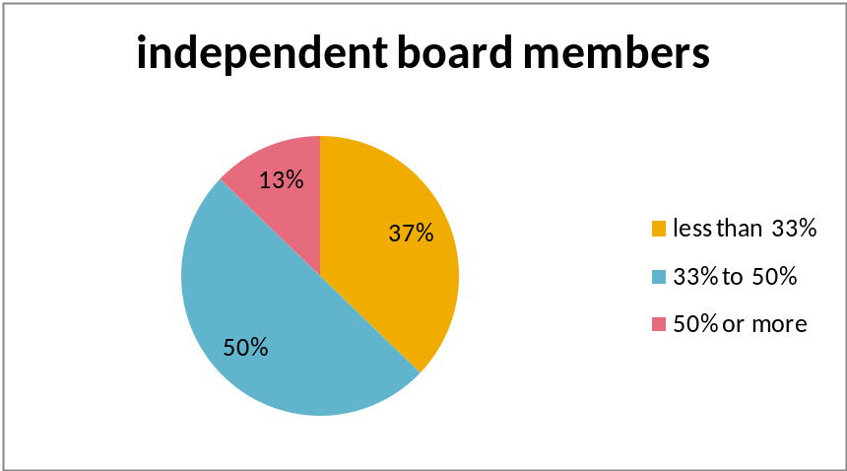
Figure 1
All companies, except for one, disclosed the number of board meetings held over the year, as many of the corporate governance codes recommend. In Figure 2 the number of board meetings can be found. It is good to see that the majority of the boards of the companies meet every two months or more often. Moreover most of the companies list the attendance of the board members at the meetings as well. The average number of board meetings is 10.
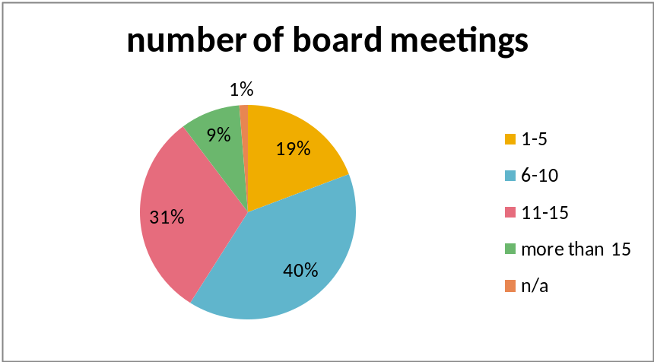
Figure 2
Audit
As is required by the SET, all companies must have an audit committee. It was therefore no surprise to see that indeed all companies had an audit committee. It is the audit committees’ main duty to discuss financial statements and earnings press releases with management and an independent auditor.
All companies had an audit statement incorporated in their annual report as well. Almost all companies of the sample had an audit committee comprised of only independent directors. Only two, Aapico Hitech and Airports of Thailand did not have an audit committee which was more than 50% independent. The frequency of the meetings of the audit committees can be found in Figure 3. As can be seen, more than half of the companies meet 5 or more times per year. Six companies did not disclose information on how many times per year the audit committee met.
All but one company disclosed a statement in their annual reports claiming the directors’ responsibilities for their financial statements. This is an important statement, which should prevent fraud. When the directors alter the financial statements they can be prosecuted by law, since the directors claim the financial statements are correct. The company that did not include this statement was Airports of Thailand.
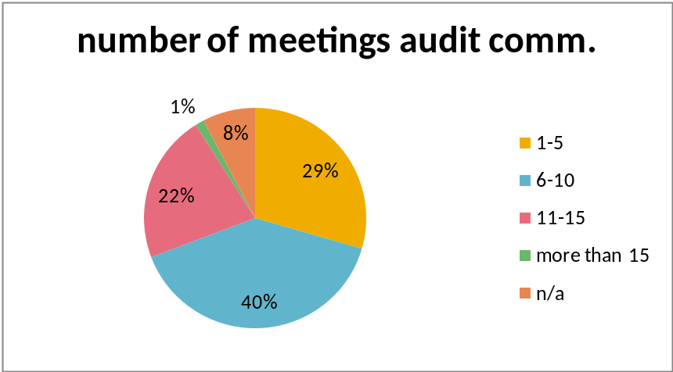
Figure 3
Remuneration and nomination
60 companies in the sample have a special committee, which deals with the remuneration issues at the companies. Mostly called a remuneration committee, sometimes a compensation committee. All the companies which had such a committee also disclosed who were in the committee. By 34 of these 60 companies the remuneration committee was comprised of more than 50% of independent directors; some had the committee consisting entirely of independent directors.
Besides this, most companies also disclosed the amount of remuneration received by the individual board members. Five companies however, only stated the total amount which was paid out to the board members.
In Figure 4 the existence of nomination committees at the companies can be found. As can be seen, most companies have a nomination committee in place to select new members of the board. However there are a few companies who either not disclose this information or use different ways of selecting board members. The Thai SEC best practices for directors of listed companies does include this as one of the points of selecting new board members.
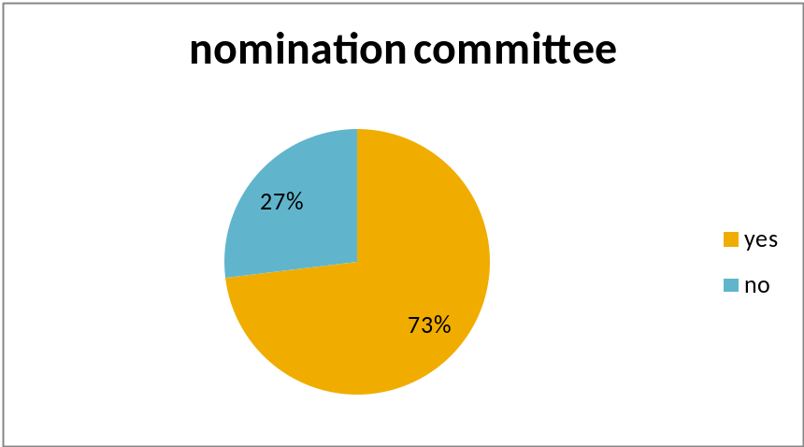
Figure 4
Corporate governance
Of the 78 companies, 76 filed a corporate governance report, stating that they complied with the corporate governance demands set by the SET. 24 companies had their own corporate governance committee in place.
No clear discrepancies were found after correcting for industry. Only the nomination committee appeared to be lesser existent for the industrials (3 out of 6 compared to 57 out of 78 for the entire SET100), but considering the number of companies only being 6 the number is hardly significant.

Conclusions
As can be seen from the results, the corporate governance tools of most of the companies are in place. All companies have an audit committee, which in general meet regularly. The independence of the audit committees is also up to standard. The same is true for the remuneration committees and the nomination committees. 24 out of 78 companies even had a special corporate governance committee in place.
The best company I came across was Krung Thai Bank (KTB). This company had 8 out of 14 independent directors (57%). The number of meetings held was among the highest, as well as the attendance to the meetings. All positions in the committees were held by independent directors and the company has a corporate governance committee as well.
I found numeral companies without a remuneration committee, a nomination committee and a corporate governance committee. All with very few independent directors in the board (20%, 22%, 23%, 25%), but Siam City Cement (SCCC) jumped out by also not disclosing information about personal remuneration of the board members. This company can definitely do some improvements to create better corporate governance policies.
Overall, Thai companies live up to the regulations set by the SET and disclose their information very well.
By looking at the different rules on corporate governance of the countries one can see that in Thailand the main emphasis is to direct the directors’ attention to their duties as a director and also to put sanctions on mischievous companies. In the United States the importance is given to the independence of the directors. A majority of directors must be independent. In Britain, it is all about balance. It is the combined weight that counts, directors should not be paid too much, but also not too little. This is a more ambiguous conduct and gives way to multiple interpretations. The Thai regulations have some issues incorporated which may seem natural in the US and UK regulation, but in general the regulations all agree on main issues.

Bibliography
Alchian, A. A. (1969). Corporate Management and Property Rights. In H. G. Manne, Economic Policy and Regulation of Corporate Securities (pp. 337-360). Washington D.C.: American Enterprise Institute for Public Policy Research.

Baek, J.-S., Kang, J.-K., & Park, K. S. (2004). Corporate governance andfirm value: evidence from the Korean financial crisis. Journal of Financial Economics , 71, 265-313.

Claessens, S., Djankov, S., & Lang, L. H. (1999, November 30). Who Controls East Asian Corporations? Working Paper . World Bank.

FSA. (2003). The combined code on corporate governance. Retrieved 3 20, 2007, from Financial Services Authority: http://www.fsa.gov.uk/pubs/ukla/lr_comcode2003.pdf

KPMG. (2006). U.S. Governance Regulations & Sarbanes-Oxley Act. Retrieved 3 20, 2007, from KPMG's Audit Committee Institute: http://www.kpmg.com/aci/gov.asp

Mitton, T. (2002). A cross-firm analysis of the impact of corporate governance on the East Asian financial crisis. Journal of Financial Economics , 64 (2), 215-241.

OECD. (1999). Corporate Governance: The Challenge Facing the Thai Economy. Seoul.
Persons, O. S. (2008, 11). Retrieved 2 20, 2009, from Thailand Law Forum: http://www.thailawforum.com/articles/Corporate-Governance-Thailand.html

SEC. (2005, April). Capital Thailand. Securities and Exchange Commission, Thailand Quarterly Newsletter (4).

SET. (1999). Code of Best Practice for Directors of Listed Companies. Retrieved 3 18, 2007, from European Corporate Governance Institute: http://www.ecgi.org/codes/documents/thailand_code_oct1999.pdf

Shleifer, A., & Vishny, R. W. (1997). A Survey of Corporate Governance. The Journal of Finance , 52 (2), 737-783.

Standard & Poor's. (2004). Corporate Governance Disclosures in Thailand: A study of SET50 companies.

Standard & Poor's. (n.d.). National University of Singapore. Retrieved 07 13, 2009, from http://bschool.nus.edu.sg/Portals/0/images/CGFRC/docs/indon_scorecard.pdf

The World Bank. (2005). Corporate governance country assessment, Thailand. The World Bank.

Xie, B., Davidson, W. N., & DaDalt, P. J. (2001). Earnings Management and Corporate Governance: The Roles of the Board and the Audit Committee. Retrieved 07 15, 2009, from SSRN: http://ssrn.com/abstract=304195

Appendix A: SET Code of Best Practice for Directors of Listed Companies (SET, 1999)
1. Board Composition
1.1 The board of directors should consist of:
1.1.1 Executive Directors who are involved in day-to-day operations or are authorized directors.
1.1.2 Non-Executive Directors who are:
- Independent Directors are defined as directors who do not hold any position in the management and are not employees of the company. They must not be an executive director or an authorized director. They must be independent of any major shareholders, management, and any other related persons and they must have the responsibility to determine if there is anything that may effect the equitable treatment of shareholders. They are also responsible for considering any transactions that may lead to a conflict of interest between a listed company and related persons.
- Outside Directors are defined as directors who do not hold any position in the management or and are not employees of the company. They must not represent any major shareholders but they may represent stakeholders, such as customers, suppliers, or creditors, etc.

1.2 The board of directors of a listed company should include independent directors and outside directors of sufficient caliber and number for their views to carry significant weight in the board’s decisions. No one director should have unfettered powers regarding decisions made by the board of directors. In this way, everyone can reach an independent judgment.

1.3 The chairman should be an independent director and should not be the same person as the managing director. The reason for this is that there should be a separation of duties in directing the company’s policies and management.

2. Roles and Responsibilities of Directors
2.1 Directors must ensure that company has management with enough competency, knowledge and experience to run the business. They are interested in the business, in which they hold a directorship. In addition, the management must have the intention to run the business continuously and conduct themselves with honesty and integrity.

2.2 Directors must comply with all laws and regulations, all objects and articles of association of the company, and they must carry out their duties in line with the resolutions of shareholders’ meetings in good faith and with care to preserve the interests of the company. They must ensure the management’s accountability to shareholders.

2.3 Directors must implement and direct the company’s policies, as well as monitor and supervise its operations to maximize economic value and shareholders' wealth.

2.4 Directors should continuously follow and monitor the business’s performance and the operations of the company, according to its bye-laws and regulations. The board of directors should be notified by the management of any significant matters regarding the company’s business.
2.5 Directors should maintain the effectiveness of the company’s internal control and internal audit.

2.6 Independent directors and outside directors should bring an independent judgment to bear on issues of strategy, performance, resources, including key appointments, and standards of conduct. They should oppose any proposal brought by other directors or management, that they consider may lead to effect the equitable treatment of shareholders.

2.7 Directors can seek independent professional advice concerning the company’s business, when considered necessary, with the company’s expenditure.

2.8 Directors should appoint a company secretary to take care of all the director’s activities and to help the director and the company conduct business in full compliance with all the relevant bye-laws and regulations.

2.9 Directors should implement a Code of Corporate Conduct and a Code of Ethics to be guidelines for the company.

3. Appointments to the Board
3.1 The company should have a written and transparent policy concerning the selection and the appointment of a director.

3.2 The board should precisely regulate the term of the directorship. Re-appointments should not be automatic.

3.3 The board should establish committees which can assist the board in regard to the entity’s financial reports, internal control system, and in fulfilling its corporate governance. Examples of such committees are an audit committee, a nominating committee, and a remuneration committee, etc.

4. Holding a Director’s Position
4.1 Director should accept the appropriate number of company directorship to hold, in order to ensure that he/she has time to attend meetings and keep up with the business performance and the operations of the company.

4.2 Director must ensure that the managing director of the listed company holds this position in only one company, in order to have time to run the business in accordance with the company’s objectives.

4.3 Director should avoid any other positions or jobs that may lead to any conflicts of interest.

5. Directors' Remuneration
5.1 The company should have a written and transparent policy concerning the remuneration of directors and management. Remuneration must be approved by a shareholders’ meeting.

5.2 The remuneration of directors, who are appointed to committees and/or are assigned any additional duties or responsibilities, should reflect the duties and responsibilities assigned by the board.

5.3 The remuneration of directors should be disclosed fully in the company’s annual report.

6. Board & Shareholders’ Meetings
6.1 The company should strive for consistent attendance at all board meetings. When the board is making decisions on any significant activities, the meeting must maintain a quorum. Examples of significant activities are: acquisitions and dispositions of assets, investment project expansions, the identification of power and management levels, financial management policies, and risk management, etc.

6.2 A written notice of all board meetings, which includes the date, the agenda, and any documents relating to matters about to be ratified or approved at the meeting, must be sent to every director in advance. The notice must be sent within the period specified in the company’s articles of association except in case of an emergency in order to maintain company benefits. This will allow the directors to arrange their schedules to attend all board meetings and also allow them to carefully consider all information in order to make decisions.

6.3 Every director has the right to examine all documents relating to all matters that concern the board of directors. If suspicions arise, other directors or management must be asked to explain these suspicions.

6.4 The company should follow the best practice for shareholders’ meetings of a listed company to ensure that the meeting is held in a transparent and legitimate manner and that it leads to the benefit of every shareholder.

6.5 The company secretary, or another person assigned by the board, should complete the minutes for each board of directors’ and shareholders’ meeting within the period specified by the relevant bye-laws. The directors have the right to examine the minutes if they inform the company in advance.

7. Reports
7.1 The board of directors is responsible for the accuracy, the completeness, and the transparency of the company’s financial reports and non-financial reports which are disclosed to shareholders and investors. The reports should include reasonable explanations and calculations to support the results of its operations, policies, future trends as well as any opportunities or any threats.

7.2 Financial Reports
7.2.1 The board should not unnecessarily intervene and should maintain full understanding regarding the objectives and professional standards of audits conducted by external auditors.
7.2.2 If any external auditor resigns or is dismissed, the company should explain the reasons for said resignation or dismissal to the Office of the Securities and Exchange Commission (SEC) and to the SET.
7.2.3 The board should present a statement of the directors’ responsibilities concerning the disclosure of its financial reports. This statement should be presented in the annual report together with the audited financial statements. This statement should cover the following points:
- The law and the requirements for directors to prepare financial statements for each financial year which present a true and fair view of the state of affairs of the entity.
- The responsibilities of the board in presenting accurate and complete financial information to maintain and safeguard the company’s assets. It should include full details in a way as to prevent any fraud or mismanagement of the company’s assets.
- The statement must show that the company has conformed with accepted accounting standards and other reporting requirements. It must use appropriate accounting policies, and that it applies them consistently. The report should be supported by reasonable and prudent judgment and estimates.

7.3 The board of directors should disclose their compliance or non-compliance with the Code of Best Practice. Any areas of non-compliance should be explained and justified.

Appendix B: Key Issues World Bank (2005)
 |  | Key issues
 |  | The following section highlights key observations of the principle-by-principle assessment of Thailand’s compliance with the OECD Principles of Corporate Governance
 |  | Investor protection
Basic shareholder rights are protected but concentrated control limits the influence of minority shareholders |  | Basic shareholder rights are largely in place in Thailand. Share registration is secure and shares are freely transferable. Shareholders can obtain material information from the company and are entitled to attend and vote in the annual general meeting (AGM). Nevertheless, because company control is concentrated, and cumulative voting, although permissible, is rare. Most company boards are dominated by the controlling shareholders.
There are some constraints on shareholder participation in the AGM |  | While shareholders may participate in the AGM, it is difficult for minority shareholders to propose additional agenda items. Legislation to address this problem is currently under the consideration of the Council of State, however, it is unclear if and when such legislation will be adopted. In addition, because most company boards are selected by controlling shareholders, it is difficult for minority shareholders to make their influence felt. This is changing gradually, however, through active participation of the Thai Investors Association at AGMs of listed companies.
 |  | Disclosure
Basic disclosure requirements are in place |  | Listed companies submit quarterly and annual financial statements, which are reviewed and audited by the company’s auditor and are available to the public. In addition, timely disclosure is required upon the occurrence of an event which may have a material effect on the company. SEC regulations also require disclosure by listed companies of top 10 shareholders and of the identities of the ultimate beneficial owners of those shareholders. Related party transactions also must be disclosed.
A new system of independent oversight over the audit profession |  | The Federation of Professional Accountants has recently been established. It is too early to determine how this new organization will help improve the audit profession. While a great deal of effort has been expended, further improvements are required. Thailand accounting standards are not yet fully consistent with international accounting standards.
 |  | Company oversight and the board
Limited understandings of duties of care and loyalty |  | While the concepts of fiduciary duty, duty of care and duty of loyalty are embedded within the law, in practice, particularly in smaller companies, it appears that directors have only a limited understanding of their roles and responsibilities.
Boards dominated by controlling shareholders |  | Thai law provides that board members are to be nominated and elected by the AGM. In practice, controlling shareholders nominate the directors and AGM approval is a mere formality.
Director independence is quite limited, particularly in smaller companies |  | The requirement that all listed companies have an independent audit committee should improve the effectiveness of boards of directors of listed companies, over time. However, it is still too early to determine whether these audit committees are acting independently from the management, particularly in smaller companies.
 |  | Legal Enforcement
While recent enforcement efforts are welcome, more aggressive prosecution is necessary |  | Legal enforcement remains a major challenge. For corporate governance reforms to result in improved practices, managers and directors must appreciate that implementation is important and will be enforced. Recent court cases have resulted in more stringent fines and imprisonment for corporate fraud. These developments send an important signal about the importance of compliance and enforcement. Regulators and prosecutors should continue these stepped up efforts.
 |  | Recommendations
 |  | Thailand has made significant strides in improving corporate governance in recent years. The focus should remain on implementation and on completing the legislative and regulatory agenda, improving legal enforcement, enhancing financial reporting and disclosure consistent with international standards, and promoting business ethics and good practices.
Legislative and regulatory reforms are both important
Legislation to strengthen minority shareholder rights should be adopted |  | Proposed amendments to the SEA and the PCA constitute important efforts to increase the protection of minority shareholders. Ratification of the SEA amendment would clarify and strengthen the fiduciary duties of board members while proposed PCA amendments would strengthen shareholders’ rights and give them more voice in the conduct of AGMs. The legislative process has been slow and uncertain, however, and it is not clear that these legislative amendments will ultimately be adopted.
Additional reform would strengthen the corporate governance framework |  | Additional legislation to strengthen minority shareholder rights is needed, including
 |  | Cost effective legal channels for shareholders seeking redress. Progress has been made in drafting the proposed Class Action Act. However, there is still a need to consider additional measures to protect minority shareholders from controlling shareholders abuse by ensuring that board members act for the benefit of all shareholders. To this end, it is also recommended that director registration be for a limited term (3-5 years) with mandatory refresher training as a condition for re-registration.
 |  | Dismissal of a director. It is recommended that consideration be given to simplifying the process for the removal of a board member. This would require an amendment to the PCA. Also, it is recommended that additional steps to allow minority shareholders a greater voice in the selection of directors be considered, including making cumulative voting more commonly used, and possibly mandatory, for listed companies under certain conditions.
 |  | Proxy Solicitation. Policy makers should focus on abuses of proxy solicitation which may occur in listed companies. It is recommended that the SET and MAI work closely with the SEC to establish a set of rules for proxy solicitation to apply to all listed companies. International good practice suggests allowing the electronic appointment of proxies. Once the proposed amendments to the SEA are enacted, these rules will refer to the SEC’s regulations as the governing rules. It is also recommended that consideration be given to allowing shareholders to cast votes electronically.
 |  | Cross-border voting. The 21-day period between XM announcement date and the date of AGM is too short for depository banks to collect voting instructions from beneficiaries. To facilitate further the exercise of cross border voting, policy makers should ensure that there are no legal impediments to the electronic appointment of proxies, in line with international good practice.
Regulatory and self-regulatory action is important, particularly in light of legislative uncertainty |  | Legislative reforms of corporate governance requirements, while important, are at best slow and their effectiveness is not at all certain. Therefore, the regulatory authorities and the stock exchanges should be proactive where possible and consider the inclusion of the proposed amendments in their listing rules. This would accelerate the improvement of corporate governance practices for listed companies, and strengthen the likelihood of legislative ratification.
Expand the coverage of the rules on conflicts of interest and self-dealing |  | Thai law prohibits insider trading and requires board approval for self-dealing by directors. The SET rule reiterates the issue by imposing self-dealing rules to exclude potential conflicts of interest. However, the law in self-dealing should be expanded to cover conflict-of-interest transactions involving controlling shareholders in listed companies and non-listed subsidiaries.
Clarify the regulations governing the activities of institutional investors |  | There is a requirement that Asset Management Companies acting on fiduciary duty to disclose their voting records on their website as well as on an-ex-post basis. It is recommended that consideration be given to extend the same requirement to all institutional investors.  The SEC may wish to consider issuing a regulation clarifying the circumstances under which consultation and voting agreements between institutional investors may take place without triggering the provisions of the SEA (1992) regarding substantial acquisitions of shares, or those concerning market manipulation. If an agreement is reached between institutional investors to vote together at a shareholders’ meeting, such cooperation should be disclosed to the SEC and the market before the shareholders’ meeting. Some institutional investors might resist such disclosure and prefer to remain anonymous in order to preserve other commercial relations with the company. However, from a policy standpoint, the greater the transparency, the more efficient the Thai capital market, and the greater its integrity.
Increase the accountability of directors and management and further clarity fiduciary duty of directors
 |  | It is recommended that further efforts be expended to improve the independence of outside directors.
The audit committee’s role should be clarified to increase its effectiveness |  | While all listed companies are now required to set up an independent audit committee, the independence and effectiveness of these committees remain as major challenges. The effectiveness of audit committees of boards of directors needs to be improved. It is recommended that steps be taken to clarify and strengthen the role and function of audit committees, consistent with international best practices. Additionally, use of outside experts should be encouraged.  In addition, it is recommended that the duties of audit committees be broadened to include the oversight of insider conflicts, and to oversee business advisory /consulting services, per international best practice. It is also recommended the audit committee’s role with respect to consulting services relate to both the nature as well as the extent of such services rendered by the external auditor.
Additional board committees could be helpful in improving accountability |  | Additional board committees could be helpful in improving accountability. It is recommended to consider requiring remuneration and nomination committees for listed companies. The remuneration committee would focus on board performance and pay, and the nomination committee would deal mainly with recruitment of high level management and executives and matters relevant to nomination. Each should largely consist of outside directors.
Directors must have a better appreciation of their role and responsibilities |  | Directors of companies listed on the SET are highly recommended to attend training at the Thai Institute of Directors, which was established in 1999. This has been an important and commendable step. However, more directors need to undergo the Institute’s training to ensure that all Thai board members are fully aware of their role and responsibilities. In addition, efforts should be made to improve the independence of outside directors. The new system of SEC director registration should be a useful tool to monitor the behavior of listed company directors.
Board evaluation procedures should be introduced |  | It is recommended that directors be required to evaluate the performance of their colleagues, once a year for example. Furthermore, it should also be considered whether or not to limit the number of boards on which directors are permitted to serve, or to make it, at a minimum, subject to mandatory disclosure.
Further improve quality and reliability of financial information and disclosures provided by public companies
Set target date for full convergence with international accounting and auditing standards |  | Accounting and auditing standards and practices need to reach convergence with international standards and be consistent with international best practices. It is important for the relevant authorities to set the target date for the completion of convergence. Accountants need to continue to be trained on international standards, and the process for taking disciplinary actions and imposing sanctions on those accountants who violate duties and commit fraud needs to be improved.
Introduce disclosure certification |  | It is recommended that considerations be given to requiring management (CEOs, CFOs) of listed companies to include in the annual reports a statement on their responsibility for establishing and maintaining adequate internal controls over financial reporting and compliance with applicable laws and regulations, as well as an assessment of effectiveness of their internal controls consistent with international best practices. External auditors should render an opinion on such reporting in the future.
Oversight of financial reporting of listed companies |  | The SEC should continue to comprehensively and regularly review all listed companies’ financial statements, including those that may have appearance/indication of potential issues.
Encourage disclosure by custodians |  | The SEC should consider asking entities that act as professional custodians to seek their customers’ agreement that they may comply with applicable regulatory disclosure requirements, including, for example, disclosing to the SEC the identity of the ultimate beneficial owners, without breaching their confidentiality agreement with their customer.
Establish corporate governance enforcement priorities
Strengthen the independence of the SEC |  | The SEC consists of a Board, which sets policy, and an Office, which implements the policies and deals with day-to-day operations. The Board is chaired by the Minister of Finance. Although the Minster does not attend board meetings, this governance structure gives the appearance that the SEC is not a fully independent regulatory body, consistent with international good practice. It weakens the SEC’s authority and can ultimately undermine the perception of market integrity by market participants. The proposed amendment to the SEA, which provides that the Board be chaired by a competent person other than the Minister of Finance, should be expedited to help ensure that the SEC cannot be subject to political intervention in its oversight of the activities of publicly listed companies and market participants.
Improve enforcement for violation of laws |  | Recent improvements in enforcement need to be reinforced. The SEC should continue to further enhance the skills and knowledge of its own investigators; More severe sanctions on insiders for false and misleading disclosure should be introduced. The SEC should have full cooperation from other criminal authorities to improve the effectiveness of criminal enforcement actions.
Introduce administrative and civil sanctions |  | Although criminal enforcement is improving, the process is still lengthy and involves high standard of proof. The authorities should, therefore, consider the introduction of civil penalties and administrative sanctions as more efficient alternative to impose on violators.
The judiciary must be trained to address corporate governance violations |  | In recent criminal cases the Thai judiciary has responded strongly to corporate fraud. These cases set a useful precedent and serve as a deterrent for future misbehavior. Nevertheless, the Thai authorities must ensure that such cases are not sui generis, and that the judiciary in general is familiar with corporate governance requirements and becomes used to adjudicating corporate law cases. Training should continue to be provided to prosecutors and judges on a regular basis on the essentials of the capital market and related laws, to ensure understanding of the intent of the law. Establishment of a specialized court to deal with corporate and securities related disputes should be considered.

Appendix C: Corporate Governance Disclosure Scorecard (Standard & Poor's)
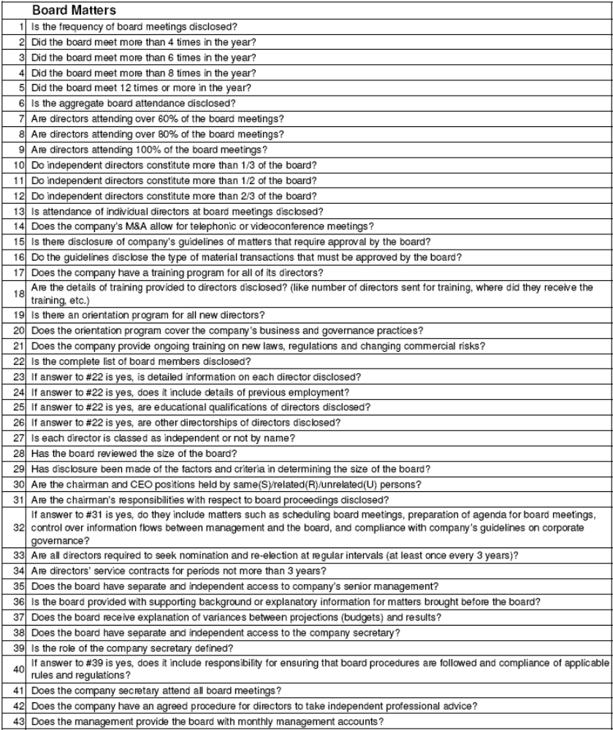

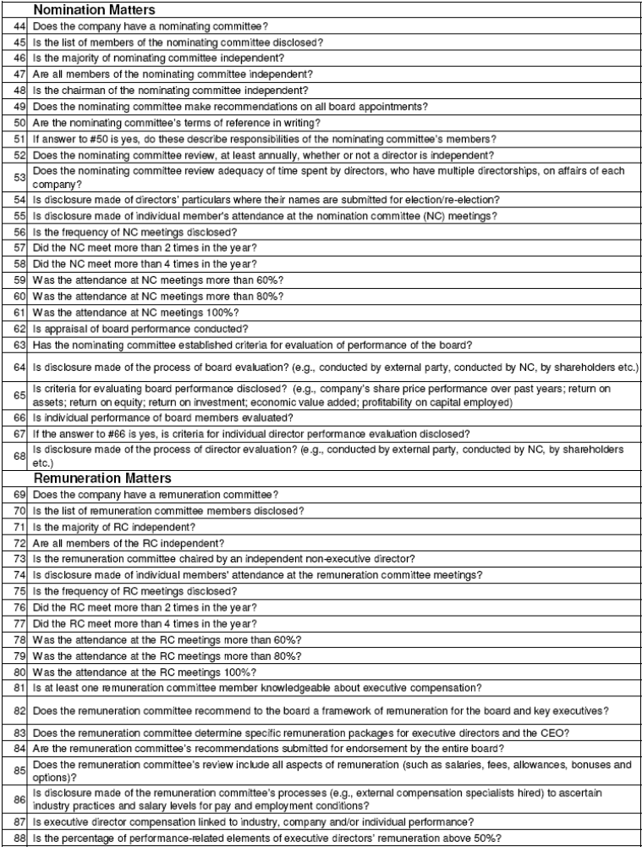

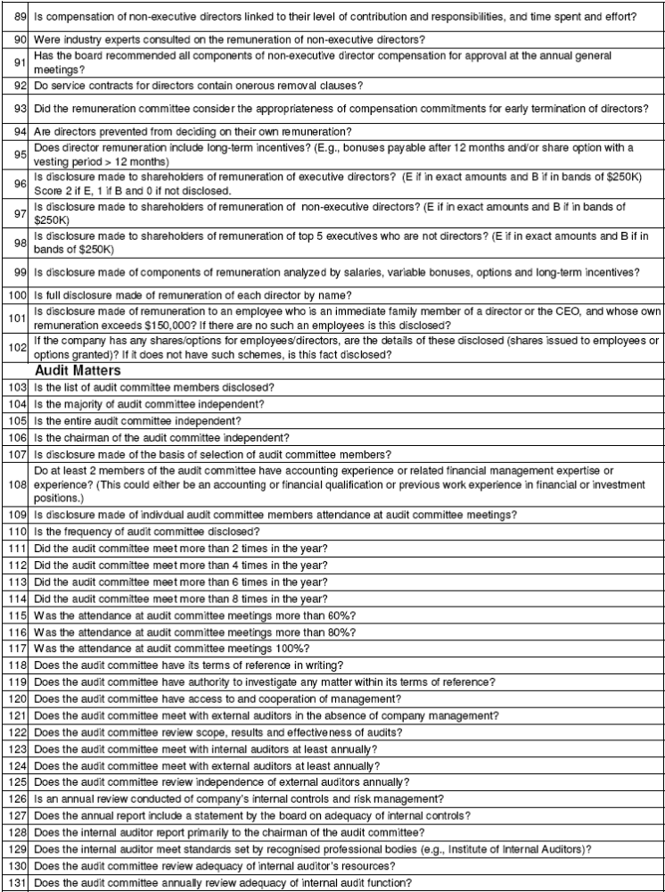

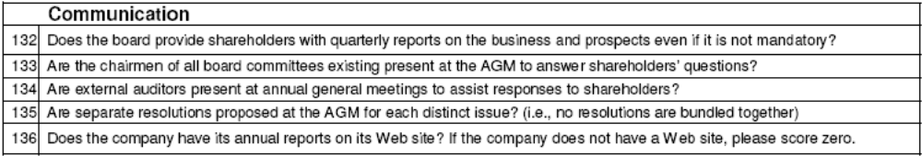

Appendix D: Data
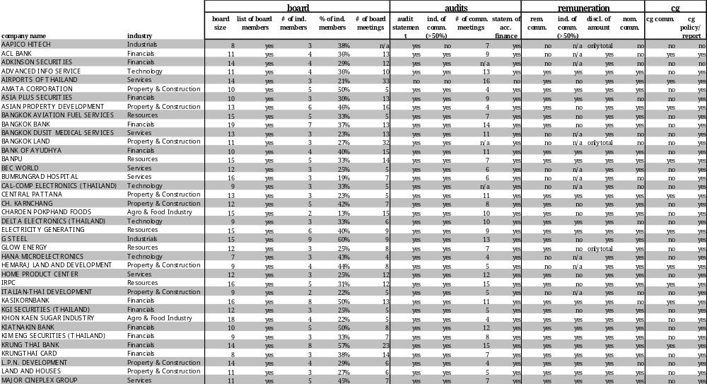

Results (cont’d)
